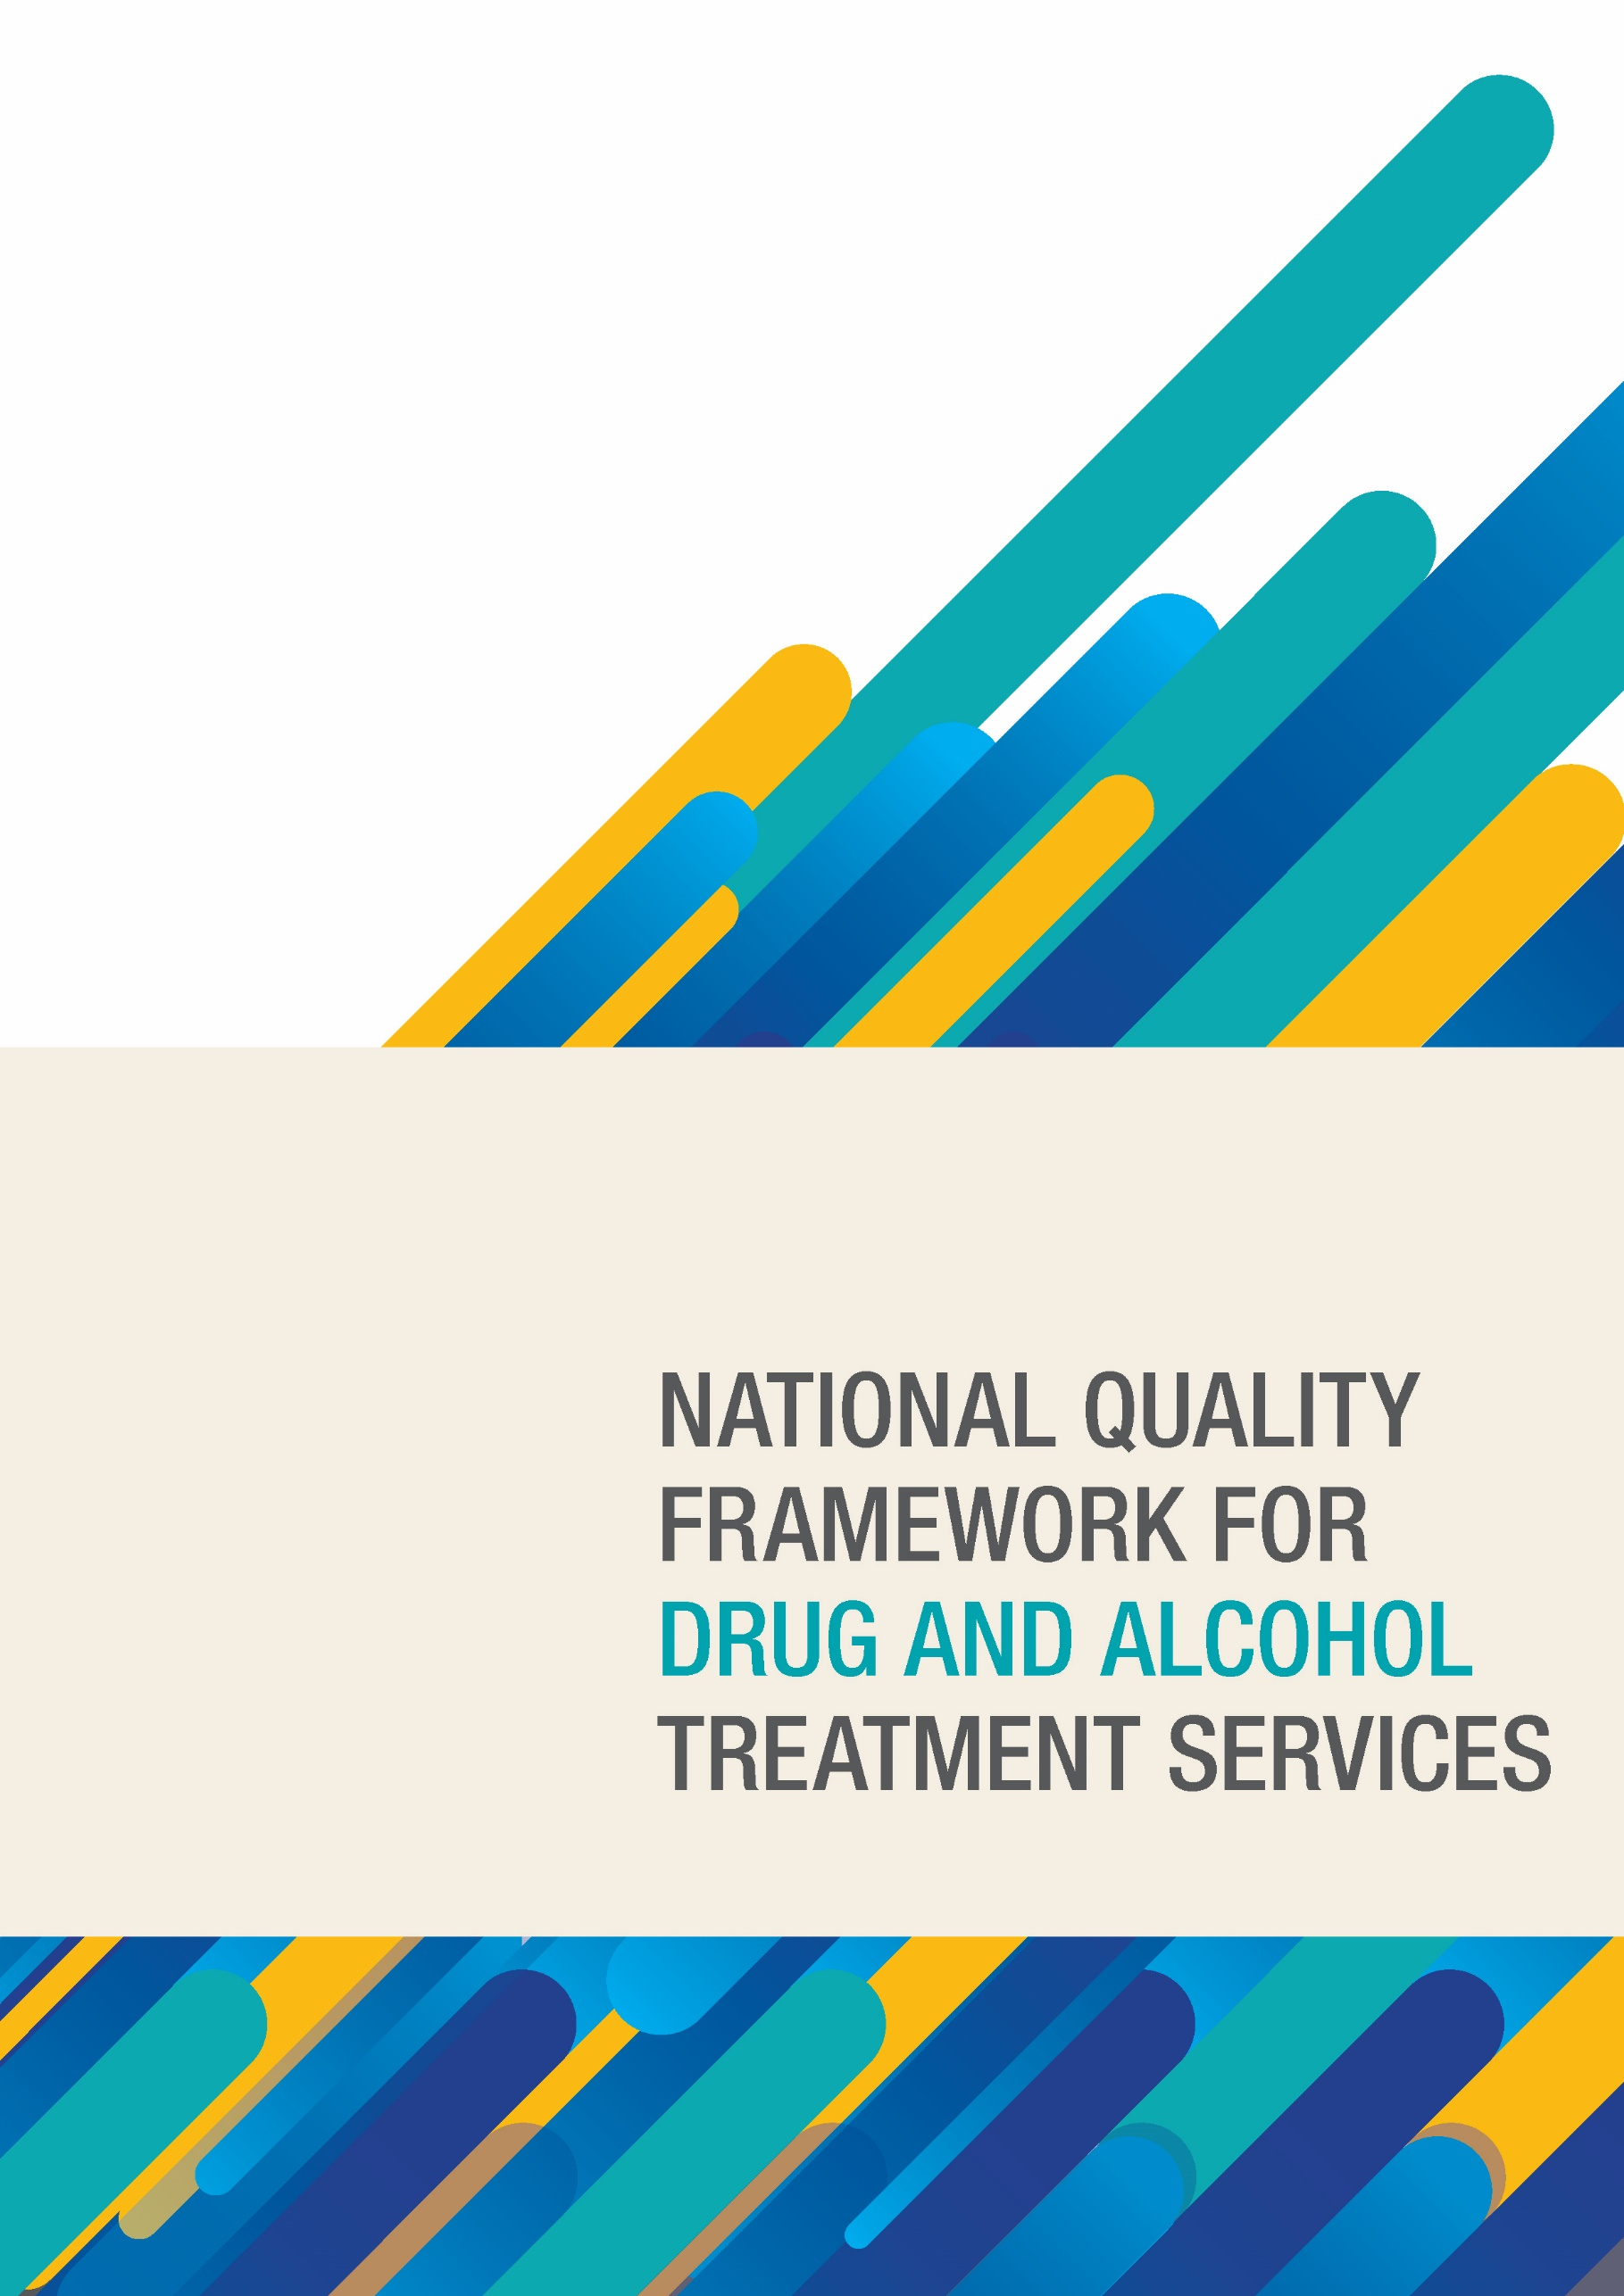

**National Quality Framework for Drug and Alcohol Treatment Services**

© Commonwealth of Australia as represented by the Department of Health 2018

Publications Number: 12149

**Creative Commons Licence**



This publication is licensed under the Creative Commons Attribution 4.0 International Public License available from https://creativecommons.org/licenses/by/4.0/legalcode (“Licence”). You must read and understand the Licence before using any material from this publication.

**Restrictions**

The Licence may not give you all the permissions necessary for your intended use. For example, other rights (such as publicity, privacy and moral rights) may limit how you use the material found in this publication.

The Licence does not cover, and there is no permission given for, use of any of the following material found in this publication:

* the Commonwealth Coat of Arms. (by way of information, the terms under which the Coat of Arms may
* be used can be found at www.itsanhonour.gov.au);
* any logos and trademarks;
* any photographs and images;
* any signatures; and
* any material belonging to third parties.

**Attribution**

Without limiting your obligations under the Licence, the Department of Health requests that you attribute this publication in your work. Any reasonable form of words may be used provided that you:

* include a reference to this publication and where, practicable, the relevant page numbers;
* make it clear that you have permission to use the material under the Creative Commons Attribution 4.0 International Public License;
* make it clear whether or not you have changed the material used from this publication;
* include a copyright notice in relation to the material used. In the case of no change to the material, the words “© Commonwealth of Australia (Department of Health) 2018” may be used. In the case where the material has been changed or adapted, the words: “Based on Commonwealth of Australia (Department of Health) material” may be used; and
* do not suggest that the Department of Health endorses you or your use of the material.

**Enquiries**

Enquiries regarding any other use of this publication should be addressed to the Branch Manager, Communication Branch, Department of Health, GPO Box 9848, Canberra ACT 2601, or via e-mail to corporatecomms@health.gov.au.

# CONTENTS

CONTENTS 3

GLOSSARY OF TERMS AND ABBREVIATIONS 4

INTRODUCTION 5

Context 5

Background 5

National Drug Strategy 6

Responsibilities 6

PURPOSE 7

APPLICATION 7

Timing 7

ELEMENTS OF THE FRAMEWORK 8

Guiding Principles 8

Guiding Principles Detail 9

Accreditation standards 12

GOVERNING AND MONITORING 12

DIRECTORY 12

# GLOSSARY OF TERMS AND ABBREVIATIONS

| **AOD** | Alcohol and Other Drugs |
| --- | --- |
| **AOD providers receiving government funding** | An organisation specifically providing evidence informed treatment to address alcohol and other drug dependence, or one that describes or promotes itself as a service that provides such treatment.  These providers receive funding through funding/service contractual arrangements, from a Commonwealth and/or State/territory government(s) or Primary Health Network.  These organisations can be government or non-government run, for profit or not for profit. |
| **AOD providers not receiving government funding** | An organisation specifically providing treatment to address alcohol and other drug dependence, or one that describes or promotes itself as a service that provides such treatment that does not receive government funding. A provider not receiving government funding may receive funding from other sources such as philanthropy, client fees and private hospitals. |
| **COAG** | Council of Australian Governments |
| **Ice** | A colloquial name for the crystalline form of methamphetamine. |
| **MDAF** | Ministerial Drug and Alcohol Forum |
| **NDSC** | National Drug Strategy Committee |
| **PHN** | Primary Health Network |
| **Third Party Accreditation** | An accreditation standard, including health, community and quality management standards. |
| **Transition Period** | Period of 3 years, from MDAF endorsement to 28 November 2022, that AOD providers have to work towards accreditation with the acceptable accreditation standards as specified in the National Quality Framework. |

# INTRODUCTION

## Context

It is well recognised that alcohol and other drug (AOD) treatment is a good investment for governments and other funders with direct savings in future health costs, reduced demands on the criminal justice system and productivity gains. More importantly, evidence-informed treatment contributes to individual, social and economic goals by reducing the harms from alcohol or drug use, and improving the wellbeing of individuals and families.

AOD treatment in Australia is provided by a variety of organisations. Organisations can receive government funding whilst others receive funding from clients and philanthropy. The multiple funding sources within the treatment system bring challenges in ensuring consumers are receiving value for money and client focused treatment, including evidence informed practice. Individuals and families seeking to access AOD treatment services are often in crisis and can be vulnerable to accepting poor quality services that are unlikely to produce good outcomes.

Existing quality mechanisms (including accreditation, contractual arrangement, professional codes and regulation) vary, may be limited and do not apply equally across treatment service providers, regardless of whether they receive government funding, including services that describe or promote themselves as assisting people to address their AOD use.

In addition, there is no consistent approach to ensure minimum quality standards and continuous quality improvement in the AOD treatment system.

The National Quality Framework will set a nationally consistent quality benchmark which consumers can expect from treatment providers.

## Background

In April 2015, the Commonwealth Government established a National Ice Taskforce to report on actions needed to address the increasing use of ice in Australia. The Taskforce highlighted the need for a national mechanism to ensure continuous quality improvement to assist services to build their capacity to deliver effective treatment and ensure the sector is best-placed to respond effectively to emerging issues and trends.

As a result of the Taskforce findings, the National Ice Action Strategy, a sub-strategy of the National Drug Strategy, was developed to reduce the prevalence of ice use and resulting harms across the Australian community. The Strategy included achievable actions across a range of areas, including the need for a National Quality Framework to be developed that sets the benchmark for the delivery of best-practice treatment services.

The implementation and monitoring of the National Ice Action Strategy, along with all national strategies, are the responsibility of all governments, with oversight by the Ministerial Drug and Alcohol Forum (MDAF).

The MDAF was formed to oversee the development, implementation and monitoring of Australia’s national drug policy framework, including the National Ice Action Strategy, from 2016. The Forum reports directly to the Council of Australian Governments (COAG) and consists of health and justice Ministers with responsibility for alcohol and drug and law enforcement policy.

The National Quality Framework has been endorsed by the MDAF.

## National Drug Strategy

The National Drug Strategy 2017-2026 is a national framework for building safe, health and resilient Australian communities through preventing and minimising alcohol, tobacco and other drug related health, social and economic harms among individuals, families and communities. The National Drug Strategy framework builds on the strategic principles of partnerships, coordination and collaboration, national direction and jurisdictional implementation, and evidence-informed responses.

The Strategy describes the nationally agreed goal of harm minimisation for reducing alcohol, tobacco and other drug problems. However, the Commonwealth, state and territory governments and local governments are all responsible for the implementation, regulation and funding of programs that reduce alcohol, tobacco and other drug problems.

The Strategy also identifies priorities for achieving the goals set out in the National Quality Framework. Under the priority of Improving National Coordination, the Strategy highlights the need for the development of a National Quality Framework.

## Responsibilities

All government have a responsibility to ensure the quality and effectiveness of AOD treatment services. This includes ensuring equity and fair delivery of treatment services and treatment outcomes.

Drug and alcohol treatment regulation and funding is primarily the responsibility of state and territory governments. The Commonwealth also performs an important role by providing sector leadership, leading national policy, and contributing to sector funding.

# PURPOSE

The National Quality Framework provides a national agreement on a quality benchmark for the delivery of AOD treatment services which allows for implementation based on funding sources and jurisdictional regulatory and non-regulatory approaches. The purpose of the National Quality Framework is to achieve positive health outcomes through improving the quality and safety of drug and alcohol treatment services for consumers and their families. The National Quality Framework does this by:

* Articulating key AOD treatment service quality principles;
* Establishing a nationally consistent approach, where practical;
* Promoting an evidence based and informed approach to treatment service delivery;
* Promoting awareness and engagement with consumers about quality treatment services, and
* Supporting quality improvement in treatment services.

# APPLICATION

The National Quality Framework is applicable to all AOD providers, including those that receive government funding and providers not receiving government funding.

In order for this to be achieved, whilst ensuring a nationally consistent approach, the following will apply:

* Through contractual arrangements - the requirement for providers receiving government funding to meet the National Quality Framework and obtain accreditation with an acceptable accreditation standard will be communicated and enforced through funding/service agreements mechanisms.
* Through jurisdictional arrangements - providers not receiving government funding, are required to comply with the National Quality Framework and obtain accreditation with an acceptable accreditation standard, through regulatory or other processes set by jurisdictions as appropriate, to ensure the National Quality Framework is applicable to local circumstances.

To complement the development and implementation of the National Quality Framework, a National Directory of treatment service providers will be established to assist consumers identify a treatment service to meet their needs.

## Timing

As shown in the diagram below, providers are in transitional arrangements until 28 November 2022 where they can hold any third party accreditation (even if not included on the acceptable list of accreditation standards) or demonstrate to be working towards holding accreditation with at least one of the National Quality Framework acceptable accreditation standards. Providers should be considering on-going accreditation requirements and transition to acceptable accreditation standards within the transition period.

From 29 November 2022 onwards, providers will be required to have accreditation with at least one of the listed acceptable accreditation standards.

### Diagram 1: Timeline to implement National Quality Framework

This image shows the four major steps in the timeline:
Providers hold accreditation as per contractual/jurisdictional arrangements
MDAF endorsement (November 2019) National Quality Framework commenced
Transition Period
All providers hold accreditation that meets the National Quality Framework from 29 November 2022

# ELEMENTS OF THE FRAMEWORK

The National Quality Framework comprises of two key components:

1. Guiding Principles; and
2. Acceptable Accreditation Standards.

## Guiding Principles

The National Quality Framework has nine nationally agreed Guiding Principles:

This image shows the nine principles:
Organisational Governance
Clinical Governance
Planning and Engagement
Collaboration and Partnerships
Workforce, Development and Clinical Practice
Information Systems
Compliance
Continuous Improvement
Health and Safety

The Guiding Principles include statements of commitment that articulate key aspects required to improve quality in AOD treatment services. Accreditation standards ability to meet the minimum level of quality for the delivery of AOD treatment services, as stated in the Guiding Principles, will be assessed. The Acceptable Accreditation list will communicate the accreditation standards that meet the minimum level of quality.

## Guiding Principles Detail

### Organisational Governance

A systematic approach to organisational governance is established.

#### Summary

Effective governance is essential to help an organisation achieve its objectives, creates value and provides accountability and control systems.

The governing body should:

* outline the goals of the organisation and how these will be achieved;
* outline how performance will be optimised;
* communicate how cultural security and competency will be supported, delivered and maintained in treatment service delivery as appropriate, pertinent to client cohorts including indigenous and culturally and linguistically diverse people;
* have an issues and risk management plan to enhance organisational performance; and
* have clearly defined roles and responsibilities.

#### Relevance to AOD

The organisation should have considered how reducing AOD related harms fits with its values and mission.

(Refer to Clinical Governance Principle for AOD evidence and best practice elements).

### Clinical Governance

Establishment of accountability of individuals for the delivery of safe and effective quality care.

#### Summary

A system through which the organisation is responsible for continuously improving the quality of their services and safeguarding high standards of care by creating an environment in which excellence in clinical care will flourish.

A clear system of clinical governance is established in line with the Australian Commission on Safety and Quality in Health Care - National Model Clinical Governance Framework, pages 1-18 (Addendum 1). The governing body should:

* have a process for the development, implementation and review of clinical services to maintain and improve quality treatment services; and
* have clear clinical governance and review mechanisms that align with evidence and best practice.

#### Relevance to AOD

The organisation should ensure effective systems of clinical governance are in place to maintain clinical safety and quality of services delivered. The organisation should ensure treatment services are informed by the evidence of what works and are respectful of, and responsive to, the preferences, needs and values of clients and the community.

### Planning and Engagement

Planning and engagement to meet and be adaptable to client (service user) and community needs.

#### Summary

The organisation uses appropriate screening and assessment processes to provide timely access to client focused treatment services, supporting clients and their representatives to participate in decision making, exercise choice and control about their treatment delivery and case management planning and treatment goals.

#### Relevance to AOD

The organisation should ensure treatment services are informed by the evidence of what works and are respectful of, and responsive to, the preferences, needs and values of clients (service user) and the community, including cultural security requirements as appropriate.

The organisation monitors AOD use trends and undertakes community engagement to support its understanding of community treatment needs and adapts treatment environments to support access and engagement, including culturally responsive treatment models.

### Collaboration and Partnerships

Partnerships are established to improve and focus on client centred care.

#### Summary

The organisation provides integrated and collaborative care with other health professionals and organisations, where appropriate, to ensure the best possible care and treatment outcome(s) are achieved for clients.

#### Relevance to AOD

The organisation’s assessment and case management planning processes identify co-occurring issues, such as mental health, physical health, housing and employment and clients are supported through referral or collaboration to address these needs.

### Workforce, Development and Clinical Practice

Engage and maintain a workforce that has the appropriate qualifications, skills, knowledge and supervision.

#### Summary

The organisation employs appropriately qualified and skilled staff to ensure treatment services are delivered in accordance with legislative and regulatory requirements, and appropriate to the client cohort, including establishing policies and upholding professional codes of practice.

Staff are provided with access to relevant evidence informed clinical practice guidelines, where available. The organisation is committed to providing access to resources for staff to perform their roles effectively, improve their understanding of current research-based findings and implement effective treatment options.

#### Relevance to AOD

The organisation implements merit based recruitment and selection processes and supports ongoing staff development, through management and clinical/practice supervision and access to professional development that supports good clinical practices and the delivery of evidence-informed treatment.

### Information systems

Secure and effective information systems to meet organisational objectives and inform decision making.

#### Summary

The effective stewardship of data and information will assist the organisation to meet their strategic objectives, monitor financial performance, inform decision making, guide client treatment and ensure that valuable information and data assets are effectively managed.

The organisation is committed to maintaining a secure and effective information system that ensures staff have ready access to organisational policies and procedures to obtain and collect information to meet the needs of clients, their representatives, staff and stakeholders.

#### Relevance to AOD

The organisation has implemented appropriate information systems to capture data on treatment delivery, financial performance and organisational operations and uses this information to ensure compliance with contractual and legislative responsibilities. The organisation uses data analysis to inform continuous improvement activities.

### Compliance

Protect clients by meeting legislative, regulatory and professional obligations.

#### Summary

The organisation is aware of and takes proactive ethical steps to comply with relevant laws, regulations, contractual arrangements, professional codes, policies and guidelines. Appropriate organisation culture, systems and guidance allows the organisation and their staff to engage with risk in a safe and considered manner that maintains integrity and is ethical.

#### Relevance to AOD

The organisation should ensure relevant legislation and regulation has been identified and systems are in place to monitor compliance. This may include monitoring staffing registration with relevant professional bodies.

### Continuous Improvement

Continuous improvement is a systematic ongoing effort.

#### Summary

The organisation demonstrates a commitment to, and undertakes, process reviews to improve the quality of treatment services, taking into account feedback from clients (service users).

To be effective, continuous improvement must be a central focus of the organisation and understood and accepted by management and staff.

#### Relevance to AOD

The organisation has established policies and procedures to guide its operations and monitors its compliance through internal review, client file reviews and feedback from stakeholders to continuously improves the delivery of treatment services.

### Health and Safety

Provide a safe and comfortable environment consistent with client and staff needs and regulatory requirements.

#### Summary

The organisation demonstrates a commitment to ensuring the health and safety of staff and clients through the assessment and mitigation of risks in the service. Consideration should be given regarding whether the environment offers a safe, culturally secure, comfortable, private and supportive experience that promotes treatment goals, and outlines the responsibilities of stakeholders.

#### Relevance to AOD

The organisation has a system to monitor the physical, psychological and cultural safety, health and wellbeing of staff, volunteers and people accessing the service and to mitigate identified risks.

## Accreditation standards

Providers of drug and alcohol treatment services are required to obtain accreditation with at least one of the accreditation standards to be compliant with the National Quality Framework.

The accreditation standards include:

* The Australian Service Excellence Standards (ASES), (Sixth edition, 2018)
* The Evaluation and Quality Improvement Program (EQuIP5), (2013)
* Human Services Quality Framework Queensland (HSQF), (Version 5, 2019)
* ISO9001: Quality Management Systems (2015)
* The National Safety and Quality Health Service (NSQHS), (second edition, 2017)
* Quality Improvement Council Health and Community Services Standards (QIC), (seventh edition, 2017)
* RACGP Standards for General Practices (fifth edition, 2017)
* Western Australian Network of Alcohol & Other Drug Agencies (WANADA) Alcohol and Other Drug Human Service Standard (version 3, 2019)

Please note the addendum referred to in the *Clinical Governance Guiding Principle (Page 9)* to guide the application and implementation of clinical governance across the standards.

Additionally, the following accreditation standards can be used in conjunction with one of the accreditation standards listed above. They cannot be used independently:

* Victorian Human Services Standards
* ATCA (second edition, 2018)
* Tasmanian Quality and Safety Standards
* National Standards for Mental Health Services (NSMHS)

# GOVERNING AND MONITORING

The governance and monitoring of the National Quality Framework is a shared responsibility between state and territory governments and the Commonwealth under the governance arrangements of the Ministerial Drug and Alcohol Forum. The National Quality Framework will be reviewed on a biennial basis to ensure it appropriately aligns with contemporary quality and evidence. Biennial review of the standards also allows for the adding, updating or removing standards from the list with a transitional period allowing for the changes to be implemented.

Providers not complying with the National Quality Framework will be subjected to jurisdictional arrangements, through regulatory and/or other processes as set by jurisdictions, as appropriate.

# DIRECTORY

To complement the development and implementation of the National Quality Framework, a National Directory of treatment service providers will be established to assist consumers identify a suitable treatment service for their needs.

The promotion of the National Directory will be done through Commonwealth drug and alcohol treatment service campaigns, drug and alcohol peak bodies, Primary Health Networks and state/territory governments.