Healthdirect Australia
My Aged Care Evaluation: Stage Two Wave 2
Summary of Findings – Final
Date: August 2017
Table of Contents
1 Research Background and Objectives 4
2 Key Findings 6
3 Summary of Findings 9
3.1 Views on the Aged Care System 9
3.2 Information, Awareness, and Contact 10
3.3 Inbound Referral 14
3.4 Screening 19
3.5 Assessment 21
3.6 Referral to Service and Service Provision 26
3.7 Home Care Package Baseline 31
3.8 Consumer Outcomes 33
4 Appendix – guide to this document 37
4.1 Reporting conventions 37
4.2 Style conventions 37

Index of Figures
Figure 1: Care recipient satisfaction with the aged care system, by wave 10
Figure 2: Carer satisfaction with the aged care system, by wave 10
Figure 3: Participant satisfaction with Contact Centre information 12
Figure 4: Participant satisfaction with website information 12
Figure 5: Service provider satisfaction with Portal activities, by wave 14
Figure 6: RAS assessor satisfaction with Portal activities, by wave 14
Figure 7: Participant agreement that they were satisfied with Contact Centre referral experience 16
Figure 8: Participant agreement that they were satisfied with fax referral experience 17
Figure 9: Participant agreement that they were satisfied with online form referral experience 17
Figure 10: GP overall rating of My Aged Care’s assistance in helping patients access services, by wave 18
Figure 11: Hospital referrer overall rating of My Aged Care’s assistance in helping patients access services, by wave 18
Figure 12: Care recipient satisfaction with screening outcome, by wave 19
Figure 13: Carer satisfaction with screening outcome, by wave 20
Figure 14: Assessor satisfaction with My Aged Care handling of referrals 20
Figure 15: Care recipient satisfaction with assessment aspects, by wave 22
Figure 16: Carer satisfaction with assessment aspects, by wave 23
Figure 18: Consumer overall satisfaction with assessment 24
Figure 20 Assessor satisfaction with assessment training 25
Figure 22: RAS assessor satisfaction with navigating the My Aged Care Assessor Portal, by wave 25
Figure 24: Assessor overall satisfaction with My Aged Care support to undertake assessments 26
Figure 26: Care recipient satisfaction with referral aspects, by wave 27
Figure 28: Carer satisfaction with referral aspects, by wave 27
Figure 30Figure 31: Service provider satisfaction with My Aged Care client matching, by wave 28
Figure 32: Assessor satisfaction with My Aged Care match and refer support 29
Figure 34: Care recipient satisfaction with service aspects, by wave 30
Figure 36Figure 37: Carer satisfaction with service aspects, by wave 30
Figure 38: Consumer likelihood of changing Home Care Package provider 32
Figure 40: Consumer perceived ease of changing Home Care Package provider 33
Figure 42: Care recipient likelihood of recommending My Aged Care (NPS), by wave 33
Figure 44: Carer likelihood of recommending My Aged Care (NPS), by wave 34
Figure 46: Service provider assessment of consumer outcomes 34
Figure 48: RAS assessor judgement of consumer outcomes 35
Figure 50: ACAT assessor judgement of consumer outcomes 35
Figure 52: GP rating of My Aged Care consumer outcomes 36
Figure 54: Hospital referrer rating of My Aged Care consumer outcomes 36

Research Background and Objectives
  - Research Background
My Aged Care is part of the Australian Government’s changes to the aged care system, which have been designed to give people more choice, more control and easier access to aged care services. My Aged Care was introduced on 1 July 2013 and the services it provides continue to expand.
From 1 July 2015, Stage Two of My Aged Care includes:
A central client record to allow client information to be appropriately shared with assessors and service providers
A National Screening and Assessment Form to ensure a nationally consistent and holistic screening and assessment process
The My Aged Care Regional Assessment Service to conduct face-to-face assessments for clients seeking to access Commonwealth Home Support Programme (CHSP) services
Web-based portals for clients, assessors and service providers.
Healthdirect Australia and the Department of Health commissioned AMR in 2015 to measure baseline information about My Aged Care brand awareness, and current experience of consumers and service providers with aged care, as a benchmark prior to the July 2015 changes taking effect. AMR conducted this baseline wave of research in June and July 2015.
Wave 1 of the longitudinal study was conducted between January and March 2016, and added a number of components to the research, as well as continuing to monitor key metrics around consumers’ and service providers’ views on the aged care system at large and higher-level aspects of the My Aged Care rollout. The Wave 1 research was required both to measure the current levels of awareness of the My Aged Care brand, and to investigate current experiences and perceptions of the aged care system with care recipients, carers, assessors, service providers and health professionals working within My Aged Care.
This report presents the findings of Wave 2 of the My Aged Care Evaluation, which took place between October 2016 and early 2017 in the lead-up to the February 27 implementation date of the Increasing Choice in Home Care reforms and other technical changes affecting stakeholders. It was designed to continue to monitor the same high-level measures of consumer, service provider, assessor and health professional views on the aged care system and My Aged Care, while also developing in several ways from the previous research, by:
Obtaining wave-on-wave data for a number of aspects of use of the My Aged Care Portal and Contact Centre systems across a number of audiences
Focusing on consumer, service provider, assessor and health professional users of My Aged Care only and moving away from general population measures, as this could be covered in other planned research relating to brand awareness and communications
Including qualitative research with health professionals and assessors, to reflect those groups’ full adoption of My Aged Care
Establishing a Home Care Package Baseline, by surveying consumers in receipt of that service type, to act as a benchmark for future research into the Increasing Choice in Home Care reforms
The study involved:
A national survey of My Aged Care consumer users aged 40+ (n=1,776 sample size) sampled from callers to the Contact Centre, to encompass experience with how My Aged Care provides access to and delivery of services, through awareness, registration, screening and assessment to the receipt of services. This total includes n=155 Culturally and Linguistically Diverse (CALD) (n=120) and Aboriginal and Torres Strait Islander (n=35) respondents, from proprietary panels
A national survey of n=300 representatives of service providers who have personally accessed the service provider portal, to assess planning and delivery of quality services from the industry perspective, focused on achieving a spread of service types among providers
A national online survey of n=479 aged care assessors, including more than n=200 Regional Assessment Service (RAS) and more than n=200 Aged Care Assessment Team (ACAT) assessors
A survey of n=226 health professionals with responsibility for making referrals into the aged care system, including n=150 GPs and n=76 hospital-based aged care referrers
Qualitative focus groups and interviews with consumers and service providers which included 118 participants, comprising:
- Three (3) mini-groups (five participants each) with aged care recipients (1) and carers (2)
- Fifteen (15) in-depth telephone and in-home interviews with mainstream aged care recipients aged 75 and over
- Thirty-five (35) face-to-face in-depth interviews with members of the CALD and Aboriginal and Torres Strait Islander communities
- Interviews with sixteen (16) service providers
- Interviews with twelve (12) assessors, including six (6) RAS and six (6) ACAT
- Interviews with ten (10) health professionals, including four (4) GPs and six (6) hospital-based referrers
- Telephone discussions with four (4) peak bodies and a further five (5) written responses
- Discussions with six (6) workplace trainers providing assessment training
The research was conducted between October 2016 and early 2017.

Key Findings
At a broad level, the satisfaction of care recipients and carers with the way that the aged care system allows older Australians to access quality services has continued to improve since the introduction of My Aged Care, and since the Baseline and Wave 1 phases of this research. Around seven in ten consumers now express satisfaction with the aged care system at large, including more than 40% overall who are ‘very satisfied’.
These suggest that the overall levels of consumer* satisfaction are improving and having a positive effect on perceptions of the Australian aged care system.
- High-level consumer satisfaction ratings remain very high, with satisfaction with screening outcome, face-to-face assessment, and the standard of services all above 80% overall
More than four in five care recipients recorded satisfaction with their experience of face-to-face aged care assessment (92%), the outcome of their screening (83%) and the standard of aged care services received (87%).
Carers also recorded 80%+ satisfaction for the assessment (92%), screening (82%), and service standards (85%) measures.
The Contact Centre, the primary My Aged Care contact point for consumers, was considered to provide reliable information by more than three in four consumers: the Contact Centre was rated satisfactory by 79% of care recipients and 76% of carers.
Ratings for the website information were somewhat lower, at 74% of care recipients and 66% of carers. However, there have been improvements in perceptions of the website versus previous waves.
- Carers’ experience of many parts of the My Aged Care process has improved to match that of care recipients, especially their experience of the Contact Centre, face-to-face assessment, and arranging services
Significant increases were recorded in carers’ responses to a number of measures across the My Aged Care service access process compared to the Wave 1 research. Among this group, satisfaction with the aged care system on the whole increased from 44% to 66%. The quality of information carers had been able to obtain from the Contact Centre had also improved, from 65% to 77% satisfied in 2016.
The later stages of arranging aged care services were also perceived as more satisfactory by carers: 92% were satisfied with the face-to-face aged care assessment process overall, a significant increase on 84% in Wave 1. The subsequent process of referral to services had also improved significantly (79% vs. 64%).
Carers’ satisfaction with the aged care services their family member had ultimately received increased significantly from 69% to 85%. Finally, the Net Promoter Score calculated among carers to gauge their likelihood to recommend the use of My Aged Care was extremely strong at +37, where the scale is -100 to +100 so a score above zero is positive. At Wave 1 this Score was +1.
- Satisfaction with the information obtained from the My Aged Care Contact Centre has risen since Wave 1 among several audiences, most notably carers, RAS assessors, and service providers
Most audiences recorded greater satisfaction with the information they were able to obtain from the Contact Centre – the only exception was GPs, where a non-significant decline was reported (65% to 57%).
Significant satisfaction increases were reported among carers (77% vs. 65%), RAS assessors (56% vs. 43%), and service providers (58% vs. 40%). There were smaller increases in satisfaction among care recipients, ACAT assessors and hospital referrers.
- Both service providers and RAS assessors recorded significantly increased satisfaction since Wave 1 on a number of measures of how My Aged Care supports them to carry out their professional roles. However, several of these ratings remain below 40%
Service provider representatives’ ratings of each of the prompted ease questions remained below 50% for each. However, they displayed significantly increased confidence in how My Aged Care enabled them to access client information on the Portal (39% vs. 23%) and to receive referrals (37% vs. 26%) since Wave 1. More provider representatives than in 2016 felt that My Aged Care had had a positive impact on their workload (25% vs. 13%), but positive responses were still low.
RAS assessors gave some positive responses, several displaying significant increases: 64% felt that My Aged Care performed well to help them establish client information vs. 42% in Wave 1, and 79% felt that they could engage with clients to meet their needs (vs. 68%). On the other hand, while there was an increase in those believing they could easily plan for the volume of services to deliver, a minority (45%) were satisfied (vs. 27%). Other measures recorded satisfaction below 50% without a significant increase, 42% (vs. 36% in Wave 1) agreeing they could easily identify service providers and 31% that they could find out clients’ history reliably (vs. 26%).
- Health professionals’ views have not generally changed significantly since Wave 1. GPs are often reasonably satisfied with aspects of the My Aged Care process, while hospital referrers continue to give satisfaction ratings below 30% for most measures
There were no major measures for which satisfaction among GPs or hospital referrers increased significantly compared to Wave 1. However, results were generally statistically comparable to those recorded in 2016 rather than in decline.
GPs were moderately satisfied with their ability to carry out some tasks under My Aged Care, such as make referrals via fax (70% finding it easy), establish patient information (44%) and refer them on to providers (48%), as well as more broadly to assist their patients into the needed services (58%).
Those based in hospitals, usually nurses and social workers, gave more consistently low scores for most measures: 21% were satisfied with their overall ability to assist patients to services, while a similar proportion (20%) agreed that they could easily identify appropriate service providers in order to do so. Overall only one in ten (10%) believed that it was easy for patients to get the services they need.
- ACAT assessors’ satisfaction was generally low across their My Aged Care experience, with usually less than 40% satisfied with measures related to their ability to carry out tasks under My Aged Care
ACATs’ satisfaction with the information they could obtain from the Contact Centre (36%) and website (46%) was low, compared to most other audiences. Some other measures of specific interaction were more explicitly negative: 16% felt that the Client Record was useful in planning services for clients, and 26% that it was easy to redirect an inappropriate referral to a RAS organisation.
Moreover, fewer than one in five agreed that they could plan effectively for the volume of services required (19%) or find out clients’ service history (18%) under My Aged Care. Overall, 25% were satisfied with how My Aged Care supported them to conduct aged care assessments.
- Consumers from Culturally and Linguistically Diverse and Aboriginal and Torres Strait Islander backgrounds had similar overall scores to the rest of the population. However, these audiences recorded lower levels of satisfaction at some specific points in the My Aged Care process, especially when navigating the referral to services and when rating aspects of the aged care services received
CALD and Aboriginal and Torres Strait Islander audiences generally gave similar ratings to most aspects of the face-to-face assessment – and very similar overall scores – to those of the general population.
Carers from a CALD background were generally similarly satisfied to others with the information they obtained from the Contact Centre and website – although CALD carers’ moderate satisfaction with the website (56% vs. 68% of others) suggests some opportunity to improve. However, Aboriginal and Torres Strait Islander respondents felt less satisfied with the Contact Centre than did others: 58% of those care recipients gave a positive response compared to 80% of non-Aboriginal and Torres Strait Islander respondents, and the gap was similar among carers (45% vs. 77%).
Overall satisfaction with the process of referral to services was rated lower among CALD care recipients than the rest of the population (75% vs. 87%), as was the standard of aged care services received (73% vs. 89%). Similar results were recorded among Aboriginal and Torres Strait Islander carers (50% vs. 80% satisfaction with referrals and 64% vs. 85% with services).
- Around one in ten Home Care Package consumers said they may consider a change of service provider as a result of the Increasing Choice in Home Care reforms.
A little more than one in ten care recipients indicated that they were likely to consider a change of provider under the Increasing Choice in Home Care reforms (12%). Carers were less likely still to suggest they would seek to help change the package provider of the person for whom they cared (9%).
The level of intent in changing providers was partly driven by a perceived lack of ease in doing so: 31% of Home Care Package recipients and 27% of relevant carers suggested they believed it would be easy.
Fewer than one in three Home Care Package (HCP) recipients (29%) believed they were aware of how much funding within their package was dedicated to the services they received. Of the small number who were confident they knew, 83% were satisfied. Similarly, around one in three (33%) carers for those in receipt of a Home Care Package indicated they were aware of how funding is allocated within their package. Those who did were also largely likely to find it satisfactory (64%, including significantly fewer males (44%) and carers residing in New South Wales (46%)).

Summary of Findings

Views on the Aged Care System
Figure 1: Care recipient satisfaction with the aged care system, by wave
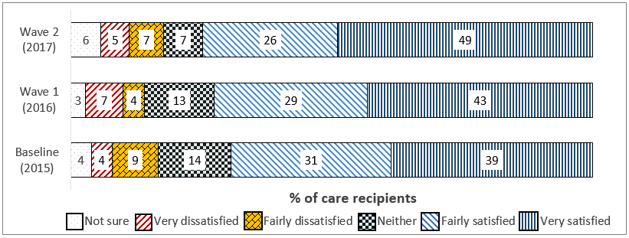
Figure 2: Carer satisfaction with the aged care system, by wave
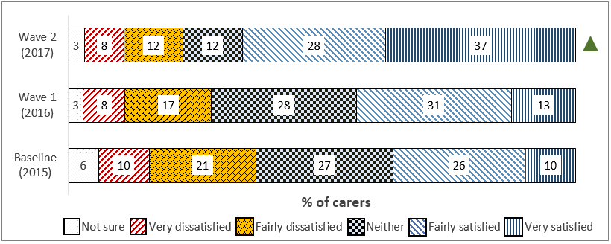
Q8. Overall, how satisfied or dissatisfied are you with the way the aged care system allows older Australians to access quality services?
Care recipients: N=908, all care recipients, W1 n=309: B n=148
Carers: N=868, all carers; W1 n=410; B n=344
Care recipients displayed a continued increase in overall satisfaction with the aged care system since the baseline wave and through Wave 1. Three in four (75%) now indicated some degree of satisfaction, with higher ratings given in Queensland (81%) and lower in New South Wales (71%). Furthermore, almost half (49%) indicated they were ‘very satisfied’, the highest rating.
Carers’ satisfaction with the aged care system displayed a significant increase since Wave 1, reaching 66% in 2017. Those aged under 65 caring for older relatives were less likely to be satisfied (60%) than were older carers (aged 75+: 75%).

Information, Awareness, and Contact

My Aged Care Awareness channels
The most common means of care recipients initially becoming aware of My Aged Care was through a GP or other health professional, with one in four (25%) giving this response. The other most frequently cited means of awareness were through an aged care service provider (17%) or from a friend or neighbour (14%). Thirty-one percent of carers had become aware of My Aged Care through a GP, also the most common means of doing so.
Care recipients from a Culturally and Linguistically Diverse background were less likely than others to have become aware of My Aged Care through an aged care service provider (7% vs. 18%), but more likely to have heard of it via a newspaper or magazine (6%) or a community organisation (4%). Carers were also more likely to have heard of My Aged Care via a community organisation if they identified as Aboriginal and Torres Strait Islander 13%, CALD 3%, or LGBTI 6%.

My Aged Care Access
Consumer participants were sampled from their contact with the Contact Centre, excepting a comparatively small number of CALD and Aboriginal and Torres Strait Islander specialist interviews, so Contact Centre contact incidence was not recorded. However, website usage was asked. Overall, less than one in six (16%) care recipients had accessed the website, with higher incidences among those with a higher income (34%) and those in Major Cities (18%).
On the other hand, almost half of carers (49%) had used the website, including a majority of those aged under 65 (67%).
Use of the My Aged Care website was almost universal among the representatives of service providers (98%), and a further 75% had called the Contact Centre, a significant increase on Contact Centre uptake from last wave. Commonwealth Home Support Programme and Home Care Package provider representatives were significantly more likely to have called the Contact Centre (81% and 85% respectively) than other providers were.
RAS Assessors were extremely likely to report using the Contact Centre (97%), website (94%), and Portal (99%), in line with last wave’s results, with similar results recorded among ACAT assessors (94%, 98%, & 93% respectively).
Access was less diverse across the different methods among health professionals. One in five GPs (20%) reported seeking information from the Contact Centre (aside from inbound referral experience), and fewer than half (47%) had accessed the My Aged Care website. Higher usage was reported among hospital referrers, more than two-thirds of whom (68%) had accessed the Contact Centre and 87% the website.

Contact Centre Experience
Figure 3: Participant satisfaction with Contact Centre information
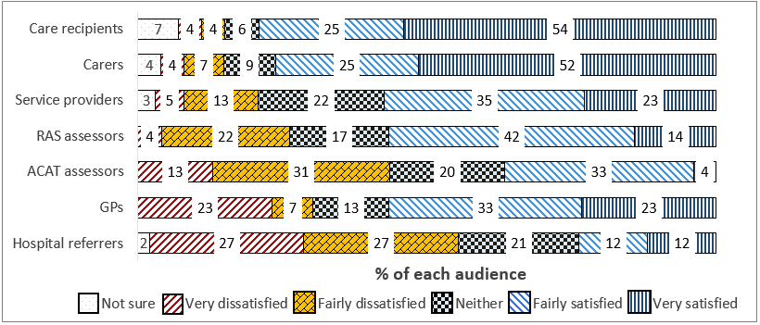
Various question numbers: How satisfied or dissatisfied were you with the quality of information that you received from the My Aged Care Contact Centre? Various base sizes.
Satisfaction with the quality of information provided by the Contact Centre rose since the last wave of research among several audiences. Almost eight in ten recipients (79%) were satisfied with this measure compared to 76% in 2016, and carers’ satisfaction rose significantly from 65% to 77%. Satisfaction was significantly lower, however, among both Aboriginal and Torres Strait Islander care recipients (58%) and carers (45%).
Service provider representatives also displayed a strong increase in satisfaction, with more than half (58%) now satisfied compared with 40% last wave – a result that was partly driven by high satisfaction ratings among providers in South Australia (81%) and Queensland (65%). RAS assessors’ satisfaction with the Contact Centre also increased significantly, from 43% to 56%.
Some groups did not display such positive views on the Contact Centre information they received. ACAT assessors were less likely to be satisfied than dissatisfied (36% giving a positive response), as were hospital-based referrers (24% satisfied vs. 21% last wave). A majority of GPs (57%) expressed satisfaction, but this represented a marginal decline on the 2016 figure of 65%.

Website Experience
Figure 4: Participant satisfaction with website information
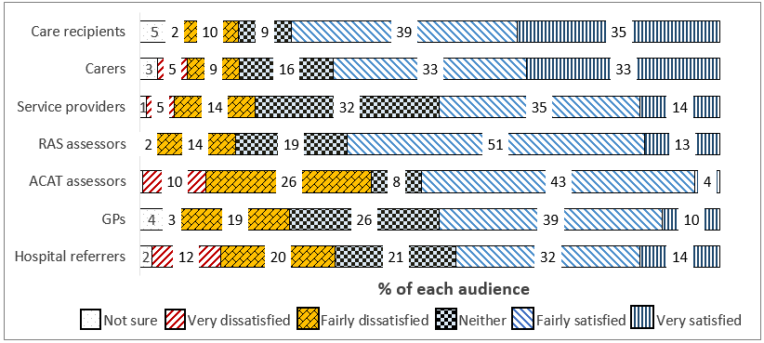
Various question numbers: How satisfied or dissatisfied were you with the quality of information that you received from the My Aged Care website [at myagedcare.gov.au]?
Various base sizes
Satisfaction with the information provided on the My Aged Care website was generally high – almost three in four care recipients (74%) indicated some degree of satisfaction, representing a marginal increase on the 66% recorded in the last wave. Female care recipients partly drove this satisfaction with a rating of 80%.
Around two in three carers (66%) using the website had been satisfied; however, among this group it was males who were significantly more positive (74% vs. 62% of females). Those from a CALD background were less satisfied (56% vs. 68% of non-CALD).
Those employed by service providers recorded a marked increase in website satisfaction since Wave 1 (58% vs. 40%), as did RAS assessors (64% vs. 42%). Other audiences were not measured wave-on-wave, and generally reported minority satisfaction: 46% of ACATs, 49% of GPs and 45% of hospital referrers expressed any degree of positivity about the website information.

Qualitative Feedback
Service providers, health professionals, as well as peak bodies representing those groups raised some specific concerns about access to My Aged Care including perceptions that:
There are sometimes excessive waiting times to reach a staff member at the Contact Centre, cited as more than one hour or 90 minutes in some cases
A web- and phone-based access system precludes access by those older people with cognitive and communication impairments, including speech and comprehension problems
There is a lack of flexibility in privacy considerations for potential care recipients, who are often not cognitively capable of participating in phone calls, but are required to be present and give their own responses despite a health professional or carer acting on their behalf
There is a lack of support for those who speak English as a second language or come from an Aboriginal and Torres Strait Islander background, many of whom are reluctant to engage with mainstream services, especially by telephone rather than face-to-face
Contact Centre staff may not possess sufficient knowledge of physiological and psychological conditions which affect older people, which has follow-on effects for the appropriateness of referrals to assessment
Some respondents felt that computer literacy is not sufficiently high among many older people meaning that an online interface for information-seeking is not yet viable
Positive comments supported the quantitative findings, specifically:
For those able to access web-based material aimed at consumers (often carers), the content of the My Aged Care website was extensive and useful
Despite the ongoing problems mentioned, the consumer-facing access points to My Aged Care had improved since commencing in July 2015
Across audiences using the Contact Centre, the professionalism and helpfulness of staff was viewed very positively, with problems stemming from their knowledge and ability to help rather than their behaviour

Portal Experience
Service provider representatives were less likely than in Wave 1 to access My Aged Care for administrative reasons, and more so for receiving client referrals. The proportions using the Portal to check organisational data (67% vs. 84% at Wave 1) and provide details for the service finder (52% vs. 74%) fell significantly, while 90% received referrals through the system.
Figure 5: Service provider satisfaction with Portal activities, by wave
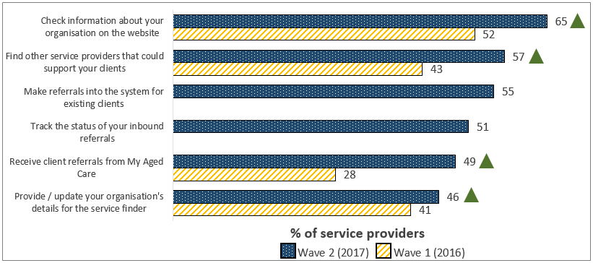
Q15. And how satisfied or dissatisfied have you been with how the Provider Portal has enabled you to…?
N=77-269, providers selecting each activity; W1 n=44-126
There was observable improvement in providers’ satisfaction with their ability to carry out each task, especially among Home Care Package providers, who were significantly more likely to be satisfied with how they could make (65%) and track (61%) inbound referrals, and receive them from My Aged Care (57%).
Figure 6: RAS assessor satisfaction with Portal activities, by wave
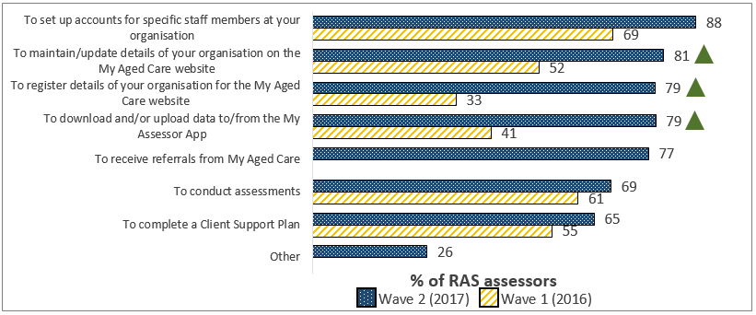
Q9. How satisfied or dissatisfied have you been with how the Assessor Portal's functionality allows you…?
N=7-235, assessors selecting each activity; W1 n=15-120
RAS assessors gave positive satisfaction ratings to each of the prompted Portal tasks, with the highest-rated activities including setting up staff accounts (88%) and maintaining organisational information (81%).
ACAT assessors, while less positive overall, ascribed over 50% satisfaction to each Portal task except for three major activities: receiving referrals and conducting assessments (49% and 40% respectively), and completing Support Plans (48%).

Qualitative Feedback
Comments on the Portal relating to its functionality included the following:
The service finders were a source of concern for some representatives of allied health professions, who indicated that not all services were shown. This included speech pathologists, dietitians and some physiologists. Other health professionals were dissatisfied because they would like Portal access and did not currently have it
There were mentions of limited ability to access National Screening and Assessment Form (NSAF) records or other patient history information among some audiences
Significant delays were reported between assessment and client information being available for providers to receive referrals through the Portal, up to 8-12 weeks was cited in some cases
When information is received in referrals via the Portal, there was a perception that it can often be insufficient or unreliable. This was especially problematic in cases where providers needed information about challenging clients or families, the suspicion of abuse, or worker safety, but did not receive it.
There was also some positive feedback on the Portal:
Several audiences reported that despite its ongoing issues, the Portal’s functionality was noticeably better than it had been in the early stages of My Aged Care
Its user-friendliness was praised, with several respondents – particularly assessors – happy with how they were able to access the information they needed by navigating the Portal

Inbound Referral

Methods of Inbound Referral
Two in five respondents representing service providers (40%) reported referring a client into the system via the Contact Centre, an increase from 30% in Wave 1. This experience was significantly more common among those from CHSP (59%) and HCP (48%) providers, and less so among partially or fully privately-funded organisations.
GPs were similarly likely to make inbound referrals via this method (37%), while a majority of hospital-based referrers (51%) had done so.
Other methods available to referrers varied in their usage levels. Referrals via fax were not commonly used among hospital referrers (42%), while use of the online referral form was almost universal among this group (92%). Among GPs, use of fax and online referral was evenly split with 49% using each.

Experience of Inbound Referral
Figure 7: Participant agreement that they were satisfied with Contact Centre referral experience
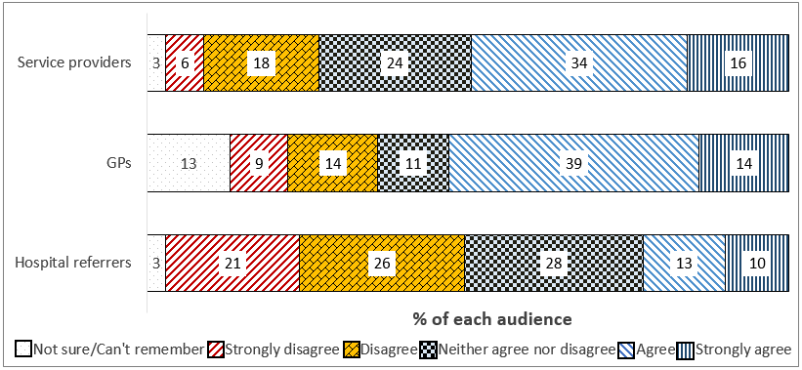
Various question numbers: To what extent do you agree with the following statements about referring a client to the Contact Centre? ‘I was satisfied with the experience overall’
n=119 service providers; n=56 GPs; n=39 hospital referrers
Service provider representatives found the process of referring a client via the Contact Centre easier this wave, with just under half (49%) affirming the process was easy in 2017 vs. 38% in 2016. Those who had made these referrals across at least a six-month time period were surveyed on their perception of change in the process, 65% agreeing that it had improved.
The overall satisfaction with referral via the Contact Centre was similar among GPs (53%), but low among those based in hospitals (23%).
Those making inbound referrals were surveyed on a number of aspects of the experience. Service provider representatives referring via the Contact Centre were positive about the personal qualities of the staff they had spoken to (85% agreeing that they were pleasant), but less satisfied with the timeliness of how the referral was dealt with (49%) and the actual knowledgeability of their contact (37%).
Overall satisfaction with the experience for service providers was 50%, driven by much higher positive ratings among Queensland providers (69%).
A similar proportion of GPs (54%) expressed overall satisfaction with Contact Centre referrals, but again measures of staff knowledgeability (52%) and outcome timeliness (46%, a significant decrease since last wave) were among the lowest rated aspects.
Each of these measures was lower among those referring via the Contact Centre based in a hospital: 23% were satisfied with the experience overall, 31% agreed that the person they spoke to was knowledgeable, and 23% agreed that the referral was dealt with rapidly.
Figure 8: Participant agreement that they were satisfied with fax referral experience
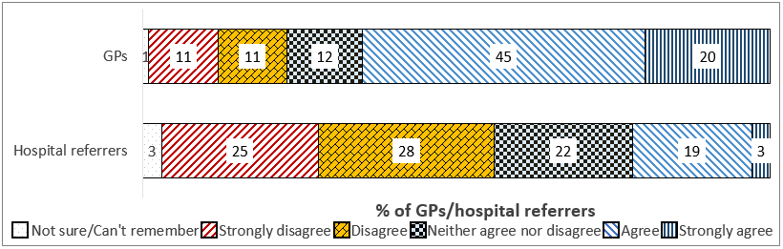
Q12. To what extent do you agree or disagree with the following statements about referring a patient via fax?
N=74 GPs; N=32 hospital referrers
Aspects of fax referrals were also surveyed. GPs were largely positive, with almost two in three (65%) indicating overall satisfaction, and 72% agreeing that My Aged Care acted on the information in the referral. Timeliness of the response was still considered an issue, however 50% were satisfied.
Hospital referrers were again markedly less satisfied, with fewer than one in three ascribing a positive rating to each measure, and only 22% satisfied overall with fax referrals, including 17% of those working in a Major Cities area.
Figure 9: Participant agreement that they were satisfied with online form referral experience
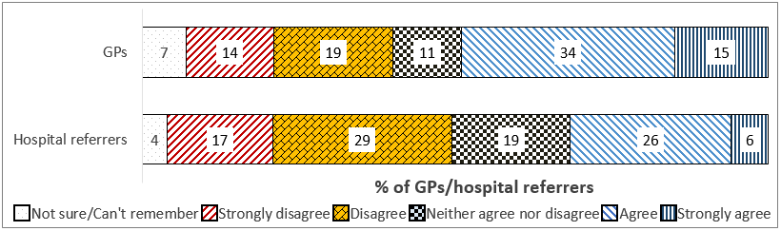
Q12. To what extent do you agree or disagree with the following statements about referring a patient via fax?
N=73 GPs; N=70 hospital referrers
Ratings of the online referral form were moderate among GPs, 49% of whom were satisfied overall with their experience of using it to make inbound referrals. Time efficiency was considered a concern, with GPs’ lowest rating for the time taken to complete and submit the form (38%, down from 50% in the last wave).
Conversely, those based in a hospital were generally dissatisfied overall with their experience of making referrals with the online form (31% satisfied), but did ascribe positive ratings to the time it took to complete and submit (69% satisfied).
The vast majority (99%) of hospital-based referrers and GPs (89%) reported making an inbound referral for a patient belonging to any Special Needs group. For both groups, social and financial disadvantage was by some margin the most common category of Special Need present among their patients (91% of hospital referrers; 75% of GPs), and more than three in four hospital referrers had made a referral for a member of a CALD community (76%).

Referral Outcomes
Figure 10: GP overall rating of My Aged Care’s assistance in helping patients access services, by wave
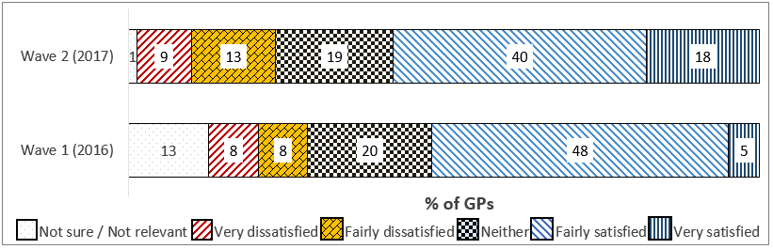
Figure 11: Hospital referrer overall rating of My Aged Care’s assistance in helping patients access services, by wave
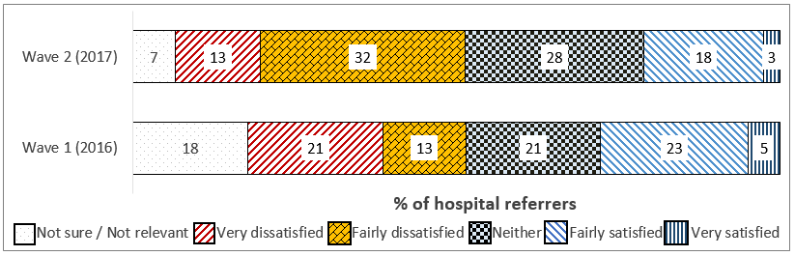
Q19. How satisfied or dissatisfied are you with the way My Aged Care has helped you to assist patients in accessing aged care services? Wave 2: n=150 GPs; n=76 hospital referrers
Wave 1: n=40 GPs; n=39 hospital referrers
A majority of GPs (58%) were satisfied generally with My Aged Care’s role in the process, a marginal increase on Wave 1, and somewhat more (64%) indicated satisfaction with how they were supported to assist Special Needs patients to access services specifically.
Hospital referrers were less positive, with only 21% expressing satisfaction, and 23% when the same overall satisfaction question was asked relating specifically to those with Special Needs.
A minority of both GPs and hospital referrers felt that each of the prompted aspects of the My Aged Care process was easy for them to achieve
Despite low results overall, GPs’ ratings were still generally significantly higher than those of hospital referrers. Similar to the results recorded in the last wave, a little under half agreed that it was easy to refer patients to appropriate services (48%), identify the best local aged care providers (45%), and establish basic patient information (44%).
Among hospital referrers each of these measures was considered satisfactory by fewer respondents (34%, 20%, and 26% respectively).
Furthermore, GPs were also more likely to agree that aspects of accessing aged care were easy for consumers themselves (39% agreeing that it was easy to ‘get assessed for eligibility for aged care’), despite overall low agreement once again

Qualitative Feedback
Health Professionals and their peaks’ perceptions of the inbound referral process and its outcomes included that:
The lack of integration of My Aged Care referral forms with existing GP patient management software was a significant issue. Options for auto-population of patient information would assist in streamlining referrals
GPs are not equipped with information about the options for urgent referrals to ACAT/ACAS. More generally, patient outcomes would be improved if a person’s regular GP could be involved more clearly in the process after making an inbound referral. This would include the abilities to:
- Track inbound referrals more easily
- Have an avenue to express their views on the services which were required by a patient, and
- Highlight more easily any impairment or condition experienced by the patient which should inform how My Aged Care interacts with them and assists them to access services
Health professionals and service providers reported some specific positives of the process including:
The option for service providers to make referrals back into the system was generally welcomed, even though many reported not making use of it
Despite GPs’ frustration with the lack of interoperability in the online referral form, many welcomed it as an easy option overall. Hospital-based referrers also indicated that it provided a smooth referral process
Referrals made via the form had also been improved by increased reliability of the My Aged Care website over time

Screening

Consumer Screening Experience
Figure 12: Care recipient satisfaction with screening outcome, by wave
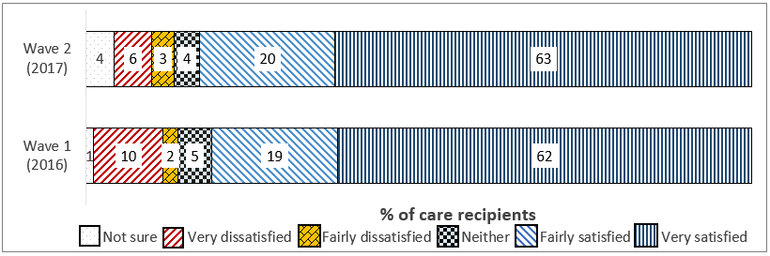
Figure 13: Carer satisfaction with screening outcome, by wave
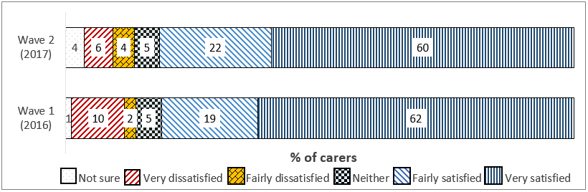
Q18. How satisfied or dissatisfied were you with this outcome?
Wave 2: n=654 care recipients; n=677 carers
Wave 1: n=54 care recipients; n=46 carers
Care recipients and carers were surveyed on their perceived participation in an aged care telephone screening, and the subsequent outcome. The majority of both groups recalled a screening taking place – 79% of recipients and 82% of carers.
There was a clear perception that the most frequent immediate screening outcome was the arrangement of a face-to-face assessment, with 60% of recipients and 61% of carers giving this response – in both cases a significant increase on the figures recorded during the last wave of research (29% and 37%).
Carers’ experience varied somewhat by demographic, with male carers (55%) less likely to report referral to an assessment, and those belonging to a Special Needs group more likely to believe that their family member had been passed on directly to a service (12%).
Satisfaction with the screening outcome was generally high, with 83% of care recipients expressing satisfaction, a result which was very steady across demographics and the time period at which they had made their first contact with the gateway.
Carers were similarly positive at 82% satisfied; however, those identifying as Aboriginal and Torres Strait Islander were significantly less likely to express satisfaction (47% vs. 82% of non-Aboriginal and Torres Strait Islander carers).

Assessor Views on Screening Results
Figure 14: Assessor satisfaction with My Aged Care handling of referrals
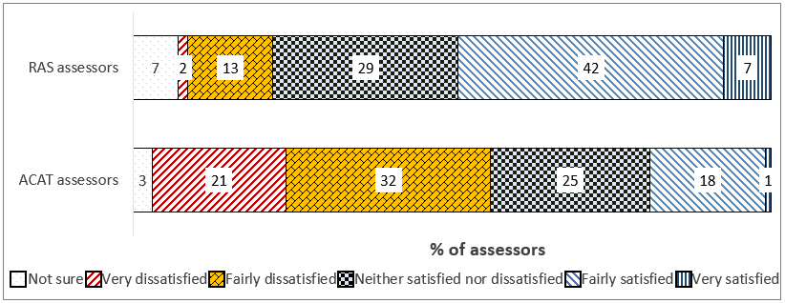
Q21. Overall, how satisfied or dissatisfied are you with the way My Aged Care refers clients to your assessment service?
n=255 RAS; n=287 ACAT
RAS assessors’ overall satisfaction with how My Aged Care referred clients to their service was moderate, with just under half (49%) expressing satisfaction, a result steady across jurisdictions.
Furthermore, of those who had received client referrals over the course of My Aged Care’s rollout, more than three in four (78%) agreed that their experience of doing so had improved.
RAS assessors were generally positive about the appropriateness of client referrals, determined at the screening phase. More than half (56%) expressed satisfaction with this measure, a significant increase on the 42% recorded in the last wave, including a significantly higher 83% among assessors based in Inner Regional areas.
ACAT assessors’ satisfaction with the appropriateness of the referrals they received was relatively low at 33%, with more (46%) actively dissatisfied.
Overall satisfaction with the way My Aged Care refers clients to ACAT services was relatively low, with under one in five (19%) giving a positive response. However, one in four indicated they were neither satisfied nor dissatisfied, leading to a total of 44% being satisfied or neutral
However, ACAT assessors who had received referrals over at least six months tended to affirm that their experience of doing so had improved (53%, including 66% of ACATs in New South Wales).

Qualitative Feedback
Some issues were identified regarding interactions throughout the process, which included the arrangement of assessments:
Some mentioned the wait time between referrals leaving the Contact Centre and the assessment being completed by a RAS or ACAT/ACAS team, which was thought to be up to two weeks for urgent cases and longer for non-urgent ones
The screening process was identified by some respondents as the point where mitigating or complicating circumstances should have been identified but were not, such as special needs, carer stress or illness, or safety issues – in some cases respondents believed that information had not been supplied to an assessor before ever reaching a provider
Referrals to assessment were perceived as inflexible when client circumstances change, such as a move of home meaning that needs shift from social to domestic support or vice versa. This was suggested amongst consumer peak bodies to especially affect vulnerable clients, whose living situation may change because they are transient or have no family or support network
Some situations were reported where assessments had been cancelled after three phone calls had not reached the client to confirm. This was seen as problematic among clients with cognitive or mobility issues for whom receiving and understanding telephone calls is difficult
Some audiences’ experience of the screening and its outcomes were widely positive:
Those seeking aged care services were often impressed with the thoroughness of the discussion, which gave them confidence that they were ‘in good hands’
Clear explanation of the next steps was also appreciated – providing customers with a reference number and information on who would contact them
RAS assessors also often fed back that the information they received from the screening was reliable and complete

Assessment

Assessment Participation
Around half (47%) of the care recipients surveyed had undertaken a face-to-face aged care assessment, including significantly fewer of those coming from a Special Needs group (39%). Somewhat more carers reported that their family member had done so (55%). This left just over half (53%) of those seeking care for themselves either not having progressed to a face-to-face assessment or not recalling that one had occurred.
Around one in four recipients (24%) believed that they had experienced a RAS assessment, and around one in three an ACAT (34%).
Eighteen percent of carers reported that the person they cared for had experienced a RAS assessment, and 70% indicated that the person had undergone an ACAT assessment.
Fewer than two in five (37%) of care recipients recalled that a carer or family member was present at their assessment, although this was significantly higher among males (46%), while most carers surveyed had themselves been present (83%). Of these, significantly more carers whose family member was experiencing an ACAT (86%), who was aged 75+ (97%), in Inner Regional Australia (91%) or from a lower income household (91%) were present.

Consumer Assessment Experience
Figure 15: Care recipient satisfaction with assessment aspects, by wave
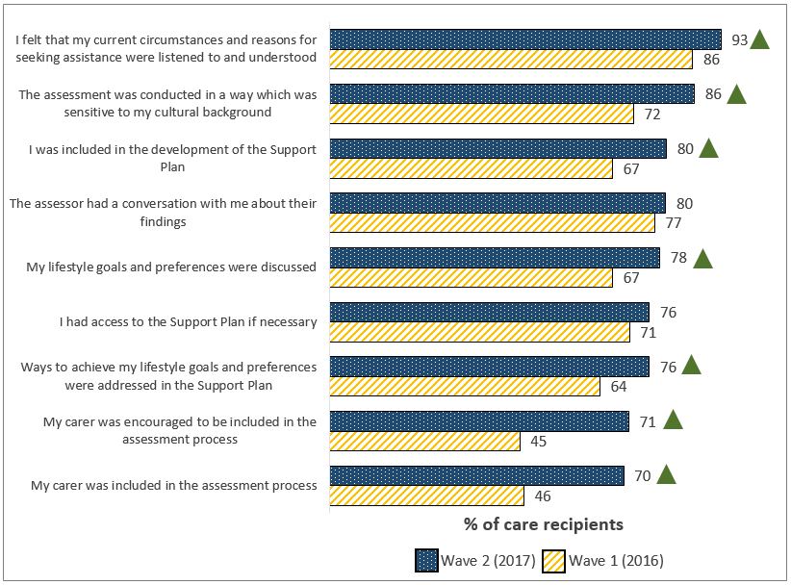
N=99-427, care recipients with assessment experience; W1 n=254
Care recipients were generally very positive about most aspects of the assessment experience: 93% agreed that they had felt listened to and understood, and more than three in four agreed with most of the other prompted statements.
All but two statements received agreement ratings which represented a significant increase from the rating recorded in Wave 1. Generally, those aged 65-74 were the most positive about their assessment experience, while those aged 75+ and those located in New South Wales were somewhat less satisfied, despite still recording over 70% agreement with most statements.
Those care recipients participating in a RAS assessment typically ascribed higher agreement to the prompted statements than those experiencing an ACAT, including significantly greater agreement that their lifestyle goals and preferences had been discussed (85%).
While often similarly satisfied, Aboriginal or Torres Strait Islander respondents were significantly less likely to agree that their lifestyle goals had been discussed (56%) and those from a CALD background were less likely to agree that the assessment had been sensitive to their cultural background (75%).
Figure 16: Carer satisfaction with assessment aspects, by wave
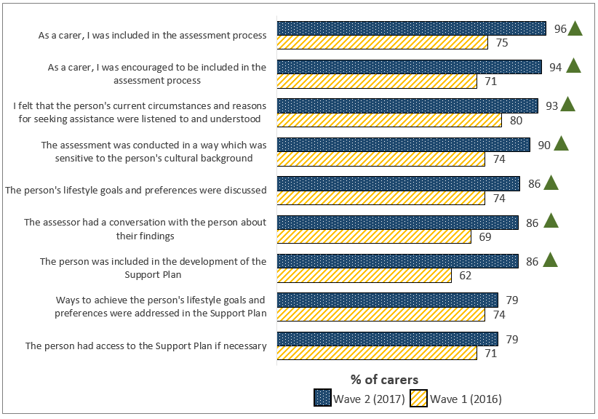
Q23. To what extent do you agree or disagree with each of the following statements about the assessment?
N=56-399, carers with assessment experience; W1 n=264
While measures of carer inclusion were the lowest-rated among recipients, 96% of carers agreed that they had been included in the process, 93% agreed that their family member’s reasons for seeking assistance had been listened to and understood, and 90% that the assessment had been sensitive to the person’s background.
While still very high, agreement that they had been encouraged to be involved (89%) and subsequently had been (90%) were significantly lower among those caring for someone undergoing a RAS assessment. This may reflect the lower care needs of the person they were caring for versus those who were caring for someone who needed an ACAT assessment.
Figure 17: Consumer overall satisfaction with assessment
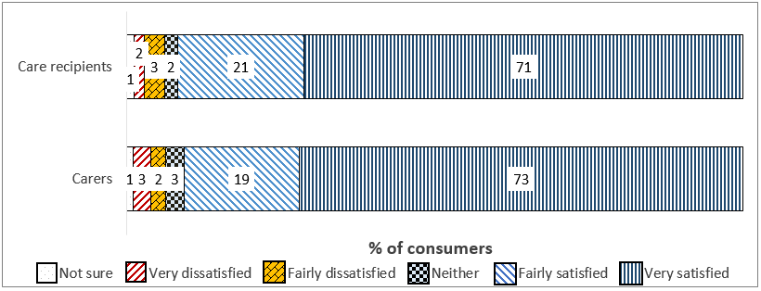
Q24. Overall, how satisfied or dissatisfied were you with the face-to-face assessment process?
n=427 care recipients; n=399 carers
Overall satisfaction with the assessment process was extremely high among care recipients, with 92% expressing any degree of satisfaction and a very high 71% reporting that they were ‘very satisfied’.
Among those experiencing an ACAT, there was a significant increase in overall satisfaction on Wave 1 (94% vs. 86%).
Overall assessment experience satisfaction among carers increased significantly compared with Wave 1, from 82% to 92% expressing satisfaction. This was marginally higher still among male carers (95%) and those aged 75+ (95%).
Overall satisfaction among carers was significantly lower among those caring for a person undertaking a RAS assessment (86%). On the other hand, the satisfaction rating of 93% ascribed by carers of those undergoing an ACAT assessment represented a significant increase on the 83% recorded at Wave 1.

Assessor Training for Assessments
A little more than one in three RAS assessors had undertaken training on using the National Screening and Assessment Form (NSAF) (38%), with a similar number reporting participation in more general assessment skills training in the last year.
ACAT assessors were very likely to have experienced NSAF training (78%), with a majority (59%) also experiencing assessment training.
RAS assessors were typically positive about their experience of NSAF training, with three in four (75%) satisfied, including 82% of those based in Queensland.
Figure 18 Assessor satisfaction with assessment training
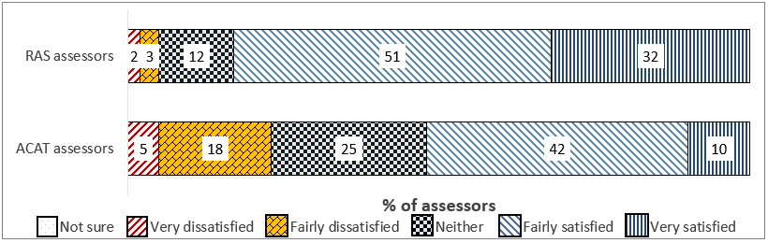
Q15. How satisfied or dissatisfied were you that the training and information you received equipped you to carry out assessments effectively within the My Aged Care guidelines?
n=91 RAS; n=170 ACAT
RAS satisfaction with assessment training was very high at 82%, a notable increase since the 30% satisfaction recorded at Wave 1. ACAT assessors were less satisfied with the training they had received but still positive, with a majority (54%) happy with how the NSAF training equipped them to use the form, and more than half (52%) also satisfied with the training in undertaking assessments under My Aged Care.

Aspects of Conducting Assessments
- RAS assessors’ satisfaction with the ease of conducting an identity verification check rose significantly since the last wave, with 84% affirming a positive response compared with 74% in 2016.
- As with many other measures, fewer ACATs responded positively, although a majority did report finding the identity verification check easy to complete (58%).
Figure 19: RAS assessor satisfaction with navigating the My Aged Care Assessor Portal, by wave
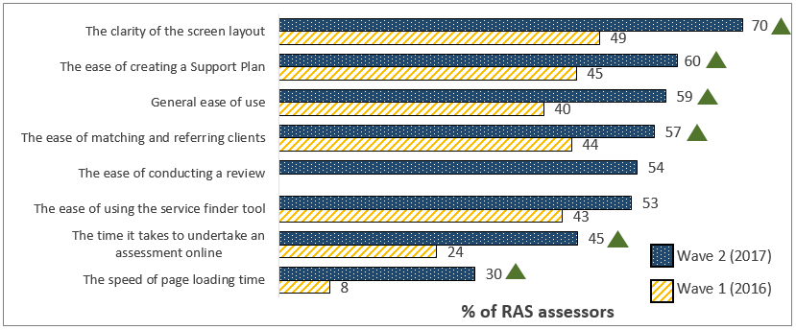
Q19. How satisfied or dissatisfied were you with each of the following aspects of navigating the My Aged Care Assessor Portal platform during and after performing assessments?
n=232, RAS assessors who had conducted assessments using the My Aged Care Assessor Portal, W1 n=142
A majority of RAS assessors gave a positive satisfaction rating to most of the prompted measures, with the highest satisfaction ascribed to the clarity of the screen layout (70%). This measure, as well as most others, recorded a satisfaction rating significantly higher than that reported at Wave 1.
The lowest rated measure, the speed of page loading time, was found satisfactory by 30% of RAS assessors – however, this represented a major increase on the very low 8% giving a positive rating in 2016. Satisfaction was generally higher among those in Queensland.
Among ACATs, the aspect receiving the highest rating was the ease of creating a Support Plan, which was found satisfactory by almost half of respondents (49%). One in four or fewer expressed satisfaction with the ease of using the service finder (23%), the time assessments take online (19%), and the speed of page loading time (17%).
Figure 20: Assessor overall satisfaction with My Aged Care support to undertake assessments
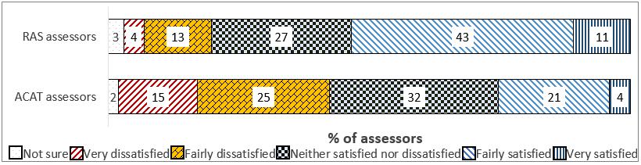
Q22. Overall, how satisfied or dissatisfied are you with the way My Aged Care supports you and your organisation to undertake assessments?
n=255 RAS; n=287 ACAT
Overall, a majority (54%) of RAS assessors expressed satisfaction with the way My Aged Care supports them to undertake assessments, a marginal increase on 50% at Wave 1, and a result more pronounced among those in Inner Regional areas (70%) and Queensland (62%).
ACATs’ satisfaction was low at 25%, but somewhat higher (34%) among those in NSW.

Qualitative Feedback
Some participants questioned the accessibility of assessment in the first place for clients in a vulnerable situation. There were reported instances of clients with dementia refusing an assessment due to lack of comprehension, and those with cognitive or speech difficulties having no means to arrange one
It was also mentioned that the NSAF was not perceived as providing assessors with a great deal of the patient information which referring health professionals, particularly GPs, had passed on to My Aged Care
The ability for RAS and ACAT assessors to skip some parts of NSAF during/after an assessment was seen as a problem by some peaks, who felt that this often resulted in the omission of information related to less common service needs, e.g. dietetics, exercise physiotherapy or speech pathology
On the other hand, others pointed out the NSAF’s length and complexity, and felt it should be streamlined to allow assessors to undertake assessments more efficiently
A number of positive remarks on the assessment process included:
Assessors’ feedback on the training on the NSAF and conducting assessments, which were largely viewed as a useful introduction to the My Aged Care system – especially when the training was conducted face-to-face
RAS assessors in particular were positive about the functionality of the Portal in allowing them to conduct assessments in a flexible way, with some using the myAssessor App, some preferring the online forms, and others switching to paper when they felt it was appropriate
Consumers, especially those seeking services for themselves, continued to give very positive qualitative feedback on the assessment process, most feeling that the assessor they had met had been pleasant, helpful and professional
The assessment was the point where consumers reported feeling for the first time a sense of ‘relief’ that something was going to be provided to them to help with everyday life – the assessment’s duration and thoroughness were mentioned as positives
Recipients and carers from CALD and Aboriginal and Torres Strait Islander backgrounds often reported being happy with how their cultural background had been understood and taken into account – CALD recipients were often positive about the option to have a family member or other interpreter present

Referral to Service and Service Provision

Referral to Services
Figure 21: Care recipient satisfaction with referral aspects, by wave
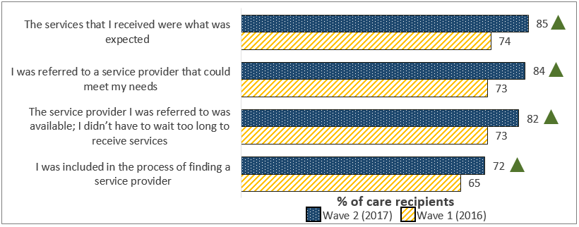
Q26. To what extent do you agree or disagree with each of the following statements about the arrangement of aged care services through My Aged Care?
N=537, care recipients receiving services through My Aged Care; W1 n=254
Figure 22: Carer satisfaction with referral aspects, by wave
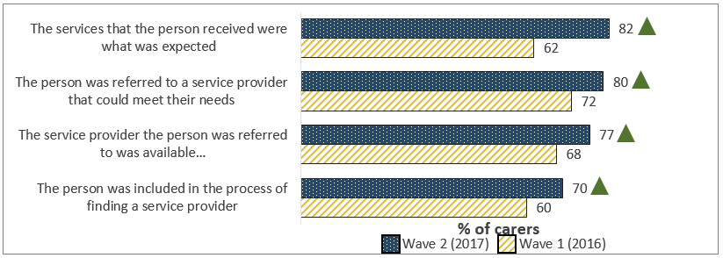
Q26. To what extent do you agree or disagree with each of the following statements about the arrangement of aged care services through My Aged Care?
N=543, carers receiving services through My Aged Care; W1 n=264
Large majorities of care recipients agreed that a provider had been sufficiently available (82%), able to provide what was expected (85%) and meet their needs (84%), and that they had been included in the process of finding one (72%); each of these figures rose significantly compared to the last wave of research.
Overall stated satisfaction with the process of referral once services had been received was 86%, compared with 73% at Wave 1. Each of these measures was considered significantly more satisfactory among Queensland respondents and less so among Special Needs audiences.
Carers displayed similar trends, with more than 70% agreeing with each statement, and an overall rating of referral to services of 79%, vs. 67% in 2016. Carers were more likely to be satisfied overall if the person for whom they cared received a Home Care Package (84%). Carers of Aboriginal and Torres Strait Islander care recipients were less likely to agree that the services provided had been as expected (57%), that the provider referred to was available (43%), and that their family member had been included in the process of finding a provider (36%).
Service provider representatives indicated that while accepting referrals from My Aged Care via the Portal was easy (68%, an increase on 63% at Wave 1) and accessing client information (50%) was also usually easy, making use of their referral code (43%) was not.
Aspects of using the Portal to initiate and accept referrals were widely considered less easy by those offering residential and respite care types, and by those in Victoria.
Figure 23: Service provider satisfaction with My Aged Care client matching, by wave
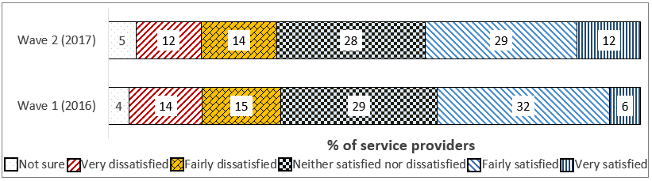
Q19. Overall, how satisfied or dissatisfied are you with how My Aged Care has matched clients to your service?
n=269, service providers who receive client referrals from My Aged Care; W1 n=102
Overall, provider representatives’ views on how well My Aged Care matches clients to their services improved slightly since the last wave, with 41% satisfied to any extent. Home Care Package providers were significantly more satisfied (49%).
While there were still comparatively low ‘positive impact’ ratings in 2017 (25%), this result represented an increase on the 13% recorded at Wave 1, and rose as high as 37% of HCP provider representatives indicating that My Aged Care had had a positive impact on their workload.
Figure 24: Assessor satisfaction with My Aged Care match and refer support
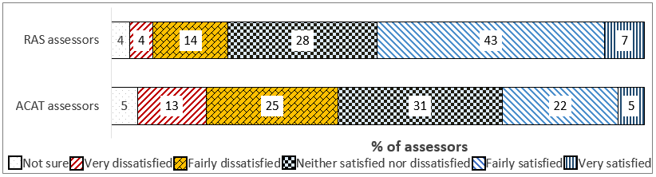
Q23. How satisfied or dissatisfied are you with the way My Aged Care supports you and your organisation to match and refer clients to appropriate services?
n=255, all RAS assessors
Half of RAS assessors (50%) were satisfied with how My Aged Care supported them to match and refer clients to services, and this was higher in Queensland (60%).
RAS reported significantly increased ease ratings for three prompted aspects: how they could engage with clients to meet their needs (79% vs. 68%), establish client information (64% vs. 42%), and plan effectively for the services they need to deliver (45% vs. 27%).
Only 27% of ACATs were satisfied with My Aged Care’s match and refer support. Under half believed that it was at all easy to carry out any of the prompted tasks under My Aged Care; fewer than one in five of those in Victoria felt that it was easy to plan effectively for the volume of services (18%), identify service providers able to deliver the right services (18%), or find out client’s service history (15%).

Qualitative Feedback
Representatives of various audiences felt that there were problems regarding the ultimate referral to services received by consumers through My Aged Care which caused issues for consumers:
Poor communication between My Aged Care and assessment organisations sometimes results in multiple or unexpected assessments occurring, and subsequently leaves consumers unsure of which services they will receive and from whom
Waiting times between assessment – especially ACAT/ACAS – and service delivery were considered to often be too long, and to risk client wellbeing
Furthermore, some service provider representatives felt the preceding steps in the system and the behaviour of other providers within My Aged Care did not always assist them in planning services for clients:
Representatives of providers of less common allied health services reported that their recommendations were too easily overturned by subsequent assessors or other providers, displaying a lack of understanding of specialist services
The knowledge and capability of RAS assessors was viewed as concerning. It was seen as problematic that RAS assessors, often not qualified health professionals, could make significant decisions or recommendations about a client’s service which may have been more suited to a health professional
It was suggested that there were cases of service providers accepting clients for whom they could not actually fund care onto a waiting list in order to ‘secure’ the work
It was perceived that the market mechanism by which services are provided and charged under My Aged Care caused a ‘siloed’ approach rather than a collaborative one between different providers servicing a client
Consumers’ feedback was often more positive:
Contrary to some peaks’ observations, some consumers seeking care indicated that they had waited only a couple of weeks for their service to begin, which was seen as impressive
The idea of inclusion in selection of a service provider was usually welcomed even though many consumers were not interested in doing so, or were not aware that it was an option
The standard and extent of subsidised services was often a pleasant surprise for older people, whose understanding of aged care had not extended beyond residential services until they contacted My Aged Care
Furthermore, there were some positives noted by service providers receiving referrals:
Some mentioned that clients’ Support Plans had become much easier to read and more reliable over time, improving their ability to plan for services
Others pointed out that despite teething problems, the referrals they received were now usually appropriate in terms of matching the services they provide

Provision of Services
Figure 25: Care recipient satisfaction with service aspects, by wave
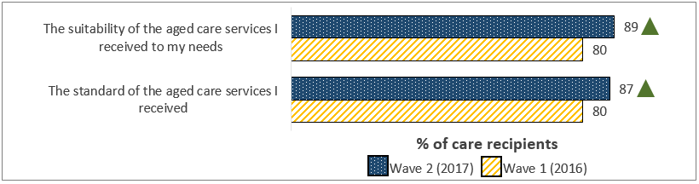
Figure 26: Carer satisfaction with service aspects, by wave
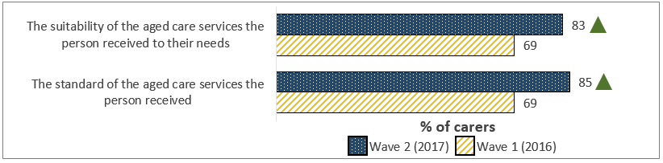
Q27. And how satisfied or dissatisfied were you with each of the following?
Wave 2: n=537 care recipients, n=543, carers
Wave 1: n=254 care recipients, n=264 carers
89% of care recipients were satisfied with the suitability of their services to their needs, and 87% were satisfied with their standard, both results representing significant increases on the last wave. Both measures received 94% satisfaction ratings among those based in Queensland, but lower ratings among Special Needs care recipients.
83% of carers were satisfied with their family member’s services’ suitability, and 85% with their standard.
In planning for service provision, 43% of service provider representatives found the information in the Support Plan to be satisfactory, a significant increase from 20% in 2016. This figure was higher among those representing Home Care Package providers, at 52%.
Overall satisfaction with My Aged Care and its ability to support providers to deliver services was also gauged: 39% of those surveyed were satisfied, an increase on 19% in the first wave.
A majority of provider representatives felt that it was easy to receive referrals for new clients under My Aged Care (52%).
CHSP and Home Care Package provider representatives were more likely to believe that My Aged Care performed well – especially to help them gain easy access to client information (CHSP 45%, HCP 46%) and to help them receive client referrals (CHSP 40%, HCP 44%).

Home Care Package Baseline

Methodology
Consumers reporting that they had progressed to the stage of My Aged Care where they or their family member was in receipt of services arranged through the gateway were asked which type(s) of services were being provided. Given the aged care sector specific terminology used in the names of services types, some measures were taken to direct respondents to an answer which reflected their real, as opposed to perceived, circumstances as far as possible.
Firstly, service types only accessible through a specific assessment type were read out as options if the respondent had previously indicated that they had experienced that assessment, for example a carer whose family member had undergone a RAS assessment would not be given the opportunity to say that residential care had been arranged as a result.
Secondly, interviewers were provided explanations of the Commonwealth Home Support Programme and Home Care Package Program, including examples of services, to read to respondents who indicated that they were not familiar with the terms being used.
Despite these measures a very high number of respondents, compared to the actual incidence among consumers, selected that they had a Home Care Package. During the analysis of the data, it was viewed as important to preserve the perceptions of consumers, even if incorrect, as far as possible, but also to make some efforts to define the group of consumers truly receiving Home Care Packages more tightly.
For this reason, results reported here omit respondents who answered ‘not sure’ to Question 31, which related to the Package level received. The question of Low versus High Care approval is a central feature of Home Care Packages, and those unsure of their approved level were likely to have selected ‘Home Care Package’ in error. This refinement process provided a quantitative sample of n=146 care recipients and n=227 carers who indicated that they or their family member received an HCP, and who were able to identify its level.
Given these methodological considerations, further research is currently being developed to build on the findings shown here.

Home Care Package Type and Level
In all, 84% of recipients indicated that they received domestic support of some kind, along with almost a third (30%) receiving transport assistance, and the majority (57%) reported that their services were provided less frequently than weekly.
Carers were more likely to identify higher-need level care services as part of their family member’s package, with domestic care still the most common (79%), but over half (52%) mentioning personal support e.g. washing, bathing or dressing, and more than one in four citing physiotherapy or occupational therapy (27%). Male carers were significantly more likely to indicate that domestic support was included in the package (92%).
Carers in general identified more varied service frequencies than care recipients, with similar numbers suggesting that package services were provided 4+ days per week (24%) to those answering less than weekly (27%).
The majority of self-reported Home Care Package recipients (79%) believed they were approved for Low Care, and more than half (71%) agreed that they were in receipt of their approved level. The high proportion of Low Care Packages reported reflects that there is a higher proportion of care recipients receiving packages at lower levels. It is also likely a natural result of sampling, whereby lower-care recipients were more likely to be able to participate in research.
Carers were more likely to identify their family member as in receipt of a High Care package, with over half (56%) at this level. The majority of carers agreed that their family received the approved package level (72%). This reflects the likelihood that care recipients on higher package levels are less likely to be able to make arrangements for themselves and participate in market research. Findings are therefore indicative of the perceptions of decision makers but not necessarily of all care recipients.

Increasing Choice
Fewer than one in three care recipients (29%) believed they were aware of how much funding within their package was dedicated to the services they received. Of the small number who were confident they knew, 83% were satisfied.
Around one in three (33%) of carers indicated they were aware of how funding is allocated within their package. Those who did were also largely likely to find it satisfactory (64%, including significantly fewer males (44%)).
Figure 27: Consumer likelihood of changing Home Care Package provider
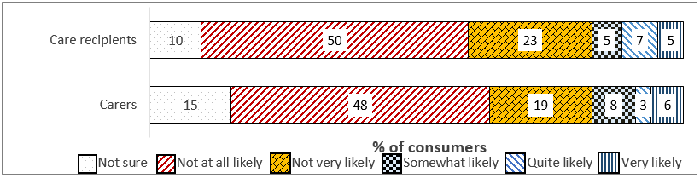
Q35. How likely are you to consider changing providers?
n=146 care recipients, n=227 carers
Figure 28: Consumer perceived ease of changing Home Care Package provider
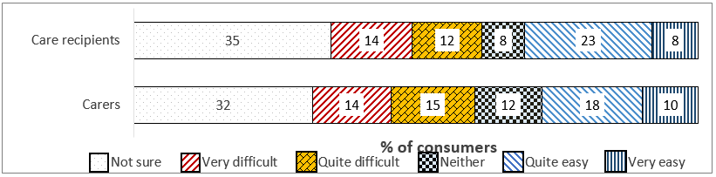
Q36. How easy or difficult do you think it would be to change providers?
n=146 care recipients, n=227 carers
A little more than one in ten care recipients indicated that they were likely to change their provider under the Increasing Choice reforms (12%), possibly partly driven by a perceived lack of ease in doing so (31% suggesting they believed it would be easy).
Carers were less likely to suggest they would seek to help change the package provider of the person for whom they cared (9%), and were also less likely to indicate that it would be easy to do so (27%).

Consumer Outcomes

Consumer Views on My Aged Care
A majority of care recipients indicated that My Aged Care performed a range of prompted activities well, with the highest rated being its capacity to provide reliable general aged care information (69%).
These ratings were higher among those aged 65-74 and in Queensland, and lower among those in Victoria. Aboriginal and Torres Strait Islander recipients were less likely to feel that My Aged Care provides reliable aged care information (46%) and helps people get the services they need (43%).
Carers often gave positive ratings to these measures: 73% felt that My Aged Care provides reliable aged care information well, and 69% felt that it succeeds in helping people get the services they need, which represented a significant increase on Wave 1 (58%). More than two in three (69%) also agreed that it assists people to arrange assessments well.
Carers from lower-income households ascribed significantly higher ratings to most of the prompted measures, with males and those aged 30-64 also more positive, and older carers and Victorians often less likely to believe that My Aged Care met each goal well.
Figure 29: Care recipient likelihood of recommending My Aged Care (NPS), by wave
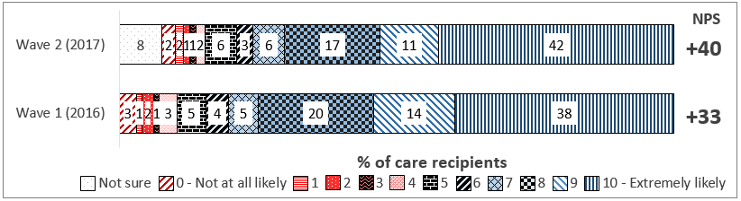
Q38. How likely would you be to recommend My Aged Care for finding out information and accessing aged care services?
N=841, all care recipients; W1 n=97
Care recipients’ ratings generated a Net Promoter Score (NPS) of +40 for My Aged Care, a very strong level of advocacy increasing from +33 last wave. This figure was significantly higher among recipients aged 65-74 (+48) and lower among those aged 75+ (+35).
Figure 30: Carer likelihood of recommending My Aged Care (NPS), by wave
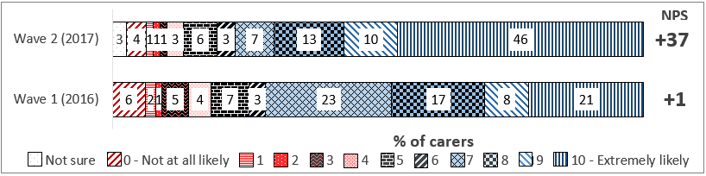
Q38. How likely would you be to recommend My Aged Care for finding out information and accessing aged care services?
N=843, all carers
Carers’ NPS was similar at +37, but had risen much more dramatically since Wave 1, when it was +1. Carers aged 50+ and those in Outer Regional/Remote Australia provided significantly higher NPSs, with the score for Aboriginal and Torres Strait Islander carers significantly lower at -9.

Provider, Assessor, and Health Professional Views on Consumer Outcomes
Figure 31: Service provider assessment of consumer outcomes
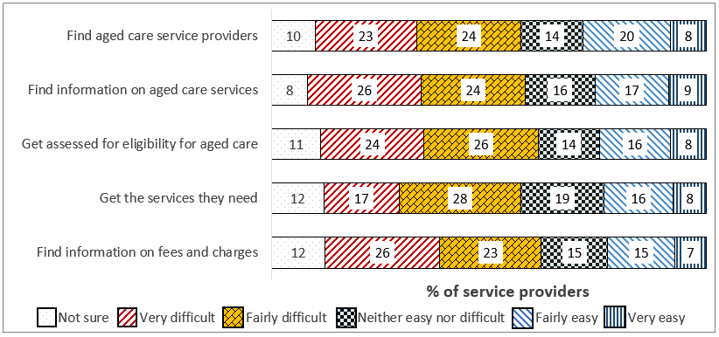
Q30. How easy or difficult do you consider it is for people looking for aged care services to do each of the following through My Aged Care?
n=300, all service providers
Contrary to the positive outcomes reported by consumers, service provider representatives felt that consumers find it difficult to access most aspects of My Aged Care, with fewer than one in four (24%) believing that it was easy for consumers to ultimately get the services they need, and only 26% believing that finding aged care information was easy for consumers.
Figure 32: RAS assessor judgement of consumer outcomes
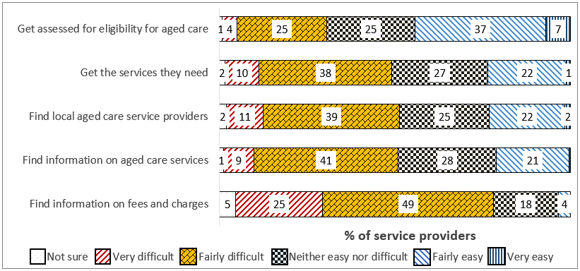
Q27. How easy or difficult do you consider it is for people looking for aged care services to do each of the following through My Aged Care?
n=255, all RAS assessors
RAS assessors gave similar scores for the ease of consumers accessing services, with 24% feeling that it was easy for consumers to get the services they need, and significant decreases since the last wave in the perceived ease of finding aged care information (21% easy vs. 30% in 2016) and of finding information on fees and charges (4% vs. 11%).
Figure 33: ACAT assessor judgement of consumer outcomes
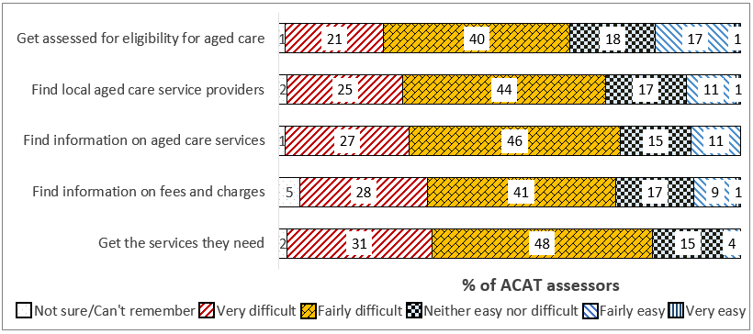
Q27. How easy or difficult do you consider it is for people looking for aged care services to do each of the following through My Aged Care?
n=287, all ACAT assessors
ACAT assessors did not feel that it was easy for consumers to carry out any of the prompted activities.
Figure 34: GP rating of My Aged Care consumer outcomes
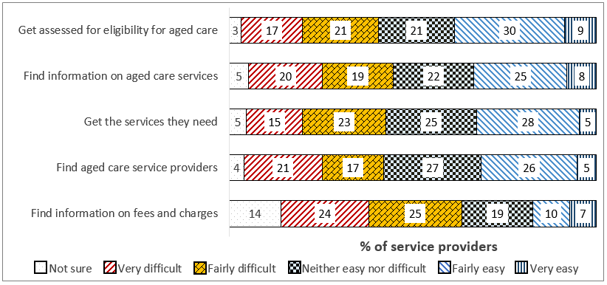
Q21. How easy or difficult do you consider it is for people looking for aged care services to do each of the following through My Aged Care?
N=150, all GPs
GPs tended to give less negative assessments of the ease of carrying out aged care activities for consumers than others. Thirty-nine percent felt that it was easy for consumers to get assessed for eligibility for aged care, and one in three also believed it easy to find aged care service information and ultimately access the needed services (both 33%, the latter a significant increase from 20% in Wave 1).
Figure 35: Hospital referrer rating of My Aged Care consumer outcomes
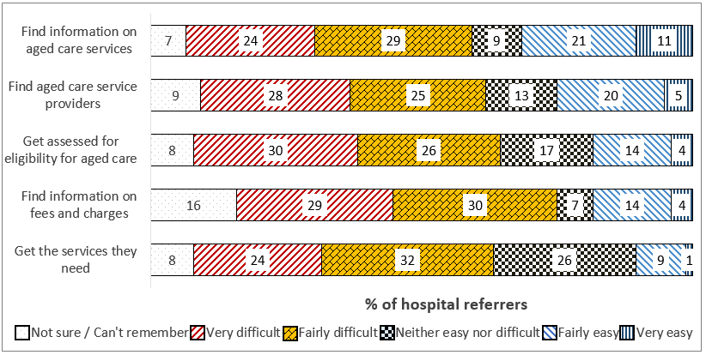
Q21. How easy or difficult do you consider it is for people looking for aged care services to do each of the following through My Aged Care?
N=76, all hospital referrers
Hospital referrers’ views, while all recording ease ratings below 35%, did display increases since the last wave for some measures: the ability to find aged care service information (32% vs. 22%), find service providers (25% vs. 20%), and find fees and charges information (18% vs. 14%).

Qualitative Feedback
Some service provider representatives, health professionals, and assessors felt My Aged Care did not streamline access to services or adequately improve appropriate service access through increased choice. Comments included that:
The distinction between the range of different service types available (for example CHSP and HCP) is not clear to many older consumers
Broadly, ‘choice’ and ‘consumer-directed care’ were not seen as widely understood concepts among older people
Care recipients in regional and remote areas are often only serviced by one relevant service provider for their condition(s), removing any element of choice
Special Needs groups, especially Aboriginal and Torres Strait Islanders and CALD consumers, were often not adequately catered for by the system, which was seen as designed primarily for the mainstream
Administrative burdens on health professionals and service providers within My Aged Care caused delays to the arrangement and implementation of services, which caused problems when delivering services to older people in need of care
Others held more positive views, such as that many consumers understood that My Aged Care was designed to help them stay at home for as long as possible, and to receive the care they need.

Appendix – guide to this document

Reporting conventions
In this report, a number of approaches have been taken to analysis of the data which result in specific modes of presentation throughout. This also affects the terminology used to refer to specific audience groups and subgroups, which is designed to be internally consistent within the report and other documents. The breakdown of sample groups for analysis have been developed in conjunction with Healthdirect Australia and the Department of Health.
With regards to the definition of top-level audience groups:
Consumers were consulted via the same qualitative and quantitative guides and survey. However, their data is reported separately as that of care recipients and carers
Aged care assessors were consulted via the same qualitative and quantitative guides and survey. However, their data is reported separately as that of RAS assessors and ACAT assessors
Health professionals were consulted via the same qualitative and quantitative guides and survey. However, their data is reported separately as that of GPs and hospital referrers
Service providers’ results are presented across all n=300 respondents, because there was no clear sampling-level distinction to be made between provider groups. Differences between service provider types are noted where relevant.

Style conventions
Several conventions are adhered to when presenting charts and tables.
Specific abbreviations used throughout include:
- ‘CALD’ = Culturally and Linguistically Diverse, ‘LGBTI’ = Lesbian, Gay, Bisexual, Transgender, and Intersex
- ‘ACAT’ is used as a national term for Aged Care Assessment Team or Service assessors and assessments, and is not intended to exclude Victorian results (where these organisations are known as ACAS)
Charts show the relevant overall sample size and the question wording used in this wave below. In the case of wave-on-wave comparisons, the relevant sample size for any previous waves is also included, but specific question wording is not, for readability
Bar charts containing a ‘not sure / can’t remember’ or ‘none of the above’ option have those bars coloured differently. This is to allow clearer visual presentation of the selection of codes presented in the question
Stacked bar charts are not always labelled with a value for every code presented – specifically in instances where page space is limited and a ‘not sure’ or other non-code response has received a small number of selections, or where a code has zero selections, this is done to reduce visual clutter
Due to rounding, overall satisfaction/ease/agreement percentage figures given for previous waves of research may in some cases vary by 1% from the figure quoted in previous reporting document

* Consumers are defined as care recipients and their carers i.e. family members, friends and representatives.
A Net Promoter Score is calculated by asking respondents of their likelihood to recommend a product or service on a scale of 0-10, and subsequently subtracting the percentage of 0-6 ratings (‘Detractors’) from the percentage of 9-10 ratings (‘Promoters’). Ratings of 7 and 8 are considered neutral. Using this model, any score above zero is considered a good result. Therefore, the Scores recorded for My Aged Care here are extremely strong.

