| Logo of Australian Government Department of Health Logo of my aged care Logo of amr |
| --- |
| Healthdirect Australia |
| *My Aged Care Stage Two Wave 1 Research**Summary of Findings* Date: 29/09/16 |

Table of Contents

1. Background and objectives 2

2. Research design 4

3. Key Findings 8

3.1. The Aged Care System: awareness, engagement and perceptions 8

3.1.1. Satisfaction with the Aged Care System 8

3.1.2. Access and Navigation to Aged Care Services 10

3.1.3. Perceptions of Aged Care Services 12

3.1.4. My Aged Care brand awareness 14

3.2. Monitoring service delivery 15

3.2.1. Enquiries 15

3.2.2. Registration 20

3.2.3. Service facilitation 21

3.2.4. Participant enablement 25

3.2.5. Engagement 26

3.3. Monitoring activity linked to benefits 27

3.3.1. Accessibility 27

3.3.2. Quality and safety 30

3.3.3. Efficiency 33

3.3.4. Community 35

4. Conclusions 37

4.1. Strengths 37

4.2. Opportunities 40

### Background and objectives

My Aged Care is part of the Australian Government’s aged care system reforms, and is designed to give people more choice, more control and easier access to aged care services. My Aged Care was introduced on 1 July 2013 and the services it provides continue to evolve and expand.

From 1 July 2015, Stage Two of My Aged Care included:

* A central client record to allow client information to be appropriately shared with assessors and service providers
* A National Screening and Assessment Form to ensure a nationally consistent and holistic screening and assessment process
* The My Aged Care Regional Assessment Service to conduct face-to-face assessments for clients seeking to access Commonwealth Home Support Programme (CHSP) services
* Web-based portals for clients, assessors and service providers

Research was undertaken for two purposes:

* To measure the current levels of awareness of the My Aged Care brand
* To investigate current experiences and perceptions of the aged care system with care recipients, carers, assessors and health professionals working within the new gateway system

Initially, baseline information was collected about My Aged Care brand awareness and current experience of consumers and service providers with aged care services, as a benchmark prior to the July 2015 changes taking effect. AMR conducted this baseline wave of research in June and July 2015. Wave 1 of the longitudinal study, the fieldwork for which took place between January and April 2016, added a number of components to the research, as well as continuing to monitor key metrics around consumers’ and service providers’ views on the aged care system more broadly and higher-level aspects of the My Aged Care rollout.

The overarching objective of Wave 1 research was to: ‘Continue monitoring and evaluating the implementation of the My Aged Care initiative’

At the next level of focus, this research sought to inform three areas of inquiry:

1. *My Aged Care brand awareness and general perceptions of the aged care system*
2. *The experiences of users of My Aged Care compared with other users of the aged care system (both compared to the baseline survey and to users in My Aged Care inactive states i.e. Victoria and Western Australia)*
3. *The extent to which My Aged Care is contributing to Aged Care Reform benefits*

### Research design

Healthdirect Australia and the Department of Health commissioned AMR research to measure the current levels of awareness of the My Aged Care brand, and to investigate current experiences and perceptions of the aged care system with care recipients, carers, assessors, and health professionals, including participants using My Aged Care.

AMR conducted a baseline wave of research in June and July 2015. This report contains the findings of Wave 1, conducted between January and April 2016, the first follow-up research of the longitudinal study. This stage added a number of components to the research, as well as continuing to monitor key metrics around stakeholders’ views on the aged care system generally and on My Aged Care services as delivered over January and February 2016. Data collection included:

* + A national survey of the general public aged 40+ (n=3,429), including:
* An online survey (n=1507)
* A Computer-Assisted Telephone Interviewing survey (n=1501)
* A telephone sample of those who had previously contacted My Aged Care (n=300)
* Culturally and Linguistically Diverse (‘CALD’) and Aboriginal and Torres Strait Islander (‘ATSI’) respondents (n=121), all of whom were either carers or care recipients, and 10% of whom were active My Aged Care users*
* A national survey of 300 service providers, including n=212 funded under the Commonwealth Home Support Program
* A national online survey of 176 aged care assessors, including n=138 working for organisations conducting Regional Assessment Service (RAS) assessments under My Aged Care
* A survey of 151 health professionals, including n=101 GPs and n=50 others, primarily discharge nurses based in hospitals
* Qualitative focus groups and interviews with consumers and service providers which included 105 participants, including:
* Six (6) mini-focus groups with aged care recipients, those considering accessing services, and carers+
* Thirty-three (33) in-depth telephone and in-home interviews with aged care recipients, considerers, and carers+
* Twelve (12) face-to-face in-depth interviews with Culturally and Linguistically Diverse and Aboriginal and Torres Strait Islander respondents+
* Discussions with five (5) peak bodies
* Discussions with ten (10) service providers
* Discussions with nine (9) workplace trainers

*Please note: These figures do not include Culturally and Linguistically Diverse and Aboriginal and Torres Strait Islander respondents captured randomly from the general public surveyed, and so the overall totals for these groups are significantly greater.

+Please note: These focus groups and depth interviews were not recruited specifically based on participants’ experience of My Aged Care, but because they comprised aged care-engaged groups, My Aged Care awareness and experience was common, allowing for discussion of their experiences with the gateway.

Fieldwork was conducted between 27 January 2016 and 1 April 2016 across all of the research components. However, the bulk of responses were received in January and February 2016.

Naturally, this timeframe means that the results presented here capture the attitudes prevailing at a particular point in time – specifically, at a point when the My Aged Care system had been rolled out in some parts of Australia but not others, and when it had been in operation for a maximum of eight months for any participant.

The major users and functions of the aged care system which were not wholly involved in My Aged Care at the point of contact for this wave of research included:

* All stakeholders in Western Australia and Victoria, aside from members of a very small pilot program in Melbourne. Consumers in these areas were not accessing aged care services through My Aged Care, and health professionals, assessors and service providers were not making referrals into the system via their respective Portals at this time. However, assessors, health professionals, and providers were of course still able to access the My Aged Care website and Contact Centre in those states.
* ACAT assessors, who were partially able to access My Aged Care to manage client details and carry out other basic tasks, but who were not utilising the NSAF or other My Aged Care-specific platforms to carry out their core job roles.
* Service providers and users providing or receiving Home Care Packages. During the field period for this wave of research, the Commonwealth Home Support Programme was the only service type administered entirely under My Aged Care.

Each of the above points of regional or service-based variation has developed since the Wave 1 research, and Western Australian and Victorian services, ACAT assessments, and Home Care Packages are all being coordinated through My Aged Care at the time of writing in September 2016.

The breakdown of respondents by location varied across sample groups, based on the extent of the My Aged Care rollout and the differing sampling methods used. Specifically:

* Consumers were nationally representative by state and territory. The final dataset was then post-weighted to represent state and territory as well as capital city (63%) versus rest of state (37%). All other datasets remained unweighted because they were not randomly sampled
* Service providers were sampled by state and territory to over-represent the states functioning under My Aged Care at the time of the survey, with fewer providers consulted in Victoria and Western Australia. In total, 50% of providers operated in both capital city and regional areas, 29% in regional areas only, and 19% in capital cities only
* Assessors were sampled via an open online link supplied to assessment organisations by the Department of Health. As the aim was to maximise response across the sector, no restrictions were placed on location
* Health professionals were approximately sampled to nationally representative population statistics, with some leeway to allow for the very small sample of hospital-based professionals available. The resulting metro/regional split was 49% working in capital cities, 40% in regional areas, and 11% in both

**Document structure**

This report is designed to align with the defined Service Functions and Benefits of the My Aged Care gateway, and is divided into three sections accordingly:

| **section** | **areas addressed** |
| --- | --- |
| The Aged Care System: Awareness, Engagement and Perceptions | * Satisfaction * Access and Navigation * Perceptions * Brand Awareness |
| Monitoring of Service Delivery | * Enquiries * Registration * Service Facilitation * Participant Enablement * Engagement |
| Monitoring Activity linked to Benefits | * Accessibility * Quality and Safety * Efficiency * Community |

**Sampling and filtering**

| The nature of this research meant that each survey instrument was designed to capture the responses of varying groups of stakeholders to different aspects of the My Aged Care rollout. For this reason, many questions were only asked of a subset of the whole surveyed group, the size of which was often determined by several factors including responses to previous questions, geographical location, and organisation or consumer type. Where relevant, the methods used to determine sample population for specific sets of questions are outlined in **a box formatted like this one**, at the head of a respondent section. |
| --- |

### Key Findings

#### The Aged Care System: awareness, engagement and perceptions

##### Satisfaction with the Aged Care System

* Satisfaction with the aged care system in Australia was moderately high among the general public. Just under half of consumers (48%) were satisfied with the way they were able to navigate and utilise the system. This outcome is consistent with the baseline findings.

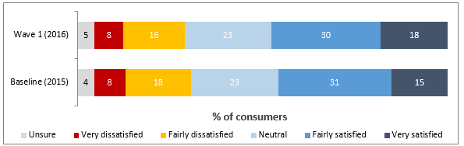

*The attached graph displays the overall satisfaction with the Aged Care System, with a 48% satisfaction rate in 2016.*

*BASE: Wave 1: all those with recent introductory involvement in the aged care system, n=1,405; Baseline: all respondents, n=2,003*

*Q13. Overall how satisfied or dissatisfied are you with the way the aged care system allows older Australians to access quality services?*

* Care recipients were significantly more satisfied with the aged care system overall than were carers(72% vs. 43%), outlining a trend which was repeated consistently across the study. However, carers’ satisfaction had risen significantly since the baseline wave from 36%. The higher satisfaction among care recipients appeared to be due to the lower expectations of older Australians receiving services, who sought practical outcomes and were positive about their experience if they had been achieved.
* Satisfaction with the aged care system overall was clearly correlated with My Aged Care experience. Those who had contacted the gateway in some capacity were consistently more satisfied with aged care provision than those who were carers or recipients with no experience of the new system.
* 43% of service providers indicate some degree of satisfaction with the aged care system, representing a decline since the 61% recorded at the baseline. CHSP-funded providers specifically had more negative perceptions, with 40% satisfied compared to 51% of those providing services funded by other programs. Service provider respondents who were active users of My Aged Care, i.e. had received referrals through the system, were marginally less satisfied with the aged care system overall, recording 40% satisfaction compared to 46% among non-users.
* 50% of assessors indicated that they were either ‘fairly’ or ‘very’ satisfied with the aged care system, with only 21% expressing dissatisfaction with the system on the whole.
* The lowest satisfaction with how the aged care system functions overall was the 38% recorded among health professionals. This result was driven by a significantly lower rating of 12% among hospital-based professionals versus 50% among GPs.

##### Access and Navigation to Aged Care Services

* There were some changes in reported behaviour since the baseline, most notably an increase in the proportion of recipients reporting that they had been ‘looking for information about aged care (45% vs. 33%).

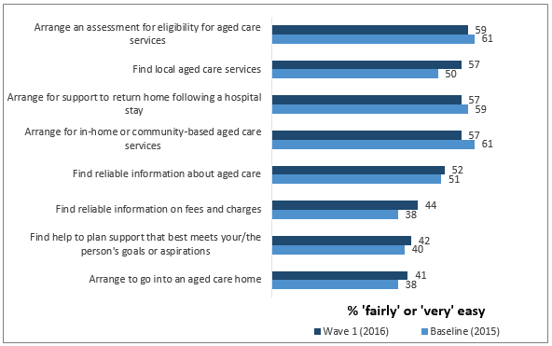

*The attached graph displays statistics on the ease of access to Aged Care Services. 2016 results showed that 59% of users found ease arranging an assessment, 57% could find local services, 57% found ease arranging support to return home after a hospital stay, 57% found ease arranging in-home or community-based services, 52% could find general reliable information, 44% could find information on fees and charges, 42% could find help to plan support which fits a person's goals, 41% found ease arranging access to an aged care home.  
BASE: All consumers selecting each option, n=various*

*Q14. Thinking about your experience with the aged care system, how easy or difficult has it been to do the following?*

* Among consumers, arranging assessments for eligibility for aged care was considered the easiest of all of the prompted activities (59% of all those with experience of doing so being satisfied), while actually arranging entry into an aged care facility was the most difficult (41%). Care recipients recorded significantly higher scores across every measure than did others. Those who had accessed care via My Aged Care were more satisfied with the ease of doing so than those who were carers or recipients not using the gateway, across most measures.
* 32% of service providers was the highest proportion indicating that any of the prompted activities were easy to access for consumers, and 27% the highest rating given by CHSP-funded providers. These figures represent declines since the baseline phase for two prompted measures: the ability to ‘find service providers’ (32% vs. 38%) and to ‘get assessed for eligibility for aged care’ (25% vs. 35%).
* Assessors asked about consumer access to the aged care system on the whole felt that it was relatively easy for them to ‘get assessed for eligibility for aged care’ (62% ‘fairly’ or ‘very’ easy), but that it was harder to achieve other goals. In particular, 24% felt it was ‘very difficult’ for consumers to ‘get the services they need’.
* No more than 40% of health professionals indicated that any of the prompted activities were easy to access for consumers, with as few as 17% – including only 9% of hospital-based professionals – suggesting that it was easy for consumers to ‘get the services they need’.

##### 3.1.3. Perceptions of Aged Care Services

* Around 40% of the general public felt that the aged care system delivers ‘fairly well’ or ‘very well’ on each of the prompted goals. However, this figure was significantly higher across every measure among care recipients, around two-thirds of whom felt that the system ‘understands older people’s needs’ and ‘provides the aged care services that older people need’. Most notably, carers and recipients with experience of using My Aged Care gave significantly more positive ratings for every measure than did carers and care recipients not using the system.

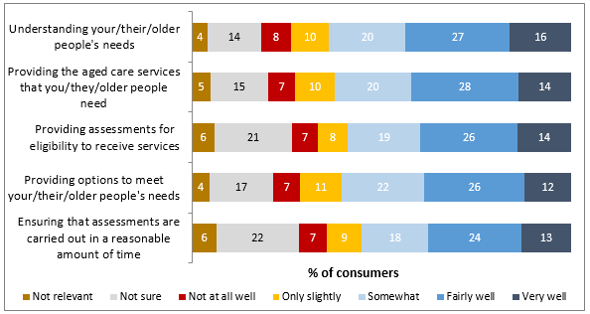

*The attached graph displays perception of Aged Care Services. The highest rated attribute was: understanding older people's needs, with a 43% satisfaction rating. The lowest rated attribute was: ensuring that assessments are carried out in a reasonable amount of time, with a 37% satisfaction rating.*

*BASE: All consumers, n=3,429*

*Q15. In your experience, how well does the aged care system achieve each of the following for [you / the person you are caring for / older people]?*

* The standard of care currently being experienced by consumers of aged care services was rated highly (74% overall), a figure which was markedly higher among recipients (83% vs. 65% among carers).
* Service providers’ ratings of how they are enabled to achieve roles within the system varied from 72% satisfaction with how they can ‘engage with clients to meet their needs’, to 33% satisfaction that they ‘plan effectively for the volume of services they need to deliver’. Those who are ‘users’ of My Aged Care – i.e. have received referrals through the gateway – were less satisfied across every measure. Each comparable measure recorded a decline in ease rating since the baseline.
* Assessors also assigned ‘engage with clients to meet their needs’ to be the easiest aspect of implementing aged care services (70% ‘fairly’ or ‘very’ easy). The weakest areas for this cohort were their perceived ability to ‘plan effectively for the volume of assessment services they need to deliver’ (38%) and ‘find out the history of what services their client has received’ (33%).
* Only a minority of health professionals felt that any of the prompted activities were easy, with 42% indicating satisfaction with the ease of establishing patient information. All other ratings were lower. Again, GPs were more positive than hospital-based professionals, no more than 38% of whom indicated that any activity had been easy.

##### 3.1.4. My Aged Care brand awareness

* Awareness of My Aged Care has increased markedly since the baseline research among consumers of all types: 24% of the Australian public indicated awareness of the My Aged Care helpline (versus 14% in 2015), and 20% of the website (versus 10% in 2015) when prompted (see below).

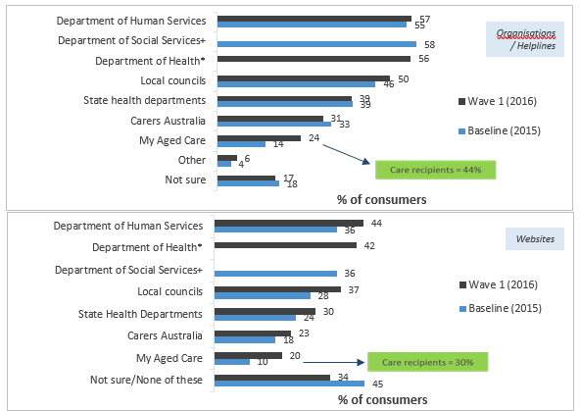

*The top graph displays 2016 results for Awareness of Aged Care Organisations and helplines. Department of Human Services had an awareness rating of 57%, Department of Health had 56% awareness, local Councils had 50% awareness, and all others were below 50%.*

*The lower graph displays 2016 results for Awareness of Aged Care Websites. Department of Human Services had an awareness rating of 44%, Department of Health had 42% awareness, and Local councils had 37% awareness. All have increased since the 2015 research.*

*BASE: Wave 1: all consumers, n=3,249; Baseline: all consumers, n=2,003*

*Q21. Which of the following organisations or helplines that you can call for information and advice about aged care are you aware of?*

*Q22. Which of the following websites for information and advice about aged care have you heard of?*

*\*Not prompted in Baseline*

*+Not prompted in Wave 1*

* Awareness was very high among care recipients specifically, with 44% aware of the My Aged Care helpline and 30% aware of the website. Unprompted awareness of My Aged Care has risen to 4% (for the helpline) and 3% (for the website), from near-zero at the baseline stage; both are encouraging results when complemented by the prompted awareness results.
* While all states and regions recorded increased prompted awareness of aged care helplines generally (rather than My Aged Care specifically), the effect was particularly pronounced in Victoria (increasing to 44% from 27%), Queensland (58% from 30%), and metropolitan areas (49% from 35%).

#### Monitoring service delivery

##### Enquiries

###### Consumer enquiries

* The My Aged Care Contact Centre was rated satisfactory by 76% of recipients and 65% of carers. These strong results were largely due to the perceived helpfulness of the Contact Centre staff, and appreciation of direct personal contact in accessing services.
* The My Aged Care website was satisfactory for 66% of recipients and 59% of carers. While still positive ratings, these were lower than those of the Contact Centre. Consumers’ appreciation of personal interaction over issues related to aged care may account for this difference.

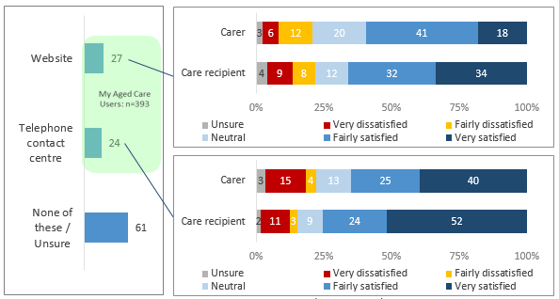

*The attached graph displays Consumer experience accessing My Aged Care. 27% of consumers used the Website; with 59% of carers and 66% of care recipients being satisfied. 24% used the telephone contact centre; with 65% of carers and 76% of recipients satisfied.*

*BASE: Consumers who had used the My Aged Care telephone contact centre/website, n=251/259*

*Q24. Overall, how satisfied were you with the quality and accuracy of the information you received from the telephone contact centre?*

*Q25. Overall, how satisfied were you with the quality and accuracy of the information you received from the My Aged Care website?*

###### Provider enquiries

| At the time of this research, access to the My Aged Care gateway had progressed to differing levels of implementation. For this reason, providers located in Victoria and Western Australia were excluded from a number of measures, as they had not at that point had the opportunity to access some aspects of the system. Providers not funded under the Commonwealth Home Support Program, and providers indicating that they were not aware of My Aged Care, were also excluded for the same reasons. This survey design technique resulted in a cohort of n=207 service providers forming the base for the majority of service delivery questions related to My Aged Care. |
| --- |

* The quality and accuracy of information being supplied by the My Aged Care Contact Centre and in referrals was viewed relatively poorly by service providers.The quality and accuracy of information from the Contact Centre was seen as satisfactory by less than half of service providers (41%). This group’s major concerns revolved around a lack of specialist knowledge possessed by Contact Centre staff, and the consistent unreliability of information being provided.

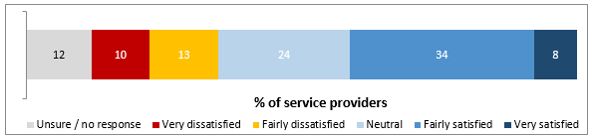

*The attached graph displays Service Provider experience accessing My Aged Care. 41% of those who called the Contact Centre were satisfied.*

*BASE: n=143; providers with experience of using the Contact Centre*

*Q29. How satisfied were you with the quality and accuracy of information that you received from the My Aged Care Contact Centre specifically?*

* The quality and accuracy of information provided on the My Aged Care website was seen as satisfactory by 30% of service providers. This result included significantly lower ratings among those who used My Aged Care to receive referrals (23%, vs. 39% among non-user providers). This result may indicate that perceptions of the website relate to initial problems with using the portal rather than myagedcare.gov.au’s function as a general information source. In future waves of research, the My Aged Care website will be defined more specifically as ‘myagedcare.gov.au’ or the relevant ‘My Aged Care portal’ to clarify this.

###### RAS enquiries

| Engagement with the different means of accessing My Aged Care was high in general among assessors. The total sample of n=176 was surveyed on these measures, because assessors in regions or organisations not yet using My Aged Care were still able to access its website or Contact Centre. In total usage of both channels was high: n=158 had used the website, and n=153 the Contact Centre. The base sizes in this section reflect these usage cohorts. |
| --- |

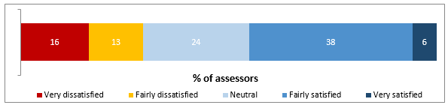

*The top graph displays Regional Assessment Service assessor experience accessing My Aged Care. 43% were satisfied with the Contact Centre.*

*BASE: n=127; all RAS assessors with experience of using the Contact Centre*

*Q29. How satisfied were you with the quality and accuracy of information that you received from the My Aged Care Contact Centre?*

* 43% of those offering RAS assessments indicated some degree of satisfaction with the quality and accuracy of information received from the My Aged Care Contact Centre. The qualitative consultation with RAS workplace trainers and selected peak bodies suggested that RAS organisations usually felt well supported to conduct assessments. However they sometimes felt hampered by the reliability of client information supplied by the Contact Centre, and the prevalence of referrals which would have been more appropriate for ACATs.
* The same overall rating of 43% was assigned to information received from the website, and was slightly higher among RAS-only organisations (46%).

###### ACAT enquiries

| The subset of assessors who indicated that their organisation only delivered ACAT assessments were asked general questions relating to their experience with the ‘aged care system’. Respondents indicating experience of RAS assessments were asked specifically about My Aged Care throughout. |
| --- |

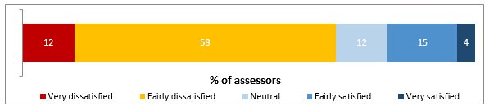

*The bottom graph displays ACAT assessor experience accessing My Aged Care. 19% were satisfied with the Contact Centre.*

*BASE: n=26; all ACAT assessors with experience of using the Contact Centre*

*Q29. How satisfied were you with the quality and accuracy of information that you received from the My Aged Care Contact Centre?*

* In total, ACAT assessors’ satisfaction with the information received from the Contact Centre was 19%. Not surprisingly, ACAT assessors’ satisfaction ratings were lower among Western Australian and Victorian ACAT organisations, which had not yet experienced the rollout of My Aged Care.
* ACAT assessors in My Aged Care active states gave an overall satisfaction rating of 31%, which was closer to the 43% among RAS assessors.
* 32% of ACAT-only assessors were satisfied with the website to some degree.

###### Inbound referral

| Perceptions of My Aged Care’s handling of inbound referrals were sought from providers and health professionals with experience of making them. N=292 providers were aware of My Aged Care and were asked about their experience, while awareness of My Aged Care was a requirement for health professionals to complete the survey, so all n=151 were asked about their referral practices. |
| --- |

* 32% of service providers had used the Contact Centre to make inbound referrals, and were typically only moderately satisfied with the ease of doing so – 38% indicated that it had been easy.
* Only 18% of health professionals had referred someone by phone to the Contact Centre, preferring the use of the online form (26%) or fax (30%). Their satisfaction with the ease of making telephone referrals was the least of any of the three methods (40%), with health professionals on the whole strongly preferring to refer via the online form (59%) or via fax (70%).
* Across both groups, the professionalism of Contact Centre agents was satisfactory (a majority of providers and health professionals agreed that ‘the person I spoke to understood the reason for the call’). These results should be understood as still being markedly lower than the consumer experience of contacting the Contact Centre, where satisfaction with the process was above 70% among some subgroups.
* The appropriateness of the outcome for the client was seen as poor by 47% of providers and 37% of health professionals.

##### Registration

###### View and maintain personal details

The ability of users of the system to ‘view and maintain personal details’ effectively was gauged by asking consumers about their experience registering their information via the Contact Centre. Specifically, questions focused on the ease of supplying their information and subsequently on the accuracy of that information when reused or when recontacting the gateway.

* Consumers were satisfied with the registration and screening processes. More than 80% of care recipients indicated satisfaction with each of the processes, while carers reported slightly lower figures, but were still positive.
* Where negative results were recorded, it was often when consumers felt that it had been difficult to find information (especially around funding), or where they had felt that accessing information was primarily based on Internet access.

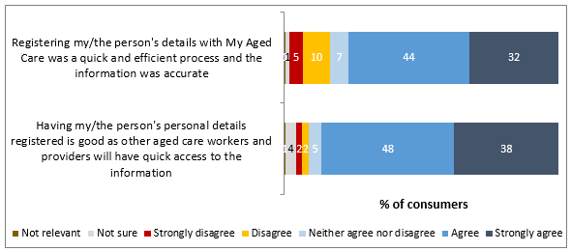

*The attached graph displays Consumer experience registering details with My Aged Care. 76% agreement that the speed and efficiency of the registration process was good, 85% agreement that registration is a useful process for accessing services*

*BASE: Consumers who registered with My Aged Care via the telephone contact centre, n=164*

*Q30b. To what extent do you agree or disagree with each of the following statements about the use of the personal details you supplied?*

###### Complete identity verification

* Assessors were largely positive about completing client identity verifications: 70% found the process at least ‘fairly easy’.
* RAS assessors gave a 78% rating to the process, significantly higher than the 53% among those only working in an ACAT.
* The negative feedback around identity verification most commonly related to a perceived lack of options for ID verification.

##### Service facilitation

| Some sampling and filtering practices are adhered to throughout the My Aged Care service sections of the main report, resulting in different base sizes across questions. As these sections deal explicitly with aspects of usage of the My Aged Care system, they do not address ‘overall’ top-level findings among any of the respondent groups, but instead ask relevant subgroups about their experiences with the gateway. Some frequent sample groups analysed include:   * N=207 service providers who are a) aware of My Aged Care, and b) funded under the Commonwealth Home Support Program – i.e. those able to receive referrals through the Portal system * N=251 consumers reporting that they had called the My Aged Care Contact Centre * N=283 consumers who had experienced an aged care assessment either as a carer or care recipient |
| --- |

###### Aged care screening

* Among the n=164 My Aged Care users reporting that they had undergone a telephone screening, the most frequent reported outcome (32%) was that the care recipient in question was referred to a face-to-face assessment. 81% of care recipients and 70% of carers were satisfied with the outcome of the screening. The highest rated individual outcome was being ‘given the contact details of local aged care services’, which was satisfactory to 84% of those who reported it.

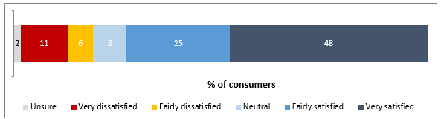

*The attached graph displays Consumer satisfaction with the outcome of the My Aged Care screening process, with 73% being satisfied.*

*BASE: Consumers recalling outcome of screening, n=157*

*Q32b. How satisfied were you with this outcome?*

###### Home care assessment

| Categorising consumers as having had a RAS or ACAT assessment was a core challenge of the research design, given that the nature of the rollout and the field of aged care services meant that consumer awareness of the RAS and ACAT terms would not be reliable enough to ascertain assessment types clearly. Therefore, carers and recipients indicating assessment experience were categorised into RAS or ACAT based on a series of qualifiers.  Firstly, their sought and received outcomes were applied to a matrix to determine the most likely assessment type they had actually received. Secondly, their responses to the ‘awareness’ and ‘usage’ My Aged Care questions were analysed to split out confident and less confident RAS category members. The result was an overall base of n=283 assessment participants, comprising n=56 RAS assessment participants who explicitly reported use of My Aged Care and were not located in the states of Victoria or Western Australia and n=227 ACAT assessment participants. |
| --- |

* Home care (RAS) assessments were viewed very positively by consumers, with 91% of those confidently categorised as RAS assessment recipients indicating that they had been satisfied with the experience.

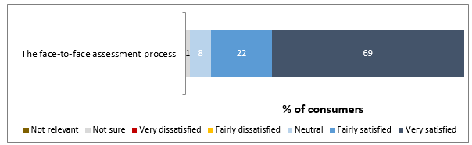

*The attached graph displays Consumer satisfaction with the home care face-to-face assessment process, with 91% being satisfied.*

*BASE: Consumers who had undergone a RAS assessment, n=56*

*Q36b. Overall, how satisfied were you with each of the following? – ‘The face-to-face assessment process’*

* While still supported by a majority of assessment recipients, the lowest ratings were for the statements related to the inclusion of carers in the process (43% indicated that they had been). Many carers expressed a desire to be better consulted about the care needs of the person for whom they care. However, 44% of consumers were ‘not sure’ of the involvement of the carer, suggesting that actual satisfaction is not necessarily as low. This may reflect the relatively low care needs of care recipients who are assessed by RAS assessors, which may mean the involvement of a carer is not always required.
* Undergoing the assessment, care recipients tended to most value being treated with respect and as an equal partner in the decision-making process. Their carers, however, were often more concerned with the competence of the assessor in recommending the most appropriate care.

###### Comprehensive assessment

* 84% of those consumers undertaking ACAT assessments were satisfied with their experience, a similar result to that recorded by RAS assessment recipients.

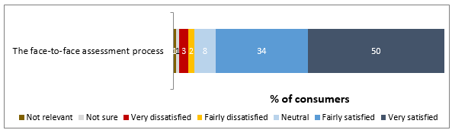

*The attached graph displays Consumer satisfaction with the home care face-to-face assessment process, with 84% being satisfied.*

*BASE: Consumers who had undergone an ACAT assessment, n=227*

*Q36b. Overall, how satisfied were you with each of the following? – ‘The face-to-face assessment process’*

* The most notable difference in ratings of individual aspects of the ACAT from the RAS process was that 60% or more of ACAT assessment recipients gave positive scores to questions regarding the involvement of the carer in the assessment.
* Several satisfied care recipients reported they were relieved that their ACAT experience had not been ‘invasive,’ or focussed too heavily on the clinical aspects of their wellbeing. On the other hand, where recipients and carers expressed reservations, they often centred on the perceived stress for elderly clients of a comprehensive assessment.

###### Match and refer service

| All consumers who had undergone an aged care assessment for themselves or as a carer for someone else were asked about their expected and received outcomes. |
| --- |

* Consumers were positive about the match and refer process. 65% felt that it had been easy to access care services post-assessment; 72% felt that a referral had been made to an appropriate provider; and 74% were satisfied with the suitability and standard of the services when they were received.

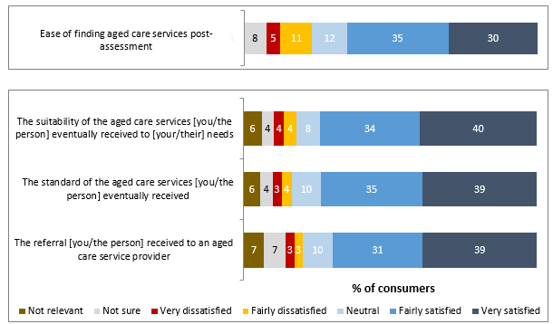

*The attached graph displays Consumer satisfaction with the process of being matched with aged care services. 65% were satisfied with the ease of finding aged care services, 70% with the referral process to reach services, 74% with the suitability of services received, and 74% with the standard of services received*

*BASE: Consumers who had undergone an assessment, n=283*

*Q35. How easy or difficult was it to find aged care services following the assessment?*

*Q36b. Overall, how satisfied were you with each of the following?*

* Only 37% of service providers were satisfied with how My Aged Care had implemented the match and refer process. Reasons for dissatisfaction included the perceived unreliability of client information, as well as information about other providers, which they said necessitated further work before they could begin to deliver services.
* Similarly, 34% of assessors indicated satisfaction, including only 9% of the ACAT assessors. A low standard and reliability of client information provided by the Contact Centre was again cited as the major problem.

##### Participant enablement

###### Provide training

* 92% of assessors had undertaken Portal training since the rollout; 31% indicated satisfaction with the process. 43% of those who had undertaken the accredited training were satisfied.

G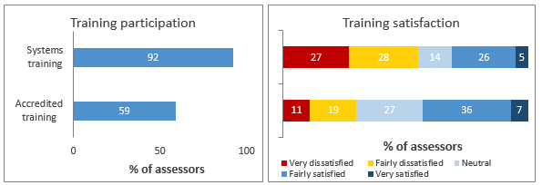

*The leftmost graph displays Aged Care Assessors participation in training. 92% undertook online systems training, 59% undertook assessment training.*

*The rightmost graph displays Aged Care Assessors satisfaction with training. 31% satisfied with the systems training, 43% satisfied with the assessment training.*

*BASE: n=138: Q12a. Have you undertaken any training on the use of the My Aged Care Assessor Portal?*

*BASE: n=127: Q12b. How satisfied were you that the training and information you received equipped you to carry out the required tasks online?*

*BASE: n=80: Q13b. How satisfied were you that the training and information you received equipped you to carry out assessments effectively within the My Aged Care guidelines?*

* Criticisms of the training processes included a perceived lack of focus on education regarding the skills applicable to interpersonal challenges faced while conducting assessments.
* Some of the workplace trainers consulted also felt that there had been unclear lines of communication between various bodies implementing, marking, and troubleshooting the online aspects of the accredited training process. However, several reported that this had been remedied and was now functioning more effectively.

##### Engagement

###### Market and educate

* When questioned on the overarching aims of My Aged Care, consumers identified the system’s key strengths and weaknesses. 70% agreed that it provides reliable information on aged care in general, while the lowest score was for the statement ‘provides accurate information on fees and charges’ (53%). The qualitative consultation echoed the sentiment that access to clear fee information was an area for improvement for the gateway.
* Overall likelihood of recommending the gateway among consumers was very high. 76% of consumers gave a score of 6 out of 10 on a likelihood scale of 0-10, with more than a third (34%) selected 9 or 10. 52% of care recipients and 29% of carers gave a score of 9 or 10, reflecting the general pattern of results throughout the survey.

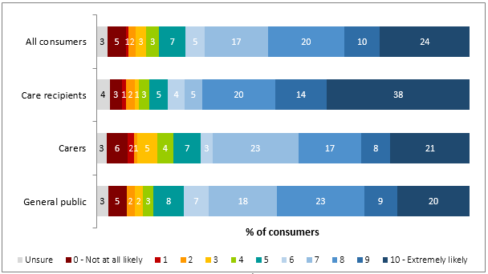

*The attached graph displays Consumers' likelihood of recommending My Aged Care, out of 10. 54% of all consumers rated 8 to 10, 72% of care recipients rated 8 to 10, 46% of carers rated 8 to 10.*

*BASE: Respondents who had used the My Aged Care contact centre and/or website, n=393*

*Q28. How likely would you be to recommend My Aged Care for finding out information and accessing aged care services?*

#### Monitoring activity linked to benefits

##### Accessibility

| To assess the performance of My Aged Care against the Benefit of Accessibility criteria, the sample was filtered to only those actively engaging with the aged care system, i.e. n=956 consumer respondents who were either carers or care recipients. This group contained n=212 carers and recipients with explicit recollection of contact with the My Aged Care gateway, and an overall total of n=405 recipients and n=551 carers. |
| --- |

###### Greater consumer choice and control

* Consumers were generally positive about their ability to access the aged care system. Exceptions included the ease of finding ‘reliable information on fees and charges’ (44% considering this easy, and 33% indicating some degree of difficulty) and ‘arranging to go into an aged care home’ (41% easy vs. 38% difficult).
* Care recipients were most positive about the ease of accessing aspects of the system, while carers, often those actually carrying out the processes, were less effusive, recording significantly lower satisfaction with each activity.
* Most significantly, access to the aged care system was consistently considered easier by those with experience of accessing My Aged Care specifically. There were two exceptions: carers and care recipients outside of My Aged Care found arranging in-home or community services, and arranging support to return home from a hospital stay, easier than My Aged Care users. Since the completion of this research, the development of My Aged Care has continued such that it is now mandatory to arrange these service via My Aged Care. As such, a number of processes have been put into place to streamline and improve the ease of accessing these services through the My Aged Care gateway.
* The CHSP-funded providers surveyed tended to give low ratings of the perceived consumer accessibility of My Aged Care. For example, only 21% thought that the system helped ‘people get the services they need’ ‘fairly’ or ‘very’ well. Qualitative consultation suggested that some providers felt that this was due to consumers not being supplied with easy to understand information about their options, particularly relating to fees and charges. However, some fees and charges information is not fixed but determined by a number of factors, and as such the My Aged Care system is not designed to provide this information up front. A solution would be to communicate this more clearly to consumers going forward.
* RAS assessors were queried on the ability of My Aged Care to aid accessibility for consumers. 44% felt that it was easy to ‘get assessed for eligibility for aged care’, but conversely, just 10% thought that consumers could ‘find information on prices/fees’ easily, a figure even lower at 8% among RAS-only assessors.
* Metrics related to consumers’ choice and control over elements of their assessment and referral generally received positive scores. 71% indicated that they had access to the Support Plan and 64% were included in its development. After the assessment, 72% felt that there had been a referral to an appropriate provider, and 74% thought that the services eventually received met their/the person’s needs.

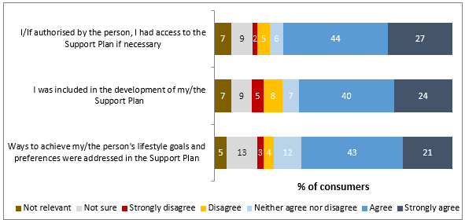

*The attached graph displays Consumer experience with an aged care assessment. 71% agreed that they had access to a Support Plan, 64% were included in the development of the Support Plan, and 64% agreed that the Support Plan addressed ways for the care recipient to achieve their lifestyle goals*

*BASE: Consumers who had undergone an assessment, n=283*

*Q36a. How far do you agree with each of the following statements about the assessment?*

##### Quality and safety

###### Improved and consistent assessment of needs

* 45% of My Aged Care-using service providers agreed that the referrals they had received had been for clients whose needs were appropriate to their service, while only 24% indicated disagreement.

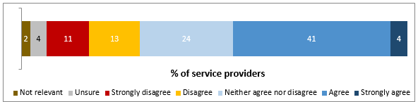

*The top graph displays Service Provider experience receiving referrals. 45% agreed that My Aged Care had sent them referrals to appropriate clients.*

*BASE: n=118*

*Q24. To what extent do you agree or disagree that you were supplied with referrals to clients whose needs were appropriate to the services you offer?*

* Assessors were often ambivalent about the appropriateness of referrals received to the services they offer; while 34% indicated agreement that clients’ needs matched their services, another 42% indicated disagreement.

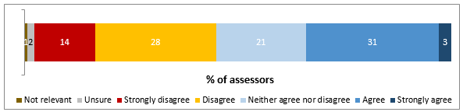

*The middle graph displays Ages Care Assessors experience receiving referrals. 34% agreed that My Aged Care had sent them referrals to appropriate clients.*

*BASE: n=138, all RAS assessors*

*Q17. To what extent do you agree or disagree that you were supplied with referrals to clients whose needs were appropriate to the assessment level you perform?*

* Health professionals’ satisfaction with the appropriateness of My Aged Care referrals was similar, at 40%. As with many other measures, GPs (53%) ascribed higher ratings to the referral system than did hospital-based professionals (32%).
* Health professionals were also surveyed on their satisfaction with My Aged Care’s role in assisting their own outbound referrals to providers and assessors. They recorded similar scores around 40% for each, and in both cases GPs were more satisfied, with around 55% indicating satisfaction.

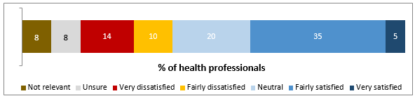

*The bottom graph displays Health Professionals experience referring to assessments. 40% agreed that My Aged Care had helped them make referrals to the right assessment service.*

*BASE: n=75*

*Q19. How satisfied or dissatisfied have you been overall with how My Aged Care has helped you refer patients to local aged care assessment organisations?*

###### Maintain and improve quality of care

* Consumers’ perceptions of the goal-oriented focus of My Aged Care were used as indicators of how assessment contributes to the perceived quality of care. 71% felt that the assessment they had experienced had adequately taken the recipient’s lifestyle goals into account, while 64% agreed that ways to actually achieve them had been addressed. How far the assessment felt like a personally-tailored process or an impersonal procedural exercise was the main factor determining agreement with the statements.

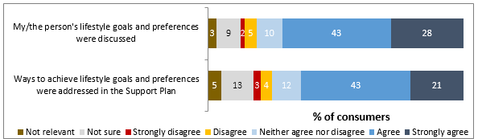*The top graph displays Consumer experience with their involvement in care decisions. 71% agreed that their lifestyle goals and preferences were discussed, 64% agreed that these were addressed in the Support Plan.* *BASE: Consumers who had undergone a face to face assessment, n=283Q36a. How far do you agree with each of the following statements about the assessment?*

###### Stronger connection between the Health and Aged Care systems

* Just 20% of service providers indicated satisfaction with how My Aged Care had helped their organisation deliver services, representing a significant decline since the baseline survey (33%). Despite this result, qualitative discussions found that at the time of the fieldwork, providers were struggling with the changes in process and administration but were often positive about the potential of My Aged Care to improve their ability to implement aged care services.

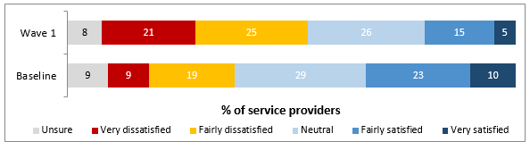

*The bottom graph displays Service Provider satisfaction with My Aged Care connectedness. 2016 result: 20% satisfied that My Aged Care has helped them deliver their services. 2015 result: 33% satisfaction.*

*BASE: Wave 1 n=207, CHSP-funded providers able to receive My Aged Care referrals; Baseline n=300, all providers*

*Q17. How satisfied or dissatisfied have you been overall with how My Aged Care has helped your organisation deliver your services to the community?*

* Connecting to the rest of the system through the provider Portal has been moderately successful. Among the most common Portal uses, 52% of providers were satisfied with how they could check information about their organisation, 42% with how they could upload that information initially, and 27% with how they could receive client referrals.
* Assessors’ use of the Client Record to gather client information for the assessment was not typically successful, with only 29% indicating that its content was useful. However, 50% of My Aged Care-using RAS assessors were satisfied with how this process worked.

##### Efficiency

###### Increased system efficiency

* 56% of providers believed that My Aged Care had worked ‘not at all well’ to reduce their administrative burden, an increase since the baseline survey. Factors cited by providers as contributing to this increase included:
* inaccurate and unreliable information being provided by the Contact Centre;
* inflexibility in cross-referrals and rejections; and
* a lack of awareness among their clients of My Aged Care, requiring them to provide further assistance to existing clients in understanding funding and service models.

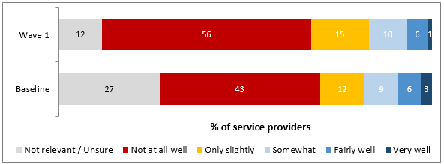

*The attached graph displays Service Provider satisfaction with My Aged Care efficiency. 2016 result: 7% satisfied that My Aged Care has reduced their administrative burden well, 56% not at all well.*

*BASE: n=207, CHSP-funded providers able to receive My Aged Care referrals; Baseline: Service providers aware of My Aged Care, n=290*

*Q18. How well has My Aged Care helped achieve each of following for your organisation? ‘Reduce the administrative burden on your organisation’*

* Only 13% felt that the rollout had had any positive impact on their workload, with 51% believing that the impact had been detrimental.
* The Support Plan supplied by assessors was not usually seen as effective by providers, with only 20% feeling satisfied in how it helped them plan services.
* Assessors themselves were moderately positive about the efficiency benefits, specifically with regards to the potential for cross-referral. 48% of RAS assessors felt that it would be easy to arrange a cross-referral to an ACAT. While only 24% of ACAT assessors felt the same way, there is potential for this to improve as the ACAT group comes under My Aged Care.

###### Reduced waiting time

* Waiting times were not usually considered a problem by consumers. 70% of all those with assessment experience were satisfied that the wait for services was not excessive, including 73% of recipients and 68% of carers. Those undergoing RAS assessments were more positive, with 76% satisfied with the waiting time, compared to 64% of those receiving ACATs. When the services were arranged, recipients were significantly more likely to agree that they matched the Support Plan (74% vs. 62% among carers), with RAS participants again somewhat happier (65% vs. 61%).

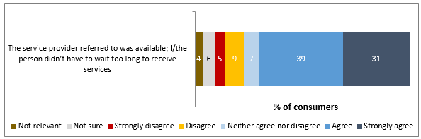

*The attached graph displays Consumer experience with service waiting times. 70% agreed that their wait for services was not too long.*

*BASE: Consumers who had undergone an assessment, n=283*

Q36a. How far do you agree with each of the following statements about the assessment?

##### Community

###### 3.3.4.1. A system that better meets the needs of older people from diverse backgrounds

* Those from Culturally and Linguistically Diverse groups were often less positive about the relevance of the services they received to their Support Plan. This discrepancy may have resulted from a lack of clarity around what the aged care system could provide, exacerbated by concerns over how their cultural preferences would be accommodated by the mainstream aged care system.

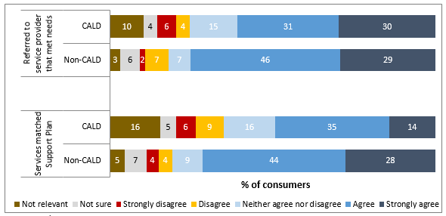

*The attached graph displays Culturally and Linguistically Diverse consumer experience accessing aged care services. CALD consumers, 61% agreement that they were referred to a provider that could meet their needs; non-CALD, 75% agreement. CALD consumers, 49% agreement that the services matched their Support Plan; non-CALD, 72% agreement.*

*BASE: Consumers who had undergone an face to face assessment, n=283*

*Q36a. How far do you agree with each of the following statements about the assessment?*

* At a quantitative level, Culturally and Linguistically Diverse carers and recipients reported results similar to the general population across most measures, but in some instances were less positive. Specifically, these respondents were less likely to be satisfied with communication with the system. They rated information supplied to the Contact Centre and the sensitivity of their aged care assessment to their cultural background less positively than non-Culturally and Linguistically Diverse consumers.
* Furthermore, 49% of Culturally and Linguistically Diverse consumers felt that the services they or the person for whom they care had received, matched the content of their Support Plan, versus 71% of non-Culturally and Linguistically Diverse consumers.
* Aboriginal and Torres Strait Islanders were committed to remaining within their community, expressing a clear desire to interact with Aboriginal and Torres Strait Islander services and staff as much as possible.

###### 3.3.4.2. Improved services for people living in rural and remote Australia

* Those in regional areas were generally positive about the community support available to them, but were often concerned about insufficient funding and a lack of local understanding which may arise from a centralised service delivery model. Their responses were largely similar to those of the broader population.

###### More carers being supported to continue in their caring roles

* As consumers, carers were usually satisfied with the majority of aspects of navigating My Aged Care. However, they were less positive than care recipients across almost all measures. Qualitative consultation suggested that this was a result of feeling that they were not always recognised clearly enough as the primary caregiver. Carers’ inclusion in the assessment process was a source of confusion for many consumers, with more than 40% of RAS participants not sure of the carer’s involvement. As noted above, this may in part reflect lower care needs of RAS recipients, which may mean the involvement of carers is not necessary.

### Conclusions

The following outlines key conclusions across the service areas studied in the research.

#### ****Strengths****

1. ***Awareness growth***

Awareness of My Aged Care has increased markedly since the baseline research among consumers of all types: 24% of the Australian public indicated awareness of the My Aged Care helpline (vs. 14%), and 20% of the website (vs. 10%) when prompted. While all states and regions recorded increased unprompted awareness of aged care helplines, the effect was particularly pronounced in Victoria, Queensland, and metropolitan areas.

Awareness of My Aged Care is almost universal among aged care professionals, even those working outside it at the time of consultation.

1. ***Accessible Contact Centre***

Along with other stages of the consumer journey, the Contact Centre was viewed positively by consumers – 76% of recipients and 65% of carers were satisfied with the quality and accuracy of the information they received. Qualitative consultation suggested that these ratings were mainly driven by the relative comfort of the experience for those making the challenging step of accessing aged care. Many respondents pointed out that the Contact Centre agent they spoke to had been pleasant and helpful, mitigating their concerns.

Similarly, the experience of calling the Contact Centre was viewed positively by service providers: the agents’ understanding, My Aged Care’s action to handle the call, and the call time were all rated as satisfactory by a majority. GPs were also consistently satisfied: two in three were positive about their interaction with the Contact Centre.

1. ***Assessors equipped to conduct quality assessments***

Overall, three in five assessors were satisfied with how they have been able to conduct assessments using the Portal, a vital measure for this group. Around seven in ten felt that it had been easy under My Aged Care to engage with their clients to meet their needs, and half were satisfied with how the gateway supports them to undertake assessments. Assessors and other personnel working for RAS organisations tended to give higher satisfaction ratings across a variety of technical and experiential measures than ACATs.

These strong results were mirrored by consumers, who were overwhelmingly positive about their experience of assessments. 91% and 84% were satisfied with their RAS or ACAT respectively. There were even higher ratings among those who identified themselves as My Aged Care users – those undertaking RAS assessments as a recipient or carer appear to have had a more positive experience if they have personally navigated the My Aged Care system beforehand.

1. ***Referrals working for consumers and GPs***

Consumers were characteristically satisfied with the referral process, with 70% giving positive feedback on their experience of being referred to a service provider. Once again, there were higher scores among those who had utilised My Aged Care as part of their service access journey. In-depth interviews and focus groups showed that the measures of ‘satisfactory’ referral were often a result of positive experiences of the services eventually received.

GPs were moderately satisfied with how My Aged Care had helped them refer patients to assessments and to aged care services. Overall satisfaction with the central match and refer role of My Aged Care was moderate, with 41% indicating satisfaction, and fewer than one in four dissatisfaction.

1. ***Aged care services that meet consumer needs***

Seventy-four percent of consumers were satisfied with the standard of the services they had received. The qualitative consultation with recipients and carers expanded on this finding, showing that many older people approached aged care services in a pragmatic way rather than as part of their medical of health environment. Satisfaction was usually achieved for consumers if a specific need was met, or specific problem solved.

Overall consumer satisfaction with both My Aged Care and the aged care system was strong. Care recipients specifically recorded very high scores across several measures, with more than 9 in 10 reporting satisfaction in some cases. A majority of this subgroup ascribed My Aged Care a recommendation likelihood of 9 or 10 out of 10, an excellent result.

1. ***Improving aged care attitudes***

Across almost all relevant measures of experience of aged care, My Aged Care users – those who had made use of the website and/or Contact Centre – were markedly more satisfied than non-users. 59% of users were satisfied that the aged care system provides the services that older people need, compared to 49% of non-users, a significant difference. The extent of this trend across the survey suggests that the process of interacting with My Aged Care has improved consumers’ overall views of aged care provision in Australia.

#### Opportunities

1. ***Information seeking and cost enquiries***

The provision of information regarding fees and charges was felt to be positive by only half of consumers, and was often highlighted in the qualitative consultation as an area for improvement. Not just consumers themselves, but also those working in residential aged care facilities, indicated that information on fees and charges was not available widely enough for those looking to enter aged care services.

On a broader level, those seeking specific information rather than access to the My Aged Care consumer pathway were often disappointed. Some information seekers were unclear on the best sources of aged care information, and in reaching My Aged Care, felt uncomfortable with the seeming focus on progressing them towards receiving aged care services.

1. ***Quality and reliability of information from the Contact Centre***

The quality of client information from My Aged Care, in particular the reliability of information about their needs, was rated as unsatisfactory by assessors and service providers in particular. A rating of 43% was assigned to the information from the Contact Centre by RAS assessors, for example. Service providers’ major criticisms were around the reliability of information contained within referrals they received. This was explored during the qualitative interviews, revealing that providers were often dissatisfied with referrals being made which did not reflect their industry area, referred to a client outside their service area, or omitted important information about the client’s needs or conditions.

While consumers were ordinarily positive about their experience with the Contact Centre, they also expressed the importance of quality knowledge underpinning the responses of the agents at the other end of the phone.

1. ***Carers’ assessment and referral needs***

In some cases, carers’ satisfaction with the system was markedly lower than that of recipients. Carers were less satisfied around consultation with assessors about the services their elderly relatives need, and support being made available for them to deal with the responsibilities of carer status. 29% of carers indicated that they would be very likely to recommend the gateway (9 or 10 out of 10) – while still a positive outcome, this figure is markedly lower than that ascribed by care recipients (52%). The qualitative interviews suggested that this result may be due to the fact that carers are often the people responsible for navigating the process on behalf of elderly family members, while many recipients have little direct contact with the aged care system until they receive an assessment or services.

1. ***Referrals between My Aged Care, providers and assessors***

The ability of My Aged Care to help providers ultimately refer clients for further assessment, find other providers for cross-referrals, and alleviate their administrative burden were all considered good by fewer than one in five providers. Similarly, My Aged Care’s matching of clients to their service, and the appropriateness of referrals to their assessment level, were both seen as satisfactory by one in three assessors.

Qualitative consultation with service providers and assessors’ peak bodies expanded on these ratings. It was often perceived that the Contact Centre was not equipped with sufficient clinical knowledge to supply actionable client information, and that this had a follow-on effect for the quality of referrals made by assessors.

1. ***Service provider burden***

The overarching sentiment of service providers was that My Aged Care, while having the potential to effectively streamline services, at this stage functioned mainly to increase the work required of them. 56% felt that the gateway had reduced their administrative burden ‘not at all well’, and only 13% felt that it had had a positive impact whatsoever on their ability to carry out their other work.

The bulk of this increased burden was reported as occurring as a result of the need to proceed through formal My Aged Care channels (i.e. the Contact Centre) to handle matters which previously could have been dealt with internally. This includes rejecting clients due to inappropriate referrals, arranging a transfer to another provider due to a change in a client’s needs, and using the changing organisational information via the Portal.