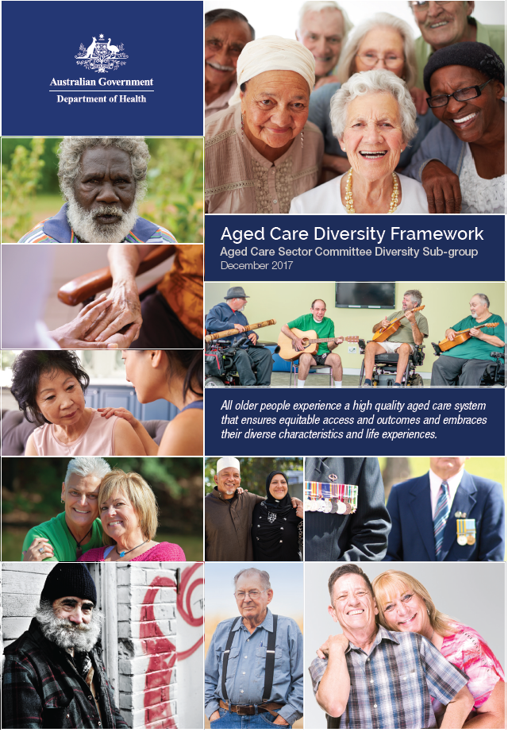
Aged Care Diversity Framework

Aged Care Diversity Framework
Aged Care Sector Committee Diversity Sub-group
December 2017
Publications Number: 12028
Creative Commons Licence - Attribution-NonCommercial-NoDerivatives CC BY-NC-ND

© 2017 Commonwealth of Australia as represented by the Department of Health (except for the photographs and the Rubik’s cube image)
This publication is licensed under the Creative Commons Attribution-NonCommercial–No Derivatives 4.0 International Public License (“Licence”) available from:
https://creativecommons.org/licenses/by-nc-nd/4.0/legalcode.
You must read and understand the Licence before using and sharing this publication.
Sharing
Without limiting your obligations under the Licence, you may share and make this publication available to the public in any medium or format, but only if:
- you share or make this publication publicly available for free and do not use it for a commercial purpose;;
- you share or make this publication publicly available ‘AS IS’ and you do not alter, change, modify, amend or rearrange the content of this publication in any way;
- you do not remove this copyright notice found in this publication; and
- you do not suggest that the Department of Health endorses you, or your use of this publication as a means to promote your goods and services.
Restrictions
The Licence may not give you all the permissions necessary for your intended use. For example, other rights (such as publicity, privacy and moral rights) may limit how you use the material found in this publication.
Enquiries
Enquiries regarding any other use of this publication should be addressed to the Branch Manager, Communication Branch, Department of Health, GPO Box 9848, Canberra ACT 2601, or via e-mail to copyright@health.gov.au

Foreword
Minister for Aged Care and Minister for Indigenous Health
The Hon Ken Wyatt AM, MP
Australia’s Aged Care Diversity Framework
Australia’s communities are diverse. We live in one of the world’s most successful multicultural nations and this diversity is also increasingly reflected in the religion, spirituality, sexuality, culture, socio-economic background, geographic spread and personal experiences of our senior population.
Providing well-rounded support to all people as they age is an Australian Government priority.
The Government acknowledges there are gaps, where more needs to be done so that all people have equal access to appropriate aged care services delivered in a sensitive manner.
This is why, in February 2017, I established the Aged Care Sector Committee Diversity Sub-Group. The Aged Care Diversity Framework is the result of the sub-group’s work after wide consultation with consumers, providers, peak bodies and the aged care sector. These conversations about diversity in all its many forms are helping change the way we look at this issue.
The Framework identifies the common barriers which prevent people accessing the aged care services they need, and suggests how this can be remedied.
I want everyone – no matter what their background, or life experience – to have access to aged care services that meet their needs and expectations. Greater choice and control in our aged care system is essential. We want all senior Australians to live a socially connected life that will enhance their health and wellbeing as they age and to ensure this strategy is appropriate to their needs.
Australia’s Aged Care Diversity Framework is a timely and important step towards a more inclusive future for aged care services in Australia. Whether barriers to appropriate aged care are perceived or real, they must be addressed to meet the diverse needs of the community.
I thank the Aged Care Sector Committee Diversity Sub-Group members for their considerable efforts for the benefit of all senior Australians now and into the future:
Samantha Edmonds (Chair), National LGBTI Health Alliance
James Beckford Saunders and Helen Barrie, Australian Association of Gerontology (AAG)
Mary Patetsos and Cristina Giusti, Federation of Ethnic Communities’ Councils of Australia (FECCA)
Noeleen Tunny, National Aboriginal Community Controlled Health Organisations (NACCHO)
Matthew Moore, Institute for Urban Indigenous Health (IUIH)
Russell Westacott, Seniors Rights Service
Netty Horton, The Salvation Army Southern Territory
Judy Gregurke, National Aged Care Alliance (NACA)
Debra Thoms and Helen Grinbergs, Department of Health
Department of Health Secretariat

What is diversity
In the context of aged care reforms and the Aged Care Roadmap (particularly the Domain ‘How are consumers with different needs supported?’), the aged care sector in Australia is moving towards a system where older people have greater choice and control. One of the key goals is ensuring diversity is catered for in the new system. Older people display the same diversity of characteristics and life experiences as the broader population (see Appendix 1). Older people with diverse needs, characteristics and life experiences can share the experience of being part of a group or multiple groups that may have experienced exclusion, discrimination and stigma during their lives. However, they are not a homogenous group. There are some similarities within groups in relation to the barriers and difficulties they may face in accessing the aged care system but additionally, each person may have specific social, cultural, linguistic, religious, spiritual, psychological, medical, and care needs.
In addition to common challenges, social differences often overlap as people identify with more than one characteristic, exacerbating already complex issues. There is no limit to the number of different characteristics a person holds and no two people’s lived experiences are the same.

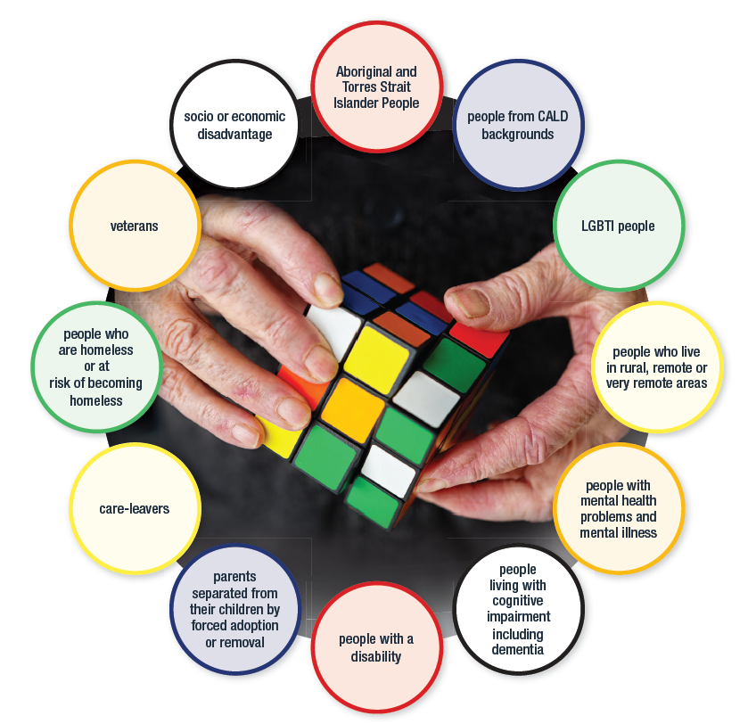



Why does the aged care sector need a Diversity Framework?
As noted previously, Australia is a diverse nation, and older people display the same diversity of characteristics and life experiences as the broader population.
Australia’s aged care system is evolving to offer increased choice and control for consumers. This transition to person centred care requires care to be tailored to meet an individual’s diverse needs. Quality care ensures that the dignity and human rights of each individual is embraced. It also requires that the diverse characteristics and life experience of the individual, that may influence their care needs, are met.
In Australia it is against the law to discriminate. Diversity contributes great advantages to society in general, and should not be perceived as a ‘problem’. In the era of person centred care, tailoring aged care services to be inclusive of individuals’ diverse characteristics and life experiences has many benefits, including:
- positive social and economic change within organisations
- greater choice and control for consumers regarding their care
- a broadened consumer base and target market for providers

Human Rights Based Approach
The protection and promotion of human rights is vital to global efforts to achieve lasting peace and security, and freedom and dignity for all. The Diversity Framework takes a human-rights based approach in line with the World Health Organization principles of non-discrimination, availability, accessibility, acceptability, quality, accountability and universality.
The rights of people with diverse characteristics and life experiences are protected under a range of legislation in Australia as listed in the ‘Relevant Legislation’ supporting document on the Department of Health website.

Objective of the Aged Care Diversity Framework
The Diversity Framework seeks to embed diversity in the design and delivery of aged care; and support action to address perceived or actual barriers to consumers accessing safe, equitable and quality aged care, while enabling consumers and carers to be partners in this process.
The Diversity Framework supports and extends upon the actions and initiatives already undertaken by the Australian Government and the aged care sector to build an inclusive, respectful, and person centred aged care system. While some aged care service providers may choose to specialise in meeting the specific needs of some groups, all elements of the aged care system and all aged care service providers should be able to meet consumers’ diverse characteristics and life experiences.
The Diversity Framework will complement the Single Quality Framework due to be released in July 2018. As part of the introduction of the Single Quality Framework, all providers will be required to provide evidence to demonstrate continuous improvement in tailoring their services and delivering care that meets the diverse characteristics and life experiences of all clients. This can be done through inclusion and monitoring of progress against diversity goals in strategic plans, business plans, operational plans, or demonstrating progress against a specific diversity plan developed by the individual organisation.

Who is the Aged Care Diversity Framework for?
The Framework provides a mechanism for:
- Government to ensure that the diverse characteristics and life experiences of older people are included when developing and implementing policies and measures.
- Peak organisations and representative groups to inform and support the sector to better meet the diverse characteristics and life experiences of older people.
- Aged care service providers to ensure their services better meet the diverse characteristics and life experiences of older people, including when developing their policies and procedures and in working with consumers.
- Consumers to actively provide feedback to inform continuous improvement and articulate their role in co-design of the aged care system and supports.

Action plans
The Diversity Framework is envisaged to be a living document that takes a holistic approach to older people with diverse characteristics and life experiences to drive cultural and systemic improvements to aged care. The Diversity Framework provides an overarching structure which includes a number of action plans. The intent of the action plans is to support government, aged care providers, consumers, families and carers by focusing on solutions to address specific barriers and challenges affecting each group’s ability to access mainstream and flexible aged care services. Initially the Aged Care Sector Committee Diversity Sub-Group will develop three action plans for Aboriginal and Torres Strait Islander people, people from Culturally and Linguistically Diverse (CALD) backgrounds, and Lesbian, Gay, Bisexual, Trans and Gender Diverse and Intersex (LGBTI) peoples. Further action plans may be considered as the need arises over time.
The Diversity Framework builds on the 2013-2017 National Culturally and Linguistically Diverse and the National Lesbian, Gay, Bisexual, Transgender and Intersex aged care strategies. The CALD and LGBTI strategies started a process of inclusion and the CALD and LGBTI action plans will continue to embed good practice into aged care and ensure that CALD and LGBTI peoples are included and respected. In addition, there are goals from the strategies that still need to be implemented, or implemented more fully. An action plan is also being developed in acknowledgement of the range and magnitude of social and cultural barriers faced by Aboriginal and Torres Strait Islander people in accessing and optimising their experience of aged care.

Supporting tools and resources
The Diversity Framework is intended to complement other policy documents and resources to assist in meeting the diverse characteristics and life experiences of older people. A list of these resources is provided in the ‘Information and Training Resources’ and ‘Complementary Frameworks’ supporting documentation on the Department of Health website. These should be referred to as needed.

Evaluation, reporting and monitoring

Evaluation
The Diversity Framework will be subject to evaluation every three years. The Australian Government will work with the sector to evaluate the effectiveness of the Diversity Framework in addressing common barriers affecting access to aged care services to drive cultural and systemic improvements for an inclusive aged care system.

Reporting
The Diversity Framework will be considered in existing mechanisms and parallel processes, while also influencing the approaches to future policies, programs and data collection. Reporting on the Diversity Framework will be captured through:
- Annual reporting to the Aged Care Sector Committee
- Annual Report on the Operation of the Aged Care Act 1997 (https://agedcare.health.gov.au/ publications-and-articles/reports/report-on-the-operation-of-the-aged-care-act-1997)
- Annual Report on Government Services (http://www.pc.gov.au/research/ongoing/ report-on-government-services)
- As part of future data collection against special needs groups as defined in the Aged Care Act 1997

Monitoring
Activities under the Diversity Framework will be regularly monitored through working groups, government funding rounds, and existing processes and networks.

Aged Care Diversity Framework
This representation of the Diversity Framework indicates how the various elements of the Diversity Framework interact.
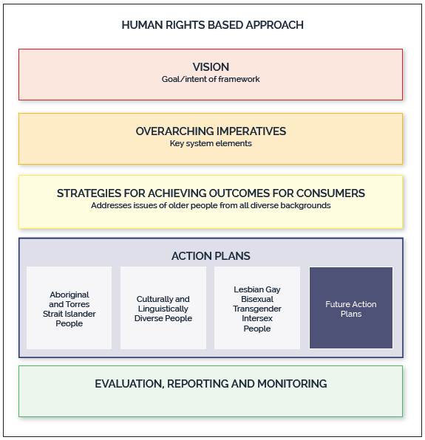

Vision
All older people experience a high quality aged care system that ensures equitable access and outcomes and embraces their diverse characteristics and life experiences.

Overarching Imperatives
The following strategic imperatives are essential in ensuring an inclusive aged care system that embraces the diverse characteristics and life experiences of older people.

- Equity of access and outcomes – Older people with diverse characteristics and life experiences have equitable access to information and services that are effective and appropriate to their needs, and that take into account individual circumstances.
- Empowerment - Older people with diverse characteristics and life experiences, and their families, carers and representatives are respected and supported, and have the information, knowledge and confidence to optimise their use of the aged care system.
- Inclusion – Older people with diverse characteristics and life experiences, and their families, carers and representatives are included in the development, implementation and evaluation of aged care policies and programs on an ongoing basis.
- Quality – Older people with diverse characteristics and life experiences are treated with dignity and respect, and can maintain their identity. They can make informed choices about their care and services and how these services support them to live the lives they choose.
- Capacity building – Older people and their communities have the capacity to articulate their ageing and aged care needs and have their diverse characteristics and life experiences embraced. They are partners in the development of services and the workforce to meet their needs.
- Responsive and accountable – The aged care system embeds the diverse characteristics and life experiences of all older people in system planning, delivery, monitoring, and transparent reporting. The aged care system is responsive and flexible in adapting to the current and emerging needs and expectations of older people, their families, carers and representatives, to ensure services are appropriate and inclusive.

Strategies for achieving outcomes for consumers
Outcome for Consumers | Action Required
 | by Government | by Peak Organisations and Representative Groups | by Aged Care Providers | by Consumers, their family, carers, or representatives
- Making informed choices  Older people have easily accessible information about the aged care system and services that they understand, and find the information helpful to exercise choice and control over the care they receive. | Ensure the diverse characteristics and life experiences of older people are embedded in the design and development of the aged care system, and that information about the aged care system is accessible for all. | Include diversity in publications and information that promotes best practice models. | Provide information in an appropriate format, through different forms (online/hardcopy/newsletter/verbal) and in a language the consumer understands. | Provide feedback on the quality and accessibility of information.
- Adopting systemic approaches to planning and implementation  Older people are active partners in the planning and implementation of the aged care system. | Respond to feedback from consumer and community consultations in developing and designing the aged care system and supporting programs. Collect, monitor, analyse and use data about diverse characteristics and life experiences of older people to ensure equitable access and outcomes. | Engage their members and communities to inform best practice to achieve an equitable aged care system. | Engage consumers in a culturally safe, supportive environment that enables them to participate as active partners, as well as articulate their individual needs. | Engage as active partners and articulate their individual needs.
- Accessible care and support  Older people in rural, remote, regional and metropolitan Australia have access to aged care services and supports appropriate to their diverse characteristics and life experiences. | Identify and overcome barriers faced by older people in accessing the aged care system. | Develop and evaluate innovative partnerships and models to overcome barriers faced by older people. | Collaborate with stakeholders to identify and overcome barriers in accessing the aged care system. | Where possible articulate the barriers to be overcome. Provide feedback of potential solutions.

Outcome for Consumers | Action Required
 | by Government | by Peak Organisations and Representative Groups | by Aged Care Providers | by Consumers, their family, carers, or representatives
- Supporting a proactive and flexible system  A proactive and flexible aged care system that responds to the needs of existing and emerging diverse groups, including an increasingly diverse aged care workforce. | Collect and use data and evidence on current and emerging trends in diversity to design, implement, evaluate and improve aged care systems and supports. | Share evidence and data with stakeholders to assist in improving the aged care system. | Engage with the local community and stakeholders to identify emerging needs and how service delivery models can be adapted to embrace those needs, including how the organisation’s workforce demonstrates an inclusive approach to care. | Provide feedback on the appropriateness of services and articulate any unmet needs.
- Respectful and inclusive services  Services effectively meet the specific needs of older people with diverse characteristics and life experiences, their families, carers and representatives in a respectful and inclusive way. | Evaluate the effectiveness of services and supports in meeting the diverse characteristics and life experiences of consumers, implement improvements when needed and share outcomes with all stakeholders. | Assist their members and communities to engage with consumers, families, carers, representatives and the broader community to inform best practice approaches in tailoring services to be inclusive of diversity. | Seek out, develop and use tools, training and information that support delivery of care that is inclusive of diverse characteristics and life experiences. | Respect the diversity of other service users and the aged care workforce. Provide feedback on the inclusiveness of services.
- Meeting the needs of the most vulnerable  Older people can access high quality and culturally safe aged care services and supports that meet their needs irrespective of their personal, social or economic vulnerabilities. | Collect data on service use by vulnerable consumers and evidence on current and emerging trends and market failures, to improve systems and supports that ensure equity of access and outcomes. | Facilitate opportunities to ensure that the most vulnerable members of diverse communities are able to participate in dialogue and articulate change. Importantly, this process should include advocacy with, and on behalf of, these groups. | Provide inclusive service models to address the needs of the most vulnerable, and work with other stakeholders to ensure the full spectrum of needs are met. | Respect other people with vulnerabilities. Vulnerable consumers, where possible, articulate needs, express their opinion and identity, and provide feedback.

Appendix 1: Statistics
Older people display the same diversity as the broader population across one or more attributes including race, religion, language, gender, sexuality, health, economic status and/or geographic location.

Available information from the National Aged Care Alliance shows that:
- There are over 100,000 older people from Aboriginal and Torres Strait Islander communities’ in Australia
- Over 36 per cent of older Australians were born outside of Australia and one in three older people were born in a non-English speaking country
- More than one in ten people have diverse sexual orientation, gender identity or intersex characteristics
- Almost 15,000 older Australians experience homelessness or are at risk of homelessness
- One in ten Australians over sixty-five lives with cognitive impairment and dementia
- More than 80% of older Australians report an affiliation to a religion of some kind
- Over half of older Australians experience some sort of disability
- More than one in ten older Australians live in regional, rural and remote communities
- One in twelve older Australians experience significant financial or social disadvantage
- One in twelve older Australians have four or more chronic diseases
- There are over 150,000 older Australian veterans
- There are half a million care leavers in Australia who are now between 40 and 90 years of age, with the numbers of parents separated from their children by forced adoption or removal still unknown
- The population of people living with HIV has aged substantially. In 1985 the proportion of the population aged over 55 years was 2.7%. In 2010, it was 25.7% and by 2020 it is expected to be 44.3%

Additionally, due to their poorer health status and higher levels of socioeconomic disadvantage, Aboriginal and Torres Strait Islander elders have health care and support needs that differ from those of other older Australians. Aboriginal and Torres Strait Islander elders have a life expectancy that is approximately 10 years less than the general population and experience dementia at rates between 3-5 times higher than the general population.

Department of Foreign Affairs and Trade (2017) Human Rights (http://dfat.gov.au/international-relations/themes/human-rights/Pages/human-rights.aspx)
World Health Organization (2015) Health and Human Rights Fact Sheet (http://www.who.int/mediacentre/factsheets/fs323/en/)
National Aged Care Alliance (2017) Ensuring equity of access and outcomes in the future aged care system (http://www.naca.asn.au/Publications/Equity%20of%20Access%20and%20Outcomes%20Statement%20of%20Principles_Landscape.pdf)
Australian Institute of Health and Welfare (2011) Older Aboriginal and Torres Strait Islander people (https://www.aihw.gov.au/getmedia/e3d40457-965c-44dd-a639-edb68aaf8a9b/12283.pdf.aspx?inline=true)
Australian Health Ministers’ Advisory Council (2017) Aboriginal and Torres Strait Islander Health Performance Framework 2017 Report (http://www.health.gov.au/indigenous-hpf)
Smith K., Flicker L., Lautenschlager N., Almeida O., Atkinson., Dwyer A., LoGuidice D., (2008) High prevalence of dementia and cognitive impairment in Indigenous Australians Neurology (71) 1470-73
Radford K, Mack H., Draper B, Chalkley S., Daylight G., Cumming R, Bennett H, Delbaere K, Broe G., 11 (2015) Prevalence of dementia in urban and regional Aboriginal Australians Alzheimer’s & Dementia (2015) 271-279
Lo Giudice D , Smith K, Fenner S, Hyde Z, Atkinson D, Skeaf L, Malay R, Flicker L (2016) Incidence and predictors of cognitive impairment and dementia in Aboriginal Australians: A follow-up study of 5 years Alzheimer’s & Dementia 12 252-261

