Aged Care Financing Authority

Seventh report on the Funding and Financing of the Aged Care Industry

July 2019

Contents

Foreword 1

Executive Summary 3

1. This report 2

1.1 Aged care in Australia 2

1.2 About the Aged Care Financing Authority 2

1.3 The Annual Report on the Funding and Financing of the Aged Care Industry 3

1.3.1 Methodology 3

1.3.2 Navigating the 2019 annual report 5

2. Aged care in Australia 6

2.1 Overview 6

2.2 Current aged care 9

2.3 Australian Government expenditure on aged care 11

2.4 Consumer contributions 12

2.5 Aged care providers 14

2.6 Aged care workforce 16

2.6.1 Aged Care Workforce Strategy 17

2.7 Aged care reforms 18

2.7.1 2017 Legislated Review 19

2.8 Royal Commission into Aged Care Quality and Safety 20

3. Access to aged care 21

3.1 Supply of subsidised aged care 21

3.2 Aged Care Approvals Round 24

3.3 Access to aged care 25

3.4 Access to home care 25

3.4.1 Release of home care packages 26

3.4.2 Demand for home care packages 27

3.4.3 Length of stay in home care 28

3.5 Access to residential care 28

3.5.1 Occupancy in residential care 28

3.5.2 Admissions to residential care 31

3.5.3 Length of stay in residential care 32

3.6 Residential respite care 34

3.6.1 Length and frequency of stay in residential respite care 37

3.6.2 High and low residential respite care 38

3.7 Supported residents 39

3.8 Age profile across care types 40

3.9 Access by Culturally and Linguistically Diverse and Indigenous Australians 42

3.9.1 Culturally and Linguistically Diverse Australians 42

3.9.2 Indigenous Australians 43

4. Home support 44

4.1 Introduction 44

4.2 Commonwealth Home Support Programme 44

4.3 Home and Community Care — Western Australia 47

4.4 Sector overview 47

4.4.1 Providers of home support 47

4.5 Funding for CHSP and HACC 48

4.5.1 Consumer contributions 49

4.6 Looking forward 50

5. Home care 51

5.1 Overview of the sector 51

5.1.1 The Home Care Packages Program 51

5.1.2 Providers of home care 52

5.2 Operational performance 54

5.2.1 Methodology 54

5.2.2 Analysis of 2017-18 financial performance of home care providers 55

5.2.3 Revenue 56

5.2.4 Expenditure 59

5.2.5 Profit 61

5.2.6 Unspent funds 66

5.3 Feedback from consultations and developments in 2018-19 67

6. Residential care 69

6.1 Overview of the sector 70

6.1.1 Supply of residential care 70

6.1.2 Residential care providers 71

6.1.3 Ownership type 72

6.1.4 Provider scale 73

6.1.5 Provider location 74

6.1.6 Residential care facility size and room configuration 74

6.1.7 Provisionally allocated places 75

6.1.8 Extra service 77

6.1.9 Additional services 78

6.2 Residential care funding sources 79

6.2.1 Operational funding 79

6.2.2 Commonwealth operational funding 80

6.2.3 Basic care subsidies 80

6.2.4 Residential care supplements 83

6.2.5 Payments for residential respite care 84

6.2.6 Resident operational funding 85

6.3 Operational performance in 2017-18 85

6.3.1 Revenue 85

6.3.2 Expenses 90

6.3.3 Financial results 94

6.3.4 Feedback from consultations and developments in 2018‑19 102

7. Residential care: capital investment 105

7.1 Capital financing 105

7.1.1 Residents as a source capital 106

7.1.2 Commonwealth as a source of capital 106

7.1.3 Other sources of capital finance 106

7.2 Accommodation deposits 106

7.2.1 Accommodation deposit prices 110

7.3 Financing status - balance sheet 112

7.3.1 Balance sheet analysis by ownership type 113

7.3.2 Balance sheet performance ratios 117

7.3.3 Recent trends in building and investment in the residential care sector 122

8. Future demand for aged care 125

8.1 Future demand for aged care services 125

8.1.1 Determinants of demand 125

8.1.2 An ageing population – older people demand more aged care 126

8.1.3 Consumer preference 127

8.1.4 Availability of alternative care types 127

8.1.5 Economic factors 128

8.2 Current demand for aged care 129

8.2.1 Residential care 129

8.2.2 Home care 130

8.3 Projecting demand into the future 130

8.3.1 Substitution of residential care and home care 130

8.3.2 Updated projections 132

8.3.3 Planning for the supply of aged care 133

8.4 Investment requirements for residential care 134

8.5 The investment environment 136

8.5.1 Access to capital 136

9. The challenge of achieving a sustainable aged care system 138

9.1 Funding and financing challenges in the aged care industry 138

9.2 Characteristics of a viable and sustainable aged care system 139

Appendix A: ACFA Membership 144

Appendix B: Work completed by ACFA to date 145

Appendix C: ACFA’s stakeholder engagement 147

Appendix D: Aged care workforce 149

Appendix E: Means testing arrangements 151

Appendix F: Financial ratios by provider ownership type 153

Appendix G: Residential aged care subsidies and supplements 157

Appendix H: Residential care subsidy and supplements rates 158

Appendix I: Residential care financing structures and balance sheets 161

Appendix J: Home care revenue and expenditure 162

Appendix K: Home care subsidies and supplements 164

Appendix L: Residential care and home care financial data 166

Appendix M: References 167

Glossary 168

Charts, tables & figures Index 178

# Foreword

I am pleased to present the Aged Care Financing Authority’s (ACFA) 2019 Report on Funding and Financing in the Aged Care Sector. This is ACFA’s seventh annual report.

Consistent with past reports, the 2019 report examines developments, issues and challenges confronting the aged care industry in Australia. It includes analysis of the financial data supplied by aged care providers in their 2017-18 Aged Care Financial Reports, supplemented by more recent data sources where available and feedback from significantly enhanced consultations with stakeholders. Drawing on this consultation and other data, the report provides some comments on financial developments in 2018-19. It also provides some observations on the sustainability and viability of the aged care industry.

A number of Government policies are impacting on the financial performance of aged care providers, in particular the changes to the Aged Care Funding Instrument (ACFI) that took effect in 2016 and 2017 and the introduction of home care consumers having choice of services under their packages and choice of the provider who delivers these services. The impact of these changes were evident in the 2017-18 data submitted by providers, which underlies this report, and is continuing to influence the industry in 2018-19.

While the data collected from providers from their Aged Care Financial Reports represents the most comprehensive data set available on financial issues in the Australian aged care industry, in most cases it is a year old at the time of publication of ACFA’s annual report. With the industry currently undergoing some significant changes, ACFA has substantially increased its consultations to gain a more contemporaneous assessment of developments. In November 2018, following its July 2018 annual report, ACFA published an additional report it gave to the Government providing an Update on Funding and Financing in the Residential Aged Care Industry. This Update was based on consultations with a broad cross section of aged care providers, financial institutions and analysts during August and September 2018. A similar round of consultations was undertaken in the first half of 2019 as part of the input to the 2019 Annual Report.

2017-18 presented a number of challenges for the aged care industry. After five years of steady improvement, the overall financial performance of residential aged care providers declined in 2017‑18, and the number of providers making a net profit fell from 68 per cent in 2016-17 to 56 per cent in 2017-18. The outcome in 2017-18 was significantly influenced by the changes to ACFI and feedback from providers suggests the pressures have continued into 2018-19.

The overall performance of home care providers also declined in 2017-18 and, as with the residential sector, the financial pressures are continuing in 2018-19. The main influence in the home care sector was the increased competition caused by the introduction of consumers being able to choose the provider from whom they receive their services.

ACFA will continue to assess these developments in the aged care industry. There are also a number of other aspects in residential care that warrant careful monitoring, including the gradual decline in overall occupancy rates, along with the apparent shift in residents’ accommodation payments from refundable accommodation deposits (RADs) to daily accommodation payments (DAPs), as well as the decline in providers intention to rebuild or upgrade their facilities and signs that an increasing number of smaller providers are seeking to leave the industry. In home care, particular aspects to monitor include: the impact of increased competition; the prospect of a rationalisation in the number of approved providers; and the implications of the continuing rise in unspent package funds. A significant development that will likely impact on funding and financing in the aged care industry is the Royal Commission into Aged Care Quality and Safety.

Against the background of recent developments, Chapter 9 of this report includes commentary on the challenges presented in obtaining a viable and sustainable aged care industry and, from a funding perspective, identifies some of the characteristics of a sustainable industry.

ACFA will continue to perform its role not only through its annual reports but also through other projects it is commissioned to undertake by the Minister responsible for aged care.

ACFA would like to acknowledge and thank the aged care providers, peak bodies, consumer representatives, financial institutions and other parties it has consulted and for their input and submissions to the range of projects ACFA has undertaken. ACFA continues to participate in a wide range of industry forums and conferences and has held a number of round tables following the publication of its annual reports.

ACFA looks forward to continuing and enhancing its role in advising the Government and informing other stakeholders of the funding and financing issues confronting the aged care industry, and to work towards ensuring its sustainability and viability and better access by consumers to quality aged care.



**Mike Callaghan AM PSM**  
Chairman  
Aged Care Financing Authority

# Executive Summary

Overview of developments in 2017-18

A significant development in the funding and financing of the aged care sector in 2017‑18 was the sizeable decline in the financial performance of both home care and residential care providers. In November 2018, ACFA published an Update on developments in the residential care sector and noted that, based on consultations, most providers indicated that their financial performance had deteriorated in 2017-18 and a number said they were moving into a loss situation. The results from the 2017‑18 Aged Care Financial Reports, which are supplied by all providers and is the basis for ACFA’s 2019 annual report, confirms that 2017-18 was a difficult year for aged care providers.

The average Earnings Before Interest, Tax, Depreciation and Amortisation (EBITDA) per resident for residential care providers had improved each year for five years since 2012‑13. In 2017‑18, however, it fell by 24 per cent, and 44 per cent of residential care providers reported a loss compared with 32 per cent in 2016-17. There was a very significant decline in the financial performance of regional residential care providers in 2017-18 and, on average the performance of not‑for‑profit providers dropped significantly more than for‑profit providers.

There was also a significant deterioration in the financial performance of home care providers in 2017-18. After several years of relatively stable returns, EBITDA per consumer for home care providers fell by over 60 per cent in 2017-18. After significantly outperforming not-for-profit and government providers in the previous three years, for-profit providers reported the largest fall in financial performance in 2017-18.

A number of Government policies had a significant impact on the financial performance of aged care providers in 2017-18.

An important influence on the decline in the performance of residential care providers was the Government’s changes to the Aged Care Funding Instrument (ACFI) that took effect in 2016 and 2017 and the pause in ACFI indexation in 2017-18. The Government said these changes were made because real growth in ACFI expenditure per resident per day was considered to be higher than the frailty growth in the population and was higher than what had been in the Budget. Throughout ACFA’s consultation with providers, the reasons for the changes to ACFI remained a controversial issue, with providers saying their ACFI claims, which they note may be subject to the Department’s audit program, reflected the care needs of residents, although most acknowledged that they took steps to ensure that they were not under-claiming. With ACFI revenue contributing over 60 per cent of the revenue of residential care providers, the changes to ACFI considerably constrained providers’ revenue while their costs, particularly staff costs, continued to rise. In 2017-18, the expenses of residential care providers increased by 5.3 per cent while their income increased by 1.7 per cent.

The financial performance of home care providers was impacted through the introduction of packages following consumers rather than being allocated to providers. This reform allows consumers to direct their care package to the provider of their choice as well as to change providers. These changes have resulted in a very large increase in the number of approved providers (873 in 2017-18 compared with 496 in 2015-16) and in turn greater competition between providers which has resulted in a decline in profit margins. Expenses per consumer for home care providers increased by 7 per cent in 2017-18 while income per consumer decreased by around 1 per cent compared with 2016-17.

Feedback from consultations with residential care providers suggests the financial pressures they experienced in 2017-18 have continued into 2018-19. Providers note that while the pause in ACFI indexation has ended, the indexation rate in 2018-19 (1.4 per cent for the activities of daily living and behaviour domains and 0.7 per cent for complex health) is below the rate of increase in their costs. While in previous years ACFI payments increased significantly more than the indexation rate, few providers are expecting such an outcome in 2018-19. This would appear to be consistent with the Government’s projection of real growth in ACFI payments of 1.4 per cent in 2018-19. Providers welcomed the $50 million increase in subsidies from September 2018 to assist in transitioning to the new quality standards and the $320 million one-off increase in subsidies from March to end June 2019, although they noted that because the increases are not ongoing they will not address their underlying financial pressures.

A development impacting on the financial outlook for residential care providers is the steady overall decline in occupancy rates in recent years. The average occupancy rate was 90.3 per cent in 2017-18, down from 91.8 per cent in 2016-17 and 92.4 per cent in 2015-16. The occupancy rate peaked in 2003-04 at 97.1 per cent. The for-profit providers recorded a sizeable decline in their average occupancy rate, from 90 per cent in 2016-17 to 87.9 per cent in 2017-18. Occupancy rates vary across providers and locations, although in the course of consultations a number of providers indicated that they were particularly concerned about trends in their occupancy, noting that only a small decline in occupancy can have a significant impact on their overall financial performance. A few providers said that they have been reducing accommodation prices in an effort to attract new residents.

The application of additional services for a fee is an option for residential care providers seeking to increase their revenue. While there is no data on additional services, it was apparent from consultations that practices vary widely across the industry. Many providers indicated that while they had not introduced a fee for additional services, given current financial pressures, it was an option they were considering. While the socio-economic composition of their residents is an important consideration in terms of capacity to pay, many providers said a major constraint they faced was regulatory uncertainty around what additional services are permitted.

Another development in 2017-18 that has significant potential implications for the residential care sector is the continuing gradual shift in the proportion of people choosing to pay their residential accommodation by a Daily Accommodation Payment/Contribution (DAP/DAC) rather than a Refundable Accommodation Deposit/Contribution (RAD/RAC). From 2014-15 to 2017-18, the proportion of residents paying for their accommodation through a RAD/RAC has fallen from 43 per cent to 37 per cent, while the proportion paying with a DAP/DAC has risen from 33 per cent to 40 per cent. In consultation with providers, a number indicated that the weakness in the housing market and the decline in house prices was impacting on the preference for DAP/DAC, particularly when the resident was only expected to stay in a facility for a short-time. A continuation in the trend in favour of DAP/DACs and away from RAD/RACs will have significant financial implications for aged care providers. DAP/DACs are recorded in a provider’s accounts as revenue, unlike RAD/RACs which are an interest free loan from residents. A shift from RAD/RACs to DAP/DACs will pose cash management issues for providers, who will have to replace interest free debt with debt with an interest charge, and RAD/RACS have been an important source of funding for capital investment by residential care providers. Unlike RAD/RACs, however, DAP/DACs are recorded as revenue for providers and included in their profit and loss accounts.

Feedback from consultations suggests that there appears to be a growing number of smaller providers, particularly in regional and remote areas, facing significant financial stress and seeking to leave the industry. There is also a view that this number will increase because scale is becoming increasingly important in the residential care sector. There has been an ongoing, gradual consolidation of residential care providers, with the number falling from 1,016 in 2013-14 to 886 in 2017‑18. This trend is likely to continue.

Home care is in a period of transition and many providers appear to be still in the process of adjusting their processes and business models to be more responsive to meeting the needs of consumers. The reforms have increased costs for providers and the increased competition, including price competition, has significantly squeezed margins. It appears that a substantial amount of the competition is in attracting new consumers who have been allocated a package, and only a small proportion of consumers are moving between providers. While additional packages will be released, given the large increase in the number of providers, it is likely that there will be a shake-out and a process of consolidation. The beneficiaries of the reforms to home care are the consumers, although some concerns have been raised that the increase in competition has resulted in some providers not only reducing their prices but also the quality of their services.

The 2019-20 Budget extended funding arrangements for Commonwealth Home Support (CHSP) providers by a further two years. This means that the Home Care Packages Program and CHSP will continue to operate as separate programs until at least mid-2022. In 2015-16 the Government announced an intention to integrate CHSP and home care into a single program. During ACFA’s consultations, a number of providers were seeking guidance as to whether the Government still intended to combine home care and CHSP.

The demand for aged care services will expand with the aging of the population, and consumers may be more demanding in the range of aged care services they are seeking. It is evident that there is currently a significant undersupply of home care services, with 127,748 people as at December 2018 waiting for a home care package or waiting for a package at their assessed package level.

While there are indications, such as the decline in the occupancy rate, suggesting that the overall demand for residential care is currently being met, the future demand for aged care services will depend not only on demographic developments but also the preferences of consumers, technological changes and the interaction between home care, residential care, retirement living and hospitals. Irrespective of how the future demand for aged care services evolves, there will be a need for substantial future investment in order to deliver these services. This investment will have to come from the non-government sector: not-for-profit and for-profit providers. These providers will not invest in the industry, nor will they be able to attract the required staff, unless they generate a sufficient rate of return and they have confidence in the stability of the funding and regulatory environment.

Against this background, a notable development in 2017-18 is the ongoing decline in the number of residential care providers reporting that they planned to rebuild or upgrade their facilities. Feedback from consultations indicated that many providers have curtailed or delayed investment plans because of policy and regulatory uncertainty. Analysts advised that a number of potential new investors in the aged care industry are waiting to see developments regarding the Royal Commission into Aged Care Quality and Safety.

Many of the developments in 2017-18 raise challenges in terms of achieving the objective of a financially viable, stable, efficient, effective, responsive and sustainable industry delivering high quality aged care services. Against this background, ACFA has offered some preliminary observations in this year’s annual report regarding the characteristics of a sustainable aged care industry from a funding perspective.

Aged care in Australia

In 2017‑18, Government subsidised aged care services were provided to around 1.3 million people. The majority of these (1.2 million) received services through the three major programs discussed in this report: Home support, home care or residential care. It is estimated that by 2020‑21 around 1.5 million people will be accessing aged care.

Australian Government expenditure on aged care in 2017‑18 was $18.1 billion, up from $17.1 billion in 2016-17. This is projected to increase to $24 billion by 2021‑22. The aged care industry makes a significant contribution to the Australian economy, representing 1 per cent of Gross Domestic Product (GDP).

In 2017-18, aged care services were provided by:

1,456 Commonwealth Home Support Programme providers, compared with 1,523 in 2016-17;

91 providers of HACC in Western Australia (98 in 2016-17);

873 home care providers (702 in 2016-17); and

886 residential care providers (902 in 2016-17).

Consumer expenditure on aged care was around $4.9 billion in 2017‑18 (excluding accommodation deposits).

There are over 366,000 paid workers in aged care with a further 68,000 volunteers.

Access to aged care

In 2017‑18 there was a significant increase in the number of home care consumers, up to 116,843 from 97,516 in 2016‑17, a 20 per cent increase. The number of consumers of residential care increased from 239,379 in 2016-17 to 241,723 in 2017‑18 (an increase of 1 per cent) and the number of consumers of home support in 2017‑18 was 847,534, up from 784,927 in 2016‑17 (an increase of 8 per cent).

The overall aged care provision target ratio is being adjusted to progressively increase from the target of 113 operational places per 1,000 people aged 70 and over that applied prior to 2012 to 125 by 2021-22. Over the same period the target for home care packages is increasing from 27 to 45, while the residential care target will reduce from 86 to 78. The remaining two places are for the Short Term Restorative Care Programme (STRC).

The proportion of people using home care and residential care at age 85 and over is more than three times that of people aged 70 and over.

During 2017‑18, across all residential care, access to services for supported residents (excluding residents receiving extra services) was stable, as has been the case in previous years.

In residential care, the average occupancy continues to fall, down to 90.3 per cent in 2017-18 from 91.8 per cent in 2016-17 and 92.4 per cent in 2015-16.

Home support

In 2017‑18 the CHSP provided services to 783,043 older Australians and the Western Australian HACC services provided services to 64,491 older Australians.

Total Australian Government expenditure on home support in 2017‑18 was $2.4 billion, comprising $2.2 billion for CHSP and $195 million in payments to the Western Australian government to support the jointly funded HACC program.

In the 2019‑20 Budget, the Australian Government extended funding agreements with CHSP providers by a further two years, meaning that the CHSP and Home Care Packages Program will continue to operate as separate programs until at least mid‑2022.

The Western Australian HACC program transitioned into the CHSP on 1 July 2018, making home support a national program.

Home care

Australian Government expenditure on home care in 2017‑18 was $2.0 billion, up from $1.6 billion in 2016‑17. Services were provided to 116,843 consumers, up from 97,516 in 2016-17.

Consumers of home care contributed $122 million toward the cost of their care through basic daily fees and income tested fees.

The home care sector continues to be predominately not-for-profit with 53 per cent of providers from this group, although this is down from 65 per cent in 2016-17. Seventy-six per cent of consumers had their package with a not‑for-profit provider at 30 June 2018.

Seventy per cent of home care providers achieved a net profit in 2017-18, down from 75 per cent in 2016-17 and 2015-16. Across the sector, providers achieved an average EBITDA of $1,217 per consumer, a significant decline from $2,989 for 2016-17 and $3,055 in 2015-16. This decline in financial performance is likely due to increased competition resulting from the changes of February 2017 which introduced the assignment of packages to consumers who then could choose their preferred provider to deliver their services.

After significantly outperforming the not‑for‑profit and government providers in the previous two years, the for‑profits reported by far the worst results in 2017-18, recording average EBITDA per consumer of $169, down from $6,767 in 2016‑17 and $7,481 in 2015‑16.

Unspent funds continue to increase significantly with home care providers holding $539 million at 30 June 2018, an increase of 64 per cent from 2016-17.

Residential care

Australian Government expenditure on residential care in 2017‑18 was $12.2 billion, up from $11.9 billion in 2016‑17. Services were provided to 241,723 residents (an increase of 1 per cent). At 30 June 2018 there were 207,142 operational places, up from 200,689 at 30 June 2017 (an increase of 3.2 per cent).

In 2017‑18, residents contributed over $4.5 billion toward their living expenses, care and accommodation (excluding lump sum accommodation deposits).

As at 30 June 2018, there were 886 residential care providers, down from 902 in 2016-17, continuing the consolidation of recent years, with the number of residential care places increasing while the number of providers gradually decreases. Not-for-profit providers continue to represent the largest proportion of ownership type in residential care, with 56 per cent of providers and 55 per cent of places, but the proportion of places operated by the for-profits continues to gradually increase.

Residential care providers generated total revenue of $18.1 billion in 2017‑18, up from $17.8 billion in 2016‑17, an increase of 1.7 per cent, equating to revenue of $272.16 per resident per day, an increase of 1 per cent from $269.55 in 2016‑17. Total expenses in 2017‑18 were $17.6 billion, up from $16.8 billion in 2016‑17, an increase of 5.3 per cent, equating to $265.62 per resident per day, compared with $254.29 the previous year, an increase of 4.5 per cent.

Total profit was $435 million in 2017‑18, a significant reduction from $1,006 million in 2016‑17. Average EBITDA per resident per annum was 24 per cent lower in 2017‑18 compared with 2016‑17, $8,746 down from $11,481.

Changes to the Aged Care Funding Instrument (ACFI) and the indexation pause impacted on the financial results of residential aged care providers in 2017‑18.

Residential care: capital investment

At 30 June 2018, the residential care sector held total assets of $48.4 billion and total liabilities of $36.6 billion. Total liabilities includes $27.5 billion of refundable accommodation deposits, up from $24.8 billion in 2016‑17.

Residential care providers recorded an average return on equity of 13.4 per cent in 2017‑18, down from 18.3 per cent in 2016-17. The average return on assets was 3.3 per cent in 2017‑18, down from 4.6 per cent in 2016‑17.

As at 30 June 2018, $4.9 billion of building works were either completed or in-progress compared with $4.7 billion at 30 June 2017, although planned building activity dropped significantly for the second year in a row.

Future demand for aged care

The demand for aged care services will expand with the ageing of the population, although it is not currently possible to accurately measure demand or to reliably establish consumer preference for residential and home care, due to existing supply constraints. Better evidence about unmet need and consumer preference is, however, gradually being revealed through the introduction of the national prioritisation system for home care packages.

The structural ageing of the Australian population over the next 20 years will see the size of the 70 years and over cohort increase by around 1 million people each decade; this is on a base of 2.7 million people in 2019. Underneath this, the older age groups will more than double over this period; for example, the 85 years and over cohort will increase from just under 500,000 people in 2019 to just over 1 million people by 2039.

At the same time that ageing population is putting pressure on the demand for aged care, the relative supply of informal carers is diminishing.

The Legislated Review of Aged Care 2017 (Tune Review) recommended changes to the aged care target planning ratio. The current ratio denominator (70+ population) is not aligned to the cohort of the population more likely to use aged care services, and results in the observed periods of relative oversupply and undersupply. ACFA supports the Tune Review recommendation to change the denominator in the ratio to the 75+ cohort in 2021-22.

ACFA also recommends that the change in the denominator be accompanied by a change in the target provision ratio formula so that it is based on the number of consumers and not the number of operational places. This will allow comparable reporting and monitoring of the supply of residential and home care places and overall supply against the provision targets, and help inform unmet demand and consumer preference.

The challenge of achieving a sustainable aged care system

Against the background of developments in aged care in recent years and the challenges confronting the industry, ACFA has identified from a funding perspective the following characteristics of a sustainable aged care system.

**Confidence and trust:** While government is the main source of funding for aged care, the services are primarily delivered by the non-government sector – for-profit and not-for-profit providers. These providers will not invest unless they have confidence in the adequacy and stability of government policies.

**Stable, predictable, efficient, equitable and effective arrangements for allocating government funding:** The desirable features of a tool in the residential care sector for allocating government funds includes: administrative simplicity, funding assessments external to providers, equitable allocation of funds based on residents and their needs, recognition that many core costs are shared between residents, independent, annual and transparent studies to determine the cost of care and indexation arrangements that adequately reflect movement in costs. The home care funding arrangements should also be based on transparent studies to determine the cost of care.

**Appropriate overall funding:** Efficient arrangements for the equitable allocation of funding across residential and home care providers is necessary, but it is also important that the overall funding pool for the aged care system is sufficient to support the level and quality of aged care services required by older Australians and provides an incentive for providers to invest in the industry.

**Funding that is flexible and adaptable to changing demographics and demands:** While the demographics of the Australian population are such that there will be increasing pressure on funding for aged care, demand will change and there will be innovations in the way services are delivered. Funding arrangements have to be responsive to these changes and should not deter but encourage innovation.

**Equitable contribution to costs by consumers:** Sustainable aged care funding arrangements will require that consumers who can afford to do so make a greater financial contribution to their living and care costs, complemented by greater choice of high quality services.

**Effective prudential oversight:** Effective prudential oversight of the aged care industry is necessary given that the range of current and prospective reforms and developments are likely to be disruptive to a number of providers. Any adjustment should be as orderly as possible and any impact on consumers minimised.

**Sound management and governance arrangements:** A sustainable aged care system will require well managed aged care service and providers with sound governance arrangements. The very wide variation in financial performance across the industry suggests there is scope for many providers to pursue greater efficiency and improve their results.

The Aged Care Financing Authority and the 2019 Annual Industry Report

# This report

## Aged care in Australia

The aged care industry in Australia provides services to around 1.3 million Australians and generates annual revenues totalling around $22.6 billion. The industry makes a significant contribution to the Australian economy, representing 1 per cent of Gross Domestic Product (GDP).

The industry is heavily reliant on taxpayer funding, receiving $18.1 billion in Commonwealth funding in 2017-18, an increase of 5.7 per cent from 2016-17. Almost 70 per cent of total funding ($12.2 billion) was for residential care. Given the amount of taxpayer funding, objective and thorough analysis of the funding and financing of the industry is of central importance to the Government, aged care consumers and providers.

## About the Aged Care Financing Authority

The Aged Care Financing Authority (ACFA) is a statutory committee whose role is to provide independent, transparent advice to the Australian Government on funding and financing issues in the aged care industry. ACFA considers issues in the context of maintaining a viable and sustainable aged care industry and accessible services that balance the needs of consumers, providers, the workforce, taxpayers, investors and financiers.

ACFA is led by an independent Chairman (Mike Callaghan) and Deputy Chair (Nicolas Mersiades) complemented by seven members with aged care or finance industry expertise. Figure 1.1 shows the ACFA membership and structure. Further details about each member are provided in Appendix A:. There are three non-voting Australian Government representatives on ACFA.

Figure 1.1: ACFA Membership

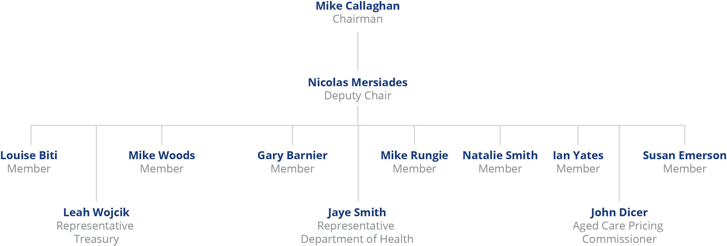

## The Annual Report on the Funding and Financing of the Aged Care Industry

Each year ACFA provides the Minister responsible for aged care with a report on the funding and financing of the aged care industry.

Over time, each annual report builds upon the last, producing a substantial body of in-time as well as trend data on the funding and financing of the aged care industry. This is the seventh annual report published.[1]

### Methodology

The 2019 annual report mainly presents and analyses 2017-18 data provided by aged care providers and data held by the Department of Health, although this is supplemented by more recent data sources where available along with consultations with industry participants.

The principal data sources are financial and administrative data collected by the Department of Health:

* From Commonwealth Home Support Programme (CHSP) providers (Home and Community Care providers in WA):

CHSP Data Exchange; and

HACC Minimum Data Set (WA).

* From home care providers:

Aged Care Financial Reports (ACFR).

* From residential care providers:

Aged Care Financial Reports (ACFR);

General Purpose Financial Reports (GPFR);

Annual Survey of Aged Care Homes (SACH); and

Published aged care accommodation prices (My Aged Care website).

* Other general data:

The 2017-18 Report on the Operation of the Aged Care Act 1997 (ROACA);

The 2016 National Aged Care Workforce Census and Survey; and

Relevant supplementary information from industry analysts, including StewartBrown.

In addition to these listed data sources, ACFA regularly consults with the sector, relevant financiers and other key stakeholders. The 2019 report is supplemented with feedback from a substantial increase in consultations ACFA has conducted with a cross section of stakeholders in the first half of 2019 to gain an insight into current factors impacting on the industry. This increase in consultation follows the approach undertaken in the preparation of ACFA’s Update on funding and financing issues in the residential aged care sector that was published in November 2018.

When discussing the financial performance of providers in this report, Earnings Before Interest, Tax, Depreciation and Amortisation (EBITDA) is the main measure used to analyse profitability. This is because EBITDA excludes items such as interest (both income and expense) and tax expenditures, which can vary depending on the financing decisions of an organisation; and non‑cash expenses, such as depreciation and amortisation which can vary greatly based on the size and age of facilities and other assets, and on ownership type and depreciation methods.

EBITDA therefore can be used to compare organisations with each other and against industry averages and is a good measure of core profit trends because it eliminates some of the extraneous factors mentioned above. This is particularly important when analysing aged care given the diversity of ownership and capital structures. EBITDA helps to smooth out these factors.

This report also refers to Net Profit Before Tax (NPBT) which also assists in making comparison between organisations subject to different tax treatments.

The financial analysis and commentary in this report does not include National Aboriginal and Torres Strait Islander Flexible Care Program providers, providers operating Multi-Purpose Services or providers under the Short Term Restorative Care Programme.

As discussed in previous annual reports, it is important to be mindful of the industry composition and the varying objectives of providers when interpreting the data. The industry continues to be dominated by not‑for‑profit providers. Traditional profit-based measures are not always consistent with the mission and objectives of not-for-profit providers.

#### Considerations and limitations

As reforms in aged care continue, some forms of service delivery, and therefore data collection, are changing. For this reason, analysis is not always directly comparable with analysis contained in previous reports. Where this is the case it is noted.

In 2017-18, as was the case for 2016-17, the Aged Care Financial Reports (ACFR) were used by home care and residential care providers to report financial data to the Department of Health. Providers previously reported their financial information using different methodologies meaning comparisons with 2015-16 and earlier years is not always possible.

The majority of financial data available to ACFA regarding home and residential care is at the approved provider level. Because many providers have services in multiple locations, ACFA is constrained in its ability to analyse performance at facility or service level or the impact of locational factors on funding, financing and financial performance of services.

### Navigating the 2019 annual report

The 2019 annual report is structured as follows:

Chapter 2 Aged care in Australia**:** Provides an overview of the aged care industry in Australia.

Chapter 3 Access to aged care**:** Discusses the supply of, and access to, subsidised aged care in Australia.

Chapter 4 Home support**:** Provides an overview of home support through the Commonwealth Home Support Programme and the Home and Community Care program in Western Australia[2].

Chapter 5 Home care**:** Provides an overview of the Home Care Packages Program and a summary of financial performance of home care providers in 2017-18.

Chapter 6 Residential care**:** Provides an overview of residential aged care and a summary of financial performance of residential care providers in 2017-18.

Chapter 7 Residential care: capital investment**:** Provides discussion and analysis of residential care provider balance sheets and capital investments, as well as building trends in the sector.

Chapter 8 Future demand for aged care**:** Discusses the future demand for aged care in the short, medium and long-term.

Chapter 9 The challenge of achieving a sustainable aged care system**:** Provides an outline of some of the challenges facing the Government, providers and consumers for Australia to move to a more sustainable aged care system.

Analysis of providers in this report is generally presented in four ways:

Whole of sector (refers to all providers operating a particular type of care);

Ownership type (not-for-profit, for-profit or government owned);

Location (metropolitan, regional[3] or a mix of metropolitan and regional);

Scale (number of services[4] operated by a home care provider or number of facilities operated by a residential care provider).

When referring to facility ‘size’ the report is referring to the number of beds operated by a single residential care facility.

When referring to ‘government owned’, the report is referring to services owned and operated by state, territory and local governments. The Australian Government does not own or operate aged care facilities or services.

# Aged care in Australia

| **This chapter discusses:**  Types of subsidised aged care in Australia;  providers of aged care;  the regulation of the supply of subsidised aged care services;  Commonwealth and consumer expenditure on aged care; and  the aged care workforce.  **This chapter reports that:**  Australian Government total expenditure on aged care was $18.1 billion in 2017-18, up from $17.1 billion in 2016-17;  total expenditure is expected to be $20.5 billion in 2018-19, and increase to $24.0 billion by 2021‑22;  services were provided to around 1.3 million[5] people in 2017-18; and is estimated to increase to 1.5 million by 2020-21;  services were provided by:  1,456 Commonwealth Home Support Programme providers, compared with 1,523 in 2016-17;  91 providers of HACC in Western Australia (98 in 2016-17);  873 home care providers (702 in 2016-17); and  886 residential care providers (902 in 2016-17). |
| --- |

## Overview

The aged care system is continuing to undergo reform so that it more effectively and efficiently supports older people to live in their homes and communities for as long as possible, and enables people to make informed decisions about their care, while remaining sustainable for taxpayers and service providers. Older Australians can access a spectrum of aged care, ranging from home based support through to 24 hour care provided in residential settings.

Many aged care services are subsidised and regulated by the Australian Government. Figure 2.1 illustrates the Commonwealth subsidised Australian aged care system.

My Aged Care, administered by the Department of Health, is responsible for arranging an assessment of a person’s eligibility for Commonwealth subsidised aged care services. The assessment determines the level of care and support for which the individual may be eligible.

Means testing conducted by the Department of Human Services determines whether an individual is required to make a contribution towards the cost of their care and accommodation, and the amount of the contribution.

Figure 2.1: Australian aged care system – guide to Australian Government subsidised aged care services

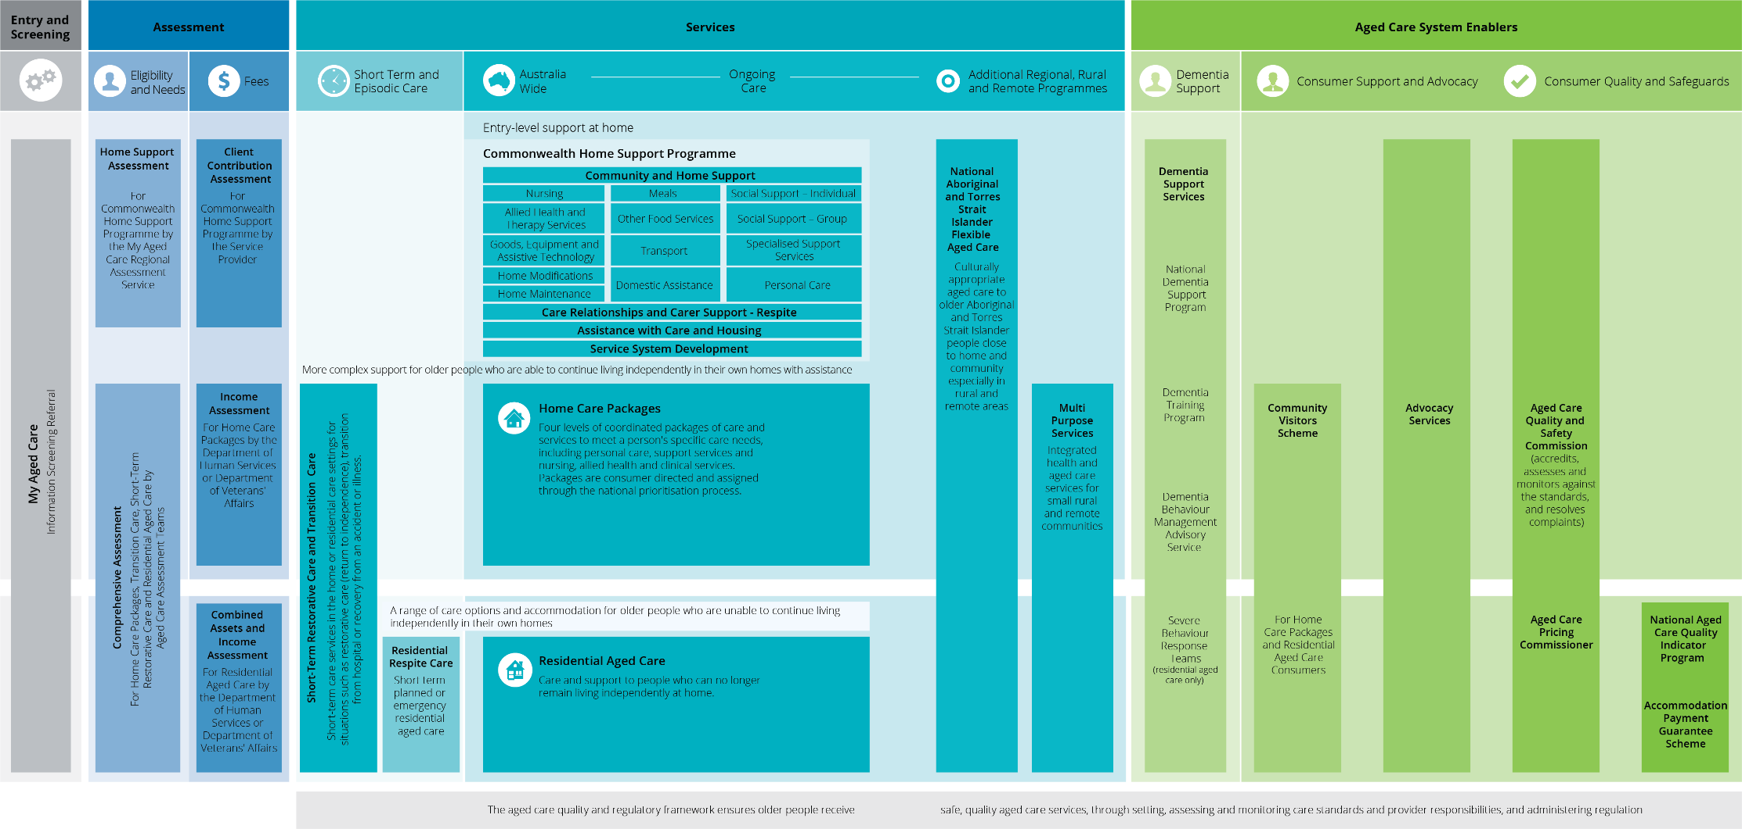

1. Current as at February 2019.
2. The Department of Veterans’ Affairs also provides Australian Government subsidised aged care services.

## Current aged care

In this report, the aged care industry is discussed in terms of the three main programs:

**Commonwealth Home Support Programme (CHSP) (Home and Community Care (HACC) in Western Australia):** Provides services for those who require basic services to assist with remaining in their own homes. On 1 July 2015, the CHSP was implemented, combining the previous Commonwealth HACC program[6], the National Respite for Carers Program, Day Therapy Centres and Assistance with Care and Housing for the Aged. On 1 July 2016, the HACC Program in Victoria transitioned to the CHSP and on 1 July 2018 HACC services in Western Australia were also incorporated into the CHSP. All states and territories now operate under the CHSP.

**Home Care Packages Program:** Provides services for those who have greater care needs and wish to remain living at home. Care and support is provided through a package of home care services.

**Residential care:** Providesaccommodation and 24 hour care for those who have greater care needs and choose or need to be cared for in an aged care facility. Care can be provided on either a temporary (respite) or permanent basis.

Table 2.1 shows the number of providers, services, places, consumers and Commonwealth and consumer funding for each of the three care types for the five years to 2017-18.

In addition there are care types about which, due to a lack of financial data, ACFA does not provide analysis or commentary. These include:

**Flexible care:** Services in either a residential or home care setting, that, due to difficulties in delivering services in some communities, are delivered using different care approaches than that provided through mainstream residential and home care. Examples of flexible care include Multi-Purpose Services in rural and remote locations and Aboriginal and Torres Strait Islander flexible care.

**Transition and Restorative care:** Services that focus on enhancing the physical and cognitive function of people who have lost or are at risk of losing condition and independence. The Short-Term Restorative Care (STRC) Programme, which commenced in February 2017, aims to reverse and/or slow ‘functional decline’ in older people and improve their wellbeing through the delivery of a time-limited, goal-oriented, multi-disciplinary and co-ordinated range of services. The Transition Care Programme seeks to optimise the functioning and independence of older people after a hospital stay, enabling them to return home rather than enter residential care. Unlike the STRC, the Transition Care Programme is a joint Commonwealth-State funded program.

**Innovative pool:** The Innovative Care Programme supports the development and testing of flexible models of service delivery in areas where mainstream aged care services may not appropriately meet the needs of a location or target group.

Table 2.1: Aged care in Australia 2013-14 to 2017-18

|  | 2013–14 | | | 2014-15 | | | 2015-16 | | | 2016-17 | | | 2017-18 | | |
| --- | --- | --- | --- | --- | --- | --- | --- | --- | --- | --- | --- | --- | --- | --- | --- |
|  | Home support | Home care | Residential care | Home support | Home care | Residential care | Home support | Home care | Residential care | Home support | Home care | Residential care | Home support | Home care | Residential care |
| Number of providers | 1,676 | 504 | 1,016 | 1,628 | 504 | 972 | 1,686 | 496 | 949 | 1,621 | 702 | 902 | 1,547 | 873 | 886 |
| Numbers of services/facilities | N/A | 2,212 | 2,688 | N/A | 2,292 | 2,681 | N/A | 2,099 | 2,669 | N/A | 2,367 | 2,672 | N/A | 2,599 | 2,695 |
| Number of allocated places | N/A | 66,149 | 189,283 | N/A | 72,702 | 192,370 | N/A | 78,956 | 195,825 | N/A | N/A[7] | 200,689 | N/A | N/A | 207,142 |
| Number of consumers | 775,959 | 83,144 | 231,515 | 812,384 | 83,838 | 231,255 | 925,432 | 88,875 | 234,931 | 784,927 | 97,516 | 239,379 | 847,534 | 116,843 | 241,723 |
| Commonwealth funding | $1.7b | $1.3b | $9.8b | $1.9b | $1.3b | $10.6b | $2.2b | $1.5b | $11.4b | $2.4b | $1.6b | $11.9b | $2.4b | $2.0b | $12.2b |
| Consumer contribution | N/A | $87m | $4.0b | N/A | $136m | $4.2b | N/A | $127m | $4.5b | $204m | $128m | $4.5b | $219m | $122m | $4.5b |

**Notes:**

1. This table only shows data for the three main types of Government funded aged care: CHSP (and Vic/WA HACC), home care and residential care. Therefore total consumers of aged care does not match the around 1.3 million stated at the beginning of this chapter as that figure includes all other types of Government funded aged care.
2. Home support for the years 2013-14 to 2014-15 comprises Commonwealth HACC as well as Vic and WA HACC, in 2015-16 comprises CHSP as well as VIC and WA HACC and in 2016-17 and 2017-18 comprises CHSP as well as WA HACC.
3. Commonwealth funding for home support in 2015‑16 and 2016‑17 includes funding for My Aged Care and Regional Assessment Service (RAS) to support the CHSP ($148 million in 2015-16 and $123 million in 2016-17).
4. The number of consumers of home support in 2015-16 (925,432) includes 285,432 for Vic and WA HACC and an estimate of over 640,000 in the CHSP as accurate data was not available. Due to the lack of accurate data and differences in counting methods the CHSP consumers for 2015‑16 are likely overstated.
5. The amounts shown for home care consumer contributions in the 2018 ACFA report ($142m in 2015-16 and $150m in 2016-17) were incorrect.

## Australian Government expenditure on aged care

The Australian Government spent $18.1 billion on aged care in 2017-18, up from $17.1 billion in 2016-17. In 2018-19, Australian Government funding is expected to be $20.5 billion with $24 billion budgeted for 2021‑2. Chart 2.1 shows Commonwealth funding in aged care since 2013-14 and budgeted expenditure to 2022-23.

More than three quarters of the 5.7 per cent increase in Australian Government funding during 2017‑18, ($746.2 million) is attributable to increases in residential and home care expenditure, $300.3 million and $445.9 million respectively. The balance is spread across a mix of programs such as CHSP and flexible aged care programs.

The growth in residential care expenditure can be attributed to a 1.4 per cent increase in the number of days of care provided during the year due to an increase in the number of total residents, and a 1.1 per cent increase in average care subsidy and supplement payments, primarily due to the indexation of the accommodation supplement and more facilities becoming eligible for the higher accommodation supplement.

The increase in home care expenditure in 2017-18 is mainly due to a 4.2 per cent increase in the number of days of care provided during the year.

Chart 2.1: Australian Government total aged care expenditure, 2014-15 to 2017-18 and total budgeted aged care expenditure, 2018-19 to 2022-23

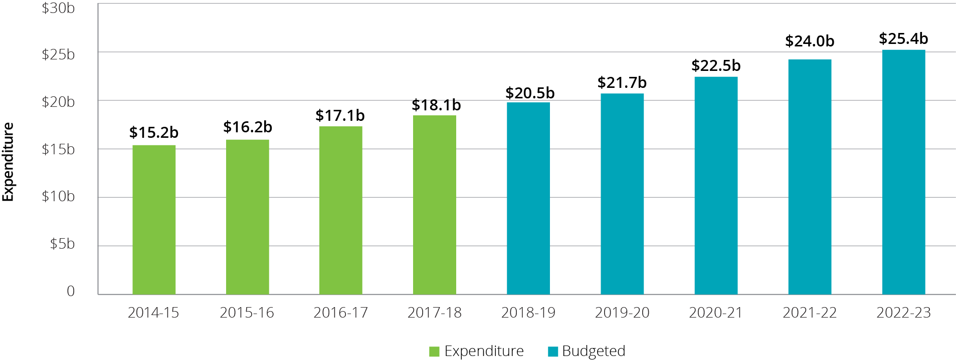

Funding for residential care is by far the largest proportion of Commonwealth expenditure at almost 68 per cent. The proportions of Commonwealth expenditure in 2017-18 across the industry are illustrated in Chart 2.2.

Chart 2.2: Australian Government total budgeted aged care expenditure, by major program, 2017-18

Chart 2.2: Australian Government total budgeted aged care expenditure, by major program, 2017-18


Australian Government expenditure on aged care is projected to nearly double as a share of the economy from 1 per cent currently to around 1.7 per cent of GDP by 2055[8]. Costs of care will continue to rise on account of growth in input costs (e.g. wages) and the increasing complexity of chronic health conditions in ageing populations.

ACFA has previously noted that the shift in the balance of care in favour of home care over residential care is expected to improve affordability for taxpayers over the long term. This is because the costs of accommodation associated with residential care are not incurred with home care, and because, on average, higher care subsidies apply in residential care where 24 hour care is provided. As noted in ACFA’s annual report last year, there are many home care consumers with higher care needs who are in receipt of a lower level package until a package suitable to their needs becomes available, as well as people with assessed needs who are waiting to be offered a package.

## Consumer contributions

Most aged care consumers contribute to the cost of their care.

In residential care, consumers contribute 85 per cent of the single age pension towards their living expenses (through the Basic Daily Fee) and, subject to means testing, may be required to contribute towards their accommodation and care costs. In 2017-18, residents contributed $3.3 billion towards their living expenses, $780 million towards accommodation costs by those who chose to pay through a Daily Accommodation Payment (which excludes those choosing to pay through a fully refundable lump sum deposit) and $504 million towards care costs. Overall contributions from residents (excluding lump sum deposits) represent 26.6 per cent of total residential care provider revenue.

Consumers of home care packages contributed around $122 million (representing 5.9 per cent of home care provider’s revenue) to their care costs in 2017‑18, while Commonwealth Home Support Programme consumers contributed $219 million, which represents 9.3 per cent of total expenditure on home support.

Table 2.2 shows the Government and consumer contribution across service types since 2013-14.

Table 2.2: Australian Government expenditure and consumer contribution, by service type, 2013‑14 to 2017-18

|  |  | 2013-14 | 2014-15 | 2015-16 | 2016-17 | 2017-18 |
| --- | --- | --- | --- | --- | --- | --- |
| Home care | Government | $1.3b | $1.3b | $1.5b | $1.6b | $2.0b |
| Consumer | $87m | $136m | $127m[9] | $126m[10] | $122m |
| Residential care | Government | $9.8b | $10.6b | $11.4b | $11.9b | $12.2b |
| Consumer | $4.0b | $4.2b | $4.5b | $4.5b | $4.5b |
| Home support | Government | $1.7b | $1.9b | $2.2b | $2.4b | $2.4b |
| Consumer[11] | N/A | N/A | N/A | $204m | $219m |

Consumers may also choose to pay additional amounts to a provider to access additional levels of care or services (e.g. to ‘top-up’ funding available under a home care package, or to purchase additional lifestyle-related services in residential care).

ACFA’s report Understanding how consumers plan and finance their aged care was published in December 2018 and the recommendations in the report are outlined below.

| **Improving information sources**  For consumers to truly understand the range of aged care services available and the cost of these services, and to facilitate both their incentive and capacity to plan for their current and future aged care needs, various information sources need to be improved, including: retirement planning tools; equity release products; My Aged Care website; retirement villages; and fee advice letters issued by DHS; as well as improving the general perception of aged care. ACFA’s recommendations included the following themes:  Ensuring retirement planning tools include future aged care needs  Raising the profile of equity release products to assist consumers with funding their aged care costs  Access to information on My Aged Care  Misconceptions regarding retirement villages  Improving fee advice letters from DHS  Improving perceptions of aged care to support increased planning  **Aged care fees**  ACFA considers that in order to assist consumers in understanding aged care fees, not only is better information required but changes should be made to the aged care fees themselves. ACFA recommends changes to: improve consumer understanding of aged care fees; the fee structures of CHSP and home care; financial hardship for home care packages; residential accommodation payment options; additional service fees; and financial abuse and complaints processes. ACFA’s recommendations included the following themes:  Improving consumer understanding of aged care fees  Improving the interface between fees for CHSP and home care packages  Review of financial hardship assistance for home care packages  Improving understanding of residential aged care accommodation payments  Improve understanding of additional service fees for residential aged care  Financial abuse and complaints processes  **Financial advisors**  ACFA considers that further work is required to encourage financial advisors to more widely upskill and include aged care advice into services, both in the pre-retirement and post-retirement planning phases. ACFA’s recommendations included the following themes:  Expansion of Financial Information Service  Ensuring financial planners are skilled to provide advice on aged care |
| --- |

## Aged care providers

In this report, providers of the three main types of Government subsidised aged care in Australia are discussed. These are CHSP (HACC in WA), home care and residential care.

There are over 3,000 providers who provide these services to older Australians. Table 2.3 shows the number of providers over the last five years. The number of home care providers was stable until 2015‑16 but has since increased dramatically. By contrast, the number of residential care providers has been steadily declining over the five years. The changing number of home care and residential care providers is discussed in Chapter 3.

Table 2.3: Number of aged care providers, by service type, 2013-14 to 2017-18

|  | Home support | Home care | Residential care |
| --- | --- | --- | --- |
| 2013-14 | 1,676 | 504 | 1,016 |
| 2014-15 | 1,628 | 504 | 972 |
| 2015-16 | 1,686 | 496 | 949 |
| 2016-17 | 1,621 | 702 | 902 |
| 2017-18 | 1,547 | 873 | 886 |

While the majority of providers operate only one type of aged care service, some operate two or all three of the major types. Chart 2.3 shows the number of providers providing only one type, two types and all three types of services in 2017-18.[12] As was the case in previous ACFA reports, this analysis excludes Western Australian HACC providers as information on whether these providers also provide residential or home care is not available.

Chart 2.3: Proportion of aged care providers providing more than one type of aged care service, 2017-18

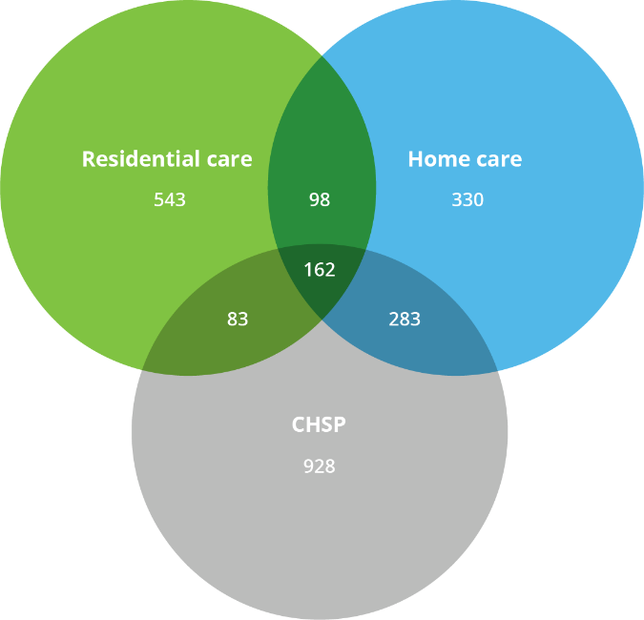

As shown, there appears to be a high degree of specialisation in terms of service types offered by providers. However the proportion of providers who have diversified into more than one type of care is continuing to increase, albeit slowly, as shown in Table 2.4. Of the 162 organisations who provide all three major types of care, only four are for‑profit providers. ACFA notes that there would be merit in examining the scope for economies of scale and other benefits from providers engaging in more than one type of service.

Table 2.4: Proportion of aged care providers providing more than one type of service, 2013‑14 to 2017‑18

|  | One type of service only | Two types of services | All three types of services |
| --- | --- | --- | --- |
| 2013-14 | 85% | 13% | 2% |
| 2014-15 | 84% | 14% | 2% |
| 2015-16 | 78% | 16% | 6% |
| 2016-17 | 76% | 17% | 7% |
| 2017-18 | 74% | 19% | 7% |

There may be more occurrences of providers providing more than one type of service than reported here, however separate provider registration in the three different sub-sectors means this is not always apparent, as providers often have different ABNs and different trading names.

## Aged care workforce

The aged care workforce is a shared responsibility between the Australian Government and the aged care industry, with many of the levers to influence the workforce resting with employers/providers. The Australian Government supports the industry through setting policy with appropriate funding that fosters flexibility, responsiveness and innovation, and supporting competitive labour markets. It also supports the industry through funding and regulating the higher education and the vocational education and training systems.

The National Aged Care Workforce Census and Survey[13] is conducted approximately every four years. In its 2017 annual report, ACFA provided a summary of the findings of the 2016 Survey.

The 2016 census reported the number of paid workers in the aged care industry was around 366,000, with an additional 68,000 volunteers. When the census was conducted in 2012, the number of paid workers was 240,000.

Total paid workers in residential care in 2016 was estimated at 235,764, of whom 153,854 were direct care workers. Total paid workers in home support and home care were estimated at 130,263, of whom 86,463 were in direct care roles.

Of the reported 434,443 people working in aged care in 2016, 60 per cent were in residential care. The remainder of the workforce were in home support and home care. Chart 2.4 shows the composition of the aged care workforce as reported in 2016.

Chart 2.4: Aged care workforce composition, 2016

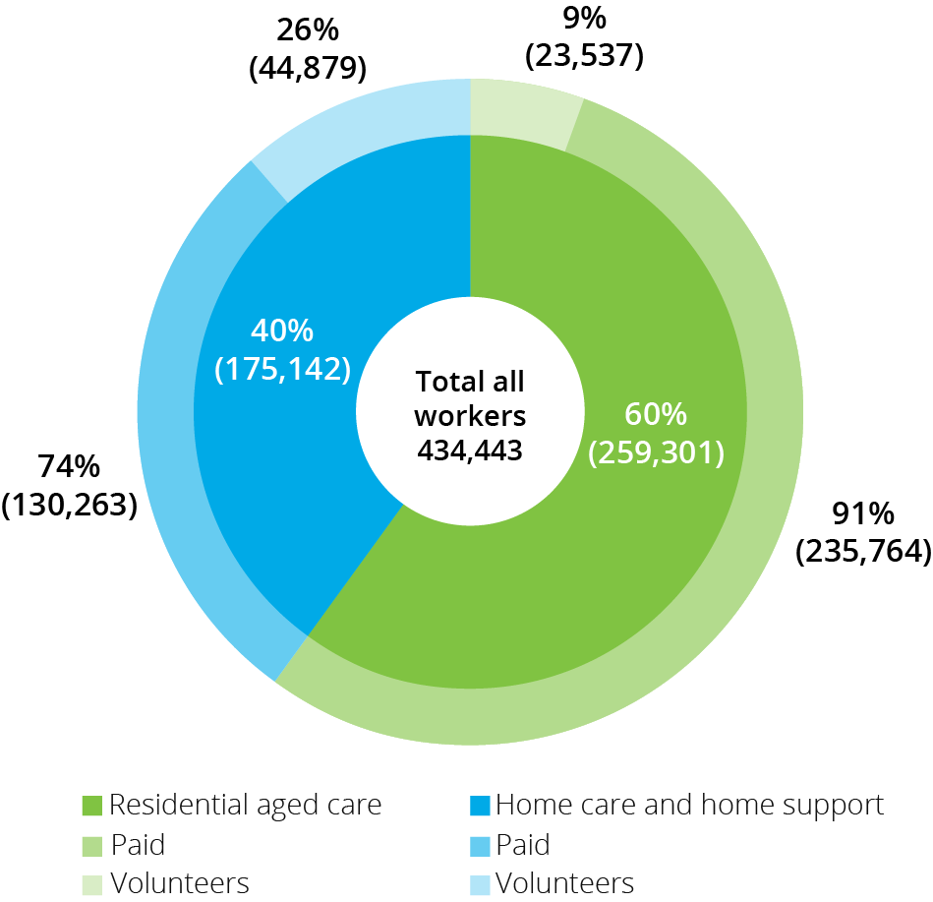

The average age of the residential care workforce decreased from 48 to 46 between 2012 and 2016. In contrast, the average age of the workforce in home support and home care increased from 50 in 2012 to 52 in 2016.

Overseas born workers continue to make up a very significant proportion of the aged care workforce. In 2016, the proportion in residential care was highest with 32 per cent of workers born overseas, while in home support and home care the proportion was 23 per cent. This compares with 35 per cent in residential care and 28 per cent in home support and home care in 2012.

Although aged care remains a female dominated industry, the proportion of males in the workforce is continuing to grow, albeit slowly and from a small base. In residential care, 13 per cent of workers were male (compared with 11 per cent in 2012). In the home support and home care sectors, men represented 11 per cent of all workers (10 per cent in 2012).

More detailed information from the 2016 National Census and Survey is provided in Appendix D. The next census will be conducted around 2020-21.

### Aged Care Workforce Strategy

As announced in the 2017–18 Budget, the Australian Government established an industry-led Aged Care Workforce Strategy Taskforce to develop an Aged Care Workforce Strategy. The Taskforce delivered its Strategy to the Minister on 29 June 2018.

In September 2018, the Strategy was released and the Government announced support for industry-led implementation. The Strategy includes 14 actions[14] to grow the professional workforce and attract, train and retain skilled and talented staff to work in aged care services in a variety of settings. A new Aged Care Workforce Industry Council, announced in January 2019, will steward the Strategy and is developing an implementation plan.

An Aged Services Industry Reference Committee (IRC) has also been established to respond to relevant recommendations in the [Aged Care Workforce Strategy](https://agedcare.health.gov.au/aged-care-workforce-taskforce-strategy-report) and to ensure that the national education and training system is able to deliver an agile workforce that can provide safe and quality care in a variety of settings. This includes addressing the current and future competencies and skill requirements for new workers entering the industry and existing staff needing to upskill in both the vocational education and training (VET) and higher education sectors.

In addition, the Aged Services IRC will establish a number of ‘specific interest’ advisory committees to provide high-level strategic and policy advice to support the work of the IRC.

## Aged care reforms

The aged care industry has undergone substantial change in recent years with a view to improving the sustainability of aged care services and increasing consumer choice and control. This change includes a suite of reforms that have had a phased implementation as part of a ten-year transition strategy announced in April 2012 and further reform announcements in subsequent years.

The reforms since 2012 are summarised below according to the care type they relate to, that is, CHSP, home care, residential care or cross-program.

Commonwealth Home Support Programme (CHSP)

From 1 July 2015, the CHSP commenced by combining the former Commonwealth-State Home and Community Care (HACC) programs in all states and territories except Victoria and Western Australia, and the Commonwealth National Respite for Carers, Day Therapy Centres and Assistance with Care and Housing for the Aged programs;

Victoria transitioned their HACC services to the CHSP on 1 July 2016 and Western Australia transitioned to the CHSP on 1 July 2018; and

Regional Assessment Services established in 2015 to assess eligibility for CHSP services.

Home care

New home care packages (levels 1-4) commenced from 1 August 2013;

income testing with subsidy reduction, including annual and lifetime caps, commenced on 1 July 2014;

all packages required to be CDC, with individualised budgets, from 1 July 2015;

from 27 February 2017:

creation of a consistent National Prioritisation System to assign home care packages; and

home care packages assigned to the consumer rather than allocated to the provider;

home care providers required to publish their current pricing information on the My Aged Care Service Finder, from 30 November 2018;

6,000 additional higher level home care packages in 2017-18 announced in the 2017-18 MYEFO;

14,000 additional higher level home care packages announced in the 2018-19 Budget;

10,000 higher level home care packages in 2018-19 announced in the 2018‑19 MYEFO;

10,000 home care packages across all levels in 2019‑20 announced as part of the 2019-20 Budget; and

home care providers required to publish their pricing information in a new standardised schedule from 1 July 2019.

Residential care

New means testing (combining income and assets test), including annual and lifetime caps, commenced on 1 July 2014;

new accommodation payment arrangements from 1 July 2014 which allow market-based accommodation prices for all non-supported residents, accompanied by consumer choice to pay by lump sum, daily payment or a combination of both;

requirements for providers to publish the maximum price they charge for accommodation and extra services, from 1 July 2014;

higher accommodation supplement payable for supported residents in residential care facilities that were newly built or significantly refurbished since 20 April 2012;

creation of an Aged Care Pricing Commissioner position in October 2013; and

rental income from the former home became assessable for all residents who enter care from 1 July 2016 (formerly exempt for residents who made a daily payment for their accommodation).

Cross-program

Overall target provision ratio for Government subsidised aged care places to increase from 113 places for every 1,000 people aged 70+ to 125 places between 2012-13 and 2021-22;

creation of a single budget item for home care packages and residential care places from 1 July 2018 that allows flexibility for the Government to direct available funding to home care or residential care in response to consumer preferences;

establishing the Aged Care Quality and Safety Commission from January 2019 and the commencement of a single set of quality standards across all aged care from 1 July 2019;

from 1 July 2019, all Commonwealth subsidised residential care facilities must collect and provide clinical quality indicator data to the Department of Health through the National Aged Care Quality Indicator Program. The program had initially started in 2016 as a voluntary program;

from 1 July 2019, the new Charter of Aged Care Rights will provide the same rights to all consumers, regardless of the type of Commonwealth subsided care and services they receive; and

further improvements to My Aged Care in 2018-19 and 2019-20.

### 2017 Legislated Review

The Legislated Review of Aged Care 2017 (the Review), led by David Tune AO PSM, considered the impacts and effectiveness of reforms implemented over the previous five years and included 38 recommendations for future reforms.

The recommendations are designed to move aged care further towards a consumer-focused demand-driven system and to trigger changes that are prerequisites for a fully consumer-driven aged care system. Some do this by targeting better consumer access through better understanding of, and response to, demand, some by improving information and assessment, some by improving sustainability, and others by supporting greater equity in consumer contributions. The latter includes greater consistency of fee arrangements within and across care types and improved equity in the treatment of different forms of income and assets.

While decisions on some recommendations have already been taken by Government, other recommendations particularly those related to the long-term sustainability of the system, are being considered within the context of long term structural reforms.

In terms of aged care pricing and fees, the Government announced in September 2017 that it does not support recommendations 13 and 15, but did announce in the 2018-19 MYEFO that it will partially implement recommendation 12 by moving towards greater proportionality in home care fees, resulting in a gradual decrease in fees paid by home care recipients with package levels 1, 2 and 3.

To improve the transparency of fees and charges for care recipients, an important element in a consumer driven competitive system, the Government has introduced price publishing requirements for home care providers as per recommendation 11.

## Royal Commission into Aged Care Quality and Safety

In October 2018, a Royal Commission into Aged Care Quality and Safety was established by the Governor-General with Terms of Reference[15] announced by Government. The Royal Commission is looking at the quality of aged care services in Australia, and the future challenges and opportunities for delivering accessible, affordable and high quality aged care services that are person-centred, including through allowing people to exercise greater choice, control and independence in relation to their care.

In December 2018 individuals and organisations were invited to make submissions. The Commission has advised it will accept submissions until at least September 2019 (a date for the closing of submissions will be announced in the second half of 2019). The Royal Commission hearings began in January 2019 and are currently scheduled up until December 2019. An interim report is due by 31 October 2019 and a final report with the Commission’s recommendations is to be provided to the Governor-General by 30 April 2020.

In April 2019 ACFA provided a submission to the Royal Commission. ACFA’s submission can be found at <https://agedcare.health.gov.au/reform/acfas-submission-to-the-royal-commission-into-aged-care-quality-and-safety>.

# Access to aged care

| **This chapter discusses:**  Access to subsidised aged care for older Australians;  the supply of subsidised aged care; and  usage of aged care and impacts of a changing population.  **This chapter reports that:**  The number of consumers of home care increased from 97,516 in 2016-17 to 116,843 in 2017‑18;  the number of consumers of residential care increased from 239,379 in 2016-17 to 241,723 in 2017‑18;  average occupancy in residential care continues to fall; 90.3 per cent in 2017-18, down from 91.8 per cent in 2016-17 and 92.4 per cent in 2015-16; and  the proportion of people using home care and residential care at age 85 and over is more than three times that of people aged 70 and over. |
| --- |

## Supply of subsidised aged care

Ensuring access to appropriate quality care remains a fundamental policy objective for the Australian Government in the funding and financing of aged care. However, access to care services needs to be balanced with affordability for both consumers and taxpayers.

The Government regulates the supply of services offered through the Commonwealth Home Support Programme (CHSP) through a capped funding amount that is indexed annually. Similarly, the Commonwealth contribution toward the joint Commonwealth‑state funded Western Australian Home and Community Care (HACC) program was also capped and indexed. The Western Australian HACC program transitioned to the CHSP from 1 July 2018 making CHSP a national program. The funding for CHSP and HACC is discussed in Chapter 4.

The Australian Government regulates the supply of home care packages and residential aged care places it funds by specifying targets. These targets, known as the aged care target provision ratios, are based on the number of people aged 70 and over.

The overall aged care target provision ratio was first set in 1985 at 100 operational residential care places per 1,000 people aged 70 and over. The overall provision ratio was increased to 108 in 2004, further increased to 113 in 2007, and in 2012 was adjusted to increase progressively to 125 operational places by 2022. Home care packages were first introduced into the ratio in the early 1990s and since then successive Governments have gradually increased home care as a proportion of the overall target provision ratio.

This population-based target provision formula is designed to allow the overall supply of services to increase in line with the ageing of the population, while also defining the total number of places/packages and, thereby, helping control the Commonwealth’s expenditure on aged care.

As set in 2012, within the current overall target provision ratio of 125, the mix of home care and residential care is being significantly altered. Over the period 2012 to 2022 the target for home care is increasing from 27 to 45 operational places, while the residential care target is to reduce from 86 to 78. The remaining two places are for the Short Term Restorative Care Programme (STRC).

Chart 3.1 shows the changes in the target ratios since 1985 and the planned increase through to 2022.

Chart 3.1: Increase in target provision ratios, 1985-2022

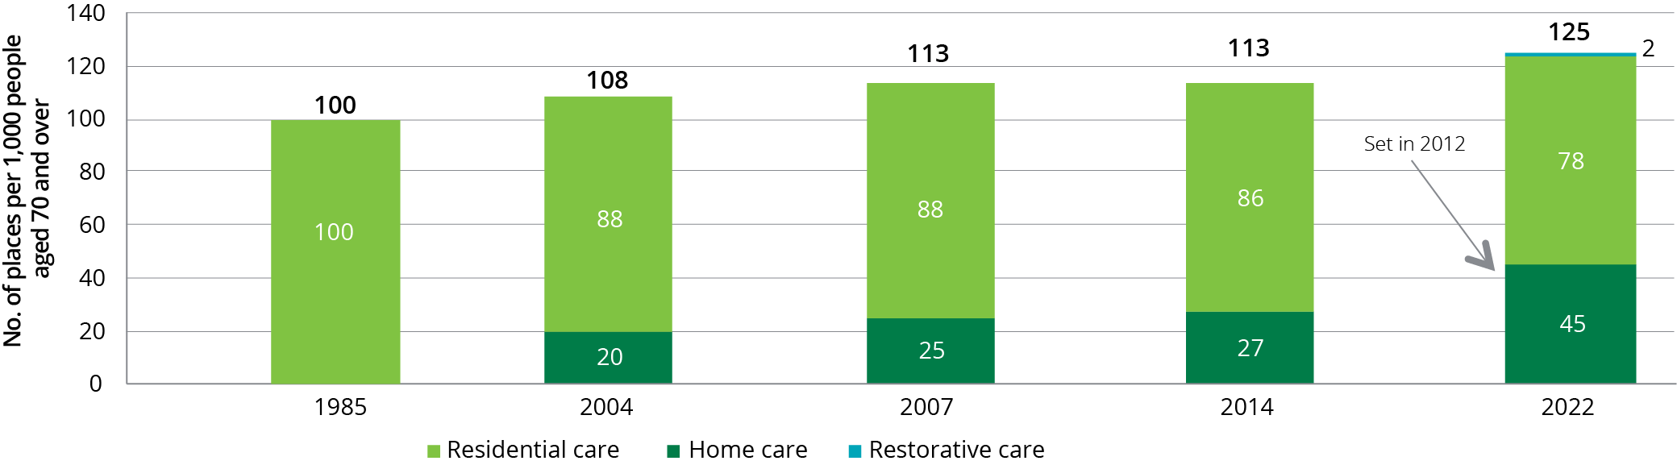

Implementation of the current target provision ratio will continue to see an overall increase in the supply of home care packages and residential care places. However, the changes result in the number of home care packages increasing at a faster rate than residential care places, which reflects the Government’s response to the increasing number of consumers wishing to remain in their own homes.

Up until and including 2015-16, the Department published achieved ratios for the overall provision target and for both home care and residential care in a consistent and comparable way, based on the number of operational places (operational places included allocated places that are vacant). The calculation of this ratio on this basis is still possible in residential care, but no longer possible for home care since February 2017 when packages were directly assigned to consumers. As a result, last year’s ACFA report did not include achieved ratios for either the overall target provision ratio or the home care target ratio.

The Department has since calculated and published achieved ratios for home care for 2016-17 and 2017-18 based on the number of consumers in a package, plus the number of consumers who have been offered a package but who have not yet accepted the offer and whose offer still remains open (i.e. within 56 days of offer). The latter effectively substitutes for formerly vacant packages. While not directly comparable to previous years, it can be used to broadly monitor progress towards the achievement of the overall provision target ratio and home care ratio.

Chart 3.2 shows the achieved overall provision ratio and the achieved home care and residential care ratios for the 10 years to 30 June 2018. The chart also shows the target of 45 for home care and 78 for residential care to be reached by 2022.

Chart 3.2: Home care and residential care achieved ratios, 2007 to 2018, and target ratios 2022

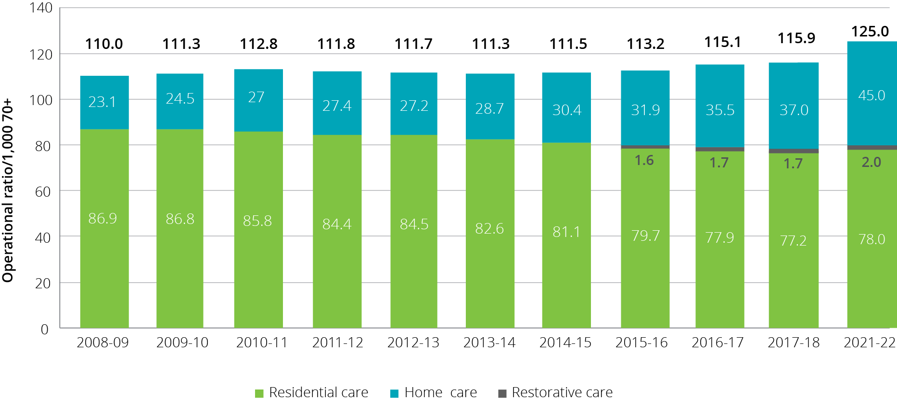

Chart 3.3 shows the number of consumers with a home care package as at 30 June for each of the previous six years, as well as the target number of packages to 2022-23 published in the Department of Health’s 2019-20 Portfolio Budget Statement. While the historical and forward estimates numbers are not directly comparable, the chart gives some indication of the increase in home care packages that is planned to be released.

Chart 3.3: Home care consumers, 2012-13 to 2017-18 and published target packages to be released, 2018-19 to 2022-23

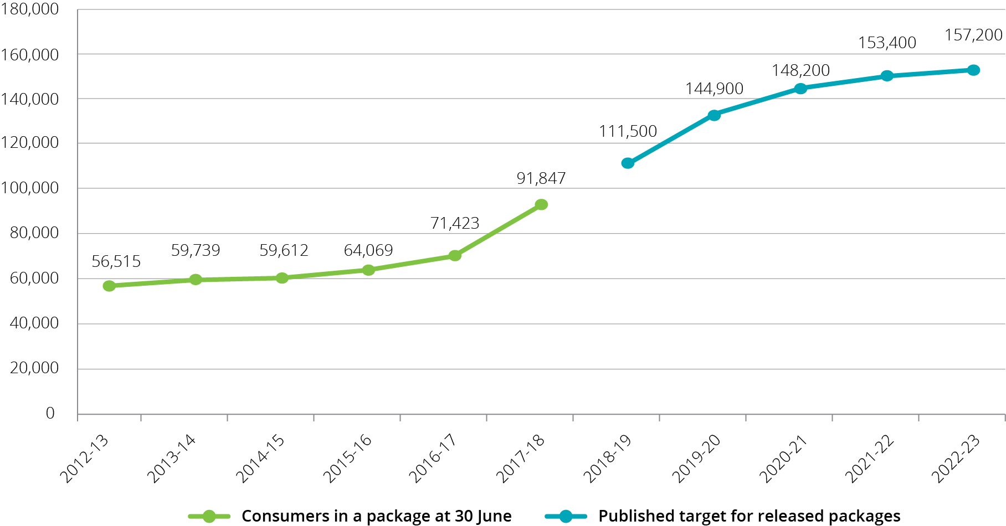

The target ratio approach applied to home care packages and residential care places does not apply to the supply of care through the CHSP. Instead, CHSP funding is subject to an annual capped funding allocation, and CHSP providers are grant funded to provide contracted home support services. Consumers who are assessed as eligible through their Regional Assessment Service (RAS) to receive CHSP services can then access those services through a provider who delivers the services for which they have been assessed.

The CHSP is discussed in Chapter 4.

## Aged Care Approvals Round

Unlike home care packages, new residential care places are still allocated to providers through a competitive Aged Care Approvals Round (ACAR).

The Australian Government announced the results of the 2018-19 ACAR[16] on 5 March 2019. Through this ACAR, 13,500 new residential care places were allocated. These places have an estimated annual recurrent funding value of $907 million. This represents an increase of 36 per cent on the 9,911 ACAR places allocated in 2016–17. The 2018-19 ACAR is the largest ACAR, although with no ACAR conducted in 2017-18, the 2018-19 ACAR is effectively allocating more than one years’ worth of places. A breakdown of the allocated places by state and territory is in Table 3.1.

A small proportion of the 13,500 residential care places initially made available for allocation were not allocated in the advertised state/territory due to insufficient suitable applications from the Northern Territory, Australian Capital Territory and Tasmania.

99 places were not allocated in the Northern Territory from a total of 149 available.

158 places were not allocated in the Australian Capital Territory from a total of 360 available.

51 places were not allocated in Tasmania from a total of 212 available.

This is similar to what occurred in the 2016‑17 ACAR. The 308 unallocated residential care places were re-allocated to New South Wales, Victoria and South Australia.

The 2018‑19 ACAR saw the continuation of the trend for a majority of places to be allocated to for‑profit providers, with 66 per cent of available places allocated to for-profits. This trend in recent ACARs is reflected in a gradual increase in the proportion of operational places held by for-profit providers, which has increased from 36 per cent in 2012 to 40.5 per cent at 30 June 2018.

The 2018‑19 ACAR saw $60 million in capital grants allocated (through the Rural, Regional and Other Special Needs Building Fund) to help aged care providers to construct new or upgrade existing residential care facilities. The capital grants were approved for 28 projects involving 286 new places. The grants targeted services for rural and remote, Indigenous, financially and socially disadvantaged and CALD communities, with the bulk of the funding going to non-metropolitan areas.

In addition to the ACAR, through a separate measure announced in the 2018‑19 Budget, $40 million was allocated for infrastructure investment in both residential and home care through The Aged Care Regional, Rural and Remote Infrastructure Grant. This funding is being paid during 2018‑19 and 2019‑20 and was designed to target funding in regional, rural and remote regions where services may not have access to infrastructure funding.

The Government also announced the successful applicants for the 775 new STRC places through the 2018-19 ACAR.

The demand for residential care places in the 2018-19 ACAR was not as strong as in recent ACARs. There were 2.8 applications for every available place compared with 4.5 for the 2016‑17 ACAR.

Table 3.1: 2018-19 ACAR results summary

| State/territory | Residential care places | Estimated annual recurrent funding ($m) | Capital grants ($m) |
| --- | --- | --- | --- |
| New South Wales | 3,485 | $234.2 | $14.0 |
| Victoria | 1,521 | $102.2 | $9.9 |
| Queensland | 4,289 | $288.2 | $11.1 |
| Western Australia | 3,295* | $221.4 | $10.1 |
| South Australia | 497 | $33.4 | $10.7 |
| Tasmania | 161 | $10.8 | $4.2 |
| Australian Capital Territory | 202 | $13.5 | - |
| Northern Territory | 50 | $3.4 | - |
| **Australia** | **13,500** | **$907.1m** | **$60m** |

*As at 5 March 2019, the above places include deferred allocations for 244 residential care places in Western Australia, in respect of applicants who are awaiting the required approved provider status.

## Access to aged care

In 2017-18 around 1.3 million older Australians accessed some form of Government subsidised aged care. Table 3.2 shows the number of consumers of the three types of aged care that this report mainly discusses (home support, home care and residential care) since 2013-14.

Table 3.2: Aged care in Australia, number of consumers, 2013-14 to 2017-18

|  | 2013-14 | 2014-15 | 2015-16 | 2016-17 | 2017-18 |
| --- | --- | --- | --- | --- | --- |
| Home support | 775,959 | 812,384 | 925,432[17] | 784,927 | 847,534 |
| Home care | 83,144 | 83,838 | 88,875 | 97,516 | 116,843 |
| Residential care | 231,515 | 231,255 | 234,931 | 239,379 | 241,723 |

## Access to home care

The number of older Australians who received home care during 2017-18 was 116,843, an increase of 20 per cent from 97,516 in 2016-17. As at 30 June 2018 there were 91,847 consumers in a package, up from 71,423 as at 30 June 2017. Chart 3.4 shows the significant increase in consumer numbers, particularly in 2017-18. Chart 3.5 shows the increase in consumers, by package levels, since 2014‑15.

Chart 3.4: Number of home care consumers in a package, 30 June 2013 to 30 June 2018

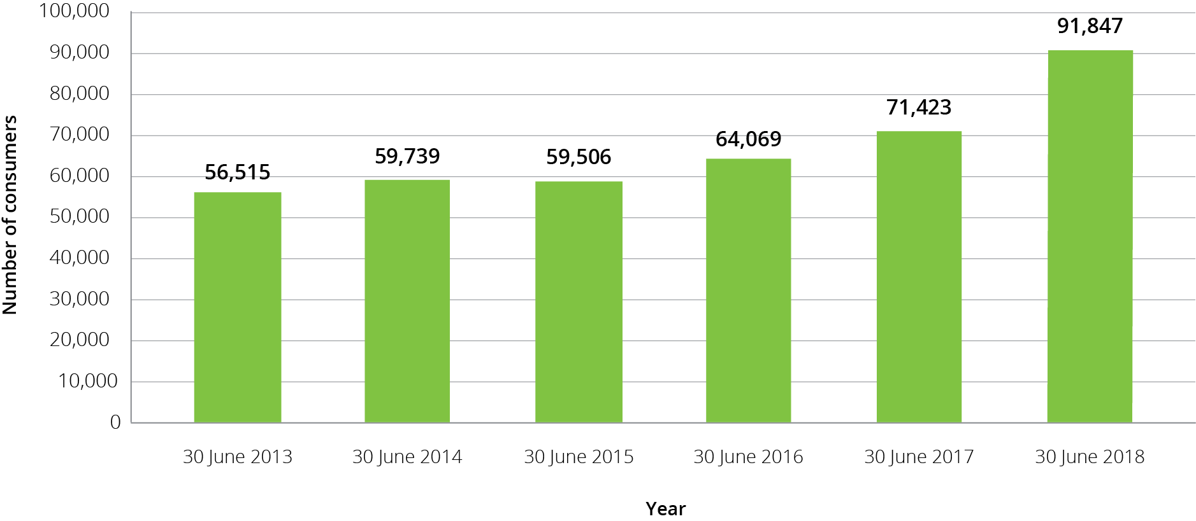

Chart 3.5: Number of home care consumers, by package level, 2014-15 to 2017-18

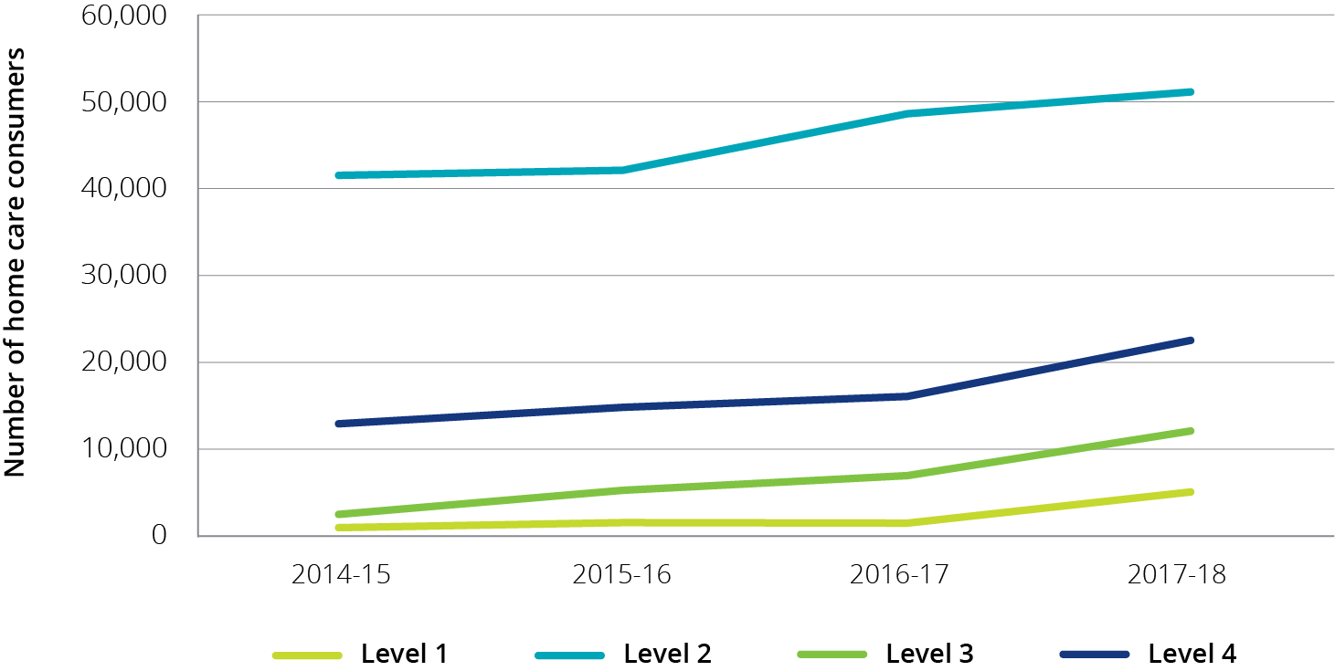

### Release of home care packages

Since February 2017, home care packages have been assigned directly to consumers rather than allocated to providers. This allows consumers to direct their package to the provider of their choice as well as change providers.

Older Australians assessed as requiring home care are placed on the National Prioritisation System based on how long they have been waiting for care and their individual needs and circumstances, regardless of where they live. Packages are periodically released and assigned directly to consumers by the Department of Health within My Aged Care. Packages are assigned to consumers according to when they were approved for home care and urgency of need.

The number of packages released at each level takes into account the number of new packages that are available (having regard to the phased increase in the target home care provision ratio), the number of packages that consumers have exited or not accepted in previous weeks, as well as the amount of unspent Commonwealth funds that have been returned when consumers leave home care. While the total number of packages will increase each year, the number of packages at each funding level will continue to be capped in line with the aged care target provision ratio and the available budget.

### Demand for home care packages

ACFA has previously noted that unmet demand for home care is long standing, but was not able to be quantified until the implementation of the National Prioritisation System for assigning packages directly to consumers. The number of people waiting for a package has been increasing since the changes were implemented in February 2017.

Data from the Department of Health shows that as at 31 December 2018 there was a total of 127,748 people waiting for a package. This is an increase of approximately 6,000 in the six months since 30 June 2018. There were 26,220 approvals for home care in the three months to 31 December 2018, of which 56 per cent were for higher level (3 and 4) packages. Although around 75 per cent of the 127,748 people waiting for a package, also had approval for permanent residential care, declining occupancy rates in residential care illustrates the preference of older people for home-based aged care services.

At 31 December 2018, there were 73,978 people waiting on a home care package at their approved level, who had not yet been offered access to a lower level package. Of these people, 93.9 per cent (69,476) had been provided with an approval to access support through the Commonwealth Home Support Program (CHSP).

At 31 December 2018, there were 53,770 people who were waiting for a home care package at their approved level, who had already been offered a lower level package. Of these people, 29,858 were receiving care through a lower level package, 6,270 were deciding on whether to take up a package and 17,642 had not taken up their previous offer(s) of a lower level package.

Information from the Department of Health indicates that waiting times for people to access a package vary depending on package level. People approved for a level 4 package are waiting in excess of 12 months to be assigned a package at any level. People approved for a level 3 package can wait up to six months for an interim package at level 1, but still wait more than 12 months for their assigned package level.

In the 2018-19 Budget, the Government announced a re-profiling of home care packages that will see 14,000 additional higher level packages being released sooner than originally planned.

Since this Budget announcement there have been two additional changes to future home care package releases, aimed at further re-profiling of package releases.

In the 2018-19 Mid-Year Economic and Fiscal Outlook (MYEFO) the Government announced an additional 10,000 higher level packages to be funded in 2018-19, followed by a further 10,000 packages (including 4,500 higher level packages) included in the 2019-20 Budget for release in 2018‑19 and 2019-20.

ACFA notes that while the overall effect of these re-profiling changes is to increase the proportion of higher level packages earlier than originally budgeted for (at significant cost to the Budget) and achieve an approximately 50/50 split of higher and lower level packages by 2021-22, the planned growth in total packages numbers by 2021-22 (to 153,437 packages) is broadly in line with the target set in 2012 when the target provision ratio was set at 45 packages per 1,000 people aged 70 and over.

The creation in the 2018-19 Budget of a single budget item for home care packages and residential care places may provide some flexibility to direct available funds to meet the emerging demand for home care packages if demand for residential care reduces.

### Length of stay in home care

Length of stay in home care differs between package levels.

For people who entered care in 2015‑16, around half the recipients of level 2 packages stayed at their package level for about 15 months and around a quarter stayed over 40 months. By contrast, for those people entering a level 4 package, around half leave care within 13 months and a quarter remain in care for up to 30 months.

For people that entered home care in 2016‑17, around half the recipients of level 2 packages stayed at their package level at least 18 months. By contrast, for those people entering a level 4 package, around half leave care within 14 months. This suggests that length of stay in home care is slightly increasing in recent years irrespective of care level.

However, given that many consumers first enter care accessing a package lower than their assessed need and the end of cross subsidisation since the creation of individual budgets, care is needed in how length of stay data is interpreted.

## Access to residential care

The number of older Australians who received permanent residential care during 2017-18 was 241,723, up from 239,379 in 2016-17, an increase of 1 per cent. At 30 June 2018 there were 180,923 residents in care.

As has been the case in recent years, the number of people accessing residential respite care is increasing proportionally faster than those accessing permanent residential care. The number of people who accessed respite care in 2017-18 was 61,993, an increase of 4.4 per cent from 59,228 in 2016-17. Residential respite care usage is discussed later in this chapter.

### Occupancy in residential care

Occupancy is measured as the total number of days an allocated place is occupied by a resident, divided by the total number of days an allocated place was available to be occupied. Occupancy rates reflect both demand and the number of places available. In 2017-18, the average occupancy rate across all residential care places was 90.3 per cent, down from 91.8 per cent in 2016-17 and 92.4 per cent in 2015-16. This decline over the last two years follows relative stability for several years at above 92 per cent.

The occupancy rate is comprised of both a numerator and a denominator. The numerator is the number of care days provided and the denominator is the number of bed days that providers had available (based on operational places).

The 1.5 percentage point decline in the occupancy rate in 2017-18 was contributed to by the growth in the number of bed days available (3.0 per cent) which grew at twice the rate of the growth in care days provided (1.4 per cent). Both the for-profit and not-for-profit sectors had faster growth in the available bed days compared with days of care provided (Table 3.3).

Table 3.3: Growth in residential care claims and growth in available beds between 2016‑17 and 2017‑18

| Provider type | Claim day growth | Bed day growth |
| --- | --- | --- |
| Not-for-profit | 0.9% | 1.9% |
| For-profit | 2.5% | 5.1% |
| Government | -2.3% | -2.3% |
| All providers | 1.4% | 3.0% |

The overall average occupancy rate in residential care peaked at 97.1 per cent in 2003‑04.

In terms of ownership type, not-for-profit providers continue to have the highest occupancy at an average of 92.1 per cent in 2017-18, down from 93.0 in 2016-17 and 94.0 per cent in 2015-16 (Table 3.4). For‑profit providers recorded a significant decline from 90 per cent for 2016‑17 to 87.9 per cent in 2017-18.

Table 3.4: Occupancy rates, by organisation type, 2013-14 to 2017-18

| Provider type | 2013-14 | 2014-15 | 2015-16 | 2016-17 | 2017-18 |
| --- | --- | --- | --- | --- | --- |
| Not-for-profit | 94.6% | 94.0% | 94.0% | 93.0% | 92.1% |
| For-profit | 91.0% | 91.0% | 91.0% | 90.0% | 87.9% |
| Government | 90.0% | 89.0% | 90.0% | 90.0% | 90.3% |
| **All providers** | **93.0%** | **92.5%** | **92.4%** | **91.8%** | **90.3%** |

There are also variations in occupancy by state and territory, as has been the case in previous years. The Northern Territory continues to have the highest occupancy with 94.4 per cent (95.4 per cent in 2016-17) while Queensland recorded the lowest with 89.1 per cent after being relatively high in recent years. Table 3.5 shows occupancy by state and territory for the last five years.

Table 3.5: Occupancy in residential care, by state and territory, 2013-14 to 2017-18

| State/territory | 2013-14 | 2014-15 | 2015-16 | 2016-17 | 2017-18 |
| --- | --- | --- | --- | --- | --- |
| New South Wales | 93.1% | 92.5% | 92.3% | 91.1% | 89.5% |
| Victoria | 92.5% | 91.6% | 91.7% | 91.1% | 90.2% |
| Queensland | 92.8% | 92.7% | 92.2% | 92.3% | 89.1% |
| Western Australia | 94.5% | 94.4% | 94.5% | 93.8% | 93.2% |
| South Australia | 93.9% | 92.3% | 93.7% | 93.5% | 93.4% |
| Tasmania | 92.1% | 90.6% | 91.0% | 91.2% | 90.2% |
| Australian Capital Territory | 95.5% | 94.5% | 88.6% | 90.1% | 91.0% |
| Northern Territory | 86.0% | 92.8% | 95.0% | 95.4% | 94.4% |
| **Australia** | **93.0%** | **92.5%** | **92.4%** | **91.8%** | **90.3%** |

There remains sizable variation in occupancy rates by remoteness location. In 2017-18 the occupancy in very remote areas was significantly less than in all other locations, as was the case in previous years. The occupancy in remote areas is also around 2-3 per cent lower than in the cities and regional areas.

Table 3.6 shows occupancy in residential care by location over the last five years.

Table 3.6: Occupancy in residential care, by location, 2013-14 to 2017-18

| Provider location | 2013-14 | 2014-15 | 2015-16 | 2016-17 | 2017-18 |
| --- | --- | --- | --- | --- | --- |
| Major cities | 93.2% | 92.6% | 92.4% | 91.4% | 90.0% |
| Inner regional | 92.9% | 92.4% | 92.5% | 92.7% | 91.4% |
| Outer regional | 92.4% | 92.1% | 92.0% | 92.2% | 90.8% |
| Remote | 88.6% | 86.5% | 89.7% | 91.7% | 88.4% |
| Very remote | 84.4% | 84.8% | 80.0% | 77.4% | 77.1% |
| **Australia** | **93.0%** | **92.5%** | **92.4%** | **91.8%** | **90.3%** |

In ACFA’s consultation with the sector, some providers have expressed concern that falling occupancy rates will put pressure on the viability of some residential aged care facilities. This could be a growing issue in future years. The Government has announced in-principle support to the proposal to transition the allocation of residential care places from the current Aged Care Approvals Round (ACAR) approach to alternative arrangements that provide greater choice for older Australians. The Centre for Health Economics Research and Evaluation (CHERE) at the University of Technology Sydney, in collaboration with aged care accounting and business advisory firm StewartBrown and the Department of Health, are undertaking an impact analysis looking at potential alternative arrangements[18]. One of the options would be to move to a model, similar to home care, where the consumer is assigned a residential care place. This would create greater competition for consumer custom, potentially putting further pressure on occupancy rates for some providers.

### Admissions to residential care

Elapsed time between when a resident is assessed as eligible for residential care and entering permanent care continues to increase (Chart 3.6). This trend has been evident since 2011‑12 however has been more obvious since 2013‑14. In 2017-18:

* 7 per cent of people entering care did so within one week of being assessed by an ACAT (18 per cent in 2011-12);
* 23 per cent did so within one month (44 per cent in 2011-12); and
* 64 per cent did so within nine months (89 per cent in 2011-12).

However, as ACFA has previously noted, the delay between an assessment of eligibility and a person entering care could be due to consumer choice and not necessarily delays in the system.

The increasing availability of and preference for home care and the increased usage of residential respite care could also be contributing to the longer time between assessment and entering permanent care.

Chart 3.6: Elapsed time between assessment and entering permanent residential care, 2011-12 to 2017-18 (%)

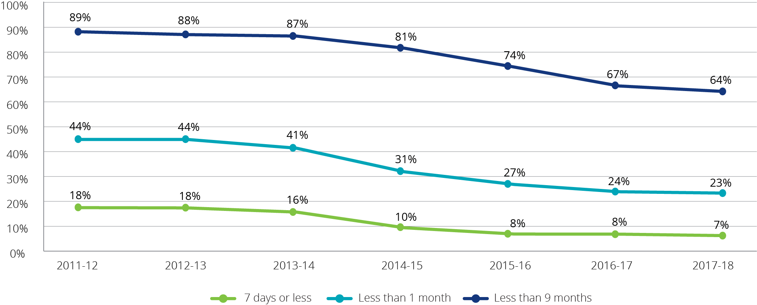

#### Consumers transitioning from home care to residential care

Chart 3.7 shows the proportion of consumers who enter permanent residential care after leaving home care. The proportion entering residential care was relatively stable at around 60 per cent for the years leading up to the introduction of the Aged Care Funding Instrument (ACFI) in 2008, when it increased to around 63 per cent. Since the start of the major reforms in 2014, the proportion has dropped to below 60 per cent and continued to decrease to below 59 per cent in 2017‑18.

This could be partly explained by the increased availability of higher level home care packages, and home care packages overall, which may impact on the proportion of package holders transferring to residential care. ACFA will monitor trends in transfers over the next few years during which a significant increase in the number of packages and the proportion of higher level packages is planned.

Chart 3.7: Proportion of consumers entering permanent residential care after leaving home care, 2008-09 to 2017‑18

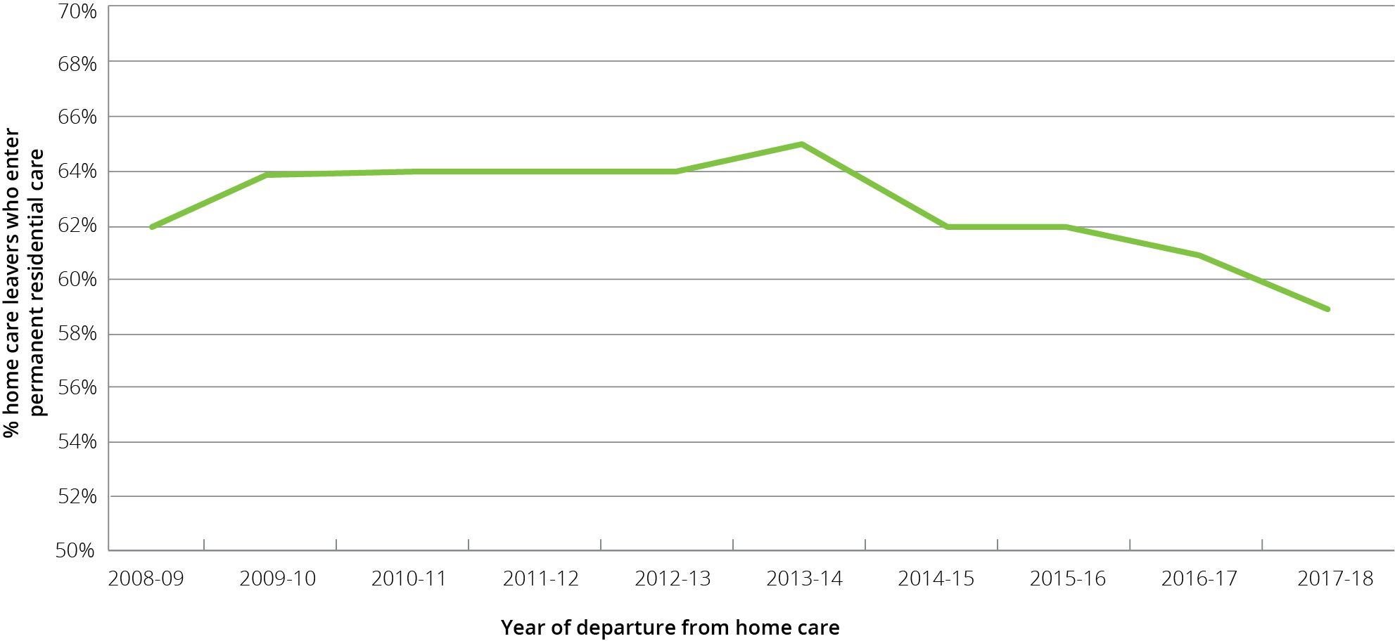

### Length of stay in residential care

The average length of time between first admission into permanent residential care, and final discharge, was decreasing gradually from around 3.3 years in 2003 to just below 3 years in 2012. Since then it has stabilized and in 2018 the average length of stay (LOS) of those leaving residential care was 2.97 years. There remains a very significant difference between males and females, with females staying in care, on average, 10 months longer than males (Chart 3.8).

Chart 3.8: Average length of stay in residential care, by gender and year of entry, 2003 to 2018

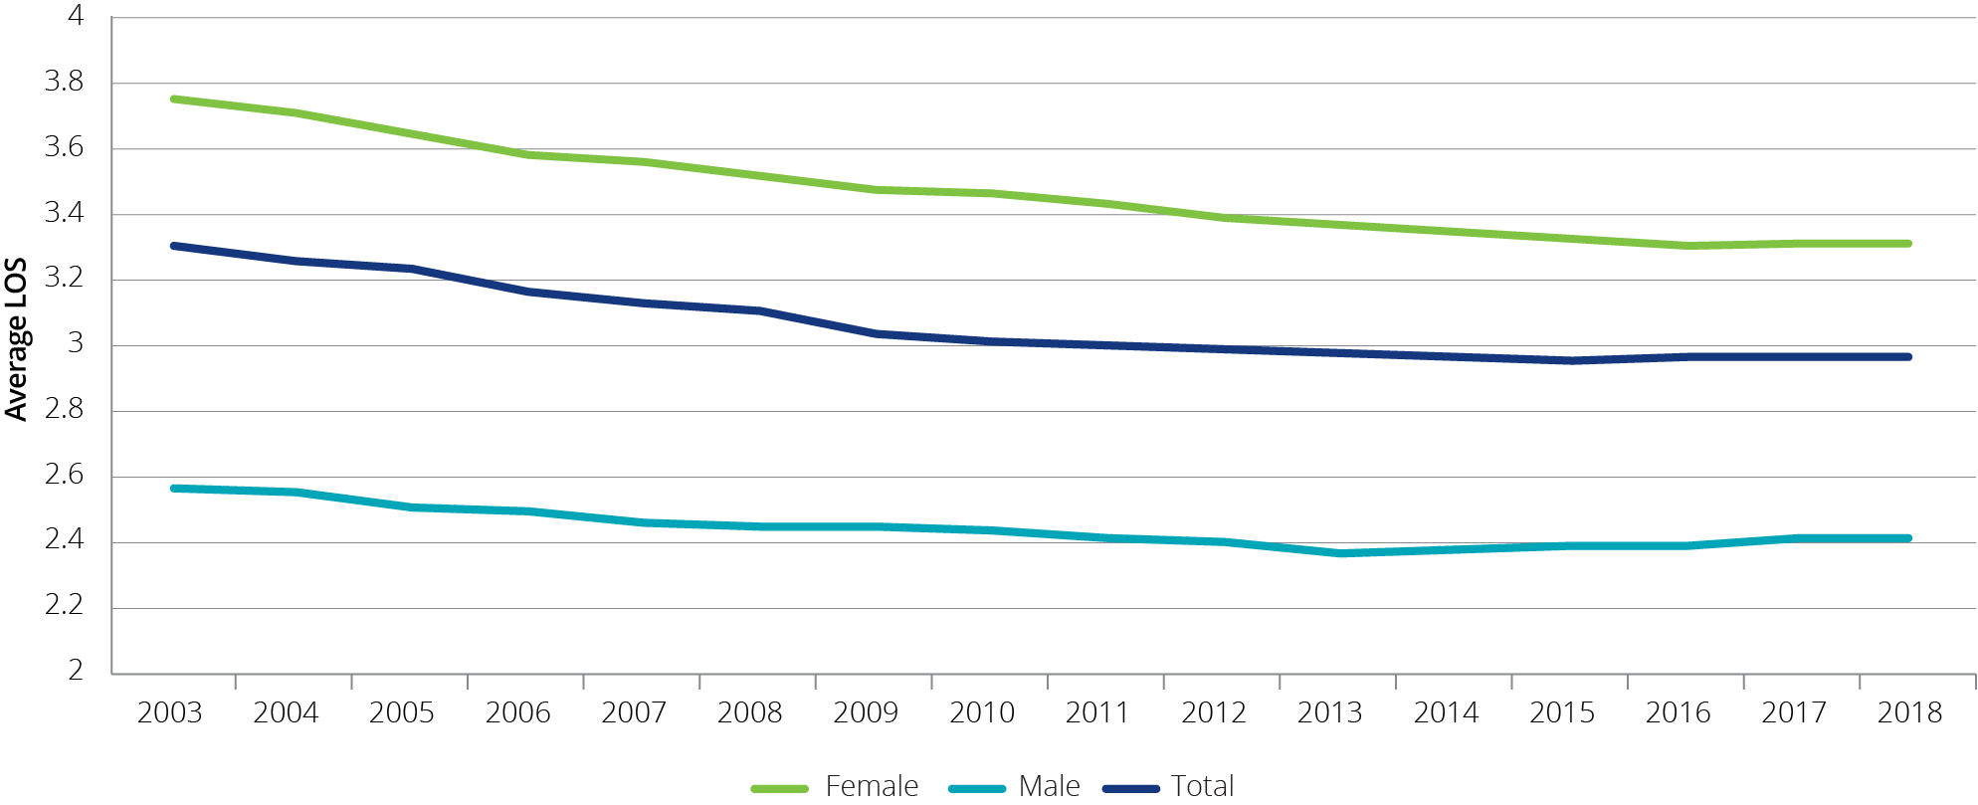

Two drivers of this decrease in LOS have been an increasing average age of entry (both male and female) and an increasing proportion of male residents. Older residents and male residents have shorter average LOS, so increasing proportions of these residents result in a shorter average LOS. Chart 3.9 shows both of these indicators, with the proportion of male entrants increasing from 36 per cent in 2003 to 41 per cent in 2018, and the average age of entry increasing from 82.7 to 84.3 over the same period.

Chart 3.9: Changes in age and gender distribution, 2003 to 2018

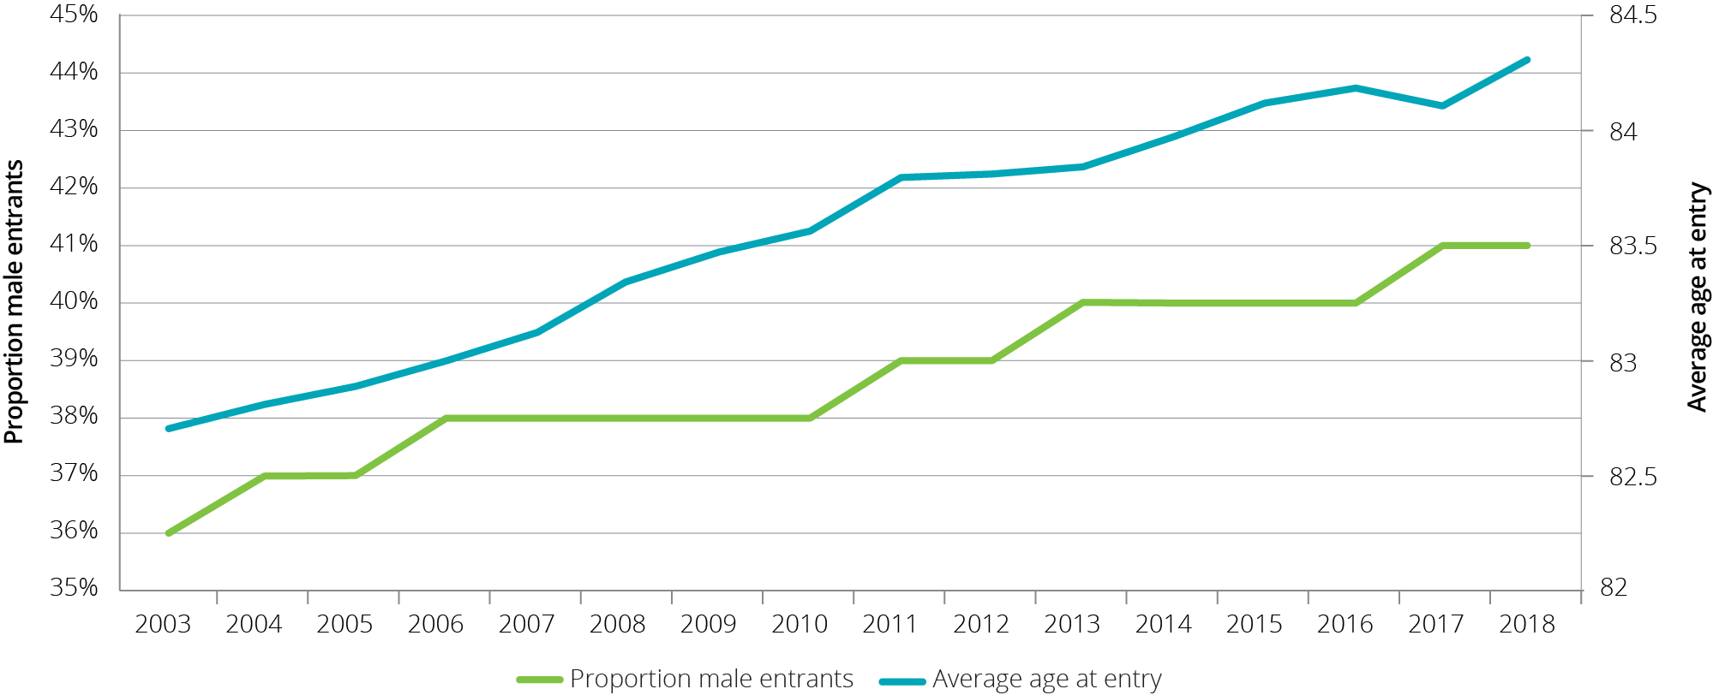

The proportion of permanent residents that leave within three, six or 12 months of first entry increased from 2003-04 to 2013‑14 (Chart 3.10), which is in line with a decreasing average LOS. However, since 1 July 2014, this proportion has tended to decrease, which will likely have an upwards impact on average LOS. However 2016-17 saw people leaving within 12 months increase slightly.

Chart 3.10: Proportion of permanent residents that leave within 3, 6 or 12 months of first entry, 2003‑04 to 2017‑18

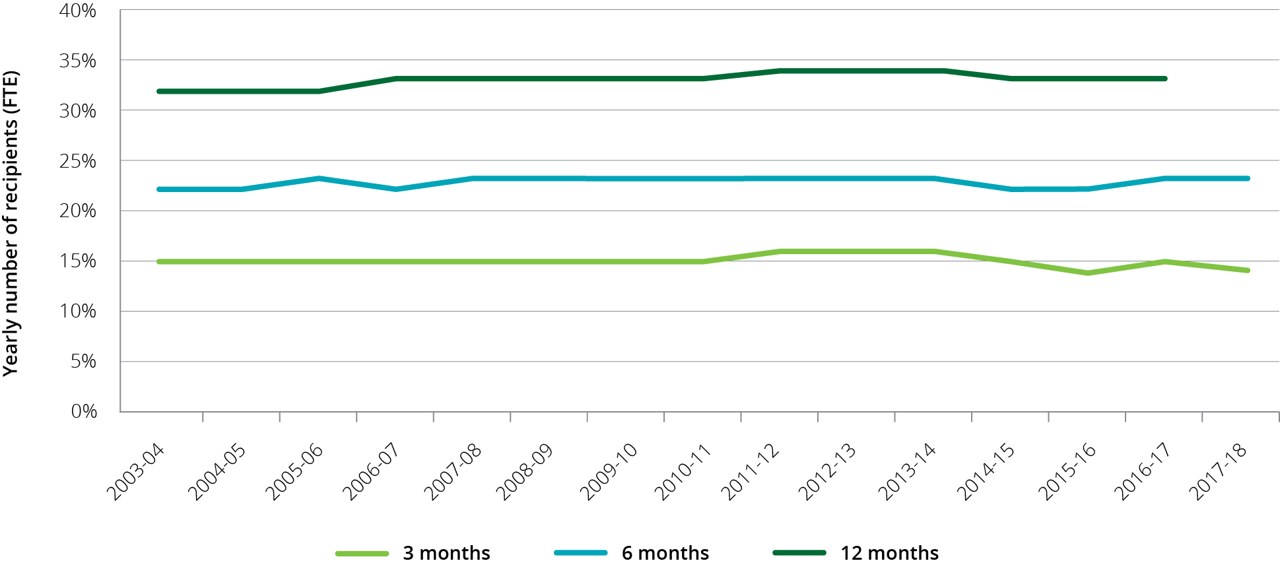

#### Dementia

Since 2008-09, the proportion of people entering residential care with a diagnosis of dementia has been consistently between around 43 per cent and 45 per cent of all permanent residents entering care, and the average age at admission for people with dementia was around six months older than for those without a diagnosis of dementia.

Chart 3.11 shows the proportion of people still in care over time by dementia status (diagnosis of dementia recorded within first 28 days of admission). It shows that half of the people entering without a dementia diagnosis died or left care within 22 months; compared with around 25 months for people entering care with an initial diagnosis of dementia. People with dementia are less likely to die or leave care in the initial period after entry, however in the longer-term, proportionally fewer people with dementia have longer lengths of stays when compared with those that do not.

Chart 3.11: Proportion of residents in care over time, with and without dementia

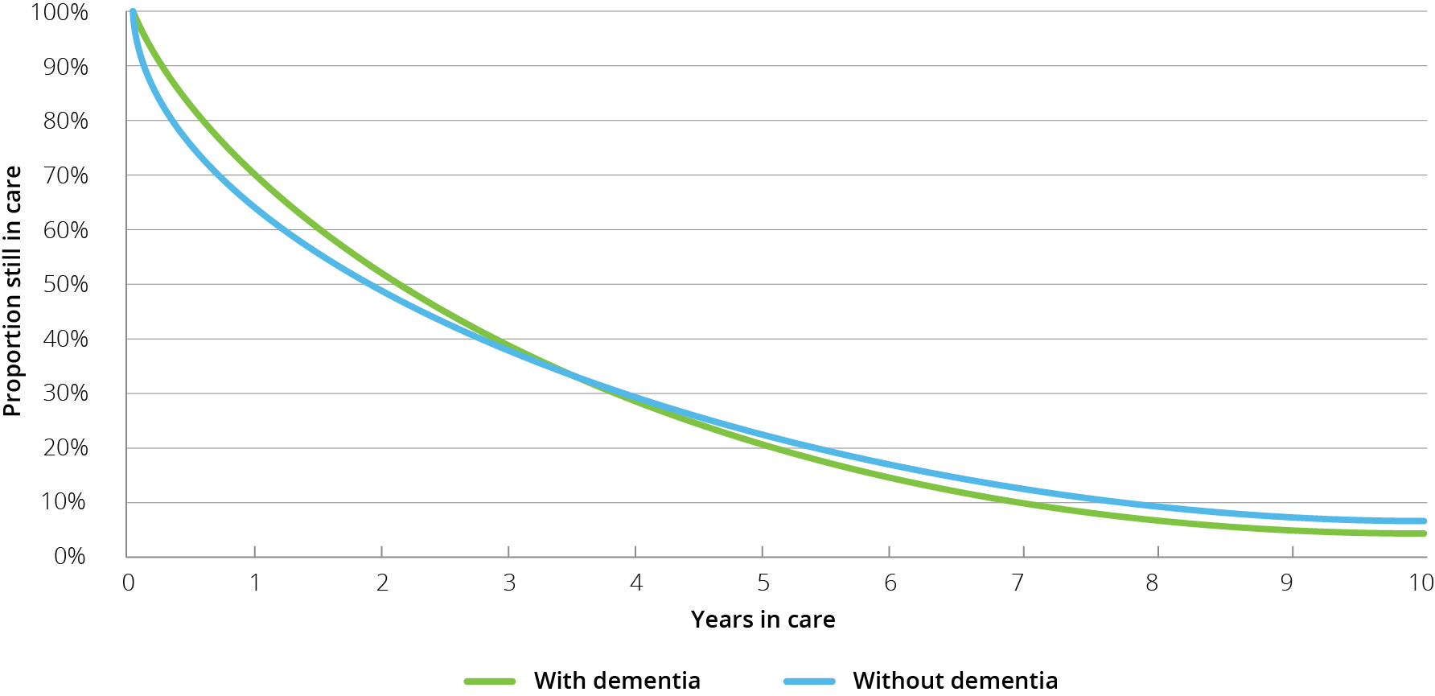

## Residential respite care

Residential respite care is short-term care delivered within an aged care facility[19] on either a planned or emergency basis. People are assessed for eligibility by an Aged Care Assessment Team (ACAT), who will approve someone for low care respite or high care respite. The distinction between high and low care was not removed from respite care when it was removed from permanent residential care on 1 July 2014. A consumer can access residential respite for up to 63 days per financial year, with extensions possible when an ACAT considers it necessary.

As noted previously, a significant difference in respite care compared with permanent residential care is that respite residents do not make any means-tested accommodation or care contributions. They can however be asked to pay the basic daily fee for living expenses, which is at the same rate as permanent residents. Respite residents can also purchase additional services, in the same manner as a permanent resident.

Residential care providers have a proportion of their allocated residential care places which may be used for the provision of respite care, and it is up to each provider what mix of permanent and respite care that they provide. Providers can vary this proportion, however currently they have to contact the Department of Health to seek approval.

Access to respite services will depend on a person’s need/choice to access this type of care and on an approved provider’s willingness and ability to provide respite care.

In its 2017 annual report ACFA discussed the increasing usage of residential respite care since 1 July 2014. Although there were no changes made to the operation of residential respite care, since 1 July 2014 the rate of increase in consumers of respite care is more than triple that of the increase of permanent residents. Following a request from the Minister for Aged Care, ACFA prepared a report on the increasing use and appropriateness of respite care. ACFA provided its Report on respite for aged care recipients[20] to Government in October 2018. ACFA made 19 recommendations concerning key issues around access, funding, consumer fees, administrative processes, and the availability of respite care.

| **Recommendations from ACFA’s report on respite for aged care recipients**   1. Recognising respite care as a vital component of aged care services and, that the Government should implement policies to facilitate a sufficient supply of the different types of respite services to meet care recipient and carer needs and preferences. 2. Ensuring the needs of carers, as well as care recipients, are recognised when assessing access to respite care. 3. Establishing funding arrangements that are neutral between respite residents and permanent residents, and not act as a disincentive to respite care. 4. Ensuring access to, and suitability of, care for special needs groups, including people with dementia, needing bariatric care, and from CALD communities. 5. Recognising that consumers should make an appropriate contribution towards the cost of their respite care and accommodation where they can afford to do so, with appropriate support from the Government where consumers are not able to contribute. 6. Ensuring consistency with other potential reforms, including that consumer fees for respite care be considered in conjunction with wider changes to consumer care fees, such as better integration of fees more broadly in the residential, home care and CHSP sectors as recommended by the Legislated Review. 7. Facilitating care recipients’ and carers’ easy access to information on respite care options (through CHSP, home care, residential and other DSS services) and in doing so help care recipients and carers readily obtain care when and where they need it. 8. Ensuring Government agencies adopt a co-ordinated approach to the delivery of, and information dissemination around, respite care, including working with providers to establish real time information on the availability of respite care. 9. Recognising that the use of respite care for purposes other than supporting people to live at home for as long as possible and their carers can be responding to a market demand for other uses of respite, but that this should not be crowding out consumers with genuine respite care needs. 10. Examining the need for specific arrangements that facilitate the transition of a resident into permanent care, particularly in the context of the current review of residential aged care funding models following the RUCS exercise. 11. Allowing the market to respond to consumer demand and in turn the numbers of respite places that providers offer based on funding arrangements that do not act as a disincentive or incentive to the provision of respite care. Given that respite care is central to the aged care system, there should be an expectation that all providers be prepared to offer respite care. 12. If neutrality in the funding of respite and permanent residential care is achieved, the Government should remove the minimum and maximum allocation rules for respite care and allow providers respond to consumer demand for respite, subject to appropriate transitional arrangements and monitoring of the impacts of such as change on respite availability. 13. Renaming the current respite care supplement as the respite care accommodation supplement to reduce confusion as to its purpose and paying the supplement irrespective of whether a person has been assessed as low or high level care, with rates aligned with those that apply for permanent residents. 14. Reviewing the respite incentive supplement in the context of the outcomes of the University of Wollongong work on broader residential care funding reform. If the relative rates of funding between respite residents and permanent residents are set appropriately, there may not be a need for a separate incentive supplement with all the associated administrative red tape that it brings. 15. Recognising that if the incentive supplement is to continue, the administrative processes that support the incentive supplement are inefficient and should be changed. The current process whereby some providers have a minimum respite allocation and others a maximum allocation is highly confusing and likely contributes to some providers missing out on respite subsidy they should receive. 16. Reconsidering the limitation of 63 days per year per respite client in residential care because it imposes administration burdens on providers, consumers and the Government, and is not readily tracked. ACFA recommends keeping a cap on respite care, but suggests that consideration be given to whether it be less than 63 days and to introducing some form of means testing after a specified period of respite use. The latter would address concerns that other uses of respite care may crowd out respite for supporting people wishing to live at home for as long as possible (and their carers). 17. ACFA does not see the need for any changes to how home care packages can be used to access respite care. While there are issues around different fee structures which should be considered, the purchasing of respite care should remain an appropriate use of home care packages. 18. Similarly, noting that other than in relation to fee contributions, ACFA does not consider there is a need for any major changes to how CHSP respite services are offered. 19. Recognising that cottage respite is in effect another type of short-term residential respite care, when considering neutrality of funding settings following the RUCS study, consideration be given to whether the current funding model for cottage respite is appropriate. |
| --- |

### Length and frequency of stay in residential respite care

During 2017-18, 61,993 people received residential respite care. Of these, on average, each person had 1.4 respite care stays[21] with each stay being an average of about 26 days. Until 2014-15 the average stay had been stable at just below 24 days however it has since risen to be between 25 and 26 days, as shown in Chart 3.12.For home care package consumers who access residential respite care, the average length of stay is shorter, at around 22 days and has remained stable since 2014‑15.

Chart 3.12: Average length of stay (days) in residential respite care, 2012-13 to 2017-18

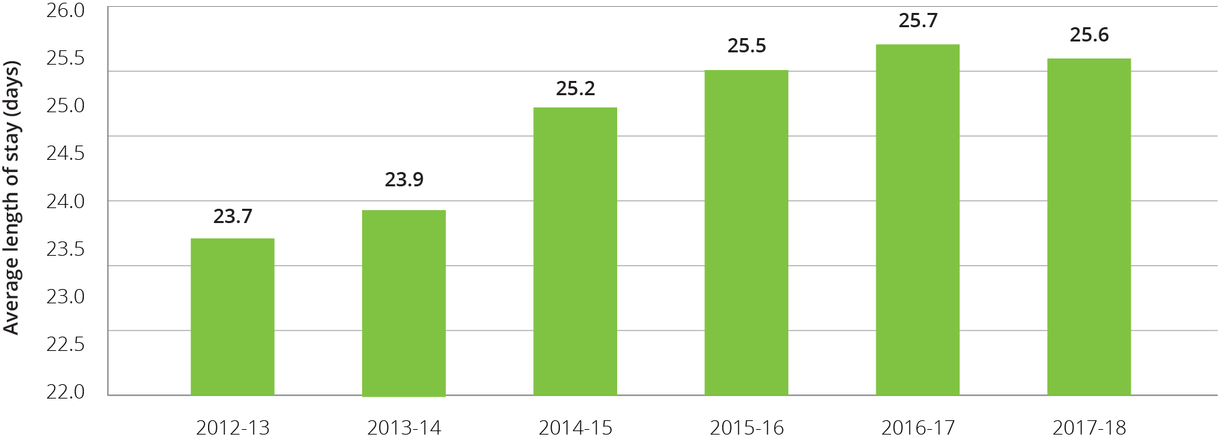

As has been the case in previous years, a clear pattern of respite care usage in 2017-18 was that it was usually for stays of whole weeks at a time (Chart 3.13). A fortnight is by far the most common residential respite care length of stay. One, three and four weeks are the next most common lengths of stay. Around 4 per cent used the maximum of 63 days in one stay. These usage trends have been stable in recent years.

Chart 3.13: Frequency of length of respite care stays, 2017-18

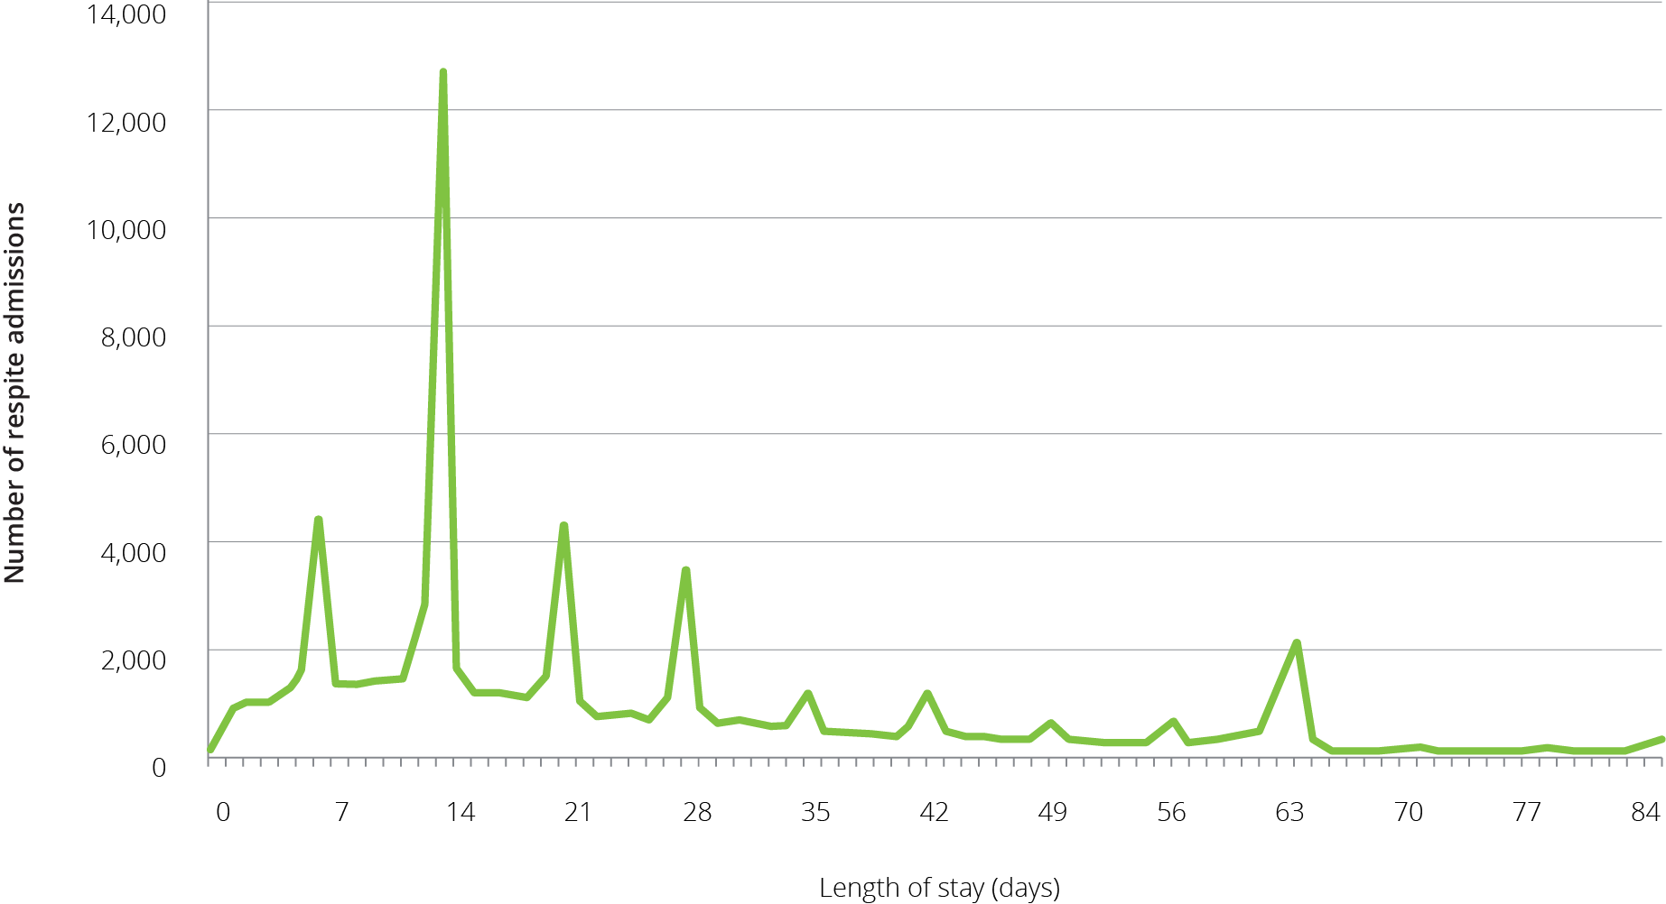

ACFA noted in its report on respite care that, in general, this pattern of respite use is provider driven, primarily due to the relatively high cost of the admission process in residential care. Feedback through consultation was that for many providers offering respite care, providing less than two weeks of residential respite is financially unviable. The feedback from consultation with consumers, however, suggested they would prefer access to shorter periods of respite care.

### High and low residential respite care

A trend that has been emerging since 2014‑15 and continued in 2017‑18 is that the number of respite consumers accessing high level respite care is increasing while the number accessing low level respite care is decreasing (Chart 3.14). This was also discussed in ACFA’s report on respite care with ACFA noting the significant difference in funding for providers between high and low care was potentially serving as a disincentive to providers taking respite consumers who had only been approved for low level care. As can be seen, the number of days of high and low level respite care provided were almost the same in 2013‑14, whereas in 2017‑18, 73 per cent of respite days were for high care consumers.

Chart 3.14: Number of residential respite care days, by level, 2013-14 to 2017-18

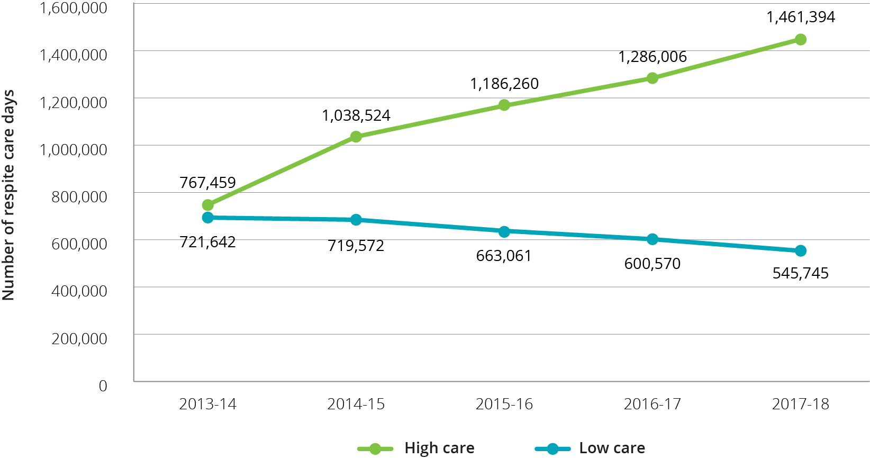

One of the recommendations from the 2018 Respite care report was that funding for respite care should be neutral between respite care and permanent residential care and also neutral between high and low care respite consumers, so that providers did not face a financial disincentive to provide respite care. As discussed in Chapter 6, ACFA suggests there would be merit in introducing changes to respite care at the same time as changes are made to broader funding arrangements.

## Supported residents

The Australian Government supports access to permanent residential care by consumers who are assessed as not being able to meet all or part of their own accommodation costs by paying providers an accommodation supplement on their behalf. These residents are known as supported (or low-means) residents.

Since the aged care reforms of 1 July 2014, eligibility for a full or partial accommodation supplement is determined by a combined assessment of an individual’s income and assets (the means test).

The amount of accommodation supplement received by a provider on behalf of a supported resident depends on:

* the outcome of the resident’s means test assessment;
* whether the residential care facility has been built or significantly refurbished since 20 April 2012; and
* whether the facility provides more than 40 per cent of its care days to supported residents.

Providers have discretion to determine the proportion of supported residents in their facilities. However providers with 40 per cent or fewer supported residents in a facility (excluding those residents receiving extra services) have the accommodation supplement they receive for all supported residents in that facility reduced by 25 per cent.

As shown in Table 3.7 and Table 3.8 the proportion of supported residents was relatively stable in 2017-18 compared with 2016-17. The trend evident in recent years of a higher proportion of supported residents in regional and remote locations compared with metropolitan areas has continued in 2017-18. Also not-for-profit providers continue to have a higher proportion of supported residents compared with for-profit providers.

The analysis used in Table 3.7 and Table 3.8 is based on claims submitted by providers on behalf of their residents.

Table 3.7: Proportion of claims for supported residents, by location, 2014-15 to 2017-18

| Location | 2014-15 | 2015-16 | 2016-17 | 2017-18 |
| --- | --- | --- | --- | --- |
| Metropolitan | 48.6% | 49.6% | 48.2% | 47.3% |
| Regional | 52.6% | 53.4% | 52.2% | 51.2% |
| Remote | 66.0% | 67.9% | 67.8% | 65.5% |
| **Australia** | **50.0%** | **51.0%** | **49.7%** | **48.7%** |

Table 3.8: Proportion of claims for supported residents, by ownership type, 2014-15 to 2017-18

| Ownership type | 2014-15 | 2015-16 | 2016-17 | 2017-18 |
| --- | --- | --- | --- | --- |
| Not-for-profit | 52.4% | 53.1% | 51.8% | 50.6% |
| For-profit | 46.3% | 47.6% | 46.6% | 46.1% |
| Government | 48.6% | 49.0% | 47.0% | 45.5% |
| **All providers** | **50.0%** | **51.0%** | **49.7%** | **48.7%** |

The relative stability in recent years in the number of supported residents in care seems to indicate that the incentive of the higher accommodation supplement for having a resident profile with more than 40 per cent supported residents, along with the higher accommodation supplement payment for facilities newly built or significantly refurbished, are combining to ensure access to care continues for this cohort of older Australians.

## Age profile across care types

As consumers of aged care get older, the types of care they access changes. Chart 3.15 shows the proportion of older Australians using home support, home care and residential care in 2017-18. The proportion using home care and residential care increases more than three-fold in the 85 and over bracket compared with those aged 70 and over.

Chart 3.15: Proportion of the population 70+ and 85+ accessing aged care, at 30 June 2018

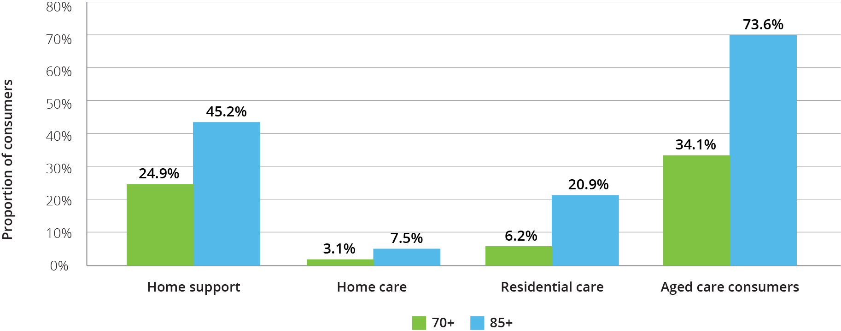

Chart 3.16 shows the age profile for consumers of home care over the five years to 30 June 2018. The proportion of those aged 65-74 has been increasing since 2014-15 and the proportion of those aged 75-84 increased noticeably in 2017-18, as it did in 2016-17, likely reflecting the expansion of home care packages in recent years. The proportion of those aged 85 and over decreased slightly for the third year in a row.

Chart 3.16: Age profile of people in home care, 30 June 2014 to 30 June 2018

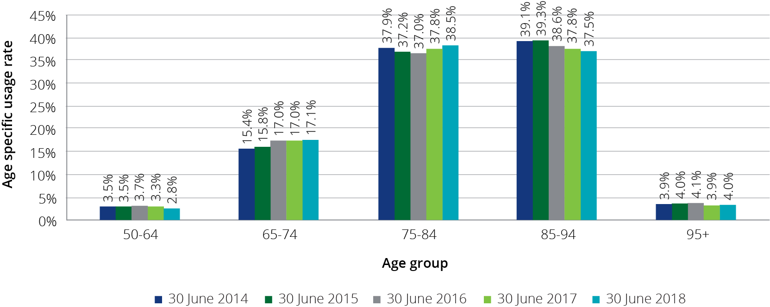

In residential care, the trends of recent years generally continued in 2017-18 (Chart 3.17). The proportion of people aged 65-74 in residential care has slowly increased over the five years while the proportions of those aged 75-84 and 85-94 have fallen. The proportion of those aged 95 and over has increased every year over the five years.

Chart 3.17: Age profile of people in residential care, 30 June 2014 to 30 June 2018

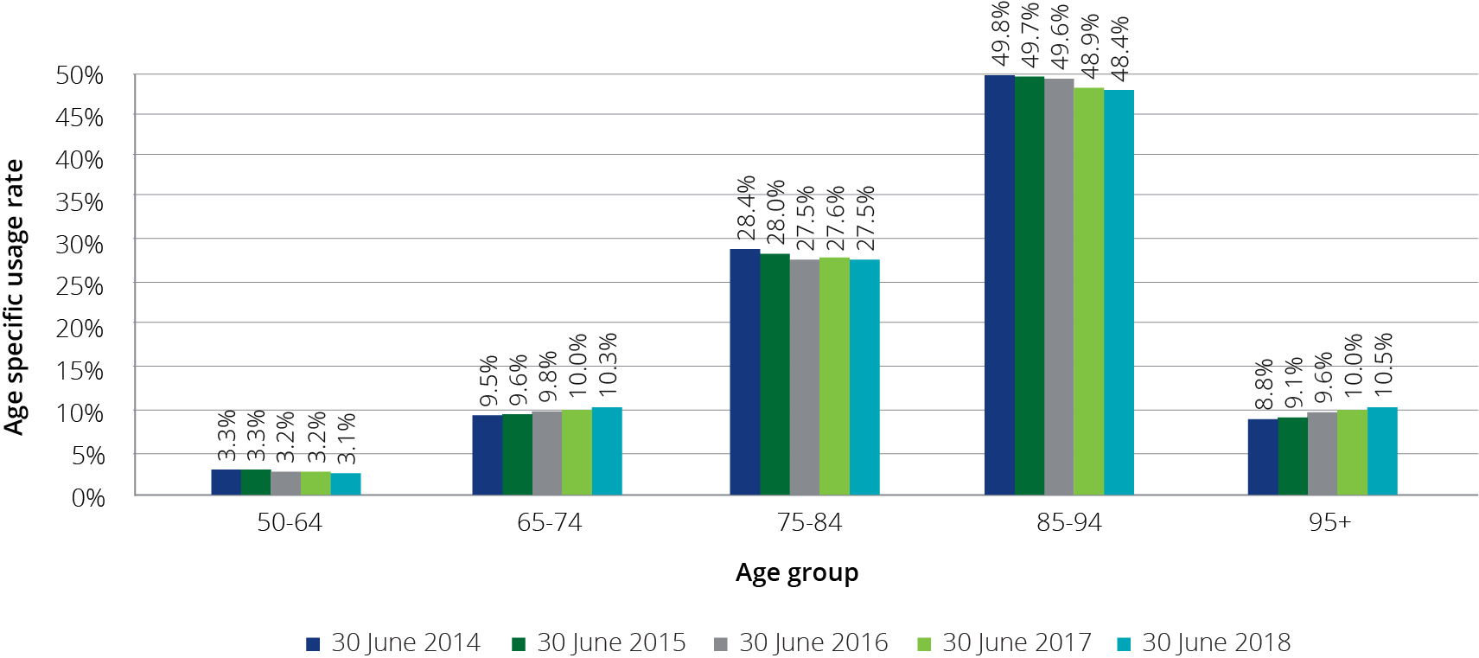

Detailed data regarding the age of consumers in CHSP is not readily available for the same level of analysis as it is for home and residential care. However the overall average age of consumers in CHSP in 2017-18 was 79.1 years compared with 79.6 in 2016-17.

## Access by Culturally and Linguistically Diverse and Indigenous Australians

### Culturally and Linguistically Diverse Australians

There is significant cultural diversity among Australians and many people from culturally and linguistically diverse (CALD)[22] backgrounds are seeking culturally appropriate aged care. This is an area where aged care is changing and will continue to change as providers respond to the cultural needs of consumers.

To assist this, the Australian Government provides aged care website information for people who do not speak English, or for whom English is a second language. The My Aged Care website provides translated material in 18 languages. In 2017‑18, there were 22,812 visits to the translation pages.

Chart 3.18 shows the number of CALD home care and residential care consumers over the last five years as well as the number of CALD consumers of the CHSP for the last two years (as previous years data was not available).

There were 22,525 older Australians from CALD backgrounds in a home care package as at 30 June 2018, representing around 25 per cent of total home care consumers. This has been stable over recent years. In residential care, as at 30 June 2018, there were 35,557 older Australians from CALD backgrounds in permanent or respite care, which represents around 19 per cent of all residents. As with home care this proportion has been stable in recent years. In 2017-18, 155,905 consumers from a CALD background accessed home support, up from 146,571 in 2016‑17.

Chart 3.18: CALD consumers in aged care, 30 June 2014 to 30 June 2018

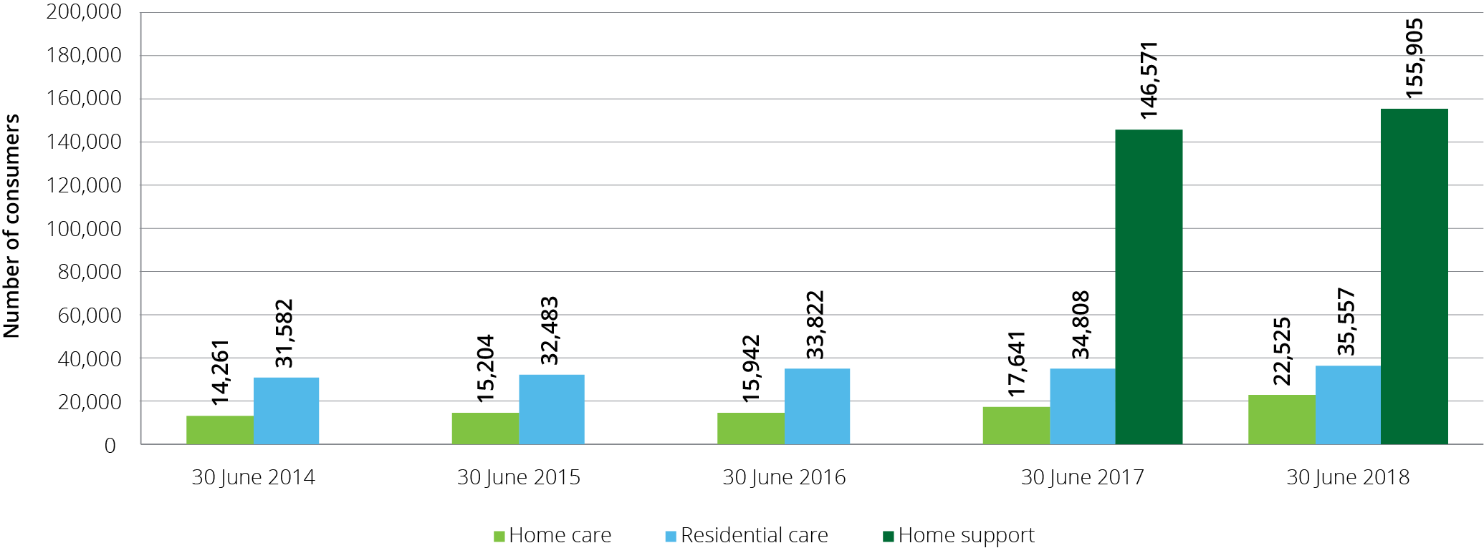

### Indigenous Australians

Chart 3.19 shows the number of Indigenous Australians accessing home care and residential care over the last five years, and the number accessing home support in 2016-17 and 2017-18 (as previous years are not available).

The number of Indigenous Australians accessing home care increased by 42 per cent from 2016-17 to 2017-18. The number of Indigenous Australians accessing residential care and home support were relatively stable from 30 June 2017.

Chart 3.19: Indigenous Australians in aged care, 30 June 2014 to 30 June 2018

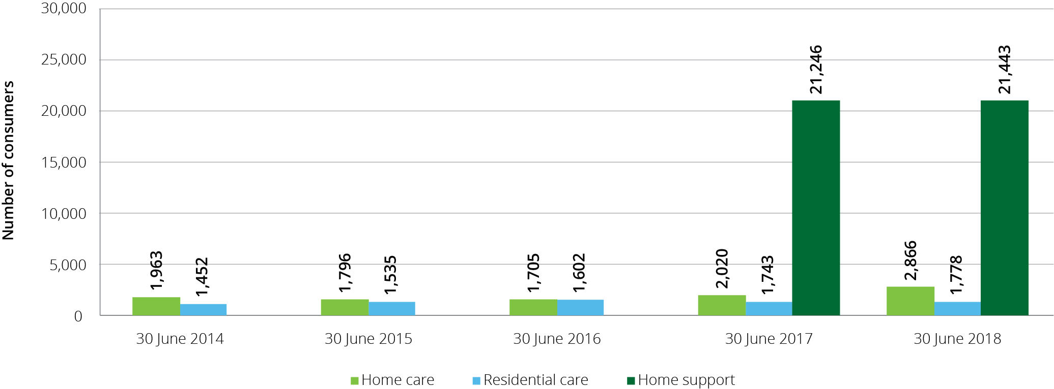

# Home support

| **This chapter discusses:**  The operation of the CHSP;  the supply and usage of CHSP and the Western Australian HACC; and  the funding of CHSP and the Western Australian HACC.  **This chapter reports that in 2017-18:**  The Commonwealth funded 1,547 providers to deliver CHSP and HACC services (1,456 CHSP providers and 91 HACC providers in Western Australia);  the CHSP provided services to 783,043 older Australians (722,838 in 2016-17);  the Western Australian HACC services provided services to 64,491 older Australians (62,089 in 2016-17); and  the total number of older Australians that received home support services was 847,534.  **The Australian Government contributed $2.4 billion to home support in 2017-18 comprising:**  $2.2 billion for CHSP ($2.1 billion in 2016-17); and  $195 million in payments to the Western Australian government to support the jointly funded HACC program ($188 million in 2016-17). |
| --- |

## Introduction

Home support generally provides small amounts of services (entry-level services) designed to help older Australians continue living in their own homes for as long as they can and wish to do so, and delay the need for higher level care, including home care packages and residential care, through early intervention. The home support programs discussed in this chapter are the Commonwealth Home Support Programme (CHSP) and the Home and Community Care (HACC) program in Western Australia.

## Commonwealth Home Support Programme

The Commonwealth Home Support Programme (CHSP) provides entry-level support services for frail, older people aged 65 years and older (or 50 years and older for Aboriginal and Torres Strait Islander people) who need assistance to keep living independently at home and in their community. CHSP entry level support is underpinned by a ‘wellness approach’, which is about building on older people’s strengths, capacity and goals to help them remain independent and to live safely at home.

The CHSP also supports homeless people, or people at risk of homelessness, to access care and housing. To be eligible for assistance with care and housing services through the CHSP, a person must be: prematurely aged; 50 years and over (45 years and over for Aboriginal and Torres Strait Islander people); on a low income; and be homeless or at risk of homelessness as a result of experiencing housing stress or not having secure accommodation.

My Aged Care is the Australian Government’s single entry point for aged care services. Access to CHSP services is coordinated through My Aged Care and Regional Assessment Services.

Table 4.1 sets out the types of services that may be accessed through the CHSP. Around 54 per cent of CHSP consumers receive one type of service, 41 per cent receive between two and four types of service and the remainder access five or more types of services through the CHSP. On average, CHSP consumers received services to the value of $2,762 per annum in 2017-18, compared with $2,882 for 2016-17. However, there can be significant variation in funding between consumers. Accurate data regarding the range of funding provided for individual consumers through the CHSP is not currently available.

Table 4.1: CHSP services: by sub-program and service type

| Sub-program | Community and home support | Care relationships and carer support | Assistance with care and housing | Service system development |
| --- | --- | --- | --- | --- |
| Objective | To provide entry-level support services to assist frail, older people to live independently at home and in the community. | To support and maintain care relationships between carers and consumers, through providing good quality respite care for frail, older people so that regular carers can take a break. | To support those who are homeless or at risk of homelessness, to access appropriate and sustainable housing as well as community care and other support services, specifically targeted at avoiding homelessness or reducing the impact of homelessness. | To support the development of the community aged care service system in a way that meets the aims of the CHSP and broader aged care system. |
| Service types funded | * Meals * Other food services * Transport * Domestic assistance * Personal care * Home maintenance * Home modifications * Social support-individual * Social support-group (formerly centre-based day care) * Nursing * Allied health and therapy services * Goods, equipment and assistive technology * Specialised support services | * Flexible respite: * In-home day respite * In-home overnight respite * Community access – individual respite * Host family day respite * Host family overnight respite * Mobile respite * Other planned respite * Centre-based respite: * Centre based day respite * Residential day respite * Community access-group respite * Cottage respite (overnight community) | Assistance with care and housing (a person must be: prematurely aged; 50 years and over (45 years and over for Aboriginal and Torres Strait Islander people); on a low income; and be homeless or at risk of homelessness as a result of experiencing housing stress or not having secure accommodation). | Sector support and development activities. |

Overall expenditure in 2017‑18 on each of the sub‑programs detailed above is as follows:

Community and home support: $1.76 billion

Care relationships and carer support: $0.26 billion

Assistance with care and housing: $0.12 billion

Service system development: $0.51 billion

## Home and Community Care — Western Australia

In 2017-18 the HACC program in Western Australia provided similar services for older people to those provided under the CHSP, but also provided support for younger people with a disability.

During 2017-18, Western Australian HACC services were delivered through the jointly funded HACC program under the HACC Review Agreement 2007. Consumers continued to be assessed for HACC services through the HACC program assessment arrangements.

From 1 July 2018 the Western Australian HACC services for older people aged 65 years and over (and 50 years and over for Aboriginal and Torres Strait Islander people) transitioned to the CHSP which means that from 1 July 2018 the CHSP was a national program.

## Sector overview

### Providers of home support

In 2017-18, there were 1,456 providers of CHSP and 91 providers of HACC in Western Australia. This compares with 1,523 CHSP providers and 98 HACC providers in Western Australia in 2016-17.

CHSP services are predominately provided by not-for-profit organisations (70 per cent in 2017-18), as shown in Chart 4.1. This has been the case since the inception of the CHSP in 2015-16, and was the case for the former programs that combined to create the CHSP.

Chart 4.1: CHSP providers by ownership type, 2017-18

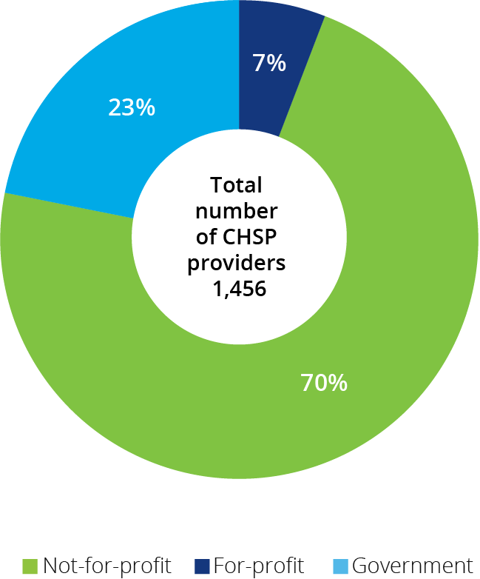

## Funding for CHSP and HACC

In 2017-18, the Commonwealth contributed funding of $2.2 billion to the CHSP, as well as providing a further $194.9 million to the Western Australian Government for the joint Commonwealth-state funded HACC program in Western Australia, bringing the total Commonwealth expenditure on home support in 2017‑18 to $2.4 billion.

Chart 4.2 shows total expenditure on home support since the introduction of the CHSP in 2015-16, along with budgeted expenditure to 2021-22.

Chart 4.2: Government expenditure and budgeted expenditure of CHSP[23] and Victorian and Western Australian HACC programs, 2015-16 to 2021-22

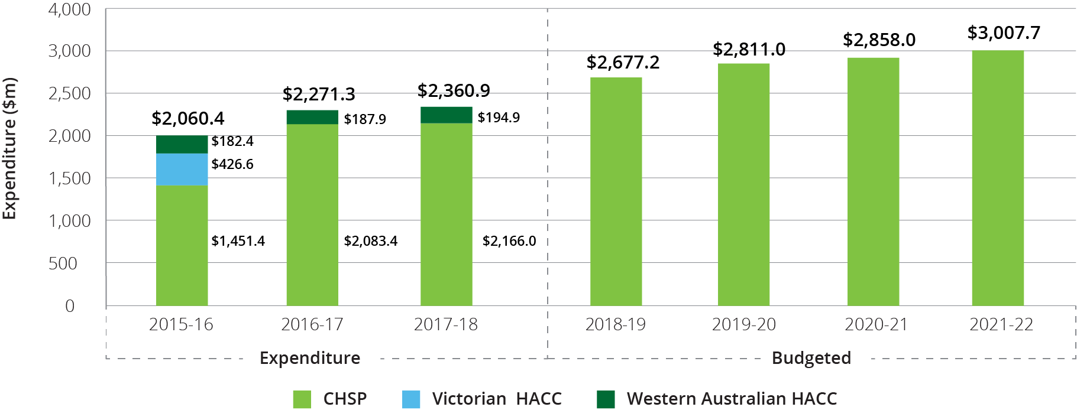

Chart 4.3 shows Commonwealth expenditure for home support (including Western Australian HACC) in 2017-18, by state and territory.

Chart 4.3: Commonwealth expenditure on CHSP and WA HACC services, by state and territory[24], 2017-18

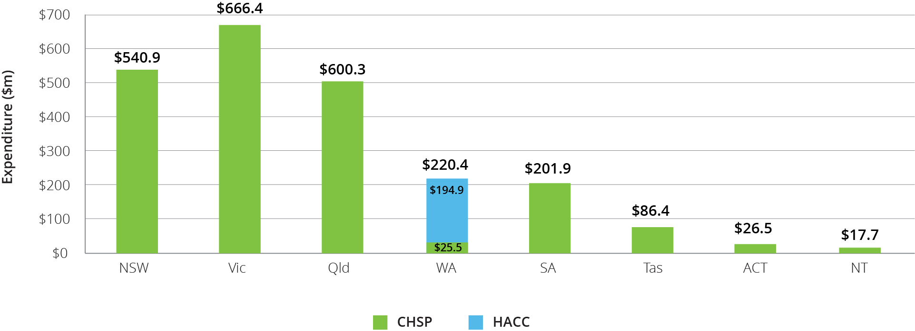

As part of the 2014‑15 Budget, the Australian Government announced a reduction in the annual real rate of growth for the CHSP from 6 per cent to 2.8 per cent in 2015‑16, 1.5 per cent in 2016‑17 and 2.4 per cent in 2017‑18. In 2018‑19 the growth rate became 3.5 per cent which aligns with the annual growth in the population aged 65 and over. Real growth is in addition to annual indexation. Growth funding enables the CHSP to respond to the changing needs of CHSP consumers and to align with the growth in Australia’s aged population. Grants under the CHSP are indexed each year by WCI-3[25] (1.3 per cent in 2018-19).

Table 4.2 shows a breakdown of the size of grants provided through the CHSP in 2017-18 by organisation type. Results from 2017-18 are similar to those in previous years. The vast majority (75 per cent) of providers receive less than $1 million and of those, almost 78 per cent receive less than $500,000.

Table 4.2: CHSP grants, by size of grant and ownership, 2017-18

| Grant size | Not-for-profit | For-profit | Government | Total |
| --- | --- | --- | --- | --- |
| Less than $500,000 | 660 | 59 | 126 | 845 |
| $500,000 - $1 million | 138 | 22 | 84 | 244 |
| $1-10 million | 195 | 21 | 120 | 336 |
| $10-50 million | 16 | 1 | 9 | 26 |
| Over $50 million | 3 | 1 | 1 | 5 |

### Consumer contributions

The Client Contribution Framework and the National Guide to the CHSP Client Contribution Framework set out principles to guide CHSP providers in setting and implementing their own consumer contribution policy.

The principles are designed to introduce fairness and consistency, with a view to ensuring that those who can afford to contribute do so, whilst protecting the most vulnerable.

Recommendation 16 of the Legislated Review of Aged Care 2017 recommended that mandatory consumer contributions based on an individual’s financial capacity be introduced for services under the CHSP. This would bring the CHSP fees policy more in line with those under other aged care programs. The Government has not yet responded to this recommendation.

In 2017-18, consumer contributions totalled $219 million which represents around 10 per cent of total CHSP funding. This is stable from 2016-17.

## Looking forward

In the 2019‑20 Budget, the Australian Government extended funding agreements with CHSP providers by a further two years, after a similar two year extension in the 2017‑18 Budget. This means the CHSP and Home Care Packages Program will continue to operate as separate programs until at least mid‑2022. In the 2015-16 Budget, the Australian Government had announced an intention to integrate CHSP and home care into a single home care and support program by July 2018.

While no decisions have been made about broader reform of care at home beyond 2022, extending the CHSP by two years will enable the Government to further refine the CHSP to better meet the entry level needs and preferences of older Australians. This includes further embedding wellness and reablement practices within the CHSP and simplifying consumer access to home-based care by combining the current RASs and ACATs into a single assessment and referral process across CHSP and home care.

Following the establishment of the CHSP as a program with full national coverage in 2018, the Department of Health issued a new Program Manual that sets out service providers’ responsibilities, including a new emphasis on wellness and reablement. CHSP providers are now required to submit an annual report outlining service level information regarding the implementation of a wellness approach within their organisation. These reports will be used to measure overall progress towards embedding wellness and reablement in CHSP service delivery.

In addition, the 2018-19 Budget provided $29.2 million over two years to 30 June 2020 to trial reablement-based assessment for the CHSP. Under the trial, consumers are asked by the Regional Assessment Services to actively demonstrate how they undertake certain tasks as part of the assessment process to better understand their abilities and limitations. The assessment model being trialled provides a time-limited reablement period, usually between six to eight weeks, prior to being referred for ongoing services. The focus is to build on the individual’s confidence and physical or cognitive skills to achieve their own goals.

# Home care

| **This chapter discusses:**  The operation of the Home Care Packages Program;  the funding of the sector; and  the financial performance of home care providers in 2017-18.  **The chapter reports that:**  There were 873 home care providers as at 30 June 2018, up from 702 at 30 June 2017;  the sector continues to be predominately not-for-profit with 53 per cent of providers (although this is down from 65 per cent in 2016‑17) and 76 per cent of consumers; and  services were provided to 116,843 consumers, up from 97,516 in 2016-17.  **Key findings on financial performance in 2017-18 compared with 2016-17:**  home care providers received an estimated $2.07 billion in revenue in 2017-18, paid $1.99 billion in expenses and generated $74 million in profit;  70 per cent of home care package providers achieved a net profit in 2017-18, down from 75 per cent in 2016-17 and 2015-16;  average EBITDA was $1,217 per consumer, a significant decline from $2,989 for 2016-17 and $3,055 in 2015-16;  EBITDA margin was 4.6 per cent, down from 11.3 per cent in 2016-17; and  as at 30 June 2018 home care providers held $539 million in unspent funds, an increase of 64 per cent over 30 June 2017. |
| --- |

## Overview of the sector

### The Home Care Packages Program

The Home Care Packages Program commenced on 1 August 2013, replacing the former home care programs – Community Aged Care Packages (CACPs), Extended Aged Care at Home (EACH) packages and Extended Aged Care at Home Dementia (EACH-D) packages.

Home care packages allow consumers to purchase a range of services and equipment which assist them living in their own home. Packages are delivered on a Consumer Directed Care (CDC) basis with consumers having an individualised budget which allows them to decide what type of care and services they purchase and who delivers the services.

In February 2017, an important change occurred in home care in that packages began being assigned directly to the consumer, rather than allocated to the provider. This means that consumers now have choice of provider to deliver their services and can opt to change providers. This has implications for both consumers and providers which are discussed further in this chapter.

Home care consumers may use their package funds to purchase the following:

* **Personal services.** Examples include help with showering or bathing, dressing and mobility;
* **Support services.** Examples include help with washing and ironing, house cleaning, gardening, basic home maintenance, home modifications related to care needs, transport to help with shopping, doctor visits or attending social activities;
* **Clinical care.** Examples include nursing and other health support including physiotherapy (exercise, mobility, strength and balance), services of a dietitian (nutrition assessment, food and nutrition advice, dietary changes) and hearing and vision services; and
* **Care management.** Coordinating care and services that will help consumers achieve the goals identified in their care plan.

In addition, providers may charge consumers a package management fee, which covers regulatory-related costs such as issuing monthly financial statements and managing unspent package funds on behalf of consumers.

For many consumers, home care packages offer an opportunity to remain living at home instead of entering residential care. Packages are categorised into four levels with level 1 being for people with basic care needs through to level 4 which supports people with higher care needs.

To obtain access to a home care package, individuals are first assessed by an Aged Care Assessment Team (ACAT) which determines eligibility for a home care package. Many people assessed as eligible to receive a package are also assessed as eligible for residential care. Once assessed as eligible for home care, an individual is placed on the National Prioritisation System and is offered a package when one becomes available. The National Prioritisation System is discussed later in this chapter.

### Providers of home care

Chart 5.1 shows overall home care provider numbers, as well as the proportion by ownership, over the six years to June 2018. There has been a significant increase in home care providers since the February 2017 changes that assigned home care packages directly to consumers rather than to providers. Many new providers have entered the market seeking to compete for consumers.

Chart 5.1: Number of home care providers, by proportion of ownership type, 30 June 2013 to 30 June 2018

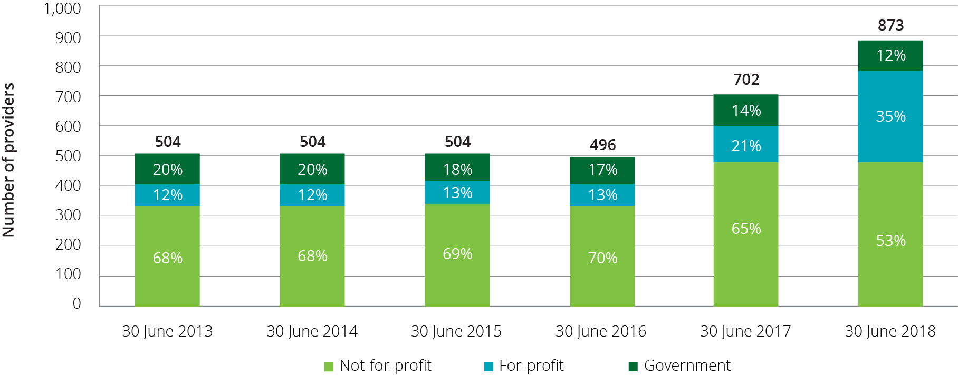

Table 5.1 presents a breakdown of home care providers by ownership type, location and scale in 2017-18.

Table 5.1: Provider numbers, number of services and number of consumers, at 30 June 2018

|  |  | | Ownership type | | | Location | | | Scale | | |
| --- | --- | --- | --- | --- | --- | --- | --- | --- | --- | --- | --- |
|  | 30 June 2017 | 30 June 2018 | Not-for-profit | For-profit | Government | Metropolitan | Regional | Metropolitan & regional | Single service | Two to six services | Seven or more services |
| Number of providers | 702 | 873 | 461  53% | 309  35% | 103  12% | 482  55% | 314  36% | 77  9% | 619  71% | 176  20% | 78  9% |
| Numbers of services | 2,367 | 2,599 | 1,860  71% | 539  21% | 200  8% | 1,577  61% | 1022  39% | N/A | 619  24% | 544  21% | 1,436  55% |
| Number of consumers | 71,423 | 91,847 | 69,944  76% | 15,545  17% | 6,358  7% | 61,676  67% | 30,171  33% | N/A | 16,220  18% | 20,833  22% | 54,736  60% |

As shown in Table 5.2, the mix of provider ownership has significantly altered since the changes of February 2017, along with a significant increase in the number of providers. The for‑profits now represent 35 per cent of the sector, up from 21 per cent in 2016-17 and 13 per cent in 2015-16. In contrast, the proportion represented by not-for-profit providers declined to 53 per cent (65 per cent in 2016-17 and 70 per cent in 2015‑16).

Table 5.2: Change in number of providers and ownership, 30 June 2016 to 30 June 2018

|  | 30 June 2016 | Proportion of total | 30 June 2017 | Proportion of total | 30 June 2018 | Proportion of total |
| --- | --- | --- | --- | --- | --- | --- |
| Not-for-profit | 347 | 70% | 407 | 65% | 461 | 53% |
| For-profit | 65 | 13% | 200 | 21% | 309 | 35% |
| Government | 84 | 17% | 95 | 14% | 103 | 12% |
| **Total** | **496** | **100%** | **702** | **100%** | **873** | **100%** |

At 30 June 2018 there were 91,847 consumers in home care, compared with 71,423 at 30 June 2017. The number of services operated by all providers also increased in 2017‑18 compared with 2016‑17 (2,599 up from 2,099). As was the case in 2016‑17, the vast majority of the increase in services was due to new single service providers entering the market. At 30 June 2018 there were 619 single service providers (71 per cent of all providers) compared with 55 per cent at 30 June 2017.

Throughout 2017-18, 116,843 older Australians were in receipt of a home care package at some time (up from 97,516 in 2016-17). In 2016‑17, 68 per cent of home care packages were level 1 and 2. In 2017‑18 this proportion has decreased to 61 per cent reflecting the trend of more consumers requiring higher level packages and Government decisions to increase gradually the proportion of higher level packages in response to demand (Table 5.3).

Table 5.3: Home care consumers, by package level and ownership, at 30 June 2018

|  | Not-for-profit | For-profit | Government | Total |
| --- | --- | --- | --- | --- |
| Level 1 | 3,353 | 1,135 | 353 | 4,841 |
| Level 2 | 39,203 | 8,183 | 4,110 | 51,496 |
| Level 3 | 9,637 | 2,281 | 775 | 12,693 |
| Level 4 | 17,751 | 3,946 | 1,120 | 22,817 |
| **Total** | **69,944** | **15,545** | **6,358** | **91,847** |

The recent increase in the proportion of for‑profit providers has not resulted in a similar change in the proportion of consumers by provider ownership with not‑for‑profit providers continuing to provide the majority of home care packages (Chart 5.2).

Chart 5.2: Home care consumers, by ownership type, 30 June 2015 to 30 June 2018

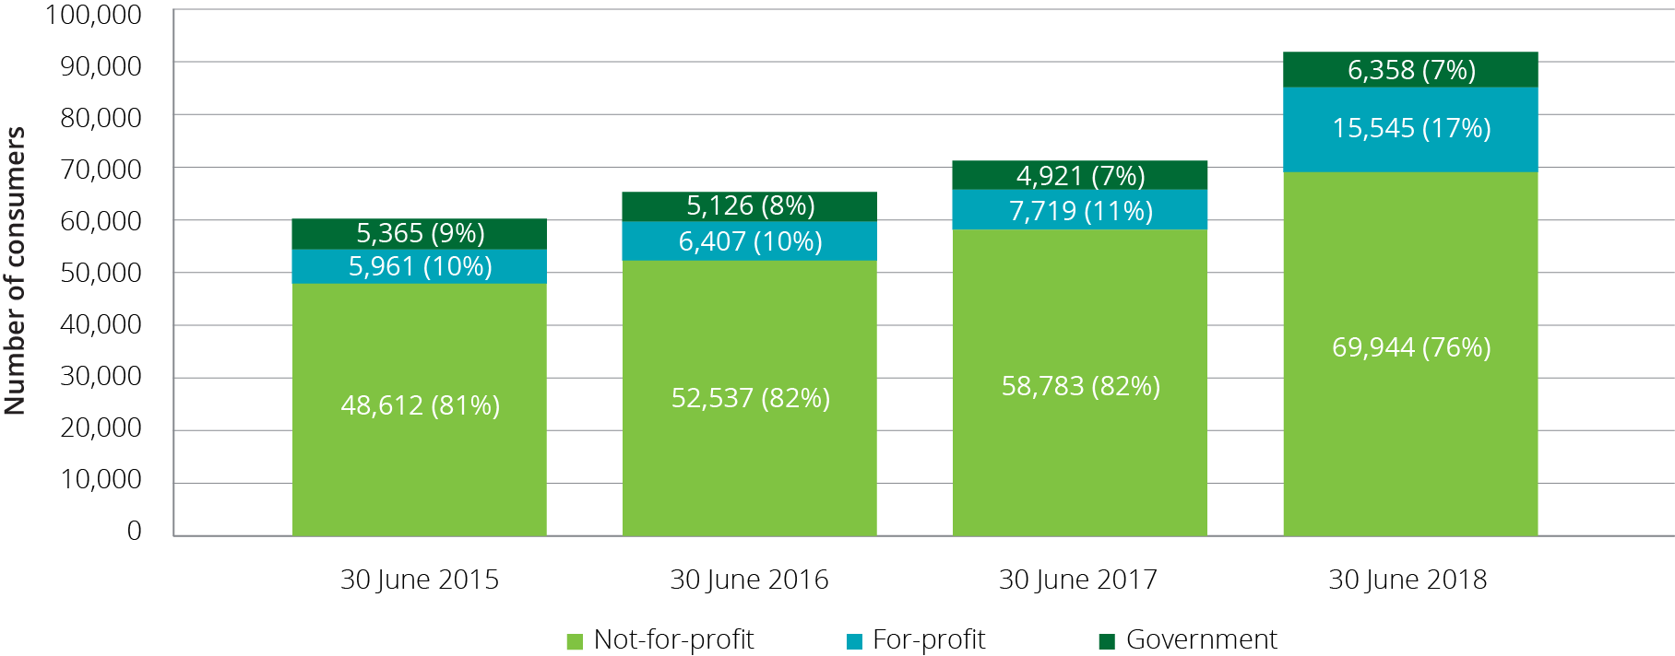

Across Australia, around 67 per cent of home care consumers are in major cities, around 25 per cent in inner regional locations, around 7 per cent of consumers are in outer regional locations, and the remaining 1 per cent are in remote and very remote areas. These proportions have been relatively steady in recent years.

## Operational performance

### Methodology

The discussion of financial performance in this chapter predominantly relates to Earnings Before Interest, Tax, Depreciation and Amortisation (EBITDA). As discussed in Chapter 1, EBITDA is the commonly used metric for analysis and comparison of the profitability of providers and the sector. Net Profit Before Tax (NPBT), which takes interest, depreciation and amortisation into the calculation, is also used.

Financial information reported in this chapter has been collected through the Aged Care Financial Report (ACFR). The Accountability Principles 2014, made under Section 96-1 of the Aged Care Act 1997, require each home care provider to submit a financial report in a form approved by the Secretary of the Department of Health. The ACFR submitted by home care providers is not required to be audited and should not be considered a General Purpose Financial Report.

Until last year’s annual report, financial performance of home care providers was largely summarised on a ‘per package’ basis as the packages were previously allocated to approved providers after a competitive tender through an ACAR. Analysis on this basis included the provider’s packages that were not fully utilised for whatever reason in a financial year. The reform changes of February 2017 have resulted in packages being assigned to consumers and as a result, the analysis is now calculated on a ‘per consumer’ basis. EBITDA calculated on a ‘per consumer’ basis is generally higher when compared with EBITDA calculated on a ‘per package’ basis as unutilised packages are excluded. When trend data is analysed, previous years have been re‑calculated on the ‘per‑consumer’ basis to allow for direct comparison between years.

### Analysis of 2017-18 financial performance of home care providers

2017-18 saw a very significant decline in the overall financial performance of home care providers compared with recent years. Average EBITDA per consumer across the sector was $1,217 after being stable at around or just below $3,000 for three years.

Chart 5.3 shows the whole of sector average EBITDA per consumer for all home care providers since 2014‑15.

Chart 5.3: Home care providers average EBITDA per consumer per year, 2014-15 to 2017-18

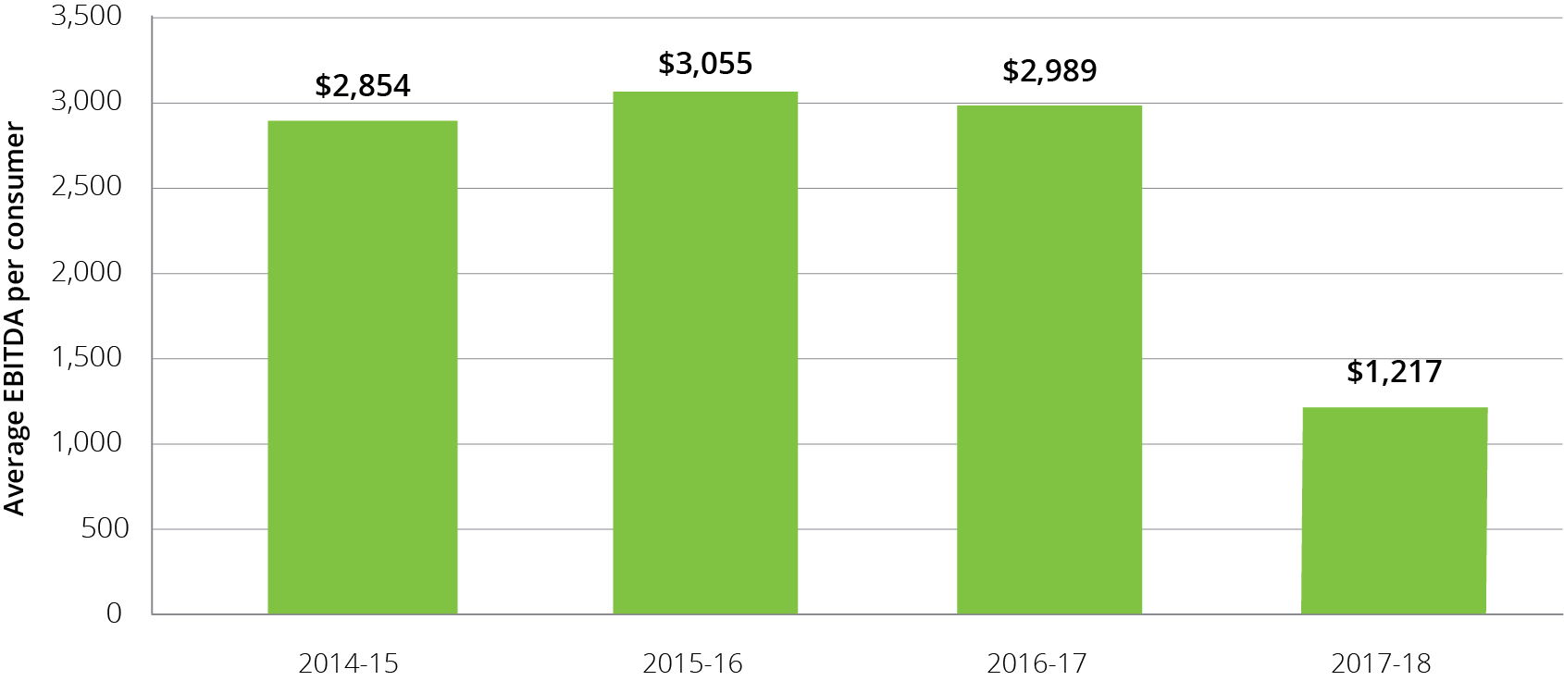

Table 5.4 provides an overview of the 2017-18 financial performance of home care providers, including a breakdown by ownership type, location and scale.

Table 5.4: Summary of financial performance of home care providers, 2017-18

|  | All providers 2016-17 | All providers 2017-18 | Not-for-profit | For-profit | Government | Metropolitan | Regional | Metropolitan & regional | Single service | Two to six services | Seven or more services |
| --- | --- | --- | --- | --- | --- | --- | --- | --- | --- | --- | --- |
| Total revenue ($m) | $1,733.6 | $2,065.5 | $1,567.3 | $381.5 | $116.7 | $1,229.4 | $321.9 | $514.2 | $283.0 | $406.2 | $1,376.3 |
| Total expenses ($m) | $1,548.4 | $1,991.1 | $1,494.0 | $389.7 | $107.5 | $1,190.3 | $304.0 | $496.8 | $271.2 | $383.2 | $1,336.8 |
| Profit ($m) | $185.1 | $74.4 | $73.3 | -$8.2 | $9.3 | $39.1 | $17.9 | $17.4 | $11.8 | $23.1 | $39.5 |
| EBITDA ($m) | $195.2 | $95.6 | $84.2 | $1.9 | $9.5 | $53.7 | $21.0 | $20.9 | $14.2 | $27.2 | $54.2 |
| Average EBITDA per consumer | $2,989 | $1,217 | $1,358 | $169 | $1,791 | $1,202 | $1,555 | $1,026 | $1,758 | $1,680 | $999 |
| Average NPBT per consumer | $2,832 | $947 | $1,183 | -$729 | $1,741 | $876 | $1,321 | $855 | $1,463 | $1,423 | $728 |
| EBITDA margin | 11.3% | 4.6% | 5.4% | 0.5% | 8.2% | 4.4% | 6.5% | 4.1% | 5.0% | 6.7% | 3.9% |
| NPBT margin | 10.7% | 3.6% | 4.7% | -2.1% | 7.9% | 3.2% | 5.6% | 3.4% | 4.2% | 5.7% | 2.9% |

### Revenue

Home care revenue consists of Commonwealth contributions in the form of subsidies and supplements, and a lessor contribution from consumers (the basic daily fee and income tested fees). Total revenue can also include other revenue sources (such as consumer contributions for non-home care related services, interest income and state and territory government payments).

In 2017-18, total Commonwealth expenditure on home care subsidies and supplements was $2.0 billion, up from $1.6 billion in 2016-17.

The basic subsidy for home care is indexed annually based on Wage Cost Index 9 (WCI‑9), the same index as applies for the care subsidy in residential care. WCI-9 is a composite index constructed by the Department of Finance that comprises a wage cost component (weighted at 75 per cent) and a non-wage cost component (weighted at 25 per cent). For all Wage Cost Indices, the value of the wage cost component is based on the dollar increase in the national minimum wage (as determined annually by the Fair Work Commission) expressed as a percentage of the latest available estimate of average weekly ordinary time earnings (AWOTE) published by the Australian Bureau of Statistics as at November of each year. The value of the non‑wage cost component of WCI-9 is based on changes in the Consumer Price Index (CPI) between March quarters each year.

Some home care supplements are also indexed by WCI-9, including the dementia and cognition and Veterans’ supplements, while the remainder, such as the oxygen and enteral feeding supplements, are indexed annually using the Consumer Price Index (CPI).

#### Commonwealth funding (subsidies and supplements)

Commonwealth funding is determined per consumer based on the level of package accessed. It is calculated on a daily basis and paid monthly in advance[26]. Each package level has a fixed maximum amount of annual funding set by the Commonwealth (Table 5.5). Supplements can also be paid in circumstances where the consumer requires additional care and/or services.

Table 5.5: Maximum home care basic subsidy payments per annum, 2018-19

| Package level | annualised subsidy |
| --- | --- |
| Level 1 | $8,270 |
| Level 2 | $15,045 |
| Level 3 | $33,076 |
| Level 4 | $50,286 |

Supplements in home care are paid in addition to the amount of basic subsidy applicable at each package level. Supplements are paid if a consumer is eligible due to a specific care need or circumstance. The supplements that apply to home care are at Appendix K. All supplements payable are included in the consumer’s individualised budget.

#### Consumer contributions

Consumers may be asked to pay a basic daily fee up to 17.5 per cent of the single basic age pension ($10.54 a day/$3,847 per annum as at 20 March 2019[27]). The basic daily fee is not subject to an income or asset test and all consumers can be asked to pay unless they prove financial hardship, in which case the Commonwealth pays the provider on their behalf. The basic daily fee, when charged by the service provider, must be included in the individualised budget for the consumer.

Additionally, consumers may be asked to make a contribution towards the cost of their care through an income tested fee. The package amount paid by the Commonwealth on behalf of a consumer is reduced by the amount of the income tested fee regardless of whether the fee is collected by the provider or not.

Consumer contributions in 2017-18 reported by providers totalled around $122 million, compared with $128 million for 2016-17 and $127 million in 2015-16. In 2017-18 the revenue from the basic daily fee was $78 million down from $101 million in 2016‑17. This reported reduction in basic daily fees was largely offset by increased revenue from the income tested fee and other consumer fees. Feedback from consultations suggest some providers foregoing charging their consumers, many of whom are pensioners, the basic daily fee, or reducing that fee. As discussed in Section 5.3, this is likely due to the increase in competition in the home care market in response to recent reforms.

#### Unspent funds

Prior to the changes that occurred in February 2017, when home care consumers moved between home care providers or exited care (often to enter residential care), unspent package funds could be retained by their former provider. As part of the changes introduced in February 2017, unspent package funds now follow the consumer to their new provider or are returned to the Commonwealth and the consumer (based on their respective proportions paid) when the consumer leaves home care.

The unspent home care amount is the total amount of each consumer’s individual budget (comprising home care subsidy, supplements and home care fees) that has not been spent or committed for the consumer’s care, less any agreed exit amount. Unspent package funds will not generally, and should not, be recognised as income by the provider until the funds have been spent or are committed for the consumer’s care.

Unspent funds are discussed in more detail at 5.2.6.

#### Total revenue

In 2017-18, total sector revenue for all home care providers was $2.07 billion, up from $1.85 billion in 2016-17, an increase of 12 per cent. Commonwealth contributions represent more than 90 per cent of the total revenue received by home care providers. As noted unspent funds held by providers ($539 million at 30 June 2018) cannot be treated as revenue.

The average income per consumer per day in 2017-18 for home care providers was $72.04 ($26,295 per annum), down slightly from $72.71 ($26,539 per annum 2016-17). Table 5.6 shows provider income per consumer per day since 2015-16, split by the major types of income. ACFA is not able to compare these results with 2014‑15 as some providers operated on a CDC basis, while others did not, which resulted in differences in the treatment of some revenue items.

As shown, there continues to be a significant amount charged for management and administration costs. However these have reduced slightly which may indicate providers responding to an increase in competition following consumers having the ability to choose their provider and the influx of new providers into the market.

Some providers have indicated that the relatively high proportion of income derived from management and administration (30 per cent) reflects the increased costs for providers as part of CDC, including regulatory-related costs such as providers being required to provide consumers with full transparency regarding their packages, negotiating an individualised budget, providing monthly itemised expenditure statements, and having to administer unspent funds in a prudentially appropriate way.

Under the comparative pricing schedule that is required to be published on My Aged Care from July 2019, providers will be required to distinguish between care management fees and package management fees. Normal business overheads will be required to be included in the fees set for services.

Table 5.6: Home care provider income per consumer per day, 2015-16 to 2017-18

| Income type | 2015-16 | % of total | 2016-17 | % of total | 2017-18 | % of total |
| --- | --- | --- | --- | --- | --- | --- |
| Provision of care / service charged to consumers | $47.15 | 61.5 | $44.71 | 61.5 | $47.94 | 66.5 |
| Management fees charged to consumers | $11.12 | 14.5 | $10.27 | 14.1 | $9.72 | 13.5 |
| Administration of packages charged to consumers | $13.63 | 17.8 | $12.88 | 17.7 | $12.10 | 16.8 |
| Unspent funds and exit amounts deducted | $3.64 | 4.7 | $2.98 | 4.1 | $0.16 | 0.2 |
| Other revenue | $1.16 | 1.5 | $1.87 | 2.6 | $2.11 | 2.9 |
| **Total** | **$76.70** | **100** | **$72.71** | **100** | **$72.04** | **100** |

1. Provision of care/services charged to consumers includes income recognised from consumers' packages and private home care consumers as care and services are provided. This amount will include Government subsidies and supplements, consumer contributions in the form of the basic daily fee, income tested care fees, top-ups and private contributions.
2. Management fees charged to consumers is the amount of income recognised for on-going management and coordination of the consumers’ packages and care requirements.
3. Administration fees charged to consumers is the amount of income recognised for on-going administration of consumers’ packages.
4. Unspent package funds reflect income remaining from a consumer’s care package when a consumer leaves the home care service (prior to the February 2017 changes). Exit amounts deducted by the approved provider when ceasing to provide home care to a consumer may also be charged after this date.
5. Other revenue includes other sources of income generated from running the home care services such as state and territory payments, consumer payments for non-home care services, trust distribution, donations and bequests, interest earned on investments, insurance and gains from the sale of assets.
6. The unspent and exit amounts reported in 2017-18 reflects only the exit fees reported by providers as the February 2017 changes in home care provide for the return of funds to the consumer or the Government when a consumers transfers or leaves care. Comparative exit amounts deducted in 2016-17 were $0.12, an increased to $0.16 in 2017-18.

### Expenditure

Total sector expenditure in 2017-18 was $1.99 billion, up from $1.65 billion in 2016‑17.

The average expenditure per consumer per day in 2017-18 was $69.45 ($25,349 per annum), an increase of 6.9 per cent from $64.94 in 2016-17. While expenses per consumer increased by almost 7 per cent, income received per consumer (as noted above) decreased slightly (1 per cent) from 2016-17 to 2017-18.

As Table 5.7 shows, the increase in expenses in 2017-18 over 2016-17 was driven by a 5.7 per cent ($2.53 per consumer per day) increase in total care costs and a 9.8 per cent ($1.98 per consumer per day) increase in total administration costs.

Within the increase in total care costs in 2017‑18, there was an increase in care-related expenses of 23 per cent and an increase in care staff costs of 4 per cent. In terms of the increase in total administration costs, the main driver was a 16 per cent increase in administration staff costs.

Table 5.7: Home care expenditure per consumer per day, 2014-15 to 2017-18

| Expenses | 2014-15 | 2015-16 | 2016-17 | 2017-18 |
| --- | --- | --- | --- | --- |
| **Care costs** |  |  |  |  |
| Wages and salaries - care staff | $29.08 | $31.98 | $28.78 | $29.99 |
| Subcontracted or brokered customer services | $7.07 | $9.44 | $10.30 | $10.32 |
| Care related expenses | $4.43 | $5.01 | $5.64 | $6.94 |
| **Total care costs** | **$40.58** | **$46.43** | **$44.72** | **$47.25** |
| **Administration costs** |  |  |  |  |
| Wages and salaries - administration staff | $7.10 | $8.77 | $8.00 | $9.26 |
| Administration costs and management fees | $10.08 | $10.55 | $10.18 | $10.26 |
| Depreciation and interest costs | $0.54 | $0.55 | $0.42 | $0.74 |
| Other expenses | $1.53 | $2.57 | $1.62 | $1.94 |
| **Total administration costs** | **$19.25** | **$22.44** | **$20.22** | **$22.20** |
| **Total costs** | **$59.83** | **$68.87** | **$64.94** | **$69.45** |

Care related expenses represent 68 per cent of total expenses per consumer per day. Administration costs represent 32 per cent of total costs which is significant.

Table 5.8 provides a breakdown of expenditure according to ownership type, location and scale. Overall, there are some notable differences.

In terms of ownership, government providers continue to incur the lowest level of expense per consumer per day with $55.33, compared with $94.97 for the for-profit providers and $66.03 for the not-for-profit providers. The main driver behind these significant differences in total expenses is the care related staff costs. For‑profit providers reported care related staff costs of $64.29 per consumer per day compared with $35.98 for the not-for-profits and $24.51 for government providers.

Provider expense per consumer is also influenced to a lesser extent by location. Similar to last year, regional providers had the lowest expenses per day on average with $61.59 per consumer per day compared with providers who operate in metropolitan areas who reported $73.04 per consumer per day.

In terms of scale, single service home care providers seem to suffer from diseconomies of scale, recording expenses on average of $92.28 per consumer per day compared with providers operating two to six services ($64.76) and those operating more than 6 services ($67.46).

Table 5.8: Home care expenditure per consumer per day, by ownership type, location and scale, 2017-18

|  | Care related salaries | Admin and Mgmt fees | Other care related expenses | Other expenses and non-direct costs | Total |
| --- | --- | --- | --- | --- | --- |
| **Ownership** |  |  |  |  |  |
| Not-for-profit | $35.98 | $10.43 | $17.47 | $2.16 | $66.03 |
| For-profit | $64.29 | $10.90 | $13.72 | $6.06 | $94.97 |
| Government | $24.51 | $6.97 | $22.32 | $1.54 | $55.33 |
| **Location** |  |  |  |  |  |
| Metropolitan | $40.45 | $10.72 | $19.13 | $2.74 | $73.04 |
| Regional | $35.78 | $7.53 | $14.73 | $3.55 | $61.59 |
| Metropolitan & regional | $38.92 | $11.08 | $14.84 | $1.96 | $66.79 |
| **Scale** |  |  |  |  |  |
| Single service | $60.50 | $11.45 | $14.69 | $5.64 | $92.28 |
| Two to six services | $38.01 | $8.27 | $15.43 | $3.04 | $64.76 |
| Seven or more services | $36.47 | $10.68 | $18.18 | $2.13 | $67.46 |
| **Total sector** | **$39.25** | **$10.26** | **$17.26** | **$2.68** | **$69.45** |

### Profit

In 2017‑18, home care providers generated $74 million in profit, down from $201 million in 2016‑17.

In terms of profit per consumer, both EBITDA and NPBT saw significant declines (Table 5.9). Average EBITDA per consumer dropped to $1,217 from around $3,000 for the previous three years. Average NPBT per consumer saw an even greater decline down to $947 from $2,832 in 2016‑17.

Table 5.9: Summary of financial performance of home care providers, per consumer per year, 2014‑15 to 2017-18

|  | 2014-15 | 2015-16 | 2016-17 | 2017-18 |
| --- | --- | --- | --- | --- |
| Average EBITDA per consumer | $2,854 | $3,055 | $2,989 | $1,217 |
| Average NPBT per consumer | $2,657 | $2,854 | $2,832 | $947 |

Approximately 70 per cent of home care providers achieved a profit in 2017‑18, down from 75 per cent in 2016‑17 and 2015-16.

Chart 5.4 shows average EBITDA per consumer by quartile. As has been the case previously, EBITDA varies considerably across the sector with the top quartile of providers (although still reporting a decline from 2016‑17) performing substantially better than the rest of the home care sector. The average EBITDA per consumer per year for the top quartile was $7,766 compared with the next top quartile returning $2,465.

Chart 5.4: Home care average EBITDA per consumer, by quartile (number of providers in parentheses), 2014-15 to 2017-18

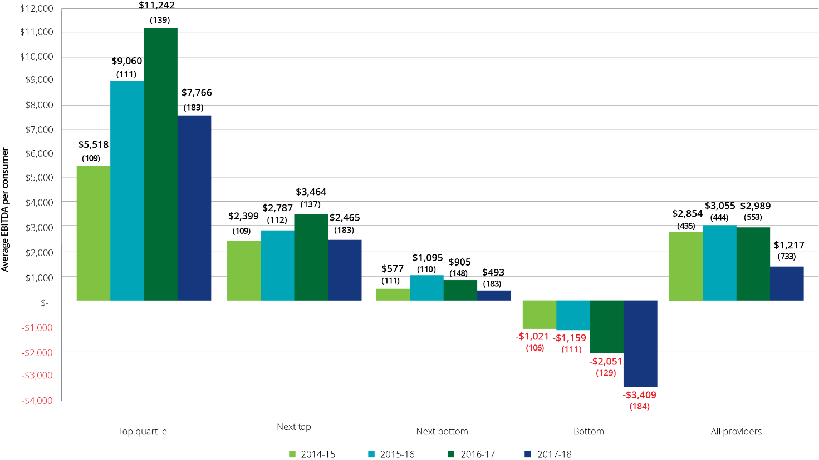

The following analysis examines home care profit based on ownership type, location and scale.

After significantly outperforming the not‑for‑profits and government providers in the previous two years, the for‑profits reported by far the worst results in 2017‑18 (Chart 5.5 and Chart 5.6). The for‑profit providers recorded average EBITDA per consumer of $169 after reporting $6,767 in 2016‑17 and $7,481 in 2015‑16. For‑profit providers reported average expenses per consumer of almost $95 per day in 2017‑18 compared with $80.93 per day in 2016‑17.

For the top quartile of for‑profit providers, total expenses increased by more than $113.68 per day however this was somewhat offset by increased income of $103.42 per day. For the next top quartile of for‑profit providers, total expenses declined by $7.49 per day in 2017-18 to $76.32, however total income fell over the same period by $8.97 to $82.51, down from $91.48 in 2016‑17. Total income also fell for the next quartile of provider by $10.90 per day to $62.92, compared with 2016-17 with total expenses falling by $8.74 over the same period. The most noticeable difference was for the bottom quartile of for-profit providers. Total income increased by $0.87 per day to $65.54 and total expenses increased by more than $10 per day to $84.49 in 2017‑18.

Not‑for‑profit providers also showed a significant decline in 2017‑18, recording EBITDA per consumer of $1,358 compared with $2,621 for 2016‑17. In the top quartile of not-for-profit providers, there was a negligible increase in income per day of $0.09 to $80.48 per day, yet expenses increased by more than $8 to $63.29 per day. For the next top quartile, income declined by $3.31 to $68.81 per day in 2017-18 while expenses only fell by $0.53 to $62.55 per day. For the next bottom quartile of not-for-profit providers, income increased by $2.48 to $66.91 per day, with expenses increasing by $3.81 to $66.09 in 2017-18. For the bottom quartile of not-for-profit providers, total income decreased by $4.51 to $67.36 in 2017-18, with expenses decreasing by only $3.12 per day.

Despite the overall poor results of for‑profit providers, the 76 for‑profit providers in the top quartile recorded average EBITDA of $14,493 (Chart 5.5) which was well above that of the top quartile not‑for‑profit providers ($6,477). However the overall significant decline in the profitability of for‑profit providers likely reflects that the influx of new providers were largely for-profit and it could be expected that new entrants into a market may make a loss as they seek to establish market presence. ACFA notes that 30 per cent of all for‑profit providers are in the bottom quartile (22 per cent in 2016‑17) and they reported, on average, EBITDA of negative $5,624.

Chart 5.5: Home care average EBITDA per consumer per year, by quartile and ownership type, 2017-18 (number of providers in parentheses)

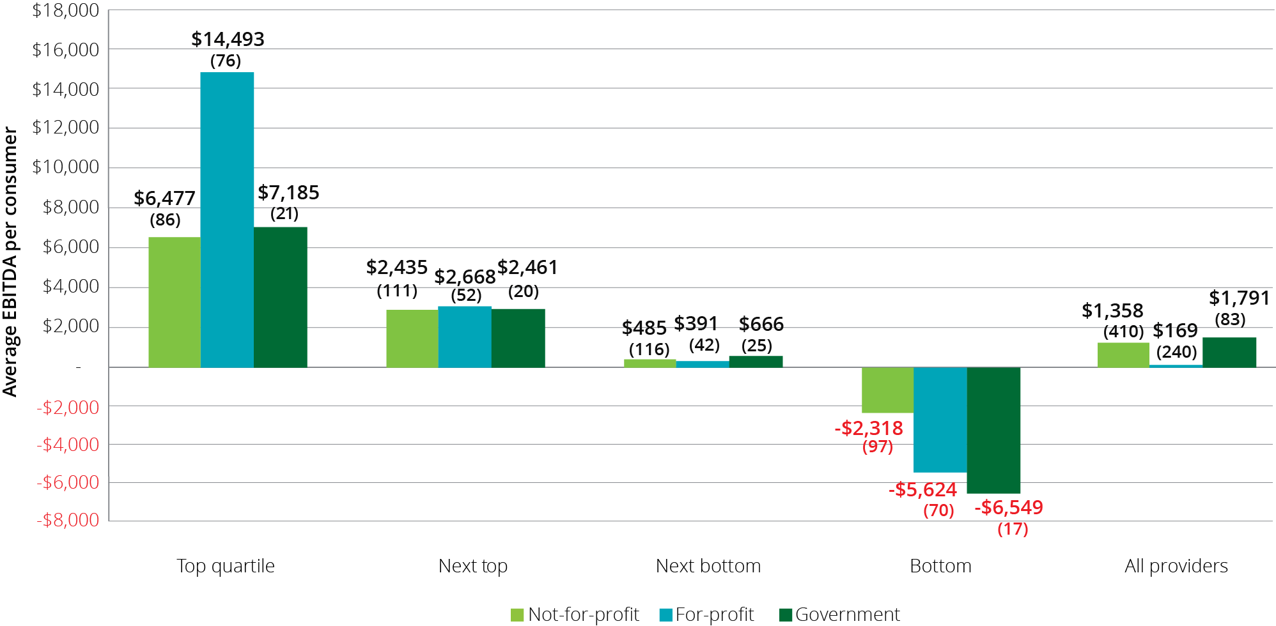

Chart 5.6: Home care average EBITDA per consumer per year, by ownership type, 2014-15 to 2017-18

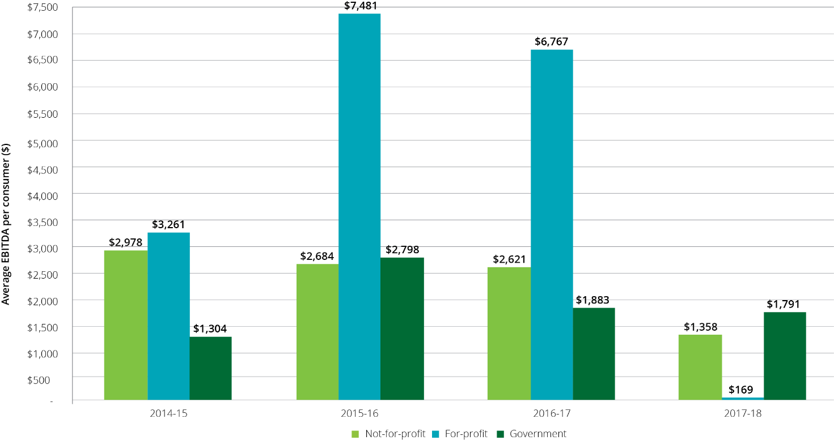

When performance is considered by location, providers in regional and metropolitan areas reported relatively similar levels of EBITDA per consumer in 2017‑18. In contrast, in 2016‑17 metropolitan providers were the strongest performers (Chart 5.8).

In terms of quartile analysis (Chart 5.7), metropolitan providers in the top quartile slightly outperformed the regional providers, however metropolitan providers were by far the worst performers in the bottom quartile. Apart from this, the average EBITDA’s across the other quartiles remained relatively similar across locations.

Chart 5.7: Home care average EBITDA per consumer per year, by quartile and provider location, 2017-18 (number of providers in parentheses)

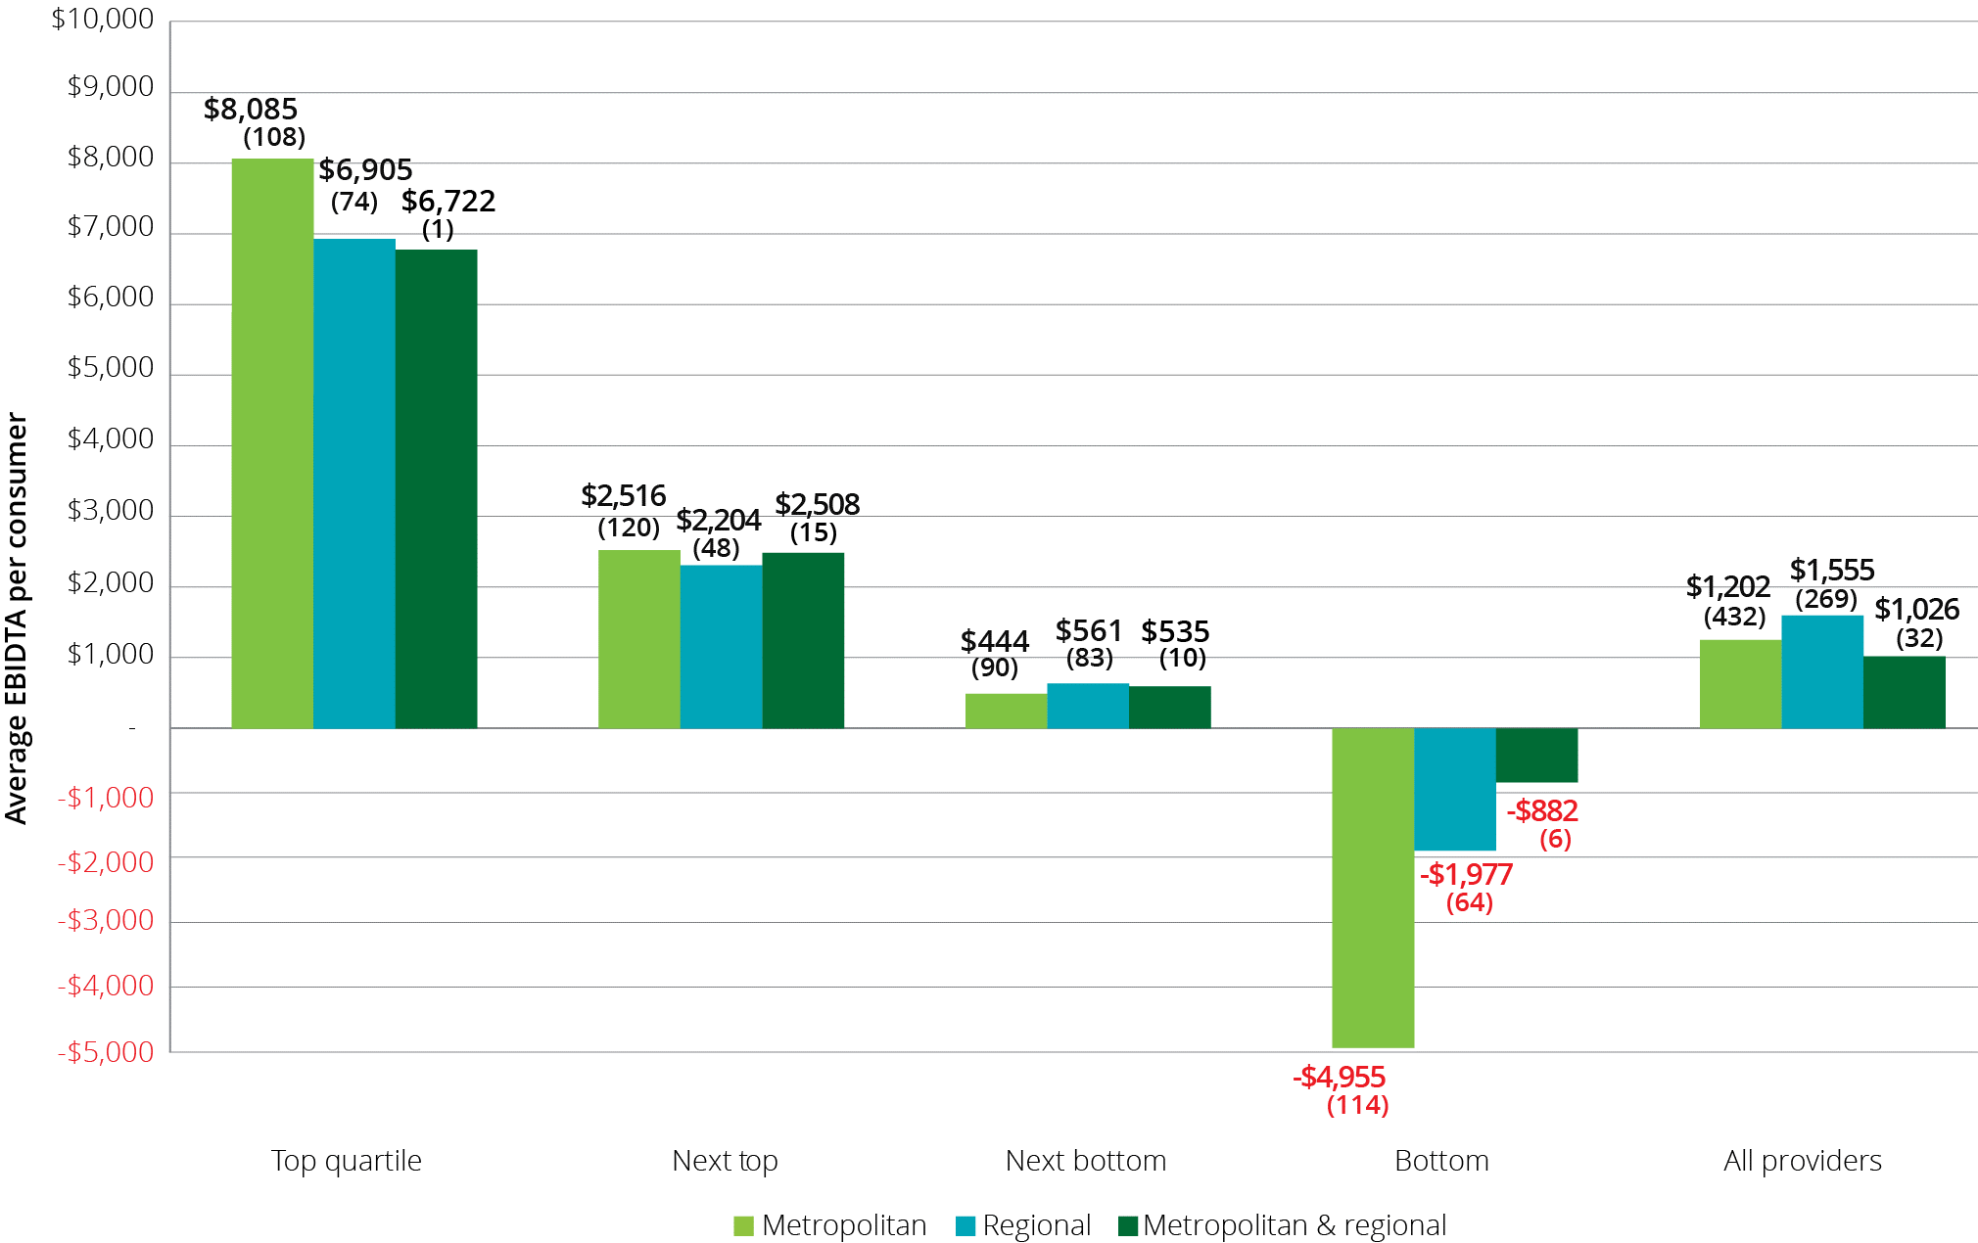

Chart 5.8: Home care average EBITDA per consumer, by provider location, 2014-15 to 2017-18

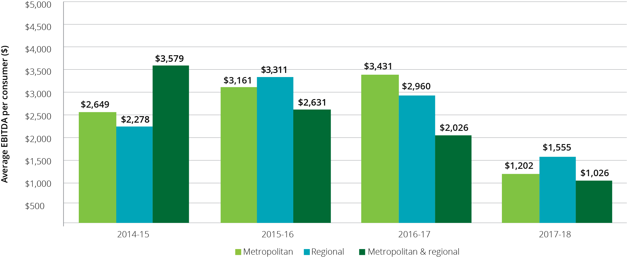

When performance is considered by scale, up to and including 2016‑17, providers who operated multiple services (2-6 and 7 or more) had performed significantly better than single service providers in terms of average EBITDA per consumer (Chart 5.10). However in 2017‑18 this trend has reversed with single service providers outperforming their larger counterparts, albeit in a year where providers of all scale reported a significant decline in financial performance. This is despite single service providers reporting significantly higher expenses as noted earlier. Interestingly, when analysed by quartiles, the single service providers were by far the best performers in the top quartile (EBITDA of $10,913) but conversely were the worst performers in the bottom quartile with negative EBITDA of $11,143 per consumer per year compared with larger providers (2‑6 services and 7 or more services) reporting negative $4,513 and negative $2,353 respectively (Chart 5.9).

Chart 5.9: Home care average EBITDA per consumer per annum, 2017-18, by quartile and provider scale (number of providers in parentheses)

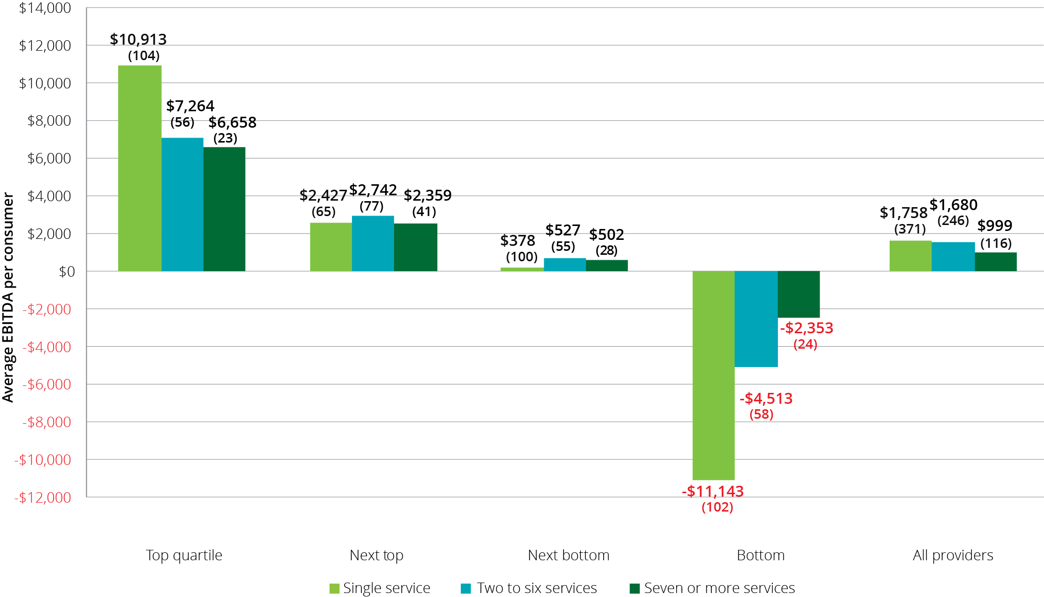

Chart 5.10: Home care average EBITDA per consumer per annum, by provider scale, 2014-15 to 2017-18

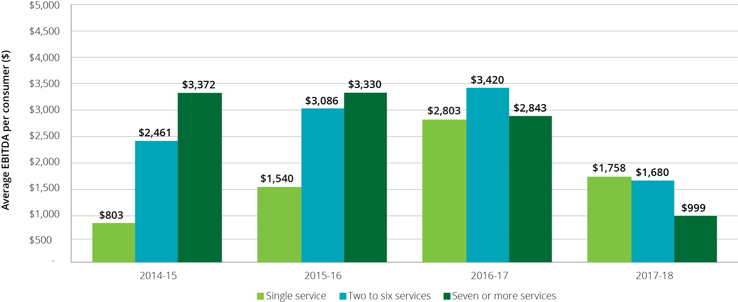

### Unspent funds

In the last two annual reports, ACFA noted the significant amount of unspent package funds held by providers on behalf of consumers. The amount held has been increasing at a significant rate over the last three years. At 30 June 2018, home care providers reported holding unspent funds of $539 million. This is up from $329 million at 30 June 2017. The level of unspent funds being held at 30 June 2018 equates to holding average unspent funds per consumer of $5,898, up from $4,613 as at 30 June 2017 and $3,667 per consumer at 30 June 2016.

Unspent funds may accumulate for a variety of reasons, including that consumers wish to save a proportion of their budget for future events; the services that the consumer wants are not available; the consumer is reluctant to allow people into their home; misconceptions that the money not spent under the package belongs to the consumer; or because the consumer does not require all the funds allocated to them. ACFA commented previously that if the consumer does not need all the funds they have been allocated, these funds could be used more effectively elsewhere, including meeting unmet demand. Unspent package funds also raises prudential issues since these funds held by providers need to be available should the consumer leave their care (either transferring to another provider or leaving home care).

The Department of Health does take into account unspent Commonwealth funds that are returned when a consumer leaves home care as an input in determining the number of new home care packages to be released.

In the 2019-20 Budget the Government announced that payment arrangements in home care to be changed from payment in-advance to payment upon delivery of service. This change is intended to avoid Commonwealth subsidies and supplements funding being held as unspent funds by providers. Consumers would still be able to access any unspent funds from the Commonwealth

## Feedback from consultations and developments in 2018-19

After several years of relatively stable overall financial performance among home care providers (although there was always a significant difference in performance across providers), there was a large overall decline in the financial results of the sector in 2017-18.

Feedback from providers, which is confirmed by an analysis of the 2017-18 results, suggests this decline in performance was mainly the consequence of the greater competition resulting from the introduction, in February 2017, of home care packages being assigned directly to consumers and consumers having choice of which provider delivers their services. It was noted in ACFA’s annual report last year that only the initial impact of this reform would be influencing the 2016-17 financial results. It is evident that the 2017-18 results have been significantly impacted by the introduction of consumer choice.

Feedback from providers indicates that the reforms have put downward pressure on their revenue and has increased their costs. Among the factors attributed to increasing costs includes having to introduce itemised accounts for consumers and changing business structures to put a greater emphasis on advertising and marketing services along with establishing long term relationships with consumers given the time between when a potential consumer joins the National Prioritisation System and when a consumer is assigned a package. Providers indicated that the introduction of the changes in February 2017 often required attracting staff with new skill sets. As noted previously, there was a significant increase in administration costs for providers in 2017-18.

As regards the impact of the reforms to home care on provider income, accompanying the change that allowed consumers to choose which provider will provide them their services, has been a very substantial increase in the number of approved providers. The result has been a significant increase in the level of competition in the home care sector which has resulted in a decrease in the price of many services, along with providers offering a range of incentives in an effort to attract consumers.

In addition, providers consulted indicate that that they are reducing management and administrative fees charged to consumers as a result of greater competition, notwithstanding that their administration costs have increased. Similarly, and as noted previously, many providers are foregoing charging their consumers the basic daily fee, or are reducing that fee, in an effort to attract consumers. Providers advise that the competition as a result of the home care reforms is not primarily directed at attracting existing consumers from another provider, and there is limited movement of existing consumers between providers, but is focused on attracting individuals who are waiting or have recently been offered a package. As a result of the increase in the number of providers and greater competition, a number of established home care providers have advised that they have lost market share.

The beneficiary of the home care reforms and the increase in competition in the sector is the consumer. There is downward pressure on prices and fees and pressure on providers to establish relationships with consumers and offer the range of services the consumer is seeking. However in the course of ACFA consultations, a number of established home care providers have suggested that some of the new entrants to the sector are not only reducing prices but also the quality of the services they are providing and that this will be at the detriment of the consumer. The aged care measures announced by the Government in February 2019 included $7.7 million to enhance safety, quality and integrity of home care packages.

A significant development following the introduction of the home care reforms has been the rise of unspent funds – the amount of each consumer’s individual budget that the consumer has not spent and now must be held by providers. Previously, a provider could have directed unspent package funds to other consumers. As noted in section 5.2.6, there are a number of possible factors influencing the increase in unspent funds and in some cases consumers may not be receiving all the care they need. From the provider’s perspective, unspent funds represent foregone business. Several providers have indicated that they are developing and implementing strategies to reduce unspent funds. To the extent that this involves providers adjusting and introducing services that are more in line with what consumers are seeking and their aged care needs, consumers will be the beneficiary.

Feedback from providers suggests that the competitive pressures evident in 2017-18 have continued in 2018-19. While not directly comparable with the data in this report, the StewartBrown Aged Care Financial Performance Survey suggests some stabilisation in the profitability of home care providers in the six months to December 2018. In the course of consultations, many providers observed that the sector is still in a process of transition and they considered that the current number of approved providers is not sustainable, irrespective of the further release of home care packages. It is also evident that a number of providers still have to adjust their operations so that they are more responsive to meeting consumer preferences. The general feeling appeared to be that a degree of rationalisation in the number of providers would take place. In keeping with this assessment, a few of the providers consulted said that they were reviewing whether they would continue to offer home care packages given the competitive pressure and low returns. In a different vein, but related, some other providers said that they were positioning themselves to take advantage of opportunities that may arise from a shake-out in the number of home care providers.

There are a range of factors influencing the home care sector as a result of the introduction of consumer choice and ACFA notes that it would be opportune to review developments, consider lessons to be learnt from the changes, including possible policy refinements.

# Residential care

| **This chapter discusses:**  The operation of residential care;  the ownership, locational and scale characteristics of residential care providers;  the funding arrangements in residential care; and  the financial performance of residential care providers in 2017-18.  **This chapter reports that:**  At 30 June 2018 there were 207,142 operational places, up from 200,689 at 30 June 2017;  during 2017-18 residential care was provided to 241,723 older Australians, up from 239,379 in 2016-17;  at 30 June 2018 there were 886 providers, down from 902 in 2016-17, continuing the consolidation of recent years with the number of residential care places increasing while the number of providers continues to gradually decrease; and  not-for-profit providers continue to represent the largest proportion of ownership type in residential care, with 56 per cent of providers and 55 per cent of places, but the proportion of places operated by the for-profits continues to gradually increase.  **Key findings on financial performance in 2017-18 compared with 2016-17:**  Total revenue of $18.1 billion, up from $17.8 billion, an increase of 1.7 per cent, equating to revenue of $272.16 per resident per day, an increase of 1.0 per cent from $269.55;  other income of $955 million down from $980 million;  total expenses of $17.6 billion, up from $16.8 billion, an increase of 5.3 per cent, equating to $265.62 per resident per day, compared with $254.29, an increase of 4.5 per cent;  average EBITDA per resident per annum of $8,746 compared with $11,481, a decrease of 24 per cent;  total profit of $435 million compared with $1,006 million, a decrease of 57 per cent; and  56 per cent of providers achieved a net profit compared with 68 per cent. |
| --- |

## Overview of the sector

### Supply of residential care

The Australian Government uses a population based planning ratio (target provision ratio) to determine the number of subsidised operational residential care places. This is outlined in Chapter 3.

Table 6.1 shows the number of providers, facilities[28], places and residents since 2013-14. The number of providers continues to decrease each year through consolidation, while the number of places and residents continues to increase. The number of facilities has increased gradually.

Table 6.1 also shows the achieved provision ratio in residential care, as well as provisionally allocated places and respite residents.

The number of allocated residential care places was less at 30 June 2018 (246,536) than it was at 30 June 2017 (247,907), while the number of operational places increased by 6,453 as provisional allocations and offline places came online. The overall reduction in allocated places was due to no new places being allocated during 2017-18 (as there was no ACAR) and 1,371 provisionally allocated places were either surrendered by providers or revoked by the Department. This is discussed in section 6.1.7.

Table 6.1: Number of residential care providers, facilities, places and residents, 30 June 2014 to 30 June 2018

|  | 30 June 2014 | 30 June 2015 | 30 June 2016 | 30 June 2017 | 30 June 2018 |
| --- | --- | --- | --- | --- | --- |
| Providers | 1,016 | 972 | 949 | 902 | 886 |
| Facilities | 2,688 | 2,681 | 2,669 | 2,672 | 2,695 |
| Allocated places | 217,006 | 228,024 | 238,843 | 247,907 | 246,536 |
| Operational places | 189,283 | 192,370 | 195,825 | 200,689 | 207,142 |
| Achieved residential care ratio | 82.6 | 81.1 | 79.7 | 77.9 | 77.2 |
| Provisionally allocated places | 21,047 | 28,000 | 35,124 | 39,294 | 31,603 |
| Provisionally allocated places as proportion of allocated places | 9.7% | 12.4% | 14.7% | 15.9% | 12.8% |
| Occupancy | 93.0% | 92.5% | 92.4% | 91.8% | 90.3% |
| Total residents | 176,816 | 177,820 | 181,048 | 184,077 | 186,597 |
| - Permanent residents | 173,974 | 172,828 | 175,989 | 178,713 | 180,923 |
| - Respite residents | 2,842 | 4,992 | 5,059 | 5,364 | 5,674 |

1. This table excludes flexible care places.

Table 6.2 shows a breakdown of residential care providers as at 30 June 2018, presented by ownership type, location and scale.

Table 6.2: Number of providers, facilities, places and residents in residential care, by ownership, location and scale, 2017-18

|  |  |  | Ownership type | | | Location | | | Scale | | | |
| --- | --- | --- | --- | --- | --- | --- | --- | --- | --- | --- | --- | --- |
|  | Total sector 2016-17 | Total sector 2017-18 | Not-for-profit | For-profit | Government | Metropolitan | Regional | Metropolitan & regional | Single facilities | Two to six facilities | Seven to 19 facilities | 20 or more facilities |
| Providers | 902 | 886 | 497 | 294 | 95 | 453 | 343 | 90 | 560 | 246 | 59 | 21 |
| Facilities | 2,672 | 2,695 | 1,549 | 906 | 240 | 739 | 1,956 | N/A | 560 | 694 | 641 | 800 |
| Operational places | 200,689 | 207,142 | 114,463 | 84,011 | 8,668 | 63,305 | 29,838 | 113,999 | 43,001 | 48,382 | 50,966 | 64,793 |
| Occupancy | 91.8% | 90.3% | 92% | 88% | 90% | 89% | 92% | 91% | 90% | 90% | 91% | 91% |
| Total residents | 184,077 | 186,597 | 105,308 | 73,554 | 7,735 | 130,611 | 55,986 | N/A | 38,377 | 42,930 | 46,325 | 58,965 |
| -Permanent residents | 178,713 | 180,923 | 102,539 | 70,856 | 7,528 | 126,813 | 54,110 | N/A | 36,921 | 41,593 | 45,135 | 57,274 |
| - Respite residents | 5,364 | 5,674 | 2,769 | 2,698 | 207 | 3,798 | 1,876 | N/A | 1,456 | 1,337 | 1,190 | 1,691 |

### Residential care providers

At 30 June 2018, there were 886 residential care providers operating 207,142 residential care places in Australia. This compares with 902 providers operating 200,689 places at 30 June 2017. As has been the case in recent years some providers are continuing to expand the scale of their businesses. As a result there has been a consolidation of residential care providers over a number of years. Chart 6.1 and Chart 6.2 show the decreasing provider numbers but increasing operational places since 2010‑11.

Chart 6.1: Number of residential care providers, 2010-11 to 2017-18

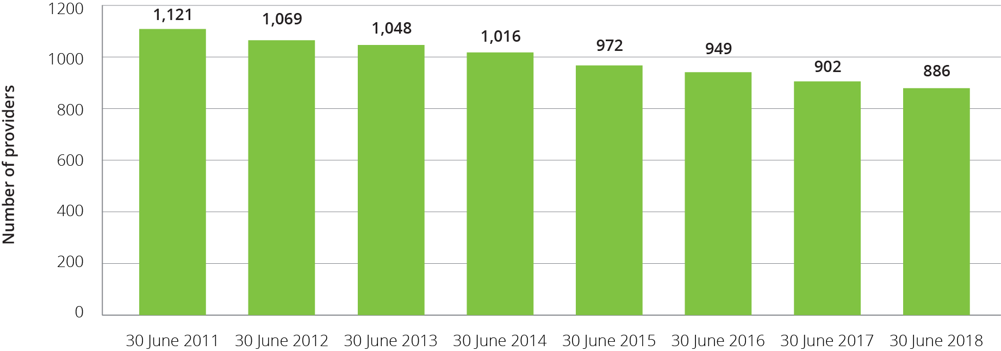

Chart 6.2: Number of operational residential care places, 2010-11 to 2017-18

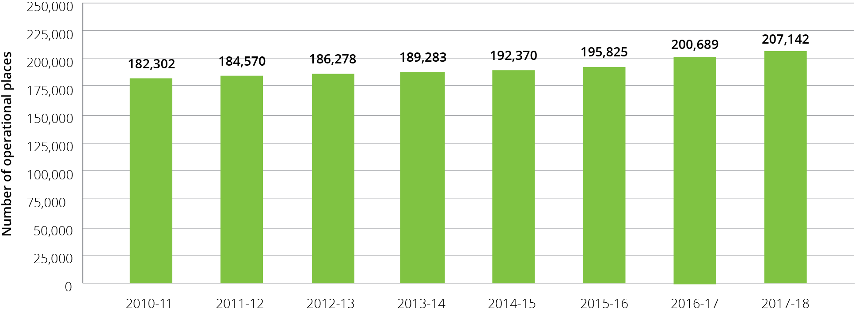

### Ownership type

As shown in Chart 6.3, the largest provider group remains the not-for-profit group (religious, charitable and community-based organisations). They represent 56 per cent of providers and operate 55 per cent of all residential aged care places. For-profit providers account for 33 per cent of providers and 41 per cent of places. The remaining providers and places are state and territory and local government-owned providers.

The proportion of providers across ownership types has remained relatively stable. However, as shown, the proportion of operational residential care places held by for-profit providers is continuing to increase gradually. This reflects for-profit providers seeking to increase the scale of their operations through both acquisitions and greater success at gaining new allocations through the Aged Care Approvals Rounds (ACAR).

Not-for-profit providers continue to operate proportionally more of the residential care places in rural and regional areas compared with the for‑profits. As at 30 June 2018, not‑for‑profits (55 per cent of all places) were operating 66 per cent of all regional places. Conversely, and also similar to previous years, for-profit providers operated 41 per cent of all places and only 24 per cent of regional places. Government providers operated the remaining 11 per cent of regional residential care places.

Chart 6.3: Residential care provider and operational places by ownership type, 2015-16 to 2017-18

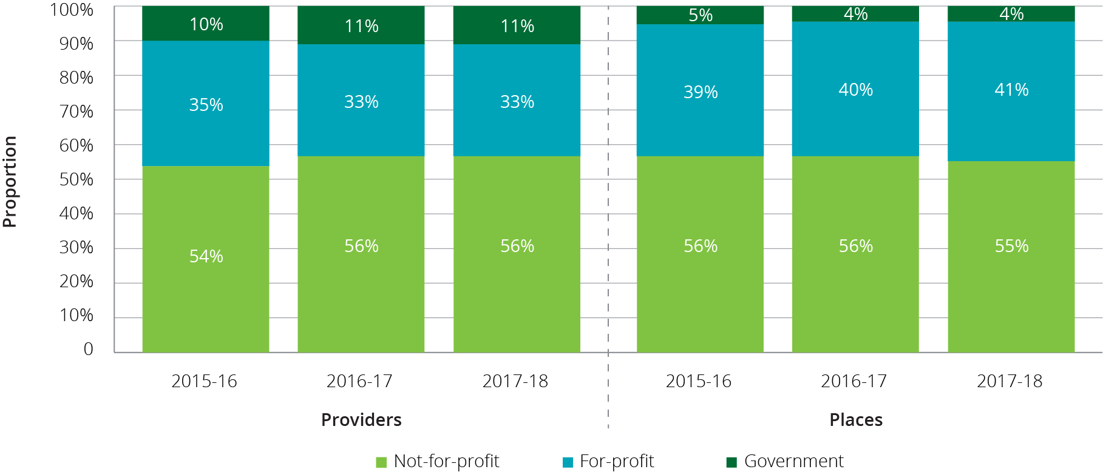

### Provider scale

The majority of residential care providers (63 per cent) operate only one residential care facility (Chart 6.4). These single aged care facility providers account for 21 per cent of all operational residential care places. Conversely, 2 per cent (21 providers in total) operate more than 20 facilities, but they account for 31 per cent of operational places.

Chart 6.4: Residential care provider and operational places by provider scale, 2015-16 to 2017-18

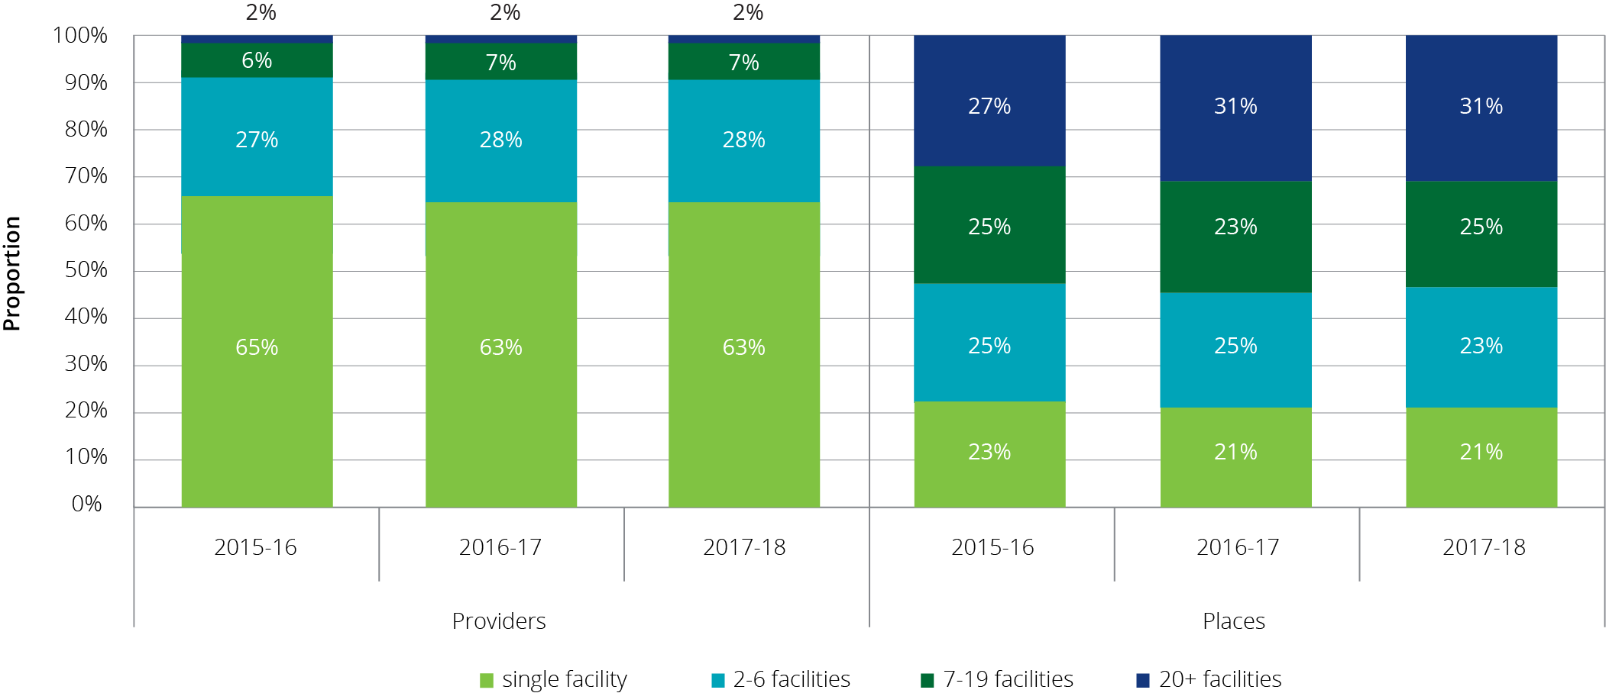

As shown in Table 6.3, for-profit and not-for-profit providers have, on average, around three facilities per provider. However within those facilities, for-profit providers, on average, operate 93 residential care places per facility, compared with not‑for‑profit providers who operate 74 places per facility. This likely reflects both some for‑profit providers expanding their facilities and also reflecting the not‑for‑profit’s bigger presence in regional locations where facility size is usually smaller.

Table 6.3: Number of residential care facilities per provider, by ownership type, 30 June 2018

| Organisation type | Number of providers | Number of facilities | Average facilities per provider | Total operational places | Average places per provider | Average places per facility |
| --- | --- | --- | --- | --- | --- | --- |
| Not-for-profit | 497 | 1,549 | 3.12 | 114,463 | 230 | 74 |
| For-profit | 294 | 906 | 3.08 | 84,011 | 286 | 93 |
| Government | 95 | 240 | 2.53 | 8,668 | 91 | 36 |

### Provider location

ACFA generally categorises residential care providers as those operating only in metropolitan areas, those operating only in regional[29] areas, and those who have facilities in both metropolitan and regional areas. A provider is categorised as being regional if more than 70 per cent of their residents are in facilities in regional areas.

Chart 6.5 shows that 51 per cent of providers operate only in metropolitan areas. However, this number has decreased from 58 per cent in 2013-14 as more providers who previously only operated facilities in metropolitan areas expanded into regional areas. Conversely, 10 per cent of providers operate facilities in both metropolitan and regional areas, up from 4 per cent in 2013‑14. The remaining 39 per cent of providers operate in regional areas only.

Chart 6.5: Residential care providers, by location, 2013-14 to 2017-18

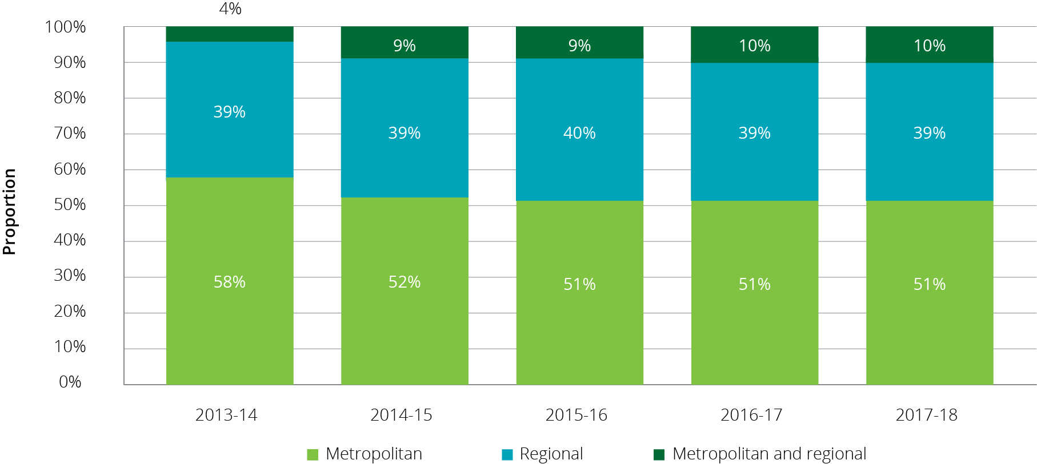

### Residential care facility size and room configuration

The average size of residential care facilities has been increasing over the last 10 years (Table 6.4). In 2008, 60 per cent of facilities had over 60 places. This has increased to 75 per cent in 2018. By contrast, the proportion of facilities with 40 places or less has decreased from 15 per cent in 2008 to below 9 per cent in 2018. This trend seems particularly evident in the for‑profit sector, as discussed in Section 6.1.3, with for‑profit providers having, on average, almost 20 more places per facility than the not‑for‑profits.

Table 6.4: Size of residential care facilities, 2008 to 2018

| Number of places | June 2008 | June 2009 | June 2010 | June 2011 | June 2012 | June 2013 | June 2014 | June 2015 | June 2016 | June 2017 | June 2018 |
| --- | --- | --- | --- | --- | --- | --- | --- | --- | --- | --- | --- |
| Proportion of facilities (%) | | | | | | | | | | | |
| 1–20 places | 1.6 | 1.4 | 1.4 | 1.4 | 1.3 | 1.2 | 1.1 | 1.1 | 1.1 | 1.0 | 0.9 |
| 21–40 places | 13.2 | 10.7 | 9.9 | 10.1 | 9.4 | 9.2 | 8.5 | 8.1 | 7.6 | 7.2 | 6.8 |
| 41–60 places | 25.2 | 22.4 | 21.4 | 21.9 | 20.4 | 19.6 | 18.1 | 17.4 | 16.4 | 15.4 | 14.2 |
| 61+ places | 59.9 | 65.5 | 67.3 | 66.6 | 68.9 | 69.9 | 72.2 | 73.3 | 74.9 | 76.4 | 78.0 |

The predominant room configuration for residential care facilities is a single-bed room with an ensuite. It is estimated that around 80 per cent (77 per cent in 2016‑17) of rooms are single-bed rooms with an ensuite and around 3 per cent (5 per cent in 2016‑17) are shared rooms with an ensuite. Around 14 per cent of residents are in rooms that could be considered ‘ward style’ which are shared and have a common shared bathroom (18 per cent in 2016-17).

### Provisionally allocated places

The Commonwealth releases residential care places through the ACAR. After a place is allocated to an approved provider, there is usually a period during which the place is considered ‘provisional’ while the provider constructs the facility or extends the current facility. Once the place is available to be occupied by a resident, it becomes ‘operational’. The average time it takes providers to bring places online is around four years.

At 30 June 2018, there were 31,603 provisional residential care places reflecting the carryover of allocated places from previous ACARs which are yet to become operational. This represents around 13 per cent of all allocated places, which compares with 16 per cent at 30 June 2017 and 14 per cent at 30 June 2014. The absence of an ACAR during 2017-18 would largely account for the proportionate reduction in provisional places compared with 2016‑17. The provisional allocations are held by around 16 per cent of all facilities.

As was the case last year, Queensland, Western Australia and the ACT have the highest proportion of provisionally allocated places. South Australia and Tasmania have once again the lowest with 3 and 4 per cent respectively (Table 6.5).

Not-for-profit providers, who have 55 per cent of operational places, have only 35 per cent of provisionally allocated places, whereas the for-profit providers, who have 41 per cent of operational places, have 65 per cent of the provisionally allocated places. This is similar to previous years.

In addition, there were also 7,802 formerly operational places at 30 June 2018 that were offline at 30 June 2018 pending refurbishment or redevelopment, or pending sale to another provider.

Table 6.5: Provisionally allocated residential care places, by state and territory, at 30 June 2018

| State/territory | Provisionally allocated places | All allocated places | Proportion |
| --- | --- | --- | --- |
| New South Wales | 8,806 | 82,169 | 10.7% |
| Victoria | 8,416 | 65,366 | 12.9% |
| Queensland | 8,170 | 48,502 | 16.8% |
| Western Australia | 4,638 | 22,121 | 21.0% |
| South Australia | 633 | 18,926 | 3.3% |
| Tasmania | 208 | 5,357 | 3.9% |
| Australian Capital Territory | 647 | 3,425 | 18.9% |
| Northern Territory | 85 | 670 | 12.7% |
| **Australia** | **31,603** | **246,536** | **12.8%** |

Changes introduced in 2016 were designed to encourage providers to operationalise their provisional places in a timely manner. The changes limit the provisional allocation period to four years (noting that up to two extensions of 12 months each may be granted by the Department of Health, and further extensions in exceptional circumstances). At the end of this time, the provisional allocations lapse and the places return to the Department for redistribution in a future ACAR.

As noted earlier 1,371 provisionally allocated places were either surrendered by providers or revoked by the Department during 2017-18. The majority (1,083) of these provisionally allocated places were surrendered by providers or lapsed as the six years expired and the provider did not apply for an extension. The remaining 298 provisionally allocated places were revoked by the Department because the providers were not able to meet the exceptional circumstances test for a further extension after six years.

Table 6.6 and Table 6.7 show the distribution of the age of provisionally allocated places by location and state and territory.

Table 6.6: Provisionally allocated residential care places by location and year of distribution, at 30 June 2018

|  | <1 year old | 1-2 years old | 2-4 years old | 4-6 years old | 6-8 years old | 8-10 years old | 10+ years | Total |
| --- | --- | --- | --- | --- | --- | --- | --- | --- |
| Metropolitan | 60 | 6,700 | 12,504 | 2,232 | 1,578 | 475 | 603 | 24,152 |
| Inner regional | 0 | 1,986 | 3,008 | 417 | 163 | 48 | 52 | 5,674 |
| Outer regional | 0 | 394 | 1,298 | 12 | 23 | 0 | 0 | 1,727 |
| Remote | 0 | 0 | 30 | 0 | 20 | 0 | 0 | 50 |
| **Total** | **0** | **9,080** | **16,840** | **2,661** | **1,784** | **523** | **655** | **31,603** |

Table 6.7: Provisionally allocated residential care places by state and territory and year of distribution, at 30 June 2018

|  | <1 year old | 1-2 years old | 2-4 years old | 4-6 years old | 6-8 years old | 8-10 years old | 10+ years | Total |
| --- | --- | --- | --- | --- | --- | --- | --- | --- |
| NSW | 0 | 2,315 | 4,340 | 1,030 | 689 | 247 | 185 | 8,806 |
| VIC | 0 | 2,438 | 5,035 | 643 | 184 | 24 | 92 | 8,416 |
| QLD | 60 | 2,259 | 4,456 | 540 | 695 | 24 | 136 | 8,170 |
| WA | 0 | 1,621 | 2,131 | 400 | 32 | 228 | 226 | 4,638 |
| SA | 0 | 200 | 336 | 7 | 90 | 0 | 0 | 633 |
| TAS | 0 | 103 | 105 | 0 | 0 | 0 | 0 | 208 |
| ACT | 0 | 144 | 372 | 41 | 74 | 0 | 16 | 647 |
| NT | 0 | 0 | 65 | 0 | 20 | 0 | 0 | 85 |
| **Total** | **60** | **9,080** | **16,840** | **2,661** | **1,784** | **523** | **655** | **31,603** |

#### Transferring residential care places

Residential aged care places (both provisionally allocated and operational) may be transferred between providers. A transfer of places commonly occurs as the result of a business transaction between two approved providers where a decision has been made by the transferor to sell all or some of their residential care places. Transfers of places need to be approved by the Department of Health.

As a general rule, when places transfer between providers, the planning region in respect of which the places are allocated does not change. This rule, and the need for approval by the Department of Health, are designed to discourage attempts to subvert the competitive allocation process and to maintain care delivery in the region where the places were originally allocated.

Data from the Department of Health shows that in 2017‑18 there were 64 transactions involving the transfer of around 4,400 operational places and 45 transactions involving the transfer of around 2,400 provisionally allocated places.

Data on the number of places being transferred between providers is an indicator of consolidation within the sector. Given increasing reports of providers looking to leave the sector, ACFA will continue to monitor this data on the transfer of residential care places.

### Extra service

Providers with extra service status are able to charge an extra service fee for residents occupying an extra service place for the duration of their stay. Extra service status involves the provision of a higher than average standard of services, including accommodation, range and quality of food, and non-care services such as recreational and personal interest activities.

To be eligible for extra service status, providers must first seek approval from the Department. Providers that have been granted extra service status apply to the Aged Care Pricing Commissioner for approval of their proposed extra service fees, including proposed increases to current extra service fees.

For extra service status places that are occupied by a resident who was in care prior to 1 July 2014 and who is covered under the pre-reform fee arrangements, the care subsidy is reduced by 25 per cent of the approved extra service fee for that place. This is known as the Extra Service Subsidy Reduction. The provider can charge a continuing care recipient an amount equal to the extra service fee plus the extra service reduction for receiving extra service. Extra service subsidy reduction does not apply to residents entering care on or after 1 July 2014.

There was a significant decrease in 2014-15 and 2015‑16 in the number of places with extra service status (Chart 6.6). This was likely because changes made to accommodation pricing on 1 July 2014 reduced the need and motivation for providers to have extra service status, partly because:

* lump sum accommodation payments can now be made for all care types – previously they were restricted to low care or high care with extra service;
* market-based prices determined by the provider apply for all new non-supported residents; and
* providers can offer additional care and services for additional fees outside the extra service framework.

This led some providers to reconsider their extra service status, with many offering residents ‘additional service’ arrangements instead. However, as shown, the number of extra service places has stabilised over the last two years.

Chart 6.6: Number of active extra service residential care places, 30 June 2014 to 30 June 2018

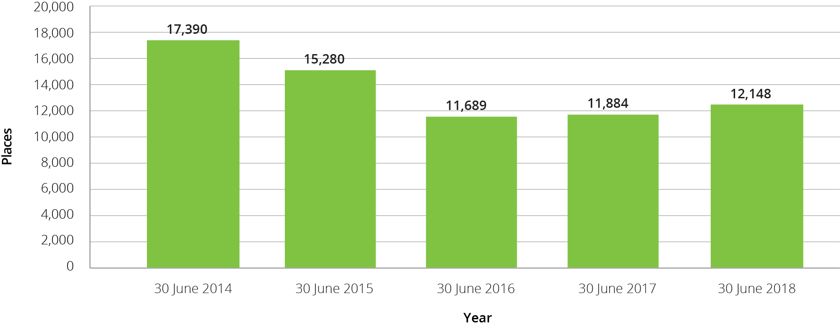

### Additional services

Additional services are care and services that aged care providers can make available to consumers above those that they are legislatively required to provide under the Schedule of specified care and services for residential care services. Additional services vary greatly but may include items such as the provision of pay TV, hairdressing, additional beverage offerings (e.g. wine and beer) and access to a gym. Additional services may be offered individually or as part of a bundle of services. These services attract an additional fee for consumers.

An additional service fee can only be charged for services that have been agreed to by the resident, that are over and above those paid for by the Commonwealth, and from which aged care residents receive a direct and tangible benefit.

There is very limited data available on additional services, however, anecdotal evidence is that this is an area that is receiving increasing attention from providers. The department is working with the sector to provide additional clarity and transparency for both providers and residents on the operation of additional services. It is anticipated that additional data will be available in future years to enable analysis.

## Residential care funding sources

### Operational funding

Funding for residential care is made up of operational funding and capital financing.

Operational funding supports day-to-day services such as nursing and personal care, living expenses and accommodation expenses. Capital financing supports the construction of new residential care facilities and the refurbishment of existing facilities. Capital financing is discussed in Chapter 7.

A combination of Australian Government and resident contributions provides the operational funding for residential care. Figure 6.1 shows the different funding types from the Commonwealth and residents for operational funding.

Figure 6.1: Residential care services

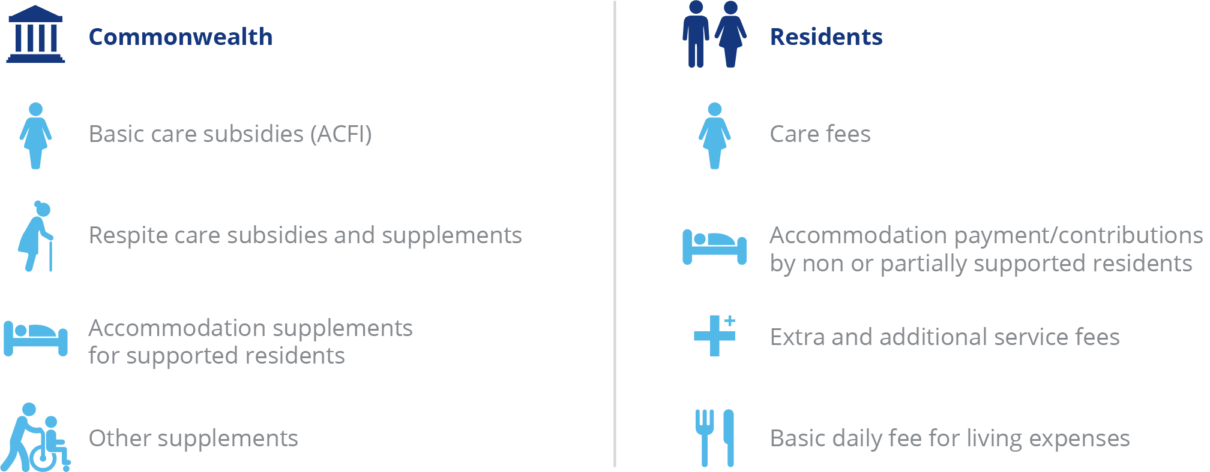

The Commonwealth determines its contributions on behalf of permanent residents in residential care by setting:

A basic care subsidy for personal and nursing care;

the rates of supplements paid to support aspects of residential care that incur higher costs to deliver; and

the maximum rate of accommodation supplement.

With regard to respite care, the Commonwealth sets the basic respite care subsidy at two levels (low or high) depending on the level of respite care the consumer is approved for by the Aged Care Assessment Team (ACAT).

The Commonwealth also sets the maximum levels for contributions made by residents for the following:

* the maximum rate of the basic daily fee for living expenses (permanent and respite); and
* the maximum means tested care fee that may be charged by providers (permanent only).

### Commonwealth operational funding

Commonwealth payments for residential care in 2017-18 can be classified as:

* basic care subsidies
* respite care subsidies and supplements
* accommodation supplements
* viability supplements
* other supplements

A full list of subsidies and supplements is at Appendix G.

Commonwealth subsidies and supplements are generally indexed either biannually (accommodation related) or annually (care related).

The indexation applied to the basic subsidy for residential care is the Wage Cost Index 9 (WCI‑9), which is a composite index constructed by the Department of Finance that comprises a wage cost component (weighted at 75 per cent) and a non-wage cost component (weighted at 25 per cent). For all Wage Cost Indices the value of the wage cost component is based on the dollar increase in the national minimum wage (as determined annually by the Fair Work Commission) expressed as a percentage of the latest available estimate of average weekly ordinary time earnings (AWOTE) published by the Australian Bureau of Statistics as at November of each year. The value of the non-wage cost component of WCI-9 is based on changes in the Consumer Price Index between the March quarters each year.

Accommodation related supplements are indexed using the Consumer Price Index (CPI) and are indexed twice a year in line with the aged pension.

### Basic care subsidies

* **The basic care subsidy** is a payment to support the costs of providing personal and nursing services for permanent residents. It is calculated based on the assessed need of each permanent resident as determined by the provider by applying the Aged Care Funding Instrument (ACFI).The Commonwealth determines the level of payments on behalf of residents by setting the prices and rules for claiming ACFI care subsidies.
* **The residential respite subsidy** is a payment to support the costs of providing personal and nursing services for respite consumers. Respite consumers are assessed by an ACAT as requiring either low or high level respite care, with payment amounts for each set by the Commonwealth.

#### The Aged Care Funding Instrument (ACFI)

The ACFI is the funding allocation tool currently used to determine the amount of funding paid to a provider on behalf of a resident for their care. It assesses the care needs of permanent residents as a basis for allocating care funding by focusing the funding allocation around the main areas that differentiate relative care needs and costs among residents.

The ACFI consists of 12 questions about assessed care needs, each having four ratings (A, B, C or D) and two diagnostic sections. ACFI is self-assessed by providers, but is subject to audits by the Department of Health.

As discussed in last year’s report, during 2015-16, real growth of expenditure per resident per day through the ACFI was 5.2 per cent, compared with a Government budgeted growth of 3.2 per cent. This resulted in an increase to the Government’s forecast expenditure over four years of $3.8 billion.

The Government responded by announcing changes to the ACFI and indexation. These changes took effect on 1 July 2016 and 1 January 2017. The changes to ACFI included a new matrix reducing the rating categories for medication under Question 11 of the Complex Health Care domain and changes to the scoring and eligibility requirements for certain Complex Health Care procedures. The changes were complemented by an indexation pause on all ACFI domains in 2017‑18 and a partial indexation pause in 2018‑19.

Annual growth in the daily average ACFI expenditure for 2017-18 was forecast to be around 2.4 per cent; the actual growth for the year was 0.0 per cent.

For 2018-19, annual real growth in ACFI is forecast to be 1.4 per cent. Real growth up to November 2018 was 1.0 per cent. Real growth refers to growth in the average ACFI above that which can be attributed to the indexation applied to ACFI rates on 1 July 2018. Separate to the annual indexation increases, the government announced two measures that will impact average subsidies paid to providers in 2018-19. These are the $50 million in ACFI funding from September 2018 to assist providers in transitioning to the new Quality Standards, and the $320 million increase in ACFI funding from March to end June 2019. These increases are for the 2018-19 year only.

The Department of Health produces monthly reports regarding actual ACFI expenditure compared with Budget estimates. These reports can be found at <https://agedcare.health.gov.au/tools-and-resources/aged-care-funding-instrument-acfi-reports>.

Chart 6.7: Average monthly ACFI payments (real and nominal), January 2016 to November 2018

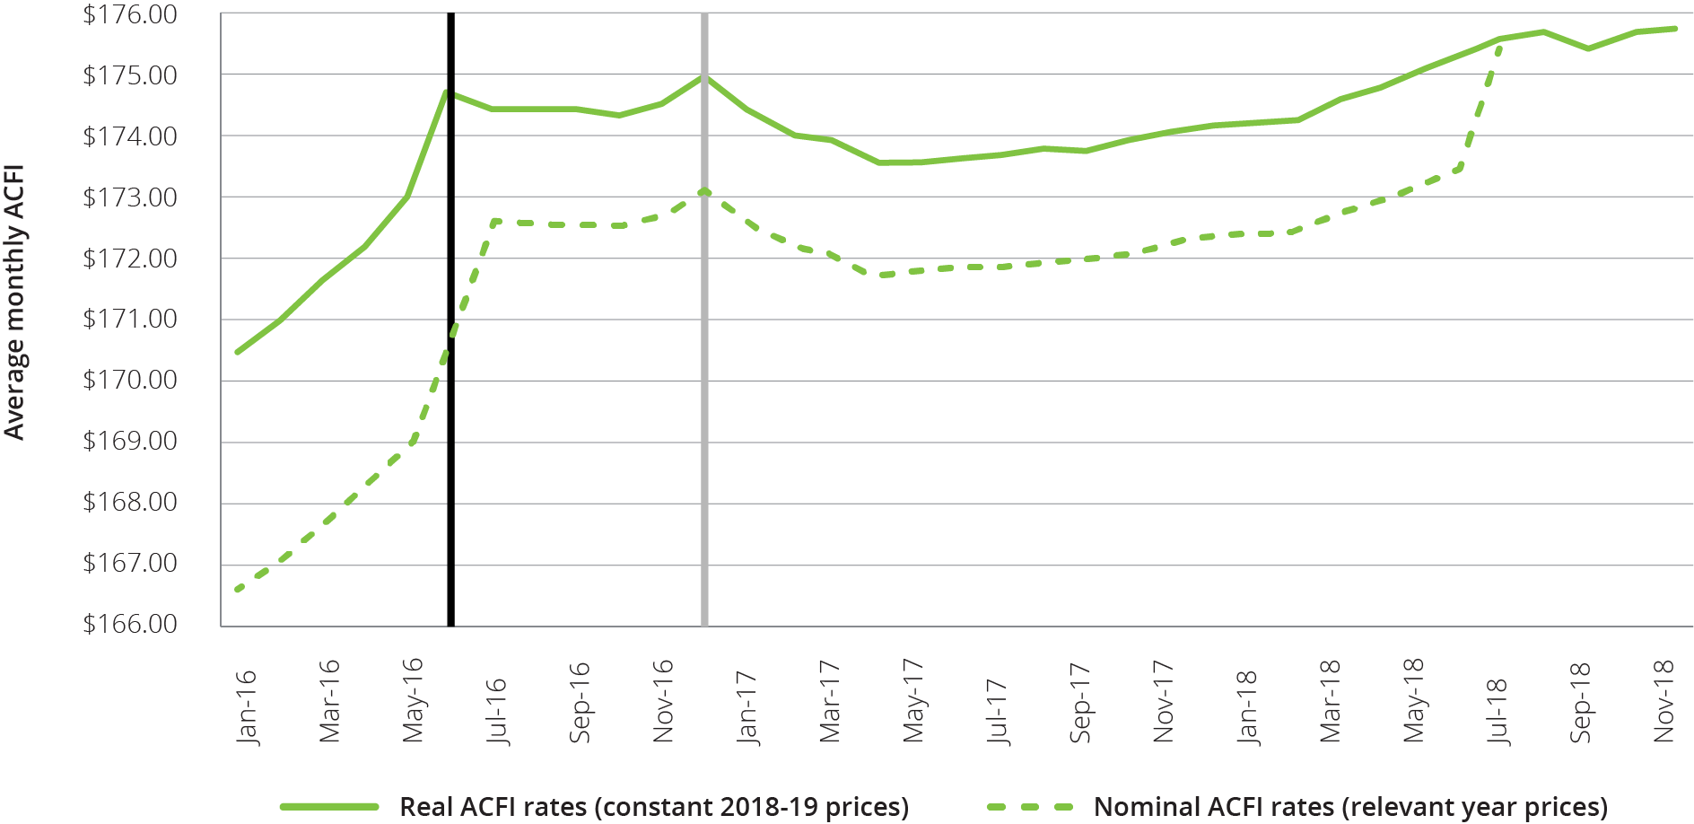

The average ACFI claim per resident per day can vary across facilities, reflecting variations in resident profile and the claiming behaviour of providers. A number of providers indicated during consultations that they were ‘under claiming’ ACFI relative to the care needs of residents and were seeking to improve their ACFI claims process. Chart 6.8 shows the range of claims for 2017-18 with some facilities averaging less than $70 per day while some average over $210 per day.

Chart 6.8: Number of residential care facilities in each range of ACFI claims per resident per day, 2017-18

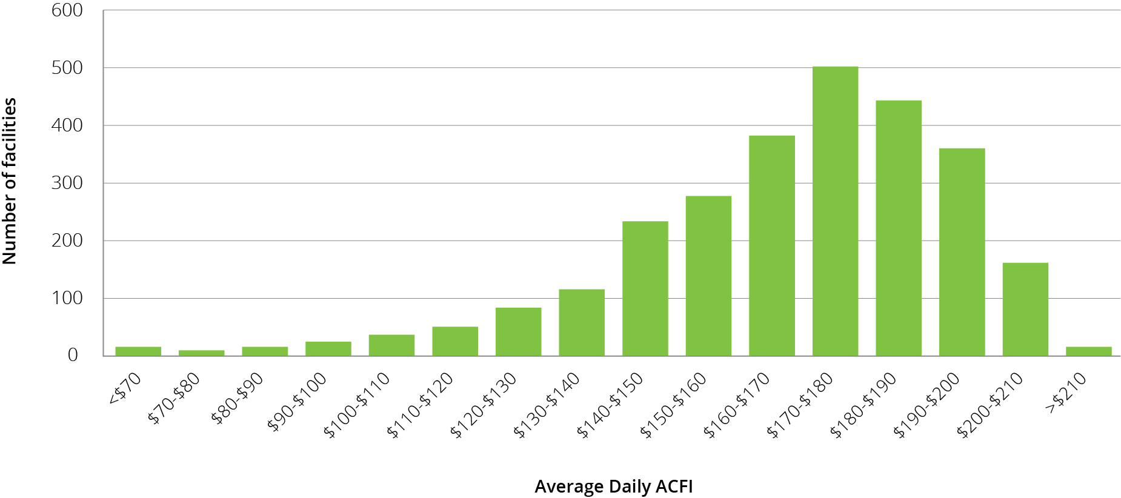

As noted last year, the Government commissioned a study on the relative costs of providing care for residents with differing care needs and has been consulting with the sector on long-term reform options for residential aged care funding. Reports from the Resource Utilisation and Classification Study (RUCS) were released in March 2019 and include evidence on the drivers of costs of care in residential care facilities as well as a proposed new funding model to replace the ACFI. The Government is consulting with the sector on the recommendations in the reports.

The RUCS suggests that ACFI does not adequately distinguish between the fixed costs of providing residential aged care and the variable costs per resident based on individual care needs. As part of the RUCS, a new assessment and funding model has been proposed, known as the Australian National Aged Care Classification (AN-ACC) system. The system includes a funding assessment tool for use by external assessors, a casemix classification system with 13 classes and a system of base care tariffs that reflects the differences in shared costs faced by providers with different care specialities and locations. Under the proposed model providers would receive a payment that consists of a base care tariff for shared costs, a payment for each resident based on their AN-ACC class and a one-off adjustment payment for each new resident that enters care.

The ACFI does not apply for residential respite care. Instead, respite care funding is paid at either a low or high rate depending on the level of care for which the consumer is approved by the ACAT. Additionally, providers who use 70 per cent or more of their respite allocation over a 12‑month period receive a higher payment[30].

### Residential care supplements

Residential care supplements are payments in addition to the basic daily subsidy (ACFI). There are two types of supplements:

primary supplements, which provide additional funds to meet specific care needs. These include the oxygen supplement and enteral feeding supplement; and

other supplements, which are accommodation-based and assist providers with costs related to the operation of a residential care facility. Other supplements include accommodation supplements, the viability supplement and homeless supplement.

The types and amounts of supplements that a residential care facility will receive depends on the provider and/or residents meeting the eligibility requirements for those supplements.

The major supplements are summarised below and a full list of supplements, including rates and expenditure over the last 3 years are included at Appendices G and H.

#### Accommodation supplements

Accommodation supplements are paid by the Commonwealth to assist with the accommodation costs of permanent residents who do not have the means to meet all of that cost themselves (supported residents). These supplements include both the current accommodation supplement and grand-parented supplements under previous policies. Accommodation supplements (or accommodation payments) do not apply for consumers accessing residential respite care.

The Commonwealth determines the amount of accommodation supplement payable by setting the maximum rate of accommodation supplement and determining the share paid by residents based on a means test.

Two significant reforms from 1 July 2014 affected accommodation payments. A new means test that combined the formerly separate income and assets tests was introduced for residents entering residential care after 1 July 2014, and the accommodation supplement paid by the Commonwealth to a provider on behalf of supported residents living in aged care facilities that have been built or significantly refurbished since 20 April 2012 was significantly increased.

#### Viability supplement

The Viability supplement aims to improve the financial position of smaller, rural and remote residential care facilities that incur additional costs due to their location and are constrained in their ability to realise economies of scale due to smaller numbers of beds. In addition, the Viability supplement also supports providers who specialise in aged care services for Indigenous people, or people who are homeless or who are at risk of becoming homeless, in recognition of the often higher costs associated with providing these services.

The supplement is available to residential care facilities, home care services, Multi-Purpose Services and Aboriginal and Torres Strait Islander Flexible services. In 2017-18, on average, the Viability supplement provided around $10,000 per resident per annum for residential care facilities in remote and very remote areas, directly improving their financial results.

A 30 per cent increase to the rate of the Viability supplement was announced by Government in December 2018, taking effect from March 2019.

#### Homeless supplement

A Homeless supplement is paid to providers for each resident of an eligible aged care facility. Eligibility for the supplement is based on the facility having more than 50 per cent of its residents who are identified as being homeless, or at risk of being homeless. The supplement is in addition to the funding provided under the Viability supplement.

In 2017-18 the Homeless supplement was paid in respect of around 1,500 residents. During 2017‑18 $8.6 million in Homeless supplement was paid to providers.

A 30 per cent increase to the rate of the Homeless supplement was announced by Government in December 2018, taking effect from March 2019.

### Payments for residential respite care

The Australian Government pays the provider a residential respite subsidy and a respite supplement for each eligible respite resident.

The subsidy and supplement are paid at either a low or high rate depending on the level of respite care the consumer is approved for by the ACAT. Additionally, facilities that use 70 per cent or more of their respite allocation over a 12 month period receive a higher daily respite supplement rate per eligible high care recipient. Respite subsidies are indexed on 1 July each year. Respite supplements are indexed on 20 March and 20 September each year in line with pension indexation. Table 6.8 shows the residential care respite rates applicable as at 20 March 2019.

A one-off increase in the respite subsidy rates for both high and low level respite care was made on 20 March 2019 as part of the Government’s Mid-Year Economic and Fiscal Outlook for 2018-19. This increase will cease on 30 June 2019, and indexation will occur on 1 July 2019 based on the basic subsidy amount less the one-off increase.

Table 6.8: Residential respite care subsidies and supplement rates, at 20 March 2019

|  | Daily subsidy | Daily supplement | Total paid per day |
| --- | --- | --- | --- |
| Low level respite care | $51.17 | $39.15 | $90.32 |
| High level respite care | $143.47 | $54.87 | $198.34 |
| High level respite care when a facility uses 70% or more of respite allocation | $143.05 | $93.36 | $236.83 |

In addition, residential respite consumers can be eligible for other supplements, such as oxygen supplement, where there is a need.

Chart 6.9 shows total Commonwealth payments for residential respite care since 2011-12.

Chart 6.9: Total residential respite care expenditure, 2011-12 to 2017-18 ($m)

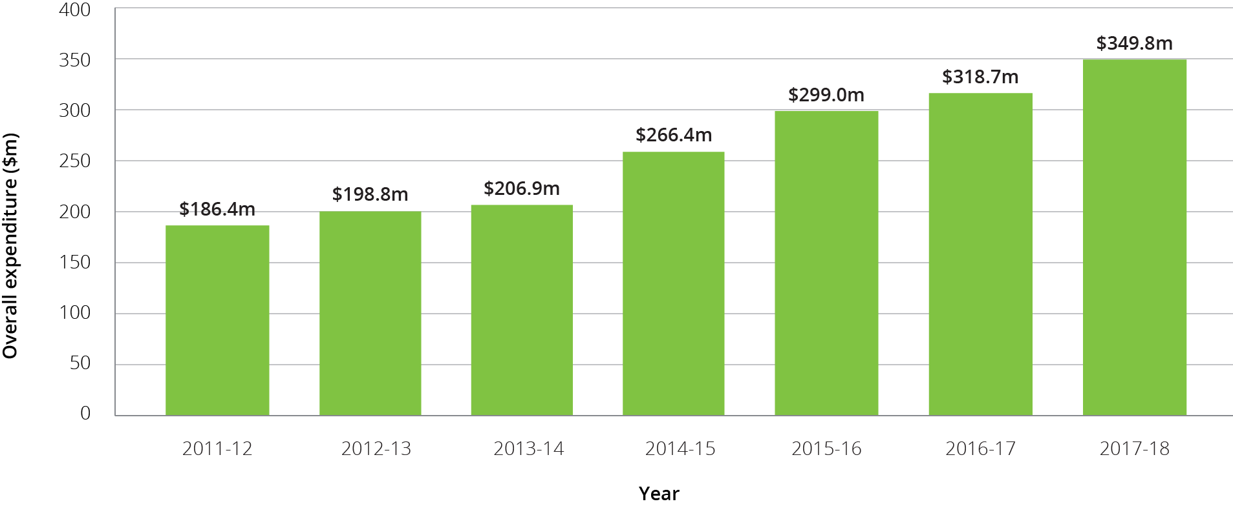

### Resident operational funding

Contributions by permanent residents in 2017-18 for operational funding were made up of:

* **A basic daily fee,** which is a contribution towards living expenses such as meals, laundry services, utilities and toiletries. The price is set by the Commonwealth, and is currently set at a maximum of 85 per cent of the single basic age pension.
* **A means tested care fee,** which is a contribution some residents make towards their care costs (personal and nursing) based on their assessable income and assets. Annual and lifetime caps on care contributions apply as a consumer protection. As at 20 March 2019 the annual cap for a means tested care fee was $27,532.59, with a lifetime cap of $66,078.27 also applying.
* **Accommodation payments,** which are daily payments for accommodation in an aged care facility. Lump sum accommodation deposits are not treated as revenue, but as capital financing, discussed in Chapter 7.
* **Extra service fees,** which residents in aged care facilities with extra service status may be asked to pay for significantly higher standards of accommodation, food and non-care services. These vary from facility to facility.

**Additional services fees,** which are for care and services in non-extra service facilities that are over and above those that providers are required to deliver under the Specified Care and Services Schedule of the Aged Care Act 1997, and must be agreed between the resident and provider. These vary from facility to facility, and are not payable at all facilities.

## Operational performance in 2017-18

### Revenue

ACFA broadly describes revenue for residential care providers in four categories: care related, living expenses, accommodation and other. Table 6.9 provides a breakdown of the revenue reported by residential care providers in 2017‑18 compared with the previous two years.

Table 6.9: Revenue sources for residential care providers, by care, accommodation, living and ‘other’, 2015-16 to 2017-18 ($m)

| Revenue sources | 2015-16 ($million) | 2016-17 ($million) | Change (%) | 2017-18 ($million) | Change (%) |
| --- | --- | --- | --- | --- | --- |
| **Care related** |  |  |  |  |  |
| Basic care subsidy (ACFI) | $9,991.3 | $10,741.7 | 7.5% | $10,812.3 | 0.7% |
| Respite subsidy | $287.7 | $301.4 | 4.8% | $346.9 | 15.1% |
| Other supplements | $72.8 | $89.3 | 22.7% | $84.5 | -5.4% |
| Resident means tested care fees | $456.0 | $468.9 | 2.8% | $504.0 | 7.5% |
| Resident other care fees | $0 | $61.2 | N/A | $48.7 | -20.4% |
| **Total care revenue** | **$10,807.8** | **$11,662.5** | **7.9%** | **$11,796.4** | **1.1%** |
| **Living related** |  |  |  |  |  |
| Resident basic daily fee | $3,088.9 | $3,186.7 | 3.2% | $3,253.4 | 2.1% |
| Extra service fees | $146.9 | $157.5 | 7.2% | $119.3 | -24.3% |
| Additional services fees | $0.0 | $0.0 | N/A | $96.7 | N/A |
| **Total living related revenue** | **$3,235.8** | **$3,344.2** | **3.4%** | **$3,469.4** | **3.7%** |
| **Accommodation related** |  |  |  |  |  |
| Accommodation supplement | $941.6 | $929.7 | -1.3% | $1,008.1 | 8.4% |
| Accommodation payments from residents | $850.8 | $778.4 | -8.5% | $781.0 | 0.3% |
| Capital grants | $0.0 | $61.7 | N/A | $56.5 | -8.4% |
| **Total accommodation related revenue** | **$1,792.4** | **$1,769.8** | -1.3% | **$1,845.6** | **4.3%** |
| **Other income** |  |  |  |  |  |
| Interest | $0.0 | $313.8 | N/A | $326.2 | 4.0% |
| Donations and fundraising | $0.0 | $32.3 | N/A | $29.0 | -10.2% |
| Gain on sale of assets | $0.0 | $29.1 | N/A | $23.2 | -20.3% |
| Revaluation of assets | $0.0 | $130.4 | N/A | $37.9 | -70.9% |
| Other | $1,335.8 | $474.4 | -64.5% | $538.6 | 13.5% |
| **Total other revenue** | **$1,335.8** | **$980.0** | -26.6% | **$954.9** | -2.6% |
| **Total residential care provider revenue** | **$17,171.8** | **$17,756.5** | **3.4%** | **$18,066.3** | **1.7%** |

1. The inclusion of a line item for additional services fees has resulted in a decrease in extra services fees, resident other care fees, and comparative decrease in accommodation payments from residents. I.e. providers allocated their revenue from additional service fees across these categories last year. This was mentioned in the note under the table last year.
2. Fees and charges received from a resident in respect of occasional care services like consultation, medication, treatment or procedures provided in addition to services required to be delivered under Schedule 1 of the Aged Care Act 1997.

In 2017‑18, care related revenue formed the majority (65.2 per cent) of total revenue earned by residential care providers ($11.8 billion), similar to 2016‑17. Living related revenue received from residents, which includes the basic daily fee, extra services fees and additional service fees, accounted for 19.2 per cent ($3.5 billion) of total revenue, again similar to 2016‑17.

Accommodation payments, consisting of accommodation supplements paid by the Government and daily accommodation payments paid by residents, accounted for 10.2 per cent ($1.8 billion) of total provider revenue in 2017‑18, compared with 9.6 per cent in 2016‑17.

Other income of $955 million made up the remaining 5.3 per cent of total residential care revenue in 2017‑18. Interest revenue, which makes up over a third of total ‘other’ income may include interest earned on lump sum deposits less any interest payments made on borrowings (providers may show these separately in their balance sheets or may combine them as ‘net’).

Chart 6.10 shows the proportions of all revenue sources for residential care providers in 2017-18.

Chart 6.10: Proportions of total residential care provider revenue, 2017-18 ($m)

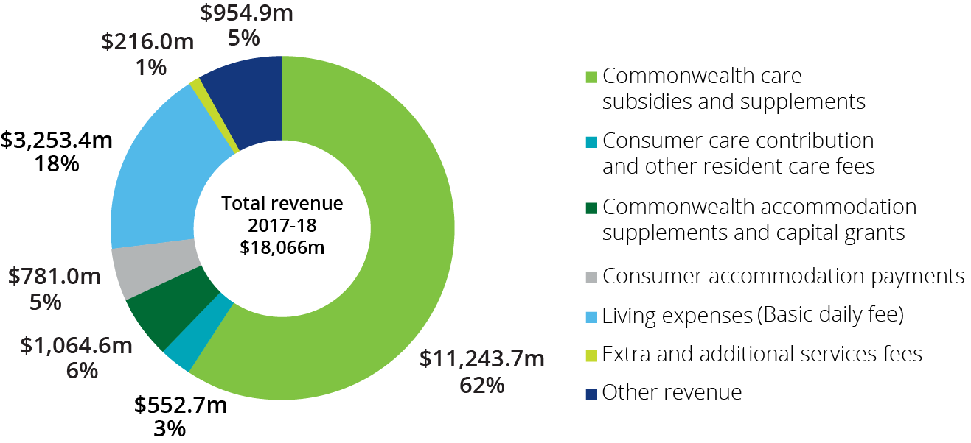

ACFA also analyses revenue sources in terms of those sources provided by the Commonwealth compared with those provided by residents. Table 6.10 shows provider revenue sources for 2016‑17 and 2017‑18, split by Commonwealth, resident and other.

Table 6.10: Revenue sources for residential care providers, Commonwealth, resident and ‘other’, 2016-17 and 2017-18 ($m)

| Revenue sources | 2016-17 ($million) | 2017-18 ($million) | Change ($million) | Change (%) |
| --- | --- | --- | --- | --- |
| **Commonwealth** |  |  |  |  |
| Basic care subsidy (ACFI) | $10,741.70 | $10,812.30 | $70.60 | 0.7% |
| Respite subsidy | $301.40 | $346.90 | $45.50 | 15.1% |
| Other supplements | $89.30 | $84.50 | -$4.80 | -5.4% |
| Accommodation supplements | $929.70 | $1,008.10 | $78.40 | 8.4% |
| Capital grants | $61.70 | $56.50 | -$5.20 | -8.4% |
| **Commonwealth funding sources** | **$12,123.80** | **$12,308.30** | **$184.50** | **1.5%** |
| **Resident** |  |  |  |  |
| Basic daily fee | $3,186.70 | $3,253.40 | $66.70 | 2.1% |
| Means tested care fees | $468.90 | $504.00 | $35.10 | 7.5% |
| Resident care fees - other | $61.20 | $48.70 | -$12.50 | -20.4% |
| Accommodation payments | $778.40 | $781.00 | $2.60 | 0.3% |
| Extra services fee | $157.50 | $119.30 | -$38.20 | -24.3% |
| Additional services fee | N/A | $96.70 | $96.70 | N/A |
| **Resident funding sources** | **$4,652.70** | **$4,803.10** | **$150.40** | **3.2%** |
| **Other income** |  |  |  |  |
| Interest | $313.80 | $326.20 | $12.40 | 4.0% |
| Donations and fundraising | $32.30 | $29.00 | -$3.30 | -10.2% |
| Gain on sale of assets | $29.10 | $23.20 | -$5.90 | -20.3% |
| Revaluation of assets | $130.40 | $37.90 | -$92.50 | -70.9% |
| Other | $474.40 | $538.60 | $64.20 | 13.5% |
| **Other funding sources** | **$980.00** | **$954.90** | -$25.10 | -2.6% |
| **Total revenue** | **$17,756.50** | **$18,066.30** | **$309.80** | **1.7%** |

1. Extra service subsidy reduction does not apply to new residents entering care from 1 July 2014, however it still applies to residents in ESS places who were in care prior to 1 July 2014.
2. Additional services fees were not reported for 2016‑17 so no comparison is possible.

Overall in 2017‑18, the Commonwealth contributed 68.1 per cent of total provider funding ($12.3 billion). Residents contributed 26.6 per cent ($4.8 billion) while income from other sources comprised the remaining 5.3 per cent ($955 million). This compares with 2016‑17 where the Commonwealth share was 68.3 per cent, residents contributed 26.2 per cent and other income was 5.5 per cent.

Chart 6.11 shows the proportion of revenue that residential care providers received in 2017‑18 from the Commonwealth. Basic subsidies (ACFI) comprised by far the greatest share at 88 per cent.

Chart 6.11: Proportions of provider revenue from the Commonwealth, 2017-18 ($m)

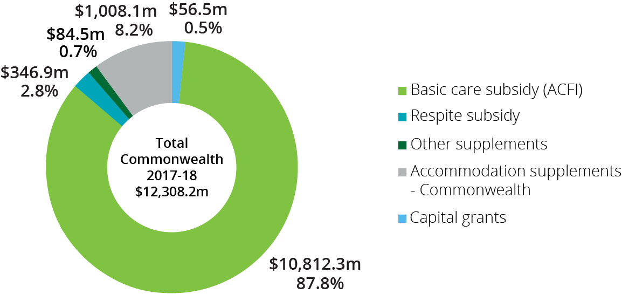

Chart 6.12 shows the proportion of total revenue that residential care providers receive from residents. The basic daily fee forms the greatest share (68 per cent). Means tested care fees formed a further 16 per cent of the revenue received.

Chart 6.12: Proportions of residential care provider revenue from residents, 2017-18 ($m)

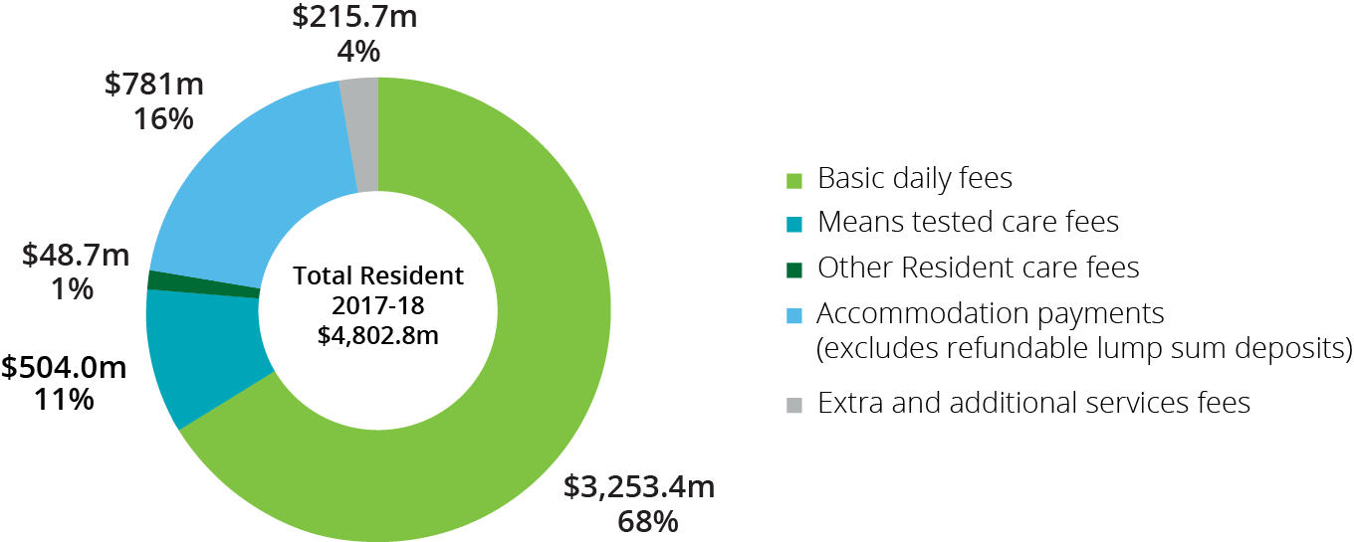

Table 6.11 shows total revenue per resident per day in 2017‑18 compared with 2016‑17. Total revenue per resident was $272.16, an increase of 1.0 per cent from 2016‑17 ($269.58).

Table 6.11: Residential care provider revenue sources per resident per day, 2016-17 and 2017-18

|  | 2016-17 | 2017-18 | Change ($ p.r.p.d.) | Change (%) |
| --- | --- | --- | --- | --- |
| **Commonwealth revenue sources** |  |  |  |  |
| ACFI | $163.07 | $162.88 | -$0.19 | -0.1% |
| Respite care subsidies and supplements | $4.58 | $5.23 | $0.65 | 14.2% |
| Other supplements | $1.36 | $1.27 | -$0.09 | -6.6% |
| Accommodation supplements | $14.11 | $15.19 | $1.08 | 7.7% |
| Commonwealth capital grants | $0.94 | $0.85 | -$0.09 | -9.6% |
| **Total Commonwealth revenue** | **$184.06** | **$185.42** | **$1.36** | **0.7%** |
| **Resident revenue sources** |  |  |  |  |
| Means tested care fees | $7.12 | $7.59 | $0.47 | 6.6% |
| Accommodation payments | $11.82 | $11.77 | -$0.05 | -0.4% |
| Basic daily fees | $48.38 | $49.01 | $0.63 | 1.3% |
| Extra services fee | $2.39 | $1.80 | -$0.59 | -24.7% |
| Additional services fees | $0.00 | $1.46 | $1.46 | N/A |
| Resident care fees - other | $0.93 | $0.73 | -$0.20 | -21.5% |
| **Total resident revenue** | **$70.64** | **$72.36** | **$1.72** | **2.4%** |
| **Other** |  |  |  |  |
| Other income | $14.88 | $14.38 | -$0.50 | -3.4% |
| **Total revenue** | **$269.58** | **$272.16** | **$2.58** | **1.0%** |

1. Extra service subsidy reduction does not apply to new residents entering care from 1 July 2014, however it still applies to residents in ESS places who were in care prior to 1 July 2014.
2. The amount shown for ACFI includes a small number of residents who are grand parented under the former ‘Resident Classification Scale,’ which was the funding instrument in place prior to the ACFI being introduced in 2008.

### Expenses

Total expenditure in 2017‑18, for residential care providers was $17.63 billion, up 5.3 per cent from $16.75 billion in 2016‑17. Chart 6.13 shows total expenses for the six years to 2017‑18. While expenses increased by 5.3 per cent in 2017‑18 compared with 2016‑17 revenue only increased by 1.7 per cent.

Chart 6.13: Total expenses, residential care providers, 2012-13 to 2017-18 ($b)

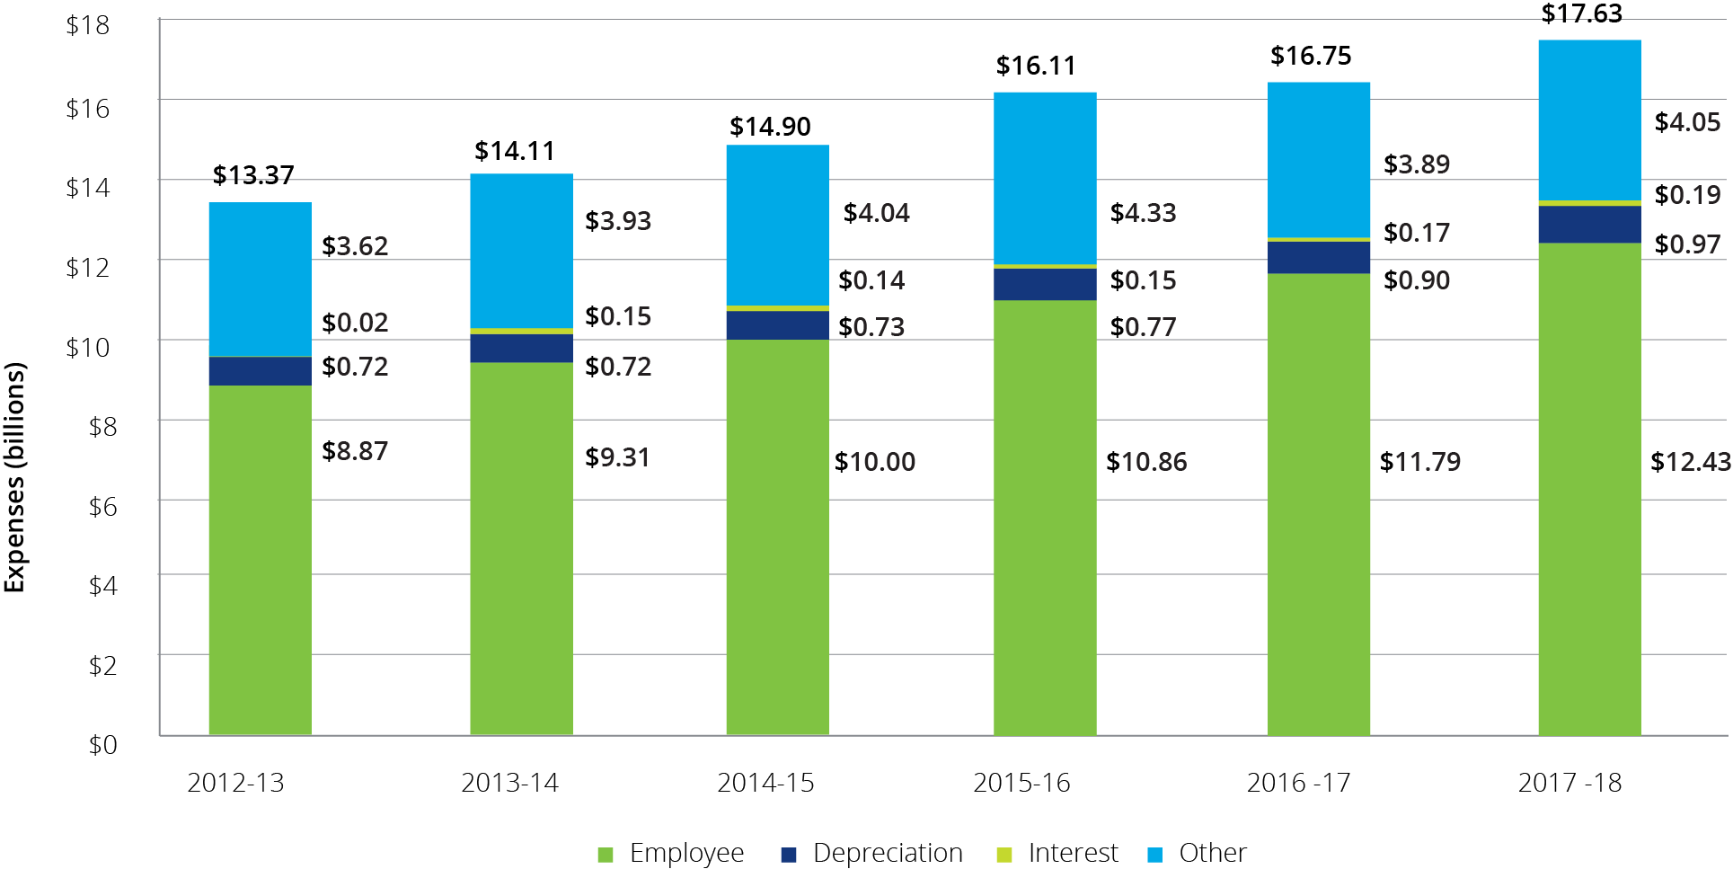

Table 6.12 shows the expenses for residential care providers in 2017‑18 compared with 2016‑17 and Chart 6.14 presents the expenses for 2017-18 as a proportion of total expenses.

Table 6.12: Summary of expenses, residential care providers, 2016‑17 and 2017‑18 ($m)

| Expenses | 2016-17 ($m) | 2017-18 ($m) | Change ($m) | Change (%) |
| --- | --- | --- | --- | --- |
| Employee | $11,792.1 | $12,426.7 | $634.6 | 5.4% |
| Depreciation | $895.3 | $968.9 | $73.6 | 8.2% |
| Interest | $171.1 | $186.7 | $15.6 | 9.1% |
| Other expenses | $3,892.3 | $4,048.8 | $156.5 | 4.0% |
| **Total expenses** | **$16,750.8** | **$17,631.1** | **$880.3** | **5.3%** |

Employee costs represent 70 per cent of the total expenses incurred by providers and these increased by 5.4 per cent from 2016‑17.

‘Other’ expenses represented 23 per cent of total costs, stable from 2016‑17. ‘Other’ expenses include building repairs and maintenance expenses, rent, utilities and costs associated with employment support activities, cleaning and administration. Depreciation and interest costs account for the remaining 5 per cent and 1 per cent respectively, the same as in 2016‑17.

Chart 6.14: Proportion of residential care provider total expenses, 2017-18 ($m)

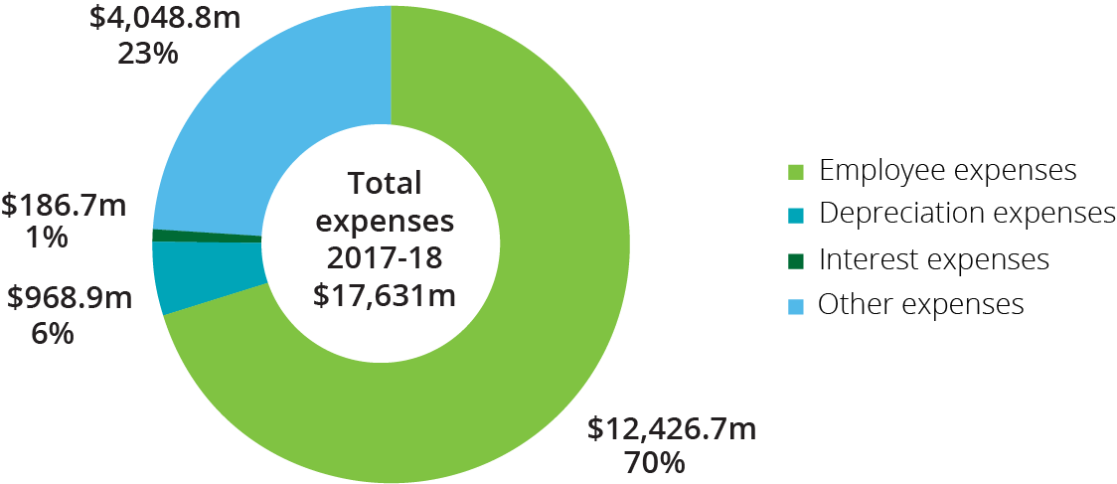

Table 6.13 shows the major expense types for providers, per resident per day, for the six years to 2017‑18. Total expenses per resident per day have generally increased each year by around 4‑5 per cent.

Table 6.13: Summary of residential care provider expenses, per resident per day, 2012-13 to 2017-18

| Expenses | 2012-13 | 2013-14 | 2014-15 | 2015-16 | 2016-17 | 2017-18 |
| --- | --- | --- | --- | --- | --- | --- |
| Employee | $142.92 | $148.81 | $157.68 | $166.84 | $179.01 | $187.21 |
| Depreciation | $11.59 | $11.56 | $11.49 | $11.87 | $13.59 | $14.60 |
| Interest | $2.57 | $2.34 | $2.21 | $2.30 | $2.60 | $2.81 |
| Other | $58.24 | $62.81 | $63.67 | $66.57 | $59.09 | $61.00 |
| **Total expenses** | **$215.32** | **$225.52** | **$235.05** | **$247.58** | **$254.29** | **$265.62** |

As noted earlier, since 2016‑17, a different breakdown of expenditure data was collected through the introduction of the ACFR. The new format has enabled the collection of more detailed expenditure information from 2016-17 onwards. Table 6.14 shows provider expenditure in 2017‑18, compared with 2016‑17, using the new categories collected through the ACFR.

Table 6.14: Breakdown of residential care provider expenses, 2016-17 and 2017-18 ($m)

|  | 2016-17 ($m) | 2017-18 ($m) | Change ($m) | Change (%) |
| --- | --- | --- | --- | --- |
| **Care** |  |  |  |  |
| Employee expenses | $8,549.9 | $8,968.7 | $418.8 | 4.9% |
| Other | $536.1 | $588.4 | $52.3 | 9.7% |
| **Total care expenses** | **$9,086.0** | **$9,557.0** | **$471.0** | **5.2%** |
| **Accommodation** |  |  |  |  |
| Employee expenses | $364.1 | $283.7 | -$80.4 | -22.1% |
| Repair & maintenance | $470.3 | $477.6 | $7.3 | 1.6% |
| Rent | $342.1 | $357.0 | $14.9 | 4.4% |
| Other | $455.4 | $497.8 | $42.4 | 9.3% |
| **Total accommodation expenses** | **$1,631.9** | **$1,616.2** | -$15.7 | -1.0% |
| **Hotel** |  |  |  |  |
| Employee expenses | $1,463.0 | $1,600.4 | $137.4 | 9.4% |
| Contracted services | $445.9 | $495.9 | $50.0 | 11.2% |
| Other | $712.1 | $722.4 | $10.3 | 1.5% |
| **Total hotel expenses** | **$2,621.0** | **$2,818.7** | **$197.7** | **7.5%** |
| **Administration** |  |  |  |  |
| Employee expenses | $922.6 | $970.4 | $47.8 | 5.2% |
| Management fees | $492.5 | $603.5 | $111.0 | 22.5% |
| Other | $594.0 | $662.4 | $68.4 | 11.5% |
| **Total administration expenses** | **$2,009.1** | **$2,236.2** | **$227.1** | **11.3%** |
| **Financing** |  |  |  |  |
| Depreciation | $874.5 | $942.9 | $68.4 | 7.8% |
| Amortisation | $20.8 | $26.0 | $5.2 | 25.0% |
| Interest | $171.2 | $186.7 | $15.5 | 9.1% |
| **Total financing expenses** | **$1,066.5** | **$1,155.6** | **$89.1** | **8.4%** |
| **Other** |  |  |  |  |
| Revaluation of assets (decrease) | $32.2 | $38.7 | $6.5 | 20.3% |
| Loss on sale of assets | $9.5 | $9.4 | -$0.1 | -1.0% |
| Other | $294.9 | $199.3 | -$95.6 | -32.4% |
| **Total other expenses** | **$336.6** | **$247.4** | -$89.2 | -26.5% |
| **Total expenses** | **$16,751.1** | **$17,631.1** | **$880.0** | **5.3%** |

Care expenditure relates to the direct costs incurred in providing care for residents within residential care facilities. Care related employee expenses make up 94 per cent of total care expenses, and 51 per cent of total expenditure, making it the largest single expense for providers. Employee expenses include payments made to doctors, nursing, therapists, nutritionists, case managers, health assistants and support staff.

Other care expenses include items such as resident medication, oxygen and related equipment, treatments and procedures, incontinence aids, items that assist mobility, recreation and social activities, rehabilitation support, personal grooming and specific cultural and social events.

Accommodation expenditure (which represents 9 per cent of total expenses) relates to the costs incurred in providing accommodation to residents. Within accommodation, employee expenses as a proportion of total accommodation related expenses decreased from 22.3 per cent in 2016‑17 to 17.5 per cent in 2017‑18. This perhaps reflects providers trying to reduce costs on non-care related areas. Repairs and maintenance make up 30 per cent of accommodation related expenses and facility rental (22 per cent), and other (31 per cent) make up the remainder.

Other accommodation expenses include property rates and taxes, bed licence fees/allocation certification fees, utilities and waste disposal.

Hotel expenditure (which represents 16 per cent of total expenses) relates to the costs incurred in the provision of everyday living expenses to residents. Within hotel, expenses relate to employees (57 per cent), contracted services (18 per cent) and other (26 per cent).

Contracted services are payments made to external providers or internal divisions for the provision of catering, cleaning or laundry. Other expenses consist of expenses such as meals, refreshments, other food consumables, bedding materials, toiletry and sanitary goods, cleaning items and laundry items.

Financing expenditure relates to depreciation incurred on property, plant and equipment, amortisation of intangible assets, and interest paid on borrowing used to fund the capital requirements of facilities. Financing accounted for 6.6 per cent of total expenditure in 2017‑18.

Other expenses relate to expenditure not covered in any of the above categories.

### Financial results

The financial performance of residential care providers is affected by variations in both revenue and expenditure. It can also vary depending on the location in which care is delivered.

Chart 6.15 shows the average EBITDA per resident per annum for all residential care providers since 2010‑11. Overall, residential care providers performed significantly worse in 2017‑18 compared with recent years. The average EBITDA per resident had improved for five years in a row since 2012-13 before dropping by 24 per cent from $11,481 in 2016‑17 to $8,746 in 2017‑18.

Chart 6.15: Residential care provider average EBITDA per resident per annum, 2010-11 to 2017-18

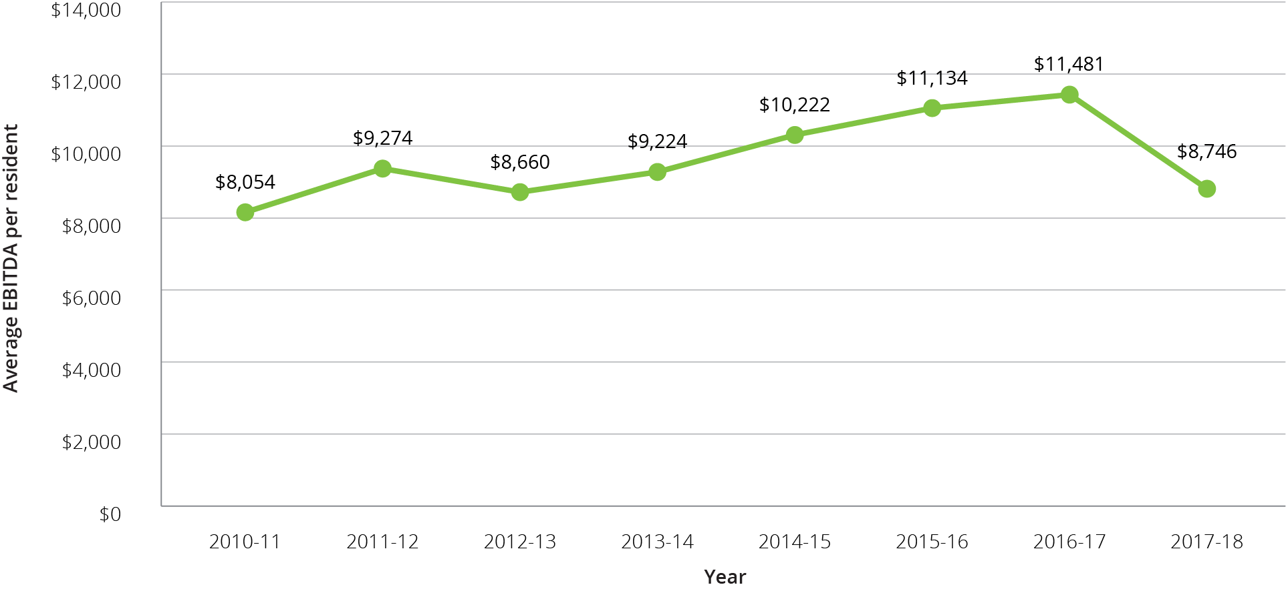

Table 6.15 shows a summary of the overall financial performance of residential care providers since 2012‑13.

Table 6.15: Summary of financial performance of residential care providers, 2012-13 to 2017-18 ($m)

|  | 2012-13 | 2013-14 | 2014-15 | 2015-16 | 2016-17 | 2017-18 |
| --- | --- | --- | --- | --- | --- | --- |
| Revenue ($m) | $13,961 | $14,826 | $15,810 | $17,172 | $17,757 | $18,066 |
| Expenses ($m) | $13,367 | $14,115 | $14,903 | $16,109 | $16,751 | $17,631 |
| NPBT ($m) | $594 | $712 | $907 | $1,063 | $1,006 | $435 |
| NPBT margin | 4.3% | 4.9% | 5.8% | 6.2% | 5.7% | 2.4% |
| EBITDA ($m) | $1,473 | $1,582 | $1,776 | $1,985 | $2,072 | $1,591 |
| Average EBITDA per resident per annum | $8,660 | $9,224 | $10,222 | $11,134 | $11,481 | $8,746 |
| EBITDA margin | 10.6% | 10.7% | 11.2% | 11.6% | 11.7% | 8.8% |

Table 6.16 shows the financial performance of providers in 2017-18 by ownership type, location and scale. In general terms, for‑profit providers outperformed not‑for‑profit providers and metropolitan providers significantly outperformed regional and rural providers. More detailed discussion of performance based on ownership, location and scale is included later in this section.

Table 6.16: Summary of financial performance of residential care providers, 2017-18

|  |  |  | Ownership type | | | Location | | | Scale | | | |
| --- | --- | --- | --- | --- | --- | --- | --- | --- | --- | --- | --- | --- |
|  | Total sector 2016-17 | Total sector 2017-18 | Not-for-profit | For-profit | Government | Metropolitan | Regional | Metropolitan & regional | Single facility | Two to six facilities | Seven to 19 facilities | 20 or more facilities |
| Revenue ($m) | $17,757 | $18,066 | $9,885 | $7,288 | $893 | $11,997 | $2,739 | $3,330 | $3,605 | $4,150 | $4,670 | $5,641 |
| Expenses ($m) | $16,751 | $17,632 | $9,762 | $6,874 | $995 | $11,583 | $2,827 | $3,220 | $3,546 | $4,148 | $4,544 | $5,393 |
| Profit ($m) | $1,006 | $435 | $123 | $414 | -$102 | $414 | -$88 | $110 | $59 | $2 | $126 | $248 |
| EBITDA ($m) | $2,072 | $1,591 | $819 | $822 | -$50 | $1,186 | $75 | $330 | $262 | $266 | $449 | $614 |
| EBITDA p.r.p.a ($) | $11,481 | $8,746 | $7,916 | $11,634 | -$6,411 | $9,920 | $2,702 | $9,571 | $7,110 | $6,340 | $9,914 | $10,622 |
| EBITDA margin | 11.7% | 8.8% | 8.3% | 11.3% | -5.6% | 9.9% | 2.8% | 9.9% | 7.3% | 6.4% | 9.6% | 10.9% |
| NPBT margin | 5.7% | 2.4% | 1.2% | 5.7% | -11.4% | 3.4% | -3.2% | 3.3% | 1.6% | 0.0% | 2.7% | 4.4% |

As noted, the residential care sector overall reported a significant decline in financial performance in 2017‑18 compared with 2016-17. Providers reported an average EBITDA per resident of $8,746 down from $11,481 in 2016‑17. This follows five years of improving financial performance since 2012‑13. Fifty-six per cent of residential care providers reported a net profit in 2017‑18, a noticeable decline from 68 per cent in 2016‑17 and 69 per cent in 2015-16.

The EBITDA margin also decreased to 8.8 per cent after improving each of the previous five years (11.7 per cent in 2016-17). The NPBT margin declined significantly to 2.4 per cent from 5.7 per cent in 2016‑17.

Chart 6.16 presents the EBITDA per resident for 2015-16 to 2017‑18 by provider performancequartiles. As shown, the average EBITDA dropped noticeably in all four quartiles.

Chart 6.16: Residential care provider comparative EBITDA per resident per annum, 2015-16 to 2017-18

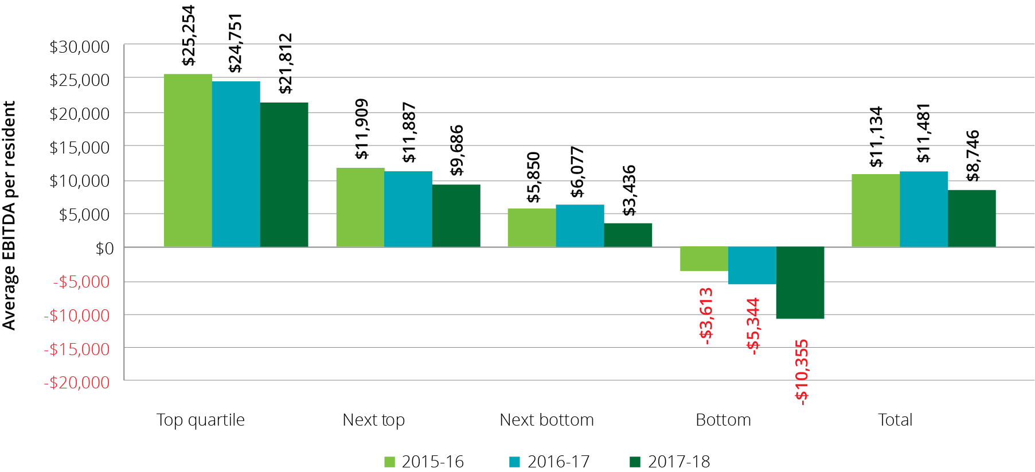

Operating performance has traditionally varied across provider ownership type, location and scale. The following commentary provides analysis across the segments of providers.

#### By provider ownership type

For‑profit providers, like the rest of the sector, derived a noticeable decline in 2017‑18 compared with 2016‑17. The for‑profits recorded EBITDA per resident per annum of $11,634, down from $13,316 in 2016‑17. However the not‑for‑profit providers dropped significantly more by comparison, falling to $7,916 in 2017‑18 from $11,408 in 2016‑17.

The trend of for‑profit providers outperforming not‑for‑profit providers has been evident for quite some time, as shown in Chart 6.17.

However, this variable needs to be considered carefully because providers in the not-for-profit and government sectors often have different business motives, business models and funding sources and often operate in areas affected by the impacts of remoteness and facility size.

ACFA has previously noted commentary from the not-for-profit sector that the generally lower operating financial results may be consistent with their community or religious missions. They may fulfil their charters in a range of ways that might be difficult or inappropriate in a more commercial environment where investors are seeking returns.

Specifically, not-for-profit providers may choose to invest in or expend funds on amenities and services for which they are not funded through regulated sources. Not‑for‑profit providers may be assisted to do this through a range of funding pathways and tax benefits, including payroll tax relief, income tax exemptions and tax deductible donations. However, where these costs are not covered by such incremental revenue, the comparatively lower EBITDA for many not‑for‑profit providers may be the product of the delivery of additional “community benefits” or “social impacts” or returns which are not recognised in the annual financial accounts.

Chart 6.17: Residential care provider operating performance ratios, by ownership type, 2015-16 to 2017-18

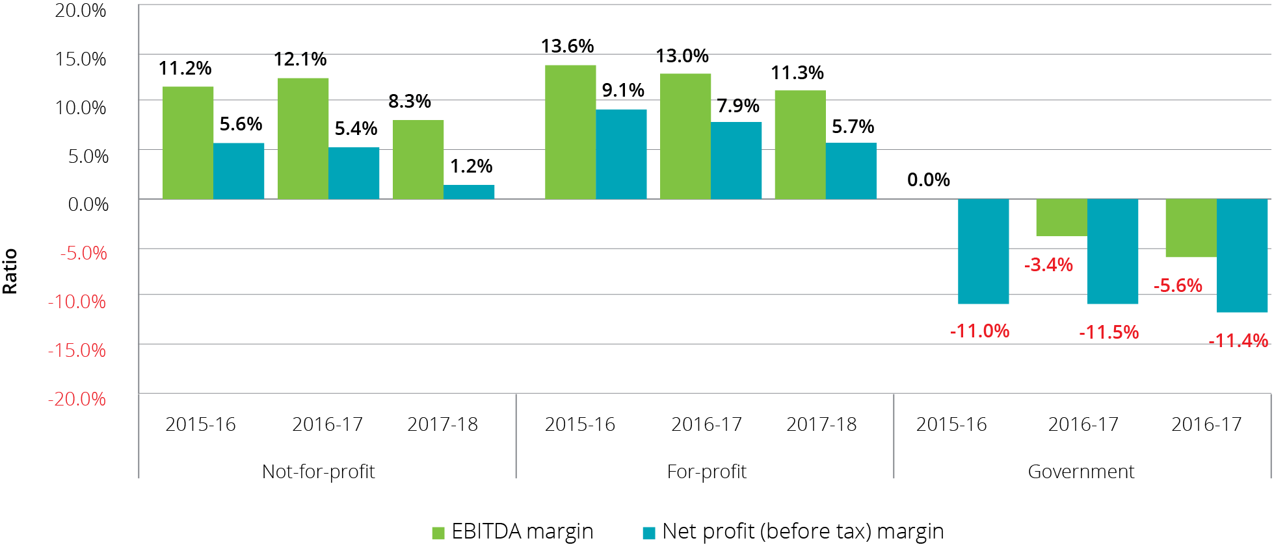

Chart 6.18 shows the average EBITDA for the four years to 2017‑18 by ownership type. While the not‑for‑profits had improved in each of the years previously they declined by almost 31 per cent in 2017‑18.

Chart 6.18: EBITDA per resident, by ownership type, 2014-15 to 2017-18

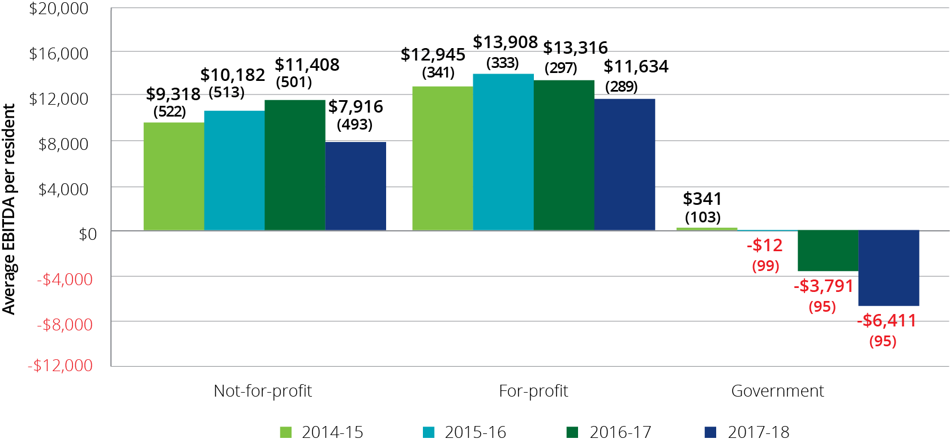

As has been the case in recent years, a significantly higher proportion (33 per cent) of for-profit providers were present in the top quartile of EBITDA performance per resident (Chart 6.19 and Chart 6.20), compared with not‑for‑profit (22 per cent) and government (16 per cent) providers. The 94 for‑profit providers who are present in the top quartile recorded an average EBITDA per resident per annum of $23,286 compared with the 110 not‑for‑profit providers in the top quartile who recorded $19,380.

As has been the case with all previous years, there is some representation of all ownership types in each quartile.

Chart 6.19: Residential care provider average EBITDA per resident per annum, by quartile (number of providers in parentheses) – by ownership type, 2017-18

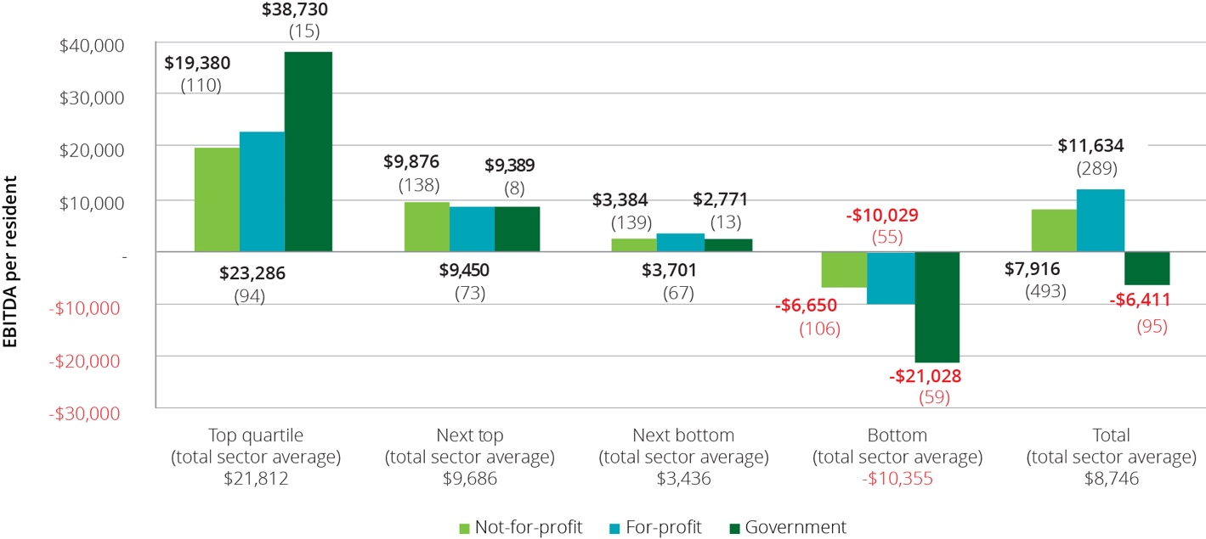

Chart 6.20: Residential care provider distribution between quartile of average EBITDA per resident per annum – by provider ownership type, 2017-18

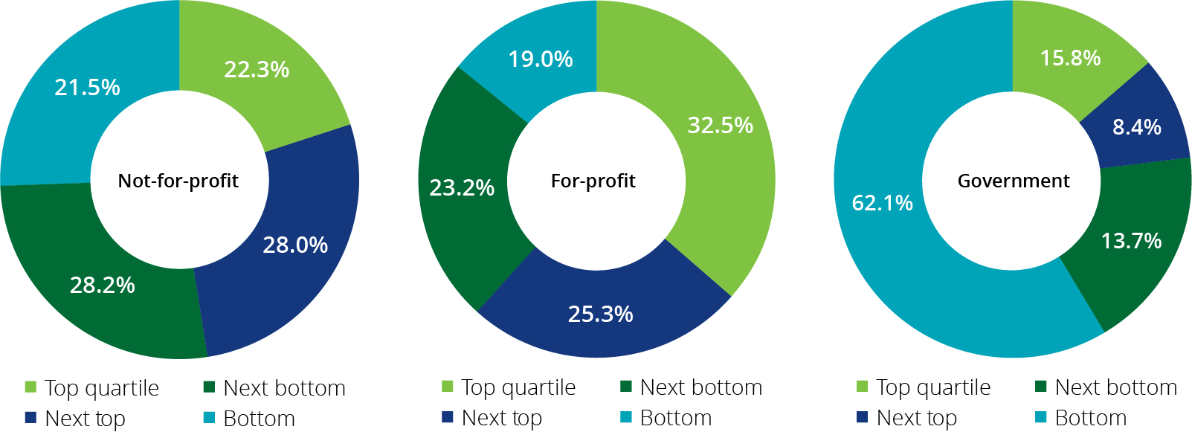

#### By provider location

As shown in Chart 6.21, the EBITDA per resident per annum for metropolitan providers improved over the three years to 2016‑17 before declining 20 per cent to $9,920 in 2017‑18. For regional providers, after relatively strong results in 2015‑16 ($9,046 per resident per annum) and in 2016‑17 ($8,257) they recorded a very significant decline to $2,702 in 2017‑18.

Chart 6.21: Residential care provider EBITDA per resident, by provider location, 2014-15 to 2017-18

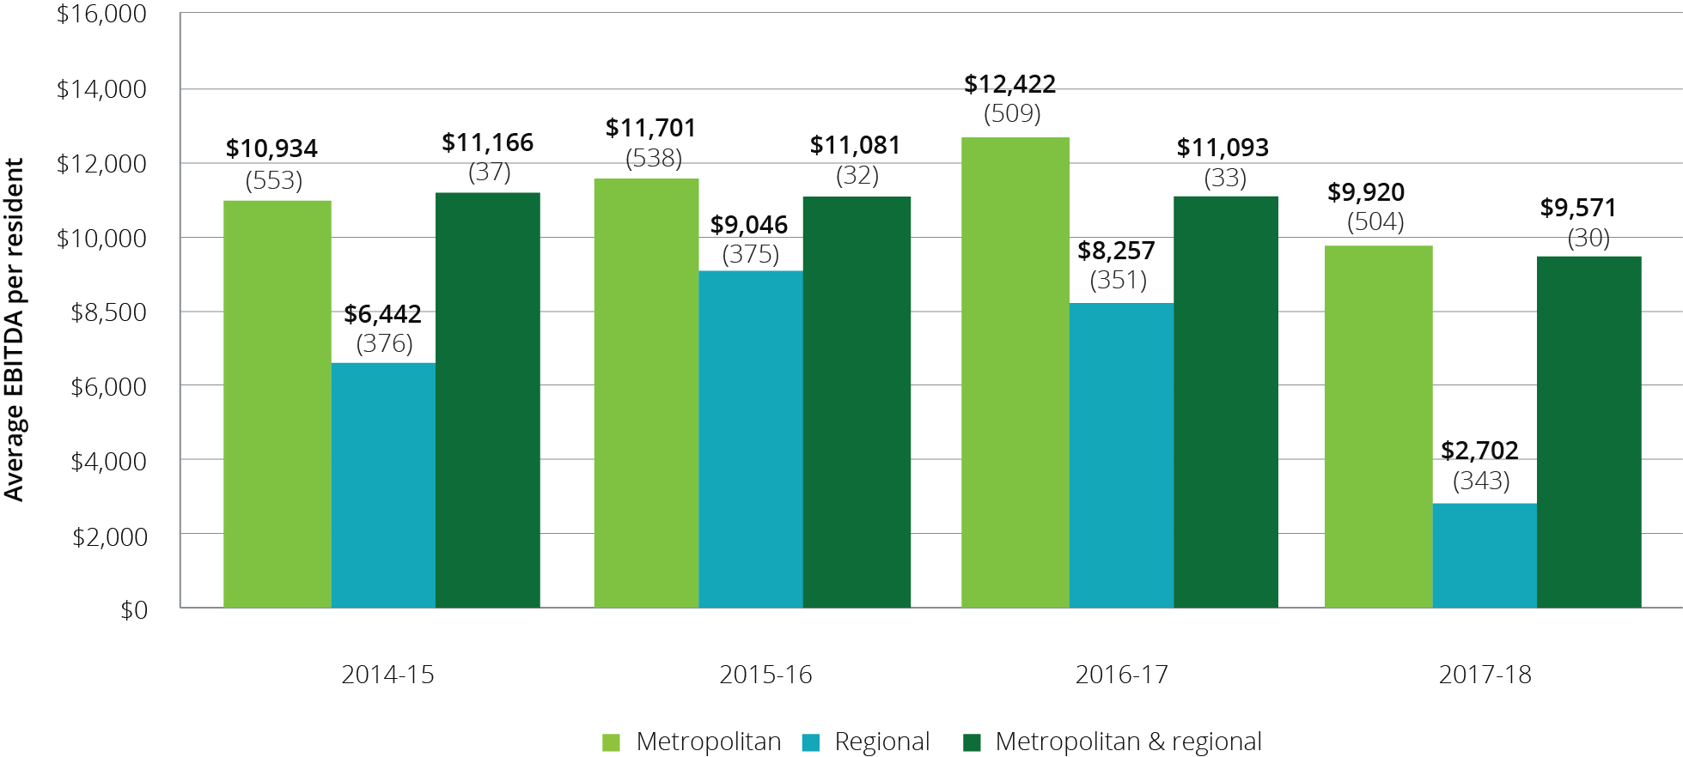

As with previous years, a higher proportion (29 per cent) of metropolitan providers are present in the top quartile of ranking by EBITDA per resident compared with regional providers (19 per cent), as shown in Chart 6.22 and Chart 6.23. Conversely, a significantly higher proportion of regional providers (33 per cent) were represented in the bottom quartile.

As was the case with analysis based on ownership type, providers from all locations are present in each quartile.

Chart 6.22: Residential care provider average EBITDA per resident per annum, by quartile (number of providers in parentheses) – by location, 2017-18

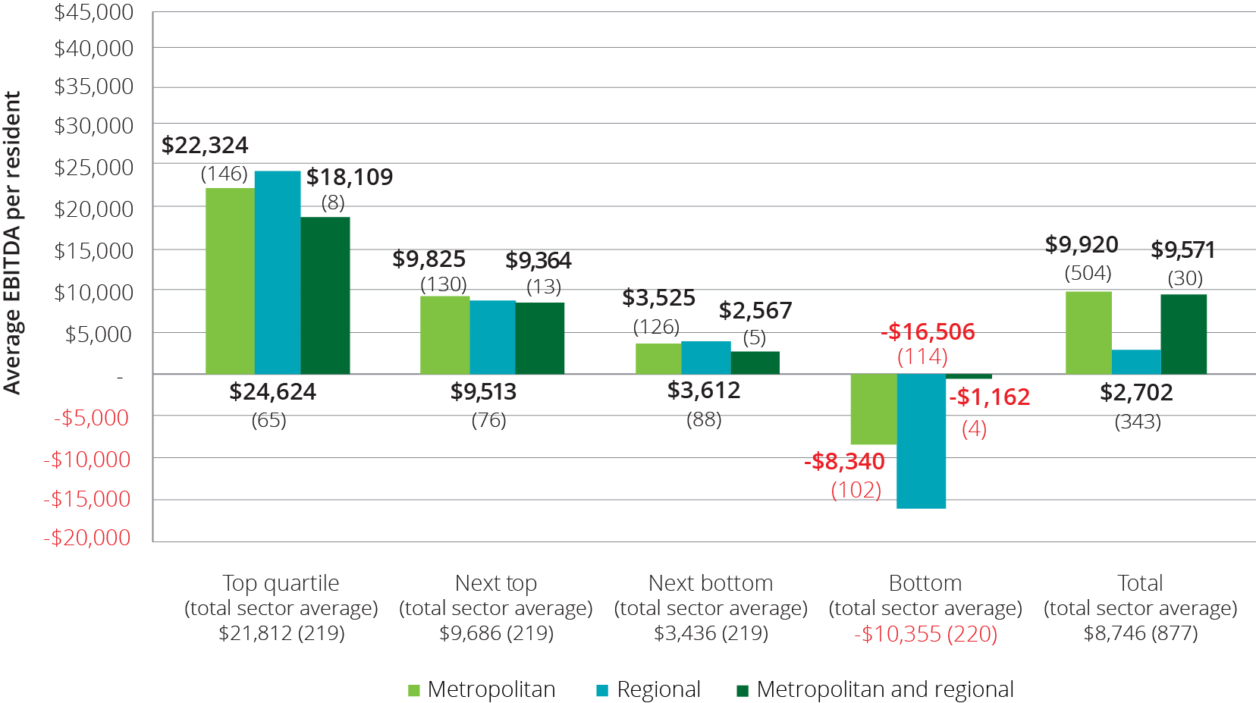

Chart 6.23: Residential care provider distribution between quartile of average EBITDA per resident per annum – by location, 2017-18

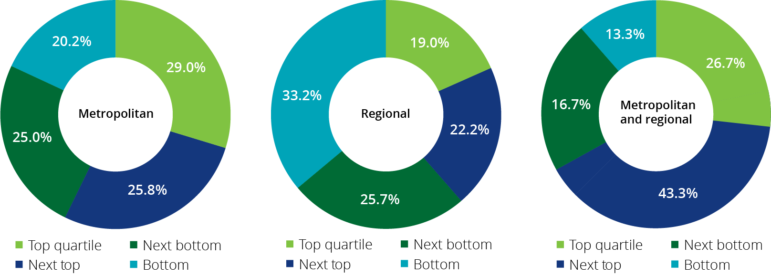

#### By provider scale

In 2017‑18, larger providers (7 and more facilities) clearly outperformed their smaller counterparts (Chart 6.24). Single facility providers recorded average EBITDA per resident per annum of $7,110, after generating higher results of more than $11,000 for the three years previously. The case is similar for providers of 2 to 6 facilities who recorded $6,340 in 2017‑18 after deriving more than $9,000 for three years. In contrast, providers operating 7 to 19 facilities improved their performance from $9,709 in 2016‑17 to $9,914 in 2017‑18. The largest providers, those operating 20 or more facilities once again recorded the strongest results with average EBITDA of $10,622, despite experiencing a decline of 17 per cent from 2016‑17.

Chart 6.24: Residential care provider EBITDA per resident per day, by provider scale, 2014-15 to 2017-18



In 2017‑18, 17 of the 21 providers who own more than 20 facilities are in the top two quartiles of ranking by EBITDA per resident per annum (Chart 6.25 and Chart 6.26). This high proportion of the larger scale providers being in the top quartiles has also been the case in previous years. This suggests that the largest providers are benefitting from economies of scale.

As was the case in previous years, providers from all the scale classifications are represented in four quartiles.

Chart 6.25: Residential care provider average EBITDA per resident per annum, by quartile (number of providers in parentheses), by provider scale, 2017-18

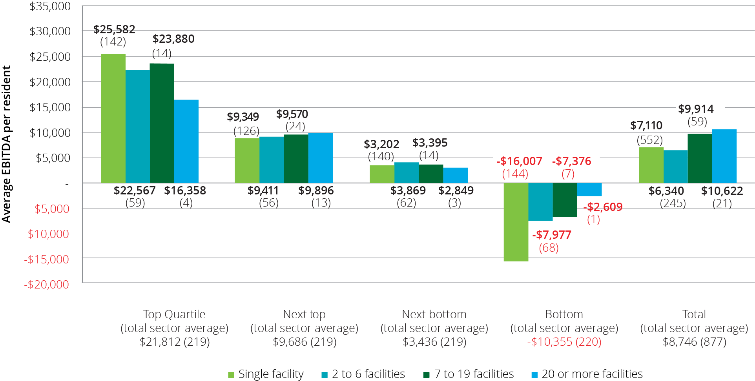

Chart 6.26: Residential care provider distribution between quartile of average EBITDA per resident per annum – by provider scale, 2017-18

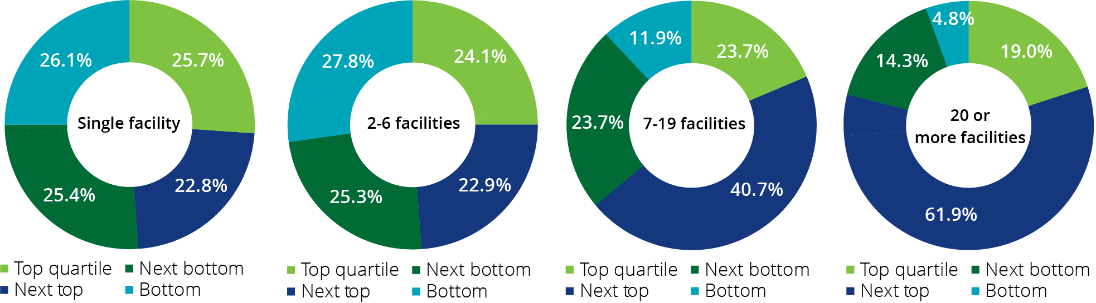

### Feedback from consultations and developments in 2018‑19

2017-18 was a challenging year for the residential aged care sector. After five years of improving financial performance, there was a significant decline in 2017-18.

All providers consulted said that 2017-18 was a difficult year with growth in revenue constrained by the Government’s decision to change the scoring arrangements for ACFI and pause indexation, while costs continued to grow, particularly wage costs. As outlined previously, Commonwealth care subsidies and supplements on behalf of residents represent around 60 per cent of the revenue of providers while employee expenses contribute around 70 percent of their total expenses. The changes to ACFI arrangements significantly contributed to providers’ revenue increasing by just 1.7 per cent in 2017‑18, while the growth in providers’ expenses was over 5 per cent. Problems with the ACFI funding tool for care payments were regularly raised in ACFA’s consultations with providers.

All providers said that they took action to constrain costs in response to the compression in margins. With staff costs representing a very large proportion of expenditure, many providers reviewed staff rosters in an effort to reduce staff hours. Some indicated that they identified savings by decentralising their roster arrangements and improving flexibility and some initiated redundancies in response to these reviews. Many providers said they had targeted savings in ancillary and administrative staff rather than care staff.

Many providers referred to the tension they faced in constraining staff costs while the pressure from increased quality audit activity, along with community expectations, was to increase staff hours and skill levels.

As to wages, most providers said their Enterprise Bargaining Agreements (EBA) provided for wage increases of between two to three percent. A few providers consulted said their EBA had expired and they had advised staff that because of financial pressures there would be a pause in wage increases. They noted the difficulties this posed in their quest to attract and retain staff.

ACFA’s consultations with providers suggest that the margin pressure felt in 2017-18 has continued in 2018-19. The StewartBrown Aged Care Financial Performance Survey for the six months to December 2018 indicates a further deterioration in the financial performance of the sector. The StewartBrown survey is not directly comparable to the data in this report, but it does give a guide as to developments in the sector. While ACFI indexation has been restored in 2018-19 (1.4 per cent for activities of daily living and behaviour domains and 0.7 per cent in the complex health care domain), providers say that this is still well below the rate of increase in their costs. StewartBrown observed in their survey for the six months ended December 2018 that the gap between direct care costs and ACFI subsidy revenue continued to grow, meaning that ACFI is not keeping pace with associated care costs.

Many providers consulted indicated that they were also experiencing lower occupancy rates and this was adding to pressure on their margins. A number noted that their occupancy rates were also becoming more volatile which added additional challenges in managing their business. All providers consulted welcomed the Government’s announcement on 10 February 2019 of a $320 million one-off increase in ACFI funding in 2018-19. While some noted the increase in the aged care subsidy was limited to 2018-19 and did not address the longer-term pressures they were facing, others interpreted the Government’s announcement as recognition of the financial pressures facing providers.

In ACFA’s Update on funding and financing issues in the residential aged care sector which was provided to the Government in September 2018, it was noted that there were a range of practices among aged care providers in the provision of additional services (that is services over and above those required to be provided under the Aged Care Act 1997) for a fee. The application of additional services is an option for providers to boost their revenue and profits. As noted in the Update, many providers indicated that while they had not offered additional services, given financial pressures this was an avenue they were considering, although the scope to introduce additional services was significantly influenced by the socio-economic area in which a facility was located. However many providers also reported that a major constraint they faced was the imprecision around which additional services were allowed. More recent consultations with providers indicate that the reservations over what additional services are permitted are continuing to constrain some providers to introduce additional services. A number of not-for-profit providers are also concerned about discriminating between the level of service offered to residents while others indicated that they provided the additional services to all residents but only charged the fee to those residents who could afford to pay.

Consistent with what was noted in ACFA’s update, recent consultations suggest that there appears to be a growing number of smaller providers, particularly in regional and remote areas, facing significant financial stress. Some providers, mainly not-for-profit providers, said they were receiving an increasing number of approaches from smaller providers who were facing difficulties and were seeking to sell their operations. The providers receiving the approaches said they had declined most of the offers because of difficulties in turning around facilities that were facing not only financial but in many cases quality problems. In addition many of the facilities, but not all of them, consisted of older residential stock.

While many of the aged care providers in regional and remote areas will benefit from the 30 per cent increase in the viability supplement that was announced in the 2018 MYEFO, it appears from recent consultations that the number of providers facing financial pressure and seeking to exit the sector remains significant. There is also a view among some providers that this number is likely to increase as scale is increasingly important, and many of the smaller providers will likely face difficulties in implementing the strengthening in the prudential framework for the residential sector which was announced by the Government in the 2018-19 Budget. The Department of Health is consulting on the detail of the strengthened framework.

Overall there are a number of aspects of the aged care residential sector that warrant close monitoring given the range of financial pressures which impacted on the sector in 2017-18 and are continuing in 2018-19.

# Residential care: capital investment

| **This chapter discusses:**  The sources of capital financing for the residential care sector, including the role of Refundable Accommodation Deposits[31];  key balance sheet metrics for residential care providers for 2017‑18; and  current building and investment trends in the residential care sector.  **On 30 June 2018, compared with 30 June 2017, the residential care sector as a whole had:**  Total assets of $48.4 billion, up from $45.0 billion, which includes:  $14.1 billion of current assets, an increase of $1.0 billion; and  $34.3 billion of non-current assets.  Total liabilities of $36.6 billion, up from $33.7 billion. This includes $27.5 billion of accommodation deposits held by the sector, up from $24.8 billion;  Net assets of $11.8 billion, an increase of $500 million;  average return on equity was 13.4 per cent, down from 18.3 per cent; and  average return on assets was 3.3 per cent, down from 4.6 per cent.  **ACFA Notes:**  $4.9 billion of building works were either completed or in-progress as at 30 June 2018 compared with $4.7 billion at 30 June 2017; and  planned building activity dropped significantly for the second year in a row. |
| --- |

## Capital financing

Capital for residential care providers is comprised of:

equity, including retained earnings;

loans from financial or other institutions;

interest free loans from residents in the form of lump sum Refundable Accommodation Deposits (bonds pre 1 July 2014);

capital investment support from Government by way of capital grants for eligible projects; and

capital endowments.

### Residents as a source capital

Lump sum accommodation payments by residents is a significant source of funding for capital investment in residential care. Refundable Accommodation Deposits (RAD) act as an interest free loan to providers, paid by residents. At 30 June 2018, a total of $27.5 billion of accommodation deposits were held by providers. The investment of accommodation deposits held by providers is a source of interest income that is included in the other income reported by providers in their operating statement.

As an alternative to RADs, residents can choose to a pay a Daily Accommodation Payment (DAP) or a combination of a RAD and DAP.

Partially supported residents contribute towards accommodation as a Refundable Accommodation Contribution (RAC) or Daily Accommodation Contribution (DAC). In this report, references to RADs also include RACs and references to DAPs include DACs.

### Commonwealth as a source of capital

The Australian Government makes capital grants available through the ACAR (via the Rural, Regional and Other Special Needs Building Fund) for services that target communities and geographic areas where there may be insufficient access to capital from other sources.

The 2018-19 ACAR allocated $60 million in capital grants under the Fund to successful approved providers, following a competitive application process. In addition to the ACAR, through a separate announcement in the 2018‑19 Budget, one-off funding of $40 million was allocated for infrastructure investment through The Aged Care Regional, Rural and Remote Infrastructure Grant.

Additionally, the higher accommodation supplement, payable where a facility has been built or significantly refurbished since 20 April 2012, is encouraging investment in residential care. Although not strictly a form of capital for providers, it provides an increased rate of return on the capital invested.

The higher accommodation supplement is $57.14 per eligible resident per day compared with $37.24 for the standard accommodation supplement (20 March 2019 rates). As at 31 December 2018, 1,395 facilities (986 at 31 December 2017) or 48 per cent of all facilities qualified for the higher accommodation supplement. Of these, 1,214 were significantly refurbished and 181 were newly built facilities.

### Other sources of capital finance

Residential care providers also obtain capital finance from investors, loans from financial and other institutions and donations/endowments. ACFA does not have data across the sector on debt and equity financing, other than that reported in the aggregated balance sheets, which are discussed in this chapter.

## Accommodation deposits

At 30 June 2018, refundable accommodation deposits (including bonds) of residential care providers totalled $27.5 billion and comprised 56 per cent of total assets of $48.4 billion and 75 per cent of liabilities ($36.6 billion).

At 30 June 2018, there were 90,899 refundable accommodation deposits held by providers (86,853 in 2016-17), with an average value of $303,000 ($283,000 in 2016-17). As shown in Table 7.1 the average value of accommodation deposits has steadily increased over the last five years.

Table 7.1: Average value of refundable accommodation deposits held by providers, 2013-14 to 2017-18

| 2013-14 | 2014-15 | 2015-16 | 2016-17 | 2017-18 |
| --- | --- | --- | --- | --- |
| $229,000 | $248,000 | $267,000 | $283,000 | $303,000 |

Residents who are assessed as having low financial capacity are eligible for Commonwealth assistance with their accommodation costs as either a partially supported or fully supported resident. Partially supported residents may be asked to contribute towards the cost of accommodation, depending on their means. They can choose to pay their accommodation contribution by a lump sum refundable accommodation contribution (RAC), a daily accommodation contribution (DAC), or a combination of the two. Fully supported residents cannot be asked to make a contribution and have their accommodation costs met in full by Government.

Residents who are not eligible for Commonwealth assistance with their accommodation costs pay the accommodation price they agree with their provider before they enter care and can choose (within 28 days of admission) to pay by a lump sum refundable accommodation deposit (RAD), a daily accommodation payment (DAP) or a combination of the two. The maximum permissible interest rate (MPIR) is used to maintain equivalence between daily payments and lump sums[32].

Chart 7.1 shows the total pool of accommodation deposits held by providers since 2011-12

Chart 7.1: Total pool of accommodation deposits held, 2011-12 to 2017-18 ($b)

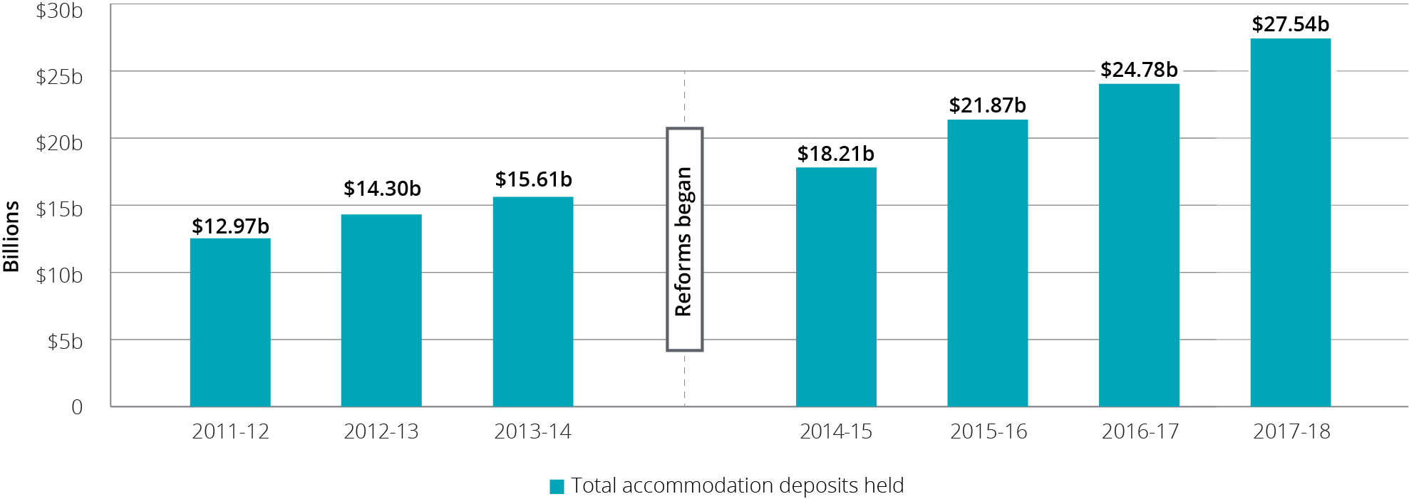

While the pool of accommodation deposits continues to grow, there is a trend emerging of a move away from RADs in favour of DAPs. Chart 7.2 shows that in 2017‑18, as was the case in 2016–17, DAP/DACs were slightly more popular than lump sum RAD/RACs. The proportion of people choosing RAD/RACs has dropped every year, albeit slightly, since 2014‑15. The proportion of residents choosing DAP/DACs has gradually increased over the four years from 33 per cent in 2014–15 to 40 per cent in 2017‑18.

While the overall shift away from RADs is modest, feedback from consultations suggest that this is a concern for some providers, (including the cash flow implications of a shift away from RADS), and a few providers said that it has resulted in them delaying some investment plans. Other providers noted that they welcomed a move towards DAPs. A sustained shift away from RADs to DAPs would significantly impact on the business model of some providers who have relied significantly on continuing growth in RADs. This is an area that requires close monitoring, including in relation to the potential impact of the recently extended scope of the Commonwealth’s Pension Loan Scheme, which could further add to the increase in daily payments over lump sum deposits.

Chart 7.2: Resident method of accommodation payment, 2014-15 to 2017-18

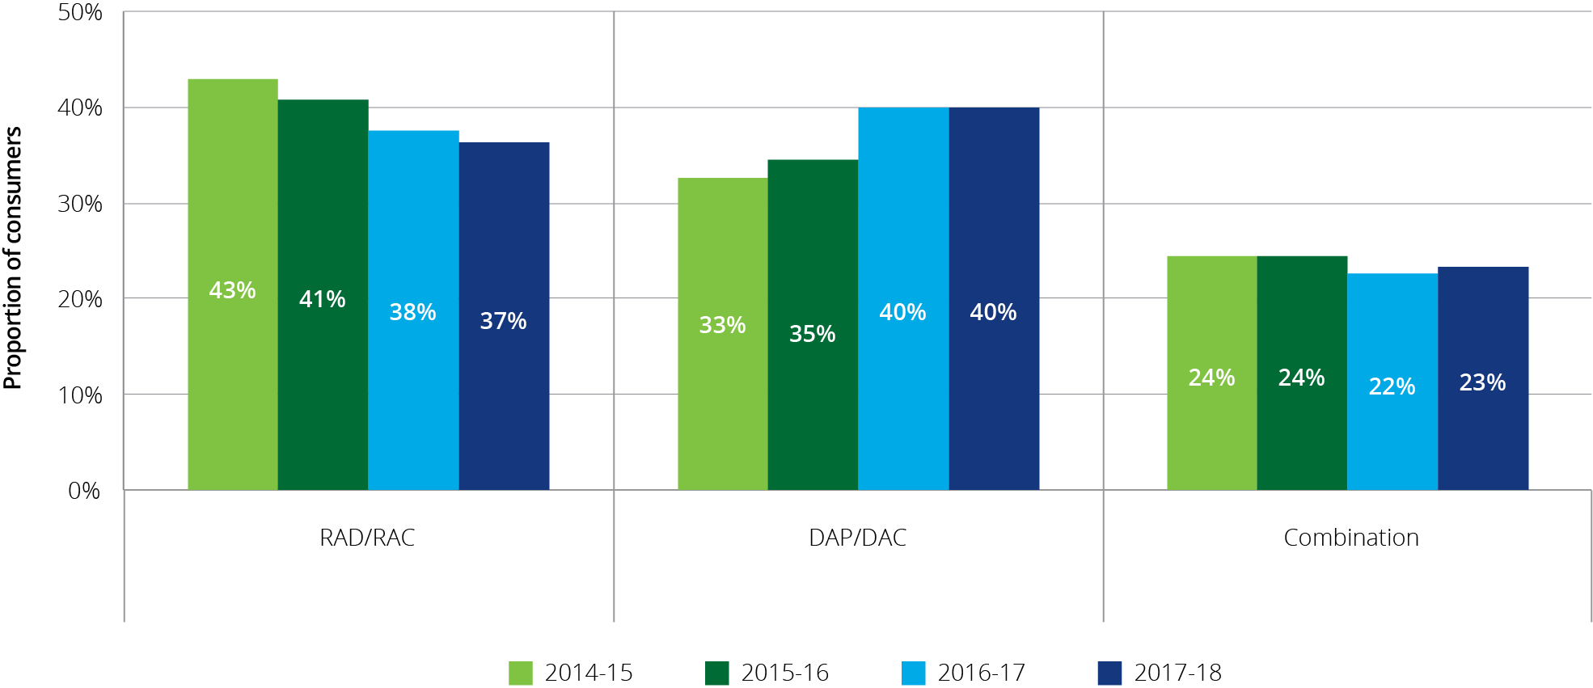

ACFA has previously noted there are several factors that a consumer might take into consideration when determining how to pay the accommodation payment, including in its report Understanding how consumers plan and finance aged care[33]. These include; the rate of the MPIR, (if interest rates fall, equivalent daily payments will fall and vice versa), expected length of stay (if shorter then more likely to pay by daily payment), personal financial circumstances and the length of time it takes to sell the family home.

Additionally, feedback from recent consultations suggest that the movement in house prices and conditions in the housing market are contributing factors in the apparent shift towards daily payments.

In terms of the MPIR influencing decisions on accommodation payments in aged care, there is the potential for movement from lump sums to daily payments if the equivalence rate is set too low. If all other things are equal, and consumers can achieve a better return, they may be inclined to invest the lump sum and pay the daily payment out of investment earnings. On the other hand, some residents see daily payments as interest charged on the outstanding lump sum. From this perspective, residents see the MPIR as a punitively high rate of interest.

For a full discussion on the MPIR and its impact on residents and providers see page 46 of ACFA’s Report to inform the 2016‑17 review of amendments to the Aged Care Act 1997. In that report ACFA advised that on balance the MPIR is an appropriate rate to determine equivalence between refundable deposits and daily payments.

Part of the reduction in the proportion of residents paying by lump sum could also be transitional and may reflect a greater understanding by consumers of their ability to choose how to pay for their accommodation as was intended by the reforms implemented in 2014.

The decrease in the proportion of RAD/RACs has been most noticeable in for-profit providers, who dropped from 46 per cent in 2016‑17 to 43 per cent in 2017‑18. This followed a drop from 48 per cent the year before (Chart 7.3). For the not‑for‑profit providers the proportion of residents choosing RAD/RACs was stable in 2017‑18 at 34 per cent.

Chart 7.3: Resident choice of payment method, by ownership, 2014-15 to 2017-18

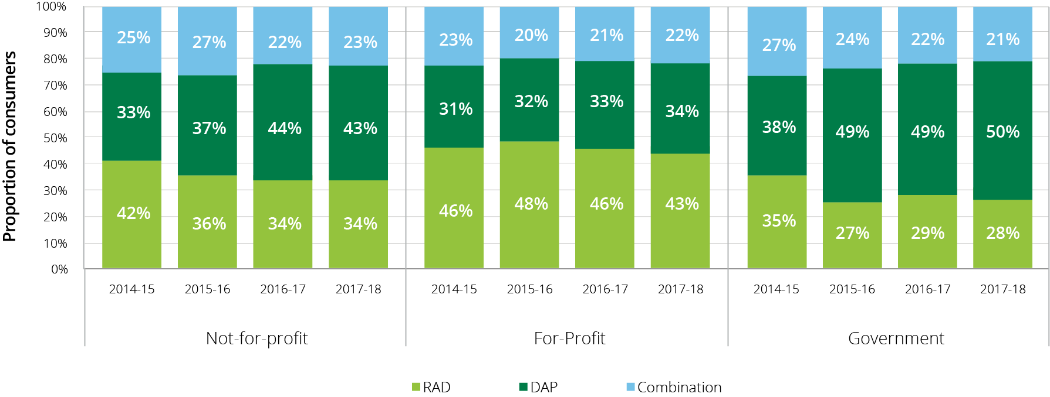

When analysed in terms of location, lump sum payments continued to drop in metropolitan areas to 39 per cent in 2017‑18 after dropping from 45 per cent to 41 per cent the year before (Chart 7.4). In contrast, in remote areas the proportion of residents choosing RAD/RACs increased to 29 per cent in 2017‑18, up from 26 per cent.

Chart 7.4: Resident choice of payment method, by location, 2014-15 to 2017-18

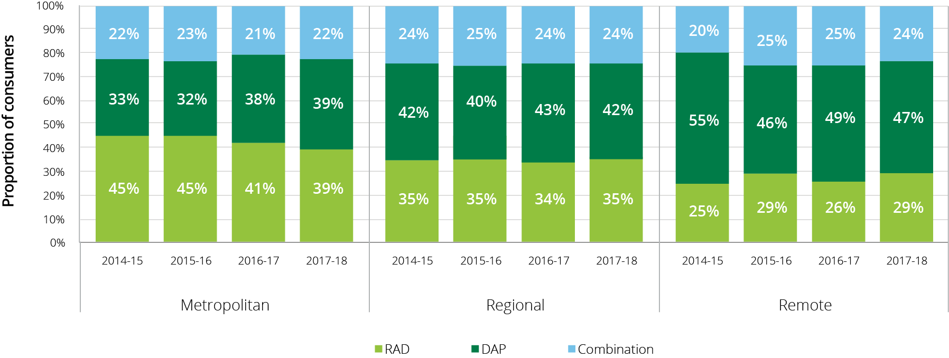

As noted previously in consultations with providers, a number indicated that a decline in the housing market is contributing to a shift away from RADs to DAPs, particularly where the individual entering residential care is very frail and the expected stay is short. The feedback is that many families are not prepared to sell a house when prices are falling.

In the last two annual reports ACFA reported the very significant difference in choice of payment between non-supported residents and partially supported residents. This trend continued in 2017‑18, as shown in Chart 7.5. Forty-five per cent of non-supported residents chose to pay their accommodation payment by a RAD whereas only 5 per cent of partially supported residents chose this option, although the proportion of non‑supported residents paying a RAD has also been decreasing, down from 48 per cent in 2016‑17 and 51 per cent in 2015‑16. The proportion of residents paying by lump sum may include residents who had commenced to pay full or partial daily payments, and then paid a lump sum during the year. Similarly, residents paying a daily payment may subsequently pay a lump sum (e.g. once their house is sold).

Chart 7.5: Resident choice of payment method, by partially supported and non-supported residents, 2015-16 to 2017-18

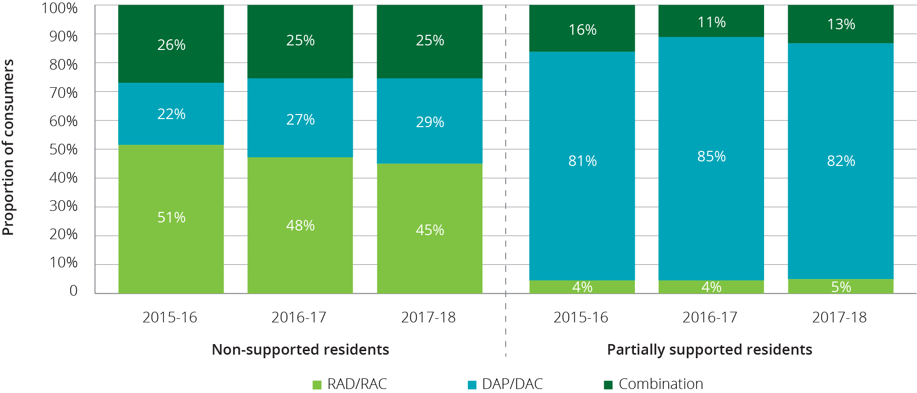

### Accommodation deposit prices

On 1 July 2014, new accommodation pricing arrangements came into effect. The changes were:

* Lump sum accommodation payments became known as Refundable Accommodation Deposits (RADs) instead of Accommodation Bonds;
* providers were able to charge a RAD to any eligible resident whereas they had previously only been able to charge an Accommodation Bond for low care residents, or a high care resident in Extra Service facilities.
* providers were no longer able to deduct a retention amount from the RAD;
* residents became able to, at their discretion, choose to pay a RAD, a Daily Accommodation payment (DAP) or any combination of RAD and DAP; and
* providers were required to publish the maximum price for their rooms, or part of a room, in their aged care facilities. Residents may negotiate a lower price (known as the agreed price) but cannot be asked to pay more than the published price.

Charts 7.6 and 7.7 show the average published and agreed accommodation prices since 1 July 2014, presented by provider ownership type and location. This data includes RADs, DAPs and combination payments and covers the price of a residential care room, not the method of payment.

In terms of provider ownership (Chart 7.6), the for‑profit providers have average published prices around $38,000 higher than the not‑for‑profit providers. Since 2014‑15 the average published price by for‑profit providers has increased by around $30,000 each year whereas the average published price for not‑for‑profit providers only increased by around $8,500 each year. Similarly, agreed prices for the for‑profit providers have continued to increase year on year faster than the average agreed price for the not‑for‑profits. The average agreed price is less than the average published price residents may negotiate a lower price.

Chart 7.6: Average agreed and published accommodation prices (lump sum equivalent), by ownership, 2014‑15 to 2017-18

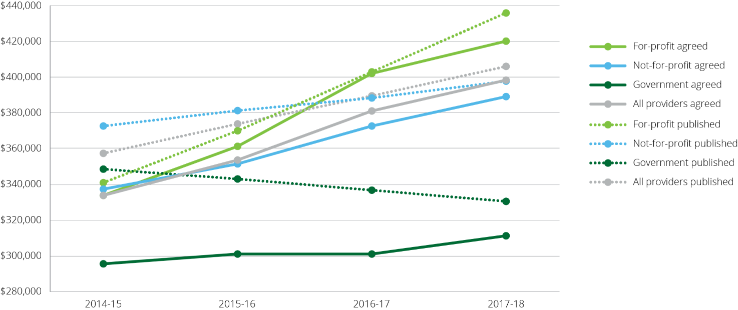

In terms of location (Chart 7.7), as has been the case in previous years, the average published price in metropolitan areas was significantly higher ($447,000) than in regional areas ($348,000) and remote areas ($293,000). This is to be expected given the difference in house prices across these areas. It is a similar case with agreed prices with the metropolitan areas recording an average agreed price almost $100,000 higher than regional areas and $160,000 higher than remote areas.

Chart 7.7: Average agreed and published accommodation prices (lump sum equivalent), by location, 2014-15 to 2017-18

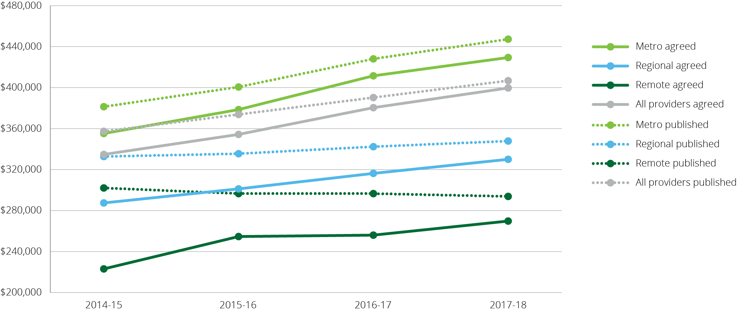

## Financing status - balance sheet

This section focuses on the balance sheet of the residential care sector, showing the liabilities, assets and net assets.

In 2016‑17 the Department of Health began collecting financial data from providers via the Aged Care Financial Report (ACFR). This allows greater disaggregation of the total assets and liabilities compared with earlier years. Some analysis contained in this section therefore is restricted to 2016‑17 and 2017‑18 only whereas other longer term trends are presented at the higher aggregate level.

Table 7.2: Balance sheet of residential care providers, 2016-17 and 2017-18

| Assets/Liabilities | 2016-17 ($m) | 2017-18 ($m) | Change ($m) | Change (%) |
| --- | --- | --- | --- | --- |
| Current assets | $13,138 | $14,101 | $963 | 7.33% |
| Fixed assets | $22,963 | $24,061 | $1,098 | 4.78% |
| Other non-current assets | $8,916 | $10,238 | $1,322 | 14.83% |
| **Total assets** | **$45,017** | **$48,400** | **$3,383** | **7.52%** |
| Accommodation deposits | $24,710 | $27,523 | $2,813 | 11.39% |
| Other liabilities | $8,981 | $9,050 | $69 | 0.76% |
| **Total liabilities** | **$33,691** | **$36,573** | **$2,882** | **8.55%** |
| **Net worth/equity** | **$11,326** | **$11,827** | **$501** | **4.42%** |

At 30 June 2018, the sector as a whole had total assets of $48.4 billion (an increase of $3.4 billion since 30 June 2017). Current assets increased by 7.3 per cent while accommodation deposits increased by 11.4 per cent.

Total liabilities were $36.6 billion (compared with $33.7 billion in 2016‑17). This includes the $27.5 billion of accommodation deposits held by the sector). Since 2013-14, the growth in liabilities has exceeded the growth in assets. In 2017-18, liabilities grew by 8.6 per cent while the growth in total assets was 7.5 per cent. Liabilities as a proportion of total assets is a measure that indicates an organisation’s leverage and shows the proportion of total assets financed through borrowings.

Overall, net worth/total equity in the sector was $11.8 billion in 2017‑18, up from $11.3 billion in 2016‑17.

As shown in Chart 7.8, accommodation deposits as a proportion of total assets has been increasing gradually over the last five years from 46 per cent in 2013‑14 to 57 per cent in 2017‑18, increasing the rate of leveraging.

Other liabilities, which include secured bank and related party lenders, creditors and provisions, represent 19 per cent of total asset financing. This has been relatively stable over the last five years.

Net worth/total equity as a proportion of assets is a measure of the share of an organisation which is contributed by and held beneficially by the owners/shareholders. Despite the fact that the overall net worth/total equity has increased in 2017‑18 ($11.8 billion compared with $11.3 billion in 2016‑17), it has continued to fall as a proportion of total assets (Chart 7.8). Over the last five years there has been a gradual decline from 33 per cent in 2013‑14 to 24 per cent in 2017‑18.

Table 7.3: Balance sheet of residential care providers 2013‑14 to 2017-18 ($m)

| Assets/liabilities | 2013-14 ($m) | 2014-15 ($m) | 2015-16 ($m) | 2016-17 ($m) | 2017-18 ($m) |
| --- | --- | --- | --- | --- | --- |
| Financial assets | $3,558 | $5,170 | $5,611 | $8,199 | $9,047 |
| Fixed assets | $10,238 | $10,674 | $11,455 | $22,963 | $24,061 |
| Other assets | $19,866 | $20,742 | $23,629 | $13,855 | $15,292 |
| **Total assets** | **$33,662** | **$36,586** | **$40,695** | **$45,017** | **$48,400** |
| Refundable accommodation deposits | $15,611 | $18,213 | $21,872 | $24,710 | $27,523 |
| Other liabilities | $6,883 | $7,472 | $7,878 | $8,981 | $9,050 |
| **Total liabilities** | **$22,494** | **$25,685** | **$29,750** | **$33,691** | **$36,573** |
| **Net worth/equity** | **$11,168** | **$10,901** | **$10,945** | **$11,326** | **$11,827** |

Chart 7.8: Residential care provider liability types as a proportion of total assets, 2013-14 to 2017-18

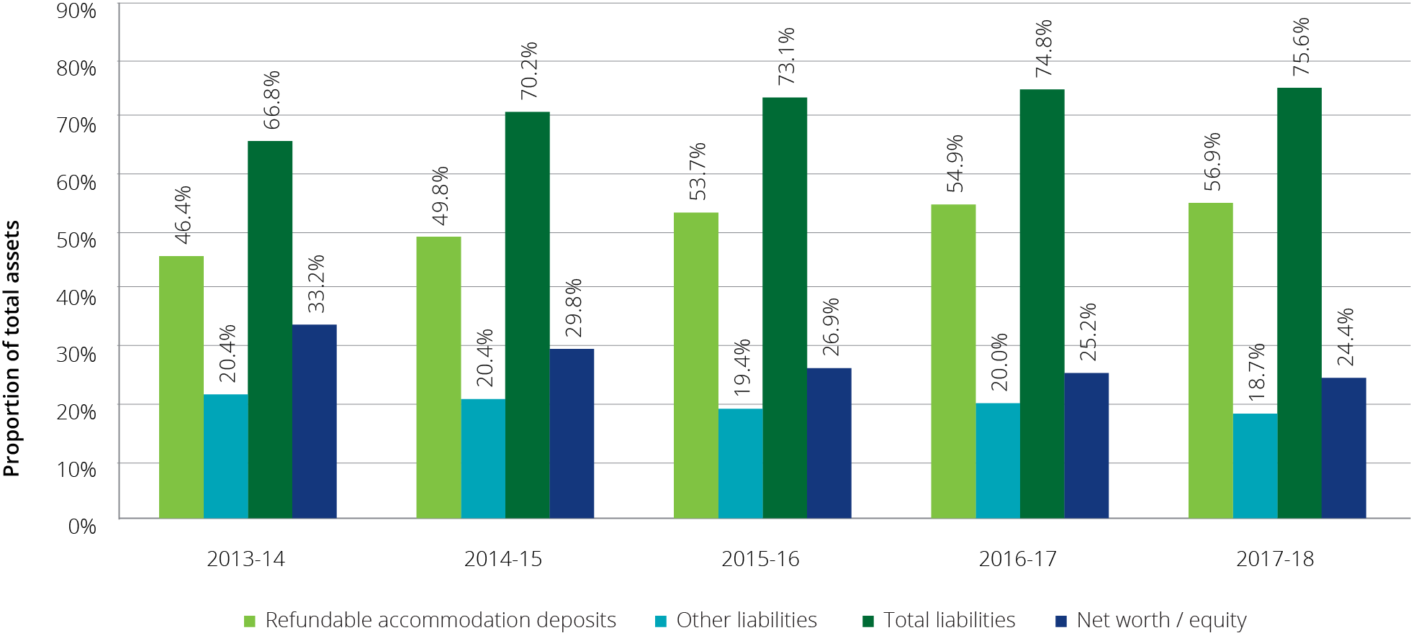

### Balance sheet analysis by ownership type

Assets and liabilities have been analysed by ownership type in order to identify differences between not-for-profit, for-profit and government providers. Table 7.4 shows liabilities and net worth/equity as a proportion of total assets by ownership type, while Chart 7.9 shows the same metric for the past three years.

At 30 June 2018, the not-for-profit providers (who hold 56 per cent of places in the sector) had total assets of $26.2 billion (54 per cent of total sector assets). This is the same as in 2016‑17. The for‑profit providers (who hold 41 per cent of places in the sector) held a slightly higher proportion of total assets of $20.5 billion which represents 42.5 per cent of the total sector assets.

As has been the case in previous years, the for-profit sector had the highest proportion of liabilities, with their total liabilities being 91 per cent (89 per cent in 2016‑17) of their total assets, compared with the not‑for‑profit providers with 66 per cent (same as 2016‑17). This significant difference is representative of the way the for-profits operate in terms of higher leveraging.

Net worth has decreased as a proportion of total assets for all provider types over the past three years. Government providers again had by far the highest net worth/equity as a proportion of assets with 57 per cent (61 per cent in 2016‑17), followed by the not‑for‑profit providers (unchanged with 34 per cent). For‑profit providers had the lowest net worth/equity as a proportion of assets with 9 per cent (11 per cent in 2016-17), which reflects both a higher proportion of accommodation deposits, greater use of debt to fund investment and greater distribution of profits. These different financing characteristics affect the ratios discussed in the rest of this section.

Table 7.4: Balance sheet, by ownership type, at 30 June 2018 ($m)

|  | Not-for-profit ($m) | For-profit ($m) | Government ($m) | Total sector ($m) |
| --- | --- | --- | --- | --- |
| **Total assets funded by:** | **$26,168** | **$20,581** | **$1,652** | **$48,400** |
| Refundable accommodation deposits | $14,077 | $12,837 | $610 | $27,523 |
| Other liabilities | $3,137 | $5,812 | $101 | $9,050 |
| **Total liabilities** | **$17,214** | **$18,648** | **$711** | **$36,573** |
| **Net worth/equity** | **$8,954** | **$1,932** | **$940** | **$11,827** |
| **As a % of total assets** |  |  |  |  |
| Refundable accommodation deposits | 53.8% | 62.4% | 36.9% | 56.9% |
| Other liabilities | 12.0% | 28.2% | 6.1% | 18.7% |
| **Total liabilities** | **66%** | **91%** | **43%** | **76%** |
| **Net worth/equity** | **34.2%** | **9.4%** | **56.9%** | **24.4%** |

Chart 7.9: Liabilities and net worth as a proportion of total assets, by provider ownership type, 2015-16 to 2017-18

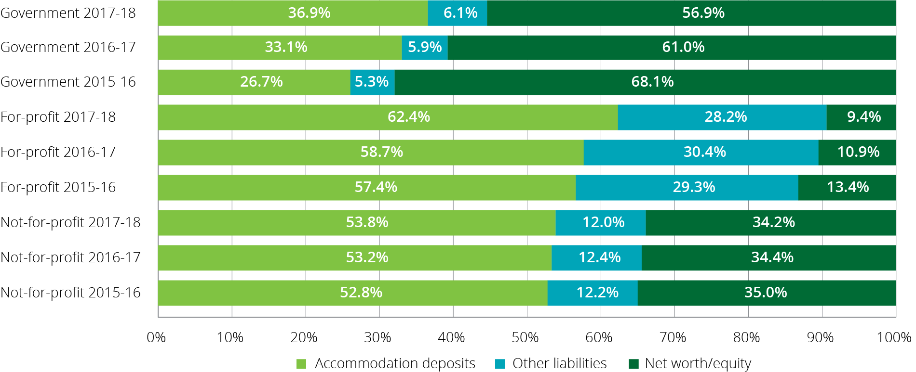

Table 7.5 presents the consolidated balance sheet at segment and organisation level for 2017‑18, with the exception of government providers as the disaggregated data is not available to the same level.

Table 7.5: Disaggregated balance sheet by provider ownership type, at 30 June 2018 ($m)

|  | Not-for-profit ($m) | For-profit ($m) | Government ($m) | All providers ($m) |
| --- | --- | --- | --- | --- |
| **Assets** |  |  |  |  |
| **Current assets** |  |  |  |  |
| Cash | $4,128 | $1,832 | $119 | $6,078 |
| Financial assets | $2,092 | $162 | $0 | $2,253 |
| Trade receivables | $330 | $299 | $0 | $629 |
| RADs & RACs receivable | $688 | $416 | $0 | $1,104 |
| Related party loans | $236 | $2,455 | $0 | $2,691 |
| Work in progress | $146 | $2 | $0 | $148 |
| Other current assets | $490 | $266 | $441 | $1,197 |
| **Total currents** | **$8,110** | **$5,431** | **$560** | **$14,101** |
| **Non-current assets** |  |  |  |  |
| Financial assets | $503 | $212 | $0 | $715 |
| Related party loans | $166 | $1,885 | $0 | $2,051 |
| Work in progress | $909 | $463 | $0 | $1,372 |
| Intangibles - bed licences | $971 | $2,025 | $0 | $2,996 |
| Intangibles - other | $281 | $2,056 | $0 | $2,337 |
| Fixed assets | $15,033 | $8,028 | $1,000 | $24,061 |
| Other non-current assets | $195 | $480 | $92 | $767 |
| **Total non-current assets** | **$18,058** | **$15,149** | **$1,092** | **$34,300** |
| **Total assets** | **$26,168** | **$20,581** | **$1,652** | **$48,400** |
| **Liabilities** |  |  |  |  |
| **Current liabilities** |  |  |  |  |
| Accommodation deposits (incl. bonds) | $14,077 | $12,837 | $610 | $27,523 |
| Bank borrowings | $194 | $319 | $0 | $514 |
| Related party loans | $95 | $1,193 | $0 | $1,288 |
| Employee provisions | $784 | $422 | $0 | $1,206 |
| Other current liabilities | $1,275 | $1,327 | $56 | $2,658 |
| **Total current liabilities** | **$16,425** | **$16,098** | **$666** | **$33,189** |
| **Non-current liabilities** |  |  |  |  |
| Bank borrowings | $409 | $1,306 | $0 | $1,715 |
| Related party loans | $107 | $747 | $0 | $854 |
| Employee provisions | $129 | $89 | $0 | $217 |
| Other non-current liabilities | $144 | $408 | $46 | $599 |
| **Total non-current liabilities** | **$789** | **$2,550** | **$46** | **$3,385** |
| **Total liabilities** | **$17,214** | **$18,648** | **$712** | **$36,574** |
| **Net assets** | **$8,954** | **$1,932** | **$941** | **$11,827** |

As shown in Table 7.5, fixed assets – predominantly residential aged care facilities are the single largest asset category held by providers ($24 billion or 48 per cent of total assets). It is also the largest asset category based on ownership type, although for not‑for‑profit providers, fixed assets represent 57 per cent of total assets whereas for the for-profit providers it represents 39 per cent. The significant difference is likely explained in part by providers in the for-profit sector being more likely to rent the facilities in which they provide residential services, often under arrangements where the facilities are rented from related party entities.

Cash ($6.1 billion) and financial assets ($2.3 billion current and $0.7 billion non-current) represent $9.0 billion (18.7 per cent) of total assets, and $8.3 billion (59 per cent) of current assets. Not-for-profit providers hold 77 per cent, or $6.2 billion of current assets in cash and financial assets, while for-profit providers hold 37 per cent, or $2.0 billion. For‑profit providers are more active in placing their funds in other categories of assets, including related parties entities.

Intangible assets make up 11 per cent, or $5.3 billion of total sector assets. Of the $5.3 billion, bed licences make up 56 per cent, or $3.0 billion, and other intangibles of $2.1 billion, consisting mostly of goodwill held by the for-profit sector, makes up the remainder. For‑profit providers hold 77 per cent ($4.1 billion) of the intangibles balance for the sector. Whilst for‑profit providers hold 41 per cent of residential operational places, they account for 68 per cent of the value attributed to bed licences.

Fifty-eight per cent of for-profit providers have recognised the value of bed licences. In contrast, only 28 per cent of not-for-profit providers have recognised the value of their bed licences.

As noted previously, the Government announced in the 2018‑19 Budget that it will fund an impact analysis of allocating residential aged care places to consumers instead of providers. It is important there is a comprehensive assessment of the potential benefits and impacts – for consumers, providers and the whole sector – of a possible alternative allocation model. ACFA notes that if there are changes to the ACAR then this may have some bearing on the valuations currently attributed to bed licences (intangible) in the future.

Another significant asset type is related party loans. Related party loans make up 10 per cent ($4.7 billion) of total assets, and for‑profit providers hold $4.3 billion (92 per cent) of this balance. Some of this might be explained by residential facilities being held by related parties as although 57 per cent ($2.5 billion) of related party loans are classified as current assets (receivable within 12 months), and fixed assets are non-current in nature, only a portion can be attributable to facilities being held by related parties. The for-profit providers would have a negative equity position if not for net related party loans ($2.4 billion), and/or intangible assets (bed licences and other).

Given the regulated permitted uses of RADs and bonds, the build-up of categories of assets other than fixed assets is noteworthy. A formal review of the use of RADs and bond financing is part of the annual focus of the Department of Health in their examination of Annual Prudential Compliance Statements. It is important that as RADs and their related investments continue to grow, the Department and Health similarly increases its oversight to ensure it keeps pace with this expanding sector.

In terms of total liabilities, RADs (including bonds) make up 75 per cent ($27.5 billion) of the capital funding of the sector. Fifty-one per cent of RADs are held by not‑for‑profit providers, 47 per cent by for‑profit providers and 2 per cent by government providers. With 41 per cent of places held in the sector, the for-profit providers have the greater exposure to RADs and bonds.

Conversely the not‑for‑profit providers have proportionally significantly less RADs exposure as they hold 55 per cent of places.

Other capital funding sources include:

* Bank borrowings make up 6 per cent, or $2.2 billion of total liabilities. The for-profit sector hold 73 per cent of bank borrowings, or $1.6 billion, while not-for-profit providers have borrowed 27 per cent, or $0.6 billion; and
* Related party loans make up 6 per cent, or $2.1 billion of total liabilities. The for-profit sector holds the majority of this funding with 91 per cent, or $1.9 billion of borrowings. It is of note that the for-profit providers have a net asset balance, indicating they loan more funding out than they receive.

Other liabilities make up 17 per cent, or $6.0 billion of total liabilities. These include balances that have not been disaggregated from data submitted from providers. Other liabilities include, but not limited to, deferred revenue, trade and other payables, income tax payable, deferred tax liabilities, financial instruments such as interest rate swaps, other financial liabilities such as lease arrangements, and non-employee related provisions.

### Balance sheet performance ratios

Balance sheet ratios provide a guide as to the financial health of providers through an analysis of their profitability, liquidity and efficiency as well as their net worth.

#### Balance sheet performance ratios – definitions

##### Current Ratio

Current ratio is a measure of an organisation’s ability to meet its short term obligations (current liabilities) from its current assets. The current ratio measures an organisation’s liquidity and provides an indication of risk that the organisation may not be able to meet its short term obligations as and when they fall due. It is calculated by dividing current assets of an organisation by its current liabilities.

Generally, a current ratio of at least 1.0, shows that an organisation has sufficient current assets to meet its short term obligations. However the requirement to categorise accommodation deposits as current liabilities[34] on the balance sheet of providers means that the current ratio needs to be treated with some caution and considered in conjunction with other financial indicators of liquidity for aged care organisations. For example, although refundable accommodation deposits (RADs) are required to be repaid when a resident leaves care, they are more often than not, repaid after a stay of longer than one year. The average length of stay for residents is currently just over three years.

##### Cash as a proportion of accommodation deposits

Cash and cash equivalents in the form of financial assets, as a proportion of refundable accommodation deposit balances provides an indication of an organisation’s capacity to repay the accommodation deposit balances with liquid resources.

##### Net Assets Value

The net assets value provides an indication of the value of an organisation. The net assets value is determined by taking the total assets of an organisation and subtracting total liabilities. A low net assets value or a decrease in the value over time indicates higher levels of financial risk for lenders and consumers.

##### Debt Ratio

The debt ratio is calculated by dividing an organisation’s total liabilities by its total assets and provides an indication of the degree of financing of an organisation. Within the aged care sector, total liabilities will consist of an organisation’s refundable accommodation deposits as well as other secured and unsecured debt balances. An organisation’s total assets will include cash and asset balances to which the refundable accommodation deposits may have been applied. As total liabilities increase as a proportion of total assets, the higher levels of debt could reflect the use of additional borrowings used to fund an organisation’s improvements and expansions.

##### EBITDA to total assets ratio

The EBITDA to total assets ratio measures the operating return generated from an organisation’s total assets. The ratio is a measure of financial performance and is calculated by taking the earnings, before interest, tax, depreciation and amortisation (EBITDA) and dividing this by the organisation’s total assets. Generally, the higher the EBITDA to total assets ratio, the better the level of return generated from the organisation’s total assets.

##### Equity to total assets ratio

Net worth/total equity as a proportion of total assets provides an indication of solvency. For the for-profit providers, it shows the proportion of an organisation’s assets which have been contributed by the owners/shareholders. For the not-for-profit and government providers, equity typically consists of retained earnings and revaluation reserves. The lower the ratio suggests that an organisation has used more debt to fund its asset balances.

As shown in Chart 7.10 the current ratio for the whole sector continued to decrease to 0.42 from 0.43 in 2016‑17 and 0.47 in 2015‑16. The decrease indicates a slight increase in the risk that organisations may not be able to meet their current liabilities from the current asset balances.

In terms of ownership type, in 2017‑18, the current ratio for not‑for‑profit providers decreased to 0.49 compared with 0.50 in 2016‑17. As has been the case in recent years, the current ratio for the not-for-profits was higher than the current ratio achieved by the for-profit providers which decreased slightly to 0.34 from 0.35 in 2016‑17. As noted, a current ratio of less than 1.0 ordinarily indicates an organisation has insufficient assets to meet their obligations when they become due and payable. However, although refundable accommodation deposits can become repayable at any time and are classified as current liabilities, in practice, the repayment period for accommodation deposit balances will vary in line with each resident’s tenure. This means that the current ratio result should be used with some caution and considered with other financial indicators in the residential aged care sector.

Chart 7.10: Current ratio, by provider ownership, 2011-12 to 2017-18

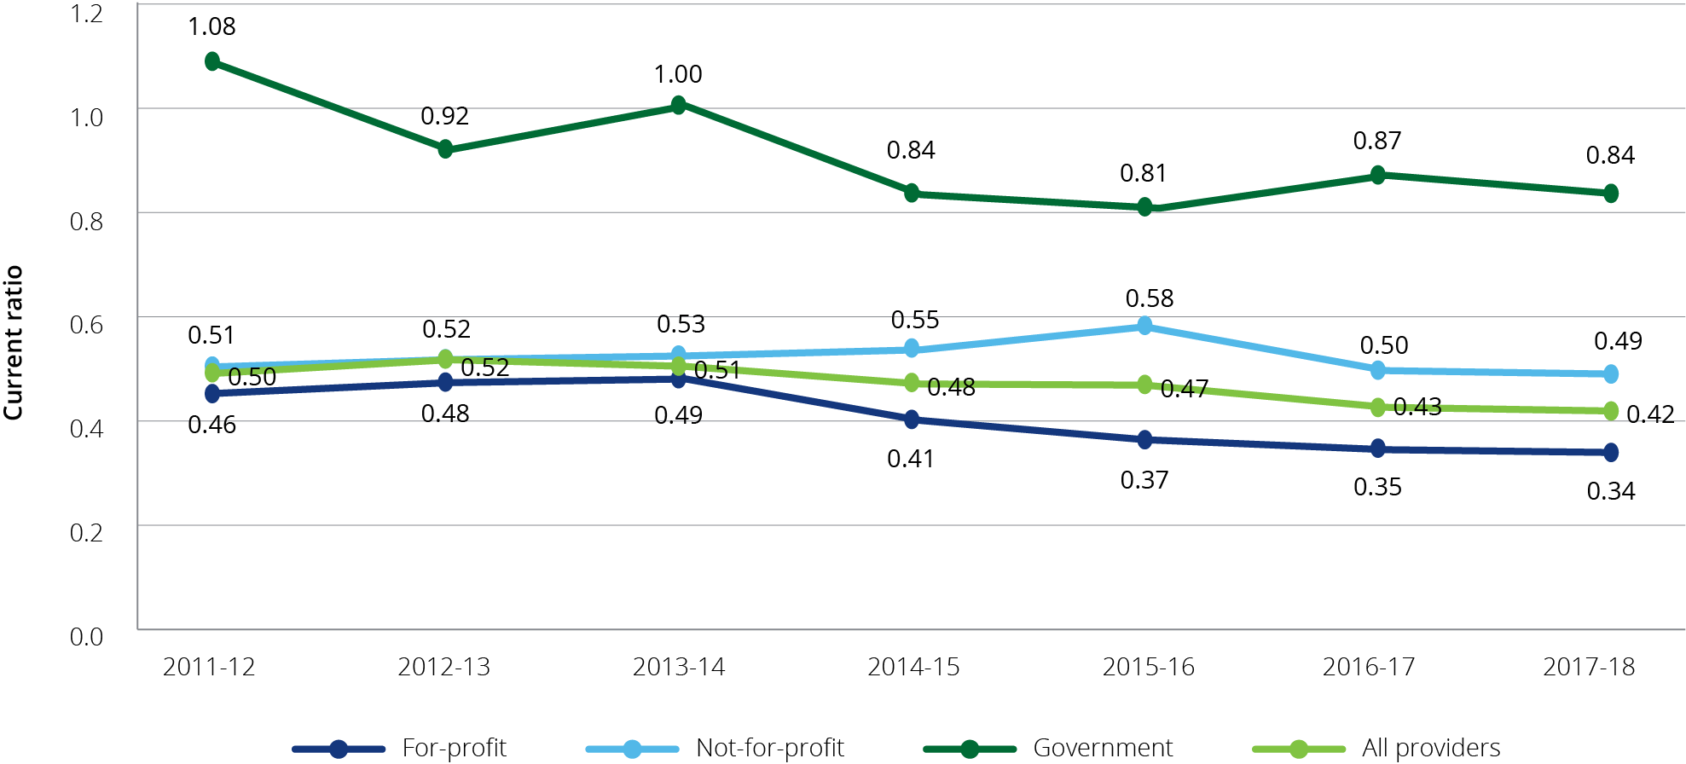

As shown in Chart 7.11 the EBITDA to total assets has been trending downwards since 2011‑12. In 2017‑18 it was almost the same for the not‑for‑profit providers (3.1 per cent) as it was for the for‑profit providers (4.0 per cent). The EBITDA to total assets ratio measures the operating return generated from an organisation’s total assets.

Chart 7.11: EBITDA to total assets, by provider ownership, 2011-12 to 2017-18

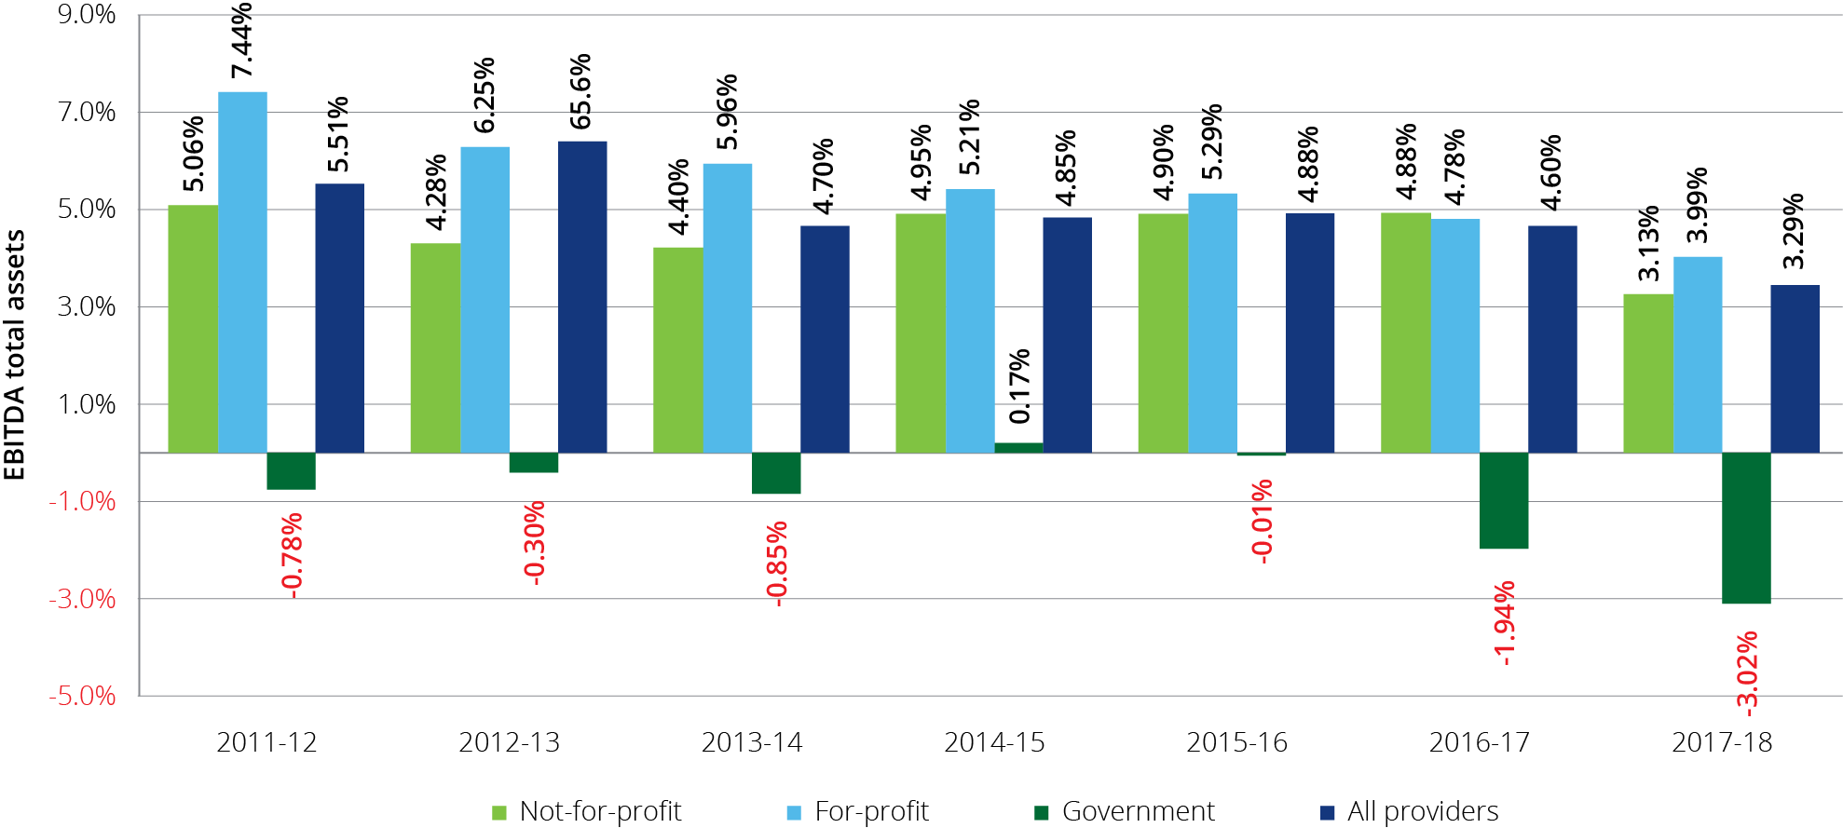

There was a significant difference between the results for provider types when looking at the results for the equity to total assets ratio as shown in Chart 7.12. Not-for-profit providers achieved a higher result of 34 per cent whereas the for-profit providers decreased by 1.5 per cent to 9.4 per cent in 2017-18. The results for all provider types have continued to decrease since 2013-14 suggesting a preference for debt to fund the growth in assets.

Chart 7.12: Equity to total assets, by provider ownership, 2011-12 to 2017-18

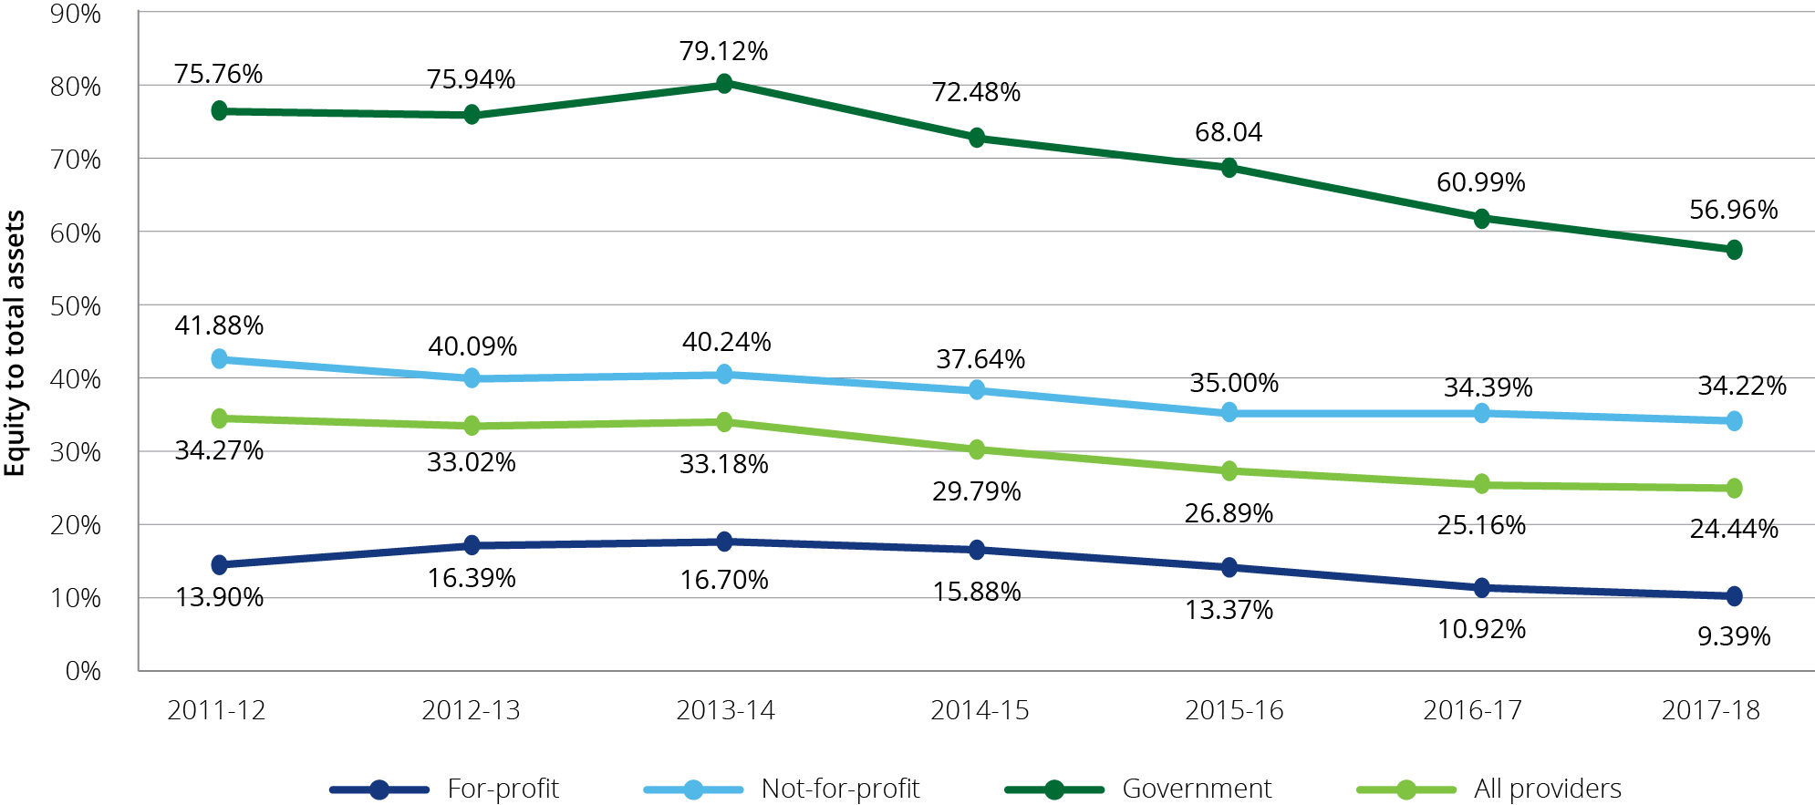

The average debt ratio across the sector again increased slightly with all three ownership types recording an increase compared with 2016-17 (Chart 7.13). The average debt ratio shows the proportion of organisational assets that are financed through debt. A ratio of more than 1.0 indicates that an organisation has a higher debt level than the value of its assets. The debt ratio for all provider types has been increasing since 2013-14.

Chart 7.13: Average debt ratio, by provider ownership, 2011-12 to 2017-18

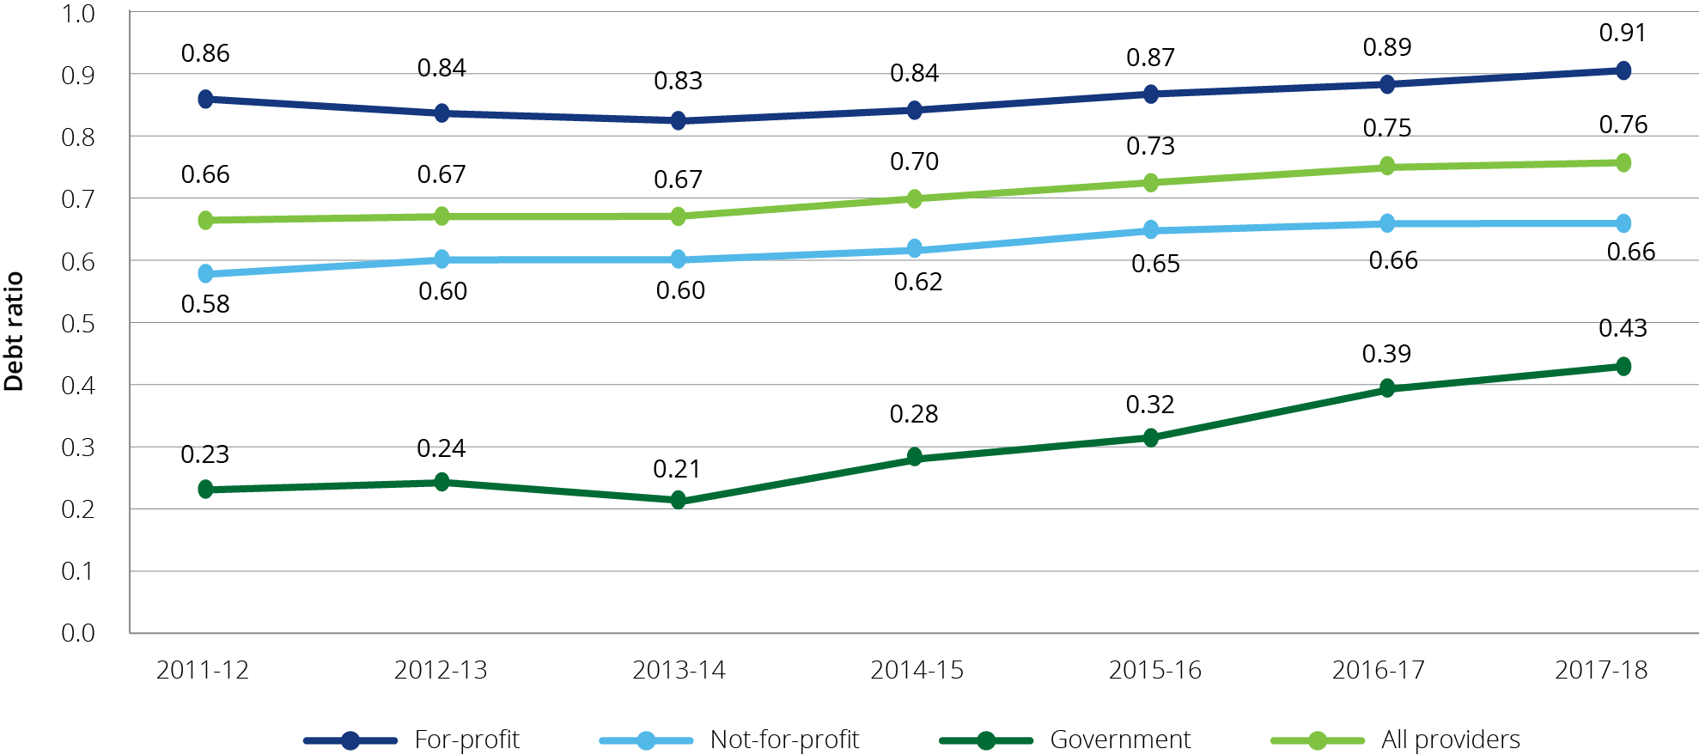

The net asset position increased across the sector for the not-for-profit providers, increasing by $695 million to $8.9 billion in 2017-18 (Chart 7.14). The net asset position decreased slightly for both the for‑profit providers and government providers to $1.9 billion and $941 million respectively. The net asset position of the sector as a whole has been increasing since 2014-15.

Chart 7.14: Net assets, by provider ownership, 2011-12 to 2017-18

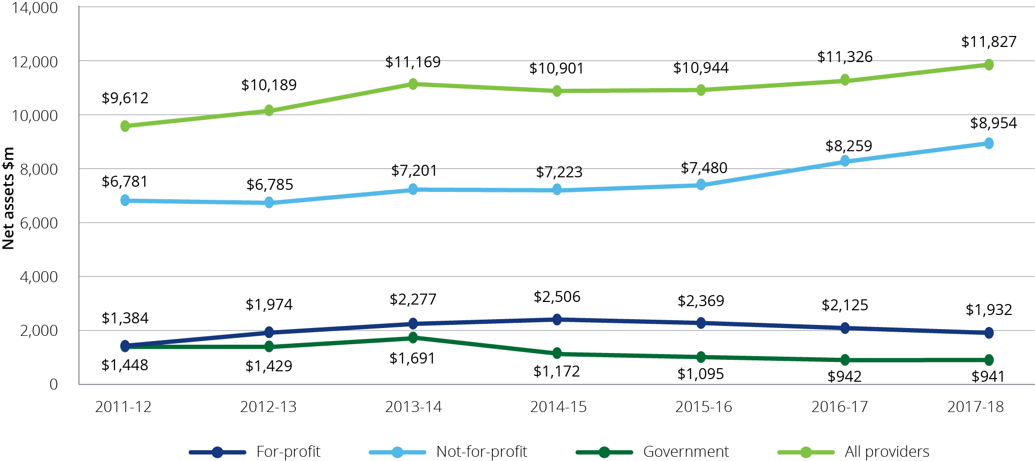

Whilst the net asset balances of the sector has increased during 2017-18, the levels of cash and cash equivalents held by not-for-profit providers and government providers has decreased in 2017‑18 (Chart 7.15). The levels of cash and cash equivalents held by the for‑profit providers increased marginally during this same period, however the for–profit providers held the lowest levels of cash and cash equivalents, as a proportion of refundable accommodation deposit balances at 15.5 per cent. Cash held as a percentage of accommodation balances received provides an indication of an organisation’s capacity to repay the accommodation deposit balances from liquid resources

Chart 7.15: Cash held as percentage of accommodation deposit balances, by provider ownership, 2016-17 and 2017-18

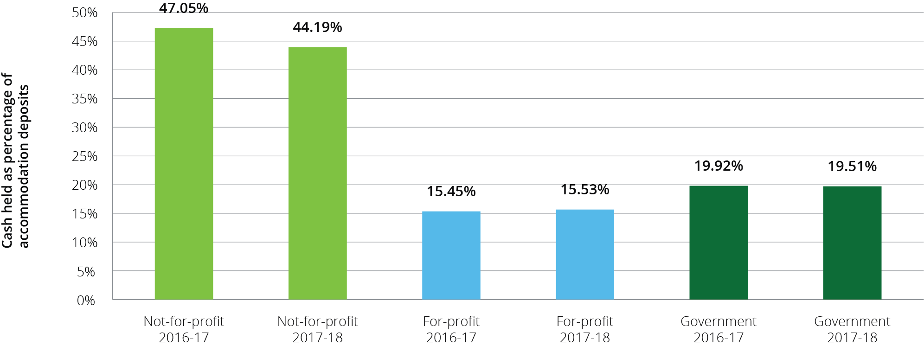

Chart 7.16 shows total assets, net worth/equity and average accommodation deposit value per resident, by ownership type in 2017‑18, compared with 2016‑17. For the whole of sector, the average for all accommodation deposits held increased to $303,107 per resident from $283,499 in 2016‑17, an increase of 7 per cent. This metric measures the average value of all bonds (pre 1 July 2014) and accommodation deposits (post 1 July 2014) that providers hold.

In terms of net worth/equity, for‑profit providers recorded a decrease of $3,238 per resident (10.6 per cent) which follows a decrease the year before of around $5,000 (15.7 per cent). In contrast, the not-for-profits recorded an increase for the second year in a row, increasing to $87,262 from $80,909 in 2016‑17.

Chart 7.16 total assets, net worth/equity and average accommodation deposit value per resident, by ownership type, 2017-18 and 2016-17

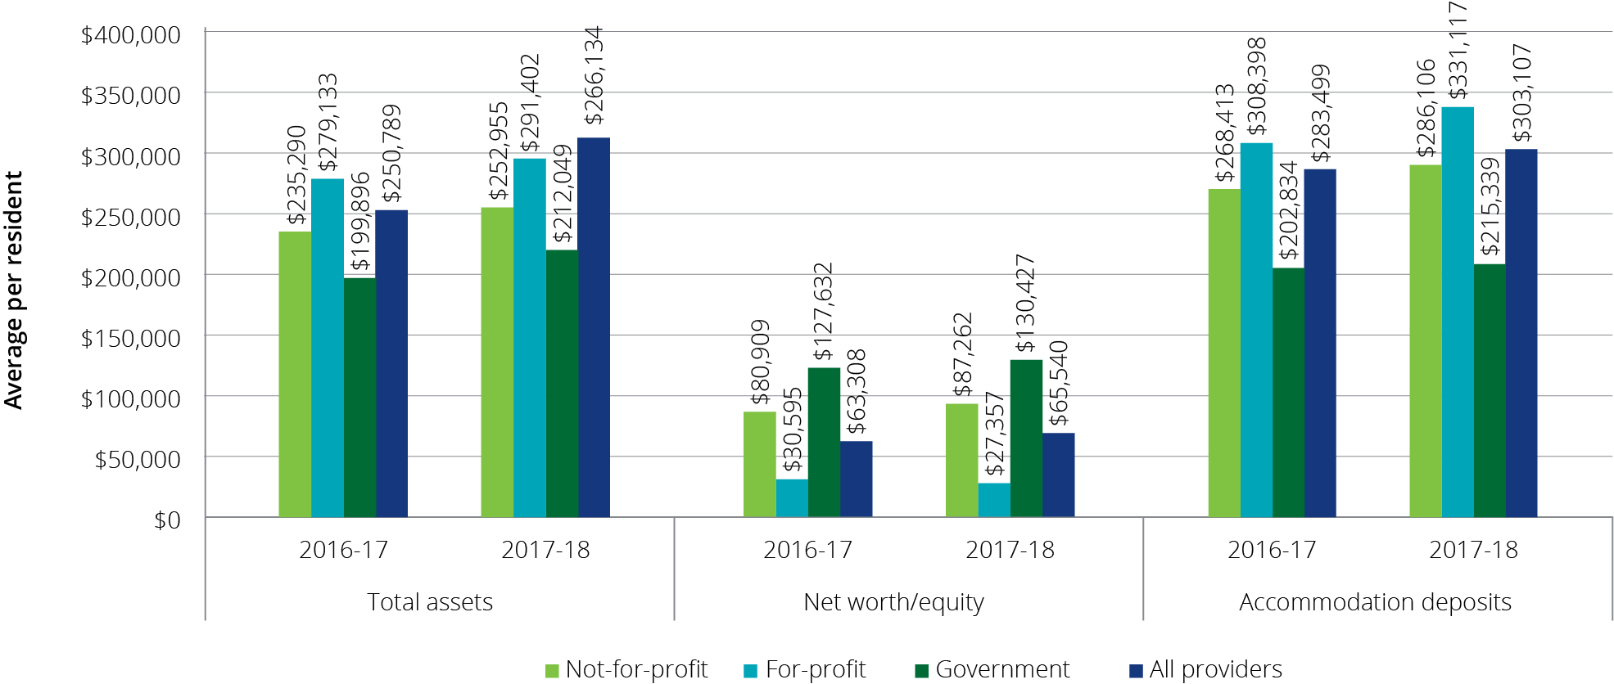

### Recent trends in building and investment in the residential care sector

In 2017‑18 the total completed or in-progress work was $4.9 billion compared with $4.7 billion in 2016‑17 (Chart 7.17).

However, following on from the decline reported in last year’s report, in 2017‑18, there was a further significant decline in providers reporting they were planning to rebuild or upgrade their facilities (Chart 7.18). In 2015‑16 the proportion of facilities planning to rebuild or upgrade were 5 per cent and 14 per cent respectively. In 2017‑18, following two years of declining intentions, only 2 per cent of facilities are reporting they are planning rebuilding works and 5 per cent planning to upgrade.

Feedback from consultations with providers indicated that many had curtailed or delayed investment plans in the residential care sector, citing depressed returns and policy and regulatory uncertainty along with the potential impact of increased home care packages. A large number of providers, both for-profit and not-for-profit, said their immediate plans would be directed to retirement living rather than residential care. Factors cited in influencing this decision included: the considerable policy and regulatory uncertainty in the aged care sector; the desirability of diversifying income streams given the volatility in residential aged care; and the advantages of establishing an integrated aged care operation that involved retirement living, home care and residential aged care. Many for-profit providers emphasised that the current return on capital employed in aged care was below the cost of capital and, in the absence of any change, this would curtail additional investment in the sector.

Chart 7.17: Residential care building activity (completed or in-progress), 2012-13 to 2017-18

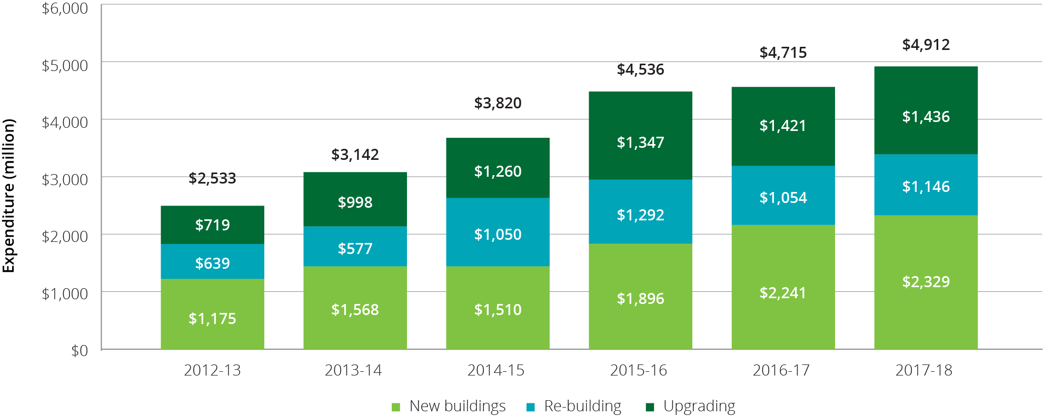

Chart 7.18: Proportion of facilities planning to either upgrade or rebuild, 2013-14 to 2017-18

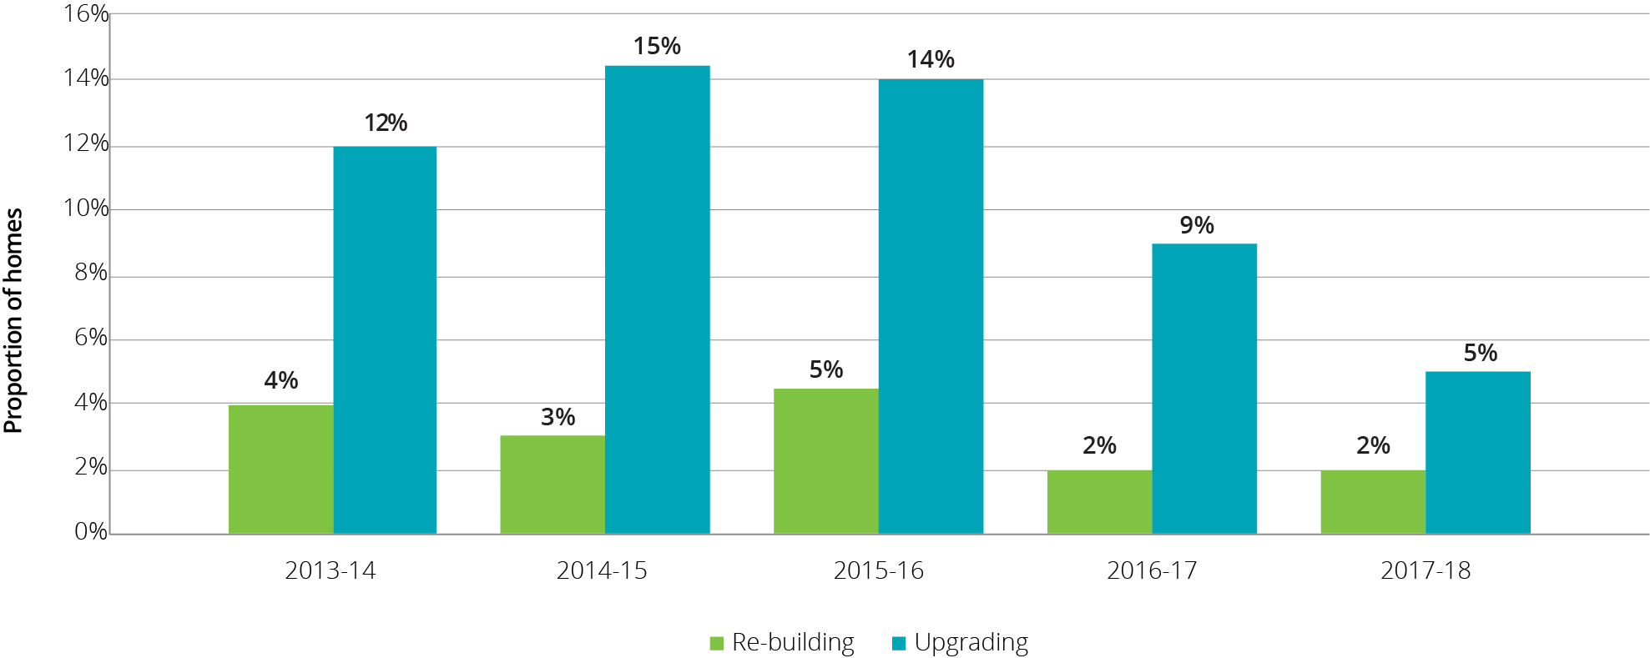

The decline in planned building activity discussed above is also evident, albeit less significantly, in data regarding aged care building approvals from the Australian Bureau of Statistics. There were 330 building approvals for aged care facilities in the 12 months up to the end of February 2019, compared with 405 for the same period up to February 2017 (Chart 7.19) and similar approval levels in the two years prior to that.

Also, as noted in Chapter 3, there was a dampening in demand for new residential care places in the 2018-19 ACAR with 2.8 applications for every available place, compared with 4.5 for the 2016‑17 ACAR.

Chart 7.19: Number of building approvals, by value of building work, 2013-14 to 2017-18

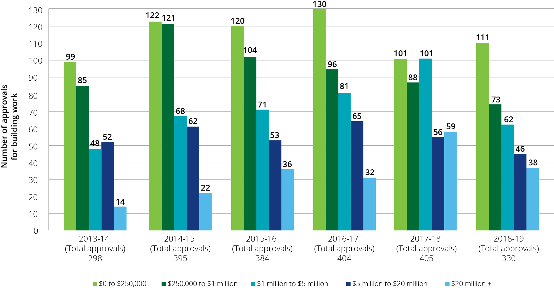

Note: Data is March to February each year.

# Future demand for aged care

| **This chapter discusses:**  The factors that affect demand for aged care;  demand for the different types of subsidised aged care;  changing population of older Australians requiring aged care; and  changing preferences of consumers seeking aged care. |
| --- |

## Future demand for aged care services

The demand for aged care services will expand with the ageing of the population. This chapter examines the factors that affect demand for the relevant aged care types, how this is likely to look in the future, and the investment that is needed to ensure the aged care system can adequately cater for the expected future requirements of the population.

An investigation into demand and supply of aged care services was undertaken by David Tune AO PSM in the Legislated Review of Aged Care 2017. The Review concluded that there was insufficient data available and that “robust measures of demand and unmet demand in aged care are a significant way off”. The Review also noted however that there is no doubt that demographic factors will lead to significant growth in service provision and expenditure requirements.

It is also currently not possible to establish consumer preference for residential and home care, due to existing supply constraints. Better evidence about unmet need and consumer preference is however, gradually being revealed as the overall provision target and the proportion of home care packages (including at higher levels) continues to increase, and through the introduction of the national prioritisation system for home care packages. The introduction of flexibility to switch funding across care types in response to consumer demand will also help to inform consumer preferences. The other variable is how providers might respond to increased consumer choice, such as innovation in accommodation options for older people and innovation is service delivery models.

With these limitations in mind, the analysis contained in this chapter focuses on projections based on current use of aged care and population growth, and should not be treated as forecasts of what is likely to happen in terms of future demand for types of aged care.

### Determinants of demand

Demand for aged care services is complex and dependent on a range of demographic, service need, and economic factors. The Productivity Commission noted in its 2011 report, Caring for Older Australians, that “The demand for aged care services depends on the number of older people needing care and support. However, care needs are not homogenous and the nature and location of aged care services demanded will depend on the physical and mental health of older people, their capacity and willingness to pay, their preferences, and the availability of informal carers.”

Figure 8.1: Factors affecting the extent and type of aged care service demand

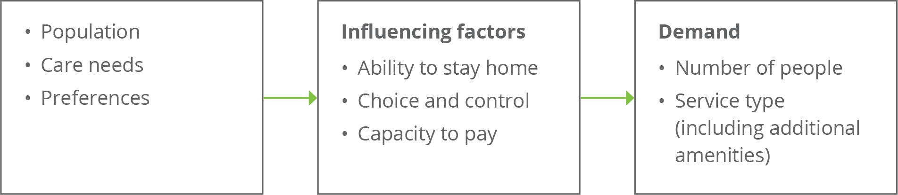

Source: adapted from Caring for older Australians (Productivity Commission, 2011)

### An ageing population – older people demand more aged care

The structural ageing of the Australian population over the next 20 years will see the size of the 70 years and over cohort increase by around 1 million people each decade; this is on a base of 2.7 million people in 2019. Underneath this, the older age groups will more than double over this period; for example, the 85 years and over cohort will increase from just under 500,000 people in 2019 to just over 1 million people by 2039.

Chart 8.1: Number of people aged 70 years and over, by 5 year age cohort, 2019 to 2039

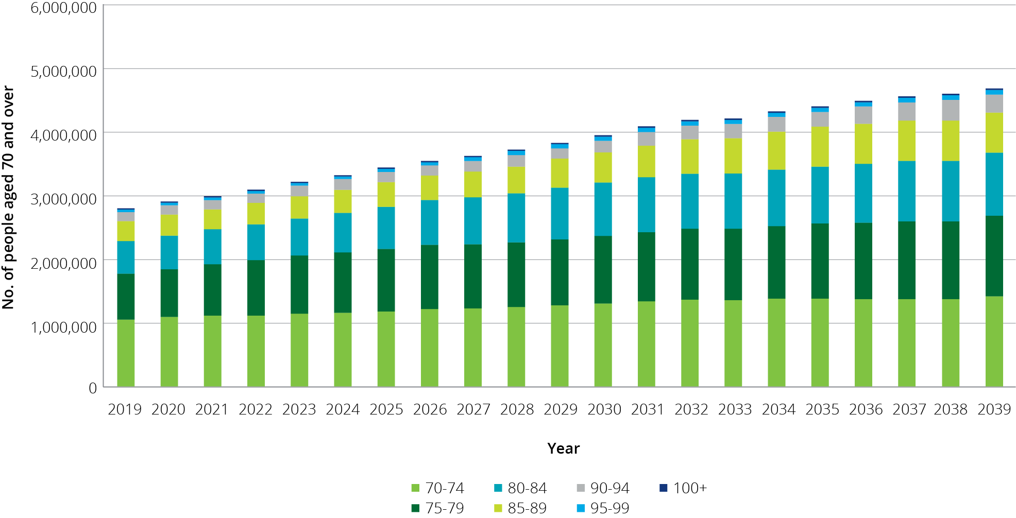

Because the baby boomers are such a large group compared with the pre-war generation, the proportion of the 70 and over population who are aged 85 and over will actually reduce over the next decade before subsequently increasing, as shown in Chart 8.2. This implies that the challenge of ensuring there is sufficient aged care supply to meet demand arising from the baby boomer generation is likely to be most strongly felt in 10–15 years (from the late 2020s) rather than over the next decade.

Chart 8.2: Proportion of 70 years and over age group who are aged 85 and over, 2019 to 2039

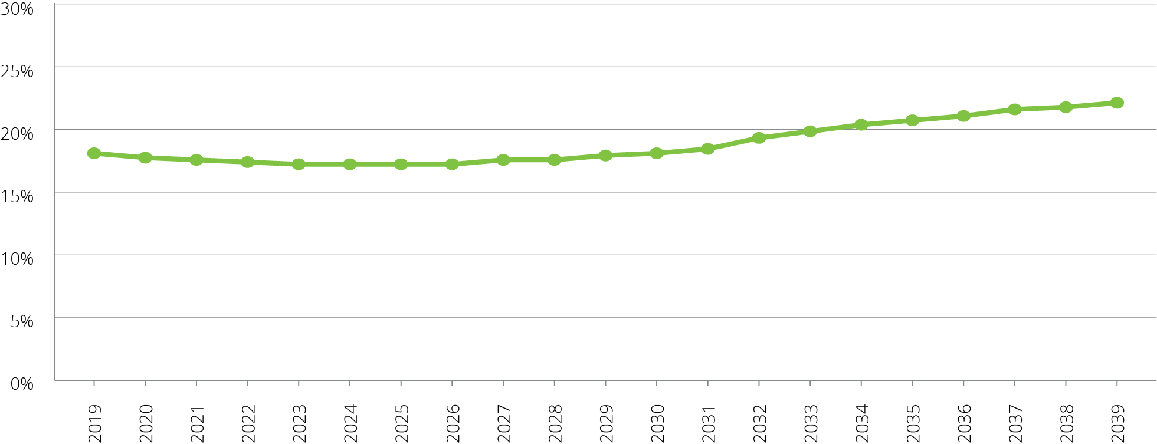

### Consumer preference

A key characteristic of the baby boomer generation is that they are wealthier than previous generations[35]. The bulk of the people likely to be demanding care in the next two decades have benefitted from high growth in property prices while paying down their mortgage, and are the first generation to have compulsory superannuation. It is reasonable to assume that they will both expect and be able to afford higher standards of residential accommodation, lifestyle amenities and quality of life than previous generations have been willing to accept. Like the current generation, however, baby boomers can be expected to prefer to remain living in their own home for as long as possible as they age.

The consequences of these trends are that while the demand for aged care will grow with the ageing of the population, consumers may be more demanding in the range and quality of aged care services they are seeking, along with having a greater capacity to pay for these services. Nevertheless, maintaining equity in access to aged care services will continue to be important and a robust safety net will continue to be necessary.

To compete in this environment, however, providers will need to be more responsive in meeting consumer needs, including in particular the desire to stay at home for as long as possible, and this may require the introduction of new business models and changes in the interaction between retirement living, home care and residential care. The aged care regulatory system will also need to adapt to enable providers greater flexibility to pursue new business models and innovation.

### Availability of alternative care types

According to the Survey of Disability, Ageing, and Carers[36], around 1 in 9 Australians, or 2.7 million people, were informal carers. Almost all carers cared for a family member. The assistance provided by informal carers can avoid or delay entry into residential care, including with the support of home-based care, and is also an important source of support for those in residential care.

At the same time that ageing population structures (discussed earlier) are putting pressures on the demand for care, the relative supply of informal carers is diminishing. This is due to increased participation of women in the workforce, and changing family structures with fewer children being born per family (1.7 babies per woman in 2017 compared with nearly 3 in 1970[37]), generational differences in marriage and divorce rates. And more people living alone.

All else equal, this will increase the demand for formal aged care for older people.

In terms of demand for specific types of aged care, the relative availability of places within each care type under current regulated supply arrangements will also affect the rates at which people access them and to the extent they are not available, redirect demand across care types. As previously outlined in this report, the Government is gradually changing the mix of residential and home care over time through adjustments to the provisional target ratios, and has implemented mechanisms whereby funding for unused residential care places can be redirected into home care where, at least over the short term, demand is expected to be more acute.

In addition, a key objective of the Legislated Review of Aged Care 2017 was “to trigger changes that are prerequisites for a fully consumer-driven system”, and outlined recommendations that were “intended as the next steps on the road to consumer-driven care”. Most of the Legislated Review’s recommendations in this regard have not been acted upon.

The unknown, therefore, is related to uncertainty about government policy and the extent to which the modes of delivering care may develop in the future in response to consumer preferences, such as further relaxation or removal of supply constraints, the availability of more higher level home care packages and closer integration between retirement living and home care. New ways of service delivery and innovation may widen the scope of aged care services available, which in turn may result in significant shifts in the types of services demand.

### Economic factors

The demand for different types of care, and the way consumers distinguish between services in the same type of care, is affected by the price they can be asked to pay and the perceived value of that contribution.

Consumers of residential and home care are currently required to make a co-contribution to the cost of their care (and residential accommodation) if they can afford to do so. However the amount and proportion of contribution required to be made by a consumer varies between residential care and home care, including in relation to capacity to pay. Such anomalies have the potential to distort the demand for types of care or additional services.

Nevertheless a challenge remains for governments to establish funding policies that ensure access to aged care services for all needing aged care and support that meet community quality of life expectation, irrespective of their means and social and cultural circumstances. Incentives in funding arrangements are also important in influencing the type of care supplied, for example if funding arrangements have no incentive for reablement services and a provider loses funding if there is an improvement in the level of acuity of a consumer, then there will be limited supply of services promoting reablement.

## Current demand for aged care

An understanding of the current profile of aged care usage is helpful for undertaking projections of future demand.

As shown in Chart 8.3 the proportion of each age group who use residential and home care package services increases dramatically with age. By age 80, the proportion of people using either permanent residential care or a home care package is around 7 per cent; this doubles by aged 85; and more than doubles again by age 90.

Chart 8.3: Proportion of people of each age using residential care and home care, by gender and age, 30 June 2018

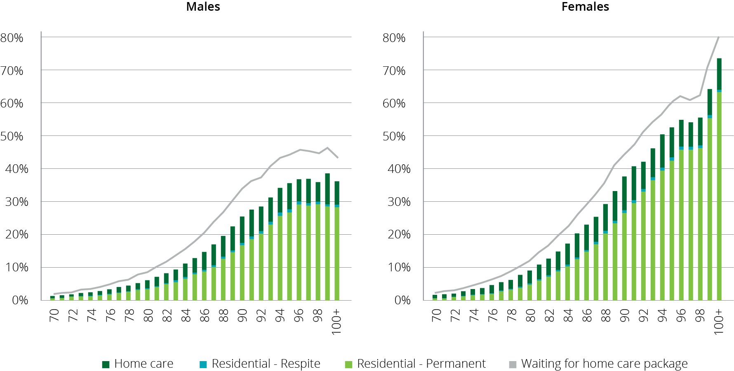

Note: Home care consumers receiving care in an interim level package are counted as using home care. People waiting for a home care package are only those consumers who do not have a package at any level.

This projection is based on current usage, which may well not reflect the extent to which consumers are having their needs and preferences met by current regulated supply. True demand is much harder to measure given the current highly regulated supply system.

### Residential care

There are indicators to suggest that overall the demand for residential care is currently being met. The occupancy rate in 2017-18 was 90.3 per cent, down from 91.8 per cent in 2016-17 and 92.4 per cent in 2015-16. The overall average occupancy rate in residential care peaked at 97.1 per cent in 2003-04. There may, nevertheless, be pockets or regions of the country where people are waiting to access residential care. The Tune Review asked stakeholders about the level of unmet demand and received little feedback to suggest that there is significant unmet demand.

Residential care usage may, however, be artificially high as result of people entering residential care prematurely as an alternative to waiting on the allocation of a home care package. Current usage also does not reflect the potential for residential care services in a more competitive and flexible system to offer a more attractive service that includes more opportunities for higher quality and meaningful life delivered in a secure environment.

### Home care

There is evidence of unmet demand for home care. As noted in section 3.4.2, at December 2018 there were 127,748 people waiting for a home care package (including those already receiving lower level home care) through the National Prioritisation System.

## Projecting demand into the future

Previous ACFA reports have contained a projection of demand for residential care over the next 20 years based on current age-specific use and the current residential aged care target provision ratio which is based on the number of people aged 70 years and over.

A projection on this basis suggests that the projected number of operational places is likely to exceed demand for residential care to 2027. This is because places are linked to growth in the 70+ population, which due to baby boomers entering their 70s, is growing at a faster rate than people who currently are using residential care, who are the 80 plus cohort of the population. Following 2027, as the baby boomers enter their 80s, demand for care is expected to rise faster than the release of places in line with the provision target ratio.

Care is needed in interpreting such projections because they are limited to residential care and do not take into account changes in consumer preferences and changes in modes of delivery of aged care. In particular, no account is taken for substitution of residential care for home care as the number of home care packages continue to expand.

### Substitution of residential care and home care

One of the key factors that has to be taken into account in projecting demand for aged care is the potential substitutability of service types. The introduction of the National Prioritisation System indicates there is significant unmet demand for home care services. It is also possible that some people have entered residential care because a home care place at a suitable level was not available.

The proportion of people in each age group (age-specific use) who are in either residential care or home care has remained stable (Chart 8.4, first column) over a long period of time. However, the amount of home care packages available has increased significantly as a share of these two care types (Chart 8.4, second column). As the amount of home care has expanded there has been a clear reduction in the age-specific use of residential care (Chart 8.4, third column and Chart 8.5 which gives a cross-section of Chart 8.4). This would indicate that home care is substituting for residential care.

It is not known what the level of home care availability is that would be needed before all people who wish to remain in their home with a home care package can do so, and do not have to enter residential care. In addition, the substitutability between residential and home care will also change if, for example, the government were to introduce a new higher level package as recommended by The Tune Review (Recommendation 7). It is possible that the introduction of higher level home care packages could see the age-specific use of residential care potentially reduce. Similarly, other possible policy changes, such as consumer contribution policies and support available for informal carers (such as improved respite services), could influence value for money and consumer choice.

Chart 8.4: Utilisation of residential care and home care, 2000 to 2018

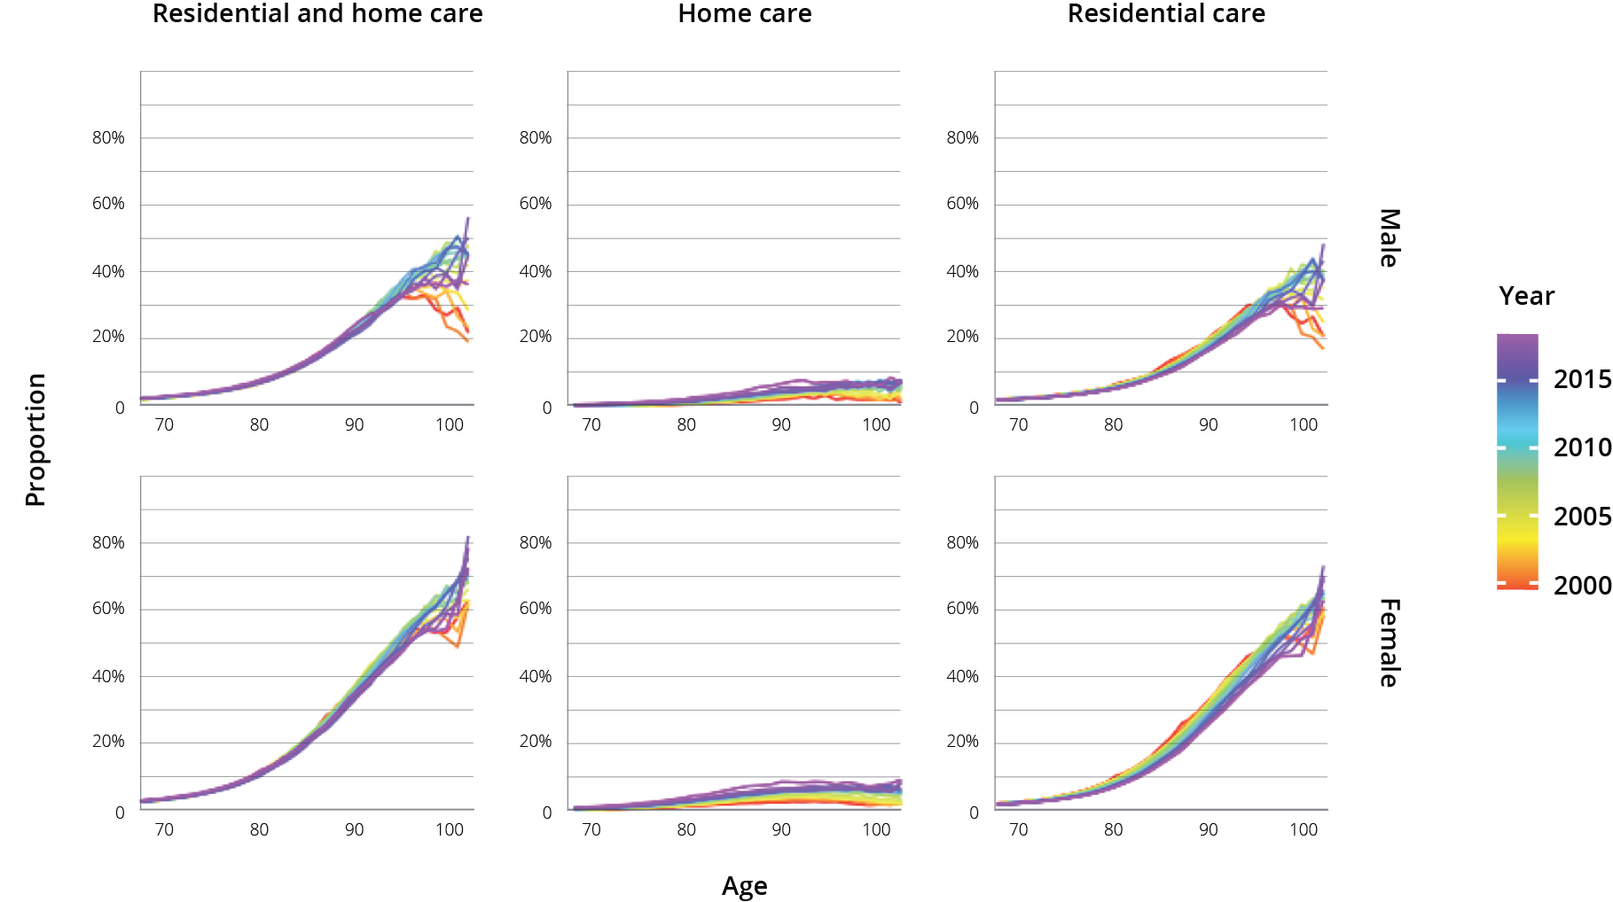

Chart 8.5: Utilisation of residential care and home care for 85-89 year olds, 2000 to 2018

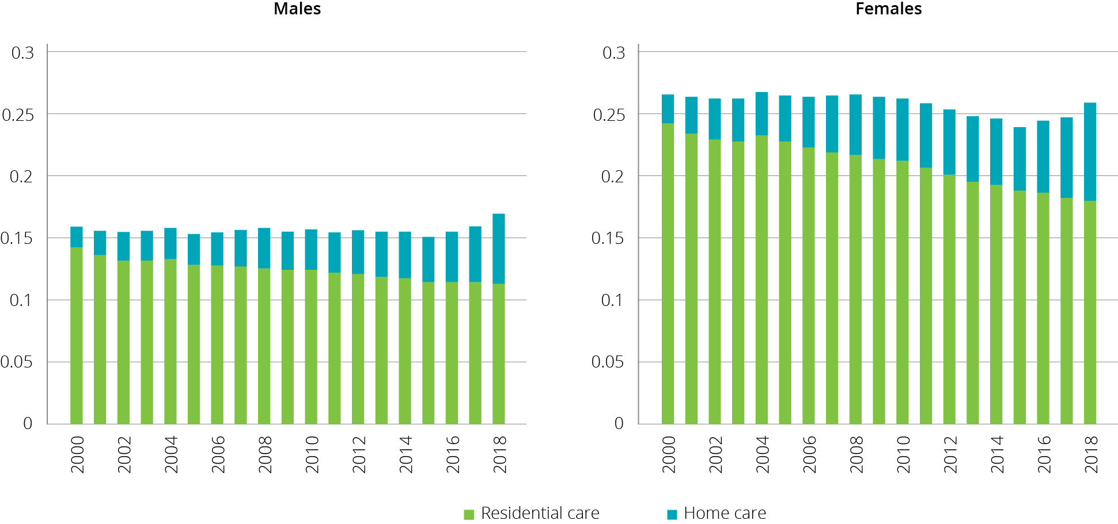

The expansion of home care is likely to not only divert people from entering residential care for longer or at all, but it will also have an impact on people receiving care from informal carers and through other programs such as the Commonwealth Home Support Program (CHSP). It is estimated that 93.9 per cent of people waiting for a home care package as at the end of December 2018 had been provided with approval to access support through CHSP.

### Updated projections

The projected demand from the current age-sex specific usage of residential care is one approach to projecting future demand for residential aged care. However, with the expansion of the home care program and the concomitant fall in the usage of residential care in all age groups (Chart 8.4 and Chart 8.5), such projections may over estimate demand for residential care. Chart 8.6 grows the number of people using residential care proportional to growth in the population (using ABS single-year-age and sex population projections).

It is evident from Chart 8.6 that, if the growth in the number of residential care places grows in line with the current target provision ratio (purple line) and not impacted by any other factors, occupancy rates will continue to fall over the 2020s, before rising in the 2030s.

Chart 8.6: Projected demand for and supply of residential care places, 2018 to 2039

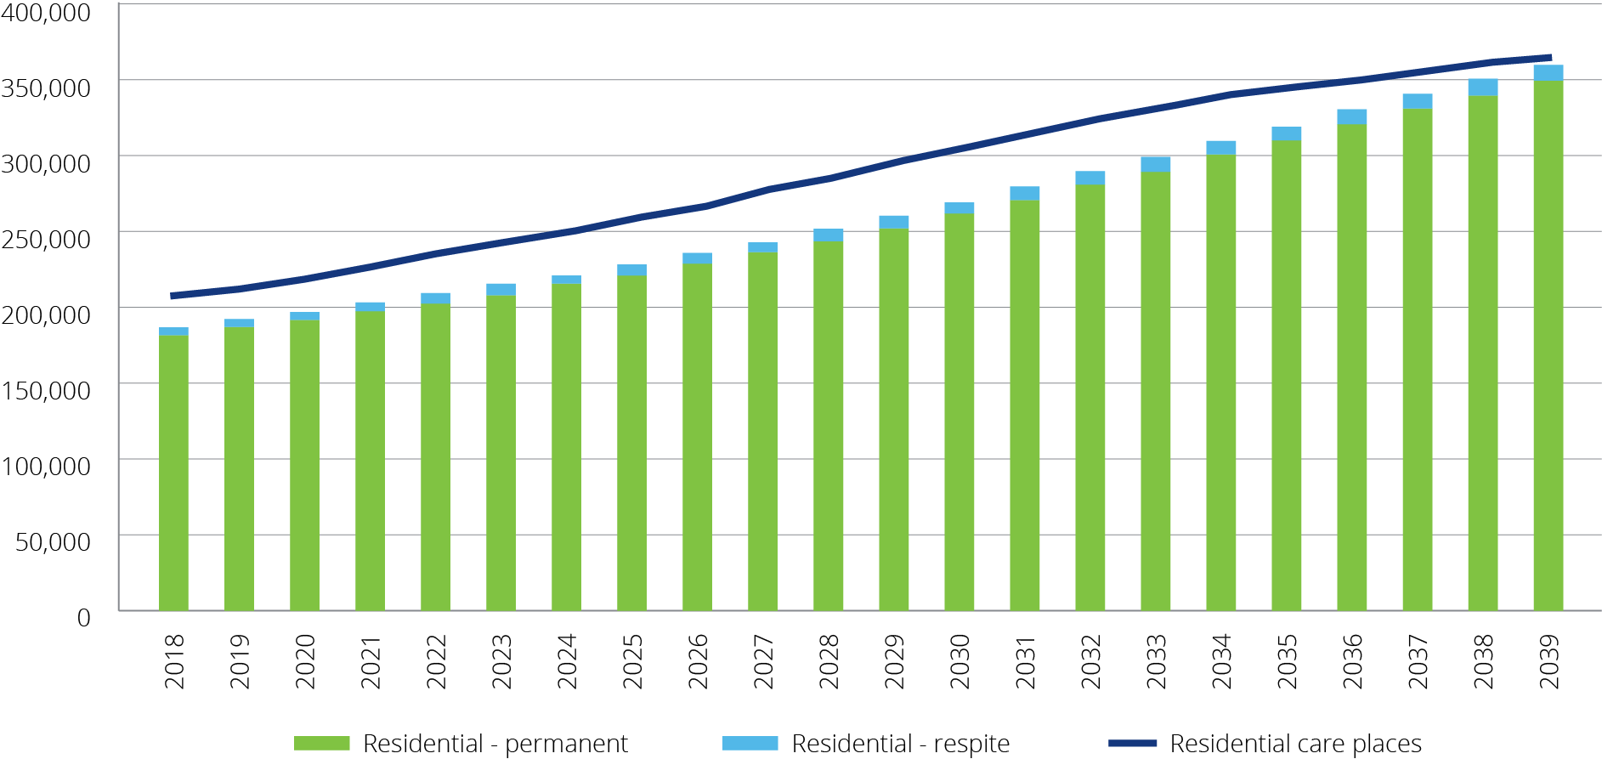

There is currently excess demand for home care. Consequently, projections based on the current usage of home care, which is constrained by current supply, are not going to give a meaningful guide as to future demand. In addition, the current profile of assessment for home care could be influenced by the number of people waiting for home care through the National Prioritisation System and prospect of long wait times.

With this in mind, Chart 8.7 grows the number of people in the home care system at 30 June 2018 - with a package (blue series) or waiting for a package to be offered (orange series) – proportional to growth in the population using the ABS single-year-age and sex population projections. These series have been broken down into sub-components:

the ‘with a package’ series (blue) is further sub-divided into those receiving a package at their assessed level, those receiving an interim package and those who have been offered a package and are in the process of deciding whether to take up the offered package;

the ‘waiting for package to be offered’ series (orange) is further sub-divided into those who have not been offered any package and those who have been offered an interim package but have not taken this up.

It is evident from this chart that the growth in the number of packages (black line) as the provision target of 45 by 2020 is achieved will, in the short-term, significantly reduce the number of people waiting for home care through the National Prioritisation System who have not yet been offered a package. However, there will still be a significant number of people without a package and over time the number of people waiting will grow again. It needs to be kept in the mind that those people who have declined the offer of an interim package have indicated they are actively seeking care and are awaiting an offer of a higher level package.

Chart 8.7: Projected demand for and supply of home care packages, 2018 to 2038

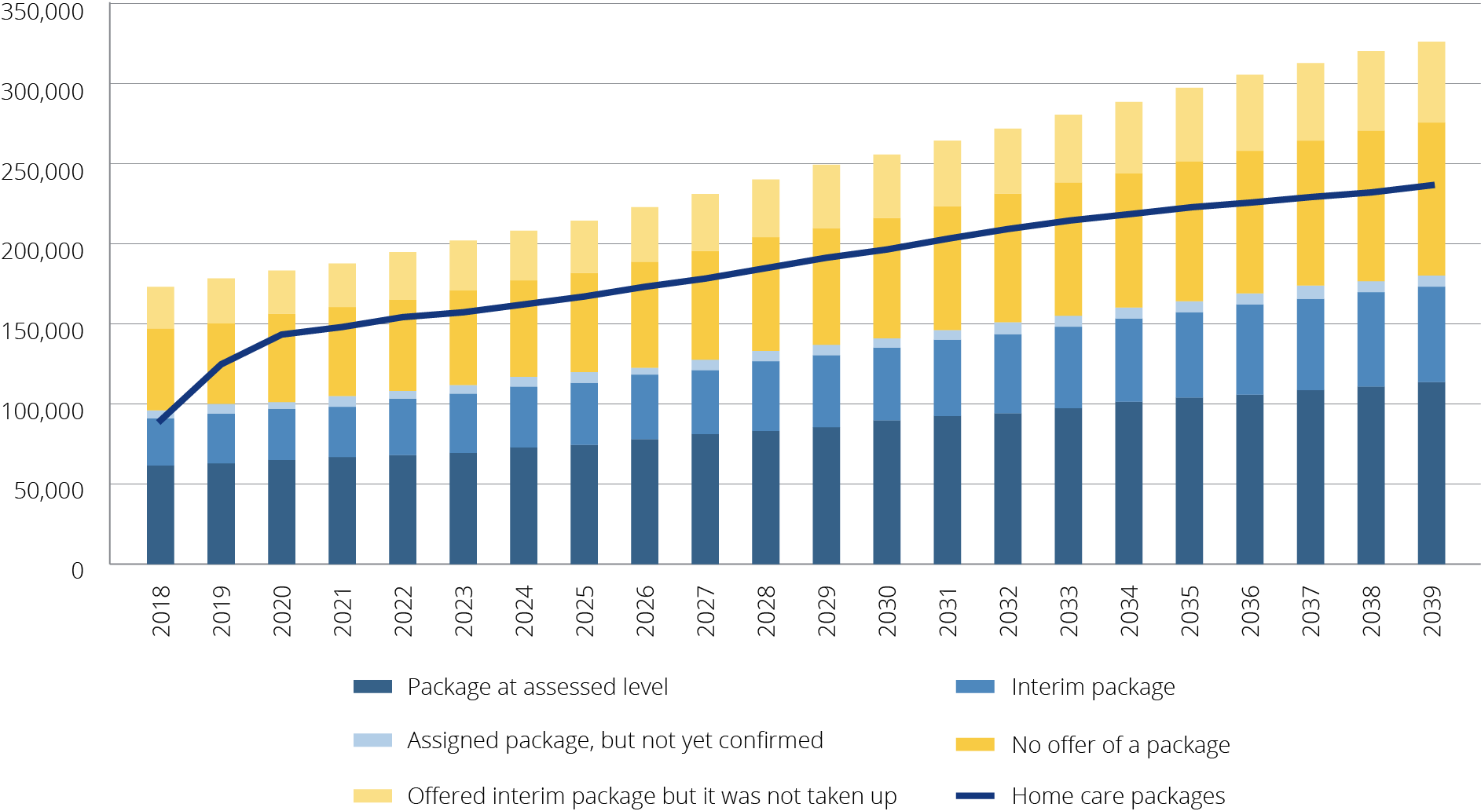

### Planning for the supply of aged care

As noted previously, if residential care places increased in line with the current target provision ratio and current age-specific use rates continued, there would be an excess supply of residential care over most of the 2020s. As the baby boomers start to enter their 80s in the 2030s, this demand could start to put pressure on the sector and its ability to ensure there is adequate supply of residential care. This has been flagged in previous ACFA reports and in the Tune Review.

There is excess demand for home care, and this is likely to remain the pressure point in the supply of aged care over the projection period. At least part of this undersupply can be met through a reduction in residential care places as currently provided for in the target provision ratio.

The Tune Review report recommended changes to the target planning ratio. The current ratio denominator of the 70+ population is not aligned to the cohort of the population more likely to use aged care services, and results in the observed periods of relative oversupply and undersupply. ACFA supports the Tune Review recommendation to change the denominator in the ratio to the 75+ cohort of the population following the achievement of the 125 ratio in 2021-22.

ACFA also recommends that the change in the denominator be accompanied by a change in the target provision ratio formula so that it is based on the number of consumers and not the number of operational places. This will allow comparable reporting and monitoring of the supply of residential and home care places against the provision targets, and help inform unmet demand and consumer preference.

The following analysis shows the supply of aged care places under the 70+ population and 80+ population. The equivalent rates (converted as at 30 June 2023) are 194 per 1,000 people aged 75+ and 351 per 1,000 people aged 80+. As can be seen in Chart 8.8 the expected growth in the number of consumers (blue line) more closely follows the 75+ population growth over the medium term to the mid 2030’s.

Chart 8.8: Cumulative growth in aged care places, 2023 to 2040

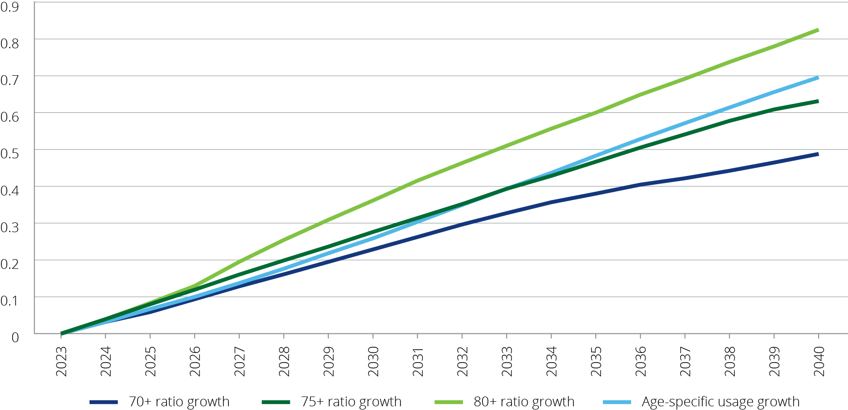

## Investment requirements for residential care

As noted above, there are many variables that will influence the future demand for residential aged care. Nevertheless, it is evident given the ageing of the population, along with increasing consumer expectations, that there will need to be significant future investment in the residential sector to both build new facilities and to refurbish existing facilities.

Using only the current target provision ratio to project the future supply of residential aged care, and not taking into account the impact of increased home care on the demand for residential care, the sector would need to build over 88,000 places over the next decade. At the same time, the sector would need to rebuild or refurbish a substantial proportion of the current stock of aged care facilities. It is assumed that over the next decade around a quarter of the existing stock of buildings, covering around 54,000 places, would need to be rebuilt or refurbished (at an even rate over the period).

Chart 8.9: Number of operational residential aged care places required 2017-18 to 2027-28

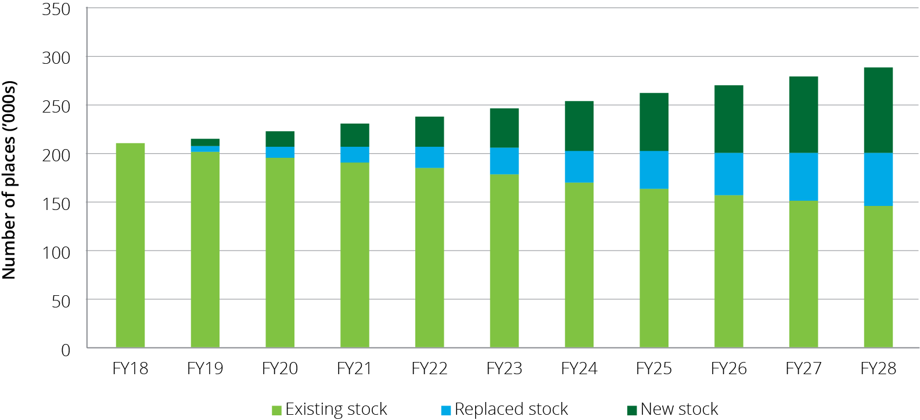

On the basis of the above assumptions, the combined total investment for new and rebuilt places over the next decade would be around $55 billion. The net present value, of this estimate is approximately $50 billion. This compares with an estimate of around $18 billion (in present value) in building and upgrade work completed between 2009 and 2018. As previously noted, however, these projections are based on particular assumptions and should be treated with care.

While the total number of residential care places increased from 174,700 to 210,800 over the last 10 years, the number of mainstream facilities decreased from 2,783 to 2,695. This means that, on average, the investment in new places was primarily through expansion of existing facilities. There is a limit to how big existing facilities can expand and future investment to increase the supply of residential care places may have to be increasingly through greenfield projects.

Chart 8.10: Future annual investment requirement, 2018-19 to 2027-28

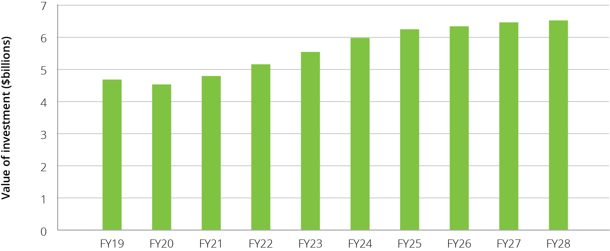

| The model used to determine the investment requirements was developed for the Department in 2018 by Deloitte Access Economics. The assumptions behind the analysis are:  Total place requirements (i.e. the total of all new and rebuilt stock) that is estimated to be operational at each point in the future is based on the Department’s projections which take into account the current stock of provisionally allocated places; the historical rate of building; and the expected number of flexible residential care places that also contribute to the overall residential care target.  The share of places that are rebuilt each year is estimated using a flat rate assumption of 2.5 per cent of the stock in that year, i.e. a 40 year average building lifetime.  The cost of construction differs by region. The base construction costs in 2018-19 of $260,700 per new place, $221,200 per rebuild, and $27,700 per upgrade (from the Survey of Aged Care Homes) have been adjusted by using indices that scale up costs in regional areas relative to the nearest capital city.  The cost of construction is indexed over time using a 10 year average of Rawlinson’s Building Cost Index for each state’s metropolitan and regional areas (averaging out at 2.4 per cent per annum nationally).  The cost of land is sourced from ABS land price data for each state’s metropolitan areas and again adjusted using the relevant regional index for that state.  The cost of land is indexed over time using a flat rate of 4.4 per cent per annum for all areas based on ABS residential property price data. |
| --- |

The value of building work completed and in progress during 2017-18, and other indicators of construction and investment in the sector is discussed in detail in Chapter 7.

## The investment environment

Chapter 9 outlines some of the characteristics of a sustainable aged care industry. This is against the background that the significant capital investment needed to meet the future demand for aged care services will largely come from the non-government sector, both for-profit and not-for-profit sectors.

The challenge facing the Government is to ensure that the funding and regulatory arrangements in the aged care sector are such that it provides the ongoing environment that facilitates the needed investment. A key requirement in this regard is that the non-government sector has confidence in the direction and stability of Government policies and those providers receive a return such that it will attract the necessary capital and labour resources. The funding arrangements will also need to be flexible so that providers can respond and adapt to changes in consumers’ preferences for aged care services as well as innovate and embrace new technologies.

### Access to capital

Capital investment in the residential aged care industry is required to expand and refurbish existing facilities, as well as building to meet future capacity. To attract investment the industry needs to generate consistent rates of return that are appropriate for the risk involved and are competitive with returns in other sectors that have similar attributes.

Viable and well-run providers are best placed to attract the financial capital, experienced management and quality staff required to deliver long term industry sustainability and growth. Key ingredients of well-run providers include the exercise of good governance that oversees the implementation of strategic investment plans and the ability to successfully monitor their operational performance against those plans.

To be viable, a provider, whether not-for-profit, for-profit or government owned, must have access to sufficient funds to repair and replace their capital stock, be able to maintain working capital to support their operations, and use capital efficiently relative to the other purposes to which it could be deployed. These outcomes are underpinned by sound financial management that effectively manages costs, sets appropriate pricing strategies to derive the revenue stream to support sustainable capital returns.

Investment activity requires equity investor and debt provider confidence in the capacity of providers to deliver sustainable returns on capital and of the sector overall. The amount of (and change in) invested capital is one key metric of sustainability.

In order to attract future investment the industry needs to generate consistent rates of return on capital that are appropriate for the risk involved and are competitive with returns in other sectors that have similar attributes.

Capital investment in the residential sector can include: equity injections or retained earnings; loans from financial institutions or investors which require sufficient profits to be generated to meet the interest costs and repayment amounts; and interest-free loans from residents in the form of lump sum accommodation payments. Where providers are unable to meet the whole cost of essential capital works, limited capital grant funding is available from the Government-funded Rural, Regional and Other Special Needs Building Fund.

Viable and well-run providers are best placed to attract the financial capital, experienced management and quality staff required to deliver long-term industry sustainability and growth. Therefore, key ingredients include the exercise of good governance that oversees the implementation of strategic investment plans and the ability to successfully monitor their operational performance against those plans.

# The challenge of achieving a sustainable aged care system

| **This chapter discusses:**  funding and financing challenges in the aged care industry now and in the future; and  the characteristics of a viable and sustainable aged care system. |
| --- |

## Funding and financing challenges in the aged care industry

To provide the level and quality of aged care services that older Australians require now and into the future, including to secure a skilled workforce, it is essential that the aged care industry is financially viable, stable, efficient, effective, responsive and sustainable. It is evident from developments in the industry over recent years that it faces many hurdles in achieving this objective. Among them include:

ACFI has not provided a stable and effective care funding tool for both the Government and providers. The Government has been concerned that the growth in ACFI payments has exceeded the underlying growth in the acuity of the Australian population and subsequent changes it has made to ACFI arrangements have had a significant impact on the financial performance of residential aged care providers. A sizeable proportion of residential care providers are currently making a loss and a number of smaller providers are seeking to leave the sector while many are concerned about their ongoing viability if current financial trends are maintained. Overall, under the ACFI funding tool, there have been cycles of high growth followed by low or no growth causing uncertainty for providers, investors and Governments. Moreover, the current ACFI arrangements cannot satisfactorily resolve the extent to which residents’ care needs have been increasing over time compared with the extent to which providers have maximised the potential to use the ACFI tool to increase revenue growth (including in response to low indexation). ACFI is also administratively complex for both providers and the Government and has resulted in the sector diverting resources away from delivering care. In addition, ACFI has some perverse incentives that may encourage outdated modes and types of care and lead to inefficiencies with providers focusing on ACFI claiming rather than on the needs of residents.

Volatility, uncertainty and margin pressures have resulted in many residential care providers putting investment projects on hold while they assess the future direction of the market and reforms. In addition, a number of providers are investing in activities other than residential aged care in order to diversify their revenue sources and reduce their exposure to the volatility in the residential aged care sector. These developments are not consistent with establishing the environment necessary for facilitating the investment needed to meet the needs of an ageing population.

The Government continues to fund the bulk of the cost of aged care notwithstanding the Living Longer Living Better reforms which introduced changes to means testing. As noted in ACFA’s Report to inform the 2016–17 review of amendments to the Aged Care Act 1997, in the case of residential care the Government’s share of the overall average cost per resident per year only reduced to 65.6 per cent under the post-reform means test compared with 68.3 if the pre-reform arrangements were applied. The Tune Review observed that given the demand for, and costs of aged care will increase significantly in the future, it is likely to be unsustainable for the Government to continue to cover two‑thirds of the cost of residential aged care and there is a strong case to increase the proportion of costs that are met by consumers.

The contribution aged care residents make to the cost of their everyday living expenses (such as food, linen, utilities) is capped at 85 per cent of the single pension. StewartBrown estimates that this is nearly an average of $8 per bed per day below the cost of providing these services. One area where providers can boost their revenue, and the level of services available to residents, is through the provision of additional services for a fee. However there remains considerable uncertainty as to what additional service fees are permitted and this is precluding a number of providers charging additional service fees to residents who can afford to do so, even where the providers are already providing the additional services.

There is a wide diversity in the financial performance of providers in both the residential and home care sectors. There are providers, irrespective of size, ownership type and location, who are achieving good returns (albeit somewhat lower than in previous years) under current funding arrangements. While a range of factors would be affecting the individual performance of providers, including in particular the demands facing providers operating in rural and remote areas, the magnitude of the variance in financial results suggests there is scope for many providers to improve their operations and performance.

The introduction of home care packages following consumers has increased competition in the home care market and compressed providers’ returns. Given the large increase in the number of approved home care providers, there is likely to be some rationalisation of providers in the future which could cause some disruption for consumers. A major development is the rise in unspent funds, which may mean that some consumers are not receiving all the care they require and is forgone business for providers. It may also indicate that some consumers could have been assessed as requiring more funding than they actually need. There are also prudential considerations in ensuring that the unspent funds being held by providers is available to be spent on consumers when required or returned to the Government and the consumer when the consumer leaves the provider. Providers also have to be more flexible in adjusting their procedures and processes so they are more responsive to what consumers are seeking.

## Characteristics of a viable and sustainable aged care system

One of ACFA’s functions is to provide advice on the impact of funding and financing arrangements on the viability and sustainability of the aged care system. In pursuing this task, and against the background of developments in the aged care industry in recent years, ACFA has identified from a funding perspective a number of characteristics of a viable and sustainable aged care system.

Confidence and trust

The overriding challenge facing the Government is maintaining confidence and trust in the quality of aged care services and the funding and financing arrangements for the industry.

Towards achieving trust, the regulatory and funding arrangements have to be stable, understood, and transparent. Trust is essential because while the Government is the main source of funding for aged care, the services are primarily delivered by the non-government sector: for-profit and not‑for‑ profit providers. These providers will not invest in the industry, nor will they be able to attract the required staff, unless they understand the basis of regulation, the Government’s approach to the funding of the industry, and they have confidence in the adequacy and stability of Government policies.

From the consumer perspective, there needs to be trust in the quality of care people will receive from the aged care system for this will influence the preparedness of consumers and their families to seek the support that they need.

Stable, predictable, efficient, equitable and effective arrangements for allocating Government funding

There needs to be a stable, efficient and effective residential aged care funding tool which provides financial stability to both aged care providers and the Government. The Government also has the challenge of ensuring that the funding tool is consistent with achieving ongoing equity of access for all consumers and that it does not incentivise outmoded or inefficient care practices and use of resources.

The current review of alternative residential care funding arrangements and the Resource Utilisation and Classification Study (RUCS) is an important exercise. Desirable features of a new funding tool include: administrative simplicity, funding assessments external to the provider, equitable allocation of funds based on the mix of residents and their needs, recognition that many care costs are shared between residents, transparent studies to determine the cost of care and indexation arrangements that adequately reflect movement in costs. In introducing a new funding model, it will be important to ensure that providers have confidence in the new arrangements. The new system needs to be transparent, robust and evidence based to achieve this objective.

Similarly, there needs to be stable and efficient funding arrangements for home care that ensure that targeted care is available for all consumers. The home care funding arrangements should also be based on transparent studies to determine the cost of care.

Appropriate overall funding

Efficient arrangements for equitably allocating funding across residential care providers and home care consumers are necessary, but it is also important that the overall funding pool for the aged care system is adequate and sustainable. The funding has to be sufficient to meet the level and quality of aged care needs of current and prospective Australians and in doing so provide the incentive for providers to invest in the industry. The level of funding provided by the Government has to support the delivery of quality aged care services required by Australians. But it should not support inefficient or poorly managed providers nor should it provide higher than necessary funding.

The Government needs to ensure that the Budget forecasts of aged care spending are as realistic as possible. Aged care is a sizeable and growing component of the Commonwealth’s Budget and its importance will grow in line with the ageing of the Australian population. An overshooting of aged care expenditure can cause problems for the management of the Government’s accounts and bring into question its fiscal sustainability. It is not, however, a simple matter to determine the appropriate amount of funding for the aged care industry, although it is an issue that requires careful consideration. The industry is very diverse and the financial results of providers vary depending on business structures, financing arrangements, and motivations, including those who are mission based. In addition, the Government has to take into account the range of aged care services sought by the community, along with the extent to which consumers will contribute to the cost of their aged care.

It is important to ensure that the Government’s contribution to care costs reflects the growth in these costs over time, although the indexation methodology should also make allowance for achievable productivity improvements. While the indexation rate for ACFI has been markedly lower than the rate of growth in the costs of providers, particularly wages, if the new funding model reduces the capacity of providers to boost their revenue through claiming behaviour, it will be important that the new indexation arrangements adequately reflect the growth in costs (while providing an incentive for productivity gains). It may take around two years before a new aged care funding tool is introduced. In the meantime the Government will need to ensure that the indexation of ACFI rates is appropriate and address the financial pressure confronting the industry.

Funding that is flexible and adaptable to changing demographics and demands

The demographics of the Australian population are such that there will be increasing pressure on funding for aged care, both residential and home care. Demand will change and there will be innovations in the way services are delivered and the interaction between aged care and other sectors, such as retirement living and hospitals. The funding arrangements have to be responsive to these changes and should not deter but rather encourage innovation.

Currently the provision of residential aged care places and home care packages is determined by the Aged Care Provision Ratio (the Ratio). The Tune Review concluded that while it would ultimately be desirable for the supply of aged care to be uncapped, significant work needed to be done before government could safely remove supply controls while ensuring the system was fiscally sustainable for government and equitable for consumers. Specifically, before uncapping supply there needs to be: an accurate understanding of underlying demand; equitable and sufficient contributions by consumers to their cost of care; a robust system for assessing eligibility for subsidised services; and provisions for ensuring equitable and continuing supply of aged care services in places where there are higher costs of service delivery limited choice and competition.

There has been progress on some of these requirements, but before they are all met the Tune Review made a number of recommendations to improve the flexibility of current arrangements, including to change the population cohort on which the target provision ratio is based, from people aged 70 years and over to people aged 75 years and over, which would allow the overall supply of aged care to better match the key demand driver in aged care, namely the ageing of the population. At the same time, the provision target ratio formula should be changed from operational places to consumers in order to enable comparable reporting and monitoring of supply and assist with assessing the level of unmet need. All these measures are consistent with ensuring the sustainability of an aged care system based on greater consumer choice and competition in service provision.

Equitable contribution to costs by consumers

Sustainable aged care funding arrangements will require consumers who can afford to do so to make a greater financial contribution towards their residential everyday living expenses and care costs, complemented by a greater choice of higher quality services. This would involve stronger means testing arrangements for care fees, which would reduce pressure on Government expenditure, and uncapping the basic daily fee in residential care, both in line with the recommendations of the Tune Review.

In addition, uncapping the basic daily fee for residential care for consumers who can afford to pay would boost the revenue of residential care providers and for some may provide the opportunity of dispensing with charging fees for the provision of additional services. There is currently uncertainty over what are permissible additional services that aged care providers can offer residents for a fee.

Another recommendation by the Tune Review which should be pursued is requiring that providers charge the income-tested care fee in home care and that the value of the basic daily fee is proportionate to the value of the home care package, although noting the measure to slightly reduce the basic daily fee for lower level care packages that was announced as part of the 2018-19 MYEFO in November 2019 was a step in this direction. There is also a need to improve consumer understanding of the fees they may be asked to pay so that they can more effectively plan for their aged care.

Effective prudential oversight

Effective prudential oversight of the aged care industry is necessary given that the range of current and prospective reforms and developments are likely to be disruptive to a number of providers. The current tight operating conditions will likely be accelerating the trend towards greater consolidation in the residential aged care market. There is also evidence that some providers are thinly capitalised (relatively higher proportion of liabilities to assets) and as a result are more exposed to financial and economic risk events. After a period of very strong growth in home care providers, it is likely that this will be followed by a reduction in the number of providers. In both residential and home care, there will always be a role for smaller operators, but the current tight conditions will likely put pressure on less efficient providers and those unable to achieve economies of scale.

An increasing number of marginal providers will likely need to sell or merge with other providers. Such a trend will lead to a more efficient and resilient aged care industry, however the adjustment should be orderly and any impact on consumers should be minimised. Towards the end, the Government should be proactive in identifying providers facing difficulties, providing advice and support to such providers, and if necessary facilitate the sale or transfer of facilities or operations to another provider. This may require the Government contributing to meet the costs associated with a provider taking over another facing significant financial and likely quality, difficulties.

Sound management and governance arrangements

A sustainable aged care system will require well managed aged care providers with sound governance arrangements. It will also require adequate sources of financing to support the level of investment required to meet current and future demand for aged care services.

Providers need to look at their internal operations to ensure they are delivering care in the most efficient and effective way. The changes taking place in the sector as it moves towards a more consumer driven and market based system will continue to challenge traditional business and workforce models.

Providers have to take the lead in shaping the aged care workforce to take the industry into the future by implementing in full the recommendations of the Aged Care Work Force Strategy Taskforce. Providers will need to be increasingly responsive and flexible. For some providers this may include adjusting their business models to deal with an apparent shift from RADs to DAPs.

Under the current funding system there are very diverse financial outcomes, with the top quartile of providers in terms of profit continuing to achieve significantly better results than the lowest quartile. The very wide variation in financial performance across the sector suggests there is scope for many providers to pursue greater efficiencies and improve their results. Towards this objective, all providers should seek to ensure that their governance arrangements and management capabilities are best practice.

Appendices

1. ACFA Membership

Members

| ACFA position | Name | Organisation |
| --- | --- | --- |
| Chairman | Mr Mike Callaghan AM PSM | Economic consultant |
| Deputy chair | Mr Nicolas Mersiades | Director Aged Care, Catholic Health Australia |
| Member | Mr Ian Yates AM | Chief Executive, COTA Australia |
| Member | Mr Gary Barnier | Former aged care executive, independent advisor |
| Member | Mrs Natalie Smith | Head of Business Execution, Business and Private Bank, ANZ |
| Member | Prof Michael Woods | Professor, Centre for Health Economics Research and Evaluation, UTS Business School |
| Member | Dr Mike Rungie | Former CEO, Aged Care Housing Group |
| Member | Ms Susan Emerson | General Manager Equip for living and Leef Independent Living Solutions SA/NT |
| Member | Ms Louise Biti | Director, Aged Care Steps |

Government representatives

| ACFA position | Name | Organisation |
| --- | --- | --- |
| Representative | Mr Jaye Smith | First Assistant Secretary, Ageing and Aged Care Group, Department of Health |
| Representative | Mr John Dicer | Aged Care Pricing Commissioner |
| Representative | Ms Leah Wojcik | Manager, Health and Disability Social Policy Division, Department of the Treasury |

1. Work completed by ACFA to date

| Work | Date of completion |
| --- | --- |
| ACFA’s report on understanding how consumers plan and finance aged care | Published 24 December 2018. |
| ACFA’s report on respite for aged care recipients | Published 28 November 2018. |
| ACFA’s Update on Funding and Financing issues in residential aged care industry | Published 5 November 2018. |
| 2018 ACFA Annual Report on Funding and Financing of the Aged Care Sector | Published 28 August 2018. |
| 2017 Annual Report on Funding and Financing of the Aged Care Sector | Published in August 2017. |
| Application of the Base Interest Rate | Published in June 2017. |
| Bond Guarantee Scheme | Published in May 2017. |
| Report to Inform the 2016-17 Review of Amendments to the Aged Care Act 1997 | Published in June 2017. |
| Access to Residential Care by Supported residents | Published in February 2017. |
| 2016 Annual Report on Funding and Financing of the Aged Care Sector | Published in August 2016. |
| Report on Issues Affecting the Financial Performance of Rural and Remote Providers, Residential and Home Care | Published in February 2016. |
| 2015 Annual Report on Funding and Financing of the Aged Care Sector | Published in August 2016. |
| Report on Factors Influencing the Financial Performance of Residential Aged Care Providers | Published in June 2015. |
| Report on Improving the Collection of Financial Data from Aged Care Providers | Published in October 2014. |
| Reports on the Impact of Financial Reforms on the Aged Care Sector | Monthly reports – August 2014 to April 2015  Quarterly reports – September 2015 to June 2016. |
| 2014 Annual Report on the Funding and Financing of the Aged Care Sector | Published in August 2014. |
| Supported Residents Data Book | Published in May 2014. |
| Interim advice to the Minister on Improving the Collection of Financial Data from Aged Care Providers | Published in August 2013. |
| First Annual Report (2013) on the Funding and Financing of the Aged Care Sector | Published in July 2013. |
| Estimation of the possible impacts on revenue and balance sheet funding from changes to accommodation payment arrangements | ACFA’s advice and KPMG modelling published in May 2013. |
| The framework for setting accommodation payments in residential aged care | Final ACFA advice provided to Minister in November 2012. Government announced its position in December 2012.  Further advice on the method for determining a RAD and a DAP using a MPIR provided to Minister on 17 May 2013. Government announced its position on 23 May 2013. |

1. ACFA’s stakeholder engagement

ACFA holds meetings and forums with representatives from the investment and financing industries, providers and consumers. This engagement is critical to ACFA’s understanding of the key issues, developments and challenges facing the industry. Since July 2018, ACFA’s consultations with the sector have increased significantly as noted in Chapter 1.

After publishing the Sixth report on the Funding and Financing of the Aged Care Sector, ACFA undertook to provide the Minister for Aged Care with an update of its assessment of the funding and financing issues currently impacting on the residential aged care sector. In August and September 2018, ACFA held over 40 consultations with a cross-section of residential care providers, financial institutions and analysts prior to the submission of the update in October 2018. The providers consulted included: profit and not-for-profit; metropolitan, regional and remote; and those operating one or a few facilities along with those operating a substantial number of facilities.

In preparation for its 2019 annual report, ACFA has once again consulted heavily with the sector, with consultations held in March and April 2019. Consultations once again included a wide range of aged care providers, financial institutions and analysts but this time also included home care providers in metropolitan and regional areas. The additional consultation this year has allowed ACFA to present an updated view of both the home care and residential care sectors in 2018-19.

ACFA Roundtables

In September and November 2018, ACFA held Roundtables in Sydney and Melbourne with members of the investment and financing community to share the findings of its 2018 annual report and to hear their views on key issues facing the sector.

Over 50 representatives from various organisations participated in the roundtables and a diverse range of issues and views were discussed regarding current and future investment in aged care, workforce issues and the availability of land and the challenges in developing that land into aged care facilities.

Presentations

Since its last annual report, ACFA has presented at the various forums:

* Aged Care Workforce Summit
* Council on the Ageing Criterion Conference on Post Budget Aged Care Reform
* Council on the Ageing Financial Sustainability in Aged Care Conference
* StewartBrown 2018 Aged Care Finance Forum
* Aged & Community Services Australia SA Finance & Aged Care Sector
* Aged & Community Services Australia NSW Finance & Aged Care Sector
* Aged & Community Services Australia TAS Finance & Aged Care Sector
* Estia Board Meeting
* Leading Age Services Australia State of the Industry Breakfast

1. Aged care workforce

Table D.1: Full-time equivalent (FTE) direct care employees in the residential aged care workforce, by occupation: 2003, 2007, 2012 and 2016 (estimated FTE and per cent)

| Occupation | 2003 | 2007 | 2012 | 2016 |
| --- | --- | --- | --- | --- |
| Nurse practitioner | n/a | n/a | 190 | 293 |
| Registered nurse | 16,265 | 13,247 | 13,939 | 14,564 |
| Enrolled nurse | 10,945 | 9,856 | 10,999 | 9,126 |
| Personal care attendant | 42,943 | 50,542 | 64,669 | 69,983 |
| Allied health professional | 5,776 | 5,204 | 1,612 | 1,092 |
| Allied health assistant | 3,414 | 2,862 |
| **Total number of employees (FTE)** | **76,006** | **78,849** | **94,823** | **97,920** |
| **As a % of total employees** |  |  |  |  |
| Nurse practitioner | n/a | n/a | 0.2% | 0.3% |
| Registered nurse | 21.4% | 16.8% | 14.7% | 14.9% |
| Enrolled nurse | 14.4% | 12.5% | 11.6% | 9.3% |
| Personal care attendant | 56.5% | 64.1% | 68.2% | 71.5% |
| Allied health professional | 7.6% | 6.6% | 1.7% | 1.1% |
| Allied health assistant | 3.6% | 2.9% |

Table D.2: Size of the home support and home care workforce, all PAYG employees and direct care employees: 2007, 2012 and 2016

| Occupation | 2007 | 2012 | 2016 |
| --- | --- | --- | --- |
| All PAYG employees | 87,478 | 149,801 | 130,263 |
| Direct care employees | 74,067 | 93,359 | 86,463 |

Table D.3: Direct care employees in the home support and home care workforce, by occupation: 2007, 2012 and 2016 (estimated FTE and per cent)

| Occupation | 2007 | 2012 | 2016 |
| --- | --- | --- | --- |
| Nurse practitioner | n/a | 55 | 41 |
| Registered nurse | 6,079 | 6,544 | 4,651 |
| Enrolled nurse | 1,197 | 2,345 | 1,143 |
| Community care worker | 35,832 | 41,394 | 34,712 |
| Allied health professional | 2,948 | 2,618 | 2,785 |
| Allied health assistant | 1,581 | 755 |
| **Total number of employees (FTE)** | **46,056** | **54,537** | **44,087** |
| **As a % of total employees** |  |  |  |
| Nurse practitioner | n/a | 0.1% | 0.1% |
| Registered nurse | 13.2% | 12.0% | 10.5% |
| Enrolled nurse | 2.6% | 4.3% | 2.6% |
| Community care worker | 77.8% | 75.9% | 78.7% |
| Allied health professional | 6.4% | 4.8% | 6.3% |
| Allied health assistant | 2.9% | 1.7% |

1. Means testing arrangements

Home care

In addition to the basic daily fee, an income-tested care fee was introduced in home care from 1 July 2014. Unlike the arrangements for the basic daily fee, the Commonwealth payment received by the provider is reduced by the amount of the income-tested care fee. Accordingly, to receive an amount equivalent to the full subsidy the provider needs to charge the appropriate income-tested care fee.

Annual income-tested care fees in home care are currently capped at $5,506.48 for part-pensioners and $11,012.99 for non-pensioners (March 2019 rate). A lifetime cap of $66,078.27 per consumer currently applies for care contributions across home care and residential care (March 2019 rate). Full pensioners are not required to contribute to their care costs and may only be required to pay the basic daily fee.

Figure E.1: Current income testing for home care (post 1 July 2014)

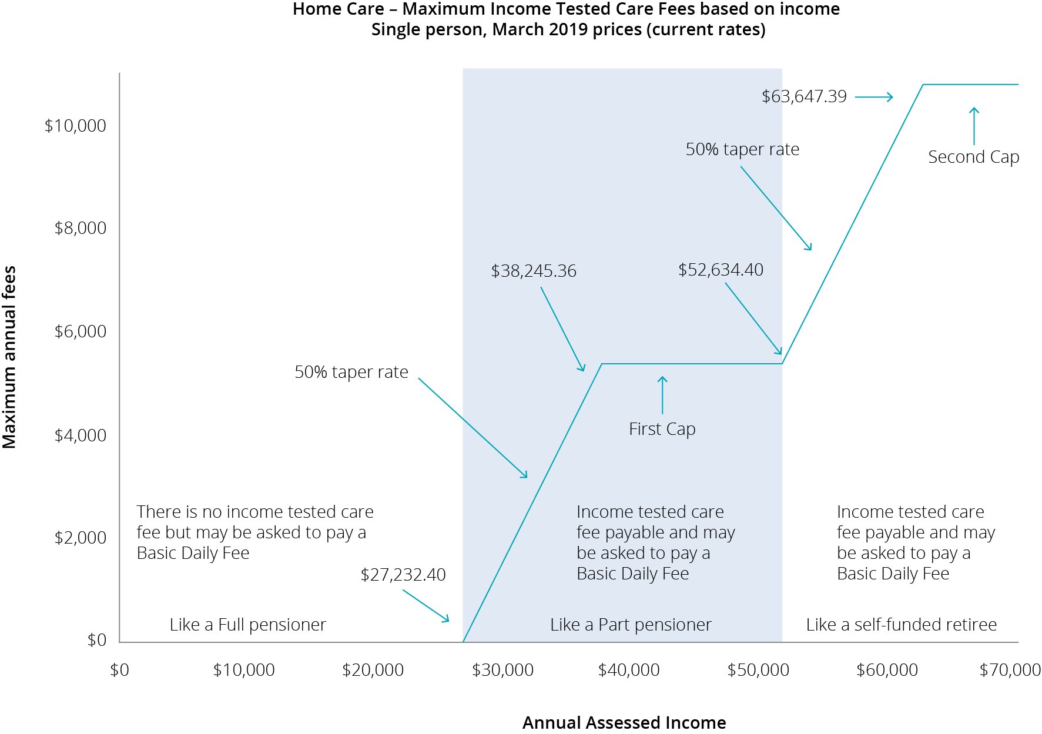

Residential care

Changes to residential care from 1 July 2014 introduced more comprehensive means testing arrangements by way of a combined assets and income assessment and a new fees structure.

Annual and lifetime caps were also introduced, with an annual cap of $27,532.59 applying to the means‑tested care fee and a lifetime cap of $66,078.27 for care contributions (March 2019 rate).

Figure E.2 demonstrates how the means testing arrangements created three tiers of consumer contributions in residential care:

consumers with low means, who are required to pay only the basic daily fee (85 per cent of the single basic age pension) as a contribution towards their daily living expenses, while their accommodation and care costs are funded by the Australian Government;

consumers with moderate means, who in addition to contributing towards their daily living expenses by paying the basic daily fee, also make a capped contribution towards their accommodation costs; and

consumers with greater means, who in addition to contributing towards their daily living expenses, also pay the basic daily fee for their accommodation costs in full and make a capped contribution towards their care costs.

Figure E.2: Current means testing for residential care (post 1 July 2014)

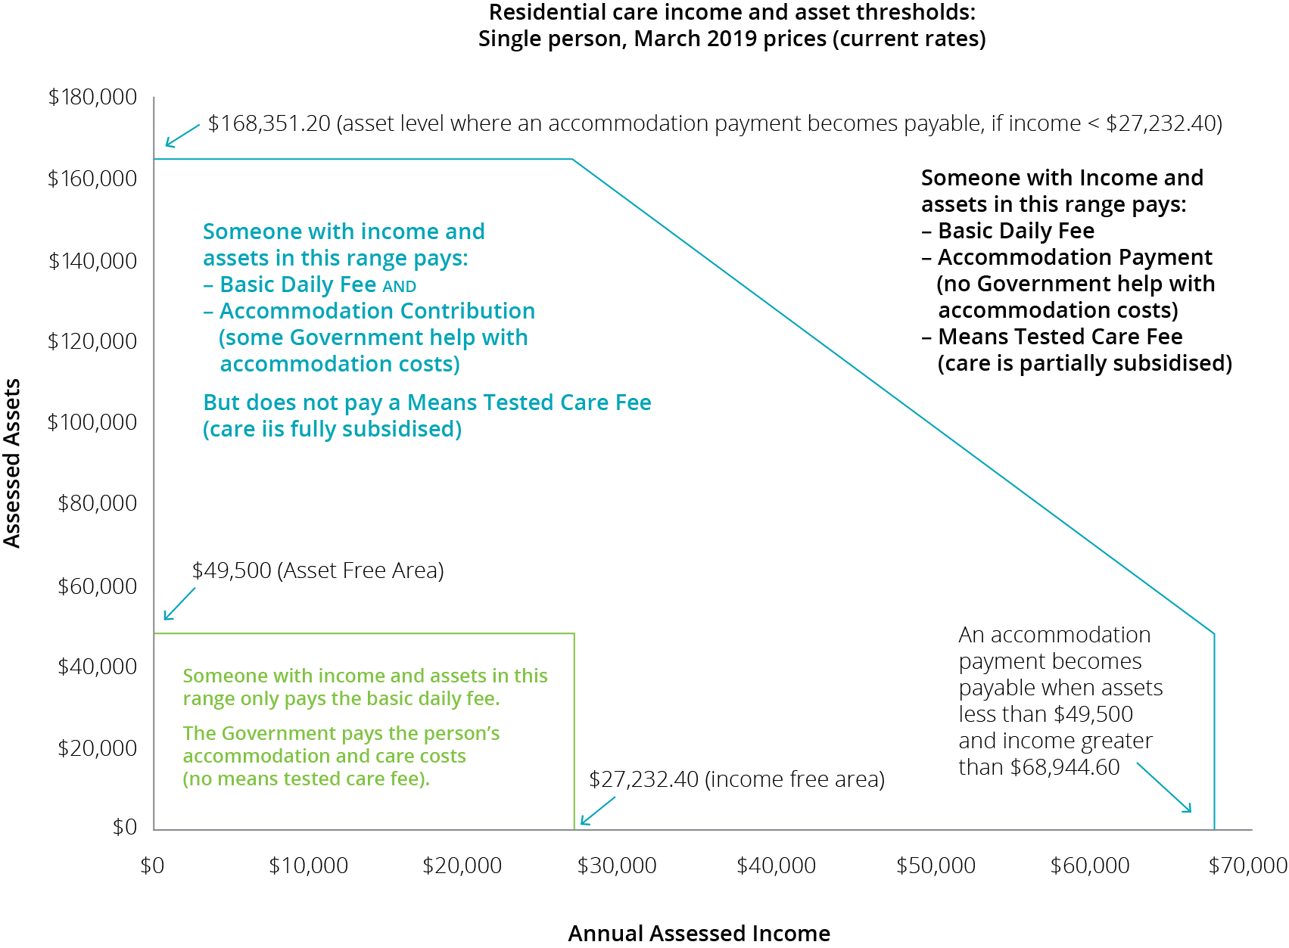

1. Financial ratios by provider ownership type

Table F.1: Financial ratios of total sector by provider type, 2017-18

|  | Not-for-profit | For-profit | Government | Total sector |
| --- | --- | --- | --- | --- |
| Total RADs ($m) | $14,077 | $12,827 | $610 | $27,513 |
| No. of providers | 493 | 289 | 95 | 877 |
| EBITDA p.r.p.a | $7,916 | $11,634 | -$6,411 | $8,746 |
| **Capital structure** |  |  |  |  |
| Assets p.r.p.a | $252,955 | $291,402 | $212,049 | $266,134 |
| No. of RADs | 49,201 | 38,738 | 2,832 | 90,771 |
| Avg RAD per resident | $286,106 | $331,117 | $215,339 | $303,107 |
| Net worth p.r.p.a | $87,262 | $27,357 | $130,427 | $65,540 |
| Working capital p.r.p.a | -$80,521 | -$151,175 | -$14,663 | -$105,445 |
| Non-current liabilities as % of total assets | 3.0% | 12.4% | 2.8% | 7.0% |
| RADs as % of total assets | 53.8% | 62.3% | 36.9% | 56.8% |
| Net worth as % total assets | 34.2% | 9.4% | 56.9% | 24.4% |
| Viability |  |  |  |  |
| **Current ratio** | 0.49 | 0.34 | 0.84 | 0.42 |
| Interest coverage | 12.1 times | 6.1 times | -17.6 times | 7.8 times |
| NPBT margin | 1.2% | 5.7% | -11.4% | 2.4% |
| Occupancy | 91.6% | 87.7% | 90.1% | 90.0% |
| % EBITDA to total assets | 3.1% | 4.0% | -3.0% | 3.3% |
| % EBITDA to net worth | 9.1% | 42.5% | -5.3% | 13.4% |
| RADs asset cover (T.A.) | 1.9 times | 1.6 times | 2.7 times | 1.8 times |

Table F.2: Financial ratios for not-for-profit providers, 2017-18

|  | Top | Next top | Next bottom | Bottom | Total |
| --- | --- | --- | --- | --- | --- |
| No. of providers | 110 | 138 | 139 | 106 | 493 |
| EBITDA p.r.p.a | $19,380 | $9,876 | $3,384 | -$6,650 | $7,916 |
| **Capital structure** |  |  |  |  |  |
| T. Assets p.r.p.a | $294,984 | $227,888 | $226,148 | $337,523 | $252,955 |
| No. of RADs | 9,092 | 21,228 | 12,655 | 6,226 | 49,201 |
| Avg RAD per resident | $288,522 | $287,627 | $269,440 | $311,262 | $286,106 |
| Net Worth p.r.p.a | $112,188 | $74,392 | $74,571 | $123,173 | $87,262 |
| Working Capital p.r.p.a | -$87,749 | -$77,613 | -$81,220 | -$78,831 | -$80,521 |
| Non.Curr Liab as % of T.Asts. | 4.8% | 1.7% | 2.5% | 4.5% | 3.0% |
| RADs as % of T. Asts | 47.4% | 58.9% | 56.6% | 45.6% | 53.8% |
| Net Worth as % T.Asts | 37.8% | 32.6% | 32.2% | 36.3% | 34.2% |
| **Viability** |  |  |  |  |  |
| Current ratio | 0.48 | 0.48 | 0.45 | 0.61 | 0.49 |
| Interest coverage | 23.8 times | 19.5 times | 5.6 times | -3.5 times | 12.1 times |
| NPBT margin | 13.1% | 2.9% | -3.2% | -14.2% | 1.2% |
| Occupancy | 93.2% | 92.7% | 91.2% | 86.4% | 91.6% |
| %EBITDA to T. Assets | 6.6% | 4.3% | 1.5% | -2.0% | 3.1% |
| %EBITDA to Net Worth | 17.4% | 13.3% | 4.7% | -5.4% | 9.1% |
| RADs Asset Cover (T.A.) | 2.1 times | 1.7 times | 1.8 times | 2.2 times | 1.9 times |

Table F.3: Financial ratios of government providers, 2017-18

|  | Top | Next Top | Next Bottom | Bottom | Total |
| --- | --- | --- | --- | --- | --- |
| No. of providers | 15 | 8 | 13 | 59 | 95 |
| EBITDA p.r.p.a | $38,730 | $9,389 | $2,771 | -$21,028 | -$6,411 |
| **Capital structure** |  |  |  |  |  |
| T. Assets p.r.p.a | $280,344 | $210,942 | $225,386 | $197,328 | $212,049 |
| No. of RADs | 316 | 287 | 485 | 1,744 | 2,832 |
| Avg RAD per resident | $204,383 | $175,831 | $225,084 | $221,115 | $215,339 |
| Net Worth p.r.p.a | $183,914 | $175,918 | $110,799 | $111,436 | $130,427 |
| Working Capital p.r.p.a | -$13,133 | $7,696 | -$32,700 | -$17,034 | -$14,663 |
| Non.Curr Liab as % of T.Asts. | 3.5% | 3.4% | 1.1% | 2.9% | 2.8% |
| RADs as % of T. Asts | 29.8% | 18.2% | 41.6% | 43.1% | 36.9% |
| Net Worth as % T.Asts | 62.0% | 83.4% | 49.2% | 49.8% | 56.9% |
| **Viability** |  |  |  |  |  |
| Current ratio | 0.87 | 1.28 | 0.71 | 0.84 | 0.84 |
| Interest coverage | 199.1 times | 42.9 times | 12.5 times | -45.3 times | -17.6 times |
| NPBT margin | 24.1% | 0.5% | -3.9% | -26.4% | -11.4% |
| Occupancy | 93.6% | 84.7% | 91.3% | 90.9% | 90.1% |
| %EBITDA to T. Assets | 13.8% | 4.5% | 1.2% | -10.7% | -3.0% |
| %EBITDA to Net Worth | 22.3% | 5.3% | 2.5% | -21.4% | -5.3% |
| RADs Asset Cover (T.A.) | 3.4 times | 5.5 times | 2.4 times | 2.3 times | 2.7 times |

Table F.4: Financial ratios of for-profit providers, 2017-18

|  | Top | Next Top | Next Bottom | Bottom | Total |
| --- | --- | --- | --- | --- | --- |
| No. of providers | 94 | 73 | 67 | 55 | 289 |
| EBITDA p.r.p.a | $23,286 | $9,450 | $3,701 | -$10,029 | $11,634 |
| **Capital structure** |  |  |  |  |  |
| T. Assets p.r.p.a | $329,509 | $261,792 | $239,490 | $406,484 | $291,402 |
| No. of RADs | 12,185 | 16,875 | 6,666 | 3,012 | 38,738 |
| Avg RAD per resident | $344,292 | $313,018 | $308,478 | $429,326 | $331,117 |
| Net Worth p.r.p.a | $26,066 | $33,116 | $25,406 | -$1,869 | $27,357 |
| Working Capital p.r.p.a | -$155,557 | -$146,381 | -$106,567 | -$232,393 | -$151,175 |
| Non.Curr Liab as % of T.Asts. | 17.4% | 8.9% | 5.2% | 16.7% | 12.4% |
| RADs as % of T. Asts | 57.6% | 57.7% | 105.0% | 59.3% | 62.3% |
| Net Worth as % T.Asts | 7.9% | 12.6% | 10.6% | -0.5% | 9.4% |
| **Viability** |  |  |  |  |  |
| Current ratio | 0.37 | 0.29 | 0.47 | 0.32 | 0.34 |
| Interest coverage | 9.3 times | 6.1 times | 3.2 times | -3.2 times | 6.1 times |
| NPBT margin | 14.5% | 4.1% | 0.5% | -16.5% | 5.7% |
| Occupancy | 88.3% | 90.1% | 85.8% | 75.4% | 87.7% |
| %EBITDA to T. Assets | 7.1% | 3.6% | 1.5% | -2.5% | 4.0% |
| %EBITDA to Net Worth | 89.3% | 28.5% | 14.6% | Note 1 | 42.5% |
| RADs Asset Cover (T.A.) | 1.7 times | 1.7 times | 1.0 times | 1.7 times | 1.6 times |

Note 1 - The bottom quartile of the for-profit sector has been distorted by a number of providers who have significant deficits in their net assets, which has resulted in the total net assets of that quartile being negative. The %EBITDA to Net Worth calculation does not return a useful amount, and therefore has not been published.

1. Residential aged care subsidies and supplements

Table G.1: Total expenditure for subsidies and supplements in residential care, 2015-16 to 2017-18

|  | 2015-16 $M | 2016-17 $M | 2017-18 $M |
| --- | --- | --- | --- |
| **Basic Care subsidies** |  |  |  |
| Permanent | 10,507.7 | 11,024.2 | 11,163.5 |
| Respite | 264.4 | 280.6 | 312.3 |
| **Primary care supplements** |  |  |  |
| Oxygen | 16.5 | 17.5 | 18.3 |
| Enteral feeding | 6.3 | 5.9 | 5.9 |
| Respite incentive | 29.0 | 30.1 | 34.6 |
| **Hardship** |  |  |  |
| Hardship | 5.2 | 4.9 | 4.0 |
| **Accommodation supplements** |  |  |  |
| Accommodation supplement | 845.7 | 907.5 | 1,029.6 |
| Hardship accommodation | 3.6 | 2.9 | 2.6 |
| Transitional accommodation Supplement | 22.3 | 15.5 | 10.7 |
| Concessional | 64.0 | 55.6 | 51.3 |
| Accommodation charge top-up | 2.1 | 1.4 | 1.0 |
| Pensioner supplement | 36.3 | 27.2 | 20.7 |
| **Viability Supplement** |  |  |  |
| Viability | 35.6 | 43.2 | 55.8 |
| **Supplements relating to grand parenting** |  |  |  |
| Transitional | 6.0 | 4.8 | 3.8 |
| Charge exempt | 3.8 | 2.0 | 1.8 |
| Basic daily fee | 0.6 | 0.4 | 0.3 |
| **Other supplements** |  |  |  |
| Veterans’ | 1.8 | 1.1 | 1.6 |
| Homeless | 7.6 | 8.3 | 8.6 |
| **Reductions** |  |  |  |
| Means testing reduction | -455.7 | -560.8 | -564.0 |
| Other | -31.5 | 31.5 | 42.0 |
| **TOTAL** | **11,372.3** | **11,903.8** | **12,204.2** |

1. Residential care subsidy and supplements rates

Table H.1: ACFI rates ($ per day), 2016-17 to 2018-19

| ACFI | 2016-17 | 2017-18 | 2018-19 |
| --- | --- | --- | --- |
| **Activities of daily living (ADL)** |  |  |  |
| Low | $36.65 | $36.65 | $37.16 |
| Medium | $79.80 | $79.80 | $80.92 |
| High | $110.55 | $110.55 | $112.10 |
| **Behaviour (BEH)** |  |  |  |
| Low | $8.37 | $8.37 | $8.49 |
| Medium | $17.36 | $17.36 | $17.60 |
| High | $36.19 | $36.19 | $36.70 |
| **Complex Health Care (CHC)** |  |  |  |
| Low | $16.37 | $16.37 | $16.48 |
| Medium | $46.62 | $46.62 | $46.95 |
| High | $67.32 | $67.32 | $67.79 |
| Interim rate for new residents pending ACFI assessment | $56.22 | $56.22 | $57.01 |

| Daily residential respite subsidy rates | 2016-17 | 2017-18 | 2018-19 |
| --- | --- | --- | --- |
| Low | $45.45 | $46.09 | $51.17 |
| High | $127.46 | $129.24 | $143.47 |

Table H.2: Residential care supplements table, 2016-17 to 2018-19

| Residential care | 2016-17 | 2017-18 | 2018-19 |
| --- | --- | --- | --- |
| Oxygen supplement* | $11.12 | $11.35 | $11.57 |
| Enteral Feeding supplement – Bolus* | $17.62 | $17.99 | $18.33 |
| Enteral Feeding supplement – Non-bolus* | $19.79 | $20.21 | $20.59 |
| Adjusted Subsidy Reduction | $12.85 | $13.03 | $13.21 |
| Veterans’ supplement | $6.88 | $6.98 | $7.08 |
| Homeless supplement | $15.72 | $15.94 | $21.01 |

*These supplements are payable in respect of eligible residential respite care recipients.

TableH.3: Residential care supplements (accommodation and hotel related)

| Residential care | 20/03/17 | 20/09/17 | 20/03/18 |
| --- | --- | --- | --- |
| Higher accommodation supplement - newly built or significantly refurbished facilities | $55.09 | $55.44 | $57.14 |
| Accommodation supplement - facilities that are not newly built or significantly refurbished but do meet set building requirements | $35.90 | $36.13 | $37.24 |
| Accommodation supplement – facilities that are not newly built or significantly refurbished and don’t meet set building requirements | $30.17 | $30.36 | $31.29 |
| Concessional resident supplement (concessional and assisted residents) - newly built or significantly refurbished facilities | $55.09 | $55.44 | $57.14 |
| Concessional resident supplement (concessional residents) – facilities that are not newly built or refurbished | $21.95 | $22.09 | $22.77 |
| Concessional resident supplement (assisted residents) - facilities that are not newly built or significantly refurbished | $9.03 | $9.09 | $9.36 |
| After 19 March 2008 and before 20 September 2010 | $8.22 | $8.27 | $8.52 |
| After 19 September 2010 and before 20 March 2011 | $5.48 | $5.51 | $5.68 |
| After 19 March 2011 and before 20 September 2011 | $2.74 | $2.76 | $2.84 |
| Transitional supplement | $21.95 | $22.09 | $22.77 |
| Basic Daily Fee supplement | $0.57 | $0.58 | $0.60 |
| Respite supplement – high level is equal to or greater than 70% of the specified proportion of respite care for the approved provider | $90.01 | $90.59 | $93.36 |
| Respite supplement – high level is less than 70% of the specified proportion of respite care for the approved provider | $52.90 | $53.24 | $54.87 |
| Respite supplement – low level | $37.74 | $37.98 | $39.15 |

Table H.4: Residential aged care viability supplement

| Residential care viability supplement* | 2016-17 | 2017-18 | 2018-19 |
| --- | --- | --- | --- |
| **2017 Scheme Services** |  |  |  |
| Eligibility score of 100 | $53.22 | $56.09 | $73.94 |
| Eligibility score of 95 | $47.17 | $49.95 | $65.85 |
| Eligibility score of 90 | $42.35 | $45.06 | $59.40 |
| Eligibility score of 85 | $36.31 | $38.94 | $51.34 |
| Eligibility score of 80 | $30.22 | $32.76 | $43.19 |
| Eligibility score of 75 | $23.03 | $25.47 | $33.58 |
| Eligibility score of 70 | $16.74 | $19.09 | $25.17 |
| Eligibility score of 65 | $11.47 | $13.75 | $18.12 |
| Eligibility score of 60 | $9.38 | $11.63 | $15.33 |
| Eligibility score of 55 | $6.27 | $8.48 | $11.18 |
| Eligibility score of 50 | $4.18 | $6.36 | $8.39 |
| Eligibility score of 45 # | $0.00 | $0.00 | $0.00 |
| Eligibility score of 40 # | $0.00 | $0.00 | $0.00 |
| Less than a score of 40 | $0.00 | $0.00 | $0.00 |

Note: the Modified Monash Model classification scale was implemented on 1 January 2017

*These supplements are payable in respect of eligible residential respite care recipients.

1. Residential care financing structures and balance sheets

Table I.1: Distribution of average lump sum accommodation deposits by ownership and quartile of EBITDA, 2017-18

|  | Top | Next top | Next bottom | Bottom | Total |
| --- | --- | --- | --- | --- | --- |
| **Not-for-profit** |  |  |  |  |  |
| No. of providers | 110 | 138 | 139 | 106 | 493 |
| No. of providers that held RADs | 105 | 136 | 134 | 100 | 475 |
| Proportion of residents that paid RADs in facilities, where RADs were held | 48.7% | 47.7% | 48.2% | 48.7% | 48.1% |
| Average RAD per resident | $288,522 | $287,627 | $269,440 | $311,262 | $286,106 |
| **For-profit** |  |  |  |  |  |
| No. of providers | 94 | 73 | 67 | 55 | 289 |
| No. of providers that held RADs | 93 | 71 | 65 | 52 | 281 |
| Proportion of permanent residents that paid RADs in facilities, where RADs were held | 55.6% | 48.6% | 83.3% | 52.2% | 55.0% |
| Average RAD per resident | $344,292 | $313,018 | $308,478 | $429,326 | $331,117 |
| **Government** |  |  |  |  |  |
| No. of providers | 15 | 8 | 13 | 59 | 95 |
| No. of providers that held RADs | 14 | 8 | 12 | 56 | 90 |
| Proportion of permanent residents that paid RADs in facilities, where RADs were held | 42.8% | 22.4% | 42.8% | 39.9% | 37.6% |
| Average RAD per resident | $204,383 | $175,831 | $225,084 | $221,115 | $215,339 |
| **Total** |  |  |  |  |  |
| No. of providers | 219 | 219 | 219 | 220 | 877 |
| No. of providers that held RADs | 212 | 215 | 211 | 208 | 846 |
| Proportion of permanent residents that paid RADs in facilities, where RADs were held | 52.2% | 47.7% | 55.9% | 47.9% | 50.4% |
| Average RAD per resident | $318,762 | $297,952 | $281,493 | $329,327 | $303,107 |

1. Home care revenue and expenditure

Table J.1: Financial performance results of home care providers per consumer per day, by ownership type, by quartile, 2017-18

|  | Top quartile | Next top | Next bottom | Bottom | Total |
| --- | --- | --- | --- | --- | --- |
| **Not-for-profit** |  |  |  |  |  |
| Number of providers | 86 | 111 | 116 | 97 | 410 |
| Provision of care/services charged | $51.67 | $43.65 | $43.32 | $47.83 | $45.27 |
| Admin and management of packages | $26.12 | $24.29 | $22.19 | $17.75 | $22.56 |
| Unspent and exit amounts | $0.18 | $0.23 | $0.14 | $0.12 | $0.18 |
| Other income | $2.51 | $0.64 | $1.26 | $1.66 | $1.26 |
| Total expenses | $63.29 | $62.55 | $66.09 | $74.21 | $66.03 |
| Net Profit Before Tax | $17.19 | $6.25 | $0.82 | -$6.85 | $3.24 |
| **For-profit** |  |  |  |  |  |
| Number of providers | 76 | 52 | 42 | 70 | 240 |
| Provision of care/services charged | $182.96 | $59.57 | $48.44 | $45.23 | $67.88 |
| Admin and management of packages | $19.60 | $18.70 | $14.09 | $17.40 | $17.67 |
| Unspent and exit amounts | $0.16 | $0.12 | -$0.19 | $0.04 | $0.05 |
| Other income | $36.52 | $4.12 | $0.58 | $2.87 | $7.37 |
| Total expenses | $203.01 | $76.32 | $62.42 | $84.49 | $94.97 |
| Net Profit Before Tax | $36.23 | $6.19 | $0.51 | -$18.95 | -$2.00 |
| **Government** |  |  |  |  |  |
| Number of providers | 21 | 20 | 25 | 17 | 83 |
| Provision of care/services charged | $43.94 | $33.35 | $39.14 | $37.11 | $36.96 |
| Admin and management of packages | $26.34 | $23.89 | $19.07 | $16.22 | $22.04 |
| Unspent and exit amounts | $0.39 | $0.28 | $0.18 | $0.31 | $0.26 |
| Other income | $2.09 | $0.31 | $1.28 | $0.03 | $0.84 |
| Total expenses | $53.36 | $51.15 | $58.03 | $71.71 | $55.33 |
| Net Profit Before Tax | $19.41 | $6.68 | $1.63 | -$18.04 | $4.77 |
| **Total** |  |  |  |  |  |
| Number of providers | 183 | 183 | 183 | 184 | 733 |
| Provision of care/services charged | $71.34 | $44.63 | $43.31 | $46.79 | $47.94 |
| Admin and management of packages | $25.13 | $23.59 | $21.51 | $17.61 | $21.83 |
| Unspent and exit amounts | $0.19 | $0.22 | $0.13 | $0.10 | $0.16 |
| Other income | $7.72 | $1.02 | $1.22 | $1.98 | $2.11 |
| Total expenses | $84.09 | $63.18 | $65.31 | $77.21 | $69.45 |
| Net Profit Before Tax | $20.29 | $6.28 | $0.86 | -$10.73 | $2.59 |

Table J.2: Financial package results for home care providers per consumer per day, by ownership type, by quartile, 2017-18

|  | Top quartile | Next top | Next bottom | Bottom | Total |
| --- | --- | --- | --- | --- | --- |
| **Not-for-profit** |  |  |  |  |  |
| Number of providers | 86 | 111 | 116 | 97 | 410 |
| Total revenue per consumer | $29,374 | $25,114 | $24,421 | $24,588 | $25,285 |
| Total expenses per consumer | $23,101 | $22,832 | $24,121 | $27,087 | $24,102 |
| NPBT per consumer | $6,273 | $2,282 | $299 | -$2,499 | $1,183 |
| **For-profit** |  |  |  |  |  |
| Number of providers | 76 | 52 | 42 | 70 | 240 |
| Total revenue per consumer | $87,324 | $30,118 | $22,967 | $23,924 | $33,935 |
| Total expenses per consumer | $74,100 | $27,857 | $22,782 | $30,840 | $34,664 |
| NPBT per consumer | $13,224 | $2,261 | $186 | -$6,915 | -$729 |
| **Government** |  |  |  |  |  |
| Number of providers | 21 | 20 | 25 | 17 | 83 |
| Total revenue per consumer | $26,559 | $21,106 | $21,776 | $19,591 | $21,937 |
| Total expenses per consumer | $19,476 | $18,669 | $21,182 | $26,175 | $20,196 |
| NPBT per consumer | $7,083 | $2,437 | $594 | -$6,585 | $1,741 |
| **Total** |  |  |  |  |  |
| Number of providers | 183 | 183 | 183 | 184 | 733 |
| Total revenue per consumer | $38,099 | $25,355 | $24,151 | $24,266 | $26,296 |
| Total expenses per consumer | $30,694 | $23,062 | $23,837 | $28,183 | $25,349 |
| NPBT per consumer | $7,406 | $2,293 | $314 | -$3,917 | $947 |

1. Home care subsidies and supplements

Table K.1: Home care subsidies per day, 2016-17 to 2018-19

| Package level | 2016-17 | 2017-18 | 2018-19 |
| --- | --- | --- | --- |
| Level 1 | $22.04 | $22.35 | $22.66 |
| Level 2 | $40.09 | $40.65 | $41.22 |
| Level 3 | $88.14 | $89.37 | $90.62 |
| Level 4 | $133.99 | $135.87 | $137.77 |

TableK.2: Home care supplement amounts per day, 2016-17 to 2018-19

| Home care supplements | 2016-17 | 2017-18 | 2018-19 |
| --- | --- | --- | --- |
| **Dementia and Cognition and Veterans’ supplement (10% of basic care subsidy)** |  |  |  |
| Level 1 | $2.20 | $2.24 | $2.67 |
| Level 2 | $4.01 | $4.07 | $4.12 |
| Level 3 | $8.81 | $8.94 | $9.06 |
| Level 4 | $13.40 | $13.59 | $13.78 |
| **Other** |  |  |  |
| EACH-D Top Up supplement | $2.66 | $2.69 | $2.73 |
| Oxygen Supplement | $11.12 | $11.35 | $11.57 |
| Enteral Feeding supplement – Bolus | $17.62 | $17.99 | $18.33 |
| Enteral Feeding supplement – Non–bolus | $19.79 | $20.21 | $22.91 |
| **Home Care Viability supplement – Modified Monash Model classification** |  |  |  |
| MMM 1,2,3 | - | $0.00 | $0.00 |
| MMM 4 | - | $1.04 | $1.05 |
| MMM 5 | - | $2.29 | $2.32 |
| MMM 6 | - | $15.16 | $15.37 |
| MMM 7 | - | $18.20 | $18.45 |

Note: the MMM classification scale was implement on 1 January 2017

| Home Care Viability supplement – ARIA value viability supplement amount | 2016-17 | 2017-18 | 2018-19 |
| --- | --- | --- | --- |
| ARIA Score 0 to 3.51 inclusive | $0.00 | $0.00 | $0.00 |
| ARIA Score 3.52 to 4.66 inclusive | $5.30 | $5.37 | $5.45 |
| ARIA Score 4.67 to 5.80 inclusive | $6.36 | $6.45 | $6.54 |
| ARIA Score 5.81 to 7.44 inclusive | $8.90 | $9.02 | $9.15 |
| ARIA Score 7.45 to 9.08 inclusive | $10.69 | $10.84 | $10.99 |
| ARIA Score 9.09 to 10.54 inclusive | $14.95 | $15.16 | $15.37 |
| ARIA Score 10.55 to 12.00 inclusive | $17.95 | $18.20 | $18.45 |

Note: the MMM classification scale was implement on 1 January 2017

Table K.3: Summary of Australian Government payments of subsidies and supplements of home care, 2015-16 to 2017-18

| Supplement | 2015-16 | 2016-17 | 2017-18 |
| --- | --- | --- | --- |
| Dementia and cognition supplement | $21.7m | $24.7m | $29.3m |
| Veterans’ supplement | $0.2m | $0.2m | $0.3m |
| Oxygen supplement | $1.8 m | $2.4m | $3.1m |
| Enteral feeding supplement | $0.5m | $0.7m | $0.9m |
| Viability supplement | $7.2m | $11.4m | $16.0m |
| Hardship supplement | $0.2m | $0.2m | $0.3m |

Supplements in home care:

**Dementia and Cognition supplement:** provides additional funding in recognition of the extra costs of caring for people with cognitive impairment associated with dementia and other conditions. This supplement is available across all levels of home care packages. The supplement is payable at a rate of 10 per cent of the basic subsidy payable for the level of home care package.

**Veterans’ supplement:** provides additional funding for veterans with a mental health condition accepted by the Department of Veterans’ Affairs (DVA) as related to their service.

**Oxygen supplement:** provides additional funding for consumers who have a specified medical need for the continual administration of oxygen.

**Enteral Feeding supplement:** provides additional funding for care recipients with a specified medical need for enteral feeding.

**Viability supplement:** is paid in recognition of the higher costs of providing services in rural and remote areas.

**Hardship supplement:** is available to home care consumers who are having difficulty paying their aged care fees for reasons beyond their control.

1. Residential care and home care financial data

Residential care and home care providers financial data is obtained from Aged Care Financial Reports (ACFRs) required to be prepared and submitted by providers of residential aged care under the Accountability Principles 2014 (Section 35, 35A, 36, 37 and 37A) made under Section 96-1 of the Aged Care Act 1997.

Residential and home care financial data and analysis given in this report includes financial information for only those services that were operational from 01 July 2017 to 30 June 2018 and whose financial information is received by the Department of Health.

Approximately 99 per cent of residential aged care providers and 97 per cent of the home care providers submitted their ACFRs.

Financial information contained in ACFRs varies from provider to provider. Accounting standards are subject to interpretation and it is possible that interpretations may differ between providers. The Department has not verified provider’s interpretation and application of the accounting standards.

The information in the ACFR is not audited. It is however tested for reasonableness to the Approved Provider’s audited General Purpose Financial Report which is also submitted annually. Whilst some verification of data is undertaken by the department, a significant portion of data submitted through the ACFR has not been independently verified.

Analysis of financial data may be affected by incomplete, aggregated data provided in ACFRs. As a result, averages stated in the report may not fully represent the sector.

Discrepancies occur in the ACFR home care income statement which can impact the overall average results of the sector. For example, there are instances where the details of the expenses are aggregated to other expenses or total expenses. There are also instances where income and expenditure through brokered services are not disclosed in their entirety thus understating revenue and expenditure. These instances result in inconsistency and limitations in deriving various metrics and measurements.

The ACFR home care income and expenses are aggregated for Commonwealth Government funded packaged consumers and private consumerss. Therefore, the analysis used in this report is not interpretable for any particular group of clients who are receiving/paying any particular funding type.

Assets and liabilities reported in the residential aged care balance sheet contain, where not already fully verifiable, some proportional allocations based on the historical and sector trends from other sources within provider ACFRs and GPFRs. These allocations have not been verified.

1. References

Aged Care Financing Authority- Report on the Funding and Financing of the Aged Care Sector- Various editions, available at <https://agedcare.health.gov.au/aged-care-reform/aged-care-financing-authority>

Aged Care Financing Authority (2016), Report on Issues Affecting the Financial Performance of Rural and Remote Providers, both Residential and Home Care Providers, available at <https://agedcare.health.gov.au/aged-care-reform/aged-care-financing-authority>

Aged Care Financing Authority (2016), Report to inform the 2016-17 review of amendments to the Aged Care Act 1997, available at <https://agedcare.health.gov.au/reform/report-to-inform-the-2016-17-review-of-amendments-to-the-aged-care-act-1997>

Aged Care financing Authority (2018) Report on respite for aged care recipients, available at <https://agedcare.health.gov.au/acfas-report-on-respite-for-aged-care-recipients>

Aged Care financing Authority (2018) ACFA Update on funding and financing issues in the residential aged care industry, available at <https://agedcare.health.gov.au/reform/acfa-update-on-funding-and-financing-issues-in-the-residential-aged-care-industry>

Australian Accounting Standards Board, Accounting Standard AASB 101 Presentation of Financial Statements, Commonwealth of Australia, Melbourne, available at: [AASB](http://www.aasb.gov.au/Pronouncements/Current-standards.aspx)

Australian Bureau of Statistics (ABS), Australian Demographic Statistics, Jun 2016 Cat No. 3101.0 Commonwealth of Australia, available at [the ABS website](http://www.abs.gov.au/)

Australian Bureau of Statistics (ABS), Building Activity, Cat No. 8762.0 Commonwealth of Australia, Canberra, available at: [www.abs.gov.au](http://www.abs.gov.au/)

Australian Bureau of Statistics (ABS), Building Approvals, Cat No. 8731.0 Commonwealth of Australia, Canberra, available at: [www.abs.gov.au](http://www.abs.gov.au/)

The National Aged Care Workforce Census and Survey – The Aged Care Workforce, 2016 Final Report, Commonwealth of Australia, Canberra

David Tune, Legislated Review of Aged Care 2017, available at <https://agedcare.health.gov.au/legislated-review-of-aged-care-2017-report>

Department of Health (Australia), 2017-18 Report on the Operation of the Aged Care Act 1997 (ROACA), Commonwealth of Australia Canberra

Department of the Treasury (Australia), 2015 Intergenerational Report: Australia in 2055. Department of the Treasury (Australia)

StewartBrown, Aged Care Financial Performance Surveys: Home Care Report – various editions

StewartBrown, Aged Care Financial Performance Survey: Residential Aged Care Report – various editions

The Intergenerational Report 2015– Australia to 2050, Commonwealth of Australia, Canberra, available at: <http://archive.treasury.gov.au/igr/igr2010/default.asp>

# Glossary

| **Term** | **Definition** |
| --- | --- |
| **Accommodation supplement** | The accommodation supplement is payable on behalf of residents receiving permanent residential aged care who do not have the capacity to contribute to all or part of the cost of their accommodation. |
| **Aged and Community Services Australia (ACSA)** | A national peak body for not-for-profit providers of aged and community care in Australia. |
| Aged Care Act 1997 **(the Act)** | The primary legislation governing the provision of aged care services. |
| **Aged Care Approvals Round (ACAR)** | A competitive application process that enables prospective and existing approved providers of residential aged care to apply for a range of new Austhralian Government funded aged care places and financial assistance in the form of a capital grant. |
| **Aged Care Assessment Team (ACAT)** | ACATs are teams of medical and allied health professionals who assess the physical, psychological, medical, restorative, cultural and social needs of frail older people and help them and their carers to access appropriate levels of support. |
| **Aged Care Financial Report (ACFR)** | A reporting template introduced for the 2016-17 reporting year that consolidates prudential and financial reporting information that was previously separately reported. The ACFR consolidates information previously reported through the Annual Prudential Compliance Statement, the Survey of Aged Care Homes, the Home Care Financial Report and the Short Term Restorative Care Financial Report. |
| **Aged Care Financing Authority (ACFA)** | ACFA is a statutory committee that provides independent advice to the Australian Government on funding and financing issues, informed by consultation with consumers, and the aged care and finance sectors. |
| **Aged Care Funding Instrument (ACFI)** | The classification instrument used to calculate subsidies to residential aged care facilities. |
| **Aged Care Pricing Commissioner** | The Aged Care Pricing Commissioner is an independent, statutory office holder appointed under the Aged Care Act 1997 and reports to the Minister for Aged Care. |
| **Aged Care Sector Committee**  **(ACSC)** | The ACSC is a representative committee of the aged care sector appointed by the Minister for Aged Care that provides advice to Government on aged care policy development and implementation and helps to guide future reform of the aged care system. |
| **Agreed accommodation price** | Accommodation prices agreed between providers and prospective residents prior to entry, as reported by providers through the Aged Care Entry Record. |
| **Approved provider** | An approved provider of aged care is an organisation that has been approved by the Secretary of the Department of Health to provide residential care, home care or flexible care under the Aged Care Act 1997. |
| **Assistance with Care and Housing for the Aged (ACHA)** | ACHA is a program which provides a range of supports for eligible clients, who are at risk of becoming homeless or are homeless, to remain in the community through accessing appropriate, sustainable and affordable housing and linking them to community care. From 1 July 2015 the ACHA program was incorporated into the new Commonwealth Home Support Programme. |
| **Australian Bureau of Statistics (ABS)** | The Government agency responsible for the production and dissemination of statistics in a range of key areas. |
| **Bed days** | The number of days for which a residential care place was available to be occupied by care recipients. |
| **Bond Asset Cover** | Provides an indication of the extent to which the accommodation bond liability is covered by assets. It is calculated as Total Assets/Total Accommodation Bonds. |
| **Brownfield site** | Site where an extension to an existing aged care operation is possible. |
| **Care days** | The number of days for which care was actually provided to a care recipient in an aged care place. |
| **Commonwealth Home Support Programme (CHSP)** | This program provides entry-level support services designed to help frail older people stay in their homes. It was introduced on 1 July 2015, consolidating four former programs: Commonwealth Home and Community Care (HACC); the National Respite for Carers Program (NRCP); Day Therapy Centres (DTC); and Assistance with Care and Housing for the Aged (ACHA). |
| **Community Aged Care Package (CACP)** | A package of services provided to a person in their own home. This type of care was replaced on 1 August 2013 when the new home care package levels 1-4 were introduced. A CACP package is generally consistent with the level of care provided in a level 2 home care package. |
| **Consumer Directed Care (CDC)** | Consumer Directed Care in home care gives consumers greater choice over their own lives by allowing them to decide what types of care and services they access and how those services are delivered. |
| **Consumer Price Index (CPI)** | CPI measures the changes in the price of a fixed basket of goods and services, acquired by household consumers who are resident in the eight state and territory capital cities. |
| **Culturally and Linguistically Diverse (CALD)** | Consumers who have particular cultural or linguistic affiliations due to their:  place of birth or ethnic origin;  main language other than English spoken at home; or  proficiency in spoken English. |
| **Current Ratio** | Represents the ability to meet short term debt through current assets. A current ratio of more than one indicates that an organisation’s current assets exceed its current liabilities. It is calculated as Current Assets/Current Liabilities. In the aged care context, current ratio needs to be interpreted with caution given all accommodation deposits (bonds pre 1 July 2014) held by providers are treated as current liabilities. |
| **Daily Accommodation Contribution (DAC)** | An amount paid by a partially supported resident as a contribution toward their accommodation costs in a residential aged care facility, calculated on a daily basis and paid periodically. |
| **Daily Accommodation Payment (DAP)** | An amount paid by a non-supported resident towards their accommodation costs in a residential aged care facility calculated on a daily basis and paid periodically. |
| **Day Therapy Centres Program (DTC)** | The DTC program provides a wide range of therapy and services to eligible frail, aged people living in the community and to residents in Commonwealth funded residential aged care facilities. It assists them to regain or maintain physical and cognitive abilities which support them to either maintain or recover a level of independence. As of 1 July 2015 the DTC program became part of the new Commonwealth Home Support Programme. |
| **Department of Health** | The department that administers the Aged Care Act 1997 and regulates the aged care industry on behalf of the Commonwealth. |
| **Earnings Before Interest, Tax, Depreciation and Amortisation (EBITDA)** | Net profit after tax with interest, tax, depreciation, and amortisation added back to it, and can be used to analyse and compare profitability between companies and industries because it eliminates the effects of financing and accounting decisions. |
| **EBITDA margin** | EBITDA margin shows the average net profit after tax (with interest, taxes, depreciation and amortisation added back into it) generated for each $1 of revenue earned. It’s calculated as EBITDA/total revenue. |
| **Extended Aged Care at Home**  **(EACH)** | Services previously provided to a person in their own home, who required a high level of care. This type of care was replaced on 1 August 2013 when the new home care package levels 1-4 were introduced. An EACH package was generally consistent with the level of care provided in a level 4 home care package. |
| **Extended Aged Care at Home Dementia (EACH-D)** | Services previously provided to a person in their own home, with dementia, who required a high level of care. This type of care was replaced on 1 August 2013 when the new home care package levels 1-4 were introduced. An EACH-D package was generally consistent with the level of care provided in a level 4 home care package, with the additional Dementia and Cognition supplement also being paid. |
| **Facility** | A residential aged care facility, approved under the Aged Care Act 1997 to provide government subsidised accommodation and care. |
| **Financial Accountability Reports (FARs)** | FARs were non-audited financial statements submitted by approved providers of home care services up until 2014-15 when they were replaced by the new Home Care Packages financial reports. In 2016-17 the Home Care Packages financial reports were subsequently replaced by the Aged Care Financial Reports. |
| **Flexible care** | For those in either a residential or home care setting, that may require a different care approach than that provided through mainstream residential and home care. |
| **General Purpose Financial Report (GPFR)** | An audited financial report that is submitted by providers with their unaudited Aged Care Financial Report (ACFR). While the ACFR provides a greater level of detail the GPFR is the only audited report and is used to verify information provided. |
| **Government provider** | In the context of this report, the term references a provider that is owned by a local, state or territory government. |
| **Greenfield site** | Site where an aged care operation is built for the first time. |
| **Gross Domestic Product (GDP)** | GDP is the market value of all officially recognised final goods and services produced within a country in a year, or over a given period of time. |
| **High care facility** | A facility where over 80 per cent of residents were classified as ‘high care’. The distinction between high care and low care in permanent residential care was removed from 1 July 2014. |
| **Higher accommodation supplement** | A higher maximum accommodation supplement was introduced on 1 July 2014 for aged care facilities that have been built or significantly refurbished since 20 April 2012. |
| **Home and Community Care (HACC)** | A previous program that provided basic support and maintenance to people living at home to help avoid premature or inappropriate admission to long-term residential care (WA only in 2016‑17). Note: the former Commonwealth HACC program was consolidated into the new CHSP from 1 July 2015. |
| **Home care** | Home based care provided through a home care package to help older Australians to remain in their own homes. Home care is provided through the Home Care Packages Program. |
| **Home care package** | A package of services, delivered though the Home Care Packages Program, tailored to meet the care needs of a person living at home. The package is coordinated by an approved home care provider, with funding provided by the Australian Government (with some contributions from the consumer). Home care packages range from level 1 to 4 depending on the care needs of the consumer. |
| **Home Care Packages Program** | An Australian Government funded program which has as its objectives to assist people to remain living at home and enable consumers to have choice and flexibility in the way that care and support is provided at home. The Home Care Packages Program commenced on 1 August 2013. |
| **Homeless supplement** | A supplement paid to better support aged care facilities that specialise in caring for people with a history of, or at risk of, homelessness. This funding is in addition to the funding provided under the viability supplement. |
| **Increasing choice in home care** | From 27 February 2017, funding for a home care package followed the consumer, replacing the former system where home care places were allocated to individual approved providers to deliver services in a particular location or region. A consistent national approach to assigning home care packages, which allowed for a more equitable and flexible distribution of home care packages. A streamlined process for organisations seeking to become approved providers under the Aged Care Act 1997. |
| **Interest Coverage** | Shows the number of times that EBITDA will cover interest expense. Indicates an organisation’s ability to service the interest on its debt. It is calculated as EBITDA/Interest Expense. |
| **Leading Age Services Australia (LASA)** | LASA is a peak body for aged service providers. |
| **Location** | Indicates where a provider, service or consumer is located based on whether they are metropolitan or regional areas. Metropolitan is all major cities and regional is any area outside of a major city. A provider is classified as metropolitan if more than 70 per cent of its services are located in metropolitan areas and similarly classified as regional if more than 70 per cent of its services are located in regional areas. |
| **Low care facility** | A facility where over 80 per cent of residents were classified as ‘low care’. The distinction between high care and low care was removed from 1 July 2014. |
| **Maximum accommodation price** | Maximum accommodation prices set by residential care providers for a room (or bed in a shared room) and published on My Aged Care. These are maximum prices (providers and residents may agree lower amounts), that apply to residents who are not eligible for support with their accommodation costs. |
| **Maximum Permissible Interest Rate (MPIR)** | The MPIR is the rate used to calculate the equivalent daily payment of a Refundable Accommodation Deposit (RAD). The RAD is multiplied by the MPIR and divided by 365 days. The MPIR is determined in accordance with Section 6 of the Fees and Payments Principles 2014 (No. 2).The MPIR is available on the Department of Health website and is updated every three months. |
| **Mixed care facility** | A facility where less than 80 per cent of residents were high care residents and more than 20 per cent were low care residents. The distinction between high care and low care was removed in permanent residential care from 1 July 2014. |
| **My Aged Care** | The main entry point to the aged care system in Australia. My Aged Care aims to make it easier for older people, their families, and carers to access information on ageing and aged care, have their needs assessed and be supported to find and access services. |
| **National Disability Insurance Scheme (NDIS)** | The NDIS offers support for Australians who are under 65 years of age with a significant and permanent disability, their families and their carers. |
| **National Respite for Carers Program (NRCP)** | The NRCP aims to support caring relationships between carers and their dependent family members or friends by facilitating access to information, respite care and other support appropriate to their individual needs and circumstances and those of the people for whom they care. The NRCP was integrated into the CHSP from 1 July 2015. |
| **National Prioritisation System** | People who have been approved for home care and have indicated they are actively seeking services are placed in the National Prioritisation System, with each person’s place in the system based on the time and date of their approval for home care and their priority for service (medium or high). |
| **Net Profit Before Tax (NPBT)** | The NPBT is determined by revenue minus expenses for the period except for taxes. |
| **Net Profit (Before Tax) Margin** | Shows the average profitability generated on each $1 of total revenue. It is calculated as Net Profit Before Tax / total revenue. |
| **Non-supported residents** | Residents who have been assessed (based on a means test) as able to pay the full cost of their accommodation and contribute toward their care costs. Non-supported residents pay a basic daily fee, accommodation payment and means-tested care fee (may still receive some assistance with care costs). |
| **Offline residential care places** | Previously operational places that are currently not being used due to renovations or rebuilding of facilities or pending sale to other providers. Providers do not receive Australian Government subsidies while places are offline. |
| **Operational places** | Operational place refers to a residential care place that was allocated to a provider and has since become available for a person to receive care. |
| **Partially supported residents** | Residents who have been assessed (based on a means test) as eligible for full government assistance with their care costs, but able to make a part contribution to their accommodation costs. Partially-supported residents pay a basic daily fee and accommodation contribution. |
| **Pay as you go (PAYG)** | Pay as you go (PAYG) instalments is a system for making regular payments towards an employee’s expected annual income tax liability. |
| **Per consumer per annum (pcpa)** | An annual average financial figure relating to home care consumers. |
| **Per consumer per day (pcpd)** | A daily average financial figure relating to home care consumers. |
| **Per resident per annum (prpa)** | An annual average financial figure relating to residential aged care residents that converts service financial data to daily amount per resident. |
| **Per resident per day (prpd)** | A daily average financial figure relating to residential aged care residents. |
| **Provisionally allocated places (PA)** | Residential care places allocated through Aged Care Approval Rounds that are not yet operational. |
| **Refundable Accommodation Contribution (RAC )** | An amount paid as a lump sum by a partially supported resident as a contribution toward their accommodation costs in a residential aged care facility. |
| **Refundable Accommodation Deposit (RAD)** | An amount paid as a lump sum by a non-supported resident for their accommodation costs in a residential aged care facility. |
| **Regional** | Geographic region outside of a major city and classified by the Australian Bureau of Statistics as inner regional, outer regional, remote and very remote. |
| **Regional Assessment Services (RAS)** | RAS provides in home, face to face assessments of new and existing clients/carers to assess their eligibility to access CHSP services. |
| **Report on the Operations of the Aged Care Act 1997 (ROACA)** | A legal requirement under the Act, the ROACA is tabled in Parliament in November each year and presents an annual snapshot of facts and figures on Commonwealth funded aged care services in Australia. |
| **Resident Classification Scale (RCS)** | The basic tool for residential aged care funding prior to 20 March 2008, when it was replaced by the ACFI. A very small number of residents who entered care before 20 March 2008 are still classified using the RCS through grand-parenting arrangements. |
| **Residential aged care** | A program that provides a range of care options and accommodation for older people who choose not to continue living in their own homes. |
| **Restorative care** | Care focusing on enhancing the physical and cognitive function of people who have lost or are at risk of losing condition and independence. The Short-Term Restorative Care (STRC) Programme, which commenced in February 2017, is a flexible care program to provide restorative care to older people to improve their capacity to stay independent and living in their own homes. |
| **Retained earnings** | Refers to the percentage of net earnings not paid out as dividends, but retained by the company to be reinvested in its core business, or to pay debt. This is recorded under shareholders' equity on the balance sheet. |
| **Retention amounts** | An amount that an approved provider is allowed to deduct per month from an accommodation bond for up to five years. The maximum retention amount is set by the Australian Government. Retentions are no longer permitted for residents entering residential aged care on or after 1 July 2014. |
| **Return on Assets** | Indicates the productivity of assets employed in the organisation. It is calculated as EBITDA/total assets. |
| **Return on Equity/ Return on Net Worth** | Indicates the productivity of equity/net worth employed in the organisation. It is calculated as EBITDA/net worth. |
| **Scale (providers)** | Refers to the number of services operated by a provider. |
| **Size (providers)** | Refers to the number of beds operated by a specific residential aged care service. |
| **Supported residents** | Residents who have been assessed (based on a means test) as eligible for full government assistance with their care and accommodation costs. Supported residents only pay a basic daily fee. |
| **Survey of Aged Care Homes (SACH)** | Each year SACH seeks information on accommodation payments and planned and actual building activity during the previous financial year for each operating residential aged care service. |
| **Target provision ratio** | The Australian Government target of subsidised operational aged care places. These targets are based on the number of persons for every 1,000 people aged 70 years or over. The population-based provision formula ensures that the supply of services increases in line with the ageing of the population. |
| **Transition care** | For those requiring time-limited, goal-oriented and therapy-focused packages of services after a hospital stay. |
| **Viability supplement** | The viability supplement aims to improve the financial position of smaller, rural and remote aged care services that incur additional costs due to their location and are constrained in their ability to realise economies of scale due to smaller numbers of care recipients. The viability supplement also provides additional funding for residential care providers who specialise in services to Indigenous people, or people who are homeless or who are at risk of becoming homeless, in recognition of the often higher costs associated with providing care to these people. |
| **Working Capital** | Defined as current assets less current liabilities. |

# Charts, tables & figures Index

Charts

Chart 2.1: Australian Government total aged care expenditure, 2014-15 to 2017-18 and total budgeted aged care expenditure, 2018-19 to 2022-23 11

Chart 2.2: Australian Government total budgeted aged care expenditure, by major program, 2017-18 12

Chart 2.3: Proportion of aged care providers providing more than one type of aged care service, 2017-18 15

Chart 2.4: Aged care workforce composition, 2016 17

Chart 3.1: Increase in target provision ratios, 1985-2022 22

Chart 3.2: Home care and residential care achieved ratios, 2007 to 2018, and target ratios 2022 23

Chart 3.3: Home care consumers, 2012-13 to 2017-18 and published target packages to be released, 2018-19 to 2022-23 23

Chart 3.4: Number of home care consumers in a package, 30 June 2013 to 30 June 2018 26

Chart 3.5: Number of home care consumers, by package level, 2014-15 to 2017-18 26

Chart 3.6: Elapsed time between assessment and entering permanent residential care, 2011-12 to 2017-18 (%) 31

Chart 3.7: Proportion of consumers entering permanent residential care after leaving home care, 2008-09 to 2017‑18 32

Chart 3.8: Average length of stay in residential care, by gender and year of entry, 2003 to 2018 32

Chart 3.9: Changes in age and gender distribution, 2003 to 2018 33

Chart 3.10: Proportion of permanent residents that leave within 3, 6 or 12 months of first entry, 2003‑04 to 2017‑18 33

Chart 3.11: Proportion of residents in care over time, with and without dementia 34

Chart 3.12: Average length of stay (days) in residential respite care, 2012-13 to 2017-18 37

Chart 3.13: Frequency of length of respite care stays, 2017-18 38

Chart 3.14: Number of residential respite care days, by level, 2013-14 to 2017-18 39

Chart 3.15: Proportion of the population 70+ and 85+ accessing aged care, at 30 June 2018 41

Chart 3.16: Age profile of people in home care, 30 June 2014 to 30 June 2018 41

Chart 3.17: Age profile of people in residential care, 30 June 2014 to 30 June 2018 42

Chart 3.18: CALD consumers in aged care, 30 June 2014 to 30 June 2018 43

Chart 3.19: Indigenous Australians in aged care, 30 June 2014 to 30 June 2018 43

Chart 4.1: CHSP providers by ownership type, 2017-18 47

Chart 4.2: Government expenditure and budgeted expenditure of CHSP and Victorian and Western Australian HACC programs, 2015-16 to 2021-22 48

Chart 4.3: Commonwealth expenditure on CHSP and WA HACC services, by state and territory, 2017-18 48

Chart 5.1: Number of home care providers, by proportion of ownership type, 30 June 2013 to 30 June 2018 52

Chart 5.2: Home care consumers, by ownership type, 30 June 2015 to 30 June 2018 54

Chart 5.3: Home care providers average EBITDA per consumer per year, 2014-15 to 2017-18 55

Chart 5.4: Home care average EBITDA per consumer, by quartile (number of providers in parentheses), 2014-15 to 2017-18 62

Chart 5.5: Home care average EBITDA per consumer per year, by quartile and ownership type, 2017-18 (number of providers in parentheses) 63

Chart 5.6: Home care average EBITDA per consumer per year, by ownership type, 2014-15 to 2017-18 64

Chart 5.7: Home care average EBITDA per consumer per year, by quartile and provider location, 2017-18 (number of providers in parentheses) 65

Chart 5.8: Home care average EBITDA per consumer, by provider location, 2014-15 to 2017-18 65

Chart 5.9: Home care average EBITDA per consumer per annum, 2017-18, by quartile and provider scale (number of providers in parentheses) 66

Chart 5.10: Home care average EBITDA per consumer per annum, by provider scale, 2014-15 to 2017-18 66

Chart 6.1: Number of residential care providers, 2010-11 to 2017-18 71

Chart 6.2: Number of operational residential care places, 2010-11 to 2017-18 72

Chart 6.3: Residential care provider and operational places by ownership type, 2015-16 to 2017-18 73

Chart 6.4: Residential care provider and operational places by provider scale, 2015-16 to 2017-18 73

Chart 6.5: Residential care providers, by location, 2013-14 to 2017-18 74

Chart 6.6: Number of active extra service residential care places, 30 June 2014 to 30 June 2018 78

Chart 6.7: Average monthly ACFI payments (real and nominal), January 2016 to November 2018 81

Chart 6.8: Number of residential care facilities in each range of ACFI claims per resident per day, 2017-18 82

Chart 6.9: Total residential respite care expenditure, 2011-12 to 2017-18 ($m) 85

Chart 6.10: Proportions of total residential care provider revenue, 2017-18 ($m) 87

Chart 6.11: Proportions of provider revenue from the Commonwealth, 2017-18 ($m) 89

Chart 6.12: Proportions of residential care provider revenue from residents, 2017-18 ($m) 89

Chart 6.13: Total expenses, residential care providers, 2012-13 to 2017-18 ($b) 91

Chart 6.14: Proportion of residential care provider total expenses, 2017-18 ($m) 92

Chart 6.15: Residential care provider average EBITDA per resident per annum, 2010-11 to 2017-18 95

Chart 6.16: Residential care provider comparative EBITDA per resident per annum, 2015-16 to 2017-18 97

Chart 6.17: Residential care provider operating performance ratios, by ownership type, 2015-16 to 2017-18 98

Chart 6.18: EBITDA per resident, by ownership type, 2014-15 to 2017-18 98

Chart 6.19: Residential care provider average EBITDA per resident per annum, by quartile (number of providers in parentheses) – by ownership type, 2017-18 99

Chart 6.20: Residential care provider distribution between quartile of average EBITDA per resident per annum – by provider ownership type, 2017-18 99

Chart 6.21: Residential care provider EBITDA per resident, by provider location, 2014-15 to 2017-18 100

Chart 6.22: Residential care provider average EBITDA per resident per annum, by quartile (number of providers in parentheses) – by location, 2017-18 100

Chart 6.23: Residential care provider distribution between quartile of average EBITDA per resident per annum – by location, 2017-18 101

Chart 6.24: Residential care provider EBITDA per resident per day, by provider scale, 2014-15 to 2017-18 101

Chart 6.25: Residential care provider average EBITDA per resident per annum, by quartile (number of providers in parentheses), by provider scale, 2017-18 102

Chart 6.26: Residential care provider distribution between quartile of average EBITDA per resident per annum – by provider scale, 2017-18 102

Chart 7.1: Total pool of accommodation deposits held, 2011-12 to 2017-18 ($b) 107

Chart 7.2: Resident method of accommodation payment, 2014-15 to 2017-18 108

Chart 7.3: Resident choice of payment method, by ownership, 2014-15 to 2017-18 109

Chart 7.4: Resident choice of payment method, by location, 2014-15 to 2017-18 109

Chart 7.5: Resident choice of payment method, by partially supported and non-supported residents, 2015-16 to 2017-18 110

Chart 7.6: Average agreed and published accommodation prices (lump sum equivalent), by ownership, 2014‑15 to 2017-18 111

Chart 7.7: Average agreed and published accommodation prices (lump sum equivalent), by location, 2014-15 to 2017-18 111

Chart 7.8: Residential care provider liability types as a proportion of total assets, 2013-14 to 2017-18 113

Chart 7.9: Liabilities and net worth as a proportion of total assets, by provider ownership type, 2015-16 to 2017-18 114

Chart 7.10: Current ratio, by provider ownership, 2011-12 to 2017-18 119

Chart 7.11: EBITDA to total assets, by provider ownership, 2011-12 to 2017-18 119

Chart 7.12: Equity to total assets, by provider ownership, 2011-12 to 2017-18 120

Chart 7.13: Average debt ratio, by provider ownership, 2011-12 to 2017-18 120

Chart 7.14: Net assets, by provider ownership, 2011-12 to 2017-18 121

Chart 7.15: Cash held as percentage of accommodation deposit balances, by provider ownership, 2016-17 and 2017-18 121

Chart 7.16 total assets, net worth/equity and average accommodation deposit value per resident, by ownership type, 2017-18 and 2016-17 122

Chart 7.17: Residential care building activity (completed or in-progress), 2012-13 to 2017-18 123

Chart 7.18: Proportion of facilities planning to either upgrade or rebuild, 2013-14 to 2017-18 123

Chart 7.19: Number of building approvals, by value of building work, 2013-14 to 2017-18 124

Chart 8.1: Number of people aged 70 years and over, by 5 year age cohort, 2019 to 2039 126

Chart 8.2: Proportion of 70 years and over age group who are aged 85 and over, 2019 to 2039 127

Chart 8.3: Proportion of people of each age using residential care and home care, by gender and age, 30 June 2018 129

Chart 8.4: Utilisation of residential care and home care, 2000 to 2018 131

Chart 8.5: Utilisation of residential care and home care for 85-89 year olds, 2000 to 2018 131

Chart 8.6: Projected demand for and supply of residential care places, 2018 to 2039 132

Chart 8.7: Projected demand for and supply of home care packages, 2018 to 2038 133

Chart 8.8: Cumulative growth in aged care places, 2023 to 2040 134

Chart 8.9: Number of operational residential aged care places required 2017-18 to 2027-28 135

Chart 8.10: Future annual investment requirement, 2018-19 to 2027-28 135

Tables

Table 2.1: Aged care in Australia 2013-14 to 2017-18 10

Table 2.2: Australian Government expenditure and consumer contribution, by service type, 2013‑14 to 2017-18 13

Table 2.3: Number of aged care providers, by service type, 2013-14 to 2017-18 15

Table 2.4: Proportion of aged care providers providing more than one type of service, 2013‑14 to 2017‑18 16

Table 3.1: 2018-19 ACAR results summary 25

Table 3.2: Aged care in Australia, number of consumers, 2013-14 to 2017-18 25

Table 3.3: Growth in residential care claims and growth in available beds between 2016‑17 and 2017‑18 29

Table 3.4: Occupancy rates, by organisation type, 2013-14 to 2017-18 29

Table 3.5: Occupancy in residential care, by state and territory, 2013-14 to 2017-18 30

Table 3.6: Occupancy in residential care, by location, 2013-14 to 2017-18 30

Table 3.7: Proportion of claims for supported residents, by location, 2014-15 to 2017-18 40

Table 3.8: Proportion of claims for supported residents, by ownership type, 2014-15 to 2017-18 40

Table 4.1: CHSP services: by sub-program and service type 46

Table 4.2: CHSP grants, by size of grant and ownership, 2017-18 49

Table 5.1: Provider numbers, number of services and number of consumers, at 30 June 2018 53

Table 5.2: Change in number of providers and ownership, 30 June 2016 to 30 June 2018 53

Table 5.3: Home care consumers, by package level and ownership, at 30 June 2018 54

Table 5.4: Summary of financial performance of home care providers, 2017-18 56

Table 5.5: Maximum home care basic subsidy payments per annum, 2018-19 57

Table 5.6: Home care provider income per consumer per day, 2015-16 to 2017-18 59

Table 5.7: Home care expenditure per consumer per day, 2014-15 to 2017-18 60

Table 5.8: Home care expenditure per consumer per day, by ownership type, location and scale, 2017-18 61

Table 5.9: Summary of financial performance of home care providers, per consumer per year, 2014‑15 to 2017-18 61

Table 6.1: Number of residential care providers, facilities, places and residents, 30 June 2014 to 30 June 2018 70

Table 6.2: Number of providers, facilities, places and residents in residential care, by ownership, location and scale, 2017-18 71

Table 6.3: Number of residential care facilities per provider, by ownership type, 30 June 2018 74

Table 6.4: Size of residential care facilities, 2008 to 2018 75

Table 6.5: Provisionally allocated residential care places, by state and territory, at 30 June 2018 76

Table 6.6: Provisionally allocated residential care places by location and year of distribution, at 30 June 2018 76

Table 6.7: Provisionally allocated residential care places by state and territory and year of distribution, at 30 June 2018 77

Table 6.8: Residential respite care subsidies and supplement rates, at 20 March 2019 84

Table 6.9: Revenue sources for residential care providers, by care, accommodation, living and ‘other’, 2015-16 to 2017-18 ($m) 86

Table 6.10: Revenue sources for residential care providers, Commonwealth, resident and ‘other’, 2016-17 and 2017-18 ($m) 88

Table 6.11: Residential care provider revenue sources per resident per day, 2016-17 and 2017-18 90

Table 6.12: Summary of expenses, residential care providers, 2016‑17 and 2017‑18 ($m) 91

Table 6.13: Summary of residential care provider expenses, per resident per day, 2012-13 to 2017-18 92

Table 6.14: Breakdown of residential care provider expenses, 2016-17 and 2017-18 ($m) 93

Table 6.15: Summary of financial performance of residential care providers, 2012-13 to 2017-18 ($m) 95

Table 6.16: Summary of financial performance of residential care providers, 2017-18 96

Table 7.1: Average value of refundable accommodation deposits held by providers, 2013-14 to 2017-18 107

Table 7.2: Balance sheet of residential care providers, 2016-17 and 2017-18 112

Table 7.3: Balance sheet of residential care providers 2013‑14 to 2017-18 ($m) 113

Table 7.4: Balance sheet, by ownership type, at 30 June 2018 ($m) 114

Table 7.5: Disaggregated balance sheet by provider ownership type, at 30 June 2018 ($m) 115

Table D.1: Full-time equivalent (FTE) direct care employees in the residential aged care workforce, by occupation: 2003, 2007, 2012 and 2016 (estimated FTE and per cent) 149

Table D.2: Size of the home support and home care workforce, all PAYG employees and direct care employees: 2007, 2012 and 2016 149

Table D.3: Direct care employees in the home support and home care workforce, by occupation: 2007, 2012 and 2016 (estimated FTE and per cent) 150

Table F.1: Financial ratios of total sector by provider type, 2017-18 153

Table F.2: Financial ratios for not-for-profit providers, 2017-18 154

Table F.3: Financial ratios of government providers, 2017-18 155

Table F.4: Financial ratios of for-profit providers, 2017-18 156

Table G.1: Total expenditure for subsidies and supplements in residential care, 2015-16 to 2017-18 157

Table H.1: ACFI rates ($ per day), 2016-17 to 2018-19 158

Table H.2: Residential care supplements table, 2016-17 to 2018-19 159

TableH.3: Residential care supplements (accommodation and hotel related) 159

Table H.4: Residential aged care viability supplement 160

Table I.1: Distribution of average lump sum accommodation deposits by ownership and quartile of EBITDA, 2017-18 161

Table J.1: Financial performance results of home care providers per consumer per day, by ownership type, by quartile, 2017-18 162

Table J.2: Financial package results for home care providers per consumer per day, by ownership type, by quartile, 2017-18 163

Table K.1: Home care subsidies per day, 2016-17 to 2018-19 164

TableK.2: Home care supplement amounts per day, 2016-17 to 2018-19 164

Table K.3: Summary of Australian Government payments of subsidies and supplements of home care, 2015-16 to 2017-18 165

Figures

Figure 1.1: ACFA Membership 2

Figure 2.1: Australian aged care system – guide to Australian Government subsidised aged care services 8

Figure 6.1: Residential care services 79

Figure 8.1: Factors affecting the extent and type of aged care service demand 126

Figure E.1: Current income testing for home care (post 1 July 2014) 151

Figure E.2: Current means testing for residential care (post 1 July 2014) 152

1. Previous ACFA annual reports can be accessed at <https://agedcare.health.gov.au/aged-care-reform/aged-care-financing-authority>
2. HACC for older Australians in Western Australia transitioned to the Commonwealth Home Support Programme on 1 July 2018.
3. ‘regional’ refers to all areas outside of major cities.
4. A home care service is a location to which a consumer goes to interact with an approved home care provider regarding their package of services.
5. The figure of 1.3 million consumers includes all consumers of Government funded aged care. Much of this report discusses only home support, home care and residential care and therefore total consumers reported may not always match. Consumers of home support, home care and residential care total 1.2 million while consumers of other aged care programs total around 100,000.
6. The Commonwealth Home and Community Care program was created on 1 July 2012 following agreement to the transfer of all formerly joint Commonwealth-state/territory HACC programs, except Victoria and Western Australia.
7. Since the changes in February 2017, packages are no longer allocated to providers. Instead packages are assigned to consumers who choose their preferred service provider.
8. Department of the Treasury *Intergenerational Report, 2015*.
9. The figure of $142 million in the 2018 ACFA report was incorrect.
10. The figure of $150 million in the 2018 ACFA report was incorrect.
11. Consumer contributions for home support were not available until 2016-17.
12. Some aged care providers, particularly not-for-profit providers, also provide disability services and seniors’ housing.
13. <https://agedcare.health.gov.au/news-and-resources/publications/2016-national-aged-care-workforce-census-and-survey-the-aged-care-workforce-2016>
14. <https://agedcare.health.gov.au/sites/default/files/documents/09_2018/at_a_glance_-_the_fourteen_strategic_actions_of_the_australias_aged_care_taskforce_strategy.docx>
15. <https://agedcare.royalcommission.gov.au/Pages/Terms-of-reference.aspx>
16. <https://agedcare.health.gov.au/funding/aged-care-approvals-round-acar/2018-19-aged-care-approvals-round/results>
17. The number of consumers of home support in 2015-16 (925,432) includes 285,432 for Vic and WA HACC and an estimate of over 640,000 in the CHSP as accurate data was not available. Due to the lack of accurate data and differences in counting methods the CHSP consumers for 2015‑16 are likely overstated.
18. <https://agedcare.health.gov.au/funding/impact-analysis-of-alternative-arrangements-for-allocating-residential-aged-care-places>
19. Other types of respite care can be accessed through the CHSP or through a home care package.
20. <https://agedcare.health.gov.au/acfas-report-on-respite-for-aged-care-recipients>
21. A residential respite ‘stay’ refers to a single stay and is from when they enter to when they exit, no matter the duration.
22. CALD status is derived from self-reported information provided by consumers.
23. CHSP expenditure shown here excludes the expenditure on RAS and My Aged Care support services of $148 million in 2015-16 and $123 million in 2016-17 as they were not for services to consumers.
24. The former non-HACC components of the CHSP all transferred to the CHSP from 2015-16. The $25.5 million identified under the CHSP in 2017-18 for Western Australia relates to the non-HACC components.
25. WCI-3 is a composite index constructed by the Department of Finance that comprises a wage cost component (weighted at 60 per cent) and a non-wage cost component (weighted at 40 per cent).For all Wage Cost Indices the value of the wage cost component is based on the dollar increase in the national minimum wage (as determined annually by the Fair Work Commission) expressed as a percentage of the latest available estimate of average weekly ordinary time earnings (AWOTE) published by the Australian Bureau of Statistics as at November of each year. The value of the non‑wage cost component of WCI-3 is based on changes in the Consumer Price Index between March quarters each year.
26. In the 2019-20 Budget the Government announced its intention to move to a payment in arrears arrangement based on services delivered.
27. As of 1 July 2019 the basic daily fee will reduce for level one packages ($400 per annum), level two packages ($200 per annum) and level three packages ($100 per annum) with a commensurate increase in the basic subsidy paid by the Commonwealth.
28. In residential care, a ‘facility’ also refers to an aged care home or service.
29. In the aged care context, ‘regional’ includes rural and remote aged care areas.
30. An additional amount is paid to residential care providers if they use an average of 70 per cent or more of their respite care allocation during the 12 months up to and including the month providing respite care. If the 70 per cent target is met, a payment is made at the end of the month for each of the high care respite days provided during that month.
31. Includes bonds prior to 1 July 2014
32. The lump sum RAD amount, which is agreed between the provider and the resident, is multiplied by the MPIR and divided by 365 days to calculate the daily DAP. Conversely, a daily DAC amount, which is advised by the Department of Human Services, is divided by the MPIR and multiplied by 365 days to calculate the lump sum RAC. The MPIR is determined quarterly in accordance with Section 6 of the *Fees and Payments Principles 2014 (No. 2).* Current and historic rates of the MPIR are available on the Department of Health website.
33. <https://agedcare.health.gov.au/reform/acfas-report-on-understanding-how-consumers-plan-and-finance-aged-care>
34. The requirements for the presentation of financial statements is set out in AASB 101 and paragraph 69(d) relates to liabilities where there is no right to defer settlement of the liability for at least 12 months after the reporting period. The average length of stay of a resident is three years and as a result, the liability for repayment of an accommodation deposit can extend beyond 12 months after year end if the resident is still in care.
35. ABS, Household Income and Wealth 2015-16 (Cat no. 6253.0)
36. ABS, 2015 Survey of Disability, Ageing and Carers, Australia (Cat no. 4430.0)
37. ABS, *Births, Australia, 2017* (Cat no. 3301.0)