REVIEW OF THE  
AGED CARE FUNDING INSTRUMENT REPORT

PART 2: MAIN REPORT

June 2017

**Applied Aged Care Solutions Pty Ltd**



AUTHORS

This report was written by AACS team members Dr Richard Rosewarne, Janet Opie, Dr Richard Cumpston, Victoria Boyd and Akira Kikkawa.

ACKNOWLEDGEMENTS

We wish to thank the people and organisations who gave generously of their time to participate in the consultation phase and provide comment throughout the project period:

* Funding Policy Branch from the Aged Care Policy and Regulation Division of the Australian Government Department of Health (DoH)
* ACFI Technical Reference Group (TRG) with representatives from

Australian Physiotherapists Association -APA (Rik Dawson)

Alzheimer’s Australia (Kaele Stokes)

Australian & New Zealand Society for Geriatric Medicine (Jeff Rowland)

The Australian Pain Society (Fiona Hodson)

Bethanie Aged Care (David Harrison)

Aged and Community Services SA & NT (ACSA) Derek Dittrich

BUPA (Maureen Berry)

Allied Health Professionals Australia (Michelle Bennett)

Southern Cross Care (Katie Nott)

Australian Nursing and Midwifery Federation (Janice McKenzie)

* Aged & Community Services Australia (ACSA) executive and expert panel
* Aged Care Guild (ACG)
* Australian Continence Foundation (ACF)
* Catholic Health Australia (CHA)
* Commonwealth Review Officers (CRO)
* Council on the Ageing (COTA) Ian Yates
* Exercise and Sports Science Australia (ESSA)
* Leading Age Services Australia (LASA) executive and expert panel
* Victorian Aged Care Assessment Team Program Departmental representatives
* Wounds Australia
* Sue Templeton, Nurse Practitioner Wound Management, Credentialed Wound Clinician
* Jan Rice, RN, Director Wound Care Services
* Associate Professor Michael Woodward AM, Consultant Geriatrician, Director, Aged Care Research, Head, Memory and Wound Clinics, Austin Health
* Mr John Kennedy, Independent Social Care Consultant UK
* Mr Andrew Downs and Mr Ross Judge, Ministry of Health New Zealand
* Mr Jeff Hatcher, Canadian Institute for Health

Dr Richard Rosewarne, Project Director

Contents

Main ACFI Review Report Summary 15

Introduction 15

R-ACFI Overview 15

In developing R-ACFI, AACS has listened carefully to stakeholders 16

R-ACFI R-ADL domain 16

R-ACFI R-BEH domain 17

R-ACFI R-CHC domain 18

Therapy Program 19

R-ACFI Funding Distribution Analysis 22

External Assessment 24

Model Comparisons – Recommendations 26

Chapter 1: ACFI Review Report Introduction 29

1.1. Aged care funding tools used in Australia 29

1.2. Development of the ACFI 33

1.3. Next Steps 37

1.4. ACFI Review Project - Terms of Reference 38

1.5. Organisation of the Report 39

Chapter 2: Methods 40

2.1. Introduction 40

2.2. Project Activities 41

2.3. Data Analysis 43

Chapter 3: Setting the Scene - the R-ACFI Model 50

3.1. The ACFI Review Project 50

3.2. Funding Model 51

3.3. R-ACFI Principles 58

Chapter 4: The new R-ACFI ADL Domain 63

4.1. The current ACFI ADL Domain 63

4.2. A Statistical Overview of the current ADL Domain 65

4.3. ADL Domain Review 71

4.4. The ADL R-ACFI Recommended Question Changes 82

Chapter 5: The new R-ACFI Behaviour Domain 97

5.1. The current ACFI BEH Domain 97

5.2. A Statistical Overview of the current BEH Domain 99

5.3. BEH Domain Review 106

5.4. The R-ACFI BEH Domain Recommended Changes 112

Chapter 6: The new R-ACFI CHC Domain 120

6.1. The current CHC Domain 120

6.2. A Statistical Overview of the current CHC Domain 122

6.3. CHC Domain Review 129

6.4. The R-ACFI CHC Domain Recommended Changes 137

Chapter 7: R-ACFI Therapy Program 147

7.1 Why consider a Therapy Program in the R-ACFI? 147

7.2 Are Physical Therapy Programs Effective? 148

7.3 Physical Therapy Program Principles 150

7.4 Funding and Design of the Therapy Program 155

7.5 Therapy Program Recommendations 157

7.6 Recommended R-ACFI User Guide 158

7.7 The R-ACFI Therapy Program – Snapshot 161

Chapter 8: R-ACFI Classification and Funding Outcomes 166

8.1 Introduction 166

8.2 The R-ACFI Classification and Payment Model 167

8.3 The ADL Domain Funding Classification 174

8.4 The BEH Domain Funding Classification 177

8.5 The CHC Domain Funding Classification 182

8.6 Therapy Program 187

8.7 R-ACFI “At a Glance” 187

Chapter 9: ACFI Funding Growth and Resident Acuity 189

9.1 Average ACFI Subsidy Growth Since Commencement 189

9.2 ACFI Items Showing Significant Growth 190

9.3 ACFI Subsidy Growth Rates & Relationship to Increases in Acuity 191

9.4 Government Response to the ACFI Subsidy Growth Rates 196

9.5 Recent ACFI Changes and Impact on Growth 197

9.6 The Need to Address Funding Volatility and Set a Platform for the Future 200

Chapter 10: International and local Approaches to Determining and Auditing Residential Aged Care Funding 201

10.1. International Approaches 201

10.2. Learnings for Australia 205

10.3. The Current ACFI Review Program – Internal Assessment and Departmental Audits 211

Chapter 11: Options for Future Consideration 217

11.1. Introduction 217

11.2. Suite of review/audit activities 217

11.3. New Model Options for Funding Determination and Accountability 219

11.4. Assessor Model Options - Indicative Outcomes 243

11.5. Model Comparisons – Recommendations 251

Chapter 12: Recommended R-ACFI and External Assessor Pilot 255

12.1. Pilot Overview 255

12.2. The Pilots in Detail 256

****List of Tables****

Table 1: ‘R-ACFI at a glance’ for General Questions and the Therapy Program 21

Table 1a: R-ACFI at a glance’ for the Activities of Daily Living (ADL) Domain 21

Table 1b: R-ACFI at a glance’ for the Behaviour Domain 22

Table 1c: R-ACFI at a glance’ for the Complex Health Care (CHC) Domain 22

Table 2: R-ACFI Funding Distribution by Categories 23

Table 3: Comparison of the Current System and New Funding Options 25

Table 4: Reductions in Growth Relative to the Current Funding System 27

Table 2.1: ACFI Review Framework & Methods 40

Table 2.2: Document Review Framework 41

Table 2.3: Consultations with Stakeholders – Australian System 42

Table 2.3a: Consultations with Stakeholders – International Systems 43

Table 2.4: Data supplied on ACFI assessments and reviews 44

Table 2.5: Nutrition Question Difficulty Coefficients 47

Table 2.6: .6: R-ACFI Nutrition Item 48

Table 2.7: R-ACFI Nutrition 49

Table 4.1: ADL items, ratings and classification overview 64

Table 4.2: ADL questions, ratings and scoring (weighting) 64

Table 4.3: ADL Domain Classification, cut-points and funding 64

Table 4.4: ADL Domain Distribution June 30, 2016 65

Table 4.5: ACFI ADL rating (Nutrition) 77

Table 4.5a: R-ACFI ADL rating (Mobility) 78

Table 4.5b: R-ACFI ADL rating (Personal Hygiene, Toileting) 79

Table 4.6: R-ACFI ADL Domain Assessment Tools Recommendations 95

Table 4.7: Summary of ADL Recommendations 96

Table 5.1: BEH items, ratings and classification overview 98

Table 5.2: BEH Domain questions, ratings and scoring (weighting) 98

Table 5.3: BEH Domain Classification, cut-points and funding 99

Table 5.4: BEH Domain Distribution June 30, 2016 100

Table 5.5: Example of Disruptiveness Ratings used in Behaviour Assessments 109

Table 5.6: Four Point Disruptiveness Scale Used in the R-ACFI BEH Domain 110

Table 5.7: Behaviour Rating Matrix 116

Table 5.8: R-ACFI Behaviour Domain Assessment Tools Recommendations 118

Table 5.9: Summary of BEH Recommendations 119

Table 6.1: CHC items, ratings and classification overview 120

Table 6.2: ACFI Q12 Items and Weights 121

Table 6.3: Matrix to determine the CHC Domain Category and Funding 121

Table 6.4: CHC Domain Distribution June 30 2016 123

Table 6.5: Growth in Pain Management Q12 Items 136

Table 6.6: Checklist of R-ACFI CHC procedures to be completed 140

Table 6.7: R-ACFI Complex Health Assessment Tools Recommendations 145

Table 6.8: Summary of CHC Recommendations 146

Table 7.1: Specified Care and Services Schedule 1, Parts 2 & 3 related to Therapy 155

Table 7.2: CHC Payments with and without the Pain Management claims 156

Table 7.3: Therapy Program Design 157

Table 7.4: The Therapy Program “At a Glance” 161

Table 7.5: R-ACFI Therapy Program Assessment Tools Recommendations 165

Table 8.1: R-ACFI Funding Distribution by Categories 170

Table 8.2: R-ACFI Payment Groups Compared with the Current ACFI 171

Table 8.3: Current & Proposed Average Subsidies by State (30 June 2016 data) 173

Table 8.4: Current & Proposed Average Subsidies by Organisation Type (30 June 2016 data) 173

Table 8.5: Current & Proposed Average Subsidies by Organisation Type and R-ACFI Domain (30 June 2016 data) 173

Table 8.6: R-ACFI ADL Questions Weights 175

Table 8.7: R-ACFI ADL Payment Groups Compared with the Current ACFI 175

Table 8.8: R-ACFI ADL Payment Groups Compared with the Current ACFI 176

Table 8.9: Funding from the Depression Question 178

Table 8.10: R-ACFI Cognitive Skills Rating 178

Table 8.11: R-ACFI Behaviour Domain Matrix 179

Table 8.12: R-ACFI Behaviour Domain Item Weights 179

Table 8.13: R-ACFI Behaviour Domain Payment Groups Compared with the Current ACFI 179

Table 8.14: R-ACFI Behaviour Domain Payment Groups Compared with the Current ACFI 180

Table 8.15: Recoding ACFI 2016-16 Data to R-ACFI for Financial Modelling 183

Table 8.16: R-ACFI Complex Health Care Payment Groups Compared with the Current ACFI 183

Table 8.17: R-ACFI Payment Groups Compared with the Current ACFI 184

Table 8.18: R-ACFI Payment Groups Compared with the Current ACFI 185

Table 8.19: R-ACFI at a glance 187

Table 8.19a: R-ACFI at a glance (Activities of Daily Living Domain) 188

Table 8.19b: R-ACFI at a glance (Behaviour Domain) 188

Table 8.19c: R-ACFI at a glance (Complex Health Care Domain) 188

Table 9.1: Average subsidies for provider types as proportions of the maximum subsidy 189

Table 9.2: ACFI ADL Domain Assistance Checklist Items showing growth 191

Table 9.3: Mortality rates by provider type, 2009-10 to 2015-16 192

Table 9.4: ACFI Appraisals (Assessments and Re-assessments) 199

Table 10.1: Most Relevant International Residential Care Systems – New Zealand 207

Table 10.2: Most Relevant International Residential Care Systems – Canada 208

Table 10.3: Most Relevant International Residential Care Systems – United States of America (USA) 209

Table 10.4: Most Relevant International Residential Care Systems – England 210

Table 10.5: Numbers of ACFI appraisals and Department reviews (supplied ACFI data) 213

Table 10.6: Chart of Department review rates from July 2015 to December 2016 214

Table 10.7: ACFI Review Statistics from 2009 to 2016 215

Table 11.1: Option 1 Summary – Modified Current Audit Model 220

Table 11.2: Option 1. Provider Self-Assessment and Modified Department Audit Model Summary 222

Table 11.3: External Assessment - Provider Considerations & Issues 224

Table 11.4: External Funding Determination – Departmental Considerations & Issues 225

Table 11.5: ACAT External Assessor Option 2 232

Table 11.6: Option 2: New Resident Funding Determination - ACAT External Assessor Process 235

Table 11.7: Option 2: Provider Re-Appraisal Application Review – ACAT External Assessor Process 236

Table 11.8: Option 3: SAA External Assessor 238

Table 11.9: Option 3: New Resident Funding Determination – SAA Assessor Process 242

Table 11.10: Option 3: Provider Re-Appraisal Application Review – Specialist Assessment Agency Assessor Process 242

Table 11.11: Projected ACFI subsidy growth rates at the end of each year 245

Table 11.12: Assumptions Applicable to Options 1, 2 & 3 246

Table 11.13: Review Officers in Present System and Option 1 Assumptions 246

Table 11.14: Options 1 and 2 (ACAT assessors) Assumptions 246

Table 11.15: Option 3 (SAA assessors) Assumptions 247

Table 11.16: Projected Residents using June 30, 2016 data by Entry Year 247

Table 11.17: Current System - Projected Care Subsidies 247

Table 11.18: Projected Care Subsidies by Option at July 1, 2016 rates 248

Table 11.19: Estimated Review Officer costs (Option 1) 248

Table 11.20: Estimated costs of ACAT and SAA assessments (Options 1, 2 and 3 248

Table 11.21: Total Outlays including Subsidy Payments & Assessor Model Costs 249

Table 11.22: Reductions in Growth Relative to the Current Funding System 250

Table 11.23: Indicators of Options Improvement over the Current Model – Three New Options 253

Table 11.24: Comparison of the Current System and New Options 254

Table 12.1: Option 1: Deliverables 257

Table 12.2: Option 2: Deliverables 257

****List of Figures****

Figure 1: ACFI and R-ACFI Funding Distributions by R-ACFI Categories (48) 23

Figure 1.1: Average subsidies growth as proportion of the maximum ACFI funding 36

Figure 1. 2: Yearly growth in pain management funding using June 30, 2016 funding levels 37

Figure 3.1: Average months of stay for all separations 56

Figure 3.2: Average ages for admissions & residents 57

Figure 3.3: Separations by length of stay 57

Figure 3.4: How the R-ACFI Enhances and Fits into the Nursing Care Process 62

Figure 4.1: ADL Domain Classifications (N, L, M, H) 2009 - 2016 65

Figure 4.2: ACFI 1 Nutrition Ratings (A, B, C, D) 2009 - 2016 66

Figure 4.3: ACFI 1 Nutrition “Readiness to Eat” Assistance Levels 2009 - 2016 66

Figure 4.4: ACFI 1 Nutrition “Eating” Assistance Levels 2009 - 2016 66

Figure 4.5: ACFI 2 Mobility Ratings (A, B, C, D) 2009 - 2016 67

Figure 4.6: ACFI 2 Mobility “Transfers” Assistance Levels 2009 - 2016 67

Figure 4.7: ACFI 2 Mobility “Locomotion” Assistance Levels 2009 – 2016 67

Figure 4.8: ACFI 3 Personal Hygiene Ratings (A, B, C, D) 2009 - 2016 68

Figure 4.9: ACFI 3 Personal Hygiene “Dressing” Assistance Levels 2009 - 2016 68

Figure 4.10: ACFI 3 Personal Hygiene “Washing” Assistance Levels 2009 - 2016 69

Figure 4.11: ACFI 3 Personal Hygiene “Grooming” Assistance Levels 2009 - 2016 69

Figure 4.12: ACFI 4 Toileting Ratings (A, B, C, D) 2009 - 2016 69

Figure 4.13: ACFI 4 Toileting “Toilet Use” Assistance Levels 2009 - 2016 70

Figure 4.14: ACFI 4 Toileting “Toilet Completion” Assistance Levels 2009 – 2016 70

Figure 4.15: ACFI 5 Continence Ratings (A, B, C, D) 2009 - 2016 70

Figure 4.16: ACFI 5 Continence “Urine” Assistance Levels 2010 - 2016 71

Figure 4.17: ACFI 5 Continence “Bowel” Assistance Levels 2010 – 2016 71

Figure 5.1: BEH Domain Classifications (N, L, M, H) 2009 - 2016 99

Figure 5.2: ACFI 6 Cognition Ratings (A, B, C, D) 2009 – 2016 101

Figure 5.3: ACFI 6 Average PAS-CIS Scores 2009 - 2016 101

Figure 5.4: ACFI 7 Wandering Behaviour Frequency Levels 2009 - 2016 102

Figure 5.5: ACFI 7 Wandering Behaviour Type 2009 - 2016 102

Figure 5.6: ACFI 8 Verbal Behaviour Frequency Levels 2009 - 2016 103

Figure 5.7: ACFI 8 Verbal Behaviour Type 2009 - 2016 103

Figure 5.8: ACFI 9 Physical Behaviour Frequency Levels 2009 - 2016 104

Figure 5.9: ACFI 9 Physical Behaviour Type 2009 - 2016 104

Figure 5.10: ACFI 10 Depression Symptoms Levels on the CSD 2009 - 2016 105

Figure 5.11: ACFI 10 Depression Diagnosis Levels 2009 - 2016 105

Figure 6.1: Complex Health Care Domain Classifications (N, L, M, H) 2009 - 2016 123

Figure 6.2: ACFI 11 Medication Rating B=Assistance Required (2009 – 2016) 124

Figure 6.3: ACFI 11 Medication Ratings A = No Help and C = Injections (2009 – 2016) 124

Figure 6.4: Blood Pressure & Blood Glucose (2009 – 2016) 125

Figure 6.5: Pain Management Simple & Complex (2009 – 2016) 125

Figure 6.6: Skin Integrity, RN Feeding, Suppositories & Catheters (2009 – 2016) 126

Figure 6.7: Infectious Conditions, Chronic Wounds, Intravenous & Oedema (2009 – 2016) 127

Figure 6.8: Oxygen Therapy, Palliative Care & Stoma Care (2009 – 2016) 128

Figure 6.9: Tracheostomy, Tube Feeding & Vital Signs Technical Equipment (2009 – 2016) 129

Figure 7.1: ACFI 12 Pain items growth 156

Figure 8.1: A Visual Guide to the R-ACFI Classifications 168

Figure 8.2: R-ACFI Model Design and Funding 169

Figure 8.3: ACFI and R-ACFI Funding Distributions by R-ACFI Categories (48) 172

Figure 8.4: R-ACFI ADL Funding Distribution Compared with the Current ACFI 177

Figure 8.5: Funding from the Depression Question 178

Figure 8.6: R-ACFI BEH Funding Distribution Compared with the Current ACFI 181

Figure 8.7: R-ACFI BEH Re-Scaled Funding Distribution Compared with the Current ACFI 181

Figure 8.8: R-ACFI CHC Funding Distribution Compared with the Current ACFI 186

Figure 8.9: R-ACFI CHC Re Scaled Funding Distribution Compared with the Current ACFI 186

Figure 9.1: Average subsidies for provider types as proportion of the maximum subsidy 189

Figure 9.2: Daily subsidy growth in pain management items using July 2016 funding rates 190

Figure 9.3: Mortality rates 2009-10 to 2015-16 192

Figure 9.4: Differences between subsidy growth rates and mortality growth rates 193

Figure 9.5: Average months of stay for all separations 193

Figure 9.6: Separations by length of stay 194

Figure 9.7: Average Age at Entry 195

Figure 9.8: Daily Average Cost per Day Trend by Month (2016-17) Dollars 198

Figure 9.9: Average ACFI Domain Subsidy Claims from July 2015 to June 2017 198

Figure 9.10: Number of ACFI Claims from July 2015 to June 2017 199

Glossary

| **Acronym** | **Descriptions** |
| --- | --- |
| AACS | Applied Aged Care Solutions |
| ABC | Antecedent, Behaviour, Consequences |
| ABF | Activity Based Funding |
| ACAT | Aged Care Assessment Team |
| ACFI | Aged Care Funding Instrument |
| ACG | Aged Care Guild |
| ACSA | Aged & Community Services Australia (ACSA) |
| ADL | Activities of Daily Living |
| AEP | Accredited Exercise Physiologist |
| AGS | American Geriatrics Society |
| AHP | Allied Health Professional |
| AHPRA | Australian Health Practitioner Regulation Agency |
| AIHW | Australian Institute of Health and Welfare |
| AIHW METeOR | METeOR is Australia’s repository for national metadata standards for health, housing and community services statistics and information. |
| AP | Approved Provider |
| APA | Australian Physiotherapy Association |
| APS | Australian Pain Society |
| Ax | Assessment |
| BBS | Berg Balance Scale |
| BEH | Behaviour |
| BEHAVE-AD | Behavioural Symptoms in Alzheimer’s Disease |
| BGL | Blood Glucose Level |
| BMI | Body Mass Index |
| BOOMER | Balance Outcome Measure for Elder Rehabilitation |
| BP | Blood Pressure |
| CAM | Care Aggregate Module |
| CDC | Consumer Directed Care |
| CFA | Continence Foundation Australia |
| CHA | Comprehensive Health Assessment |
| CHC | Complex Health Care |
| CHAOP | Comprehensive Health Assessment for Older People |
| CMA | Comprehensive Medical Assessment |
| CMAI | Cohen Mansfield Agitation Index |
| CMI | Casemix Index |
| CNC | Clinical Nurse Consultant |
| CNO | Commonwealth Nursing Officer |
| CNS | Clinical Nurse Specialist |
| COTA | Council on the Ageing (COTA) |
| CQI | Continuous Quality Improvement |
| CSD/CSDD | Cornell Scale for Depression in Dementia |
| R-CSD | Revised Cornell Scale for Depression (in dementia) |
| CTT | Classical Test Theory |
| DBMAS | Dementia Behaviour Management Advisory Service |
| DBRS | Disruptive Behaviour Rating Scale |
| DHB | District Health Board |
| DoH | Australian Commonwealth Government Department of Health |
| DR | Daily Rate |
| DS-DAT | Discomfort Scale for Dementia for the Alzheimer’s Type |
| DSM-V | Diagnostic and Statistical Manual of Mental Disorders, Fifth Edition |
| DVT | Deep Vein Thrombosis |
| EA | External Assessor |
| EN | Enrolled Nurse |
| ESSA | Exercise & Sports Science Australia |
| FRAT | Falls Risk Assessment Tool |
| GDS | Geriatric Depression Scale |
| GP | General Practitioner |
| GRM | Graded Response Method |
| HP | Health Professional |
| IA | Independent Assessor |
| IADL | Instrumental Activities of Daily Living |
| ICF | International Classification of Functioning, Disability and Health |
| IFSO | International Federation for the Surgery of Obesity |
| IHPA | Independent Hospital Pricing Authority |
| interRAI | International Resident Assessment Instrument |
| IPA | International Psychogeriatric Association |
| IHPA | Independent Hospital Pricing Authority |
| IQCODE | Informant Questionnaire on Cognitive Decline in the Elderly |
| IRT | Item Response Theory |
| IT | Information Technology |
| LASA | Leading Age Services Australia |
| K-10 | Kessler Psychological Distress Scale |
| KICA-ADL | Kimberly Indigenous Cognitive Assessment – Activities of Daily Living |
| KICA-Carer | Kimberley Indigenous Cognitive Assessment – Carer |
| KICA-COG | Kimberley Indigenous Cognitive Assessment |
| K10 | Kessler Psychological Distress Scale |
| M-RVBPI | Modified Resident’s Verbal Brief Pain Inventory |
| MDS | Minimum Data Set |
| MMT | Manual Muscle Test |
| MNA | Mini Nutritional Assessment |
| MNA-SF | Mini Nutritional Assessment Short Form |
| MP | Medical Practitioner |
| MYEFO | Mid Year Economic and Fiscal Outlook |
| NASC | Needs Assessment and Service Coordination Team |
| NATFRAME | National Framework for Documenting Care in Residential Aged Care services |
| NHS | National Health Service |
| NP | Nurse Practitioner |
| NPI | Neuropsychiatric Inventory |
| NPRS | Numeric Pain Rating Scale |
| NSAF | National Screening and Assessment Form |
| OARS | Older Americans Resources and Services |
| OHAT | Oral Health Assessment Tool |
| OT | Occupational Therapist |
| pa. | Per annum |
| PAINAD | Pain Assessment in Advanced Dementia |
| PAS/PAS-CIS | Psychogeriatric Assessment Scales- Cognitive Impairment Scale |
| PCA | Personal Care Assistant |
| PCAI | Personal Care Assessment Instrument |
| PCW | Personal Care Worker |
| pd. | Per day |
| PMG | Pain Management Guidelines |
| PMS | Physical Mobility Scale |
| QoC | Quality of Care |
| QoL | Quality of Life |
| R-ACFI | Revised Aged Care Funding Instrument |
| R-BEH | Revised Behaviour Domain |
| R-ADL | Revised Activities of Daily Living |
| R-CHC | Revised Complex Health Care |
| RAC | Residential Aged Care |
| RACF | Residential Aged Care Facility |
| RACID | Residential Aged Care Service Departmental Identification Number |
| RAI | Resident Assessment Instrument for Long Term Care |
| RAS | Regional Assessment Service |
| RCI | Resident Classification Instrument |
| RCS | Resident Classification Scale |
| RN | Registered Nurse |
| RO | Review Officer |
| RUDAS | Rowland Universal Dementia Assessment Scale |
| RUGs | Resource Utilization Groups |
| SAA | Specialised Assessment Agency |
| SAM | Standard Aggregated Module |
| SC&S | Specified Care and Services |
| SMART | Specific, Measurable, Action-oriented, Realistic, Time-based |
| SMMSE | Standardised Mini Mental State Examination |
| SP | Speech Pathologist |
| SPC | Supra Pubic Catheter |
| Standard care | Minimum level of assistance such as setting up activities, verbal assistance and episodic assistance; given to all residents from time to time; does not differentiate between individual resident assessed care needs |
| The Department / The Dept | Australian Commonwealth Government Department of Health |
| TRG | ACFI Technical Reference Group |
| VRS | Verbal Rating Scale |
| WHO | World Health Organization |
| WLL | Working Load Limit |

# Main ACFI Review Report Summary

Applied Aged Care Solutions (AACS) was engaged by the Department of Health to review the Aged Care Funding Instrument (ACFI) and provide recommendations on potential modifications that could be made to:

* Reduce subjectivity in the needs assessment process.
* Deliver a more accurate and reliable assessment that is not open to ‘gaming’.
* Be consistent with contemporary care practices.
* Support the assurance and validation process for ACFI claims.

The recommended changes will result in:

* Improved objectivity in the assessments used.
* Standardisation of the information requested.
* Further provision of evidence to support resident needs assistance level claimed.
* A standardised method for checking the accuracy of claims.
* Improved claim review efficiencies.

## Introduction

ACFI was introduced in March 2008, to classify aged care facility residents by care needs, and thus determine the subsidies paid by the Commonwealth to residential aged care providers.

The subsidy payments determined by the ACFI have grown much more quickly than expected and cannot be adequately explained by increases in resident numbers or frailty. There has been minimal change to resident length of stay, proportion of people who are residents for a short, resource intense period prior to death or increases in age at entry in the past 10 years.

While there has likely been some increase in the care need profiles of residents (they are slightly older on entry compared to 8 years ago) the ongoing increases in the subsidy payments have largely resulted from (i) the interpretation of what constitutes ‘physical assistance’ in the ADL domain and (ii) the significant increases in the proportion of complex pain management claims resulting from uncertainty as to what constitutes ‘complex pain’.

## R-ACFI Overview

A review process has been undertaken which has resulted in a proposal to implement a revised eight question Revised-ACFI (R-ACFI). R-ACFI contains modified questions including a new ADL rating scale that clarifies physical assistance; simplified nutrition section; behaviour items that now include disruptiveness measurement and depression items simplified and moved to the complex health section. Medication management has been incorporated into a list so is no longer a stand-alone item. Redundant items have been removed making the  
R-ACFI clearer, more contemporary and easier to use. Pain management items have been moved into a newly designed Therapy Program that provides a method through which, residential aged care facilities can support resident reablement, maintenance or improvement of functional capacity and greater personal choice about methods to approach pain management.

## In developing R-ACFI, AACS has listened carefully to stakeholders

For residents requiring support with very significant all-day mobility impairments, a new very high care ADL category is proposed with a higher funding level than is currently the case with ADL High.

The ADL domain has four levels, with the base level paid to all residents. This addresses the ‘base care’ funding issue but keeps the amount low to encourage efficient care practices.

The R-ACFI is now clearly an assessment and funding tool.

R-ACFI is intended to reduce subjectivity in needs assessment, and provide best practice assessments linked to claims which will be less open to 'gaming' while allowing for more transparency for the audit program. It is designed to be consistent with contemporary assessment and care practices, and compatible with external assessment.

A new feature of the R-ACFI is the proposal for an innovative broadly-based flexible physical therapy program, which will better target care needs for all residents while incorporating fixed funding that was previously attributed only to a narrowly focused pain management items.

The project recommends the implementation of a new R-ACFI covering, to at least some degree, almost all areas related to the operation of the ACFI. The entire ACFI system has been reviewed as part of this project and changes have been recommended for:

* ACFI Questions
* ACFI Checklist items
* ACFI Care Domains
* ACFI Assessment Tools
* ACFI Funding Model
* Business Rules
* The Audit System and External Assessment.

## R-ACFI R-ADL domain

A definition of the concept of standard care will be included in the R-ADL questions. Changes have been made to clarify examples of levels of assistance in the R-ADL domain and standardise the rating scale approach across the questions.

Revised Nutrition questions have been developed to:

* Focus on assistance needed due to evidence-based assessed nutritional risk.
* Identify residents needing either verbal or physical assistance due to a swallowing issue (i.e. dysphagia).
* Mandate the MNA assessment tool in R-ACFI as it provides the basis for a nutritional approach based on a BMI and a nutrition risk assessment.

The grooming item has been removed and a medical diagnosis of incontinence or completion of the recommended assessment is needed for a continence claim.

The R-ACFI will have four ADL domain levels with the highest level receiving increased funding compared to the current ACFI. In addition, all approved residents in aged care facilities should (at a minimum) receive the base payment of the R-ADL lowest funding level.

A summary of the changes to the ADL domain include:

1. The ADL becomes a four-level domain with levels Low, Medium, High and Very High.
2. At a minimum, all residents will be funded at the Low domain level.
3. The ACFI Question ratings of A, B, C, D are dropped as the revised weightings are based on ACFI checklist items only.
4. New rating scale descriptors of Standard Care, Moderate Assistance, and Full Assistance (2 persons) with Mechanical Lifting for Transfers, now included in the weightings.
5. Removal of the Grooming checklist item as it is redundant.
6. Inclusion of a suite of Mandated Assessments for the R-ACFI ADL domain. Assessments are current for 3 months.
7. Supporting evidence is required regarding the reasons for the assistance needed.

## R-ACFI R-BEH domain

The R-ACFI is recommended to have three Behaviour domain levels (Nil, Moderate, High). The Depression item and its associated funding has been moved to the Complex Health Care domain. This change has led to a slight reduction in the maximum funding allocated from the current ACFI BEH domain.

The changes to the Behaviour domain (in brief) include:

1. Becomes a three-level domain with levels of Nil, Moderate and High. Analysis of the distribution of the scores indicated that a four-level split was not necessary to achieve the sufficient precision for funding allocation purposes.
2. A single ACFI Behaviour question replaces the three separate behaviour questions Wandering, Verbal and Physical.
3. The Depression item has been moved to the Complex Health Care domain as it now focuses on Major Depression.
4. The funding amount attributable to the Depression question ($3.64 per day) has been re-allocated to the CHC domain.
5. Weightings adjusted proportionally for the removal of the Depression item.
6. The PAS-CIS replaced by the S-MMSE in a direct swap for the mandated cognitive assessment. Assessments are current for 3 months.
7. Inclusion of a detailed individualised behaviour description to clarify the behaviour claimed.
8. Inclusion of new severity item “disruptiveness” to clarify that there is a requirement for “staff intervention”.
9. The Behaviour frequency rating descriptors have been modified to daily, twice a day and more than twice a day on a daily basis over a seven-day period to better distribute the relative care needs and acknowledge that the domain is targeting those requiring additional staffing support of a specific nature.
10. A matrix between the “disruptiveness” level and behaviour “frequency” must be completed to determine the final Behaviour domain rating.
11. Behaviour descriptions “constantly physically agitated” and “verbal refusal of care” have been removed due to definitional problems and inappropriate labelling.
12. A Mental and Behavioural diagnosis (excluding Depression) is required to receive the highest funding level in the Behaviour domain.
13. A referral and review by a Behaviour Specialist (e.g. DBMAS; Psychiatrist; Psychologist) and Behaviour Care Plan is also required to receive the highest funding level in the Behaviour domain.

## R-ACFI R-CHC domain

AACS conducted a series of consultations, review of relevant tools and literature on assessment and statistical analysis on the Complex Health domain items. The major changes recommended for this domain involve the removal of the pain management items and the associated funding ($15 per day) and the addition of the depression item which contributed an additional $3.64 per day to the CHC funding pool.

Changes (in brief) to the Complex Health domain include:

1. A new requirement a claim in the Complex Health Care domain is that there is documented evidence that the resident has a regular ongoing 3 monthly comprehensive health assessment undertaken and signed off by a registered nurse.
2. The Medicationquestion (ACFI 11) hasbeen moved into the R-ACFI Complex Health Care Procedures list as two separate items. The items are now (i) daily medications, patches, suppositories and enemas (weight 3) and (ii) daily injections (weight 6).
3. Removal of the items 12.1 blood pressure, 12.18 vital signs technical equipment as these are considered not discriminating items and low in complexity.
4. Removal of the item 12.12a management of arthritic joints & oedema as it is included and covered in the R-ACFI 3 checklist item “dressing and undressing”.
5. Improvements to the ACFI item focusing on non-arthritic oedema 12.12b (R-ACFI CHC item 7) to include aspects associated with a medical diagnosis of specific types and a detailed directive covering measurements, level of compression, types of garments and application.
6. Re-weighting of the blood glucose and oxygen therapy items from three points to one to reflect their lower level of complexity in relation to the other items.
7. Inclusion of a Depression item into the CHC procedures list and re-framed as “Major Depression”. The funding from the Depression question has been added into the Complex Health Domain funding pool ($3.65 per day).
8. A palliative care claim will now trigger a 6-month mandatory re-appraisal.
9. Relocation of the pain management items (12.3, 12.4a, 12.4b) and funding into the new R-ACFI Therapy Program which has a broader physical therapy focus. The funding determined from the pain management items over the past four years has been averaged and $15 per day has been transferred from the Complex Health Domain into the new Therapy Program.

## Therapy Program

The R-ACFI has introduced a new Therapy Program concept and funding (from the pain management items) that will be available to all residents. There is good contemporary evidence that physical therapy interventions that include general wellness, restorative or maintenance approaches are of benefit to aged care residents. A new broadly-based Therapy Program will not only better target resident needs, but also give an opportunity to directly include the consumer and families in the choice of options and hence improve consumer input into care.

Wellness fits into the new Physical Therapy program in the R-ACFI, as physical therapies have been associated with improving not only physical, but also social and psychological wellness (Martin et al, 2013). A flexible Therapy Program approach could also support short term interventions, with the wellness approach being ongoing.

**Main Therapy Program Principles**

* *Broadening the type of physical therapy interventions to include an evidence-based general wellness, restorative approach.*
* *Include a wider range of therapeutic inputs from a variety of health professionals.*
* *Provide an opportunity to directly include the consumer in the choice of options.*

As an outcome of the feedback and comments from the consultations and other input from subject matter experts, the following principles were developed to guide the design of the Therapy Program:

1. Therapy programs should encompass a broad range of physical therapy interventions to ensure (where relevant) inclusion of a maintenance of general wellness and a restorative approach.
2. Therapy Programs should have an evidence-based underpinning and approach.
3. The Programs should include a wide range of therapeutic inputs from a variety of health professionals.
4. Therapy Programs should be designed and delivered as 1:1 or group activities.
5. Consumers should be provided with opportunities to directly influence the type and features of any program designed for them.
6. The Therapy Program will incorporate an Accountability Framework.
7. All residents of aged care facilities will be eligible for the Therapy Program.
8. Funding will be available to support all residents in a facility.

The recommended Therapy Program options to be funded are:

* **Option A:** One (1) individual physical therapy session and three (3) small group sessions with a total requirement of 180 minutes of physical therapy per week.
* **Option B:** Two (2) individual physical therapy sessions and two (2) small group sessions with a total requirement of 140 minutes of therapy per week.
* **Option C:** Three (3) individual physical therapy sessions with a total requirement of 60 minutes of therapy per week.

The Therapy Program will be funded at one level only. It is expected that at any one time, at least 75 per cent of residents in a facility will be funded under the program. The Therapy Program will be funded through the R-ACFI system and follow the usual ACFI submission and   
re-appraisal rules. The Therapy Program will not expire but will need to be re-submitted if appropriate when the ACFI is updated. The Therapy Program will not be prescriptive about the type of services that will be covered, but it will prescribe minimum time requirements and who can undertake assessment, an evidence base, care planning and program delivery.

The quality of a Therapy Program could be audited by either the Quality Agency and, for funding accountability purposes, via the usual validation activities. Audit criteria for the Therapy Program could include:

* Evidence-based assessments
* Individualised Therapy Programs including detailed directives
* Clearly defined goals that include measurable therapy outcomes and personalised resident goals
* Records of treatment to be maintained to demonstrate delivery
* On request, the availability of regular three-monthly evaluations of the program effectiveness with documented measurement-based outcomes and clinician observations, and feedback from residents and their families
* Evidence of consumer involvement.

Table 1: ‘R-ACFI at a glance’ for General Questions and the Therapy Program

| **Question** | **Appraisal Evidence Requirements** |
| --- | --- |
| Mental and Behavioural Diagnosis | * Disorders/ diagnosis checklists * Source materials checklists * Copies of source materials e.g. NSAF, ACCR, GP comprehensive medical assessment, other medical practitioner assessments or notes |
| Medical Diagnosis |
| **Therapy Program**  Available for all residents at any level of care need. Consumer involvement - consent, developing goals and therapy options, sign off on Therapy Care Plan, evaluation feedback. Therapy service- delivered for 60/140/180 minutes /week on 3 -4 days of the week. Time depends on mix of mode. Therapy service mode: One-to-one or small group (max of 5 residents) | * Evidence-based assessment tools by defined list of HP * Therapy Care Plan developed by defined list of AHP * Directive: developed by defined list of AHP lists the activities to achieve the goals, what is to be delivered, resources needed, who delivers it (by defined list of AHP) and the program timelines * Record of Treatment is maintained * 3 monthly evaluation of measurable outcomes, observed outcomes and resident goals |

Table 1a: R-ACFI at a glance’ for the Activities of Daily Living (ADL) Domain

| No. | Question | Appraisal Evidence Requirements |
| --- | --- | --- |
| **1** | **Nutrition**  Care need: *Eating activities*  Assistance level = Standard Care OR Monitoring OR Moderate Assistance OR Full Assistance | * Mini Nutritional Assessment (MNA-short) * Nutrition Assessment Summary * Nutrition Checklist |
| **2** | **Mobility**  Care needs*: Transfers / Locomotion*  Assistance level = Standard Care OR Moderate Assistance OR Full Assistance OR Mechanical lifting | * PMS & FRAT Assessment * Mobility Assessment Summary * Mobility Checklists |
| **3** | **Personal Hygiene**  Care needs: *Dressing / Washing*  Assistance level = Standard Care OR Moderate Assistance OR Full Assistance | * Assessment * Personal Hygiene Checklists * PMS & FRAT Assessment |
| **4** | **Toileting**  Care needs: *Use of toilet / Toilet completion*  Assistance level = Standard Care OR Moderate Assistance OR Full Assistance | * Assessment * Toileting Checklists * PMS & FRAT Assessment |
| **5** | **Continence**  Urinary continence/Faecal continence  Measurement = frequency  (*Note: Other types of logs or diaries may be used to complete the continence record providing they contain all the required information). | * Continence Records* * Diagnosis of urine/faecal incontinence or Assessment completed (Continence Assessment Form and Care Plan) * Continence Assessment Summary * Continence Checklists |
| *NA* | **Reason for Assistance with ADLs** | * ADL Checklist |

Table 1b: R-ACFI at a glance’ for the Behaviour Domain

| No. | Question | Appraisal Evidence Requirements |
| --- | --- | --- |
| **6** | **Cognitive Skills**  Care needs: needs arising from cognitive impairment  Measurement = none, mild, moderate, severe | * SMMSE if appropriate * Cognitive Skills Assessment Summary * Cognitive Skills Checklist   (Note: Evidence is required if SMMSE is not completed e.g. a clinical report may be attached to provide supporting evidence) |
| **7** | **Behaviour**  Care need: 7 behaviour types  Measurement 1= Frequency (less than daily; daily; two times per day; more than two times per day)  Measurement 2 = Disruptiveness (mildly; moderately; severely; extremely)  Individualised Behaviour Descriptions | * Wandering/verbal/physical behaviour records* * Behaviour Assessment Summary   (Note: Other types of logs or diaries may be used to complete the behaviour records. Copies of these records can also be included in the ACFI Answer Appraisal Pack to provide further supporting evidence) |
| *NA* | **Requirement for a High BEH Domain claim:** | * Mental and Behavioural diagnosis (excluding Depression) * Behaviour Referral & Review by Behaviour Specialist (e.g. DBMAS; Psychiatrist; Psychologist) and Behaviour Care Plan |

Table 1c: R-ACFI at a glance’ for the Complex Health Care (CHC) Domain

| No. | Question | Appraisal Evidence Requirements |
| --- | --- | --- |
| **8** | **Complex Health Care**  Care need: 15 complex health care procedures.  Measurement = complexity and frequency | * Complex Health Care Procedures Checklist * Diagnoses, assessments, directives and Records of Treatment as specified * Palliative Care Claims mandatory re-appraisal |
| *NA* | **Requirement for any CHC Domain item claim** | * 3-monthly comprehensive health assessment (RN) |

## R-ACFI Funding Distribution Analysis

The ACFI has been re-weighted and re-structured. A summary of the overall distribution of the new R-ACFI funding outcomes is shown in the Table 2 and Figure 1 below. The R-ACFI has 48 funding R-ACFI combinations compared to the current 64 ACFI payment categories. Any changes to the ACFI system were to be cost neutral and the average overall funding is the same at $172.02 for both the ACFI and R-ACFI as at June 30, 2016.

Table 2: R-ACFI Funding Distribution by Categories

| ADL Domain | Frequency | Proposed Funding ($ Per Day) |
| --- | --- | --- |
| 1 Low | 10.0% | $44.54 |
| 2 Medium | 29.8% | $71.27 |
| 3 High | 38.0% | $98.00 |
| 4 Very High | 22.2% | $124.73 |
| Behaviour Domain | **Frequency** | Proposed Funding ($ Per Day) |
| 0 Base1 | 9.9% | $0.00 |
| 1 Moderate | 29.2% | $17.51 |
| 2 High | 60.9% | $30.65 |
| Complex Health Care Domain | **Frequency** | Proposed Funding ($ Per Day) |
| 0 Base1 | 1.0% | $0.00 |
| 1 Low | 24.0% | $33.11 |
| 2 Medium | 60.9% | $44.15 |
| 3 High | 14.1% | $55.19 |
| Therapy Program Domain | **Frequency** | Proposed Funding ($ Per Day) |
| Highest Funding Possible | 100% | $225.56 |

**1**Base = all assessed care needs must be provided as per Specialised Care & Services & Quality of Care Principles

Figure 1: ACFI and R-ACFI Funding Distributions by R-ACFI Categories (48)

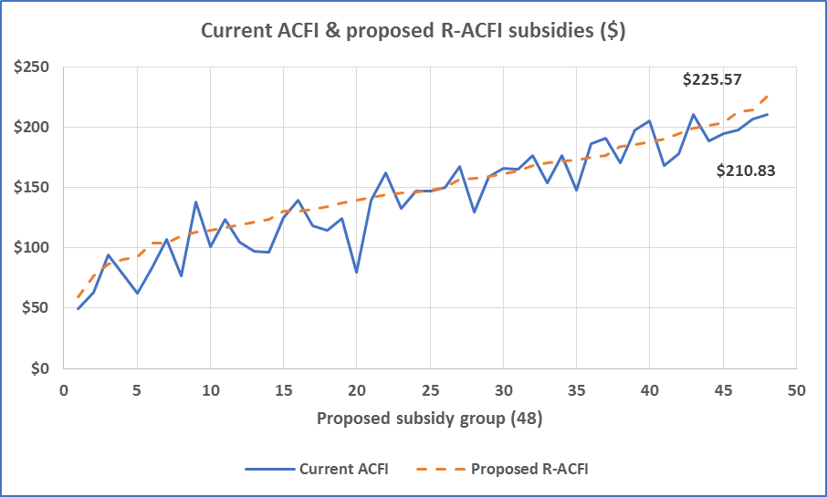

## External Assessment

Funding volatility and the lack of predictability with the aged care forward budget estimates has been a major issue for both the Government and the Sector. Consultations with representatives of the sector have supported the notion that the rate of the ACFI care subsidy increases has been unsustainable and peak bodies agreed that some corrective action was needed. However, subsequent action by Government to slow the growth have created uncertainty (e.g. will it happen again, soon?) producing a destabilised environment for aged care providers.

Reductions in funding by government are often seen by the industry as summary reductions. Additionally, any action to cut funding tends to affect all providers, not just those that have benefited more from the increased subsidy income. This has the effect of creating a lack of confidence and trust which can then impact on future reforms where both parties need to play a constructive role.

For these reasons, it is necessary to address the issue of funding volatility. While the ACFI changes described in this report will make the ACFI more contemporary, clearer in the question intent, more reliable and less susceptible to up scoring, experience from previous aged care funding tools introduced in Australia and internationally has shown that an improved scale alone will only go part way to ensuring the integrity of the system in the longer term. When funding is determined by a provider ‘self-assessment’, it is reasonable to expect that the incentive to maximise the funding overly influences the outcome and widespread up-scoring occurs. This project has therefore also researched the options for improving the current audit system in addition to the consideration of external assessment options.

The following options have been proposed as viable options for consideration:

**Option 1**: The present system, using R-ACFI assessments made by ACAT staff as part of residential care approval or at entry, providers making R-ACFI assessments for entrants and reassessments, and with review officers making site visits for 10 per cent of entrants and reassessments, selected by data analytics.

**Option 2**: Care subsidies based on R-ACFI assessments made by ACAT staff as part of residential care approval or at entry, with providers having a right of appeal. ACAT staff will also make R-ACFI assessments for a minimum of 25 per cent of resident reappraisals, selected by data analytics.

**Option 3**: Using Specialist Assessment Agency (SAA) assessors to make site visits to make   
R-ACFI assessments for 100 per cent of new residents and a minimum of 25 per cent of reappraisals, selected by data analytics.

A more detailed description is provided in the following Table.

Table 3: Comparison of the Current System and New Funding Options

| **Aspect** | **Current System** | **Option 1 – Modified Current** | **Option 2 - ACAT** | **Option 3 - SAA** |
| --- | --- | --- | --- | --- |
| **Funding Model** | Provider self-assessment | Provider self -assessment | ACAT (RN/AHP) | SAA assessor |
| **New Resident - $ assess** | Facility | Facility | Pre-admission; home, hospital, respite | Facility |
| **ACAT changes?** | No: no R-ACFI pre-entry, no $ role | Yes: 3 months R-ACFI pre-entry, no $ role | Yes: 3 months R-ACFI pre-entry,  sets $, review role | No: no R-ACFI pre-entry, no $ role |
| **R-ACFI Users** | Provider | ACAT & Provider | ACAT & Provider | Provider & SAA |
| **Review by** | Review Officers (RO) | Review Officers (RO) | ACAT (RN/AHP) | SAA assessor |
| **New Residents: audit %** | 10% (assess) | 10% visit audit; 90% data | 100% assessment pre/post entry | Up to 100% via visit assessment |
| **Funding Determination - review process.** | **Provider R-ACFI used for $**  RO audits sample (10%) after payment using care provided, resident review, documentation, staff discussions | **Provider R-ACFI used for $**  RO audits 100% after payment using: Matching (ACAT/ Provider), data analytics,  e-audit, site visits for around 10% of submissions. | **ACAT R-ACFI used for funding $s**  ACAT assessor sets funding pre-entry. No review if accepted.  Contested R-ACFI process – Matching data analytics, e-audit, site visits and assess. | **Provider R-ACFI used for initial funding determination** but SAA assessor confirms for up to 100% of R-ACFI submissions via joint determination approach.  SAA/DoH also checks claims using data analytics, e-audit. |
| **Funding certainty & Audits** | Audit: unrestricted time period | Audit: restricted to 12 months | Not contested: Payment on admission. If contested: Payment review within one month. | Payment 2 months after admission. Assessment audits up to 12 months. |
| **When full funding paid?** | Within 2 months of admission | Within 2 months of admission | On admission. Contest: 1 month | Within 2 months of admission |
| **Provider does R-ACFI in…** | With 2 months | Within 2 months | Within 1 month but not for $s | Within 2 months used for $s |
| **Re-appraisals: audit assess** | 10% (assess) | 10% visit audit; 90% data | 25% visit assessment; 75% data | 25% visit assessment; 75% data |
| **Funding Determination Process** | **Provider R-ACFI used for $**  RO checks sample (10%) as per new resident checks. | **Provider R-ACFI give $s**  RO checks after payment using: data analytics, e-audit, site visits for around 10% of submissions. | **Provider & ACAT R-ACFI give $s**  ACAT checks after payment using: data analytics, e-audit. **Site assessment checks for 25% - 50% of R-ACFI submissions** | **Provider & SAA R-ACFI give $s** SAA assessor checks after payment using: data analytics, e-audit. **Site assessment checks for 25% - 50% of R-ACFI submissions** |
| **When full funding paid? Funding certainty & Audit** | On submission but subject to audit, no time limit | On submission but subject to audit for 12months | On submission but can have assessments checked up to 12m | On submission but can have assessments checked up to 12m |
| **Method Used to Audit $** | Assessed care + Care provided | Assessed care + Care provided | Assessed care need | Assessed care need |
| **Stable funding** | Low | Medium | High | Medium-High |
| **Growth Reduction: 2018-22 FYE** | **NA** | **$3,619M** | **$5,753M** | **$5,372M** |

## Model Comparisons – Recommendations

There are several reasons to consider changing the way funding is determined in the current aged care funding system. Modifying the system is important to ensure the stability and sustainability of the system but also to ensure that the system remains one where evidence based assessment results in the best possible care for residents with appropriate funding for providers to enable the delivery of the care. It should be noted that an external assessor model would be targeted on the subsidy growth aspect and adjustment to the base subsidies may be required if the introduction lowered average subsidy payments on a system wide basis as is projected in this modelling exercise.

The aim of changing the current R-ACFI assessment and review system to an external assessment approach is to:

### Improve the equity and fairness of the system

The basic requirement of any aged care funding system is that residents with similar levels of care needs attract the same amount of Government funding irrespective of the aged care service they are living in. At present some providers are receiving significantly more funding and others less funding for the same resident’s due to variations in claiming practices. While making the funding tool less susceptible to gaming will help, ultimately the ability to provide a more standardised basis for the decision about the residents funding assessment will provide the most equitable outcomes. It is important that any increases in Government expenditure on aged care residents are related to changes in resident acuity and numbers of residents rather than anomalies in claiming behaviour.

### Improve the surety, stability and predictability of provider income and government expenditure

Most of residential aged care in Australia is undertaken by private businesses. It is important that they have funding surety, stability and predictability in their income stream so they are able to run effective and efficient businesses. It is also important that Government can prepare budgets that allow for appropriate funding growth for residential care subsidies and be confident that increases in the budget are overwhelmingly due to an increase in the care needs of residents as the population ages.

The External Assessment Options 2 and 3 are almost certain to bring about a lasting change to the pattern of unpredictable growth in residential care subsidies. The ACAT option is likely to bring the most benefits overall but it will also be the most disruptive change in the short term compared to Option 3, which is also viable and perhaps easier to introduce in the shorter term. While a structural change will be required to introduce a national program based on a modified ACAT external assessment model, it is viewed as having benefits beyond better control of care subsidies as it will also lead to a fairer and more equitable way to fund the care needs of people needing aged care services whether it is to be in the community or residential care.

An ACAT based external assessment model also gives the opportunity to consolidate assessment and funding in high level community care programs and residential care. Direct comparison of R-ACFI payment and Community Care Package or CHSP funding will be possible as a person living in the community will also have an R-ACFI funding rating. This will give the basis for the single instrument and funding model in community and residential care. The External Assessor models will also enable accurate monitoring of the changes in care needs over time in the community and residential care populations and give information to drive research to inform government planning. The Government can more accurately analyse disability trends and compare residential and community care client profiles to measure unmet demand for aged care which is a statutory government obligation.

Investment in the changes now would potentially result in a more streamlined system for all of Australia’s aged population that can grow with the ageing population.

Investment in IT and training now will ensure the system is robust and resilient into the future with costs contained to those relating to resident/care recipient acuity rather than business processes.

### Options Comparisons – Costs and Benefits

A modelling exercise was undertaken to provide an indication of the likely costs and benefits of the three proposed options. All options show a significant reduction in care subsidy growth after costs compared to the current system. The differences are significant from year 1 (2018-19) and the cumulative impact over the projected period is significant for all options. While the specific amounts estimated in this exercise are indicative and open to debate regarding the specific amounts, the reductions in the care subsidy growth will be significant, particularly for the external assessor Options 2 and 3. The estimated reduction in growth over the 4-year period from July 2018 to June 2022 compared to the current system is $3,328 million for Option 1 (modified current), $5,851 million for the ACAT Option 2 and $5,476 million for the Specialist Assessment Agency Option 3.

Table 4: Reductions in Growth Relative to the Current Funding System

| Year to 30 June | Option 1 ACAT / Review Officer $M | Option 2 ACAT $M | Option 3 SAA $M |
| --- | --- | --- | --- |
| 2019 | 293 | 546 | 494 |
| 2020 | 802 | 1410 | 1307 |
| 2021 | 1060 | 1832 | 1725 |
| 2022 | 1173 | 2063 | 1950 |
| Total | **3,328** | **5,851** | **5,476** |

### Conclusion

There are several reasons to modify the current aged care funding system to prepare it for the future. Ageing of the population will put pressure on the system that will need to be scalable as the industry grows. The changes made to ACFI will support system stability, sustainability and cost containment. Importantly, it also ensures that the system uses a thorough evidence based assessment approach which puts in place, for all residents, the foundations for the provision of appropriate, effective and efficient care planning which will then underpin the best possible care for residents of aged care facilities.

1. ACFI Review Report Introduction

**This Chapter covers the following topics:**

* A historical overview to provide context for this project.
* Briefly describes the funding classification approaches used in Australia over the past 40 years.
* The Department Evaluation of the ACFI conducted on 2011.
* The Growth on the ACFI care subsidy.
* Project Terms of Reference and Deliverables.
* Structure of the report.
  1. Aged care funding tools used in Australia

Various systems of classification of resident dependency and funding tools have provided the basis for national residential aged care funding for nearly 40 years.

The tools used have been similar to dependency assessments used internationally (e.g. Resource Utilisation Groups (RUGs)), with items assessing care needs in areas such as mobility, continence, bathing, dressing, cognitive ability, behaviour, and nursing procedures and treatments. The following discussion is based on the research paper ‘Australian approaches to resident classification and quality assurance in residential care’ (Rosewarne, 2002) and government publications.

1. Aged care funding – High care

Commonwealth funding for nursing home care commenced in 1963 and was divided into two levels, ordinary and extensive care. This was followed, in 1969, by the first funding classification of nursing home residents. The aged care provider, using basic criteria, classified residents and determined which residents would attract additional government funding due to their need for extensive care. Without pre-admission screening (national ACAT eligibility screening for residential aged care was implemented in the mid 1980’s), there was a tendency for facilities to admit residents with the lowest care needs possible to allow a claim at the highest government funding level (extensive care benefit).

Nursing home reforms introduced by the joint Commonwealth-State Working party on Nursing Home Standards (the Working Party) in 1987, resulted in the implementation of the more objective Resident Classification Instrument (RCI) in 1992. The RCI introduction was a component of a suite of changes, including the introduction of Care Aggregate Module linked to the RCI levels (CAM) and the Standard Aggregated Module (SAM) for subsidising the infrastructure costs of non-government nursing homes. The RCI provided funding for five categories of nursing home residents using a 14-item scale, with ratings at four levels of dependency on each item. On the basis of the RCI category assigned to each resident, CAM funding was provided to cover the cost of employing a specified standard level of nursing and personal care staff to care for nursing home residents.

The CAM scale was calibrated and the items weighted via factor analytic and regression methods to determine question importance in allocating funding. Large scale trials were conducted with the RCI assessment tool and the distribution was divided into five categories, with cut-off points calculated to constrain bracket creep and therefore funding growth.

1. Aged care funding – Low care

In 1969, a two-tiered system of recurrent funding was introduced for Hostel (low) care. Residents requiring basic hostel care, (no nursing or personal care assistance) paid fees to cover board and lodging and the level was linked to the Age Pension. Residents requiring personal care attracted the government funded Personal Care Subsidy.

In 1992, the system was changed and the Personal Care Assessment Instrument (PCAI), classification tool was introduced. The PCAI was a 16-item assessment tool that placed residents into payment levels of Personal Care High, Medium, and Low, with those not requiring personal care classified into Hostel Care. This tool was maintained until it was replaced by the Resident Classification Scale (RCS) in 1997, when hostels and nursing homes were reclassified into a single system of residential care under an ageing in place model.

1. Bringing Nursing Homes and Hostels Together – Ageing in Place

The nursing home and hostel systems developed separately from the early 1970’s but there was evidence that around 20 per cent of people living in hostels were more dependent in terms of their care needs, than many nursing home residents (Duckett 1995; Australian Institute of Health and Welfare (AIHW) 1997. These findings and the desire to create an ‘ageing in place’ environment led to the introduction of the Commonwealth Aged Care Act, in 1997. The ‘Ageing in place’ policy was designed to allow hostel residents to remain in their hostel instead of having to move to a nursing home when their care needs increased   
(AIHW: Gibson D, Rowland F, Braun P & Angus P 2002).

To achieve the objective of integrating hostels and nursing homes into a single residential care system, a new care classification and funding model was required. The new system needed to objectively classify residents needing low levels of personal care, through to those with intensive nursing care needs, on a nationally consistent scale.

It should be noted that while there were criticisms of the RCI and PCAI covering hostels and nursing homes, the tools did mark a significant improvement in the measurement of care needs producing a more equitable, consistent method of distributing Government aged care funding. Systems designed to determine and distribute aged care funding have always been subject to criticism and review. As noted by Hindle (1996 p. 4) when referring to the RCI and PCAI “It is important to recognise there would have been criticisms of any approach, no matter how sophisticated. This is simply because the underlying problems are not capable of resolution to the satisfaction of all parties. In addition to the significant technical problems of classification of a highly heterogeneous population, there is the virtually unmanageable difficulty of ensuring there are adequate resources in the face of growing needs and expectations for care”.

1. The Resident Classification Scale

The Resident Classification Scale (RCS) replaced the PCAI and RCI and included questions about each resident’s care needs across activities of daily living (ADLs), behaviours, medication, nursing, and therapy. Each question had four possible levels with weightings related to their importance in determining the cost of care which was established through a costing study. The sum of the weights gave an overall score for each resident that was then allocated to eight categories on the RCS. The RCS was phased in from October 1997.

*How was the RCS developed?*

*The development of the new classification scale was the subject of detailed technical investigation reviews, consultations with providers, large-scale field trials, and extensive statistical analysis, and these activities have been well documented (Rhys Hearn, 1997).*

*The first step was the selection of resident characteristics that were highly related to the cost of care. This selection was made by canvassing staff in aged care facilities about resident characteristics they felt were most strongly related to the cost of care and examination of existing information on cost-related resident characteristics. A cost/time variable was also developed from a study that examined staff costs, staff time spent on resident care, and the cost of consumables such as dressings, continence products, etc. Relationships between the time/cost variable and data on activities of daily living, behavioural care, nursing care, and social needs were then analysed to determine which of these data items were most highly related to the ‘cost’ of care.*

*Once the set of candidate predictor items were developed, a draft scale was trialled in a survey of 20,000 residents. Extensive analyses of the data collected in these trials informed decisions about key aspects of the new scale, namely:*

1. *Whether an additive multiple regression model (like the old RCI) or a branching model   
   (a regression tree like RUGs or DRGs) should be used to determine level or membership of a payment class;*
2. *Whether bands or funding groups should be used if an additive model was selected or whether continuously varying scores would be allowed; and*
3. *How the payment rate per band/group would be determined.*

*It was decided that an additive approach was most appropriate on both methodological and practical grounds. The additive model was seen as a better predictor of cost where a continuous distribution is used to determine payment classes. Whereas patients in acute care settings differ in the kind of care they need and receive, and can be grouped accordingly, residents in aged care facilities have largely common areas of dependency in which their degree of dependency differs, so that their care need in each area can be rated on a continuous or ordinal scale and summed across all areas. The additive model was also found to explain slightly more of the variance in the cost/time variable when compared to the branching model. It was also considered an easier transition for staff and providers to from the existing scales to the single new RCS. The familiar four level ratings were retained for most items. (Rosewarne, R.C, 2002)*

1. Commonwealth Auditing Reviews of RCS Claims

The Department review program for the RCS was reliant on auditing care plan documentation (developed by care staff) as the basis for claims as residents were not assessed directly by a Review Officer. There was however concern that using the providers RCS documentation for funding audits had resulted in care plans being designed with the main aim of supporting the funding claim, resulting in a reduced focus on broader comprehensive care documentation. Provision of funding for ‘care provided’ that could be designed/manipulated via documentation to attract the higher levels of funding, led to resident care plans being directly influenced by the RCS funding model. It was also believed that the RCS approach which relied on care provided documentation, was leading to a high level of funding volatility and manipulation. As reported by Department of Health and Ageing (2011; pp24-25), the Hogan review of pricing arrangements in 2004 found that the “three main disadvantages of the RCS arrangements were: the administrative burden inherent in the RCS; the adequacy of funding arrangements to appropriately compensate for care needs of particular groups of residents; and the volatility of the RCS, including its susceptibility to manipulation and the potential for residents with similar care needs to be classified into different categories.”

An integrated residential care system with the full spread of resident dependencies included in the RCS funding model, also meant that the number of residents for whom higher levels of funding could be claimed increased significantly. The RCS Review Audit program was expanded to address this issue, as without controls to prevent the documentation of ever rising care needs, systematic increases in RCS claims had the potential to significantly increase government expenditure. Over time, RCS claims did rise significantly with the majority of aged care residents being classified as needing the highest levels of funding   
(RCS 1 and 2), outcomes which significantly impacted on the relativities in the original scale design and government expenditure, which increased beyond budget projections.

Claims also became harder to audit effectively with a high proportion of Departmental review decisions being challenged. For example, during 2008-09, 12,548 reviews of RCS appraisals were completed. Of those reviews, 3,749 or 30 per cent resulted in reductions of funding, of which 350 or 9.3 per cent were appealed by providers. In approximately 43.7 per cent of appealed cases, the original classiﬁcation by the home was reinstated (Commonwealth of Australia 2009).

* 1. Development of the ACFI

In response to concerns about the perceived burden resulting from the administrative and documentation requirements of the RCS assessment tool and a financial growth at a higher level than expected by Government, four reviews were undertaken and culminated in a project to develop and implement the ACFI.

**The ACFI and Assessed Care Needs**

Resulting from the learnings associated with the RCS operation it was seen as more appropriate to build future funding systems around assessed care need as:

* It would provide for a standardised basis for funding system determinations wherever a person was supported, including community care.
* Providers could build flexible care models to address the assessed care needs without having the care provided aspect dictated by a funding mechanism.
* It would allow more flexible ‘care provided’ responses by providers to resident desires and preferences (promotes consumer directed care).
* Care provided is a quality of care matter that is better covered separately by the Specified Care and Services requirements and the Quality Agency.
* It allowed for the introduction of an External Assessment model and funding determination if required at a future time.
* It fitted better with the residential aged care environment where there are many possible appropriate responses to an identified care need. This is in contrast to a hospital or sub-acute environment where the response to the care need is more clearly defined allowing funding to be determined on the basis of the activity.

**ACFI Design Principles**

The change from the RCS to the ACFI was guided by a number of underlying principles which were determined in consultation with an Industry Reference Group. The principles included:

* A reduced question set which identified key resource drivers.
* These key resource drivers or indicator questions were to determine the funding which was to cover all care need areas as described in the specified care and services legislated requirements. The funding was not provided to just cover the areas specified in the ACFI tool.
* An assessment approach that measured the need for care and not care provided.
* Development of clear question descriptions and guidelines to reduce disagreement between providers and Departmental auditors (i.e. wording refinements, single focussed questions form the minimum data set, consistent rating approach across ADLs).
* Specifying the evidence required for a claim in each domain - excluding care plans and nursing notes (i.e. assessments, clinical reports, diagnoses, written directives by health professionals), and modifying the RCS domains of medication and complex nursing.

Additionally, in contrast to the RCS that had eight categories of funding with no identifiable resident types, the new funding model was to allow description of identifiable ‘case types’. These case types were to be based on the three major care domains inherent in any aged care support system (personal care, health/nursing, behaviour/dementia). The case types developed allowed classification of individuals into clinically meaningful categories such as for example, low personal care needs, moderate behaviour care needs and low health/nursing care needs to assist staff understanding of resident support requirements.

An extensive national trial was undertaken and resulted in the ACFI being focused on questions that varied according to resident dependency that best discriminated care needs between residents. RCS questions such as those about social and human needs and family support, while obviously important aspects of care, were not areas that varied greatly between residents with different levels of care need (impairments and dependency).   
These areas of support were considered a relatively ‘constant’ part of everyday care, and were included in the ‘specified care and services’ that all facilities were expected to provide.

More detailed discussion about ACFI system development, including the funding model, is included in Chapter 3. Statistical analyses of the ACFI domains and funding growth is provided in Chapters 4-6, 8 and 9.

In summary, the ACFI which was implemented on 20 March 2008 was designed to deliver:

* An approach that measured the need for care, not care provided when determining funding but where some elements remained (Q11, Q12).
* A funding model with identifiable ‘case types’.
* A funding redistribution from lower care to higher care levels to provide more funding to those residents with higher staff resource demands.
* Funding to enable new care programs focusing on pain management.
* Transparency in the subsidy amount paid for the key care domain (ADL) with Behaviour & Complex Health Care payments included as ‘supplements’.
* Funding allocation between the care domains to be modified if, in future, the standard care costs can be demonstrated to necessitate a change in relativities.

1. Departmental Review of the ACFI

A Departmental Review of the ACFI was conducted in 2011. The review included extensive consultations with the aged care sector and data analysis of the first 34 months of operation of the ACFI (Australian Government Department of Health and Ageing, 2011). The review found that the ACFI was functioning as intended but required modification in some areas.

The recommendations of most relevance to the current project were:

* 1. Complex Health Care Pain Management Items Q12. Items 3 and 4:
  + Should be modified to remove the focus from specific interventions to allow a broader intervention approach. Therapeutic massage and application of heat packs are too narrow and not consistent with contemporary practice.
  + Other care modalities could be included such as exercise (strengthening interventions are also an effective way to reduce musculoskeletal pain).
  + The list of allied health professionals that can provide directives and interventions is too restrictive and should be broadened.
  + It should be noted that when the ACFI was developed, the Department strongly believed that some specific activities had to be included or the provider would take the funding and deliver the least costly option.
  1. The Department, in consultation with the Ageing Consultative Committee, should continue to carefully monitor expenditure trends under the ACFI, with emphasis on achieving an appropriate balance between:
     1. The extent to which overall expenditure growth rates are contained within a sustainable range over the longer term.
     2. The distributional impact of the introduction of the ACFI across providers.
     3. The Department should undertake further work, in consultation with the Ageing Consultative Committee, to enhance the integration of the funding and classification systems with the assessment and quality assurance arrangements across residential and community care.

Failure to implement the above recommendations from the 2011 Report would have implications for the future performance of the ACFI care subsidy payment system.

1. Care Subsidy Growth under ACFI

While the Department’s 2011 Review found that the ACFI matched *funding to care needs by identifying the significant drivers of relative costs* and that the industry was largely happy with the tool, business rules and claim requirements, the concern was that *average basic subsidies for most aged care homes had increased significantly in real terms since the introduction of the ACFI* (Key Finding 3, p 11).

The variable care subsidies used in the Australian aged care funding systems over the years have been of special interest to the government as they comprise a significant risk for the budget position as:

* Funding increases year on year if more than predicted impact on budget forward estimates and, as there is no actual limit on the global budget, the risk is high.
* The Department’s ability to ‘restrain’ the increases via their audit program has been limited in the past although more effective of recent times.
* While the care subsidy determined by the ACFI is means tested and the Government may have been expecting a significant contribution from residents, this has not been the reality and the majority of the ACFI subsidy is still paid by Government. Income tested fees are having only a small impact in this area (under 3 per cent) and this may increase far less than anticipated (Australian Government Aged Care Funding Authority, *Third Report on the Funding and Financing of the Aged Care Sector, July 2015*. Department of Social Services 1438.9.15. Commonwealth of Australia. Canberra. 2015).

Figure 1.1 shows the average ACFI subsidies growth as proportion of the maximum ACFI funding year on year across the charitable, community, government and private sectors from 2009 to June 30, 2016.

Figure 1.1: Average subsidies growth as proportion of the maximum ACFI funding

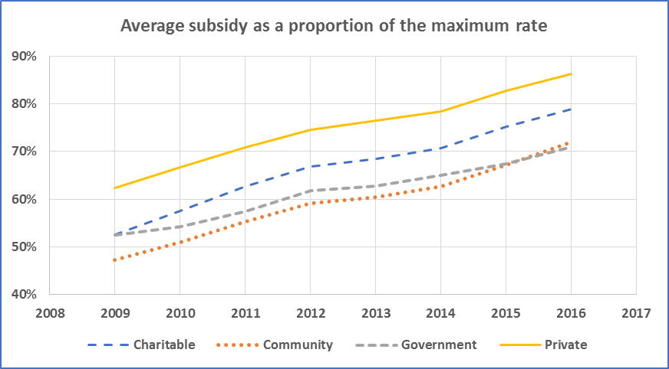

ACFI funding growth was relatively controlled, although still increasing, from 2012 until 2014. However, from June 2014 further increases beyond expectation occurred. A number of possible factors have coalesced to influence the funding increases since this time including:

* A minor increase in frailty and care needs of new admissions.
* New consultancy business models developed to maximise ACFI funding for the sector that focused on ‘no fee if no ACFI funding gain’. These consultancy models were successful at significantly improving average ACFI funding levels, particularly with existing residents who had not been re-appraised for some time.
* Benchmarking services became widely available highlighting providers and facilities that were considered ‘below benchmark’.
* There were specialised ACFI co-ordinators established in most organisations which led to better management and co-ordination of claiming reviews which resulted in a reduction in the number of facilities that were under-claiming.
* New aged care companies entered the market with a focus on building scale and using business models that were predicated on increasing revenue growth from an increase in ACFI funding year on year.
* There was significant growth in the proportion of private providers in the sector (from 2012) who have been historically more efficient at generating the best ACFI claim possible.
* Claims in the Complex Health Care domain pain management items (Q12.3; Q12.4a; 12.4b) were subject to significant growth, beyond expectation when the ACFI was calibrated.

The two Complex Health Care domain items covering pain management interventions (Q12.3; Q12.4a; Q12.4b) have had the single most significant impact on ACFI funding growth since inception (Figure 1.2). The pain management items comprised 11.3 per cent of the average daily subsidy by June 30, 2016, and alone contributed $1,248 million to the total ACFI funding allocation by the Department.

Figure 1. 2: Yearly growth in pain management funding using June 30, 2016 funding levels

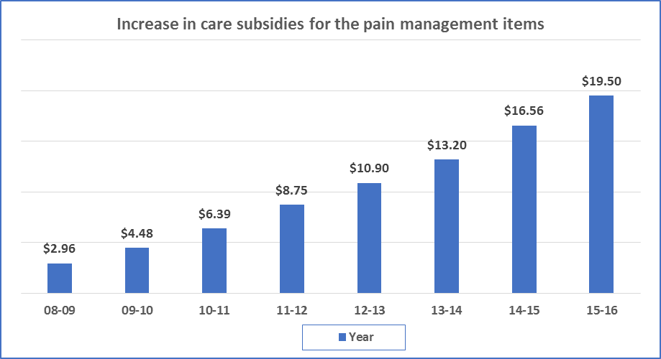

* 1. Next Steps

As a result of the ongoing growth of the care subsidy budget (determined via the ACFI), the government has had serious concerns regarding the program sustainability with the current ACFI funding model. On several occasions, expenditure for aged care has significantly outgrown projections, resulting in the introduction of savings measures that have been applied to the sector.

The first of these occurred in the 2012‐13 budget, which saw a reduction of payments under ACFI by $1.6 billion over five years. Analysis of claims trends showed growth occurred at twice the rate of wages. *‘(G)iven that ACFI subsidies make up around 70 per cent of provider revenue and wages make up around 70 per cent of provider costs’* the then Minister for Aged Care noted at the time, *‘there is clearly a disjoint between care subsidies and the cost of care*.’ (Butler, 2012).

In 2015‐16, there was also higher than anticipated claiming under the Complex Health Care domain of the ACFI that resulted in further adjustments to the budget in 2017.

This higher than predicted claiming has led to the Department undertaking various projects to review the current funding model and to explore options for the future.

This project is the result of the Department needing to address these issues. It was undertaken by Applied Aged Care Solutions (AACS) with a view to providing options to redesign the current ACFI funding system into a more sustainable and predictable model.

* 1. ACFI Review Project - Terms of Reference

Under its contract with the Department of Health, AACS was engaged to review the ACFI and provide recommendations to the Department on potential modifications that could be made to the ACFI to improve its operational effectiveness and the applicability of a process where ACFI claims were prepared by an independent assessor.

The key deliverables of the project were to include:

**Recommendations for cost effective improvements to the ACFI that would be consistent with external assessment.**

The recommendations should:

* Reduce subjectivity in the needs assessment process;
* Deliver a more accurate and reliable assessment that is not open to ‘gaming’;
* Be consistent with contemporary care practices; and
* Support the assurance and validation process for ACFI claims.

**Key design considerations:**

* Ability of the recommendations to be implemented in a short time-frame.
* That the proposed modifications are able to be integrated with existing Australian aged care client pathways and system structures i.e. Gateway (My Aged Care).
* Ability of the needs assessment tool to be used by assessors from an appropriate and available workforce.

**The contract materials were to comprise:**

* A targeted literature review of assessment tools used in the Australian health and aged care sector with a focus on validated contemporary care practices, including but not limited to practices for restorative care, reablement, dementia care and consumer directed care.
* A targeted literature review of international approaches to needs assessment and external assessment.
* A review of the current ACFI funding model and guidelines to better discriminate care needs and support contemporary care practices.
* A review of the ACFI User Guide and other operational documents to clarify areas of inconsistencies.
* Analysis of the benefits, disadvantages, system adjustments, and viable options for initial and re-appraisal assessments in the context of external assessment.
* Statistical analysis of the ACFI questions, domains, weightings and re-calibrations.
  1. Organisation of the Report

The report is structured in a series of chapters as follows:

**Chapter 1**: Report Introduction and Terms of Reference.

**Chapter 2**: Outline of the Project Methodology.

**Chapter 3**: Sets the scene for the R-ACFI Classification and Funding model.

**Chapter 4**: Describes the new R-ACFI ADL Domain in detail.

**Chapter 5**: Describes the new R-ACFI BEH Domain in detail.

**Chapter 6**: Describes the new R-ACFI CHC Domain in detail.

**Chapter 7**: Provides a description of the new Therapy Program.

**Chapter 8**: Describes the R-ACFI Classification and Funding Model Outcomes.

**Chapter 9**: Examines Funding Growth and Resident Acuity.

**Chapter 10**: Reviews in brief selected International Aged Care Systems approaches to determining and setting funding.

**Chapter 11**: Provides three options to consider for changes to the way assessment for funding is determined in Australian aged care facilities.

**Chapter 12**: Provides an overview of the recommended pilot studies to test the R-ACFI changes and inform on the operation of the External Assessment Options.

**Note**: The R-ACFI refers to the Revised ACFI rather than the currently in use ACFI.

1. Methods
2. Introduction

The ACFI Review Project comprised a number of components. The review methods were focused around the two major project aspects:

* A review of the ACFI system covering suggestions for change and analysis of the changes using existing data.
* The rationale for and possible options if an external assessment model was to be considered for the resident funding determination.

Table 2.1 provides an overview of the ACFI Review Project tasks and methods. Subsequent sections provide more detailed information on the project activities.

Table 2.1: ACFI Review Framework & Methods

| Tasks | Identify ACFI Issues | Practical modification | Develop modified ACFI | External Assessment |
| --- | --- | --- | --- | --- |
| Review assessment tools used in Australian health and aged care sector, including validated contemporary care practices (e.g. restorative care, reablement, dementia care, CDC) | Identify alternative validated assessment tools | Stakeholder interviews | Consider use of Australian aged care tools and contemporary care practices | Consider how to fit external assessment with Australian aged care sector |
| Targeted review of international (USA, Canada, UK and NZ residential care environments) approaches to needs assessment and external assessment | Dept. document review.  Targeted literature search and personal communication on external assessments | Stakeholder interviews | Consider international approaches & tools when modifying ACFI | Consider international approaches to external assessment |
| A review of the current ACFI funding model and guidelines to better discriminate care needs and support contemporary care practices | Stakeholder interviews | Stakeholder interviews | AACS analysis | Stakeholder interviews |
| A review of the ACFI User Guide and other operational documents to clarify areas of inconsistency | ACFI User Guide; Data analysis, industry stakeholder feedback written and verbal, department officials & reports | Stakeholder interviews | Improve supporting documentation | *No assessments noted* |
| Analyses of the benefits, disadvantages, system adjustments, and viable options for initial and re-appraisal assessments in the context of external assessment | *No issues identified* | Stakeholder interviews.  Data analysis | *No modifications noted* | Options for External Assessment (fully external, partially external model etc.) |
| Statistical analysis of the ACFI questions, domains, weightings and re-calibrations | *No issues identified* | *No modifications noted* | Modified ACFI to better discriminate care needs | *No assessments noted* |

1. Project Activities
2. Documentation Review

A documentation review was undertaken to inform on ACFI issues and practical modifications that could be made to the ACFI. The review was also designed to cover how a modified ACFI might fit into an External Assessment approach to funding determination.   
The sources of information were:

* Documents supplied by the Australian Department of Health (e.g. Review Officers issues logs; Technical Reference Group associated documents; Australian Government compliance documents).
* Stakeholder documentation.
* Targeted literature searches and personal communications on:
* Needs assessment tools used in the Australian aged care sector and internationally (e.g. NSAF assessments; InterRAI)
* International approaches to needs assessments
* The inclusion of contemporary care practices
* Assessor options.
* Review of the ACFI User Guide and operational documents to identify inconsistencies.
* Review of assessment tools used in the Australian health and aged care sector, including validated contemporary care practices (e.g. restorative care, reablement, Consumer Directed Care) (Appendix 2.1).

A review framework was developed (Table 2.2) to guide the approach for reviewing documents.

Table 2.2: Document Review Framework

| Criteria | Description |
| --- | --- |
| Assessments & Diagnoses | The information/tools that will be used for determining initial and re-appraisals; the purpose is for both care and funding; could cover ADLs, behaviour/dementia, CHC, contemporary aspects such as restorative and consumer directed care (CDC) and reablement approaches. |
| Summaries & Classifications | e.g. a MDS that summarises the assessment outcomes. The summaries can be used for both funding and care planning.  e.g. ACFI questions are rated A, B, C, D in a manner that can also be used for resident profiling.  For ACFI, the Assessments, Summaries and Classifications are all detailed in the ACFI User Guide and Assessment Pack. |
| Funding Approach | e.g. additive/ branching models, fixed/variable models, can be used for funding or supplement approaches for rural groups or individual care needs such as oxygen supplements; can assist to determine expected program requirements for auditing purposes. |
| Activity Measures | e.g. Activity Based Funding (ABF) or other models.  Based on care provided or assessed care needs, records of treatment,  Care Plans etc. |
| Business Rules | e.g. Residential Care Manual, Government Advice and Legislation.  [link to Department of Health's Ageing and Aged Care guides/advice/policy page](https://agedcare.health.gov.au/publications-articles/guides-advice-policy)  [link to Department of Health's Ageing and Aged Care legislation page](https://agedcare.health.gov.au/publications-and-articles/legislation) |
| Assessors | Internal/external or mixed assessment methods.  Who undertakes the assessment at entry and for re-appraisals.  Who determines the assessment outcomes, MDS, classifications. |

1. Consultations

Consultations were undertaken with a broad range of stakeholders as listed in Table 2.3.   
An agenda was prepared to provide a consistent background to the discussions   
(Appendix 2.2). The agenda covered in brief:

1. ****Project Background****

* Identify ACFI Issues
* Views on modifications
* Develop modified ACFI
* External / Independent Assessment Options

1. ****Discussion Points****

* The ACFI Model
* Changing the basic model design
* Number of ACFI Questions
* Assessment tools & mandatory requirements
* Therapy program incentives
* ACFI question considerations
* Business Rules
* External / Independent Assessment
* Other Suggestions / Comments

Table 2.3: Consultations with Stakeholders – Australian System

| Stakeholders consulted with | Method |
| --- | --- |
| ACFI Technical Reference Group (TRG) | Teleconference |
| Aged & Community Services Australia (ACSA)  Executive & Expert Panel | Teleconference |
| Aged Care Guild (ACG) | Face to face workshop |
| Australian Continence Foundation (ACF) | Teleconference |
| Australian Government Review Officers | Videoconference |
| Australian Physiotherapy Association | Teleconference |
| Catholic Health Australia (CHA) | Teleconference |
| Council on the Ageing (COTA) - Ian Yates | Teleconference |
| Exercise Physiologists (ESSA) | Teleconference |
| Leading Age Services Australia (LASA)  Executive & Expert Panel | Teleconference  Conference workshop |
| Victorian Aged Care Assessment Team | Interview |

Table 2.3a: Consultations with Stakeholders – International Systems

| Stakeholders consulted with | Method |
| --- | --- |
| Canadian system | Teleconference |
| NZ System | Meetings and teleconferences |
| UK system | Teleconference |
| USA system | Teleconference |

1. Literature review

A targeted literature review of residential aged care systems in the USA, Canada, UK and NZ was undertaken together with teleconferences with representatives from these countries on their approaches. The literature reviews and teleconferences covered:

* Assessment needs, systems and tools
* Methods for determining funding (DRGs, Case Mix, Activity based funding (ABF), assessed care need)
* Approach to wellness and rehabilitation programs
* How funding is audited
* Who does the assessment and where is it done
* The model and operation of External Assessment.

Outcomes of the review and discussions are provided throughout the report in the relevant sections.

1. Data Analysis
2. Data received on ACFI assessments and reviews

Table 2.4 provides information on the contents of the three sets of ACFI data provided by the Department. The initial data consisted of eight CSV files, one for each of the financial years 2008-09 to 2015-16. Each file contained details of each assessment or review current at any time during the financial year, so many records were common to more than one of the eight CSV files. All eight files were combined into a single STATA file, converting dates into numeric format. Sorting by recipient ID and assessment date, and selecting the most recent record for each combination of ID and date, resulted in a data set with a single record for each assessment or review current at any time in the eight-year data period.

Data checks were conducted by comparing entrants and exits in each financial year up to 2014-15, and the numbers in residential care at the end of each year, against data published by the Australian Institute of Health and Welfare (AIHW). The average time from first entry to residential care to exit was also checked for consistency. In general, the completeness of data recording was high, with no ‘unknown’ data. Answers to some ACFI checklist items were not available before 2010-11, and answers to five other questions were not recorded before 2009-10. In almost every case, data tabulations or model-fitting gave plausible results, consistent with expectations.

The data sets used in the project covered the period from 2008-09 to 2015-16 (Table 2.5).   
It was not possible to included data provided covering part of the 2016-17 period (supplied on 26th May 2017) due to time restraints.

Table 2.4: Data supplied on ACFI assessments and reviews

| Data field | Number similar fields | 2008-09 to 2015-16  Received 25-02-17 | 2008-09 to 2015-16  Received 9-03-17 | 2008-09 to 2015-16  Received 12-05-17 | 2016-17  Received 26-05-17 |
| --- | --- | --- | --- | --- | --- |
| RECIPIENT_ID | 1 | yes | yes | yes | yes |
| ADMISSION_DATE | 1 | yes | yes | yes | yes |
| DISCHARGE_DATE | 1 | yes | yes | yes | yes |
| DISCHARGE_REASON | 1 | yes | yes | yes | yes |
| ASSESSMENT_ID | 1 | yes | yes | yes | yes |
| ASSESSMENT_DATE | 1 | yes | yes | yes | yes |
| ASSESSMENT_START_DATE | 1 | yes | yes | yes | yes |
| ASSESSMENT_END_DATE | 1 | yes | yes | yes | yes |
| ASSESSMENT_REASON | 1 | no | yes | yes | yes |
| ASSESSMENT_CLASSIFICATION | 1 | no | yes | yes | yes |
| REASSESSMENT_REASON | 1 | yes | yes | yes | yes |
| ACFI_CATEGORY | 1 | yes | yes | yes | yes |
| ORGANISATION_TYPE | 1 | yes | yes | yes | yes |
| ABS_DESCRIPTION | 1 | yes | yes | yes | yes |
| STATE_NAME | 1 | yes | yes | yes | yes |
| DAYS | 1 | yes | yes | yes | yes |
| Q01 | 12 | yes | yes | yes | yes |
| Q01-R01 | 90 | yes | yes | yes | yes |
| VALID_YN | 1 | no | no | yes | yes |
| Number CSV files | *NA* | 8 | 8 | 8 | 1 |
| Size combined file (MB) | *NA* | 1679 | 1766 | 2647 | 430 |
| Number records | *NA* | 2446356 | 2446921 | 3867923 | 627437 |
| Latest discharge date | *NA* | 11-11-16 | 3-3-17 | 12-5-17 | 12-5-17 |

1. Analysis methods

The data was used to:

* Analyse the current ACFI distribution and changes since introduction.
* Conduct statistical analysis of the ACFI questions, domains, weightings and  
  re-calibrations.
* Conduct an analysis of the Departmental Review Program outcomes since ACFI introduction.
* Determine new cut points and weightings using distribution analysis and Item Response Theory (IRT) models in the ACFI domains.
* Analyse the benefits, disadvantages, system adjustments, and viable options for initial and re-appraisal assessments in the context of external assessment.

1. Regression and Logistic Models

Tables and graphs were used extensively to explore the changes that have occurred in the responses to some of the ACFI questions. The effects of proposed changes were tested with STATA analyses of all the records current at June 30, 2016. A logistic model was used to fit the probabilities of a review resulting in a subsidy reduction, and a regression model was used to fit the size of the reduction, if a reduction occurred. EXCEL spreadsheets with interactive assumptions were used to model the effects of proposed changes.

1. Item Response Theory (IRT) Analysis

IRT was used as the measurement basis for re-weighting the revised Activities of Daily Living Domain (R-ADL). The Behaviour (BEH) domain and Complex Health Care (CHC) domains were left intact apart from the removal of some items as the existing weightings still enabled the achievement of a relative resource distribution.

The IRT analysis provides the best practice method for determining the relationship between item discrimination, difficulty of an item and the level of functioning of the residents. Once the measurement of each person’s level of functioning has been accurately described, the financial aspect can be determined and assigned with confidence.

All measurement implies underlying homogenous dimensions or traits and a series of items, for example in the ADL domain, each reflect an aspect of the dimension. Once the data is obtained, an analysis uses the data to compute a single score for each person.

Classical Test Theory (CTT) is not applicable to some aspects of the current ACFI dataset. Since most ACFI variables are skewed it is not valid to use correlations, and hence factor analysis, regression and other parametric procedures.

*“Item response theory (IRT) has a number of potential advantages over classical test theory in assessing self-reported health outcomes. IRT models yield invariant item and latent trait estimates (within a linear transformation), standard errors conditional on trait level, and trait estimates anchored to item content. IRT also facilitates evaluation of differential item functioning, inclusion of items with different response formats in the same scale, and assessment of person fit and is ideally suited for implementing computer adaptive testing. Finally, IRT methods can be helpful in developing better health outcome measures and in assessing change over time. These issues are reviewed, along with a discussion of some of the methodological and practical challenges in applying IRT methods”. Item Response Theory and Health Outcomes Measurement in the 21st Century; Hays, R.D., Morales, L.S., & Reise, S.P. (2000).*

Most instruments in health measurement are now based on IRT. IRT is used for all major measurement and assessment programs in Australia and internationally [e.g. Australia: National Assessment Program – Literacy and Numeracy (NAPLAN); US: National Assessment of Educational Progress (NAEP), College Testing Board (CTB)].

The essence of IRT is that you start with a set of items (e.g. ADL items) applied to a set of people (e.g. aged care facility residents). Each of the ADL items is deemed to reflect some aspect of an underlying trait (e.g. functional ability or capacity) that is possessed by the resident cohort. The IRT analysis is based on a set of encounters between the ADL items of a given difficulty (e.g. transfers vs. washing and drying) and residents of a given overall functional ability. The ADL items define the trait, known as the latent trait. IRT defines a single scale with each of the ADL items (or each step of an item with several categories) located at a point in the ADL scale. Each resident in the aged care population is also located at a point in the scale. Since IRT is a probability model, it is important to be precise. An ADL item is located on the scale at the point where a resident with that value on the latent trait has a 50 per cent probability of being rated on the item. A resident is located on the scale at the point where they have a 50 per cent probability of scoring on an item at that point on the scale.

The IRT scale has no specific metric, and so can be scored (with a linear transformation) to suit descriptive purposes. Items and persons are referred to having a point or location on the scale. For these analyses, the person scores were transformed to a 0/100 scale.

The value (position on the scale) for each item and each person has an associated error of measurement. Items and persons near the centre of the scale have smaller errors of measurement since they are based on more information because there are more items and more persons near the centre of the scale than at the extremes.

Since IRT is not an additive model, the analysis can proceed even if there are cases with missing data on some items. All that is required is a sufficient spread of items and persons across the range of the scale. However, it should be noted that a person with missing data will have a higher error of measurement.

CTT cannot use cases with such missing data since procedures like factor analysis depend on a correlation matrix (or covariance matrix) that excludes any case with data missing on any item.

1. R-ACFI IRT Analysis Example

The Graded Response Method (GRM) version of IRT was used as the ADL items have several categories for which it is assumed that the differences between categories vary across the ADL items. If the model converges, there is a uni-dimensional set of items.

In the following example, the new R-ACFI ADL Nutrition item is used to show the IRT analysis steps. The new R-ACFI nutrition item (readiness to eat and eating are combined) was created from re-coding the current two items as follows:

* R-ACFI Nutrition = 0 (standard care) if Readiness to Eat and Eating = 0
* R-ACFI Nutrition = 1 (monitoring) if Readiness to Eat = 2 or Eating = 1
* R-ACFI Nutrition = 2 (some assistance) if Readiness to Eat = 2 and Eating = 1
* R-ACFI Nutrition = 3 (full assistance) if Eating = 2

In the excerpts of analysis results below, the ‘difficulty coefficients’ for the categories of the new nutrition item run from a low of –2.700 to +1.054. These are the coefficients before transformation to the 0 to 100 scale.

The cumulative difficulty coefficients are reported in Table 2.5.

Table 2.5: Nutrition Question Difficulty Coefficients

| Nutrition | Difficulty Coefficient |
| --- | --- |
| Nutrition >=1 | -2.483 |
| Nutrition >=2 | -1.267 |
| Nutrition =3 | 1.054 |

* The first entry means that a resident with a trait value of –2.483 has a 50 per cent probability of being rated at 1 rather than response 0 for the R-ADL item Nutrition.
* The second entry means that a resident with a trait value of –1.267 has a 50 per cent probability of being rated at 2 rather than response 0 or response 1 for the R-ADL item Nutrition.
* The third entry means that a resident with a trait value of +1.054 has a 50 per cent probability of being rated at 3 for R-ADL item Nutrition.

For practical purposes, it is easier to look at the relativities, that is: how widely spaced are the categories, and by how much the high values are greater than the lower values.

1. Looking at the item categories in terms of the IRT latent score

Another insight into the data is obtained by looking at the mean value of the IRT latent score for each category of an item (Table 2.6).

Table 2.6: .6: R-ACFI Nutrition Item

| Category | Response Code | Mean Latent Score |
| --- | --- | --- |
| Standard care | 0 | 34.74 |
| Monitoring | 1 | 41.10 |
| Some assistance | 2 | 65.73 |
| Full assistance | 3 | 83.72 |
| Total Mean Latent Score | | **65.07** |

The latent score has a range from 0 to 100. The table shows that the mean latent score for the whole group of residents is 65.07. The mean latent score for the group of residents with response 0 for the R-ACFI Nutrition item is 34.74, the mean latent score for the group with response 1 for the R-ACFI Nutrition item is 41.10, etc.

1. ACFI data

The ACFI data from 2015/2016 have been used for the IRT analyses. The data includes all residents that were present in an aged care facility at some point in the 12-month period (233,996 records). Strictly, if there were new cases from a new year they should be submitted to IRT analysis to obtain their scores on the set of ACFI items. This is possible, and there is the option to anchor the parameter values, so that the new cases are scored based on the parameter values of the set of analysis data from the previous year. This would ensure consistency across years. In practice, this is unlikely to be feasible, and dummy (indicator) variable regression analysis is used for this purpose.

1. Dummy variable regression analysis

The linear regression procedure normally attempts to explain the variance in a dependent variable in terms of one or more independent variables. For the IRT analysis, a latent variable was developed. Dummy variable linear regression is used to explain the variance in the latent variable in terms of categories of the items used to create that latent variable (Table 2.7).

There is redundancy of using a dependent variable derived from the same variables used in the analysis, but this allows scoring of people (residents) without running through an IRT analysis. This adapted procedure will only work where there are no cases with missing data, which is the situation with the ACFI data.

Since this analysis deals with variables with more than two categories, a set of dummy (indicator) variables for each category of a variable is generated by regressing the latent variable (ADL Latent) against the dummy variables generated from the R-ACFI Nutrition item.

Table 2.7: R-ACFI Nutrition

| Nutrition | Regression Coefficient |
| --- | --- |
| General care | 0 |
| Monitoring | 1.20 |
| Some assistance | 3.43 |
| Full assistance | 10.23 |

1. R-ACFI ADL Domain Total Score Calculations

The total score on the R-ADL domain is determined by summing the relevant regression coefficients across all the ADL item checklists (e.g. nutrition, transfers, locomotion, etc) to compute a total score for each resident. A resident can only have one of these values for each item. A resident with a response of 0 to all ADL checklist items would get a total score of 0. A resident with the maximum response (e.g. physical assistance and lifting device) to all ADL checklist items would get a total score of 100.

For the Nutrition example:

* For response 0, add 0.00
* For response 1, add 1.20
* For response 2, add 3.43
* For response 3, add 10.23

1. Setting the Scene - the R-ACFI Model

This Chapter covers:

**Background information on the ACFI & R-ACFI Funding Models**

* ACFI & Cost of Care using Pricing Review Data.
* Do ACFI Profiles relate to Aged Care Staffing Models?
* Statistical Underpinnings of the R-ACFI.
* Additive vs. Branching Models Considerations.

**R-ACFI Principles**

* What does the R-ACFI Fund?
* The R-ACFI Focuses on Assessed Care Need.
* The R-ACFI Rewards Improved Resident Functioning.
* The R-ACFI has a Minimum ‘Base’ Funding ADL Classification.
* The R-ACFI Promotes Best Practice Assessment and Care Planning.

**An introduction to the R-ACFI covering the ADL, Behaviour, CHC Domains and Therapy Program**

* The R-ACFI Classification and Payment Model.
* A summary of the R-ACFI is described in the ‘R-ACFI at a glance’.
* Details of a proposed pilot project to test the R-ACFI assessment and classification model.

1. The ACFI Review Project

The review of the ACFI funding system was precipitated by the ongoing increases in ACFI claiming and more specifically the CHC domain items focusing on pain management (covered in detail in Chapter 9). This led the Department to undertake a number of projects with a view to redesigning the funding system to ensure a more predictable and sustainable model.

This review project recommends the implementation of a new R-ACFI covering, to at least some degree, almost all areas related to the operation of the ACFI. The entire ACFI system has been reviewed as part of this project and changes have been recommended for:

* ACFI Questions.
* ACFI Checklist items.
* ACFI Care Domains.
* ACFI Assessment Tools.
* ACFI Funding Model.
* Business Rules.
* The Audit System and External Assessment.

1. Funding Model

The R-ACFI is a relative resource instrument – it divides up the available funding on a resident by resident basis based on their relativities and resource demands, as identified in the RCS costing study and the ACFI cost of care analyses conducted in 2006. While these analyses were undertaken 11 years ago, relativities in regard to residential aged cost models have proven very consistent in the most widely used classification system worldwide; RUGs II, III and IV models, which is similar to the ACFI design. Nevertheless, a re-calibration study at least at the domain level is recommended to adjust for any changes that may have occurred since the last analyses.

The R-ACFI is based on the differential ‘cost of care’ of individual residents and is primarily intended to deliver adequate funding to the financial entity supporting the residents. This entity for most practical purposes is the facility. The facility receives an amount of funding and distributes that funding on the basis of the R-ACFI ‘assessed needs’ of the residents. The system does not require that the actual care or attention an individual resident receives is to be directly and exactly determined by their specific recurrent funding – it operates as an approximation for individuals within the facility and the average care provided to individuals. The daily cost of care for an individual is related to their ‘average’ dependency (predictable and measured by the R-ACFI funding instrument) together with other ‘unpredictable’ care requirements related to health, psychological and emotional status that will change for all residents from time to time – this aspect is not a part of the recurrent funding model (e.g. exceptional short term needs). Short-term aspects that cannot be measured by an ‘averaged’ model should be funded via limited time supplements that will target these particular care need areas. Supplements can be added at any time to the R-ACFI model to better adjust for the exceptional needs that may cause large unpredictable resource demands.

The R-ACFI focuses on those questions related to day-to-day, high frequency need for care. These aspects are more appropriate for measuring the average cost of care in longer stay environments.

There was substantial previous research conducted to calibrate the ACFI funding model to actual facility costs, and there has also been more recent research examining the relationship between care staff costs and the ACFI which showed that the ACFI is still strongly related to direct care facility costs.

The R-ACFI funding model represents a modification of the current ACFI. The development of the ACFI used a sophisticated analytical approach which calculated the relative funding to be allocated to each care domain (ADL, BEH, CHC) from the:

* RCS costing study.
* ACFI National Trial.
* Analysis of Care Costs Study which used the Pricing Review facility costing data.

It should be noted that the underlying ACFI structure and weightings were derived from traditional statistical methods (factor analysis, regression analysis etc). For the current review project, AACS has used IRT (item response theory) methods, (which have become more recently available and are considered gold standard regarding scale development) on the ADL scale with the R-ACFI update.

1. ACFI & Cost of Care using Pricing Review Data

An ACFI costing analysis project was conducted in 2006 to examine aspects of care costs from data submitted on 642 facilities to the Pricing Review (Productivity Commission 2003, Productivity Commission Submission to the Review of Pricing Arrangements in Residential Aged Care, June). This review was undertaken to check whether:

* The ACFI funding model explained a significant proportion of the costs of residential care.
* If there was a clear relationship between increasing costs in residential care as measured by the imputed ACFI (the RCS data was converted into ACFI scores) and increasing resident dependence.
* There was a ceiling effect beyond which costs did not increase with resident dependency in aged care facilities.

This research was conducted by AACS and Cumpston Sarjeant Pty Ltd and showed, in summary, that:

* **Economies of Scale:** There was no evidence of economies of scale or a flattening of the cost curve as the care needs increased. The relationship between costs and care needs continued to increase without any sign of economies of scale affect or attenuation due to higher proportions of high care need residents.
* **For Total Costs:** The total cost per day progressively increased with a higher proportion of higher resident care bed days.
* **Variable Care Subsidy Related Costs:** The pattern of the results was similar to total costs. This is to be expected as care related costs comprise the major component of the total costs.

In terms of the cost of care, did the imputed ACFI model predict the cost of care?

* The imputed ACFI scores were significant predictors of total costs.
* Analysis of the relationship of total costs to imputed ACFI subsidy payments showed that the ACFI explained a significant amount of the variance in total facility costs. The analysis indicated that the imputed ACFI explained around 70 per cent of total facility costs.

The ACFI was introduced on the back of this research which showed that the ACFI was a reliable and valid way of determining residential aged care subsidies.

1. Do ACFI Profiles relate to Aged Care Staffing Models?

The Aged Care Staffing and Skills Mix Project conducted in 2013 examined whether ACFI profiles related to aged care staffing models. This was done by analysing a national survey of 121 facilities that submitted detailed staff rosters. Results from the project (Aged Care Staffing & Skills Mix Project, Report January 2013, Applied Aged Care Solutions Pty Ltd) indicated that the ACFI care areas that had the most impact on direct care nursing time were ADLs, Cognition and Complex Health Care items.

The results showed that the amount of direct care staff time on a per resident basis for all nursing staff comprising Registered Nurses (RN) and Personal Care Workers (PCW) was related to, and could be significantly predicted by, the care needs of the residents in the facility as identified by the ACFI checklist data. This finding however, while showing a strong relationship between care needs and direct care time, did not inform on whether the amount or quantum of care time is sufficient for the residents in care. It did show that as resident care needs increased, as measured by the ACFI, the more care time per resident by RN and PCW staff was provided. The result also shows that the ACFI checklist variables were measuring care need aspects that, at a statistically significant level, predicted direct care staffing provision and by association, costs.

The ACFI, while in need of an update, still operates to resource the care needs of residents in a direct relationship to the assessed care needs in personal care, behavioural areas and health and nursing care.

The R-ACFI analysis has re-adjusted the scoring and relativities using contemporary best practice methods to re-focus the classification system and resources to those residents with higher care needs. The R-ACFI funding system outcomes are described in Chapter 8.

1. Statistical Underpinnings of the R-ACFI

The R-ACFI scales have been developed as separate ‘independent’ measures of care need, and the coefficients are only relevant within the scale in question, as the amount of funding associated with each care domain (ADL, BEH, CHC) was calibrated separately (cost relativities approximately ADL 60 per cent, BEH 15 per cent and CHC 25 per cent; Appendix 3.2).

The scales within the domains comprise items whose importance is calculated ‘in combination’ by IRT for the ADL domain in the R-ACFI. Because of the skewed distribution in the ADL domain (i.e. large number of full physical assistance claims), the variables are not normally distributed and linear regression was not appropriate. The IRT analysis identified the most important ADL items (e.g. mobility items) and re-weighted the items based on the IRT analysis.

The funding amounts determined by the domains can then be added as they all are components of the overarching latent domain of ‘aged care needs’. The R-ACFI uses latent trait analysis to determine item weightings within domains – they are not simply added as in the RUGs ADL model used in many casemix systems.

In the BEH and CHC domains, the approach after some items were removed, was to reallocate the weights back up to 100. This method provides understandable, meaningful and valid clinical groupings with associated costs which are then combined into cost group (case mix) combinations for individual resident profiles. The R-ACFI therefore allows for the identification of meaningful ‘case types’ as the first priority (clinical meaning preferred) which are based on the three major care domains inherent in any aged care support system (personal care, behaviour/dementia, health/nursing,) which are then associated with the available funding. The ACFI domain design is clinically plausible, statistically defensible and provides a widely understood approach.

The ACFI and R-ACFI methodology of partitioning the care needs into three main areas means that the R-ACFI funding models are; flexible for future developments as the various components (ADL, BEH, CHC) can be adjusted with additional or modified questions, funding amounts can be differentially applied to the scale domains (e.g. a future cost calibration study may indicate a change in the funding relativities between or within the scales), and particular resident ‘types’ can be further targeted with the R-ACFI models at a more resident specific level. The ACFI domain structure was also designed to allow for relative resource adjustments across domains in a way that had face validity for services and consumers. Also, as Government considers consumer payment options in the future, it may be deemed more flexible to allow for separate domains in personal care, behaviour and complex health care. For example, Governments or insurers may decide to pay all CHC costs but apply full means testing to the personal care component. A model that combines these three care aspects into an average cost grouping will reduce the flexibility of adjustments in future as the funding will represent a composite of care need areas.

The ACFI and now R-ACFI domains are designed to represent the key resource drivers in long term care and to provide a readily accessible care profile for each resident. While an update and improvements should be made, research reported earlier shows that, as of 2013, the ACFI was predicting with statistical certainty the level of direct care staffing resources in the 121 aged care facilities in the study sample.

1. Considerations when Measuring the Cost of Care

The R-ACFI uses a combination of an additive model (regression) and IRT. The most important consideration in the development of an additive (regression) or branching (regression tree) classification model is the underlying measurement model. In this regard, the R-ACFI scales are the primary data source and a funding classification model could be determined effectively with either approach. It is suggested for further review, that both approaches are developed and compared to determine which method more accurately explains the costs of care.

Careful consideration must be given to the decision about whether an inherently more complex branching model of some type is used compared to the R-ACFI type model (IRT and Regression). A classification model based on ‘activities’ relies on specific nursing documentation of the care being provided, that is, resources used (or documented as being used). ADL care needs in general drive the system, along with associated medical and ancillary costs which are calibrated yearly against the cost of these direct components of care, which can an additional overhead to the system. However, funding in these types of classification models is still constrained within the existing budget envelope of the entity managing the funding system.

Using data analysis of the activities provided (or documented as being provided) and the estimated cost of the specific activities, case mix systems generally use regression tree analysis to solve for ‘homogenous’ averaged cost groups which represent various combinations of care needs (e.g. ADL, health) as determined by analysis. This approach provides a case mix index for every individual resident based on their profile and the payment can be varied depending on a range of factors including the available funding. Funding is ultimately distributed on the basis of relative care needs (i.e. as in the R-ACFI model) or their case mix index.

Case mix models are used more frequently in hospital and sub-acute environments, as the major reason for the care being provided is usually identifiable and co-morbidities are limited in number and importance. In Australian aged care facilities, with ageing in place, there can be a wide range of resident types in one facility and the major reason for care is not easily identified. For sub-acute aged care, the major reason for admission and care might be maintenance or rehabilitation, but it is usually structured around shorter term ‘episodes of care’. Once out of the research phase, case mix models usually explain around 25-30 per cent of the variation in the cost of care (‘a’ cost versus ‘the’ cost) as the care provided basis can vary significantly from person to person. A case mix measure for long term aged care services will be intrinsically more complex than that for sub-acute care because it must describe a multidimensional system of health, functional, and social needs evolving over a potentially long-time span. The determinants of service need will be more complex, involving several dimensions (e.g. cognitive and physical) of functional disability as well as the medical condition of the resident.

There has been comment of recent times from providers suggesting that residential aged care is becoming on average more ‘sub-acute’ in nature with much shorter length of stays of higher acuity sicker residents. This has led to some discussion of the introduction of a higher initial payment and necessarily lower ongoing payment, once this initial period has expired. There are at least three issues to consider in this regard. Firstly, building a higher initial payment into the system, which mimics a hospital or sub-acute funding model which encourages faster churn, will disadvantage facilities with longer stay profiles. Secondly, it may introduce an unpredictable funding environment for providers and even government as length of stay will be an important factor operating on income for providers and expenditure for government. Thirdly, there is no evidence to suggest that there has been a system wide significant shift with aged care residents becoming more ‘sub-acute’ type with much shorter lengths of stay or that they are sicker and older on entry to care. The characteristics of residents in aged care homes in Australia has changed only slightly since the introduction of the ACFI in 2008 and, while the measurement model and some aspects of the design have needed updating in the R-ACFI, its basic design remains ‘fit for purpose’ as the aged care population has undergone only minor changes since its introduction.

When using reliable measures, it can be shown that:

* Length of stay (LOS) has been increasing over the past 15 years as indicated by AIHW data analysis (Figure 3.1). The average length of stay for all separations has increased from 31.5 months in 2000 to 34.8 months in 2015.
* There has been a small increase in the age at entry to an aged care facility in the last 6 years (83.4 years in 2008; 83.9 years in 2014 - Figure 3.2).
* The age of residents in care has increased slightly (84.5 years to 85 years – Figure 3.2) indicating that the residents admitted are not dying at an increased rate because they are ‘sicker’.
* Figure 3.3 shows the distribution of lengths of stay for separations in 2007-08 and  
  2014-15, from AIHW 2009 and 2016 data. The proportions at the two shortest durations decreased, and those at all the higher durations have increased. The proportion leaving in less than 2 years has also dropped from 53.3 to 50.9 per cent. The proportion of residents with shorter lengths of stay has therefore been decreasing.

While it is possible different trends may emerge in the future, the current evidence indicates that residents are not much older, sicker or having significantly shorter lengths of stay than was the case 10 years ago. The residential aged care population as a whole (there may be local effects) is not dissimilar to the population that the ACFI was calibrated on in 2008 and it is unlikely to change dramatically over the next 10 years unless there is a significant change in government policy.

Figure 3.1: Average months of stay for all separations

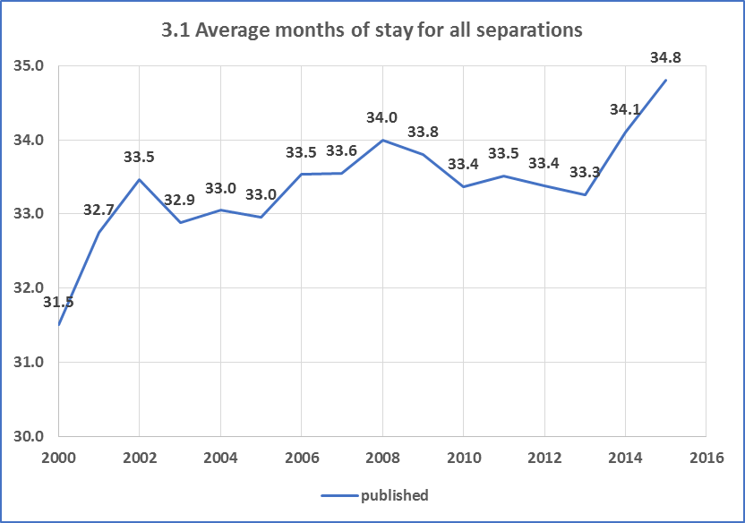

LOS data compiled by AACS from range of publications by AIHW.

Figure 3.2: Average ages for admissions & residents

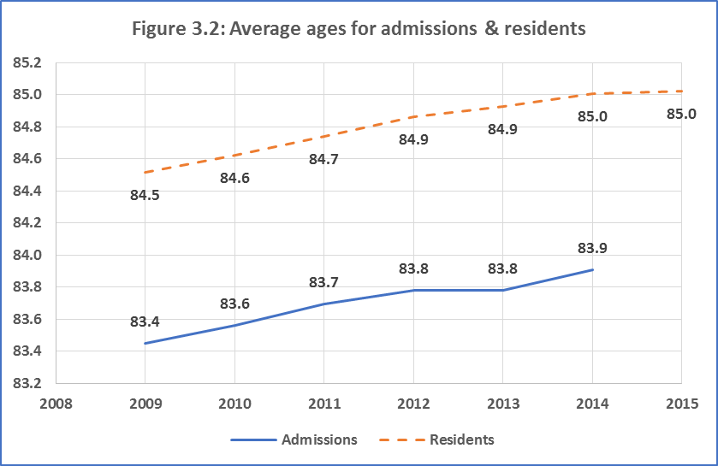

Admission date up to 2013-14 are for all admissions. Published admission data up to 2012-13, and resident data for 2008-09, were incompletely subdivided by ages, so the age assumptions of the youngest and oldest groups were based on those derived from 2013-14 for admissions, and from 2009-10 for residents. Where full subdivisions by age were available, the average age for each group was assumed to be at the midpoint of the range.

Figure 3.3: Separations by length of stay

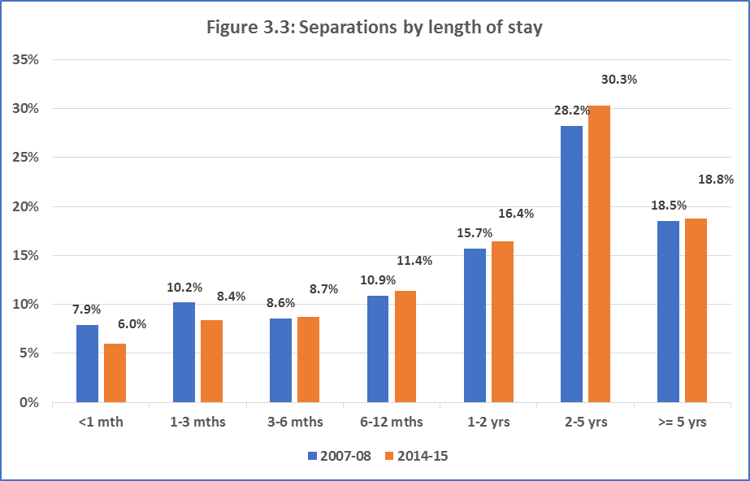

Separation durations for 2007-08 are from Table 3.9 of "Residential aged care in Australia 2007-08 (AIHW June 2008). Separation durations for 2014-15 are from table S1.39 of "Residential aged care and home care   
2014–15"

1. R-ACFI Principles

The R-ACFI funding model represents a significantly improved version of the current ACFI. The first part of this section answers the question: What does the R-ACFI Fund?

The following sections explain the principles upon which the R-ACFI has been developed which are:

* The R-ACFI Focuses on Assessed Care Need.
* The R-ACFI Rewards Improved Resident Functioning.
* The R-ACFI has a Minimum ‘Base’ Funding ADL Classification.
* The R-ACFI includes a broadly-based Therapy Program available to all residents.
* The R-ACFI Promotes Best Practice Assessment and Care Planning.

1. What does the R-ACFI Fund?

The R-ACFI, from a funding determination perspective, follows on from the ACFI model. The funding provides money to cover all a resident’s care need areas - not just those areas covered by the specific R-ACFI questions. The R-ACFI funding is directly linked to the broader care need areas covered by (i) Specified Care and Services and (ii) the Quality of Care Principles. The ACFI operates within a national legislative framework, the *Aged Care Act 1997* (Section 41‐3). This defines residential aged care as being personal care or nursing care, or both personal care and nursing care, that is provided to a person in a residential facility in which the person is also provided with accommodation that includes:

* Appropriate staffing to meet the nursing and personal care needs of the person.
* Meals and cleaning services.
* Furnishings, furniture and equipment for the provision of that care and accommodation.
* Meets any other requirements specified in the Subsidy Principles.

The basic subsidy amount per resident per day is ‘the amount determined by the *Subsidy Principles 2014*’, currently ACFI. Residential aged care subsidies are paid to approved providers of residential care to contribute to the costs of providing care to residents in a manner that meets its accreditation requirement (*Aged Care Act 1997, section 42‐1(1) (c).*

The *Quality of Care Principles 2014* are also articulated under the Aged Care Act 1997. The purpose of these principles is to specify the care and services that an approved provider of residential aged care (and Home Care Packages) must provide and their responsibilities relating to quality of care. *An approved provider* ***must*** *provide the care or service specified in the Quality of Care Principles 2014 to any care recipient who has an assessed care need.* For some services however, residents may be required to pay additional fees, if their care dependency (ACFI) profile is lower care. Higher care residents (i.e. one high domain or two medium domains) cannot be charged additional fees for services described in the specified care and services legislation.

1. The ACFI, Specified Care and Services and the Quality of Care Principles

The ACFI was designed to explicitly link to the Accreditation Standards and Specified Care and Services applicable at the time (2008-9). The ACFI measurement and funding model was framed to directly relate to the quality of care and services requirements, covering social and emotional support, recreation therapy, rehabilitation support, social and human needs and broader therapy. Funding in these areas from the previous RCS funding model (calibrated from a costing study) was rolled over into the ACFI funding pool and providers were expected to cover these areas from the ACFI funding, which effectively provided a pooled amount to cover care needs beyond that identified in the specific 12 ACFI questions.

The ACFI questions should be considered selective ‘indicators’ that provide the necessary resources to allow all of the required care related services to be delivered. It is not correct to interpret the ACFI funding as only covering areas targeted in the question set or that it only funds some care activities and not others or that it somehow restricts what can be done to assist residents. The ACFI funding is provided to cover the entire gamut of care areas as covered in the legislation. Providers are not restricted in what care can be provided with the ACFI funding. Restrictions, if they do exist, are necessarily imposed by the provider model of care, not the ACFI funding model. Appendix 3.1 provides a comparison between the ACFI questions and Specified Care and Services requirements.

1. The R-ACFI Focuses on Assessed Care Need

While there is debate about the best methodology when determining the measurement basis of a funding model, the methodology has to be designed to fit the actual circumstances of the care environment. The R-ACFI has moved further toward a model based around assessed care need in contrast to a model that focuses on ‘care provided’.

Measuring the need for care is preferred to measuring care provided as it is more objective, more easily audited and helps staff focus on the underlying issues of relevance to better care outcomes. Assessment forms the information base that is subsequently used to determine what type and amount of care will be required. Assessment can also be used to assess the success or otherwise of the various interventions provided to support resident care needs. The R-ACFI therefore uses assessment information, not care plans (which can appropriately vary for residents with the same care needs) or care provided information, to determine funding.

Assessed care need is a better approach to determine the resource demands in longer term care environments where day to day care needs are a combination of co-morbidities averaged out over the days and weeks of care. Hindle (1996) also indicated that measures of need are preferred as cost predictor variables in costing studies. Funding on the basis of assessed care need also encourages providers to be more responsive to resident directed care, and it enables providers to develop more innovative ways to provide the care that is not built around a prescribed care model.

1. The R-ACFI Rewards Improved Resident Functioning

The R-ACFI is not designed to be prescriptive or directive in terms of the actual care or interventions to be provided to a resident. An assessment and funding tool cannot adequately specify the clinical health, nursing and social care need interventions and supports for residents or ensure that care is actually delivered.

The R-ACFI contributes to the funding for these aspects and the provider will determine what to provide from a comprehensive assessment of the resident’s care needs.

The R-ACFI now provides an even stronger financial incentive for facilities to introduce and further develop physical Therapy Programs (refer Chapter 7).

As is the case with the current ACFI, once a facility completes an accurate appraisal of a resident’s care needs, the funding received will be retained even if the resident’s functioning improves.

The R-ACFI funding model therefore supports the use of Therapy Programs and rewards outcomes that improve resident care.

1. The R-ACFI has a Minimum ‘Base’ Funding ADL Classification

As the R-ACFI has a four level ADL domain, it is recommended that all residents in care receive funding in the ADL base layer. The amount however should be kept at a minimum. Large fixed funding bases have been developed from hospital and institutional funding systems where the basic care infrastructure is, to a large extent, fixed. Aged care is different as the care needs can be met in different and emerging ways via building designs, varying shift lengths, staff numbers, mix, handover models, IT etc. These all impact on the ‘cost of care’. Fixing a large care base will hard code in inefficiencies, stifle innovation, reduce flexibility for providers (design to a price), over-fund some facilities and expose the Department to cost increases where they have limited control.

1. The R-ACFI Promotes Best Practice Assessment and Care Planning

The R-ACFI strongly supports the creation of an assessment and care planning evidence basis which will then lead to the funding outcome. This is a ‘care first’, ‘funding later’ model.

1. R-ACFI Assessment and Care Planning

Most clinical care software systems use summary ‘assessments’ that record a care outcome (e.g. unable to participate in transfers) as evidence of a care need (requires physical assistance with transfers). These are not actual assessments as they represent a summary of the assessment outcomes describing what a person can do based on an incremental Likert scale. In the review of the ACFI, it has been acknowledged that improved assessment outcomes will be achieved if contemporary, well designed tools can be used as the fundamental assessment basis. This high quality information will lead to better care planning outcomes and represent an improvement on an industry basis of assessment practices, but only if the tools are mandated.

In line with the enhanced assessment and care planning (e.g. Therapy Program discussed later) focus of the R-ACFI, there is an enhanced suite of mandated assessments. The R-ACFI provides a more contemporary and comprehensive set of assessments that will assist in the identification of resident care needs and directly relate to the care planning process to improve quality of care outcomes. Figure 3.4 shows how the R-ACFI fits into the nursing process by providing a more comprehensive assessment base than the current ACFI. It also shows that application of the new R-ACFI assessment model will directly lead to the R-ACFI claim for funding as an outcome. This provides a more seamless and efficient approach that links care assessment to funding outcomes.

Figure 3.4 shows that the process commences with an initial nursing assessment and R-ACFI and other essential assessments (e.g. cultural, social, emotional needs) for a comprehensive assessment approach. The identification phase then leads into the implementation phase where the information is used to design the care plan interventions and, in the review phase, to evaluate the outcomes of the care.

The R-ACFI places emphasis on physical therapy and the ADLs as these activities are central in the life of residents. ADL support is of a personal nature and is provided throughout the day and on all days of a resident’s life. ADL activities performed using evidence informed approaches will contribute significantly to a resident’s quality of care and quality of life outcomes. Assisting residents with their ADLs provides staff with daily opportunities to validate and respect resident choice, participation and self-determination. The ADL care aspects are also a major focus of the funding system due to their importance in everyday care provision and the associated cost of the care. It is therefore essential that the facility R-ACFI claiming for ADL care is supported by the best possible assessment and documentation, to provide for accurate and evidence-based funding claims.

The following chapters detail the changes to the care domains and the new assessment basis for the funding determination and audit/review processes.

Figure 3.4: How the R-ACFI Enhances and Fits into the Nursing Care Process

Figure 3.4 is a workflow diagram illustrating how the revised-Aged Care Funding Instrument (R-ACFI) fits into the care planning process. 
The diagram is split into 3 main headings:
1. Identify care needs
2. Apply
3. Review and evaluate.
Part of the ACFI system has been outlined in the text prior to this image.

1. The new R-ACFI ADL Domain

This Chapter has the following sections:

* An overview of the current ACFI ADL Domain.
* A statistical overview of the ADL Domain since ACFI commencement.
* The ADL Domain Review.
* Recommended ADL Domain Changes.
* The new R-ADL Domain Items.

1. The current ACFI ADL Domain

ADL Domain Questions

The ADL domain consists of five ACFI questions: Nutrition, Mobility, Personal Hygiene, Toileting, and Continence, and each of these questions has a subset of care need items. The provider rates these items to show the level of care needed based on assessments completed in the previous 6 months, which must reflect the resident’s usual care needs at the time of the ACFI appraisal for funding. *Usual care needs are defined as “the day-to-day assessed care needs that are predictable and required for the specific activities”.*

While the ADL ACFI questions 1 to 4 are required to have assessments completed, the actual assessment tool is not mandated. The only mandated evidence for the ADL questions is the ACFI 5 Continence Records.

The ACFI User Guide (January 2017 version dated December 9, 2016) gives details of each ADL question checklist, item assistance levels (independent; supervision; physical assistance) and how to convert the assistance levels into the subsequent rating keys (A, B, C, D) for each ADL question. The ratings keys (A, B, C, D) for each ADL question are then used in combinations to decide the overall ADL domain category outcome of Nil (N), Low (L), Medium (M), or High (H). A funding amount is then assigned to each ADL Domain category. Table 4.1 describes the ADL questions 1 to 5, the items, assistance levels and ratings. Table 4.2 shows the weighting (as determined via a statistical analysis based on the relative importance of each question) associated with each ADL question rating. These weightings are summed to determine the ADL classification levels and associated funding (2016-17) (Table 4.3).

Changes to the ADL Domain Since ACFI Introduction

The ADL domain has had three changes introduced by the Department since commencement. These changes were:

* The D weighting in Personal Hygiene was reduced which meant that four D ratings and one C rating were now required to obtain a High funding level (July 1, 2012).
* Validated tools (not specified) to be used to justify a claim in the ADL domain (February 2013).
* A physical assistance claim had to be for all tasks throughout the nominated activity (February 1, 2013).

Table 4.1: ADL items, ratings and classification overview

| Question | Items | Assistance Level | Ratings calculated from Assistance Levels |
| --- | --- | --- | --- |
| 1: Nutrition | 1.1 Readiness to Eat  1.2 Eating | *Usual day-to-day assessed care needs:*  0- Independent  1- Supervision  2- Physical Assistance  3- Lifting Machine* | Rating key => A, B, C, D |
| 2: Mobility | 2.1 Transfers*  2.2 Locomotion | Rating key => A, B, C, D |
| 3: Personal Hygiene | 3.1 Dressing & Undressing  3.2 Washing & Drying  3.3 Grooming | Rating key => A, B, C, D |
| 4: Toileting | 4.1 Toilet Use  4.2 Toilet Completion | Rating key => A, B, C, D |
| 5: Continence | 5.1 Urinary Continence  5.2 Faecal Continence | *Frequency as recorded in a RECORD.*  Daily frequency for urine.  Weekly frequency for bowels. | Rating key => A, B, C, D |

Table 4.2: ADL questions, ratings and scoring (weighting)

| Question | Rating | Score (Weighting) |
| --- | --- | --- |
| 1 Nutrition | A | 0 |
| B | 6.69 |
| C | 13.39 |
| D | 20.09 |
| 2 Mobility | A | 0 |
| B | 6.88 |
| C | 13.76 |
| D | 20.65 |
| 3 Personal Hygiene | A | 0 |
| B | 6.88 |
| C | 13.76 |
| D | 20.65 |
| 4 Toileting | A | 0 |
| B | 6.11 |
| C | 12.21 |
| D | 18.31 |
| 5 Continence | A | 0 |
| B | 5.79 |
| C | 11.53 |
| D | 17.31 |

Table 4.3: ADL Domain Classification, cut-points and funding

| Category Cut Points | Funding |
| --- | --- |
| Nil (<18) | $ 0.00 |
| Low (>= 18) | $ 36.65 |
| Medium (>=62) | $ 79.80 |
| High (>=88) | $ 110.55 |

1. A Statistical Overview of the current ADL Domain

The results described in this chapter are from analysis of the ACFI dataset supplied by the Department covering the period from 2009 to June 30, 2016 (refer Chapter 2, Section 2.3).

This section gives a statistical overview of the trends with ADL domain classifications (N, L, M, H), ratings (A, B, C, D) and checklist assistance levels (independent, supervision, physical assistance) since 2009. Growth pa. reported in this section is the compound growth rate pa.

Average ADL funding has increased significantly since 2009 with growth driven by an increase in the High ADL domain category (Figure 4.1). Additionally, while around 9 per cent of residents did not score sufficiently to receive ADL domain funding in 2009, there were less than 1 per cent in the ADL unfunded category at June 30, 2016 (Table 4.4).

A little over a third of residents, 33.5 per cent, were in the High ADL classification in 2009 but this has steadily increased to 56.3 per cent of residents by June 30, 2016. While some growth in ADL dependency can be attributed to increases in resident care needs (refer Chapter 9), a contributing factor has been a beneficial interpretation of one-to-one physical assistance for a ‘resident’s usual day-to-day assessed care needs’. This has been further clarified in the R-ACFI covered later in this chapter.

Table 4.4: ADL Domain Distribution June 30, 2016

| ADL Level | Number of Residents | Percentage | ADL Mean Amount |
| --- | --- | --- | --- |
| Nil | 1,155 | 0.7% | $0.00 |
| Low | 23,980 | 13.7% | $36.65 |
| Medium | 51,883 | 29.6% | $79.80 |
| High | 98,342 | 56.3% | $110.55 |
| Total | **175,360** | **100.0%** | **$90.62** |

Figure 4.1: ADL Domain Classifications (N, L, M, H) 2009 - 2016

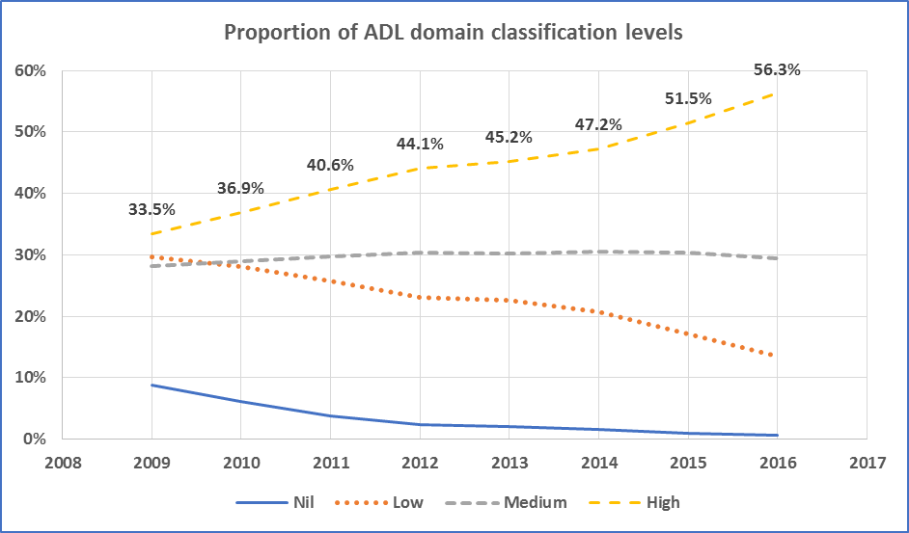

1. ACFI 1 Nutrition

The proportion of residents rated as needing moderate assistance with Nutrition has increased from around 3 in 10 residents in 2009 to over 6 in 10 by June 30, 2016 (Figure 4.2). The main drivers of this increase were physical assistance with readiness to eat (4.7 per cent growth pa.) (Figure 4.3) and supervision with eating (4.3 per cent growth pa.) (Figure 4.4). The growth in the proportion of residents needing physical assistance with ‘readiness to eat’ reflects, to a considerable extent, the increased scoring for cutting up or vitamising food.

Figure 4.2: ACFI 1 Nutrition Ratings (A, B, C, D) 2009 - 2016

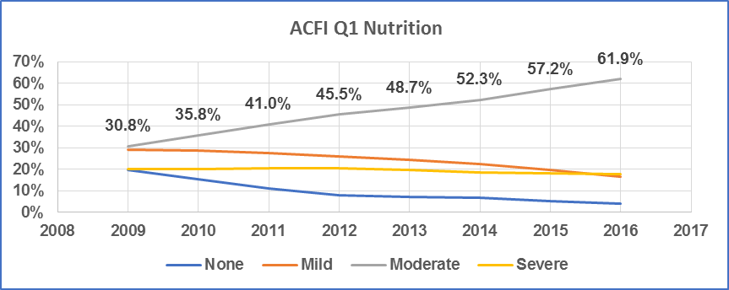

Figure 4.3: ACFI 1 Nutrition “Readiness to Eat” Assistance Levels 2009 - 2016

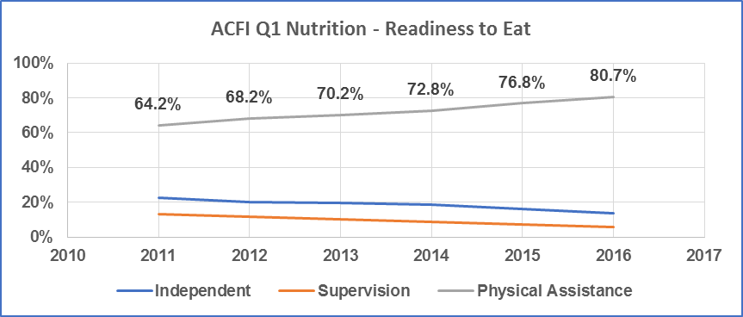

Figure 4.4: ACFI 1 Nutrition “Eating” Assistance Levels 2009 - 2016

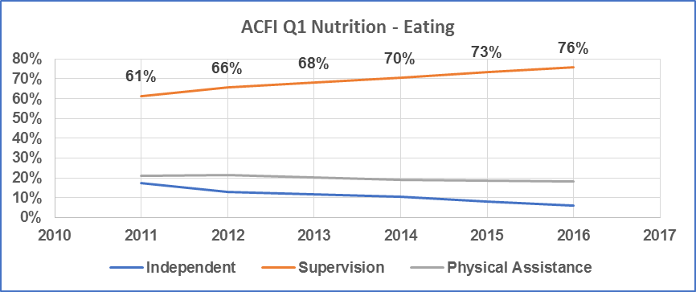

1. ACFI 2 Mobility

The proportion of residents rated as needing physical assistance with mobility increased from 4 in 10 residents in 2009 to around 6 in 10 residents by June 30, 2016 (Figure 4.5).   
This increase was due to the growth in the proportion of residents needing physical assistance with both transfers (7 per cent growth pa.) (Figure 4.6) and locomotion (4.7 per cent growth pa.) (Figure 4.7). However, there has been no growth in the proportion of residents needing lifting machines for transfers, which was expected given the increased physical assistance recorded over the period.

Figure 4.5: ACFI 2 Mobility Ratings (A, B, C, D) 2009 - 2016

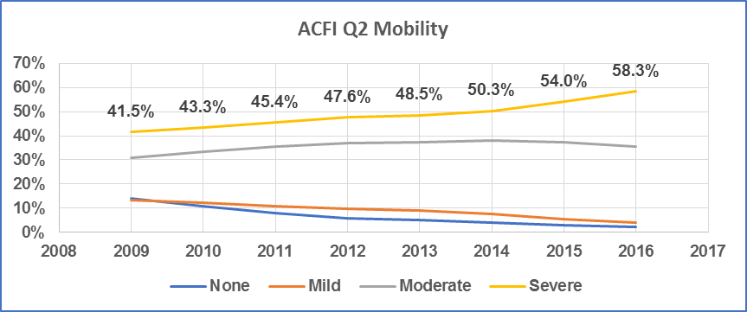

Figure 4.6: ACFI 2 Mobility “Transfers” Assistance Levels 2009 - 2016

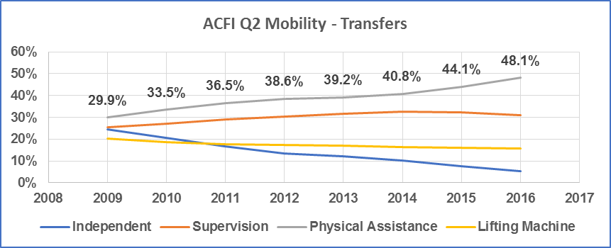

Figure 4.7: ACFI 2 Mobility “Locomotion” Assistance Levels 2009 – 2016

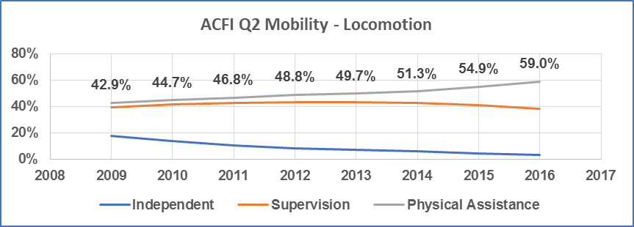

1. ACFI 3 Personal Hygiene

The proportion of residents rated as needing physical assistance with personal hygiene increased from around 66.2 per cent in 2009 to 83.4 per cent of residents by June 30, 2016 (Figure 4.8). This increase is due mainly to the growth in the proportion of residents rated as needing physical assistance for grooming (3.1 per cent growth pa.) (Figure 4.11). Physical assistance with dressing (2.3 per cent growth pa.) (Figure 4.9) and washing (1.5 per cent growth pa.) (Figure 4.10) registered lower levels of growth over the period.

Figure 4.8: ACFI 3 Personal Hygiene Ratings (A, B, C, D) 2009 - 2016

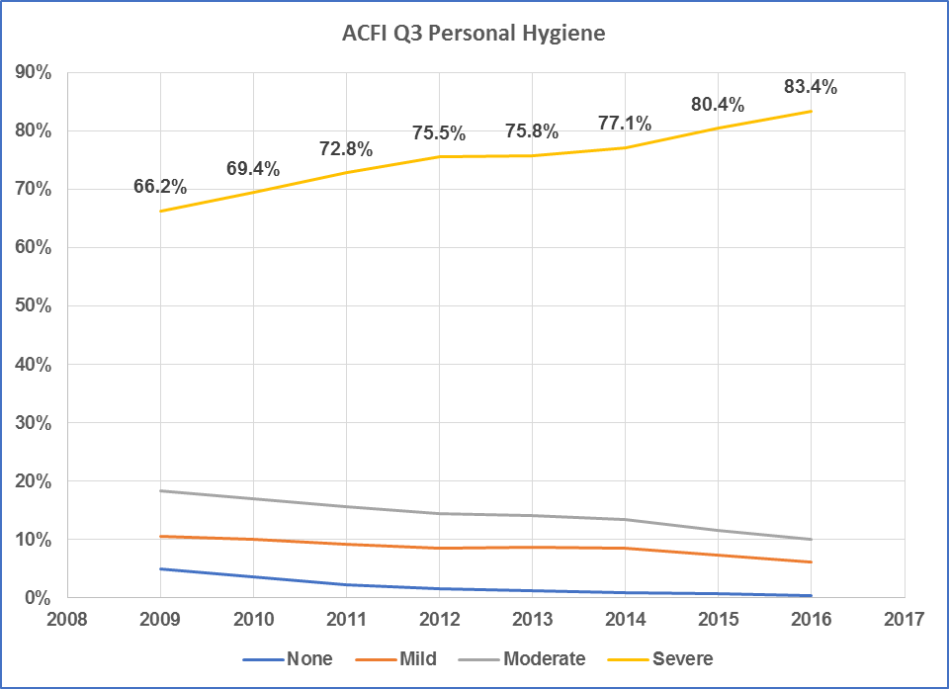

Figure 4.9: ACFI 3 Personal Hygiene “Dressing” Assistance Levels 2009 - 2016

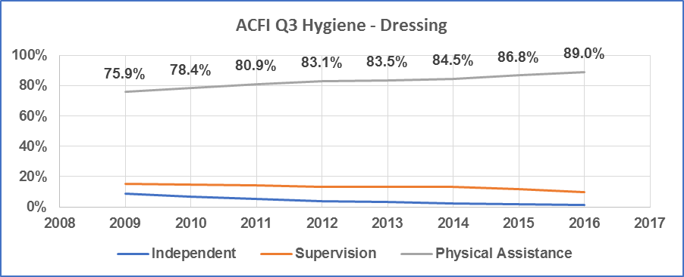

Figure 4.10: ACFI 3 Personal Hygiene “Washing” Assistance Levels 2009 - 2016

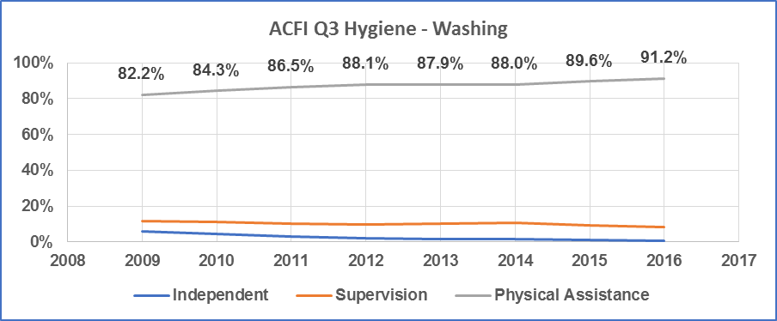

Figure 4.11: ACFI 3 Personal Hygiene “Grooming” Assistance Levels 2009 - 2016

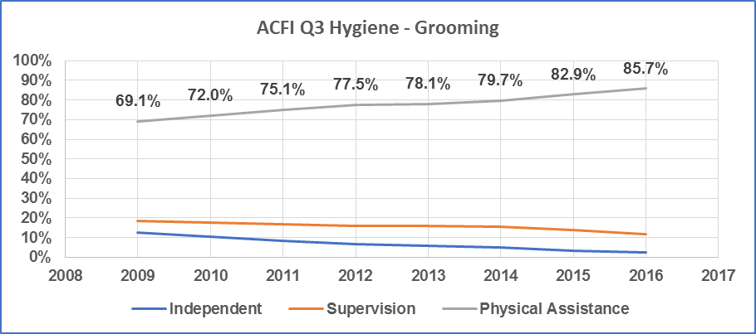

1. ACFI 4 Toileting

The proportion of residents rated as needing physical assistance with toileting increased from 5 in 10 residents in 2009 to around 7 in 10 residents by June 30, 2016 (Figure 4.12). This increased proportion was due to the growth in physical assistance with both toilet use (4.6 per cent growth pa.) (Figure 4.13) and toilet completion (5.2 per cent growth pa.) (Figure 4.14).

Figure 4.12: ACFI 4 Toileting Ratings (A, B, C, D) 2009 - 2016

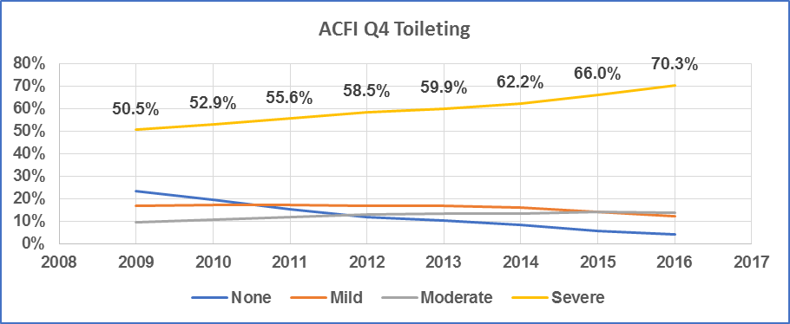

Figure 4.13: ACFI 4 Toileting “Toilet Use” Assistance Levels 2009 - 2016

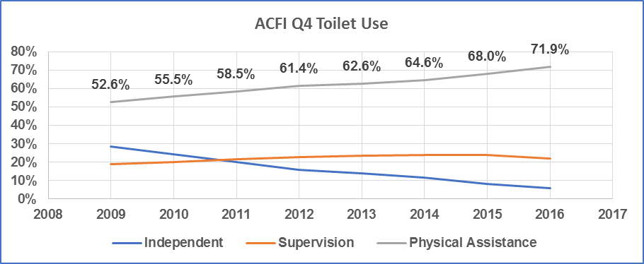

Figure 4.14: ACFI 4 Toileting “Toilet Completion” Assistance Levels 2009 – 2016

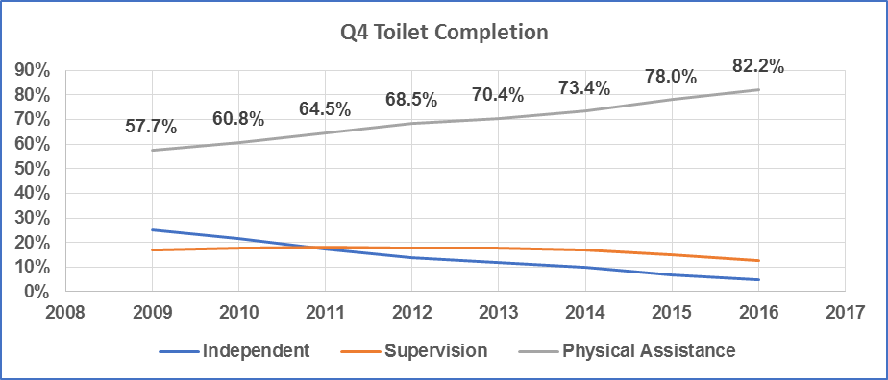

1. ACFI 5 Continence

The proportion of residents rated with severe incontinence increased from around 6 in 10 residents in 2009 to nearly 8 in 10 residents by June 30,2016 (Figure 4.15). This increase was due to the growth in the proportion of residents rated with severe urinary incontinence (56 per cent to 72.6 per cent) (3.8 per cent growth pa.) (Figure 4.16). There was no significant recorded increase in the proportion of residents rated with bowel incontinence from 2010 to 2016 (Figure 4.17).

Figure 4.15: ACFI 5 Continence Ratings (A, B, C, D) 2009 - 2016

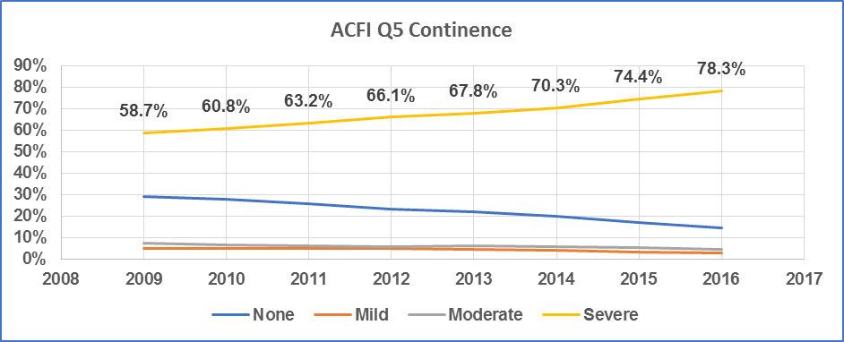

Figure 4.16: ACFI 5 Continence “Urine” Assistance Levels 2010 - 2016

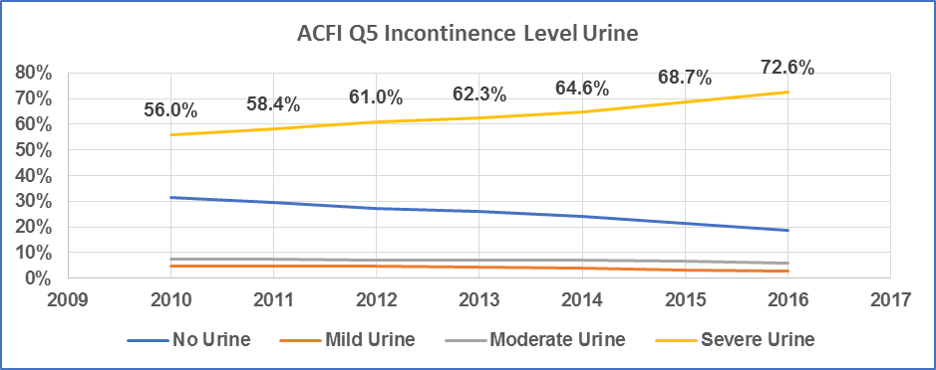

Figure 4.17: ACFI 5 Continence “Bowel” Assistance Levels 2010 – 2016

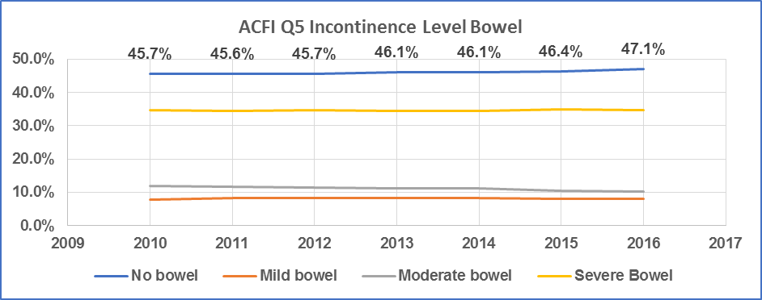

1. ADL Domain Review

The review project aimed to investigate improvements to the ACFI that would:

* Reduce subjectivity in the needs assessment process.
* Deliver a more accurate and reliable assessment that is not open to ‘gaming’
* Be consistent with contemporary care practices.
* Support the assurance and validation process for ACFI claims.
* Be consistent with external assessment.

Regarding these requirements, AACS conducted a series of consultations, reviews of relevant assessment tools and literature and undertook statistical analyses. A summation of findings is presented in the remaining sections of this Chapter as follows:

* The adequacy of the ADL evidence framework.
* Whether the ADL rating scales need to be made less subject to interpretation.
* Benefits of standardised assessments.
* Issues with the specific checklist items.
* The removal of items that are not discriminating.

1. The ADL Evidence Framework

The ACFI evidence requirements for the current ADL claims require an assessment to be undertaken to support the claim, although there are no specific mandated assessments mandated. Many providers use their software systems ‘assessments’ as evidence for an ACFI claim and for care planning purposes. However, most software systems simply repeat the required ‘summary’ outcomes as stated in the ACFI User Guide checklist, such as ‘requires physical assistance with an activity’ without using a validated assessment tool to determine the specific underlying issues and rationale for the resident’s care requirement.

Finding: Most assessments used to support ADL claims do not provide objective evidence of the actual need for the claimed level of assistance.

This ‘checklist’ assessment approach does not provide the objective evidence needed to develop an informative and accurate care plan or, in the case of a Departmental ACFI review, information to help validate a claim. Without a mandated validated assessment, Department desk reviews are largely limited to clerical validation activities such as checking if the boxes have been ticked appropriately. For on-site reviews, the lack of assessment evidence means that reviewers need to consider the progress notes, care plans, discussions with staff as well resident observations to determine a more accurate picture of the resident’s care needs and the accuracy of the claim.

Finding: Inadequate assessments of the residents’ care needs in the ADL domain mean that it is difficult to validate the resident’s care needs and the accuracy of the claim. This leaves decisions about a claims accuracy in the subjective rather than objective domain.

A more robust rationale for the resident’s ADL care needs assessment and ACFI claim might include, as an example:

* Documented diagnoses from medical notes confirming a fractured right hip in December 2015 with associated severe arthritis in the right hip in 2016;
* Assessment by a physiotherapist in December 2016 showing a severe limitation in the range of movement of the right hip, an unsteady gait needing staff to give physical assistance throughout the activity of all transfers due to high falls risk; and
* A care staff assessment in February 2017 using a validated assessment tool such as the Physical Mobility Scale (PMS) to assess functioning with sitting to standing items, standing balance and transfer items.

This documentation approach describes the physical and functional limitations of the resident in daily activities, provides a range of documentation that fits into care plans and therapy plans that will address the identified needs. A range of documentation should be reviewed to give congruent and objective evidence of the overall functional care needs of the resident.

**Recommendations**: The lack of documentation describing the evidence of the need (that can be used for both care planning and ACFI claims), could be addressed by modifications to the ACFI User Guide, Assessment Pack and Appraisal Pack by:

**(i)** Mandating assessments that provide objective measured outcomes of an assessed care need, obtained from tools such as the Mini Nutritional Assessment (MNA Short), Physical Mobility Scale (PMS), Falls Risk Assessment Tool (FRAT) and the Continence Resources for community and residential care by the Australian Continence Foundation -.

**(ii)** Requiring users to inform further on why staff assistance is needed for the resident’s day-to-day care needs; the user is to provide supporting objective information (e.g. NSAF, medical/AHP notes, clinical reports) when the resident has a physical, sensory, cognitive impairment or behavioural issue that supports the ADL claims.

These recommended changes would result in:

* Improved objectivity in the assessments
* Standardisation of the information requested
* Further provision of evidence to support why the resident needs the assistance level claimed
* A standardised method for checking the accuracy of claims
* Improved desk review efficiencies
* Fewer downgrades to provider ACFI claims

1. The ADL Rating Scales

Currently, each ACFI ADL question (e.g. mobility) has checklist questions (e.g. transfers) which are rated on the day-to-day assessed care needs for the assistance level required, for example:

0- Independent

1- Supervision

2- Physical Assistance

3- Lifting Machine (transfers checklist)

There have been three issues with this approach. Firstly, it is unclear to many provider assessors and Department Review Officers (ROs) what constitutes ‘usual care needs’, secondly the difference between supervision and physical assistance is problematic in certain circumstances and thirdly the number of residents rated as requiring physical assistance is large because it covers residents needing lower to much higher levels of assistance, which compromises the ACFI’s ability to operate as a relative resource discriminator. To address the ADL rating scale issues, a review of the types of assistance definitions and the rating scale was undertaken.

**Verbal Assistance**

Consultations showed that Department ROs had difficulty in identifying the reason verbal assistance was needed. While verbal prompting may be recorded as an assessment outcome, the reason for the assistance may remain unclear, as many assessment approaches do not inform on the rationale behind the outcome. It was also determined that verbal assistance is common across all levels of ADL support and it is not a discriminator of resource needs.

A review of the ADL assessments (from the NSAF and interRAI approaches) supported that verbal assistance, such as cuing or directing, is placed at the lowest end of ADL scales. The need for constant physical assistance throughout an activity is most often used by ADL scales to determine care needs at the higher end of ADL scales. It is common in the most widely used ADL resource utilisation scales, such as the interRAI RUGs and the AIHW METEOR data standard RUG-ADL (http://meteor.aihw.gov.au/content/index.phtml/itemId/477780), in which the provision of regular physical assistance by one or two staff relates to higher resource use for mainstream residential aged care environments.

Verbal assistance was therefore dropped as a consideration for a claim (above standard care) in the R-ADL domain.

**The Concept of Standard Care**

Standard care is considered a minimum level of assistance such as verbal assistance, setting up activities and episodic assistance. Standard care is given to all residents from time to time and it does not differentiate between individual resident assessed care needs. To adjust for this change, all residents, irrespective of their rating in the domain, will qualify for the lowest level of the R-ACFI ADL domain funding.

A definition of the concept of standard care is included in the new R-ADL questions.

**Usual Care Needs**

The lack of a clear definition of what constitutes usual care needs has led to varying interpretations with providers tending to rate residents at a higher level than might be the case if the intent of the question was applied. This lack of clarity has often led to provider claims being downgraded on review. Feedback from the consultations highlighted that usual may mean:

* Usually every morning
* Often need help
* Usually once a day but at the same time
* Most days

To address this issue the R-ACFI has applied a clearer definition for a claim which is now ‘daily care needs’. The staff support activity must be always required, whenever the activity is needed.

**What constitutes Physical Assistance?**

Feedback from the consultations with providers and Department ROs showed there is uncertainty on the difference between the supervision and physical assistance levels. As an example, when the Physiotherapist states ‘physically assist the resident by applying a gentle guiding hand’, there are different interpretations of whether this should be rated as the resident needing physical assistance or perhaps only supervision as the support is of a low intensity.

Further, the ADL rating scales do not clearly identify the difference between residents needing minor or moderate levels of physical assistance, from those requiring more intensive levels of physical assistance. This is a problem as there are a high number of residents being rated as requiring physical assistance when in fact their care needs can be significantly different. The problem is that residents receiving minor levels of physical help (e.g. a resident being ‘guided’ by a staff member while walking) can be rated the same as a person needing assistance by two staff or more with their ADL support needs.

The R-ACFI clarifies these issues by removing the ‘supervision’ descriptor. The R-ACFI describes two different levels of physical assistance - moderate and full assistance. Applying a gently guiding hand by one staff is Moderate Assistance. Two staff providing physical assistance with locomotion throughout the entire activity, whenever the activity is needed, is Full Assistance.

The R-ACFI definition for Full Assistance is now “Always providing physical assistance, by at least two staff, throughout the entire activity, whenever the activity is needed.”

1. Recommended R-ACFI ADL Functional Rating Scale

**Recommendation**

That the rating scale approach across the ADL R-ACFI questions be as follows:

**Standard Care**

* Independent (with or without aids) OR
* Standing by for occasional or episodic assistance OR
* Setting up activities OR
* Verbal assistance, prompting, cuing.

**Moderate Assistance**

Always providing physical assistance, on a one-to-one basis, for at least part of the activity, whenever the activity is needed.

**Full Assistance**

Always providing physical assistance, by at least two staff, throughout the entire activity, whenever the activity is needed.

**Mechanical lifting**

Always providing physical assistance by the use of mechanical lifting equipment, throughout the entire transfer activity, whenever the activity is needed.

This standardised **approach** is common with most international ADL scales used in aged care. The approach:

* Defines the standard level of care, including active but less intense care which is expected for all residents in residential aged care, from what is needed for a specific resident based on their assessed care need.
* Clarifies the meaning of Moderate Assistance which involves at least some physical assistance, every time an activity is needed, on a one to one basis, for at least part of the activity.
* Determines that Full Assistance only applies to those residents needing physical assistance from at least two staff, every time an activity is needed, rewarding the more intense level of staff resourcing and time requirements.
* Acknowledges that very highly dependent residents demand significant multiple staff resources and more highly funds residents needing mechanical lifting every time a transfer is required

Tables 4.5a to 4.5c describe the recommended new R-ACFI ADL rating and supporting evidence requirements.

Table 4.5: ACFI ADL rating (Nutrition)

| **Requirements** | **0**  **Standard Care** | **1**  **Monitoring** | **2**  **Moderate assistance** | **3**  **Full assistance Nutrition** |
| --- | --- | --- | --- | --- |
| **Nutrition** | Standard Care: Independent during the EATING activity.  Staff standing by for occasional or episodic assistance.  Provision of modified textured food and drinks.  Setting up activities e.g. taking lids off, cut up food, specialised plates and cutlery, special diets, placing food in front of resident.  Providing verbal assistance (e.g. prompting, cueing). | Needs general monitoring for an assessed nutritional need using the mandated assessment.. | Always providing physical assistance, on a one-to-one basis, for part of the EATING activity, whenever the activity is needed, due to a swallowing issue or other impairment. | Always providing physical assistance, on a one-to-one basis, throughout the entire activity, whenever the activity is needed. |
| **Mandated Evidence** | *Not required for standard care.* | R-ACFI Q1: MNA Short (completed within last 3 months of appraisal) | | |
| **Supporting Evidence** | *Not required for standard care.* | *Not required for monitoring.* | Swallowing impairment:  Evidence- Speech Pathologist report  Physical/ sensory impairment: Evidence- NSAF, MP notes, diagnoses.  Moderate Cognitive Impairment- requires staff to initiate or complete the activity.  Evidence: Cognition Assessment (SMMSE), clinical report, NSAF, MP notes, diagnoses. | Swallowing impairment:  Evidence- Speech Pathologist report  Physical/ sensory impairment: Evidence- NSAF, MP notes, diagnoses.  Severe Cognitive Impairment: e.g. does not participate in the activity  Evidence: Cognition Assessment (SMMSE), clinical report, NSAF, MP notes, diagnoses. |

Table 4.5a: R-ACFI ADL rating (Mobility)

| **Requirements** | **0**  **Standard Care** | **1**  **Moderate assistance** | **2**  **Full assistance** | **3**  **Mechanical Lifting** |
| --- | --- | --- | --- | --- |
| **Mobility**   * **Transfers** * **Locomotion** | Independent (with or without aids).  Standing by for occasional or episodic assistance.  Transfer Setting up activities e.g. preparing or providing wheelchair or other transfer aid.  Locomotion Setting up activities e.g. handing the resident the mobility aid.  Verbal assistance, prompting, cuing. | Always providing physical assistance, on a one-to-one basis, for at least part of the activity, whenever the activity is needed. | Always providing physical assistance, by at least two staff, throughout the entire activity, whenever the activity is needed. | Use of Mechanical Lifting device for Transfers:  Always providing physical assistance by the use of mechanical lifting equipment, throughout the entire transfer activity, whenever the activity is needed. |
| **Mandated Evidence** | *Not required for standard care.* | R-ACFI Q2: PMS & FRAT items (completed within last 3 months of appraisal) | | |
| **Supporting Evidence** | *Not required for standard care.* | Sensory Impairment: Evidence: NSAF, MP notes, diagnoses  Behavioural Issues: Evidence- clinical report, NSAF, MP notes.  Physical impairment e.g. gait, balance. Evidence: Functional Assessment (PMS), Physiotherapy report, NSAF, MP notes, diagnoses. | | |
| **Supporting Evidence** | *Not required for standard care.* | Moderate cognitive impairment, requires staff to initiate the activity.  Evidence: Cognition Assessment (SMMSE), clinical report, NSAF, MP notes. | Severe cognitive impairment e.g. does not participate in the activity.  Evidence: Cognition Assessment (SMMSE), clinical report, NSAF, MP notes, diagnoses | Evidence: Physiotherapy Assessment, NSAF, MP notes, diagnoses |

Table 4.5b: R-ACFI ADL rating (Personal Hygiene, Toileting)

| **Requirements** | **0**  **Standard Care** | **1**  **Moderate assistance** | **2**  **Full assistance** |
| --- | --- | --- | --- |
| **Personal Hygiene**   * **Toileting** | Independent (with or without aids).  Standing by for occasional or episodic assistance.  Setting up activities:  Dressing e.g. choosing and laying out clothes  Washing e.g. up toiletries within reach, turning on or adjusting taps  Use of Toilet e.g. setting up toilet aids or handing the resident the bedpan or urinal, or placing ostomy articles in reach  Toilet Completion: e.g. emptying drainage bags, urinals, bed pans or commode bowl.  Verbal assistance, prompting, cuing. | Always providing physical assistance, on a one-to-one basis, for at least part of the activity, whenever the activity is needed. | Always providing physical assistance, by at least two staff, throughout the entire activity, whenever the activity is needed. |
| **Supporting Evidence** | *Not required for standard care.* | Supporting Evidence R-ACFI Q3-4:  PMS/FRAT items, NSAF, MP/AHP notes.  Moderate cognitive impairment, requires staff to initiate the activity.  Evidence: Cognition Assessment (SMMSE), clinical report, NSAF, MP notes.  Sensory Impairment: Evidence- NSAF, MP notes, diagnoses  Behavioural Issues: Evidence - clinical report, NSAF, MP notes. | Supporting Evidence: PMS/FRAT items, NSAF, MP/AHP notes - as directed by AHP or MP.  Severe cognitive impairment e.g. does not participate in the activity.  Evidence: COGNITION Assessment (SMMSE), clinical report, NSAF, MP notes, diagnoses.  Sensory Impairment: Evidence- NSAF, MP notes, diagnoses  Behavioural Issues: Evidence- clinical report, NSAF, MP notes. |

### 4.3.3 Mandated Assessments

1. Resident Care Needs Assessment and Mandated Assessments

There are a range of assessments used in the residential aged care sector for determining care needs in the ADL domain. These are often based on the ACFI checklists or similar summary tools such as those found in the NSAF, RUGs ADL scales, interRAI scales and the widely used modified Barthel Index.

None of these measures are an actual assessment as they represent a summary of the assessment outcomes describing what a person can do based on an incremental Likert scale. In the review of the ACFI, it has been widely acknowledged that improved actual assessment outcomes will be achieved if contemporary, well designed tools are used as the fundamental assessment basis. This quality information will lead to better care planning outcomes and represent an industry wide improvement in assessment practices, but only if the tools are mandated within the R-ACFI framework. Training programs and software providers can also target the one set of tools which will assist with efficiency and collaboration across aged care services.

**The R-ACFI is an Assessment and Funding Tool**

It is important to note that the R-ACFI is not simply a funding tool as it gives vital assessment and background information (e.g. diagnoses) to assist with resident care planning. High quality, informative, mandated R-ACFI assessments will fit within the broader nursing process to assist with quality of care outcomes.

The R-ACFI was designed around the International Classification of Functioning, Disability and Health (ICF) framework for describing and organising information on functioning and disability. This gives a standard language and a conceptual basis for the definition and measurement of health and disability. It also provides a scientific basis for understanding and studying health and health-related states, outcomes, determinants, and changes in health status and functioning.

The R-ACFI fits into the nursing process and supports best practice in the following ways:

* The ACFI diagnoses and assessments identify body functions and structures (both impairments and strengths), but these alone do not always explain why a particular type of care is needed.
* The assessment outcomes can be used to describe how they impact on the activities and participation levels of the resident (giving further contextual and individualised explanation of the reason why care is needed).
* The Care Plan describes the strategies to improve the participation of the resident (assessment outcomes can then be used to help evaluate the strategies).

1. Department Review Program and Mandated Assessments

Mandated assessments will further standardise the assessment approach and outcomes when used by all assessors across the aged care pathway i.e. NSAF assessment, ACAT comprehensive assessment, residential aged care assessment and departmental audits/reviews of claims.

While there are recognised concerns with the currency of pre-entry assessments if changes have occurred to the persons’ health, data shows that 52 per cent of ACAT assessments are completed within 3-months of entry to a RACF. The shorter that time frame, the greater the likelihood the assessment will be a more accurate reflection of the resident’s needs at the time of admission. If the same assessment tool is used, better understanding and communication about assessment outcomes will result.

By using the same set of recommended tools for both the facility staff and for other External Assessors such as ACATs or RAS assessors, it also focuses the assessments and review process on the ‘assessed care need of the resident’ and it will support a shared understanding of the revised R-ACFI items.

Departmental R-ACFI audits are likely to lead to more transparent outcomes as shared assessments could shift the focus of reviewers away from the care provided at the time of the visit (which may vary due to a resident’s variable needs or a change in staffing resources), to the assessed care need which will be much more objective with the mandated tools. While an observation of a resident (e.g. mobilising without supervision) can give vital information, it should only flag a potential issue that needs further investigation. Inconsistencies with the claim (i.e. for supervision with locomotion when resident observed walking with no staff supervision) may be due to cognitive impairments or a change in resident needs. The use of mandated assessments and supporting evidence will help assessors to focus on the assessed care need and will reduce the variation between a Department RO and provider ACFI assessment. The use of the mandated physical mobility scale (PMS) will also assist with better consistency between physiotherapists’ assessments and care staff interpretations needed for R-ACFI completion.

Detailed information on the recommended changes to the ADL domain in the R-ACFI are contained in Appendix 4.1 to 4.5 which covers:

* How the change fits with the related assessment approaches such as the NSAF comprehensive assessment and the RUGs tools embedded in the interRAI suite.
* How the modified ACFI would fit into an external assessment approach.
* Detailed changes needed covering descriptions, requirements, mandated assessment tools, checklists, modified R-ADL rating scales and the reasons for assistance being provided.

1. The ADL R-ACFI Recommended Question Changes
2. R-ACFI 1: Nutrition

The ACFI 1 Nutrition ratings for moderate assistance in this question have increased from around 3 in 10 residents in 2009 to over 6 in 10 residents in 2016 (Figure 4.2). Both nutrition care need items (1.1 Readiness to Eat and 1.2 Eating) were reported to be inadequately discriminating between residents, as demonstrated by the very high percentage of claims for (i) physical assistance with readiness to eat (e.g. cutting up food) (Figure 4.3; 81 per cent) and (ii) supervision with eating (Figure 4.4; 76 per cent).

Department ROs and provider assessors found it difficult to agree when ’cutting up food‘ is a required care need. Often, it was associated with a diagnosis of arthritis in the hands with a presumed grip strength loss (without evidence of an assessment). Additionally, further clarification was requested on what is ’sufficient proximity‘ for standing-by to provide assistance at the table (item 1.2), as this is a very common claim.

It was also found that the wording in the Nutrition item 1.2 does not reflect contemporary care practices. A focus on texture-modified foods and thickened fluid rather than vitamised meals would be more consistent with modern dietary practices. Food modification is also often completed by kitchen staff or by pre-prepared food companies and does not generally impact on care provision time from direct care staff. Participants at the consultations also expressed views that any nutrition question should ideally focus on assistance needed due to evidence-based assessed nutritional risk.

**Recommendation**: Revised Nutrition questions be developed to:

* Focus on assistance needed due to evidence-based assessed nutritional risk.
* Identify residents needing either verbal or physical assistance due to a swallowing issue (i.e. dysphagia).

The NSAF comprehensive assessment approach was evaluated to decide if aspects on nutrition assessment could be included in the R-ACFI. The NSAF supplementary assessment tools include the Mini Nutritional Assessment (MNA), South Australian Oral Health Referral Pad, and Oral Health Assessment Tool (OHAT) for non-dental professionals. The NSAF approach includes items of oral health, appetite, weight loss and fluid intake.

As part of the NSAF supplementary tools, the MNA was considered a suitable tool when assessing nutritional needs for the target population (older persons), and it will also support shared assessments across the community and residential settings. There are both long and short forms of the MNA. Some items of the full version are not needed or applicable to the modified R-ACFI nutrition item.

**Recommendation**: the MNA short form be a mandated assessment tool in R-ACFI as it gives the identified items for a nutritional approach based on a BMI and a nutrition risk assessment.

**Further detail on the rationale for the new R-ACFI Nutrition Question is in Appendix 4.1.**

1. Recommended User Guide R-ACFI Format for the Nutrition Question

**Description:** This question relates to the resident’s day-to-day assessed care needs with regard to nutritional needs and eating (the intake of food throughout the day).

For tube feeding refer to R-ACFI 8 CHC. For assisting a resident to the dining room or assisting residents who are unable to position their chair or position themselves in an upright posture appropriately, see R-ACFI 2 Transfers and R-ACFI-3 Locomotion.

**Requirements:** To support a claim (above Standard Care) in R-ACFI 1.

* The Mini Nutritional Assessment (MNA-short) must be completed and the requested outcomes entered into the Assessment Summary. The required assessment must have been completed within the last 3 months and it must continue to reflect the resident’s nutritional needs at the time of the appraisal.
* The Nutrition Checklist must be completed.

**Nutrition Assessment Summary:** Indicate if the mandatory assessment was completed and record the requested scores.

| Nutrition Assessment Summary | Tick if yes | **SCORE** |
| --- | --- | --- |
| Medical Practitioner or Speech Pathologist (SP) notes that provide evidence of a swallowing issue | 🞏 1.1 | *NA* |
| No MNA-short undertaken - nil or minimal nutritional needs | 🞏 1.2 | *NA* |
| MNA-short - BMI score | 🞏 1.3 | *[note score]* |
| MNA-short - Screening score | 🞏 1.4 | *[note score]* |

**Nutrition Checklist:** Rate the level of assistance for the Nutrition question

| 1. Nutrition   *Daily care needs for Eating activities* | Assistance level  (Tick one) |
| --- | --- |
| Standard Care: Independent during the activity, staff standing by for occasional or episodic assistance, or provision of modified textured food and drinks, or verbal assistance, or setting up activities e.g. taking lids off, cut up food, specialised plates and cutlery, special diets, placing food in front of resident etc. | 🞏 0 |
| **Monitoring:** Needs general monitoring for an assessed nutritional need as defined by the mandated assessment. | 🞏 1 |
| Moderate Assistance: Always providing physical assistance, on a one-to-one basis, for part of the activity, whenever the activity is needed due to a swallowing issue or other impairment. | 🞏 2 |
| Full assistance: Always providing physical assistance, on a one-to-one basis, throughout the entire activity, whenever the activity is needed. | 🞏 3 |

1. R-ACFI 2: Mobility

The NSAF comprehensive assessment approach was investigated to determine if aspects could be included in the R-ACFI. NSAF supplementary assessment tools include the Older Americans Resources and Services (OARS) Activities of Daily Living, Barthel Index of Activities of Daily Living and Kimberly Indigenous Cognitive Assessment - Activities of Daily Living (KICA-ADL). These tools were not suitable for the R-ACFI assessment model as they record a rating summary and do not provide the evidence to support the assessed care need outcome.

The Physical Mobility Scale (PMS) and the Falls Risk Assessment Tool (FRAT) were reviewed and determined to be suitable for use by both external and provider assessors (Appendix 4.2; 4.6). Guidelines for the use and scoring of the PMS were developed by AACS and are included in Appendix 4.6.

The assessment outcomes of these validated tools can be directly compared to the selected ADL rating level for Mobility (Transfers and Locomotion), and for supporting the Personal Hygiene and Toileting items. The information from the tools provide valuable added information for care planning as it directly informs on the specific aspects of mobility assistance required by the resident. For example, can they roll in bed? (vital in deciding if staff need to regularly turn a resident to protect their skin integrity); is their sitting balance good enough to leave them sitting on the edge of the bed or toilet? and can they push up to stand? It is the detailed aspects that are important in understanding the type and degree of assistance needed, while still safely encouraging independence.

The changes to the ADL rating scale in R-ACFI 2-4 (Mobility, Personal Hygiene, Toileting) will also identify residents who need extra staffing resources (e.g. needing bariatric care).

**Further detail on the rationale for the new R-ACFI Mobility Question is in Appendix 4.2.**

1. Recommended User Guide R-ACFI Format for the Mobility Questions

**Description:** These questions relate to the resident’s day-to-day assessed care needs in regard to mobility. For manual handling for maintenance of skin integrity, such as frequent changing of the position of a resident with severely impaired mobility, refer to R-ACFI 8 CHC, item 4. Generally, a claim of full assistance with ACFI 2 mobility for transfers or mechanical lifting or for locomotion will not be accompanied by a claim in ACFI 7 Behaviour item W1 ‘interfering while wandering’.

**Requirements:** To support a claim (above Standard Care) in the ACFI 2.

* The PMS and the FRAT must be completed and the requested outcomes entered into the Assessment Summary. The required assessments must have been completed within the last 3 months and continue to reflect the resident’s mobility needs at the time of the appraisal.
* The Mobility Checklists must be completed using the Rating Scales. The care needs to be rated are:

1. Transfers;
2. Locomotion.

**Mobility Assessment Summary**: Indicate if the mandatory assessments were completed and record the requested scores.

| Mobility Assessment Summary | Tick if yes | **SCORE** |
| --- | --- | --- |
| No PMS undertaken | 🞏 2.1 | *NA* |
| PMS supine to side (L) | 🞏 2.2 | *[enter score]* |
| PMS supine to side (R) | 🞏 2.3 | *[enter score]* |
| PMS Supine to sit | 🞏 2.4 | *[enter score]* |
| PMS Sitting Balance | 🞏 2.5 | *[enter score]* |
| PMS Sitting to standing | 🞏 2.6 | *[enter score]* |
| PMS Standing to sitting | 🞏 2.7 | *[enter score]* |
| PMS Standing Balance | 🞏 2.8 | *[enter score]* |
| PMS Transfer Item | 🞏 2.9 | *[enter score]* |
| PMS Ambulation Item | 🞏 2.10 | *[enter score]* |
| No FRAT undertaken | 🞏 2.11 | *NA* |
| FRAT Risk score | 🞏 2.12 | *[enter score]* |

**Mobility Checklists:** Rate the level of assistance for each of the two mobility care needs.

| 2.1 Transfers  *Daily care needs for moving to or from chairs, or wheelchairs or beds* | Assistance level  (Tick one) |
| --- | --- |
| Standard Care: Independent (including when using aids), staff standing by for occasional or episodic assistance, verbal assistance, setting up activities e.g. preparing wheelchair or other transfer aid. | 🞏 0 |
| **Moderate Assistance:** Always providing physical assistance, on a one-to-one basis, for at least part of the activity, whenever the activity is needed. | 🞏 1 |
| Full Assistance: Always providing physical assistance, by at least two staff, throughout the entire activity, whenever the activity is needed. | 🞏 2 |
| Mechanical Lifting Assistance: Always providing physical assistance by the use of mechanical lifting equipment, throughout the entire transfer activity, whenever the activity is needed. | 🞏 3 |

**Mobility Checklists (cont.)**

| 2.2 Locomotion  *Daily care needs for fitting of lower limb items to enable locomotion (callipers, leg braces, prostheses); moving around inside the facility; Physical Assistance includes pushing a wheelchair.* | Assistance level  (Tick one) |
| --- | --- |
| Standard Care: Independent (including when using mobility aids), or staff standing by to supervise for occasional or episodic assistance, or verbal assistance, or setting up activities e.g. handing the resident the mobility aid. | 🞏 0 |
| **Moderate Assistance:** Always providing physical assistance, on a one-to-one basis, for at least part of the activity, whenever the activity is needed. | 🞏 1 |
| Full Assistance: Always providing physical assistance, by at least two staff, throughout the entire activity, whenever the activity is needed. | 🞏 2 |

1. R-ACFI 3 & 4: Personal Hygiene & Toileting Questions

The NSAF comprehensive assessment approach was investigated to determine whether aspects could be included in the R-ACFI. NSAF supplementary assessment tools include the same tools for personal hygiene and toileting as discussed previously in the Mobility section (OARS-ADL, Barthel, KICA-ADL). These tools were not suitable for use in the R-ACFI as they record a summary rating and as such, they do not give sufficient evidence to support the assessment care need outcome.

As most ADL assessments are standardised (they have scaled outcomes) they do not give the reason for the selected outcomes, so by themselves do not give an objective rationale for the selected outcome. For example, reporting that the person cannot dress without help does not give objective evidence of why the care is needed. The outcome would be strengthened with evidence of the underlying impairments that impact on the resident’s level of independence (described in section 4.4.10 Supporting Evidence requirements).

**The rationale for the new R-ACFI Personal Hygiene Questions is described in Appendix 4.3.**

1. Recommended User Guide R-ACFI Format for the Personal Hygiene Questions

**Description:** These questions relate to the resident’s day-to-day assessed care needs with regard to personal hygiene.

**Requirements:** To support a claim (above Standard Care)

* An assessment must have been completed within the last 3 months and continue to reflect the resident’s personal hygiene needs at the time of the appraisal.
* ThePersonal Hygiene checklists must be completed using the Rating Scales. The care needs to be rated are:

1. Dressing and Undressing;
2. Washing and Drying.

**Personal Hygiene Checklists:** Rate the level of assistance for each of the two Personal Hygiene care needs.

| 3.1 Dressing & Undressing  *Daily care needs for:*   * *Undoing and doing up zips, buttons or other fasteners including velcro.* * *Putting on or taking off clothing and footwear (e.g. Underwear, shirts, skirts, pants, cardigan, socks, stockings);* * *Fitting and removing of hip protectors, slings, cuffs, splints, medical braces, tubular elasticised support bandage, and prostheses other than for the lower limb.* | Assistance level  (Tick one) |
| --- | --- |
| Standard Care: Independent, staff standing by for occasional or episodic assistance, verbal assistance, setting up activities (e.g. choosing and laying out clothes). | 🞏 0 |
| **Moderate Assistance:** Always providing physical assistance, on a one-to-one basis, for at least part of the activity, whenever the activity is needed. | 🞏 1 |
| **Full Assistance:** Always providing physical assistance, by at least two staff, throughout the entire activity, whenever the activity is needed. | 🞏 2 |
| 3.2 Washing & Drying  *Daily care needs for washing & drying the body* | Assistance level  (Tick one) |
| Standard Care: Independent, staff standing by for occasional or episodic assistance, verbal assistance, setting up activities (e.g. up toiletries within reach, turning on or adjusting taps). | 🞏 0 |
| **Moderate Assistance:** Always providing physical assistance, on a one-to-one basis, for at least part of the activity, whenever the activity is needed. | 🞏 1 |
| Full Assistance: Always providing physical assistance, by at least two staff, throughout the entire activity, whenever the activity is needed. | 🞏 2 |

1. Recommended User Guide R-ACFI Format for the Toileting Questions

**Description:** This question relates to the resident’s day-to-day assessed care needs with regard to toileting. It relates to the assessed needs with regard to use of a toilet, commode, urinal or bedpan. It also includes emptying drainage bags for residents who have stomas and catheters.

For location change related to toileting, refer to the R-ACFI 2 Mobility questions. For the clinical care of catheters, stomas and the administration of suppositories and enemas in continence management see ACFI 8 CHC.

**Requirements:** To support a claim (above Standard Care)

* An assessment must have been completed within the last 3 months and continue to reflect the resident’s toileting needs at the time of the appraisal.
* The Toileting items must be completed using the Rating Scales covering. The care needs to be rated are:

1. Use of toilet (setting up to use the toilet);

2. Toilet completion (the ability to appropriately manage the toileting activity).

**Toileting Checklists:** Rate the level of assistance for each of the two toileting care needs.

| 4.1 Use of Toilet  *Daily care needs* *for positioning resident for use of toilet or commode or bedpan or urinal* | Assistance level  (Tick one) |
| --- | --- |
| Standard Care: Independent, staff standing by for occasional or episodic assistance, verbal assistance, setting up activities (e.g. setting up toilet aids or handing the resident the bedpan or urinal, or placing ostomy articles in reach). | 🞏 0 |
| **Moderate Assistance:** Always providing physical assistance, on a one-to-one basis, for at least part of the activity, whenever the activity is needed. | 🞏 1 |
| Full Assistance: Always providing physical assistance, by at least two staff, throughout the entire activity, whenever the activity is needed. | 🞏 2 |
| 4.2 Toilet Completion  *Daily care needs for adjusting clothing & wiping the peri-anal area* | Assistance level  (Tick one) |
| Standard Care: Independent, staff standing by for occasional or episodic assistance, verbal assistance, emptying toileting items (e.g. emptying drainage bags, urinals, bed pans or commode bowls). | 🞏 0 |
| **Moderate Assistance:** Always providing physical assistance, on a one-to-one basis, for at least part of the activity, whenever the activity is needed. | 🞏 1 |
| Full Assistance: Always providing physical assistance, by at least two staff, throughout the entire activity, whenever the activity is needed. | 🞏 2 |

1. R-ACFI 5: Continence

It was reported that Records (for both Continence and Behaviours) alone do not provide objective evidence that can be checked for accuracy. Also, a Continence Record with frequency collected over several days (e.g. 3 days for bladder and 7 days for bowels) needs reliable informants for completion ‘on the spot’ by an External Assessor.

It was suggested that a full continence assessment would give evidence to show that an evidence based assessment has been undertaken and that it would inform on the accuracy of the records.

The NSAF approach was investigated to determine its applicability for inclusion in the R-ACFI. The NSAF supplementary assessments are the Revised Urinary Incontinence and Revised Faecal Incontinence Scales. These tools rely on self-report and are therefore unsuitable for much of the residential aged care population.

The Continence Tools for Residential Aged Care, developed by researchers from Deakin University and funded under the National Continence Management Strategy in 2011, was reviewed as an Australian comprehensive continence assessment that is freely available. The 2011 toolkit (which is being revised in 2017) includes the following:

* Continence management flow chart.
* Continence screening form.
* Three-day bladder chart.
* Seven-day bowel chart.
* Monthly bowel chart.
* Continence assessment form and care plan.
* Continence care summary.

It includes a User Guide with clear processes and simple tools.

Consultations were undertaken with the Continence Foundation Australia (CFA) who are reviewing and refining the Continence Tools for use across both community and residential aged care (in Australia). The tools are evidence-based, reflect current best practice, and their usability across community and residential care will make them suitable for use by both External and provider assessors.

Along with an improved assessment approach, evidence requirements could be strengthened by adding the prerequisite of a diagnosis when the recommended (i.e. not mandated) comprehensive assessment has not been completed. Medical diagnoses give an objective construct that can be validated, and the recommended continence tool gives contextual information that will help to validate the claim.

Importantly, the continence tools which have information about interventions and how to use the assessment outcomes for care planning purposes, will give value-added information for quality care delivery. They will also encourage residential aged care staff to view continence as an area that can be managed beyond containment, using evidence-based strategies that aim to improve the resident’s quality of life.

Recommendation: The continence tools are recommended (not mandated for RACFs), with a small sub-set of specified questions being mandated for use by External Assessors.

**The rationale for the new R-ACFI Continence Question is described in Appendix 4.5.**

1. Recommended User Guide R-ACFI Format for the Continence Question

**Description:** This question relates to the resident’s assessed needs with regard to urine and faeces continence.

For the administration of stool softeners, aperients, suppositories or enemas for continence management see the Medication item 9a in R-ACFI 8 CHC. For the care and management of an indwelling catheter or ostomy see R-ACFI 8 CHC item 4.

Episodes **of incontinence** include:

* Changing of wet or soiled pads;
* Increase in pad wetness;
* Passing urine/ bowels open during scheduled toileting (as this is an avoided incontinence episode).

For the purposes of this ACFI question, **scheduled toileting** is:

* Staff accompanying a resident to the toilet (or commode); or
* Providing a urinal or bedpan or other materials for planned voiding or evacuation according to a documented or assessed daily schedule designed to reduce incontinence.

**Requirements:**

* A medical diagnosis of incontinence or a completed Continence Assessment Form and Care Plan is required if claiming incontinence. The medical diagnosis must meet the requirements for a medical diagnosis as stated under the section ‘Medical Diagnosis’ (R-ACFI User Guide). The Continence Assessment Form and Care Plan is the mandated comprehensive continence assessment tool, when a medical diagnosis of incontinence is not provided. The assessment must have been completed within the last 3 months and it must continue to reflect the resident’s continence needs at the time of the appraisal.
* To support a claim (above continence) a Continence Record must be completed.
* To support a claim (above continence) the Continence items must be completed.   
  The care needs to be rated are:

1. Urinary incontinence.
2. Faecal incontinence.

**Continence Records:** The required Continence Record is found in the ACFI Assessment Pack. The Continence Record includes a three-day Urinary Record and a seven-day Bowel Record. Alternatively, continence logs or diaries that were completed within the three months prior to the appraisal may be used to complete the Continence Record if the log or diary accurately informs on the Continence Record and it continues to reflect the resident’s continence status at the time of the appraisal.

A urine assessment (i.e. urine continence section of the Continence Record) is not needed if the resident is continent of urine (including residents with a urinary catheter) or self-manages continence devices. A bowel assessment (i.e. faecal continence section of the Continence Record) is not needed if the resident is continent of faeces (including residents with an ostomy) or self-manages continence devices.

Complete the urinary record for three consecutive days and bowel record for seven consecutive days. In exceptional circumstances where the resident is unavailable in a 24-hour period, then an extra 24 hours can be taken, and the reason noted on the record. Use the codes provided and complete the record. Codes 1 to 4 relate to episodes of urinary incontinence. Codes 5 to 7 relate to episodes of faecal incontinence.

Code 1: incontinent of urine

Code 2: pad change for incontinence of urine

Code 3: increase in pad wetness

Code 4: passed urine during scheduled toileting

Code 5: incontinent of faeces

Code 6: pad change for incontinence of faeces

Code 7: bowel open during scheduled toileting

**Continence Assessment Summary:** Indicate which assessments and medical diagnoses of incontinence have been completed.

| Continence Assessment Summary | Tick if YES |
| --- | --- |
| No incontinence recorded | 🞏 5.1 |
| 3-day Urine Continence Record | 🞏5.2 |
| 7-day Bowel Continence Record | 🞏 5.3 |
| Continence Assessment Form and Care Plan | 🞏 5.4 |
| Diagnosis of Urinary incontinence | 🞏 5.5 |
| Diagnosis of Faecal incontinence | 🞏 5.6 |

**Continence Checklists:** Rate the level of continence for each of the two continence care needs.

| 5.1 Urinary Continence | Tick one |
| --- | --- |
| No episodes of urinary incontinence or self-manages continence devices *OR has catheter* | 🞏 1 |
| Incontinent of urine up to 4 times per day | 🞏 2 |
| Incontinent of urine > 4 times per day (always or most of the time) | 🞏 3 |
| 5.2 Faecal Continence | **Tick one** |
| No episodes of faecal incontinence in past week, or self-manages continence devices *OR has ostomy* | 🞏 1 |
| Incontinent of faeces up to 4 times per week | 🞏 2 |
| Incontinent of faeces >4 episodes per week | 🞏 3 |

1. The New R-ACFI - Supporting Evidence Requirements

**Recommendation:** To improve the objectivity of the Appraisal Pack, a new checklist be added to the ADL section relating to R-ACFI questions 1 to 4.

Users are requested to inform why staff assistance is needed for the resident’s day-to-day care needs covering physical, sensory, cognitive impairment or behavioural issues. The required evidence is set out to support the R-ACFI claim.

**Requirements:**

The checklist identifies evidence to support the R-ADL questions 1 to 4 for the resident’s day-to-day care needs.

* The evidence supports the reason staff assistance is required.
* The evidence requirements for each reason are described.
* At least one of the requested evidence sources (per reason) should be in the ACFI Pack to support the claim.

**ADL Checklist**

| Reason for Assistance with ADLs | (Can tick more than one) |
| --- | --- |
| Not Applicable | 🞏 0 |
| **Physical Impairment**  Requested Evidence: 🞏 NSAF 🞏 MP notes 🞏 Physical Therapist1 notes | 🞏 1 |
| Sensory Impairment (vision)  Requested Evidence: 🞏 NSAF 🞏 MP notes 🞏 Clinical Report | 🞏 2 |
| Cognitive Impairment  Requested Evidence: 🞏 NSAF 🞏 MP notes 🞏 Clinical Report 🞏 SMMSE | 🞏 3 |
| Behavioural  Requested Evidence: 🞏 NSAF 🞏 MP notes 🞏 Clinical Report 🞏 Behaviour Report | 🞏 4 |

1 Physical Therapist is defined as a registered Physiotherapist or Exercise Physiologist.

**Clinical Reports**

If there is an existing clinical report available it may be included in the R-ACFI Answer Appraisal Pack to support the rating or the reason for assistance with ADLs. The clinical report must be completed by a registered health professional in the following disciplines:

* Medical Practitioner; Medical specialist; Psychiatrist.
* Psychologist.
* Nurse practitioner.

**Behaviour Reports**

A report from a government funded Behaviour Support Team (i.e. DBMAS, Severe Behaviour Response Team) may be included as evidence for the reason for assistance with ADLs.

1. The R-ACFI Classification Model

Currently, the ADL domain classification is determined from the conversion of the checklists in the A, B, C, D question weights which are summed and then grouped via cut points into the domain categories of Nil, Low, Medium and High.

In contrast, the R-ACFI ADL analysis uses the checklists underlying each question (e.g. mobility has transfers and locomotion checklists) and determines the domain weightings based on the assistance level (e.g. standard, moderate, full) in each checklist item. The new R-ACFI ADL “question” weightings have been determined using IRT analysis from the supplied ACFI dataset. All the weightings from the new questions across the ADL domain are then summed and grouped into funding categories (refer to Chapter 8).

1. Accountability

The strategies to improve accountability are:

* Recommended mandated assessments in Nutrition, Mobility and Continence to improve the objectivity of the outcomes.
* Recommended standard supporting evidence for why assistance is needed in the ADL questions to improve the objectivity of the supporting evidence.
* Recommended changes to improve the assurance/audit system by recommending assessments that fit with an external assessment and/or gateway approaches, or by providing standardised and objective outcomes for review.
* Recommendations to remove items that lacked agreement on definitions (e.g. cutting up food), or to add more contemporary items (e.g. nutritional risk).
* Supporting family members to sign off on the ACFI pack – this would also support CDC by ensuring that family have a clear understanding of their relative’s care needs and required services.
* Mandating that a RN or AHP sign off on all assessments as this is current practice in most organisations, for both legal and quality requirements.
* The R-ACFI User Guide will emphasise that Health Professionals are accountable to their registration body (AHPRA) for their professional decisions, and identified issues will be referred to AHPRA.

1. The ADL Domain – R-ACFI snapshot

A summary of the changes to the ADL domain include:

1. The ADL becomes a four-level domain with levels Low, Medium, High and Very High.
2. At a minimum, all residents will be funded at the Low domain level.
3. The ACFI Question ratings of A, B, C, D are dropped as the revised weightings are based on ACFI checklist items only.
4. New rating scale descriptors of Standard Care, Moderate Assistance, and Full Assistance (with Mechanical Lifting for Transfers) now included in the weightings.
5. Removal of the Grooming checklist item as it is redundant.
6. Inclusion of a suite of Mandated Assessments for the R-ACFI ADL domain. Assessments are current for 3 months.
7. Supporting evidence is required regarding the reasons for the assistance needed.
8. **Key Points**

**New Rating Scale**

**Standard Care**: Independent or staff standing by for occasional assistance or verbal assistance or provision of setting up activities (Independent, standing by, setting up, verbal assistance)

**Moderate Assistance**: Always providing physical assistance, on a one-to-one basis, for at least part of the activity, whenever the activity is needed.

**Full Assistance:** Always providing physical assistance, by at least two staff, throughout the entire activity, whenever the activity is needed.

**Mechanical lifting:** Always providing physical assistance by the use of mechanical lifting equipment, throughout the entire transfer activity, whenever the activity is needed.

**Four Level ADL Domain**

The R-ACFI is recommended to have four ADL domain levels (Low, Medium, High, Very High) with the highest level receiving increased funding compared to the current ACFI. In addition, it is recommended that all approved residents in aged care facilities should (at a minimum) receive the base payment of the ADL lowest funding level.

There were a number of factors that influenced this recommendation. Firstly, analysis of the ADL domain data indicated that the top funding category (ADL – High) had increased from around 33 per cent of residents in 2009 to 56.1 per cent at 30 June 2016 (Figure 4.2). There was also a group of residents receiving the highest ADL funding that also needed mechanical lifting for all transfers. As these residents are even more resource intensive, requiring multiple staff assistance, it was decided to additionally weight this aspect. As the ACFI is a relative resource tool and payments were determined on the basis of the initial relativities and frequencies, an adjustment was needed to re-calibrate the distribution. IRT (item response theory) analysis (described in Chapter 2) was used to re-calibrate the relativities and weightings using only the checklist items. The IRT scores were then used to create an updated ADL scale and distribution that was best categorised into four levels with a very high payment band. Details of the new weightings and funding are shown in Chapter 8.

**ADL Low Funding as a Minimum**

A decision was also made to recommend that the lowest ADL category funding should apply as a minimum to all residents. This recommendation was made as:

* + - 1. the number of residents receiving no ACFI ADL domain funding once in care had reduced significantly from 8.8 per cent in 2009 to only 0.6 per cent at 30 June 2016;
      2. the ACAT role as residential care “gate keeper” is likely to further reduce the numbers of negligible low care residents being approved for residential care;
      3. the increased provision of community care services will mean even fewer people with no ADL care needs would be entering care; and
      4. there was a strong view in the consultations that all residents in care should receive a base ADL payment or “fixed base layer payment” to cover off basic care provision requirements.

**ADL Assessment Suite**

The R-ACFI now has a more clearly defined purpose as an assessment and funding tool. Table 4.6 provides a summary of the R-ACFI ADL mandated and recommended assessments.

Table 4.6: R-ACFI ADL Domain Assessment Tools Recommendations

| Nutrition | | |
| --- | --- | --- |
| Mandatory | **Recommended** | **Source** |
| Mini Nutritional Assessment (MNA Short) | *No recommendation* | NATFRAME |
| Functional | | |
| Mandatory | **Recommended** | **Source** |
| Physical Mobility Scale (PMS) with guided instructions | *No recommendation* | R-ACFI Assessment Pack |
| Falls Risk Assessment Tool (FRAT) | *No recommendation* | NATFRAME |
| Continence | | |
| Mandatory | **Recommended** | **Source** |
| Continence Record | *No recommendation* | ACFI Assessment Pack |
| Continence Assessment Form and Care Plan (if no diagnosis) | Continence Toolkit which includes:   * + Management flow chart   + Screening form   + Three-day bladder chart   + Seven-day bowel chart   + Monthly bowel chart   + Assessment form and care plan * Care summary | The Continence Tools for Residential Aged Care (updated 2017) |

Table 4.7 following provides a summary of the ADL domain recommendations. Note any "NR" references indicate no recommendation was provided.

Table 4.7: Summary of ADL Recommendations

| **Item** | **Change** | **Assessments, Checklists, Ratings** | | | | | **Audit system** | | | | |
| --- | --- | --- | --- | --- | --- | --- | --- | --- | --- | --- | --- |
| *Items noted below* | *Changes noted below* | **Mandated** | **Validated assessment** | **Standardised information** | **Contemporary** | **Outcomes** | **Fit to External Assessment** | **Fit to RAC workforce** | **Fit to Gateway** | **Clarifies** | **Improves reviews** |
| **Assessments (Ax)** | Rules | *NR* | *NR* | *NR* | *NR* | Currency improved (3/12) | *NR* | RN/AHP sign off | *NR* | Professional Accountability | Claim requires a new Ax |
| **Nutrition** | Assessment | MNA-Short | YES | YES & objective | YES | BMI, nutritional status | YES | In NATFRAME | In NSAF | Objective outcomes | Objective evidence |
| **Nutrition** | Checklist | *NR* | *NR* | *NR* | *NR* | Reduced to one checklist. | *NR* | *NR* | *NR* | Standard Care- removed Readiness to Eat (vitamised food, cutting up food) | Uses the Ax outcomes |
| **Nutrition** | Rating | *NR* | *NR* | *NR* | Monitoring of nutritional needs | Standard care;  Monitoring;  Moderate Assist;  Full Assistance | *NR* | *NR* | *NR* | *NR* | Uses the Ax outcomes |
| **Mobility** | Assessment | PMS | YES, for PT, fit for nurses | YES & objective | *NR* | Transfers, mobility | YES | In NATFRAME | Add to NSAF | Guidelines | Objective evidence |
| **Mobility** | Assessment | FRAT | YES, for nurses, fit for PT | YES | *NR* | *NR* | YES | In NATFRAME | Add to NSAF | Guidelines | Objective evidence |
| **Personal Hygiene** | Checklist | *NR* | *NR* | *NR* | Based on Statistical analysis | Grooming removed | *NR* | *NR* | *NR* | *NR* | Redundant |
| **Continence** | Evidence | Continence Ax Form and Care Plan OR Diagnosis | *NR* | YES | Comprehensive assessment supported | More than frequency and Ax if tool completed | YES- use a subset of Qs | Designed for RACs/community | Add to NSAF | *NR* | Objective evidence |
| **Continence** | Checklists | *NR* | *NR* | *NR* | *NR* | Minor changes to frequency | *NR* | *NR* | *NR* | *NR* | *NR* |
| **ADL**  (R-ACFI 2-4) | Rating scale | *NR* | *NR* | *NR* | *NR* | Standard Care;  Moderate assist;  Full assist;  Mechanical lifting | *NR* | *NR* | *NR* | STANDARD CARE: verbal assist, setting up, occasional or episodic | Clarifies the assistance type and resources used. |
| **ADL**  (R-ACFI 1-4) | Reason for assistance (new) | *NR* | *NR* | YES & requests evidence | *NR* | Physical;  Sensory;  Cognitive; Behavioural | YES | *NR* | Yes- Map from NSAF | *NR* | YES- improves evidence |

1. The new R-ACFI Behaviour Domain

This Chapter contains the following sections:

* An overview of the current ACFI Behaviour (BEH) Domain.
* A statistical overview of the BEH Domain since ACFI commencement.
* The BEH Domain Review.
* Recommended BEH Domain Changes.
* The new R-BEH Domain Items.

1. The current ACFI BEH Domain
2. ****BEH Domain Questions****

The ACFI BEH domain consists of five ACFI questions covering cognition, behaviour and depression (Table 5.1).

ACFI 6 relates to Cognition and is rated (A, B, C, D) based on either the score from a mandated assessment (Psychogeriatric Assessment Scales-Cognitive Impairment Scale; PAS-CIS) or by a checklist (for residents that cannot be interviewed).

ACFI 7, 8 & 9 are Behavioural items (Wandering, Verbal, Physical respectively) and are rated (A, B, C, D) based on Behaviour Record/s (frequency over 7 days).

ACFI 10 relates to Depression and is rated (A, B, C, D) based on the score from a mandated assessment (Cornell Scale for Depression; CSD). To have a valid C or D rating the provider needs to have, or be seeking, a confirmed diagnosis for depression.

Each ACFI question rating (A, B, C, D) has an associated weight related to its importance in the scale (Table 5.2). The weighted scores in the scale are summed, and cut points place the summed scores into the categories of Nil (N), Low (L), Medium (M) and High (H) (Table 5.3).

A mental or behavioural diagnosis is required to claim High in the BEH category.

1. ****Changes to the Behaviour Domain Since ACFI Introduction****

The behaviour domain has had two minor changes introduced by the Department since commencement. These are:

* For the questions relating to wandering, verbal and physical behaviours the rating of B was changed from “at least once in a week” to “at least two days per week” (July 2013).
* To justify why the PAS-CIS assessment is not able to be conducted on a resident the Department has indicated that the provider ‘must provide the reason why it could not be completed and alternative supporting evidence such as a clinical report must be provided’ (January 2017).

Table 5.1: BEH items, ratings and classification overview

| Question | Items | Assessment Summary | Classification |
| --- | --- | --- | --- |
| ACFI 6: Cognition | PAS-CIS consists of 9 questions to test the subject’s memory and other cognitive functions | 0-3 (none)  4-9 (mild)  10-15 (mod)  16-21 (severe) | Rating A, B, C, D from the total score. |
| ACFI 7: Wandering | Two types of wandering behaviour   * + - * 1. Interfering while wandering  1. Trying to get to inappropriate places | 1. No behaviours 2. Behaviours at least 2 days in a week 3. Behaviours at least 6 days in a week 4. Behaviours at least 2/day, at least 6 days in a week | Rating A, B, C, D from the frequency of behaviour. |
| ACFI 8: Verbal Behaviour | Four types of verbal behaviour   * + - * 1. Verbal refusal of care         2. Verbal disruption         3. Paranoid ideation         4. Verbally sexually inappropriate |
| ACFI 9: Physical Behaviour | Three types of physical behaviour   * + - * 1. Physically threatens         2. Socially inappropriate         3. Constant physical agitation |
| ACFI 10: Depression | Modified CSD has 19 questions covering mood, behavioural, physical, cyclic and ideational disturbance | A. 0-8  B. 9-13  C. 14-18  D. 19-38 | Rating A, B, C, D from the total score. |

Table 5.2: BEH Domain questions, ratings and scoring (weighting)

| ACFI Question | Rating | Score (Weightings) |
| --- | --- | --- |
| 6 Cognition | A | 0 |
| B | 6.98 |
| C | 13.91 |
| **D** | 20.88 |
| 7 Wandering | A | 0 |
| B | 5.91 |
| C | 11.82 |
| **D** | 17.72 |
| 8 Verbal | A | 0 |
| B | 7.04 |
| C | 14.10 |
| **D** | 21.14 |
| 9 Physical | A | 0 |
| B | 7.70 |
| C | 15.40 |
| **D** | 23.11 |
| 10 Depression | A | 0 |
| B | 5.71 |
| C | 11.43 |
| D | 17.15 |

Table 5.3: BEH Domain Classification, cut-points and funding

| Cut Points | Funding |
| --- | --- |
| Nil (0<12.99) | $ 0.00 |
| Low (13 to 29.99) | $ 8.37 |
| Medium (30 to 49.99) | $ 17.36 |
| High (50 to 100) | $ 36.19 |

1. A Statistical Overview of the current BEH Domain

The results described in this section are derived from analysis of the ACFI dataset supplied by the Department covering the period from 2009 to June 30, 2016. This section provides a statistical overview of the trends with BEH domain classifications (N, L, M, H), question ratings (A, B, C, D) and checklist frequency levels since 2009.

Growth pa. reported in this section is the compound growth rate pa.

Average BEH Domain funding has increased significantly since 2009 with funding growth driven by an increase in the High BEH domain category from 37 per cent in 2009 to 62.9 per cent of residents in June 2016 (Figure 5.1, Table 5.4). While 15 per cent of residents had no BEH domain claims in 2009, this proportion has decreased considerably to only 4.4 per cent without a behaviour claim in 2016. Table 5.4 provides a description of the domain level frequencies as at June 30, 2016.

Figure 5.1: BEH Domain Classifications (N, L, M, H) 2009 - 2016

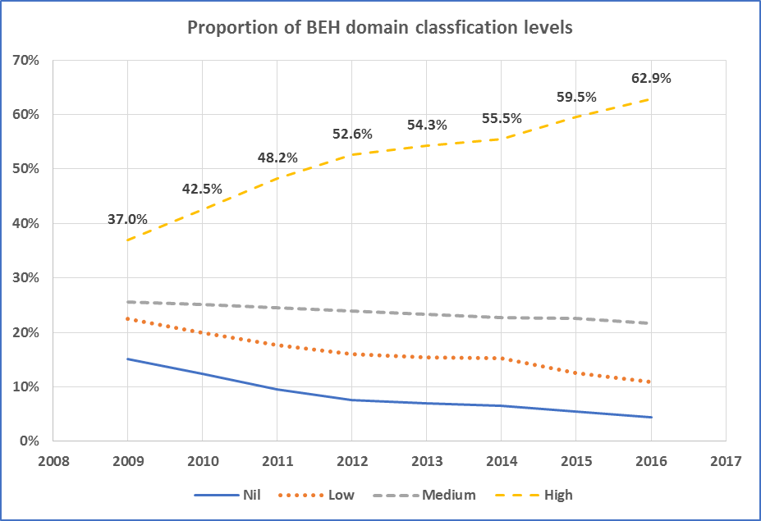

Table 5.4: BEH Domain Distribution June 30, 2016

| BEH Domain Level | Number of Residents | Percentage |
| --- | --- | --- |
| Nil | 7,736 | 4.4% |
| Low | 19,364 | 11.0% |
| Medium | 38,253 | 21.8% |
| High | 110,007 | 62.9% |
| Total | 175,360 | 100.0% |

1. ACFI 6 Cognitive Skills

Ratings on the ACFI 6 Cognitive Skills question and changes since 2009 are shown in Figure 5.2. The increasing claims in this area relate to the growth in the moderate cognition claims (C rating) which increased from 23.6 per cent in 2009 to 34 per cent in 2016, a compound growth rate of 5.3 per cent pa.

The cognition rating can be determined via either a cognitive impairment screening assessment which is conducted with the resident, or via a checklist with the analogous levels (A, B, C, D). This allows for those residents who are not able to be directly assessed due to their high level of impairment, sensory or cultural issues, to be rated on this question.

Figure 5.3 shows the average PAS-CIS cognitive score for those residents directly assessed, which has increased marginally since 2009 from 9.58 to 9.79 by June 30, 2016, placing the average score in the mild cognitive grouping (Table 5.1) throughout this period.

The increase in the cognitive question rating since 2009 is due to the tendency for those rated on the checklist items to receive a higher ACFI 6 rating than those assessed directly by the PAS-CIS cognitive assessment, therefore increasing the proportion of residents overall with a C or moderate ACFI 6 rating.

The reasons for the increase in residents assessed by the checklist only has been due to provider reports of resident refusal (from 1.9 per cent in 2009 to 6.7 per cent by June 30, 2016 - growth rate of 19.5 per cent pa.), sensory issues (from 1.6 per cent in 2009 to 5.2 per cent by June 30, 2016 - growth rate of 17.8 per cent pa.), cultural issues (from 3.7 per cent in 2009 to 6.6 per cent by June 30, 2016 - growth rate of 8.7 per cent) and a severe level of impairment (from 12 per cent in 2009 to 15.8 per cent by June 30, 2016 – a growth rate of 4.1 per cent pa.).

To ensure confidence that the increased use of the checklist accurately reflects the true situation, the Department has mandated that evidence must support the decision not to use the PAS-CIS for the cognitive assessment in the 2017 User Guide, as follows: ‘*If a score is not included, the assessment must provide the reason why it could not be completed and alternative supporting evidence such as a clinical report must be provided in the ACFI Answer Appraisal Pack.’* (Department of Health, 2016, p.27).

Figure 5.2: ACFI 6 Cognition Ratings (A, B, C, D) 2009 – 2016

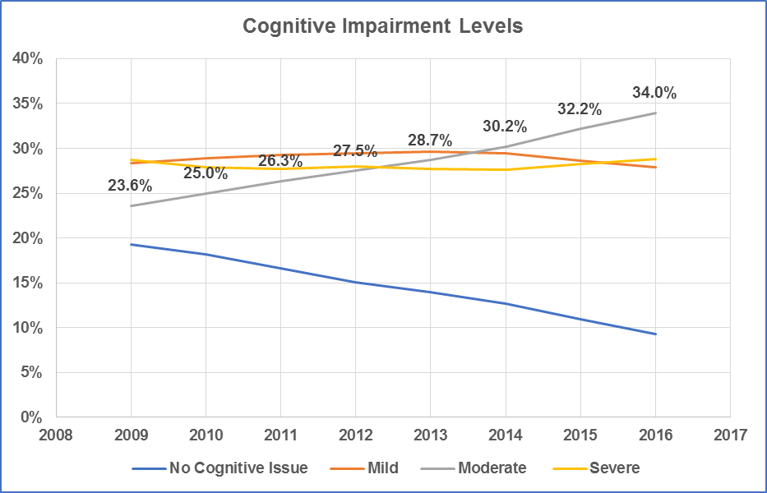

(Labeled percentages are for the moderate cognition claims)

Figure 5.3: ACFI 6 Average PAS-CIS Scores 2009 - 2016

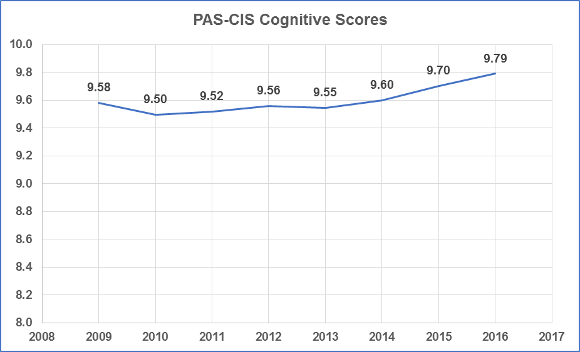

1. ACFI 7 Wandering Behaviour

The proportion of residents rated with problem wandering behaviour has shown a consistent decrease since 2011 (Figure 5.4 – yellow, red and grey lines). The ‘no wandering’ rating has increased from 65.7 per cent in 2011 to 79.2 per cent by June 30, 2016 indicating that only around 2 in 10 residents are now reported to problem wander. The type of wandering reported has similarly decreased for both ‘interfering’ and ‘inappropriate places’ behaviours in the period since 2009 (Figure 5.5).

Figure 5.4: ACFI 7 Wandering Behaviour Frequency Levels 2009 - 2016

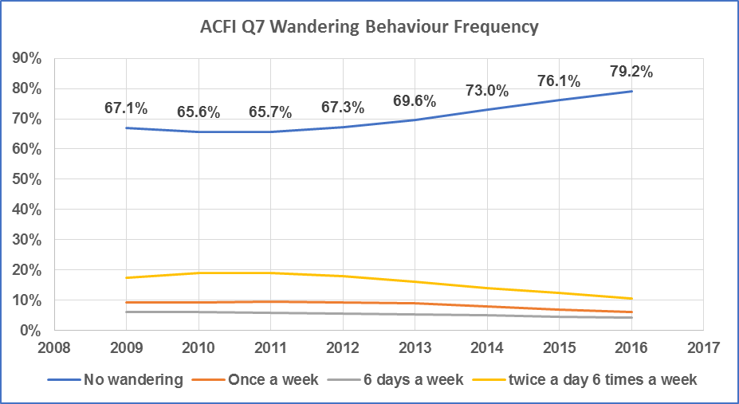

Figure 5.5: ACFI 7 Wandering Behaviour Type 2009 - 2016

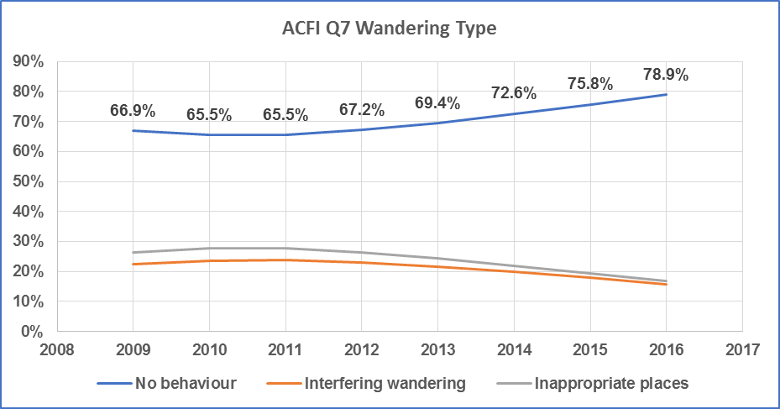

1. ACFI 8 Verbal Behaviour

The proportion of residents rated with the highest level of verbal behaviour frequency (twice a day, 6 days a week – D rating) has consistently increased since 2009 from 4 in 10 residents to nearly 6 in 10 residents by June 30, 2016 (Figure 5.6). The main driver of this increase was ratings on ‘refusal of care’ which increased from 52.2 to 72.4 per cent of residents, as shown in Figure 5.7 (4.8 per cent growth pa.).

Figure 5.6: ACFI 8 Verbal Behaviour Frequency Levels 2009 - 2016

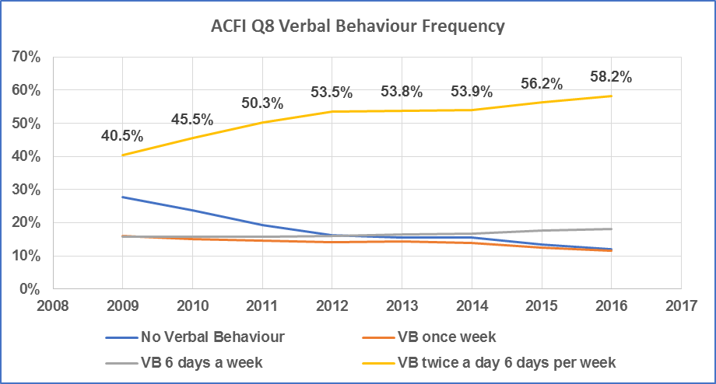

Figure 5.7: ACFI 8 Verbal Behaviour Type 2009 - 2016

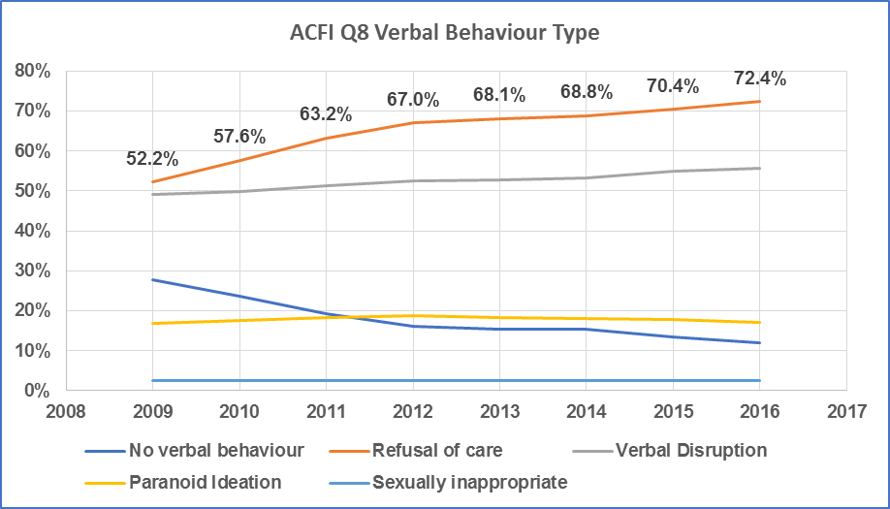

1. ACFI 9 Physical Behaviour

The proportion of residents rated at the highest level of physical behaviour (twice a day, six days a week - D rating) significantly increased from 2009 to 2012 but then remained steady at around 45 to 43 per cent of residents from 2012 to June 30, 2016 (Figure 5.8). The behaviour type which was overwhelmingly responsible for residents being rated with physical behaviours was ‘constantly agitated’ (Figure 5.9) which had an increase of 6.8 per cent pa. over the period to June 30, 2016.

Figure 5.8: ACFI 9 Physical Behaviour Frequency Levels 2009 - 2016

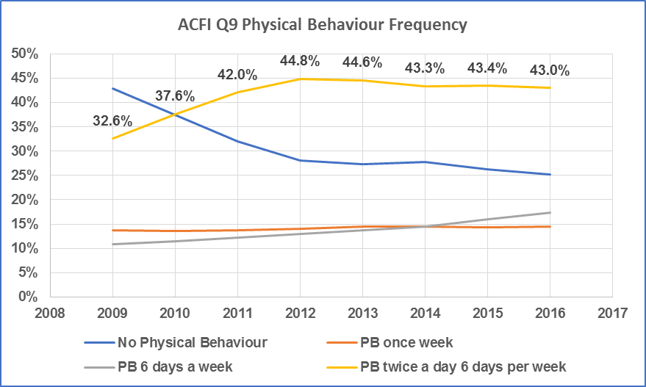

Figure 5.9: ACFI 9 Physical Behaviour Type 2009 - 2016

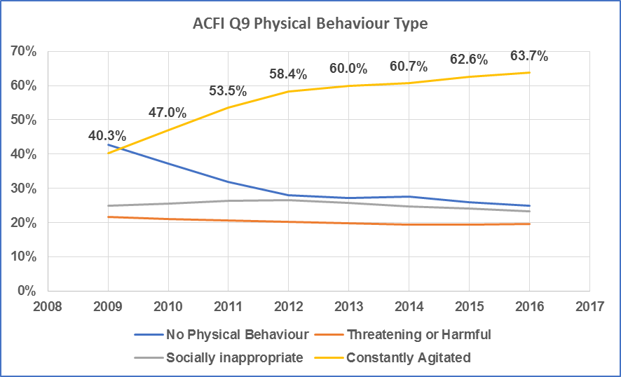

1. ACFI 10 Depression

The average Cornell Scale for Depression (CSD) score has increased from 9.9 in 2009, which is in the B funding category on average (mild degree of symptoms), to 13.1 at June 30, 2016 which is just below the C funding category on average (moderate degree of symptoms).

The category (A, B, C, D) growth rates between 2009 and June 30, 2016 for symptom counts were 4.7 per cent pa. for B (19.2 to 26.6 per cent); 6.8 per cent pa. for C (12.2 to 19.4 per cent); and 8.4 per cent pa. for D (9.7 to 17.1 per cent) (Figure 5.10). This gradual and consistent growth seems plausible given the greater awareness of the prevalence of depression in residential aged care residents over the period. The proportion of residents with a formal diagnosis of depression also increased over the period from 20.6 to 35.9 per cent (Figure 5.11).

Figure 5.10: ACFI 10 Depression Symptoms Levels on the CSD 2009 - 2016

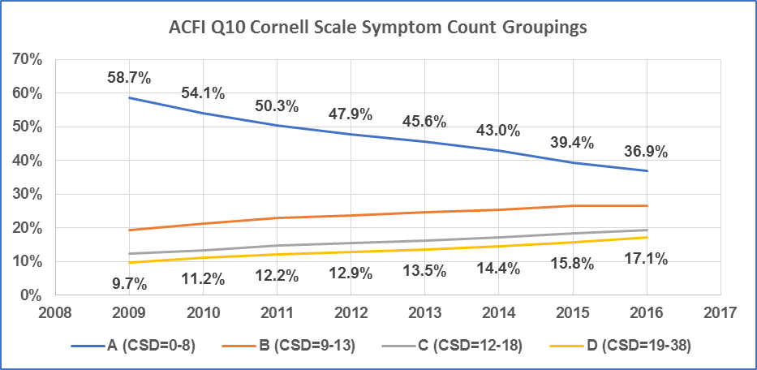

Figure 5.11: ACFI 10 Depression Diagnosis Levels 2009 - 2016

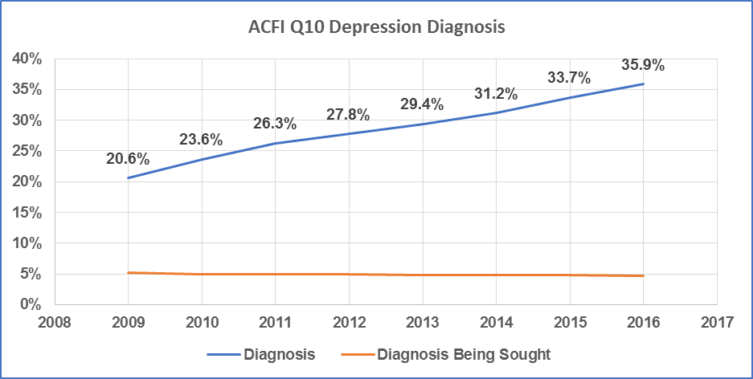

1. BEH Domain Review

AACS conducted a series of consultations, review of relevant tools and literature on assessment and statistical analysis on the BEH domain items. Specific areas investigated and discussed in this section are:

* Should the Standardised Mini Mental State Examination (SMMSE) replace the current PAS-CIS to allow for consistency with other parts of the aged care system?
* Does the Depression question better fit in the CHC domain?
* Is the CSD assessment too complex for care staff to complete with a reasonable level of accuracy?
* If the Depression question remains in ACFI, should funding be dependent on a diagnosis and treatment regime and expire after a period of time, for example 12 months?

The review process informed on the following identified issues and recommended outcomes.

1. ACFI 6 Cognition Question

The use of the same cognitive assessment screening tool for both community and residential care was strongly endorsed by participants at the consultations and in discussion with health care professionals. The use of the same tool would enable a common understanding of:

* The level of cognitive impairment when community care clients are being placed in residential care settings, as ACATs universally use the SMMSE.
* Allow training programs to focus on a single assessment.
* Provide a reliable pre-entry external assessment comparison for the Departmental ROs when auditing ACFI claims.

Thus, there was general agreement that the PAS-CIS should be replaced with the SMMSE. The SMMSE is currently a supplementary tool in the NSAF, and is also widely used by registered health professionals. Replacing the PAS-CIS with the SMMSE will allow for a universal cognitive assessment tool to be used by all assessor types along the person’s aged care pathway (pre-entry assessment, residential care assessment, reviews and re-appraisals).

Previous concerns regarding public availability of the SMMSE have been resolved. The SMMSE tool and guidelines are provided for use in Australia by the Independent Hospital Pricing Authority (IHPA) under a licence agreement with the copyright owner, Dr D. William Molloy (Molloy & Standish, 1997; Molloy, 2014).

Finding: Departmental ROs reported an over-use of the cognitive checklist without objective evidence to support the outcome rating. Support for this view has been previously described in section 5.2.1.

**Recommendation:** To address this concern and strengthen the objectivity of supporting evidence, it is recommended that providers identify the documents that support their checklist rating from a defined list (e.g. NSAF, Medical Practitioner notes, Clinical reports). The expectation will be that when the checklist is used (as there are many cases where it is not suitable to interview a resident), there will be objective documentation available that supports the checklist rating.

The Department has also emphasised in the 2017 ACFI User Guide that providers need to provide the reason why the checklist could not be completed, together with alternative supporting evidence such as a clinical report that will need to indicate why the resident could not be interviewed with the PAS-CIS cognitive assessment tool.

1. ACFI 7-9 Wandering, Verbal & Physical Behaviour Questions

There are a number of changes to behaviour questions recommended as follows.

* + - 1. Verbal Refusal of Care (Figure 5.7)

The behaviour sub-type has been dropped as it has not proven possible to accurately define and then measure this descriptor with any consistency. There has been a very significant increase in recording of this behaviour type from 52.2 per cent of residents in 2009 to 72.4 per cent of all aged care residents in June 2016. The significant increase is highly unlikely to be due to an actual rise in residents ‘refusing care’ but is more likely in the greater part due to confusion over what constitutes refusal of care behaviour that requires ongoing staff intervention.

It has also become a term that is regularly used to describe behaviours that are reasonable and normal for a person who may be attempting to have some level of control, autonomy and choice over their day-to-day preferences with routines and activities. Dealing and negotiating with residents over needed activities such as dressing, washing and hygiene are considered usual business in an aged care context and successful strategies will reduce the impact of what may have been considered a problem behaviour.

Residents or persons who refuse required health care in a persistent and consistent way that requires additional and excessive resources will almost certainly trigger another behaviour in the spectrum covered in the behaviour domain, or require a high level of support that will be captured in the ADL domain.

* + - 1. Constantly Physically Agitated (Figure 5.9)

Thebehaviour sub-type has been removed as all of the ACFI behaviour items cover various aspects of ‘agitation’ and there is widespread misidentification of this behaviour. There has also been a very significant increase in recording of this behaviour type, from 40 per cent of residents in 2009 to 63.7 per cent of all residents in June 2016. The increase is highly unlikely to be due to a significant rise in constantly agitated behaviour but more likely due to staff difficulty in understanding the provided definition.

**Performing Repetitive Mannerisms**

The behavioural description of ‘performing repetitious/ stereotypic mannerisms that are likely to cause physical harm to self or others e.g. patting, tapping, rocking self, fiddling with something, rubbing self or object, sucking fingers, taking off and on shoes, picking at self or clothing or objects, picking imaginary things out of the air/ floor, manipulation of nearby objects’ has been simplified to ‘Performing repetitious/ stereotypic mannerisms that cause physical harm to self or others’.

**Always moving around in seat**

Additionally, unable to sit still has been deleted.

* + - 1. Concept of Standard Care

The concept of ‘standard care’ as described in the ADL domain, also applies to the Behaviour claims. From time to time many residents will exhibit a behaviour on an occasional basis that may be regarded as problematic. However, interventions that are less than daily have been considered episodic and part of typical day-to-day interactions therefore not requiring additional staff resources beyond the number and type usually rostered in the facility.

The R-ACFI behaviour domain only allows claims for behaviours that occur on at least a daily basis.

* Daily
* Twice per day
* Multiple times per day

A behaviour must have occurred on a daily basis as recorded over a 7-day period to be claimed and a four-point scale of disruptiveness (discussed next) determines severity together with a frequency record which must be completed by aged care providers.

* + - 1. Introduction of a Disruptiveness Scale

To make a claim in the ACFI behaviour questions, wandering, verbal and physical behaviours, a provider’s submission must;

(i) fit the required frequency levels as shown in the behaviour records; and

(ii) document the impact on current care needs and attention requirements from a staff member to attend to the behaviour.

Provider ACFI submissions often have insufficient documentation describing the impact and attention requirement aspect of the questions. To provide a more objective measurement for this aspect the R-ACFI has introduced a disruptiveness rating that must accompany the frequency rating to qualify for a claim.

**External Assessors and Behaviour Assessment**

The introduction of a disruptiveness rating will also be helpful in the case of an assessment of the behavioural care needs of a person living in the community. As a 7-day behaviour record cannot be completed with sufficient accuracy for persons living in a community setting, an approach that focuses on disruptiveness for a carer will provide sufficient information to determine a rating on the ACFI-R behaviour questions. For this reason, it is recommended that the external assessor collects information about the specific behaviour and the disruptiveness of the behaviour from the carer and/or other informant. This approach is supported by Robinson, Adkisson, and Weinrich (2001), who reported that the caregiver’s (family) reporting of a problem behaviour was more highly associated with the impact and severity rather than the frequency. Many validated behaviour assessments also collect the severity or the disruptiveness of the behaviour along with type of behaviour and the frequency. Examples include the Neuropsychiatric Inventory (NPI) (Cummings et al., 1994), [Behavioural Pathology in Alzheimer’s Disease (BEHAVE-AD)](http://dementiakt.com.au/doms/domains/behaviour/behave-ad/) (Reisberg et al., 1987), [Pittsburgh Agitation Scale (PAS)](http://dementiakt.com.au/doms/domains/behaviour/pas/) (Rosen et al., 1994), and the Cohen-Mansfield Agitation Index (CMAI) (Cohen-Mansfield, 1991) which is a widely-used behaviour tool that was the basis for the original ACFI behaviour questions (Table 5.5).

Table 5.5: Example of Disruptiveness Ratings used in Behaviour Assessments

| **Assessment** | **Disruptiveness Rating** |
| --- | --- |
| CMAI | Not at all disruptive; A little; Moderately; Very Much; Extremely |
| NPI | No distress; Minimal; Mild; Moderately; Moderately severe; Very severe or extreme.  Mild severity- little distress to patient;  Moderate severity- disturbs patient but can be redirected;  Severe- very disturbing to patient, difficult to redirect. |
| BEHAVE-AD | Not at all troubling to the caregiver or dangerous to the patient;  Mildly troubling to the caregiver or dangerous to the patient;  Moderately troubling to the caregiver or dangerous to the patient;  Severely troubling or intolerable to the caregiver or dangerous to the patient. |
| Pittsburg Agitation Scale (PAS) | Intensity for vocalisations: Not present; Low volume, not disruptive in milieu; Louder than conversational, mildly disruptive, difficult to redirect; Extremely loud, highly disruptive, unable to redirect. |
| Disruptive Behaviour  Rating Scale (DBRS) (Mungas, Weiler, Franzi, & Henry, 1989) | No intervention; Intervention required; Major effect e.g. injury or major intervention; Severe effect or extreme intervention. |

An External Assessor will rely on informants for collecting disruptiveness over a recent time period (last 7 days). Recalling the most frequently disruptive behaviour in the past week that required an intervention should be easier and less subjective than recalling and estimating numerous frequency events.

The description for the four-point disruptiveness rating scale is shown in Table 5.6.

Table 5.6: Four Point Disruptiveness Scale Used in the R-ACFI BEH Domain

| **Rating** | **Description** |
| --- | --- |
| Not at all or Mildly | Requires no intervention by staff OR  Receives intervention, settles quickly. Mildly disruptive, co-operative response to intervention, not disruptive to other residents or visitors. |
| Moderately | Receives intervention, takes multiple attempts to settle.  Moderately disruptive, not always co-operative, but can be resolved with intervention, sometimes disruptive to other residents or visitors. |
| Severely | Requires numerous interventions, often unable to settle.  Very disruptive, sometimes requires immediate intervention, interferes with others, their belongings or visitors, asocial behaviour. |
| Extremely | Receives ongoing intervention, cannot effectively settle.  Extremely disruptive, always requires immediate intervention, wakes others at night, disruptive to others during the day, requires one or more staff attention or constant attention. |

* + - 1. Behaviour Description

Further, while disruptiveness is a key determinant of whether a behaviour is problematic, a behaviour description is also essential for developing care interventions, staff communication around behaviour, and when including information from relatives. The International Psychogeriatric Association (IPA) recommends the ABC (Antecedent, Behaviour, Consequences) approach for behaviour support and management, which includes a detailed behaviour description (International Psychogeriatric Association, 2012). Therefore, the R-ACFI BEH domain also includes, as mandatory, a description of the behaviour with any funding claim.

A detailed behaviour description is to be included in the Behaviour Assessment Summary to describe what was seen/heard. The behaviour description (i.e. the B in the ABC) will improve the identification of the behaviour from the resident’s file notes, as it will be expected to be possibly included in ADL assessments (as this is a common trigger or antecedent for behaviours), recorded as an exceptional event in progress notes (disruptive behaviours should stand out as unusual), and should be included in the Care Plan. For simplicity, just the behaviour description has been requested, but it is intended to encourage the consideration of the context of the behaviour. Effective behaviour management begins by trying to clearly describe the behaviour.

* + - 1. Recommendations for the Behaviour Assessment Aspect

**Behaviour Record Completion by Residential Aged Care Assessors (as per current approach)**

* The behaviour must require staff intervention at a minimum frequency of daily for an ACFI claim, as evidenced in a 7-day Behaviour Record completed by the provider (refer Appendix Tables Table A5.3.6-8).

**Disruptiveness and Frequency Rating:**

* The current ACFI uses a frequency-based assessment to measure the severity of behaviours that require staff intervention. The R-ACFI uses both the frequency (obtained from the 7-day behaviour record) and disruptiveness of the behaviour to determine the claim, which is a more contemporary and valid method of determining support demands. For provider assessors, the disruptiveness rating is to be completed via reference to progress notes and clinical reports.

**Completion of a Behaviour Assessment Summary (Table Appendix A5.3.9)**

* A Behaviour Assessment Summary to be completed that includes an individualised Behaviour Description, Disruptiveness and Frequency rating for each claimed behaviour - this tool is suitable for both the residential aged care provider and the External Assessor although the external assessor will not complete the frequency rating aspect. Disruptiveness is not a new concept, as all current behaviour recordings must receive staff interventions to meet the eligibility criteria. The level of disruptiveness is to be validated by informants and file notes. The Disruptiveness Rating produces an objective outcome of the type of staff intervention. If the disruptiveness was rated mild it is considered to be part of standard care. The behaviours (Wandering, Verbal or Physical) must occur at least daily to be allocated above Rating A (i.e. B, C or D rating).

**Behaviour Description**

* An individual behaviour description is also a recommended requirement with the R-ACFI Behaviour claims. An individualised description improves the objectivity of the tool, by allowing for a more accurate confirmation of behaviours from either data analysis, documentation (e.g. ADL assessments, care plans, clinical reports and progress notes) or from informants (carers, family etc.). This recommendation follows the IPA recommendation for behaviour management – the use of the ABC (Antecedents, Behaviour and Consequences) theoretical approach for managing disruptive behaviours (IPA, 2012).
* The external assessor will be required to complete the Disruptiveness Rating (Table 5.6) and the Behaviour Assessment Summary only (Table Appendix A5.3.9), not the frequency aspect.

**Assessment - Recommended Behaviour Assessment approach**

* Residential providers and external assessors complete the Behaviour Assessment Summary which covers seven behaviour types and includes a Disruptiveness Scale and individualised Behaviour Descriptions
* For External Assessors, the Disruptiveness rating is to be completed from discussions with carers, service provider and other clinical reports
* For residential facility assessors, the Disruptiveness rating is to be completed via reference to progress notes and clinical reports
* Residential providers will also complete a 7-day Behaviour record to provide evidence that the claimed behaviour occurred on a daily basis.

1. ACFI 10 Depression Question

Depression was included in the original ACFI to raise care staff awareness of the presence and impact of depressive symptoms and to provide a funding signal so that more targeted programs to address depression in residential care could be developed. The mandated assessment tool was the revised CSD in Dementia. Feedback from the consultations however indicated that the depression assessment is not well understood by care staff and is not completed appropriately (i.e. notes are not regularly completed for the items). There was also concern that the CSD total score was open to interpretation by providers and maximisation of scores to achieve the highest rating level (A, B, C, D) was lessening the usefulness of the CSD in care planning activities and causing regular disagreement with Department Review Officers.

While a focus on depression and its symptoms in residential care needs to continue, it is essential to improve the current approach while still providing an emphasis and funding in this area. The recommended option is to move the depression question from the behaviour BEH domain (statistical analysis using IRT also indicated that it now does not fit with the BEH domain questions) and to make it a single item within the CHC domain.

The detailed recommended changes for Depression are further described in the CHC section (Chapter 6) of this report.

1. The R-ACFI BEH Domain Recommended Changes

The rationale and the recommended changes for the R-ACFI 6 Cognition and R-ACFI 7 Behaviour questions can be found in Appendix 5.1 and 5.2.

1. Recommended User Guide R-ACFI Format for Cognition Question

**Description:** This question relates to the resident’s assessed cognitive skills.

**Requirements:** To support a claim in ACFI 6, the SMMSE must be completed and the score entered into the checklist. If a score is not included, the assessment must provide the reason why it could not be completed and alternative supporting evidence such as a clinical report must be provided in the ACFI Answer Appraisal Pack.

If the SMMSE has been completed for the resident in the last three months, it may be used if it continues to reflect the cognitive status of the resident at the time of appraisal - this would require the resident’s mental status to be reviewed for any recent changes and the assessment to be signed off (for no changes to short-term memory loss, long-term memory loss, orientation to time, place and person) during the appraisal period.

The SMMSE may not be suitable for some people of non-English speaking background and for some Aboriginal or Torres Strait Islander persons, depending on their background. In some circumstances, resident impairments may also prevent the use of the SMMSE. However, if the SMMSE or another cognitive assessment described in the User Guide is not used, suitable objective evidence is to be made available to support the decision to use the checklist e.g. diagnosis or medical notes, clinical report.

If a clinical report is provided in the Answer Appraisal Pack, this must be recorded in the assessment summary. Refer to Definitions and Acronyms for further information on a Clinical Report.

**Assessment Summary**

| R-ACFI Cognitive Skills Assessment Summary | Tick if yes | SMMSE  Score |
| --- | --- | --- |
| No SMMSE undertaken–and nil or minimal cognitive impairment | 🞏 6.1 | *[Enter score here]* |
| Cannot use SMMSE due to severe cognitive impairment or unconsciousness (severe cognitive impairment confirmed by Clinical Report or Medical Practitioner), or have ACAT diagnosis items of 520, 530, 570 or 580 | 🞏 6.2 | *[Enter score here]* |
| Cannot use SMMSE due to speech impairment (confirmed by Speech Pathologist or Medical Practitioner) | 🞏 6.3 | *[Enter score here]* |
| Cannot use SMMSE due to cultural or linguistic background (severe cognitive impairment confirmed by Clinical Report or Medical Practitioner) | 🞏6.4 | *[Enter score here]* |
| Cannot use SMMSE due to sensory impairment (confirmed by Medical Practitioner) | 🞏 6.5 | *[Enter score here]* |
| Cannot use SMMSE due to resident’s refusal to participate (severe cognitive impairment confirmed by Clinical Report or Medical Practitioner) | 🞏 6.6 | *[Enter score here]* |
| Clinical report provides supporting information for the ACFI 6 appraisal | 🞏 6.7 | *[Enter score here]* |
| SMMSE completed: enter score | 🞏 6.8 | *[Enter score here]* |

**R-ACFI 6 Cognition Checklist to be completed**

| R-ACFI 6. Cognitive Skills Checklist | Tick one |
| --- | --- |
| 1. None or minimal impairment   SMMSE = 25-30  If no SMMSE assessment:  No significant problems in everyday activities. Demonstrates no difficulties or only minor difficulties in the following–memory loss (e.g. may forget names, misplace objects), handling money, solving problems (e.g. judgement and reasoning skills are intact), cognitively capable of self-care. | 🞏 1 |
| 1. Mild impairment   SMMSE = 21-24  If SMMSE assessment is inappropriate:  May appear normal but on investigation has some problems in everyday activities.  Memory: 3 item recall orientation (time then place).  IADL: Problems with driving, finances, shopping.  Not independent in chores/ interests requiring reasoning, judgement, planning etc. (i.e. cooking, use of telephone).  Personal care: Memory loss of recent events that impacts on ADLs (i.e. needs prompting not physical assistance).  Orientation: Disorientation in unfamiliar places.  Communication: Word finding, repeating, goes off topic, loses track. | 🞏 2 |
| 1. Moderate impairment   SMMSE = 10-20  If SMMSE assessment is inappropriate:  Has significant problems in the performance of everyday activities, requires supervision and some assistance.  Memory: WORLD spelling, language and 3 step commands. New material rapidly lost, only highly learned material retained.  Personal care: Requires physical assistance with some ADLs (e.g. dressing, washing body, toileting).  Orientation: Disorientation to time and place is likely.  Communication: Possibly sentence fragments, empty speech, vague terms (i.e. this, that). | 🞏 3 |
| 1. Severe impairment   SMMSE = 0-9  If SMMSE assessment is inappropriate:  Has severe problems in everyday activities and requires full assistance as unable to respond to prompts and directions.  Memory: All areas show obvious deficits. Only fragments of past events remain.  Personal care: Requires full assistance with most or all ADLs related to cognitive impairment.  Orientation: Orientation to person only.  Communication: Speech disturbances (i.e. slurring, stuttering) are common. | 🞏 4 |

1. Recommended User Guide R-ACFI Format for the Behaviour Question

**Description:** This question relates to seven behaviour types as described in the R-ACFI 7 Behaviour Checklist ratings.

All behaviours must have occurred in a 1-week period (within the Appraisal period).

There are two aspects of the behaviour to be recorded as follows:

* The behaviour frequencies are (1) less than daily, (2) daily, (3) twice a day, every day (4) more than twice per day, every day.
* The disruptiveness ratings are (1) Not at all or mildly, (2) Moderately, (3) Severely and (4) Extremely.

The final behaviour domain level is determined by a matrix covering disruptiveness and frequency.

A Mental and Behavioural diagnosis (excluding Depression) is required to receive the highest funding level in the Behaviour domain.

A referral and review by a Behaviour Specialist (e.g. DBMAS; Psychiatrist; Psychologist) and Behaviour Care Plan is also required to receive the highest funding level in the Behaviour domain.

**Requirements:** The mandated evidence requirements are:

* + - 1. **Seven-day Behaviour Record (for a RAC service)**

The **Behaviour Records** (Appendix Table A5.3.6 to A5.3.8) are mandated for the Residential aged care service as evidence of the frequency rating, and must be available for review. The codes in the Behaviour records must be completed according to the description of behavioural symptoms in Appendix Table A5.3.3. In exceptional circumstances where the resident is unavailable in a 24-hour period, then an extra 24 hours can be taken, and the reason noted on the record.

The frequency information is collected in the seven-day Behaviour Records:

* *Appendix Table A5.3.6 – Wandering Behaviour Record*
* *Appendix Table A5.3.7 – Verbal Behaviour Record*
* *Appendix Table A5.3.8 – Physical Behaviour Record*
  + - 1. **A Completed Behaviour Assessment Summary**

Completion of the **Behaviour Assessment Summary** in Appendix Table A5.3.9 includes:

* *Frequency rating (Appendix Table A5.3.5);*
* *Disruptiveness rating (Appendix Table A5.3.4); and*
* *An individualised Behaviour Description for each claimed behaviour type***.**

The behaviour description is best provided in a contextual framework around what was happening at the time of the incident (who was there, where it occurred, interactions), and it should inform on the disruptiveness of the behaviour (impact on others). The behaviour description must also be supported by documentation recorded in the resident’s file notes and Care Plan.

* + - 1. **A Completed Frequency and Disruptiveness Matrix for each Behaviour being Claimed**

The completed Behaviour Assessment Summary is then used to complete:

* *the R-ACFI Behaviour Matrix is determined for each claimed behaviour type (Wandering, Verbal or Physical).*

Table 5.7: Behaviour Rating Matrix

| Rating per Behaviour Type | Frequency | | | |
| --- | --- | --- | --- | --- |
| Disruptiveness | **1. less than daily** | **2. daily** | **3. twice per day, everyday** | **4. more than twice per day, everyday** |
| 1. None or mild | A | A | A | A |
| 2. Moderately | A | A | B | C |
| 3. Severely | A | B | C | D |
| 4. Extremely | A | C | D | D |

* + - 1. **Behaviour Matrix Ratings**

The behaviour summary ratings are then used to determine the final behaviour ratings in each of the items covering wandering, verbal and physical behaviour.

**Behaviour Checklist Rating:** Rate each behaviour type – Wandering, Verbal, Physical

| R-ACFI 7 Behaviours | A | B | C | D |
| --- | --- | --- | --- | --- |
| Wandering: (tick one) | 🞏 0 | 🞏 1 | 🞏 2 | 🞏 3 |
| **Verbal:** (tick one) | 🞏 0 | 🞏 1 | 🞏 2 | 🞏 3 |
| Physical: (tick one) | 🞏 0 | 🞏 1 | 🞏 2 | 🞏 3 |

1. The R-ACFI BEH Classification Model

Apart from the relocation of the Depression question to the CHC domain, the BEH domain classification is still determined from the current A, B, C, D question weights which have been re-configured to add to 100, summed and then grouped into three domain categories of None/Low, Medium and High. The cut points have, however, been revised to include more behaviours in the standard care level.

Specific details of the classifications and funding level changes are described in Chapter 8.

A Mental and Behavioural diagnosis (excluding Depression as this is now covered in the CHC domain) is still required to receive the highest funding level in the BEH domain.

A referral and review by a Behaviour Specialist (e.g. DBMAS; Psychiatrist; Psychologist) and Behaviour Care Plan is also required to receive the highest funding level in the Behaviour domain.

1. Accountability

The strategies to improve accountability are:

* New recommended mandated assessment in Cognition that matches the current gateway toolkit and will fit into an external assessment or RACF approach as it is commonly used in aged care.
* Recommendation to add an individualised behaviour description that will strengthen the linking of documentation to the evidence of the behaviour.
* Recommendation to add a behaviour disruptiveness scale – this scale is a better fit to the External Assessor as it asks about events that were disruptive.
* Supporting family members to sign off on the ACFI pack – this would also support CDC practices by ensuring that they have a clear understanding of their relative’s care needs and required services.
* Mandating that a RN or AHP sign off on all assessments as this is current practice in most organisations, for both legal and quality requirements.
* The ACFI User Guide should emphasise that Health Professionals are accountable to their registration body (AHPRA) for their professional decisions, and identified issues will be referred to AHPRA.

1. The BEH Domain - R-ACFI snapshot

The R-ACFI is recommended to have three Behaviour domain levels (Nil, Moderate, High). The Depression item and its associated funding has been moved to the Complex Health Care domain. This change has led to a slight reduction in the maximum funding allocated from the current ACFI BEH domain. Full details of the R-ACFI Behaviour domain funding level are shown in Chapter 8.

The changes to the Behaviour domain (in brief) include:

1. Become a three-level domain with levels of Nil, Moderate and High. Analysis of the distribution of the scores indicated that a four-level split was not necessary to achieve the sufficient precision for funding allocation purposes.
2. A single ACFI Behaviour question replaces the three separate behaviour questions Wandering, Verbal and Physical.
3. The Depression item has been moved to the Complex Health Care domain as it now focuses on Major Depression.
4. The funding amount attributable to the Depression question ($3.64 per day) has been re-allocated to the CHC domain.
5. Weightings adjusted proportionally for the removal of the Depression item.
6. The PAS-CIS replaced by the S-MMSE in a direct swap for the mandated cognitive assessment. Assessments are current for 3 months.
7. Inclusion of a detailed individualised behaviour description to clarify the behaviour claimed.
8. Inclusion of a new severity item “disruptiveness” to clarify that there is a requirement for “staff intervention”.
9. The behaviour frequency rating descriptors have been modified to daily, twice a day and more than twice a day on a daily basis over a 7-day period to better distribute the relative care needs and acknowledge that the domain is targeting those requiring additional staffing support of a specific nature.
10. A matrix between the “disruptiveness” level and behaviour “frequency” must be completed to determine the final Behaviour domain rating.
11. Behaviour descriptions “constantly physically agitated” and “verbal refusal of care” have been removed due to definitional problems and inappropriate labelling.
12. A Mental and Behavioural diagnosis (excluding Depression) is required to receive the highest funding level in the Behaviour domain.
13. A referral and review by a Behaviour Specialist (e.g. DBMAS; Psychiatrist; Psychologist) and Behaviour Care Plan is also required to receive the highest funding level in the Behaviour domain.
14. BEH Assessment Suite

Table 5.8 provides a summary of the R-ACFI BEH mandated and recommended assessments.

Table 5.8: R-ACFI Behaviour Domain Assessment Tools Recommendations

| Cognition Assessments | | |
| --- | --- | --- |
| **Mandatory** | **Recommended** | **Source** |
| SMMSE Cognition Assessment | *No recommendation* | R-ACFI Assessment Pack |
| **Behaviour Assessments** | | |
| **Mandatory** | **Recommended** | **Source** |
| Behavioural Descriptions (text) | *No recommendation* | R-ACFI Assessment Pack |
| Frequency (from the Behaviour Records) | *No recommendation* | R-ACFI Assessment Pack |
| Disruptiveness Rating | *No recommendation* | R-ACFI Assessment Pack |
| Modified Behaviour Assessment Form (collates the above behaviour information) | *No recommendation* | R-ACFI Assessment Pack |

Table 5.9 following provides a summary of the BEH domain recommendations. Note any "NR" references indicate no recommendation was provided.

Table 5.9: Summary of BEH Recommendations

| **Item** | **Changes** | **Assessments, Checklists, Ratings** | | | | | **Audit system** | | | | |
| --- | --- | --- | --- | --- | --- | --- | --- | --- | --- | --- | --- |
| *Items noted below* | *Changes noted below* | **Mandated** | **Validated assessment** | **Standardised information** | **Contemporary** | **Outcomes** | **Fit to External Assessment** | **Fit to RAC workforce** | **Fit to Gateway** | **Clarifies** | **Improves reviews** |
| **Assessments (ax)** | Rules | *NR* | *NR* | *NR* | *NR* | Currency improved (3/12) | *NR* | RN/AHP sign off | *NR* | Professional Accountability | Claim requires a new ax |
| **Cognition** | Assessment | SMMSE | YES | Fits to Checklist | YES | Cognitive score | YES | MMSE NATframe | In NSAF | *NR* | Shared evidence |
| **Cognition** | Checklist | YES | *NR* | Updated | *NR* | Updated to fit SMMSE scores | *NR* | *NR* | *NR* | Requires evidence if no assessment used | *NR* |
| **Behaviour** | Frequency | YES-ACFI Behaviour Record | *NR* | *NR* | *NR* | 1 = Not at all or less than daily;  2 = Daily;  3= 2 times per day everyday;  4 = > 2 times per day everyday | No assessment | No change | In NSAF, as a rating | *NR* | *NR* |
| **Behaviour** | Verbal refusal & constantly agitated | *NR* | *NR* | *NR* | *NR* | Removed | *NR* | *NR* | *NR* | Behaviour types | *NR* |
| **Behaviour** | Description | YES- Behaviour description | ABC approach is widely used | *NR* | IPA recommends Behaviour description in ABC approach | Individualised description of the behaviour- for clear communication about the behaviour | YES- ask an informant | Previously expected, not a new concept | Add to NSAF | The behaviour contex - what is heard/seen for the individual | Improves mapping the behaviour to resident documents |
| **Behaviour** | Disruptiveness | YES- Disruptiveness rating with contextual information | Disruptiveness scale used in other assessments | YES | *NR* | Not at all/Mildly;  Moderately;  Severely;  Extremely  For care planning and evaluation | YES- ask an informant | Minor training/ support required to implement | Add to NSAF | How disruptive the behaviour is, the level of staff input | Disruptive behaviour should be documented in notes for feedback on strategies. Informants will have better recall of disruptive events. |
| **Behaviour** | Checklist | *NR* | *NR* | YES | *NR* | Matrix of frequency and disruptiveness | *NR* | *NR* | *NR* | Severity of behaviour and intensity of interventions | *NR* |

1. The new R-ACFI CHC Domain

This Chapter contains the following sections:

* An overview of the current ACFI CHC Domain.
* A statistical overview of the CHC Domain since ACFI commencement.
* The CHC Domain Review.
* Recommended CHC Domain Changes.
* The new R-CHC Domain Items.

1. The current CHC Domain

**CHC Domain Questions**

The Complex Health Care (CHC) domain (from January 1, 2017) consists of 2 ACFI questions (Table 6.1; 6.2) which are combined in a matrix to determine the domain classification and funding levels (Table 6.3).

ACFI 11 is Medication and is rated (A, B, C) based on the level of assistance required with medication:

* A = no assistance.
* B = assistance with patches and medications.
* C = daily administration of drugs by injection (subcutaneous, intramuscular, intravenous).

ACFI 12 is CHC and is rated (A, B, C, D) depending on the items selected and the total of their individual weights (Table 6.2).

Table 6.1: CHC items, ratings and classification overview

| Question | Items and scores | Assessment Summary | Classification |
| --- | --- | --- | --- |
| ACFI 11: Medication | No medications or self manages; Assistance with patches at least weekly or daily assistance with medications; Daily administration of injections. | **A** (None or self manages)  **B** (Assistance with weekly patches or daily medications)  **C** (Daily injections) | Rating A, B, C from the assessment summary. |
| ACFI 12: CHC | 20 procedures covering at least weekly complex care treatments. | A procedure can score 1, 3, 6 or 10. | Rating A, B, C, D from the total score. |

Table 6.2: ACFI Q12 Items and Weights

| ACFI Q12. Item | Weight |
| --- | --- |
| 1. Daily Blood Pressure | 1 |
| 2. Daily Blood Glucose | 3 |
| 3. Simple Pain management - 20 minutes weekly | 1 |
| 4a. Complex pain – 20 minutes weekly by RN or AHP | 3 |
| 4b. Complex pain – 80 minutes weekly by AHP | 6 |
| 5. Skin Integrity- 4 times per day | 3 |
| 6. Daily RN Feeding | 3 |
| 7. Suppositories & enemas | 1 |
| 8. Catheter Care program | 3 |
| 9. Chronic Infectious conditions | 6 |
| 10. Chronic Wounds | 6 |
| 11. Intravenous fluids & Dialysis etc. | 6 |
| 12a. Oedema related to arthritis | 1 |
| 12b. Non-arthritic Oedema, DVT & Chronic Skin Conditions | 3 |
| 13. Oxygen Therapy | 3 |
| 14. Palliative Care program (end of life) | 10 |
| 15. Stoma Care | 1 |
| 16. Tracheostomy care | 6 |
| 17. Management of Tube Feeding | 6 |
| 18. Technical Equipment for monitoring of vital signs | 3 |
| ACFI Q12. Categories (in accordance with weight) | |
| A | 0 |
| B | 1 – 4 |
| C | 5 – 9 |
| D | 10 or more |

Table 6.3: Matrix to determine the CHC Domain Category and Funding

| Assessment Summary | ACFI 12 Rating | | | |
| --- | --- | --- | --- | --- |
| List of items as per Table 6.1 | **A** | **B** | **C** | **D** |
| No assistance needed | Nil  $0 | Nil  $0 | Low  $16.37 | Medium  $46.62 |
| Assistance Needed | Low  $16.37 | Low  $16.37 | Medium  $46.62 | High  $67.32 |
| Injections | Low  $16.37 | Medium  $46.62 | Medium  $46.62 | High  $67.32 |

1. Changes to the CHC Domain since ACFI Introduction

The CHC domain has had a number of changes since the ACFI was introduced in an attempt to control the growth in funding outlays in this domain. Funding has increased significantly, with the High category growing from 12.7 per cent of residents in 2009 to 61.4 per cent of residents by June 30, 2016 (Figure 6.1).

In summary, the Departmental changes have involved:

* CHC Matrix changed reducing the funding for some combinations by reducing the importance of the medication question (ACFI 11) (2012).
* Pain management by an Allied Health Professional (12.4b) was changed to four separate days a week from 4 times in a week and, in addition, a pain assessment was mandated (2013).
* Further changes reducing the importance of the medication question by altering the CHC scoring matrix which again reduced the funding for some combinations (July 1, 2016).
* Changing the medication question to three levels covering (i) No assistance   
  (ii) Assistance Needed and (iii) Injections (subcutaneous, intramuscular, intravenous) and re-designing the CHC scoring matrix (January 1, 2017).
* Modifying the weightings and splitting some items in the ACFI 12 items (January 1, 2017) as follows:

1. **Item 12.1**:Blood pressure measurement *-* score reduced from 3 points to 1.
2. **Item 12.4b**: Complex pain management by AHP at least 4 days per week - a timing requirement was added requiring 80 minutes of delivery of one-on-one treatment over a week.
3. **Item 12.12**: Management of oedema, deep vein thrombosis (DVT), arthritic joints or chronic skin conditions by fitting of certain garments, bandages and dressings – this item was split into two. For 12.12a the score was reduced from 3 points to 1 where the treatment is for the management of arthritic joints and oedema related to arthritis by the application of tubular and/or other elasticised support bandages. The new sub item 12.12b which covers non-arthritic oedema, DVT & chronic skin conditions remained at 3 points.
4. A Statistical Overview of the current CHC Domain

The results described in this chapter are derived from analysis of the ACFI dataset supplied by the Department covering the period from 2009 to June 30, 2016. This section provides a statistical overview of the trends with CHC domain classifications (N, L, M, H), medication question Q11 and Q12 procedures items responses since 2009. A table describing the Q11 and Q12 claims since 2009 is provided in Appendix 6.1.

Growth pa. reported in this section is the compound growth rate pa.

While the High CHC category had the lowest proportion of residents in 2009 with 12.7 per cent, significant growth since then has meant that the High category now has 61.4 per cent of residents by June 30, 2016 (Figure 6.1; Table 6.4). This has led to a large growth in funding outlays over this period.

Figure 6.1: Complex Health Care Domain Classifications (N, L, M, H) 2009 - 2016

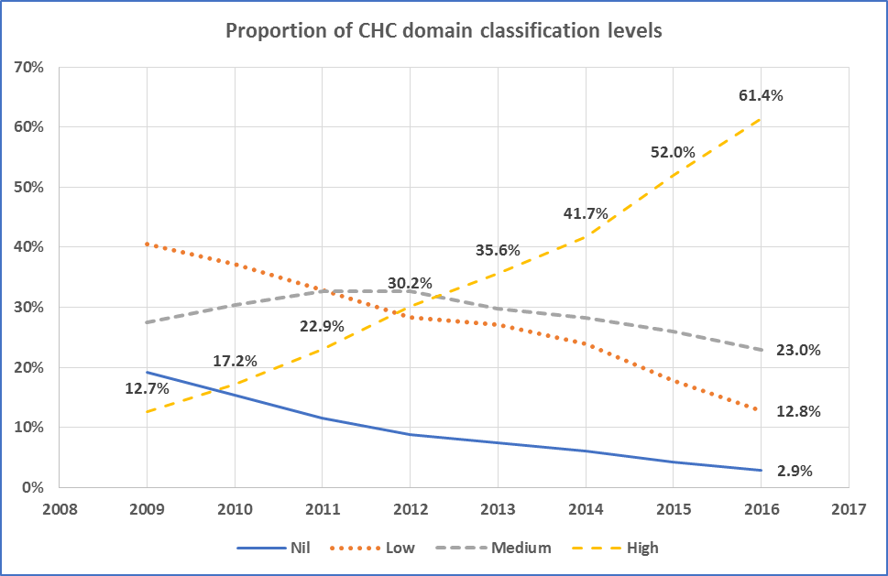

Table 6.4: CHC Domain Distribution June 30 2016

| Classification | Number of Residents | Percentage | Funding (per resident) |
| --- | --- | --- | --- |
| Nil | 5,065 | 2.9% | $0.00 |
| Low | 22,797 | 13.0% | $16.37 |
| Medium | 40,393 | 23.0% | $46.62 |
| High | 107,105 | 61.1% | $67.32 |
| Total | **175,360** | **100.0%** | **$53.98** |

* Minor differences between the chart and table per cent are due to rounding

1. ACFI 11 Medication

The proportion of residents receiving assistance with medications has been virtually unchanged since 2009 (Figure 6.2). The proportion of residents receiving injections (Figure 6.3) has grown by 5.2 per cent pa. from 2009 to June 30, 2016 (4.4 to 5.9 per cent) with around 10,200 residents receiving this type of support. Only 1.9 per cent of residents received no help with medication.

Figure 6.2: ACFI 11 Medication Rating B=Assistance Required (2009 – 2016)

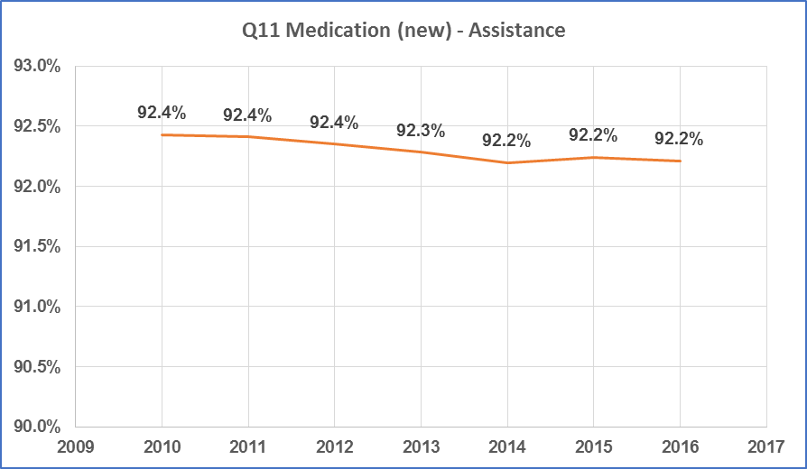

Figure 6.3: ACFI 11 Medication Ratings A = No Help and C = Injections (2009 – 2016)

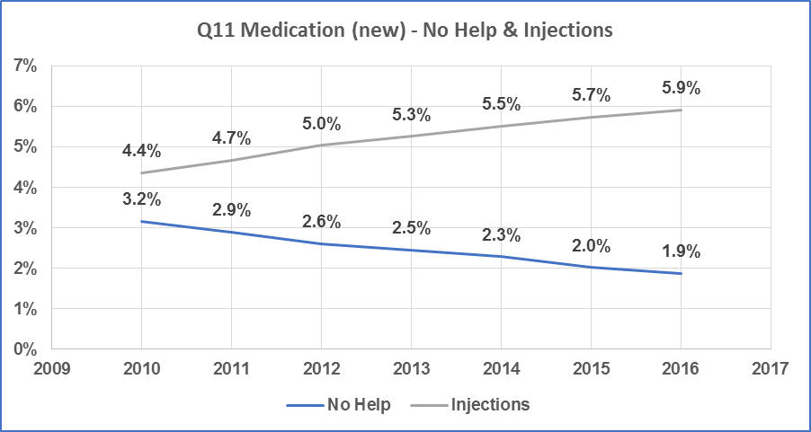

1. ACFI 12 CHC
2. ****Blood Pressure & Blood Glucose****

The proportion of residents receiving daily blood pressure checks has increased by 10.4 per cent pa. since 2009, from 3.1 per cent of residents to now 6.2 per cent of residents (Figure 6.4). Daily blood glucose tests have also increased to 8.6 per cent of residents in 2016, but at a lower growth rate of 4.9 per cent pa. since 2009.

Figure 6.4: Blood Pressure & Blood Glucose (2009 – 2016)

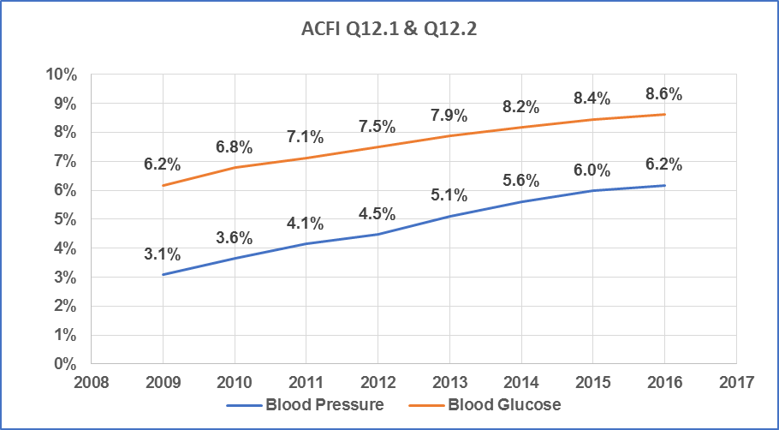

**Pain Management Items**

The pain management items have registered very significant growth from 2009 to June 30, 2016. The proportion of residents receiving simple pain treatment (Q12.3) has increased by 15.1 to 50.4 per cent pa.; complex pain management for 20 minutes a week (Q12.4a) has increased by 28.7 to now 33.7 per cent pa. of residents; and complex pain for 80 minutes by an AHP (Q12.b) has increased by 54.4 per cent pa. with 35.3 per cent of residents receiving this level of treatment by June 30, 2016.

Figure 6.5: Pain Management Simple & Complex (2009 – 2016)

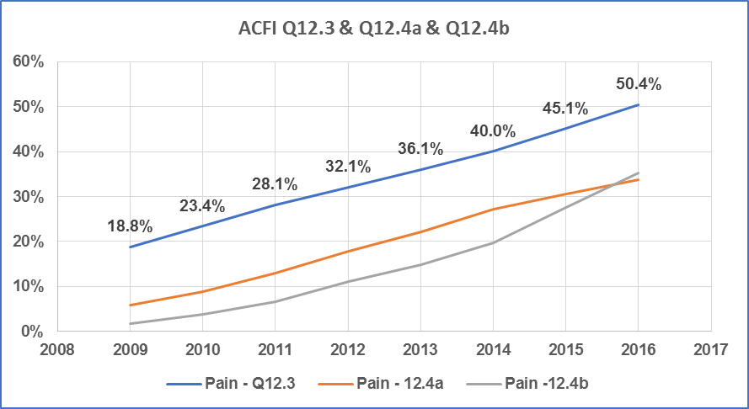**Skin Integrity, RN Feeding, Suppositories & Catheter Care**

The proportion of residents with claims for RN special feeding (0.3 per cent on June 30, 2016; negative growth pa. -14.4 per cent) and suppositories (0.7 per cent on June 30, 2016; negative growth pa. -17.6 per cent) have remained low and reducing since the ACFI was introduced (Figure 6.6). The proportion of residents with catheter care claims are also relatively low (3.2 per cent on June 30, 2016) but have remained consistent over the period since 2009 (growth pa. 1.1 per cent).

As might be expected, the proportion of residents with claims for skin integrity needs (re-positioning at least 4 times per day) applies to a much higher proportion of residents at June 30, 2016 (38.7 per cent) although the growth in this item has been relatively modest over the period since 2009 (2.6 per cent pa.). This item, however, is showing a slightly increased rate of growth since 2013 (Figure 6.6).

Figure 6.6: Skin Integrity, RN Feeding, Suppositories & Catheters (2009 – 2016)

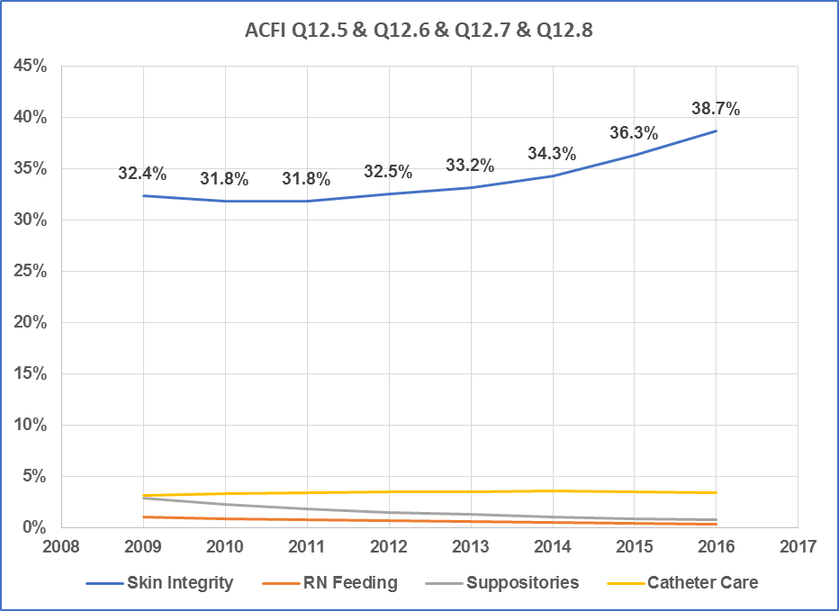

**Infectious Conditions, Chronic Wounds, Intravenous Fluids & Oedema**

The proportion of residents with claims for intravenous fluids and dialysis is extremely low (0.1 per cent) showing no growth since ACFI introduction. Similarly, infectious conditions were claimed for a low proportion of residents throughout the period (1.7 per cent) although there has been some growth (6.3 per cent pa.). The proportion of residents with chronic wounds claims is at 6.6 per cent or slightly over 11,000 residents at June 30, 2016 but this proportion has been consistent over the period since 2009 (Figure 6.7).

In comparison to these items, the proportion of residents with oedema claims has risen from 11.6 per cent in 2009 to 41 per cent in June 2016. This is a growth rate of 19.7 per cent pa. In this regard, the Department has split this item into two levels from January 2017, as described earlier in the discussion on changes to the ACFI since introduction.

Figure 6.7: Infectious Conditions, Chronic Wounds, Intravenous & Oedema (2009 – 2016)

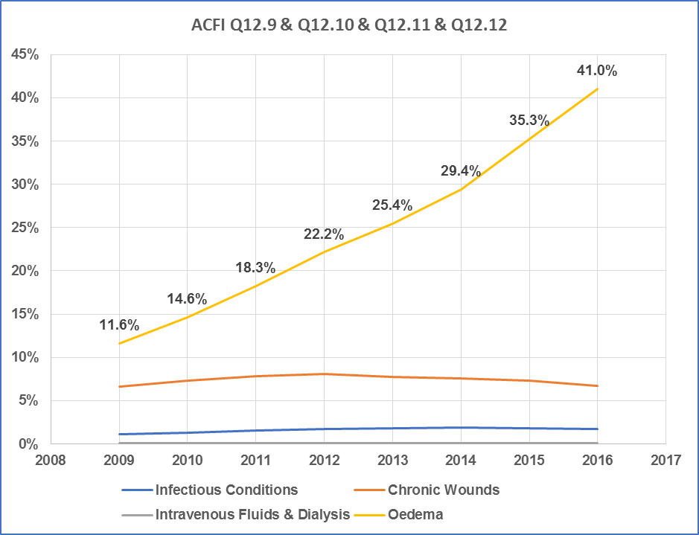

**Oxygen Therapy, Palliative Care & Stoma Care**

As at June 30, 2016, the proportion of residents with claims for oxygen therapy (2.1 per cent; growth rate 2.4 per cent pa.) and stoma care (1.2 per cent; growth rate -0.8 per cent pa.) are low and have been stable since ACFI introduction in 2009.

In contrast, the proportion of residents with palliative care claims, while also relatively low at June 30, 2016, has varied from 0.9 per cent in 2009, up to almost 2.3 per cent in 2013, and more recently down to 0.4 per cent (approximately 7,000 residents) at June 30, 2016. This represents a growth rate of negative 10.1 per cent pa. The reduction in the number of claims in the palliative care area is most likely due to a clarification from the Department regarding the criteria for a claim in this area and additional focus from the Departmental ACFI Review Program on what constituted a valid claim.

Figure 6.8: Oxygen Therapy, Palliative Care & Stoma Care (2009 – 2016)

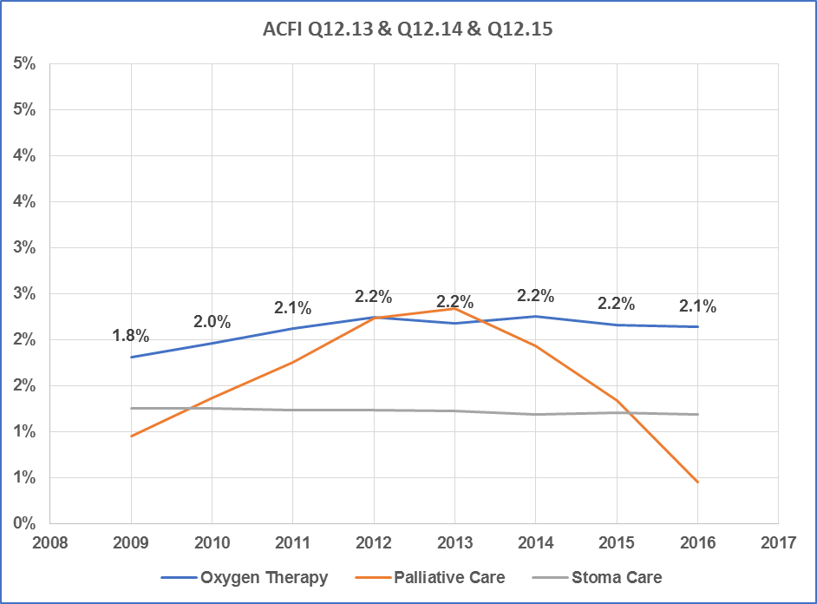

**Tracheostomy, Tube Feeding & Vital Signs Technical Equipment**

The proportion of residents with claims for tracheostomy, tube feeding and the use of vital signs technical equipment is extremely low (0.1 per cent) and has remained low since the introduction of the ACFI (Figure 6.9). In fact, negative growth has been recorded for both tracheostomy care (-6.4 per cent pa.) and tube feeding (-6.5 per cent pa.) since ACFI introduction. The use of vital signs technical equipment has shown growth over the period from 2009 (growth rate 17.9 per cent pa.) and was claimed for 0.6 per cent of residents (over 10,000) as at June 30, 2016.

Figure 6.9: Tracheostomy, Tube Feeding & Vital Signs Technical Equipment (2009 – 2016)

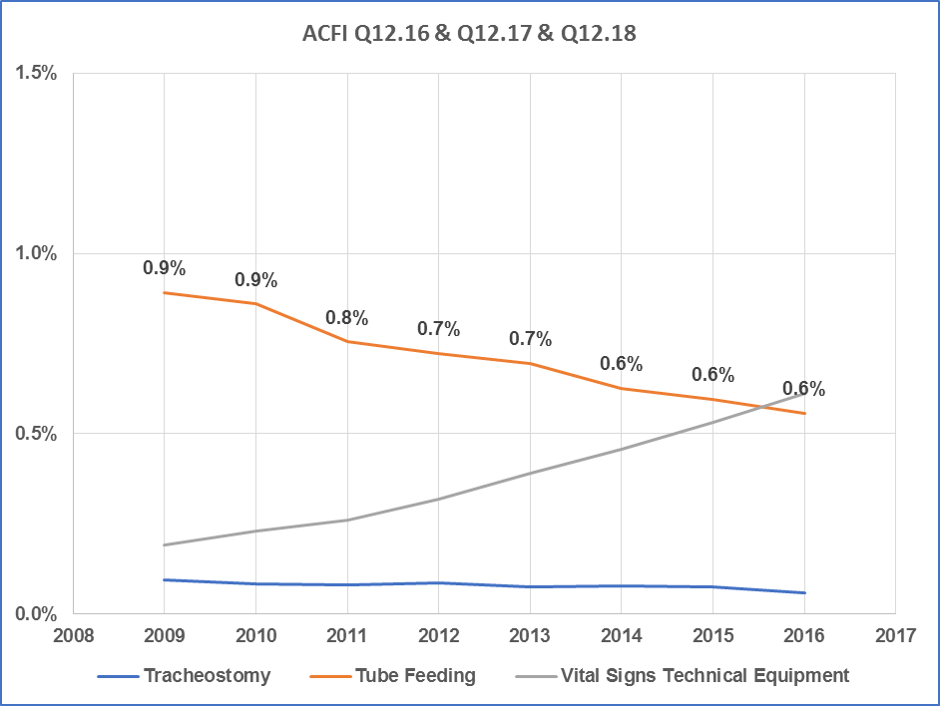

1. CHC Domain Review

AACS conducted a series of consultations, review of relevant tools and literature on assessment and statistical analysis on the CHC domain items as described in section 6.1 covering the distributional changes in the various items since 2009.

Contemporary issues were considered and using the findings from the consultations, item distributions and further statistical analyses, it was determined that a number of changes would be made to ACFI questions 11 and 12 to simplify the domain (e.g. remove the matrix), remove items that were not considered complex and reframe the complex pain management items in a broadly based therapy program. The following sections discuss the changes and recommendations.

1. Comprehensive Health Assessment Requirement

While the primary operation of the ACFI is as a funding tool, the R-ACFI has further expanded the requirement for evidence based assessments to underpin claims and the assessed care needs of residents. Although the individual items or list of health care procedures in this domain have requirements covering various specific items (e.g. assessments, directives), there is no overall requirement for a comprehensive health care assessment and the item requirements do not always cover the need for overall supervision and monitoring of the interventions by suitably qualified staff operating in their scope of practice.

In this regard, it is expected that all residents will receive regular nursing services which include health care assessments, care planning and evaluation by a nurse practitioner or registered nurse (RN). The CHC items in the R-ACFI are indicative items of complex health care needs, and the stated R-ACFI requirements are in addition to the expectation that all residents will receive regular health assessments, care planning and evaluation.

**Recommendation:** It will be required, for a claim in the CHC domain, that a resident has a regular documented comprehensive three-monthly health assessment undertaken and signed off by a registered nurse (RN) (e.g. Comprehensive Health Assessment – https://www2.health.vic.gov.au/ageing-and-aged-care/residential-aged-care/safety-and-quality/improving-resident-care/comprehensive-health-assessment).

1. Reconfiguration of Existing ACFI Questions
2. Medication Question moved into the CHC Procedure List

The ACFI 11 Medication question has been used in a matrix with ACFI 12 which covers complex health care procedures since the ACFI introduction. The matrix ‘weighting’ has been changed several times including the major change introduced on January 1, 2017 where Medication Q11 levels were combined into none, some help and injections and the new matrix with the ACFI 12 ratings (A, B, C, D) was created.

However, there are some issues with the matrix arrangement:

1. Current matrix funding approach does not reflect care needs for one scenario where the resident has an A in ACFI 11 and a B in ACFI 12 (scores zero). The ACFI 12 aspect is not funded.
2. Medication is effectively just another health procedure; thus, it does not warrant being a pivotal item in the determination of funding in the CHC Domain.
3. Combining medications into the procedures items also simplifies the funding determination as the domain and weights can be individually allocated to medication assistance and injection aspects. These weights can be adjusted in future.
4. By including the administration of medications in the health care procedures list, it allows the administration of suppositories at least weekly (ACFI 12.7) to be combined into the medication assistance procedure where it best fits.

By including medication into the single CHC question, all valid claims in medications and for CHC will be recognised in the scoring of the new R-ACFI 8 (CHC).

**Recommendation:** The medication items are included with the other procedures in the CHC domain. The recommended new medication item will have two levels, but only the item reflecting the higher complexity can be included in the claim.

The following items were therefore added to the R-ACFI CHC procedures list:

* Medication Item 9a (Level 1) – weight 3 points (determined in relativity to the other procedures): Suppositories and enemas (from ACFI 12.7), weekly patches, daily assistance with medications.
* Medication Item 9b (Level 2) – weight 6 points (determined in relativity to the other procedures): Daily administration of injections (subcutaneous, intramuscular and intravenous).

The medication changes do not impact on current care practices, and there are no changes to items that can be claimed. Additionally, it also better reflects the nursing resources required as stakeholders reported that daily medications are commonly administered by PCA staff who are monitored by RNs. Nurses (Enrolled Nurses and Registered Nurses) administer injections (and some of the other more complex medicines).

1. Depression Question is moved from the BEH Domain into the CHC Procedures List

**Care Staff and the Cornell Scale for Depression (CSD)**

Feedback from the consultations indicated that the depression assessment is not well understood by care staff and is not completed appropriately i.e. notes are not regularly completed for the items. Without notes against each CSD item, it is not possible to use the assessment information for care planning, as the scores do not inform on care needs.

**Validating the Cornell Scale for Depression (CSD) ACFI Claims**

From the Department RO perspective, the assessment result and ratings cannot be properly validated without the notes informing on why the outcome was reached. The assessment notes are central to validating the CSD items and completion of the notes would need to be made mandatory as an evidence requirement if the depression question continues to be the basis for the outcome of an assessment tool rating.

**Reframing the ACFI Depression Approach**

While a focus on depression and its symptoms in residential care needs to continue, it is essential to improve the current approach while still providing an emphasis and funding in this area. The option considered was to move the depression question from the behaviour BEH domain (statistical analysis using IRT also indicated that it now does not fit with the BEH domain questions) and to make it a single item within the CHC domain.

Consultations with stakeholder groups were in favour of this option, including the use of a simplified approach to Depression assessment in keeping with the skills of care staff. This will also allow for the selection of assessment tools to suit the needs of the resident.

There were several considerations that influenced the decision to move ACFI 10 Depression and place it with the CHC procedures list. These considerations, in brief, included:

The Major Depression question is a better fit to the CHC domain than to the current behaviour domain.

ACFI Depression claims require use of a depression assessment tool that has proven complex for many provider assessors and, as well, it has been subject to up-scoring which has impacted on the validity of the results. A depression assessment will still be needed as the basis for the claim but the score on the assessment will not determine the level of the claim.

A claim for Major Depression can be determined and validated via a diagnosis of Major Depression alone (evidence of how this was determined will be required). Some 36 per cent of claims had a diagnosis of depression. Seeking a diagnosis will no longer qualify as a diagnosis for a claim.

**Recommendation:** The depression question is included in the R-ACFI 8 CHC procedures list as a stand-alone item. The evidence requirements for a Depression claim will include:

* A mandated requirement for a current diagnosis of Major Depression (that impacts on current care needs). Example criteria for a diagnosis are set out in DSM-V (American Psychiatric Association, 2013).
* Completion of a depression assessment tool from the recommended list (no mandated tool).
* Provision of a care directive setting out the treatment and management approach.
* An item weight of 3 points (determined in relativity to the other procedures).

**Major Depression (APA, 2013)**

***Major Depressive Disorder – DSM V***

*1, Criteria A-C represent a major depressive episode.*

* 1. ***Five (or more) of the following symptoms have been present during the same 2-week period and represent a change from previous functioning; at least one of the symptoms is either (1) depressed mood or (2) loss of interest or pleasure.*** *Note: Do not include symptoms that are clearly attributable to another medical condition.*

1. *Depressed mood most of the day, nearly every day, as indicated by either subjective report  
   (e.g., feels sad, empty, hopeless) or observation made by others (e.g., appears tearful).*
2. *Markedly diminished interest or pleasure in all, or almost all, activities most of the day, nearly every day (as indicated by either subjective account or observation.)*
3. *Significant weight loss when not dieting or weight gain (e.g., a change of more than 5% of body weight in a month), or decrease or increase in appetite nearly every day. (Note: In children, consider failure to make expected weight gain.)*
4. *Insomnia or hypersomnia nearly every day.*
5. *Psychomotor agitation or retardation nearly every day (observable by others, not merely subjective feelings of restlessness or being slowed down).*
6. *Fatigue or loss of energy nearly every day.*
7. *Feelings of worthlessness or excessive or inappropriate guilt (which may be delusional) nearly every day (not merely self-reproach or guilt about being sick).*
8. *Diminished ability to think or concentrate, or indecisiveness, nearly every day (either by subjective account or as observed by others).*
9. *Recurrent thoughts of death (not just fear of dying), recurrent suicidal ideation without a specific plan, or a suicide attempt or a specific plan for committing suicide.*
   1. ***The symptoms cause clinically significant distress or impairment in social, occupational, or other important areas of functioning.***
   2. ***The episode is not attributable to the physiological effects of a substance or to another medical condition****.*

**Depression Assessment**

There are three recommended assessment tools - the modified CSD in Dementia (as used in the current ACFI), the K-10 and the GDS. This would cover the range of residents who can be interviewed and those who cannot be interviewed. This approach would also support the common use of the NSAF supplementary depression assessment tools, the K-10 and the GDS.

**Care Directive**

The depression care directive should set out the planned and individualised management strategy to address the resident’s depressive symptoms. For example, the Challenge Depression Kit (Fleming, 2001) sets out some practical steps that aged care staff can use to reduce depressive symptoms.

After identifying the symptoms (i.e. by assessment), the causes or underlying factors need to be considered. Evidence-based interventions can then be developed, and individualised care directives implemented to address the symptoms. In accordance with a quality improvement approach, the intervention should be reviewed regularly (e.g. three-monthly) and updated as required.

1. ACFI 12 Items to be Re-Weighted

The consultations covered CHC domain items and identified items not clinically complex to undertake, that should still be included as Registered Nursing staff play a role in supervising and, in the case of blood glucose measurement, assessing the significance of the results. Enrolled nurses or PCAs typically performed the activity. These items were therefore re-weighted as their importance relative to other procedures in the list was weighted too highly. The following changes are recommended:

**ACFI 12.2 Blood Glucose**

The measurement of blood glucose is no longer considered a complex care procedure. Blood Glucose readings were reported at the consultations to be undertaken by ENs with the RN monitoring the outcomes. This item could be reduced in weight from 3 points to 1 to reflect the lower complexity.

**Recommendation:** Theblood glucose item be re-weighted from 3 points to 1 point.

**ACFI 12.13 Oxygen Therapy**

Oxygen therapy was reported at the consultations as not clinically complex, with most associated activities undertaken by PCA staff with RN monitoring. This item could be reduced in weight from 3 points to 1 to reflect the lower complexity.

**Recommendation:** The oxygen therapy item be re-weighted from 3 points to 1 point.

1. ACFI 12 Items recommended to be removed from the R-ACFI Complex Health Care Domain

The consultations covered items that should be removed as they were not clinically complex and did not fit within the CHC domain. Accordingly, the following changes are recommended:

**ACFI 12.1 Blood Pressure**

This aspect of care is no longer considered a complex care issue, with the availability of automatic reading machines. It is also within the scope of practice of many care staff types (ENs and PCAs with some minor training), with the RN playing a monitoring role. As such, Blood Pressure measurement does not discriminate between residents, and is considered to be part of the usual nursing care provided to all residents (i.e. as part of the regular resident reviews).

**Recommendation:** The blood pressure item be removed and the funding re-allocated to the remaining CHC procedures.

**ACFI 12.18 Technical equipment for continuous monitoring of vital signs including Continuous Positive Airway Pressure (CPAP) machine**

Consultations informed that this item is not a complex treatment – it is a monitoring task and is undertaken by, and within the scope of practice of, nearly all care staff types.

**Recommendation:** Item 12.18 Technical equipment for continuous monitoring of vital signs item be removed and the funding reallocated to the remaining CHC procedures.

1. ACFI 12 Items to be included within existing R-ACFI Questions

Some items were found to have a more logical fit to another R-ACFI question or were considered effectively covered elsewhere. These items are to be moved or removed:

**ACFI 12.7 Suppositories and enemas**

As the R-ACFI includes medication in the procedures list, it is appropriate to include suppositories and enemas in the medication assistance item (R-ACFI item 9a).

**Recommendation:** ACFI12.7 Suppositories and enemas be moved to the new Medication Item (Level 1). The weekly administration of suppositories or enemas is clinically infrequent and not considered best practice as a frequent intervention.

**ACFI 12.12a Management of arthritic joints and oedema related to arthritis by the application of tubular and/or other elasticised support bandages**

As the former ACFI 12.12 item has now been split into two aspects (item 12.12b is discussed later), it was considered that the current ACFI 12.12a ‘Management of arthritic joints and oedema related to arthritis by the application of tubular and/other elasticised support bandages’ is adequately covered in the activities of R-ACFI 3 Personal Hygiene (Dressing & Undressing). Consultations informed that this item is not a complex care issue – it is within the scope of practice of nearly all care staff types, and is undertaken as part of the daily dressing routine. Also, treatments and procedures under Specified Care and Services (SC&S 2.4) covers the care and services related to bandages and dressing as directed for use by a Health Professional (i.e. such as directed in ACFI 12.12a).

**Recommendation:** ACFI12.12a Management of arthritic joints and oedema related to arthritis by the application of tubular and/or other elasticised support bandages be included as a normal part of care under R-ACFI 3 Personal Hygiene (Dressing & Undressing). The fitting and removing of hip protectors, slings, cuffs, splints, medical braces, tubular elasticised support bandage and prostheses other than for the lower limb is to be moved to the R-ACFI 3 question.

1. Pain Management Items Restructure

More detailed discussion on the re-framing of the pain management items is covered in Chapter 7. This section provides a brief overview of the issues and recommended outcomes.

**ACFI 12.3, 12.4a, 12.4b: Pain Management Items**

* + - 1. **Narrow Focus**

While these items target an important care need area, the specific interventions listed are too narrowly focused (heat packs, massage, technical equipment). Funding would be better targeted to a broader physical Therapy Program to provide not only pain management programs but support physical therapies for improvement or maintenance of functioning. This would enable the therapy interventions to be broadened to include a general wellness, restorative approach, and provides an opportunity to directly include the consumer in choice of options.

* + - 1. **Excessive Growth**

The funding provided to target pain management via these three items has grown significantly since 2009 (Table 6.5). The item that funds AHP interventions to target pain management (item 12.4b) has had a per annum growth rate of 54.5 per cent since 2009 and a disproportionate amount of the ACFI funding is now determined by these three items.

Table 6.5: Growth in Pain Management Q12 Items

| ACFI sub-question | Level | Years of data | Value at start | Value at June 2016 | Growth pa |
| --- | --- | --- | --- | --- | --- |
| Q12.3 | Pain – basic | 7 | 18.8% | 50.4% | 15.1% |
| Q12.4a | Pain – RN | 7 | 5.8% | 33.7% | 28.7% |
| Q12.4b | Pain – AHP | 7 | 1.7% | 35.3% | 54.4% |

**Recommendation:** To address the narrow focus of the current pain management items, deliver a more consistent and predictable funding outcome and fund a more broadly-based physical Therapy Program. It is recommended that the three pain management items are removed from the CHC Domain and combined into a new R-ACFI Therapy Program. The Therapy Program would be funded from the money currently attributed to these items.

Stakeholders were very supportive of moving the pain items into a Therapy Program. The recommended Therapy guidelines are discussed in Chapter 7.

1. Restructure of Item 12.12b Management of Non-Arthritic Oedema

The CHC procedure covering non-arthritic oedema (12.12b) is currently:

**Current item 12.12b:** Management of oedema related to:

“Non-arthritic oedema OR deep vein thrombosis by the fitting and removal of compression garments and/or compression bandages or chronic skin conditions by the application and removal of dry dressings and/or protective bandaging.”

Feedback from the consultations and discussions with wound management experts has indicated that a further review of the item is needed to better fit with contemporary practice to ensure the correct clinical approach is supported. It is recommended that 12.12b (R-ACFI CHC item 7) be modified to include aspects associated with:

Oedema due to a medical diagnosis of:

* chronic venous insufficiency
* lymphedema
* acute (ongoing) DVT

A more specified directive covering:

* measurements taken
* level of compression required
* type/description of the prescribed garment; and
* application directions

Refer to the recommended R-ACFI procedures list in section 6.4.1 (Table 6.6) for full details.

1. Mandatory Re-Appraisal 6-Months after a Claim for Palliative Care

To ensure that palliative care claims are congruent with the intent and requirements as specified in the R-ACFI User Guide, it is recommended that the full R-ACFI must be re-submitted 6 months after the claim comes into effect.

1. Future Changes for Consideration in the R-ACFI

There were a number of other changes considered for inclusion in the R-ACFI that are described in Appendix 6.3 (e.g. Bariatric care). The changes were deemed not feasible for implementation within this phase (i.e. within 12 months). It is recommended that they should be considered in future R-ACFI modifications.

1. The R-ACFI CHC Domain Recommended Changes

The rationale for and the recommended changes to the R-ACFI CHC question is described in Appendix 6.2. The recommended changes in summary are:

1. A new requirement a claim in the Complex Health Care domain is that there is documented evidence that the resident has a regular ongoing 3 monthly comprehensive health assessment undertaken and signed off by a registered nurse.
2. The Medicationquestion (ACFI 11) hasbeen moved into the R-ACFI Complex Health Care Procedures list as two separate items. The items are now (i) daily medications, patches, suppositories and enemas (weight 3) and (ii) daily injections (weight 6).
3. Removal of the items 12.1 blood pressure, 12.18 vital signs technical equipment as these are considered not discriminating items and low in complexity.
4. Removal of the item 12.12a management of arthritic joints & oedema as it is included and covered in the R-ACFI 3 checklist item “dressing and undressing”.
5. Improvements to the ACFI item focusing on non-arthritic oedema 12.12b (R-ACFI CHC item 7) to include aspects associated with a medical diagnosis of specific types and a detailed directive covering measurements, level of compression, types of garments and application.
6. Re-weighting of the blood glucose and oxygen therapy items from 3 points to 1 point to reflect their lower level of complexity in relation to the other items.
7. Inclusion of a Depression item into the CHC procedures list and re-framed as “Major Depression”. The funding from the Depression question has been added into the Complex Health Domain funding pool ($3.65 per day).
8. A palliative care claim will now trigger a 6-month mandatory re-appraisal.
9. Relocation of the pain management items (12.3, 12.4a, 12.4b) and funding into the new R-ACFI Therapy Program which has a broader physical therapy focus. The funding determined from the pain management items over the past 4 years has been averaged and $15 per day has been transferred from the Complex Health Domain into the new Therapy Program.

These changes have meant that the domain required re-calibration with revised cut points. The removal of the pain management items also means that the funding attached to these claims is removed from the CHC domain and re-allocated into the new Therapy Program.

Details of the Therapy Program are provided in Chapter 7 and the funding changes are detailed in Chapter 8.

1. Recommended User Guide R-ACFI Format for the CHC Domain

**Description**

This question relates to the assessed need for ongoing Complex Health Care (CHC) procedures and activities. It excludes temporary nursing interventions e.g. management of temporary post-surgical catheters or stomas, management of minor injuries or acute illnesses such as colds.

The ratings in this question relate to the technical complexity and frequency of the procedures. The minimum frequency of procedures is ‘at least weekly’ – if less than this it is not taken into account in calculating a rating.

**Requirements**

To be eligible for CHC Domain funding:

* There must be a claim on at least one item in the R-ACFI 8 procedures list; and
* There is evidence that the resident has a regular ongoing documented three-monthly comprehensive health assessment undertaken and signed off by a RN.

A procedure satisfies the requirements for R-ACFI 8 if:

* The stated requirements in the checklist are met for an item;
* A Health Professional acting in their scope of practice conducts an Assessment of the resident’s usual care needs at the time of the appraisal;
* The Health Professional identifies the resident’s care needs in a Directive; and
* A record of treatment is provided in requested items; and
* A Palliative Care claim will require a mandatory re-appraisal in 6 months.

**Directives**

A Directive must:

* Be given by a Health Professional acting in their scope of practice;
* Be given by a Medical Practitioner or RN or AHP, if specifically required by the item;
* Direct the manner in which the care is to be provided, the qualifications of any person involved in providing the care, and the frequency of the treatment; and
* Identify the associated management and /or treatment plan.

**Record of Treatment**

The Record of Treatment must be kept in accordance with the Directive as long as the treatment is being provided. An Australian Government Authorised Officer may request to see a record of treatment.

The R-ACFI Answer Appraisal Pack must include copies of treatment records post the submission date, for a reasonable period, to support the claim (refer ACFI User Guide page 8, Record Keeping, the *‘ACFI appraisal pack must include all information needed by the department to verify a provider’s ACFI claim’)*.

**Assessments**

Assessments are required for skin integrity, special RN feeding, depression, chronic wound management and palliative care. The recommended assessments for depression are:

* Revised CSD in Dementia
* GDS
* K-10

The CSD is found in the ACFI Assessment Pack. The GDS and K-10 are supplementary tools used by the ACATs in the NSAF.

It is recommended that for an assessment to be current it must have been completed within the past 3 months and continue to reflect the resident’s complex health care needs at the time of appraisal. This would require the resident’s complex health care needs to be reviewed for any recent changes and the assessment/directive to be signed off (indicating there are no changes) during the appraisal period.

‘**Health Professional’** means a practitioner listed in A or B below:

**List A**

* Nurse practitioner;
* Registered nurse;
* Medical practitioner; or
* An allied health professional who is an: Occupational Therapist; Physiotherapist; Podiatrist; Chiropractor; Osteopath and has a current certificate of registration issued by the National Board for that person’s profession (see the *Health Practitioner National Regulation Law 2009* (the National Law).

**List B**

An allied health professional who is a Dietitian, Speech Pathologist or Exercise Physiologist and has current accreditation with the relevant self-regulated professional body.

Table 6.6: Checklist of R-ACFI CHC procedures to be completed

| R-ACFI Score | CHC procedures | Evidence Requirements | Tick if yes |
| --- | --- | --- | --- |
| 1 | Management of ongoing stoma care.  Excludes temporary stomas e.g. post-surgery. Excludes supra pubic catheters (SPCs). | 1. Diagnosis  **AND**  2. Directive [registered nurse or medical practitioner] | 🞏 1 |
| 1 | Blood glucose measurement for the monitoring of a diagnosed medical condition e.g. diabetes, is an ongoing care need AND frequency at least daily. | 1. Medical practitioner directive  AND  on request: record | 🞏 2 |
| 1 | Oxygen therapy not self-managed. | 1. Diagnosis  **AND**  2. Directive [registered nurse or medical practitioner] | 🞏 3 |
| 3 | Complex skin integrity management for residents with compromised skin integrity who are usually confined to bed and/ or chair and cannot self-ambulate. The management plan must include repositioning at least 4 times per day. | 1. Directive [registered nurse or medical practitioner or allied health professional]  **AND**  2. Skin integrity assessment | 🞏 4 |
| 3 | Management of special feeding undertaken by RN, on a one-to-one basis, for people with severe dysphagia, excluding tube feeding.  Frequency at least daily. | 1. Diagnosis  AND  2. Directive [registered nurse or medical practitioner or allied health professional]  **AND**  3. Swallowing Assessment | 🞏 5 |
| 3 | Catheter care program (ongoing); excludes temporary catheters e.g. short term post-surgery catheters. | 1. Diagnosis  **AND**  2. Directive [registered nurse or medical practitioner] | 🞏 6 |
| 3 | Complex management of oedema, when the management plan includes the use of compression therapy that includes (bandages/ hosiery/ garment) applied at least weekly for oedema due to one of the following medical conditions as diagnosed by the medical practitioner:   * + chronic venous insufficiency   + lymphoedema   + acute (ongoing) DVT (lower leg)   The compression garments must be selected correctly to apply the degree of compression required by the individual resident, as evidenced in the diagnosis, assessment and directive.  It is expected that the Health Professional providing the directive for treatment would have the clinical expertise to identify the appropriate garments for treating these complex health care conditions. | 1. Diagnosis (documented by a Medical Practitioner)   **AND**   1. Directive [registered nurse or medical practitioner or allied health professional].   The Directive is to contain the assessment outcomes, goals of treatment and treatment plan, covering:   1. Aim of the compression therapy 2. Type/description of the bandage/hosiery/garment 3. Objective measurements  e.g. calf size, ankle size, Doppler ankle brachial pressure index [ABPI] etc. 4. Compression mmHg 5. Application directions (e.g. frequency of application, who is to apply the therapy). 6. Review details.   **AND**  **3.** Record of Treatment | 🞏 7 |
| 3 | Depression | 1. Diagnosis of Major Depressive Disorder   **AND**   1. Directive [registered nurse or medical practitioner]   **AND**   1. Depression Assessment (recommend CSD, GDS, K-10) | 🞏 8 |
| 3 | Medications 1- Weekly patches, suppositories or enemas, Daily Medication Assistance. | 1. Medication Directive/Chart [medical practitioner] | 🞏 9a |
| **OR** | | | |
| 6 | Medications 2- Daily administration of injections (Subcutaneous, intramuscular, intravenous).  Can only claim one item- either 9a or 9b. | 1. Medication Directive/Chart [medical practitioner] | 🞏 9b |
| 6 | Management of chronic infectious conditions   * Antibiotic resistant bacterial infections * Tuberculosis * AIDS and other immune-deficiency conditions * Infectious hepatitis | 1. Diagnosis  **AND**  2. Directive [registered nurse or medical practitioner] | 🞏 10 |
| 6 | Management of chronic wounds, including varicose and pressure ulcers, and diabetic foot ulcers | 1. Diagnosis  **AND**  2. Directive [registered nurse or medical practitioner or allied health professional]  **AND**  3. Wound Assessment  **AND**  On request: record | 🞏 11 |
| 6 | Management of ongoing administration of intravenous fluids, hypodermoclysis, syringe drivers and dialysis. | 1. Directive/prescription [authorised nurse practitioner or medical practitioner] | 🞏 12 |
| 6 | Suctioning airways, tracheostomy care. | 1. Diagnosis  **AND**  2. Directive [registered nurse or medical practitioner] | 🞏 13 |
| 6 | Management of ongoing tube feeding. | 1. Diagnosis  **AND**  2. Directive [registered nurse or medical practitioner or allied health professional] | 🞏 14 |
| 15 | Palliative Care Program involving End of Life care where ongoing care will involve intensive clinical nursing and/or complex pain management in the residential care setting.  **End-of-life (terminal) care definition**  ***This description is similar to and modified from the end-of-life description found in page 6 of the 2017 ACFI User Guide.***  *“… palliative care is appropriate when the resident is in the final days or weeks of life and care decisions may need to be reviewed more frequently.” (Australian Palliative Residential Aged Care Project, 2006, p. 38)* | 1. Directive by [CNC/CNS in pain or palliative care or medical practitioner]  **AND**  2. Pain Assessment (as per Pain Management Guidelines (PMG) kit)  **AND**  3. Assess the resident using the Palliative Approach Toolkit in Residential Aged Care Facilities.  *Note: a Palliative Care claim will require a mandatory re-appraisal in 6 months. | 🞏 15 |

1. The R-ACFI CHC Classification Model

The R-ACFI CHC domain uses the list of procedures and their weightings to derive a distribution and then cut points based on categories of none (no score), low, medium and high. The weightings are described in Table 6.6. A score in any item will result in a low domain rating. The distribution has been aligned as far as possible to the current ACFI CHC domain although changes in funding outcomes from the ACFI to R-ACFI are mainly dependent on the level of claims in the pain management items. The funding outcomes in the CHC domain should be considered in combination with the funding available in the new Therapy program ($15 per day).

Full details on the R-ACFI CHC funding are described in Chapter 8.

1. Accountability

The strategies to improve accountability are:

* New recommended Comprehensive Health Assessment to be completed three-monthly.
* Recommendation to only allow a depression claim for major depression.
* A palliative care claim will now trigger a 6-month mandatory re-appraisal.
* Mandating that a RN or AHP sign off on all assessments as this is current practice in most organisations, for both legal and quality requirements.
* The R-ACFI User Guide should emphasise that Health Professionals are accountable to their registration body (AHPRA) for their professional decisions, and identified issues will be referred to AHPRA.
* Supporting family members to sign off on the ACFI pack – this would also support CDC practices by ensuring that they have a clear understanding of their relative’s care needs and required services.

1. The R-ACFI CHC Domain - Snapshot

AACS conducted a series of consultations, review of relevant tools and literature on assessment and statistical analysis on the Complex Health domain items. The major changes recommended for this domain involve the removal of the pain management items and the associated funding ($15 per day) and the addition of the depression item which contributed an additional $3.64 per day to the CHC funding pool. Full details of the R-ACFI CHC funding is provided in Chapter 8.

Changes (in brief) to the Complex Health domain include:

* + 1. A new requirement for any claim in the Complex Health Care domain is that there is evidence that the resident has a regular ongoing documented 3 monthly comprehensive health assessment undertaken and signed off by a registered nurse.

1. The Medicationquestion (ACFI 11) hasbeen moved into the R-ACFI Complex Health Care Procedures list as two separate items. The items are now (i) daily medications, at least weekly patches, suppositories and enemas (weight 3) and (ii) daily injections (weight 6).
2. Removal of the items 12.1 blood pressure, 12.18 vital signs technical equipment as these are considered not discriminating items and low in complexity.
3. Removal of the item 12.12a management of arthritic joints & oedema as it is included and covered in the R-ACFI 3 checklist item “dressing and undressing”.
4. Improvements to the ACFI item focusing on non-arthritic oedema 12.12b (R-ACFI CHC item 7) to include aspects associated with a medical diagnosis of specific types and a detailed directive covering measurements, level of compression, types of garments and application.
5. Re-weighting of the blood glucose and oxygen therapy items from 3 points to 1 point to reflect their lower level of complexity in relation to the other items.
6. Inclusion of a Depression item into the CHC procedures list and re-framed as “Major Depression”. The funding from the Depression question has been added into the Complex Health Domain funding pool ($3.65 per day).
7. A palliative care claim will now trigger a 6-month mandatory re-appraisal
8. Relocation of the pain management items (12.3, 12.4a, 12.4b) and funding into the new R-ACFI Therapy Program which has a broader physical therapy focus. The funding determined from the pain management items over the past 4 years has been averaged and $15 per day has been transferred from the Complex Health Domain into the new Therapy Program.

Table 6.7 provides a summary of the assessments relevant to the R-ACFI CHC domain.

Table 6.7: R-ACFI Complex Health Assessment Tools Recommendations

| Complex Health Care (CHC) | | |
| --- | --- | --- |
| **Mandatory** | **Recommended** | **Source** |
| **Comprehensive Health Assessment (CHA)** Regular, ongoing, documented 3-monthly, comprehensive health assessment, undertaken and signed off by a Registered Nurse | Comprehensive Health Assessment for Older People: Documentation Template, 2014. (CHAOP) | La Trobe University (ACEBAC) research team: Dr Deirdre Fetherstonhaugh, Dr Margaret Winbolt, Dr Michael Bauer, Professor Rhonda Nay. This project was supported with funding from Victorian Department of Health, Wellbeing, Integrated Care and Ageing Division and from the Home and Community Care Program which is jointly funded by the Commonwealth and Victorian Governments. [Comprehensive health assessment of the older person](https://www2.health.vic.gov.au/ageing-and-aged-care/residential-aged-care/safety-and-quality/improving-resident-care/comprehensive-health-assessment) |
| **Nursing Assessments** are required for:  Skin Integrity-  R-ACFI 8 item 4  Swallowing-  R-ACFI 8 item 5  Wounds-  R-ACFI 8 item 11 | Validated assessments | For example, NATFRAME (National Framework for Documenting Care in Residential Aged Care Services) |
| **Nursing Assessment**  R-ACFI 8 item 7-  Complex management of oedema | Compression garment selection, fitting and monitoring education resource (2014) | Queensland Health. Compression garment selection, fitting and monitoring education resource (2014) [Compression garment selection, fitting and monitoring education resource Component 1: Self guided learning package](https://www.health.qld.gov.au/__data/assets/pdf_file/0021/146109/self-guided-learn.pdf) |
| **Depression Assessment**  R-ACFI 8 item 8 | Revised Cornell Scale for Depression (CSD) | ACFI Assessment Pack |
| Kessler Psychological Distress Scale (K10) | NSAF |
| Geriatric Depression Scale (GDS) | NSAF & NATFRAME |
| **Palliative Care Assessment**  R-ACFI 8 item 15 | The resident is to be assessed using the Palliative toolkit in Residential Aged Care. | Recommended Pain Assessments from the Pain Management Guidelines (PMG) kit. |

Table 6.8 below provides a summary of the CHC domain recommendations. Note any "NR" references indicate no recommendation was provided.

Table 6.8: Summary of CHC Recommendations

| **Change** | **Detail** | **Assessments, Checklists, Ratings** | | | | | **Audit system** | | | | |
| --- | --- | --- | --- | --- | --- | --- | --- | --- | --- | --- | --- |
| *Changes noted below* | *Details noted below* | **Mandate/ Recommend** | **Validated assessment** | **Standardised information** | **Contemporary** | **Outcomes** | **Fit to External Assessment** | **Fit to RAC workforce** | **Fit to Gateway** | **Clarifies** | **Improves reviews** |
| **Assessm’t (Ax)** | Comprehensive Health Assessment | Recommend  3-monthly CHA tool | YES | *NR* | *NR* | Currency (3/12)  For all CHC claims | No assessment | RN/AHP sign off | *NR* | Professional Accountability | Claim requires a new Ax |
| **Assessm’t** | Depression Assessments for Depression item | Recommend  CSD, GDS &  K-10 | YES | *NR* | YES | CSD  GDS  K-10 | YES | CSD | GDS &  K-10 in NSAF | Information is for care planning, score not used | Shared evidence |
| **Assessm’t** | Palliative Care needs Ax | Palliative toolkit in Residential Aged Care | *NR* | YES | YES | Description of end stage | YES | No change- in current ACFI User Guide | *NR* | *NR* | Definition clarity |
| **Assessm’t** | Pain Ax for Palliative item | Pain Management Guidelines (PMG) kit | YES | *NR* | YES | R-ACFI 8. 15 Scores 15 | YES | No change- in current ACFI User Guide | *NR* | *NR* | *NR* |
| **Items removed** | BP;  Vital signs | *NR* | *NR* | *NR* | *NR* | Not complex | No assessment | *NR* | *NR* | Complexity | *NR* |
| **Items re-scored** | BGL ;  Oxygen Therapy | *NR* | *NR* | *NR* | *NR* | R-ACFI 8 Q2  R-ACFI 8 Q3 (scores reduced from 3 to 1) | YES | No change | *NR* | Low complexity | *NR* |
| **Item relocated** | Pain mgmt. items; | Pain Mgmt Guidelines (PMG) kit | *NR* | *NR* | YES- broader therapy choice | Moved into Therapy Program | Broad need | No ax changes | *NR* | *NR* | As set out in Therapy Program |
| **Item relocated** | Management of arthritic joints/oedema | *NR* | *NR* | *NR* | *NR* | Covered in  R-ACFI 3 | No assessment | No practice change | *NR* | Standard care | Reduces requirements |
| **Item relocated** | Suppositories & enemas | *NR* | *NR* | *NR* | Following best practice | Included in Medication  R-ACFI 8. Q9a | YES | No change | *NR* | *NR* | *NR* |
| **Item clarified** | Mgmt. of oedema | Assessment | *NR* | *NR* | Following best practice | R-ACFI Q8.7 | YES | YES | *NR* | *NR* | Objective Directive |
| **Items added** | Medication  - 2 levels | *NR* | *NR* | *NR* | *NR* | R-ACFI 8 Q9a (scores 3)  R-ACFI 8 Q9b (scores 6) | YES | No change | *NR* | *NR* | *NR* |
| **Items added** | Depression | *NR* | YES | Major Depression | Broader ax choice | R-ACFI 8 Q8 (scores 3) | YES | Broader ax choice | *NR* | *NR* | Stronger Diagnosis |

1. R-ACFI Therapy Program

This Chapter contains the following sections:

* Rationale for a Therapy Program.
* Research on Physical Activity Interventions.
* Program Principles.
* Program Funding.
* Recommendations and User Guide Overview.
  1. Why consider a Therapy Program in the R-ACFI?

There are two key reasons why a Therapy Program has been considered for the R-ACFI. Firstly, the current ACFI funding for physical therapy is limited to pain management and the approved specific interventions listed are narrowly focused (heat packs, massage, technical equipment). This means that broader-based physical Therapy Programs are not directly linked to ACFI funding. As there is good evidence that physical therapy interventions that include general wellness, restorative or maintenance approaches will benefit aged care residents, it is appropriate to review the structure and operation of these items. A new broadly-based Therapy Program will not only better target resident needs, but also give an opportunity to directly include the consumer and families in the choice of options.

Secondly, the excessive growth in the pain management items needs to be addressed as it is the single most important factor in ACFI funding growth beyond the Government’s forward financial estimates. From 2014 to 2015, there was funding growth of 5.2 per cent in the ADL domain, 5.2 per cent in the Behaviour domain and 11.2 per cent in the CHC domain. The growth of funding in the CHC domain is almost exclusively due to the increased proportion of residents with pain management claims. The growth in the proportion of residents with pain management claims has risen significantly and consistently since the introduction of the ACFI. For example:

* ACFI 12.3 proportion of resident claims were 19% in 2009, 40% in 2014, and 50% in 2016.
* ACFI 12.4a proportion of resident claims were 6% in 2009, 27% in 2014, and 34% in 2016.
* ACFI 12.4b proportion of resident claims were 2% in 2009, 20% in 2014, and 35% in 2016.

Without modification, these items will eventually be significantly altered or dropped altogether from the ACFI to maintain the Government’s budget commitments.

The current review of the ACFI gives an opportunity to redress these issues and to provide more financial certainty for the Government and providers, in addition to improving the assistance and support to people living in residential aged care.

* 1. Are Physical Therapy Programs Effective?

There is a growing body of evidence of the range of positive outcomes from physical therapy interventions with older frail persons. It not only improves or maintains functional ability, but can also impact on the management of chronic diseases and their associated risks, reducing falls, and improving social and quality of life outcomes.

A recent literature review by Bauman, Merom, and Bull (2016) titled “Updating the Evidence for Physical Activity” stated that:

“*There is a global imperative to increase awareness of the emerging evidence on physical activity (PA) among older adults. “Healthy aging” has traditionally focused on preventing chronic disease, but greater efforts are required to reduce frailty and dependency and to maintain independent physical and cognitive function and mental health and well-being. … There is epidemiological evidence that physical activity impacts (positively) on chronic disease prevention and risk reduction, functional status, psychological well-being, and social outcomes. … Many reviews and position statements support the benefits of PA for function, chronic disease outcomes, and mortality benefits in older adults, and these functional benefits extend to frail elders.”* (p. S268).

An evidence review by Sherrington, Lord, and Close (2008) reported that:

*“There is some evidence that exercise can be effective as part of a multifaceted approach to prevent falls in both community and residential aged care settings”* (p. 1), and that *“group exercise can be safely provided for residents…(and) suggest that group programs could also prevent falls in nursing homes if they are delivered with sufficient staff/participant ratios to ensure safety”* (p 17).

Updated best practice recommendations and meta-analysis findings for falls prevention in older adults by Sherrington, Tiedemann, Fairhall, Close, and Lord (2011) reported that:

*“…systematic reviews now provide clear evidence that falls in older people can be prevented with appropriately designed intervention programs”* (p. 78). The authors further suggest that exercise should be undertaken for at least 2 hours per week, on an ongoing basis, with a mixture of group-based and home-based (individual) exercise, with both options to be available; these recommendations are applicable to people in residential aged care (p. 81).

Physical therapies can be undertaken by AHPs such as physiotherapists, chiropractors, osteopaths, occupational therapists and exercise physiologists (Transport Accident Commission, n.d.).

Currently, Exercise Physiologists are not recognised in the list of Health Professionals in the ACFI User Guide (page 38). However, their practices fit strongly into the planned Therapy Program and their inclusion is recommended in the new R-ACFI Therapy Program model.

Deloitte Access Economics (2015) identified that:

*AEP (Accredited Exercise Physiologist] led interventions are efficacious and highly cost effective in the Australian health care setting, with cost benefit ratios calculated for pre-diabetes, type 2 diabetes, mental illness, cardiovascular disease, chronic back pain, osteoarthritis and rheumatic disease, concluding that AEPs can provide substantial benefits across a range of conditions* (p. 75)*.*

Exercise & Sports Science Australia (ESSA) (2016a) state that:

*“Increasing the exercise and physical activity levels of older people can prevent, or aid in the management of, a myriad of chronic health problems. It can also improve and maintain physical function, promote independence, reduce falls, improve quality of life and slow cognitive decline. Many chronic diseases can be prevented or delayed by healthy behaviours and, importantly, by the environments that support them. Health and social systems can work together to strengthen and maintain capacity and even reverse declines. However this requires a shift in focus from reactive care to preventative measures.”* (p. 1).

ESSA (2016b) further assert that:

*“There is strong evidence that clinical exercise interventions, as delivered by accredited exercise physiologists, provide a range of physical, mental and psychosocial benefits to older people, independent of age, disability or disease. For example, exercise can improve cardiovascular fitness, muscular strength and balance, decrease symptoms of depression, anxiety and pain and, when completed in a group setting, foster social connections and feelings of belonging. Further, exercise is a very accessible intervention that can be undertaken in a range of settings, including residential aged care facilities and is proven to be highly cost effective, when delivered by accredited exercise physiologists*… *ESSA supports the adoption of contemporary policies and funding models within aged care that develop and maintain an individual’s functional abilities…including their ability to engage in evidenced-based physical activity programs.”* (p. 1-2).

A wellness and reablement approach in home care has been actively supported by the Australian government (Nous Group, n.d.) and is described on the website as:

* Wellness is building on strengths and goals of individuals to promote independence in daily living skills.
* Reablement is short term interventions to adapt to functional loss or to regain confidence and capacity.

Wellness fits into the new Physical Therapy program in the R-ACFI, as physical therapies have been associated with improving not only physical but also social and psychological wellness (Martin et al, 2013). A flexible Therapy Program approach could also support short term interventions, with the wellness approach being ongoing.

* 1. Physical Therapy Program Principles

Consultations with a broad range of stakeholders within the Australian aged care sector were undertaken regarding possible changes to the ACFI. Stakeholders included representatives from peak bodies, leading industry groups, government ROs, and the ACFI Technical Reference Group. There was widespread interest in the development of a new, broadly-based Therapy Program in the new R-ACFI. Questions covered in the consultations focusing on the content and funding approach for the new Therapy Program included:

* Does Specified Care and Services ensure the provision of a Therapy Program?
* Should we include a Therapy Program in the R-ACFI as a “price signal”?
* How to structure such a program – ‘package up’ the pain interventions into a broader physical Therapy Program?
* Should it include a broader range of therapeutic inputs from a variety of AHPs, providing physical therapies, with flexibility around the program design and the AHPs who will deliver it?
* Would a new single domain or question focused only on therapy be the best way to target the program and provide a basis for accountability?
* Could the funding for the program be re-allocated from the pain management items into a Therapy Program?
* Should the Therapy Program be based on a Consumer Directed Care approach, with individualised goals?
* How could the Therapy Program be designed for accountability purposes? Should it be time based Therapy Program? What documentation requirements would be needed?

Stakeholders were very supportive of developing a broadly-based Therapy Program that incorporated the pain items as well as using the ACFI funding from the pain claims in the new Therapy Program. As an outcome of the feedback and comments from the consultations and other input from subject matter experts, the following principles were developed to guide the design of the Therapy Program:

1. Therapy programs should encompass a broad range of physical therapy interventions to ensure (where relevant) inclusion of a maintenance of general wellness and a restorative approach.
2. Therapy Programs should have an evidence-based underpinning and approach.
3. The Programs should include a wide range of therapeutic inputs from a variety of health professionals.
4. Therapy Programs will be designed and delivered as 1:1 or group activities.
5. Consumers should be provided with opportunities to directly influence the type and features of any program designed for them.
6. The Therapy Program will incorporate an Accountability Framework.
7. All residents of aged care facilities will be eligible for the Therapy Program.
8. Funding will be available to support all residents in a facility.

The principles will now be discussed in more detail.

1. Therapy programs should encompass a broad range of physical therapy interventions to ensure (where relevant) inclusion of a maintenance of general wellness and a restorative

Participants indicated that it would be a better outcome for residents’ wellbeing if the item is not restricted solely to pain management, but should incorporate other Therapy Programs e.g. individual exercise, strengthening, balance and falls prevention programs – as determined clinically by the registered health professionals in consultation with the resident and their family. This would give a focus on wellness, reablement and maintenance of physical functioning.

Feedback from a consultation participant indicated *“We believe the industry would readily embrace an approach that provides a more expansive view of ‘therapy’ within the funding instrument and one that is not limited to incentivising therapy through Q12 items 12.3, 12.4a and 12.4b”.*

1. Therapy Programs should have an evidence-based underpinning and approach

The Therapy Program will need to:

1. Incorporate the pain management interventions currently being implemented so as not to lose the benefits of current pain management programs
2. Include new wellness, reablement and maintenance physical therapies
3. Ensure that any new physical therapy programs have an evidence base for their design and implementation approach
4. Support evidence-based assessments that produce measurable, objective outcomes that will form the basis of the program evaluation component.

A new Therapy Program is a logical fit with the ACFI pain items, and the new program would be designed to fit with contemporary best pain practice and a broader range of physical interventions – for example, evidence-based pain treatments including therapeutic exercises as recommended by the PMG (Pain Management Guidelines) Kit for Aged Care. The PMG Kit for Aged Care accompanies The Australian Pain Society’s Pain in Residential Aged Care Facilities: Management Strategies (Goucke, Kristjanson, & Toye, 2007).

Appendix 7.1 Assessment Pack for the Therapy Program provides reviews of recommended functional and pain assessments.

1. The Programs should include a wide range of therapeutic inputs from a variety of health professionals

Each Therapy Program should allow for a range of physical therapist and RN inputs to provide a multi-disciplinary range of specialist assessment and program delivery options.

A subset of the Health Professionalsas identified in the current ACFI User Guide (page 38) have been suggested as suitableto undertake assessments, develop the Therapy Program Care Plan and deliver the interventions.

1. Therapy Programs will be designed and delivered as 1:1 or group activities

Consultation feedback, discussions with content matter experts (e.g. physiotherapists, exercise physiologists) and review of relevant literature (refer to section 7.2) have informed on the following aspects of Therapy Program design and delivery.

**Group size:**

Both individual and small groups may be appropriate Therapy Program models, depending on the resident’s physical therapy needs and individual choice.

**One-on-one therapy:**

* Usually requires a more intense input by the participant
* Best delivered in a session time of around 20 to 30 minutes.

**Group Therapy Sessions:**

* Provide both physical and psychosocial benefits for participants.
* Foster social connections and feelings of belonging (Martin et al., 2013). It was considered that group sessions could be delivered in a longer session.
* Should have a maximum of 5 people, following similar Medicare/ Private health Insurance rebate practices.
* Small group sessions should be delivered in approximately 50 minute sessions.

Feedback also indicated that the profile of aged care residents (e.g. frailty, older age, poor functional status) are most suited to a maximum of 3 to 4 sessions per week.

The most complex ACFI pain item (ACFI 12.4b) currently requires 80 minutes of therapy per week. The R-ACFI Therapy Program would operate using a mix of individual and groups sessions that would both suit various resident profiles and choice, and be cost effective.

1. Consumers should be provided with opportunities to directly influence the type and features of any program designed for them

To ensure the Therapy Program has a consumer focus from commencement, residents and their families should be meaningfully involved in the design of the therapy program care plan, including goals and desired outcomes.

The consumer should be involved in:

* Consenting to program participation.
* The selection of program options.
* The design of resident determined goals (e.g. by using SMART Goals – refer below).
* Signing off on the Therapy Care Plan.
* Consumer feedback as part of the evaluation.

SMART goals provide a guide for the health professional on how to develop (resident informed) goals and outcomes that will fit into a quality improvement approach, ensuring that the collected information is functional and fit for multiple purposes. SMART goals describe what the resident wants out of the Therapy Program, and will also be capable of forming part of an objective outcome measure.

**Recommendation:** Information on SMART goals be inserted into the R-ACFI Assessment Pack.

***SMART goals*** *(Project Smart, 2017) are an example of a standardised approach to goal setting with measurable outcomes. The acronym SMART stands for:*

* ***Specific –*** *they provide clarity, focus and direction. A specific goal identifies exactly what is intended to be achieved, not just a general intention.*
* ***Measurable –*** *objective measures are used to demonstrate the effectiveness of the goal. These are things you can ‘measure’ as improvements rather than just having a hunch that things are improving.*
* ***Action-oriented –*** *the actions provide a strategy to achieve the goals, and are part of the Care Plan.*
* ***Realistic –*** *they are to be achievable. Failure to achieve goals can impact on the resident’s motivation, interest and participation. The goal must match with the known situation.   
  They should be realistic. Achievement of small goals can provide motivation and pleasure.*
* ***Time-based –*** *they should be current for a specific period of time. These goals can be measured at intervals, and re-evaluated on an ongoing basis. Goals need to have a time frame to determine the timing of the evaluation.*

1. Therapy Program and an Accountability Framework

Does a Therapy Program belong under the accreditation standards or should it be audited with ACFI validation? The quality of a Therapy Program could be audited by both the Quality Agency and, for funding accountability purposes, via the ACFI RO validation activities.

Audit criteria for the Therapy Program could include evidence of:

* Evidence-based assessments.
* Consumer involvement.
* Documented program delivery.
* Documented individualised Therapy Programs.
* Clearly defined and measurable goals.
* Documented regular evaluations of the program effectiveness (including resident and family feedback).

1. All residents of aged care facilities will be eligible for the Therapy Program

The Therapy Program will be available for all residents at any level of care need however, to make claims for a Therapy Program an appropriately qualified person must be available to design, manage and run the program. The only requirements will be that:

1. The resident wants to participate in the program on an ongoing basis.
2. It is likely to be beneficial for the resident.
3. The Program benefits are evaluated for each resident and reported in documentation every 3 months.
4. Sufficient and appropriately qualified staff are available to design, implement, assess and evaluate the Program.
5. There is evidence that there is regular multi-disciplinary input into the development and modification of the program.
6. Funding will be available to support all residents in a facility if required

Funding that is currently allocated to the pain management items will be removed from the CHC domain and allocated into the new Therapy Program. The Therapy Program will be funded at one level only. It is expected that at any one time, around 75 per cent of residents will be funded under the program, although all residents could be included if the program criteria are met – there is no limit on the number of residents that can be included in the program.

The Therapy Program will be funded through the R-ACFI system, and be subjected to the same rules for appraisals and re-appraisals.

**A note about - Specified Care and Services**

As Pain management (12.3 + 12.4a + 12.4b) is considered a ‘maintenance and reablement therapy’ in the R-ACFI, will the proposed structures conflict with providers’ ‘additional services option’? If therapy is funded in R-ACFI can it still be offered as an additional service?

Specified Care and Services sets out the care and services that Approved Providers are responsible to provide for residents of aged care facilities. Within those care and services specifications are rehabilitation and therapy services. However, Specified Care and Services are not systematically audited or monitored, and there are some differences in opinion about the full intent of the requirements (i.e. should residents expect every item to be provided?).

Although Specified Care and Services potentially cover some aspects of therapy (Table 7.1), there is an opportunity for the R-ACFI to give a clear price signal to further support the importance of rehabilitation, therapy and wellness and the quality of life of aged care clients. The R-ACFI Therapy Program targets physical therapy to the longer-term care needs of residents. It constitutes delivery of an ongoing “program” evaluated and designed by a multi-disciplinary team of therapists.

While further consideration is required of what qualifies as therapy services to be provided under the Specified Care and Services Schedule and whether providers can charge for additional services in the physical therapy area, providers will likely be prohibited from charging an additional fee for physical therapy services if the resident is receiving funding from the R-ACFI Therapy Program.

Table 7.1: Specified Care and Services Schedule 1, Parts 2 & 3 related to Therapy

| **Item** | **Care or Service** | **Content** |
| --- | --- | --- |
| 2.6 | Rehabilitation support | Individual Therapy Programs designed by health professionals that are aimed at maintaining or restoring a resident’s ability to perform daily tasks for himself or herself, or assisting residents to obtain access to such programs. |
| 2.8 | Assistance in obtaining access to specialised therapy services | Making arrangements for speech therapists, podiatrists, occupational or physiotherapy practitioners to visit residents, whether the arrangements are made by residents, relatives or other persons representing the interests of residents. |
| 3.11 | Therapy services, such as, recreational, speech therapy, podiatry, occupational, and physiotherapy services | (a) Maintenance therapy delivered by health professionals, or care staff as directed by health professionals, designed to maintain residents’ levels of independence in activities of daily living;  (b) More intensive therapy delivered by health professionals, or care staff as directed by health professionals, on a temporary basis that is designed to allow residents to reach a level of independence at which maintenance therapy will meet their needs.  Excludes intensive, long‑term rehabilitation services required following, for example, serious illness or injury, surgery or trauma. |

* 1. Funding and Design of the Therapy Program

1. Allocating Funding to the Therapy Program

Given that the recommendation is to broaden the pain management domain, this analysis looked at the funding attributable to the pain management questions in ACFI 12 and the amount of funding that may be available for allocation to a broadly-based Therapy Program.

There are three pain items covered in ACFI 12 (12.3, 12.4a, 12.4b) as described in Table 7.2. The analysis determined the amount of funding that was attributable to these items by removing them from Q12 scoring calculations. This analysis determined how important these items were in lifting the CHC domain claims from a lower level to a higher level (e.g. Low to Medium; Medium to High; Low to High) and the attributable funding.

Results of the analysis are shown in Table 7.2 and Figure 7.1. The analysis gave an average of $52.91 funding for the CHC domain from the Commonwealth supplied ACFI data covering the period from 2008 to June 30, 2016. Omitting only the pain items gave a CHC estimate of $33.41 for 2015-16, a reduction per resident per day of $19.50. The annual difference as at June 30, 2016 from removing the pain items from CHC can be estimated as $19.50 x 365 days x 175360 residents, which is about $1248 million. As the average daily subsidy at June 30, 2016 was $172, and the daily reduction in funding attributable to the pain items was $19.50 in 2015-16, the proportion of overall ACFI funding determined by the pain management items is about 11.3 per cent.

Using the estimates from this analysis, it is recommended that an amount of the CHC funding attributable to the pain management items is moved to the proposed Therapy Program. Using the average of the last four years’ daily subsidies for the pain management items gives $15 per resident per day to allocate to the program. Using this approach, approximately $5 per day will remain to be distributed in the CHC domain. Please refer to Chapter 8 for a description of the funding amounts allocated in the recommended R-ACFI classification model domains.

Table 7.2: CHC Payments with and without the Pain Management claims

|  |  |  |  |
| --- | --- | --- | --- |
| **Year** | **CHC payments with pain items Q12.3 & Q12.4a or 12.4b** | **CHC payments without pain items Q12.3 & Q12.4a or 12.4b** | **CHC payment Reductions Q12.3 & Q12.4a or 12.4b** |
| 2008-09 | $25.68 | $22.72 | $2.96 |
| 2009-10 | $29.29 | $24.81 | $4.48 |
| 2010-11 | $33.29 | $26.91 | $6.39 |
| 2011-12 | $37.49 | $28.74 | $8.75 |
| 2012-13 | $40.59 | $29.69 | $10.90 |
| 2013-14 | $43.79 | $30.60 | $13.20 |
| 2014-15 | $48.80 | $32.24 | $16.56 |
| 2015-16 | $52.91 | $33.41 | $19.50 |

Figure 7.1: ACFI 12 Pain items growth

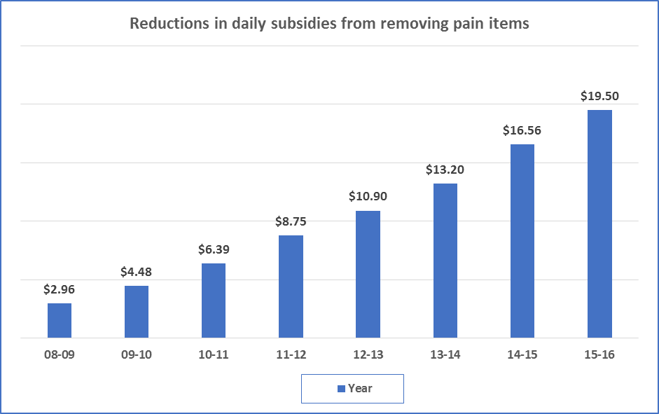

1. Recommended Design of the Therapy Program

To illustrate the feasibility of the Therapy Program, the three program options in a sixty-bed facility, with 75 per cent participation rate are described in Table 7.3. Each participant receives $105 per week Therapy Program subsidy. The estimated AHP cost includes a 20 per cent preparation time above the session times but does not include broader costs incurred by Providers for equipment and facility expenses. It is assumed that the group sessions will also need additional staff to assist the therapist which will add to the cost of program delivery.

The three program options are as follows:

1. Option A: One (1) individual physical therapy session and three (3) small group sessions with a total requirement of 180 minutes of therapy per week.
2. Option B: Two (2) individual physical therapy sessions and two (2) small group sessions with a total requirement of 140 minutes of therapy per week.
3. Option C: Three (3) individual physical therapy sessions with a total requirement of 60 minutes of therapy per week.

Table 7.3: Therapy Program Design

|  |  |  |  |
| --- | --- | --- | --- |
| **Considerations (based on assumptions)** | **Option A** | **Option B** | **Option C** |
| Number of Residents | 60 | 60 | 60 |
| How many are program participants (in this case, 75 per cent) | 45 | 45 | 45 |
| Subsidy per day | $15 | $15 | $15 |
| AHP cost per hour | $80 | $80 | $80 |
| Preparation time (as per cent of session time) | 20% | 20% | 20% |
| Individual sessions per week | 1 | 2 | 3 |
| Group sessions per week | 3 | 2 | 0 |
| Maximum group size | 5 | 5 | 5 |
| Individual session time (minutes) | 30 | 20 | 20 |
| Group session time (minutes) | 50 | 50 | 50 |
| **Total Therapy minutes per week** | **180 mins** | **140 mins** | **60 mins** |

* 1. Therapy Program Recommendations

1. Design

The Therapy Program will be funded at one level only. It is expected that at any one time, at least 75 per cent of residents in a facility will be funded under the program. The Therapy Program will be funded through the R-ACFI system and follow the usual ACFI submission and re-appraisal rules. The Therapy Program will not expire but will need to be re-submitted if appropriate when the ACFI is updated. The Therapy Program will not be prescriptive about the type of services that will be covered, but it will prescribe minimum time requirements and who can undertake assessment, an evidence base, care planning and program delivery.

1. Accountability

The program should be appropriate and effective, and provided within an affordable and transparent funding system for all stakeholders.

The program quality definition sets out what is to be achieved and how to measure and monitor those achievements.

The quality of a Therapy Program could be audited by either the Quality Agency and, for funding accountability purposes, via the ACFI RO validation activities. Audit criteria for the Therapy Program could include:

* Evidence-based assessments.
* Individualised Therapy Programs including detailed directives.
* Clearly defined goals that include measurable therapy outcomes and personalised resident goals.
* Records of treatment to be maintained to demonstrate delivery.
* On request by a RO, the availability of regular three-monthly evaluations of the program effectiveness with documented measurement-based outcomes and clinician observations, and feedback from residents and their families.
* Evidence of consumer involvement.
  1. Recommended R-ACFI User Guide
     1. Physical Therapy Program
        1. Description

This question relates to the assessed need for a physical Therapy Program.

The goal of the Program is to provide quality care and support underpinned by a Wellness approach. It is to be based on a systematic process, starting with an evidence-based assessment of care needs (with objective outcomes that can be used in the evaluation of the intervention), taking into account the resident’s choices and goals, to collaboratively determine and document a unique Therapy Program with the resident (or their family representative).

The therapy is to include one of the following:

* A wellness aspect that aims to promote (maintain or improve) the independence of the resident in their activities of daily living.
* A reablement aspect that focuses on short term interventions to address loss of capacity.
* A rehabilitation aspect that has a longer-term focus to address the resident’s functional and mobility ability to improve or maintain their level of independence.
* A treatment of complex pain which can inhibit a resident’s ability to participate in everyday activities and impact on their enjoyment of life.
  + - 1. Requirements

A therapy satisfies the requirements if:

* A Health Professional (list a or b – refer below) acting in their scope of practice conducts an evidence-based Assessment of the resident’s Physical Therapy Needs; and
* An Allied Health Professional (list a or b) identifies the resident’s care needs in an individualised Therapy Care Plan which includes the resident consent and a Directive.
* The Therapy Program is to be delivered and evaluated by an AHP (list a or b), the AHP may be assisted by other care staff during therapy sessions.
* The Therapy Program is to be delivered in three (3) to four (4) sessions on three to four separate days of the week.
* Individual therapy sessions will be of 30 minutes duration (Option A) or 20 minutes duration (Option B and Option C). A resident must have at least one individual therapy session per week.
* Small group (maximum of five residents) sessions will be of 50 minutes duration. The total group activity time (50 minutes) counts to the individual’s total weekly minutes.
* Records of treatment must be maintained, and regular (three-monthly) evaluations of the program effectiveness with documented measurement-based outcomes, clinician observations, and feedback from residents and their families.
  + - 1. Directives

A **Directive** must:

* Be documented by a suitable AHP (see subset of Allied Health Professions) acting in their scope of practice; and
* Direct the manner in which the care is to be provided, the qualifications of any person involved in providing the delivery of the program, activities to achieve the goals, what is to be delivered, resources needed, who delivers it, evaluation timeline and the frequency of the intervention.
  + - 1. Record of Treatment

The Record of Treatment must be kept in accordance with the directive as long as the therapy is being provided. The R-ACFI Answer Appraisal Pack must include copies of treatment records post the submission date, for a reasonable period, to support the claim. Refer to ACFI Userguide page 8, Record Keeping: *‘ACFI appraisal pack must include all information needed by the department to verify a provider’s ACFI claim’*. An Australian Government Authorised Officer may request to see a record of treatment.

* + - 1. Assessments

Evidence-based objective assessments must be used, however there is no mandated set of assessment tools. Recommendations have been made for assessing physical functioning, which include:

* Physical Mobility Scale (PMS).
* Manual Muscle Test (MMT).
* Berg Balance Scale (BBS).
* Balance Outcome Measure for Elder Rehabilitation (BOOMER).
* Short Physical Performance Battery.

The recommended pain assessment tools are those found in the PMG Kit for Aged Care (An implementation kit to accompany The Australian Pain Society’s Pain in Residential Aged Care Facilities: Management Strategies) prepared by Edith Cowan University (2007):

* Modified Resident’s Verbal Brief Pain Inventory (M-RVBPI) is suitable for residents who can be interviewed.
* Pain Assessment in Advanced Dementia (PAINAD) or Abbey Pain Scale is suitable for observational assessment.
* Unidimensional tools (Numeric Pain Rating Scale (NRS) and Verbal Rating Scale (VRS)] for the ongoing evaluation of pain intensity and response to treatment. Not suitable for residents with severe cognitive impairments.

The assessments are found in the R-ACFI Assessment Pack (Appendix 7.1) and are suggested tools. The inclusion of these tools also provides the industry with examples of assessment tools that are selected for their objectivity, inter-rater reliability, accessibility and ease of use and supports evidence-based processes and professional care practice.

The required assessment must have been completed within the last 3 months and it must continue to reflect the resident’s physical therapy needs at the time of the appraisal. This would involve the resident’s physical therapy needs to be reviewed for any recent changes and the assessment/directive to be signed off (indicating there are no changes) during the appraisal period.

* + - 1. Health Professionals

**‘Health Professional’** means a practitioner listed in (a) or (b) below:

**List (a)**

* Nurse practitioner;
* Registered nurse;
* Medical practitioner; or
* An allied health professional who is an: Occupational therapist; Physiotherapist; and has a current certificate of registration issued by the National Board for that person’s profession (see the *Health Practitioner National Regulation Law 2009* (the National Law).

**List (b)**

An allied health professional who is a Dietitian, Speech Pathologist or Exercise Physiologist and has current accreditation with the relevant self-regulated professional body.

**Physical Therapy Program**

**Indicate if a Physical Therapy Program is in place:**

| Physical Therapy Program | Evidence Requirements (Tick evidence) | Tick if yes |
| --- | --- | --- |
| No Physical Therapy Program | NA | 🞏 1 |
| Physical Therapy Program | 🞏 Consent  🞏 Physical Therapy Care Plan  🞏 Physical Functional Assessment  🞏 Pain Assessment  🞏 Other Assessment  🞏 Directive  🞏 Records of Treatment  🞏 Regular Evaluations | 🞏 2 |

* 1. The R-ACFI Therapy Program – Snapshot

The recommended Therapy Program is summarised in “At a Glance” format below.

Table 7.4: The Therapy Program “At a Glance”

| **Program Element** | **Details** |
| --- | --- |
| **Process** | * + 1. Resident/family/advocate collaboration     2. Assessment of need     3. Therapy Care Plan development     4. Therapy Program implementation     5. Three monthly evaluation     6. Application for funding follows usual R-ACFI appraisal rules & timeframes |
| **Assessments for the physical therapy program** | Evidence-based assessments must be used that produce measurable objective outcomes.  Recommendations have been made for   1. functional assessments (PMS, MMT, BBS, Boomer and Short Physical Performance Battery); and 2. pain assessments (M-RVBIP, PAINAD, ABBEY Pain scale, uni-dimensional pain intensity tools) |
| **Who can do assessments for the physical therapy program?** | R-ACFI User Guide   1. Health Professionals under AHPRA - will include RN, MP, AHP (OT, Physio). 2. AHP self-regulated professional body - Dietitian, SP, Exercise Physiologist. |
| **Who will qualify for the Therapy Program?** | The Therapy Program will be available for all residents at any level of care need. The only requirements will be that:   1. the resident wants to participate in the program on an ongoing basis and it can be delivered; 2. it is likely to be beneficial for the resident and the benefits are evaluated and reported in documentation on a 3-monthly basis; and 3. there is evidence that there is regular multi-disciplinary input into the development and modification of the program. |
| **How are residents and families included?** | The Therapy Program has a consumer focus included in the design of the therapy care plan, including goals and desired outcomes.   * Consent for program participation from resident/family or advocate. * Selection of program options. * Design of resident focussed goals. * Sign off on Therapy Care Plan. * Providing feedback for the 3-monthly evaluations.   Consideration should be given to the communication method between the therapist and the person consenting i.e. personalised flyers, inviting family to observe a group in action and to talk to the therapist.  Information to be provided about SMART goals that will assist the therapist to develop consumer identified goals that can be measured and evaluated. |
| **Who can develop the Therapy care plan?** | The individualised Therapy Care Plan must be developed and documented by the most appropriate AHP from lists in the ACFI User Guide page 38.   1. Health Professionals under AHPRA - will include AHP (OT, Physio). 2. AHP self-regulated professional body - Dietitian, SP, Exercise Physiologist. |
| **Therapy Program Principles** | * Broadening the type of physical therapy interventions to include a general wellness, restorative approach. * Evidence-based approach. * Include a wider range of therapeutic inputs from a variety of health professionals. * Provide an opportunity to directly include the consumer in the choice of options. * Therapy Program and an Accountability Framework. * Defining who will qualify for a Therapy Program. * Funding Options. * Specified Care and Services. |
| **How are the sessions to be structured?** | Feedback supports that it is appropriate to deliver some of the therapies on a one-to-one basis and also in groups (e.g. increased socialisation opportunities, can be safely delivered). |
| **Therapy Program Action Plan** | Lists the activities to achieve the goals, what is to be delivered, resources needed, who delivers it and the timeline. |
| **Therapy Program parameters** | Consultation feedback and the literature supported that both individual and small groups can be appropriate therapy program models. Group sessions can provide both physical and psychosocial benefits for participants; group settings can foster social connections and feelings of belonging.  The overall therapy program has the flexibility to be preventative, reactive as required or maintaining the resident’s enjoyment of life.   * The program will be an individualised physical therapy program. * Provided over three (3) to four (4) sessions on three (3) to four (4) days of the week, via one-to-one therapy or in a small group (small groups are defined as being for a maximum of five (5) residents). * Individual sessions will be for 30 minutes (Option A) or 20 minutes (Option B and Option C), and small group sessions will be 50 minutes duration. * A total of 180 minutes weekly if the resident has one individual session and three small group sessions (Option A); 140 minutes weekly if the resident has two individual sessions and two small group sessions (Option B); 60 minutes weekly if the resident has three individual sessions (Option C). * The time that the resident is in a group activity counts to their total minutes e.g. five residents participate in a 50-minute group session, each resident includes 50 minutes to their total weekly therapy time. |
| **Who can deliver the therapy** | Individual sessions must be one-on-one with the selected AHPs.  The group sessions must be directly supervised by the selected AHP from lists in the R-ACFI User Guide.   1. Health Professionals under AHPRA - will include AHP (OT, Physio). 2. AHP self-regulated professional body - Dietitian, SP, Exercise Physiologist.   The AHP must manage and run the sessions i.e. be present and face-to-face. Other care staff can assist in supporting the running of the program. |
| **Three monthly evaluation** | Audit criteria for the Therapy Program could include:   * The length of time that the program must be delivered with records of treatment to be maintained to demonstrate delivery * Individualised Therapy Programs to be documented in Care Plans * Containing personalised goals * Regular 3-monthly evaluations of program effectiveness using documented measurement-based outcomes, clinician observations, meeting of personalised goals and feedback from residents and their families |
| **SMART Goals**  **(Project Smart, 2017)** | SMART Goals will be recommended for determining resident informed goals. That is, goals that have a meaning to the resident, not necessarily therapist goals.  **SMART goals** are an example of a standardised approach to goal setting with measurable outcomes:  **Specific –** they provide clarity, focus and direction. A specific goal identifies exactly what is intended to be achieved, not just a general intention.  **Measurable –** objective measures are used to demonstrate the effectiveness of the goal. These are things you can ‘measure’ as improvements rather than just having a hunch that things are improving.  **Action-oriented –** the actionsprovide a strategy to achieve the goals and are part of the Care Plan.  **Realistic –** they are to be achievable. Failure to achieve goals can impact on the resident’s motivation, interest and participation. The goal must match with the known situation. They should be realistic. Achievement of small goals can provide motivation and pleasure.  **Time-based –** they should be current for a specific period of time. These goals can be measured at intervals, and re-evaluated on an ongoing basis. Goals need to have a time frame to determine the timing of the evaluation. |
| **Therapy Program and an Accountability Framework** | The quality of a therapy program could be audited by both the Quality Agency and, for funding accountability purposes, via the ACFI Review Officer validation activities. |
| **Expiry of Therapy Program** | The therapy program application will be submitted with an R-ACFI appraisal and be subject to the same business rules. |

Table 7.5 provides a summary of the assessments relevant to the R-ACFI Therapy program.

Table 7.5: R-ACFI Therapy Program Assessment Tools Recommendations

| Therapy Program: Physical Functional Performance | | |
| --- | --- | --- |
| **Mandatory** | **Recommended** | **Source** |
| Functional assessment tool must be completed | * Physical Mobility Scale (PMS) (note this is mandatory in the ADL domain). * Manual Muscle Test. * Berg Balance Scale. * Balance Outcome Measure for Elder Rehabilitation. * Short Physical Performance Battery. | R-ACFI Assessment Pack |
| **Therapy Program: Pain Assessment** | | |
| **Mandatory** | **Recommended** | **Source** |
| Pain assessment must be completed | * Modified Resident’s Verbal Brief Pain Inventory (M-RVBPI) is suitable for residents who can be interviewed. | PMG Kit |
| * Pain Assessment in Advanced Dementia (PAINAD).   OR   * Abbey Pain Scale is suitable for observational assessment. | PMG Kit |
| * Unidimensional tools (Numeric Pain Rating Scale (NRS).   AND   * Verbal Rating Scale (VRS)] for the ongoing evaluation of pain intensity and response to treatment.   Not suitable for residents with severe cognitive impairments. | PMG Kit |

1. R-ACFI Classification and Funding Outcomes

This Chapter covers:

* An introduction to the ACFI funding approach.
* The proposed R-ACFI classification and payment model.
* Analysis of the R-ACFI funding impacts by care domain & Therapy Program.

Chapter 2 and Appendix 8 of this report provide a description of the IRT methods used to re-analyse the ADL domain. A detailed discussion of the R-ACFI statistical underpinnings and model is provided in Chapter 3.

* 1. Introduction

The ACFI system provides the funding (issues about adequacy aside), to cover all care related areas and requirements as described in the Specified Care and Services (there are exclusions where fees can be charged) and the Quality of Care Principles legislation. The ACFI questions should be considered selective ‘indicators’ that provide the necessary resources to allow all of the required care related services to be delivered. It is not correct to interpret the ACFI funding as only covering areas targeted in the question set or only funding some care activities. It does not restrict, in any way, what can be done to assist residents. The ACFI funding is provided to cover the entire gamut of care areas covered in the legislation. Providers are not restricted in what care can be provided with the ACFI funding and restrictions, if they do exist, are necessarily imposed by the provider model of care, not the ACFI funding model.

1. The ACFI Funding Model

This chapter provides modelling of the financial outcomes of the R-ACFI recommended changes. The results are necessarily indicative as a number of changes to the ACFI were not able to be accurately modelled, and the available data only covered the period to June 2016. More recent data with the latest ACFI changes would improve the accuracy of the modelling and allow further adjustment to the various cut points and funding determinations in the three care domains. Nevertheless, the modelling provides a useful indication of the likely outcomes if the R-ACFI changes are implemented.

It should also be noted that the project guidelines stipulated that any changes to the ACFI had to be cost neutral in total. The R-ACFI funding levels have been determined in reference to rates that would apply from 1 July 2018 although firm rates can only be determined once 2017 ACFI data has been analysed, and the results of a proposed pilot have been analysed. The rates and financial outcomes discussed in the report should therefore be considered as ‘indicative’.

The R-ACFI scales have been developed as separate ‘independent’ measures of care need, and the coefficients are only relevant within the scale in question, as the amount of funding associated with each care domain (ADL, BEH, CHC) was calibrated separately (refer Appendix 3.2; Appendix 8).

1. R-ACFI Domain Model

The AFCI domain model has not changed although it could be easily re-structured around a branching design, as the measurement basis is sound and improved in the R-ACFI.

The ACFI and R-ACFI methodology of partitioning the care needs into three main areas means that the R-ACFI funding models are flexible for future developments as the various components (ADL, BEH, CHC) can be adjusted with additional or modified questions, funding amounts can be differentially applied to the scale domains (e.g. a future cost calibration study may indicate a change in the funding relativities between or within the scales) and particular resident ‘types’ can be further targeted with the R-ACFI models at a more resident specific level. The ACFI domain structure was also designed to allow for relative resource adjustments across domains in a way that had face validity for services and consumers. The R-ACFI is a significant change to the ACFI and it better identifies the relative resource needs of residents, key resource and cost drivers in long term care as well as providing a readily accessible care profile for each resident. More detail on the R-ACFI measurement basis and comparison to other design methodologies can be found in Chapter 3.

* 1. The R-ACFI Classification and Payment Model

There are nine funded categories, which generate 48 payment classes, excluding the Therapy Program payment (Figures 8.1, 8.2). Funding is determined in a similar way to the ACFI although there are now no A, B, C and D ratings in the ADL domain as the score is calculated directly from the checklist item weightings. The residents R-ACFI ADL score would equal the sum of the coefficients in the ADL scale table shown in the next section. The ADL domain now has four funded classification levels with all residents receiving the lowest ADL funding. The BEH domain determination has changed as there is a new matrix which links behaviour frequency and disruptiveness to achieve the outcome of only two funded levels. The CHC domain is simplified with the removal of the medication matrix. With the movement of the depression item into the CHC domain, the removal of the pain management and other items, new cut points have been established. The domain still has four classification levels with three funded, as is currently the case.

**Note: for the following tables and charts, the ACFI subsidies are determined as at July 1, 2016, while R-ACFI rates are proposed from July 1, 2018.**

Figure 8.1: A Visual Guide to the R-ACFI Classifications

Figure 8.1 is a diagram illustrating how the revised-Aged Care Funding Instrument (R-ACFI) categories fit in the classification model, as summarised in the text prior to this image. The four categories are:
1. Activities of daily living (ADL) (ratings are low, medium, high or very high)
2. Behaviour (ratings are moderate or high behaviour)
3. Complex health care (CHC) (ratings are low, medium or high)
4. The therapy program.

Figure 8.2: R-ACFI Model Design and Funding

Figure 8.2 is a diagram illustrating the calculation of a resident’s total funding under the revised aged care funding instrument (R-ACFI) model. The calculation is split into the four domains:
1. Activities of daily living (ADL), where funding is required for all four care categories (low, medium, high and very high)
2. Behaviour, where funding is required for the moderate or high categories (funding is not required for the base category)
3. Complex health care (CHC), where funding is required for the low, medium or high categories (funding is not required for the base category)
4. Therapy program, where funding is required if the resident is in the program (funding is not required for the base category).

**1**Base = all assessed care needs must be provided as per Specialised Care & Services & Quality of Care Principles

1. R-ACFI Funding Distribution Analysis

A summary of the overall distribution of R-ACFI funding outcomes is shown in Table 8.1, Table 8.2 provides more detail by the 48 funding R-ACFI combinations. Figure 8.3 plots the 48 R-ACFI payment categories against the current 64 ACFI payment categories. The average overall funding is the same at $172.02 for both the ACFI and R-ACFI.

The funding outcomes are a result of the way the distribution of scores in each domain are weighted and then divided into classification groups. The more classifications, the better the funding emulates a more ‘continuous’ model. Fewer categories means the classification groups will be more varied with a larger range of costs captured in the classifications. Figure 8.3 shows that the R-ACFI funding, in total, maps closely to the current ACFI although individual resident findings will show differences.

Table 8.1 shows that the R-ACFI ADL domain is better distributed than the current ACFI while providing a ‘base’ funding layer and also a very high funding category for residents with extremely high resource demands. The BEH domain has been simplified with two funded categories. The outcome will be similar to the current ACFI except that the removal of the Depression item and associated funding ($3.65 per day) lowers the funding attached to each level. This funding has been moved to the CHC domain. The CHC classification allows funding for any resident with a minimal score on the health procedures scale and provides a more graduated funding outcome compared to the current ACFI. With the pain items and associated funding ($15 per day) being moved to a Therapy Program, the funded levels are lower. The actual health procedure items now determine all of the funding in this domain which has retained some of the funding attributed to the pain management items. This effectively provides an increase in funding to residents with a number of complex health procedures compared to the ACFI.

Table 8.1: R-ACFI Funding Distribution by Categories

| ADL | Frequency (Percentage) | Proposed Funding (Amount per Day) |
| --- | --- | --- |
| 1 Low | 10.0% | $44.54 |
| 2 Medium | 29.8% | $71.27 |
| 3 High | 38.0% | $98.00 |
| 4 Very High | 22.2% | $124.73 |
| Behaviour | **Frequency** | Proposed Funding (per Day) |
| 0 Base1 | 9.9% | $0.00 |
| 1 Moderate | 29.2% | $17.51 |
| 2 High | 60.9% | $30.65 |
| Complex Health Care | **Frequency** | Proposed Funding (per Day) |
| 0 Base1 | 1.0% | $0.00 |
| 1 Low | 24.0% | $33.11 |
| 2 Medium | 60.9% | $44.15 |
| 3 High | 14.1% | $55.19 |
| Therapy Program | **Frequency** | Proposed Funding (per Day) |
| Lowest Funding Possible (July 2018) | 75-100% | $15.00 |
| Highest Funding Possible (July 2018) | $225.56 |

**1**Base = all assessed care needs must be provided as per Specialised Care & Services & Quality of Care Principles

Table 8.2: R-ACFI Payment Groups Compared with the Current ACFI

| R-ACFI Payment Groups (48)* | Current ACFI | Proposed R-ACFI** |
| --- | --- | --- |
| 1 | $49.38 | $59.54 |
| 2 | $63.12 | $77.06 |
| 3 | $94.05 | $86.27 |
| 4 | $78.54 | $90.19 |
| 5 | $62.66 | $92.66 |
| 6 | $83.25 | $103.70 |
| 7 | $107.32 | $103.78 |
| 8 | $76.53 | $110.18 |
| 9 | $138.24 | $113.00 |
| 10 | $101.00 | $114.74 |
| 11 | $123.78 | $116.92 |
| 12 | $104.89 | $119.39 |
| 13 | $96.98 | $121.21 |
| 14 | $96.41 | $123.31 |
| 15 | $124.97 | $130.43 |
| 16 | $139.46 | $130.51 |
| 17 | $118.01 | $132.25 |
| 18 | $114.38 | $134.35 |
| 19 | $124.23 | $136.90 |
| 20 | $79.80 | $139.73 |
| 21 | $139.65 | $141.47 |
| 22 | $161.88 | $143.65 |
| 23 | $132.52 | $145.39 |
| 24 | $146.84 | $146.12 |
| 25 | $146.81 | $147.94 |
| 26 | $149.73 | $150.04 |
| 27 | $167.20 | $157.16 |
| 28 | $129.63 | $157.24 |
| 29 | $158.74 | $158.98 |
| 30 | $165.80 | $161.08 |
| 31 | $165.00 | $163.63 |
| 32 | $176.37 | $168.20 |
| 33 | $153.68 | $170.37 |
| 34 | $176.31 | $172.11 |
| 35 | $147.80 | $172.84 |
| 36 | $186.62 | $174.67 |
| 37 | $190.84 | $176.76 |
| 38 | $170.23 | $183.88 |
| 39 | $197.36 | $185.71 |
| 40 | $205.01 | $187.80 |
| 41 | $168.52 | $190.36 |
| 42 | $178.14 | $194.92 |
| 43 | $210.45 | $198.84 |
| 44 | $188.91 | $201.40 |
| 45 | $194.63 | $203.49 |
| 46 | $197.34 | $212.43 |
| 47 | $207.01 | $214.53 |
| 48 | $210.83 | $225.57 |
| Average | **$172.02** | **$172.02** |

* Total subsidies, including $15 for Therapy Program

** Payment Groups sorted by old and new total subsidies into the 48 R-ACFI groupings. The average R-ACFI and ACFI funding within these bands was then calculated.

Figure 8.3: ACFI and R-ACFI Funding Distributions by R-ACFI Categories (48)

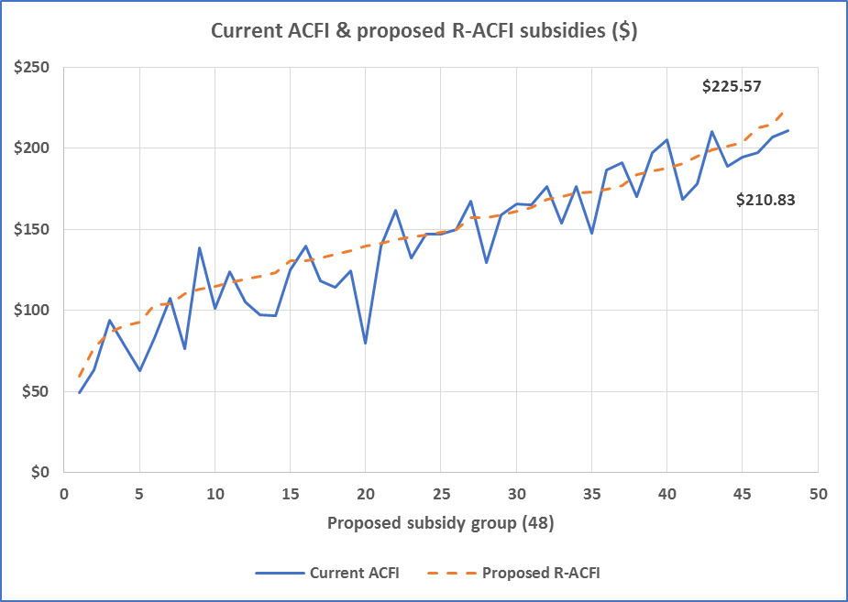

1. R-ACFI Funding Impacts by State and Organisation

A breakdown of the differential impact of the R-ACFI model compared to the ACFI by State is shown in Table 8.3, by organisation type in Table 8.4, and for organisation by R-ACFI domain in Table 8.5.

It should be noted that these tables represent outcomes based on the data available as at 30 June 2016. Changes in claiming patterns since that date may have an impact on the modelled results. Additionally, providers may not have been making claims in areas that will receive increased focus in the proposed R-ACFI.

Changes in the distribution of the R-ACFI funding as modelled are influenced by the following factors:

The proportion of higher level claims attributable to the pain management items in ACFI Q12.3, Q12.4a and Q12.4b. Organisations whose CHC domain claims were more dependent on scoring on these items receive a lower proportion of the redistributed funds with the R-ACFI. These funds have been re-allocated to the Therapy Program which will be available to all residents.

Organisations with a higher proportion of residents needing full physical assistance with mobility covering transfers (lifting machines) and locomotion also receive a higher proportion of the R-ACFI ADL funding compared to the current ACFI.

Table 8.3: Current & Proposed Average Subsidies by State (30 June 2016 data)

| State | Residents | Current Average ACFI Funding | 1Proposed Average R-ACFI Funding | Proposed to Current Ratio |
| --- | --- | --- | --- | --- |
| ACT | 2174 | $166.95 | $168.17 | 1.007 |
| NSW | 59576 | $169.20 | $170.93 | 1.010 |
| NT | 444 | $170.55 | $174.91 | 1.026 |
| QLD | 31897 | $169.43 | $171.68 | 1.013 |
| SA | 16169 | $172.28 | $171.09 | 0.993 |
| TAS | 4364 | $166.96 | $166.51 | 0.997 |
| VIC | 46114 | $176.43 | $173.69 | 0.984 |
| WA | 14622 | $177.21 | $174.98 | 0.987 |
| Total | **175,360** | **$172.02** | **$172.01** | **1.000** |

1 Includes $15 per day for Therapy Program

Table 8.4: Current & Proposed Average Subsidies by Organisation Type (30 June 2016 data)

| Type | Residents | Current Average ACFI Funding | 1Proposed Average R-ACFI Funding | Proposed to Current Ratio |
| --- | --- | --- | --- | --- |
| Government | 7881 | $151.74 | $166.67 | 1.098 |
| Not-For-Profit | 100346 | $165.22 | $168.20 | 1.018 |
| Private | 67133 | $184.56 | $178.33 | 0.966 |
| Total | **175360** | **$172.02** | **$172.01** | **1.000** |

1 Includes $15 per day for Therapy Program

Table 8.5: Current & Proposed Average Subsidies by Organisation Type and R-ACFI Domain (30 June 2016 data)

| Activities of daily living (ADL) | | | |
| --- | --- | --- | --- |
| Organisation | **Current ACFI** | | **Proposed R-ACFI** |
| Government | $82.75 | | $87.33 |
| Not-For-Profit | $87.48 | | $88.14 |
| Private | $96.23 | | $94.71 |
| Total for ADL) | **$90.62** | | **$90.62** |
| Behaviour (BEH) | | | |
| Organisation | **Current ACFI** | | **Proposed R-ACFI** |
| Government | $24.59 | | $22.17 |
| Not-For-Profit | $26.04 | | $22.95 |
| Private | $29.80 | | $25.18 |
| Total for BEH | **$27.41** | | **$23.77** |
| Complex Health Care (CHC) | | | |
| Organisation | **Current ACFI** | **Proposed R-ACFI** | |
| Government | $44.39 | $42.17 | |
| Not-For-Profit | $51.70 | $42.11 | |
| Private | $58.52 | $43.44 | |
| Total for CHC | **$53.98** | **$42.62** | |
| Therapy Program | | | |
| Organisation | **Current ACFI** | **Proposed R-ACFI** | |
| Government | *Not applicable* | $15.00 | |
| Not-For-Profit | *Not applicable* | $15.00 | |
| Private | *Not applicable* | $15.00 | |
| Total for Therapy Program | *Not applicable* | **$15.00** | |

* 1. The ADL Domain Funding Classification

1. The ADL Domain

The rationale and changes to the ADL domain are discussed in detail in Chapters 3 and 4 of this report.

**The Activities of Daily Living (ADL) Domain**

The ADL domain is the most fundamental layer in the R-ACFI (and all residential care payment models internationally) as care needs in this area are the most resource intensive. ADL care needs for residents are ever-present and represent an ongoing and unpredictable demand on staffing resources. Resident directed care will also impact on the cost of providing assistance in the ADL domain.

When investigating improvements to the ACFI, it was apparent that the ADL domain required special attention. The ADL question frequencies had become skewed with a high proportion of residents rated in the ‘D’ category (Physical Assistance) of most questions. The latest best practice approach to scale development (IRT) was therefore used to re-calibrate the domain and improve the discrimination of the items.

The IRT analysis sought to create a latent dimension for ADL based on the modified ACFI checklist data. The A, B, C, D ratings were not used as the distributions were highly skewed and were effectively composites of the checklists. As the checklists were deemed the best indicators of care needs and resource requirements, they were used for the analysis.

Since IRT is not an additive (regression) model, the analysis can proceed even if there are cases with missing data. There is a requirement for sufficient spread of items and persons across the range of the scale being developed. Classical test theory (CTT) methods cannot accommodate missing data since procedures, such as factor analysis depends on a correlation matrix (or covariance matrix) that excludes any case with data missing on any item. IRT handles skewed data, unlike factor analysis which assumes normally distributed items. More details on the IRT analysis can be found in Appendix 8 and Chapter 2.

The R-ACFI is recommended to have four ADL domain levels (Low, Medium, High, Very High), with the highest level receiving increased funding compared to the current ACFI (ACFI $110.55 vs. R-ACFI $124.73). In addition, it is recommended that all approved residents in aged care facilities should (at a minimum) receive the base payment of the ADL lowest funding level (current ACFI $36.65 vs. R-ACFI $44.54).

The R-ACFI ADL domain weightings as determined by IRT analysis are shown in Table 8.6. The R-ACFI funding categories, amounts, cut points and comparison with the current ACFI funding can be seen in Table 8.7.

The overall distribution of R-ACFI ADL funding outcomes by 50 funding bands (created for illustrative purposes) is shown in Table 8.8. The R-ACFI funding was sorted into increasing levels and grouped into 50 bands of approximately 3,500 records. The average R-ACFI and ACFI funding within these bands was then calculated. Figure 8.4 shows how the R-ACFI ADL funding distribution compares with the current ACFI funding.

Table 8.6: R-ACFI ADL Questions Weights

| R-ACFI ADL Scale | Coefficiency Weights |
| --- | --- |
| Nutrition | |
| Monitoring | 1.48 |
| Moderate Assistance | 3.73 |
| Full Assistance | 10.75 |
| Mobility - Transfers | |
| Moderate Assistance | 2.43 |
| Full Assistance | 8.89 |
| Mechanical Lifting | 26.48 |
| Mobility - Locomotion | |
| Moderate Assistance | 4.62 |
| Full Assistance | 15.57 |
| Hygiene - Dressing | |
| Moderate Assistance | 5.34 |
| Full Assistance | 8.77 |
| Hygiene – Washing | |
| Moderate Assistance | 9.51 |
| Full Assistance | 12.47 |
| Toileting – Use | |
| Moderate Assistance | 4.91 |
| Full Assistance | 11.67 |
| Toileting - Completion | |
| Moderate Assistance | 2.26 |
| Full Assistance | 7.38 |
| Urinary - continence | |
| Incontinent at times | 0.57 |
| Incontinent at all times | 3.34 |
| Faecal - continence | |
| Incontinent at times | 1.14 |
| Incontinent at all times | 3.57 |

Table 8.7: R-ACFI ADL Payment Groups Compared with the Current ACFI

| R-ACFI ADL Category | Number in Group | Category Cut Point Low | Category Cut Point High | Average Current ACFI Subsidy1 | Proposed R-ACFI Subsidy1 |
| --- | --- | --- | --- | --- | --- |
| Low | 17523 | 0.00 | 34.66 | $34.33 | $44.54 |
| Medium | 52255 | 34.67 | 64.43 | $74.49 | $71.27 |
| High | 66695 | 64.44 | 75.38 | $106.99 | $98.00 |
| Very High | 38887 | 75.50 | 100.00 | $109.57 | $124.73 |
| Total | **175360** | **0.00** | **100.00** | **$90.62** | **$90.62** |

1 based on 1 July 2016 rates

Table 8.8: R-ACFI ADL Payment Groups Compared with the Current ACFI

| Funding Bands1 | Number in Bands | Average funding in band  (ACFI Subsidy) | Average funding in band  (R-ACFI Subsidy) |
| --- | --- | --- | --- |
| 1 | 3507 | $24.58 | $44.54 |
| 2 | 3507 | $36.65 | $44.54 |
| 3 | 3507 | $36.65 | $44.54 |
| 4 | 3507 | $36.65 | $44.54 |
| 5 | 3507 | $37.14 | $44.64 |
| 6 | 3508 | $36.65 | $71.27 |
| 7 | 3507 | $36.65 | $71.27 |
| 8 | 3507 | $73.16 | $71.27 |
| 9 | 3507 | $79.80 | $71.27 |
| 10 | 3507 | $79.80 | $71.27 |
| 11 | 3508 | $79.80 | $71.27 |
| 12 | 3507 | $79.80 | $71.27 |
| 13 | 3507 | $79.80 | $71.27 |
| 14 | 3507 | $79.80 | $71.27 |
| 15 | 3507 | $79.80 | $71.27 |
| 16 | 3508 | $79.80 | $71.27 |
| 17 | 3507 | $79.80 | $71.27 |
| 18 | 3507 | $79.80 | $71.27 |
| 19 | 3507 | $79.80 | $71.27 |
| 20 | 3507 | $92.90 | $74.05 |
| 21 | 3508 | $79.80 | $98.00 |
| 22 | 3507 | $79.80 | $98.00 |
| 23 | 3507 | $108.49 | $98.00 |
| 24 | 3507 | $110.55 | $98.00 |
| 25 | 3507 | $110.55 | $98.00 |
| 26 | 3508 | $110.55 | $98.00 |
| 27 | 3507 | $110.55 | $98.00 |
| 28 | 3507 | $110.55 | $98.00 |
| 29 | 3507 | $110.55 | $98.00 |
| 30 | 3507 | $110.55 | $98.00 |
| 31 | 3508 | $110.55 | $98.00 |
| 32 | 3507 | $110.55 | $98.00 |
| 33 | 3507 | $110.55 | $98.00 |
| 34 | 3507 | $110.55 | $98.00 |
| 35 | 3507 | $110.55 | $98.00 |
| 36 | 3508 | $110.55 | $98.00 |
| 37 | 3507 | $110.55 | $98.00 |
| 38 | 3507 | $110.55 | $98.00 |
| 39 | 3507 | $107.76 | $100.34 |
| 40 | 3507 | $102.48 | $124.73 |
| 41 | 3508 | $110.55 | $124.73 |
| 42 | 3507 | $110.55 | $124.73 |
| 43 | 3507 | $110.55 | $124.73 |
| 44 | 3507 | $110.55 | $124.73 |
| 45 | 3507 | $110.55 | $124.73 |
| 46 | 3508 | $110.55 | $124.73 |
| 47 | 3507 | $110.55 | $124.73 |
| 48 | 3507 | $110.55 | $124.73 |
| 49 | 3507 | $110.55 | $124.73 |
| 50 | 3508 | $110.55 | $124.73 |
| Total | **175360** | **$90.62** | **$90.62** |

1Funding Bands: The R-ACFI funding was sorted into increasing levels and grouped into 50 bands of approximately 3,500 records. The average R-ACFI and ACFI funding within these bands was then calculated.

Figure 8.4: R-ACFI ADL Funding Distribution Compared with the Current ACFI

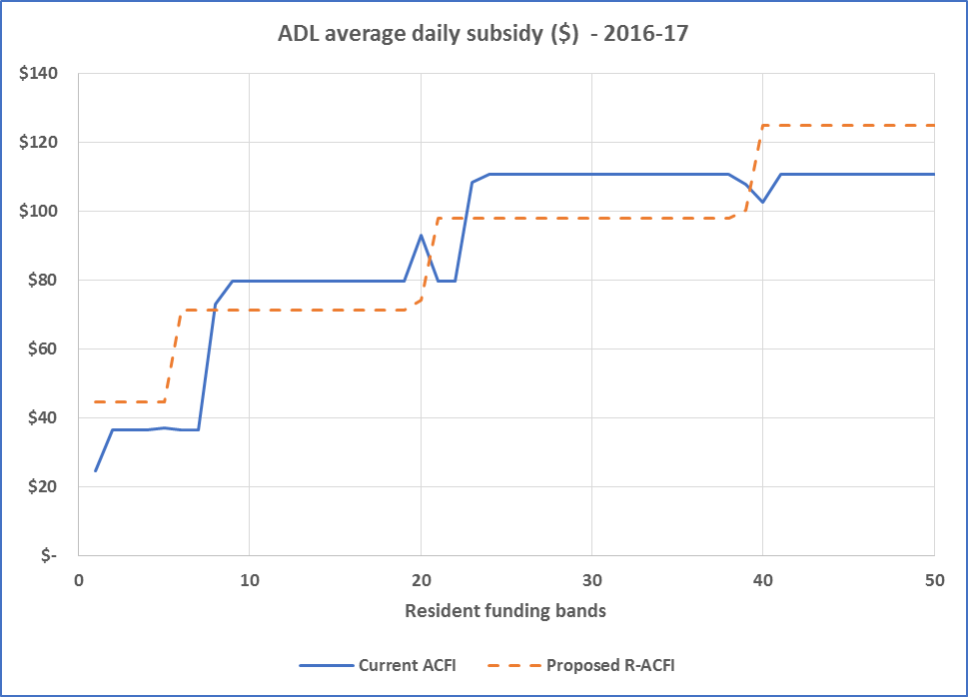

* 1. The BEH Domain Funding Classification

1. The BEH Domain Overview

The rationale and changes to the BEH domain are covered in detail in Chapter 5.

The BEH domain questions have been modified to clarify the intent. Other changes include a new matrix, designed to improve the identification of residents with very high levels of behavioural expressions. Apart from the removal of the depression item and its associated funding (discussed in Chapter 5) which necessitated a minor adjustment to all remaining question ratings to bring the scale score back to 100, it was decided after examining the distributions to also simplify the domain by turning it into a three instead of four level classification. The BEH domain now has two funded levels, moderate and high.

The Depression item and its associated funding ($3.65 per day) has been moved to the CHC domain. This change has led to a reduction in the maximum funding allocated from the current ACFI BEH domain (ACFI $36.19 vs. R-ACFI $30.65).

1. Depression Item Funding Analysis

Analysis of ACFI BEH domain data since 2009 shows that the funding directly attributable to the Depression item has increased steadily (Table 8.9 and Figure 8.5). As the Depression item in the R-ACFI has been moved to the CHC domain, an amount of $3.65 has been removed from the BEH domain.

Table 8.9: Funding from the Depression Question

| Year | BEH payments with depression (per day) | BEH payments without depression (per day) | BEH payment reduction (per day) |
| --- | --- | --- | --- |
| 2008-09 | 20.15 | 18.63 | 1.52 |
| 2009-10 | 21.91 | 20.20 | 1.71 |
| 2010-11 | 23.67 | 21.74 | 1.93 |
| 2011-12 | 24.97 | 22.83 | 2.14 |
| 2012-13 | 25.38 | 22.99 | 2.39 |
| 2013-14 | 25.63 | 22.91 | 2.72 |
| 2014-15 | 26.77 | 23.56 | 3.21 |
| 2015-16 | $27.67 | $24.02 | $3.65 |

Figure 8.5: Funding from the Depression Question

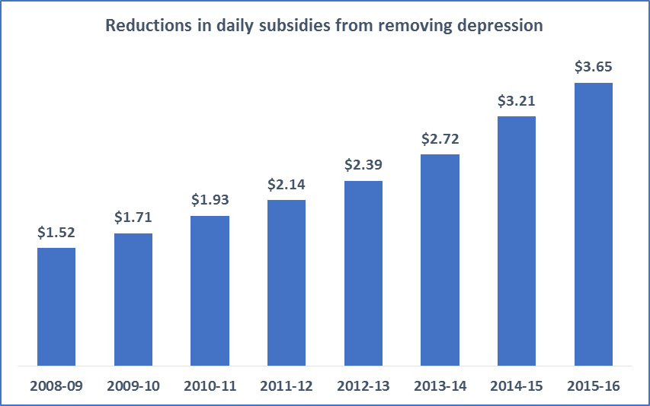

### Calculating the Behaviour Domain Level (L, M, H)

The BEH domain level is calculated as follows:

* 1. Determine the Cognitive Skills rating (S-MMSE).

Table 8.10: R-ACFI Cognitive Skills Rating

| **Cognitive Skills Checklist** | **Rating** |
| --- | --- |
| None or minimal impairment | **A** |
| Mild impairment | **B** |
| Moderate impairment | **C** |
| Severe impairment | **D** |

* 1. Use the Behaviour Record and Disruptiveness Rating to determine the rating level (A, B, C, D) of each of wandering, verbal and physical behaviour. Use the Frequency and Disruptiveness matrix to complete the checklist and obtain the rating.

Table 8.11: R-ACFI Behaviour Domain Matrix

| Disruptiveness | Frequency (less than daily) | Frequency (daily) | Frequency (twice a day, daily) | Frequency (over twice a day, daily) |
| --- | --- | --- | --- | --- |
| None or mild | A | A | A | A |
| Moderately | A | A | B | C |
| Severely | A | B | C | D |
| Extremely | A | C | D | D |

* 1. Use the weightings associated with each item in the BEH domain to determine the final score (Table 8.12).
  2. The score is then divided into categories using the cut points as indicated in Table 8.13.

Table 8.13 compares the R-ACFI and ACFI funding outcomes. Differences are related to the removal of the Depression funding ($3.65 per day) and simplification from three funded levels to two levels. The overall distribution of R-ACFI behaviour funding outcomes by 50 funding bands is shown in Table 8.13.

Table 8.12: R-ACFI Behaviour Domain Item Weights

| Cognition Domain | |
| --- | --- |
| Scale | Weights |
| None | 0 |
| Mild | 8.42 |
| Moderate | 16.79 |
| Severe | 25.2 |
| Wandering Behaviour Domain | |
| Scale | Weights |
| Less than Daily | 0 |
| Daily | 7.13 |
| Twice per day | 14.27 |
| More than Twice per day | 21.39 |
| Verbal Behaviour Domain | |
| Scale | Weights |
| Less than Daily | 0 |
| Daily | 8.5 |
| Twice per day | 17.02 |
| More than Twice per day | 25.52 |
| Physical Behaviour Domain | |
| Scale | Weights |
| Less than Daily | 0 |
| Daily | 9.29 |
| Twice per day | 18.59 |
| More than Twice per day | 27.89 |
| Total of ALL | **100** |

Table 8.13: R-ACFI Behaviour Domain Payment Groups Compared with the Current ACFI

| R-ACFI BEH Category | Number in Group | Category Cut Point Low | Category Cut Point High | Average Current ACFI $ Subsidy1 | Average Proposed R-ACFI $ Subsidy1 |
| --- | --- | --- | --- | --- | --- |
| Base2 | 17428 | 0.00 | 16.92 | $5.19 | $0.00 |
| Moderate | 51144 | 17.02 | 51.51 | $19.37 | $17.51 |
| High | 106788 | 51.60 | 100.00 | $34.89 | $30.65 |
| Total | **175360** | [not applicable] | [not applicable] | $**27.41** | $**23.77** |

1 1 July 2016 rates **2** Base: note that all assessed care needs must be provided as per Specialised Care & Services & Quality of Care Principles

Table 8.14: R-ACFI Behaviour Domain Payment Groups Compared with the Current ACFI

| Funding Bands1 | Number in Bands | Average funding in band  (Current ACFI Subsidy) | Average funding in band  (Current ACFI Re-Scale) | Average funding in band  (R-ACFI Subsidy) |
| --- | --- | --- | --- | --- |
| 1 | 3507 | 0.00 | 0.00 | 0.00 |
| 2 | 3507 | 0.00 | 0.00 | 0.00 |
| 3 | 3507 | 6.65 | 5.76 | 0.00 |
| 4 | 3507 | 8.37 | 7.26 | 0.00 |
| 5 | 3507 | 11.03 | 9.56 | 0.53 |
| 6 | 3508 | 8.37 | 7.26 | 17.51 |
| 7 | 3507 | 8.37 | 7.26 | 17.51 |
| 8 | 3507 | 8.37 | 7.26 | 17.51 |
| 9 | 3507 | 17.15 | 14.87 | 17.51 |
| 10 | 3507 | 17.36 | 15.05 | 17.51 |
| 11 | 3508 | 17.36 | 15.05 | 17.51 |
| 12 | 3507 | 17.36 | 15.05 | 17.51 |
| 13 | 3507 | 17.36 | 15.05 | 17.51 |
| 14 | 3507 | 17.36 | 15.05 | 17.51 |
| 15 | 3507 | 17.36 | 15.05 | 17.51 |
| 16 | 3508 | 17.36 | 15.05 | 17.51 |
| 17 | 3507 | 26.12 | 22.65 | 17.51 |
| 18 | 3507 | 36.19 | 31.38 | 17.51 |
| 19 | 3507 | 36.19 | 31.38 | 17.51 |
| 20 | 3507 | 27.75 | 24.07 | 23.40 |
| 21 | 3508 | 17.36 | 15.05 | 30.65 |
| 22 | 3507 | 23.93 | 20.75 | 30.65 |
| 23 | 3507 | 36.19 | 31.38 | 30.65 |
| 24 | 3507 | 36.19 | 31.38 | 30.65 |
| 25 | 3507 | 36.19 | 31.38 | 30.65 |
| 26 | 3508 | 36.19 | 31.38 | 30.65 |
| 27 | 3507 | 36.19 | 31.38 | 30.65 |
| 28 | 3507 | 36.19 | 31.38 | 30.65 |
| 29 | 3507 | 36.19 | 31.38 | 30.65 |
| 30 | 3507 | 36.19 | 31.38 | 30.65 |
| 31 | 3508 | 36.19 | 31.38 | 30.65 |
| 32 | 3507 | 36.19 | 31.38 | 30.65 |
| 33 | 3507 | 36.19 | 31.38 | 30.65 |
| 34 | 3507 | 36.19 | 31.38 | 30.65 |
| 35 | 3507 | 36.19 | 31.38 | 30.65 |
| 36 | 3508 | 36.19 | 31.38 | 30.65 |
| 37 | 3507 | 36.19 | 31.38 | 30.65 |
| 38 | 3507 | 36.19 | 31.38 | 30.65 |
| 39 | 3507 | 36.19 | 31.38 | 30.65 |
| 40 | 3507 | 36.19 | 31.38 | 30.65 |
| 41 | 3508 | 36.19 | 31.38 | 30.65 |
| 42 | 3507 | 36.19 | 31.38 | 30.65 |
| 43 | 3507 | 36.19 | 31.38 | 30.65 |
| 44 | 3507 | 36.19 | 31.38 | 30.65 |
| 45 | 3507 | 36.19 | 31.38 | 30.65 |
| 46 | 3508 | 36.19 | 31.38 | 30.65 |
| 47 | 3507 | 36.19 | 31.38 | 30.65 |
| 48 | 3507 | 36.19 | 31.38 | 30.65 |
| 49 | 3507 | 36.19 | 31.38 | 30.65 |
| 50 | 3508 | 36.19 | 31.38 | 30.65 |
| Total | 175360 | 27.41 | 23.77 | 23.77 |

1Funding Bands: The R-ACFI funding was sorted into increasing levels and grouped into 50 bands of approximately 3,500 records. The average R-ACFI and ACFI funding within these bands was then calculated.

1. Behaviour Charts

Figures 8.6 and 8.7 show the distribution of the data presented in Table 8.14 of the R-ACFI and ACFI BEH domain funding bands. As the funding bands have large numbers of cases to simplify the chart, fluctuations in the averages will be present in lines. Figure 8.6 shows the impact of the removal of the $3.65 from the Depression question and the two-level funding. The current data shows that a two-level funding option is appropriate although more recent data may be needed to confirm this approach.

Figure 8.6: R-ACFI BEH Funding Distribution Compared with the Current ACFI

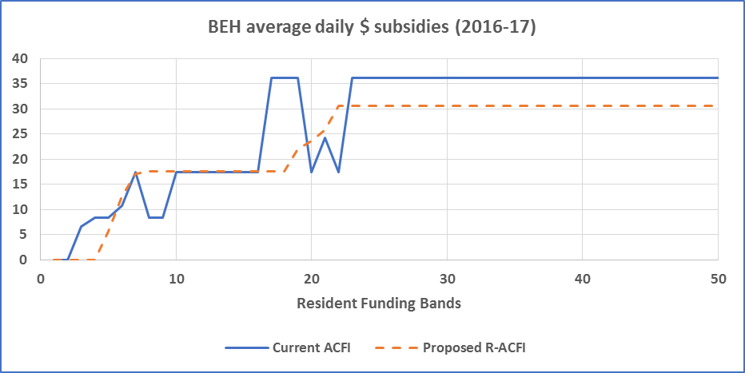

Figure 8.7 shows the same comparison but uses re-scaled ACFI data which has been averaged to equal that of the proposed R-ACFI rates. This provides a clearer comparison (after removal of the $3.65) of the impact of the differences between the R-ACFI and ACFI distributions.

Figure 8.7: R-ACFI BEH Re-Scaled Funding Distribution Compared with the Current ACFI

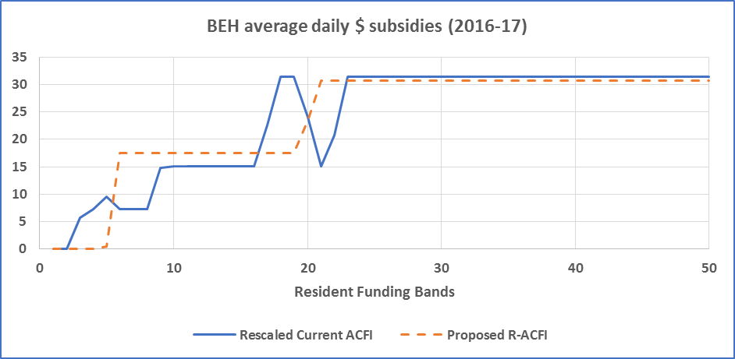

* 1. The CHC Domain Funding Classification

1. The CHC Domain

The rationale for and changes to the CHC domain are presented in Chapter 6. AACS conducted a series of consultations, review of relevant tools and literature on assessment and statistical analysis on the CHC domain items. Contemporary issues were also considered in reviewing this domain.

The CHC domain has been simplified by the removal of the matrix between Medication Q11 and the procedures total in ACFI Q12. While there have been some other changes to specific items (discussed in Chapter 3, 6 and later here) the major change to the CHC domain has been the removal of the pain management items and the associated funding. This has also been covered in Chapters 6 and 9. The removal of the pain management items and their associated funding has provided an opportunity to create a new funded Therapy Program which is discussed in detail in Chapter 7.

Moving the pain management funding to the new Therapy Program has resulted in a reduction in the maximum funding allocated from the current ACFI CHC domain (ACFI $67.32 vs. R-ACFI $55.16).

1. Analysis Assumptions – CHC Domain

The data set provided by the Department included ACFI appraisals up to June 30, 2016. This data set included ACFI information that has subsequently changed in the post July 2016 and January 2017 ACFI implementations.

Given that the most recent data set was not available when the modelling was undertaken, the following assumptions were made to model the R-ACFI financial outcomes in the CHC domain:

* + - 1. As the R-ACFI has removed ACFI 12.12a and moved this item to R-ACFI Q3 (dressing), an assumption regarding the proportion of residents that claimed Q12.12 in the 2015-16 data set and who would quality for the R-ACFI CHC item (same as 12.12b in the current ACFI) was required. It was assumed that 75 per cent of residents that claimed 12.12 (3 points) in the 2015-16 data set would migrate to the 12.12b level (3 points). In the R-ACFI, this is CHC item 7 (Table 8.17).
      2. The R-ACFI has included the Medication question in the R-ACFI CHC procedures list to remove the matrix and provide a simpler, more graduated CHC scale. The R-ACFI includes two medication items, assistance needed (R-ACFI item 9a. – 3 points) and injections (R-ACFI item 9b. 6 points) which are identical items to the current ACFI levels used in the CHC matrix. To include these changes in the R-ACFI, the medication item from the 2015-16 was recoded as described in Table 8.15.

Table 8.15: Recoding ACFI 2016-16 Data to R-ACFI for Financial Modelling

| ACFI Item 2015-16 | R-ACFI item |
| --- | --- |
| No medication | Not applicable |
| Self-manages medication |
| Application of patches at least weekly, but less frequently than daily | R-ACFI item 9a |
| Needs assistance for less than 6 minutes per 24-hour period with daily medications |
| Needs assistance for between 6 and 11 minutes per 24-hour period with daily medications |
| Needs assistance for more than 11 minutes per 24-hour period with daily medications |
| Needs daily administration of a subcutaneous drug | R-ACFI item 9b |
| Needs daily administration of an intramuscular drug |
| Needs daily administration of an intravenous drug |

1. Analysis Outcomes – CHC Domain

Table 8.16 and Table 8.17 (by funding band) show the comparison between the R-ACFI and ACFI CHC funding. Given the number of significant changes to this domain, a direct funding comparison between the R-ACFI and ACFI should be considered as indicative only.

The removal of the pain management items ($15 per day is the average funding over previous 4 years) has had a variable impact on the funding comparisons as scoring on these questions was not related to the pattern of responses on the health care procedures. Also, an additional $3.65 was added from the depression question and there were also assumptions made with the available data (refer earlier discussion).

There were relatively few residents who did not receive funding from the CHC domain at June 30, 2016. The R-ACFI will provide funding if any single procedure item is selected, unlike the current ACFI model which uses a matrix between the Medication Q11 and the Procedures listed in Q12 and claims in these questions may not always result in a funding outcome because of the matrix arrangement.

As indicated earlier, health care procedure items now determine all of the funding in this domain, which has retained some of the funding attributable to the pain management items ($5 per day) as at June 30, 2016. This effectively provides an increase in funding to residents with complex health procedures claims compared to the ACFI.

Table 8.16: R-ACFI Complex Health Care Payment Groups Compared with the Current ACFI

| R-ACFI  CHC Category | Number in Group | Category Cut Point Low | Category Cut Point High | Average Current ACFI $ Subsidy1 | Average R-ACFI Subsidy1 |
| --- | --- | --- | --- | --- | --- |
| Nil2 | 1713 | 0 | 0 | $20.08 | $0.00 |
| Low | 42169 | 1 | 5 | $38.99 | $33.11 |
| Medium | 106779 | 6 | 11 | $57.63 | $44.15 |
| High | 24699 | 12 | 38 | $66.19 | $55.19 |
| Total | **175360** | *Not applicable.* | *Not applicable.* | **$53.98** | **$42.62** |

1 1 July 2016 rates **2** Claims based on pain management items only not included in the R-ACFI

Table 8.17: R-ACFI Payment Groups Compared with the Current ACFI

| Item Number | Complex Health Care procedures | R-ACFI weighting |
| --- | --- | --- |
| 1 | Management of ongoing stoma care | **1** |
| 2 | Blood glucose measurement | **1** |
| 3 | Oxygen therapy not self-managed | **1** |
| 4 | Complex skin integrity management | **3** |
| 5 | Management of special feeding undertaken by RN | **3** |
| 6 | Catheter care program | **3** |
| 7 | Complex management of oedema | **3** |
| 8 | Major Depression | **3** |
| 9a | Medications 1- Weekly patches, suppositories or enemas, Daily Medication Assistance | **3** |
| 9b | Medications 2- Daily administration of injections.  Can only claim one item- either 9a or 9b. | **6** |
| 10 | Management of chronic infectious conditions | **6** |
| 11 | Management of chronic wounds, including varicose and pressure ulcers, and diabetic foot ulcers | **6** |
| 12 | Management of ongoing administration of intravenous fluids, hypodermoclysis, syringe drivers and dialysis. | **6** |
| 13 | Suctioning airways, tracheostomy care | **6** |
| 14 | Management of ongoing tube feeding | **6** |
| 15 | Palliative Care Program | **15** |

Table 8.18: R-ACFI Payment Groups Compared with the Current ACFI

| Funding Bands1 | Number in Bands | Average funding in band  (Current ACFI Subsidy) | Average funding in band  (Current ACFI Re-Scale) | Average funding in band  (R-ACFI Subsidy) |
| --- | --- | --- | --- | --- |
| 1 | 3507 | 10.61 | 8.38 | 16.94 |
| 2 | 3507 | 8.91 | 7.03 | 33.11 |
| 3 | 3507 | 16.37 | 12.92 | 33.11 |
| 4 | 3507 | 16.37 | 12.92 | 33.11 |
| 5 | 3507 | 16.37 | 12.92 | 33.11 |
| 6 | 3508 | 43.31 | 34.19 | 33.11 |
| 7 | 3507 | 46.62 | 36.81 | 33.11 |
| 8 | 3507 | 46.62 | 36.81 | 33.11 |
| 9 | 3507 | 48.67 | 38.43 | 33.11 |
| 10 | 3507 | 67.32 | 53.15 | 33.11 |
| 11 | 3508 | 67.32 | 53.15 | 33.11 |
| 12 | 3507 | 57.33 | 45.26 | 33.11 |
| 13 | 3507 | 37.22 | 29.38 | 38.50 |
| 14 | 3507 | 16.37 | 12.92 | 44.15 |
| 15 | 3507 | 16.37 | 12.92 | 44.15 |
| 16 | 3508 | 45.03 | 35.55 | 44.15 |
| 17 | 3507 | 46.62 | 36.81 | 44.15 |
| 18 | 3507 | 46.62 | 36.81 | 44.15 |
| 19 | 3507 | 46.62 | 36.81 | 44.15 |
| 20 | 3507 | 58.44 | 46.14 | 44.15 |
| 21 | 3508 | 67.32 | 53.15 | 44.15 |
| 22 | 3507 | 67.32 | 53.15 | 44.15 |
| 23 | 3507 | 67.32 | 53.15 | 44.15 |
| 24 | 3507 | 67.32 | 53.15 | 44.15 |
| 25 | 3507 | 67.32 | 53.15 | 44.15 |
| 26 | 3508 | 67.32 | 53.15 | 44.15 |
| 27 | 3507 | 67.32 | 53.15 | 44.15 |
| 28 | 3507 | 67.32 | 53.15 | 44.15 |
| 29 | 3507 | 57.94 | 45.75 | 44.15 |
| 30 | 3507 | 65.42 | 51.65 | 44.15 |
| 31 | 3508 | 46.44 | 36.67 | 44.15 |
| 32 | 3507 | 46.62 | 36.81 | 44.15 |
| 33 | 3507 | 51.77 | 40.87 | 44.15 |
| 34 | 3507 | 67.32 | 53.15 | 44.15 |
| 35 | 3507 | 67.32 | 53.15 | 44.15 |
| 36 | 3508 | 67.32 | 53.15 | 44.15 |
| 37 | 3507 | 67.32 | 53.15 | 44.15 |
| 38 | 3507 | 67.32 | 53.15 | 44.15 |
| 39 | 3507 | 67.32 | 53.15 | 44.15 |
| 40 | 3507 | 67.32 | 53.15 | 44.15 |
| 41 | 3508 | 67.32 | 53.15 | 44.15 |
| 42 | 3507 | 64.19 | 50.68 | 44.15 |
| 43 | 3507 | 66.42 | 52.44 | 44.62 |
| 44 | 3507 | 61.09 | 48.23 | 55.19 |
| 45 | 3507 | 67.32 | 53.15 | 55.19 |
| 46 | 3508 | 67.32 | 53.15 | 55.19 |
| 47 | 3507 | 67.15 | 53.02 | 55.19 |
| 48 | 3507 | 66.62 | 52.60 | 55.19 |
| 49 | 3507 | 67.32 | 53.15 | 55.19 |
| 50 | 3508 | 67.30 | 53.13 | 55.19 |
| Total | 175360 | 53.98 | 42.62 | 42.62 |

1Funding Bands: The R-ACFI funding was sorted into increasing levels and grouped into 50 bands of approximately 3,500 records. The average R-ACFI and ACFI funding within these bands was then calculated.

1. CHC Comparison Charts

Figures 8.8 and 8.9 show the distribution of the data presented in Table 8.18 of the R-ACFI and ACFI CHC domain funding bands. As the funding bands have large numbers of cases to simplify the chart, fluctuations in the averages are present. Figure 8.8 shows the large fluctuations in the ACFI CHC funding related to the removal of the pain management items ($15 per day) and the lower average funding overall. The funding for the health procedures however is effectively increased as they distribute all the funding in the modified domain.

Figure 8.8: R-ACFI CHC Funding Distribution Compared with the Current ACFI

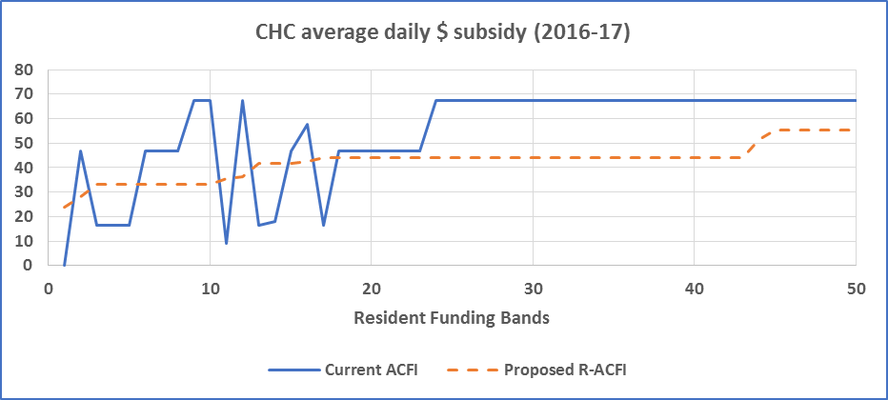

Figure 8.9 shows the same comparison but uses re-scaled ACFI data which has been averaged to equal that of the proposed R-ACFI rates. This provides a clearer comparison of the impact of the differences between the R-ACFI and ACFI CHC distributions as it adjusts to some extent, for the removal of the $15 per day attributed to the pain management items.

Figure 8.9: R-ACFI CHC Re Scaled Funding Distribution Compared with the Current ACFI

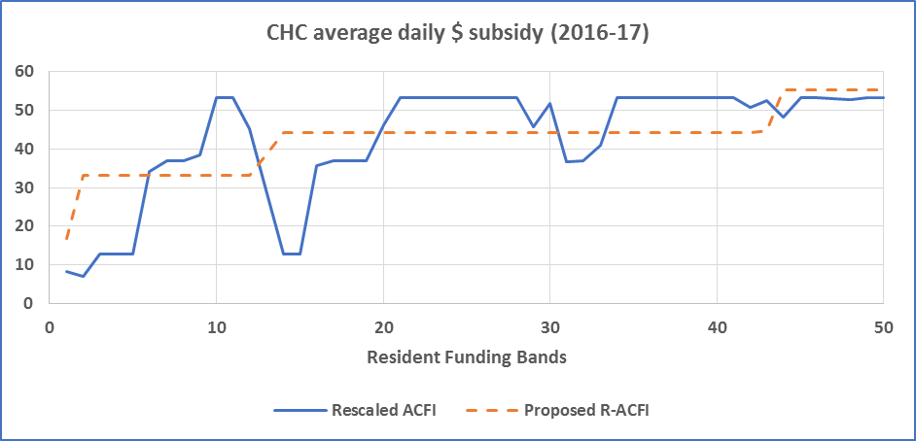

* 1. Therapy Program
     1. The Therapy Program

The rationale and design of the Therapy Program is presented in Chapter 7.

The R-ACFI has introduced a new Therapy Program concept and funding (from the pain management items) that will be available to all residents.

Using the average of the last four years daily subsidy reductions gives an average per day rate of around $15 per resident per day to distribute to the Therapy Program.

The Therapy Program will be funded at one level only. It is expected that at any one time at least 75 to 100 per cent of residents in a facility will be funded under the program. The physical Therapy Program will not be prescriptive about the type of services that will be covered, but it will prescribe minimum time requirements and who can undertake assessment, care planning and program delivery (Chapter 7).

The R-ACFI funding allocation allows for 100 per cent of residents to be funded under the program.

The three recommended program options that will attract funding are as follows:

1. Option A: One (1) individual physical therapy session and three (3) small group sessions with a total requirement of 180 minutes of therapy per week.
2. Option B: Two (2) individual physical therapy sessions and two (2) small group sessions with a total requirement of 140 minutes of therapy per week.
3. Option C: Three (3) individual physical therapy sessions with a total requirement of 60 minutes of therapy per week.
   1. R-ACFI “At a Glance”

The R-ACFI in summarised format is provided in Tables 8.19 to 8.19c.

Table 8.19: R-ACFI at a glance

| Question | Appraisal Evidence Requirements |
| --- | --- |
| Mental and Behavioural Diagnosis | * Disorders/ diagnosis checklists * Source materials checklists * Copies of source materials e.g. NSAF, ACCR, GP comprehensive medical assessment, other medical practitioner assessments or notes |
| Medical Diagnosis |
| **Therapy Program**   * Available for all residents at any level of care need. * Consumer involvement - consent, developing goals and therapy options, sign off on Therapy Care Plan, evaluation feedback. * Therapy service- delivered for 60/140/180 minutes /week on 3 -4 days of the week. * Time depends on mix of mode. * Therapy service mode: One-to-one or small group (max of 5 residents) | * Evidence-based assessment tools by defined list of HP * Therapy Care Plan developed by defined list of AHP * Directive: developed by defined list of AHP lists the activities to achieve the goals, what is to be delivered, resources needed, who delivers it (by defined list of AHP) and the program timelines * Record of Treatment is maintained * 3 monthly evaluation of measurable outcomes, observed outcomes and resident goals. |

Table 8.19a: R-ACFI at a glance (Activities of Daily Living Domain)

| No. | Question | Appraisal Evidence Requirements |
| --- | --- | --- |
| **1** | **Nutrition**  Care need: *Eating activities*  Assistance level = Standard Care OR Monitoring OR Moderate Assistance OR Full Assistance | * Mini Nutritional Assessment (MNA-short) * Nutrition Assessment Summary * Nutrition Checklist |
| **2** | **Mobility**  Care needs*: Transfers / Locomotion*  Assistance level = Standard Care OR Moderate Assistance OR Full Assistance OR Mechanical lifting | * PMS & FRAT Assessment * Mobility Assessment Summary * Mobility Checklists |
| **3** | **Personal Hygiene**  Care needs: *Dressing / Washing*  Assistance level = Standard Care OR Moderate Assistance OR Full Assistance | * Assessment * Personal Hygiene Checklists * PMS & FRAT Assessment |
| **4** | **Toileting**  Care needs: *Use of toilet / Toilet completion*  Assistance level = Standard Care OR Moderate Assistance OR Full Assistance | * Assessment * Toileting Checklists * PMS & FRAT Assessment |
| **5** | **Continence**  Urinary continence/Faecal continence  Measurement = frequency  (*Note: Other types of logs or diaries may be used to complete the continence record providing they contain all the required information). | * Continence Records* * Diagnosis of urine/faecal incontinence or Assessment completed (Continence Assessment Form and Care Plan) * Continence Assessment Summary * Continence Checklists |
| *NA* | **Reason for Assistance with ADLs** | * ADL Checklist |

Table 8.19b: R-ACFI at a glance (Behaviour Domain)

| No. | Question | Appraisal Evidence Requirements |
| --- | --- | --- |
| **6** | **Cognitive Skills**  Care needs: needs arising from cognitive impairment  Measurement = none, mild, moderate, severe | * SMMSE if appropriate * Cognitive Skills Assessment Summary * Cognitive Skills Checklist   (Note: Evidence is required if SMMSE is not completed e.g. a clinical report may be attached to provide supporting evidence) |
| **7** | **Behaviour**  Care need: 7 behaviour types  Measurement 1= Frequency (less than daily; daily; two times per day; more than two times per day)  Measurement 2 = Disruptiveness (mildly; moderately; severely; extremely)  Individualised Behaviour Descriptions | * Wandering/verbal/physical behaviour records* * Behaviour Assessment Summary   *(Note: Other types of logs or diaries may be used to complete the behaviour records. Copies of these records can also be included in the ACFI Answer Appraisal Pack to provide further supporting evidence). |
| *NA* | **Requirement for a High BEH Domain claim:** | * Mental and Behavioural diagnosis (excluding Depression) * Behaviour Referral & Review by Behaviour Specialist (e.g. DBMAS; Psychiatrist; Psychologist) and Behaviour Care Plan |

Table 8.19c: R-ACFI at a glance (Complex Health Care Domain)

| No. | Question | Appraisal Evidence Requirements |
| --- | --- | --- |
| **8** | **Complex Health Care**  Care need: 15 complex health care procedures.  Measurement = complexity and frequency | * Complex Health Care Procedures Checklist * Diagnoses, assessments, directives and Records of Treatment as specified * Palliative Care Claims mandatory re-appraisal |
| *NA* | **Requirement for any CHC Domain item claim:** | * 3-monthly comprehensive health assessment (RN) |

1. ACFI Funding Growth and Resident Acuity
   1. Average ACFI Subsidy Growth Since Commencement

Average ACFI subsidy rates have grown significantly in recent years. Table 9.1 shows the average subsidy by provider type as a proportion of the maximum payment achievable, as well as a total across the four industry sectors. The total average subsidy as a proportion of the maximum subsidy has grown from 55.1 per cent in 2008 to 80.4 per cent in 2015-16. These estimates have been calculated using the ACFI data supplied by the Department in March 2017, and the subsidy rates applicable for residents from 1 July 2016. Figure 9.1 graphically represents the proportions for charitable, community, government and private provider types. While private providers have consistently had the highest ACFI subsidy rates, (which may reflect the higher proportion of high care or nursing home type facilities in this category), each of the provider types has had continuing consistent growth in the average subsidy as a proportion of the maximum subsidy since ACFI introduction in 2008. The 7-year growth rates shown in Table 9.1 are the increases in proportions from 2008-09 to 2015-16, and the 1-year growth rates are the corresponding annual compound growth rates.

Table 9.1: Average subsidies for provider types as proportions of the maximum subsidy

| Year | Charitable | Community | Government | Private | Total |
| --- | --- | --- | --- | --- | --- |
| 2008-09 | 52.6% | 47.3% | 52.5% | 62.4% | **55.1%** |
| 2009-10 | 57.5% | 50.9% | 54.3% | 66.6% | **59.5%** |
| 2010-11 | 62.6% | 55.3% | 57.4% | 70.8% | **64.1%** |
| 2011-12 | 66.9% | 59.2% | 61.9% | 74.6% | **68.2%** |
| 2012-13 | 68.4% | 60.4% | 62.7% | 76.5% | **69.8%** |
| 2013-14 | 70.8% | 62.7% | 65.0% | 78.4% | **72.1%** |
| 2014-15 | 75.2% | 67.2% | 67.5% | 82.7% | **76.5%** |
| 2015-16 | 78.9% | 71.9% | 70.9% | 86.2% | **80.4%** |
| 7-year growth | **49.9%** | **52.0%** | **35.1%** | **38.1%** | **45.9%** |
| 1-year growth | **6.0%** | **6.2%** | **4.4%** | **4.7%** | **5.5%** |

Figure 9.1: Average subsidies for provider types as proportion of the maximum subsidy

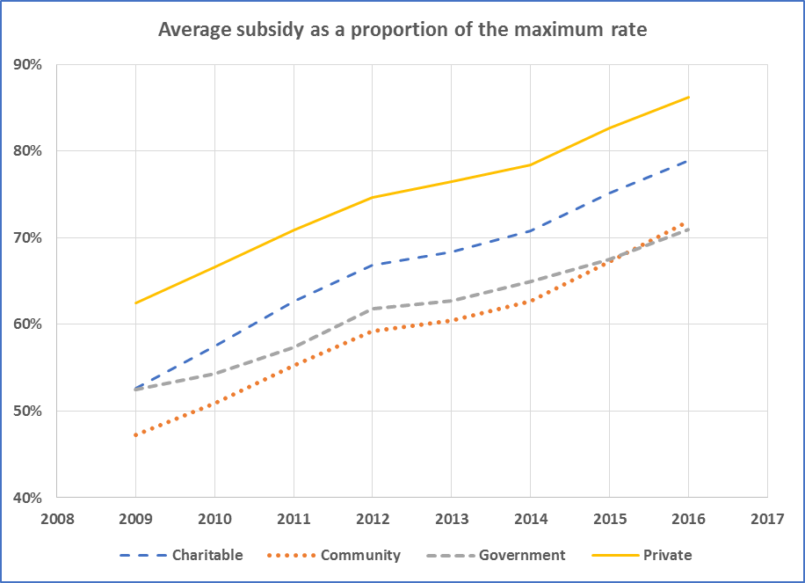

* 1. ACFI Items Showing Significant Growth

Examination of the data from the 2008-2016 period indicates that ACFI funding growth has been driven by several items, the most significant of which are two items covering pain management interventions in the CHC domain. Six checklist items in the ADL domain also contributed to the growth in ACFI funding.

Figure 9.2 shows the growth in the daily ACFI care subsidies for the pain management items since the commencement of the ACFI system. To standardise the comparison of how the funding attributable to the pain management items has changed since 2008-09, the subsidy rates and rules applying from 1 July 2016 have been used. These were applied to resident ACFI data at each 30 June, to estimate the subsidies payable with 1 July 2016 conditions, and then re-estimated omitting the pain management items. The differences are shown in Figure 9.2.

Figure 9.2: Daily subsidy growth in pain management items using July 2016 funding rates

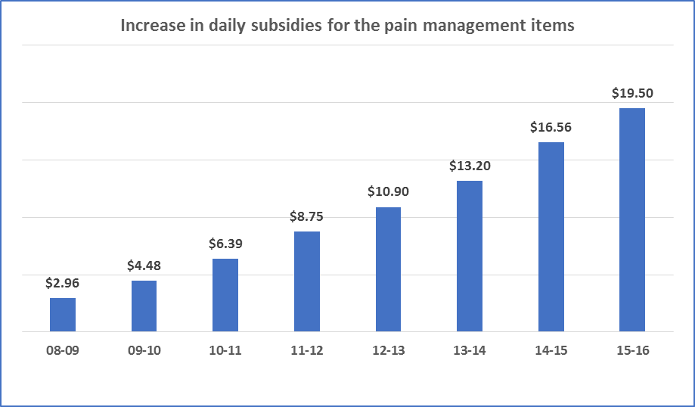

The six ADL domain items which have shown the largest increases in numbers of people rated at the highest level of need in the most recent six years are described in Table 9.2. The 6-year compound growth rate to the highest care need level for these items are:

* 31.7 per cent Transfers (Mobility)
* 27.4 per cent Toilet Completion (Toileting)
* 26.0 per cent Locomotion (Mobility)
* 25.8 per cent Readiness to Eat (Nutrition)
* 24.2 per cent Urine Incontinence (Continence)
* 22.9 per cent Use of Toilet (Toileting)

Table 9.2: ACFI ADL Domain Assistance Checklist Items showing growth

| Percentage of People Assessed as requiring Full Physical Assistance | | | | | | |
| --- | --- | --- | --- | --- | --- | --- |
| Year | **Nutrition: Readiness to eat** | **Mobility: Transfers** | **Mobility: Loco-motion** | **Toileting: Toilet use** | **Toileting: Toilet completion** | **Continence: Urine incontinence** |
| 2010-11 | 64.1% | 36.5% | 46.7% | 58.4% | 64.5% | 58.3% |
| 2011-12 | 68.1% | 38.5% | 48.7% | 61.3% | 68.4% | 60.9% |
| 2012-13 | 70.1% | 39.2% | 49.6% | 62.5% | 70.3% | 62.2% |
| 2013-14 | 72.7% | 40.8% | 51.2% | 64.4% | 73.2% | 64.5% |
| 2014-15 | 76.7% | 44.0% | 54.7% | 67.8% | 77.9% | 68.6% |
| 2015-16 | 80.7% | 48.0% | 58.9% | 71.9% | 82.1% | 72.4% |
| 6-year growth | **25.8%** | **31.7%** | **26.0%** | **22.9%** | **27.4%** | **24.2%** |

* 1. ACFI Subsidy Growth Rates & Relationship to Increases in Acuity

One explanation for the higher than predicted growth in ACFI funding is related to possible increases in resident care needs. For example, “residents are going into facilities at a much more advanced age when their health conditions are far more acute” (participant at consultations). It is also possible that the increase in acuity and frailty of residents, as reflected in increased ACFI funding, is due to the success of community care programs at delaying the need for residential aged care. It is postulated that the consequence of this may be that residents could be sicker, older, frailer, and have shorter lengths of stay now than 8-10 years ago. To investigate these hypotheses, the data were analysed to examine mortality trends, LOS, average age and age at entry.

**Mortality changes give an approximate indication of care need changes**

Analyses of ACFI data, supplied by the National Aged Care Data Clearinghouse for research purposes, have shown that ACFI ADL and CHC domain values are strong predictors of mortality rates (Cumpston and Jukic, 2017).

Mortality rates are estimated by using the number of deaths in a facility reported in a financial year, divided by the mean number of residents in the year. Table 9.3 and Figure 9.3 provide mortality rates by provider type over the six-year period, 2009-10 to 2015-16.

The mortality analysis is not definitive but is provided to give a general indication of trends. The mortality data will be impacted by the differential impact of resident’s end of life support being provided in the facility or hospital, as the analysis only counts deaths as recorded in the aged care facility.

Table 9.3: Mortality rates by provider type, 2009-10 to 2015-16

| Year | Charitable | Community | Government | Private | Total |
| --- | --- | --- | --- | --- | --- |
| 09-10 | 26.6% | 25.5% | 31.5% | 33.6% | 29.1% |
| 10-11 | 27.8% | 26.9% | 33.2% | 34.2% | 30.2% |
| 11-12 | 28.4% | 28.2% | 32.4% | 33.9% | 30.5% |
| 12-13 | 29.1% | 28.7% | 34.1% | 34.6% | 31.3% |
| 13-14 | 29.5% | 28.2% | 33.7% | 33.4% | 30.9% |
| 14-15 | 29.9% | 29.6% | 34.0% | 34.1% | 31.6% |
| 15-16 | 30.6% | 30.6% | 34.8% | 33.1% | 31.7% |
| 6-year growth | **15.0%** | **19.8%** | **10.4%** | **-1.4%** | **9.1%** |
| 7-year growth | **17.7%** | **23.4%** | **12.3%** | **-1.6%** | **10.7%** |
| 1-year growth | **2.4%** | **3.1%** | **1.7%** | **-0.2%** | **1.5%** |

Figure 9.3: Mortality rates 2009-10 to 2015-16

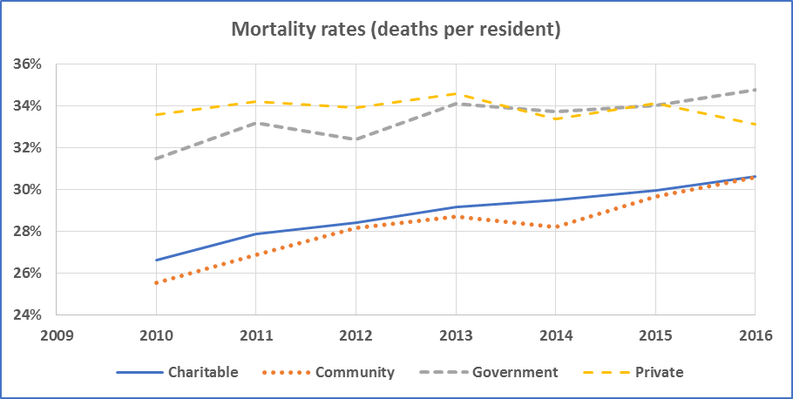

Overall, mortality rates increased by 9.1 per cent over the 6 years. Allowing for another year of growth at the same rate, there is a 7-year mortality rate increase of approximately 10.7 per cent.

Comparing this with the 45.9 per cent growth in average subsidies (see Table 9.1) suggests that it is possible that about 23 per cent of the total subsidy growth is due to increased frailty as indicated by mortality rates. While ACFI funding is growing, mortality rate changes account for only a small proportion of this growth.

Figure 9.4 shows the differences between subsidy growth rate and mortality growth rate, for each sector, and overall for the industry. For the industry, the subsidy growth rate has been 46 per cent from 2008-09 to 2015-16, and the estimated mortality growth has been 11 per cent, a difference of 35 per cent.

Figure 9.4: Differences between subsidy growth rates and mortality growth rates

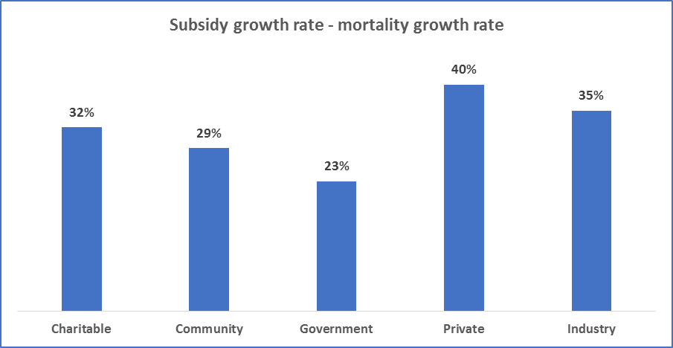

* + 1. Length of Stay Analysis

This analysis has been undertaken to examine the relationship between LOS and growth in ACFI funding. The published LOS data has been compiled by AACS and has come from a range of publications by the AIHW. Figure 9.5 shows that the average LOS has been steadily increasing since 2000 with a sharp increase evident from 2013.

Figure 9.5: Average months of stay for all separations

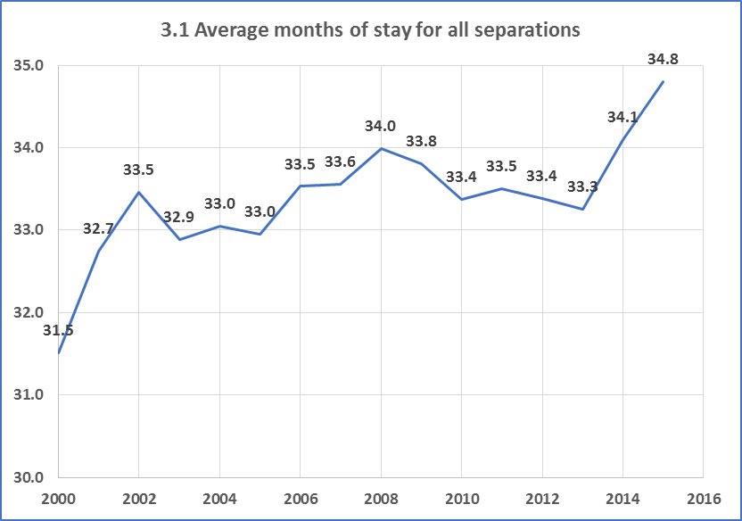

Length of stay data compiled by AACS from range of publications by AIHW

* + 1. Separations by Length of Stay

A further analysis was conducted to assess if there were cohort differences which may have been masked by the average LOS analysis described in Figure 9.5. Are residents now coming into residential aged care sicker and dying sooner than when the ACFI was first introduced in 2008?

Figure 9.6 illustrates the outcome of the analysis which looked at separation trends by LOS sub groups from 2007-8 to 2014-15. The data show that the proportion of residents with shorter LOS has decreased, not increased in the up to three months separation cohorts.   
It also can be seen that compared to 2007-8 the 7-year trend to 2014-15 is towards longer LOS.

Figure 9.6: Separations by length of stay

Figure 9.6 is a bar graph illustrating the percentage of lengths of stay for 2007-2008 and 20014-2015, as summarised in the text prior to this image. The lengths of stay have been separated into seven categories:
1. less than a month
2. 1-3 months
3. 3-6 months
4. 6-12 months
5. 1-2 years
6. 2-5 years
7. over 5 years.

Separation durations for 2007-08 are from Table 3.9 of "Residential aged care in Australia 2007-08 (AIHW 2009). Separation durations for 2014-15 are from table S1.39 of "Residential aged care and home care 2014–15"

* + 1. Average Age at Entry and Aged in Care

The average age at entry to residential aged care and the average age of a resident in aged care from AIHW data sources are shown in Figure 9.7. The data between 2009 and 2014 show a 6-month (83.4 to 83.9 years) average increase in the age of a resident on admission to residential aged care and a similar 6-month increase in the average age of a resident over the same period.

These small increases in age at admission and resident age are unlikely to be significantly impacting on resident acuity nor ACFI dependency ratings and therefore, increased age of residents as a possible explanation for growth in ACFI funding is not supported by the evidence.

Figure 9.7: Average Age at Entry

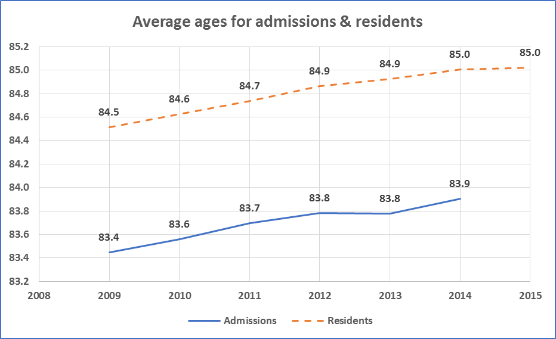

Published admission data up to 2012-13, and resident data for 2008-09, were incompletely subdivided by ages, so the age assumptions of the youngest and oldest groups were based on those derived from 2013-14 for admissions, and from 2009-10 for residents. Where full subdivisions by age were available, the average age for each group was assumed to be at the midpoint of the range.

Using published data, it can be shown that:

* LOS has been at the least maintained and possibly increasing over the past 15 years (Figure 9.5). The average months of stay for all separations has consistently increased from 31.5 months in 1999-00 to 34.8 months in 2014-15.
* There has been a very small increase in the age at entry to an aged care facility in the last 6 years (83.4 years in 2008-9; 83.9 years in 2014-15 - Figure 9.7).
* The age of residents in care has increased slightly (84.5 years to 85 years - Figure 9.7).
* Figure 9.6 shows the distribution of LOS for separations in 2007-08 and 2014-15, from AIHW 2008-9 and 2015-16 data. The proportions at the two shortest durations decreased, and those at all the higher durations have increased. The proportion of residents leaving in less than 2 years has dropped from 53.3 to 50.9 per cent. Residents are tending to have increased LOS in aged care facilities.

Current evidence indicates that residents are not much older, sicker or having shorter LOS than was the case 10 years ago. The residential aged care population as a whole (there may be local effects) is not that dissimilar to the population that the ACFI was calibrated on in 2008 and while it is likely there will be incremental acuity increases in the years ahead, it is unlikely to change dramatically over the next 10 years.

* 1. Government Response to the ACFI Subsidy Growth Rates

Due to the higher than expected growth in ACFI funding claims over the past few years, the Government responded in two main ways:

1. Revision of estimates of expenditure on residential aged care. At the 2015-16 Mid-Year Economic and Fiscal Outlook (MYEFO) and in the 2016-17 Budget, the residential aged care budget was increased by a total of $3.8 billion to 2019-20.
2. Decision made to make changes to the ACFI to mitigate the growth and return the ACFI funding to ‘more sustainable levels’. It was decided the increase in ACFI claiming was most likely due to score maximisation and up-scoring by facilities.

The Government announced a range of measures at MYEFO and in the 2016-17 Budget which included:

* Half indexation of the CHC domain in the 2016-17 financial year only.
* Changes to CHC scoring matrix 1 July 2016 – 31 December 2016.

The changes effective from 1 January 2017 (updated in December 2016) were:

* A re-designed CHC (ACFI 11 and 12) scoring matrix effective from 1 January 2017.
* The Medication question (ACFI 11) modified to have three levels:

(i) No assistance.

(ii) Assistance Needed.

(iii) Injections (subcutaneous, intramuscular, intravenous).

* Some of the CHC questions (ACFI 12) were adjusted as follows:
* Item 12.1 - Blood pressure measurement *-* score reduced from 3 points to 1.
* Item 12.4b - Complex pain management by AHP at least 4 days per week - a timing requirement was added requiring 80 minutes of delivery of one on one treatment on at least 4 days of the week.
* Item 12.12 - Management of oedema, deep vein thrombosis, arthritic joints or chronic skin conditions by fitting of certain garments, bandages and dressings. This item was split into two.
* 12.12a the score was reduced from 3 points to 1 where the treatment was for the management of arthritic joints and oedema related to arthritis by the application of tubular and/or other elasticised support bandages.
* 12.12b remained at 3 points and covered management of non-arthritic oedema OR deep vein thrombosis by the fitting and removal of compression garments and/or compression bandages, OR chronic skin conditions by the application and removal of dry dressings and/or protective bandaging. Note: Tubular elasticised support bandages are not compression garments.
* An indexation pause was placed on all ACFI subsidies in 2017–18 and a 50 per cent indexation pause was placed on the CHC domain for 2018–19.

In addition, the Department has stated they will increase the effectiveness of the audit program. This will involve:

* Focusing more of its compliance activities on high-risk providers.
* Carrying out a more comprehensive review of a service’s claims where there is a higher risk of inaccurate claiming or there are concerns identified during an ACFI review.
* Including information from staff, care recipients or their nominated representatives, or observations of residents. This will include: Observation of residents/Interviewing an informant (staff or relative)/Interviewing a resident/Completing a Task Assessment with a resident.
* Auditing much earlier after the ACFI submission for the above.

After the changes to the ACFI ratings, indexation removal and the increased audit program efforts are implemented, funding to the residential aged care sector is estimated to continue to grow in aggregate, but at a reduced rate, by an average 5.1 per cent per annum over the forward budget estimates.

* 1. Recent ACFI Changes and Impact on Growth

The recent ACFI changes implemented by the Department in the 2016 MYEFO have had an impact on ACFI funding growth. The latest Department ACFI Monitoring Report March 2017 (page 2), has charts showing the trends in daily average claims in the ACFI domains and overall monthly averages (Figure 9.8). It can be seen that the rate of increase has declined since both the July 2016 and January 2017 changes were applied. The impact of the changes that took effect from January 2017, including the auditing program changes, appear to be also having a dampening impact on average ACFI claims up until the end of March 2017 period.

The available data from the April, May, June period in 2017 however shows that the level of ADL claims may be on the increase (Figure 9.9; Table 9.4), although these results should be treated with caution as they are preliminary and the sample size is small as the number of ACFI claims has reduced significantly since March 2017 (Figure 9.10).

Whatever the longer-term trends, which may start to show an increase is emerging, the recent Department changes have impacted on provider behaviour in terms of the frequency of ACFI claims (mainly re-assessments) and the level of the claims.

Figure 9.8: Daily Average Cost per Day Trend by Month (2016-17) Dollars

Figure 9.8 contains four line graphs that illustrate the trends in daily average claims for the aged care funding instrument (ACFI) per month from January 2016 to March 2017, as summarised in the text prior to this image. When viewing the graphs left to right, top to bottom:
• the first graph illustrates the daily average claims (per month, from January 2016 to March 2017) for the activities of daily living (ADL) domain
• the second graph illustrates the daily average claims (per month, from January 2016 to March 2017) for the behaviour (BEH) domain
• the third graph illustrates the daily average claims (per month, from January 2016 to March 2017) for the complex health care (CHC) domain
• the fourth graph illustrates the total of ACFI’s daily average claims (per month, from January 2016 to March 2017).

Figure 9.9: Average ACFI Domain Subsidy Claims from July 2015 to June 2017

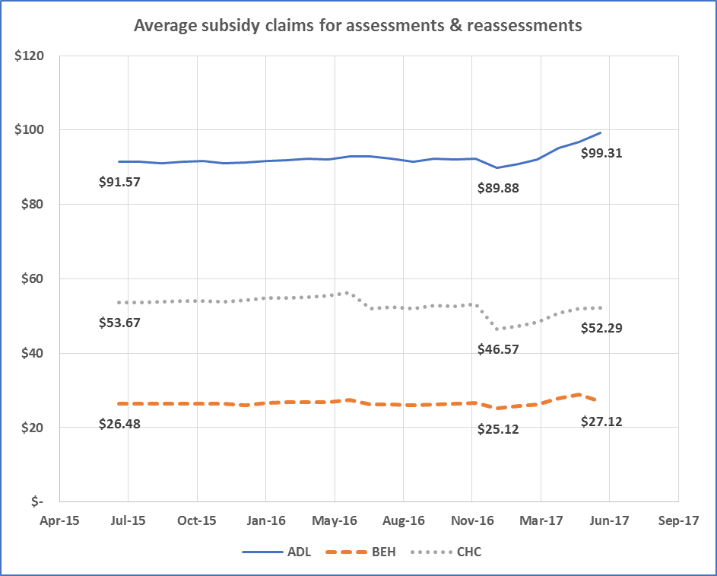

Figure 9.10: Number of ACFI Claims from July 2015 to June 2017

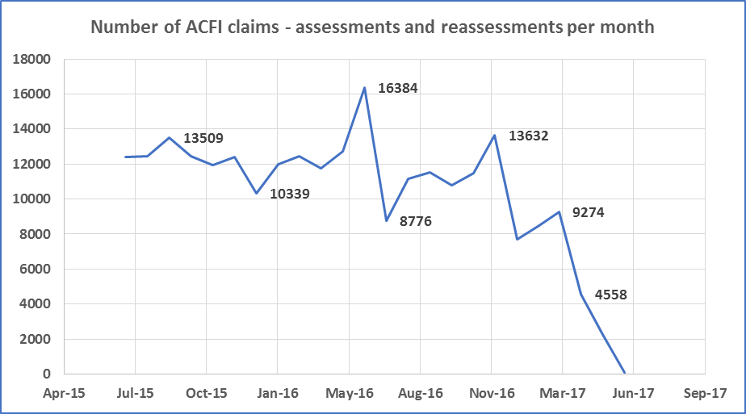

Table 9.4: ACFI Appraisals (Assessments and Re-assessments)

| Month | Number | Subsidy ADL $ | Subsidy BEH $ | Subsidy CHC $ | Subsidy Total $ |
| --- | --- | --- | --- | --- | --- |
| Jul-15 | 12387 | $91.57 | $26.48 | $53.67 | $171.72 |
| Aug-15 | 12473 | $91.50 | $26.36 | $53.75 | $171.61 |
| Sep-15 | 13509 | $91.00 | $26.43 | $53.94 | $171.36 |
| Oct-15 | 12456 | $91.41 | $26.43 | $53.98 | $171.82 |
| Nov-15 | 11957 | $91.71 | 26.47 | $54.12 | $172.31 |
| Dec-15 | 12395 | $91.10 | $26.40 | $53.94 | $171.43 |
| Jan-16 | 10339 | $91.33 | $26.10 | $54.24 | $171.66 |
| Feb-16 | 12005 | $91.61 | $26.70 | $54.90 | $173.21 |
| Mar-16 | 12464 | $91.86 | $26.83 | $54.86 | $173.56 |
| Apr-16 | 11742 | $92.39 | $26.76 | $55.03 | $174.18 |
| May-16 | 12732 | $92.19 | $26.93 | $55.53 | $174.65 |
| Jun-16 | 16384 | $92.84 | $27.50 | $56.24 | $176.58 |
| Jul-16 | 8776 | $92.86 | $26.19 | $52.06 | $171.11 |
| Aug-16 | 11138 | $92.34 | $26.28 | $52.34 | $170.96 |
| Sep-16 | 11514 | $91.49 | $26.05 | $52.11 | $169.65 |
| Oct-16 | 10773 | $92.22 | $26.31 | $52.91 | $171.44 |
| Nov-16 | 11480 | $92.01 | $26.43 | $52.65 | $171.09 |
| Dec-16 | 13632 | $92.27 | $26.72 | $53.14 | $172.13 |
| Jan-17 | 7709 | $89.88 | $25.12 | $46.57 | $161.57 |
| Feb-17 | 8506 | $90.91 | $25.79 | $47.20 | $163.90 |
| Mar-17 | 9274 | $92.18 | $26.15 | $48.30 | $166.63 |
| Apr-17 | 4558 | $95.13 | $27.77 | $50.76 | $173.67 |
| May-17 | 2251 | $96.79 | $28.95 | $52.08 | $177.82 |
| Jun-17 | 75 | $99.31 | $27.12 | $52.29 | $178.72 |

* 1. The Need to Address Funding Volatility and Set a Platform for the Future

Funding volatility and the lack of predictability with the aged care forward budget estimates has been a major issue for both the Government and the Sector. Consultations with representatives of the sector have supported the notion that the rate of the ACFI care subsidy increases has been unsustainable and peak bodies agreed that some corrective action was needed. However, subsequent action by government to slow the growth have created uncertainty (e.g. will it happen again, soon?) producing a destabilised environment for aged care providers.

Reductions in funding by government are often seen by the industry as summary reductions. Additionally, any action to cut funding tends to affect all providers, not just those that have benefited more from the increased subsidy income. This has the effect of creating a lack of confidence and trust which can then impact on future reforms where both parties need to play a constructive role.

For these reasons, it is necessary to address the issue of funding volatility. As has been outlined in Chapters 4, 5 6 and 7, the first step in this process is to build a stronger ACFI measurement model. While the ACFI changes described in the earlier chapters of this report will make the ACFI more contemporary, clearer in the question intent, more reliable and less susceptible to up scoring, experience from previous aged care funding tools introduced in Australia and internationally has shown that an improved scale alone will only go part way to ensuring the integrity of the system in the longer term.

When funding is determined by a provider ‘self-assessment’, it is reasonable to expect that the incentive to maximise the funding overly influences the outcome and widespread up-scoring occurs.

Chapter 10 reviews selected international aged care systems approaches to determining and setting funding.

Chapter 11 provides options to consider for changes to the way assessment for funding is determined in Australian aged care facilities.

1. International and local Approaches to Determining and Auditing Residential Aged Care Funding

This Chapter discusses selected international approaches to determining and auditing residential aged care funding including and an analysis of the Australian review and audit model and the outcomes of the funding audit program.

* 1. International Approaches

The approaches to aged care funding in four countries (New Zealand (NZ), England, Canada, and the USA) are examined briefly in this section. These countries have broadly similar residential aged care systems to Australia and provide a context for the discussion on future approaches to the determination and validation of funding claims in Australia. This work is presented as an overview with specific focus on how care subsidy payments are determined and managed. More detailed descriptions of the approaches in these countries are provided in Tables 10.1 to 10.4.

While it may seem superficially appealing to adopt an approach used in another country, on closer inspection it is apparent that each system is influenced by, and structured around, local historical circumstances which includes the funding system, community care system and the existing facility type models and infrastructure. There is no system internationally that is directly comparable or transferable to the Australian situation, although some relevant themes emerge.

* + 1. New Zealand (NZ)
       1. System description

NZ has four types of residential care (rest home, continuing care, dementia care, psychogeriatric care) with block funding attached to each in contrast to Australia’s ageing in place, single tier model. A residential care provider will often provide more than one level of care but in different buildings.

* + - 1. Assessment:

If a person is likely to need residential care, the District Health Board’s (DHB) Needs Assessment and Service Coordination (NASC) team will use the community care assessment Community interRAI (completed within the past 6 months) when determining the appropriate facility type. If the Community interRAI is older than 6 months and the client is entering care, the NASC Team will update the Community interRAI prior to admission. The NASC determines the most appropriate level of care by matching care needs to the facility type, which effectively sets the funding amount that will be received by the facility for the care provision of residents of a particular type.

A nurse assessor at the facility is required to complete the residential interRAI within 21 days of admission and updates are done at six-monthly intervals.

The care facility can dispute NASC determinations of care level at entry and subsequently, but there are no defined links between interRAl assessments and care levels. The interRAI home care assessment pre-entry can be compared with the interRAI long term care facility assessment when the person is admitted and assessed in the facility.

* + - 1. Future considerations

It is thought by some that the introduction of interRAI into NZ residential care (NH Inter-RAI) will accelerate the push to determine funding levels based on the interRAI resource utilization groups (RUGs) levels. If in future, a more targeted funding model is adopted in NZ and the facilities interRAI is used to inform on the residents funding level within a facility type, there will be reduced scope for ‘up-coding’ as the auditing model will have an external assessment reference point.

* + - 1. Challenges of the model

The block funding approach appears to provide a simple solution when compared to highly categorised funding models (e.g. RUGs Casemix, ACFI) which can lead to frequent resident care need reviews, placing a demand on the administration of the funding system. However, in this model, residents in each facility type are assumed to have homogenous care needs and associated resource requirements aligned to the staffing models. If not, they must move facilities when their care needs exceed what is provided by the facility. Importantly too, consumers prefer a home for life with the care they need rather than being moved around to fit the needs of the system.

There has been some disquiet from providers who believe there is inadequate funding for those with higher care needs given facilities receive the same subsidy irrespective of the resident’s care needs requirements. Additionally, it may take longer to place a higher care needs person from hospital if the facility believes the persons care needs exceed the flat amount paid for the care provision.

* + 1. England
       1. System description

Approaches to residential care funding in England have limited relevance to Australia as funding models vary and are based around the home types:

1. Residential homes, which are primarily social care models providing board, lodging and personal care
2. Nursing homes, which must have at least one qualified nurse to support residents with higher health and nursing care needs.

While homes get funded on a set fee per resident, nursing care aspects of care are determined by the NHS and can vary from resident to resident. There are three nursing care levels (based on 3 subjective classification levels) with National Health Service (NHS) funding amounts based on complexity, stability, predictability, and risk.

* + - 1. Assessment for residential care

Needs assessments pre-entry are conducted by External Assessors such as physicians, nurses, social workers or combinations of these forming ‘socio-medical’ teams. Assessors are usually independent from providers, and may or may not be independent from the local health authority. There is no apparent auditing of the External Assessor’s decision relating to nursing care level determination.

* + 1. Canada

As an example of a Canadian Province, Ontario uses RUGs to determine the resident’s Casemix group. Casemix groups are determined by the coding of specific interRAI MDS items related to the amount of assistance the resident receives with ADLs plus, to a lesser extent, selected treatments, health conditions, diagnoses, behaviour and cognitive status. While the aged care provider determines the resident RUG grouping post-entry via quarterly individual resident RUGs ADL assessments, the provider is not paid on a resident by resident basis. Payment is based on the annualised Casemix average (case mix index – CMI) which considers variations in resident care needs during the year as assessed by the RUGs assessment tool.

In all long-term aged care environments the ADL domain is the biggest driver of funding costs. Therapy minutes based on care provided is also a funding driver but this item is believed to be open to manipulation and is currently being reviewed by the developers of the interRAI. The need for therapy is extremely difficult to objectively determine, and relying on a therapist’s view on the amount of therapy care needed has proven problematic. Ontario is considering linking the therapy minutes to outcomes and benefits to residents.

As the aged care provider completes a ‘self-assessment’ for funding, there are extensive data checks and audit visits to validate the accuracy of RUGs MDS. Anecdotally, it is reported there is a relatively high level of over-claiming (15 per cent). Penalties apply for inaccurate claiming patterns.

* + 1. USA

As is the case in Ontario, the aged care system in the USA uses an internal facility assessor to complete the interRAI MDS which classifies residents into distinct reimbursement groups through the production of RUGs classifications in the skilled nursing home environment. The funding groups are determined by the coding of specific interRAI MDS items related to the amount of assistance the resident receives with activities of daily living plus selected treatments.

Payments to providers are made on a regular per resident basis, unlike Ontario where a retrospective Casemix average is used from the previous year to determine payment in the current year. Facilities are paid a daily rate based on the resident’s RUG which determines the resident’s case mix classification. The Casemix classification is then associated with a payment level as determined by the local health department.

The interRAI covers a comprehensive range of domains and is completed every 3-6 months. To limit the potential for over-claiming when using the facility based self-assessment model, the various states have developed sophisticated audit models. An example of the Minnesota audit model used in the USA is provided below.

**Audits of the assessments used for Case Mix Classifications**

A percentage of MDS assessments used for Minnesota Case Mix Classifications are audited for accuracy by MDH staff. Audits may be performed through desk audits or on-site review. On site audits are unannounced and may include review of residents’ records, observations of residents, and interviews with residents, staff, and families. Residents may be reclassified if MDH staff determine that the resident was incorrectly classified. Within 15 working days of the audit completion, MDH will post electronic notices of the case mix classification for each resident whose case mix classification has changed subsequent to the audit.

Audits consist of annual audits for all facilities or special audits if problems are noted with a facility’s completion and submission of MDS assessments. For example, a facility may be subject to a special audit if there is an atypical pattern of scoring MDS items, assessments are not being submitted, assessments are late, or a facility has a history of audit changes of 35 percent or greater. Depending on audit results, the sample of assessments being audited may be expanded up to 100%.

Each facility shall be audited annually. If a facility has two successive audits with five percent or less percentage of change and the facility has not been the subject of a special audit in the past 36 months, the facility may be audited biannually. A stratified sample of 15 percent, with a minimum of ten assessments, of the most current assessments shall be selected for audit. If more than 20 percent of the RUG-IV classifications are changed the audit shall be expanded to a second 15 percent sample, with a minimum of ten assessments. If the total change between the first and second sample 35 percent, the commissioner may expand the audit to all of the remaining assessments.

If a facility qualifies for an expanded audit, the commissioner may audit the facility again within six months. If a facility has two expanded audits within a 24-month period, that facility will be audited at least every six months for the next 18 months.

The commissioner may conduct special audits if the commissioner determines that circumstances exist that could alter or affect the validity of case mix classifications of residents. These circumstances include, but are not limited to, the following:

* + - 1. frequent changes in the administration or management of the facility;
      2. an unusually high percentage of residents in a specific case mix classification;
      3. a high frequency in the number of reconsideration requests received from a facility;
      4. frequent adjustments of case mix classifications as the result of reconsiderations or audits;
      5. a criminal indictment alleging provider fraud;
      6. other similar factors that relate to a facility's ability to conduct accurate assessments;
      7. an atypical pattern of scoring minimum data set items;
      8. non-submission of assessments;
      9. late submission of assessments; or
      10. a previous history of audit changes of 35 percent or greater.

(Case Mix Classification Manual for Nursing Facilities Case Mix Review. Minnesota Department of Health, June 2015, p24)

* 1. Learnings for Australia

While the international systems reviewed have been developed to fit their local circumstances and have limited application to Australia, there are some consistent learnings that are relevant to the future development of aged care funding systems in Australia.

* + 1. Self-assessment

If the funding assessment is completed by facility staff (self-assessment), it is inevitable that there will be an incentive (even if sub-conscious) for up-scoring the resident’s care need assessment. To counter this behaviour, and to ensure system costs do not grow beyond expectation, there must be a well-resourced and thorough auditing system with severe penalties embedded. The systems that show the least growth in funding due to provider ‘up-scoring’ appear to have the most stringent and sophisticated monitoring and auditing models (refer Minnesota assessment audit model). This sophisticated approach has been used by many states in the USA to maintain funding control in their Case mix funding systems which rely on self-assessment by providers and are open to maximisation. Significant auditing resources are needed to monitor and regulate the systems.

* + 1. External assessment - prior to facility admission

Alternative assessment models rely on external assessment prior to facility admission to determine funding. These assessments must be as recent as possible and based on assessed care need - not care to be provided. This approach will be most effective if the pre-entry and post-entry assessment tool is identical. This model allows for a single MDS to be used across community and residential care systems. This model also means that the facility can contest the rating (prior to admission) to allow for significant changes in a resident’s care needs immediately after admission.

* + 1. Categorising facilities

Some funding systems approach the issue of funding aged care by reducing classification categories and promoting ‘simplicity’ using block funding approaches. These models often rely on a system comprised of different residential facility types (e.g. low care; high care; dementia care) to allow for more homogenous care need groupings. Even with these approaches, there is pressure emerging to better target funding to residents within these facility types to better cover the cost of higher care need residents and to ensure those without financial resources but with high health care needs (e.g. in hospital) can access residential care in a timely manner.

* + 1. Assessment tools and the determination of funding

We have not been able to identify any system internationally, that sets long term care or residential care funding based on an absolute assessment tool determination of dollars. The assessment tools are used to determine relativities across resident types and the health system then determines how much funding will be distributed across the relative care need levels.

Table 10.1: Most Relevant International Residential Care Systems – New Zealand

|  |  |  |  |  |  |
| --- | --- | --- | --- | --- | --- |
| **Country** | **Payment level determination** | **Mandated Care funding tool** | **Care Classification levels** | **Review of needs** | **Auditing of Funding Claims** |
| **New Zealand** | **Pre-entry – External Assessor**  DHBs fund residential care.  DHBs determine the level of care needed by having NASC teams conducting assessments using the community inter-RAI. (Valid for 6-months).  This model provides a transparent and consistent assessment approach.  Assessments and judgement by NASC teams assigns resident to one of four care levels.  Each care level attracts one flat payment amount. | **None**  interRAI is done pre and post entry.  interRAI used for MDS and to promote care planning not used for funding.  Considering using the facility completed interRAI – RUGs ADL but concerned it may increase payments due to inflated ratings  Considering moving to interRAI and RUGs for not only needs but funding assessment.  Providers have indicated that the length of time to complete the interRAI assessments and the efforts to regularity repeat the assessments is a significant resource demand. | **Four facility classifications** and related funding types.   * 1. Rest home.   2. Hospital care.   3. Specialist dementia care with locked unit accommodation.   4. Psychogeriatric care associated with hospital care.   interRAI completed on-line and DHB has access to all data. | **External Assessor**  Facility must complete NH inter-RAI within 21 days post admission and facility **c**an dispute the allocated home type level.  Visit from an External Assessor determines decision.  Facility asks for home type review using interRAI & NASC determines outcome, may require visit. The decision to move to a higher-level care facility is made in consultation with facility staff.  Higher care facilities are often on the same campus as lower level options. | **None**  Facility assessor requests review if resident has higher care need than facility type can manage.  Local Health Body (DHB) - NASC assessor determines if move approved. |

Table 10.2: Most Relevant International Residential Care Systems – Canada

|  |  |  |  |  |  |
| --- | --- | --- | --- | --- | --- |
| **Country** | **Payment level determination** | **Mandated Care funding tool** | **Care Classification levels** | **Review of needs** | **Auditing of Funding Claims** |
| **Canada**  **(Varies across provinces)**  **Example based on Ontario.** | **Internal – Facility Assessor Post-entry**  The Ministry of Health and local health care authority manage waiting lists and determine who is admitted to a facility. Clients on wait list must take first offer (could be 50km away) or go to the bottom of the list. When a place becomes available at a facility nearer their home/family, a further move can be approved. There are significant issues regarding the waiting times. The median waiting time is around 4 months, while those in hospital needing placement wait around 3 months.  Getting timely access to residential care has become a system issue which is being addressed by a new ‘home first’ program.  RUGs groupings result from the case mix classification system. The groups are determined by the coding of specific interRAI MDS items related to the intensity of assistance the resident received with ADLs plus selected treatments, health conditions, diagnoses, behaviour and cognitive status.  While the Aged Care Provider determines their overall funding post-entry via regular individual resident RUGs ADL determinations, the provider is not paid on a resident by resident basis. Payment is based on an annualised Casemix average (case mix index – CMI). | interRAI – case mix results in RUGs used to determine funding group.  Algorithms vary across provinces. | RUGs-ADL 44 Groupings  Case Mix Design  Yearly adjustments based on historical average yearly Casemix index.  ADLs are the biggest driver of funding.  Therapy minutes based on care provided, not outcomes.  Therapy question under review due to inability to audit and lack of linkage to outcomes. | **Facility Assessors**  Facility assessors complete the interRAI quarterly on each resident to determine care needs.  The funding groupings for each quarter are then averaged annually, to determine the Casemix average or index (CMI). The funding is then related to the variations in resident care needs and by implication resources, via these updated groupings. | Data checks and audit visits are undertaken to assess the accuracy of the RUGs MDS.  Facility case managers need to account for claims and accuracy.  Penalties apply for inaccurate claiming patterns. |

Table 10.3: Most Relevant International Residential Care Systems – United States of America (USA)

|  |  |  |  |  |  |
| --- | --- | --- | --- | --- | --- |
| **Country** | **Payment level determination** | **Mandated Care funding tool** | **Care Classification levels** | **Review of needs** | **Auditing of Funding Claims** |
| **USA**  **(variations across states)**  Example based on approach used in Minnesota which is representative | **Internal – Facility Assessor Post-entry**  The interRAI MDS produces RUGs classifications. There are 7 major groupings and 44 minor classifications. This description focuses on skilled nursing homes.  Funding groups are determined by the coding of specific interRAI MDS items related to the amount of assistance the resident receives with ADLs plus selected treatments, health conditions, diagnoses, behaviour and cognitive status.  RAI-> RUGs ADL score has a range from 0-16 which is the main driver of funding determination.  Payments are made on a resident basis (unlike Ontario). Facilities are paid a daily rate based on the residents RUG grouping which determines the residents case mix classification. The Casemix index (CMI) is then associated with a payment level as determined by the local health department on a state by state basis.  The CMI determines the relativities and not the specific funding associated with the groupings. | interRAI  RUGs III/IV  States have varying algorithm based models.  The Long-Term Care RAI (Resident Assessment Instrument) is completed by facility staff in skilled nursing homes across the USA. Tool used for residents that fit into the sub-acute or intermediate level of care through to residential care. The RAI produces a 108 item minimum data set data which is used for care planning. Funding data (RUGs III/iv) is extracted from the MDS. The funding level is determined by computer algorithm based on a case-mix funding method. | RUGs 7 Major Groupings  44 minor classifications.  Different approaches but RAI-> RUGs ADL score (0-16) plus additional modifiers.  Starting with the 108 items from the Resident Assessment Instrument for Long Term Care (RAI), the funding instrument (RUGs III/IV) extracts a smaller subset of items. Residents are classified into 1 of 7 major categories, and then further classified into 1 of 44 minor categories. The ADLs and therapy minutes underlie most classifications. | **Internal Assessor**  Nursing.  interRAI completed every 3-6 monthly | **State Review Program**  Claims subject to a sophisticated electronic review and visit based audit program to assess claims. Serious penalties are applied if the RUGs assessment is over estimated.  The interRAI which covers a comprehensive range of domains is completed every 3-6 months and is externally audited by review of the care documentation and interviews with staff, resident and family.  Case Mix Classifications are audited for accuracy by state health staff. Audits may be performed through desk audits or on site review. On site audits are unannounced and may include review of residents’ records, observations of residents, and interviews with residents, staff, and families.  Note: The approach used by Minnesota is detailed in section 10.2. |

Table 10.4: Most Relevant International Residential Care Systems – England

|  |  |  |  |  |  |
| --- | --- | --- | --- | --- | --- |
| **Country** | **Payment level determination** | **Mandated Care funding tool** | **Care Classification levels** | **Review of needs** | **Auditing of Funding Claims** |
| **England** | **External Assessor - Pre-entry PCT/local, External assessor Case Manager**  Homes are paid a flat fee as determined by local agreements.  Nursing Care is funded by the NHS in Nursing Homes based on individual resident needs.  **Eligibility**  If admission to LTC facility is a possibility, a multi-disciplinary assessment (e.g. old age mental health team) is undertaken to identify opportunities for rehabilitation and to reduce inappropriate admissions. A suitably trained registered nurse must be involved in any assessment that identifies nursing needs and in deciding the appropriate setting.  Two main types of care facilities:  **Residential homes** - primarily social care that provide board/lodging/personal care.  Aged care ‘adult social care’ is the responsibility of local governments. Local authority/PCT must provide a NH coordinator (budget manager) and Lead Nurse (advice on personal care).  **Nursing Homes** - must have 1 qualified nurse, residents more severe impairments (physically & mentally).  NHS reimburse the nursing care element. Can claim costs of social care against client property /assets. | **None**  Various, single assessment instrument process and tools developed but not broadly implemented across England.  Access to residential and home care services requires local authorities to conduct a needs assessment as well as a means test.  Services determined by the needs assessment may be directly provided by the local authority, commissioned by the local authority, delivered by joint agreements with the NHS, or be funded by a cash payment issued to the care recipient or their representative.  The needs assessment process is conducted by local governments and is not standardised. | **Residential homes**  Primarily social care that provide board/lodging/personal care.  **Nursing Homes**  Nursing Homes must have 1 qualified nurse, residents more severely impaired (physically & mentally).  Classification level determined by NHS.  Three nursing care levels (no algorithm, based on 3 subjective classification levels) with funding amounts (based on complexity, stability, predictability, risk).  Four severity levels with no maximum funding amount attached. | **External Assessor**  PCT/local  Regularly | **No auditing of External Assessor determination** of nursing care level determination.  Needs assessments are typically conducted by individual physicians, nurses, social workers or combinations of these forming ‘socio-medical’ teams. Assessors will usually be independent from providers, and may or may not be independent from the local authority. |

* 1. The Current ACFI Review Program – Internal Assessment and Departmental Audits
     1. The Current Australian Assessment and Audit Model

Examination of international examples leads us back to the Australian situation. How are assessments currently done in Australia and how are audits conducted?

* + - 1. Care Subsidy (Funding) Determination

Care subsidies for permanent aged care facility residents are determined by the provider completed ACFI. Aged care providers apply for resident classification from the Department of Human Services (Medicare Australia) after 28 days and within two months of a new resident’s admission. When an existing resident’s care needs increase significantly, as measured by a two-category increase in their ACFI rating, the provider can submit another ACFI within 12 months of the current appraisal. For lower level increases in care needs (one category ACFI increases), the provider can submit an ACFI re-appraisal after a 12-month period. Approved providers are also required to do mandatory six-month appraisals for residents who have entered care from hospital or have had a two-category increase in their ACFI rating.

Providers are paid from the applicable date (e.g. admission; re-appraisal start date) based on their internally completed, self-assessed ACFI claims, which are submitted to the Department. The Department can audit the submission with no set time frame, after the funding has been paid to the provider, via their review or audit program.

* + - 1. Review or Audit Program

The Review Program was established to ensure that funding appraisals were completed as per the Classification Principles (ACFI User Guide) and reflect the resident care needs at the time of signing. Providers complete their resident appraisals using the ACFI User Guide and Answer Appraisal Pack. As the Department audit is supposed to cover only the period when the resident was appraised for their care requirements, providers need to make sure, either via their software system or paper documentation, that the specified materials for accountability and audit purposes are available.

The Department ROs who conduct the audits check if the ACFI appraisal reflects the resident’s care needs at the time of ACFI appraisal submission. The methods used to conduct audits include checking the completeness and accuracy of the Answer Appraisal Pack and congruence between the ACFI appraisal documentation and clinical reports, assessment information, discussions with care staff, and observations and interviews with the resident. Downgrades result in retrospective funding reductions. These reductions are backdated to the ACFI appraisal prior to the current classification change, which can result in a severe financial penalty.

The Review Program has both targeted and random components. The targeted component considers the classification profiles and review history of a provider. While the targeted review can cover the entire ACFI question set, in most instances it focuses on particular questions or question sets at individual facilities where previous full classification reviews have revealed possible systematic problems. The random component is used to monitor the effectiveness of the targeted reviews and to assist in the identification of systemic issues.

* + - 1. Review Officer (RO) Workforce

Traditionally, the role of a RO has been undertaken by a Commonwealth Nursing Officer (CNO). In 2012, non-CNO staff were introduced to undertake ACFI reviews. While it is not a legislative or policy requirement that ROs are RNs, it was initially considered beneficial to the implementation of the review program given the clinical nature of some ACFI questions. The Department wished to broaden the professional background of ROs. In August 2012, a trial of the use of non-CNO officers to undertake ACFI reviews was conducted in Victoria. The results from the trial showed that with clinical support, ROs without a clinical background were proficient in conducting the ACFI reviews. Currently around 60 per cent of ROs are CNOs and 40 per cent non-CNOs. ROs with a clinical background tend to approach audits with a clinical focus by devoting additional time to understanding the impact of medical conditions on the question ratings. Non-CNOs generally approach reviews from a stringent audit perspective, focusing on checking compliance aspects (for example the dates for various documentation) and requirements of the ACFI User Guide and liaise with their peers to clarify clinically-based queries when required.

* + - 1. Numbers of assessments and reviews since ACFI began

The number of ACFI appraisals and Department Reviews to June 2016 are shown in Table 10.5 based on data supplied for this project (refer Chapter 2). Appraisals and Department reviews are shown by financial year, based on ACFI appraisal date. Data for 2017 are shown in italics to reflect they are incomplete. Provider submitted ACFI appraisals for any reason are included. Department reviews exclude second reviews and Administrative Appeals Tribunal cases. The review rates in Table 10.5 and illustrated in Figure 10.1 were calculated by dividing the number of Department reviews dated in a financial year by the numbers of provider ACFI appraisal start dates in the same financial year. Department reviews (audits) are on average done about 4 months after the ACFI appraisal start date.

Table 10.5: Numbers of ACFI appraisals and Department reviews (supplied ACFI data)

| Year to 30 June | ACFI Appraisals | Department Reviews | Review Rate |
| --- | --- | --- | --- |
| 2008 | 47,427 | NA | NA |
| 2009 | 186,722 | 7,480 | 0.040 |
| 2010 | 139,095 | 23,411 | 0.168 |
| 2011 | 144,403 | 23,063 | 0.160 |
| 2012 | 151,047 | 18,806 | 0.125 |
| 2013 | 145,493 | 21,549 | 0.148 |
| 2014 | 152,040 | 19,880 | 0.131 |
| 2015 | 147,256 | 20,609 | 0.140 |
| 2016 | 150,843 | 15,713 | 0.104 |
| 20171 | *99,686* | *7,632* | *0.077* |
| Total | **1,364,012** | **158,143** | **0.116** |

**1**Data for 2017 is incomplete.

Figure 10.1: Chart of Department review rates from 2009 - 2017

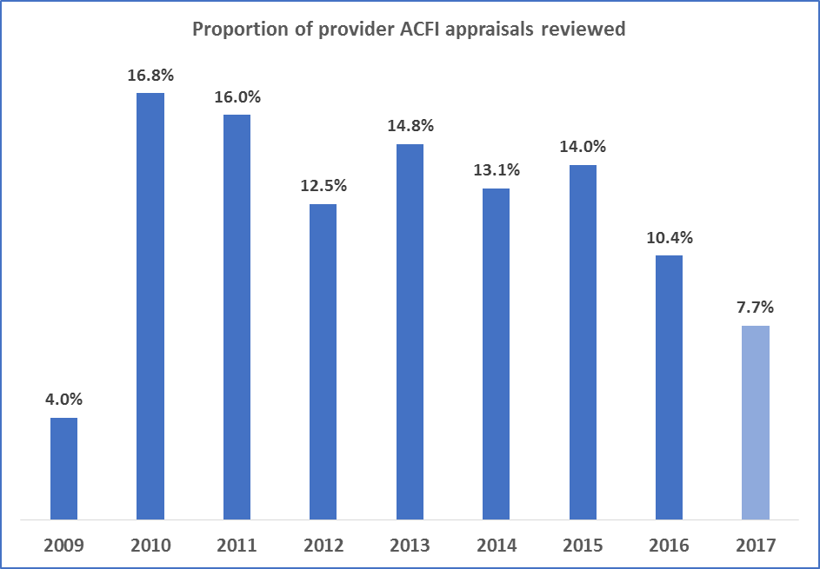

* + 1. Impact of the Audit Model

1. ACFI quarterly monitoring data since January 2016

The Department review program is now targeted to facilities where up-scoring is more likely. For this reason, the outcomes of the reviews cannot be taken as indicative of potential outcomes if a more random approach was taken. Nevertheless, the review program results do show that the ACFI can be audited and downgrades are now recorded at a relatively high frequency when compared to the number of ACFIs reviewed. Table 10.6 shows that the proportion of downgraded claims has almost doubled, from 13.2 per cent in the 9 months from beginning of July 2015 to end of March 2016, to 25.2 per cent in the 9 months from beginning April to end of December 2016. Figure 10.2 illustrates the results from the quarterly review rates.

Table 10.6: Chart of Department review rates from July 2015 to December 2016

| Period | Downgraded Reviews | Downgraded Percentage | Unchanged Reviews | Unchanged Percentage | Upgraded Reviews | Upgraded Percentage | Total Reviews |
| --- | --- | --- | --- | --- | --- | --- | --- |
| 7/15-9/15 | 596 | **13.9%** | 3634 | 84.8% | 53 | 1.2% | **4283** |
| 10/15-12/15 | 623 | 13.0% | 4144 | 86.3% | 33 | 0.7% | **4800** |
| 1/16-3/16 | 367 | 12.3% | 2590 | 87.0% | 20 | 0.7% | **2977** |
| 4/16-6/16 | 937 | 26.3% | 2602 | 73.0% | 27 | 0.8% | **3566** |
| 7/16-9/16 | 457 | 20.7% | 1725 | 78.2% | 25 | 1.1% | **2207** |
| 10/16-12/16 | 763 | **27.3%** | 2024 | 72.3% | 11 | 0.4% | **2798** |
| Total of Periods | **Downgraded Reviews** | **Downgraded Percentage** | **Unchanged Reviews** | **Unchanged Percentage** | **Upgraded Reviews** | **Upgraded Percentage** | **Total Reviews** |
| 7/15-3/16 | 1586 | 13.2% | 10368 | 86.0% | 106 | 0.9% | **12060** |
| 4/16-12/16 | 2157 | 25.2% | 6351 | 74.1% | 63 | 0.7% | **8571** |

Health ACFI Quarterly Reports for September quarter of 2015 to December quarter of 2016

Figure 10.2: Chart of Department review rates from September 2015 to December 2016

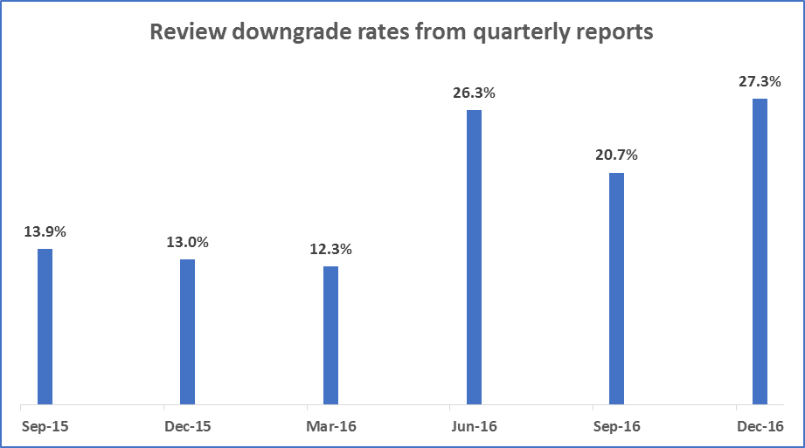

Table 10.7 shows the outcomes of reviews since the commencement of the ACFI system using the provided ACFI data. It will show slight deviations from the quarterly reports data discussed previously as the data source is different. The results of reviews since ACFI commencement are also presented graphically in Figure 10.3. This shows that the downgrade rate from reviews in 2016-17 is likely to be about 25 per cent, compared with a historic average of around 16 per cent.

Table 10.7: ACFI Review Statistics from 2009 to 2016

| Year to 30 June | Downgraded Reviews | Downgraded Percentage | Unchanged Reviews | Unchanged Percentage | Upgraded Reviews | Upgraded Percentage | Total Reviews |
| --- | --- | --- | --- | --- | --- | --- | --- |
| 2009 | 1094 | 14.6% | 5961 | 79.7% | 425 | 5.7% | 7480 |
| 2010 | 3811 | 16.3% | 18638 | 79.6% | 961 | 4.1% | 23410 |
| 2011 | 3866 | 16.8% | 18393 | 79.8% | 804 | 3.5% | 23063 |
| 2012 | 3433 | 18.3% | 14882 | 79.1% | 491 | 2.6% | 18806 |
| 2013 | 3417 | 15.9% | 17777 | 82.5% | 354 | 1.6% | 21548 |
| 2014 | 3396 | 17.1% | 16175 | 81.4% | 309 | 1.6% | 19880 |
| 2015 | 2471 | 12.0% | 17925 | 87.0% | 213 | 1.0% | 20609 |
| 2016 | 2516 | 16.0% | 13062 | 83.1% | 134 | 0.9% | 15712 |
| 2017 | *1867* | *24.7%* | *5590* | *73.8%* | *113* | *1.5%* | *7570* |
| Total | **25871** | **16.4%** | **128403** | **81.2%** | **3804** | **2.4%** | **158078** |
| To 2016 | **24004** | **15.9%** | **122813** | **81.6%** | **3691** | **2.5%** | **150508** |

Figure 10.3: ACFI Review Statistics from 2009 to 2016

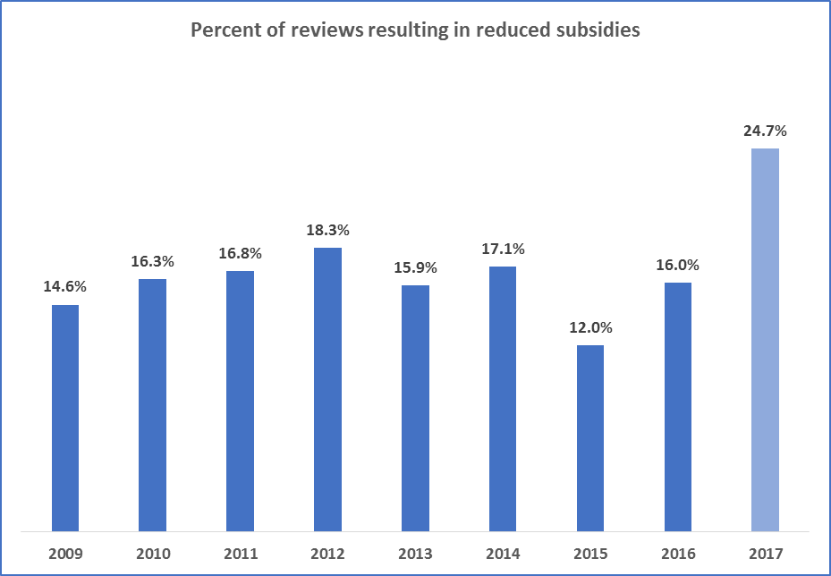

* + 1. Future of the Current Audit Program Model

The current review program model has been operating since the RCS was introduced. While the program has worked effectively in recent times, as can be seen from the results in Table 10.6 and 10.7, the key issues moving forward are its scalability as the industry grows and its ability to maintain funding growth in the years ahead, even given an improved, ‘much less open to gaming’ assessment tool. While some of the funding growth may have been due to increasing resident care needs, the Review Program has been slow to respond to the developing issues (e.g. progressive predicable increase in pain management claims – Figure 9.2) and for whatever reason, has not been scaled up to audit a sufficient number of ACFI submissions in a timely manner to provide a viable threat to those providers up scoring the ACFI claims.

Some of the issues are the result of:

* Restrictions placed on the Departmental audit program in terms of numbers of audits possible per site.
* The penalties for mis-claiming have been inadequate and have not provided sufficient deterrent to halt claim maximisation behaviour.
* The absence of sophisticated predictive modelling and use of sector IT clinical systems has also been an issue for the Review Program. Most international models that allow a facility self-assessment for funding are underpinned by sophisticated analytical models and extensive site audit processes to constrain funding increases, as far as possible, to changes in resident dependency.

International systems show that significant resources must be applied to maintain funding levels to reasonable growth if the providers conduct the assessment for funding. This is not a specific aged care problem as it also applies more generally to other areas such as hospital funding models using case mix approaches.

The next chapter discusses options for an external assessment system for funding in Australia.

1. Options for Future Consideration
2. Introduction

While the current ACFI Review program has run effectively for the most part, the key issues moving forward are its scalability as the industry grows and its ability to maintain funding growth in the years ahead, even with an improved, ‘less open to gaming’ assessment tool.

The current method of ensuring funding claims are accurate via Departmental audits is limited in scope, and funding growth due to optimisation has proven difficult to contain. Funding growth beyond that articulated in the Department’s forward estimates means that regular action to cut the overall expenditure is a recurrent feature of the aged care environment. Also, providers, while benefiting from funding growth spurts, are consequently subject to government funding reductions that they believe are unfair, unpredictable and affecting business confidence and ultimately investment.

1. Suite of review/audit activities

A suite of recommended review/audit activities will be discussed in the options presented in section 11.2 of this chapter. The following provides a detailed description of the recommended activities for reference purposes. The use of data analytics and, in future, e-audits will limit the number of site visits needed and allow the program to maintain flexibility and be scalable as the number of aged care beds continues to grow over the next 10-15 years.

1. Data analytics

This process involves comparisons between pre and post entry data and R-ACFI data analysis to identify inconsistent profiles and item patterns within facilities and across provider services. It will involve:

* Comparison of pre-admission information from the NSAF, other sources such as medical records (e.g. the Comprehensive Medical Assessment (CMA)) and R-ACFI if completed externally by the ACAT and comparison with the provider’s R-ACFI.
* R-ACFI data analysis to identify inconsistent profiles and item patterns.

1. Future remote electronic audits - e-audits.

Comprehensive electronic reviews of the resident’s clinical documentation should be considered for introduction in the next 5 years. These would include:

* Remote access to provider electronic clinical software system ‘partitioned sections’ to enable an e-Review. An e-Review will involve a detailed audit of the R-ACFI, including reviewing the nursing assessments, care plans, progress notes, GP notes and Allied Health notes to validate the provider claim.
* The Department Electronic Reviews may involve facilities providing additional information on request to support the claim.
* The Department comprehensive electronic reviews may trigger a targeted on-site visit review program.

An electronic review option is not yet available but is a recommended development in several (possibly all) of the options listed.

1. Site visits to review claims

* Case by case audits - on-site R-ACFI reviews:
  + These reviews will cover individual submissions as is currently the case. However, there will be new guidelines developed for in-provider reviews (assessed care need versus care provided and relevance to a review decision) to clarify the RO’s R-ACFI review protocols and the compliance aspect of their role. RO’s will focus on resident assessed care needs and assessment accuracy but will not complete the resident assessments, unlike Options 2 and 3 discussed later.
* A visit program may include:
  + a review of residents’ records (file notes, assessments, care plans etc.).
  + observations of residents.
  + interviews with residents, staff, AHPs, GPs and families.

These data sources can be used to inform on the accuracy of the assessed need. Incongruences noted during direct observation of the resident should be used as a flag for further investigations to check the accuracy of the assessed care need.

1. Special Audits

* This proposed new category of special audits will be introduced to broaden Department Reviews beyond single or multiple R-ACFI submissions. The Department may conduct ‘special audits’ if circumstances exist that could alter or affect the validity of R-ACFI classifications for a cohort of residents. These circumstances will include, but are not limited to:
  + frequent changes in the administration or management of the provider.
  + an unusually high percentage of residents in high R-ACFI classifications and, in particular, a significant change in the long-term average funding.
  + frequent adjustments of R-ACFI classifications as the result of reconsiderations or audits.
  + other similar factors that relate to a provider's ability to conduct accurate assessments.
  + an atypical pattern of scoring R-ACFI assessment items on a significant proportion of residents.
  + a previous history of Department audit changes in a 12-month period.

1. New Model Options for Funding Determination and Accountability

The following options are proposed to address the current issues with funding determination and allow for scalability in the future. Each option:

* Takes into account current issues
* Allows for future scalability

Each of the proposed options will require a commitment to additional investment in people, IT and aged care systems. Option 2 will, in time, deliver a single assessment process for community and residential aged care clients

1. Option 1: Enhanced Department Audit Model (post entry)

This model, described in Table 11.1 is based on the current Department audit approach and further develops the review program. This optionis designed to improve the effectiveness of the Department ACFI Review Program outcomes via data analytics, e-audits (when available), and site visits to review claims while also giving more funding certainty to providers by placing a limit (12 months) on the time that claims can be subject to an audit.

The fundamental requirement with Option 1 is the completion of the R-ACFI in the NSAF when the Aged Care Assessment Team (ACAT) recommends residential aged care, as one of the options for a person’s future care. This R-ACFI will also need to be updated before admission to a RACF if it is older than 3 months.

In this option the aged care provider completes the care needs assessment (e.g. R-ACFI) as is currently the case with the ACFI but all R-ACFI submissions are reviewed at a number of levels (data analytics, comparison of the ACAT R-ACFI to the provider R-ACFI, e-audits (in future), and site visits to review claims).

Under this model, the Department will be required to conclude any audit review of a provider funding submission within 12 months of whichever is the more recent of:

* + - 1. the appraisal start date or
      2. the accepted Medicare received date.

If there is no review within 12 months of submission, the facility’s submitted Medicare accepted funding submission will not be subject to audit.

Table 11.1: Option 1 Summary – Modified Current Audit Model

| **General Aspects** | **Details** |
| --- | --- |
| **Funding Model** | Provider self –assessment |
| **New Resident - $ assess** | Facility |
| **ACAT changes?** | Yes: 3 months validity R-ACFI pre-entry, no $ role |
| **R-ACFI Users** | ACAT & Provider |
| **Review by** | Review Officers (RO) |
| **Aspects for New Residents** | **Details** |
| **Funding Determination - review process** | **Provider R-ACFI used for funding determination $s**  DoH validates 100% of claims using: Matching (ACAT/Provider) R-ACFIs, data analysis, e-Audit, site visits.  **RO audits 10% of R-ACFI claims via site visit** |
| **Funding certainty & Audits** | Audit: restricted to 12 months |
| **When full funding paid?** | Within 2 months after admission |
| **Period RACF does R-ACFI** | Within 2 months of admission |
| **Aspects for Re-appraisals** | **Details** |
| **Funding Determination Process**  **R-ACFI less open to ‘gaming’.** | **Provider R-ACFI used for funding determination $s**  DoH validates claims after payment using: data analytics, e-audit, site visit.  **RO audits 10% of R-ACFI claims via site visit** |
| **When full funding paid?** | Immediate on submission but subject to audit |
| **Funding certainty & Audit** | Audit: restricted to 12 months |
| **Other Aspects** | **Details** |
| **Method Used to Audit Funding** | Assessed care need + Care provided – Department Audits |
| **Stability of funding** | Medium |

1. New Residents - Provider Self-Assessment & Review Officer Audits

This includes all appraisals related to clients living in the community (including those coming from hospital, sub-acute or other supported residential locations). The following will apply:

* The provider will complete the R-ACFI after resident admission and submit within two months (as currently) to the Department for funding approval.
* The facilities funding submission will be paid from the appraisal start date (as currently).
* Table 11.2 has a summary of the approach.

**Modified Review Officer Audit Program**

* + - 1. **Time-Frame Restrictions will lead to more funding certainty for providers**

The Department will conclude any audit review of a provider funding submission within 12 months of whichever is the more recent of the:

* + Start date or
  + Accepted Medicare received date.

For new admissions only (ii) will apply.

* If there has been no formal Department audit commenced within 12 months of the more recent of the:
  + Appraisal start date or
  + The accepted Medicare received date, the facilities submitted Medicare accepted funding submission will apply. There will be no further funding audits after this period.
    - 1. **Validation of R-ACFI Claims**
* Every R-ACFI submission will be subject to some level of audit as described in Table 11.2. The Department will use a variety of methods to at least at some level, review 100 per cent of R-ACFI submissions. Methods will include: Data analytics comparing the ACAT R-ACFI with the provider R-ACFI which may lead to a targeted on-site visit reviews.

1. Re-appraisal of Existing Residents - Provider Self-Assessment & Review Officer Audits

This includes all re-appraisals of residents in the facility or residents that have transferred from one provider into another facility with a separate RACID. The following will apply:

* + - 1. **Re-Appraisal Rules**
* There are fewer classification funding changes possible with the R-ACFI (8) compared to the current ACFI (9) and fewer funding levels (64 levels versus 48 levels). This will operate to give a more stable funding system, with fewer re-appraisal triggers, but still allow for encouragement to support higher care need residents.
* A funding submission for re-appraisal may be made within the first 12 months if there is a two-domain category change in the existing R-ACFI.
* A funding submission for re-appraisal may be made after each 12-months resident stay if there is a one domain category change in the existing R-ACFI.
  + - 1. **Documentation and on-site Reviews**

The department will review at some level re-appraisal claims via data analysis or during a site visit. This will involve data analytics and/or e-audit which may also involve facilities being requested to provide additional information to support the claim.

* + - 1. **Time-Frame Restrictions**

It is expected that time frame restrictions will lead to more funding certainty for providers.

* The Department will complete any audit review of the re-appraisal funding submission within 12 months of whichever is the more recent of the:
  + Appraisal start date or
  + Accepted Medicare received date.
* If there has been no formal Department audit commenced within the 12 months period the providers funding submission will apply with no further funding audits applicable.

Table 11.2: Option 1. Provider Self-Assessment and Modified Department Audit Model Summary

|  |  |  |  |
| --- | --- | --- | --- |
| **Audit Approach** | **Appraisal Types**  Entry Funding Appraisal / Mandatory 6-month re-appraisal  One category re-appraisal / Two category major re-appraisal | **Review Outcomes** **Agree** | **Review Outcomes** **Disagree** |
| **New Resident** | Provider completes R-ACFI and submits to Medicare (current rules apply) | *NA* | *NA* |
| **Validation Approach**  Three tiered | Can only be applied for a period of 12 months. R-ACFIs not reviewed are automatically approved.  From most recent of:   * R-ACFI appraisal start date or * R-ACFI submission to Medicare. | *NA* | *NA* |
| **Validation Level 1**  Data Matching & Algorithm Audits  **Time requirement**  computer program | * + 1. Basic data validation check     2. Data algorithm check * checks facility R-ACFI against ACAT completed NSAF R-ACFI (new residents) * applies current data modelling analytics and historical data to predict likely changes since NSAF R-ACFI was completed. | Funding Approved | Downgrade **OR**  Go to Validation Level 2/3 |
| **Validation Level 2**  e-Review  (medium to longer term possibility) | ROs use remote access to provider electronic clinical software system ‘partitioned sections’ to conduct e-Review.  ROs document their findings and provide a report for providers which provides the rationale for their decisions | Funding Approved | Downgrade **OR**  Possible Level 3 |
| **Validation Level 3**  RO visit | New guidelines need to be developed for site reviews (assessed care need vs care provided and relevance to a review decision) to clarify:   * the ROs R-ACFI review protocols * compliance aspects of the RO role.   A visit program may include:   * review of residents’ records * observations of residents * interviews with residents, staff, and families.   Incongruences noted during direct observation of the resident should be used as a flag for further investigations to check the accuracy of the assessed care need. Interviews with informants (residents, families, staff, AHPs, GPs) could be used to inform on the accuracy of the assessed need. | Funding Approved | Downgrade |
| **Appeals** | Provider can appeal as per current process to review outcome. | | |

1. External Assessor Models
2. ****Why are new models of External Assessment being considered?****

The following tables cover the considerations and issues when considering External Assessment for providers (Table 11.3) and the Department (Table 11.4). The tables outline why, on balance, External Assessment in at least part, is the longer-term solution to managing the interface between community and residential care. The External Assessment approach will also result in a funding environment that all parties can come to expect will be fair and predictable whilst allowing for a joint determination between the Department and the Aged Care Industry of acceptable funding growth to meet the needs of the ageing population.

In the Option 2 modified ACAT model described later, all new residents (100 per cent) will be assessed for funding by the External Assessor. For re-appraisals, the provider will submit the R-ACFI and be funded as currently but around 25 to 50 per cent of these re-appraisals will be re-assessed via a facility visit. The check by the External Assessor will be different from the current Departmental Audit model in that it will be an assessment review, not one based solely around care provided as indicated in documentation.

With Option 3, which involves Specialist Assessment Agency (SAA) assessors, it is proposed that up to 100 per cent of new residents and 25 to 50 per cent of re-appraised residents will be subjected to an External Assessor check, but only after the provider has assessed the resident and been funded via the R-ACFI. There is no pre-entry funding determination with this option. As for Option 2, the check by the SAA in Option 3 will be different from the current Departmental Audit model in that it will be an assessment review, not one based solely around care provided as indicated in documentation.

For both Option 2 and 3, External Assessor visits will be arranged for as soon as possible after the R-ACFI submission to reduce uncertainty with funding. However the External Assessor checks will not impact on the current Department payment rules.

1. ****External Assessors Performance Monitoring****

Given that the Department would bear the risk of the funding determinations, the organisation managing the R-ACFI External Assessor appraisals would need to be subjected to performance reviews to establish the accuracy and consistency of their External Assessors. The performance reviews would be regularly completed on the assessment data to ascertain whether any assessors were systematically assessing at levels significantly different to the benchmark expectations established via data analysis at a system level.

Funding validation/assurance mechanisms would involve the audit of performance of assessors using a range of indicators. Assurance mechanisms should be designed so there was minimal impact on services. For example, if the External Assessor consistently overestimated dependency for funding, the Commonwealth would not subsequently adjust the funding but would bear the risk of this outcome. If there was systematic underestimation detected, business rules could give an opportunity for the provider to request a re-assessment.

Table 11.3: External Assessment - Provider Considerations & Issues

|  |  |  |
| --- | --- | --- |
| **Considerations** | **Provider Funding Assessment** | **External Funding (EA) Assessment** |
| **Funding Certainty for Planning & Financial Management** | **No:** Given the ageing population, the growing number of residential care beds and the ‘bracket creep’ to the highest funding levels, accountability systems will be enhanced significantly with regular government funding ‘claw backs’. A well-resourced Government validation system will mean more ROs and more resident funding downgrades. A direct consequence of this will be ongoing funding uncertainty. | **Yes:** The system gives certainty of funding. Once a provider accepts the prospective resident’s EA pre-entry funding rating in the ACAT Option 2; this level of funding is guaranteed until the next review or the provider requests a re-assessment.  The Department should have more confidence in the External Assessor’s rating and the system issues will be dealt with at this level, not the level of the provider. |
| **Ability to Conduct an Adequate Assessment for Funding Purposes & Fund Resident Needs, Not Documentation.** | **Inconsistent:** Currently facilities that are less ‘skilled’ at appropriately completing required documentation receive lower funding even though the resident may have a significant care need requirement. The EA will base the system of funding around resident need, not the ability of the service to develop the best care documentation. | **Consistent:** All EAs will be trained to undertake/administer a standard set of assessments which would result in a consistent assessment approach of ‘assessing care required’ and facilitate the provision of information to the provider to assist with the development of care planning requirements. |
| **Documentation Required for Funding** | **No change:** Documentation via the R-ACFI will be needed for new admissions and re-appraisals if the provider wishes to contest the EA funding determination. | **Yes**: EA will be required to fully document their assessment, which will be based on the R-ACFI. At present for ACAT assessors, not all NSAF items are completed. |
| **Disruption for Service if Funding Reduced After Departmental Reviews** | **Highly disruptive:** The accountability system ‘claws back’ monies from facilities for inappropriate claims. Residents may be, to some extent, affected by this outcome as the provider must ‘pay back’ money it has already spent and staff hours and hence, care provision may be affected. | **Reduced:** The EA model effectively eliminates this possibility as facilities will not lose money retrospectively and they will be certain of the funding once the EA has rated the resident. |
| **Pre-Admission Resident Care Needs Profile** | **No:** Facilities have limited information on the care needs of residents before admission. | **Yes:** Facilities will have an easily accessible list of available residents with a completed assessment and funding allocation described. This will enable provider staff to better match their capabilities and staff skills and mix with the case type of the resident (e.g. person with dementia or behavioural issue). |

Table 11.4: External Funding Determination – Departmental Considerations & Issues

| **Considerations and issues** | **Provider Self-Assessment for Funding** | **External Assessment (EA) for Funding** |
| --- | --- | --- |
| **Health Management of Residential Aged Care Sector Funding Growth Due to Non-Dependency Related Systematic Changes in Cost.** | **Limited scope.** Provider assessment relies on the accuracy of assessments and documentation as completed by providers. For example, only around 12,000 of a possible 230,000 ACFI appraisals were audited in 2016/17. | **Enhanced Scope:** The EAs will be trained, and be part of an external system that will be more easily monitored for consistency and quality. Focused training and the use of the same instrument nationally such as the R-ACFI will ensure a more consistent outcome that will not be affected by ‘self-assessment’ bias. With EA models, all new funding appraisals are ‘checked’ before approval, unlike the current system where only a small sample of appraisals are reviewed and this is subsequent to the receipt of the funding. |
| **Residential Aged Care Global Budget Management – Managing High Risk Periods**  New pressures are likely to emerge with the surge in new beds built and available in the next 10 years. | **Limited ability:** With an unprecedented period of high bed growth and industry consolidation, it is essential that the monitoring and accountability systems are methodologically robust and scalable. Given that there will be a significant increase in the number of beds as the baby boomers reach their 80’s in the 2020’s and together with a more professional, better managed industry, the margin for additional growth beyond the expected ‘dependency’ creep is considerable and unpredictable. | **Enhanced ability:** As the population ages and the newly allocated residential care beds become available, the impact on the global residential care budget can be better monitored with the EA model. |
| **Commonwealth:**  **Equity of Funding Outcomes** | **Inconsistent:** Those organisations and providers with more resources and scale will generally better optimise their funding claims compared to fewer resources and scale. | **Fairer.** The Commonwealth can be more confident of the consistency and integrity of the funding determination across the country and the equity in the system. That is, providers with residents with similar care needs receive similar funding for care no matter their location. |
| **Disputation with The Aged Care Industry** | **Worsening:** A more aggressive and comprehensive validation approach will inevitably lead to more disputation and distrust in the sector. Global budget growth beyond forward estimates may produce an over-reaction from the Department to pull the funding back into an ‘acceptable’ range. | **Improved:** The level of disputation with the industry will be significantly reduced as providers will be accepting or rejecting the allocated funding ‘upfront’ and funding certainty is achieved.  The Commonwealth bears the risk of the funding determinations by the EAs. |
| **Promotion of Synergies with Residential & Community Care Packages** | **Not possible:** A comparison of what care funding a person would attract in residential care while still being supported by an aged care package or CHSP program is not possible if pre-admission R-ACFI not completed. | **Possible:** An EA model gives the opportunity to consolidate assessment and funding in high level community care programs and residential care. Also, direct comparison of R-ACFI payment and Community Care Package or CHSP funding possible as person living in the community but has an R-ACFI rating. This will give the basis for the single instrument model in community and residential care. |
| **Macro Program Monitoring and Targeted Interventions** | **Limited:** The R-ACFI assessment information will be less consistent; provider assessors and the ability to rely on the data for global planning is more limited. | **Yes:** As the R-ACFI assessment is subject to multiple assessor input and will be more reliable, the Dept. can accurately analyse disability trends & compare residential and community care client profiles to measure unmet demand for aged care (also statutory obligation).  It will also enable accurate monitoring of the changes in care needs over time in the community and residential care populations and give information to drive research to inform government planning. |

1. Option 2 - External Assessment using a Modified ACAT System
2. Background – Aged Care Assessment Program

The Australian Government uses state and territory governments to manage and administer the Aged Care Assessment Program (ACAP). The ACAP has an extensive geographic coverage across all states and territories with 80 ACATs operating at a cost of $114.3 million to deliver 192,087 assessments nationally in 2016-17.

The ACATs use a national system to record referrals and provide assessments for clients with complex needs using the NSAF (*2015-16 Report on the Operation of the Aged Care Act 1997*).

*‘ACATs comprehensively assess the care needs of older people and assist them to access services most appropriate to meet those needs. This includes approving the person as eligible for Australian Government subsidised aged care services under the Aged Care Act 1997 such as for residential aged care, home care and/or flexible care services. If a person has been assessed as eligible for a particular level of home care package, but there are none available, the person can be offered a lower-level package as an interim measure, until a higher level package is available.’ Commonwealth of Australia Department of Health. (2016)*

*‘From early 2016, all ACATs transitioned to using the My Aged Care system to conduct assessments and approvals and make referrals to services or to service provider waitlists. Aged care service providers are also able to receive these referrals through the My Aged Care system.’ Commonwealth of Australia Department of Health. (2016).*

1. Considerations and Issues using ACATs as the External Assessor for Residential Aged Care

The ACATs are considered a logical provider of external assessment services for persons likely to transition to residential aged care given:

**ACAT Staff Skills and Background**

A successful implementation of the External Assessor approach will require the availability of suitably qualified assessors at all local levels. Ideally, the External Assessor should have the following skills and experience:

* Experience, knowledge and skills with older persons care issues.
* Cultural sensitivity, communication and interpersonal skills.
* Positive view on ageing.
* Tertiary trained health professionals - Registered Nurses and Allied Health Professionals.
* Training in the assessment process.
* Training in the audit process.
* Commitment to on-going learning, skill development and review of practices.
* Understanding of IT system requirements.

The ACAT program does have staff that fulfil these criteria as:

* Most teams have registered health professionals that are competent at assessment and would need only basic training to attain an R-ACFI ‘accredited’ assessor status. ACAT staff appropriate for the External Assessor role would include medical practitioners, RNS and AHPs.
* ACAT staff will be completing resident assessment using evidence based tools. ACAT staff, tertiary trained registered health professionals are skilled in assessment and are familiar with the residential care environment.
* ACAT staff have proven in an earlier national trial that the ACFI assessment task is within their existing capability and they already complete a dependency profile for their assessments in residential and community care contexts (refer previous section).

**Extension of Current Functions**

* ACAT staff currently determine individuals’ eligibility for differing levels of home care packages. An extension of this role to residential care funding determination would be an efficient way to deliver the EA model.
* The R-ACFI funding instrument provides a mechanism for improved consistency in ACAT recommendations for residential aged care, including the level of care that is appropriate, by providing a comprehensive assessment and appraisal system that could support both eligibility testing and funding assessment.
* The workload increase associated with the ACAT reassessment activity will require extra resources.

**ACAT Infrastructure**

The ACAT program has a wide national geographic spread and is generally available across Australia. In regions where access to the ACAT is limited, the ACAT would supervise and support local assessors (all assessors would need to be trained, supervised and accredited by the regional ACAT).

**Time between R-ACFI External Assessment for Funding and Residential Placement**

One of the major concerns for aged care providers regarding ACAT external assessment for funding has been that the ACAT assessment is often ‘out of date’ and therefore possibly inaccurate. The recent report on the Operation of the Aged Care Act 1997, Department of Health (p 88) showed:

* 26 per cent of new entrants to permanent residential care entered less than 1 month after an ACAT assessment.
* 52 per cent of new entrants to permanent residential care enter within less than 3 months after an ACAT assessment.
* 74.3 per cent of new entrants to permanent residential care enter within less than 9 months after an ACAT assessment in 2015-16.

While these findings show that ACAT assessments are generally undertaken within months of an admission to residential aged care, new rules will ensure providers have confidence that the ACAT assessment reflects client care needs and is less than 3 months old. The rules would mean that an ACAT R-ACFI and approval for residential care would lapse after 3 months, and the client would need to have another ACAT assessment pre-entry or occasionally post entry (e.g. in respite, emergency placement) before residential care was approved. This approach would:

* Give an added check to make sure all avenues to keep the person at home had been explored.
* Ensure that the ACAT assessment is as up to date as possible which will deliver a more accurate funding appraisal for residential care providers.
* Reduce the likelihood of providers contesting the ACAT funding determination as a two-category difference in the claim will be less likely if the ACAT assessment is, at most, 3 months old before residential placement.
* Assist in mitigating the risk to the Commonwealth that the ACAT assessment is out of date and the funding estimate is much higher than the case when the person is admitted.

**Indicative costs of ACAT assessments being no older than 3 months on residential care entry**

Until June 30, 2009, ACAT approvals for low level residential care were valid for a year. Since then, the rules have been changed so that approvals for residential care remain valid indefinitely. The indicative annual cost of keeping the ACAT R-ACFI assessment up to date (three months after their last ACAT R-ACFI if entering residential care) is about $18 million.

**Calculation assumptions**

* Approximately 117,000 ACAT approvals for residential care per year.
* Around 60% of those assessed enter residential care.
* 52% of admissions to residential care occur within 3 months of an ACAT assessment.
* The number of ACAT R-ACFI re-assessments needed immediately before entry would be approximately 117,000 x 0.60 x (1 - 0.52) i.e. about 34,000 p.a.
* Assume it costs $520 for each updated ACAT assessment.

**Investment in ACAT Program Essential to Deliver a Viable External Assessor Operation**

While it appears obvious that the ACAT Program is ideally placed to deliver an External Assessment model for residential aged care assessment, it was apparent from discussions with providers and ACAT staff that significant ongoing additional funding for recruiting additional assessors, training on completing the R-ACFI and the assessments, competencies around auditing methods and IT systems, and skills support would be needed to be made to bring the current ACAT staff up to a consistent national standard capable of determining accurate funding assessment for residential care.

1. Introduction Option 2 –ACAT as the External Assessors

**Option 2** bases the model around the existing infrastructure and role played by the ACAT although considerable modification and investment will be required to effectively deliver the proposed option. ACAT registered health professional assessors (RN, Allied Health staff) will conduct both the new admission assessments (pre-entry) and from 25 to 50 per cent of re-appraisal assessment checks when a resident’s care needs had significantly increased.

This option uses the infrastructure of the MyAgedCare systems and the associated Regional Assessment Services (RAS) and ACAT to provide the R-ACFI External Assessor (EA) function.

In the Option 2 modified ACAT model, all new residents (100 per cent) will be assessed for funding by the External Assessor. For re-appraisals, the provider will submit the R-ACFI and be funded as currently but around 25 to 50 per cent of these re-appraisals will be re-assessed via a facility visit.

The check by the External Assessor will be different from the current Departmental Audit model in that it will be an assessment review, not one based solely around care provided as indicated in documentation. If the facilities R-ACFI re-appraisal submissions were very different to when the ACAT assessor did the assessments and a difference threshold was reached, the facility would have to enter into an arrangement whereby every re-appraisal would be checked by the ACAT for a set period (e.g. 6 months) before payment would be confirmed.  This will be a disincentive to submit re-appraisals that could not be re-confirmed by the ACAT assessment.

As with Option 1, the fundamental requirement is the completion of the R-ACFI when the ACAT recommends residential aged care admission as one of the options for a person’s ongoing care requirements. In this case, aligned with Option 1, the R-ACFI will need to be updated before admission to a RACF if it is older than 3 months.

The ACAT process for re-appraisal reviews will use data analytics, e-audits (future option) and visits to conduct resident assessments using the R-ACFI and compare to the provider R-ACFI.

This model could be modified by using a blended approach where (i) the ACAT undertakes the new admission R-ACFI funding assessments (pre-entry) but (ii) the re-appraisal assessments for funding when a resident’s care needs have significantly increased are managed by the Department conducting the data analytics and (iii) site visits, if needed, are conducted by a Specialist Assessment Agency (SAA) assessor.

**In summary, Option 2:**

* Is an External Assessor model where all people admitted to residential care will have an R-ACFI completed externally by the ACAT before entry on most occasions (except respite, emergency in facility).
* Extends the role of the ACAT from one which completes national eligibility assessments for aged care programs, including the levels of care for aged care packages, to one which also sets the funding for residential aged care via use of the R-ACFI.
* Will require that the R-ACFI be embedded in the NSAF comprehensive ACAT assessment. Changes required to the NSAF will be relatively minor as many items in the comprehensive NSAF section are similar to the R-ACFI questions. However, the R-ACFI has associated mandated assessments which will also need to be completed by the ACAT assessor.
* Will use registered health professionals to undertake the R-ACFI and the associated mandatory assessments. The ACAT assessor will give an external assessment (not just a documentation review) of the clients care needs using the R-ACFI. For people entering residential care, the resident funding category will be determined by the ACAT completed R-ACFI.
* Requires that an R-ACFI pre-admission is no older than 3 months which will mean additional reviews by ACAT assessors. Up-to-date R-ACFI means the provider will have the R-ACFI funding confirmed on entry via the MyAgedCare portal (possibly prior to entry). This eliminates the funding uncertainty for providers associated with Departmental audits and retrospective funding reductions.
* Will be supported by data analytics and in future, possibly e-audits via electronic access to the resident’s clinical record. This will limit the number of site visits needed and allow the program to maintain flexibility and be scalable as the number of aged care beds continues to grow.

Table 11.5 provides a summary of the key aspects of Option 2. Table 11.22 at the end of the section gives further detail on the operation of the Option 2. A detailed description of the operation of Option 2 follows, covering new appraisals, and re-appraisal requirements.

Table 11.5: ACAT External Assessor Option 2

| **General Aspects** | **Details** |
| --- | --- |
| **Funding Model** | ACAT (RN/AHP) |
| **New Resident - $ assess** | Before admission; home, hospital, respite |
| **ACAT changes?** | Yes: 3 months R-ACFI pre-entry, sets $, review role |
| **R-ACFI Users** | ACAT & Provider |
| **Review by** | ACAT |
| **Aspects for New Residents** | **Details** |
| **Funding Determination** | **ACAT R-ACFI used for setting funding pre-entry**  ACAT assessor sets funding pre-entry. No further audit if accepted.  Contested R-ACFI process – Matching, Data analytics, e-Audit, Visit. Outcome determined within in 3 months |
| **When full funding paid?** | On admission |
| **Period provider does R-ACFI** | 1 month but not used for funding $ |
| **Aspects for Re-appraisals** | **Details** |
| **Funding Determination Process**  **R-ACFI less open to gaming** | **1. Provider R-ACFI used for re-appraisal funding determination**  **2. ACAT re-assesses 25% to 50% of re-appraisal claims at site visit**  ACAT or DoH checks using: Data analytics, e-Audit, Site visit & assessment. |
| **When full funding paid?** | Immediate on submission but subject to audit |
| **Funding certainty & Audit** | Audit: restricted to 12 months |
| **Other Aspects** | **Details** |
| **Method Used to Audit Funding** | Assessed care need |
| **Stable funding** | High |

1. Option 2 New Residents - ACAT Funding Determination

This includes all appraisals from clients living in the community or coming from hospital, sub-acute or other supported residential locations. The following will apply:

* New admissions funding will be determined by ACAT R-ACFI assessment pre-entry. To operate effectively, Option 2 will need the R-ACFI embedded in the NSAF assessment. This needs relatively minor changes as many items in the comprehensive NSAF section are similar to the R-ACFI questions. However, the R-ACFI has associated mandated assessments which will also need to be completed by the ACAT assessor.
* The ACAT assessor will undertake an external assessment of the clients care needs using the R-ACFI which is then used to set the resident funding category if they enter residential care.
* The ACAT assessed care need includes
* Capability (can the person do the task? – assessment identifying needs)
* Performance (does the person do the task? – residents’ actual ability to complete all day, everyday tasks).
* The ACAT will be expected to use all available information e.g. GP comprehensive medical assessment (CMA), and any other clinical information and discussions with health professionals (e.g. GPs, physiotherapists) to assist them in determining the assessed care need and therefore funding level.

**ACAT R-ACFI will be no more than three months old**

* ACAT completed R-ACFIs will expire after 3 months. After 3 months has elapsed since the last R-ACFI has been completed, reassessment will be required to update the R-ACFI to re-confirm eligibility (i.e. they can be eligible for a Government subsidies place).
* The provider will have the R-ACFI funding confirmed on entry via the MyAgedCare portal (possibly prior to entry). This eliminates the funding uncertainty associated with Departmental audits and retrospective funding reductions.

**Mandatory Re-Appraisal Not Required**

* There will be no requirement for the ACAT to re-assess the resident in 6 months if the resident has come directly from hospital (no mandatory re-appraisal).

**Funding Certainty at Entry to Residential Care**

* If the provider accepts the ACAT R-ACFI funding determination, there will be no further Department funding audit of the resident’s funding claim.

**Provider Contests the ACAT Funding Determination for a New Resident**

* The provider can request a funding assessment re-evaluation by the ACAT if the provider’s R-ACFI is two (2) categories higher than the ACATs determination.
* The provider must detail the reasons for the re-evaluation request and submit electronically.
* The provider will have one month after the resident’s confirmation of the funding level on MyAgedCare to determine if they will challenge the ACAT determination.
* To determine the outcome of contested ACAT assessments, the ACAT will review the provider’s R-ACFI submission by reviewing the clinical records. The ACAT may also request more information, telephone key informants or arrange a resident re-assessment visit by an ACAT team member in circumstances where they need additional information before finalising the re-evaluation.
* For contested funding determinations, using any method as outlined previously, the ACAT assessor can:
* confirm their original funding determination
* increase their initial funding determination
* decrease the funding determination.

Increasing or decreasing the funding determination would be based on the reassessment evaluation and would apply only if they believe the initial determination does not now accurately reflect the usual care needs.

There will be no Department funding audits once the ACAT funding determination is finalised.

1. Option 2 Existing Residents - Care Needs Re-appraisals

There are fewer domain level classification funding changes possible with the R-ACFI (8) compared to the current ACFI (9) and fewer funding levels (64 levels versus 48 levels). The R-ACFI will result in a more stable funding system, with fewer re-appraisal triggers, but still allow for encouragement to support higher care need residents. The following will apply:

* The provider submits the R-ACFI re-appraisal for funding purposes as per the current payment arrangements.
* The funding review application can be made after 6 months and before 12 months after the most recent appraisal but will need to show a two-category change in the R-ACFI domains to warrant consideration.
* The funding review application can be made after 12 months from the previous R-ACFI for a single category change.
* Provider re-appraisal submissions will need all R-ACFI domains to be re-submitted
* The same payment rules for current re-appraisals will apply.

**How will the ACAT Assess the Care Needs Review Application?**

To determine the outcome of re-appraisal, the ACAT will use various methods to determine the accuracy of the provider’s re-appraisal submission.

* Data analytics will be used to identify unusual provider R-ACFI profiles and to assess if diagnoses and basic claim requirements are provided.
* The ACAT assessor will conduct:
* A review of the submitted R-ACFI and assessments (R-ACFI, NSAF, e-Health Record information, CMA)
* Additional information requests and discussion with the provider assessor
* Telephone discussions with key informants such as GPs, AHPs
* The ACAT assessor may visit the facility to conduct a care needs assessment (not based on, but informed by facility assessments) of the R-ACFI. Around 25 to 50 per cent of re-assessments will require a facility visit to directly assess the resident.
* The appraisal period used by the ACAT assessor to determine usual care needs will be the previous two weeks and the resident’s current status.
* There will be no Department funding audits once ACAT assessor’s funding determination is finalised.

**Time-Frame for funding re-appraisal reviews**

* The ACAT will need to have concluded the re-appraisal funding review within 12 months of the accepted Medicare received date although most all will be completed within a 3 to 6-month period after the R-ACFI submission.

Table 11.6: Option 2: New Resident Funding Determination - ACAT External Assessor Process

|  |  |  |  |
| --- | --- | --- | --- |
| **Situation** | **ACAT** | **Provider** | **R-ACFI Contested ACAT Funding Reviews** |
| **Client living in Community (e.g. home, hospital, other supported accommodation)**  **Client has a pre-entry R-ACFI**  **Client coming directly from hospital not subject to mandatory re-appraisal** | ACAT completes R-ACFI assessments as a part of usual activities  Clients eligibility for residential care will lapse 3 months post R-ACFI completion  Clients wishing to enter residential care will need to have their R-ACFI updated before eligibility is re-confirmed (i.e. they can be eligible for a Government subsidised place) | Provider aware of R-ACFI funding already approved pre-entry. This gives predictability and ensures the person is placed in the most appropriate environment  Full R-ACFI funding payable immediately on admission (no DR period)  Provider must complete R-ACFI for assessment, minimum data set (MDS) and submit to the Department | The provider can choose to contest the pre-admission ACAT completed R-ACFI if their R-ACFI is two categories higher than the ACAT R-ACFI. A three-level approach will be used to review the ACAT assessment.   1. The provider details the reasons for the re-evaluation request and submits electronically 2. A desktop review of the provider R-ACFI and assessments including:  * Review of the available e-Health record and/or CMA * Requests for more information * Discussion with the provider assessor * -Telephone discussions with key informants such as GPs and AHPs  1. Site visit to facility to conduct a re-assessment   In the medium to longer term (e.g. 5 years) an e-audit can be used to conduct a detailed review of the R-ACFI, including reviewing supporting documentation.  Contest Review Outcomes:  - no change, increase or decrease to pre-entry funding estimate |

Table 11.7: Option 2: Provider Re-Appraisal Application Review – ACAT External Assessor Process

|  |  |  |  |
| --- | --- | --- | --- |
| **Situation** | **Provider** | **ACAT** | **R-ACFI Contested Funding Reviews** |
| **Resident has two category R-ACFI change within 12 months of previous funding determination**  OR  **Resident has one category R-ACFI change 12 months after previous funding determination** | Provider precipitates funding review request with R-ACFI re-appraisal submission  Full R-ACFI funding payable on R-ACFI submission as per current payment rules | ACAT uses a three-level approach to review the re-appraisal submission comprising:   1. Data algorithm check 2. A desktop review of the submitted R-ACFI and assessments including:  * Review of the available e-Health record and/or CMA * Requests for more information * Discussion with the provider assessor * Telephone discussions with key informants such as GPs and AHPs  1. The ACAT assessor may visit the facility to conduct a care needs re-assessment. It is expected this will apply to 25 to 50 per cent of re-appraisals   The ACAT assessor may determine the following outcomes:   * no change, increase or decrease to current funding   Future reviews may include e-Reviews | The provider can contest the ACAT determination of the R-ACFI re-appraisal by submitting a documented request to the Department for re-consideration. |

1. Option 3 External Assessor – Specialist Assessment Agency Assessors

Thiscan be regarded as a minimal change External Assessor model. It does not impact on the current ACAT National Screening and Assessment Form (NSAF) arrangements, timing or roles and assumes that the ACAT assessment uses the current NSAF and not the R-ACFI.

This is an external assessment model but the R-ACFI assessment for funding is initially completed by the provider internally for both new residents and current residents when care needs change. The Specialist Assessment Agency (SAA) assessor will re-assess up to 100 per cent of new resident R-ACFI claims after entry and 25 to 50 per cent of re-appraisal claims.This contrasts with Option 2 where the new resident assessment is conducted externally by the ACAT prior to entry on most occasions (respite, emergency in facility) and full payment, not a limited daily rate (DR), is made on admission.

This optioncould be considered more of a joint determination model but like the other options it will be supported by data analytics and, in future, e-audits. This model limits the number of site visits at the re-appraisal stage to conduct resident assessments, and allows the program to maintain flexibility and be scalable as the number of aged care beds continues to grow.

This option will consider for re-appraisals, similarly to Option 2, if the provider re-appraisal submissions are very different to the Specialist Assessor assessment outcome. If a difference threshold was reached, the facility would have to enter into an arrangement whereby every re-appraisal would be checked by the SAA for a set period (e.g. 6 months) before payment would be confirmed.  This will be a disincentive to submit re-appraisals that could not be re-confirmed by the Specialist Assessor.

1. Option 3 in Brief

**Option 3** is an External Assessor model but the R-ACFI assessment for funding is initially completed by the provider internally for both new residents and current residents when care needs change. This contrasts with Option 2 where the new resident assessment is conducted externally by the ACAT before entry on most occasions (respite, emergency in facility).

**Option 3** does not impact on the current ACAT NSAF arrangements and roles and assumes that the ACAT assessment uses the NSAF not the R-ACFI.

**Option 3** could be considered more of a joint determination model, but like the other options it will be backed up by data analytics and future e-audits via electronic access to the resident’s clinical record. This will limit the number of site visits for re-appraisals and allow the program to maintain flexibility and be scalable as the number of aged care beds continues to grow.

**Option 3** is based on the use of SAA assessors (who are Registered Health Professionals) to undertake both the new admission assessment site visits (post entry for up to 100 per cent of new resident assessments) and re-appraisal assessment site visits for funding (covering 25 to 50 per cent of re-appraisals), when a resident’s care needs have increased. In both cases the provider will have completed an R-ACFI as a reference for the SAA assessor.

Table 11.8 provides a summary of the key aspects of Option 3. Table 11.9, at the end of the section, gives further detail on the operation of the Option 3. A detailed description of the operation of Option 3 follows covering new appraisals, re-appraisals and basic requirements.

Table 11.8: Option 3: SAA External Assessor

| **Genera Aspects** | **Details** |
| --- | --- |
| **Funding Model** | SAA (RN/AHP) |
| **New Resident - $ assess** | Facility |
| **ACAT changes?** | No: no R-ACFI pre-entry, no $ role |
| **R-ACFI Users** | Provider & SAA |
| **Review by** | SAA (RN/AHP) |
| **New Residents** | **Details** |
| **Funding determination process** | **Provider R-ACFI used for funding determination.**  **SAA** assessor reviews funding application using: data analytics, e-audit, site visits and assessment to compare R-ACFIs.  **SAA assessor reviews up to 100% of claims at a site visit** |
| **Proportion of residents undergoing full external assessment** | Up to 100% of residents will receive an external assessment by the specialist assessor. |
| **Funding certainty & Audits** | On R-ACFI submission but subject to audit for up to 12 months,  Most reviews completed within 6 months of admission |
| **When full funding paid?** | Within 2 months after admission |
| **Period provider does R-ACFI** | 2 months |
| **Re-appraisals** | **Details** |
| **Funding Determination Process**  Compare R-ACFIs | **Provider R-ACFI used for re-appraisal funding determination**  **SAA assessor reviews 25% to 50% of claims at site visit**  SAA assessor checks R-ACFIs using: data analytics, e-audit, site visits and assessment |
| **When full funding paid?** | Immediate on submission but subject to audit |
| **Funding certainty & Audit** | Assessment Audit: restricted to 12 months |
| **Other Aspects** | **Details** |
| **Method Used to Audit Funding** | Assessed care need |
| **Stable funding** | High |

1. Option 3 New Appraisals – Specialist Assessment Agency

This includes all appraisals for clients in the community or coming from hospital, sub-acute or other supported residential locations. The following will apply:

* Providers will complete the R-ACFI for new residents within two months of admission.
* The SAA will conclude their funding determination usually within 3 to 6 months but to a maximum of 12 months.

**Funding Determination Process**

* The provider submits the R-ACFI for funding purposes as per the current payment arrangements.
* The SAA assessor will visit the facility to conduct a care needs assessment on up to 100 per cent of new resident R-ACFI appraisals (not based on but, informed by facility assessments) of the R-ACFI. The SAA assessor will use pre-admission information from the NSAF, e-Health Record information, CMA and discussions with health professionals (e.g. GPs, physiotherapists) to assist determine the assessed care need and therefore resident funding level.
* The appraisal period used by the SAA assessor to determine usual care needs will be the previous two weeks and the resident’s current status.
* There will be no Department funding audits once the SAA assessor’s funding determination is finalised.
* In a longer term option (next 5 years) the SAA assessor may conduct an e-audit review remotely by accessing the provider’s electronic clinical software ‘partitioned sections’. An e-audit will involve a detailed audit of the R-ACFI, including reviewing the nursing assessments, care plans, progress notes, GP notes and Allied Health notes to assess the provider claim. A provider’s R-ACFI claim may be approved or rejected at this step and a facility visit may not be required.

**No Requirement for Mandatory Reviews**

* There will be no requirement for the SAA to re-assess the resident in 6 months if the resident has come directly from hospital (no mandatory re-appraisal).

**Contesting the Specialist Assessment Agencies Funding Determination**

* If the provider accepts the SAA assessor’s funding determination, there will be no further audit of this resident’s funding claim.
* The provider can request a re-evaluation of the initial funding assessment conducted by the SAA within one month of the SAA assessor completing the funding determination if the provider continues to believe that their funding determination is significantly higher (two categories), as determined by their completion of the R-ACFI.
* The provider must detail the reasons for the re-evaluation request and submit electronically.
* To determine the outcome of contested funding determination, the SAA may either electronically review the facilities full clinical record, request more information, telephone key informants or arrange another visit by another SAA assessor.
* Contested funding determinations will be reviewed within two (2) months of the provider’s application.
* For contested funding determinations, using any method as outlined previously, the SAA assessor can:

(a) Confirm the original SAA funding determination.

(b) Increase the initial SAA funding determination.

(c) Decrease the SAA funding determination if they believe the initial determination does not now accurately reflect the usual care needs of the resident.

Table 11.9 summarises Option 3 new resident appraisals processes.

1. Option 3 Re-Appraisals – Specialist Assessment Agency

This includes all re-appraisals of residents living in the facility or residents that have transferred from one provider to another with a separate RACID. The following rules will apply:

**Re-Appraisal Rules**

* The provider submits the R-ACFI re-appraisal for funding purposes as per the current payment arrangements.
* A submission for a funding re-appraisal may be made within 12 months of a previously accepted R-ACFI if there is a two-category change in the existing R-ACFI.
* A submission for funding re-appraisal may be made after each 12-months resident stay if there is a one category change in the existing R-ACFI.
* The provider will precipitate the re-appraisal funding review by submitting an updated R-ACFI to the SAA.
* There will be fewer re-appraisal triggers with the R-ACFI than the ACFI but it continues to allow for encouragement to support residents with high care needs.
* Provider re-appraisal submissions will need all R-ACFI domains to be re-submitted in contrast to the new R-ACFI supplement applications which can be standalone applications.

**No Requirement for Mandatory Reviews**

* There will be no requirement for the SAA assessor to re-assess the resident if the resident has spent more than 30 days in hospital.

**The SAA will use On-site Reviews for 25 to 50 per cent of Re-appraisals**

* To determine the outcome of re-appraisal, the SAA assessor will use various methods to determine the accuracy of the facilities re-appraisal submission. These methods will include:

- A review of the submitted R-ACFI and assessments.

- Review of the available e-Health record and/or CMA.

- A request for more information.

- Discussion with the provider assessor.

- Telephone discussions with key informants such as GPs.

- A facility visit by a SAA assessor in circumstances where the SAA requires additional information before finalising their determination. It is expected that 25 to 50 per cent of re-appraisals will be checked at some level by the SAA assessor.

**Contesting the SAA Re-Appraisal Determination**

* The provider can request a re-evaluation by the SAA of the funding assessment within one month after the SAA assessor has completed the funding determination if the provider continues to believe that their funding determination is significantly higher (two categories), as determined by their completion of the R-ACFI (Table 11.10).
* For contested funding determinations, using any method as outlined previously, the SAA assessor can:

(a) Confirm the original SAA funding determination.

(b) Increase the initial SAA funding determination.

(c) Decrease the SAA funding determination if they believe the initial determination does not now accurately reflect the usual care needs of the resident.

**Time-Frame for funding re-appraisal reviews**

* The SAA assessor will need to have concluded the re-appraisal funding review within 12 months of the accepted Medicare received date although most all will be completed within a 3 to 6-month period after R-ACFI submission.

Table 11.9: Option 3: New Resident Funding Determination – SAA Assessor Process

|  |  |  |  |
| --- | --- | --- | --- |
| **Situation** | **Provider** | **SAA assessor** | **R-ACFI Contested Funding Reviews** |
| **Funding Determined after resident admitted**  **R-ACFI funding assessments after a person has become a permanent resident**  **Client does NOT have a pre admission R-ACFI**  **Client coming directly from hospital not subject to mandatory re-appraisal** | Provider completes R-ACFI within two months after admission and submits application.  Full R-ACFI funding payable on R-ACFI submission as per current payment rules. | The SAA will use a three-level approach to review the R-ACFI funding submission:   1. Data analytics of the claim information 2. A desktop review of the submitted R-ACFI and assessments including:    * Review of the available e-Health record and/or CMA    * Requests for more information    * Discussion with the provider assessor    * Telephone discussions with key informants such as GPs and AHPs 3. Site visit to facility to conduct a care needs re-assessment on up to 100 per cent of new resident R-ACFI assessments.   In the medium to longer term (e.g. 5 years) an e-audit can be used to conduct a detailed review of the R-ACFI, including reviewing supporting documentation. | The provider can contest the SAA assessment determination of the R-ACFI appraisal by submitting a documented request to the Department for re-consideration. |

Table 11.10: Option 3: Provider Re-Appraisal Application Review – Specialist Assessment Agency Assessor Process

|  |  |  |  |
| --- | --- | --- | --- |
| **Situation** | **Provider** | **SAA assessor** | **R-ACFI Contested Funding Reviews** |
| **Resident has two category R-ACFI change within 12 months of last funding determination**  **OR**  **Resident has one category R-ACFI change 12 months after last funding determination** | Provider precipitates funding with R-ACFI re-appraisal submission.  Full R-ACFI funding payable on R-ACFI submission as per current payment rules | The SAA will use a three-level approach to review the R-ACFI funding submission (usually within 3-6 months of submission):   1. Data analytics of the claim information 2. A desktop review of the submitted R-ACFI and assessments including:    * Review of the available e-Health record and/or CMA    * Requests for more information    * Discussion with the provider assessor    * Telephone discussions with key informants such as GPs and AHPs 3. Site visit to facility to conduct a care needs re-assessment on 25 to 50 per cent of resident R-ACFI re-appraisals   In the medium to longer term (e.g. 5 years) an e-audit can be used to conduct a detailed review of the R-ACFI, including reviewing supporting documentation. | The provider can contest the SAA assessment determination of the R-ACFI appraisal by submitting a documented request to the Department for re-consideration. |

1. Assessor Model Options - Indicative Outcomes
2. Introduction

A modelling exercise was undertaken to estimate the likely costs and reductions in growth due with the three assessor model options described previously. An External Assessor model would be targeted on the subsidy growth aspect and adjustment to the base subsidies may be required if the introduction significantly lowered average subsidy payments on a system wide basis, as indicated in this modelling exercise. Four sets of projections were made, for the present system and options 1 to 3. These are summarised as:

* + - 1. **Current:** The present system which uses the Review Officer program to audit claims in around 10 per cent of funding appraisals.
      2. **Option 1:** The present system, using R-ACFI assessments made by ACAT staff as part of residential care approval or at entry, providers making R-ACFI assessments for entrants and reassessments, and with review officers making site visits for 10 per cent of entrants and reassessments, selected by data analytics.
      3. **Option 2:** Initial subsidies based on R-ACFI assessments made by ACAT staff as part of residential care approval or at entry, with providers having a right of appeal. ACAT staff will also make R-ACFI assessments for 25 per cent of resident reappraisals, selected by data analytics.
      4. **Option 3:** Using Specialist Assessment Agency (SAA) assessors to make site visits to make R-ACFI assessments for 100 per cent of new residents and 25 per cent of reappraisals, selected by data analytics.

For each of Options 1 to 3, the subsidy growth rate in 2016-17 and 2017-18 is assumed to be the same as in the present system. There have been no allowances for the costs incurred by the Department in supervising the External Assessors and the necessary IT infrastructure and software application costs.

1. Uncertainties in the modelling

It must be noted that the modelling exercise is indicative, as of necessity, there are a number of uncertainties associated with the assumptions and estimates. Nevertheless, the results provide a broad indication of outcomes that could be expected from implementation of the options.

The following uncertainties are noted:

**Uncertainty about subsidy rate optimisation in the present system**

We have assumed the average subsidy optimisation at July 1, 2018 of 25 per cent although this figure could be significantly different as there is considerable uncertainty in this assumption. In making the assumption of 25 per cent we took into account:

* the observed increase in average subsidy rate from 55.1 per cent at June 30, 2009 to 80.4 per cent at June 30, 2016
* the observed increase in mortality rate from 29.1 per cent in 2009-10 to 31.7 per cent in 2015-16
* past subsidy growth reductions implemented by the Department, including those on July 1, 2016 and January 1, 2017.

**Uncertainty about subsidy optimisation in all options**

All the options involve greater scrutiny of provider R-ACFI appraisals, or their replacement by external assessments, so that a reduction in subsidy optimisation will likely occur. The extent of this reduction for each option has been estimated and is indicative only.

**Uncertainty about costs / expenses**

There is uncertainty about the costs and expenses of ACAT staff in options 1, 2 and of SAA assessors in options 3. These expenses are however less than 0.5 per cent of estimated R-ACFI care subsidies, so any uncertainty is of very low overall consequence.

**Uncertainty about the timing of changes**

For convenience, the introduction of R-ACFI and assessment options 1 to 3 have been assumed to occur on July 1, 2018.

1. Modelling Steps

Modelling the impact of the Options to June 30, 2022 included the following steps:

**1.** Determine the assumptions used in the projections.

**2.** Determine the current system ‘base’ for comparison with the Options 1, 2 and 3.

Estimate the current system subsidies, projected to 2021-22 and the costs associated with the Review Officer program from July 1, 2018. This is the base case that all options are compared against.

**3.** Determine the reduction in growth associated with the three options to calculate the projected care subsidies and compare the outcome to the current system projections.

**4.** Estimate the costs of delivering each option and project these forward to 2022.

**5.** Compare the differences between the current system and three options care subsidy outcomes over the period to 2022 including the costs associated with delivering each approach.

The following sections provide the analysis results from applying the steps as described.

1. Assumptions used for costing estimates

Over the 7 years from 2008-09 to 2015-16, average subsidy rates (at July 1, 2016 values) have grown at 5.5 per cent pa (Table 11.11; Figure 11.1). Zero growth rate has been assumed in 2016-17, reflecting the zero growth in average subsidy rate observed from June 30, 2016 to May 12, 2017. The zero growth may reflect the CHC changes applied by the Department on July 1, 2016 and January 1, 2017. Declining care subsidy growth rates are assumed from 2017-18 based on the recent Department auditing results, the stronger potential penalties introduced from March 2017, and the decreased room for care subsidy optimisation as the funding ceiling approaches. Average subsidy rates were 80.4 per cent at 30 June 2016, leaving little room for further growth at high rates (Table 11.11; Figure 11.1).

Table 11.11: Projected ACFI subsidy growth rates at the end of each year

| Year | Subsidy actual | Subsidy projected | Growth rate |
| --- | --- | --- | --- |
| 2009 | 0.551 | *NA* | *NA* |
| 2010 | 0.595 | *NA* | 0.080 |
| 2011 | 0.641 | *NA* | 0.078 |
| 2012 | 0.682 | *NA* | 0.064 |
| 2013 | 0.698 | *NA* | 0.023 |
| 2014 | 0.721 | *NA* | 0.033 |
| 2015 | 0.765 | *NA* | 0.060 |
| 2016 | 0.804 | *NA* | 0.050 |
| 2017 | *NA* | 0.804 | 0.000 |
| 2018 | *NA* | 0.836 | 0.040 |
| 2019 | *NA* | 0.861 | 0.030 |
| 2020 | *NA* | 0.878 | 0.020 |
| 2021 | *NA* | 0.887 | 0.010 |
| 2022 | *NA* | 0.896 | 0.010 |
| Average pa to June 30, 2016 | | | **0.055** |

Figure 11.1: Growth in the average ACFI subsidy as a proportion of the maximum rate

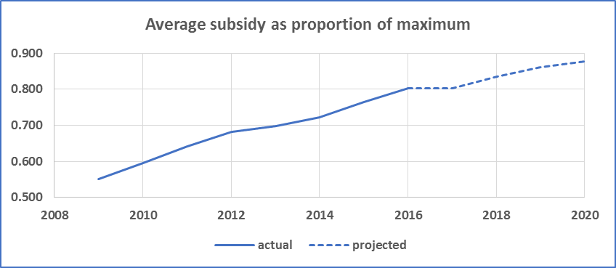

Assumptions common to present system and all three Options are described in Table 11.12. Subsidy indexation is assumed to be in line with CPI, but with only half indexation for CHC at July 1, 2018.

Table 11.12: Assumptions Applicable to Options 1, 2 & 3

| Assumption | Value | Source |
| --- | --- | --- |
| Residents as of 30 June 2016 | 175,989 | DoH |
| Resident growth pa | 1.5% | 7 years to 30 June 2016 |
| Entries to residential care in 2016-17 | 70,000 | *No source.* |
| Increases in entries pa | 1.5% | *No source.* |
| Provider reappraisals in 2016-17 | 80,000 | *No source.* |
| Increases in reappraisals pa | 1.5% | *No source.* |
| Maximum daily subsidy from 1 July 2017 | 214.06 | DoH |
| Subsidy indexation from 1 July 2018 | 1.7% | *No source.* |
| Subsidy indexation from 1 July 2019 | 2.0% | *No source.* |
| Maximum average subsidy percent from 1 July 2017 | 80.4% | *No source.* |
| Average subsidy optimisation from 1 July 2018 | **25.0%** | *No source.* |
| Growth pa in subsidy without optimisation | 1.5% | *No source.* |

Other assumptions used in the present system modelling were the projected number and p.a. cost of Review Officers (Table 11.13). Specific assumptions about Options 1 and 2 (Table 11.14) and Option 3 (Table 11.15) and the number of residents projected (Table 11.16) are also used to determine the analysis outcomes reported in section 11.4.5.

Table 11.13: Review Officers in Present System and Option 1 Assumptions

| Assumption | Value | Source |
| --- | --- | --- |
| Number of review officers 17-18 | 83 | DoH |
| Growth pa in review officers | 1.5% | As for residents |
| Annual cost of review officer in 17-18 | 150000 | Estimated |
| Cost indexation pa for review officers | 2.0% | *No source.* |

Table 11.14: Options 1 and 2 (ACAT assessors) Assumptions

| Assumption | Value |
| --- | --- |
| ACAT approvals in 2016-17 (Options 1 & 2) | 120000 |
| Assumed growth pa in ACAT approvals (Options 1 & 2) | 1.5% |
| Extra hours per ACAT approval (Options 1 & 2) | 0.5 |
| ACAT update needed at entry (Options 1 & 2) | 50% |
| Site visits per reappraisal (Options 1 & 2) | 25% |
| ACAT hours per update at entry (Options 1 & 2) | 2 |
| ACAT hours per reappraisal visit (Options 1 & 2) | 3.5 |
| Hourly cost of ACAT staff in 17-18 (Estimated) (Options 1 & 2) | 100 |
| Cost indexation pa for ACAT staff (Options 1 & 2) | 2.0% |
| Optimisation level for new entrants (Option 1) | 10.0% |
| Optimisation level for new entrants (Option 2) | 2.0% |
| Optimisation level for long-term residents (Option 1) | 25.0% |
| Optimisation level for reappraisals (Option 2) | 10.0% |
| Optimisation level for all grandfathered residents (Option 1) | 25.0% |
| Optimisation level for new grandfathered residents (Option 2) | 25.0% |
| Optimisation level for long-term grandfathered residents (Option 2) | 10.0% |

Table 11.15: Option 3 (SAA assessors) Assumptions

| Assumption | Value |
| --- | --- |
| Assessor visits per entry | 100% |
| SAA hours per visit | 3.5 |
| SAA visits per reassessment | 25% |
| SAA cost per hour in 2017-18 | 100 |
| Cost indexation pa for SAA staff | 2.0% |
| Optimisation level for new entrants | 5.0% |
| Optimisation level for reappraisals | 10.0% |
| Optimisation level for new grandfathered residents | 25.0% |
| Optimisation level for long-term grandfathered residents | 10.0% |

Table 11.16: Projected Residents using June 30, 2016 data by Entry Year

| Entry Year | Residents (as at 30 June 2018) | Residents (as at 30 June 2019) | Residents (as at 30 June 2020) | Residents (as at 30 June 2021) | Residents (as at 30 June 2022) |
| --- | --- | --- | --- | --- | --- |
| Up to 2018 | 181308 | 127119 | 91404 | 64089 | 45195 |
| 2019 | *NA* | 56908 | 37622 | 28686 | 19856 |
| 2020 | *NA* | *NA* | 57762 | 38186 | 29116 |
| 2021 | *NA* | *NA* | *NA* | 58629 | 38759 |
| 2022 | *NA* | *NA* | *NA* | *NA* | 59508 |
| Total | **181308** | **184028** | **186788** | **189590** | **192434** |
| Mid-year | *NA* | **182668** | **185408** | **188189** | **191012** |

1. Results – Estimated Care Subsides and Costs
2. Projected Care Subsidies as impacted by the Options

The projected care subsidies are described Table 11.17 for the current system and Table 11.18 for Options 1, 2 and 3.

These estimates together with the estimated costs of the various options described in section 11.4.5.2, will be used to determine the likely financial impact of the options in terms of a reduction of growth in the care subsidy outlays by the Commonwealth.

Table 11.17: Current System - Projected Care Subsidies

| Year to 30 June | Residents at midyear | Subsidy as percentage of maximum | Maximum subsidy rate in year ($) | Subsidies in year ($m) |
| --- | --- | --- | --- | --- |
| 2019 | 182668 | 84.8% | 217.70 | 12312 |
| 2020 | 185408 | 86.9% | 222.05 | 13065 |
| 2021 | 188189 | 88.2% | 226.49 | 13728 |
| 2022 | 191012 | 89.1% | 231.02 | 14355 |
| Total of Subsidies in from 2019-2022 | | | | **53461** |

Table 11.18: Projected Care Subsidies by Option at July 1, 2016 rates

| Year to June | Residents at midyear | Subsidy as percentage of maximum without optimising | Assumed average optimising during year | Maximum subsidy rate in year $ | Care Subsidies in year $m as a result of Option adoption |
| --- | --- | --- | --- | --- | --- |
| Projections for Option 1 | | | | | |
| 2019 | 182668 | 68.5% | 18.5% | 217.70 | 11780 |
| 2020 | 185408 | 69.5% | 16.2% | 222.05 | 12138 |
| 2021 | 188189 | 70.6% | 15.0% | 226.49 | 12630 |
| 2022 | 191012 | 71.6% | 14.5% | 231.02 | 13214 |
| Total of Care Subsidies for 2019-2022 for Option 1 (funding amount in millions) | | | | | **49762** |
| Projections for Option 2 | | | | | |
| 2019 | 182668 | 68.5% | 16.4% | 217.70 | 11571 |
| 2020 | 185408 | 69.5% | 11.3% | 222.05 | 11635 |
| 2021 | 188189 | 70.6% | 9.2% | 226.49 | 11988 |
| 2022 | 191012 | 71.6% | 7.9% | 231.02 | 12457 |
| Total of Care Subsidies for 2019-2022 for Option 2 (funding amount in millions) | | | | | **47651** |
| Projections for Option 3 | | | | | |
| 2019 | 182668 | 68.5% | 16.8% | 217.70 | 11617 |
| 2020 | 185408 | 69.5% | 12.3% | 222.05 | 11732 |
| 2021 | 188189 | 70.6% | 10.1% | 226.49 | 12090 |
| 2022 | 191012 | 71.6% | 8.9% | 231.02 | 12564 |
| Total of Care Subsidies for 2019-2022 for Option 3 (funding amount in millions) | | | | | **48003** |

#### Estimated Option Costs

The estimates of Review Officers costs in the present system and Option 1 are shown in Table 11.19. The ACAT and SAA external assessment options estimated costs are shown in Table 11.20. No allowances are included for Department staff or for capital expenses in these estimates.

Table 11.19: Estimated Review Officer costs (Option 1)

| Year to 30 June | Present $m | Option 1 $m |
| --- | --- | --- |
| 2019 | 12.9 | 12.9 |
| 2020 | 13.3 | 13.3 |
| 2021 | 13.8 | 13.8 |
| 2022 | 14.3 | 14.3 |
| Total | **54.4** | **54.4** |

Table 11.20: Estimated costs of ACAT and SAA assessments (Options 1, 2 and 3

| Year | Option 1 ACAT/RO $m | 1Option 2 ACAT $m | 2Option 3 SAA $m |
| --- | --- | --- | --- |
| 18-19 | 18.9 | 26.3 | 33.1 |
| 19-20 | 19.6 | 27.2 | 34.3 |
| 20-21 | 20.3 | 28.2 | 35.5 |
| 21-22 | 21.0 | 29.2 | 36.7 |
| Total | **79.8** | **110.8** | **139.6** |

1Option 2 costs include costs for 100 per cent of new resident reviews, 25 per cent of reappraisal reviews & pre-entry update reviews

2Option 3 costs include costs for 100 per cent of new resident reviews (108.6M) and 25 per cent of reappraisal reviews (31M)

1. Total Outlays and Reductions in Care Subsidy Growth

Estimated total outlays are described in Table 11.21 and Figure 11.2 by year which includes the care subsidies (Tables 11.17; 11.18) and costs (Tables 11.19; 11.20) of the various assessor model options. Reductions in care subsidy growth including the costs of the current system and options is shown in Table 11.22 and Figure 11.3. Figure 11.4 shows the impact of the External Assessor options on the average care subsidies as a percentage of the maximum payment, over time.

All options show a significant reduction in growth after costs compared to the current system. The differences are significant from year 1 (2018-19) and the cumulative impact over the projected period is significant for all options. While the specific amounts estimated in this exercise are indicative and open to debate regarding the specific amounts, the reductions in the care subsidy growth will be significant, particularly for the External Assessor Options 2 and 3. The estimated reduction in growth over the 4-year period from July 2018 to June 2022 compared to the current system is $3,328 million for Option 1 (modified current), $5,851 million for the ACAT Option 2 and $5,476 million for the Specialist Assessment Agency Option 3.

Table 11.21: Total Outlays including Subsidy Payments & Assessor Model Costs

| Year | Present $m | Option 1 ACAT/RO $m | Option 2 ACAT $m | Option 3 SAA $m |
| --- | --- | --- | --- | --- |
| 2019 | 12325 | 12033 | 11779 | 11832 |
| 2020 | 13078 | 12276 | 11668 | 11771 |
| 2021 | 13742 | 12682 | 11910 | 12017 |
| 2022 | 14369 | 13196 | 12306 | 12419 |
| Total | **53515** | **50186** | **47664** | **48039** |

Figure 11.2: Outlays including Subsidy Payments & Assessor Model Costs Per Year

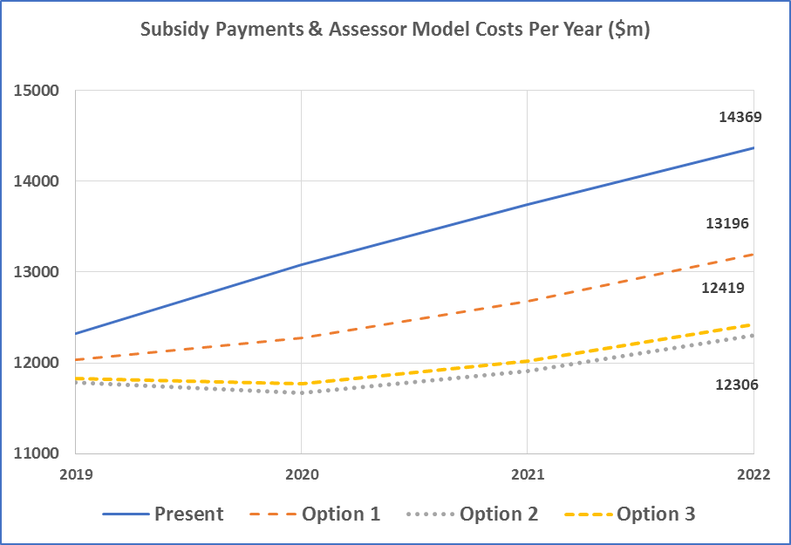

Table 11.22: Reductions in Growth Relative to the Current Funding System

| Year to 30 June | Option 1 ACAT/RO $m | Option 2 ACAT $m | Option 3 SAA $m |
| --- | --- | --- | --- |
| 2019 | 293 | 546 | 494 |
| 2020 | 802 | 1410 | 1307 |
| 2021 | 1060 | 1832 | 1725 |
| 2022 | 1173 | 2063 | 1950 |
| Total | **3328** | **5851** | **5476** |

Figure 11.3: Reductions in Growth by Year Relative to the Current System

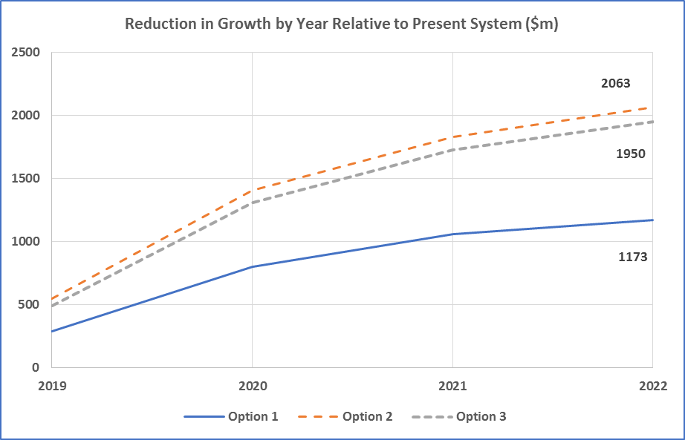

Figure 11.4: Average Subsidies as Percentage of the Maximum ACFI rate

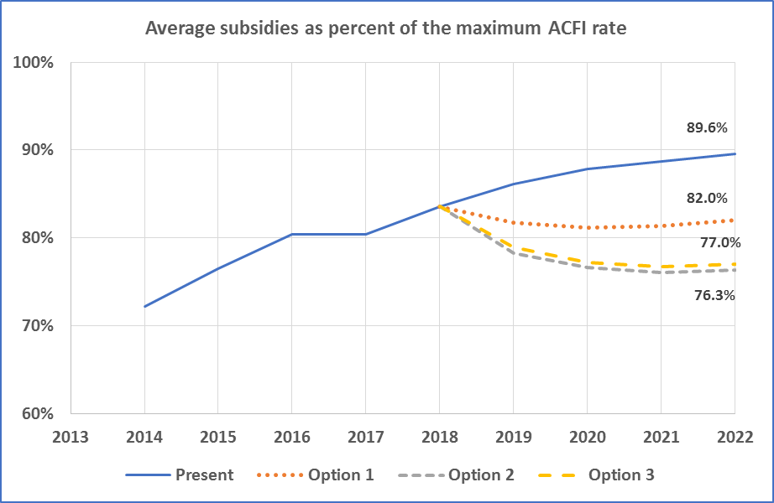

1. Model Comparisons – Recommendations

There are several reasons to consider changing the way funding is determined in the current aged care funding system. Modifying the system is important to ensure the stability and sustainability of the system but also to ensure that the system remains one where evidence based assessment results in the best possible care for residents with appropriate funding for providers to enable the delivery of the care.

The aim of changing the current R-ACFI assessment and review system to an External Assessment approach is to:

**Improve the equity and fairness of the system**

The basic requirement of any aged care funding system is that residents with similar levels of care needs attract the same amount of Government funding irrespective of the aged care service they are living in. At present some providers are receiving significantly more funding and others less funding for the same residents due to variations in claiming practices. While making the funding tool less susceptible to gaming will help, ultimately the ability to provide a more standardised basis for the decision about the residents funding assessment will provide the most equitable outcomes. It is important that any increases in Government expenditure on aged care residents are related to changes in resident acuity and numbers of residents rather than anomalies in claiming behaviour.

**Improve the surety, stability and predictability of provider income and government expenditure**

Most of residential aged care in Australia is undertaken by private businesses. It is important that they have funding surety, stability and predictability in their income stream so they are able to run effective and efficient businesses. It is also important that government can prepare budgets that allow for appropriate funding growth for residential care subsidies and be confident that increases in the budget are overwhelmingly due to an increase in the care needs of residents as the population ages.

1. Assessing the Options

Table 11.23 provides the list of indicators against which each of the models is rated.   
The main indicators are related to:

* equity and fairness of the system
* quality and consistency of assessment
* government expenditure/funding predictability and save costs where possible
* the surety, stability and predictability of provider income

The External Assessment Options 2 and 3 are almost certain to bring about a lasting change to the pattern of unpredictable growth in residential care subsidies. It is apparent that the ACAT option is likely to bring the most benefits overall but it will also be the most disruptive change in the short term compared to Option 3, which is also viable and perhaps easier to introduce in the shorter term. While a structural change will be required to introduce a national program based on a modified ACAT External Assessment model, it is viewed as having benefits beyond better control of care subsidies as it will also lead to a fairer and more equitable way to fund the care needs of people needing aged care services whether it is to be in the community or residential care.

An ACAT based External Assessment model also gives the opportunity to consolidate assessment and funding in high level community care programs and residential care. Direct comparison of R-ACFI payment and Community Care Package or CHSP funding will be possible as a person living in the community will also have an R-ACFI funding rating. This will give the basis for the single instrument and funding model in community and residential care. The External Assessor models will also enable accurate monitoring of the changes in care needs over time in the community and residential care populations and give information to drive research to inform government planning. The Government can more accurately analyse disability trends and compare residential and community care client profiles to measure unmet demand for aged care which is a statutory government obligation.

Investment in the changes now would potentially result in a more streamlined system for all of Australia’s aged population that can grow with the ageing population.

Investment in IT and training now will ensure the system is robust and resilient into the future with costs contained to those relating to resident/care recipient acuity rather than business processes.

Table 11.23: Indicators of Options Improvement over the Current Model – Three New Options

| **Indicators** | **Option 1**  **Modified Current** | **Option 2**  **ACAT** | **Option 3**  **SAA** |
| --- | --- | --- | --- |
| Does the model improve the equity and fairness of the system? | Yes | Yes | Yes |
| Improved review and audit? | Yes | Yes | Yes |
| Potential for income maximisation by providers reduced? | Yes | Yes | Yes |
| Does the model improve the quality and consistency of assessment? | No | Yes | Yes |
| Is the initial assessment by an external assessor who is a registered health professional? | No | Yes | No |
| Is the review/audit process undertaken by an independent, registered health professional? | No | Yes | Yes |
| Will the R-ACFI assessment model be more high quality than the current model? | Yes | Yes | Yes |
| Is there an appeal process for providers (where there are External Assessors? | Yes | Yes | Yes |
| Is the proposed assessment tool evidence based and suited to provide an evidence base for care planning? | Yes | Yes | Yes |
| Does the model improve the predictability of system expenditure/funding? | Yes | Yes | Yes |
| Is there a hierarchical review and audit process that uses technology to improve the system’s review and audit processes? | Yes | Yes | Yes |
| The funding determination method for new residents if fully external will reduce administration costs for providers | No | Yes | No |
| Does the option lend itself to integration of RAC and Community Aged Care assessment systems? | No | Yes | No |
| Does the model improve the surety, stability and predictability of provider income? | No | Yes | Yes |
| Is the audit period limited? | Yes | Yes | Yes |
| Is the length of the audit window period conducive to planning for providers? | Yes | Yes | Yes |
| Are new resident R-ACFI subsidies free from auditing at entry to care? | No | Yes | No |
| Will the changes result in a reduction in growth due to maximised claiming? | Yes | Yes | Yes |
| ***Aggregate ranking of the model options*** | ***3*** | ***1*** | ***2*** |

Table 11.24: Comparison of the Current System and New Options

| **Aspect** | **Current System** | **Option 1 – Modified Current** | **Option 2 - ACAT** | **Option 3 - SAA** |
| --- | --- | --- | --- | --- |
| **Funding Model** | Provider self-assessment | Provider self -assessment | ACAT (RN/AHP) | SAA assessor |
| **New Resident - $ assess** | Facility | Facility | Pre-admission; home, hospital, respite | Facility |
| **ACAT changes?** | No: no R-ACFI pre-entry, no $ role | Yes: 3 months R-ACFI pre-entry, no $ role | Yes: 3 months R-ACFI pre-entry,  sets $, review role | No: no R-ACFI pre-entry, no $ role |
| **R-ACFI Users** | Provider | ACAT & Provider | ACAT & Provider | Provider & SAA |
| **Review by** | Review Officers (RO) | Review Officers (RO) | ACAT (RN/AHP) | SAA assessor |
| **New Residents: audit %** | **10% (assess)** | **10% visit audit; 90% data** | **100% assessment pre/post entry** | **Up to 100% via visit assessment** |
| **Funding Determination - review process.** | **Provider R-ACFI used for $**  RO audits sample (10%) after payment using care provided, resident review, documentation, staff discussions | **Provider R-ACFI used for $**  RO audits 100% after payment using: Matching (ACAT/Provider), data analytics, e-audit, site visits for around 10% of submissions. | **ACAT R-ACFI used for funding $s**  ACAT assessor sets funding pre-entry. No review if accepted.  Contested R-ACFI process – Matching data analytics, e-audit, site visits and assess. | **Provider R-ACFI used for initial funding determination** but SAA assessor confirms for up to 100% of R-ACFI submissions via joint determination approach.  SAA/DoH also checks claims using data analytics, e-audit. |
| **Funding certainty & Audits** | Audit: unrestricted time period | Audit: restricted to 12 months | Not contested: Payment on admission. If contested: Payment review within one month. | Payment 2 months after admission. Assessment audits up to 12 months. |
| **When full funding paid?** | Within 2 months of admission | Within 2 months of admission | On admission. Contest: 1 month | Within 2 months of admission |
| **Provider does R-ACFI in…** | With 2 months | Within 2 months | Within 1 month but not for $s | Within 2 months used for $s |
| **Re-appraisals: audit assess** | **10% (assess)** | **10% visit audit; 90% data** | **25% visit assessment; 75% data** | **25% visit assessment; 75% data** |
| **Funding Determination Process** | **Provider R-ACFI used for $**  RO checks sample (10%) as per new resident checks. | **Provider R-ACFI give $s**  RO checks after payment using: data analytics, e-audit, site visits for around 10% of submissions. | **Provider & ACAT R-ACFI give $s**  ACAT checks after payment using: data analytics, e-audit. **Site assessment checks for 25% - 50% of R-ACFI submissions** | **Provider & SAA R-ACFI give $s** SAA assessor checks after payment using: data analytics, e-audit. **Site assessment checks for 25% - 50% of R-ACFI submissions** |
| **When full funding paid? Funding certainty & Audit** | On submission but subject to audit, no time limit | On submission but subject to audit for 12months | On submission but can have assessments checked up to 12m | On submission but can have assessments checked up to 12m |
| **Method Used to Audit $** | Assessed care + Care provided | Assessed care + Care provided | Assessed care need | Assessed care need |
| **Stable funding** | Low | Medium | High | Medium-High |
| **Growth Reduction: 2018-22 FYE** | **NA** | **$3,619M** | **$5,753M** | **$5,372M** |

1. Recommended R-ACFI and External Assessor Pilot
2. Pilot Overview

The Review of the ACFI has recommended the implementation of a new R-ACFI covering to at least some degree, almost all areas related to the operation of the R-ACFI. Components of the R-ACFI system that have been reviewed and changes recommended, include:

* The R-ACFI Questions and Checklist items
* The R-ACFI Assessment Tools
* External Assessment

Further, it is recommended that a short pilot be undertaken before implementation of the R-ACFI, to test the assessment approach, and the changes to the checklists and ratings. Two pilot design options are presented. Both test the R-ACFI assessments, checklists and compare the results to the current ACFI.

**Option 1 involves provider assessors and external assessors:** The first option tests the recommended R-ACFI assessments and checklists across all potential users when assessing both new residents and conducting resident re-appraisals.

**Option 2 involves only provider assessors:** The second option tests the recommended changes for providers when assessing both new residents and conducting resident re-appraisals.

Both options include collecting health professional’s feedback on the workload, R-ACFI assessments and checklists.

**Training and support** will be provided to all participants during the pilot, on-line, via email and by telephone. On-line training materials will be provided for all participants, covering the R-ACFI process (assessments and checklists). Option 1 also includes face to face training for ACATS and External Assessors and also covers the post entry review process.

**Recruitment requirements** (Options 1 & 2):

* **Options 1 & 2**: It is anticipated that up to 25 RACFs will be required to provide a sufficient sample for the pilot project. It is estimated that around 10 per cent of residents will have an R-ACFI completed per month, with an expected average of 5-10 R-ACFIs per month depending on the size of the facility.
* **Option 1**: Will involve ACAT assessors that cover the pilot RACFs. It is expected that a minimum of two ACAT assessors per RACF will be required for the pilot.

1. The Pilots in Detail
2. Option 1: Involving ACAT, Providers & External Assessment Agencies

This option tests the R-ACFI assessments and checklists across all potential user types and for both new resident and resident re-appraisal assessments. The pilot will identify:

* Workload impacts for potential health professional user types (ACAT, Specialist Assessors and RACF staff).
* Changes to the R-ACFI assessments and checklists.

Feedback will be collected during focus groups and by user completion of an on-line survey.

**Pilot process – new residents entering a RACF**

1. The pilot RACFs will inform the study coordinator when they are going to accept a new resident.
2. A pilot participating ACAT assessor will then complete an R-ACFI for those about to enter the RACF (pre-entry R-ACFI).
3. ACAT assessors will use the R-ACFI assessments and checklists (and satisfy NSAF requirements).
4. Within one month of admission: The internal assessor at the RACF will complete an entry ACFI and R-ACFI and all associates checklists.
5. The **ACAT assessor** will visit the resident in the RACF, to review any variations between the ACAT pre-entry R-ACFI and the RACF R-ACFI.
6. The ACAT will also complete a post entry R-ACFI.

**Pilot process – re-appraisals for residents of pilot site RACFs**

1. The pilot RACFs will inform the study coordinator when a re-appraisal is due to fall within the pilot study period.
2. The **External Assessor** will visit the facility, to audit the RACF R-ACFI (for re-appraisals).

During the 2-month pilot project period, participating RACFs will use the ACFI and R-ACFI for each new or re-appraisal assessment and will be requested to complete the data collection within one month of entry or appraisal start date.

Table 12.1: Option 1: Deliverables

| Role | Deliverables |
| --- | --- |
| ACAT | * Pre-entry R-ACFI completed * Feedback on workload, R-ACFI assessments and checklists |
| Provider | * Facility completed R-ACFI & ACFI (new residents & re-appraisals) * Comparison: R-ACFI & ACFI (new residents & re-appraisals) * Feedback on workload, R-ACFI assessments and checklists |
| ACAT | * Comparison: Pre-entry R-ACFI & Facility R-ACFI (new residents) * Post entry R-ACFI (for new residents) completed * Comparison: Facility R-ACFI & Post entry R-ACFI (new residents) * Comparison: Pre-entry R-ACFI & Post entry R-ACFI * Feedback on workload, R-ACFI assessments and checklists |
| External Assessment Agency | * Audit: Facility R-ACFI (re-appraisals) * R-ACFI (re-appraisals) completed * Comparison: Facility R-ACFI & External Assessor Agency R-ACFI (re-appraisals) * Feedback on workload, R-ACFI assessments and checklists |

1. Option 2: Involving only Aged Care Providers

This option tests the R-ACFI assessments, R-ACFI checklists and ACFI checklists completed by RACF for new residents and re-appraisals.

This option will enable investigation of:

* workload impacts associated with the introduction of R-ACFI from the perspective of the different health professionals who are involved in RACFs.
* The R-ACFI assessments and checklists.

Feedback will be collected by user completion of an on-line survey.

The participating **RACFs** will include the R-ACFI assessment tools into their ACFI toolset for the pilot period. The RACFs will complete all required ACFIs (for new residents and re-appraisals) during this time and complete the R-ACFI assessments and checklists. They will be requested to complete all data collection within a three-month period.

Table 12.2: Option 2: Deliverables

| Role | Deliverables |
| --- | --- |
| Provider | * Facility R-ACFI & Facility ACFI (for new residents and re-appraisals) completed * Comparison: Facility R-ACFI & Facility ACFI * Feedback on workload, R-ACFI assessments and checklists. |

1. Timeline for Options 1 & 2

| Phase 1: Preparation Phase | |
| --- | --- |
| Time | Activity |
| Months 1-2  *Option 1* | **Production** Option 1   * On-line video training; * Training presentation and materials to ACATs/ External Assessors; * R-ACFI packs (paper or IT); * Feedback (IT survey).   **Planning** Option 1   * Face to face training - sites, requirements, invitations * Focus groups -- sites, requirements, invitations * Hosting of video training on-line, feedback survey |
| Months 1-2  *Option 2* | **Production** Option 2   * On-line video training; * R-ACFI packs (paper or IT); * Feedback (IT survey).   **Planning** Option 2   * Hosting of video training on-line, feedback survey |
| Month 3  *Option 1* | **Training** Option 1  Face to face training for ACATS and External Assessors - this will cover the audit/review process and requirements.  Video training on-line for all participants - this will cover the R-ACFI process (assessments and checklists). |
| Month 3  *Option 2* | **Training** Option 2  Video training on-line for all participants - this will cover the R-ACFI process (assessments and checklists). |
| Phase 2: Data Collection Phase | |
| Time | Activity |
| Months 4-7  *Option 1* | **Data Collection** Option 1- ACATs, RACFs, External Assessors |
| Months 4-7  *Option 2* | **Data Collection** Option 2- RACFs |
| Phase 3: Feedback & Analysis Phase | |
| Time | Activity |
| Month 6-9  *Option 1* | Option 1: Focus groups & feedback survey   * Analysis of feedback * R-ACFI data entry/cleaning * Analysis of R-ACFI data * Report writing |
| Month 6-9  *Option 2* | Option 2: Feedback survey   * Analysis of feedback * R-ACFI data entry/cleaning * Analysis of R-ACFI data * Report writing |

1. R-ACFI Pilot Overview Chart

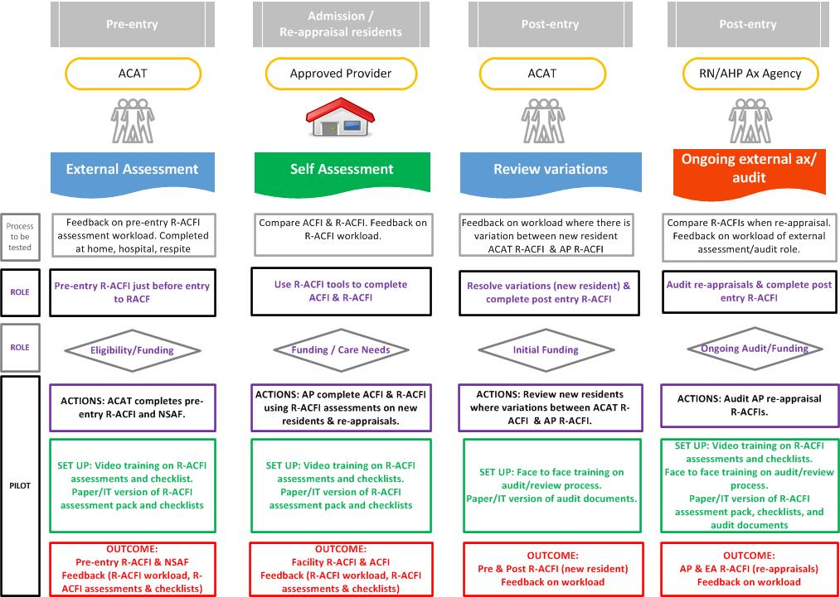

1. R-ACFI Pilot Data Collection Requirements

|  |  |  |  |  |
| --- | --- | --- | --- | --- |
| **R-ACFI Data** | **Pre-entry** | **RACF Assessment** | **Post review** | **Post audit** |
| Nutrition Assessment Summary (complete MNA short) | Yes | Yes | Yes | Yes |
| Nutrition Checklist- Eating (Standard, Monitor, Moderate, Full) | Yes | Yes | Yes | Yes |
| Mobility Assessment Summary (complete PMS & FRAT) | Yes | Yes | Yes | Yes |
| Mobility Checklist – Transfer (Standard, Some, Full, Mechanical/2-person) | Yes | Yes | Yes | Yes |
| Mobility Checklist -Mobility (Standard, Some, Full, 2-person) | Yes | Yes | Yes | Yes |
| Personal Hygiene Checklist -Dressing (Standard, Some, Full, 2-person) | Yes | Yes | Yes | Yes |
| Personal Hygiene -Washing (Standard, Some, Full, 2-person) | Yes | Yes | Yes | Yes |
| Toileting Checklist -Use of Toilet (Standard, Some, Full, 2-person) | Yes | Yes | Yes | Yes |
| Toileting Checklist -Toilet Completion (Standard, Some, Full, 2-person) | Yes | Yes | Yes | Yes |
| Continence Records | NA | Yes | audit | audit |
| Continence Assessment Summary (collate diagnoses) | Diagnoses | Yes | Yes | Yes |
| Continence Checklist (frequency) | Informant | Yes | audit | audit |
| Cognitive Assessment Summary (complete SMMSE if appropriate) | Yes | Yes | Yes | Yes |
| Cognitive Checklist: (None/minimal; Mild; Moderate; Severe) | Yes | Yes | Yes | Yes |
| Behaviour Record x 3 (Wandering, Verbal, Physical) | NA | Yes | audit | audit |
| Behaviour Assessment Summary (Descriptions, frequency & disruptiveness) | Informant | Yes | audit | audit |
| Complex Health Care Procedures List | Yes / No | Yes | Agree / disagree | Agree / disagree |
| Complex Health Care Evidence Requirements - Diagnosis | Yes | Yes | audit | audit |
| Complex Health Care Evidence Requirements - Directives | NA | Yes | audit | audit |
| Complex Health Care Evidence Requirements - Assessments | NA | Yes | audit | audit |
| Complex Health Care Evidence Requirements - Records | NA | Yes | audit | audit |
| Therapy Program Checklist | Yes / No | Yes | Agree / disagree | Agree / disagree |
| Therapy Program Functional assessment | Yes | Yes | Yes | Yes |
| Therapy Program Pain assessment | Yes | Yes | Yes | Yes |
| Therapy Program Care Plan | NA | Yes | audit | audit |
| Therapy Program Records | NA | Yes | audit | audit |
| Therapy Program Evaluation | NA | Yes | audit | audit |

1. R-ACFI Pilot Checklist Example

Type: 🞏 ACAT pre-entry assessment; 🞏 RACF assessment; 🞏 ACAT post-entry; 🞏 External Agency re-appraisal

|  |  |  |  |  |
| --- | --- | --- | --- | --- |
| **No.** | **Activities completed- circle options (where applicable)** | **Yes** | **No** | **Timing** |
| 1 | Mini Nutritional Assessment (MNA Short) | 🞏 | 🞏 | *Enter timing.* |
| 2 | Physical Mobility Scale (PMS) | 🞏 | 🞏 | *Enter timing.* |
| 3 | Falls Risk Assessment Tool (FRAT) | 🞏 | 🞏 | *Enter timing.* |
| 4 | Continence Record | 🞏 | 🞏 | *Enter timing.* |
| 5 | Continence Assessment Form and Care Plan | 🞏 | 🞏 | *Enter timing.* |
| 6 | SMMSE | 🞏 | 🞏 | *Enter timing.* |
| 7 | Behaviour Records | 🞏 | 🞏 | *Enter timing.* |
| 8 | Behaviour Assessment Form | 🞏 | 🞏 | *Enter timing.* |
| 9 | Comprehensive Health Assessment | 🞏 | 🞏 | *Enter timing.* |
| 10 | Skin Integrity Assessment | 🞏 | 🞏 | *Enter timing.* |
| 11 | Wound Assessment | 🞏 | 🞏 | *Enter timing.* |
| 12 | Depression Assessment: CSD / GDS / K10 | 🞏 | 🞏 | *Enter timing.* |
| 13 | Functional Assessment: MMT / BBS / BOOMER/ SPPB | 🞏 | 🞏 | *Enter timing.* |
| 14 | Pain Assessment: M-VRBPI / PAINAD/ ABBEY | 🞏 | 🞏 | *Enter timing.* |
| 15 | Resident observations of structured activity | 🞏 | 🞏 | *Enter timing.* |
| 16 | Resident observations unstructured | 🞏 | 🞏 | *Enter timing.* |
| 17 | Resident interview | 🞏 | 🞏 | *Enter timing.* |
| 18 | Interview informants – Care staff, | 🞏 | 🞏 | *Enter timing.* |
| 19 | Interview informants – Health Professionals (AHP/ MP) | 🞏 | 🞏 | *Enter timing.* |
| 20 | Interview informants – Non-professional e.g. family | 🞏 | 🞏 | *Enter timing.* |
| 21 | Documentation (ACFI Pack) | 🞏 | 🞏 | *Enter timing.* |
| 22 | Documentation (File notes) | 🞏 | 🞏 | *Enter timing.* |
| 23 | Care Plan | 🞏 | 🞏 | *Enter timing.* |
| 24 | Other- describe | 🞏 | 🞏 | *Enter timing.* |