REVIEW OF THE  
AGED CARE FUNDING INSTRUMENT REPORT

PART 1: SUMMARY REPORT

June 2017

**Applied Aged Care Solutions Pty Ltd**



AUTHORS

This report was written by AACS team members Dr Richard Rosewarne, Janet Opie, Dr Richard Cumpston, Victoria Boyd and Akira Kikkawa.

ACKNOWLEDGEMENTS

We wish to thank the people and organisations who gave generously of their time to participate in the consultation phase and provide comment throughout the project period:

* Funding Policy Branch from the Aged Care Policy and Regulation Division of the Australian Government Department of Health (DoH)
* ACFI Technical Reference Group (TRG) with representatives from

Australian Physiotherapists Association -APA (Rik Dawson)

Alzheimer’s Australia (Kaele Stokes)

Australian & New Zealand Society for Geriatric Medicine (Jeff Rowland)

The Australian Pain Society (Fiona Hodson)

Bethanie Aged Care (David Harrison)

Aged and Community Services SA & NT (ACSA) Derek Dittrich

BUPA (Maureen Berry)

Allied Health Professionals Australia (Michelle Bennett)

Southern Cross Care (Katie Nott)

Australian Nursing and Midwifery Federation (Janice McKenzie)

* Aged & Community Services Australia (ACSA) executive and expert panel
* Aged Care Guild (ACG)
* Australian Continence Foundation (ACF)
* Catholic Health Australia (CHA)
* Commonwealth Review Officers (CRO)
* Council on the Ageing (COTA) Ian Yates
* Exercise and Sports Science Australia (ESSA)
* Leading Age Services Australia (LASA) executive and expert panel
* Victorian Aged Care Assessment Team Program Departmental representatives
* Wounds Australia
* Sue Templeton, Nurse Practitioner Wound Management, Credentialed Wound Clinician
* Jan Rice, RN, Director Wound Care Services
* Associate Professor Michael Woodward AM, Consultant Geriatrician, Director, Aged Care Research, Head, Memory and Wound Clinics, Austin Health
* Mr John Kennedy, Independent Social Care Consultant UK
* Mr Andrew Downs and Mr Ross Judge, Ministry of Health New Zealand
* Mr Jeff Hatcher, Canadian Institute for Health

Dr Richard Rosewarne, Project Director

Contents

Summary Report and Recommendations 8

Chapter 1. Background 9

1.1. 1997: The Resident Classification Scale 9

1.2. 2005-2008: Development of the ACFI 10

1.3. 2011: Departmental Review of the ACFI 11

Chapter 2. Further Review of the ACFI System 15

2.1. Methods 16

2.2. R-ACFI Funding Classification Model 17

2.3. R-ACFI Principles 19

Chapter 3. Setting the Scene - the R-ACFI Model 21

Chapter 4. Developing the R-ACFI ADL Domain 22

4.1. A Statistical Overview of the ACFI ADL Domain 22

Chapter 5. Developing the R-ACFI BEH Domain 28

5.1. A Statistical Overview of the ACFI BEH Domain 28

5.2. Recommended Changes to the BEH Domain 28

Chapter 6. Developing the R-ACFI CHC Domain 30

6.1. A Statistical Overview of the ACFI CHC Domain 30

6.2. Recommended Changes to the CHC Domain 30

Chapter 7. Developing the R-ACFI Therapy Program 35

7.1. Why consider a Therapy Program in the R-ACFI? 35

7.2. Are Physical Therapy Programs Effective? 35

7.3. Physical Therapy Program Principles 37

7.4. Funding and the Therapy Program 40

7.5. Therapy Program Design Recommendations 40

Chapter 8. Summary R-ACFI at a glance 45

8.1. Activities of Daily Living Domain 45

8.2. Behaviour Domain 46

8.3. Complex Health Care Domain 47

Chapter 9. R-ACFI Classification and Funding Outcomes 48

9.1. Introduction 48

9.2. The R-ACFI Classification and Payment Model 49

Chapter 10. Determination and Validation of Funding 52

10.1. The Need to Address Funding Volatility and Set a Platform for the Future 52

10.2. Modelled Impact of the Options on Care Subsidy Growth 55

Chapter 11. Model Comparisons – Recommendations 57

11.1. Assessing the Options 57

11.2. Conclusion 58

11.3. Recommendations 58

****List of Tables****

Table 1: R-ACFI ADL rating (Nutrition) 24

Table 2: R-ACFI ADL rating (Mobility) 25

Table 3: R-ACFI ADL rating (Personal Hygiene, Toileting) 26

Table 4: R-ACFI ADL Domain Assessment Tools Recommendations 27

Table 5: R-ACFI Behaviour Domain Assessment Tools Recommendations 29

Table 6: R-ACFI CHC procedures to be completed 31

Table 7: R-ACFI Complex Health Assessment Tools Recommendations 34

Table 8: R-ACFI Funding Distribution by Categories 50

Table 9. Comparison of the Current System and New Options 54

Table 10: Total Outlays including the Estimated Subsidy Payments & Costs by Model 55

Table 11: Reductions in Growth Relative to the Current Funding System 55

Table 12: Indicators of model improvement over current model – 3 New Options 59

****List of Figures****

Figure 1 Average subsidies growth as proportion of the maximum ACFI funding 13

Figure 2: Yearly growth in pain management funding using June 30, 2016 funding levels 14

Figure 3: Separations by length of stay 19

Figure 4: How the R-ACFI Enhances and Fits into the Nursing Care Process 21

Figure 5: ADL Domain Classifications (N, L, M, H) 2009 - 2016 22

Figure 6: BEH Domain Classifications (N, L, M, H) 2009 - 2016 28

Figure 7: Complex Health Care Domain Classifications (N, L, M, H) 2009 - 2016 30

Figure 8: R-ACFI Model Design and Funding 49

Figure 9: ACFI and R-ACFI Funding Distributions by R-ACFI Categories (48) 51

Figure 10: Outlays including Subsidy Payments & Assessor Model Costs Per Year 56

Figure 11: Average Subsidies as Percent of the Maximum ACFI rate 56

Glossary

| **Acronym** | **Descriptions** |
| --- | --- |
| AACS | Applied Aged Care Solutions |
| ABC | Antecedent, Behaviour, Consequences |
| ABF | Activity Based Funding |
| ACAT | Aged Care Assessment Team |
| ACFI | Aged Care Funding Instrument |
| ACG | Aged Care Guild |
| ACSA | Aged & Community Services Australia (ACSA) |
| ADL | Activities of Daily Living |
| AEP | Accredited Exercise Physiologist |
| AGS | American Geriatrics Society |
| AHP | Allied Health Professional |
| AHPRA | Australian Health Practitioner Regulation Agency |
| AIHW | Australian Institute of Health and Welfare |
| AIHW METeOR | METeOR is Australia’s repository for national metadata standards for health, housing and community services statistics and information. |
| AP | Approved Provider |
| APA | Australian Physiotherapy Association |
| APS | Australian Pain Society |
| Ax | Assessment |
| BBS | Berg Balance Scale |
| BEH | Behaviour |
| BEHAVE-AD | Behavioural Symptoms in Alzheimer’s Disease |
| BGL | Blood Glucose Level |
| BMI | Body Mass Index |
| BOOMER | Balance Outcome Measure for Elder Rehabilitation |
| BP | Blood Pressure |
| CAM | Care Aggregate Module |
| CDC | Consumer Directed Care |
| CFA | Continence Foundation Australia |
| CHA | Comprehensive Health Assessment |
| CHC | Complex Health Care |
| CHAOP | Comprehensive Health Assessment for Older People |
| CMA | Comprehensive Medical Assessment |
| CMAI | Cohen Mansfield Agitation Index |
| CMI | Casemix Index |
| CNC | Clinical Nurse Consultant |
| CNO | Commonwealth Nursing Officer |
| CNS | Clinical Nurse Specialist |
| COTA | Council on the Ageing (COTA) |
| CQI | Continuous Quality Improvement |
| CSD/CSDD | Cornell Scale for Depression in Dementia |
| R-CSD | Revised Cornell Scale for Depression (in dementia) |
| CTT | Classical Test Theory |
| DBMAS | Dementia Behaviour Management Advisory Service |
| DBRS | Disruptive Behaviour Rating Scale |
| DHB | District Health Board |
| DoH | Australian Commonwealth Government Department of Health |
| DR | Daily Rate |
| DS-DAT | Discomfort Scale for Dementia for the Alzheimer’s Type |
| DSM-V | Diagnostic and Statistical Manual of Mental Disorders, Fifth Edition |
| DVT | Deep Vein Thrombosis |
| EA | External Assessor |
| EN | Enrolled Nurse |
| ESSA | Exercise & Sports Science Australia |
| FRAT | Falls Risk Assessment Tool |
| GDS | Geriatric Depression Scale |
| GP | General Practitioner |
| GRM | Graded Response Method |
| HP | Health Professional |
| IA | Independent Assessor |
| IADL | Instrumental Activities of Daily Living |
| ICF | International Classification of Functioning, Disability and Health |
| IFSO | International Federation for the Surgery of Obesity |
| IHPA | Independent Hospital Pricing Authority |
| interRAI | International Resident Assessment Instrument |
| IPA | International Psychogeriatric Association |
| IHPA | Independent Hospital Pricing Authority |
| IQCODE | Informant Questionnaire on Cognitive Decline in the Elderly |
| IRT | Item Response Theory |
| IT | Information Technology |
| LASA | Leading Age Services Australia |
| K-10 | Kessler Psychological Distress Scale |
| KICA-ADL | Kimberly Indigenous Cognitive Assessment – Activities of Daily Living |
| KICA-Carer | Kimberley Indigenous Cognitive Assessment – Carer |
| KICA-COG | Kimberley Indigenous Cognitive Assessment |
| K10 | Kessler Psychological Distress Scale |
| M-RVBPI | Modified Resident’s Verbal Brief Pain Inventory |
| MDS | Minimum Data Set |
| MMT | Manual Muscle Test |
| MNA | Mini Nutritional Assessment |
| MNA-SF | Mini Nutritional Assessment Short Form |
| MP | Medical Practitioner |
| MYEFO | Mid Year Economic and Fiscal Outlook |
| NASC | Needs Assessment and Service Coordination Team |
| NATFRAME | National Framework for Documenting Care in Residential Aged Care services |
| NHS | National Health Service |
| NP | Nurse Practitioner |
| NPI | Neuropsychiatric Inventory |
| NPRS | Numeric Pain Rating Scale |
| NSAF | National Screening and Assessment Form |
| OARS | Older Americans Resources and Services |
| OHAT | Oral Health Assessment Tool |
| OT | Occupational Therapist |
| pa. | Per annum |
| PAINAD | Pain Assessment in Advanced Dementia |
| PAS/PAS-CIS | Psychogeriatric Assessment Scales- Cognitive Impairment Scale |
| PCA | Personal Care Assistant |
| PCAI | Personal Care Assessment Instrument |
| PCW | Personal Care Worker |
| pd. | Per day |
| PMG | Pain Management Guidelines |
| PMS | Physical Mobility Scale |
| QoC | Quality of Care |
| QoL | Quality of Life |
| R-ACFI | Revised Aged Care Funding Instrument |
| R-BEH | Revised Behaviour Domain |
| R-ADL | Revised Activities of Daily Living |
| R-CHC | Revised Complex Health Care |
| RAC | Residential Aged Care |
| RACF | Residential Aged Care Facility |
| RACID | Residential Aged Care Service Departmental Identification Number |
| RAI | Resident Assessment Instrument for Long Term Care |
| RAS | Regional Assessment Service |
| RCI | Resident Classification Instrument |
| RCS | Resident Classification Scale |
| RN | Registered Nurse |
| RO | Review Officer |
| RUDAS | Rowland Universal Dementia Assessment Scale |
| RUGs | Resource Utilization Groups |
| SAA | Specialised Assessment Agency |
| SAM | Standard Aggregated Module |
| SC&S | Specified Care and Services |
| SMART | Specific, Measurable, Action-oriented, Realistic, Time-based |
| SMMSE | Standardised Mini Mental State Examination |
| SP | Speech Pathologist |
| SPC | Supra Pubic Catheter |
| Standard care | Minimum level of assistance such as setting up activities, verbal assistance and episodic assistance; given to all residents from time to time; does not differentiate between individual resident assessed care needs |
| The Department / The Dept | Australian Commonwealth Government Department of Health |
| TRG | ACFI Technical Reference Group |
| VRS | Verbal Rating Scale |
| WHO | World Health Organization |
| WLL | Working Load Limit |

# Summary Report and Recommendations

This paper provides a summary of the information contained in the main ACFI Review Report.

The paper discusses:

* The ACFI Review Project.
* Development of R-ACFI.
* Development and validation of funding.
* Approaches to reviewing the R-ACFI and options for the future.
* Options for the future of review and audit.

***Purpose:***

*To provide a summary document that covers the main outcomes and findings of the review and recommendations*

1. Background

In Australia, various systems of classification of resident dependency in long-term care facilities have provided a basis for national funding for nearly 40 years.

The nursing home and hostel systems developed separately from the late 1960’s but there was evidence that around 20 per cent of people living in hostels were more dependent in terms of their care needs, than many nursing home residents (Duckett 1995; Australian Institute of Health and Welfare (AIHW) 1997). These findings and the desire to create an ‘ageing in place’ environment led to the introduction of the Commonwealth Aged Care Act, in 1997. The ‘Ageing in place’ policy was designed to allow hostel residents to remain in their hostel instead of having to move to a nursing home when their care needs increased (AIHW: Gibson, Rowland, Braun & Angus 2002).

To achieve the objective of integrating hostels and nursing homes into a single residential care system, a new care classification and funding model was required. The new system needed to objectively classify residents needing low levels of personal care, through to those with intensive nursing care needs, on a nationally consistent scale.

1. 1997: The Resident Classification Scale

The Resident Classification Scale (RCS) replaced the PCAI (for hostels) and RCI (for nursing homes) and included questions about each resident’s care needs across activities of daily living (ADLs), behaviours, medication, nursing, and therapy. Each question had four possible levels with weightings related to their importance in determining the cost of care which was established through a costing study. The sum of the weights gave an overall score for each resident that was then allocated to eight categories on the RCS. The RCS was phased in from October 1997.

The Department review program for the RCS was reliant on auditing care plan documentation (developed by care staff) as the basis for claims as residents were not assessed directly by a Review Officer. There was however concern that using the providers documentation for funding audits had resulted in care plans being designed with the main aim of supporting the funding claim, resulting in a reduced focus on broader comprehensive care documentation. Provision of funding for ‘care provided’ that could be designed/manipulated via documentation to attract the higher levels of funding, led to resident care plans being directly influenced by the RCS funding model.

It was also believed that the RCS approach was leading to a high level of funding volatility and manipulation. As reported by Department of Health and Ageing (2011; pp24-25), the Hogan review of pricing arrangements in 2004 found that the “three main disadvantages of the RCS arrangements were: the administrative burden inherent in the RCS; the adequacy of funding arrangements to appropriately compensate for care needs of particular groups of residents; and the volatility of the RCS, including its susceptibility to manipulation and the potential for residents with similar care needs to be classified into different categories.”

An integrated residential care system with the full spread of resident dependencies included in the RCS funding model, also meant that the number of residents for whom higher levels of funding could be claimed increased significantly. The RCS Review Audit program was expanded to address this issue, as without controls to prevent the documentation of ever rising care needs, systematic increases in RCS claims had the potential to significantly increase government expenditure. Over time, RCS claims did rise significantly with the majority of aged care residents being classified as needing the highest levels of funding (RCS 1 and 2), outcomes which significantly impacted on the relativities in the original scale design and government expenditure, which increased beyond budget projections.

Claims also became harder to audit effectively with a high proportion of Departmental review decisions being challenged. For example, during 2008-09, 12,548 reviews of RCS appraisals were completed. Of those reviews, 3,749 or 30 per cent resulted in reductions of funding, of which 350 or 9.3 per cent were appealed by providers. In approximately 43.7 per cent of appealed cases, the original classiﬁcation by the home was reinstated (Commonwealth of Australia 2009).

1. 2005-2008: Development of the ACFI

In response to concerns about the perceived burden resulting from the administrative and documentation requirements of the RCS assessment tool and a financial growth at a higher level than expected by Government, four reviews were undertaken and culminated in a project (starting in 2005) to develop and implement the Aged Care Funding Instrument (ACFI).

1. The ACFI and Assessed Care Needs

Resulting from the learnings associated with the RCS operation it was deemed more appropriate to build future funding systems around assessed care need as:

* It would provide for a standardised basis for funding system determinations wherever a person was supported, including community care.
* Providers could build flexible care models to address the assessed care needs without having the care provided aspect dictated by a funding mechanism.
* It would allow more flexible ‘care provided’ responses by providers to resident desires and preferences (promotes consumer directed care).
* Care provided is a quality of care matter that is better covered separately by the Specified Care and Services requirements and the Quality Agency.
* It allowed for the introduction of an External Assessment model and funding determination if required at a future time.
* It fitted better with the residential aged care environment where there are many possible appropriate responses to an identified care need. This contrasts with a hospital or sub-acute environment where the response to the care need is more clearly defined allowing funding to be determined on the basis of the required activity which is more easily defined.

1. ACFI Design Principles

The change from the RCS to the ACFI was guided by a number of underlying principles which were determined in consultation with an Industry Reference Group. The principles included:

* A reduced question set which identified key resource drivers.
* These key resource drivers or indicator questions were to determine the funding which was to cover all care need areas as described in the specified care and services legislated requirements. The funding was not provided to just cover the areas specified in the ACFI tool.
* An assessment approach that measured the *need* for care and not care provided.
* Development of clear question descriptions and guidelines to reduce disagreement between providers and Departmental auditors (i.e. wording refinements, single focussed questions form the minimum data set, consistent rating approach across ADLs).
* Specifying the evidence required for a claim in each domain - excluding care plans and nursing notes (i.e. assessments, clinical reports, diagnoses, written directives by health professionals), and modifying the RCS domains of medication and complex nursing.

In summary, the ACFI which was implemented on 20 March 2008 was designed to deliver:

* An approach that measured the need for care, not care provided when determining funding but where some elements remained (Q11, Q12).
* A funding model with identifiable ‘case types’.
* A funding redistribution from lower care to higher care levels to provide more funding to those residents with higher staff resource demands.
* Funding to enable new care programs focusing on pain management.
* Transparency in the subsidy amount paid for the key care domain (ADL) with Behaviour & Complex Health Care payments included as ‘supplements’.
* Funding allocation between the care domains to be modified if, in future, the standard care costs can be demonstrated to necessitate a change in relativities.

1. 2011: Departmental Review of the ACFI

A Departmental Review of the ACFI was conducted in 2011. The review included extensive consultations with the aged care sector and data analysis of the first 34 months of operation of the ACFI (Australian Government Department of Health and Ageing, 2011). The review found that the ACFI was functioning as intended but required modification in some areas.

The recommendations of most relevance to the current project were:

1. **Complex Health Care Pain Management Items Q12. Items 3 and 4:**

* Should be modified to remove the focus from specific interventions to allow a broader intervention approach. Therapeutic massage and application of heat packs are too narrow and not consistent with contemporary practice.
* Other care modalities could be included such as exercise (strengthening interventions are also an effective way to reduce musculoskeletal pain).
* The list of allied health professionals that can provide directives and interventions is too restrictive and should be broadened.
* It should be noted that when the ACFI was developed, the Department strongly believed that some specific activities had to be included or the provider would take the funding and deliver the least costly option.

1. **The Department, in consultation with the Ageing Consultative Committee, should continue to carefully monitor expenditure trends under the ACFI, with emphasis on achieving an appropriate balance between:**
2. The extent to which overall expenditure growth rates are contained within a sustainable range over the longer term.
3. The distributional impact of the introduction of the ACFI across providers.
4. The Department should undertake further work, in consultation with the Ageing Consultative Committee, to enhance the integration of the funding and classification systems with the assessment and quality assurance arrangements across residential and community care.

Failure to implement the above recommendations from the 2011 Report would have implications for the future performance of the ACFI care subsidy payment system.

1. Care Subsidy Growth under ACFI

While the Department’s 2011 Review found that the ACFI matched *funding to care needs by identifying the significant drivers of relative costs* and that the industry was largely happy with the tool, business rules and claim requirements, the concern was that *average basic subsidies for most aged care homes had increased significantly in real terms since the introduction of the ACFI* (Key Finding 3, p 11).

The variable care subsidies used in the Australian aged care funding systems over the years have been of special interest to the government as they comprise a significant risk for the budget position as:

* Funding increases year on year if more than predicted impact on budget forward estimates and, as there is no actual limit on the global budget, the risk is high.
* The Department’s ability to ‘restrain’ the increases via their audit program has been limited in the past although more effective of recent times.
* While the care subsidy determined by the ACFI is means tested and the Government may have been expecting a significant contribution from residents, this has not been the reality and the majority of the ACFI subsidy is still paid by Government. Income tested fees are having only a small impact in this area (<3 per cent) and this may increase far less than anticipated (Australian Government Aged Care Funding Authority, *Third Report on the Funding and Financing of the Aged Care Sector, July 2015*. Department of Social Services 1438.9.15. Commonwealth of Australia. Canberra. 2015).

Figure 1 shows the average ACFI subsidies growth as proportion of the maximum ACFI funding year on year across the charitable, community, government and private sectors from 2009 to June 30, 2016.

****Figure 1 Average subsidies growth as proportion of the maximum ACFI funding****

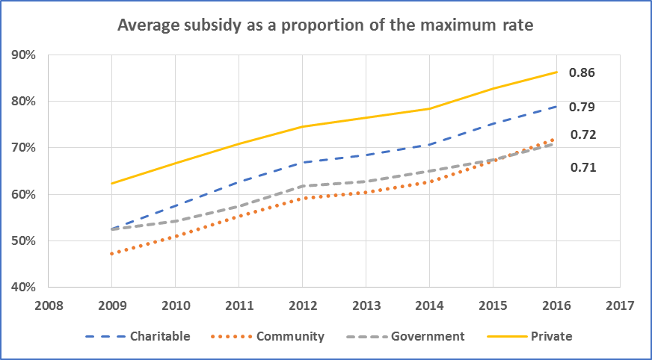

ACFI funding growth was relatively controlled, although still increasing, from 2012 until 2014. However, from June 2014 further increases beyond expectation occurred. A number of possible factors have coalesced to influence the funding increases since this time including:

* A minor increase in the frailty and care needs of new admissions.
* New consultancy business models developed to maximise ACFI funding for the sector that focused on ‘no fee if no ACFI funding gain’. These consultancy models were successful at significantly improving average ACFI funding levels, particularly with existing residents who had not been re-appraised for some time.
* Benchmarking services became widely available highlighting providers and facilities that were considered ‘below benchmark’.
* There were specialised ACFI co-ordinators established in most organisations which led to better management and co-ordination of claiming reviews which resulted in a reduction in the number of facilities that were under-claiming.
* New aged care companies entered the market with a focus on building scale and using business models that were predicated on increasing revenue growth from an increase in ACFI funding year on year.
* There was significant growth in the proportion of private providers in the sector (from 2012) who have been historically more efficient at generating the best ACFI claim possible.
* Claims in the Complex Health Care domain pain management items (Q12.3; Q12.4a; Q12.4b) were subject to significant growth, beyond expectation when the ACFI was calibrated.

The two Complex Health Care domain items covering pain management interventions (Q12.3; Q12.4a; 12.4b) have had the single most significant impact on ACFI funding growth since inception (Figure 2). The pain management items comprised 11.3 per cent of the average daily subsidy by June 30, 2016, and alone contributed $1,248 million to the total ACFI funding allocation by the Department.

****Figure 2: Yearly growth in pain management funding using June 30, 2016 funding levels****

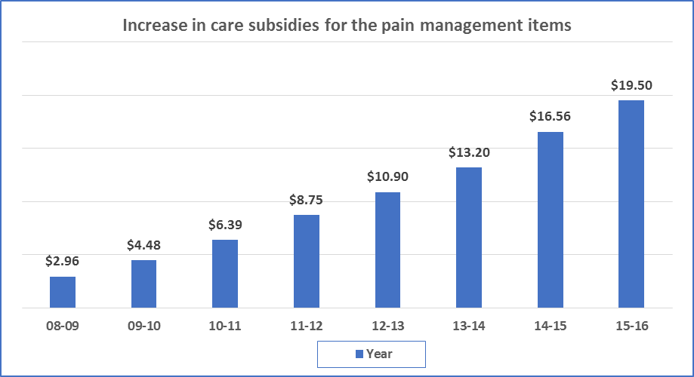

1. Further Review of the ACFI System

As a result of the ongoing growth of the care subsidy budget (determined via the ACFI), the government has had serious concerns regarding the program sustainability with the current ACFI funding model. On several occasions, expenditure for aged care has significantly outgrown projections, resulting in the introduction of savings measures that have been applied to the sector.

The first of these occurred in the 2012‐13 budget, which saw a reduction of payments under ACFI by $1.6 billion over five years. Analysis of claims trends showed growth occurred at twice the rate of wages. *‘(G)iven that ACFI subsidies make up around 70 per cent of provider revenue and wages make up around 70 per cent of provider costs’* the then Minister for Aged Care noted at the time, *‘there is clearly a disjoint between care subsidies and the cost of care*.’ (Butler, 2012).

In 2015‐16, there was also higher than anticipated claiming under the Complex Health Care domain of the ACFI that resulted in further adjustments to the budget in 2017.

This higher than predicted claiming has led to the Department undertaking various projects to review the current funding model and to explore options for the future.

This project is the result of the Department needing to address these issues. It was undertaken by Applied Aged Care Solutions (AACS) with a view to providing options to redesign the current ACFI funding system into a more sustainable and predictable model.

The project addresses the following areas:

* 1. Recommendations for cost effective improvements to the ACFI that would be consistent with external assessment. The recommendations should:
* Reduce subjectivity in the needs assessment process;
* Deliver a more accurate and reliable assessment that is not open to ‘gaming’;
* Be consistent with contemporary care practices; and
* Support the assurance and validation process for ACFI claims.

Key design considerations:

* Ability of the recommendations to be implemented in a short time-frame;
* That the proposed modifications are able to be integrated with existing Australian aged care client pathways and system structures i.e. Gateway (My Aged Care); and
* Ability of the needs assessment tool to be used by assessors from an appropriate and available workforce.
  1. External assessment options
* Provide options regarding external / internal assessment models from targeted consultations and available literature
* Specific activities regarding external assessment models

1. Targeted literature search
2. Consultations with DoH team members
3. Consultations with sector representatives from the ACFI Technical Reference Group and Peak Aged Care Bodies.
4. Methods

The ACFI Review Project comprised a number of components. The review methods were focused around the two major project aspects:

* A review of the ACFI system covering suggestions for change and analysis of the changes using existing data
* The rationale for and possible options if an external assessment model was to be considered for the resident funding determination.

1. Documentation reviews and consultations

A documentation review was undertaken to inform on ACFI issues and practical modifications that could be made to the ACFI. The reviews included relevant assessment and funding tools and the literature. The reviews were also designed to cover how a modified ACFI might fit into an external assessment approach to funding determination. A targeted literature review of international residential aged care systems in the USA, Canada, UK and NZ was undertaken together with teleconferences with representatives from these countries on their approaches.

Consultations were conducted with a broad range of stakeholders within the Australian aged care sector regarding possible changes to the ACFI. Stakeholders included representatives from peak bodies, leading industry groups, government ROs, and the ACFI Technical Reference Group. The detailed consultation discussion points and literature reviews are found in the References and Appendices (Report Part 3).

1. Data Analysis

ACFI data was provided to AACS for each of the financial years 2008-09 to 2015-16.

The data was used to:

* Analyse the current ACFI distribution and changes since introduction.
* Conduct statistical analysis of the ACFI questions, domains, weightings and re-calibrations.
* Conduct an analysis of the Departmental Review Program outcomes since ACFI introduction.
* Determine new cut points and weightings using distribution analysis and Item Response Theory (IRT) models in the ACFI domains.
* Analyse the benefits, disadvantages, system adjustments, and viable options for initial and re-appraisal assessments in the context of external assessment.

1. R-ACFI Funding Classification Model

The R-ACFI is a relative resource instrument – it divides up the available funding on a resident by resident basis based on their relativities and resource demands, as identified in the RCS costing study and the ACFI cost of care analyses conducted in 2006. While these analyses were undertaken 11 years ago, relativities in regard to residential aged cost models have proven very consistent in the most widely used classification system worldwide; RUGs II, III and IV models, which is similar to the ACFI design. Nevertheless, a re-calibration study at least at the domain level is recommended to adjust for any changes that may have occurred since the last analyses.

The R-ACFI is based on the differential ‘cost of care’ of individual residents and is primarily intended to deliver adequate funding to the facility supporting the residents. The facility receives an amount of funding and distributes that funding on the basis of the ‘assessed needs’ of the residents. The daily cost of care for an individual is related to their ‘average’ dependency (predictable and measured by the R-ACFI funding instrument) together with other ‘unpredictable’ care requirements related to health, psychological and emotional status that will change for all residents from time to time – this aspect is not a part of the recurrent funding model (e.g. exceptional short-term needs). Short-term aspects that cannot be measured by an ‘averaged’ model should be funded via limited time supplements that will target these particular care need areas. Supplements can be added at any time to the R-ACFI model to better adjust for the exceptional needs that may cause large unpredictable resource demands.

The R-ACFI focuses on those questions related to day-to-day, high frequency need for care. These aspects are more appropriate for measuring the average cost of care in longer stay environments.

The R-ACFI funding model represents a modification of the current ACFI. It should be noted that the underlying ACFI structure and weightings were derived from traditional statistical methods (factor analysis, regression analysis etc). For this project, AACS has used IRT methods, (which have become more recently available and are considered gold standard regarding scale development), on the ADL scale with the R-ACFI update.

1. Statistical Underpinnings of the R-ACFI

The R-ACFI scales have been developed as separate ‘independent’ measures of care need, and the coefficients are only relevant within the scale in question, as the amount of funding associated with each care domain (ADL, BEH, CHC) was calibrated separately (cost relativities approximately ADL 60 per cent BEH 15 per cent CHC 25 per cent).

The scales within the domains comprise items whose importance is calculated ‘in combination’ by IRT for the ADL domain in the R-ACFI. The funding amounts determined by the domains can then be added as they all are components of the overarching latent domain of ‘aged care needs’. The R-ACFI uses latent trait analysis to determine item weightings within domains – they are not simply added as in the RUGS ADL model used in many casemix systems.

This method provides understandable, meaningful and valid clinical groupings with associated relativities which are then combined into cost group (case mix) combinations for individual resident profiles. The R-ACFI therefore allows for the identification of meaningful ‘case types’ as the first priority (clinical meaning preferred) which are based on the three major care domains inherent in any aged care support system (personal care, health/nursing, behaviour/dementia) which are then associated with the available funding. The ACFI domain design is clinically plausible, statistically defensible and provides a widespread understood approach.

The ACFI and now R-ACFI domains are designed to represent the key resource drivers in long term care and to provide a readily accessible care profile for each resident.

1. Considerations when Measuring the Cost of Care

The R-ACFI uses a combination of an additive model (regression) and IRT. The most important consideration in the development of an additive (regression) or branching (regression tree) classification model is the underlying measurement model. In this regard, the R-ACFI scales are the primary data source and a funding classification model could be determined effectively with either approach. It is suggested for further reviews, that both approaches are developed and compared to determine which method more accurately explains the costs of care.

Residential aged care in Australia does not approach the complexity of care needed or provided in sub-acute environments. There is also no evidence to suggest that there has been a system wide significant shift with aged care residents becoming more ‘sub-acute’ with shorter lengths of stay or that they are sicker or older on entry to care.

When using reliable measures, it can be shown that:

* Length of stay has been increasing over the past 15 years. The average length of stay for all separations has increased from 31.5 months in 2000 to 34.8 months in 2015.
* There has been a small increase in the age at entry to an aged care facility in the last 6 years (83.4 years in 2008; 83.9 years in 2014).
* The age of residents in care has increased slightly (84.5 years to 85 years) indicating that the residents are not dying at an increased rate because they are ‘older and sicker’.
* The proportion of residents with shorter lengths of stay has been decreasing. Figure 3 shows the distribution of lengths of stay for separations in 2007-08 and 2014-15, from AIHW 2009 and 2016 data. The proportions at the two shortest durations decreased, and those at all the higher durations have increased. The proportion leaving in less than 2 years has also dropped from 53.3 to 50.9 per cent. The proportion of residents with shorter lengths of stay has therefore been decreasing.

Current evidence indicates that residents are not much older, sicker or having shorter lengths of stay than was the case 10 years ago. The residential aged care population as a whole (there may be local effects) is not that dissimilar to the population that the ACFI was calibrated on in 2008 and it is unlikely to change dramatically over the next 10 years.

****Figure 3: Separations by length of stay****

Figure 3 is a bar graph that illustrates the comparison of the distribution of lengths of stay (LOS) for the periods of 2007-2008 and 2014-2015, as per the Australian Institute of Health and Welfare data, which is summarised in the text prior to this image. 
There are seven LOS categories: 
1.  Under a month
2.  One to three months
3.  Three to six months
4.  Six to 12 months
5.  One to two years
6.  Two to five years
7.  Over five years.

1. R-ACFI Principles

The R-ACFI funding model represents a significantly improved version of the current ACFI. The following sections explain the principles upon which the R-ACFI has been developed which are:

* The R-ACFI Focuses on Assessed Care Need
* The R-ACFI Rewards Improved Resident Functioning
* The R-ACFI has a Minimum ‘Base’ Funding ADL Classification
* The R-ACFI includes a broadly-based Therapy Program available to all residents
* The R-ACFI Promotes Best Practice Assessment and Care Planning

The R-ACFI strongly supports the creation of an assessment and care planning evidence basis which will then lead to the funding outcome. This is a care first, funding later model.

1. R-ACFI Assessment and Care Planning

Some ACFI areas use only summary ‘assessments’ that record a care outcome (e.g. unable to participate in transfers) as evidence for a care need (requires physical assistance with transfers). These are not actual assessments as they represent a summary of the assessment outcomes describing what a person can do based on an incremental Likert scale.

In the review of the ACFI, it has been acknowledged that improved assessment outcomes will be achieved if contemporary, well designed tools can be used as the fundamental assessment basis. This high-quality information will lead to better care planning outcomes and represent an improvement on an industry basis of assessment practices, but only if the tools are mandated.

In line with the enhanced assessment and care planning focus of the R-ACFI, there is an enhanced suite of mandated assessments. The R-ACFI provides a more contemporary and comprehensive set of assessments that will assist in the identification of resident care needs and directly relate to the care planning process to improve quality of care outcomes.

Figure 4 shows how the R-ACFI fits into the nursing process by providing a more comprehensive assessment base than the current ACFI. It also shows that application of the new R-ACFI assessment model will directly lead to the R-ACFI claim for funding as an outcome. This is to provide a more seamless and efficient approach that links care assessment to funding outcomes.

1. Setting the Scene - the R-ACFI Model

This review project recommends the implementation of a new R-ACFI covering, to at least some degree, almost all areas related to the operation of the ACFI. The entire ACFI system has been reviewed as part of this project and changes have been recommended for:

* ACFI Questions
* ACFI Checklist items
* ACFI Care Domains
* ACFI Assessment Tools
* ACFI Funding Model
* Business Rules
* The Audit System and External Assessment.

****Figure 4: How the R-ACFI Enhances and Fits into the Nursing Care Process****

Figure 4 is a workflow diagram illustrating how the revised-Aged Care Funding Instrument (R-ACFI) fits into the care planning process. 
The diagram is split into 3 main headings:
1.  Identify care needs
2.  Apply
3.  Review and evaluate.
Part of the ACFI system has been outlined in the text prior to this image.

1. Developing the R-ACFI ADL Domain
2. A Statistical Overview of the ACFI ADL Domain

Average ADL funding has increased significantly since 2009 with growth driven by an increase in the High ADL domain category (Figure 5). Additionally, while around 9 per cent of residents did not score sufficiently to receive ADL domain funding in 2009, there were less than 1 per cent in the ADL unfunded category at June 30, 2016.

A little over a third of residents, 33.5 per cent, were in the High ADL classification in 2009 but this has steadily increased to 56.3 per cent of residents by June 30, 2016. While some growth in ADL dependency can be attributed to increases in resident care needs, a contributing factor has been a beneficial interpretation of one-to-one physical assistance for a ‘resident’s usual day-to-day assessed care needs’. This has been addressed in the R-ACFI.

****Figure 5: ADL Domain Classifications (N, L, M, H) 2009 - 2016****

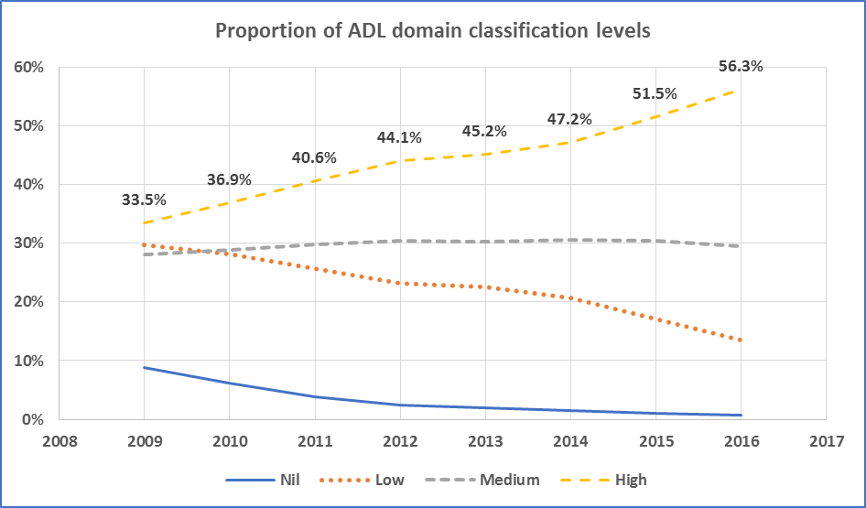

1. Recommended Changes to the ADL Domain

The R-ACFI now has a more clearly defined purpose as an assessment and funding tool. Recommendations for changes to the ACFI ADL Domain are:

1. **The ADL becomes a four-level domain with levels Low, Medium, High and Very High**

The R-ACFI is recommended to have four ADL domain levels (Low, Medium, High, Very High) with the highest level receiving increased funding compared to the current ACFI. In addition, it is recommended that all approved residents in aged care facilities should (at a minimum) receive the base payment of the ADL lowest funding level.

There were a number of factors that influenced this recommendation:

* analysis of the ADL domain data indicated that the top funding category (ADL – High) had increased from around 33 per cent of residents in 2009 to 56.1 per cent at 30 June 2016.
* there was also a group of residents receiving the highest ADL funding that also needed mechanical lifting for all transfers. As these residents are even more resource intensive, requiring multiple staff assistance, it was decided to additionally weight this aspect.
* as the ACFI is a relative resource tool and payments were determined on the basis of the initial relativities and frequencies, an adjustment was needed to re-calibrate the distribution.

1. **At a minimum, all residents will be funded at the Low domain level.**

A decision was also made to recommend that the lowest ADL category funding should apply as a minimum to all residents. This recommendation was made as:

* the number of residents receiving no ACFI ADL domain funding once in care had reduced significantly from 8.8 per cent in 2009 to only 0.6 per cent at 30 June 2016;
* the ACAT role as residential care “gate keeper” is likely to further reduce the numbers of negligible low care residents being approved for residential care;
* the increased provision of community care services will mean even fewer people with no ADL care needs would be entering care; and
* there was a strong view in the consultations that all residents in care should receive a base ADL payment or “fixed base layer payment” to cover off basic care provision requirements.

1. **The ACFI Question ratings of A, B, C, D are dropped as the revised weightings are based on ACFI checklist items only.**
2. **New rating scale descriptors of Standard Care, Moderate Assistance, and Full Assistance (with Mechanical Lifting for Transfers) are now included (****Table 3****).**
3. **Removal of the Grooming checklist items as they are redundant.**
4. **Inclusion of a suite of Mandated Assessments for the R-ACFI ADL domain. Assessments are current for 3 months.** **Table 4** **provides a summary of the R-ACFI ADL mandated and recommended assessments.**
5. **Supporting evidence is now required regarding the reasons for the assistance needed.**

****Summary of assistance needed provisions for R-ACFI 1 to 4****

****Table 1: R-ACFI ADL rating (Nutrition)****

| **Requirements** | **0**  **Standard Care** | **1**  **Monitoring** | **2**  **Moderate assistance** | **3**  **Full assistance Nutrition** |
| --- | --- | --- | --- | --- |
| **Nutrition** | **Standard Care**: Independent during the EATING activity; OR  Staff standing by for occasional or episodic assistance; OR  Provision of modified textured food and drinks; OR  Setting up activities e.g. taking lids off, cut up food, specialised plates and cutlery, special diets, placing food in front of resident; OR  Providing verbal assistance (e.g. prompting, cueing). | Needs general monitoring for an assessed nutritional need using the mandated assessment. | Always providing physical assistance, on a one-to-one basis, for part of the EATING activity, whenever the activity is needed, due to a swallowing issue or other impairment. | Always providing physical assistance, on a one-to-one basis, throughout the entire activity, whenever the activity is needed. |
| **Mandated Evidence** | *Not required* | R-ACFI Q1: MNA Short (completed within last 3 months of appraisal) | | |
| **Supporting Evidence** | *Not required* | *Not required* | Swallowing impairment:  Evidence- Speech Pathologist report  Physical/ sensory impairment: Evidence- NSAF, MP notes, diagnoses.  Moderate Cognitive Impairment- requires staff to initiate or complete the activity.  Evidence: Cognition Assessment (SMMSE), clinical report, NSAF, MP notes, diagnoses. | Swallowing impairment:  Evidence- Speech Pathologist report  Physical/ sensory impairment: Evidence - NSAF, MP notes, diagnoses.  Severe Cognitive Impairment: e.g. does not participate in the activity  Evidence: Cognition Assessment (SMMSE), clinical report, NSAF, MP notes, diagnoses. |

****Table 2: R-ACFI ADL rating (Mobility)****

| **Requirements** | **0**  **Standard Care** | **1**  **Moderate assistance** | **2**  **Full assistance** | **3**  **Mechanical Lifting** |
| --- | --- | --- | --- | --- |
| **Mobility**   * **Transfers** * **Locomotion** | Independent (with or without aids); OR  Standing by for occasional or episodic assistance; OR  Transfer Setting up activities e.g. preparing or providing wheelchair or other transfer aid; OR  Locomotion Setting up activities e.g. handing the resident the mobility aid; OR  Verbal assistance, prompting, cuing. | Always providing physical assistance, on a one-to-one basis, for at least part of the activity, whenever the activity is needed. | Always providing physical assistance, by at least two staff, throughout the entire activity, whenever the activity is needed. | Use of Mechanical Lifting device for Transfers:  Always providing physical assistance by the use of mechanical lifting equipment, throughout the entire transfer activity, whenever the activity is needed. |
| **Mandated Evidence** | *Not required* | R-ACFI Q2: PMS & FRAT items (completed within last 3 months of appraisal) | | |
| **Supporting Evidence** | *Not required* | Sensory Impairment: Evidence: NSAF, MP notes, diagnoses  Behavioural Issues: Evidence- clinical report, NSAF, MP notes.  Physical impairment e.g. gait, balance. Evidence: Functional Assessment (PMS), Physiotherapy report, NSAF, MP notes, diagnoses. | | |
| **Supporting Evidence** | *Not required* | Moderate cognitive impairment, requires staff to initiate the activity.  Evidence: Cognition Assessment (SMMSE), clinical report, NSAF, MP notes. | Severe cognitive impairment e.g. does not participate in the activity.  Evidence: Cognition Assessment (SMMSE), clinical report, NSAF, MP notes, diagnoses | Evidence: Physiotherapy Assessment, NSAF, MP notes, diagnoses |

****Table 3: R-ACFI ADL rating (Personal Hygiene, Toileting)****

| **Requirements** | **0**  **Standard Care** | **1**  **Moderate assistance** | **2**  **Full assistance** |
| --- | --- | --- | --- |
| **Personal Hygiene**   * **Toileting** | Independent (with or without aids); OR  Standing by for occasional or episodic assistance; OR  Setting up activities:  Dressing e.g. choosing and laying out clothes  Washing e.g. up toiletries within reach, turning on or adjusting taps  Use of Toilet e.g. setting up toilet aids or handing the resident the bedpan or urinal, or placing ostomy articles in reach  Toilet Completion: e.g. emptying drainage bags, urinals, bed pans or commode bowl; OR  Verbal assistance, prompting, cuing. | Always providing physical assistance, on a one-to-one basis, for at least part of the activity, whenever the activity is needed. | Always providing physical assistance, by at least two staff, throughout the entire activity, whenever the activity is needed. |
| **Supporting Evidence** | *Not required* | Supporting Evidence R-ACFI Q3-4:  PMS/FRAT items, NSAF, MP/AHP notes.  Moderate cognitive impairment, requires staff to initiate the activity.  Evidence: Cognition Assessment (SMMSE), clinical report, NSAF, MP notes.  Sensory Impairment: Evidence- NSAF, MP notes, diagnoses  Behavioural Issues: Evidence - clinical report, NSAF, MP notes. | Supporting Evidence: PMS/FRAT items, NSAF, MP/AHP notes - as directed by AHP or MP.  Severe cognitive impairment e.g. does not participate in the activity.  Evidence: COGNITION Assessment (SMMSE), clinical report, NSAF, MP notes, diagnoses.  Sensory Impairment: Evidence- NSAF, MP notes, diagnoses  Behavioural Issues: Evidence- clinical report, NSAF, MP notes. |

****Table 4: R-ACFI ADL Domain Assessment Tools Recommendations****

| Nutrition | | |
| --- | --- | --- |
| Mandatory | **Recommended** | **Source** |
| Mini Nutritional Assessment (MNA Short) | *No recommendation.* | NATFRAME |
| Functional | | |
| Mandatory | **Recommended** | **Source** |
| Physical Mobility Scale (PMS) with guided instructions | *No recommendation.* | R-ACFI Assessment Pack |
| Falls Risk Assessment Tool (FRAT) | *No recommendation.* | NATFRAME |
| Continence | | |
| Mandatory | **Recommended** | **Source** |
| Continence Record | *No recommendation.* | ACFI Assessment Pack |
| Continence Assessment Form and Care Plan (if no diagnosis) | Continence Toolkit which includes:  - Management flow chart  - Screening form  - Three-day bladder chart  - Seven-day bowel chart  - Monthly bowel chart  - Assessment form and care plan  - Care summary | The Continence Tools for Residential Aged Care (updated 2016) |

1. Developing the R-ACFI BEH Domain
2. A Statistical Overview of the ACFI BEH Domain

Average BEH Domain funding has increased significantly since 2009 with funding growth driven by an increase in the High BEH domain category from 37 per cent in 2009 to 62.9 per cent of residents in June 2016 (Figure 6). While 15 per cent of residents had no BEH domain claims in 2009, this proportion has decreased considerably to only 4.4 per cent without a behaviour claim in 2016.

****Figure 6: BEH Domain Classifications (N, L, M, H) 2009 - 2016****

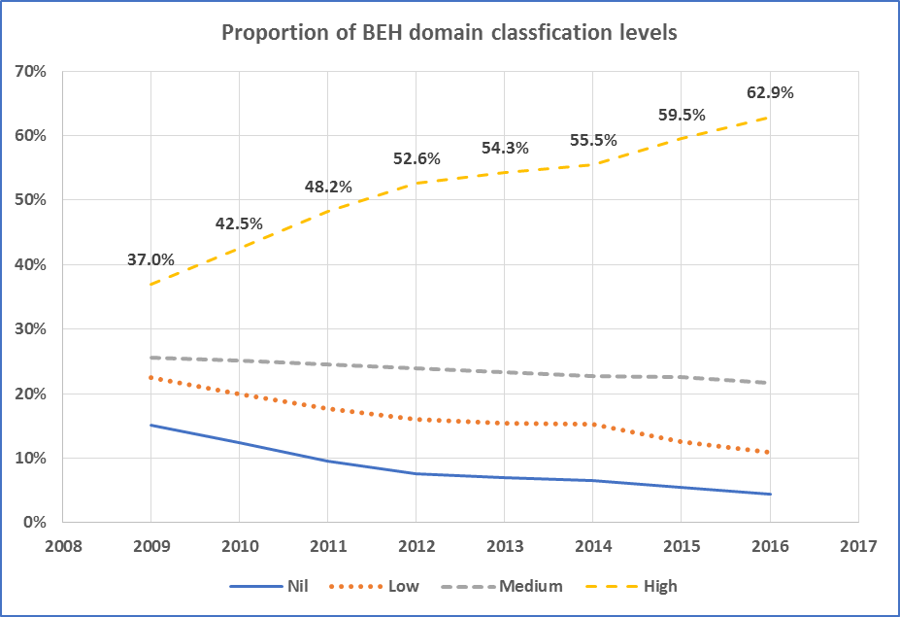

1. Recommended Changes to the BEH Domain

The recommended changes to the Behaviour domain (in brief) include:

1. Becomes a three-level domain with levels of Nil, Moderate and High. Analysis of the distribution of the scores indicated that a four-level split was not necessary to achieve the sufficient precision for funding allocation purposes.
2. A single ACFI Behaviour question replaces the three separate behaviour questions Wandering, Verbal and Physical.
3. The Depression item has been moved to the Complex Health Care domain as it now focuses on Major Depression.
4. The funding amount attributable to the Depression question ($3.64 per day) has been re-allocated to the CHC domain.
5. Weightings adjusted proportionally for the removal of the Depression item.
6. The PAS-CIS replaced by the S-MMSE in a direct swap for the mandated cognitive assessment. Assessments are current for 3 months.
7. Inclusion of a detailed individualised behaviour description to clarify the behaviour claimed.
8. Inclusion of a new severity item “disruptiveness” to clarify that there is a requirement for “staff intervention”.
9. The behaviour frequency rating descriptors have been modified to daily, twice a day and more than twice a day on a daily basis over a 7-day period to better distribute the relative care needs and acknowledge that the domain is targeting those requiring additional staffing support of a specific nature.
10. A matrix between the “disruptiveness” level and behaviour “frequency” must be completed to determine the final Behaviour domain rating.
11. Behaviour descriptions “constantly physically agitated” and “verbal refusal of care” have been removed due to definitional problems and inappropriate labelling.
12. A Mental and Behavioural diagnosis (excluding Depression) is required to receive the highest funding level in the Behaviour domain.
13. A referral and review by a Behaviour Specialist (e.g. DBMAS; Psychiatrist; Psychologist) and Behaviour Care Plan is also required to receive the highest funding level in the Behaviour domain.
14. BEH Assessment Suite

Table 5 provides a summary of the R-ACFI BEH mandated and recommended assessments.

****Table 5: R-ACFI Behaviour Domain Assessment Tools Recommendations****

| Cognition Assessment | | |
| --- | --- | --- |
| **Mandatory** | **Recommended** | **Source** |
| SMMSE Cognition Assessment | *No recommendation.* | R-ACFI Assessment Pack |
| **Behaviour Assessment** | | |
| **Mandatory** | **Recommended** | **Source** |
| Behavioural Descriptions (text)  *(recorded in the Behaviour Assessment Summary)* | *No recommendation.* | R-ACFI Assessment Pack |
| Frequency  *(recorded in the Behaviour Record)* | *No recommendation.* | R-ACFI Assessment Pack |
| Disruptiveness Rating  *(recorded in the Behaviour Record)* | *No recommendation.* | R-ACFI Assessment Pack |
| Modified Behaviour Assessment Form  *(collates the above behaviour information)* | *No recommendation.* | R-ACFI Assessment Pack |

1. Developing the R-ACFI CHC Domain
2. A Statistical Overview of the ACFI CHC Domain

While the High CHC category had the lowest proportion of residents in 2009 with 12.7 per cent, significant growth since then has meant that the High category now has 61.4 per cent of residents by June 30, 2016 (Figure 7). This has led to a large growth in funding outlays over this period.

****Figure 7: Complex Health Care Domain Classifications (N, L, M, H) 2009 - 2016****

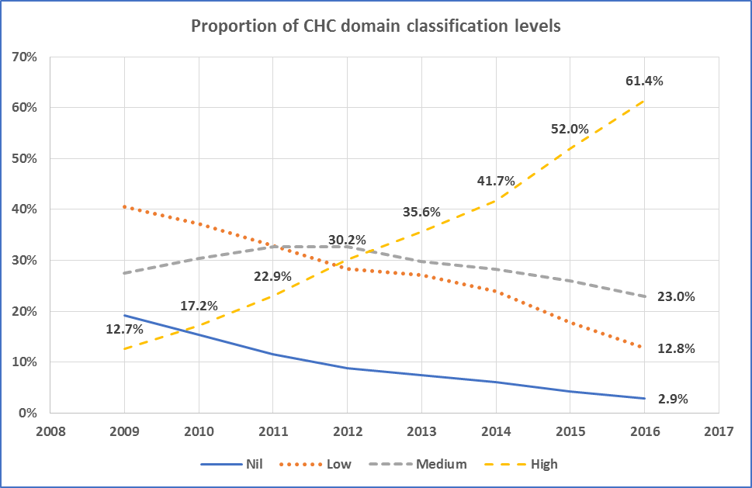

1. Recommended Changes to the CHC Domain

A summary of the recommended changes to the CHC domain include:

1. A new requirement a claim in the Complex Health Care domain is that there is documented evidence that the resident has a regular ongoing 3 monthly comprehensive health assessment undertaken and signed off by a registered nurse.
2. The Medicationquestion (ACFI 11) hasbeen moved into the R-ACFI Complex Health Care Procedures list as two separate items. The items are now (i) daily medications, patches, suppositories and enemas (weight 3) and (ii) daily injections (weight 6).
3. Removal of the items 12.1 blood pressure, 12.18 vital signs technical equipment as these are considered not discriminating items and low in complexity.
4. Removal of the item 12.12a management of arthritic joints & oedema as it is included and covered in the R-ACFI 3 checklist item “dressing and undressing”. As (ACFI 12.12a) Management of arthritic joints and oedema related to arthritis by the application of tubular and/or other elasticised support bandages is no longer considered a complex care issue but a dependency related matter (it is included and covered in the R-ACFI 3 checklist item ‘dressing and undressing’). It is recommended that R-ACFI 3 Checklist 1 include this item e.g. ‘Fitting and removing of hip protectors, slings, cuffs, splints, medical braces, tubular elasticised support bandage and prostheses other than for the lower limb.’
5. Changes to ACFI item 12.12b item to bring the requirements in line with contemporary care practices (now R-ACFI item 7)
6. Re-weighting of the blood glucose and oxygen therapy items from 3 points to 1 point to reflect their lower level of complexity in relation to the other items.
7. Inclusion of a Depression item into the CHC procedures list and re-framed as “Major Depression”. The evidence requirements for a Depression claim have been strengthened. The funding from the Depression question has been added into the Complex Health Domain funding pool ($3.65 per day).
8. A palliative care claim will now trigger a 6-month mandatory re-appraisal.
9. Relocation of the pain management items (12.3, 12.4a, 12.4b) and funding into the new R-ACFI Therapy Program which has a broader physical therapy focus. The funding determined from the pain management items over the past 4 years has been averaged and $15 per day has been transferred from the Complex Health Domain into the new Therapy Program.

Table 6 provides a description of the updated R-ACFI CHC procedures list. Table 7 provides a list of the mandated and recommended assessments to be used in the CHC domain.

****Table 6: R-ACFI CHC procedures to be completed****

| R-ACFI Score | CHC procedures | Evidence Requirements | Tick if yes |
| --- | --- | --- | --- |
| 1 | Management of ongoing stoma care.  Excludes temporary stomas e.g. post-surgery. Excludes supra pubic catheters (SPCs). | 1. Diagnosis  AND  2. Directive [registered nurse or medical practitioner] | 🞏 1 |
| 1 | Blood glucose measurement for the monitoring of a diagnosed medical condition e.g. diabetes, is an ongoing care need AND frequency at least daily. | 1. Medical practitioner directive  AND  on request: record | 🞏 2 |
| 1 | Oxygen therapy not self-managed. | 1. Diagnosis  AND  2. Directive [registered nurse or medical practitioner] | 🞏 3 |
| 3 | Complex skin integrity management for residents with compromised skin integrity who are usually confined to bed and/ or chair and cannot self-ambulate. The management plan must include repositioning at least 4 times per day. | 1. Directive [registered nurse or medical practitioner or allied health professional]  AND  2. Skin integrity assessment | 🞏 4 |
| 3 | Management of special feeding undertaken by RN, on a one-to-one basis, for people with severe dysphagia, excluding tube feeding.  Frequency at least daily. | 1. Diagnosis  AND  2. Directive [registered nurse or medical practitioner or allied health professional]  AND  3. Swallowing Assessment | 🞏 5 |
| 3 | Catheter care program (ongoing); excludes temporary catheters e.g. short term post-surgery catheters. | 1. Diagnosis  AND  2. Directive [registered nurse or medical practitioner] | 🞏 6 |
| 3 | Complex management of oedema, when the management plan includes the use of compression therapy that includes (bandages/ hosiery/ garment) applied at least weekly for;  Oedema due to one of the following medical conditions as diagnosed by the medical practitioner:   * + chronic venous insufficiency   + lymphoedema   + acute (ongoing) DVT (lower leg)   The compression garments must be selected correctly to apply the degree of compression required by the individual resident, as evidenced in the diagnosis, assessment and directive.  It is expected that the Health Professional providing the directive for treatment would have the clinical expertise to identify the appropriate garments for treating these complex health care conditions. | **1.** Diagnosis (documented by a Medical Practitioner)  **AND**  **2.** Directive [registered nurse or medical practitioner or allied health professional].  The Directive is to contain the assessment outcomes, goals of treatment and treatment plan, covering:   1. Aim of the compression therapy 2. Type/description of the bandage/hosiery/garment 3. Objective measurements e.g. calf size, ankle size, Doppler ankle brachial pressure index [ABPI] etc. 4. Compression mmHg 5. Application directions (e.g. frequency of application, who is to apply the therapy). 6. Review details.   **AND**  **3.** Record of Treatment | 🞏 7 |
| 3 | Depression. | 1. Diagnosis of Major Depressive Disorder   AND   1. Directive [registered nurse or medical practitioner]   AND   1. Depression Assessment (recommend CSD, GDS, K-10) | 🞏 8 |
| 3 | Medications 1- Weekly patches, suppositories or enemas, Daily Medication Assistance. | 1. Medication Directive/Chart [medical practitioner] | 🞏 9a |
| **OR** | | | |
| 6 | Medications 2- Daily administration of injections (Subcutaneous, intramuscular, intravenous).  Can only claim one item- either 9a or 9b. | 1. Medication Directive/Chart [medical practitioner] | 🞏 9b |
| 6 | Management of chronic infectious conditions.   * Antibiotic resistant bacterial infections * Tuberculosis * AIDS and other immune-deficiency conditions * Infectious hepatitis | 1. Diagnosis  AND  2. Directive [registered nurse or medical practitioner] | 🞏 10 |
| 6 | Management of chronic wounds, including varicose and pressure ulcers, and diabetic foot ulcers. | 1. Diagnosis  AND  2. Directive [registered nurse or medical practitioner or allied health professional]  AND  3. Wound Assessment  AND  On request: record | 🞏 11 |
| 6 | Management of ongoing administration of intravenous fluids, hypodermoclysis, syringe drivers and dialysis. | 1. Directive/prescription [authorised nurse practitioner or medical practitioner] | 🞏 12 |
| 6 | Suctioning airways, tracheostomy care. | 1. Diagnosis  AND  2. Directive [registered nurse or medical practitioner] | 🞏 13 |
| 6 | Management of ongoing tube feeding. | 1. Diagnosis  AND  2. Directive [registered nurse or medical practitioner or allied health professional] | 🞏 14 |
| 15 | Palliative Care Program involving End of Life care where ongoing care will involve intensive clinical nursing and/or complex pain management in the residential care setting.  **End-of-life (terminal) care definition**  ***This description is similar to and modified from the end-of-life description found in page 6 of the 2017 ACFI User Guide.***  *“… palliative care is appropriate when the resident is in the final days or weeks of life and care decisions may need to be reviewed more frequently.” (Australian Palliative Residential Aged Care Project, 2006, p. 38)* | 1. Directive by [CNC/CNS in pain or palliative care or medical practitioner]  AND  2. Pain Assessment (as per Pain Management Guidelines (PMG) kit)  AND  3. Assess the resident using the Palliative Approach Toolkit in Residential Aged Care Facilities.  *Note: a Palliative Care claim will require a mandatory re-appraisal in 6 months. | 🞏 15 |

****Table 7: R-ACFI Complex Health Assessment Tools Recommendations****

| Complex Health Care (CHC) | | |
| --- | --- | --- |
| **Mandatory** | **Recommended** | **Source** |
| **Comprehensive Health Assessment (CHA)** Regular, ongoing, documented 3 monthly, comprehensive health assessment, undertaken and signed off by a registered nurse. | Comprehensive Health Assessment for Older People: Documentation Template. (CHAOP) | La Trobe University (ACEBAC) research team: Dr Deirdre Fetherstonhaugh, Dr Margaret Winbolt, Dr Michael Bauer, Professor Rhonda Nay.  This project was supported with funding from Victorian Department of Health, Wellbeing, Integrated Care and Ageing Division and from the Home and Community Care Program which is jointly funded by the Commonwealth and Victorian Governments.  [The Victorian Government's Web Page](https://www2.health.vic.gov.au/ageing-and-aged-care/residential-aged-care/safety-and-quality/improving-resident-care/comprehensive-health-assessment) |
| **Nursing Assessments** are required for Skin Integrity, Wounds, Swallowing. | Validated assessments | For example, the NATFRAME (National Framework for Documenting Care in Residential Aged Care Services) |
| **Depression Assessment.** | Revised Cornell Scale for Depression (CSD) | ACFI Assessment Pack |
| Kessler Psychological Distress Scale (K10) | NSAF |
| Geriatric Depression Scale (GDS) | NSAF & NATFRAME |
| **Palliative Care**  **Pain Assessment** is required, tool is not mandated. | Pain Management Guidelines (PMG) kit. | Recommended Pain Assessments are from the Pain Management Guidelines (PMG) kit. |
| **Palliative Care**  End of Life determination. | *[no recommendation]* | End of Life definition (2017 ACFI User Guide, page 6).  End of life definition (Australian Palliative Residential Aged Care Project, 2006, p. 38) |

1. Developing the R-ACFI Therapy Program
2. Why consider a Therapy Program in the R-ACFI?

There are two key reasons why a Therapy Program has been considered for the R-ACFI. Firstly, the current ACFI funding for physical therapy is limited to pain management and the approved specific interventions listed are narrowly focused (heat packs, massage, technical equipment). This means that broader-based physical Therapy Programs are not directly linked to ACFI funding. As there is good evidence that physical therapy interventions that include general wellness, restorative or maintenance approaches will benefit aged care residents, it is appropriate to review the structure and operation of these items. A new broadly-based Therapy Program will not only better target resident needs, but also give an opportunity to directly include the consumer and families in the choice of options.

Secondly, the excessive growth in the pain management items needs to be addressed as it is the single most important factor in ACFI funding growth beyond the Government’s forward financial estimates. From 2014 to 2015, there was funding growth of 5.2 per cent in the ADL domain, 5.2 per cent in the Behaviour domain and 11.2 per cent in the CHC domain. The growth of funding in the CHC domain is almost exclusively due to the increased proportion of residents with pain management claims. The growth in the proportion of residents with pain management claims has risen significantly and consistently since the introduction of the ACFI.

Without modification, these items will eventually be significantly altered or dropped altogether from the ACFI to maintain the Government’s budget commitments.

The current review of the ACFI gives an opportunity to redress these issues and to provide more financial certainty for the Government and providers, in addition to improving the assistance and support to people living in residential aged care.

A new Therapy Program is a logical fit with the ACFI pain items, and the new program would be designed to fit with contemporary best pain practice and a broader range of physical interventions – for example, evidence-based pain treatments including therapeutic exercises as recommended by the PMG (Pain Management Guidelines) Kit for Aged Care. The government funded PMG Kit for Aged Care accompanies The Australian Pain Society’s Pain in Residential Aged Care Facilities: Management Strategies (Goucke, Kristjanson, & Toye, 2007).

1. Are Physical Therapy Programs Effective?

There is a growing body of evidence of the range of positive outcomes from physical therapy interventions with older frail persons. It not only improves or maintains functional ability, but can also impact on the management of chronic diseases and their associated risks, reducing falls, and improving social and quality of life outcomes.

Physical therapies can be undertaken by AHPs such as physiotherapists, chiropractors, osteopaths, occupational therapists and exercise physiologists (Transport Accident Commission).

Currently, Exercise Physiologists are not recognised in the list of Health Professionals in the ACFI User Guide (page 38). However, their practices fit strongly into the planned Therapy Program and their inclusion is recommended in the new R-ACFI Therapy Program model.

*Exercise & Sports Science Australia (ESSA) (2016a) state that:*

*“Increasing the exercise and physical activity levels of older people can prevent, or aid in the management of, a myriad of chronic health problems. It can also improve and maintain physical function, promote independence, reduce falls, improve quality of life and slow cognitive decline. Many chronic diseases can be prevented or delayed by healthy behaviours and, importantly, by the environments that support them. Health and social systems can work together to strengthen and maintain capacity and even reverse declines. However, this requires a shift in focus from reactive care to preventative measures.”* (p. 1).

*ESSA (2016b) further assert that:*

*“There is strong evidence that clinical exercise interventions, as delivered by accredited exercise physiologists, provide a range of physical, mental and psychosocial benefits to older people, independent of age, disability or disease. For example, exercise can improve cardiovascular fitness, muscular strength and balance, decrease symptoms of depression, anxiety and pain and, when completed in a group setting, foster social connections and feelings of belonging. Further, exercise is a very accessible intervention that can be undertaken in a range of settings, including residential aged care facilities and is proven to be highly cost effective, when delivered by accredited exercise physiologists*… *ESSA supports the adoption of contemporary policies and funding models within aged care that develop and maintain an individual’s functional abilities…including their ability to engage in evidenced-based physical activity programs.”* (p. 1-2).

A wellness and reablement approach in home care has been actively supported by the Australian government (Nous Group, n.d.) and is described on the website as:

* Wellness is building on strengths and goals of individuals to promote independence in daily living skills.
* Reablement is short term interventions to adapt to functional loss or to regain confidence and capacity.

Wellness fits into the new Physical Therapy program in the R-ACFI, as physical therapies have been associated with improving not only physical but also social and psychological wellness (Martin et al, 2013). A flexible Therapy Program approach could also support short term interventions, with the wellness approach being ongoing.

1. Physical Therapy Program Principles

Consultations with a broad range of stakeholders within the Australian aged care sector were undertaken regarding possible changes to the ACFI. Stakeholders included representatives from peak bodies, leading industry groups, government ROs, and the ACFI Technical Reference Group. There was widespread interest in the development of a new, broadly-based Therapy Program in the new R-ACFI.

Stakeholders were very supportive of developing a broadly-based Therapy Program that incorporated the pain items as well as using the ACFI funding from the pain claims in the new Therapy Program. As an outcome of the feedback and comments from the consultations and other input from subject matter experts, the following principles were developed to guide the design of the Therapy Program:

1. **The Programs should Include a wide range of therapeutic inputs from a variety of health professionals**

Each Therapy Program developed, should allow for a range of physical therapist and RN inputs to provide a multi-disciplinary range of specialist assessment and program delivery options.

A subset of the Health Professionalsas identified in the current ACFI User Guide (page 38) have been suggested as suitableto undertake assessments, develop the Therapy Program Care Plan and deliver the interventions.

1. **Therapy Programs will be designed and delivered as 1:1 or group activities**

Consultation feedback, discussions with content matter experts (e.g. physiotherapists, exercise physiologists) and review of relevant literature (refer to section 7.2) have informed on the following aspects of Therapy Program design and delivery.

**Group size**

Both individual and small groups may be appropriate Therapy Program models, depending on the resident’s physical therapy needs and individual choice.

**One-on-one therapy**

* Usually requires a more intense input by the participant.
* Best delivered in a session time of around 20 to 30 minutes.

**Group Therapy Sessions**

* Provide both physical and psychosocial benefits for participants.
* Foster social connections and feelings of belonging (Martin et al., 2013). It was considered that group sessions could be delivered in a longer session.
* Should have a maximum of 5 people, following similar Medicare/ Private health Insurance rebate practices.
* Small group sessions should be delivered in approximately 50 minute sessions.

Feedback also indicated that the profile of aged care residents (e.g. frailty, older age, poor functional status) are most suited to a maximum of 3 to 4 sessions per week.

The most complex ACFI pain item (ACFI 12.4b) currently requires 80 minutes of therapy per week. Modelling was undertaken to demonstrate how the Therapy Program would operate using a mix of individual and groups sessions that would both suit various resident profiles and choice, and be cost effective.

The recommended three options are:

* **Option A:** One (1) individual physical therapy session and three (3) small group sessions with a total requirement of 180 minutes of physical therapy per week.
* **Option B:** Two (2) individual physical therapy sessions and two (2) small group sessions with a total requirement of 140 minutes of therapy per week.
* **Option C:** Three (3) individual physical therapy sessions with a total requirement of 60 minutes of therapy per week.

1. **Consumers should be provided with opportunities to directly influence the type and features of any program designed for them**

To ensure the Therapy Program has a consumer focus from commencement, residents and their families should be meaningfully involved in the design of the therapy program care plan, including goals and desired outcomes.

The consumer should be involved in:

* Consenting to program participation.
* The selection of program options.
* The design of resident determined goals (e.g. by using SMART Goals – refer below).
* Signing off on the Therapy Care Plan.
* Consumer feedback as part of the evaluations.

SMART goals provide a guide for the Health Professional on how to develop (resident informed) goals and outcomes that will fit into a quality improvement approach, ensuring that the collected information is functional and fit for multiple purposes. SMART goals describe what the resident wants out of the Therapy Program, and will also be capable of forming part of an objective outcome measure.

1. **Therapy Program and an Accountability Framework**

Does a Therapy Program belong under the accreditation standards or should it be audited with ACFI validation? The quality of a Therapy Program could be audited by both the Quality Agency and, for funding accountability purposes, via the ACFI RO validation activities.

Audit criteria for the Therapy Program could include evidence of:

* Evidence-based assessments.
* Consumer involvement.
* Documented program delivery.
* Documented individualised Therapy Programs.
* Clearly defined and measurable goals.
* Documented regular evaluations of the program effectiveness (including resident and family feedback).

1. **All residents of aged care facilities will be eligible for the Therapy Program**

The Therapy Program will be available for all residents at any level of care need however, to make claims for a Therapy Program an appropriately qualified person must be available to design, manage and run the program. The only requirements will be that:

* The resident wants to participate in the program on an ongoing basis.
* It is likely to be beneficial for the resident.
* The Program benefits are evaluated for each resident and reported in documentation every 3 months.
* Sufficient and appropriately qualified staff are available to design, implement, assess and evaluate the Program.
* There is evidence that there is regular multi-disciplinary input into the development and modification of the program.

1. **Funding will be available to support all residents in a facility if required**

Funding that is currently allocated to the pain management items will be removed from the CHC domain and allocated into the new Therapy Program. The Therapy Program will be funded at one level only. It is expected that at any one time, around 75 per cent of residents will be funded under the program, although all residents could be included if the program criteria are met – there is no limit on the number of residents that can be included in the program.

The Therapy Program will be funded through the R-ACFI system, and be subjected to the same rules for appraisals and re-appraisals.

**A note about - Specified Care and Services**

As Pain management (12.3 + 12.4a + 12.4b) is considered a ‘maintenance and reablement therapy’ in the R-ACFI, will the proposed structures conflict with providers’ ‘additional services option’? If therapy is funded in R-ACFI can it still be offered as an additional service?

Specified Care and Services sets out the care and services that Approved Providers are responsible to provide for residents of aged care facilities. Within those care and services specifications are rehabilitation and therapy services. However, Specified Care and Services are not systematically audited or monitored, and there are some differences in opinion about the full intent of the requirements (i.e. should residents expect every item to be provided?).

Although Specified Care and Services potentially cover some aspects of therapy, there is an opportunity for the R-ACFI to give a clear price signal to further support the importance of rehabilitation, therapy and wellness and the quality of life of aged care clients. The R-ACFI Therapy Program targets physical therapy to the longer-term care needs of residents. It constitutes delivery of an ongoing “program” evaluated and designed by a multi-disciplinary team of therapists.

While further consideration is required of what qualifies as therapy services to be provided under the Specified Care and Services Schedule and whether providers can charge for additional services in the physical therapy area, providers will likely be prohibited from charging an additional fee for physical therapy services if the resident is receiving funding from the R-ACFI Therapy Program.

1. Funding and the Therapy Program

Given that the recommendation is to broaden the pain management domain, this analysis looked at the funding attributable to the pain management questions in ACFI 12 and the amount of funding that may be available for allocation to a broadly-based Therapy Program.

Using the estimates from this analysis, it is recommended that an amount of the CHC funding attributable to the pain management items is moved to the proposed Therapy Program. Using the average of the last four years’ daily subsidies gives an average per day rate of around $15 per resident per day to allocate to the program. Using this approach, approximately $5 per day will remain to be distributed in the CHC domain.

1. Therapy Program Design Recommendations

The Therapy Program will be funded at one level only. It is expected that at any one time, at least 75 per cent of residents in a facility will be funded under the program. The Therapy Program will be funded through the R-ACFI system and follow the usual ACFI submission and re-appraisal rules. The Therapy Program will not expire but will need to be re-submitted if appropriate when the ACFI is updated. The Therapy Program will not be prescriptive about the type of services that will be covered, but it will prescribe minimum time requirements and who can undertake assessment, an evidence base, care planning and program delivery.

The recommended Therapy Program is summarised in “At a Glance” format below.

### The Therapy Program “At a Glance”

| **Program Element** | **Summary** |
| --- | --- |
| **Aim** | The aim of the program is to provide quality care and support underpinned by a Wellness approach. It is to be based on a systematic process, starting with an evidence-based assessment of care needs (with objective outcomes that can be used in the evaluation of the intervention), taking into account the resident’s choices and goals, to collaboratively determine and document a unique Therapy Program with the resident (and/or their family representative). |
| **Scope** | The wellness aspect aims to promote (maintain or improve) the independence of the resident in their activities of daily living. The reablement aspect focuses on short term interventions to address loss of capacity. The rehabilitation aspect has a longer-term focus to address the resident’s functional and mobility ability to improve or maintain their level of independence. Along with these aspects will also be the treatment of complex pain which can inhibit a resident’s ability to participate in everyday activities and impact on their enjoyment of life. The overall Therapy Program has the flexibility to be preventative, reactive as required or maintaining the resident’s enjoyment of life. |
| **Process** | * 1. Resident/family/advocate collaboration.   2. Assessment of need.   3. Therapy Care Plan development.   4. Therapy Program implementation.   5. Three monthly evaluation.   6. Application for funding follows usual R-ACFI appraisal rules & timeframes. |
| **Assessments for the physical therapy program** | Evidence-based assessments must be used that produce measurable objective outcomes.  Recommendations have been made for   1. Functional assessments (PMS, MMT, BBS, Boomer and Short Physical Performance Battery); and 2. Pain assessments (M-RVBIP, PAINAD, ABBEY Pain scale, uni-dimensional pain intensity tools). |
| **Who can do assessments for the physical therapy program?** | R-ACFI User Guide   1. Health Professionals under AHPRA: will include RN, MP, AHP (OT, Physio). 2. AHP self-regulated professional body: Dietitian, SP, Exercise Physiologist. |
| **Who will qualify for the Therapy Program?** | The Therapy Program will be available for all residents at any level of care need. The only requirements will be that:   * The resident wants to participate in the program on an ongoing basis and it can be delivered; * It is likely to be beneficial for the resident and the benefits are evaluated and reported in documentation on a three-monthly basis; and * There is evidence that there is regular multi-disciplinary input into the development and modification of the program. |
| **How are residents and families included?** | The Therapy Program has a consumer focus included in the design of the therapy care plan, including goals and desired outcomes.   * Consent for program participation from resident/family or advocate. * Selection of program options. * Design of resident focussed goals. * Sign off on Therapy Care Plan. * Providing feedback for the 3-monthly evaluations.   Consideration should be given to the communication method between the therapist and the person consenting – i.e. personalised flyers, inviting family to observe a group in action and to talk to the therapist.  Information to be provided about SMART goals that will assist the therapist to develop consumer identified goals that can be measured and evaluated. |
| **Who can develop the Therapy care plan?** | The individualised Therapy Care Plan must be developed and documented by the most appropriate AHP from lists in the ACFI User Guide (page 38).   1. Health Professionals under AHPRA – will include AHP (OT, Physio). 2. AHP self-regulated professional body – Dietitian, SP, Exercise Physiologist. |
| **Therapy Program Principles** | * Broadening the type of physical therapy interventions to include a general wellness, restorative approach. * Evidence-based approach. * Include a wider range of therapeutic inputs from a variety of health professionals. * Provide an opportunity to directly include the consumer in the choice of options. * Therapy Program and an Accountability Framework. * Defining who will qualify for a Therapy Program. * Funding Options. * Specified Care and Services. |
| **How are the sessions to be structured?** | Feedback supports that it is appropriate to deliver some of the therapies on a one-to-one basis and also in groups (e.g. increased socialisation opportunities, can be safely delivered). |
| **Therapy Program Action Plan** | Lists the activities to achieve the goals, what is to be delivered, resources needed, who delivers it and the timeline. |
| **Therapy Program parameters** | Consultation feedback and the literature supported that both individual and small groups can be appropriate therapy program models. Group sessions can provide both physical and psychosocial benefits for participants; group settings can foster social connections and feelings of belonging.  The overall therapy program has the flexibility to be preventative, reactive as required or maintaining the resident’s enjoyment of life.   * The program will be an individualised physical therapy program. * Provided over three to four sessions on three to four days of the week, via one-on-one therapy or in a small group (small groups are defined as being for a maximum of five residents). * Individual sessions will be for 30 minutes (Option A) or 20 minutes (Option B and Option C), and small group sessions will be 50 minutes duration. * A total of 180 minutes weekly if the resident has one individual session and three small group sessions (Option A); 140 minutes weekly if the resident has two individual sessions and two small group sessions (Option B); 60 minutes weekly if the resident has three individual sessions (Option C). * The time that the resident is in a group activity counts to their total minutes e.g. five residents participate in a 50-minute group session, each resident includes 50 minutes to their total weekly therapy time. |
| **Who can deliver the therapy** | Individual sessions must be one-on-one with the selected AHPs.  The group sessions must be directly supervised by the selected AHP from lists in the R-ACFI User Guide.   1. Health Professionals under AHPRA - will include AHP (OT, Physio). 2. AHP self-regulated professional body - Dietitian, SP, Exercise Physiologist.   The AHP must manage and run the sessions i.e. be present and face-to-face. Other care staff can assist in supporting the running of the program. |
| **Three monthly evaluation** | Audit criteria for the Therapy Program could include:   * The length of time that the program must be delivered with records of treatment to be maintained to demonstrate delivery. * Individualised Therapy Programs to be documented in Care Plans. * Containing personalised goals. * Regular three-monthly evaluations of program effectiveness using documented measurement-based outcomes, clinician observations, meeting of personalised goals and feedback from residents and their families. |
| **SMART Goals  (Project Smart, 2017)** | SMART Goals will be recommended for determining resident informed goals. That is, goals that have a meaning to the resident, not necessarily therapist goals.  **SMART goals** are an example of a standardised approach to goal setting with measurable outcomes.  **Specific:** they provide clarity, focus and direction. A specific goal identifies exactly what is intended to be achieved, not just a general intention.  **Measurable:** objective measures are used to demonstrate the effectiveness of the goal. These are things you can ‘measure’ as improvements rather than just having a hunch that things are improving.  **Action-oriented:** the actionsprovide a strategy to achieve the goals and are part of the Care Plan.  **Realistic:** they are to be achievable. Failure to achieve goals can impact on the resident’s motivation, interest and participation. The goal must match with the known situation. They should be realistic. Achievement of small goals can provide motivation and pleasure.  **Time-based:** they should be current for a specific period of time. These goals can be measured at intervals, and re-evaluated on an ongoing basis. Goals need to have a time frame to determine the timing of the evaluation. |
| **Therapy Program and an Accountability Framework** | The quality of a therapy program could be audited by both the Quality Agency and, for funding accountability purposes, via the ACFI Review Officer validation activities. |
| **Expiry of Therapy Program** | The therapy program application will be submitted with an R-ACFI appraisal and be subject to the same business rules. |

1. Summary R-ACFI at a glance

| Question | Appraisal Evidence Requirements |
| --- | --- |
| Mental and Behavioural Diagnosis | * Disorders and diagnosis checklists. * Source materials checklists. * Copies of source materials e.g. NSAF, ACCR, GP comprehensive medical assessment, other medical practitioner assessments or notes. |
| Medical Diagnosis |
| **Therapy Program**   * Available for all residents at any level of care need. * Consumer involvement – consent, developing goals and therapy options, sign off on Therapy Care Plan, evaluation feedback. * Therapy service: delivered for 60, 140 or 180 minutes per week on three to four days of the week. Time depends on mix of mode. * Therapy service mode: One-to-one or small group (max of 5 residents). | * Evidence-based assessment tools by defined list of HP * Therapy Care Plan developed by defined list of AHP * Directive: developed by defined list of AHP lists the activities to achieve the goals, what is to be delivered, resources needed, who delivers it (by defined list of AHP) and the program timelines. * Record of Treatment is maintained * three monthly evaluation of measurable outcomes, observed outcomes and resident goals. |

1. Activities of Daily Living Domain

| No. | Question | Appraisal Evidence Requirements |
| --- | --- | --- |
| **1** | **Nutrition**   * Care need: *Eating activities*. * Assistance level equals Standard Care OR Monitoring OR Moderate Assistance OR Full Assistance. | * Mini Nutritional Assessment (MNA-short) * Nutrition Assessment Summary * Nutrition Checklist |
| **2** | **Mobility**   * Care needs: *Transfers / Locomotion*. * Assistance level equals Standard Care OR Moderate Assistance OR Full Assistance OR Mechanical lifting. | * PMS & FRAT Assessment * Mobility Assessment Summary * Mobility Checklists |
| **3** | **Personal Hygiene**   * Care needs: *Dressing / Washing*. * Assistance level equals Standard Care OR Moderate Assistance OR Full Assistance. | * Assessment * Personal Hygiene Checklists * PMS & FRAT Assessment |
| **4** | **Toileting**   * Care needs: *Use of toilet / Toilet completion*. * Assistance level equals Standard Care OR Moderate Assistance OR Full Assistance. | * Assessment * Toileting Checklists * PMS & FRAT Assessment |
| **5** | **Continence**   * Urinary continence / Faecal continence. * Measurement equals frequency.   *Note: Other types of logs or diaries may be used to complete the continence record providing they contain all the required information.* | * Continence Records* * Diagnosis of urine / faecal incontinence or Assessment completed (Continence Assessment Form and Care Plan) * Continence Assessment Summary * Continence Checklists |
| *NA* | **Reason for Assistance with ADLs** | * ADL Checklist |

1. Behaviour Domain

| No. | Question | Appraisal Evidence Requirements |
| --- | --- | --- |
| **6** | **Cognitive Skills**   * Care needs: *needs arising from cognitive impairment*. * Measurement equals none, mild, moderate, severe. | * SMMSE if appropriate * Cognitive Skills Assessment Summary * Cognitive Skills Checklist   *Note: Evidence is required if SMMSE is not completed e.g. a clinical report may be attached to provide supporting evidence.* |
| **7** | **Behaviour**   * Care need: *Seven behaviour types*. * Measurement One equals Frequency (less than daily; daily; two times per day; more than two times per day). * Measurement Two equals Disruptiveness (mildly; moderately; severely; extremely). * Individualised Behaviour Descriptions. | * Wandering/verbal/physical behaviour records* * Behaviour Assessment Summary * *Note: Other types of logs or diaries may be used to complete the behaviour records. Copies of these records can also be included in the ACFI Answer Appraisal Pack to provide further supporting evidence.* |
| *NA* | **Requirement for a High BEH Domain claim** | * Mental and Behavioural diagnosis (excluding Depression) * Behaviour Referral & Review by Behaviour Specialist (e.g. DBMAS; Psychiatrist; Psychologist) and Behaviour Care Plan |

1. Complex Health Care Domain

| No. | Question | Appraisal Evidence Requirements |
| --- | --- | --- |
| **8** | **Complex Health Care**   * Care need: *15 complex health care procedures*. * Measurement equals complexity and frequency. | * Complex Health Care Procedures Checklist * Diagnoses, assessments, directives and Records of Treatment as specified * Palliative Care Claims mandatory re-appraisal |
| *NA* | **Requirement for any CHC Domain item claim** | * Three-monthly comprehensive health assessment (RN) |

1. R-ACFI Classification and Funding Outcomes
2. Introduction

The ACFI system provides the funding (issues about adequacy aside) to cover all care related areas and requirements as described in the Specified Care and Services (there are exclusions where fees can be charged) and the Quality of Care Principles legislation. The ACFI questions should be considered selective “indicators” that provide the necessary resources to allow all of the required care related services to be delivered. It is not correct to interpret the ACFI funding as only covering areas targeted in the question set or only funding some care activities. It does not restrict in any way, what can be done to assist residents. The ACFI funding is provided to cover the entire gamut of care areas covered in the legislation. Providers are not restricted in what care can be provided with the ACFI funding and restrictions, if they do exist, are necessarily imposed by the provider model of care, not the ACFI funding model.

1. The ACFI Funding Model

This section provides modelling of the financial outcomes of the R-ACFI recommended changes. The results are necessarily indicative as a number of changes to the ACFI were not able to be accurately modelled and the available data only covered the period to June 2016. More recent data with the latest ACFI changes would improve the accuracy of the modelling and allow further adjustment to the various cut points and funding determinations in the three care domains. Nevertheless, the modelling provides a useful indication of the likely outcomes if the R-ACFI changes are implemented.

It should also be noted that the project guidelines stipulated that any changes to the ACFI had to be cost neutral in total. The R-ACFI funding levels have been determined in reference to rates that would apply from 1 July 2018 although (i) firm rates can only be determined once 2017 ACFI data has been analysed and the results of a proposed pilot have been analysed. The rates and financial outcomes discussed in the report should therefore be considered as “indicative”.

The R-ACFI scales have been developed as separate ‘independent’ measures of care need, and the coefficients are only relevant within the scale in question, as the amount of funding associated with each care domain (ADL, Behaviour, Complex Health Care) was calibrated separately.

1. R-ACFI Domain Model

The AFCI domain model has not changed although it could be easily re-structured around a branching design, as the measurement basis is sound and improved in the R-ACFI.

The ACFI and R-ACFI methodology of partitioning the care needs into three main areas means that the R-ACFI funding models are flexible for future developments as the various components (ADL, BEH, CHC) can be adjusted with additional or modified questions, funding amounts can be differentially applied to the scale domains (e.g. a future cost calibration study may indicate a change in the funding relativities between or within the scales) and particular resident ‘types’ can be further targeted with the R-ACFI models at a more resident specific level. The ACFI domain structure was also designed to allow for relative resource adjustments across domains in a way that had face validity for services and consumers. The R-ACFI is a significant change to the ACFI and it better identifies the relative resource needs of residents, key resource and cost drivers in long term care as well as providing a readily accessible care profile for each resident.

1. The R-ACFI Classification and Payment Model

There are 9 funded categories that generate 48 payment classes, excluding the Therapy Program payment (Figure 8). Funding is determined in a similar way to the ACFI although there are no A, B, C and D ratings now in the ADL domain as the score is calculated directly from the checklist item weightings.

****Figure 8: R-ACFI Model Design and Funding****

Figure 8 is a diagram illustrating the calculation of a resident’s total funding under the revised aged care funding instrument (R-ACFI) model. The calculation is split into the four domains:
1.  Activities of daily living (ADL), where funding is required for all four care categories (low, medium, high and very high)
2.  Behaviour, where funding is required for the moderate or high categories (funding is not required for the base category)
3.  Complex health care (CHC), where funding is required for the low, medium or high categories (funding is not required for the base category)
4.  Therapy program, where funding is required if the resident is in the program (funding is not required for the base category).
Part of the funding model has been outlined in the text prior to this image.

**1**Base = all assessed care needs must be provided as per Specialised Care & Services & Quality of Care Principles.

1. R-ACFI Funding Distribution Analysis

A summary of the overall distribution of R-ACFI funding outcomes is shown in Table 8. Figure 9 shows a chart of the 48 R-ACFI payment categories against the current 64 ACFI payment categories. The average overall funding is the same at $172.02 for both the ACFI and R-ACFI.

The funding outcomes are a result of the way the distribution of scores in each domain are weighted and then divided into classification groups. The more classifications, the better the funding emulates a more “continuous” model. Fewer categories means the classification groups will be more varied with a larger range of costs captured in the classifications. Figure 9 shows that the R-ACFI funding, in total, maps closely to the current ACFI although individual resident findings will show differences.

Table 8 shows that the R-ACFI ADL domain is better distributed than the current ACFI while providing a “base” funding layer and also a very high funding category for residents with extremely high resource demands. The BEH domain has been simplified with two funded categories. The outcome will be similar to the current ACFI except that the removal of the Depression item and associated funding ($3.64 per day) lowers the funding attached to each level. This funding has been moved to the CHC domain. The CHC classification allows funding for any resident with a minimal score on the health procedures scale and provides a more graduated funding outcome compared to the current ACFI. With the pain items and associated funding ($15 per day) being moved to a Therapy Program, the funded levels are lower. The actual health procedure items now determine all of the funding in this domain which has retained some of the funding attributable to the pain management items. This effectively provides an increase in funding to residents with a number of complex health procedures compared to the ACFI.

****Table 8: R-ACFI Funding Distribution by Categories****

| ADL Domain | Frequency | Proposed Funding ($ Per Day) |
| --- | --- | --- |
| 1 Low | 10.0% | $44.54 |
| 2 Medium | 29.8% | $71.27 |
| 3 High | 38.0% | $98.00 |
| 4 Very High | 22.2% | $124.73 |
| Behaviour Domain | **Frequency** | Proposed Funding ($ Per Day) |
| 0 Base1 | 9.9% | $0.00 |
| 1 Moderate | 29.2% | $17.51 |
| 2 High | 60.9% | $30.65 |
| Complex Health Care Domain | **Frequency** | Proposed Funding ($ Per Day) |
| 0 Base1 | 1.0% | $0.00 |
| 1 Low | 24.0% | $33.11 |
| 2 Medium | 60.9% | $44.15 |
| 3 High | 14.1% | $55.19 |
| Therapy Program Domain | **Frequency** | $15.00 |
| Highest Funding Possible (July 2018) | 75-100% | $225.56 |

**1**Base = all assessed care needs must be provided as per Specialised Care & Services & Quality of Care Principles

****Figure 9: ACFI and Ro-ACFI Funding Distributions by R-ACFI Categories (48)****

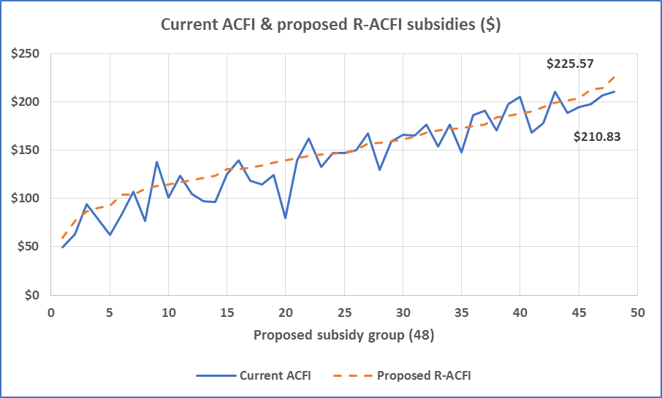

1. Determination and Validation of Funding

The total average subsidy as a proportion of the maximum subsidy has grown  
from 55.1% in 2008 to 80.4% in 2015-16.

1. The Need to Address Funding Volatility and Set a Platform for the Future

Funding volatility and the lack of predictability with the aged care forward budget estimates has been a major issue for both the Government and the Sector. Consultations with representatives of the sector have supported the notion that the rate of the ACFI care subsidy increases has been unsustainable and peak bodies agreed that some corrective action was needed. However, subsequent action by government to slow the growth have created uncertainty (e.g. will it happen again, soon?) producing a destabilised environment for aged care providers.

Reductions in funding by government are often seen by the industry as summary reductions. Additionally, any action to cut funding tends to affect all providers, not just those that have benefited more from the increased subsidy income. This has the effect of creating a lack of confidence and trust which can then impact on future reforms where both parties need to play a constructive role.

For these reasons, it is necessary to address the issue of funding volatility. While the ACFI changes described in this report will make the ACFI more contemporary, clearer in the question intent, more reliable and less susceptible to up scoring, experience from previous aged care funding tools introduced in Australia and internationally has shown that an improved scale alone will only go part way to ensuring the integrity of the system in the longer term. When funding is determined by a provider ‘self-assessment’, it is reasonable to expect that the incentive to maximise the funding overly influences the outcome and widespread up-scoring occurs. This project has therefore also researched the options for improving the current audit system in addition to the consideration of external assessment Options.

The following options have been recommended as viable options for consideration.

1. Option 1

The present system, using R-ACFI assessments made by ACAT staff as part of residential care approval or at entry, providers making R-ACFI assessments for entrants and reassessments, and with review officers making site visits for 10 per cent of entrants and reassessments, selected by data analytics.

1. Option 2

Care subsidies based on R-ACFI assessments made by ACAT staff as part of residential care approval or at entry, with providers having a right of appeal. ACAT staff will also make  
R-ACFI assessments for a minimum of 25 per cent of resident reappraisals, selected by data analytics.

1. Option 3

Using Specialist Assessment Agency (SAA) assessors to make site visits to make R-ACFI assessments for 100 per cent of new residents and a minimum of 25 per cent of reappraisals, selected by data analytics.

A more detailed description is provided in the following Table 9 which describes the key similarities and differences between the current system and the three options.

****Table 9. Comparison of the Current System and New Options****

| **Aspect** | **Current System** | **Option 1 – Modified Current** | **Option 2 - ACAT** | **Option 3 - SAA** |
| --- | --- | --- | --- | --- |
| **Funding Model** | Provider self-assessment | Provider self -assessment | ACAT (RN/AHP) | SAA assessor |
| **New Resident - $ assess** | Facility | Facility | Pre-admission; home, hospital, respite | Facility |
| **ACAT changes?** | No: no R-ACFI pre-entry, no $ role | Yes: 3 months R-ACFI pre-entry, no $ role | Yes: 3 months R-ACFI pre-entry,  sets $, review role | No: no R-ACFI pre-entry, no $ role |
| **R-ACFI Users** | Provider | ACAT & Provider | ACAT & Provider | Provider & SAA |
| **Review by** | Review Officers (RO) | Review Officers (RO) | ACAT (RN/AHP) | SAA assessor |
| **New Residents: audit %** | **10% (assess)** | **10% visit audit; 90% data** | **100% assessment pre/post entry** | **Up to 100% via visit assessment** |
| **Funding Determination - review process.** | **Provider R-ACFI used for $**  RO audits sample (10%) after payment using care provided, resident review, documentation, staff discussions | **Provider R-ACFI used for $**  RO audits 100% after payment using: Matching (ACAT/Provider), data analytics, e-audit, site visits for around 10% of submissions. | **ACAT R-ACFI used for funding $s**  ACAT assessor sets funding pre-entry. No review if accepted.  Contested R-ACFI process – Matching data analytics, e-audit, site visits and assess. | **Provider R-ACFI used for initial funding determination** but SAA assessor confirms for up to 100% of R-ACFI submissions via joint determination approach.  SAA/DoH also checks claims using data analytics, e-audit. |
| **Funding certainty & Audits** | Audit: unrestricted time period | Audit: restricted to 12 months | Not contested: Payment on admission. If contested: Payment review within one month. | Payment 2 months after admission. Assessment audits up to 12 months. |
| **When full funding paid?** | Within 2 months of admission | Within 2 months of admission | On admission. Contest: 1 month | Within 2 months of admission |
| **Provider does R-ACFI in…** | With 2 months | Within 2 months | Within 1 month but not for $s | Within 2 months used for $s |
| **Re-appraisals: audit assess** | **10% (assess)** | **10% visit audit; 90% data** | **25% visit assessment; 75% data** | **25% visit assessment; 75% data** |
| **Funding Determination Process** | **Provider R-ACFI used for $**  RO checks sample (10%) as per new resident checks. | **Provider R-ACFI give $s**  RO checks after payment using: data analytics, e-audit, site visits for around 10% of submissions. | **Provider & ACAT R-ACFI give $s**  ACAT checks after payment using: data analytics, e-audit. **Site assessment checks for 25% - 50% of R-ACFI submissions** | **Provider & SAA R-ACFI give $s** SAA assessor checks after payment using: data analytics, e-audit. **Site assessment checks for 25% - 50% of R-ACFI submissions** |
| **When full funding paid? Funding certainty & Audit** | On submission but subject to audit, no time limit | On submission but subject to audit for 12months | On submission but can have assessments checked up to 12m | On submission but can have assessments checked up to 12m |
| **Method Used to Audit $** | Assessed care + Care provided | Assessed care + Care provided | Assessed care need | Assessed care need |
| **Stable funding** | Low | Medium | High | Medium-High |
| **Growth Reduction: 2018-22 FYE** | **NA** | **$3,619M** | **$5,753M** | **$5,372M** |

1. Modelled Impact of the Options on Care Subsidy Growth

Estimated total outlays are described in Table 10 and Figure 10 by year which includes the care subsidies and costs of the various assessor model options.

All options show a significant reduction in care subsidy growth after costs compared to the current system. The differences are significant from year 1 (2018-19) and the cumulative impact over the projected period is significant for all options. While the specific amounts estimated in this exercise are indicative and open to debate regarding the specific amounts, the reductions in the care subsidy growth will be significant, particularly for the External Assessor Options 2 and 3.

It is important to note that an External Assessor model would be targeted on the subsidy growth aspect and adjustment to the base subsidies may be required if the introduction significantly lowered average subsidy payments on a system wide basis, as indicated in this modelling exercise.

Table 11 shows a summary of the estimated reduction in growth over the 4-year period from July 2018 to June 2022 compared to the current system is $3,328 million for Option 1 (modified current), $5,851 million for the ACAT Option 2 and $5,476 million for the Specialist Assessment Agency Option 3. Figure 11 shows the impact of the External Assessor options on the average care subsidies as a percentage of the maximum payment, over time.

****Table 10: Total Outlays including the Estimated Subsidy Payments & Costs by Model****

| Year | Present $m | Option 1 ACAT/RO $m | Option 2 ACAT $m | Option 3 SAA $m |
| --- | --- | --- | --- | --- |
| 18-19 | 12325 | 11812 | 11597 | 11650 |
| 19-20 | 13078 | 12171 | 11662 | 11766 |
| 20-21 | 13742 | 12665 | 12017 | 12126 |
| 21-22 | 14369 | 13249 | 12486 | 12600 |
| Total | **53515** | **49896** | **47762** | **48143** |

****Table 11: Reductions in Growth Relative to the Current Funding System****

| Year to 30 June | Option 1 ACAT/RO $m | Option 2 ACAT $m | Option 3 SAA $m |
| --- | --- | --- | --- |
| 2019 | 293 | 546 | 494 |
| 2020 | 802 | 1410 | 1307 |
| 2021 | 1060 | 1832 | 1725 |
| 2022 | 1173 | 2063 | 1950 |
| Total | **3328** | **5851** | **5476** |

****Figure 10: Outlays including Subsidy Payments & Assessor Model Costs Per Year****

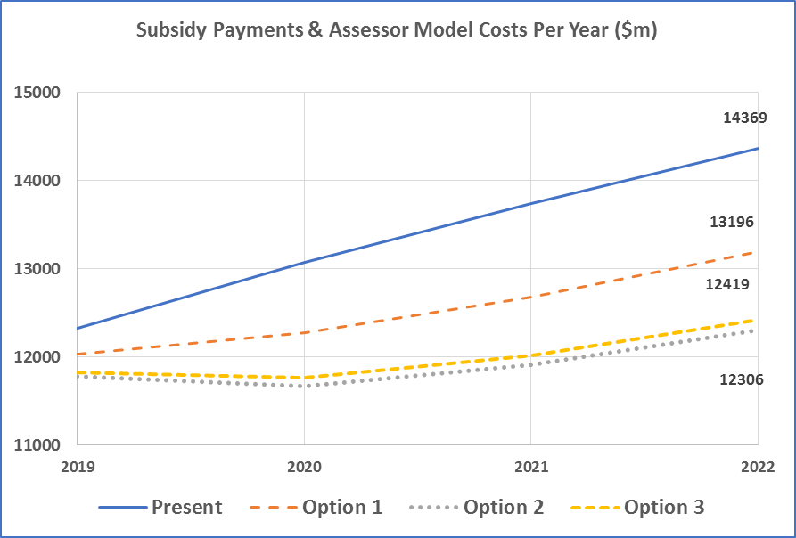

****Figure 11: Average Subsidies as Percent of the Maximum ACFI rate****

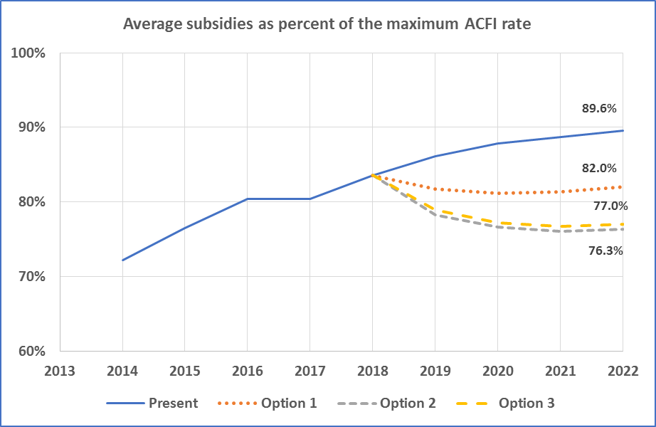

1. Model Comparisons – Recommendations

There are several reasons to consider changing the way funding is determined in the current aged care funding system. Modifying the system is important to ensure the stability and sustainability of the system but also to ensure that the system remains one where evidence based assessment results in the best possible care for residents with appropriate funding for providers to enable the delivery of the care.

The aim of changing the current R-ACFI assessment and review system to an External Assessment approach is to:

1. **Improve the equity and fairness of the system**

The basic requirement of any aged care funding system is that residents with similar levels of care needs attract the same amount of Government funding irrespective of the aged care service they are living in. At present some providers are receiving significantly more funding and others less funding for the same residents due to variations in claiming practices. While making the funding tool less susceptible to gaming will help, ultimately the ability to provide a more standardised basis for the decision about the residents funding assessment will provide the most equitable outcomes. It is important that any increases in Government expenditure on aged care residents are related to changes in resident acuity and numbers of residents rather than anomalies in claiming behaviour.

1. **Improve the surety, stability and predictability of provider income and government expenditure**

Most of residential aged care in Australia is undertaken by private businesses. It is important that they have funding surety, stability and predictability in their income stream so they are able to run effective and efficient businesses. It is also important that government can prepare budgets that allow for appropriate funding growth for residential care subsidies and be confident that increases in the budget are overwhelmingly due to an increase in the care needs of residents as the population ages.

1. Assessing the Options

Table 12 provides the list of indicators against which each of the models is rated. The main indicators are related to:

* equity and fairness of the system.
* quality and consistency of assessment.
* government expenditure/funding predictability and save costs where possible.
* the surety, stability and predictability of provider income.

The External Assessment Options 2 and 3 are almost certain to bring about a lasting change to the pattern of unpredictable growth in residential care subsidies (Table 11). It is apparent that the ACAT option is likely to bring the most benefits overall but it will also be the most disruptive change in the short term compared to Option 3, which is also viable and perhaps easier to introduce in the shorter term. While a structural change will be required to introduce a national program based on a modified ACAT External Assessment model, it is viewed as having benefits beyond better control of care subsidies as it will also lead to a fairer and more equitable way to fund the care needs of people needing aged care services whether it is to be in the community or residential care.

An ACAT based External Assessment model also gives the opportunity to consolidate assessment and funding in high level community care programs and residential care. Direct comparison of R-ACFI payment and Community Care Package or CHSP funding will be possible as a person living in the community will also have an R-ACFI funding rating. This will give the basis for the single instrument and funding model in community and residential care. The External Assessor models will also enable accurate monitoring of the changes in care needs over time in the community and residential care populations and give information to drive research to inform government planning. The Government can more accurately analyse disability trends and compare residential and community care client profiles to measure unmet demand for aged care which is a statutory government obligation.

Investment in the changes now would potentially result in a more streamlined system for all of Australia’s aged population that can grow with the ageing population.

Investment in IT and training now will ensure the system is robust and resilient into the future with costs contained to those relating to resident/care recipient acuity rather than business processes.

1. Conclusion

There are several reasons to modify the current aged care funding system to prepare it for the future. Ageing of the population will put pressure on the system that will need to be scalable as the industry grows. The changes made to ACFI will support system stability, sustainability and cost containment. Importantly, it also ensures that the system uses a thorough evidence based assessment approach which puts in place, for all residents, the foundations for the provision of appropriate, effective and efficient care planning which will then underpin the best possible care for residents of aged care facilities.

1. Recommendations

* ACATs or another SAA are incorporated into the options for the future of the Australian Residential Aged Care funding system.
* A robust trial is designed and implemented to test and refine the preferred option which will form the basis of funding auditing for at least the next 10-15 years.

****Table 12: Indicators of model improvement over current model – 3 New Options****

| **Indicator** | **Option 1**  **Modified Current** | **Option 2**  **ACAT** | **Option 3**  **SAA** |
| --- | --- | --- | --- |
| Does the model improve the equity and fairness of the system? | Yes | Yes | Yes |
| Improved review and audit? | Yes | Yes | Yes |
| Potential for income maximisation by providers reduced? | Yes | Yes | Yes |
| Does the model improve the quality and consistency of assessment? | No | Yes | Yes |
| Is the initial assessment by an external assessor who is a registered health professional? | No | Yes | No |
| Is the review/audit process undertaken by an independent, registered health professional? | No | Yes | Yes |
| Will the R-ACFI assessment model be more high quality than the current model? | Yes | Yes | Yes |
| Is there an appeal process for providers (where there are External Assessors? | Yes | Yes | Yes |
| Is the proposed assessment tool evidence based and suited to provide an evidence base for care planning? | Yes | Yes | Yes |
| Does the model improve the predictability of system expenditure/funding? | Yes | Yes | Yes |
| Is there a hierarchical review and audit process that uses technology to improve the system’s review and audit processes? | Yes | Yes | Yes |
| The funding determination method for new residents if fully external will reduce administration costs for providers | No | Yes | No |
| Does the option lend itself to integration of RAC and Community Aged Care assessment systems? | No | Yes | No |
| Does the model improve the surety, stability and predictability of provider income? | No | Yes | Yes |
| Is the audit period limited? | Yes | Yes | Yes |
| Is the length of the audit window period conducive to planning for providers? | Yes | Yes | Yes |
| Are new resident R-ACFI subsidies free from auditing at entry to care? | No | Yes | No |
| Will the changes result in a reduction in growth due to maximised claiming? | Yes | Yes | Yes |
| ***Aggregate ranking of the model options*** | ***3*** | ***1*** | ***2*** |