Streamlined Consumer Assessment for Aged Care

Summary report – Key insights from consultation

# Overview

A [public discussion paper](https://consultations.health.gov.au/in-home-aged-care-division/streamlined-consumer-assessments-for-aged-care-ser/) on Streamlined Consumer Assessment for Aged Care was available for consultation from 10 December 2018 to 11 February 2019.

223 submissions were received from a range of stakeholders, including providers, consumers, carers, assessors, local and state governments, professional associations, advocacy groups and peak bodies (see Attachment A).

This report provides a summary of the key issues and feedback from the consultation.

# Design principles

* Most stakeholders supported the design principles proposed in the discussion paper.
* Additional principles proposed:
  + *Informed consumer choice, control and direction.* The assessment process is conducted in partnership with consumers, providing information and support to inform consumer choice. *Timeliness and responsiveness.* Timely and responsive assessment supports consumers to receive the right type and level of services.
  + *Local engagement and networks.* Local networks, communication and information sharing facilitate effective referral pathways.
  + *Access*. Access to assessment recognises equity, cultural safety and appropriateness, assessment of carer needs and disability.

# Intake and triage

* Most stakeholders supported a continued role for the My Aged Care Contact Centre with provision of information, registration and determining eligibility.
* Many stakeholders supported moving detailed screening questions about a person’s function from the Contact Centre to the triage point of an assessment workforce.
  + Most stakeholders indicated that a highly skilled triage workforce was necessary to undertake functional screening to assign a suitable assessor and priority.
  + Many stakeholders highlighted the need for a standardised triage process to support nationally consistent practice.

# Health professional referrals

* Many stakeholders supported direct referrals for aged care assessment from General Practitioner (GP) clinical software. In addition, many stakeholders requested an electronic feedback mechanism to referring GPs and health professionals on the progress of clients.
* Many stakeholders suggested formal partnerships with Primary Health Networks (PHNs) and other health and community services could enhance collaboration and referrals.
* Some stakeholders suggested My Aged Care should be interoperable with the My Health Record.
* Some stakeholders suggested there should be capacity for GPs and health professionals to refer patients directly for time-limited Commonwealth Home Support Programme (CHSP) services.

# Expedited access to a single time-limited CHSP service

* Most stakeholders supported a pathway for expedited access to a single time-limited CHSP service for clients requiring basic assistance e.g. community transport.
* Many stakeholders identified the risk that direct referral for service may not clearly identify a client’s underlying needs or reablement opportunities. Stakeholders suggested risk mitigations:
  + Appropriately qualified and skilled triage staff in the assessment workforce should manage eligibility and appropriate access through a simplified phone assessment.
  + Follow-up procedures towards the end of the time-limited service period should confirm the end date for services and check on the client’s circumstances.
* Many stakeholders suggested that ‘direct to service’ pathways should also consider urgent CHSP services, services upon discharge from hospital and access to time-limited allied health and nursing services (on referral from a GP).

# Support plan reviews

* Many stakeholders indicated that a streamlined assessment model has the potential to improve the process for support plan reviews by reducing double handling and wait times for clients.
* Many stakeholders emphasised that ongoing information, guidance and training could ensure requests are appropriate and supported by reasons for the review.
* Other suggestions included:
  + Assigning dedicated staff to manage support plan reviews.
  + Scheduling review dates as part of the initial assessment.
  + Dedicated funding for support plan reviews.

# Assessment workforce qualifications

* There were two main stakeholder views on qualifications for a national assessment workforce.
  + Many stakeholders supported maintaining the current qualification arrangements for home support and comprehensive assessors, noting they are ‘fit-for-purpose’. Stakeholders suggested that assessment providers should be required to maintain an appropriate number of clinical health professionals.
  + Alternatively, many stakeholders suggested the whole workforce be clinically trained, in accordance with the current Aged Care Assessment Team (ACAT) workforce, to enable a single assessment process. Under this approach, some stakeholders suggested transition support and upskilling of existing home support assessors.
* Some stakeholders indicated minimum qualifications for home support assessors should be established e.g. vocational education and training (VET) qualifications at Certificate III, IV or diploma level in aged and community care.
* Some stakeholders raised the need for greater involvement of Aboriginal Health Workers and Aboriginal and Torres Strait Islander Health Practitioners in the assessment workforce.
* Stakeholders generally supported maintaining the Delegate role to review assessment recommendations and approve care types under the *Aged Care Act 1997* (the Act).

# Competencies

* Many stakeholders identified the following competencies for a national assessment workforce:
  + Understanding of aged care health issues and health terminology.
  + Skills in undertaking assessment including a conversational interview style, observational techniques and ability to support problem solving.
  + Empathy working directly with senior Australians.
  + Knowledge of aged care types and service offerings.
  + Ability to escalate issues and seek clinical input where necessary.

# Clinical and multidisciplinary approaches

* Many stakeholders noted that clinical expertise and/or multidisciplinary team-based approaches are required to support assessment where clients have:
  + Complex or chronic health conditions, including palliative conditions.
  + Severe functional or cognitive disability, including dementia.
  + Special needs requiring culturally appropriate care.
  + Mental health conditions.
  + Restorative care needs.
  + Risk factors for elder abuse, social isolation, psychosocial issues or complex family relationships.
  + Clients in a hospital or residential care setting.

# Design features for an integrated workforce

* All stakeholders indicated a new workforce will benefit from extensive knowledge of health and other service systems e.g. disability and carer support.
* Many stakeholders noted the role of clinical governance in operating an integrated workforce across the full continuum of aged care needs.
* Various stakeholders also suggested the following design features:
  + The workforce should include assessors from diverse backgrounds to deliver culturally appropriate assessments for special needs groups.
  + The assessment process should be flexible to allow team-based approaches.
  + Assessors should be able to recommend services from CHSP and care types under the Act.

# Training

* Many stakeholders were supportive of the existing training requirements, including the Statements of Attainment and the My Aged Care Learning Environment (MACLE).
* Some stakeholders outlined that a competency-based system should be developed for continuing professional development to achieve greater national consistency.
* Stakeholders identified the following training areas to build workforce capability:
  + Competency-based training on working with special needs groups.
  + Application of multidisciplinary team-based approaches.
  + Mental health (recognising signs of depression and dementia).
  + Use of technology for virtual assessment and application of aids and equipment.
* Some stakeholders raised the benefits of regional communities of practice.

# Quality and value for money

* There was broad support for updating the Aged Care Assessment Quality Framework to match the new assessment model. Many stakeholders suggested a regular external audit process.
* Some suggested that assessment providers should be subject to the same quality measures as approved providers including oversight by the Aged Care Quality and Safety Commission, compliance against the Aged Care Quality Standards and transparent complaints management.
* Many stakeholders supported protocols for assessment providers relating to assessor qualifications, clinical governance and capability for working with special needs groups.
* Some stakeholders sought strengthened conflict of interest management measures to ensure aged care assessment is independent from service provision.

# Efficiency and value for money

* Most considered that an appropriately qualified and experienced workforce was the main driver of efficiency and value for money.
* There were different positions amongst stakeholders on contestability for assessment services.
  + Some stakeholders believe a competitive model is unsuitable for assessment functions that focus on quality, consistency and equity of access.
  + Others indicated that competition for assessment services would provide the best value for money and drive performance, efficient use of resources and innovation.
* Many stakeholders highlighted the importance of economies of scale in terms of market share and assessment volumes to achieve value for money.

# Assessment in a hospital setting

* Many stakeholders indicated that current arrangements enable timely assessment in a hospital setting and coordinated access to health and aged care services.
  + For people being discharged home, most stakeholders agreed it is best practice for hospital assessments to arrange interim services (along with subacute services). A later assessment at the client’s home should consider improvements made and need for ongoing home-based services.
  + Many stakeholders identified the need for smooth pathways from hospital to transition care, as well as careful consideration of approvals for residential care and residential respite.
* There were different views on the future workforce to conduct assessment in a hospital setting.
  + Some stakeholders supported retaining state and territory government assessors through alternate workforce models e.g. existing hospital clinical teams and transition care clinicians.
  + Other stakeholders indicated that a national workforce, separate from state and territory health systems, should deliver aged care assessment in community and hospital settings.
* Stakeholders raised other issues in relation to assessment in a hospital setting:
  + Assessors require high-level skills and experience to liaise with specialists and allied health teams regarding patients with complex needs.
  + Assessors require access to hospitals and client medical records.
  + Interface with the health system must support timely discharge, patient flows through hospital and linkages to state-funded health and community services.

# Assessment in remote Australia

* There was broad agreement from stakeholders that a streamlined assessment model needs to be flexible to accommodate timely and high quality aged care assessments in remote areas.
* Common views included:
  + Face-to-face assessment should remain the preferred mode.
  + Quality assessment in remote areas requires collaboration with locally based workers, service providers and health professionals who have established relationships.
  + The funding model needs to address the higher fixed costs of remote assessment.
* Some stakeholders indicated that all assessors in remote areas should be clinical health professionals, to ensure assessment is undertaken in consideration of all aged care services.

# Wellness and reablement

* Most stakeholders supported a wellness and reablement approach to assessment practice, through the following strategies:
  + Embedding the wellness and reablement philosophy in the whole aged care system.
  + Training on active assessment that considers social engagement, mental health and physical health needs.
  + An appropriate funding model and performance framework, including consumer outcome measures.
  + My Aged Care system changes to allow a period of reablement at any time, including at assessment and support plan review.
  + Greater co-ordination with GPs and allied health professionals to support short-term reablement and restorative care.
  + Greater assessor knowledge and use of assistive technologies, aids and equipment to support self-management and consumer independence.

# Linking support

* Most stakeholders indicated it was appropriate and necessary for the national assessment workforce to support vulnerable clients through a short-term linking role.
* Many emphasised that effective linking support would require partnerships with local service providers and protocols for working with advocacy services and aged care system navigators.
* The following suggestions were made to support linking services:
  + Enabling self-referral for all assessors (i.e. bypassing the Contact Centre).
  + Improved identification of vulnerable clients through the triage process.
  + The use of dedicated linking expertise within teams.
  + Compulsory training and ongoing professional development.
  + Improvements to the My Aged Care system to collect data on vulnerable groups and allow linking support at any time including assessment and support plan review.
  + Consideration of block funding for linking support, with appropriate performance measures.
* Many stakeholders noted there is a growing workload associated with supporting vulnerable clients who are waiting for home care packages. Some stakeholders suggested that medium to long-term case management be considered as a service type for providers in rural and remote areas and for those who specialise in provision of services to vulnerable clients. Key benefits and risks
* Most stakeholders identified the key benefit of a streamlined model as simplifying the client’s aged care journey through less confusion, delays and duplication. Stakeholders identified other key benefits including:
  + Expedited access to time-limited single CHSP service.
  + Stronger emphasis on wellness and reablement approaches.
  + A more efficient and consistent assessment experience.
  + Greater transparency of assessment performance and unmet demand.
* The key risk of a streamlined model for most stakeholders was de-skilling the assessment workforce through loss of clinical expertise and knowledge. Other risks identified included:
  + Backlog of assessment during transition, impacting access and continuity of care.
  + Breaking existing relationships between assessors, providers and health services.
  + Lack of sector readiness and training for system changes.
  + Conflicts of interest within assessment organisations.
  + Unintended consequences of funding model and performance framework.
* The following mitigation strategies were suggested:
  + Qualification requirements for assessors.
  + Sufficient lead-time for implementation, workforce transition and change management.
  + Expansion of quality assurance measures including external audit processes, clinical governance protocols, performance reporting and conflict of interest management.
  + Retaining state and territory government involvement in hospital settings and remote areas.
  + An appropriate funding model and performance framework.
  + Further consultation with the sector on the model.

# Implementation and transition issues

Additional implementation and transition considerations for a streamlined consumer assessment model included:

* Phased implementation to support continuity of care for clients during transition.
* Communication, training and support for system changes to My Aged Care.
* Ongoing engagement with health professional groups.
* Building on the outcomes from trials of reablement-focussed assessment and aged care system navigation.

# Attachment A – Profile of submissions, based on stakeholder category and location

The Department received 223 submissions from a wide range of stakeholders across jurisdictions. A break‑down of the stakeholder categories and state/territory in which the stakeholders operate or reside is presented below.

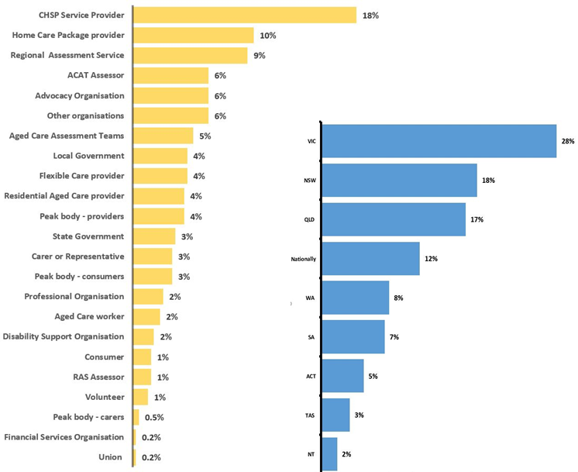

**Note:** Stakeholder could select more than one category and state/territory.