National Strategic Framework for Chronic Conditions
All Australians live healthier lives through effective prevention and management of chronic conditions

National Strategic Framework for Chronic Conditions
Copyright
© Australian Health Ministers’ Advisory Council 2017
This publication is copyright, no part may be reproduced by any process except in accordance with the provisions of the Copyright Act 1968 (Cth).
This publication was prepared under the auspices of the Australian Health Ministers’ Advisory Council.
Enquiries about the content of this publication should be directed to the Australian Government Department of Health (www.health.gov.au).
ISBN: 978-1-76007-287-2
Online ISBN: 978-1-76007-288-9
Publications approval number: 11643
Suggested Citation:
Australian Health Ministers’ Advisory Council, 2017, National Strategic Framework for Chronic Conditions. Australian Government. Canberra.

Foreword
The National Strategic Framework for Chronic Conditions is the result of extensive collaboration between the Commonwealth, and all state and territory, governments under the Australian Health Ministers’ Advisory Council. It presents the agreed high level guidance that will allow us all to work towards the delivery of a more effective and coordinated national response to chronic conditions. Our commitment is to improve the health and wellbeing of Australians, and to deliver a sustainable health system that is responsive to the increasing burden of chronic conditions in Australia.
Chronic conditions are becoming increasingly common due to our ageing population, as well as our changing lifestyles. The increasing prevalence of chronic conditions, combined with their long-term and persistent nature, and their impact on quality of life and overall health, is placing unprecedented pressure on individuals, families, our communities and the health system.
Our new approach recognises that there are often similar underlying principles for the prevention and management of many chronic conditions. As such, this Framework moves away from a disease-specific focus and better considers shared health determinants, risk factors and multimorbidities across a broad range of chronic conditions.
The Framework is the outcome of thorough consultation with a broad spectrum of stakeholders, including state and territory governments, peak bodies, non-government organisations, clinical experts, health professionals, academics, researchers, industry, consumer representatives and community members, including people with chronic conditions, their carers and families.
The Framework builds on existing work and is an important tool to enhance activities already underway and to guide the development of new and innovative policies and approaches. It embraces a systemic, person-centred approach which values the coordinated and collective influence of partnerships to jointly establish a strong foundation for all Australians to experience optimal health outcomes today, and in the years to come.
The Framework provides the platform to achieve the Vision that “all Australians live healthier lives through effective prevention and management of chronic conditions”.
The Hon Jill Hennessy MP
Chair
COAG Health Council

Acknowledgements
Many individuals and organisations have given their time and expertise to the development of this National Strategic Framework for Chronic Conditions. The Commonwealth and all state and territory governments would like to thank organisations and individuals who provided feedback through an online public consultation in 2016, as well as those who participated in the scoping and national targeted consultation workshops during 2015.
Jurisdictional Working Group
The Framework has been developed through the Australian Health Ministers’ Advisory Council’s Community Care and Population Health Principal Committee, with valued input from a Jurisdictional Working Group. The Working Group provided advice on all aspects of the development of the Framework. Membership comprised a Commonwealth Chair and members from each jurisdiction, as well as a representative from New Zealand and the National Aboriginal and Torres Strait Islander Health Standing Committee.
Expert Advice
Advice from a range of experts was also sought throughout the development of the Framework, in particular relating to chronic conditions, their risk factors, the outcomes and measurability.

Contents
Part 1: Setting the scene 7
Introduction 7
Chronic Conditions Defined 7
Purpose 8
Audience 8
Timeframe 8
About the Framework 8
The Challenge of Chronic Conditions 11
Current Status and Impact of Chronic Conditions 11
The Cost of Chronic Conditions 11
International and National Challenges 12
Prevention and Management 12
Priority Populations 13
Determinants of Health 14
Part 2: The Framework 16
The National Strategic Framework for Chronic Conditions 16
Vision 16
Principles 16
Enablers 16
Partners 17
Objectives 17
Strategic Priority Areas 17
Outcomes 18
Measuring Progress 18
Objective 1: Focus on prevention for a healthier Australia 19
Strategic Priority Area 1.1: Promote health and reduce risk 21
Strategic Priority Area 1.2: Partnerships for health 23
Strategic Priority Area 1.3: Critical life stages 24
Strategic Priority Area 1.4: Timely and appropriate detection and intervention 26
Objective 1 — Measuring Success 28
Objective 2: Provide efficient, effective and appropriate care to support people with chronic conditions to optimise quality of life 32
Strategic Priority Area 2.1: Active engagement 34
Strategic Priority Area 2.2: Continuity of care 36
Strategic Priority Area 2.3: Accessible health services 38
Strategic Priority Area 2.4: Information sharing 40
Strategic Priority Area 2.5: Supportive systems 42
Objective 2 — Measuring Success 43
Objective 3: Target priority populations 45
Strategic Priority Area 3.1: 47
Strategic Priority Area 3.2: Action and empowerment 49
Objective 3 — Measuring Success 51
Part 3: Part 3: Future work 53
Focus on the Future 53
Further Work 53
Ongoing Review 54
Appendix: WHO Targets and Indicators 55
References 57
Commissioned Work 61

Setting the scene
Part 1 explores the impact of chronic conditions in Australia and outlines the approach of the Framework.

Introduction
Chronic conditions are the leading cause of illness, disability and death in Australia¹. Tackling chronic conditions and their causes is the biggest challenge facing Australia’s health system². Along with our ageing population, increasing consumer expectations and the high cost of pharmaceuticals and treatments, ever-increasing rates of chronic conditions are putting unprecedented strains upon individuals, communities and the health system.
Over the past 40 years, the burden of disease in Australia has shifted away from infectious diseases and injury, well suited to an episodic care model, towards chronic conditions requiring attention to prevention activities and coordinated management. Chronic conditions are occurring earlier in life and Australians may live for longer with complex care needs. This means individuals require more services from a range of providers across the health system over extended periods of time. Change must occur to deliver a sustainable health system that responds more effectively to chronic conditions.
A focus on prevention can significantly reduce the volume and severity of chronic conditions and provide long-term cost savings and better health outcomes. Strategies to effectively manage chronic conditions are equally important, to minimise multimorbidities, complications and associated disabilities and to optimise quality of life.
By reducing the impact of chronic conditions, there is more to be gained than building an economically viable and sustainable health system. Reducing the physical, psychological, social and financial impacts of chronic conditions will improve quality of life and enhance health outcomes for individuals, families and communities. Furthermore, the inequitable burden of chronic conditions and the higher prevalence of risk factors in priority populations, particularly amongst Aboriginal and Torres Strait Islander people, must be acknowledged³. Greater emphasis towards identifying and supporting these populations is needed to reduce the impact of, and the risk of developing, chronic conditions.
Similar to Australia, other countries face the challenge of the increasing prevalence of chronic conditions. To address this, the World Health Organization (WHO) has developed a Global Action Plan for the Prevention and Control of Noncommunicable Diseases 2013–2020⁴. The Global Action Plan aims to reduce the burden of noncommunicable diseases by 2025, through a set of nine global targets and 25 indicators⁵ (refer to Appendix). As a member state of the WHO, Australia has an international commitment to address noncommunicable diseases in line with the Global Action Plan. International and national experience indicates a multisectoral response is most effective and should involve governments at all levels, non-government and private sectors, communities and individuals. The National Strategic Framework for Chronic Conditions (the Framework) supports Australia’s international commitments and provides national guidance for a multisectoral response in the prevention and management of chronic conditions.

Chronic Conditions Defined
Various terminology is used to describe chronic health conditions, including ‘chronic diseases’, ‘noncommunicable diseases’, and ‘long-term health conditions’. In the Framework, the use of the term ‘chronic conditions’ encompasses a broad range of chronic and complex health conditions across the spectrum of illness, including mental illness, trauma, disability and genetic disorders. This broad definition is intended to move the focus away from a disease-specific approach. The Framework only uses the term ‘chronic disease’ when referencing disease-specific data.
International policy from the WHO relating to chronic conditions focuses primarily on noncommunicable diseases. However, both communicable and noncommunicable diseases can become chronic and the origins of chronic conditions are varied and complex.
Chronic conditions:
- have complex and multiple causes;
- may affect individuals either alone or as comorbidities;
- usually have a gradual onset, although they can have sudden onset and acute stages;
- occur across the life cycle, although they become more prevalent with older age;
- can compromise quality of life and create limitations and disability;
- are long-term and persistent, and often lead to a gradual deterioration of health and loss of independence; and
- while not usually immediately life threatening, are the most common and leading cause of premature mortality.
This definition is consistent with the definition of noncommunicable diseases used by the WHO, without referring to specific disease groups.

Purpose
The Framework supersedes the National Chronic Disease Strategy 2005⁶ and associated National Service Improvement Frameworks^{7,8,9,10,11} as the overarching policy for the prevention and management of chronic conditions in Australia. It provides guidance for the development and implementation of policies, strategies, actions and services to address chronic conditions and improve health outcomes.
While the Framework is primarily health focused, it recognises that the health sector must take a leadership role, where appropriate, to foster advocacy, engagement and partnering with external sectors to achieve its Vision. Relevant external sectors may include environment, housing, education, employment, transport and social services.

Audience
The Framework is directed at decision and policy makers at national, state and local levels. It is a useful resource for governments, the non-government sector, stakeholder organisations, local health service providers, private providers, industry and communities that advocate, and provide care and education, for people with chronic conditions and their carers and families.

Timeframe
The timeframe of the Framework is eight years
(2017–2025), with a review proposed every three years.

About the Framework
The Framework is the overarching policy document for chronic conditions that sets the direction and outcomes to achieve the Vision that “all Australians live healthier lives through effective prevention and management of chronic conditions”.
Working within the guidance of the Framework will contribute to the long-term sustainability of Australia’s health system and reduce the impact of, and provide better care for people with, chronic conditions.
Figure 1 illustrates the relationship between the components of the Framework and depicts the essential elements that interact to guide policies, strategies, actions and services.

Figure 1: Concept map of the National Strategic Framework for Chronic Conditions
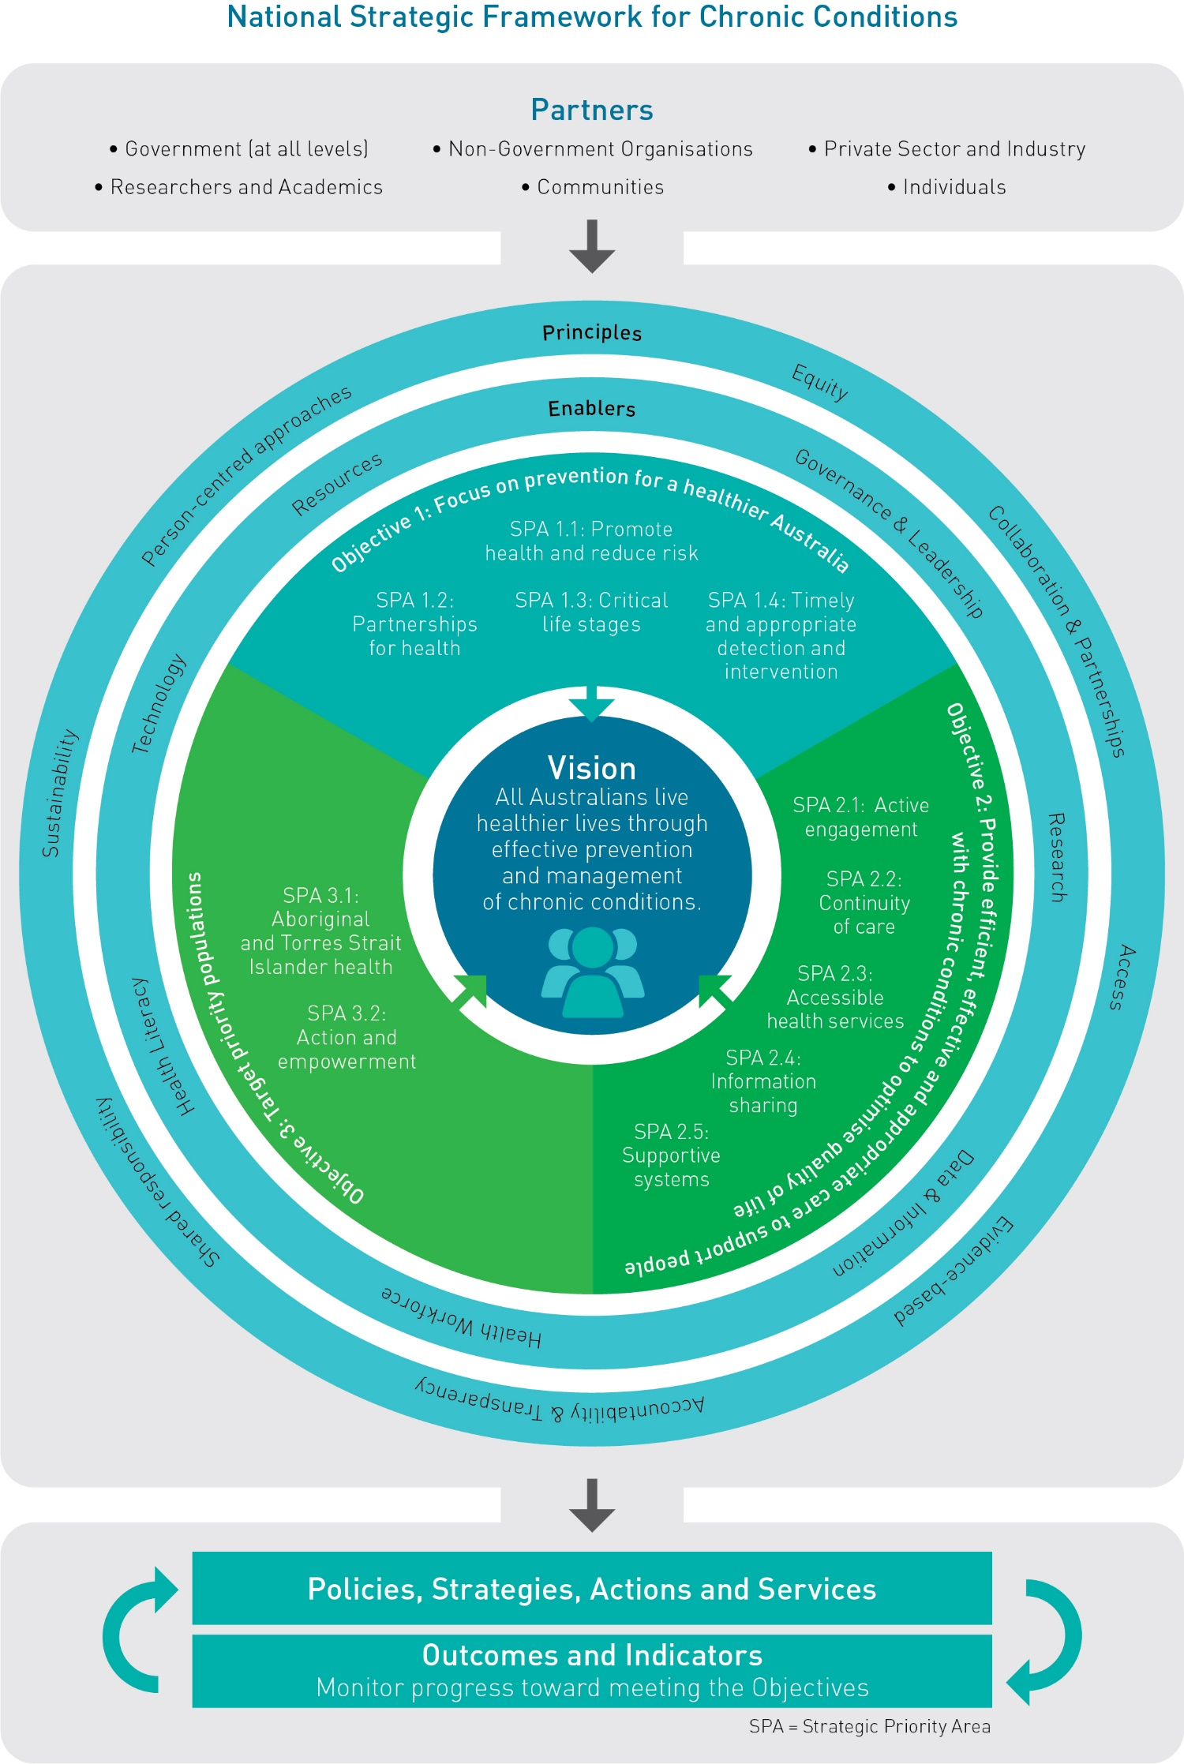
The Framework:
- moves away from a disease-specific approach;
- identifies the key principles for the effective prevention and management of chronic conditions;
- supports a stronger emphasis on coordinated care across the health sector;
- acknowledges and builds on work already in place that supports chronic conditions;
- complements state-based, national and international policy for chronic conditions;
- accommodates existing and new strategies and policies without changing the responsibilities of the Australian or state and territory governments;
- acknowledges the important role that the health sector may take as a leader and advocate in working with other sectors to address the social, economic and environmental determinants of health; and
- provides flexibility to accommodate future and emerging priorities and allows for innovative solutions for the prevention and management of chronic conditions.
National action is required to strengthen Australia’s approach to reducing the impact of chronic conditions. A national approach should be coordinated and needs to accommodate the variable policy environments in Australia, including the range of perspectives and practices that are supported by current evidence and existing state, national and international policies. There are many existing national and state-based strategies and actions that target chronic conditions (refer to Figure 2). The Framework does not replace current policies or strategies, but provides guidance to enhance current disease-specific policies and develop new and innovative approaches to address chronic conditions.
Figure 2: Relationship between the Framework and other health and chronic conditions policies and programs
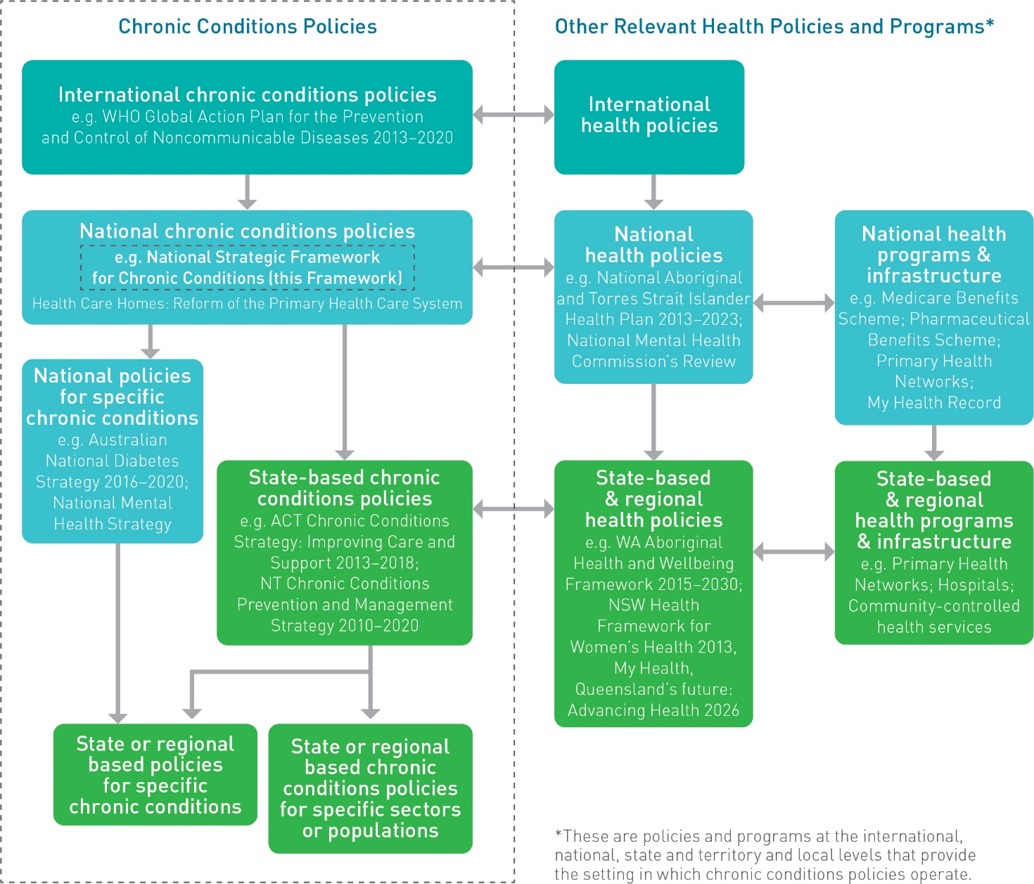

The Challenge of Chronic Conditions

Current Status and Impact of Chronic Conditions
Chronic conditions are threatening to overwhelm Australia’s health budget, the capacity of health services and the health workforce. They remain the predominant cause of illness, premature mortality and health system utilisation; in fact most of the burden of disease in Australia in 2011 was from chronic diseases, with approximately 66 per cent, or two-thirds, of the total burden of disease resulting from five disease groups — cancer, cardiovascular diseases, mental and substance use disorders, musculoskeletal conditions and injuries¹². Changing lifestyles, an ageing population, improvements in managing infections, changing consumer expectations and finite resources are all contributing to the impact of chronic conditions on Australia’s economy and population, now and into the future.
The term ‘chronic conditions’ refers to a broad range of often complex health conditions; therefore overall prevalence is difficult to quantify. Current evidence indicates:
- In 2014–2015, more than 50 per cent of Australians reported having at least one chronic condition, and 1 in 4 (23 per cent) reported having two or more chronic conditions¹³.
- The likelihood of having one or more chronic conditions increases with age¹⁴, and in Australia’s ageing population there is a corresponding increase in multimorbidities.
- Almost 1 in 3 Australians (29 per cent) aged 65 and over reported having three or more chronic diseases, compared with just 2.4 per cent of those aged under 45¹⁵.
- Having more than one chronic condition is associated with worse health outcomes, more complex disease management and increased health costs¹⁶.
- Premature mortality (that is, deaths among people aged less than 75 years) from chronic disease accounted for 83 per cent (over four out of five) of all premature deaths in Australia in 2007¹⁷.
The Primary Health Care Advisory Group’s December 2015 report to the Australian Government on: Better Outcomes for People with Chronic and Complex Health Conditions¹⁸ states that “Our current health system is not optimally set up to effectively manage long-term conditions.” The report also reveals that patients often experience:
- a fragmented system, with providers and services working in isolation from each other rather than as a team;
- uncoordinated care;
- difficulty finding services they need;
- at times, service duplication; at other times, absent or delayed services;
- a low uptake of digital health and other health technology by providers to overcome these barriers;
- difficulty in accessing services due to lack of mobility and transport, plus language, financial and remoteness barriers; and
- feelings of disempowerment, frustration and disengagement.
The report highlights the need to strengthen primary health care, particularly to better manage the large numbers of patients with multiple chronic conditions. Considerable change is under way through ongoing national reforms to deliver a more sustainable, person-centred health system. This includes, pharmacy and medicine price reforms; the Healthier Medicare Initiative, particularly Health Care Homes — Reform of Primary Health Care System; the establishment of Primary Health Networks; the redevelopment of the My Health Record; landmark mental health reforms; reforms to improve aged care services; and the National Medical Training Advisory Network project. These reforms are supported through Schedule 2 of the Heads of Agreement between the Commonwealth and the States and Territories on Public Hospital Funding (April 2016).

The Cost of Chronic Conditions
People with chronic conditions use health services and medicines frequently and over extended periods of time — a pattern exacerbated by the presence of multimorbidities. Consequently, chronic conditions are associated with high health care expenditure. Health care costs are expected to rise with the increasing prevalence of chronic conditions, escalating treatment costs, costs of medications and increasing demand for services.
Most information regarding the economic impact of chronic conditions in Australia is sourced from disease-specific data that focuses on a select group of chronic conditions. Estimates based on disease-specific allocated health care expenditure indicate that the four most costly disease groups are chronic — cardiovascular diseases, oral health, mental illness and musculoskeletal conditions — incurring direct health care costs of $27 billion in 2008–2009 (36 per cent of allocated health expenditure)¹⁹.
Taking into account the broad definition of chronic conditions used in the Framework, it is likely that the true economic burden of chronic conditions is considerably greater than can be demonstrated with available data. Most expenditure is associated with admitted patient hospital services, out-of-hospital services, medications and dental services²⁰. Additionally, the economic impact of chronic conditions would be greater if non-health sector costs, such as residential care and lost productivity from compromised health, illness and death, were considered²¹.
Chronic conditions are also associated with non-economic costs, including personal, social and community costs such as loss of independence, social isolation, discrimination, stigma, and potential disability and aged care impacts. These factors can have lasting impacts through reduction in quality of life and lost opportunities that extend beyond individuals to their carers and families, and to future generations.

International and National Challenges
The escalating burden of chronic conditions is a global health issue. The WHO’s Global Action Plan for the Prevention and Control of Noncommunicable Diseases 2013–2020²² follows on from commitments made by Heads of State and Government. The Global Action Plan recognises the primary role and responsibility of governments in responding to the challenge of noncommunicable diseases and the important role of international cooperation and solidarity to support national efforts.
Dialogue on strengthening international cooperation on noncommunicable diseases recognises:
- the significant socio-economic impact of noncommunicable diseases;
- the massive disconnect between the scale and complexity of the problem and the lack of resources dedicated to tackle it;
- that even more important than increasing resources is the necessity of getting national policies right, in particular those beyond the health sector; and
- the potential for noncommunicable diseases to be integrated into other development programs through strategic partnerships, including the role of information and communications technology in empowering individuals to manage their own health.
Australia faces similar challenges to other economically developed countries in relation to chronic conditions. Unbalanced diets heavy with unhealthy (high fat, high sugar, high salt content) foods, physical inactivity and sedentary behaviour, the prolonged burden of tobacco-related disease and alcohol-related harm are common characteristics. Improved health care that supports people to live longer with chronic conditions places extended and intensive demands on the health system along with social and economic burdens on individuals, families, communities and economies. There is increasing international recognition that preventive measures are an essential means of reducing this burden²³.

Prevention and Management
The focus of Australia’s health system has been on treating illness rather than on preventing it. Focusing attention toward prevention activities, while continuing to ensure chronic conditions are well managed, will provide better health, social and economic outcomes for all Australians.
The prevention and management of chronic conditions in Australia is evolving. The increasing burden of chronic conditions, both nationally and internationally, is placing greater demands on existing traditional arrangements. Australia must adopt a consistent and integrated approach to the effective prevention and management of chronic conditions to improve health outcomes for all Australians and to ease the pressure on the health system.
Objectives 1 and 2 of the Framework explore the prevention and management of chronic conditions in more detail.

Priority Populations
Priority populations are those that are negatively impacted by chronic conditions more than the general population. This is demonstrated by a higher prevalence of chronic conditions and a greater burden of disease in these populations resulting in inequitable health outcomes. Priority populations include, but are not limited to: Aboriginal and Torres Strait Islander people; people from culturally and linguistically diverse backgrounds; older Australians; carers of people with chronic conditions; people experiencing socio-economic disadvantage; people living in remote, or rural and regional locations; people with disability; people with mental illness; and people who are, or have been, incarcerated. Targeted guidance to better support priority populations is explored in Objective 3.
Examples of the prevalence of chronic conditions in some priority populations include:
- In 2014–15, 87 per cent of older Australians (people aged 65 years and over) reported having at least one chronic condition (compared with 50 per cent in the general population), and 60 per cent reported having two or more chronic conditions (compared with 25 per cent in the general population)²⁴.
- In 2011–12, Australians aged under 65 with severe or profound disability had a higher prevalence of long-term health conditions. They were also 3.3 times as likely to have three or more long-term health conditions as people without disability (74 per cent compared with 23 per cent)²⁵.
- Mental health conditions affect, and are affected by, other chronic conditions: they can be a precursor or consequence of a chronic condition, or the result of the interactions between common risk factors and comorbidities²⁶.
- Australians living in rural areas experience poorer health outcomes such as higher mortality rates associated with chronic disease, a higher prevalence of mental illness, more potentially avoidable hospitalisations and higher rates of injury than those living in cities²⁷.
Further, Australia has long had geographic challenges in health care delivery in a way that few Organisation for Economic Co-operation and Development (OECD) countries have experienced. This is compounded by maldistribution in the workforce²⁸. Barriers experienced by people living in remote communities can include: limited access to services; transport; limited opportunities for education and work; and difficulties in accessing affordable nutritious food. These disadvantages perpetuate socio-economic disadvantage and existing health conditions.
The Framework is designed to be used for all Australians. Objective 3 sets out targeted information and outcomes specific to priority populations. However, Objectives 1 and 2 also apply to priority populations and should be considered in tandem to inform policies, strategies, actions and services to meet the needs of all priority populations.
Aboriginal and Torres Strait Islander Health
In 2008, the Council of Australian Governments agreed to targets to address disadvantage experienced by Aboriginal and Torres Strait Islander people — the Closing the Gap initiative. One of the targets identified was to close the life expectancy gap between Aboriginal and Torres Strait Islander people and non-Indigenous Australians within a generation (by 2031)²⁹. The Implementation Plan for the National Aboriginal and Torres Strait Islander Health Plan 2013–2023³⁰ builds on the Closing the Gap approach and recognises the importance of social and cultural determinants of health. The Implementation Plan identifies health-specific strategies and actions, including those that address chronic conditions, to improve health outcomes for Aboriginal and Torres Strait Islander people³¹.
The overall burden of disease for Aboriginal and Torres Strait Islander people is more than twice that for non-Indigenous Australians, of which a large proportion is due to chronic conditions³².
- In 2012–13, two-thirds (67 per cent) of Aboriginal and Torres Strait Islander people reported having at least one chronic health condition, and one-third (33 per cent) reported having three or more chronic health conditions³³.
- Aboriginal people experience much earlier onset of a number of chronic diseases, in some cases up to 20 years earlier than non-Indigenous Australians³⁴.
- In 2012–13, 36 per cent of Aboriginal and Torres Strait Islander people had some form of disability, which is one-and-a-half times the rate experienced by non-Indigenous Australians³⁵.
- In 2012–13, 29 per cent of Aboriginal and Torres Strait Islander people rated their health as ‘fair’ or ‘poor’ which is more than double the non-Indigenous rate of 14 per cent³⁶.
- In 2010–2012, the average life expectancy of Aboriginal and Torres Strait Islander people was approximately 10 years less than that of non-Indigenous Australians³⁷.
- Chronic disease accounts for around three quarters of the gap in mortality rates between Aboriginal and Torres Strait Islander people and non-Indigenous Australians³⁸.

Determinants of Health
The determinants of health are many and varied, they interact to raise or lower the health status of individuals and populations. They operate at every life stage — maternal and infancy, childhood, adolescence, adulthood and older age — both to immediately influence health and as a foundation for future health³⁹. The determinants of health can have cumulative effects over the course of a lifetime and across generations. For example, children who experience disadvantage are more likely to have poor educational outcomes, thus influencing employment opportunities, socio-economic status and health in adult life, and this can contribute to intergenerational disadvantage.
The determinants of health fall into four main categories:
- Physical environment — for example, housing, sanitation and the natural and built environments;
- Social environment — for example, education, employment, political structures, relationships and culture;
- Economic factors — for example, income, expenditure and affordability; and
- Individual characteristics — for example, sex, genetics and physical or mental determinants⁴⁰.
The factors within each of these categories and their interactions influence knowledge, attitudes and beliefs; social norms and expectations; and means and opportunities — which can ultimately impact health (refer to Figure 3).
While some determinants of health sit within the realm of the health sector, there are many that fall outside the boundaries of health. The WHO recognises that influencing public policies in sectors outside of health which tackle the determinants of health, will enable health systems to respond more effectively and equitably to the health care needs of people with chronic conditions⁴¹. With this in mind, it is important that the health sector does not work in isolation from other sectors and services. The Framework takes the approach of promoting, where practical, the benefits of partnerships and coordinated efforts within and outside of the health sector to minimise the impacts of the determinants of health and positively influence the health of all Australians. A united approach to achieve change is a shared responsibility.
Figure 3: Influence of the Determinants of Health
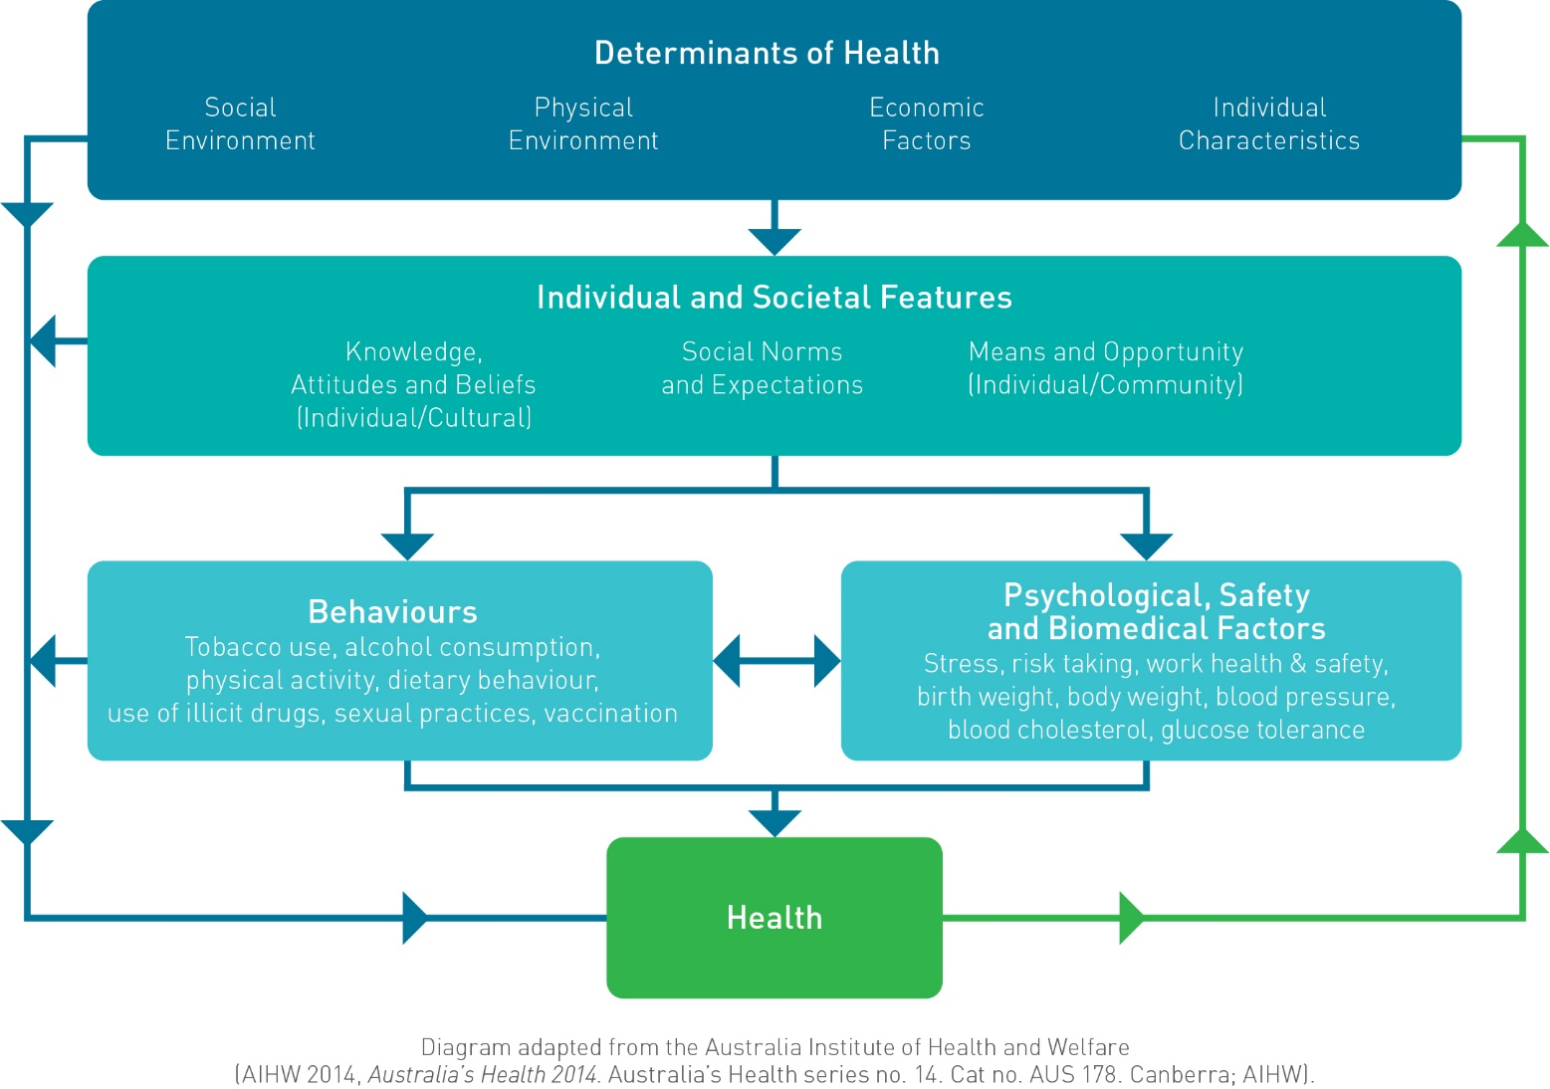

The Framework
Part 2 sets out the Vision, Objectives and Aspirational Outcomes of the Framework

The National Strategic Framework for Chronic Conditions

Vision
All Australians live healthier lives through effective prevention and management of chronic conditions.

Principles
Eight guiding Principles have been identified to enable the successful prevention and management of chronic conditions for all Australians. The Principles should be clearly evident in the planning, design and implementation of policies, strategies, actions and services aimed at preventing and/or managing all chronic conditions.
The Principles are:
- Equity — all Australians receive safe, high-quality health care irrespective of background or personal circumstance.
- Collaboration and partnerships — identify linkages and act upon opportunities to cooperate and partner responsibly to achieve greater impacts than can occur in isolation.
- Access — high standard, appropriate support and services are available, accessible, equitable and affordable for all Australians.
- Evidence-based — rigorous, relevant and current evidence informs best practice and strengthens the knowledge base to effectively prevent and manage chronic conditions.
- Person-centred approaches — the health system is shaped to recognise and value the needs of individuals, their carers and their families, to provide holistic care and support.
- Sustainability — strategic planning and responsible management of resources delivers long-term improved health outcomes.
- Accountability and transparency — decisions and responsibilities are clear and accountable, and achieve best value with public resources.
- Shared responsibility — all parties understand, accept and fulfil their roles and responsibilities to ensure enhanced health outcomes for all Australians.

Enablers
Seven specific Enablers have been identified that will assist in achieving the Vision of the Framework. Appropriate use of the Enablers will give effect to successful policies, strategies, actions and services that will support people with, or at risk of developing, chronic conditions.
The Enablers comprise:
- Governance and leadership — supports evidence-based shared decision-making and encourages collaboration to enhance health system performance.
- Health workforce — a suitably trained, resourced and distributed workforce is supported to work to its full scope of practice and is responsive to change.
- Health literacy — people are supported to understand information about health and health care, to apply that information to their lives and to use it to make decisions and take actions relating to their health.
- Research — quality health research accompanied by the translation of research into practice and knowledge exchange strengthens the evidence base and improves health outcomes.
- Data and information — the use of consistent, quality data and real-time data sharing enables monitoring and quality improvement to achieve better health outcomes.
- Technology — supports more effective and accessible prevention and management strategies and offers avenues for new and improved technologically driven initiatives.
- Resources — adequate allocation, appropriate distribution and efficient use of resources, including funding, to address identified health needs over the long-term.

Partners
The effective prevention and management of chronic conditions is strongly influenced by the contributions made by a wide range of Partners. Partners in the prevention and management of chronic conditions include:
- individuals, carers and families
- communities
- all levels of government
- non-government organisations
- the public and private health sectors, including all health care providers and private health insurers
- industry
- researchers and academics
All Partners have shared responsibility for health outcomes according to their role and capacity within the health care system. Greater cooperation between Partners can lead to more successful individual and system outcomes.

Objectives
The Vision is supported by the following three Objectives:
            - Focus on prevention for a healthier Australia.
            - Provide efficient, effective and appropriate care to support people with chronic conditions to optimise quality of life.
            - Target priority populations.

Strategic Priority Areas
Strategic Priority Areas have been identified under each Objective as shown in Tables 1, 2 and 3. These are the core priority areas where Partners should focus attention to achieve each of the Objectives. Partners can readily identify, plan and implement their own policies, strategies, actions and services against the Strategic Priority Areas.
Table 1: Strategic Priority Areas for Objective 1
Objective 1: Focus on prevention for a healthier Australia
Strategic Priority Area 1.1 | Promote health and reduce risk
Strategic Priority Area 1.2 | Partnerships for health
Strategic Priority Area 1.3 | Critical life stages
Strategic Priority Area 1.4 | Timely and appropriate detection and intervention

Table 2: Strategic Priority Areas for Objective 2
Objective 2: Provide efficient, effective and appropriate care to support people with chronic conditions to optimise quality of life
Strategic Priority Area 2.1 | Active engagement
Strategic Priority Area 2.2 | Continuity of care
Strategic Priority Area 2.3 | Accessible health services
Strategic Priority Area 2.4 | Information sharing
Strategic Priority Area 2.5 | Supportive systems
Table 3: Strategic Priority Areas for Objective 3
Objective 3: Target priority populations
Strategic Priority Area 3.1 | Aboriginal and Torres Strait Islander health
Strategic Priority Area 3.2 | Action and empowerment

Outcomes
Outcomes are described for each Strategic Priority Area. They describe the result of actions, rather than the actions required, to allow flexibility for Partners to develop and implement their own strategies, policies, actions and services within the boundaries of their specific health responsibilities and governing authorities.
A phased outcome approach has been used to recognise that a continuum of progress is required to meet each Objective. It is acknowledged that relevant Partners will be at different stages along this continuum; therefore, timeframes for the achievement of each outcome have not been specified.
Phase 1 Outcomes are intended to be achieved in the short-term, whereas Phase 2 Outcomes build upon the Phase 1 Outcomes and represent
long-term achievements.
Aspirational Outcomes outline the ambitious long-term results that would be seen if collective action was successful against each of the Phase 1 and Phase 2 Outcomes. The Aspirational Outcomes are offered to stretch responses and to foster innovative and creative solutions to meet the challenges of the burden of chronic conditions in Australia.

Measuring Progress
Progress should be measured at various levels and is the responsibility of all Partners. Each layer of the Framework — the Objectives, the Strategic Priority Areas and the Outcomes — contributes to achieving its Vision — “All Australians live healthier lives through effective prevention and management of chronic conditions”.
Due to the complexities associated with the prevention and management of chronic conditions there is no single indicator to determine the impact of the Framework. Rather, a description of what success will look like, and example indicators, have been included at the Objective level. The example indicators may not be a comprehensive list, but are provided to demonstrate the information currently available to monitor the impact of collective action. In addition, Partners should monitor their own strategies, policies, actions or services to ensure that these activities are contributing to the Outcomes described in each Strategic Priority Area.
More robust and relevant data and information may become available in the future. Partners should take these opportunities to review and refine the measures they use to track and monitor progress against the Framework.

Objective 1: Focus on prevention for a healthier Australia
What success will look like:
            - The proportion of Australians living with preventable chronic conditions or associated risk factors is reduced.
            - Australia meets the voluntary global targets outlined in the WHO Global Action Plan for the Prevention and Control of Noncommunicable Diseases 2013–2020⁴².
            - Australians with chronic conditions, or associated risk factors, develop them later in life and receive timely interventions to achieve optimal health outcomes.
Prevention is key to improving the health of all Australians, reducing health related expenditure and ensuring a sustainable health system. Changing lifestyles, characterised by poor diet and nutrition, physical inactivity, the harmful consumption of alcohol and tobacco use, and an ageing population, all contribute to the current burden of chronic conditions which is placing increasing demands on the health system and the economy more broadly. Prevention generates long-term health and economic benefits, delivers the greatest improvement in health outcomes and improves the health of future generations⁴³.
Health promotion and prevention activities which encourage healthy environments, communities and behaviours can:
- lessen predisposing factors for chronic conditions through improved environmental and social conditions, and reduce the development of behavioural and biomedical risk factors (primordial prevention);
- prevent the occurrence, or delay the onset, of chronic conditions (primary prevention);
- minimise or prevent disease progression in people with chronic conditions (secondary prevention);
- reduce the risk of developing additional chronic conditions, complications and/or associated disabilities (tertiary prevention);
- support improved quality of life; and
- reduce demand on the health care system⁴⁴.
There are multiple risk factors and health determinants that contribute to the development of chronic conditions. However, chronic conditions often share common behavioural risk factors, biomedical risk factors and social determinants, with a small number of risk factors accounting for much of the morbidity and mortality attributed to chronic conditions. The Australian Burden of Disease Study: impact and causes of illness and death in Australia 2011⁴⁵ identified that almost one-third of the burden of disease in Australia in 2011 could be prevented by eliminating exposure to risk factors such as tobacco use, high body mass, harmful use of alcohol, physical inactivity and high blood pressure⁴⁶. Further, the burden of disease experienced by priority populations, for example those living in remote locations or those experiencing socio-economic disadvantage, is greater than for Australians residing in major cities, or with increasing socio-economic status, respectively⁴⁷. This highlights the significant potential to target common preventable risk factors and determinants of health as an effective approach to reducing the burden associated with chronic conditions.
Nevertheless, not all chronic conditions can be prevented through action to address risk factors and determinants of health. However, preventive action can foster protective factors, such as good nutrition and regular physical activity, which can contribute to greatly improved health outcomes for people with non-preventable chronic conditions⁴⁸.
The multiple and complex interaction of risk factors and determinants for chronic conditions means that prevention must be considered from a range of different perspectives. Preventive action can:
- occur at different points along the continuum of disease progression — in healthy populations; in those recognised as being at an increased risk of developing chronic conditions; and in individuals displaying early signs of a chronic condition or those experiencing long-term and persistent chronic conditions;
- occur across the life course — from conception and birth, for infants, throughout childhood, adolescence, adulthood and into older age;
- take place in different settings — childcare centres and schools, workplaces and the urban environment, as well as more traditional health service locations; and
- be undertaken by individuals, families, community organisations, employers, private health insurers, non-government organisations, industry and different sectors and levels of government.
Action to prevent chronic conditions is a shared responsibility. The complex nature of chronic conditions, combined with the need to create positive sustainable change for individuals, families, communities, governments and the economy requires an inclusive, multi-faceted approach whereby all Partners respond to the challenges in a cooperative and responsible manner.
The Strategic Priority Areas and Aspirational Outcomes in this Objective are outlined in Table 4.
Table 4: Strategic Priority Areas and Aspirational Outcomes for Objective 1
Objective 1: Focus on prevention for a healthier Australia
Strategic Priority Areas | Aspirational Outcomes
1.1: Promote health and reduce risk | 1.1 Australians live healthy lifestyles with reduced risk of developing chronic conditions.
1.2: Partnerships for health | 1.2 Responsible partnerships promote health and reduce risk factors for chronic conditions.
1.3: Critical life stages | 1.3 Australians maintain good health and healthy behaviours through times of developmental, social or environmental change.
1.4: Timely and appropriate detection and intervention | 1.4 Timely and appropriate detection and intervention reduces the risk of chronic conditions and/or disease severity.

Strategic Priority Area 1.1: Promote health and reduce risk
Health promotion activities encourage a healthy lifestyle, reduce health risk factors and are an important element in preventing chronic conditions and helping people to improve quality of life and live longer. Health promotion focuses on a broad range of social and environmental strategies, rather than on individual behaviour change⁴⁹. It encourages healthy communities and environments by increasing the capacity of people, communities, organisations and governments to positively influence health. Health promotion is the process of empowering people to increase control over their health and its determinants, thereby improving their health^{50,51}. An effective approach to promoting health recognises the relationship and interaction between health related behaviours and the environments in which people live⁵².
A diverse range of factors influence the health and wellbeing of the Australian population. These factors are attributes, characteristics or exposures that increase the likelihood of a person developing a disease or health disorder⁵³. They can be categorised as follows:
- Behavioural risk factors — these are the most common risk factors for many chronic conditions. As such, they are often a major focus for prevention strategies and interventions.
    - Examples include smoking, poor diet and nutrition, harmful consumption of alcohol, physical inactivity and/or cognitive inactivity.
- Biomedical risk factors — these relate to the condition, state or function of the body that contributes to the development of chronic conditions. The effects of a single biomedical risk factor can be intensified when additional biomedical risk factors or behavioural risk factors are present.
    - Examples include high blood pressure, high blood cholesterol, overweight or obesity, impaired glucose tolerance, stress, mental illness, trauma, or illness (communicable disease).
- Non-modifiable risk factors — these comprise individual physical and psychological components.
    - Examples include age, sex, genetics or intergenerational influences.
- Physical environment determinants — these comprise both the natural and built environment, can impact health in a subtle or obvious manner and can occur over the short or the long-term.
    - Examples include UV exposure, air pollution, urban environment, or geographic location.
- Social and economic determinants — these can be difficult for individuals to control, however they influence the way in which people live their lives⁵⁴.
    - Examples include beliefs, customs and culture, education and employment status.
Risk factors are often discussed individually; however in practice they do not operate in isolation — they often coexist and interact with one another. Many chronic conditions share common risk factors and determinants, and are often risk factors for each other.
Risk factors for chronic conditions should be addressed through a coordinated suite of evidence-based interventions targeted across the spectrum from individual to population level approaches over a sustained period of time⁵⁵. A cohesive approach to promoting health and preventing chronic conditions should empower individuals and their families to make healthy choices, facilitate local leadership and encourage wider societal responsibility to address the broader factors that influence health⁵⁶.
While in some circumstances the evidence may be limited, the evidence that does exist shows that the greatest impact is likely to come from a broad range of actions which occur across multiple and different settings, sectors, age groups and life stages⁵⁷. A comprehensive approach to promoting health and reducing risk factors allows action to be taken at the social and cultural level and in the physical locations in which people undertake daily activities, and in which environmental, organisational and personal factors interact to influence health and wellbeing⁵⁸.
Policies, strategies, actions and services developed under this Strategic Priority Area by relevant Partners should aim to achieve the Outcomes outlined in Table 5.

Table 5: Strategic Priority Area 1.1 Outcomes
Strategic Priority Area 1.1: Promote health and reduce risk
Phase 1 Outcomes | Phase 2 Outcomes | Aspirational Outcome
Consistent and coordinated health promotion positively influences healthy behaviour choices.  Targeted health messages and education meet community needs.  Health and non-health sectors and settings promote the risks and protective factors for chron-ic conditions.  People navigate and use health information to meet their needs.  Risk factors are identified early and acted on appropriately.  Individuals and communities are motivated and skilled to positively modify behaviour.  The health workforce is adequately equipped to deliver holistic action to prevent and manage the risk factors for chronic conditions.  At risk people and populations receive evidence-based targeted interventions.  Research builds the evidence base around effective preventive health measures.  Data collection and sharing improves identification and management of risk factors. | Australians make healthier choices and change behaviour to reduce their risk of developing chronic con-ditions.  Increased population health literacy in chronic conditions prevention, risk factor identification and healthy behaviours.  The evidence base strengthens prevention policy and action.  Innovative solutions, including diagnostic technology, support risk factor identification and reduction.  All Partners contribute to creating health promoting environments.  Fiscal and regulatory levers are used, where considered appropriate, to incentivise healthy behaviours. | 1.1 Australians live healthy lifestyles with reduced risk of developing chronic conditions.

Strategic Priority Area 1.2: Partnerships for health
The physical, mental and social health of Australians can be positively or negatively influenced by the physical and social environments in which people live, learn, work and play. The complexity and diversity of these influences means that the prevention of chronic conditions not only relies on activities undertaken within the health sector, but on action across a wide range of social, economic, political, cultural and environmental determinants of health⁵⁹. A comprehensive approach to prevention is benefited by establishing responsible partnerships and sharing responsibility to facilitate positive cultural change and to make the healthy choices become the easy choices. With this in mind, the settings for health promotion and prevention activities should be varied: covering geographic locations, including cities, towns or urban spaces; using organisational structures such as childcare centres, schools, workplaces or hospitals; through event-based activities delivered at festivals or sporting events; or social media and online communication.
Strong, cooperative and productive partnerships between governments at all levels, non-government organisations, the private sector, industry, researchers and academics, communities, and individuals, carers and families, are crucial to successfully preventing chronic conditions and supporting those with chronic conditions. When responsible and effective partnerships are developed, the benefits can exceed those achieved when action is taken in isolation. Effective partnerships are characterised by:
- the sharing of responsibility and expertise;
- enhanced cooperation and understanding within and across sectors;
- an extended breadth and reach of communication and action;
- more efficient resourcing and reduced duplication;
- sustained, multi-faceted and strategic approaches that meet the needs of identified populations; and
- mutual benefits for partners.
Within the health sector, partnerships can drive consistent and coordinated national and local prevention strategies. Beyond the health sector, leadership from the health sector to advocate, engage and collaborate with partners can enhance efforts to establish and maintain evidence-based multi-pronged prevention approaches that meet local requirements, including the needs of priority populations. With this in mind, effective existing partnerships should be consolidated and strengthened, and new and responsible partnership opportunities explored.
Policies, strategies, actions and services developed under this Strategic Priority Area by relevant Partners should aim to achieve the Outcomes outlined in Table 6.
Table 6: Strategic Priority Area 1.2 Outcomes
Strategic Priority Area 1.2: Partnerships for health
Phase 1 Outcomes | Phase 2 Outcomes | Aspirational Outcome
Partners collaborate and build on common goals to create health promoting environments.  Clear governance and leadership supports responsible decision-making processes between partners.  Investment in prevention strategies engages multiple partners wherever practical.  Consistent and robust data collection and sharing occurs between relevant partners to promote health. | Partnerships promote healthy local environments and settings, and encourage healthy behaviours.  Responsible partnerships that promote population health and foster healthy environments are evaluated and recognised as best practice.  Regulatory and legislative changes are introduced where considered appropriate.  New, non-traditional and responsible partnerships evolve. | 1.2 Responsible partnerships promote health and reduce risk factors for chronic conditions..

Strategic Priority Area 1.3: Critical life stages
There are critical periods throughout life where exposure to risk factors and determinants of health can independently and interactively impact on long-term health outcomes. The adverse impact of risk factors for chronic conditions can have a cumulative impact on the health outcomes of individuals as they age and can also be transferred to future generations. Targeting policies, strategies, actions and services at different stages of life, key transition points and developmentally sensitive stages can prevent or minimise the impact of, chronic conditions, positively influencing health outcomes throughout life and for successive generations.
A comprehensive life course approach to prevent chronic conditions and improve health and wellbeing considers relevant age-related and developmental circumstances, as well as transition points, significant events and risk factors that may occur across the lifespan. Examples include:
- maternal health and nutrition to give children an optimal start in life and to reduce infant mortality;
- the impact of breastfeeding, nutrition, weight gain and socio-economic factors on physical, cognitive and mental development throughout infancy and childhood;
- the health and development of children, which may in turn enhance educational outcomes, facilitate healthy lifestyles and reduce the risk of mental illness and other chronic conditions;
- the transition for young people from dependent children to independent adults, in particular relating to education and career path decisions, employment and financial decisions, relationships with family and peers, exposure to alcohol and drugs, and susceptibility to mental illness and behavioural risk factors, including smoking, alcohol use and physical inactivity;
- support for young people when they transition from paediatric to adult health services;
- the health and wellbeing of adults of working age to facilitate engagement in economic and social activities;
- critical transition points such as retirement or bereavement, which can be a catalyst for deteriorating health and wellbeing, particularly for older Australians;
- the influence of environmental and
- socio-economic factors, carer responsibilities, disability, and the development of risk factors and/or unhealthy habits on future health outcomes; and
- the risk of developing a chronic condition for future generations due to genetic and epigenetic factors.
Targeting opportunities to tackle chronic conditions at critical life stages, including through action to address risk factors and improve the determinants of health, can positively influence individual and population health outcomes both now and into the future.
Policies, strategies, actions and services developed under this Strategic Priority Area by relevant Partners should aim to achieve the Outcomes outlined in Table 7.

Table 7: Strategic Priority Area 1.3 Outcomes
Strategic Priority Area 1.3: Critical life stages
Phase 1 Outcomes | Phase 2 Outcomes | Aspirational Outcome
Prevention opportunities target life stages:  - maternal health (in utero);  - children (0–5 and 5–12 years);  - young people  - (13–17 and 18–24 years);  - adults (25–64 years); and  - older people (65 years and older).  Preventive action is directed at critical life transition points.  The health workforce provides support for antenatal, postnatal and early life to reduce risk factors for chronic conditions.  Interventions target multiple settings (such as general practices, schools, workplaces families and communities), using multiple strategies, covering a range of behavioural risk factors.  Research better identifies the critical age points for focused prevention interventions to prevent and/or reduce risk of chronic conditions.  Evidence base strengthened around critical life stages to reduce life-long risk of chronic conditions and intergenerational risk. | Longitudinal monitoring and research is used to determine the life-long effects of preventive interventions delivered to young Australians.  Australians receive appropriate prevention measures at any stage of life.  Research drives new approaches that improve health and quality of life across the life course. | 1.3 Australians maintain good health and healthy behaviours through times of developmental, social or environmental change.

Strategic Priority Area 1.4: Timely and appropriate detection and intervention
Timely and appropriate detection and intervention for chronic conditions involves identifying and planning action for people with, or at risk of developing, a chronic condition. The concept of ‘timely and appropriate’ detection and intervention, aims to avoid: over-diagnosis; over-medicalisation; unnecessary, intrusive and costly procedures; inaccurate or inconclusive test results; and high financial outlay for individuals and families.
The detection of chronic conditions requires the identification of, and appropriate monitoring for:
- risk factors linked to the development of chronic conditions, in particular behavioural or biomedical risk factors;
- the development of signs or symptoms commonly associated with chronic conditions; and
- the emergence of complications associated with existing chronic conditions.
Individuals and health care providers play an important role in the detection and intervention for chronic conditions and their risk factors. Detection is enhanced when both individuals and health care providers are able to recognise risk factors, signs or symptoms and to then implement the most suitable follow up processes.
The benefits of timely and appropriate detection, paired with appropriate follow up, include:
- improved detection and management of people at increased risk of developing a chronic condition;
- delayed progression and more effective treatment or management of chronic conditions;
- reduced risk of developing additional chronic conditions, complications and/or associated disabilities;
- utilisation of opportunities to improve individuals’ understanding of their condition;
- supporting individuals who wish to actively participate in the management of their chronic conditions and/or associated risk factors to develop the necessary skills and resources for self-management;
- fewer avoidable hospitalisations;
- improved health outcomes for people with chronic conditions; and
- improved quality of life.
The detection of chronic conditions can occur through a variety of settings, including in general practice, pharmacies, fitness and recreation centres and through community events. Detection can be opportunistic or targeted in nature, including through the implementation of evidence-informed screening for average risk population groups, as well as groups identified as being at increased risk of developing chronic conditions⁶⁰ — for example, Aboriginal and Torres Strait Islander people or those with a genetic predisposition for a particular chronic condition⁶¹.
An integrated approach to detecting and managing chronic conditions moves away from the detection of specific chronic conditions and recognises the interaction between chronic conditions and their risk factors. Integrated risk assessments or integrated health checks are important tools that identify an individual’s risk across a range of chronic conditions. These tools should be combined with suitable follow-up processes or diagnostics to ensure timely detection and intervention for people identified as being at increased risk. Communication and coordination between and within health care services, and with individuals, will enhance the effectiveness of chronic conditions’ risk assessment, detection and intervention.
Policies, strategies, actions and services developed under this Strategic Priority Area by relevant Partners should aim to achieve the Outcomes outlined in Table 8.

Table 8: Strategic Priority Area 1.4 Outcomes
Strategic Priority Area 1.4: Timely and appropriate detection and intervention
Phase 1 Outcomes | Phase 2 Outcomes | Aspirational Outcome
Health checks, integrated risk assessments and evidence-based screening programs are promoted and utilised in various settings.  People recognise their risk of developing a chronic condition and have the necessary skills to take appropriate action.  Health workforce delivers comprehensive health checks, referral pathways, evidence-based screening and genetic counselling as appropriate.  Information sharing and appropriate follow-up or referrals occur between health care providers across settings and sectors. | Innovative and improved methods of detection and integrated risk assessment are developed.  Technology supports individuals to identify their own risk for chronic conditions and prompts appropriate action and/or follow-up.  Enhanced quality and accuracy of detection methods are achieved.  Appropriate intervention reduces disease severity and associated complications and disabilities. | 1.4 Timely and appropriate detection and intervention reduces the risk of chronic conditions and/or disease severity

Objective 1 — Measuring Success
Table 9: Example Indicators to measure progress against Objective 1
Objective 1: Focus on prevention for a healthier Australia
What success will look like:
1. The proportion of Australians living with preventable chronic conditions or associated risk factors is reduced.
Example Indicator | Relevant Strategic Priority Area (SPA) | Agency
Morbidity and mortality
Incidence of heart attacks | SPA 1.1 | AIHW
Incidence of selected cancers | SPA 1.1 | AIHW
Prevalence of cardiovascular disease, cancers, diabetes or chronic respiratory diseases, by age group | SPA 1.1 | ABS, AIHW
Prevalence rate for mental illness | SPA 1.1 | Health, ABS
High/Very high levels of psychological distress, by age group | SPA 1.1 | ABS
Non-fatal burden of disease (Years Lost due to Disability — YLD) | SPA 1.1 | AIHW*
Fatal burden of disease (Years of Life Lost — YLL) | SPA 1.1 | AIHW*
Unconditional probability of dying between ages 30–70 years from cardiovascular disease, cancers, diabetes or chronic respiratory diseases | SPA 1.1 | AIHW
Alcohol-related morbidity and mortality among adolescents and adults | SPA 1.1 | AIHW
Risk factors
Low income | SPA 1.1 | ABS
Education attainment | SPA 1.1 | ABS
Unemployment | SPA 1.1 | ABS
Alcohol consumption per capita | SPA 1.1 | ABS
Single occasion and lifetime risky drinking, by age group | SPA 1.1, 1.3 | AIHW, ABS
Insufficient physical activity, by age group | SPA 1.1, 1.3 | ABS
Salt intake per capita | SPA 1.1 | ABS*
Daily smoking, by age group | SPA 1.1, 1.3 | AIHW, ABS
Raised blood pressure, by age group | SPA 1.1, 1.3 | ABS
Raised blood glucose levels (including diabetes), by age group | SPA 1.1, 1.3 | ABS*
Overweight/obese, by age group | SPA 1.1, 1.3 | ABS
Energy intake from discretionary foods, by age group | SPA 1.1, 1.3 | ABS*
Inadequate fruit and/or vegetable consumption, by age group | SPA 1.1, 1.3 | ABS
Raised total cholesterol, by age group | SPA 1.1, 1.3 | ABS*
Absolute cardiovascular risk, ages 45–74 years | SPA 1.1 | NHF, ABS*
What success will look like:
2. Australia meets the voluntary global targets outlined in the WHO Global Action Plan for the Prevention and Control of Noncommunicable Diseases 2013–2020.
Example Indicator | Relevant Strategic Priority Area (SPA) | Agency
Unconditional probability of dying between ages 30–70 years from cardiovascular disease, cancers, diabetes or chronic respiratory diseases | SPA 1.1 | AIHW
Incidence of selected cancers | SPA 1.1 | AIHW
Alcohol consumption per capita | SPA 1.1 | ABS
Single occasion and lifetime risky drinking, by age group | SPA 1.1, 1.3 | AIHW, ABS
Alcohol-related morbidity and mortality among adolescents and adults | SPA 1.1 | AIHW
Insufficient physical activity, by age group | SPA 1.1, 1.3 | ABS
Salt intake per capita | SPA 1.1 | ABS*
Daily smoking, by age group | SPA 1.1, 1.3 | AIHW, ABS
Raised blood pressure, by age group | SPA 1.1, 1.3 | ABS
Raised blood glucose levels (including diabetes), by age group | SPA 1.1, 1.3 | ABS*
Overweight/obese, by age group | SPA 1.1, 1.3 | ABS
Energy intake from discretionary foods, by age group | SPA 1.1, 1.3 | ABS*
Inadequate fruit and/or vegetable consumption, by age group | SPA 1.1, 1.3 | ABS
Raised total cholesterol, by age group | SPA 1.1, 1.3 | ABS*
Immunisation rates among children | SPA 1.3 | Health
Screening rates for breast, cervical and bowel cancer | SPA 1.4 | AIHW
Eligible persons receiving drug therapy and counselling to prevent heart attacks and stroke | SPA 1.1, 1.4 | ABS*
What success will look like:
3. Australians with chronic conditions, or associated risk factors, develop them later in life
and receive timely interventions to achieve optimal health outcomes.
Example Indicator | Relevant Strategic Priority Area (SPA) | Agency
Smoking during pregnancy | SPA 1.3 | AIHW
Low birth weight | SPA 1.3 | AIHW
Exclusive breastfeeding | SPA 1.3 | AIHW*
Children exposed to tobacco smoke in the home | SPA 1.3 | AIHW
Children with developmental health checks | SPA 1.3 | Health**
Immunisation rates among children | SPA 1.3 | Health
Single occasion and lifetime risky drinking, by age group | SPA 1.1, 1.3 | AIHW, ABS
Insufficient physical activity, by age group | SPA 1.1, 1.3 | ABS
Daily smoking, by age group | SPA 1.1, 1.3 | AIHW, ABS
Raised blood pressure, by age group | SPA 1.1, 1.3 | ABS
Raised blood glucose levels (including diabetes), by age group | SPA 1.1, 1.3 | ABS*
Overweight/obese, by age group | SPA 1.1, 1.3 | ABS
Energy intake from discretionary foods, by age group | SPA 1.1, 1.3 | ABS*
Inadequate fruit and/or vegetable consumption, by age group | SPA 1.1, 1.3 | ABS
Raised total cholesterol, by age group | SPA 1.1, 1.3 | ABS*
Consultation with health professional for long-term condition  in last 12 months | SPA 1.4 | ABS
Annual health assessment for older people | SPA 1.4 | Health
Dentist visit in last 12 months | SPA 1.4 | AIHW
Screening rates for breast, cervical and bowel cancer | SPA 1.4 | AIHW
Diagnostic assessment rate for breast, cervical and bowel cancer (proportion of population with positive screening test and follow-up diagnostic assessment) | SPA 1.4 | AIHW
Time between positive screen and diagnostic assessment  — breast, cervical and bowel cancer | SPA 1.4 | AIHW

* Data not routinely available
** Indicator comprehensiveness issues
ABS — Australian Bureau of Statistics
AIHW — Australian Institute of Health and Welfare
Health — Commonwealth Department of Health
NHF — National Heart Foundation

Objective 2: Provide efficient, effective and appropriate care to support people with chronic conditions to optimise quality of life
What success will look like:
            - Australians with chronic conditions receive coordinated, person-centred and appropriate care.
            - Australians experience fewer complications, multimorbidities or disabilities associated with chronic conditions.
            - Fewer Australians die prematurely due to specific chronic conditions.
All Australians are entitled to efficient, effective and appropriate quality health care. People with chronic conditions may have multimorbidities with varying levels of complexity; require increased, ongoing access to a range of services and self-management support; and are likely to be on multiple pharmacotherapies. Without effective support these people often experience poor health and reduced quality of life. Actively engaging people in their own health care (with appropriate involvement of carers and families) empowers people to take greater control in managing their health and optimising their quality of life.
Provision of clinically appropriate, evidence-based, safe and accessible health care for people with chronic conditions can:
- slow disease progression;
- help to prevent and delay the onset of additional chronic conditions, complications, and associated disabilities;
- improve health and wellbeing; and
- enhance quality of life.
Effective and appropriate care improves overall health and social outcomes for people with chronic conditions, and their carers and families.
People with chronic conditions often require joined-up and coordinated health care which can be complex and traverse a range of different health care providers, settings and sectors. Establishing collaborative and trusting relationships across health sectors will: provide the foundation for improved communication; strengthen continuity of care; and facilitate information sharing. An adequately equipped and trained health workforce is essential to provide care that is of a high standard to those who need it, when they need it, in a way that meets individual needs.
Addressing risk factors and providing the right support at early onset of a chronic condition will also contribute to long-term management strategies by helping to slow disease progression and reducing the risk of developing additional chronic conditions, complications and associated disabilities. Objective 1 addresses these interrelated issues.
The Strategic Priority Areas and Aspirational Outcomes in this Objective are outlined in Table 10.

Table 10: Strategic Priority Areas and Aspirational Outcomes for Objective 2
Objective 2: Provide efficient, effective and appropriate care to support people with chronic conditions to optimise quality of life
Strategic Priority Areas | Aspirational Outcomes
2.1: Active engagement | 2.1 people with chronic conditions, and their carers and families, are central to, and have an informed role in, their care management.
2.2: Continuity of care | 2.2 Australians receive consistent, holistic, coordinated care across the health system to manage their chronic conditions.
2.3: Accessible health services | 2.3 People with chronic conditions have equitable access to quality health care.
2.4: Information sharing | 2.4 Effective sharing of consistent, relevant and secure health information  and data improves service delivery performance and health outcomes.
2.5: Supportive systems | 2.5 Systems work together to better meet the needs of people  with chronic conditions.

Strategic Priority Area 2.1: Active engagement
Active engagement embodies a person-centred approach that puts people at the centre of their own health care and empowers them to play an informed role according to their interest and abilities. People with chronic conditions should not manage their health in isolation, nor be expected to play a passive role. Wherever possible, individuals should be actively engaged in shared decision-making processes, with care partnerships created between individuals and their health care providers, carers, families and communities as appropriate.
Chronic conditions have a range of potential impacts on a person’s individual circumstances, including broader social, emotional and economic effects⁶². Actively engaging individuals allows personal factors to be considered — such as home, family and work life, education, psychosocial factors, constraints caused by their condition, and economic and community contribution. Effectively engaging people in the management of their chronic conditions empowers individuals to:
- improve their knowledge about their condition;
- set goals appropriate to their health and social needs and values;
- involve their carers and families in care planning as appropriate;
- discuss treatment preferences; and
- set individual quality of life goals.
Improving health literacy is essential to activating people in their own health care⁶³. Decisions and behaviours required to improve health and wellbeing are often undertaken on a daily basis by people themselves: effective self-management is a key part of optimal care for chronic conditions. Health literacy is critical to empowerment and affects a person’s capacity to make good decisions about their health and health care and take appropriate action^{64,65}.
Active engagement is more than just effective self-management. Active engagement in the decision-making process is especially important for people with complex care needs and limited capacity for self-management, so they can work in partnership with health professionals to gain more control over their health.
The more advanced stages of chronic conditions can be associated with disability and impaired decision-making capability. For some people, advance care planning in the early stages of chronic conditions can greatly improve quality of life by encouraging individuals to make informed decisions about matters such as palliative care and end-of-life care, and plan appropriately for the future.
Empowering individuals to make informed decisions about their health and wellbeing builds confidence and understanding that enables action to maximise their health outcomes and maintain optimal quality of life at any stage of illness⁶⁶.
Active engagement necessitates a health workforce with strong capabilities in effective communication techniques, proficiency in the use of technology, and willingness to embrace new and emerging technologies, to support individuals accordingly. The health workforce is a critical partner in delivering health information, education and services to people who have varying levels of health literacy. Digital technology and telehealth have great potential to enable people to take more control over their health and support person-centred care and self-management where used appropriately⁶⁷.
Policies, strategies, actions and services developed under this Strategic Priority Area by relevant Partners should aim to achieve the Outcomes outlined in Table 11.

Table 11: Strategic Priority Area 2.1 Outcomes
Strategic Priority Area 2.1: Active engagement
Phase 1 Outcomes | Phase 2 Outcomes | Aspirational Outcome
The health workforce supports delivery of information and services to people who have varying levels of health literacy.  People have sufficient and relevant information and support to learn more about their chronic condition and its management.  Individuals, carers and families have access to resources and information to better navigate the health system.  Individuals, carers and families are active in the management of chronic conditions as recognised and valued members of the care team.  Personalised goal setting and care planning enhance social, economic and community engagement and improve quality of life.  Integrated care plans are developed in partnership with individuals (and carers and families), and implemented and reviewed through a flexible  team-based approach.  People with chronic conditions are educated about the benefits of, and encouraged to consider, advance care planning.  Innovative care models support uptake of referrals and active self-management.  Better self-management and active engagement is supported by technology.  The health workforce is proficient in the use of technology to support active engagement. | People have better health literacy and improved confidence to partner in the management of their chronic conditions.  Quality of life for people with chronic conditions is enhanced through effective care management strategies.  The health workforce has strong capabilities in effective communication techniques.  People with chronic conditions participate in advance care planning as appropriate.  People’s capacity for active  self-management is improved. | 2.1 People with chronic conditions, and their carers and families, are central to, and have an informed role in, their care management.

Strategic Priority Area 2.2: Continuity of care
Continuity of care is concerned with how an individual’s health care is connected over time⁶⁸. Continuity of care covers:
an individual’s experience of the health system and relationship with an identified care provider (relational continuity); and
the consistency of care and continuity of information to ensure that individuals have seamless and timely access to the full range of services they require across the health system (informational and management continuity)⁶⁹.
For people with chronic conditions, health needs can rarely be met by a sole practitioner. As such, a stronger focus is required on coordination of care and integration where possible.
Australia’s health system has tended to operate as a disparate set of service sectors rather than an integrated service system. Services have not always been well aligned to support the ongoing and multidisciplinary care required for managing the increasing number of people living with chronic conditions. Communication barriers can also exist between the various health sectors, limiting the connectivity required for continuity of care.
Integrated care involves the provision of seamless, effective and efficient care that responds to the breadth of a person’s health needs, across physical and mental health, in partnership with the individual, their carers and families⁷⁰. For people with chronic conditions, services are frequently required from multiple health care providers, across disciplines and across different service sectors. There is an increasing need to build strong partnerships within the health system and across health sectors such as: primary, community and acute care; specialist and generalist care; mental health, aged care, and disability services; as well as public, private and not-for-profit providers. All relevant parts of the system must work to facilitate better integration or coordination of services to enhance health service delivery that is centred on the needs of the individual. Innovative solutions, technology and new models of care should be harnessed to successfully respond to this challenge.
Transition points across the health system often act as a barrier to continuity of care. Health care transition points occur across the lifespan, and between health care providers and services such as: acute to primary care and aged care; maternity to community-based care; paediatric to adult health services; and day-to-day health provider transitions such as shift changes, admission, referral or discharge. These transition points are often difficult for people to navigate. Making these transitions navigable and as seamless as possible minimises handover risk, avoids duplication and treatment delays, and ensures the provision of high-quality, consistent care⁷¹.
A greater emphasis on coordinating care can improve people’s health and wellbeing, and result in a better individual experience of the health system. However, not all people with a chronic condition will benefit from coordinated care⁷². For example, individuals who are largely high functioning with little reduction in quality of life are unlikely to expect or receive much value from coordinated care. Resources should therefore be targeted to individuals who stand to gain the most benefit from coordinated care, including those who:
- are not well linked into health and community services;
- lack knowledge of their condition;
- have mental health or lifestyle risk factors and lack motivation to change behaviour; or
- have poorly controlled chronic conditions or multiple chronic conditions.
Coordinated care should also be offered to people who have had previous hospital admissions or have potential to improve self-management⁷³.
Achieving continuity of care across the health system requires concentrated effort at the system level and strong partnerships to deliver the changes required. Management and care for people with chronic conditions requires coordination, flexible service delivery and team-based care. This should be underpinned by a well-resourced health workforce with capacity to communicate effectively across sectors and to work in flexible team-based care arrangements. Appropriate leadership, commitment and innovation will strengthen the health system’s capacity to achieve coordinated and integrated service delivery.
The most effective strategies and initiatives to achieve continuity of care and improve health outcomes are multi-faceted and include:
- communication and support for providers and individuals;
- structural arrangements to support integration and enable care coordination for people within and between different health services; and
- strong relationships and establishment of trust between the different components of the health sector⁷⁴.
Continuity of care and accessibility are implicitly intertwined: inaccessible health services can be a barrier to achieving continuity of care. Accessible health services are addressed in Strategic Priority Area 2.3 (Accessible health services). Policies, strategies, actions and services developed to improve continuity of care may also contribute towards achieving Outcomes in Priority Area 2.3 (Accessible health services), and vice versa.
Policies, strategies, actions and services developed under this Strategic Priority Area by relevant Partners should aim to achieve the Outcomes outlined in Table 12.
Table 12: Strategic Priority Area 2.2 Outcomes
Strategic Priority Area 2.2: Continuity of Care
Phase 1 Outcomes | Phase 2 Outcomes | Aspirational Outcome
People with multiple chronic conditions or complex care needs are supported to navigate and access coordinated care across multiple health settings and services.  Effective transfer, discharge and referral pathways exist between health care services.  Systems support the effective use of, and communication about, advance care plans, particularly during care transitions.  Innovative funding and care models enhance coordination and flexible team-based care on an ongoing basis.  The health workforce works in flexible multidisciplinary teams to address single or multiple chronic conditions.  Clinical care provided across the health system reflects evidence-based best practice guidelines.  Effective communication pathways are established within and across health services, settings and sectors.  Technology enhances secure communication and coordination between multidisciplinary care providers and with patients. | Transitions between services and across health care settings are smooth for people with chronic conditions.  Health services deliver well-coordinated and holistic care to people with chronic conditions.  Health service planning addresses gaps and fragmentation in the health system at the national and local levels.  Continuity of care is enhanced by improved technological capabilities.  Safe, high-quality and consistent systems and processes improve continuity of care and health outcomes. | 2.2 Australians receive consistent, holistic and coordinated care across the health system to manage their chronic conditions.

Strategic Priority Area 2.3: Accessible health services
Accessible health services are those that are physically available, affordable, appropriate and acceptable⁷⁵. Access can be limited by physical and economic barriers as well as cultural or individual factors including lack of knowledge about what, where and how to access health services. Adequate distribution of the health workforce and services underpins accessible and timely provision of high-quality health care across the health system.
In 2009, the National Health and Hospitals Reform Commission found that fragmentation in the health system leads to uneven access to services and quality of care⁷⁶. People with chronic conditions should receive the right care, at the right time, in the right place, by the right team. They need equitable access to a range of health services across a variety of settings and often require flexibility in service provision to allow quality, culturally safe and appropriate care that meets the needs of the individual, when it is most needed.
To date, this has required navigation of a complex health system requiring a strong understanding of care requirements and providers, which can result in access barriers. Improving people’s access to relevant health information and their capacity to use it effectively will improve individual health literacy and assist individuals to better navigate the health system.
There are various barriers to accessing health care. People with chronic conditions can experience cost barriers associated with managing single or multiple chronic conditions, multiple pharmacotherapies, and accessing a range of health services, including those for which there is little or no rebate available. Accessing some services may require travel, accommodation or other support services and can result in additional out-of-pocket expenses. In some cases, physical access may not be feasible and out-of-hospital or at-home service delivery methods may be required, particularly for palliative care services.
The health sector can advocate and partner responsibly with other sectors and partners where possible to:
- identify how to better align health and other support services to assist people with chronic conditions;
- work in partnership to improve affordability and accessibility of health services; and
- provide innovative service delivery options.
Telehealth and digital technology also have the potential to improve access to health care, improve the quality of health care delivery, and reduce health care costs. These tools offer opportunities to enhance access for people where physical access is limited, and can be harnessed to provide flexible, accessible health services that are responsive to individual needs. This may include utilising non face-to-face services where clinically appropriate — enabled by telephone, videoconferencing or other digital health platforms. Used effectively and appropriately, technology can improve communication and information sharing and enhance collaboration across health settings and services.
However, technology may be a barrier to access for people if they lack the skills or infrastructure to use it appropriately. The health workforce is a critical partner in using technology to improve access. A skilled workforce proficient in the use of e-technologies, effective communication and in providing information and services to people who have varying levels of health literacy will help to overcome barriers and facilitate improved access to health services.
Inaccessible health services can negatively impact continuity of care. Policies, strategies, actions and services developed to achieve Outcomes in Strategic Priority Area 2.2 (Continuity of care) may contribute towards achieving Outcomes in Strategic Priority Area 2.3 (Accessible health services), and vice versa.
Policies, strategies, actions and services developed under this Strategic Priority Area by relevant Partners should aim to achieve the Outcomes outlined in Table 13.

Table 13: Strategic Priority Area 2.3 Outcomes
Strategic Priority Area 2.3: Accessible health services
Phase 1 Outcomes | Phase 2 Outcomes | Aspirational Outcome
Information about how, who, where and when to access health services is readily available and provided to people in a timely manner through a range of formats and settings.  Technology broadens access to health services, including appropriate use of telehealth and digital health options.  The health workforce is suitably trained, resourced and distributed to meet identified need.  The health workforce is skilled in the use of technology and in effective communication that is appropriate to health literacy levels.  The health workforce works to its full scope of practice.  Innovative and flexible service options enhance access to health information and services.  Innovation drives cost-effective delivery of health care services and prescribing of medicines. | People easily navigate the health system through a range of innovative options.  Access barriers are addressed through needs identification, advocacy and appropriate coordinated action.  Funding and incentives take into account addressing access barriers. | 2.3 People with chronic conditions have equitable access to quality health care.

Strategic Priority Area 2.4: Information sharing
Sharing quality, accessible information about the health system’s performance and the health of Australians can improve monitoring, reduce waste and duplication of effort, build the evidence base and improve the safety and quality of care. Access to quality information informs prevention and management of chronic conditions, and allows priority populations to be readily identified and effectively supported.
Collection, linkage and sharing of consistent, reliable and de-identified data provides information about the health of Australians and the impact of chronic conditions. National data sources are beneficial as they provide information at the population level; state and territory level information helps to identify health needs and complements national data; and regional and local data enables better understanding of the needs of local communities and the extent to which available services meet these needs. Integrating data sources by data linkage will help to provide a more complete picture and maximise the utility of information, allowing data collected once to be used multiple times by many partners.
Access to health data in a timely, comprehensive and routine manner also enables researchers to generate new information and knowledge to improve the quality of care, support new and innovative solutions and identify successful, clinically safe strategies to better prevent, treat or manage chronic conditions. Translating this evidence into practice can be challenging, as various barriers to this process often leads to a gap between the knowledge produced and what happens at the policy, strategy, action and service level. A number of knowledge exchange and translation models exist which can facilitate information flow to the right people in a useable format, and help to influence evidence-based decision-making and policy⁷⁷.
Enabling health professionals from all sectors to share and act upon a wider range of readily accessible health information, paired with clinical support to use it for data and/or research purposes, can have a positive impact on the quality and safety of clinical care. Continuous quality improvement processes and review of performance procedures individually, or as part of a team, makes provision of care safer and more effective. Engaging people with chronic conditions in the ongoing monitoring, measurement and evaluation of health service performance to support continuous quality improvement will ensure a better patient experience of the health system and better health outcomes⁷⁸. Sharing information will provide the basis for implementing changes to improve the quality, safety, and appropriate delivery of health care.
Access to appropriate technological infrastructure can enhance information sharing. A universal health record (such as the My Health Record) has the potential to facilitate secure, real-time sharing of health information. A continuing and stronger focus is required to facilitate broader sharing of information between all health workforce sectors.
Privacy laws can be a barrier to sharing health information. Mechanisms that provide people with the choice to consent to their information being used to improve policy, services, and their own health care, and the use of de-identified data in population, state and local level planning help overcome this barrier.
Policies, strategies, actions and services developed under this Strategic Priority Area by relevant Partners should aim to achieve the Outcomes outlined in Table 14.

Table 14: Strategic Priority Area 2.4 Outcomes
Strategic Priority Area 2.4: Information sharing
Phase 1 Outcomes | Phase 2 Outcomes | Aspirational Outcome
Effective data sharing occurs across health settings, services and sectors, such as acute and primary care settings, aged care, disability and mental health services.  A universal electronic health record (My Health Record) is used to securely share health information between health care providers.  The health workforce uses health information to inform quality improvement processes and service delivery options.  People with chronic conditions understand the need for data sharing and are asked to give informed consent.  Consistent data collection meaningfully informs the design, innovation and continuous quality improvement of services and policy at national and local levels.  Relevant and robust research, including real-life research, knowledge exchange and translation, occurs to strengthen the evidence base, inform policy development and support innovative solutions.  Care plans (including advance care plans) and relevant medical records are securely shared between all health sectors and the aged care sector.  Technology enhances the collection of relevant data and information to support continuous quality improvement and better service planning.. | A connected health system has timely and secure access to accurate health information and data.  Real-time, secure data sharing occurs across the health system and between partners as appropriate.  Quality, transparent data and research findings are readily available and drive new evidence-based solutions.  Research findings inform new solutions to service delivery that respond to changing population needs. | 2.4 Effective sharing of consistent, relevant, secure health information and data improves service delivery performance and health outcomes.

Strategic Priority Area 2.5: Supportive systems
The current health system in Australia is largely based on an acute model of care and is not well structured to deliver optimal care for people with chronic conditions. With an increasing number of people with chronic conditions and multimorbidities, it is becoming more important that health infrastructure and services are designed to better support the needs of people with chronic conditions.
Current health reforms are already going some way to implement the change required to enable the health system to respond more effectively to chronic conditions and their complications. Proposed new models of primary health care, workforce reform, innovative funding models, incentive payments, mental health reform, aged care reform, and reforms to Medicare, are some of the more recent developments. Sustained efforts within the health sector are required to better provide supportive systems and innovative models of care to support people with chronic conditions in a coordinated and patient-centred way. However, creating systems that better support people with chronic conditions is not necessarily the responsibility of the health sector alone.
People with chronic conditions often require support from services beyond the health sector such as disability and social services, and infrastructure support (physical and technological). Consultation between relevant partners and people with chronic conditions is essential to identify who, where, what and how support is needed, and to design, plan, and implement innovative solutions to optimise the ways in which services support population health. This requires long-term plans, collaborative partnerships across sectors, coordinated action at the local, state and national levels, and strong governance arrangements to ensure that funders, providers, communities and individuals are engaged in the process and in ongoing evaluation.
Wherever possible, the health sector should engage relevant partners from within and beyond the health sector, working within the boundaries of current political directions and organisational governance arrangements. Building leadership skills in appropriate representatives, including across local networks and at the non-government organisation level, will help strengthen capacity for cross-sector engagement, and will assist the health sector to advocate for broader systemic change to better support the needs of people with chronic conditions.
Policies, strategies, actions and services developed under this Strategic Priority Area by relevant Partners should aim to achieve the Outcomes outlined in Table 15.
Table 15: Strategic Priority Area 2.5 Outcomes
Strategic Priority Area 2.5: Supportive systems
Phase 1 Outcomes | Phase 2 Outcomes | Aspirational Outcome
The health sector identifies where and how people with chronic conditions could be better supported.  Coordinated action reduces duplication and improves efficacy of health services.  Continued commitment to health reforms that aim to more effectively respond to chronic conditions.  Collaborative research partnerships examine cross-sectoral issues and inform evidence-based responses. | Health services collaborate with external support services to better support people with chronic conditions and reduce access barriers.  The health sector advocates and works collaboratively with external sectors to influence planning and delivery of services.  Innovative services and funding models better support people with chronic conditions. | 2.5 Systems work together to better meet the needs of people with chronic conditions.

Objective 2 — Measuring Success
Table 16: Example Indicators to measure progress against Objective 2
Objective 2: Provide efficient, effective and appropriate care to support people with chronic conditions to optimise quality of life
What success will look like:
1. Australians with chronic conditions receive coordinated, person-centred and appropriate care.
Example Indicator | Relevant Strategic Priority Area (SPA) | Agency
Health literacy | SPA 2.1 | ABS*
Patient experience | SPA 2.1, 2.2 | ABS
People with (i) asthma, (ii) diabetes, (iii) mental illness with a care plan | SPA 2.1, 2.2 | ABS**
Chronic Disease Management Medicare Items  (GPMP Item 721 and TCA Item 723) | SPA 2.2 | Health
Efficient management of diabetes | SPA 2.2 | ABS*
Community follow-up after psychiatric discharge | SPA 2.2 | AIHW
Waiting times for (i) GPs, (ii) public dentistry, (iii) elective surgery, (iv) emergency | SPA 2.3 | AIHW, ABS
Cancer care pathway — cancer care waiting times | SPA 2.3 | AIHW
Eligible persons receiving drug therapy and counselling  to prevent heart attacks and stroke | SPA 2.3 | ABS*
Hospital procedures, by region | SPA 2.3 | AIHW
Potentially preventable hospitalisations for chronic conditions | SPA 2.3 | AIHW
Bulk-billing for non-referred (GP) attendances | SPA 2.3 | Health
Out-of-pocket medical expenditure | SPA 2.3 | AIHW
Unmet need for medical, dental care due to cost | SPA 2.3 | ABS
GP, nursing, public dentist availability by region | SPA 2.3 | Health
GP practices in the Practice Incentives Program (PIP) using computers for clinical purposes | SPA 2.4 | Health
Uptake of My Health Record | SPA 2.4 | Health
What success will look like:
2. Australians experience fewer complications, multimorbidities or disabilities associated with chronic conditions.
Example Indicator | Relevant Strategic Priority Area (SPA) | Agency
Unplanned hospital readmissions for chronic conditions | SPA 2.3 | AIHW
Prevalence of chronic condition multimorbidities | SPA 2.3 | ABS
Chronic conditions among people with disability | SPA 2.3 | ABS
What success will look like:
3. Fewer Australians die prematurely due to specific chronic conditions.
Example Indicator | Relevant Strategic Priority Area (SPA) | Agency
Potentially avoidable deaths | SPA 2.3 | AIHW, ABS
Potential Years of Life Lost (PYLL) from chronic conditions | SPA 2.3 | AIHW
* Data not routinely available.
** Indicator comprehensiveness issues.
ABS — Australian Bureau of Statistics
AIHW — Australian Institute of Health and Welfare
Health — Commonwealth Department of Health

Objective 3: Target priority populations
What success will look like:
            - Priority populations have reduced risk of developing chronic conditions.
            - Priority populations experience fewer complications, multimorbidities or disabilities associated with chronic conditions.
            - Aboriginal and Torres Strait Islander people have reduced risk of developing chronic conditions and those with chronic conditions have an improved life expectancy.
Chronic conditions impact all Australians, but some populations are disproportionally affected due to a complex interaction between the physical environment, social and cultural determinants and biomedical and behavioural risk factors. This is demonstrated by a higher prevalence of chronic conditions and a greater burden of disease in these populations, resulting in inequitable health outcomes. Due to the disparity in health outcomes, equal focus is not sufficient: greater investment and sustained efforts are required to positively advantage priority populations and overcome current inequities in health outcomes.
Priority populations include, but are not limited to:
- Aboriginal and Torres Strait Islander people;
- people from culturally and linguistically diverse backgrounds;
- older Australians;
- carers of people with chronic conditions;
- people experiencing socio-economic disadvantage;
- people living in remote, or rural and regional locations;
- people with disability;
- people with mental illness; and
- people who are, or have been incarcerated.
The prevention and management approaches outlined in Objective 1 and 2 apply equally for priority populations as they do for the wider population. However, given the disproportionate burden of chronic conditions experienced by priority populations, targeted action is essential to ensure that they receive access to quality, safe health care and relevant information. The health system at all levels must be responsive to the specific needs of priority populations to effectively address chronic conditions by providing:
- culturally safe and appropriate services;
- accessible health services that are effective, high-quality and affordable; and
- flexible service options.
The planning and delivery of health services should recognise the diversity of people in Australia and the range of requirements for urban, regional, rural and remote locations.
A range of issues that specifically focus on Aboriginal and Torres Strait Islander people are provided under Strategic Priority Area 3.1 (Aboriginal and Torres Strait Islander health). Strategic Priority Area 3.2 (Action and empowerment) establishes key outcomes to guide policies, strategies, actions and services to address health inequities and empower all priority populations. As such, Strategic Priority Area 3.2 (Action and empowerment) is inclusive of all priority populations.
The Strategic Priority Areas and Aspirational Outcomes in this Objective are outlined in Table 17.

Table 17: Strategic Priority Areas and Aspirational Outcomes for Objective 3
Objective 3: Target priority populations
Strategic Priority Areas | Aspirational Outcomes
3.1: Aboriginal and Torres Strait Islander health | 3.1 The disparity in health outcomes due to chronic conditions between Aboriginal and Torres Strait Islander people and non-Indigenous Australians is reduced.
3.2: Action and empowerment | 3.2 Community empowerment and targeted action improves local and population health outcomes for priority populations at risk of, or with, chronic conditions.

Strategic Priority Area 3.1:
Aboriginal and Torres Strait Islander health
In 2008, the Council of Australian Governments agreed to a set of targets to address the disadvantage experienced by Aboriginal and Torres Strait Islander people — the Closing the Gap initiative. One of the targets identified was to close the gap in life expectancy between Aboriginal and Torres Strait Islander people and non-Indigenous Australians within a generation (by 2031)⁷⁹. The Implementation Plan for the National Aboriginal and Torres Strait Islander Health Plan 2013–2023 builds on the Closing the Gap approach through identified strategies and actions and recognises the importance of social and cultural determinants of health.
Since 2008, the health of Aboriginal and Torres Strait Islander people has slowly improved with positive progress toward the Closing the Gap targets, but there are still significant gains to be made. Continued effort to close the gap in life expectancy between Aboriginal and Torres Strait Islander people and non-Indigenous Australians by 2031 and achieve equitable health outcomes remains a critical goal⁸⁰.
Chronic conditions are the leading cause of the health gap between Aboriginal and Torres Strait Islander people and non-Indigenous Australians⁸¹. Aboriginal and Torres Strait Islander people experience a greater burden of chronic conditions and they tend to develop them earlier in life⁸². Action to prevent and manage chronic conditions and their risk factors must occur across the life course to increase life expectancy for Aboriginal and Torres Strait Islander people, reduce the occurrence of multimorbidities and improve health outcomes now and for future generations. Strategic Priority Area 3.1 (Aboriginal and Torres Strait Islander health) complements the range of current activity underway by specifically focusing on improving health outcomes relating to chronic conditions.
The concept of health for Aboriginal and Torres Strait Islander people is holistic, with culture, land and spirituality playing a key role⁸³. To improve health outcomes for Aboriginal and Torres Strait Islander people with, or at risk of chronic conditions, health care services must be culturally safe and appropriate. Culturally safe and appropriate services for Aboriginal and Torres Strait Islander people:
- are provided by a culturally competent workforce, who communicate respectfully and are able to establish good relationships;
- are flexible to meet local needs and are provided at a local level as appropriate to minimise the need for people to move away from family and community; and
- include Aboriginal and Torres Strait Islander people as part of the health care team wherever possible.
To improve the cultural competence of the health workforce, action is needed to increase the number of Aboriginal and Torres Strait Islander people in the health workforce. The current number of Aboriginal and Torres Strait Islander people represented in the health workforce does not reflect the need of the population and potentially contributes to reduced access to health services⁸⁴. In addition, to enhance health service delivery for Aboriginal and Torres Strait Islander people, a greater focus on culture within health care education is needed to improve the cultural competency of the health workforce.
Responsible partnerships combined with strong community leadership and advocacy will optimise access, quality and sustainability of culturally safe and appropriate health services to address chronic conditions. Engaging and collaborating with Aboriginal and Torres Strait Islander communities, community Elders and leaders, the community controlled sector, health professionals, and peak bodies representing Aboriginal and Torres Strait Islander people encourages active, individual and family participation. This inclusive approach will also contribute to the identification of community health needs and the development and implementation of locally responsive and appropriate services.
Supporting Aboriginal and Torres Strait Islander people to self-identify to the health sector as being of Aboriginal and Torres Strait descent will help to better inform evidence-based health policy. By improving data collection processes across the health system, a more complete picture of Aboriginal and Torres Strait Islander health can be gained⁸⁵. Accurate and reliable information about Aboriginal and Torres Strait Islander peoples’ health allows stronger understanding of where and how these can be more effectively supported to prevent and appropriately manage chronic conditions.
Policies, strategies, actions and services developed under this Strategic Priority Area by relevant Partners should aim to achieve the Outcomes outlined in Table 18.

Table 18: Strategic Priority Area 3.1 Outcomes
Strategic Priority Area 3.1: Aboriginal and Torres Strait Islander health
Phase 1 Outcomes | Phase 2 Outcomes | Aspirational Outcome
Aboriginal and Torres Strait Islander people engage with culturally appropriate health promotion activities.  Culturally appropriate information and interventions reduce Aboriginal and Torres Strait Islander peoples’ risk of developing a chronic condition.  Aboriginal and Torres Strait Islander people access culturally safe, high-quality and appropriate health and wellbeing services.  Personalised goal setting and care planning enhances social and community engagement and improves quality of life for Aboriginal and Torres Strait Islander people.  Aboriginal and Torres Strait Islander people partner in, and lead, the planning, design, evaluation and implementation of locally responsive and culturally appropriate services.  Aboriginal and Torres Strait Islander Elders and community leaders are recognised, valued and engaged to positively influence health and wellbeing outcomes.  Aboriginal Community Controlled Health Organisations are leaders in the prevention and management of chronic conditions for Aboriginal and Torres Strait Islander people.  Mainstream health services are inclusive, accessible, and understand and respect the cultural values of Aboriginal and Torres Strait Islander people.  The capability of the health workforce is enhanced to meet current and future needs of Aboriginal and Torres Strait Islander people. | Individuals, carers and families participate in the management of chronic conditions as recognised and valued members of the care team.  Aboriginal and Torres Strait Islander people are consulted and active in health research specific to their cultural and/or population health needs.  The health workforce actively works to meet the current and future health needs of Aboriginal and Torres Strait Islander people.  Improved data collection better supports Aboriginal and Torres Strait Islander health outcomes. | 3.1 The disparity in health outcomes due to chronic conditions between Aboriginal and Torres Strait Islander people and non-Indigenous Australians is reduced.

Strategic Priority Area 3.2: Action and empowerment
People within priority populations have a higher risk of developing a chronic condition, and they are also more likely to experience inequitable access to health services, more rapid progression of their chronic condition and have higher rates of associated hospitalisation and death⁸⁶. Targeted action through population level and community level approaches, as well as empowering individuals, communities and populations, will also positively advantage priority populations and improve health equity.
Approaches for targeted action should be based on the shared characteristics of a population, or consider geographical communities who share common values and health needs. Actions to improve health outcomes for priority populations should:
- provide high-quality, safe health care services and appropriate health information to more effectively meet specific health needs, including addressing health literacy;
- improve screening and timely detection for those at high risk of developing chronic conditions;
- be supported by an appropriately distributed health workforce who understand different populations’ values, beliefs and priorities and who work effectively in cross-cultural and social settings;
- be provided at a local level, as appropriate, to minimise the need for people to move away from their family and community; and
- engage individuals as active participants in the prevention and management of their chronic conditions.
Targeted action should also aim to facilitate individual, community and population empowerment. Empowerment is the process by which people gain control over the factors and decisions that shape their lives and can lead to an improvement in the health status of an individual, community and population⁸⁷. Empowerment is achieved through communication and consultation and implies community ownership and action⁸⁸.
Communities have an important role in identifying local health needs for community members with chronic conditions, particularly for those in priority populations, and in providing leadership and support to ensure that these needs are met. Communities can be empowered to deliver locally responsive health care services that are culturally safe, of high-quality and readily accessible to meet the specific needs of their community.
Investment in community empowerment builds greater community resilience and ownership, influences the environment to promote healthy behaviour, allows individuals to increase control over the factors that influence their health, and leads to sustained improvements in health outcomes.
Policies, strategies, actions and services developed under this Strategic Priority Area by relevant Partners should aim to achieve the Outcomes outlined in Table 19.

Table 19: Strategic Priority Area 3.2 Outcomes
Strategic Priority Area 3.2: Action and empowerment
Phase 1 Outcomes | Phase 2 Outcomes | Aspirational Outcome
Interventions reduce the risk of developing a chronic condition in priority populations.  Health information and education enables self-management where appropriate and encourages engagement with health services.  Community partnerships contribute to the planning, design, evaluation and implementation of locally responsive and culturally appropriate services.  The health workforce delivers appropriate information and services to people who have varying levels of health literacy.  Services are delivered in a culturally safe way involving people from the same cultural background.  Local champions foster health and wellbeing.  Information and technology better supports local needs. | Locally responsive health services for people with chronic conditions are accessible to communities.  Flexible service delivery and care teams are available to areas and populations with the greatest access barriers.  Research informs innovative solutions to community health service delivery needs.  The health workforce effectively engages with diverse communities in a culturally appropriate manner.  Research provides evidence-based solutions to specific community needs. | 3.2 Community empowerment and targeted action improves local and population health outcomes for priority populations at risk of, or with, chronic conditions.

Objective 3 — Measuring Success
Table 20: Example Indicators to measure progress against Objective 3
Objective 3: Target priority populations
What success will look like:
1. Priority populations have reduced risk of developing chronic conditions.
Example Indicator | Relevant Strategic Priority Area (SPA) | Agency
Low income | SPA 3.1, 3.2 | ABS
Education attainment | SPA 3.1, 3.2 | ABS
Unemployment | SPA 3.1, 3.2 | ABS
Single occasion and lifetime risky drinking | SPA 3.1, 3.2 | AIHW, ABS
Insufficient physical activity | SPA 3.1, 3.2 | ABS
Daily smoking | SPA 3.1, 3.2 | AIHW, ABS
Raised blood pressure | SPA 3.1, 3.2 | ABS
Raised blood glucose levels (including diabetes) | SPA 3.1, 3.2 | ABS*
Overweight/obesity | SPA 3.1, 3.2 | ABS
Inadequate fruit and/or vegetable consumption | SPA 3.1, 3.2 | ABS
Raised total cholesterol | SPA 3.1, 3.2 | ABS*
What success will look like:
2. Priority populations experience fewer complications, multimorbidities or disabilities associated with chronic conditions.
Example Indicator | Relevant Strategic Priority Area (SPA) | Agency
Unplanned hospital readmissions for chronic conditions | SPA 3.2 | AIHW
Prevalence of chronic condition multimorbidities | SPA 3.2 | ABS
Chronic conditions among people with disability | SPA 3.2 | ABS
What success will look like:
3. Aboriginal and Torres Strait Islander people have reduced risk of developing chronic conditions
and those with chronic conditions have an improved life expectancy.
Example Indicator | Relevant Strategic Priority Area (SPA) | Agency
Low income | SPA 3.1, 3.2 | ABS
Education attainment | SPA 3.1, 3.2 | ABS
Unemployment | SPA 3.1, 3.2 | ABS
Access to functional housing with utilities | SPA 3.1, 3.2 | ABS
Single occasion and lifetime risky drinking | SPA 3.1, 3.2 | AIHW, ABS
Insufficient physical activity | SPA 3.1, 3.2 | ABS
Daily smoking | SPA 3.1, 3.2 | ABS
Drug and other substance use including inhalants | SPA 3.1, 3.2 | AIHW
Raised blood pressure | SPA 3.1, 3.2 | ABS
Raised blood glucose levels (including diabetes) | SPA 3.1, 3.2 | ABS*
Overweight/obese | SPA 3.1, 3.2 | ABS
Inadequate fruit and/or vegetable consumption | SPA 3.1, 3.2 | ABS
Raised total cholesterol | SPA 3.1, 3.2 | ABS*
Early detection and early treatment for Aboriginal  and Torres Strait Islander people | SPA 3.1 | Health
Indigenous persons who did not access health services when needed | SPA 3.1 | ABS
Proportion of services with cultural safety policies or processes in place | SPA 3.1 | AIHW
Employed health practitioners, by Indigenous status | SPA 3.1 | AIHW
Proportion of Indigenous primary health care services accredited | SPA 3.1 | AIHW
* Data not routinely available.
ABS — Australian Bureau of Statistics
AIHW — Australian Institute of Health and Welfare
Health — Commonwealth Department of Health

Part 3: Future work
Part 3 outlines future directions for further work and ongoing review.

Focus on the Future
The Framework’s primary role is to provide high level guidance to support the planning and development of specific policies, strategies, actions and services so that all Australians may live healthier lives through effective prevention and management of chronic conditions. The Framework establishes the policy context and evidence-based strategic priority areas where action is required to meet the three overarching Objectives. The outcome focused approach of the Framework provides high level direction and identifies where opportunities might be taken by Partners to achieve the best outcomes to prevent and/or manage chronic conditions.
The increasing burden of chronic conditions in Australia demands immediate action from across the health sector to address chronic conditions to maximise health outcomes and optimise the quality of life of the population. Implementing policies, strategies, actions and services to meet the outcomes identified through the Framework requires the combined response of all Partners. Partners, including governments at all levels, non-government organisations, industry and public and private health sectors, should establish the areas where they can deliver and/or influence action according to the remit of organisational charters and governance direction. Action must start now and responsibility rests with all Partners.

Further Work
Several complementary actions are planned to maximise the utility of the Framework. The call throughout the consultations undertaken to inform the development of the Framework has been strong in recommending that a nationally agreed set of performance measures be developed to allow activity and achievements to be monitored in a consistent manner. These measures should, where possible, align with Australia’s international reporting requirements for the WHO Global Action Plan for the Prevention and Control of Noncommunicable Diseases 2013–2020⁸⁹.
As an initial step, the Framework provides a description of what success will look like, and example indicators, at the Objective level. Where possible, these are based upon existing indicators that are measurable and where data are available. Where data are not routinely available to support measures, these have been highlighted.
It is recognised that there is a need to create accountability to ensure prevention and management actions are successfully implemented and that progress is reported in a consistent way. Partners should seize the opportunity to develop their own organisational reporting processes to monitor their progress in achieving results in relevant areas.
In recognition of the core role that the Australian and state and territory governments have across the health system, formalised reporting on progress towards the Objectives of the Framework is anticipated at the national and state level (refer to Figure 4). Further work will be undertaken to develop a reporting mechanism that will build on existing work and available data and underpin Australia’s international reporting commitments.
Future work will be undertaken in collaboration with states and territories, and relevant experts, resulting in a companion document to support the Framework. Once developed, the reporting mechanism will be publicly available and used by all jurisdictions, including the Australian Government, for reporting purposes at regular intervals for the life of the Framework. Other Partners will be encouraged to refer to the document in monitoring their individual progress and to review the way they track and evaluate their activities against the Framework.
Figure 4: Monitoring and Reporting Cycle


Ongoing Review
The Framework will remain a living document that will continue to be refined to meet changing needs, environments and emerging evidence.
The Framework will be reviewed every three years, and informed by achievements against the Objectives. In recognition of the successful consultative process through which the Framework was developed, the review of the Framework will be managed in a collaborative way, involving Partners, experts and all jurisdictions. Figure 5 sets out the ongoing review and monitoring of the Framework.
Through an ongoing, shared commitment, positive change can be achieved for people at risk of, or with, chronic conditions. Improving health outcomes for all Australians requires a united approach.
Figure 5: Monitoring and Reviewing the Framework
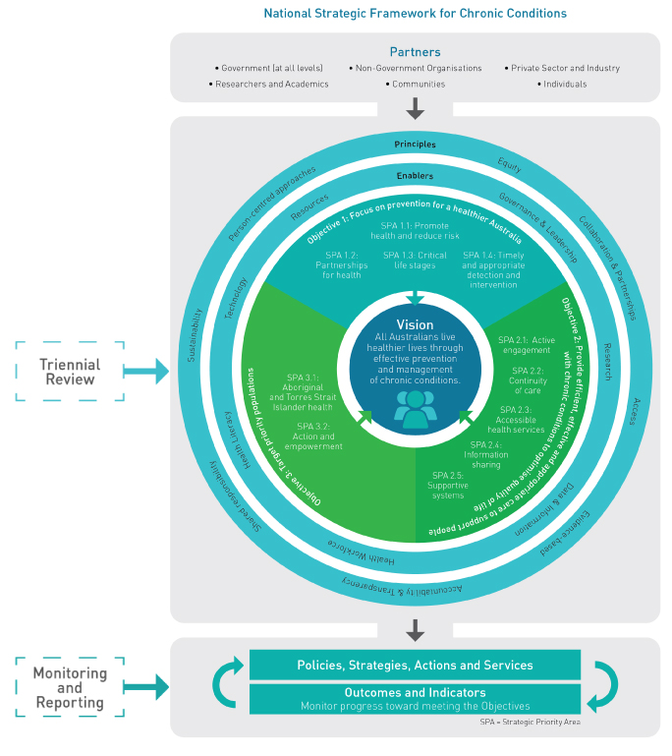
        - WHO Targets and Indicators
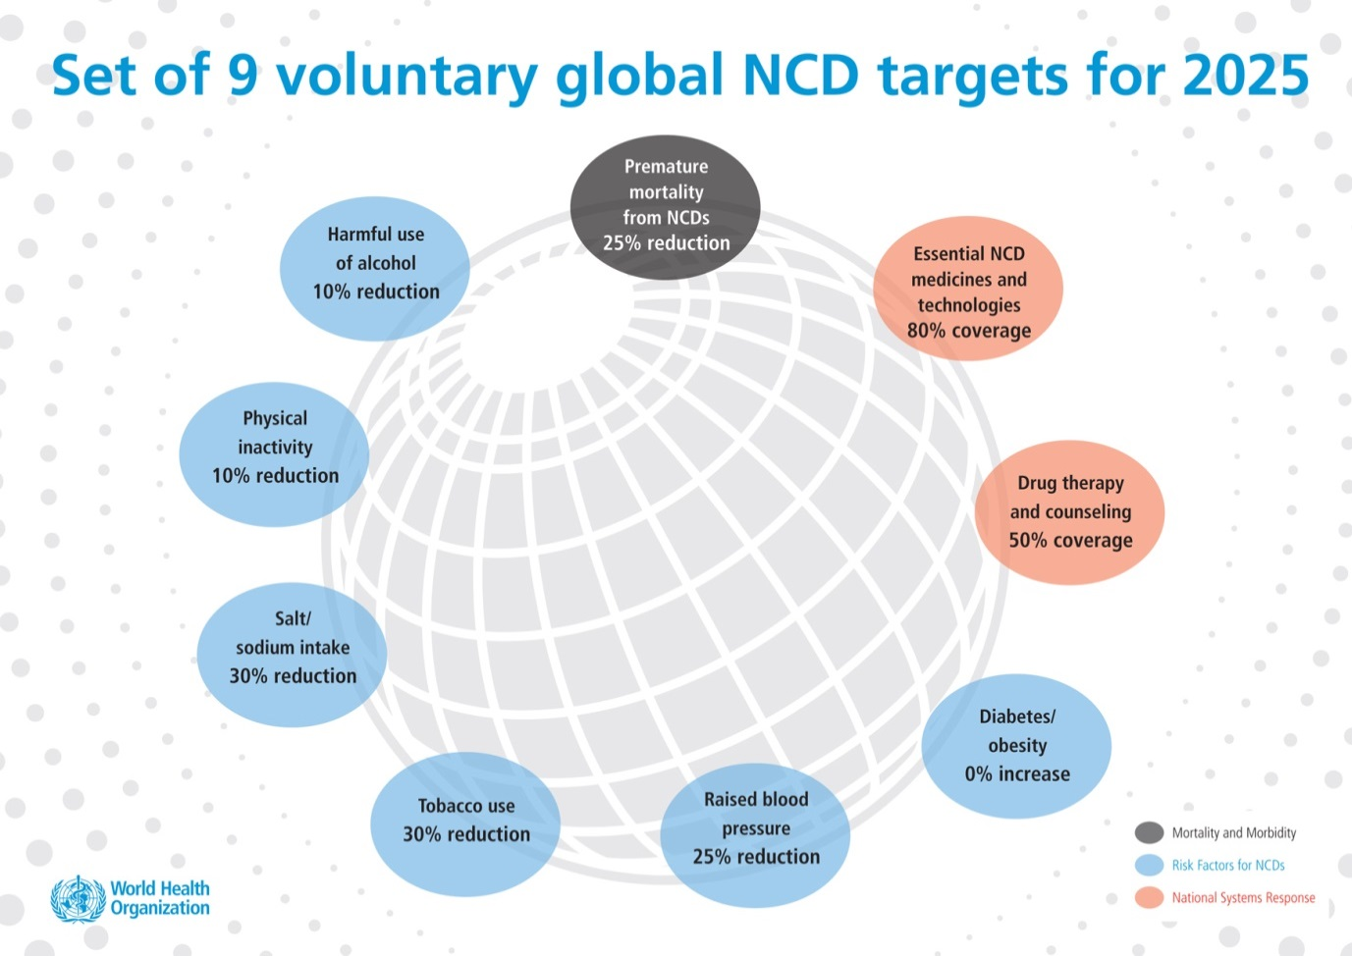
Image from the World Health Organization (WHO) — World Health Organization (WHO). Noncommunicable Disease Global Monitoring Framework — Ensuring progress on noncommunicable diseases in countries [Internet]. Geneva, Switzerland: WHO; Available from: http://www.who.int/nmh/global_monitoring_framework/gmf1_large.jpg?ua=1

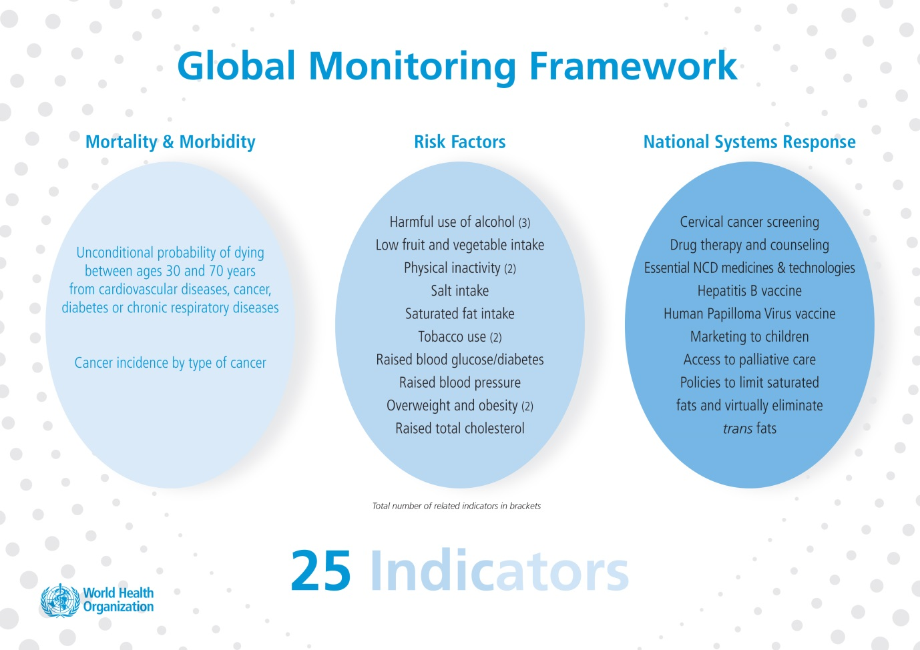
Image from the World Health Organization (WHO) — World Health Organization (WHO). Noncommunicable Disease Global Monitoring Framework — Ensuring progress on noncommunicable diseases in countries [Internet]. Geneva, Switzerland: WHO; Available from: http://www.who.int/nmh/global_monitoring_framework/gmf2_large.jpg?ua=1

References
            - Australian Institute of Health and Welfare 2014. Australia’s health 2014. Australia’s health series no. 14. Cat. no. AUS 178. Canberra: AIHW.
            - Australian Institute of Health and Welfare 2014. Australia’s health 2014. Australia’s health series no. 14. Cat. no. AUS 178. Canberra: AIHW.
            - Australian Health Ministers’ Advisory Council, 2015, Aboriginal and Torres Strait Islander Health Performance Framework Report 2014, AHMAC, Canberra.
            - World Health Organization (WHO). Global Action Plan for the Prevention and Control of Noncommunicable Diseases (NCDs) 2013–2020 [Internet]. Geneva, Switzerland: WHO Press; 2013. 103 p. Available from: http://apps.who.int/iris/bitstream/10665/94384/1/9789241506236_eng.pdf
            - World Health Organization (WHO). Global Action Plan for the Prevention and Control of Noncommunicable Diseases (NCDs) 2013–2020 [Internet]. Geneva, Switzerland: WHO Press; 2013. 103 p. Available from: http://apps.who.int/iris/bitstream/10665/94384/1/9789241506236_eng.pdf
            - National Health Priority Action Council (NHPAC) 2006. National Chronic Disease Strategy. Australian Government Department of Health and Ageing, Canberra.
            - National Health Priority Action Council (NHPAC) 2006. National Service Improvement Framework for Asthma. Australian Government Department of Health and Ageing, Canberra.
            - National Health Priority Action Council (NHPAC) 2006. National Service Improvement Framework for Cancer. Australian Government Department of Health and Ageing, Canberra.
            - National Health Priority Action Council (NHPAC) 2006. National Service Improvement Framework for Diabetes. Australian Government Department of Health and Ageing, Canberra.
            - National Health Priority Action Council (NHPAC) 2006. National Service Improvement Framework for Heart, Stroke and Vascular Disease. Australian Government Department of Health and Ageing, Canberra.
            - National Health Priority Action Council (NHPAC) 2006. National Service Improvement Framework for Osteoarthritis, Rheumatoid Arthritis and Osteporosis. Australian Government Department of Health and Ageing, Canberra.
            - Australian Institute of Health and Welfare 2016. Australian Burden of Disease Study: Impact and causes of illness and death in Australia 2011. Australian Burden of Disease Study series no. 3. Cat. no. BOD 4. Canberra: AIHW.
            - Australian Institute of Health and Welfare 2016. Australia’s health 2016. Australia’s health series no. 15. Cat. no. AUS 199. Canberra: AIHW.
            - Australian Institute of Health and Welfare 2012. Australia’s health 2012. Australia’s health series no. 13. Cat. no. AUS 156. Canberra: AIHW.
            - Australian Institute of Health and Welfare 2016. Australia’s health 2016. Australia’s health series no. 15. Cat. no. AUS 199. Canberra: AIHW.
            - Australian Institute of Health and Welfare 2012. Risk factors contributing to chronic disease. Cat. No. PHE 157. Canberra: AIHW.
            - Australian Institute of Health and Welfare 2010. Premature mortality from chronic disease. Bulletin no. 84. Cat. no. AUS 133. Canberra: AIHW.
            - Commonwealth of Australia Department of Health. Primary Health Care Advisory Group Final Report: Better Outcomes for People with Chronic and Complex Health Conditions. Canberra, ACT: Commonwealth of Australia; 2016.
            - Australian Institute of Health and Welfare 2014. Australia’s health 2014. Australia’s health series no. 14. Cat. no. AUS 178. Canberra: AIHW.
            - Australian Institute of Health and Welfare 2014. Australia’s health 2014. Australia’s health series no. 14. Cat. no. AUS 178. Canberra: AIHW.
            - Australian Institute of Health and Welfare 2014. Australia’s health 2014. Australia’s health series no. 14. Cat. no. AUS 178. Canberra: AIHW.
            - World Health Organization (WHO). Global Action Plan for the Prevention and Control of Noncommunicable Diseases (NCDs) 2013–2020 [Internet]. Geneva, Switzerland: WHO Press; 2013. 103 p. Available from: http://apps.who.int/iris/bitstream/10665/94384/1/9789241506236_eng.pdf
            - Australian National Preventive Health Agency (ANPHA). State of Preventive Health 2013. Report to the Australian Government Minister for Health. Canberra; ANPHA, 2013.
            - Australian Institute of Health and Welfare 2016. Australia’s health 2016. Australia’s health series no. 15. Cat. no. AUS 199. Canberra: AIHW.
            - Australian Institute of Health and Welfare 2016. Australia’s health 2016. Australia’s health series no. 15. Cat. no. AUS 199. Canberra: AIHW.
            - World Health Organization (WHO). Global Action Plan for the Prevention and Control of Noncommunicable Diseases (NCDs) 2013–2020 [Internet]. Geneva, Switzerland: WHO Press; 2013. 103 p. Available from: http://apps.who.int/iris/bitstream/10665/94384/1/9789241506236_eng.pdf
            - OECD, OECD Reviews of Health Care Quality: Australia 2015: Raising Standards [Internet], Paris: OECD Publishing, 2015 [cited 20 July 2016]. 219 p. Available from: http://dx.doi.org/10.1787/9789264233836-en
            - OECD, OECD Reviews of Health Care Quality: Australia 2015: Raising Standards [Internet], Paris: OECD Publishing, 2015 [cited 20 July 2016]. 219 p. Available from: http://dx.doi.org/10.1787/9789264233836-en
            - Australian Government Department of Prime Minister and Cabinet. Closing the Gap Prime Minister’s Report 2016 [Internet]. Canberra, ACT; Commonwealth of Australia; 2016 [cited 26 July 2016].60 p. Available from: http://closingthegap.dpmc.gov.au/assets/pdfs/closing_the_gap_report_2016.pdf
            - Department of Health. Implementation Plan for the National Aboriginal and Torres Strait Islander Health Plan 2013–2023, Canberra, ACT: Australian Government, 2015.
            - Department of Health. Implementation Plan for the National Aboriginal and Torres Strait Islander Health Plan 2013–2023, Canberra, ACT: Australian Government, 2015.
            - Vos T, Barker B, Stanley L, Lopez AD 2007. The burden of disease and injury in Aboriginal and Torres Strait Islander peoples: Summary report [Internet]. Brisbane: School of Population Health, The University of Queensland [cited 2 September 2016]. Available from: https://www.lowitja.org.au/sites/default/files/docs/Indigenous-BoD-Summary-Report_0.pdf
            - Australian Institute of Health and Welfare 2016. Australia’s health 2016. Australia’s health series no. 15. Cat. no. AUS 199. Canberra: AIHW.
            - Government of Western Australia Department of Health. WA Aboriginal Health and Wellbeing Framework 2015–2030 [Internet]. Western Australia: Department of Health; 2015 [cited 26 July 2016]. 26 p. Available from: http://ww2.health.wa.gov.au/~/media/Files/Corporate/general%20documents/Aboriginal%20health/PDF/12853_WA_Aboriginal_Health_and_Wellbeing_Framework.ashx
            - Australian Institute of Health and Welfare 2016. Australia’s health 2016. Australia’s health series no. 15. Cat. no. AUS 199. Canberra: AIHW.
            - Australian Institute of Health and Welfare 2016. Australia’s health 2016. Australia’s health series no. 15. Cat. no. AUS 199. Canberra: AIHW.
            - Australian Bureau of Statistics. 3302.0.55.003 — Life Tables for Aboriginal and Torres Strait Islander Australians — Media Release — Aboriginal and Torres Strait Islander Life Expectancy Increases [Internet]. Canberra, ACT: ABS; November 2013 [updated 15 November 2013; cited 27 July 2016]. Available from: http://www.abs.gov.au/AUSSTATS/abs@.nsf/Latestproducts/3302.0.55.003Media%20Release12010-2012?opendocument&tabname=Summary&prodno=3302.0.55.003&issue=2010-2012&num=&view=
            - Australian Government Department of Prime Minister and Cabinet. Closing the Gap Prime Minister’s Report 2016 [Internet]. Canberra, ACT; Commonwealth of Australia; 2016 [cited 26 July 2016].60 p. Available from: http://closingthegap.dpmc.gov.au/assets/pdfs/closing_the_gap_report_2016.pdf
            - Solar O, Irwin A. A conceptual framework for action on the social determinants of health. Social Determinants of Health Discussion Paper 2 (Policy and Practice) [Internet]. Geneva, World Health Organization, 2010 [cited 2 September 2016]. Available from: http://www.who.int/social_determinants/corner/SDHDP2.pdf
            - World Health Organization. Health impact Assessment (HIA) — The determinants of health [Internet]. Geneva, Switzerland: WHO; 2016 [cited 11 February 2016]. Available from: http://www.who.int/hia/evidence/doh/en/
            - World Health Organization. Social Determinants of Health [Internet]. Geneva, Switzerland: WHO; 2016 [cited 21 July 2016]. Available from: http://www.who.int/social_determinants/thecommission/finalreport/key_concepts/en/
            - World Health Organization (WHO). Global Action Plan for the Prevention and Control of Noncommunicable Diseases (NCDs) 2013–2020 [Internet]. Geneva, Switzerland: WHO Press; 2013. 103 p. Available from: http://apps.who.int/iris/bitstream/10665/94384/1/9789241506236_eng.pdf
            - World Health Organization. Chronic diseases and health promotion — integrated chronic disease prevention and control [Internet]. Geneva, Switzerland: WHO; 2016 [cited 1 February 2016]. Available from: http://www.who.int/chp/about/integrated_cd/en/
            - Bauer UE, Briss PA, Goodman RA, Bowman BA. Prevention of chronic disease in the 21st century: elimination of the leading preventable causes of premature death and disability in the USA [Internet]. The Lancet. 5 July 2014; Vol 384, 45–52. Available from http://www.thelancet.com/pdfs/journals/lancet/PIIS0140-6736(14)60648-6.pdf
            - Australian Institute of Health and Welfare 2016. Australian Burden of Disease Study: Impact and causes of illness and death in Australia 2011. Australian Burden of Disease Study series no. 3. Cat. no. BOD 4. Canberra: AIHW.
            - Australian Institute of Health and Welfare 2016. Australian Burden of Disease Study: Impact and causes of illness and death in Australia 2011. Australian Burden of Disease Study series no. 3. Cat. no. BOD 4. Canberra: AIHW.
            - Australian Institute of Health and Welfare 2016. Australian Burden of Disease Study: Impact and causes of illness and death in Australia 2011. Australian Burden of Disease Study series no. 3. Cat. no. BOD 4. Canberra: AIHW.
            - Australian Institute of Health and Welfare 2012. Risk factors contributing to chronic disease. Cat. No. PHE 157. Canberra: AIHW.
            - World Health Organization. Health promotion [Internet]. Geneva, Switzerland: WHO; 2016 [cited 21 July 2016]. Available from: http://www.who.int/topics/health_promotion/en/
            - World Health Organization. The Ottawa Charter for Health Promotion [Internet]. Geneva, Switzerland: WHO; 2016 [cited 21 July 2016]. Available from: http://www.who.int/healthpromotion/conferences/previous/ottawa/en/
            - World Health Organization. The Bangkok Charter for Health Promotion in a Globalized World (11 August 2005) [Internet]. Geneva, Switzerland: WHO; 2016 [cited 4 August 2016]. Available from: http://www.who.int/healthpromotion/conferences/6gchp/bangkok_charter/en/
            - World Health Organization. The Bangkok Charter for Health Promotion in a Globalized World (11 August 2005) [Internet]. Geneva, Switzerland: WHO; 2016 [cited 4 August 2016]. Available from: http://www.who.int/healthpromotion/conferences/6gchp/bangkok_charter/en/
            - World Health Organization. Health Topics: Risk factors [Internet]. Geneva, Switzerland: WHO; 2016 [cited 5 January 2016]. Available from: http://www.who.int/topics/risk_factors/en/
            - Australian Institute of Health and Welfare 2012. Risk factors contributing to chronic disease. Cat. No. PHE 157. Canberra: AIHW.
            - Australian Government Preventive Health Taskforce. Australia: The healthiest country by 2020 — the roadmap for action. Canberra, ACT: Commonwealth of Australia; 2009.
            - HM Government. Healthy Lives, Healthy People: our strategy for public health in England [Internet]. United Kingdom: The Stationary Office Limited; November 2010 [cited 2 August 2016]. Available from http://guides.lib.monash.edu/citing-referencing/vancouver-govt-tech-reports
            - Pikora T, Christian H, Trapp G, Villanueva K. Chronic disease prevention interventions in children and young adults: A rapid review prepared for the Australian Government Department of Health on behalf of The Australian Prevention Partnership Centre; 2016
            - World Health Organization. WHO Health Promotion Glossary [Internet]. Geneva, Switzerland: WHO; 1998 [cited 2 August 2016]. Available from: http://www.who.int/healthpromotion/about/HPR%20Glossary%201998.pdf?ua=1
            - Government of South Australia. Implementing Health in All Policies — Adelaide 2010 [Internet]. South Australia: Department of Health, Government of South Australia; 2010 [cited 28 July 2016]. Available from: http://www.who.int/sdhconference/resources/implementinghiapadel-sahealth-100622.pdf
            - ACT Government Health Directorate. ACT Chronic Conditions Strategy — Improving Care and Support [Internet]. Canberra, ACT: ACT Government — Health; 2013 [cited 29 July 2016]. Available from: http://health.act.gov.au/sites/default/files/Policy_and_Plan/Chronic%20Conditions%20Strategy%202013%20-%202018.pdf
            - World Health Organization. 2016. Genomic resource centre — Genes and human disease [Internet]. Geneva, Switzerland: WHO. 2016 [cited 5 August 2016]. Available from: http://www.who.int/genomics/public/geneticdiseases/en/index3.html
            - Australian Institute of Health and Welfare. Chronic diseases [Internet]. Canberra, ACT: AIHW; 2016 [cited 1 February 2016] Available from: http://www.aihw.gov.au/chronic-diseases/
            - Commonwealth of Australia Department of Health. Primary Health Care Advisory Group Final Report: Better Outcomes for People with Chronic and Complex Health Conditions. Canberra, ACT: Commonwealth o Australia; 2016.
            - World Health Organization. Health Promotion — Track 2: Health literacy and Health Behaviour — 7th Global Conference of Health Promotion: track themes [Internet]. Geneva, Switzerland: WHO; 2016 [cited 1 February 2016]. Available from: http://www.who.int/healthpromotion/conferences/7gchp/track2/en/
            - Australian Commission on Safety and Quality in Health Care. Consumers, the health system and health literacy: Taking action to improve safety and quality. Consultation Paper. Sydney, NSW: ACSQHC; 2013.
            - Zoffmann V, Harder L, Kirkevold M. A person-centered communication and reflection model: shared decision-making in chronic care. Qual Health Res. 2008;18(5): 670–685.
            - Georgeff, M. Digital technologies and chronic disease management [Internet]. Australian Family Physician 2014 Dec;43(12):842–6. Available from: http://www.racgp.org.au/download/Documents/AFP/2014/December/AFP-2014-12-Focus-Georgeff.pdf
            - Haggerty JL, Reid RJ, Freeman GK, Starfield B, Adair CE, McKendry R. Continuity of care: a multidisciplinary review. BMJ 2003;327:1219–21.
            - Haggerty JL et al. Continuity of care: a multidisciplinary review [Internet]. BMJ. 2003 Nov 22; 327(7425): 1219–1221. Available from: http://www.ncbi.nlm.nih.gov/pmc/articles/PMC274066/
            - NSW Government. NSW Health Integrated Care Strategy 2014–2017 [Internet]. Sydney, NSW: NSW Government; 2016 [update 25 July 2016; cited 27 July 2016]. Available from: http://www.health.nsw.gov.au/integratedcare/Pages/integrated-care-strategy.aspx
            - Australian Commission on Safety and Quality in Healthcare. Australian Safety and Quality Framework for Health Care: Getting Started for the Health Care Team. Sydney, NSW: ACSQHC; 2010.
            - Battersby et al, 2007. SA HealthPlus: A Controlled Trial of a Statewide Application of a Generic Model of Chronic Illness Care. Milbank Quarterly 2007 Mar; 85(1): 37–67.
            - Battersby et al, 2007. SA HealthPlus: A Controlled Trial of a Statewide Application of a Generic Model of Chronic Illness Care. Milbank Quarterly 2007 Mar; 85(1): 37–67.
            - Bywood PT, Jackson-Bowers E, Muecke S. Initiatives to integrate primary and acute health care, including ambulatory care services. PHCRIS Policy Issue Review. Adelaide, SA: Primary Health Care Research & Information Service. 2011.
            - Ware V-A. Improving the accessibility of health services in urban and regional settings for Indigenous people. Resource sheet no. 27. Produced for the Closing the Gap Clearinghouse. Canberra: Australian Institute of Health and Welfare & Melbourne: Australian Institute of Family Studies. 2013.
            - National Health and Hospitals Reform Commission. A Healthier Future for All Australians: final report 2009. Canberra, ACT: Australian Government; 2009, pp. 56–57.
            - Australian Primary Health Care Research Institute (APHCRI). Knowledge Exchange Report (2011). Canberra, ACT: Australian Primary Health Care Research Institute (APHCRI); 2011.
            - Australian Commission on Safety and Quality in Health Care, National safety and Quality Health Service Standards (September 2012). Sydney, NSW: ACSQHC; 2012.
            - Australian Government Department of Prime Minister and Cabinet. Closing the Gap Prime Minister’s Report 2016 [Internet]. Canberra, ACT; Commonwealth of Australia; 2016 [cited 26 July 2016].60 p. Available from: http://closingthegap.dpmc.gov.au/assets/pdfs/closing_the_gap_report_2016.pdf
            - Australian Government Department of Prime Minister and Cabinet. Closing the Gap Prime Minister’s Report 2016 [Internet]. Canberra, ACT; Commonwealth of Australia; 2016 [cited 26 July 2016].60 p. Available from: http://closingthegap.dpmc.gov.au/assets/pdfs/closing_the_gap_report_2016.pdf
            - Vos T, Barker B, Stanley L, Lopez AD 2007. The burden of disease and injury in Aboriginal and Torres Strait Islander peoples: Summary report [Internet]. Brisbane: School of Population Health, The University of Queensland [cited 2 September 2016]. Available from: https://www.lowitja.org.au/sites/default/files/docs/Indigenous-BoD-Summary-Report_0.pdf
            - Australian Bureau of Statistics, 4727.0.55.003 — Australian Aboriginal and Torres Strait Islander Health Survey: Biomedical Results, 2012–13 [Internet]. Canberra, ACT: ABS; September 2014 [cited 2 September 2016]. Available from: http://www.abs.gov.au/ausstats/abs@.nsf/Lookup/by%20Subject/4727.0.55.003~2012–13~Main%20Features~Feature%20article:%20%20Chronic%20disease%20results%20for%20Aboriginal%20and%20Torres%20Strait%20Islander%20and%20non-Indigenous%20Australians~134
            - Australian Government Department of Health. Implementation Plan for the National Aboriginal and Torres Strait Islander Health Plan 2013–2023. Canberra, ACT: Australian Government; 2015.
            - Australian Health Ministers’ Advisory Council, 2015, Aboriginal and Torres Strait Islander Health Performance Framework Report 2014, AHMAC, Canberra.
            - Australian Institute of Health and Welfare 2014. Australia’s health 2014. Australia’s health series no. 14. Cat. no. AUS 178. Canberra: AIHW.
            - Australian Institute of Health and Welfare 2014. Australia’s health 2014. Australia’s health series no. 14. Cat. no. AUS 178. Canberra: AIHW.
            - Laverack, G. Improving Health Outcomes through Community Empowerment: A review of the Literature. J Health Popul Nutr 2006 Mar;24(1):113–120. Auckland, New Zealand: Centre for Health and Population Research; 2006.
            - World Health Organizations. Health Promotion — Track 1: Community empowerment — 7th Global Conference of Health Promotion: track themes [Internet]. Geneva, Switzerland: WHO; 2016 [cited 10 August 2016]. Available from: http://www.who.int/healthpromotion/conferences/7gchp/track1/en/
            - World Health Organisation (WHO). Global Action Plan for the Prevention and Control of Noncommunicable Diseases (NCDs) 2013–2020 (Internet). Geneva, Switzerland: WHO Press: 2013. 103 p.Available from: http://apps.who.int/iris/bitstream/10665/94384/1/9789241506236_eng.pdf

Commissioned Work
Australian Institute of Health and Welfare. National Strategic Framework for Chronic Conditions — Advice on indicators for monitoring progress. Canberra, ACT: Australian Government — Australian Institute of Health and Welfare; August 2016.
Pikora T, Christian H, Trapp G, Villanueva K. Chronic disease prevention interventions in children and young adults: A rapid review prepared for the Australian Government Department of Health on behalf of The Australian Prevention Partnership Centre; 2016.

