# BreastScreen and You

**Information about mammography screening**

Breast Screen Australia — a Joint Australian, State and Territory Government Program

This information is about screening for breast cancer. It aims to help you choose whether or not you take part in the BreastScreen Australia Program.

Find out more about:

* **Screening for breast cancer**
* **Deciding about breast screening**
* **Further information**

**Acknowledgement**

This information has been developed by Cancer Australia using the most up-to-date evidence and research available at the time of publication.

## Screening for breast cancer

### What is BreastScreen Australia?

BreastScreen Australia is the national screening program for breast cancer. BreastScreen Australia started in 1991 and aims to reduce illness and death from breast cancer through the early detection of the disease using mammography screening.

BreastScreen Australia offers screening mammograms for women aged 40 years and over.

Screening mammograms are used to find breast cancers early, before they can be seen or felt. A mammogram is an X-ray picture of the breast. By finding breast cancers early, screening mammograms reduce deaths from breast cancer.

BreastScreen Australia is a free service and women do not need a doctor’s referral.

### Who can attend BreastScreen?

BreastScreen Australia specifically targets women aged between 50 and 74[1](http://cancerscreening.gov.au/internet/screening/publishing.nsf/Content/breastscreen-n-you-html#1) years and invites them for a free screening mammogram every two years. This is because the evidence of benefit is strongest in this age group.

Women aged between 40 and 49 years, or 75 years and older can also have a free screening mammogram through BreastScreen Australia.

Screening mammograms are not effective for women under 40 years.

For more information see the BreastScreen websites.

### Is BreastScreen right for you?

Some women may need different care and services that are not part of screening. This includes women who have:

* symptoms of breast cancer
* a strong family history of breast and/or ovarian cancer
* a previous diagnosis of breast cancer within the last five years

Speak with your GP or phone BreastScreen Australia on 13 20 50 to make sure you receive the most suitable service for you.

### Why does BreastScreen use mammograms to find breast cancer?

BreastScreen Australia uses mammography (X-ray pictures of the breast) because it is the most effective screening test to detect breast cancer.

No other technology has been proven as a screening test to reduce deaths from breast cancer.

### How can I make an appointment with BreastScreen?

Phoning BreastScreen Australia on 13 20 50 will connect you to your local BreastScreen service, so you can make an appointment for a screening mammogram.

Online booking is available for some BreastScreen services.

### Where do I go for screening?

BreastScreen Australia operates in every state and territory in Australia, in over 600 locations.

BreastScreen Australia uses clinics, purpose built buses and four-wheel-drives to provide screening to women across Australia.

When you call to make an appointment, BreastScreen will give you information about services that are near you.

### What happens during screening?

Screening mammograms are performed by health professionals called radiographers. The radiographer will explain to you what will happen. You will be asked to remove your clothing from the waist up. The radiographer will then place one breast at a time between two plates on the mammography machine. The machine will press firmly on your breast for about 10 seconds to take the picture. Usually two pictures are taken of each breast, one from the side and one from the top.

Having the mammograms should only take a few minutes. The whole appointment usually takes less than 30 minutes.

### Does having a mammogram hurt ?

You may find having a mammogram is uncomfortable. This is because your breasts need to be pressed firmly between two plates on the mammogram machine so that a clear picture can be taken.

It is normal to feel discomfort, but this should only last a few seconds. If you feel pain, please tell the radiographer at the time, as the pressure can be released.

### Are there radiation risks?

Each time you have a mammogram, your breasts are exposed to a very small amount of radiation. Modern mammography machines use the smallest amount of radiation possible while still getting a high quality X-ray picture.

The radiation from screening (which involves two X-rays of each breast) is about the same as 18 weeks of exposure to natural radiation in the environment.

### How are my results decided?

Your mammogram will be looked at by two or more health professionals specially trained in screening mammography. They are looking for any unusual areas of the breast which might be a sign of breast cancer.

Based upon their decisions, you will be given one result—either ‘no evidence of breast cancer’ or ‘recalled for further tests’.

### What results might I get?

The vast majority of women will get a screening result that says ‘no evidence of breast cancer’. Women should still continue to know the look and feel of their breasts between screening mammograms, and report any changes that are unusual for them to their GP.

Sometimes women will be asked to come back to BreastScreen for more tests. This does not mean breast cancer is present, but sometimes more tests are needed to make sure. This happens more often for women having a mammogram for the first time. This is usually because there are no other mammograms to compare with. Something that may look unusual on your first mammogram may be completely normal for you.

Most women who are asked to come back for more tests do not have breast cancer. These tests are provided by BreastScreen Australia and are free of charge.

### When will I get my results?

Most women will be sent their results in about two weeks. This is because every mammogram at BreastScreen is carefully and independently examined by two or more specially trained health professionals.

If you have not received your results after two weeks you should phone BreastScreen Australia on 13 20 50 to find out when you will be receiving your results.

The results of your mammogram will also be sent to your GP if you have agreed to this.

### How might I feel before and after my mammogram?

Some women may feel worried before they have a screening mammogram and while waiting for their results. Some women may feel worried if they are called back to have more tests.

The vast majority of women who have a screening mammogram will get a result of ‘no evidence of breast cancer’ and will feel reassured.

If you are feeling worried, phone your BreastScreen service for further information and support.

### What if I have breast cancer?

A small number of women who are called back for further tests will be told they have breast cancer.

One of the doctors at BreastScreen will explain the test results and what will happen next.

While BreastScreen does not treat women with breast cancer, they will help you to arrange your future care needs by contacting your GP. Your GP will discuss your specialist referral, treatment and follow-up choices with you.

For further information about breast cancer please see the Cancer Australia website.

### How common is breast cancer?

One in eight women in Australia will develop breast cancer in their lifetime.

Getting older is the biggest risk factor in developing breast cancer.

Women diagnosed with breast cancer in Australia have better survival prospects compared with women in most other countries.

Having regular mammograms through BreastScreen Australia is one of the best things you can do to detect breast cancer early, and improve your chance of survival.

### Why is breast awareness important?

Even if you have two-yearly mammograms, it is still important to be breast aware because breast cancer can develop at any time. This includes the time in-between screening appointments.

It is important to know the normal look and feel of your breasts. Things you should look out for include:

* a new lump or lumpiness in your breasts, especially if it is in only one breast
* a change in the size and shape of your breast
* a change to the nipple such as crusting, an ulcer, redness or the nipple pulled in
* a discharge from your nipple that happens without squeezing the nipple
* a change in the skin of your breast such as redness or dimpling or puckered skin
* a pain that does not go away

Most breast changes will not be due to breast cancer but you should get them checked. If you notice a change in the look or feel of your breasts, even if your screening mammogram was normal, see your GP without delay.

### What happens to my mammograms after screening?

Your BreastScreen service will store your digital mammogram pictures on a computer system in agreement with state and territory health record and privacy legislation.

Prior images may be used to monitor any changes in breast tissue over time.

## Deciding about breast screening

### What are the potential benefits of attending BreastScreen?

#### Preventing deaths from breast cancer

Having a mammogram every two years through BreastScreen prevents deaths from breast cancer. Screening mammograms can show very small breast cancers before they can be seen or felt. The earlier breast cancer is found, the better the chance of surviving it.

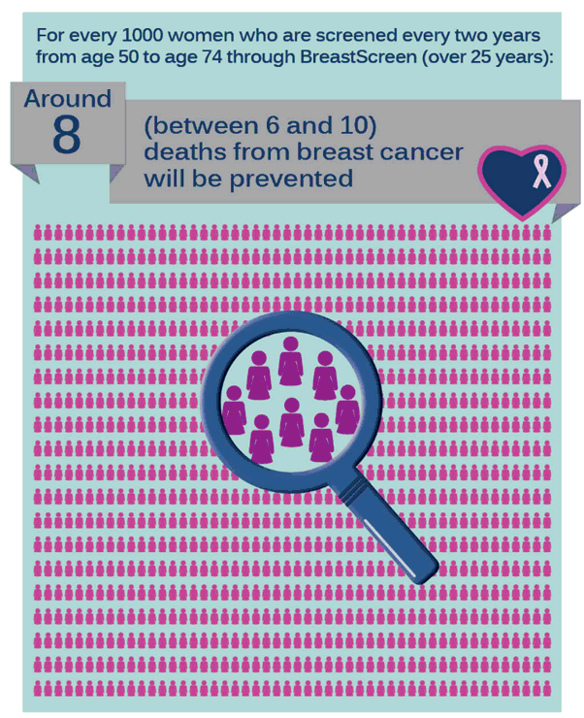

#### Less invasive treatment

For every 1000 women who have a mammogram through BreastScreen, only 6 women will be found to have breast cancer.

Women who have breast cancers that are found through a screening mammogram are less likely to have a mastectomy (have their breast removed). They may also have more treatment choices.

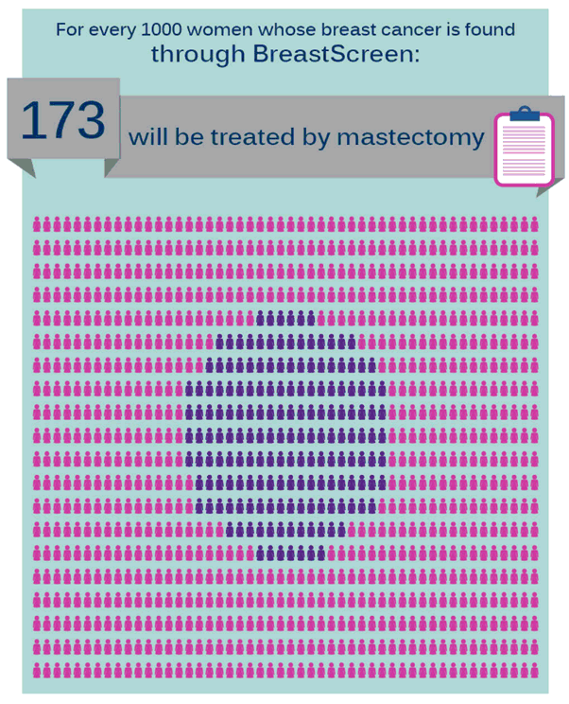

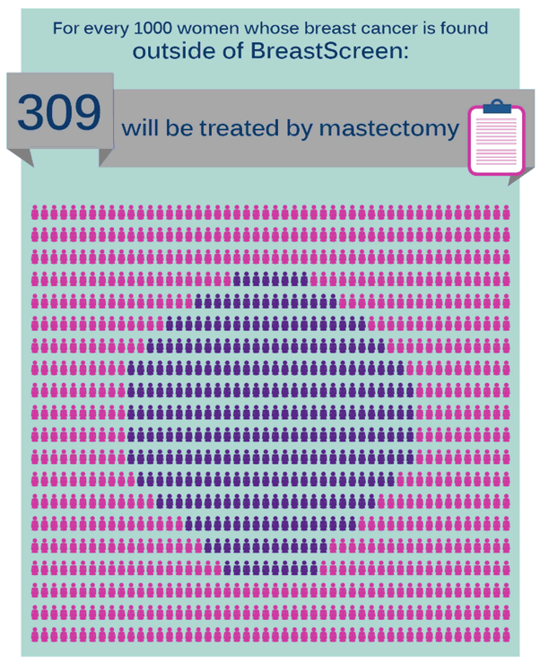

#### Reassurance

The vast majority of women who have a screening mammogram will get a result of ‘no evidence of breast cancer’ and will feel reassured.

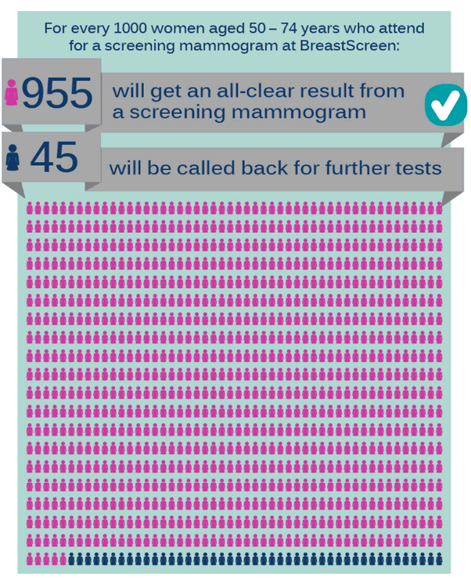

### What are the potential harms of attending BreastScreen?

#### Finding and treating breast cancers that may not have become life-threatening

Most breast cancers that are found through BreastScreen would grow and be life-threatening if they were not treated. However, some breast cancers that are found and treated may not have become life-threatening.

At this time, it is not possible to tell exactly which breast cancers may become life-threatening and which breast cancers may not.

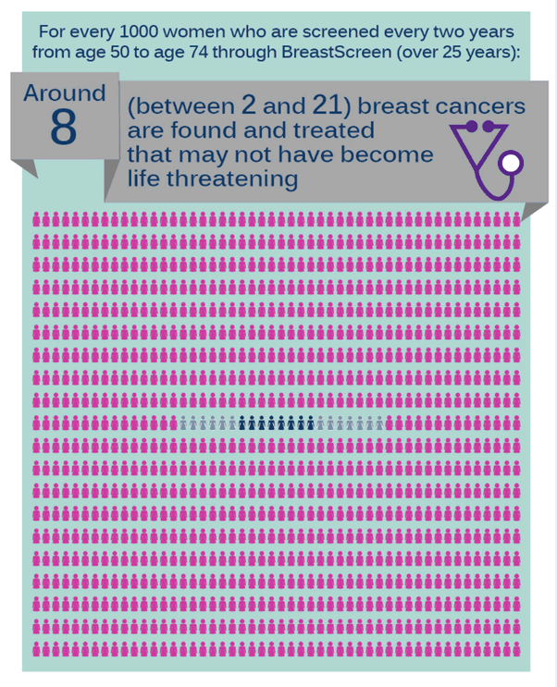

#### Further tests done but breast cancer is not found

Some women will be called back for more tests after a screening mammogram because the mammogram showed an abnormality. For most of these women, the mammogram is found to be normal and breast cancer is not found.

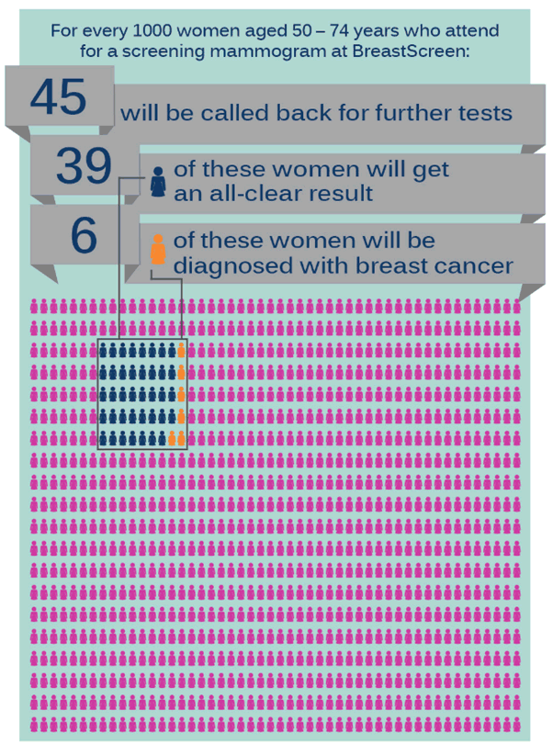

#### Breast cancer is present but not found

Screening mammograms are the most effective test for finding breast cancer early. However, they are not 100% accurate. There is a small chance that a screening mammogram will look normal even if a breast cancer is present. For example, fewer than one woman per 1000 aged 50–74 years will be found to have a breast cancer in the 12 months following their screening mammogram.

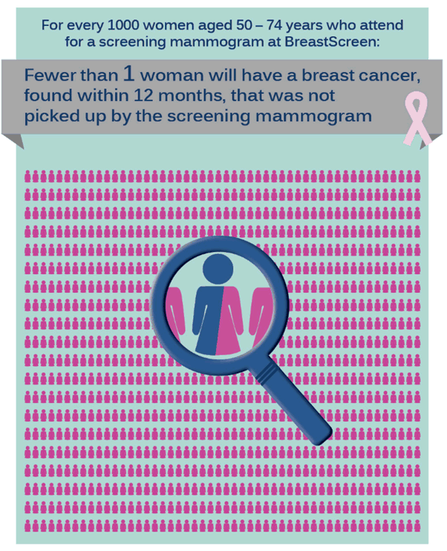

## Further information

### How can I make an appointment with BreastScreen?

Phoning BreastScreen Australia on 13 20 50 will connect you to your local BreastScreen service, so you can make an appointment for a free screening mammogram.

### What evidence is used in this resource?

The information in this resource is based on the best available international and Australian data. The figures presented are estimates from the data for women aged 50 to 74 years, and includes both invasive cancer and ductal carcinoma in-situ (DCIS).

### Where can I go for further information?

* [Cancer Screening website](http://www.cancerscreening.gov.au/)
* [BreastScreen Victoria website](http://www.breastscreen.org.au/Home)
* [NT Health Department website](http://www.health.nt.gov.au/index.aspx)
* [SA Health Department website](http://www.sahealth.sa.gov.au/wps/wcm/connect/public+content/sa+health+internet/healthy+living/recommended+health+checks/breast+screening)
* [Tasmanian Department of Health and Human Services website](http://www.dhhs.tas.gov.au/)
* [BreastScreen NSW website](http://www.bsnsw.org.au/)
* [BreastScreen Queensland website](http://www.health.qld.gov.au/breastscreen/)
* [BreastScreen WA website](http://www.breastscreen.health.wa.gov.au/home/)
* [BreastScreen ACT](http://www.health.act.gov.au/our-services/women-youth-and-children/breastscreen)

For further information about breast cancer please visit: [Cancer Australia website](http://canceraustralia.gov.au/)

[1](http://cancerscreening.gov.au/internet/screening/publishing.nsf/Content/breastscreen-n-you-html" \l "1a) Currently, women 70–74 years of age are eligible to attend BreastScreen Australia but are not actively invited. From 2013–14, women 70–74 years of age will start being invited to participate in BreastScreen Australia through a phased approach.