

Department of Health

Corporate Plan

2019-20

## Our commitment



**We are committed to effectively delivering the Government’s reforms under four pillars set out in the Long Term National Health Plan.**

The four pillars are supported by major initiatives, making up our key areas of focus:

* Pillar One

Guaranteeing Medicare, stronger primary care and improving access to medicines through the PBS

* Pillar Two

Supporting our public and private hospitals, including improvements to private health insurance

* Pillar Three

Mental health and preventive health

* Pillar Four

Medical research to save lives and boost our economy

* Ageing well and aged care
* Reshaping Australian sport.

We are committed to:

* working with consumers and key stakeholders to develop, implement and oversee coherent, connected and evidence-based policies and programs
* learning from, and sharing our experience and expertise with partners in Australia and around the world, and improving health outcomes in the region and globally
* being a high-performance organisation focused on improving workforce capability, providing high-quality advice and delivering key reforms and priorities
* an inclusive, collaborative workplace.

**Our plan**

As the accountable authority of the Australian Government Department of Health, I present the

2019-20 Department of Health Corporate Plan, covering the periods 2019-20 to 2022-23, as required under paragraph 35(1)(b) of the *Public Governance, Performance and Accountability Act 2013* (PGPA Act).

The Corporate Plan, Portfolio Budget Statements and Annual Performance Statements (included in the

Annual Report) are the core elements of the enhanced Commonwealth performance framework. These documents provide information on our performance and meet our accountability obligations.

As our primary strategic planning document, the Corporate Plan sets out our key areas of focus for the next four years and beyond. It presents our strategies for achieving our purpose, how we will measure our progress and some of the challenges we will face.

The Corporate Plan also describes our operating environment, our approach to managing risk and includes information on improving our capability.

I would like to acknowledge the dedication of the department’s staff, without whom we could not deliver our objectives and achieve our purpose.

**Glenys Beauchamp Secretary**

## Contents

###### Our plan at a glance 3

Our operating environment 4

Challenges 6

Improvements to the health system 7

Our performance 8

Pillar One 10

Guaranteeing Medicare, stronger primary care and improving access to medicines through the PBS

Pillar Two 17

Supporting our public and private hospitals, including improvements to private health insurance

Pillar Three 19

Mental health and preventive health

Pillar Four 24

Medical research to save lives and boost our economy

Ageing well and aged care 26

Reshaping Australian sport 30

Our capability 33

Our management of risk 34

**Our plan at a glance**

Our purpose

With our partners, support the Government to lead and shape Australia’s health and aged care system and sporting outcomes through evidence-based policy, well targeted programs, and best practice regulation.

Our performance

In working to achieve our purpose, we have six key areas of focus. Our performance will be assessed and reported in our 2019-20 Annual Performance Statements.

**Table: Our plan at glance**

|  |
| --- |
| **Pillar One**  Guaranteeing Medicare, stronger primary care and improving access to medicines through the PBS  We are improving health outcomes, safety and quality for all Australians |
| **Pillar Two**  Supporting our public and private hospitals, including improvements to private health insurance  We support Australian’s access to health care options, including world-class hospital services when they need them |
| **Pillar Three**  Mental health and preventive health  We are encouraging healthy lifestyles and providing services to support people with mental illnesses |
| Pillar Four  Medical research to save lives and boost our economy  We are improving lives through medical research and new medicines and treatments |
| Ageing well and aged care  We are supporting older Australians to live active and engaging lives by improving the quality and safety of aged care services |
| Reshaping Australian sport  We are building a healthier, more active nation |

##### Our challenges

* Ageing population
* Impact of technology
* Chronic conditions
* Consumer expectations
* A sustainable, affordable health system

##### Our capability

* Leadership and management
* Implementation and delivery
* Governance
* Policy advice and data analytics
* Stakeholder engagement and collaboration
* Workforce diversity and inclusiveness
* Enabling function

#### Our operating environment

Australians’ expectations of their health system are changing. Many people see themselves not only as patients but also as consumers of health services.

As consumers, people expect choice and a health system that recognises individual needs and is able to meet those needs, when and where they are required.

Our responsibility, in supporting the Australian Government, is to help meet the health needs of Australians and their expectations of health care services.

We are also responsible for ensuring our health system is affordable and sustainable, now and for future generations.

Australia’s health system is complex and involves service delivery from all levels of government and the private sector. These services need to be delivered to all Australians including in remote and regional areas.

Universal health care

Australia’s universal health insurance scheme, Medicare, along with a mix of public and private health services, ensures all Australians have access to a wide range of health and hospital services, including medicines at little or no cost. Universal and affordable access to high-quality medical, pharmaceutical and hospital services has led to Australians living longer than ever before.

The Commonwealth Fund ranks Australia’s health system number two in the world, ranking number one for administrative efficiency and health care outcomes.1

Maintaining this success faces challenges, including increased demand for treating chronic conditions, and the need for new and different models of care for our ageing population. Aboriginal and Torres Strait Islander Australians continue to be disproportionately affected by a range of health conditions.

**Figure 1: Australia’s health landscape**

D

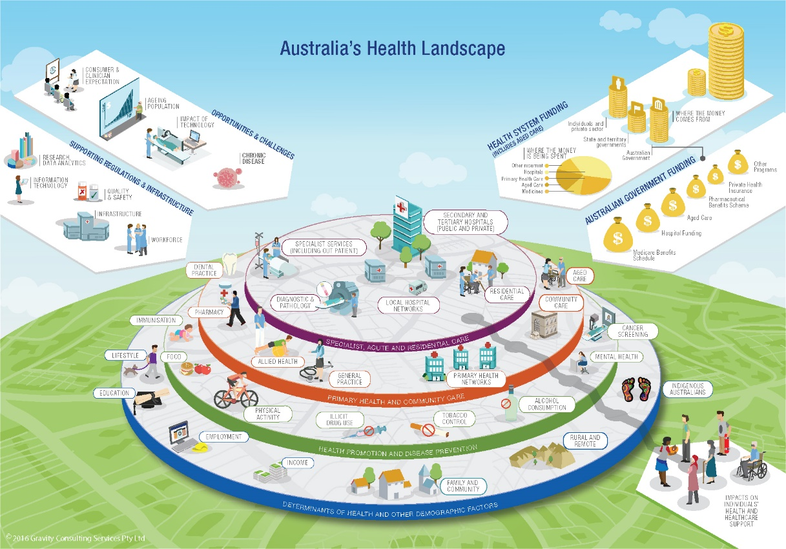

1 [www.commonwealthfund.org/chart/2017/health-care-system-performance-rankings](http://www.commonwealthfund.org/chart/2017/health-care-system-performance-rankings)

T

Regulation

We continue to have strong regulatory oversight for medicines and medical products, vaccines, the health workforce, health services, and the quality and safety of health care. There are also effective health information systems in place to ensure government policy is well informed and there is a robust health technology assessment system to inform decisions about quality and safety and funding of health care.

Aged care

Most older Australians are living in their own homes and are not using aged care services. For older Australians our aged care system offers different services and levels of support to help them stay in their own homes, and remain connected to their communities.

There is also a range of residential aged care options and accommodation for older people who are unable to continue living independently in their own home, either on a permanent or short-term basis. The department continues its work to protect the health, welfare, and interests of consumers of aged care services through policy development and funding services, regulatory and compliance action.2

Meeting these challenges requires foresight. We must recognise opportunities to build a more sustainable health system that is better tailored to individual needs. We need to respond to, anticipate, and be open to change. This includes taking advantage of technology; embracing

the power of genomics and personalised medicine; and better using digital capabilities to support better care for patients and decision making by doctors.

Sport

Sport has helped shape the Australian culture and our way of life. It provides a key source of identity, a focus for national pride and community engagement. Sport also makes a significant contribution to Australia’s economy.

Participation in sport can play a significant role in our overall health and wellbeing. It can reduce the risk of developing chronic health conditions, improve mental health, and support personal development and social inclusion.

Sport should embody the notions of fair play, commitment and mutual respect. The department is committed to safeguarding the integrity of sport in Australia and globally from threats such as doping, match-fixing and illicit drug use.

Figure 2: 2019-20 health portfolio budget

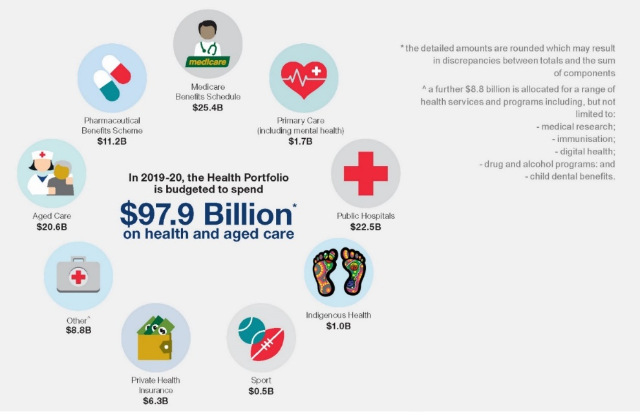

2 The aged care regulatory functions remaining in the Department of Health are to transfer to the Aged Care Quality and Safety Commission from 1 January 2020.

#### Challenges

Ageing population

Many health conditions and associated disabilities become more common with age, and older Australians are greater users of health services than younger Australians.

For example, while people are living longer and healthier lives, the prevalence of health conditions associated with ageing, such as dementia or managing multiple complex comorbidities, is projected to increase.

Technology

Advances in medical science, and genomics in particular, have seen a growth in genomic testing services.

Genomic testing can provide early diagnosis, or avoidance, of a range of health conditions and diseases. Genomic testing services pose many ethical and legal issues, including the high cost to consumers; the extent to which tests actually inform treatment options and the effect on a healthy person of discovering a predisposition to a certain disease.

Technology also underpins health and medical services – from digital health technologies through to medical artificial intelligence for diagnostic testing. These technologies may provide efficiencies and improvements for the health system, but could also create tension between consumer demand for early access to new products and ensuring products meet requirements for quality, safety and effectiveness.

Chronic conditions

Most illness and deaths in Australia are caused by chronic conditions. Chronic conditions place a high burden on individuals, their families and carers, and the health and aged care system.

Expectations

Consumers are more informed and aware of developments in health and aged care, particularly in relation to choice and access to care, service design, and the safety and quality of health services. With better access to information and My Health Record, there is a trend towards people more actively participating in their own and their families’ health care – a trend strongly encouraged by the department. Clinicians also have increasing expectations about patient care, including ensuring the Medicare Benefits Schedule aligns with best practice, and that the delivery and funding of primary care remains fit for purpose.

A sustainable, affordable health system

As people live longer and the incidence of chronic disease increases, so does the cost for governments and the community. Without new models of care, earlier intervention strategies and appropriate disinvestment strategies, health care costs will continue to rise.

#### Improvements to the health system

We are committed to supporting a culture across the health system that includes collaboration, discovery, testing/trialling, and embracing new technologies that will help us respond quickly and effectively to the challenges of supporting and maintaining our world-class health care system. This will better position us to drive change and deliver benefits to citizens, businesses and government.

The Government continues to strengthen links with industry, both at home and abroad, to collaborate on medical breakthroughs and access to research and development in health care.

We will build on our previous behavioural insight work, health data analytics and use of statistics to further increase our ability to improve health outcomes for the Australian population.

The Therapeutic Goods Administration is driving reforms to deliver efficient, best practice regulatory outcomes. It supports small-to-medium-sized enterprises, researchers and those unfamiliar with therapeutic goods regulation to better understand regulatory requirements.

The Medical Research Future Fund, Biomedical Translation Fund, and ongoing support through the National Health and Medical Research Council, are set

to improve health outcomes, continuing to fuel new ideas and discoveries with potential to transform health care.

**Figure 3: Health challenges for Australia**

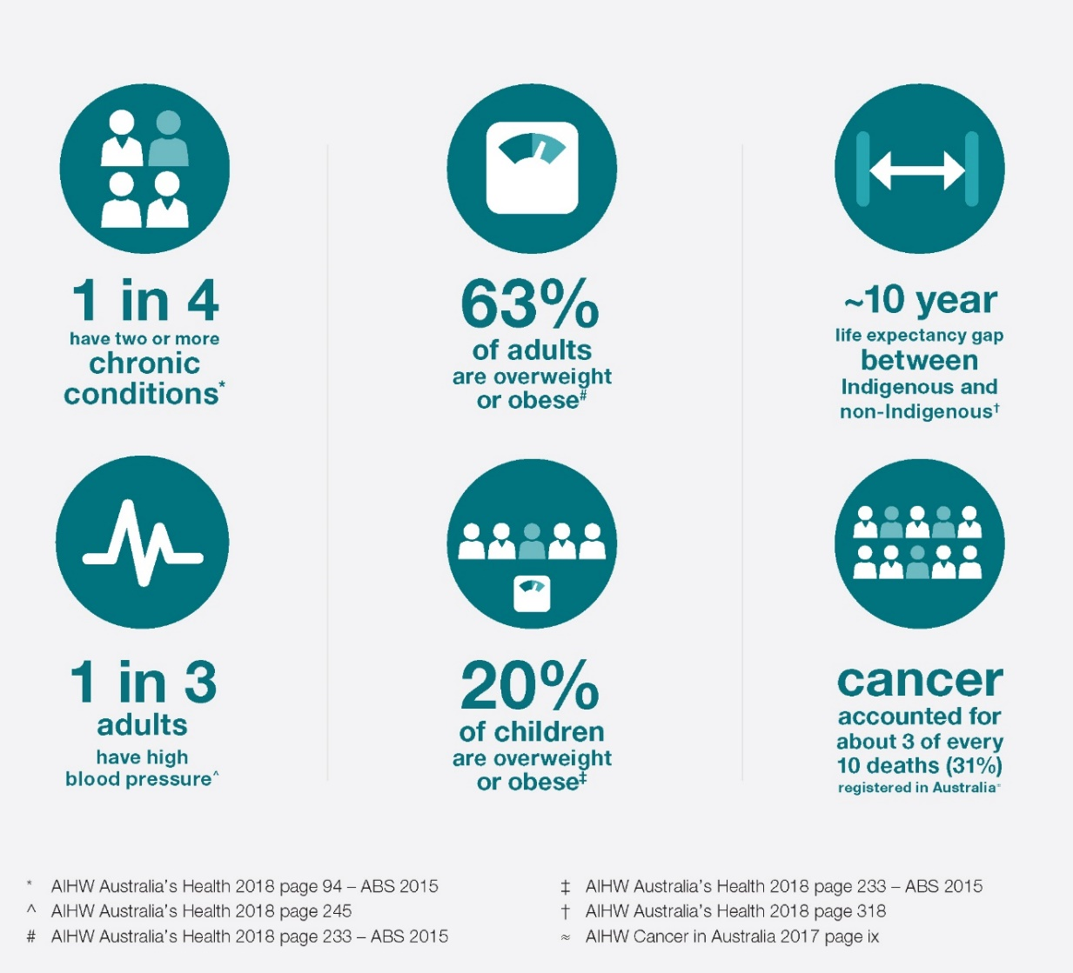

## Our performance

**The Government’s Long Term National Health Plan sets the health agenda and charts the direction foreforming Australia’s health system over the coming year**

This section of the Corporate Plan provides information on the six key areas of focus. Presented as individual fact sheets, we discuss our aims, our challenges and the work we are doing to achieve the Government’s Long Term National Health Plan objectives. We also discuss how we will measure our performance, the key risks we face and how we will manage these risks.

Each area of focus aligns to one or more of the department’s six Outcomes, which are set by the Government and detailed in the 2019-20 Health Portfolio Budget Statements.

These Outcomes communicate what benefits the Government is seeking to achieve for the Australian community.

The results and assessments of our performance in working to achieve our purpose and Outcomes will be reported in the 2019–20 Annual Performance Statements (included in our Annual Report).

The following fact sheets include an extract of performance measures, originally published in the 2019-20 Health Portfolio Budget Statements, which detail how we intend to measure our performance against our purpose over the next four years.

The performance measures have been chosen to provide a representation of the kind of work the department undertakes. To see all the department’s performance measures, and their targets refer to the 2019-20 Health Portfolio Budget Statements.

**Enhanced Commonwealth Performance Framework**

The **Corporate Plan, Portfolio Budget Statements** and the **Annual Performance Statements** (included in the Annual Report) are the core elements of the enhanced Commonwealth performance framework.

The **Portfolio Budget Statement**s (usually published in May) is primarily a funding document. It sets out the funding allocated to the department to achieve the outcomes set by the Government. It also details how we will measure the impact of that expenditure on the Australian community.

The **Corporate Plan** (published in August) is primarily a strategic planning document. It sets out our purpose and the activities we will undertake to achieve our purpose and the results we expect to achieve over the next four years. It also includes discussion on our operating environment, our capability and our management of risk.

The **Annual Performance Statements** (published in October the following year) is produced at the end of the reporting cycle and provides an assessment of how successful we have been in achieving our purpose. It includes results against planned performance in both the Portfolio Budget Statements and Corporate Plan.

Key initiatives and activities July 2019 to June 2020 and Beyond

July 2019

|  |
| --- |
| **New aged care quality standards are**  **implemented** |
| **Support Australia’s bid to host the 2023 FIFA Women’s World Cup tournament** |
| **Negotiate a new Community Pharmacy Agreement** |
| **Implement a National Rural Generalist Pathway to provide end-to-end training for rural generalists** |
| **A new primary health care funding model under the Indigenous Australians’ Health**  **Programme is implemented** |
| **Finalise implementation of Private Health Insurance reforms** |
| **Start implementing key mission investments under Medical Research Future Fund (MRFF)** |
| **Finalise a new National Health Reform Agreement** |
| **Aged care regulatory functions transfer from the Department of Health to the Aged Care Quality and Safety Commission** |
| **Release the next iteration of the *Implementation Plan for the National Aboriginal and Torres Strait Islander Health Plan 2013–2023*** |
| **Establish new headspace services** |
| **Implement the Government’s response to the Wood Review into Australia’s Sport Integrity arrangements** |
| **100% of MBS items reviewed** |
| **94.5% or more of all 5 year old children immunised** |
| **93% or more of 12 to 15 month old Aboriginal and Torres Strait Islander children immunised** |
| **144,900 Home Care Packages allocated** |
| **Next set of MRFF priorities released** |
| **Deliver new hospital infrastructure projects under the Community Health and Hospitals Program** |
| **Establish adult mental health centres pilot** |

### Pillar One

#### 

#### Guaranteeing Medicare, stronger primary care and improving access to medicines through the PBS

To support the Long Term National Health Plan, the Medicare Guarantee Fund was established along with restoration of indexation for Medicare and an increased investment in new medicines.

Further initiatives are building a sustainable, high-quality health workforce distributed across the country according to community needs, particularly in rural and remote areas.

Aligns to Outcomes 1, 2, 4, 5 & 6

##### Our aim

* Improve the life of every Australian through a universal Medicare system.
* Support Australia’s health providers to deliver improved access and outcomes for patients.
* Support bulk billing by health providers.
* Ensure Medicare and the Pharmaceutical Benefits Scheme (PBS) are sustainable and protected against fraud and inappropriate practices.
* List new and effective medicines and ensure the sustainability of the PBS.
* Support continued access to cheaper, safer medicines and information to better manage health care issues.
* Improve access to life-saving and life-changing medicines and health products.
* Improve Aboriginal and Torres Strait Islander health through access to culturally appropriate, high-quality health services.
* Improve patient care and help to strengthen the primary health care sector through improved quality and coordination of services.
* Support access to high-quality hearing services and hearing devices.
* Ensure that primary health care services are more patient-focused, more accessible, and better able to provide preventive health and management of chronic conditions.
* Provide rural and remote communities with better access to comprehensive, safe and continuous care as close to home as possible.
* Target support for individuals to undertake medical education and training, and then practice in rural locations.
* Increase and retain the health workforce in Aboriginal Community Controlled Health Organisations.
* Increase the number of doctors achieving specialist general practitioner (GP) qualifications
* Improve coordination and expansion of primary care training for rural generalists.
* Enable Australian-trained junior doctors to undertake private practice in rural and remote locations.
* Better manage patients with complex and chronic conditions.
* Increase the sophistication of data and evidence to support improved workforce analysis and planning.
* Improve coordination and expansion of primary care training for rural generalists.
* Enable Australian-trained junior doctors to undertake private practice in rural and remote locations.
* Better manage patients with complex and chronic conditions.
* Increase the sophistication of data and evidence to support improved workforce analysis and planning.

##### Our challenges

* Ensuring the right health interventions at the right price are available to patients when required.
* Keeping pace with rapidly developing technologies.
* Ensuring integrity and value for money of our health system and programs.
* There is an over-supply of GPs in some urban areas, and shortages in rural, regional and remote areas.
* The need to incentivise non-vocationally recognised doctors to obtain specialist GP qualifications.
* The need for team-based and multidisciplinary primary health care responses to Australians’ increasingly complex and chronic health needs.

##### Our work to achieve this initiative

* Continuing a clinician-led review of the Medicare Benefits Schedule (MBS).
* Implementing Government responses to MBS Review recommendations.
* Improving Medicare and PBS compliance and debt recovery.
* Listing of new and amended PBS items, as recommended by the Pharmaceutical Benefits Advisory Committee (PBAC).
* Continuing delivery of arrangements relating to the Sixth Community Pharmacy Agreement.
* Negotiating a new Community Pharmacy Agreement (new agreement to start on 1 July 2020).
* Introducing electronic prescribing and real-time prescription monitoring.
* Providing earlier access to life-saving and life-changing medicines and health products.
* Delivering services for Aboriginal and Torres Strait Islander Australians through the Indigenous Australians’ Health Programme and other whole-of-population program
* Targeting specific health issues affecting Aboriginal and Torres Strait Islander Australians and increasing cultural capability of the broader health workforce.
* Implementing a new primary health care funding model under the Indigenous Australians’ Health Programme.
* Working with comparable overseas regulators and with regional and international organisations to increase efficiencies in regulatory systems and processes.
* Continuing to implement reforms arising from the Review of Medicines and Medical Devices Regulation.
* Ongoing monitoring of medicines and medical devices to ensure they remain safe and effective for all Australians.
* Continuing the health protection and emergency response efforts to protect the health of the Australian community.
* Administering the Hearing Services Program.
* Developing a Primary Health Care 10 Year Plan to look at the system as a whole and identify innovative solutions towards person-centred health care focused on improved health outcomes.
* Implementing a voluntary patient enrolment measure for people aged 70 and over to enable doctors to be more flexible in the way they deliver services to their patients.
* Continuing to support Primary Health Networks (PHNs) in increasing the efficiency and effectiveness of health services to improve health outcomes for patients across Australia.
* Investing in the Practice Incentives Program Quality Improvement Incentive to focusing on improving quality of care for patients.
* Establishing a single, integrated, quality source of health workforce and services data.
* Improving training opportunities and supporting the teaching of students in rural areas.
* Streamlining GP qualification pathways to support non-vocationally recognised doctors to achieve specialist GP status.
* Incentivising more health professionals to work and stay in rural and remote areas.
* Funding the Royal Flying Doctor Service to deliver dental, mental health and emergency aeromedical services.
* Increasing funding to Aboriginal and Torres Strait Islander Health Professional Organisations.
* Strengthening the role of nursing in primary health care and reviewing the current education preparation of nurses entering the workforce.
* Working with the Department of Home Affairs to regulate the number of overseas-trained doctors entering Australia and directing them to areas of workforce shortage.
* Implementing a National Rural Generalist Pathway to provide end-to-end training for rural generalists.
* Establishing the Murray-Darling Medical School Network to provide an end-to-end approach to rural training to improve the future distribution of the medical workforce.

##### Our role and that of our partners

* We will continue to strengthen relationships with our stakeholders and work with health providers and hospitals to improve services
* We will invest in new technology to automate activities, providing more consistent and streamlined decisions, reduced effort and improved outcomes.
* We will build our internal capability to contribute to an effective and equitable health system.
* We will continue to work closely with the National Aboriginal Community Controlled Health Organisation, its state and territory affiliates, and PHNs on Aboriginal and Torres Strait Islander health and wellbeing issues.
* We work with the Department of Human Services (Services Australia) to administer relevant payments and services to eligible recipients, such as the GP rural incentive program.
* We work with the Department of Education, and the Department of Home Affairs to support implementation of the Medical Schools and Visas for GP programs respectively.
* We are supported by other departments who provide insight, advice, compliance and enforcement, administration of payments and/or services on our behalf to achieve our objectives.

**Table: Managing risks**

|  |  |
| --- | --- |
| Key risks | Management strategies |
| Unable to meet citizen expectations with a modern and sustainable Medicare program that supports access to high-quality and cost effective professional services and medicines that are in line with current clinical evidence.  Failure to complete the MBS Review efficiently, effectively and on time.  Implementation of regulatory changes create unintended consequences for groups of medical trainees or doctors.  Stakeholders are not aware of changes that will affect their practice and income. | We will continue to regularly engage with consumers, patients and stakeholders to help us understand their expectations and requirements.  This engagement ensures we can meet the Government’s obligation to deliver a clinically and cost effective Medicare program and provide access to essential services, medicines and health products.  We are reviewing the more than 5,700 items on the MBS to better align services with contemporary clinical practice and best available evidence to improve patient outcomes. The Review also allows us to ensure a clinically effective and cost effective Medicare program so that the right services are available when required.  We continue to engage with key stakeholders to ensure that the design and implementation of regulatory changes are achieving policy intent. Ongoing monitoring will identify issues to be addressed.  We are developing communication products and materials for individual changes as well as our strategy, which will  be updated regularly and pushed out through multiple communication channels. |

**Table: Measuring our performance against key measures**

|  |  |  |  |  |  |  |  |
| --- | --- | --- | --- | --- | --- | --- | --- |
| Performance criteria | | | | | | | |
|  | | | | | | | |
| Effective investment in workforce programs will improve the distribution of the health workforce.   1. The number of general practitioners3 per 100,000 population4 in Australia. 2. The number of non-general practice medical specialists5 per 100,000 population6 in Australia. 3. The number of nurses7 per 100,000 population8 working in General Practices in Australia. 4. The number of allied health practitioners9 per 100,000 population10 working in general practices in Australia.   (Program 2.3: Health Workforce – 2019-20 Health Portfolio Budget Statements p.68) | | | | | | | |
| *Target 2019-20* | | ***Target 2020-21*** | | ***Target 2021-22*** | | *Target 2022-23* | |
| *Cities* | ***Rural*** | ***Cities*** | ***Rural*** | ***Cities*** | ***Rural*** | ***Cities*** | *Rural* |
| a.143.4 | 162.9 | 146.2 | 166.2 | 149.1 | 169.5 | 152.1 | 172.8 |
| b.182.7 | 147.3 | 184.5 | 148.7 | 186.3 | 150.2 | 190.0 | 151.7 |
| c.173.2 | 209.7 | 176.6 | 213.9 | 180.2 | 218.2 | 185.5 | 222.5 |
| d.16.7 | 14.2 | 17.2 | 14.6 | 17.7 | 15.0 | 18.2 | 15.4 |

3 General practitioners are defined as medical practitioners with fellowship, or training towards fellowship under an accredited training program, of the Royal Australian College of General Practitioners or the Australian College of Rural and Remote Medicine.

4 The Australian Bureau of Statistics (ABS) 2017-18 Estimated Resident Population (ERP) is used to calculate headcount per 100,000 population for 2019–2023.

5 Non-general practice medical specialists are defined as medical practitioners with fellowship, or training towards fellowship under an accredited training program, of a medical college recognised by the Medical Board of Australia, working in private practice, except those classified as General Practitioners above.

6 The ABS 2017-18 ERP is used to calculate headcount per 100,000 population for 2019–2023.

7 Nurses, as defined under the National Law.

8 The ABS 2017-18 ERP is used to calculate headcount per 100,000 population for 2019–2023.

9 Allied Health Practitioners are defined as workers registered under one of the 15 professions under the National Law.

10 The ABS 2017-18 ERP is used to calculate headcount per 100,000 population for 2019–2023.

**Table: Performance criteria**

|  |  |
| --- | --- |
| Performance criteria | |
| Efficiency and effectiveness of health services and coordination of care at the local level is improved.  (Program 2.5: Primary Health Care Quality and Coordination – 2019-20 Health Portfolio Budget Statements p.73) | |
| *Target 2019-20*  All PHNs will provide support to general practices and other healthcare providers to deliver quality, coordinated care to people in their PHN region. PHNs continue to commission services to meet regionally identified needs. | *Target 2020-21 (& beyond)*  As per 2019-20. |
| Continued review of MBS items to maintain a Medicare system that provides the Australian public with high-value care based on contemporary evidence and best clinical practice as informed by leading clinical experts.  (Program 4.1: Medical Benefits – 2019-20 Health Portfolio Budget Statements p.90) | |
| *Target 2019-20*  Clinical Committees will have considered 100% of the MBS items.  Implementation of all Government responses to the MBS Review recommendations will be either underway or complete. | *Target 2020-21 (& beyond)*  Departmental mechanisms will monitor outcomes of the MBS Review to maintain clinical quality and cost effectiveness of MBS services. |
| Percentage of submissions for new medicines that are recommended for listing by the PBAC, that are listed on the PBS within six months of agreement of budget impact and price.  (Program 4.3: Pharmaceutical Benefits – 2019-20 Health Portfolio Budget Statements p.92) | |
| *Target 2019-20*  80% | Target 2020-21 (2021-22 & 2022-23)  80% |
| Deliver a quality health provider compliance program that prevents non-compliance where possible and ensures audits and reviews are targeted effectively to those providers whose claiming is non-compliant, so that the following proportions of audits and reviews that are undertaken by the Department find non-compliance.  (Program 4.7: Health Benefit Compliance – 2019-20 Health Portfolio Budget Statements p.98) | |
| *Target 2019-20*  >90% | *Target 2020-21 (2021-22 & 2022-23)*  >90% |

**Table: Performance criteria**

|  |  |
| --- | --- |
| Performance criteria | |
| Improving timeliness, transparency, and compliance functions in relation to the *Therapeutic Goods Act 1989*, whilst increasing awareness and maintaining safety for consumers.  (Program 5.1: Protect the Health and Safety of the Community Through Regulation – 2019-20 Health Portfolio Budget Statements p.107) | |
| *Target 2019-20*  Ongoing review of the Australian Government’s reforms arising from the review of the Medicines and Medical Devices Regulation.  Appropriate administration and/or legal action is taken in response to non-compliance with the *Therapeutic Goods Act 1989*, and in response to post-market safety monitoring. Ongoing engagement, education and consultation with our stakeholders including consumers and industry. Continue to meet statutory timeframes for the evaluation of therapeutic goods. | *Target 2020-21 (& beyond)*  Continue to efficiently deliver new and emerging therapeutic goods for consumers while providing best practice regulation.  As per 2019-20. |

### Pillar Two

#### Supporting our public and private hospitals, including improvements to private health insurance

We are contributing funding to states and territories for public hospital services.

This provides support for patients to receive the best care when they need it, delivered efficiently, safely and cost-effectively, now and into the future. Further initiatives will be implemented to make private health insurance simpler and more affordable.

Aligns to Outcomes 1, 2 & 4

Our aim

* + Maintain activity-based funding and focus on improved safety and quality, coordinated care and health innovation.
  + Improve health outcomes through a focus on value.
  + Support record numbers of surgeries and services, and an increased number of doctors and nurses in Australia’s public hospitals.
  + Improve hospital services in each state and territory through the Community Health and Hospitals Program.
  + Promote affordable, quality private health insurance and greater choice for consumers.

##### Our challenges

* + Finalising a new National Health Reform Agreement based on the Government’s increased funding offer to the states and territories.

##### Our work to achieve this initiative

* Increasing funding for public hospitals and providing policy advice on public hospital funding matters.
* Finalising a National Health Reform Agreement for 2020–2025, with state and territory governments, for public hospital funding and health reform.
* Extending reforms commenced under the current National Health Reform Agreement.
* Delivering new hospital infrastructure projects under the Community Health and Hospitals Program, in partnership with states and territories and the health sector.
* Continuing implementation of private health insurance reforms and publishing data on out-of-pocket costs.

##### Our role and that of our partners

* We will continue to strengthen relationships with our stakeholders and work with local health providers and hospitals to improve services.

**Table: Managing risks**

|  |  |
| --- | --- |
| Key risks | Management strategies |
| Arrangements do not support the states and territories to deliver quality and efficient public hospital services.  Drafting of the new National Health Reform Agreement is delayed. | Funding provisions under the new National Health Reform Agreement will increase over the coming years. This funding will support an increase in the number of surgeries and services, and employ more doctors and nurses in our public hospitals.  We will work closely with state and territory governments to negotiate the new agreement. |

**Table: Measuring our performance against key measures**

|  |  |
| --- | --- |
| Performance criteria | |
| Advice is provided to the Minister and external stakeholders in relation to public hospital funding policy.  (Program 2.7: Hospital Services – 2019-20 Health Portfolio Budget Statements p.76) | |
| *Target 2019-20*  Provide advice and analysis in relation to public hospital funding to the Minister and external stakeholders.  Support the development and implementation of a new agreement on public hospital funding arrangements.  Represent the department and the Commonwealth at inter-jurisdictional forums on issues of public hospital funding policy. | *Target 2020-21 (& beyond)*  Provide advice and analysis in relation to public hospital funding to the Minister and external stakeholders.  Represent the department and the Commonwealth at inter-jurisdictional forums on issues of public hospital funding policy. |

### Pillar Three

#### Mental health and preventive health

We support Australians with, or at risk of, mental health illness through more and better coordinated services.

We aim to reduce the rates of preventable mortality and morbidity caused by chronic disease, substance misuse and other risk factors, such as tobacco use and dietary risks. This will be achieved through evidence-based promotion of healthy lifestyles, early detection of cancer and other conditions, targeted education and increased immunisation coverage rates. Further initiatives will be implemented to improve health outcomes for Aboriginal and Torres Strait Islander Australians.

Aligns to Outcomes 1, 2 & 5

Our aim

* Encourage and enable all Australians to live a healthy and active lifestyle.
* Support coordinated mental health services.
* Support the continued delivery of culturally appropriate, comprehensive primary health care and essential health services for Aboriginal and Torres Strait Islander Australians.
* Improve prevention, early detection, treatment, and survival outcomes for people with chronic conditions.
* Support earlier intervention and faster recovery for people affected by drug and alcohol abuse.
* Prevent the spread of disease and promote higher vaccination uptake in at-risk populations.

##### Our challenges

* Information on mental health can be constrained by the availability of comparable national data on mental health.
* Increasing demand on health services continues to put pressure on existing health workforce and servicesPublic debate on immunisation has led to misinformation about vaccination.
* Overweight and obesity rates are continuing to rise: the percentage of overweight or obese adults rose from 63% to 67% between 2014-15 and 2017-18.
* Almost one quarter (24.9%) of children aged 5-17 years were overweight or obese in 2017-18 (17% overweight and 8.1% obese). The rates were similar for boys and girls and this has remained stable over the last ten years.
* Continuing to develop nutrition and physical activity resources, tools and innovative technology.
* Providing support for families and friends affected by alcohol and drug issues.
* Expanding alcohol and drug treatment services in rural and remote areas.
* Delivering targeted vaccination programs.
* Continuing to actively invite all Australians to participate in cancer screening programs.
* Implementing activities to improve the health outcomes for people with chronic conditions.
* Supporting delivery of a whole-of-government approach towards mental health and suicide to build more resilient communities and integrated government services.
* Delivering mental health budget measures and government priorities particularly the National Child Mental Health Strategy; National Mental Health Workforce Strategy; Adult Mental Health Centres; expansion of headspace services; and Residential Community Eating Disorder facilities.

##### Our work to achieve this initiative

* Continuing to support PHNs, service providers and mental health stakeholders to deliver mental health services and address chronic conditions.
* Continuing to implement actions under the *Implementation Plan for the Aboriginal and Torres Strait Islander Health Plan 2013–2023*.
* Developing a ten-year National Preventive Health Strategy to address the prevention of disease for all Australians across all stages of life

##### Our role and that of our partners

* We will continue to strengthen relationships with our stakeholders and work with local health providers and hospitals to improve services.
* We will continue working with states and territories to ensure a nationally consistent approach to achieving better health outcomes for all Australians.
* We are supported by other departments who provide insight, advice, and administration of services on our behalf to achieve our objectives including:
  + improving access to services and supports for people with psychosocial disability; and
  + improving mental health and suicide prevention systems, and increasing immunisation coverage rates

**Table: Managing risks**

|  |  |
| --- | --- |
| Key risks | Management strategies |
| Failure to sufficiently coordinate and integrate existing services to support people with, or at risk of, mental illness resulting in fragmented services which patients and medical practitioners are unable to navigate.  Inability to reduce the incidence of vaccine preventable diseases through the National Immunisation Program and associated immunisation initiatives.  Inability to increase participation rates across cancer screening programs. | We will continue to invest and support key areas of need, such as mental health, infant health, and preventive health to make sure the community has the services that are needed, when they are needed.  We will closely monitor arrangements and services provided through the National Immunisation Program and associated immunisation initiatives.  We will continue to invest in program promotion and awareness, refining program populations and measurement of screening outside of the programs.  We will consult with our program partners (state and territory governments) to develop collaborative approaches to increasing participation, including by vulnerable population groups. |

**Table: Measuring our performance against key measures**

|  |  |
| --- | --- |
| Performance criteria | |
| Mental health services are coordinated and supported.  (Program 2.1: Mental Health – 2019-20 Health Portfolio Budget Statements p.64) | |
| *2019-20*  Support PHNs, service providers, and mental health stakeholders to continue to deliver on mental health reforms through:   * funding PHNs to commission organisations to deliver mental health services to people who most need them; * continued establishment of new headspace services, with one centre and five new satellite services to commence operating in 2019; * planning for the establishment of a further 30 services (10 centres and 20 satellites); * continued iterations and enhancements to ‘Head to Health’ in response to user feedback; and * implementation of the second tranche of * sites delivering the Way Back Support Service under the Aftercare after a Suicide Attempt initiative. | *Target 2020-21 (& beyond)*  Support PHNs, service providers, and mental health stakeholders to continue to deliver on mental health reforms through:   * funding PHNs to commission organisations to deliver mental health services to people who most need them; * continued establishment of new headspace services; and * establishment of adult mental health centres pilot. |
| Health outcomes of Aboriginal and Torres Strait Islander Australians are improved through implementing actions under the *Implementation Plan for the National Aboriginal and Torres Strait Islander Health Plan 2013–2023* (Implementation Plan).  (Program 2.2: Aboriginal and Torres Strait Islander Health – 2019-20 Health Portfolio Budget Statements p.66) | |
| *Target 2019-20*  Complete and release the next iteration of the Implementation Plan, developed in consultation with Aboriginal and Torres Strait Islander Australians and organisations.  The Implementation Plan to align with the Closing the Gap refresh agenda and include a focus on the social determinants and cultural determinants of health. | *Target 2020-21 (& beyond)*  Achieve the identified outcomes in the next iteration of the Implementation Plan, in partnership with key stakeholders.  In continued partnership with Aboriginal and Torres Strait Islander Australians and organisations, work towards achieving the identified deliverables and goals for 2023, as specified in the revised Implementation Plan |

**Table: Performance criteria**

|  |  |
| --- | --- |
| Performance criteria | |
| The percentage of people participating in national cancer screening programs is maintained.   1. National Bowel Cancer Screening Program.11 2. BreastScreen Australia (women 50–74 years of age).12   (Program 2.4: Preventive Health and Chronic Disease Support – 2019-20 Health Portfolio Budget Statements p.71) | |
| *Target Jan 2019 – Dec 2020*  a. 56.6%  b. 54% | *Target Jan 2020 – Dec 2021*  (Jan 2021 – Dec 2022 & Jan 2022 – Dec 2023)  a. 56.6%  b. 54% |

**Table: Performance criteria**

|  |  |
| --- | --- |
| The percentage of women in the target age group (25–74 years) participating in the National Cervical Screening Program is maintained.13  (Program 2.4: Preventive Health and Chronic Disease Support – 2019-20 Health Portfolio Budget Statements p.71) | |
| *Target Jan 2019 – Dec 2023*  57% | *Target Jan 2020 – Dec 2024*  (Jan 2021 – Dec 2025 & Jan 2022 – Dec 2026)  57% |
| National direction supports a collaborative approach to preventing and reducing the harms from alcohol, tobacco and other drugs.  (Program 2.4: Preventive Health and Chronic Disease Support – 2019-20 Health Portfolio Budget Statements p.72) | |
| *Target 2019-20*  Continue investment in quality alcohol and drug treatment services consistent with the National Quality Framework.  Continue to build the evidence base in relation to alcohol and drugs through high quality research, data analysis and consultation with industry experts.  Continue to work with states and territories, and other relevant agencies to support the development, implementation and monitoring of Australia’s national alcohol and other drug policy frameworks, including  reporting on the National Drug Strategy and associated sub-strategies. | *Target 2020-21 (& beyond)*  As per 2019-20. |

11 Participation is defined as the percentage of people invited to screen through the National Bowel Cancer Screening Program over a two-year period (1 January to 31 December) who return a completed screening test within that period or by 30 June of the following year.

12 Participation in the BreastScreen Australia program has remained stable over the past five years. The ongoing participation trend is expected to remain stable over the forward years.

13 From 1 December 2017, the two yearly Pap test for women 18 to 69 years of age changed to a five yearly Human papillomavirus test for women 25 to 74 years of age. Prior to 1 December 2017, this measure was reported on a rolling two-calendar-year basis, however, biennial targets are no longer applicable due to the change in the screening interval from 2 to 5 years. Participation rates for the renewed National Cervical Screening Program will only be accurately measured after a full phase of screening (5 years) has been completed and the data assessed. Prior to this, interim indicators will be used to estimate participation using available data. The aim of the renewed National Cervical Screening Program is to maintain participation rates.

**Table: Performance criteria**

|  |  |
| --- | --- |
| Performance criteria | |
| Immunisation coverage rates in children at 5 years of age are increased and maintained at the protective rate of 95%.14  (Program 5.3: Immunisation – 2019-20 Health Portfolio Budget Statements p.114) | |
| *Target 2019-20*  ≥94.50% | *Target 2020-21 (2021-22 & 2022-23)*  ≥94.75% (95% & 95%) |
| Immunisation coverage rates among 12–15 months of age Aboriginal and Torres Strait Islander children are increased to close the gap.15  (Program 5.3: Immunisation – 2019-20 Health Portfolio Budget Statements p.114) | |
| *Target 2019-20*  ≥93.00% | *Target 2020-21 (2021-22 & 2022-23)*  ≥93.50% (≥94.00% & ≥94.25%) |

14 Further information is available at: health.gov.au/health-topics/immunisation/childhood-immunisation-coverage

15 Ibid

Pillar Four

**Medical research to save lives and boost our economy**

Medical research has the power to save and improve lives through driving better health care and improved health outcomes from new medicines, medical devices and treatments.

Australia is a world leader in health and medical research and will maintain this position through continued investment in research.

A new ten-year Medical Research Future Fund investment plan will give researchers and industry certainty and direction around projects across four themes: patients; researchers; missions; and translation.

Aligns to Outcomes 1, 2 & 5

##### Our aim

* Transform the lives of Australians by developing new treatments and cures informed by the latest research and using innovative technology.
* Cement Australia’s place as a world leader in health and medical research.
* Strengthen Australia’s position as a global destination for clinical trials.
* Increase clinical trials, exports, new markets and global market leadership in biotechnology, medical devices and pharmaceuticals.
* Support early-stage health and medical research discoveries to reach proof-of-concept and progress to clinical trials.
* Improve health services and systems through evidence-based research.

##### Our challenges

* Australia’s small patient population can constrain clinical research activity, making international collaboration essential.

##### Many medical research discoveries and ideas fail to progress due to limited resources at critical phases of development.Our work to achieve this initiative

* Through the Medical Research Future Fund (MRFF), investing in transformative research that drives innovation in areas of unmet need or disruptive potential that will improve patient outcomes.
* Funding research into rare cancers, rare and chronic diseases, genomics, and mental health.
* Investing in clinical trials to deliver scientific breakthroughs.
* Supporting research into biomedical technology and devices and pharmaceutical innovations.
* Using innovative research funding models that drive improvements in research quality and translation.
* SME Assist initiative assisting researchers,
* start-ups and small businesses to navigate therapeutic goods regulation.

##### Our role and that of our partners

* Support health and medical research and innovation through the MRFF, the Biomedical Translation Fund, and the National Health and Medical Research Council.
* Collaborate with the states and territories to improve clinical trial operating systems to make it easier to conduct and participate in safe, high-quality clinical trials.

**Figure 4: Ten-year Medical Research Future Fund investment plan16**

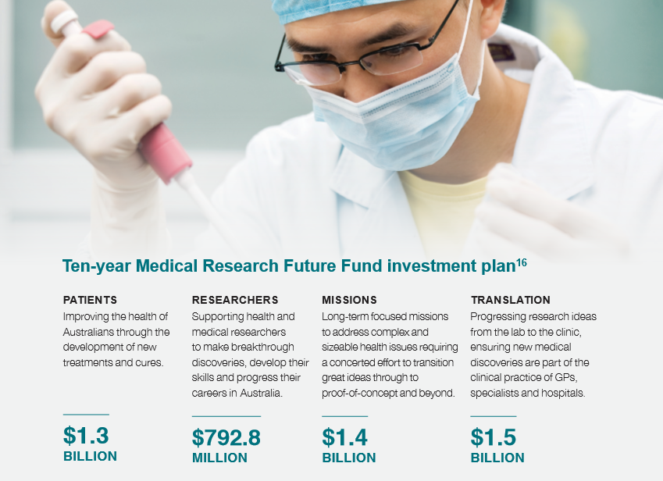

**Table: *Managing risks***

|  |  |
| --- | --- |
| Key risks | Management strategies |
| The implementation of the ten-year Medical Research Future Fund investment plan and other MRFF initiatives is delayed.  The states and territories are delayed in implementing important clinical trial system redesign strategies. | We will apply rigorous project management processes and establish governance arrangements.  We will proactively engage with internal and external stakeholders to ensure collaboration and management of expectations. |

**Table: *Measuring our performance against key measures***

|  |  |
| --- | --- |
| Performance criteria | |
| A sustainable source of funding is provided for transformative health and medical research that improves lives, contributes to health system sustainability and drives innovation.  (Program 1.1: Health Policy Research and Analysis – 2019-20 Health Portfolio Budget Statements p.50) | |
| *Target 2019-20*  Investments announced, grant opportunities offered and grant agreements executed under various MRFF initiatives consistent with the Medical Research Future Fund Act 2015. | *Target 2020-21 (& beyond)*  The next set of MRFF priorities will be released in 2021.  The next five-year MRFF Strategy will be released in 2022. As per 2019-20. |

16 from 2018-19 to 2027-28.

#### Ageing well and aged care

To improve the wellbeing of older Australians, we support them and their families, representatives and carers. We are working with the sector to develop policy and implement programs to provide targeted support, access to quality care and related information services.

Aligns to Outcomes 2 & 6

Our aim

* + Improve wellbeing for older Australians through targeted support, access to quality care and related
  + information services.
  + Ensure the provision of sustainable quality aged care, including equitable care for people from diverse backgrounds, and support for people with dementia.
  + Support a sustainable aged care system underpinned by strong and effective assessment and funding arrangements.
  + Provide support and services that promote greater independence, mobility and autonomy, reducing or delaying the need for more complex aged care support services.
  + Help older Australians and their families to engage with and understand the aged care system, have a greater say in the care they receive, and have increased confidence in the quality of their care and services.
  + Continue to design sound policy and deliver a range of services to support independence and wellness for older Australians, including providing aged care information and assessment of needs through My Aged Care.
  + Ensure policy development and service delivery meet the needs of vulnerable and hard-to-reach older Australians, including people living with dementia.
  + Improve aged care regulation to give greater confidence to older Australians about the quality of care being delivered by aged care providers.
  + Support reform of Australia’s aged care workforce to ensure it is well placed to meet current and future needs.

##### Or challenges

* Continuing increase in demand for aged care services, due to Australia’s ageing population.
* Ensuring aged care services are able to adapt to the changing needs and expectations of older people.
* Ensuring aged care services are available and accessible to the increasing numbers of people living with dementia, people with chronic health conditions and people living with disability.
* Addressing residential care sector financial pressures.
* Managing financial and prudential risk in the sector.
* Ensuring the information is available to support consumers of aged care services to make the best choices for their care.
* Ensure access to My Aged Care meets the needs of consumers, including through better use of technology while catering to those with diverse needs.
* Ensuring a strong regulatory framework for home care and residential care.
* Supporting industry to build aged care workforce capability.

##### Our work to achieve this initiative

* Improving the My Aged Care website, providing greater transparency of quality in aged care, simplifying forms, and implementing a new framework for streamlined and faster assessments for all aged care services.
* Continuing to implement initiatives to help people make better health choices, improve mental health services and promote physical activity for older Australians.
* Supporting older Australians to stay living independently in their own homes for longer, while still receiving the support and services they need to remain connected to their communities.
* Implementing the Specialist Dementia Care Program to help people experiencing severe behavioural and psychological symptoms of dementia.
* Piloting a new navigator system to support older people to access the aged care services they need and build their capacity to understand and engage with the aged care system.
* Developing options to improve access to quality aged care services for people in regional, rural and remote locations.
* Delivering culturally appropriate care for older Aboriginal and Torres Strait Islander Australians close to home.
* Continuing to implement new models of palliative care in aged care facilities and end-of-life coordination.
* Continuing to strengthen regulation in aged care.
* Continuing to support the Royal Commission into Aged Care Quality and Safety.
* Continuing to develop and test an alternative funding tool to replace the Aged Care Funding Instrument.
* Implementing measures for improved medication management including appropriate prescribing in residential aged care.

##### Our role and that of our partners

* We will continue to strengthen relationships with our stakeholders to improve services.
* We will develop capability to strengthen
* regulatory practices relating to residential aged care facility monitoring.
* We will continue to work with state and territory governments to improve quality and safety in aged care.
* We will continue to work closely with other government departments, such as the Department of Human Services (Services Australia) that undertakes means testing and administers payments, and the Department of Social Services, which provides assistance, support and services for people with a disability and their carers.
* We will continue to work with the Aged Care Quality and Safety Commission to deliver current regulatory obligations.
* We will continue to work with older Australians, their carers and families to ensure My Aged Care is accessible and easy to navigate.
* We will continue to support the families and carers of older Australians through inclusive aged care
* assessments, referral to carer support and access to respite services.

**Table: Managing risks**

|  |  |
| --- | --- |
| Key risks | Management strategies |
| The My Aged Care contact centre and website does not provide information and guidance to customers in a timely manner, impacting older Australians and their families and carers from accessing the support they need.  The quality of aged care facilities is not adequate, exposing vulnerable people to sub-standard care.  Home care packages are insufficient to meet the needs of the ageing population and are not tailored to required services.  Insufficient capability to manage sector prudential and financial viability risks.  Availability of sufficient and suitably skilled aged care workforce. | Through the new My Aged Care website, launched in June 2019, older Australians, their families and carers can register with My Aged Care, access information and get help connecting with service providers. Continued improvements to the website will enable consumers to access information they need at any time and free up the contact centre to help those who have more complex questions or cannot access the internet.  The independent Aged Care Quality and Safety Commission enables flexible and responsive regulatory powers, providing assurance to residents of aged care facilities.  The Government is investing in new high-level home care packages, which will be complemented by new residential care places and restorative places.  The department is undertaking a review of prudential standards with the aim of strengthening these standards.  The department is working with the Aged Care Workforce Industry Council to support the implementation of the Aged Care Workforce Strategy. |

**Table: Measuring our performance against key measures**



|  |  |
| --- | --- |
| Performance criteria | |
| Maintain efficiency of My Aged Care assessments as demonstrated by the percentage of:   1. High priority comprehensive assessments with clinical intervention completed within two calendar days of referral acceptance. 2. High priority home support assessments completed within ten calendar days of referral acceptance.   (Program 6.1: Access and Information – 2019-20 Health Portfolio Budget Statements p.119) | |
| *Target 2019-20*  a. >90.0%  b. >90.0% | *Target 2020-21 (2021-22 & 2022-23)*  a. >90.0% (>90.0% & N/A17)  b. >90.0% (>90.0% & N/A18) |
| Commonwealth Home Support Programme (CHSP) provides older people with entry-level support to stay independent and live in their homes and communities for longer.19  (Program 6.2: Aged Care Services – 2019-20 Health Portfolio Budget Statements p.121) | |
| *Target 2019-20*  Support the CHSP to deliver activities that support independence and wellness. | *Target 2020-21 (& beyond)*  As per 2019-20. |

17 Subject to Government decision post June 2020.

18 Ibid.

19 This is measured through program evaluation and by accessing data from My Aged Care.

**Table: Performance criteria**

|  |  |
| --- | --- |
| Performance criteria | |
| Support is provided to older people with complex care needs to keep them living independently in their own homes through the Home Care Packages program.  a. Number of allocated Home Care Packages.  (Program 6.2: Aged Care Services – 2019-20 Health Portfolio Budget Statements p.121) | |
| *Target 2019-20*  a. 144,900 | *Target 2020-21 (2021-22 & 2022-23)*  a. 148,200 (153,400 & 157,200) |

#### Reshaping Australian sport

We are aiming for Australia to be the world’s most active sporting nation, known for its integrity, sporting success and world leading sports industry.

Aligns to Outcome 3

Our aim

* Increase physical activity and participation in sport.
* Use sport as a platform to help address disadvantage, gender equality and social inclusion challenges.
* Strengthen the sports industry, including coordinating Australia’s hosting of major sporting events.
* Reduce the incidence of water and snow-related injury and deaths in Australia.
* Safeguard the integrity of sport, including by implementing key national reforms and leading effective national and international collaboration to combat integrity threats.
* Drive sporting excellence and success, national pride, inspiration and motivation through international sporting success.

##### Our challenges

* Encouraging more Australians to play sport or engage in physical activity.
* Lack of suitable sporting facilities or inefficient use of existing sporting facilities.
* Identifying, addressing, and deterring threats to sport integrity.
* Increasing costs associated with hosting major international sporting events.

##### Our work to achieve this initiative

* Continuing to support the delivery of *Sport 2030*, Australia’s first national sport plan.
* Increasing participation in physical activity through promotion and better access to quality facilities.
* Delivering the Government’s local community sports infrastructure grants.Continuing to support the hosting of major sporting events in consultation with state and territory governments and sports and physical activity organisations, including the T20 World Cup 2020 and supporting Football Federation Australia’s bid to host the 2023 FIFA Women’s World Cup.
* Providing funding to key water and snow safety organisations to conduct activities in accordance with an approved activity plan.
* Developing and implementing the Australian Sports Diplomacy 2030 strategy, with the Department of Foreign Affairs and Trade.
* Developing a Sports Industry Growth Plan.
* Implementing the Government’s response to the Review of Australia’s Sports Integrity Arrangements (Wood Review).
* Supporting national sport organisations and state and territory partners through a range of sports integrity initiatives.
* Supporting effective and targeted engagement with international stakeholders to address global sports integrity threats.

##### Our role and that of our partners

* We work closely with Sport Australia (Australian Sports Commission), states and territories and national sporting organisations to develop, implement and promote policies and strategies to increase participation in sport.
* We assist the Australian Sports Anti-Doping Authority to provide an effective national anti-doping framework.
* We support water and snow safety organisations to promote the importance of water and snow safety.
* We strategically coordinate the support of Australian Government agencies involved in delivering major international sporting events in Australia.
* We work closely with sports, industry, regulators,
* law enforcement, states and territories and other partners in Australia and internationally to safeguard the integrity of sport.

**Table: Managing risks**

|  |  |
| --- | --- |
| Key risks | Management strategies |
| Without increased opportunities for participation in sport and promotion of sport and physical activity across the community (particularly for children), chronic disease risk will continue to increase.  Compromised integrity and corruption of Australian sport reduces public confidence in the sector, and undermines the economic, social, cultural and health benefits of sport. | Through the Better Ageing grants program we will provide increased opportunities for older people to participate in and benefit from being more active. Grants to improve local community infrastructure will also enable increased participation and activity.  The implementation of the comprehensive Government response to the recommendations of the Wood Review will provide Australia with a world’s best framework and capability to safeguard Australian sport from integrity compromises including criminal exploitation of sport, match-fixing and related corruption, doping, illicit drug use and other unethical practices in sport. |

**Table: Measuring our performance against key measures**

|  |  |
| --- | --- |
| Performance criteria | |
| Participation in sport is supported through the development, implementation and promotion of national policies and strategies.  (Program 3.1: Sport and Recreation – 2019-20 Health Portfolio Budget Statements p.80) | |
| *Target 2019-20*  Support the ongoing delivery of the Australian Government’s sport policies and initiatives, including implementation, monitoring and evaluation of relevant programs and initiatives.  Provide strategic, high quality policy advice to Government. | *Target 2020-21 (& beyond)*  As per 2019-20.  Ongoing monitoring of key targets and outcomes of *Sport 2030* such as ‘by 2030, 15% more Australians participating in at least 150 minutes of moderate to vigorous activity each week’. |
| Whole-of-government leadership and coordination of major international sporting events in Australia is provided, including the development and implementation of related policies and strategies, to support each event.  (Program 3.1: Sport and Recreation – 2019-20 Health Portfolio Budget Statements p.80) | |
| *Target 2019-20*  Policies and operational arrangements are implemented to meet agreed Australian Government commitments to support the:   * International Cricket Council T20 World Cup Australia 2020 men's tournament; and * submission of a potential Australian bid for the 2023 FIFA Women’s World Cup. | *Target 2020-21 (& beyond)*  Policies and operational arrangements are implemented to meet Australian Government commitments to support future major sporting events in Australia. |
| The integrity of Australian sport is protected from threats of match-fixing, doping, criminal infiltration and other forms of corruption.  (Program 3.1: Sport and Recreation – 2019-20 Health Portfolio Budget Statements p.81) | |
| *Target 2019-20*  Contribute to the review of the World Anti-Doping Code and implement required changes to Australia’s anti-doping arrangements to align with the revised Code.  Implement the Government response to the Wood Review working with national sporting organisations, Commonwealth partners, states and territories, and other stakeholders.  Support the establishment of the National Sports Tribunal and preparations to establish  Sport Integrity Australia. | *Target 2020-21 (& beyond)*  As per 2019-20. |

Our capability

**We have the right capability to be a high performance organisation.**

More than 4,000 people work at the Department of Health in locations around Australia. Our people and our partnerships with health, aged care and sport stakeholders are central to the delivery of our objectives and achievement of our purpose.

The Department’s People Strategy 2016–20 sets out our strategy to enhance the performance of individuals, teams and the organisation as a whole. We will continue to invest in building a high-performance organisation that:

* delivers the Government’s agenda and strategic priorities
* provides trusted, evidence-based policy advice
* aligns and maintains organisational functions, performance and capability to meet current and emerging priorities.

Our capability improvement agenda continues to focus on the key areas outlined below.

**Leadership and management** – We continue to foster leadership capability at all levels and build the skills of our managers to ensure we have a capable, agile and productive workforce.

**Project management and governance** – The department is focused on strengthening the implementation and delivery of the Government’s priorities through enhancing project management capability and effective governance.

We partner with state and territory governments to govern the broader health system including through our role in the Council of Australian Governments Health Council, the Australian Health Ministers’ Advisory Council (AHMAC) and AHMAC’s principal committees.

**Strategic policy advice** – The department provides high-level, long-term strategic advice that delivers on the Government’s agenda. We operate in a constantly evolving domestic and global health landscape.

We approach the development of policy and advice holistically, work effectively in partnership with our stakeholders, understand our challenges, and identify opportunities for lasting change that improves health outcomes.

**Data, analytics and informatics** – The department effectively harnesses data and analytics to inform evidence-based decision-making.

We work collaboratively with other agencies, jurisdictions and non-government partners to securely analyse large datasets to provide insights to decision-makers, building on a strong foundation of data governance. We are enhancing our information management capability, systems and processes to facilitate accountability, transparency, preservation, collaboration and deliver better digital services.

**Stakeholder engagement and collaboration** – The department continues to strengthen its stakeholder collaboration and engagement. We understand the importance of shared responsibility and ongoing collaboration with our stakeholders and the need to work together to continually improve our health system. We invest in methods to improve and support effective stakeholder engagement, including equipping our staff with the right skills and tools.

**Workforce diversity and inclusiveness** – We continue to invest in attracting, developing and retaining a diverse workforce. We value the range of views and approaches diversity brings to the workplace. We are committed to being inclusive, culturally aware, and responsive to the needs of individuals in our policies and practices.

**Enabling functions** – The Corporate Operations Group is the department’s enabling and support team, providing professional, collaborative corporate services that include financial and people management, legal, assurance, communication, parliamentary and information technology support and services.

## Our management of risk

**We continue to build our risk culture and awareness around the management of risks.**

The department maintains its critical role in providing high-quality, evidence-based advice to the Government on how we can continue to improve health outcomes for all Australians, now and for future generations.

Work is ongoing on our risk management framework, with regular updates to our Risk Management Policy, Enterprise Risk Appetite Statement and Enterprise Level Risks. Providing practical and relevant guidance to staff on engaging with risk is a key priority for us.

Our Risk Management Policy aligns with both the Risk Management International Standard and the Commonwealth Risk Management Policy.

Our risk management framework is designed to mature as our environment and requirements of the department change, allowing us to be responsive and contemporary. The framework is currently focused on building risk management capability. This includes developing a risk management training program, and embedding the management of risk into key business processes by using risk management as a business improvement tool.

We will also continue to confidently identify, manage and implement new practices to deliver on our purpose and key initiatives.

=