Department of Health

Evaluation of Cape York Wellbeing Centres

Final Evaluation Report

APpendices

September 2014

C

# Contents

Contents i

Tables ii

Figures iv

Introduction 1

Appendix 2: Stakeholders Consulted 2

Appendix 3: Profile of Clients Interviewed 5

Appendix 4: Staff Survey – Staff Profile 7

Appendix 5: HOI’s CYWBC Program Theory 9

Appendix 6: Service Description, WBC Service Agreement and Alignment 11

6.1 Key elements of the WBC service agreement 11

6.2 Service model alignment 12

Appendix 7: Individual Outcome Measures Impact 14

7.1. Audit 14

7.2. K10 15

7.3. HoNOS 17

Appendix 8: Local Clinical Presentations and Hospital Admissions – Alcohol 21

8.1 Local Primary Health Care Clinic Presentations 21

8.2 Queensland Health Admitted Patient Data Collection 22

Appendix 9: Local Clinical Presentations and Hospital Admissions – Other Drugs 25

9.1 Local primary health care clinic presentations 25

9.2 Queensland Health Admitted Patient Data Collection 26

Appendix 10: Local Clinic Presentations and Hospital Admissions – Assault 28

10.1 Local primary health care clinic presentations 28

10.2 Queensland Health Admitted Patient Data Collection 29

Appendix 11: Self-reported Impact on Client 30

Appendix 12: Queensland Health ATODS data 32

Appendix 13: Case Studies 34

Appendix 14: Queensland Government Key Indicators 35

14.1 Snapshot summary 35

14.2 Charges resulting in a conviction of alcohol carriage offences 37

14.3 Hospital admissions for assault related conditions 38

14.4 Reported offences against the person 41

14.5 Mossman Gorge reported offences against the person 42

Appendix 15: Service Activity and Client Profile 43

15.1 Service activity 43

15.2 Profile of clients and presentations 49

Appendix 16: Service Comparison to Similar Communities 68

1.1. Access 68

Appendix 17: Community Engagement Data 71

17.1 Number of clients by year 71

17.2 Who is using and not using the WBC 71

17.3 Self-referrals 73

T

# Tables

Table 1.1: Sequence and purpose of evaluation reports 14

Table 1.2: Key evaluation questions by domain 15

Table 1.3: Report Structure 20

Table 2.1: Statistical summary of changes in AUDIT, SDS and IRIS scores 25

Table 2.2: Annual changes in charges resulting in a conviction for breaches of sections 168B and 168C of the Liquor Act, 1992 28

Table 2.3: Snapshot of AOD impact indicators by community 32

Table 2.4: K10 – Statistical overview of score changes (n=153) 35

Table 2.5: Statistical overview HONOS score changes 36

Table 2.6: IRIS profile of WBC clients – mean scores 37

Table 2.7: Snapshot of SEWB impact indicators by community 44

Table 2.8: Comparison HoNOS first scores WBC and Cairns SEWB team 46

Table 2.9: Number of indicators improving/deteriorating 47

Table 3.1: Number and proportion of all clients and FRC clients completing selective module streams 65

Table 3.2: Original referral sources 71

Table 3.3: WBC’s staff by category 1 80

Table 3.4: Indigenous staff activity 82

Table 3.5: WBC operating costs and unit costs 87

Table 4.1: Comparison of what works 97

F

# Figures

Figure 5‑1: Program Theory for the CYWBC 10

Figure 8‑1: Presentations where alcohol was a primary presenting reason 21

Figure 8‑2: Presentations where alcohol was listed as a contributing factor 22

Figure 8‑3: Admissions where principal diagnosis is mental health and behavioural disorders due to use of alcohol 23

Figure 8‑4: Admissions where other diagnosis is mental health and behavioural disorders due to use of alcohol 23

Figure 9‑1: Presentations where other drugs was a primary presenting reason 25

Figure 9‑2: Presentations where other drugs were listed as a contributing factor 26

Figure 9‑3: Admissions where principal diagnosis is mental health and behavioural disorders due to use of cannabinoids 26

Figure 9‑4: Admissions where other diagnosis is mental health and behavioural disorders due to use of cannabinoids 27

Figure 10‑1: Presentation where assault was a primary presenting reason 28

Figure 10‑2: Presentations where violence was listed as a contributing factor 29

Figure 10‑3: Admissions where assault was mentioned as being factor 29

Figure 14‑1: Aurukun. Charges resulting in a conviction of alcohol carriage offences 37

Figure 14‑2: Hopevale. Charges resulting in a conviction of alcohol carriage offences 37

Figure 14.14‑3: Aurukun. Hospital admissions for assault related conditions 38

Figure 14‑4: Coen. Hospital admissions for assault related conditions 39

Figure 14‑5: Hopevale. Hospital admissions for assault related conditions 40

Figure 14‑6: Mossman Gorge. Hospital admissions for assault related conditions 40

Figure 14‑7: Aurukun. Reported offences against the person 41

Figure 14‑8: Coen. Reported offences against the person 41

Figure 14‑9: Hopevale. Reported offences against the person 42

Figure 15‑1: Contacts per client – All clients and FRC clients 45

Figure 15‑2: Total contacts by month since first contact all clients 47

Figure 15‑3: Total contacts by month since first contact FRC clients 47

Figure 15‑4: Reason for presentation all WBCs 56

Figure 15‑5: Reason for presentation males versus females (percentages) 57

Figure 15‑6: Primary and secondary messages – January to June 2013 61

Figure 15‑7: Number of contacts relating to any selective module stream by year 63

Figure 15‑8: Reason for presentation since inception – Aurukun 65

Figure 15‑9: Reason for presentation since inception - Coen 67

Figure 15‑10: Reason for presentation since inception – Hopevale 69

Figure 15‑11: Reason for presentation since inception – Mossman Gorge 71

Figure 17‑1: Age profile of clients 77

Figure 17‑2 Number of self referrals by quarter (all WBCs) 78

Figure 17‑3: Self referrals by quarter – by WBC 79

1

# Introduction

This document presents the appendices associated with the evaluation of Cape York Wellbeing Centres draft final report (May 2014).

It has been presented separately due to its size and for ease of reference of readers when moving between the main report and the appendices.

2

# Appendix 2: Stakeholders Consulted

This appendix provides an overview of stakeholders consulted excluding clients and community members. Consultations took place over three site visits and a significant number of stakeholders listed were consulted on more than one occasion.

Table 2‑1Community based stakeholders

|  |  |
| --- | --- |
| **COEN** | **MOSSMAN GORGE** |
| Coen Wellbeing Centre staff | Council – BBN CEO, Chair, and Housing Officer |
| WBC LAG | Mossman Gorge Wellbeing Centre staff |
| Government Coordination Officer | WBC LAG x 2 |
| Cape York Partnerships Hub Manager | Government Coordination Officer |
| RAATSIC | Cape York Partnerships Opportunity HUB - parenting program manager and HUB manager |
| Justice Group Coordinator | Mossman ATODS |
| Probation and Parole | Apunipima health clinic |
| Queensland Health Clinic | Queensland Mental Health - Mossman Gorge |
| Remote Area Child and Youth Mental Health Service | Probation and Parole |
| QH Mental Health | PCYC |
| Apunipima Health Council | Primary school principal |
| Child Safety | FRC Commissioners X 4 and executive officer |
| Coen Kindy Association |  |
| Lama Lama Rangers |  |
| Kalun Rangers |  |
| FRC Commissioners X2 |  |
| **HOPEVALE** | **AURUKUN** |
| Hopevale Wellbeing Centre staff | Aurukun Wellbeing Centre staff |
| WBC LAG | Cape York Academy X 10 (principal and staff) |
| Government Coordination Office | Government Coordination Office |
| Queensland Police Service | Justice Group |
| Hopevale Clinic staff and manager | Queensland Police Service |
| QH Mental Health and ATODS | Probation & Parole |
| Child Safety | Queensland Mental Health Weipa |
| Art Centre | Child Safety Weipa |
| **HOPEVALE** | **AURUKUN** |
| Probation and Parole | West Cape College |
| Hopevale school | PHAMS |
| FRC coordinator | Aurukun Primary Health Care Clinic |
| Apunipima | Youth worker |
| FRC Commissioners X3 | FRC Commissioners X3 |
| Cooktown School deputy principal | LAG members x 3 |
| Hopevale Council CEO | Cape York partnerships – HUB manager and parenting program |
| Local program officers |  |
| Cooktown Community Centre Coordinator |  |

Table 2‑2: Non-community based stakeholders

|  |  |
| --- | --- |
| **Queensland Health** | |
| Sam Schefe and Allanah Obrien | Director MH & ATODS  Cape York Hospital & Health Service Director Cape York South Child Safety  (and former Director) |
| **Apunipima** | |
| Paul Stephenson | Director Primary Health Care |
| Jackie Mein | Senior medical officer |
| Lou Livingstone | Manager – Social and Emotional Wellbeing |
| **Cape York Institute** | |
| Fiona Jose | CEO, Cape York Institute for Policy and Leadership |
| Zoe Ellerman | Head of Policy |
| Daireen Dwyer | Head Welfare Reform Program Office |
| Project officer (health) | |
| **RFDS** | |
| Angela Jarkiewicz, | Regional Manager (Far North) |
| Alison Brown | Manager Mental Health |
| Maree Cormican | WBC Manger |
| John Hannan | Clinical support |
| Heather Isbister | Nurse Manager primary care |
|  | A number of other RFDS Cairns staff |
| **Family Responsibilities Commission** | |
| David Glasgow | Commissioner |
| Sharon Newcomb | Principal Case Manager |
| Rob White | Registrar |
| **Queensland Aboriginal and Islander Health Council** | |
| Sandy Taylor | Regional SEWB Workforce Coordinator (FNQ) |
| **Evaluation Steering Committee** | |
| John Shevlin | Department of the Prime Minister and Cabinet |
| Brenda Campe | Department of the Prime Minister and Cabinet |
| Kathy Brown | Department of Health |
| Tim Albers | Department of Health |
| Kristina Musial-Aderer | Department of the Prime Minister and Cabinet |
| Darren Benham | Department of the Prime Minister and Cabinet |
| Connie Archer | Department of the Prime Minister and Cabinet |
| Helena Wright | Department of the Prime Minister and Cabinet |
| Steve Marshall | Planning and Partnership Unit, Queensland Health |
| Ben Norris | Partnerships and Diversions Programs, Queensland Health |
| **Expert Reference Group** | |
| A/Prof John Pead | Cape York Family Centre |
| Professor Dennis Grey | Deputy Director, National Drug Research Institute  Curtin University |
| Ernest Hunter | Regional Psychiatrist, Queensland Health |
| Professor Cairan O’Faircheallaigh | Griffith Business School |
| **Other** | |
| Manager Mental Health Services | Far North Queensland Medicare Local |
| Representative for Professor Komla Tsey, | Team Leader, Education for Social Sustainability, James Cook University |
| The Department of Aboriginal and Torres Strait Islander and Multicultural Affairs (Queensland) | |

3

# Appendix : Profile of Clients Interviewed

Appendix 4 sets out a profile of all clients who were interviewed during both phase 1 and phase 2 site visits. Twenty three clients were interviewed in the phase 2 evaluation and 32 clients were interviewed in the phase 1 evaluation. Four clients were interviewed in both phases and their information has only been included once in the data below.

* 51 clients interviewed, 34 male and 17 females
* average age 38.5 years ranging from 17 – 65 years (median 34.5 years)
* average time from first visit to date interviewed 2.5 years
* attendance pattern
  + 33% attended regularly
  + 17% attend frequently
  + 25% attend as required
  + 14% attended weekly, fortnightly or monthly
  + 12% attend infrequently and/or inconsistently

Table 3‑1 presents the referral source for clients interviewed. Self-referral and FRC were the two most common sources of referral.

Table 3‑1: Referral source for clients interviewed

|  |  |  |
| --- | --- | --- |
| **Referral source** | **Number** | **Percent** |
| Self | 23 | 40% |
| FRC | 18 | 32% |
| Child safety | 4 | 7% |
| Probation & parole | 5 | 9% |
| Mental health | 2 | 4% |
| Queensland Health | 1 | 2% |
| Health | 1 | 2% |
| Cape York partnerships | 1 | 2% |
| Youth justice | 1 | 2% |
| **Total** | **571** | **100%** |

Note (1): Greater than number of clients. Difference due to clients continuing after mandatory referral ends.

Table 3‑2 presents the profile of modules completed by clients who were interviewed. The profile of modules completed aligns with the reason for presentation as presented in the following table.

Table 3‑2: Modules completed

|  |  |  |
| --- | --- | --- |
| **Module** | **Number** | **Percent of clients** |
| Alcohol and Other Drug Misuse Modules | 18 | 32% |
| Relationships/Parenting and Family Modules | 18 | 32% |
| Domestic Violence Modules | 9 | 16% |
| Mental Health Modules | 8 | 14% |
| Judicial Modules | 4 | 7% |
| **Total** | **57** | **100%** |

Note (1): Some clients completed more than one module. 21 clients were recorded as not completing a module, 6 clients partially completed a module.

Table 3‑3 presents the reasons for presentation for the clients interviewed (note clients can and do have multiple reasons for presentation).

Table 3‑3: Reasons for presentation

| **Reason for presentation** | **Number** | **Percent** |
| --- | --- | --- |
| Mental health disorders | 27 | 26% |
| Alcohol and other drug and dependence | 21 | 20% |
| Anger management | 15 | 14% |
| Welfare support | 13 | 13% |
| Relationship breakdown/problems | 9 | 9% |
| Child safety/advocacy | 9 | 9% |
| Breached parole /court related | 5 | 5% |
| Limited coping skills | 3 | 3% |
| Intellectual disability | 1 | 1% |
| **Total** | **103** | **100%** |

4

# Appendix : Staff Survey – Staff Profile

Appendix 5 sets out the profile of staff who responded to the staff survey.

Table 4‑1 presents the number and location of respondents. The response rate for surveys that could be included in the analysis was about 45%. All sites were included in the survey analysis. While staff survey data is informative it cannot be considered definitive given the limited number of responses. It was supplemented by conducting staff and management interviews during community visits and at Cairns base.

Table 4‑1: Number and location of respondents

|  |  |  |
| --- | --- | --- |
|  | **Number** | **Percent of respondents** |
| Aurukun | 1 | 7% |
| Coen | 0 | 0% |
| Hopevale | 6 | 43% |
| Mossman Gorge | 4 | 28% |
| Cairns Base | 3 | 21% |
| **Total** | **14** | **100%** |

Table 4‑2 presents the length of time respondents have been working at the WBC. Of note is that 35% of respondents were working at the WBCs for less than 12 months.

Table 4‑2: Length of time respondents working at the WBC

|  |  |  |
| --- | --- | --- |
| **Length of time** | **Number** | **Percent** |
| Less than 6 months | 3 | 21% |
| Less than 1 year | 2 | 14% |
| More than 1 year | 4 | 28% |
| More than 2 years | 2 | 14% |
| More than 3 years | 3 | 21% |
| **Total** | **14** | **100%** |

Table 4‑3 presents the respondents role. Overall there is good cross section of roles included in the survey responses.

Table 4‑3: Respondents role at the WBC

|  |  |  |
| --- | --- | --- |
| **Role** | **Number** | **Percent** |
| Manager | 2 | 14% |
| Team Leader | 3 | 21% |
| Clinical Councillor | 4 | 28% |
| Community Councillor and Development Officer | 2 | 14% |
| Community Development Consultant | 1 | 7% |
| Project Officer - clinical | 1 | 7% |
| Project Officer - non clinical | 1 | 7% |
| **Total** | **14** | **100%** |

Table 0:4 presents the Aboriginal status of respondents.

Table 4‑4: Respondents Aboriginal status

|  |  |  |
| --- | --- | --- |
| **Aboriginal Identification** | **Number** | **Percent** |
| Yes | 3 | 21% |
| No | 11 | 78% |
| **Total** | 14 | 100% |

In conclusion the survey response profile provides a good basis for analysis with the proviso that 35% of respondents were working at the WBCs for less than 12 months.

5

# Appendix : HOI’s CYWBC Program Theory

Appendix 6 presents the CYWBC program theory documented by HOI. Please refer to Figure 5‑1 overleaf.

Figure 5‑1: Program Theory for the CYWBC

**SERVICE MANAGEMENT**

**(Competent and stable staffing / Service availability)**

**PARTNERSHIPS  
(Other Agencies and Community based Groups)**

**COMMUNITY ENGAGEMENT**

**WELL BEING CENTRES ESTABLISHED**

Governance/Service Agreement/ Service Model  
Facilities/Policies and Procedures/ Recruitment

**Programs provided or supported**

* Types – Individual/family counselling, Group programs, Education, Community development
* Topics - D&A, Mental Health, Family Violence, Physical Health, Parenting, Cultural/Spiritual
* Settings - In-centre, home, community, outstation, other service based (e.g. school, clinic)

**Individuals and families participate in WBC programs**

* Referrals from other agencies including mandated FRC
* Self or family referrals (voluntarily)

**Individuals are well enough and are motivated to take personal responsibility for individual, family and community functioning**

6

# Appendix : Service Description, WBC Service Agreement and Alignment

Appendix 7 provides a description of the key elements of the service agreement between the DoH and RFDS and it sets out whether the key elements of the WBC program theory and service agreement have been integrated into the WBC service model.

## Key elements of the WBC service agreement

The key elements for the WBC service agreement include:

* The operation of a service model which is culturally safe and competent for both clients and staff. To this end, developing, supporting and involving ‘grass roots’ community input at the ‘front‐end’ is critical to ensuring the implementation of services which are accessible, responsive and appropriate to each community’s local needs and culture, including consideration of traditional views of health and healing.
* A point of contact for community members to access support services by identifying the services needed by a person and to ‘connect’ the person to the services in the most appropriate way (with the WBC providing the needed service directly, or providing seamless referral to the necessary service).
* Clinical assessment, care planning, counselling, follow up, linkages/referrals with other community and non‐community based alcohol and other drug services, and linkages/referrals with other health services, including primary health care brief intervention strategies, mental health co‐morbidity responses, and other specialist support services as appropriate.
* Flexible services for individuals and their families, delivered from the WBC and also from other locations (e.g. homes, schools, outstations etc.).
* Active support for the development of community based initiatives aimed at addressing alcohol and other drug abuse, family violence, gambling etc. (includes early intervention, health promotion and education activities).
* A visible anti‐abuse presence in the community and equipping other members of the community, such as other service workers, with the tools to better confront destructive social norms when they encounter them.
* A ‘community based’ model of care where the focus of the WBCs will be the quality and cultural appropriateness of the services being delivered on the ground in communities, including the degree to which local autonomy and decision making are promoted and evident. This will be reflected through:
  + maximising the employment of local Aboriginal and Torres Strait Islander staff, and creating organisational arrangements which strengthen and empower these staff to exercise leadership roles within the WBCs and their communities
  + building the capacity of the LAGs to ensure their input into the direction and operation of the WBCs is highly valued
  + maximising the number of community based staff (compared to fly‐in outreach arrangements).
* Responding to referrals from the FRC through a Memorandum of Understanding that includes agreed referral pathways and formal policy and procedures relating to FRC clients.
* Services that align with and support the objectives and philosophy of the Cape York Welfare Reform Trial, including a holistic and systemic approach to treating addiction, preventing gambling, addressing family violence, confronting denial, promoting self-responsibility and rebuilding norms at the individual, family and community level.
* Pathways to employment through collaboration with relevant job readiness and training providers.

These key elements can be aligned to the evaluation domains of; Service Management, Service Model, Partnerships and Community Engagement.

## Service model alignment

The following table sets out the key elements of the WBC program theory and service agreement and whether they have been integrated into the WBC service model.

Table 6‑1: Service model alignment

| **Source** | **Key element** | **Incorporated into WBC service model** |
| --- | --- | --- |
| WBC program theory/CYWRT | Behaviour change program consistent with Kelman’s theory of influence[1] | ✓ |
| Village hub concept | ✓ |
| Accept mandatory referrals | ✓ |
| Partner with other organisations | ✓ |
| Service agreement | * Cultural safety and competence * Grassroots community input * Responsive to local need including consideration of traditional views of health and healing | ✓ |
| Key point of contact and referral | ✓ |
| Clinical assessment, care planning counselling follow-up linkage/referral to other providers for alcohol and other drugs and other services   * including structured primary health care brief intervention strategies | ✓  X |
| Flexible services from various service settings | ✓ |
| Active support for development of community based initiatives aimed at addressing alcohol and other drug abuse family violence, gambling etc. | ✓ |
| Visible anti-abuse presents in community and equipping members of the community (including service providers) with tools to better confront destructive social norms | ✓ |
| Community-based model of care including quality and cultural appropriateness and degree of local autonomy | ✓ |
| Responding to FRC referrals | ✓ |
| Alignment with objectives and philosophy of CYWRT | ✓ |
| Pathways to employment through collaboration with other providers | ✓ |

7

# Appendix : Individual Outcome Measures Impact

This appendix presents detailed information on individual outcome measure changes administered as part of the WBC evaluation by the RFDS.

## Audit

Table 0:1 presents the summary of AUDIT screen matched observation score changes in total and by WBC. The table shows overall WBCs demonstrated a small or small to medium clinically significant effect on clients except Aurukun (which had very small numbers and was statistically not significant). Overall WBC clients moved from a score of higher risk or harmful drinking (a score between 16 and 19) to a lower level of risky or hazardous drinking (a score between eight and 15), with variations between WBCs. WBC FRC clients also demonstrated a small clinically and statistically significant effect (there were no statistically significant changes at individual WBCs for FRC clients due to small numbers.

Overall 89 clients (67%) improved their score.

Table 7‑1: AUDIT Summary of changes in total score

|  | **Mean on initial score** | **Mean on review** | **Variation** | **Clinical significance** | **Statistically significant** |
| --- | --- | --- | --- | --- | --- |
| Aurukun (n= 5 ) | 18.2 | 14.8 | 8.50% | 0.62 (medium) | ✗ |
| Coen (n= 45) | 14.24 | 11 | 8.10% | 0.31 (small) | ✓ |
| Hopevale (n= 39) | 14.59 | 11.18 | 8.53% | 0.33 (small) | ✓ |
| Mossman Gorge (n= 44) | 23.75 | 18.86 | 12.23% | 0.44 (small to medium) | ✓ |
| **Total (n= 133)** | **17.64** | **13.8** | **9.60%** | **0.34 (small)** | **✓** |
| **FRC clients (n=43)** | **20.44** | **17.03** | **8.53%** | **0.32** | ✓ |

Note (1): A score of 0-7 reflects a low risk, a score of 8 to 15 represents the risky or hazardous level, score 16 to 19 represents high risk or harmful level, and a score 20 or more represents high risk.

### Severity of Dependence Scale for cannabis

Table 7‑2 presents the Severity of Dependence Scale (SDS) observations for cannabis for matched clients. There is no benchmark data. The table shows across all WBC clients there was a small clinically significant effect which was statistically significant. Overall 75 clients (59%) had a zero initial and review score. At Hopevale and Mossman Gorge, both had a clinically and statistically significant small to medium effect. In the case of Hopevale clients on average moved from the cannabis dependent to the non-dependent category. Coen clients rated very lowly on the cannabis dependence scale.

Table 7‑2: SDS profile of WBC clients – mean scores1

|  | **Mean on entry** | **Mean on review** | **Change in score** | **% Variation** | **Clinical significance** | **Statistically significant** |
| --- | --- | --- | --- | --- | --- | --- |
| Aurukun (n= 4 ) | 5 | 4.75 | 0.25 | 1.67% | 0.07 (none) | ✗ |
| Coen (n= 47) | 1.04 | 0.68 | 0.36 | 2.40% | 0.15 (none) | ✗ |
| Hopevale (n= 31) | 3.68 | 2.06 | 1.62 | 10.80% | 0.44 (small to med) | ✓ |
| Mossman Gorge (n= 45) | 5.44 | 3.4 | 2.04 | 13.60% | 0.47 (small - med) | ✓ |
| **Total (n= 127)** | **3.37** | **2.11** | **1.26** | **8.40%** | **0.33 (small)** | ✓ |

Note (1): A score of three or greater indicates dependence.

### Indigenous risk impact screen (IRIS)

Table 7‑3 presents the IRIS profile of WBC matched clients for both the alcohol and other drug (AOD) and mental health and emotional well-being risk. Note there is a high degree of convergence in the questions asked in this screen with the K10 and AUDIT tool. Overall there was clinically significant effect which was statistically significant for both the AOD (small to medium) and mental health scores (medium). All WBCs demonstrated either small medium or large effect (with Aurukun being not statistically significant due to small numbers).

Table 7‑3: IRIS profile of WBC clients – mean scores

|  | **Mean on entry** | **Mean on review** | **Change in Mean** | **% Variance** | **Clinical significance** | **Statistically significant** |
| --- | --- | --- | --- | --- | --- | --- |
| **AOD** | | | | | | |
| Aurukun (n= 5 ) | 14.80 | 13.80 | 1.00 | 3.57% | 0.2 (small) | ✗ |
| Coen (n= 46) | 11.85 | 9.41 | 2.44 | 8.71% | 0.53 (medium) | ✓ |
| Hopevale (n= 40) | 11.55 | 10.05 | 1.50 | 5.36% | 0.34 (small) | ✓ |
| Mossman Gorge (n=15) | 18.73 | 14.73 | 4.00 | 14.29% | 0.87 (large) | ✓ |
| **Total (n=106)** | **12.85** | **10.61** | **2.24** | **8.00%** | **0.45 (small – med)** | **✓** |

## K10

As shown in Table 7‑4, the WBC clients of Coen and Hopevale showed statistically (p<0.05) and clinically significant changes (Cohen’s d>0.2) in the K10 scale.. Across the WBCs of Coen and Hopevale there was a medium effect (0.5). FRC clients also showed a small clinical significance but not at a statistically significant level. The table also shows a comparison to the Cairns SEWB team. Overall 76 clients (59%) improved their score. There were variations between WBCs which are discussed below.

These findings indicate a positive improvement in the anxiety and depressive symptoms of the clients, with WBC clients remaining on average in Risk Zone II (Likely to have a moderate disorder, K10 score 16-21).[2]

Table 7‑4: K10 – Overview of score changes (n=153)

|  | **First Mean Score** | **Latest Mean Score** | **Change in Score** | **% Change** | **Clinical Significance (Effect Size)** | **Statistically Significant** |
| --- | --- | --- | --- | --- | --- | --- |
| FRC (n=26) | 15.19 | 13.35 | 1.85 | 3.69% | 0.23 (small) | ✗ |
| Other (103) | 19.35 | 16.25 | 3.09 | 6.19% | 0.33 (small) | ✓ |
| **All (n=129)** | **18.51** | **15.67** | **2.84** | **5.69%** | **0.31(small)** | **✓** |
| SEWB Cairns (n=43) | 25.33 | 21.12 | 4.21 | 8.42% | 0.46 (small to medium) | ✓ |

Note (1): 13% of the adult population will score 20 and over and about 1 in 4 patients seen in primary care will score 20 and over.[3],[4]

Note (2): Cohen’s *d* was calculated to establish the clinical significance and size of effect, where a value of >0.2 indicates a small clinical significance and effect, 0.5 a medium effect and 0.8 large effect. A two tailed paired *t* test was then undertaken. The *t* value represents statistical significance, with a value of <0.05 indicating statistical significance.

Note (3): In the case of Mossman Gorge, whilst a number of entry or baseline K10 scores were available for analysis, there were an insufficient number of follow-up scores available to allow for any potential change in score to be reliably interpreted.

Table 7‑5 presents changes in K10 score by WBC. The table shows that Aurukun had no clinically significant effect, Coen had a small effect and Hopevale had a large effect. The changes were statistically significant at all WBCs except Aurukun.

Table 7‑5: K10 Score changes by WBC

|  | **Aurukun (n=46)** | **Coen (n=46)** | **Hopevale (n=37)** | **Total (n=129)** | **SEWB Cairns (n=43)** |
| --- | --- | --- | --- | --- | --- |
| Initial Score | 16.76 | 21.33 | 17.19 | 18.51 | 25.33 |
| Review Score | 16.87 | 18.41 | 10.76 | 15.67 | 21.12 |
| Change in Score | -0.11 | 2.92 | 6.43 | 2.84 | 4.21 |
| % Change | -0.22% | 5.84% | 12.86% | 5.69% | 8.42% |
| Clinical Significance (Effect Size) | -0.01 (none) | 0.33  (small | 0.85  (large) | 0.31 (small) | 0.46 (small to med) |
| Statistically Significant | ✗ | **✓** | **✓** | ✓ | ✓ |

## HoNOS

As reflected in Table 7‑6 in aggregate WBC clients showed no clinically significant effect changes (effect size <0.2) and the change demonstrated was not statistically significant (p>0.05). This was replicated at subscale level. However there are significant differences between WBCs as discussed below. Note it is not appropriate to undertake statistical analysis at the item level and this information is provided for information only. Of the 199 matched scores, 112 clients (57%) improved their score.

Table 7‑6: HONOS Summary of changes in mean scores for WBCs on a per item and subscale basis (n=199)

|  | **First Mean Score** | **Latest Mean Score** | **Change in Score** | **% Change** | **Clinical Significance (Effect Size)** | **Statistically Significant** |
| --- | --- | --- | --- | --- | --- | --- |
| Overactive, aggressive, disruptive behaviour | 1.03 | 0.83 | 0.20 | 1.63% |  |  |
| Non-accidental self-injury | 0.24 | 0.21 | 0.03 | 0.21% |  |  |
| Problem-drinking or drug-taking | 1.06 | 0.97 | 0.09 | 0.71% |  |  |
| **Behaviour Total** | **2.32** | **2.01** | **0.31** | **2.55%** | **.16 (none)** | **✓** |
| Cognitive problems | 0.47 | 0.46 | 0.01 | 0.08% |  |  |
| Physical illness or disability problems | 0.54 | 0.52 | 0.02 | 0.17% |  |  |
| **Impairment Total** | **1.01** | **0.97** | **0.03** | **0.25%** | **.03 (none)** | **✗** |
| Problems associated with hallucinations and delusions | 0.08 | 0.11 | -0.03 | -0.21% |  |  |
| Problems with depressed mood | 1.04 | 0.90 | 0.13 | 1.09% |  |  |
| Other mental and behavioural problems | 0.85 | 0.80 | 0.05 | 0.38% |  |  |
| **Symptoms Total** | **1.96** | **1.81** | **0.15** | **1.26%** | **.09 (none)** | **✗** |
| Problems with relationships | 1.30 | 1.02 | 0.29 | 2.39% |  |  |
| Problems with activities of daily living | 0.50 | 0.49 | 0.02 | 0.13% |  |  |
| Problems with living conditions | 0.86 | 0.91 | -0.05 | -0.42% |  |  |
| Problems with occupation and activities | 0.72 | 0.66 | 0.07 | 0.54% |  |  |
| **Social Total** | **3.39** | **3.07** | **0.32** | **2.64%** | **.10 (none)** | ✗ |
| **Total** | **8.67** | **7.87** | 0.80 | 6.67% | **.14 (none)** | ✗ |

Note (1): The 12 scale HoNOS relates to four health and social domains of Behaviour, Impairment, Symptoms and Social. The 12 HoNOS items are each scored 0-4, yielding a total score in the range 0-48. The Scales are scored according to the following (0, no problem; 1, minor problem requiring no action; 2, mild problem but definitely present; 3, moderately severe problem; 4, severe to very severe problem). With the HoNOS, comparing the total score resulting from adding up all 12 scales is not particularly informative, as they are so wide in their coverage. Marked improvements in one scale or domain may be cancelled out by deterioration in another, such that it looks as if nothing has changed. Looking at changes in individual scales and domains is more helpful in showing areas of service impact. Accordingly, the analysis of the HoNOS scores is focussed on domains

Note (2): HoNOS scores should not be analysed for clinical effectiveness at the item level. The information here is presented for information only.

Note (3): Cohen’s *d* was calculated to establish the clinical significance and size of effect, where a value of <0.2 indicates a small clinical significance and effect, 0.5 a medium effect and 0.8 large effect. A two tailed paired *t* test was then undertaken. The *t* value represents statistical significance, with a value of <0.05 indicating statistical significance.

Table 7‑7 presents scores at a subscale level by WBC and includes the Cairns SEWB team for comparative purposes. On a total score level, there was a medium statistically significant clinical change at Coen and Hopevale and a small change at Mossman Gorge. Scores at Aurukun did not improve and in fact they deteriorated. Excluding Aurukun, the behaviour, symptoms and social subscales were the areas where there was greatest level of improvement although there was a statistically significant improvement in the impairment subscale at Coen, which is to be expected given the focus of the WBCs in behaviour and social areas. One reason for the lack of improvement in Aurukun is likely to be the high level of recent community disruption in that community which in turn has a disruptive impact on individuals.

Table 7‑7: HONOS Summary of changes in mean scores by WBC

| **ALL** | **Aurukun (n=71)** | **Coen (n=47)** | **Hopevale (n=53)** | **Mossman Gorge (n=28)** | **Total (n=199)** | **SEWB Cairns (n=77)** |
| --- | --- | --- | --- | --- | --- | --- |
| **Behaviour** |  |  |  |  |  |  |
| Intial Score | 1.93 | 2.53 | 2.34 | 2.89 | 2.32 | 1.74 |
| Review Score | 2.35 | 1.64 | 1.68 | 2.39 | 2.01 | 1.39 |
| Change in Score | -0.42 | 0.89 | 0.66 | 0.50 | 0.31 | 0.35 |
| % Change | -3.52% | 7.45% | 5.50% | 4.17% | 2.55% | 2.92% |
| Clinical Significance (Effect Size) | -.23 (none) | .48 (small to med) | .39 (small) | .24 (small) | .16 (none) | .19 (small) |
| Statistically Significant | ✗ | **✓** | **✓** | ✗ | **✓** | **✗** |
| **Impairment** |  |  |  |  |  |  |
| Intial Score | 1.15 | 0.83 | 0.58 | 1.71 | 1.01 | 1.65 |
| Review Score | 1.49 | 0.43 | 0.57 | 1.36 | 0.97 | 1.43 |
| Change in Score | -0.34 | 0.40 | 0.02 | 0.36 | 0.03 | 0.22 |
| % Change | -4.23% | 5.05% | 0.24% | 4.46% | 0.38% | 2.76% |
| Clinical Significance (Effect Size) | -.29 (none) | .40 (small) | .02 (none) | .27 (small) | .03 (none) | .14 (none) |
| Statistically Significant | **✓** | **✓** | ✗ | ✗ | **✗** | **✗** |
| **Symptoms** |  |  |  |  |  |  |
| Intial Score | 2.00 | 2.40 | 1.36 | 2.29 | 1.96 | 4.08 |
| Review Score | 2.34 | 1.79 | 1.11 | 1.86 | 1.81 | 2.48 |
| Change in Score | -0.34 | 0.62 | 0.25 | 0.43 | 0.15 | 1.60 |
| % Change | -2.82% | 5.14% | 2.04% | 3.57% | 1.26% | 13.31% |
| Clinical Significance (Effect Size) | -.19 (none) | .36 (small) | .18 (small) | .31 (small) | .09 (none) | .88 (large) |
| Statistically Significant | ✗ | **✓** | ✗ | ✗ | **✗** | **✓** |
| **Social** |  |  |  |  |  |  |
| Intial Score | 4.04 | 2.70 | 2.74 | 4.11 | 3.39 | 3.09 |
| Review Score | 5.08 | 1.72 | 1.47 | 3.25 | 3.07 | 2.61 |
| Change in Score | -1.04 | 0.98 | 1.27 | 0.86 | 0.32 | 0.48 |
| % Change | -8.69% | 8.16% | 10.58% | 7.14% | 2.64% | 4.00% |
| Clinical Significance (Effect Size) | -.28 (none) | .48 (small - med) | .63 (med) | (.35 small) | .10 (none) | .18 (none) |
| Statistically Significant | **✓** | **✓** | **✓** | ✗ | ✗ | **✗** |
| **Total** |  |  |  |  |  |  |
| Intial Score | 9.13 | 8.47 | 7.02 | 11.00 | 8.67 | 10.56 |
| Review Score | 11.27 | 5.57 | 4.83 | 8.86 | 7.87 | 7.91 |
| Change in Score | -2.14 | 2.89 | 2.19 | 2.14 | 0.80 | 2.65 |
| % Change | -4.46% | 6.03% | 4.56% | 4.46% | 1.67% | 5.52% |
| Clinical Significance (Effect Size) | -.32 (none) | .58 (med) | .56 (med) | .37 (small) | .14 (none) | .43 (med) |
| Statistically Significant | **✓** | **✓** | **✓** | **✓** | ✗ | **✓** |

Note (1): Where the review score is higher than initial score the effect size has been listed as none.

Table 0:8 presents the same information for WBC FRC clients only. There was an overall large clinical effect improvement at Coen and a medium improvement at Hopevale and this was driven by all subscales at Coen and the behaviour, symptoms and social subscales at Hopevale. Note in all cases they are non-statistically significant given the small numbers in the sample.

Table 7‑8: HONOS Summary of changes in mean scores by WBC for FRC clients

| **FRC** | **Aurukun (n=16)** | **Coen (n=9)** | **Hopevale (n=7)** | **Mossman Gorge (n=14)** | **Total** |
| --- | --- | --- | --- | --- | --- |
| **Behaviour** |  |  |  |  |  |
| Intial Score | 1.68 | 2.38 | 2.42 | 3.50 | 2.39 |
| Review Score | 2.53 | 1.63 | 1.75 | 3.08 | 2.33 |
| Change in Score | -0.84 | 0.75 | 0.67 | 0.42 | 0.06 |
| % Change | -7.02% | 6.25% | 5.56% | 3.47% | 0.49% |
| Clinical Significance (Effect Size) | -.43 (none) | .54 (medium) | .34 (small) | .19 ( none) | .03 (none) |
| Statistically Significant | ✗ | ✗ | ✗ | ✗ | ✗ |
| **Impairment** |  |  |  |  |  |
| Intial Score | 1.05 | 0.50 | 0.58 | 1.58 | 0.98 |
| Review Score | 1.11 | 0.25 | 0.50 | 1.50 | 0.92 |
| Change in Score | -0.05 | 0.25 | 0.08 | 0.08 | 0.06 |
| % Change | -0.66% | 3.13% | 1.04% | 1.04% | 0.74% |
| Clinical Significance (Effect Size) | -.05 (none) | .33 (medium) | .08 (none) | .06 (none) | .05 (none) |
| Statistically Significant | ✗ | ✗ | ✗ | ✗ | ✗ |
| **Symptoms** |  |  |  |  |  |
| Intial Score | 1.47 | 2.00 | 1.83 | 2.08 | 1.78 |
| Review Score | 1.89 | 1.50 | 1.42 | 1.83 | 1.71 |
| Change in Score | -0.42 | 0.50 | 0.42 | 0.25 | 0.08 |
| % Change | -3.51% | 4.17% | 3.47% | 2.08% | 0.65% |
| Clinical Significance (Effect Size) | -.24 (none) | .4 (small) | .24 (small) | .23 (small) | .05 (none) |
| Statistically Significant | ✗ | ✗ | ✗ | ✗ | ✗ |
| **Social** |  |  |  |  |  |
| Intial Score | 3.32 | 3.25 | 3.00 | 4.17 | 3.43 |
| Review Score | 5.16 | 1.25 | 2.00 | 3.92 | 3.51 |
| Change in Score | -1.84 | 2.00 | 1.00 | 0.25 | -0.08 |
| % Change | -15.35% | 16.67% | 8.33% | 2.08% | -0.65% |
| Clinical Significance (Effect Size) | -.48 (none) | 1.06 (large) | .47 (small - med) | .1 (none) | .03 (none) |
| Statistically Significant | ✗ | ✗ | ✗ | ✗ | ✗ |
| **Total** |  |  |  |  |  |
| Intial Score | 7.53 | 8.13 | 7.83 | 11.33 | 8.59 |
| Review Score | 10.68 | 4.63 | 5.67 | 10.33 | 8.47 |
| Change in Score | -3.16 | 3.50 | 2.17 | 1.00 | 0.12 |
| % Change | -6.58% | 7.29% | 4.51% | 2.08% | 0.25% |
| Clinical Significance (Effect Size) | -.44 (none) | .8 (large) | .49 (med) | .16 (none) | .02 (none) |
| Statistically Significant | ✗ | ✗ | ✗ | ✗ | ✗ |

Note (1): Where the review score is higher than initial score the effect size has been listed as none.

8

# Appendix : Local Clinical Presentations and Hospital Admissions – Alcohol

This appendix presents for people residing in the WBC communities, the CYHHS local clinic presentations related to alcohol and Queensland Health hospital admissions related to alcohol (regardless of the location of the hospital).

## Local Primary Health Care Clinic Presentations

Figure 0‑1 shows that the number of presentations to the relevant local primary health care clinics where alcohol was listed as a primary presenting reason has declined overall, driven by downward trends at all WBCs since the commencement of the WBCs around the mid-2009 calendar year.

Figure 8‑1: Presentations where alcohol was a primary presenting reason

Figure 8.1 is a line graph displaying the number of presentations to the relevant local primary health care clinics where alcohol was listed as a primary presenting reason.  The number of presentations where alcohol was listed as a primary presenting reason has declined overall (from approximately 71 in 2008/9 to 18 in 2013/14).  All WBCs (Aurukun, Coen and Hopevale) displayed a downard trend since the commencement of the WBCs around the mid-2009 calendar year, after a large spike in 2008/9. 

Aurukun displayed approximately 6 presentations at 2004/5, approximately 22 presentations at 2008/9, and approximately 7 presentations at 2013/14.  Coen displayed approximately 16 presentations at 2004/5, approximately 7 presentations at 2008/9, and approximately 6 presentations at 2013/14.  Hopevale displayed approximately 8 presentations at 2004/5, approximately 42 presentations at 2008/9, and approximately 7 presentations at 2013/14.  No data was available for Mossman Gorge.

Note (1): No data available for Mossman Gorge.

Note (2): The primary presenting reason is the primary clinical reason/condition for which the patient is requiring care.  For example in the case of the primary presenting reason relating to alcohol, codes such as ‘Abuse; alcohol; chronic’, ‘Problem; alcohol; chronic’ are used.

Note (3): The total for 2013/14 has been estimated based on doubling the number for the period July to December 2013.

Figure 0‑2 shows that the number of presentations to the relevant local primary health clinics where alcohol was listed as a contributing factor has declined at Hopevale and Coen and that there are significant fluctuations at Aurukun, particularly in 2012/13.

Figure 8‑2: Presentations where alcohol was listed as a contributing factor

Figure 8.2 is a line graph displaying the number of presentations to the relevant local primary health care clinics where alcohol was listed as a contributing factor.  The number of presentations where alcohol was listed as a contributing factor has declined at Hopevale (approximately 160 in 2004/5, to approximately 100 in 2008/9, and approximately 40 in 2013/14) and Coen (approximately 140 in 2004/5, approximately 80 in 2008/9, and approximately 40 in 2008/9). 
Aurukun displayed significant fluctuations, particularly in 2012/13 where there were approximately 450 presentations (approximately 170 in 2004/5, approximately 140 in 2008/9, and approximately 180 in 2013/14).  No data was available for Mossman Gorge.

Note (1): No data available for Mossman Gorge.

Note (2): A contributing factor to the presentation is a factor that may have contributed to the reason for the patient seeking care, but it was not the primary reason for the patient requiring care.  For example, a presenting reason of ‘Injury; neck’, where alcohol was a contributing factor.

Note (3): The total for 2013/14 has been estimated based on doubling the number for the period July to December 2013.

## Queensland Health Admitted Patient Data Collection

This data is based on the Queensland Health Admitted Patient Data Collection which utilises the International classification of diseases (ICD). It represents patients admitted from one of the WBC communities regardless of the location of the hospital. This is different to the coding system used by the CYHHS.

Figure 0‑3 presents admission data where the principal diagnosis is mental health and behavioural disorders due to the use of alcohol. This demonstrates that there has been an upward trend in this admission type since July 2002 to July 2012. Since the establishment of the WBCs there have been significant fluctuations that has largely been driven by Hopevale and to a lesser extent Aurukun.

Figure 8‑3: Admissions where principal diagnosis is mental health and behavioural disorders due to use of alcohol

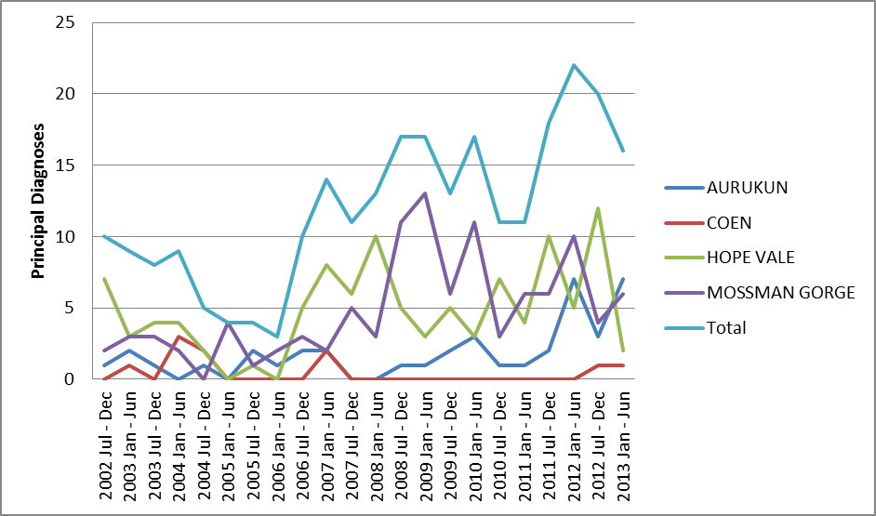

Figure 0‑4 presents admissions where the other diagnosis was mental health and behavioural disorders due to the use of alcohol. This means that it was not the primary reason for the admission to hospital but it was noted as another diagnosis. The trend for this other diagnosis had been significantly upward since January 2011 to June 2011 with the exception that in the January to June 2013 period no other diagnosis was recorded

Figure 8‑4: Admissions where other diagnosis is mental health and behavioural disorders due to use of alcohol

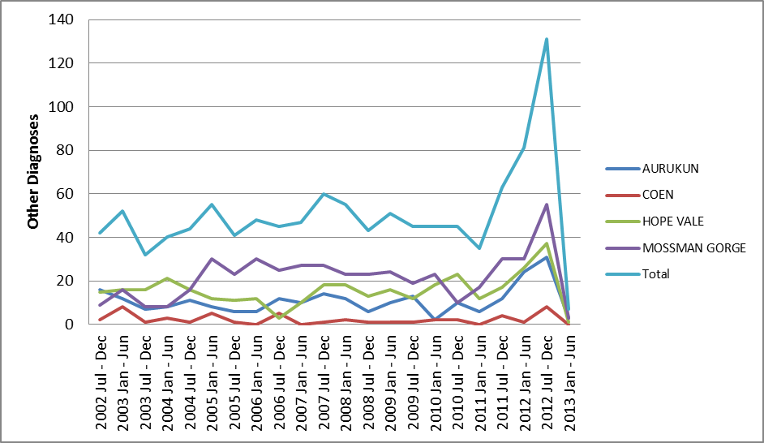

The data is not presented for external course codes in relation to the toxic effect of alcohol or where alcohol use was another factor influencing health status and contact with health services, as there were insufficient numbers. This reflects coding not been done at that level rather than a lack of those type of admissions.

9

# Appendix : Local Clinical Presentations and Hospital Admissions – Other Drugs

This appendix presents for people residing in the WBC communities, the CYHHS local clinic presentations related to other drugs and Queensland Health hospital admissions related to other drugs (regardless of the location of the hospital).

## Local primary health care clinic presentations

Figure 0‑1 shows that the number of presentations to relevant local primary health care clinics where other drugs were listed as a primary presenting reason has declined overall and in each clinic. Of note is that both Hopevale and Aurukun increased in 2012/13 but decreased in 2013/14, although there are significant annual fluctuations and small numbers. Presentations have declined since the commencement of the WBCs.

Figure 9‑1: Presentations where other drugs was a primary presenting reason

Figure 9.1 is a line graph that presents data on the number of presentations at the relevant local PHC where other drugs was a primary presenting reason between 2004/5 and 2013/14.  Data is presented for Aurukun, Coen and Hopevale.   Data for Mossman Gorge was not available.  
The graphs shows a is slightly upward trend in these presentations overalldue to slight increases in all three communities.  The graph shows a large increase in the total number of these presentations between 2006/7 to 2010/11, with the highest number being recorded in Aurukun in 2010/11.  The line then drops down to close to 2004/5 levels in 2011/12.   

Note (1): Data presented since 2006/7 due to very low numbers in earlier years distorting data trends.

Note (2): No data available for Mossman Gorge.

Note (3): The total for 2013/14 has been estimated based on doubling the number for the period July to December 2013.

Figure 0‑2 shows the number of presentations to relevant primary health care clinics where other drugs were listed as a contributing factor has declined since the inception of the WBCS at Hopevale and Coen and also at Aurukun (after a large increase 2012/13 at Aurukun) with significant yearly fluctuations. The overall trend is downwards. Note there are small numbers.

Figure 9‑2: Presentations where other drugs were listed as a contributing factor

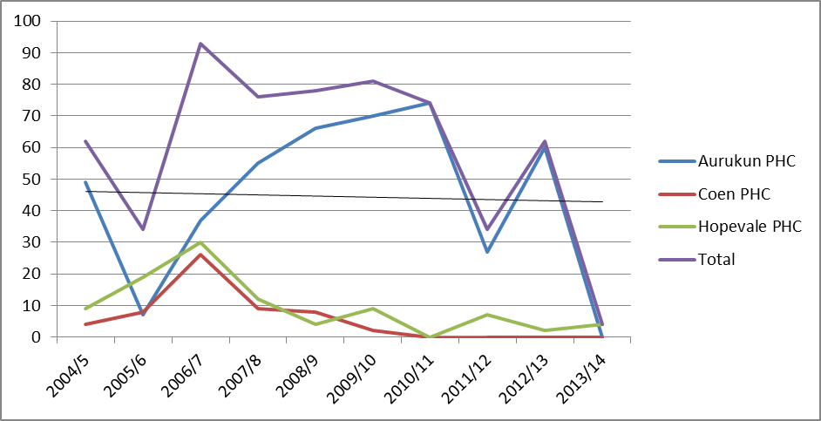

Note (1): No data available for Mossman Gorge.

Note (2): The total for 2013/14 has been estimated based on doubling the number for the period July to December 2013.

## Queensland Health Admitted Patient Data Collection

Figure 0‑3 and Figure 0‑4 present admissions where the principal diagnosis and other diagnosis related to mental health and behavioural disorders due to the use of cannabinoids. The numbers are very small.

Figure 9‑3: Admissions where principal diagnosis is mental health and behavioural disorders due to use of cannabinoids

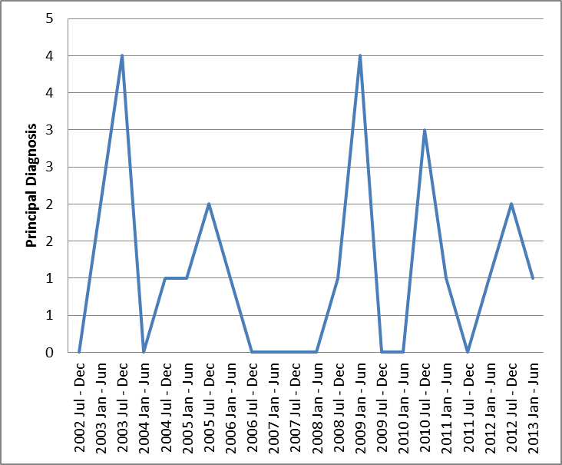

Figure 9‑4: Admissions where other diagnosis is mental health and behavioural disorders due to use of cannabinoids

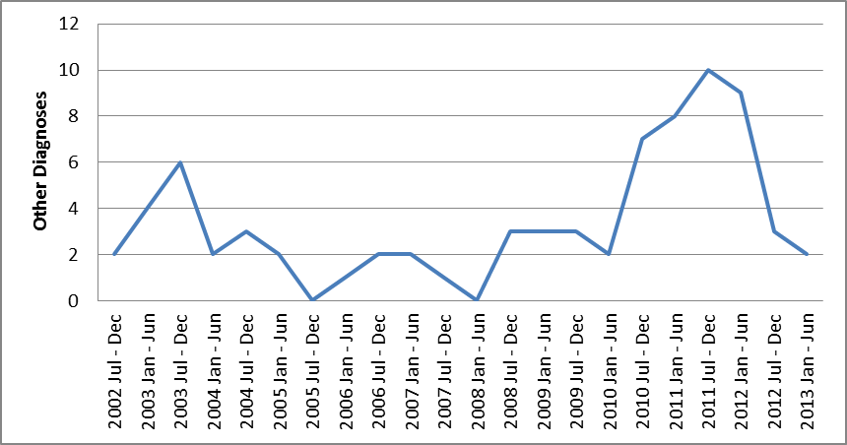

The data is not presented for external course codes in relation to where drug use was another factor influencing health status and contact with health services, as there were insufficient numbers recorded.

10

# Appendix : Local Clinic Presentations and Hospital Admissions – Assault

This appendix presents for people residing in the WBC communities, the CYHHS local clinic presentations related and Queensland Health hospital admissions related assault (regardless of the location of the hospital).

## Local primary health care clinic presentations

Figure 0‑1 shows that the number of presentations to the local primary health care clinics where assault is primary factor has remained static at Hopevale, declined at Coen and increased at Aurukun since the commencement of the WBCs, although there are significant annual fluctuations and small numbers.

Figure 10‑1: Presentation where assault was a primary presenting reason

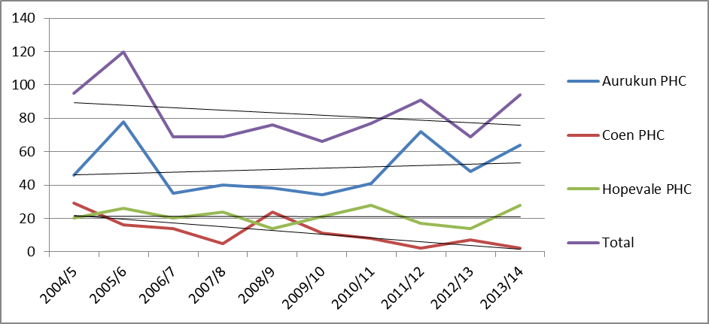

Note (1): No data available for Mossman Gorge.

Note (2): The total for 2013/14 has been estimated based on doubling the number for the period July to December 2013.

Figure 0‑2 shows the number of presentations to relevant primary health care clinics where other assault was listed as a contributing factor has remained static at Hopevale and Coen and increased at Aurukun with significant yearly fluctuations. The overall trend is downwards. Note there are small numbers in some cases.

Figure 10‑2: Presentations where violence was listed as a contributing factor

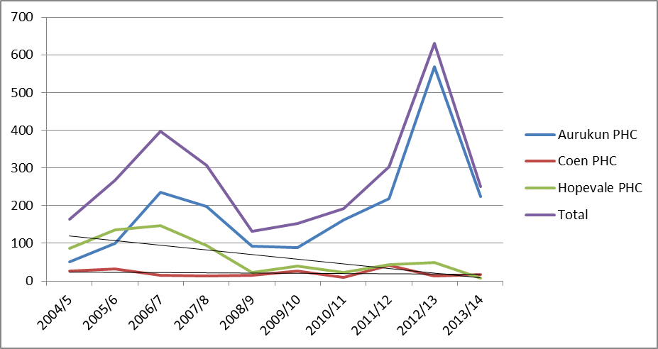

Note (1): No data available for Mossman Gorge.

Note (2): The total for 2013/14 has been estimated based on doubling the number for the period July to December 2013.

## Queensland Health Admitted Patient Data Collection

Figure 0‑3 present admissions where assault was mentioned as being factor in the admission. There are significant annual fluctuations and numbers are small.

Figure 10‑3: Admissions where assault was mentioned as being factor

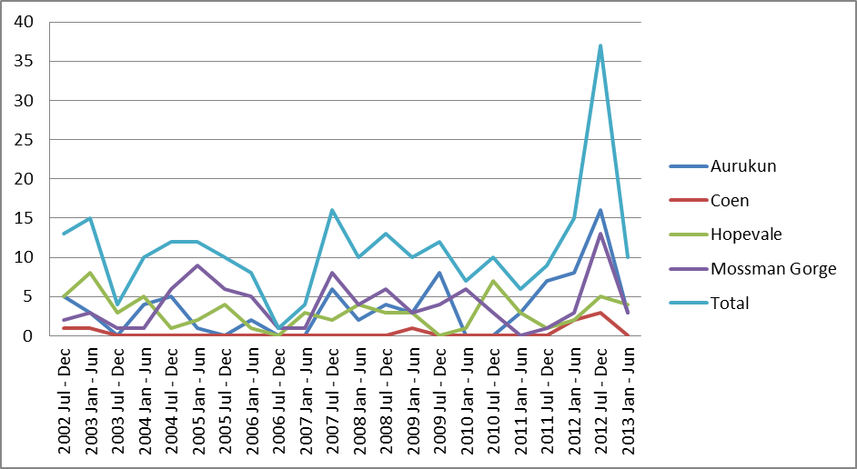

11

# Appendix : Self-reported Impact on Client

This appendix as shown in Table 11‑1 presents what clients reported as the most significant change(s) to occur in their lives in the last 6 to 12 months as a result of attending the WBC or that the WBC has contributed to.

The majority of clients reported a range of significant benefits with the most common benefits being: feeling less stressed (77%); feeling better emotionally and mentally (74%); feeling more in control of my life (72%); better relationships with family (60%); feeling better about life (62%); taking more responsibility for my actions (51%) and using less alcohol (47%). Note that very few interviews were also attended by family members. Where family members did attend their reporting was consistent with the client.

Table 11‑1: Self-reported impact on client (n=47)

| **Impact as reported by client** | **Number** | **Percent** |
| --- | --- | --- |
| Feeling less stressed | 36 | 77% |
| Feeling better emotionally and mentally | 35 | 74% |
| Feeling more in control of my life | 34 | 72% |
| Feeling better about life | 29 | 62% |
| Better relationships with family | 28 | 60% |
| Taking more responsibility for my actions | 24 | 51% |
| Using less alcohol | 22 | 47% |
| Better relationships in the community | 21 | 45% |
| Period between consuming too much alcohol increased | 19 | 40% |
| Feeling safer and more secure environment at home | 13 | 28% |
| Less issues/concerns associated with alcohol use | 13 | 28% |
| Better health | 13 | 28% |
| Children attending school (including more often) | 7 | 15% |
| Employment | 7 | 15% |
| Less angry/violence | 6 | 13% |
| Kept out of jail | 4 | 9% |
| Using WBC when well | 3 | 6% |
| Using less drugs | 3 | 6% |
| Less suicide thoughts | 3 | 6% |
| More active | 3 | 6% |
| Organise medicare/birth certificate/house application etc. | 3 | 6% |
| New house | 2 | 4% |
| Reunification with children (better parent) | 2 | 4% |
| Less issues/concerns associated with drug use | 2 | 4% |
| Gave up smoking | 2 | 4% |
| Working towards reuniting with kids | 2 | 4% |
| Improved financial management | 2 | 4% |
| Help in court | 1 | 2% |
| Gain skills paint/craft/ | 1 | 2% |
| Transformed life | 1 | 2% |
| Feeling less stressed | 36 | 77% |

12

# Appendix : Queensland Health ATODS data

This appendix presents an overview of ATODS data (service contacts, number of clients and contacts per client per annum) provided by Queensland Health for the WBC communities and a number of other communities from 2005/6 to 2012/13. As demonstrated, there are significant data gaps which do not allow any meaningful presentation or analysis of data for the purpose of this evaluation.

Table 12‑1: ATODS total contacts

|  |  |  |  |  |  |  |  |  |
| --- | --- | --- | --- | --- | --- | --- | --- | --- |
| **Area** | **2005/06** | **2006/07** | **2007/08** | **2008/09** | **2009/10** | **2010/11** | **2011/12** | **2012/13** |
| **Aurukun** | 1 |  |  | 9 | 58 | 71 | 38 |  |
| **Coen** |  |  |  |  |  | 8 |  |  |
| **Hopevale** |  | 1 | 11 | 1 | 2 | 1 |  |  |
| **Mossman Gorge** |  |  |  |  |  |  |  |  |
| **Other communities** | | | | | | | | |
| Kowanyama - Cairns QIDDI/ Weipa Outreach | 1 | 5 | 11 | 79 | 144 | 320 | 101 | 2 |
| Lockhart River - Cairns QIDDI/ Weipa Outreach |  | 34 | 19 | 70 | 387 | 681 | 261 | 49 |
| Napranum - Weipa Outreach |  |  | 6 | 119 | 350 | 263 | 174 | 38 |
| Pormpuraaw - Cairns QIDDI/ Weipa Outreach |  |  |  | 34 | 89 | 32 |  |  |

Note (1): A blank cell means no data was recorded in that year.

Table 12‑2: ATODS total clients

|  |  |  |  |  |  |  |  |  |
| --- | --- | --- | --- | --- | --- | --- | --- | --- |
| **Area** | **2005/06** | **2006/07** | **2007/08** | **2008/09** | **2009/10** | **2010/11** | **2011/12** | **2012/13** |
| **Aurukun** | 1 |  |  | 6 | 17 | 17 | 7 |  |
| **Coen** |  |  |  |  |  | 2 |  |  |
| **Hopevale** |  | 1 | 6 | 1 | 1 | 1 |  |  |
| **Mossman Gorge** |  |  |  |  |  |  |  |  |
| **`Other communities** | | | | | | | | |
| Kowanyama - Cairns QIDDI/ Weipa Outreach | 1 | 1 | 5 | 19 | 35 | 51 | 25 | 2 |
| Lockhart River - Cairns QIDDI/ Weipa Outreach |  | 7 | 5 | 20 | 56 | 63 | 43 | 6 |
| Napranum - Weipa Outreach |  |  | 1 | 21 | 50 | 31 | 18 | 3 |
| Pormpuraaw - Cairns QIDDI/ Weipa Outreach |  |  |  | 8 | 19 | 11 |  |  |

Note (1): A blank cell means no data was recorded in that year.

Table 12‑3: ATODS contacts per client

|  |  |  |  |  |  |  |  |  |
| --- | --- | --- | --- | --- | --- | --- | --- | --- |
| **Area** | **2005/06** | **2006/07** | **2007/08** | **2008/09** | **2009/10** | **2010/11** | **2011/12** | **2012/13** |
| **Aurukun** | 1.0 |  |  | 1.5 | 3.4 | 4.2 | 5.4 |  |
| **Coen** |  |  |  |  |  | 4.0 |  |  |
| **Hopevale** |  | 1.0 | 1.8 | 1.0 | 2.0 | 1.0 |  |  |
| **Mossman Gorge** |  |  |  |  |  |  |  |  |
| **Other communities** | | | | | | | | |
| Kowanyama - Cairns QIDDI/ Weipa Outreach | 1.0 | 5.0 | 2.2 | 4.2 | 4.1 | 6.3 | 4.0 | 1.0 |
| Lockhart River - Cairns QIDDI/ Weipa Outreach |  | 4.9 | 3.8 | 3.5 | 6.9 | 10.8 | 6.1 | 8.2 |
| Napranum - Weipa Outreach |  |  | 6.0 | 5.7 | 7.0 | 8.5 | 9.7 | 12.7 |
| Pormpuraaw - Cairns QIDDI/ Weipa Outreach |  |  |  | 4.3 | 4.7 | 2.9 |  |  |

Note (1): A blank cell means no data was recorded in that year.

13

# Appendix : Case Studies

This appendix includes a series of case study reports based around individuals and families who received services from the Cape York Wellbeing Centres.

Whilst every effort has been made to de-identify the people described in the case study reports, the reality is that should these reports be publicly available, those people could be re-identifiable by people living and working in the Cape. Given the very personal nature of the scenarios discussed it would be completely unacceptable for these reports to be publicly available.

Accordingly these have been provided to the funders only to support the findings in relation to the Cape York Wellbeing Centres.

14

# Appendix : Queensland Government Key Indicators

This appendix presents a selection of data from the *Annual Bulletin for Queensland’s Discrete Indigenous Communities: 2011/12, April 2013*. This data is subject to change retrospectively and the subject of detailed explanatory notes. The reader should refer to that document for further information.

## Snapshot summary

Table 14‑1 presents a snapshot of both trend data and the latest annual data for WBC and other Cape communities.

Table 14‑1: Snapshot comparison of select discrete indigenous communities indicators

|  | **Hospital admissions for assault related conditions** | | **Reported offences against the person** | | **Breaches of Sections 168B and C of the Liquor Act 1992** | | **Substantiated notification of harm** | | **Children admitted to child protection orders** | | **Student attendance** | |
| --- | --- | --- | --- | --- | --- | --- | --- | --- | --- | --- | --- | --- |
| **Community** | Annual rate 2011/12 per '000 | Trend 2002/03 to 2011/12 | Annual rate 2011/12 per '000 | Trend 2002/03 to 2011/12 | Annual rate 2011/12 per '000 | Charges resulting in convictions 2010/11 to 2011/12 | Annual rates of children per '000 (0-17 years) | Change 2010/11 to 2011/12 | Annual rates of children per '000 (0 to 17 years) | Change 2010/11 to 2011/12 | Student attendance rate term two, 2012 % | Trend 2007 to 2012 semester one |
| **WBC communities** |  |  |  |  |  |  |  |  |  |  |  |  |
| Aurukun | 15.9 | na | 69 | ↓ | 76.6 | ↔ | 21.8 | ↔ | 39.6 | ↔ | 60 | ↑ |
| Coen | 11.9 | ↓ | 88.8 | ↔ | na | n.a. | 72.7 | ↔ | na | ↔ | 88.5 | ↔ |
| Hopevale | 19.6 | ↓ | 64.4 | ↔ | 90.6 | ↔ | 61.5 | ↔ | 36.3 | ↔ | 71.5 | na |
| Mossman Gorge | 135.9 | ↔ | 174.8 | na | na | n.a. | 0 | ↔ | na | ↔ | 74.7 | ↔ |
| **Comparison communities** |  |  |  |  |  |  |  |  |  |  |  |  |
| Kowanyama | 16.4 | ↓ | 72.8 | ↓ | 52.9 | ↓ | 35.4 | ↔ | na | ↓ | 75.9 | ↔ |
| Napranum | 16.2 | ↓ | 36.7 | ↓ | 150.3 | ↔ | 25.9 | ↔ | 20.1 | ↔ | 53.8 | ↓ |
| **Other Cape communities** |  |  |  |  |  |  |  |  |  |  |  |  |
| Lockhart River | 22.7 | ↔ | 58.6 | ↑/↓ | 68.1 | ↔ | 59.2 | ↔ | 98.7 | ↔ | 68.8 | ↓ |
| Pormpuraaw | 9.4 | ↓ | 75.5 | ↓ | 37.7 | ↔ | 80.2 | ↔ | 37.7 | ↔ | 70.6 | ↔ |

* Note (1): Not applicable

## Charges resulting in a conviction of alcohol carriage offences

Figure 14‑1: Aurukun. Charges resulting in a conviction of alcohol carriage offences

Figure 14‑2: Hopevale. Charges resulting in a conviction of alcohol carriage offences

## Hospital admissions for assault related conditions

Figure 14‑3: Aurukun. Hospital admissions for assault related conditions

Figure 14‑4: Coen. Hospital admissions for assault related conditions

Figure 14‑5: Hopevale. Hospital admissions for assault related conditions

Figure 14‑6: Mossman Gorge. Hospital admissions for assault related conditions

## Reported offences against the person

Figure 14‑7: Aurukun. Reported offences against the person

Figure 14‑8: Coen. Reported offences against the person

Figure 14‑9: Hopevale. Reported offences against the person

## Mossman Gorge reported offences against the person

The annual rate of all reported offences against the person in Mossman Gorge in 2011/12 was 174.8 per thousand persons (116.5 per thousand persons for serious offences and 58.3 per thousand persons other offences). This was similar to the rate of 108.1 per thousand persons in 2010/11. Mossman Gorge rates are highly variable due to its small population and have not been graphed. Trend analysis was not undertaken for Mossman Gorge is data have only been collected consistently since 2007/8.

Total offences are for Mossman Gorge are presented below.

Table 14‑2: Mossman Gorge. Reported offences against the person

|  |  |
| --- | --- |
|  | **Total Offences** |
| 2007/08 | 18 |
| 2008/09 | 25 |
| 2009/10 | 14 |
| 2010/11 | 12 |
| 2011/12 | 18 |

15

# Appendix : Service Activity and Client Profile

This appendix presents details of service activity and individual and group activity and associated analysis for the period from inception to 30 June 2013, and a profile of diagnosis assessment issues presentations and modules undertaken.

## Service activity

This section presents details of individual and group activity and associated analysis for the period from inception to 30 June 2013.

* + 1. **Number of clients**

The number of clients that were referred to the WBCs since inception in 2008 to March 2014 is presented in Table 15‑1. As at 31 March 2014, a total of 1,274 people have been referred to the WBC and there have been 1,220 clients, with 333 clients being classified as current. The table also presents the percentage of the community that are or have been recorded as WBC clients. Overall, 48% of the entire community, 57% of the adult community (>19 years) and 26% of the population <20 years are currently or have been WBC clients.. As at 31 March 2014 13% of the entire community were recorded as being WBC clients.

The percentage of the community who have been clients is relatively consistent in the communities of Aurukun, Coen and Hopevale. Mossman Gorge has the highest percentage of the community as clients, although the population is considerably less than the other three communities. This is due to mobile nature of that population and its proximity to Cairns and Mossman.

Table 15‑1: Number of WBC clients

|  |  |  |  |  |  |  |  |  |  |
| --- | --- | --- | --- | --- | --- | --- | --- | --- | --- |
| **Community** | **Current Clients** | **Service Completed** | **Never Attended** | **Refused Service** | **Total** | **All Clients as % of community** | **All Adult clients as % of Adult Community** | **Clients<20 as % of pop <20** | **Total Population 2011 census** |
| Aurukun | 155 | 319 | 16 | 1 | 491 | 41% | 50% | 21% | 1294 |
| Coen | 47 | 130 | 27 |  | 204 | 47% | 54% | 28% | 416 |
| Hopevale | 81 | 314 | 3 | 1 | 399 | 43% | 53% | 23% | 1,005 |
| Mossman Gorge | 50 | 124 | 4 | 2 | 180 | 181% | 191% | 150% | 100 |
| **Grand Total** | **3334** | **887** | **50** | **4** | **1274** | **48%** | **57%** | **26%** | **2815** |

Note (1): Data in table relates to the number of clients since inception to 31 March 2014 and current is at 31 March 2014.

Note (2): The population of the communities used for this calculation are per ABS 2011 census data statistics and it excludes children 0-4 years of age. as this age group is not targeted by the WBCs.

Note (3): Percentage calculations excludes never attended and refused service referrals.

Note (4): This differs to the number of current clients as per Table 17.1 which is 643, as the “current” classification from the file from which this data is extracted is not 100% accurate.

* + 1. **Additional analysis of contacts**

Figure 0‑1 presents the number of total and actual contacts per client for all clients and FRC clients by year. There were 9.6 contacts per client in 2013/14 for all clients and 4.1 for FRC clients. The ratio of actual to total contacts for all clients and FRC clients has increased in the more recent years and in 2013/14 was 65% for all clients (55% for FRC clients).

Figure 15‑1: Contacts per client – All clients and FRC clients

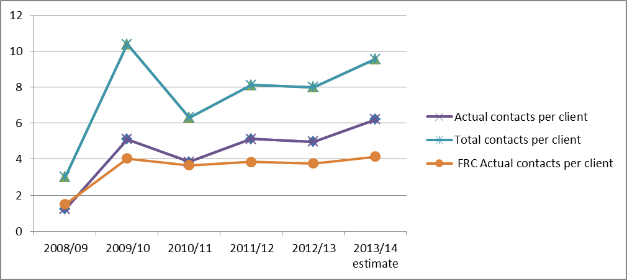

Note (1): 2013/14 Estimate based on extrapolation of July to March 2014 data.

2nd 52% by the end of 12 months.

Figure 0‑2 presents the total WBC contacts in each month since the individual client’s first contact. The figure shows that 16% of total contacts occurred within the first two months of first contact, 33% of total contacts occur by the end of six months and 49% of contacts occur by the end of 12 months. The profile is almost identical for FRC referred WBC clients as presented in Figure 0‑3 where 14% of total contacts occurred within the first two months, 32% by the end of six months and 52% by the end of 12 months.

Figure 15‑2: Total contacts by month since first contact all clients

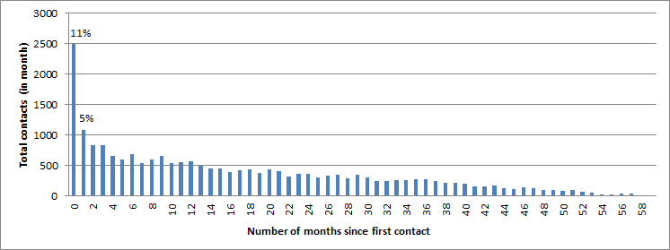

Note (1): Based on data to 30 June 2013.

Figure 15‑3: Total contacts by month since first contact FRC clients

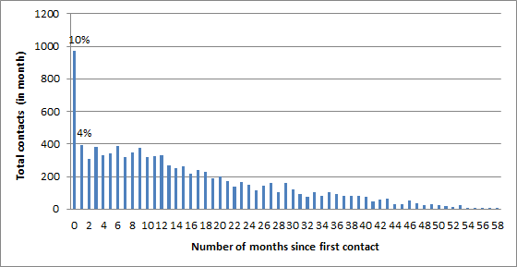

Note (1): Based on data to 30 June 2013.

presents since inception the number of clients by the number of contacts they had in various ranges. The table shows that 48% of all clients have had a total of 1 to 10 contacts to date (29% for FRC clients) and 44% of all clients had between 11 and 50 contacts (57% for FRC). Please note the data in this table is since inception to 30 June 2013 whereas the data presented in Figure 15.1 is for the particular year.

Table 15‑2: Number of clients by number of contacts

|  | **All Contacts - Number of clients** | | | |
| --- | --- | --- | --- | --- |
| **No. of Contacts** | **Clients** | **All %** | **FRC Clients** | **FRC %** |
| 1 contact | 57 | 5% | 4 | 1% |
| 2 - 5 | 268 | 23% | 52 | 10% |
| 6 - 10 | 224 | 20% | 99 | 19% |
| **Subtotal 1 - 10** | **549** | **48%** | **155** | **29%** |
| 11 - 15 | 158 | 14% | 88 | 17% |
| 16 - 20 | 123 | 11% | 66 | 12% |
| 21 - 35 | 159 | 14% | 104 | 20% |
| 36 - 50 | 61 | 5% | 47 | 9% |
| **Subtotal 11 - 50** | **501** | **44%** | **305** | **57%** |
| 51 - 75 | 44 | 4% | 29 | 5% |
| 76 - 100 | 28 | 2% | 24 | 5% |
| 101 - 150 | 15 | 1% | 14 | 3% |
| 151 - 200 | 3 | 0% | 3 | 1% |
| >200 | 2 | 0% | 2 | 0% |
| **Subtotal >50** | **92** | **8%** | **72** | **14%** |
| **Total** | **1142** | **100%** | **532** | **100%** |

* + 1. **Service contacts – groups/events**

Table 15‑3 provides details of the current groups in operation at each WBC.

Table 15‑3: Current groups

| **Name of group** | **Number of regular participants** | **Frequency of meetings** | **Target  age/sex** | **Lead agency** |
| --- | --- | --- | --- | --- |
| **Aurukun** | | | | |
| Men’s Group | 13 | Fortnightly | Male 18+ | WBC |
| Women’s Group | 15 | Fortnightly | Female 18+ | WBC |
| Boys Group | 10 | Weekly | Male <13 | WBC |
| Girls Group | 20 | Fortnightly | Females <13 | Queensland Mental Health |
| **Coen** | | | | |
| **Name of group** | **Number of regular participants** | **Frequency of meetings** | **Target  age/sex** | **Lead agency** |
| Elders Movie day | 7 | Fortnightly | 50+ | WBC |
| Arts and Crafts day | 6 | Fortnightly | 18+ | WBC |
| Parenting (Arts and Crafts or cooking ) | 8 | weekly | Parents - male/female | CYP |
| Nutritional Cooking | 15 | Fortnightly | 6-12  (male /female) | Apunipima |
| Mums and Bubs | 6 | weekly | 0-4 plus mothers | Child and Family Services |
| MPower (Pride of Place) | 4 | When required fortnightly | 18+ | CYP |
| MPower (Student Education Trust ) | 4 | Fortnightly | 0-25 | CYP |
| Women’s health Check | 25 |  | 18+ | RFDS/WBC |
| Family Support (DV and Child Safety Issues ) | 8 | Monthly | 18+  (male/females) | Qld Indigenous Family Violence Legal Service |
| Children in Care | 4 | Monthly | 0-17 | Child Safety |
| Respite Day for carers | 5 | Weekly | 0-5 | WBC |
| **Hopevale** | | | | |
| **Name of group** | **Number of regular participants** | **Frequency of meetings** | **Target  age/sex** | **Lead agency** |
| Men’s group | 20 | Weekly | Male 25+ | WBC |
| Women’s group | 15 | Weekly | Female 25+ | WBC and CYP parenting |
| Young girls group | 12 | Fortnightly | Female 10-14 | WBC |
| Young boys group | 6 | Fortnightly | Male | WBC |
| Elders group | 15 | Fortnightly | Female | WBC |
| Young girls group (health) | 7 | Fortnightly | Female | WBC/RFDS |
| Garden group | 5 | Weekly | Male | WBC/Cooktown Community Centre |
| **Mossman Gorge** | | | | |
| **Name of group** | **Number of regular participants** | **Frequency of meetings** | **Target  age/sex** | **Lead agency** |
| Men’s group | 10+ | Fortnightly | Male 25+ | WBC |
| Women’s group | 8 | Fortnightly | Female 25+ | WBC |
| Young men’s group | 6 | Fortnightly | Male 10-15 | WBC |
| Elders group | 10 | Fortnightly | 55+ | WBC |
| Young girls group | 12 | Fortnightly | Female 10-14 | WBC |
| Homework club | 10 | Twice weekly | Male and female 8-12 | WBC |
| Positive parenting group | 6 | Fortnightly | Female 20+ | CYP |

* + 1. **Drop-in activity**

As noted above, Drop-in activity has not been specifically counted for the WBCs to date. While some drop-in activity will be recorded as a service contact where WBC staff have a brief intervention with the client, a significant component has not be counted.

Table 15‑4 presents the results of an internal survey conducted over three days in mid-January 2014. The table shows that 73% of all visits in that period were not recorded and advice is that these visits related primarily to drop-in and other informal activities not counted. It should be noted that this collection occurred during school holidays when there was a significant level of drop-in related activity. Given its limitation, this data is presented for information only and not evaluation purposes.

Table 15‑4: Sample of visits not recorded

|  | **Total visits** | **Visits not recorded** | **Number of visits not recorded** |
| --- | --- | --- | --- |
| Aurukun | 170 | 95 | 56% |
| Coen | 129 | 123 | 95% |
| Hope Vale | 26 | 22 | 85% |
| Mossman Gorge | 109 | 75 | 69% |
| **Total** | **434** | **315** | **73%** |

RFDS was instructed by the Department of Health on 18 December 2013 to immediately commence collection of all contacts. The RFDS commenced capturing drop-in activity as a category (numbers and estimated demographics only) on a structured basis with the implementation of the upgraded data system (i.e. April 2014). This was not available for evaluation purposes.

## Profile of clients and presentations

* + 1. **Diagnosed assessment issues**

Table 15‑5 presents the primary diagnosis assessment issue for those clients with a contact in the July to December 2013 period, the only period for which this data is available. Ideally this information would have been available since commencement as it would have allowed both the funder and service provider to monitor the primary diagnosed assessment issue on an ongoing basis. Funders and the service provider have utilised reasons for presentation to help understand who is using the well-being centre and why. Whilst this is a reasonable proxy, it has now been agreed that diagnosed assessment issue will be collected on an ongoing basis. This limited data availability has not impacted upon capacity to undertake the evaluation.

Table 15‑5: Diagnosed assessment issue

| **Category** | **Diagnosed Assessment Issue** | **AUR** | **COE** | **HPV** | **MOG** | **Total** |
| --- | --- | --- | --- | --- | --- | --- |
| Alcohol | Harmful use of alcohol | 13 | 6 | 17 | 17 | 53 |
| Alcohol | Alcohol dependence syndrome | 24 | 4 | 0 | 4 | 32 |
| Child safety | Current/Past Removal of Children from Parent or Carer Care | 4 | 0 | 0 | 4 | 8 |
| Problems with family member | Family Member of person with problems | 3 | 8 | 8 | 1 | 20 |
| Family Member of person with problems | Other person's physical health issues | 0 | 0 | 1 | 0 | 1 |
| Grief and loss | Disappearance and death of family member | 0 | 0 | 5 | 6 | 11 |
| Mental Health | Suicide concerns - self | 4 | 3 | 1 | 2 | 10 |
| Mental Health | Unspecified disorder of adult personality and behaviour | 8 | 2 | 0 | 0 | 10 |
| Mental Health | Conduct disorder, unspecified | 0 | 0 | 5 | 2 | 7 |
| Mental Health | Unspecified schizophrenia | 2 | 4 | 0 | 0 | 6 |
| Mental Health | Depressive episode, unspecified | 1 | 0 | 4 | 0 | 5 |
| Mental Health | Paranoid schizophrenia | 4 | 0 | 0 | 1 | 5 |
| Mental Health | Personality disorder, unspecified | 4 | 1 | 0 | 0 | 5 |
| Mental Health | Deliberate Self Harm | 2 | 1 | 0 | 0 | 3 |
| Mental Health | Dissocial personality disorder (Antisocial personality disorder) | 2 | 1 | 0 | 0 | 3 |
| Mental Health | Unsocialised conduct disorder | 2 | 1 | 0 | 0 | 3 |
| Mental Health | Borderline type | 1 | 1 | 0 | 0 | 2 |
| Mental Health | Dysthymia | 0 | 0 | 2 | 0 | 2 |
| Mental Health | Issues related to stress/anxiety/worries | 0 | 0 | 2 | 0 | 2 |
| Mental Health | Mild depressive episode | 0 | 1 | 0 | 1 | 2 |
| Mental Health | Other specified behavioural and emotional disorders with onset usually occurring in childhood and adolescence | 0 | 1 | 0 | 1 | 2 |
| Mental Health | Post-traumatic strerss disorder | 0 | 0 | 1 | 1 | 2 |
| Mental Health | Schizoaffective disorder, unspecified | 1 | 0 | 1 | 0 | 2 |
| Mental Health | Severe depressive episode without psychotic symptoms | 1 | 1 | 0 | 0 | 2 |
| Mental Health | Unspecified behavioural syndromes associated with physiological disturbances and physical factors | 1 | 1 | 0 | 0 | 2 |
| Mental Health | Bipolar affective disorders, unspecified (recurrent manic episodes NOS) | 1 | 0 | 0 | 0 | 1 |
| Mental Health | Depressive conduct disorder | 1 | 0 | 0 | 0 | 1 |
| Mental Health | Disturbance of activity and attention (Attention-deficit hyperactivity disorder) | 0 | 0 | 1 | 0 | 1 |
| Mental Health | Enduring personality change after catastrophic experience | 1 | 0 | 0 | 0 | 1 |
| Mental Health | Manic episode, unspecified | 1 | 0 | 0 | 0 | 1 |
| Mental Health | Mild mental and behavioural disorders, associated with the puerperium (Postnatal/Postpartum depression NOS) | 1 | 0 | 0 | 0 | 1 |
| Mental Health | Mild mental retardation | 0 | 0 | 1 | 0 | 1 |
| Mental Health | Mixed disorder of conduct and emotions, unspecified | 0 | 0 | 0 | 1 | 1 |
| Mental Health | Moderate depressive episode | 0 | 1 | 0 | 0 | 1 |
| Mental Health | Moderate mental retardation | 0 | 0 | 0 | 1 | 1 |
| Mental Health | Oppositional defiant disorder | 1 | 0 | 0 | 0 | 1 |
| Mental Health | Other childhood disorders of social functioning | 0 | 0 | 1 | 0 | 1 |
| Mental Health | Other recurrent depressive disorders | 1 | 0 | 0 | 0 | 1 |
| Mental Health | Separation anxiety disorder of childhood | 0 | 0 | 0 | 1 | 1 |
| Other drugs | Cannabis dependence 2 | 11 | 1 | 0 | 1 | 13 |
| Other drugs | Nicotine withdrawal | 0 | 0 | 1 | 0 | 1 |
| Other drugs | Short-term effects of cannabis | 0 | 0 | 0 | 1 | 1 |
| Parenting | Atypical Parenting Situation | 2 | 1 | 1 | 5 | 9 |
| Relationship | Problems in relationship with spouse or partner | 1 | 2 | 5 | 8 | 16 |
| Relationship | Problems in relationship with parents, family and/or in-laws | 1 | 1 | 0 | 5 | 7 |
| Relationship | Discord with neighbours, lodgers and landlord | 1 | 0 | 0 | 0 | 1 |
| Sexual violence | Adult Sexual Assault: Survivor | 1 | 0 | 1 | 0 | 2 |
| Sexual violence | Child Sexual Assault: Survivor | 0 | 0 | 2 | 0 | 2 |
| Violence | FDV - Family Violence Survivor | 19 | 7 | 3 | 3 | 32 |
| Violence | IVA - Interpersonal Violence/Assault: Perpetrator | 13 | 2 | 12 | 3 | 30 |
| Violence | FDV - Family Violence Perpetrator | 14 | 2 | 1 | 2 | 19 |
| Violence | IVA - Interpersonal Violence/Assault: Survivor | 3 | 1 | 5 | 0 | 9 |
| Welfare and other support | Welfare Support | 27 | 7 | 1 | 21 | 56 |
| Welfare and other support | Financial Issues | 2 | 0 | 0 | 1 | 3 |
| Welfare and other support | Legal Issues | 3 | 0 | 0 | 0 | 3 |
| Welfare and other support | Physical Health | 2 | 1 | 0 | 0 | 3 |
| Welfare and other support | Problems related to employment and unemployment | 1 | 2 | 0 | 0 | 3 |
| Welfare and other support | Inadequate Housing/Overcrowding | 1 | 0 | 0 | 0 | 1 |
|  | **Total** | **186** | **64** | **82** | **93** | **425** |

Note (1): This data has been prepared manually by the RFDS. From April 2014 it will be captured in the upgraded information system. The total number of clients on which this table is based was 425.

Note (2): This number is lower than what would have been expected given the level of cannabis use reported elsewhere. However, this table presents the diagnosed assessment issue which is the primary reason for presenting and in most cases this is not cannabis use

* + 1. **The reason for presentation - individual consultations**

Table 15‑6 presents the proportion of all clients and FRC clients seen by the WBC, as per the ATODS National Minimum Data Set categories. The RFDS have indicated that the data contained in this table is not likely to be 100% accurate (rectified in April 2014). The majority of all clients (66%) have been recorded as presenting for non-drug related issues. Not surprisingly, a greater percentage of FRC clients were referred for their own alcohol or other drug use (48% compared to 33% for all clients).

The percentage of clients recorded as presenting for non-drug related issues is significantly higher than that recorded in the alcohol and other drug national minimum data set, where 96% of clients were receiving treatment to their own drug use [5]. This is not surprising given the broader SEWB focus of the WBCs than alcohol and other drug specific services.

Table 15‑6: Proportion of clients per National MDS

|  | **Aurukun** | **Coen** | **Hopevale** | **Mossman Gorge** | **Total clients** | **FRC clients** |
| --- | --- | --- | --- | --- | --- | --- |
| Other (Non-Drug Related) | 67% | 73% | 60% | 72% | 66% | 51% |
| Other’s alcohol or other drug use | 0% | 2% | 0% | 1% | 1% | 0 % |
| Own alcohol or other drug use | 32% | 24% | 40% | 27% | 33% | 48% |

Note (1): Based on client demographic data file as at 31 March 2014.

The reason for presentation to all WBCs since 2008/09 to 31 March 2014 is set out in Figure 0‑4. The data illustrates that: addictions to alcohol/other drugs/gambling (20%), violence (11%) relationships (10%), welfare support (14%), stress (7%) and legal (7%) which together make up 68% of the reasons for presentations. Note the term “addiction” relates to clients presenting with problems associated with alcohol and/or other drug use and gambling, including problems of heavy episodic use, rather than those formally diagnosed as being alcohol or other drug dependent. More detailed reason for presentation data is presented below.

The diagnosed assessment issue and reason for presentation present a similar profile in relation to the use of the WBC. The diagnosed assessment issue has more clients, with specific mental health issues as this was identified as being one of the highest areas of primary diagnosis.

Data indicates that the recording of the reason for presentation has increased in each year with particularly significant increases in both 2011/12 and 2012/13. This is due primarily to improved data recording systems and practices. While the reasons for presentation are of similar proportion in 2013/14 to that since inception, the proportion of welfare support activity has increased from 12% since inception to 24% in 2013/14. This has been driven by all sites. It may be the case that this has been driven by improved coding practices.

The RFDS have reported that undoubtedly welfare support is a significant indicator of a type of use of the Wellbeing Centres across the service and that this is relatively high in Mossman Gorge in comparison with other communities. They consider the provision of assistance with matters of welfare as an important way of addressing the overall level of stress in a community and that is an important tool for engaging clients and providing a lead in to more in-depth counselling. They see it as an invaluable tool in promoting the WBC service and engaging with all communities.

Whilst this is undoubtedly true, the provision of welfare support is also responding to the underlying need in the community (a key strength of the model).

Figure 15‑4: Reason for presentation all WBCs

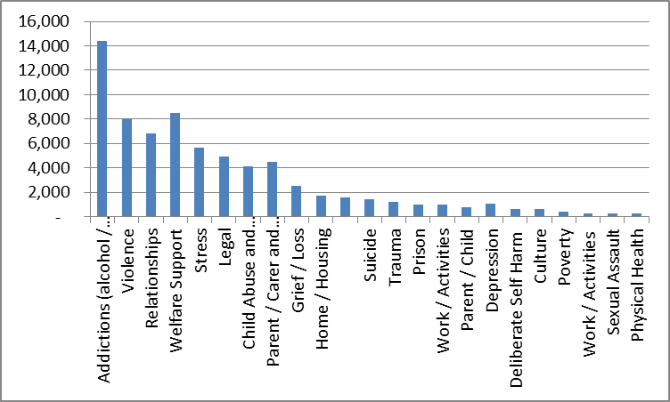

Note (1): The database does not allow for an accurate breakdown of the ‘addiction’ reason for presentation.

Note (2): Addictions relate to clients presenting with problems associated with alcohol and/or other drug use and gambling, including problems of heavy episodic use, rather than those formally diagnosed as being alcohol or other drug dependent.

Note (3): Since inception to 31 March 2014.

More detailed data for ‘reasons for presentation’ by year and by WBC is set out in Section 15.2.7.

Similarly Figure 0‑5 presents the proportion of reasons for presentation by male and female. For males, addictions and prison related matters make up a significantly greater percentage of the reasons for presentation than females. For females, welfare support, relationships and parent/carer and child support makes up a greater proportion of reasons for presentation.

Figure 15‑5: Reason for presentation males versus females (percentages)

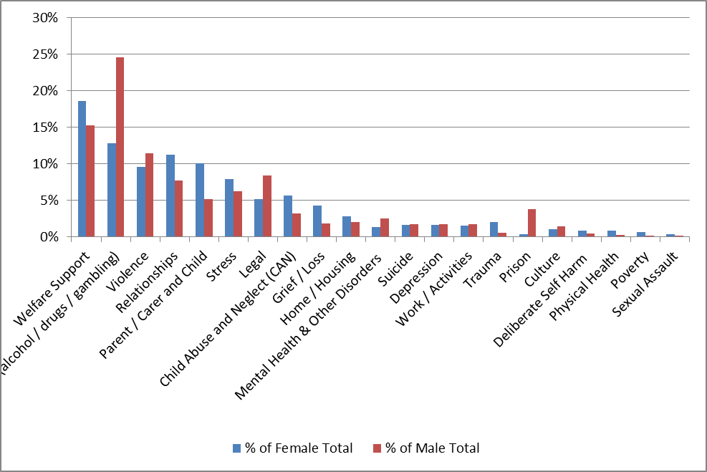

* + 1. **HonoS, K10, SDS and IRIS profile of clients**

#### HoNOS

Table 15‑7 presents the HoNOS profile by item number for all WBC clients as well as both non-FRC clients and FRC clients, and contrasts these scores at subscale level to the national data set and the RFDS Cairns SEWB team (whose services are primarily Aboriginal communities). The table shows that the total HoNOS scores for all WBC clients is similar to the national profile of mental health ambulatory clients (8.69 compared to 9.1).

On a subscale basis, behaviour scores are greater than the national profile (2.25 to 1.6) and the impairment and symptoms subscale are less (0.95 compared to 1.3 and 2.06 compared to 3 respectively). This result is not surprising given both behavioural problems in these Aboriginal communities, and in relation to impairment and symptoms the national profile is based on people with diagnosed mental illness whereas the WBC is a SEWB service seeing a much broader range of clients. The Cairns SEWB team client profile total score is greater than the WBCs, with the WBC having a higher behaviour and social subscale score and a lower impairment and symptoms subscale score which may indicate the SEWB team is more focused on mental health clients. Non-FRC client profile is similar.

Table 15‑7: HoNOS profile of WMC clients – mean scores1

| **HoNOS Item** | **Non FRC clients mean** | **FRC clients mean** | **% Difference** | **All clients mean (n=331)** | **AMHOCN2** | **Cairns SEWB team (n=191)** |
| --- | --- | --- | --- | --- | --- | --- |
| **(n=253)** | **(n=78)** |  |
| 1.Overactive, aggressive, disruptive behaviour | 0.98 | 0.89 | 9% | 0.95 |  | 0.9 |
| 2. Non-accidental self-injury | 0.23 | 0.26 | -3% | 0.24 |  | 0.32 |
| 3. Problem-drinking or drug-taking | 1.01 | 1.23 | -22% | 1.07 |  | 0.63 |
| **Behaviour Subscale Total** | **2.21** | **2.38** | -17% | **2.25** | **1.6** | **1.85** |
| 4. Cognitive problems | 0.44 | 0.49 | -5% | 0.46 |  | 0.52 |
| 5. Physical illness or disability problems | 0.49 | 0.46 | 3% | 0.48 |  | 1.04 |
| **Impairment Subscale Total** | **0.93** | **0.95** | -2% | **0.95** | **1.3** | **1.57** |
| 6. Problems associated with hallucinations and delusions | 0.12 | 0.1 | 2% | 0.13 |  | 0.15 |
| 7. Problems with depressed mood | 1.09 | 0.93 | 16% | 1.05 |  | 1.54 |
| 8. Other mental and behavioural problems | 0.91 | 0.79 | 12% | 0.89 |  | 1.91 |
| **Symptoms Subscale** | **2.12** | **1.83** | 29% | **2.06** | **3** | **3.6** |
| 9. Problems with relationships | 1.26 | 1.3 | -4% | 1.27 |  | 1.21 |
| 10. Problems with activities of daily living | 0 | 0 | 0% | 0 |  | 0 |
| 11. Problems with living conditions | 0.95 | 1.02 | -7% | 0.97 |  | 0.7 |
| 12. Problems with occupation and activities | 0.72 | 0.74 | -2% | 0.72 |  | 0.58 |
| **Social Subscale** | **3.41** | **3.53** | -12% | **3.44** | **3.3** | **3.07** |
| **Total Score** | **8.67** | **8.69** | -2% | **8.69** | **9.1** | **10.08** |

Note (1): Scores based on mean of clients first score. Each client is only included once.

Note (2): Scores based on Australian Mental Health Outcomes Classification Network data base and represent all ambulatory mental health scores in Australia (entry, review and discharge for 2011/12). No item scores are available.

#### K 10

Table 15‑8 presents the mean K10 score for WBC clients and both non-FRC clients and FRC clients, and contrasts these scores to the national data set and the RFDS Cairns SEWB team. The table shows that the K10 score for all WBC clients is similar to the national profile of mental health ambulatory clients. This result is to be expected given WBC clients is a SEWB service and sees a broad range of clients many of whom can be stressed. The score indicates that on average clients are in Risk Zone II (likely to have a moderate disorder, K10 score 16-21) at the time their first score is collected.

Table 15‑8: K10 profile of WBC clients – mean scores1

| **Non FRC mean (n=196)** | **FRC mean (n =81)** | **% Difference** | **All WBC clients mean (n= 276)** | **AMHOCN mean** | **Cairns SEWB team** |
| --- | --- | --- | --- | --- | --- |
| 18.87 | 16.95 | 10% | 18.3 | 21 | 22.8 |

Note (1): Scores based on mean of clients first score. Each client is only included once.

Note (2): Scores based on Australian Mental Health Outcomes Classification Network data base and represent all ambulatory mental health scores in Australia (entry, review and discharge for 2011/12).

Table 15‑9 provides additional benchmark information by comparing WBC clients with other available Indigenous data collections. The table shows that the percentage of WBC clients at high or very high distress levels is marginally greater than the general Indigenous population (33% compared to around 27% to 30%) and significantly greater than the non-Indigenous population. This level of distress is to be expected given the presenting circumstances of the WBC clients.

Table 15‑9: Comparison of K10 to the Indigenous population

| **Survey** | **Low/moderate distress level** | **High/very high distress level** |
| --- | --- | --- |
| ABS ATSI Health Survey - ATSI % 2012/13 (n =362)2 | 69.5% | 30.1% |
| ABS ATSI Health Survey - Non-Indigenous % 2012/13 (n = 16,771)2 | 88.5% | 10.7% |
| NATSIHS 2004/05 % - ATSI (n = 218,400)3 | 71.5% | 27.0% |
| WBC 2013 % (n = 276)1 | 66.7% | 33.3% |

Note 1: WBC data is represented by the first/entry K10 score recorded.

Note 2: The ABS ATSI Health Survey is the Australian Bureau of Statistics: Australian Aboriginal and Torres Strait Islander Health Survey: First Results, Australia, 2012-13. (cat. no. 4727.0.55.001).

Note 3A: NATHSIHS 2004/5 is the Australian Bureau of Statistics: National Health Survey and the National Aboriginal and Torres Strait Islander Health Survey 2004-05: Data Reference Package (cat. no. 4363.0.55.002)

Note 3B: The ABS ATSI Health Survey and the NATSIHS are both based on the K5, whilst the WBC data is based on the K10. For the K5 scores, low/ moderate distress is 0 – 11 and high/ very high distress 12 – 25. For the K10 low/ moderate distress is 0 – 21 and high/ very high distress 22 – 50.  
For the K10 we have utilised the ABS K10 score group categorisation. Alternatively, if the CRUfAD & GP care score groupings and categorisation were utilised the percentages change as there is a lower cut-off for high/ very high distress. The Cape York % would then be 70.7% for low/ moderate psychological distress and 29.3% for high/ very high distress.

#### AUDIT alcohol screen

Table 15‑10 presents the alcohol screen (AUDIT) tool score on entry. The table shows that overall WBC clients fell in the risky or hazardous level of drinking category on initial score. FRC clients were in the same category. There were variations between WBCs with Mossman Gorge clients on average being in the high risk category and all other WBCs being in the risky or hazardous level of drinking. There is no benchmark data.

Table 15‑10: AUDIT profile of WBC clients - mean scores

|  | **Non FRC clients mean** | **FRC clients mean** | **% Variation** | **All clients mean** |
| --- | --- | --- | --- | --- |
| Aurukun (n= 62 ) | 7.94 | 10.3 | -5.90% | 9.08 |
| Coen (n= 55) | 13.11 | 16.67 | -8.90% | 13.69 |
| Hopevale (n= 67) | 13.85 | 9.5 | 10.88% | 13.07 |
| Mossman Gorge (n= 59) | 20.79 | 26.35 | -13.90% | 22.68 |
| **Total (n=243)** | **14.13** | **15.49** | **-3.40%** | **14.52** |

Note (1): Scores based on mean of clients first score. Each client is only included once.

Note (2): A score of 0-7 reflects a low risk, a score of 8 to 15 represents the risky or hazardous level, score 16 to 19 represents high risk or harmful level, and a score 20 or more represents high risk.

Table 15‑11 presents the Severity of Dependence Scale (SDS) for cannabis on entry. There is no benchmark data. The table shows that the average score was 2.87 across all WBCs with 36% of clients demonstrating dependence with significant variations between WBCs.. Mossman Gorge and Aurukun had the highest percentage of clients recorded as being dependent upon cannabis and consequently the highest average score.

Table 15‑11: SDS profile of WBC clients - mean scores1

|  | **All clients mean (including 0)** | **% Clients dependent** |
| --- | --- | --- |
| Aurukun (n=56) | 3.07 | 43% |
| Coen (n=55) | 0.93 | 11% |
| Hopevale (n=67) | 2.30 | 31% |
| Mossman Gorge (n= 60) | 5.08 | 58% |
| **Total (n=238)** | **2.87** | **36%** |

Note (1): Scores based on mean of clients first score. Each client is only included once.

Note (2): A score of three or greater indicates dependence.

#### Indigenous risk impact screen (IRIS)

Table 15‑12 presents the IRIS profile of WBC clients. Note there is a high degree of convergence in the questions asked in this screen with the K10 and AUDIT tool. There is no benchmark data. The total score reflects that on average clients were indicated as requiring a brief intervention for AOD, and were just below the cut-off in relation to the mental health and emotional well-being requirement for a brief intervention. There were variations between WBCs with Mossman Gorge clients scoring the highest on both scales.

Table 15‑12: IRIS profile of WBC clients – mean scores

|  |  |  |
| --- | --- | --- |
|  | **AOD subscale mean** | **MH subscale mean** |
| Aurukun (n= 36) | 13.94 | 10.68 |
| Coen (n= 55) | 11.87 | 11.8 |
| Hopevale (n= 63) | 10.81 | 9.27 |
| Mossman Gorge (n=37) | 17.03 | 13.56 |
| **Total (n=191)** | **12.97** | **11.08** |

Note (1): For the AOD subscale a score above 10 indicates the need for a brief intervention and for the mental health and emotional well-being risk a score of above 11 indicates the need for a brief intervention.

* + 1. **Groups/events – foci of messages**

The WBCs conduct a range of groups including men’s and women’s groups, camp days, exercise programs, movies, health checks, parent and children’s groups. Figure 0‑6 presents the underlying focus of messages imparted at those group activities. Alcohol and other drugs and social facilitation are the two main message areas.

Figure 15‑6: Primary and secondary messages – January to June 2013

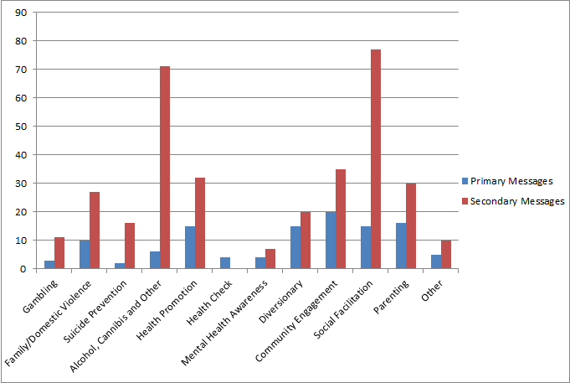

Note (1): Source RFDS ‘s six monthly report January to June 2013. DoHA Activity 2 Cape York Well-Being Centres.

As reported by the RFDS, the message content of groups, demonstrate a clear intent within the WBCs to entwine alcohol and other drug messages into many of the activities undertaken by the WBCs.

* + 1. **Introductory modules**

As outlined previously, following presentation at or referral to any one of the WBCs, a comprehensive holistic assessment and engagement process should be undertaken for every client. Engagement processes will determine the most appropriate programs and activities from which that particular client would most benefit. Engagement processes will also determine the most appropriate mode/s of delivery for each particular client, for example a men’s group or individual counselling.

Table 15‑13 sets out the number of clients completing each of the key introductory processes (i.e. intake, holistic assessment and engagement) since inception. The table shows that the most common introductory process recorded as being undertaken was the intake process, which was completed by 76% of clients since inception. However as illustrated in Table 15‑14, data recording in this area was not rigorous in the first few years of operation.

Table 15‑13: Number of clients recorded as participating in introductory processes1

| **Process** | **Aurukun** | **Coen** | **Hope-vale** | **Mossman Gorge** | **Total** | **% of all clients** | **% of FRC clients** |
| --- | --- | --- | --- | --- | --- | --- | --- |
| Intake Process Completed | 375 | 131 | 244 | 187 | 937 | 77% | 103% |
| Holistic Assessment Completed | 193 | 68 | 178 | 122 | 561 | 46% | 62% |
| Engagement, Socio-Education Session Streaming Completed | 138 | 44 | 173 | 134 | 489 | 40% | 54% |

Note (1): Period is since inception to March 14.

Table 15‑14 sets out the number of clients completing each of the key introductory processes by year. The table shows significant increases in the 2012/13 year which likely reflects embedding of the WBCs in the community, a strengthened commitment to intake processes more generally and strengthened data recording systems and practices.

Table 15‑14: Number of clients recorded as participating in introductory processes by year

| **Process** | **2008/09** | **2009/10** | **2010/11** | **2011/12** | **2012/13** | **Jul13 – Mar 14** | **Total** |
| --- | --- | --- | --- | --- | --- | --- | --- |
| Intake Process Completed | 37 | 72 | 244 | 132 | 302 | 151 | 938 |
| Holistic Assessment Completed | 4 | 23 | 139 | 97 | 186 | 112 | 561 |
| Engagement, Socio-Education Session and Streaming Completed | 1 | 19 | 126 | 107 | 156 | 80 | 489 |

#### Psycho-educational modules

The number, proportion and percentage of all clients and FRC clients completing the selective psycho-educational module streams is illustrated in Table 15‑15. The most commonly selected module was the drug and alcohol misuse module undertaken by 26% of all clients and 47% of FRC clients. The judicial module was the least common. Almost half the selective modules recorded as being undertaken were done so in the year 2012/13. This reflects strengthened data collection systems and practices.

It should be noted that there is a high degree of alignment between the proportion of clients recorded as attending WBCs for their own alcohol or other drug use (33%) with the percentage of clients completing the drug and alcohol module (26%). For FRC clients 48% were recorded as attending the WBCs for their own alcohol and other drug use compared to 47% of FRC clients who were recorded as undertaking the drug and alcohol module.

Table 15‑15: Number and proportion of all clients and FRC clients completing the selective module streans1

| **Module** | **All clients** | **FRC clients** | **% of All clients** | **% of FRC clients** |
| --- | --- | --- | --- | --- |
| Drug and Alcohol Misuse | 314 | 199 | 26% | 47% |
| Domestic Violence | 224 | 90 | 18% | 21% |
| Relationships/Parenting and Family | 199 | 106 | 16% | 25% |
| Mental Health Modules | 133 | 40 | 11% | 10% |
| Judicial Modules | 22 | 13 | 2% | 3% |

Note (1): Period is since inception to March 2014.

There were 1,758 contacts that related to one or more selective module streams as set out in Figure 0‑7: Number of contacts relating to any selective module stream by yearand approximately 90% of these contacts were face-to-face. Actual contacts that relate to undertaking any selective module stream comprised approximately 12% of total WBC actual contacts. In other words 88% of actual contacts were related to clients who were either not recorded as undertaking specific modules or whose treatment and was not provided within the context of those modules. This reflects a need to articulate more clearly in the revised model of care, the purpose and use of the modules.

Figure 15‑7: Number of contacts relating to any selective module stream by year

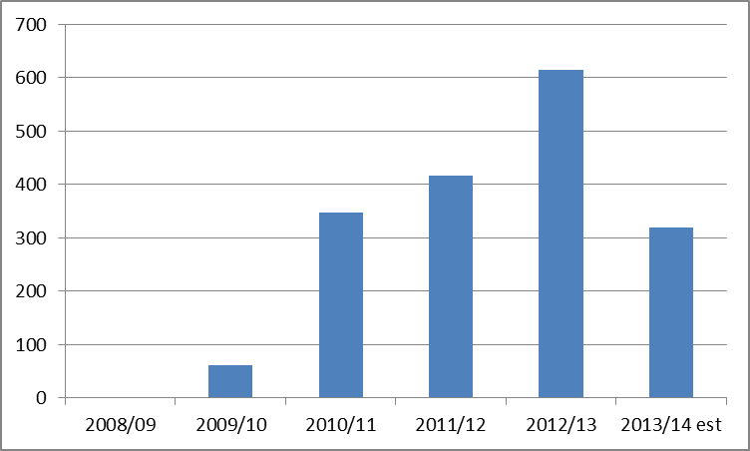

Note (1): A single contact can relate to more than one module and topics within the module.

#### More detailed reason for presentation data

This section provides more detail on the reasons for presentation by year including at WBC level.

Table 15‑15 overleaf sets out the reason for presentation for all WBCs by year. Recording of the reason for presentation has increased in each year with particularly significant increases in both 2011/12 and 2012/13. This is due primarily to improved data recording systems and practices.

Table 15‑16: Reason for presentation – all WBCs

| **Reason for presentation** | **2008/09** | **2009/10** | **2010/11** | **2011/12** | **2012/13** | **Jul 13 to Mar 14** | **Total** | **% of Total** | **% of Total Jul to Mar14** |
| --- | --- | --- | --- | --- | --- | --- | --- | --- | --- |
| Addictions (alcohol / drugs / gambling) | 504 | 1,335 | 2,294 | 3,339 | 4,974 | 1,974 | 14,420 | 20% | 14% |
| Violence | 123 | 282 | 849 | 2,496 | 2,981 | 1,266 | 7,997 | 11% | 9% |
| Relationships | 113 | 245 | 521 | 1,694 | 2,855 | 1,405 | 6,833 | 10% | 10% |
| Welfare Support | - | - | 25 | 1,120 | 3,844 | 3,516 | 8,505 | 12% | 24% |
| Stress | 83 | 268 | 650 | 1,564 | 1,999 | 1,111 | 5,675 | 8% | 8% |
| Legal | 44 | 231 | 513 | 1,562 | 1,811 | 781 | 4,942 | 7% | 5% |
| Child Abuse and Neglect (CAN) | 104 | 165 | 472 | 1,336 | 1,355 | 686 | 4,118 | 6% | 5% |
| Parent / Carer and Child | - | 22 | 10 | 890 | 2,196 | 1,378 | 4,496 | 6% | 10% |
| Grief / Loss | 69 | 92 | 221 | 620 | 1,105 | 407 | 2,514 | 4% | 3% |
| Home / Housing | 25 | 83 | 235 | 306 | 788 | 274 | 1,711 | 2% | 2% |
| Mental Health & Other Disorders | 53 | 37 | 170 | 619 | 477 | 251 | 1,607 | 2% | 2% |
| Suicide | 24 | 63 | 186 | 423 | 526 | 182 | 1,404 | 2% | 1% |
| Trauma | 29 | 21 | 149 | 344 | 464 | 193 | 1,200 | 2% | 1% |
| Prison | 2 | 23 | 99 | 279 | 459 | 127 | 989 | 1% | 1% |
| Work / Activities | - | 3 | 1 | 333 | 504 | 173 | 1,014 | 1% | 1% |
| Parent / Child | 115 | 170 | 474 | 10 | - |  | 769 | 1% | 0% |
| Depression | 6 | 22 | 85 | 264 | 365 | 324 | 1,066 | 1% | 2% |
| Deliberate Self Harm | 6 | 12 | 78 | 199 | 245 | 72 | 612 | 1% | 0% |
| Culture | - | - | - | 112 | 303 | 173 | 588 | 1% | 1% |
| Poverty | 2 | 5 | 29 | 148 | 166 | 31 | 381 | 1% | 0% |
| Work / Activities | 27 | 84 | 176 | 6 | - |  | 293 | 0% | 0% |
| Sexual Assault | 4 | 8 | 25 | 58 | 108 | 19 | 222 | 0% | 0% |
| Physical Health | - | - | - | 3 | 150 | 125 | 278 | 0% | 1% |
| **Total** | **1,333** | **3,171** | **7,262** | **17,725** | **27,675** | **14,468** | **71,634** | **100%** | **100%** |

Note (1): One contact can have multiple reasons for presentation.

This remainder of this Appendix sets out the reasons for presentation by WBC for each WBC from 2008/09 to 31 March 2014 and for the nine months to 31 March 2014.

Figure 15‑8: Reason for presentation since inception – Aurukun

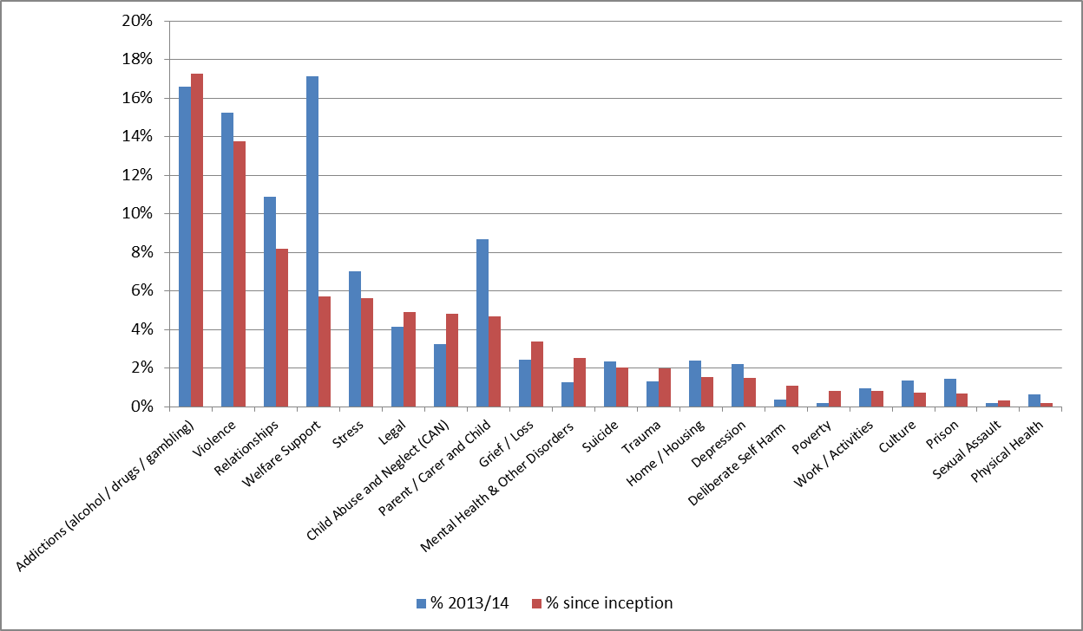  
Note (1): One contact can have multiple reasons for presentation.

Table 15‑17: Reasons for presentation – Aurukun

| **Reason for presentation** | **2008/09** | **2009/10** | **2010/11** | **2011/12** | **2012/13** | **Jul to Mar 14** | **Total** | **% of Jul to Mar 14** | **All Years as % of Total** |
| --- | --- | --- | --- | --- | --- | --- | --- | --- | --- |
| Addictions (alcohol / drugs / gambling) | 86 | 299 | 427 | 1,732 | 2785 | 890 | 5329 | 17% | 17% |
| Violence | 51 | 55 | 243 | 1,879 | 2020 | 818 | 4248 | 15% | 14% |
| Relationships | 23 | 45 | 140 | 876 | 1446 | 584 | 2530 | 11% | 8% |
| Welfare Support | 0 | 0 | 0 | 210 | 1553 | 919 | 1763 | 17% | 6% |
| Stress | 13 | 36 | 187 | 700 | 805 | 376 | 1741 | 7% | 6% |
| Legal | 13 | 66 | 105 | 617 | 717 | 223 | 1518 | 4% | 5% |
| Child Abuse and Neglect (CAN) | 23 | 17 | 96 | 683 | 673 | 173 | 1492 | 3% | 5% |
| Parent / Carer and Child | 14 | 25 | 42 | 411 | 957 | 465 | 1449 | 9% | 5% |
| Grief / Loss | 8 | 11 | 67 | 416 | 546 | 130 | 1048 | 2% | 3% |
| Mental Health & Other Disorders | 9 | 11 | 32 | 456 | 269 | 67 | 777 | 1% | 3% |
| Suicide | 11 | 24 | 73 | 269 | 244 | 126 | 621 | 2% | 2% |
| Trauma | 2 | 1 | 37 | 274 | 297 | 71 | 611 | 1% | 2% |
| Home / Housing | 5 | 12 | 42 | 83 | 326 | 129 | 468 | 2% | 2% |
| Depression | 4 | 3 | 19 | 210 | 229 | 118 | 465 | 2% | 2% |
| Deliberate Self Harm | 3 | 1 | 47 | 152 | 135 | 20 | 338 | 0% | 1% |
| Poverty | 1 | 0 | 8 | 126 | 121 | 11 | 256 | 0% | 1% |
| Work / Activities | 6 | 36 | 16 | 101 | 94 | 51 | 253 | 1% | 1% |
| Culture | 0 | 0 | 0 | 74 | 146 | 72 | 220 | 1% | 1% |
| Prison | 1 | 6 | 14 | 103 | 81 | 78 | 205 | 1% | 1% |
| Sexual Assault | 1 | 1 | 7 | 37 | 52 | 10 | 98 | 0% | 0% |
| Physical Health | 0 | 0 | 0 | 1 | 56 | 35 | 57 | 1% | 0% |
| **Total** | **274** | **649** | **1602** | **9410** | **13552** | **5366** | **30853** | **100%** | **100%** |

Figure 15‑9: Reason for presentation since inception - Coen

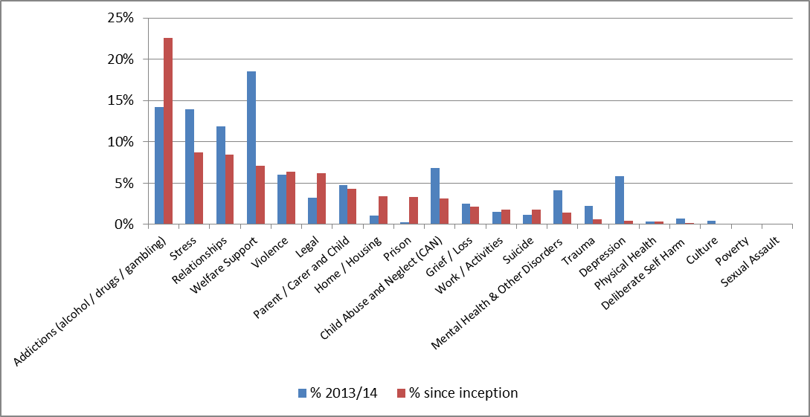

Note (1): One contact can have multiple reasons for presentation.

Table 15‑18: Reason for presentation – Coen

| **Reason for presentation** | **2008/09** | **2009/10** | **2010/11** | **2011/12** | **2012/13** | **Jul to Mar 14** | **Total** | **% of Jul to Mar 14** | **All Years as % of Total** |
| --- | --- | --- | --- | --- | --- | --- | --- | --- | --- |
| Addictions (alcohol / drugs / gambling) | 187 | 409 | 772 | 858 | 1261 | 379 | 3487 | 14% | 23% |
| Stress | 39 | 87 | 112 | 383 | 720 | 373 | 1341 | 14% | 9% |
| Relationships | 25 | 67 | 85 | 392 | 742 | 317 | 1311 | 12% | 8% |
| Welfare Support | 0 | 0 | 0 | 114 | 980 | 495 | 1094 | 19% | 7% |
| Violence | 8 | 21 | 165 | 266 | 532 | 161 | 992 | 6% | 6% |
| Legal | 18 | 26 | 78 | 329 | 502 | 87 | 953 | 3% | 6% |
| Parent / Carer and Child | 0 | 23 | 52 | 183 | 409 | 127 | 667 | 5% | 4% |
| Home / Housing | 0 | 27 | 61 | 140 | 300 | 28 | 528 | 1% | 3% |
| Prison | 0 | 4 | 19 | 152 | 335 | 8 | 510 | 0% | 3% |
| Child Abuse and Neglect (CAN) | 4 | 21 | 43 | 207 | 212 | 182 | 487 | 7% | 3% |
| Grief / Loss | 2 | 11 | 30 | 91 | 200 | 66 | 334 | 2% | 2% |
| Work / Activities | 0 | 3 | 7 | 61 | 207 | 40 | 278 | 1% | 2% |
| Suicide | 10 | 16 | 54 | 60 | 134 | 32 | 274 | 1% | 2% |
| Mental Health & Other Disorders | 0 | 15 | 7 | 42 | 163 | 111 | 227 | 4% | 1% |
| Trauma | 2 | 5 | 16 | 20 | 52 | 61 | 95 | 2% | 1% |
| Depression | 0 | 3 | 5 | 29 | 36 | 156 | 73 | 6% | 0% |
| Physical Health | 0 | 0 | 0 | 1 | 48 | 10 | 49 | 0% | 0% |
| Deliberate Self Harm | 2 | 2 | 5 | 1 | 14 | 19 | 24 | 1% | 0% |
| Culture | 0 | 0 | 0 | 1 | 19 | 12 | 20 | 0% | 0% |
| Poverty | 0 | 0 | 0 | 5 | 12 | 2 | 17 | 0% | 0% |
| Sexual Assault | 2 | 7 | 2 | 4 | 2 | 1 | 17 | 0% | 0% |
| **Total** | **299** | **747** | **1513** | **3339** | **6880** | **2667** | **15445** | **100%** | **100%** |

Note (1): One contact can have multiple reasons for presentation.

Figure 15‑10: Reason for presentation since inception – Hopevale

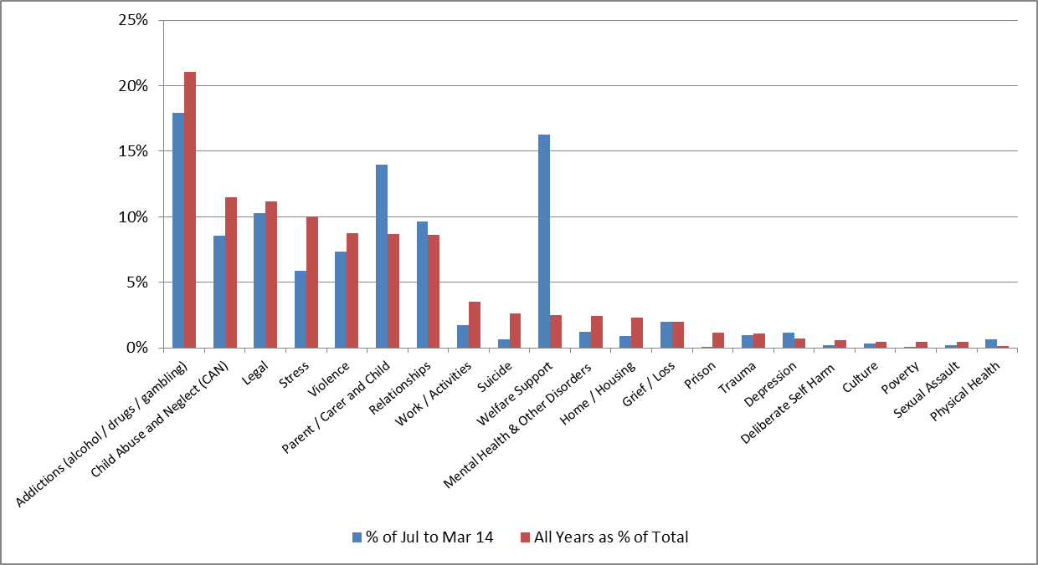

Note (1): One contact can have multiple reasons for presentation.

Table 15‑19: Reason for presentation – Hopevale

| **Reason for presentation** | **2008/09** | **2009/10** | **2010/11** | **2011/12** | **2012/13** | **Jul to Mar 14** | **Total** | **% of Jul to Mar 14** | **All Years as % of Total** |
| --- | --- | --- | --- | --- | --- | --- | --- | --- | --- |
| Addictions (alcohol / drugs / gambling) | 101 | 221 | 689 | 597 | 300 | 413 | 1908 | 18% | 21% |
| Child Abuse and Neglect (CAN) | 23 | 65 | 256 | 434 | 261 | 197 | 1039 | 9% | 11% |
| Legal | 12 | 33 | 210 | 502 | 253 | 236 | 1010 | 10% | 11% |
| Stress | 7 | 19 | 225 | 412 | 244 | 135 | 907 | 6% | 10% |
| Violence | 13 | 49 | 308 | 311 | 111 | 169 | 792 | 7% | 9% |
| Parent / Carer and Child | 25 | 52 | 202 | 262 | 247 | 322 | 788 | 14% | 9% |
| Relationships | 19 | 59 | 181 | 354 | 170 | 221 | 783 | 10% | 9% |
| Work / Activities | 8 | 20 | 112 | 126 | 51 | 40 | 317 | 2% | 3% |
| Suicide | 3 | 14 | 42 | 81 | 97 | 15 | 237 | 1% | 3% |
| Welfare Support | 0 | 0 | 0 | 88 | 139 | 374 | 227 | 16% | 3% |
| Mental Health & Other Disorders | 1 | 4 | 121 | 79 | 16 | 28 | 221 | 1% | 2% |
| Home / Housing | 10 | 12 | 83 | 64 | 37 | 21 | 206 | 1% | 2% |
| Grief / Loss | 13 | 16 | 13 | 34 | 106 | 46 | 182 | 2% | 2% |
| Prison | 1 | 9 | 65 | 23 | 8 | 1 | 106 | 0% | 1% |
| Trauma | 1 | 5 | 25 | 37 | 29 | 22 | 97 | 1% | 1% |
| Depression | 2 | 12 | 21 | 18 | 11 | 27 | 64 | 1% | 1% |
| Deliberate Self Harm | 1 | 2 | 8 | 39 | 5 | 5 | 55 | 0% | 1% |
| Culture | 0 | 0 | 0 | 27 | 15 | 7 | 42 | 0% | 0% |
| Poverty | 1 | 5 | 12 | 15 | 5 | 1 | 38 | 0% | 0% |
| Sexual Assault | 1 | 0 | 16 | 12 | 9 | 5 | 38 | 0% | 0% |
| Physical Health |  |  |  |  | 10 | 15 | 10 | 1% | 0% |
| **Total** | **242** | **597** | **2589** | **3515** | **2124** | **2300** | **9067** | **100%** | **100%** |

Note (1): One contact can have multiple reasons for presentation.

Figure 15‑11: Reason for presentation since inception – Mossman Gorge

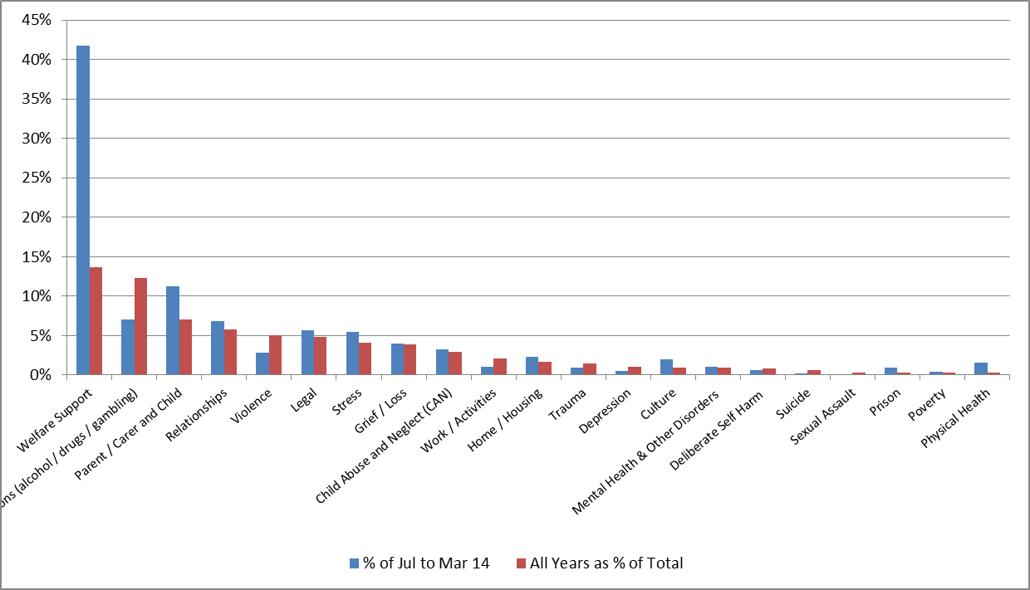

Note (1): One contact can have multiple reasons for presentation.

Table 15‑20: Reason for presentation – Mossman Gorge

| **Reason for presentation** | **2008/09** | **2009/10** | **2010/11** | **2011/12** | **2012/13** | **Jul to Mar 14** | **Total** | **% of Jul to Mar 14** | **All Years as % of Total** |
| --- | --- | --- | --- | --- | --- | --- | --- | --- | --- |
| Welfare Support | 0 | 0 | 25 | 708 | 1172 | 1728 | 1905 | 42% | 14% |
| Addictions (alcohol / drugs / gambling) | 130 | 406 | 406 | 152 | 628 | 292 | 1722 | 7% | 12% |
| Parent / Carer and Child | 76 | 92 | 188 | 44 | 583 | 464 | 983 | 11% | 7% |
| Relationships | 46 | 74 | 115 | 72 | 497 | 283 | 804 | 7% | 6% |
| Violence | 51 | 157 | 133 | 40 | 318 | 118 | 699 | 3% | 5% |
| Legal | 1 | 106 | 120 | 114 | 339 | 235 | 680 | 6% | 5% |
| Stress | 24 | 126 | 126 | 69 | 230 | 227 | 575 | 5% | 4% |
| Grief / Loss | 46 | 54 | 111 | 79 | 253 | 165 | 543 | 4% | 4% |
| Child Abuse and Neglect (CAN) | 54 | 62 | 77 | 12 | 209 | 134 | 414 | 3% | 3% |
| Work / Activities | 13 | 28 | 42 | 51 | 152 | 42 | 286 | 1% | 2% |
| Home / Housing | 10 | 32 | 49 | 19 | 125 | 96 | 235 | 2% | 2% |
| Trauma | 24 | 10 | 71 | 13 | 86 | 39 | 204 | 1% | 1% |
| Depression | 0 | 4 | 40 | 7 | 89 | 23 | 140 | 1% | 1% |
| Culture | 0 | 0 | 0 | 10 | 123 | 82 | 133 | 2% | 1% |
| Mental Health & Other Disorders | 43 | 7 | 10 | 42 | 29 | 45 | 131 | 1% | 1% |
| Deliberate Self Harm | 0 | 7 | 18 | 7 | 91 | 28 | 123 | 1% | 1% |
| Suicide | 0 | 9 | 17 | 13 | 51 | 9 | 90 | 0% | 1% |
| Sexual Assault | 0 | 0 | 0 | 5 | 45 | 3 | 50 | 0% | 0% |
| Prison | 0 | 4 | 1 | 1 | 35 | 40 | 41 | 1% | 0% |
| Poverty | 0 | 0 | 9 | 2 | 28 | 17 | 39 | 0% | 0% |
| Physical Health | 0 | 0 | 0 | 1 | 36 | 65 | 37 | 2% | 0% |
| **Total** | **518** | **1178** | **1558** | **1461** | **5119** | **4135** | **13969** | **100%** | **100%** |

Note (1): One contact can have multiple reasons for presentation.

16

# Appendix : Service Comparison to Similar Communities

This appendix considers the question, has the service model resulted in better access to services than in other comparable communities and how does the service profile and service approach compare?

For the purposes of this analysis we have, on advice from the Cape York Hospital and Health Services (CYHHS), contrasted Aurukun to Kowanyama, Coen to Laura, and Hopevale to Napranum. Mossman Gorge does not have a comparator site given its uniqueness in relation to its proximity to Mossman, a significant town and of course Cairns. We only reviewed Cape York communities to assist with accessing any available data.

It should be noted that:

* Aurukun is unique in its community profile in that it has five major clans grouped together
* Laura is similar to Coen in that it is not a specific Indigenous community.

## Access

Table 0:1: Service access comparison compares a number of indicators for each of these communities. The table includes where available, activity and staffing information for mental health, ATODS and SEWB services provided by the RFDS and Queensland Health Mental Health and ATODS services.

It is assumed based on advice that the CYHHS primary health care clinic is not providing this service type. We have not been able to include ATODS data in the analysis given significant data gaps.

Table 16‑1 demonstrates that service access is greatly enhanced in WBC communities. Specifically the:

* population per FTE for WBC communities is much greater than non WBC communities (i.e. more staff available to service the community)
* following on from the previous point, the percentage of population that is a client of the RFDS operated WBC or SEWB service is significantly greater in the WBC communities compared to other communities
* the number of contacts per client per annum is greater in WBC communities than in other communities receiving SEWB services.

Table 16‑1: Service access comparison

|  | **Hopevale** | **Napranum** | **Coen** | **Laura** | **Aurukun** | **Kowanyama** |
| --- | --- | --- | --- | --- | --- | --- |
| Population | 1,005 | 855 | 416 | 499 | 1293 | 1031 |
| RFDS clients in 2012/13 | 207 | 18 | 140 | 18 | 261 | 70 |
| % of population RFDS clients | 21% | 2% | 34% | 4% | 20% | 7% |
| Total individual RFDS contacts 2012/13 | 1254 | 86 | 1419 | 86 | 2251 | 316 |
| Total contacts per client pa 2012/13 | 6.1 | 4.8 | 10.1 | 4.8 | 8.6 | 4.5 |
| FTE in community: RFDS | 7 | 0.6 | 5.6 | 0.6 | 6.6 | 0.6 |
| FTE in community: QH MH & ATODS | 0.4 | 1.5 | 0.3 | 1.5 | 1 | 1 |
| Population per FTE (RFDS & QH MH & ATODS) | 144 | 407 | 74 | 238 | 196 | 644 |
| RFDS total service contacts per FTE pa | 179 | 143 | 253 | 143 | 341 | 527 |

Note (1): Population figures based on ABS 2011 census.

Note (2): The reference to RFDS relates to the WBC’s in the relevant communities and to the RFDS SEWB service in the non-WBC communities.

Note (3): Queensland Health MH & ATODS staffing provided by relevant manager in the CYHHS. The figures do not include the Child Youth Mental Health Service worker visits every community once per month for three days.

* + 1. **Service approach**

Table 16‑2 sets out the service staffing for mental health, SEWB and ATODS services.

Table 16‑2: Service staff comparison

| **WBC community** | **Comparison community** |
| --- | --- |
| **Aurukun**  **QH:** Weekly service. Mental health  clinician five days per week  **RFDS:** WBC multidisciplinary team staffed Mon-Fri. 6.6 FTE | **Kowanyama**  **QH:** Weekly service. Mental health clinician and ATODS clinician in alternate weeks. Each clinician assists the other in terms of dealing with emergencies  **RFDS:** counselling SEWB service three days per week |
| **Coen**  **QH:** mental health clinician 3 days every 2 weeks  **RFDS:** WBC Staffed Mon-Fri. FTE 5.6 | **Laura**  **QH**: one day per month  **RFDS**: counselling SEWB service one day every month |
| **Hopevale**  **QH:** one mental health clinician and one Aboriginal health worker each two days per week  **RFDS**: WBC staffed Mon-Fri. FTE 7.0 | **Napranum**  **QH**: one mental health clinician and one ATODS clinician 2 to 3 days per week. Detox nurse 2 to 3 days a week  **RFDS**: counselling SEWB service five days per month |

Note (1): WBC FTE as at 30 June 2012.

Note (2): The figures do not include the Child Youth Mental Health Service worker visits every community once per month for three days.

In all these communities Queensland Health provide a mental health service assessing, treating and supporting those clients with a diagnosed mental illness including managing their medications. They work closely with the RFDS WBCs and SEWB services and other services as required.

Where indicated Queensland Health provide an ATODS service which aims to prevent, minimise and respond to alcohol, tobacco and other drug use and harm by provision of primary prevention programs clinical support and counselling and rehabilitation programs. Services are provided by clinical staff and Aboriginal health workers.

As outlined previously in this chapter, WBCs provide a broad based five day a week SEWB service and provide support to people with drug and alcohol problems. Services are provided by qualified psychologists/social workers who are supported by community development consultants employed from within the community.

The RFDS SEWB services to non WBC communities provide a visiting service comprised of a multidisciplinary team consisting of mental health nurses, psychologists and social workers supported by a mental health officer and community development worker. Staff work collaboratively with the Queensland Health Mental Health Services to participate in case reviews and support seamless referral pathways for clients. RFDS staff are rostered to deliver outreach services to their designated community on a regular scheduled basis and provide further support and intervention to clients through telephone contact and consultations. They provide further support on an as needs basis for clients who require treatment in Cairns.[6]

The key points of difference include:

* significantly lower population per FTE (i.e. more staff available in WBC communities as evidenced in Table 16.2)
* the WBCs are a five day a week service with service staff and local community development consultants whose sole focus is the clients and people of that community. The WBC has a clear mandate and resourcing to provide programs/campaigns at the individual, group and community level and they are fully embedded into the community
* their presence in the community and diverse range of programs facilitates the capacity to engage a wider range of community members on a regular basis, both as clients and potential clients. They also work closely with, support and assist other partners, for example child safety, probation and parole, the school, in supporting their clients.

17

# Appendix : Community Engagement Data

This appendix presents data in relation to community engagement in particular, the number of clients by year, who is using the WBC and self-referral data.

## Number of clients by year

Table 17‑1 presents by year the number of individual clients who were recorded as being seen by the WBCs in that year. In the year ended 30 June 2013, 24% of the entire community were clients of the WBCs. Consistent with data presented in the report, Mossman Gorge has the highest percentage of the community as clients.

When comparing the average of the 2011/12 and 2012/13 years to the baseline year of 2009/10 (being the first full year of operation) there have been substantial increases in the number of clients in all communities except Mossman Gorge, which already had a higher number of clients.

At Mossman Gorge and Aurukun the number of clients in the current year (2013/14) has already exceeded all prior years with the introduction of new management in both WBCs.

Table 17‑1: Number of clients by year

| **Community** | **2008/09** | **2009/10** | **2010/11** | **2011/12** | **2012/13** | **Nine months to Mar 14** | **All Clients in 2012/13 as % of Community** | **% Change average 11/12 & 12/13 to 09/10** |
| --- | --- | --- | --- | --- | --- | --- | --- | --- |
| Aurukun | 124 | 166 | 234 | 295 | 261 | 300 | 20% | 67% |
| Coen | 51 | 83 | 78 | 104 | 140 | 94 | 34% | 47% |
| Hopevale | 135 | 192 | 231 | 267 | 207 | 138 | 21% | 23% |
| Mossman Gorge | 57 | 69 | 73 | 74 | 67 | 112 | 64% | 2% |
| **Grand Total** | **367** | **510** | **616** | **740** | **675** | **643** | **24%** | **39%** |

Note (1): A client may be represented in more than one year, so it is not possible to add the years together.

Note (2): No comparisons have been made to the 2013/14 as that data for the full year is not available.

## Who is using and not using the WBC

Service data reflects that females make up 48% of WBC clients and males 51%. As demonstrated in Table 17‑2 the number of female and male clients is generally reflective of the broader population.

Table 17‑2: Percentage if male/female clients compared to community population

| **Community** | **% Female Clients** | **% of Females in Community** | **% Male Clients** | **% of Males in Community** |
| --- | --- | --- | --- | --- |
| Aurukun | 46% | 51% | 53% | 49% |
| Coen | 54% | 49% | 44% | 51% |
| Hopevale | 45% | 47% | 55% | 53% |
| Mossman Gorge | 53% | 48% | 47% | 52% |
| **Grand Total** | **48%** | **49%** | **51%** | **51%** |

Note (1): The population of the communities used for this calculation are per ABS 2011 census data statistics.

Note (2): Data represents clients with a current or service completed status as of 31 march 2014. It incorporates all clients since inception.

Note (3): 1% of clients did not have their sex recorded.

Figure 0‑1 presents the age profile of WBC clients. The figures show that 64% of WBC clients are between the ages of 26 – 59 and young people less than 20 years comprise 17% of clients. Overall the average client age is 34 years (median 35 years). The age profile is relatively consistent between WBCs.

Figure 17‑1: Age profile of clients

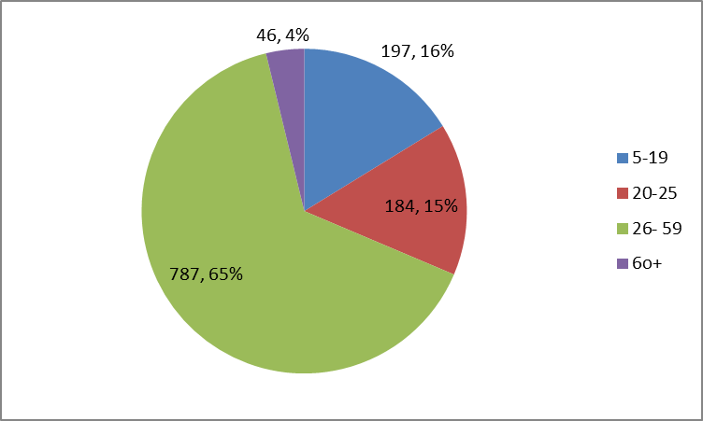  
Note (1): Data represents clients with a current or service completed status as of 31 March 2014. It incorporates all clients since inception.

Note (2): No clients in the 0- 4 year age range.

Table 17‑3 presents the younger age profile of WBC clients compared to the community profile. Overall the profile of WBC younger clients is line with the .community profile.

Table 17‑3: Age profile of younger clients compared to community profile

|  |  |  |  |  |
| --- | --- | --- | --- | --- |
| **Community** | **% WBC clients<20 years** | **% Community pop between 5-19 years** | **% WBC clients 20 to 24 years** | **% Community pop between 20-24 years** |
| Aurukun | 21% | 29% | 14% | 10% |
| Coen | 28% | 21% | 18% | 10% |
| Hope Vale | 23% | 28% | 16% | 11% |
| Mossman Gorge | 150% | 22% | 13% | 6% |
| Total | 26% | 27% | 15% | 10% |

Note (1): Community age profile based on 2011 ABS census. Client age profile is since inception.

## Self-referrals

This appendix presents the total number of self-referrals by quarter in total and for each WBC. As highlighted by the graph the trend is demonstrating a steady increase in the number of self-referrals. The WBCs continue to receive new self-referrals, although in some quarters there are no new self-referrals. This is due in part to the large number of people that are already recorded as clients and the relatively small numbers involved. At Mosman Gorge there was a large spike in The September 2013 quarter coinciding with management changes.

As presented in Figure ‑ Number of self referrals by quarter (all WBCs)Figure 0‑3 the underlying data reflects that most of this increase on a trend basis is driven by Aurukun. The Hopevale, Coen and Mossman Gorge new self-referral trend is relatively static referrals are static or showing small increases.

Note that this trend is likely to be understated as the system does not take account of where a referral changes from say a mandatory referral to self-referral. This has been addressed by the recent information system upgrade.

Figure 17‑2: Self referrals by quarter – by WBC

Figure 17.3 displays four line graphs and presents the total number of self-referrals by quarter for Aurukun, Coen, Mossman gorge and Hopevale.  On each of the four line graphs, the x-axis displays the time by quarters from September 2008 to February 2014.  On each of the four line graphs, the y-axis displays the number of self-referrals ranging from 0 to 9 and 0 to 14.
The graphs show that self-referrals to the WBCs increased mildly in Coen and Mossman Gorge, increased significantly in Aurukun (from 0 to 10) and increased slightly, but trended down from a period of high self-referrals between June 2009 and June 2012 in Hopevale. 

1. Kelman, Herbert C. ‘Compliance, Identification, and Internalization: Three Processes of Attitude Change. *Journal of Conflict Resolution*, 2, no. 1 (1958): 51-60. Retrieved 26th March from http://www.wcfia.harvard.edu/node/879
2. Australian Bureau of Statistics. Information paper: use of the Kessler psychological distress scale in APS health surveys. 4817.0.55.001.
3. Kessler, R.C., Andrews, G., Colpe, .et al (2002) Short screening scales to monitor population prevalence and trends in non-specific psychological distress. *Psychological Medicine, 32*, 959-956.
4. Andrews, G., Slade, T (2001). Interpreting scores on the Kessler Psychological Distress Scale (k10). *Australian and New Zealand Journal of Public Health*, 25, 494-497.
5. Australian Institute of Health and Welfare. Alcohol and Other Drug Treatment Services in Australia, 2011/12.
6. Royal Flying Doctor Service. Social and Emotional Well-being. DOHA Activity One Activity Plan July 12 to June 2014. Unpublished