Annual Progress Report 2025

  - National Roadmap for Improving the Health of People with Intellectual Disability
Copyright © 2026 Commonwealth of Australia as represented by the Department of Health, Disability and Ageing
This work is copyright. You may copy, print, download, display and reproduce the whole or part of this work in unaltered form for your own personal use or, if you are part of an organisation, for internal use within your organisation, but only if you or your organisation:
(a) do not use the copy or reproduction for any commercial purpose; and
(b) retain this copyright notice and all disclaimer notices as part of that copy or reproduction.
Apart from rights as permitted by the Copyright Act 1968 (Cth) or allowed by this copyright notice, all other rights are reserved, including (but not limited to) all commercial rights.
Requests and inquiries concerning reproduction and other rights to use are to be sent to the Communication Branch, Department of Health, Disability and Ageing, GPO Box 9848, Canberra ACT 2601, or via email to copyright@health.gov.au.

Foreword

The health and wellbeing of Australians with intellectual disability is a clear test of our nation’s approach to health and social care. While we are right to celebrate the many strengths of our health and social care systems, the difficult reality remains that Australians with intellectual disability still face poorer health outcomes than many other Australians. These include systemic barriers in accessing care, higher rates of avoidable hospitalisation, and greater risk of preventable disease.
People with intellectual disability should have the same quality of health care and access to health care as everybody else. That is why it is critical that we make progress in addressing the actions outlined in the National Roadmap for Improving the Health of People with Intellectual Disability (the Roadmap).
The Roadmap is approaching the halfway point of its 10-year lifespan. While meaningful progress has been made in many areas, many barriers and challenges still remain. Continued progress towards the Roadmap’s shared vision depends on coordinated action across jurisdictions and across sectors, and on genuine partnership with people with intellectual disability, their families and their carers.
The next steps in implementing the Roadmap build on important foundations for change, including strengthened workforce capability, improved models of care, better coordination across health and disability systems, and investment in research and data to better inform national policy and clinical practice. The new National Centre of Excellence in Intellectual Disability Health is already demonstrating the value of national leadership in bringing together evidence, expertise and lived experience to drive change.
As Australia’s Chief Medical Officer, I have a clear responsibility to advocate for health and social care systems that work better for all people with disability, including those with intellectual disability. This requires listening carefully to people whose experiences of care have too often fallen short of the standards we all expect. It requires support for health professionals to provide inclusive and person-centred care, and it requires continuing to challenge systems to adapt to the needs of individuals, rather than expecting individuals to adapt to the needs of the system. Addressing these inequities and embedding intellectual disability health in broader health system planning, are important responsibilities for our nation’s health leadership.
2025 saw the Disability portfolio come into the same Australian Government department with responsibility for Health and Ageing. This provides many new and exciting opportunities to ensure all of our social care systems – health, disability, and ageing – are fit for every Australian. This restructuring has been a core step in the right direction to ensure disability policy reform is approached in the most appropriate manner.
It is important to state that disability is not a health condition that needs to be treated. Disability does not need to be “fixed” or “cured”. Disability policy should focus on breaking down the barriers that stand in the way of people with disability participating in society equally – including in their access to appropriate health care services.
There is still substantial work ahead, but the case for change is as strong as ever. The findings of the Royal Commission into Violence, Abuse, Neglect and Exploitation of People with Disability provide a stark reminder of the consequences of systemic failures and the obligation on all of us to do better. The Disability Royal Commission gave us an important understanding of what needs to change. The recommendations in the Disability Royal Commission highlight areas where health services and social care systems can provide much better support for all people with disability.
Our response to these recommendations is already underway, and some of this is directly linked to the actions in the Roadmap. This includes continuing the Primary Care Enhancement Program for people with intellectual disability, giving Australia’s general practitioners and other health care professionals the skills they need to deliver better care to all people with intellectual disability.
As the implementation of the Roadmap progresses, our focus must remain on translating recommendations into practical change. We need governments, experts, advocates, carers and, most importantly, people with lived experience, all working together to improve health care for all Australians with intellectual disability.
Professor Michael Kidd AO FAHMS
Chief Medical Officer for Australia
Australian Government Department of Health, Disability and Ageing

Preface

My name is Laura Naing. I am a project worker with the NSW Council for Intellectual Disability and the National Centre of Excellence in Intellectual Disability Health. I am also a member of the Intellectual Disability Health Roadmap Implementation Governance Group (RIGG).
I like to be connected to other people in my community. In my work I learn about the experiences of other people with intellectual disability. I use my own voice to fight for better health outcomes for people with intellectual disability.
I am concerned that training on intellectual disability is not compulsory for health professionals. Intellectual disability is very complex and is different for every person. This makes it hard for health professionals to know how to care for us. How to communicate better, how to understand our needs.
Health professionals also need access to some information about us. It is hard to have to tell my story every time I have a health appointment. It is also important for me to have health information in Easy Read or plain English so I can understand it.
This is why the Roadmap is so important. It shows how the health system can better support people like me with intellectual disability. I like to be a member of the RIGG so that my experience and ideas can help make sure the Roadmap is done the right way.
Dental health is an example of this. It is stressful, time consuming and expensive to access dental care. Some people find it upsetting or scary. Dental health professionals need to have better skills at looking after us. Dental health systems need to be better set up to manage our needs and help us to stay calm. I will work with the RIGG so that these changes can happen.
Every person with intellectual disability has different experiences and abilities. This should not affect our right to the best health care. Implementing the Roadmap is our best chance to make this happen.
Laura Naing
NSW Council for Intellectual Disability, National Centre of Excellence in Intellectual Disability Health
Roadmap Implementation Governance Group
Contents
Foreword iii
Preface v
Introduction 1
National Roadmap: Summary of progress 3
Element A: Improved support for people with intellectual disability and their families and carers 4
Element B: Models of care for people with intellectual disability 9
B1: Developing better models of health care 9
B2: Better use of existing MBS items 11
B3: Continuity of care, care coordination and integration within the health system 13
B4: Better coordination with other sectors 15
Element C: Support for health care professionals to provide better care for people with intellectual disability 17
Element D: Improving oral health for people with intellectual disability 22
Element E: Research, data and measurement to support continuing improvement 24
Element F: Emergency preparedness and response 29
Element G: Arrangements for oversight, monitoring and implementation of the National Roadmap 31
Appendix A: Organisations providing input to this report 33
List of acronyms and abbreviations 34

Introduction
The National Roadmap for Improving the Health of People with Intellectual Disability (the Roadmap) was launched on 13 August 2021. It is a 10-year plan from 2021 to 2031 and is an associated plan under Australia’s Disability Strategy 2021–2031.
The Roadmap aims to address the serious health inequities experienced by people with intellectual disability. It outlines actions to support a health system where people with intellectual disability are valued, respected, and have access to high-quality, timely and comprehensive health care.
The Royal Commission into Violence, Abuse, Neglect and Exploitation of People with Disability (Disability Royal Commission) highlighted the critical need for national reforms to address these inequities in Australia. The Roadmap aligns with the health issues raised through the Disability Royal Commission.
To date, the Australian Government has invested $63.9 million to fund priority actions under the Roadmap.
The Department of Health, Disability and Ageing (the department) publishes annual progress reports to provide updates on implementation of the Roadmap. This is the fourth annual progress report, covering the period 1 January 2025 to 31 December 2025. It highlights key achievements, activities underway, and areas where further work is needed or where barriers remain. The previous 3 reports are available on health.gov.au.
Many activities featured in this report are led or supported by organisations across the health, disability and community sectors. Some are funded by the Australian Government, while others are funded through other sources. This report includes funding attribution where information is available.

Note on terminology
The Australian Government acknowledges that people use different words to talk about their identity. The Roadmap was published in 2021 and used language that reflected preferences at the time. In this report, the department has adapted some of the language from the Roadmap and uses updated language where appropriate, recognising that language continues to change and evolve. This report uses person-first language to talk about intellectual disability. This means we usually use the term ‘person with intellectual disability’ in this report. We recognise that the appropriate use of language varies between individuals and disability communities. We acknowledge the importance of having conversations with individuals about their preferred language.

Elements and actions in the Roadmap
The Roadmap is divided into 10 elements, A through G. (Element B has 4 sub-elements that are addressed individually.) Each element has a theme, desired outcomes, and actions that contribute to achieving those outcomes. The information in this report is presented against each element.
There are 116 actions in the Roadmap, of which:
- 72 are short term (1–3 years)
- 31 are medium term (4–6 years)
- 8 are long term (7–10 years)
- 5 relate to governance and are ongoing for the term of the Roadmap (Element G).
Of these 116 actions:
- 37 actions are the responsibility of the department
- 58 actions are the collaborative responsibility of the department and other external agencies
- 21 actions are the responsibility of agencies external to the department.
The actions are listed in the Roadmap, available on health.gov.au.

How the department collected and collated data for the report
The Roadmap Implementation Governance Group (RIGG) Secretariat asked 40 organisations for input on progress against Roadmap actions. A total of 29 organisations responded (Appendix A).
The department sought input against the specific themes in the Roadmap. The department collated the input received and reviewed activities for relevance to the goals of the Roadmap. Where activities aligned with specific actions, the actions were assigned a status, as follows:
- Not commenced: no activity has been reported against the action during any reporting period.
- In progress: some activity has occurred that directly or partially addresses the action.
- Completed: no further activity is required for the action.
For actions that are rated “in progress”, some have discrete end points and are expected to be completed within the life of the Roadmap. Other actions are considered to be ongoing and are expected to continue throughout the lifespan of the Roadmap and beyond.
In 2025, the department introduced a new qualifier to provide more context for actions that have been assigned the in progress rating:
- On track: actions that had significant progress in 2025, momentum for change is strong, or activity is well-established or ongoing and consistently implemented across Australia.
- Not on track: actions where activity was newly started, limited, stalled, or insufficient to demonstrate progress in 2025, or the activity is not nationally consistent. This rating also applies to actions where the activity only partially addresses the action or applies to people with any type of disability rather than specifically for people with intellectual disability. It also is assigned to actions where activity may have been undertaken in a previous reporting period, but not during the reporting period for this report.
This year, a small, time-limited working group of 6 RIGG members was established to determine ratings of all actions during 2025. Discussions focused particularly on whether in progress actions were on track or not on track, and the parameters for these new qualifier ratings.

National Roadmap: Summary of progress
The department has endeavoured to include as much information in this report as possible about the many activities reported by organisations. To help manage the length of the report, activities have been included where there is clear and specific relevance to improving health outcomes for people with intellectual disability in line with the desired outcomes under the Roadmap.
In some cases, information about individual activities has been summarised. The department has reduced the information, or in some cases, not included information, where:
- there was insufficient information provided
- there was no clear evidence provided that people with intellectual disability are being prioritised, or
- the activity did not clearly address an ID Roadmap action.
The chart below gives a summary of progress of ID Roadmap actions at the end of the reporting period (31 December 2025).
Overall progress of ID Roadmap actions (End of reporting period 31 December 2025)
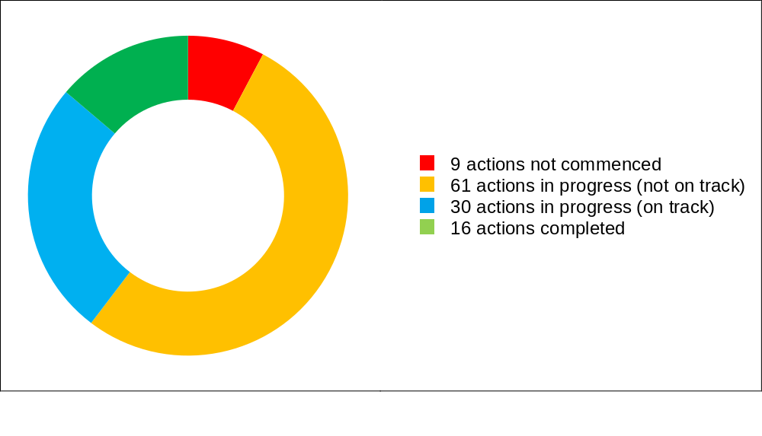

Element A: Improved support for people with intellectual disability and their families and carers

Desired Outcomes
- People with intellectual disability and their families and carers are empowered to make informed, supported decisions about their health care, in consultation with their health care providers.
- Improved health and health systems literacy among people with intellectual disability, and their families and carers.
- People with intellectual disability are better supported to navigate the health system and access appropriate health services.


Highlights in 2025
Highlights of activities being undertaken to deliver Element A include:
- The Down Syndrome Australia Health Ambassador Project. This project employs 10 people with Down syndrome to deliver training to health care workers and students. The training focuses on themes including communication, person-centred care, reasonable adjustments, annual health assessments, supported decision-making, and health care coordination. In 2025, the Health Ambassadors delivered training to around 500 health professionals and students through face to face and online training sessions. The Health Ambassadors also produced a Top tips for mental health and wellbeing resource that featured in the Voice magazine, and video resources to support tailored training for health professionals.
- The Victorian Department of Health Disability Liaison Officer (DLO) Program. This program supported almost 2,650 people with intellectual disability in around 20 metropolitan and regional health services to access health care in hospitals. Support included communication and psychosocial support, and assistance to make hospital bookings. DLOs also supported access to care to manage chronic or complex health conditions, pathology testing and preventative health care, such as vaccinations.
- The All About Me Tile – Top 5 tool. This tool enables parents and carers to communicate essential information about their child’s individual needs to hospital staff, prompting the use of appropriate reasonable adjustments in care delivery. In NSW, the tool was made accessible in the Sydney Children’s Hospitals Network Electronic Medical Record to support safe engagement with the hospital for a child with intellectual or developmental disabilities, autism, or complex medical and care needs. In 12 months, 411 All About Me tiles were completed, with more than 2,800 occasions of service across all disciplines and departments.

Information in Easy Read
Many organisations continued to develop health information, resources and tools in Easy Read. Easy Read materials support people with intellectual disability to understand health information, improve navigation, improve supported decision-making and support better communication between people with intellectual disability and health professionals. Examples include:
- The National Centre for Action on Child Sexual Abuse released Create safer spaces in primary health care and an Easy Read version, Feeling safer at health services. These resources were co-developed with victims and survivors of sexual violence.
- The ACT Government, under the ACT Disability Health Strategy 2024–2033 and its First Action Plan 2024–2026, is improving the accessibility of health care information through Easy Read training and translations for health care and disability services.
- Canberra Health Services (CHS) coordinated Easy Read translations of CHS consumer handouts, in consultation with consumers with lived experience. Nine new Easy Read booklets were produced to provide information about getting ready for cancer treatment, what to expect, and staying at hospital.
- Central Coast Local Health District (NSW) reviewed and adapted the Pregnancy Family Conferencing facilitator guide and client-facing materials to ensure they are accessible and inclusive for people with intellectual disability.
- Adult clients of the Sydney Local Health District Intellectual Disability Health Service (NSW) are offered an Easy Read version of the medical or health report from their comprehensive, multidisciplinary clinic assessment.
- The Australian Commission on Safety and Quality in Health Care published its Easy Read brochure Could it be sepsis?, which explains what sepsis is, who can get sepsis, the signs and symptoms, and what to do if worried about sepsis.
Spotlight – Disability Health Navigators
Recommendation 6.34 of the Disability Royal Commission’s Final Report recommended that the Australian Government and state and territory governments should:
- jointly fund a national workforce of ‘disability health navigators’ to support people with cognitive disability and complex health needs access health services and to embed safe, accessible and inclusive practice in everyday health service provision
- develop a national evaluation framework to assess the impact of disability health navigators and share lessons learned across jurisdictions. Evaluation findings should be published.
In response to this recommendation, the Commonwealth and states and territories agreed to work together to scope a nationally consistent framework for disability health navigation. The Australian Government subsequently provided $700,000 in the 2024–25 Budget to support this work, as part of a broader measure to support design and scoping of navigators for the National Disability Insurance Scheme (NDIS) and associated reforms.
The Disability Health Navigators project is considering the:
- current and future activities that health agencies undertake to provide support and adjustments for people with disability across all health settings
- functions and capabilities of disability navigators in the health system, and other staff or programs providing disability support, navigation and liaison
- workforce, information sharing and digital capabilities that enable navigation for people with disability throughout their health care journey, and referral pathways at discharge
- identification of processes that can be made more consistent across jurisdictions for people with disability
- utility of a national framework for disability health navigation.
Advice from the project will be provided to the Health Ministers’ Meeting for consideration in 2027.

Spotlight – Procedural Support and Sedation Pathways
Medical procedures can be challenging, and at times, unsafe for people with intellectual disability without appropriate adjustments. Procedural support and sedation can help, however current access pathways are inconsistent and often inaccessible.
While procedural support and sedation are not explicitly referenced in the Roadmap, they align closely with several key Roadmap priorities. These include improving trauma-informed models of care and addressing service gaps to improve health equity and health outcomes for people with intellectual disability.
Several states and territories are actively progressing initiatives to strengthen access to appropriate procedural support and sedation, demonstrating emerging models and practical approaches to addressing these gaps.
- The South Australian Intellectual Disability Health Service (SAIDHS) has developed the Health Care Access Service, a pre-procedure sedation and general anaesthetic service that provides people with intellectual disability access to medical care including basic, preventative health care that they otherwise would not have access to. The service is run in collaboration with Modbury Hospital, Benson Radiology and the SA Dental Special Needs Unit, and was developed by a SAIDHS multidisciplinary team.
- CHS Mental Health Service for People with Intellectual Disability has established a pathway in collaboration with the CHS Dental Service to support patients needing dental sedation services to receive additional procedures relevant to their mental health care (such as pathology for metabolic monitoring or a CT scan). CHS Dental coordinates these procedures to take place while the patient is under sedation.
- In NSW, the Grafton Base and Lismore Base Hospitals have an evidence-based sedation pathway designed to promote proactive care and prevent complications. It involves coordinated planning between medical, surgical, and allied health teams to deliver comprehensive treatment, assessment, and procedures for people with intellectual disability. This includes dental, gynaecological, CT scans, pathology, lumbar punctures, and other day procedures. Planned hospital admissions for day procedures have increased under this pathway.
- The South Western Sydney Local Health District Specialist Intellectual Disability Health Service (NSW) leads a community partnerships sedation project for blood collection to occur in familiar settings such as schools and homes for children and young adults with severe disability and behaviours of concern. The tiered model was co-designed with carers and providers and uses community pathways recommended by carers. This project now operates as business as usual in South Western Sydney and received the 2025 NSW Government Health Equity Award.

- The Inclusive Care Clinic project, led by Dr Jessica Smith, commenced in 2023 as a research pilot funded through a Southern Adelaide Local Health Network Seed Research Grant, supported by the Flinders Foundation and The Hospital Research Foundation Group. The project was initially established to support and test a different approach to the delivery of blood tests and immunisations for people with neurodevelopmental disability who may require additional support to access these routine health measures. The pilot used a tiered support model, providing patients with the least restrictive approach possible. It aimed to improve patient safety and access to health care through a person-centred, trauma-informed model. Using a multidisciplinary team approach, the service considered sensory interventions and reasonable adjustments before escalating to sedation-based options.
- The Disability Healthcare Access Service (DHAS) is a nurse-led service model run by the Centre for Developmental Disability Health, Monash Health. It operates from a sedation clinic in a community health building with doctors on site in Melbourne. DHAS provides a 4-tier sedation support model aimed at providing the least restrictive method to assist blood tests, immunisations, health checks, diagnostic imaging, dental care, ear check and clean, cervical screening and specialised procedures.

Priorities for further action in Element A
While accessible health information and resources are becoming more routinely available, implementation remains inconsistent across jurisdictions and service settings. The practice of providing health information in Easy Read and other accessible health communications is not nationally consistent, and disability liaison or navigation supports are not consistently available across jurisdictions.
Work in this element could be strengthened by supporting people with intellectual disability to participate more actively in multidisciplinary care planning. Often digital health tools, including My Health Record, health passports and other digital communication tools, are not accessible for people with intellectual disability. Barriers include inaccessible design, limited support to use digital tools, and inconsistent uptake by health professionals, families, carers and support workers.
Further work is also needed to strengthen access to individual health advocacy supports and supporting broader representation of people with intellectual disability in health ambassador and awareness-raising activities.

Element B: Models of care for people with intellectual disability

B1: Developing better models of health care

Desired Outcomes
- Better models of care are developed and implemented for children, youth, adults and older people with intellectual disability.
- Transition points are considered and better managed.
- Models of care are person-centred, trauma-informed, and incorporate reasonable adjustments.
- Models of care are multidisciplinary, where appropriate. Models of care include GPs, medical specialists, nurses and midwives, allied health professionals, dental practitioners, and pharmacists.
- Models of care include strategies to ensure good communication between health professionals and improve linkages between the health sector, the National Disability Insurance Scheme (NDIS) and other disability and social support services, including family where relevant.
- Models of care are intersectional and tailored to meet the needs of people with intellectual disability who live in rural and remote areas, who are First Nations people, from culturally and linguistically diverse backgrounds, or who identify as LGBTIQ+.
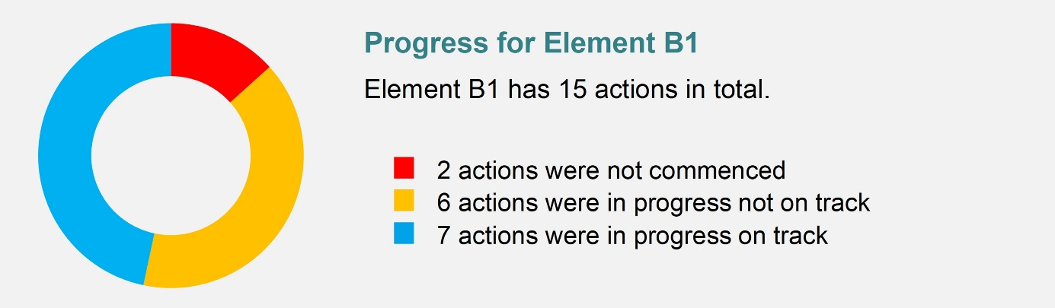

Highlights in 2025
Highlights of activities being undertaken to deliver Element B1 include:
- The Information for Life Program. Down Syndrome Australia (DSA), in consortium with Down Syndrome Associations across Australia, was funded by the Australian Government through the Information, Linkages and Capacity Building program to deliver this Program. This provides comprehensive, up-to-date information to benefit people with Down syndrome, their families and the community, with resources available through the DSA National Resource Hub. Health was a key focus of information developed and delivered in 2025, including information on sleep apnoea, transition to adult health care, nutrition and thyroid health, and development of the Good Health app.
- The Tasmanian Department of Health is working to ensure low sensory design considerations are incorporated into its infrastructure design and master planning. These designs support people with intellectual disability by ensuring a more inclusive and respectful care experience. A recent example is the design for the Royal Hobart Hospital Emergency Department Expansion, which features low sensory waiting areas.
- Regional Outreach Clinics. SAIDHS has established regular regional outreach clinics, travelling to the regional health networks every 2 months to see patients in-person. In 2025, 3 clinics were completed in Limestone Coast, Eyre & Far North and Yorke & Northern Local Health Networks with 26 patients seen in regional South Australia.
- Quiet Pathway for peri-procedural anxiety management Program. This program, delivered in Central Coast Local Health District (NSW), includes reasonable adjustments, sensory supports, and inclusive communication strategies for people with intellectual disability and cognitive impairment. This work has strengthened the capability of staff to deliver safe, trauma-informed care across diagnostic and procedural settings.
- Intellectual Disability Palliative Care Model of Care. Developed and piloted by South Eastern Sydney Local Health District (NSW), this innovative model incorporates a multidisciplinary approach. It embeds an Intellectual Disability Palliative Care Lead Clinical Nurse Consultant within Palliative Care Community Supportive Care Services to provide equitable access to palliative care services for people with intellectual disability.
- Referral pathway for refugees with intellectual disability. In Western Australia, the Humanitarian Entrant Health Service in collaboration with Mental Health Neurosciences Unit created a referral pathway for adult refugees with an intellectual disability who do not have the required documentation identifying their disability, allowing for access to appropriate supports via the NDIS.

Priorities for further action in Element B1
There are a range of promising models and initiatives across jurisdictions, PHNs and local health services. However, many remain localised, pilot-based or in early stages of implementation, with limited evidence of consistent national implementation.
Further work in this area will need to focus on supporting a more coordinated approach across governments, professional colleges, PHNs and researchers. This will support person-centred, trauma-informed and multidisciplinary models of care to be implemented more consistently. Key gaps include limited progress on specialist training pathways, limited evidence on home visit models, and opportunities to better embed intellectual disability health in broader national health strategies and reforms.

B2: Better use of existing MBS items

Desired Outcomes
- Increased use of annual health assessments and other MBS items for people with intellectual disability.
- Increased use of the CHAP tool by GPs in providing health assessments to people with intellectual disability.
- More comprehensive health plans for people with intellectual disability developed that include action on health promotion, disease prevention, and chronic disease detection (for example, such as hearing and vision testing, and cancer screening).
- Better communication between primary health care providers and people with intellectual disability, their families and carers, support workers and disability service providers, about preventive health and chronic disease management.
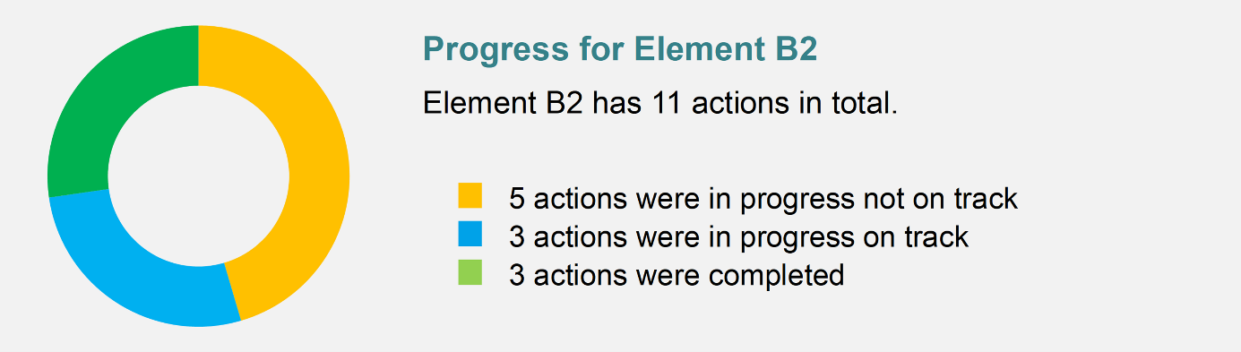

Highlights in 2025
Highlights of activities being undertaken to deliver Element B2 include:
- The department undertook a review of all Medicare Benefits Schedule (MBS) health assessment services, including health assessments for people with intellectual disability. The review was informed by a systematic literature review of evidence for health assessment services, analysis of MBS data, and extensive stakeholder consultation. It was completed in 2025, with recommendations to be considered by government.
- The Australian Digital Health Agency produced a digitised CHAP using smart form technology. This digital form can be integrated into clinical software to make it easier for GPs to conduct annual health assessments for people with intellectual disability. Software vendors are expected to commence integration from late 2026.
- The “It’s Doctor Time campaign” was a national campaign delivered by Inclusion Australia to promote annual health assessments and the CHAP. The campaign concluded in August 2025.

Priorities for further action in Element B2
Progress has been made to promote annual health assessments and support better use of the CHAP. However, barriers remain in measuring uptake and impact. Reliable national data on annual health assessment uptake remains limited, with more comprehensive usage data expected once the digitised CHAP is integrated into clinical software.

Areas for improvement include clarifying mechanisms for promoting annual health assessments through disability support settings, including supported accommodation. Some people with intellectual disability continue to face practical barriers to attending appointments, including access to support workers, transport and funding arrangements.

B3: Continuity of care, care coordination and integration within the health system

Desired Outcomes
- Better continuity of care for people with intellectual disability.
- Better communication and trust between health professionals, people with intellectual disability, their families and carers.
- Better integration across the health system, including primary, specialist and hospital care, allied health, oral health, and pharmacy.
- Improved communication and coordination among health professionals and greater provision of appropriate multidisciplinary care that meets the needs of people with intellectual disability.
- Improved GP access to intellectual disability health specialists and clearer referral pathways for GPs to specialised intellectual disability health services.


Highlights in 2025
Highlights of activities being undertaken to deliver Element B3 include:
- CHS Mental Health Service for People with Intellectual Disability has progressed work to use the Health of the Nation Outcome Scales for People with Intellectual Disability (HoNOS-ID). Use of this tool will provide a more accurate measurement of mental health outcomes for people with intellectual disability, avoid over-pathologising disability, and improve care planning. HoNOS-ID is a clinician-rated tool developed by the Royal College of Psychiatry in the UK designed to measure health and social functioning for people with intellectual disability and mental illness. It is currently being built into the clinical records system for clinician use.

Priorities for further action in Element B3
Some local initiatives are working to provide better continuity of care, improve integration and build better communication and trust between health professionals, people with intellectual disability, their families and carers. However, these approaches are not yet widespread and there is limited evidence of consistent implementation across jurisdictions.

Key gaps include unclear referral pathways, limited mechanisms to alert receiving clinicians to reasonable adjustments, and inconsistent use of tools and systems that support information sharing and continuity of care. Implementation could be strengthened by improving coordination across primary care, hospitals, allied health, oral health and specialist services, including practical mechanisms for case-conferencing and multidisciplinary team-based care.

B4: Better coordination with other sectors

Desired Outcomes
- Health professionals better understand the NDIS and referral options to appropriate services.
- Increased focus in the NDIS and other disability support arrangements on promoting good health, supporting preventive health care, and timely access to health services.
- Disability providers and the disability workforce have better health literacy, enabling them to better support people with intellectual disability to access health care.
- Better linkages, and more effective communication and coordination between health care professionals and disability support providers.
- Better linkages between health care and aged care providers supporting older people with intellectual disability.
- Increased collaboration between health and disability services to reduce the use of restrictive practices in disability and health services.
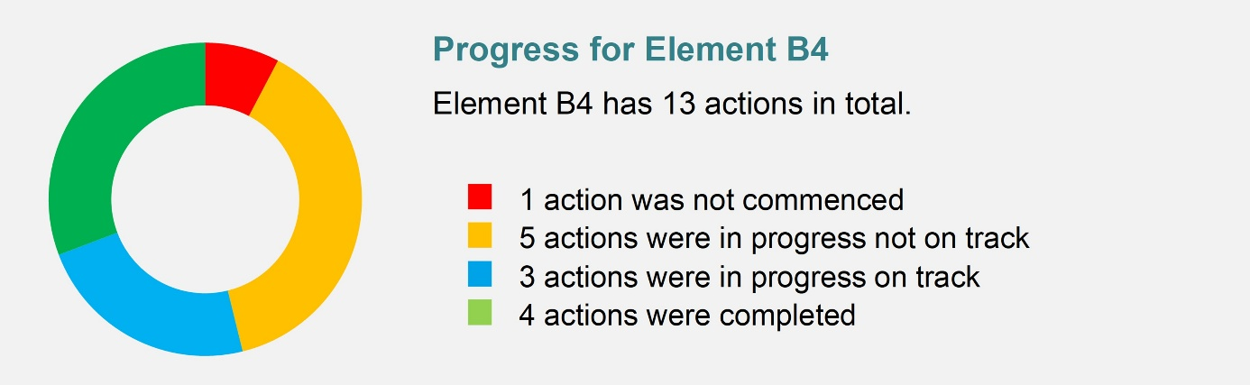

Highlights in 2025
Highlights of activities being undertaken to deliver Element B4 include:
- The National Disability Insurance Agency (NDIA) made progress in reducing hospital discharge wait times for NDIS participants who are medically ready to leave hospital. Since the first Hospital Discharge Operational Plan was introduced in 2022, hospital discharge wait times have reduced by 55%. From December 2022 to December 2025, the average hospital discharge wait time fell from 33 days to 15 days, with more than half of participants being discharged the same day they were medically ready.
- A new Joint Hospital Discharge Operational Plan between the NDIA and state and territory health authorities came into effect in November 2025. The new plan builds on the progress to date and details collaborative initiatives to further improve discharge timeframes for NDIS participants.
- NDIA Hospital Liaison Officers (HLOs) continue to support participants from hospital admission through to discharge. They work with participants, their circle of support, and state and territory hospital staff to ensure appropriate NDIS supports are in place to enable safe and timely discharge. HLOs also support prospective NDIS participants and hospital staff to explore eligibility for access, and ensure stakeholders have the information they need to progress NDIS access requests in a timely manner. Continuous improvement practices have been implemented to ensure the HLO role can continue to adapt and respond to changing priorities and emerging trends.
- The Victorian Department of Health’s Disability Liaison Officer (DLO) program supports people with disability to access health care. DLOs are also driving longer-term health service and system improvement projects in line with Inclusive Victoria: State disability plan (2022–2026).

Priorities for further action in Element B4
Better coordination between the health, disability and other service systems remains a significant implementation challenge. Gaps remain in role clarity and cross-sector communication, including limited progress in sharing health information across other systems such as justice and education.

Work in this area could be strengthened by building disability workforce capability in health literacy and preventive health, improving awareness of peer support and advocacy services, and clarifying how health and disability systems can work together to support people with intellectual disability. This includes clearer roles and responsibilities for navigation, hospital liaison and coordination supports.

Element C: Support for health care professionals to provide better care for people with intellectual disability

Desired Outcomes
- Health professionals are better equipped to communicate with people with intellectual disability and have better knowledge of the different ways people with intellectual disability interact with health professionals and communicate their health needs and preferences.
- Health professionals and staff of health services treat people with intellectual disability and their families and carers with respect and dignity, and provide services in an appropriate, supportive and sensitive manner.
- Improved access to appropriately trained and culturally sensitive health care professionals for people with intellectual disability, including First Nations people, people from culturally and linguistically diverse backgrounds and those who identify as LGBTIQ+.
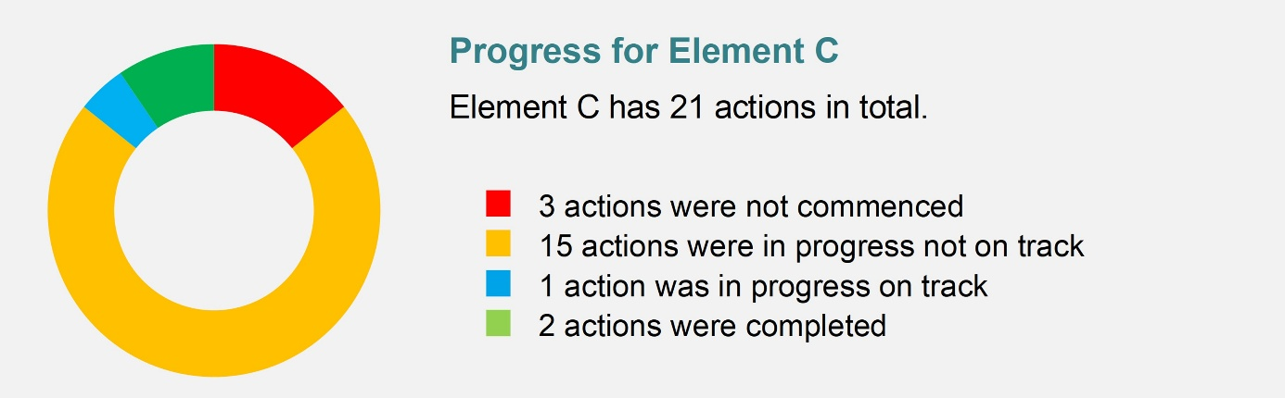

Highlights in 2025
Highlights of activities being undertaken to deliver Element C include:
- In May 2025, the department published education resources to support implementation of the Intellectual Disability Health Capability Framework (the Framework). Freely available materials include case studies, lecture plans, tutorial activities, information on facilitating student placement opportunities and other materials that can be modified for different health disciplines. To support implementation, the department also engaged the University of New South Wales Sydney to deliver a targeted promotional campaign in July–September 2025. This project built on earlier promotional activities following the Framework’s release in August 2024.
- In September 2025, an evaluation of the department’s Curriculum Development Project was published on health.gov.au. The evaluation showed that the processes to develop the Framework and resources were inclusive and collaborative, and the Framework was fit-for-purpose. The evaluation also noted limited implementation due to known barriers in the education and accreditation sectors.
- Down Syndrome Australia launched the Down Syndrome Medical Interest Group. Its purpose is to improve the knowledge of Australian health care professionals in the medical aspects of Down syndrome by sharing and disseminating relevant information.
- The Final report on the evaluation of the NSW Health Intellectual Disability Health Service was published in September 2025. The evaluation found the service is highly valued providing comprehensive health assessments to clients with intellectual disability and complex needs. The service also provides advice, information, support and training to NSW Health and primary health clinicians. The report contains recommendations for NSW Ministry of Health and local health districts to address data gaps and support more consistent and efficient service delivery by the statewide service.

Resources and training for health professionals
- The Australian Association of Psychologists Inc developed several resources for their members to use to facilitate consent for treatment conversations with people with disability, particularly intellectual disability. This includes Easy Read consent forms and service agreements.
- The Professional Association of Developmental Disability Nurses in Australia (PANDDA) facilitated 5 webinars for health professionals on the health needs of people with intellectual disability. Topics included co-occurring mental health conditions, nutrition and intellectual disability, using Talking Mats® to support choice and voice, continence management for neurodivergent children, and vision assessment.
- Sydney Children’s Hospitals Network (NSW) hospital staff received training through the Motivated for Change program to build confidence and capability in caring for children and young people with intellectual disability. The program was co-designed with parent advocates, clinicians, educators and researchers. Training was also delivered to other NSW Health organisations, including the Agency for Clinical Innovation and external organisations such as the Primary Health Network Intellectual Disability Nurse Navigators and Westmead Private Hospital.
- Northern Sydney Local Health District Intellectual Disability Health Service (NSW) provided training to Prevention and Response to Violence Abuse and Neglect clinicians on appropriate adjustments for people with intellectual disability and developed Easy Read resources.
- Murrumbidgee Local Health District (NSW) developed and implemented an Interactive Management of Complex Behaviour Escalation workshop and resource. It will strengthen understanding of behaviour management strategies, implementation of behaviour support strategies and partnering with people with disability. It aims to reduce unnecessary use of restrictive practices and optimise participation in care.

Primary Care Enhancement Program (PCEP)
The Australian Government made an initial investment of $6.56 million from 2020–21 to 2023–24 to develop the PCEP for people with intellectual disability, as one of several priority actions under the Roadmap. As part of the Australian Government Response to the Disability Royal Commission, a further $3.7 million was invested from 2024–25 to 2025–26 to continue the pilot for a further 2 years to 30 June 2026. The University of Queensland led a second phase of evaluation, with the final report due to be submitted to the department in July 2026.
Spotlight: Highlights of PCEP Activities for 2025
Western Victoria PHN
- Piloted an Intellectual Disability Quality Improvement in General Practice project in 9 general practices to strengthen inclusive and person-centred primary care.
- Procured a local disability support provider to trial Specialist Intellectual Disability Integrator roles, to work directly with general practice teams to deliver tailored training, quality improvement support, and enhanced care coordination grounded in disability expertise. This supports education on inclusive communication and reasonable adjustments, improved patient identification, strengthening clinical coding practices and supporting the use of the CHAP tool.
- Co-developed a resource package, including guidance on using the CHAP tool and patient information handouts.
Central and Eastern Sydney PHN
- Delivered a suite of activities, including the Primary Care Intellectual Disability Inclusion Program to 17 general practices, Supported Independent Living (SIL) provider workshops, continuing professional development (CPD) events, and service navigation support. The program included 2 education workshops and 2 quality improvement activities.
- The program also expanded into new priority areas to improve access to oral health care, and a collaboration with Sydney Local Health District on a shared care pathway between a specialist intellectual disability team and GPs.
Primary Health Tasmania
- Continued work on the development of 3 online modules aimed at delivering underpinning knowledge and building skills and confidence of health professionals.
- Capacity-building work commenced with 4 general practices focusing on data collection, education and training needs, and resources. One practice was further engaged in the development of a video resource showcasing how to support inclusion and access to primary care.
- In collaboration with Oral Health Services Tasmania, reproduced 2 resource booklets: How to brush someone else’s teeth: a guide for carers of adults with disability, and How to care for your child’s teeth: a guide for parents and carers of children with disability.
Country to Coast Queensland
- Launched a series of online education modules to improve the understanding, knowledge and capability of the primary health care workforce to support people with intellectual disability.
- Commissioned 3 place-based pilot projects, co-designed with people with intellectual disability and delivered by local organisations. The pilots test new approaches to improve both access to, and experiences of, primary health care for people with intellectual disability, as well as broader health and wellbeing, including in times of disaster.

Spotlight – National Centre of Excellence in Intellectual Disability Health
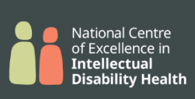
During 2025, the National Centre of Excellence in Intellectual Disability Health (NCEIDH) progressed a range of work relating to the desired outcomes under various elements of the Roadmap. These include:
- Excellence in Practice: Voices for Better Care Podcast series, featuring experts, health care professionals, and people with lived experience sharing real stories and practical advice to improve health care services for people with intellectual disability.
- Knowledge Exchange Hub (‘Our Health Space’), an online space where people can share information, access resources and connect with each other about intellectual disability health.
- National Conference, bringing together academics, clinicians, advocates and people with lived experience of intellectual disability.
NCEIDH also funded 5 Innovation Seed Funding Grants for projects on:
- improving health literacy for people with intellectual disability and their supporters
- developing a health checklist for people with cerebral palsy and intellectual disability
- helping people with intellectual disability to understand how to use medicines safely and how pharmacists can support them
- improving health care for Aboriginal people with intellectual disability in Western NSW
- supporting young people with intellectual disability to transition from children’s dental services to adult dental care.
NCEIDH conducted key reviews on health care, including:
- an international review of research on improving access to health care for people with intellectual disability, published in the Scandinavian Journal of Public Health;
- a scoping review of models of health care for people with intellectual disability in Australia to identify key features of effective models of care.

Priorities for further action in Element C
While education resources and capability frameworks are available, implementation of education, training, continuing professional development and accreditation requirements is minimal. Structural barriers in education and accreditation systems continue to affect uptake of the Intellectual Disability Health Capability Framework, and intellectual disability health capabilities are not consistently embedded in registration standards, practice standards or professional training.
Uptake of intellectual disability health training by the existing health workforce also remains a key challenge. There are existing training modules on intellectual disability health, but barriers to uptake include limited awareness of available training and resources, competing workforce pressures, and consistent integration of training across professions and settings.

Sustained progress will require coordinated action across different parts of the health system, including registration standards, accreditation processes, professional development requirements and support for implementation.

Element D: Improving oral health for people with intellectual disability

Desired Outcomes
- People with intellectual disability are supported to maintain dental/oral hygiene as a vital preventive health measure.
- Oral health care is integrated into general health care.
- Establishment of an oral health data collection on people with disability, including intellectual disability.
- More oral health promotion done in the disability sector.
- Training for dentists, dental therapists and hygienists to include modules on oral health care for people with intellectual disability during undergraduate training and continuing professional development.
- Better access to dental services for people with intellectual disability in the private and public sectors.
- A national approach to dental care for people with intellectual disability is developed and linked to a National Oral Health Plan.
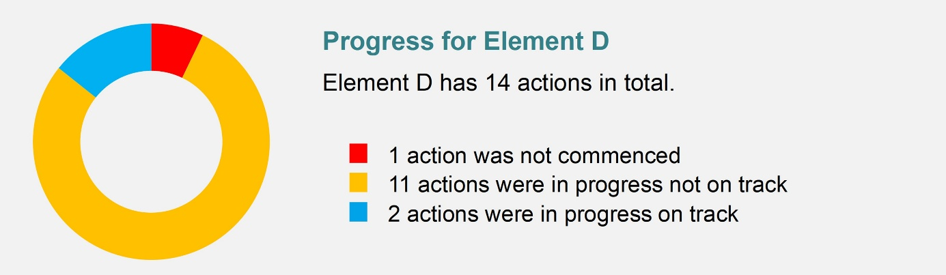

Highlights in 2025
Highlights of activities being undertaken to deliver Element D include:
- National Oral Health Plan. The Australian Government progressed work to develop a new National Oral Health Plan in partnership with states and territories. The new plan will guide national efforts over the next 10 years to improve oral health outcomes and reduce disparities across the population. Feedback from the private sector, community, and consumers has been collected through targeted and public consultations to inform its development. The new plan will align Australia's oral health priorities with broader reforms, including the National Preventive Health Strategy 2021–2030, the National Agreement on Closing the Gap and other related strategies supporting oral health, such as the Roadmap. It is expected to be finalised in 2026.
- In August, CHS Dental delivered targeted oral health promotion outreach for children with intellectual disability through 2 visits to PlayConnect+ playgroups. Children took part in structured oral health activities, including dental storybook reading, food sorting (’everyday’ vs ’sometimes’ foods), brushing practice, and learning about germs and brushing. CHS Dental staff also provided oral health education to parents and guardians, promoted accessible ACT dental services, and shared information about the Child Dental Benefits Schedule (CDBS). Families received toothbrushes, information on accessible toothbrush alternatives, and handouts on topics such as first dental visits, CDBS, children’s oral health, tooth eruption charts, Lift the Lip, and dietary guidance.
- NSW Health held an oral health webinar for public dental staff on strategies for the dental management of children and adults with special needs. It was attended by 96 staff and the recording was later viewed by an additional 43 staff.
- A collaboration between Oral Health Services Tasmania and Primary Health Tasmania reproduced 2 resource booklets on oral care for people with disability – refer to Spotlight: Primary Care Enhancement Program updates (p 20).
- Smile Squad Program. The Victorian Smile Squad is a free school dental program delivered in Victorian government schools including specialist schools. Specialised dental treatment is provided to all children referred through Smile Squad at new regional specialist hubs. Located in Geelong, Bendigo and Latrobe, and working with the Royal Dental Hospital Melbourne, these hubs offer government school students a range of specialised dental services that not all general dentists are able to provide. Services can include treatment under nitrous sedation and general anaesthetic where needed.
- In Western Australia, the purpose-built Special Needs Dental Clinic (SNDC) for patients with disability opened in September 2025. The clinic includes soft lighting, noise reduction elements, a low sensory waiting area, end of trip facilities, large dental surgeries to accommodate wheelchairs, hoists to aid patients transfer to the dental chair and medical gas for anaesthesia.
- The NCEIDH continued to develop its clinician networks, which bring clinicians together to share expertise and strengthen practice. Expressions of interest were sought for the National Intellectual Disability Oral Health Community of Practice, to support improved access to oral health care as part of overall health for people with intellectual disability.

Priorities for further action in Element D
Access to oral health care for people with intellectual disability remains inconsistent, particularly where people require specialist care, general anaesthetic, sedation or tailored support. Some localised models exist, but they are not implemented consistently across Australia.
Further work in this element will need to focus on developing sustainable pathways, supported by state and territory leadership, for people with intellectual disability to access oral health care safely and in a timely way. Areas for improvement include strengthening oral health data, building oral health capability across the dental and disability workforces, and developing clearer pathways for people with complex oral health needs.
Further work is needed to improve data on CDBS eligibility and use by children with intellectual disability. Consideration needs to be given to how the CDBS can better support people who require complex dental care, including care under sedation or general anaesthetic. A more coordinated approach could strengthen links between oral health, primary care, disability support and specialist services.

Element E: Research, data and measurement to support continuing improvement

Desired Outcomes
- Health outcomes for people with intellectual disability including health status, health service utilisation, and health outcomes are recorded, analysed and reported at a national level.
- Experiences of people with intellectual disability are captured throughout the patient journey.
- Targeted research drives the development of evidence-based tools/strategies and initiatives to improve the health of people with intellectual disability and the health services provided to them.
- Research includes people with intellectual disability during design and implementation.
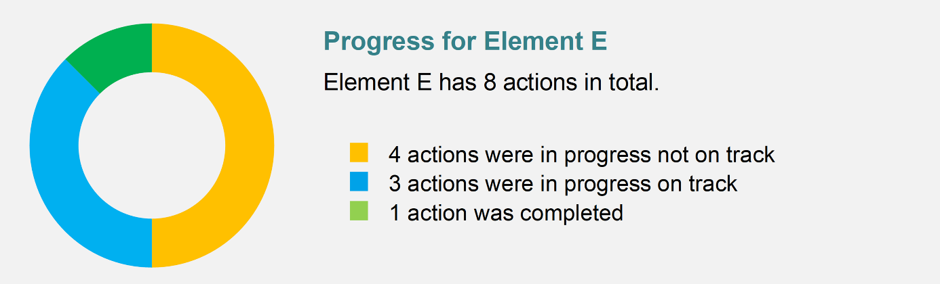

Highlights in 2025
Highlights of activities being undertaken to deliver Element E include:
- The Toolkit for Engaging People with Disability in Evaluation was released on the Australia’s Disability Strategy Hub in September 2025. The Toolkit aims to support people with disability to confidently engage in evaluations and to ensure evaluations are accessible and inclusive. This includes supporting people with disability to make informed decisions about taking part and to understand their role in evaluations. It also provides guidance on applying reasonable adjustments in engagement processes to support people with intellectual disability to share insights on their lived experience. The Toolkit was created in consultation with people with disability, disability representative organisations and people with experience in evaluation.
- Disability Data Measures Project. In response to Recommendation 12.5 of the Disability Royal Commission (a nationally consistent approach to data collection), the Australian Bureau of Statistics conducted the Disability Data Measures project over 2024–25. The project included research, consultations and question testing for different disability measures, including measures for ‘disability group’, which stakeholders identified as a high priority data need. The project proposed further development of a short set of questions that could be adopted in population surveys in Australia, however further consultations and testing were recommended. A summary of the key information from the project is available via abs.gov.au and also in Easy Read.

- The NDIS Quality and Safeguards Commission undertook a review to identify strategies used by organisations or services to reduce inappropriate prescribing and administration of psychotropic medications. Psychotropic medications can be important in treating mental disorders or physical illnesses and are also often prescribed to manage behaviours of concern in people with disability. However, evidence suggests that psychotropic medications are overprescribed and overused for people with intellectual disability. The review found evidence that medication reviews, workplace training, organisational guidelines and policies, and multi-component intervention strategies could decrease prescribing and administration of psychotropic medications in people with neurodevelopmental disabilities. The review also found that decision-making about appropriate psychotropic medication use should include the person with disability, their family, and a multi-disciplinary team that could include medical practitioners, pharmacists, allied health professionals, nurses, behaviour support practitioners, and disability support workers. The review was finalised in June 2025.
Spotlight – The National Disability Data Asset – development of an intellectual disability flag
The National Disability Data Asset (NDDA) uses linked, de-identified administrative and survey data from Australian and state and territory datasets and seeks to improve information and research about people with disability. However, much of this data does not include information about a person’s disability. To help address this, the NDDA Council agreed to the development of an intellectual disability flag for use in the NDDA. The flag is being developed in collaboration with the University of Melbourne.
In the NDDA, disability flags are indicators that help identify whether a person is likely to have a disability or type of disability, based on information already collected in existing systems. The flags are community-supported ways of measuring disability and help to consistently include and describe people with disability in the NDDA. They do not include personal identifying information. Researchers using the NDDA will be provided with a description of the flags and their limitations, informed by people with disability and the broader disability community.
The aim is to develop an intellectual disability flag that is consistent, transparent and evidence-informed. While it will not capture all people with intellectual disability, researchers will receive clear information about who is included and which subgroups may be underrepresented. This will strengthen analysis of service use and outcomes, and support evaluation of health pathways for people with intellectual disability.
The flag could improve health outcomes for people with intellectual disability by:
- supporting identification of health disparities and underrepresentation
- improving the visibility of people with intellectual disability in data
- enabling better population-level health research and evidence-informed decision-making
- ensuring health research is informed by people with disability and appropriate representative organisations.
Two dedicated workshops were held in September and December 2025 with disability representative organisations to inform development of the flag. The workshops sought expert advice on:
- how to appropriately describe the flag
- what considerations about the flag should be provided to researchers
- how the flag could be improved.
These considerations are essential to reduce the risk of data misinterpreting people and to support better understanding, inclusion and decision-making. The Australian Bureau of Statistics, Australian Institute of Health and Welfare and the University of Melbourne will use the information from the workshops to develop a design for the creation of the flag. The final design will be provided to the NDDA Council for approval in mid-2026.

Spotlight – MRFF funded projects – Improving the Health Outcomes of People with Intellectual Disability
In September 2025, more than $19 million was awarded through the Australian Government’s Medical Research Future Fund to support 11 projects under the 2024 Improving the Health Outcomes of People with Intellectual Disability grant opportunity. Funding is intended to improve understanding and uptake of preventive health care by people with intellectual disability, support people with intellectual disability to access appropriate health care throughout their lives and improve the identification of health issues in people with intellectual disability.
Funded projects:
- Professor Loc Do (University of Queensland): Achieving good oral health for young people with intellectual disability is everyone's task
- Professor Nathan Wilson (Western Sydney University): Australia’s first co-created workforce model to advance preventive oral healthcare for people with intellectual disability
- Dr Jessica Smith (Flinders University): Enhancing access to healthcare for people with intellectual disabilities: a multi-tiered sedation model
- Associate Professor Leanne Hassett (University of Sydney): Co-designing and evaluating a cross-sector physical activity navigator program for adults with intellectual disability
- Dr Michelle King (University of Queensland): Profound Pathways: improving health care transition and decision-making for young adults with severe and profound intellectual disabilities
- Professor Iva Strnadova (University of New South Wales): My Health Care Choices My Way
- Professor Kate Laver (Flinders University): From silos to synergy: Improving timely access to health services that support healthy ageing in people with intellectual disability
- Professor Stuart Wark (University of New England): Reducing health inequities for older people with intellectual disability in rural Australia
- Professor Reema Harrison (Macquarie University): Patient-led identification of unmet health and psychosocial needs by people with intellectual disability
- Associate Professor Margo Barr (University of New South Wales): Know Me, Support Me: AI reasoning tool for identifying and managing health issues of people with intellectual disability
- Professor Biswadev Mitra (Monash University): Building Reasonable adjustments, Inclusion, and Dignity in Emergency care for people with Intellectual Disabilities (BRIDGE-ED)

Priorities for further action in Element E
Significant work is underway to strengthen national data capability, but important gaps remain in measuring the health outcomes and service experiences of people with intellectual disability. In many datasets, people with intellectual disability are not consistently identified, which limits the ability to monitor outcomes, understand disparities and measure progress over time.
Further work in this area will need to focus on improving identification of people with intellectual disability in health and disability data, linking data across systems, and strengthening national reporting. This includes ensuring data development is informed by people with intellectual disability and representative organisations, and that reporting clearly communicates the context, strengths and limitations of the data.

Areas for improvement also include nationally consistent mortality reporting, better identification of people with intellectual disability in communicable disease and population-level health data, and stronger patient experience and outcome measures. This would support better understanding of whether health services are accessible, inclusive and responsive to individual needs.

Element F: Emergency preparedness and response

Desired Outcomes
- Emergency preparedness planning and responses include people with intellectual disability and consider their needs.
- Emergency responses include timely, targeted actions that support the health and wellbeing of people with intellectual disability.
- Communications meet the needs of people with intellectual disability, their families and carers during national and local emergencies.
- The health and disability sectors are equipped to respond to the needs of people with intellectual disability during emergencies.
- Person-centred plans for people with intellectual disability are activated during emergencies.


Highlights in 2025
Highlights of activities being undertaken to deliver Element F include:
- CHS Mental Health Service for People with Intellectual Disability has developed an accessible safety planning tool in an Easy Read format. This tool is an adaption of the My Mental Health Passport created by the University of New South Wales Department of Developmental Disability Neuropsychiatry to support people with intellectual disability to actively engage in safety planning. It also provides their supporters with personalised information on how to support them in a crisis or emergency. The tool is being integrated into the clinical record, and once achieved, other areas within CHS’ Mental Health, Justice Health and Alcohol and Drug Services area will be able to use the tool for consumers with intellectual disability.
The development of a safety plan:
- ensures people with intellectual disability can meaningfully participate in crisis planning
- provides carers and clinicians with clear, personalised safety information
- supports early crisis intervention and reduces risk of emergency escalation.
- Country to Coast PHN covers a region that is prone to natural disasters, including flood, bushfire, drought and pandemics. The PHN funded the Emergency Planning with People with Intellectual Disability (EPPID) project. This project works alongside people with intellectual disability and primary health care partners to co-produce Easy Read tools and resources for emergency health planning. Once developed, these resources will be distributed and embedded across primary health care, disability, social care, and community care providers. This will improve providers’ ability to support people with intellectual disability to stay healthy and well before, during, and after emergencies.

Priorities for further action in Element F
Emergency preparedness and response planning generally considers the needs of vulnerable populations, including people with disability, but does not always specifically address the needs of people with intellectual disability. Ongoing barriers include emergency messages not consistently being available in accessible formats, limited accessibility of emergency housing, transport and relief centres, and insufficient accommodation of people’s support needs during emergencies.
Further work in this element could be strengthened by ensuring emergency communication is accessible, timely and available in formats such as plain language and Easy Read. There are also ongoing challenges in maintaining continuity of health, disability and support services during emergencies, particularly for people in supported accommodation or who rely on coordinated supports.

Future planning should continue to involve people with intellectual disability, families, carers and disability stakeholders so that lived experience informs emergency planning, response and recovery.

Element G: Arrangements for oversight, monitoring and implementation of the National Roadmap

Desired Outcomes
- Implementation of the Roadmap is overseen by a diverse group of health and disability stakeholders, including:
- people with intellectual disability
- families and carers of people with intellectual disability
- representatives from the health and disability sectors
- representatives of universities, professional colleges, accreditation and registration bodies
- Commonwealth and state and territory government representatives.
- Implementation of the Roadmap is conducted in an inclusive and transparent manner.
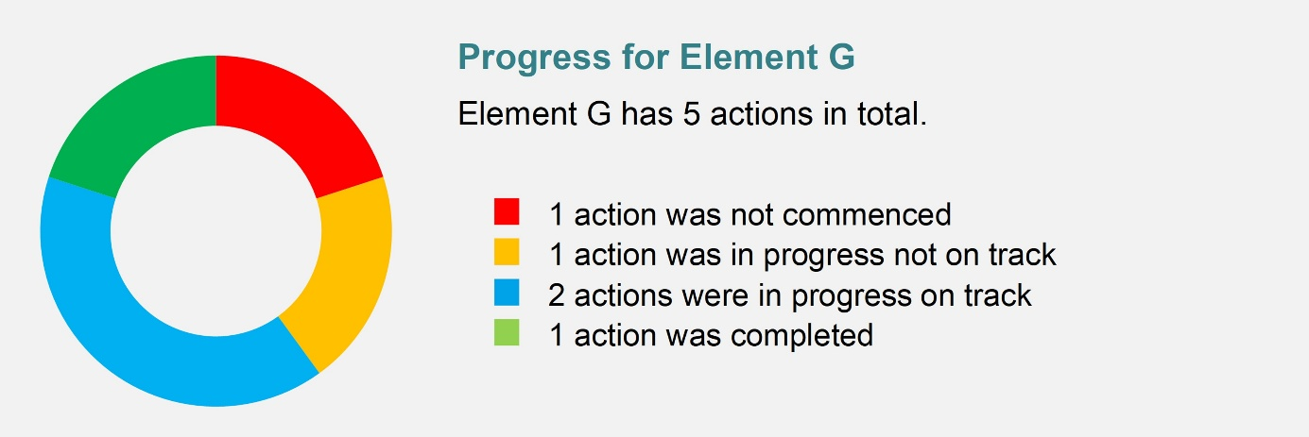

Highlights
Highlights of activities being undertaken to deliver Element G include:
- The Roadmap Implementation Governance Group (RIGG) has been in place since November 2021. The RIGG provides oversight and advice on the implementation of the Roadmap throughout its lifespan (2021–31), ensuring it is delivered in an inclusive and transparent manner. The RIGG also makes sure that governments and other stakeholders remain accountable for implementing Roadmap actions.
The RIGG has members representing:
- people with intellectual disability, their families and carers
- representatives from the health and disability sectors
- representatives of universities, professional colleges, and accreditation and registration bodies
- relevant Commonwealth government agencies
- Australian and state and territory government representatives.
- The RIGG met 3 times in 2025. Key issues discussed include:
- strengthening education and training for the existing health workforce
- supporting the implementation of the Intellectual Disability Health Capability Framework within university curricula
- improving access to procedural support and sedation for people with intellectual disability.
- The department continues to publish RIGG meeting summaries in standard and Easy Read versions.

Priorities for further action in Element G
Governance arrangements are established and continue to support oversight of Roadmap implementation. However, work in this element could be strengthened by improving monitoring, evaluation and reporting over the life of the Roadmap.

Annual reporting should continue to identify areas where progress is slow and where implementation barriers remain. Future evaluation will also be important to support continued accountability, transparency and implementation through to 2031.

Appendix A: Organisations providing input to this report
Thank you to the following organisations for providing input to this report:
Commonwealth government agencies
Australian Bureau of Statistics
Australian Centre for Disease Control
Australian Commission on Safety and Quality in Health Care
Australian Digital Health Agency
Department of Health, Disability and Ageing
Department of Social Services
National Disability Insurance Agency
NDIS Quality and Safeguards Commission
Advocacy and professional organisations
Allied Health Professions Australia
Down Syndrome Australia
National Disability Services
NSW Council for Intellectual Disability
Professional Association of Nurses in Developmental Disability Australia
Royal Australasian College of General Practitioners
Royal Australian College of Physicians
State and territory health agencies
ACT Health and Community Services Directorate
NSW Health
Queensland Department of Health
SA Department of Health and Wellbeing
Tasmanian Department of Health
Victorian Department of Health
WA Department of Health
Primary Health Networks (PHNs)
Brisbane South PHN
Central and Eastern Sydney PHN
Country to Coast Queensland (Central Queensland, Wide Bay, Sunshine Coast PHN)
Primary Health Tasmania (Tasmania PHN)
Western Victoria PHN
Universities and research centres
Centre for Developmental Disability Health
National Centre of Excellence in Intellectual Disability Health

List of acronyms and abbreviations
Acronym/abbreviation | Definition
3DN | Department of Developmental Disability Neuropsychiatry, UNSW
ABS | Australian Bureau of Statistics
ACSQHC | Australian Commission on Safety and Quality in Health Care
CHAP | Comprehensive Health Assessment Program
CHS | Canberra Health Services
CPD | continuing professional development
DLO | Disability Liaison Officer
GP | general practitioner
MBS | Medicare Benefits Schedule
NCEIDH | National Centre of Excellence in Intellectual Disability Health
NDDA | National Disability Data Asset
NDIA | National Disability Insurance Agency
NDIS | National Disability Insurance Scheme
NDIS Commission | NDIS Quality and Safeguards Commission
NSQHS Standards | National Safety and Quality Health Service Standards
PCEP | Primary Care Enhancement Program
PHN | Primary Health Network
RIGG | Roadmap Implementation Governance Group
the Roadmap | National Roadmap for Improving the Health of People with Intellectual Disability
SIL | Supported Independent Living

Health.gov.au
All information in this publication is correct as at October 2026

