Name | Details
Professor Sally Green (Chair)  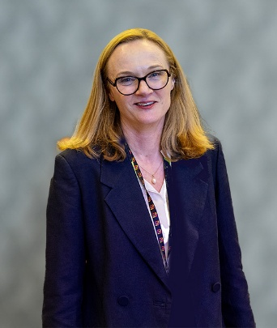 | Professor Sally Green is Co-Director of Cochrane Australia and Deputy Head (Research) of the School of Public Health and Preventive Medicine at Monash University. She holds a PhD in Epidemiology and Preventive Medicine from Monash. Professor Green’s research aims to improve health outcomes and strengthen health services through high quality, timely research synthesis and guideline development. Her work is focused on implementation of research into clinical practice and health policy.  Professor Green is a member of Cochrane’s international Governing Board.
Dr Clare Skinner (Deputy Chair)  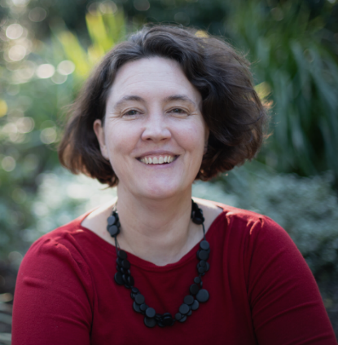 | Dr Clare Skinner is a specialist emergency physician with interests in health system reform, clinical redesign, leadership, advocacy, and workplace culture and safety.  Clare served as President of the Australasian College for Emergency Medicine from November 2021-2023 and currently holds important roles as a Senior Staff Specialist in Emergency Medicine at Hornsby Ku-ring-gai Hospital and the Northern Sydney Local Health District.  Clare regularly shares her insights through contributions to academic journals, mainstream media, and medical blogs, and as a regular speaker at emergency medicine and leadership conferences.  Clare‘s contributions to the field were recognised in 2018 when she was selected among the Top 50 Public Sector Women in NSW.
Dr Lorraine Anderson  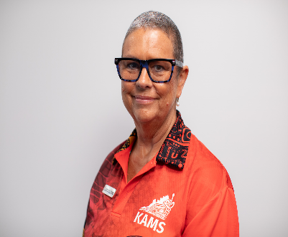 | Dr Lorraine Anderson is the Medical Director at Kimberley Aboriginal Medical Services, based in Broome, Western Australia. Lorraine is proudly linked through her father to the Palawa people of Tasmania. She gained her primary degree in Medicine at The University of Auckland in New Zealand, followed by post graduate qualifications in Public Health and Tropical Medicine (Masters), Child Health, Palliative Medicine and General Practice (PGDips). Lorraine is a Fellow of the Royal New Zealand College of General Practice and the Royal Australian College of General Practice. She has been working in Aboriginal health and remote rural practice in the Pilbara, Indian Ocean Territories and now the Kimberley for the past 19 years. Lorraine has a passion for Aboriginal Health, the Aboriginal Community Controlled Health Sector model of care and loves to see technology being used well in this environment.  Lorraine sits on National Aboriginal and Torres Strait Islander Health Protection Committee (NATSIHP), Communicable Diseases Network Australia (CDNA), Australian Prescriber Editorial Committee, WA Country Health Services Board member, Therapeutic Goods Advertising (TGA) and Compliance Committee and TGA Women’s Health Products Working Group.  Lorraine has previously been a member of Medical Services Advisory Committee (MSAC) and HTA Review Implementation Advisory Group.
Dr Katie Ellard  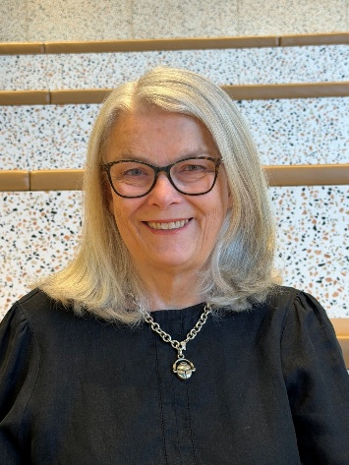 | Dr Katie Ellard graduated from the University of Sydney in 1978. She has worked as a gastroenterologist in private practice for more than thirty years. During that time she has been involved in student teaching, development of practice guidelines and the development of the National Bowel Screening program, on behalf of the Gastroenterological Society of Australia. This prompted an interest on methods focused on improving the quality of colonoscopy for the Australian public, which led over time to the development of the Recertification Program for colonoscopy which is supervised by the Conjoint Committee representing the RACP, RACS and the Gastroenterological Society of Australia. She was involved in the Medicare Benefits Schedule Review Task Force gastroenterology committee from 2015 until 2019 and has contributed to the development of the Clinical Care Standards for Colonoscopy for the Australian Commission for Safety and Quality in Health Care, as well as the Atlas showing the variation in colonoscopy per head of population throughout Australia, reflecting inequality of access to medical services . Her main clinical interests are inflammatory bowel disease and functional gut disease, and she has a focus on the continuing gender pay gap in medicine in Australia.
Professor Adam Elshaug  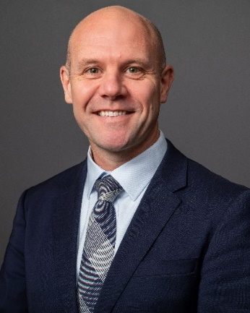 | Professor Adam Elshaug is a Director for the Centre for Health Policy, Melbourne School of Population and Global Health at the University of Melbourne  Adam is a health services and systems researcher, and policy advisor. He directs a program of research measuring health service utilisation with a particular focus on low-value or inappropriate healthcare. Partners include four state health departments, Veterans Affairs, four PHIs (representing ~68% of privately insured Australians), US Medicare, NICE and Thailand. For this program Adam has been awarded the HSRAANZ Impact Award and the Research Australia Data Innovation in Health and Medical Research Award.  Adam was a member of the MBS Review Taskforce and its Principles and Rules sub-committee. He is a Board Member of the NSW Bureau of Health Information (BHI), sits on the Expert Advisory Committee for Evidence-based Interventions (NICE and NHS England) and since 2014 he has been economic and policy advisor to Cancer Australia.  A 2010-11 Commonwealth Fund Harkness Fellow based at AHRQ (USA), then Sidney Sax Fellow at Harvard Medical School, for 2019-20 Adam was Visiting Fellow at The Brookings Institution in Washington DC.  Prior to joining Melbourne in September 2020 Adam was Co-Director of the Menzies Centre for Health Policy at The University of Sydney.
Dr Chloe Furst   | Dr Chloe Furst is a dual trained geriatrician and palliative care physician working across both specialties within the Central Adelaide Local Health Network (CALHN) in South Australia. She is the Medical Director for the Acute and Urgent Care program at the Royal Adelaide Hospital (RAH) which comprises general medicine, geriatrics, the emergency department, toxicology and trauma. She has been the South Australian state division president of the Australian and New Zealand Society of Geriatric Medicine for the last 4 years. She has a special interest in capacity, cognitive impairment, multimorbidity and end of life care and the ethics around these complex issues. She has a strong commitment to the care of the older adult and ensuring that our hospital systems are safe for patients and doctors alike and that patients get treatment aligned to their goals of care in the right environment. She has been heavily involved in the roll out of Voluntary Assisted Dying (VAD) in SA as part of the SA VAD implementation task force and as South Australia’s VAD clinical liaison and has clinically been an active VAD practitioner.
Dr Terence Heng  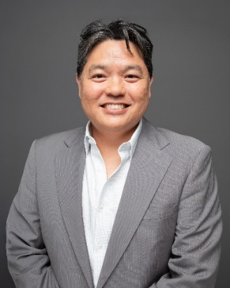 | Dr Heng has contributed extensively to medical education and clinical training at both undergraduate and postgraduate levels. He previously served as a Conjoint Clinical Senior Lecturer with the School of Medicine, Deakin University, and currently supervises medical students and GP registrars across all stages of training.  Earlier in his career, Dr Heng was an invited lecturer in Public Health and Clinical Pharmacology at RMIT University. In collaboration with his local Primary Health Network, he helped develop clinical pathways and strengthen partnerships between local hospitals and general practice to improve outpatient access and continuity of care.  He continues to contribute to professional assessment and medical education as an Examiner for RACGP, with involvement in both the Clinical Competency Examination (CCE) and Pre-Employment Structured Clinical Interview (PESCI) assessments.  Dr Heng currently lives and works as a Rural Generalist at Great Ocean Road Health, Apollo Bay (MM5), where he provides comprehensive general practice, urgent care, and aged care services to the local community.
Dr Ronelle Hutchinson   | Ronelle is a consumer member of the committee. She is an experienced consumer advocate in the health and disability sectors. Ronelle has a special interest in incorporating the lived experience of people who are blind or have low vision into health and service design and public policy and serves on a range of boards and advisory committees in the eye health sector in Australia.  Ronelle is a person with disability and a frequent user of all levels of the health system. She is passionate about ensuring that people with difference, disability and disadvantage are able to access the health care they need.  In her professional life, Ronelle has over two decades of experience in public policy in the health, aged care and disability sectors. She has worked for and with all levels of governments to design and evaluate a diverse range of health and human services policies. She has specific expertise in economic evaluation and quality and safety regulation in the general practice, aged care and allied health sectors and has worked in corporate consultancy, national health peak member organizations and for a national health provider. Ronelle serves on a range of boards and advisory committees in the not for profit and government sectors. Ronelle holds postgraduate qualifications in public health and social research and is a graduate of the Australian Institute of Company Directors.
Professor Guy Maddern   | Professor Guy Maddern is the RP Jepson Professor of Surgery at Adelaide University. He is an active hepatobiliary and pancreatic surgeon with an interest not only in health technology assessment but also in surgical evaluation.  Over many years he has been involved in providing systematic reviews through the Royal Australasian College of Surgeons as well as being the Chair of the International Network of Agencies for Health Technology Assessment (INAHTA) and the President of Health Technology Assessment International (HTAi).  At present Guy is serving as the Chair of the Advisory Committee on Medical Devices (ACMD) of the Therapeutic Goods Administration (TGA) assessing new devices and technology. He also leads the South Australian Policy Advisory Committee on Technology (SAPACT) assessing new devices and technologies, and Head of the Central Local Health Network (CALHN) New Clinical Procedures, Services and Other Interventions Committee (NCPSOIC).  He has been responsible for coordinating and deploying regional surgical services to South Australia and was responsible for setting up reliable and sustainable general surgical services to Port Lincoln, Whyalla, Port Augusta, Mount Gambier, Naracoorte and Millicent, as well being the Director of Surgery of the Central Adelaide Local Health Network (CALHN) for over a decade.  For the past 25 years he has been the Director of Research at the Basil Hetzel Institute based on the campus of The Queen Elizabeth Hospital in Adelaide.
Dr Andrea Mosler  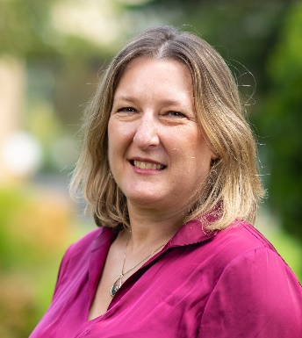 | Dr Andrea Mosler is a Specialist Sports and Exercise Physiotherapist and Senior Research Fellow at La Trobe University and is currently working on injury prevention in football, hip/groin pain, and women in sport research projects. Her PhD, completed in 2018, investigated the risk factors for hip and groin pain in professional football players and was conducted while working at Aspetar, Qatar. Andrea previously worked for 18 years at the Australian Institute of Sport as a Senior Sports Physiotherapist and has been an Australian team physiotherapist at many sporting events including the 2000, 2004 and 2008 Olympics Games and the 1998 Commonwealth Games. She is Deputy Editor of the British Journal of Sports Medicine, Associate Editor of the Journal of Science and Medicine in Sport and continues to practice clinically in conjunction with her research work.
Dr Tristan Nickless, PhD  BA(Hons)/BBus(Mgmt), MSpPath, PhD, MSPAA, CPSP  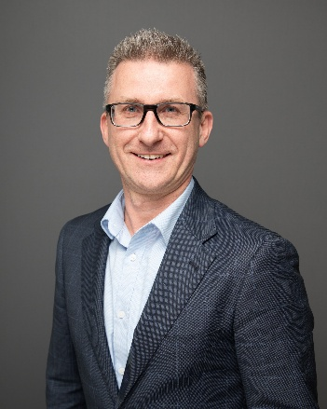 | Tristan Nickless has more than two decades of clinical experience in communication disorders, with special interests in developmental language disorder, speech sound disorders (including phonological disorders and Childhood Apraxia of Speech), stuttering, and specific learning difficulties such as dyslexia and dysgraphia. He serves as Principal Speech & Language Pathologist at Word By Mouth Pty Ltd, a Melbourne-based independent practice providing clinic- and school-based services across metropolitan and regional schools, refugee and First Nations’ communities, within a Response-to-Intervention framework.  Tristan has made significant contributions to the speech pathology profession through research, leadership, and national advocacy. As Speech Pathology Australia’s National Advisor – Private Practice (2005–2009), he oversaw the development of the profession’s inaugural public funding pathways across Medicare, Helping Children with Autism, and private health insurance. He served on the National Ethics Board from 2015 to 2021 and, in 2025, was appointed as one of five Senior Members of Speech Pathology Australia’s Ethics Board. Tristan’s international contributions were further recognised in 2025 when he was appointed to the Child Language Committee of the International Association of Communication Sciences and Disorders.  Tristan has been subject lead and advisor for the University of Melbourne’s Master of Speech Pathology program (2010 – 2018) and continues to mentor students through clinical education at Word By Mouth.  In 2025, he was awarded his PhD from the University of Melbourne for research analysing public funding models supporting access to independent speech-language pathology services in Australia. His peer-reviewed publications further advance understanding of major funding mechanisms such as the NDIS and multiple Medicare Benefits Schedule item. Before pursuing a career in speech pathology, Tristan worked in international marketing, project management, and economic development.
Dr Jamie Nuttall   | Dr Jamie Nuttall is a working General Practitioner based in Brisbane. He is Deputy Clinical Director at Inala Primary Care, a not-for-profit organisation devoted to health equity and quality primary care. He also sees patients at the Metro South Pain Rehabilitation Centre at Princess Alexandra Hospital. He has worked in general practice across private, public, non-profit, and Aboriginal Community Controlled Health Organisation settings. Jamie has clinical interests in persistent pain, migraine, mental health, and chronic disease management.
Dr Charlotte Ogilvy   | Dr Charlotte Ogilvy is a Nephrologist and General Physician based in Wangaratta, in regional Victoria. She is a Fellow of the Royal Australasian College of Physicians in both Nephrology and General and Acute Care Medicine. She also holds a Master of Public Health from the University of Melbourne, a Master of Bioethics from Monash University, a Clinical Diploma in Palliative Medicine and a Professional Diploma in Tropical Medicine and Hygiene from the London School of Hygiene and Tropical Medicine.  Charlotte has built her career in rural, regional and remote Australia. She has worked at Royal Darwin Hospital, Alice Springs Hospital, Orange Health Service and Northeast Health Wangaratta. At Royal Darwin Hospital she was involved in setting up a Kidney Supportive Care service. She contributed to the 2026 ANZSN–ANZSPM consensus guidance on kidney supportive care in Australia and New Zealand. Internationally, she worked with Médecins Sans Frontières as Non-Communicable Diseases Technical Referent in Lebanon’s Beqaa Valley.  Charlotte is a passionate advocate for high-quality, equitable healthcare delivered closer to home, particularly for rural communities and First Nations peoples. She is a member of the RACP Ethics Committee, the AMA Ethics and Medicolegal Committee and the AMA Victoria Rural and Regional Doctors Policy Council.
Adjunct Professor Chris Raftery  BNur, MEmergN, MBA(HSM), MNSc(NP), PhD, MAICD, FACN, FACNP, FCHSM, CHE   | Adjunct Professor Chris Raftery is a national healthcare leader and practising Nurse Practitioner from Queensland, who has been part of the health sector for more than 25 years spanning across various clinical, operational management and strategic roles. Having broad clinical and system leadership experience and influence at the local, state and national levels, through various board and committee appointments over the years, Chris is a leading identity on the nursing and midwifery workforce, advanced practice and nurse practitioners, health system planning, regulation, technology, economics and leadership. Having worked with many health system leaders and agencies, academic and governing bodies, his contributions have informed policy, workforce strategy, practice innovation and health system reform. Recognised for his professional eminence and contribution to education, clinical practice and policy, Chris also holds adjunct Professor of Nursing and Midwifery titles at Griffith University, Queensland University of Technology and Monash University.
Mrs Sandy Robertson  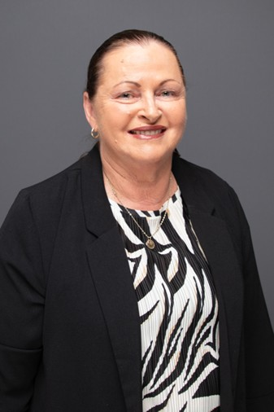 | Sandy Robertson is a dedicated consumer advocate with over 10 years of experience, beginning with the BreastScreen Qld Committee after a personal breast cancer diagnosis. Committed to improving health communication and resources for women, with a focus on making information more accessible and consumer friendly.  Professional experience with Medicare Australia over 22 years has provided her extensive knowledge of the Australian Health System. This knowledge has been shared with the health professionals within Aboriginal & Torres Strait Islander Community Controlled Clinics in Queensland and throughout Australia over the past 18 years.  Sandy has provided consumer representation on the following significant initiatives: MBS Taskforce Review committee (Aboriginal & Torres Strait Islander Reference Group), MBS Time Tiered Review, the implementation of Voluntary Assisted Dying in Qld, BreastScreen Qld committee and Qld Dense Breast Study, ACTMED research study (UQ), Qld Health Digital Informed Consent, Support Meds – De Prescribing Project (Monash Uni), Interprofessional Prescribing Advisory Group (UQ), Services Australia - New System Consumer feedback, Qld Health - Patient Administration System modernisation, Qld Health Cancer Carer Working Group, and Chronic Disease Prevention Advisory Group.  Sandy demonstrates a strong commitment to advancing the health system through meaningful consumer representation and collaborative improvement.
Associate Professor Beverley Rowbotham AO, MD, MBBS (Hons 1), FRACP, FRCPA, FAICD  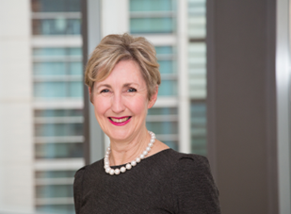 | Associate Professor Beverley Rowbotham Is a haematologist and chairs the Federal Government’s National Pathology Accreditation Advisory Council. She has a strong background in medical leadership and patient safety through her roles as President of the Royal College of Pathologists of Australasia, long serving Chair of Federal Council of the Australian Medical Association, and Chair of the medical indemnity company, Avant Mutual Group. She brings her experience as a member of many Federal Government advisory committee roles including the original MBS Review Taskforce.
Mr Brady Schulz  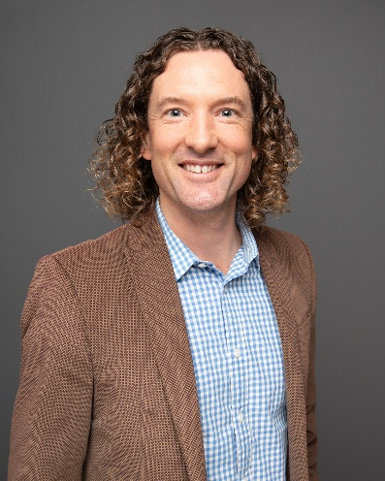 | Brady Schulz is an Accredited Exercise Physiologist, Accredited Practising Dietitian and Advanced Sports Dietitian with extensive experience delivering multidisciplinary allied health services across metropolitan, regional, rural and remote Australia. He is the Founder and Managing Director of Healthy Lifestyles Australia, a primary care organisation delivering Dietetics, Exercise Physiology and Diabetes Education services to more than 120 centres across Queensland.  Brady has more than 16 years’ experience working in rural and remote health, supporting communities across the Darling Downs, South East, South West, Western QLD, Fraser Coast and North Queensland. His clinical expertise spans cardiometabolic health, chronic disease prevention and management, exercise prescription for metabolic, musculoskeletal and neurological conditions, and sports nutrition for elite and recreational athletes.  Through Healthy Lifestyles Australia, Brady leads delivery of government-funded chronic disease programs and multidisciplinary diabetes initiatives, overseeing workforce development, clinical governance and scalable models of care that strengthen primary health services in underserved regions. He has a strong commitment to early intervention, patient-centred care pathways, integrated multidisciplinary practice and sustainable rural and remote allied health workforces.  In addition to his organisational leadership, Brady serves on the Brisbane North PHN Allied Health Advisory Committee, contributing to regional planning, service integration and primary care strengthening across the North Brisbane catchment.  Brady holds a Bachelor of Applied Science (HMS) (Hons) and a Master of Nutrition and Dietetics. He is a member of Sports Dietitians Australia, Exercise and Sports Science Australia, Dietitians Australia, Health Workforce Queensland, and Services for Australian Rural and Remote Allied Health (SARRAH), contributing to national efforts to enhance rural health strategy, workforce capability and equitable access to allied health services.
Conjoint A/Professor Deshan Sebaratnam MBBS(Hons) MMed FRCP (London) FACD  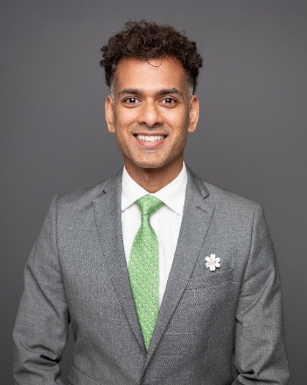 | Deshan Sebaratnam is a dermatologist based in NSW. He graduated medical school with Honours and went on to complete his Master of Medicine with a focus in health economics. He is a Staff Specialist at Liverpool Hospital where he leads Paediatric Dermatology, and established vascular laser, Genodermatology and Vascular Anomalies multi-disciplinary clinics. He also established a Dermatology service at Dubbo Base Hospital and has previously worked in the NT and ACT. He holds an academic appointment at UNSW, having published over 150 research publications and regularly supervising medical students completing their Honours. He was awarded the Australasian College of Dermatologists' Research Fellowship at St John's Institute of Dermatology in London and a scholarship from the Ministry of Health to integrate genomics into healthcare delivery. He is on the Editorial Board of the Australasian Journal of Dermatology and a Director of the Skin Hospital.
Professor David Story  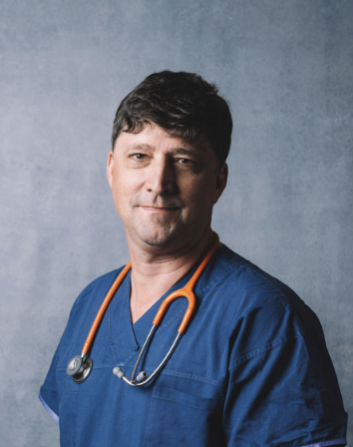 | Dave Story is Professor of Anaesthesia and Head of the Department of Critical Care at the University of Melbourne, covering Anesthesia, Emergency Medicine, and ICU Medicine. He is a member of Council and Immediate Past-President of the Australian and New Zealand College of Anesthetists (ANZCA). His main research interest is clinically and cost-effective approaches to reduce perioperative risk, complications, disability, and mortality. His clinical work at the Austin Hospital in Melbourne covers many procedural specialties including liver transplantation.
Dr Christopher Symmons  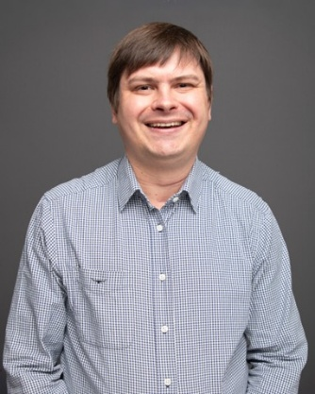 | Dr Chris Symmons is a Rural Generalist Senior Medical Officer in Longreach in western Queensland. He works in primary care in Longreach and remote primary health centres and has an interest in procedural general practice including skin surgery. Additionally, he works as a rural generalist anaesthetist at Longreach hospital where he was previously Acting Director of Medical Services. He is a member of the Queensland Clinical Senate. Outside of medicine, he runs an ecotourism business and is on the board of Desert Channels Queensland.
Professor Rosalie Viney  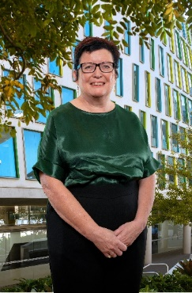 | Rosalie Viney is Professor of Health Economics and Director of the Centre for Health Economics Research and Evaluation at the University of Technology Sydney. She has extensive experience in health economics, health services and health policy research. Her research interests include health technology assessment and priority setting, measurement and valuation of quality of life and health outcomes, consumer preferences for health and health care, evaluation of health policy, and the impact of funding arrangements on utilisation and outcomes of health care. Rosalie has undertaken a broad range of commissioned projects for State/Territory Health authorities, and for the Australian Government Department of Health. Rosalie has also had longstanding involvement in the fields of health economics and health services research in Australia and internationally, through the Australian Health Economics Society and the Health Services Research Association of Australia and New Zealand, and through the International Health Economics Association where she was a Board member from 2020-2024, and the EuroQol Foundation, where she is a member and the current Chair of the Scientific Executive. Rosalie was a member of the NHMRC Research Committee from 2015-2021. Until March 2017 she was also a member of the Pharmaceutical Benefits Advisory Committee (PBAC) and Chair of its Economics Sub-Committee. She is a current member of the Life Saving Drugs Panel. She is a Fellow of the Australian Academy of Social Sciences.

