
Evaluation of the COAG s19(2) Exemptions Initiative and emerging rural health reform
Department of Health, Disability and Ageing
4 December 2025


Nous Group acknowledges Aboriginal and Torres Strait Islander peoples as the First Australians and the Traditional Custodians
of Country throughout Australia. We pay our respect to Elders
past and present, who maintain their culture, Country and
spiritual connection to the land, sea and community.
This artwork was developed by Marcus Lee Design to reflect Nous Group’s Reconciliation Action Plan and our aspirations for respectful and productive engagement with Aboriginal and Torres Strait Islander peoples and communities
Disclaimer:
Nous Group (Nous) has prepared this report for the benefit of the Department of Health, Disability and Ageing (the Client).
The report should not be used or relied upon for any purpose other than as an expression of the conclusions and recommendations of Nous to the Client as to the matters within the scope of the report (Permitted Purpose). Nous and its officers and employees expressly disclaim any liability: (i) to any person other than the Client, and (ii) to the Client to the extent the report is used or relied upon for any purpose other than the Permitted Purpose.
© Nous Group
Nous has prepared the report with care and diligence. The conclusions and recommendations given by Nous in the report are given in good faith and in the reasonable belief that they are correct and not misleading. The report has been prepared by Nous based on information provided by the Client and by other persons. Nous has relied on that information and has not independently verified or audited that information.
Contents
Executive Summary 5
1 Introduction and Background 10
1.1 Primary care in rural and remote Australia 11
1.2 About the Initiative 12
1.3 Reform of rural and remote health is a continuing area of focus for governments 18
2 Evaluation Methodology 20
2.1 Evaluation purpose and objectives 21
2.2 Evaluation approach 21
3 Key Findings 29
3.1 Policy Context 30
3.2 Program Design 43
3.3 Program Delivery 55
3.4 Program Outcomes 69
4 Future Direction 79
4.1 Reform approaches can better align the Initiative to today’s realities and aspirations 80
4.2 Options for reform 81
Appendix A Evaluation conceptual approach 92
Appendix B Key evaluation questions 95
Appendix C Organisations consulted 98
Appendix D Recommendation considerations 100
Appendix E Site Visit Case Studies 104

Glossary and acronyms
Acronym | Description
ACCHS | Aboriginal Community Controlled Health Service
ACCHOs | Aboriginal Community Controlled Health Organisation
AIHW | Australian Institute of Health and Welfare
AMS | Aboriginal Medical Service
COAG | Council of Australian Governments
DPA | Distribution Priority Area
DWS | District of Workforce Shortage
ED | Emergency Department
FTE | Full Time Equivalent
GP | General Practitioner
GPCCMP | GP Chronic Conditions Management Plan
IMG | International Medical Graduates
KEQ | Key Evaluation Question
LHN | Local Hospital Network
MBS | Medicare Benefits Schedule
MMM | Modified Monash Model
MoU | Memorandum of Understanding
MPS | Multi-Purpose Service
NDIS | National Disability Insurance Scheme
NHRA | National Health Reform Agreement
NTAHF | Northern Territory Aboriginal Health Forum
PHN | Primary Health Network
RFDS | Royal Flying Doctor Service
RWA | Rural Workforce Agencies
The Department | Department of Health, Disability and Ageing
The Initiative | Section 19(2) Exemptions Initiative

Executive Summary

Introduction and background
The Council of Australian Governments (COAG) s19(2) Exemptions Initiative (the Initiative) was established in 2006 with the aim of improving access to primary care services in rural and remote areas. It enables this by allowing approved sites to claim Medicare Benefits Schedule (MBS) payments for services provided in State and Territory run services such as hospital Emergency Departments (EDs) and community clinics.
In July 2025, Nous Group (Nous) was engaged by the Department of Health, Disability and Ageing (the Department) to undertake an independent evaluation of the Initiative to assess how well it was performing against its stated objectives. In addition to a specific evaluation of the Initiative, Nous was also tasked with considering its place and future in the context of wider health sector reforms to critically assess how changes to funding mechanisms could address issues in thin markets and improve access to primary care services in rural and remote areas.
To address the Key Evaluation Questions (KEQs) developed by the Department, Nous adopted a mixed methods approach including:
- A detailed policy review of relevant literature and documentation including assessing the findings and recommendations of previous evaluations of the Initiative.
- Interviews and focus groups with key stakeholders these have included representatives of all jurisdictions; relevant peak bodies; Departmental stakeholders; Primary Health Networks (PHNs); and Aboriginal and Torres Strait Islander peak bodies and community-controlled organisations.
- Site visits carried out in person to six sites and virtually to four sites. These produced case studies that illustrated how the Initiative is used within a local primary care, thin market context.
- A survey of all existing participating sites and local health networks.
- Quantitative analysis including analysis of billing data and some assessment of State and Territory primary care investment.
The evaluation was limited by the absence of defined outcome metrics, low survey response rates in some regions, and incomplete jurisdictional data, which constrained the ability to fully assess the Initiative’s impact. These limitations were mitigated through triangulation of data sources and broad stakeholder consultation and as such the evaluation has been able to deliver evidence-based findings and recommendations.

Key evaluation findings
The evaluation has found that the Initiative is valued and contributing to improved access to services in many hospital settings and workforce availability in the participating sites. However, these benefits are variable across sites, and the coverage of the Initiative is not consistent across jurisdictions. Additionally, there are opportunities to streamline the operation of the Initiative to improve efficiency and effectiveness.
More broadly, the policy and primary care landscape has shifted significantly since the Initiative was introduced over 20 years ago. Notably, there has been a greater emphasis on multidisciplinary models of care that support continuity of care and management of more complex and chronic health conditions. The Initiative is unable to fully support this development, which utilises a fee-for-service funding mechanism. At the same time, the primary care market in rural and remote areas has changed markedly, with a continued decline in private general practices creating a stronger need for Local Health Networks (LHNs) and other public providers to assist with and deliver primary care services. Recent policy reviews have also recommended changes to funding models, advocating a shift away from fee-for-service arrangements towards blended funding mechanisms that better support integrated care.
The Initiative was established in 2006 in recognition of the challenges experienced in accessing and delivering primary health care in rural and remote areas. Despite the Initiative and substantial government investment in other measure, persistent challenges remain for rural and remote health services:
- People living in rural and remote areas in general have poorer health than people living in urban areas, with several indicators of health and wellbeing deteriorating with increased remoteness.
- Per capita expenditure on health and related services is lower in non-urban areas, and evidence indicates that this gap is widening.
- Workforce supply in rural and remote areas continues to be lower across medical, nursing and allied health professions.
The evaluation finds that while the Initiative continues to support access to primary and broader medical care in specific contexts, there are barriers and broader challenges that remain in provision of rural and remote primary care. The Initiative’s design and implementation face limitations, including administrative complexity, inequitable uptake across and within jurisdictions, and misalignment with contemporary policy directions that emphasise integrated, multidisciplinary, and place-based care. Across some sites, the Initiative is working well and improving primary care access, but in many places the Initiative is used narrowly as a funding source to fill gaps in service provision - for example through the employment of locums or ED support.
The application process is widely regarded as difficult and onerous, including the requirement to obtain agreement from other local service providers, who can act to veto applications. Sites must adapt to MBS billing, which requires significant upskilling, cultural change and additional administrative burden – something that can be difficult to manage in under resourced settings, with a transient workforce. Successful implementation of the Initiative is often found in sites where there is the ability to dedicate specific resources to the application process and ongoing running of the Initiative.
In terms of outcomes, the evaluation has found that the Initiative has delivered modest but important benefits to improving access to primary care services in rural and remote regions, by providing access to a source of funding that complements other streams and is often key to keeping certain services viable. Integrating the Initiative within a broader, more strategic framework that supports sustainable, equitable and community-responsive primary care in rural and remote Australia could significantly enhance its impact. The evaluation was unable to determine how many potential eligible sites may exist and the extent to which states are delivering primary care services in rural and remote areas, due to gaps in the completeness of jurisdictional data available.

Future direction
The report presents a series of options for future development based upon the findings of this evaluation. From its inception, the Initiative has been an important part of activity to address challenges in rural and remote areas, but not sufficient on its own to address these challenges. Accordingly, the evaluation has considered the initiative in the context of broader reform considerations and developed options for future directions accordingly. These options are categorised into three areas along a continuum of increasing size and complexity. The three areas are:
- Reform within the Initiative to improve its impact. Recommendations in this option are predicated upon the Initiative remaining in its current form but considering ways that the Initiative can be streamlined and minimise complexity, alongside improved local governance arrangements to ensure strategic investment of funds in line with local primary care priorities.
- Broader reform to expand the role of the Initiative. Builds on Option 1 to take the Initiative beyond its remit to address broader system barriers and consider complementary activities to support improved rural and remote primary care access. Recommendations considered in this section include changes to MBS rules to allow broader access to billing by other professions such as nurse practitioners; the consolidation of existing programs to simplify processes and encourage uptake; and allowing funding to be used in a more flexible manner with stronger sub-regional oversight. It also considers complementary activities, to support improved primary care access through PHNs and other stakeholders at the local level.
- Bold system-wide reform. Would see the Initiative replaced over time, with current quantum of funding levels retained. This may begin with a review of the specific legislation referring to the Initiative to ensure that it supports the contemporary goals of primary care. This option proposes shifting funding and governance to a central function such as the PHNs, pooling Commonwealth and state resources, and addressing workforce enablers such as housing, training, and flexible employment to support sustainable, place-based care.
A summary of recommendations is presented in Table 1, across the three options.
Table 1 | Summary of options and recommendations
Option | Recommendation
Improving the Initiative  Reform within the Initiative to build on its weaknesses. | - Distil a clearer overview of primary care expenditure across all levels of government.  - Streamline and simplify the billing rules for efficiency.  - Review and clarify billing items and reinvestment to ensure greater focus on primary care.  - Annual review of eligible MBS billing to ensure changes in clinical practice are captured.  - Centralised knowledge repository and leadership.  - A joint sub-regional governance committee is established to support and make recommendations around COAG s19(2) application, implementation and ongoing investment decisions.  - Complement 19(2) exemptions approvals with a regional reinvestment plan as recommended by the committee to ensure appropriate, coordinated primary care investment.  - Eligibility of the Initiative is granted through a data-driven methodology.
Broader reform  Reform to expand the role of the Initiative to and go beyond its current remit. | - Develop broader MBS for eligible regions and define a range of professionals and activities billable for the MBS.  - Funding is tied to a regional primary care funding amount.  - Consolidate s19(2) exemptions (excluding AMS exemptions), to reduce the complexity of existing arrangements, reduce barriers to services who want to apply and encourage greater uptake.  - Allow great flexibility in requirements for referral for a GPCCCP in thin markets.  - Yearly costing studies to ensure Medicare loading and broader funding is reflective of true costs of rural and remote service delivery (including outreach).
Bold system-wide reform  Reform to replace the Initiative, with changes more broadly across the system. | - Conduct a legislative review of Section 19(2) of the Health Insurance Act (1973).  - Expand the role of relevant PHNs to conduct regular thin market assessments and coordinate planning for solutions, in line with input from other local organisations.  - Develop an agreed process to establish local governance committees with broad jurisdictional, and local representation.  - Direct regional primary care funding the PHN to ensure funding is used according to local need and place-based implementation is facilitated.  - Develop funding allowances that extend to workforce enablers including housing, transport and technology.  - Make funding conditional on investment in training and supervision pathways to address workforce gaps, reduce barriers to professional development.  - Target low health professional pipeline areas by expanding flexible employer arrangements for training and existing workforce across all specialties.


Introduction and Background

Section title: 01 Introduction and Background
[The image shows a sunset over a rocky landscape with sparse greenery in Northern Territory, featuring a vibrant sky.]
This section provides an overview of primary care in rural and remote Australia and the Initiative.

Primary care in rural and remote Australia

Rural and remote communities have lower access to primary care
Nearly one-third of Australians live in rural and remote areas and, despite ongoing government efforts, continue to face significantly poorer health outcomes than those in metropolitan regions. These disparities can intensify with increasing rurality and stem from a complex interplay of factors, including geographic isolation, workforce shortages, limited infrastructure, and fragmented service delivery. As a result, rural populations experience higher rates of morbidity and mortality. Life expectancy in very remote areas is markedly lower, while preventable hospitalisations and chronic disease rates remain substantially higher.
Primary care services are the first point of contact for many Australians navigating the healthcare system. Effective primary care is based on accessible, continuous, and person-centred care, that can prevent avoidable hospitalisations, manage chronic conditions, and promote overall wellbeing. A diverse team of trained professionals, including general practitioners, allied health workers, registered nurses, nurse practitioners, midwives, pharmacists, Aboriginal Health Practitioners, Aboriginal Health Workers, and support staff, deliver this essential care. Primary care anchors Australia’s health system, especially in rural and remote communities where specialist and hospital services are not available locally.
Workforce challenges can be a common barrier to improving outcomes and access to care in rural and remote regions. Rural and remote communities struggle to access holistic, person-centred, and ongoing multidisciplinary care due to acute shortages of GPs, nurses, midwives, and allied health professionals. High staff turnover, reliance on locum practitioners, and limited opportunities for training and professional development further compound these issues. These constraints undermine continuity of care and reduce the capacity of services to respond effectively to community needs.

Federal, state and local governments all contribute to the delivery of primary care in rural and remote areas
The Australian and State and Territory Governments share responsibility for funding, operating, managing and regulating the health system. The Australian Federal Government predominantly funds primary health care through the MBS, in addition to providing supports for target services (e.g., Aboriginal Community Controlled Health Services (ACCHS)). The Commonwealth also funds PHNs to coordinate primary health care, including assessing regional needs and supporting coordination and commissioning of primary and mental health services. The State and Territory Governments are responsible for funding, jointly with the Commonwealth Government, and managing public hospitals, in addition to community-based and ambulance services.
Successive governments have tried to address the challenge of primary care access in rural and remote communities over many years, and both the Commonwealth Government and State and Territory Governments have a range of initiatives in place that aim to improve access to primary care in rural and remote areas, including:
- Block funding and incentives through discrete services and programs.
- Workforce initiatives including training, placement and recruitment pathways.
- Service models for specific locations and populations, including the Royal Flying Doctor Service (RFDS) and ACCHS.
- Provision of infrastructure and housing for health workforce and services.
State and Territory Governments also play a direct role in the provision of primary care through community health services, public clinics and initiatives that complement Commonwealth-funded programs. Lack of access to primary care caused by thin markets often lead to a reliance upon on public hospitals and state-funded services acting as the ‘provider of last resort’. Local Governments often play a complementary role in primary care at the community level. This involvement is uneven across states and depends on local resources, priorities and state legislation. Contributions often include health promotion, infrastructure and targeted roles based on need.

About the Initiative
The Initiative is designed to encourage higher levels of primary care by allowing eligible health practitioners at eligible sites to bulk-bill MBS for eligible primary care services in rural and remote areas.

The Initiative is based upon an exemption provision in the Health Insurance Act 1973
Section 19 of the Health Insurance Act 1973 (the HI Act) provides that Medicare benefits are not payable for in respect of a professional attendance that has been rendered by, or on behalf of, or under an arrangement with:
- the Commonwealth;
- a State;
- a local governing body; or
- an authority established by a law of the Commonwealth, a law of a State or a law of an internal Territory.
This includes services provided in public hospitals, Multi-Purpose Services (MPS) and community clinics, where other Commonwealth Government funding is already provided for that service. In essence, it prevents duplication of public funding.
Section 19(2) allows the Minister for Health, Disability and Aging (or delegate) to grant exemptions that allows Medicare benefits to be payable for services that would normally be excluded under the Initiative is one of several s19(2) exemptions in operation. Other s19(2) exemptions in place in rural areas, some of which intersect with the Initiative include:
- The Aboriginal Community Controlled Health Services (ACCHS’) Directions
- The Medical Services in Remote and Aboriginal and Torres Strait Islander Communities Program – Queensland and the Northern Territory (AMS Directions)
- Noarlunga and Smaller Medical Services in South Australia
- The Single Employer Model (SEM) Trials
- Medicare Urgent Care Clinics (UCCs)

The Initiative aims to improve primary care in rural and remote areas
The Initiative was introduced in February 2006 with three key aims:
- Increase patient access to primary health care services, including after hours, in rural and remote public hospitals and health services.
- Support workforce recruitment and retention in rural and remote Australia.
- Support the viability of existing small rural hospitals through increased access to funding – without an impact on existing primary care health services.
The Initiative recognises the challenges in attracting and retaining a primary care health workforce in rural and remote areas, particularly privately operated general practices. In these areas, often the only option for the community to receive primary care services is through state-run EDs or outpatient clinics in public hospitals, MPS and community clinics.
For approved sites, upon generating revenue through the MBS billing, at least 70 per cent of the revenue must be reinvested to improve access to primary care at the relevant sites. Eligible expenditure could include contributing towards employing additional staff, provision of primary care telehealth services, staff training, patient education programs and purchasing equipment. A maximum of 30 per cent can be directed toward covering administrative costs associated with operating the Initiative.

The Commonwealth enters into agreements with jurisdictions to deliver the Initiative
The operation of the Initiative is governed by bilateral Memorandums of Understanding (MoUs) between the Commonwealth and each participating state or territory. These MoUs establish the framework for collaboration, define responsibilities, and outline the processes for site approval, reporting, and funding reinvestment. Approved sites and eligible MBS items are formalised through Minister’s Directions, which are issued as notifiable instruments.
Roles and responsibilities are explored in Table 2.
Table 2 | Roles and responsibilities relating to the Initiative
Initiative stakeholder | Responsibility
Commonwealth Government | - Responsible for the overall administration of the Initiative nationally but does not work directly with sites.  - Works with state departments to assess site applications and Operational Plans.  - Reviews annual reports and updates the directions and MoUs as required.
State and Territory Health Departments | - Oversee the implementation of the Initiative in their respective state or territory and liaise with their sites and the Commonwealth on matters related to the Initiative.  - Can propose sites for the Commonwealth Government to consider.  - May work with sites to develop their Operational Plans and endorse applications and submit to the Commonwealth on behalf of the site.  - Also responsible for consolidating and quality assuring site annual reports and providing these to the Commonwealth for assessment.  - In WA, this role is performed by the WA Country Health Service (WACHS)).
LHNs  Hospitals and Health Services (sites) | - The role of LHNs (or equivalent) and health services differ depending on their location and jurisdiction.  - They may support sites through the application and reporting and are encouraged to work in close collaboration with the state health department, particularly around stakeholder support for the site joining the Initiative.

Eligibility is based upon location, billing practices and local consultation
Public hospital and health services located in the Monash Modified Model (MMM) 5-7 areas (eligible sites) can apply for a COAG s19(2) exemption. MMM classifications are based on the Australian Statistical Geography Standard – Remoteness Areas (ASGS-RA) framework and refer to:
- MM5: Small rural towns,
- MM6: Remote communities,
- MM7: Very remote communities.
To apply for the Initiative, jurisdictions must consult with and seek support from local primary health care providers and other relevant stakeholders, such as local ACCHS and the PHN.
Approved sites must also meet the following requirements to utilise MBS for services, provided that:
- They are for patients who have not been admitted to the hospital or health facility.
- Non-referred services are provided by state-funded medical practitioners, participating midwives and participating nurses.
- Referred services are provided by state-funded allied health and dental health professionals.
There are no limits on how many sites can be approved under the Initiative, provided they meet the eligibility criteria and other requirements. These include having full stakeholder support and not charging any co-payments.
After every census cycle, the MMM classification system is reviewed. As outlined in the MoU, if a site becomes ineligible under the COAG Initiative during the term of the MoU due to changes in the MMM classification, it will continue to be treated as an approved site until the MoU expires.

A set of principles guide the Initiative
The Initiative is underpinned by a set of principles, which have been agreed to by the Commonwealth Government and participating jurisdictions and outlined in the MoUs. The principles are summarised in Figure 1.
Figure 1 | Principles of the Initiative
Principle | Explanation
Equitable access | All Australians should have equitable access to appropriate and quality health care throughout their lifetime, regardless of their place of residence within Australia.
A shared responsibility | Australians in rural and remote areas face challenges when it comes to accessing appropriate health care, and it is the responsibility of all Australian governments to seek to address these.
Valuable, finite workforce | The health and medical workforce is a finite and valuable resource and its members' involvement and support is crucial to the continued success of the Initiative.
Protect existing services | Funding accessed through the Initiative should not be used for any purpose that undermines the viability or profitability of existing privately operated health services, including existing general practices.
Transparent and simple | Implementation of the Initiative should take place as transparently as possible, while ensuring that agreed data collection and reporting requirements remain straightforward and use existing processes where possible.

As of April 1, 2025, there were 167 approved sites and outreach services across six jurisdictions
Since 2021, there has been an increase in the number of participating sites from 118 to 167, including the addition of two further jurisdictions; South Australia and Victoria. Figure 2 highlights the geographic spread of approved sites under the Initiative by jurisdiction. Figure 3 denotes the total number of approved sites by jurisdiction, separating primary and outreach services. Queensland has the highest number of approved sites at 58, which includes six dedicated outreach services. Tasmania does not have any active sites at present, while the Australian Capital Territory remains ineligible as an MM1 region.
Figure 2 | Distribution of approved sites in April 2025
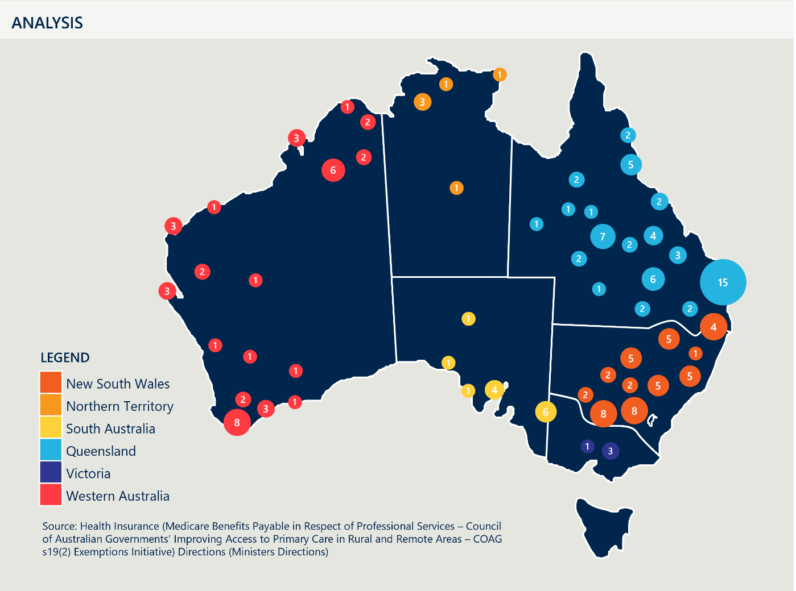
[Map of Australia, divided into its states and territories, showing the distribution of COAG sites using coloured circles with numbers to indicate the quantity of sites in various regions].
Detailed description:
State-by-State Breakdown:
- Queensland (QLD): Approved sites are dispersed across QLD, represented in approximately 17 clusters. The largest clusters are in the western corridor and on and near the border in the south-east. The total number of sites in the state is 58.
- New South Wales (NSW): There is a total of 47 sites in the state, clustered in 11 regions, ranging from single-site clusters to clusters of eight. The largest clusters are near the border with Victoria.
- Western Australia (WA): The state has a total of 20 sites, across a number of clusters ranging from single sites to eight sites. Sites are concentrated in the northern and southern most corners, and the far west.
- South Australia (SA): The state has a total of 11 sites. Sites are concentrated around central and southeast SA, with six near the border of Victoria.
- Northern Territory (NT): The territory has a total of six sites, clustered in four regions, consisting of a single site to a cluster of three. Most sites are in the northern region, and one is in central NT.
- Victoria (VIC): The state has a total of four sites across two clusters, with one being a single-site cluster and the other being a cluster of three. These clusters are in central VIC.
Source: Ministers Directions – Approved site information.
Figure 3 | Number of approved across jurisdictions, by service location type, 2025
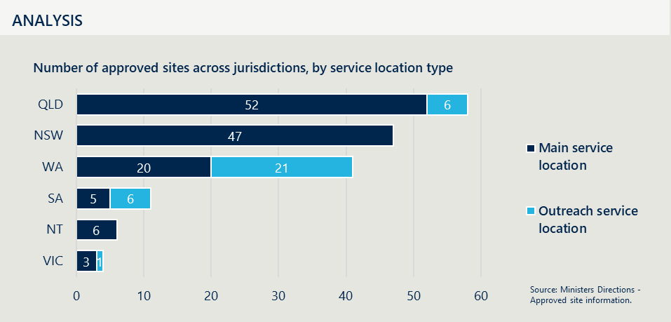
[Bar chart showing the number of approved service sites in 2025 by state or territory jurisdiction and service type (main site or outreach), ordered from most to lease approved sites].
Each state includes two types of service locations:
- Main Service Locations: These are the primary sites where services are delivered.
- Outreach Service Locations: These are additional sites aimed at extending services to more remote or underserved areas.
State-by-State Breakdown:
- QLD: 52 main service locations and six outreach service locations.
- NSW: 47 main service locations and no outreach service locations.
- WA: 20 main service locations and 21 outreach service locations.
- SA: five main service locations and six outreach service locations.
- NT: six main service locations and no outreach service locations.
- VIC: three main service locations and one outreach service location.
Source: Ministers Directions – Approved site information.

Reform of rural and remote health is a continuing area of focus for governments
Australia’s primary care system has been subject to significant reviews and strategic assessments, particularly in rural and remote settings where service fragmentation persists. A number of these reviews are still under consideration by the Commonwealth Government, such as the Strengthening Medicare reform and related reviews, and the NHRA mid-term review. Additionally, the Productivity Commission Delivering Quality Care Efficiently interim report offers further commentary on the sector.
The Strengthening Medicare Taskforce Report calls for a more equitable, person-centred, and integrated primary care system. This includes a strong emphasis on tailored, community-driven solutions and sustainable funding for rural and remote healthcare. One of the key recommendations from the report includes:
- Recommendation 1: A range of recommendations to support increasing access to primary care, including the need to develop new funding models that are locally relevant for sustainable rural and remote practice in collaboration with people, providers and communities. Changes should ensure new funding models do not disadvantage people who live in communities with little or no access to regular GP care, and whose care is led by other healthcare providers.
The Productivity Commission’s interim report, released in August 2025, reinforces the need to address fragmentation in health care, particularly in rural and remote settings. These recommendations are designed to foster innovation, improve care outcomes, and generate savings. The report makes two recommendations relevant to rural and remote primary care:
- Recommendation 2.1: Calls for governments to embed collaborative commissioning, with joint needs assessments, pooled funding tied to shared outcomes, and governance reforms such as joint committees and data-sharing arrangements.
- Recommendation 3.1: Proposes a National Prevention Investment Framework, including an independent advisory board and co-funded mechanisms, to support sustained investment in prevention and reduce long-term care expenditure.
The NHRA Addendum, is an agreement between the Commonwealth Government and State and Territory Governments to jointly fund and reform Australia’s public hospital system. It outlines shared commitments to improve health outcomes, equity of access, and financial sustainability through mechanisms such as activity-based funding and long-term reform priorities.
The Mid-Term Review of the NHRA Addendum, commissioned by Health Ministers across jurisdictions, identified several recommendations directly relevant to rural and remote primary care:
- Recommendation 35: Inclusion of clear roles and responsibilities in the governance of rural and remote health care provision, including clear accountability and escalation mechanisms to address market failure in thin markets and pathways to support flexible models.
- Recommendation 36: a dedicated NHRA Schedule to improve equity of access, including consistent national datasets, minimum service standards, and fair regional funding weightings.
- Recommendation 37: simplifying and expanding applications and approvals of exemptions from Section 19(2) Health Insurance Act 1973 to improve access to bulk-billed primary care in rural and remote areas and in thin and failing markets.
On 5 February 2025, all states and territories signed a 12-month extension of the 2020-2025 Addendum. Negotiations for a new longer-term agreement are underway. The Initiative is an independent measure that is enabled through the NHRA. Evaluation findings will inform development and delivery of appropriate locally driven, place-based solutions to support primary care access for rural and remote communities. This includes the role of hospitals in local service delivery when indicated.
The recommendations from the Productivity Commission complement the NHRA Mid-term Review’s emphasis on governance clarity, flexible funding and improved access in thin markets. This suggests a broader systems-level shift toward collaborative, outcome-driven models of care.


Evaluation Methodology

Section title: 02 Evaluation and Methodology
[The image captures a picturesque view of vineyards in South Australia during sunset.]
This section provides an overview of the evaluation purpose and objectives and the analytical approach, methodology and limitations.

Evaluation purpose and objectives
The evaluation is a requirement under the current bilateral COAG s19(2) Exemptions Initiative MoU between the Commonwealth and State Governments and the Northern Territory. It aims to provide a robust evidence-base to inform future policy decisions for governments, and has the following objectives:
- Establish an in-depth understanding of the current policy context, focusing on the primary care market dynamic in rural and remote regions compared to urban areas.
- Inform future policy directions for the Initiative.
- Identify opportunities to improve primary care access in thin markets, through enabling system-level governance and funding reforms.
This evaluation assesses the Initiative’s effectiveness within the current policy environment. It also explores future directions, including opportunities to modernise the Initiative to better align with contemporary needs. This includes examining alternative models for improving access to primary care in rural and remote areas and considering the role of other services operating under separate s19(2) exemptions – such as those in the Northern Territory and Queensland for Aboriginal Medical Services, and the s19(2) exemption arrangements for metropolitan sites in South Australia.
The MoUs stipulate that evaluations are conducted every four years, with the most recent evaluation published in October 2021 (2021 Evaluation).
This report describes the findings of the current evaluation, reflecting on what has changed since the 2021 Evaluation, as well as consideration of future policy options.

Evaluation approach
The Evaluation methodology adopts a mixed-methods approach to ensure a comprehensive and triangulated evidence base by drawing on multiple data collection underpinned by a program logic and key evaluation questions. A copy of the conceptual approach is outlined Appendix A.

Program Logic
The Program Logic underpins the evaluation structure and sets out the intended relationships between inputs, activities and outcomes. This program logic was designed by the Department and validated by Nous. The program logic guided the development of KEQs and is summarised in Figure 4 below.
Figure 4 | COAG s19(2) Exemptions Initiative program logic model
Problem Statement: People living in rural and remote areas throughout Australia face difficulties in gaining access to appropriate health professionals and healthcare services in their community.
Program Goal: Improving access to primary care in rural and remote areas.
Program Objectives: (1) Improving access to primary care for people living in rural and remote areas (2) Supporting participating sites to attract and retain a relevant primary healthcare workforce, and (3) Assisting with the sustainability of rural hospitals (service providers).
Participants: Australian Government Department of Health, Disability and Ageing, State Governments and Northern Territory; Local Health Networks (and equivalents), Primary Health Networks, Aboriginal Community Controlled Health Services, primary care workforce (rural generalists and GPs, nurse practitioners, mid wives, allied health professionals) and individuals living in rural and remote communities (MM5-7).
Assumptions: S19(2) exemption is required to access MBS funding; Eligible sites will invest MBS funding as outlined in the MoU; Quantum of billed funds is sufficient to achieve outcomes.
External Factors: Changing policy context (i.e. thin markets), primary care workforce challenges, National Health Reform Agreement parameters; MBS rules and regulations
Time Frame: 2022 to 2025
Inputs: what we invest | Activities: what the program does | Outputs: what the program delivers | Short-term outcomes | Medium-term outcomes | Long-term outcomes
Financial inputs  - Access to MBS funding for eligible state health facilities delivering primary care services.  Non-financial inputs  - Program administration including assessment and approval of eligible sites, and reporting  - MoU between commonwealth and states  - Legislative instruments by MIIRS/ Medicare Benefits and Digital Health Division. | Government  - States apply for a COAG s19(2) exemption on behalf of site (operational plan), once sites have obtained local stakeholder support  - Commonwealth assesses the eligibility of the site  - Commonwealth makes a legislative instrument to provide site access to the MBS.  COAG s19(2) exempt sites  - Bill MBS for primary care services, as per the s19(2) exemption legislative direction  - MBS funding is invested as per local governance and decision-making arrangements outlined in operational plan  - Monitor MBS billing and investment of fund. | COAG s19(2) exempt sites  - Site spends up to 30 per cent of MBS revenue in administration.  - Sites invest 70 per cent of MBS funding in the facility for new and additional primary care services including:  - Support for locum cover  - Employing additional salaried doctors and nurses  - Employing allied health professionals  - Professional development  - Recruitment and retention incentives  - Capital improvements  - Primary care equipment  - Additional services to enhance primary care.  Governments  - States provide commonwealth with a consolidated annual report and individual site annual reports detailing MBS billing and investment of MBS funding. | Rural and remote communities  - Increased access to reliable, timely and affordable primary care services.  - Reduced potentially preventable hospitalisations and potentially preventable deaths for acute presentations  - Service providers in rural and remote regions  - Attraction and recruitment of primary health care workforce to the community  - Increased collaboration across private and public service providers (workforce and continuity of services).  Governments  - Improved communication and collaboration through annual bilateral meeting. | Rural and remote communities  - Reliable, timely and affordable access to primary care services  - Reduced PPH and PPD and acute and chronic conditions  - Service providers in rural and remote regions  - Ongoing retention of primary care providers in the community  - Financial sustainability of private and public service providers.  Governments  - Improved transparency in decision making and reporting between commonwealth and state and territory governments. | Rural and remote communities  - Reliable, timely and affordable access to primary care services, at levels comparable to urban counterparts.  - Reduced PPH and PPD, comparable to urban counterparts.  Service providers in rural and remote regions  - Sustainable funding supports ongoing primary care service provision by public and private providers  - Primary care workforce sufficiently meets rural and remote community need.  Governments  - Commonwealth and state and territory governments work in partnership to ensure access to primary care services in rural and remote areas.

Key evaluation questions
The KEQs are the central organising framework for the evaluation. They define the scope of inquiry across four critical domains: appropriateness, implementation, effectiveness and value for money. These key lines of inquiry guided the structure of the ‘findings’ and ‘future directions’ sections of this report. ‘Future directions’ was pulled out as a separate domain to clearly communicate future policy recommendations after detailing the findings of the evaluation. These domains are listed below in Table 3, with a full list in Appendix B.
Table 3 | Summary of KEQs by domain
1.  Appropriateness | 2.  Implementation | 3.  Effectiveness | 4.  Value for money | 5.  Future directions
In the context of emerging rural health reforms, is the COAG s19(2) Exemptions Initiative currently fit for purpose at improving access to primary care in rural and remote Australia? | How well has the COAG s19(2) Exemptions Initiative been implemented, and what improvements could be made? | Is the COAG s19(2) Exemptions Initiative achieving its intended outcomes? | Is access to fee-for-service funding (i.e., MBS through Initiative) a cost-effective funding mechanism in the current policy context? | What alternative policy solutions at the national, state and/or regional/local levels could support improved and equitable access to primary care in rural and remote regions?
The sub-sections within the findings chapter relate to these KEQs, however for simplicity are described as:
- Policy Context
- Program Design
- Program Delivery
- Program Outcomes.

Methodology
The evaluation used mixed methods, triangulating a desktop policy review with quantitative and qualitative data from site reporting and surveys, interviews, site visits, and billing data.
This approach enabled a robust and comprehensive assessment of the Initiative’s design, delivery and outcomes. A detailed engagement and analysis approach was developed as part of the Evaluation Plan, which set out the quantum, format, and purpose of engagement with each group.
Surveys were distributed through state and territories to all participating sites. Site visits were conducted both in person (six sites) and virtually (four sites), resulting in ten case studies. These sites were selected in collaboration with the Department to ensure a broad representation across jurisdictions and to reflect the diversity of service delivery contexts. The selection criteria included geographic diversity across MM5 to MM7, service delivery models (e.g. community health service, hospital, multi-purpose service), length of experience with the Initiative, and jurisdiction. A metropolitan site (Metro Youth Health Service) was also selected to offer a broader perspective on thin markets.
Evaluation engagement and data collection activities conducted is summarised in Figure 5, with further details of stakeholders engaged in Appendix C.
Figure 5 | Mixed method data collection, including engagement summary
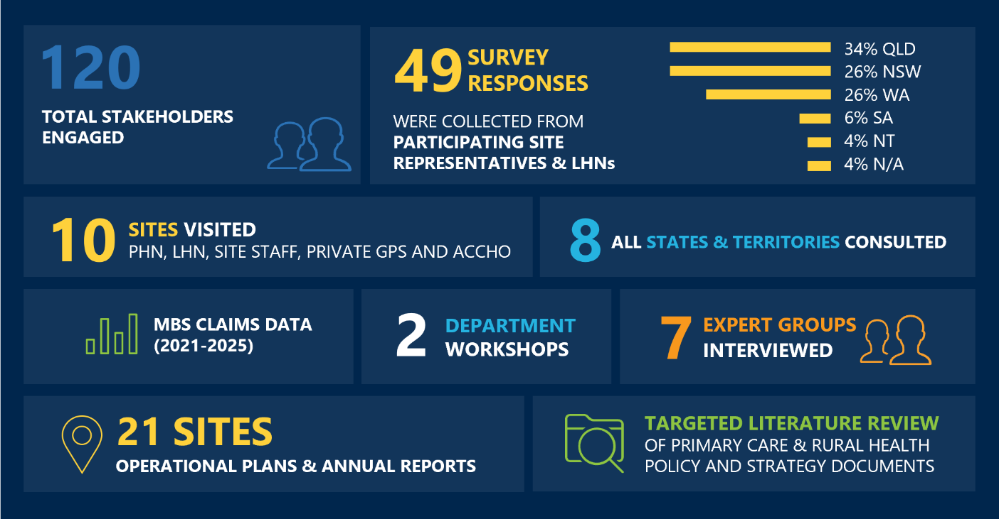
[Infographic summarising stakeholder engagement, survey responses, site visits, and data collection for a research project.]
Detailed description:
Stakeholder engagement:
- 120 Total Stakeholders Engaged
- 49 Survey Responses: Collected from participating site representatives and LHNs. Survey Response Distribution:
  - 34 per cent from QLD
  - 26 per cent from NSW
  - 26 per cent from WA
  - Six per cent from SA
  - Four per cent from NT
  - Four per cent not applicable.
- 10 Sites Visited: Includes PHN, LHNs, site staff, private GPs, and ACCHOs.
- Eight All States and Territories Consulted: Ensures comprehensive geographic coverage.
Data Collection and Analysis
- MBS Claims Data (2021-2025): Medicare Benefits Schedule data collected for analysis.
- 21 Sites Operational Plans and Annual Reports: Reviewed for insights into site operations and strategies.
Workshops and Interviews
- Two Department Workshops.
- Seven Expert Groups Interviewed.
Literature Review
- Targeted Literature Review: Focused on primary care and rural health policy and strategy documents to inform the project.

Evaluation limitations
The evaluation seeks to deliver findings in relation to the Initiative and future reform options in rural and remote primary care. While a rigorous approach and methodology has been developed, there are a number of key limitations that impact on the outcomes of the evaluation, including:
- Complexity of the policy landscape | The intersections between the Initiative and other programs are complex and evolving. This means that it is difficult to isolate the Initiative’s impact. Careful consideration has been given to acknowledge the role of other programs in this landscape.
- Incomplete or inconsistent state and territory data | The absence of comprehensive quantitative data, especially from states and territories, limits the robustness of some findings. This includes the type and funding amounts going towards primary care services in rural and remote regions. Strategies used to mitigate the effect of this include triangulating data sources and using qualitative inquiry.
- Limited visibility of non-COAG s19(2) services | The absence of data relating to sites who have been rejected or not yet applied for a COAG s19(2) exemption, limits the robustness of findings comparing COAG s19(2) and non-COAG s19(2) sites. Site visits and broad consultation sought to gather a broader understanding on the broader primary care sector beyond the participating sites.
- Variable survey responses | Approximately 29 per cent of sites responded to the survey, with generally low response rates from NSW (28 per cent), NT (33 per cent) and QLD (33 per cent) sites and no representation from Victoria. However, the survey saw strong response rates from WA (76 per cent) and SA (60 per cent) sites. There is a risk of response bias weighted on sites with greater capacity and engagement with the Initiative. To ensure broad representation, insights were taken from multiple sources, including consultation and site visits.
- Lack of defined and reported outcome metrics | The absence of defined outcome metrics that are consistently reported by sites make measuring the impact of the Initiative more challenging. Although the program logic defines outcomes, these are difficult and sometimes unrealistic for sites to report. The evaluation has measured outcomes against the original aims of the Initiative to measure impact. In addition, the Evaluation did not have access to all annual plans for each site, however, was able to obtain analysis on 21 sites across a good representation of jurisdictions and MMMs.
- COAG s19(2) revenue data | The evaluation utilised MBS revenue data that was validated by the Department, using the Medicare Provider Numbers provided by individuals sites and jurisdictions through the previous annual reporting processes. There may be slight variances in this data which what was reported by individual sites/jurisdictions as their estimated MBS revenue. Any discrepancies are insignificant and do not impact the overall COAG s19(2) evaluation findings. As MBS data is protected, data is only reported at the jurisdictional level to protect the privacy of individuals and providers.


Key Findings

Section title: 03 Key Findings
[The image presents an aerial view of a rugged coastline in New South Wales, Australia.]
This section provides detail on the key findings of the evaluation – design, delivery and outcomes – in the context of the current policy landscape.

Policy Context
This section informs KEQ 1A | Appropriateness: How has the policy context changed from when the Initiative was first implemented in 2006, and since the 2021 evaluation of the Initiative?
This section explores the current state of the policy context and the Initiative, including whether it is an appropriate funding mechanism and represents value-for-money. Alternate solutions are considered in Section 4: Future Direction.

Findings from the 2021 evaluation
The 2021 Evaluation highlighted the complex policy environment in which the Initiative operated at both a national and jurisdiction level.
- At a national level: the Commonwealth continued to invest in policies seeking to improve recruitment and retention of the rural health workforce through education and training, professional development and financial incentives (largely targeting GPs). In addition, there was increasing engagement of specialised nursing and allied health workforce by NGOs through PHN commissioned services and Rural Health Outreach Funded services working in rural, remote and regional areas. However, persistent workforce shortages and maldistribution prevailed.
- At a jurisdictional level: States and territories utilised different mechanisms to engage GPs and other medical practitioners to provide services in small rural hospitals including as salaried employees and Visiting Medical Officer arrangements which was identified as potentially impacting implementation of the Initiative.
- The Initiative was one of a number of s19(2) exemptions in place in 2021. This included exemptions at a national level (The Aboriginal Community Controlled Health Services Section 19(2) Direction); jurisdiction specific exemptions (The Queensland State Government (Indigenous Health) Section 19(2) Direction and The Northern Territory State Government (Indigenous Health) Direction); and exemptions to support GP training (the Remote Vocational Training Scheme Direction and the Murrumbidgee Local Health District Direction). In some communities multiple exemptions could be in place.

Summary of current findings
The Initiative is increasingly out-of-step with the evolving rural health policy landscape, which prioritises integrated, place-based, and multidisciplinary care.
- Since the initiatives establishment in 2006, the policy environment has shifted significantly, with national strategies (e.g., Strengthening Medicare, NHRA Mid-Term Review, Scope of Practice Review) now emphasising flexible, blended funding models, multidisciplinary team-based care and locally governed, place-based service planning. Workforce policy has also evolved, with a stronger focus on generalist, team-based models and expanded roles for nurses and allied health professionals.
- Jurisdictional differences in service models, workforce arrangements, and governance further complicate implementation and equity of access. There is no nationally agreed benchmark for minimum primary care access, making it difficult to assess adequacy of service provision or hold systems accountable.
- Despite significant government investment, the gap in rural health outcomes is persisting and the disparities in funding per capita is widening in rural Australia, particularly in MMM5–7 regions. Without reform, the Initiative risks becoming increasingly obsolete, failing to align with contemporary policy directions or address the structural inequities it was designed to mitigate.

The policy landscape has shifted dramatically since 2006
The Initiative was introduced in 2006 to address immediate gaps in rural primary care access by enabling Medicare billing in public facilities. At the time, the Initiative was consistent with broader approaches to improve access to medical services in rural and remote areas. However, the Initiative was not designed as a system-wide reform mechanism and it remains one funding lever to be complemented by other initiatives, not a structurally integrated solution to offset the full cost of primary care service delivery.

Policy emphasis has evolved toward integrated, place-based reform
Increasingly, rural health policy is focused on strategic, system-wide reform. This is reflected in a series of recent national reviews and strategies that collectively emphasize integration, multidisciplinary care, the importance and increase of virtual care and locally tailored service models.
- The Strengthening Medicare Taskforce Report (2022) advocates for flexible funding models and place-based planning, explicitly identifying thin markets as requiring tailored solutions.
- The Primary Health Care 10-Year Plan (2022–2032) outlines a long-term vision for integrated care, workforce development, and regional commissioning, with rural-specific actions including multidisciplinary team support and telehealth integration.
- The Scope of Practice Review (2024) calls for rural-specific implementation pathways and blended payment models to enable team-based care and improve workforce productivity.
- The NHRA Mid-Term Review (2023) recommends defining minimum access standards and clarifying governance roles for rural health, reinforcing the need for structural reform.
- The Working Better for Medicare Review (2024) critiques existing classification systems (e.g., Distribution Priority Area, MMM) and recommends more nuanced, data-driven approaches to workforce distribution and rural service planning.

Workforce strategies place greater emphasis on support for multidisciplinary, generalist models
Workforce policy increasingly recognises workforce shortages a root cause of many rural and remote health gaps. Approaches have increasingly developed as a shift toward generalist, team-based models that are better suited to rural contexts. Key strategies include:
- The National Rural Generalist Pathway supports doctors with broad scopes of practice across primary care, emergency care and other medical specialist care in hospital and community settings as part of a rural healthcare team.
- The National Medical Workforce Strategy (2021–2031) promotes rural training pipelines, integrated career pathways, and expanded supervision capacity to support sustainable rural workforce development.
- The Nurse Practitioner Workforce Plan (2023–2033) and the National Rural and Remote Nursing Generalist Framework (2023–2027) both emphasize the role of nurses in delivering comprehensive care in rural areas, including culturally safe and community-led models.
- The Draft National Allied Health Workforce Strategy (2025) targets maldistribution and retention of allied health professionals in rural and remote regions through tailored incentives and professional development.
In addition, there are a number of initiatives that are aimed at enhancing workforce and primary care access:
- The Single Employer Model (SEM) Trials aim to enhance workforce recruitment and retention especially in rural areas by centralising employment for GP and RG trainees under a single jurisdictional employer to improve access to leave entitlements and create more stable training pathways. These trials are mainly focused on rural and remote areas, but have occasionally been utilised in in MM2-4 areas as well.
- The Innovative Models of Care (IMOC) Trials aim to test new multidisciplinary primary care models to strengthen workforce sustainability and accessible service delivery in thin markets.
These strategies reflect a broader shift away from siloed, GP-led models toward multidisciplinary teams that can flexibly respond to local needs. The Initiative, however, was not designed to support such models and does not incentivise their development.

There are no minimum agreed standards for primary care access
There are no nationally agreed minimum standards for primary care access in Australia, making it challenging to determine whether current initiatives and funding are enabling reasonable level of access to care. While there are some quantitative benchmarks (such as a 60-minute drive time to core services or population-to-provider ratios), they are not comprehensive or consistently applied. For example, the RFDS has identified that over 44,000 Australians live beyond a 60-minute drive from essential services, despite this being a clinically meaningful threshold. Similarly, workforce ratios, such as one doctor per 600 people or one nurse per 250 people have been proposed in specific contexts, but these do not account for geographic nuance, variation in models of care and service delivery models, or the mix of health professionals needed in different communities.
Qualitative dimensions such as cultural safety, continuity of care, and community engagement are also widely recognised as essential to meaningful access, but there is no consistent framework for measuring or enforcing them. The Northern Territory Aboriginal Health Forum (NTAHF) Framework offers one example of a structured approach that combines both quantitative and qualitative benchmarks, but its application is limited. Without a shared definition of what constitutes a minimum acceptable level of access, it is difficult to judge whether the combined efforts of Commonwealth, state, local, and other actors are meeting the needs of rural and remote communities. This lack of clarity makes it harder to identify where gaps persist or where reform is most urgently needed. The potential to define and deliver minimum levels of access may be facilitated by the use of virtual care, which supports a more mobile workforce.

There is an emerging argument to benchmark according to need rather than access
The Working Better for Medicare Review investigated the use of the National Assessment Tool (NAT) for evaluating workforce requirements. The review recommended leveraging the NAT, which integrates diverse data on community needs and GP availability, to establish DPA classification thresholds alongside a graduated priority scale. This approach presents an opportunity to create benchmarks that are directly informed by need, as defined by the NAT, and to ensure these benchmarks reflect the qualitative service standards outlined.

COAG s19(2) sits in a complex landscape of initiatives and legislation

The Commonwealth has a large suite of initiatives aimed at improving primary care
The Commonwealth funds a wide range of programs targeting rural primary care, including PHN commissioning, ACCHS support, RFDS services, and workforce initiatives. However, these programs tend to operate in parallel with variable strategic alignment. Stakeholders report difficulty navigating the policy environment, including confusion around the distinct roles of PHNs, Rural Workforce Agencies, LHNs, and state and territory governments. Furthermore, primary care does not exist in a silo but intersects closely with aged care and disability sectors. Service providers and patients may be interfacing across these sectors, accessing Medicare and the National Disability Insurance Scheme (NDIS) or Support at Home or the Commonwealth Home Support Program. Across some sites, including MPS’ and Community Health clinics, these funding streams can be highly intertwined, adding additional complexity and inflexibility in applying funding where it is most needed.
Figure 6 illustrates an overview of Initiatives that operate at different levels, including Commonwealth, State and Territory Government, and locally. This highlights the extensive scope and complexity of this multilayered landscape.
Many of the Initiatives outlined in the figure are granted through, or supported by, other s19(2) exemptions, including the SEM and IMOC trials. However, stakeholders report the presence of multiple exemptions has led to confusion, ambiguity, and administrative burden among service providers, as the most appropriate exemption pathway is not always apparent. For example, in QLD there are s19(2) exemptions that support a number of AMS Direction sites, which delivery primary care clinics in rural and remote locations primarily to First Nations people. The intent is similar to the Initiative but not supported by same application and eligibility or reporting. Similarly in NT, this occurs through another AMS Direction, and there is often confusion as to which exemption should be utilised.
Furthermore, primary care does not exist in a silo but intersects closely with aged care and disability sectors. Service providers and patients may be interfacing across these sectors, accessing Medicare and the National Disability Insurance Scheme (NDIS) or Support at Home or the Commonwealth Home Support Program. Across some sites, including MPS’ and Community Health clinics, these funding streams can be highly intertwined, adding additional complexity and inflexibility in applying funding where it is most needed.
This situation is further compounded by the layered governance structure and the overlap of responsibilities between different levels of government and service providers, resulting in ongoing challenges for effective resource allocation. As a consequence, many initiatives—while well-intentioned—struggle to respond swiftly to emerging needs or adapt funding priorities to local circumstances, ultimately impacting the ability of communities to access timely and appropriate care.
Figure 6 | A summary of initiatives aiming to improve access to primary care
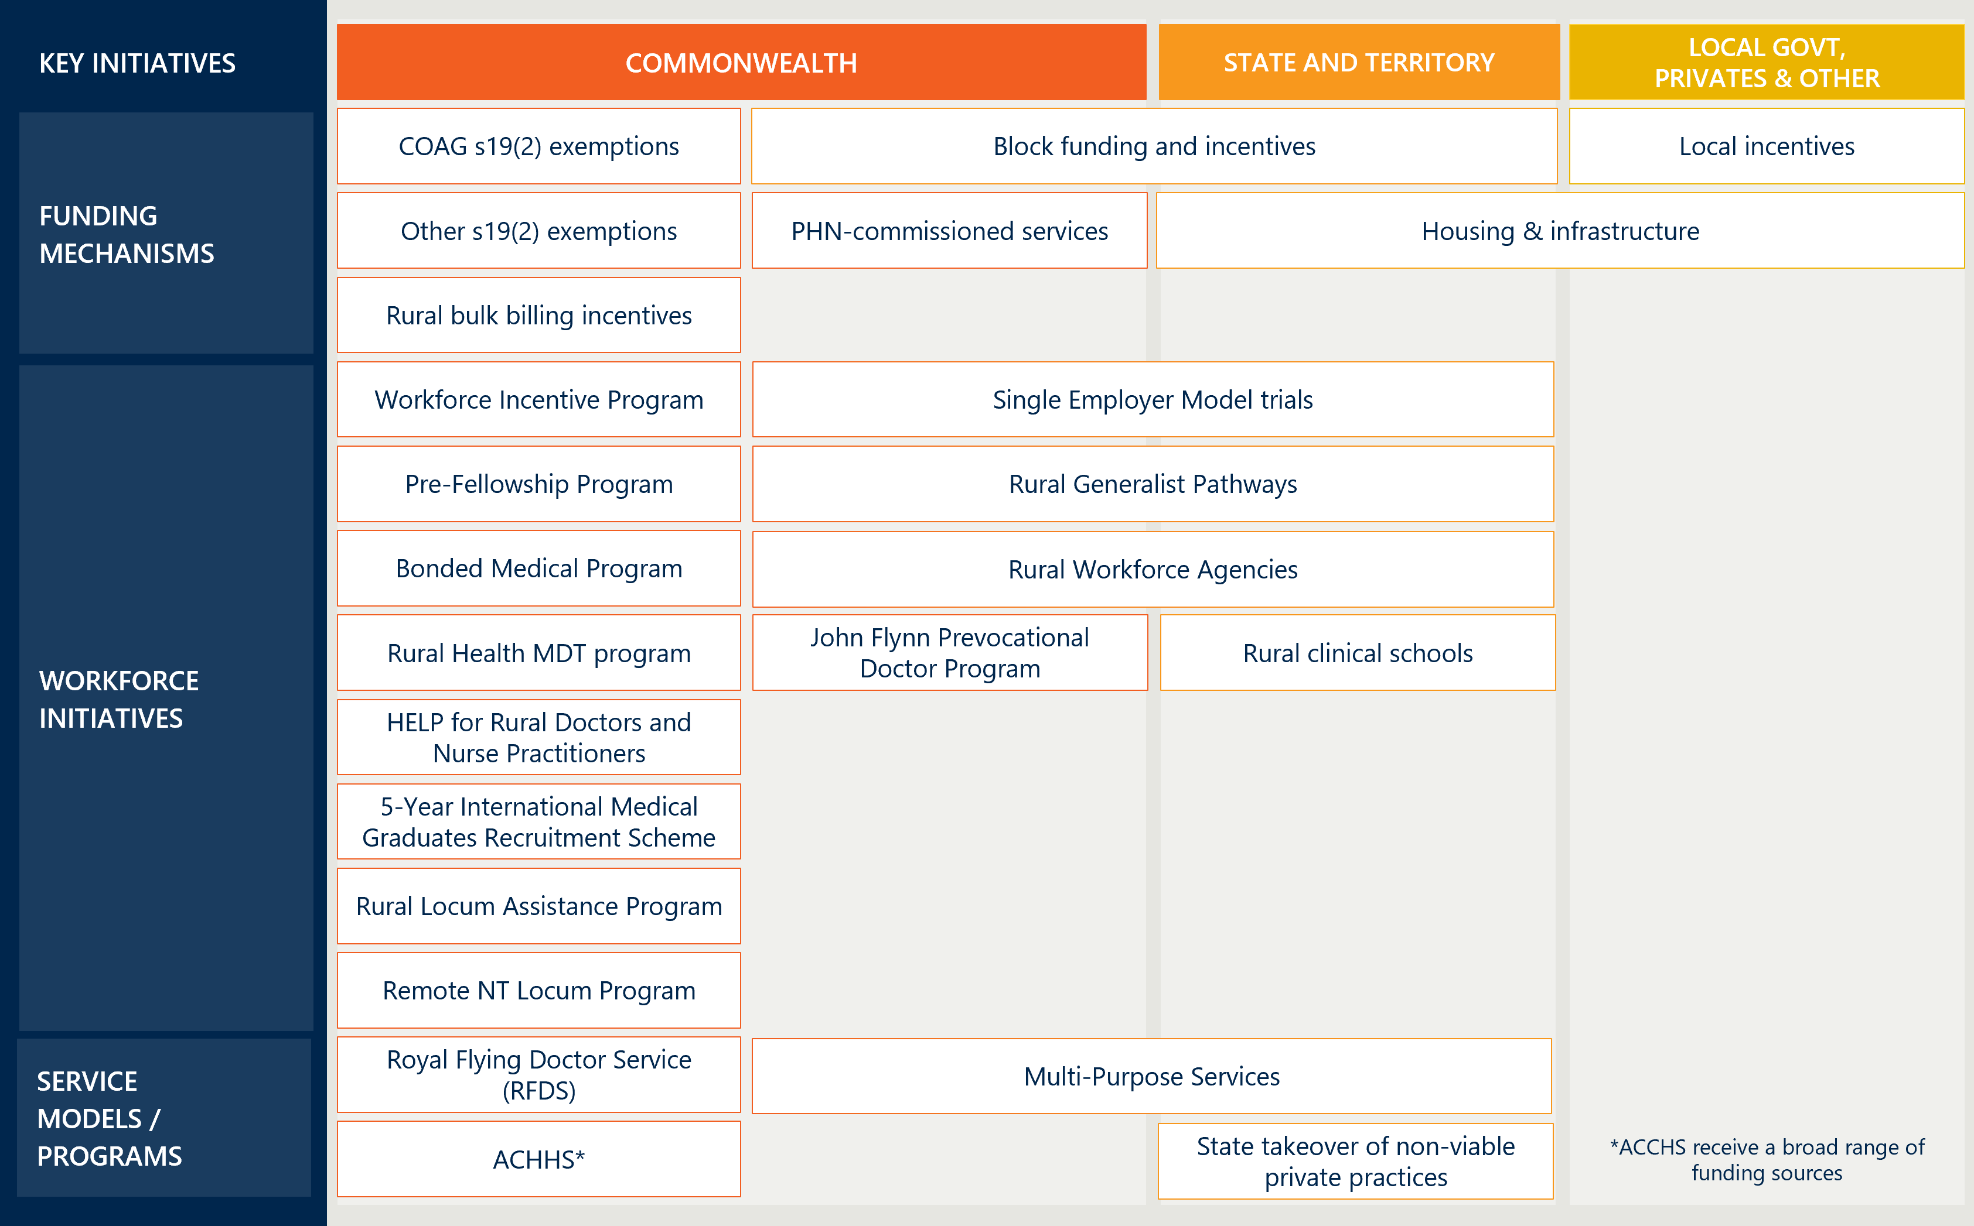
[Table showing healthcare initiatives across commonwealth, state, and local levels, including funding, workforce, and service models.]
Detailed description
This table presents healthcare initiatives and service models across three governance levels in Australia: Commonwealth, State and Territory, and Local Government/Private/Other. Each level includes initiatives grouped under three categories—Funding Mechanisms, Workforce Initiatives, and Service Models.
Commonwealth
- Funding: COAG s19(2) exemptions, other s19(2) exemptions, rural bulk billing incentives
- Workforce: Workforce Incentive Program, Pre-Fellowship Program, Bonded Medical Program, Rural Health MDT Program, HELP for Rural Doctors and Nurse Practitioners, Remote Health Areas Corps, Royal Flying Doctor Service
- Service Models: Innovative Models of Care Program, PHN-commissioned services, John Flynn Prevocational Doctor Program, 5-Year International Medical Graduates Recruitment Scheme.
State and Territory
- Funding: Block funding and incentives
- Workforce: Single Employer Model trials, Rural Generalist Pathways, Rural workforce agencies
- Service Models: Rural clinical schools, ACCHOs, Multi-Purpose Services.
Local Government, Private, and Other
- Funding: Local incentives, housing and infrastructure
- Service Models: State takeover of non-viable private practices.
Each state has unique differences in how they fund and support primary care
States and territories utilise a range of unique strategies to fund and support primary care in rural and remote areas. Table 4 outlines an overview of jurisdictional approaches to service provision, workforce arrangements and initiatives across Australia. The table includes the ACT, despite not being eligible for the Initiative.
Table 4 | Jurisdictional differences in the delivery of primary care in rural and remote areas
State / Territory | Service provision | Workforce | Jurisdiction-specific initiatives
ACT | As with other urban areas, primary care services are predominantly delivered through private practice fee-for-service models.  Nurse-led walk-in centres are the main publicly funded minor illness and injury and primary care service. While the centres predated the establishment of Commonwealth funded Urgent Care Centres, they have received funding under the Urgent Care Clinic program but differ from the GP-led models used elsewhere in Australia. | The ACT faces ongoing workforce shortages in primary care, similar to rural and remote areas. GP Full-Time Equivalent (FTE) rates per capita in the ACT are among the lowest in the country.  The nurse-led primary care services were established in part to respond to these shortages. | - ACT Primary Care Pilot (PCP).  - Primary Health Care Research Initiative.  - ACT Budget 2025-26 bulk billing incentives.
NSW | NSW rural and remote areas primarily run through a model of state-run MPS where one facility covers hospital, aged care, and GP-type care in small towns.  Increasing use of virtual care pilots. | Historically reliant on private GPs as Visiting Medical Officers (VMOs) but shifting towards Single Employer Models (SEM) for Rural Generalists.  VMOs negotiate individual contracts. | - Rural Health Workforce Incentive Scheme.  - Isolated Patients Travel and Accommodation Assistance Scheme (IPTAAS).
NT | Primarily NT Government (NTG) clinics and non-government organisations. Private practice becoming less common in NT. | Heavy reliance on remote area nurses and rotating/fly-in fly-out or locum doctors.  NT Health EBAs offer remote loading, travel concessions and retention bonuses. | - NT Health Remote Clinics and Workforce Programs.  - Nurse Practitioner / Remote Nurse Training Programs.  - NT Aboriginal Health Academy.  - CheckUP NT.
QLD | Hospital and Health Service (HHS)-run hospitals and clinics in remote/very remote areas as well as hub-and spoke models.  Strong integration with virtual care.  Some HHSs have private GPs as well. | Medical Practitioner with Private Practice (MPPP) Model, allowing doctors to work in public hospitals and run private practices.  Mature Rural Generalist Pathway training program producing multi-skilled doctors for small hospitals and clinics. | - Office of Rural and Remote Health / Rural and Remote Health Workforce Programs.  - Virtual Integrated Practice (VIP) Partnership Pilot.  - CheckUP QLD  - Health Workforce Queensland.
SA | Mostly private GPs as well as state-run integrated clinics where GP shortages exist. | Historically dependent on private GP/VMO model and shifting toward salaried GP teams in critical areas.  VMOs retain negotiated rates, but salaried roles are bound by EBA limits. | - Rural Doctors Workforce Agency (RDWA) Grants.  - Relocation support of up to $15,000 when relocating to work in a remote location.
TAS | Almost entirely private/NGO GP services. Public hospitals provide after-hours/ED only. | Recruitment support including housing and other incentives, as well as contracts with providers (e.g., Ochre Health) for islands.  Limited dual practicing arrangements. | - Island GP Contracting (e.g., Ochre Health).  - Rural GP Incentive and Recruitment Support.
VIC | Predominantly private GP clinics and where the state intervenes in towns experiencing market failure. | Relies on private GP workforce with a small number of salaried doctors employed via health services.  Salary caps and rigid pay bands limit flexibility under the Enterprise Bargaining Agreement. | - Victorian GPs Grant Program.  - Rural Workforce Agency Victoria (RWAV) grants and recruitment programs.  - Rural Generalist Advanced (RGA) training posts.  - Victorian community health GP service models.
WA | Wide reliance on state/contracted clinics including nursing posts and WACHS hospitals as well as outreach services to remote Aboriginal communities. | Remote area nurses and Nurse Practitioners increasingly used.  Rural proceduralist GP incentives.  Offer regional salary loadings, travel concessions and flexible leave arrangements.  High reliance on agency and locum staff. | - Remote Area Nursing Post (RANP) in partnership with NGO Silverchain.  - WACHS workforce programs.

It is difficult to measure the investment by non-Commonwealth Governments and the broader sector towards primary care
The inherent complexity of each jurisdiction’s primary care system makes it challenging to capture the full breadth of state and territory activities aimed at improving access to, and the delivery of, primary care. The fragmented nature of funding and service delivery limits transparency and accountability, especially when some funding decisions can occur in isolation and without consultation. While the AIHW collects some data, it does not capture all primary care expenditure, particularly that delivered in non-traditional settings such as hospital settings.
The majority of reported State and Territory spend in FY23 relates to community health and other (73 per cent), followed by public health (21 per cent) and to a small extent, dental services (seven per cent). In contrast, the commonwealth’s expenditure is primarily unreferred medical services and pharmaceuticals. This limited data capture understates the true scope of jurisdictional investment in primary care.
Although Nous engaged with jurisdictions to obtain relevant data, it was not readily accessible or available in a consistent format. This limited our ability to develop a clear and comprehensive picture of jurisdictional activity. Stakeholder consultations and site visits indicate that state and territory investment in rural and remote primary care is occurring at scale. Without clear visibility, policy planning and evaluation efforts are constrained by an incomplete picture of who funds what, where and to what extent.

Current approaches are failing to reverse the decline of private practices in thin markets
Nationally, there is an observed reduction in the number of private general practices in thin markets. With lower patient volumes and high operational costs, many face financial challenges that become unsustainable. Viability is particularly challenging when the cost of recruiting GPs to live and work in rural and remote areas is significant, leaving critical gaps when existing GPs leave or retire.
Communities affected by these gaps often experience limited access to care, with remaining doctors stretched and wait times increasing. In response, some state governments have intervened to maintain service delivery. Examples identified in Queensland’s Central West HHS and South Australia’s Eyre and Far North LHN, where hybrid models combining public and private elements were introduced to prevent practice closures.
PHNs also play an increasingly prominent role in sustaining general practice, offering capacity-building support such as improved billing practices, and working with RWAs to bolster recruitment and retention of medical professionals. The General Practice Incentive Fund (GPIF) grant supports this by enabling PHNs to commission primary services that have either failed, at risk of failure, or facing ongoing instability in thin-market regions. However, it is limited in scale, scope and duration, supporting recovery rather than enabling innovation or reshaping general practice viability in rural and remote areas.

Despite considerable government effort, there is a widening disparity in primary healthcare in rural and regional Australia
Despite investment by Commonwealth, State and Territory Governments, disparities in access to primary healthcare in rural and remote Australia continue to widen. Medicare is designed to support universal access, however there is debate as to whether it sufficiently addresses the challenges of thin markets, where low patient volumes and high service delivery costs undermine the viability of fee-for-service models.
Recent analysis commissioned by the National Rural Health Alliance, found that Australians in rural areas are receiving less MBS and public hospital funding than people living in urban areas in 2023-24. This gap is illustrated in Table 5. When comparing between Modified Monash Model (MMM) regions, the Medicare and public hospital expenditure is lower across MM 5-7 areas. These shortfalls are further compounded by the higher costs of delivering health services in rural and remote locations.
Table 5 | Per capita expenditure on public hospitals and MBS across grouped MMM areas, FY24
Expenditure category | MM1 | MM2-4 | MM5-7 | MM2-7
Public hospitals | $4,198 | $4,621 | $2,254 | $3,748
MBS | $1,310 | $1,212 | $832 | $1,071
Note: Expenditure estimated using Local Health Network/District Annual Reports, 2023-24, distributed between ABF and small rural hospital’s using National Health Reform funding data and to public hospital locations based on AIHW Public Hospital patient admissions and the NPHED hospitals database.
Additionally, there are significant disparities in the supply of GPs in MM 5-7 areas. This gap in GP availability across rural and remote areas is projected to widen over the next two decades. Figure 7 illustrates this comparison by analysing MBS bulk billing rates and the general practitioner workforce in relation to the MMM classification. This figure was part of the analysis commissioned by the National Rural Health Alliance.
Figure 7 | Per capita GP Workforce providing primary care services in Australia relative to age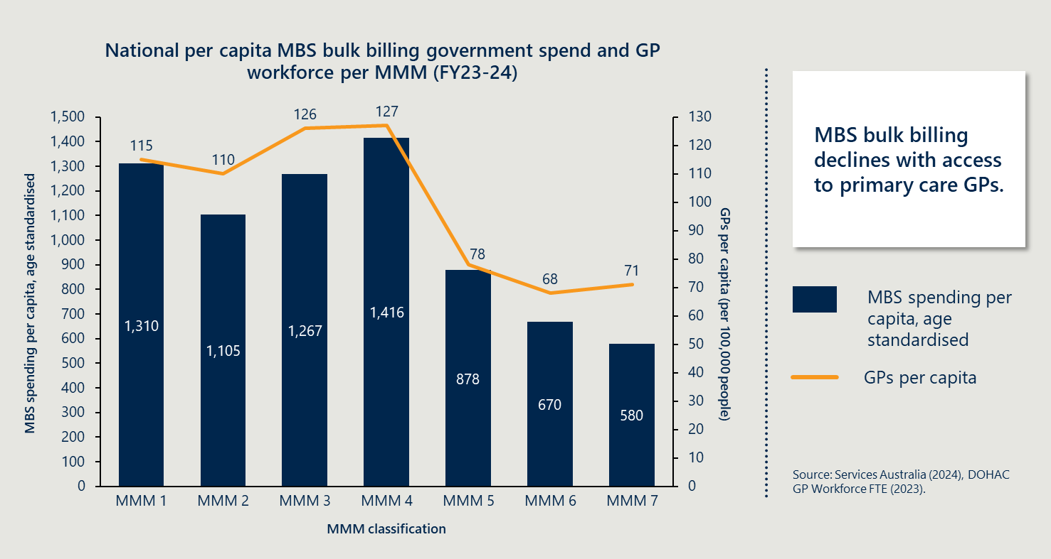
[Bar and line graph showing MBS spending and GP availability across regional MMM classifications for FY23-24.]
Detailed Description
This image is a bar and line graph illustrating the relationship between MBS bulk billing government spending and GP workforce per MMM classification for the fiscal year 2023-2024.
Graph Components
- Title: The graph is titled ‘National per capita MBS bulk billing government spend and GP workforce per MMM (FY23-24)’.
- Axes:
  - The y-axis on the left measures MBS spending per capita, age standardised, ranging from 0 to 1,500.
  - The y-axis on the right measures GPs per capita (per 100,000 people), ranging from 0 to 130.
  - The x-axis lists the MMM classifications from 1 to 7.
Data Representation
- Bars: Represent MBS spending per capita, age standardised, for each MMM classification:
  - MMM 1: $1,310
  - MMM 2: $1,105
  - MMM 3: $1,267
  - MMM 4: $1,416
  - MMM 5: $878
  - MMM 6: $670
  - MMM 7: $580.
- Line: Represents GPs per capita for each MMM classification:
  - MMM 1: 115 GPs
  - MMM 2: 110 GPs
  - MMM 3: 126 GPs
  - MMM 4: 127 GPs
  - MMM 5: 78 GPs
  - MMM 6: 68 GPs
  - MMM 7: 71 GPs.
Key Insight: A text box on the right highlights the key insight: ‘MBS bulk billing declines with access to primary care GPs.’
Source: The data is sourced from Services Australia (2024) and DOHAC GP Workforce FTE (2023).

Program Design
This section informs KEQ 1 | Appropriateness: In the context of emerging rural health reforms, is the Initiative currently fit for purpose at improving access to primary care in rural and remote Australia, and what alternate solutions exist?
In particular it responds to KEQ 1B, to explore the extent to which the program design presents an equitable funding mechanism to support improved rural and remote primary care access.

Findings from the 2021 evaluation
The 2021 Evaluation highlighted key issues in the design of the Initiative such that revenue derived was largely dependent on medical workforce capacity and the capability of administrative systems and staff. As such, the Initiative was not well targeted to benefit those communities with greater challenges in accessing primary care.
More specifically:
- Success is often reliant on a large, stable workforce: Larger sites with more salaried doctors have a greater ability to undertake MBS billing rather than a direct link to the demand for primary care in the community. The foundation of the Initiative is primarily as a top-up to funding, enabled by access to MBS billing. Communities and health service providers need to access other funding sources to address local healthcare needs in a more targeted way.
- Funding does not target systemic access challenges: The Initiative’s reliance on MBS billing to determine the level of top-up revenue to a site is unable to be sufficiently nuanced to address the full range of access issues rural and remote communities face. These issues relate to service availability of primary care, geographic proximity to services, affordability, system navigation by patients, cultural acceptability and health literacy.
However, the evaluation noted that a unilateral withdrawal of the current funding would have a harmful impact to primary healthcare services in locations currently receiving funding.

Summary of current findings
The inherent inequity of the Initiative observed in the 2021 Evaluation persists, with MBS billing tied to medical workforce, administration capacity and governance support rather than community need.
The Initiative’s approach is misaligned with contemporary primary care objectives for several reasons:
- It is predominantly focused on delivering medical services within a hospital environment, often in the absence of systems and broader health workforce arrangements necessary for integrated, multidisciplinary care.
- The scope of service delivery continues to under-represent nurses, allied health professionals, and virtual care models, despite these being increasingly central to improving access in remote settings.
- There is minimal integration with other primary health care programs, and the design of the Initiative limits its flexibility to respond to local context and changing community needs.
- While the Initiative provides a modest yet valuable funding stream for health services, its current reliance on a fee-for-service model limits its sustainability and capacity to drive meaningful change in rural and remote health outcomes.

The Initiative does not adequately support contemporary rural service delivery

The Initiative is not fully aligned with strategic directions in rural and remote primary care
While it provides a targeted funding mechanism for small public hospitals and services in MM5–7 regions to deliver care, the Initiative’s design is misaligned with the current goals of primary care, as highlighted by Australia’s Primary Health Care 10 Year Plan (the 10-Year Plan), summarised in Figure 8.
Figure 8 | Objectives of ‘Australia’s Primary Health Care 10 Year Plan, 2022-2032’
[Infographic illustrating seven primary care objectives with icons, which are: Continuity of care, Improving access, Safety and quality, Closing the gap, Integrated care, Keeping people well in the community, Future focus.]
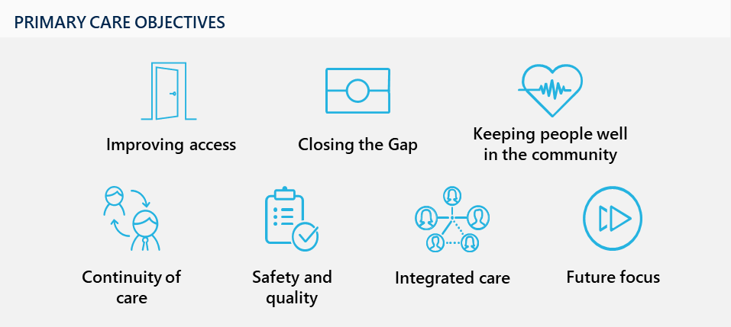
The Initiative remains anchored to fee-for-service funding, which is often delivered in an ED setting. An ED is a reactive environment by nature and has restrictions in its ability to offer continuity of care and true integrated care within the community, particularly when it comes to chronic disease management and mental health care plans.
The evaluation explored a number of challenges within the Initiative, including restrictive rules, variable governance and in parts, inequitable implementation. These challenges are at odds with the ability of the Initiative to remain future focused and contribute to progress toward Closing the Gap priorities through community-led governance, noting there are other s19(2) exemptions focused on Aboriginal and Torres Strait Islander populations (such as the ACCHS Directions). Since its establishment, almost two-decades ago, the Initiative has become increasingly out of step with service delivery models, current challenges, and future trends. These elements will be elaborated on further below.

The Initiative overlooks ongoing workforce challenges
The Initiative’s design is reliant on rural and remote communities already having available and eligible clinicians who can bill Medicare. In reality, persistent workforce shortages remain a defining challenge for many MM5-7 areas. Where there is not already an available workforce, the Initiative has limited capacity to generate income that can be used to attract and retain qualified practitioners. Even when funding is available, many communities struggle to fill positions, often relying on costly locums or temporary staff, which undermines the development of a sustainable workforce.
Measures like the 19(2) have become one of a series of band aids to try and stop the bleeding, but individually they're pretty ineffective in doing very much.
Jurisdictional stakeholder
Furthermore, the Initiative does not address the systemic and emerging challenges facing the health workforce. Stakeholders have emphasised that broader factors, such as housing, education, and employment, significantly impact workforce attraction and retention in rural and remote areas. Current funding models are seen as limited in their ability to address broader, complex, and interrelated issues. Since the 2021 Evaluation, a number of trends have persisted and emerged, shaping the lack of available doctors, nurses, allied health and other critical staff in these regions. These include:
- Challenges in recruitment and retention, exacerbated by broader social factors like housing and education availability.
- Emphasis on multidisciplinary and generalist workforce models, particularly where GP-led models are not viable.
- Growth in virtual care and telehealth, enabling access to services in remote areas and reducing the need for long-distance travel for patients.
- Increased demand for flexible work arrangements, such as Fly-In, Fly-Out (FIFO) and virtual care models, to address workforce shortages and support practitioner wellbeing. Many single-employer model trials have emerged, particularly within training programs to support flexible working arrangements.
- Need for upskilling and advanced scope roles, as outlined in the Scope of Practice Review and echoed in stakeholder consultations.
- Ongoing reliance on locum and temporary staff, which, while necessary, can undermine workforce stability and the attractiveness of permanent role
People don’t want to live in communities anymore, they want to fly in and fly out.
Site clinician
The Unleashing the Potential of our Health Workforce: Scope of Practice Review (Scope of Practice Review) calls for investment in both the capacity and capability of the rural health workforce. These strategies emphasise the need for upskilling, advanced scope roles, interdisciplinary training, and the development of resilient, community-based care teams. They also highlighted the importance of supporting multi-disciplinary teams, integrating technology and digital capability and strengthening relationships with stakeholders across the health system.

The increasing role of nurses and allied health are not adequately represented within the Initiative
Due to its use of the MBS, the Initiative remains fundamentally GP-centric, with limited opportunities to bill for non-medical services, despite nurse practitioners, nurses and allied health workers being core to the successful delivery of multidisciplinary place-based primary care in rural and remote areas.
Dependence on non-medical workforce will continue to grow due to challenges retaining medical workforce, and health and demographic factors that will increase the need for chronic and complex care. However, increased competition for non-medical workforce, including through significant projected growth in the NDIS risks further reductions in the available non-medical workforce in MM5-7 regions. The NDIS care and support workforce is projected to double by 2049–2050 if current trends continue. Around 1 in every 20 Australian jobs will be in this sector, primarily made up of disability support workers and allied health professionals. The limited billing opportunities under the Initiative provide limited scope to compete with the NDIS for the available workforce.
In many jurisdictions, nurse practitioners are increasingly leading urgent care services, particularly in outreach or satellite communities where there is limited full-time GP presence. However broader MBS restrictions limit their impact. For example, nurse practitioners cannot initiate GP Chronic Conditions Management Plan (GPCCMP), the key mechanism to receive funded MBS-billed allied health services. This mirrors the Initiative, where access to allied health and nursing services also requires a GP referral and services are typically capped at five sessions per year. Stakeholders have suggested there is a need to expand access to MBS items to more accurately represent current provision and support the workforce.
Case study: Central Highland Rural Health, Victoria
The Initiative adds no flexibility or support for allied health beyond MBS arrangements
At Central Highlands Rural Health, the Initiative has had low impact due to its limited ability to support an ageing population. Stakeholders in the region often reiterated the need for allied health services to focus on prevention for ageing populations. The requirement for GP referral and capped sessions at 5 limits access to allied health for chronic conditions. This is particularly difficult when patients forget if they have used their 5 sessions, and this is only known after the services are provided and potentially no longer billable. These requirements are misaligned with need.
“When you’ve got 5 sessions, you want one to go to [X], maybe two to [Y] and the last two to [Z]. It isn’t enough. Chronic disease management simply does not happen in 5 sessions a year.”
– Allied health clinician
For the full case study on Longreach, refer to Case Study 5 in Appendix C.

Billing rules limit revenue for sites relying on virtual care
As discussed, there is a trend toward the use of virtual care and telehealth in rural and remote communities as a response to workforce shortages and significant travel distances for patients. Despite this, virtual care providers are excluded from claiming under virtual care unless delivered by an approved provider from the physical site itself. Clinicians based outside the site are not eligible for the exemption, even if they are still providing services for that community. Virtual allied health services are also excluded, despite often equivalent to in-person care.

Implementation of the Initiative is not enhancing primary care access equitably
There are two fundamental challenges that contribute to inequity in the Initiative’s design and implementation. First, eligibility for participation is determined by an opt-in process that is closely tied to MMM classification, which can exclude communities with significant unmet needs. Secondly, as described above, the fee-for-service funding model requires sites to have sufficient workforce capacity and operational stability, often disadvantaging those with the greatest need. These structural barriers interact to limit equitable access to primary care and highlight the implications for rural and remote communities.

Eligibility is determined by an opt-in process that is reliant on MMM classification
The exemption framework operates on a site-specific basis involving considerable negotiation and compliance requirements that can slow progress and result in some sites missing out, even where there is evident unmet need. Consequently, the mechanism has developed into a funding approach that is challenging to scale and not always well suited to the complexities of rural service delivery.

Coverage across jurisdictions and MMM areas is highly inconsistent
The proportion of sites that have taken up the Initiative is highly variable across states and territories and MMM areas – highlighting potential unmet need. An analysis of sites in FY24, shows that out of the 150 approved sites, 74 per cent were public hospitals and multipurpose health services, with the remaining being outreach sites, community health or outpatient services.
Figure 9 illustrates the distribution of the approved hospitals, relative to the number of eligible (MM5-7) public hospitals. Small rural towns (MM5) have the largest number of small rural hospitals of all MMM areas, most of which are not operating under the exemption. Jurisdictions access the Initiative to varying degrees, with Tasmania choosing not to enter an MoU for the Initiative with the commonwealth altogether. This analysis in Figure 9 does not include 39 other approved sites that are a mix of Community Health centres, small Health Services and outreach sites. The inconsistent uptake by sites and jurisdictions is driven by fundamental limitations in the Initiative’s design that are explored further below. Even though not all areas with small public hospitals will have a need for the Initiative, it highlights potential disparities in MBS accessibility across the country.
Figure 9 | Initiative coverage of public hospitals across MMM’s and jurisdictions
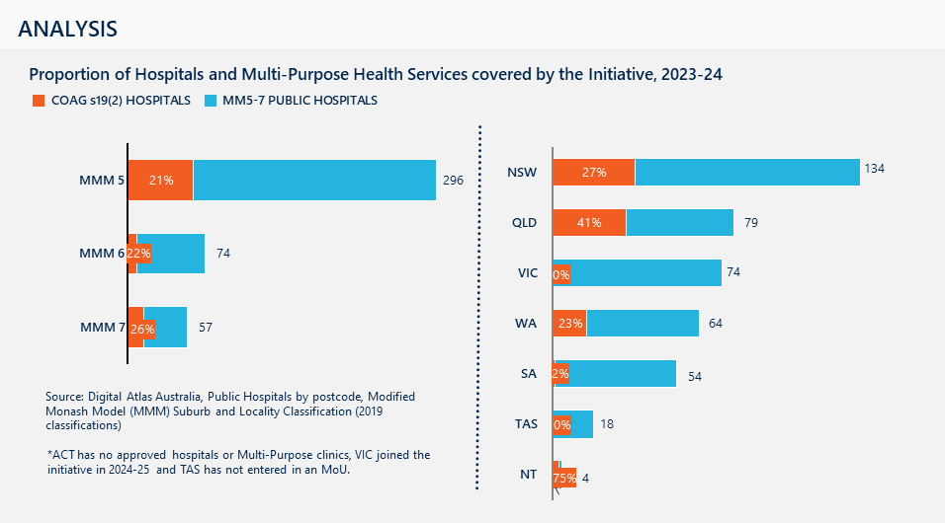
[Bar chart showing proportion of COAG s19(2) hospitals by MMM classification and state/territory for 2023–24.]
Detailed description:
The chart presents findings on the coverage of hospitals and Multi-Purpose Health Services under the COAG s19(2) Exemptions Initiative for 2023–24. Coverage is shown by MMM classification and by state/territory.
By MMM classification:
- MMM 5: 21 per cent covered out of 296
- MMM 6: 22 per cent covered out of 74
- MMM 7: 26 per cent covered out of 57.
By State/Territory:
- NSW: 27 per cent covered out of 134
- QLD: 41 per cent covered out of 79
- VIC: zero per cent covered out of 74
- WA: 23 per cent covered out of 64
- SA: two per cent covered out of 54
- TAS: zero per cent covered out of 18
- NT: 75 per cent covered out of four.
Source: Digital Atlas Australia, Public Hospitals by postcode, MMM Suburb and Locality Classification (2019 classifications).
Note: ACT has no approved hospitals or multi-purpose clinics, VIC joined the initiative in 2024-25 and TAS has not entered in an MoU.

Services reliant on visiting medical officers are often unable to utilise the Initiative
In some states, VMOs and private providers in the area saw the Initiative as at odds with existing contractual arrangements. For example, in South Australia and Victoria, commonly VMOs are private contractors to small rural hospitals and therefore can claim MBS billing in their own practice. The Initiative could reduce this income stream and rely on new contractual arrangements to be negotiated with the health services. As a result of these challenges in Victoria, there has only been one example of a hospital service approved under the Initiative, with the remainder in community health settings. South Australia has also seen limited site approvals, where VMO arrangements are prominent.

The requirement to demonstrate unanimous stakeholder support effectively acts as a veto
Stakeholders consistently highlight the importance of local engagement to ensure the Initiative meets community needs. Effective consultation supports alignment with local priorities and fosters trust among providers and communities. Jurisdictions report that the current requirement for full stakeholder support can create barriers to implementation, as a single stakeholder’s refusal may prevent approval even where there is strong overall support and demonstrated local need. This requirement is perceived as operating as a veto, which can delay or block applications in thin or failing markets.
Under the MoU, site approval requires consultation with all relevant stakeholders who may be impacted by the Initiative. These include local private general practices, contracted or visiting medical practitioners, AMS, allied health providers, PHNs, local community representatives (e.g., Consumer Health Councils or Health Community Councils), local council officials, and the Royal Flying Doctor Service. Stakeholders are given 20 working days to provide written support or raise objections; failure to respond is treated as support.
Where support is not received from relevant stakeholders, a review process may be conducted by the Commonwealth and jurisdictions, noting the Commonwealth have final discretion. Stakeholders, however, perceive that the requirement to demonstrate unanimous stakeholder support effectively operates acts as a gatekeeper for site approval. Jurisdictions have reported that a single stakeholder’s refusal can cause applications to be rejected, despite broader consensus and demonstrated local needs.
The requirement that applicants engage with all stakeholders, and that all stakeholder views are presented in the application is important to ensure that consultation and consideration of different perspectives has been undertaken in preparing an application. However, an assessment on the collective view of key stakeholder groups on balance, may be a more equitable and objective approach rather than a requirement for unanimous support.

MMM classification eligibility risks excluding communities despite service needs
The eligibility criteria, based on MMM classification, risks excluding communities with genuine service needs. Some jurisdictions have expressed concern that excluding MM4 communities overlooks significant service gaps. For example, in SA, many MM4 communities face similar challenges to those in MM5 and MM6 regions but remain ineligible for the Initiative. Additionally, changes to the MMM classification system can result sites losing their exemption if they move from MM5 to MM4, even if service needs remain unchanged. This creates uncertainty and undermines long-term planning, especially as some MM4 communities deliver services to more remote locations (MM5-7) and support Virtual Rural Generalist-reliant sites, as well as other remote medical service models.

There are also undersupplied regions in metropolitan areas
Where the focus of this evaluation remained on rural and remote regions, there are examples where metropolitan regions saw the utility in having the Initiative or were using historical non-COAG s19(2) exemptions.
In the ACT, the jurisdiction is ineligible for the COAG s19(2) exemption due to its largely metropolitan classification and lack of eligible hospitals in rural or remote areas. However, it faces challenges similar to those in rural and remote regions, particularly in terms of GP FTE rates, which are among the lowest per capita in the country.
Metropolitan Youth Health in South Australia is an example of a metropolitan service operating under a historical s19(2) exemption. Engagement with this site highlighted that ‘thin markets’ do exist in metropolitan settings, particularly in areas where there are vulnerable and underserved populations. The service relies on additional MBS funding to maintain access for young people and support MBS-subsidised allied health referrals. Without alternative funding, the exemption helps prevent further service decline. However, excluding other metropolitan sites in thin markets from this support creates inequity. Addressing this requires either broadening funding eligibility to all affected metropolitan areas or removing the current exemption.
If the Department were to revise exemption arrangements, it is recommended that MBS funding for such metropolitan sites be maintained during transition until the future directions are settled. This approach safeguards continuity for vulnerable populations while future funding arrangements are clarified, rather than withdrawing support prematurely.
Case study: Metropolitan Youth Health (MYH), South Australia
The Initiative can support multidisciplinary wrap-around care in thin markets
In SA MYH, a specific 19(2) exemption supports an outer-metropolitan clinic serving vulnerable populations, namely young people exiting guardianship and individuals experiencing homelessness. The exemption allows MYH to trigger MBS items for mental health care plans, chronic disease management, and allied health referrals. Young people can then access subsidised visits to psychologists, dietitians, psychiatrists, and other specialists - critical for early intervention.
“If that exemption was to leave… a lot of these children will stop seeing our service or fail to attend GP services.”
– General Practitioner, MYH
For the full case study on MYH, refer to Case Study 8 in Appendix E.

The fee-for-free service funding model requires sites to have sufficient capacity and stability
The value of the Initiative is dependent on the available workforce, and this creates difficulties in areas that are unable to attract and retain a stable medical workforce. Additionally, sites report significant administrative burden associated with the Initiative and that the availability and turnover of administrative workforce can significantly impact the level of billing.

Initiative funding is dependent on provider capacity, not community health needs
Billing amounts under the Initiative vary widely and are largely determined by workforce availability, administrative capacity, and governance support. This is consistent with the 2021 Evaluation findings which highlight MBS claim levels are not correlated with community need. Sites with salaried medical clinicians achieve higher billing and service provision, while those struggling with workforce retention are unable to leverage the Initiative effectively - often in communities with greatest need.
Moreover, the administrative burden associated with the Initiative can make participation impractical for smaller sites, which are often those with the highest levels of need. Stakeholders highlighted that the current allocation of 30 per cent of reinvestment funds for administrative costs does not adequately cover the actual expenses involved in managing the program at smaller sites. Paradoxically, these locations are generally more likely to see the greatest impact of improved primary care.

The current operation of the Initiative limits the extent to which it can meet the broader needs of the community

The Initiative doesn’t support integration between public sector and other services
One of the three key objectives of the Initiative is to support the viability of small rural hospitals, without adversely affecting local privately run services. This points to a fundamental challenge that the Initiative aims to directly support the public hospital and health service, however, has limited impact on other primary care service providers such as private GPs and allied health clinics and NGO organisations including ACCHS.
Stakeholder consultation consistently pointed to uneven integration and regional planning with other service providers. Rather than being embedded within the Initiative’s design, collaboration often relies on individual sites cultivating their own relationships with external organisations. This approach risks duplication of effort and, in some cases, competition between providers particularly from a workforce and financial sustainability.
Stakeholder perspectives include:
- ACCHS | Opportunities exist to provide greater integration and resources sharing with public hospital services, but engagement is inconsistent across sites. Where there is a distinct role for ACCHS in communities, many ACCHS face similar challenges in recruiting and maintaining staff and managing acute presentations in the community, that could warrant a more collaborative funding approach.
- NGOs | Few NGOs were engaged throughout the evaluation; however there is limited evidence of integration as part of the Initiative. There are instances where MBS revenue has been reinvested towards individual contracts with NGOs to deliver community services such as youth mental health workers.
- Private providers | Some private organisations perceive public hospitals as being favoured in workforce allocation, though flexible employment models in certain regions have facilitated greater workforce sharing. Of the remaining private providers in the thin market areas visited, many were facing significant viability challenges.
- RFDS | The RFDS is increasingly providing primary care throughout Australia. The RFDS has emphasised that their ability to provide continuity of care is restricted by their inability to provide MBS-rebatable referrals within community, as non-MBS billing GPs.
We can’t offer that continuity of care which the RFDS is equipped to offer, particularly in terms of chronic disease management plans, diabetes care plans, et cetera.
RFDS stakeholder
Additionally, the exemption does not always complement state-funded rural GP training incentives, which can present as a barrier to workforce recruitment. Stakeholders have indicated that improved coordination of recruitment and credentialling processes across programs would support provider mobility and service delivery across multiple initiatives.

There is still a need for intervention in thin markets and to support delivery of primary care in rural and remote regions

The Initiative remains a modest but important funding lever
The Initiative provides an important source of income to support access to primary care in rural and remote communities where demand outstrips supply and private practice is non-viable and declining in rural and remote communities. The myriads of challenges faced by rural and remote services across the board, as described in this report, highlight the need for government intervention to supplement existing funding mechanisms when required. Consultation has suggested many sites rely on the additional Medicare revenue to sustain service delivery (see Section 3.4). Across many sites, the additional revenue has supported services to offer after-hours care and receive funding for primary care services already in place.
Where a significant amount of revenue is generated in a hospital environment, many stakeholders saw this as positive to help free up GP capacity within community, where it exists, to focus on ongoing chronic care. Additionally, in many cases the Initiative is an important access point to MBS subsidised care plans and referrals.
However, the contribution within communities remains modest. The Initiative has seen $21.57 million injection go to eligible sites in FY24, reflecting a relatively small contribution to MM5-7 primary care. Growth has been slow, averaging just 2.6 per cent annually over the past seven years, hampered by workforce availability, implementation barriers and complexity of billing. Stakeholder consultations emphasised that the Initiative functions best as a workaround rather than a strategic solution. It is described as a backstop, providing supplementary funding in contexts of market failure, rather than a solution to primary care access.

The fee-for-service funding model is increasingly seen as unsustainable in rural and remote areas
Fee-for-service models rely on throughput and activity, which is difficult in areas of low population and when services struggle to maintain the workforce. Increasingly, concerns are being raised about the utility of the MBS as a fee-for-service funding model in thin markets. Many private practices are closing down, reporting that MBS funding is insufficient to sustain the cost of running a rural or remote health service.
As such, the Initiative’s funding model does not align with these concerns about the realities of thin markets, where low patient numbers and high operating costs make financial viability challenging. Respondents to the participating site survey reflected these concerns. As outlined in Figure 10, only 39 per cent of survey participants felt that the Initiative’s funding mechanisms were adequate and sustainable, while 16 per cent disagreed and 45 per cent remained neutral. Rising cost of living and ongoing workforce shortages in rural regions threaten the long-term intent of the Initiative to maintain hospital viability. These sustainability concerns are likely to intensify, especially as recruitment and retention become more difficult and populations continue to age.
Case study: Eyre and Far North LHN, South Australia
The Initiative does not reflect the realities of delivering primary care in rural and remote areas
Whilst a critical funding source, the Initiative alone does not adequately reflect the cost to Eyre and Far North LHN to provide primary care services where there is market failure. For example, the LHN is required to contribute significant funding to staffing, administration, infrastructure and other overheads to provide these services.
“We’re making a big loss now in GP practices because of bulk billing. Under COAG, we had to stop charging a gap in some locations.”
– Site executive
For the full case study on EFNLHN, refer to Case Study 9 in Appendix E.
Figure 10 | Survey respondents’ perspectives on the Initiative’s funding mechanism
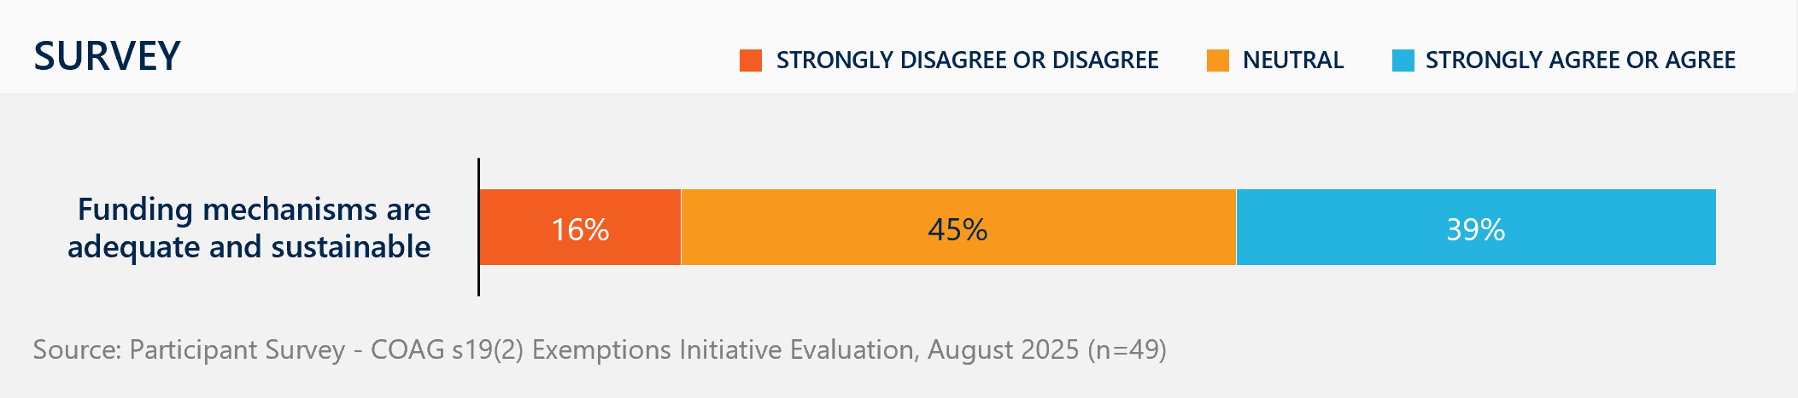
[Horizontal stacked bar chart showing survey responses on whether funding mechanisms are adequate and sustainable.]
Detailed description:
Participants were asked for their level of agreement with the statement: ‘Funding mechanisms are adequate and sustainable.’
Response breakdown:
- 16 per cent strongly disagree or disagree, indicating a minority of respondents expressed scepticism about the adequacy and sustainability of funding mechanisms
- 45 per cent neutral, neither agreeing nor disagreeing with the statement, representing the largest proportion and suggesting many respondents did not hold a strong view either way
- 39 per cent strongly agree or agree, showing that a substantial share of respondents view funding mechanisms positively.
Source: Participant Survey – COAG s19(2) Exemptions Initiative Evaluation, August 2025 (n=49).

Program Delivery
This section informs KEQ 2 Implementation: How well has the Initiative been implemented, and what improvements could be made?
It explores the change in the Initiative over time, and the experience of participating sites in implementing and delivering the Initiative. Improvements are suggested in Section 4 Future Direction.

Findings from the 2021 evaluation
The 2021 Evaluation identified that there are significant administrative barriers with the Initiative and for some sites, were prohibitive to effectively implementing the Initiative.
Common barriers included:
- Planning and approval with delays in site application and sign-off due to local stakeholder concerns on intent and use of the Initiative.
- Lack of guidance and support for sites to prepare local patient consent forms, check lists for in-scope MBS items, application forms and processes for new registered provider numbers.
- Administrative burdensome processes to lodge compliant MBS claims contributing to high site-level administration costs.
- High turnover of hospital doctors requiring constant attention to ensure the provision of site-specific provider numbers to mitigate claims rejection. These doctors also have variable exposure and comfort with Initiative administration systems.
- Lack of clarity whether particular types of expenditure met the reinvestment rules of the program.
- Governance: Strong variability in how governance operated across jurisdictions and sites, which created confusion and issues around transparency in some areas.

Summary of current findings
There is significant inconsistency in how the Initiative is implemented across sites and jurisdictions.
Eight per cent of sites billed over $500,000 in FY24, however majority billed less than $50,000. All sites have found implementation challenging, resource-intensive and time-consuming. This is due to administrative burden, uncertainty around program guidelines and disconnect with jurisdictional nuances, with success largely dependent on local capacity, leadership, and governance.
Key insights from stakeholders suggest:
- Applying for and administering the Initiative requires significant investment of time and resources, involving extensive local consultation, stakeholder endorsement, and the establishment of new billing and reporting systems. This can be prohibitive for smaller sites.
- The ability to benefit from the Initiative is contingent on having a stable, eligible workforce, which is impacted by high turnover and shortages undermine implementation, especially in the most remote and underserved areas.
- Governance arrangements are highly variable and are often not clear or transparent. Many sites lack clarity or visibility over how funds are used, reducing the Initiative’s impact.
- Clinicians and staff often lack direct incentives to engage with the Initiative, and the administrative burden and lack of visible local benefit can also deter participation.

There is significant variation in the Initiative’s implementation across sites and jurisdictions
The delivery of the Initiative has been shaped by a complex interplay of site-level capability, administrative burden, governance structures, and workforce stability. While the Initiative has enabled new revenue streams for some rural and remote services, its implementation has been uneven and often constrained by systemic and operational challenges. This section outlines the key barriers and enablers to implementation, structured across four key areas:
- Navigating the application process
- Complexity and uncertainty of the Initiative’s rules
- Administrative burden and workforce constraints are key barriers to implementation
- Governance and reinvestment
As described in Section 3.1 - Policy Context, the jurisdictions have a diverse mix of policy and structural differences in how they operate hospitals and health services and employ the health workforce. These variances have also led to variability in how the Initiative is utilised across services, including within jurisdictions, as local governance and capacity is also seen to drive differences. The following pages provide a description of how the Initiative is operating in practice, utilising MBS billing data across FY22 – FY24. Of note:
- Western Australia has the highest rate of MBS billing through the Initiative across 17 sites in FY24.
- Queensland has the highest number of sites, with the largest total revenue from the Initiative in FY24.
- South Australia and Victoria are new entrants to the Initiative from FY22 and FY24 respectively, however Victoria has not billed in FY24. Anecdotally there has been very limited billing activity in Victoria to date.
- Most sites are in MM5 regions, however on average MM7 sites bill higher proportions per site.
- Majority of MBS revenue is generated through non-afterhours GP services followed by after-hours GP services, a trend that has been consistent across all three years. There is limited billing for Nurse Practitioners and Allied Health across services.
- 53 per cent of sites are generating less than $50,000 in FY24 highlighting significant challenges in many sites. On the other end, eight per cent of sites generated more than $500,000.
- The most common type of approved site are public hospitals and MPS, which also generate the most on average per site and in total.
NT generates the highest average revenue per site; however, these figures are likely skewed by the number of outreach sites in other jurisdictions. There are 58 non-billing sites within the Initiative, meaning that 35 per cent of approved sites are not generating any MBS revenue.

Overview of site participation and MBS billing
Currently, there are 167 approved sites, including at least 109 billing sites in FY23-24.
Table 6 shows the number of sites and total MBS billing (FY23-24) by jurisdiction.
Table 6 | MBS billing by jurisdiction
State/territory | Number of sites | MBS billing | Notes
Queensland | 58 | $6.2M | Received second largest funding from the initiative; includes 6 outreach sites
New South Wales | 47 | $2.7M | Includes 9 non-billing sites in FY24
Western Australia | 41 | $8.7M | Includes 24 outreach sites; receives largest total funding from the initiative
South Australia | 11 | $0.7M | Includes 6 outreach sites; three Metro Youth Services sites (approved to 2026); receive ~0.8M p.a. in benefits through the s18(2) exemptions
Northern Territory | 6 | $3.3M | Including 3 hospitals, no MMM5
Victoria | 4 |  | Non-billing sites in FY24
Tasmania | 0
Further insights:
- Since 2021, the number of participants sites has increase from 118 to 167.
- VIC and SA have joined the initiative in FY24 with 4 and 8 sites respectively in FY25. Only SA has billed in the last financial year.
- Since 2021, there has been an average of $143,800 MBS benefits billed p.a. per site.
State and Territory participation is highly variable with a unique mix of MMM areas.
Table 7 below shows the number of sites across jurisdictions, by MMM classification FY23–24 with change since FY22.
Table 7 | Number of sites by MM and jurisdiction
State/territory | MM5 | MM6 | MM7 | Change since FY22
Queensland | 34 | 8 | 16 | +4
New South Wales | 43 | 4 | 0 | 0
Western Australia | 17 | 2 | 16 | +5
Northern Territory | 0 | 4 | 2 | -1
South Australia | 3 | 1 | 0 | +8
On average, MMM7 areas bill more. Table 8 below shows a comparison of MBS billing and number of sites, by MMM classification FY23–24.
Table 8 | MBS billing and number of sites by MMM
MMM classification | Number of sites | MBS billing (FY23-24)
MM5 | 97 | $11.0M
MM6 | 19 | $2.8M
MM7 | 34 | $7.8M

Most revenue is billed from GP non-referred services. Table 9 below shows the percentage of revenue from FY23-24 by service type.
Table 9 | Revenue by service type
Service type | Percentage of revenue (FY23-24)
Non-afterhours GP non-referred services | 52 per cent
Afterhours GP non-referred services | 20 per cent
Diagnostic imaging services | 12 per cent
Other MBS services | 10 per cent
Operations services | 3 per cent
All other service items | 2 per cent

Aside from fluctuations in WA, there has been limited growth in total revenue over the past 7 years. Table 10 below shows jurisdictional MBS billing between FY18-24.
Table 10 | MBS billing across financial years, by participating jurisdiction
Financial year | NSW | NT | QLD | SA | WA
FY17-18 | $3.1M | $2.3M | $4.4M |  | $8.2M
FY18-19 | $1.5M | $0.5M | $4.8M |  | $4.6M
FY19-20 | $2.0M | $2.1M | $5.4M |  | $4.1M
FY20-21 | $2.9M | $2.3M | $5.8M |  | $5.2M
FY21-22 | $2.4M | $2.5M | $5.9M |  | $5.4M
FY22-23 | $2.4M | $3.0M | $6.1M | $0.5M | $7.5M
FY23-24 | $2.7M | $3.3M | $6.2M | $0.7M | $8.7M

In FY23-24, most sites receive less than $50,000 in revenue per year. Table 11 below shows the proportion of MBS revenue received by COAG sites within each revenue range in 2023-24.
Table 11 | Distribution of MBS revenue by site
MBS revenue range | Proportion of revenue
$0 | 3 per cent
$1-$10k | 22 per cent
$10k-$50k | 28 per cent
$50k-$500k | 39 per cent
$500k-$1m | 6 per cent
>$1m | 2 per cent

Billing capacity per site is highly variable across jurisdictions. Table 12 below shows the average revenue per site FY2023-24.
Table 12 | Average MBS revenue per site
Jurisdiction | Average revenue per site (FY23-24)
Northern Territory | $546,000
Western Australia | $248,000
South Australia | $172,000
Queensland | $127,000
New South Wales | $71,000

Key insights:
- Despite having the most participating sites NSW and QLD have the lowest billing averages of $57k and $107k per billing site.
- NT have the highest revenue per site, averaging $546k across 6 sites. WA have more outreach sites, which brings down the average
Majority of sites within the Initiative are hospital and health services / MPS, which see a considerably higher amount of funding than Community Health Centres and state-run Medical Clinics.
Table 13 and Table 14 below show the number of sites and MBS revenue across jurisdictions by practice type, FY2023-24.
Table 13 | Number of sites by practice type and jurisdiction
Practice type | NSW | NT | QLD | SA | WA
Hospital / MPS | 46 | 3 | 42 | 3 | 18
Community Health Centre | 1 | 1 | 12 |  | 10
Medical Clinic | - | 2 | 4 | 1 | 7

Table 14 | MBS revenue by practice type
Practice type | MBS revenue (FY23-24)
Hospital / MPS | $19.9M
Community Health Centre | $2.3M
Medical Clinic | $0.8M

Source: Ministers Directions COAG s19(2) approved sites, FY23-24; MBS Benefits by site, FY23-24, supplemented by data provided by the Department

There are opportunities to reduce administrative burden associated with applying for the Initiative
Stakeholders, including jurisdictions and sites, cited that the process of applying for the Initiative can be difficult and resource intensive. The application process is led by jurisdictions, with sites and LHNs both reporting significant input into the process, particularly in navigating a steep learning curve. The application process requires detailed local consultations, written endorsements from key local stakeholders and the development of a site-specific Implementation Plan. This process is designed to ensure that exemptions are locally supported, strategically aligned, and do not undermine existing service viability.
Key challenges raised by stakeholders relating to the application process include:
- A lack of clarity and understanding of eligibility across jurisdictions and services. Sites and jurisdictions commonly found the application process unclear and difficult to navigate. Where a site’s application has been rejected, stakeholders raised that the rationale is not always well understood. In the view of some stakeholders, application approvals felt inconsistent, highlighting an interest in more transparency as to the decision-making process and eligibility.
- Where critical, written approval from local stakeholders to demonstrate buy-in takes time. As described earlier, establishing local endorsement and stakeholder buy-in is seen as a challenging aspect of the approval process, as a requirement of the Initiative. Whilst stakeholders agree in the value of gaining local buy-in to ensure the Initiative is fit for purpose in the local community, the need for engagement can create delays in the application process, and in some cases, prevented sites receiving approval.
- Speed of the application process may hinder responsiveness. The complex and lengthy application process makes it difficult for the Initiative to respond swiftly to rapid market changes. While expedited approvals have occasionally occurred in emergencies, this is not a standard feature, limiting the ability to use the Initiative to intervene proactively.

Implementing the Initiative is highly complex and difficult to navigate

The Initiative is complex and poorly understood, risking compliance challenges
Stakeholder consultations consistently highlighted that the Initiative is poorly understood across jurisdictions and service providers. Sites regularly described difficulty fully understanding its design and purpose, raising concerns about how frontline practitioners are expected to engage with it effectively. Clinicians and administrative staff often lack familiarity with the billing process and struggle to keep pace with frequent changes to MBS item numbers and eligibility rules.
This challenge is particularly acute in regions with high workforce turnover, where new clinicians and administrators must repeatedly learn how to correctly administer the Initiative. This constant learning delays implementation and increases the risk of compliance issues.
I am very careful about what I do – terrified I will misuse Commonwealth funds.
Site Finance Manager
Many sites expressed fear of incorrectly billing, however lack of clarity about billing guidelines also means that there may be examples where sites are over-billing. Due to uncertainty about what constitutes primary care, and broad billing items, sites were not always clear on what could and couldn’t be billed. In other sites, many services were cautiously underbilling, further limiting the Initiative’s impact.

Sites receive variable support from jurisdictions and LHNs
Support for implementation varies significantly across jurisdictions and LHNs. In some jurisdictions, such as Queensland and New South Wales where the Initiative has been long-running, dedicated revenue officers within the LHNs actively assist sites with application development, stakeholder engagement, and implementation, often with centralised resources.
Stakeholders anticipated that the flexibility of the MoU may be driving the variability in how the Initiative is interpreted and managed. Where there is expectation for broad consultation, it does not provide descriptions or implementation advice on how sites can implement the Initiative.
They are running slightly different to each other, but we've all got the same MoU, so it must be a way people are interpreting the content of the MoU and how they're actually operating their COAG sites. Sites all interpret it and use it differently.
Jurisdictional stakeholder

There are few avenues to uncover consistent, clear information
Jurisdictions and sites consistently reported that there are few reliable avenues to access consistent and clear information about the Initiative. The absence of centralised support or implementation guidance means that sites must rely on informal networks or ad hoc advice. This was further complicated by variable interpretations of MBS rules when they requested information from the Medicare provider enquiry line.
In Victoria, a relatively new entrant to the Initiative, stakeholders described a lack of accessible expertise. The state department was asked to run information sessions to support sites, but many participants stressed that there were few people they could reach out to who understood the Initiative and could assist with implementation.

Administrative burden and workforce constraints are key barriers to implementation
The most cited challenges impacting successful implementation identified in a survey of 49 participating site representatives were workforce shortages and administrative burden. As outlined in Figure 11 over half of respondents highlighted these challenges as limiting the functioning of the Initiative.
Figure 11 | Perceived barriers to successful implementation
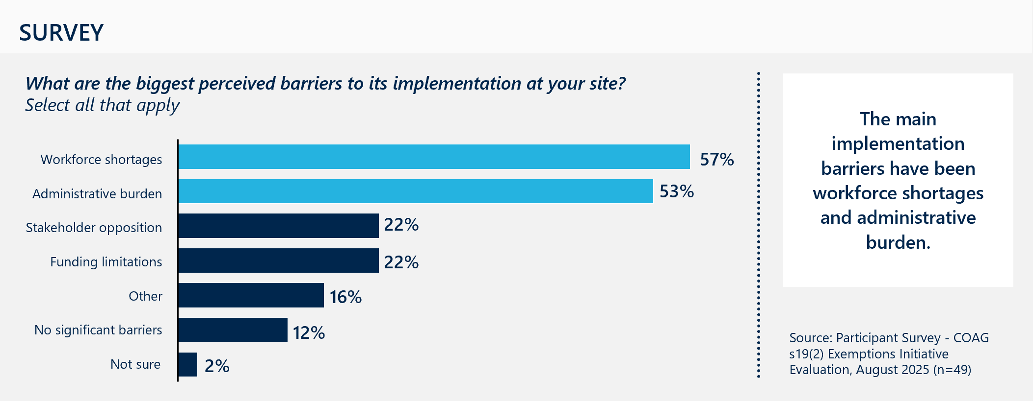
[Horizontal bar chart showing survey responses on perceived barriers to implementation at participant sites.]
Detailed description:
Participants were asked what the biggest perceived barriers to implementing the Initiative at their site were and could select all that apply.
Response breakdown:
- Workforce shortages – 57 per cent
- Administrative burden – 53 per cent
- Stakeholder opposition – 22 per cent
- Funding limitations – 22 per cent
- Other – 16 per cent
- No significant barriers – 12 per cent
- Not sure – two per cent.
Key insight: The main implementation barriers have been workforce shortages and administrative burden.
Source: Participant Survey – COAG s19(2) Exemptions Initiative Evaluation, August 2025 (n=49).

Successful implementation relies on a stable, sufficient workforce
The availability of the requisite clinical and administrative workforce limits the implementation of the Initiative. Sites are unable to take advantage of MBS billing and therefore receive the additional revenue if they do not have the available and eligible staff. This is primarily a challenge for services who struggle to employ GPs, as GP services are the services most billed across sites.
In pockets, SEM trials have supported greater flexibility in engaging GPs where the state or territory is the employer, however this is not applicable to situations, such as in Victoria and South Australia, where there are visiting medical officers (employed privately).
Case study: Longreach Hospital, Queensland
Transient workforce creates inconsistent billing over time
In QLD, within the Central West HHS, Longreach Hospital has a stable workforce and has ramped up their MBS revenue generation significantly. Barcaldine, a smaller site within the HHS, operates within the Initiative as well. However, despite strong structural foundations, the site faces persistent challenges in maintaining billing consistency due to workforce turnover and limited onboarding support.
“A transient workforce makes the knowledge gap difficult. Revenue fluctuates, because at the start of the term the [junior doctors] don’t know how to use it.”
– Barcaldine hospital executive
For the full case study on Longreach, refer to Case Study 1 in Appendix E.
Sites which have a more permanent workforce, who understand how the billing works, are anecdotally better off, compared to more transient locations with workforce constraints who are reliant on locums and temporary staff.
This is the result of to two key factors:
- The requirement to have an MBS provider number prior to billing. Waiting for a provider number from Services Australia can limit staff being able to utilise the program when new to a service.
- Developing an understanding of the Initiative and associated site-specific billing practices. This challenge is explored further below.

MBS billing is not core business for many sites
There are significant operational changes required across new sites when implementing the Initiative. MBS billing is not standard operating procedure for many hospital and health services. Once approved, sites must independently establish billing systems, secure provider numbers, and train staff to manage MBS processes. Most sites do not have existing infrastructure for Medicare billing, and the Initiative does not provide structured onboarding or implementation support.
As a result, sites face a steep operational uplift, particularly smaller services with limited administrative capacity. The Initiative’s complexity has created a fragmented and resource-intensive environment that undermines its intent and limits uptake.
Some sites report finding this difficult within the funding guidelines, which caps expenditure towards administration to 30 per cent of total revenue. For smaller sites, this often means the cost of participation exceeds the benefit. This likely explains why some approved sites did not bill any MBS items.
As the program grows in smaller sites in my LHN, the 30 per cent of reinvestment funds for admin of the process will be inadequate to cover the actual costs of administering the program, yet the smaller sites are where the greatest benefit from enhanced primary care will come, due to their remoteness.
Survey respondent

Successful implementation is closely tied to site-level administrative expertise
Implementation success is closely tied to site-level expertise and understanding of the Initiative. Sites who appear to be operating well often have dedicated revenue officers or administrative staff who can dedicate significant time to the Initiative and develop adequate processes and guardrails. Often these resources are located within a subregional health service, for example, within Manjimup, WA, whereas there are other effective examples where a central revenue manager manages a number of sites, as is the case in Northern Territory.
In sites with staff turnover or constrained resources, the lack of dedicated staffing limits the Initiatives impact and creates equity challenges. Without centralised training resources, sites must develop their own onboarding or training, requiring significant upskilling to navigate the exemption and Medicare billing requirements when new staff commence.
There’s been a lot of figuring out as we go.
Site Operations Manager

Additional paperwork poses a burden on busy clinical staff
The Initiative most commonly operates in public hospital environments. The additional paperwork requirements on patients and staff, to access MBS billing sees extensive pushback across the board. This is exacerbated by the fact MBS billing mechanisms often don’t align with existing ED systems and therefore relies on manual data capture. In busy clinical environments, doctors and staff will prioritise patients, and as such, busy services suggest there is extensive under-billing occurring as a result.

Cultural change is required to encourage clinicians to adopt an additional billing step
Even when sites have workforce available, eligible clinicians often see little benefit in performing the additional administrative work, limiting billing uptake. Successful sites have worked hard on educating their clinicians and developing streamlined processes to ensure billing takes place. For many clinicians it is important to understand how the Initiative is working within the hospital, to understand the impact of the additional billing. However, there was variable understanding and knowledge of how the Initiative was operating within sites from clinicians.
It is a challenge getting doctors in the ED onboard, as they see it as extra admin work for little benefit.
Survey respondent
The Northern Territory have taken a different approach to incentivising clinicians. Clinicians are given 50 per cent of the MBS revenue they generate on top of their salary, to encourage MBS billing. Sites consulted in NT, saw this as a broadly positive offer, to enhance the retention of GPs in their services. However, this does receive mixed perspectives – as summarised in the case study below.
Case study: Katherine Hospital, Northern Territory
The NT incentivises staff to implement the Initiative
At Katherine Hospital, workforce is heavily reliant on locums and there is extensive demand for acute services. As a result, it is difficult to ensure clinicians are completing the MBS billing forms for the Initiative. However, the NT has a state-wide incentive to encourage staff to implement the Initiative. Staff that generate MBS revenue through the Initiative are entitled to 50 per cent of this revenue, in addition to their salaries. There is evidence at the sites that this is incentive is driving implementation. This incentive has received a mixed response from local stakeholders. These local stakeholders often voice concerns about losing their workforce to the hospital, due to competition in salary.
Sites in other jurisdictions generally do not provide a personal incentive to manage the administrative burden.
“One on hand, the incentive is good. It stops the ‘If I'm not benefiting, why should I try?’ concern. On the other hand, some doctors don't understand it. They feel they are double dipping.”
– Site stakeholder
For the full case study on Katherine Hospital, refer to Case Study 6 in Appendix E.

Governance mechanisms are variable across sites
Governance of the Initiative differs across jurisdictions, as enabled by the non-prescriptive nature of the MoU. Some jurisdictions rely on existing governance structures (for example through clinical governance forums), while others have established dedicated committees with broad representation from sites, PHNs, LHNs, and private providers. Stakeholder views on the effectiveness and transparency of these arrangements were mixed, shown below in Figure 12.
Figure 12 | Survey respondents’ perspectives on the Initiative’s governance arrangements
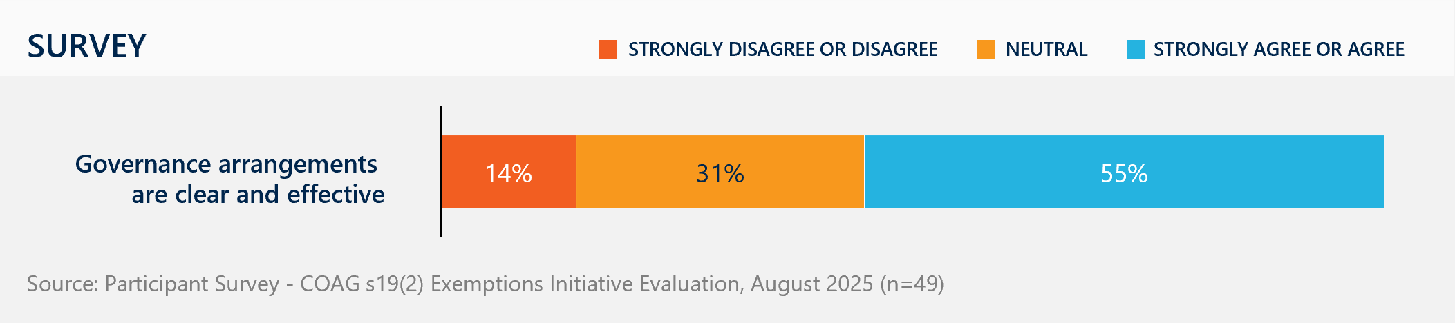
[Horizontal stacked bar chart showing survey responses on clarity and effectiveness of governance arrangements.]
Detailed description:
Participants were asked for their level of agreement with the statement: ‘Governance arrangements are clear and effective.’
Response breakdown:
- 14 per cent strongly disagree or disagree, indicating minor scepticism about the clarity and effectiveness of governance arrangements.
- 31 per cent neutral, neither agreeing nor disagreeing with the statement.
- 55 per cent strongly agree or agree, reflecting majority support for governance arrangements being clear and effective.
Source: Participant Survey – COAG s19(2) Exemptions Initiative Evaluation, August 2025 (n=49).
Although the application process requires initial consultation with external organisations, the program lacks clear expectations for ongoing community engagement in reinvestment decisions. This places responsibility on individual sites, resulting in inconsistent implementation and governance. These inconsistencies hinder integrated service planning and collaboration with other agencies.
In addition, the role of PHNs is not clear in the context of the Initiative. PHNs were established in 2015 to help ensure stronger coordination of primary care services. However, the standard or expectation of a role for PHNs in working with Initiative sites in governance or decision-making has not been set.

Strategic reinvestment depends on local governance
Analysis of a sample of site annual reports (n=21) and consultations indicated a significant portion of MBS revenue reinvestment is being directed toward supporting acute service workforce, often through locums. While the evaluation did not have visibility across all participating site reinvestments, an analysis of these sources provides a useful snapshot of reinvestment trends.
The most common reinvestment expenditure categories include:
- Medical labour, including locums and sometimes private GPs
- Additional services to enhance primary care
- Medical equipment
- Facility upgrade
- Employment of nursing or allied health professionals
- Recruitment and retention incentives
- Outreach-based primary care services.
Where there was evidence of reinvestment strongly tied to community need and primary care provision, strong local governance structures consistently emerged as a key enabler. The reinvestment trends suggest a stronger focus on sustaining acute service delivery, and limited emphasis on expanding community-based care. Gundagai MPS serves as an example of strategic reinvestment enabled by local governance. Its governance model ensures that reinvestment decisions are closely aligned with local service priorities and community needs, however in this case, does not include involvement from the local PHN.
Case study: Gundagai Multipurpose Service, New South Wales
Strong governance mechanisms support strategic reinvestment strategies
In NSW, Gundagai Multipurpose Service uses a local governance committee to support strategic reinvestment decision-making. This committee has representation from the Local Health Advisory Council, the site manager, cluster manager and strategic revenue managers. This governance mechanism has supported the development of both new primary care outreach services and local school-based traineeships that reinvest in the community.
“We’ve had a cardiac outreach clinic, a geriatric clinic, and an endocrinology clinic. A lot of the people we’ve referred through these clinics wouldn’t travel to Wagga to see a specialist. The 19(2) funding certainly helps us to support these services.”
– Private General Practitioner
For the full case study on Gundagai Multipurpose Service, refer to Case Study 3 in Appendix E.
Governance committees that incorporated broad local perspectives (including external stakeholders, community representatives and strategic revenue managers) identified gaps in primary health care, generated ideas for initiatives to address those gaps, and navigated jurisdictional procurement and compliance requirements more effectively. The result was reinvestment that responded to local needs and remained sustainable over the long term. Sites without strong governance mechanisms (likely due to capacity) often diverted funds more reactively, rather than investing sustainable improvements or service development.

Barriers to strategic reinvestment exist
The Initiative does not adequately drive strategic reinvestment into primary care due to the following barriers:
- Uncertainty and variability in MBS billing – MBS revenue can be highly variable from year-to-year, subject to changes in workforce availably (to bill), eligibility (e.g., MMM classification), local market conditions, or Commonwealth policy.
- Lack of transparency over funds received and decision-making – Some site managers and administrative staff reported lacking access to financial data, limiting their ability to plan or advocate for local needs. Several of the consulted sites expressed confusion around how funds were being reinvested and how reinvestment decisions were being made.
- Requirement to reinvest in within the financial year – Sites report that they cannot roll over funding, meaning they are often rushed to spend the revenue ‘before it disappears’ and cannot pool money for strategic investments. While this is not a requirement of the Department or Initiative, it is often guided by jurisdictional requirements, which sees public money subject to the annual appropriation and budget rules of that jurisdiction’s Treasury department. Under these rules, public entities usually cannot carry forward funds from one financial year to the next without explicit Treasury approval, restricting how they can utilise funds derived from the Initiative.
- Limited ability to generate enough revenue to meaningfully reinvest – Due to the large inequities in billing capacity, most sites generate marginal revenue through the Initiative. After administrative costs, there is little left over to reinvest in primary care.
- Hospital spending rules and procurement requirements – Public hospitals are not typically set up to commission primary health care services. As such, jurisdictions and hospital networks have different spending rules and requirements which may impact reinvestment. For instance, since starting MBS billing in 2020, the Manjimup Warren Health Service has generated over $2.5 million in revenue across 2021–24 thanks to its efficient set-up and administration. However, they have been limited in what they can reinvest the funds towards new FTE, due to jurisdictional head count policies and procurement rules.

Program Outcomes
This section informs KEQ 3 Effectiveness: Is the Initiative achieving its intended outcomes?
It also responds to KEQ 4 Value for Money: Is access to fee-for-service funding (i.e. MBS through Initiative) a cost-effective funding mechanism in the current policy context?

Findings from the 2021 evaluation
The 2021 evaluation found that the Initiative's effectiveness in generating revenue for reinvestment in primary care varied across jurisdictions and was primarily influenced by medical workforce engagement mechanisms and site-level capacity.
- While the Initiative enabled access to urgent medical care and after-hours services, MBS revenue reinvestment was largely allocated to medical officer and locum remuneration to support acute hospital emergency services particularly in jurisdictions using salaried mechanisms for medical officer engagement.
- In sites where billing levels were lower and revenue limited, the impact was constrained, reducing the ability to engage additional staff.
- The Initiative had limited impact on enhancing access to integrated, comprehensive primary care. Where it did provide benefits was dependent on location and LHN/site linkages with private general practice and/or Aboriginal Medical Services.
- There were examples where the Initiative supported innovative workforce models, including junior doctor placements and flexible employment arrangements, indicating potential for longer-term workforce retention strategies.
- The Initiative made a reasonable contribution to overall revenue of participating services, representing in the order of six per cent of modelled salaries and wages of survey respondent sites.
- However, access to the Initiative is not a guarantee of an individual health service’s long-term viability.
- Historical service delivery arrangements, industrial arrangements, gradual population decline, and the sudden resignation of a key manager or clinician can all interact to threaten the sustainability of health services and compromise the models of clinical care available to some small communities.

Summary of current findings
The Initiative has delivered modest but critical benefits in improving access to primary care in rural and remote areas, by providing a valuable funding stream in thin markets and enabling MBS referral where it might otherwise not be available.
However, its effectiveness is highly variable across jurisdictions and sites, and its design constraints limit broader impact.
Overall, the Initiative lays a foundation for financial support, though further efforts are needed to fully realise its intended improvements in primary care outcomes.
- Revenue generated through the Initiative is not a reliable funding stream to enable strategic reinvestment into improving primary care access.
- The Initiative has supported recruitment, but has limited impact on long-term workforce retention, which requires significant investment, policy alignment and structural reform.
- Funding is often minimal and does not guarantee the long-term viability of small rural hospitals, and risks disadvantaging non-hospital primary care services that may be better placed to provide primary care, by redirecting resources and workforce.
The effectiveness of the Initiative is determined by its ability to deliver on its intended objectives. The objectives of the Initiative can be summarised as:
- Patient access: Increase patient access to primary health care services, including after hours, in rural and remote public hospitals and health services.
- Workforce: Improve attraction and retention of primary health care workforce in rural and remote areas.
- Viability: Support the viability of existing small rural hospitals through increased access to funding – without an impact on existing primary care health services.
These are drawn from the Initiative’s MoU with jurisdictions, public messaging from the Department. This section draws on feedback gathered through consultation and the participating site survey.
1 | Patient access

The Initiative has helped support access to primary health care in many hospital settings
As described above, the implementation of the Initiative is highly variable, which has a direct impact on the outcomes that sites have been able to achieve. The Initiative has delivered modest but important benefits to improving access to primary care services in rural and remote regions by providing access to a source of funding, but this is not a common pattern across all services.

There is some evidence the Initiative is supporting greater access to health services
The Initiative aims to increase patient access to reliable, timely, and affordable primary care, which helps to lower preventable hospitalisations and deaths. Though measurable primary health outcomes have been difficult to obtain, there is a general sentiment that the Initiative has supported access to primary care services, albeit limited to some services. In the participating site survey (n=49), two-thirds of respondents reported improvements in community access to primary care because of the Initiative, as shown in Figure 13.

Figure 13 | The extent to which the Initiative has improved access to primary care
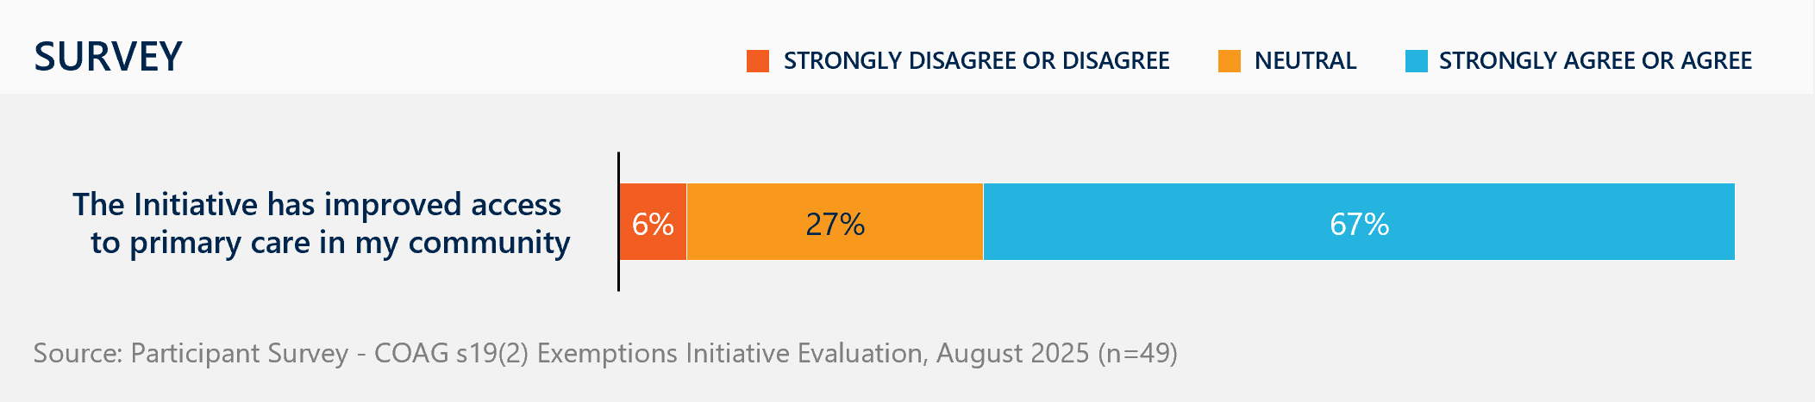
[Horizontal stacked bar chart showing survey responses on whether the Initiative has improved access to primary care.]
Detailed description:
Participants were asked for their level of agreement with the statement: ‘The Initiative has improved access to primary care in my community.’
Response breakdown:
- 6 per cent strongly disagree or disagree, indicating very minor scepticism about the Initiative’s impact on access.
- 27 per cent neutral, neither agreeing nor disagreeing with the statement.
- 67 per cent strongly agree or agree, reflecting majority support for the Initiative’s role in improving access to primary care.
Source: Participant Survey – COAG s19(2) Exemptions Initiative Evaluation, August 2025 (n=49).
Where positive, survey responses, reinvestment data, and stakeholder feedback demonstrate there are common positive outcomes associated with the Initiative. Figure 14 summarises the key benefits participating sites saw the Initiative delivering.

Figure 14 | Perceived benefits of the Initiative in the community
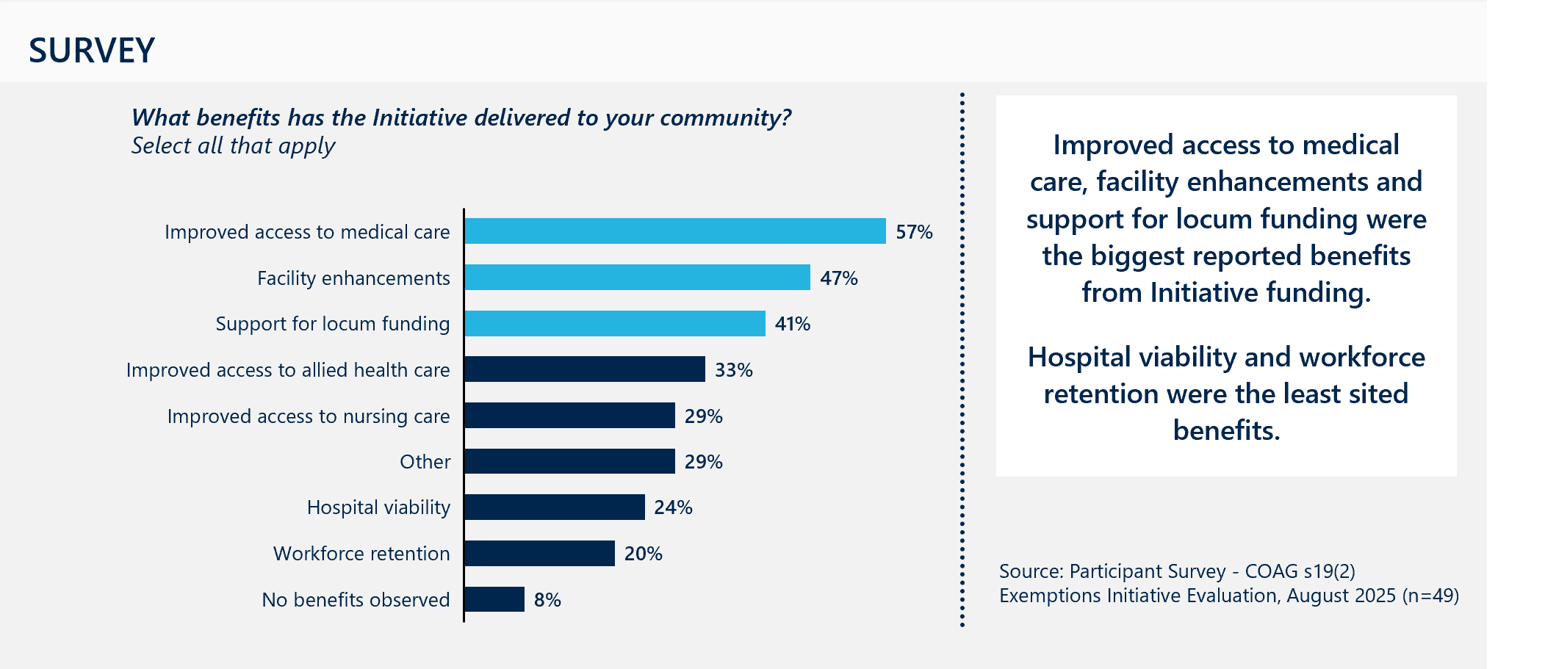
[Horizontal bar chart showing survey responses on benefits delivered by the Initiative to the community.]
Detailed description:
Participants were asked what benefits the Initiative has delivered to their community and could select all that apply.
Response breakdown:
- Improved access to medical care – 57 per cent
- Facility enhancements – 47 per cent
- Support for locum funding – 41 per cent
- Improved access to allied health care – 33 per cent
- Improved access to nursing care – 29 per cent
- Other – 29 per cent
- Hospital viability – 24 per cent
- Workforce retention – 20 per cent
- No benefits observed – eight per cent
Key insight: Improved access to medical care, facility enhancements, and support for locum funding were the biggest reported benefits from Initiative funding. Hospital viability and workforce retention were the least cited benefits.
Source: Participant Survey – COAG s19(2) Exemptions Initiative Evaluation, August 2025 (n=49).
Consultation with a broad range of stakeholders identified some other key benefits:
- Increased funding stream and workforce support to local hospitals. Stakeholders valued the Initiative for providing an important safety net in the community where private general practices have failed or don’t exist. Many stakeholders saw the Initiative as providing an important revenue source to bolster primary care services that are already being delivered by health services. The Initiative has provided improved funding for workforce FTE including locums (elaborated on in Section 3.4.2 below).
Providing access to MBS subsidised referrals. The Initiative is also an important gateway to other MBS subsidised services, such as allied health referrals and subsidised care plans, that would otherwise not be available in these areas. Around one-third of survey participants noted that benefits of the Initiative were improved access to allied health care (n=16) and nursing care (n=14) (see Figure 14).
- Supporting and expanding access to after-hours services. The second highest billing item across services relates to after-hours GP services. Many sites report relying heavily on MBS billing to ensure they receive adequate funding to keep this service running in the community. For example, in Nhulunbuy, Gove District Hospital provides the only after-hours and weekend clinics in the community.
- Funding for additional programs and services in the community. There are anecdotal examples of sites reinvesting revenue to meaningfully increase primary care access in their area in collaboration with local services:
  - The Tully Hospital has used MBS revenue to create distinct spaces for its ED and primary care services. This separation has alleviated pressure on the ED, while simultaneously improving patient access to primary care. According to their operational plan, they reinvested over $716,000 to enhancing access to local General Practice services, and to further extend delivery of high-quality primary health care, chronic disease management and improve delivery of preventative health measures.
  - The Gundagai Multipurpose Service has used revenue to pay GPs from the local practice to participate in an on-call roster at the hospital, to establish outreach programs and school-based traineeships. This reinvestment has not only improved service delivery at the site but increased broader community access to care.
  - The Warren Health Service in Manjimup has been able to effectively pilot innovative primary and community health programs, including a Youth Mental Health service and Moort Mia, a vulnerable family playgroup to provide wraparound supports for Aboriginal women and their children. If effective, these can then be considered for continued funding from the Initiative or operationally through WACHS.
I think the 19(2) in this instance has really supported innovation, which may not be as common across other sites that are just trying to sort of bring up the level of like basic service.
Site Operations Manager

Sites are constrained in their ability to provide preventative primary care
Where many sentiments for the Initiative are positive, not all sites are seeing benefit to access. Most approved sites, as demonstrated in Section 3.3 – Project Delivery, are hospital services, rather than community health or medical practice settings which can limit the ability of the service to invest in continuous and preventative primary care. As a result, the Initiative is often improving access to acute or urgent care, but at the expense of comprehensive primary care.
Many describe the primary care they are delivering within ED settings as non-urgent services, including the common cold, minor rashes, prescriptions and medical certificates. Sites report that patients presenting for these conditions have no other options, as the alternative GPs may have long wait times.
In highly constrained services, the Initiative’s impact on primary care access is inconsistent and often overshadowed by the need to sustain core acute hospital services, particularly in the emergency department.
2 | Workforce

The Initiative has supported recruitment, but has limited impact on long-term workforce retention

The Initiative has supported short-term recruitment of medical practitioners in some instances
Of sites that generate enough funds, many are reinvesting MBS revenue into medical salaries and locums. From the analysis of 19 operational plans highlights that commonly services are reinvesting in locum GP and GP salaries, and to a lesser extent, nurses. This is consistent with the site survey, which indicated that improved access to medical care and support for locum funding were two of the most sited benefits. However, most sites generate modest MBS revenue, which has limited contribution to staff salaries, particularly as many sites continue to rely on expensive locum workforce.
We have been able to use that funding to create a casual GP pool where we can from time to time offer additional clinics.
Site Manager
Many rural and regional sites noted that the cost of attracting an annual GP position can exceed $500,000. With only eight per cent of sites drawing revenue of more than $500,000, there is restricted impact the Initiative can have on recruitment of an FTE GP. As a result, sites look to more creative solutions across multidisciplinary teams and contracted programs.

The Initiative is constrained in its ability to improve systemic workforce challenges
As a relatively small and volatile funding stream, the Initiative has little impact on long-term workforce retention – a system-wide challenge that requires significant investment and broader structural reform that goes beyond the scope and intent of the initiative. In Queensland, where stable, permanent funding streams are required for public sector employment, stakeholders expressed reluctance to recruit permanent staff against inconsistent s19(2) revenue. As described in Figure 15, although approximately half (53 per cent) of survey respondents agreed that the Initiative supports workforce retention, fewer than one in four identified it as a primary benefit. For most sites, revenue generated by the Initiative is too limited to make meaningful investments in workforce attraction and retention, and many continue to rely on expensive locum staff.
Figure 15 | Perceived benefits of the Initiative in the community
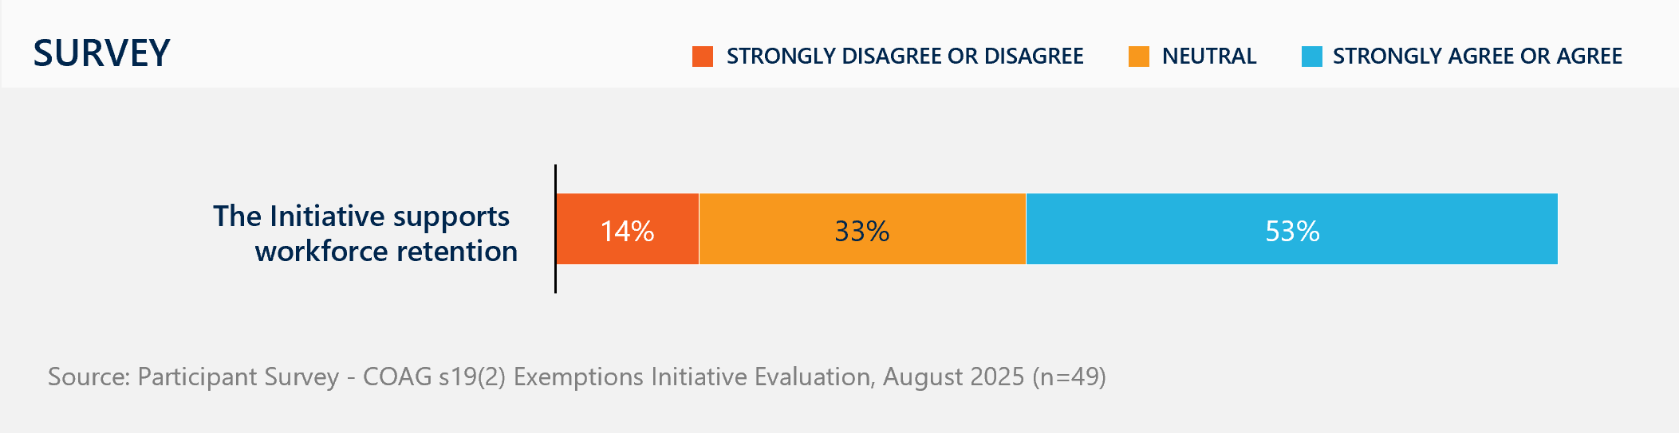
[Horizontal stacked bar chart showing survey responses on whether the Initiative supports workforce retention.]
Detailed description:
Participants were asked for their level of agreement with the statement: ‘The Initiative supports workforce retention.’
Response breakdown:
- 14 per cent strongly disagree or disagree, indicating minor scepticism about the Initiative’s impact on retention.
- 33 per cent neutral, neither agreeing nor disagreeing with the statement.
- 53 per cent strongly agree or agree, reflecting majority support for the Initiative’s role in workforce retention.
Source: Participant Survey – COAG s19(2) Exemptions Initiative Evaluation, August 2025 (n=49).
In addition to funding limitations, attracting and retaining staff is further hampered by a range of factors including lack of suitable housing, inadequate infrastructure, and FTE caps imposed in some jurisdictions. Where some sites invested revenue in capital upgrades such as accommodation, sites on their own are unable to address broader systemic barriers such as shifting workforce trends, limited incentives to remain in rural practice, and the challenges of remoteness, which restrict opportunities for families and discourage long-term commitment. Nevertheless, at sites like Warren Health Service in WA, reinvested s19(2) revenue in primary care has contributed to improved staff morale, with some attributing their retention to the Initiative.
In addition, as described above, there are distinct challenges effectively supporting non-medical workforce or non-hospital settings. Longer-term solutions that respond to workforce trends and include support for the full range of multidisciplinary primary care workers are supported by stakeholders.
Stakeholders have also highlighted that the Initiative does not align with other federally funded workforce programs, such as rural GP training incentives. Such incentives have different eligibility criteria and application processes, may not be provided to the same services and are often not coordinated with Initiative sites.
3 | Viability of small rural hospitals

Funding is often minimal and does not guarantee long-term viability

Access to MBS revenue varies widely between sites and states
Despite the policy intent to improve the viability of small rural hospitals, many sites generate low levels of revenue. Revenue and reinvestment depend more on billing capacity, workforce, and administration than on actual health needs, concentrating revenue in high-capacity locations. In 2023–24, 10 of 173 sites made up over half of total billing, mostly those with salaried, stable doctors.
As highlighted in Section 3.3 – Program Delivery, revenue distribution remains persistently skewed, with large differences between jurisdictions seen in the FY24 billing data: SA had the lowest MBS revenue as a new jurisdiction ($687,227) and WA the highest ($8,692,992). There is also significant variation even within states. For instance, in WA alone, the lowest MBS revenue received by a site was $586, while the highest was $2,455,227. This pattern mirrors previous years, indicating a persistent skew in revenue distribution to larger higher capacity sites.
The initiative tends to favour larger sites with more salaried doctors who can generate high levels of MBS billing. This doesn't necessarily reflect the actual health needs of the community, and the sustainability of rural health services is still sort of not viable despite the initiative due to external factors such as population decline, industrial issues and staff turnover.
Jurisdictional stakeholder

The Initiative does not guarantee long-term viability of small rural hospitals
As a fee-for-service mechanism, the Initiative does not ensure long-term viability, especially for smaller sites, which often struggle to generate enough revenue to reinvest or offset participation costs. In FY24, 44 sites billed less than $50,000, with some sites not billing at all. With administrative costs reaching up to 30 per cent, these sites typically see minimal financial benefit. For small sites, this revenue may not cover setup, training, and compliance expenses. The lack of standardised billing systems and guidance further complicates matters, and unstable workforce makes implementation expensive.

The administrative burden of the $21.5 million funding reduces the efficiency of the program for governments
The Initiative, in its current form, requires significant levels of administrative effort from the Commonwealth and jurisdictional governments, relative to the level of funding available to support primary care. In line with the findings from the 2021 Evaluation, the costs to administer the Initiative are not adequately accounted for, however the Initiative is administratively burdensome, not only for sites, but for those involved in its implementation and administration.

The Initiative risks disadvantaging existing local primary care services, despite being a key support to some rural hospitals
The Initiative aims to address market failures in community general practice and primary care but may inadvertently disadvantage existing private and NGO providers by redirecting patients, funding, and workforce towards subsidised public hospital services. By permitting hospitals to bill Medicare, the Initiative tends to shift resource allocation towards hospitals, which in some cases reduces significant financial load on these hospitals. However, this funding shift often creates greater competition for general practice staff, which can inadvertently undermine local clinics and ACCHS. The requirement to obtain written support from local primary care providers ensures a level of consultation occurs, however local providers suggest there remains a need for stronger collaboration and local planning, to avoid unexpected consequences.
While stakeholder competition for patients is not a primary concern, given that most providers are experiencing high demand, common concerns from stakeholders consulted include:
- Risk of deterring potential market entrants: Stakeholders from both Tasmania and WA flagged the risk that introducing s19(2) exemptions can destabilise fragile private practice markets., Particularly in thin markets where a single practitioner’s departure can trigger a cascade of service failures, some jurisdictions were cautious about applying for the Initiative when revenue was uncertain. While stakeholder support from private practices is sought for a new site approval, there is a risk the Initiative may make the market less attractive for new private entrants.
One of the reasons that we've never used the COAG 19(2) exemption is because we've always had private practices maintained in the same areas as our district hospitals... we've really attempted to maintain and stabilise those because generally private general practice runs a pretty efficient ship.
Jurisdictional stakeholder (Tasmania)
- Competing with limited resources: Many GPs and ACCHS report limited direct benefit from the Initiative and suggest that resources could be more equitably distributed. Stakeholders have been known to express opposition to the proposed introduction of Initiative specifically citing fears of losing doctors to public hospitals if changes proceed without adequate sector involvement.
- Inadequate stakeholder engagement: While the requirement for stakeholder consultation is intended to mitigate these risks, the current requirement for stakeholder engagement does not necessarily mean there is strong buy in, negotiation and understanding between the Initiative sites and existing services. Where Section 3.2.2 describes the challenges with the potential to ‘veto’ the Initiative by one stakeholder, it’s critical to ensure stakeholder engagement is transparent, meaningful and supports an ongoing, collaborative relationship.
- Not directing care in the most appropriate ways. Particularly in regions with significant Aboriginal and Torres Strait Islander populations; evidence indicates that community-controlled solutions have better outcomes. At present, integration with ACCHS and other NGOs is variable and site-dependant. Future solutions, discussed in the next section, should support these solutions from a system lens, not leave it to chance.


Future Direction

Section title: 04 Key Findings
[The image presents an aerial view of a dirt road through a yellow canola field in Western Australia, Australia.]
This section provides detail on the key recommendations from the evaluation. This section informs KEQ 1C What alternative policy solutions at the national, state and/or regional/local levels could support improved and equitable access to primary care in rural and remote regions?

Reform approaches can better align the Initiative to today’s realities and aspirations
Primary care remains a cornerstone of the Australian health system. However, difficulties accessing primary care in rural and remote areas contributes to these communities experiencing poorer health outcomes than their urban counterparts. This challenge is not new, but there is evidence that the funding gap in rural and remote areas and associated outcomes are worsening. Despite the Initiative’s intent to improve access, its design and implementation have not kept pace with growing needs and changing approaches to primary care service delivery.
The Initiative delivers value in a small number of high-capacity sites with stable workforces, but most communities are limited in their ability to gain longer-term benefit. Many providers struggle to bill, or cannot participate at all, due to workforce instability and heavy administrative requirements. Reliance on a fee-for-service model ties revenue to billing capability rather than population health need. The Initiative was not created to reform the system. Instead, it aimed to address the funding gap through location-specific and negotiated ad-hoc arrangements, which were not integrated into the broader health system. Where the Initiative’s objectives remain appropriate and clear, the application of the Initiative is increasingly misaligned with the realities of thin rural markets, as it relies on doctors and there are increasing difficulties in recruiting doctors and other health professionals.
Since the Initiative’s inception in 2006, the policy context has shifted significantly. Reforms highlighted in the NHRA mid-term review and the Productivity Commission’s Interim Report stress the need for stronger Commonwealth–state collaboration, joint commissioning, and integrated service planning. With NHRA negotiations underway this is an opportune time to reconsider the Initiative’s role.
National reform directions emphasise integrated, multidisciplinary, place-based care enabled by flexible funding and local governance. The Initiative, in its current form, does not support these principles.
While the Initiative is a relatively small funding mechanism, it remains an important lever for enabling access in specific contexts. Systemic challenges in rural and remote areas such as workforce shortages, fragmented funding, and inequitable access, all require a more strategic and coordinated response.

A set of revised principles to guide the Initiative and broader reform
The existing MoUs set out five principles to guide the development and operation of the Initiative. Two additional principles are proposed to guide future directions for the Initiative and broader reform. These new principles are:
- Place-based, culturally safe and flexible: To ensure any future reform avoids a ‘one size fits all’ approach, allowing flexibility to meet the unique needs of local communities, embedding cultural safety principles, and drawing on the lived experience and breadth of expertise across the health sector and the patients it serves. Place-based approaches are underpinned by collaborative, local governance.
- Strategically aligned: Connecting the Initiative with current health system reforms to recognise these programs do not exist in a silo and supports the directional desire for coordinated, comprehensive care across health, disability and aged care.
All seven principles would then include the following:
- Equitable access
- A shared responsibility
- Valuable, finite workforce
- Protect existing services
- Transparent and simple
- Place-based, culturally safe and flexible
- Strategically aligned.

Options for reform
The following section outlines proposed changes to support the provision of rural and remote primary care. This is explored across three key options:
- Reform within the Initiative
- Reform alongside the Initiative
- Reform to replace the Initiative.
Considerations within each option may not all occur at once, nor are they intended to be prescriptive or sequential. Rather, they represent a suite of directions that the Commonwealth may choose to adopt in whole or in part, depending on local priorities, readiness, and alignment with broader Commonwealth and jurisdictional reform agendas. The options are designed to be modular, allowing for targeted negotiation and implementation, while also enabling jurisdictions to isolate areas of contention and build consensus around feasible enhancements. The three options are:
- Improving the Initiative
Reform within the Initiative to build on its weaknesses. As broader reform is determined, there are changes that could streamline and enhance the Initiative in its current form.
Assessment: Lower capacity to deliver outcomes and lower investment and time requirement.
- Broader reform
Reform to expand the role of the Initiative and go beyond its current remit. Breaking down system barriers to complement the Initiative and build a more adaptive, place-based, and integrated access to primary care.
Assessment: Moderate capacity to deliver outcomes and moderate investment and time horizon requirement.
- Bold system-wide reform
Reform to replace the Initiative, with changes more broadly across the system. True system transformation that provides flexible funding solutions to meet the needs of individual communities.
Assessment: Highest capacity to deliver outcomes and the highest investment and time horizon requirement.

Enablers for primary care delivery
The options put forward are primarily funding and governance changes, however a broader system view is needed to ensure outcomes are achieved. This system-lens approach requires consideration of critical enablers that underpin the funding and governance recommendations put forward. These enablers are summarised in Table 15.
Option 1 focuses on the Initiative within its current scope, resulting in actions that are less targeted towards these enablers. Options 2 and 3 have a broader approach to rural and remote primary care, which means that they address more of the enablers.
Table 15 | Enablers for primary care delivery in rural and remote areas
Enabler | Relevant dimensions
Workforce | - Recruitment: Ensuring the right number of health professionals are available to maintain service availability.  - Retention: Retaining the same health professionals to maintain continuity of care.  - Preferences: Understanding workforce preferences (e.g., flexible hours) helps align service provision with staff needs, improving satisfaction, and retention.  - Scope of practice: Maximising the role of all health professionals to maintain service availability with different combinations of professionals.
Infrastructure | - Service infrastructure: Providing workforce with the external requirements for high-quality, safe and efficient care.  - Housing and other supports: Supporting access to stable, affordable housing to live in rural and remote communities long-term as well as other requirements such as educational, childcare and employment opportunities for family members.  - Transport: Supporting reliable transport options to increase access to health services for both patients and workforce.
Technology | - Patient management system: Maintaining centralised patient record systems that support continuity of care across providers and safer clinical decision-making.  - Telehealth services: Improving access to care by complementing in-person services and extending reach to patients with accessibility needs, especially when escalation is required.  - Data analytics: Supporting evidence-based planning, population health monitoring, and service evaluation for informed decision-making.
Service delivery models | - Multidisciplinary team-based care: Enabling cross-collaboration between health professionals to improve care, address complex health needs, and distribute workload efficiently.  - Integrated care: Coordinating primary care with secondary, tertiary, and community services to improve continuity of care, reduce duplication, and improve outcomes.

1. Reform within the Initiative
Option 1 | Improving the Initiative | Timeframe: Short term

Reform within the Initiative to reduce complexity, enhance place-based governance and coordination, and a more responsive Initiative
Many stakeholders supported retaining the Initiative in some form, at least until broader and more appropriate funding levers are in place. Given the barriers associated with the Initiative, this option includes a set of recommendations to streamline and minimise complexity around the Initiative and ensure appropriate eligibility for in-need services and reinvestment in local primary care provision.
These changes are framed within the existing legislative context, to ensure access is maintained to an additional funding source. However, it should be noted, that given the broader challenges impacting rural and remote areas, tweaking the Initiative alone won't fully deliver on the objectives, but can improve the degree to which it contributes.
Potential recommendations to support Option 1 are summarised below. The options are presented in order of ease of implementation.
- Eligibility of the Initiative is granted through a data-driven methodology. For example, data driven definition for ‘undersupplied’ is used and eligibility reviewed if new services are maintained in the locality. This recommendation seeks to replace the MMM criteria with a transparent, evidence-based approach. By defining ‘undersupplied’ areas using agreed data metrics and reviewing eligibility as service availability changes, this approach ensures that exemptions are targeted to areas of genuine need and can adapt over time. An evidence-based approach was described and recommended in the Working Better for Medicare Review and is reflected in the process now being adopted by RWAs and PHN’s in community workforce prioritisation processes, which could be applied. An effective data-driven methodology would negate the current ‘veto’ powers of stakeholders, however, would have oversight from the sub-regional governance committee, described above.
- Streamline application process to reduce administrative burden. The evaluation has noted significant administrative burden throughout the application process for the Commonwealth, states and territories, and prospective sites. To promote a smoother application process, a standardised, biannual application process could be implemented. This could create time savings for the Commonwealth by batching processes such as updating Legislative Instruments and minimise unnecessary delays for sites. However, the application process should still retain the ability to remain flexible and responsive through escalation to the subregional governance committee. This would mean that the Initiative would still have the ability to respond to rapid changes in the market.
- Review and clarify billing items and reinvestment guidelines to ensure greater focus on primary care. Many sites lacked an accurate understanding around the intent, purpose and process of the Initiative, particularly in areas with high staff turnover. Developing a clear definition and guidance of what is appropriate to bill under the Initiative may reduce the complexity for on the ground clinicians. For example, a definition to describe what services are eligible under the MBS billing could include where ‘the patient could be safely treated in a GP practice.’ Sites often also reported that they could not roll over funding to the next financial year. However, this can be done with jurisdictional treasury approval. There is opportunity for jurisdictions to work with the Commonwealth to create clearer guidance to support strategic reinvestment.
- Distil a clearer overview of baseline of primary care service delivery and funding across all levels of government. It has become clear that there is no single source of information on the amount of funding that States and Territories put into primary care services. Much of the information the evaluation was provided with was anecdotal and many jurisdictions do not have data systems to allow them to accurately collect this information. The Department could work with the Australian Institute of Health and Welfare (AIHW), Independent Health and Aged Care Pricing Authority (IHACPA) and National Health Funding Body (NHFB) to collect related data. Working with state and territory governments and local governments would also be key to collecting this data in future. Stronger visibility of funding would bolster coordination and strategic planning across governments, including needs assessment and gap analysis.
- Streamline and simplify the billing rules for efficiency. The evaluation has noted many examples of administrative challenges and complexity, including the delays posed by the approval process, receiving site-specific provider numbers and patient eligibility forms. Small changes such as retrospectively allowing billing for provider number delay where a clinician meets other criteria and allowing patient DB4 form to be signed once per year, rather than once per visit, could help ensure sites are not prevented from accessing MBS billing for administrative reasons.
- Annual review of eligible MBS billing to ensure changes in clinical practice are captured. At present, the Initiative has not kept pace with evolving clinical practice and does not always reflect the scope of services provided at each site. An annual review of eligible MBS items would allow for the inclusion of services that are now standard in general practice but not currently billable under the Initiative, such as minor procedures, immunisations and wound management.
- A joint sub-regional governance committee is established to support and make recommendations around COAG s19(2) application, implementation and ongoing investment decisions. This would improve transparency, coordination and planning by introducing a regional or sub-regional governance structure that reflects local context. The intent is not to create a new layer of complexity, but to ensure that decisions around the Initiative and reinvestment are informed by a broader set of stakeholders - including LHNs, PHNs, Rural Workforce Agencies (RWAs), ACCHS and local clinicians - rather than being made in isolation with recommendations being provided to the funding recipient. This approach supports more equitable and strategic use of funds, initiatives and services. The sub-region will differ across regions/jurisdictions to best suit the context and governance in place.
- Complement s19(2) exemptions approvals with a regional reinvestment plan as recommended by the committee to ensure appropriate, coordinated primary care investment. To ensure funds generated through the Initiative are aligned with the local region’s priorities, the sub-regional governance committee could provide endorsement for a reinvestment plan. This would also provide clarity and accountability, reduce end-of-year spending scrambles, and support longer-term planning. It also addresses the current lack of visibility and consistency in how funds are used.
- Centralised knowledge repository and leadership. Across jurisdictions and sites, there is administrative duplication in how sites are navigating application processes, billing processes and navigating change across the Initiative. The Commonwealth could play a stronger role in facilitating leadership and coordination to ensure greater compliance, efficiency and effectiveness across sites. In line with a recommendation from the 2021 Evaluation, a central knowledge repository could support sites and jurisdictions, to share resources and learnings for capability uplift and onboarding of new staff and promote best practice to facilitate a sustainable and efficient system.

2. Reform alongside the Initiative
Option 2 | Broader reform to expand the role of the Initiative | Timeframe: Medium term

Breaking down system barriers to allow for a more adaptable, effective and sustainable primary care system
The Initiative is currently limited by many external factors, such as workforce availability, limited training pathways and scope of practice. The Initiative focuses on boosting care within hospital and MPS, which does not directly support existing primary care service providers, such as private practice and non-government organisations.
Option 2 seeks to unlock broader system barriers by expanding the role of the Initiative, supporting better planning and governance and better utilising the existing, limited resources by mobilising access to multidisciplinary care and services within regions. This option operates within current commonwealth/state roles and responsibilities and can be variously implemented alongside the recommendations in Option 1.
Potential recommendations to support Option 2, are summarised below:
- Develop broader MBS for eligible regions and define a range of professionals and activities billable for the MBS. In thin markets and rural and remote areas that are facing workforce shortages, allowances to utilise a range of health professionals in diverse settings is crucial. As the current MBS billing items under the Initiative are largely geared towards GP services, a broader review of MBS billing items for nurses, nurse practitioners, allied health practitioners, Aboriginal health workers and paramedics could support greater provision of care. Many stakeholders expressed that limiting patient access to allied health to five funded appointments was insufficient to provide multidisciplinary care for complex, chronic conditions. In addition, greater allowances to utilise innovations such as virtual care services in these regions could support more flexible models of care that support place-based and accessible care.
- Funding is tied to a regional primary care funding amount. In line with current reforms looking at moving to a blended funding model for primary care, there would be merit in allowing services greater flexibility in obtaining the funding. This option would envisage a level of Commonwealth funding being given to areas of thin markets for them to allocate in line with reinvestment priorities identified within Option 1. The level of funding would be based on a population-based funding formula based on the size, demographics, geography and health need of regional populations. The regional primary care funding amount could operate alongside MBS and/or the Initiative, to cover shortfalls in MBS funding in eligible regions, or as a broader regional funding amount that would replace the MBS and the Initiative. Under this model it would be important to identify, maintain and index primary care funding in the region from other sources, including states and territories, so that the regional funding from the Commonwealth leads to additional resourcing being available in the region. This approach requires close monitoring of what the funding is used for, to ensure that it is delivering what is intended. This may be through an agreed minimum service level standard or key performance indicators. PHNs would be required to jointly undertake needs assessment, planning and commissioning with LHNs, to support sustainable primary care services in their regions. This approach would retain the MBS demand driven funding source and combine it with a block funding component to drive equity in supporting recruitment and retention of workforce. This collaborative commissioning arrangement would require local governance input from private providers (if any), ACCHSs, and other NGO and other stakeholders.
- Consider opportunities to consolidate s19(2) exemptions (excluding AMS exemptions), to reduce the complexity of existing arrangements, reduce barriers to services who want to apply and encourage greater uptake. At present there are over 26 s19(2) exemptions and as such this recommendation seeks to simplify the current complex exemption landscape. In some cases, exemptions are duplicative. The Department may consider a review of relevant exemptions to unearth potential areas to streamline and consolidate, ensuring applicability to the current policy context. Consolidating s19(2) exemptions that are managed between the Commonwealth and state would aim to reduce administrative burden and make it easier for services to apply, while preserving the distinct arrangements for the exemptions related to Aboriginal and Torres Strait Islander-specific services, which are managed at a Commonwealth level. This balance supports broader uptake of the Initiative without undermining culturally safe care models.
- Allow greater flexibility in requirements for referral for a GP chronic condition management plan (GPCCCP) in thin markets. In regions with poor access to GPs, requirements for MBS-billed GPs to sign off on GPCCPs are reducing access to allied health services. Outside of the Initiative, this also limits non-MBS funded GPs such as within the RFDS, from providing care plans. As such, expanding the eligibility of who can complete a GPCCCP would need to move beyond the Initiative, to include non-Initiative clinicians such as the RFDS. However, consideration should be made to ensure referrals to care plans are only made when a pre-existing relationship with a service does not exist (e.g., an existing ACCHS or local GP), to limit unintended consequences.
- Yearly costing studies to ensure Medicare loading and broader funding are reflective of true costs of rural and remote service delivery (including outreach). Health services in remote communities (particularly MM7) have unique geographical challenges, which impact on the cost of patient transport, outreach and broader access to resources. Stakeholders expressed that despite rural loadings, there is a mismatch between funding levels and actual costs of delivering care in rural and remote areas. Annual costing studies that account for regional realities would ensure Medicare loadings and broader funding mechanisms are evidence-based and responsive to changing conditions, including outreach and travel costs, to better support financial sustainability and service viability.

3. Reform to replace the Initiative
Option 3 | Bold system-wide reform | Timeframe: Medium to long-term
Transforming the system to a place-based funding and governance approach
While the Initiative has played a role in enabling access to primary care in rural and remote communities, the findings of the evaluation show that its impact is relatively limited both in terms of the level of funding it supports and the geographic coverage of participating sites. The exemption framework, originally designed to allow Medicare billing in public facilities, now operates within a primary care landscape that increasingly emphasises multidisciplinary care and continuity, that are not well supported by the episodic, medical focus of the MBS. Across jurisdictions, stakeholders have consistently highlighted that the mechanism is administratively burdensome, poorly understood, and structurally misaligned with contemporary models of care.
Exemptions are inherently reactive and site-specific, requiring extensive stakeholder negotiation and compliance processes that often delay or prevent implementation, even in communities with clear unmet need. Moreover, the exemption model is rooted in a fee-for-service paradigm that fails to reflect a number of realities, including:
- Workforce undersupply in thin markets, which means there is less billing to generate revenue
- The fee-for-service approach is suited to episodic care which is not well matched to the needs with more complex and chronic conditions
- Service delivery in rural areas is more expensive and that is not adequately reflected in the MBS arrangements, limiting its effectiveness as a workforce incentive and creating financial instability for providers.
The findings of the evaluation, feedback from stakeholders and broader evidence indicates that without broader reforms, current shortfalls in access to primary care in rural and remote areas are likely to continue or worsen. Evidence indicates that reforms that are tailored to local contexts, support multidisciplinary care, and enable flexible funding arrangements that reflect the true cost of service delivery, have the greatest potential to address these shortfalls.
Option 3 comprises recommendations for broader reform approaches to support models of funding and delivering primary care in rural and remote areas that recognise the limitations of current funding approaches, the challenges in attracting and retaining health workforce and are better able to support integrated, multidisciplinary primary care.
Potential recommendations to support Option 3, are summarised below:
- Conduct a legislative review of Section 19(2) of the Health Insurance Act (1973). Given key findings of this evaluation about the limitations of the Initiative in its current form, the relevant sections of legislation should be reviewed to ensure they are supporting agreed key aspirations for the delivery of health services, including in rural and remote populations. Any review should seek to reduce the complexity of existing legislative arrangements, the need for exemptions and support strategically aligned primary care reform, including within rural and remote care. Key areas of focus should include the following, but will be subject to this future strategy:
  - Enable flexible funding models with a greater focus on blending funding to better support chronic disease management, multidisciplinary care and financial stability.
  - Consider a data-driven eligibility criterion that links to needs assessments and RWA data, instead of the MMM-based eligibility.
- Expand the role of relevant PHNs to conduct regular thin market monitoring and coordinate planning for solutions, in line with input from RWAs and other local organisations. PHNs were established to address service gaps and improve integrated local primary care services, which is directly relevant to the proposed role described in this recommendation. PHNs should undertake thin market monitoring annually in collaboration with LHNs and link in with their ongoing needs assessment processes. Thin market monitoring should directly inform their planning coordination role for funding solutions alongside the local governance committee and RWAs. Under this model the PHN would define feasible levels of service in thin market areas and create a suggested funding plan with sources and levels of funding indicated. This would allow them to match service levels and funding with place-based models of care. This would require new funding for PHNs to collaboratively develop and implementation local solutions to support primary care access.
- Tie regional primary care funding to an agreed local governance body (e.g., a local governance committee, or PHNs) to ensure funding is used according to local need and place-based implementation is facilitated. This arrangement would pool funding from the Commonwealth and jurisdictions and distribute it through the agreed local governance mechanisms. This would involve providing options for service providers including block, fee-for-service or blended funding models, to be considered based on needs. If the PHN took on this role, then they would be given dedicated funding to address thin market issues which would be based upon funding currently directed through the Initiative. Additional funding may be channelled through jurisdictional sources with the aim of having a single organisation with responsibility for primary care provision. This arrangement would require strong transparency from jurisdictions and the Commonwealth to ensure ongoing complementary and indexed investment.
- Develop funding allowances that extend to workforce enablers including housing, transport and technology. These enablers significantly affect workforce wellbeing, and workforce stability as a result. In collaboration with jurisdictions and local governments, these enablers are critical to encourage workforce to live in rural and remote communities long-term.
- Make funding conditional on investment in training and supervision pathways to address workforce gaps, reduce barriers to professional development and support broader adoption of generalist models. Current supervision capacity is limited and training pathways are fragmented. This recommendation strengthens workforce development by embedding supervision requirements into funding eligibility. Conditional funding would ease training bottlenecks, enable cross-professional supervision and support rural placements.
- Target low health professional pipeline areas by expanding flexible employer arrangements for training and existing workforce across all specialties. Currently, rigid employment structures and limited career pathways deter professionals from working in rural areas. A common enabler of workforce stability observed across sites with reduced workforce constraints, saw the implementation of flexible employer arrangements. This recommendation seeks to simplify employment arrangements and enable portability of benefits and single-employer models. Flexible models would reduce administrative burden, support continuity of employment, and improve access to Medicare billing, while preserving service viability.
Case study: Longreach Hospital, Queensland
The single-employer employment arrangement can stabilise workforce
In QLD, within the Central West HHS, Longreach Hospital has been able to develop a stable workforce using their ‘single-employer’ employment arrangement. This has worked by CWHHS own the General Practice locations nearby due to market failure. This model has been able to reduce unwanted competition and support greater continuity of care in the region.
“This model allows us to recruit the right number to make after hours sustainable. It works for this community really well”.
– Site executive
For the full case study on Longreach, refer to Case Study 1 in Appendix E.
These recommendations will require further consideration; some risks are outlined below in Appendix D.
- Evaluation conceptual approach
Figure 16 | Evaluation conceptual approach
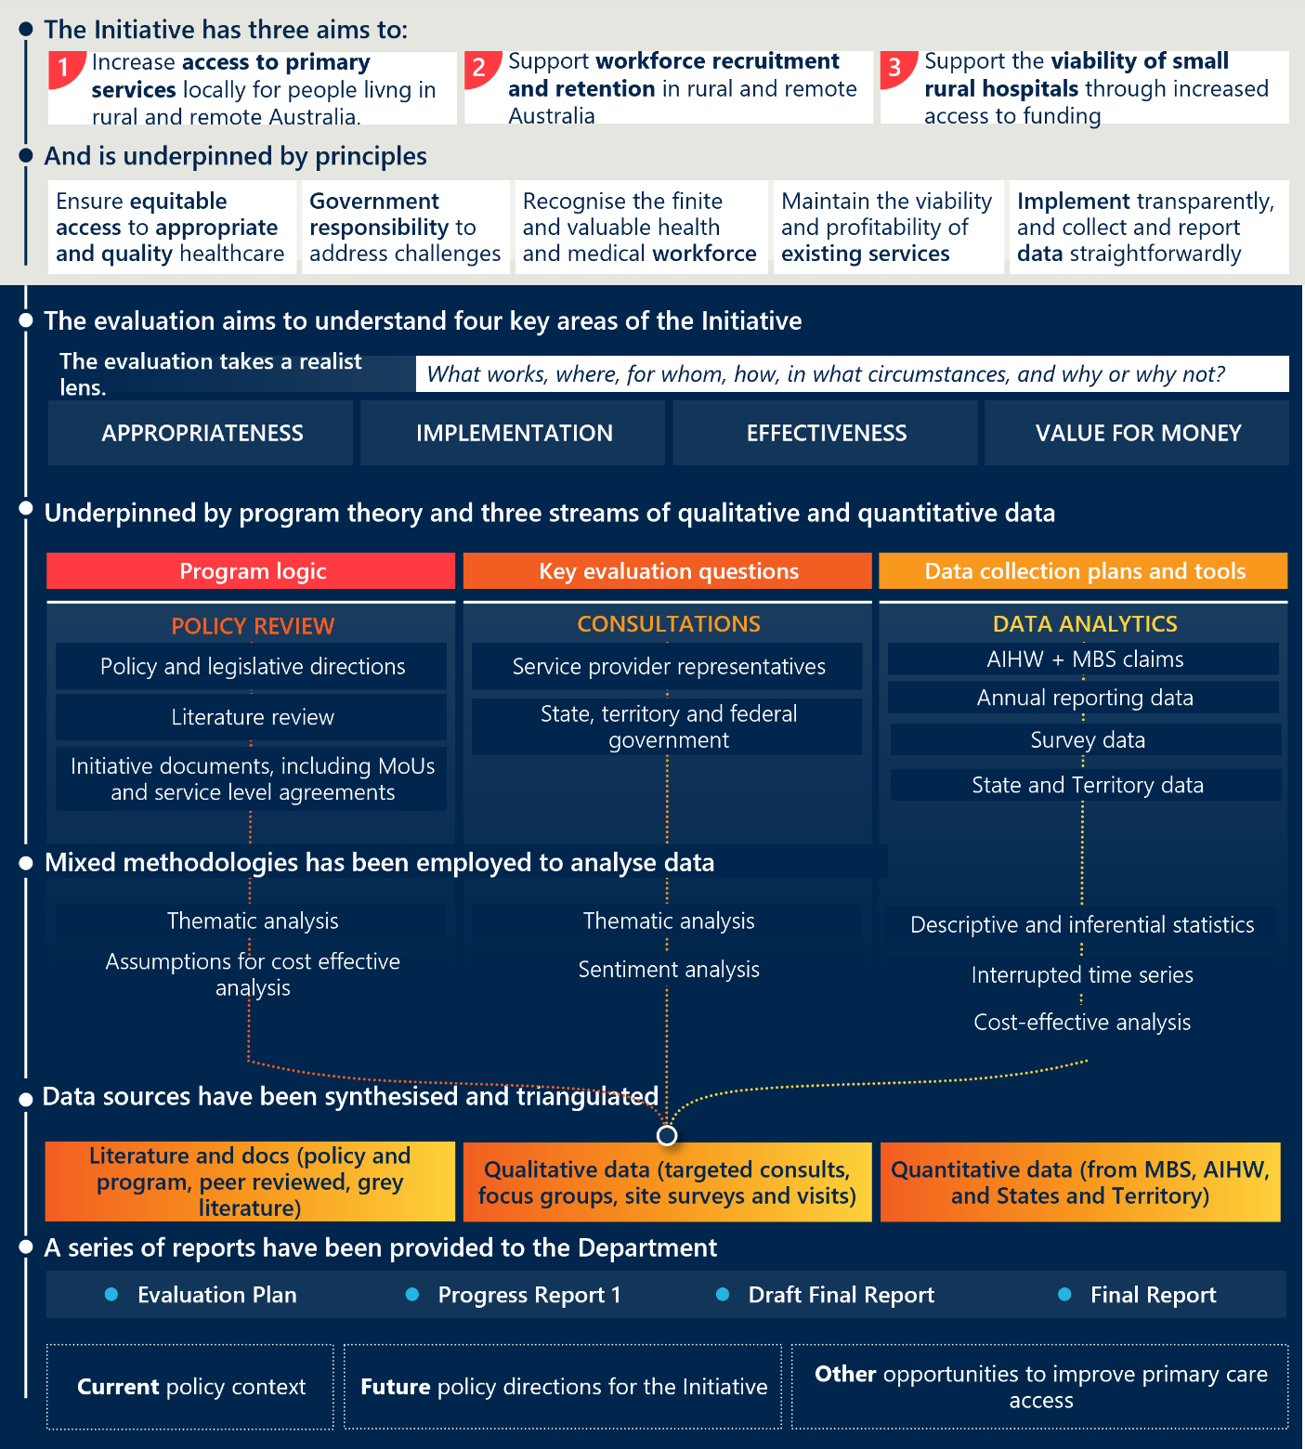
[Flowchart showing the evaluation framework for the COAG s19(2) Exemptions Initiative.]
Detailed description:
The figure outlines the evaluation framework for the COAG s19(2) Exemptions Initiative. It presents content in the following sections, in order from top to bottom:
The Initiative has three aims to:
- Increase access to primary services locally for people living in rural and remote Australia.
- Support workforce recruitment and retention in rural and remote Australia.
- Support the viability of small rural hospitals through increased access to funding.
And is underpinned by principles:
- Ensure equitable access to appropriate and quality healthcare
- Government responsibility to address challenges
- Recognise the finite availability of resources and medical workforce
- Maintain the viability of existing services
- Implement transparent data sharing for accountability
The evaluation aims to understand four key areas of the Initiative:
The evaluation takes a realist lens and asks: What works, where, for whom, how, in what circumstances, and why or why not?
The four key areas are:
- Appropriateness
- Implementation
- Effectiveness
- Value for money.
It is underpinned by program theory and three streams of qualitative and quantitative data:
Program logic
- This involved policy review of:
- Policy and legislative directions
- Literature review
- Initiative documents, including MoUs and service level agreements.
KEQs:
- This involved consultations with:
- Service provider representatives
- State, territory and federal government.
Data collection plans and tools:
- This involved data analysis of:
- AIHW + MBS claims
- Annual reporting data
- Survey data
- State and Territory data.
Mixed methodologies have been employed to analyse data:
- Thematic analysis
- Assumptions for cost effective analysis
- Sentiment analysis
- Descriptive and inferential statistics
- Interrupted time series
- Cost-effective analysis.
Data sources have been synthesised and triangulated:
- Literature and docs (policy and program, peer reviewed, grey literature)
- Qualitative data (targeted consults, focus groups, site surveys and visits)
- Quantitative data (from MBS, AIHW, and State and Territory).
A series of reports have been provided to the Department:
- Current policy context
- Future policy directions for the Initiative
- Other opportunities to improve primary care access
These reports cover content that includes:
- Current policy context
- Future policy directions for the Initiative
- Other opportunities to improve primary care access.
- Key evaluation questions
The evaluation is intended to assess the appropriateness, implementation, effectiveness and value for money of the Initiative. The key lines of enquiry and key evaluation questions (KEQs), presented in Table 16 will guide Nous’ data collection and analysis. Any refinement and revision of the KEQs will occur in consultation with the Department project team.
Table 16 | Key evaluation questions
KEQ 1 | Appropriateness:  In the context of emerging rural health reforms, is the COAG s19(2) Exemptions Initiative currently fit for purpose at improving access to primary care in rural and remote Australia, and what alternate solutions exist?

Number | Sub-Question
1A | How has the policy context changed from when the Initiative was first implemented in 2006, and since the 2021 evaluation of the Initiative?
1A.1 | What proportion of primary care services are funded by state government funded providers, private providers, ACCHSs or other service providers, in rural and remote Australia, compared to urban regions?
1A.2 | What does existing research, if available, indicate is an appropriate minimum level of primary care service access for rural and remote Australia, and would this be appropriate for urban areas?
1A.3 | What are the primary care market indicators or thresholds (and potential data sources) that can also be routinely monitored and reported on that would provide an indication of market instability, and would these differ for rural and remote and urban areas?
1A.4 | What other Commonwealth, jurisdictional and/or local government market interventions are currently implemented in rural and remote regions to support improved primary care access? How adequately do these incentivise (or disincentivise) or otherwise impact private or other NGO provider viability/sustainability to remain in and/or enter the market?
1B | Is the Initiative an appropriate and equitable funding mechanism to support improved rural and remote primary care access in the current policy context (1A)?
1B.1 | Should the Initiative be continued its current form? If not, what changes could be implemented in the short, medium and longer term?
1B.2 | What barriers is the Initiative creating which are adverse to its intent, and what considerations should be applied in future planning?
1B.3 | Where a COAG s19(2) exemption has been granted but not used, what are the system level barriers/factors to this decision for a community?
1C | What alternate policy solutions at the national, state and/or regional/local levels could support improved and equitable access to primary care in rural and remote regions?
1C.1 | What are the current and emerging system level governance barriers and/or enablers to implementation?
1C.2 | What are the current and emerging system level funding barriers and/or enablers to implementation?
1C.3 | Would these system level governance and funding changes support the implementation of alternate place-based innovative solutions to improving primary care access in rural and remote areas?

KEQ 2 | Implementation:  How well has the COAG s19(2) Exemptions Initiative been implemented, and what improvements could be made?

Number | Sub-Question
2.1 | To what extent has the Initiative been delivered as intended in the Memorandum of Understanding?
2.2 | What are the barriers or facilitators to the implementation of the Initiative?
2.3 | What changes could be made to support the efficient implementation of the Initiative, in the current policy context?
2.4 | Are there any inconsistencies in the implementation of the Initiative, including inequities?

KEQ 3 | Effectiveness:  Is the COAG s19(2) Exemptions Initiative achieving its intended outcomes?

Number | Sub-Question
3.1 | To what extent is the Initiative effective in achieving its policy objectives, during the current MoU period (2022-25):  - Increasing access to primary services locally for people living in rural and remote Australia  - Supporting workforce recruitment and retention in rural and remote Australia  Supporting the viability of small rural hospitals through increased access to funding
3.2 | What are barriers or facilitators to the effectiveness of the Initiative, in the current policy context?
3.3 | What changes could be made to support the effectiveness of the Initiative in achieving its intended policy outcomes, in the current policy context?
3.4 | To what extent does the Initiative support or impede other local activities aimed at improving primary care access?

KEQ 4 | Value for Money:  Is access to fee-for-service funding (i.e. MBS through Initiative) a cost-effective funding mechanism in the current policy context?

Number | Sub-Question
4.1 | To what extent does the Initiative provide a cost-effective solution to improving access to primary care?
4.2 | How could the Initiative be better aligned and integrated with other activities to achieve improved cost-effectiveness?

- Organisations consulted
Nous undertook broad consultations to inform the evaluation, including departmental workshops, jurisdictional and expert group discussions, site visits, and other engagements. These activities involved a wide range of stakeholders from Commonwealth Government divisions, health departments, expert bodies, and local providers. See Section 2.2.4 for engagement limitations.
Table 17 | Summary of consultation activities and participating stakeholders
Consultation | Stakeholders
Department workshops | Representation across multiple divisions including Primary Health Networks and Partnerships, Medicare Implementation, Strengthening Medicare Taskforce, Public Hospitals, Workforce Distribution and the Office of the Rural Health Commissioner.
Jurisdictional consultations and cross jurisdictional workshop | - ACT Department of Health  - NSW Ministry of Health  - NT Department of Health  - QLD Department of Health  - SA Department of Health and Wellbeing  - TAS Department of Health  - VIC Department of Health  - WA Health and WA Country Health Service
Expert group consultations | - Australian College of Rural and Remote Medicine  - Indigenous Allied Health Australia  - National Aboriginal Community Controlled Health Organisation  - National Rural Health Alliance  - Royal Flying Doctors Service  - Rural Doctors Association of Australia  - Rural Workforce Agency Network
Site visits | Site visit locations detailed in Appendix E.  At each site visit, a range of stakeholders were invited to participate in consultations, coordinated by the site. This includes but is not limited to:  - Site executive teams  - Site clinical staff (including Rural Generalists, Nursing, Allied health, Aboriginal Health Workers)  - Site administrators, including revenue managers  - LHN representatives  - PHN representatives  - Local primary care stakeholders (including ACCHS and private providers)
Other consultation | - Murray PHN

- Recommendation considerations
Table 18 | Overview of recommendations and considerations
Option 1 - Improving the Initiative

Recommendation | Considerations and risks
- Distil a clearer overview of primary care expenditure across all levels of government. | This is fundamental to allow an accurate assessment of total primary care expenditure in rural and remote areas to be made.  It will rely upon the cooperation of all jurisdictions to contribute to the process with agreed definitions. Local council/government input may be challenging to gather full visibility.  This is likely to be a role that the AIHW would be best equipped to lead.
- Streamline and simplify the billing rules for efficiency. | Clear communication and resources will be important to ensure sites do not see flexibility as reduced compliance.  If done well this may increase the number of applications for the Initiative which will have budgetary implications.
- Review and clarify billing items and reinvestment to ensure greater focus on primary care. | Potential for reinvestment rules to be inconsistently applied across jurisdictions.
- Annual review of eligible MBS billing to ensure changes in clinical practice are captured. | A clear mechanism will need to be developed to assess changes and to include them in updated guidance and rules.  This is likely to be administratively complex and will have resource implications for the Department.
- Centralised knowledge repository and leadership. | Requires active management to ensure information is accurate and contemporary.  Stronger Commonwealth leadership role should not replace jurisdictional involvement, but enhance it.
- A joint sub-regional governance committee is established to support and make recommendations around COAG s19(2) application, implementation and ongoing investment decisions. | Without legislative or jurisdictional backing such a committee may be difficult to establish and maintain. Clear terms of reference and guiding principles will be key, with more detail MoU’s to guide applications and implementation.  Decisions of such a committee would need to be open and transparent to minimise any potential disquiet around decisions.  Care will need to be taken to ensure this does not add additional governance complexity and create unclear authority, as well as adequate jurisdictional representation will be important to avoid fragmentation in decision-making.
- Complement s19(2) exemptions approvals with a regional reinvestment plan as recommended by the committee to ensure appropriate, coordinated primary care investment. | Inconsistent endorsement processes across regions should be mitigated through transparent decision making and clear guiding principles.  Local priorities may conflict with Commonwealth objectives.
- Eligibility of the Initiative is granted through a data-driven methodology. | Requires cooperation at all levels and agreement on broad range of data definitions and data collection methods.  There may be jurisdictional data gaps that limit equity, therefore requires local and RWA broader input.

Option 2 – Broader reform to expand the role of the Initiative

Recommendation | Considerations and risks
- Develop broader MBS for eligible regions and define a range of professionals and activities billable for the MBS. | This will require an economic cost-benefit analysis to ensure risks to government are accounted for and budgetary impacts are assessed.  This will be a complex exercise to undertake but would be in line with policy moves to expand scopes of practice.
- Funding is tied to a regional primary care funding amount. | Reliant on successful operation of governance structures.  Should aim to reduce inequity however could create additional layers of complexity if appropriate mechanisms are not followed.
- Consolidate s19(2) exemptions (excluding AMS exemptions), to reduce the complexity of existing arrangements, reduce barriers to services who want to apply and encourage greater uptake. | Consolidation would require a comprehensive transition plan and risk management planning to mitigate undesirable outcomes.  Excludes the AMS-related exemptions as these are not managed between the Commonwealth, States and sites, but directly between the Commonwealth and sites.
- Allow great flexibility in requirements for referral for a GPCCCP in thin markets. | Clinical governance concerns may need to be managed.  Careful parameters will need to be put in place to avoid unintended consequences such as non-local service providers providing care plans where existing services are available in the community. This should be a mechanism to support multidisciplinary care when there are no available GPs in the community.
- Yearly costing studies to ensure Medicare loading and broader funding is reflective of true costs of rural and remote service delivery (including outreach). | Collection of accurate and contemporary cost data will be difficult to obtain and should align with existing National Hospital Cost Data Collection rounds.

Option 3 – Bold system-wide reform to replace the Initiative

Recommendation | Considerations and risks
- Conduct a legislative review of Section 19(2) of the Health Insurance Act (1973). | Legislative review can be time consuming and costly. This would require a significant amount of effort to change legislation.  It would require agreement on the overarching aims for health provision within rural and remote areas.  Jurisdictions may see this as an opportunity to push more funding responsibility to the Commonwealth.
- Expand the role of relevant PHNs to conduct regular thin market assessments and coordinate planning for solutions, in line with input from other local organisations. | This option expands on the current role of PHNs and gives them a greater level of focus in rural areas. This role would build upon existing roles in health needs assessment and commissioning.  There may be objections to the expanded role from jurisdictions.  Variable capability within PHNs may be an issue.
- Develop an agreed process to establish local governance committees with broad jurisdictional, and local representation. | This option is an expansion of the governance committees in option 1 but sees a more formal advisory role to the PHN.  Without legislative or jurisdictional backing such a committee may be difficult to establish.  Decisions of such a committee would need to be open and transparent to minimise any potential disquiet around decisions.  Care will need to be taken to ensure this does not add additional governance complexity and create unclear authority.  Ensuring there is adequate jurisdictional representation will be important to avoid fragmentation in decision-making.
- Tie regional primary care funding either to the local governance committee or to the PHN to ensure funding is used according to local need and place-based implementation is facilitated. | Consideration has been given to have another entity manage primary care funding. However, with as jurisdictions also oversee public hospital and health services, there is a risk that funding decisions would not distinctly support primary care.  There will likely be sensitivities with this approach and require broad consultation and a re-defined role and capability uplift for the PHNs.  This would rely upon accurate levels of funding to be assessed as in Option 1 above.
- Develop funding allowances that extend to workforce enablers including housing, transport and technology. | This would have budgetary implications and would require careful negotiations with professional bodies around appropriate levels of incentives.  These enablers often fall under multiple stakeholders (e.g. state and local governments), which can lead to coordination challenges and fragmented implementation. This could be tied into the local governance committee to avoid duplication or there would need to be a centralised coordination mechanism.
- Make funding conditional on investment in training and supervision pathways to address workforce gaps, reduce barriers to professional development and support broader adoption of generalist models. | Some regions may lack the infrastructure or workforce to implement training and supervision programs effectively.  Not all regions or services may be ready to adopt generalist models, especially where specialist care is entrenched.  Would require agreement of colleges and training providers but this is to some degree already happening with rural generalist training.
- Target low health professional pipeline areas by expanding flexible employer arrangements for training and existing workforce across all specialties. | Would require agreement across all professionals and would be a complex piece of work – but could link into areas highlighted within the Scope of Practice review.  Some areas of the private sector and peak bodies are resistant to the single-employer model and are advocacy for portability models.

- Site Visit Case Studies
To inform the Evaluation, Nous undertook ten site visits across August and September 2025 with participating Initiative sites, to develop a deeper understanding of how the Initiative is operating in practice, including its impact on service delivery, workforce, and community access to care.
Across each site visit, a range of stakeholders were invited to participate, including:
- Executive leaders across the hospital and health service
- Administrative staff including revenue and finance managers
- Clinical staff including rural generalists, nurses, allied health and Aboriginal Health workers
- Primary Health Network representatives
- Local health network (or equivalent) representatives
- Other services within the community:
  - Private general practice and allied health services
  - ACCHS
  - Non-government providers.
Table 19 provides a summary of the site’s engaged.
Table 19 | Site visits overview
# | Site name | Jurisdiction
1 | Longreach Hospital, Longreach | Queensland
2 | Tully Hospital, Tully | Queensland
3 | Gundagai Multipurpose Service, Gundagai | New South Wales
4 | Nyngan Health Service, Nyngan | New South Wales
5 | Central Highlands Rural Health; Clunes and Trentham | Victoria
6 | Katherine Hospital, Katherine | Northern Territory
7 | Gove District Hospital, Nhulunbuy | Northern Territory
8 | Metropolitan Youth Health, Adelaide | South Australia
9 | Eyre and Far North LHN (Ceduna District Health Service), Ceduna | South Australia
10 | Warren Health Service, Manjimup | Western Australia
Site visits were performed in-person, with the exception of Tully Hospital, Metropolitan Youth Health and Eyre and Far Norther LHN. These site visits were conducted virtually.
Case Study 1 | Longreach Hospital
Longreach Hospital | Case Study 1

MM Classification | MM7
HHS | Central West
PHN | Western Queensland
Initiative site since | 2011
MBS billing (FY24) | $126,823
Per cent of Initiative spend (FY24) | 0.6 per cent

Local context | Longreach Hospital serves as a hub for Central West Queensland, supporting a large, dispersed population across remote and rural communities.  Primary care is delivered through hospitals, community based primary healthcare centres and General Practice locations. Due to market failure, CWHHS own the General Practice locations. These operate as a commercial business unit of CWHHS.  Specialist and allied health services, including physiotherapy, counselling, and mental health support, are provided by state-employed or visiting teams.
Site context | The site delivers hospital services, including maternity services and limited theatre capacity. Visiting specialists and outreach clinicians are engaged periodically, while the site employed RACGP and FRACRM workforce provide emergency care, minor ops, and inpatient services on call arrangements.

State-owned practices working with the hospital enables workforce sharing and lower unmet need in primary care.
Longreach Hospital services a large portion of Central West Queensland, using their stable workforce. The hospital applied for a 19(2) exemption to address workforce shortages and promote sustainable access to primary care. The initiative has supported their single-employer workforce arrangement.

Effective use in practice | State-owned GP-hospital integration:  Ownership of practices drives recruitment and retention and reduces locum dependence. This makes the model sustainable in that market. The model has also supported public outreach to community facilities.  Stable medical workforce:  Single-employer and rural generalist arrangements have achieved 92 per cent medical capacity, supporting continuity of care and service stability.  Revenue incentive model:  Billing revenue is reinvested locally into medical labour and outreach, aligning funding with community needs and supporting recruitment and retention.
Ongoing challenges with the Initiative | Complex and inconsistent billing rules:  Limited COAG items compared to MBS, lack of access via primary care billing, and limited MBS numbers compromise the initiative.  Administrative burden in billing:  Paper-based compliance with multiple systems (e.g., AOB) and complex workflows adds time.  Limited chronic disease support:  The service bills MBS for their ED, maternity and minor ops. These items cannot be billed for chronic disease management which is required for rural MBS items and creates financial barriers under the initiative.

This model allows us to recruit the right number to make after hours sustainable. It works for this community really well.

Case Study 2 | Tully Hospital
Tully Hospital | Case Study 2

MM Classification | MM5
HHS | Cairns and Hinterland
PHN | Northern Queensland
Initiative site since | 2011
MBS billing (FY24) | $837,841
Per cent of Initiative spend (FY24) | 3.9 per cent

Local context | Tully Hospital operates across two main locations; Tully and Mission Beach. It sits within in a region where there is minimal availability of bulk billing services between Townsville and Cairns.  Primary care is predominantly provided by the hospital itself, supplemented by a single private practice and a part-time Aboriginal controlled clinic, which offers services exclusively to Aboriginal and Torres Strait Islander peoples.
Site context | The hospital site provides a range of clinical services, including accident and emergency care, though pathology and imaging capabilities are limited. The allied health workforce remains stable, comprising a full-time physiotherapist and a part-time social worker.  Additionally, the hospital supports clinical education by hosting James Cook University medical students for Rural Rotations and is actively pursuing accreditation to enable primary care terms.

Effective workforce support and community engagement, despite administrative challenges
The hospital utilises the Initiative to support workforce challenges where recruitment is somewhat improving, but retention remains a challenge due to temporary contracts and rotating doctors.

Effective use in practice | Separation of primary care from Emergency Department (ED):  Reinvestment has enabled the hospital to create distinct spaces for its ED and primary care services. This separation has alleviated pressure on the ED, while simultaneously improving patient access to primary care.  Enabling workforce development:  Funding has been used to support new doctors and trainees to gain experience across both hospital and private clinic settings. This dual exposure strengthens primary care capability while ensuring clinicians maintain essential hospital skills.  Supporting outreach to Jumbun:  The introduction of outreach services to the Jumbun community has deepened engagement with Aboriginal community members, fostering trust and facilitating greater emphasis on preventative care. As a result, community members are now more inclined to seek hospital care in emergencies.
Ongoing challenges with the Initiative | Administrative burden:  Paper-based billing and provider number onboarding are burdensome, with a heavy administrative load. This creates delays in billing and risks lost revenue. A streamlined electronic process is needed.

Wish there was some sort of easier process to help clinicians apply for provider numbers […] because if you don’t sort it out quickly, you’re at the potential of more lost revenue.

Case Study 3 | Gundagai Multipurpose Service
Gundagai Multipurpose Service | Case Study 3

MM Classification | MM5
LHD | Murrumbidgee
PHN | Murrumbidgee
Initiative site since | 2014
MBS billing (FY24) | $159,324
Per cent of Initiative spend (FY24) | 0.7 per cent

Local context | The hospital services a broad geography in the South-East, beyond its local population.  Gundagai has one private GP practice and two allied health providers. These providers deliver counselling and physiology.
Site context | Gundagai operates under the NSW Multipurpose Service (MPS) model, integrating acute care, aged care, and community health under one roof. GPs from the local private practice participate in an on-call roster for the hospital and outreach clinics.

Investing in nurse-led delivery and strategic reinvestment in private GPs for support helps Gundagai address community need.
Gundagai Health Service is a hub for care in the area. The service applied for a 19(2) exemption to ensure they could provide the right medical support for a nurse-led model that utilises the resources they have. Since implementation, Gundagai has seen significant benefit, supporting them to meet more of the community need.

Effective use in practice | Built strong GP-hospital collaboration:  Through active engagement by the executive team with visiting GPs and stakeholders, Gundagai has aligned hospital services with community needs. This supports continuity of care and shared planning.  Established effective local governance:  Shared governance between site managers, revenue leads, and community representatives ensures oversight of the Initiative. This enables responsive reinvestment planning.  Maintained consistent implementation support:  Ongoing guidance from the LHD has helped Gundagai navigate billing, reinvestment, and compliance. This ensures the Initiative is implemented effectively despite administrative complexity.
Ongoing challenges with the Initiative | Limited allied health access:  Gundagai lacks consistent physiotherapy, occupational therapy, and speech pathology. This limits rehabilitation, safe discharge, and chronic care. It reduces the Initiative’s impact on comprehensive primary care.  Complex and resource-intensive billing:  Manual MBS billing processes require daily reconciliation, coding checks, and consent tracking. Errors and admin gaps reduce revenue capture and deter participation, especially after hours.  Telehealth underutilised and unsupported:  Despite having telehealth infrastructure, Medicare rules restrict billing for remote consults. This limits access for patients in outlying areas and weakens continuity of care.

Our practice wouldn’t be viable without the 19(2) funding we get from supporting the hospital. Private General Practitioner
Case Study 4 | Nyngan Health Service
Nyngan Health Service | Case Study 4

MM Classification | MM6
LHD | Western NSW
PHN | Western NSW
Initiative site since | 2011
MBS billing (FY23-24) | $7,899 in MBS billing in FY23, which has since picked up to modest $26,755 in MBS billing in FY24.

Local context | Nyngan has a small local hospital and a Multipurpose Service that provides an emergency department, inpatient and residential aged care beds, as well as a range of ambulatory, primary and community health care services. It relies on locums and Virtual Rural Generalist Service, with on-site GP presence every six weeks.
Site context | There is a GP service in town, owned by the local council and primarily staffed by locum GPs, who do not have admitting rights or responsibilities within the hospital. The community relies on Dubbo (2 hours drive) for specialist or urgent health services.

Implementation barriers limit the Initiatives effectiveness in a highly constrained rural setting.
Nyngan Health Service serves the local area of Bogan-shire that has faced persistent workforce shortages. While the Initiative enables some billing through a dedicated nurse practitioner, its impact is limited by administrative complexity, lack of transparency, and an incompatibility with virtual care and nurse-led models.

What has enabled success | Nurse practitioner-led billing:  Nyngan’s nurse practitioner is the primary contributor to MBS billing under the initiative. This has driven a steady increase in revenue over the past three years.
Ongoing challenges with the Initiative | Misaligned with workforce realities:  The current MBS structure does not reflect the full scope of nurse practitioner work. Nurse practitioners cannot initiate care plans, which restricts access to allied health services and undermines multidisciplinary care. VRGS —central to service delivery—and virtual allied health are not eligible for s19(2) billing.  Lack of integration with the local GP practice:  There is no formal referral pathway or shared care arrangement between the GP practice and the Health Service. This leaves aged care residents without access to MBS benefits such as care plans—a problem persisting since the 2021 evaluation.  Underutilised by locums and allied staff:  Locums are not signing onto the initiative due to lack of incentives, short-term contracts, and administrative complexity. Aboriginal Health Practitioners and allied health staff are eligible to bill but are not doing so due to lack of system support to access provider numbers, training and system readiness to support billing.  Administrative burden and governance gaps:  Clinicians and administrators face significant challenges in navigating billing rules, setting up provider numbers, and understanding what can be claimed. There is no clear governance structure or reporting mechanism to track revenue, reinvestment, or compliance. Manual billing processes and informal handovers increase risk and reduce efficiency.  Barriers to strategic reinvestment:  Stakeholders estimate that around 60 per cent of reinvestment funds are going towards locum cover. The requirement to spend funds within the same financial year prevents strategic roll-over or investment in longer-term primary care workforce or service development.

If 19(2) was available to virtual work… we could in theory do an aged care assessment and do the EPC for them. But right now, they’re stuck with nothing until you get a locum willing to come out to do it.
VRG, Western NSW LHD
Case Study 5 | Central Highlands Rural Health
Central Highlands Rural Health | Case Study 5

MM Classification | MM5
PHN | Western Victoria
Initiative site since | 2024
MBS billing (FY24) | <$1000

Local context | The central highlands region is a broad geographical region servicing approximately 80,000 people. The region is experiencing challenges associated with a growing ageing population, including complex chronic conditions. Transport is a key challenge for the region in attracting workforce and managing patient access. Where there are private general practice and services in the area, there are limited options for those who cannot afford mixed billing services.
Site context | The Central Highlands Rural Health service has five key health services, incorporating hospitals, community health and aged care. Clunes and Trentham are two Community Health sites with the 19(2) exemption of the five services.

Restricted use of the Initiative in Victoria as a result of a VMO model
Central Highlands Rural Health sought to leverage the 19(2) exemptions initiative in an attempt to boost access to allied health services in the region, amidst an ageing population. In practice, referral requirements and a limit of five allied health services has limited the Initiative’s applicability.

How the initiative could make a difference | Integrated allied health and community care:  Central Highlands through its Community Health services places a strong emphasis on the value of allied health, to promote hospital avoidance and support chronic disease management. However, barriers to MBS-funded allied health services limits access for those who cannot afford it.  Supporting additional workforce in urgent care:  The use of the visiting medical officer (VMO) model means that hospital services in this region are ineligible for the Initiative. However, the services faces significant challenges in retaining and attracting staff to support out of hours and weekend care.
Challenges with the Initiative | Application process:  Applying for the Initiative was a long process for Central Highlands to gain local understanding and buy-in and rules were not clear. Significant investment was undertaken to implement the Initiative, however in practice, they have not seen the benefit.  Billing complexity:  The services draws on 13 funding sources. The Initiative adds additional complexity for patients, clinical and administrative staff to navigate.  Inflexible funding model for chronic and multidisciplinary care:  The requirement for a GP referral and capped sessions (five per year) limits the effectiveness of the Initiative in accessing allied health, as it operates in the same way as the existing GP chronic condition management plan.

Chronic disease management simply does not happen in 5 sessions a year.
Case Study 6 | Katherine Hospital
Katherine Hospital | Case Study 6

MM Classification | MM6
NT Health | Big Rivers Region
PHN | NT PHN
Initiative site since | 2021
MBS billing (FY24) | $641,473
Per cent of Initiative spend (FY24) | 2.9 per cent

Local context | The region faces significant rates of domestic and family violence and mental health challenges, as well as high rates of preventable, chronic conditions such as rheumatic heart disease.  Over the past five years, Katherine has seen a dramatic reduction in GP services, from three practices to just one, which faces sustainability pressures and long wait times. The nearby ACCHO is an important service provider, however, faces similar challenges in retaining workforce.  15km from Katherine is a significant Royal Australian Airforce Base, which homes many staff and families.
Site context | Katherine Hospital services the local region and surrounding remote areas, with approximately 70 per cent of clients of Aboriginal descent. The hospital is now the default provider for many primary care needs, resulting in increased emergency presentations and higher acuity cases.

A vital service facing significant challenges.
Katherine Hospital is a service under intense strain, owing to a community increasingly reliant on acute services, and challenges in recruiting and maintaining long term staff. The Initiative has offered the service a way to bill existing primary care services, however systemic and operational barriers limit its reach and impact across the service.

What has enabled success | Local experience with the Initiative:  Northern Territory health services have relatively strong experience with the Initiative, with centralised administrative support. However, the site could benefit from more ‘on the ground’ administrative support to upskill staff on the Initiative, particularly as the workforce are highly transient.  Workforce incentives:  Doctors within NT receive 50 per cent of the MBS billing revenue generated at the site. This has helped incentivise staff to complete the billing form and provides an incentive for rural generalists to remain in Katherine.
Ongoing challenges with the initiative | Preventative care impacted by acute demand:  Local GP closures have led to increased emergency department presentations, limiting the service’s capacity for preventative primary care. This strain is worsened when high-acuity cases require extra staffing, potentially triggering clinician fatigue leave and further reducing availability.  Local governance:  Formal governance for the Initiative is part of existing clinical governance processes within the hospital and does not involve broader services. Funds are often directed to cover staffing in the emergency department, in addition to 24/7 mental health staffing in ED, which has reduced the need for transfers to Darwin.  Visibility and understanding:  As a relatively new site and revenue officers offsite, there is relatively limited understanding and visibility of the importance, value and impact of the Initiative on the ground.  Administrative burden:  Billing is complex and requires administration and capacity building when new staff are onboarded. Additional paperwork within the ED environment may be deprioritised to ensure patient care is the priority.

19(2) relies on the form being completed – this is difficult when locums are present and is often neglected when patient care needs are acute and overwhelming.
Case Study 7 | Gove District Hospital
Gove District Hospital | Case Study 7

MM Classification | MM6
NT Health | East Arnham Region
PHN | NT PHN
Initiative site since | 2021
MBS billing (FY24) | $996,178
Initiative spend (FY24) | 4.6 per cent

Local context | The East Arnhem region covers over 40,000 sq km, including Groote Eylandt. The Region has a population of around 16,000. A large proportion of the population live across 100 homelands and outstations that are almost exclusively Indigenous and range from 30 to 200 people. This population also tends to experience very high levels of disadvantage.  A number of ACCHOs service the region, in collaboration with NT Government run primary care clinics. In Nhulunbuy itself, there is a private GP and allied health clinic and Miwatj, an independent ACCHO.  Insufficient housing and the significant cost of travel exacerbate the challenges associated with the broad geographic spread in the region. NT has the highest rate of avoidable death, with the lowest average life expectancy.
Site context | Gove District Hospital (GDH) operates as the central hub for health services across East Arnhem Land, including 15 remote community clinics.

The Initiative is driving a solid stream of revenue in GDH, but the impact is localised
GDH has a long history with the Initiative, which now operates as a relatively steady income stream for most ED presentations. The Initiative has allowed GDH to maintain a 24/7 triage service and offer competitive salaries to help retain consistent staff. However, impact is largely limited to the hospital setting, and only offers indirect benefits to the local ACCHO, private GP and broader outreach services.

What has enabled success | Workforce incentives:  As is the case in Katherine Hospital, Doctors within NT receive 50 per cent of the MBS billing revenue generated at the site and has meant GDH offers competitive employment.  Urgent care and after-hours service reduces pressure on local primary care:  The hospital’s urgent care and after hours services manages a variety of acute presentations, relieving pressure on overstretched GPs. This enables GPs to focus on chronic disease and mental health care plans.
Ongoing challenges with the initiative | Preventative care impacted by acute demand:  Local GP closures have led to increased emergency department presentations, limiting the service’s capacity for preventative primary care. This strain is worsened when high-acuity cases require extra staffing, potentially triggering clinician fatigue leave and further reducing availability.  Primary care in an ED setting does not support continuity of care:  On the flipside, ED is often used for primary care due to staffing shortages and long wait times at other services. This undermines continuity and appropriateness of care, especially for chronic conditions.  Limited impact on existing services and fragmentation:  The local private GP is facing considerable sustainability challenges, owing to challenges recruiting staff and sustaining MBS billing. They are unable to compete with the workforce incentives offered within the hospital setting. Piecemeal integration with existing services, including the ACCHO means some services are duplicating effort.  Outreach services continue to face significant challenges:  The Initiative incentivises hospital-based services but does not support place-based care delivery and bolster outreach services.  Systemic issues remain:  Broader regional challenges such as housing shortages, poor infrastructure, and high travel costs are persistent issues. Outreach is frequently cancelled due to these constraints.

The Initiative doesn’t have an impact on the ultra-remote communities without a hospital service.
Case Study 8 | Metropolitan Youth Health
Metropolitan Youth Health | Case Study 8

MM Classification | MM5
LHN | Women’s and Children’s Health Network
PHN | Adelaide
Initiative site since | 1970s (reviewed every 2-5 years)
MBS billing (FY23-24) | $220,000 for 3,871 presentations

Local context | Metropolitan Youth Health (MYH) provides trauma-responsive primary care to vulnerable young people across metropolitan Adelaide.  MYH operates near several general practices and allied health providers. Despite these providers, there is an existing need to support the younger underserved population.
Site context | MYH operates across three sites in Adelaide—Elizabeth (North), Christies Beach (South), and Angle Park (West).  The catchment areas are characterised by:  Lower-than-average household incomes  Higher rates of youth homelessness and family violence  Elevated First Nations populations, especially in Playford (Elizabeth area)

Even in metro areas, there is no mechanism to support multidisciplinary wrap-around care for thin markets.
MYH operates under a rare historic Medicare s19(2) exemption in a metropolitan setting, enabling it to provide MBS-subsidised care and direct referrals for vulnerable youth. Without this exemption, the clinic would have closed. However, with no alignment to current policy frameworks, and is set to expire in June 2026.

What has enabled success | Direct access to MBS subsidised care plans and allied health referrals:  The exemption allows MYH to trigger MBS items for mental health care plans, chronic disease management, and allied health referrals. Young people can then access subsidised visits to psychologists, dietitians, psychiatrists, and other specialists—critical for early intervention.  Greater continuity or care:  Funding from MBS billing is reinvested into tools, equipment, and a casual GP pool to meet fluctuating demand.
Ongoing challenges with the initiative | Policy misalignment and uncertainty:  The exemption is considered a ‘historical anomaly’ and does not align with current Commonwealth policy. MYH have had to continuously advocate for the exemption and have been informed that it will not be renewed beyond June 2026.  Funding limitations for service expansion:  While the exemption provides some funding, it is not sufficient to meet growing demand or expand the model. Wait times average two months, and staff capacity is stretched.  No alternative fit-for purpose policy mechanism:  There is no existing Commonwealth policy that accommodates MYH’s metro-based, trauma-informed model. Without the exemption, MYH cannot trigger MBS items, forcing clients to seek care plans from external GPs. This risks disengagement, delays, and poorer outcomes due to trauma, cost, and access barriers.

If that exemption was to leave… a lot of these children will stop seeing our service or fail to attend GP services.
General Practitioner at MYH
Case Study 9 | Eyre and Far North LHN
Eyre And Far North LHN | Case Study 9

MM Classification | MM7
LHN | Eyre and Far North (EFN)
PHN | Country SA
Initiative site since | 2024
Coverage | Responsible for provision of hospital services across 337,626 square kilometres with the smallest population of 40,000 people

Local context | EFNLHN runs 11 hospital sites, 10 of which combine hospital and residential aged care facilities (MPS sites). Port Lincoln hospital is the largest hospital site followed in size by Ceduna, Coober Pedy and then 8 small MPS sites. Six of the communities are experiencing private primary care failure.  In each of those communities, the GP practices are fully state-run, which no permanent or salaried doctors and relying on a locum workforce, except for in Ceduna. In many other parts of the region where there is not a state-run primary care service, timely access to primary care remains a critical issue for the community.
Site context | Ceduna District Health Service is the main s19(2) site in the Eyre and Far North LHN. Its services include emergency, inpatients, obstetrics and anaesthetics and residential aged care. The service also provides primary care outreach services in Ceduna and five other locations. One of these locations is Coober Pedy, which has a small/medium hospital and primary care practice. These six locations also have a thin market for private allied health services.

The Initiative supported primary care continuity despite funding challenges but does not ensure sustainability in the long-term
Whilst a critical funding source, the Initiative alone does not adequately reflect the cost to Eyre and Far North LHN to provide primary care services where there is market failure. For example, the LHN is required to contribute significant funding to staffing, administration, infrastructure and other overheads to provide these services.

Effective use in practice | Maintaining service delivery:  The Initiative is currently helping maintain service delivery in the absence of private providers, even though it is not seen as a long-term solution and does not provide adequate reimbursement to the LHN.
Ongoing challenges with the initiative | High turnover of staff at hospitals:  With frequent turnover and many short-term and high-cost locums, the hospital cannot consistently utilise MBS billing, resulting in lost revenue and gaps in billing and thus Medicare billing difficult to maintain.  Bulk billing is not sustainable  The requirement to bulk bill under the Initiative threatens the financial sustainability of practices, as they need to charge a gap to move towards a break-even point. However, the Bulk Billing Practice Incentive Program that will commence in Nov 2025 is seen as having a potential impact on this current consideration.  Involvement of external stakeholders:  The Initiative requires income distribution decisions to involve external stakeholders, which is problematic when the Medicare revenue is the only funding source and is needed to cover operational costs.  Clarity and flexibility in reinvestment:  There is a need for clearer guidance and greater flexibility regarding the use of MBS revenue, specifically to allow its application toward covering operational costs rather than being restricted to funding new projects or initiatives.

Case Study 10 | Warren Health Service
Warren Health Service | Case Study 10

MM Classification | MM5
LHN | WA Country Health Services (WACHS)
PHN | Country Western Australia
Initiative site since | 2020
MBS billing (FY24) | $974,272
Per cent of Initiative spend (FY24) | 5 per cent

Local context | The hospital services a broad geography in the South-West encompassing MM6 areas. Manjimup has three private GP practices as of September 2025, limited allied health and no local specialists. The community face challenges as a result of limited public transport, rising rates of mental illness and social disadvantage.
Site context | The service is part of WA Country Health Service’s (WACHS) Integrated District Health Service model. The facility hospital services, alongside aged care and community health. Local GPs contribute to hospital services through admitting rights and on-call arrangements, supported by visiting specialists and WACHS-employed clinicians.

Driving increased investment in mental health, chronic disease management, and new equipment
Warren Health Service (WHS) has invested in their effective governance, processes and organisational change to successfully implement the Initiative. Funds generated as a result of MBS billing has allowed WHS to fund innovative projects to meet the needs of the local community.

What has enabled success | Effective governance and consultation:  WHS’ governance committee has wide stakeholder representation including the PHN and WACHS and meets regularly to explore how funds are reinvested. A regular consumer consultation forum ensures programs funded meet the needs of the local community.  A stable workforce:  WHS have a relatively steady workforce with salaried doctors, who have developed a strong understanding of the Initiative and its process. Staff report feeling more satisfied in working for the service, as a result of the Initiative.  Spending has focussed on new initiatives:  WHS has been able to effectively pilot innovative primary and community health programs, including a Youth Mental Health service and Moort Mia, a vulnerable family playgroup to provide wraparound supports for Aboriginal women and their children.
Ongoing challenges with the initiative | Commissioning primary care services is novel for hospital services:  After more than four years of MBS billing, WHS has only recently been able to meaningfully address its Initiative underspend. Effective reinvestment of Initiative funds is hampered by the need to navigate WACHS spending requirements and complex procurement rules. The site described a steep-learning curve in becoming ‘commissioners’ of new primary care services.  Ongoing difficulty with billing complexity:  Clinicians and administrators expressed frustration with integrating complex MBS billing into existing hospital administration. All staff agreed potential revenue was being missed as a result.

There’s been a lot of figuring out as we go.
WHS Executive

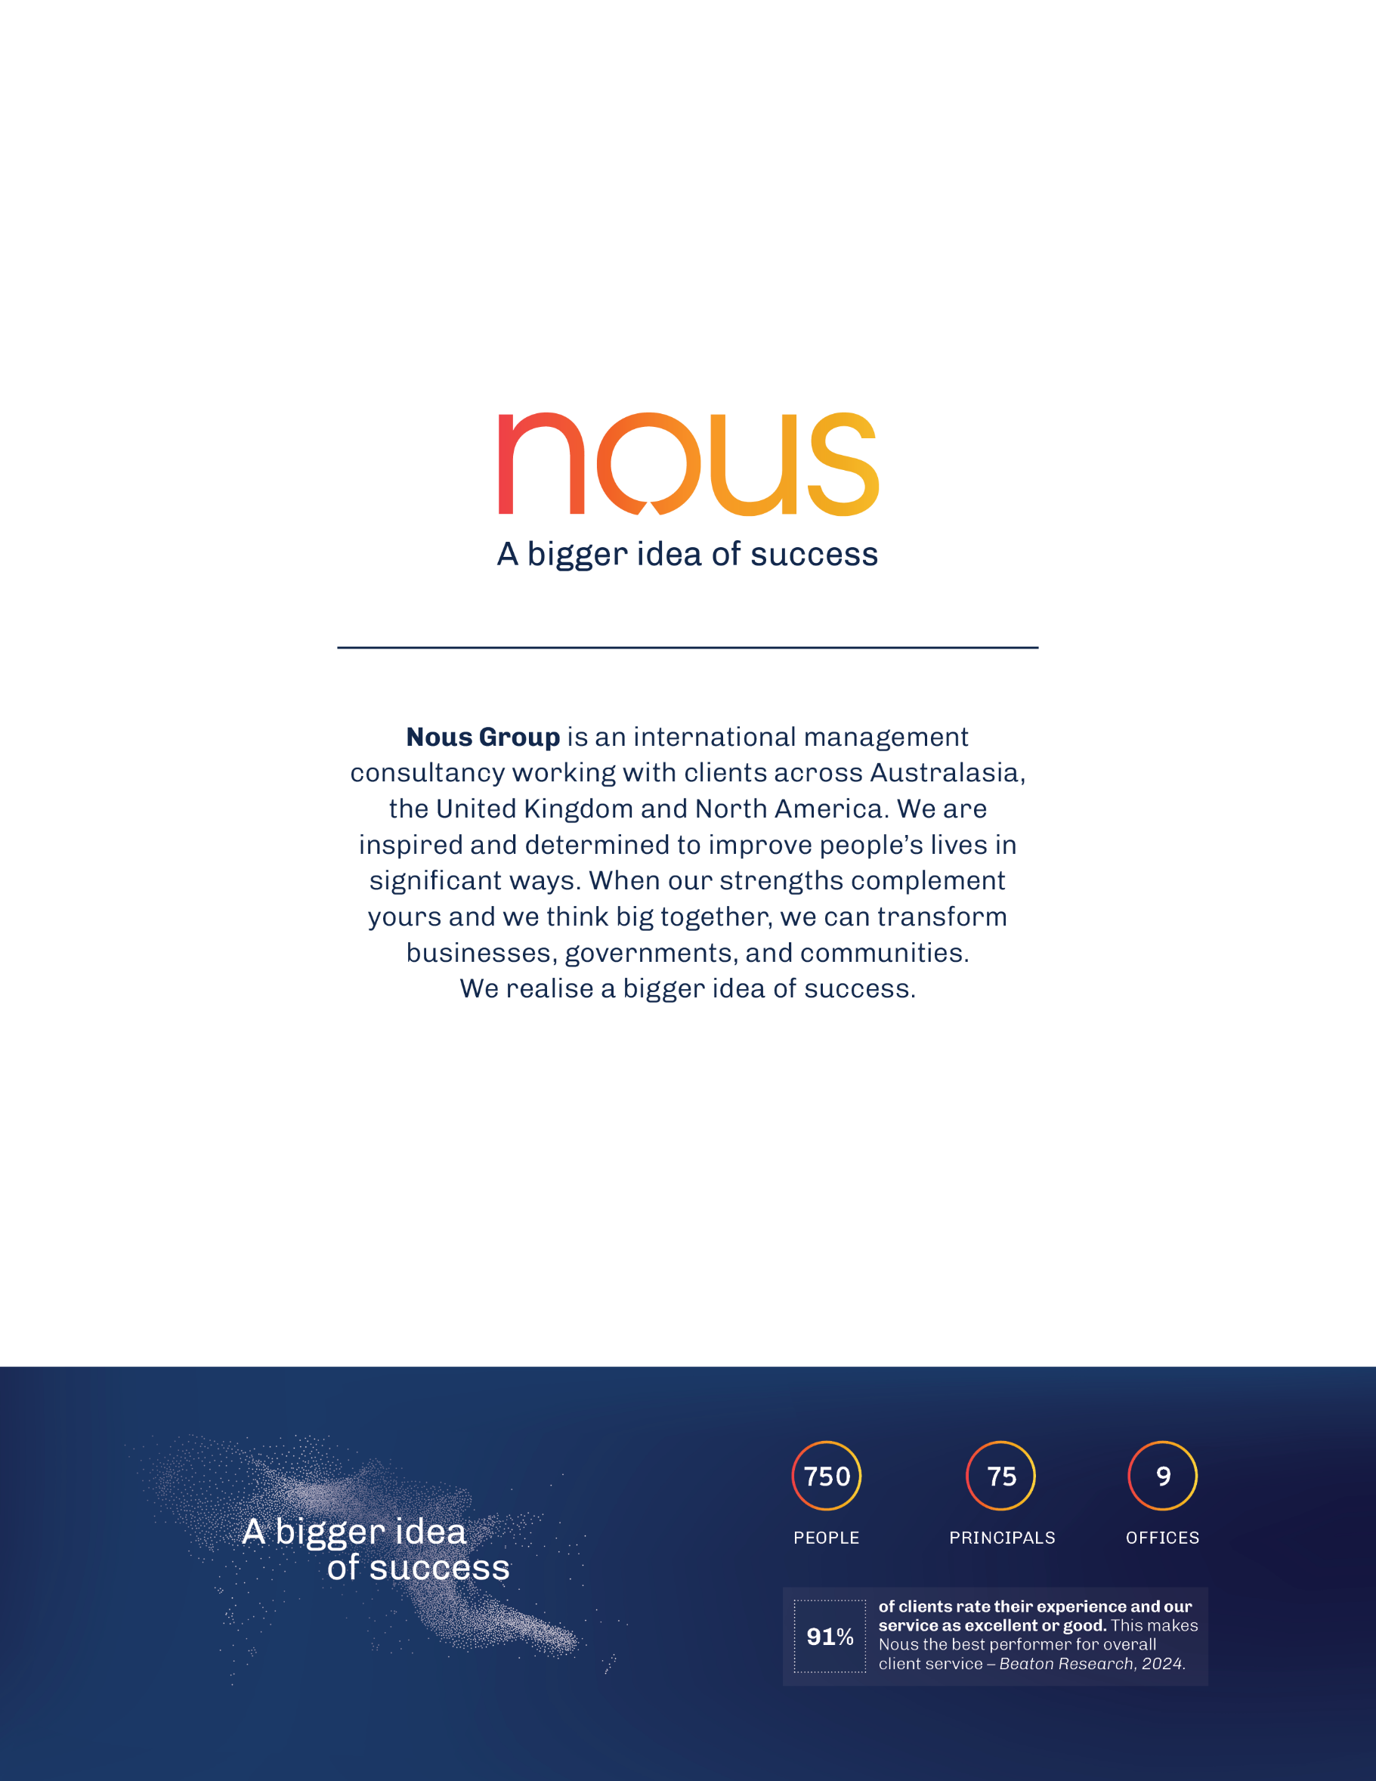
[Nous Back page – A bigger idea of success]

Australian Institute of Health and Welfare, Rural and remote health, 2024 (accessed 22 August 2025), https://www.aihw.gov.au/reports/rural-remote-australians/rural-and-remote-health
Australian Bureau of Statistics, Provisional Mortality Statistics, January - December 2024 (accessed 22 August 2025), https://www.abs.gov.au/statistics/health/causes-death/provisional-mortality-statistics/jan-dec-2024
Australian Bureau of Statistics, Provisional Mortality Statistics, January - December 2024 (accessed 22 August 2025), https://www.abs.gov.au/statistics/health/causes-death/provisional-mortality-statistics/jan-dec-2024
This exemption was previously known as the Remote Medical Benefits Scheme (RMBS)
Australian Government (2022). Strengthening Medicare Taskforce Report. https://www.health.gov.au/sites/default/files/2023-02/strengthening-medicare-taskforce-report_0.pdf. Four reviews: Australian Government Department of Health and Aged Care. (2024). Review of General Practice Incentives https://www.health.gov.au/sites/default/files/2024-10/review-of-general-practice-incentives-expert-advisory-panel-report-to-the-australian-government_0.pdf, Australian Government Department of Health and Aged Care. (2024). Review of After-hours Primary Care Programs and Policy. https://www.health.gov.au/sites/default/files/2024-10/a-better-after-hours-system-review-of-after-hours-primary-care-programs-and-policy_0.pdf, Australian Government Department of Health and Aged Care (2024). Working Better for Medicare Review: Final Report. https://www.health.gov.au/sites/default/files/2024-10/working-better-for-medicare-review-final-report-and-appendices_0.pdf, Australian Government Department of Health and Aged Care (2024). Unleashing the Potential of our Health Workforce: Scope of Practice Review: Final Report. https://www.health.gov.au/sites/default/files/2024-11/unleashing-the-potential-of-our-health-workforce-scope-of-practice-review-final-report_0.pdf
Productivity Commission (2025). Delivering quality care more efficiently, Interim Report. https://www.pc.gov.au/inquiries/current/quality-care/interim/quality-care-interim.pdf
Australian Government Department of Health and Aged Care. (2023). Mid-Term Review of the National Health Reform Agreement Addendum 2020–2025: Final Report. https://www.health.gov.au/sites/default/files/2023-12/nhra-mid-term-review-final-report-october-2023.pdf
At the time this evaluation was undertaken, negotiations to establish the next NHRA were ongoing. The NHRA was subsequently finalised on 30 January 2026. References throughout this report to ongoing NHRA negotiations reflect the policy context at the time the evaluation was conducted.
Royal Flying Doctor Service of Australia (2020) Equitable Patient Access to Primary Healthcare in Australia.
Wakerman J, et al. (1997) Kimberley Regional Aboriginal Health Plan. Menzies School of Health Research.
Tilton E and David Thomas D (2011). Core functions of primary health care: a framework for the Northern Territory. Prepared for the Northern Territory Aboriginal Health Forum.
National Rural Health Alliance, The Forgotten Health Spend: A Report on the Expenditure Deficit in Rural Australia, August 2025
Department of Disability and Ageing, General Practice Workforce providing Primary Care services in Australia, 2025 [Link]
Australian Government Department of Aged Care, Supply and demand study – General practitioners in Australia, 2024 [Link]
Department of Health. Australia’s Primary Health Care 10 Year Plan 2022-2032. Commonwealth of Australia, 2022 [Link]
Australian Government Department of Health and Aged Care. Unleashing the Potential of our Health Workforce: Scope of Practice Review – Final Report. November 2024, [Link]
Australian Government, NDIS Review, Building a more responsive and supportive workforce, 2023 [Link]
National Rural Health Alliance, The Forgotten Health Spend: A Report on the Expenditure Deficit in Rural Australia, August 2025

