Chronic Conditions Prevention and Integrated Care Program round 1 grant opportunity (GO8398) feedback for applicants
November 2026
The Department of Health, Disability and Ageing has completed the assessment process for round 1 of the Chronic Conditions Prevention and Integrated Care Program. We thank all organisations for their interest and participation in this important initiative.

About the program
The Chronic Conditions Prevention and Integrated Care Program (CCPIC) Program is the Australian Government's new ongoing, open and competitive grants program that supports initiatives to improve health outcomes for people living with, or at risk of developing, chronic conditions.
Chronic conditions are a leading cause of illness, disability and premature death in Australia. Three in five Australians live with at least one chronic condition and nearly two in five live with two or more. The impact of chronic conditions is expected to grow as Australia's population ages.
The Government has committed more than $148.2 million over four years to the CCPIC Program, with approximately $38 million per year ongoing thereafter. The program aligns investment with the National Strategic Framework for Chronic Conditions 2026–35 and supports activities that strengthen:
- health promotion and education
- prevention and early detection
- integrated, multidisciplinary and person-centred care
- management of multimorbidity
- improved health equity outcomes.
The CCPIC Program complements broader Government investment through programs such as the Medicare Benefits Schedule (MBS), Pharmaceutical Benefits Scheme (PBS), National Health Reform Agreement (NHRA) and National Disability Insurance Scheme (NDIS).
The CCPIC Program also represents a shift from previous approaches, where funding for chronic condition activities was often provided through non-competitive arrangements. An open and competitive grants process ensures funding is directed to the strongest proposals that support activities that deliver measurable improvements, value for money and the greatest potential benefit for people living with chronic conditions. It also supports new ideas, encourages collaboration, including through consortium arrangements, and reduces fragmentation and duplication across the sector.

CCPIC Program grant round 1 overview
The CCPIC Program grant opportunity was established to drive improved health outcomes for people in Australia, living with, or at risk of, chronic conditions by supporting early detection, prevention, and effective management.
Round 1 was advertised via a forecast opportunity on Grant Connect from 30 March 2026 with applications open for submission from 6 May until 17 June 2026.
Funding allocations and descriptions for the CCPIC Program (Tier 1 and Tier 2) are detailed below:
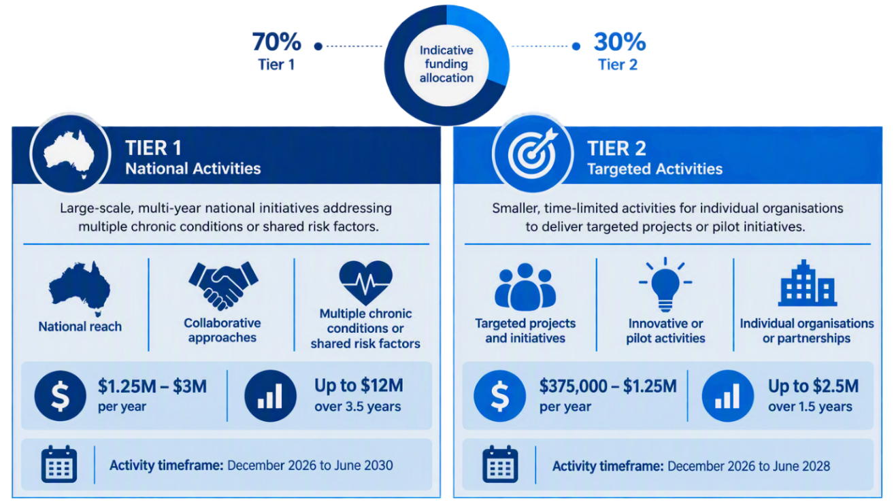

Outcome of applications
The CCPIC Program grant round 1 attracted a very strong response from the sector. More than 500 applications were received, with applicants seeking funding worth more than ten times the funding available. This demonstrates both the significant interest in the program and the strong commitment of organisations across Australia to improving outcomes for people living with chronic conditions.
Twenty-four applications were successful for funding through this open competitive grant process. Successful organisations are listed on the GrantConnect website within 21 calendar days of the grant agreements being executed.

Assessment of applications
Applications were assessed in accordance with the published Grant Opportunity Guidelines (GOGs). Assessment considered both eligibility requirements and the published assessment criteria, including organisational capability, strategic alignment, and value for money. Applications were assessed on their merits and comparatively against other applications, with consideration given to factors including, but not limited to:
- the type of activity and how they proposed to meet program objectives and outcomes
- how well they met the assessment criteria
- whether they demonstrated value with relevant money, and
- consideration of sustainability beyond the funding period.
The GOGs outlined the amount of detail and supporting evidence required to be provided in applications, which needed to be relative to the project size, complexity and funding amount requested.

Assessment feedback
Below we outline the common elements of strong applications and provide examples of how these applications met the selection criteria.

Criterion 1: Alignment with grant requirements, objectives and outcomes
Strong responses:
- demonstrated how the proposed activity fits within the relevant Tier.
- described how the proposed activity contributes to the objective(s) and outcomes of the grant opportunity as described under section 2 of the GOGs.
Criteria | Common Elements and Examples
Identify the grant opportunity objectives the proposed activity aligns with, and describe how these activities will be undertaken | - Clearly articulated how the proposed activity aligns with the objectives of the grant opportunity and how they will deliver meaningful outcomes to achieve these objectives (for example, tangible benefits for consumers and/or health professionals).
Provide evidence of need for the activity, including relevant data, examples or scenarios | - Demonstrated a clear need or service gap for the activity.  - Used evidence or examples that support the need.  - Clearly articulated how the activity addresses unmet need and avoids duplication.
Demonstrate how the organisation will identify, engage and collaborate with relevant stakeholders to support effective delivery of the grant objectives and outcomes, including where (locations) the grant activity will be delivered which groups | - Clearly described how partnerships are meaningful and linked to delivery outcomes.  - Clearly articulated how key stakeholders will be identified and engaged to support delivery, including in the locations where grant activities will be delivered.  - Partnerships or co-design approaches are clearly described.  - For Tier 1 - clear evidence provided of cross-sector collaboration at a national scale.
Describe how the organisation will evaluate the grant activity/grant activities | - Clearly outlined how the grant activity/activities will be evaluated, including what will be measured (outputs/outcomes), how and when data will be collected, and how findings will be used.
If applicable, how the activities proposed in the application contribute to meeting  the Closing the Gap targets, as identified in Section 2 | - Clearly identified relevant Closing the Gap target(s).  - Described strategies that are aligned with reducing health inequalities and disparities.  - Articulated delivery methods that are tailored, culturally safe and informed by community and/or demonstrated engagement with delivery partners
For Tier 1 applications, how the activity will be delivered nationally. | - Demonstrated delivery across all states and territories from commencement of activity.  - Clearly articulated how the activity supports equitable access across locations (metropolitan, regional, rural, and remote).  - A clear national delivery model described (e.g. central coordination with local partners).  - Demonstrated the delivery model is scalable and supported by appropriate workforce, infrastructure, and governance.
Activity Work Plan (AWP) completed using the correct template on GrantConnect. | - AWP listed key tasks that will be undertaken to meet the objectives of the grant opportunity within the timeframe, including how an evaluation will measure whether the activity achieved intended outcomes.  - AWP detailed the proposed deliverables and outputs for the activity, performance measures for the activity, and timelines for the milestones of the activity.

Criterion 2: Organisational capacity and capability to deliver the grant activities
Strong responses:
- Described the organisation or consortia’s capacity and capability to deliver the grant activities, and how the proposal addresses the delivery risks involved in undertaking the grant activity.
- Included a detailed description of the proposed activities, the delivery methodology (including existing infrastructure and relationships that will support the project activities), and the key outputs.
Criteria | Common Elements and Examples
Evidence of the organisations track record in managing similar projects and access to  personnel and/or partners with the right skills and experience | - Demonstrated experience and capability to deliver the project.  - Detailed experience delivering similar programs or projects of comparable scale.  - Described access to subject matter expertise and skilled personnel or partners.
Sound project planning to manage and monitor the project, which addresses  associated timeframes, milestones, and risks | Demonstrated sound planning, governance and risk management including:  - Description of clear timelines, milestones, and deliverables.  - Description of governance structures and decision-making processes.  - Evidence of a strong project management framework.  - Key risks identified (including strategic and operational risks) and are clearly described, including likelihood and impact. Description of appropriate and realistic controls in place to manage the identified risks.
How your partnerships and linkages with relevant stakeholders will work together to achieve your project outcomes | - relevant, fit for purpose partnerships and clearly defined engagement and delivery arrangements.  - Clearly articulated roles and responsibilities of partners.  - Provided evidence of partnerships that supported effective delivery and reach.  - Demonstrated accessibility for priority populations.  - For Tier 1 – provided evidence of partnerships and linkages already established at a national scale.
Risk Management Plan is completed using the template on Grant Connect | - Analysed identified risks, including the likelihood of the identified risks occurring; the impact on the activity should the identified risks occur; risk mitigation strategies to respond to identified risks.

Criterion 3: Efficient and economical use of grant funds
Strong responses:
- Described how the organisation will ensure the efficient and economical use of grant funds when delivering the proposal.
- Included details of intended outcomes, target priority groups for each project and a brief explanation of how each project will contribute to achieving the objectives and outcomes of the grant opportunity in a cost-effective way.
Criteria | Common Elements and Examples
Describe how the proposed expenditure would contribute to achieving the objectives and outcomes of the grant opportunity and provide outstanding value with relevant money | - Clearly demonstrated that expenditure supports outcomes and represents value for money.  - Clearly demonstrated that spending aligns with the grant opportunity objectives and activities. Costs described are reasonable relative to expected outcomes.  - Provided a clear justification for why this approach represents value for money.  - Demonstrated how the activity shows cost effective use of resources while maintaining high-quality outcomes.
How the proposed budget is appropriate to support the successful delivery of the  proposal | - Clearly described how the budget is appropriate and sufficient for the activity.  - Clearly described how the budget is proportionate to the scope, and complexity of the activities.  - Clearly explained and justified costs.  - The budget reflected delivery requirements including regional, logistical and operational factors.  - Evidence provided of financial planning to support timely and effective delivery.  - Clearly justified the budget items against the delivery plan.  - Clearly described contingency measures to manage risks.  - Demonstrated appropriate systems in place to manage and monitor expenditure effectively.
How the project/activities will achieve high-quality outcomes in a cost-effective way that are financially sustainable beyond the funding period | - Clearly demonstrated how the activities will achieve high-quality outcomes in a cost-effective way, and considered how these outcomes would be financially sustainable beyond the funding period.
How the organisation strives to adhere to ethical principles when administering grant funding. | - Clearly described how the organisation will administer grant funding in line with ethical principles (e.g., integrity, transparency, accountability and probity).
Indicative Activity Budget is completed using the template on GrantConnect | - Indicative activity budget aligned with proposed activities and included only eligible expenditure items.

Criterion 4: Provide support activities for priority population groups that target an area of specific need
Strong responses:
- Described how the grant activity will deliver tailored support for chronic conditions of one or more priority population groups as defined in Section 14 of the GoGs, noting that a person may fall into one or more groups.
Criteria | Common Elements and Examples
Provide details about how your activity will identify and address the chronic conditions concerns of priority population group(s), and address any service delivery gap(s) and/or area(s) of need relevant to this population(s) | - Clearly identified priority population groups (e.g. (but not limited to) Aboriginal and Torres Strait Islander peoples, CALD communities, people with disability, rural/remote populations, socio-economically disadvantaged groups) and describes chronic conditions of concern being addressed.  - Demonstrated a clear understanding of the specific chronic condition challenges experienced by these populations (e.g. higher prevalence, barriers to access, poorer outcomes).  - Identified specific service gaps or unmet needs, including:  - geographic gaps (e.g. regional/remote access)  - system gaps (e.g. fragmented care, lack of culturally appropriate services)  - population-specific barriers (e.g. language, cultural safety, affordability, stigma).  - Clearly linked the proposed activities to addressing those gaps or needs with solutions.  - Demonstrated an understanding of intersectionality impacts (e.g. overlapping disadvantage across multiple population groups) where relevant.  - Described approaches that are tailored, culturally safe, and appropriate to the target population(s).
Provide evidence (e.g. relevant data or literature) demonstrating how your activity will align with program objectives/focus areas and outcomes, and represent outstanding value with money by targeting specific priority populations and/or filling service delivery gaps | - Demonstrated that the proposed activities are evidence-based and aligned to health equity outcomes.  - Aligned activities with the program objectives/ focus areas and enhanced and targeted support to improve health equity.  - Described how the proposal targets priority populations and demonstrated efficient and impactful use of funding, including:  - focused resources where need is greatest  - addressed systemic inequities  - avoided duplication of existing services.  - Identified measurable outcomes or impact for priority population(s).  - Demonstrated how the proposal represents value for money in addressing identified gaps.
Outline the organisation’s demonstrated experience in consultation, co-design and tailoring of resources for one or more priority population groups | - Demonstrated experience working with relevant priority populations.  - Evidence provided of meaningful consultation and/or co-design, including:  - involvement of community representatives or organisations  - partnerships with community-controlled or culturally specific organisations  - Demonstrated how co-design has influenced (or will influence):  - program design  - delivery methods  - resources and materials  - Capability to develop tailored resources, including:  - culturally appropriate materials  - language accessibility  - health literacy considerations  - Evidence provided of established or trusted relationships with the target population(s).  - For Tier 1 (if applicable): The applicant demonstrated national or cross-jurisdictional experience with diverse priority populations.
Detail the organisations policies, procedures, guidelines related to better supporting chronic  conditions outcomes for this priority group | - Identified relevant organisations policies or frameworks, such as:  - cultural safety frameworks  - access and equity policies (e.g. Multicultural Access and Equity Policy)  - inclusion and diversity policies  - clinical or service delivery guidelines.  - Policies aligned with national frameworks or standards, where appropriate.  - Clearly describes how these policies support:  - equitable access to services  - culturally safe and appropriate care  - improved chronic condition prevention and management.  - Included relevant policies, such as:  - community engagement and participation  - safeguarding and ethical considerations  - workforce capability and cultural competency  - Policies described are current, operationalised, and embedded within the organisation.
Identify how the organisation will apply these to the proposed project / activity | - Demonstrated how policies and frameworks will be implemented in practice/.  - Cleary explained of how policies will be applied:  - service delivery design and approach  - workforce training and capability  - stakeholder engagement and co-design processes.  - Provided practical examples of historical implementation including:  - culturally safe service models  - tailored communication strategies  - inclusive access pathways.  - Describe how the policies support consistent, and equitable delivery.  - Articulated processes in place to monitor and evaluate implementation and described what the activity will achieve for priority populations and health inequities.

Additional feedback
Other important factors that applicants should consider when preparing grant applications include:
Other factors | Considerations
Indicative activity budget | - Check budgets to ensure all expense items add up to the total grant funds requested and do not exceed the funds available.  - Ensure budgets are consistent with the described activities, detailing the cost of proposed activities. The budget should only include eligible expenditure items as detailed in the GoGs.
Value for money | - Carefully consider how applications are assessed regarding value for money, as outlined in the GoGs.  - Assessment of value for money for this grant opportunity included:  - the overall objective/s to be achieved in providing the grant.  - the extent to which the evidence in the application demonstrates that it will contribute to meeting the outcomes/objectives.  - the relative value of the grant sought.  - the extent to which the grant activities match identified priorities; and  - how the grant activities will benefit groups and/or individuals.  - To support value for money assessment, applicants should clearly identify:  - proposed grant activities.  - how the proposal aligns with relevant government health policy frameworks, priorities and reform agendas.  - proposed activity benefits and how they align with the objectives and outcomes of the grant opportunity; and  - the potential grantee’s relevant experience and performance history.
Risk management approach | - Demonstrate sound knowledge of risk management principles.  - Clearly articulate practical measures and controls to mitigate risks associated with the proposed activities.
Activity work plan | - The activity work plan should provide clear, high level, supporting evidence of proposed deliverables, measures of success and key milestones.
General feedback | - Applicants are encouraged to focus responses on the grant objectives most relevant to their project. Carefully consider which grant objectives the project will address and ensure the application clearly demonstrates how you will deliver against each objective selected.  - Addressing all objectives does not necessarily improve the likelihood of funding and may reduce the clarity, depth, and effectiveness of responses against the most relevant objectives.  - Draft the application for an audience that may not be familiar with the organisation. Explain acronyms and provide all relevant information within the application itself.  - Clearly articulate proposal summaries to outline what the project will aim to achieve.

Outcome notification
All applicants have been notified of the outcome of their application in writing.

Future Grant Rounds
The Chronic Conditions Prevention and Integrated Care Program is an ongoing program. The next Tier 2 round will open in late 2027 and the next Tier 1 round is anticipated in early 2030. Organisations should commence early preparations for the grant rounds, familiarise themselves with the Grant Opportunity Guidelines (GOGs) available on GrantConnect and align their funding proposals with the new National Strategic Framework for Chronic Conditions 2026–35.

