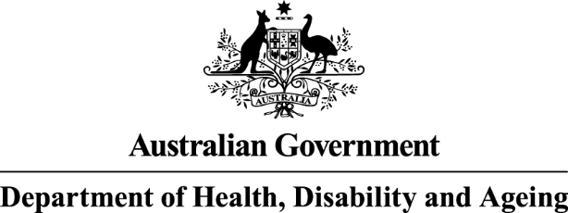
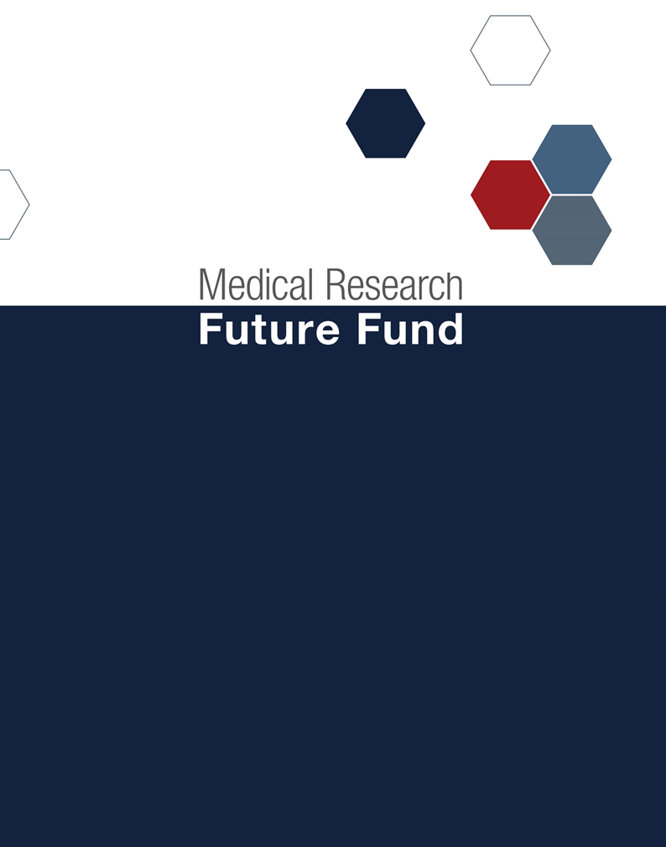

Australian Medical Research and Innovation Strategy 2026-2031 and Priorities 2026-2028 consultation report
Table of Contents

Introduction 3
Consultation process 3
Report structure 4
Public consultation metrics 5
Online survey 5
Individual respondents 5
Organisational respondents 6
National webinar 6
Consultation feedback 6
Online Survey Statistics 6
Key Themes from Consultation Feedback 8
Appendix A: Targeted Roundtable Discussion Summary 11
Appendix B: A comparison of the draft and final Strategy and Priorities 13

Introduction
The Australian Medical Research Advisory Board (AMRAB) is required to consult on the Australian Medical Research and Innovation Strategy (the Strategy) every five years and the Australian Medical Research and Innovation Priorities (The Priorities) every two years.
This report outlines the consultation process undertaken by AMRAB to inform the 2026-2031 Strategy and 2026-2028 Priorities, consistent with the requirements of the Medical Research Future Fund Act 2015 (the Act).
The process combined broad public engagement through an online survey and a national webinar and targeted discussions involving expert advisory committees and key stakeholders across the health and medical research system.
The consultation sought views on the proposed Vision, Strategic Objectives, Cross-cutting Principles and Shared Enablers for the Strategy, as well as the proposed Priorities and Priority Populations. It engaged a broad range of stakeholders across the health and medical research ecosystem, including researchers, research organisations, health services, consumers, industry, philanthropy, governments and the broader community.
In addition, AMRAB’s international advisors, Professor Lucy Chappell (United Kingdom) and Dr Tammy Clifford (Canada), were consulted throughout the development of the Strategy and Priorities, bringing valuable international perspectives to AMRAB’s deliberations. Drawing on their leadership of major national health and medical research systems, they provided insights into emerging global trends, research funding approaches and strategic priorities. Their expertise helped AMRAB test and refine the proposed approach, ensuring the Strategy and Priorities were informed by international best practice while remaining relevant to the Australian context.
The consultation report provides a transparent record of the consultation process and demonstrates how stakeholder feedback was considered in developing the Strategy and Priorities. It supports accountability in AMRAB’s decision-making and helps stakeholders understand how their views shaped the final documents.
This report summarises the feedback received, identifies who was consulted and the key themes raised, and explains how this feedback informed the final Strategy and Priorities.

Consultation process
Following detailed consideration and analysis, AMRAB developed a draft Strategy and Priorities for consultation to test whether the proposed framework was robust, fit for purpose and responsive to Australia’s current and emerging health and medical research needs.
Consultation commenced on 17 July 2026 and comprised two complementary approaches:
Public consultation
- An online consultation survey, open from 17 July 2026 to 16 August 2026, through the Department’s Consultation Hub.
- A national webinar on 4 August 2026 hosted by AMRAB to explain the draft Strategy and Priorities, outline the advice being sought from the public, and respond to questions.
Targeted stakeholder engagement
- Engagement with the National Health and Medical Research Council (NHMRC), NHMRC Research Committee, and joint NHMRC-MRFF advisory committees.
- Discussions with stakeholders through existing meetings and established advisory boards and committees (details below).
- Direct engagement with key advocacy groups representing particular sectors and areas of expertise (details below).
- A targeted roundtable on 4 September 2026.
AMRAB developed the consultation drafts following consideration of:
- the current Strategy and Priorities
- findings from a review of the health and medical research funding landscape
- insights from consultation on the National Health and Medical Research Strategy
- findings from recent reviews and consultations across the health and medical research system.
Participants were invited to test the proposed Vision, Strategic Objectives, Cross-cutting Principles, Shared Enablers, Priorities and Priority Populations. Feedback was sought on whether they would provide an effective framework for future MRFF investment and adequately reflect Australia’s current and emerging health and medical research needs.
Targeted engagement complemented the public survey and webinar by enabling more detailed discussion with stakeholders representing particular sectors and areas of expertise. This included consumers, Aboriginal and Torres Strait Islander advocacy groups, state and territory governments, research organisations, and other sector representatives. AMRAB also consulted closely with the NHMRC, NHMRC Research Committee, and the four joint NHMRC–MRFF advisory committees: the Consumer Advisory Group, Indigenous Advisory Group, Public Health and Health Systems Committee, and Industry, Commercialisation and Philanthropy Committee. This engagement drew on members’ specialist expertise and practical experience across the health and medical research system, enabling them to provide detailed and nuanced feedback within their respective fields. Their advice helped AMRAB test the robustness of the proposals, identify potential gaps and ensure the final Strategy and Priorities reflected diverse sector perspectives. One of these activities was a targeted roundtable held on 4 September 2026, which is summarised in Appendix A.

Report structure
This consultation report provides a record of the input received from the consultation process described above and aggregates the key inputs from that process.
The report is structured as follows:
- Public consultation metrics – who we heard from through public consultation
- A summary of feedback including the key themes identified through the consultation process
- Appendix A - Targeted Roundtable Discussion Summary
- Appendix B - A comparison of the draft and final Strategy and Priorities, including AMRAB’s comments on how the documents evolved in response to consultation feedback.

Public consultation metrics
The public consultation attracted substantial participation, with 262 survey responses and 338 webinar attendees (Table 1).
Table 1: Stakeholder involvement
Stakeholder interaction | Number
Stakeholder submissions – consultation hub | 262
Stakeholder submissions – email | 7
Stakeholders attending public webinar | 338

Online survey
The online survey was open from 17 July to 16 August 2026.
Responses received included:
- 149 responses (57%) provided by individuals.
- 113 responses (43%) provided on behalf of organisations.

Individual respondents
Individual respondents represented all Australian jurisdictions, with the largest numbers from New South Wales (50) and Victoria (49), followed by South Australia (16) and Queensland (15) (Figure 1).
Respondents included researchers, research organisations, health services, consumers, industry, philanthropy, government, and the wider community (Figure 1). Researchers and academics were the largest individual cohort (113 respondents), followed by health professionals (53 respondents).
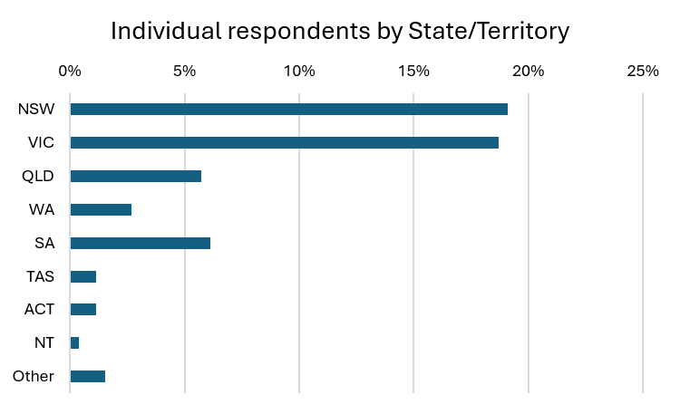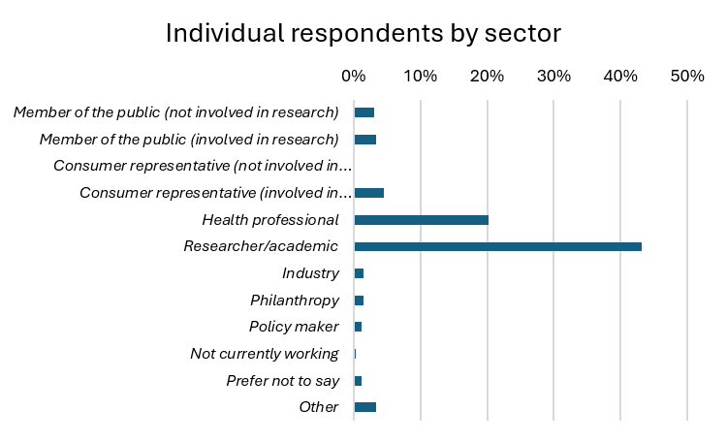
Figure 1 - Geographic distribution and work sectors (individual)

Organisational respondents
Organisational respondents also represented a range of jurisdictions, with the largest identified groups from Victoria (32) and New South Wales (23), followed by the Australian Capital Territory (8), South Australia (7) and Queensland (6) (Figure 2).
Research and academic organisations were the largest organisational cohort (65 organisations). Responses were also received from advocacy organisations (38), consumer organisations (19), health services (16), government (14), industry (13) and philanthropy (11) (Figure 2).
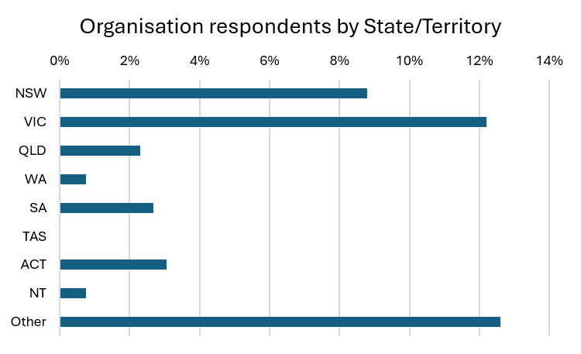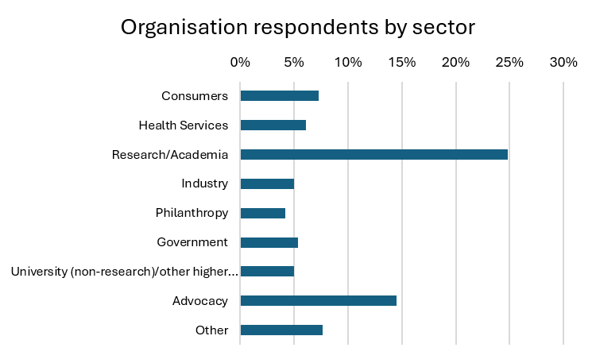
Figure 2 - Geographic distribution and work sectors (organisation)

National webinar
The public webinar on 4 August 2026 attracted:
- 420 registrations
- 338 attendees
- 61 questions submitted through the Q&A function.
Questions submitted during the webinar reflected strong engagement across the research, healthcare, consumer, industry and policy sectors. Recurring areas of interest included equity, priority populations, translation, implementation, workforce capability, artificial intelligence, data infrastructure and future MRFF investment directions.

Consultation feedback
This section summarises feedback received through the consultation process, including survey responses, written submissions, targeted engagement and roundtable discussions. It identifies the main areas of support, recurring issues raised by stakeholders and opportunities to strengthen the final Strategy and Priorities. While these statistics exclude email submissions, targeted engagement and roundtable discussions, feedback from all consultation channels are reflected in the key themes outlined in this report.

Online Survey Statistics
Online survey results indicated broad support for the overall strategic direction of the draft Strategy. A majority of respondents supported the proposed Vision (71% of those who responded), Cross-Cutting Principles (71%) and Shared Enablers (65%). Support for the proposed Strategic Objectives was also mostly positive, with 151 of 235 respondents who answered indicating support (64%) (Table 2).
Table 2: Online survey statistics – Draft MRFF Strategy
Survey Item | Number of respondents | Support for the draft  (% respondents) | Additional elements needed  (% respondents)
Vision | 236 | 71% | 29%
Strategic Objectives | 235 | 64% | 36%
Cross-cutting Principles | 230 | 71% | 29%
Shared Enablers | 243 | 65% | 35%
Feedback on the proposed Priorities was more mixed (Table 3). Respondents indicated strongest support for Aboriginal and Torres Strait Islander community governed and directed research, with 76% respondents indicating the priority was well addressed (Table 3). Environmental health, determinants of health, integrated digital health systems and multiomics-informed healthcare also received moderate levels of support. For several priorities, responses indicated that additional elements were needed, particularly in the areas of skilled and sustainable health and medical research workforce, AI in research and health systems, advanced therapeutics and emerging technology, multiomics-informed healthcare, and embedding research in the health system. Feedback suggested that stakeholders generally supported the direction of the proposed Priorities while seeking further clarity, refinement or additional emphasis in key areas.
Survey feedback indicated strong support for the proposed Priority Populations (71% respondents). Feedback emphasised that priority populations should be used to support more equitable research design, participation, access and outcomes, while recognising intersectionality, under-served groups and place-based needs. Stakeholders also highlighted the importance of maintaining sufficient flexibility so that future MRFF investments can respond to emerging evidence and community needs.
Table 3: Online survey statistics – Draft MRFF Priorities
Survey Item | Number of respondents | Support for the draft  (% respondents) | Additional elements needed  (% respondents)
Proposed Priority
AI in research and health systems | 214 | 44% | 56%
Integrated digital health systems | 212 | 50% | 50%
Aboriginal and Torres Strait Islander community governed and directed research | 201 | 76% | 24%
Advanced therapeutics and emerging technology | 206 | 48% | 52%
Health impacts from environmental factors, including climate change | 201 | 64% | 36%
Multiomics-informed healthcare | 216 | 47% | 53%
Determinants of health | 198 | 54% | 46%
Embedding research in the health system | 197 | 45% | 55%
Skilled and sustainable health and medical research workforce | 214 | 38% | 62%
Priority Populations | 220 | 71% | 29%

Key Themes from Consultation Feedback
A thematic analysis was conducted across all feedback received on the draft Strategy and Priorities to identify common issues, areas of support and opportunities for refinement. The key themes and subthemes below summarise the main issues raised through survey responses, written submissions, targeted engagement and roundtable discussions.
Table 4: Key themes from consultation feedback
Key theme | Subtheme
Strategic clarity, scope and accountability | Clarify the MRFF vision, objectives and investment logic
Strategic clarity, scope and accountability | Strengthen transparency, accountability and impact measurement
Strategic clarity, scope and accountability | Align investment with prevention, equity and long-term health system outcomes
Funding design, assessment and resourcing | Value implementation, community partnership, equity and real-world impact in assessment
Funding design, assessment and resourcing | Support translation, commercialisation and co-investment pathways
Funding design, assessment and resourcing | Invest in infrastructure, platforms, data assets and shared capability
Translation, implementation and embedded research | Strengthen implementation science and evidence-to-practice capability
Translation, implementation and embedded research | Embed research in routine care and learning health systems
Translation, implementation and embedded research | Broaden research settings beyond hospitals to primary care, community, aged care, disability and rural services
Translation, implementation and embedded research | Support models-of-care, service delivery and clinical pathway research
Translation, implementation and embedded research | Improve access to clinical trials and research participation
Equity, determinants of health and prevention | Address social, commercial, structural and environmental determinants of health
Equity, determinants of health and prevention | Prioritise prevention, early intervention and public health approaches
Equity, determinants of health and prevention | Embed equity across research design, access, participation and outcomes
Equity, determinants of health and prevention | Recognise priority populations, intersectionality and under-served groups
Equity, determinants of health and prevention | Support rural, regional and remote health through place-based responses
Aboriginal and Torres Strait Islander community governance, sovereignty and capability | Ensure Aboriginal and Torres Strait Islander research is community governed and directed
 | Strengthen Indigenous data sovereignty, ethics and governance
 | Build Aboriginal and Torres Strait Islander research workforce and capability
 | Invest in culturally safe, place-based and community-led models
 | Align with Closing the Gap and Aboriginal and Torres Strait Islander health strategies
Data, digital health and AI governance | Build interoperable, linked and secure digital health data infrastructure
Data, digital health and AI governance | Ensure responsible, ethical, safe and equitable use of AI
Data, digital health and AI governance | Address digital inclusion, literacy and workforce capability
Emerging technologies, precision health and advanced therapeutics | Advance genomics, multiomics and precision health
 | Strengthen regulatory, manufacturing, validation and clinical evidence pathways
 | Address equity, access, affordability and ethical risks
 | Support national platforms, biobanks and enabling infrastructure
Environmental, climate and planetary health | Examine climate-related health impacts and adaptation
Environmental, climate and planetary health | Address environmental exposures, pollution, disasters and occupational or community impacts
Environmental, climate and planetary health | Strengthen surveillance, preparedness and resilient health systems
Environmental, climate and planetary health | Integrate environmental determinants with prevention and equity
Workforce sustainability, capability and career pathways | Support clinician-researchers and embedded research roles
Workforce sustainability, capability and career pathways | Strengthen early- and mid-career researcher pathways
Workforce sustainability, capability and career pathways | Support rural, regional, multidisciplinary and under-represented researchers
Partnership, consumer and community leadership | Embed patient, consumer and lived-experience involvement
Partnership, consumer and community leadership | Build partnerships across sectors, jurisdictions, industry and philanthropy
AMRAB systemically reviewed all consultation feedback, considered proposed wording changes, and discussed potential amendments and refinements before finalising the Strategy and Priorities. In doing so, AMRAB assessed the evidence and differing stakeholder perspectives before agreeing changes to strengthen the clarity, scope and strategic intent of the final Strategy and Priorities. AMRAB thanks all stakeholders for their valuable contributions. A comparison of the draft and final documents including AMRAB’s comments on how the documents evolved in response to feedback is provided in Appendix B.
While the above key themes summarise the main issues raised through consultation, some include activities and policies that are already in effect. In addition, some themes were beyond the scope or level of detail required for the MRFF Strategy and Priorities. These matters will be considered by AMRAB as part of the ongoing implementation of the MRFF Strategy and Priorities, including through future MRFF policies and grant opportunity design.

Appendix A: Targeted Roundtable Discussion Summary
AMRAB undertook proactive targeted engagement with key stakeholders throughout the consultation process, drawing on members’ networks, existing meetings and established expert advisory channels. A targeted roundtable was held on 4 September 2026 with representatives from NHMRC-MRFF joint advisory committees, including:
- NHMRC-MRFF Consumer Advisory Group
- NHMRC-MRFF Indigenous Advisory Group
- NHMRC-MRFF Public Health and Health Systems Committee
- NHMRC-MRFF Industry, Commercialisation and Philanthropy Committee.
The discussion sought feedback on the draft MRFF Strategy and Priorities and tested whether the proposed strategic direction aligned with issues being identified across health and medical research.
Participants broadly supported the proposed Vision, Strategic Objectives, Cross-cutting Principles and Priorities. Discussion largely focused on opportunities to strengthen implementation, collaboration and impact while maintaining the strategic focus of the documents. Key themes of the discussion are summarised below.
1. Strengthening Consumer and Community Voice
Participants emphasised the importance of ensuring consumers and people with lived experience have meaningful opportunities to influence research priorities. There was strong support for maintaining accessible pathways that enable community-led ideas and priorities to inform future funding decisions, particularly for individuals and groups without established links to research institutions.
2. Aboriginal and Torres Strait Islander health and wellbeing
Participants supported the emphasis on Aboriginal and Torres Strait Islander community-governed and directed research and highlighted the importance of maintaining a strong focus on health equity. Feedback emphasised the need to support Aboriginal and Torres Strait Islander leadership across the research cycle, strengthen research capability and workforce pathways, and ensure research priorities align with community-identified needs and policies. Participants encouraged approaches that support adaptation and scaling of successful interventions across communities while maintaining local relevance.
3. Demonstrating Research Impact and Building Public Trust
A consistent theme was the need to better communicate the value and outcomes of health and medical research. Participants highlighted the importance of sharing success stories, demonstrating real-world impact, and improving public understanding of how research contributes to better health outcomes. Clear communication was seen as critical to building trust and maintaining community support for research investment.
4. Embedding Research in Health Systems
Participants emphasised the importance of creating learning health systems that integrate research into healthcare delivery and service improvement. Research capability within health services, including clinician researchers, implementation specialists, data scientists and experts from a diverse range of disciplines, was viewed as critical to accelerating the generation and uptake of evidence and improving health outcomes. Participants highlighted opportunities to strengthen research culture, workforce capability and collaboration across healthcare settings. Participants also highlighted the importance of developing a future-ready workforce across a diverse expertise and capabilities to support research excellence and translation.
5. Supporting the Full Research Pipeline
Participants recognised the importance of maintaining a balanced investment approach across the entire research spectrum, from discovery research through to translation and implementation. Discussion acknowledged that some breakthroughs require sustained investment over many years, while other research can generate more immediate improvements in healthcare delivery and outcomes.
6. Accelerating Translation, Implementation and Scale
There was strong support for greater focus on translating research into practice and ensuring successful innovations are adopted more broadly. Participants highlighted the need to identify effective approaches, share lessons learned, and support implementation at scale to maximise benefits across communities and health systems.
7. Fostering Collaboration and National Coordination
Participants emphasised the value of stronger coordination across the Australian research funding ecosystem, including the MRFF, NHMRC and ARC. Greater alignment was seen as an opportunity to reduce duplication, support multidisciplinary collaboration and promote coordinated national approaches to common challenges. Effective partnerships between consumers, researchers, funders, industry and health service providers were identified as important enablers of research translation, implementation and impact.

Appendix B: A comparison of the draft and final Strategy and Priorities
Table 5: A comparison of the draft and final Strategy and Priorities, including changes and comments on how the documents evolved in response to consultation feedback
Document section | Draft version | Final version | Changes and response to consultation feedback
MRFF Strategy
Statement of intent | A coordinated approach will span prevention, AI, digital health, precision medicine, advanced therapeutics, climate resilience, and mental health. This will enable learning health systems that respond and adapt to population health needs. The approach is designed to complement funding from the National Health and Medical Research Council (NHMRC) and other funders. | This coordinated approach is designed to complement funding from the National Health and Medical Research Council (NHMRC) and other funders. | References to specific areas, including prevention, AI, digital health, precision medicine, advanced therapeutics, climate resilience and mental health, were removed to maintain flexibility for future priority-setting and ensure the Strategy can respond to emerging health and medical research needs.
Strategic Objectives | - A research-rich, data-enabled learning health system that continuously improves quality, efficiency, cultural safety, and equity  - End-to-end translation of discoveries and innovation into real-world impact - building sovereign capability and delivering measurable health and economic benefits | - A research-rich, data-enabled learning health system that continuously improves quality, efficiency, productivity, cultural safety, and equity  - End-to-end translation of discoveries and innovation into real-world impact - building sovereign capability and delivering measurable health, productivity and economic benefits | “Productivity” was added to strengthen recognition of the role of health and medical research and to clarify that the benefits of health and medical research include improvements in health system performance alongside health outcomes.
Cross-cutting Principles:  Translation and Implementation | Appropriate translation and implementation planning, including clear pathways, are crucial to: … | Appropriate translation and implementation planning, including clear pathways through early validation, regulatory readiness, implementation research, scale-up, and commercial and non-commercial routes to impact, are crucial to: … | Translation pathways were expanded to include early validation, regulatory readiness, implementation research, scale-up, and commercial and non-commercial routes to impact. This responses to consultation feedback on translation, implementation and commercialisation pathways to real-word impact.
MRFF Priorities
AI in research and health systems | The establishment … transparency at every stage of research.  Building Australia’s sovereign AI … | The establishment … transparency at every stage of research. [added: This includes strong AI governance that spans the full lifecycle of research from data and model validation through to deployment and monitoring.]  Building Australia’s sovereign AI … | Wording was added to clarify that AI governance should apply across the full research lifecycle. This responds to feedback about responsible, ethical, safe and equitable use of AI by making governance expectations more explicit.
Integrated Digital Health Systems | Investment in research-informed digital health innovations will advance prevention, early intervention, translation and adoption, and improve access to high-quality health care. It will also provide data for future health care research. | Investment in research-informed digital health innovations will advance prevention, early intervention, translation and adoption, and improve access to high-quality health care, especially in rural and remote settings. It will also strengthen digital literacy, data science and implementation capabilities and provide data for future research. | Wording was added on rural and remote access, digital literacy, data science and implementation capability. This responds to consultation feedback on digital inclusion, workforce capability and implementation science. These changes strengthen the Priority’s focus on equitable access to digital health innovation and the capabilities needed to support its effective adoption and use.
Aboriginal and Torres Strait Islander community governed and directed research | Invest in Aboriginal and Torres Strait Islander researchers … innovative solutions. Additionally, this … | Invest in Aboriginal and Torres Strait Islander researchers … innovative solutions. [added: This includes replicating, adapting and accelerating effective interventions that will improve health and wellbeing.] Additionally, this … | Wording was added to emphasise replicating, adapting and accelerating effective interventions. This responds to feedback on supporting community-governed and community-led approaches, including the adaptation and scaling of successful interventions while maintaining local relevance.
Advanced Therapeutics and Emerging Technology | Health technology development and commercialisation have the potential to advance Australia’s biomedical industry, generate jobs, build domestic workforce and infrastructure capabilities, attract and retain expert talent, diversify the economy, and deliver improved health outcomes. | Health technology development, assessment and commercialisation have the potential to advance Australia’s biomedical industry, generate jobs, and build domestic workforce and infrastructure capabilities. This will attract and retain expert talent, diversify the economy, increase productivity, and deliver improved health outcomes. | Wording was added to recognise health technology assessment and productivity. This provides clearer alignment with feedback on translation, implementation and real-world impact by highlighting factors that support the adoption and effective use of innovation within the health system.
Advanced Therapeutics and Emerging Technology | This will accelerate regulatory readiness (including health technology assessment), implementation, early market development and scale-up of advanced therapeutics and health technologies. | This will accelerate regulatory readiness (including health technology assessment and cost-effectiveness evaluation), manufacturing capability, implementation, early market development and scale-up of advanced therapeutics and health technologies. | Wording was added on cost-effectiveness evaluation and manufacturing capability to strengthen pathways from innovation to implementation and adoption. This reflects consultation feedback on supporting translation, commercialisation and the capabilities needed to realise the benefits of emerging technologies.
Advanced Therapeutics and Emerging Technology | De-risking innovation and enabling Australian discoveries to be translated into scalable products and services will strengthen sovereign capability, deliver economic benefits, and improve health system outcomes. | De-risking innovation and enabling Australian discoveries to be translated into scalable products and services will strengthen sovereign capability, deliver economic benefits, and improve productivity and health system performance and outcomes. | Wording was added to make productivity and health system performance more explicit. This reflects consultation feedback on implementation, real-world impact and the role of research in improving health system outcomes.
Health Impacts from Environmental Factors, including Climate Change | A climate-resilient health system that is prepared for and responsive to the health impacts of environmental factors, including climate change. | A climate-resilient health system that is prepared for and responsive to pandemics and the health impacts of environmental factors, including climate change. | Wording was added to include pandemic preparedness, responding to consultation feedback on environmental health, preparedness and resilient health systems in response to emerging health threats.
 | Human-caused environmental change, amplifies chronic disease, mental health conditions, antimicrobial resistance, zoonotic spillover, habitat destruction, food insecurity, and infectious disease risks, disproportionately impacting vulnerable communities and at-risk populations. | Pandemics and human-caused environmental change, amplify chronic disease, mental health conditions, antimicrobial resistance, zoonotic spillover, habitat destruction, food insecurity, and infectious disease risks, disproportionately impacting vulnerable communities and at-risk populations. | Wording was added to acknowledge pandemics alongside environmental change, reflecting consultation feedback on preparedness and resilient health systems in response to emerging health threats.
 | Coordinated research investment into understanding, preventing, and addressing the health impacts of environmental factors, such as pollution and climate change, will translate evidence into practical interventions and support robust surveillance and monitoring systems. | Coordinated research investment into understanding, preventing, and addressing pandemics and the health impacts of environmental factors, such as pollution and climate change, will translate evidence into practical interventions and support robust surveillance and monitoring systems. | Wording was added to include pandemics, reflecting consultation feedback on strengthening surveillance, preparedness and resilient health systems in response to emerging health threats.
 | Invest in multidisciplinary and cross-sectoral research and partnerships to understand and address global health and biosecurity issues, including surveillance, preparedness, prevention, response and countermeasures through a One Health approach. | Invest in cross-disciplinary and -sectoral research and partnerships to understand and address global health and biosecurity issues, including surveillance, pandemic preparedness, prevention, response and countermeasures through a One Health approach. | Wording was added to explicitly include pandemic preparedness, reflecting consultation feedback on strengthening surveillance, preparedness and resilient health systems in response to emerging health threats.
 | Invest in interdisciplinary, cross-sectoral research to address health challenges resulting from environmental factors, including pollution and climate-related risks. | Invest in cross-disciplinary and -sectoral research to address health challenges resulting from pandemics and environmental factors, including pollution and climate-related risks. | Wording was added to include pandemics, reflecting consultation feedback on strengthening surveillance, preparedness and resilient health systems in response to emerging health threats.
 | This will build the evidence needed to inform effective interventions, strengthen surveillance and prevention efforts, enable climate-resilient health care, and improve health outcomes for and with communities disproportionately affected by environmental change. | This will build the evidence needed to inform more effective interventions, surveillance, prevention efforts and climate-resilient health care through equitable, place-based co-design and evaluation. | Wording was revised to emphasise equitable, place-based co-design and evaluation. This responds to feedback highlighting the importance of prevention, equity and community-centred approaches.
Multiomics-Informed Healthcare | This supports the delivery of preventive, diagnostics, monitoring, and therapeutic approaches that are acceptable, accessible and tailored to diverse populations. | This supports the delivery of preventive, diagnostics, monitoring, and therapeutic approaches that are acceptable, equitable, accessible and tailored to diverse populations. | An explicit reference to equitable access was added. This responds to consultation feedback highlighting the importance of equity, access, affordability and ethical considerations in multiomics and precision health technologies.
Embedding research in the health system | Co-locating and co-producing research within health systems - supported by a hybrid workforce of clinician-scientists, health service leaders and researchers - will break down barriers between evidence generation, implementation, uptake and scale. | Co-locating and co-producing research within health systems - supported by a hybrid workforce of clinician-scientists, health service leaders and researchers from a diverse range of disciplines - will break down barriers between evidence generation, implementation, uptake and scale. | Wording was expanded to include researchers from a diverse range of disciplines, recognising feedback that embedded research requires broad capability across the health and medical research ecosystem.
Embedding research in the health system | Research that is co-produced and implemented with researchers, clinician-scientists, health services, consumers and community, and that is responsive to the needs and experiences of diverse population groups, will improve relevance, uptake, equity, and impact. | Research that is co-produced and implemented with researchers from a diverse range of disciplines, clinician-scientists, health services, consumers and community, and that is responsive to the needs and experiences of diverse population groups, will improve relevance, uptake, equity, and impact. | Wording was expanded to include researchers from a diverse range of disciplines, recognising feedback on multidisciplinary capability and the importance of embedding research across health and care settings.
Skilled and sustainable health and medical research workforce | Invest in high-quality research that creates career opportunities for researchers across diverse career stages, pathways and expertise. | Invest in high-quality research that creates career opportunities for researchers across diverse career stages, pathways, expertise and locations. | Wording was expanded to explicitly mention researchers across locations. This responds to feedback on supporting researchers across regional, rural and remote settings and under-represented researchers.
Priority populations
Priority populations | MRFF Priority Populations includes:  …  - older people experiencing diseases of ageing (e.g. cognitive decline and dementia)  - people with rare or currently untreatable diseases/conditions. | MRFF Priority Populations includes:  …  - older people experiencing diseases of ageing (e.g. cognitive decline and dementia)  - women and girls  - people with rare or currently untreatable diseases/conditions. | Women and girls were added as a priority population in response to feedback.

Some submissions were received by email after the formal consultation period closed and are therefore not reflected in the figures below. However, the broad themes raised in this feedback are captured in this document.

