

Youth Specialist Care Centres Model of Care

All information in this publication is correct as of August 2026

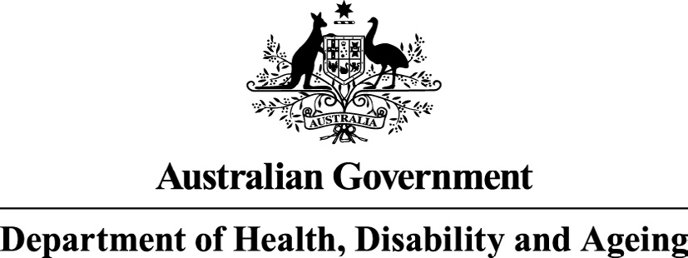

Orygen received funding from the Australian Government Department of Health, Disability and Ageing to develop this model of care.

Contents

Foreword 6
- Introduction 9
- Service overview 10
  - Service objectives 10
  - Target group 11
  - Service principles 12
  - Minimum service requirements 16
- Enablers 19
  - Leadership, culture, and shared vision 19
  - Governance, accountability, and system stewardship 19
  - Measurement-based care, continuous learning, and a learning healthcare system 19
  - Technology, digital capability, and data infrastructure 20
  - Workforce development, capability, and sustainability 20
  - Multidisciplinary, team-based,
and relational care 20
  - Partnerships, integration, and coordinated pathways 20
  - Lived experience, participation, and co-design 21
  - Local adaptation and equity of access 21

- Service components 22
  - Community awareness, mental health literacy,
and early detection 24
  - Access and referral pathways 25
  - Entry and assessment 29
  - Shared formulation and diagnosis 31
  - Outreach and assertive engagement 32
  - Key clinician and care team members 32
  - Psychiatry and medical interventions 34
  - Psychological therapies 35
  - Youth peer support 36
  - Physical health 36
  - Integration of substance use care 38
  - Functional and psychosocial recovery 38
  - Family programs and family peer support 40
  - Integration of digital care 42
  - Specialist interventions 42
  - Demand management and episodes of care 52
  - Transition of care 54
- Workforce 56
  - Service and team structure 56
  - Multidisciplinary care team 57
  - Workforce development and training 59
  - Flexible and distributed workforce models 60
  - Staff wellbeing and sustainability 60

Youth Specialist Care Centres Model of Care | 3

- Integration 61
  - Conceptual foundations for integrated care 61
  - How YSCC operationalise integration 62
  - YSCC contribution to system integration 63
  - Integration as a foundation for quality outcomes 64
- Governance 65
  - Corporate governance 65
  - Clinical governance 65
  - Cultural governance 69
- Flexibilities 70
  - Service flexibility and local adaptation 70
  - Model limitations and future adaptation 71
- Service implementation 72
  - Hub-and-spoke approaches 73
  - Implementation approach 74
- Evaluation and reporting 76
  - Individual outcomes 77
  - Service performance and model fidelity 77
  - Continuous quality improvement 78
  - Evaluation governance and data collection 79
Glossary 80
Appendix A: Service structure 84
Three teams 84
Continuing care team pods 84
Leadership 85
Appendix B:
Indicative staffing profiles 86
Service capacity summary 86
Service assumptions 87
Indicative large service profile 88
Indicative medium service profile 90
Indicative small service profile 92
Appendix C: Lived and living experience journey maps
for young people and families 94
References 99

4 | Youth Specialist Care Centres Model of Care

List of acronyms

ACRONYM | DEFINITION
ACCO | Aboriginal Community Controlled Organisation
ACCHO | Aboriginal Community Controlled Health Organisation
ACT | Acceptance and commitment therapy
ADHD | Attention deficit hyperactivity disorder
AI | Artificial intelligence
ARFID | Avoidant/restrictive food intake disorder
CBT | Cognitive behavioural therapy
CBT-AR | Cognitive behavioural therapy for avoidant/restrictive food intake disorder
CBT-E | Enhanced cognitive behavioural therapy
CPG | Clinical practice guideline
CTN | Clinical trial network
CTO | Community treatment order
CQR | Clinical quality registry
DBT | Dialectical behaviour therapy
DBT-ED | Dialectical behaviour therapy for eating disorders
DUP | Duration of untreated psychosis
EIPD | Early intervention for personality disorder
EPPIC | Early Psychosis Prevention and Intervention Centre
EPYS | Early psychosis youth services
FBT | Family-based treatment
FEP | First episode psychosis
FREED | First Episode Rapid Early Intervention for Eating Disorders
GP | General practitioner
IAR-DST | Initial Assessment and Referral Decision Support Tool
IDG | Indigenous Data Governance
IDS | Indigenous Data Sovereignty
IPS | Individual Placement and Support
LGBTIQA+ | Lesbian, gay, bisexual, transgender, intersex, queer, asexual (and other sexuality or gender diversity)
MBS | Medicare Benefits Schedule
NDIS | National Disability Insurance Scheme
NGO | Non-governmental organisation
NSQHS | National Safety and Quality Health Service
OCD | Obsessive-compulsive disorder
OSFED | Other specified feeding or eating disorder
PD | Personality disorder
PHN | Primary Health Network
RCC | Relational Clinical Care
SEWB | Social and Emotional Wellbeing
TF-CBT | Trauma-focused cognitive behavioural therapy
TMS | Transcranial magnetic stimulation
TBT-S | Temperament-Based Therapy with Supports
UHR | Ultra high risk
YES | Youth Enhanced Services
YSCC | Youth Specialist Care Centres
Youth Specialist Care Centres Model of Care | 5

Foreword

headspace Plus and Youth Specialist Care Centres represent a significant reform to the youth mental health system and will strengthen the continuum of care by addressing well-recognised service gaps for young people with higher intensity needs.
Despite Australia’s innovation in youth mental health over the last two decades, the prevalence of mental disorders among young people has increased from 26% in 2007 to almost 39% in 2020-2022 and is the highest of any age group.^{1,2} A growing cohort of young people require more intensive and sustained support than can be provided through existing primary mental health care, but do not meet thresholds for acute and specialist tertiary services.³ This cohort of young people are falling through the ‘missing middle’ service gap in the mental health system and are experiencing minimal or no improvement in outcomes because they are not receiving appropriate or timely care.⁴
Through the 2025–26 Mid-Year Economic and Fiscal Outlook (MYEFO) and following the 2025 Federal election, the Australian Government committed more than $700 million over four years from 2025-26 to deliver more free mental health services for young people aged 12 to 25 years. This includes enhancing 30 headspace centres to deliver the headspace Plus model of care and introducing a new network of 20 Youth Specialist Care Centres (YSCC).
headspace Plus and YSCC will strengthen the continuum of care and support the growing number of young people whose needs are not being met by existing services. They will provide higher intensity levels of care to complement existing services (see Figure 1) and address the well-recognised ‘missing middle’ gap between existing primary mental health services and state-funded acute and specialist tertiary care.
Together, headspace Plus and YSCC complement each other to strengthen the system’s ability to support young people with higher intensity needs.

- Australian Bureau of Statistics (2025), National Study of Mental Health and Wellbeing, 2020-2022, accessed 13 May 2026.
- Australian Bureau of Statistics (2008), National Survey of Mental Health and Wellbeing: Summary of Results, 2007, accessed 13 May 2026.
- Orygen (2021), Defining the Missing Middle, accessed 13 May 2026.
- Orygen (2025), Sector-led advice on new and/or refined models of youth mental health care: Final advice, accessed 13 May 2026

6 | Youth Specialist Care Centres Model of Care

headspace Plus builds on the long established and trusted headspace model, enhancing capacity to provide a greater range of holistic and specialist care for young people who need a higher level of care.
YSCC provide specialist, multidisciplinary, longer-term care for young people with severe or emerging mental health conditions who have high complexity needs that exceed primary care, but who do not require state-funded acute and specialist tertiary treatment. YSCC build on Early Psychosis Youth Services and extend care to a broader range of mental health conditions.
Implementation will be tailored to the unique service landscape in each area and consider local needs and gaps to ensure that headspace Plus and YSCC complement existing services. Across the system, all services share responsibility for ensuring appropriate step-up and step-down care and for working together so young people can access the right care, at the right time.
This model of care provides a framework that will be used by Primary Health Networks, lead agencies and service partners to inform delivery of YSCC.
It sets out the principles, intended target clients and service expectations in delivering YSCC. It does not include detailed operational or implementation matters as these will be worked through separately to allow services to adapt to local circumstances.
This model of care has been developed by Orygen on behalf of the Department of Health, Disability and Ageing. It has been informed by:
- advice provided by an Expert Advisory Group that includes a cross-section of key sector stakeholders
- advice provided by a Jurisdictional Working Group that includes representatives from the Commonwealth, states and territories
- a public consultation process
- targeted consultations undertaken by Orygen
- sector-led advice on youth mental health models of care that was delivered in 2025.

Youth Specialist Care Centres Model of Care | 7

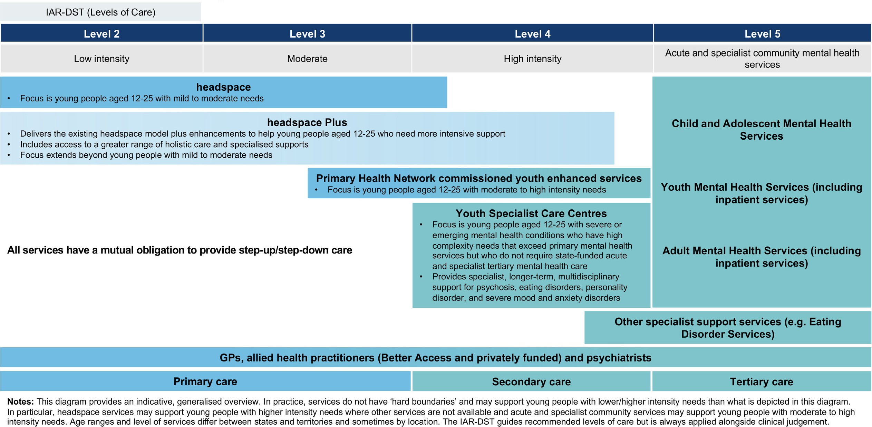
Figure 1. Overview of the position of headspace Plus and Youth Specialist Care Centres in the youth mental health service system

Introduction

Youth Specialist Care Centres (YSCC) provide specialist mental health services for young people aged 12 to 25 years with severe or emerging mental health conditions who have high complexity needs that exceed primary care, but who do not require state-funded acute and specialist tertiary treatment. The services are led through a dual leadership model comprising a Clinical Director (Psychiatrist) and an Operations Manager. Care is delivered through a multidisciplinary, syndrome-based, stage-linked, and formulation-guided model. YSCC integrate transdiagnostic care with access to syndrome-specific expertise for psychosis, eating disorders, personality disorder and severe mood and anxiety disorders. This reflects evidence that flexible, person-centred approaches better support engagement for young people with complex and overlapping needs.5 Care is developmentally informed, youth-friendly and tailored to the evolving needs of young people, recognising that mental health presentations often involve interacting clinical, psychosocial, and developmental factors.
The YSCC model builds on more than three decades of youth mental health reform, specifically the Early Psychosis Prevention and Intervention Centre (EPPIC) model and associated national early psychosis youth services (EPYS). The EPPIC model has demonstrated that youth-focused, stage-informed, and recovery-oriented care significantly improves outcomes during the early course of psychotic illnesses. YSCC extends this reform paradigm beyond psychotic disorders to a broader range of potentially severe and complex mental disorders, while retaining the structural and operational disciplines that underpin effective early intervention. The YSCC model also builds upon existing Primary Health Network (PHN)-commissioned Youth Enhanced Services (YES), which have supported young people with more complex needs over the past decade.
YSCC operate as part of a vertically integrated youth mental health system spanning prevention, enhanced primary care, specialist community care, and state-funded tertiary services. Effective care requires strong integration across these levels to reduce fragmentation, ensure young people receive care proportional to the stage and complexity of illness, and address broader psychosocial and cultural needs.4 Within this continuum, YSCC provides a high-intensity specialist service platform for young people whose needs exceed the capacity of enhanced primary mental health care but who do not require or cannot access state-funded acute and specialist tertiary treatment, while supporting coordinated pathways and shared care across services as needs change.



Service overview

Service objectives

The objectives of YSCC are to:
- Improve early identification and timely access to specialist mental health care
Provide rapid access to specialist multidisciplinary care for young people aged 12–25 with complex needs and severe or emerging mental illness.
- Deliver stage-linked, syndrome-based, and formulation-guided care
Provide coordinated, evidence-based interventions aligned to clinical syndrome(s), clinical stage, functional impact, and risk profile, integrating transdiagnostic and syndrome-specific expertise within a single service platform.
- Reduce duration of untreated illness
Minimise the duration of complex and severe or emerging mental health conditions by deploying specialist intervention early in the course of illness.
- Improve functional, developmental, and vocational outcomes
Support participation in education, employment, relationships, and community life, recognising that contribution to society through meaningful roles is a key protective factor for mental health and recovery, alongside functional and symptom improvement.
- Prevent progression of illness and relapse
Deliver proportionate, stage-matched interventions to reduce illness progression, prevent relapse and functional impairment, minimise avoidable escalation to tertiary or inpatient care, and accumulation of long-term disability.
- Strengthen physical health and long-term wellbeing
Integrate physical health screening, lifestyle intervention, and proactive metabolic monitoring to reduce long-term morbidity and improve overall health outcomes.
- Embed family-inclusive and culturally responsive care
Partner with families, significant others, and community to strengthen recovery environments, and ensure culturally safe, trauma-informed, and developmentally appropriate care that is responsive to the needs of First Nations young people and those from culturally and linguistically diverse backgrounds.
- Strengthen continuity of care
Ensure continuity of care through allocation of a key clinician, multidisciplinary collaboration, clear governance structures, structured step-up, and step-down pathways, and streamlined re-entry processes.
- Enhance workforce capability and system integration
Strengthen specialist capability through specific education, training, and supervision to support multidisciplinary youth mental health practice, structured secondary consultation, digital enablement and partnerships with primary care, tertiary services, National Disability Insurance Scheme (NDIS), and community providers.
- Operate as a Learning Health System
Embed routine outcome monitoring, measurement-based care, and continuous quality improvement processes through a nominated Clinical Quality Registry (CQR), to ensure services remain responsive, effective, and sustainable.

Target group

YSCC provide specialist, developmentally appropriate mental health care for young people aged 12–25 years whose needs exceed primary mental health services but do not require state-funded acute and specialist tertiary mental health care (including inpatient treatment).
Access is determined by clinical stage, functional impairment, and overall complexity, rather than diagnosis alone. However, certain conditions, such as psychotic disorders and anorexia nervosa, are prioritised due to their lower prevalence and higher clinical risk. In contrast, higher-prevalence conditions (e.g. mood and anxiety disorders) typically require additional indicators of complexity, including significant functional impairment, psychosocial adversity, or non-response to initial treatment.
YSCC primarily support young people presenting with Clinical Stage 1b and Stage 2 illness, where symptoms are functionally impairing or progressing. Consistent with the principle of relational continuity, young people who enter YSCC at an earlier clinical stage and subsequently experience illness progression may continue to receive care within the service into Clinical Stages 3–4, where this remains clinically appropriate and their needs can be safely and effectively met within the YSCC model.
Presentations may include, but are not limited to:
- First episode psychosis (FEP), and a subset of Ultra High Risk (UHR) with additional complex needs or adversity
- Eating disorders
- Severe or treatment non-responsive mood and anxiety disorders, especially where additional complexity or adversity is present
- Personality disorder
While clinical staging provides an anchor for evidence-informed care, young people rarely present with discrete or stable conditions. Care pathways explicitly accommodate non-linear illness trajectories. Where a young person’s presentation evolves across diagnostic groupings, the shared formulation and treatment plan are revised through multidisciplinary review rather than requiring re-assessment or a new episode of care.
Three key cross-cutting domains are consistently considered within YSCC care. Substance use assessment and treatment is understood as integral to mental health presentations, influencing risk, engagement, and recovery, and is addressed within assessment, formulation, and intervention. Neurodevelopmental differences may shape how difficulties emerge, are experienced, and respond to care, requiring adaptation in engagement and treatment approaches that may include diagnosis, therapeutic and medical interventions. Trauma, including exposure to abuse, neglect, and other adverse experiences, is recognised as a core driver of complexity and is addressed through trauma-informed care.
Young people’s presentations are often evolving, with co-occurring conditions and psychosocial adversity common. This may include experiences such as discrimination, stigma, interaction with the justice system, housing instability, disruption to education and employment, and family stress or violence. These factors interact to increase vulnerability and reinforce the importance of restoring function, participation, and connection as central to recovery.
Young people suitable for YSCC are those with mental health presentations who:
- Require specialist assessment, medication management, or targeted intervention
- Are experiencing early progression of mental health disorders
- Are experiencing significant functional challenges across education, employment, relationships, or daily living
- Require coordinated multidisciplinary care

YSCC recognise that needs may change over time, including progression to more advanced clinical stages (Clinical Stage 3-4). Where needs remain consistent with the service scope, young people may continue to receive care within YSCC to support continuity of therapeutic relationships and care planning. Where acuity or risk increases beyond service thresholds, clear pathways are in place to support timely transition to tertiary mental health services.
YSCC is not intended to replace primary mental health services for mild or transient presentations, or tertiary mental health services for young people presenting with high acuity and/or risk who require intensive care. Clear pathways exist for step-up to tertiary-based care where necessary, and step-down or shared care with primary providers as recovery stabilises. Where a young person’s presentation sits at either boundary, a shared care discussion between services determines the most appropriate care setting, guided by the principles of consumer choice, and a preference for the least restrictive and most connected care.

Through this defined but flexible cohort, YSCC aim to address the needs of young people who may otherwise fall between primary and tertiary systems, ensuring timely access to specialist, coordinated, and developmentally appropriate care.

Service principles

Accessible, timely and youth-friendly care
YSCC provide equitable, early, and timely entry to specialist mental health care for young people and their families through clear, responsive referral pathways. Referrals are accepted from health, mental health, education, and social care providers, enabling rapid access for young people with complex needs. Services are designed to actively reduce structural, cultural, financial, and geographic barriers, including distance to services and transport limitations. This includes no-cost to young people and their families, flexible service hours, outreach, and blended digital care, alongside policies that minimise administrative exclusion. YSCC do not require fixed addresses to access care and adopts flexible engagement approaches that do not penalise young people for missed appointments. Particular attention is given to improving access for young people experiencing homelessness or unstable living situations, recognising the systemic barriers they face. Environments and practices are designed to be experienced as safe by young people and families and support their engagement with the service.

Clinical care, research and digital integration and innovation
YSCC deliver specialist youth mental health care through the deliberate integration of empirical evidence, clinical expertise, digital innovation, and the lived and living experience of young people and their families. Services are led through a dual leadership model comprising a Clinical Director (Psychiatrist) and an Operations Manager. Care is delivered by appropriately skilled multidisciplinary teams and guided by clinical staging frameworks that match interventions to a young person’s stage of illness progression, complexity of needs, and risk, enabling timely, proportionate, and evidence-based responses. Clinical practice is connected to translational research and sector innovation, with active participation in research and quality improvement partnerships and the purposeful integration of evidence-based digital tools to enhance access, engagement, continuity, personalisation, and effectiveness.

Holistic, comprehensive, and integrated care
YSCC deliver holistic, biopsychosocial care through multidisciplinary teams with advanced capability across psychiatry, psychology, medicine, nursing, allied health, psychosocial and lived experience disciplines, providing comprehensive assessment and specialist support for young people with complex needs. Care is underpinned by integrated care planning and coordination, ensuring services work together rather than operating in parallel, with a shared understanding of needs, priorities, risks, and roles across systems. This supports continuity, particularly where needs span mental health, education, disability, social supports, and home environments.
Psychiatric assessment and medical leadership are integral to diagnosis, clinical staging, risk management, and safe, effective intervention. Care recognises the interaction of biological, lifestyle, psychological, social, cultural, relational, environmental, and developmental factors, delivering evidence-informed clinical, psychosocial, digital, educational, vocational, and community-based supports that promote recovery, participation, and long-term wellbeing. Embedded psychosocial capability ensures social determinants, including participation in
education and employment, are addressed as core components of care, supporting identity, social inclusion, and contribution to society.

Developmentally appropriate, individualised, and stage-informed care
YSCC deliver care tailored to each young person’s developmental stage, clinical stage, history, preferences, and goals. The service recognises that young people span a broad range of ages and developmental stages, and that concepts such as autonomy, consent, confidentiality, safety, decision-making and care planning must be understood
and applied in ways that reflect both chronological age and developmental context. Autonomy within this model is understood as developmentally
and relationally situated. The degree and form of autonomy exercised by young people varies according to age, developmental capacity, circumstances, and reliance on family or other
supports. For children and young people under 18 years, autonomy is exercised within the context
of parental responsibility and family involvement, with shared decision-making increasing as age and capacity develop.
Interventions are evidence-based and matched to stage, complexity of needs, and acuity, prioritising the least intrusive and most appropriate options while enabling timely step-up or step-down responses as needs change. Care is delivered within defined episodes and coordinated with referrers and partner services to ensure continuity, shared responsibility, and planned transitions.
Care planning is collaborative, dynamic, and regularly reviewed, promoting autonomy, shared decision-making, and self-management in ways that are developmentally appropriate and aligned with the young person’s evolving capacity, strengthening independence and long-term wellbeing. Services are delivered in youth-friendly environments designed to promote accessibility, engagement, and recovery-oriented care.

Young person-centred, participatory, and hope-oriented practice
YSCC place each young person’s preferences, values, goals, and circumstances at the centre of care, collaborating with them, their families, and supporters to identify strengths, build
resilience, and support recovery and participation in everyday life. Practice is delivered through respectful, empathetic, and transparent therapeutic relationships, with shared and supported decision-making embedded in treatment planning. Care actively upholds young people’s rights, autonomy, and self-determination, enabling them to make informed choices and define their own goals, priorities, and recovery pathways. Young people are provided with clear, evidence-based information about the potential benefits and
risks of treatment options and are supported to express what matters most to them. Participation extends beyond individual care into service design, delivery, governance, evaluation, and community engagement, with lived and living experience recognised as equally valuable to clinical and scientific expertise. This is enabled through structured and supported mechanisms, with each service required to establish a Youth Advisory Council and other advisory structures as is beneficial to the local context.

Inclusive, culturally responsive, and intersectional care
YSCC recognise and respond to the diverse cultural, social, linguistic, gender, disability, neurodiversity, and identity contexts in which young people live. YSCC adopts an intersectional approach to how overlapping experiences of marginalisation shape mental health, help-seeking, engagement, and understandings of wellbeing.
Care is delivered in culturally safe, respectful, and accessible ways for all young people, including those from culturally and linguistically diverse, refugee and migrant backgrounds, LGBTIQA+ young people, young carers, young people in regional, rural and remote communities, and others underserved by existing systems.
For Aboriginal and Torres Strait Islander young people and families, cultural and spiritual perspectives are embedded across all aspects of care, and cultural safety is an ongoing, context-responsive practice that reflects community context, including significant events, family dynamics, and cultural obligations. This is consistent with the Gayaa Dhuwi (Proud Spirit) Declaration and the shared decision-making and data and information sharing Priority Reforms under the National Agreement on Closing the Gap. YSCC are intended to operate in partnership with Aboriginal Community Controlled Health Organisations (ACCHOs), recognising their
leadership in delivering culturally grounded models of care.
Care is proactively adapted to accessibility needs, including communication differences, sensory sensitivities, and cognitive or processing
differences, through flexible, sensory-informed, and culturally appropriate approaches, including access to interpreters, translation, and communication supports (including for Deaf and hard of hearing young people). Services are delivered in physically accessible premises, including for young people requiring mobility aids.

Trauma-informed, safe, and rights-based care
YSCC are underpinned by a trauma-informed approach that recognises how personal, interpersonal, and intergenerational trauma, along with attachment disruption and neglect, affect mental health, development, relationships, and service engagement, particularly for young people with experiences of out of home care. This includes recognising and responding to family violence as
a common and often under-identified experience among young people, as well as the complex and cumulative trauma experienced by young people from refugee and asylum seeker backgrounds, including exposure to conflict, displacement, loss, and ongoing resettlement stressors. All aspects of care promote physical, emotional, cultural, and psychological safety and actively seek to prevent re-traumatisation. Trauma-informed principles are embedded across organisational policy, service environments, clinical practice, and workforce development, with staff trained to recognise and respond to trauma in young people, families and colleagues in ways that support recovery and empowerment. Suicide risk assessment, safety planning and risk management are integrated into care in ways that balance safety with dignity, autonomy, and hope, consistent with a rights-based approach that prioritises autonomy, dignity, and self-determination in all aspects of care.

Family-inclusive, relational, and network-oriented practice
“Family” is understood broadly to include parents, siblings, extended kin, partners, friends, and chosen family, including culturally defined kinship systems for First Nations young people. YSCC values and works with the wider relational networks that foster connection, resilience, and sustained wellbeing.
YSCC is underpinned by a commitment to family inclusive practice as a foundational approach
to care for young people. YSCC recognise the essential role of families and support networks in a young person’s recovery and wellbeing, including beyond the age of 18, and delivers family-inclusive practice that is flexible and responsive to the young person’s wishes, needs, developmental stage, cultural context, and family structure.
For young people aged 12–17, family-inclusive practice is developmentally appropriate, aligned with the legal responsibilities of parents and
guardians, and informed by Australia’s obligations under the United Nations Convention on the Rights of the Child (particularly Article 5). Families and supporters are key partners in assessment, care planning, safety planning, recovery, transitions, decision-making, and information sharing unless there are strong reasons not to do so. Family and supporter involvement recognises the young person’s emerging autonomy and evolving capacity to participate in decisions about their care.
For young people aged 18–25, care places greater emphasis on autonomy and self-determination, while recognising that family and supporter involvement often remains critical to recovery, continuity, and wellbeing, particularly for those who live with, rely on, or choose to involve their family.
Families, including siblings, and support networks are recognised and engaged as active partners in care wherever possible, bringing valuable knowledge, insights, and skills that strengthen a young person’s recovery. They are provided with information, resources, and opportunities to further build their capacity to contribute. Engagement with families is approached with flexibility and sensitivity, recognising that families may also be navigating their own challenges and are not always the primary pathway for engagement. Families and support networks are also provided with access to their own supports, such as carer and sibling support.

Prevention, early intervention, and recovery-oriented systems
YSCC prioritise early and timely intervention for young people experiencing complex or escalating mental disorders, recognising that targeted intervention can positively influence clinical, functional, and developmental trajectories and reduce risk of progression. Recovery is understood as a personal and non-linear process encompassing symptom improvement, functional gains, identity development, and quality of life. YSCC contributes to broader prevention and early intervention through partnership, consultation, and shared care across the service system, acknowledging the role of social determinants and community-level protective factors in mental health. The model strengthens system coordination, capability, and referral pathways, and supports planned transitions to self-management, peer support, and community-based care (e.g. social prescribing and youth wellbeing hubs) to sustain wellbeing beyond specialist involvement.

Learning Health System
YSCC operate as a Learning Health System committed to continuous improvement, transparency, and accountability, in which data collected through routine care is systematically captured, analysed, and used in real time to inform practice. Meaningful clinical data flows through integrated mechanisms, including a nominated CQR, real-time evaluation pipelines, and measurement-based care, and is supported by access to relevant state-based data systems where appropriate, directly informing clinical decision-making. New knowledge is created through structured evaluation and reflective processes and rapidly translated into service improvement, embedding learning within everyday care rather than as a separate research function. This continuous cycle of data capture, analysis, and feedback drives ongoing improvement.
Young people and families are active partners in service design and quality improvement. As a
socio-technical system, this approach is enabled by clinical leadership, workforce capability, robust data governance, and a culture of trust and psychological safety that supports innovation, critical reflection and measurable improvement in outcomes, safety, and experience.



Minimum service requirements

To maintain consistency and fidelity across the network, YSCC are expected to implement the complete set of core components and enabling practice elements that underpin the model of care. These requirements ensure that young people across locations can access a comparable standard of specialist youth mental health care, while allowing flexibility for local adaptation.

Core service components
YSCC must deliver an integrated, multidisciplinary model of specialist youth mental health care
that provides all the core service components as described in Section 4. This includes a dual leadership model comprising clinical and
operational oversight. Leadership is visible and accessible within the service. The Clinical Director and Operations Manager maintain a regular onsite presence at the service during core operating hours, and a designated senior clinician provides onsite clinical leadership when the service is operating, including during extended and weekend hours. Where services operate across hub
and spoke sites, arrangements ensure regular onsite leadership presence at each location.
Care is coordinated through shared formulation and diagnosis, with a nominated key clinician responsible for care coordination and continuity, including planned re-engagement where appropriate. Services provide access to psychiatric assessment and evidence-based, stage-informed interventions across key diagnostic groupings, complemented by transdiagnostic supports.
Targeted outreach is undertaken to improve access for young people who face barriers to care.
Care delivery integrates physical health, substance use, and functional recovery, and is supported by measurement-based care and routine outcome monitoring to inform clinical decision-making and track progress. Digital tools are used to enhance engagement, continuity, and effectiveness.
Services embed family-inclusive, culturally responsive, and recovery-oriented practice, including the integration of peer support roles. Services maintain capability to identify and respond to family violence, including risk assessment, safety planning, and trauma-informed intervention.
These core service components are supported by a set of enabling practice elements that underpin consistent and effective implementation across diverse service contexts.
Strong partnerships with local services, including headspace services, Primary Health Networks, hospitals, state-funded and specialist tertiary services, and community providers, are central to supporting integration with existing systems and delivering coordinated care. Structured intake, assessment, and proactive transition processes and clear pathways for step-up and step-down care are locally agreed upon to minimise disengagement and support continuity.

Service availability and operating hours
YSCC operate scheduled service hours that extend beyond standard business hours, improving access for young people and families whose education, employment, or caring responsibilities make weekday daytime appointments difficult. At a minimum, each large and medium service must:
- Provide extended hours at least one weekday per week
- Open on at least one weekend day each week
- Extend operating hours further where local demand, population need, or access and utilisation data indicate this is required
Weekend and extended hours apply at minimum to access, engagement, and scheduled appointment functions, with the full multidisciplinary team operating during business hours.
Services maintain clear pathways to state-funded crisis and tertiary services outside operating hours, so that young people and families understand
how to access urgent support when the service is closed.
Operating hours are set in consultation with young people, families, and local partners, and reviewed over time against demand and utilisation data to ensure they remain responsive to community need.

Enabling practice elements

Cultural safety and responsiveness
Services are culturally safe, inclusive, and responsive to the diverse identities and
experiences of young people. This includes
Aboriginal and Torres Strait Islander young people, culturally and linguistically diverse communities, LGBTIQA+ young people, and those with disability or neurodivergence. Care recognises the experiences of marginalisation, including the impacts of colonialism and racism on engagement with services, and actively works to address these barriers.
YSCC provides access to language and cultural supports (e.g. interpreters, translation tools, cultural brokerage, and tailored communication), to improve access and service quality for people from diverse cultural, linguistic and faith communities. Services build and sustain relationships with local Aboriginal Community Controlled Organisations (ACCOs) and ACCHOs and align care with the Social and Emotional Wellbeing (SEWB) framework for First Nations young people.6,7 This is consistent with the Gayaa Dhuwi (Proud Spirit) Declaration and the shared decision-making and data and information sharing Priority Reforms under the National Agreement on Closing the Gap Care is informed by, and responsive to, cultural practices and belief systems that shape the social and emotional wellbeing of First Nations young people and families.

Inclusive approaches for priority populations
Each YSCC develops and implements an inclusion plan describing how the service will identify, engage and respond to priority populations within its catchment. Priority populations include Aboriginal and Torres Strait Islander people, LGBTIQA+ young people, neurodivergent young people, culturally and linguistically diverse communities, refugee and asylum seeker young people, young people in out-of-home care, young people in contact with justice systems, young people with caring responsibilities, and young people experiencing social or geographic disadvantage. The plan is developed with local communities and priority population representatives, describes tailored engagement and access strategies, sets measurable access and outcome expectations, and is reviewed at least annually against service data on access, experience and outcomes.

Embedding lived and living experience
Lived and living experience perspectives are embedded across service design, delivery, governance, and quality improvement, including integration of peer workforce roles.⁸ YSCC support meaningful participation and leadership of young people and families through organisational structures, culture, and capability that enable genuine influence.

Family, carers, and supporters
Families, carers, and supporters are recognised as key partners in recovery. Family-inclusive practice is embedded across a spectrum of involvement, responsive to need, preference, and clinical complexity. A developmentally informed approach balances autonomy and family involvement, particularly for young people aged 18–25, ensuring participation is safe, appropriate, and aligned with the young person’s preferences and consent.

Developmentally appropriate care
YSCC adopts a developmentally informed approach to care, explicitly integrating the needs of young people across early adolescence (approximately 12–14 years), late adolescence (approximately 15–18 years), and early adulthood (18+ years). Care delivery recognises that both normative developmental processes and emerging or established mental ill-health influence engagement, presentation, and response to intervention.
Care is tailored to developmental stage, with the emphasis of care shifting in response to developmental need. In early adolescence, care is more likely to prioritise family involvement, school engagement, and support for emotional
and social development. In late adolescence, care places greater emphasis on increasing autonomy, identity formation, and engagement in education and vocational pathways. In early adulthood, care prioritises independence, life transitions, and participation in employment, higher education, and community life.

The model of care is applied in conjunction with these developmental considerations, ensuring care is responsive not only to clinical need but also to the young person’s developmental context, strengthening engagement, relevance, and effectiveness of interventions.

Co-design
YSCC embeds co-design as a core approach to service development, delivery, and improvement, and as an ongoing commitment to partnership, innovation and accountability. Young people and families actively shape planning, implementation, and evaluation, including the fit-out and design of service environments and facilities in collaboration with local communities, and YSCC staff. Co-design processes engage a diverse range of participants who reflect the communities served by the YSCC and are designed to accommodate varying
needs and accessibility requirements to enable meaningful participation. Clear feedback loops demonstrate how input leads to service changes, strengthening accountability, responsiveness, and the creation of youth-friendly environments.

Youth-friendly and inclusive environments
YSCC provide environments that are welcoming, safe, and developmentally appropriate, and inclusive, supporting engagement and a sense of belonging. Youth-friendliness extends beyond physical space to include access, staff culture, flexibility of care, and relational, strengths-based practice. Environments and service delivery approaches must accommodate sensory, communication, and accessibility needs, supporting comfort, safety, and engagement for young people with neurodivergence, disability (including physical, sensory, cognitive, and psychosocial disabilities), and chronic health conditions.
Services are co-designed with young people and are culturally safe and inclusive, reducing stigma and supporting sustained engagement. This includes consideration of the needs of First
Nations young people, culturally and linguistically diverse communities, refugee and asylum seeker young people, LGBTIQA+ young people, and other priority populations to ensure environments and service approaches are responsive to the diverse identities, experiences, and circumstances of the communities they serve.

Out of scope functions
YSCC provide coordinated, formulation- and diagnosis-led care for young people experiencing complex, emerging, or persistent mental health difficulties that exceed the capacity of brief or
low-intensity services but do not require state-funded acute and specialist community mental health services (including inpatient treatment). The service is not a substitute for acute, residential, Hospital in the Home, or 24/7 crisis services, and does not replace state-delivered specialist mental health care. The use of Community Treatment Orders (CTOs) varies across states and territories in accordance with relevant mental health legislation and depends on the type of lead agency, such as whether the service is a designated mental health service or a non-government organisation (NGO).
Flexibility within scope includes:
- Stepped intensity of intervention (increasing or reducing frequency and modality as required)
- Blended delivery (in-person, outreach, telehealth)
- Shared care arrangements with General Practitioners (GPs) and other providers
- Coordinated integration of specialist and transdiagnostic interventions
All care is subject to regular multidisciplinary review, outcome monitoring, and risk assessment to guide continuation, transition, or discharge.
Services that are out of scope for YSCC:
- Inpatient or 24-hour crisis response services
- Indefinite care without clinical review and defined treatment goals
- Disability support services provided through NDIS
Clear referral, escalation, and transition pathways are maintained to ensure young people can move safely and efficiently across the broader mental health system as their needs change.

Enablers

Effective implementation of the YSCC model of care requires a set of enabling conditions to support consistent, high-quality delivery, and these must be addressed during service commissioning. These enablers provide the organisational, workforce, and system foundations required to translate the model into practice. While consistent in intent, their application may vary locally to reflect community needs and service contexts.

Leadership, culture and shared vision

Effective implementation requires strong dual leadership comprising a Clinical Director (Psychiatrist) and an Operations Manager, grounded in a shared vision. Leadership supports integrated, youth-centred care across diagnostic boundaries, sectors, and acuity levels, with a focus on early intervention, recovery, and functional outcomes. It also fosters an inclusive, scientifically grounded culture that embeds young people, families, and lived experience representatives as partners, supports First Nations and cultural leadership through local pathways, and sustains a skilled workforce through collaborative and reflective practice.

Governance, accountability, and system stewardship

Robust clinical governance underpins quality, safety, risk management, and system integration. Governance arrangements enable clinical leadership, inter-agency coordination, and clear accountability for outcomes across sectors. They ensure safe, high-quality care across the full spectrum of need, maintain fidelity to an evidence-based model, reduce fragmentation and unwarranted variation, and support continuous learning while allowing local flexibility.

Measurement based-care, continuous learning, and a learning healthcare system

Measurement-based care operationalises YSCC’s role as a Learning Health System through the routine collection, use, and reporting of clinical, functional, and experience data to inform real-time care and evaluate outcomes. A nominated CQR is embedded within care, supporting clinical decision-making, care planning, team-based coordination, and referrals. At a service level, the CQR enables performance monitoring, data linkage with national datasets, and continuous quality improvement, informing refinement of care and understanding of longer-term outcomes and system impact. YSCC also support clinical trials through collaboration with Clinical Trial Networks (CTNs) and platform trials, accelerating translation of evidence into practice. A continuous learning approach ensures YSCC remains adaptive and evidence informed.

Technology, digital capability, and data infrastructure

Digital capability underpins how care is delivered and shared. Integrated digital technologies and evidence-based tools support accessible, flexible, and blended care across in-person, outreach, and telehealth settings. Shared or interoperable digital systems across key service partners are essential to integrated care, enabling timely information exchange, reducing duplication, and enhancing safety. Digital solutions must be practical, resourced, and designed to support care delivery without creating additional administrative burden. All systems must comply with the principles of Indigenous Data Sovereignty (IDS) and Indigenous Data Governance (IDG), including clear arrangements for data governance, ownership, and how communities benefit from the use of their data.

Workforce development, capability, and sustainability

A capable, supported, and sustainable workforce is fundamental to YSCC delivery, requiring clinicians and peer workers to provide transdiagnostic, stage-informed, developmentally appropriate youth-centred and recovery-oriented care across the full spectrum of need, including emerging psychosis and complex presentations. Workforce capability must include skills in adapting care to accessibility needs, including communication support and sensory-informed practice.
High-quality supervision, consultation, reflective practice, and professional development are essential to clinical quality, workforce wellbeing, and retention, while team-based and shared-care models strengthen capability, role clarity, and knowledge transfer across services. Workforce capability must extend to integrated face-to-face and digital care to deliver continuous and responsive support. Structured student and early-career pathways support recruitment, retention, and sustainability. This includes structured leadership development, with planning and transition support for staff moving into senior clinician, team leader, and other leadership roles.
A culturally safe and supported workforce is essential. This includes not only employing Aboriginal and Torres Strait Islander staff, but ensuring access to cultural supervision, peer support, and communities of practice that enable connection, reflection, and shared learning. Workforce planning must also align with the National Aboriginal and Torres Strait Islander Health Workforce Strategy.

Multidisciplinary, team-based, and relational care

YSCC are a specialised model led by a dual Clinical Director and Operations Manager structure and delivered through multidisciplinary teams that integrate diverse professional and lived experience roles to address the complex, interrelated needs of young people. Team-based care requires clear roles, shared accountability, and effective communication within and across services to support coordinated delivery. Multidisciplinary collaboration enables integrated interventions addressing mental health, physical health, functioning, and social determinants of wellbeing. This includes capability to respond to family violence and complex trauma, recognising their prevalence and impact on young people’s mental health, safety, and recovery.

Partnerships, integration, and coordinated pathways

Strong partnerships across and beyond the mental health system are essential to YSCC, enabling coordinated support and clear pathways across levels of intensity to improve access, engagement, continuity, and outcomes. Given the complexity of the service system, clear navigation, and shared understanding of need (including definitions of severity and complexity) are critical to support young people, families, and referrers to access the right care at the right time. Integration may be operationalised through partnership-based service arrangements involving state-funded mental health services alongside primary and community partners. A shared language across services and multidisciplinary teams supports communication, reduces access barriers, and promotes consistent quality of care, and may require targeted workforce development.
Integration within YSCC is as important as integration between services and is supported through blended clinical, psychosocial, and digital models that reduce fragmentation, minimise repeated storytelling and sustain continuity as needs change.
Partnerships with specialist services, primary care and community providers address the broader determinants of wellbeing. This includes connections with education, employment, housing, justice and social services, and NDIS providers. Coordinated pathways may be enabled through co-location, formal agreements, shared care arrangements, embedded roles, and defined referral and consultation processes, supported by shared values, clear accountability, strong information governance and flexible step-up and step-down care. Effective integration requires dedicated resourcing to support coordination, partnership management, and system navigation.

Lived experience, participation, and co-design

Meaningful inclusion of lived and living experience is a critical enabler of YSCC, underpinning genuinely person-centred and participatory care by embedding the expertise of young people, families, and supporters across design, delivery, governance, and evaluation. This requires intentional structures, resourcing, and capability to support participation across system levels, including co-design, lived experience roles, and involvement in leadership, governance, and advisory functions, alongside clear pathways to peer support within care. Services must actively engage diverse young people and families in ways that are safe, accessible, and developmentally appropriate, using mechanisms such as advisory groups, consultation processes, surveys, and embedded roles, supported by training, remuneration, and feedback loops to ensure genuine influence rather than tokenism. Sustainable implementation requires investment in lived experience leadership, role clarity, supervision, and workforce development.

Local adaptation and equity of access

While grounded in core components and principles, YSCC must remain flexible and responsive to local population needs, service contexts, and infrastructure. The model is designed to be implemented by building on and strengthening existing service environments. This approach supports adaptation to local conditions while maintaining effectiveness across varying levels of acuity, complexity, and system integration. The current model has been primarily developed for metropolitan and regional contexts and will require structured adaptation to ensure feasibility and effectiveness in rural and remote settings.
Local adaptation is informed by engagement with communities, including regional and underserved populations, and guided by evidence to ensure approaches are appropriate and effective. Local adaptation enables services to address inequities in access and outcomes for groups underserved by the mental health system, including Aboriginal and Torres Strait Islander young people, culturally and linguistically diverse communities, rural and regional communities facing challenges in access, workforce availability, and service connectivity, and LGBTIQA+ young people.
Within the agreed service area, all young people should have access to the full range of YSCC core components, with local adaptation enabling equitable delivery rather than variation in the quality or level of care. This includes using a hub-and-spoke model to ensure equitable access and geographical reach, coordinated care, and efficient use of workforce and specialist capability.

Service components

YSCC deliver specialist youth mental health care through a transdiagnostic, stage-informed model. Care is organised according to clinical stage and delivered through phase-specific interventions that adapt as needs change.
Core interventions are delivered through multidisciplinary care teams using shared formulation, coordinated care planning and phase-specific treatment approaches. While care is primarily delivered through a transdiagnostic, formulation-informed approach, syndrome-specific expertise is introduced where symptoms are present. Specialist interventions for psychosis, eating disorders, personality disorder and severe
mood and anxiety disorders operate within the same multidisciplinary service platform, ensuring young people receive coordinated care rather than fragmented disorder-specific treatment.
Implementation is operationalised through 17 core components that together form an integrated system of specialist youth mental health care.
These components are consistent across sites to ensure fidelity and equity, while allowing appropriate local adaptation to community context, population needs, and service arrangements. Collectively, they are designed to operate in coordination with the broader service landscape to support continuity across levels of need.

1. Community awareness, mental health literacy, and early detection
2. Access and referral pathways
3. Entry and assessment
4. Shared formulation and diagnosis
5. Outreach and assertive engagement
6. Key clinician and care team members
7. Psychiatry and medical interventions
8. Psychological therapies
9. Youth peer support
10. Physical health
11. Integration of substance use care
12. Functional and psychosocial recovery
13. Family programs and family peer support
14. Integration of digital care
- Specialist interventions:
  - Psychosis
  - Eating disorders
  - Personality disorder
  - Severe mood and anxiety disorders
16. Demand management and episodes of care
17. Transition of care

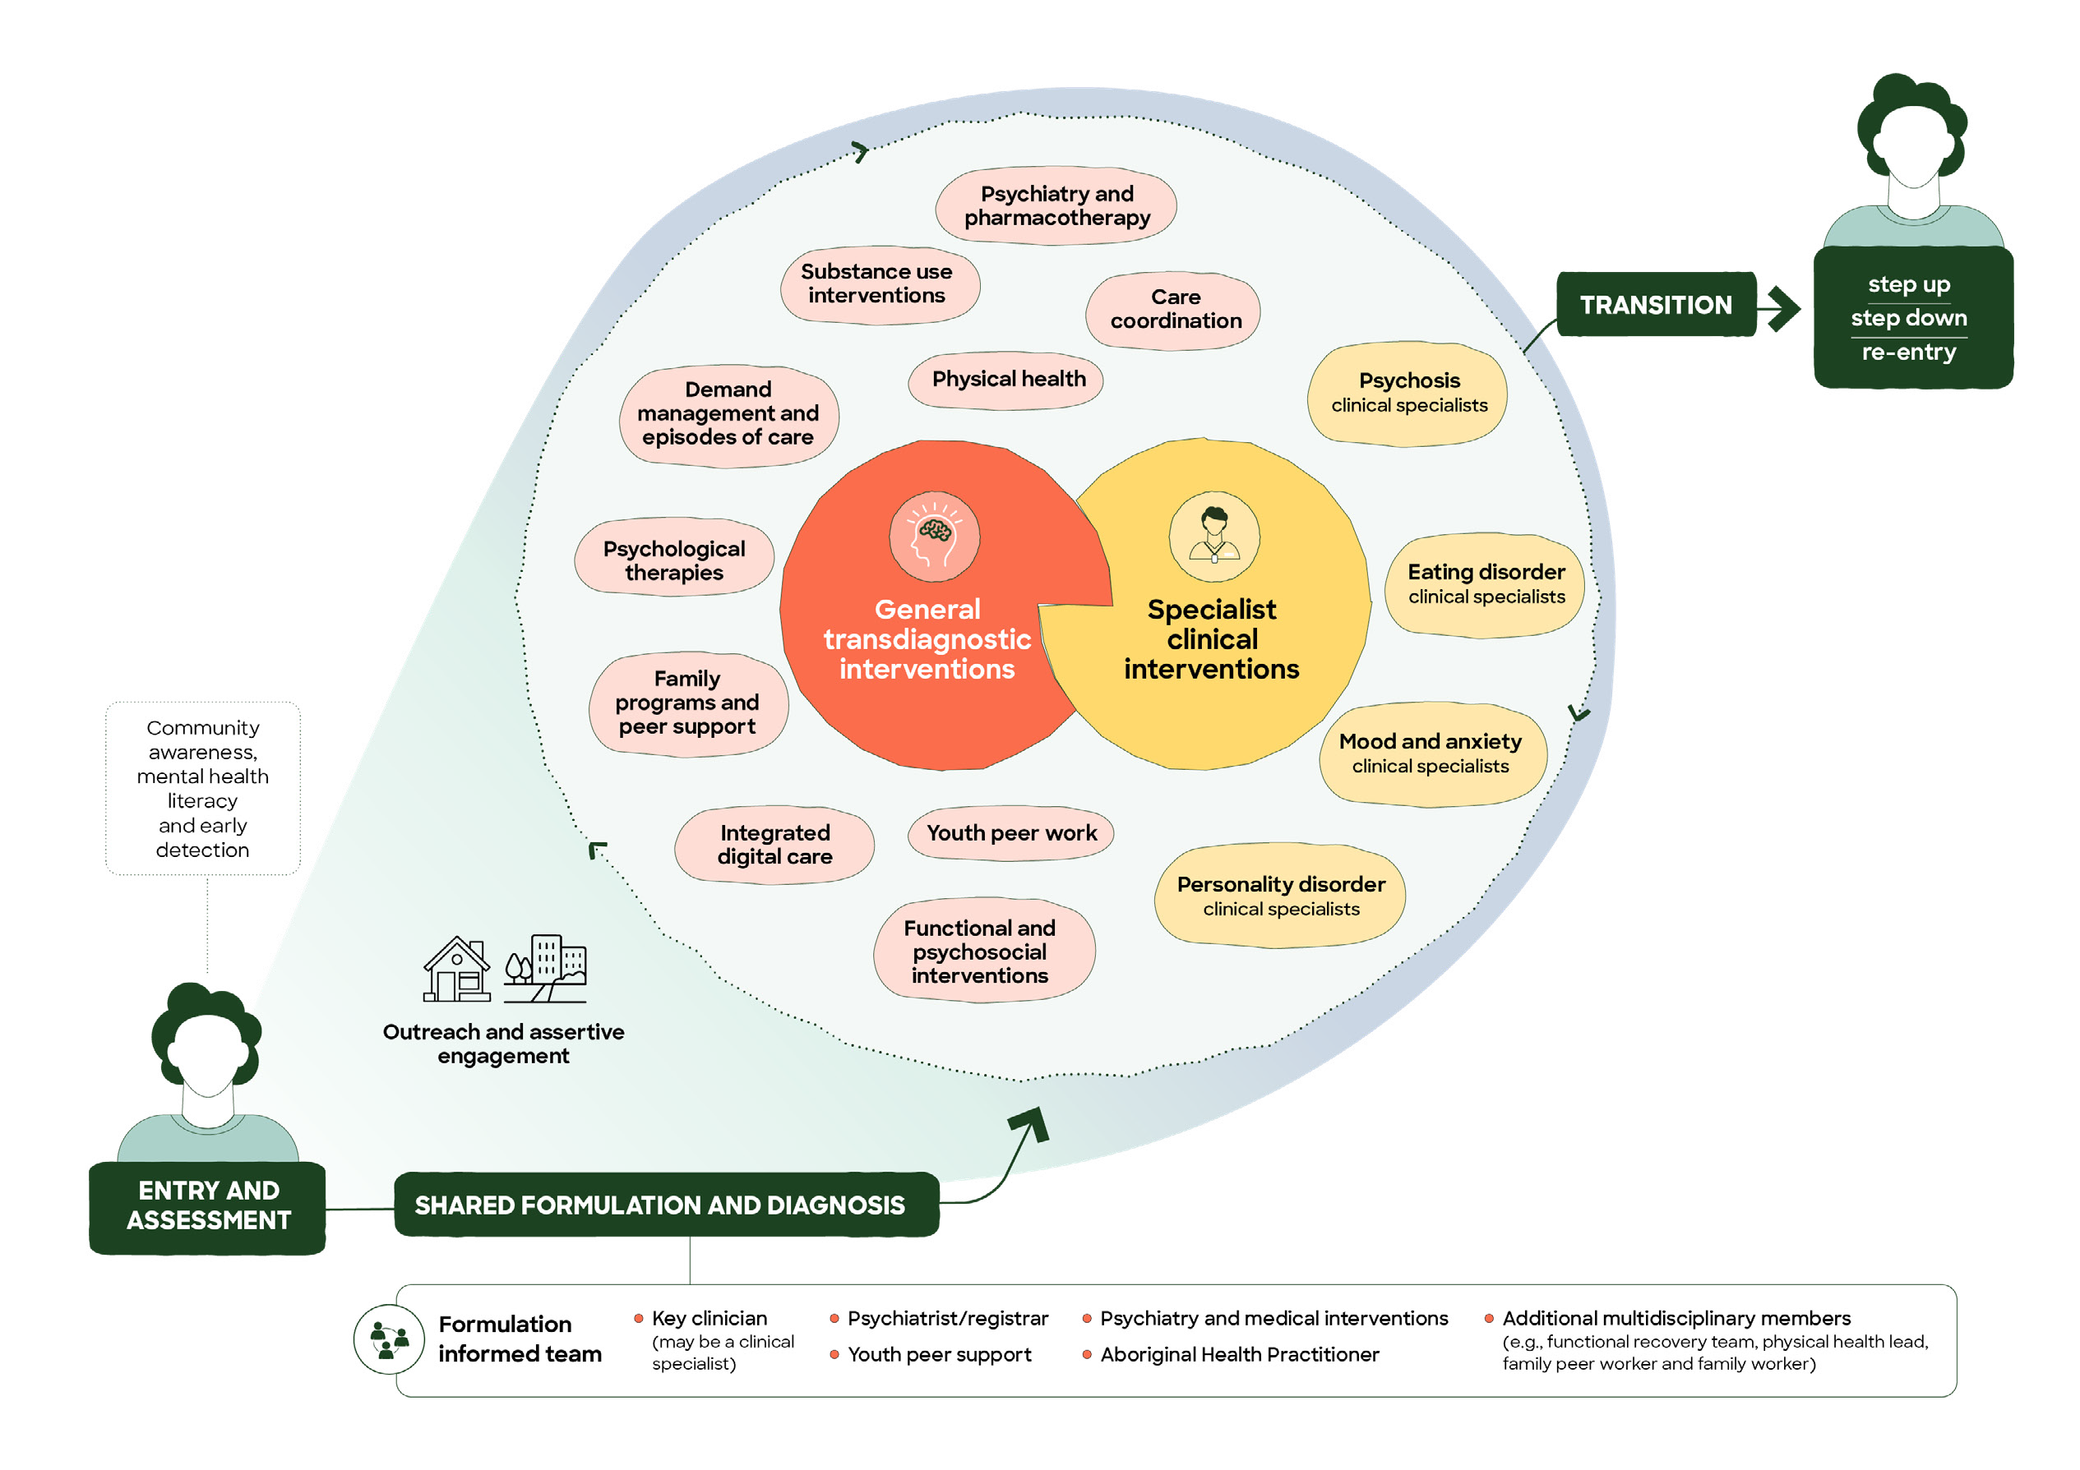

Figure 2. Service Components

Youth Specialist Care Centres Model of Care | 23

Community awareness, mental health literacy, and early detection

Community awareness, mental health literacy, and early detection are core operational components of YSCC. Together, they enable earlier identification of young people with severe or emerging mental health difficulties, strengthen referral pathways, and reduce delays in accessing appropriate care. These functions also improve system navigation and referral quality across the youth mental health continuum. In this context, YSCC focus on building awareness and detection of severe, complex, and emerging mental health conditions requiring specialist care, complementing primary care platforms such as headspace rather than duplicating their mental health promotion and early help-seeking role.

Community awareness
YSCC maintain structured, ongoing engagement with key referrers, including GPs, headspace centres, private practices (including Medicare Benefits Schedule (MBS)-funded providers), education providers, community organisations, ACCHOs, and state-funded mental health services. Engagement is co-designed where possible, tailored to local contexts, and focused on strengthening recognition, response, and pathways into care, including using language and concepts that reflect how communities understand care and wellbeing, rather than relying solely on clinical terminology. For example, working with multicultural youth and families to co-design resources and tools to help their young people with mental health services.
YSCC also undertake targeted communication and promotion of the service to ensure visibility and accessibility for young people, families, and communities. This includes developmentally appropriate, culturally responsive, and accessible information delivered through multiple channels (e.g. digital platforms, social media, community campaigns, and local outreach), supporting awareness of how and when to seek help. This includes developing relationships with cultural organisations and community members to build trust in the YSCC.
Measures used to assess the reach, quality, and impact of community awareness may include:
- Reach and frequency of engagement and promotional activities
- Diversity of stakeholders and communities engaged
- Participation rates from priority populations
- Changes in referral source patterns
- Awareness and understanding of YSCC within target populations

Mental health literacy
YSCC deliver education, consultation, and clear referral guidance to improve recognition of early warning signs and understanding of clinical staging, functional impact, access criteria thresholds, and care pathways. Communication is developmentally appropriate, recovery-oriented, culturally responsive and co-designed with young people and families.
Measures of the reach, quality, and effectiveness of YSCC education, consultation, and referral guidance may include:
- Number and type of education and consultation activities
- Workforce participation across sectors
- Pre-post changes in knowledge, confidence, and capability
- Appropriateness and quality of referrals

Early detection
YSCC establish clear, accessible, and coordinated referral pathways across primary, community, and tertiary services to support timely access to the most appropriate level of care and reduce fragmentation. Early signs of distress are often first recognised outside the formal mental health system, by families, peers, educators, youth workers, coaches, cultural leaders, and others in the community, and YSCC actively engage these groups to support recognition and pathways into care.
Early detection is supported not only through referral pathways, but also through proactive case-finding approaches, including mobile and outreach capacity to identify and engage young people who may not present through traditional pathways.

For priority conditions such as FEP and eating disorders, early detection includes assertive outreach and targeted community engagement to reduce duration of untreated illness and improve early access to evidence-based care.
Measures of the effectiveness, timeliness, and accessibility of referral pathways and case-finding approaches may include:
- Referral volumes and sources (including outreach and non-traditional pathways)
- Timeliness and completeness of referrals
- Proportion of referrals meeting access criteria
- Time from referral to initial assessment
- Time from symptom onset to treatment (e.g. duration of untreated psychosis)
- Time from first service contact to initiation of care
- Distribution of presentations by clinical stage
- Timeliness of response for higher-risk cohorts

Access and referral pathways

Access
YSCC provide specialised, evidence-informed care for young people whose mental health needs are significantly impacting their life, and who require a level of support beyond that typically available in primary care settings. The service specifically supports access to specialised, evidence-based care for young people with attenuated and/or symptoms of severe or emerging mental health conditions.
Access is guided by both:
- Clinical presentation (clinical decision informed by staging model)

Youth Specialist Care Centres Model of Care | 25
- Recommended level of care (Initial Assessment and Referral Decision Support Tool [IAR-DST] - Level 4)
Young people are eligible to access the service if they:
  - Are aged 12 to 25 years, and
  - Are experiencing mental health distress, emerging mental illness, or psychosocial difficulties that are equivalent to Level 4 (high intensity services) on the IAR-DST, and
  - Present with mental health needs consistent with:
    - Sub-threshold symptoms of severe mental illness, with functional decline and additional complexity indicators (Clinical Stage 1b), (see Table 1), or
    - A full-threshold disorder, with moderate to severe symptoms and functional decline (Clinical Stage 2) (see Table 1), or
    - Previously received treatment within a YSCC and require re-entry to support continuity
of care following relapse or changes in clinical presentation or functioning
The young person must not:
  - Require inpatient care, 24-hour support, or intensive tertiary interventions due to acuity, risk, or clinical instability
Note that the use of CTOs will be determined at a local service level, reflecting variation in state and territory mental health legislation and the type of lead agency (e.g. designated mental health service or non-government organisation).
Where demand exceeds capacity, access is prioritised according to clinical risk and rate of deterioration, low-prevalence, high-severity presentations, severity of functional impairment, and the absence of an alternative service able to safely meet the young person’s needs. Prioritisation decisions are made through structured streaming frameworks and are documented, with young people who are not prioritised for immediate entry provided with active, warm referral and interim support.

Table 1. Clinical staging model

STAGE | SYMPTOMS | FUNCTIONING | NEUROCOGNITION
0 | No current symptoms; increased risk of disorder | No historical change | Normal to mild deficits
1a | Mild or non-specific symptoms | Mild functional change or decline | Mild neurocognitive deficits or relatively normal profile
1b | Moderate but sub-threshold symptoms | Moderate functional decline | Moderate neurocognitive changes, particularly in attention, learning, or executive function
2 | Full-threshold disorder with moderate to severe symptoms | Functional decline | Neurocognitive deficits
3 | Incomplete remission or relapse | Persistent functional decline | Persistent decrement in neurocognition, including social cognition
4 | Severe, unremitting, or refractory illness | Poor treatment effectiveness despite persistently intensive interventions | Poor treatment effectiveness despite persistently intensive interventions

Note. Adapted from Scott et al. (2024)⁹

Access is confirmed through the initial screening, triage, and assessment process, which includes multidisciplinary assessment and shared formulation. Structured tools, including the IAR-DST and clinical staging models are used to support understanding of the young person’s level of need and to inform care planning.
Where a young person’s needs are better aligned with another service (e.g. primary care, mental health tertiary care), staff will support active, warm referral and navigation support to the most appropriate alternative service. Active, warm referral and navigation support includes:
  - Direct communication between services to facilitate referral (e.g. phone or case discussion)
  - Sharing relevant clinical information, with consent, to support continuity of care
  - Supporting the young person to understand and engage with the referral, including appointment coordination where needed
  - Confirming successful connection with the receiving service, with follow-up where appropriate
  - Maintaining involvement until care is effectively transferred, particularly where there is elevated risk or vulnerability
  - Where a receiving service declines a referral, retaining clinical responsibility for the young person, convening a shared-care discussion with the receiving service, and agreeing an interim support plan, so that no young person is left without a service while eligibility or suitability is resolved
  - Identifying young people at increased risk of disengagement, including those with previous disengagement from services, unstable housing, justice involvement, or trauma-related avoidance, and proactively offering assertive engagement and outreach (Section 4.5) throughout the referral and transition period

Diagnostic and stage-informed streaming
To ensure equitable access and service sustainability, YSCC operates a structured streaming framework informed by:
  - Clinical stage (Stage 1b; Stage 2, and incomplete remission or relapse Stage 3-4)
  - Diagnostic grouping (e.g. psychotic disorders, eating disorders, personality disorder and severe mood and anxiety disorders)
  - Anticipated intensity and tenure of care
The expected tenure of care within YSCC is guided by clinical need, stage of illness, and recovery goals, rather than fixed timeframes. For young people experiencing early psychosis, evidence supports a longer duration of care, typically between 2–5 years following first episode, to optimise clinical and functional outcomes.
Clinical staging is dynamic, and young people may progress to more advanced stages over time. Where needs remain within service scope, care is adjusted to support continuity. Where progression is accompanied by increased acuity or risk beyond service thresholds, escalation to tertiary mental health services occurs (see Section 7.2 Risk assessment and management for further details).
Streaming decisions are informed by epidemiology, expected treatment duration, workforce capacity, and service configuration.
A stratified quota model is applied across diagnostic streams to ensure capacity for low-prevalence, high-severity presentations (such as FEP and anorexia nervosa) while managing demand from higher-prevalence conditions.
Allocation decisions are guided by:
  - Clinical staging
  - Functional impairment
  - Risk profile
  - Episode duration
  - Multidisciplinary intensity required
  - Clinical priority weighting for low-prevalence, high-severity and/or rapidly deteriorating and time-critical presentations (e.g. FEP, severe eating disorders, severe mood and anxiety, severe personality disorder)
This ensures YSCC retains its specialist focus within a defined and sustainable case-mix profile.

Referral pathways
YSCC operate on the principle that referral pathways should:
  - Ensure easy and timely access to those who need it to support early intervention and reduce the impact of mental health difficulties
  - Reduce the likelihood of young people being assessed by YSCC and diverted to a different level of care thus delaying timely care
  - Facilitate services being able to concentrate sufficient resources on providing treatment care and support to young people with severe and complex needs.
To achieve this, the service develops and maintains strong relationships and referral pathways with local health, mental health, education, vocational, social and community services that are supporting young people experiencing mental health challenges, particularly headspace.
Referrals may be received from a range of sources including GPs and other primary care providers, headspace, state-funded mental health services, emergency departments, suicide prevention services, private clinicians. Referral pathways with organisations outside health and mental health services (such schools and tertiary institutions, community organisations, and social and community service providers) may be developed locally in line with the principles above. Non-health organisations will have more difficulty determining if a young person’s mental health difficulties and functioning require the specialist level of care provided by YSCC so any referral pathways would need to consider how to maximise the number of young people accessing the right level of care first time.

Step-up and step-down arrangements
Locally agreed protocols define step-up and step-down arrangements between YSCC and acute, inpatient and crisis services. At a minimum, these protocols address:
  - Eating disorders: medical instability criteria consistent with current national clinical guidelines that trigger immediate medical review, transfer or admission, together with shared care arrangements with paediatric and adult medical services during periods of medical risk, and where in place, tertiary eating disorder service admission criteria. Step-down requires medical stabilisation against these same criteria, together with a joint physical health monitoring plan agreed between the medical team and YSCC.
  - Psychosis: criteria for escalation to acute care and planned step-down arrangements to YSCC once acute symptoms have resolved to a level manageable in community care, following admission or periods of tertiary treatment. This is supported by an agreed relapse prevention plan, and a finalised medication/monitoring plan YSCC can deliver.
  - Increased risk to self or others: criteria requiring same-day senior clinical or psychiatry review, safety planning requirements, and clear pathways to crisis, emergency and tertiary services, with the safety plan reviewed and updated before step-down back to YSCC.
  - Rapid deterioration: defined timeframes for multidisciplinary review and escalation to crisis, emergency and tertiary services, with step-down requiring confirmation that deterioration has stabilised against these same escalation criteria.
All step-up transitions include direct clinician-to-clinician handover, and the YSCC retains clinical responsibility for the young person until responsibility is formally accepted by the receiving service (Section 7.2). Step-down arrangements include joint discharge planning and timely re-engagement with the YSCC care team.



Entry and assessment

Entry
Consistent with early intervention principles, YSCC operate a low threshold for assessment, with early engagement focused on building connection, trust, and safety as essential foundations for assessment, enabling young people to receive early assessment without strict access thresholds or diagnostic certainty. This approach reduces delays in care and minimises the risk that young people experiencing emerging illness are turned away due to uncertainty or incomplete referral information. This enables young people to access assessment and support even where diagnostic certainty has not yet been established.
Young people are seen as early as possible following referral, recognising that timely response is critical to engagement, trust, and early intervention. A centralised mobile Engagement Team provides a single, identifiable access point for young people, families, and referrers. The Engagement Team partners with the young person and their family, where it is safe to do so, during the assessment and initial formulation process and retain early clinical governance to ensure risk is actively monitored, acuity is stabilised and assessment is completed in a timely and coordinated manner.
Young people with severe or emerging mental illness often face barriers to engaging with services such as stigma, discrimination, trauma, financial constraints, cultural and language barriers, and negative experiences with previous services. Flexible entry pathways, assertive mobile engagement, and relational continuity are therefore essential to sustaining engagement and ensuring timely intervention. Where a young person does not attend scheduled appointments, proactive follow-up and assertive engagement strategies are initiated to maximise engagement.
Services provide flexible entry points including same-day triage or rapid assessment appointments. These approaches support early engagement for young people who may not yet be connected to primary care providers or who present during periods of escalating distress.
Engagement Team clinicians are mental health practitioners who lead initial engagement, prioritising listening to the young person and their family. They provide active service navigation to
connect young people to the most appropriate supports, reducing the risk of being redirected between services. This may include single-session or brief interventions to address immediate needs and optimise use of specialist resources.
Clinicians have demonstrated expertise in screening and assessment across a broad range of mental health and developmental presentations, including eating disorders, early psychosis, severe mood and anxiety disorders, personality disorder, substance use disorders, and neurodevelopmental conditions. This ensures timely identification of need and early intervention, supports accurate formulation and triage, reduces the risk of delayed care, and facilitates rapid access to the most appropriate level of support within the service.
Early identification of a key clinician, peer worker and family worker occurs as soon as possible, including allocation to a clinician with specialist capability aligned to emerging diagnoses where indicated. This supports relational continuity from the outset, facilitating a smooth transition from intake to ongoing care. When a clear plan for ongoing care is agreed, clinical governance moves to the key clinician and formulation-informed team. When a young person presents with a clear clinical presentation and low level of risk, rapid transfer to the key clinician and treating team is recommended to support the early establishment of therapeutic relationships.
For young people previously known to the service, streamlined re-entry pathways enable rapid review and reconnection to care, reducing duplication of assessment and preventing delays. This allows young people who have completed an episode of care and been discharged to primary or community care to be re-referred and re-engaged quickly, without undergoing full intake or triage where clinically appropriate.

Assessment
Assessment within YSCC is relational, interactive, and collaborative, holistic, clinically led, and digitally enabled. It is a critical point for building trust and therapeutic relationships, recognising that young people, their families, and supporters are also assessing whether the service can meet their needs. Engagement is prioritised, particularly for young people with acute needs who may be at risk of disengagement.
Assessment processes are designed to minimise duplication and burden for young people, family, and supporters. Where appropriate, and with consent, existing assessment information from referring services (including headspace and primary care providers) is incorporated to inform formulation and care planning.
Young people identified as potentially meeting access criteria are offered a timely biopsychosocial assessment. Assessment may occur in the service setting, in community environments such as the young person’s home, remotely via digital tools, or via telehealth where appropriate. Assessment processes are delivered in a flexible and developmentally appropriate manner, recognising that young people engage more effectively in environments and approaches that are informal, relational, and responsive to their preferences and needs. The process is led by the young person’s priorities and goals, with clinical staging and decision-support tools applied in the background to guide care. The assessment process is intentionally paced and relational, so the young person and their family and supporters feel heard, allowing time to build trust and understand the young person’s experiences. This approach supports young people to retain agency in how their needs are understood and addressed, reinforcing their role as active decision-makers. Assessment also adapts to accessibility requirements, including language, communication format, and sensory needs, while maintaining clinical rigour and consistency.
The assessment incorporates artificial intelligence (AI)-supported clinical scribing to reduce clinician administrative burden, improve documentation consistency, and allow clinicians to focus on therapeutic engagement. Decision support tools are integrated to assist clinical judgement. These tools might include prompts to support clinical staging, risk assessment and management, metabolic and physical health, and evidence-based treatment pathways. This enables clinicians
to match interventions to stage, acuity, and complexity of needs.
Therapeutic assessment is an interactive and collaborative process in which the young person, and their families and supporters, actively participate in identifying their needs, engaging in change, and addressing immediate priorities, while exploring multiple domains to build a holistic understanding of their experiences and needs. Assessment is conducted in a non-judgemental and context-informed manner, recognising that behaviours and challenges may reflect the interaction of mental health, neurodevelopmental differences, social determinants, and unmet support needs. It maintains a focus on the young person as a whole person, not defined by diagnosis or service need.
Assessment must include an understanding of:
- Presenting concerns and mental health experiences
- Functional impact across education, employment, relationships, and daily living
- Developmental history and neurodevelopmental profile
- Physical health, including lifestyle factors and potentially contributing medical factors
- Substance use
- Psychosocial context, including family, cultural identity, housing, trauma, and social stressors
- Risk assessment, including risks to self, others, and vulnerability
- Strengths, protective factors, and recovery goals
- Previous supports and responses to treatment
- Cultural considerations, including opportunities to connect with First Nations staff
Where assessment identifies a need for formal neurodevelopmental assessment for a young person who meets access criteria, YSCC facilitates this either through in-house clinicians or via established partnership arrangements with external providers.
Family and supporters are engaged in the assessment process unless there are strong reasons not to do so. They can provide valuable insights into the young person’s history, functioning, and support needs. Assessment processes recognise the diversity of family structures, cultural contexts, and relational dynamics, and are responsive to circumstances where family involvement is not wanted, unsafe,
or clinically inappropriate. In these situations, alternative supports and perspectives are identified to ensure a comprehensive and safe assessment.
Assessment leads to the development of a shared formulation that guides care planning, team composition, and intervention selection. Where a young person’s needs or goals will be better met by another service, active, warm referral and navigation support are provided to ensure safe and supported transfer.

Shared formulation and diagnosis

Shared formulation and diagnosis are central mechanisms within the YSCC model of care, underpinning assessment, care planning, and review. The formulation process is structured, collaborative, and dynamic, involving the young person, their family and supporters where it is safe to do so, and the multidisciplinary care team in developing a shared understanding of contributing factors, risks, strengths, and recovery goals. This approach supports shared power and decision-making, with the young person’s voice central to defining their needs, goals, and care priorities. Intervention choices are guided by the young person’s preferences and goals alongside clinical evidence and professional expertise. For children and young people under 18 years, family and supporters are key partners in this process unless there are strong reasons not to do so.
Within YSCC, formulation extends beyond diagnosis alone, which is a necessary shorthand to guide treatment. It integrates clinical staging, diagnostic considerations, developmental history, trauma exposure, neurodevelopmental factors, substance use, physical health, current functioning, social determinants of health, and cultural identity to guide care planning. This approach recognises that young people’s presentations are often complex and evolving, diagnosis is often best seen as provisional, and that care must remain flexible and responsive over time.
The formulation process explicitly identifies:
    - Predisposing, precipitating, perpetuating, and protective factors
    - Stage of illness progression
    - Functional impacts and recovery priorities
    - Family and relational dynamics
    - Social determinants and environmental context
    - System-level factors affecting engagement with care
    - Strengths and resilience factors
    - Wellness and recovery planning
Shared formulation and diagnosis are documented in a clear and accessible format with the aid of AI scribes to increase clinician availability for face-to-face clinical contact, and reviewed regularly, particularly at key points such as allocation of the multidisciplinary care team, changes in care intensity (step-up or step-down), or preparation for transition of care. The formulation provides the organising framework for intervention selection, care intensity, tenure planning, shared decision-making, and multidisciplinary coordination.
Formulation is not a one-off process. It is revisited and refined as new information emerges, treatment responses are observed, and the young person’s circumstances change. This ensures care remains proportionate, responsive, and aligned with the young person’s evolving needs and goals.



Outreach and assertive engagement

YSCC incorporate structured outreach and assertive engagement approaches to support young people and their families whose needs cannot be met through centre-based appointments alone. Care is not limited to centre-based delivery and is embedded within community settings where young people live, learn, and connect, including schools, youth programs, family services, and on Country. This includes proactively engaging young people who may be experiencing significant barriers to attending clinic-based appointments, including those experiencing acute symptoms or elevated risk, homelessness or insecure housing, living in regional or rural communities, involved in out-of-home care or child protection systems, affected by family substance use, or in contact with the justice system. Outreach and assertive engagement play a key role in maintaining continuity of care for these groups, recognising the impact of structural and systemic barriers on access, engagement, and outcomes.
Outreach may involve clinicians meeting young people in their home, schools, workplaces, on Country, or places where young people thrive and feel most safe and is delivered through existing community settings and relationships wherever possible, including in partnership with people and services already known and trusted by young people. Outreach may also involve actively following up when appointments are missed or disengagement is emerging. Outreach and assertive engagement should be considered as part of the formulation and care planning process and include the preferences of young people and their families.
Intensive outreach may be implemented during acute phases of illness or when there is heightened risk of disengagement, relapse, or avoidable hospital admission. This includes responding to changes in risk and stability associated with legal issues (e.g. intervention orders, court conditions), which may impact living arrangements, family support, and service engagement. The aim is to stabilise the young person within the least restrictive setting possible and to prevent unnecessary escalation to tertiary services where safe and clinically appropriate.
Outreach and assertive engagement strategies are guided by shared formulation and coordinated by the key clinician in collaboration with the
multidisciplinary care team. They are delivered in partnership with the young person and, where appropriate, their family or support network, ensuring care remains developmentally appropriate, culturally responsive, and grounded in trust, shared language, and culturally safe engagement approaches. This includes recognising that young people may prefer to access support in informal or private ways and adapting engagement approaches accordingly and adopting locally informed approaches that respond to how young people move through their communities, rather than relying on immediate engagement through formal service processes.

Key clinician and
care team members

Continuity of care is a key organising principle of the YSCC model. Young people with complex and evolving mental health needs benefit from care that is relationally consistent, well-coordinated and sustained over time. Within YSCC, continuity of care operates across three interrelated domains:
- Relational continuity, through stable therapeutic relationships with a key clinician and multidisciplinary care team across time and multiple episodes of care
- Informational continuity, through shared formulation, clear documentation and effective information sharing across services, and
- Model continuity, through consistent application of an agreed upon model of care.
Allocation of a key clinician (may be known locally as a case manager or care coordinator) is the central mechanism through which YSCC operationalises continuity of care. Each young person is allocated a key clinician who works in partnership with them and their family, supporters and community to develop, implement and regularly review a shared formulation and individualised care plan. Where possible, matching between the young person and key clinician is guided by the young person’s preferences, such as communication style, cultural background, and gender, to foster trust, comfort, and engagement from the outset. The key clinician may be drawn from one of the clinical specialist teams or may include roles such as Aboriginal Health Practitioners where culturally safe, person-
centred care and coordination aligned with the SEWB model would be beneficial. Where neurodevelopmental differences are identified, the care team may incorporate clinicians or external partners with expertise in neurodevelopmental assessment, educational support, or disability services to ensure coordinated care. This ensures care is adapted to the young person’s accessibility needs to support engagement and continuity.
The key clinician builds and sustains a therapeutic relationship with the young person and their family, holding primary responsibility for clinical coordination and continuity following initial assessment. This includes oversight of formulation, diagnosis, clinical stage and functional trajectory, risk assessment, and safety planning, and ensuring interventions remain proportionate to acuity and complexity of needs. The key clinician retains overall accountability for care, even where specific interventions are delivered by other members of the multidisciplinary team. They play a central role in enabling integrated care planning, maintaining shared understanding across services, and coordinating responses to risk, need, and change over time. The key clinician supports the young person’s autonomy and self-determination, ensuring their preferences and choices guide care planning and coordination.
The shared formulation and diagnosis guide the composition of the young person’s multidisciplinary care team. Care team members may include psychiatrists, nursing and allied health professionals, family therapists, psychosocial supports, peer workers, First Nations workers and other specialist roles. The key clinician facilitates collaborative care planning, clarifies roles and responsibilities, and ensures coordinated implementation of agreed interventions. The composition and intensity of the care team may evolve across the episode of care as needs change, with different disciplines becoming more or less involved as the young person’s clinical stage, priorities and recovery goals develop.
The role integrates therapeutic work and care coordination. The key clinician supports recovery through an intentional, developmentally informed therapeutic relationship, provides direct intervention where appropriate, and coordinates access to specialist, peer, and community-based supports. Other care team members also contribute by supporting and facilitating linkages to psychosocial and community services to address broader needs of young people. Attention is given to the social determinants of health, including housing, education and employment participation, substance use, family context, and physical health. Informational continuity is supported through shared formulation, structured documentation and consent-based information sharing across providers, reducing the need for young people to repeatedly recount their experiences as they move through distinct phases of care. This includes ensuring GPs are provided with timely updates on medication and treatment changes.
The key clinician provides relational continuity across the care journey, including during periods of changing needs (step-up to higher intensity care and step-down to lower intensity supports) and transitions within and beyond the service. Support includes both face to face and integrated digital support to enhance continuity of care across treatment phases. Streamlined re-entry pathways enable rapid reconnection should needs escalate.
This role is relationship-based and grounded in a scientifically based, recovery-oriented approach, recognising the importance of engagement, collaboration, and flexibility. Care is delivered in partnership with the young person, and their family, supporters, and community, ensuring support remains responsive to their strengths, needs, goals, and circumstances.

Psychiatry and medical interventions

Psychiatric assessment and medical leadership are integral components of the YSCC model of care. The Clinical Director (Psychiatrist) holds accountability for medical and psychiatric clinical governance, including prescribing practices, clinical risk, and adherence to evidence-based care. Psychiatric care within YSCC is delivered in close collaboration with the key clinician and broader multidisciplinary team, working alongside the young person and, where appropriate, their family or supports. This approach emphasises the development of therapeutic relationships, continuity of care, and shared decision-making, alongside specialist clinical expertise.
Psychiatrists provide both direct clinical care and consultation to the multidisciplinary team, supporting diagnostic clarification, clinical staging, formulation, risk assessment, and treatment planning. This includes management of treatment resistance and prolonged recovery, complex prescribing decisions, and integration of pharmacological and psychological interventions. Psychiatric input supports early identification of severe and complex conditions and ensures treatment decisions are clinically governed within a multidisciplinary formulation.
Pharmacological treatment is delivered as one component of a comprehensive biopsychosocial care plan. Medication decisions are guided by clinical staging (including risk–benefit considerations), diagnostic formulation, symptom profile, functional impact, and the young person’s preferences and goals. Prescribing is undertaken collaboratively, with shared and supported decision-making informing treatment planning. Prescribing practices operate within service-level medication governance frameworks overseen by psychiatric leadership.
Prescribing for children and young people may include off-label use of medications where clinically indicated. In these instances, prescribing is guided by the best available evidence, clinical expertise, and established clinical guidelines. Decisions are made with careful consideration of risks and benefits and involve shared and supported decision-making with the young person and, where appropriate, their parent or legal guardian. Clear documentation, informed consent, and structured
monitoring are required to ensure safety and governance oversight.
Consistent with early intervention principles, pharmacological treatment is applied cautiously, with careful dose titration and regular review of treatment response and side effects. Medication may be used to stabilise acute symptoms, reduce relapse risk, and support functional recovery where clinically indicated.
Medication management includes structured monitoring of therapeutic response, physical health, and potential adverse effects. This includes attention to cardiometabolic risk associated with antipsychotic and mood-stabilising medications, alongside routine metabolic monitoring, physical health screening, and lifestyle interventions to minimise long-term health risks. Psychiatric leadership oversees monitoring standards and escalation pathways for medication-related risk.
Pharmacological care within YSCC aligns with national and international clinical guidelines and is responsive to the developmental needs of young people. Medication use is regularly reviewed and adjusted in line with changes in clinical stage, treatment response, and recovery goals, ensuring it remains integrated with psychological, psychosocial, and functional interventions that support recovery and long-term wellbeing.
In addition to pharmacological treatment, YSCC may incorporate access to neurostimulation interventions, such as transcranial magnetic stimulation (TMS), for young people with moderate to severe depression or treatment-resistant presentations consistent with regulatory approvals and clinical guidelines. Access may be provided directly or through established referral partnerships, with clinical governance and suitability overseen by psychiatric leadership and integrated within the multidisciplinary care plan.

Psychological therapies

Psychological therapies are a core component of care within YSCC and are delivered within a transdiagnostic, formulation-informed framework. Interventions are guided by the shared formulation and diagnosis and matched to the young person’s clinical stage, presenting needs, preferences, and recovery goals. Psychological therapies are integrated with psychiatric care, family work, peer support, psychosocial supports, and functional recovery supports to provide coordinated multidisciplinary treatment.
Interventions prioritise evidence-based approaches that address common processes contributing to mental ill-health in young people, including emotional dysregulation, trauma responses, behavioural avoidance, interpersonal difficulties, and identity development. This transdiagnostic approach supports flexibility as presentations evolve or involve overlapping symptom domains.
YSCC must have capability to deliver the following core psychological therapies:
- Brief interventions (e.g. Motivational Interviewing, Skills Coaching or Solutions-Focused Therapy)
- Cognitive Behavioural Therapy (CBT)
- Behavioural Activation
- Acceptance and Commitment Therapy (ACT)
- Emotion regulation interventions (including Dialectical behaviour therapy (DBT)-informed approaches)
- Trauma-focused therapies (e.g. TF-CBT and other evidence-based trauma interventions), with these sequenced according to stabilisation, safety, readiness and the young person’s preferences
In addition, services should have access to:
- Family-based and systemic therapies
- Group-based therapeutic supports
- Social prescribing
- Cognitive assessment and rehabilitation
- Interventions tailored for neurodevelopmental presentations, including adaptations
to communication, pacing, sensory environment, and cognitive demands
- Evidence-informed holistic and complementary approaches, including structured exercise
and physical activity programs and arts-based therapies
Therapies are delivered in developmentally appropriate ways that reflect the tasks of adolescence and young adulthood, supporting not only symptom improvement but also functional recovery across education, employment, relationships, and community participation.
Interventions may be delivered individually, in groups, with families, or through blended digital and face-to-face formats. Digital tools and structured online interventions can extend therapeutic support between sessions, support self-management, and enhance engagement where appropriate.
Care is collaborative and participatory, with young people actively involved in setting goals, monitoring progress, and shaping their treatment pathway. Measurement-based care and routine outcome monitoring inform ongoing review and adjustment of interventions to ensure responsiveness to changing needs.



Youth peer support

Youth peer support is a core component of the YSCC model and is embedded within multidisciplinary team-based care. It is essential to creating services that are accessible, youth-friendly, and engaging, supporting young people to feel safe, understood, and willing to connect with care. Youth peer workers, who deliver this support, are individuals with lived or living experience of mental ill-health, recovery, and/ or service use. They are employed because of these experiences to provide purposeful, recovery-oriented support through building mutual and reciprocal relationships where understanding and emotional, social, spiritual, and physical wellbeing and recovery are possible. In youth mental health settings, these roles are ideally filled by young adults with proximate and relevant experience to the communities who access the service (including First Nations peer workers), enhancing relatability, credibility, and engagement.
Youth peer workers support young people to engage with and maintain a positive connection to our services, provide practical and emotional support to help young people access community activities and programs, and encourage young people to make progress towards their identified recovery goals. Peer support provides a framework for both the youth peer worker and young person to learn and grow together through building mutual support, providing hope, connecting over shared experiences of mental ill-health, and a desire to move forwards together and to work on their recovery goals.
Youth peer workers engage across the care continuum as a key part of a young person’s care team. At entry, they may be service navigators, creating a welcoming and youth-friendly environment, reducing barriers to engagement, and supporting young people and families during intake, assessment, and referral processes. During ongoing care, youth peer workers complement clinical interventions by reinforcing recovery principles, supporting skill development, modelling adaptive coping strategies, and strengthening connection to community and meaningful activity. This may also include supporting young people to establish and sustain routines that promote wellbeing and recovery, such as sleep routines, meal routines, physical activity, and connection to meaningful daily structure. At transition and exit, youth peer workers support young people
to consolidate gains, maintain connection to
community and supports, and navigate step-down
or discharge processes in ways that sustain recovery
and reduce risk of disengagement or relapse. For
younger adolescents, peer roles are adapted to
complement family involvement, with clear boundaries maintained between peer support and family roles
to ensure care remains developmentally appropriate
and supportive of family engagement.
The role of youth peer workers includes:
- Service navigation and orientation
- Emotional support grounded in shared lived experience
- Mentoring and modelling recovery-oriented coping strategies
- Resource and information sharing
- Advocacy for young people’s goals and preferences within care planning and service improvement
- Supporting connection to social, educational, vocational and community opportunities
Peer workers operate within clearly defined role boundaries and do not replace clinical assessment or therapeutic treatment. Effective integration of youth peer support workers within the YSCC model requires a strong level of understanding within multidisciplinary care teams about the role and value of peer support in the care of young people. Youth peer workers are supported through ongoing discipline-based supervision from trained and experienced peer workers, reflective practice through co-reflection, and integration within multidisciplinary care team processes to ensure safe, effective, and sustainable practice. Lived experience leadership oversees this workforce within the YSCC to support and facilitate the onboarding, training, and professional development needs of peer workers as well as to embed lived experience perspectives in the leadership structures of services.

Physical health

Physical and sexual health care is an integral component of the YSCC model, recognising the strong relationship between physical and mental health, and the importance of early intervention to support lifelong wellbeing.10 Young people accessing services often experience poorer physical and sexual
health outcomes, contributing to long-term morbidity and reduced life expectancy. Physical health screening and lifestyle interventions are collective responsibilities across the multidisciplinary care team. The key clinician plays a central coordinating role in ensuring these domains are routinely assessed, integrated into formulation, and actively addressed throughout treatment.
Physical health care is delivered through a multidisciplinary approach that includes medical practitioners, psychiatrists, physical health nurses, exercise physiologists, and dietitians as members of the care team. These roles work collaboratively to support comprehensive assessment, prevention, and intervention, ensuring physical health needs are addressed alongside mental health care. Physical health functions may be delivered through shared, sessional or partnership arrangements at small sites.
Comprehensive medical screening is undertaken at entry to the YSCC and reviewed regularly. Evidence-based pharmacological treatment is guided by national clinical guidelines and delivered in a developmentally sensitive manner. The YSCC model emphasises careful prescribing practices, collaborative decision-making, structured medication review, and proactive management of side effects. Attention is given to cardiometabolic risk, especially where antipsychotic or mood-stabilising medication is prescribed, with routine metabolic monitoring embedded within care pathways.^{11–13} Partnerships with GPs and allied health providers underpin shared care arrangements and support continuity beyond the YSCC setting.
Physical health nurses play a significant role in coordinating screening, monitoring, and health promotion activities. They support young people to navigate health systems, facilitate access to primary and specialist medical services and ensure continuity of care across settings. Exercise physiologists provide tailored movement and lifestyle and activity interventions to improve physical functioning, sleep, energy, emotional regulation, confidence-building, and cognitive performance. Dietitians offer specialist assessment and intervention addressing nutrition, metabolic health, eating patterns and the physical impacts of mental illness and treatment.
Oral health is explicitly recognised within the model.14 Routine consideration of oral hygiene,
supported access to dental services and the impact of medication, diet and substance use on oral health is embedded within assessment and care planning, acknowledging its importance for physical wellbeing, self-esteem, and social participation.
Sexual health is routinely considered within assessment and care planning. This includes screening and interventions relating to sexual development, relationships, medication-related sexual side effects, gender-affirming care considerations and consent. It also includes attention to sexual health risks, including sexually transmitted infections, unplanned pregnancy and experiences of coercion or exploitation, where relevant. Young people are supported to access appropriate sexual health services where required, recognising sexual health as a key component of physical wellbeing, identity development, and overall mental health.¹⁵ Integrated physical and sexual health screening and interventions are consistent with national and international guidance, including the Equally Well Consensus Statement,¹⁰ iPHYS: Improving Physical Health in Youth Mental Health Services,¹² Eating Disorder Safe Principles,¹⁶ and relevant clinical, sexual, and public health frameworks.

Integration of substance use care

Substance use is highly prevalent among young people accessing specialist mental health services and is often closely interconnected with mental health, trauma, physical health, and social functioning. Within YSCC, substance use is treated as a core component of holistic care. Assessment, formulation, and intervention for substance use are embedded within multidisciplinary care, with referral to specialist services as needed. The key clinician maintains oversight of care, supporting navigation across systems and ensuring interventions remain aligned with the shared formulation and recovery goals.
Substance use assessment includes detailed evaluation of substance type, frequency, severity, functional impact, substance-related harms, dependence risk, withdrawal risk, and the functional role substance use plays. This includes recognising that many young people engage in opportunistic or situational substance use, such as experimentation, social use or use during periods of distress, which may not meet criteria for a substance use disorder but can still interact with mental health symptoms, risk, and recovery. Assessment is iterative and reviewed regularly.
YSCC provide integrated psychosocial and clinical interventions that support harm reduction, stabilisation and recovery goals, aligned with each young person’s priorities. Evidence-informed treatments may include brief interventions, motivational interviewing, cognitive behavioural strategies targeting substance use, psychoeducation, relapse prevention approaches, and family-inclusive interventions that support behaviour change and recovery. Care may also involve coordination with housing, family, financial, educational and justice supports to address the social determinants that contribute to recovery and stability. Interventions are delivered as part of integrated multidisciplinary care and are tailored to he young person’s needs, goals, and readiness for change.
The model emphasises a non-judgemental, youth-friendly, culturally responsive, and trauma- informed approach to substance use that supports engagement and recognises the importance of safety, choice, and collaboration.

Functional and psychosocial recovery

Supporting functional and psychosocial recovery and meaningful activity are central objectives of YSCC. Psychosocial and functional support complements clinical care, recognising that progress in education, employment, social participation, daily living, and meaningful activity is as critical as clinical improvement in achieving sustained recovery. By strengthening these domains, YSCC seeks to restore and extend each young person’s functional trajectory, promoting long-term wellbeing and participation. Protective factors, including supportive relationships, engagement in education or employment, stable housing, access to timely care, and connection to community and culture, play a critical role in reducing risk, supporting recovery, and improving outcomes. A core focus is enabling young people to participate in education, training, and employment, recognising these as central to identity, contribution, and long-term recovery.
Psychosocial and functional supports address the social, emotional, functional, and environmental factors that influence a young person’s mental health and recovery. YSCC provides access to a range of individual and group-based programs that support young people to build capacity, strengthen day-to-day living and psychosocial skills, develop confidence and self-management, enhance resilience, instil hope, and consolidate a positive sense of identity.
Group-based programs and social prescribing provide structured opportunities for skill development, peer connection, and shared learning, and may include psychosocial recovery groups, wellbeing and lifestyle programs, psychoeducational and personal development, creative and expressive activities, recreational activities, and culturally responsive programs. Delivered in flexible, youth-friendly environments and integrated within each young person’s overall care plan, they promote vocational engagement, educational participation, social connection, spirituality, life-skill and lifestyle development, and meaningful activity as central components of recovery.

Programs are responsive to local needs and context and can be delivered in partnership with community organisations to strengthen pathways beyond the service and support sustainable recovery. This can also include established referral pathways to community based psychosocial supports to foster ongoing recovery externally to YSCC.
The YSCC recognise that partnerships and connections with education, employment, housing, justice and social services, and other community providers address the broader social determinants of health. Coordinated pathways may be enabled through defined referral processes, co-location or in-reach arrangements, formal agreements, or shared care arrangements that reflect local needs and service availability. These approaches ensure that partnerships move beyond referral pathways to actively strengthen system integration, delivering coordinated, responsive, and person-centred care that supports sustained engagement and improved functional and psychosocial outcomes for young people.
Supporting young people to maintain or re-engage in education, training, and employment is a core component of recovery and long-term wellbeing. YSCC actively prioritise functional recovery by working with young people and their families to identify goals, address barriers, and
build capacity for participation in meaningful roles.
The multidisciplinary team supports this through
care coordination, advocacy, and linkages with
education providers, vocational services, and
community supports, recognising that sustained engagement is a key protective factor against
long-term unemployment, social exclusion,
and poorer health outcomes.
The Individual Placement and Support (IPS) model is a key element of functional recovery for young people and should be embedded within YSCC, scaled proportionate to funded caseload.^{17,18}
IPS involves embedding vocational specialists within multidisciplinary mental health teams to work collaboratively with clinicians and young people to support access to, and retention in, employment and education. The IPS program is tailored to each young person’s preferences for employment and education, is voluntary, and support continues for as long as the participant wants and needs. IPS workers spend substantial time in the community building relationships with employers, schools, training providers, and other career-support services to create opportunities that align with each young person’s vocational goals. Where neurodevelopmental differences are present, functional recovery planning incorporates appropriate educational adjustments, vocational supports and collaboration with disability or learning support services.



Family programs and family peer support

YSCC recognise families, supporters, and communities as essential partners in a young person’s recovery. For young people in the early phases of emerging disorders, family-focused support is a critical and effective lever to prevent progression to more complex forms of mental ill-health. Family-inclusive practice is embedded across the model and delivered through a structured spectrum of support (illustrated in Figure 3), responsive to the level of need, preference, and clinical complexity. All staff are expected to have baseline capability in family-inclusive practice, supported through appropriate training and supervision.
At the foundation, all families and supporters are offered early engagement, orientation, and clear information about the service, with support provided from the outset of care rather than only in response to emerging need. A family session is held early to invite key supporters, including siblings where appropriate, to share their perspective, contribute to shared formulation, and establish collaborative partnerships with the treating team. This approach recognises the importance of providing parallel support to those who will remain alongside the young person throughout and beyond episodes of care. Ongoing communication and involvement in care planning, including safety and crisis planning, are offered in line with the young person’s consent and preferences.
For families requiring additional support, targeted interventions are available, including diagnosis-specific programs and supports. These may include psychoeducation, structured family-therapy sessions, problem-solving and communication work, relapse prevention planning, and participation in group-based family programs. Families are supported with access to appropriate services, resources, and pathways to maintain their own mental health and wellbeing alongside their caring role. Evidence-based digital interventions, such as Altitudes, provide integrated therapist- and peer-supported platforms to reduce caregiver burden, improve wellbeing, and strengthen the recovery environment.¹⁹
Where more complex relational, systemic, or intergenerational factors are identified, specialist family therapeutic supports are provided. Family clinicians with training in family and systems therapy deliver direct therapeutic work and provide primary and secondary consultation to the multidisciplinary care team. This ensures that family-inclusive practice remains a shared responsibility across disciplines while enabling access to specialist expertise when required.
Family peer workers use their lived experience to provide practical and emotional support to families through the provision of psychoeducation, information, linking families into further support, empathic listening, and hope. In addition to supporting families to support their young people, they understand that caring for a young person with mental ill-health can be challenging for families, who have their own needs and a right to have these needs met. Their role strengthens engagement, promotes hope, and supports families to navigate the service system.
YSCC adopt a developmentally informed approach to balancing young person autonomy with family involvement, recognising this as a central and ongoing aspect of care. While care is guided by the young person’s rights, preferences, and consent, services actively work to involve families and supporters in ways that are safe, appropriate, and acceptable to the young person. This includes transparent discussions about information sharing, identifying areas where family input can support care, and ensuring families are not excluded from receiving general guidance, psychoeducation, and support in their own right.
For young people aged 12–17, care involves navigating developmental stage, evolving decision-making capacity, and the legal responsibilities of parents and guardians. Young people in this age group often rely more heavily on family support, while also developing independence and a need for privacy. This can create complexity in balancing confidentiality, consent, and family involvement. Services adopt a developmentally appropriate approach that supports the young person’s voice and emerging autonomy, while actively engaging families as key partners in care through clear communication, shared understanding, and appropriate information sharing.

For young people aged 18–25, care places greater emphasis on autonomy and self-determination, while recognising that family and supporter involvement can remain critical to recovery and wellbeing. Services work collaboratively with the young person to determine the nature and extent of family involvement, guided by their preferences and consent, and continue to offer families information, guidance, and support where appropriate.
Where direct involvement in care is limited or not possible, alternative approaches are used to
maintain connection with families, support their
wellbeing, and strengthen the broader recovery
environment, while respecting the young person’s
autonomy and confidentiality.
Underpinning all levels of support is a strengths-based, no-blame philosophy that recognises families are doing their best within the context of their circumstances. Through this layered approach, family-inclusive practice enhances collaboration, reduces family distress, strengthens recovery environments, and improves outcomes for young people and those who support them.

Figure 3. Spectrum of offered family support (adapted from Stavely et al., 2013)20
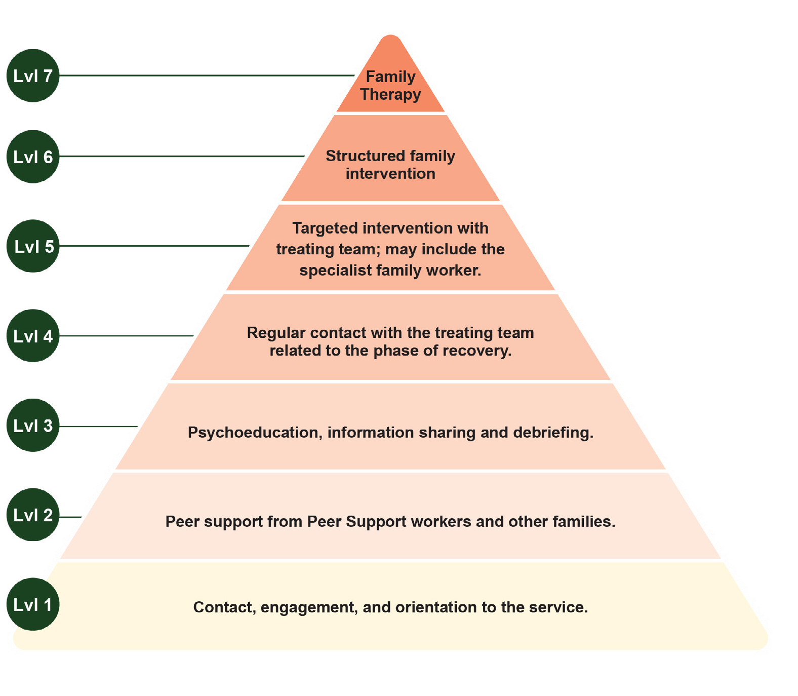

Integration of digital care

YSCC offer young people integrated evidence-based digital mental health interventions that comply with National Safety and Quality Digital Mental Health Standards as part of specialist care.21 Digital tools are used alongside face-to-face treatment to enhance access, engagement, continuity of care and personalisation of interventions across all phases of treatment.
Evidence-based, youth-focused digital platforms (such as MOST)^{22–25} will be offered as an integrated component of care to support ongoing engagement, recovery, and treatment continuity. These platforms provide access to multi-modal support including clinician, vocational and peer support as well evidence-based therapeutic programs and mobile monitoring of symptoms and progress feedback to complement and enhance clinical care.
Digital supports can extend care beyond scheduled appointments and provide young people with flexible ways to access therapeutic resources, connect with peers, and track progress between sessions. They also support continuity during transitions into and out of YSCC, helping maintain engagement, reduce disruption to care and prevent relapse and hospital admissions beyond discharge from services. Family members and supporters may be supported through digital platforms that provide psychoeducation, peer connection, and wellbeing resources.¹⁹
Where appropriate, young people may also access other evidence-based digital tools such as mental health monitoring applications or digitally delivered therapeutic programs. These supports can improve access to care, particularly for young people who experience barriers to attending in person services and can strengthen engagement with treatment.
Digital care is integrated with face-to-face clinical support and coordinated by the key clinician to ensure it aligns with the young person’s formulation, care plan, and recovery goals. This includes proactive engagement and support for young people and their families to effectively use digital approaches and resources.

Specialist interventions

YSCC provide access to specialist consultation and targeted interventions for psychosis, eating disorders, personality disorders, and severe mood and anxiety disorders. Specialist expertise is embedded within the young person’s overall care plan and integrated with multidisciplinary care.
Within the transdiagnostic, formulation-informed model, interventions are matched to clinical stage, formulation, level of risk, complexity of needs, and response to treatment. Clinicians within YSCC bring varying levels of generalist and specialist capability, enabling care to be tailored and intensified as required without fragmentation. Specialist input is introduced early to prevent illness progression, reduce functional decline, and support recovery.
Specialist capability within YSCC includes both clinical specialists (e.g. psychology, nursing, allied health) and psychiatrists, who contribute distinct but complementary expertise within the multidisciplinary team.
Psychiatrists provide medical leadership, diagnostic expertise, and pharmacological management, and work alongside other clinical specialists to support integrated, relational, and formulation-led care. While psychiatrists are not typically allocated as key clinicians, they are embedded within the care team and actively contribute to ongoing assessment, formulation, and treatment planning, with responsibility for medical decision-making and oversight of psychiatric care.
Clinical specialists contribute as members of the young person’s formulation-informed team. Specialist involvement may occur as:
- Primary clinician role, where the clinician holds relevant specialist expertise
- Shared care, where additional specialist input is provided alongside the key clinician
- Time-limited, focused intervention, to clarify diagnosis, optimise treatment planning, or deliver specific therapeutic components

It is expected that clinical specialists have protected time (expected to be 40% of their Full-Time Equivalent (FTE)) allocated for capability development of all staff, secondary consultations, supervision and for the provision of time-limited, focused interventions.
More than one clinical specialist may be involved in the young person’s treatment pathway dependent on their needs and preferences over the course of their episode of care. Care is integrated within the young person’s overall care plan to ensure it is coordinated, flexible and continuous.
It is preferred that interventions are provided within the YSCC, but it is also acknowledged that access to specialist expertise may vary across sites, especially during early implementation phases or in more regional and remote areas. Secondary consultation, either through the service, the national specialist capability group, or another YSCC, provides the care team with access to specialist expertise to support assessment, formulation, diagnosis, care planning, and intervention where additional complexity of needs has been identified.
For young people presenting with significant complexity, limited response to intervention, or competing treatment priorities, a Complex Needs Panel may be convened. Panels provide structured multidisciplinary review and prioritisation of
interventions, including cases of delayed recovery (e.g. persistent psychotic symptoms despite appropriate treatment), complex prescribing and discussions around positive risk taking. Participation may include psychiatric and clinical specialists, family workers, lived experience expertise, psychosocial practitioners and, if possible, the young person and their family and supporters. Panels may be scheduled regularly or convened on an ad hoc basis depending on local context. To ensure consistency of expertise regardless of geography, national experts may be invited to attend.
Targeted specialist interventions are provided when indicated and may include psychiatric care, specialist psychological therapies and multidisciplinary interventions tailored to specific presentations. Interventions are delivered within the context of ongoing care, either in-person, digitally or via telehealth (depending on local context and resources). The intensity and duration of specialist interventions are regularly reviewed by the broader multidisciplinary care team.
Through this flexible, hybrid access model, YSCC avoids siloed clinic structures while ensuring high-fidelity, symptom-specific expertise is available when required. Specialist care enhances, rather than replaces, coordinated, formulation-led care within a single, continuous service platform.



Specialist interventions: Psychosis
Young people experiencing FEP receive all core components of the YSCC model, including shared formulation, multidisciplinary care, physical health integration, family-inclusive practice, functional recovery, and digital supports, in addition to a defined set of psychosis-specific interventions. Care is delivered by a cohort of clinical specialists who have specific expertise in delivering care and treatment for psychosis. Young people are actively involved in shaping their care, with treatment planning and recovery goals developed collaboratively in ways that promote agency, engagement, and sustained participation in care.
FEP treatment is characterised by the following interventions, which should be read alongside the EPPIC Model and Service Implementation Guide, and/or the EPPIC briefing pack manual for further detail.^{20,26}

Active early detection and rapid access
Early intervention in psychosis is based on the principle that the early course of illness represents a critical period during which the trajectory of illness may be altered. Reducing the duration of untreated psychosis (DUP) is associated with improved clinical, functional and social outcomes and remains a central objective of early psychosis services.
Consistent with the early detection and proactive case-finding approaches described in Section 4.1, a defined priority pathway exists for suspected FEP to minimise DUP. Referrals suggestive of emerging psychosis are triaged urgently, with rapid assessment by clinical specialists with psychosis expertise. The service maintains targeted engagement with referrers to support early identification and immediate consultation where psychosis is suspected.

At-risk mental state
For those considered at elevated risk of developing psychosis (i.e. those meeting criteria for an at-risk mental state), antipsychotic medication is not recommended as a first line treatment, but other medications may be suitable depending on symptoms and presentation. Specific evidence-based psychological interventions are provided to reduce stress and presenting symptoms to reduce the risk of transition to psychosis.

Phase-specific care
Care is explicitly organised according to phase of illness (acute phase, early recovery, late recovery, relapse, and delayed recovery). Intervention intensity and frequency are matched to phase, with more intensive support during acute and early recovery periods and structured relapse prevention planning in later stages. Phase-specific biopsychosocial assessment is provided in the least restrictive and most appropriate environment for the young person and their family. Evidence-based pharmacological treatment is delivered alongside structured psychological, social, and functional interventions specifically for psychosis. Ongoing suicide risk assessment, particularly during early recovery, is a critical element of the model.

Medical interventions
Evidence-based, low-dose antipsychotic medication is prescribed for FEP with careful monitoring and attention to side effects, in line with national and international clinical guidelines. Medication may also be used to treat co-occurring conditions such as depression and anxiety where clinically indicated.
Young people with FEP receive systematic metabolic and physical health monitoring from the commencement of treatment. Management of metabolic and medication-related risks is prioritised, recognising the increased physical health vulnerability associated with both psychosis and antipsychotic treatment. Monitoring includes weight, waist circumference, blood pressure, metabolic profile, lifestyle assessment, and cardiovascular risk factors. Exercise physiology, dietetics, and lifestyle interventions are embedded from early in treatment to mitigate long-term health risks. Where possible, antipsychotic medications with lower risk of metabolic side effects are preferred as first-line options.
For young people who do not respond adequately to initial antipsychotic treatment, timely review and adjustment of care intensity are required. Clozapine should be actively considered and offered following inadequate response to two trials of antipsychotic medication, consistent with clinical guidelines, with earlier consideration where clinically appropriate.²⁷ Despite strong evidence of effectiveness, clozapine is often underutilised and delayed in practice. Its use within YSCC is supported through careful
monitoring, shared decision-making, and structured follow-up to ensure safety and optimise outcomes.Psychosis-specific psychological interventions
Structured psychological therapies adapted for psychosis (e.g. CBT for psychosis within cognitive behavioural case management, and behavioural activation) are delivered. Interventions target positive symptoms, negative symptoms, mood disturbance, trauma, substance use and functional recovery. Relapse prevention or wellness recovery action planning is a principal component of care, recognising that early relapse can disrupt recovery trajectories and contribute to long-term disability. Structured monitoring of early warning signs, proactive follow up and collaborative relapse action plans are used to support sustained recovery.

Substance use integration
Given the strong association between substance use and relapse in early psychosis, integrated substance use interventions are delivered within the psychosis stream rather than as a separate referral pathway. Harm reduction, motivational enhancement and relapse prevention are embedded within routine care.

Family intervention for psychosis
Structured family psychoeducation and communication/problem-solving interventions are provided to reduce relapse risk, improve coping, and strengthen the recovery environment. Family work is proactive rather than reactive and is considered a core component of FEP care.

Defined tenure of care
Early psychosis services are designed to provide sustained support during the critical early years of illness, a period in which relapse risk, functional disruption and long-term disability often emerge.²⁸ Intensive and continuous treatment during this period aims to optimise recovery and prevent deterioration in social and occupational functioning. Keeping people well once remission and recovery is achieved is as important as getting them well in the first place. Young people experiencing FEP should therefore not be discharged within a minimum window of 2 years.²⁹ There must be sustained specialist involvement for a period typically ranging from 2 years as a minimum but for a substantial subset for as much as five years.²⁹ Premature discharge is avoided where ongoing specialist input is required to consolidate recovery and reduce relapse risk.



Specialist interventions: Eating disorders
Young people experiencing eating disorders receive all core components of the YSCC model, including shared formulation, multidisciplinary care, physical health integration, family-inclusive practice, and functional recovery support. In addition, they have access to specialised assessment and eating disorder-specific interventions delivered by clinicians with experience and expertise in eating disorders. Young people are actively involved in shaping their care, with treatment planning and recovery goals developed collaboratively between the young person, their family, and the clinical team, in ways that promote agency, engagement, and sustained participation in care.
This specialist pathway is designed for young people with anorexia nervosa, avoidant/restrictive food intake disorder (ARFID), bulimia nervosa, binge eating disorder, and other specified feeding or eating disorders (OSFED), including atypical anorexia nervosa.

Early identification
Eating disorders most commonly emerge in adolescence and young adulthood. Early intervention in eating disorders is based on the principle that intervening early is critical to altering the course of the illness. However, the ego-syntonic nature of many eating disorders, particularly anorexia nervosa, can often hinder timely early identification.
Consistent with the early detection and proactive case-finding approaches described in Section 4.1, YSCC adopt active identification and rapid response strategies for eating disorders. This includes maintaining a high index of suspicion for disordered eating and body image concerns in young people presenting with other difficulties (e.g. mood or anxiety disorders) and ensuring timely access to specialist assessment and early intervention to disrupt emerging illness patterns. Care is intensive in the early phase, including outreach, with a focus on stabilisation and recovery within the least restrictive environment.
These approaches align with emerging models such as First Episode Rapid Early Intervention for Eating Disorders (FREED), which emphasise early identification, rapid access to care, and stage-informed intervention to improve outcomes.

Biopsychosocial care
Eating disorders are characterised by psychological symptoms, as well as serious, and often, life-threatening, physical complications. As such, coordinated psychological and medical care should be delivered concurrently. Eating disorders care involves a multidisciplinary team of professionals with experience and expertise in eating disorders including, clinical psychologists, dietitians, psychiatrists, paediatricians, mental health nurses, family workers, social workers, occupational therapists, and peer workers. Multidisciplinary teams should collaborate closely with the young person and their family/supports to ensure person-centred care that is inclusive of family/support people.

Medical interventions
While no evidence-based pharmacological interventions currently exist to specifically treat anorexia nervosa or ARFID, medications such as antidepressants, anxiolytics, and antipsychotics can help with co-occurring conditions and symptoms. Fluoxetine and lisdexamfetamine have been found to reduce binge-purge and binge eating frequency in bulimia nervosa and binge eating disorder, respectively.
The physical consequences associated with eating disorders require medical monitoring, including weight, blood pressure, cardiovascular risk, bone density, as well as various blood levels, including electrolyte imbalances (note, waist circumference is intentionally excluded from medical monitoring of eating disorders). Dietetics is a critical component of eating disorder treatment and is embedded throughout the course of interventions.

Psychological interventions
Psychological therapies for eating disorders are matched to age, illness stage, and eating disorder presentation. Interventions focus on nutritional restoration (particularly for anorexia nervosa and ARFID), alongside addressing behavioural, cognitive, and emotional processes that maintain the disorder.

YSCC must have capability to deliver the following evidence-based treatments:
- Family-Based Treatment (FBT) for adolescents with anorexia nervosa
- Enhanced Cognitive Behavioural Therapy (CBT-E) across eating disorder presentations, including anorexia nervosa, bulimia nervosa, binge eating disorder, and OSFED
In addition, services should have access to:
- Maudsley Model of Anorexia Nervosa Treatment for Adults (MANTRA)
- Specialist Supportive Clinical Management (SSCM), particularly for individuals with previous treatment non-response, co-occurring complexity, or low readiness for change
Emerging and adjunctive approaches may include:
- Temperament-Based Therapy with Supports (TBT-S) for anorexia nervosa
- Dialectical Behaviour Therapy for Eating Disorders (DBT-ED) for presentations with binge eating features
- Cognitive Behavioural Therapy for ARFID (CBT-AR), recognising the evolving evidence base
Despite the availability of evidence-based treatments, outcomes for anorexia nervosa remain variable, and a significant proportion of young people do not achieve sustained recovery. This highlights an ongoing need for treatment innovation, particularly for anorexia nervosa,
including the development, evaluation, and integration of novel therapeutic approaches and service models.
Consistent with YSCC’s role as a learning health system, services support the implementation and evaluation of emerging interventions, contributing to continuous improvement in treatment effectiveness and long-term outcomes for young people with eating disorders.

Relapse prevention and continuity of care
Eating disorders are associated with high rates of relapse and continuity of care is critical to reducing relapse risk. This includes clear pathways for stepping up or down into different levels of care or referring to other services and ensuring support for young people and their families in the community.
YSCC align clinical practice and service delivery with the National Eating Disorder Collaboration’s National Eating Disorder Strategy 2023–2033, with implementation tailored to the level of specialist care provided within the YSCC model of care.
Practitioner training is delivered in accordance with the Eating Disorder Workforce Core Competencies and the National Framework for Eating Disorders Training, ensuring a consistent, evidence-informed, and appropriately skilled workforce to support the identification, assessment, and treatment of eating disorders.



Specialist interventions: Personality disorder
Young people experiencing personality disorder receive all core components of the YSCC model, including shared formulation, multidisciplinary care, physical health integration, family-inclusive practice, and developmentally informed, functional recovery support. In addition, they have access to specialised assessment and intervention delivered by clinicians with expertise in personality disorder.
Personality disorder (PD) is characterised by enduring disturbance of self- and/or interpersonal functioning, with clinical onset and peak prevalence from puberty to early adulthood. Young people living with personality disorder are at high risk of poor short- and long-term personal, social, and economic outcomes, including poor quality of life, high distress, poor physical and sexual health, drop-out from education/employment, interpersonal violence, increased mortality and reduced life expectancy.
Early Intervention for Personality Disorder (EIPD) focuses on providing early, accessible, evidence-based, developmentally informed Relational Clinical Care (RCC), that counteracts stigma and nurtures hope. Interpersonal problems are central to PD, making a relational and reflective framework essential.

Relational Clinical Care (RCC)
RCC is responsive and adaptive to young people’s needs, delivered in preferred settings (with a focus on assertive outreach), over a time-limited period, and supporting informed choices. It aims to build skills, confidence, and autonomy, and to promote active collaboration in change, with realistic goals and outcomes. RCC recognises the evidence that individual psychotherapy is neither necessary nor sufficient for good EIPD outcomes. Its central focus is on practical, goal-oriented clinical case management and other aspects of care, with time-limited individual therapy added according to the young person’s goals and needs.

RCC’s four key aims
The four aims of RCC are to:
- Improve psychosocial functioning (relationships, educational, and vocational pathways)
- Reduce mental health problems and distress
- Improve capacity to effectively seek care from others
- Increase the young person’s health, wellbeing, and sense of agency
Improving functional outcomes is often more important to young people than symptom reduction alone. Young people identify and work towards personally meaningful social, occupational, and vocational goals.
EIPD involves families early. Families of young people with PD experience high levels of distress, burden, and mental ill-health. EIPD supports greater family involvement in assessment, diagnosis, and treatment, respecting the young person’s emerging autonomy and offering support to improve relationships and communication.
RCC is a comprehensive, multidisciplinary program and comprises:
  - Practical Clinical Case Management: Focusing on functional goals, system navigation, and support.
  - Psychiatric Care: including safety planning, safe and ethical prescribing, and appropriate treatment of co-occurring mental state disorders.
  - Family Work: focusing on enriching understanding and supporting new ways of relating.
  - Optional Time-limited Individual Therapy: involving usually a contract of 16 sessions.

The principles of RCC in practice:
  - Assessment, feedback, and psychoeducation: Careful, collaborative, biopsychosocial assessment of personality disorder, and a non-judgemental, honest approach to diagnosis and psychoeducation. This addresses stigma and offers support and validation.
  - Establishing a collaborative working relationship: Emphasising curiosity, mutual respect, and demonstrating trustworthiness. It involves negotiating expectations (length, frequency, location) and viewing ruptures/ tensions in the working relationship as opportunities for reflection and repair.
  - Working within the developmental capacities of the young person: Actively engaging the young person in a way that maximises their potential for change, scaffolding learning (e.g. using diagrams), and adapting techniques. It acknowledges that the capacity to engage can shift day-to-day.
  - Developing collaborative management plans: Exploring what young people want and articulating realistic, achievable, shared goals across educational, vocational, relationship, and health domains. Functional goals and living a life of meaning are prioritised. Behavioural patterns are explored to understand their function before seeking more adaptive strategies.
  - Relational formulations: Are developed collaboratively with every young person, and their network. This narrative and/or diagrammatic understanding provides a non-blaming explanation of current difficulties, their origins, and the relational patterns that maintain them, guiding treatment and providing hope.
  - Managing risk and safety planning: Structured safety planning and clear processes clarify expectations of young people and clinicians and ensure organisational support at all levels. Interventions explore the functional aims of self-harm, encourage reflection on systemic responses, and build adaptive coping skills. The goal is to balance responsibility for safety with ‘dignity of risk’ and opportunities for the young person to develop new skills.
  - Managing transitions and endings: Endings are approached openly and explicitly, acknowledging that for most young people with PD, past endings have been abrupt and distressing. The focus shifts from loss to celebrating achievements, promoting autonomy, and supporting a “good enough” ending, despite the inevitable emergence of old patterns as the end draws near.
  - Supervision: Using a relational lens is crucial to assist clinicians in understanding and responding helpfully to rapid “state shifts” in how a young person might present from day-to-day.

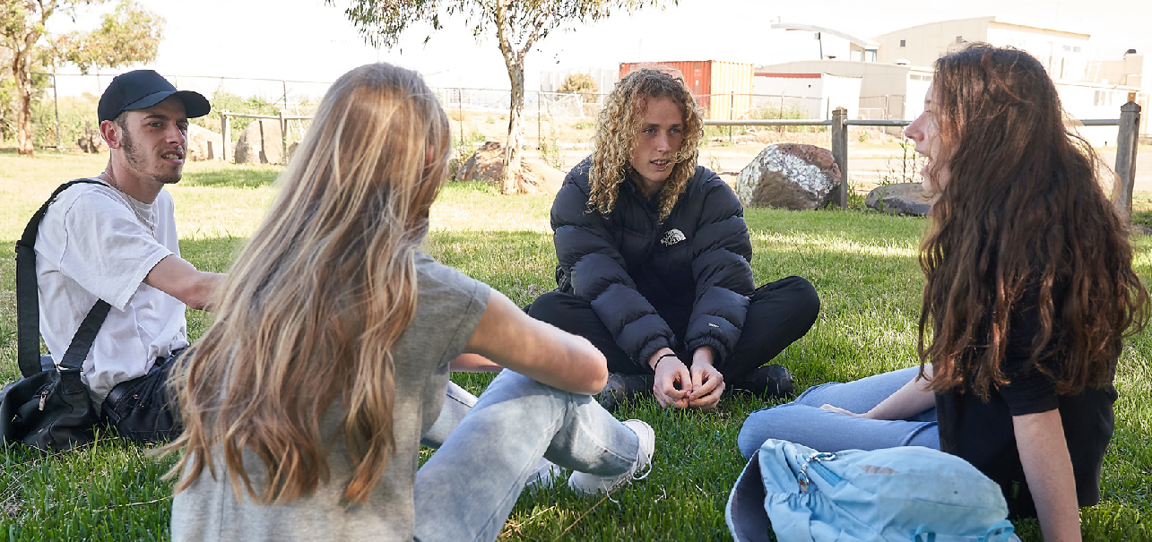

Specialist interventions: Severe mood & anxiety disorders
Young people experiencing severe, persistent, or treatment-resistant mood or anxiety disorders receive all core components of the YSCC model, including shared formulation, multidisciplinary care, physical health integration, family-inclusive practice, and functional recovery support. In addition, they have access to specialised assessment and intervention delivered by clinicians with expertise in mood and anxiety disorders.
This specialist pathway is designed for young people with bipolar affective disorder, obsessive-compulsive disorder (OCD), or whose depression or anxiety presentation is severe, recurrent, functionally impairing, or has not responded adequately to initial treatment, and for those whose presentation suggests an elevated risk of illness progression or recurrence.
Mood and anxiety presentations in youth frequently involve co-occurring conditions, functional impairment, and developmental disruption, including impacts on education, relationships, and identity formation. Early specialist intervention therefore aims to reduce illness persistence, prevent recurrence and support recovery of developmental trajectories.
Specialist care may involve the following components:

Early identification and diagnostic clarification
Mood and anxiety disorders often emerge during adolescence and young adulthood and may initially present with non-specific symptoms such as irritability, sleep disturbance, or functional decline. Early specialist assessment focuses on clarifying diagnosis, identifying bipolar spectrum conditions, and distinguishing mood and anxiety disorders from overlapping presentations such as personality disorder, trauma-related difficulties, or neurodevelopmental conditions.
Careful, longitudinal assessment is particularly important for identifying bipolar disorder, including bipolar II, where recurrent depressive episodes may precede or overshadow hypomanic
symptoms, increasing the risk of misdiagnosis
as unipolar depression. Early specialist input
supports diagnostic clarification and helps ensure
that treatment strategies are appropriate to the illness trajectory, including cautious use of antidepressant
medication and consideration of mood stabilising
approaches where indicated.

Psychological therapies for severe
mood and anxiety disorders
Psychological therapies are a core component of treatment for mood and anxiety disorders in young people. Cognitive behavioural therapy and related evidence-based approaches are commonly used to address depressive and anxiety symptoms, maladaptive thinking patterns, behavioural withdrawal, and functional impairment. Psychological therapies are integrated with pharmacological treatment, where indicated, and are adapted to address co-occurring presentations such as substance use, trauma, or emerging personality disorder features.
Psychological interventions are an essential component of bipolar disorder care and complement pharmacological treatment. Therapies focus on helping young people understand mood fluctuations, recognise early warning signs of relapse, and develop strategies to manage stress, sleep patterns, and emotional regulation. Evidence-based approaches may include cognitive behavioural therapies and structured psychoeducation designed to support self-management and illness awareness. These interventions help young people develop skills to maintain stability and reduce the likelihood of recurrent episodes.
Pharmacological treatments
For young people experiencing severe or persistent mood or anxiety disorders, pharmacological treatment may be indicated as part of a comprehensive treatment plan. Antidepressant medication may be considered when depressive or anxiety symptoms are severe or have not responded to psychological intervention alone and are always prescribed by a suitably qualified practitioner. Careful monitoring is required to balance potential benefits and risks.


For young people with bipolar disorder, treatment typically includes mood-stabilising medications and careful monitoring of mood fluctuations, sleep patterns, and early warning signs of relapse.
Medication management occurs within a multidisciplinary framework and includes regular review of treatment response, side effects, and functional recovery. Where clinically indicated, pharmacological treatments may be complemented by neurostimulation interventions, including TMS and other brain stimulation therapies. Refer to
the NICE Guidelines and RANZCP Guidelines for further treatment details.^{30,32}

Functional recovery and psychosocial
interventions
Mood and anxiety disorders during adolescence and young adulthood frequently disrupt education, employment, and social participation. Recovery therefore involves more than symptom reduction and requires active support for functional reintegration. Intentional integration of the interventions within the functional and psychosocial recovery section of this model of care are therefore essential. These approaches aim to restore developmental trajectories and reduce the long-term disability associated with recurrent mood disorders.

Relapse prevention and continuity of care
Many mood disorders follow a recurrent course, with a high likelihood of further episodes after an initial depressive episode. Specialist care therefore emphasises relapse prevention, including monitoring early warning signs, maintaining treatment engagement, and supporting long-term self-management strategies. Young people with bipolar disorder or recurrent depression may require extended specialist involvement to stabilise illness trajectories and consolidate recovery.

Demand management and episodes of care

YSCC support timely access to care while maintaining continuity, flexibility and responsiveness to young people’s evolving needs. Service planning accounts for high demand and complexity of needs, with mechanisms to prioritise care, manage flow, and maintain service quality. Demand management approaches balance access and quality, ensuring young people receive the right level of care at the right time without unnecessary delays or fragmentation. This requires strong clinical and operational leadership to actively manage demand, flow, and length of care. Strategies include structured monitoring of capacity and throughput, regular multidisciplinary review, and active management of entry, review, and transition points to ensure timely access and movement through the service.
Care is organised around episodes of care guided by formulation, diagnosis, best practice guidelines, clinical staging and need, and recovery goals rather than fixed time limits. Tenure within YSCC is therefore determined by clinical need, stage of illness, and recovery goals. For young people experiencing early psychosis, evidence supports a longer duration of care, typically 2-5 years following first episode, to optimise clinical and functional outcomes.
The intensity, duration, type, and modality of support may vary over time, recognising that young people’s needs can fluctuate and that periods of increased or reduced support are a normal part of recovery.
Demand management within YSCC is operationalised through the diagnostic and stage-informed streaming framework outlined in Section 4.2. Capacity is planned commensurate with the funded staffing establishment, with concurrent caseload determined by funded clinician FTE against caseload benchmarks. It considers:
- Proportion of young people presenting with Clinical Stage 1b, Stage 2, and incomplete remission or relapse
- Expected tenure of care across diagnostic groupings
- Caseload intensity requirements
- Workforce skill mix
YSCC maintains protected capacity for time-critical presentations, including FEP and eating disorders, using a stratified quota across diagnostic streams. This supports timely specialist assessment and intervention, consistent with early intervention principles and the objective of reducing duration of untreated illness.
Regular review of case-mix distribution across clinicians supports fidelity to the intended service profile and protects capacity for presentations requiring longer tenure and higher intensity intervention.





Flexible care pathways, including step-up and step-down options, enable young people to move between levels of intensity without losing continuity of relationship or care coordination. Young people who respond to treatment and achieve recovery may be offered structured step-down options, including targeted psychoeducation, digital support, and facilitated linkages to community, peer and family supports to maintain clinical and psychosocial gains, and enable timely re-entry to care if required.
When demand exceeds immediate capacity, proactive engagement strategies support young people while waiting for ongoing care such as integrated digital supports that provide immediate access to care and facilitate a seamless and effective transition to face to face support as needed. This may include brief interventions, integrated digital supports across all phases of treatment (waiting for care, receiving care, post face to face care), check-ins, group programs or linkage with peer and community supports, ensuring young people remain connected and supported during periods of transition.
YSCC model emphasises proactive, digitally enabled re-engagement, and outreach when disengagement has occurred. Young people can move in and out of care as needed without unnecessary barriers, and re-entry pathways are designed to be simple, timely and youth friendly.
There is no fixed length of care. Duration is guided by formulation, best practice evidence, clinical need, and functional goals, with regular reviews to ensure care remains appropriate and responsive. Some young people may require brief episodes of care, whilst others may benefit from longer-term involvement or intermittent support over time. Some young people may receive a brief period of face-to-face care followed by ongoing digitally enabled support as part of a planned step-down pathway.
Demand management approaches are responsive to local population needs, service availability and community context, including First Nations, rural, and remote communities. Services adapt care pathways to ensure equitable and culturally safe care across diverse settings.

Transition of care

Transition from YSCC is understood as a planned and supported process rather than an endpoint, reflecting progress towards recovery goals and changes in support needs over time. Transitions are guided by shared formulation, diagnosis, clinical judgement, and the young person’s preferences, ensuring care remains continuous, responsive, and coordinated.
Planning for transition begins early and is revisited throughout. Transition pathways include primary care, enhanced primary mental health services (e.g. headspace and headspace Plus), Medicare Mental Health Centres, private practices (including MBS-funded providers), community psychosocial services, and state-funded mental health services where indicated. Transitions also include timely step-up to acute and tertiary mental health services (including inpatient and emergency care) when clinical acuity or risk escalates, ensuring rapid access to higher-intensity support without disruption to continuity of care. Transitions may also include planned transfer of care to state-funded adult community mental health services for longer-term treatment, where this is clinically indicated.
Young people are actively involved in a structured, collaborative, and developmentally informed process that prioritises the young person’s ongoing recovery, safety, and autonomy. It focuses on building self-efficacy through the co-development of relapse prevention plans, including early warning signs, coping strategies, and clear crisis management plans for both the young person and their family or supporters, with young people supported to step down to appropriate community-based services, including headspace centres, evidence-based digital services such as MOST, GPs, or other relevant providers.
Transitions should be experienced by young people and their families as a single, seamless process. To support this, YSCC should explicitly aim to minimise the need for young people to repeat their story by ensuring efficient, timely, and consent-based information sharing between services. This continuity of information is critical to reducing distress, disengagement, and the burden on young people and families, and supports more responsive and person-centred
care. This expectation applies equally to step-up
transitions, with YSCC maintaining active
coordination and information sharing with tertiary
services to support safe admission and continuity of therapeutic understanding.
The key clinician maintains oversight of transition planning to ensure continuity, engagement and minimise fragmentation. Wherever possible, this transition should include a period of overlapping engagement and a face-to-face handover involving the young person, their family, supporters and community, and the receiving clinician, to promote continuity of care, trust, engagement, and shared understanding of information and ongoing needs. This approach should be consistently applied to all transitions between service providers. For step-up transitions, this includes liaison with tertiary services prior to admission and active involvement in discharge planning to support timely step-down back to YSCC or other appropriate services.
All handover processes must be accompanied by a timely sharing of information including a comprehensive discharge summary, provided to the receiving service and the young person’s GP, with copies also given to the young person and their family, and retained within the YSCC. For young people stepping up to tertiary care, relevant clinical information should be shared at the point of transfer, with discharge information from tertiary services integrated back into the YSCC record. In addition, the YSCC should equip young people and families with psychoeducation, accessible information and resources, and supported linkages to local community and peer supports, alongside digitally enabled step-down models of care with seamless re-engagement pathways as needs evolve.
Transition planning recognises the transient nature of some young people’s engagement with services, particularly those experiencing homelessness or involvement with the justice system. The key clinician proactively plans for continuity of care where engagement may be brief and movement across catchment areas is likely, including timely information sharing, flexible handover arrangements, and coordination across jurisdictions. Transition is conceptualised not only as entry to and exit from services, but also as movement between programs and providers, with a focus on maintaining continuity and reducing disruption.

Peer workers play a critical role in supporting young people through transition out of care, with peer-run groups (in person and online), where feasible, offering ongoing connection, shared experience, and support to sustain recovery. Recognising that recovery is not always linear, the model supports flexible re-entry pathways via both face-to-face and digital means. Young people can re-engage with YSCC if needs change, without unnecessary barriers, ensuring continuity of care across the broader service system.
Transitions are approached in a culturally responsive and developmentally appropriate way, recognising the importance of family, community, and cultural connections, particularly for First Nations young people and those from diverse backgrounds. This includes early and ongoing involvement of family, kinship networks, and culturally relevant supports as identified by the young person; collaboration with ACCHOs and other culturally specific services; and access to cultural consultants, interpreters, and bicultural workers where required. Transition planning is guided by culturally informed formulations that consider the impact of culture, identity, community connection, and experiences of marginalisation or trauma on engagement and care needs.
Developmentally, transitions are tailored to the young person’s age, stage, and functional capacity, recognising variability in independence, decision-making, and support needs. This includes flexible pacing of transitions, developmentally appropriate communication, and active support for skill-building in areas such as self-management, help-seeking, and system navigation. Where appropriate, this also includes gradual shifts in responsibility from family-supported to more independent care, without compromising safety or continuity.
Specific safeguards apply for young people approaching age thresholds. Transition planning for young people approaching 25 years commences at least 12 months before the upper age boundary, or as early as practicable for those entering the service after 24 years. Planning identifies the receiving service, established shared care arrangements where possible, and includes a period of parallel engagement with both services. The YSCC retains clinical responsibility for the young person until responsibility is formally accepted by the receiving service. Equivalent care is undertaken
for younger adolescents moving between child
and adolescent services and YSCC, with joint
planning to avoid gaps, duplication of assessment,
or abrupt changes in therapeutic relationships.
Services monitor and report on transitions at
age boundaries, including demand and referral
patterns, to support planning across the network.
Services actively adapt transition processes to reduce barriers to engagement, including outreach, flexible service delivery (e.g. in-person, digital, or community-based settings), and coordination across youth and adult-oriented systems to avoid abrupt or poorly timed transitions. Cultural safety and developmental appropriateness are continuously reviewed through feedback from young people and families, and through reflective practice within the multidisciplinary team.

Workforce

The YSCC workforce is purpose-built to support relational continuity while delivering transdiagnostic, stage-informed care alongside access to specialist evidence-based interventions. This model represents an emerging area of practice in youth mental health, requiring clinicians to work flexibly across diagnostic boundaries, hold complexity over time, and integrate biological, psychological, and social approaches within a developmentally informed framework.
Workforce structures combine transdiagnostic clinicians with access to specialist expertise for specific clinical presentations, enabling coordinated multidisciplinary care while ensuring access to disorder-specific interventions when clinically indicated.
The YSCC workforce includes three complementary capability layers:
- Clinicians delivering formulation-informed care and transdiagnostic interventions
- Clinical specialists providing diagnosis-specific expertise
- Care team members supporting engagement, recovery, psychosocial and functional outcomes
YSCC are expected to maintain a multidisciplinary workforce capable of delivering the full range of clinical, recovery, psychosocial and functional supports and specialist interventions described in this model of care. While core workforce capability is consistent across services, specific role composition may vary depending on local workforce availability, service partnerships, and population needs.
Workforce capability development is a core component of the YSCC model. Given the specialised capabilities required, services actively support the development of a workforce with the skills, confidence, and clinical judgement to deliver stage-informed, youth-focused care. This includes structured supervision, interdisciplinary learning, and access to national capability development initiatives.
YSCC contribute to workforce development through clinical training, supervision, student placements, and participation in national initiatives. Services play a key role in attracting and developing early-career clinicians, including through structured early-career pathways, placements, and emerging credentialing approaches that build capability in youth mental health practice.
In addition to site-based multidisciplinary care teams, YSCC have access to national specialist expertise that supports complex case consultation and workforce development across the network. This ensures consistent access to specialist capability while maintaining coordinated local care.

Service and team structure

Each YSCC is organised into three teams that reflect the young person’s journey through the service. The Engagement Team provides a single, identifiable access point, leading intake, assessment, brief intervention and assertive engagement (Section 4.3). The Continuing Care Team is the largest team in the service, providing sustained, multidisciplinary, formulation-informed care for young people requiring ongoing treatment. The Functional Recovery Team delivers the vocational, educational, psychosocial and group-based programs described in Section 4.12, working in parallel with clinical care rather than following it. Transitions between teams are planned and clinically governed, and peer support, family work and continuity of relationship operate across all three teams.
Because of its size, the Continuing Care Team is organised into pods: small, consistent, transdiagnostic teams each holding a defined caseload of approximately 140 to 180 young people. Each pod comprises a pod lead, key clinicians, youth peer workers and consistent
psychiatry input, with clinical specialists deployed within and across pods from the specialist clinician pools. Every young person is held by a small, named team rather than a large undifferentiated caseload, preserving relational continuity and clear clinical governance as services scale. Pods hold mixed, staged caseloads and are not organized by diagnosis, consistent with the transdiagnostic principle. Large services operate three pods, medium services two, and small services a single pod. The service structure, including teams, pods and leadership arrangements, is summarised at Appendix A, with indicative staffing profiles at Appendix B.

Multidisciplinary care team

Clinicians
Young people accessing YSCC frequently present with complex, evolving, and overlapping mental health needs that do not fit neatly within single diagnostic categories. A transdiagnostic workforce enables clinicians to respond to this complexity through formulation-informed care that integrates mental health, physical health, substance use, functional recovery, and social determinants of wellbeing. This capability allows clinicians to maintain relational continuity and coordinated care while drawing on specialist expertise when specific diagnostic or treatment needs arise. All clinicians within the multidisciplinary team are required to have, or be supported to develop, specialist youth mental health expertise. This includes capability in assessing, engaging, and delivering care to young people aged 12–25 in a developmentally appropriate, youth-centred manner, recognising developmental stage, family context, and transitions to adulthood.
Clinicians provide formulation-informed, stage-informed transdiagnostic care across presentations. They are skilled in managing complexity, co-occurring conditions and evolving symptom profiles and may deliver:
    - Comprehensive biopsychosocial assessment
    - Competency in clinical staging
    - IAR-DST administration
    - Shared formulation and diagnosis development
    - Transdiagnostic psychological interventions (e.g. CBT, ACT, behavioural activation)
    - Ongoing risk monitoring and safety planning
    - Functional recovery and psychosocial intervention
    - Alcohol and other drug assessment and intervention
    - Coordination of multidisciplinary input
Clinicians may include accredited (through the Australian Health Practitioner Regulation Agency (AHPRA) or other relevant registration bodies):
    - Psychiatrists
    - Psychiatric registrars
    - Clinical psychologists
    - Mental health nurses
    - Nurse practitioners
    - Social workers
    - Occupational therapists
    - Other allied health professionals with youth mental health capability

Care team members
Care team members extend the impact of clinical care by delivering lived experience, functional, and community-based supports that address the broader determinants of a young person’s wellbeing. This includes clinical roles delivered within the Functional Recovery Team (physical health nursing, exercise physiologist, and dietetics), which are distinct in scope and function from the multidisciplinary clinicians described above.
Delivered through full-time, part-time or shared roles proportionate to service scale, care team members roles may include:
    - Youth peer workers
    - Family peer workers
    - Physical health nurse
    - Exercise physiologist
    - Dietitian
    - Family workers
    - Aboriginal Health Practitioners
    - Vocational, employment, and education specialists (IPS model)
Where funding permits, additional roles may include:
    - Speech pathology
    - General Practitioners
    - Cultural workers
    - Youth psychosocial workers

Clinical specialists
Clinical specialists provide advanced assessment and intervention for young people presenting with severe or emerging mental illness, complex presentations, or limited response to initial treatment. It is expected that clinical specialists have protected time (expected to be 40% of their FTE) allocated for capability development of all staff, secondary consultations, supervision and for the provision of time-limited, focused interventions. These clinicians specialise in diagnostic-specific interventions and may contribute through shared care, targeted intervention, or structured consultation. Specialist roles may include:
    - Psychiatry (including early psychosis, mood disorders, eating disorders and personality disorder expertise)
    - Clinical psychology with symptom-specific and therapeutic expertise
    - Neuropsychology with expertise in cognitive assessment and rehabilitation
    - Mental health nursing with advanced practice capability in complex presentations and/or therapeutic expertise (e.g. DBT, CBT for psychosis, FBT for eating disorders)
    - Occupational therapy and social worker clinicians with advanced practice capability in complex presentations and/ or therapeutic expertise (e.g. DBT, CBT for psychosis, FBT for eating disorders)
    - Other allied health practitioners with specialist therapeutic expertise (as above)
Specialists deliver high-fidelity, evidence-based interventions, as outlined in Sections 4.7, 4.8 and 4.15, while working within the shared formulation and coordinated care plan led by the key clinician.

Leadership, corporate and support functions
Corporate and support functions are critical to the delivery of the YSCC model, providing the operational leadership, system coordination, and partnership development required to sustain integrated, high-quality care. Roles may include:
    - Clinical Director
    - Operations Manager
    - Lived Experience Leader
    - First Nations and/or cultural leadership (established through local pathways)
    - Coordinator of Psychiatry Training (College accreditation requirement)
    - Training Coordinator
    - Health Information Manager
    - Quality Improvement and Evaluation Coordinator
    - Community Development and Partnerships Manager
    - Administration Manager

National specialist capability
The national specialist capability group supports local teams through secondary consultation, workforce training, clinical supervision, and lived experience supervision to strengthen capability and maintain model fidelity across the network. This group operates as a national resource and complements, rather than replaces, the expertise within local multidisciplinary care teams.
The national specialist capability group provides structured secondary consultation and advice to local clinical teams where additional expertise is required. This may include consultation on complex clinical presentations, diagnostic clarification, complex prescribing, treatment resistance, and specialised intervention planning across priority streams such as psychosis, severe mood disorders, eating disorders and personality disorders.
In addition to case consultation, the group supports workforce development through the provision of clinical training, supervision, communities of practice and implementation support. This includes contributing to structured training programs, supporting the development of specialist clinical skills, and providing guidance to support consistent, high-quality clinical practice across services
Access to national specialist capability is prioritised according to clinical complexity, service capability, and local context. Services with more limited access to specialist expertise, including smaller, regional, and remote services, are supported through prioritised access to consultation, supervision, and capability development to ensure equitable delivery of care across the network.

Workforce development and training

YSCC demonstrate a strong commitment to ongoing workforce development, recognising the need to build and sustain a specialised workforce over time. This includes:
    - Structured onboarding and induction Comprehensive onboarding processes that orient staff to the YSCC model of care, youth-friendly approach, expectations, and ways of working, supporting a consistent approach and avoiding replication of practices that are not aligned with the model’s intent.
    - Protected learning and development time Dedicated time for ongoing professional learning, skill development, and reflective practice embedded within workforce planning.
    - Core and specialist capability development Each service maintains a training plan that maps workforce capability against the interventions required by this model of care, with completion and currency monitored through clinical governance structures. Services ensure access to training that supports both foundational competencies and specialist skills, including cultural safety, working with Aboriginal and Torres Strait Islander communities, LGBTIQA+ young people, culturally and linguistically diverse communities, and neurodevelopmental conditions.
    - Alignment with standards and competencies Training and development aligned with relevant national frameworks, professional standards, and competency requirements, ensuring consistency and quality across the workforce.
    - Workforce needs assessment and planning Regular assessment of workforce capability and gaps to inform targeted investment in training, supervision, and recruitment. This includes structured support for staff moving into senior clinician, team leader, and other leadership roles, including planning, mentoring, and development of leadership and quality improvement skills, to strengthen retention and service culture.
    - Supervision and reflective practice
All staff regularly receive individual clinical supervision, at least monthly, with more frequent supervision for early-career clinicians and for staff holding high-acuity caseloads. Supervision includes discipline-specific, case-based and reflective components, with group supervision and multidisciplinary reflective practice complementing individual arrangements. Clinical specialists use their protected time in part to provide supervision and secondary consultation that builds clinicians’ capability in high-intensity, evidence-informed care.
    - Investment in early-career workforce Targeted investment in upskilling early-career clinicians to build capability within the emerging specialist workforce, including structured support, supervision, and progression pathways.
    - Graduate and workforce pipeline programs Establishing links with state and territory graduate programs and training pathways to build a sustainable pipeline of skilled practitioners.
    - Placement and supervision opportunities Supporting student placements and providing supervision to trainees, contributing to workforce development across the broader system.

Flexible and distributed workforce models

To support service delivery across diverse contexts, including regional and remote areas, YSCC adopt flexible workforce approaches, including:
    - Shared workforce arrangements Leveraging shared roles, supervision, and specialist input across services and regions to address workforce shortages and variability in availability.
    - Regional workforce support
Targeted strategies to recruit, develop, and retain staff in regional and remote areas, where demand and turnover may be higher.
    - Access to supervision and reflective practice in remote settings
Using virtual platforms and cross-site arrangements to ensure equitable access to supervision, mentoring, and reflective practice.

Staff wellbeing and sustainability

YSCC prioritise staff wellbeing as a core enabler of safe, high-quality, and sustainable care. Recognising the complexity and intensity of the work, services implement proactive and structured approaches to support workforce wellbeing, reduce burnout, and improve retention. This includes:
    - Clear role definition and manageable workloads
Establishing clear scopes of practice, role clarity, and appropriate caseload expectations to support safe and sustainable service delivery. Services actively monitor workload and capacity to reduce the risk of burnout and ensure staff can provide high-quality care.
    - Structured onboarding and early support Providing consistent and comprehensive onboarding processes to support staff transition into the YSCC model, build confidence, and reduce early role-related stress and uncertainty.
    - Support for moral distress and vicarious trauma
Embedding mechanisms to identify and respond to moral distress, vicarious trauma,
and cumulative stress, including access to supervision, reflective practice, and debriefing following complex or critical incidents.
    - Access to supervision and reflective practice
Ensuring regular, high-quality clinical supervision and opportunities for reflective practice that support emotional processing, clinical decision-making, and professional growth.
    - Team-based support and culture
Fostering a psychologically safe team environment where staff feel supported, valued, and able to seek guidance and share responsibility for complex care.
    - Flexible and responsive workforce practices Implementing flexible work practices where possible, and adapting workforce models to respond to demand, reduce pressure on individuals, and support continuity of care.
    - Wellbeing resources and supports Providing access to wellbeing initiatives and supports, including employee assistance programs and other resources that promote mental health and resilience.



Integration

YSCC are designed to operate as a core component of Australia’s youth mental health service continuum, strengthening connectivity between primary care, community-based services, and state-funded mental health systems. The youth mental health landscape comprises a range of services operating across levels of care, from self-management and low intensity supports through to acute and state-funded mental health services.
Young people access support across multiple entry points including digital mental health programs, primary care, headspace centres, suicide prevention services, school-based supports, private practitioners, and specialist services. While this diversity provides choice and flexibility, it risks the creation of complexity and fragmentation, particularly for young people with enhanced care needs whose presentations do not align neatly within existing service thresholds.
YSCC are positioned within the higher intensity levels of care to address this gap, providing a specialist multidisciplinary response for young people whose needs exceed the capacity of primary care, but who may not require or are unable to access state-funded mental health services. These services operate within a broader system context that includes state-funded specialist services, which are often structured across child and adult streams and may not align fully with the 12–25 youth cohort.

Conceptual foundations
for integrated care

YSCC are grounded in contemporary evidence and international best practice in integrated youth mental health care. Integrated care is widely recognised as the preferred approach for improving outcomes for young people with complex needs, as it reduces fragmentation, improves coordination, and supports more person-centred and developmentally appropriate care.4,33 Evidence and sector consultation consistently show that young people benefit most when mental health care is not delivered in silos, but through an integrated, single-service model. Young people also experience better outcomes when care extends beyond crisis response. Effective care includes wrap-around support that addresses wellbeing, functional recovery, and psychosocial needs. This approach maintains a clear focus on supporting young people to participate meaningfully in everyday life.
Integrated care is understood within the YSCC model as the deliberate alignment of person-centred clinical practice, service delivery, governance, workforce, and information systems to provide seamless and coordinated care for a wide range of needs across settings and stages of need. This includes health professionals working together across mental health, physical health, alcohol and other drug services, and social and functional supports.
Integration occurs across multiple domains:
- Clinical integration, through shared assessment, formulation, diagnosis, and care planning

- Service integration, through multidisciplinary team-based care
- Organisational integration, through partnerships, formalised service level agreements that outline shared governance, roles, responsibilities and accountabilities, and coordinated pathways
- Functional integration, through shared systems, data, and infrastructure
Integration also occurs across the broader system through horizontal integration across sectors such as health, education, and social services; vertical integration across primary, secondary, tertiary and specialist care; and longitudinal integration supporting continuity across developmental stages and service transitions.
YSCC adopt a continuum view of integration, recognising that services may operate at various levels of integration while working towards fully integrated practice characterised by shared accountability, coordinated pathways and unified care planning.

Some young people may prefer discrete supports or wish to separate clinical and psychosocial care. The model remains flexible, responsive, and led by the young person’s preferences, choices, and goals.

How YSCC operationalise integration

YSCC operationalise integration through a whole-system approach that strengthens connections across services, sectors, and levels of care. This includes:

Coordinated entry and pathways
YSCC provide clear referral pathways from primary care, headspace centres, suicide prevention services, hospitals, community services, education settings, and specialist services, ensuring young people can easily access the right level of care at the right time. Integration also includes pathways to neurodevelopmental, and disability supports, including educational services, NDIS-funded supports and specialist neurodevelopmental assessment where indicated.
Integration arrangements are formalised through documented protocols or memoranda of understanding with key interface services, including child and adolescent (or child and youth) mental health services, adult mental health services, headspace, general practice, emergency departments and acute services, NDIS partners and local area coordination, schools and tertiary education providers, and community and psychosocial support services. These documents describe referral criteria in each direction, information sharing arrangements, escalation contacts and review timeframes, so that integration is sustained through agreed processes rather than relying on informal relationships or local goodwill alone.

Multidisciplinary team-based care
Integrated multidisciplinary care teams bring together psychiatry, psychology, nursing, allied health, psychosocial supports and lived experience roles to deliver coordinated, holistic care.

Partnerships across the service system
YSCC work in partnership with primary care providers, headspace, ACCHOs and other First Nations programs, digital mental health services, education, social services, justice services, alcohol and other drug services, neurodiversity services, disability services, private practices (including MBS-funded providers), and state-funded mental health services to support coordinated care and shared responsibility for outcomes. These partnerships may include co-location or in-reach arrangements, where staff are based within partner service settings to enhance integration, coordination, and continuity of care.

Shared care and transition planning
YSCC support continuity of care through shared care arrangements, step-up and step-down pathways, and planned transitions between services, ensuring young people experience continuity across episodes of care. YSCC retain clinical accountability for young people under its care, including within shared care arrangements with external providers, until a formally agreed transfer of care is completed.

Integration of physical and mental health care
Care addresses the interaction between mental health, physical health, and functional outcomes, recognising the importance of holistic, whole-person care. This includes integration with primary care and access to relevant physical health expertise, including GPs, nursing, dietetics, and exercise physiology, either embedded within the service or through coordinated partnerships. Care planning and delivery consider physical health needs alongside mental health treatment, with shared responsibility across the multidisciplinary team.

Digital integration, blended care, and information sharing
Digital capability supports coordinated and continuous care, information sharing, measurement-based care, and flexible modes of service delivery including telehealth and access to specialised and evidence-based digital youth mental health platforms across all phases of treatment.

YSCC contribution to
system integration

Beyond delivering specialist care, YSCC support broader system integration by strengthening collaboration across the youth mental health ecosystem. Through consultation, shared care, and partnership, YSCC contribute to reducing fragmentation and duplication.
Each service site will operate within a unique local service landscape, and formal relationships will need to form between YSCC and other relevant services including state and territory funded services, headspace services, suicide prevention services, NGOs, community-based services, private services, Aboriginal and Torres Strait Islander health services and other services commissioned by the PHNs.
Each YSCC operates under a lead agency model which is responsible for building and sustaining partnerships with relevant local providers. This includes key stakeholders such as state-funded services, PHNs, Aboriginal and Torres Strait Islander health services, community organisations, and private providers. This includes formalised service agreements that define shared governance, roles, responsibilities, and accountabilities, supported by clear communication, information sharing, and coordinated care pathways to optimise integration. This localised approach promotes shared responsibility and ensures YSCC are embedded within, and aligned to, the local service system.
YSCC further support system integration by:
    - Consulting with young people, families, supporters, and partner agencies to identify gaps, overlaps and needs

    - Partnering with PHNs and local services to understand the needs of young people aged 12–25, map existing service provision, and define the role and fit of YSCC within the local service system
    - Supporting shared understanding of service roles to minimise duplication or confusion
    - Providing specialist consultation and secondary support to partner services
    - Supporting shared care planning and coordinated case review
    - Strengthening connections between primary care and specialist services to enable shared care and clear step-up and step-down pathways to reduce the need for emergency or hospital services, particularly in regional and rural areas
    - Supporting smoother transitions across age-based and service boundaries
    - Exploring opportunities for co-design and co-commissioning and workforce sharing where this strengthens local integration

System integration could be further strengthened through the establishment of local or regional alliances of service providers. A clearly designated lead organisation is critical to the effectiveness of these alliances, providing coordination, governance, and operational oversight to ensure integrated, accountable, and sustainable service delivery.
There is significant value in expanding system capacity through YSCC to create a more connected, responsive, and comprehensive service landscape. However, the distinction between headspace services, YSCC and state and territory public mental health services may not be uniform, varying across regions and influenced by changing service capacity and local system dynamics. As such, services will need to actively work through these alliances to minimise duplication and reduce confusion for young people and their families, particularly where multiple services offer overlapping specialist responses (e.g. eating disorders, early psychosis). Clear communication, defined roles, and coordinated pathways are essential to support navigation and ensure young people can access the most appropriate care at the right time. This approach will contribute to a more connected, responsive, and developmentally appropriate youth mental health system.

Integration as a foundation
for quality outcomes

Integration is fundamental to achieving improved clinical, functional and experience outcomes for young people. By aligning services, strengthening coordination, and reducing fragmentation, YSCC support more timely access to care, improved engagement, and more effective responses to complex needs.
Integration also underpins the YSCC Learning Health System approach, supporting continuous improvement of YSCC through shared data, evaluation, research, and system learning. YSCC engage in shared learning through structured mechanisms such as communities of practice, cross-site forums, and regular knowledge exchange activities, enabling the dissemination of best practice, local innovation, and service improvement insights across the network.

Governance

YSCC operate within an integrated governance framework encompassing corporate, clinical, and cultural governance. This framework brings together the people, systems, processes, policies, and procedures through which responsibility and accountability are operationalised, ensuring services are safe, high-quality, inclusive, and responsive to the diverse needs of young people and their families. It supports clear oversight, shared responsibility, and continuous improvement across all aspects of service delivery.

Corporate governance

YSCC demonstrate effective corporate governance through:
    - Oversight of finances, resources, infrastructure, and workforce to support safe, efficient, and sustainable service delivery
    - Compliance with legislative and regulatory requirements, including privacy, safeguarding, and workplace standards
    - Robust corporate risk management systems, with clear escalation pathways
    - Secure and ethical data governance, including the collection, storage, and use of information to support service delivery and improvement
    - Structured mechanisms for embedding lived and living experience participation in governance and decision-making, including the Youth Advisory Council (see Sections 2.3 and 3.8)
    - Defined accountability relationships, with transparent reporting to governance bodies and stakeholders
    - Clear line management structures and escalation processes to support decision-making and issue resolution
    - Ongoing planning, monitoring, and review of corporate performance to drive continuous improvement and organisational learning

Clinical governance

Clinical governance is a core component of the YSCC governance framework, ensuring the delivery of safe, high-quality, and evidence-informed care for young people and their families. It establishes the structures, processes, and accountabilities through which clinical quality, safety, and continuous improvement are maintained across all aspects of care.
YSCC demonstrate effective clinical governance through:
    - Leadership and oversight of clinical quality and safety, with clear clinical leadership from a designated Clinical Director (Psychiatrist), and defined lines of accountability, ensuring care is evidence-informed, and developmentally appropriate.
    - Compliance with all relevant national and jurisdictional legislation and quality and safety standards (including the National Safety and Quality Health Service Standards NSQHS³⁴ as well as professional practice requirements).
    - Delivery of evidence-based, formulation-led and transdiagnostic care, supported by specialist capabilities, adherence to clinical practice guidelines, timely psychiatric review, and interventions provided by appropriately trained clinicians across a range of presentations.
    - Use of structured assessment, formulation, and care planning processes, supported by routine multidisciplinary case review and formulation, to enable consistent and high-quality clinical decision-making.

    - Implementation of risk assessment and management frameworks, including suicide risk, self-harm, and safeguarding, with defined escalation pathways for managing complexity and high-risk presentations.
    - Defined medical monitoring requirements for high-risk conditions, including minimum schedules for medical review for young people with eating disorders, routine metabolic monitoring for young people prescribed antipsychotic or mood-stabilising medication, and clear, guideline-aligned thresholds at which urgent medical review, transfer or admission is required (see Sections 4.7 and 4.15).
    - Clear clinical accountability and decision-making structures, including formal credentialing, scope-of-practice oversight, and defined roles and responsibilities.
    - Access to regular structured clinical supervision (discipline-specific and case-based), multidisciplinary review, and reflective practice to support safe, consistent, and high-quality care.
    - Monitoring of clinical outcomes, service effectiveness, and experience, using outcome measures and feedback to inform care and continuous improvement.
    - Systems for incident reporting, review, and clinical and systems learning, supporting continuous improvement, and strengthening safety and service quality.
    - Ongoing clinical workforce capability development, ensuring staff maintain the skills required to respond to complexity and deliver high-quality care.
    - Participation in continuous quality improvement processes, informed by outcomes, feedback, and experience data, and aligned with broader evaluation, reporting frameworks (see Section 10), and national reform priorities (including the National Mental Health and Suicide Prevention Agreement).³⁵

Clinical governance is supported by service-level governance arrangements, including a lead agency model working in partnership with local service providers. This arrangement includes key system partners such as state-funded mental health services, PHNs, primary care services, headspace, Aboriginal and Torres Strait Islander health services, and community organisations. These arrangements support shared accountability for quality and safety across organisational boundaries and enable coordinated approaches to care delivery. Partners may contribute resources, infrastructure, and workforce, including in-kind support, to strengthen service capability and integration within the local system, while ensuring that clinical governance responsibilities remain clearly defined within the YSCC.
Where a YSCC is delivered through a lead agency working with partner organisations, or where staff are employed by, or seconded from, or co-located with multiple agencies, a documented governance agreement specifies: which organisation holds clinical governance responsibility for each service function; accountability for each young person at every point in the pathway, including during referral, shared-care and transition; incident reporting, review and open-disclosure responsibilities across agencies; information sharing arrangements; and processes for resolving disagreements about care or responsibility. Clinical accountability for each young person is identifiable, documented and held by a single nominated service at any point in time.
Clear interfaces are established with state-funded mental health services to support shared care, step-up and step-down pathways, and acute risk management. Interface protocols with acute, inpatient, tertiary, emergency and crisis services are determined locally and specify: referral and admission processes, including the clinical information that accompanies each person; YSCC in-reach during admission to maintain therapeutic continuity and support discharge planning; notification and joint discharge planning requirements before step-down; timeframes for YSCC follow-up after discharge; and named escalation contacts for after-hours and crisis presentations. These protocols are developed with local health networks and reviewed regularly to remain current with local service configurations.

Risk assessment and management
YSCC use structured, developmentally appropriate risk assessment processes that:
    - Assess suicide risk, self-harm, aggression, harm to others, vulnerability, and safeguarding concerns
    - Integrate dynamic risk formulation rather than checklist-only approaches
    - Actively involve the young person’s families (where appropriate), including identifying early warning signs, understanding what strategies are realistic and achievable within the home environment, and clarifying what supports families require to maintain safety
    - Are reviewed regularly and following any change in presentation
Risk management plans are documented, shared (with consent), and revisited as part of ongoing care. Plans are developed using a relationally informed approach, prioritising safe, least restrictive, and developmentally appropriate responses. Responding to suicidal distress and other high-risk situations is understood as a shared responsibility between the service, the young person, families and supporters, unless there are strong reasons not to do so, and partner services, rather than a responsibility transferred to families or left undefined during periods of acute need. Services support families and supporters to contribute to the development, implementation, and monitoring of safety plans, and to safely de-escalate and manage risk. This includes providing relevant information and building the confidence and capability needed to respond to emerging concerns in the home and community environment.
Formal protocols are established with local health networks and other relevant services to ensure that young people who require urgent or acute care are identified quickly and supported to access appropriate services without delay, and that community-based alternatives do not compromise safety or timely access to emergency care. YSCC retains clinical responsibility for the young person until responsibility is formally accepted by the receiving service. Warm handovers are used wherever possible, with direct clinician-to-clinician communication and clear documentation of accountability during transfer to ensure continuity of care and avoid gaps in responsibility.
Escalation protocols must specify at a minimum:
    - The criteria for escalation, including indicators of deterioration for each priority group
    - Decision-making authority at each step
    - Timeframes for psychiatric review following escalation
    - Referral and transfer pathways to emergency departments, acute inpatient units and crisis services, including the clinical information that accompanies the young person and the requirement for direct clinician-clinician handover
    - Arrangements for escalation outside operating hours
    - Responsibilities for follow-up where a referral is declined or a young person does not attend
This protocol is agreed locally with local health networks and relevant crisis services, is accessible to all staff, and is reviewed at least annually and following any serious incident.
Where services operate after hours, appropriate arrangements are in place to ensure staff and young people are not placed at risk. This includes minimum staffing levels, clear procedures for managing intoxication or behavioural escalation, and coordinated arrangements with police and emergency services where necessary. These arrangements also support staff from any co-located services to respond safely and consistently.

Child safety and safeguarding
YSCC support young people and must comply with relevant jurisdictional child protection legislation and safeguarding requirements, including mandatory reporting obligations. Services maintain clear policies, procedures, and workforce training to ensure environments are safe for children and young people, including mechanisms for recognising, responding to, and reporting concerns about abuse, neglect, or exploitation. Child safety is embedded within governance arrangements, workforce capability, and everyday practice, ensuring the rights, safety, and wellbeing of younger service users are actively protected.

Privacy, information sharing, and consent
YSCC uphold confidentiality and privacy in accordance with the Privacy Act 198836 and the Australian Privacy Principles,37 while facilitating appropriate information sharing to support high-quality, coordinated care. Young people are informed about how their information is used, the purpose of any sharing arrangements, and will be supported to provide informed consent. Information sharing is guided by safety, developmental context, and care responsibility, as well as consent and privacy. Where family or supporters are responsible for contributing to care or responding to risk, information sharing is recognised as necessary to safe and effective care, unless there are strong reasons not to do so.
Safeguards are in place to carefully manage information sharing where clinical information could otherwise create unintended risk, including in the context of family violence or where disclosure may affect access to psychosocial supports. YSCC adheres to relevant Commonwealth and state or territory legislation, including differing requirements across jurisdictions relating to consent, decision-making capacity, and information sharing. For young people under the age of 18, services assess decision-making capacity and apply relevant legal frameworks (e.g. mature minor principles), while supporting appropriate involvement of parents, carers, guardians, and others holding parental responsibility.

Cultural safety and diversity
Cultural safety is central to the YSCC safety and quality approach. Services are culturally responsive and delivered in a way that respects identity, background, lived experience, and intersectional needs. YSCC strengthen partnerships with ACCHOs and other culturally led service providers to improve access, relevance, and trust in healthcare. YSCC ensure that clinical practice is inclusive and responsive to the needs of young people from diverse backgrounds, including those with disability and neurodivergence. This includes consideration of physical, sensory, cognitive, and psychosocial disabilities, with adaptation of assessment, communication, and care approaches to support equitable access, participation, and outcomes. Neurodiversity is recognised as an important dimension of diversity, with services promoting environments
and clinical practices that are responsive to sensory, communication, and cognitive differences to ensure
safe and accessible care.

Families and supporters
In line with the Carer Recognition Act 2010,³⁸ YSCC recognise families and supporters as partners in care where appropriate and with consent. YSCC embed family-inclusive practice as a core component of clinical governance, recognising that partnering with families is fundamental to safe, high-quality care. Services actively involve families in care, in line with consent and preferences, including recognising the role of parents or legal guardians in providing consent for young people under 18 years, in accordance with legal and clinical requirements, while supporting the young person’s autonomy and evolving capacity. Services provide clear information, support, and opportunities to contribute to care planning and review. At a service and governance level, family perspectives are embedded through participation mechanisms, peer and carer support initiatives, and structured feedback processes that inform service design, delivery, and continuous quality improvement, ensuring services remain responsive and aligned with the needs of families. Families and supporters are provided with timely information, support, and referral, and involved in care decisions when agreed by the young person.

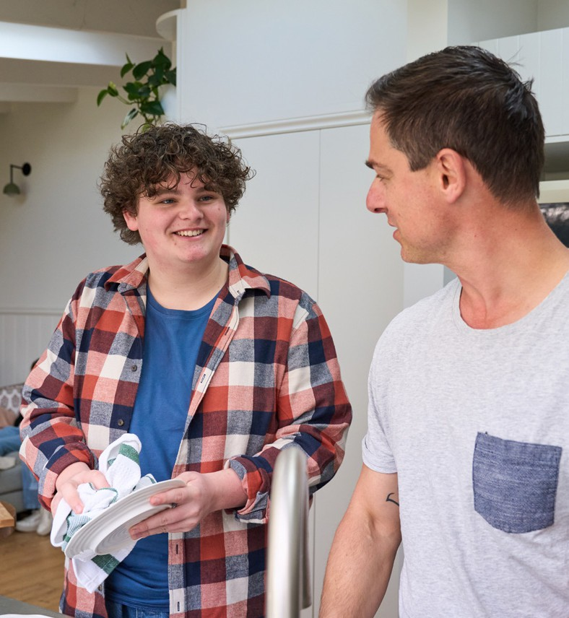


Cultural governance
Cultural governance ensures that YSCC are culturally safe, inclusive, and responsive, with clear accountability for embedding equity, respect, and cultural responsiveness across all aspects of care. YSCC demonstrates effective cultural governance through:
    - Leadership and oversight that prioritise cultural safety, responsiveness, and equity across all aspects of service delivery
    - Embedding Aboriginal and Torres Strait Islander leadership, partnerships, and decision-making within governance structures and processes, consistent with leadership arrangements at Appendix A
    - Ongoing cultural capability development, including training, supervision, and reflective practice for staff
    - Workforce development and practice informed by Aboriginal and Torres Strait Islander peoples and organisations
    - Workforce development of career pathways for Aboriginal and Torres Strait Islander peoples across all service levels
    - Mechanisms to engage and partner with local communities and cultural stakeholders, to integrate cultural practices into service delivery through shared learning and ongoing development, ensuring services are responsive to local context and needs
    - Monitoring and addressing equity of access, experience, and outcomes, including identifying and responding to disparities
    - Incorporation of cultural perspectives in service design, delivery, and evaluation, including through lived and living experience participation
    - Systems for continuous improvement in cultural safety, informed by feedback, data, and community engagement

Flexibilities

YSCC is a specialist, youth-focused service operating within clearly defined clinical and system boundaries. While the model is designed to be responsive and adaptable to individual need, flexibility operates within structured parameters to ensure accountability, consistency, and alignment with commissioning intent.

Service flexibility and local adaptation

YSCC are required to deliver a consistent, reliable model of care including core service components. However, flexibility is essential to ensure services are responsive to local context, population need, and service system configuration.
Services are expected to adapt delivery within the intent and integrity of the YSCC model, ensuring that flexibility supports responsiveness without compromising core components or model fidelity. Approaches may include:
    - Complementing existing services
Tailoring service delivery to align with the local service ecosystem, ensuring YSCC complement rather than duplicate existing services within the region.
    - Responding to local population needs
Adapting service delivery to meet the cultural and community needs of the region, including Aboriginal and Torres Strait Islander peoples, culturally and linguistically diverse communities, and LGBTIQA+ young people. Services may develop enhanced capability, targeted programs, or specific workforce expertise to support priority or vulnerable groups and make optimal use
of already available services. This includes
opportunity for the development of innovative
approaches to complement core services
provided through YSCC.
    - Flexible workforce models
Adapting workforce arrangements in response to local availability, including shared or integrated roles with hospitals or state-funded mental health services (e.g. psychiatrists, mental health nurses), particularly in areas of workforce scarcity. This may include the use of blended, outreach, and telehealth-enabled workforce models to extend specialist capability.
    - Partnership-based service delivery Enabling external providers or partner organisations to deliver services through the YSCC platform, supporting a more integrated, co-located, and resource-efficient service offering.
    - Workforce development and training
Actively building workforce capability and sustainability through structured training, supervision, and partnership with education providers. This may include student placements, support for early-career professionals (e.g. probationary and registrar levels), and development of peer workforce roles. Services are expected to contribute to workforce pipeline development and capability-building within the broader service system.

Model limitations and future adaptation

This model of care has been primarily designed based on metropolitan and regional service contexts, where workforce availability, service density, and infrastructure enable full implementation of the core components. It is recognised that rural and remote contexts
present distinct challenges, including workforce
constraints, geographic dispersion, and limited
service integration. As such, implementation in
these settings will require deliberate adaptation
while maintaining fidelity to core principles. Over
time, further development and refinement of the
model will be required to ensure it remains
fit-for-purpose across diverse geographic contexts,
including rural and remote communities.



Service implementation

YSCC implementation will be guided by a phased and adaptive approach that enables services to start at a manageable scale, build capability over time, and develop service capacity at full model fidelity. The approach recognises that some YSCC will transition from existing early psychosis services, while others will be newly established. Implementation pathways may therefore vary; however, all YSCC are expected to progressively:
- Establish readiness and foundational infrastructure
- Commence delivery of core model components
- Scale capacity and expand each model component
- Achieve and maintain fidelity to the model
- Participate in developmental evaluation from the outset
Evaluation will assess whether YSCC improve access, continuity of care, safety, equity and outcomes for young people, alongside service performance, and fidelity and system impact. Findings from early implementation sites directly inform the model of care and implementation supports prior to, and during, broader roll out, so that scaling decisions are informed by evidence of what is working and for whom. Evaluation domains, measures and governance are described in Section 10.
Implementation will be informed by local barriers and enablers identified by services and regions, with tailored supports provided to address contextual challenges while maintaining alignment with the core components of the model. Digital and telehealth-enabled models of care will be embedded across implementation to support equitable access, particularly in regional, rural, and underserved areas.
Effective commissioning arrangements are critical to successful implementation of the YSCC model. Commissioning approaches should align with the principles and requirements of the model, including support for integrated, multidisciplinary care, flexible service delivery, and continuity across service interfaces. This includes enabling appropriate service scope, workforce configuration, and collaboration to support delivery of the full model of care.
As YSCC will operate within an existing and diverse service landscape, services will need to adapt local structures, workforce capability, and partnerships to align with the YSCC model. This will involve ongoing implementation and change management at the local level. Key challenges may include:
- Planning services to complement, integrate with, and avoid unintended duplication or displacement of existing services
- Managing system impacts associated with the introduction of YSCC, including potential changes to referral patterns, workforce distribution, and the roles of existing services (e.g. headspace, YES, and state-funded services)
- Managing demand to enable timely access to support and advice whilst scaling up to full model implementation
- Building and sustaining a skilled multidisciplinary workforce in the context of workforce constraints
- Identifying and responding to unmet local and cultural needs while maintaining a standard suite of core services
- Developing pathways required to deliver a comprehensive range of services and referral pathways

- Variability in available resources, infrastructure, and workforce capacity across regions, impacting the ability to deliver best practice care from commencement
- Variation in state and territory legislation, governance arrangements, and service interfaces, influencing service setup, clinical decision-making, and models of care delivery
Implementation will be supported through national coordination and tailored supports to address these contextual factors. During implementation, a period of overlap between YSCC and existing services is expected, reflecting unmet need and the importance of maintaining continuity of care. Implementation will focus on complementarity, coordination, and appropriate service utilisation over time. Co-design with partner agencies, young people, families, and local communities will be integral across all phases of implementation.
Implementation will include a focus on supporting young people and families to navigate the service system and make informed decisions about care. This includes recognising the importance of “reciprocal assessment,” where services assess suitability while also supporting young people and families to determine whether a service feels appropriate, safe, and responsive to their needs. Clear pathways, communication, and shared decision-making processes will support engagement and continuity of care.

Hub-and-spoke approaches

YSCC are implemented using a hub-and-spoke model to support equitable access and geographical reach, coordinated care, and efficient use of workforce and specialist capability across PHN catchments.
It is expected that each YSCC include a single
lead centre (hub), with the number and configuration of spoke sites determined by
the size of the catchment area, population distribution, and local accessibility needs.
The hub functions as the central site for clinical leadership, governance, and coordination of care. It is expected to maintain the full complement of
the multidisciplinary team, including psychiatric,
psychological, nursing, allied health, psychosocial,
and lived experience roles, as well as access to
specialist capability across priority clinical streams.
The hub supports complex assessment, specialist intervention, workforce capability development,
and system coordination across the catchment.
The hub is responsible for operationalising the YSCC model of care across the catchment, including ensuring consistent delivery of core components across all spoke locations. This includes leadership in areas such as community awareness and engagement, integration with local service systems, workforce capability development, and maintenance of model fidelity.
Spoke sites extend the reach of the service and improve accessibility for young people and families. Spokes are expected to deliver the full suite of YSCC interventions, supported by appropriately skilled multidisciplinary teams, while working in close partnership with the hub. The configuration of spoke teams may vary depending on local context, but care remains aligned to the YSCC model of care and supported by shared clinical governance, supervision, and consultation.
The hub-and-spoke model enables:
- Delivery of care closer to home, particularly in regional, rural, and outer metropolitan areas
- Flexible movement of young people between locations without loss of continuity
- Efficient deployment of specialist expertise through outreach, in-reach, and integrated telehealth delivery
- Workforce development through supervision, mentoring, and secondary consultation
Care is coordinated through a single care plan and key clinician, regardless of where services are delivered. Clinical governance, data systems, and model fidelity processes are shared across hub and spoke sites to ensure consistency in quality and safety.
This model supports scalability and responsiveness to local context, while maintaining the integrity of the YSCC model and ensuring that all young people, regardless of location, have access to comprehensive, specialist youth mental health care.

Implementation approach

Implementation will occur across four phases: establishment, initial implementation, full implementation, and consolidation. Services may move through phases at different rates depending on local context and organisational readiness.
Implementation will be supported through national coordination, shared learning, strong leadership and governance structures, and structured implementation supports to promote consistency while balancing flexibility to respond to local context.
Structured change management approaches will support implementation, recognising the impact of service transformation on workforce, partner organisations, and the broader service system. This includes supporting staff through transition, managing uncertainty, and building confidence and capability in delivering the new model.
Implementation will support workforce understanding of fidelity requirements, including what is required, how it is achieved in practice, and why it is critical to outcomes, through guidance, training, and tools to support consistent delivery and effective fidelity monitoring.
Evaluation and data collection will be embedded from the outset, enabling early learning, continuous improvement, and refinement of the model as services are established and scaled.
Implementation will be tailored to local context, with regions and services supported to identify key barriers and enablers and adapt delivery approaches accordingly. National implementation supports will respond to these local needs while maintaining consistency with core model requirements.
Implementation of YSCC is expected to occur through partnership-based arrangements that bring together primary care, community, and state-funded mental health providers. This approach will support collaborative planning and ensures that specialist expertise, multidisciplinary capability, and clear step-up and step-down pathways are embedded from the outset. Inclusion of state-funded mental health services within partnership arrangements supports the delivery of coordinated care, shared governance, clinical consultation, workforce capability
development, and coordinated care for young
people whose needs escalate or change over time.
Implementation will be locally informed and led, with services supported to identify priority needs, barriers, and effective approaches within their context. National guidance and resources will enable this local ownership while ensuring alignment with the core components and expectations of the YSCC model.
For services transitioning from EPYS, implementation as a YSCC will build upon existing service provision. Existing investment is expected to be directed towards delivery of the YSCC model, with additional resources applied to expand service scope beyond early psychosis to a broader transdiagnostic cohort. This approach supports continuity of care and workforce stability while enabling progressive implementation of the full model.

Establishment phase
This phase focuses on readiness and planning activities required to establish the foundations for implementation. For services transitioning from existing models, this phase will support a shift in vision, scope, and service identity towards a transdiagnostic approach.
Key activities include:
- Clarifying whether implementation involves transition or new service establishment
- Establishing the YSCC leadership (Clinical Director and Operations Manager)
- Conducting a gap analysis across workforce, skill mix, infrastructure, and site requirements
- Identifying, securing, and fitting out premises, including co-design with young people to ensure spaces are youth-friendly, accessible, culturally safe, and support flexible models of care
- Identifying what areas will require national specialist capability support (e.g. telehealth access, supervision, secondary consultation) during the earlier phases of implementation
- Working with the PHN and state-funded mental health services on local service mapping and needs assessment
- Developing partnerships and referral pathways with local services (primary, secondary, and tertiary), community organisations, and other key partners

- Conducting workforce planning and recruitment
- Undertaking orientation and education to support understanding of the model, including similarities and differences with existing models
- Establishing governance, data systems, and implementation support
- Establishing processes to enable rapid feedback, decision-making, and refinement during early implementation, including clear escalation pathways and mechanisms to respond to emerging challenges and opportunities
This phase ensures services are positioned for safe commencement and supports alignment with the core principles and expectations of the YSCC model.

Initial implementation phase
This phase focuses on commencing service delivery and implementing core model
components at a manageable scale.
Key activities include:
- Commencing delivery of all core service components
- Implementing priority clinical pathways and essential core functions
- Providing workforce training, supervision, and implementation support
- Utilising telepsychology and digital service delivery as an interim approach to support access and extend workforce capacity while local capability is established
- Developing or strengthening partnerships and referral pathways
- Monitoring early implementation challenges and adapting processes
- Identifying areas requiring access to secondary or remote consultation whilst workforce capability is grown
- Supporting workforce understanding and application of fidelity requirements through training, supervision, and practical tools, including early use of fidelity monitoring processes
- Developing a road map to achieve the timely scaling of service capacity of the full model
Fidelity monitoring will begin during this phase to inform continuous improvement and identify areas requiring additional support.

Full implementation phase
This phase focuses on achieving service capacity of the full suite of model components.
Key activities include:
- Expanding workforce and service capacity
- Delivering, at full capacity, all the core components of the model
- Strengthening multidisciplinary care approaches
- Embedding transdiagnostic care approaches
- Enhancing partnerships to broaden service reach
Formal fidelity monitoring will support quality improvement, ensure alignment with the model of care, and identify areas for further education, support, and supervision.

Consolidation phase
The consolidation phase focuses on embedding the model within local systems, maintaining fidelity, and supporting ongoing service improvement and system impact.
Key activities include:
- Ongoing workforce development
- Continuous quality improvement processes
- Maintaining partnerships and integration across the service system
- Using data to inform service planning and improvement
Implementation will align with a Learning Health System approach, supported by developmental and process evaluation to enable continuous learning, adaptation, and system-wide improvement.

Evaluation and reporting

Evaluation and reporting are central components of the YSCC model of care, supporting continuous improvement, transparency, and accountability. Services provide routine performance reporting to commissioning PHNs through data submissions and performance reviews. In addition to site-level monitoring, aggregated data across the YSCC network contributes to national evaluation, enabling assessment of system impacts, service accessibility, equity of access, and long-term outcomes for young people.
Consistent with the Learning Health System approach underpinning YSCC, data generated through routine care is systematically collected and used to inform clinical practice, service improvement, and program-level learning. The primary purpose of evaluation is to improve outcomes for young people, while also monitoring progress against key system objectives. These include improving access to specialist youth mental health care, reducing duration of untreated illness, improving functional outcomes, and
reducing reliance on acute services (including
emergency department attendances) and
inpatient mental health services. Evaluation
also supports monitoring of equity of access and
outcomes for priority populations, including
Aboriginal and Torres Strait Islander young people,
culturally diverse communities, and young people
in rural and regional areas.
Evaluation within YSCC occurs across three interconnected levels:
- Individual outcomes, to guide clinical care
- Service performance and model fidelity, to ensure high-quality and consistent implementation
- System impact, to assess the contribution of YSCC to the broader youth mental health system



Individual outcomes

YSCC use measurement-based care to support clinical decision-making and monitor progress over time. Standardised outcome measures are collected at key points across the care journey, including entry, review points during care, and transition from the service.
Outcome monitoring focuses on domains that are meaningful for young people and central to recovery, including:
    - Mental health symptoms
    - Functioning (education, employment, and social participation)
    - Quality of life and wellbeing
    - Physical health
    - Safety and risk
    - Service experience
Lived experience perspectives are incorporated into the design and interpretation of outcome measurement and evaluation activities.
Engagement with young people, families and supporters helps identify gaps between system priorities and the experiences and needs of those directly interacting with services, ensuring evaluation approaches remain meaningful and relevant.

Service performance and model fidelity

Maintaining fidelity to the service model ensures that young people receive evidence-informed, developmentally appropriate, and integrated care. Fidelity monitoring supports consistency across services while allowing adaptation to local contexts.
Minimum fidelity requirements will be defined by the model custodians and specify the core components that must be delivered to maintain model integrity. While services may adapt aspects of delivery in response to local workforce, service system, or community context, partial or selective implementation of core components is not considered consistent with the model. Where constraints impact delivery, services will be supported to achieve fidelity over time through phased implementation and continuous quality improvement processes.
At the service level, data is used to monitor performance, ensure alignment with the model of care, and support quality improvement. Services will contribute to a national minimum dataset to enable consistent monitoring of access, continuity, safety, equity, activity, outcomes, and model fidelity across the YSCC network. Wherever possible, the minimum dataset will be aligned with existing national data collections to support comparability with the broader system and enable analysis of system-wide impacts.
Detailed reporting and data collection requirements will be specified in funding agreements and associated reporting guidance for commissioned services, and will include indicators relating to:

Access and service activity
- Intake and access, including timeliness of assessment and commencement of care
- Referral rates, caseloads, and tenure of care
- Engagement and retention in care
- Equity of access for priority communities, including Aboriginal and Torres Strait Islander young people, culturally and linguistically diverse communities, gender diverse young people, and young people experiencing socioeconomic or geographic disadvantage
- Service accessibility, including outreach opportunities and flexible options for access

Workforce and model delivery
- Multidisciplinary care team composition
- Quality, intensity, and frequency of care delivered
- Provision of psychological therapies
- Physical health care including lifestyle-related expertise and care
- Access to medical interventions

Recovery and functional outcomes
- Clinical and functional outcomes, aggregated from individual-level measures collected under Section 10.1, including mental health symptoms, functioning and quality of life
- Vocational and educational participation and engagement
- Reduction in duration of untreated illness
- Reduction in use of acute services (including ED attendances) and inpatient mental health services

Experience and system integration
- Experience-of-care data to support outcome monitoring and ensure the experiences of young people and families inform service evaluation and improvement
- Family and supporter involvement, including feedback on assessment and care processes
- Evidence of integrated care planning and delivery across clinical and psychosocial domains (e.g. shared care plans, multidisciplinary case review, coordinated interventions)
- Feedback from external organisations, including referrers and partner services, to monitor service accessibility, referral pathways, and integration with the broader service system
- Participation of young people and families in service design and improvement activities
In addition to routine performance monitoring, services participate in periodic fidelity reviews to assess alignment with the core components of the model and identify opportunities for service development.
Findings from performance monitoring and fidelity reviews support continuous quality improvement. Services are expected to use data to inform reflective practice, identify areas for improvement, and implement targeted actions to strengthen service delivery.
At a network level, aggregated data supports benchmarking across services, enabling identification of emerging trends, sharing of effective practice, and collective learning across the YSCC network.
Together, these indicators support accountability, strengthen service delivery, and ensure the model is implemented as intended. Aggregated data also contributes to understanding broader system impacts, including improved access to specialist youth mental health care, reductions in duration of untreated illness, and stronger integration across the youth mental health system.

Continuous quality improvement

YSCC participate in continuous quality improvement processes that support reflective practice, shared learning, and service development. Multidisciplinary care teams regularly review outcome data, service performance indicators, and feedback from young people and families to inform improvements in care delivery.
A central national coordination function, led by the model custodians, will support engagement with state and territory stakeholders on cross-jurisdictional implementation issues, including service interfaces, referral pathways, and shared care arrangements. This approach reduces duplication of effort at the local level and ensures consistent positioning of the YSCC within broader service systems.
These processes contribute to building a culture of learning across YSCC, where data and evaluation are used to support reflection, shared learning, and translation of evidence into improved clinical practice.

Evaluation governance and data collection

An independent evaluation of the YSCC program will be undertaken to assess implementation of the model of care, service performance, outcomes for young people and families, and system impacts. As YSCC represent an additional component within the broader youth mental health system rather than a replacement for existing services, evaluation will need to consider both implementation and service outcomes within this broader context.
Evaluation approach, scope and timing will be determined by government. YSCC will support this through routine data collection, monitoring of implementation progress, and reporting on service activity and early performance indicators, to enable assessment of outcomes over time as services mature.
Reporting and data collection requirements for YSCC will be specified in funding agreements and supported by a defined minimum dataset. Data collection will focus on the information required to monitor service activity, assess performance, and support evaluation of the YSCC initiative.
The minimum dataset will be designed to reflect both service delivery and lived experience of care, capturing not only operational and activity-based data but also how care is delivered and experienced in practice. This will include input from multiple stakeholder perspectives, including young people, families and carers, clinicians, and partner services, to ensure a comprehensive understanding of service quality and impact.
Data collection approaches will incorporate a combination of quantitative and qualitative measures, including patient-reported outcomes and experience measures, to ensure the model is assessed in a way that reflects real-world care delivery.
YSCC will have access to their own data to support benchmarking, local service planning, and continuous quality improvement. This will be enabled through a Learning Health System approach, including the use of a CQR, providing timely and meaningful feedback to services to support reflective practice, testing of service improvements, and monitoring of change over time.
Digitally enabled data collection and infrastructure will be used to streamline data capture, reduce duplication, and minimise reporting burden on services. Where possible, data collection processes will be integrated within existing clinical systems and workflows to support efficient and high-quality data capture.
Workforce development will support staff capability in the safe, effective collection, interpretation, and use of data, including embedding data-informed decision-making into routine clinical practice and service improvement.
The Department of Health, Disability and Ageing will determine the evaluation framework, reporting requirements, and minimum dataset in partnership with relevant stakeholders. These will be developed through a structured co-design process involving clinical, service delivery, research, and lived experience expertise to ensure relevance, feasibility, and alignment with best practice. Technical design will be led in partnership with subject matter experts in youth mental health service delivery, implementation science, and data systems.
Key performance indicators (KPIs) and targets will reflect the full scope of the YSCC model of care, including clinical, psychosocial, functional, and experience outcomes, rather than focusing solely on service activity or clinical outputs. Findings from routine monitoring and evaluation will also contribute to ongoing policy development and program refinement.

Glossary

TERM | DEFINITION
Attenuated | Mental health symptoms that are milder, less frequent, and/or subthreshold compared to established diagnostic criteria.
Biopsychosocial assessment | An assessment of a young person that looks at all the domains of biological, psychological (thoughts, emotions, behaviour), and social factors that may impact on their health and wellbeing.
Clinical staging | The progression of mental health difficulties over time, from early, non-specific, or attenuated presentations through to more discrete, persistent, or recurrent disorders. It provides a framework for delivering timely, proportionate, and evidence-based care by matching interventions to a person’s current stage and risk of progression.
Comorbidity | The co-occurrence of one or more conditions for a young person at the same time or following on from a disorder.
Complexity | Mental health presentations shaped by the interaction of multiple, co-occurring clinical, developmental, psychosocial and system factors that significantly impact a young person’s mental wellbeing, functioning and capacity to engage with standard service pathways. Young people may experience overlapping needs across these areas, and presentations may evolve over time. This includes young people experiencing emerging or first episode symptoms of low prevalence mental health conditions, where specialist, evidence-based care is indicated.
Cultural safety | The provision of accessible and responsive healthcare that is free of racism and bias and perceived by the young person as safe for their cultural identity and cultural connections.39 Cultural safety is created when practitioners recognise and respond to power imbalances and critically reflect on how their own cultural identity, knowledge, skills, attitudes, practice, and conscious and unconscious biases influence the care they provide.
Discharge planning | Processes of considering and preparing the young person for discharge from the service, often linking them to other community services for ongoing care, focused on the future.

TERM | DEFINITION
Duration of untreated psychosis (DUP) | Time from onset of psychosis to initial treatment.
Early psychosis | While there is no single authoritative definition, ‘early psychosis’ refers to the prodromal period preceding first episode psychosis and can include the critical period up to five years from entry into initial treatment.
Evidence-based | Describes interventions and practices grounded in the best available evidence. Priority should be given to interventions supported by high-quality clinical trial evidence, including randomised controlled trials. Where such evidence is not yet available, interventions should be consistent with current clinical guidelines and expert consensus.
Family | People whom the young person views as such which may include parents, siblings, friends, supporters, or significant others who play a strong role in the young person’s life. Family is broadly defined and inclusive of family of choice and origin, and broader kin.  For children and young people under 18, this includes their parent(s), legal guardian or kinship carer, whose involvement in care planning and delivery is the default position unless the child is in statutory care or a documented assessment determines that such involvement is not safe or appropriate. Family may also include, in recognition of cultural, kinship and community-based family structures, extended family members, Elders and other trusted adults identified by the young person, where their involvement supports the young person’s care, cultural identity and wellbeing.
First episode psychosis (FEP) | The first onset of a psychotic disorder in a person’s lifetime. It represents the first treated episode of psychosis in the person’s life.
Functional recovery | Functional recovery is defined by a young person’s capacity to engage in education, employment, relationships, and community life, reflecting improved functioning, independence, and overall wellbeing.
Home-based care | Assessing and/or treating young people at home, in a community setting, or other environment that they are comfortable in.
Individual treatment plan | A goal-directed treatment plan, created collaboratively between a young person and their key clinician.
Lived experience | A past, present, and/or ongoing personal experience of significant life challenges (such as mental ill-health, distress, and substance use and/or addiction); or the experience of supporting someone who has experienced such challenges.8 This may also include how specific experiences intersect with mental ill-health, system navigation, and healing and recovery. These experiences have transformed people’s life trajectories and shaped their knowledge, skills, perspectives, resilience, and overall outlook on life.40 Each person’s path of healing, hope, and recovery is unique.41

TERM | DEFINITION
MOST | A digital mental health platform co-designed by and for young people offering personalised tools, mental health professional support, evidence-based therapies, and resources for a range of mental health and life challenges. More information can be found on most.org.au.
Neurodiversity | An umbrella term used to describe the different neurological ways that people, including those who are neurodivergent or neurotypical, process information. Young people who are neurodivergent include those with (but not limited to) attention deficit hyperactivity disorder (ADHD), autism, dyslexia, dyscalculia, and Tourette’s. Neurodiversity encompasses the whole person and their environment, including their strengths as well as the barriers and challenges they may face.42
Psychoeducation | A process of providing information and education on mental health and recovery for young people and families. Psychoeducation can range from ‘passive’ methods such as information leaflets and websites to ‘active’ methods such  as individual or group-based sessions involving exercises and professional guidance.43
Psychosis | A group of conditions characterised by misinterpretation and misapprehension of the nature of reality as reflected in certain symptoms, particularly disturbances in perception (hallucinations), disturbances of belief and interpretation of the environment (delusions), and disorganised speech patterns (thought disorder).
Psychosocial supports | Psychosocial supports are the supports and services that address the psychological, social, and functional aspects of a young person’s life, which help them build the skills, relationships, and stability needed for recovery. They focus on strengthening daily functioning, social participation, relationships,  and the skills and resources needed to participate in education, employment, relationships, and live well in the community.
Recovery | A variable and non-linear process of improving a range of areas including wellbeing, resilience, hope, identity and positive sense of self, personal autonomy, engagement in active life, and sense of meaning or purpose in life following mental health and other challenges.44 Each young person’s recovery journey is unique to them and can involve both achievements and setbacks (e.g. relapses) in any combination of areas.
Relapse | Re-experiencing mental health symptoms from a previous episode or experiencing a new presentation of symptoms after a period of recovery.
Risk assessment | The process of identifying biopsychosocial factors that may increase a young person’s risk of things such as (but not limited to) self-harm, suicide, and harm to self or others. These may include individual, community, and population-level risk factors. The process aims to understand the young person, address risk factors, and enhance their wellbeing and recovery.45

TERM | DEFINITION
Shared decision making | In youth mental health, this collaborative process involves the clinician and young person (and caregiver, where appropriate) working together to make informed treatment decisions. The clinician explains the available options in developmentally appropriate language, including the benefits and risks, compared to what may happen without treatment, and actively supports the  young person to consider and express their preferences, values, and goals. The emphasis is on a respectful exchange of information that integrates the best available evidence with the young person’s individual circumstances to guide care decisions.
Supported decision making | In youth mental health, this approach upholds young people’s right to make decisions about their own care by providing the support they need to understand information, consider options, and communicate their preferences. This may include assistance from clinicians, caregivers, or other trusted supporters. It  is grounded in the principle of dignity of risk, recognising that young people have the right to make reasonable decisions involving risk as part of learning and autonomy. In situations where a young person is temporarily unable to exercise full decision-making authority, supported decision making seeks to  maximise their involvement through mechanisms such as advance statements or nominated persons, rather than defaulting to substitute decision making.
Ultra high risk (UHR) | A state in which a young person meets predictive criteria for an increased chance of developing a psychotic condition. Criteria include trait risk factors (vulnerability) and impaired functioning; subthreshold (attenuated) psychotic symptoms; or a recent history of brief, limited psychotic symptoms that spontaneously resolved. Other related terms include at-risk mental state (ARMS) and clinical high risk (CHR).
Young person/ people | Adolescents and young adults aged 12-25 years.

Appendix A: Service structure

Each YSCC is organised around the young person’s journey rather than diagnosis or discipline. The structure below is consistent across large, medium and small services, with size of teams and number of pods adjusting according to service size. Indicative staffing profiles for each service size are at Appendix B.

Three teams
- Engagement Team: a centralised, mobile access point providing intake, assessment, brief intervention and assertive engagement, retaining early clinical governance until a plan for ongoing care is agreed (Section 4.3). The Engagement Team may support assertive engagement and outreach during care, as negotiated with the Continuing Care Team and in addition to care received by the Continuing Care Team.
- Continuing Care Team: the largest team in the service, providing sustained, multidisciplinary, formulation-informed care for young people requiring ongoing treatment, organised into pods.
- Functional Recovery Team: vocational, educational, psychosocial and group-based programs supporting participation and functional recovery, delivered in parallel with clinical care (Section 4.12).
Transitions between teams are planned and clinically governed. Peer support, family work and continuity of relationship operate across all three teams.

Continuing care team pods
Pods are the operational unit of the Continuing Care Team: small, consistent, transdiagnostic teams each holding a defined caseload of approximately 140 to 180 young people. They may be located separate from the YSCC hub (i.e., they may be located at spoke sites). Each pod comprises a pod lead, key clinicians, youth peer workers and consistent psychiatry input, with clinical specialists from the specialist clinician pools working within and across pods. Every young person is held by a small, named team rather than a large undifferentiated caseload, preserving relational continuity and clear clinical governance as services scale. Pods hold mixed, staged caseloads and are not organised by diagnosis, consistent with the transdiagnostic principle. Large services operate three pods, medium services two, and small services a single pod.

LEVEL | ROLES | ACCOUNTABILITY AND REPORTING
Service leadership | Clinical Director (consultant psychiatrist); Operations Manager | Dual leadership model. The Clinical Director holds clinical and medical governance; the Operations Manager holds operational, workforce and corporate accountability.
Team leadership | Engagement Team Manager; Continuing Care Team Manager; Functional Recovery Team Manager | Day-to-day operation of each team: flow, allocation, clinical review and staff support. The team managers’ report to the Operations Manager.
Pod leadership | Pod leads (one per pod) | Operational leadership of each pod, reporting to the Continuing Care Team Manager. Psychiatrist holds clinical leadership.
Cultural leadership | Determined through local pathways. May include a senior Aboriginal Health Practitioner role, shared leadership arrangements with a local Aboriginal Community Controlled Health Organisation, or community governance structures. | Services are expected to establish First Nations and/or cultural leadership within the existing establishment or through local partnership agreements. Cultural leadership informs culturally safe practice, service design and community connection across all teams, and advises the service leadership.
Practice leadership | Clinical Specialists; Lived Experience Leader. | Practice leadership across teams and pods: model fidelity, supervision and capability building, with the Lived Experience Leader overseeing the youth and family peer workforce.

Role titles and configurations are indicative and reflect the staffing profiles at Appendix B. Services will confirm local arrangements in line with the flexibilities described in Section 8.

Appendix B: Indicative staffing profiles

The staffing profiles in this appendix are indicative. They are provided to guide commissioning and operationalisation decisions and to illustrate how the core components of the model of care translate into a multidisciplinary workforce at three service scales: large, medium and small. Local configuration will vary in line with funding allocations, the flexibilities described in Section 8, local workforce availability, enterprise agreements, and the service and community context of each site.

Service capacity summary
Each profile has been modelled against the caseload and demand management assumptions described below. Capacity is expressed as both the number of young people held in care at any one point in time (stock) and the number of young people expected to move through the service annually (flow).

 | LARGE SERVICE | MEDIUM SERVICE | SMALL SERVICE
Continuing Care Team pods | Three | Two | One
Concurrent caseload held at any one time (stock) | ~440 young people | ~310 young people | ~180 young people
Young people supported across a year (flow) | ~1200 young people | ~900 young people | ~550 young people
Total staffing establishment | ~76.5 FTE | ~58.7 FTE | ~35.3 FTE
Engagement Team operating days | Six days per week | Six days per week | Five days per week

Figures are approximate and will vary with local case mix, episode duration and clinical acuity.

Service assumptions
- Caseload benchmarks. Key clinicians hold a concurrent caseload of around 20 young people (individual caseload targets informed by young person acuity and intensity). Clinical specialists and Continuing Care Team Aboriginal Health Practitioners hold a concurrent caseload of around 12 young people per FTE (for small services, a smaller caseload per FTE is preferred to allow sufficient time for the tasks of a clinical specialist). This reflects the higher intensity of specialist intervention and their protected time (expected to be 40 per cent of FTE) for capability development, secondary consultation, supervision and time-limited focused interventions. Family workers, psychiatry, peer, physical health, functional recovery and other care team roles provide input into held caseloads rather than generating separate caseload capacity.
- Discipline mix. Clinician lines have been calculated on a blended discipline assumption (40 per cent nursing, 60 per cent allied health and psychology), consistent with the multidisciplinary intent of the model. The actual mix at any site will reflect local workforce availability.
- Operating hours. Engagement Teams operate six days per week in large and medium services and five days per week in small services, consistent with the minimum service availability requirements in Section 2.4. Continuing Care Teams may roster their staff across six days per week.
- Leadership. Each profile carries the dual leadership model comprising a Clinical Director (Psychiatrist) and an Operations Manager, together with a lived experience leadership role and a Coordinator of Psychiatry Training (College accreditation requirement). First Nations and/or cultural leadership is established through local pathways within the existing establishment of partnership arrangements and is not costed as a separate line.
- Pod structure. Continuing Care Teams are organised into pods of approximately 140 to 180 young people, each with a dedicated pod lead, to preserve relational continuity, team-based care and clear clinical governance as services scale. Large services operate three pods, medium services two, and small services a single pod.

Indicative large service profile
Approximately 440 young people held in the service at any one time. Total establishment 76.5 FTE.

Team 1: Engagement Team (six days per week)

ROLE / POSITION | DISCIPLINE / CLASSIFICATION GROUP | FTE | NOTES
Engagement Team Manager | Clinical Manager | 0.8
Mental Health Nurse | Mental Health Nurse | 3.0 | Inclusive of 3 FTE Senior Clinician
Mental Health Clinician | Blended Nursing / Allied Health | 5.0 | Inclusive of 3 FTE Senior Clinician
Consultant Psychiatrist | Psychiatry | 0.4
Psychiatric Registrar | Psychiatric Registrar | 1.0
Aboriginal Health Practitioner | Aboriginal Health Practitioner | 0.6
Youth Peer Worker | Lived Experience Workforce | 1.0
Administration | Administration | 1.0
Team total |  | 12.8

Team 2: Continuing Care Team (three pods)

ROLE / POSITION | DISCIPLINE / CLASSIFICATION GROUP | FTE | NOTES
Continuing Care Team Manager | Clinical Manager | 1.4 | 0.4FTE may include speciality clinician leadership support
Pod Leads | Senior Clinician | 1.5 | 0.5 FTE per pod
Specialist Clinician Pool: Psychosis | Senior Clinician | 3.0 | 1.0 FTE per pod
Specialist Clinician Pool: Eating Disorders | Senior Clinician | 2.0 | Working across the three pods
Specialist Clinician Pool: Personality Disorder | Senior Clinician | 2.0 | Working across the three pods
Specialist Clinician Pool: Mood and Anxiety | Senior Clinician | 2.0 | Working across the three pods
Family Workers | Senior Clinician | 2.4 | Working across the three pods; provide input into held caseloads
Mental Health Clinician (Key Clinician) | Blended Nursing / Allied Health | 16.0
Aboriginal Health Practitioner | Aboriginal Health Practitioner | 1.0
Consultant Psychiatrist | Psychiatry | 4.5 | Services may consider distributing some of this Consultant FTE to the Engagement Team
Psychiatric Registrar | Psychiatric Registrar | 6.0 | 1.0 FTE may be substituted with a Nurse Practitioner
Youth Peer Worker | Lived Experience Workforce | 3.5 | May also work in Functional Recovery Team
Family Peer Worker | Lived Experience Workforce | 1.8 | May also work in Functional Recovery Team
Physical Health Lead (Nurse) | Nursing | 0.6 | May also work in Functional Recovery Team
Administration | Administration | 1.0
Reception | Administration | 1.0
Team total |  | 49.7

Team 3: Functional Recovery Team

ROLE / POSITION | DISCIPLINE / CLASSIFICATION GROUP | FTE | NOTES
Functional Recovery Team Manager | Clinical Manager | 0.8
IPS Employment and Education Specialist | Vocational | 1.5
Allied Health (Functional Recovery) | Allied Health | 3.0
Exercise Physiologist | Allied Health (Senior) | 0.6
Dietitian | Allied Health (Senior) | 0.8
Administration | Administration | 0.5
Team total |  | 7.2

Team 4: Senior Management and Operations

ROLE / POSITION | DISCIPLINE / CLASSIFICATION GROUP | FTE | NOTES
Clinical Director | Consultant Psychiatrist | 0.8
Coordinator of Psychiatry Training | Consultant Psychiatrist | 0.2 | College accreditation requirement
Operations Manager | Management | 1.0
Lived Experience Leader | Lived Experience Workforce | 1.0 | Oversees youth and family peer workforce
Training Coordinator | Senior Clinician | 0.8
Health Information Manager | Data and Information Management | 0.5
Quality Improvement and Evaluation Coordinator | Quality and Evaluation | 0.5
Community Development and Partnerships Manager | Clinical or Administration | 1.0 | *Works across all teams
Administration Manager | Administration | 1.0
Team total |  | 6.8
Total service |  | 76.5

Indicative medium service profile
Approximately 310 young people held in the service at any one time. Total establishment 58.7 FTE.

Team 1: Engagement Team (six days per week)
ROLE / POSITION | DISCIPLINE / CLASSIFICATION GROUP | FTE | NOTES
Engagement Team Manager | Clinical Manager | 0.8
Mental Health Nurse | Mental Health Nurse | 3.0 | Inclusive of 3 FTE Senior Clinician
Mental Health Clinician | Blended Nursing / Allied Health | 5.0 | Inclusive of 3 FTE Senior Clinician
Consultant Psychiatrist | Psychiatry | 0.4
Psychiatric Registrar | Psychiatric Registrar | 1.0
Aboriginal Health Practitioner | Aboriginal Health Practitioner | 0.6
Youth Peer Worker | Lived Experience Workforce | 1.0
Administration | Administration | 1.0
Team total |  | 12.8

Team 2: Continuing Care Team (two pods)
ROLE / POSITION | DISCIPLINE / CLASSIFICATION GROUP | FTE | NOTES
Continuing Care Team Manager | Clinical Manager | 1.4 | 0.4FTE may include speciality clinician leadership support
Pod Leads | Senior Clinician | 1.0 | 0.5 FTE per pod
Specialist Clinician Pool: Psychosis | Senior Clinician | 2.0 | 1.0 FTE per pod
Specialist Clinician Pool: Eating Disorders | Senior Clinician | 1.0 | Working across the two pods
Specialist Clinician Pool: Personality Disorder | Senior Clinician | 1.0 | Working across the two pods
Specialist Clinician Pool: Mood and Anxiety | Senior Clinician | 1.0 | Working across the two pods
Family Workers | Senior Clinician | 2.0 | Working across the two pods; provide input into held caseloads
Mental Health Clinician (Key Clinician) | Blended Nursing / Allied Health | 12.0
Aboriginal Health Practitioner | Aboriginal Health Practitioner | 0.6
Consultant Psychiatrist | Psychiatry | 2.5 | Services may consider distributing some of this Consultant FTE to the Engagement Team
Psychiatric Registrar | Psychiatric Registrar | 3.0 | 1.0 FTE may be substituted with a Nurse Practitioner
Youth Peer Worker | Lived Experience Workforce | 3.0 | May also work in Functional Recovery Team
Family Peer Worker | Lived Experience Workforce | 1.0 | May also work in Functional Recovery Team
Physical Health Lead (Nurse) | Nursing | 0.5 | May also work in Functional Recovery Team
Administration | Administration | 1.0
Reception | Administration | 1.0
Team total |  | 34.0

Team 3: Functional Recovery Team
ROLE / POSITION | DISCIPLINE / CLASSIFICATION GROUP | FTE | NOTES
Functional Recovery Team Manager | Clinical Manager | 0.8
IPS Employment and Education Specialist | Vocational | 1.0
Allied Health (Functional Recovery) | Allied Health | 2.0
Dietitian | Allied Health (Senior) | 0.6
Exercise Physiologist | Allied Health (Senior) | 0.6
Administration | Administration | 0.5
Team total |  | 5.5

Team 4: Senior Management and Operations
ROLE / POSITION | DISCIPLINE / CLASSIFICATION GROUP | FTE | NOTES
Clinical Director | Consultant Psychiatrist | 0.8
Coordinator of Psychiatry Training | Consultant Psychiatrist | 0.2 | College accreditation requirement
Operations Manager | Management | 1.0
Lived Experience Leader | Lived Experience Workforce | 1.0 | Oversees youth and family peer workforce
Training Coordinator | Senior Clinician | 0.6
Health Information Manager | Data and Information Management | 0.5
Quality Improvement and Evaluation Coordinator | Quality and Evaluation | 0.5
Community Development and Partnerships Manager | Clinical or Administration | 0.8 | *Works across all teams
Administration Manager | Administration | 1.0
Team total |  | 6.4
Total service |  | 58.7

Indicative small service profile
Approximately 180 young people held in the service at any one time. Total establishment 35.3 FTE. At this scale several functions are consolidated into shared roles, and some functions, including physical health nursing and training coordination, are expected to be delivered through shared, sessional, hub or partnership arrangements.

Team 1: Engagement Team (five days per week)
ROLE / POSITION | DISCIPLINE / CLASSIFICATION GROUP | FTE | NOTES
Engagement Team Manager | Clinical Manager | 0.8
Mental Health Nurse | Mental Health Nurse | 2.0 | Inclusive of 2 FTE Senior Clinician
Mental Health Clinician | Blended Nursing / Allied Health | 4.0 | Inclusive of 2 FTE Senior Clinician
Consultant Psychiatrist | Psychiatry | 0.3 | Scheduled sessions supported by phone consultation
Psychiatric Registrar | Psychiatric Registrar | 1.0
Aboriginal Health Practitioner | Aboriginal Health Practitioner | 0.5
Youth Peer Worker | Lived Experience Workforce | 0.5
Administration | Administration | 0.5
Team total |  | 9.6

Team 2: Continuing Care Team (single pod)
ROLE / POSITION | DISCIPLINE / CLASSIFICATION GROUP | FTE | NOTES
Continuing Care Team Manager | Clinical Manager | 1.2 | Also carries the pod lead function at this scale
Specialist Clinician Pool: Psychosis | Senior Clinician | 1.0
Specialist Clinician Pool: Eating Disorders | Senior Clinician | 0.5
Specialist Clinician Pool: Personality Disorder | Senior Clinician | 0.5
Specialist Clinician Pool: Mood and Anxiety | Senior Clinician | 0.5
Family Workers | Senior Clinician | 0.5
Mental Health Clinician (Key Clinician) | Blended Nursing / Allied Health | 7.0
Aboriginal Health Practitioner | Aboriginal Health Practitioner | 0.5
Consultant Psychiatrist | Psychiatry | 1.5 | Services may consider distributing some of this Consultant FTE to the Engagement Team
Psychiatric Registrar | Psychiatric Registrar | 2.0 | 1.0 FTE may be substituted with a Nurse Practitioner
Youth Peer Worker | Lived Experience Workforce | 1.4 | May also work in Functional Recovery Team
Family Peer Worker | Lived Experience Workforce | 0.5
Administration | Administration | 0.5
Reception | Administration | 1.0
Team total |  | 18.6

Team 3: Functional Recovery Team
ROLE / POSITION | DISCIPLINE / CLASSIFICATION GROUP | FTE | NOTES
Functional Recovery Team Lead | Senior Clinician | 0.8 | *Classified at senior clinician level reflecting the breadth of the role at this scale
IPS Employment and Education Specialist | Vocational | 0.8
Psychosocial Recovery Worker / Group Facilitator | Allied Health | 0.8
Dietitian | Allied Health (Senior) | 0.2
Exercise Physiologist | Allied Health | 0.2
Team total |  | 2.8

Team 4: Senior Management and Operations
ROLE / POSITION | DISCIPLINE / CLASSIFICATION GROUP | FTE | NOTES
Clinical Director | Consultant Psychiatrist | 0.6
Coordinator of Psychiatry Training | Consultant Psychiatrist | 0.2 | College accreditation requirement
Operations Manager | Management | 1.0
Lived Experience Leader | Lived Experience Workforce | 0.5 | Oversees youth and family peer workforce
Training Coordinator | Senior Clinician | 0.2
Health Information Manager | Data and Information Management | 0.3
Quality Improvement and Evaluation Coordinator | Quality and Evaluation | 0.3
Community Development and Partnerships Manager | Clinical or Administration | 0.6 | *Works across all teams
Administration Manager | Administration | 0.6
Team total |  | 4.3
Total service |  | 35.3

Appendix C:
Lived and living experience journey maps

for young people and families

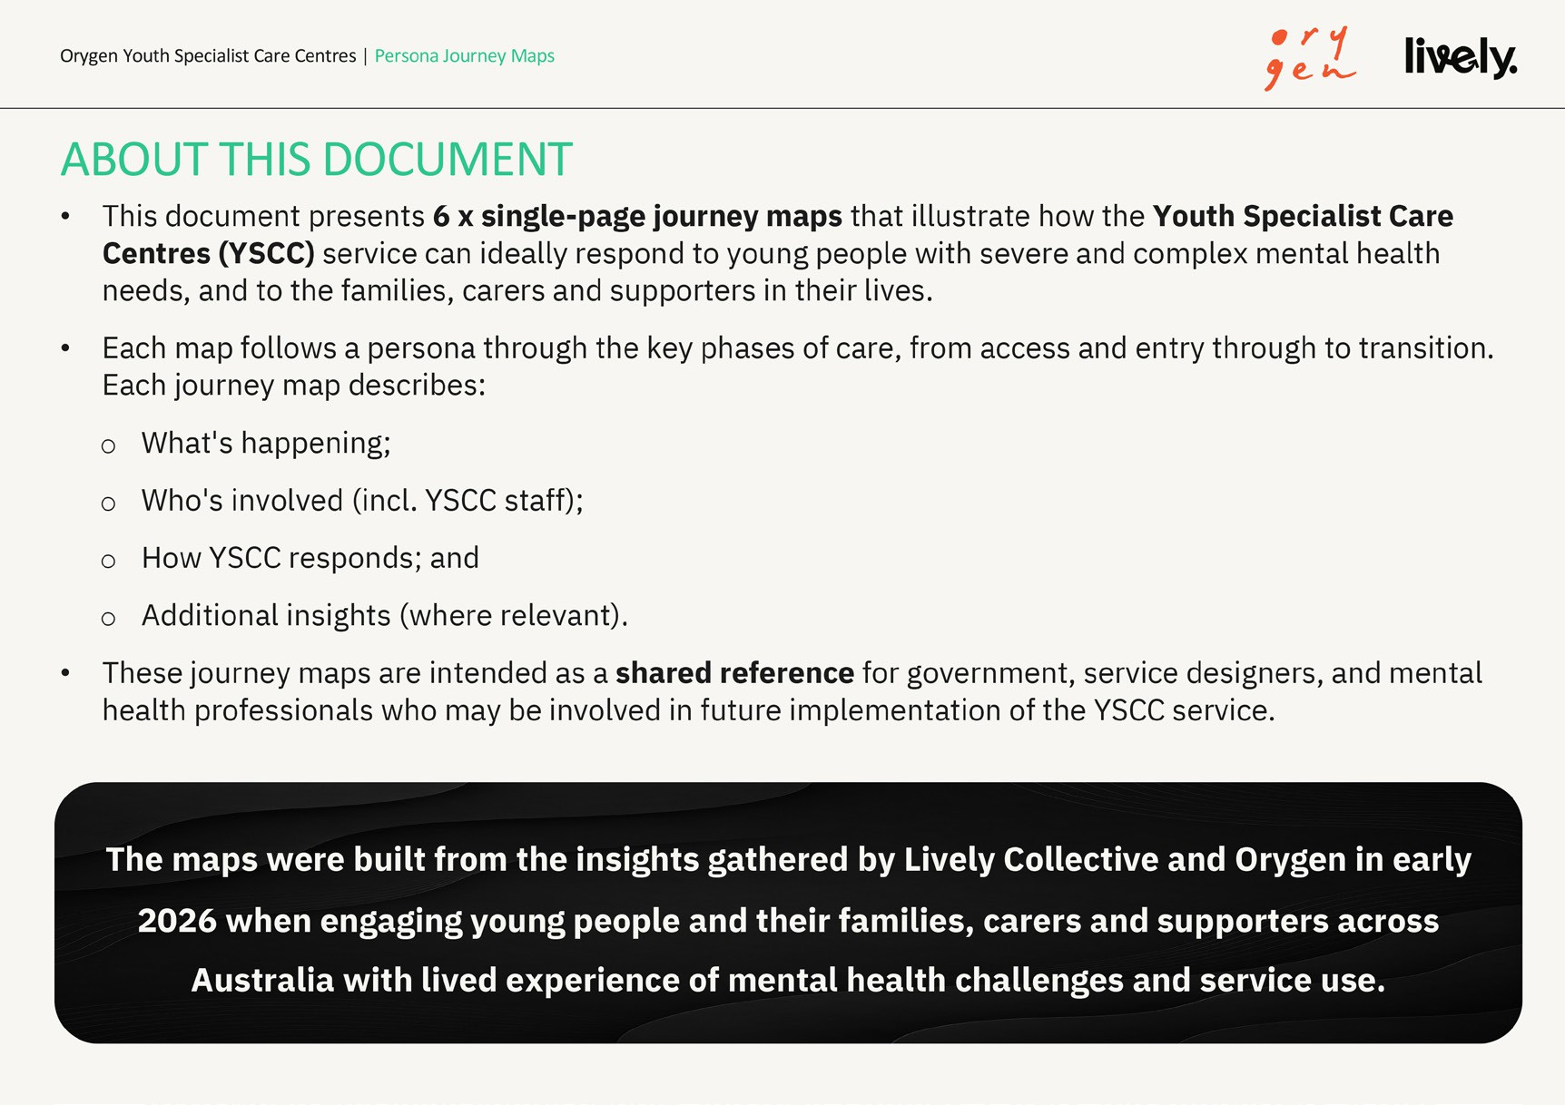

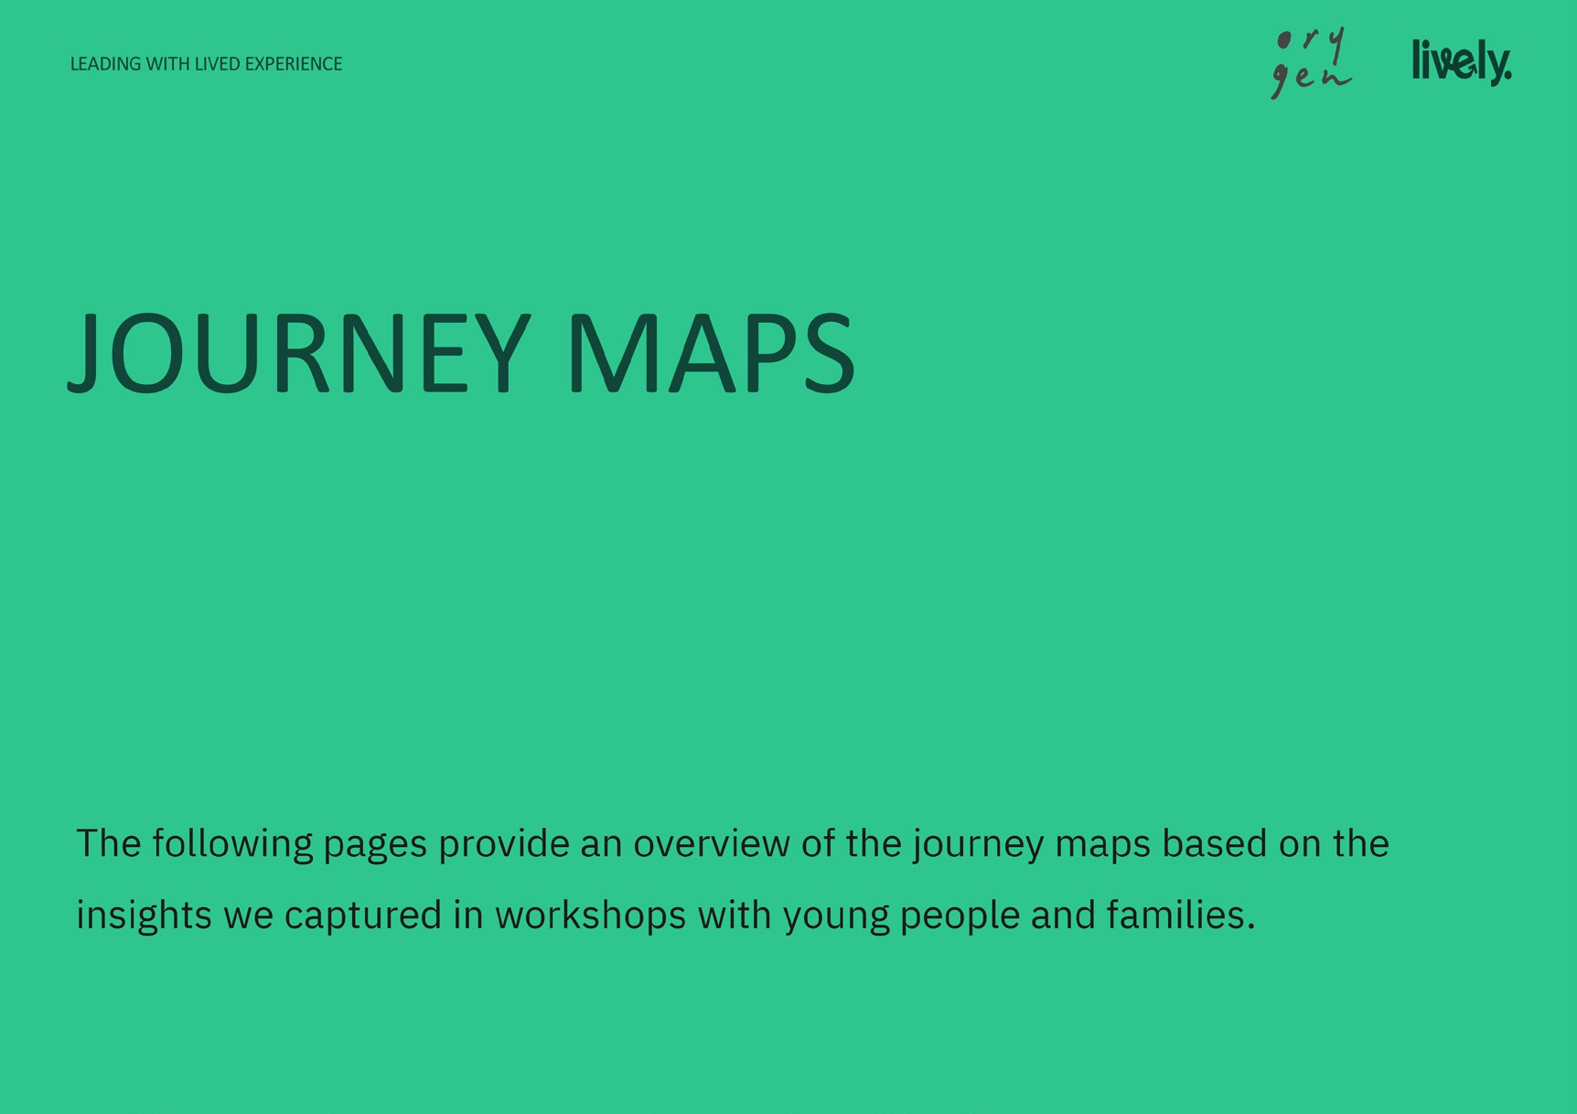
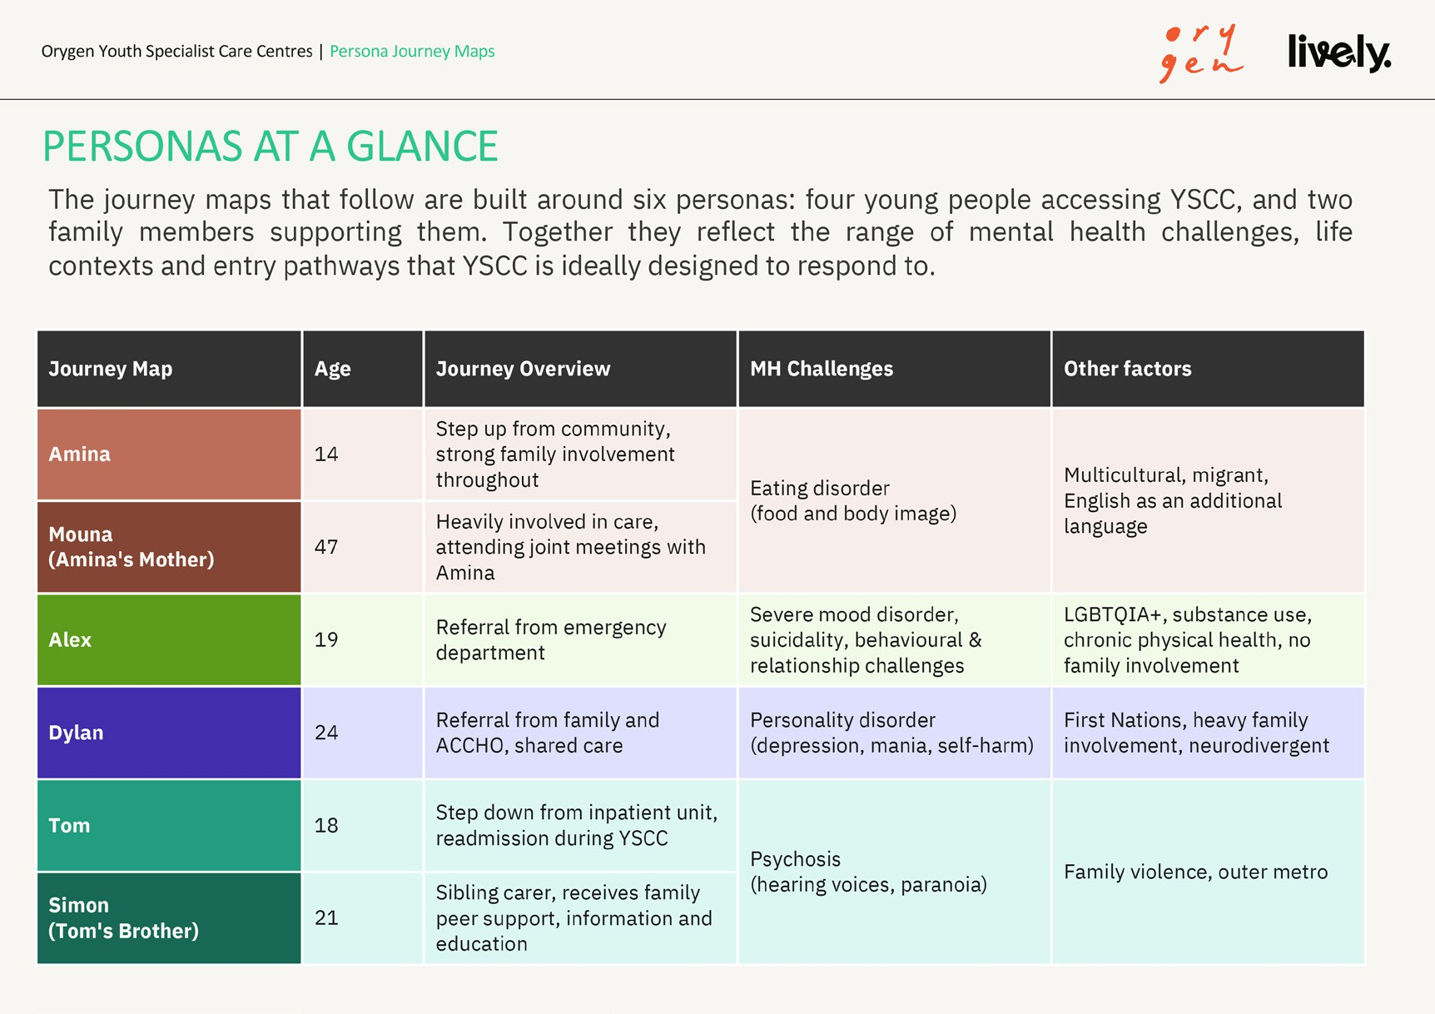

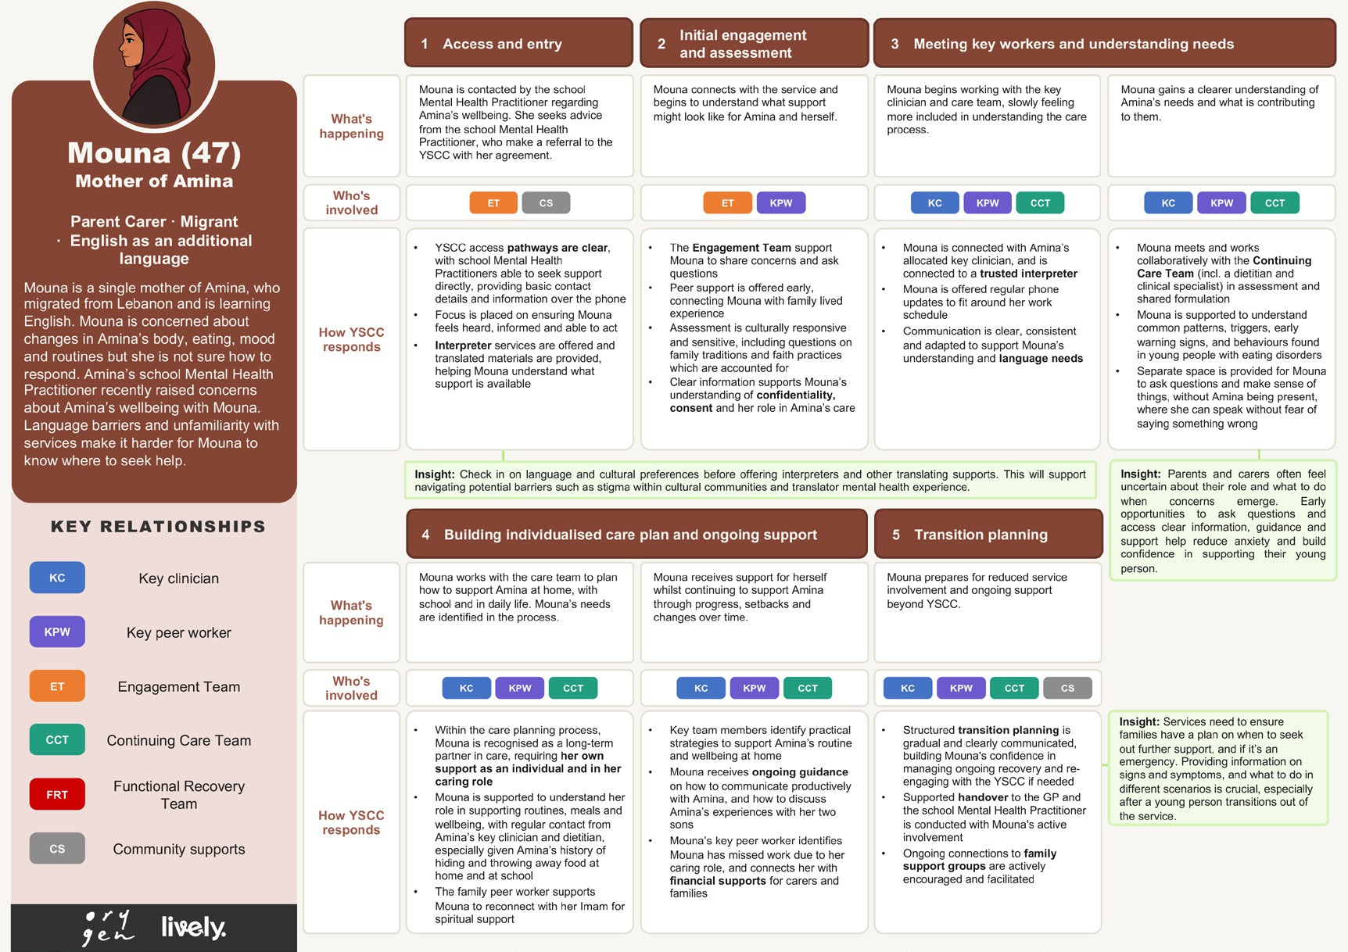
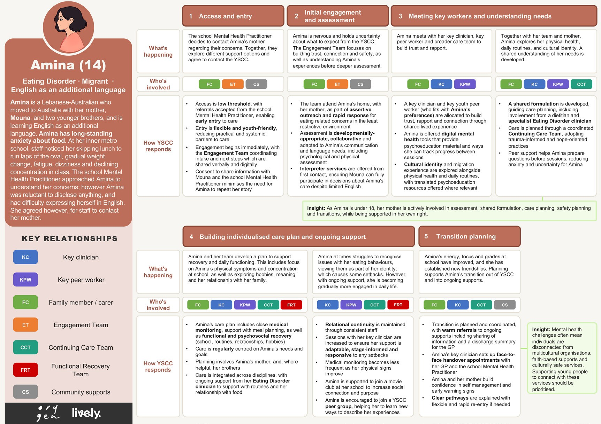
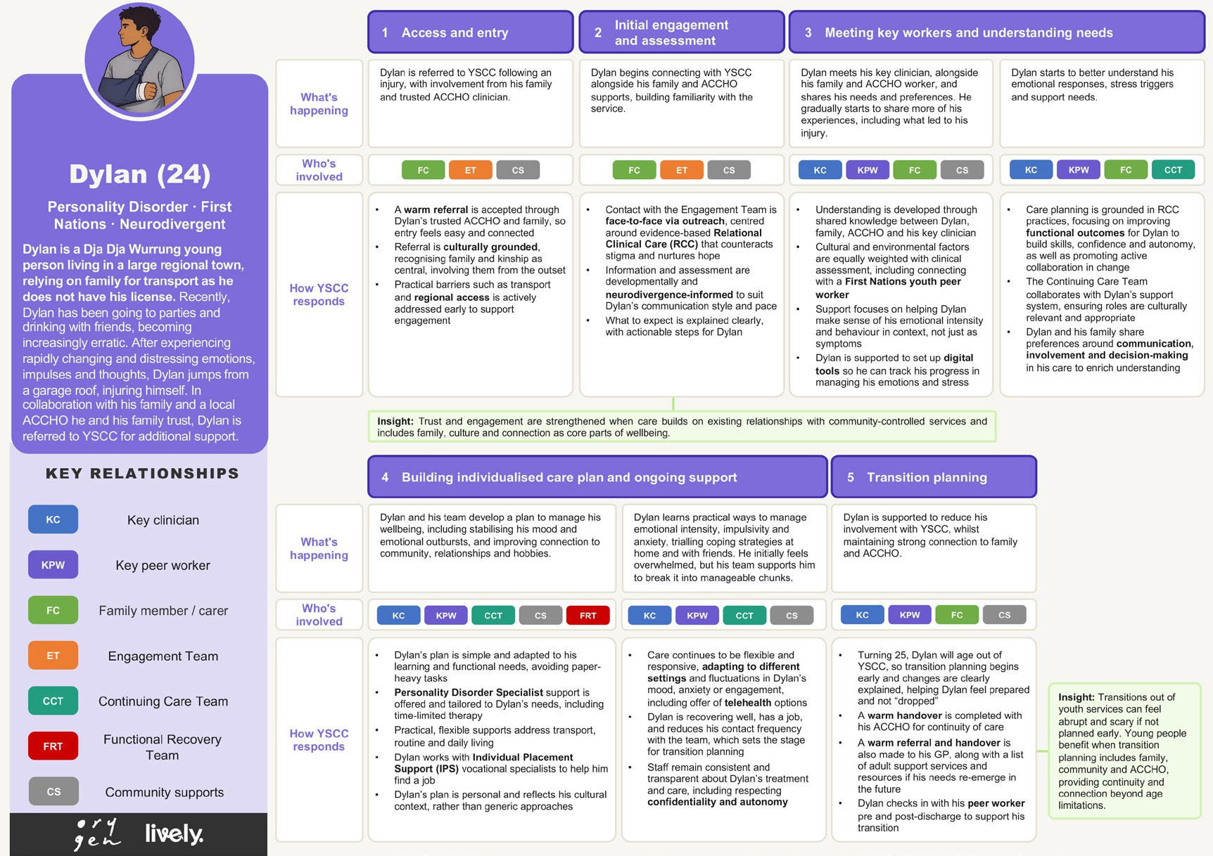
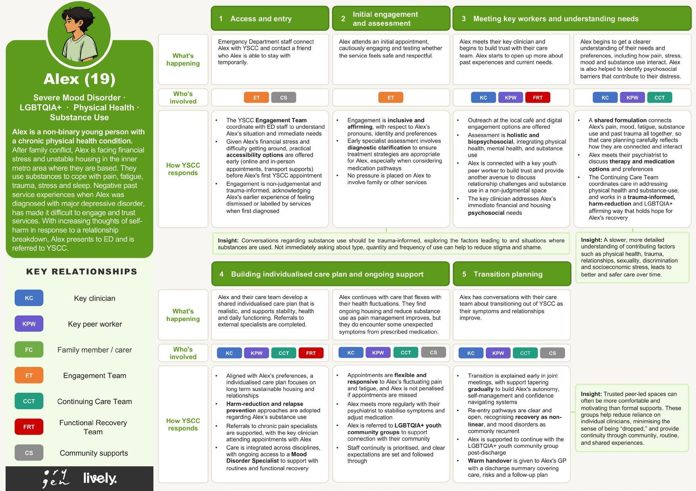

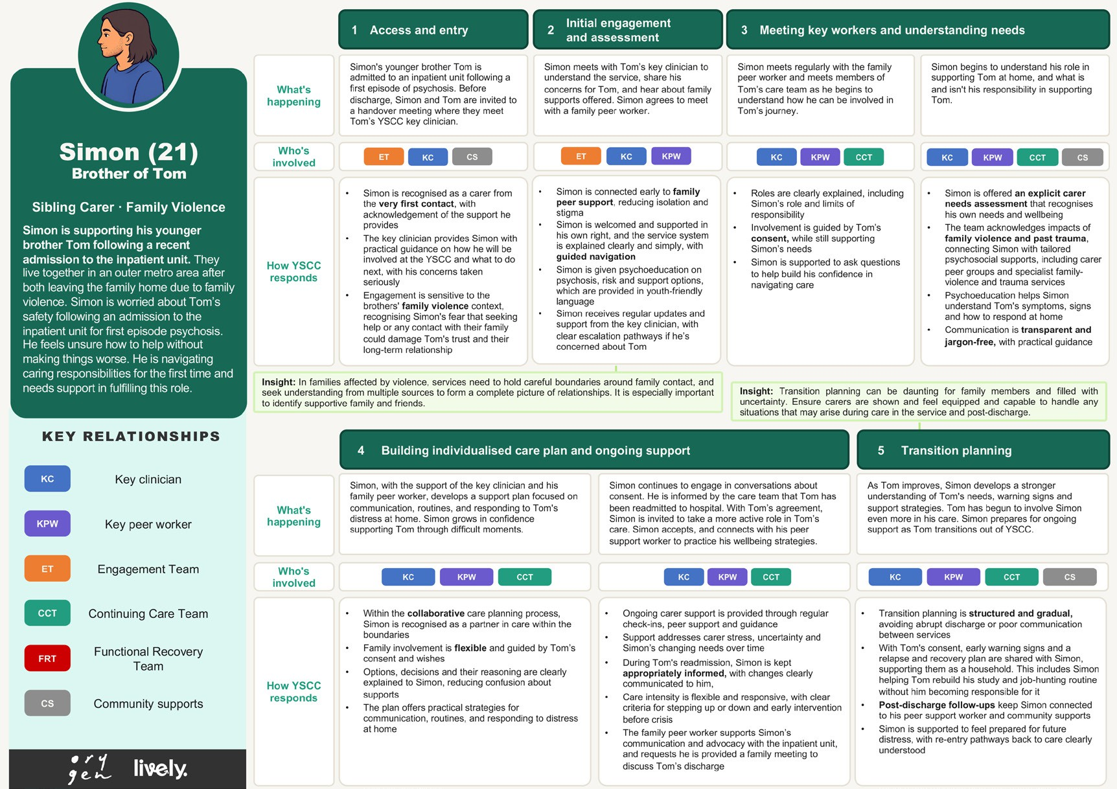
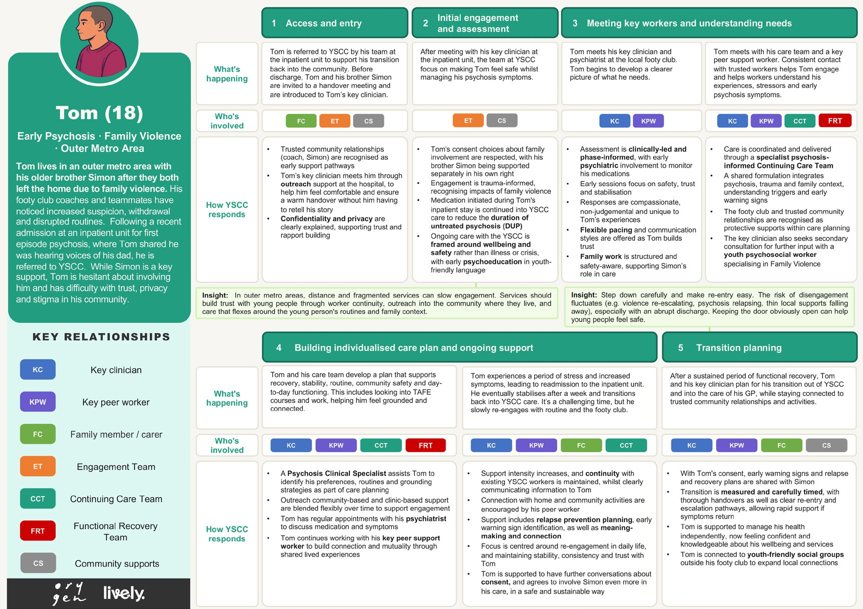

References

- Australian Bureau of Statistics. (2025). National Study of Mental Health and Wellbeing, 2020-2022. https://www.abs.gov.au/statistics/ health/mental-health/national-study-mental-health-and-wellbeing/ latest-release
- Australian Bureau of Statistics. (2008, October 23). National Survey of Mental Health and Wellbeing: Summary of Results, 2007. https:// www.abs.gov.au/statistics/health/mental-health/national-study-mental-health-and-wellbeing/2007
- Orygen. (2021). Defining the Missing Middle.
- Orygen. (2025). Sector led advice on new and/or refined models of youth mental health care: Final advice.
- Tindall, R., Simmons, M., Allott, K., & Hamilton, B. (2020). Disengagement Processes Within an Early Intervention Service for First-Episode Psychosis: A Longitudinal, Qualitative, Multi-Perspective Study. Frontiers in Psychiatry, 11, 565. https://doi. org/10.3389/fpsyt.2020.00565
- National Aboriginal and Torres Strait Islander Health Worker Associations. (2016). Cultural Safety Framework. NATSIHWA. https://www.naatsihwp.org.au/sites/default/files/natsihwa-cultural_ safety-framework_summary.pdf
- Commonwealth of Australia. (2017). National Strategic Framework for Aboriginal and Torres Strait Islander Peoples’ Mental Health and Social and Emotional Wellbeing 2017-2023. Department of the Prime Minister and Cabinet. https://www.niaa.gov.au/sites/default/ files/documents/publications/mhsewb-framework_0.pdf
- Orygen. (2025). Orygen Lived Experience Workforce Framework. Orygen.
- Scott, J., Iorfino, F., Capon, W., Crouse, J., Nelson, B., Chanen, A. M., Dwyer, D., Conus, P., Bechdolf, A., Ratheesh, A., Raballo, A., Yung, A., Berk, M., McKenna, S., Hockey, S., Hutcheon, A., Scott, E., McGorry, P., Shah, J., & Hickie, I. B. (2024). Staging 2.0: Refining transdiagnostic clinical staging frameworks to enhance reliability and utility for youth mental health. The Lancet Psychiatry, 11(6), 461–471. https://doi.org/10.1016/S2215-0366(24)00060-9
- National Mental Health Commission. (n.d.). Equally Well Consensus Statement: Improving the physical health and wellbeing of people living with mental illness in Australia. Retrieved March 30, 2026, from https://www.mentalhealthcommission.gov.au/sites/default/ files/2024-03/equally-well-consensus-statement_1.pdf
- Watkins, A., Denney-Wilson, E., Curtis, J., Teasdale, S., Rosenbaum, S., Ward, P. B., & Stein-Parbury, J. (2020). Keeping the body in mind: A qualitative analysis of the experiences of people experiencing first-episode psychosis participating in a lifestyle intervention programme. International Journal of Mental Health Nursing, 29(2), 278–289. https://doi.org/10.1111/inm.12683
- International Physical Health in Youth (iphYs) working group. (2013). Healthy Active Lives (HeAL) consensus statement 2013. https://www.iphys.org.au/_files/ ugd/3536bf_87e499b483ee444fbeacdd0b5f103e17.pdf
- Fibbins, H. (2025). Keeping their hearts in mind – cardiometabolic health and severe mental illness. Medicine Today, 26.
- Mishu, M. P., Aggarwal, V., Shiers, D., Peckham, E., Johnston, G., Joury, E., Chew-Graham, C. A., Goodall, K., Elliott, E., French, P., Harris, R., Laverty, L., & Palmier-Claus, J. (2024). Developing a Consensus Statement to Target Oral Health Inequalities in People With Severe Mental Illness. Health Expectations, 27(4), e14163. https://doi.org/10.1111/hex.14163
- Brown, E., Monaco, S. L., O’Donoghue, B., Nolan, H., Hughes, E., Graham, M., Simmons, M., & Gray, R. (2021). Improving the Sexual Health of Young People (under 25) in High-Risk Populations: A Systematic Review of Behavioural and Psychosocial Interventions. International Journal of Environmental Research and Public Health,
18(17). https://doi.org/10.3390/ijerph18179063
- National Eating Disorders Collaboration (NEDC). (2024). Eating Disorder Safe principles: Whole-of-community approaches to do no harm in relation to eating disorders, disordered eating and body image distress. NEDC. https://nedc.com.au/downloads/Eating-Disorder-Safe-Principles-2025.pdf
- De Winter, L., Couwenbergh, C., Van Weeghel, J., Sanches, S., Michon, H., & Bond, G. R. (2022). Who benefits from individual placement and support? A meta-analysis. Epidemiology
and Psychiatric Sciences, 31, e50. https://doi.org/10.1017/ S2045796022000300
- Modini, M., Tan, L., Brinchmann, B., Wang, M.-J., Killackey, E., Glozier, N., Mykletun, A., & Harvey, S. B. (2016). Supported employment for people with severe mental illness: Systematic review and meta-analysis of the international evidence. British Journal of Psychiatry, 209(1), 14–22. https://doi.org/10.1192/bjp. bp.115.165092
- Gleeson, J. F. M., Koval, P., Zyphur, M., Lederman, R., Herrman, H., Eleftheriadis, D., Bendall, S., Cotton, S. M., Gorelik, A., & Alvarez-Jimenez, M. (2023). A randomized controlled trial of moderated online social therapy for family carers of first-episode psychosis patients in a specialist treatment setting. Schizophrenia Research, 255, 203–212. https://doi.org/10.1016/j.schres.2023.03.019
- Stavely, H., Hughes, F., Pennell, K., McGorry, P. D., & Purcess, R. (2013). EPPIC Model and Service Implementation Guide. Orygen Youth Health Research Centre.
- Australian Commission on Safety and Quality in Health Care. (2020). National Safety and Quality Digital Mental Health Standards. ACSQHC.
- Alvarez-Jimenez, M., Nicholas, J., Valentine, L., Liu, P., Mangelsdorf, S., Baker, S., Gilbertson, T., O’Loughlin, G., McEnery, C., McGorry, P. D., Gleeson, J. F., & Cross, S. P. (2025). A national evaluation of a multi-modal, blended, digital intervention integrated within Australian youth mental health services. Acta Psychiatrica Scandinavica, 151(3), 317–331. https://doi.org/10.1111/acps.13751
- Alvarez-Jimenez, M., Koval, P., Schmaal, L., Bendall, S., O’Sullivan, S., Cagliarini, D., D’Alfonso, S., Rice, S., Valentine, L., Penn, D. L., Miles, C., Russon, P., Phillips, J., McEnery, C., Lederman, R., Killackey, E., Mihalopoulos, C., Gonzalez-Blanch, C., Gilbertson, T., … Gleeson, J. F. M. (2021). The Horyzons project: A randomized controlled trial of a novel online social therapy to maintain treatment effects from specialist first-episode psychosis services. World Psychiatry, 20(2), 233–243. https://doi.org/10.1002/wps.20858
- Engel, L., Alvarez-Jimenez, M., Cagliarini, D., D’Alfonso, S., Faller, J., Valentine, L., Koval, P., Bendall, S., O’Sullivan, S., Rice, S., Miles, C., Penn, D. L., Phillips, J., Russon, P., Lederman, R., Killackey, E., Lal, S., Maree Cotton, S., Gonzalez-Blanch, C., … Mihalopoulos, C. (2024). The Cost-Effectiveness of a Novel Online Social Therapy to Maintain Treatment Effects From First-Episode Psychosis Services: Results From the Horyzons Randomized Controlled Trial. Schizophrenia Bulletin, 50(2), 427–436. https://doi. org/10.1093/schbul/sbad071

- Ratheesh, A., Gates, J., Hammond, D., Shelton, C., Macneil, C., Hasty M, M., Dhar, A., D’Alfonso, S., Schmaal, L., Kessing, L. V., Gleeson, J. F., Davey, C., Chanen, A., Murray, G., Cotton, S. M., McGorry, P. D., Berk, M., & Alvarez-Jimenez, M. (2025). Bipolar Early Intervention Using New Digital Technologies (BLEND): A Pilot Randomised Controlled Trial of a Novel Blended-Digital Early Intervention Model of Care for Youth With Bipolar Disorder I or II. Early Intervention in Psychiatry, 19(6), e70060. https://doi. org/10.1111/eip.70060
- The EPPIC National Support Program Writing Group. (2012). EPPIC Model Briefing Pack. Orygen Youth Health Research Centre. https:// www.orygen.org.au/Training/Resources/Psychosis/Manuals/Manual-PDF-files/Orygen-EPPIC-Model-Briefing-Pack-Manual-pdf.aspx
- Li, X., Lu, C., Zhai, Z., Smith, R. C., Zhang, S., Wang, H., Wang, C., Yao, Z., Chen, Z., Xu, X., Xie, S., Feng, T., Gao, T., Dong, Y., Zhuo, K., Xiang, Q., Jin, H., Davis, J. M., Jiang, K., … Liu, D. (2026). Clozapine After 1 Failed Antipsychotic Drug Trial in First-Episode Psychosis: A Randomized Clinical Trial. JAMA Psychiatry. https:// doi.org/10.1001/jamapsychiatry.2026.0086
- McGorry, P., Killackey, E., & Yung, A. (2008). Early intervention in psychosis: Concepts, evidence and future directions. World Psychiatry, 7(3), 148–156. https://doi.org/10.1002/j.2051-5545.2008. tb00182.x
- Salazar De Pablo, G., Estradé, A., Cutroni, M., Andlauer, O., & Fusar-Poli, P. (2021). Establishing a clinical service to prevent psychosis: What, how and when? Systematic review. Translational Psychiatry, 11(1), 43. https://doi.org/10.1038/s41398-020-01165-x
- Malhi, G. S., Bell, E., Bassett, D., Boyce, P., Bryant, R., Hazell, P., Hopwood, M., Lyndon, B., Mulder, R., Porter, R., Singh, A. B., & Murray, G. (2021). The 2020 Royal Australian and New Zealand College of Psychiatrists clinical practice guidelines for mood disorders. Australian & New Zealand Journal of Psychiatry, 55(1), 7–117. https://doi.org/10.1177/0004867420979353
- Hussain, S., Gale, C., Sarma, S., Smith, J., Bayes, A., & Loo, C. (2025). Royal Australian and New Zealand College of Psychiatrists professional practice guidelines for the use of ketamine in psychiatric practice. Australian & New Zealand Journal of Psychiatry, 59(7), 576–587. https://doi.org/10.1177/00048674251333577
- National Institute for Health and Care Excellence. (2019). Depression in children and young people: Identification and management. NICE. www.nice.org.uk/guidance/ng134
- Lindstrom, G., Smith, R., & Cooper, A. (2025). Youth at the Centre: Young People’s Vision for Mental Health Care in Australia. batyr.
- Australian Commission on Safety and Quality in Health Care. (2021). National Safety and Quality Health Service Standards, Second Edition. Australian Commission on Safety and Quality in Health Care. https://www.safetyandquality.gov.au/sites/default/ files/2021-05/national_safety_and_quality_health_service_nsqhs_ standards_second_edition_-_updated_may_2021.pdf
- Commonwealth of Australia. (2022). National Mental Health and Suicide Prevention Agreement. https://federalfinancialrelations.gov. au/sites/federalfinancialrelations.gov.au/files/2022-05/nmh_suicide_ prevention_agreement.pdf
- Privacy Act 1988 (2014). https://www.legislation.gov.au/ C2004A03712/2014-03-12/text
- OAIC. (2023, March 10). Australian Privacy Principles. OAIC. https:// www.oaic.gov.au/privacy/australian-privacy-principles
- Carer Recognition Act 2010 (2010). https://www.legislation.gov.au/ C2010A00123
- Department of Health. (2021). National Aboriginal and Torres Strait Islander Health Plan 2021–2031. Commonwealth of Australia. https://www.health.gov.au/resources/publications/national-aboriginal-and-torres-strait-islander-health-plan-2021-2031
- Department of Health. (2025). Lived experience. Victoria State Government. https://www.health.vic.gov.au/mental-health-reform/ lived-experience
- Byrne, L., Wang, L., Roennfeldt, H., Chapman, M., Darwin, L., Castles, C., Craze, L., & Saunders, M. (2021). National Lived Experience (Peer) Workforce Development Guidelines. National Mental Health Commission. https://www.mentalhealthcommission. gov.au/sites/default/files/2024-03/national-lived-experience-peer-workforce-development-guidelines.pdf
- Australian Disability Network. (2024). What is neurodiversity? https:// australiandisabilitynetwork.org.au/wp-content/uploads/2024/11/ What-is-neurodiversity.pdf
- Donker, T., Griffiths, K. M., Cuijpers, P., & Christensen, H. (2009). Psychoeducation for depression, anxiety and psychological distress: A meta-analysis. BMC Medicine, 7(79). https://doi.org/10.1186/1741-7015-7-79
- Leamy, M., Bird, V., Boutillier, C. L., Williams, J., & Slade, M. (2011). Conceptual framework for personal recovery in mental health: Systematic review and narrative synthesis. British Journal of Psychiatry, 199(6), 445–452. https://doi.org/10.1192/bjp. bp.110.083733
- Office of the Chief Psychiatrist. (2024). White paper: On the principles of mental health risk assessment. Victorian Government. https://www.health.vic.gov.au/chief-psychiatrist/white-paper-on-the-principles-of-mental-health-risk-assessment

