

Factsheet for the workforce

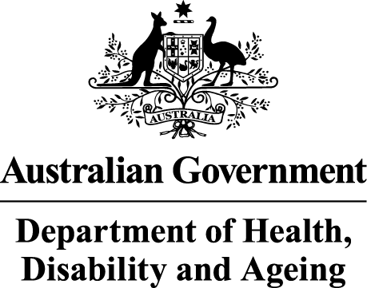 |  | The Australian Government Department of Health Disability and Ageing wrote this.  We say DHDA for short.  When you see the word we it means DHDA.
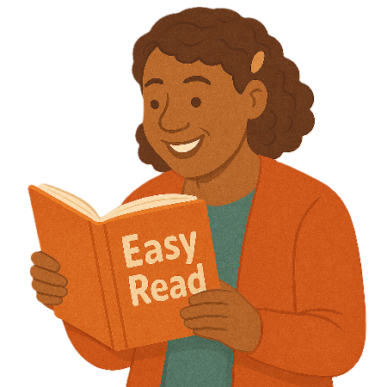 |  | We wrote this in an easy to read way.  We use pictures to explain some ideas.
 |  | We have some words in bold.  This means the letters are thicker and darker.  These are important words.
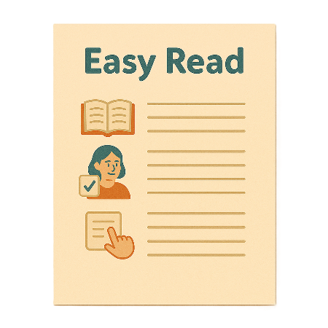 |  | This is an Easy Read summary of another document.  This means it has the most important ideas.
 |  | We can answer any questions by email.  Email us thriving.kids@health.gov.au
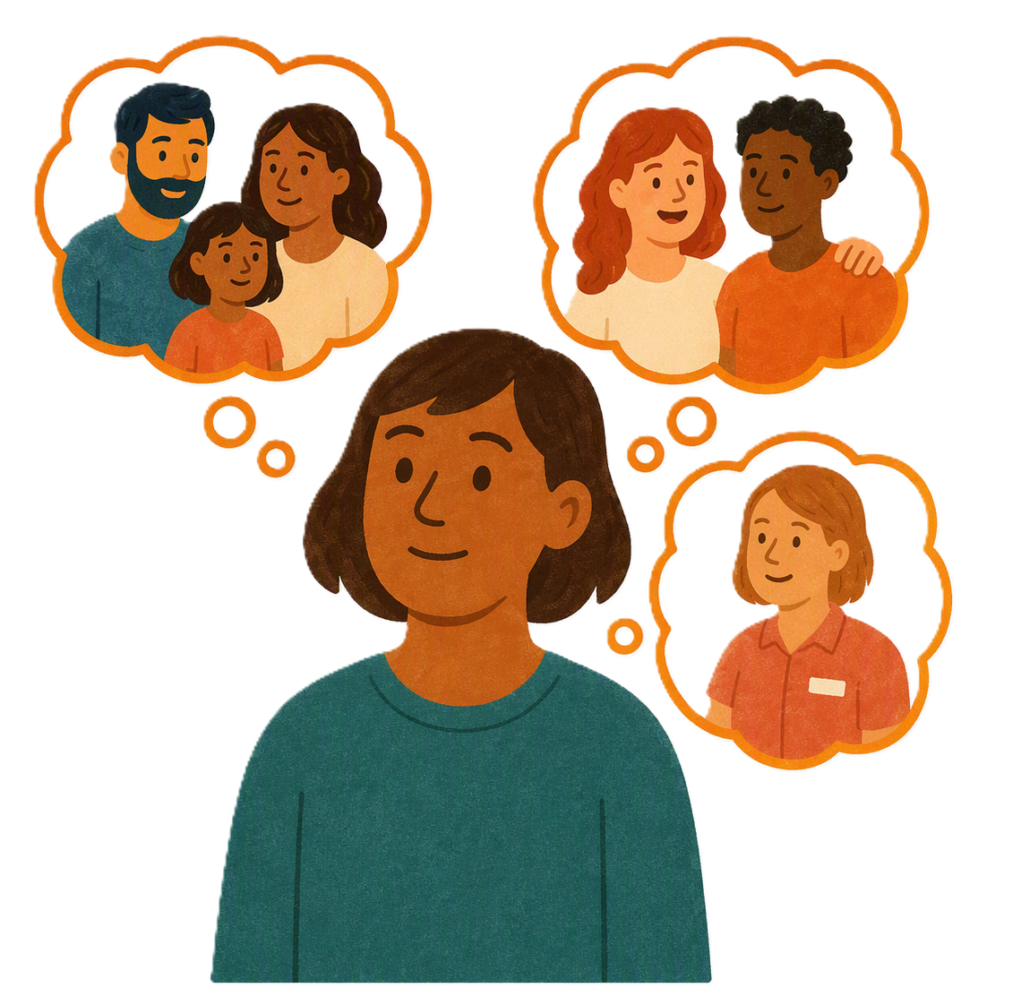 |  | You can ask for help to read this document.  You can ask  - A friend  - Family members  - A support person.
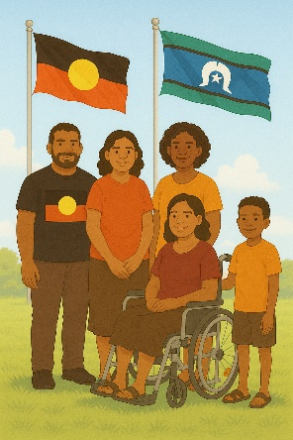 |  | We recognise Aboriginal and Torres Strait Islander people as the Traditional Owners of the land we live on.
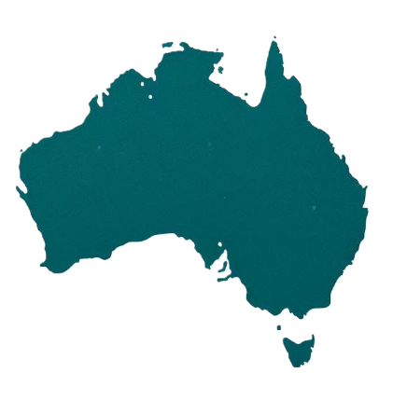 |  | They were the first people to live on and use the  - Land  - Waters.

Contents

What is Thriving Kids | 5
How Thriving Kids will help | 7
Support for children | 8
Who can support families | 11
Thriving Kids supports | 14
Where to go for Thriving Kids | 17

What is Thriving Kids

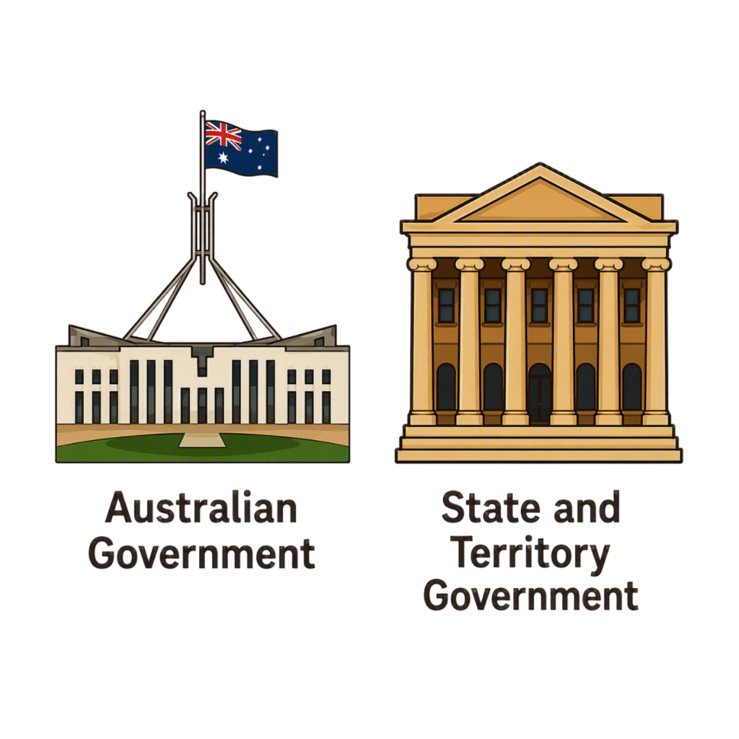 |  | All governments are working together to make Thriving Kids.  That means the  - Australian Government  - State and territory governments.
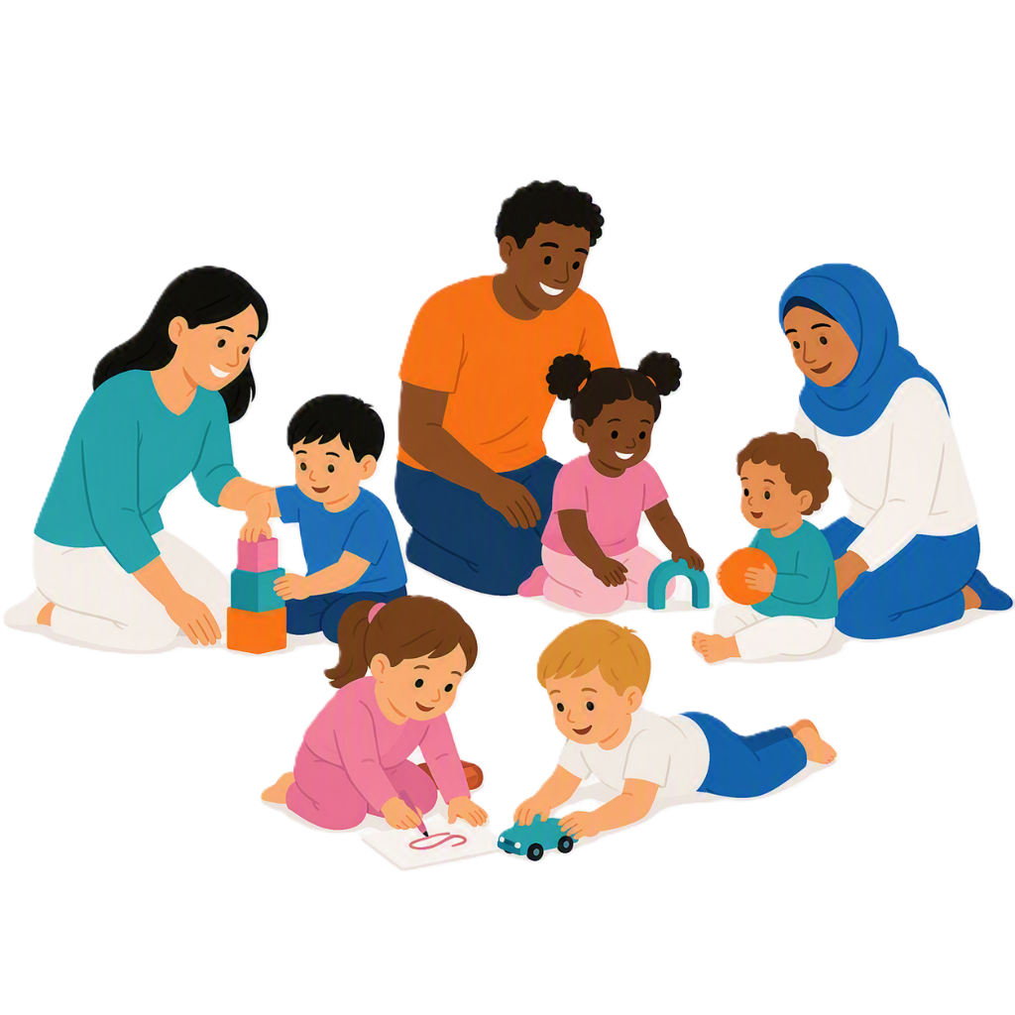 |  | Thriving Kids will have  - Some new supports  - Some supports now that will be expanded.  It will be different to the NDIS.
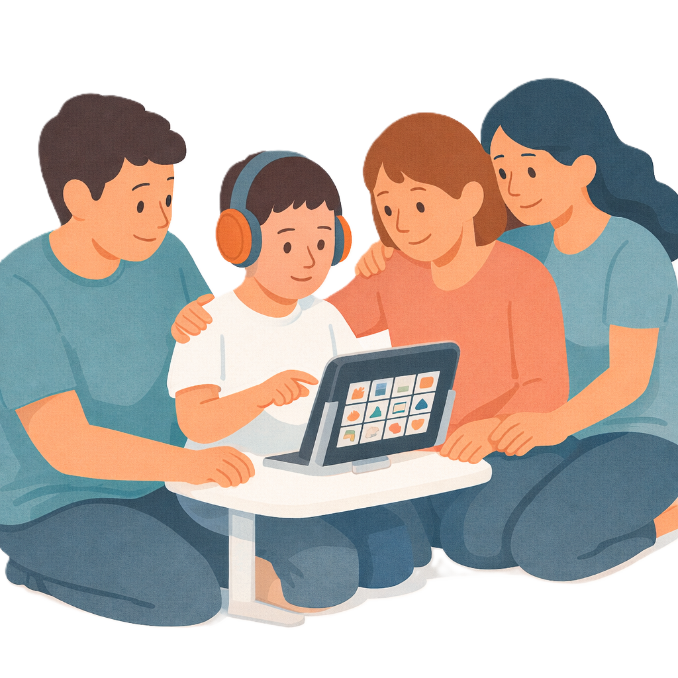 |  | It will support children who  - Are 8 years old and younger  - Have developmental delay  - Have autism  - Need some support.  It will also support families and carers.
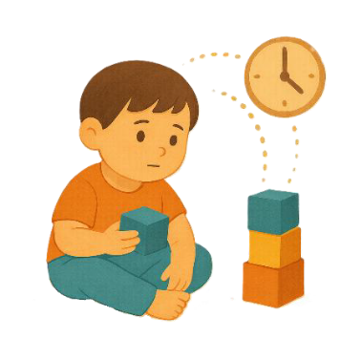 |  | Development delays are when  - Someone might be slower to develop than other people their age.  They might need extra help with  - Talking  - Moving  - Their emotions.
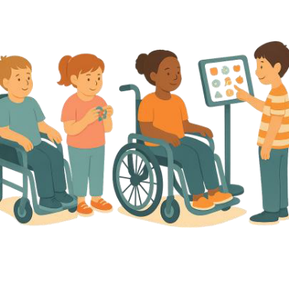 |  | Children who need lots of support can still apply for the NDIS.  Apply means you send information about  - Who you are  - Your disability  - What supports you need.  This helps us decide if you need NDIS supports.

How Thriving Kids will help

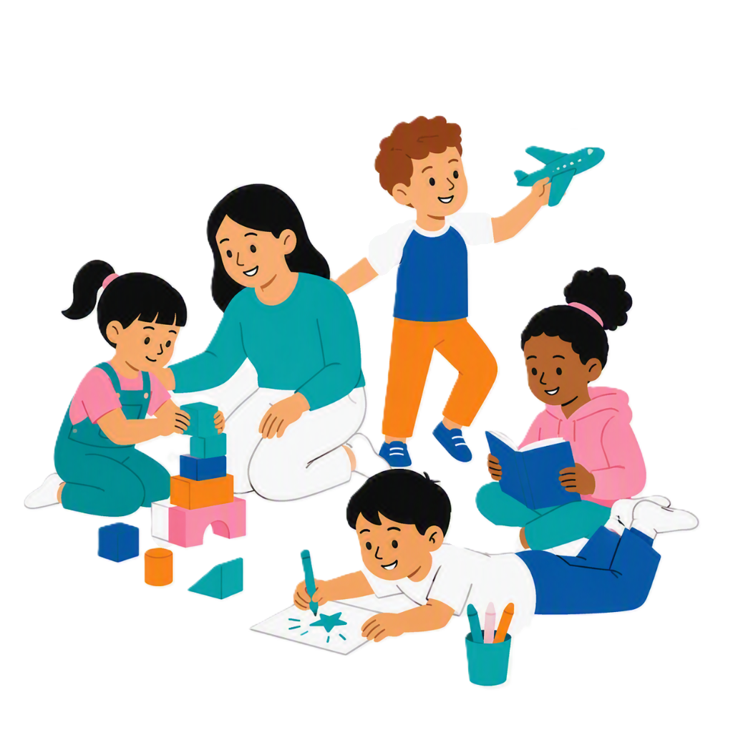 |  | Getting support early can help children  - Get better at what they are good at
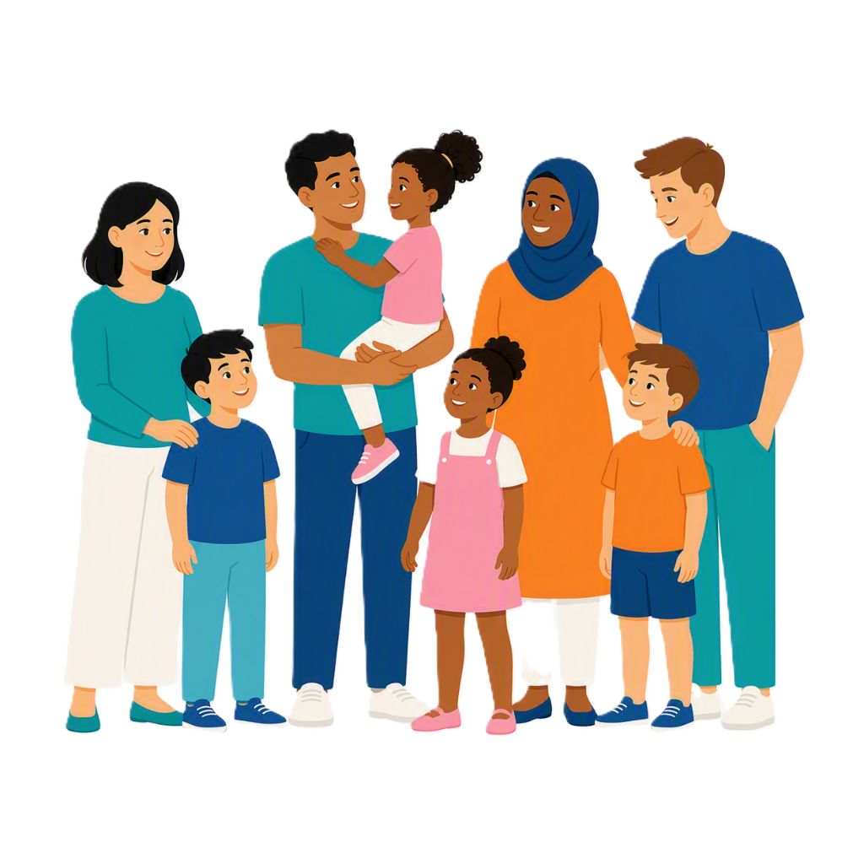 |  | - Take part in their community
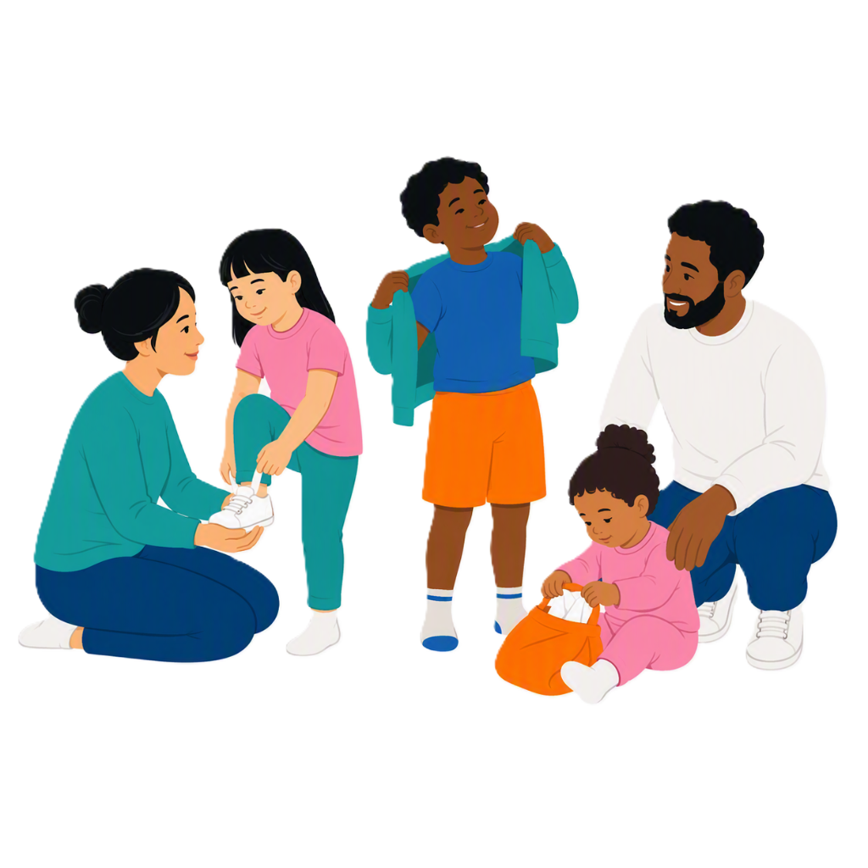 |  | - Learn the skills they need for everyday life.

Support for children

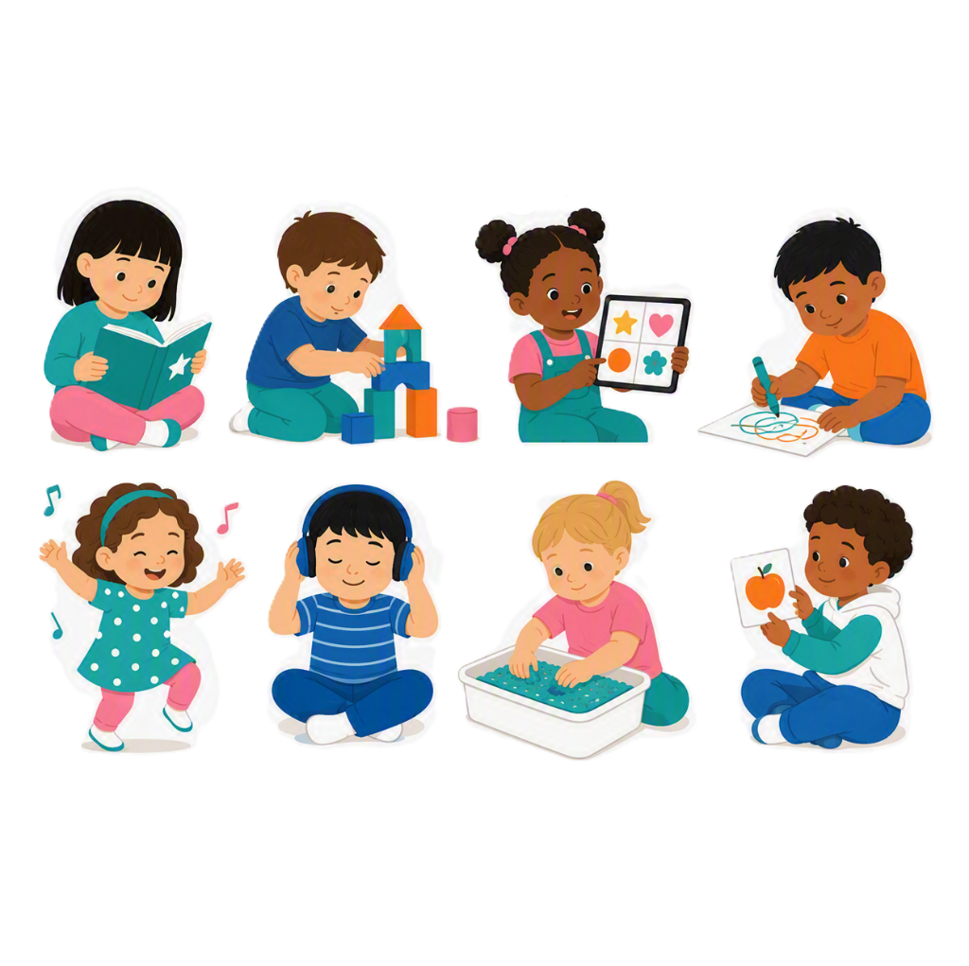 |  | Children learn in their own way.  Some children need more support for things like
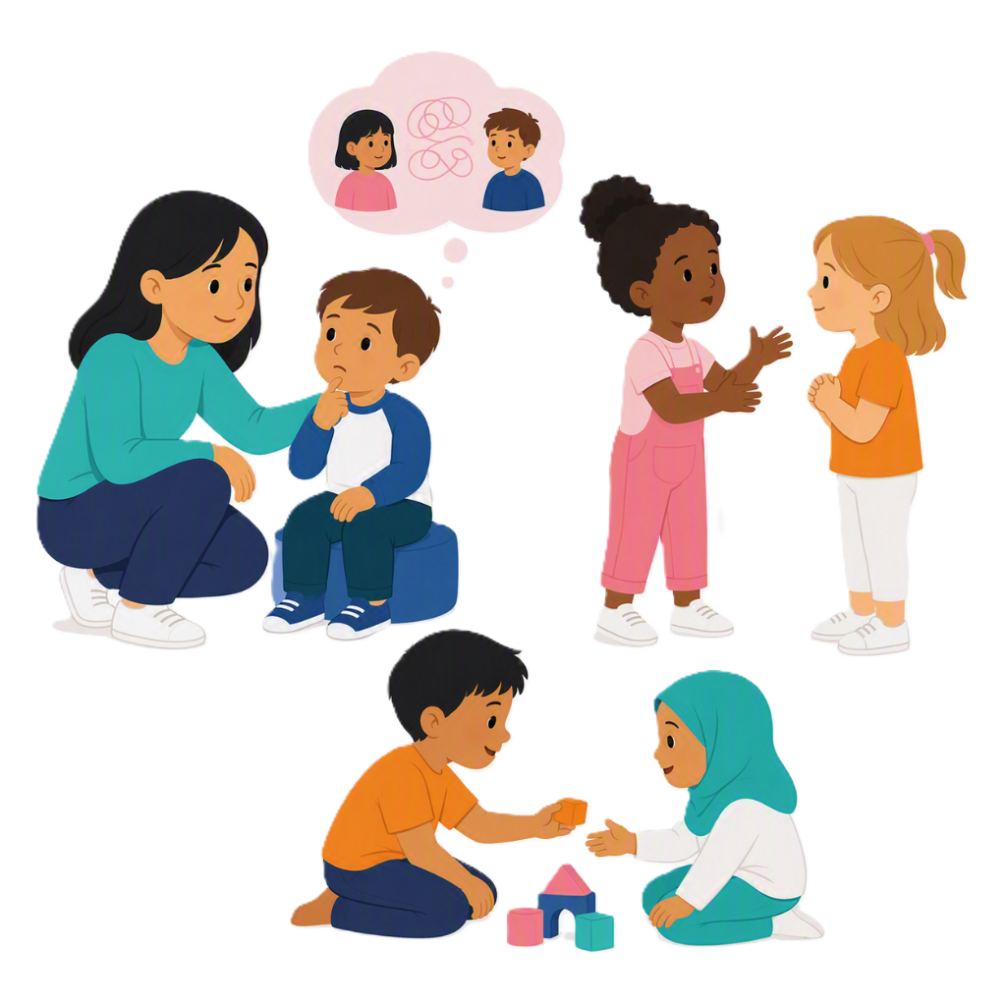 |  | - Talking
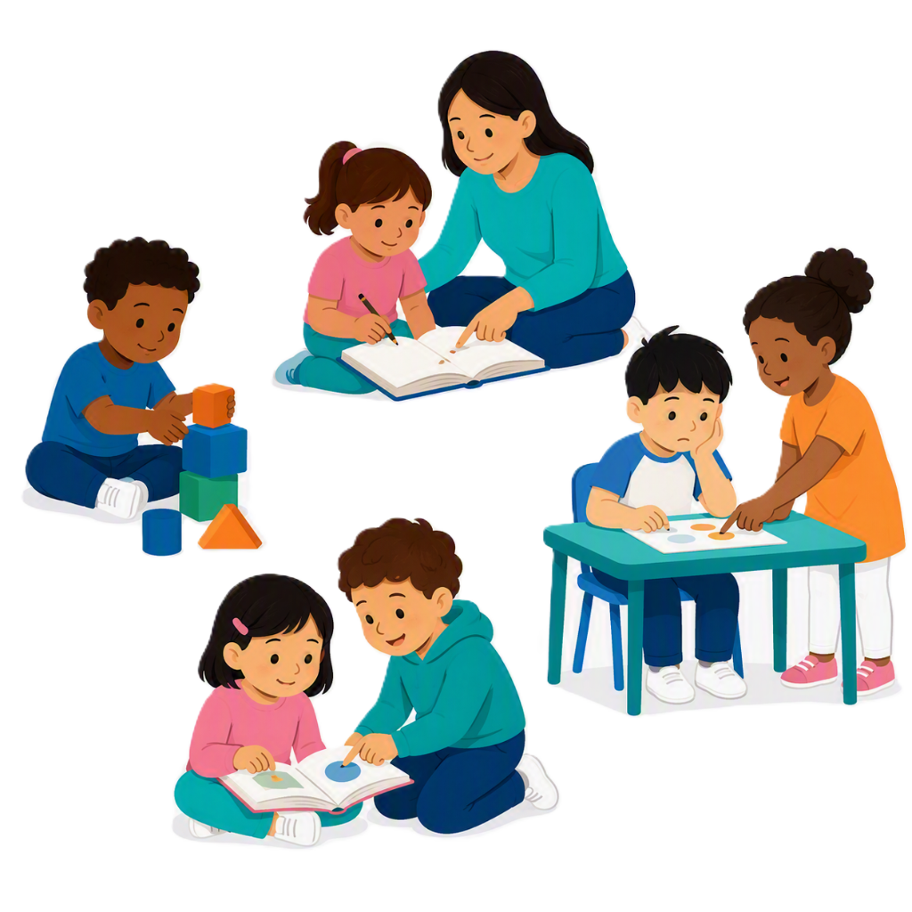 |  | - Learning
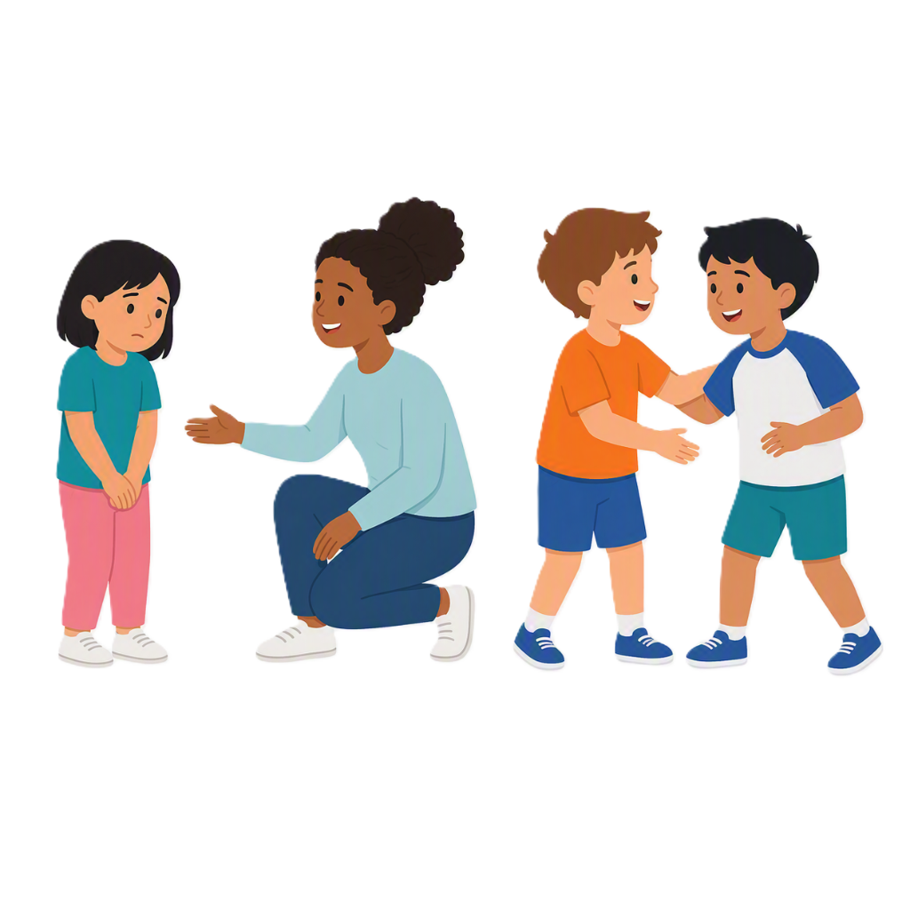 |  | - Connecting with others
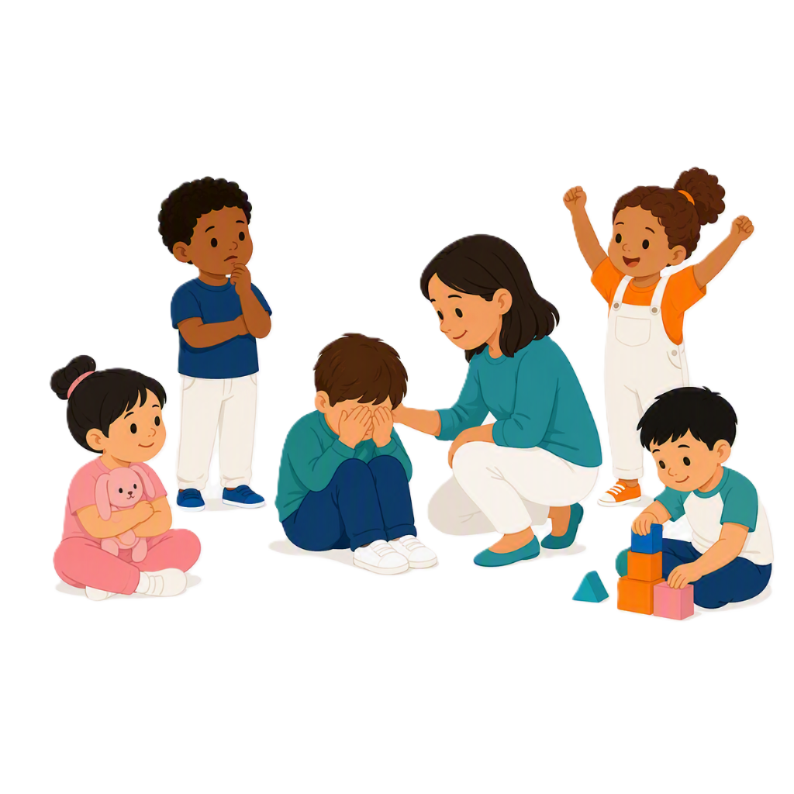 |  | - Dealing with emotions.
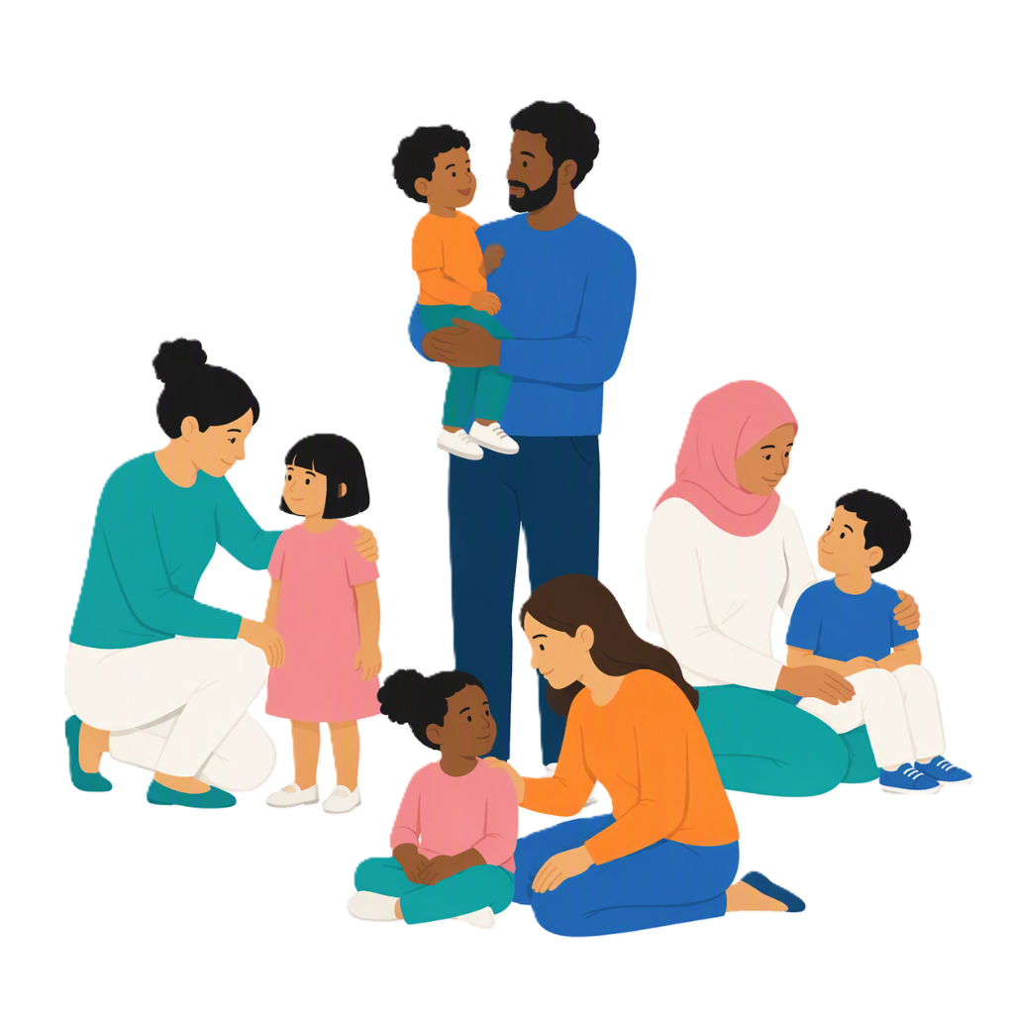 |  | Children might need extra support to do these things.
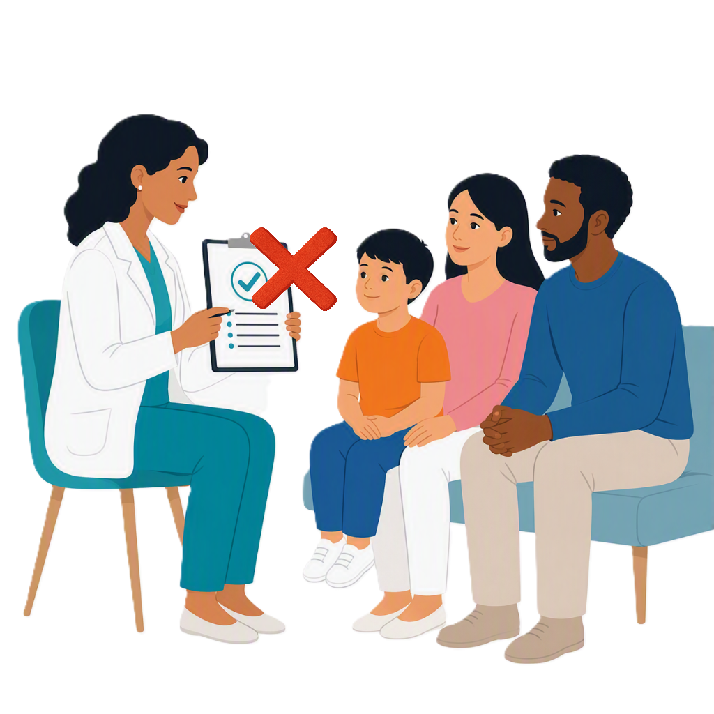 |  | Children do not need a diagnosis to get support.  Diagnosis means the way we work out if someone has a condition.  It is mostly done by medical workers.
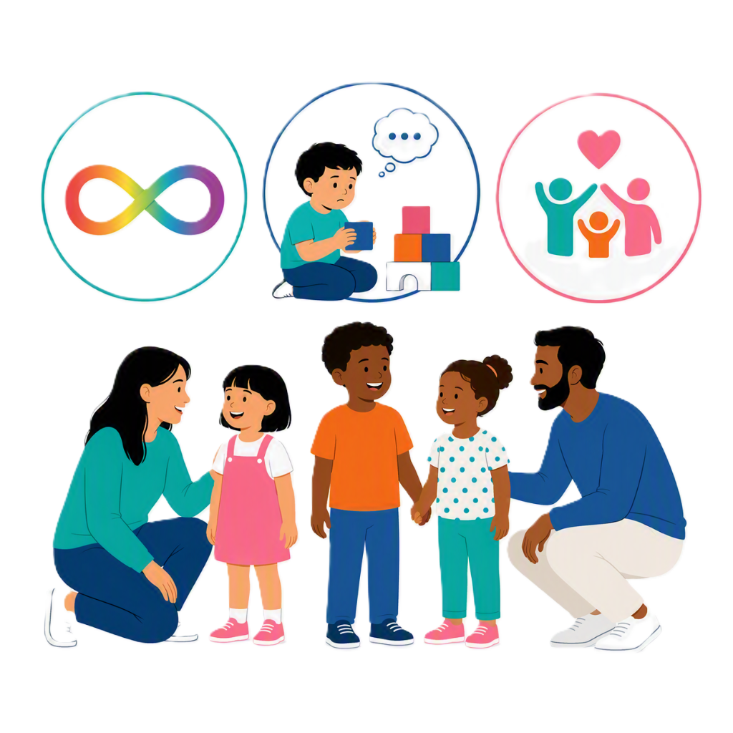 |  | Thriving Kids can help families find information and advice about  - Autism  - Developmental delay  - What support there may be to help families.

Who can support families

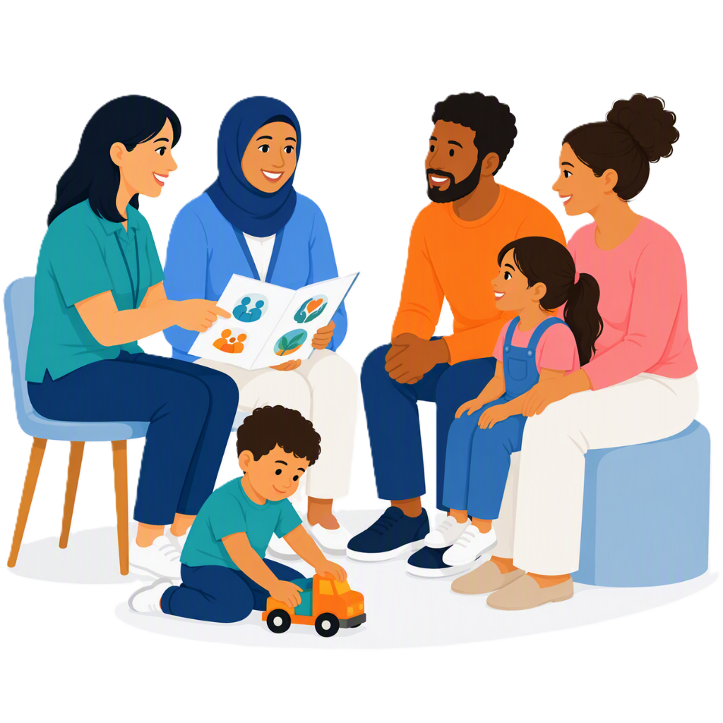 |  | It is important for children to get support early.  You can share information about Thriving Kids with families that need support.
 |  | If you are a  - Nurse
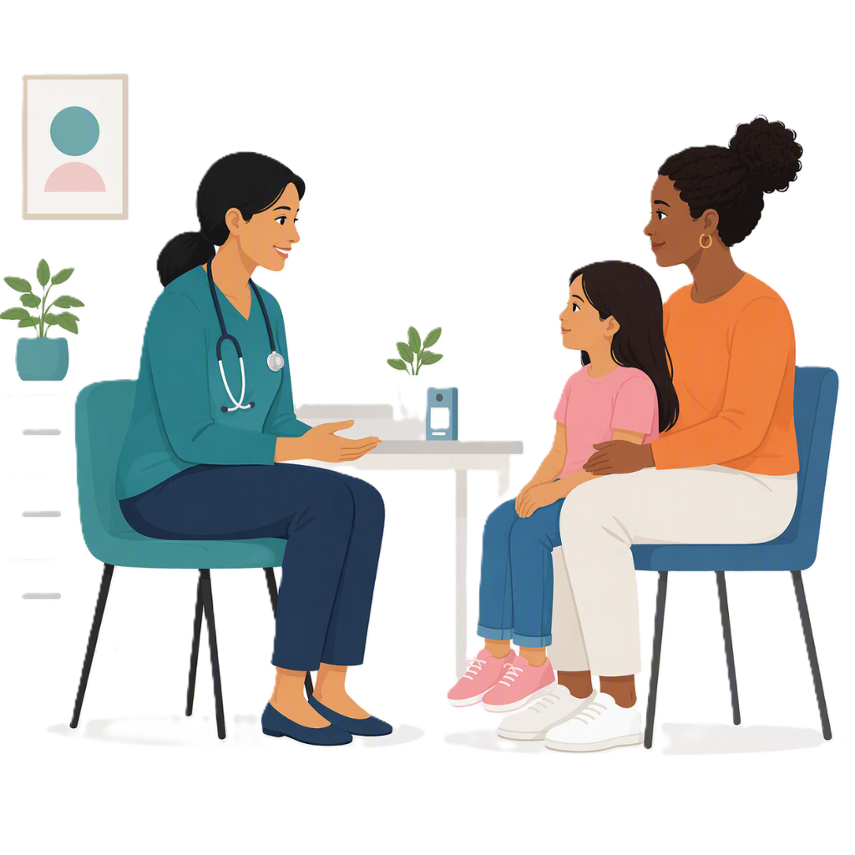 |  | - GP
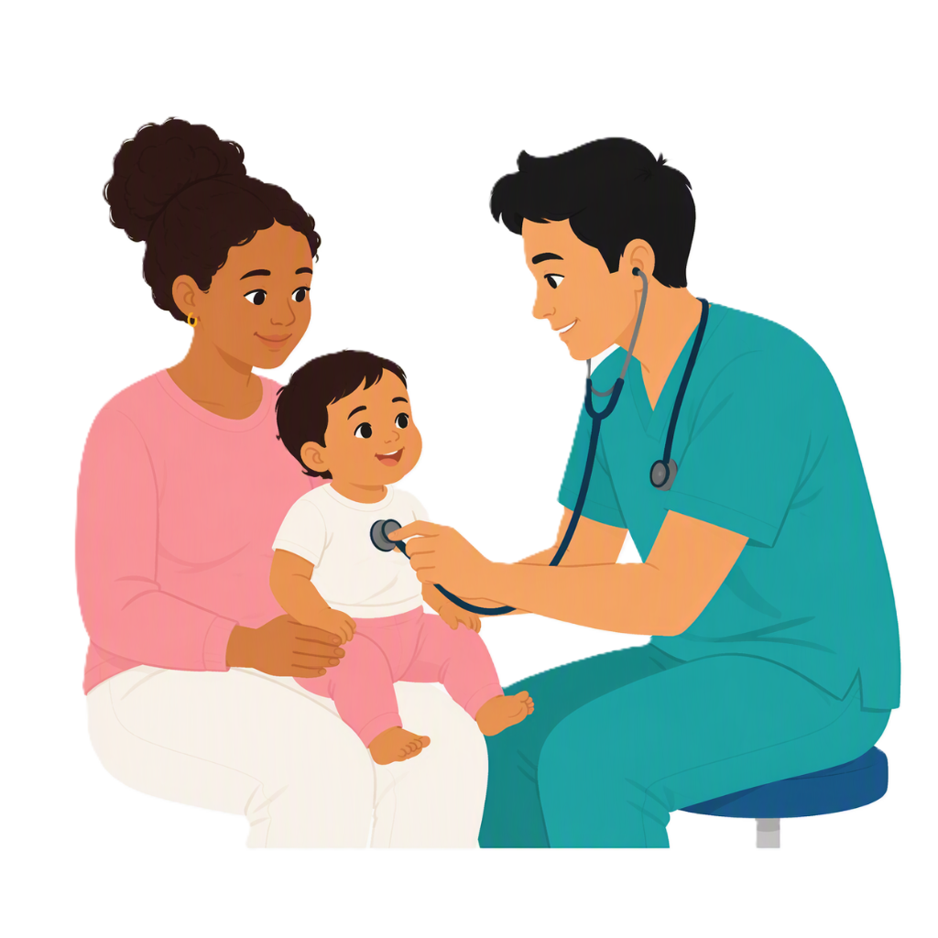 |  | - Paediatrician  This is a doctor for people under 18 years old.
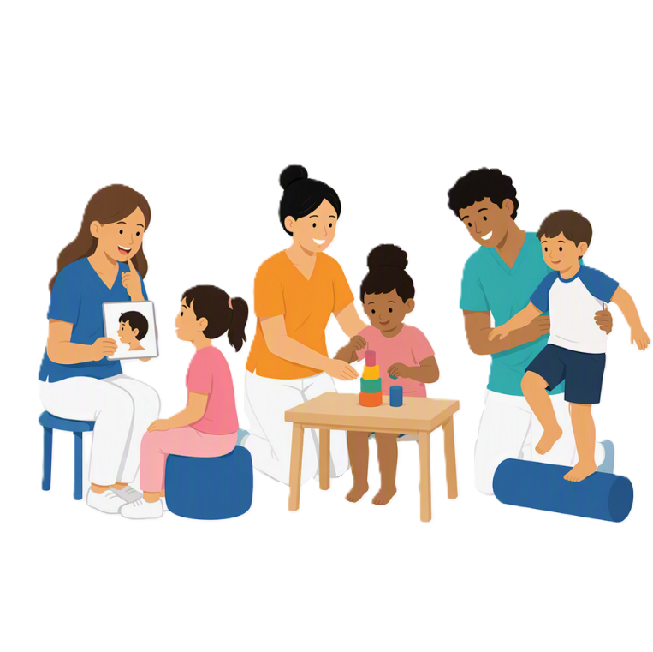 |  | You could be a  - Allied health worker  Allied health workers support people with their health.
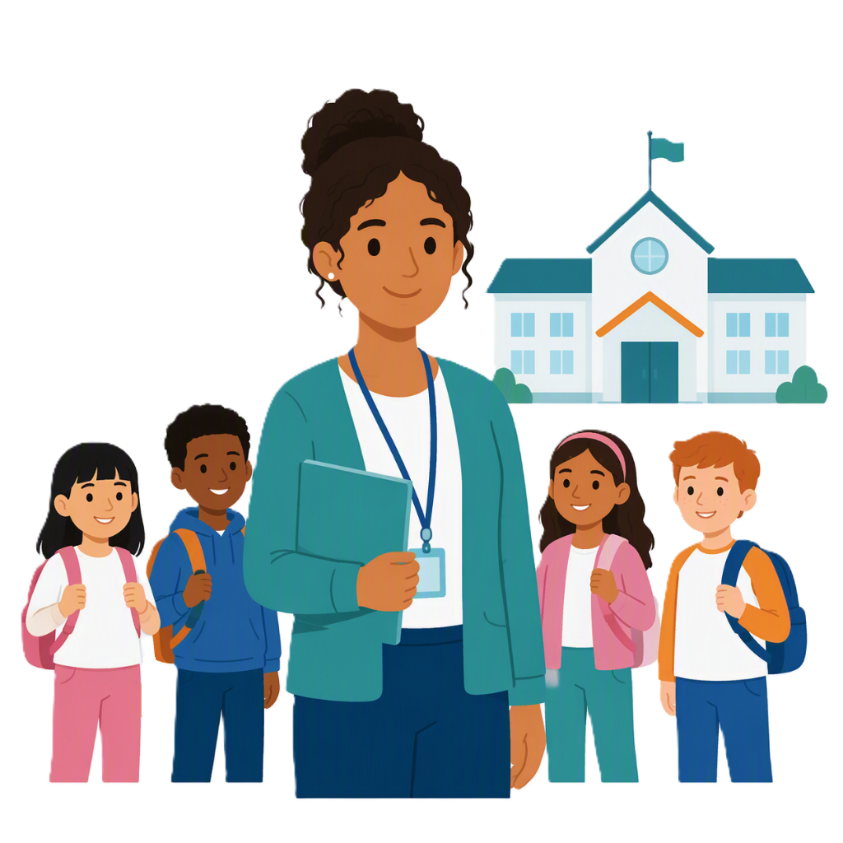 |  | - Work at a school
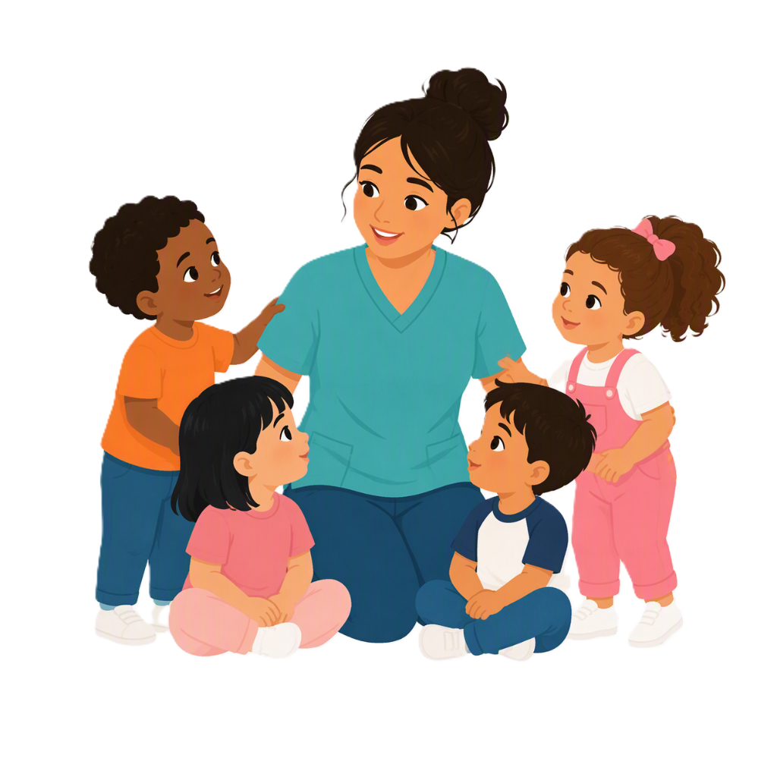 |  | - Work at an Early childhood education centre  This means learning for children before they go to school.
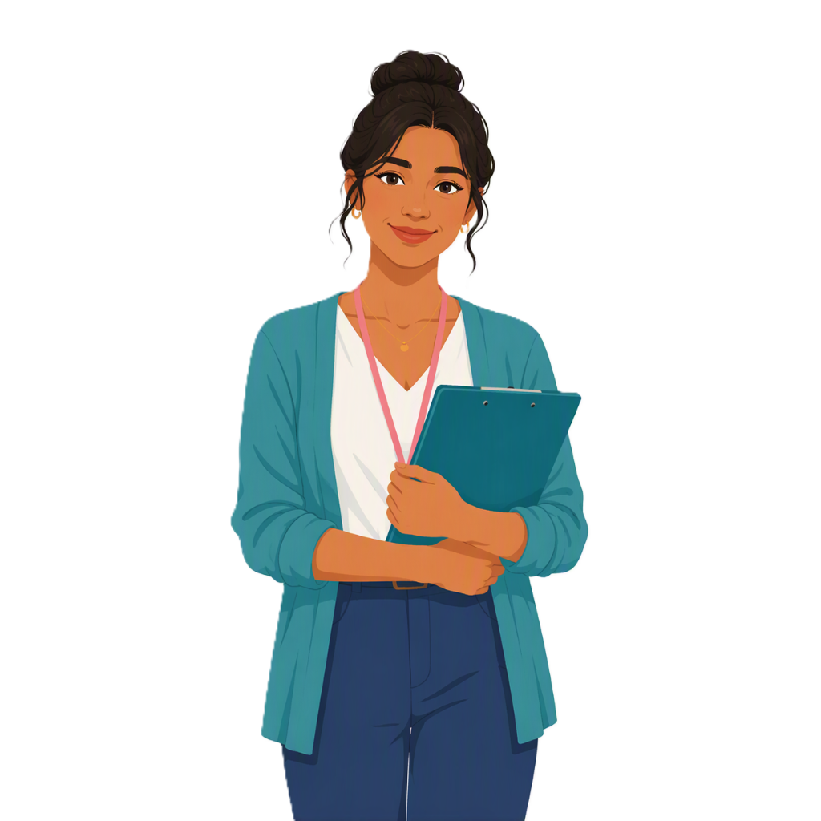 |  | If you are a  - Social worker  They help people get support and services.
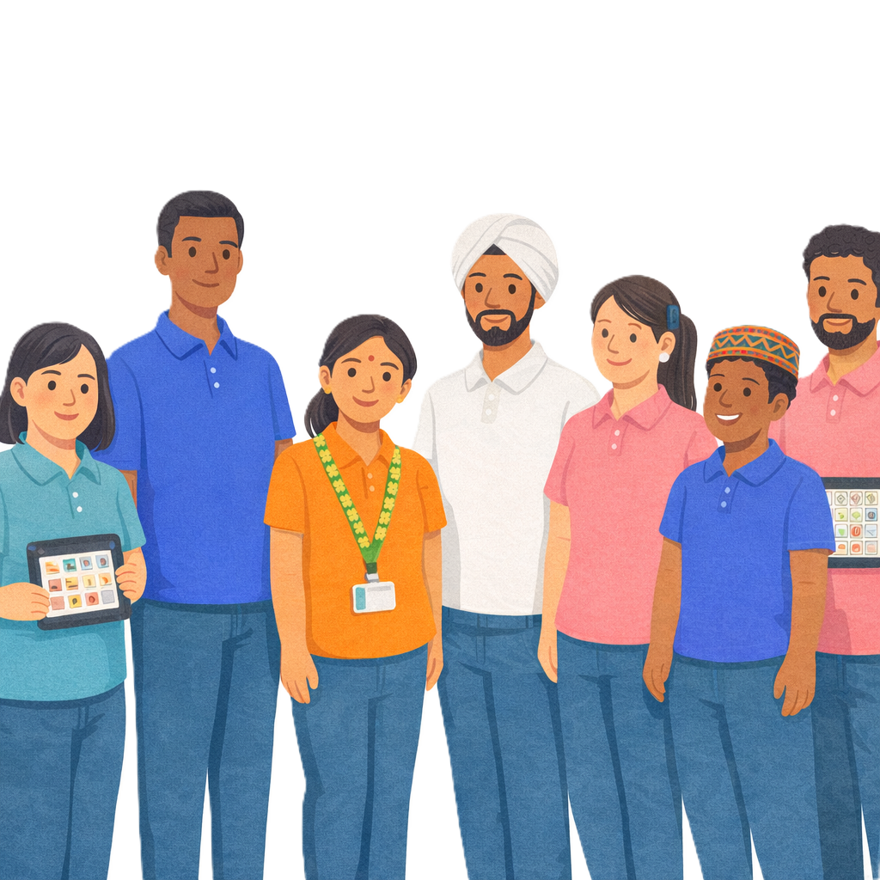 |  | - Community worker.
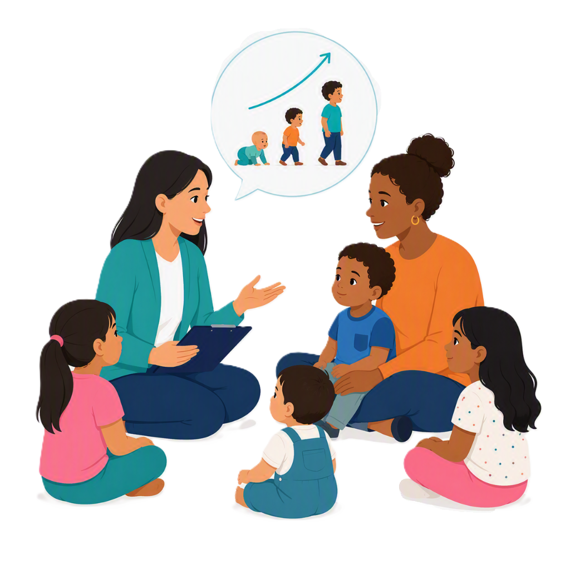 |  | You can talk to families about  child development.  Child development is how a child grows and learns over time.

Thriving Kids supports

 |  | Some Thriving Kids supports started in October 2026
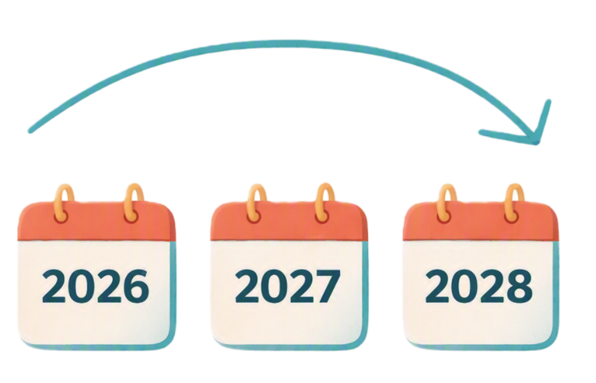 |  | More supports will start over time.  All supports will be ready by the start of 2028.
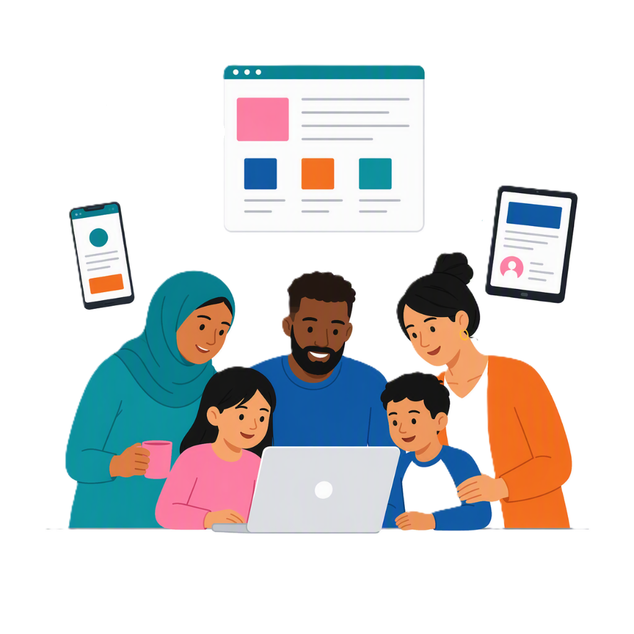 |  | Some supports Thriving Kids are  - Online information and resources  Resources are information that tell someone a way to do something.
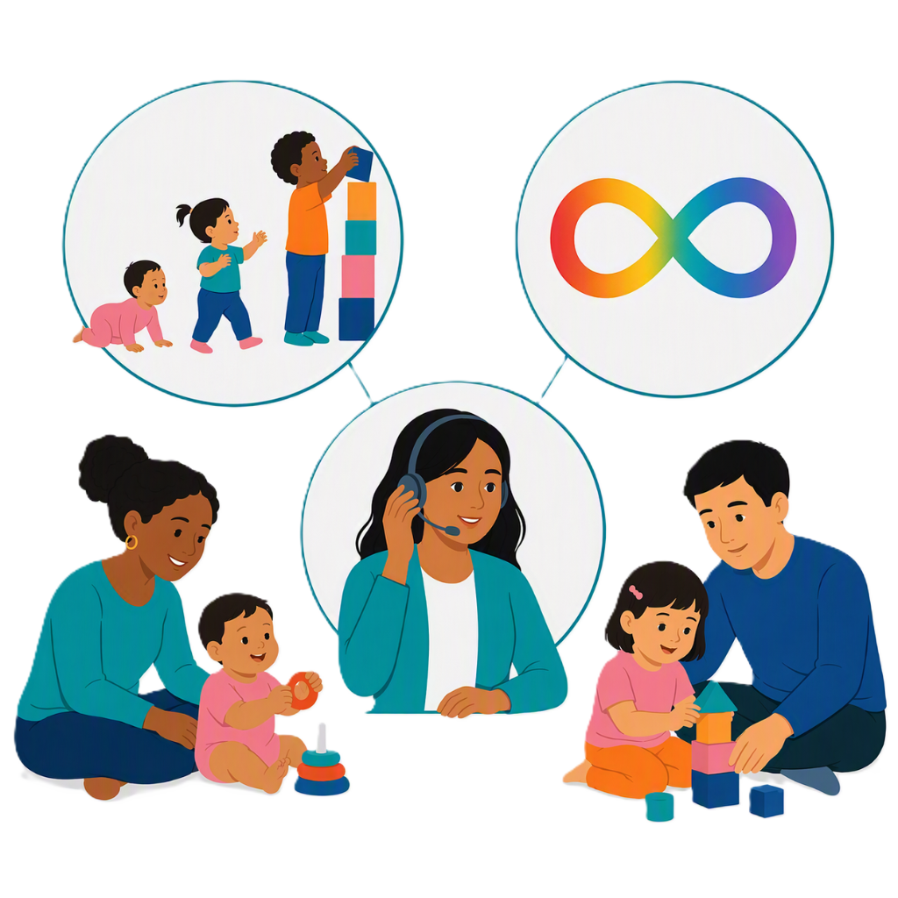 |  | - Advice about  - Child development  - Autism
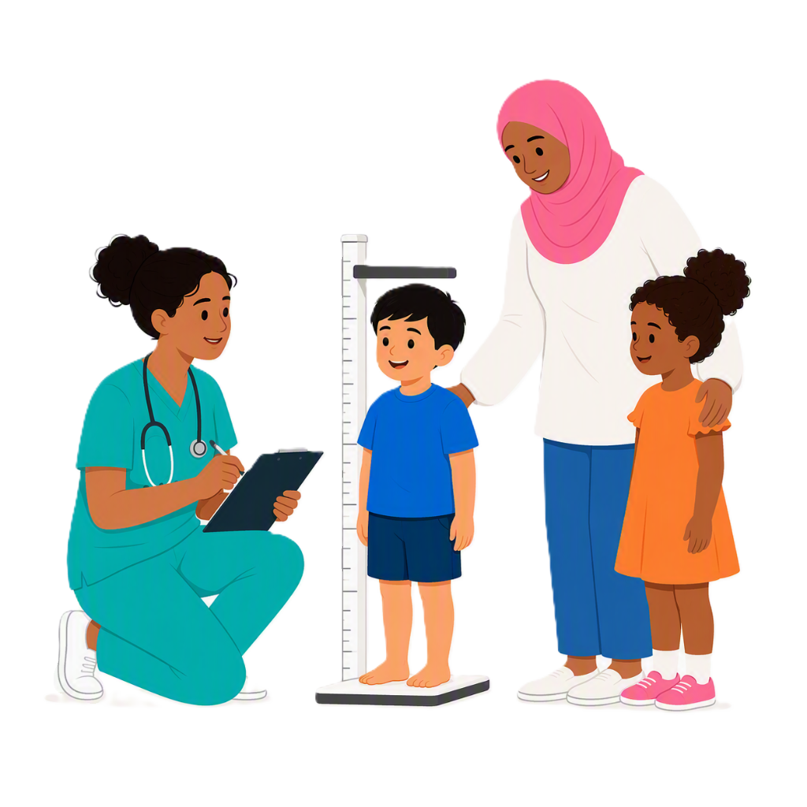 |  | - Health and development checks
 |  | - Peer support  Peer support is when other families give each other support and advice.
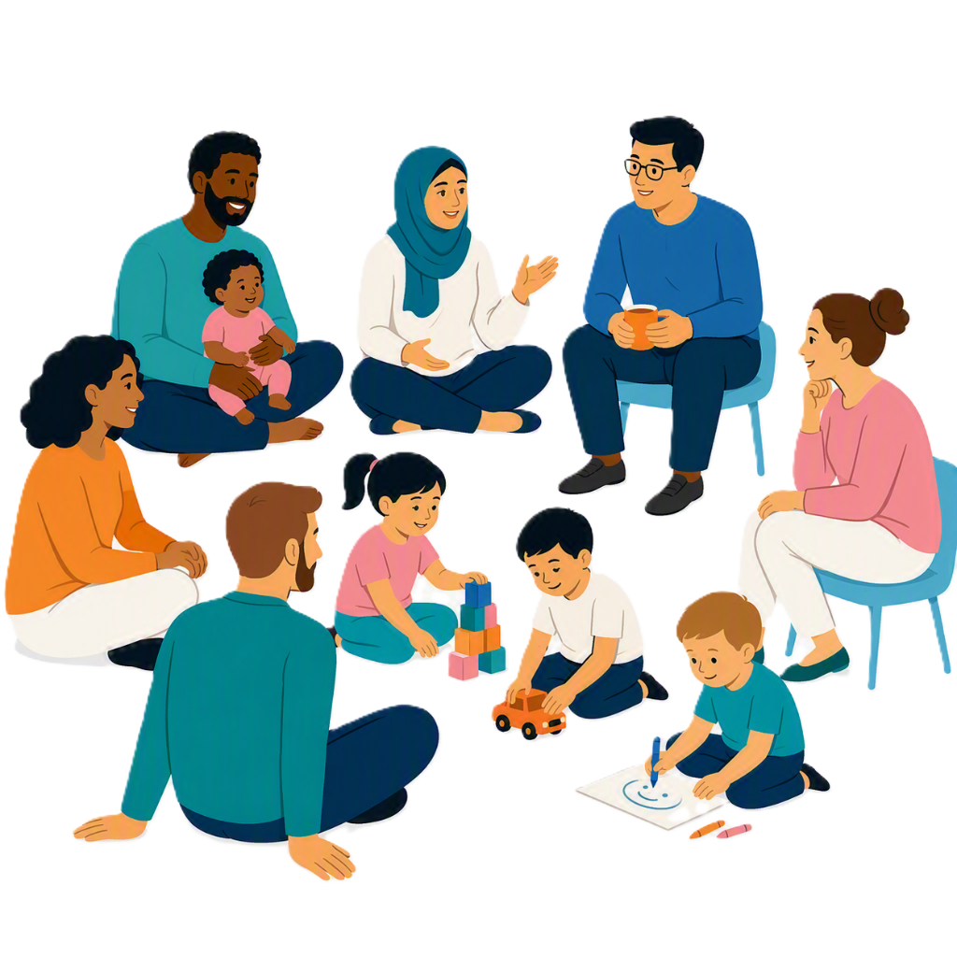 |  | - Parenting groups
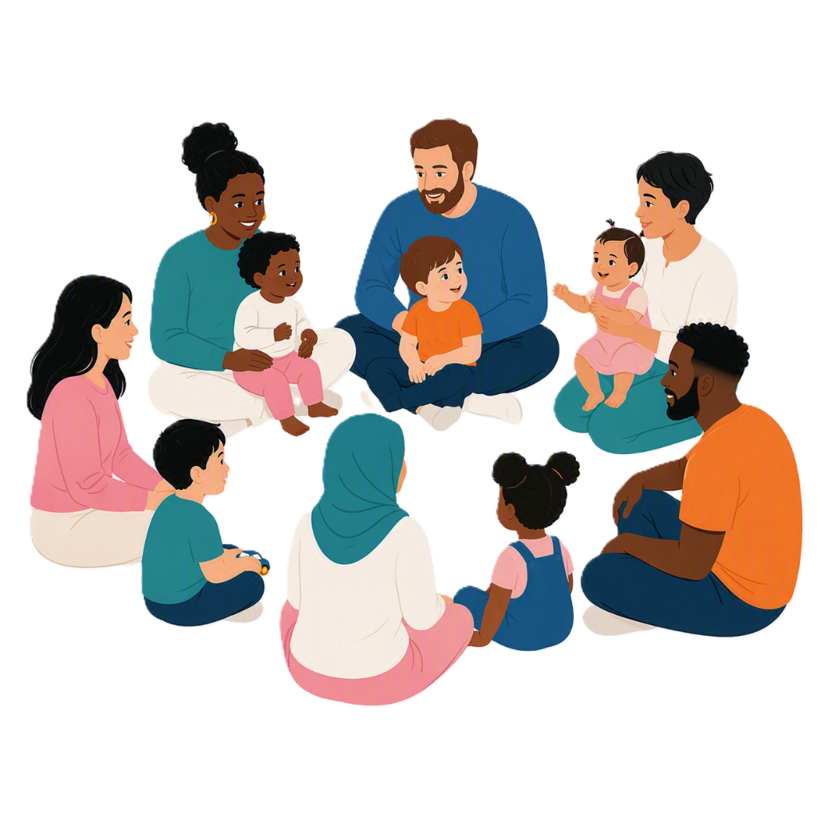 |  | - Supported playgroups
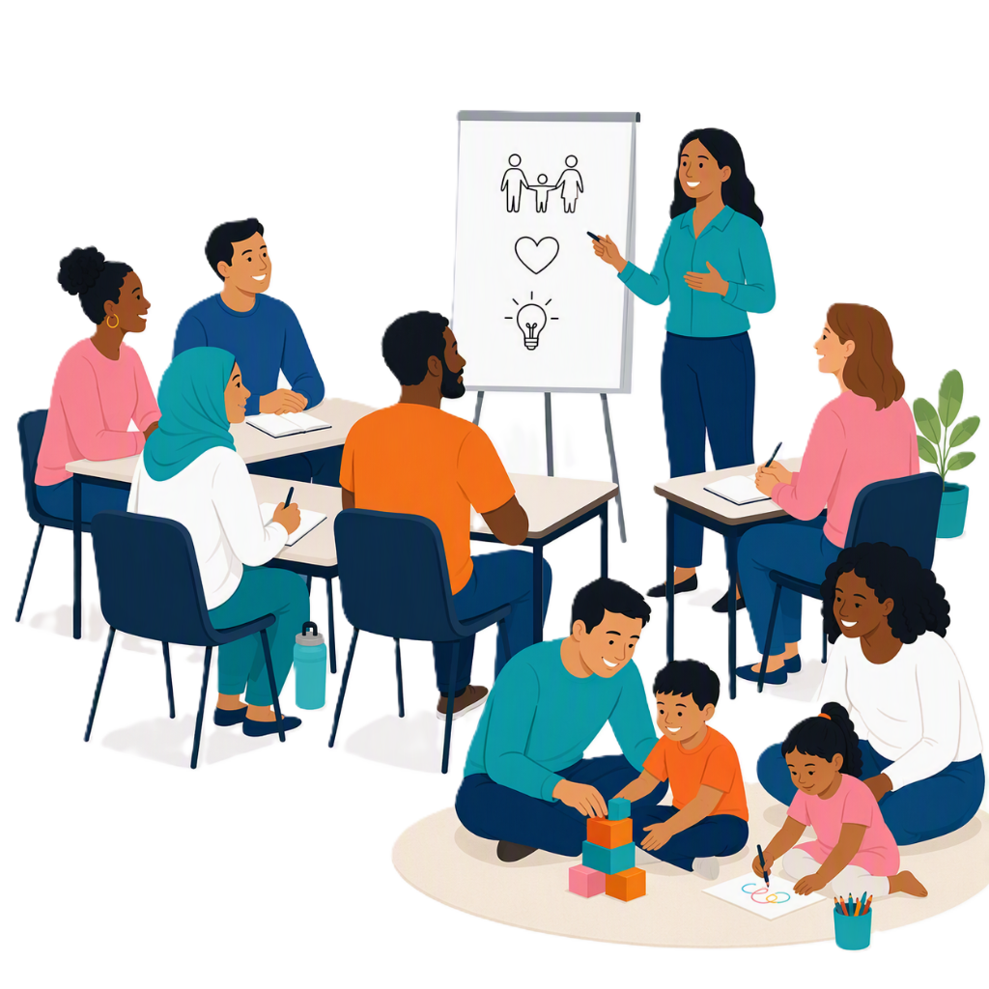 |  | - Family programs  Family programs help parents and carers build their  - Skills  - Confidence  This will support their childs development
 |  | - Support from healthcare professionals.  Professionals are people who are trained to do a job like a doctor or teacher.

Where to go for Thriving Kids

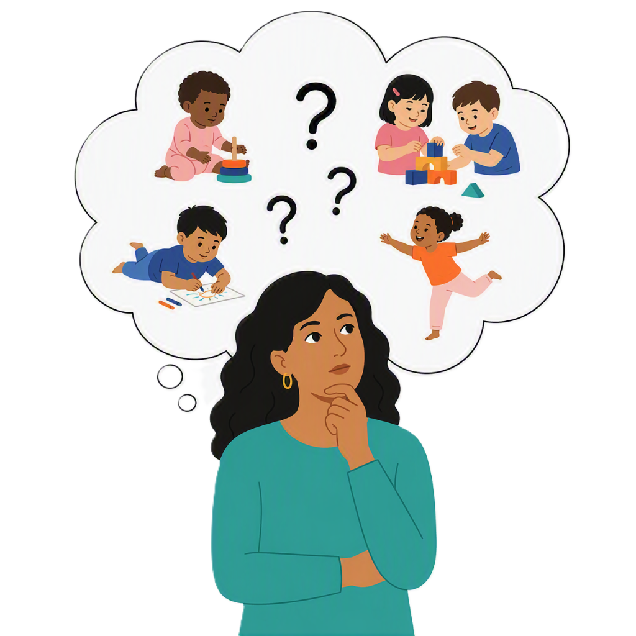 |  | If you are working with a family who  - Has questions about their childs development  - Are looking for information or support
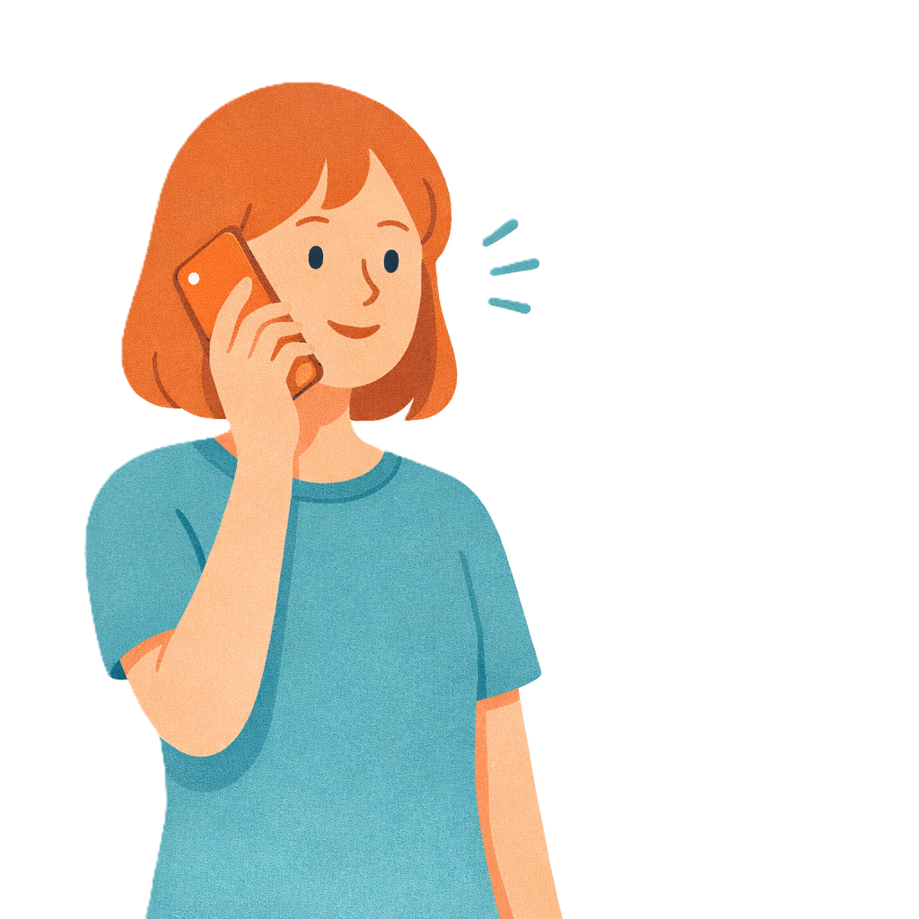 |  | You can call  1800 882 436  You can do a video call.
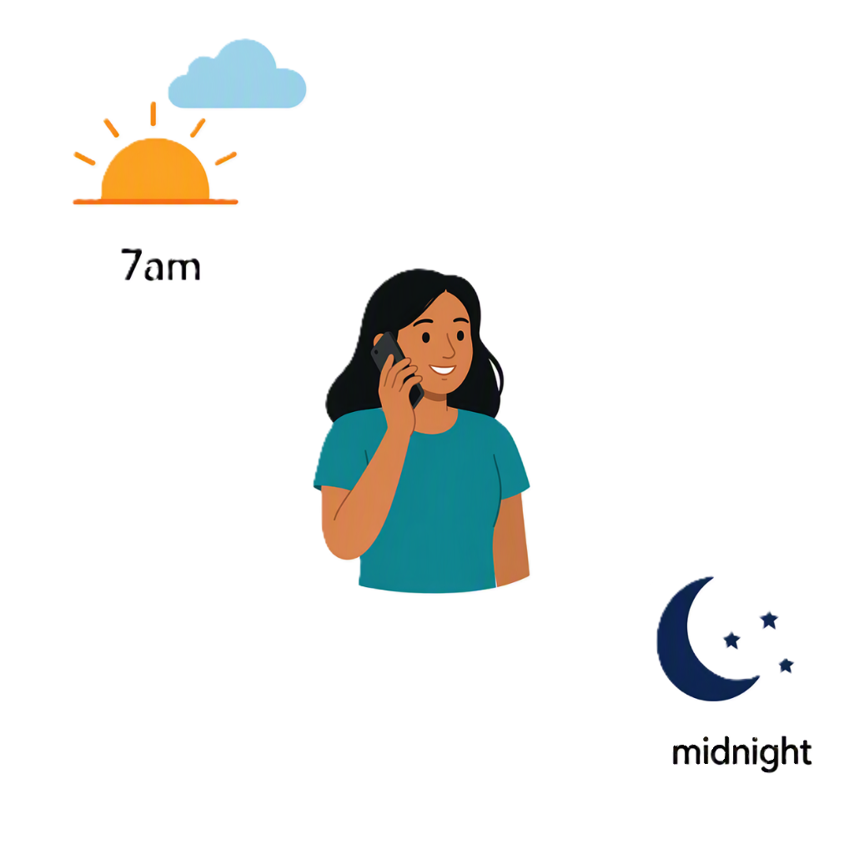 |  | You can call every day between  - 7am  - Midnight.
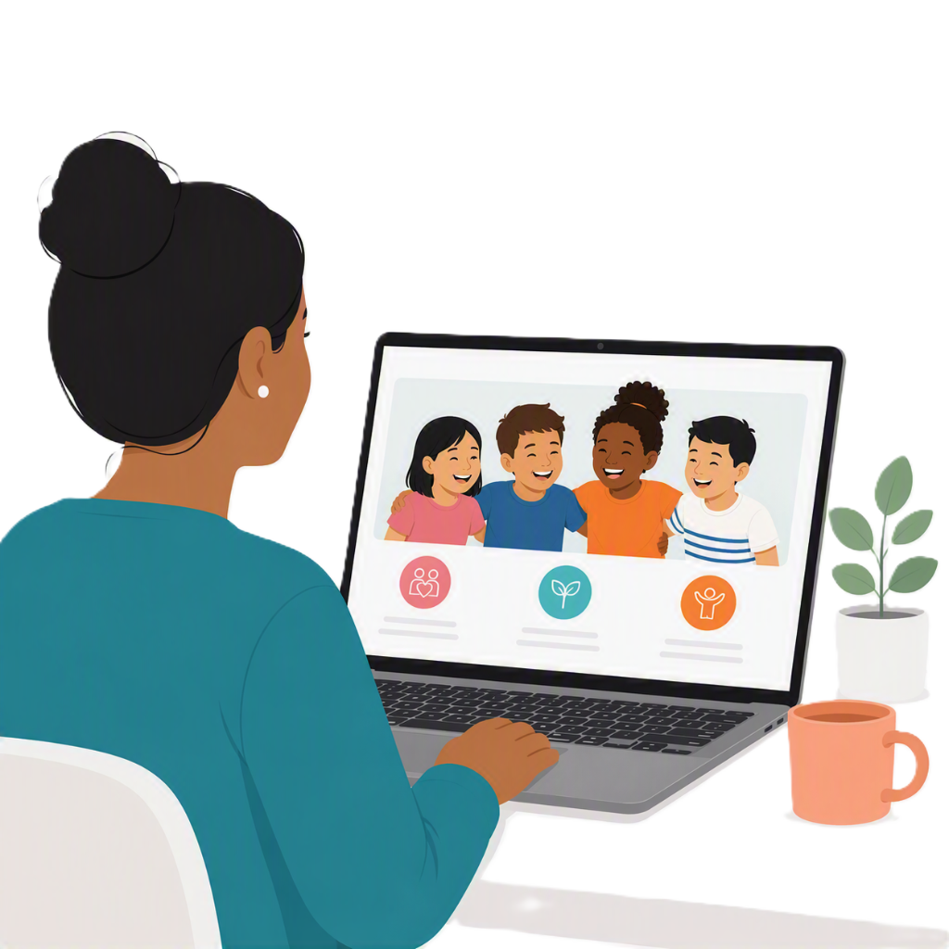 |  | Families can go to the Thriving Kids website.  www.health.gov.au/thrivingkids

Some images in this Easy Read were made using AI.
You must not share or copy any of the images without permission.
September 2026.

