



Monitoring of self-collection in the National Cervical Screening Program

Summary pack

QUARTERLY REPORT – Q2 2026
Professor Dorota Gertig, NCSR Medical Director Dr. Farhana Sultana, Epidemiologist
Jack Davies, Business and Data Analyst

August 2026



EXECUTIVE SUMMARY

SCEE appears to be targeting more vulnerable groups including those under-screened
National SC Uptake: Increased to 52%, despite declining HPV test volumes

By Age: Uptake rose across all age groups, highest in 70–74 years at almost 58%
By State/Territory: Uptake also increased across all S&T; highest in Tasmania at 64%

By SEIFA Quintile: Uptake increased across all quintiles; highest in Quintile 1 (lowest) at 55%
By Remoteness (ARIA): Uptake rose in all areas; highest in very remote areas at almost 68%
Never/Under screened (30–74 yrs): Increased uptake in the hard-to-reach groups with the uptake being slightly higher in under-screened at 66%
HPV Positivity Rate: Remains higher for SC samples compared to CC samples
Follow-Up After HPV 16/18: 81% had colposcopy within 6 months of HPV 16/18 positive result and it was similar in CC & SC
LBC Follow-Up (SC non-16/18): 83% had an LBC after a SC HPV non-16/18 positive result

Switching to SC: 41.0% of people who screened in Q1 and Q2 2026 switched from CC to SC

Page 2 Monitoring of Self-Collection in the National Cervical Screening Program

SELF-COLLECT UPTAKE- SCEE PERIOD
Since the Self-Collection Eligibility Expansion (SCEE) in July 2022, the proportion of self-collected HPV tests has steadily increased each quarter.

450,000

400,000

350,000

300,000
Total count and % of all HPV screening tests reported as self-collect vs total count of clinician collected in each quarter

60%

50%
49.15%
50.61%
45.92%
40.36%
42.65%
37.40%
33.82%
29.64%
27.08%
23.91%
19.61%
15.72%
13.13%
9.90%
Q3
Q4
Q1
Q2
Q3
Q4
Q1
Q2
Q3
Q4
Q1
Q2
Q3
Q4
Q1
Q2
2023 2024 2025 2026
48.64%
52.34%

40%

250,000

200,000

30%

150,000

100,000

50,000
20%

10%

0 0%

CC SC %SC

Page 3 Monitoring of Self-Collection in the National Cervical Screening Program

SELF-COLLECT BY AGE GROUP- SCEE PERIOD
The proportion of tests that were self-collected continued to rise across all age groups, highest in the 70-74 years age group.

70%

60%

50%

40%

57.94%

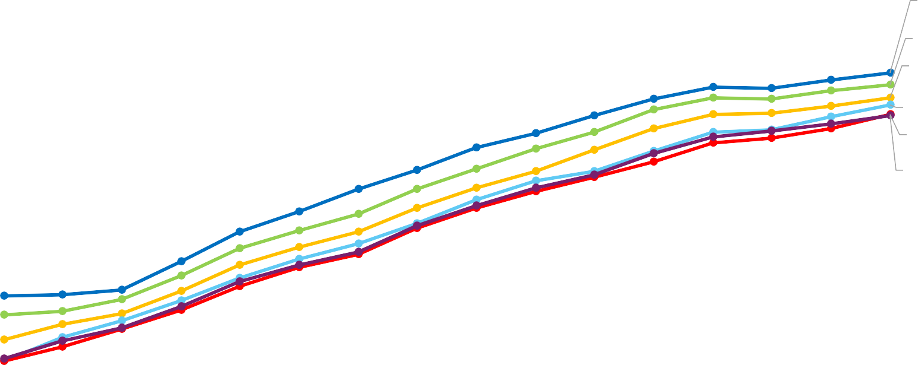
55.89%
53.61%

52.28%
50.71%

50.52%
70-74 yrs

60-69 yrs

50-59 yrs

25-29 yrs

30-39 yrs

40-49 yrs

30%

20%

10%

0%
Q3 | Q4 | Q1 | Q2 |  | Q3 | Q4 | Q1 | Q2 |  | Q3 | Q4 | Q1 | Q2 |  | Q3 | Q4 | Q1 |  | Q2
 |  |  |  | 2023 |  |  |  |  | 2024 |  |  |  |  | 2025 |  |  |  | 2026

Page 4 Monitoring of Self-Collection in the National Cervical Screening Program

SELF-COLLECT BY STATE OR TERRITORY- SCEE PERIOD

The proportion of tests that were self-collected continued to rise across all states, highest in Tasmania.

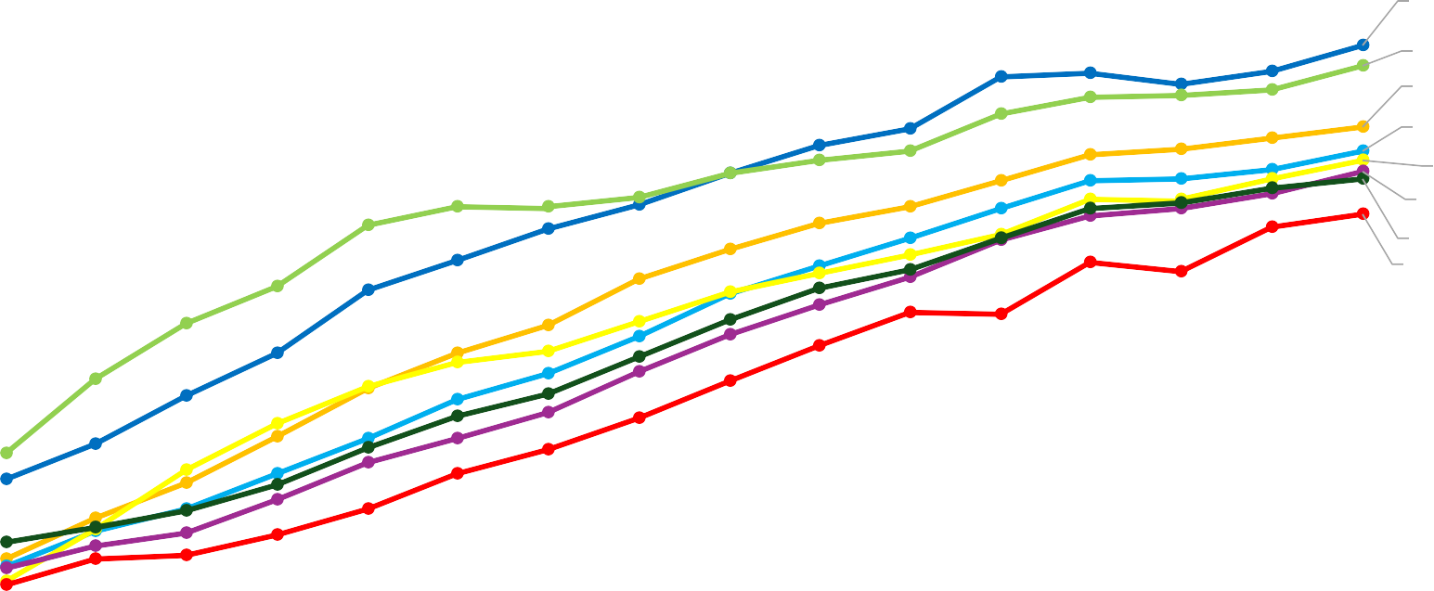
TAS NT VIC WA SA NSW QLD ACT
70% |  | 63.78%
 |  | 61.69%
60% |  | 55.19%
 |  | 52.72%
50% |  | 51.64%
 |  | 50.46%
 |  | 49.78%
40% |  | 46.07%

30%

20%

10%

0%
Q3 | Q4 | Q1 | Q2 |  | Q3 | Q4 | Q1 | Q2 |  | Q3 | Q4 | Q1 | Q2 |  | Q3 | Q4 | Q1 |  | Q2
 |  |  |  | 2023 |  |  |  |  | 2024 |  |  |  |  | 2025 |  |  |  | 2026

Page 5 Monitoring of Self-Collection in the National Cervical Screening Program

SELF-COLLECT BY SEIFA QUINTILE- SCEE PERIOD
The proportion of tests that were self-collected continued to rise across all quintiles; highest in SEIFA quintile 1.

60%

50%
54.80%
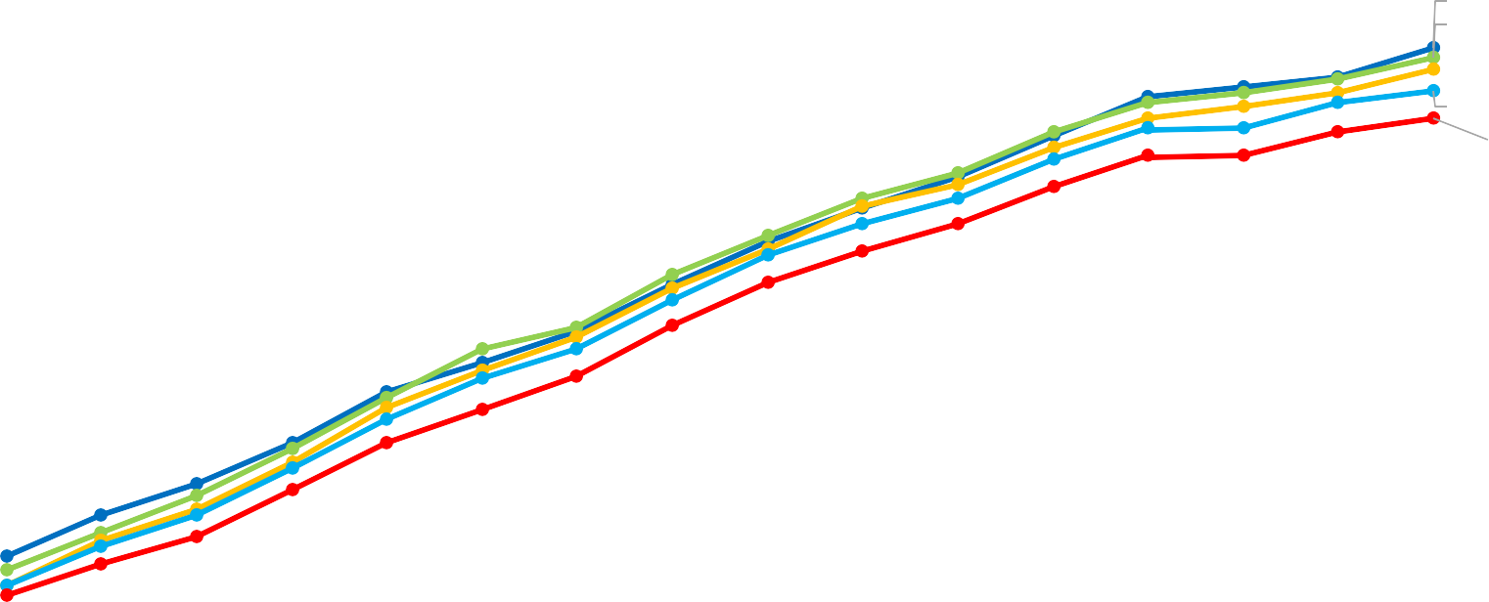
54.08%
52.97%
51.24%
48.88%
SEIFA Quintile 1
SEIFA Quintile 2
SEIFA Quintile 3
SEIFA Quintile 4
SEIFA Quintile 5

40%

30%

20%

10%

0%
Q3 | Q4 | Q1 | Q2 |  | Q3 | Q4 | Q1 | Q2 |  | Q3 | Q4 | Q1 | Q2 |  | Q3 | Q4 | Q1 |  | Q2
 |  |  |  | 2023 |  |  |  |  | 2024 |  |  |  |  | 2025 |  |  |  | 2026

A small number of geocodes are unknown and being resolved so numbers may change slightly.

Page 6 Monitoring of Self-Collection in the National Cervical Screening Program

SELF-COLLECT BY ARIA REMOTENESS INDEX- SCEE PERIOD
The proportion of tests that were self-collected continued to rise for all remoteness areas; highest uptake in very remote areas.

70%

60%

50%

68.35%
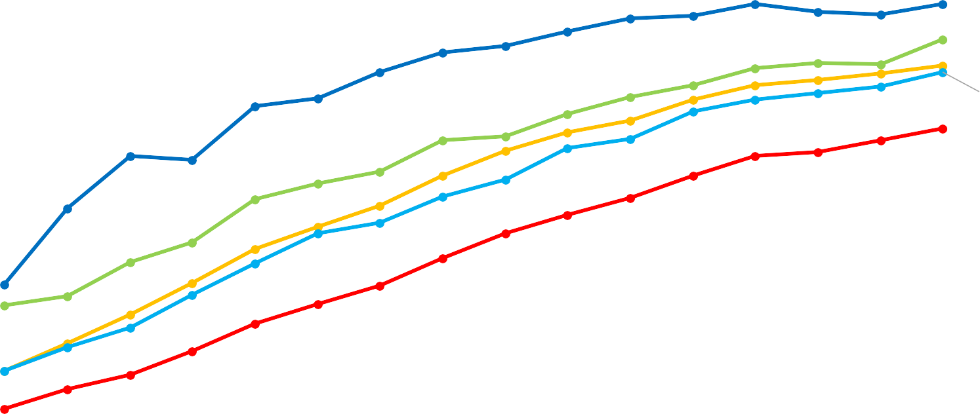
63.15%
59.24%
58.32%
49.84%
Very Remote Remote Australia Inner Regional Outer Regional Major Cities

40%

30%

20%

10%

0%
Q3 | Q4 | Q1 | Q2 |  | Q3 | Q4 | Q1 | Q2 |  | Q3 | Q4 | Q1 | Q2 |  | Q3 | Q4 | Q1 |  | Q2
 |  |  |  | 2023 |  |  |  |  | 2024 |  |  |  |  | 2025 |  |  |  | 2026

A small number of geocodes are unknown and being resolved so numbers may change slightly.

Page 7 Monitoring of Self-Collection in the National Cervical Screening Program

SELF-COLLECT BY SCREENING HISTORY- SCEE PERIOD

70%

Never screened:
No prior screening test and aged 30-74 years

63.81%

70%

Under screened:
>2 years overdue and aged 30-74 years

66.05%

60% 60%

50% 50%

40% 40%

30% 30%

20% 20%

10% 10%

Page 8
0% 0%

There was a consistent increase in uptake in both never-screened and under-screened individuals; higher uptake in under-screened.

Monitoring of Self-Collection in the National Cervical Screening Program | Q3 2024
Q3 | Q4 | Q1 | Q2 Q3 | Q4 | Q1 | Q2 Q3 | Q4 | Q1 | Q2 Q3 | Q4 | Q1 Q2
 |  |  | 2023 |  |  | 2024 |  |  | 2025 |  | 2026

Q3 | Q4 | Q1 | Q2 Q3 | Q4 | Q1 | Q2 Q3 | Q4 | Q1 | Q2 Q3 | Q4 | Q1 Q2
 |  |  | 2023 |  |  | 2024 |  |  | 2025 |  | 2026


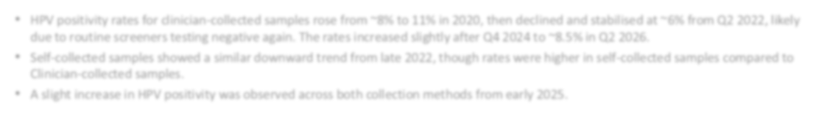
ANY HPV POSITIVITY BY COLLECTION METHOD- FULL PERIOD
- HPV positivity rates for clinician-collected samples rose from ~8% to 11% in 2020, then declined and stabilised at ~6% from Q2 2022, likely
due to routine screeners testing negative again. The rates increased slightly after Q4 2024 to ~8.5% in Q2 2026.
- Self-collected samples showed a similar downward trend from late 2022, though rates were higher in self-collected samples compared to Clinician-collected samples.
- A slight increase in HPV positivity was observed across both collection methods from early 2025.

20%
18%
16%
14%
12%
10%
8%
6%
4%
2%
0%

Any HPV positivity in each quarter by collection method

10.20%

8.47%

% any HPV SC % any HPV CC
Q4 2017 | Q1 Q2 Q3 Q4 2018 | Q1 Q2 Q3 Q4 2019 | Q1 Q2 Q3 Q4 2020 | Q1 Q2 Q3 Q4 2021 | Q1 Q2 Q3 Q4 2022 | Q1 Q2 Q3 Q4 2023 | Q1 Q2 Q3 Q4 2024 | Q1 Q2 Q3 Q4 2025 | Q1 Q2 2026

Page 9 Monitoring of Self-Collection in the National Cervical Screening Program

1ST COLPOSCOPY AFTER PRIMARY HPV 16/18 POSITIVE RESULT
BY COLLECTION METHOD – SCEE PERIOD

Collection method | First HPV16/18 positive result on a primary screening test  (1 Jul 2022 – 31 Dec 2025) (n) | Colposcopy within 6 months  of 16/18 pos result (n, %) | Colposcopy by 30 Jun 2026  after 16/18 pos result (n, %)
Clinician-collected | 27,700 | 22,291 (81%) | 25,783 (93%)
Self-collected | 23,927 | 19,386 (81%) | 21,946 (92%)
Total | 51,627 | 41,677 (81%) | 47,729 (92%)

Page 10 Monitoring of Self-Collection in the National Cervical Screening Program
- 81% had a colposcopy follow-up within 6 months of an HPV 16/18 positive result.
- Colposcopy follow-up was similar for CC and SC at 6 months (80.4% vs 81.0%; p=0.115) but significantly higher in CC compared to SC by 30 June 2026 (93.1% vs 91.7%; p<0.001).

1ST LBC FOLLOW-UP AFTER PRIMARY SELF-COLLECT
HPV NOT 16/18 POSITIVE RESULT – SCEE PERIOD

Collection method | First HPV not 16/18 positive result on a primary screening test (1 Jul 2022 – 31  Dec 2025) (n) | Any LBC  (all reasons included)  within 6 months (n, %) | Any LBC  (all reasons included)  by 30 Jun 2026 (n, %)
Self-collected | 91,634 | 76,575 (83.6%) | 81,965 (89.4%)
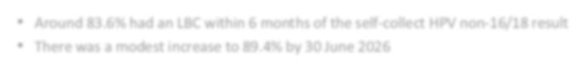
- Around 83.6% had an LBC within 6 months of the self-collect HPV non-16/18 result
- There was a modest increase to 89.4% by 30 June 2026

Page 11 Monitoring of Self-Collection in the National Cervical Screening Program

SWITCH FROM CLINICIAN-COLLECTION TO SELF-COLLECTION FOR EACH CALENDAR YEAR

45%

40%

35%

30%

25%

20%

41.59%

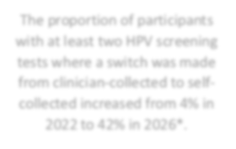
39.12%
The proportion of participants with at least two HPV screening tests where a switch was made from clinician-collected to self-collected increased from 4% in 2022 to 42% in 2026*.

31.17%

18.64%

15%

10%

5%

0%

4.09%

2017* includes only December 2017 2026* includes only Q1 & Q2 2026
0.00% | 0.02% | 0.03% | 0.02% | 0.05%
2017 | 2018 | 2019 | 2020 | 2021 | 2022 | 2023 | 2024 | 2025 | 2026

Denominator: Count of all participants with two HPV screening tests with the more recent HPV test reported in the year that i t was performed.
Numerator: Count of all participants with two HPV screening tests where the collection method in the most recent HPV test was SC and the collection method in the prior screening test was CC.

Page 12 Monitoring of Self-Collection in the National Cervical Screening Program

