Support at Home classification system
The Support at Home classification system (the classification system) was introduced on 1 November 2025 on commencement of the Support at Home program and Aged Care Act 2024.
The classification system determines a person’s eligibility for ongoing home support services (e.g. Commonwealth Home Support Program [CHSP] or Support at Home) and a classification (funding) level (e.g. CHSP or Support at Home classification levels 1 – 8) for those who are eligible for ongoing home support services.
The classification system uses a standardised set of information which draws from data entered into the Integrated Assessment Tool (IAT) by an assessor to evaluate an older person’s functional ability, the extent to which their needs are met, and other relevant factors.
The classification system consists of two distinct steps:
- Determining eligibility for ongoing home support classification, which assesses whether a person meets the criteria to receive an ongoing home support classification
- Determining the funding level, which assesses the person’s needs and circumstances to determine the appropriate classification level and associated funding amount.
Taken together, these steps ensure that older people are both eligible for funding and assigned a funding level that reflects their assessed care needs.
The eligibility algorithm is used to assess an older person’s clinical acuity against a minimum threshold to identify the person as being eligible or ineligible for government funded home care service support. The threshold is primarily based on assessing a person’s clinical characteristics against each of the 5 tools including BARTHEL, OARS, PHQ4, FRAIL, and COGNITIVE IMPAIRMENT. If a person is found to have no clinical concerns as determined against any of the 5 tools, the person is deemed ineligible for ongoing home support services. The details of the 5 tools are available under the Eligibility Algorithm section.
For people assessed as eligible for home support services, the funding algorithm is used to allocate a home support classification level. The funding algorithm has three layers - functional sum, needs met score and compounding factors, which are applied in this order to allocate a home support classification level.
The funding algorithm is guided by a set of rules that are built into the IAT to generate a classification (funding) level. It considers an older person’s needs at three levels:
- Identification of their functional abilities captured through a set of questions in the function section of the IAT, which are aggregated into an overall functional score.
- Assessment of how well their functional needs are currently being met, captured through the needs met set of questions in the function section of the IAT, aggregated into an overall needs met score.
- Consideration of compounding factors, which allows the algorithm to differentiate between people with similar functional status and level of met needs.
The detailed classification tree (see figure below) shows the process in more detail, and further detail of each layer of the classification tree follows. This same figure is shown in the tab ‘Classification Tree’ in the Support at Home classification algorithm technical details.
Figure: Detailed classification tree
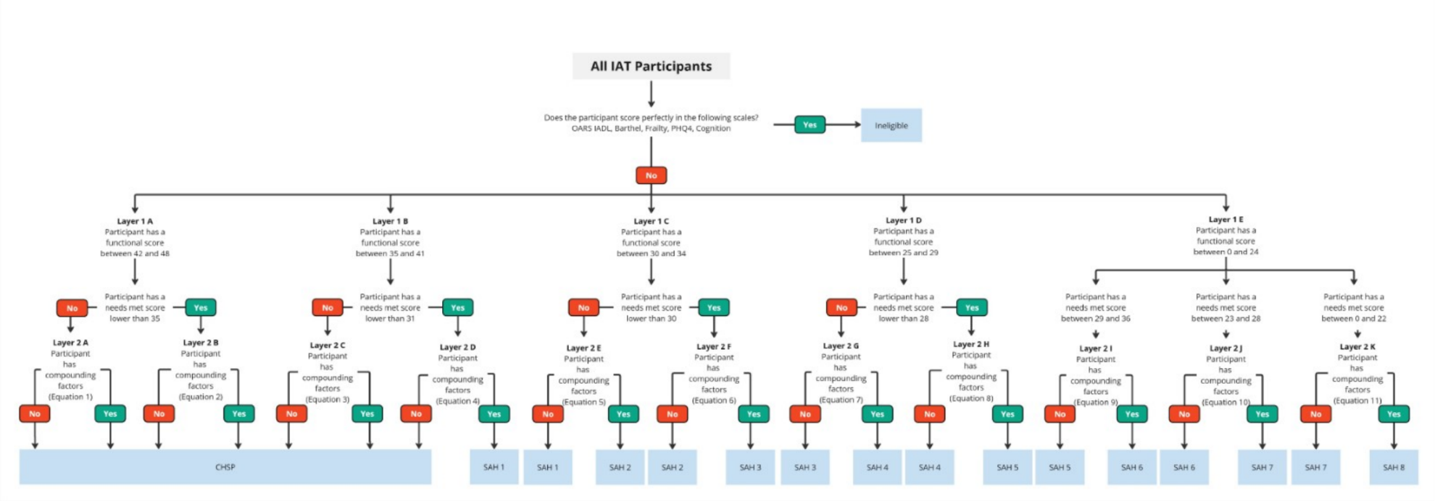

Eligibility algorithm
The first step in the classification system is assessing eligibility for ongoing services. This is assessed using information collected from the IAT form.
Figure: Eligibility node of the classification tree
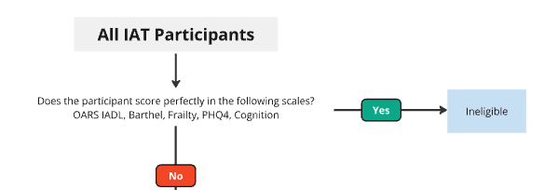
The five aspects of the form which are drawn from are as follows.
- Older Americans Resources and Services Instrumental Activities of Daily Living (OARS IADL)
- Barthel Index of Activities of Daily Living (Barthel Index for ADLs)
- Fatigue, Resistance, Ambulation, Illnesses, and Loss of weight (FRAIL Scale)
- Patient Health Questionnaire (PHQ4)
- Cognition. This is assessed with reference to a confirmed dementia diagnosis, and/or a clinically validated cognitive tool (General Practitioner Assessment of Cognition (GPCOG), and/or Kimberley Indigenous Cognitive Assessment (KICA)), and/or additional health conditions related to cognitive concerns documented in the IAT. These tools are further detailed in the Conditions section of this document.
If a person’s scores show that they have no care needs at all in any of these areas (i.e., they score “perfectly” across the five tools), they are deemed ineligible for ongoing home support services.
The scores which indicate no care needs in any of the 5 areas are as follows.
- OARS IADL: 14 (the maximum score)
- Barthel Index for ADLs: 20 (the maximum score)
- FRAIL Scale: 0 (the minimum score)
- PHQ4: 0 (the minimum score)
- Cognition: 0 (encoded as no cognitive issue; 1 = cognitive issue).
The method by which this algorithm draws from the IAT questions is outlined in further detail later in the document (see the section titled ‘Conditions’).

Funding algorithm
The funding algorithm consists of three ‘layers’.

Layer 1: Functional ability
The first layer looks at how well a person can carry out everyday activities: activities of daily living (ADLs) such as bathing, and instrumental activities of daily living (IADLs), such as going shopping.
It uses the following parts of the IAT:
- Barthel Index for ADLs
- OARS IADL
- 6 additional questions including:
  - uses other communication device
  - uses online services
  - upper body strength
  - does the client drive
  - health literacy difficulties
  - wheelchair mobility.
Together, these produce a combined score out of 48 (the functional sum). This places a person into one of 5 functional ability levels:
- layer 1A: participant has a functional sum between 42 and 48
- layer 1B: participant has a functional sum between 35 and 41
- layer 1C: participant has a functional sum between 30 and 34
- layer 1D: participant has a functional sum between 25 and 29
- layer 1E: participant has a functional sum between 0 and 24.
These layer labels are shown in the diagram on the Classification Tree tab.
This is the first step in determining a person’s classification. The figure below shows the functional ability layer of the classification tree.

Figure: Functional ability layer of classification tree
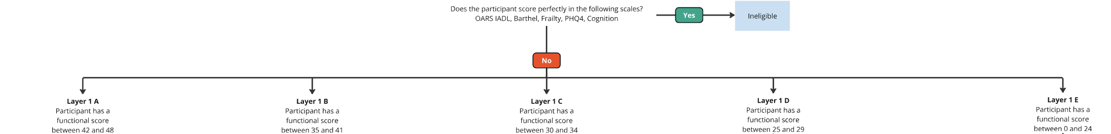

Layer 2: Needs met
The second step is to consider how well a person’s needs are being met through a combination of:
- self-ability
- formal care (such as services they are already receiving)
- informal care (such as family).
For each of the ADL and IADL questions, along with the additional questions including wheelchair mobility and upper body strength, the person is asked how much of each need is being met. Each of these 18 questions is scored:
- 2 (needs completely met)
- 1 (needs partially met)
- 0 (needs completely unmet).
Added together, these give a maximum needs met score of 36.
The 36-point score is grouped into 11 score ranges, each set out in section 81-10 of the Rules. The needs met score narrows down the number of classification levels an older person could be eligible for. See figure below for needs met layer of the classification algorithm.
Figure: Example of needs met layer of classification algorithm (layer 1A)
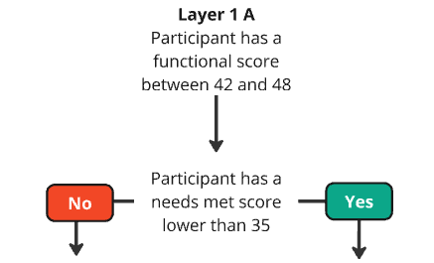

Layer 3: Compounding factors
The third and final step uses a set of factors from a person’s clinical and social circumstances. These factors are known as compounding factors. Consideration of compounding factors decides whether the person needs more or less support than someone with similar functional ability and needs met scores.
A person’s compounding factors assign them into one of the two remaining eligible classification levels. The compounding factors, listed in section 81-7 of the Rules, are:
- continence
- social isolation
- sustainability of carer arrangements (strain on existing carers)
- frailty
- anxiety and depression
- cognition (memory and thinking).
See an example of the compounding factors layer of the classification algorithm decision tree.
Figure: Example of the compounding factors component of the classification algorithm decision tree
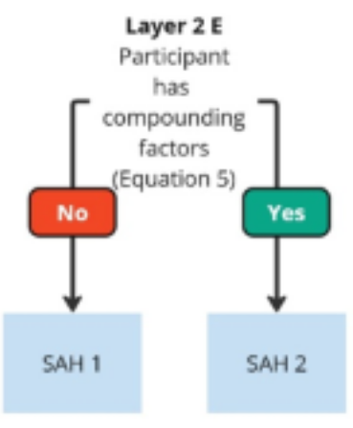

Conditions
The tab ‘Conditions’ in the Support at Home classification algorithm technical details outlines the specific business rules or criteria used to determine eligibility for ongoing home support services, and a recommended classification funding level. The criteria are based on the information collected during the aged care assessment in the IAT.
There are different sets of criteria known as ‘conditions’ used to test the eligibility and/or the classification funding level deemed appropriate for an older person. The 'conditions’ include the terms: ‘functional sum’, ‘needs met score’, and ‘compounding factors’.
These terms are ‘constructed variables’ derived using the data captured in the IAT. Each of the ‘conditions’ refers to constructed variables.
- For eligibility criteria – five tools (cognitive indication, OARS IADL score, Barthel score, Frail score, PHQ4 score)
- For layer 1, the functional sum
- For layer 2, the needs met score.
- For layer 3, have or does not have compounding factors determined using complexity equations.
The details of how these variables are constructed is explained in the tabs ‘Constructed Variables’ and ‘Complexity Equations’ in the Support at Home classification algorithm technical details.

Eligibility criteria for ongoing home support services
The eligibility criteria are based on an older person’s clinical acuity determined from the assessment data captured against the set of 5 tools including:
- Barthel Index of Activities of Daily Living: A scale that evaluates an older person’s capacity to perform daily life activities independently. The Barthel uses 10 questions from the IAT and sums them into a score ranging from 0 – 20 where lower scores indicate lower functional ability.
  - For details on the textual response to numerical encoding of the Barthel items, please refer to the tab ‘Constructed Variables’, lines 348 – 372 in the Support at Home classification algorithm technical details.
- Older Americans Resources and Services – Instrumental Activities of Daily Living (OARS-IADL): A 7-item physical assessment instrument. The OARS scale sums the scores into a score ranging from 0 – 14 where lower scores indicate lower functional ability.
  - For details on the textual response to numerical encoding of the OARS items, please refer to the tab ‘Constructed Variables’, lines 374 – 384 in the Support at Home classification algorithm technical details.
- Cognitive Indication: A binary indicator represented as 0 or 1 used to identify an older person’s cognitive function.
  - For details on the textual response to numerical encoding of the Barthel items, please refer to the tab ‘Constructed Variables’, lines 120 – 346 in the Support at Home classification algorithm technical details.
- Patient Health Questionnaire (PHQ4): A 4-item score used to detect anxiety and depression disorders. Each item/question is scored on a scale of 0 – 3 to sum up to a range of 0 – 12 where higher scores indicate anxiety or depression.
  - For details on the textual response to numerical encoding of the Barthel items, please refer to the tab ‘Constructed Variables’, lines 111 – 118 in the Support at Home classification algorithm technical details.
- Fatigue, Resistance, Ambulation, Illness, Loss of weight (FRAIL): A 5-item scale used to assess disability and mortality. Scoring is based on the following 5 areas:
  - fatigue
  - resistance
  - ambulation
  - illness
  - loss of weight.
Each area is scored on a scale of 0 – 1 with a higher score associated with a higher frailty.
- For details on the textual response to numerical encoding of the Barthel items, please refer to the tab ‘Constructed Variables’, lines 96 – 109 in the Support at Home classification algorithm technical details.
If an older person is found to have no assessed care needs on all of these 5 tools, then the person is deemed ineligible for government assisted ongoing home support services.
Otherwise, the older person is recommended either CHSP or one of the 8 Support at Home classification levels based on the combination of functional sum, needs met score, and compounding factors.
For CHSP, the set of conditions defined in the ‘Conditions’ tab – lines 14-34 in the Support at Home classification algorithm technical details and as represented through the Classification tree – showcase 4 separate CHSP classification levels 1-4.
Currently, an older person classified into any of the 4 CHSP levels is simply recommended for the CHSP, as the CHSP sits outside the scope of Support at Home and has no sub-classification levels.

Constructed variables
Encoding for each constructed variable is specified in the tab
A ‘constructed variable' is a derived measure created from the raw responses collected through the IAT. Rather than using each individual assessment question directly in the Support at Home classification process, responses are scored and derived into standardised numerical values. These values are combined to produce clinically meaningful indicators such as functional ability, cognitive impairment, needs being met, frailty etc.
The constructed variables allow information from many assessment questions to be summarised into a single measure that can be consistently applied across all older people who are assessed. The Support at Home classification algorithm technical details uses these constructed variables as key criteria to determine eligibility and classification levels, helping ensure that people with similar needs receive similar levels of support.
For example, functional ability is measured using the Barthel Index for ADLs, which is constructed from a set of IAT questions relating to everyday tasks. To illustrate how this functional variable is created; one of these questions asks are you able to dress yourself, with possible responses of:
- without help
- with some help
- completely unable.
During the construction of the Barthel score, these text responses are encoded into numeric values:
- without help is assigned a score of 2
- with some help is assigned a score of 1
- completely unable is assigned a score of 0.
Similar encoding occurs across all Barthel items except for the Walk question, which is encoded into 0-3 for the 4 response levels. The resulting values are summed to create a Barthel score ranging from 0 to 20, where lower scores indicate lower functional ability.

Complexity equations
A complexity equation represented by compounding factors determines if an older person’s care needs are more or less complex relative to the cohort of people with similar functional sum and needs met score.
Layer 3 of the classification tree has 11 complexity equations. Each equation makes use of the same set of constructed variables, but the weighting given to each of these variables depends on an older person’s position in the classification tree.
A complexity equation makes use of 6 constructed variables including:
- carer_var
- cog_indication
- continence_score
- FeelslonelyDownOrSociallyIsolated_4.1
- Frail.score
- PHQ4_score.
Similar to the functional sum and needs met score, the encodings and construction of these 6 constructed variables is explained in the tab ’Constructed Variables’ in the Support at Home classification algorithm technical details.
In the complexity equation, the score for each of the above constructed variables is multiplied by its corresponding weight in the complexity equation and summed to determine the older person’s compounding factors indicator.
The complexity equation is solved. A score from the equation >0 indicates the participant has significant compounding factors. A score of <= 0 indicates the participant does not have significant compounding factors.

Case study example: an eligible participant is classified into Support at Home 1
To recommend Support at Home 1, an older person is required to be eligible for ongoing home support services, and to have either of the below:
- functional sum of 35 – 41 and needs met score of 0 – 30 and complexity equation 4 > 0
- functional sum of 30 – 34 and needs met score of 30 - 36 and complexity equation 5 < 0.
The criteria for eligibility for ongoing home support services is shown on rows 9-13 of the Conditions tab. To illustrate, one of these criteria is the presence or absence of cognitive issues. Cell F9 on Conditions specifies that cognitive issues are considered. This draws from the ’cog_indication‘ indicator variable, which is explained from row 329 on the Constructed variables tab. The questions from this question set are drawn from the Questions tab. One of these is shown on row 64 of that tab, which specifies the Boolean variable ’client_ConfirmedDementiaDiagnosis_Bln‘ is used in the Cognitive indicator. The source question from the IAT for this variable is “Does client have a confirmed dementia diagnosis from a geriatrician or neurologist?”
A functional sum is constructed using a set of questions in the function section of the IAT (rows 9-48 in the tab ’Constructed Variables‘ in the Support at Home classification algorithm technical details specification). Using the encoding methodology in column F in the tab ’Constructed Variables‘, each of the question responses is assigned a score of 0 – 3. The encoded scores are summed up to assign a functional sum.
For example, if an older person’s response to the question ’go shopping‘ is “with some help” (refer to line 11 in the Constructed Variables tab), the response will be encoded into a score of 1. Similarly, if the response to the question ’eating‘ is “without help” (refer to line 20 in the ’Constructed Variables‘ tab), the response will be encoded into a score of 2. If the sum total of the encoded numeric scores of all of the questions in scope is between 35 – 41, then layer 1 of the classification tree will move the person towards layer 2C or 2D.
At layer 2, the classification tree will assess if the older person’s needs met score is higher or lower than 31. Similar encoding methodology will be used to convert the response for a needs met question (rows 58-65 in the tab ’Constructed Variables‘ in the Support at Home classification algorithm technical details) into a numeric score.
For example, if the response selected for the question ’dress - need met‘ is “partially met” (refer to line 61 in the ’Constructed Variables‘ tab), then it will be converted into a score of 1. If the sum total of the encoded numeric scores of all of the questions in scope is >=31, the participant moves to Layer 2D. Compounding factor criteria will then be assessed as part of layer 3.
At layer 3, the classification tree will check the older person’s score calculated using the appropriate complexity equation (Equation 4 for this branch of the tree: lines 35 – 41 in the ’Complexity Equations‘ tab). If the score of the complexity equation 4 is > 0, the older person is classified as having compounding factors indicator equal to 1 and is recommended Support at Home 1 as the final classification outcome.

Questions
The tab ’Questions‘ in the Support at Home classification algorithm technical details shows how each question in the IAT flows into the constructed variables and complexity equations.
The Support at Home classification algorithm draws information from a range of sections within the IAT.
These sections capture information about a person's functional ability, continence, cognitive status, psychological wellbeing, frailty, social circumstances, home environment, carer supports and personal goals. Constructed variables are used to encode the information from person’s responses and then used as inputs to the classification algorithm to determine eligibility and classification level.
The main IAT sections contributing to the algorithm include:
- function
- frailty
- cognition
- psychological
- social
- carer profile.

Barthel Index of Activities of Daily Living (Barthel Index for ADLs)
The Barthel Index is a constructed measure of functional ability derived from the function section of the IAT. It incorporates questions relating to:
- are you able to walk?
- are you able to take a bath or shower?
- are you able to transfer yourself from a chair, bed etc?
- are you able to dress yourself?
- are you able to go to the toilet, wipe and re-dress?
- toileting - bladder
- toileting - bowels
- grooming/personal appearance
- eating
- climbing stairs.

OARS IADL
The OARS IADL score is constructed from responses to the following questions:
- get to places out of walking distance
- undertake housework (heavy or moderate)
- go shopping
- prepare meals
- take medicine
- handle money
- use the telephone.

Functional sum
The functional sum is a broader constructed measure of functional capacity that combines responses from a large number of function section questions, including activities of daily living, instrumental activities of daily living, communication, mobility, technology use and related functional tasks. It incorporates responses to the following questions:
- get to places out of walking distance
- undertake light housework
- undertake housework (heavy/moderate)
- go shopping
- prepare meals
- take medicine
- handle money
- use the telephone
- use other communication device
- use online services
- walk
- wheelchair mobility
- climb stairs
- take a bath or shower
- dressing
- grooming
- eating
- transfers
- upper body strength
- toilet use.

Needs met score
The needs met score is constructed using the is the need being met? responses attached to functional assessment questions above. For activities where a person requires assistance, assessors record whether the need is:
- completely unmet
- partially met
- completely met
- client does not require assistance.

Continence score
The continence score is constructed from:
- toilet – bladder
- toilet – bowels.
Responses relating to bladder and bowel continence are combined into a single continence measure which contributes to the complexity component of the ongoing classification framework.

Cognitive indication
The cognitive indication variable is a constructed indicator that identifies whether the assessment indicates the presence of cognitive impairment. The variable is derived from information collected across the cognition section of the IAT, including:
- dementia diagnosis information
- validated cognitive assessment tools
- a set of reported medical conditions representative of cognitive concerns.
Responses from these assessment components are combined to determine whether cognitive impairment is indicated. The resulting cognitive impairment indicator is then used within the Support at Home classification algorithm.

PHQ4Score
This is constructed from four IAT psychological questions:
- feeling nervous, anxious or on edge the last 2 weeks?
- not being able to stop or control worrying last 2 weeks?
- little interest or pleasure in doing things last 2 weeks?
- feeling down, depressed or hopeless last 2 weeks?

Frailty
The questions from the IAT that are used to construct the frailty score are:
- how much of the past four weeks did the person feel tired?
- difficulty walking up 10 steps without resting
- difficulty walking 300 metres or around the block
- presence of specified illnesses
- unintentional weight loss during the previous three months.

Loneliness or social isolation
This constructed variable is derived from a person’s response to the question:
- do you ever feel lonely, down or socially isolated?

Carer availability and sustainability
This constructed variable is derived from a person’s response to the question:
- are there factors affecting carer availability and sustainability of care relationship?

