Service and Support Portal User Guide – Managing Referrals for Service
This guide is for Team Leaders who use the My Aged Care Service and Support Portal. It explains how to manage referrals.
Each provider outlet must have at least one person with the Team Leader role in the portal.
The Team Leader manages referrals for services. This includes accepting referrals, placing referrals on a waitlist, rejecting referrals, and revoking referrals after acceptance.

Table of Contents
Introduction 2
Viewing and searching for referrals 2
Accepting or rejecting a referral for service 7
Accepting a referral 12
Rejecting a referral 15
Revoking an accepted referral 18
Revoking a referral - client deceased 21
Accepting a Referral to Waitlist 22
Retrieving a Referral Code 23
Drawing a Client into Service from a Waitlist 26
Notifications for Overdue Referrals 28
Referral History 29
Referral Priority Status 30
More Information and Support 31

Introduction
Service providers can receive referrals for services in the following ways:
- Clients with existing care approvals under the Aged Care Act 2024 and a referral code can contact service providers directly.
- Service providers can receive electronic referrals through the My Aged Care portal issued by an assessor directly or by broadcast.
This guide explains each referral pathway in more detail.
For more information about managing referrals, refer to the My Aged Care Service and Support Portal user guide: Part 2 - Team leader and staff member functions.
! | All clients with existing approvals should be registered in My Aged Care. Please contact the My Aged Care Assessor and Service Provider helpline on 1800 836 799 for further assistance.
! | Support at Home referrals  Support at Home referrals can include more than one service type and service.  Providers receive referrals either through the portal or by a referral code, depending on the client's preference.  Each incoming referral includes a priority level: low, medium, or high.

Viewing and searching for referrals
- From the homepage, select Service Referrals.
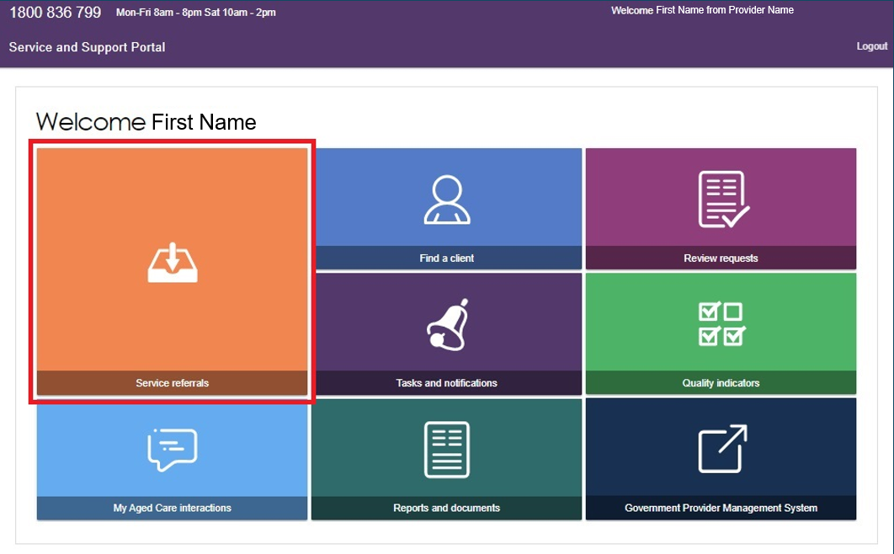

Team Leaders and Staff Members can view referrals. Only Team Leaders can:
- Accept referrals
- Add referrals to a waitlist
- Reject referrals
- Revoke referrals after they have been accepted.
You may have more than one role in the Portal. The tiles displayed on your homepage will depend on your assigned role or roles.
You can also access Service Referrals from the toolbar at the top of the Service and Support Portal from any page.
- Before searching for referrals, make sure you have selected the correct outlet.
To change outlets, select the outlet name in the top-right corner of the portal, next to the Logout link, and choose the relevant outlet. This ensures you view referrals for the correct outlet.
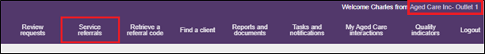
- The Incoming Referrals page shows all referrals that have not yet been actioned.
You can switch between Card View and List View using the toggle at the top of the page.
LIST VIEW
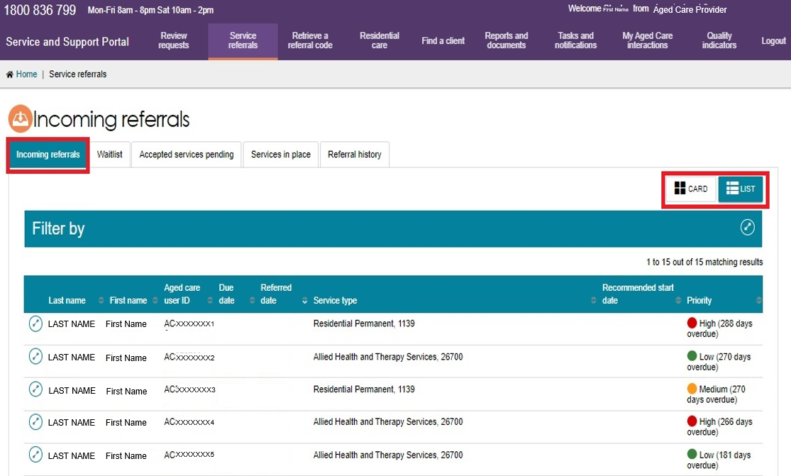

CARD VIEW
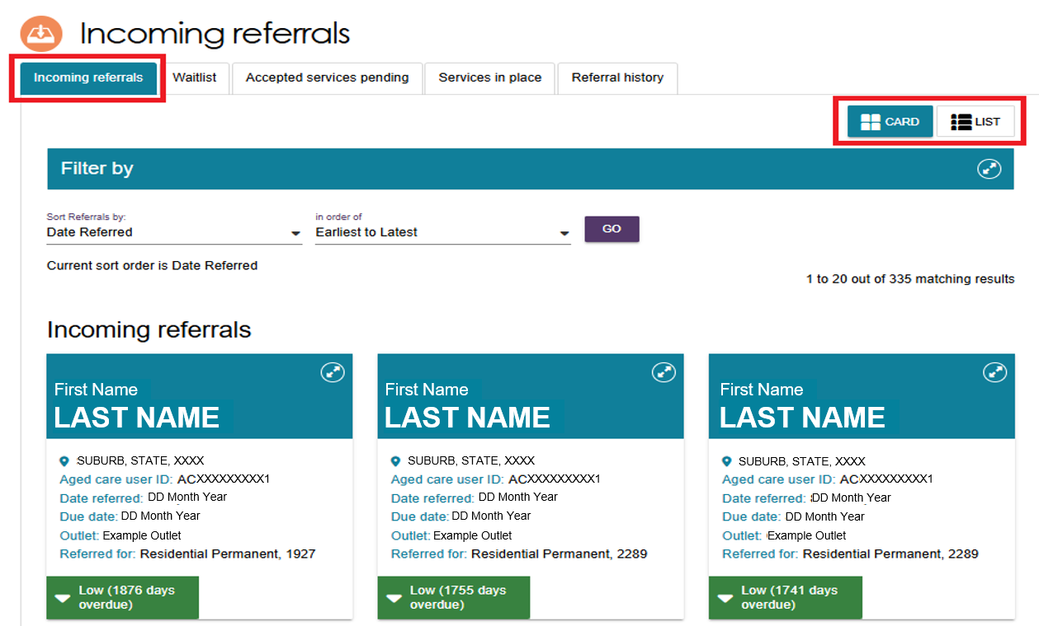
- Select the Expand icon (double arrows) next to a client's record in either Card View or List View to see more information about the referral.
For Support at Home referrals, the expanded view shows all Support at Home classifications assigned to or approved for the client, along with the funding status for each classification.
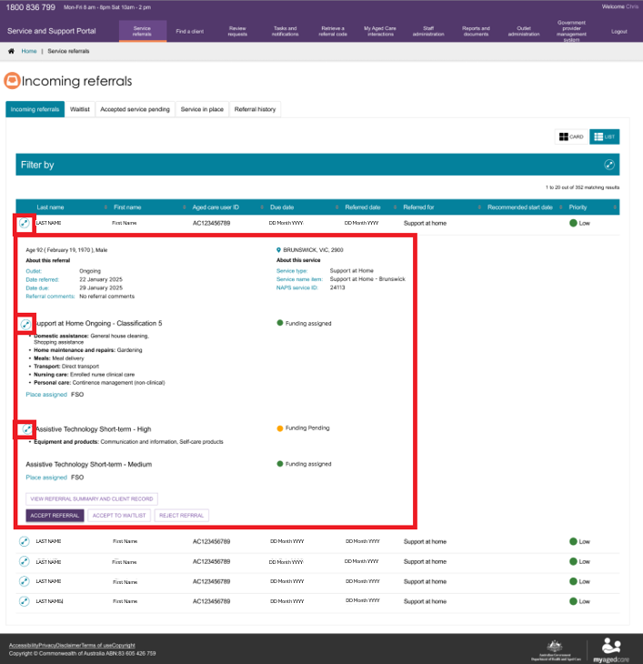
- To find a specific client, enter the client's first name, last name, or Aged Care User ID in the search field.
To view filter options, select the Expand icon (double arrows) on the right side of the filter bar.
To search using additional criteria, select Advanced Search. The Search Incoming Referrals window will open.
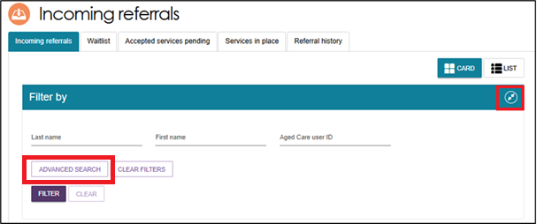
- In the Optional Filter Field drop-down list, select a filter and then choose Add Filter to apply it to your search.
You can save your selected filters by choosing Save Filter. This lets you quickly reuse them from the Advanced Search option.
Available filters include:
- Aged Care User ID
- Due Date
- First Name
- Last Name
- Locality
- Outlet
- Postcode
- Priority
- Recommended Start Date
- Referred Date
- Service Type
- State
- Suburb.
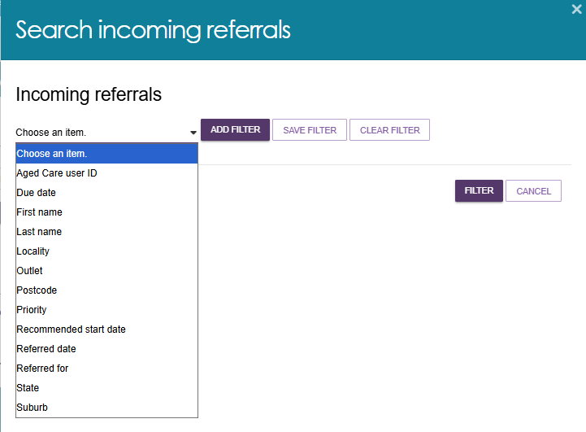
When you have finished adding filters, select Filter.
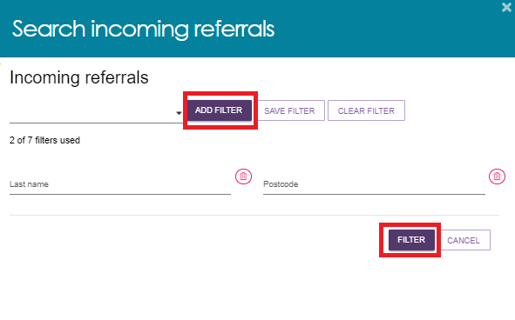
- You can sort incoming referrals using any of the following fields:
- Client Last Name
- Client First Name
- Aged Care User ID
- Suburb
- State
- Postcode
- Locality
- Date Referred
- Due Date
- Recommended Start Date
- Priority
- Service Type.
You can sort the results in ascending or descending order, or alphabetically from A to Z or Z to A, depending on the field you select.
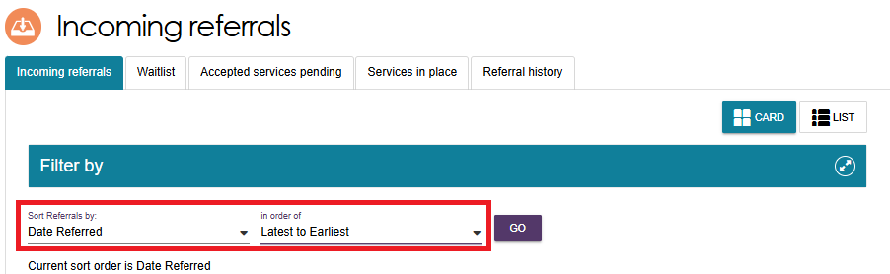

Accepting or rejecting a referral for service
- To accept a referral, select Service Referrals from:
- the homepage
- the toolbar at the top of the portal, or
- the sidebar menu in the top-left corner of the portal.
For Support at Home services, providers can view the referral code that has been issued to the client once funding has been assigned. Providers should also check the take-up deadline. You must start services before this date, or the client's funding may be withdrawn.
! | Waitlist referrals are no longer sent as a separate referral type. If a waitlist is available for the referred service, a Team Leader can either:  - accept the referral and start services immediately, or  - accept the referral onto the waitlist.
- From the Incoming Referrals tab in Service Referrals:
- In Card View, select the Expand icon (double arrows) at the top-right corner of the referral.
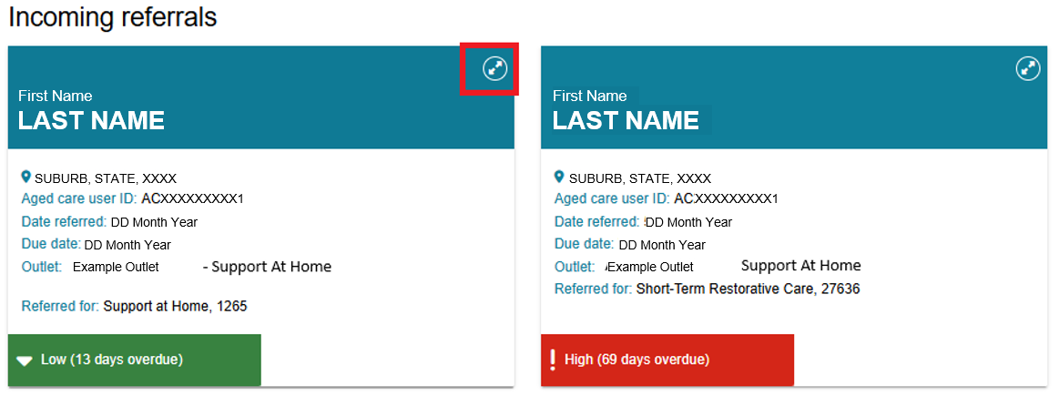
- In List View, select the Expand icon (double arrows) on the left side of the referral.
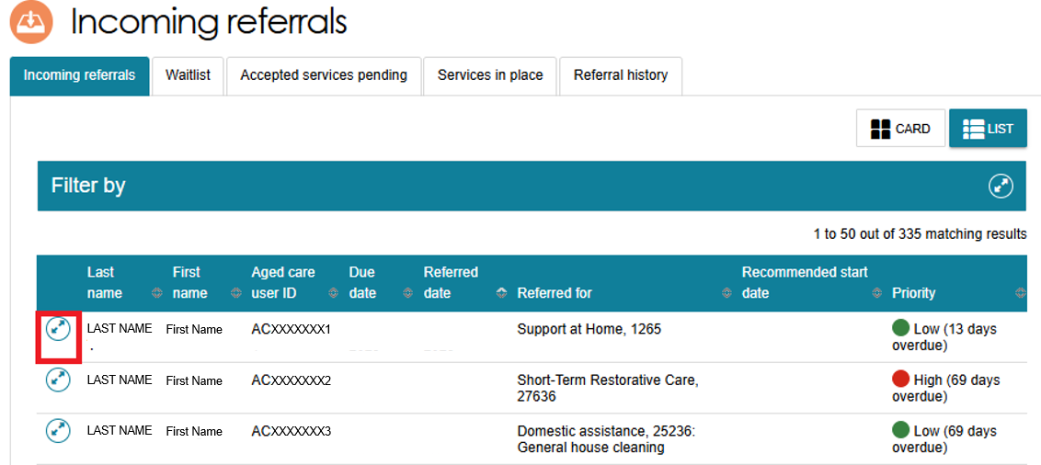
- The expanded view provides additional information, including:
- the NAPS Service ID the referral was sent to
- any comments added by the assessor or My Aged Care Contact Centre
- whether the client has additional referrals for other service types with your outlet.
You can use the information on the referral card to decide whether to accept, reject, or waitlist the referral.
If you need more information before making a decision, select View Referral Summary and Client Record. This page shows:
- referral details
- the client's assessment information
- assessment outcomes
- additional client information relevant to service delivery.
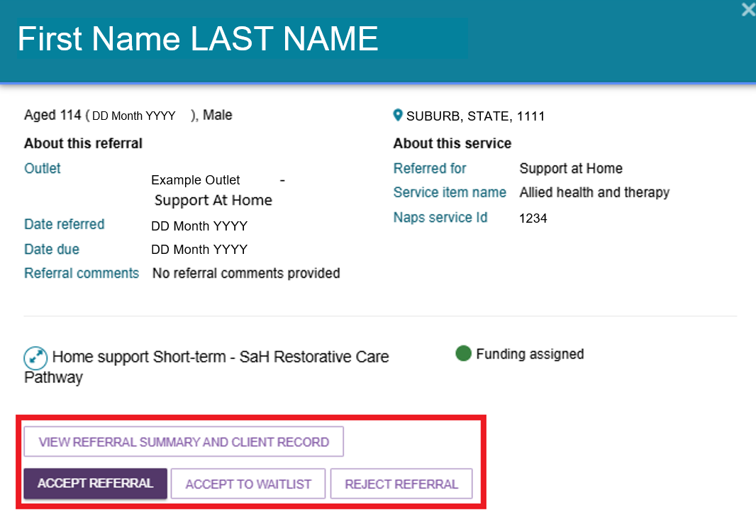
!  ! | For Support at Home services, the detailed referral view shows the recommended frequency and intensity of services.  The detailed referral view also shows the recommended frequency and intensity for CHSP services. These recommendations help providers discuss service options with the client. You can also find this information in the Services and Referrals for My Organisation tabs in the client record.  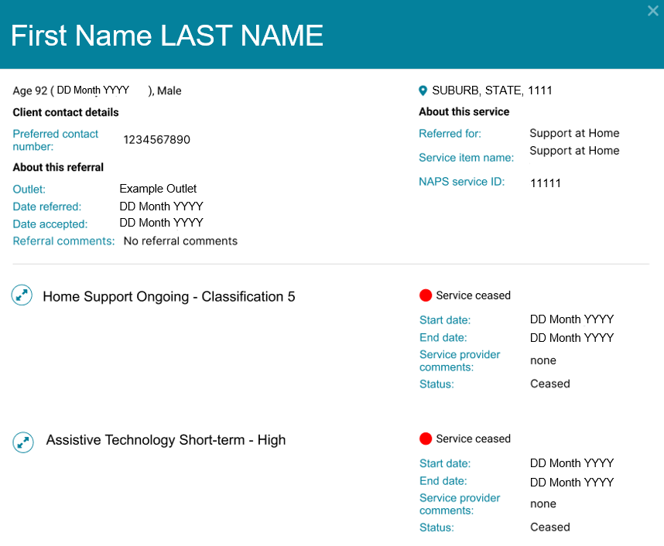
- If you select View Referral Summary and Client Record, the Referrals for My Organisation page opens. This page shows all referrals issued to your organisation for the client.
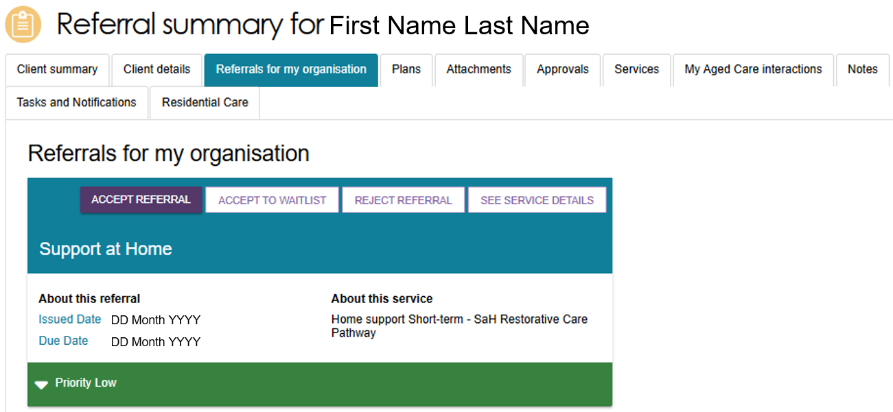

You can also view referrals on the Services tab.
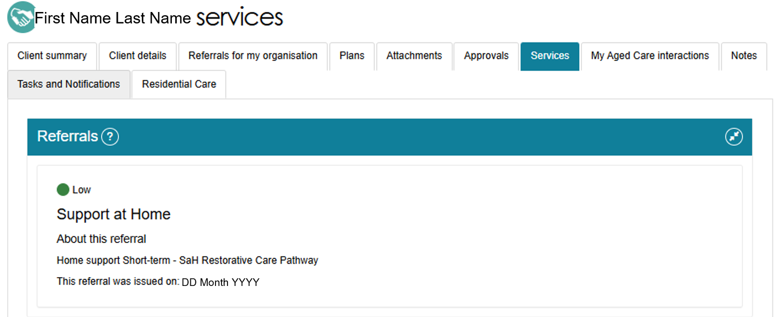
- Before you accept a referral, review the referral and client information and confirm that you can provide services to the client.
You can find this information in the Client Details tab, including:
- Primary contact person
- Identity information and the status of the identity check
- Communication requirements
- Address and contact details (suburb, state or territory, and postcode only).The full address becomes available after you accept the referral.
- Payment details
- Health insurance details
- Service information
- Current notes
- The Notify My Aged Care of Death button.
You can view additional client information on the following tabs:
- Client summary
- Referrals for my organisation
- Plans
- Attachments
- Approvals
- Services
- My Aged Care interactions
- Notes
- Tasks and Notifications.
The image below shows the Client Details page. From this page, you can select other tabs to view additional information about the client.
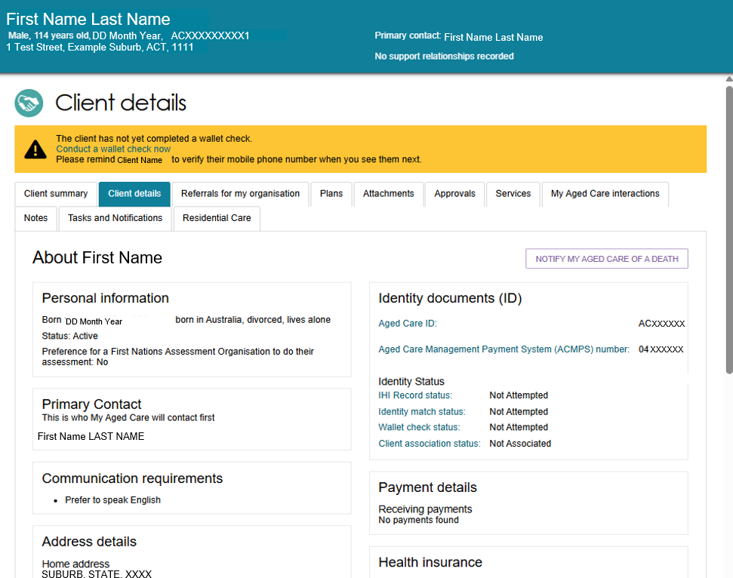
- To accept the referral, refer to Accepting a Referral.
To reject the referral, refer to Rejecting a Referral.
To accept the referral to waitlist, refer to Accepting a Referral to Waitlist.
For more information about navigating the client record and viewing client information, refer to the My Aged Care Service and Support Portal user guide – The client record.
!  !  ! | Before you accept a referral, review the referral and client information and confirm that you can provide the required services.  Only accept a referral after your organisation has confirmed that it has the capacity to deliver the services the client needs. You should also confirm that the client agrees to proceed before accepting the referral.  You can view the client's contact details and full address only after you have accepted the referral.

Accepting a referral
- To accept the referral, select ACCEPT REFERRAL from the Referral summary page or from the expanded card or list view in incoming referrals tab.
Accepting Referral from Referral Summary
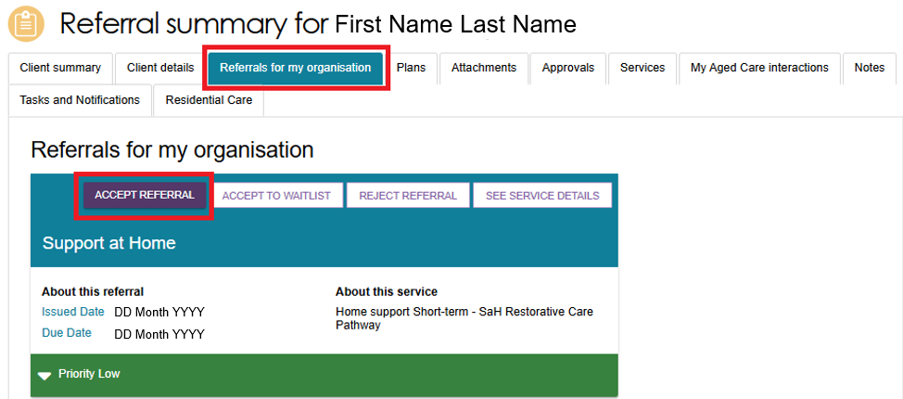
Accepting Referral from Incoming Referrals Tab (Card View)
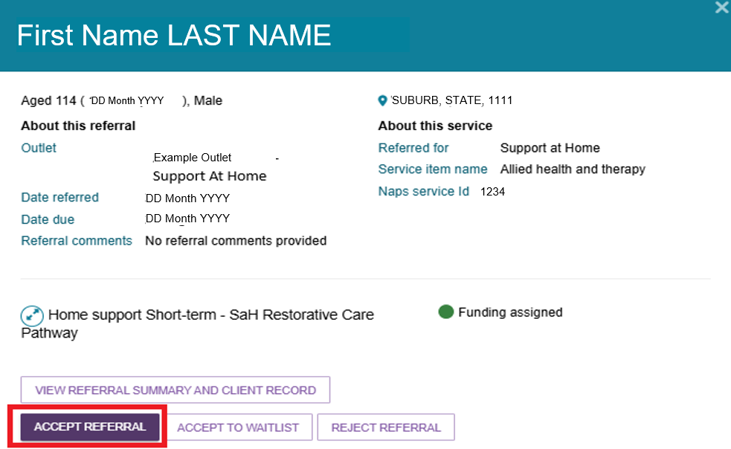
Accepting Referral from Incoming Referrals Tab (List View)
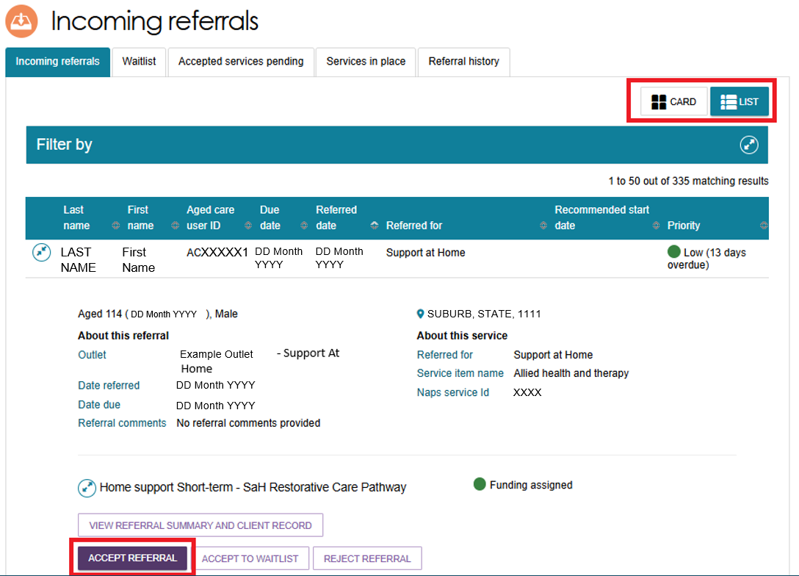
- If your organisation has more than one service or NAPS Service ID for the service type, select the correct service item or NAPS Service ID to link to the referral.
To confirm your decision, select Accept.
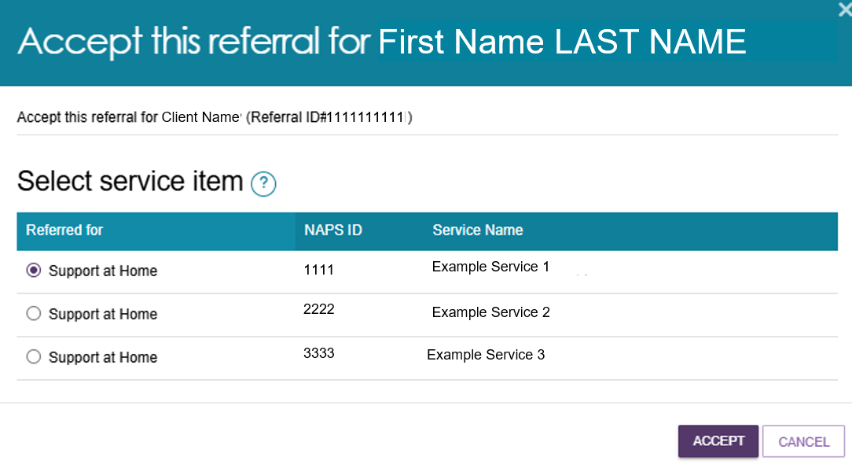

- A confirmation message will appear at the bottom of the screen to confirm that you have accepted the referral.

- After you accept the referral, you can access the client's full record, including complete address and contact details, from the Accepted Services Pending tab.
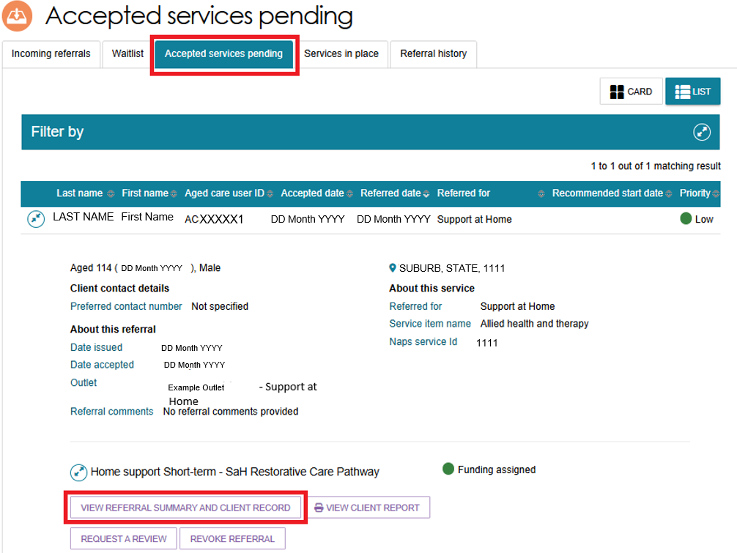
! | After you accept a referral, you must provide service delivery information within the required timeframe for the referral's priority level.  For more information about these requirements, visit the My Aged Care - Service and Support Portal resources page on the department’s Website.

Rejecting a referral
    - To reject a referral, select Reject Referral from the referral card or the Referral Summary page.
Rejecting Referral from the Referral Summary Page
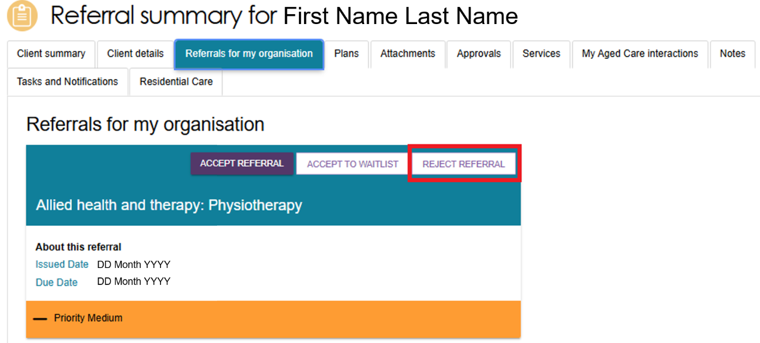
Rejecting Referral from Incoming Referrals Tab (Card View)
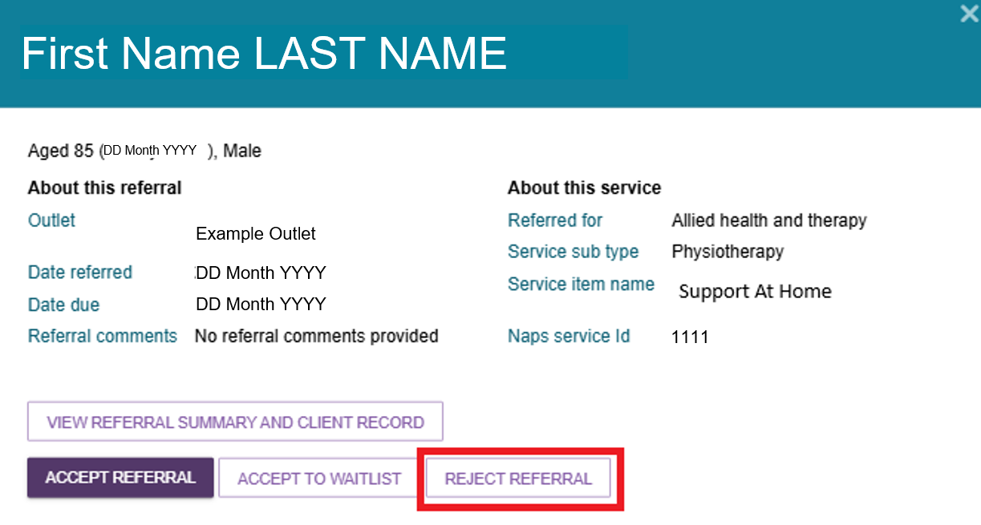
Rejecting Referral from Incoming Referrals Tab (List View)
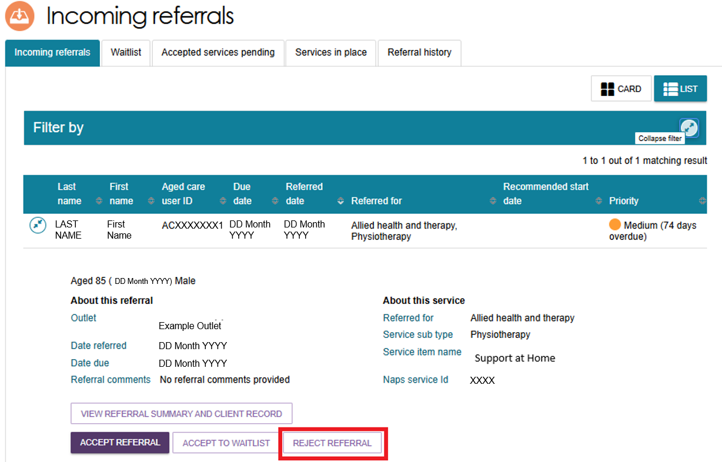
    - Select a reason for rejecting the referral from the drop-down list.
You can also add more information in the Rejection Reason field if needed.
If the client passed away during the assessment period, select Client Deceased from the drop-down list.
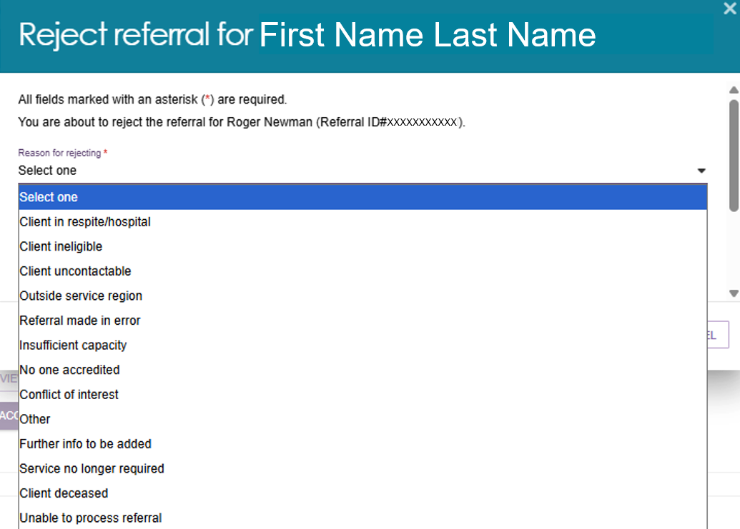

    - The system shares your rejection comments with assessors through the Assessor Portal, but clients cannot see these comments in their Online Account.
Providing a reason for rejection helps assessors and the My Aged Care Contact Centre support clients to find appropriate services.
After you reject the referral, a confirmation message appears at the bottom of the screen.
! | If your outlet cannot provide the service because of limited capacity, ask your Administrator to update your service availability and information in the portal.  For more information, refer to the Adding service items section of the Service and Support Portal user guide Part 1 – Administrator functions.
    - If you cannot provide the service immediately and your outlet has a waitlist, you can add the referral to the waitlist instead of rejecting it.
The referral will appear in your outlet's Waitlist tab.
This option is only available if your Administrator has set up the service to use a waitlist. For more information, refer to the Service and Support Portal User Guide Part 1 – Administrator Functions.

Rejecting a referral – client deceased
! | If you reject a referral and select Client Deceased as the reason, the system changes the client's status to Deceased and makes the client record read-only.  The system will then:  - Recall any referrals that have not been accepted.  - End any services currently in place.  - Cancel any scheduled or ongoing assessments.  - Remove the client's access to the client portal.  After the client's status changes to Deceased, My Aged Care will stop sending correspondence to the client and their supporters.  If the client is active in the Support at Home Priority System or has been assigned Support at Home funding, the system will remove the client from the priority system and withdraw the assigned funding.
After you select Client Deceased as the rejection reason, the system will take you to the Reject Referral screen.
Enter the following information:
- How, when, and by whom you were told that the client has died.
For example: "Mrs Smith called to advise that Mr Smith passed away on Saturday."
- The client's date of death, if known.
- Any supporting documents, such as:
- a death certificate
- hospital discharge documents
- other relevant evidence
- Any additional information in the Rejection Reason field (optional).
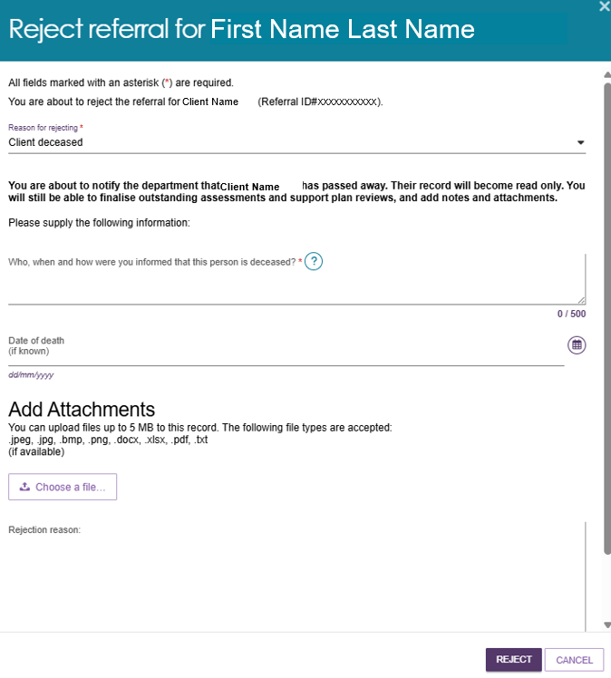
! | The provider can add notes and attachments to the client record for 14 days after ceasing services for their client.

Revoking an accepted referral
Sometimes, circumstances change after you accept a referral and you can no longer provide services to the client. For example, the client may withdraw their consent or their situation may change.
You can only revoke an accepted referral if:
- You have not entered any service delivery information, and/or
- Services have not started.
The Department monitors how providers use this feature.
If your outlet revokes 20% or more of the referrals issued to it over a 12-month period, the Department will send a notification to your organisation.
Follow these steps to revoke a referral after you have accepted it:
- Go to the Accepted Services Pending tab in the Service Referrals section of the Portal.
Find the referral you want to revoke, you can:
- Use the Filter options to narrow your search.
- Sort the results and select Go to update the list.
- Switch between Card View and List View.
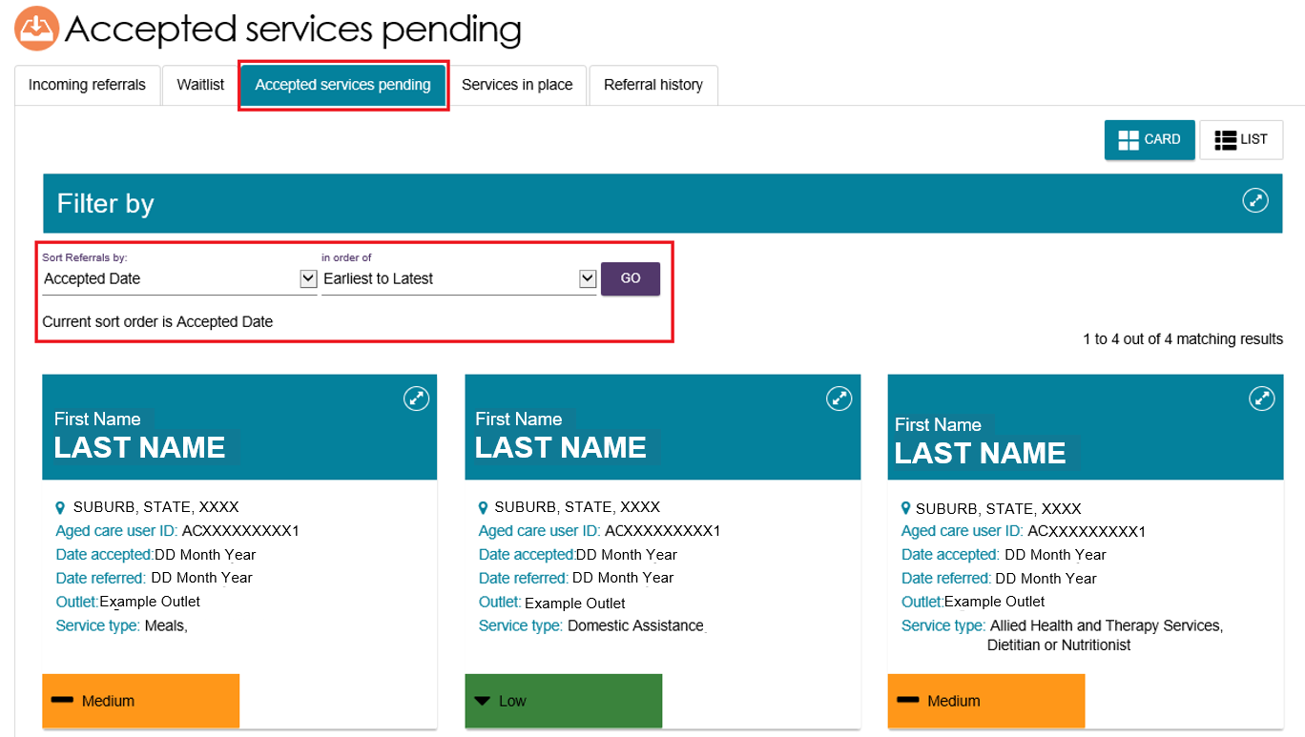
- Open the referral by selecting the Expand icon (double arrows) in card or list view.
Then select Revoke Referral.
CARD VIEW
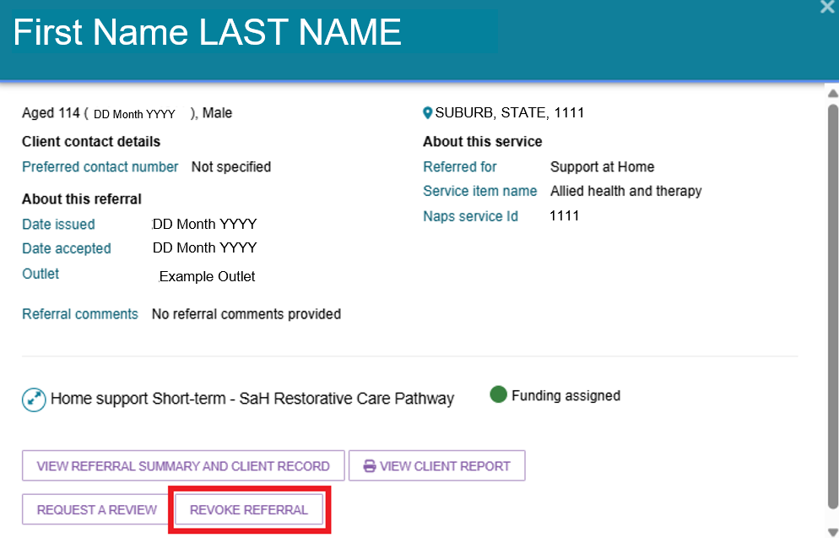
LIST VIEW
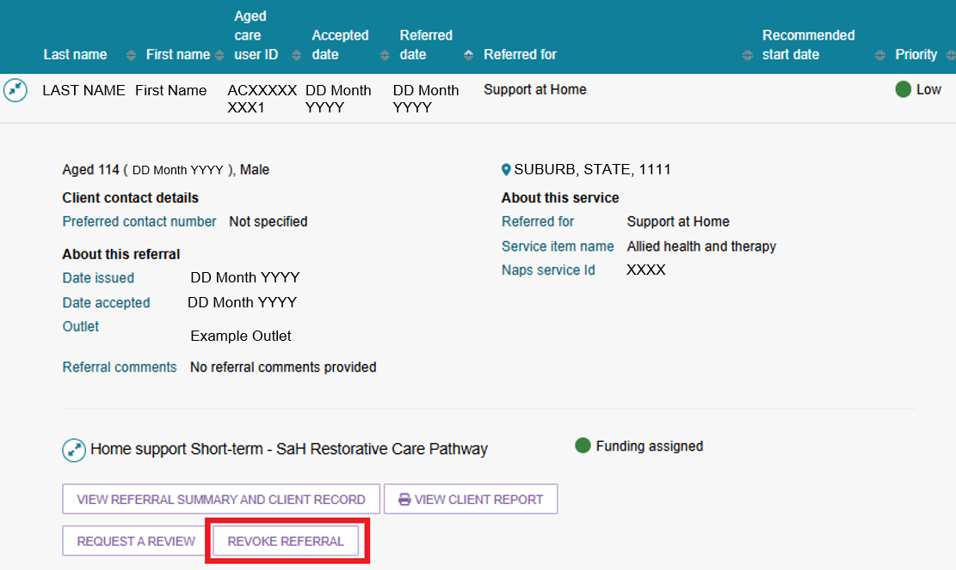
- Select a revocation reason from the drop-down list.
In the Comments field, explain why you are revoking the referral after accepting it.
Select Revoke Referral to confirm your decision.
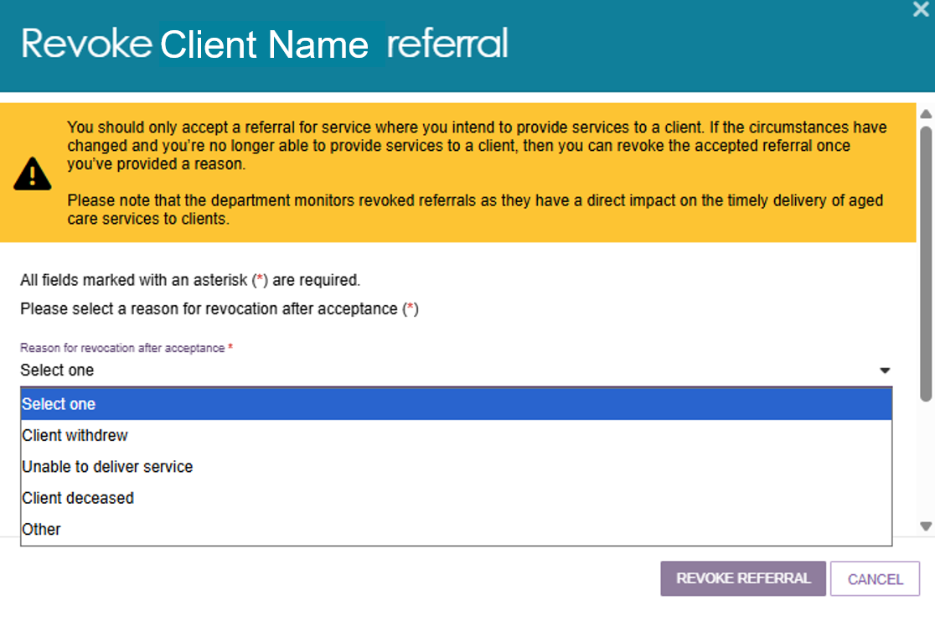
- The system will display a confirmation message to show that the referral has been revoked.
The referral will no longer appear in the Accepted Services Pending tab.
! | If you revoke a referral after acceptance, the system may automatically issue other available referrals for the client, such as broadcast or preference referrals.

Revoking a referral - client deceased
If you revoke a referral and select Client Deceased as the reason, the system changes the client's status to Deceased and makes the client record read-only.
The system will then:
- Recall any referrals that have not been accepted.
- End any services currently in place.
- Cancel any scheduled or ongoing assessments.
Remove the client's access to the My Aged Care Online Account.
After the client's status changes to Deceased, My Aged Care will stop sending correspondence to the client and their support network.
If the client is active in the Support at Home Priority System or has been assigned a Support at Home service, the system will remove the client from the priority system and withdraw any assigned Support at Home services.
When you select Client Deceased, enter the following information:
- How, when, and by whom you were told that the client has died. For example: "Mrs Smith called to advise that Mr Smith passed away on Saturday."
- The client's date of death, if known.
- Any supporting documents, such as:
  - a death certificate
  - hospital discharge documents
  - other relevant evidence.
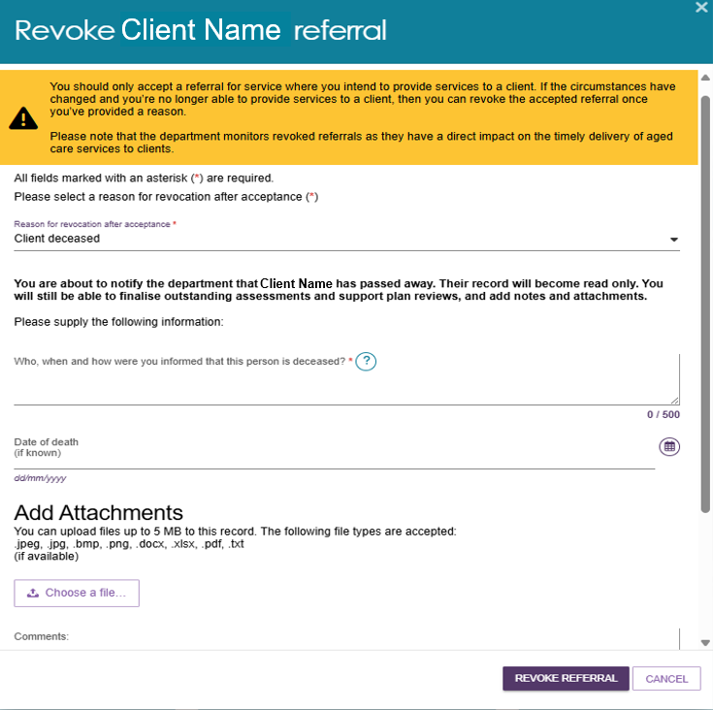

Accepting a Referral to Waitlist
If your organisation enables the waitlist function in the portal, you can accept electronic referrals onto a waitlist. This allows clients to join a waitlist for a service until a place becomes available.
Before you can accept referrals to a waitlist, your organisation's Administrator must turn on Waitlist Availability for the relevant services. For instructions, refer to My Aged Care – Service and Support Portal user guide – Creating service delivery outlets and adding service information.
Follow these steps to accept a referral to a waitlist:
- Go to Service Referrals and open the Incoming Referrals tab.
- In either Card View or List View, expand the client's referral to view more details, then select ACCEPT TO WAITLIST.
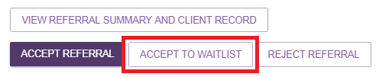
- Select ACCEPT to confirm your choice.
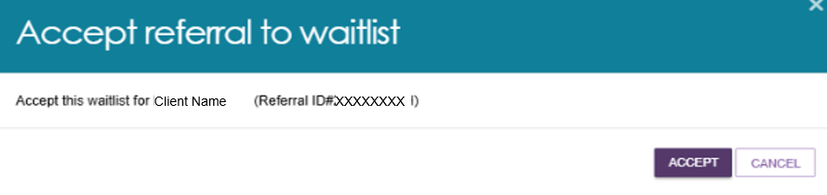
- The system will display a confirmation message to show that the referral has been added to the waitlist. The referral will then appear in the Waitlist tab on the Service Referrals page.
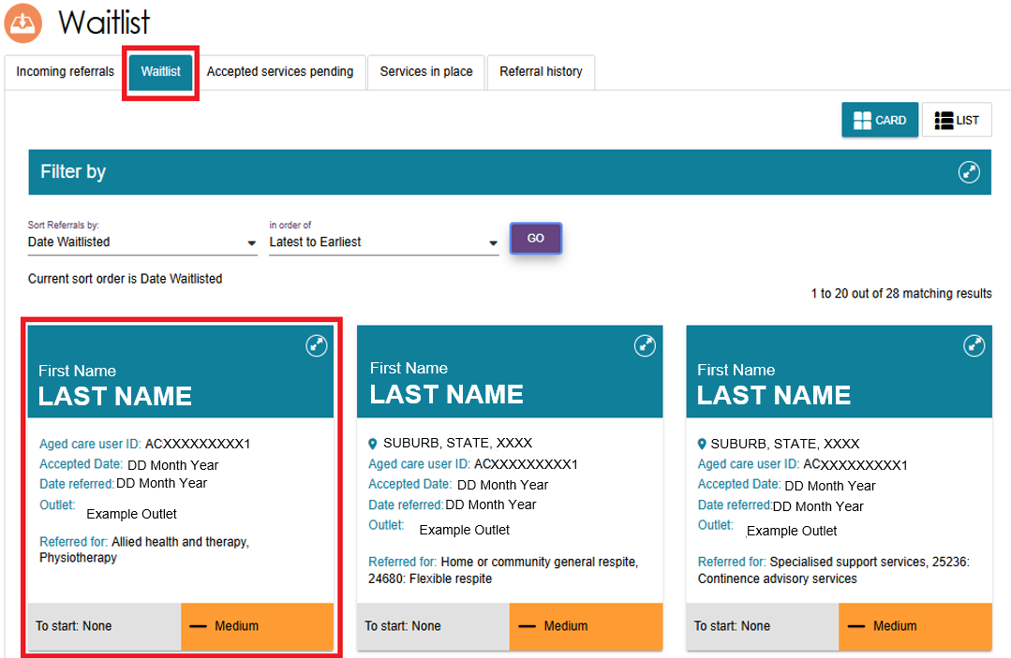

Retrieving a Referral Code
Clients can choose to receive a referral code from an assessor or the My Aged Care Contact Centre.
A referral code lets clients talk to different service providers about their needs before choosing their preferred provider.
If a Team Leader receives a referral code from a client, follow these steps to retrieve the referral:

- From the homepage select Retrieve a referral code.
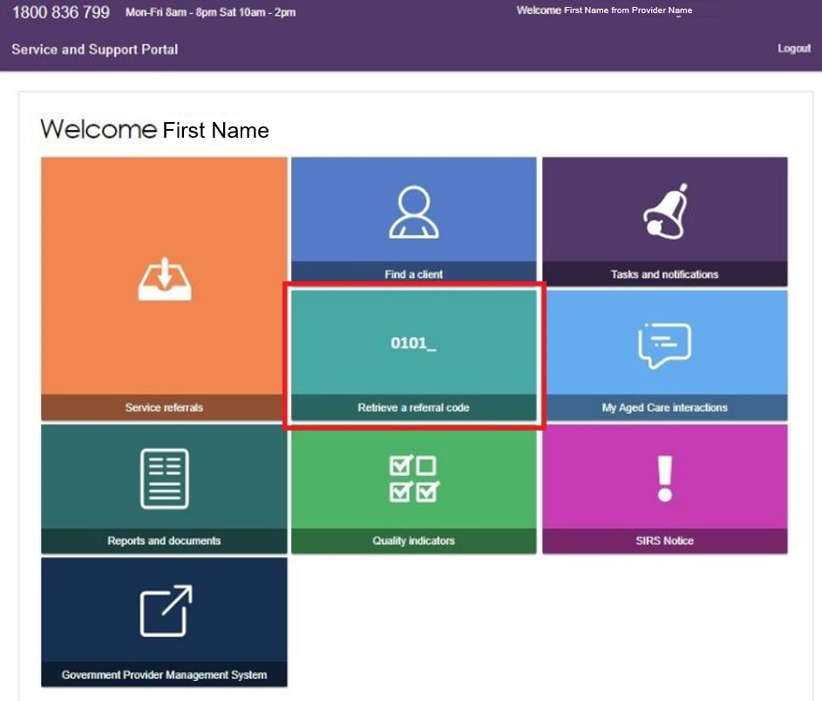
You can also select Retrieve a Referral Code from the toolbar at the top of any page in the portal.
- Enter the client's referral code.
Select the outlet that will provide the services, then select Retrieve Referral.
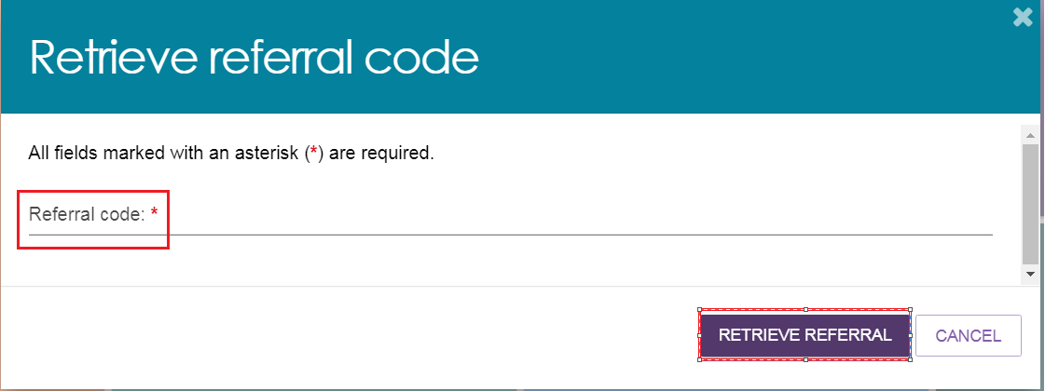

If you are an organisation Team Leader, you can choose the outlet that will receive the referral. Outlet Team Leaders do not have this option.
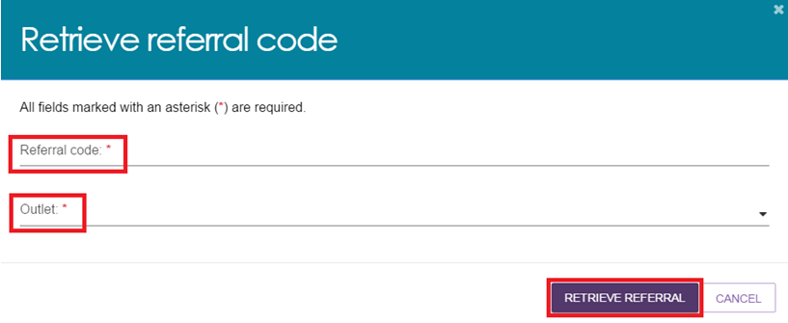
- The system will display a confirmation message to show that it has successfully retrieved the referral.
The referral will then appear in the Incoming Referrals tab under Service Referrals.
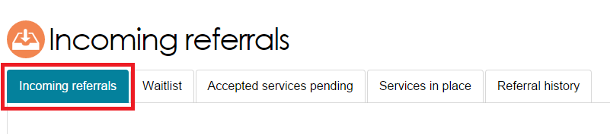
The system will take you to the Incoming Referrals page, where you can review the referral details.
Depending on the client's preferences and your organisation's capacity, you can:
- accept or reject the referral for service(s);
- accept the referral to waitlist; or
- revoke the referral after acceptance.
!  !  ! | Before you accept a referral, review the referral and client information and confirm that your organisation can provide the required services. Only accept the referral when both your organisation and the client agree to start services.  Before you accept a referral, review the referral and client information and confirm that your organisation can provide the required services. Only accept the referral when both your organisation and the client agree to start services.  Clients and their supporters can manage referral codes through their My Aged Care Online Account.  Home Support services  If you provide Support at Home services and a client wants to change providers, the client can reactivate their referral code through their My Aged Care Online Account.  For more information, direct the client to the Access your information online website or call the My Aged Care Contact Centre on 1800 200 422.  For Support at Home services, clients usually receive a referral only after funding has been assigned. In most cases, My Aged Care provides the client with a referral code to share with their chosen provider.  After receiving a referral, providers should check the take-up deadline. You must start services before this date. If you do not start services by the deadline, My Aged Care may withdraw the assigned Support at Home services.

Drawing a Client into Service from a Waitlist
When a place becomes available, you can move a client (‘drawing a client’) from the waitlist into service and start delivering services.
A client can join waitlists with multiple providers at the same time. Once a provider starts the client on a service (‘drawn down into service’), the system automatically removes the client from all other waitlists for the same service type.
- Go to the Waitlist tab in the Service Referrals section of the Service and Support Portal.
This tab shows all referrals that have been accepted onto a waitlist.
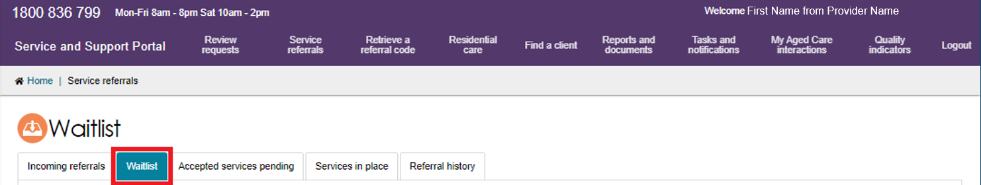
- Find the client's referral and expand the record in either Card View or List View.
You can:
- Use the Filter options to narrow your search.
- Sort the results and select Go to update the list.
- Switch between Card View and List View.
! | Before moving the client into service, review the Referral Summary and Client Record to confirm that you can still provide the service.
Then, select Draw down into service.
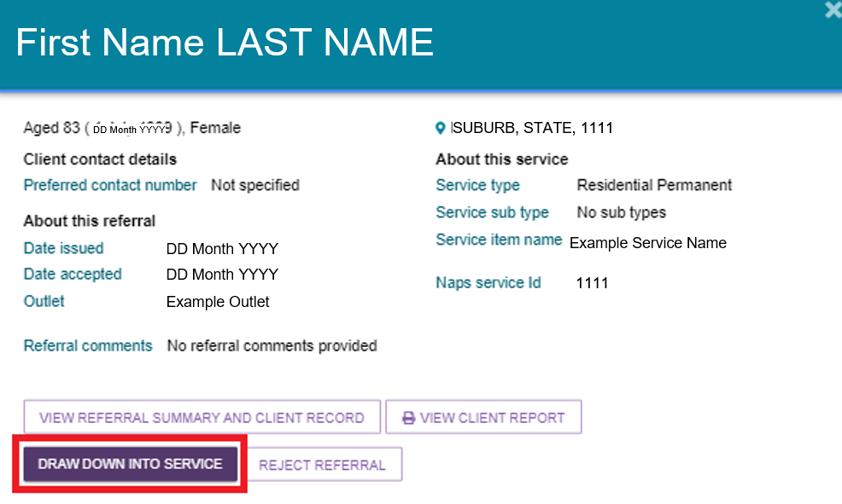
- If your organisation has more than one service item or NAPS Service ID for the service type, select the correct service item or NAPS Service ID.
Select Accept to confirm the referral.
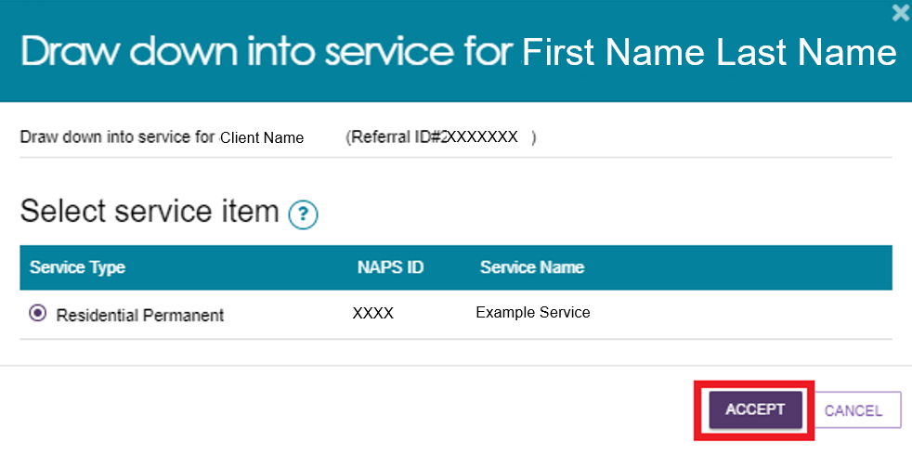
The system will display a confirmation message to confirm that you have accepted the referral.
The referral will move to the Accepted Services Pending tab until you record the service delivery information.
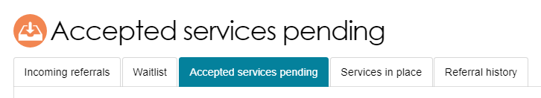

If you cannot provide the service, you can reject the referral.
- Select Reject Referral.
- Choose a rejection reason.
- Select Reject.
Providing a rejection reason helps assessors and the My Aged Care Contact Centre support clients to access services.
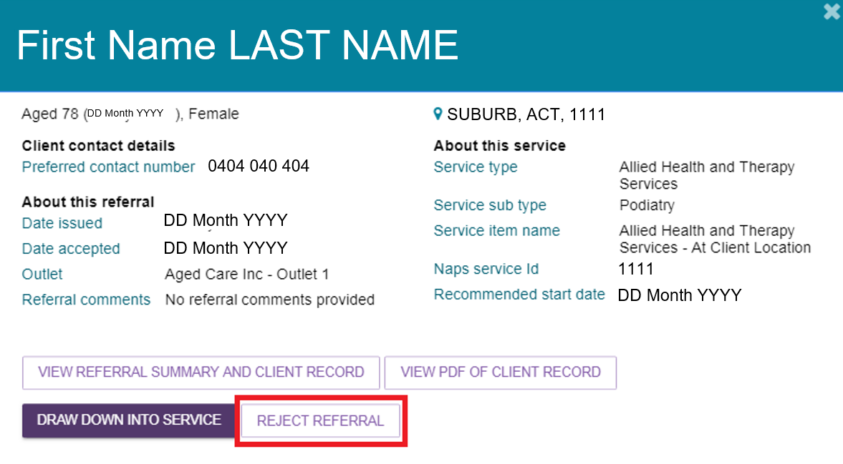
After you reject the referral, the system removes it from your waitlist and it will no longer appear in the Service and Support Portal.

Notifications for Overdue Referrals
Team Leaders can see visual alerts in the Incoming Referrals tab when referrals have not been actioned within the required priority timeframes.
A referral is considered actioned when you:
- Accept the referral
- Reject the referral, or
- Add the referral to a waitlist.
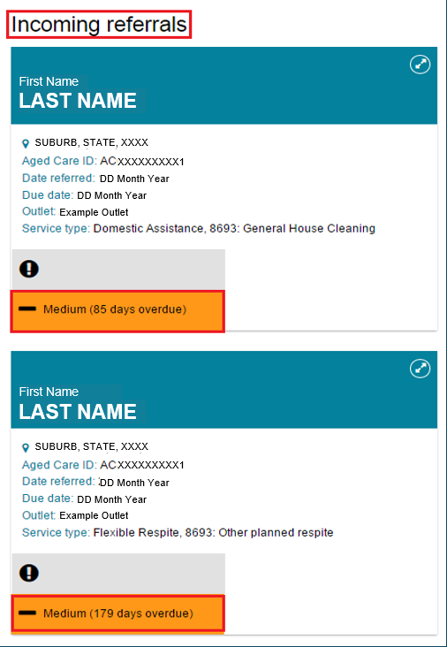
The system also sends an email notification to the email address linked to the outlet, reminding staff to action the referral.
In addition, the portal displays these alerts in the Tasks and Notifications section as Overdue Referral Tasks.
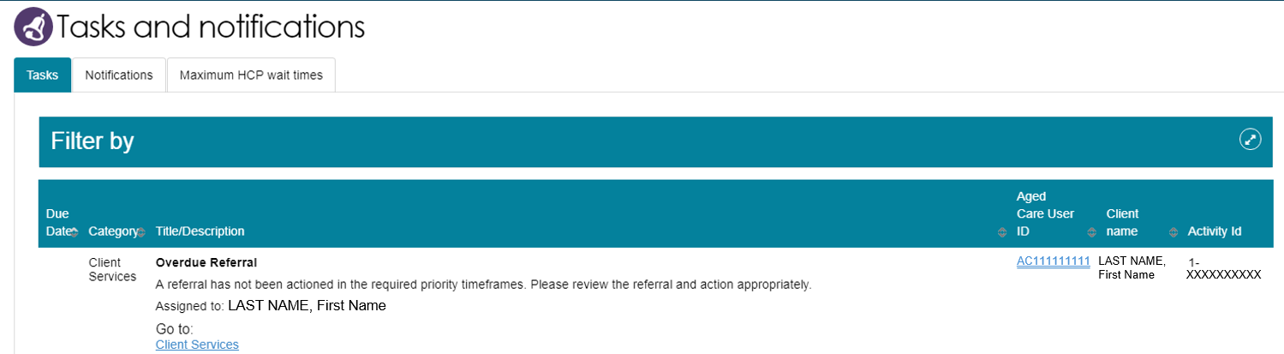

Referral History
The Referral History tab lets Team Leaders and Staff Members view a client's referral history, including whether a referral was revoked or recalled.
To see more details about a referral:
- In List View, select the arrow next to the referral.
- In Card View, select the arrow on the referral card.
The expanded view shows additional referral information.
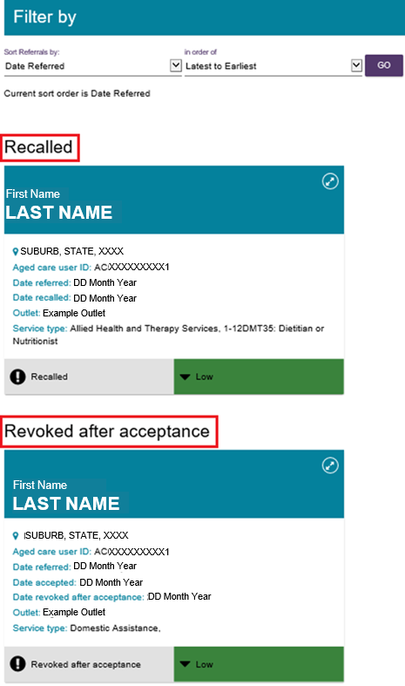
For Support at Home services, the expanded view also shows all Support at Home classifications assigned to or approved for the client, along with the client's service history for each classification.

Referral Priority Status
Incoming service referrals have a priority level of low, medium, or high. My Aged Care assigns the priority level based on:
- The client's ability to manage daily activities.
- Any risks related to the client's care needs.
- Other concerns identified during screening or assessment.
Service providers must action referrals within 3 calendar days of receiving an electronic referral or an electronic waitlist referral.
You can action a referral by:
- Accepting the referral.
- Rejecting the referral.
- Adding the referral to a waitlist.
! | Support at Home program approvals will not display as a service priority.

More Information and Support
For more information, visit the My Aged Care – Service and Support Portal resources webpage.
If you need assistance, contact the My Aged Care Service Provider and Assessor Helpline on 1800 836 799.

