Quarterly Financial Snapshot
Aged Care Sector

Quarter 4 2025-26
1 April to 30 June 2026
Contents

Introduction 3
Residential aged care 6
Support at Home 7
Residential aged care 8
Financial performance 8
Average care minutes 13
Staff cost and time 14
Hourly rates 16
Food and nutrition 18
Support at Home 19
Financial performance 19
Staff cost 23
Hourly rates 24
Unspent funds 26
Glossary 27
Appendix 28

Introduction
The Australian Government is committed to transparency in aged care. The publication of financial information gives valuable insights to the sector and community.
The Department of Health, Disability, and Ageing (the department) publishes a Quarterly Financial Snapshot (QFS) on the Australian aged care sector. The QFS:
- informs older people about providers’ finances and operations, helping them and their families make decisions about their care
- provides information for aged care providers to benchmark their performance against sector results
- supports the monitoring of critical financial metrics across the aged care system
- complements other publications, such as the:
- annual Financial Report on the Australian Aged Care Sector
- Registered nurse coverage in aged care dashboard
- Care minutes in residential aged care dashboard
- financial and operations information published on My Aged Care.
This QFS covers 1 April to 30 June 2026 (Q4 2025-26) and includes results for the residential aged care sector and Support at Home sector.
The Appendix contains tips on how to read the QFS, including provider type definitions, information about data sources, and methodologies used.
An Excel data extract containing all headline figures from QFS reports published to date is available on the department’s website. It includes a breakdown of results by provider type.
The department would like to thank all aged care providers who completed the Quarterly Financial Report (QFR) and helped develop the QFS.

Data reference: Timeframe and acronyms used in this report
Report timeframe
- The financial results presented in this report are year-to-date (YTD) results for the 12-months ending 30 June 2026 or quarter 4 (Q4) 2025-26 and shows comparisons to the year/s prior. The average care minutes results in residential aged care however, shows comparisons to the prior quarter.
Acronyms
- prpd (residential aged care) refers to ‘per resident per day’. Dividing sector results by the total number of residents and days allows the data to be standardised. This is calculated by the total dollar amount divided by the care payment entitlement days (as reported by Services Australia).
- pppd (Support at Home) refers to ‘per participant per day’. This standardised result is derived by dividing sector results by the total claim days. It includes days where no care was delivered to a given participant.
- pp refers to ‘percentage point’. This is the difference between two percentages, used to avoid confusion with a relative percentage change. For example, a 0.3 percentage point change is observed when a value moves from 2.0% to 2.3%.
- NPBT and EBITDA refer to net profit before tax and earnings before interest, taxes, depreciation, and amortisation, respectively. These indicators are monitored to understand changes in financial performance.

Reform impacts on Q4 2025-26 results
The Q4 2025-26 results show the impact of the following initiatives on providers:
- additional investment to fund the Fair Work Commission’s (FWC) further decisions in the Aged Care Work Value Case, which included a wage increase on 1 October 2025 for aged care nurses and many other aged care workers.
- consecutive increases to the hotelling supplement from $13.46 per resident per day to $15.60 per resident per day from 1 July 2025, and to $22.15 from 20 September 2025.
- measures announced in the Government’s response to the Aged Care Taskforce:
- requiring providers to permanently retain 2% per annum of Refundable Accommodation Deposits and Refundable Accommodation Contributions (capped at five years of retentions) from 1 November 2025, and
- requiring providers to index Daily Accommodation Payments twice per year by the consumer price index for residents that enter care on or after 1 November 2025.
- the release of an additional 20,000 Home Care Packages (HCPs) in September 2025 (ahead of the implementation of the Support at Home program on 1 November 2025).
- grant funding to eligible Support at Home program providers operating in areas where aged care services are limited.
Further information on aged care reform is available on the department’s website.

Residential aged care
Overview of financial performance
The financial performance of the residential aged care sector decreased between Q4 2024-25 and Q4 2025-26 (Figure 1).
Figure 1: Summary of financial performance for residential aged care providers at Q4 2025-26, and comparison with Q4 2024-25
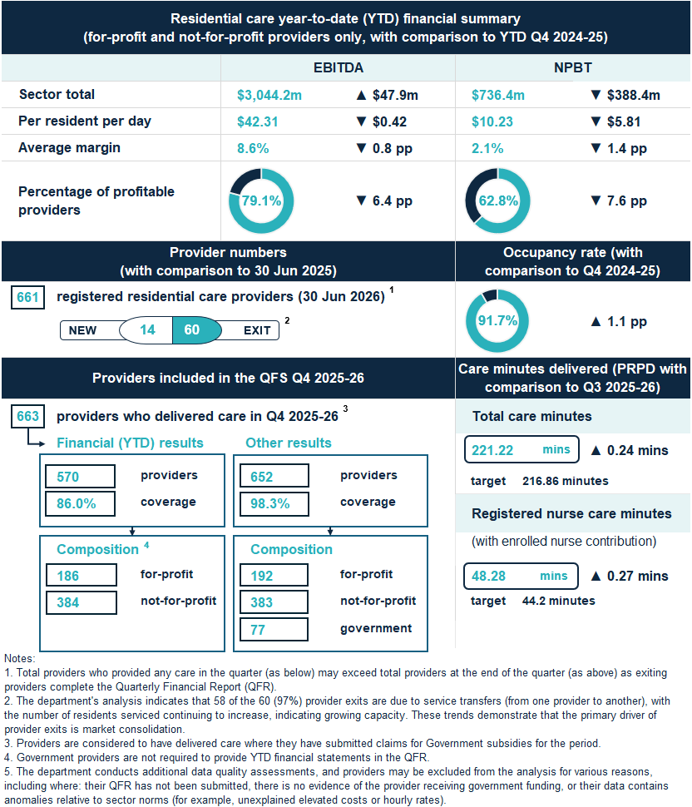

Support at Home
Overview of financial performance
The financial performance of the Support at Home sector decreased between Q4 2024-25 and Q4 2025-26 (Figure 2).
Figure 2: Summary of financial performance for Support at Home providers at Q4 2025-26, and comparison with Q4 2024-25
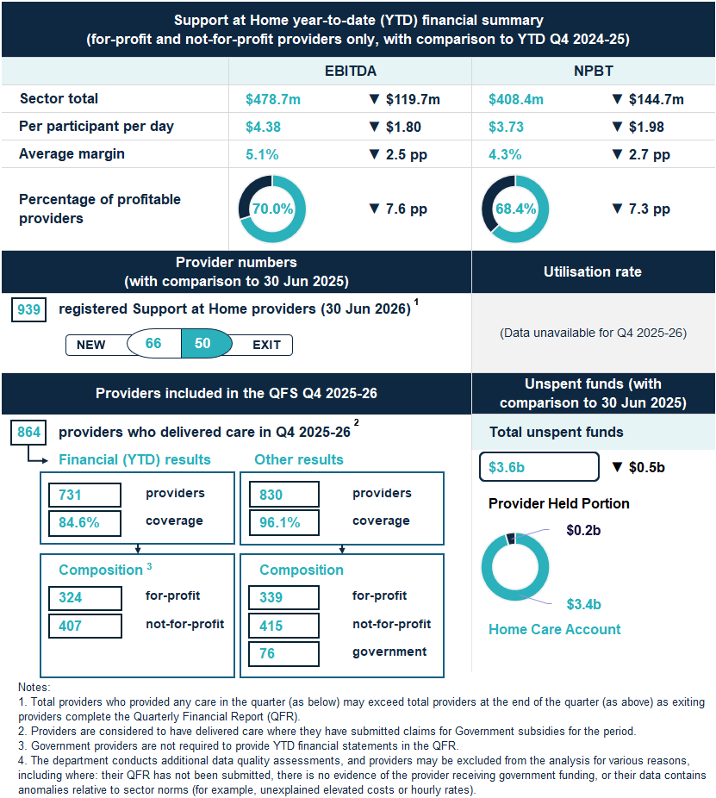

Residential aged care

Financial performance

Financial summary
In Q4 2025-26:
- revenue grew by $33.28 prpd (up 7.3%).
- expenses (operating and non-operating) grew by $39.09 prpd (up 8.9%).
- sector EBITDA was $3,044.2 million, with an average EBITDA margin of 8.6% (down from 9.4% in Q4 2024-25).
- sector NPBT was $736.4 million, with an average NPBT margin of 2.1% (down from 3.5% in Q4 2024-25).
Expense growth was driven by increased wages, above routine inflationary growth, for direct care staff, following FWC decisions. There was also an increase in average time that care and services were delivered to residents.
In addition, as highlighted in the previous two QFS reports, a small number of providers reported a significant write-off of intercompany balances in the first half of 2025-26. This resulted in large non-operating expenses being reported for those providers. When excluding the impact of these write-offs, the sector average NPBT margin would have been 2.6% in Q4 2025-26, rather than 2.1%.
Table 1: Q4 2025-26 and comparison with Q4 2024-25, summary of financial performance of residential for-profit and not-for-profit aged care providers
 | Total | PRPD | Change from Q4  2024-25 PRPD
Revenue | $ 35,215.1m | $489.45 | ▲ $33.28
Operating expenses | $ 32,170.9m | $447.14 | ▲ $33.70
EBITDA | $ 3,044.2m | $42.31 | ▼ $0.42
Average EBITDA margin | 8.6% | 8.6% | ▼ 0.8 pp
Non-operating expenses | $ 2,307.8m | $32.08 | ▲ $5.39
NPBT | $ 736.4m | $10.23 | ▼ $5.81
Average NPBT margin | 2.1% | 2.1% | ▼ 1.4 pp
Note: The average EBITDA and NPBT margins (which indicate the EBITDA and NPBT returns on revenue) are calculated by dividing the sector EBITDA and NPBT results by the sector total revenue.

Profitable providers
At Q4 2025-26:
- 62.8% of providers were profitable (defined by NPBT) (down 7.6 pp from Q4 2024-25) (Figure 3).
- profitable providers serviced 70.0% of residents (down 7.6 pp from Q4 2024-25).
Figure 3: Percentage of profitable providers and percentage of residents serviced by profitable providers at Q4 2025-26, and comparison with Q4 2024-25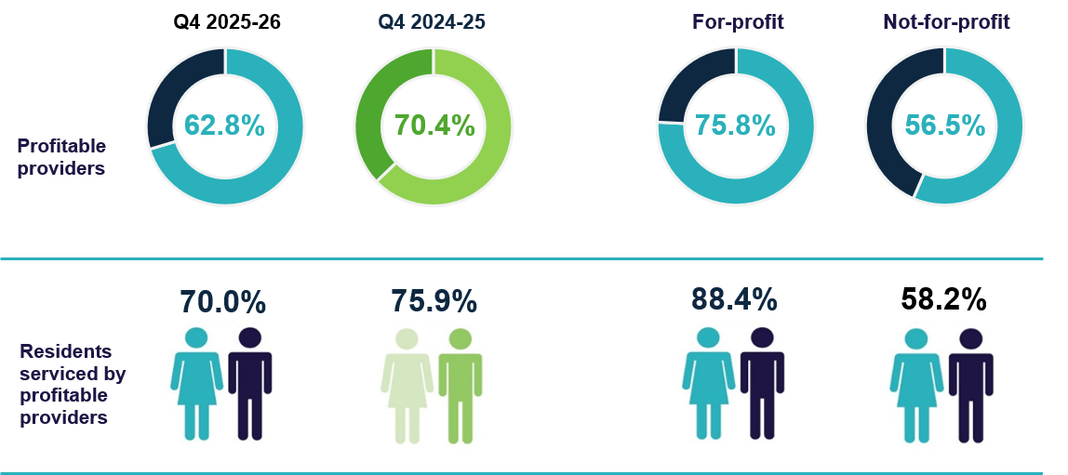

Median EBITDA and NPBT margin
In Q4 2025-26:
- the median EBITDA margin for the sector was 6.4% (down 1.6 pp from Q4 2024-25), which means an EBITDA return of $6.40 for every $100 of revenue earned (Chart 1).
- the median NPBT margin for the sector was 2.2% (down 1.4 pp from Q4 2024-25), which means a NPBT return of $2.20 for every $100 of revenue earned (Chart 2).
Chart 1: Median and quartile EBITDA margin
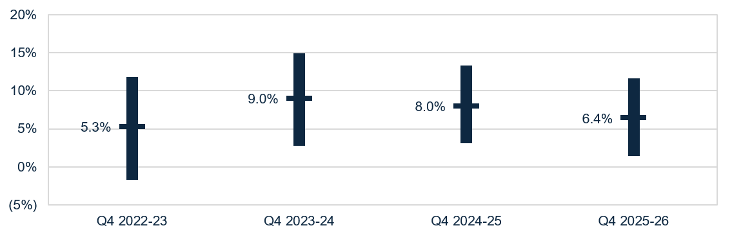

Chart 2: Median and quartile NPBT margin
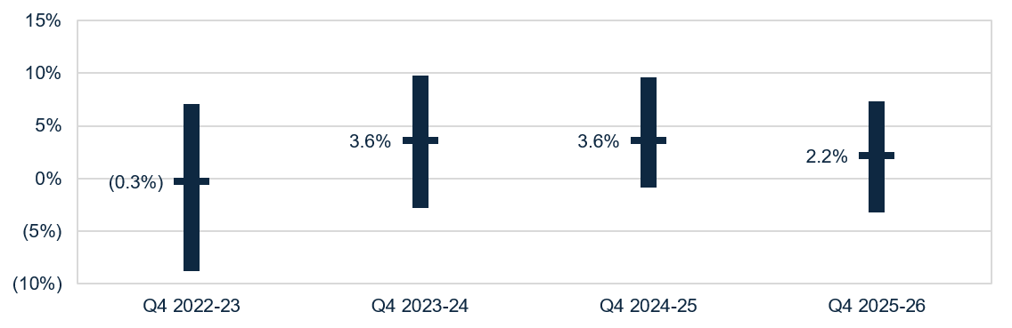

Occupancy
In Q4 2025-26, the average occupancy rate was 91.7% (up 1.1 pp from Q4 2024-25) (Chart 3).
Chart 3: Average occupancy rate
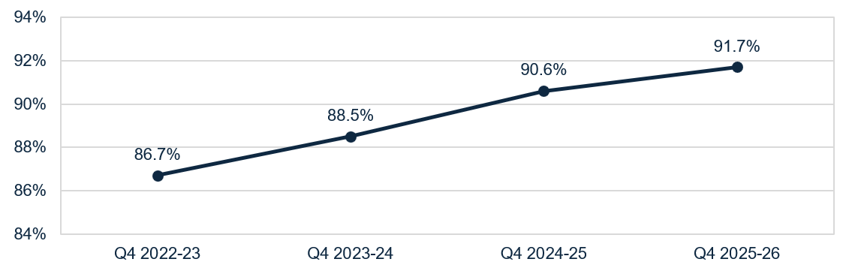
Residential care occupancy rate (%) = (occupied bed days for residential care homes ÷ operational bed days for residential care homes) x 100, where:
residential care occupied bed days for an approved residential care home, refers to the total number of days that operational beds for the residential care service were occupied by individuals to whom funded residential care homes were delivered.
residential care operational bed days for an approved residential care home, means the total number of days that residential care beds covered by the approval of the home were not offline beds.
residential care offline beds for an approved residential care home, means residential care beds covered by the approval of the home that are covered by a notice under section 167 of the Aged Care Act 2024, given in accordance with section 167-70 of the Aged Care Rules 2025.
Notes:
1. The occupancy rate is for mainstream (permanent and respite) residential aged care homes only. It excludes places or beds used to deliver other Commonwealth-funded aged care homes, including the National Aboriginal and Torres Strait Islander Flexible Aged Care Program, the Transition Care Program, and Multi-Purpose Services, and excludes beds used to deliver non-aged care or non-Commonwealth funded homes, including private residential care, NDIS services, or health services.
2. Residential care offline beds includes beds offline due to: a lack of capacity to deliver care due to workforce or operational issues; redevelopment, refurbishment, or extension of whole or part of the building or site in which the residential care service is delivered; the opening of new residential care home in stages, or the pending permanent closure of whole or part of the residential care home in which a residential care service is delivered.

Liquidity
In Q4 2025-26, the median liquidity ratio for the sector was 0.45 (up 0.03 from Q4 2024-25) (Chart 4). This means for every $100 of debt obligations, providers had $45 in liquid assets. The liquidity position has steadily improved since Q4 2022-23, with a further improvement in Q4 2025-26, after allowing for the recalculation of liquid assets to include trade receivables.
Chart 4: Median and quartile liquidity ratio
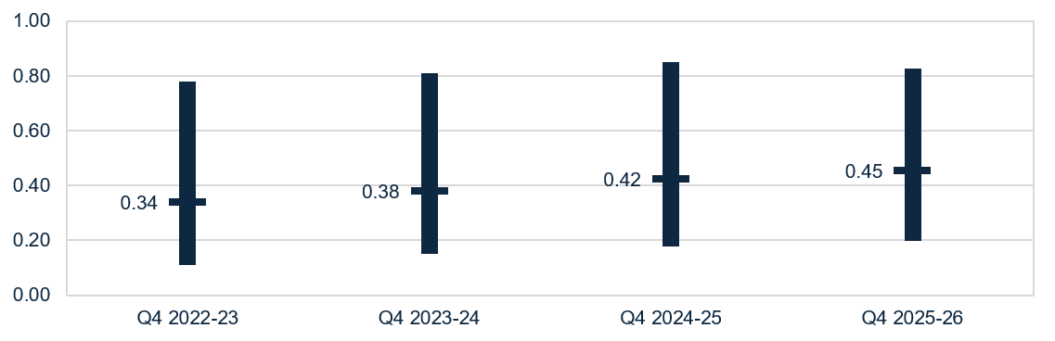
Note: From Q1 2025-26, the liquidity formula includes trade receivables as liquid assets. This is aligned with the Aged Care Quality and Safety Commission’s Financial and Prudential Standards.

Capital adequacy
In Q4 2025-26, the median capital adequacy ratio for the sector was 0.30 (up 0.02 from Q4 2024-25) (Chart 5), meaning for every $100 of assets owned, $30 was funded through equity and $70 through debt or other liabilities.
Chart 5: Median and quartile capital adequacy ratio
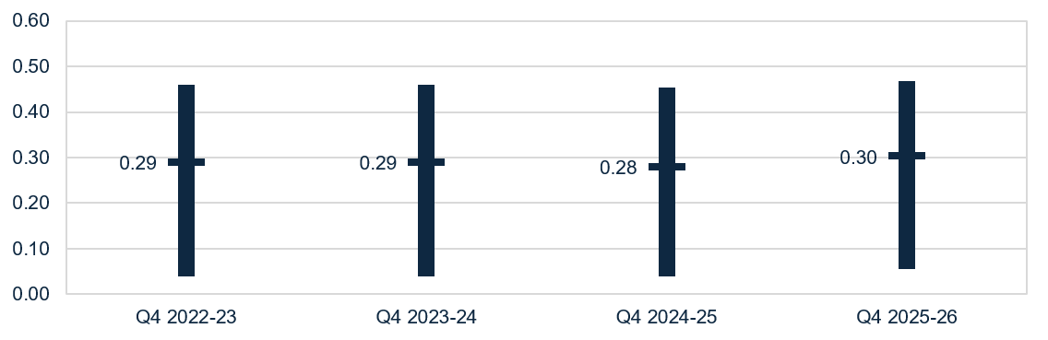
Capital adequacy ratio = (net assets - intangible assets) ÷ (total assets - intangible assets)
Note: Intangible assets are removed from the calculation as they are not considered to have value in the event of insolvency. This more realistically reflects the available capital to absorb unforeseen circumstances.

Wages to revenue
In Q4 2025-26, wages as a proportion of revenue for the sector had a median of 73.7% (up 2.3 pp from Q4 2024-25) (Chart 6).
Chart 6: Median and quartile wages to revenue percentage
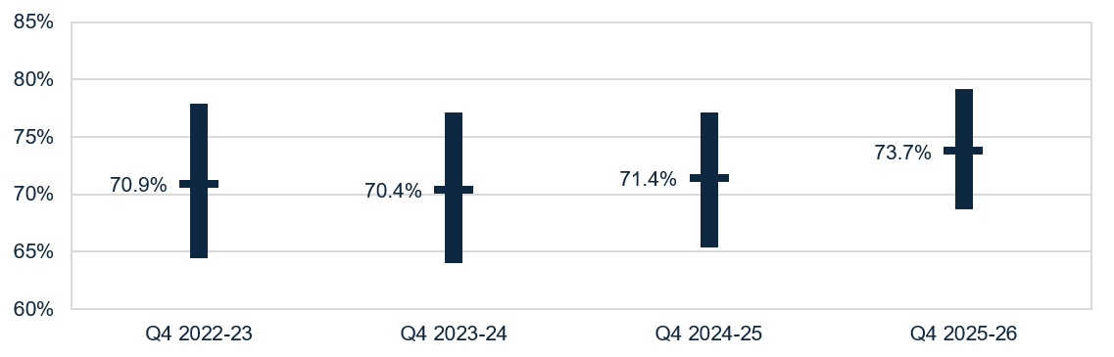
Note: Wages include salaries and employment benefits, agency and subcontractor costs, and management fees. Wages do not include staff training and development.

Average care minutes
In Q4 2025-26, the sector average target for total care minutes was 216.86 minutes prpd. This includes at least 44.20 minutes prpd for registered nurse care time, of which up to 10% can be met with enrolled nurse time.
- The sector delivered above the care minute targets with residents receiving an average of 221.22 total care minutes prpd (up 0.24 minutes prpd from Q3 2025-26) (Table 2).
- This includes 48.28 minutes delivered by a registered nurse (up 0.27 minutes prpd from Q3 2025-26). This includes enrolled nurse time, which can contribute up to 10.0% of the registered nurse care minutes target.
- 71.6% of homes met their total care minutes targets, up 1.3 pp from Q3 2025-26.
- 83.8% of homes met their registered nurse targets (with enrolled nurse contribution), up 2.4 pp from Q3 2025-26.
- 66.3% of homes met both their total care and registered nurse care minute targets (with enrolled nurse contribution), up 2.7 pp from Q3 2025-26.
Table 2: Q4 2025-26 and comparison with Q3 2025-26, average care minutes met prpd (sector and by provider type) ¹
 | Sector | Change from Q3 2025-26 | For-profit | Not-for-profit | LST government
Registered nurses | 45.25 | ▲0.22 | 43.29 | 44.86 | 79.74
Registered nurses  (with enrolled nurse contribution) | 48.28 | ▲0.27 | 46.55 | 47.58 | 83.95
Enrolled nurses | 11.80 | ▼0.08 | 8.51 | 10.27 | 85.25
Personal care workers & assistants in nursing | 164.14 | ▲0.07 | 167.40 | 166.23 | 79.81
Total ² | 221.22 | ▲0.24 | 219.20 | 221.37 | 244.80
Notes:
1. Average care minutes prpd is calculated by dividing total care minutes delivered by occupied bed days (not claim days).
2. The total sector care minutes result does not equal the sum of care minutes by role due to rounding. Minor discrepancies may also exist between the results above and those published in the Care minutes in residential aged care dashboard due to timing of data extraction.
3. Figures may not align exactly with other data published on the department’s website, this is due to late or resubmission of care minute data by providers.

Staff cost and time

Total median staff cost and time
Median staff costs and time increased from Q4 2024-25 to Q4 2025-26 (Table 3).
- Total costs were $275.03 prpd (up $23.52 or 9.4% from Q4 2024-25)
- Total time was 239.55 minutes prpd (up 3.61 minutes or 1.5% from Q4 2024-25).
Personal care workers and assistants in nursing (the largest component) saw a $16.70 increase in costs (11.1%) and 3.08 increase in minutes (1.9%).
Table 3: Q4 2025-26 and comparison with Q4 2024-25, median staff cost and time prpd ¹
 | Cost  PRPD | Change from  Q4 2024-25 | Minutes PRPD | Change from Q4 2024-25
Registered nurses | $69.38 | ▲ $5.42 | 45.18 | ▲ 0.85
Enrolled nurses | $10.78 | ▼ $0.53 | 9.86 | ▼ 0.59
Personal care workers & assistants in nursing | $166.81 | ▲ $16.70 | 164.58 | ▲ 3.08
Allied health staff | $6.06 | ▲ $0.54 | 4.24 | ▲ 0.20
Diversional, lifestyle, recreation or activities officers | $7.63 | ▲ $1.05 | 8.75 | ▲ 0.65
Care management staff | $6.15 | ▼ $0.02 | 3.64 | ▲ 0.12
Total median ² | $275.03 | ▲ $23.52 | 239.55 | ▲ 3.61
Notes:
1. Direct labour costs include all on-costs for engaging staff (such as superannuation, leave, allowances), while hourly rates presented in this QFS are the base gross hourly rates of pay and do not include on-costs.
2. Total median staff cost and time is derived from the totals calculated in the individual QFR submissions and is not the sum of the medians in the sub-categories listed above. LST government providers are included in this data.

Agency staff cost and time
In Q4 2025-26, agency staff costs and hours decreased at the sector level and for all staff roles, when compared to Q4 2024-25.
- Agency staff costs represented 5.2% of total direct care labour costs (down 1.6 pp from Q4 2024-25).
- Agency staff hours represented 4.1% of total direct care labour hours (down 1.2 pp from Q4 2024-25).
Table 4: Q4 2025-26 and comparison with Q4 2024-25, agency staff costs and hours as a percentage of direct care costs and hours
 | Agency costs as % of total | Change from  Q4 2024-25 | Agency hours as % of total | Change from  Q4 2024-25
Registered nurses | 5.5% | ▼ 2.5 pp | 4.4% | ▼ 1.7 pp
Enrolled nurses | 4.0% | ▼ 0.9 pp | 3.2% | ▼ 0.6 pp
Personal care workers & assistants in nursing | 3.2% | ▼ 1.4 pp | 2.7% | ▼ 1.2 pp
Total direct care | 5.2% | ▼ 1.6 pp | 4.1% | ▼ 1.2 pp

Allied health median staff cost and time
The median total cost and time for allied health services prpd were $6.06 and
4.24 minutes (Table 3), respectively.
The highest median allied health cost and time prpd was for physiotherapists:
- median cost was $3.73 prpd (up $0.29 or 8.4% from Q4 2024-25) (Table 5).
- median minutes was 2.73 minutes prpd (up 0.13 or 5.2% from Q4 2024-25).
Table 5: Q4 2025-26 and comparison with Q4 2024-25, median allied health cost and time prpd
 | Cost  PRPD | Change from  Q4 2024-25 | Minutes PRPD | Change from  Q4 2024-25
Physiotherapist | $3.73 | ▲ $0.29 | 2.73 | ▲ 0.13
Podiatrist | $0.38 | ─ $0.00 | 0.23 | ▼ 0.01
Dietetic care | $0.32 | ▲ $0.02 | 0.17 | ▲ 0.01
Speech pathologist | $0.23 | ▲ $0.04 | 0.09 | ▲ 0.01
Note: Results for occupational therapists, allied health assistants, and other allied health have not been included as over half of QFR respondents did not report expenditure for these categories. LST government providers are included in this data.

Hourly rates
In Q4 2025-26, median sector hourly rates increased for all direct care staff compared to Q4 2024-25. The sector median of the average hourly rate was:
- $53.62 for registered nurses (up $2.02 or 3.9% from Q4 2024-25) (Chart 7)
- $40.54 for enrolled nurses (up $2.39 or 6.3% from Q4 2024-25) (Chart 8)
- $35.38 for personal care staff (up $2.38 or 7.2% from Q4 2024-25) (Chart 9).
Average hourly rates are for staff employed per the employee award, enterprise agreement or contract. These do not include on-costs, penalty rates, casual rates, agency fees and subcontracting arrangements. Nil-value responses are excluded.
Chart 7: Highest, average, and lowest hourly rates (medians) paid to registered nurses
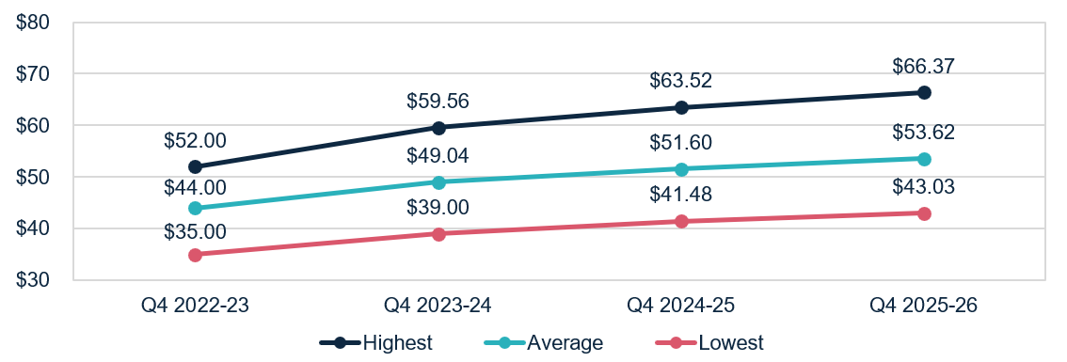
Chart 8: Highest, average, and lowest hourly rates (medians) paid to enrolled nurses
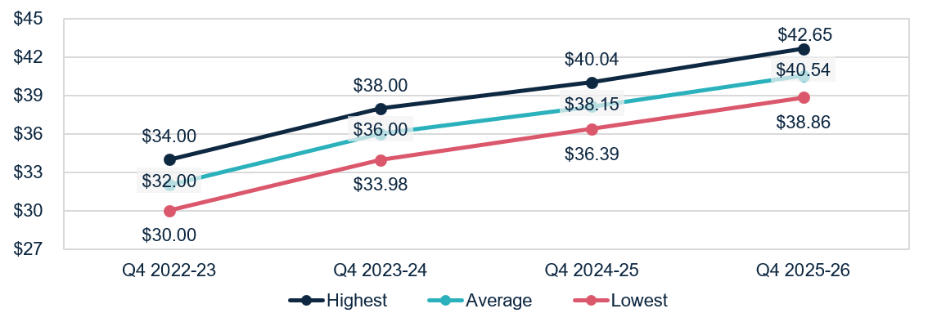

Chart 9: Highest, average, and lowest hourly rates (medians) paid to personal care workers and assistants in nursing
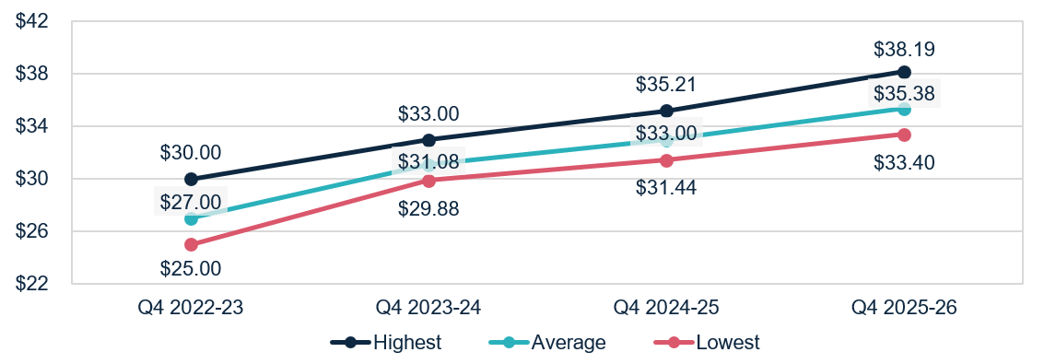

Food and nutrition
In Q4 2025-26, at a sector level:
- the median total cost of food and ingredients was $16.07 prpd (up $0.48 or 3.1% from Q4 2024-25) (Chart 10).
- the proportion of the total cost of food and ingredients spent on fresh food and ingredients (foods free of GST as per itemised purchase receipts) was 83.2%
(up 0.2 pp from Q4 2024-25).
Chart 10: Median food and ingredients cost prpd
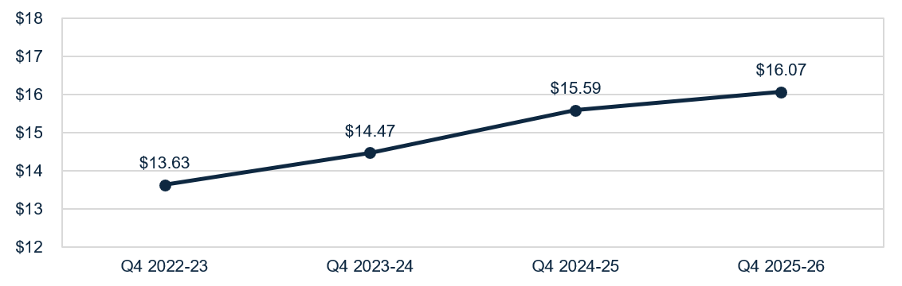

Support at Home

Financial performance

Financial summary
In Q4 2025-26:
- revenue grew by $4.85 pppd (up 6.0%).
- expenses (operating and non-operating) grew by $6.83 pppd (up 9.0%)
- sector EBITDA was $478.7 million, with an average EBITDA margin of 5.1% (down 2.5 pp from Q4 2024-25).
- sector NPBT was $408.4 million, with an average NPBT margin of 4.3% (down 2.7 pp from Q4 2024-25).
Table 6: Q4 2025-26 and comparison with Q4 2024-25, summary of financial performance of Support at Home for-profit and not-for-profit aged care providers
 | Total | PPPD | Change from Q4  2024-25 PPPD
Revenue | $9,423.1m | $86.16 | ▲ $4.85
Operating expenses | $8,944.4m | $81.78 | ▲ $6.65
EBITDA | $478.7m | $4.38 | ▼ $1.80
Average EBITDA margin | 5.1% | 5.1% | ▼ 2.5 pp
Non-operating expenses | $70.3m | $0.64 | ▲ $0.17
NPBT | $408.4m | $3.73 | ▼ $1.98
Average NPBT margin | 4.3% | 4.3% | ▼ 2.7 pp
Note: The average EBITDA and NPBT margins (which indicate the EBITDA and NPBT returns on revenue) are calculated by dividing the sector EBITDA and NPBT results by the sector total revenue.

Profitable providers
At Q4 2025-26:
- 68.4% of providers were profitable (defined by NPBT) (Figure 4). This was a decrease of 7.3 pp from Q4 2024-25.
- profitable providers serviced 74.3% of Support at Home participants. This was a decrease of 9.2 pp from Q4 2024-25.
Figure 4: Percentage of profitable providers and percentage of Support at Home participants serviced by profitable providers at Q4 2025-26, and comparison with Q4 2024-25
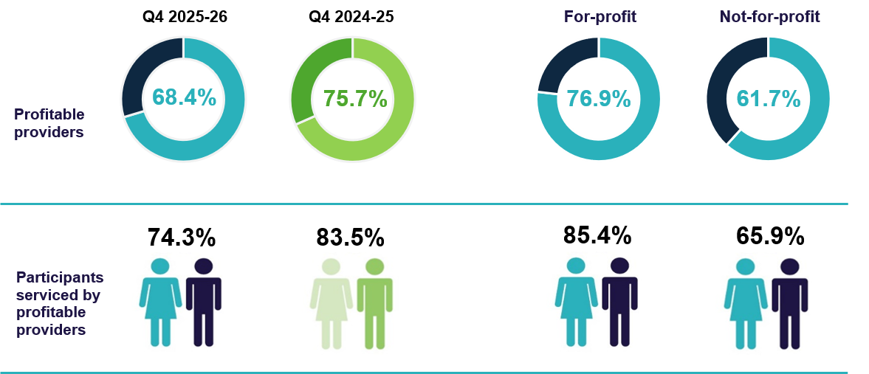

Median EBITDA and NPBT margin
In Q4 2025-26:
- the median EBITDA margin for the sector was 3.9% (down 2.8 pp from
Q4 2024-25), which means an EBITDA return of $3.90 for every $100 of revenue earned (Chart 11).
- the median NPBT margin for the sector was 3.4% (down 2.6 pp from
Q4 2024-25), which means a NPBT return of $3.40 for every $100 of revenue earned (Chart 12).
Chart 11: Median and quartile EBITDA margin
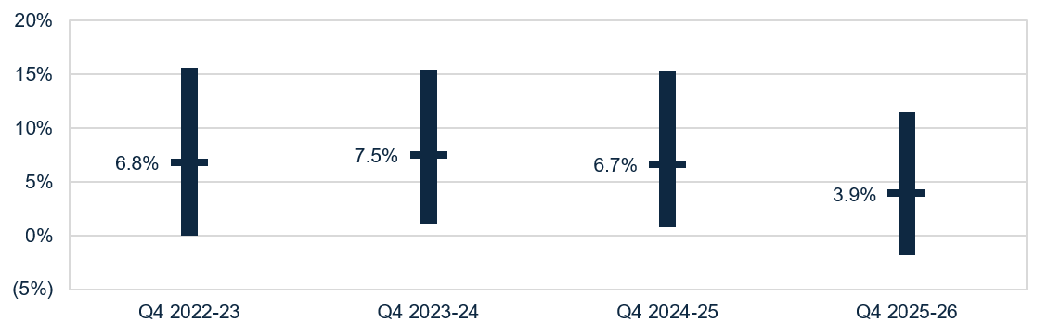
Chart 12: Median and quartile NPBT margin
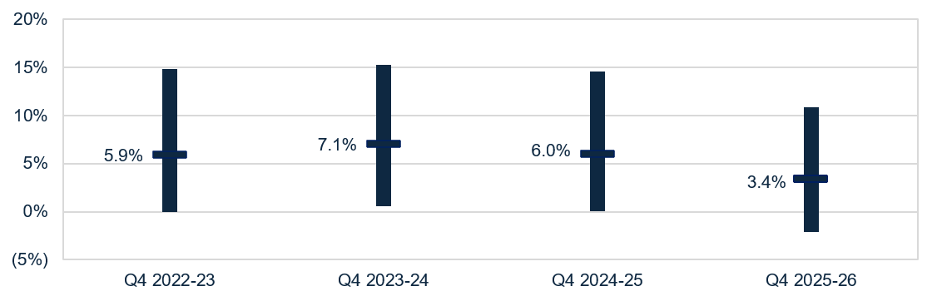

Liquidity
In Q4 2025-26, the median liquidity ratio for the sector was 1.05 (up 0.26 from Q4 2024-25) (Chart 13). This means for every $100 of debt obligations, providers had $105 in liquid assets. The increase in liquidity position in Q4 2025-26 is attributed to the impact from recalculating liquid assets to include trade receivables.
Chart 13: Median and quartile liquidity ratio
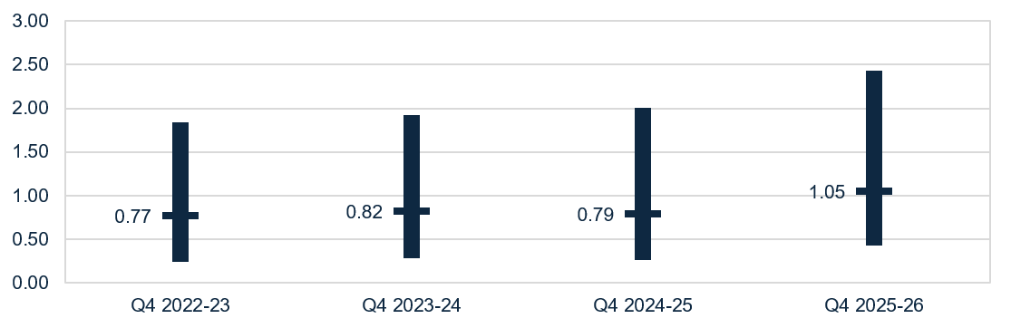
Note: From Q1 2025-26, the liquidity formula includes trade receivables as liquid assets. This is aligned with the Aged Care Quality and Safety Commission’s Financial and Prudential Standards.

Capital adequacy
In Q4 2025-26, the median capital adequacy ratio for the sector was 0.51 (down 0.04 from Q4 2024-25) (Chart 14). This means for every $100 of assets owned, $51 was funded through equity and $49 through debt or other liabilities.
Chart 14: Median and quartile capital adequacy ratio
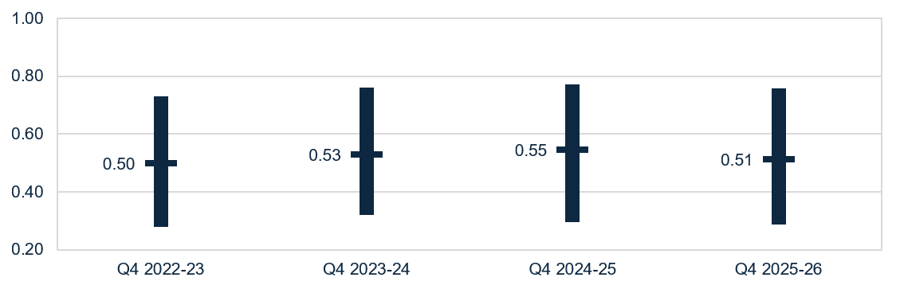
Capital adequacy ratio = (net assets - intangible assets) ÷ (total assets - intangible assets)

Wages to revenue
In Q4 2025-26, wages as a proportion of revenue for the sector had a median of 61.1% (up 0.7 pp from Q4 2024-25) (Chart 15).
Chart 15: Median and quartile wages to revenue percentage
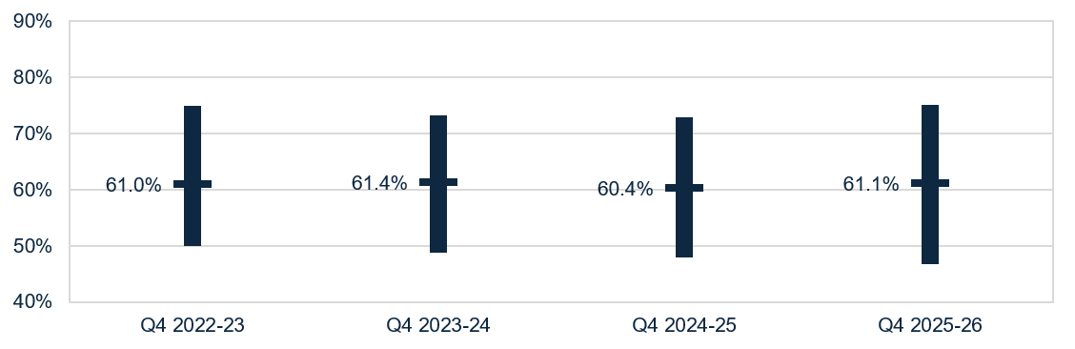
Note: Wages include salaries and employment benefits, agency and subcontractor costs, and management fees. Wages do not include staff training and development.

Staff cost
In Q4 2025-26, the total median staff costs decreased slightly to $56.03 pppd (down $2.02 or 3.5% from Q4 2024-25) (Table 7). The decrease was attributed to lower utilisation of packages. Definition changes introduced from Q2 2025-26 to the personal care staff and other direct care staff had a significant impact on the movements of those categories.
Table 7: Q4 2025-26 and comparison with Q4 2024-25, median staff cost ¹
 | Cost PPPD | Change from Q4 2024-25 PPPD
Registered nurses ² | $1.44 | ▲ $0.22
Personal care staff | $21.42 | ▼ $7.16
Allied health staff | $5.42 | ▲ $0.58
Other direct care staff | $4.88 | ▲ $4.52
Care management staff | $6.88 | ▼ $0.84
Administrative & non-care staff | $7.08 | ▼ $0.20
Total median ³ | $56.03 | ▼ $2.02
Notes:
1. Staff travel, or work done on administration tasks during care staff paid hours, is included in the results of Chart 15, which shows the median wages to revenue percentage. All provider types are included in this data, including LST government providers.
2. Data for enrolled nurses has not been included as 66.5% of Support at Home providers did not report expenditure in this category.
3. Total median staff cost is derived from the totals calculated in the individual QFR submissions and is not the sum of the medians in the sub-categories listed above.

Hourly rates
In Q4 2025-26, the sector median of the average hourly rate increased for all direct care staff in comparison to Q4 2024-25:
- $55.00 for registered nurses (up $2.50 or 4.8% from Q4 2024-25) (Chart 16)
- $41.91 for enrolled nurses (up $2.40 or 6.1% from Q4 2024-25) (Chart 17)
- $36.51 for personal care staff (up $1.58 or 4.5% from Q4 2024-25) (Chart 18).
Average hourly rates are for staff employed per the employee award, enterprise agreement or contract. These do not include on-costs, penalty rates, casual rates, agency fees and subcontracting arrangements. Nil-value responses are excluded.
Chart 16: Highest, average, and lowest hourly rates (medians) paid to registered nurses
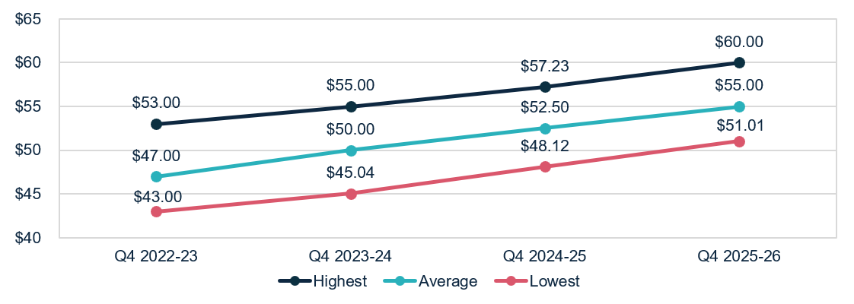
Chart 17: Highest, average, and lowest hourly rates (medians) paid to enrolled nurses
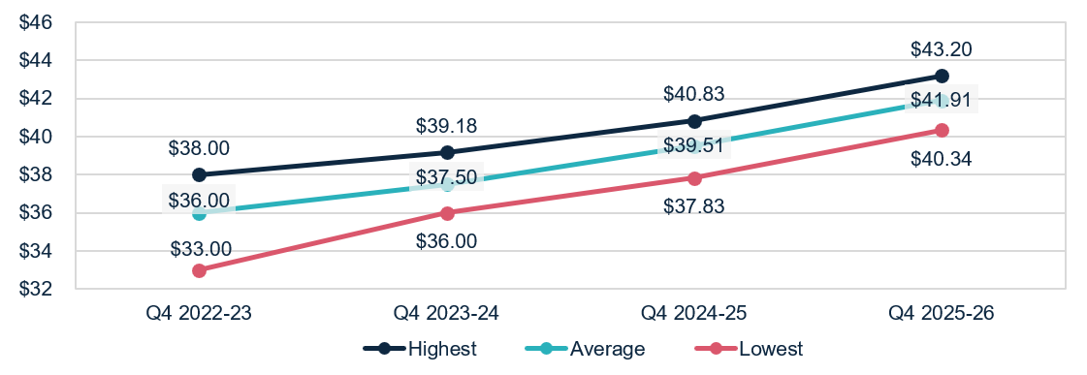

Chart 18: Highest, average, and lowest hourly rates (medians) paid to personal care staff
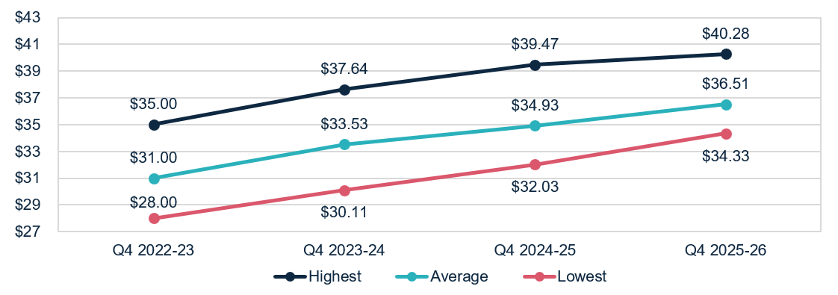

Unspent funds
At 30 June 2026, there was $3.6 billion in unspent HCP funds, down $0.5 billion from 30 June 2025 (Chart 19). This includes:
- $3.4 billion of unspent funds in the Home Care Account (down $0.4 billion)
- $0.2 billion in the Provider Held Portion of unspent funds (down $0.1 billion).
A participant’s HCP unspent funds balance was retained in the transition to the Support at Home Program on 1 November 2025, and can be used to fund assistive technology, home modifications, and/or pay approved services once their quarterly budget has been fully exhausted. Under Support at Home, the rollover amount for unspent funds is capped at the greater of $1,000 or 10% of the quarterly budget, resulting in a decrease to overall unspent funds.
Chart 19: Unspent funds
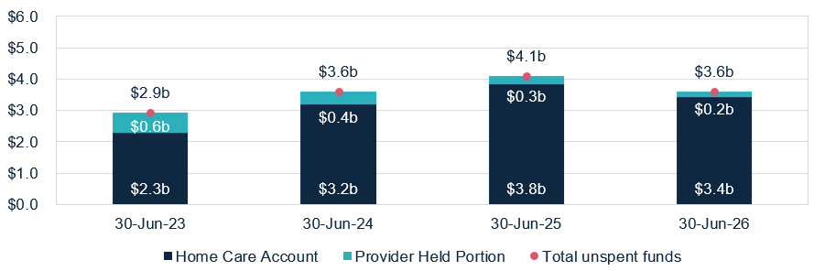

Glossary
Term | Description
Australian National Aged Care Classification (AN-ACC) funding model | Is a case mix funding model that represents the care component of residential aged care funding from the Australian Government. AN-ACC is designed to provide equitable care funding to approved residential aged care homes, by linking subsidy to characteristics of homes and residents.
Care minutes | Refers to the amount of care time people who live in government-funded residential aged care homes receive from registered nurses, enrolled nurses, personal care workers and assistants in nursing. Mandatory care minutes requirements are in place for residential aged care providers.
Capital adequacy ratio | Measures a provider's net asset position divided by total asset position (not including intangibles). This ratio can be used as an indicator of a provider's ability to absorb unexpected losses through their net asset position (also known as an asset buffer).  Intangible assets are removed as they are not considered to have value in the event of insolvency.
EBITDA margin | Is used as an indicator of a provider’s financial performance and underlying profitability before accounting for depreciation assumptions, tax obligations or financing choices.  EBITDA margins focus on a provider’s operating profitability and cash flow. The higher the EBITDA margin is, the lower operating expenses are in comparison to total revenue.
NPBT margin | Is used as an indicator of a provider’s financial performance and underlying profitability before accounting for tax obligations.  NPBT margins focus on a provider’s operating profitability and cash flow. The higher the NPBT margin is, the greater the proportion of total revenue retained as profit before tax.
Fair Work Commission (FWC) decisions | The Australian Government is providing funding to support the FWC’s decisions under the Aged Care Work Value Case. The Government also provides funding to support FWC decisions relating to Annual Wage Reviews through usual program funding arrangements. These decisions are collectively referred to as ‘FWC decisions’ in this report.
Total labour (staff) costs | Includes salaries for all care and non-care staff, superannuation, bonuses and incentives, allowances, termination payments, value of fringe benefits, salary sacrifice and leave entitlements. Training costs for all employment categories are included under ‘Administration and non-care staff’ costs. Total worked staff hours excludes leave and training hours and only includes the time spent delivering care.
Liquidity ratio | Measures the availability of cash and financial assets to cover providers' debt obligations (without raising external capital) if they were to become immediately due and payable. If the ratio result is greater than 1.0, the provider has more cash and financial assets than their debt obligations. If the ratio result is less than 1.0, the provider’s debt obligations are more than their cash and financial assets.

Appendix

How to read the QFS

Comparison data
Charts include results from previous financial years to highlight trends in performance over time. YTD results are compared to the same quarter in past years to enable the comparison of totals and reduce seasonal effects. The exception is data on the average care minutes delivered by residential aged care providers (sector and by provider type), which compares to the prior quarter.
Data notes: Throughout the document, this grey box gives guidance on calculations, data notes and caveats to support providers interpret results and benchmark their performance against the sector.
Quartile charts show the median, upper quartile (the 75th percentile) and lower quartile (the 25th percentile) to illustrate the spread of results.

Provider types
Provider type | Definition
Sector | All providers.
For-profit | Providers that are generally a private incorporated body or a publicly listed company with the intention to generate financial returns for its owners or investors.
Not-for-profit | Providers that are either charitable, community based or religious organisations.
Local, state and territory (LST) government | Providers owned by a local, state and territory government. These providers do not report YTD financial data in the QFR.

Data sources and method
- The QFS primarily draws on data collected from aged care providers through the QFR. The QFR data published in this QFS report was extracted from the department’s Ageing and Aged Care Data Warehouse (CASPER).
- QFR data is unaudited but must be authorised by a director of a provider’s board, a member of the governing body, or one of the provider’s Key Personnel (for government providers). The department undertakes data validation processes, and providers may be invited to re-submit data if anomalies are identified.
- The department conducts additional data quality assessments, and providers may be excluded from the analysis for various reasons, including where:
- there is no evidence of the provider receiving government funding, or
- their data contains anomalies relative to sector norms.
- The QFS presents the financial summary, wages to revenue percentage, EBITDA margin and percentage of profitable providers in YTD format. This ensures information is presented the way it has been collected, and is consistent with standard accounting practices. Care minutes, labour costs, and food and nutrition ingredient expenditure are reported as quarter-specific results only.
- Provider entry and exit data is extracted from the Government Provider Management System. Some providers may be counted in both residential and Support at Home entry and exit data.
- Sector-level results published in the QFS may differ from information on the
My Aged Care website. The QFS presents median results at the provider-level, while the My Aged Care website presents median results at a home-level.

Previous snapshots and feedback
Previous QFS publications are available on the department’s website. The department is committed to working with the sector to inform future publications of the QFS. Feedback is welcome and should be directed to QFS.FRAACS@health.gov.au.

