National Health Emergency Response Plan
© Commonwealth of Australia 2026
This Plan is intended to be reviewed every three years.
For the latest version, please visit: https://www.health.gov.au/resources/collections/emergency-management-plans
Copyright notice
This publication is available for use under a Creative Commons Attribution 4.0 licence with exception of the Commonwealth Coat of Arms, photographs, images, signatures and where otherwise stated. The full licence terms are available from https://creativecommons.org/licenses/by/4.0/.

You must read and understand the Licence before using any material from this publication.
Restrictions
The Licence may not give you all the permissions necessary for your intended use.
The Licence does not cover, and there is no permission given for, use of the following material found in this publication:
- the Commonwealth Coat of Arms (the terms under which the Coat of Arms may be used are on the Department of the Prime Minister and Cabinet website: https://www.pmc.gov.au/cca)
- logos and trademarks
- photographs and images
- material belonging to third parties identified in this publication.
Attribution
This publication should be attributed as follows:
© Commonwealth of Australia, Department of Health, Disability and Ageing, National Health Emergency Response Plan.
Enquiries
Feedback regarding this document is welcome by email to HEMB.Planning@health.gov.au.
Enquiries regarding this licence and any other use of this publication should be emailed to copyright@health.gov.au.
Document information
Document owner | Australian Government Department of Health, Disability and Ageing
Document contact | HEMB.Planning@health.gov.au
Version control
Date | Version | Approval | Comment
20 October 2026 | 1.0 | Deputy Secretary responsible for health emergency management  (Lead Coordinating Senior Official). | National Health Emergency Response Plan replaces the National Health Emergency Response Arrangements (2011).
Contents
How to use the National Health Emergency Response Plan 5
Structure of the National Health Emergency Response Plan 5
Section 1: Overview and approach 7
Scope 7
Intersection with state and territory health emergency response 7
Health responsibilities during national emergencies 8
Principles 10
Approach to health emergency management 11
A stepped model for emergency response 12
Section 2: Responsibilities and governance 14
Governance and coordination 20
National health sector coordination 21
Whole of Australian Government coordination 23
Health emergency operations 24
Section 3: High-level guidance for responding to national health emergencies 26
Summary of elements for an effective health emergency response 27
High-level indicators for health emergency response 28
Coordinating an emergency response 33
Early recovery 41
Policy, legislation, and international obligations 42
ANNEX A: Emergency communication 44
Emergency communication with jurisdictions and supporting agencies 44
Department roles and responsibilities 44
Clearing and distributing communications products 46
Out of scope 46
ANNEX B: The intersection of State, Territory and Australian governments 47
Emergency communications 47
Public health surveillance 47
Clinical services 47
Public health and social measures 48
State and territory legislative and policy settings 48
ANNEX C: Supporting agencies 49
ANNEX D: Supporting national plans and documents 56
ANNEX E: Acronyms 58

How to use the National Health Emergency Response Plan
The National Health Emergency Response Plan is the overarching national plan guiding responses to health emergencies arising from any incident with significant negative consequences on the health of Australians, health systems or federally managed health services and assets.
This Plan is primarily for officials in the Department of Health, Disability and Ageing (the department) with a role in coordinating responses to national health emergencies. It is also relevant to officials with a role in managing – or supporting the management of – health emergencies in other Australian Government agencies and in state and territory governments.
This Plan is subsidiary to the Australian Government Crisis Management Framework (AGCMF). This Plan can be used on its own or with other Australian Government emergency response plans but takes precedence when the identified hazard is a ‘domestic public health emergency.’ This Plan is underpinned by:
- other plans addressing the range of human health consequences that can arise in a national emergency
- departmental guidance and documents that support operational aspects of an emergency response
- incident specific action plans established when the National Incident Centre is activated for an emergency response and archived when the National Incident Centre is deactivated.

Structure of the National Health Emergency Response Plan

Section 1: Overview and approach
Provides an overview of the department’s health emergency management responsibilities, its approach to health emergency management, and the guiding principles that support a health emergency response.

Section 2: Responsibilities and governance arrangements
Details the roles and responsibilities for identified senior officials and the department. Outlines governance and coordination arrangements for department led emergency responses.

Section 3: Responding to national health emergencies: high-level guidance
Provides high level guidance to support the coordination of national health emergency responses. It also provides indicators to support the activation of a health emergency response and decisions about escalation, de-escalation and deactivation. The operational arrangements underpinning this guidance are in the department’s internal guidance and documents.
Section 1
Overview and approach

Section 1 of this Plan provides an overview of the department’s health emergency management responsibilities, approach to health emergency management, and the guiding principles that support a health emergency response.

Section 1: Overview and approach
The Australian Government works with state and territory governments to prevent, minimise and manage the impacts of national emergencies on human health and life, health systems, and Australian Government health services and assets.
The purpose of the National Health Emergency Response Plan is to promote effective emergency management, accountability, and transparency by articulating the department’s health emergency management approach, responsibilities, governance and coordination arrangements, and high-level guidance for responses to national health emergencies.

Scope
This Plan applies to emergencies with significant negative consequences for human health and health systems requiring national coordination.
The Plan guides the department’s responses to national health emergencies in Australia, including its non-self-governing territories, as well as to emergencies that affect the health of Australians and Australia’s health sector interests overseas.

Intersection with state and territory health emergency response
Australia’s state and territory governments have primary responsibility for managing emergencies, including any human health consequences that may arise, within their jurisdictions.
The Australian Government’s emergency response role starts when:
- a state, territory, or external territory requests Australian Government assistance
- multiple states or territories are affected, requiring national coordination
- Australians or Australian health sector interests are affected overseas
- Australian Government systems, services, or assets are directly affected.
The department supports states and territories by harnessing, prioritising, and deploying national capabilities and health resources to ensure they are applied equitably in line with response priorities and requirements.
This Plan operates alongside state and territory emergency response plans. This Plan also operates alongside the Australian Government Disaster Response Plan (COMDISPLAN) which provides the framework for addressing state and territory requests for Australian Government
non-financial assistance arising from any type of emergency.
Further information about state and territory responsibilities during national health emergencies is in Section 2 (State and Territory governments).

Health responsibilities during national emergencies
The Australian Government Department of Health, Disability and Ageing
(the department) is responsible for coordinating two types of responses to national emergencies.
- National (multijurisdictional) health sector responses for any emergency that results in significant human health consequences.

What is a nationally significant emergency for a department led response?
Under this Plan, a national health emergency can arise from any incident that requires an immediate department led response outside business-as-usual arrangements to manage potential or realised adverse consequences to human health, health systems or federally managed health services and assets.
Responses of this type may require coordination across the health sector including with state, territory, and Australian governments, and health related industry and civil society organisations.
The department may have a role in leading a response to, or coordinating the Australian Government response to the health sector consequences of, a broad range of emergencies, including from:
- communicable disease
- hazardous materials, including chemical, biological, radiological, or nuclear materials
- climate-related disasters, including extreme weather events such as floods, heatwaves, bushfires, and cyclones
- mass casualty incidents
- cyber security incidents
- critical infrastructure and supply chain disruptions, including medicines shortages
- food and water insecurity or contamination
- terrorist incidents
- civil unrest and conflict.
The department’s responsibilities for this type of response align with the department’s designation as a Sector Lead Agency under the AGCMF. A department led response may contribute to a national emergency response led by a different Australian Government agency.

- Whole of Australian Government (federal) cross-sectoral responses to domestic public health emergencies.

What is a domestic public health emergency?
When a national emergency is considered a domestic public health emergency under the AGCMF, the department is responsible for the national health sector response and whole of Australian Government (cross-sectoral) coordination. The AGCMF designates the department as the Australian Government Coordinating Agency for domestic public health emergencies, with responsibilities for bringing together multiple sector led responses across Australian Government portfolios.
The department’s cross-sectoral emergency response coordination obligations apply when the nation is faced with nationally significant communicable disease outbreaks including pandemics, or hazardous material incidents with human health consequences (excluding terrorist incidents).
While the department is an Australian Government Coordinating Agency for domestic public health emergencies, it may also act as Sector Lead Agency by contributing health sector considerations into emergency responses coordinated by other Australian Government agencies.

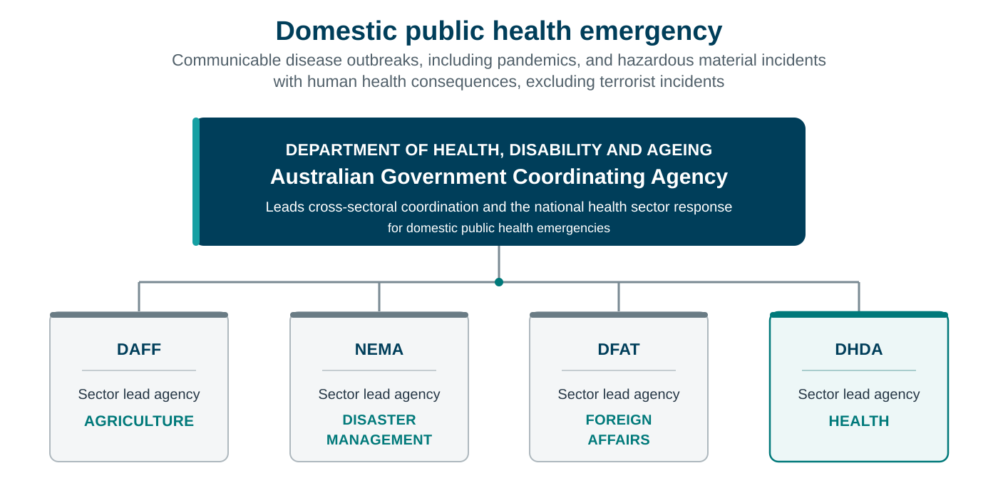
- Example: The Department of Health, Disability and Ageing as an Australian Government Coordinating Agency

Principles
All responses to national health emergencies should:
- contribute to:
- saving lives, reducing harm, and minimising the impacts on health systems and infrastructure
- providing national leadership and maintaining public trust and confidence
- prioritising and deploying national resources and capabilities equitably
- continual improvement to strengthen preparedness for future emergencies
- recognise Australia’s states and territories as the first responders to health emergencies in their jurisdictions
- promote continuity of effort across Australian, state and territory governments, industry, and civil society
- acknowledge community at the core of response and recovery and consider and address the needs of Australians who may be disproportionately at risk of harm
- consider human rights to ensure measures enacted during emergencies are necessary, reasonable, proportionate, and accessible
- acknowledge the importance of recognising and engaging with First Nations people and their communities, before, during and after emergencies
- recognise the intrinsic link between the health of humans, animals, and the environment for effective responses to our health challenges – a One Health approach
- ensure effective communication during national health emergencies by prioritising the timely, accurate and inclusive sharing of information.

Approach to health emergency management
The following elements frame the department’s approach to managing national health emergencies.
- Use of an all-hazards approach. This approach is flexible, holistic and focuses on all emergencies, regardless of cause or nature. This approach encompasses any emergency that results in significant negative human health consequences or health system impacts.
- Application of consequence management principles. This recognises incident (or hazard) oriented approaches may have limitations in novel emergencies. Consequence management plans can be used in health emergency responses across multiple types of incidents.
- A scalable and adaptable health emergency response model to support appropriate and consistent levels of coordination and to support adaptation of a response as the severity and complexity of consequences change over time.
- Systematic consideration of at-risk and priority populations during emergency responses. This approach:
- integrates the consideration of at-risk and priority populations across national health emergency arrangements, spanning preparedness, response and recovery, and national health emergency governance mechanisms
- addresses the needs of at-risk and priority populations during a response in line with incident and context-specific factors.
- An understanding of the Australian Government Crisis Management Continuum, recognising its phases are not necessarily linear and frequently overlap. The department has adapted this Continuum for a health emergency context. The department’s Health Emergency Management Branch focuses on health emergency planning, preparedness, response, review, and early recovery. This recognises that broader prevention, preparedness, recovery, and resilience efforts require a whole of portfolio approach.
- Facilitating continuous improvement across health emergency management to embed lessons from past emergencies and exercises into overarching health emergency plans and response arrangements. To support continuous improvement, After Action Reviews are recommended following all health emergency responses and are mandatory following responses at
Levels 3-4.

A stepped model for emergency response
The department uses a four-level model for responding to national health emergencies.
This model complements the four tiers of coordination in the AGCMF, but the levels and tiers do not always directly correspond. The AGCMF tiers reflect the complexity of coordination required, while the department’s model guides decisions about the health response and resourcing required, informed by health consequences.
The stepped model supports:
- the assessment of an incident and whether a department led response might be needed
- understanding when a national health emergency response should begin and end
- a dynamic response that addresses consequences as they change over time
- decisions about the level of response coordination required and when to escalate or
de-escalate a response aligned to the department’s levels of health emergency response coordination
- decisions about prioritisation of health capabilities and resourcing
- the assessment of whether and when to end a department led response and the transition of ongoing functions to business areas.
Section 3 of this Plan provides more information about assessing the level of response required and escalating or de-escalating a response over the course of an emergency.
- Four-level model for health emergency response
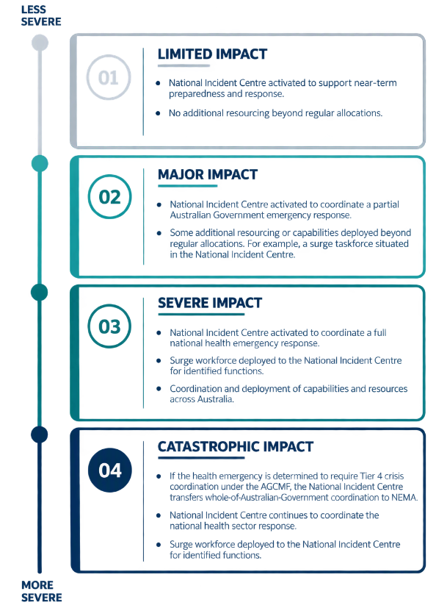

Section 2
Responsibilities and governance

Section 2 of this Plan details the roles and responsibilities for identified senior officials and the department itself. It outlines the governance and coordination arrangements for department led emergency responses.

Section 2: Responsibilities and governance
During a national health emergency, clarity of roles and responsibilities help ensure an Australian Government response is effective and sustains community trust.
This section of the Plan articulates the responsibilities of the:
- Lead Minister
- Lead Coordinating Senior Official
- Chief Medical Officer
- Health Emergency Coordinator
- Department of Health, Disability and Ageing
- Supporting agencies and State and Territory governments

Lead Minister
During a national health emergency, the Minister responsible for Health and Ageing assumes the role of Australian Government minister responsible for leading coordination of the health emergency response.
As Lead Minister, the Minister for Health and Ageing is responsible for:
- providing advice to the Prime Minister, the National Security Committee of Cabinet (or other committee of cabinet), and National Cabinet on national emergency response priorities and consequence management objectives
- overseeing a coordinated Australian Government response to national health emergencies
- coordinating cross-jurisdictional efforts through the Health Ministers Meeting and via direct collaboration with state and territory counterparts
- exercising executive responsibilities and decision making in consultation with ministers with relevant interests
- exercising ministerial powers and overseeing the exercise of officials’ powers relevant to the management of a human health biosecurity risk under the Biosecurity Act 2015
- acting as the lead Australian Government spokesperson for the national emergency response
- ensuring their Office maintains business continuity plans should the Office be directly affected by the emergency
- recording ministerial decisions and actions relevant to the emergency.

Lead Coordinating Senior Official
The Deputy Secretary responsible for health emergency management is the Lead Coordinating Senior Official accountable for coordinating a national response to a health emergency from the point at which an incident is assessed as requiring an Australian Government response.
The Deputy Secretary responsible for health emergency management may delegate their responsibilities depending on the level or nature of response required, with:
- Assistant Secretary as the minimum lead for a Level 1 response
- First Assistant Secretary as the minimum lead for a Level 2 response
- Chief Medical Officer as the lead for some or all components of a health emergency response.
The Deputy Secretary cannot delegate their overarching responsibility for responses at Levels 3-4.
The Deputy Secretary responsible for health emergency management, or their delegate, is responsible for:
- ensuring the department is prepared and positioned to respond to national health emergencies, including:
- ensuring the department is prepared to coordinate a national health emergency response that brings together health sector considerations in every jurisdiction, and cross-sectoral considerations across Australian Government portfolios
- ensuring the department is prepared to support the emergency response in instances where the department is not the Australian Government Coordinating Agency
- ensuring sufficient resources are allocated to deliver the federal Health portfolio’s emergency response obligations
- authorising a national health emergency response and activating the National Incident Centre
- determining the level of emergency response required, informed by advice of the Health Emergency Coordinator, and establishing, reviewing and adapting the level of coordination over the course of the emergency
- facilitating shared agreement to national emergency response priorities and requirements – including through the Australian Health Protection Committee (AHPC)
- co-chairing the National Coordination Mechanism (NCM) and the Australian Government National Coordination Mechanism (NCM-AUSGOV) when required with the Deputy Coordinator General of the National Emergency Management Agency (NEMA)
- advising the Secretary, acknowledging the Secretary’s responsibilities as a member of the Health Chief Executives Forum (HCEF) and as Director of Human Biosecurity under the Biosecurity Act 2015
- advising the Minister for Health and Ageing (as Lead Minister), including:
- maintaining clear lines of communication with the Minister for Health and Ageing’s office
- providing incident specific and coordinated cross-government advice to ministers, senior officials and national decision-making bodies
- where the lead minister is the Prime Minister (AGCMF tier 4), advising and supporting the Prime Minister through the Department of the Prime Minister and Cabinet (PM&C)
- overseeing requests for, or offers of, assistance received by the department from state, territory or foreign governments, in consultation with the Department of Foreign Affairs and Trade
- as the emergency coordination concludes, ensuring transfer of ongoing responsibilities and processes to senior officials, agencies (including state and territory leads) and recovery leads
- maintaining records of decisions and actions relevant to the emergency.

Chief Medical Officer
The Commonwealth Chief Medical Officer is the principal health advisor to the Australian Government and the Department of Health, Disability and Ageing. During national health emergencies, the Chief Medical Officer may take the responsibility of Lead Coordinating Senior Official if the emergency is likely to have a major impact on public health or clinical services.
The Chief Medical Officer is responsible for engaging with and chairing AHPC. This recognises AHPC’s role in providing health advice and contributing to national coordination of responses to any emergency with significant public health consequences.
During a health emergency response, the Chief Medical Officer may:
- advise Ministers, the Secretary, and the department across the full range of health issues confronting the Australian community
- in collaboration with the Australian Centre for Disease Control, provide public health advice and consider the health impacts on communities arising from an emergency
- convene emergency meetings of AHPC
- lead on some or all components of a health emergency response at the request of the Lead Coordinating Senior Official
- work closely with the Director General of the Australian CDC
- work closely with the Surgeon General of the Australian Defence Forces
- work closely with the Health Security and Immunisation Division of the Department of Health, Disability and Ageing
- act as a key spokesperson for the Department of Health, Disability and Ageing.

Health Emergency Coordinator
The Assistant Secretary, Health Emergency Management Branch, or delegate, is the Health Emergency Coordinator responsible for managing the department’s operational response to specific incidents under the direction of the Lead Coordinating Senior Official.
The Health Emergency Coordinator is responsible for recommending to the Lead Coordinating Senior Official the appropriate level of response coordination and activation of the National Incident Centre.
When the National Incident Centre is activated, the Health Emergency Coordinator is responsible for:
- leading the department’s operational response to the health emergency
- regularly assessing the severity and complexity of the emergency and its consequences, and recommending the appropriate level of response coordination, when this should change, and corresponding resource requirements
- establishing and leading an Incident Management Team to manage the departmental coordination of a national health emergency response
- notifying relevant departmental and state, territory and Australian government officials (including the Australian Centre for Disease Control), of the activation of a national health emergency response
- briefing and advising the Lead Coordinating Senior Official
- monitoring and communicating impacts with stakeholders outside the health sector through decision making and coordination mechanisms (such as the NCM), and with relevant agencies and counterparts (such as NEMA)
- ensuring incident specific action plans are maintained during a response and After Action Reviews are conducted following a response
- ensuring the Corporate Communication Branch is invited to Incident Management Team meetings and the delivery of obligations under the emergency communication framework.

The Department of Health, Disability and Ageing
The department is responsible for developing, maintaining, exercising, and evaluating the plans and capabilities required to coordinate a national response to a health emergency.
During a health emergency response, the department is responsible for:
- monitoring potential or actual incidents that could impact human health and life, health systems, and Australian Government health services and assets
- supporting the Health Emergency Coordinator and the Lead Coordinating Senior Official to make decisions about the level of response required and ongoing response requirements
- working with Australian, state and territory governments, industry, and civil society to coordinate a national health sector response
- communicating the level of health emergency response and subsequent changes to stakeholders
- communicating a shared national situational awareness throughout the health emergency
- establishing and maintaining an incident specific action plan, in consultation with stakeholders, for the duration of a response to that incident
- delivering the core functions of the National Incident Centre
- establishing and deploying a surge workforce for the department with relevant training and security clearances – drawing initially from departmental personnel and, if needed, through the Australian Public Service Commission Surge Reserve
- delivering obligations under the emergency communication framework and, when appropriate, establishing an accessible incident specific communication plan
- ensuring the development and dissemination of tailored, targeted, and timely accessible communications products and public information (such as situation reports, whole of government talking points and the use of Easy Read and Auslan interpreters)
- harnessing and deploying health capabilities and resources in line with response requirements including but not limited to medical countermeasures in the National Medical Stockpile, vaccines or other health resources and capabilities (such as the Australian Medical Assistance Team (AUSMAT), the National Immunisation Program, or an emergency listing process)
- leveraging the Primary Health Network program, Medicare Urgent Care Clinics, and Aboriginal Community Controlled Health Services to mobilise primary care services during emergencies and reduce pressure on hospital systems
- coordinating Australia’s international border health activities and meeting international reporting obligations
- regulating therapeutic goods through the Therapeutic Goods Administration, including
fast-tracking approvals and exemptions, monitoring safety, managing risks, coordinating responses to medicine and health product shortages, providing advice on medicines and health products regulation to Australian Government agencies and jurisdictions, and ensuring public and interagency communication to maintain the safety, quality, and availability of therapeutic goods during national health emergencies
- maintaining business continuity plans, and coordinating incident specific corporate response to ensure the department can continue to perform its role if affected directly by an emergency
- facilitating the movement of liaison officers to and from the National Incident Centre, National Situation Room, DFAT Crisis Centre or other operations centres to support situational awareness
- as the emergency coordination concludes, supporting the transfer of continuing functions and responsibilities to relevant officials and agencies (including state and territory leads) and recovery coordination mechanisms
- conducting After Action Reviews and supporting integration of relevant lessons into the department’s emergency management plans and response arrangements
- maintaining and filing a chronology of the incident response and records of decisions and actions relevant to the health emergency
- when an emergency occurs in an Australian External Territory, working with relevant administrator (i.e. the Department of Infrastructure, Transport, Regional Development, Communications, Sport and the Arts (DITRDCSA), the Department of Climate Change, Energy, the Environment and Water (DCCEEW), the Director of National Parks) to coordinate the management of the health emergency
- when an emergency occurs in a jointly managed National Park (Kakadu National Park,
Uluru-Kata-Tjuta National Park (UKTNP) or Booderee National Park) working with the Director of National Parks to coordinate the management of the health emergency.

Supporting agencies
Supporting agencies include all Australian Government agencies which are not the department, and which have a significant operational role that contributes to a health emergency response. Supporting agencies have important capabilities within their portfolio to support a health emergency response. Health emergency responsibilities of key supporting agencies are provided at Annex C.

Australian Centre for Disease Control
The department and the Australian CDC have distinct but complementary roles during a national health emergency. The department leads national coordination of health emergency responses, while the Australian CDC, as an independent statutory agency, provides independent, evidence informed technical advice and guidance within its legislative functions under the Australian Centre for Disease Control Act 2025 and publishes relevant advice in accordance with its transparency settings.
During a health emergency response, the Australian CDC is responsible for:
- supporting the department and state and territory governments (including multijurisdictional groups such as the AHPC) by providing evidence-informed public health advice, including disease surveillance outputs, epidemiological analysis, risk assessments and technical guidance. These may inform National Incident Centre situation reports, whole-of-government communications and escalation of preparedness and response efforts.
- contributing to rapid assessments and assisting the Incident Management Team and National Incident Centre by providing and updating Australian CDC public health advice throughout an incident
- developing and publishing national guidance for public health professionals and public health units (including Series of National Guidelines, Laboratory Case Definitions and Surveillance Case Definitions), in accordance with legislative transparency and exemption settings
- delivering international health reporting, including National Focal Point functions under the International Health Regulations (2005), with the National Incident Centre providing 24/7 operational coordination and liaison support.

State and Territory governments
While Australia’s states and territories have primary responsibility for managing emergencies within their jurisdictions, it is important that Australian, state and territory governments collaborate effectively to enable joined-up health sector responses to national emergencies with significant human health consequences. More detail on the responsibilities of state and territory governments in a national response is articulated in Annex B.

Governance and coordination
This Plan integrates with the Australian Government’s overarching emergency coordination arrangements outlined in the AGCMF and supports responses across the Australian and state and territory governments.
The governance structures underpinning department led emergency responses align with responsibilities for two types of national response coordination.

Always applies
When the department leads a national (multijurisdictional) health sector response, the AHPC is the overarching senior officials’ group responsible for the high-level national coordination of health sector emergency responses. AHPC’s role in emergency response is described on page 21.

Only applies in responses to a “domestic health emergency” (per AGCMF)
When the department also leads a cross-sectoral (federal) response, the NCM-AUSGOV is the overarching Australian Government (federal) senior officials’ crisis coordination mechanism.

Used when needed
Issue specific National Coordination Mechanism (NCM) meetings enable collaboration across all levels of governments as well as industry and civil society. The NCM can be used in both health sector and cross-sectoral responses.
National (multijurisdictional) health sector emergency responses and Australian Government (federal) cross-sectoral emergency responses can occur concurrently. The Lead Coordinating Senior Official bridges these forums by attending AHPC when it meets in an emergency response capacity and co-Chairing the NCM when it is convened for national health emergencies.
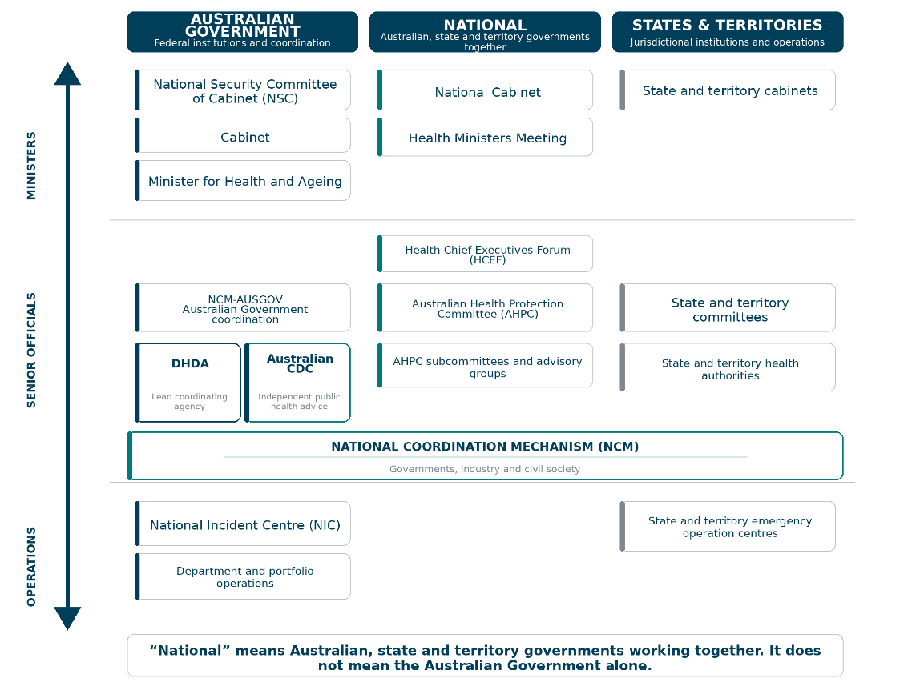
- Australia’s governance arrangements for national health emergencies

National health sector coordination
The following forums contribute to the coordination of national health sector responses for emergencies with significant human health consequences.

The Australian Health Protection Committee
The Australian Health Protection Committee (AHPC) is the national coordination committee for health emergencies. AHPC has an ongoing role to advise the Health Chief Executives Forum (HCEF) on health protection matters and national priorities. The committee works to reduce emerging health threats posed by infectious diseases, environmental issues, and both natural and human-made disasters. The committee works with states and territories to develop, adopt and align national health protection policies, guidelines and standards.
When a national response is required AHPC may provide overarching national coordination and strategic direction for health sector preparedness, response, and recovery to emergencies with nationally significant health consequences. During an emergency, AHPC advises HCEF, Health Ministers and National Cabinet on public health protection and emergency response. AHPC may co-opt officials with decision making authority for specific response requirements, as well as subject matter expertise and views from representatives of at-risk and priority populations to inform decisions and advice in national emergencies.
AHPC membership includes representatives from the Commonwealth and every state and territory, as well as non-voting members, including the Director General of the Australian CDC and the Surgeon-General of the Australian Defence Force. The Lead Coordinating Senior Official responsible for health emergency management may attend AHPC when it meets in an emergency response capacity.
During a national health emergency, AHPC’s responsibility is to:
- provide national leadership and coordinate the national health response
- agree national health emergency response priorities and requirements
- identify, prioritise, and recommend allocation of health capabilities and resources
- ensure consistent, timely and accurate communications between jurisdictions and other organisations
- harness the expertise of its sub-committees, especially the National Health Emergency Management Sub-Committee (NHEMS)
- delegate specific response functions to its sub-committees depending on the nature or severity of the emergency
- regularly update and make recommendations to HCEF, Health Ministers Meeting (HMM) and other governmental bodies.

The National Health Emergency Management Sub-Committee
The National Health Emergency Management Sub-Committee (NHEMS) of AHPC enables
cross-jurisdictional collaboration on health emergency management in an all-hazards context. NHEMS advises the AHPC on health emergency management matters and escalates issues of national significance.
During a national health emergency, NHEMS responsibility is to:
- support the national coordination of responses to health emergencies
- identify, prioritise, and recommend allocation of health resources and capabilities to AHPC
- regularly update and make recommendations to AHPC about response options
- undertake specific tasks requested by AHPC
- support activation and operationalisation of jurisdictional health incident management structures
- facilitate timely sharing of operational intelligence and situational reports across jurisdictions
- integrate inputs from relevant agencies such as the Australian CDC, state and territory health authorities, and national surveillance systems
- monitor and support the coordination and deployment of health resources (such as personal protective equipment, vaccines, and medical equipment)
- facilitate interjurisdictional support arrangements, including surge health workforce deployment and AUSMAT mobilisation
- engage with representatives of at-risk and priority populations.

Other sub-committees and advisory groups
AHPC is additionally supported by the following sub-committees and advisory groups that provide
high-level advice in a national health emergency response. Each sub-committee’s membership includes representatives from state and territory health authorities.
- Public Health Laboratory Network
- Communicable Diseases Network Australia
- Environmental Health Sub-Committee
- National Aboriginal and Torres Strait Islander Health Protection AHPC Sub-Committee
- Aged Care Advisory Group
- Blood Borne Viruses and Sexually Transmissible Infections Sub-Committee

Health Chief Executives Forum
The Health Chief Executives Forum (HCEF) facilitates strategic policy and national
decision making to support a national emergency response. As its sub-committee, AHPC provides regular updates and advice about the health emergency response to HCEF. HCEF supports the Health Ministers Meeting to deliver national emergency response priorities and requirements.

Health Ministers Meeting
The Health Ministers Meeting works to progress health issues of national importance which require cross-border collaboration. It is made up of the health ministers of each state and territory government, along with the Australian Government Minister for Health and Ageing. During an emergency, health ministers may progress matters delegated by National Cabinet.

National Cabinet
National Cabinet provides a forum for the Prime Minister, Premiers and Chief Ministers to work collaboratively. National Cabinet may task the Health Ministers Meeting to support development and implementation of national priorities during an emergency.

Whole of Australian Government coordination
The following Australian Government arrangements are used to consider, prioritise and respond to significant national consequences of an emergency across all sectors – including health. The department may be required to coordinate updates and advice for these forums when there are nationally significant health consequences in an emergency.

National Security Committee of Cabinet
The National Security Committee of Cabinet (NSC) is the peak all-hazards emergency decision making committee of Cabinet and enables time critical ministerial decision making and coordinated emergency response. It also provides coordinated cross government updates to the public and advice on resource prioritisation and public communications.

National Coordination Mechanism
The Australian Government National Coordination Mechanism (NCM-AUSGOV) is a specialised NCM that brings together senior officials from across Australian Government agencies to coordinate responses to cross-sectoral consequences of national emergencies. Its primary responsibilities include setting federal response priorities and managing the allocation of nationally controlled resources and capabilities to ensure an effective and coordinated response.
During national health emergencies, the NCM-AUSGOV is co-chaired by the Lead Coordinating Senior Officials of the department and NEMA.
The National Coordination Mechanism (NCM) enables senior officials’ coordination across Australian Government, state and territory government, industry, and civil society before, during and after an emergency. The NCM is a flexible, scalable, and hazard-agnostic mechanism that facilitates rapid problem definition, shared situational awareness, and ownership of solutions. NEMA convenes and chairs the NCM on behalf of the Australian Government. The department may request – and co-chair – an NCM to support responses to national health emergencies.

Health emergency operations
The department maintains a range of operational capabilities to support emergency response coordination.

National Incident Centre
The National Incident Centre is the department’s emergency operations centre during
department led responses. The National Incident Centre is responsible for essential response functions such as national communication, coordination, and logistics. During an emergency, the National Incident Centre is the primary information conduit, in collaboration with the Australian CDC, for health emergency management and communicable disease information between state and territory emergency operations centres, the National Situation Room (NEMA), the Global Watch Office (DFAT), the World Health Organization (WHO) and other international partners. With the Australian CDC, the National Incident Centre supports Australia’s National Focal Point under the International Health Regulations (2005).

Incident Management Team
An Incident Management Team is established on the activation of an emergency response to manage the department’s operational response to an emergency. The Incident Management Team is led by the Assistant Secretary, Health Emergency Management Branch, as the Health Emergency Coordinator, with support from the National Incident Centre Manager and the National Incident Centre. The size and composition of the Incident Management Team is flexible – and may be supported by subject matter expertise from the Australian CDC and other Australian Government agencies. The composition of the Incident Management Team is determined by incident and context specific factors, affected business areas, and the nature of external expertise and advice required. The Incident Management Team must always consider potential or actual impacts for at-risk and priority populations.
Health emergency operations are described in more detail in Section 3: High-level guidance for responding to national health emergencies.
Section 3
High-level guidance for responding to national health emergencies

Section 3 of this Plan provides high-level guidance to support the coordination of emergency responses and indicators to support decisions about escalating and de-escalating an emergency response.
This guidance should be used with:
- departmental documents that support operational emergency response
- incident specific action plans that are established when an emergency response is activated.

Section 3: High-level guidance for responding to national health emergencies
The flowchart below outlines the high-level steps the department might use when coordinating a response to a national health emergency.
These steps are often non-linear and overlapping. They should be adapted when needed to address incident and context specific factors.
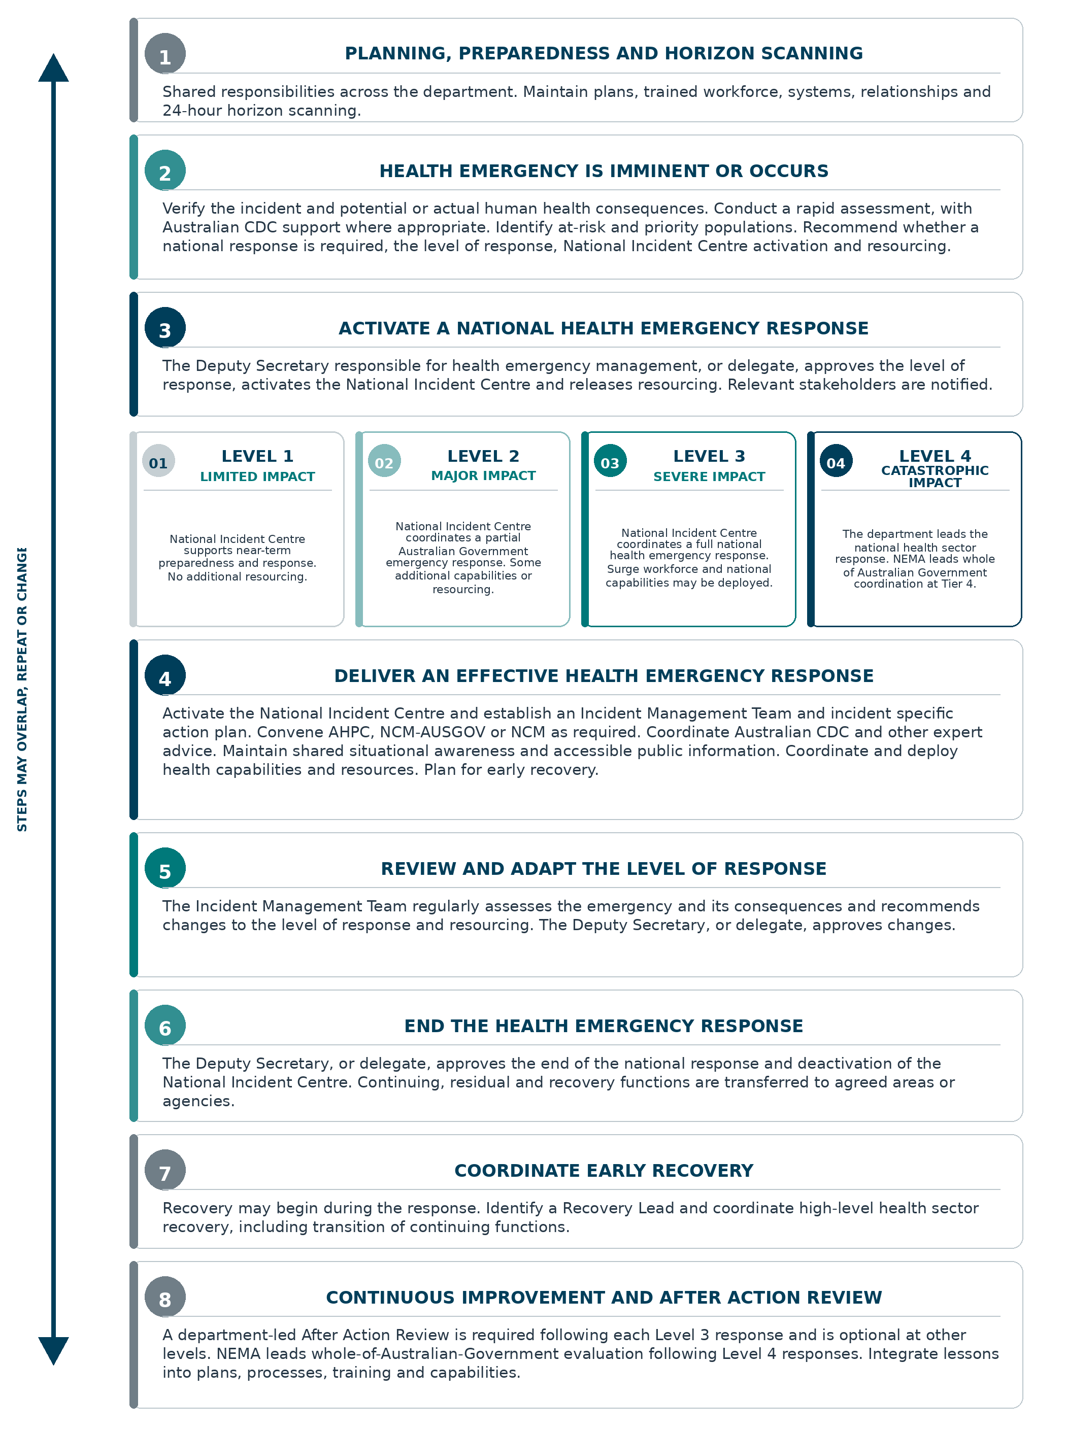
- Health emergency response flowchart

Summary of elements for an effective health emergency response
Elements of an effective health emergency response are guided by the principles outlined in Section 1. The steps should be considered alongside these principles.
The summary below is followed by indicators to guide decisions on the level of health emergency response.
All the steps of the flowchart are further detailed from page 33 (Coordinating an emergency response).
- Elements of an effective emergency response
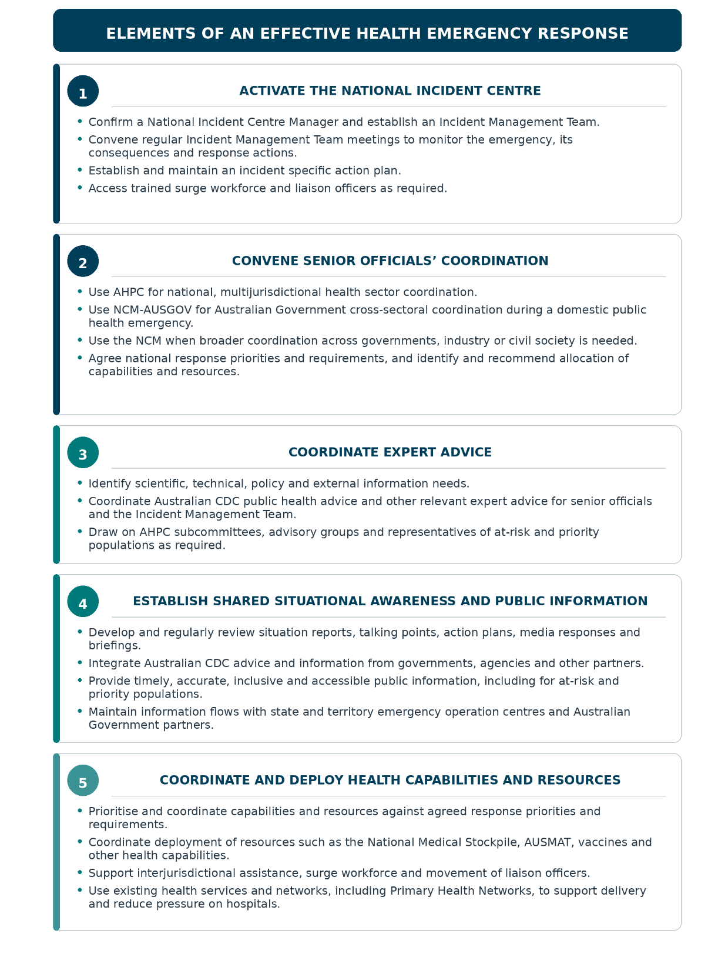

High-level indicators for health emergency response
The following high-level indicators may be used to guide decisions on the level of health emergency response and resourcing required. Business areas in the department may use the indicators to inform subsidiary or business specific emergency planning and indicators.
- High-level indicators to guide decisions on the appropriate level of health emergency response
INDICATOR | LEVEL 1  LIMITED  High-level indicators may include some or all the following, but are not limited to: | LEVEL 2  MAJOR  High-level indicators may include some or all the following, but are not limited to: | LEVEL 3  SEVERE  High-level indicators may include some or all the following, but are not limited to: | LEVEL 4  CATASTROPHIC  High-level indicators may include some or all the following, but are not limited to:
Oversight and coordination | Minimum level for delegation of Lead Coordinating Senior Official is Assistant Secretary. | Minimum level for delegation of Lead Coordinating Senior Official is First Assistant Secretary. | Lead Coordinating Senior Official is Deputy Secretary (cannot be delegated). | National health sector (multijurisdictional) response:  - Lead Coordinating Senior Official is the Deputy Secretary responsible for health emergency management.  Whole of Australian Government (cross-sectoral) response:  - Lead Coordinating Senior Official is the Deputy Coordinator General, NEMA.
Health system capacity / request for assistance | A state or territory government has formally requested assistance from the Australian Government, or elements of a state or territory health system may be at risk of becoming overwhelmed. | More than one state or territory government has requested assistance from the Australian Government, or health systems in one or more states or territories may be overwhelmed. | Multiple state or territory governments have requested assistance from the Australian Government, or health systems and services in multiple jurisdictions may be overwhelmed. | - Multiple jurisdictions have requested Australian Government assistance.  - Health systems and health care services in most jurisdictions may be overwhelmed.  - The Department of Health, Disability and Ageing may require supplementary assistance from others (NEMA and/or Defence and/or international assistance).
Health resources, critical infrastructure and supply chains | - Australian Government coordination may be required to preposition or deploy medical countermeasures in line with risk.  - Limited disruption to supply chains, critical infrastructure, or internet and telecommunications systems affecting the health sector. These remain mostly operational.  - Australian Government services, assets or workforce are not significantly affected (such as but not limited to, Primary Health Networks, mental health, at-risk and priority populations, corporate offices and surge workforce). | - Relevant medical countermeasures (including vaccines) may not be easy to access or may not be available.  - Australian Government coordination may be required to procure, preposition or deploy supplies in line with risk.  - Significant and/or sustained disruption to supply chains, critical infrastructure, or internet and telecommunications systems may be affecting the health sector.  - Australian Government services, assets or workforce may be directly affected (such as but not limited to Primary Health Networks, mental health, at-risk and priority populations, corporate offices and workforce). | - Relevant medical countermeasures (including vaccines) may not be available. Australian Government coordination may be required to procure, preposition or deploy supplies in line with risk.  - Extreme and/or sustained disruption to supply chains, critical infrastructure, or internet and telecommunications systems affecting the health sector.  - Australian Government services, assets or workforce may be seriously compromised (such as but not limited to, Primary Health Networks, mental health, at-risk and priority populations, corporate offices and workforce). | - Relevant medical countermeasures (including vaccines) are not available.  - Extreme and/or sustained disruption to supply chains, critical infrastructure, or internet and telecommunications systems affecting the health sector.  - Australian Government services, assets or workforce may be critically compromised.
Australian Government interest / public expectation | - Low but rising public expectation of an Australian Government-led response.  - Low but rising level of media coverage.  - Some links with the interests and policy priorities of Ministers, parliamentarians or other senior stakeholders. | - Moderate to high public expectation of an Australian Government-led response.  - Significant media coverage.  - Clear links with the interests and policy priorities of Ministers, parliamentarians or other senior stakeholders. | - Universal public expectation of an Australian Government-led response.  - Constant media coverage.  - Tangible adverse impacts on the interests and policy priorities of Ministers, parliamentarians or other senior stakeholders. | - Universal public expectation of an Australian Government-led response.  - Constant and ongoing media coverage.  - Tangible adverse impacts on the interests and policy priorities of Ministers, parliamentarians or other senior stakeholders.
Communicable disease threats / consequences (potential or actual) | - Hazard may be a novel virus or novel viral strain, and human health impacts may be moderate to serious but not well understood.  - Small number of people are likely to or have experienced significant adverse health and wellbeing consequences and there may be a moderate to high risk more people will experience significant adverse health and wellbeing consequences. | - Hazard may be a listed human disease (LHD) under the Biosecurity Act 2015 or may be added as an LHD.  - Moderate and/or growing number of people are likely to or have experienced significant adverse health and wellbeing consequences and there may be a high risk more people will experience significant adverse health and wellbeing consequences. | - Hazard may be an LHD under the Biosecurity Act 2015 or may be added as an LHD.  - Threat from a novel virus or novel viral strain may be transmissible between humans.  - High and growing number of people are likely to or have experienced significant adverse health and wellbeing consequences and there may be a high risk more people will experience significant adverse health and wellbeing consequences. | - Threat from a novel virus or novel viral strain may be transmissible between humans.  - Widespread and rapidly growing number of people are likely to or have experienced significant adverse health and wellbeing consequences and there may be a very high risk more people will experience significant adverse health and wellbeing consequences.
Geographic and demographic spread | - Impacts are experienced or are likely to be experienced in more than one Australian jurisdiction.  - Impacts are localised or are likely to be localised in one or a few demographic cohorts. | - Impacts may be experienced in two or more Australian jurisdictions.  - Impacts may expand to a larger or higher number of demographic cohorts, with at-risk and priority populations disproportionately affected. | - Impacts may be experienced in most Australian jurisdictions.  - Many demographic cohorts may be experiencing impacts, with at-risk and priority populations disproportionately affected.  - Significant and growing multi-sectoral impacts. | - All jurisdictions may be affected.  - Protracted impact.  - Most sectors are affected, with economic impacts affecting many Australians and Australian residents.  - Education and employment severely disrupted.
Number of people affected | - Low number of people affected or likely to be affected, and:  - moderate to high probability more people may be affected but not yet aware / symptomatic  - more people are at material risk of becoming affected  - there is a material risk the number of people affected will rise rapidly  - there is a material risk environmental factors will contribute to more people becoming affected (air quality, flooding, drought, heat waves). | - Moderate and/or growing numbers likely to be affected, and:  - high probability more people may become affected but not yet aware / symptomatic  - the number of people affected may be rising exponentially  - a high number of people may be at material risk of becoming affected  - environmental factors are contributing to more people becoming affected (air quality, flooding, drought, heat waves). | - Widespread and rapidly growing numbers likely to be affected, and:  - the number of people who may be affected but are not yet aware or symptomatic is rising exponentially  - the number of affected people may be rising exponentially  - environmental factors may be contributing to more people becoming affected (air quality, flooding, drought, heat waves). | Most Australians likely to be affected, with at-risk and priority populations disproportionately affected.
International human health consequences | Low to moderate impact on Australia’s consular interests and/or the health systems of countries in our region. | - Widespread in countries in our near region and/or countries with major global transit hubs.  - WHO may have declared a Public Health Emergency of International Concern (PHEIC).  - A moderate to high impact on Australia’s consular interests and/or the health systems of countries in our region. | - Global impact.  - WHO may have declared a PHEIC and/or a pandemic emergency.  - A high impact on Australia’s consular interests and/or the health systems of countries in our region. | - Global impact.  - WHO may have declared a PHEIC and/or a pandemic emergency.  - A high impact on Australia’s consular interests and/or the health systems of countries in our region.
Activation of other Australian Government plans | Any of the following plans may be activated:  COMDISPLAN, AUSRECEPLAN, AUSASSISTPLAN, OSMASSCASPLAN, AUSRNEPLAN, or AUSBIOAGPLAN.  AUSCATPLAN not activated. | COMDISPLAN has been activated, and any of the following plans may be activated:  AUSRECEPLAN, AUSASSISTPLAN, OSMASSCASPLAN, AUSRNEPLAN, or AUSBIOAGPLAN.  AUSCATPLAN not activated. | AUSCATPLAN may be activated.  COMDISPLAN is activated, and any of the following plans may be activated:  AUSRECEPLAN, AUSASSISTPLAN, OSMASSCASPLAN, AUSRNEPLAN, or AUSBIOAGPLAN. | AUSCATPLAN may be activated.
National Incident Centre activation / assistance | The National Incident Centre is activated for up to three Level 1 responses to national health emergencies. | The National Incident Centre is activated for more than three Level 1 responses to national health emergencies. | - The National Incident Centre is activated for more than two Level 2 responses to national health emergencies.  - Many Australian Government Health portfolio business areas may be overwhelmed or may have requested National Incident Centre assistance. | Many Australian Government Health portfolio business areas may be overwhelmed or may have requested National Incident Centre assistance.
Additional resourcing | None | Partial | Full | Full

Coordinating an emergency response
The following sections provide more detail about the high-level steps in the health emergency flowchart.

Planning, preparedness and horizon scanning
Planning, preparedness and horizon scanning are shared responsibilities. Each business area across the department must understand, plan and prepare for how a health emergency could affect their specific areas of work. The Health Emergency Management Branch has a role to lead, enable and support this by providing national health emergency management architecture — including an overarching framework, high-level emergency plans and response coordination mechanisms.
When essential functions of business areas are, or at risk of becoming, overwhelmed, they may approach the National Incident Centre for a rapid assessment to test whether a national emergency response is appropriate, in line with the indicators for a national response.

Planning
Planning is an essential part of preparedness for emergencies. This Plan meets the department’s obligations under the AGCMF for a national health emergency. It covers the essential and repeatable emergency response functions and governance arrangements for responses to any emergency with significant human health consequences.
This Plan is underpinned by:
- subsidiary plans addressing the range of human health consequences that can arise in a national emergency
- departmental guidance and documents that support operational aspects of emergency response
- incident specific action plans that are established when the National Incident Centre is activated for an emergency response and archived when the National Incident Centre is
de-activated.
The department’s incident specific action plans are informed by the NEMA led Crisis Appreciation and Strategic Planning (CASP) approach.

Preparedness
Beyond planning, preparedness involves activities that build the capability and capacity to effectively respond to national health emergencies and transition from response to recovery.
The Health Emergency Management Branch is responsible for operational health emergency preparedness. This includes developing, maintaining, exercising and evaluating:
- health sector emergency governance and coordination arrangements
- an emergency workforce, including a surge cohort of trained officers with appropriate security clearances
- delivery of health emergency training and a national health emergency exercising program in accessible formats
- high-level systems and processes for responses to national health emergencies
- relationships and networks within the agency and with other Australian Government, state and territory government, industry and civil society counterparts that can be contacted promptly in an emergency.

Horizon scanning
The department is responsible for monitoring, identifying, verifying, and alerting incidents and emergencies in Australia and overseas with the potential to lead to a national health emergency. Multiple business areas and agencies have a role to play in horizon scanning, particularly across the department and the Australian CDC.
The department’s National Incident Centre provides a 24-hour watch office function and maintains a Public Health Information Hotline to facilitate reporting of national health emergencies or incidents (1800 004 599).
The department and the Australian CDC work together to assess threats, risks and potential health consequences to Australia’s national health landscape.
The National Incident Centre works closely and shares information with the National Situation Room, managed by NEMA, and the Global Watch Office, managed by DFAT.
NEMA integrates multiple sources of information about incidents and events with potential or actual significant impact in Australia. This is reflected through the National Joint Common Operating Picture (NJCOP) and the National Situation Room Daily All Hazards Report.

Health emergency is imminent or occurs
When the National Incident Centre becomes aware of an imminent or actual incident, it:
- verifies the incident and any human health consequences with other Australian Government agencies, state and territory counterparts, and international partners
- confirms whether the department is the Australian Government Coordinating Agency under the AGCMF
- assesses the incident and the severity and complexity of potential or actual human health consequences to determine if a department led response is required
- identifies and addresses the needs of at-risk and priority populations, including through engagement with representative groups, peak bodies and stakeholders
- recommends the level of response coordination, the activation of the National Incident Centre for an incident specific response and resources that may be required
- on approval of the Deputy Secretary responsible for health emergency management, (or delegate) confirms the level of response and activates the National Incident Centre for an incident specific response at the appropriate level
- notifies relevant stakeholders of the activation of an incident specific response by the National Incident Centre and the level of response.

Assessing an incident
Indicators in this Plan are provided to guide decisions on the level of health emergency response and whether the National Incident Centre should be activated for the purposes of near-term emergency preparedness or response to address a specific incident. The indicators are not prescriptive and should be adjusted to accommodate incident and context-specific factors.
At the outset of an emergency, the National Incident Centre uses a rapid assessment to determine if an emerging, imminent, or actual threat requires monitoring or emergency response coordination at the national level.

Rapid assessments
A Rapid Assessment Team led by the Assistant Secretary, Health Emergency Management Branch, in their capacity as the Health Emergency Coordinator, validates the information available (with support from the Australian CDC where appropriate), assesses the scale and complexity of level of response and if the National Incident Centre should be activated for the purposes of near-term emergency preparedness or response to a specific incident.
If the rapid assessment determines that National Incident Centre activation is not necessary, the department will continue to:
- monitor the situation, impact and consequences and provide updates to relevant teams
- update emergency communications through the Corporate Communication Branch
- respond to requests for escalation to a national response, including through AHPC and its
sub-committees.

Incident Management Team
When an appropriate level of health emergency response has been confirmed and the National Incident Centre is activated, an Incident Management Team is established to lead the operational response within the department. The composition of the Incident Management Team is flexible and scalable – framed by the level of response required and incident specific considerations. It is led by the Assistant Secretary, Health Emergency Management Branch or their delegate, as the Health Emergency Coordinator.
The Incident Management Team should include members with expertise and authority related to:
- emergency management and response coordination
- the specific hazard or its consequences to support problem definition and consequence management
- potential or actual impacts for at-risk and priority populations.
Once the National Incident Centre is activated, the Incident Management Team is responsible for regularly assessing the emergency and its consequences as they evolve over time and recommending changes to the level of response (and corresponding resourcing needs) or deactivation of response.
The outcomes of assessment processes should be reflected in incident specific action plans which are updated regularly during an emergency response.

Activate a national health emergency response

The Deputy Secretary responsible for health emergency management, or their delegate, in their capacity as the Lead Coordinating Senior Official is responsible for approving the level of health emergency response, the activation of the National Incident Centre for near-term preparedness or response to specific incidents, and the release of resourcing aligned to emergency response requirements. Indicators for health emergency response should guide decisions on the level of emergency response.

Activating a health emergency response at different levels
Levels 1-3
For emergency responses between Levels One and Three, the responsible Minister is the Minister for Health and Ageing, and the Lead Coordinating Senior Official is the Deputy Secretary responsible for health emergency management (or delegate).
The Deputy Secretary responsible for health emergency management (or delegate) is responsible for approving the level of emergency response (between Levels One and Three) and resourcing, informed by the advice of the Health Emergency Coordinator following a rapid assessment.

NEMA can assume responsibility for whole of Australian Government (cross-sectoral) emergency response coordination from Tier 3 under the AGCMF by request of the department if overwhelmed. In such instances, the department remains responsible for leading the national health sector response.
Level 4
NEMA assumes responsibility for whole of Australian Government (cross-sectoral) emergency response coordination when the threshold for a Tier 4 is met under the AGCMF.
In this Plan, coordination of a response at Level 4 includes:
- a national (multijurisdictional) health sector response to a catastrophic health emergency coordinated by the department
- a whole of Australian Government (cross-sectoral) response to a catastrophic health emergency coordinated by NEMA at Tier 4 under the AGCMF.
In these instances, the department, as a sector lead agency, remains responsible for leading the coordination of the national health sector emergency response across all states and territories. The department’s Lead Coordinating Senior Official has an important role attending AHPC when it meets for health emergencies, and as co-chair of the NCM-AUSGOV when it is convened for health emergencies.
A decision to escalate a health emergency response to a NEMA-coordinated Tier 4 response (or Tier 3 response by request) under the AGCMF can be made by:
- mutual agreement of the Deputy Secretary responsible for health emergency management (Department of Health, Disability and Ageing) and the Deputy Coordinator General Emergency Management and Response (NEMA)
- a relevant senior officials emergency coordination committee (such as AHPC or the
NCM-AUSGOV)
- PM&C in consultation with the Deputy Secretary responsible for health emergency management (Department of Health, Disability and Ageing) and the Deputy Coordinator General Emergency Management and Response NEMA.
For Tier 4 whole of Australian Government coordination, the Lead Minister becomes the Prime Minister, and the Lead Coordinating Senior Official becomes the Deputy Coordinator General Emergency Management and Response, NEMA.
The Minister for Health and Ageing, supported by the department, remains responsible for the national health sector emergency response.

Deliver an effective health emergency response
Elements of an effective health emergency response are summarised in Figure 5. Depending on the level of response, incident, and context specific factors, some or all the following may be required.

Activate the National Incident Centre

Agree National Incident Centre Manager, establish Incident Management Team and convene regular Incident Management Team meetings to monitor the emergency and its consequences, and to coordinate response actions.

Convene senior officials’ coordination group
AHPC for a national multijurisdictional health sector response and/or NCM-AUSGOV for
cross-sectoral coordination at the Australian Government level and NCM for whole of government, industry and civil society national coordination.

Coordinate expert advice
Identify scientific, technical, policy, or external information needs. Invite relevant experts to inform the overarching emergency response coordination group and Incident Management Team.

Establish shared situation awareness and public information
The National Incident Centre, in collaboration with relevant stakeholders (such as the Australian CDC), develops and reviews emergency response products such as situation reports, talking points, action plans, media responses and briefings which are release regularly, ensuring that information is inclusive of, and accessible to, at-risk and priority populations.

Coordinate and deploy health capabilities and resources

The National Incident Centre, when activated, is responsible for coordinating the deployment of capabilities and resources to support the response priorities and requirements. Examples of health capabilities and resources may include the following:

The National Medical Stockpile
The Australian Government purchases and stockpiles a strategic reserve of chemical, biological, radiological, or nuclear (CBRN) countermeasures and a limited supply of personal protective equipment for use in national health emergencies or incidents of national significance.
National Medical Stockpile countermeasures are:
- prepositioned in strategic locations around Australia
- deployed following request from a State or Territory Chief Health Officer
- not intended for broad scale responses.
The content and holdings of the National Medical Stockpile are regularly reviewed and adapted to align with current needs.

Australian Medical Assistance Teams (AUSMAT)
The Australian Medical Assistance Team is the official Australian Government multidisciplinary healthcare team equipped to deploy a range of self-sustaining capabilities in response to national health emergencies both in Australia and internationally. Australian Medical Assistance Team deployments are managed by the National Critical Care Trauma and Response Centre in conjunction with the department, NEMA and, if deploying internationally, DFAT.

Primary Health Networks
Primary Health Networks are independent organisations, funded by the department, responsible for coordinating primary health care services within their respective regions. Primary Health Networks work to enhance the efficiency and effectiveness of health services, with a particular focus on improving outcomes for at-risk and priority populations.
By better coordination of care, Primary Health Networks ensure increased access and quality support for people. Australia has 31 Primary Health Network regions, which are closely aligned with state and territory local hospital networks.
The department works with Primary Health Networks, jurisdictions and Healthdirect to:
- support the provision of clinical services and disability supports and implement changes to models of care to support patient management, such as telehealth access and associated Medicare subsidies, national helplines, e-prescribing, home medicines delivery and continued access to medical devices
- ensure the provision of primary health care is adapted to the needs of at-risk and priority populations
- coordinate consumers’ access to virtual care services such as nurse triage, health advice and access to virtual GPs, through 1800MEDICARE
- scaling up services or redirecting existing services, where possible and in context of the emergency
- align with existing jurisdictional services and promote consistency of service quality across emergency-affected areas, regardless of geographic boundaries.

Review and adapt level of response
The department should adapt a health emergency response reflective of the nature of the emergency, and in line with its consequences which may change over time.
The Incident Management Team is responsible for regularly assessing the health emergency and its impacts and consequences, informing the senior officials group oversighting the response (usually AHPC), and when appropriate, recommending a change in the level of response coordination and associated resourcing.
The Deputy Secretary responsible for health emergency management (or delegate) is responsible for approving changes to the level of response and resourcing over the course of the health emergency.
Escalation of levels may require new or expanded public health measures, coordination and/or messaging relevant to the health emergency. Features of the emergency, and requirements of response, may be considered when deciding to increase measures.

End a health emergency response
The Deputy Secretary responsible for health emergency management (or delegate), as the Lead Coordinating Senior Official, is responsible for approving the end of a department led national emergency response and the deactivation of the National Incident Centre.
This approval is informed by a recommendation from the Incident Management Team when it assesses the emergency no longer meets the thresholds for a national response and can be managed within regular departmental arrangements.
On approval to end an emergency response, the Health Emergency Coordinator, with the Incident Management Team, will:
- identify residual, continuing or recovery functions or responsibilities
- transfer identified functions and responsibilities to agreed areas in the department or other agencies
- stand down health emergency coordination and the National Incident Centre.

Continuous improvement
Responding to national health emergencies is an ongoing and iterative process, and monitoring, evaluation and learning is required to improve future emergency responses. All the department’s business areas and Health portfolio agencies have responsibilities for continuous improvement relevant to their areas of work, including during national emergencies.
The Deputy Secretary responsible for health emergency management (or delegate), as the Lead Coordinating Senior Official, has overall responsibility for ensuring an After Action Review is completed following significant emergency responses, and that sufficient resources are allocated to meet this requirement.
A single department led After Action Review is required following responses at level 3 and is optional following responses at other levels. NEMA conducts whole of Australian Government post-response evaluation and supports integration of relevant lessons following responses at Level 4.
After Action Reviews following any health emergency response is best practice and should be proportionate to the level and length of the emergency response. Outcomes should be integrated into the department’s health emergency plans, processes, training and capabilities, as well as broader departmental arrangements where relevant.

After Action Reviews
The Health Emergency Coordinator supports the Lead Coordinating Senior Official by ensuring an After Action Review is developed. The Health Emergency Coordinator is responsible for:
- oversighting the review process
- ensuring the department completes a review within 12 months of each department led
Level 3 response
- procuring independent review or evaluation expertise where appropriate or where there is a need for an impartial assessment
- reporting review findings and recommendations to identified senior officials,’ relevant stakeholders and oversighting bodies.

Other continuous improvement responsibilities
The department additionally supports the continuous improvement of its health emergency management functions and responsibilities by:
- updating health emergency plans managed by the department, with the National Health Emergency Response Plan to be reviewed at least every three years
- developing, delivering, and updating a health emergency training and exercising program
- integrating lessons from health emergency exercises into health emergency plans, processes, training and capabilities, as well as broader departmental arrangements where relevant
- maintaining awareness of, contributing to, and learning from relevant audits, reviews, inquiries, or initiatives led by other agencies or organisations with implications for Australia’s health sector.

Early recovery
Under the AGCMF, the Lead Coordinating Senior Official, the Deputy Secretary responsible for health emergency management (or delegate), is responsible for the coordination of early recovery during a national health emergency.
Recovery is key to restoring health system function, rebuilding community trust, and capturing lessons to strengthen future resilience. Recovery efforts frequently occur alongside response efforts and are not necessarily conducted following an emergency response. The focus is supporting the community to return to routines including school and work.
While recovery responsibilities are shared across the department, the Deputy Secretary responsible for health emergency management (or delegate) leads the coordination of high-level health sector recovery efforts. This may include:
- facilitating cross-agency and interjurisdictional recovery planning
- supporting the department’s business areas to integrate recovery planning in their operations.
During national responses, the department supports states and territories by:
- guiding the phased removal of public health and social measures
- continuing the provision of Australian Government mental health services
- providing support for First Nations people and at-risk and priority populations
- enhancing cost sharing arrangements.

Enabling recovery from national health emergencies
The Health Emergency Coordinator, supported by the Incident Management Team, should identify a Recovery Lead to coordinate recovery activities related to a national health emergency. The Recovery Lead should be included in the Incident Management Team and should report to relevant senior officials groups such as AHPC, NCM or NCM-AUSGOV.
While not mandatory, the designated Recovery Lead may develop a recovery plan in line with best practice. This should:
- be incident specific
- articulate a timeframe for recovery
- designate a lead senior official responsible for the recovery phase
- identify and allocate essential recovery functions and responsibilities
- align with the emergency response priorities and lines of effort
- consider the needs of at-risk populations which may be disproportionately affected.

Policy, legislation, and international obligations
The department’s emergency management obligations and levers are framed by policy, legislation, and international frameworks, including:
- Aged Care Act 2024
- Australian Centre for Disease Control Act 2025
- Australian Government Crisis Management Framework
- Australia’s Disability Strategy 2021-2031
- Biosecurity Act 2015
- Disability Discrimination Act 1992
- Health Practitioner Regulation National Law
- International Health Regulations 2005
- National Emergency Declaration Act 2020
- National Health Act 1953
- National Health Security Act 2007
- Security of Critical Infrastructure Act 2018
- Sendai Framework on Disaster Risk Reduction 2015-2030
- Therapeutic Goods Act 1989
- United Nation Convention on the Rights of Persons with Disabilities (UN CRPD)

Annexes

ANNEX A: Emergency communication
Effective communication is critical in a national health emergency. It ensures timely, accurate information reaches the right audiences – supporting public safety, informed decision making, and coordinated action. It also enables clarity, consistency, and trust during national emergencies.
The department's emergency communication strategy should be informed by the principles of the Australian Government Crisis Communication Guidelines, with a strong emphasis on accessibility, inclusivity, and customised messaging for at-risk and priority populations. This includes providing information in Easy Read and Auslan formats.

Emergency communication with jurisdictions and supporting agencies
During national health emergencies, the department facilitates nationally consistent public health messaging and information sharing, through national committees such as the AHPC, NHEMS, state and territory governments, Australian CDC, NEMA and other Australian Government supporting agencies.
All levels of government in Australia are responsible for sharing information with the department’s National Incident Centre (health.ops@health.gov.au) about:
- actual or potential human health threats of significance
- actual or potential significant human health consequences arising from an emergency
- disease outbreaks with significant actual or potential human health consequences
- [states and territories only] the ability and capacity of the jurisdiction to respond to health threats, human health consequences, and disease outbreaks of significance.

Department roles and responsibilities

Corporate Communication Branch
The Corporate Communication Branch has overall responsibility for communication during national health emergencies in close coordination with the National Incident Centre and other relevant areas of the department. The Branch:
- is responsible for maintaining and testing an emergency communication framework aligned to this plan and the Australian Government Crisis Communications Guidelines
- leads public-facing emergency communication for health sector responses
- develops and delivers public safety messaging, strategic communication campaigns and media statements in accessible and inclusive formats and in line with the severity of the emergency and response requirements
- anticipates and resolves communication risks, including misinformation and disinformation
- handles website content, and materials for diverse audiences
- may establish an incident specific communications plan during an emergency response
- participates in the Australian Government Crisis Communication Forum when it is convened during national emergencies
- contributes expertise and resourcing to a surge emergency communication function in the National Incident Centre – including a Media Liaison Officer – when required.

The National Incident Centre
The National Incident Centre acts as the gateway and coordination point for communication during national health emergencies. The National Incident Centre:
- coordinates and disseminates governmental communication products such as – but not limited to – talking points, situation reports, and briefing for ministers and senior officials and support staff such as Auslan interpreters
- develops and reviews departmental emergency response products such as action plans and media responses
- shares relevant information with state and territory governments to ensure consistent and coordinated emergency messaging across jurisdictions
- interfaces with the National Situation Room and state, territory, federal and international emergency operation centres to support information sharing and inform whole of government communication products
- facilitates the exchange of information between jurisdictions, the World Health Organization, and the governments of other countries as a support to Australia’s National Focal Point
- ensures the Corporate Communication Branch is informed when the National Incident Centre is activated for an emergency response and invites the Corporate Communication Branch to Incident Management Team meetings.

The Australian CDC
The Australian CDC is an independent statutory agency that provides public health advice to support decision-making during a national health emergency. This advice:
- includes technical advice, guidance products and analytical outputs such as epidemiological assessments, surveillance outputs and risk assessments
- is version-controlled, dated and updated as new evidence emerges, with prior versions retained to support transparency, audit and review requirements
- is published in accordance with the Australian Centre for Disease Control Act 2025 and associated transparency settings, with exemptions applied where release would compromise national security, sensitive operations or government deliberative processes, consistent with legislative and policy requirements
- informs National Incident Centre situation reports, briefing products and whole-of-government talking points, with the National Incident Centre responsible for integrating advice into coordinated communications and operational outputs.

Clearing and distributing communications products
Emergency communication products including accessible versions should be distributed through the Health Operations Team when the National Incident Centre is activated for an emergency response.
Emergency communication products should be cleared by:
- the relevant senior official in the Corporate Communication Branch
- the Lead Coordinating Senior Official, or their delegate, responsible for the emergency response.

Out of scope
During a national emergency, the department is not responsible for:
- emergency communication led by state and territory governments or industry and civil society
- emergency communication, reporting and clinical guidance led by the Australian CDC
- emergency communication led by other Australian Government agencies when the department is not the Australian Government Coordinating Agency.

ANNEX B: The intersection of State, Territory and Australian governments
During national emergencies, Australian, state and territory governments work together to enable effective collaboration and coordinated action across jurisdictions. This facilitates the timely sharing of information, supports joint decision making, and ensures the delivery of nationally consistent health sector responses to incidents with significant human health consequences.
By working together in accordance with respective legislative and policy frameworks, governments can identify and assess health threats, streamline emergency management structures, and implement integrated public health measures.

Emergency communications
State and territory health authorities are responsible for jurisdictional and local communication to the public and primary health care sectors as well as reporting issues to the National Incident Centre (health.ops@health.gov.au) that may require a coordinated response and/or reporting under the International Health Regulations 2005. Australia’s National Focal Point supports emergency communications under the International Health Regulations 2005 by enabling urgent information exchange with the World Health Organization and domestic sectors. The National Incident Centre delivers this function on behalf of the Australian CDC.

Public health surveillance
State and territory health authorities are responsible for the detection and reporting of emerging issues to the department to support national surveillance and visibility.
Working with state and territory representatives, the department and the Australian CDC assess the risk to inform decision making about response actions.

Clinical services
State and territory health authorities are responsible for establishing and maintaining public health services, public hospitals and laboratories as well as the operational aspects of clinical care responses such as coordinating and sharing clinical resources.
The department, with state and territory governments, works to develop models of care to address challenges around access to health services during emergencies. This may include, for example, telehealth services, emergency related Medicare subsidies and national helplines. Efforts may also involve adapting primary health care services to address the needs of at-risk and priority populations, and to respond to requests for health assistance.
Some Australian Government resources and services can be operationalised at the jurisdictional level during national emergencies. For example, Primary Health Networks provide important services at a local level during emergencies. It is important Primary Health Networks – and other federally funded services – are empowered to plug in and support local disaster planning and response coordination.

Public health and social measures
State and territory health authorities are responsible for the operational aspects of public health responses such as:
- contact tracing and laboratory testing
- implementation of public health and social measures (non-pharmaceutical interventions)
- infection control guidelines
- health care safety and quality standards
- distribution of antivirals and vaccines if required
- maintaining core capacities under the International Health Regulations (2005).
The department works with state and territory governments to provide advice and leadership on the methods and timing for implementing public health and social measures, developing communications strategies and resources, and coordinating the implementation of immunisation programs.
State, territory and Australian governments work collaboratively to:
- manage cross-border events on a cooperative basis with neighbouring jurisdictions
- deploy medical assistance to other states and territories
- contribute to overseas deployments to other countries in need.

State and territory legislative and policy settings
There are diverse and complex legislative and policy frameworks informing health emergency responses, roles and responsibilities across Australia’s jurisdictions. For example, different jurisdictions may identify different lead and support agencies for specified hazards (such as extreme heat events).
Different approaches across jurisdictions necessitates close coordination and collaboration to facilitate continuity of responses across emergency and disaster management structures, coordination arrangements, the assignment of responsibilities, and the deployment of public health and social measures.

ANNEX C: Supporting agencies
A supporting agency is an Australian Government agency with a significant operational role that contributes to a health emergency response. The following agencies have important capabilities to support national responses.

Australian Border Force
During a health emergency, the Australian Border Force provides:
- border control advice to the Department of Health, Disability and Ageing and decision-making groups
- human biosecurity and border control activities to reduce the risk of harmful communicable human diseases entering and leaving Australia
- regulation of visas for temporary entrants / visitors who have special requirements during a national health emergency
- operation of a 24/7 intelligence area to provide information on travellers
- provision of Passenger Seat Allocation Lists, flight manifests and passenger data for contact tracing purposes
- relevant officers, upon request, to the Incident Management Team and the National Incident Centre.

Australian Centre for Disease Control
The Australian CDC is an independent statutory agency. During an emergency with a health impact, the Australian CDC provides:
- independent, evidence-informed technical advice and guidance to the nation, Ministers and Australian, State and Territory governments (this includes surveillance information, situation reports, risk assessments and epidemiological analysis)
- public health laboratory capacity and pathogen health security surveillance
- communicable disease surveillance
- independent technical and policy advice to the Department of Health, Disability and Ageing, decision making groups, and other Australian Government agencies
- information for public health professionals and public health units
- international health reporting as per the responsibilities of the National Focal Point and International Health Regulations (2005)
- administration of the Security Sensitive Biological Agent (SSBA) scheme
- relevant officers to support emergency response led by the Department of Health, Disability and Ageing, or another lead Government agency in line with the AGCMF.
The Director-General of the Australian CDC may make a Listed Human Disease (LHD) determination under the Biosecurity Act 2015 when a communicable disease is assessed as capable of causing significant harm to human health.

Australian Digital Health Agency
During a health emergency, the Australian Digital Health Agency provides:
- access to health information, including medicines information, for consumers and healthcare providers through the My Health Record system
- advice to governments and the health sector on cyber security threats.

Australian Radiation Protection and Nuclear Safety Agency
During a health emergency involving exposure to radiological or nuclear material, the Australian Radiation Protection and Nuclear Safety Agency (ARPANSA) will:
- coordinate with the Department of Health, Disability and Ageing and other relevant agencies under the Australian Government Radiological and Nuclear Events Plan (AUSRNEPLAN) to produce nationally to guide whole of Australian Government responses regarding the radiological effects of a health incident
- activate the Radiological Emergency Coordination Centre (RECC). Once activated, and based on the nature of the emergency, the RECC will provide a coordinated radiological and nuclear sector response, including the provision of technical, scientific and clinical advice and engagement with states and territories
- deploy an ARPANSA Liaison Officer, and relevant technical officers, to the Incident Management Team and the National Incident Centre
- undertake and coordinate response actions, including deployment of specialised radiation monitoring capabilities, relevant to responsibilities described in the AUSRNEPLAN
- provide notification to the International Atomic Energy Agency (IAEA) of radiological or nuclear incidents.

Bureau of Meteorology
During a health emergency, the Bureau of Meteorology provides:
- observations, forecasts, warnings, analyses and advice to support decision making by NEMA and other emergency management agencies.
Information is shared via the National Situation Room (NEMA).

Department of Agriculture, Fisheries and Forestry
During a health emergency, the Department of Agriculture, Fisheries and Forestry (DAFF) provides:
- management of human biosecurity measures and border control activities to reduce the risk of Listed Human Diseases entering, emerging, establishing, spreading in, or exiting Australian territory. A Listed Human Disease (LHD) is a communicable disease determined by the Director-General of the Australian CDC under the Biosecurity Act 2015 as capable of causing significant harm to human health
- relevant officers, upon request, to the Incident Management Team and National Incident Centre
- relevant technical expertise to assist with the response to emerging zoonotic diseases (epidemiologists and veterinarians) coordination of response activities for agriculture sector impacts of human health emergencies
- liaison with the Department of Health, Disability and Ageing regarding One Health coordination
- joint efforts with state and territory governments, research and development corporations, community bodies and the food and grocery sector to support food security and the food supply chain
- cross sectoral emergency response coordination across health and agriculture portfolios when an emergency results in nationally significant consequences for both portfolios (especially when interdependent or compounding).

Department of Climate Change, Energy, the Environment and Water
During a health emergency, the Department of Climate Change, Energy, the Environment, and Water (DCCEEW) provides:
- the ability to close a national park, including the township of Mutitjulu in UKTNP, under the Environmental Protection and Biodiversity Conservation Regulations 2000
- Antarctic, cold climate and Southern Ocean expertise, health and operational response capability and advice
- deployable icebreaking vessel (RSV Nuyina) and contracted air transport (rotary and fixed wing) capability
- Centre for Antarctic, Remote and Maritime Medicine (CARMM) austere, remote and extreme medicine capability and response including long-range aeromedical and maritime medical evacuation capability with state, federal and international partners
- Antarctic, sub-Antarctic and Southern Ocean search and rescue (SAR) and critical incident management and response
- coordination with other National Antarctic Programs through COMNAP
- Antarctic Science and emerging communicable disease advice for threats such as H5N1 HPAI.

Department of Defence
During a health emergency, the Department of Defence provides:
- assistance through a range of military capabilities to support national response efforts, under the Defence Assistance to the Civil Community (DACC) Policy
- capabilities, which may include logistics support including airlift (fixed and rotary wing aircraft), sealift, land transport, engineering and medical support, temporary accommodation, imagery, and communications
- relevant health liaison officers, upon request, to the Incident Management Team and the National Incident Centre for level 2-4 incidents.
If assistance is required, this request must be made through the Defence Assistance to the Civil Community (DACC) Policy.

Department of Foreign Affairs and Trade
During international emergencies which impact or may impact the health of Australians overseas, the Department of Foreign Affairs and Trade (DFAT) provides:
- leadership for offshore coordination of the repatriation of Australians and Approved Foreign Nationals for an overseas mass casualty incident
- advice to the Department of Health, Disability and Ageing of repatriation operations to enable onshore repatriation operations in Australia
- requests for and facilitation of AUSMAT medical deployments overseas in consultation with NEMA and Department of Health, Disability and Ageing
- consular assistance to affected Australians and their families
- health advice to overseas travellers via Smartraveller
- consular and/or humanitarian teams to support Australians and Australian interests overseas and to assist local authorities in partner countries
- humanitarian relief supplies, logistics and financial assistance
- relevant officers, upon request, to the Incident Management Team and the National Incident Centre.

Department of Home Affairs
During a health emergency, the Department of Home Affairs provides:
- regulation and provision of visas for temporary entrants / visitors who have special requirements including health requirements during a national health emergency
- pathways that promote social cohesion through close family reunification in Australia
- communication with impacted visa applicants and visa holders on immigration, border and travel arrangements
- management of the impacts of cyber security threats, critical infrastructure resilience and malicious disruptions to supply chains
- disaster recovery payments for affected Australians
- secretariat and management of the Trusted Information Sharing Network
- relevant officers, upon request, to the Incident Management Team and National Incident Centre
- administration of, and advice on operational policy matters relevant to the National Emergency Declaration Act 2020 (NED Act)
- coordination of responses to domestic terrorist incidents, including chemical, biological, radiological or nuclear incidents.

Department of Industry, Science and Resources
During a health emergency, the Department of Industry, Science and Resources provides:
- monitoring and advice on the management of critical medical product shortages.

Department of the Prime Minister and Cabinet
During a health emergency, the Department of the Prime Minister and Cabinet provides:
- advice and support to the Prime Minister, including advice on key decision points, such as recommending a National Emergency Declaration be made or convening of a Committee of Cabinet or National Cabinet
- Australian Government crisis management policy arrangements and continuity of executive government arrangements
- support for strategic policy coordination across government
- support or initiation to escalate to NEMA led coordination
- co-chair peak senior official’s crisis coordination committees, including the NCM or IDETF.
The Department of the Prime Minister and Cabinet can initiate an Australian Government response and determine the initial Australian Government Coordinating Agency.

Food Standards Australia New Zealand
During a health emergency involving food, Food Standards Australia New Zealand (FSANZ) will:
- coordinate with the Bi-national Food Safety Network (BFSN) the whole of Australian Government response under the National Food Incident Response Protocol
- prepare rapid risk assessments to support the national response
- support the food enforcement agencies implementing risk management strategies
- coordinate and lead public messaging on food recalls and incidents, in collaboration with the BFSN
- liaise with the International Food Safety Authorities Network, as appropriate.

National Blood Authority
During a health emergency, the National Blood Authority provides:
- arrangements for management of issues that affect the national supply of blood and blood products
- support and guidance to the Department of Health, Disability and Ageing on emergency matters related to national blood supply
- support to the Department of Health, Disability and Ageing, including through the activation of the National Blood Supply Contingency Plan
- assessment of jurisdiction and national inventory levels and forecasts
- notification of blood supply risk to suppliers (including the Australian Red Cross Lifeblood and CSL Behring), Jurisdictional Blood Committee, Therapeutic Goods Administration, Australian health providers (including hospitals and pathology laboratories), and relevant professional colleges and societies of blood supply risk
- tailored and specific guidance on blood product groups in short supply and the management of other crises
- joint efforts with the Australian Red Cross Lifeblood, CSL Behring and other suppliers to manage and rectify issues.

National Emergency Management Agency
During a health emergency, the National Emergency Management Agency (NEMA) provides:
- whole of Australian Government (cross sectoral) emergency response coordination for domestic national health emergencies that meet the threshold of a Tier 4 response (or a Tier 3 response under the AGCMF if requested by the Department)
- support to the Department of Health, Disability and Ageing on emergency matters, especially on state/territory intersection, Disaster Recovery Funding Arrangements (DRFA), transport, supply chains, and other critical infrastructure, including via the NCM as required
- support to the Department of Health, Disability and Ageing through the activation of relevant plans, including but not limited to, COMDISPLAN, AUSRECEPLAN, AUSASSISTPLAN, OSMASSCASPLAN, AUSCATPLAN
- advice on the requirements of the National Disaster Mental Health and Wellbeing Framework
- relevant officers, upon request, to the Incident Management Team and the National Incident Centre
- national situation awareness via the National Joint Common Operating Picture (NJCOP)
- secretariat and management of the National Coordination Mechanism, in collaboration with Department of Health, Disability and Ageing, that support responses for national health emergencies.

Services Australia
During a health emergency, Services Australia provides:
- delivery of health and disability services and support for community recovery
- delivery of government payments and services (such as recovery payments)
- delivery of support services, such as mental health and social work
- joint efforts with state and territory governments to maintain essential services
- operation of a national call centre – an important vehicle for distributing emergency information to the public
- relevant officers, upon request, to the Incident Management Team and the National Incident Centre.

ANNEX D: Supporting national plans and documents
This Plan operates alongside state and territory emergency response plans. It can be used on its own or with other Australian Government emergency response plans. This Plan takes precedence during an emergency response when the initiating hazard is considered a ‘domestic public health emergency’ under the AGCMF.
Irrespective of the initiating hazard, this Plan always supports national health sector responses and can contribute to an overarching response led by a different Australian Government agency.

Australian Digital Health Agency
- Australian Digital Health Agency Crisis Management Plan

Australian Radiation Protection and Nuclear Safety Agency
- Australian Government Radiation and Nuclear Event Plan (AUSRNEPLAN)

Department of Agriculture, Fisheries and Forestry
- Australian Government Biosecurity and Agricultural Response Plan (AUSBIOAGPLAN)

Department of Climate Change, Energy, the Environment and Water
- National Liquid Fuels Emergency Response Plan (NLFERP)
- Interruption to Gas Supply Process (ITGSP)
- Power System Emergency Management Plan (PSEMP)

Department of Foreign Affairs and Trade
- International Crisis Management Framework

Department of Home Affairs
- Australian Cyber Response Plan (AUSCYBERPLAN)
- Australian Government Domestic Security Crisis Plan (AUSSECPLAN)
- Australia-New Zealand Counter-Terrorism Committee - National Counter-Terrorism Plan

Department of the Prime Minister and Cabinet
- Australian Government Crisis Management Framework

Food Standards Australia New Zealand
- Food Industry Recall Protocol

National Blood Authority
- National Blood Supply Contingency Plan

National Emergency Management Agency
- Australian Government Catastrophic Crisis Plan (AUSCATPLAN)
- Australian Government Crisis Communication Guidelines (Crisis Communication Guidelines)
- Australian Government Disaster Response Plan (COMDISPLAN)
- Australian Government National Plan for the Reception of International Assistance (AUSRIAPLAN)
- Australian Government Overseas Assistance Plan (AUSASSISTPLAN)
- Australian Government Response Plan for Overseas Mass Casualty Incidents (OSMASSCASPLAN)
- Australian Government Plan for the Reception of Australian Citizens and Approved Foreign Nationals Evacuated from Overseas (AUSRECEPLAN)
- Crisis Recovery Coordination Plan
- Crisis Appreciation and Strategic Planning Guidebook (CASP)
- Disability Inclusive Emergency Management (DIEM) Toolkit
- National Disaster Mental Health and Wellbeing Framework

ANNEX E: Acronyms
Acronyms used in this document
AAR | After Action Review
ACAG | Aged Care Advisory Group
AGCA | Australian Government Coordinating Agency
AGCMF | Australian Government Crisis Management Framework
AHPC | Australian Health Protection Committee
ARPANSA | Australian Radiation Protection and Nuclear Safety Agency
AUSMAT | Australian Medical Assistance Team
Australian CDC | Australian Centre for Disease Control
BBVSS | Blood Borne Viruses and Sexually Transmissible Infections Standing Committee
BOM | Bureau of Meteorology
CASP | Crisis Appreciation and Strategic Planning (NEMA)
CDNA | Communicable Diseases Network Australia
CHO | Chief Health Officer
CMO | Chief Medical Officer
COMDISPLAN | Australian Government Disaster Response Plan
DACC | Defence Assistance to the Civil Community (DACC Policy)
DAFF | Department of Agriculture, Fisheries and Forestry
DCCEEW | Department of Climate Change, Energy, the Environment and Water
DFAT | Department of Foreign Affairs and Trade
DISR | Department of Industry, Sciences and Resources
DITRDCSA | Department of Infrastructure, Transport, Regional Development, Communications, Sport and the Arts
DRFA | Disaster Recovery Funding Arrangements (NEMA)
enHEALTH | Environmental Health Standing Committee
FSANZ | Food Standards Australia New Zealand
GWO | Global Watch Office (DFAT)
HCEF | Health Chief Executives Forum
HEMB | Health Emergency Management Branch
HMM | Health Ministers Meeting
HPAI | Highly Pathogenic Avian Influenza
IAEA | International Atomic Energy Agency
IDETF | Inter-Departmental Emergency Taskforce (DFAT)
IHRs | International Health Regulations 2005
IMT | Incident Management Team
LCSO | Lead Coordinating Senior Official
LHD | Listed Human Disease (determination under the Biosecurity Act 2015)
NATSIHP | National Aboriginal and Torres Strait Islander Health Protection Sub-Committee of AHPC
NCCTRC | National Critical Care and Trauma Response Centre, Darwin
NCM | National Coordination Mechanism
NCM-AUSGOV | Australian Government National Coordination Mechanism
NED | National Emergency Declaration
NEMA | National Emergency Management Agency
NFP | National Focal Point under the International Health Regulations 2005
NHEMS | National Health Emergency Management Sub-Committee of AHPC
NHERP | National Health Emergency Response Plan
NIC | National Incident Centre (Department of Health, Disability and Ageing)
NJCOP | National Joint Common Operating Picture (NEMA)
NMS | National Medical Stockpile
NSC | National Security Committee of Cabinet
NSR | National Situation Room (NEMA)
PHLN | Public Health Laboratory Network
PHNs | Primary Health Network Program
PM&C | Department of the Prime Minister and Cabinet
PPE | Personal protective equipment
SSBA | Security Sensitive Biological Agent (SSBA Scheme)
TGA | Therapeutic Goods Administration
WHO | World Health Organization



AGCMF (version 4.2, September 2026). Appendix A. Page 57. Under the AGCMF, the Department of Health, Disability and Ageing is the Australian Government Coordinating Agency for ‘domestic public health crises. For this Plan, and to facilitate alignment with departmental arrangements, the department uses the term ‘emergencies’ rather than ‘crises.’
Australia’s external and mainland non-self-governing territories include Norfolk Island, Jervis Bay Territory and the Indian Ocean Territories (administered by DITRDCA) and Herd Island and the McDonald Islands and the Australian Antarctic Territory (administered by DCCEEW).
National emergencies requiring department led responses (due to nationally significant health consequences) are not limited to national emergencies as defined or declared under the National Emergency Declaration Act 2020 (NED Act).
AGCMF (version 4.2, September 2026). Appendix A. Page 57. The department is the Australian Government Coordinating Agency for domestic public health crises (emergencies) when coordinating responses from Tiers 1 to 3 under the AGCMF.
The Department of Home Affairs is the Australian Government Coordinating Agency for responses to domestic terrorist incidents (this includes deliberate CBRN incidents).
Assessment of at-risk populations is incident specific but may include First Nations people, people with disability, culturally and linguistically diverse communities, older Australians, children and young people, people with low incomes, and regional, rural and remote communities. Assessment should also consider intersectionality and compounding effects of people in multiple at-risk categories.
AGCMF (version 4.2, September 2026). Australian Government Crisis Management Continuum, page 14.
Indicators to guide an assessment of an appropriate level of response, and examples of past responses aligned to levels are provided in Section 3.
The Minister’s responsibilities are articulated in the AGCMF. AGCMF (version 4.2, September 2026). Appendix A. Page 57.
Chapter 8 of the Biosecurity Act 2015 provides the legislative framework for human biosecurity powers. Relevant powers under the Biosecurity Act can only be used in relation to ‘listed human diseases’ (LHD).
Ministerial powers apply irrespective of where powers sit, for example, the Department of Health, Disability and Ageing or Australian CDC.
The AGCMF states the span of crisis management responsibilities of Australian Government Coordinating Agencies. These responsibilities are not fully replicated in this Plan.
Australia’s external and mainland non-self-governing territories include Norfolk Island, Jervis Bay Territory and the Indian Ocean Territories (administered by DITRDCA) and the Australian Antarctic Territory (administered by DCCEEW).
The Director of National Parks has additional responsibilities for the township of Mutitjulu, a closed First Nations community within UKTNP, including the provision of essential services (power, water and sewerage).
The National Health Emergency Response Plan operates on a single, clear model in which the Australian CDC owns Australia’s National Focal Point functions under the International Health Regulations (2005) and provides independent technical public health advice within its remit, while the National Incident Centre provides the Australian Government’s 24/7 operational platform for coordination, including drafting, routing and liaison workflows.
AGCMF (version 4.2, September 2026). Page 19.
AGCMF (version 4.2, September 2026). Page 20.
AGCMF (version 4.2, September 2026). Pages 35.
AGCMF (version 4.2, September 2026). Page 28
AGCMF (version 4.2, September 2026). Page 29
The Australian Government Crisis Communications Guidelines are owned by NEMA.
The Australian Government Crisis Communication Forum is maintained and convened by NEMA.
The BFSN includes FSANZ, the Department of Health, Disability and Ageing, Australian CDC, state and territory food enforcement agencies, DAFF and New Zealand.
AGCMF (version 4.2, September 2026). Page 35.
AGCMF (version 4.2, September 2026). Appendix A. Page 57.

