Service and Support Portal User Guide – The client record
This guide is for Staff Members and Team Leaders who use the My Aged Care Service and Support Portal. It explains how to search for and view information in a client's record.
The client record includes client details, service referrals, assessment information, documents attached to the record, care approval details, service delivery information, client interactions with My Aged Care, and notes created about the client.
Team Leaders can use all the features available to Staff Members and have access to the same functions.
Table of contents
Finding a client 2
Viewing client information 4
What information is in the client record? 5
Client Summary 6
Client Details 7
Support Network 8
Referrals for my organisation 9
Plans 9
Attachments 11
Approvals 12
Services 13
My Aged Care interactions 14
Notes 14
Viewing and adding client notes 15
Tasks and notifications 16
Residential Care 17
For more information or support 17

Finding a client
Follow these steps to find a client who has been referred to, or accepted for services by, your organisation:
- Select Find a client from the home page.
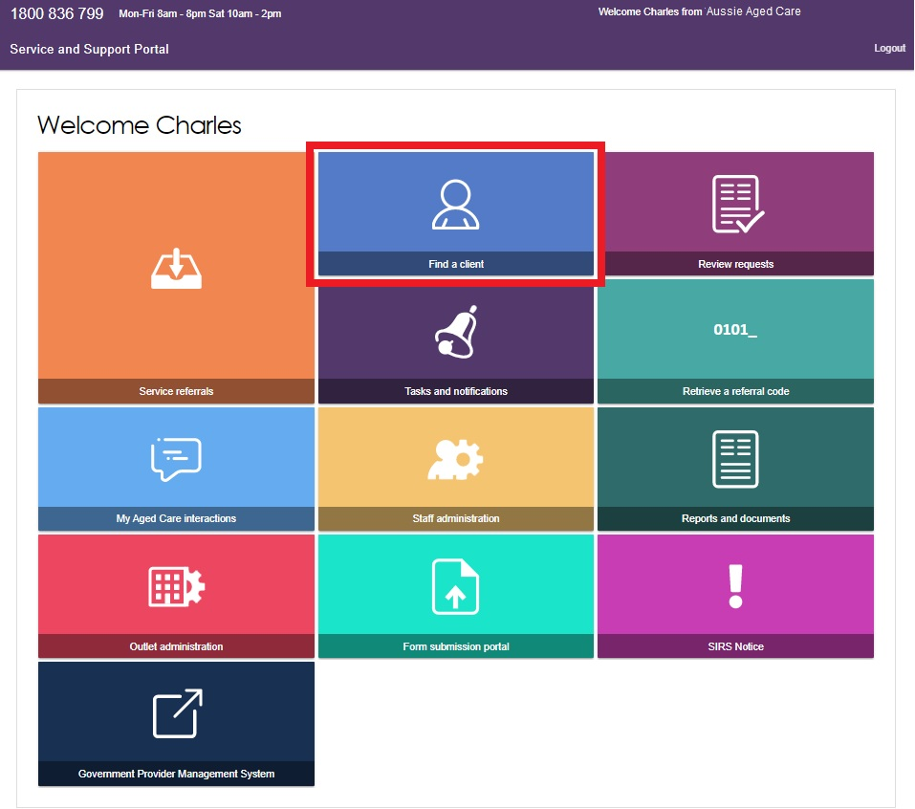
- Enter the client's First Name, Last Name, or Aged Care User ID, and then select Search. To view additional search options, select Advanced Search.
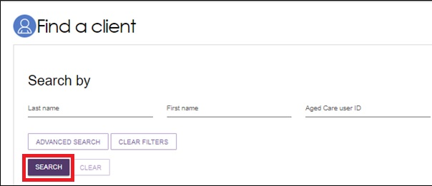
- On the Find a Client page, the Recently Viewed Persons section shows clients you have recently accessed. Select a client's name to open their record. The system displays any matching search results.
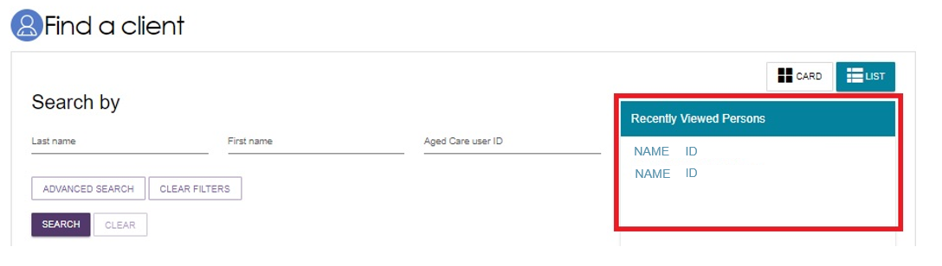
- Use Advanced Search to apply additional filters or combine multiple filters to narrow your search results.
The filters available include:
- Aged Care Management Payment System (ACMPS) number
- Centrelink Customer Reference Number (CRN)
- Client status
- Date of birth
- Department of Veterans’ Affairs (DVA) card number
- Home contact number
- Locality
- Medicare Card number
- Postcode
- Preferred name
- State
- Suburb
- System for the Payment of Aged Residential Care (SPARC) number.
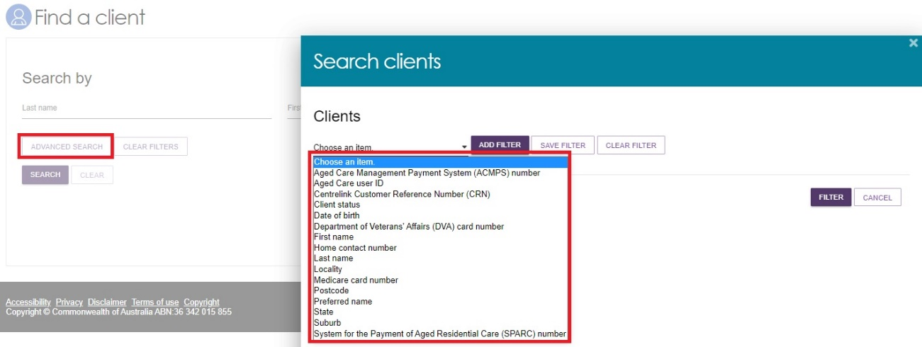

Viewing client information
After you find the client, you can view the information in the client's record. You can view all client information except contact details before you accept a referral.
- Select the client record using one of three ways.
- Select the client's name from the search results.
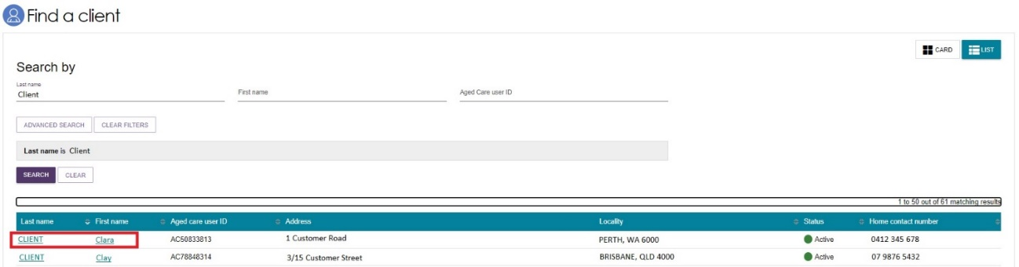
- In the Find a Client section, select the client's name when using Card View.
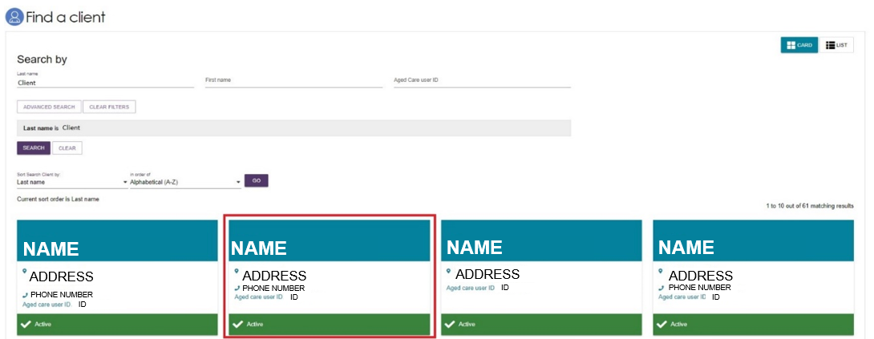
- Select Service Referrals, then:
- select the expansion arrow on the client card in Card View, or
- select the expansion arrow next to the record in List View,
then select View Client Record.
Card view
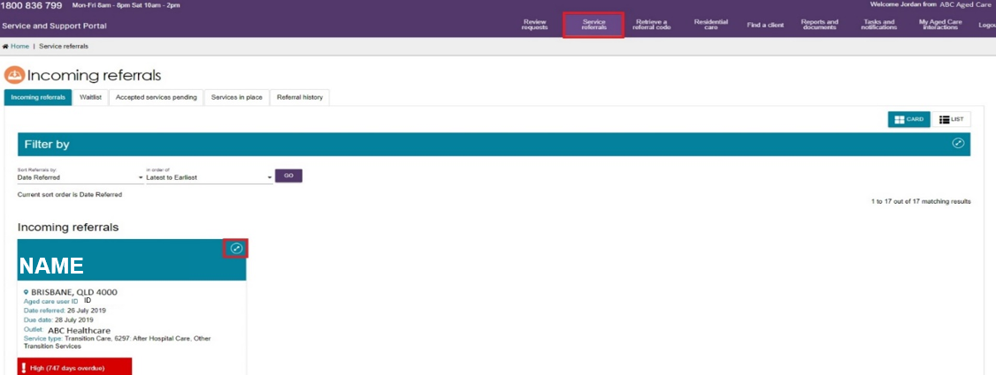
List view
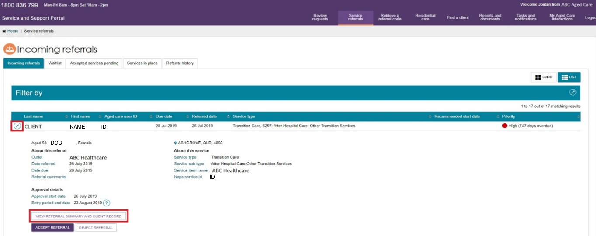
- The Referrals for my organisation page will be displayed.
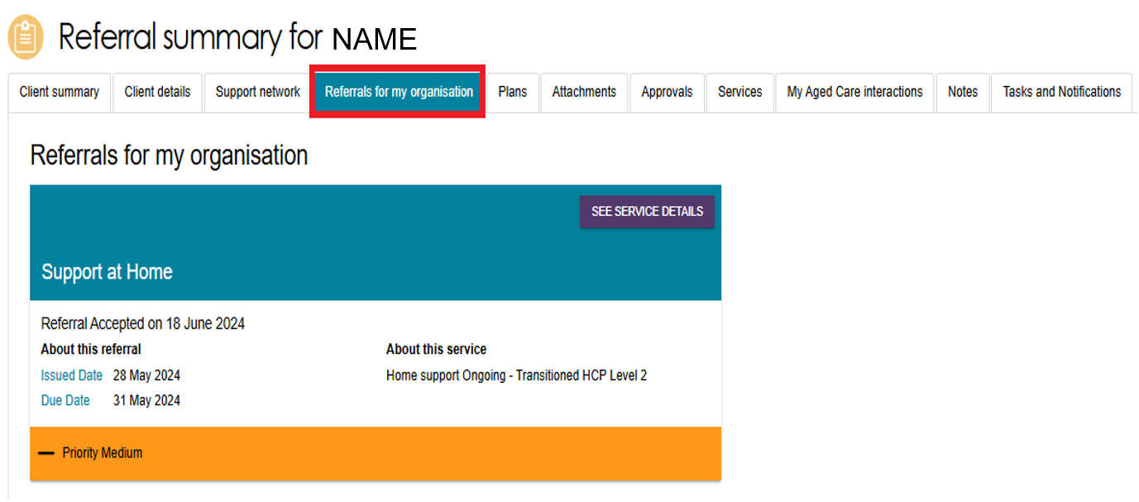

What information is in the client record?
The client record displays client information across 12 tabs. Each tab contains different information about the client and is described in more detail below.
The client record includes the following tabs:

- Client Summary
- Client Details
- Support network
- Referrals for my Organisation
- Plans
- Attachments
- Approvals
- Services
- My Aged Care interactions
- Notes
- Tasks and Notifications
- Residential Care.

Client Summary
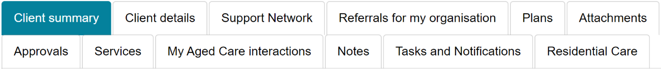
The Client summary tab contains a dashboard of key information about the client’s interactions with My Aged Care.
The Client tracker section shows the Client Journey Tracker, which is a visual tool that shows where a client is in their My Aged Care journey and what happens next.
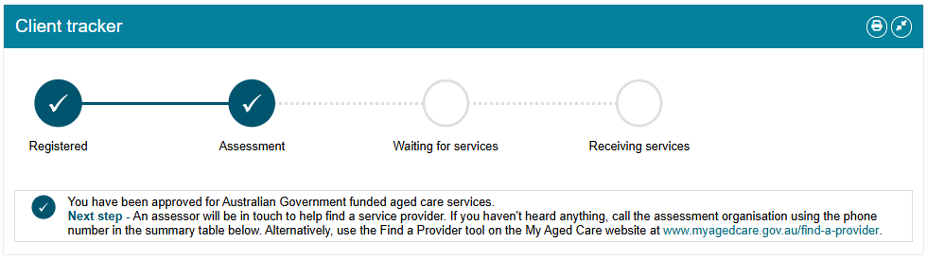
The Client summary section includes information about:
- Assessments.
- Recommendations and Approvals
- Urgency and Priority categories for residential care clients
- Service recommendations
- Service delivery status
- Client goals
- Reablement and linking support periods, where available).
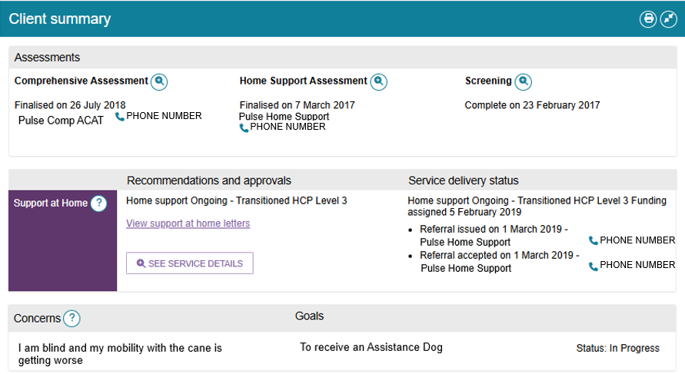

To print the Client Summary information, select Print Page on the right side of the relevant heading. The information prints in the same format shown in the portal.
To expand the Client Summary section, select the double-arrow icon next to the Print Page icon.
You can use these two features on any tab in the client record page.

Client Details
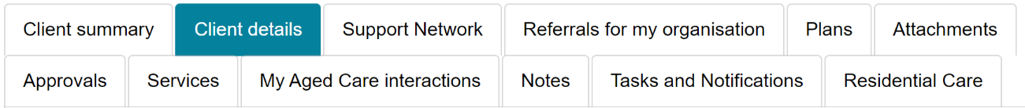
The Client Details tab provides the client's basic personal and contact information. It also shows summary information about active support plans, services, current notes, and primary contact details.
You can also use this tab to notify My Aged Care when a client has passed away.
.
The Primary Contact is usually the client. However, the client can nominate another person, such as an agent or registered supporter, as the primary contact. This information helps assessors, My Aged Care contact centre staff, Aged Care Specialist Officers, and service providers identify the main contact for the client. It does not affect any system-generated correspondence that My Aged Care sends to the client.
To update client information, select the Edit (pencil) icon next to any section that allows editing.
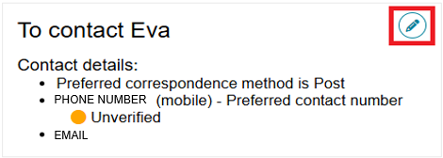
My Aged Care can send email and SMS notifications to clients and members of their support network (except Supporters Lite) when the client reaches key stages in their aged care journey. These stages include:
- completing client registration
- finalising an assessment
- approving the client for care after a comprehensive assessment
- assigning a service under the Support at Home Program
- submitting a Support Plan Review request
- activating, declining, inactivating, or approaching the expiry of a support relationship
- submitting or processing documents related to a support relationship
- generating a Support at Home letter, such as a funding allocation or withdrawal letter.
Clients, registered supporters who are authorised to receive the client's information automatically, and relevant support people automatically receive copies of Support at Home letters.
Registered supporters can stop receiving these letters by contacting My Aged Care.
When My Aged Care generates a Support at Home letter, it sends a notification to the client and the relevant people in the client's support network:
- Supporter
- Supporter Manager
- Agent
- Agent Manager
- Organisation Supporter
- Organisation Agent.
! | When you mark a client as Deceased, the system changes the client record to read-only. You cannot edit the client's information after this change.  You can still add notes and attachments to the client record, and you can finalise assessments after updating the client's status.  The system displays a Deceased status banner on every tab of the client record.  If the Deceased status is incorrect, contact the Service Provider and Assessor Helpline on 1800 836 799.

Support Network
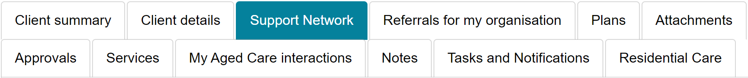
The Support Network tab shows the people and organisations that support the client throughout their aged care journey.
The client's support network can include:
- registered supporters (individuals and organisations)
- Supporter Lite contacts
- agents (organisations)
- carers
- emergency contacts
- GPs
- support persons.
Supporter guardians can choose not to let My Aged Care send letters to the client. However, supporter guardians must continue to receive these letters themselves and cannot opt out.
You can also use the Support Network tab to notify My Aged Care when a person listed in the client's support network has died.
Carers listed in the Support Network tab can request callbacks from the Carer Gateway and the Dementia Australia - National Dementia Helpline.

Referrals for my organisation
The Referrals for My Organisation tab shows all service referrals that your organisation has received or accepted.
This tab helps you view and manage referrals and identify any referrals that require action.
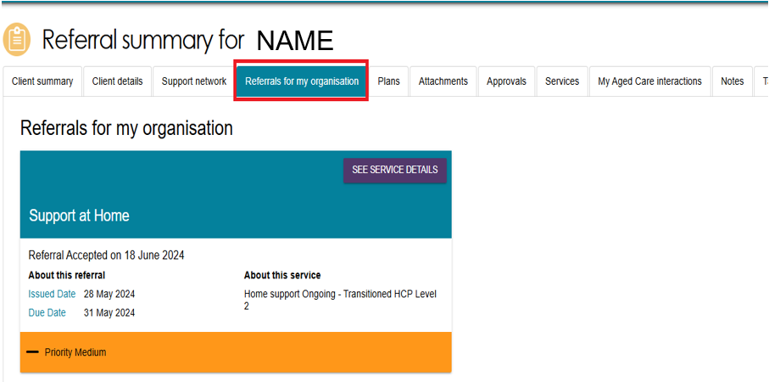
This example shows a referral that requires action. Use the ACCEPT REFERRAL or REJECT REFERRAL button to respond to the referral.
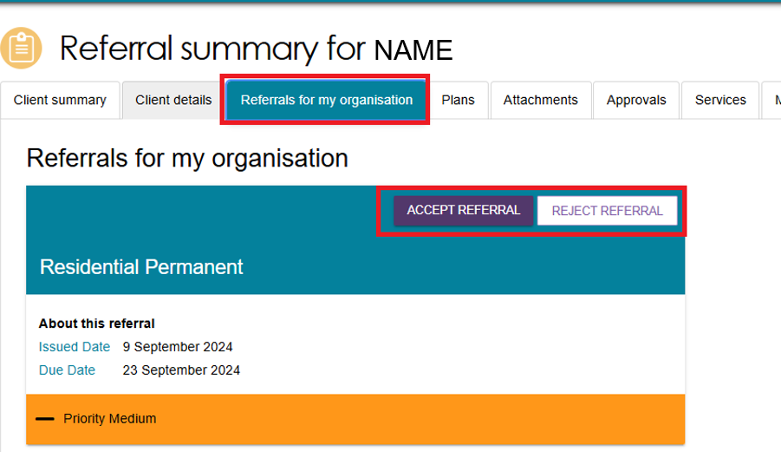

Plans
The Plans tab provides detailed information about the client's current and previous screenings and assessments. It includes the client's goals, recommendations, motivations, and support plan.
To view more information, select the double-arrow icon next to a heading. The system will display the detailed information recorded during the assessment.
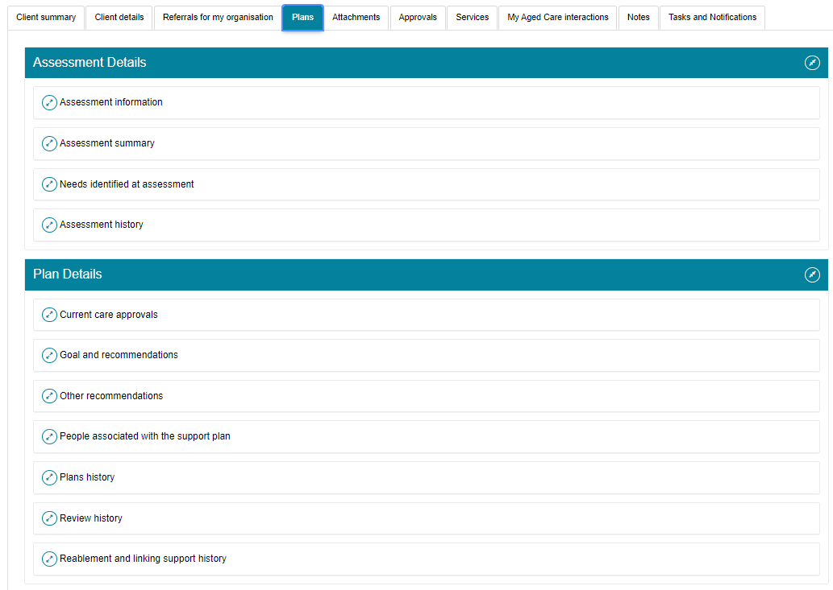
The Plans tab allows providers to view a client's support plan, previous screenings, and assessments in read-only mode. Providers can print this information when required.
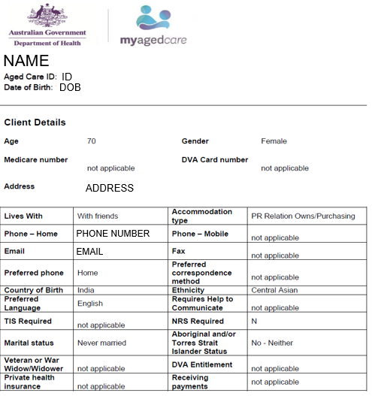

Attachments
The Attachments tab stores documents attached to the client record. You can also use this tab to add new documents.
- Select Add an Attachment from the Attachments page.
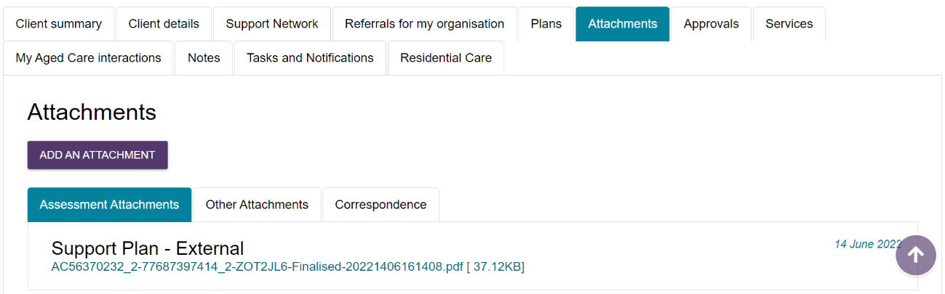
- Select Choose File and select the document you want to upload.
Enter the required information, including the attachment name and document type.
Select Upload to add the document to the client record.
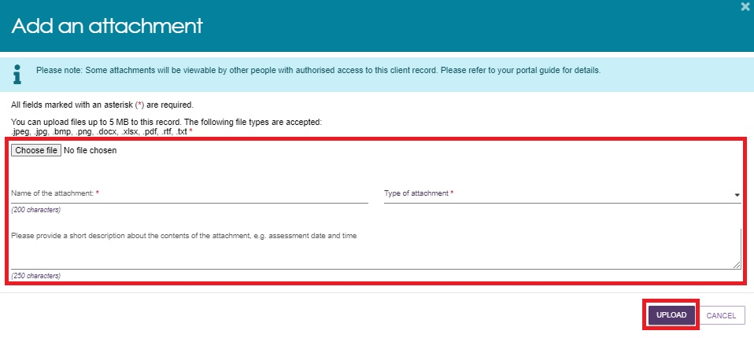
The Type of Attachment drop down menu includes the following options:
Assessment Attachments: Upload documents that support the client's assessment, such as clinical notes or discharge summaries.
Other Attachments: Upload documents related to the client's circumstances, including:
- documents that establish a support relationship, such as legal documents or an Appointment of Support Person or Organisation form
- occupational therapist drawings used for home modifications
- documents that support a request to extend a home modifications approval period.
You can view a client's Statement of Reasons in this section, but you cannot upload it.
Correspondence: This category contains letters and documents generated in My Aged Care for Home Support and Residential Care services. My Aged Care sends these letters to clients at different stages of their care journey and may also send copies to registered supporters.

Sensitive Attachments: they contain information that requires additional protection, such as:
- financial information
- safety concerns
- legal matters that may affect service delivery.
! | If a client record contains a Sensitive Attachment, service providers who receive a referral for the client or provide services to the client will see a notification that a Sensitive Attachment exists. Contact the assessor or the My Aged Care Service Provider and Assessor Helpline for more information about a Sensitive Attachment.  If someone uploads an attachment by mistake, contact the My Aged Care Service Provider and Assessor Helpline on 1800 836 799 to request its removal.

Approvals
The Approvals tab shows the client's approvals for aged care services under both the Aged Care Act 2024 and the Aged Care Act 1997. This tab also includes approvals that were recorded before My Aged Care began, where the client's record links to Services Australia systems, such as Centrelink and Medicare.
If the client has a Home Support service approval, the Current Care Approvals section displays the approved classifications and any short-term pathways.
The example below shows how Home Support services and non-Support at Home services appear when you expand the approval details.
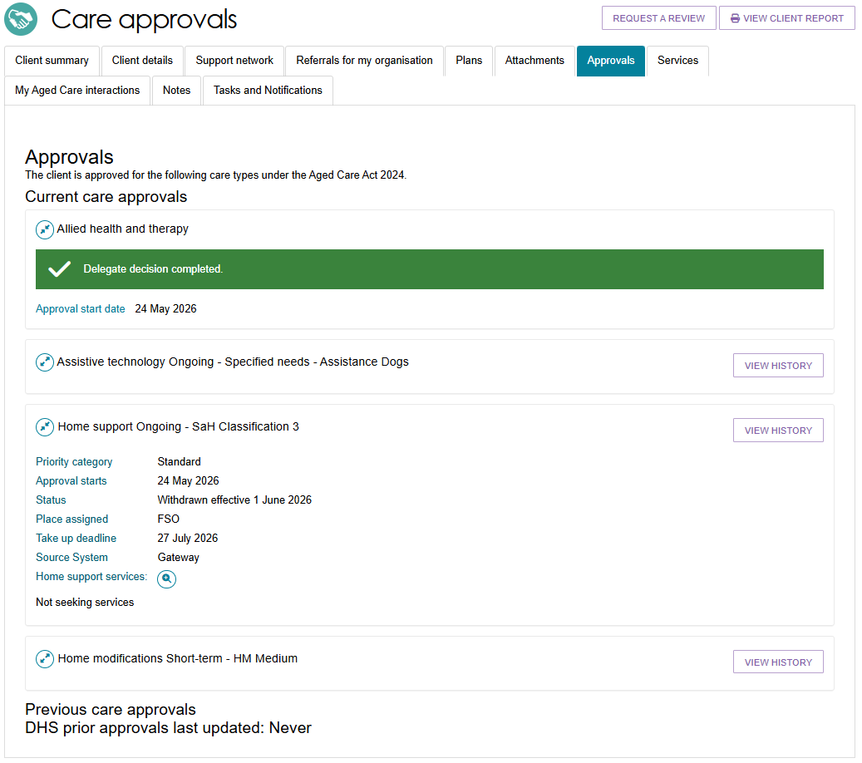

Services
The Services tab shows the client's current, pending, and past services. Select the expand icon  next to each item to view the details:
The tab includes:
- services the client is currently receiving
- services that are pending and not yet in place
- service referrals that providers have not yet accepted
- services the client received in the past
- services recorded in other systems that My Aged Care does not manage.
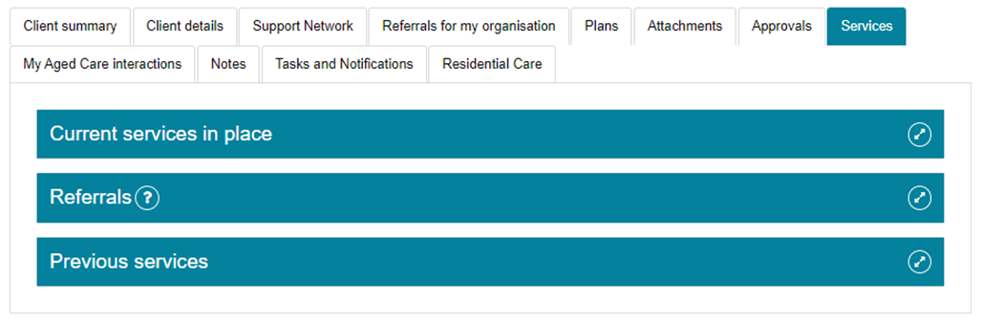
! Updating service delivery information is not available for clients referred to Support at Home services, as service information is already recommended and approved during the assessment.
The following images show a client with a Residential Permanent service in place and a Support at Home service in place.
Residential Permanent service in place
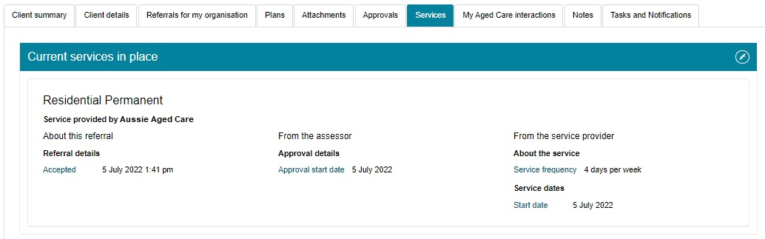
Support at Home service in place
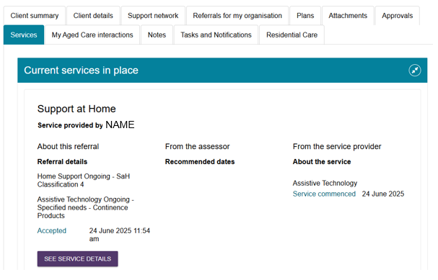

My Aged Care interactions
Use the My Aged Care Interactions tab to view the client's past interactions with My Aged Care, including contact centre enquiries and phone calls.
If applicable, the tab also shows interactions with the Carer Gateway and the National Dementia Helpline.

Notes
The Notes tab shows all notes recorded about the client.
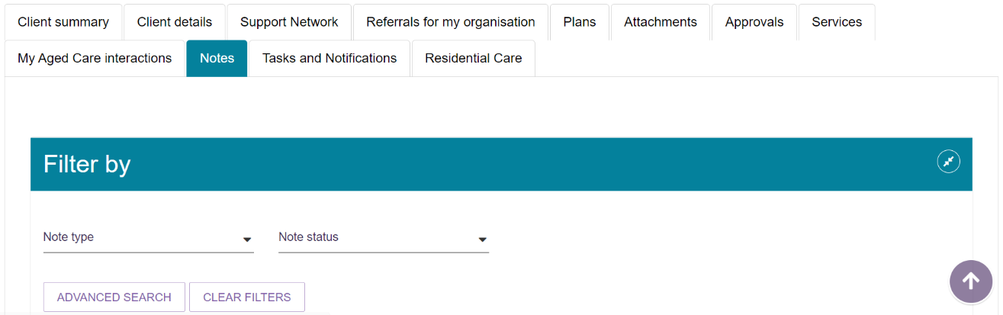
The table below describes the different types of notes available.
Note type | Who can add? | Who can view? | Description | Examples
Client story | Assessor | Client Assessor Provider | A summary of the client’s current circumstances. | Mrs Jones has just been discharged from hospital and is seeking help at home.  Lives with her husband and has early onset dementia.
Observations | Provider Assessor | Provider Assessor | Observations from service provider and/or assessors’ interactions with the client. | There is a dog on the property.  Mrs Smith seems more energetic than she did during my last visit.
Other | Client Provider Assessor | Client Provider Assessor | Additional information about the client. | Jennifer has planned respite on 01/08/2017.
! If My Aged Care contact centre staff or assessors add a Sensitive Note to a client's record, providers who receive a referral for that client will see a Sensitive Note alert. To access more information, providers must contact the My Aged Care contact centre.

Viewing and adding client notes
Follow these steps to add a note to a client record:
- Open the client’s record and select the Notes tab.
- Review the existing notes, then select Add a Note.
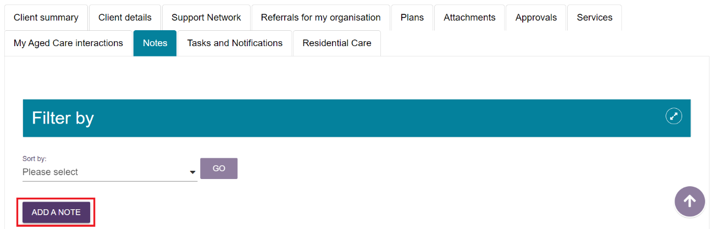

- In the pop-up window, select a Note Type and enter a description. Select Save to add the note to the client record.
The help icon in the pop-up window explains the different note types and helps you choose the most appropriate category.
Staff Members, Team Leaders, and service providers using the Service and Support Portal can add notes, but they cannot edit, delete, or inactivate existing notes.
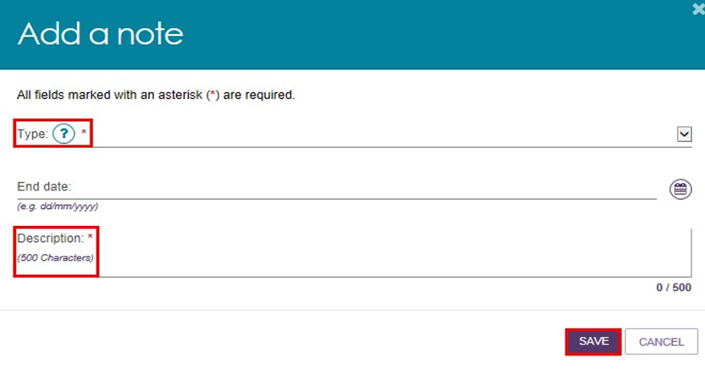

Tasks and notifications
The Tasks and Notifications tab shows all tasks and notifications for a single client.
You can only see tasks and notifications that relate to your outlet and to clients you provide services for.
The image below shows a notification when a new referral is created between a client and a Service and Support outlet.
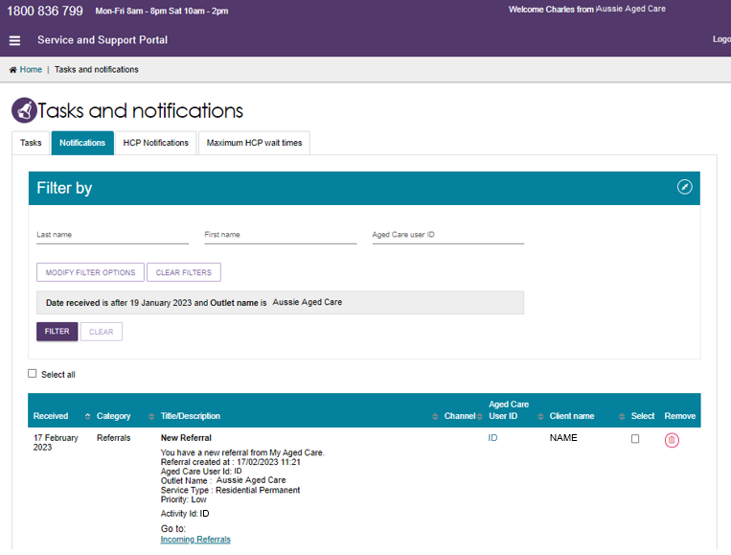

Residential Care
This section shows information for clients living in Residential Permanent Care or Residential Respite Care who have received an Australian National Aged Care Classification (AN-ACC) assessment or are currently having an AN-ACC assessment.
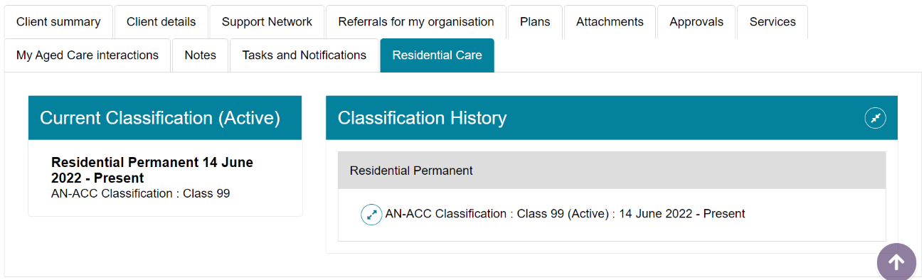

For more information or support
You can find more information on the My Aged Care for Service Providers page on the Department's website.
If you need help, call the My Aged Care Service Provider and Assessor Helpline on 1800 836 799. The helpline is available Monday to Friday from 8:00 am to 8:00 pm and Saturday from 10:00 am to 2:00 pm.

