Service and Support Portal User Guide - Recording and updating client service delivery information
This guide is for Staff Members and Team Leaders who use the My Aged Care Service and Support Portal. It explains how to record and update service delivery information in a client's record. Team Leaders can manage referrals and perform all the tasks available to Staff Members.
You must record service delivery information for every client who has accepted a service. This includes:
- the service start date
- the service frequency
- the service end date, if the service has ended.
Enter this information within 14 calendar days of accepting the service. If the information is not recorded within this period, the system will send reminder notifications.
For Home Support and Permanent Residential Care services, the service start date is automatically populated from Services Australia records and cannot be edited. Providers must still maintain other service delivery information, such as service frequency.
For more information about updating service delivery information, refer to the My Aged Care for service providers section on the Department’s website.
Adding service delivery information 2
Viewing service delivery information 4
Updating service delivery information 7
Recording note of changes made to client service information 9
Requesting an extension to the client’s care (Transition Care and Residential Respite) 11
Requesting an extension to the client’s care (Support at Home) 14
Requesting a Support Plan Review 22
For more information and support 26

Adding service delivery information
! | Adding service delivery information is not available for clients referred to Home Support services, as service information is already recommended and approved during the assessment.
- From the Services and Support Portal home page, select Service Referrals.
If you know the client’s name, you can also use Find a Client.
Select the Accepted Services Pending tab.
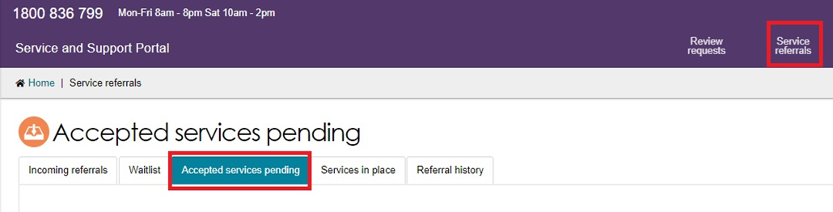
- Find the client’s referral:
  - In Card View, select the arrow on the client card and then select ADD SERVICE INFORMATION.
- In List View, expand the client record and select ADD SERVICE INFORMATION.
Card View
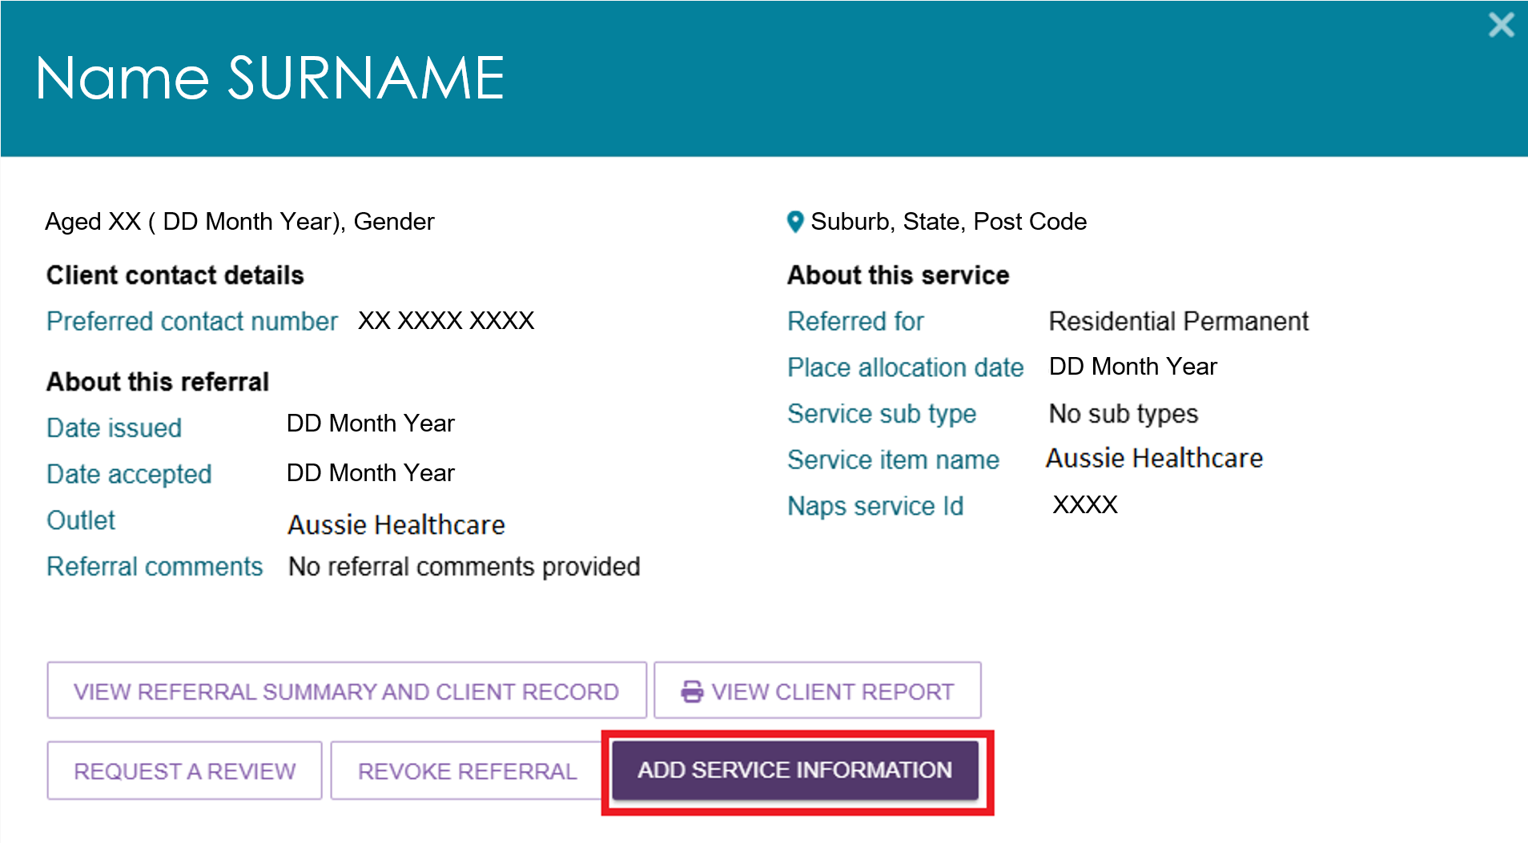
List View
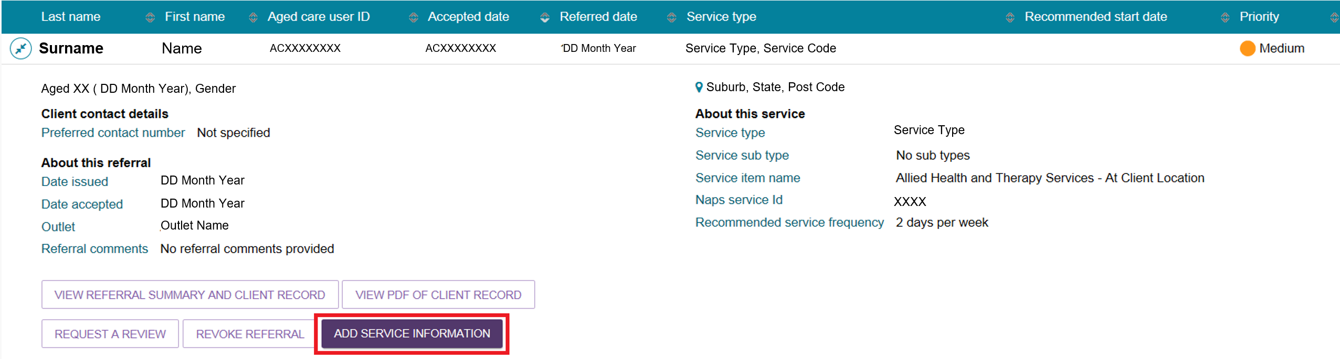
! | For Home Support service referrals, the Add Service Information button is not available because the service information is recommended and approved during the assessment.  To view details of the recommended services, select the Expand button.  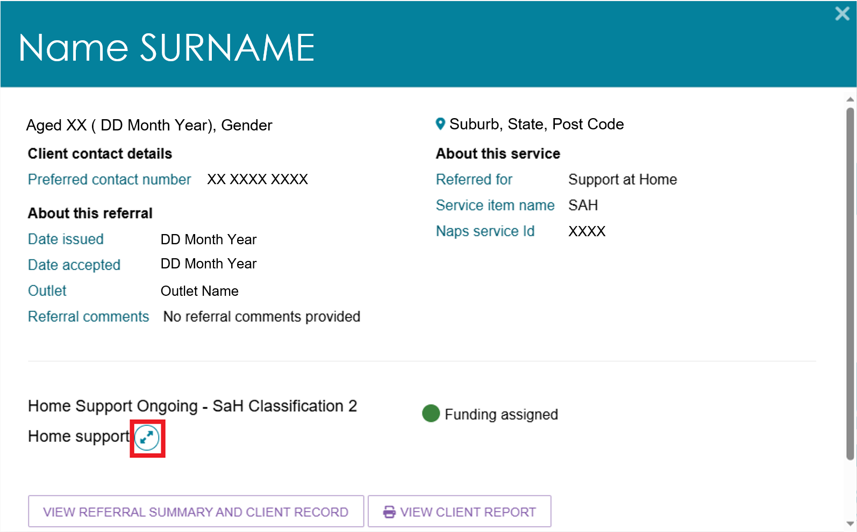
- The Add Service Information screen opens.
For Residential Respite Care, Transition Care, and Commonwealth Home Support Programme (CHSP) services, enter:
- Service Start Date
- Frequency
- Intensity.
These fields are mandatory. Enter any additional information in the remaining fields.
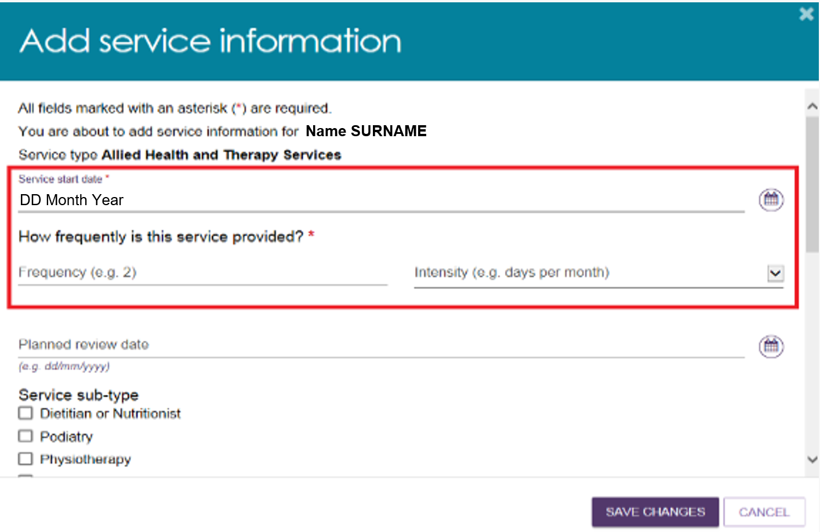
To record specific service delivery details, select Other – Specify and enter the information in the free-text field.
Select SAVE CHANGES.
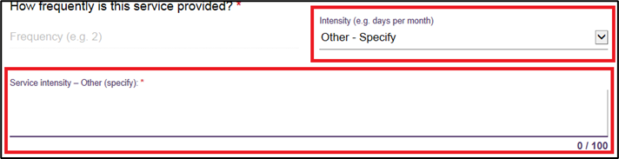
- After you save the information:
- The service information appears in the Services section of the client record.
- The system updates the service start date when it receives commencement information from Services Australia.
- The client information moves from Accepted Services Pending to Services in Place. This happens for residential care including respite, transition care, and Commonwealth home support programme services, and once a Service start date is available, for Home Support services.
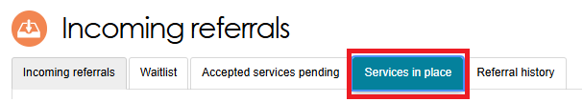

Viewing service delivery information
After adding service delivery information, The Services tab of the client record will now display the following:
Non-Home Support services:
- Service status, such as: Not yet in place; In place
- Name of service, such as ‘Residential permanent’
- Who is providing the service and the date of the provider’s acceptance
- Referral details
- Approval details
- Service key dates.
Home Support services:
- Service status, such as: Not yet in place; In place
- Name of service group is ‘Support at Home’
- Urgency category (urgent, high, medium, low)
- Name of approved service type, classification and whether it is ongoing or short-term
- Funding status: Pending, Approved or Withdrawn
- Service start date
- Who is providing the service and the date of the provider’s acceptance.
To view more details about an approved Support at Home service from Service Referrals:
- Go to Service Referrals from the portal home page.
- Select the Accepted services pending tab.
- Select the client’s record in Card view or List view. Select View Referral Summary and Client Record to open the client record.
- On the Referrals for My Organisation page, select See Service Details on the top right of the Support at Home referral card.
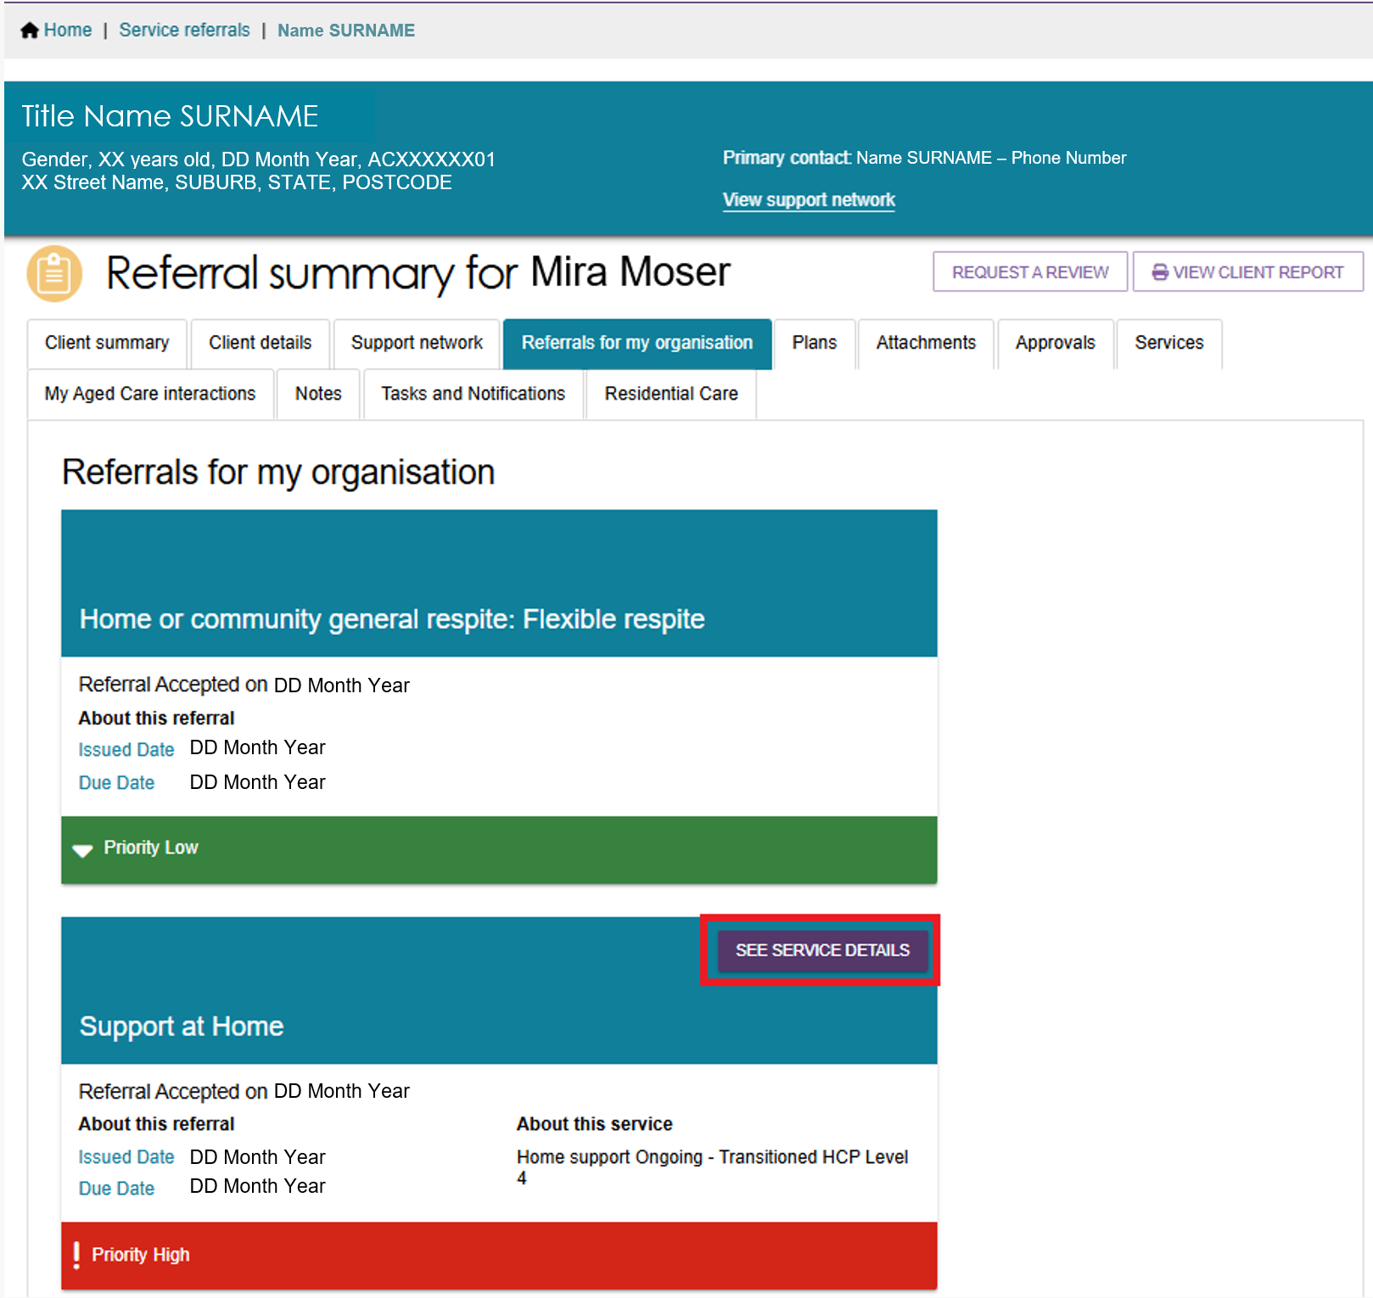
- Select the Expand button next to the service type name to view the service details.
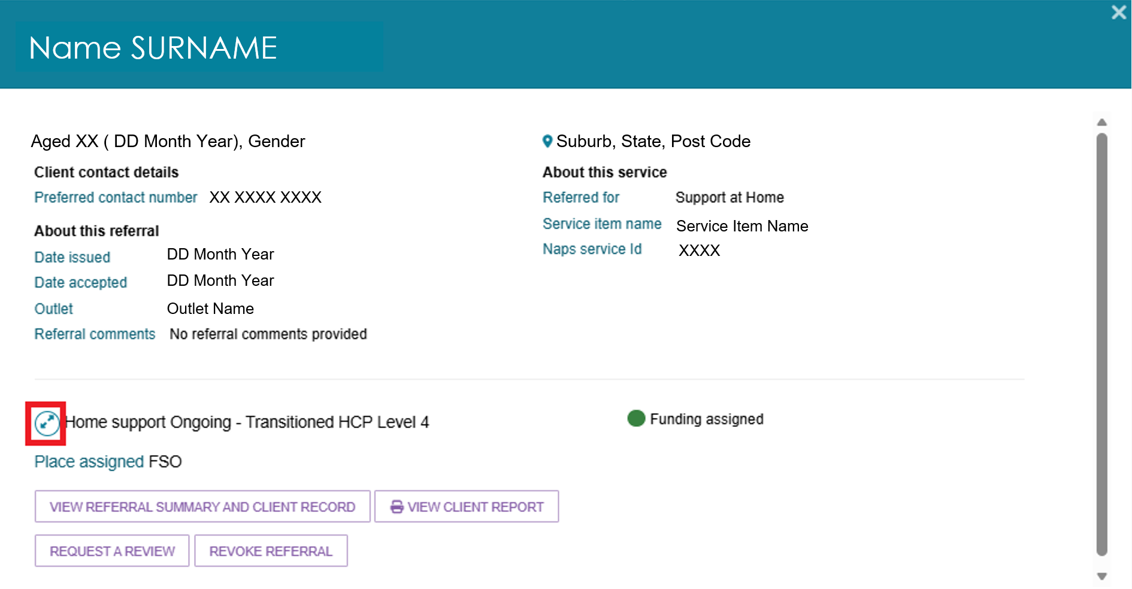
To view service details from the Services tab:
- Go to Find a Client from the portal home page.
- Search for your client, or select one from the Recently Viewed Persons section.
- The Client Summary displays. Select the Services Tab.
Non-Support at Home service example
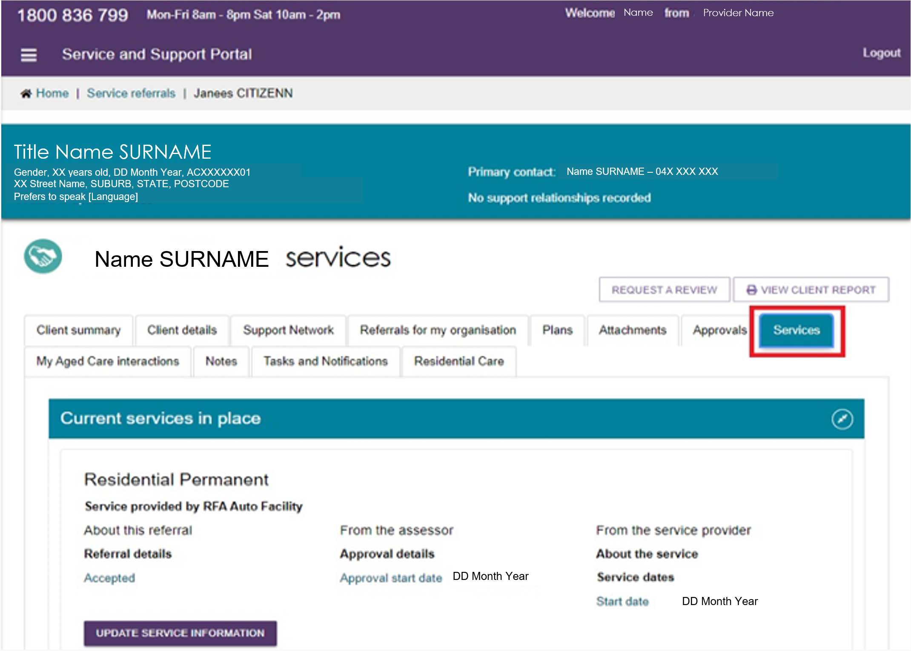
Support at Home service example
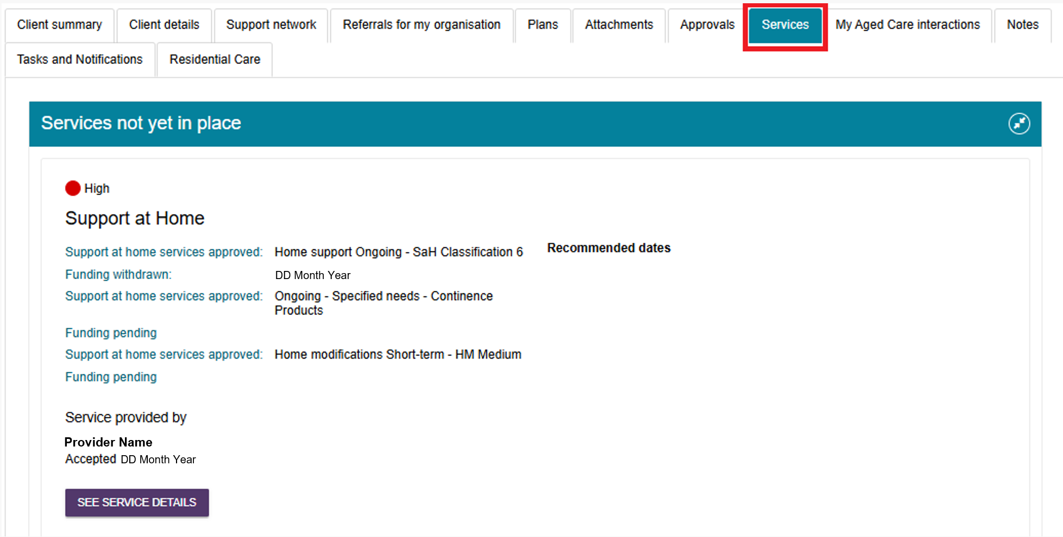

Updating service delivery information
The Services in Place tab in the Service Referrals section of the Services and Support Portal shows accepted services that include recorded service delivery information.
! | For Support at Home services, you cannot update service information because an assessor approves the required services.
- Open the Services in Place tab by selecting Service Referrals from the home page, the navigation banner, or the menu in the top-left corner.
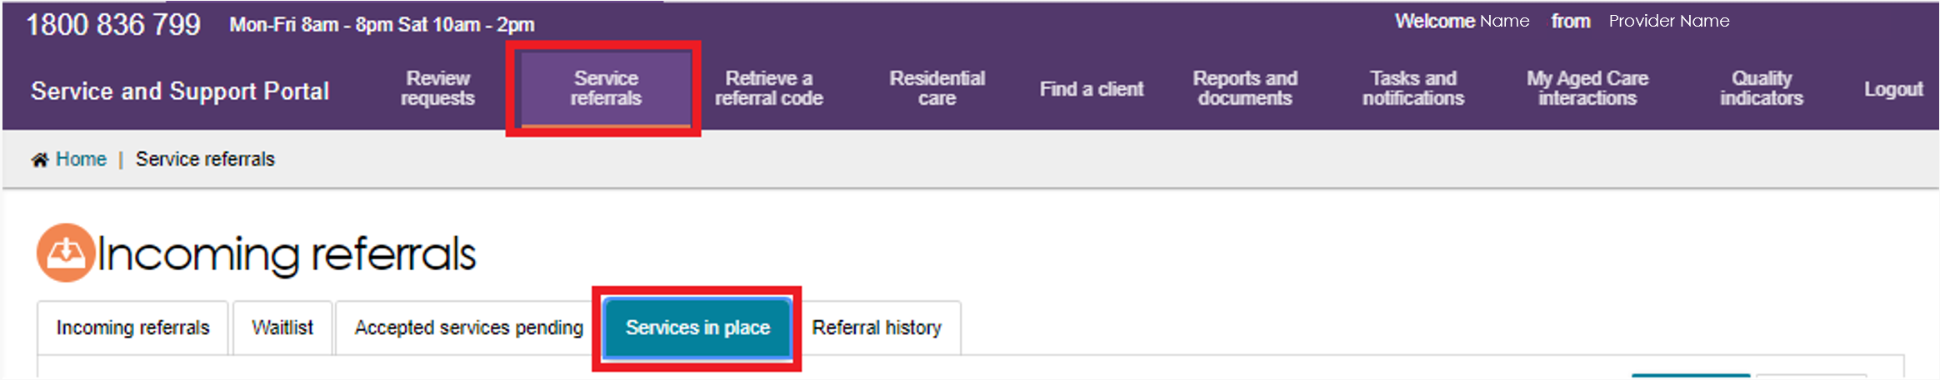
- Find the service you want to update.
- In List View, expand the client record and select UPDATE SERVICE INFORMATION.
- In Card View, expand the client card and select UPDATE SERVICE INFORMATION.
Update the service information and select SAVE CHANGES.
The system updates the information in both the Services in Place tab and the Services tab of the client record.
Card View
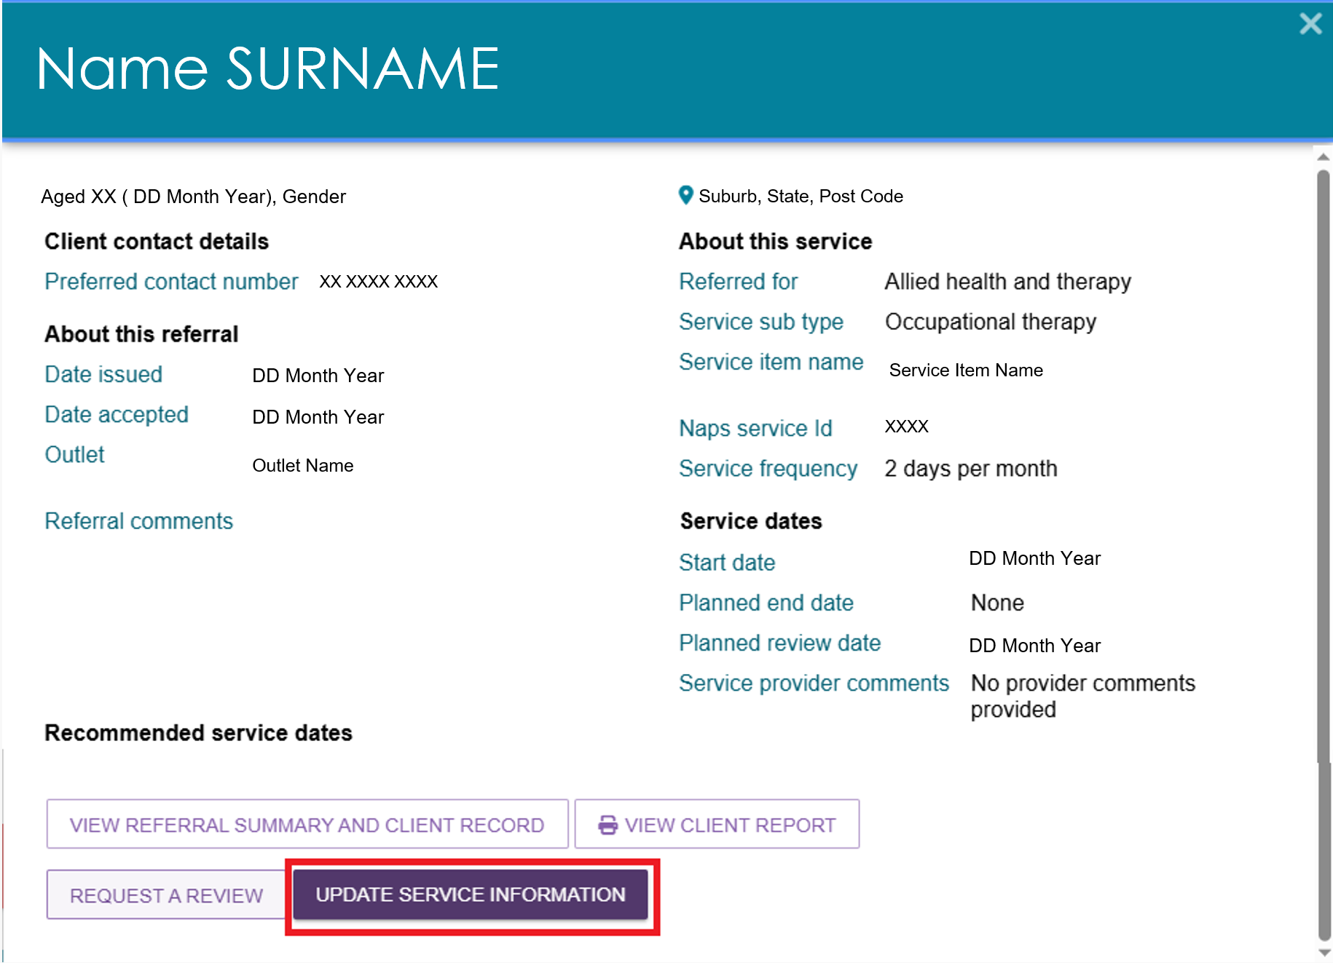

List View
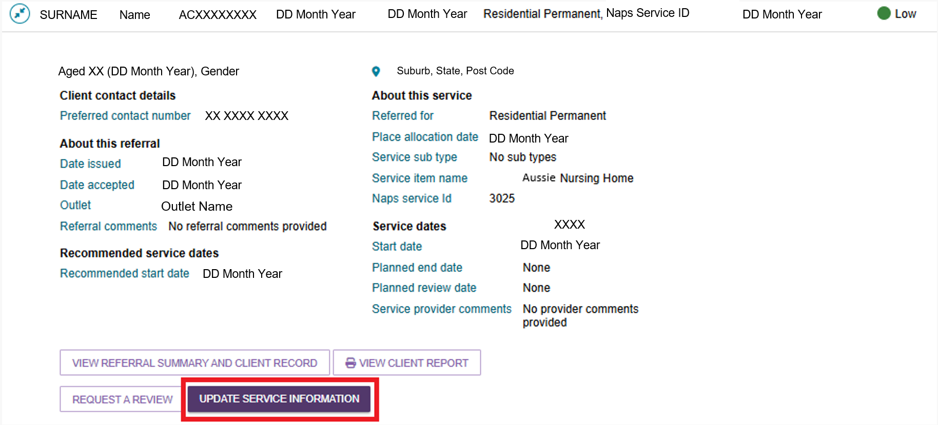
- You can also update service information from the Services tab in the client record.
- Select UPDATE SERVICE INFORMATION next to the relevant service.
- Make the required changes and select SAVE CHANGES.
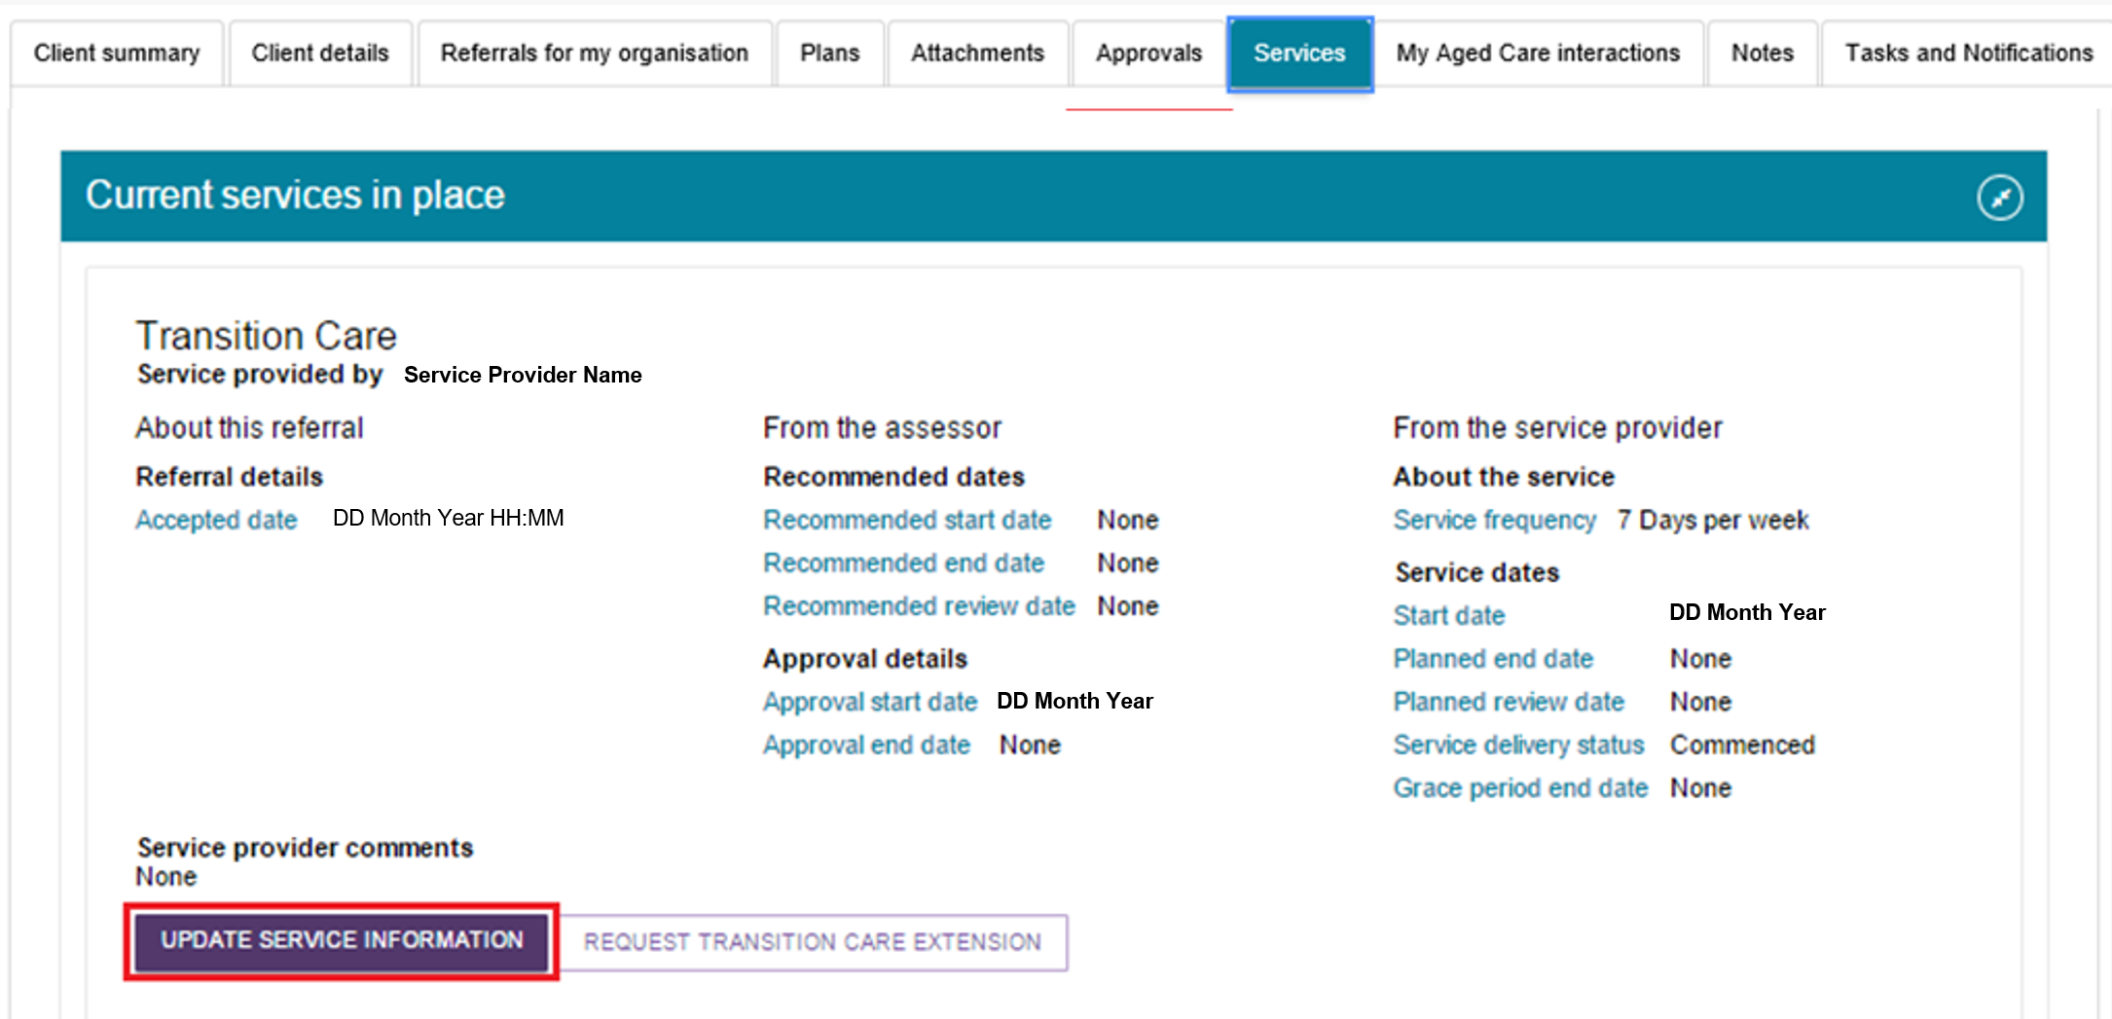
! | If you cease a client’s service and select Client Deceased as the reason, the system changes the client’s status to Deceased and makes the client record read-only. When you update a client’s status to Deceased, the system will:  1. Recall any unaccepted service referrals.  2. Cease all services currently in place.  3. Cancel any assessments in progress.  4. Revoke the client’s access to the client portal.  You can add notes and attachments to a client’s record for up to 14 days after you cease their services.  After the status changes to Deceased, My Aged Care will no longer send correspondence to the client or their support network. However, service providers will receive a notification reminding them to close or finalise any activities still in progress for the client.  If the client is active in the Support at Home Priority System or has an assigned Support at Home classification, the system will remove the client from the Priority System and withdraw any assigned Support at Home funding.  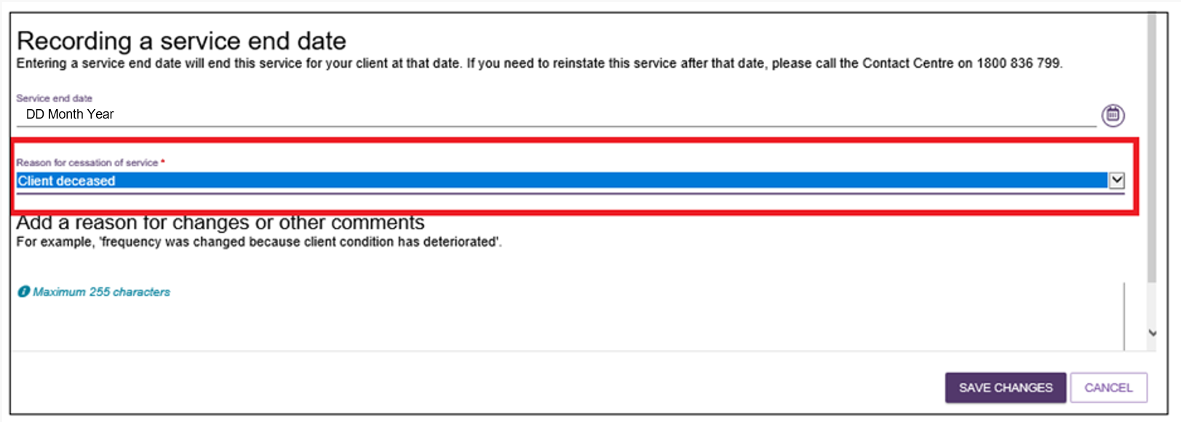

Recording note of changes made to client service information
My Aged Care Contact Centre staff, assessors, and providers can view and add notes to a client’s record in the My Aged Care portals.
If a client’s service delivery information changes significantly, update the service information and add a note to the client record.
! | If a client’s needs or circumstances have changed since their last assessment, a review of the client’s support plan may be required.
Providers can add the following types of notes:
- Observations: Information recorded during interactions with the client by a provider or assessor. Assessors and providers can view these notes.
- Other: Additional information about the client. Assessors, providers, and clients can view these notes.
Providers can only view notes with the following note types:
- Client Story
- Other
- Observations.
If My Aged Care Contact Centre staff or an assessor adds a Sensitive note to a client’s record, the system displays a banner advising providers to contact the My Aged Care contact centre for more information.
The contact centre will only share information from a sensitive note when it is relevant to the provider’s role in supporting the client.
To add a note to the client record:
  - Open the client record and select the Notes tab.
- The client’s existing notes will display.
- For more information about accessing a client record, refer to My Aged Care Service and Support Portal user guide – The client record.
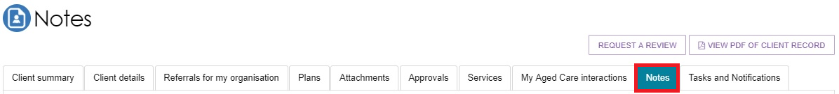
  - Select ADD A NOTE.
- Choose the appropriate Note Type.
- Enter a description.
- Select SAVE to add the note to the client record.
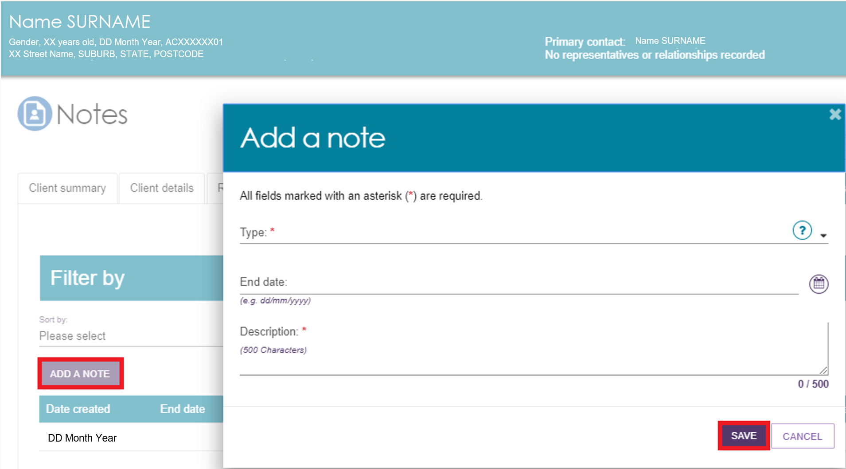
Alternatively, from the Client Details tab, select ADD A NOTE in the Current Notes section.
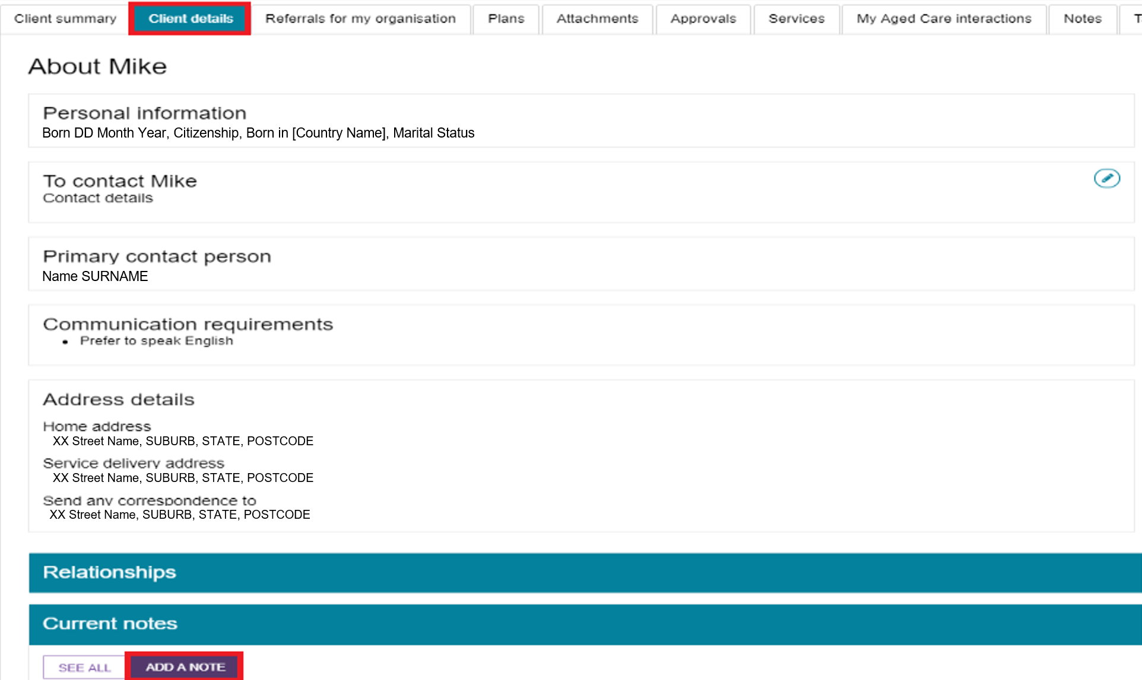
  - You can add Other and Observations notes to the records of any clients referred to your outlet, including clients in the Incoming Referrals tab.
My Aged Care Contact Centre staff, assessors, and other providers supporting the client can view these notes.
Select the blue question mark icon for information about each note type and who can view it.
For more information about note types and permissions, refer to Service and Support Portal User Guide - The Client Record.

Requesting an extension to the client’s care (Transition Care and Residential Respite)
You can request care extensions, including respite care extensions, through the Services and Support Portal. The system sends the request to a Delegate for approval.
If you cannot submit a care extension request through the portal, call the My Aged Care Service Provider and Assessor Helpline on 1800 836 799.
You can extend:
- Transition Care for up to 42 consecutive days.
- Residential Respite Care for up to 21 non-consecutive days.
A care extension takes effect from the commencement date entered in the request, subject to Delegate approval. You cannot backdate extension requests unless special circumstances apply.
For more information about care extensions and eligibility requirements, refer to the My Aged Care Assessment Manual.
! | Submit extension requests through the My Aged Care Services and Support Portal on or before the client's entitled days expire, if they need additional care.
! | You can only grant a care extension at the client’s current approved level of care. If the client needs a higher level of respite care, they must receive a new Respite Classification. To arrange this, request a Residential Respite Assessment in the MyAssessor app.
To request a care extension:
- Locate the client who requires a care extension.
- Go to the Services in Place tab and expand the client record in either Card View or List View.
- Select REQUEST [CARE TYPE] EXTENSION.
Transition Care Extension Example
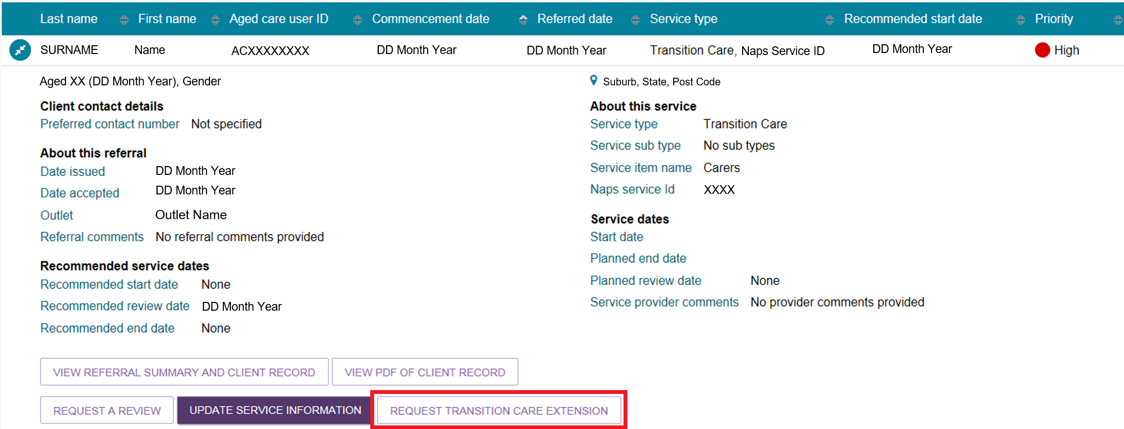
Residential Respite Care Extension Example
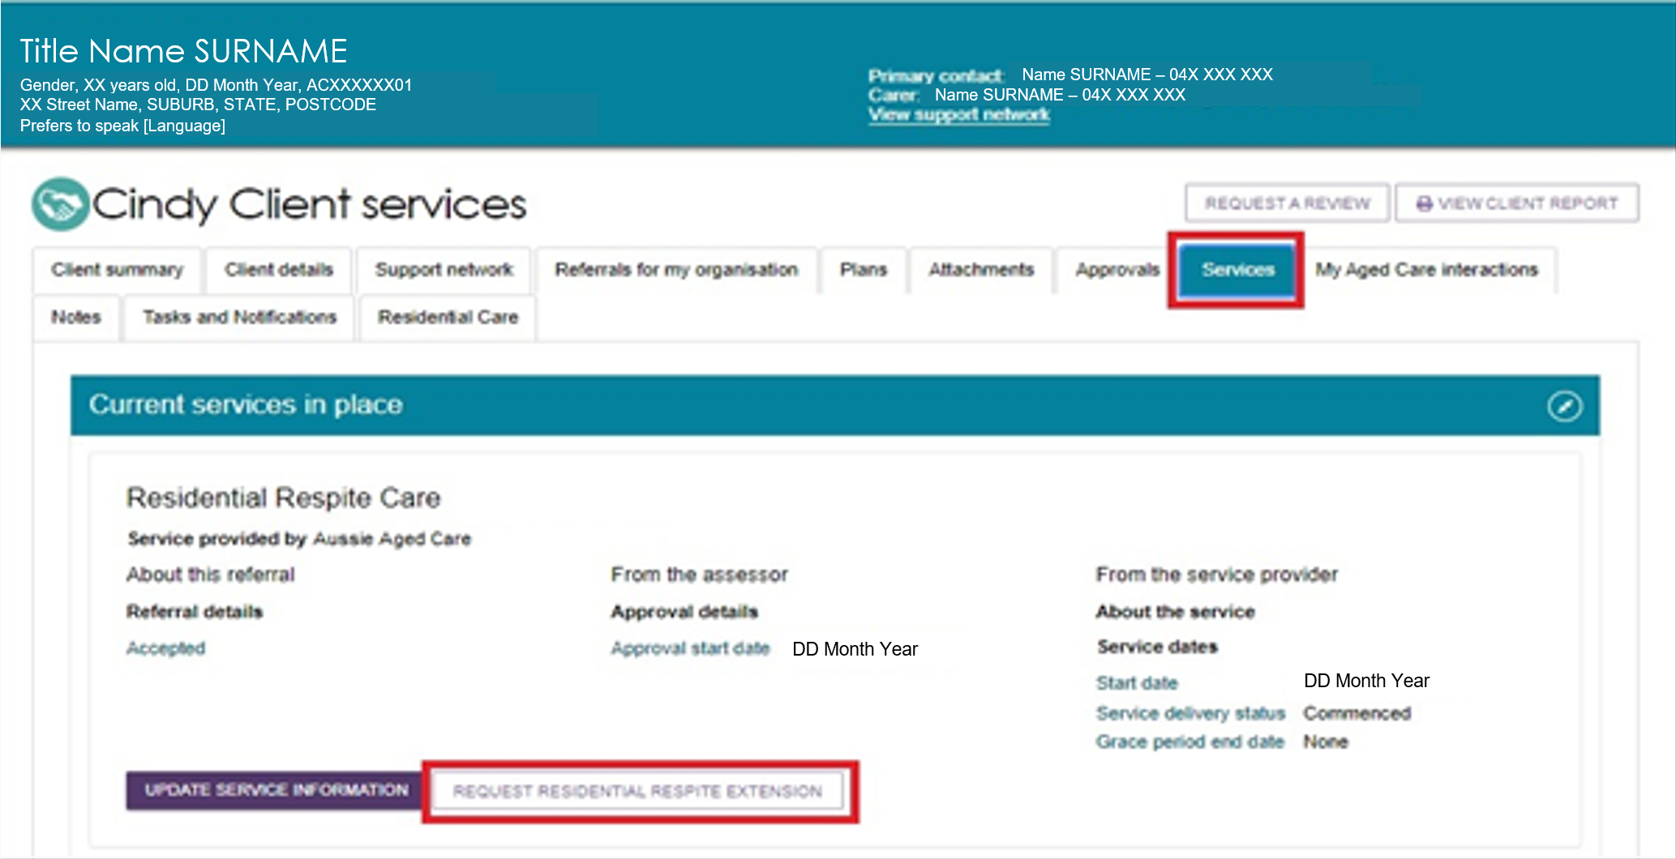
Alternatively, use Find a Client to locate the client, then open the Services or Approvals tab in the client record and select REQUEST [CARE TYPE] EXTENSION.
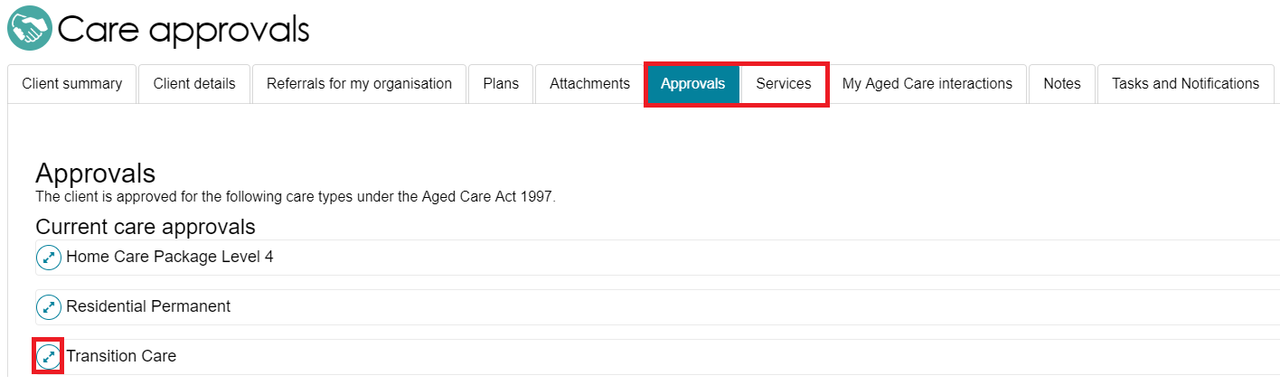
- Complete all required fields in the extension request pop-up.
- The required information varies depending on the type of care extension you are requesting.
- Include the client's paid days balance from the Services Australia Aged Care Payment System and the date you calculated the balance.
- Select SUBMIT REQUEST.
Transition Care Extension Example
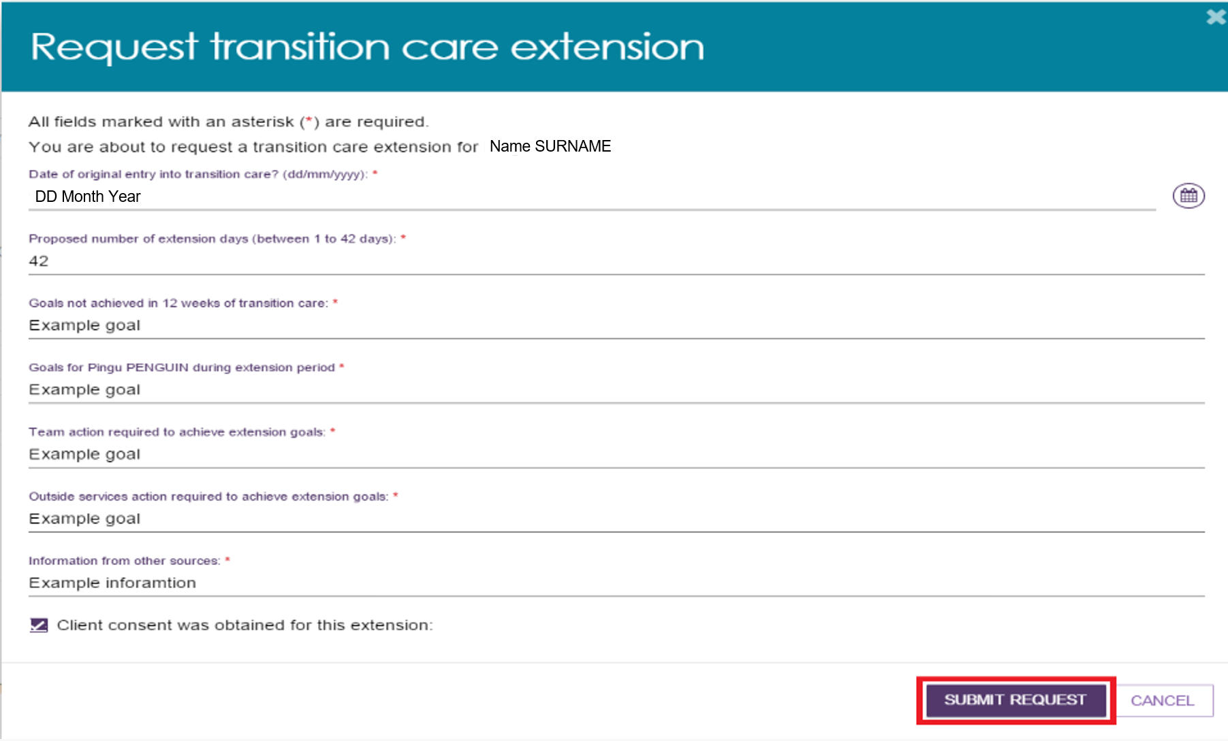
Respite Extension Example
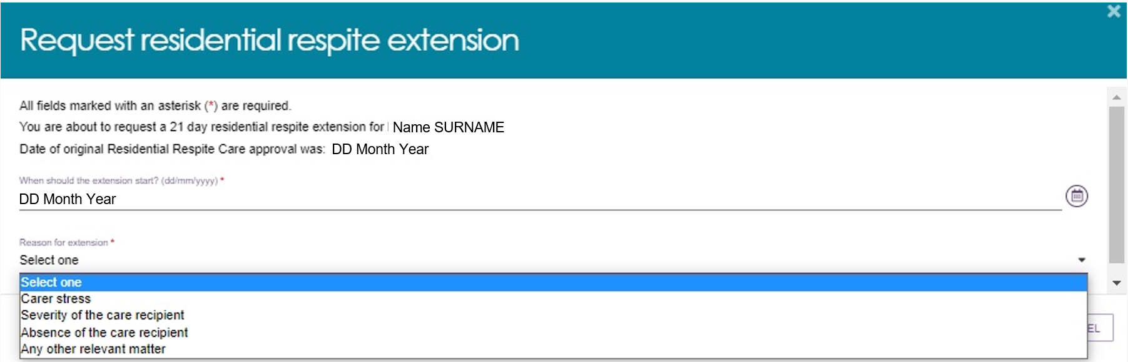
- The system displays a confirmation message when it submits the request to the Delegate.
- You will also receive a notification confirming that the request has been submitted.
The system will send you an email notification after the Delegate makes a decision on the care extension request.
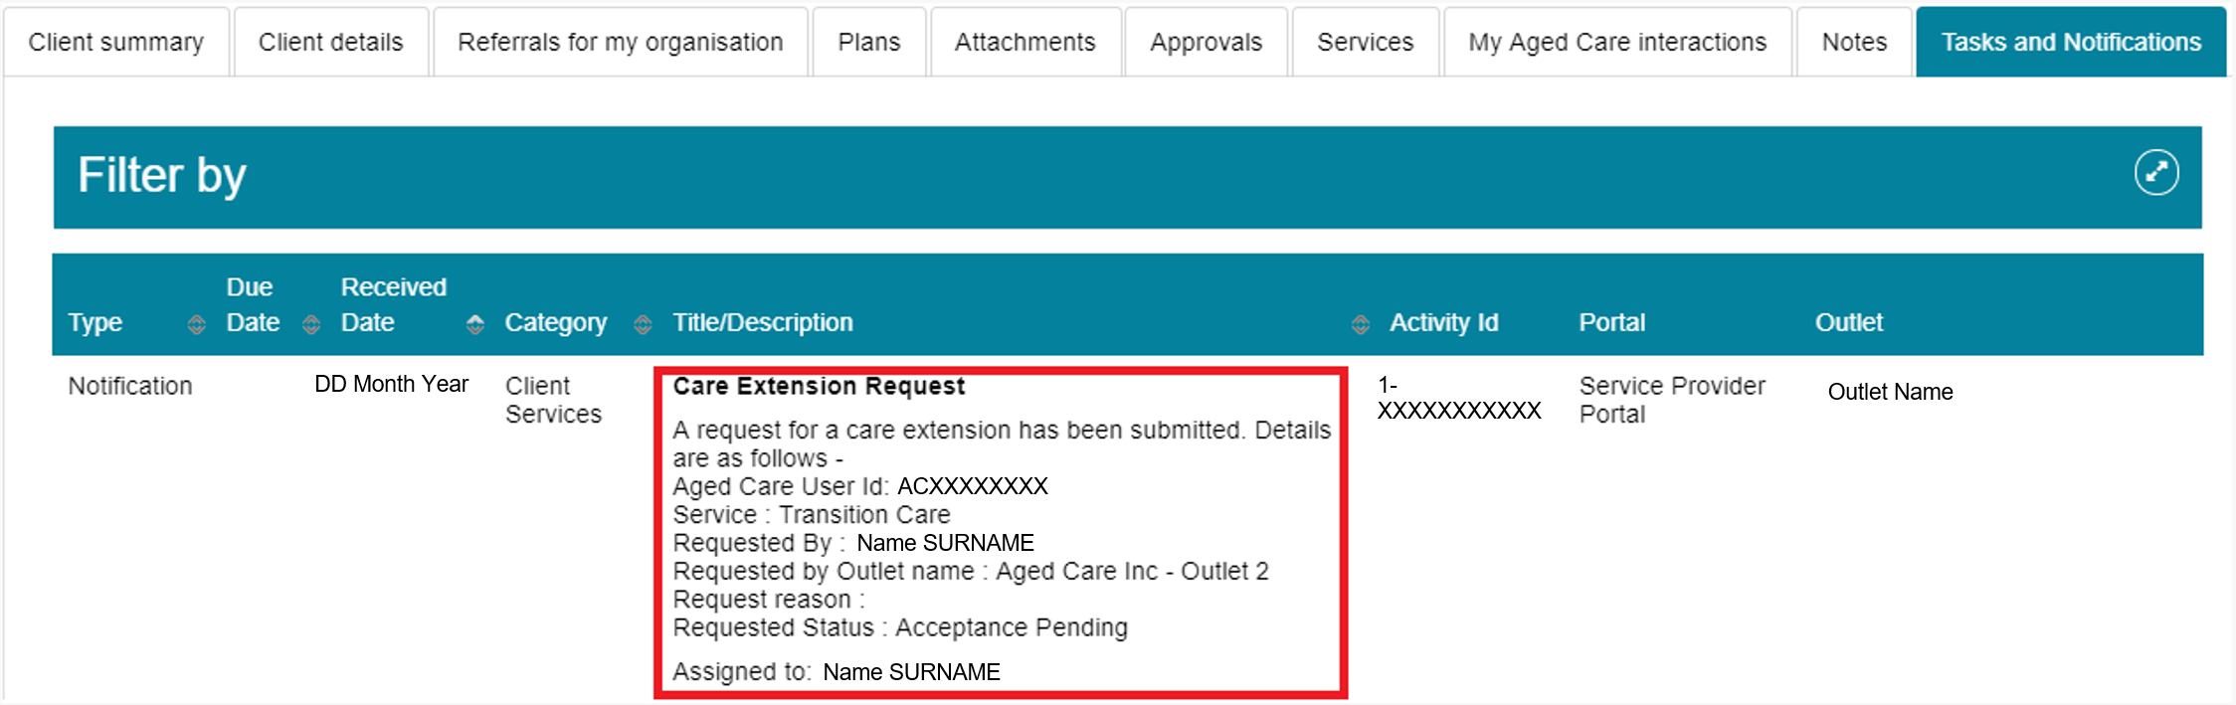

Requesting an extension to the client’s care (Support at Home)
You can request Support at Home care extensions for Assistive technology (AT) and Home modifications (HM) for the following clients:
- Clients receiving AT Medium Tier or AT High Tier services who have a recorded progressive condition: These clients can receive an extension of up to 24 additional months, for a total approval period of 48 months.
- Clients receiving HM High Tier services: These clients can receive an extension of up to 12 additional months, for a total approval period of 24 months. You must provide evidence that the client's condition has progressed.
! | You do not need Delegate approval for Support at Home care extension requests. When you submit the request, the system automatically applies the extension.
To request a care extension for a client receiving AT Medium Tier or AT High Tier services who has a progressive condition, follow the steps below:
- Find the client by using one of the following methods:
  - Select Find a Client, open the client record, go to the Services tab, and select SEE SERVICE DETAILS under the Current Services in Place section.
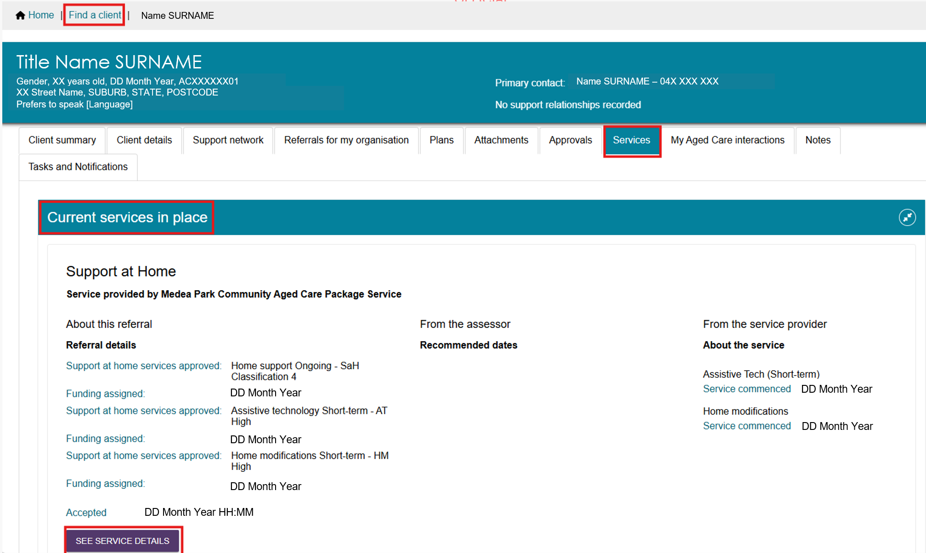
- Go to the Services in Place tab in Service Referrals, then expand the client record in either Card View or List View.
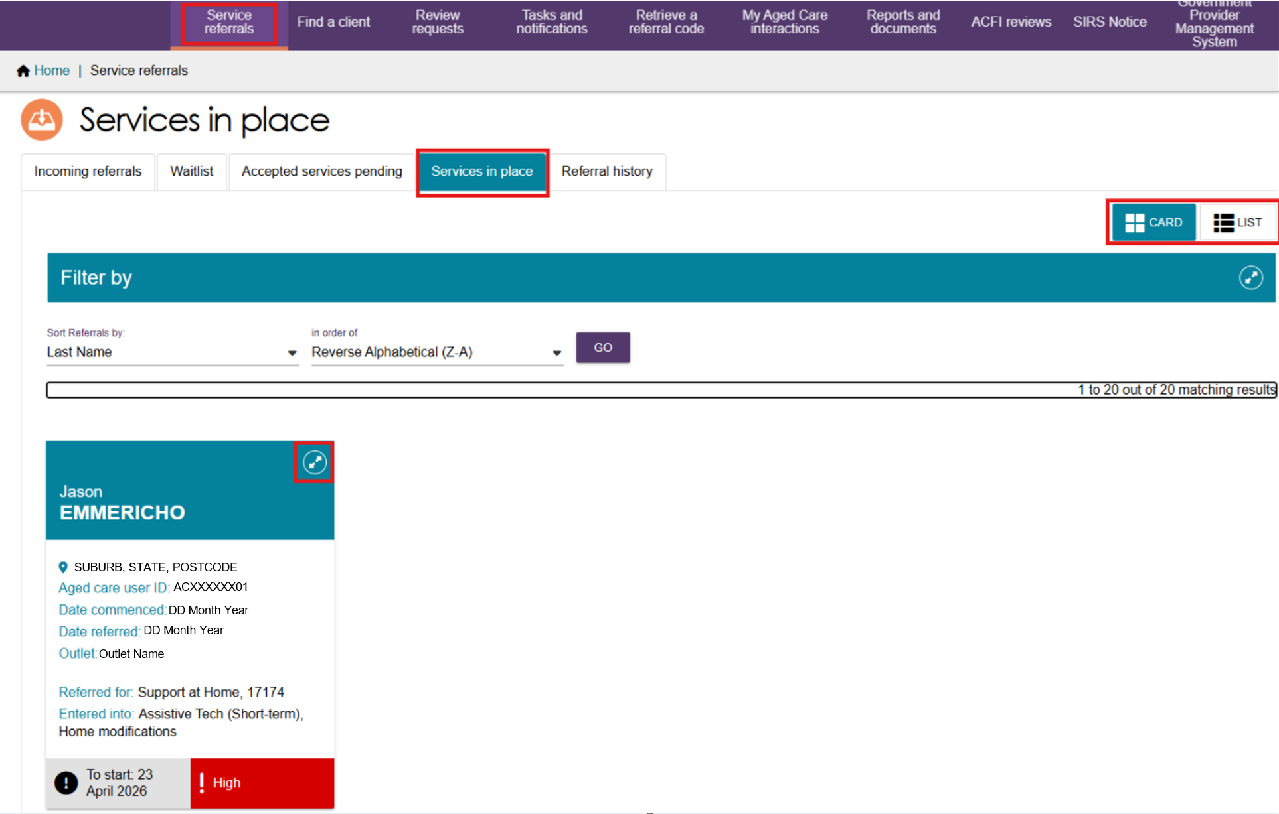
- Select ADD ASSISTIVE TECHNOLOGY EXTENSION.
! | The ADD ASSISTIVE TECHNOLOGY EXTENSION button is only available for clients who have a progressive condition recorded during their assessment and who currently receive AT Medium or AT High services.  You can apply the extension only once. After you apply the extension, the system removes the button and you can no longer request another extension.
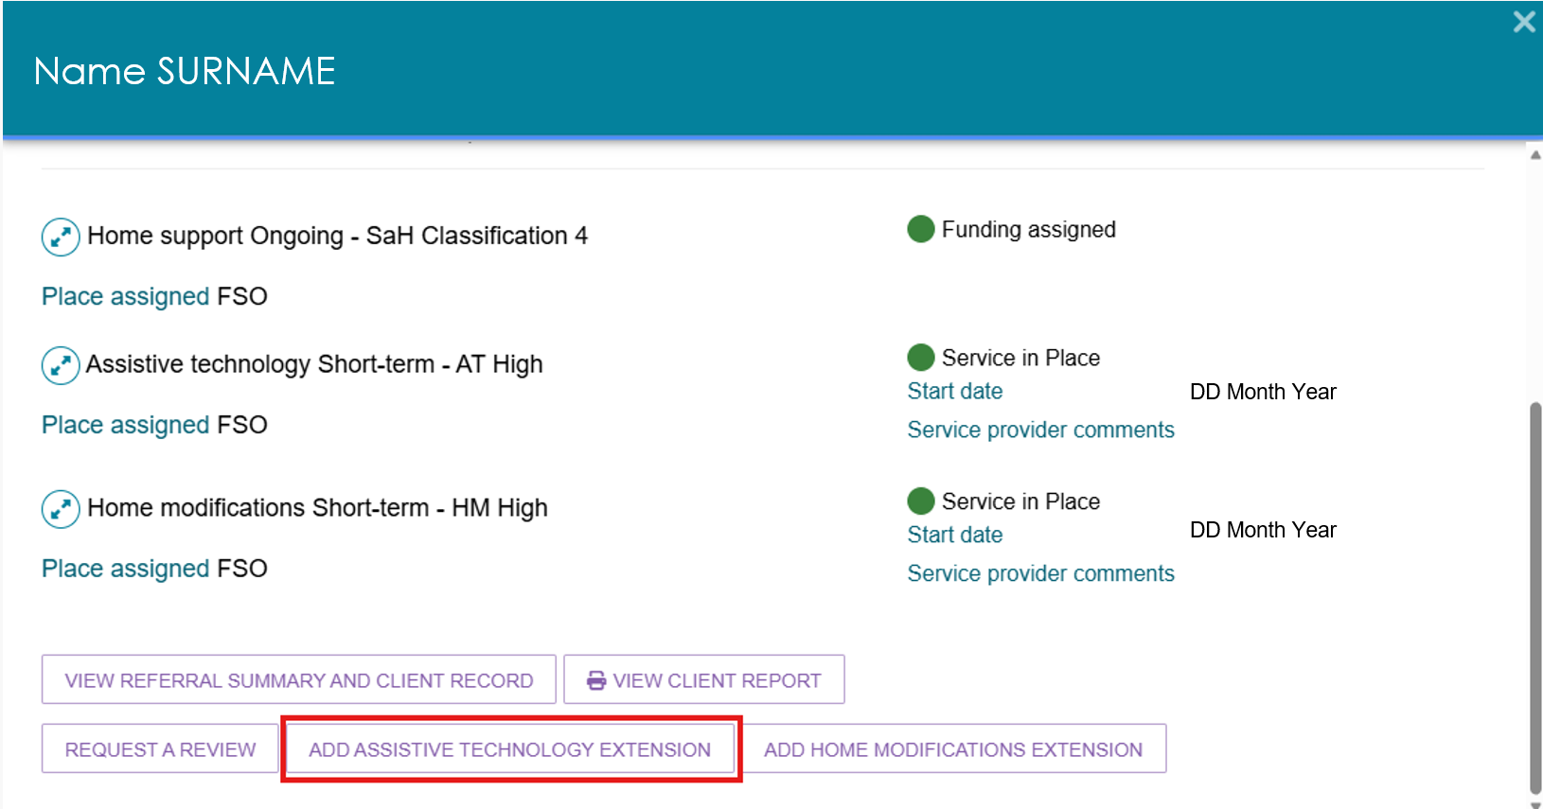
- In the Confirm Assistive Technology Extension pop-up, select CONFIRM.
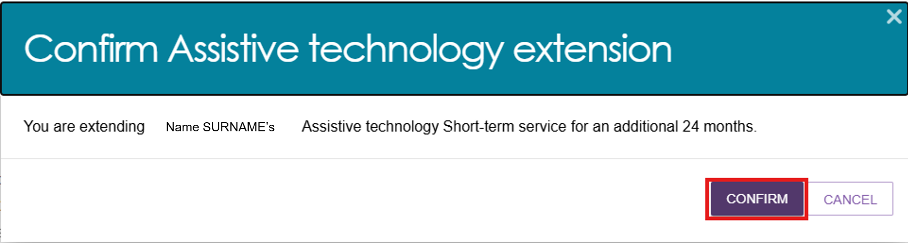
- The system automatically extends the Assistive Technology approval by 24 months and displays a confirmation message.
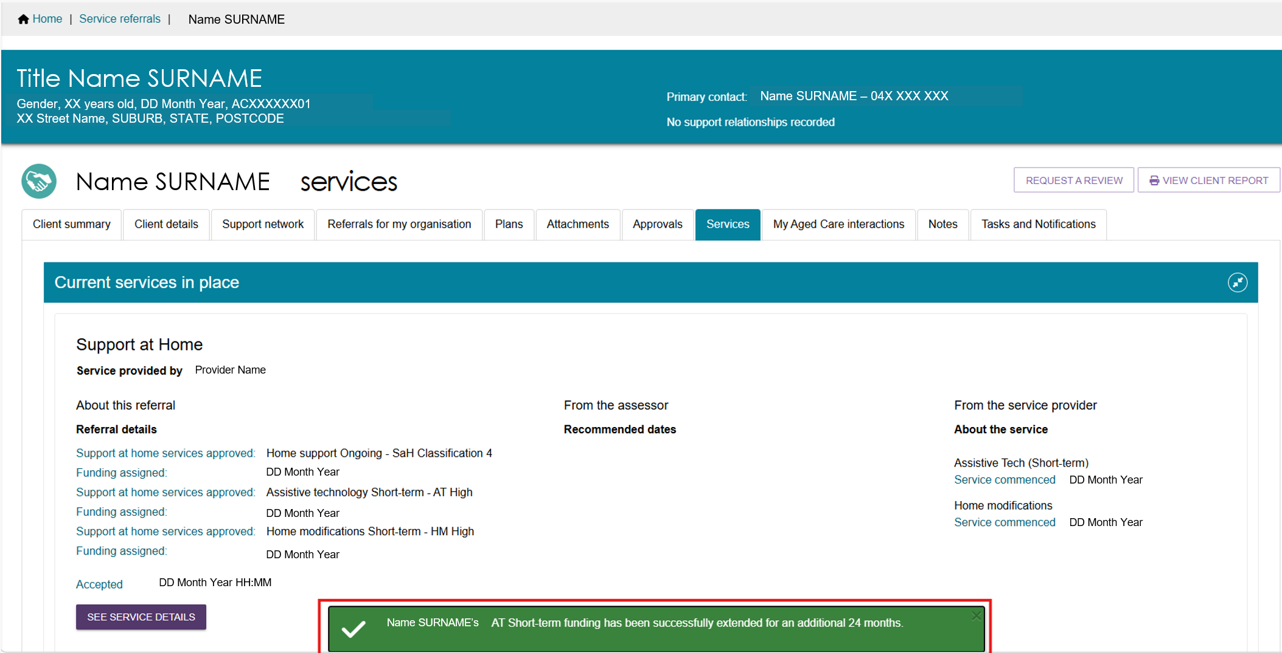
- To view the updated approval end date:
- Open the Approvals tab.
- Expand the Assistive Technology approval.
- View the Approval Stops field, which shows when the approval ends.
Approvals screen before AT Extension
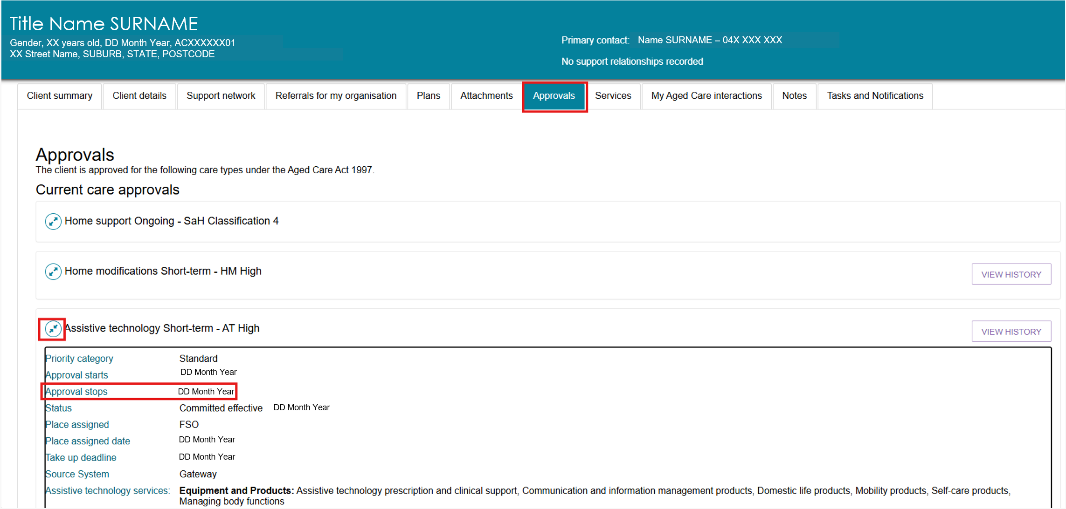
Approvals screen after AT Extension
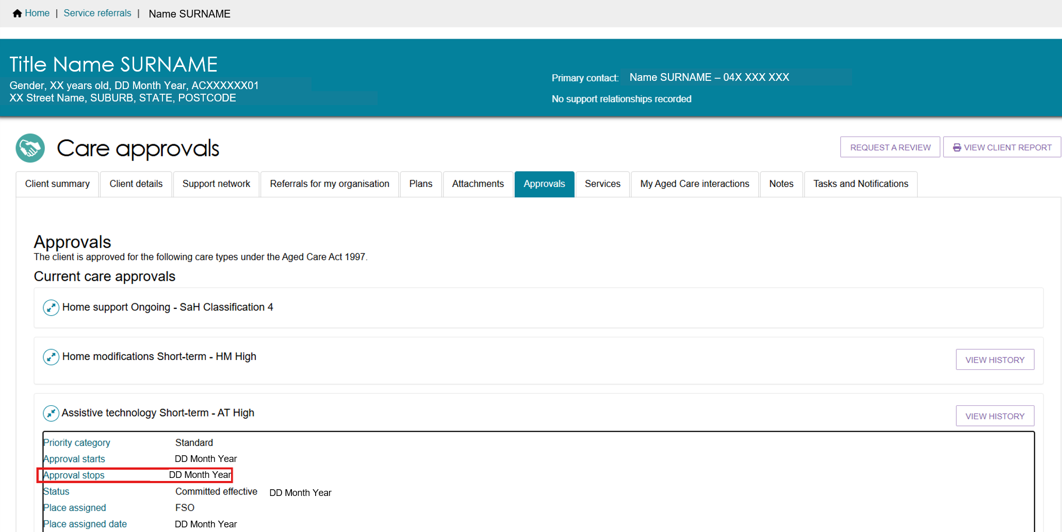
To request an extension for a Home modifications (HM High Tier) client:
- Find the client using one of the following methods:
- Select Find a Client, open the client record, go to the Services tab, and select SEE SERVICE DETAILS under the Current Services in Place section.
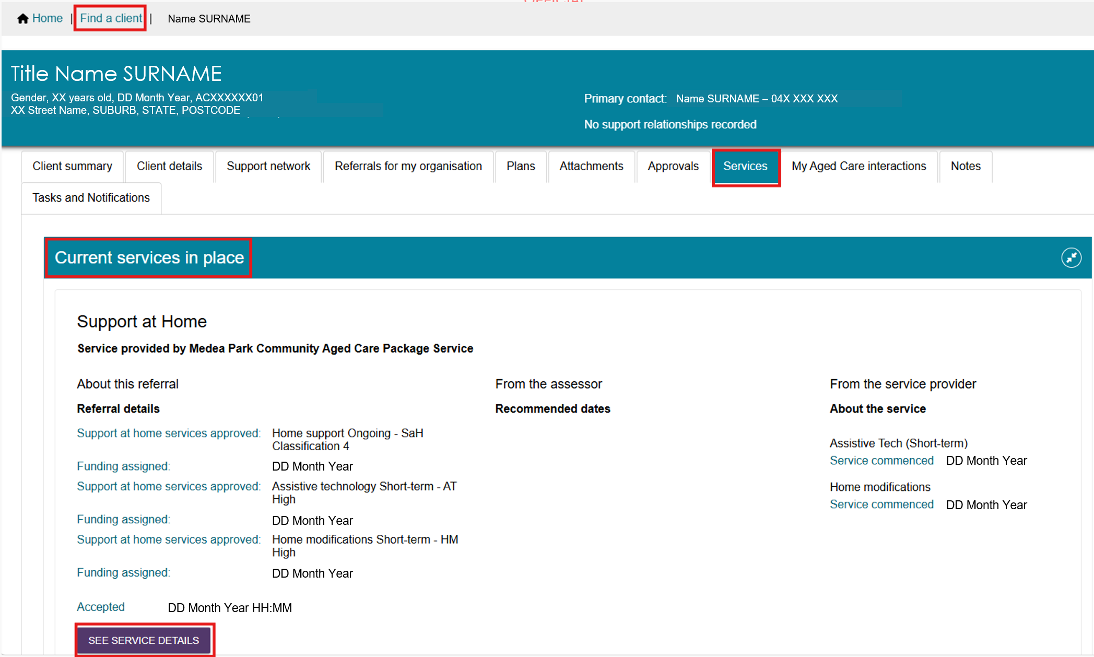
- Go to the Services in Place tab in Service Referrals, then expand the client record in either Card View or List View.
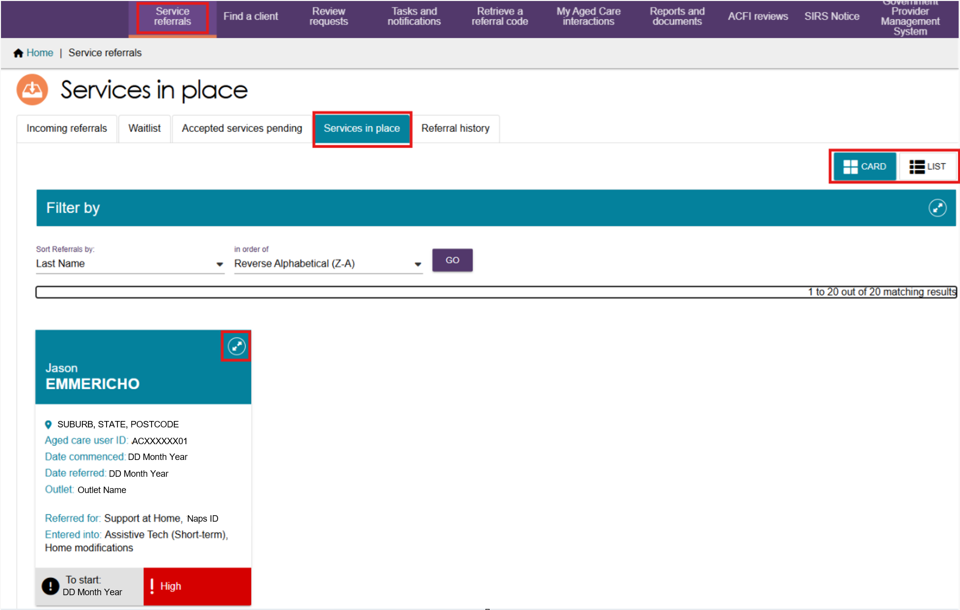
- Select ADD HOME MODIFICATIONS EXTENSION.
! | The ADD HOME MODIFICATIONS EXTENSION button is only available for clients who currently receive HM High services. You can apply the extension only once. After you apply the extension, the system removes the button and you cannot request another extension.
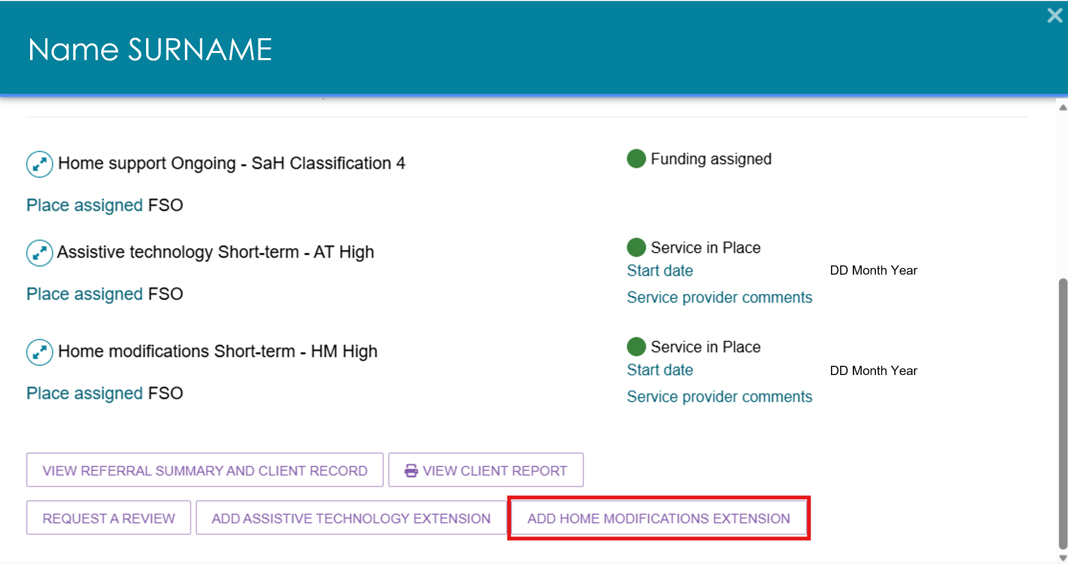

The Home Modifications Allocation Period Extension pop-up opens.
Select UPLOAD PROOF OF PROGRESSION.
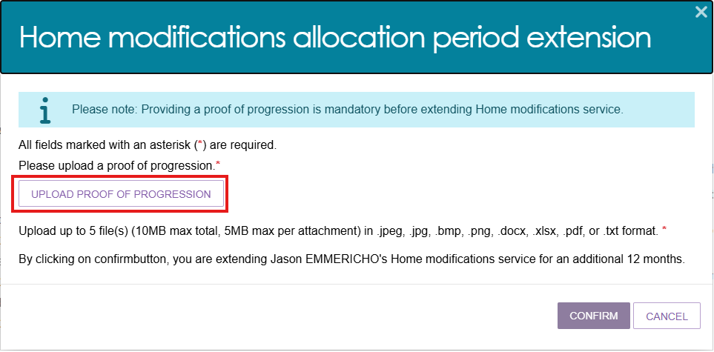
- In the Add Attachment form:
- Select CHOOSE FILE and select the document you want to upload.
- The file name will appear next to the CHOOSE FILE button after you attach the file.
- Enter a name in the required Attachment Name field.
- Optionally, enter a short description of the attachment.
- Select UPLOAD.
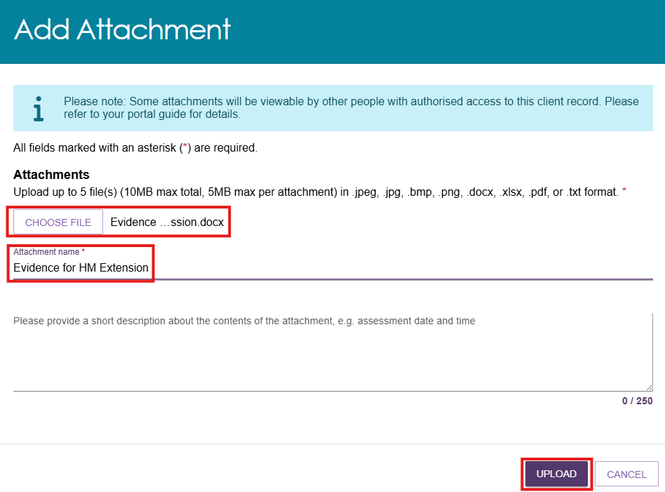
- The system displays the uploaded attachment.
- To remove an attachment, select the bin icon next to the file name.
- To upload additional documents, repeat Step 3.
- After uploading all required documents, select CONFIRM.
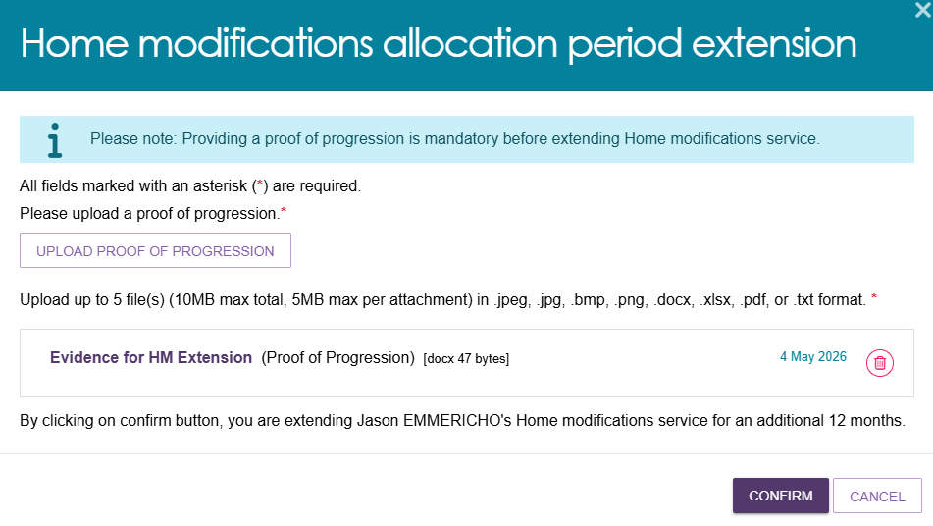
- The system displays a confirmation message and automatically extends the HM High approval by 12 months.
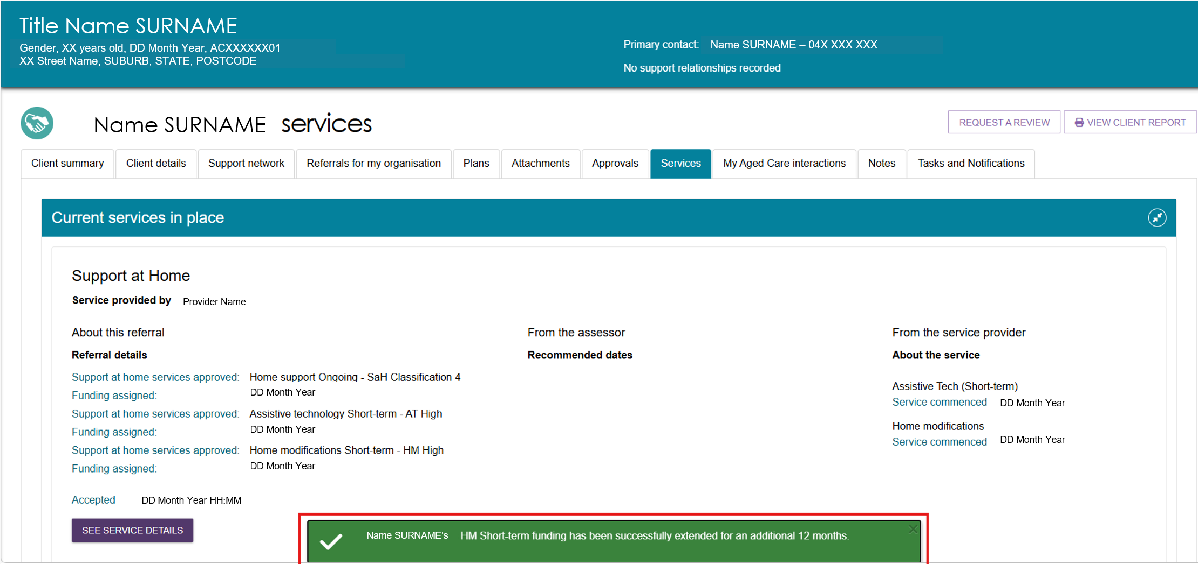
To view the updated approval end date, open the Approvals tab and expand the Home Modifications approval.
The Approval Stops field shows when the approval ends.
Approvals screen before HM extension
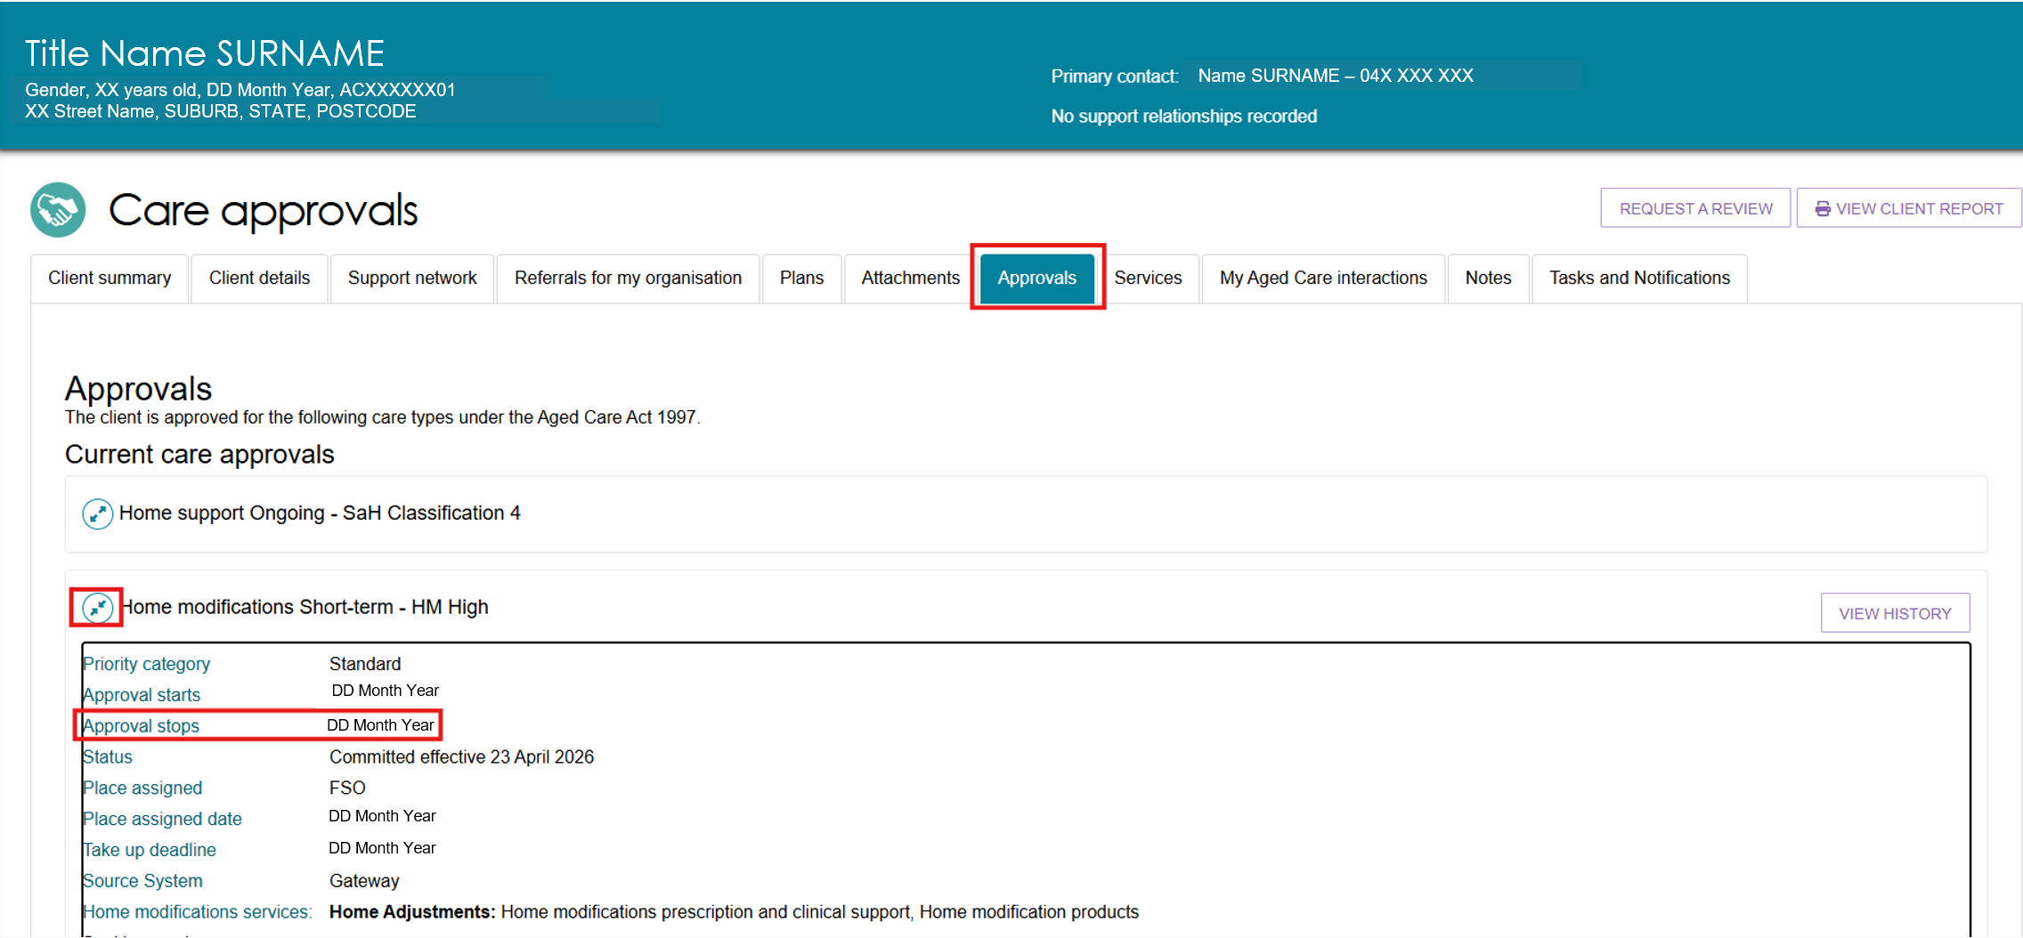
Approvals screen after HM extension
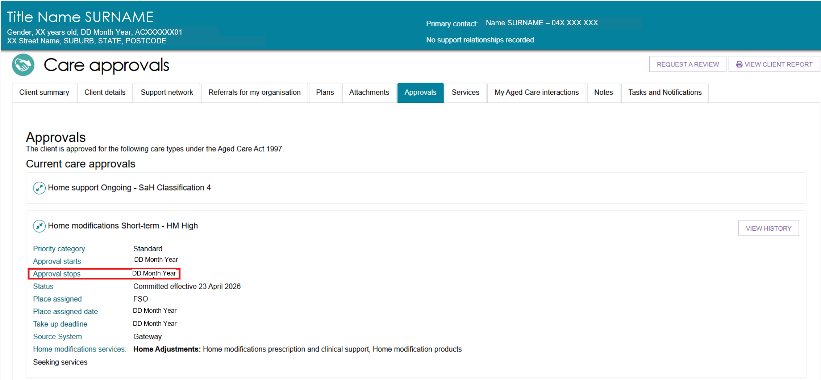
- The system stores the uploaded documents in the Attachments tab under Other Attachments and labels them Proof of Progression.
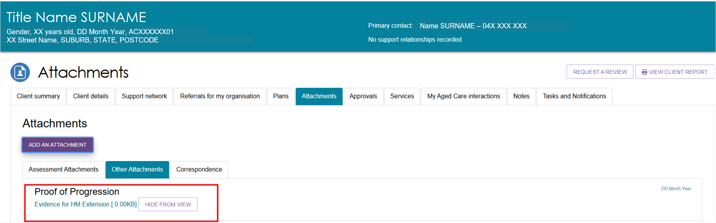

Requesting a Support Plan Review
A provider can request a Support Plan Review (SPR) through the Service and Support Portal when:
- the client’s needs, goals, or circumstances have changed since their last assessment
- the client’s support plan no longer reflects their current situation
- the client needs additional services
- a time-limited service has ended.
An assessor will review the request and the client’s circumstances. This may result in a new assessment of the client’s needs.
When submitting an SPR request, providers must attach supporting documents that describe the client’s current care arrangements, such as a quarterly budget or care plan. Include as much relevant information as possible to help assess the client’s needs and the urgency of the request.
For detailed assessment history, go to the Plans tab in the client record.
If the client has not previously had a My Aged Care assessment, contact the My Aged Care service provider and assessor helpline on 1800 836 799 to request a new assessment.
Follow these steps to request a review of a client’s support plan:
- Review the client’s assessment information. For detailed assessment history, go to the Plans tab in the client record.
You cannot submit a review request if the client already has an assigned review in the Assessor Portal or is currently undergoing an assessment. Check this before starting a review request.
If you have concerns, contact the assessment organisation that completed the client's most recent assessment. You can find their details in the Plans tab.
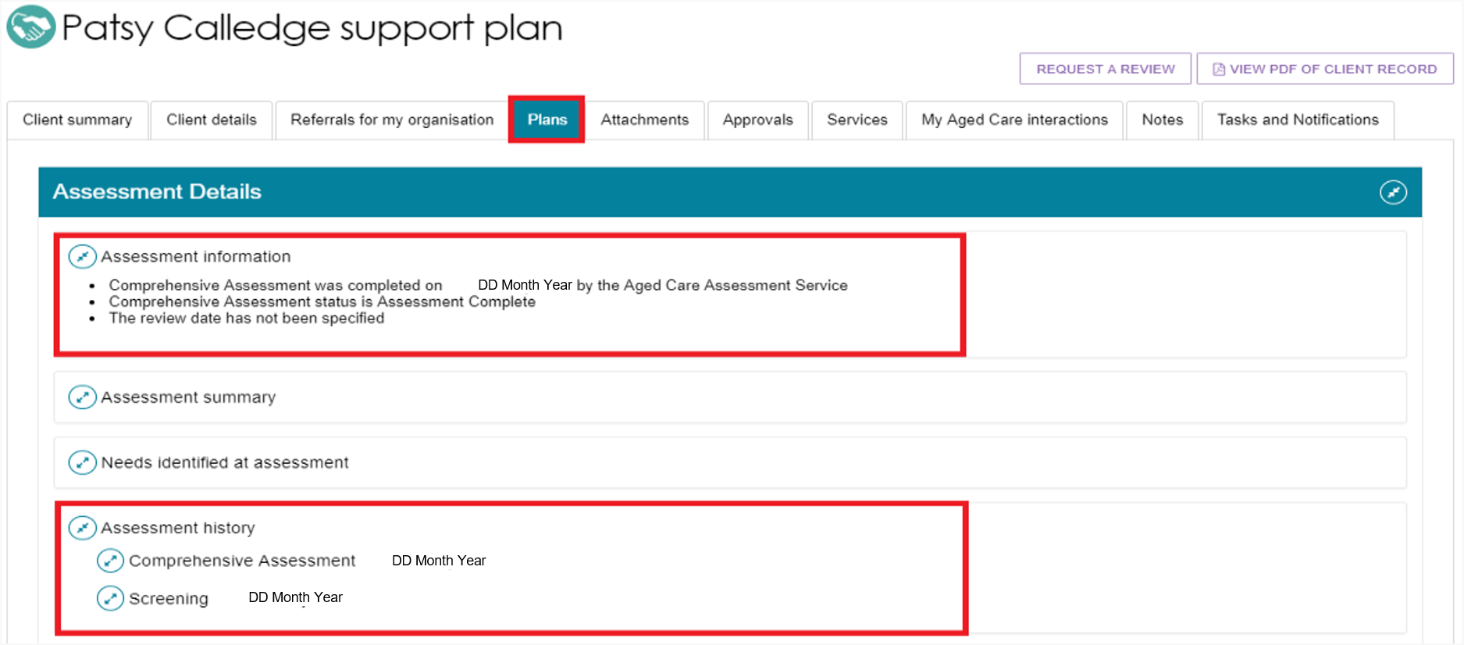

- Select Service referrals from the homepage.
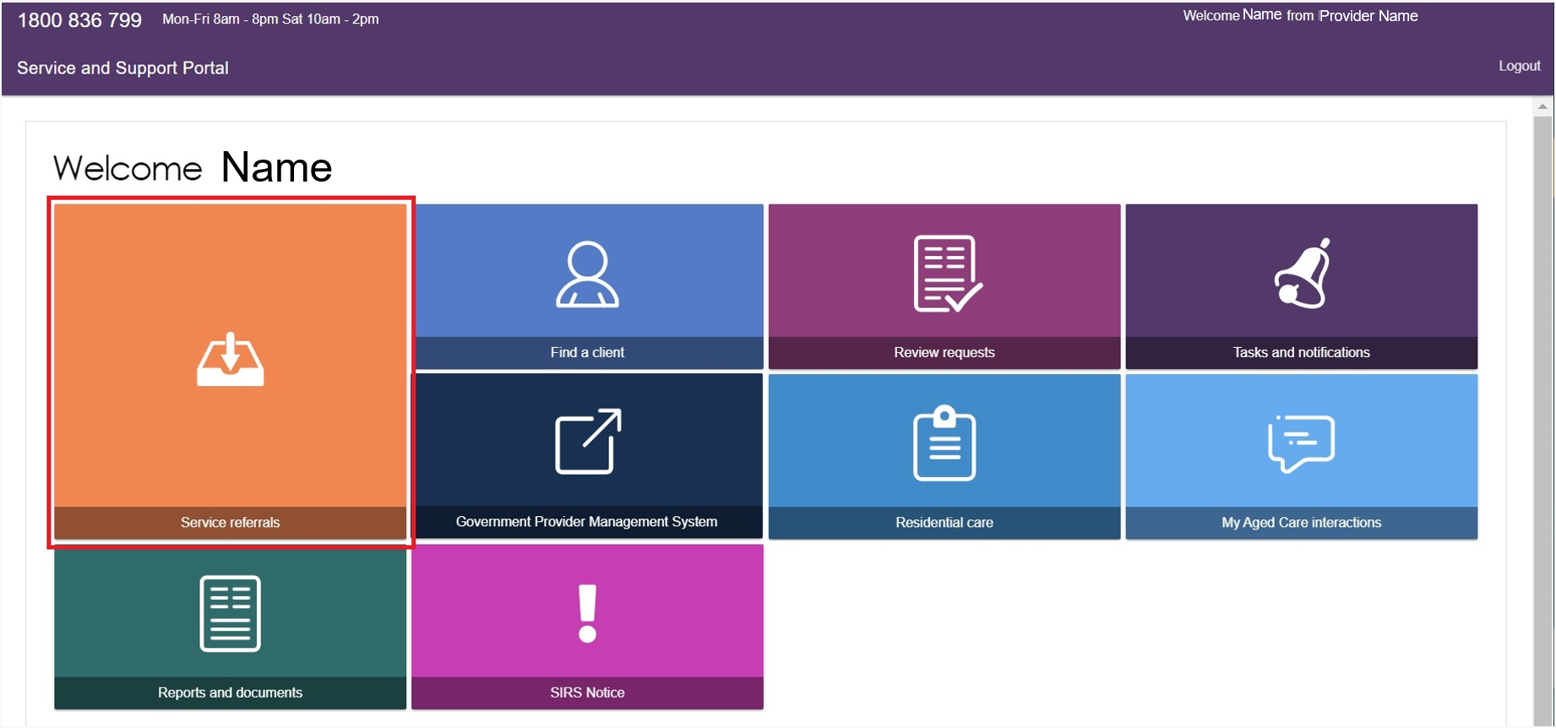
- Select Services in Place. Find the client and select Request a Review.
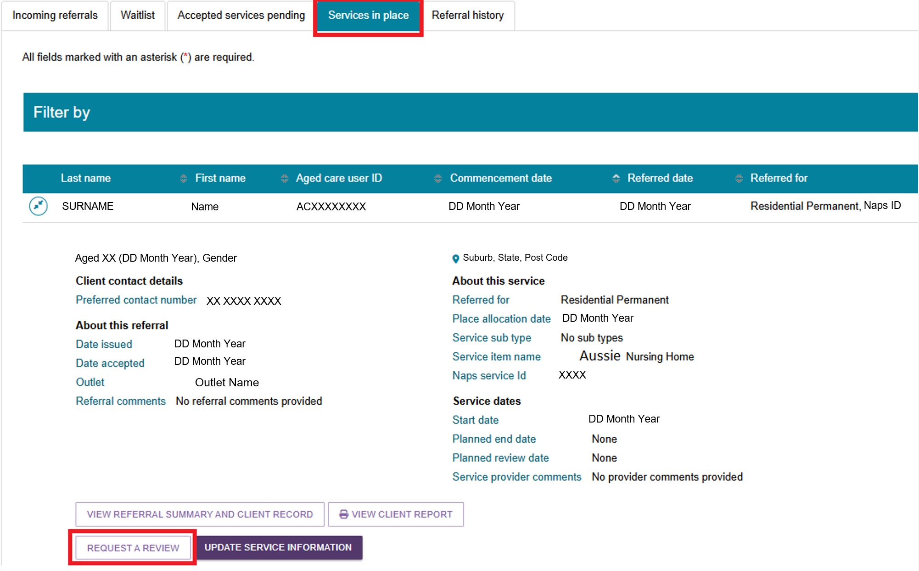
You can also select the Request a Review link displayed at the top of any page in the client's record.
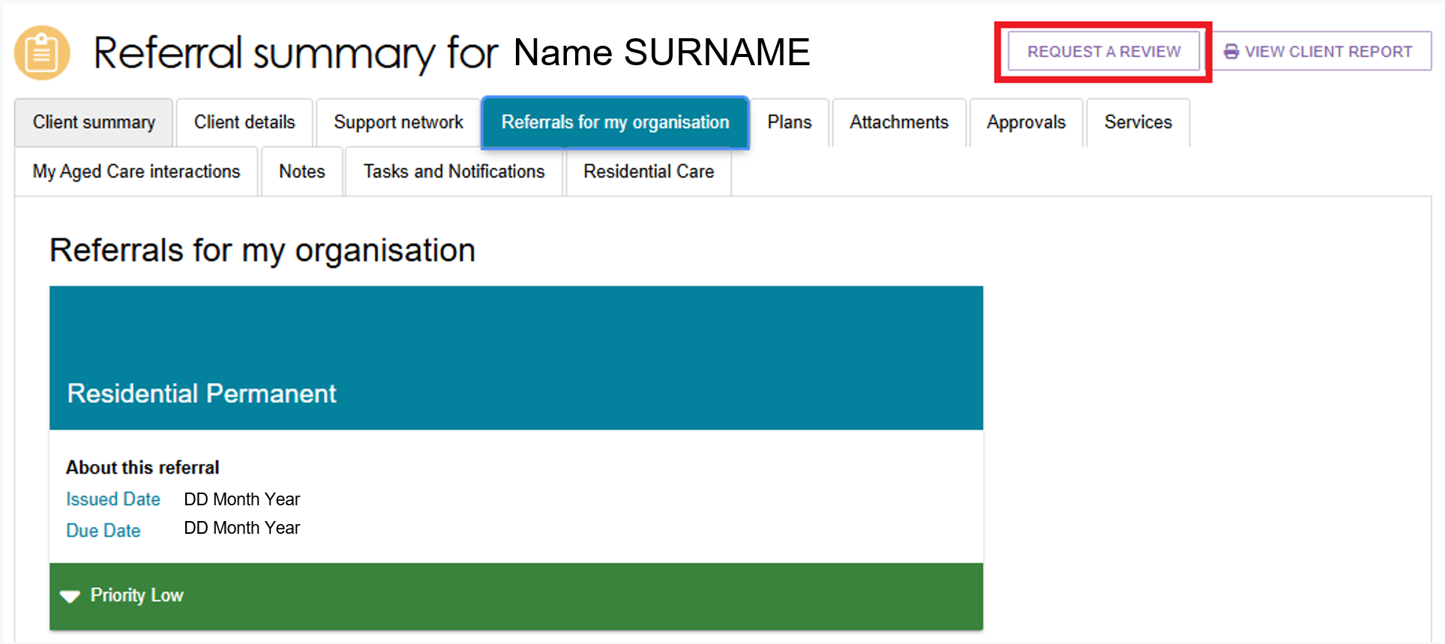
- On the Request a Review screen, indicate whether the client meets the criteria for a direct comprehensive assessment.
If you select Yes, you will be prompted to call the My Aged Care Service Provider and Assessor Helpline on 1800 836 799 and ask the Contact Centre to issue a direct referral. The referral will be sent to the assessment organisation for review, and a banner will appear on the client record to show that a direct referral has been issued.
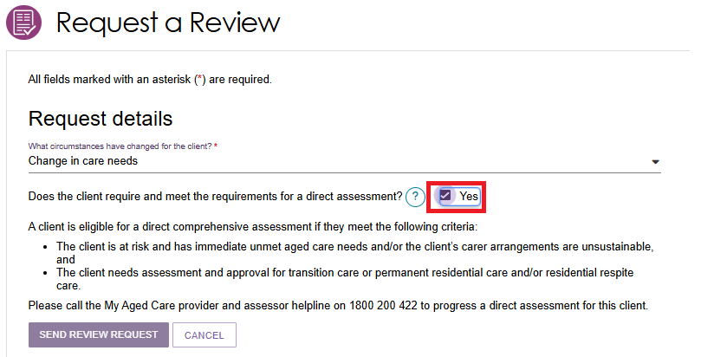
- Complete all mandatory fields within the review request.
Different questions will need to be completed at this step depending on which option/s are selected.
If the client needs an urgent review, select Yes for Does this request need to be actioned urgently? and explain why. This information helps the assessor or Contact Centre prioritise the request.
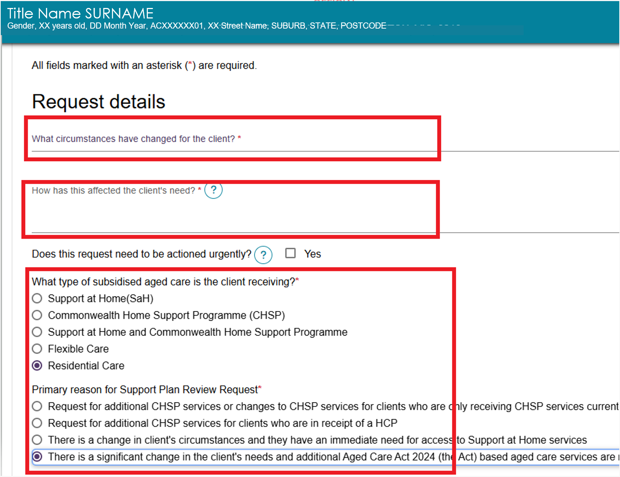
- If the client receives Support at Home services, or a combination of Support at Home and CHSP services, you must attach a care plan and budget. The system will not allow you to submit the request without these documents.
Select ADD CARE PLAN or ADD BUDGET. Complete all required fields and select Upload.
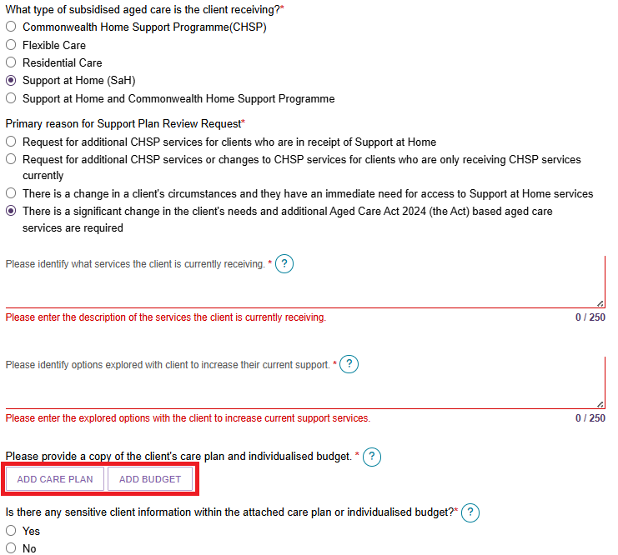
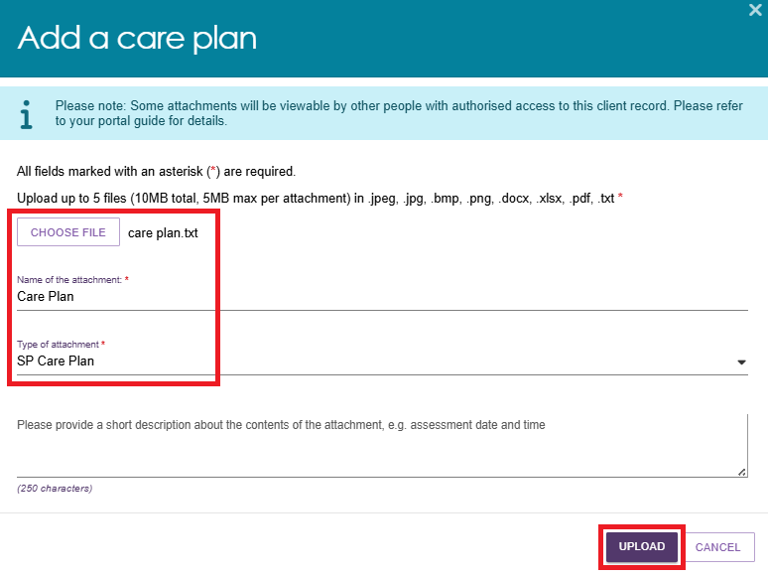
- Uploaded documents will appear in the review request once the upload is successful.
To remove an attachment, select the Delete (rubbish bin) icon next to the file name. The system will delete the attachment immediately without displaying a confirmation message.
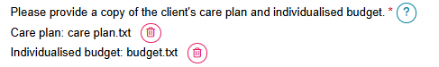
- After completing all required fields, select I have reviewed the information on this page and confirm it is correct, then select Send Review Request.
A confirmation message will appear when the review request has been submitted successfully.
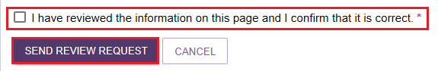
- A confirmation will display if the request is submitted successfully.

For more information and support
Further information is available from Service and Support Portal User Guide: Part 2 Team leader and staff member functions on the department’s website.
For further information about a client’s support plan review, refer to When to request a Support Plan Review from an Assessor fact sheet, available on the department’s website.
The My Aged Care service provider and assessor helpline is available on 1800 836 799.

