Service and Support Portal User Guide Part 2: Team Leader and Staff Member Functions
The My Aged Care Service and Support Portal User Guide - Part 2 (Service and Support Portal User Guide) outlines how Commonwealth-funded registered providers (providers) use the My Aged Care Service and Support Portal for their organisation. This portal is previously known as the My Aged Care Service Provider Portal.
The Service and Support Portal User Guide is split into two parts as follows:
- Part One provides an overview of the portal and describes the functions that an individual with the Administrator role in the Service and Support Portal will perform.
- Part Two (this document) provides an overview of the portal and describes the functions that an individual with the Team Leader or Staff Member role in the Service and Support Portal (‘you’) will perform.
This guide does not cover detailed instructions on how to obtain a myID (which can be found in the user guide Logging in to the Aged Care Systems).

1 Introduction 3
2 Staff Roles 3
2.1 Administrator homepage 5
2.2 Team Leader homepage 5
2.3 Staff Member homepage 6
2.4 Homepage for person assigned multiple roles 7
3 Managing Referrals 7
3.1 Viewing referrals 8
3.2 Accepting or rejecting a referral for service 11
3.3 Revoking a referral after acceptance 18
4 Clients and Services 20
4.1 Find a client 20
4.2 Viewing client information 22
4.2.1 Client Summary 24
4.2.2 Client Details 25
4.2.3 Support Network 27
4.2.4 Referrals for My Organisation 29
4.2.5 Plans 29
4.2.6 Attachments 31
4.2.7 Approvals 31
4.2.8 Services 34
4.2.9 My Aged Care Interactions 34
4.2.10 Notes 35
4.2.11 Tasks and Notifications 35
4.3 Completing identity verification 36
4.4 Viewing tasks and notifications 39
4.5 Adding service information 42
4.6 Updating service information 47
4.6.1 Recording note of changes made to client service information 49
4.6.2 Requesting an extension to the client’s care (Transition Care and Residential Respite) 51
4.6.3 Requesting an extension to the client’s care (Support at Home) 54
4.6.4 Requesting a Support Plan Review (SPR) to meet changing needs 63
4.6.5 Checking the status of a Support Plan Review 69
5 Generating reports and accessing forms 71
5.1 Generating reports 71
5.2 Viewing reports 73
5.3 Accessing forms 74
6 Serious Incident Response Scheme (SIRS) 75
7 Residential Client Classifications and Reassessments 75
7.1 Viewing residential clients and their residential funding classification 76
7.2 Filtering the Care Recipients lists 78
7.3 Advanced Search 79
7.4 Requesting Residential Funding Reassessments 81
7.5 Requesting Residential Funding Reconsiderations 85
7.6 Recalling a Residential Funding Reassessment or Reconsideration request 88
7.7 Notify client is available for assessment 90
7.8 Request tab and request status definitions 92
7.9 Palliative Care 92
7.9.1 View clients marked palliative on entry 92
7.9.2 Upload palliative care documents 93
7.9.3 Palliative Care Status Form outcomes 96

Introduction
Use the Service and Support Portal to:
- Manage information about the services you provide.
- Manage service referrals from My Aged Care contact centre staff or assessors by accepting, rejecting, or waitlisting referrals.
- Update client records with details of the services you deliver.
- Request a support plan review by an assessor for a client.
- Report Serious Incident Response Scheme (SIRS) Priority 1 and Priority 2 incidents in residential, in-home, and Support at Home aged care services.
- Generate reports.
- Manage residential clients’ classifications, reassessments, reconsiderations, and palliative care administration.
To access the Service and Support portal, each staff member must have a My Aged Care portal user account linked to a supported third-party authentication service.
For information on setting up user accounts and logging in, refer to Logging in to the Aged Care Systems.

Staff Roles
The My Aged Care Organisation Administrator must be the first person in your organisation to log in to the Service and Support Portal.
The Logging in to the Aged Care Systems guide explains how to nominate your first Organisation Administrator.
The Organisation Administrator assigns roles to other staff members. They can also assign administrator roles to additional staff to help set up and maintain your organisation's information in the Service and Support Portal. Assign roles based on each staff member's responsibilities within your organisation.
! If you have more than one role, your access applies across all outlets that you can access in the Service and Support Portal.
The following tables describe the functions available for each role in the Service and Support Portal. They cover both client-focussed and organisation-focussed tasks.
Client Focused key functions
Key Functions | Organisation Administrator | Outlet Administrator | Team Leader | Staff Member
Search for a client record  (for referred clients) | ü |  | ü | ü
View client records (for referred clients) |  |  | ü | ü
View referrals |  |  | ü | ü
Accept, reject, and revoke referrals |  |  | ü
View tasks and notifications | ü | ü | ü | ü
Manage organisation preferences for tasks and notifications | ü
Manage outlet preferences for tasks and notifications | ü | ü
View My Aged Care interactions | ü | ü | ü | ü
Add client service information |  |  | ü | ü
Transfer clients between services | ü
View list of residential care recipients and their residential funding classifications |  |  | ü | ü
View list of requests for residential funding assessments and reassessment |  |  | ü | ü
Request Residential Funding Reassessments |  |  | ü
ORGANISATION FOCUSSED KEY FUNCTIONS
Key Functions | Organisation Administrator | Outlet Administrator | Team Leader | Staff Member
View Palliative Care recipients |  |  | ü | ü
Upload Palliative Documentation |  |  | ü | ü
Submit notifications under the  Serious Incident Response Scheme | ü
Request change to contractual information |  | ü
Add outlets | ü
Manage outlets: edit, activate, deactivate, remove | ü | ü
Manage services: add, edit, activate, transfer (organisation administrator only) or deactivate | ü | ü
Manage staff (organisation level): add, edit, deactivate, remove | ü
Manage staff (outlet level): add, edit, deactivate, remove | ü | ü
Apply, manage and view Specialisation Verification information | ü | ü

Administrator homepage
! Go to Service and support portal user guide – Part 1: Administrator functions for more information for Administrators.
People with an administrator role at the organisation level (Organisation Administrator) can view and manage information for the entire organisation in the Service and Support Portal.
People with an administrator role at the outlet level (Outlet Administrator) can only view and manage information for the outlet or outlets assigned to them.
When you log in to the Service and Support Portal as an administrator, the following tiles appear on your home page:
- Tasks and Notifications
- My Aged Care Interactions
- Reports and Documents
- Government Provider Management System
- Outlet Administration
- Staff Administration.
If your Organisation Administrator has assigned you the SIRS role, you will also see the SIRS Notice tile on your home page.
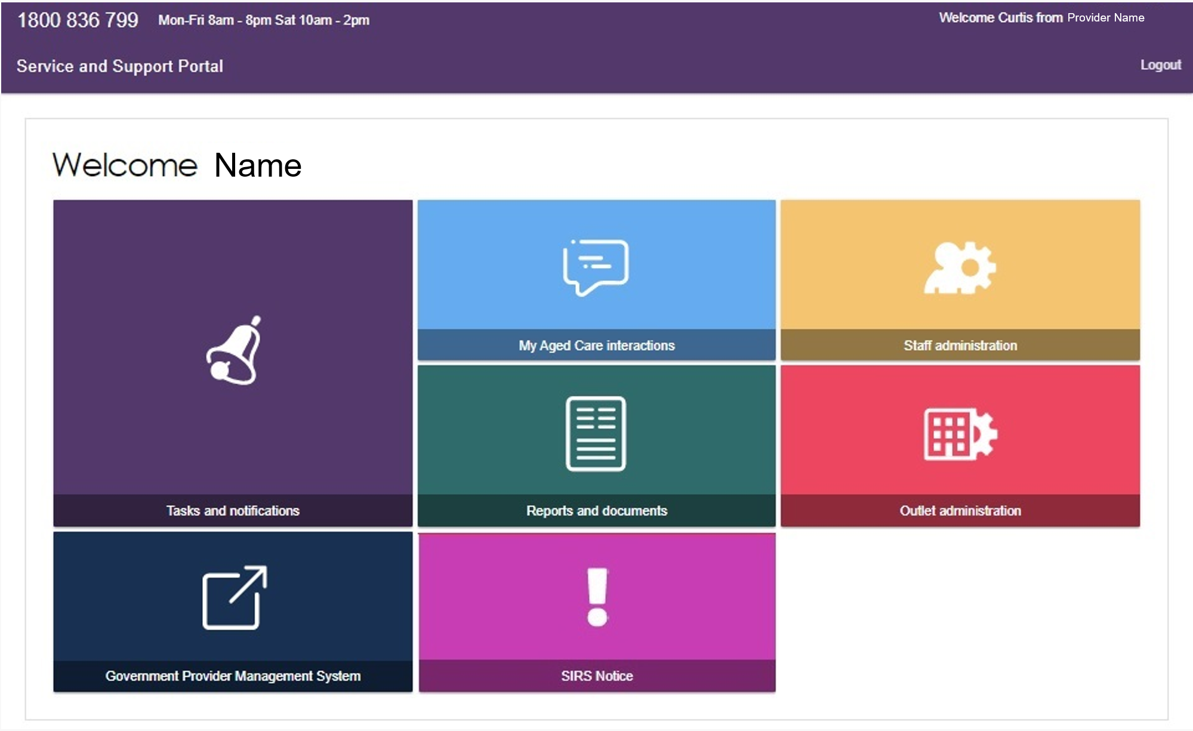

Team Leader homepage
People with the Team Leader role can do everything available to a Staff Member. They are also responsible for managing service referrals and residential funding reassessment requests.
When you log in to the Service and Support Portal as a Team Leader, the following tiles appear on your home page:
- Service Referrals
- Find a Client
- Tasks and Notifications
- My Aged Care Interactions
- Reports and Documents
- Retrieve a Referral Code
- Residential Care
- Government Provider Management System.
If your Organisation Administrator has assigned you the SIRS role, you will also see the SIRS Notice tile on your home page.
For information about adding the SIRS application for staff members, refer to Service and Support Portal user guide – Serious incident response scheme: Residential aged care services (SIRS) portal.
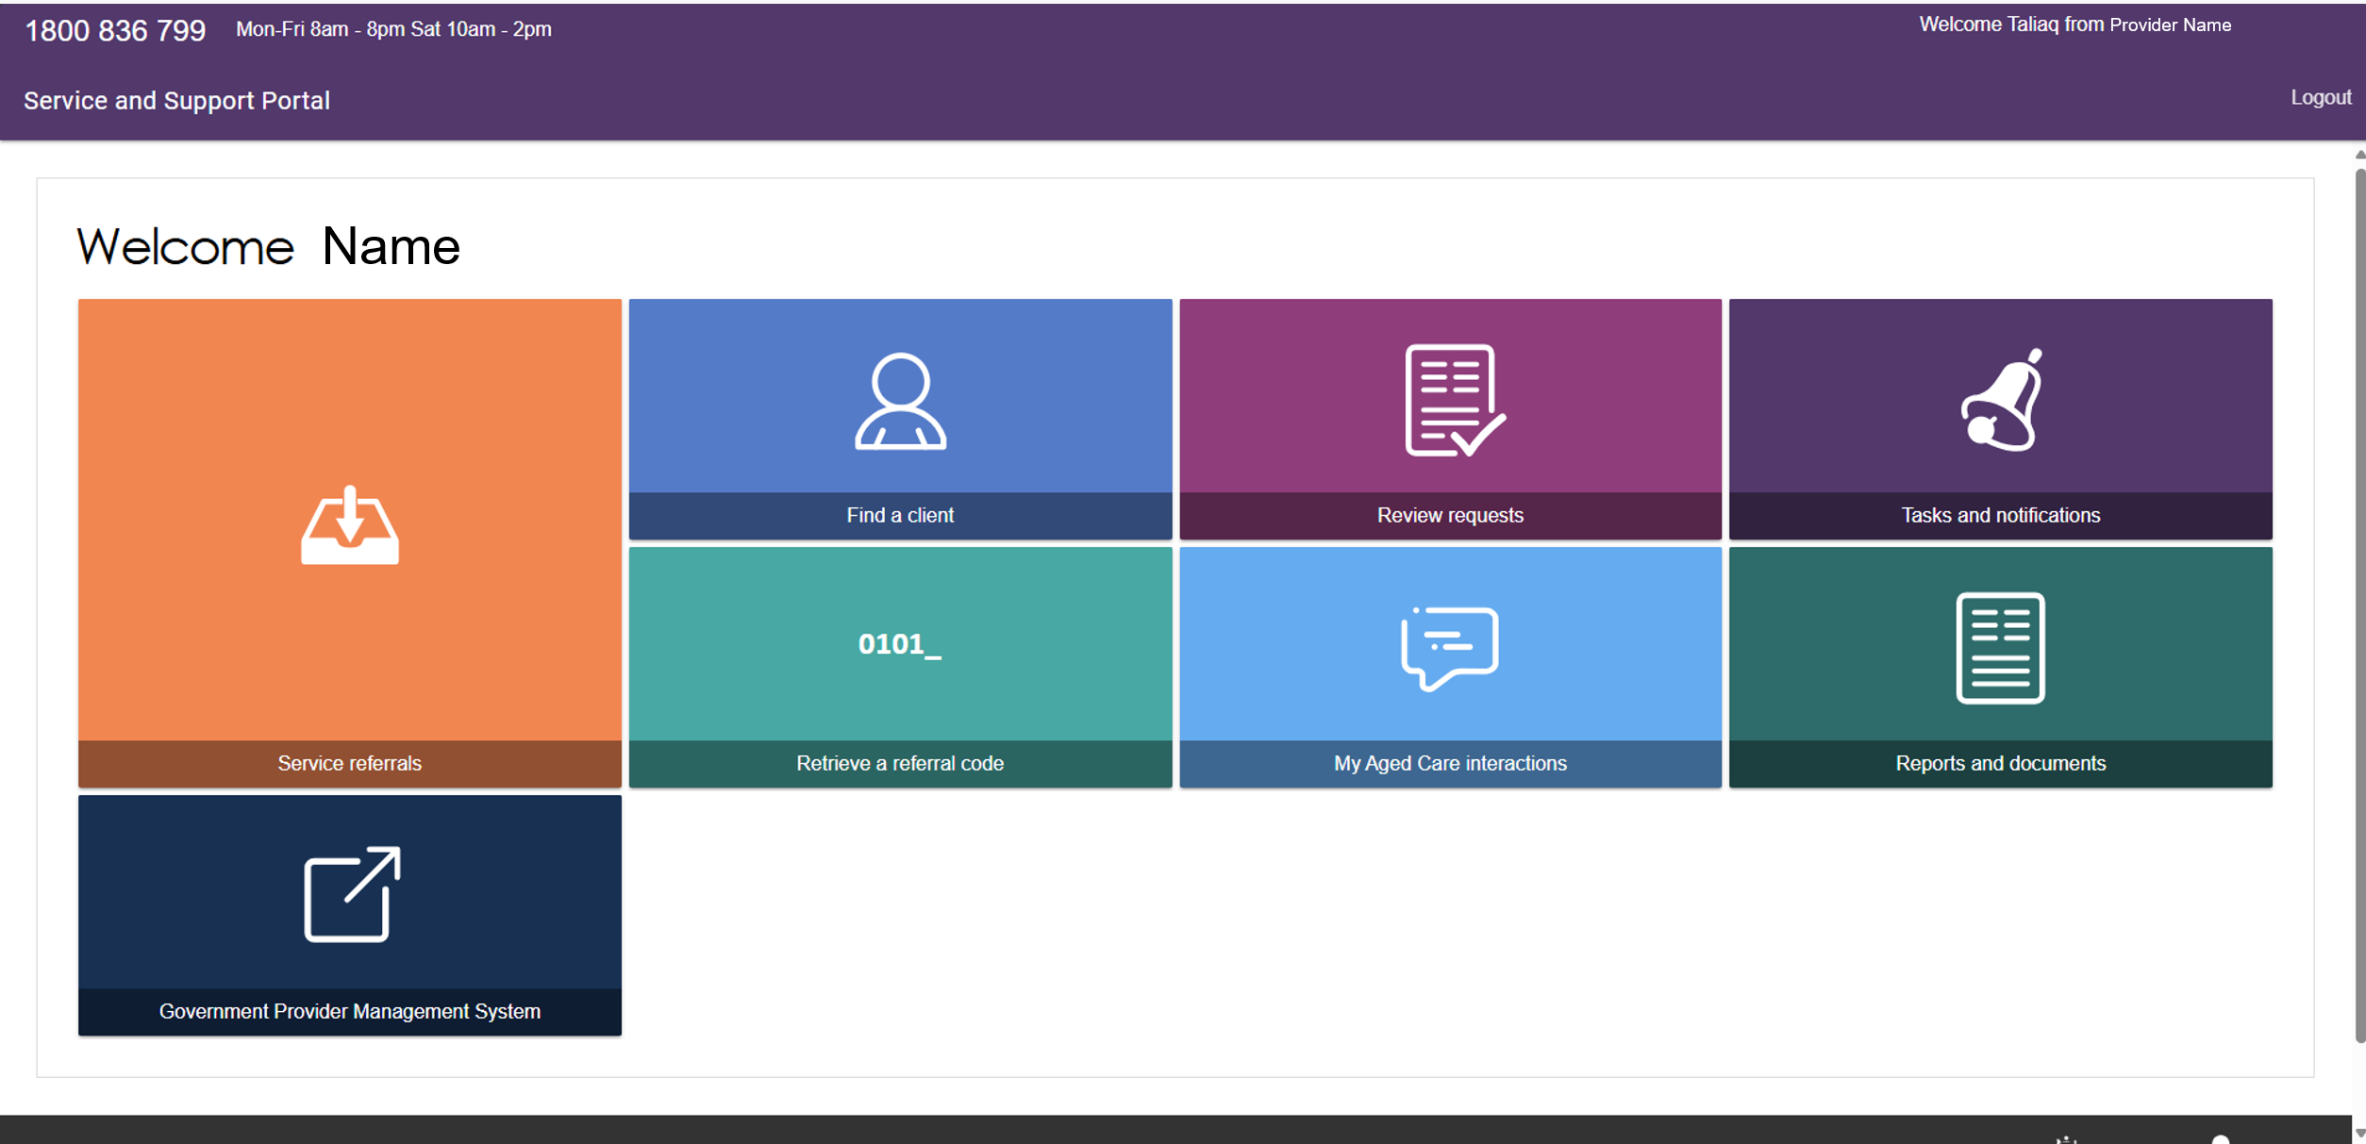

Staff Member homepage
People with the Staff Member role are responsible for adding and updating information about services provided to clients in their client records.
Your organisation may also authorise you to submit notifications under the Serious Incident Response Scheme (SIRS).
As a Staff Member, you can view clients in your residential facility and access their current and previous classifications through the Residential Care tile.
When you log in to the Service and Support Portal as a Staff Member, the following tiles appear on your home page:
- Service Referrals
- Find a Client
- Review Requests
- Tasks and Notifications
- My Aged Care Interactions
- Residential Care
- Government Provider Management System
- Reports and Documents.
If your Organisation Administrator has assigned you the SIRS role, you will also see the SIRS Notice tile on your home page.
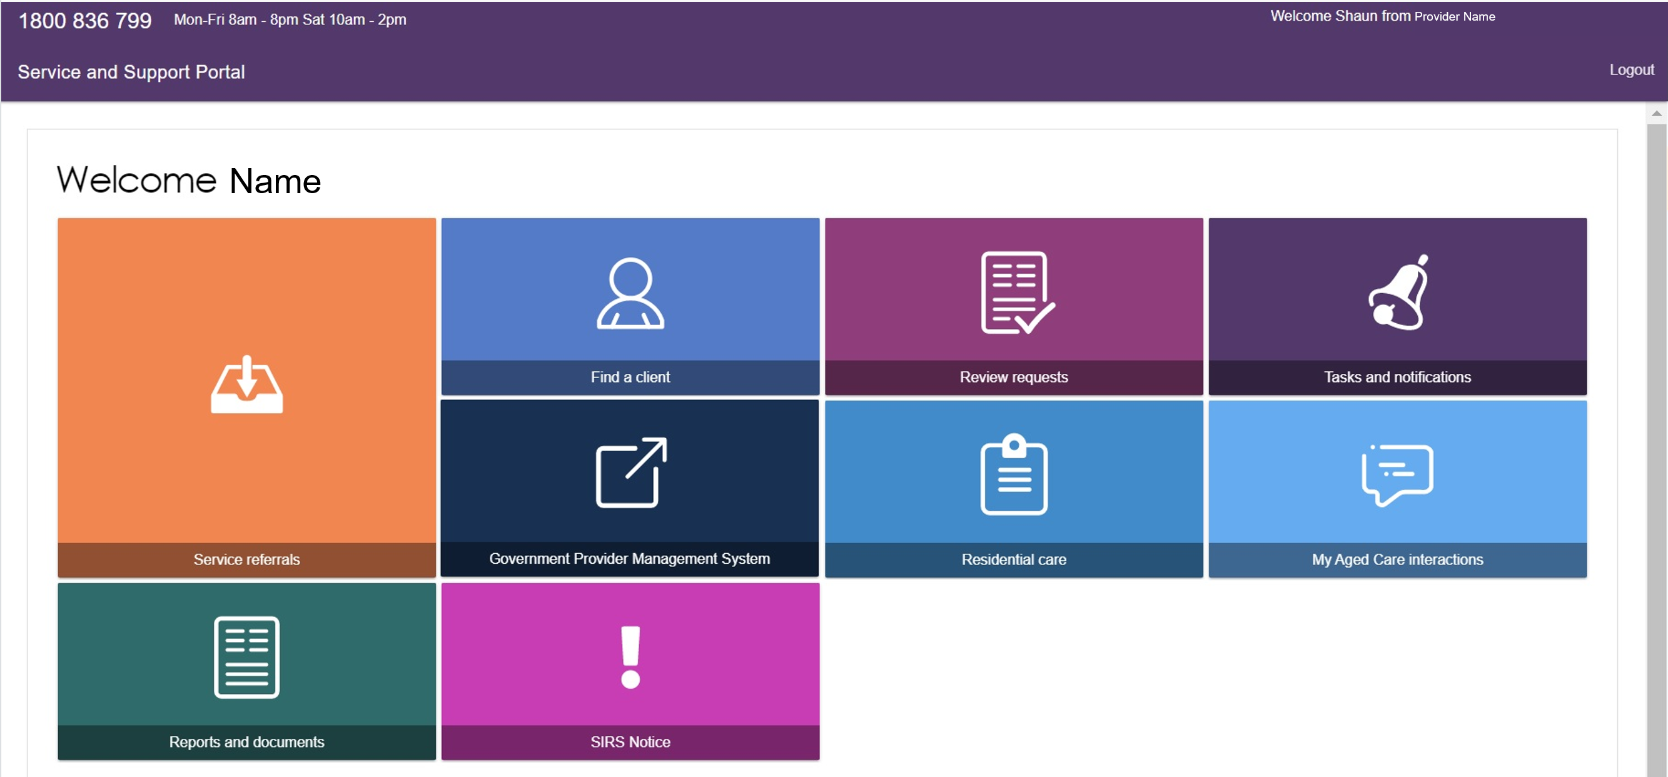

Homepage for person assigned multiple roles
If you log in to the Service and Support Portal as a user with more than one role, your home page will display the tiles available for all your roles. This gives you access to all features associated with those roles.

Managing Referrals
! For more information about Residential Funding and Residential Respite referrals, refer to Residential Client Classifications and Reassessments.
Providers can receive referrals for services via four pathways:
- Clients who already have approved care types under the Aged Care Act 2024 can contact service providers directly. These clients must be registered with My Aged Care.
- Clients can contact providers directly with a referral code issued by an assessor or the My Aged Care Contact Centre.
- Providers can receive electronic service referrals through the Service and Support Portal.
- Providers can accept electronic referrals onto their waitlist, if a waitlist is available.
The Team Leader is responsible for managing service referrals. Each provider outlet must have at least one staff member assigned the Team Leader role in the Service and Support Portal.

The roles involved in the referral process are outlined below:
Referral functions | Team Leader | Staff Member
View Referral | ü | ü
Accept Referral | ü | X
Accept to Waitlist | ü | X
Reject Referral | ü | X
Revoke Referral after Acceptance | ü | X
Request urgent referral | ü | X
Manage referral notifications | ü | X
All clients with valid service approvals must be registered with My Aged Care. If a client needs to be registered and already has an approved service, the provider should arrange a review or reassessment of the client's care needs. You can do this by:
- Calling the My Aged Care Contact Centre, or
- Submitting an online referral through the My Aged Care website.
This helps ensure the client's care needs and service approvals are up to date.
! Support at Home referrals
Support at Home referrals may include multiple service types and services. Providers either receive referrals electronically or via a referral code, depending on the client’s preferences, and incoming referrals have a priority status (low, medium, high).

Viewing referrals
- Select Service referrals from the homepage.
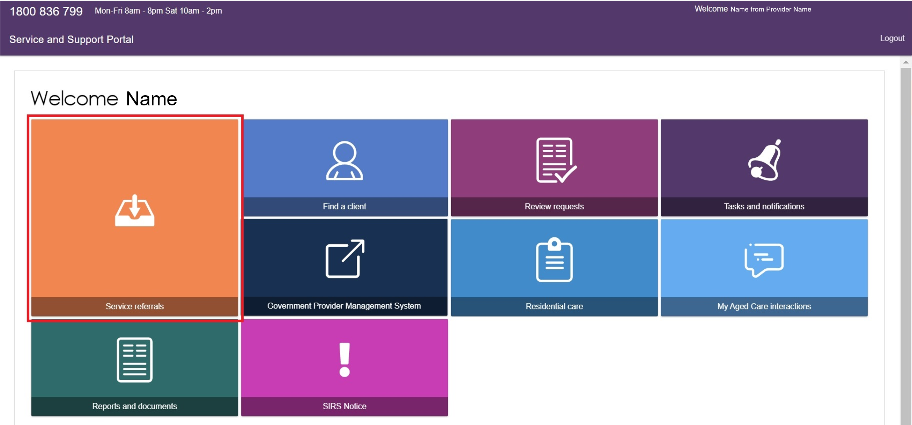
You can also access Service Referrals from any page in the Service and Support Portal by selecting Service Referrals from the toolbar at the top of the screen.
Before searching for referrals, make sure you have selected the correct outlet. To do this, select the relevant outlet name in the top-right corner of the portal, above Logout. This ensures you view referrals for the correct outlet.
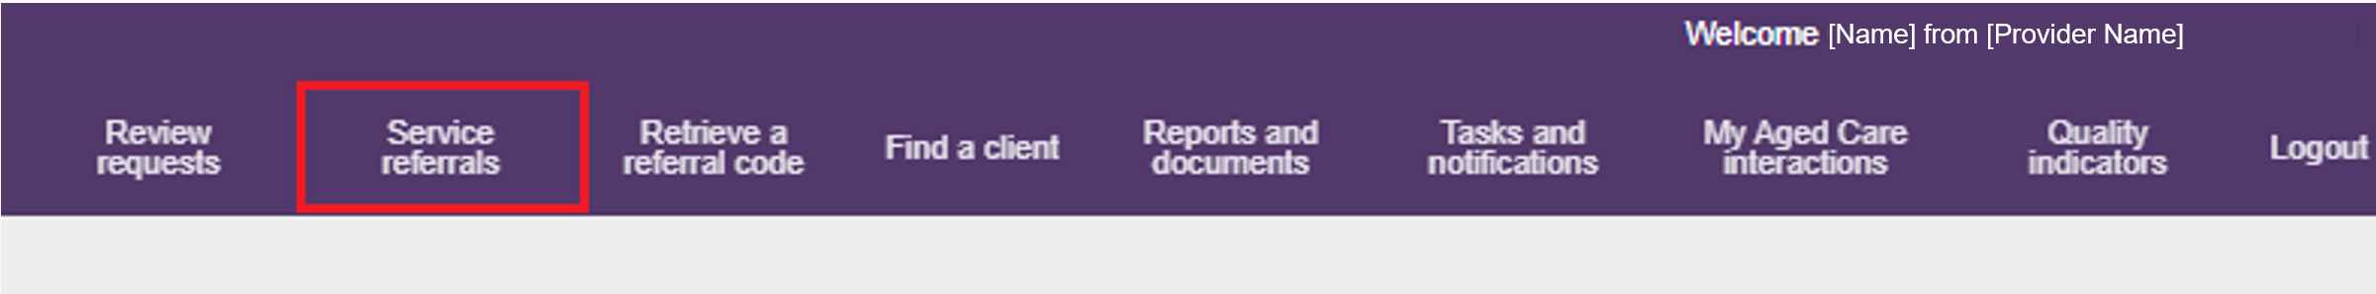
- The Incoming Referrals page displays all incoming referrals that have not yet been actioned. You can switch between card view and list view using the toggle at the top of the page.
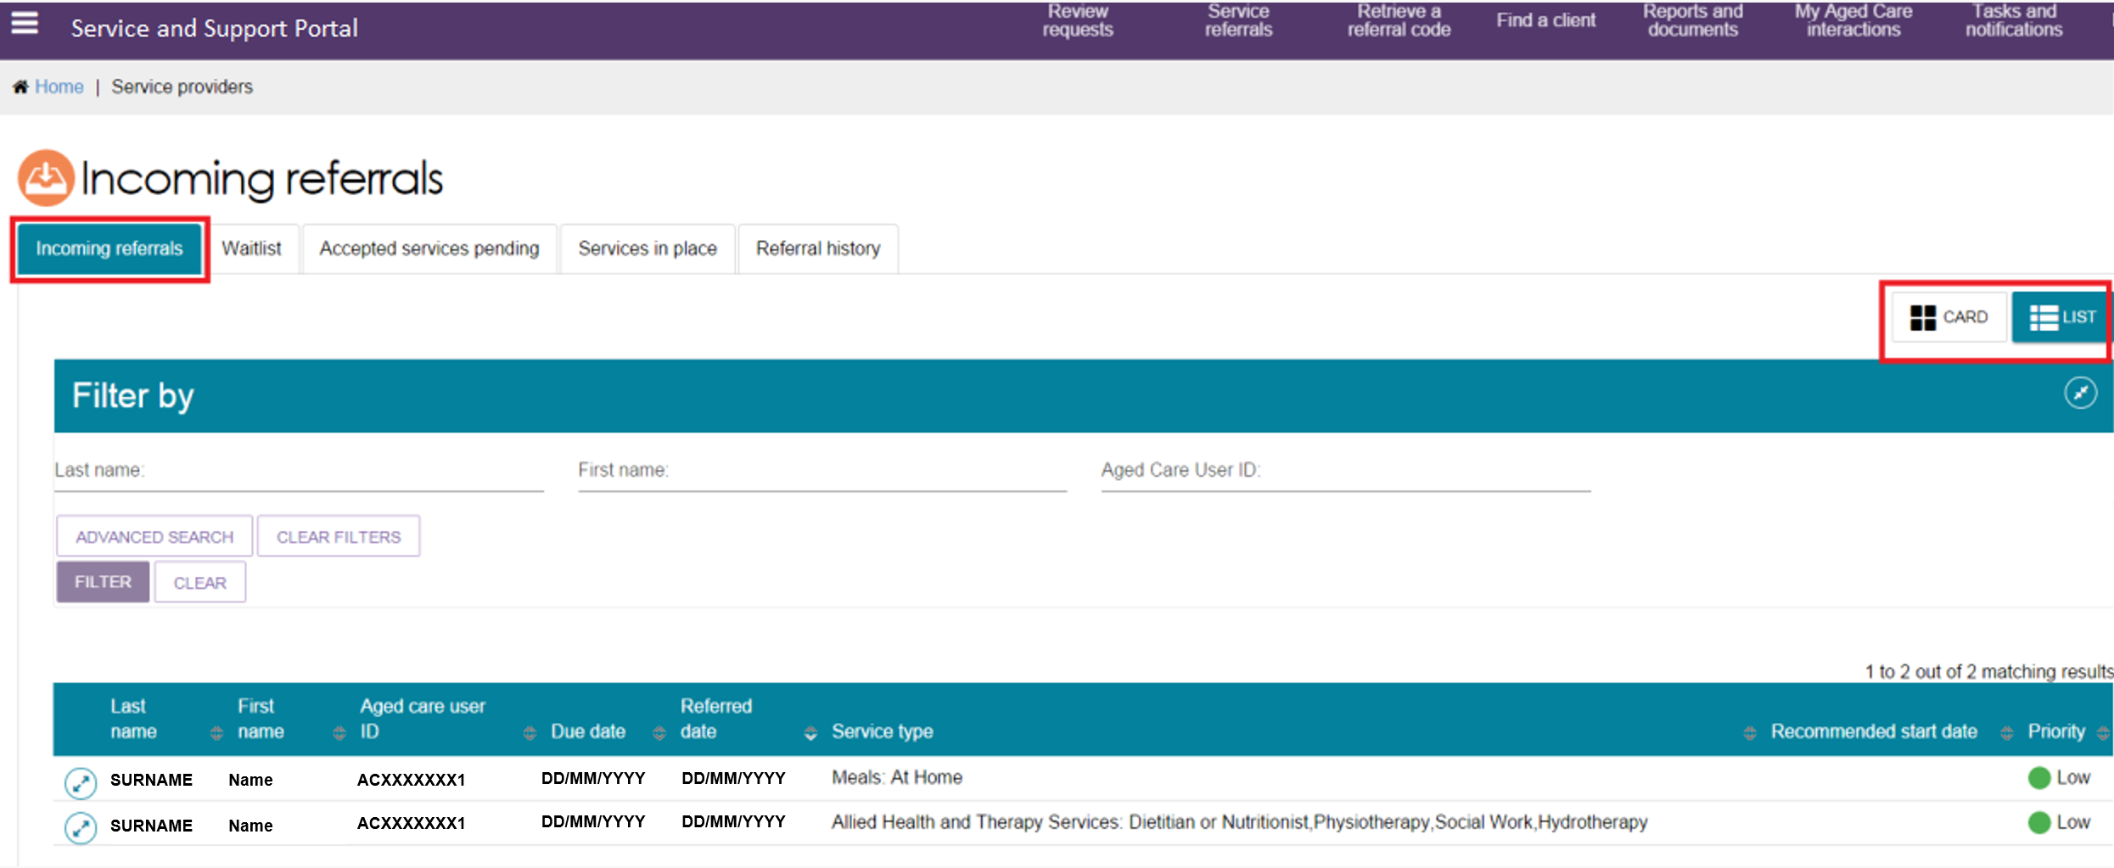
- To find a specific referral, open the Filter by section by selecting the expand arrows, then enter the client's first name, last name, or Aged Care User ID.
- To apply additional search criteria, select Advanced Search.
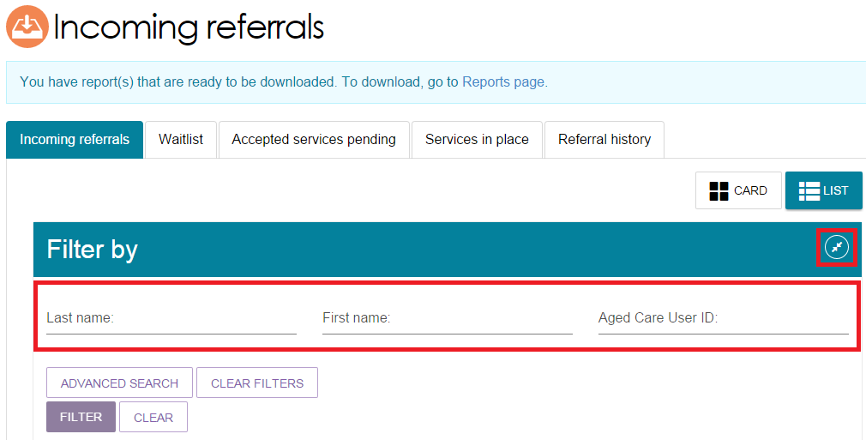
Choose a search filter from the drop-down menu, then select Add Filter to apply it to your search.
- Aged Care User ID
- Due date
- First name
- Last name
- Locality
- Outlet
- Postcode
- Priority
- Recommended start date
- Referred date
- Service type
- State
- Suburb.
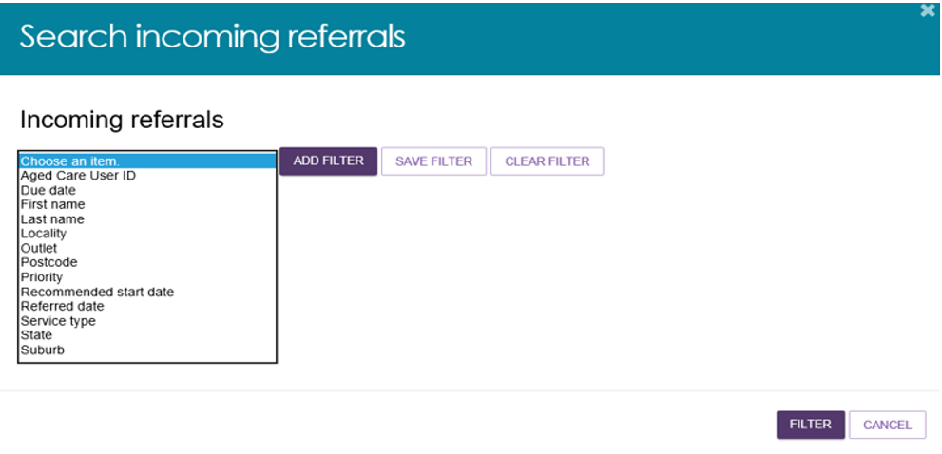
You can add multiple filters, or delete them by selecting the Bin icon.
You can save any filters that have been applied by selecting SAVE FILTER, so that they may be quickly used again through the ADVANCED SEARCH option.
Select FILTER to apply the filter/s.
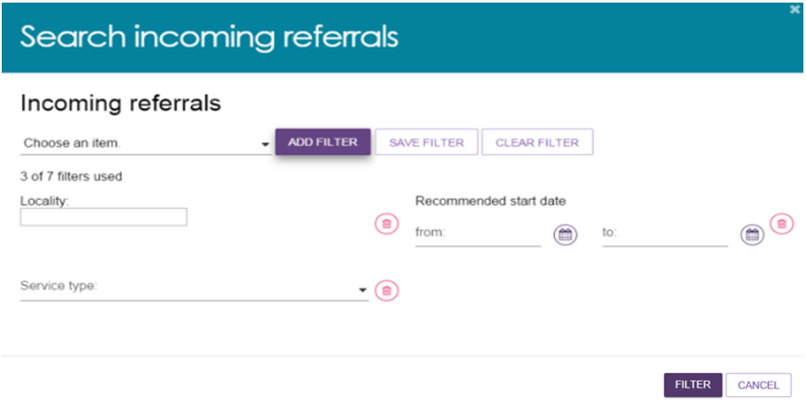
- You can also sort referrals by the following fields, in either ascending, descending or alphabetically:
- Client Last Name
- Client First Name
- Aged Care User ID
- Suburb
- State
- Postcode
- Locality
- Date Referred
- Due Date
- Recommended Start Date
- Priority
- Service Type.
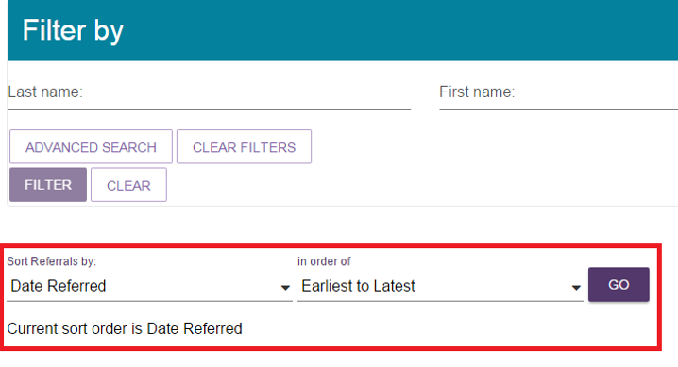

Accepting or rejecting a referral for service
To accept a service referral, select Service Referrals from the home page, the toolbar at the top of the portal, or the sidebar menu in the top-left corner of the portal. Then follow the steps below.
For Support at Home services, providers can view the referral code issued to the client once funding has been allocated. Make sure you note the take-up deadline. You must start services with the client by this date or the funding may be withdrawn.
! Referrals are not sent as specific waitlist referrals. If a waitlist is available for the referred service, staff members or team leaders can place the referral on the waitlist, depending on their access permissions.
- On the Incoming Referrals tab in Service Referrals, locate the referral you want to view.
To display the referral details:
- In card view, select the expand arrows in the top-right corner of the referral card.
- In list view, select the expand arrows to the left of the referral.
The portal will then display information about the selected referral.
Card view
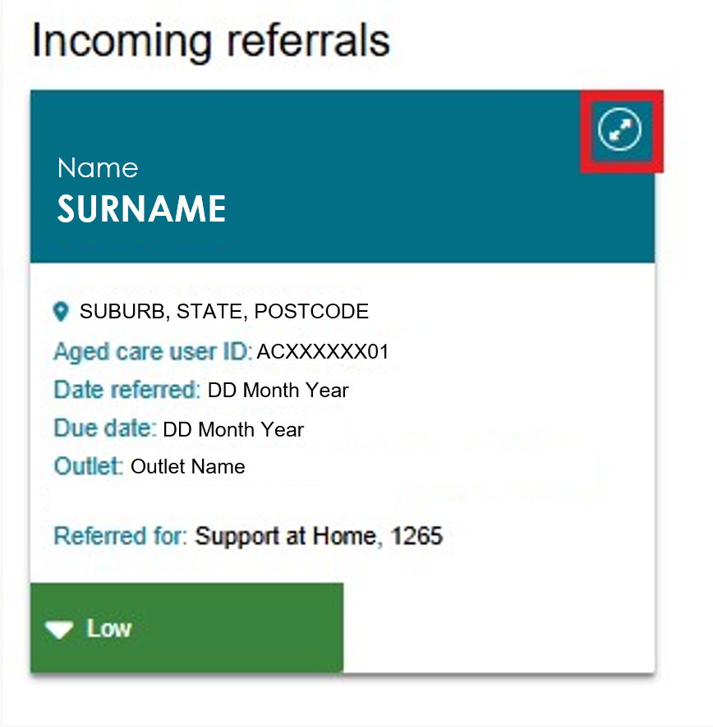
List view
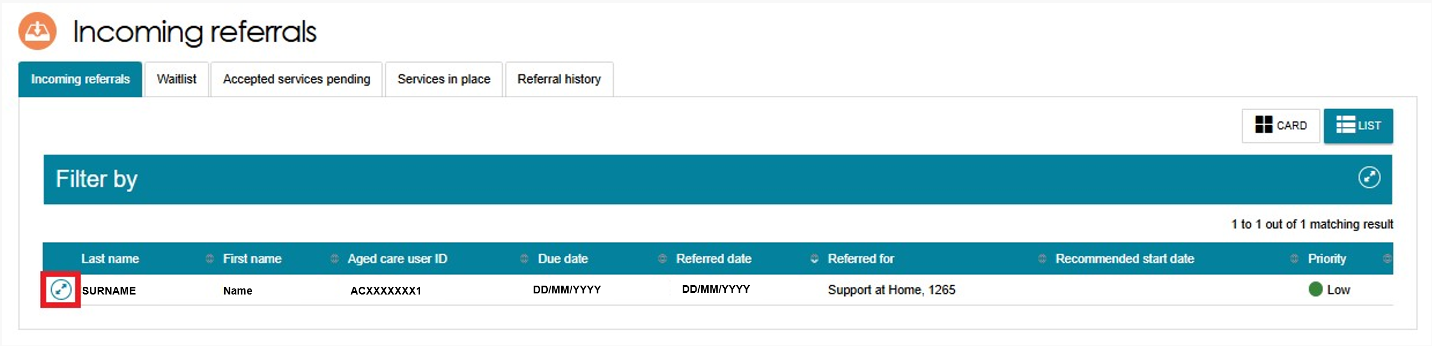
When you expand a referral, you can view additional information, including:
- Comments added by the assessor or My Aged Care Contact Centre
- Whether the client has other referrals for additional service types at your outlet.
Based on the information on the referral card, you can choose to accept, reject, or place the referral on a waitlist.
If you need more information before making a decision, select View Referral Summary and Client Record. This option lets you view:
- Referral details
- The client's assessment information
- Assessment outcomes
- More detailed client information.
For Support at Home referrals, the detailed referral view also shows assigned funding information, including MSO (Minimum service offer) and FSO (Full service offer) details for both Support at Home (SaH) and Assistive Technology/Home Modifications (AT/HM) services.
If the client has two active classifications within the same service group, the portal displays details for both classifications.
Expanded referral - card view
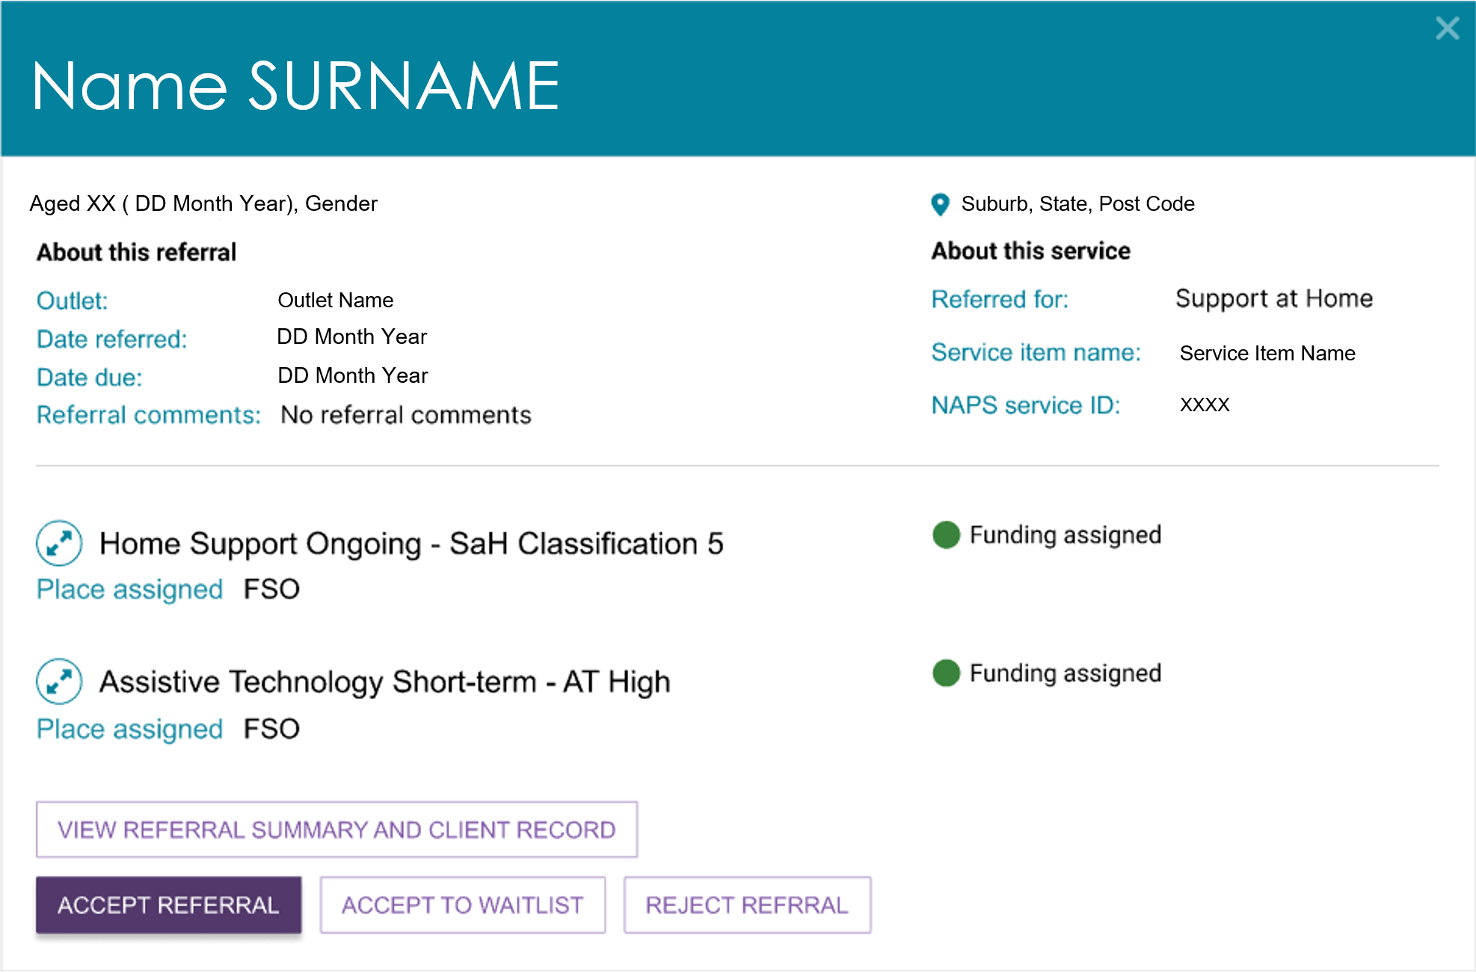
Expanded referral - list view
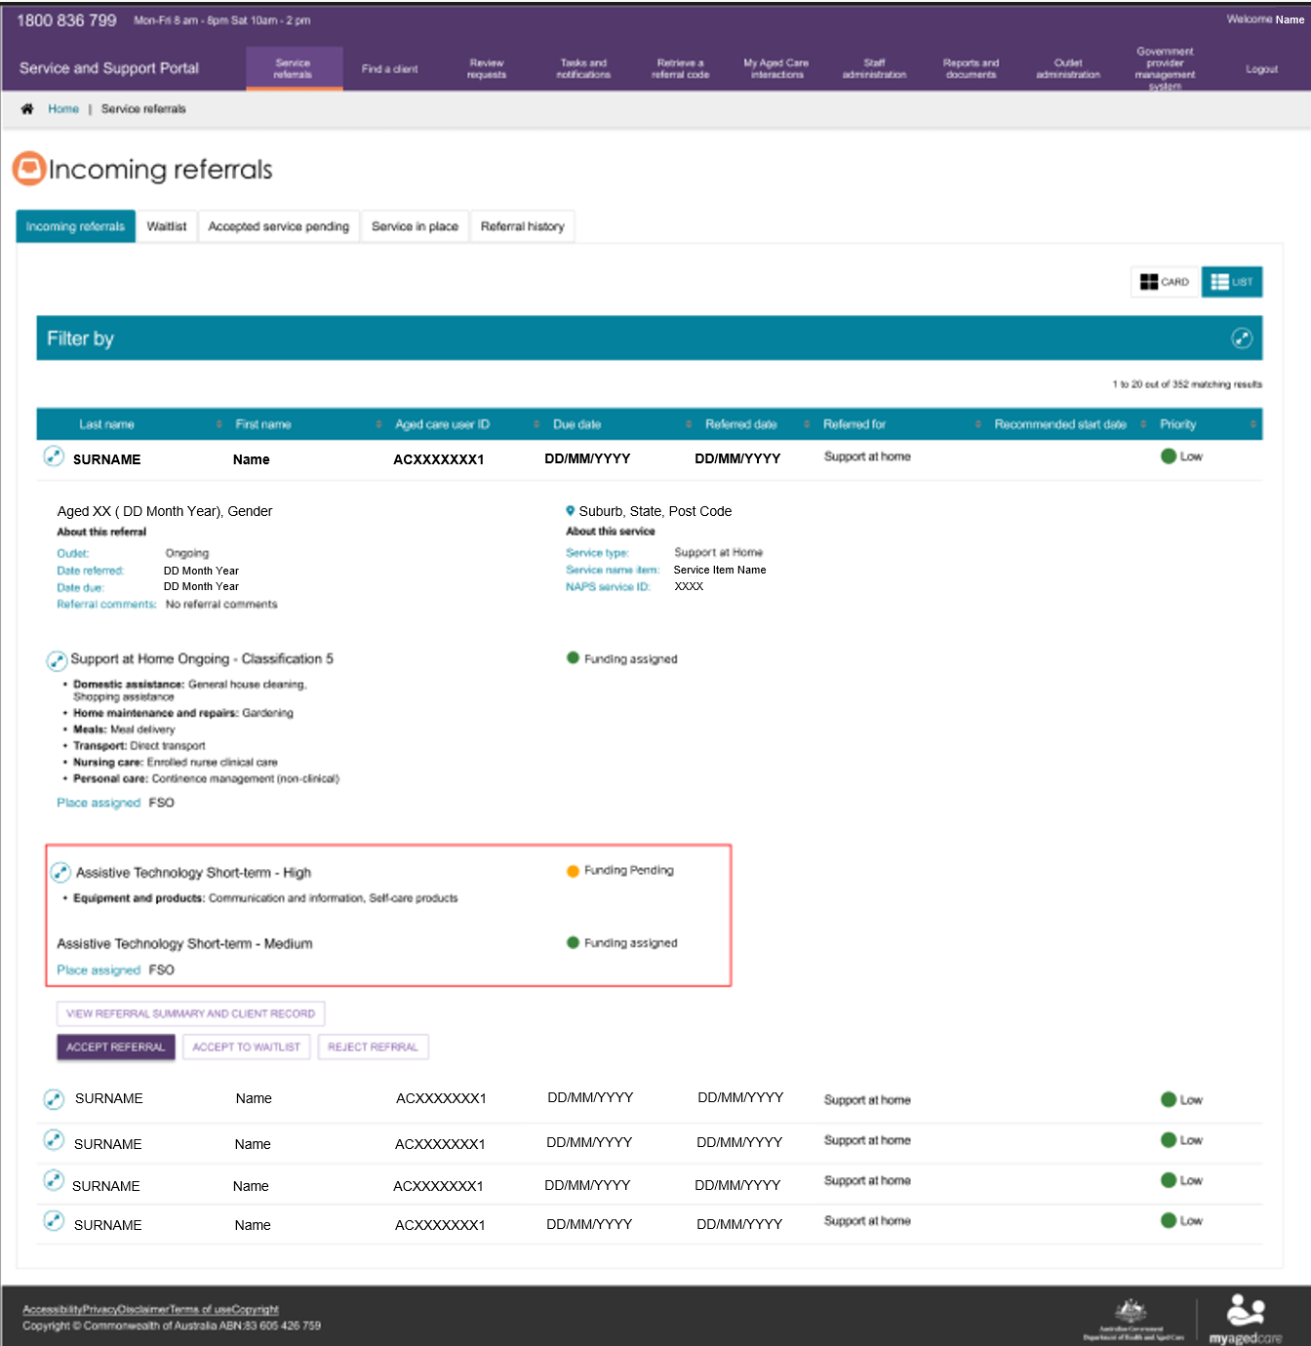
For Support at Home services, the detailed referral view will display the recommended frequency and intensity (for example, 2 hours a week, or 3 times a month). This information is a recommendation only and is intended to support discussions with the client and assist providers when considering service options. This information is also available in the Services and Referrals for my organisation tabs in the client record.
- If you select View Referral Summary and Client Record, the Referrals for My Organisation screen opens. This screen displays all referrals that your organisation has received for the client.
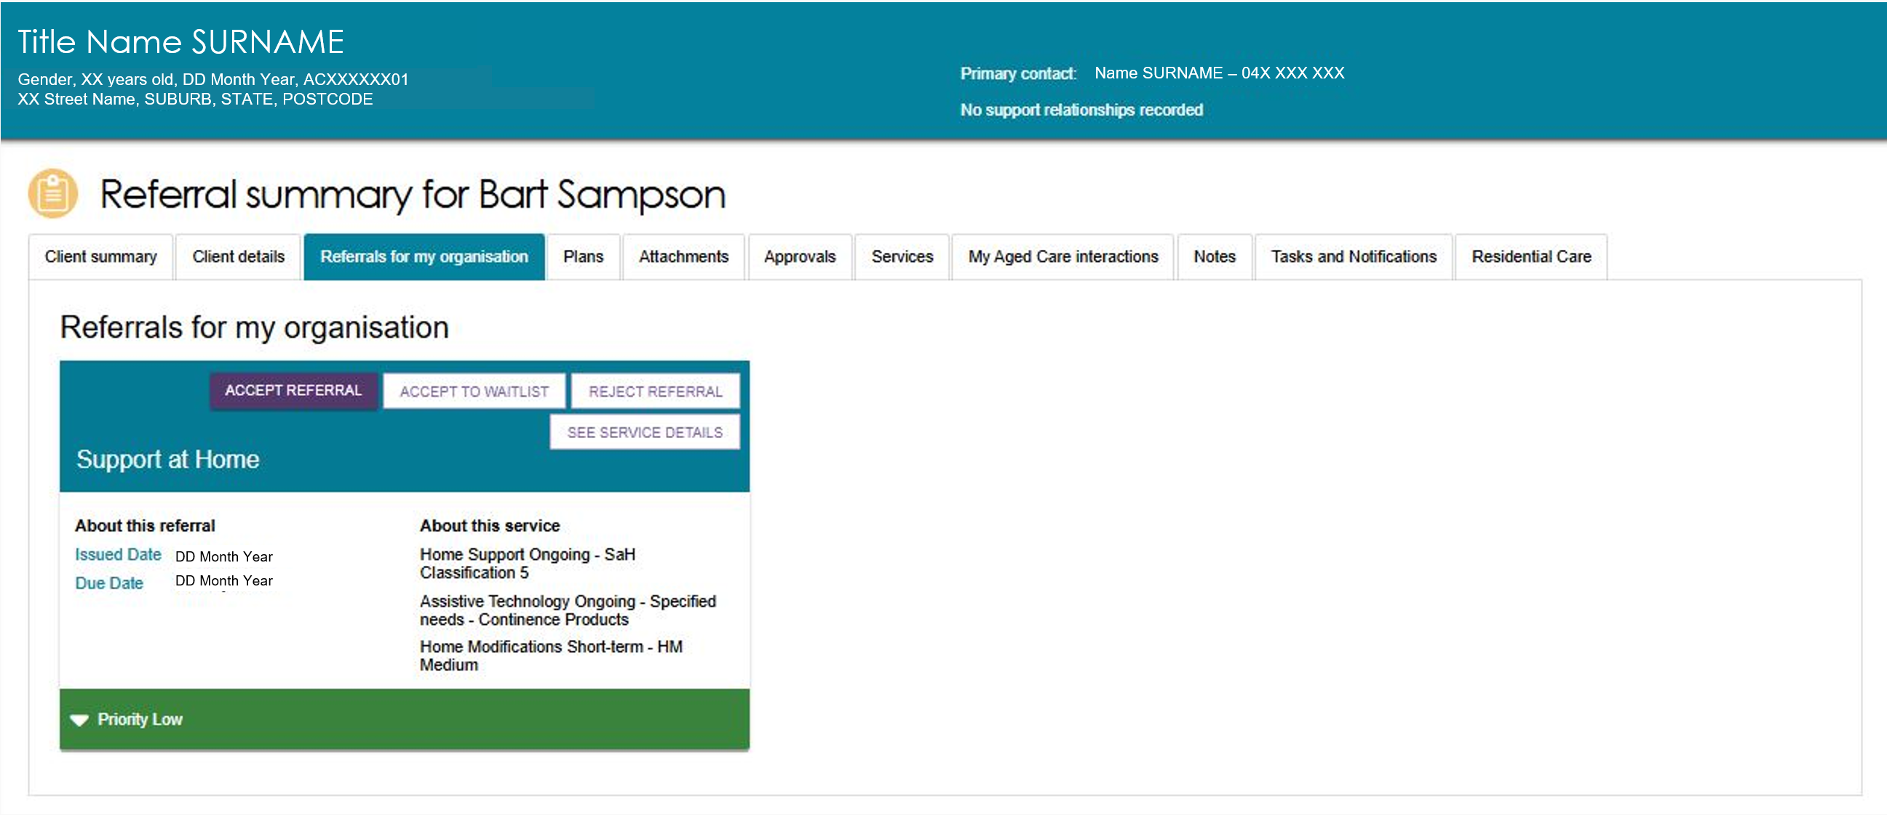
You can view more client information in the Client summary tab (client contact details and full address details can only be viewed once a referral has been accepted):
To accept the referral, refer to Step 3.
To reject the referral, refer to Step 4.
To accept the referral to waitlist, refer to Step 5.
The My Aged Care Service and Support Portal user guide – The client record contains further information about navigating the client record and what information can be viewed.
- To accept the referral, select ACCEPT REFERRAL from the Referral summary page or from the expanded referral in the Incoming referrals tab.
! Before you accept a referral, make sure you have reviewed the referral and client information and decided that your organisation will provide services to the client.
Only accept the referral after you have confirmed that your organisation has the capacity to deliver the required services, and confirmed that the client has agreed to proceed with the service.
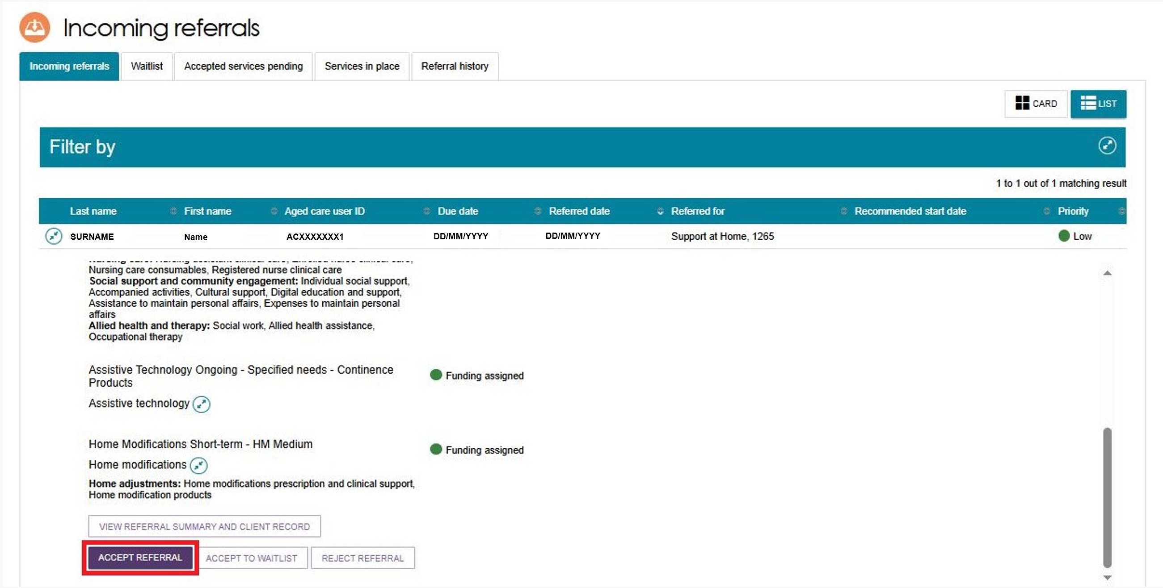
Selected the correct service item name or NAPS Service ID (if your organisation has more than one service or NAPS Service ID available for that service type).
To complete the process, select Accept to confirm your decision.
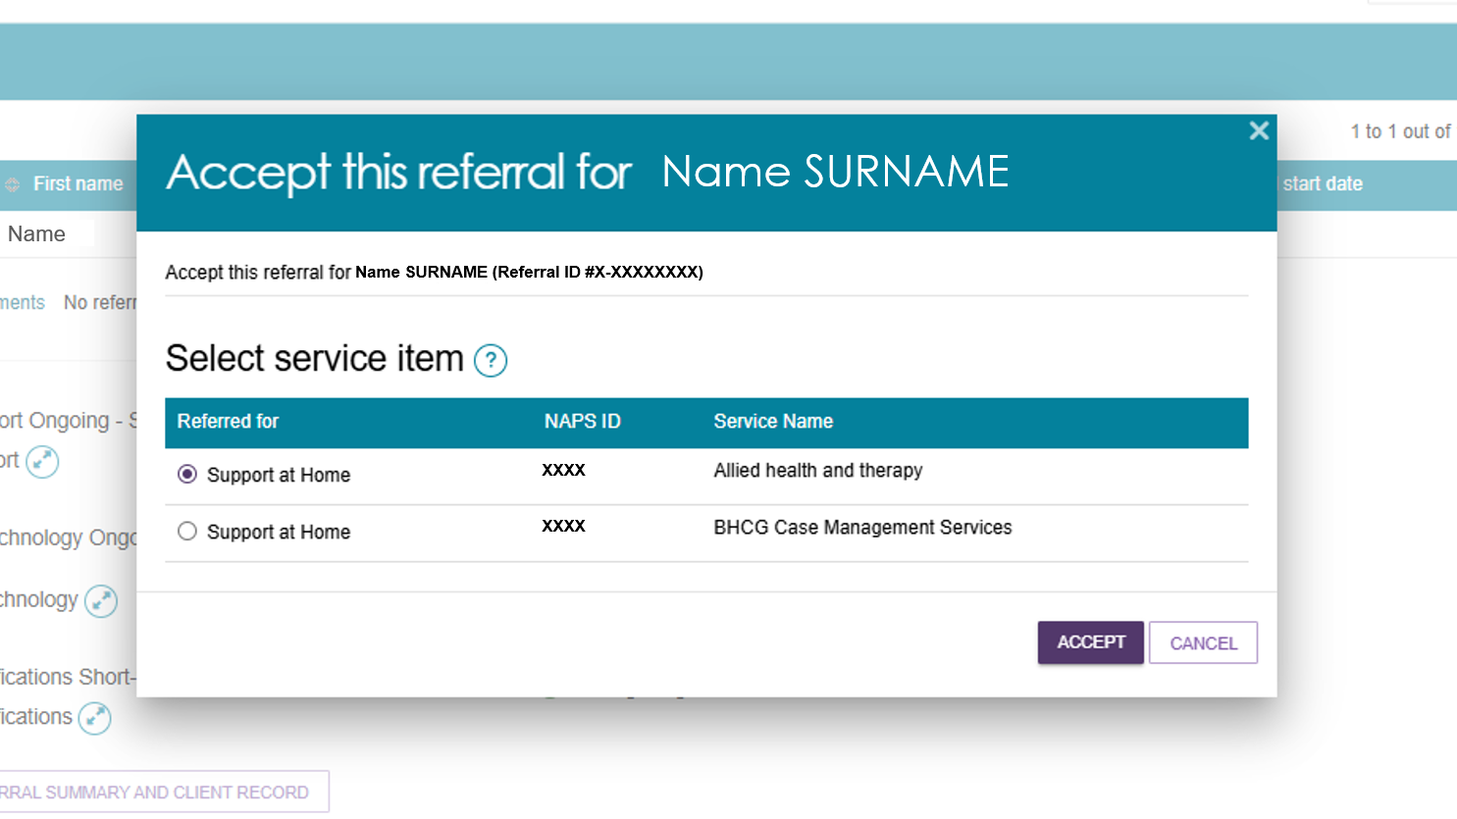
A confirmation message will appear at the bottom of the screen. The accepted referral will then move to the Accepted Services Pending tab. You will also gain access to the client's full record, including their complete address and contact details.
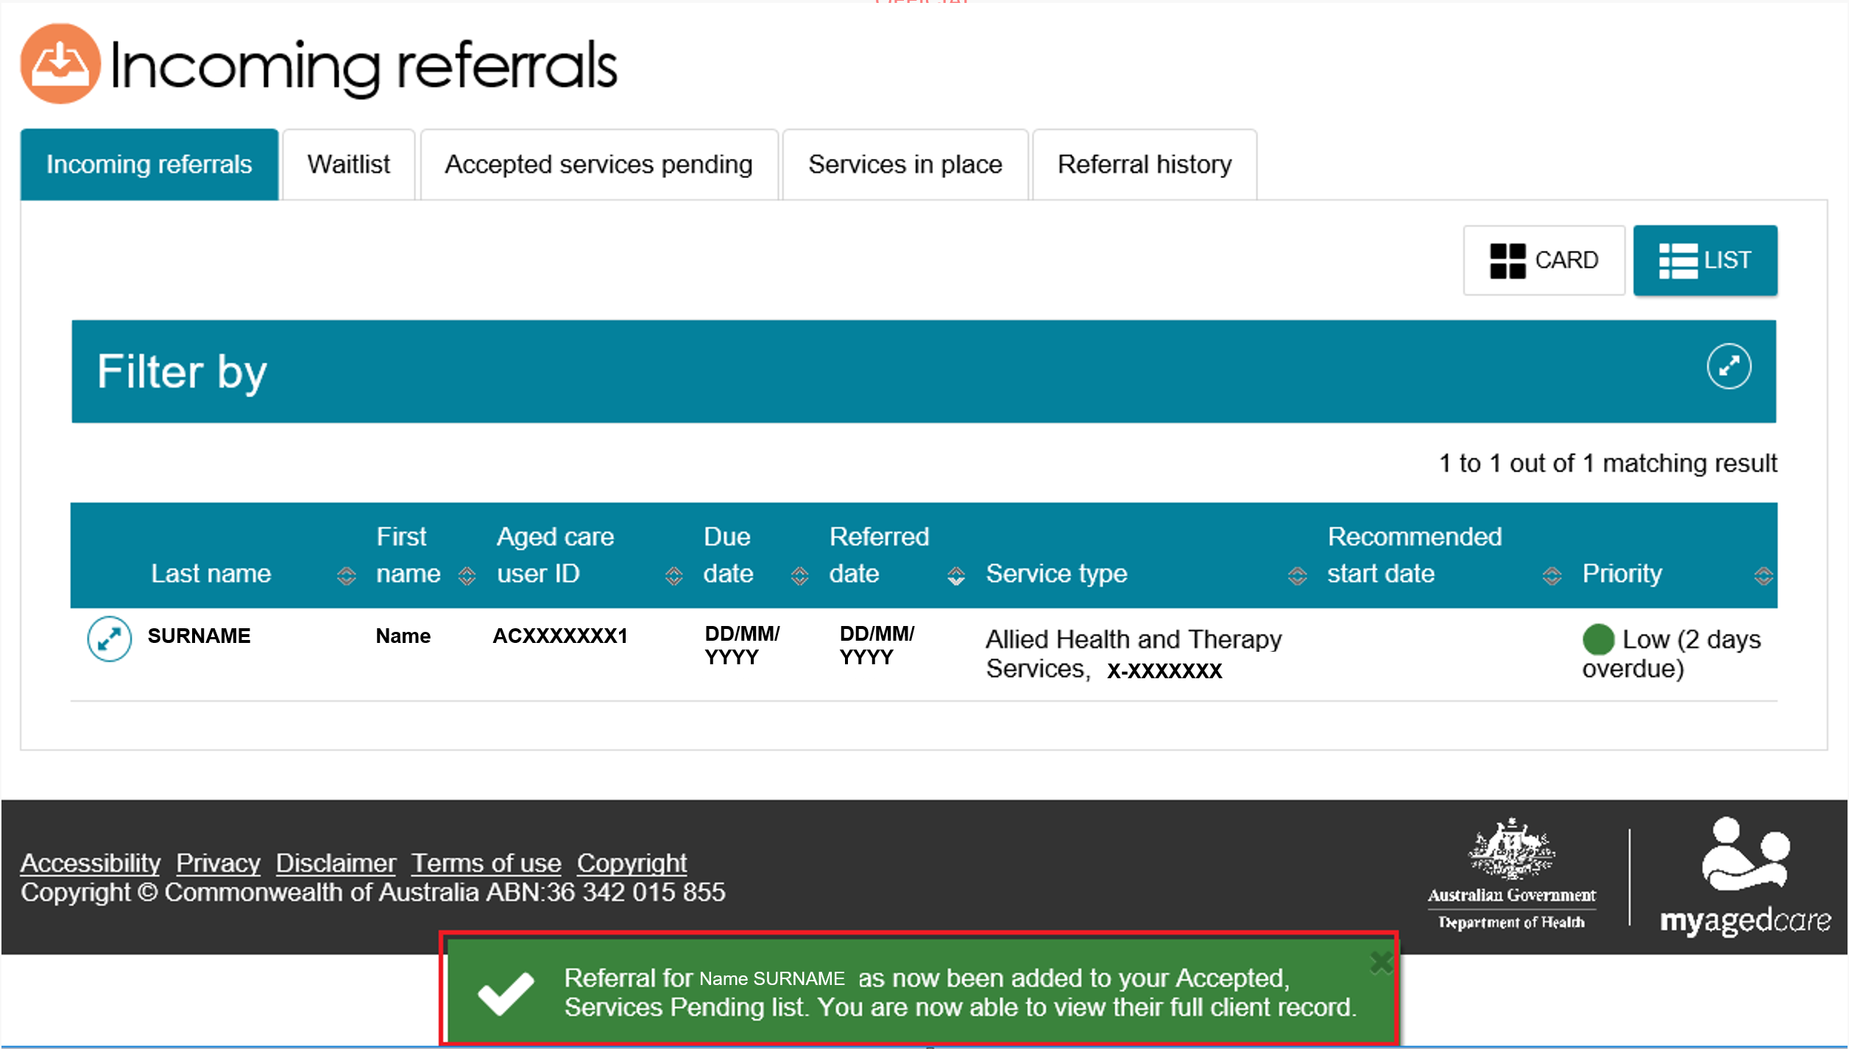
! After accepting a referral, you must provide service delivery information within the required priority timeframes. For more information, refer to the My Aged Care - Service and Support Portal Resources page on the Department’s Website.
- To reject a referral, select Reject Referral on the referral card or the Referral Summary page.
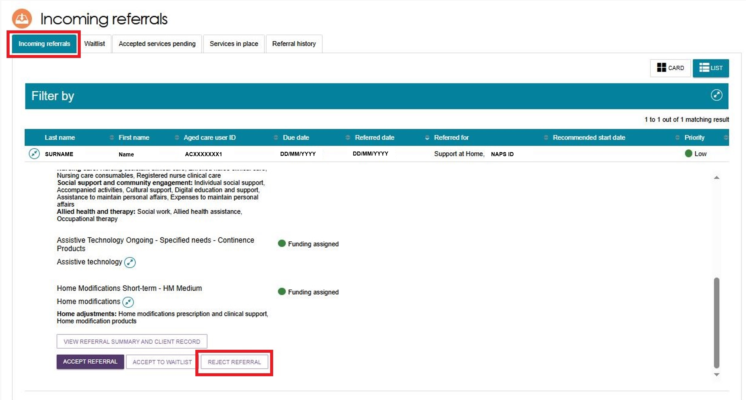
When you reject a referral, select a reason from the drop-down list. You can also add extra details in the Rejection Reason text box if needed.
Other My Aged Care users can view your rejection comments, but the client cannot see them in their My Aged Care Online Account.
Providing a clear reason for rejection helps assessors and the My Aged Care Contact Centre support clients to find appropriate services.
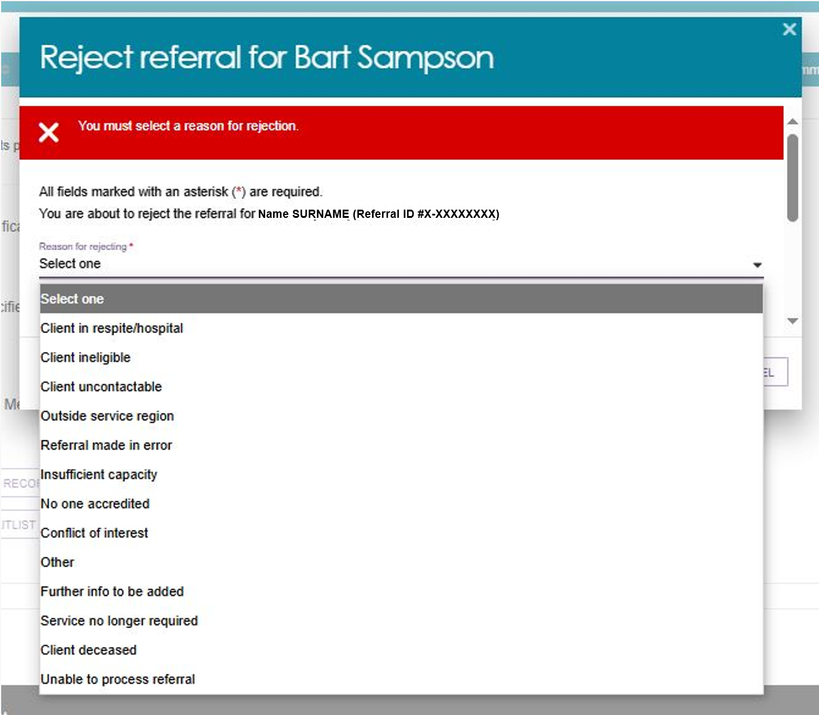
! If you reject a referral and select Client Deceased as the reason, the portal changes the client's status to Deceased and makes their record read-only.
When this happens, the system recalls any service referrals that have not been accepted, ends any active services, and cancels any scheduled assessments. The client can no longer access the My Aged Care client portal.
My Aged Care will also stop sending correspondence to the client, their registered supporters, and any appointed decision-makers.
If the client is in the Support at Home Priority System or has been allocated Support at Home funding, the system will remove them from the priority system and withdraw any assigned funding.
After you reject the referral, a confirmation message will appear at the bottom of the screen.
! If your organisation cannot provide the service because of limited capacity, your administrator should update your service availability and service information in the portal. This is described in My Aged Care – Service and Support Portal user guide – Part 1: Administrator functions.
- If you cannot provide the service immediately and your organisation offers a waitlist, you can ACCEPT TO WAITLIST. The referral will then appear in your outlet's Waitlist tab. You can only use this option if your Organisation Administrator has configured the service to accept waitlist referrals. This process is described in My Aged Care – Service and Support Portal user guide – Part 1: Administrator functions.
! Support at Home Waitlists
Placing a client on a provider waitlist does not pause the Support at Home place take-up deadline.
If the take-up deadline passes while the client is still on the waitlist, the allocated waitlist place will expire, and the system will automatically withdraw it.
To avoid this, providers should not place clients on a waitlist after funding has been allocated. Instead, providers should accept the referral and start services as soon as possible.

Revoking a referral after acceptance
Sometimes, after you accept a service referral, circumstances may change and affect your ability to provide services to the client. For example, the client may withdraw their consent, or their care needs or personal situation may change.
You can only revoke an accepted referral if:
- You have not entered any service delivery information, and/or
- Services have not yet started.
The department monitors the use of referral revocations. If your outlet revokes 20% or more of the referrals it receives over a 12-month period, the department will notify your organisation.
When you revoke an accepted referral, the system automatically issues any other available referrals for the client, such as broadcast or preference referrals.
Follow these steps to revoke a referral after acceptance:
- Go to the Accepted services pending tab in the Service referrals section of the Service and Support Portal and find the referral that you want to revoke.
You can:
- Use the Filter options to narrow your search.
- Change the sort order and select Go to reorganise the results.
- Switch between Card View and List View.
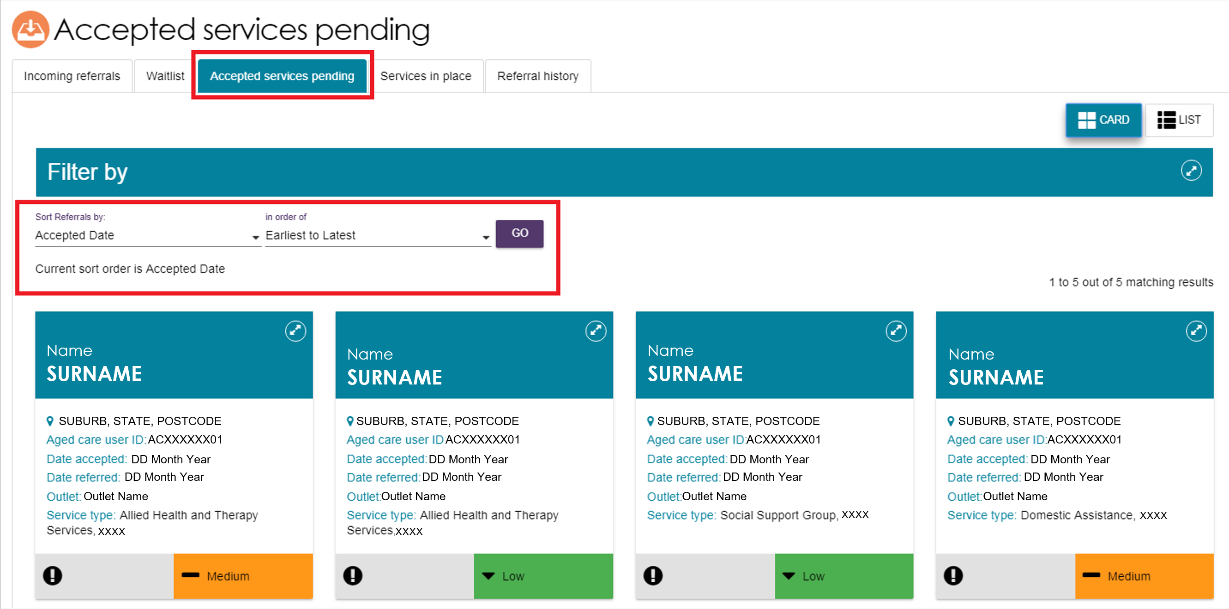
- Open the referral by expanding its details, then select REVOKE REFERRAL.
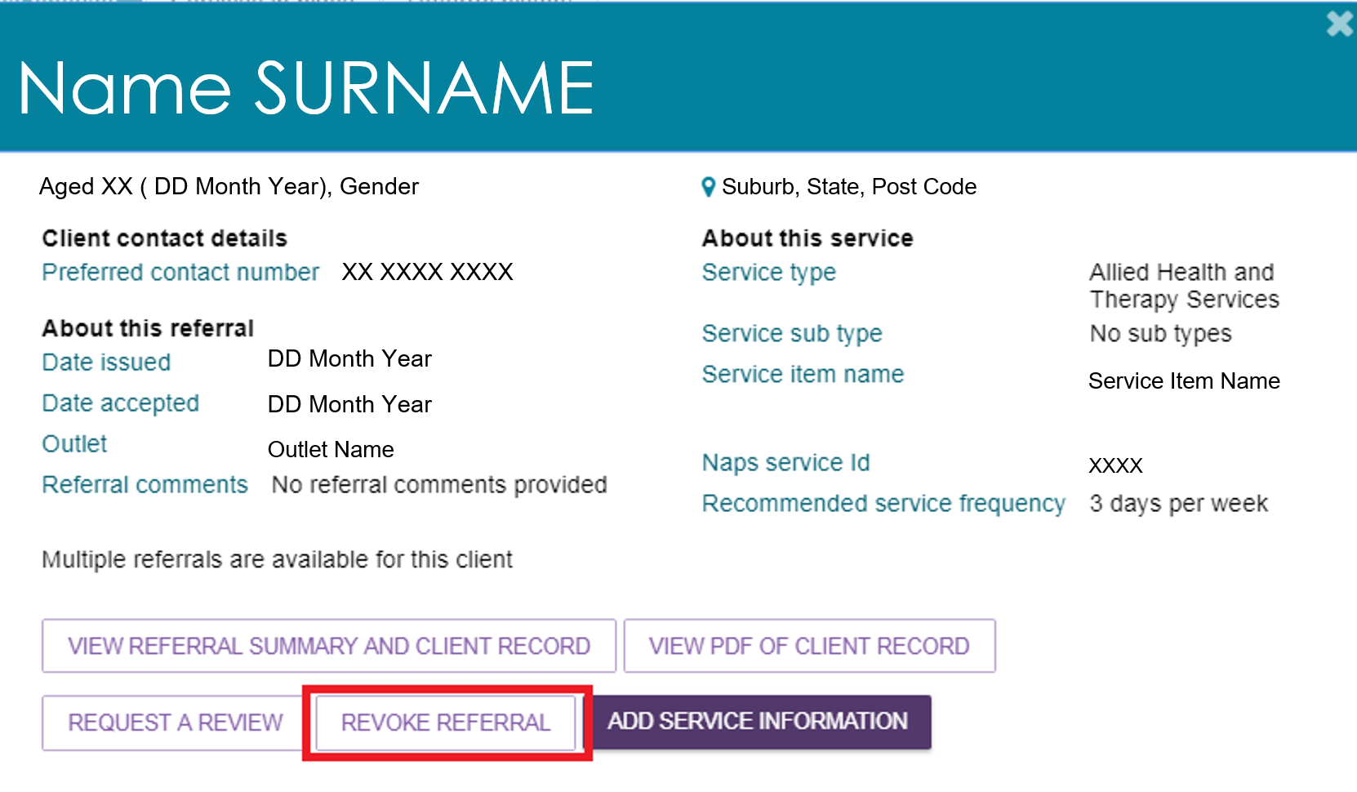
- Select a revocation reason from the drop-down list. In the Comments field, enter details explaining why you are revoking the referral after accepting it.
Select REVOKE REFERRAL to confirm your decision.
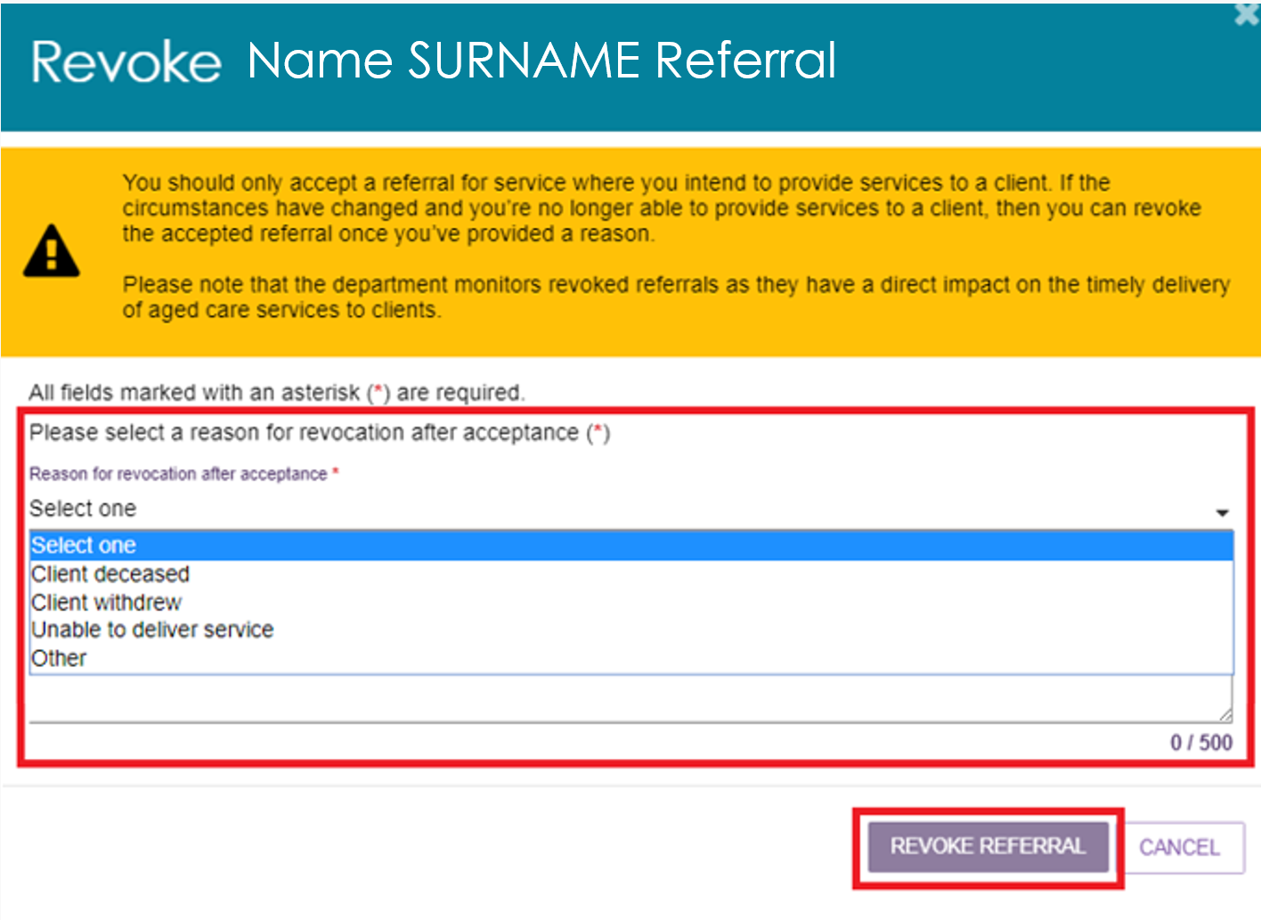
- The portal will display a confirmation message. The referral will then be removed from the Accepted Services Pending tab.

Clients and Services
This section explains the portal features you use to manage clients and services.

Find a client
Follow these steps to find a client who has been referred to or accepted to service by your organisation.
- Select Find a client from the home page.
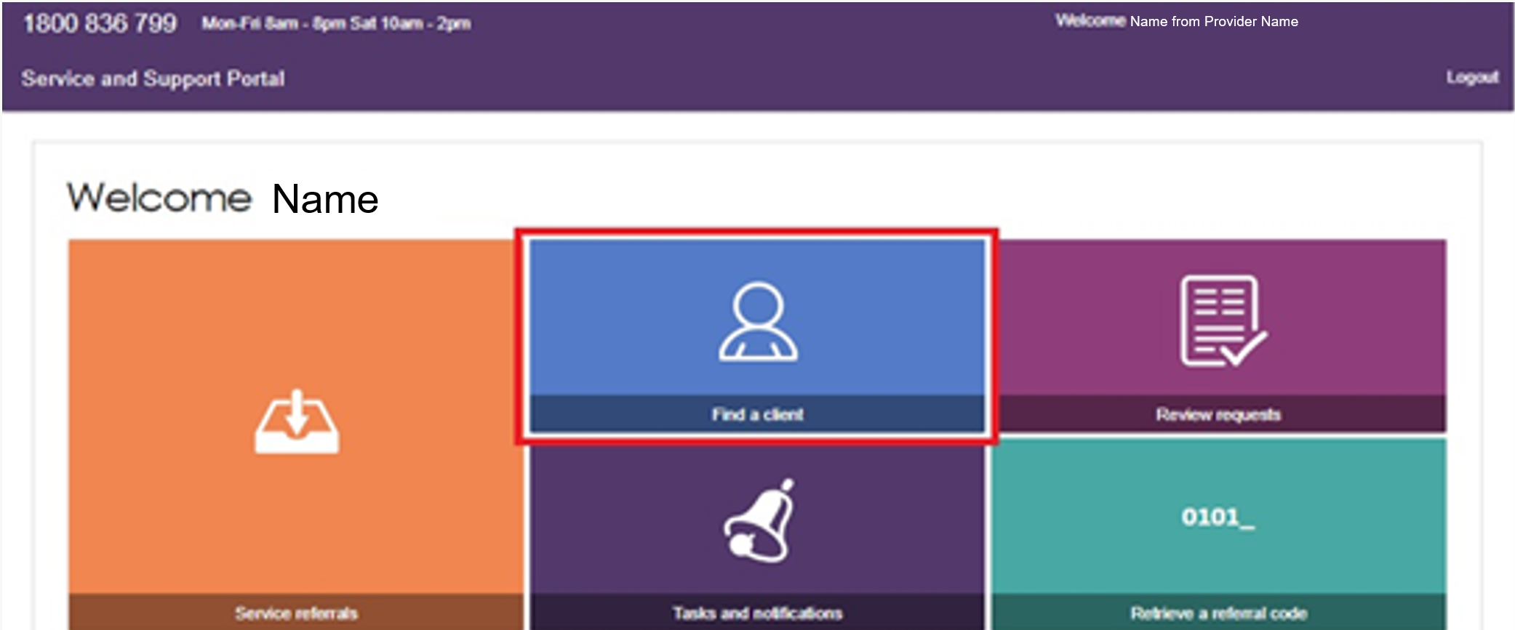
You can also find a client's referral from any page in the Service and Support Portal by selecting Find a Client from the toolbar at the top of the screen.
- On the Find a Client page, enter the client's first name, last name, or both to search for a client.
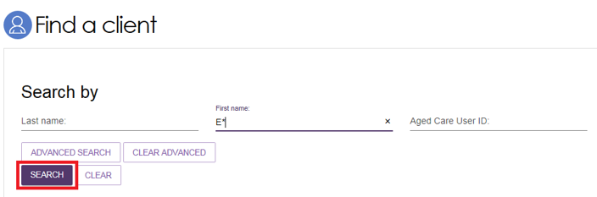
The system will display any matching results.
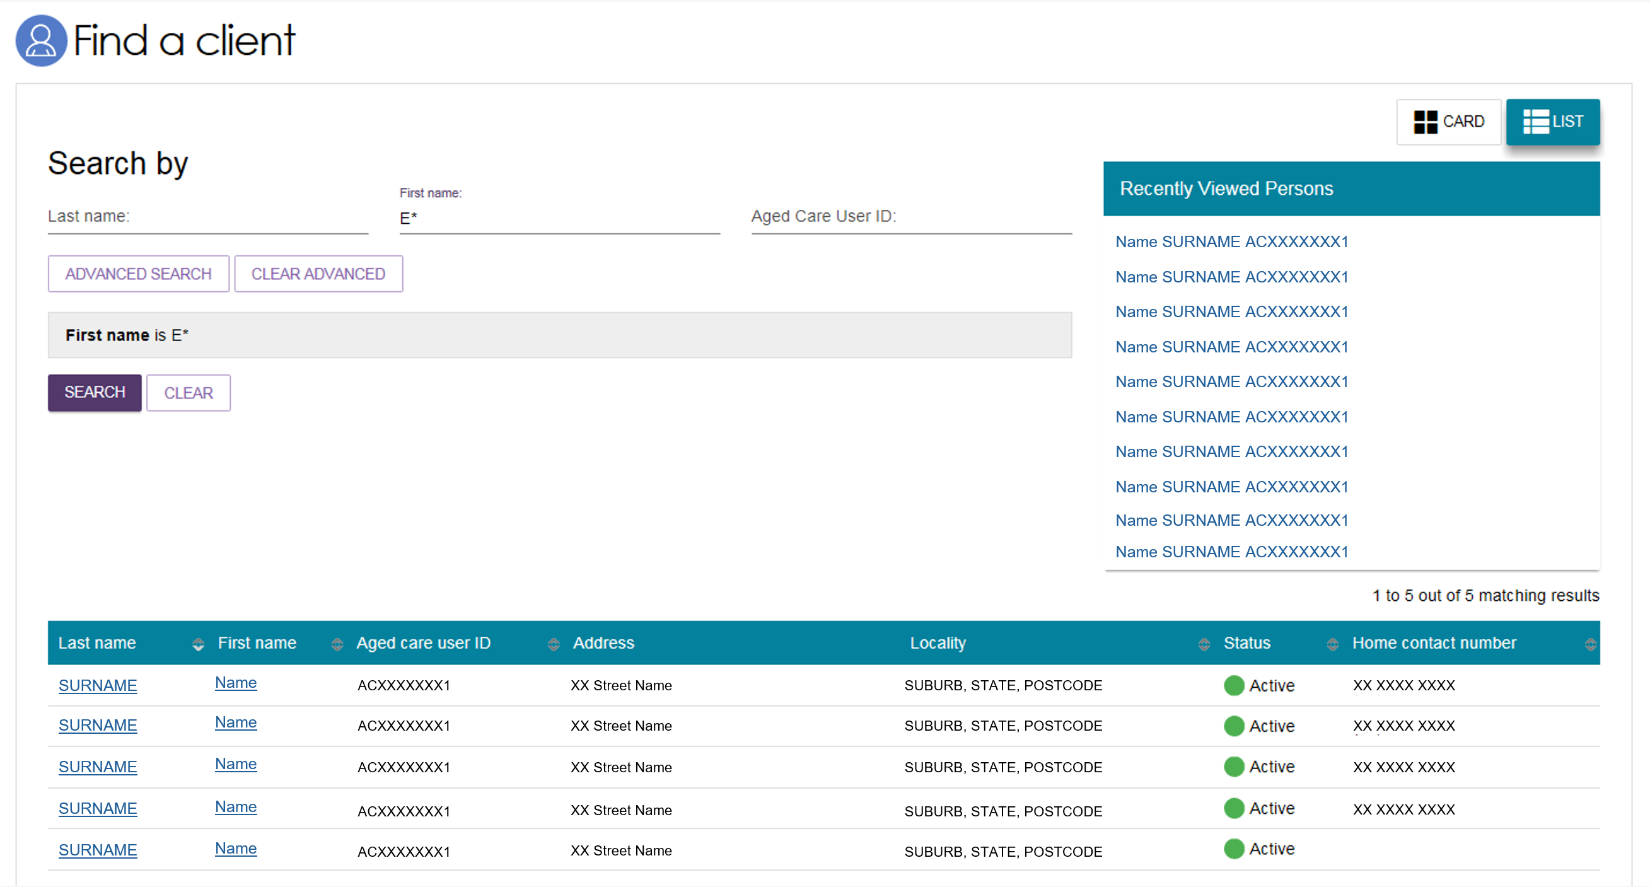
- You can also select Advanced Search to use additional search options, including:
- Aged Care Payment Management System (ACMPS) number
- Aged Care User ID
- Centrelink Customer Reference number (CRN)
- Client Status
- Date of Birth
- Department of Veterans’ Affairs (DVA) card number
- First name
- Home contact number
- Last name
- Locality
- Medicare Card Number
- Postcode
- Preferred name
- State
- Suburb
- System for the Payment of Aged Residential Care (SPARC) number.

Viewing client information
You can only view information for clients who have been referred to your organisation.
After you find a client, you can view the information in their client record.
Before you accept a referral, you can view most client information, but you cannot see their full address or contact details.
Follow these steps to view client information:
- Find the client. You can do this via the Find A Client functionality.
When you select the client’s name, the Client Summary page appears.
Card view from Find a Client functionality
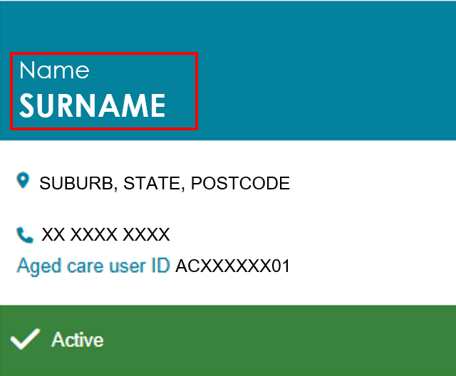
List view from Find a Client functionality
- Or view a client from a new referral. Find the client’s card or listing by following the Viewing Referrals procedure.
Select the expand icon at the top-right corner of the card, or on the left side of the listing.
The client card or listing opens. Select VIEW REFERRAL SUMMARY AND CLIENT RECORD.
The client’s record opens at the Referrals for my organisation tab.
Card view from incoming referrals
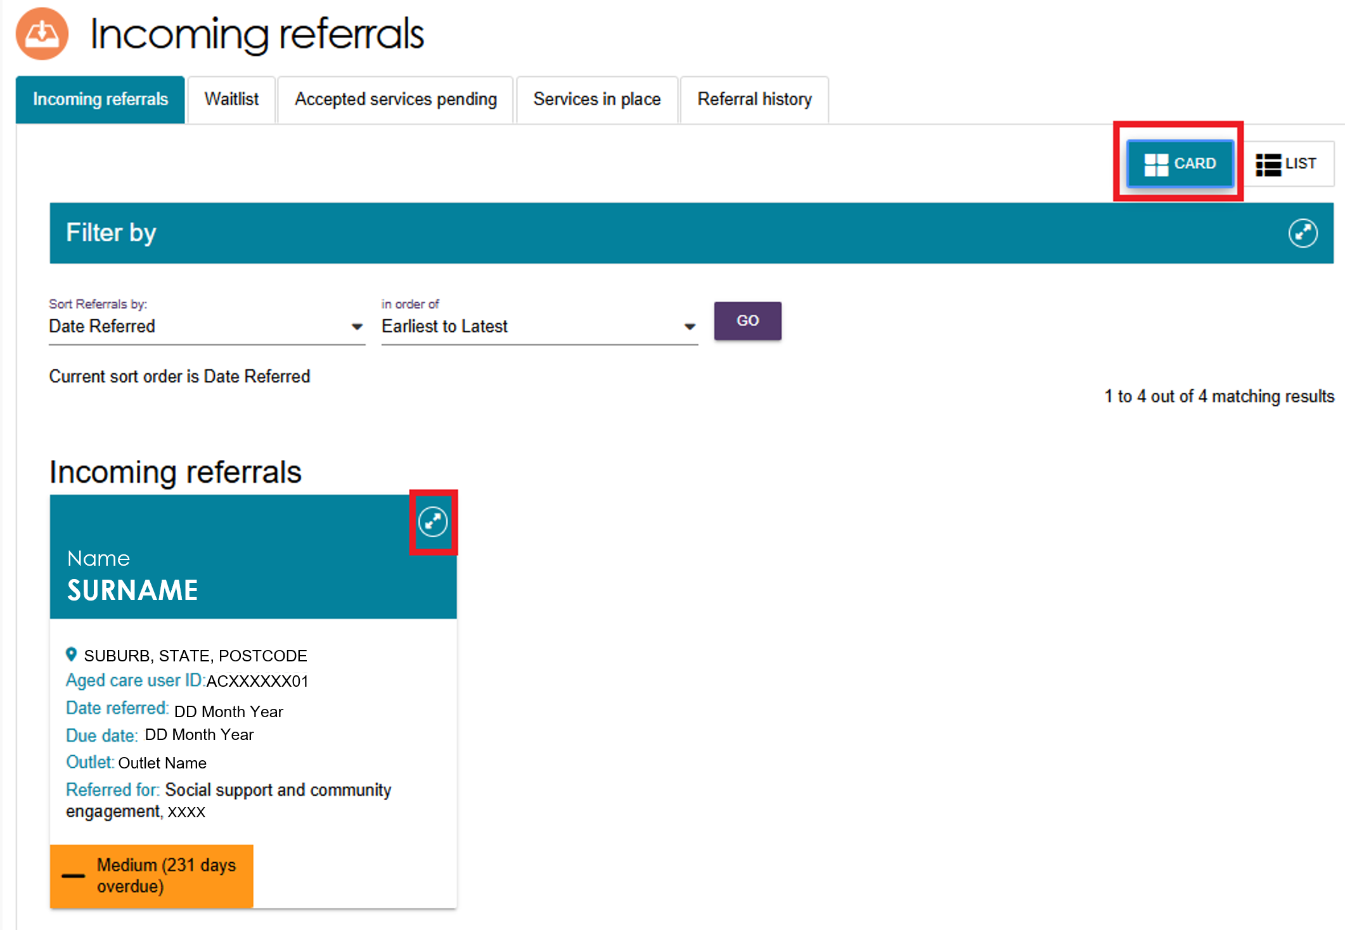
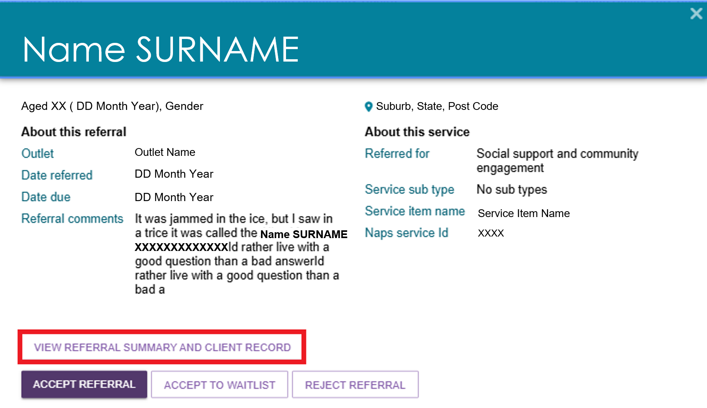
List view from incoming referrals
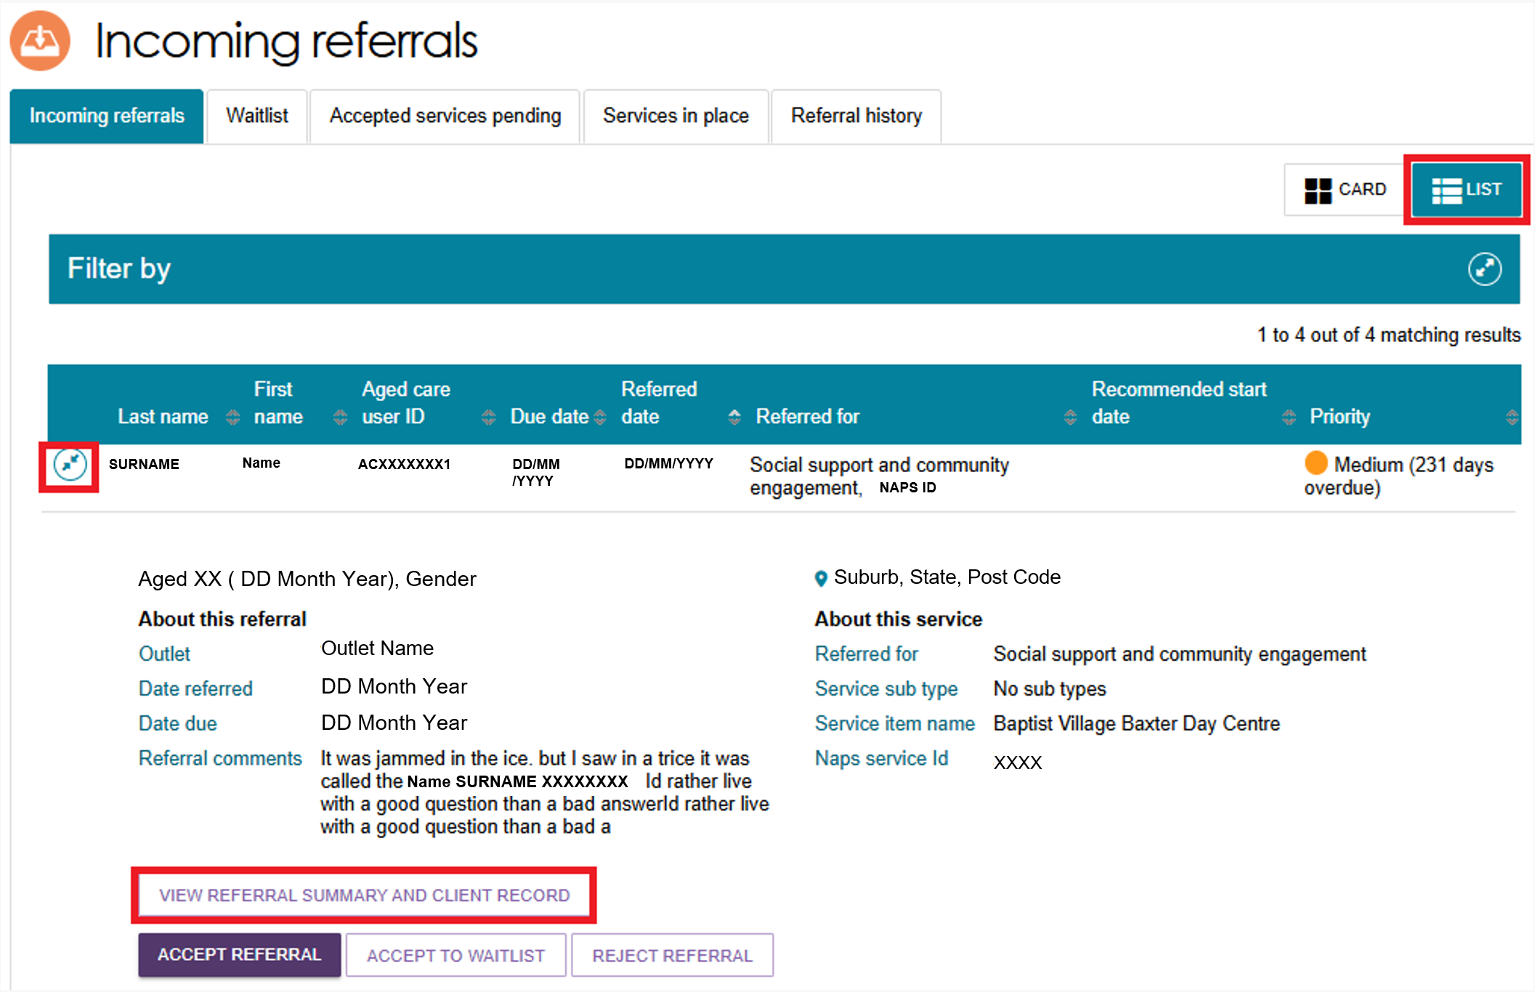
- The client record contains several tabs. Select a tab to open and view its information. For more information about each tab, refer to the relevant section of this guide:
- Client summary
- Client details
- Support network
- Referrals for my organisation
- Plans
- Attachments
- Approvals
- Services
- My Aged Care interactions
- Notes
- Tasks and Notifications.
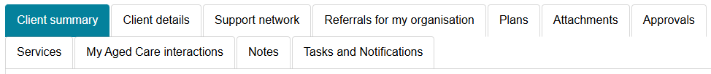

Client Summary
The Client summary tab contains an overview of the client’s key information and their interactions with My Aged Care. The tab has two sections:
Client Journey Tracker (Client tracker): This visual tool shows where the client is in their My Aged Care journey and what steps come next. It displays above the Client Summary.
Client summary: This section provides information about the client’s interactions with My Aged Care, including: Assessments, Approvals, Service recommendations, Service delivery status, Client goals, and Reablement and linking support periods (where available).
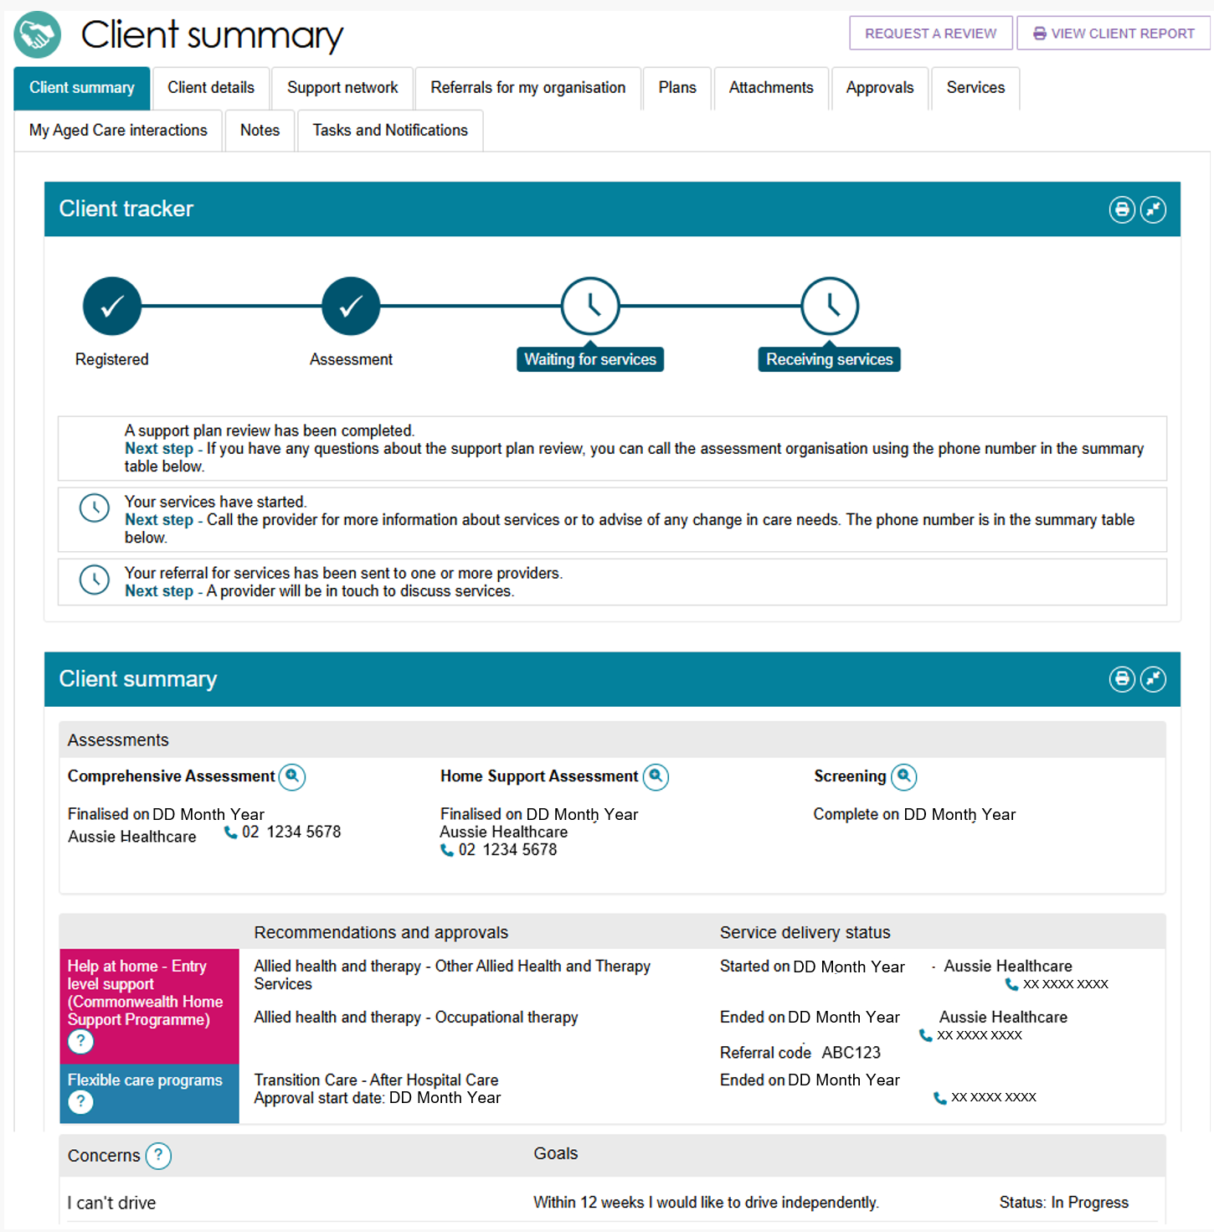
To print a section, select the Print Page button on the right side of the section heading.
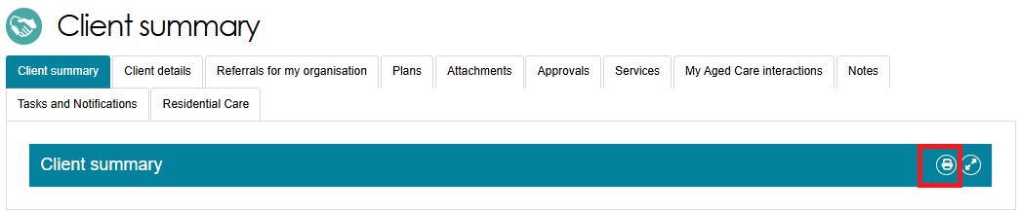

Client Details
The Client details tab contains basic demographic and contact information about the client, including:
- Personal information
- How to contact the client
- Primary contact details
- Notification preferences
- Communication requirements
- Address details
- Identity documents
- Payment details
- Health insurance
- Service information
- Consent information.
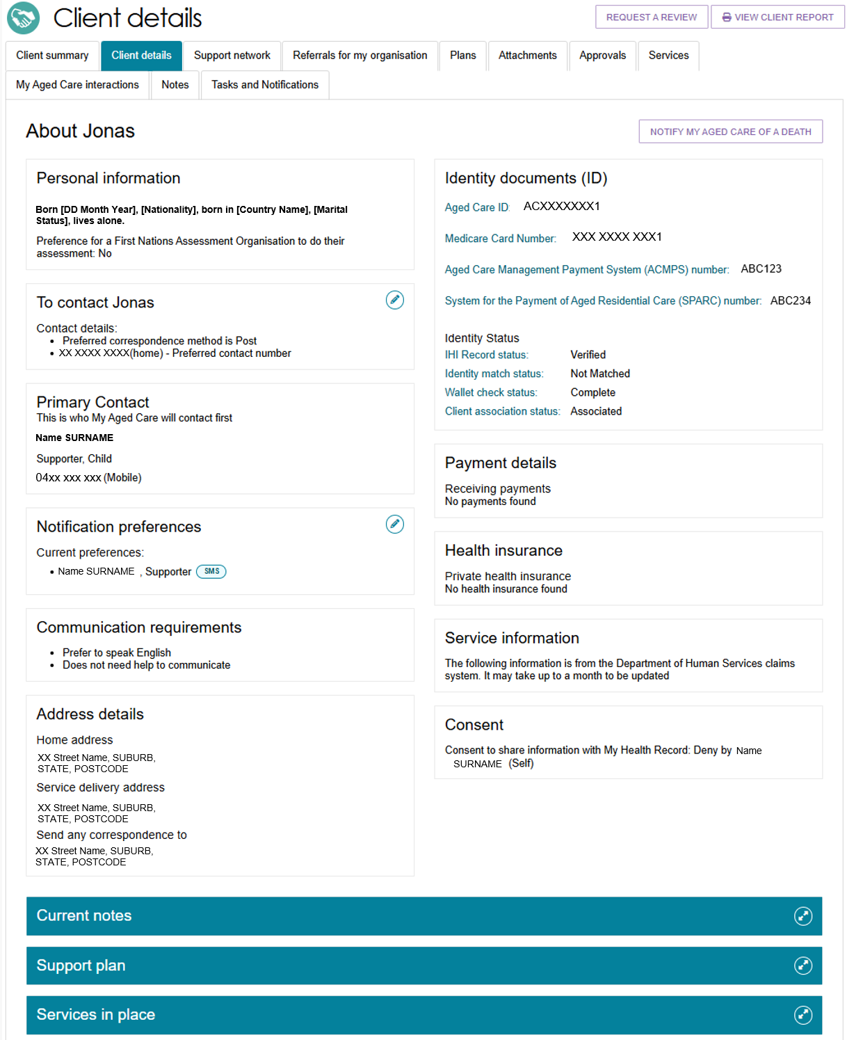
The Client Details tab also has links to current notes, the client’s current support plan, and any services that are in place.
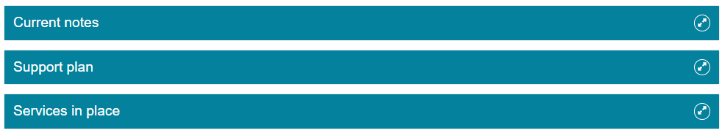
Clients and their support network may automatically be opted in to receive copies of Support at Home letters. Refer to the Support Network tab section for more information.
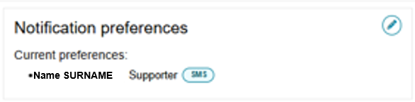
If a client has passed away, you can notify My Aged Care by selecting the NOTIFY MY AGED CARE OF A DEATH button on this page.
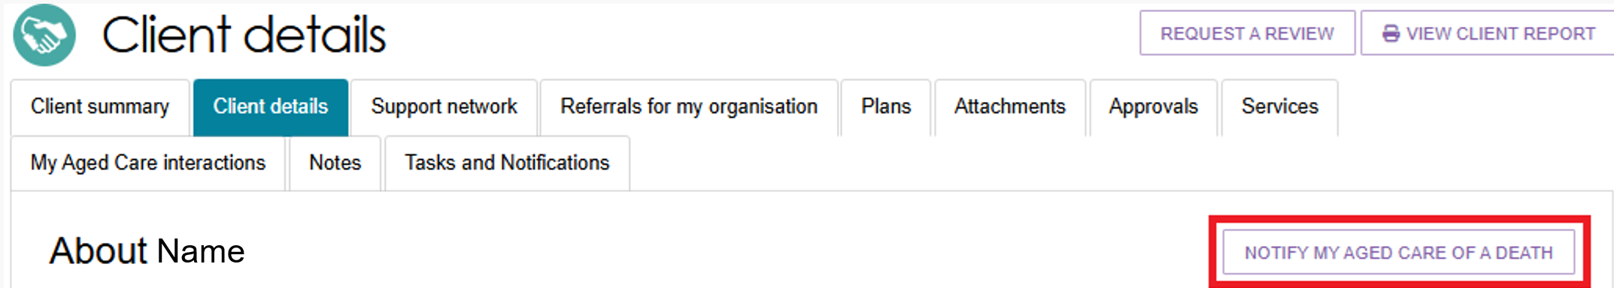
! When a client's status is Deceased:
The client record becomes read-only, and you cannot edit any information.
You can still add notes and attachments to the client record for up to 14 days after services stop.
You will receive reminders to close or complete any outstanding tasks related to the client.
A banner will appear on all tabs of the client’s record to show that the client is deceased.
If the client's status is incorrect, contact the My Aged Care Service Provider and Assessor Helpline on 1800 836 799.

Support Network
The Support Network tab shows information about the people who support the client, including the client’s primary contact, registered supporters, appointed decision maker, agent organisations, general practitioners (GPs), carers, emergency contacts, or other support people.
This tab appear in a client’s record if there are supporters registered under the Aged Care Act (2024) and recorded in My Aged Care. If this tab is not available, select the VIEW SUPPORT NETWORK link to open the Support network tab instead. The client’s Primary Contact details always appear above this link, along with their relationship(s) to the client.

Providers may report that a client’s support person is now deceased using the NOTIFY MY AGED CARE OF DEATH button on this page.
Support network page showing two supporters
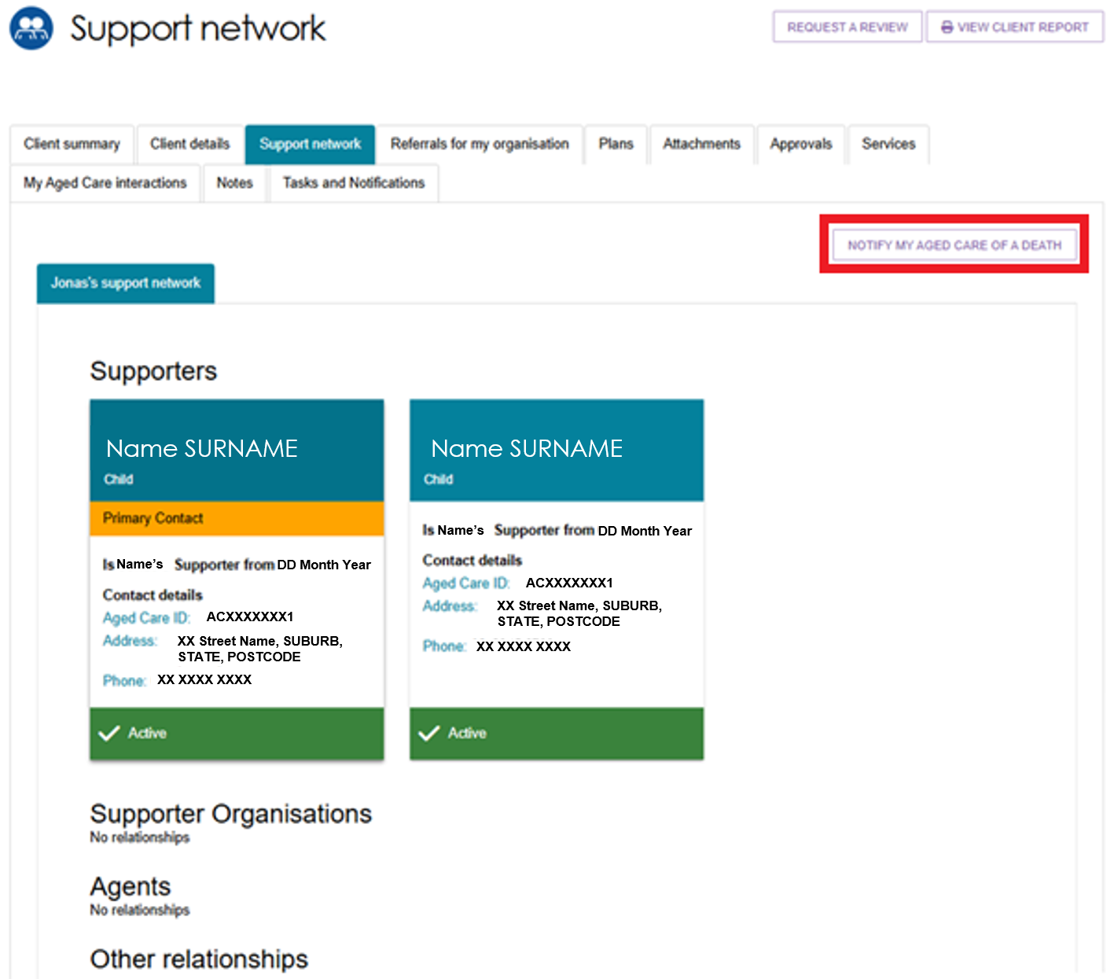
In the Support Network tab, you can do the following:
- View the client’s support network, divided into the Supporters, Supporter Organisations, Agents, and Other Relationships categories. The cards show the support person’s name, relationship to client, whether they are the primary contact, date of relationship, contact details, and whether the relationship is active. For information about adding support people and relationships, go to the Registering Support People and Adding Relationships guide.
- Depending on the status of the relationship/s, you could Activate the relationship, Delete the relationship, Edit relationship details, or (for Carers) start a Call Back Request from Carer Gateway and/or Dementia Australia Helpline. For more information on these functions, refer to Assessor Portal user guide on Registering support people and adding relationships.
- If the client also supports other people in My Aged Care, there will be another tab called People <Client> supports next to the <Client’s support network>.
Clients and their support network (including registered supporters, agents and/or appointed decision makers) may automatically be opted in to receive copies of Support at Home letters. At the same time, they may also receive notifications in the portal. You can configure this in the Client Details tab.
The support network roles that will receive notification in the portal when a client is sent a Support at Home letter are:
- Supporter
- Supporter Manager
- Agent
- Agent Manager
- Organisation Supporter
- Organisation Agent.
Registered supporters who are Supporter Lite should not automatically receive information or documents that are given to the client under the Aged Care Act (2024).
Registered supporters and Organisation agents can opt out of receiving copies of Support at Home letters by calling My Aged Care. Supporter guardians can opt the client out from receiving Support at Home letters but they themselves cannot opt out.

Referrals for My Organisation
The Referrals for My Organisation tab displays all service referrals that your organisation has received or accepted.
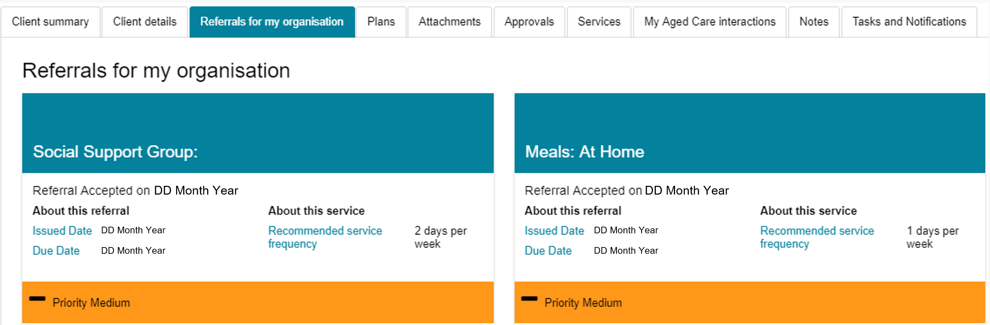

Plans
The Plans tab shows detailed information about the client's current and previous screenings and assessments. This includes the client's goals, recommendations, motivations, and support plans.
To view more details, select the double-arrow icon next to a section heading. The portal will display the information recorded during the assessment.
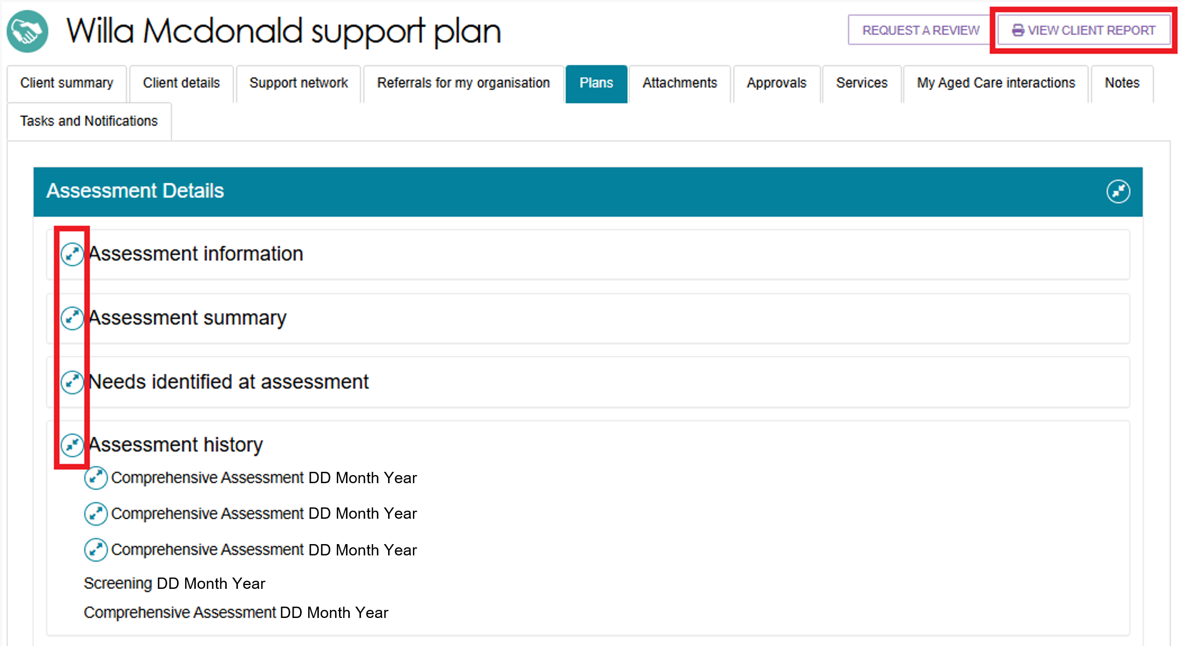
Providers can view read-only copies of a client's support plan, as well as any previous screenings and assessments.
You can download or print this information if needed. To create a report, select View Client Report in the top-right corner of the Plans page. The portal will generate the report in Rich Text Format (RTF).
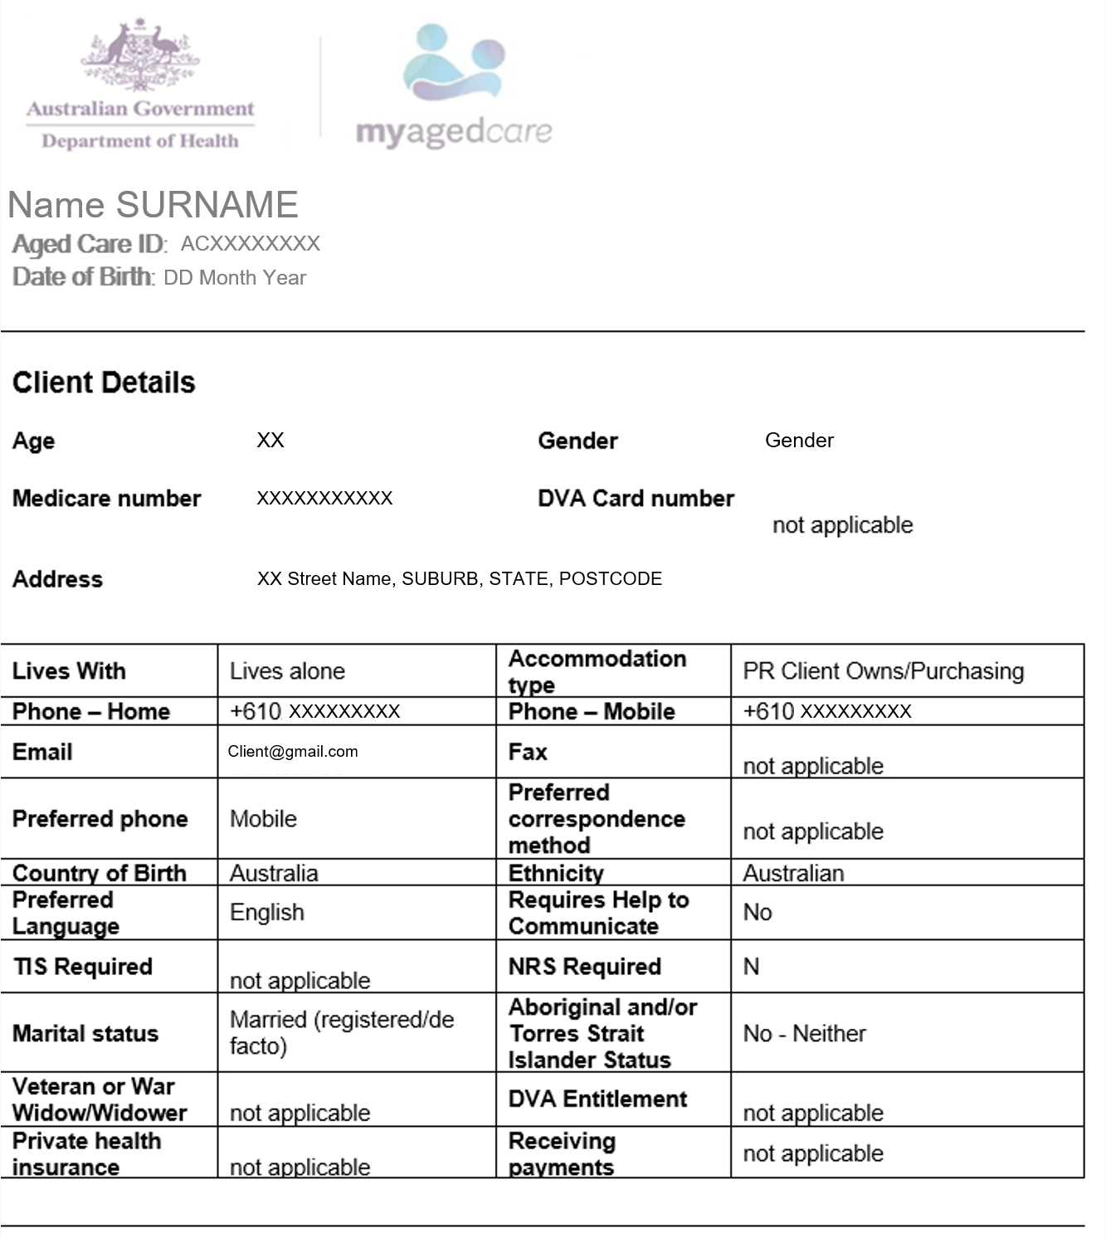

Attachments
The Attachments tab displays all documents attached to the client's record.
To add a document, open the Attachments tab and select Add an Attachment. The portal will upload the document to the client's record.
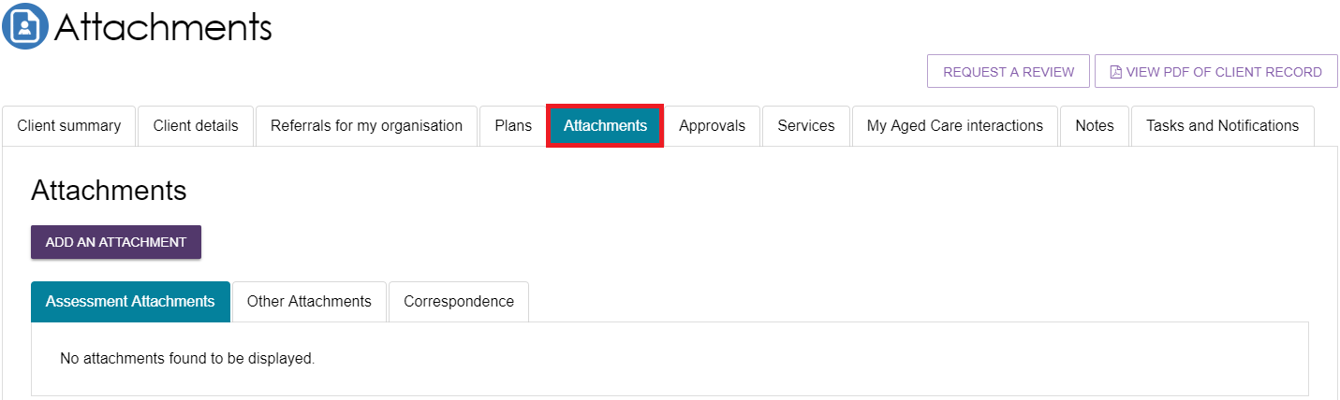
You can add four types of attachments to a client's record:
- Assessment Attachments: Upload documents that support the client's assessment, such as clinical notes or discharge summaries. Staff Members and Team Leaders can also view Notice of Decision letters in this section.
- Other Attachments: Upload documents related to the client's general circumstances. Examples include support person nomination forms (including legal documents), occupational therapist drawings for home modifications, and evidence to support an extension of a home modifications approval period. You can view a client's Statement of Reasons in this section, but you cannot upload it.
- Correspondence: View documents and letters generated through My Aged Care for Support at Home and other programs at various stages of service delivery.
- Sensitive Attachments: Store documents that contain sensitive client information. If a client's record contains a Sensitive Attachment, providers who have received a referral or are delivering services to the client will see a notification that a Sensitive Attachment exists. To access the information, contact the last assessment organisation or the My Aged Care Service Provider and Assessor Helpline.
! If you uploaded an attachment by mistake, please contact the My Aged Care service provider and assessor helpline on 1800 836 799 for deletion.

Approvals
The Approvals tab shows a client's approvals for aged care services under the Aged Care Act 2024.
If a client has an approved aged care service or classification, the portal displays details of any pending or assigned funding under Current Care Approvals.
! If the client has had a previous assessment, any approved classification that is still active will also appear in the client record.

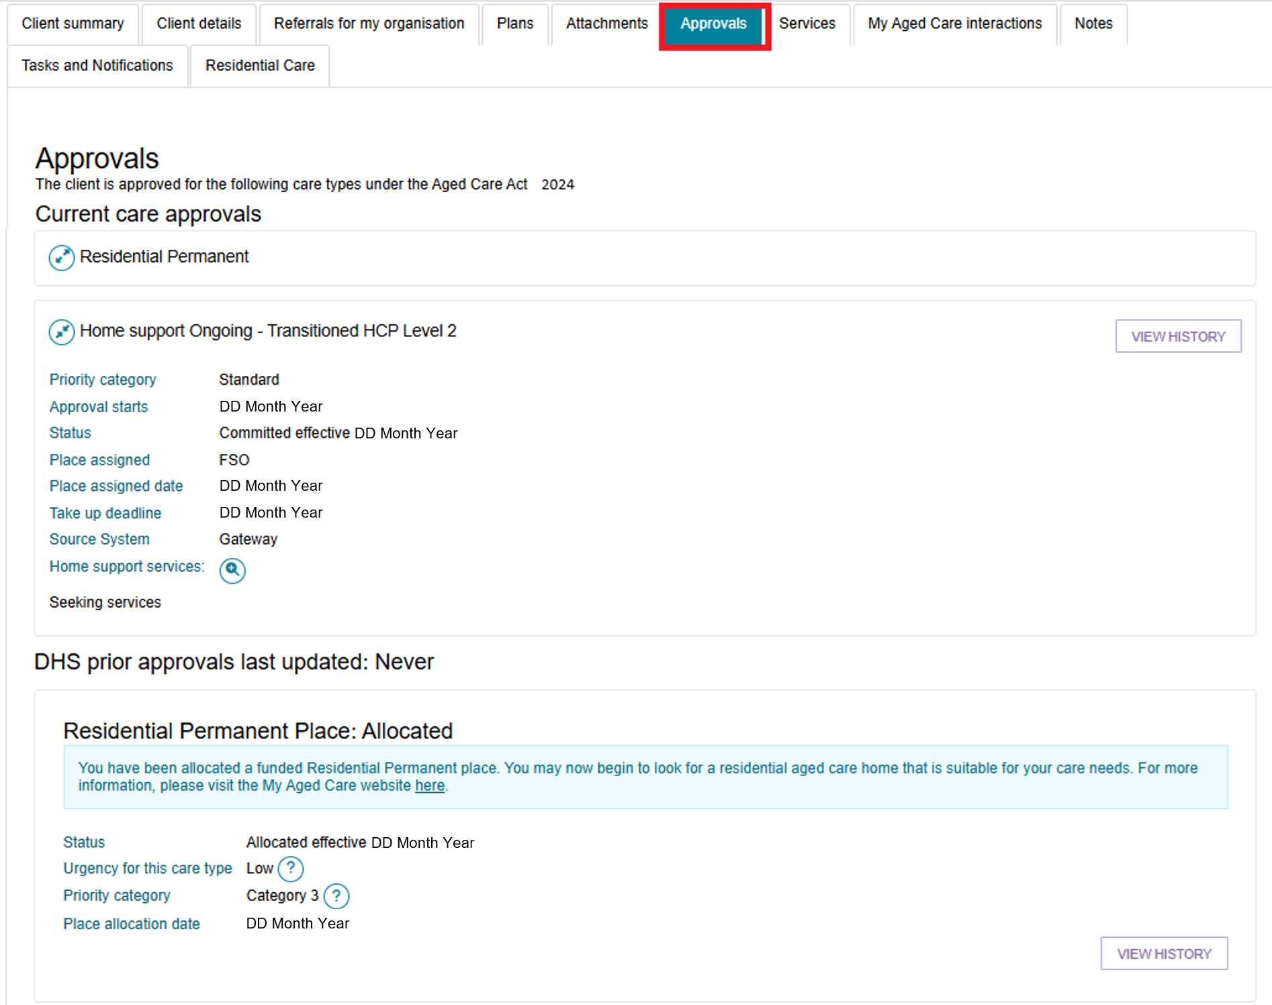
The below image shows an example of Home Support’s Assistive technology and Home modifications classifications.
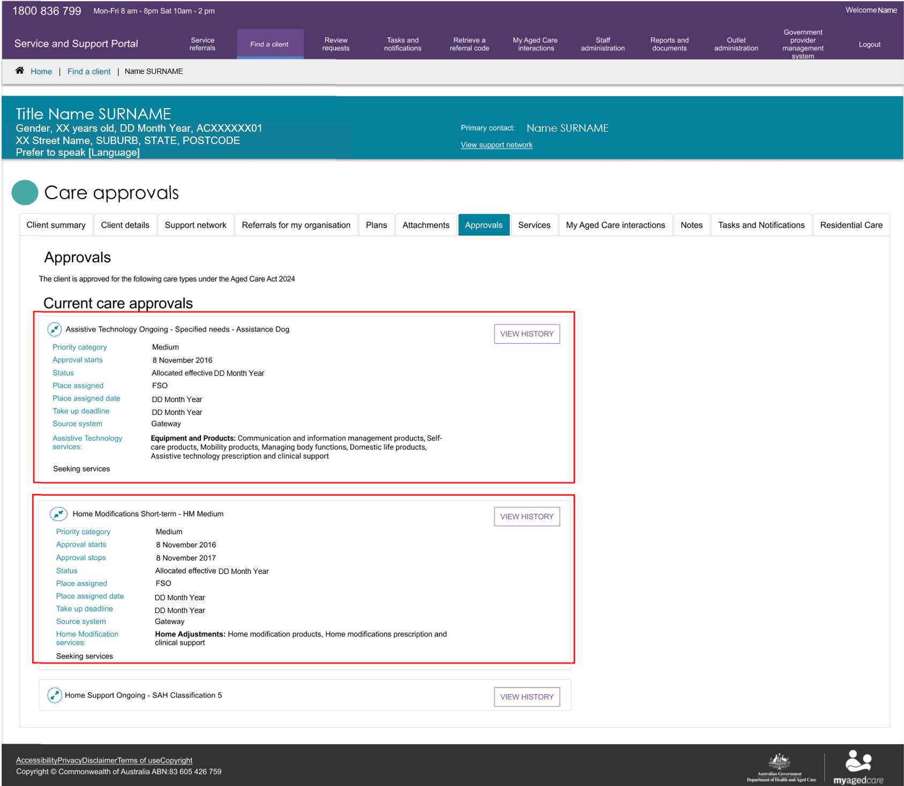
The Approvals tab also shows the client’s referral and take-up deadline details. However, take-up deadlines do not appear in the Service and Support Portal for the Restorative Care Pathway or End-of-Life Pathway.
The following information may be displayed:
- Approval starts – The date from which the approval becomes valid.
- Approval stops – The date the approval ends. This date may change if services start within the take-up period. If services do not start within the take-up period, the approval will end even if the displayed date does not change.
- Take-up deadline – The last date by which the client must take up the service. This means a service agreement must be in place by this date.

! | Clients must start services within the required take-up period. If services do not start within this period, the approval can no longer be used to start care, even if the Approval Stops date remains unchanged.  If services start within the take-up period, the Approval Stops date may update to reflect the length of the approved care episode.  When this happens, the client can continue to use the approval, including transferring to another provider if needed, until the updated Approval Stops date.  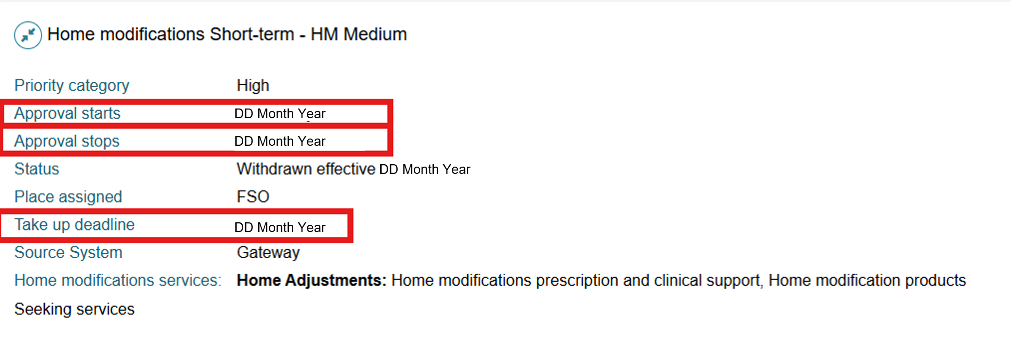
! | For Restorative Care Pathway and End-of-Life Pathway referrals, check the Take Up End Date in the Services Australia Provider Digital Access (PRODA) portal.  Do not use the Approval Stops date to determine when the service must start. The Approval Stops date does not show the deadline for taking up the service. Instead, use the Take Up End Date in PRODA to confirm when the client must commence services.  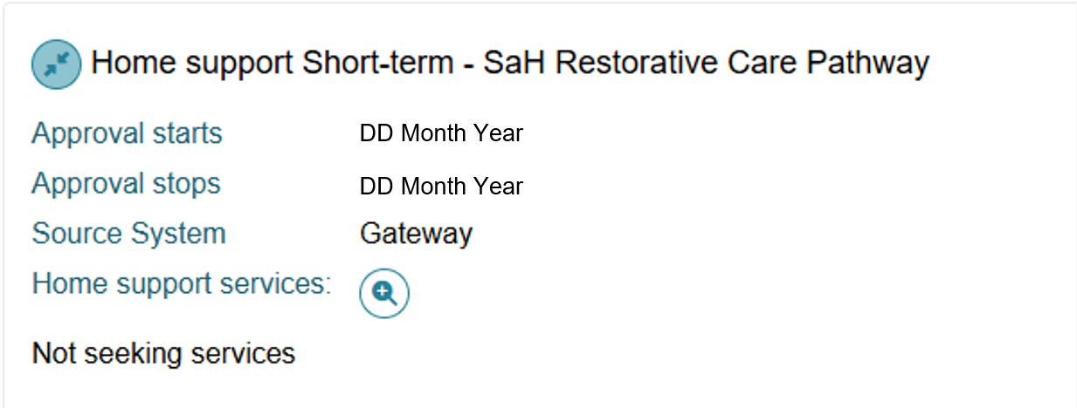

Services
The Services tab contains a record of:
- Services the client is currently receiving
- Services that are pending (services that have been accepted but have not yet started).
- Service referrals that are still awaiting action.
- Services the client received in the past.
The following images show Home Support services.
When they are in place, this section will also show:
- The current funding status (for example, Pending).
- The date funding was assigned.
- The date the service started.
- The full name of the approved service.
Services not in place
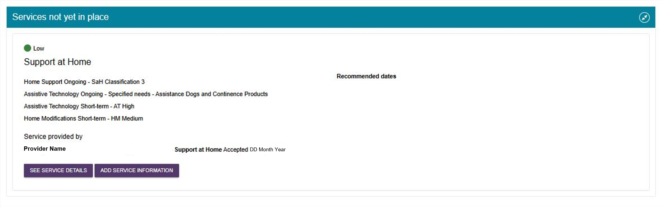
Services in place
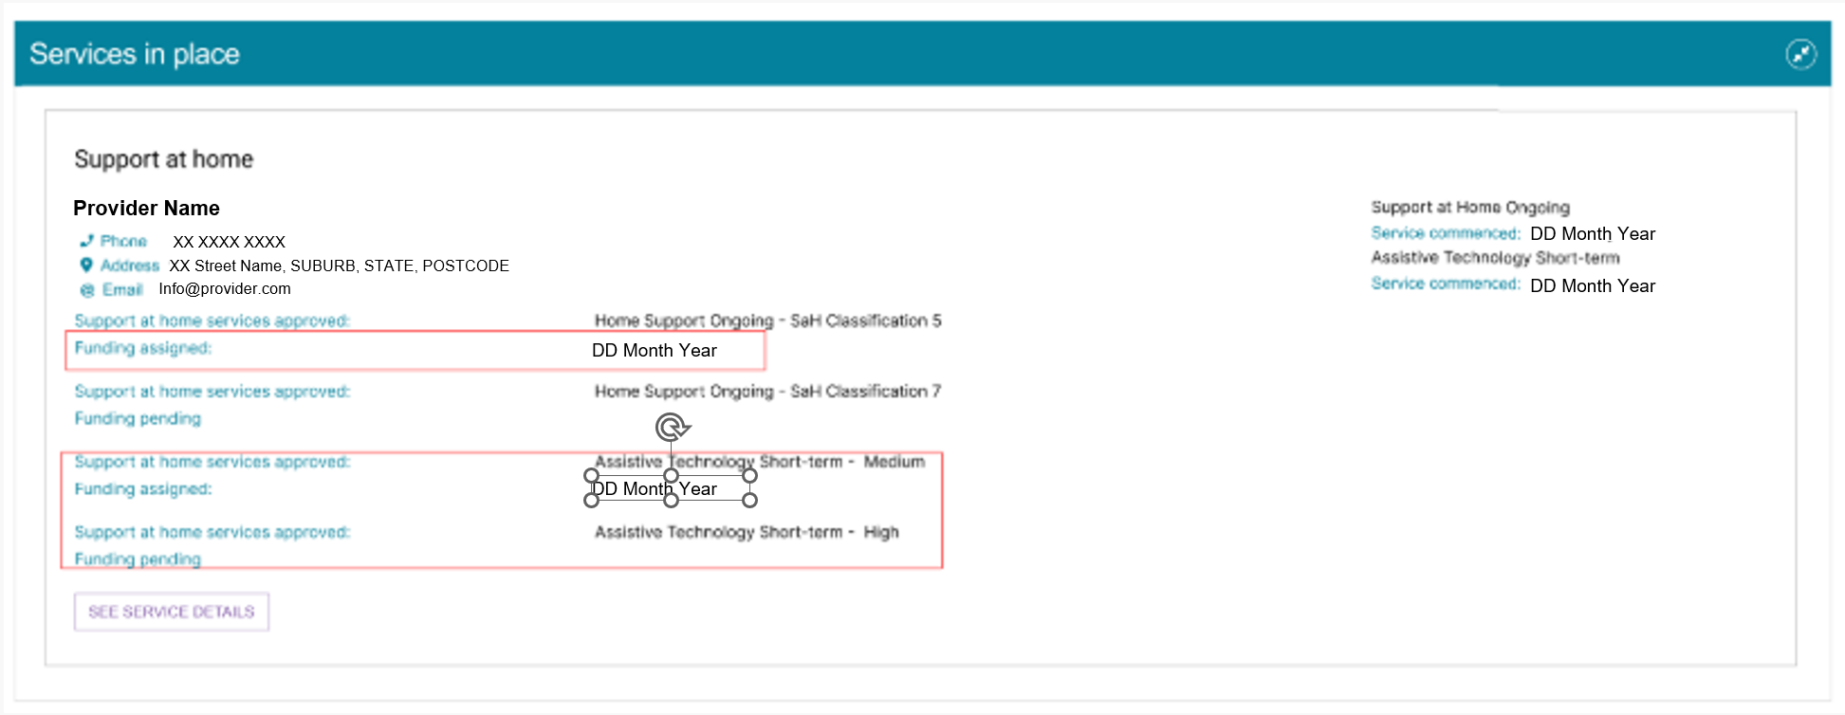

My Aged Care Interactions
The My Aged Care interactions tab will show the client’s history of interactions with My Aged Care, for example, a phone call to the My Aged Care contact centre, or (for carer relationships) a history of call back requests to the Carer Gateway or Dementia Australia Helpline.

Notes
The Notes tab contains notes that have been created about the client.
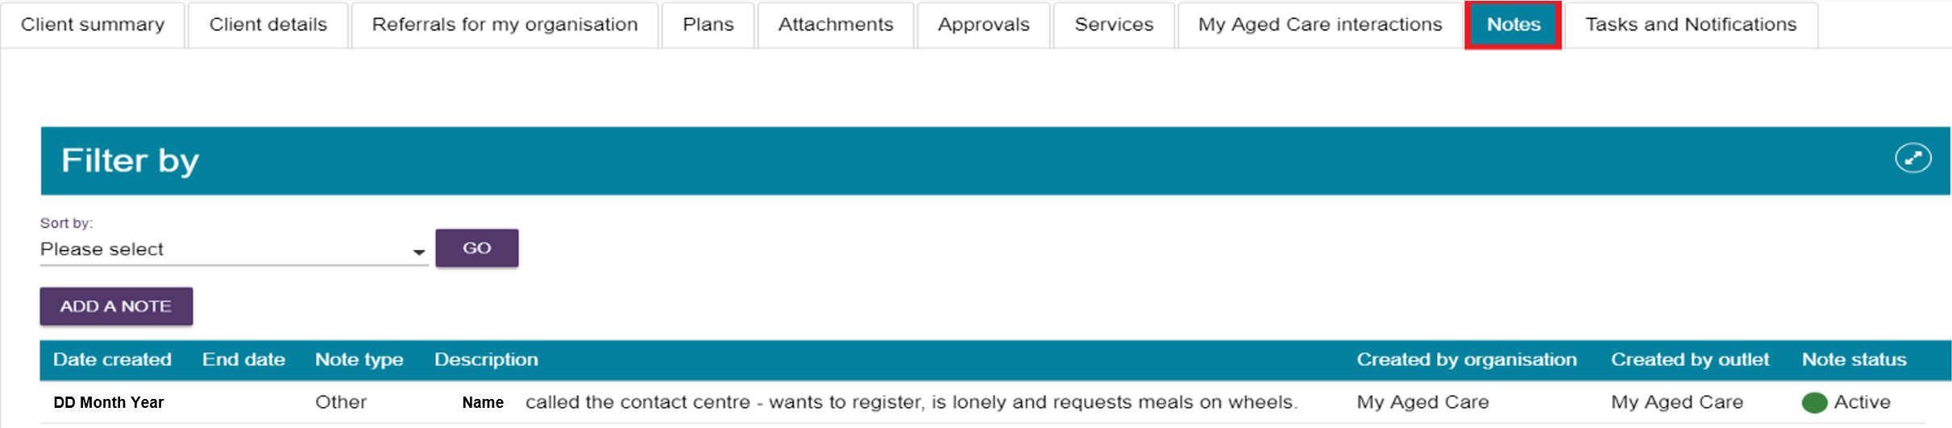
There are different types of notes in the Notes tab of the client record, listed in the table below:
Note type | Who can add? | Who can view? | Description | Examples
Client Story | Assessor | Client Provider Assessor | A summary of the client’s current circumstances. | Mrs Jones has just been discharged from hospital and is seeking help at home.  Lives with her husband and has early onset dementia.
Observations | Provider Assessor | Provider Assessor | Observations from service provider and/or assessors’ interactions with clients. | There is a dog on the property.  Mrs Smith seems more energetic than she did during my last visit.
Other | Client Provider Assessor | Client Provider Assessor | Additional information about the client. | Jennifer has planned respite on 01/08/2017.
! When the My Aged Care contact centre staff or assessors add a Sensitive note about a client, there will be a flag informing service providers that there is a sensitive note about the client and instructing them to call the My Aged Care contact centre for more information.

Tasks and Notifications
The Tasks and Notifications tab will display all tasks and notifications for a singular client. You can only view tasks and notifications that are associated to your outlet and for clients you are providing services to.
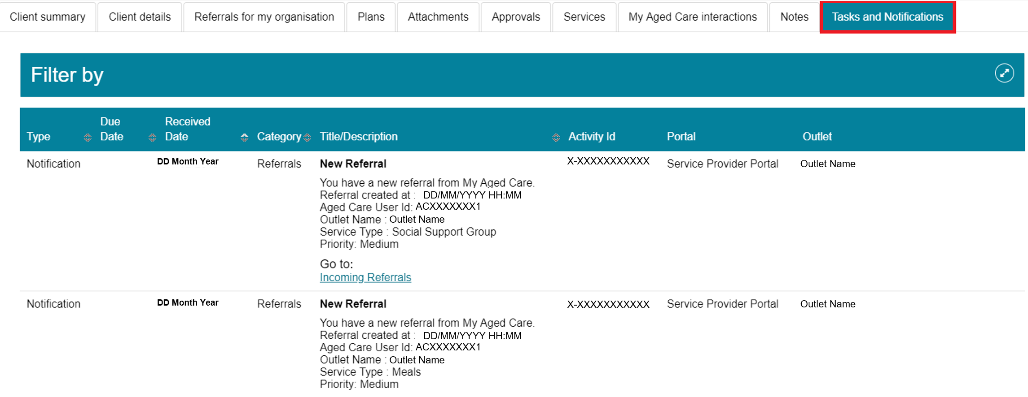

Completing identity verification
To complete identity verification, the first person who has contact with the client, either an assessor or a service provider, must sight the client’s identification and record the details in the Assessor Portal or Services and Support Portal.
To record that you have sighted the client’s identification:
- From the Service and Support Portal homepage, select Find a client.
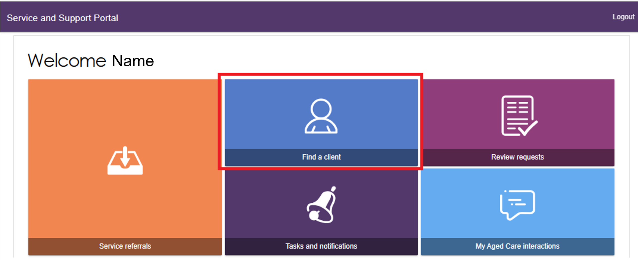
- Search for the client using their first name, last name, or Aged Care ID.
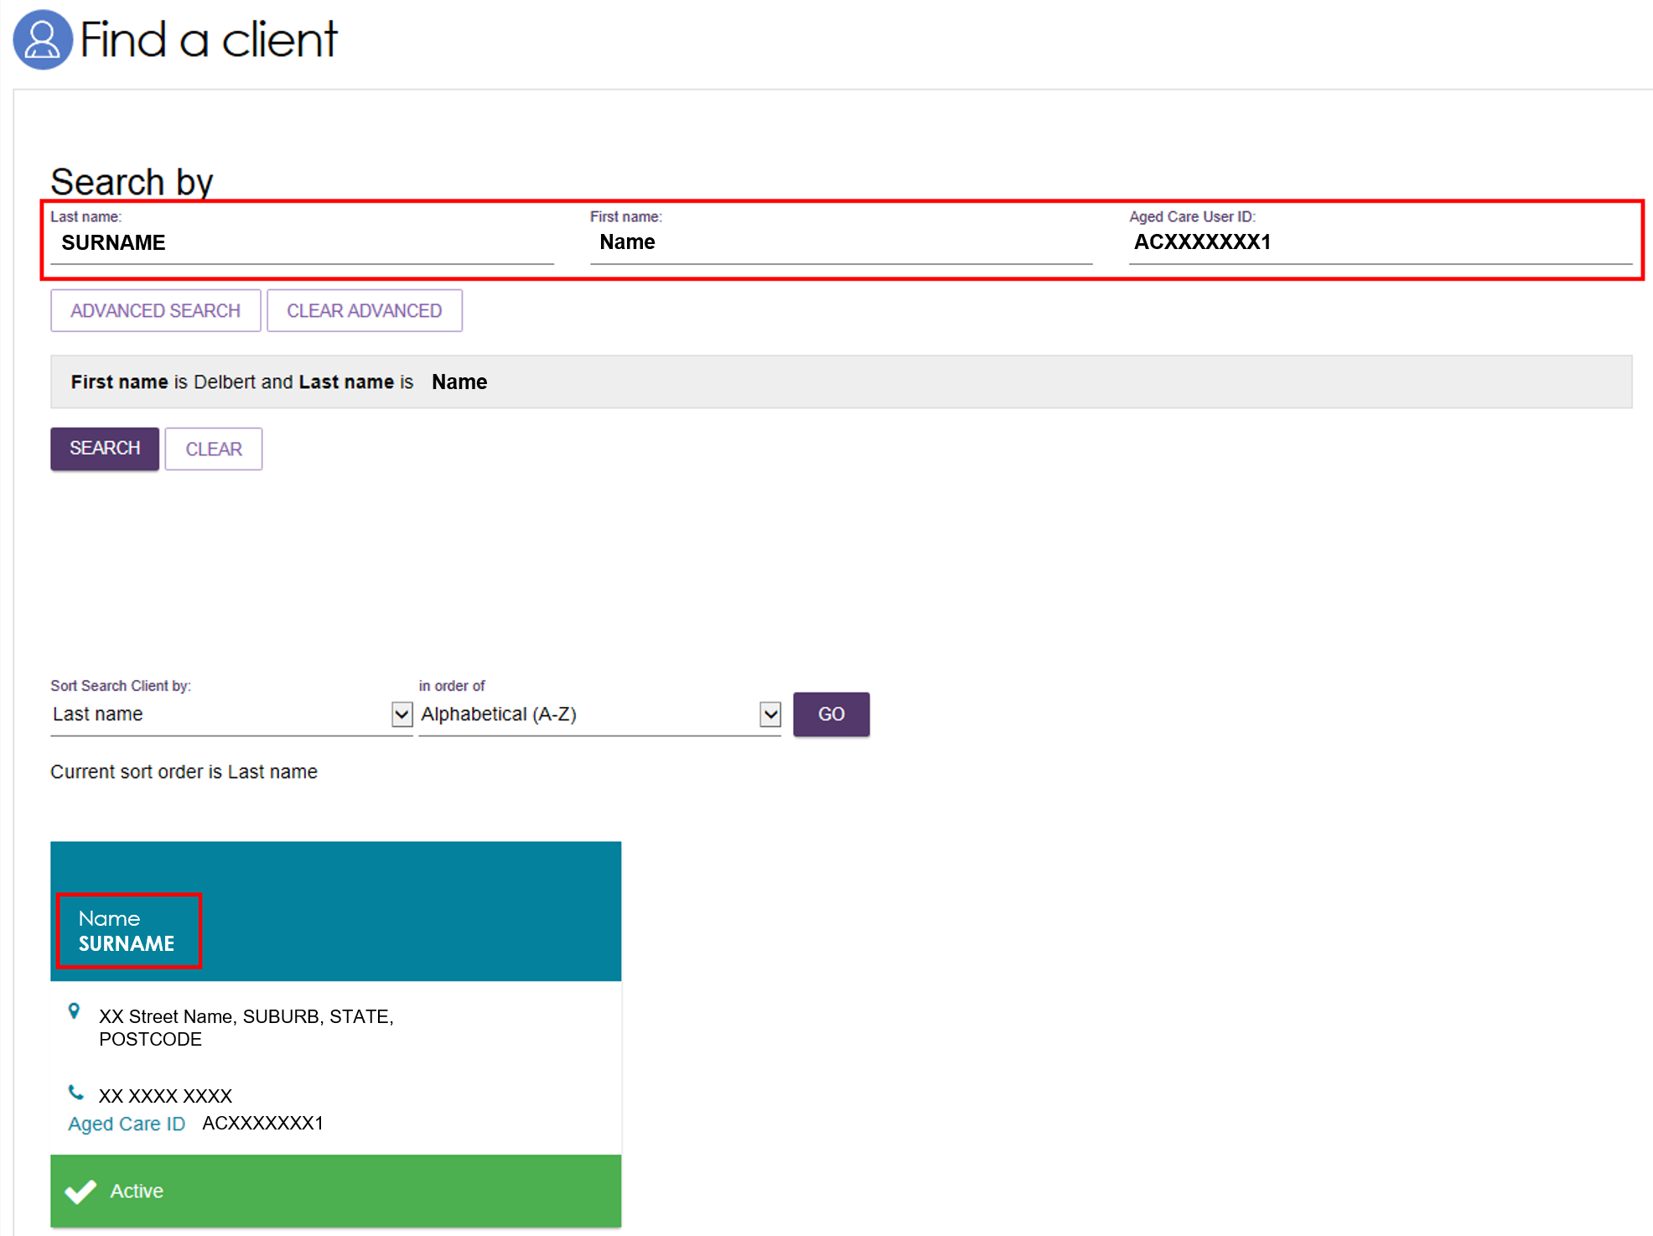
Alternatively, open the client record from the Accepted Services Pending tab in the Service Referrals section.
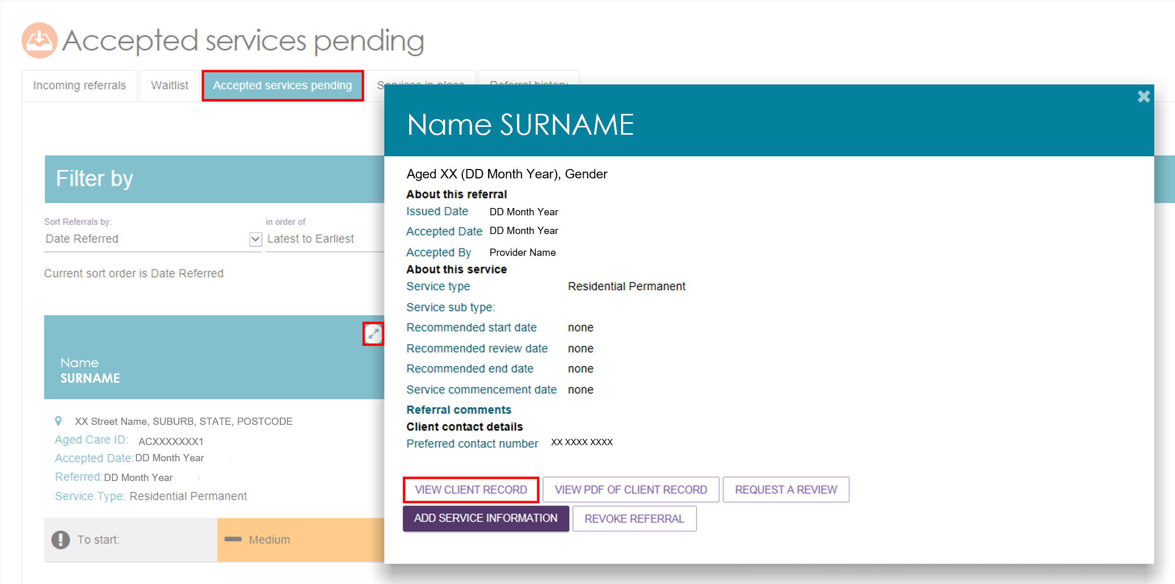
- Open the client’s record and select Conduct a wallet check now.
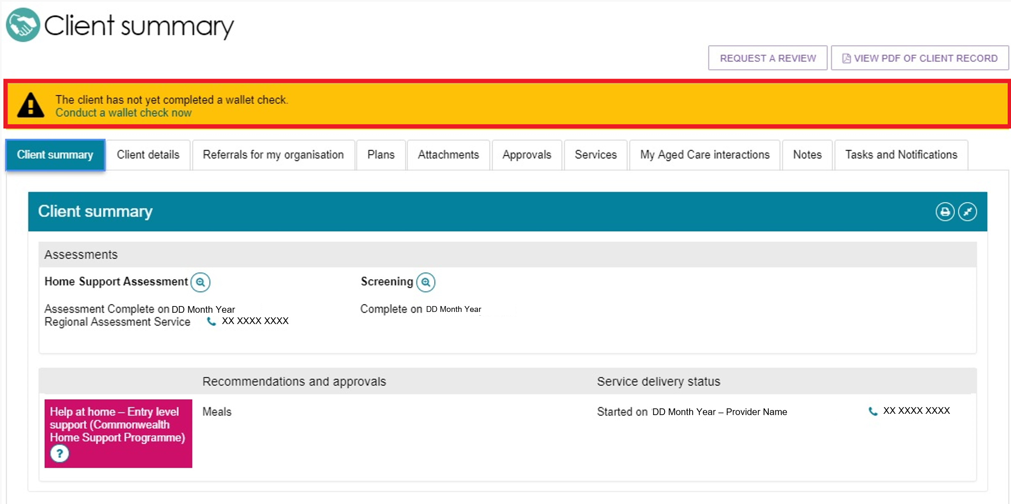
- In the Wallet Check pop-up, select the option that best applies:
- My client has identification
- My client has no valid identification at this time
- My client will be unable to produce valid identification.
If the client provides identification:
- Select My client has identification.
- Select at least two identification documents that you sighted from the list provided.
- Enter the date you completed the wallet check.
- Select SAVE DETAILS.

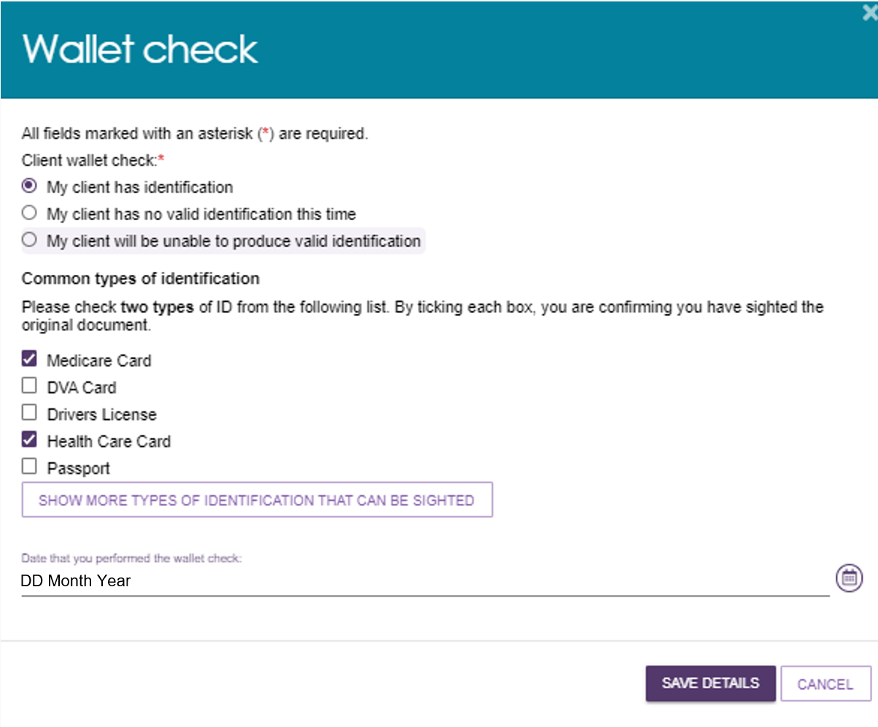
If the client cannot provide identification:
- Select My client has no valid identification at this time or My client will be unable to produce valid identification
- Select SAVE DETAILS
- The system updates the client record with the information you entered.
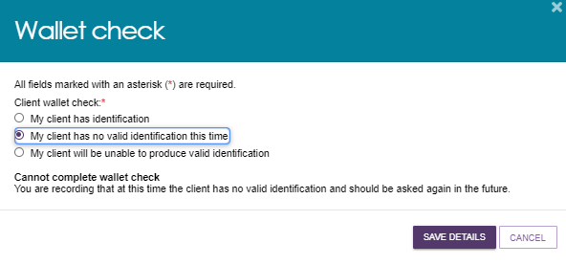
! The Wallet Check status on the client record remains Incomplete until you sight and record the client’s identification documents.

Viewing tasks and notifications
You can view tasks and notifications in the Services and Support Portal.
To view tasks and notifications:
- From the Service and Support Portal homepage select Tasks and notifications.
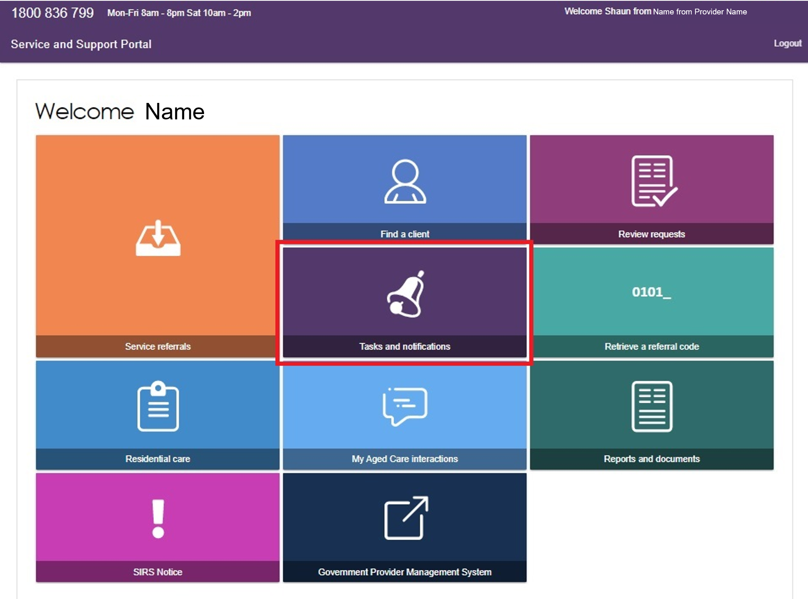
- Select the Notifications tab to view notifications relevant to your role from the last 30 days.
- The filter section shows the earliest date currently displayed.
- The system automatically removes notifications older than 30 days.
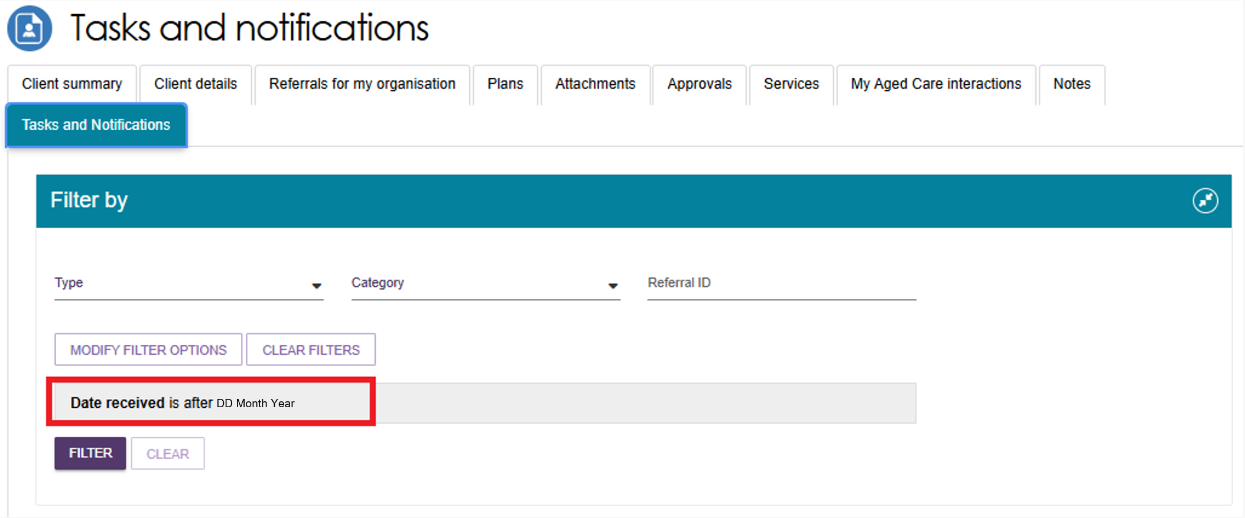

To view all tasks and notifications for a specific client, open the client’s record and select the Tasks and Notifications tab.
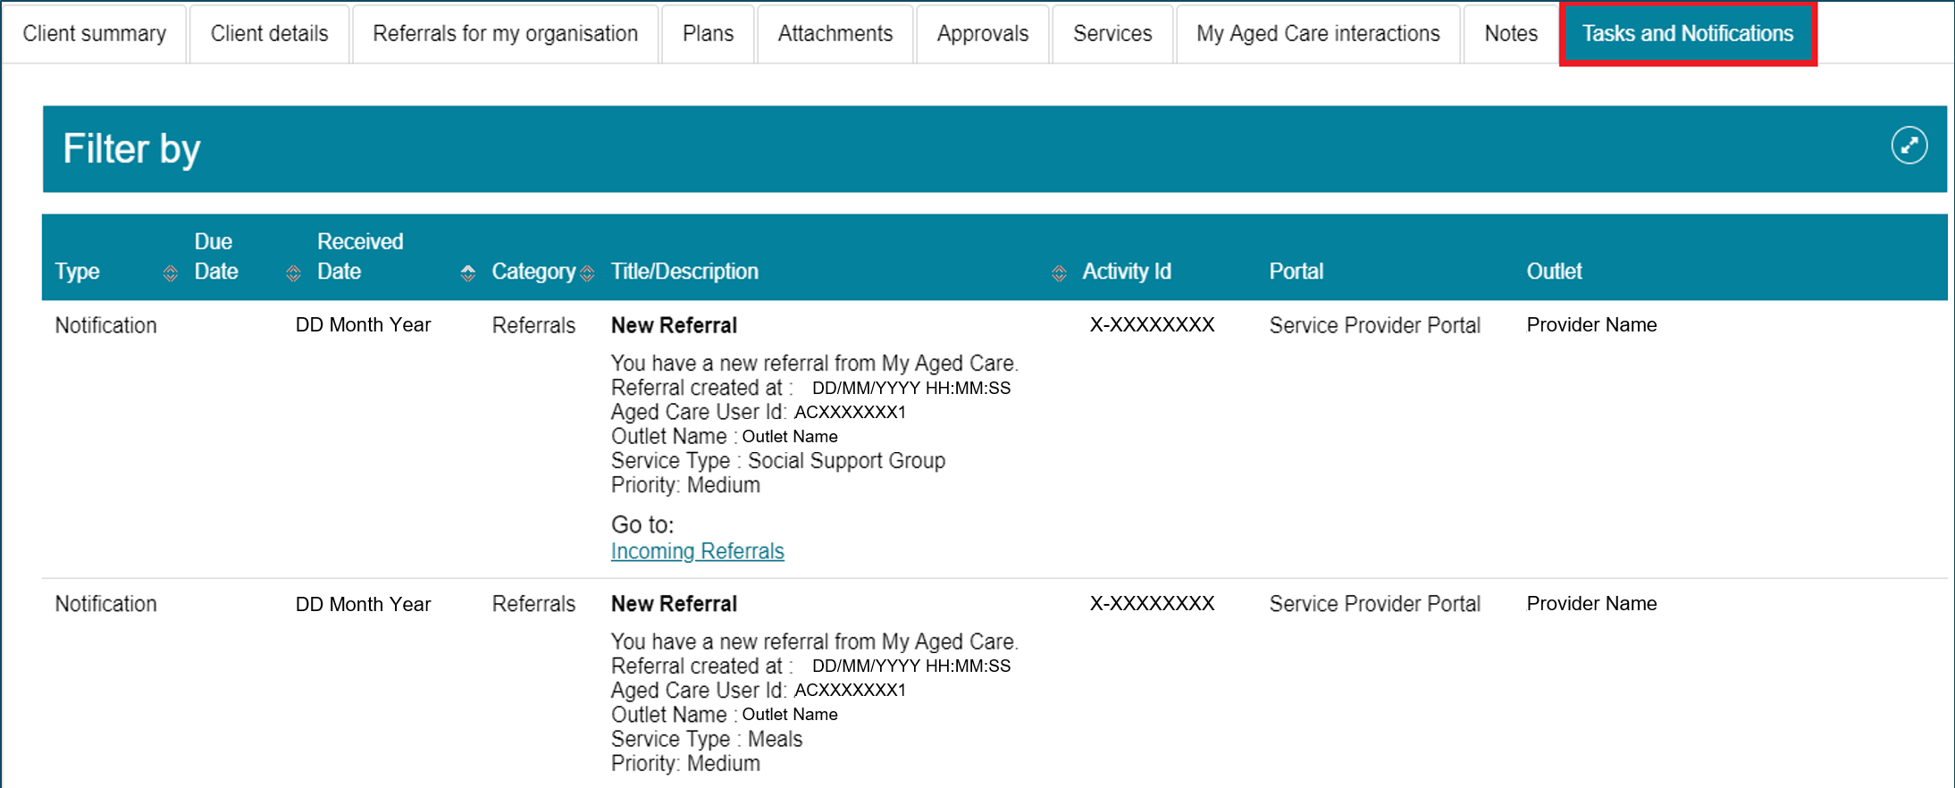
- You can only view tasks and notifications associated with your outlet and clients receiving services from your organisation.
You can sort notifications by:
- Received Date
- Category
- Title/Description
- Aged Care User ID
- Client Name.
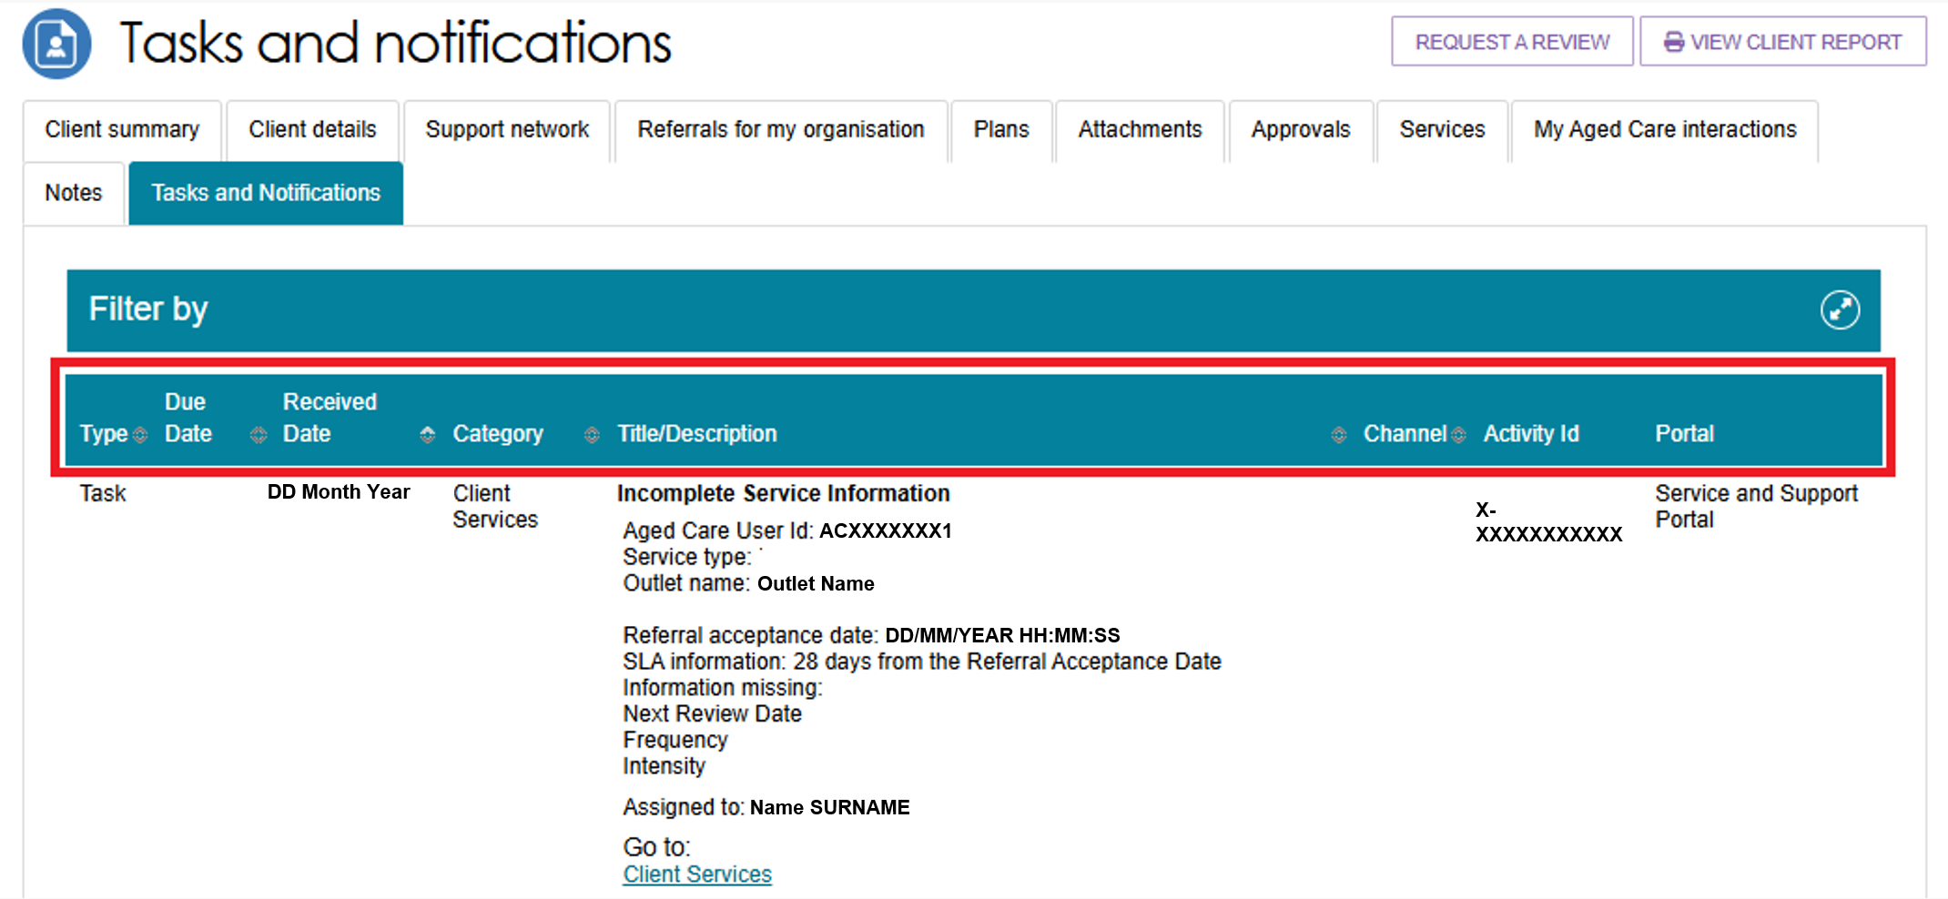

! Notifications that your outlet administrator marks as important for outlet will have a visual indicator.
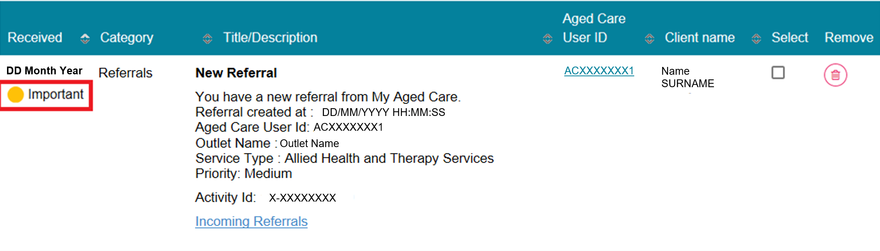

- To remove notifications, select the rubbish bin icon. You can remove notifications individually or in bulk.
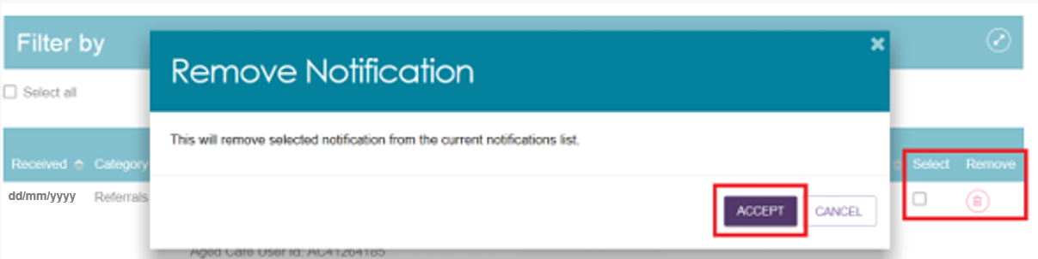
- Use the filter options or ADVANCED SEARCH to find specific notifications.
- Select the double arrow (expand) icon to expand or collapse the filter options.
- Filter notifications by Date Received.
- Select View Client Record to open the related client record directly.
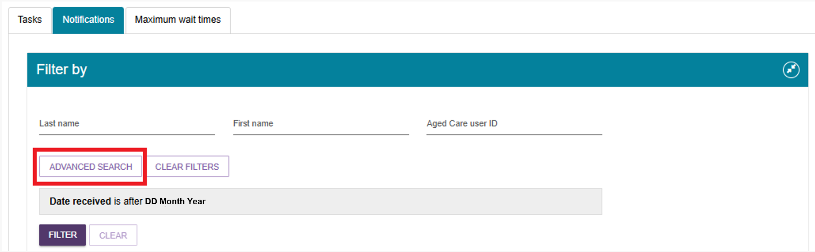
- To apply additional filters, select ADVANCED SEARCH, choose a filter from the drop-down list, and select ADD FILTER for each filter you want to apply.
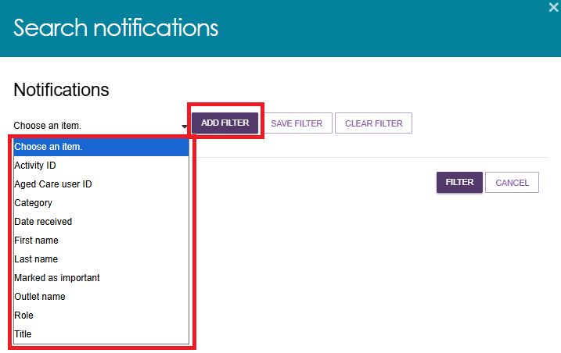
- Select the hyperlink in the notification description to open the related record and view more information or complete any required action.
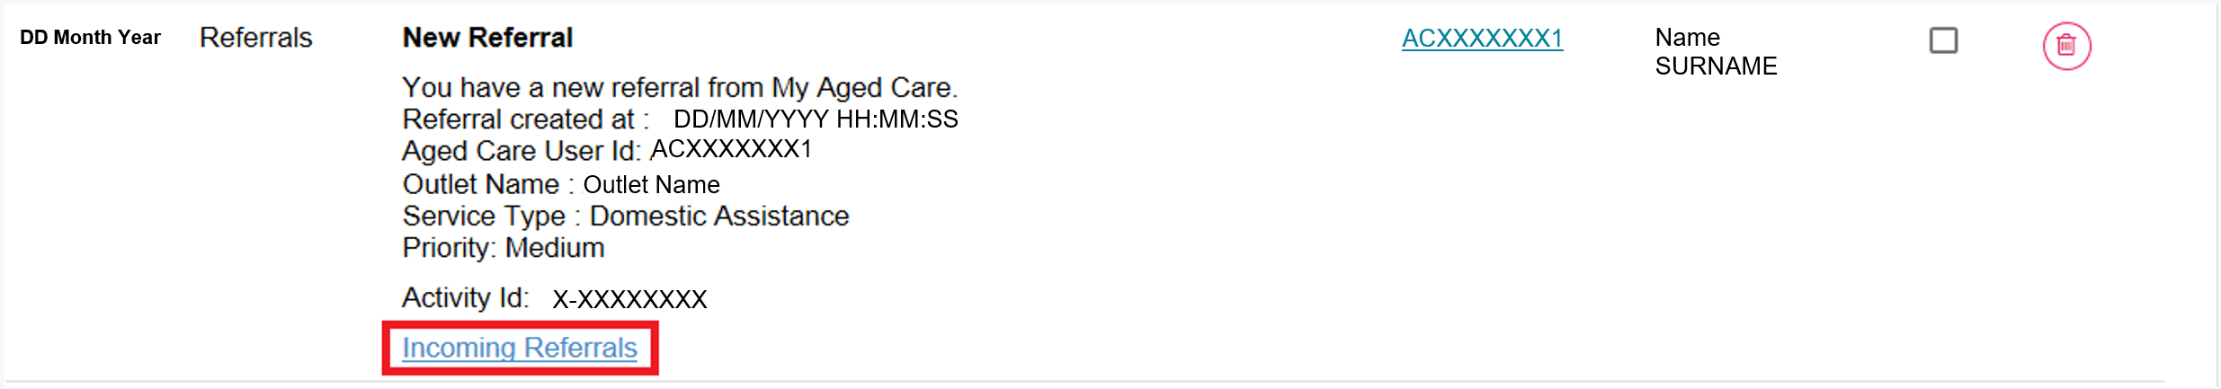
For example, selecting the Incoming Referrals link in a New Referral notification opens the Incoming Referrals tab, where you can review and action the referral.
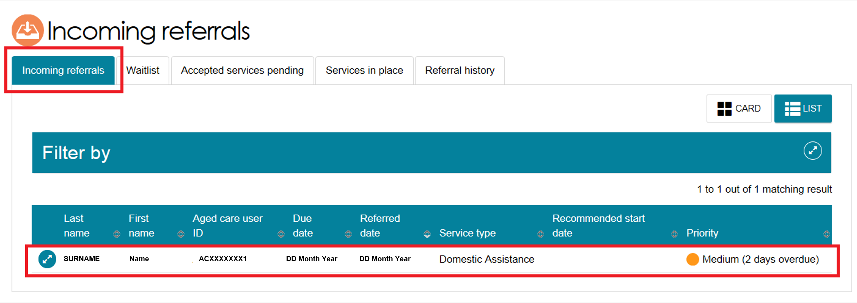

Adding service information
Record service delivery information in the My Aged Care client record for all clients who have accepted a service. This information includes the service start date, service frequency, service intensity, and service end date (if the service has ended).
Record this information within 14 calendar days of accepting the service. If you do not record it within this timeframe, the system will send reminder notifications.
For Home Support and Permanent Residential Care services, the system automatically populates the service start date from Services Australia records. You cannot edit this date.
To add service delivery information:
- From the Services and Support Portal home page, select Service Referrals.
If you know the client’s name, you can also use Find a Client.
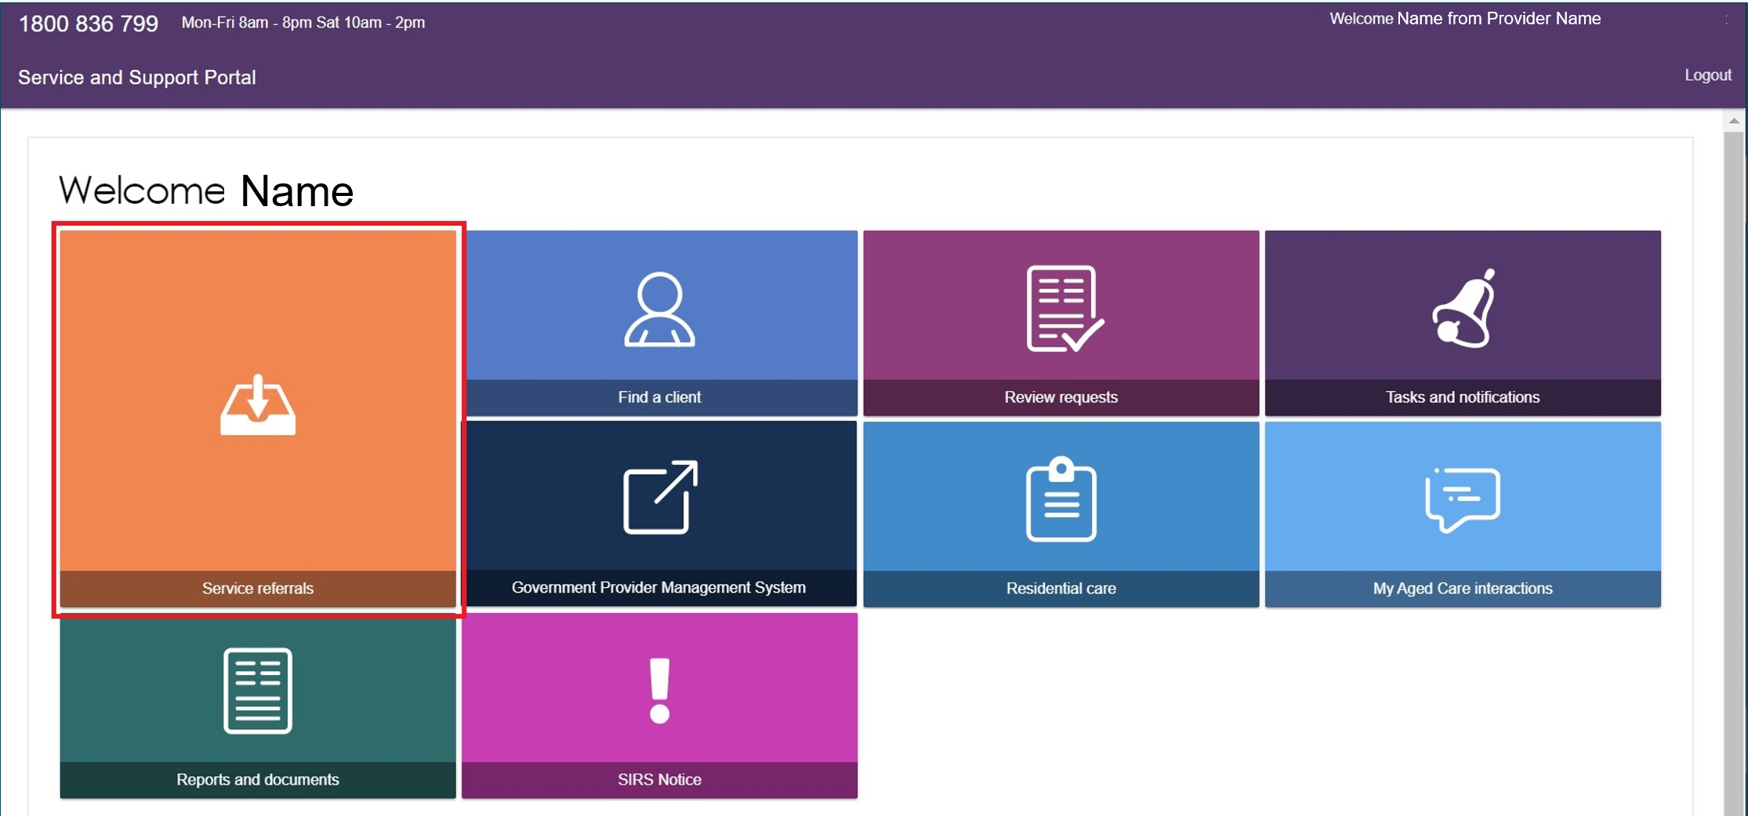
- Select the Accepted Services Pending tab and find the client’s referral:
- In Card View, select the arrow on the client card and then select ADD SERVICE INFORMATION
- In List View, expand the client record and select ADD SERVICE INFORMATION.
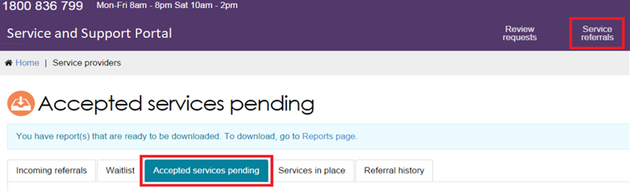
Card view
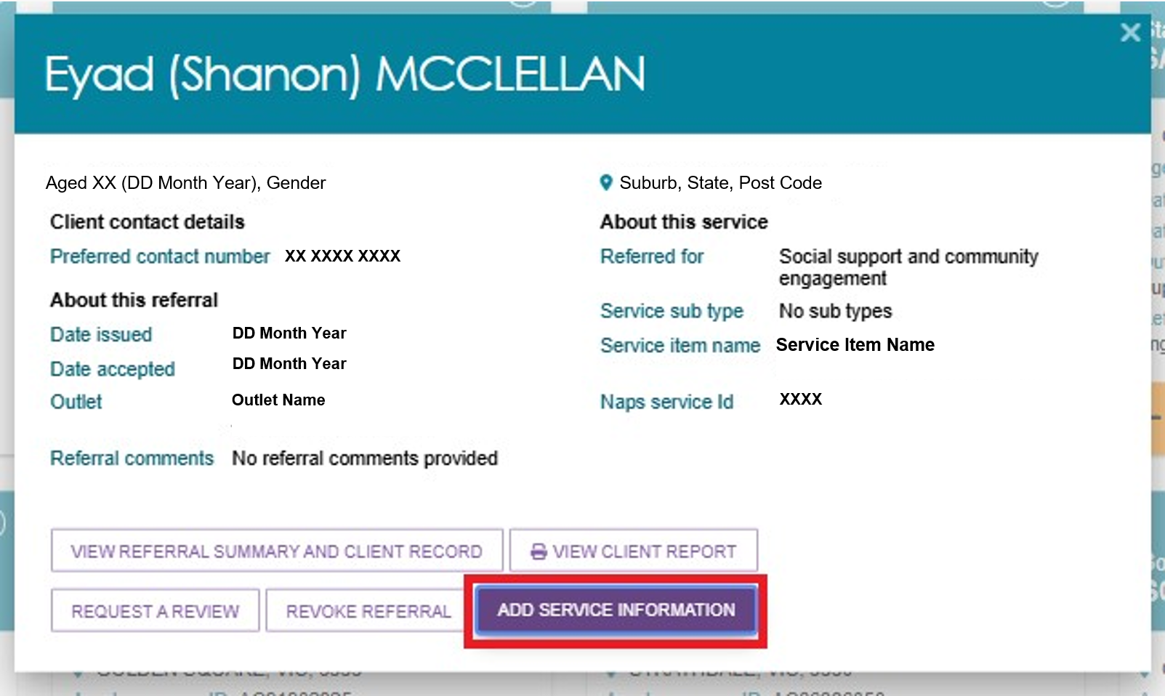
List view
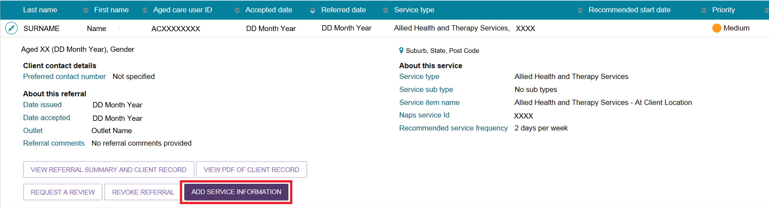
! | For Home Support service referrals, the Add Service Information button is not available because the service information is recommended and approved during the assessment.  To view details of the recommended services, select the Expand button.  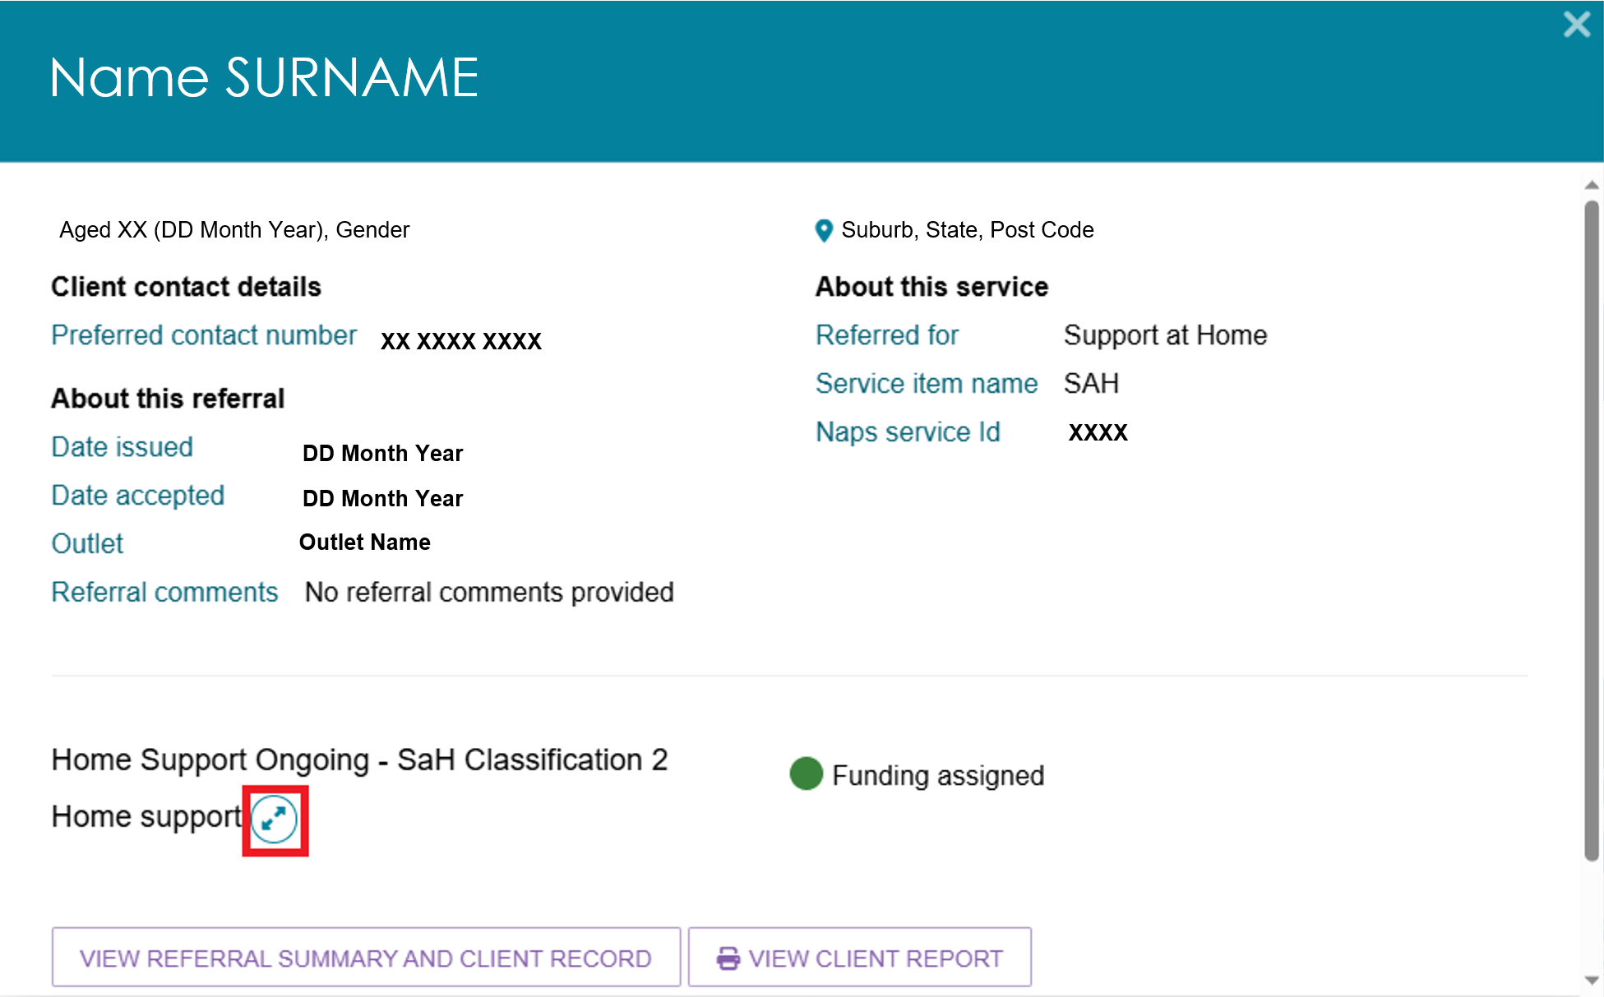  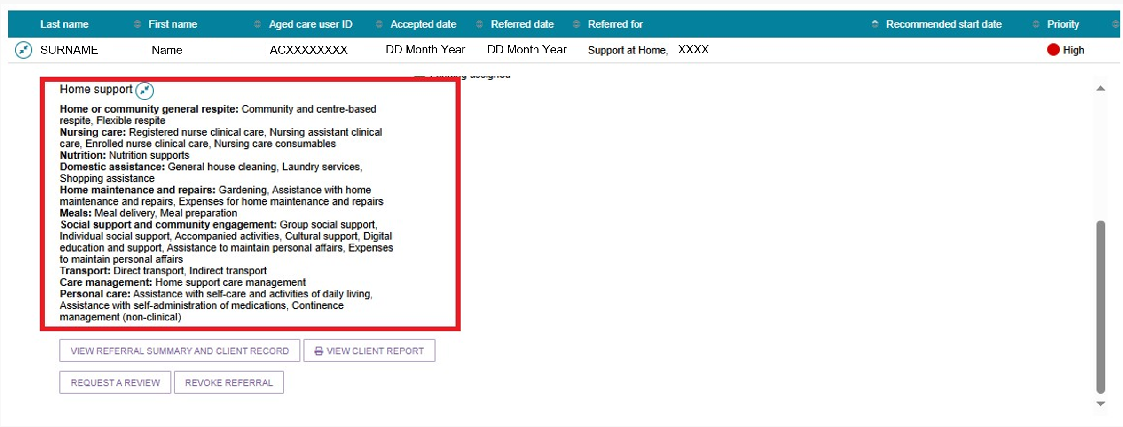
- The Add Service Information screen opens.
For Residential Respite Care, Transition Care, and Commonwealth Home Support Programme (CHSP) services, enter:
- Service Start Date
- Frequency
- Intensity.
These fields are mandatory.
Enter any additional information in the remaining fields.
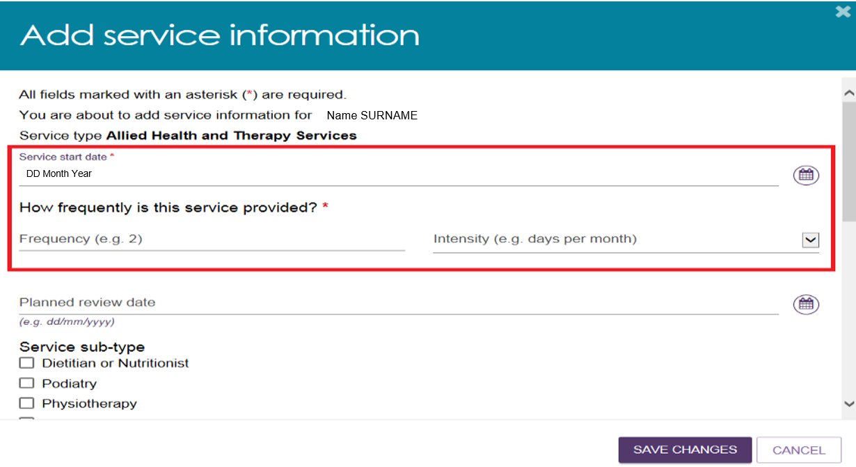
To record specific service delivery details, select Other – Specify and enter the information in the free-text field.
Select SAVE CHANGES.
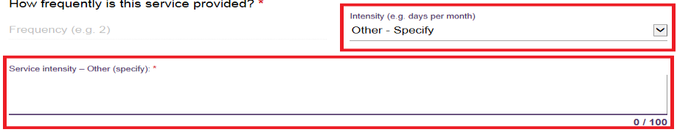
- After you save the information:
- The service information appears in the Services section of the client record.
- The system updates the service start date when it receives commencement information from Services Australia.
- The client information moves from Accepted Services Pending to Services in Place. This happens for residential care including respite, transition care, and Commonwealth home support programme services, and once a Service start date is available, for Home Support services.
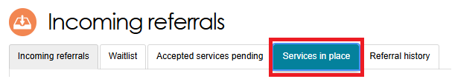
! The system automatically updates the service start date when Services Australia processes the Aged Care Entry Record (ACER). To avoid funding issues, accept the client's service referral before you submit the ACER. Once Services Australia processes the ACER, the system moves the referral from the Accepted Services Pending tab to the Services in Place tab.

Updating service information
The Services in Place tab in the Service Referrals section of the Services and Support Portal shows accepted services that include recorded service delivery information.
! For Support at Home services, you cannot update service information because an assessor approves the required services. If the participant’s needs, goals, or circumstances change, or if they need additional services, a provider can request a Support Plan Review (SPR). Refer to Requesting a Support Plan Review (SPR) to meet changing needs for more information.
- Open the Services in Place tab by selecting Service Referrals from the home page, the navigation banner, or the menu in the top-left corner.
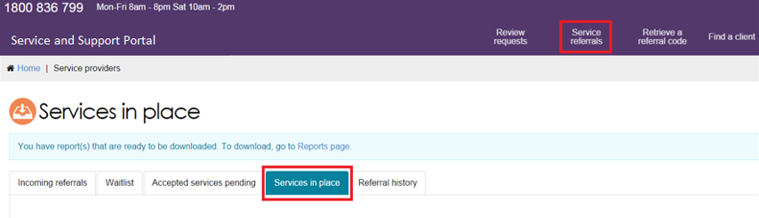
- Find the service you want to update.
- In List View, expand the client record and select UPDATE SERVICE INFORMATION
- In Card View, expand the client card and select UPDATE SERVICE INFORMATION.
Update the service information and select SAVE CHANGES.
The system updates the information in both the Services in Place tab and the Services tab of the client record.
List view
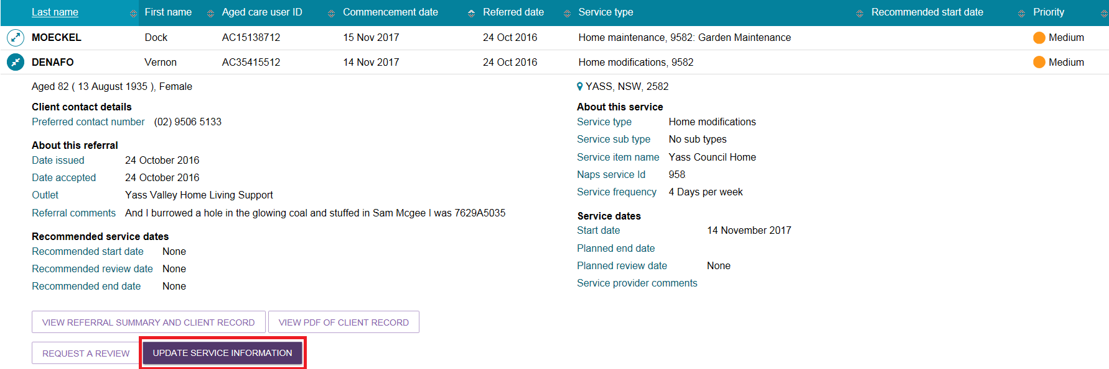
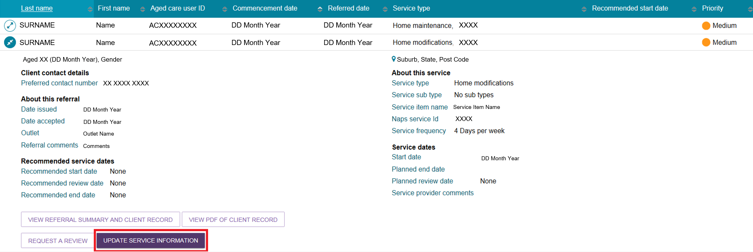
Card view
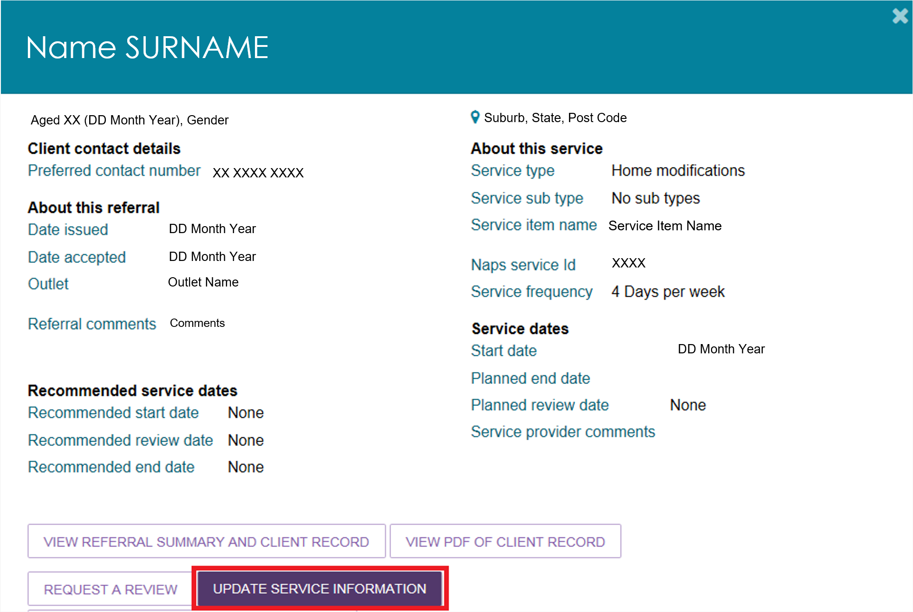
- You can also update service information from the Services tab in the client record.
- Select UPDATE SERVICE INFORMATION next to the relevant service.
- Make the required changes and select SAVE CHANGES.
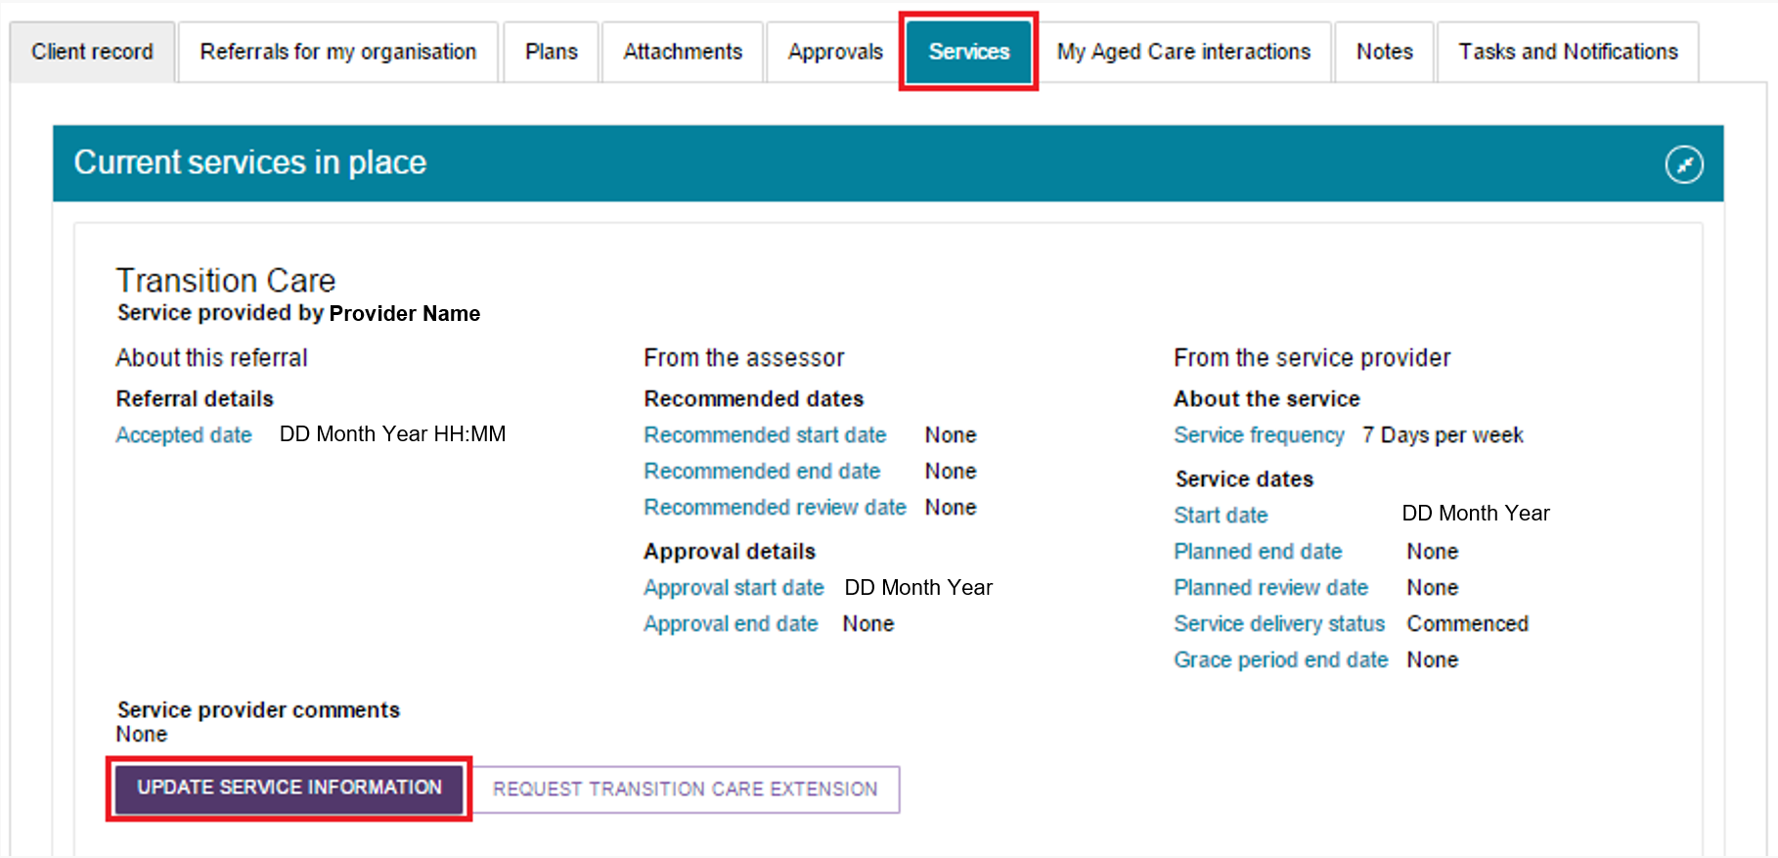
! If you cease a client’s service and select Client Deceased as the reason, the system changes the client’s status to Deceased and makes the client record read-only. When you update a client’s status to Deceased, the system will:
1. Recall any unaccepted service referrals.
2. Cease all services currently in place.
3. Cancel any assessments in progress.
4. Revoke the client’s access to the client portal.
You can add notes and attachments to a client’s record for up to 14 days after you cease their services.
After the status changes to Deceased, My Aged Care will no longer send correspondence to the client or their support network. However, service providers will receive a notification reminding them to close or finalise any activities still in progress for the client.
If the client is active in the Support at Home Priority System or has an assigned Support at Home classification, the system will remove the client from the Priority System and withdraw any assigned Support at Home funding.

Recording note of changes made to client service information
My Aged Care Contact Centre staff, assessors, and providers can view and add notes to a client’s record in the My Aged Care portals.
If a client’s service delivery information changes significantly, update the service information and add a note to the client record.
! If a client’s needs or circumstances change after their last assessment, you may need to request a review of their Support Plan. To request a review, follow the process described in Request a Support Plan Review (SPR) to meet changing needs. If the client requires a reassessment for residential aged care funding, follow the process described in Requesting Residential Funding Reassessments.
Providers can add the following types of notes:
- Observations: Information recorded during interactions with the client by a provider or assessor. Assessors and providers can view these notes.
- Other: Additional information about the client. Assessors, providers, and clients can view these notes.
Providers can only view notes with the following note types:
- Client Story
- Other
- Observations.
If My Aged Care Contact Centre staff or an assessor adds a Sensitive note to a client’s record, the system displays a banner advising providers to contact the My Aged Care contact centre for more information.
The contact centre will only share information from a sensitive note when it is relevant to the provider’s role in supporting the client.
To add a note to the client record:
  - Open the client record and select the Notes tab.
- The client’s existing notes will display.
- For more information about accessing a client record, refer to My Aged Care Service and Support Portal user guide – The client record.
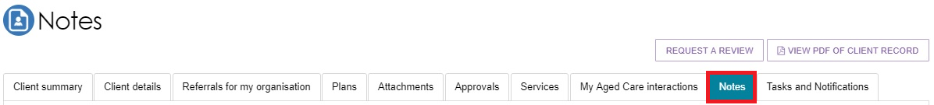
  - Select ADD A NOTE.
- Choose the appropriate Note Type.
- Enter a description.
- Select SAVE to add the note to the client record.
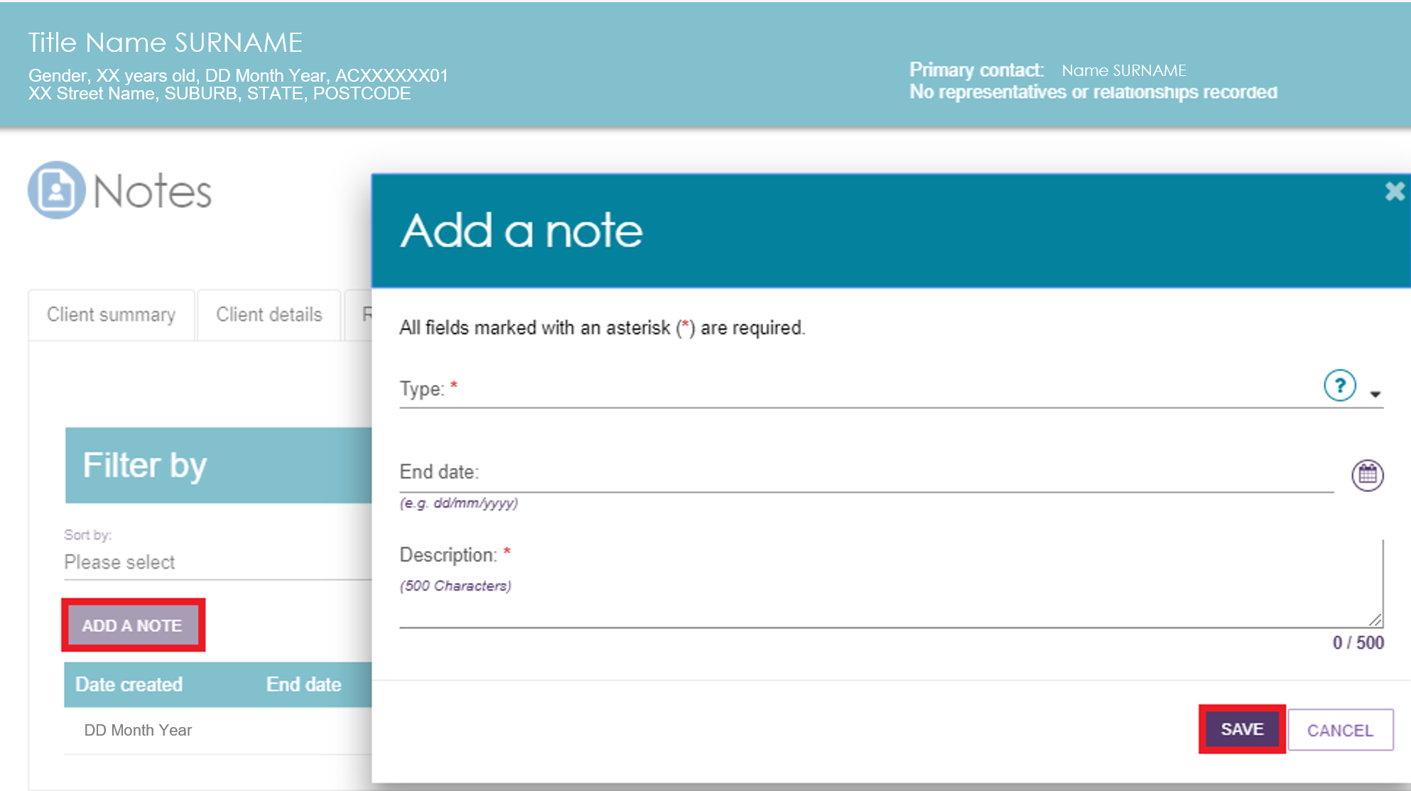
Alternatively, from the Client Details tab, select ADD A NOTE in the Current Notes section.
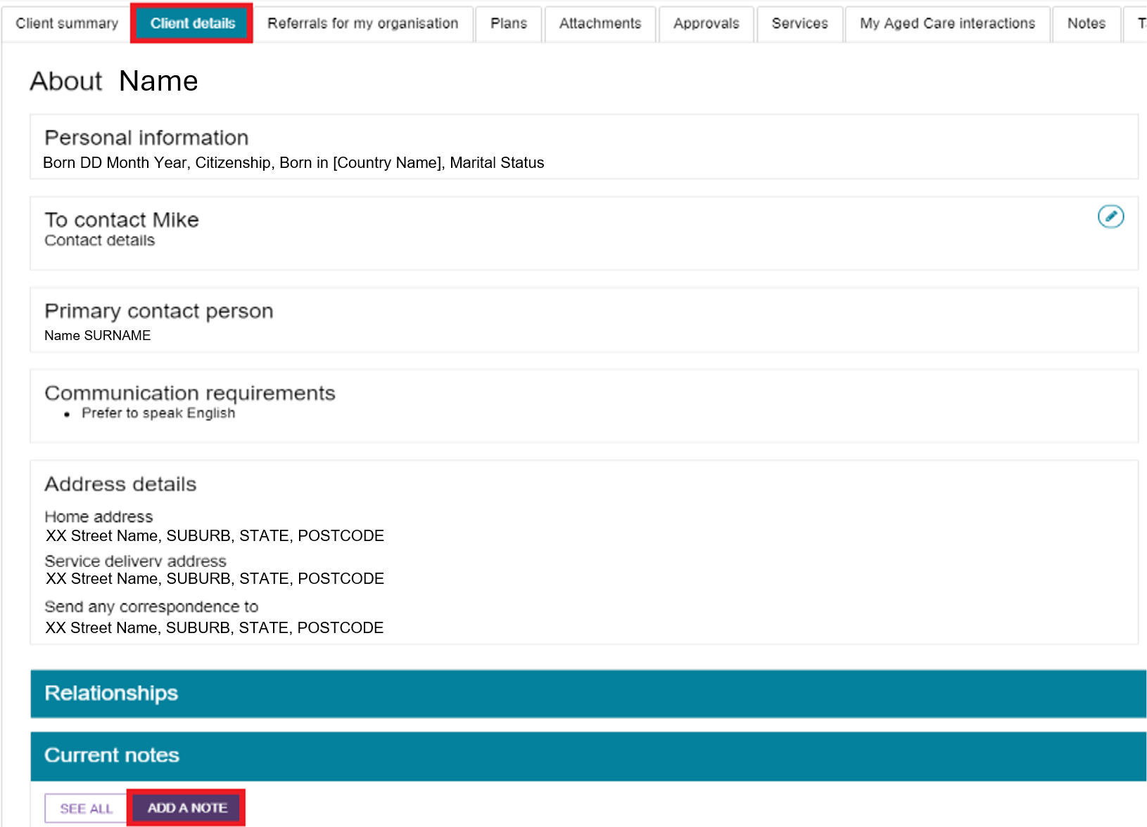
  - You can add Other and Observations notes to the records of any clients referred to your outlet, including clients in the Incoming Referrals tab.
My Aged Care Contact Centre staff, assessors, and other providers supporting the client can view these notes.
Select the blue question mark icon for information about each note type and who can view it.
For more information about note types and permissions, refer to Service and Support Portal User Guide - The Client Record.

Requesting an extension to the client’s care (Transition Care and Residential Respite)
You can request care extensions, including respite care extensions, through the Services and Support Portal. The system sends the request to a Delegate for approval.
If you cannot submit a care extension request through the portal, call the My Aged Care Service Provider and Assessor Helpline on 1800 836 799.
You can extend:
- Transition Care for up to 42 consecutive days
- Residential Respite Care for up to 21 non-consecutive days.
A care extension takes effect from the commencement date entered in the request, subject to Delegate approval. You cannot backdate extension requests unless special circumstances apply.
For more information about care extensions and eligibility requirements, refer to the My Aged Care Assessment Manual.
! Submit extension requests through the My Aged Care Services and Support Portal on or before the client's entitled days expire, if they need additional care.
! | You can only grant a care extension at the client’s current approved level of care. If the client needs a higher level of respite care, they must receive a new Respite Classification. To arrange this, request a Residential Respite Assessment in the MyAssessor app.
To request a care extension:
- Locate the client who requires a care extension.
- Go to the Services in Place tab and expand the client record in either Card View or List View.
- Select REQUEST [CARE TYPE] EXTENSION.
Transition care extension example
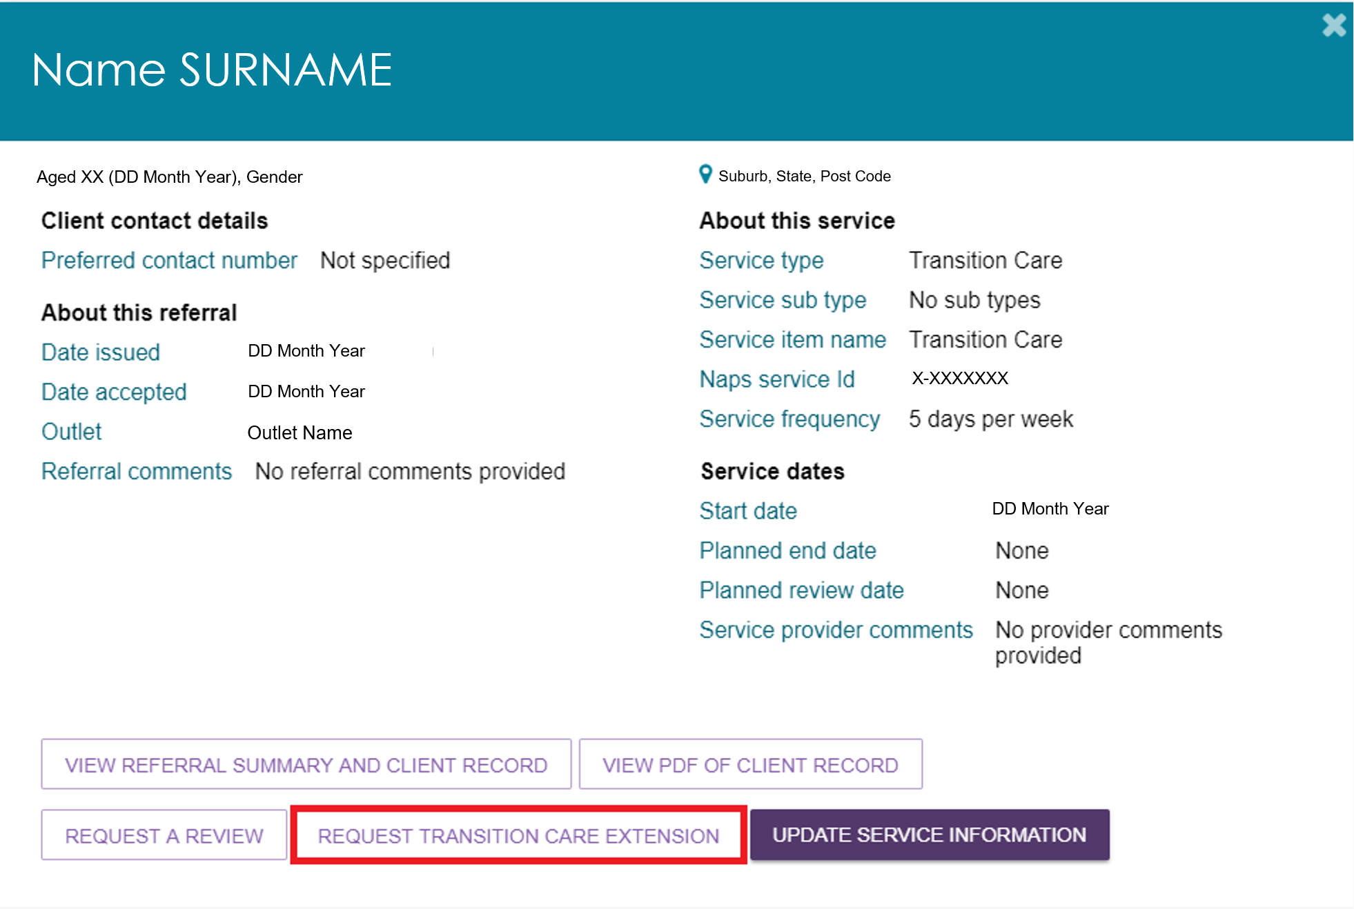
Residential respite care extension example
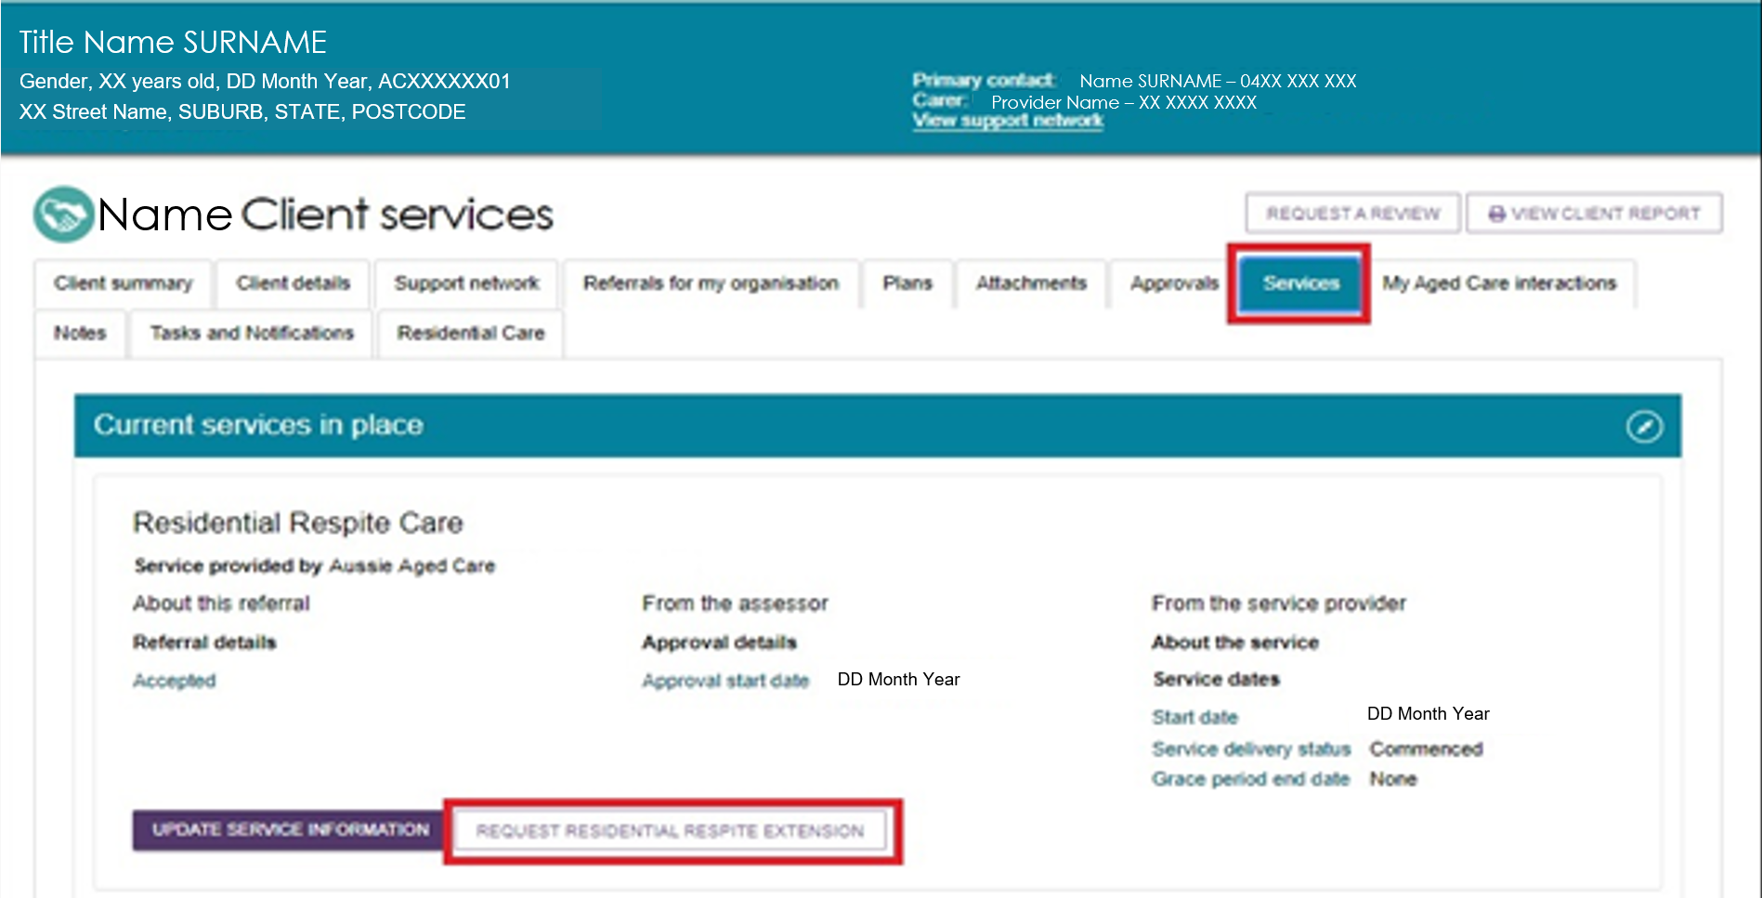
Alternatively, use Find a Client to locate the client, then open the Services or Approvals tab in the client record and select REQUEST [CARE TYPE] EXTENSION.
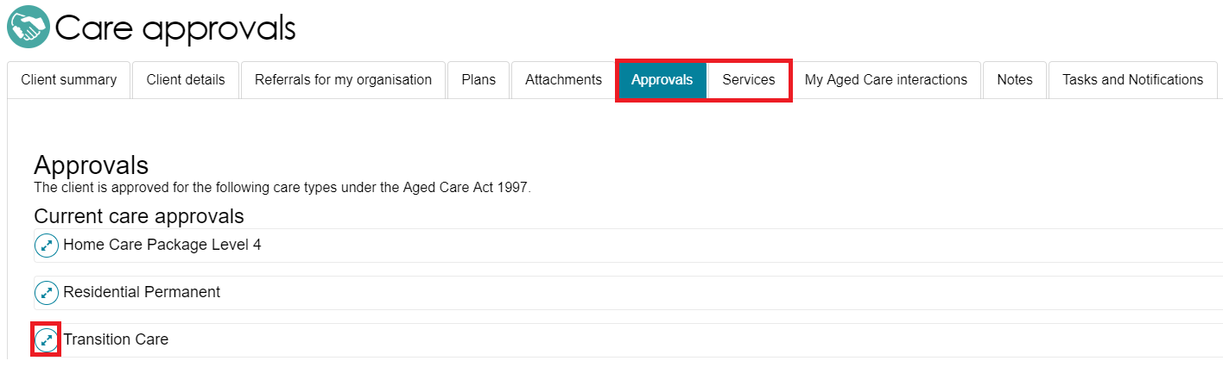
- Complete all required fields in the extension request pop-up.
- The required information varies depending on the type of care extension you are requesting.
- Include the client's paid days balance from the Services Australia Aged Care Payment System and the date you calculated the balance.
- Select SUBMIT REQUEST.
Transition care extension example:
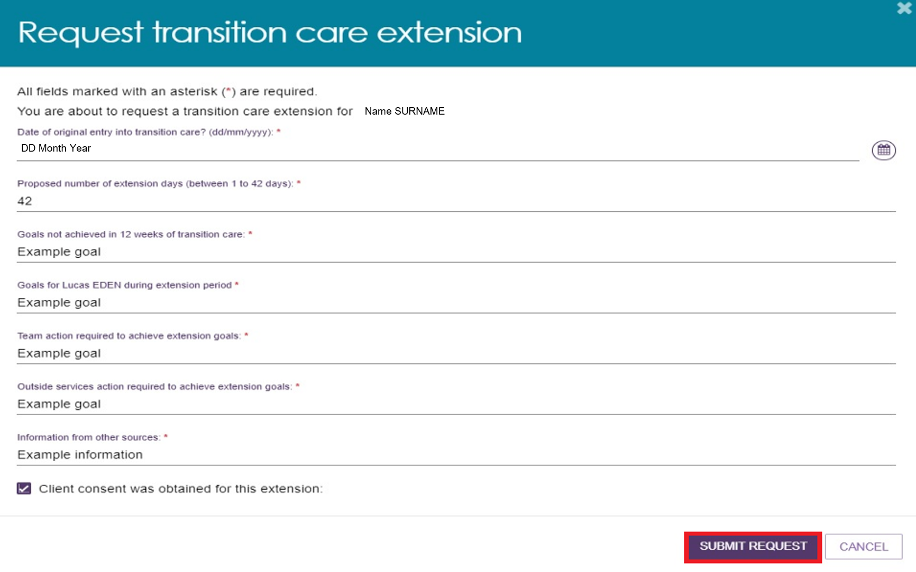
Respite extension example:
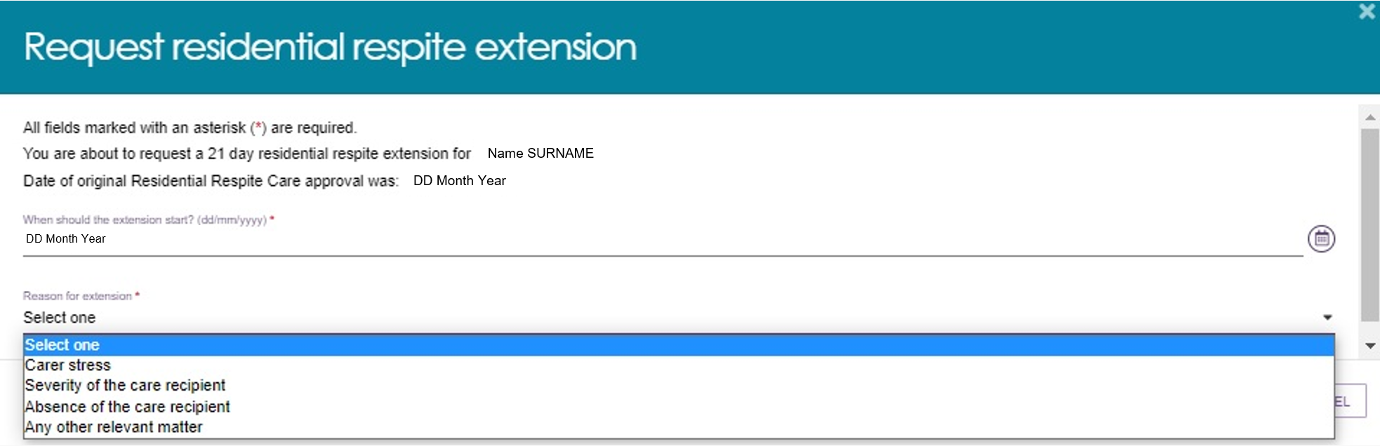
- The system displays a confirmation message when it submits the request to the Delegate.
- You will also receive a notification confirming that the request has been submitted.
The system will send you an email notification after the Delegate makes a decision on the care extension request.
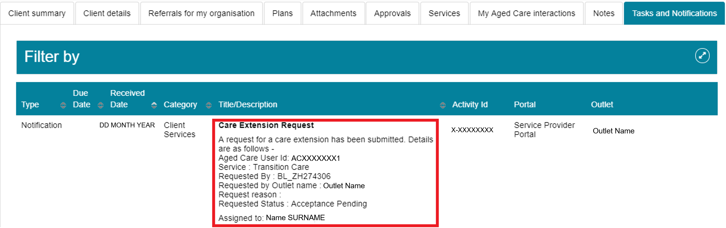

Requesting an extension to the client’s care (Support at Home)
You can request Support at Home care extensions for Assistive technology (AT) and Home modifications (HM) for the following clients:
- Clients receiving AT Medium Tier or AT High Tier services who have a recorded progressive condition: These clients can receive an extension of up to 24 additional months, for a total approval period of 48 months,
- Clients receiving HM High Tier services: These clients can receive an extension of up to 12 additional months, for a total approval period of 24 months. You must provide evidence that the client's condition has progressed.
! You do not need Delegate approval for Support at Home care extension requests. When you submit the request, the system automatically applies the extension.
To request a care extension for a client receiving AT Medium Tier or AT High Tier services who has a progressive condition, follow the steps below.
- Find the client by using one of the following methods:
  - Select Find a Client, open the client record, go to the Services tab, and select SEE SERVICE DETAILS under the Current Services in Place section.
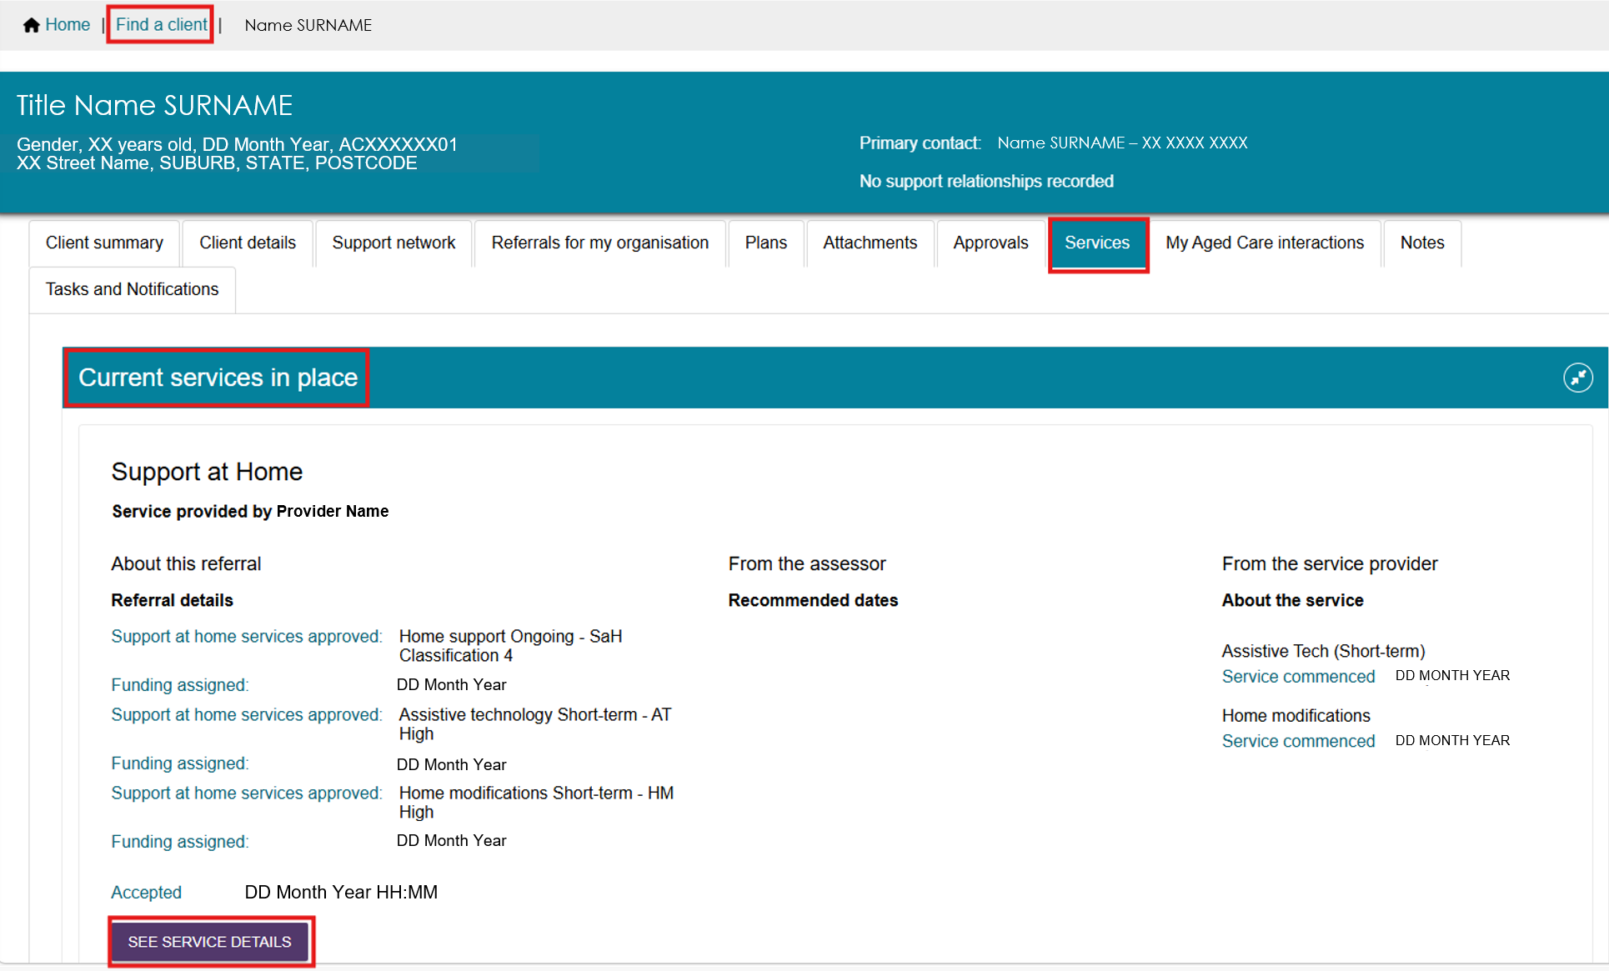
- Go to the Services in Place tab in Service Referrals, then expand the client record in either Card View or List View.
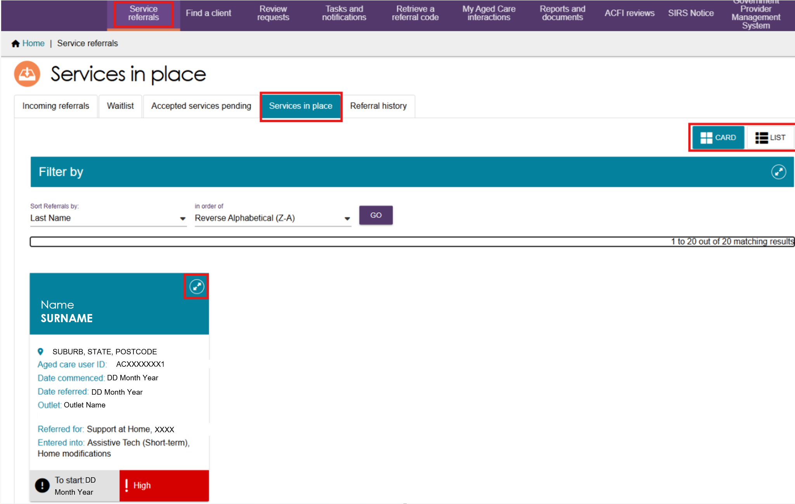
- Select ADD ASSISTIVE TECHNOLOGY EXTENSION.
! The ADD ASSISTIVE TECHNOLOGY EXTENSION button is only available for clients who have a progressive condition recorded during their assessment and who currently receive AT Medium or AT High services.
You can apply the extension only once. After you apply the extension, the system removes the button and you can no longer request another extension.
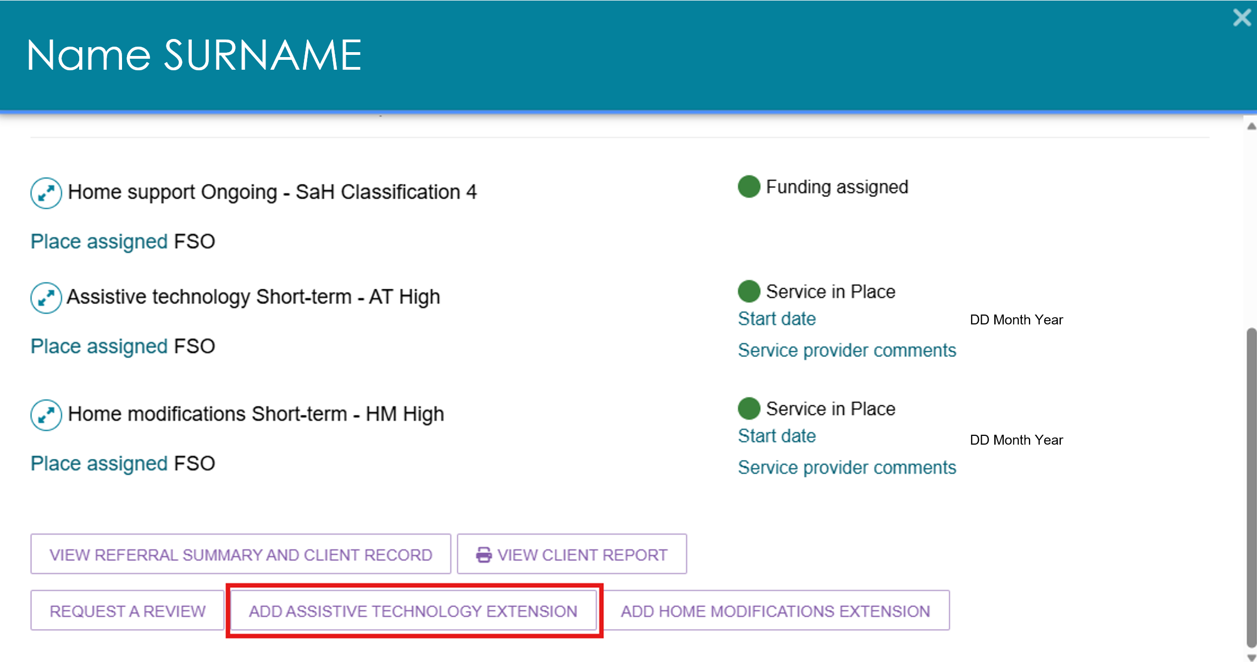
- In the Confirm Assistive Technology Extension pop-up, select CONFIRM.
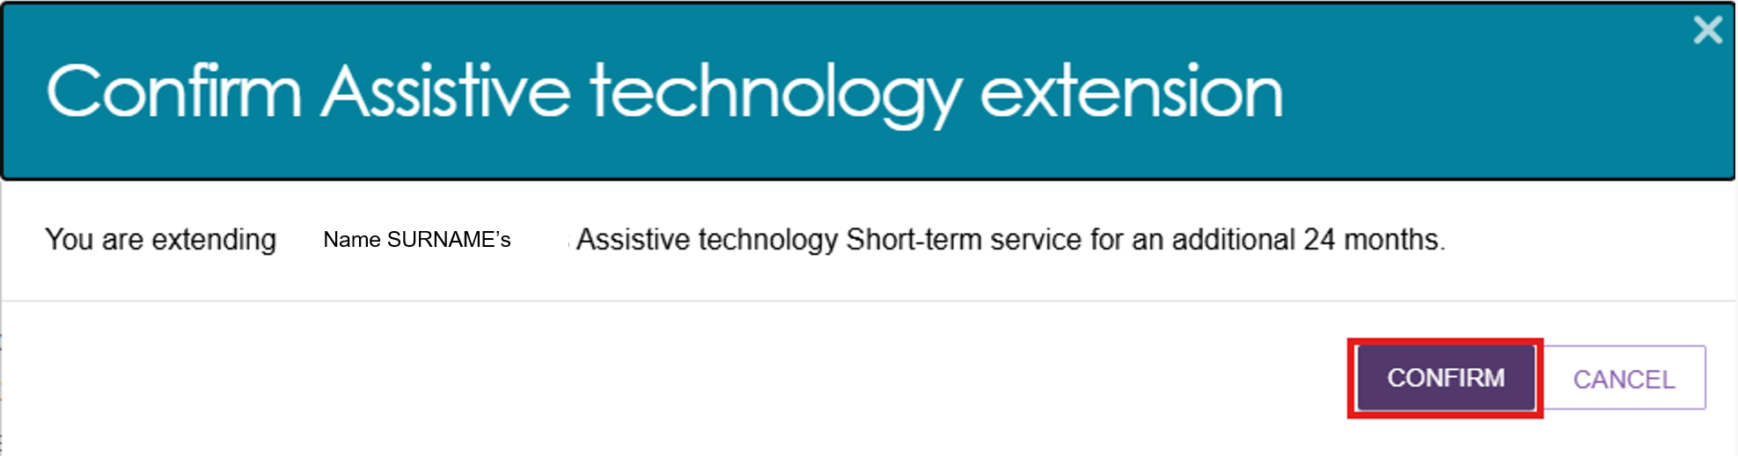
- The system automatically extends the Assistive Technology approval by 24 months and displays a confirmation message.
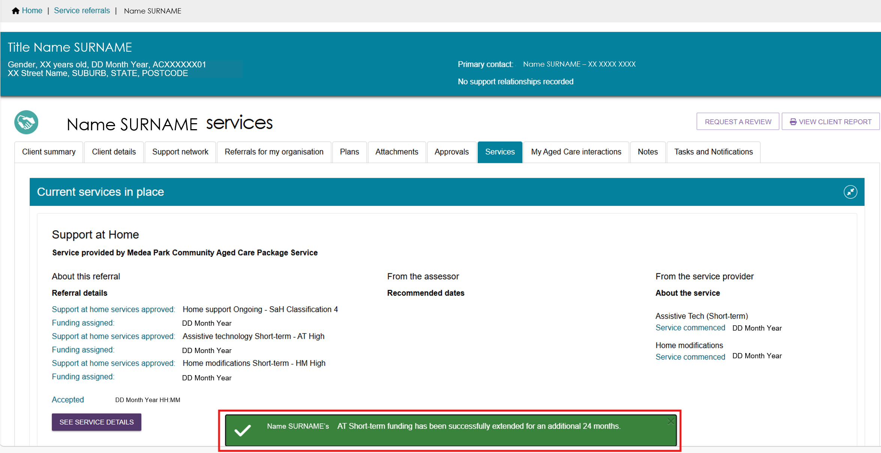
- To view the updated approval end date:
- Open the Approvals tab
- Expand the Assistive Technology approval
- View the Approval Stops field, which shows when the approval ends.
Approvals screen before AT Extension
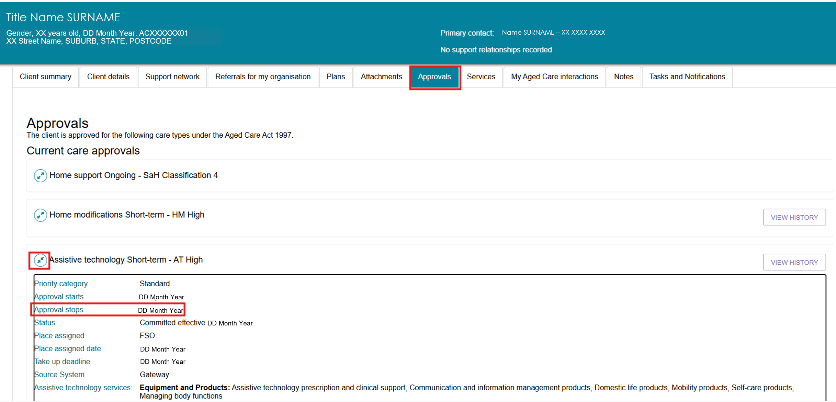
Approvals screen after AT Extension
To request an extension for a Home modifications (HM High Tier) client:
- Find the client using one of the following methods:
- Select Find a Client, open the client record, go to the Services tab, and select SEE SERVICE DETAILS under the Current Services in Place section.
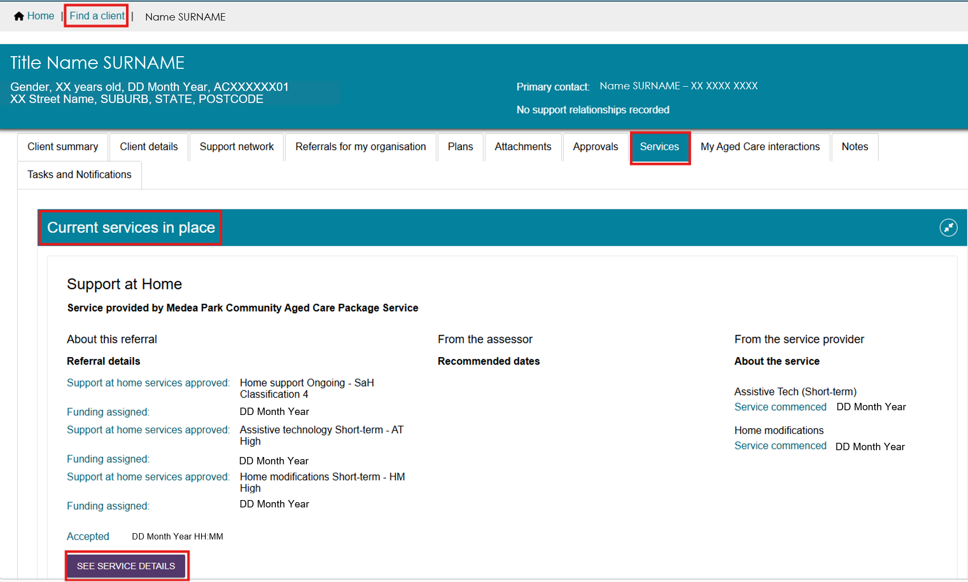
- Go to the Services in Place tab in Service Referrals, then expand the client record in either Card View or List View.
- Select ADD HOME MODIFICATIONS EXTENSION.
! The ADD HOME MODIFICATIONS EXTENSION button is only available for clients who currently receive HM High services. You can apply the extension only once. After you apply the extension, the system removes the button and you cannot request another extension.
The Home Modifications Allocation Period Extension pop-up opens.
Select UPLOAD PROOF OF PROGRESSION.
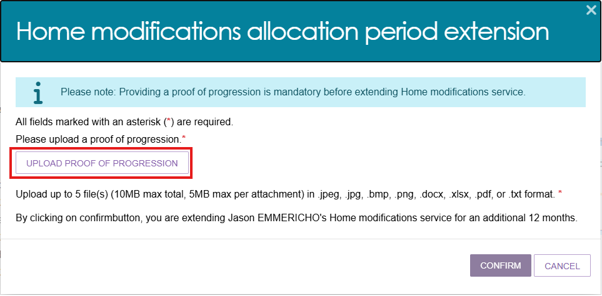
- In the Add Attachment form:
- Select CHOOSE FILE and select the document you want to upload
- The file name will appear next to the CHOOSE FILE button after you attach the file
- Enter a name in the required Attachment Name field
- Optionally, enter a short description of the attachment
- Select UPLOAD.
- The system displays the uploaded attachment.
- To remove an attachment, select the bin icon next to the file name.
- To upload additional documents, repeat Step 3.
- After uploading all required documents, select CONFIRM.
- The system displays a confirmation message and automatically extends the HM High approval by 12 months.
To view the updated approval end date, open the Approvals tab and expand the Home Modifications approval.
The Approval Stops field shows when the approval ends.
Approvals screen before HM extension
Approvals screen after HM extension
- The system stores the uploaded documents in the Attachments tab under Other Attachments and labels them Proof of Progression.

Requesting a Support Plan Review (SPR) to meet changing needs
This function is available for any client receiving subsidised aged care through a referral from the Assessor Portal.
! If a residential care client’s care needs have changed and they require a different residential funding classification, follow the process in Requesting Residential Funding Reassessments.
A provider can request a Support Plan Review (SPR) through the Service and Support Portal when:
- the client’s needs, goals, or circumstances have changed since their last assessment
- the client’s support plan no longer reflects their current situation
- the client needs additional services
- a time-limited service has ended.
An assessor will review the request and the client’s circumstances. This may result in a new assessment of the client’s needs.
With the introduction of Support at Home, providers can request an SPR in a wider range of situations. In most cases, the client’s provider submits the request through the My Aged Care Service and Support Portal, with the client’s consent.
When submitting an SPR request, providers must attach supporting documents that describe the client’s current care arrangements, such as a quarterly budget or care plan. Include as much relevant information as possible to help assess the client’s needs and the urgency of the request.
You can find detailed assessment history information in the client’s support plan on the Plans tab of the client record.
If the client has not previously had a My Aged Care assessment, contact the My Aged Care service provider and assessor helpline on 1800 836 799 to request a new assessment.
Follow these steps to request a review of a client’s support plan:
- Review the client’s assessment information. For detailed assessment history, go to the Plans tab in the client record.
You cannot submit a review request if the client already has an assigned review in the Assessor Portal or is currently undergoing an assessment. Check this before starting a review request.
If you have concerns, contact the assessment organisation that completed the client's most recent assessment. You can find their details in the Plans tab.

- Select Service referrals from the homepage.
- Select Services in Place. Find the client and select Request a Review.
You can also select the Request a Review link displayed at the top of any page in the client's record.

- On the Request a Review screen, indicate whether the client meets the criteria for a direct comprehensive assessment.
If you select Yes, you will be prompted to call the My Aged Care Service Provider and Assessor Helpline on 1800 836 799 and ask the Contact Centre to issue a direct referral. The referral will be sent to the assessment organisation for review, and a banner will appear on the client record to show that a direct referral has been issued.
- Complete all required fields in the Request Details pop-up window.
Different questions will need to be completed at this step depending on which option/s are selected.
If the client needs an urgent review, select Yes for Does this request need to be actioned urgently? and explain why. This information helps the assessor or Contact Centre prioritise the request.
The below image shows example reasons for a client’s SPR request.
The table below outlines the circumstances that can be used to request a support plan review, as well as the circumstances in which a new assessment (instead of an SPR) will be required.
Circumstance | Definition
Hospital Discharge | Client has been discharged from hospital and requires a review of their current care needs and the type and level of support that will be required.
Fall(s) or risk of falling | Client has had a recent fall or is at risk of falling.
Change in medical condition | Client has had a recent change in a medical condition.
Change in cognition status | Client has had a recent change in their cognition status.
Change in care needs | Client has had a recent change in their care needs.
Increasing frailty | Client has increased in frailty.
Change in caring arrangements | Client has had a recent change in their caring arrangements.
Change in living arrangements | Client has had a recent change in their living arrangements.
Review service recommendations | Client is receiving Support at Home services and requires an additional service type within their current Support at Home classification.
Vulnerable client | Client is now vulnerable (e.g. experiencing or at risk of domestic or family violence or elder abuse, at risk of hospitalisation, primary carer is absent or non-existent).

Circumstance | Definition
Needs Transition Care program | If the client receiving other aged care services enters hospital and needs Transition Care program (TCP), a new assessment is required.
Needs Residential Care Permanent (N/A) | Clients needing residential care who have not had residential care added as a care type to their support plan will require a new assessment.
Needs Residential Respite (N/A) | Clients needing residential care who have not had residential respite care added as a care type to their support plan will require a new assessment.
Client has relocated | Client has moved or relocated.
Needs End-of-Life Pathway (high priority) | - Request a high priority SPR to be assessed for End-Of-Life (EoL) pathway if the person is already on Support at Home or CHSP ongoing classification  - A person new to the aged care system who has not yet been assessed for aged care services will need a reassessment to be approved for the EoL pathway.
Review End-of-Life Pathway (high priority) | Request a high priority SPR to move to an ongoing SaH classification if the person need services beyond the EoL pathway funding period.
Review existing  AT-HM funding tier | - To request a higher Assistive Technology-Home Modifications (AT-HM) funding tier  - If participant’s technology or equipment have repair or maintenance needs
Needs AT-HM funding tier | - Addition of new Assistive Technology (AT) or Home Modification (HM) funding tier for participants with restorative care or End-of-Life classifications  - For existing HCP care recipients, providers can identify their AT and/or HM needs through the AT-HM scheme data collection. This is the preferred method for accessing AT-HM funding for this group. All transitioned HCP care recipients will have approval to access the AT-HM scheme without a new aged care assessment. Alternatively, you can request a support plan review by an aged care assessor.
Needs Restorative Care Pathway | If participant is already approved for a Support at Home classification and needs access to a period of restorative care in order to improve level of function, they will need a new assessment conducted.
Review Restorative Care Pathway | Approval for additional services during the restorative care period or provide evidence that additional funding is required/ request a 2nd unit of RCP funding for an existing RCP participant.
Needs additional CHSP services (for existing CHSP participants) | To meet changing needs which may require additional CHSP services (when participant has already been approved for CHSP ongoing)
Needs CHSP ongoing | To close off a period of reablement support and/or meet changing needs which may include needing an ongoing service type after the episode of reablement has finished.
Ongoing Support at Home (for existing participants) | Additional services within a service type that has already been included in the individual’s support plan and is within the current Support at Home classification. This will be submitted by the individual’s Support at Home provider.
- If the client receives Support at Home services, or a combination of Support at Home and CHSP services, you must attach a care plan and budget. The system will not allow you to submit the request without these documents.
Select ADD CARE PLAN or ADD BUDGET. Complete all required fields and select Upload.
! Web Referrals for Support at Home Support Plan Reviews
A provider may receive a request from the My Aged Care Contact Centre after a health professional submits a web referral requesting a clinical reassessment for an existing Support at Home participant.
The provider should review the client’s circumstances, care plan and budget. If the client needs a change to their Support at Home classification or priority level, the provider should submit a Support Plan Review request to the assessor.
If the provider decides not to submit a Support Plan Review because the client’s current Support at Home classification already meets their needs, the provider should contact the health professional and explain why the reassessment request will not proceed.
- Uploaded documents will appear in the review request once the upload is successful.
To remove an attachment, select the Delete (rubbish bin) icon next to the file name. The system will delete the attachment immediately without displaying a confirmation message.
- After completing all required fields, select I have reviewed the information on this page and confirm it is correct, then select Send Review Request.
A confirmation message will appear when the review request has been submitted successfully.

Checking the status of a Support Plan Review
- If a client, provider, or aged care needs assessor requests a review of a client’s support plan, an aged care needs assessor will complete the review. A Team Leader can check the status of the review in the Service and Support Portal by selecting the Review Requests tile.
- On the Review Requests page, select the Request History tab to view the status of review requests.
If a review has recently been completed, a green Review Complete banner will appear at the bottom of the client’s record.
Select the Expand icon to view more details about the review request.
- You can then view the review outcome. Depending on the result, you may need to make changes to the services you provide.
The client record includes information to help you understand whether any changes are needed to better support the client.
An aged care needs assessor may determine that:
- no changes are required
- services should increase or decrease within the client's current approval
- the client requires a comprehensive assessment under the Aged Care Act 2024.
If the review outcome affects the client's current services, the assessor may contact you to discuss the review findings and any recommendations relevant to your services.
If the review results in an increase or decrease in services, update the service delivery information in the client record.
If the review leads to a new assessment and approval for a different service type, either:
- you will receive a notification of a new referral in the Portal (for Support at Home classifications, you must wait until a classification is assigned), or
- the client may contact you to discuss ending services with your organisation if you cannot provide the newly approved service.
Funding and classification details are assigned when services are recommended and are available in the client record.

Generating reports and accessing forms
Providers can generate reports and access forms through the Service and Support Portal.
You can also use the Reports feature to generate and print documents, including completed Integrated Assessment Tool (IAT) PDF reports and client record PDFs.

Generating reports
Both Team Leaders and Staff Members can generate reports.
- Select Reports and Documents from the home page. The Reports and Documents page opens.
- The page contains three tabs:
- Reports
- Forms
- Links.
The Reports tab displays:
- Recently Requested Reports
- Reports.
The Recently Requested Reports section shows client record PDFs and IAT reports that you have previously generated.
You can also access the Workload Management Report from the Reports tab.
- To generate a report, select the report name from the Reports list.
- Select the Outlet ID, enter the start date and end date, and choose an output format (CSV or PDF). Then select Request Report.
If you do not want to generate the report, select Cancel.

Viewing reports
Follow these steps to view a report:
- Select Reports and Documents from the home page. The Reports and Documents page opens.
- In the My Reports section, find the report you want to view and select View next to the report name.

Accessing forms
Follow these steps to access forms.
- Select Reports and Documents from the homepage.
- Select the Forms tab. The system displays a list of all available forms.

Serious Incident Response Scheme (SIRS)
Users with the Staff Member or Team Leader role can create, view and manage SIRS notifications in the Service and Support Portal, provided their Organisation Administrator has assigned them the SIRS role.
For detailed instructions on using SIRS functions, refer to the Service and Support Portal User Guide - Serious Incident Response Scheme (SIRS) Portal

Residential Client Classifications and Reassessments
Residential care providers with the Team Leader or Staff Member role can access the Residential Care tile to view information related to the Australian National Aged Care Classification (AN-ACC) funding program.
Select the Residential Care tile to access the following tabs:
- Care Recipients: Displays all clients receiving permanent residential care or residential respite care.
- Requests: Displays current and historical requests for initial assessments, reassessments and reconsiderations.
- Palliative Care: Displays clients who entered permanent residential care under palliative care arrangements.

Viewing residential clients and their residential funding classification
- On the Home screen, select the Residential Care tile.
The Care Recipients tab displays all clients receiving permanent residential care, along with details of their residential funding classification.
The Request Type column shows whether the client has an active request for a palliative care status form approval, initial assessment, reassessment, or reconsideration.
- Select a client to view their current and previous classifications.
Residential funding classifications may appear with the following statuses:
- Active: The client has completed a Residential Funding Assessment and has an active classification on their record.
- Pending: The client has completed a Residential Funding Assessment, but a classification has not yet been assigned. This status is usually displayed for one day after the assessment is completed or uploaded.
- Default Classification: The client has not yet completed a Residential Funding Assessment.
You can identify default classifications by their classification code:
- Most permanent residential care clients with a default classification are assigned Class 99.
- Clients who entered residential care for palliative care and are awaiting confirmation of eligibility are assigned Class 98.
- Residential respite care clients are assigned Class 100 as their default classification.

Filtering the Care Recipients lists
You can filter the Care Recipients list by Last Name, First Name, Request Type, or Aged Care User ID. Select Advanced Search to view additional filter options, such as Classification.
- Expand the Filter by section.
- Enter search criteria and select FILTER.

Advanced Search
Use Advanced Search to find care recipients using additional search criteria. You can apply up to seven filters to refine your search results.
  - Select ADVANCED SEARCH.
  - Select the filter you want to add, such as Classification, and then select Add Filter.
  - Select a value for the filter, for example Class 4, and then select Filter. The system updates the Care Recipients list to show only records that match the selected criteria.
  - To save the filter for future use, select Save Filter. To clear all filters and start a new search, select Clear Filter.
  - After you apply the filters, the system displays the number of clients that match the selected criteria.

Requesting Residential Funding Reassessments
! Only request a Residential Funding (AN-ACC) Reassessment if the client’s care needs have changed significantly.
You can only request a reassessment while the client is receiving care from your organisation.
Only users with the Team Leader role can submit reassessment requests.
- On the Home screen, select the Residential Care tile.
- On the Care Recipients screen, select the client who requires a reassessment.
! You cannot request a reassessment if the client already has an initial assessment, reassessment or reconsideration in progress. Check the Requests tab before submitting a reassessment request.
- The client’s record opens. You can view the client’s current Residential Permanent and/or Respite Classification and request a reassessment for the client.
For a Residential Permanent reassessment, select Request Reassessment next to the current Residential Permanent classification.
For a Residential Respite reassessment, select Request Reassessment next to the current Residential Respite classification.
- Select Yes if there has been a significant change in care needs.
Then, select CONFIRM REASSESSMENT button.
(For Residential Permanent reassessments only: You can mark the request as Urgent if the client is nearing end of life and has a documented care plan that has been discussed with the resident and their family and/or carers.)
- Select the reassessment criteria that apply to the client, then select Request Reassessment.
For Residential Permanent clients, criteria that do not meet the required timeframes appear in light grey and cannot be selected.
For Residential Respite clients, enter the client's expected departure date from respite care.
Request reassessment - Residential Care example
Request reassessment: Residential Respite example
- A green confirmation banner will appear when the reassessment request has been submitted successfully.
A banner at the top of the screen will also show when you can expect the new classification details to become available.
- To track the progress of a reassessment request, go to the Requests tab. For more information, refer to Request Tab and Request Status Definitions. The system will send notifications when a new classification decision is made after the assessment is completed. For more information, refer to Viewing Tasks and Notifications.

Requesting Residential Funding Reconsiderations
! Only users with the Team Leader role can request a residential funding reconsideration. You should only request a reconsideration if you disagree with the classification resulting from an assessment or reassessment. You must submit the request within 28 days of receiving notification of the new classification, and while the client remains in your care.
- On the Home screen, select the Residential Care tile.
- On the Care Recipients screen, select the client whose classification you want reconsidered.
! You cannot request a reconsideration if the client has an initial assessment, reassessment or reconsideration in-progress. Check the Requests tab for in-progress assessments.
- The client’s record opens. View the client’s current Residential Permanent and/or Residential Respite classification and submit a reconsideration request:
- For a Residential Permanent classification, select Request Reconsideration next to the current classification.
- For a Residential Respite classification, select Request Reconsideration next to the current classification.
- Select Yes if you disagree with the current classification and select CONFIRM RECONSIDERATION.
(For Residential Permanent classifications only: You can mark the request as Urgent if the client is nearing end of life and has a documented care plan that has been discussed with the resident and their family and/or carers.)
- Select the reason that supports your reconsideration request, then select Request Reconsideration. For Residential Respite clients, you must enter the client's expected departure date from respite care before submitting the request.
Expected departure date from respite care example
- A green confirmation banner appears when the reconsideration request has been submitted successfully.
You can track the progress of the request on the Requests tab. For more information, refer to Request Tab and Request Status Definitions.
The system will send notifications when a new classification decision is made after the assessment is completed. For more information, refer to Viewing tasks and notifications.

Recalling a Residential Funding Reassessment or Reconsideration request
If you accidentally request a reassessment for a client, or if the client is no longer available for reassessment (for example, they are on social or emergency leave), you can recall the request.
- On the Home screen, select the Residential Care tile.
- Open the Requests tab. Find the reassessment or reconsideration request you want to recall by scrolling through the list or using the available filters. Expand the client record.
- Select Recall Reassessment Request or Recall Reconsideration Request.
! If you select Client Unavailable, you can notify the Department when the client becomes available for assessment again. The system can then automatically submit a new reassessment request.
If you select Client Deceased, the system updates the client's status to deceased in Department records and closes the reassessment request. Make sure you have confirmed this information before submitting the request.
If you select Other, enter a reason for the recall. The system will then close the reassessment request.
- Choose a reason for the recall from the drop-down list, then select Recall Reassessment Request or Recall Reconsideration Request to confirm.
- A green confirmation banner appears when the reassessment or reconsideration request has been successfully recalled.


Notify client is available for assessment
Only Team Leaders can notify the Department when a client becomes available for assessment after returning to your residential care facility.
The Notify Client Is Now Available for Assessment option is available if the client's previous residential funding assessment referral was rejected or recalled with the reason Client Unavailable.
- On the Home screen, select the Residential Care tile.
- On the Care Recipients screen, select the client who is now available for assessment.
- In the Residential Care tab of the client record, select Notify Client Is Now Available for Assessment.
- A confirmation window will appear.
- To notify the Department and automatically submit a reassessment request, select Request Reassessment and Confirm Client Is Available.
- To notify the Department without submitting a reassessment request, select Confirm Client Is Now Available for Assessment. You can request a reassessment later if needed.
- A green confirmation banner will appear when the client has been marked as available for assessment. If you selected the automatic reassessment option, the system will also submit a reassessment request.

Request tab and request status definitions
The Requests tab in the Residential Care tile displays all residential funding assessment requests, including initial assessments, reassessments and reconsiderations.
The Request Status shows the current stage of each assessment request.
The table on the following page describes each request status in the order it typically occurs.
! In this guide, the term assessment refers to initial assessments, reassessments and reconsiderations.
REQUEST STATUS DEFINITIONS
Status | Description
Pending Allocation | A referral for a residential funding assessment has been created and is yet to be issued to a residential funding assessment organisation.
Pending Assessment | A referral for a residential funding assessment has been issued to a residential funding assessment organisation and the assessment is yet to be completed.
Finalised | The assessment has been completed and uploaded by the assessor.
Rejected | The request for assessment has been rejected for reasons the client is unavailable for assessment i.e., in hospital or on leave
Recalled | The request for assessment has been recalled for reasons the client is unavailable for assessment i.e., the client is deceased

Palliative Care

View clients marked palliative on entry
The Palliative Care tab displays clients who entered a residential care facility under permanent palliative care and shows any actions required to confirm their palliative care status.
Forms submitted through this process are reviewed by the Department, which will determine the outcome and take the appropriate action.
After the Department completes the validation process, the client’s record remains available in the Palliative Care tab.
To view all clients who were recorded as Palliative on Entry, select the Palliative Care tab.

Upload palliative care documents
For clients who were recorded as Palliative on Entry, the status initially displays as Pending Upload.
  - Expand the client record and select Upload Palliative Documents.
! The Palliative Care Status Form must be submitted within 14 days of notification of entry to the department via the My Aged Care Service and Support Portal.
Once the entry is processed, a notification will be generated.
Please refer to Viewing tasks and notifications for more information.
  - Upload the completed Palliative Care Status Form and submit it before the due date.
Select Upload Palliative Documentation to open the upload window, then choose the form saved on your computer.
  - Enter a file name and a short description.
Use the following file naming convention for both the file name and the uploaded document:
[Client Last Name] PCSF [Date Uploaded – DDMMYY]
If the Department has requested additional supporting information, you can upload it by selecting Upload Palliative Documentation and repeating the steps above.
! Only one file may be uploaded each time, as each file requires an individual name and description.
  - If you are not ready to submit the documents, select Save Documents & Exit. The Department will not review saved documents until you submit them.
When you have reviewed all documents and are ready to send them to the Department, select Submit Documents.
  - The client's status changes to Pending Approval, and a Department Palliative Review Officer will review the submitted documents.
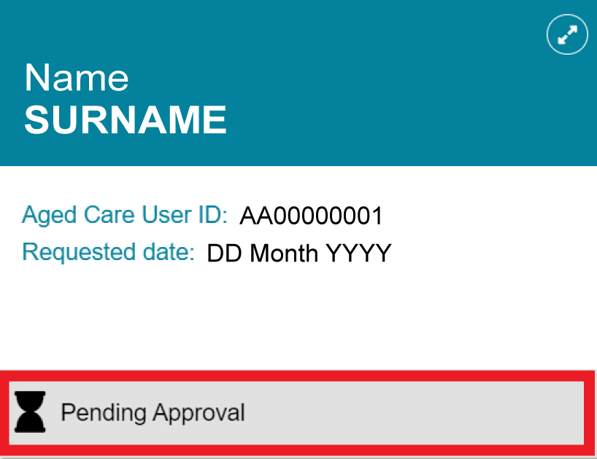

Palliative Care Status Form outcomes
A submitted Palliative Care Status Form can have one of three outcomes:
- More Information Requested
- Approved
- Rejected.

More Information Requested
If the Palliative Review Officer determines that there is not enough information to assess the form, they will request additional information and explain what is required.
When this happens, you have 14 days from the date of the request to upload the requested documents. This extension is available once only for each resident, so make sure you provide all information needed to confirm the resident’s palliative care status.
When the Department requests more information, the system generates a notification. For more information, refer to Viewing tasks and notifications.
  - Expand the client record and select View More Details to read the comments and instructions from the Palliative Review Officer.
! After the Department requests more information, you can no longer view or edit the previously submitted document. You must upload a new version of the document.
Use the following file naming convention and include the latest upload date:
[Client Last Name] PCSF [Date Uploaded – DDMMYY]
  - If required, select Add Response to provide additional information, upload the updated documents, and resubmit the form.

Approved and Rejected Palliative Care Status Forms
If the Department approves the Palliative Care Status Form, you will receive a notification and the client's status will change to Approved. The client will be assigned AN-ACC Class 1 and become eligible for funding at that classification level.
If the Palliative Review Officer determines that the additional documents do not provide enough evidence to confirm the client's palliative status, they will reject the request.
You will receive a notification and the client's status in the Palliative Care tab will change to Rejected. The system will also generate a referral for an AN-ACC assessment to determine the client's AN-ACC classification.
If you would like to appeal the decision, email myagedcare@health.gov.au and provide evidence to support your appeal.

