Service and Support Portal User Guide - Part 1: Administrator Functions
The My Aged Care Service and Support Portal User Guide – Part One (User Guide) outlines how Commonwealth-funded service providers (providers) set up and maintain the My Aged Care Service and Support Portal (Portal) for your organisation.
The User Guide is split into two parts as follows:
Part One (this document) provides an overview of the Portal and describes the functions an Administrator can perform.
Part Two provides an overview of the Portal and describes the functions that a Team Leader or Staff Member can perform.
This guide does not cover:
- Detailed instructions on how to set up organisations in the Relationship Authorisation Manager, which can be found on the RAM website.
- Detailed instructions on how portal users obtain a myID (which can be found in the user guide Logging in to the Aged Care Systems.
Contents
1 Introduction 3
2 Staff roles 3
2.1 Administrator homepage 5
2.2 Team Leader homepage 5
2.3 Staff Member homepage 6
2.4 Homepage for users assigned multiple roles 7
3 Creating service delivery outlets 8
3.1 Creating or adding a new outlet 8
3.2 Viewing outlets 11
3.3 Editing the Organisation philosophy 12
3.3.1 Add/edit cultural specialisations 12
3.3.2 Add/edit religious specialisations 14
3.4 Specialisation Verification 15
3.4.1 Verified specialisations and service items 18
3.4.2 Manage specialisation verifications for the outlet 18
3.4.3 Managing applications 18
3.4.4 Managing verifications 19
3.4.5 Submitting a new application 22
3.4.6 Reissued applications 32
3.4.7 Viewing applications 34
4 Creating and maintaining service Items 38
4.1 Adding a service item 38
4.2 Editing a service item 44
4.3 Editing availability and waitlists for a service 46
4.4 Editing service delivery area 47
4.5 Specialisations 51
4.6 Specialisation Verification 52
4.7 Specialised Services 52
4.8 Languages 52
4.9 Attaching promotional material 53
4.10 Removing a service sub-type 56
5 Configuring service attributes 57
5.1 Classifications 58
5.2 Hours of operation (non-Support at Home) 59
5.3 Delivery Hours (Support at Home) 60
5.4 Staffing notes 61
5.5 Service specific delivery details 61
5.6 Service Description 61
5.7 Pricing Information (Support at Home) 62
5.7.1 Updating Pricing Information at the Organisation Level 64
5.7.2 Updating Pricing Information at the Outlet Level 67
5.7.3 Updating Pricing Information at the Service Item Level 68
5.7.4 Updating Pricing at the Service Level 70
5.7.5 Reporting service pricing status 73
5.8 Rooms (Residential Care) 75
5.8.1 Add a room type 75
5.8.2 Edit room details 79
5.8.3 Change room status 82
5.8.4 Delete a room 83
5.9 Transferring service items 84
5.10 Activating or deactivating a service item 84
6 Maintaining service delivery outlets 87
6.1 Activating an outlet 87
6.2 Deactivating an outlet 88
6.3 Removing an outlet 89
6.4 Editing outlet details 90
6.5 Tasks and notifications 92
6.5.1 Viewing tasks and notifications 92
6.5.2 Managing task and notification preferences 95
7 Creating and maintaining staff accounts 98
7.1 Viewing staff accounts 98
7.2 Adding new staff accounts, allocating roles and outlets 98
7.3 Editing a staff account 101
7.4 Deactivating staff accounts 102
7.5 Removing staff accounts 104
8 Generating reports and accessing forms 106
8.1 Generating reports 106
8.2 Viewing reports 107
8.3 Accessing forms 108

Introduction
The Service and Support Portal is used to:
- Manage information about the services you provide.
- Manage referrals for service(s) issued by My Aged Care contact centre staff or aged care needs assessors (assessors) by accepting, rejecting, or placing on a waitlist.
- Update client records with information about services being delivered.
- Request that an assessor undertakes a Support Plan Review for a client.
- Report Serious Incident Response Scheme (SIRS) Priority 1 and Priority 2 incidents in residential, in-home, and Support at Home aged care services.
- Generate reports.
- Manage residential client classifications, reassessments, reconsiderations, and palliative care administration.
- Administering Specialisation Verifications.
To access the Service and Support portal, each administrator must have a My Aged Care portal user account linked to a supported third-party authentication service. For more information regarding setting up users and logging into the system please refer to Logging in to the Aged Care Systems.

Staff roles
The person nominated as the Organisation Administrator needs to be the first person from your organisation to log in to the Portal. Refer to Logging in to the Aged Care Systems for more information.
The Organisation Administrator will be responsible for assigning roles to other staff; this can include assigning other staff the administrator role to help set up and maintain information about your organisation in the Portal. Roles should be assigned in accordance with the duties the person performs within your organisation.
Service information is publicly displayed in the My Aged Care Find a Provider tool on the My Aged Care website and the Find a Service tool within the Assessor and Staff portals.
My Aged Care contact centre staff and assessors use this service information to send referrals. Potential My Aged Care recipients and their support network use this service information to research and access services.
It is the Administrator’s responsibility to set up and maintain this information to ensure accurate referrals.
! | If you are assigned more than one role, this access will apply across all outlets you have been granted access to in the Service and Support Portal.
The following tables outline the functions for each role within the Portal. It includes both client-focussed and organisation-focussed tasks.
Client Focussed Key Functions | Organisation Administrator | Outlet Administrator | Team Leader | Staff Member
Search for a client record  (for referred clients) |  |  | ü | ü
View client records  (for referred clients) |  |  | ü | ü
View referrals |  |  | ü | ü
Accept, reject, and revoke referrals |  |  | ü
View tasks and notifications | ü | ü | ü | ü
Manage organisation preferences  for tasks and notifications | ü
Manage outlet preferences for  tasks and notifications | ü | ü
View My Aged Care interactions | ü | ü | ü | ü
Add client service information |  |  | ü | ü
Transfer clients between services (Currently Disabled) | ü
Submit notifications under the  Serious Incident Response Scheme | ü | ü | ü | ü

Organisation Focussed Key Functions | Organisation Administrator | Outlet Administrator
Request change to contractual information | ü | ü
Add outlets | ü
Manage outlets: edit, activate, deactivate, remove | ü | ü
Manage services: add, edit, activate, transfer  (Organisation Administrators only) or deactivate | ü | ü
Manage staff (organisation level): add, edit, deactivate, remove | ü
Manage staff (outlet level): add, edit, deactivate, remove | ü | ü
Apply for specialisation verification | ü | ü
Manage and view verified specialisations information | ü | ü

Administrator homepage
Administrators at an Organisation level can view and manage information for the entire organisation in the Service and Support Portal. Administrators for one or more outlet(s) in the organisation (Outlet level) will only be able to view and manage information for the outlet(s) they have been assigned.
If you log in to the Service and Support Portal as an Administrator, you can view Tasks and notifications, My Aged Care interactions, Reports and Documents, Outlet administration, SIRS Notice, Government Provider Management System and Staff administration tiles on your homepage.
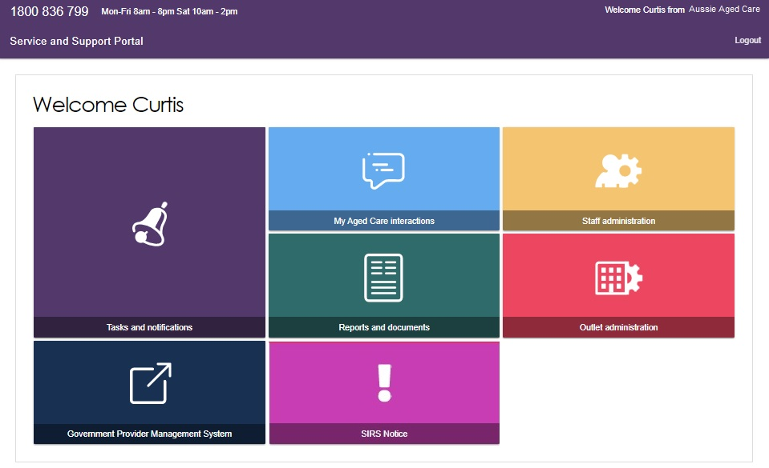

Team Leader homepage
People assigned the Team Leader role in the Service and Support Portal have the same functions as the Staff Member role but are also responsible for managing referrals for service(s).
If you log in to the Service and Support Portal as a Team Leader, you can view Service referrals, Find a client, Tasks and notifications, My Aged Care interactions, Reports and Documents, Retrieve a referral code, SIRS Notice, and Government Provider Management System tiles on your homepage.
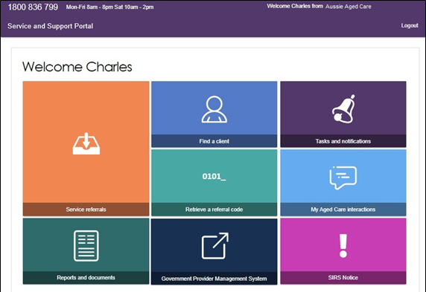
If you do not have access to the SIRS notice tile, your Administrator for Service and Support Portal can add the SIRS role to your staff profile.
For information on how to add the serious incident report tile for staff members please refer to the guide on How to use the Serious Incident Response Scheme Portal.

Staff Member homepage
People assigned the Staff Member role in the Service and Support Portal are responsible for adding and updating client service information in the client record.
If you log in to the Service and Support Portal as a Staff Member, you can view Service referrals, Find a client, Review requests, Tasks and notifications, My Aged Care interactions, Government Provider Management System and Reports and documents.
If you do not have access to the SIRS Notice tile, your Administrator for the Portal can add the SIRS role to your staff profile.
For information on how to add the SIRS Notice tile for staff members please refer to the guide on How to use the Serious Incident Response Scheme Portal.
If you have been assigned the SIRS role by your Organisation Administrator, you will have access to a SIRS Notice tile.
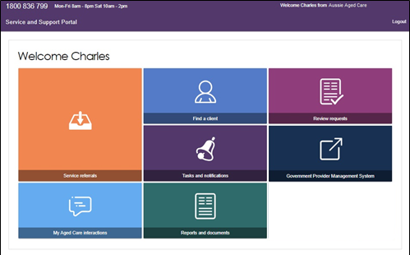

Homepage for users assigned multiple roles
If you log in to the Service and Support Portal as a user with Administrator, Team Leader, and/or Staff Member roles, you can view the functions for all your roles on the homepage.
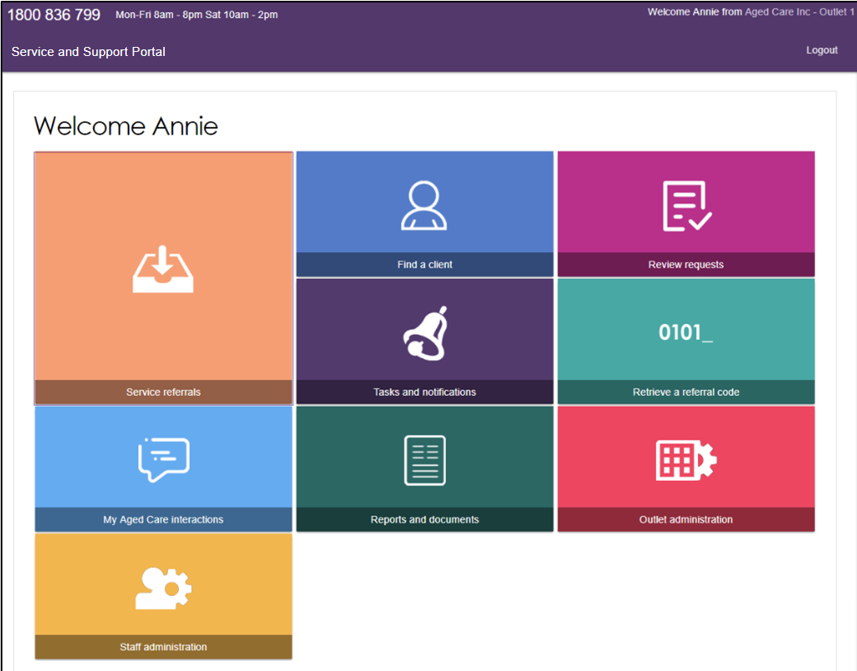

Creating service delivery outlets
Administrators will need to set up at least one outlet in the Service and Support Portal before they can add their organisation’s service information such as service items. Administrators can choose how to set up service(s) in the Portal: either all under one outlet or under multiple outlets.
Each outlet you set up can have different staff, service information, locations, and contact details recorded. Ideally, outlets should be established based on distinct delivery areas to manage client intake effectively and avoid overlapping delivery areas between outlets to prevent confusion and duplication of services. Refer to the user guide on Create service delivery outlets and add service information for further information about outlets.

Creating or adding a new outlet
Administrators need to set up outlets in the Portal before service information can be added. When you create an outlet, the status is set to Inactive by default. You must activate the outlet and create service items in an outlet before it can be made operational.
- From the Outlet administration page, select ADD NEW OUTLET.
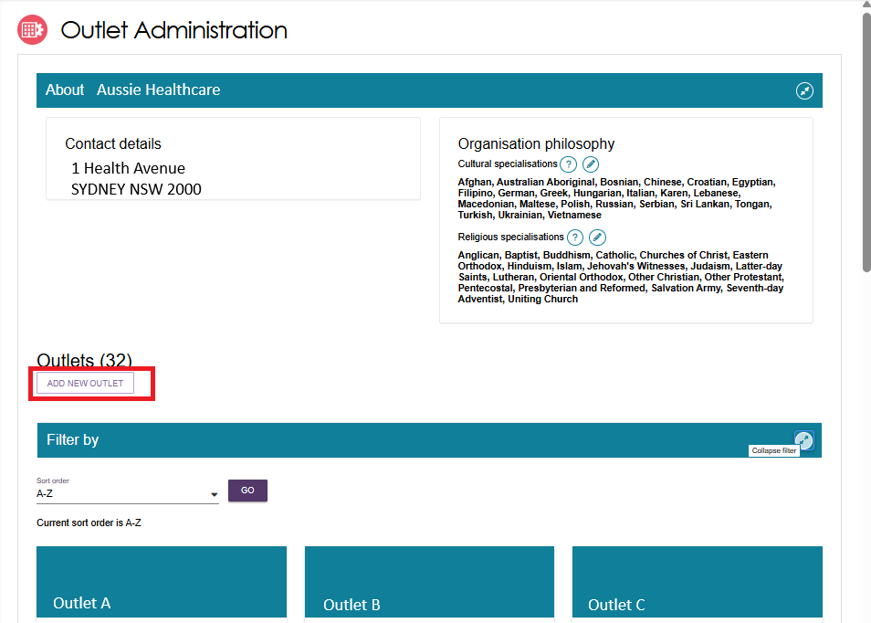
- Enter outlet details.
- To add an outlet address, select ADD OUTLET ADDRESS.
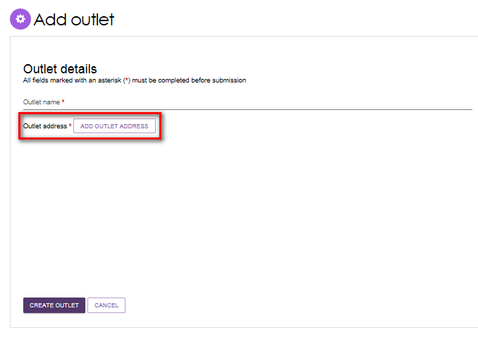
- Fill out your address details, then select VALIDATE THIS ADDRESS.
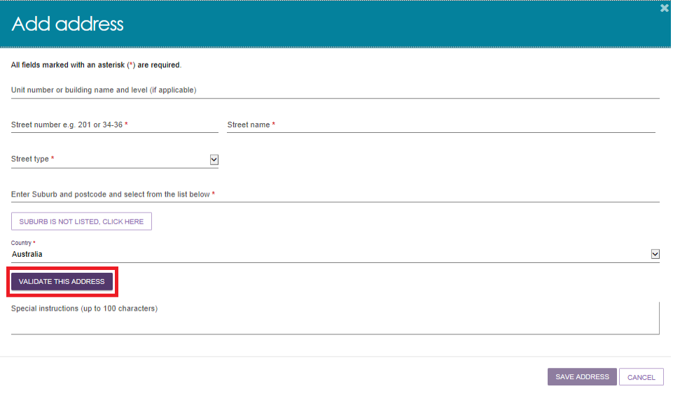

- Confirm that the address is displayed correctly, then select SAVE ADDRESS.
If the address has been entered correctly but is not returned as a result, select Not found use entered address anyway.
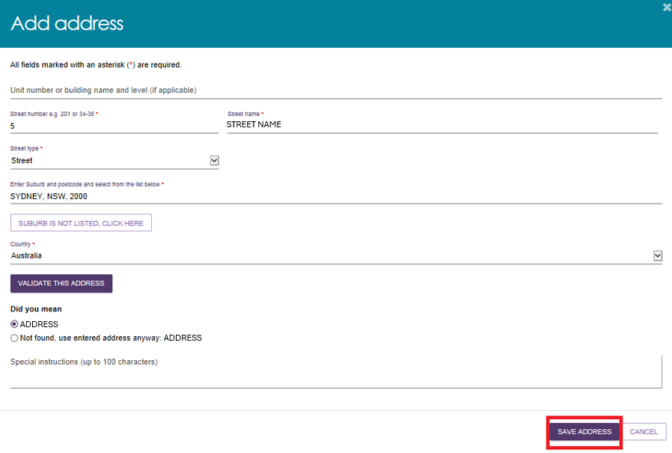
- Complete the remaining fields. Select CREATE OUTLET to save the record and create the outlet.
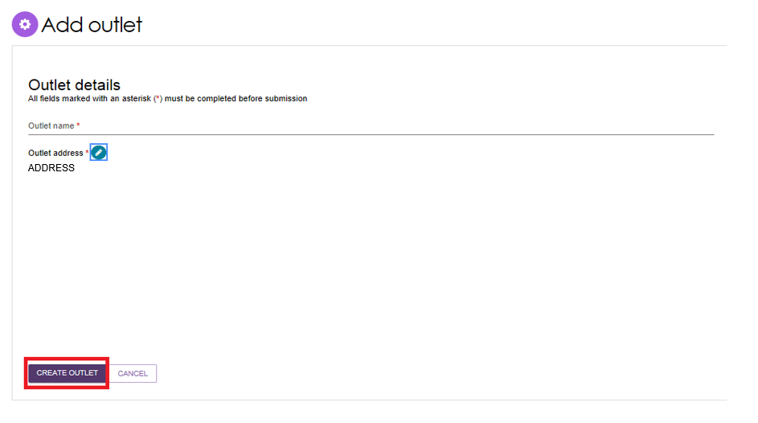
The outlet has now been created and the details for the outlet have been saved. Repeat this process for remaining outlets, if required.

Viewing outlets
To view outlets, follow the procedure below.
- Select Outlet administration from the homepage.
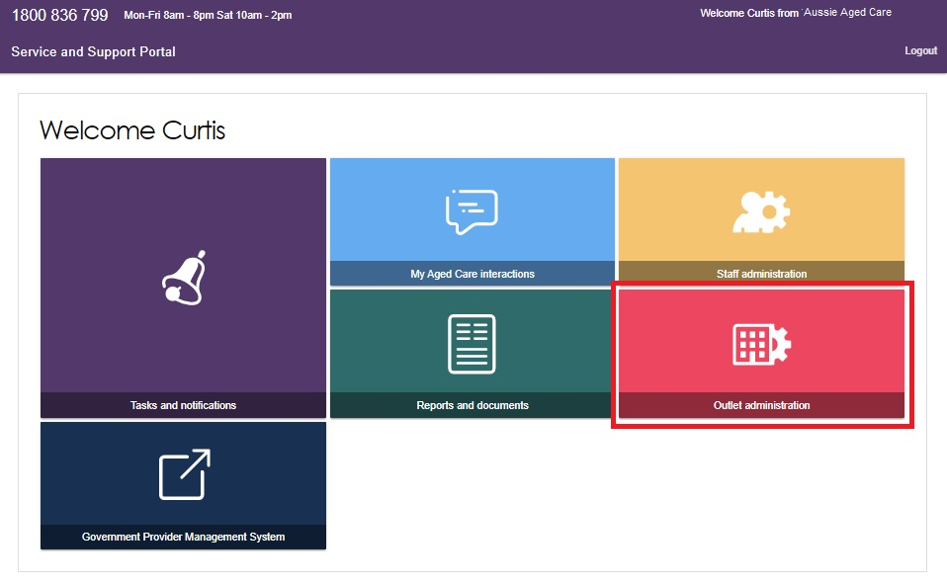
- From here, you can view all of the outlets for your organisation.
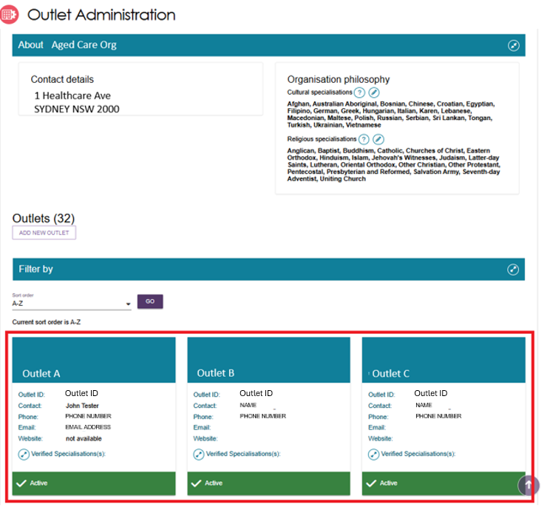
- You can sort and filter your outlets by outlet name, outlet status, support type, or verified specialisation,
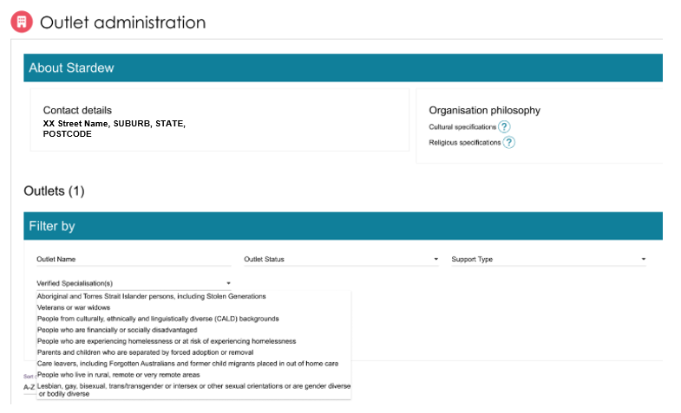
When you expand an outlet tile, any current verified specialisations for that outlet appear in a list.
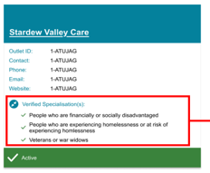

Editing the Organisation philosophy
Organisation philosophy attributes and other specialisations will be shown in the service finder results and displayed as part of the detailed information for each of your services. These attributes and specialisations are not verified by the Department.

Add/edit cultural specialisations
- In the View Outlet page, select the Edit icon  next to Cultural specialisations to select those groups that you have a focus on providing culturally specific care to.
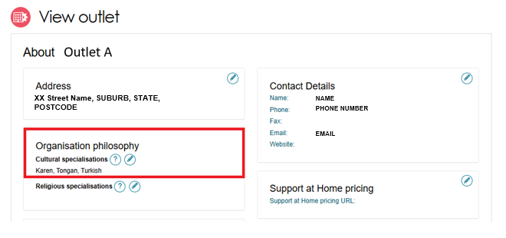
You can choose to apply this to all services in your organisation by using the SAVE AND APPLY TO ALL OUTLETS option or save as a default for all new services added by using the SAVE AND DON’T APPLY TO ALL OUTLETS option.
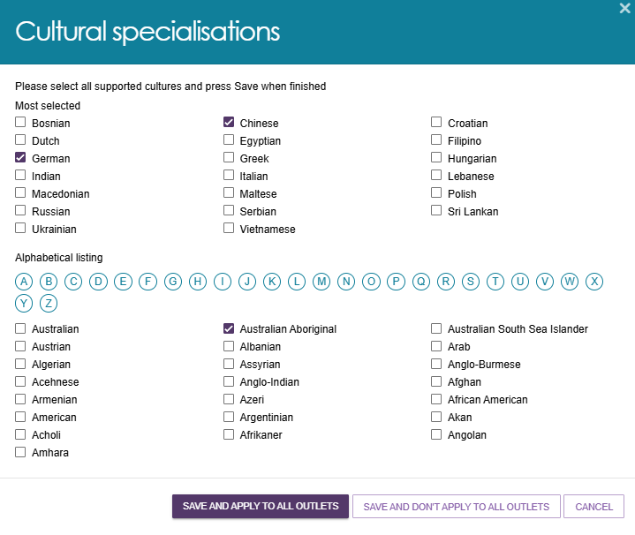

Add/edit religious specialisations
- Select the edit icon next to Religious specialisations to indicate if you have a focus on delivering care that aligns with particular religious needs or values.
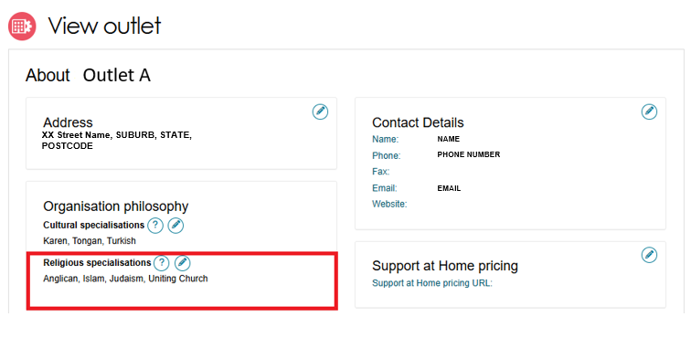
You can choose to apply this to all current services in your organisation by using the SAVE AND APPLY TO ALL OUTLETS option or save as a default for all new services added by using the SAVE AND DON’T APPLY TO ALL OUTLETS option.
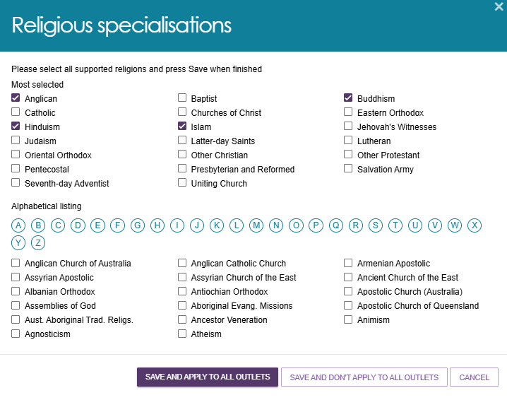

Specialisation Verification
All aged care service providers must deliver inclusive services that meet each person's individual needs, regardless of where they live, their background, or their life experiences.
Some providers choose to offer specialised aged care services tailored to the needs of specific groups or communities. Through Specialisation Verification, providers can formally demonstrate their expertise in supporting these groups.
While all providers must meet the Aged Care Quality Standards, Specialisation Verification is optional. It allows providers to show they have additional expertise in delivering specialised aged care services.
To become verified, a provider must show that their service outlet meets the requirements of the 2025 Specialisation Verification Framework for a specific specialisation group or community. Providers do this by submitting evidence to support their application.
A service outlet can be verified in any of the nine specialisation areas:
- Aboriginal and Torres Strait Islander persons, including the Stolen Generations
- Veterans or war widows
- People from culturally, ethnically, and linguistically diverse (CALD) backgrounds
- People who are financially or socially disadvantaged
- People who are experiencing homelessness or at risk of experiencing homelessness
- Parents and children who are separated by forced adoption or removal
- Care leavers, including Forgotten Australians and former child migrants placed in out of home care
- Lesbian, gay, bisexual, trans/transgender or intersex or have other sexual orientations or are gender diverse or bodily diverse
- People who live in rural, remote, or very remote areas.
Outlets with current verified specialisations appear in Service Finder and Match and Refer. This helps assessors and My Aged Care contact centre staff find services that meet an older person's specific needs.
Current verified specialisations also appear in the Find a Provider tool on the My Aged Care website. This helps older people and their support network find, compare and choose suitable aged care services.
A Specialisation Verification remains valid for three years from the date of issue unless it is removed or renewed earlier.
Verification is applied at the outlet level. Any service items linked to that outlet automatically inherit the verified specialisation.
When an outlet has one or more current verified specialisations, the View Outlet page displays the specialisation name, verification date and expiry date. The image below shows an outlet that does not have any current verified specialisations:
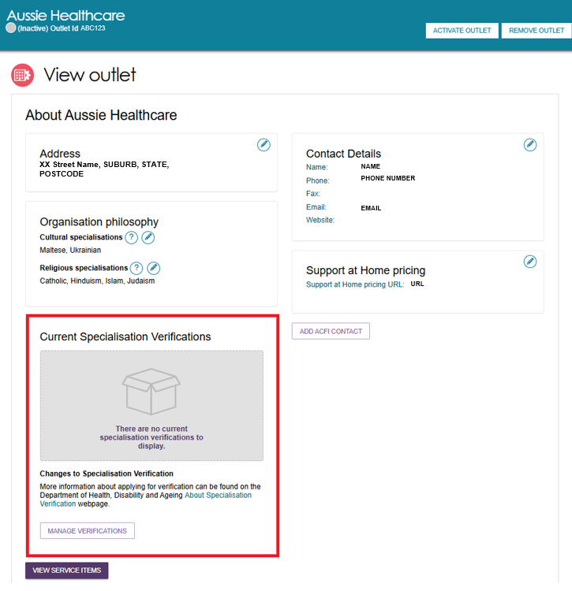
Once an outlet has at least one current verified specialisation, the View Outlet page displays the specialisation name, verification date and validity period.
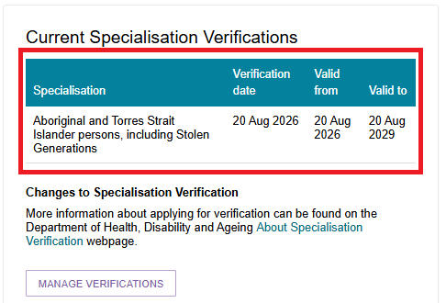
Providers may have current verified specialisations that were assessed under the 2022 Specialisation Verification Framework. These specialisations will continue to appear alongside any current verified specialisations assessed under the 2025 Specialisation Verification Framework. All displayed specialisations use a consistent naming convention regardless of the framework they were assessed under, shown below as the ‘Displayed Specialisation Name’:
2022 Specialisation Verification Framework – Specialisation Name | 2025 Specialisation Verification Framework – Specialisation Name | Displayed Specialisation Name
Aboriginal and Torres Strait Islander peoples and communities | Aboriginal and Torres Strait Islander persons, including Stolen Generations | Aboriginal and Torres Strait Islander persons, including Stolen Generations
Veterans | Veterans or war widows | Veterans or war widows
People from culturally and linguistically diverse (CALD) backgrounds | People from culturally, ethnically and linguistically diverse (CALD) backgrounds | People from culturally, ethnically and linguistically diverse (CALD) backgrounds
People who are financially or socially disadvantaged | People who are financially or socially disadvantaged | People who are financially or socially disadvantaged
People who are homeless or at risk of becoming homeless | People who are experiencing homelessness or at risk of experiencing homelessness | People who are experiencing homelessness or at risk of experiencing homelessness
Parents separated from children by forced adoption/removal | Parents and children who are separated by forced adoption or removal | Parents and children who are separated by forced adoption or removal
Care leavers | Care leavers, including Forgotten Australians and former child migrants placed in out of home care | Care leavers, including Forgotten Australians and former child migrants placed in out of home care
Lesbian, gay, bisexual, transgender and intersex (LGBTI) people | Lesbian, gay, bisexual, trans/transgender or intersex or other sexual orientations or are gender diverse or bodily diverse | Lesbian, gay, bisexual, trans/transgender or intersex or other sexual orientations or are gender diverse or bodily diverse
People who live in rural or remote areas | People who live in rural, remote or very remote areas | People who live in rural, remote or very remote areas
! | From 1 November 2025, all new Specialisation Verification applications are assessed under the 2025 Specialisation Verification Framework.  When you transfer a service item to another outlet, the Portal removes any verified specialisations inherited from the original outlet. The transferred service item then automatically inherits any current verified specialisations assigned to the new outlet.
For more information about eligibility, evidence requirements and the application process, visit the Specialisation Verification for aged care services website.
To manage verified specialisations for service items within an outlet, refer to Specialisation Verification in the Creating and maintaining service items section.

Verified specialisations and service items
Current verified specialisations automatically apply to all operational and offline service items within an outlet. You cannot add, remove, or edit specialisations at the individual service item level.
If an outlet has verified specialisations approved under the 2022 Specialisation Verification Framework and those specialisations remain current, the system automatically applies them to all operational and offline service items in the outlet.
When you add a new service item, the system automatically applies all current verified specialisations. By making the service item operational, you confirm that the outlet can meet the relevant criteria for those specialisations when delivering services.
Message after adding a new service item in an outlet with a verified specialisation
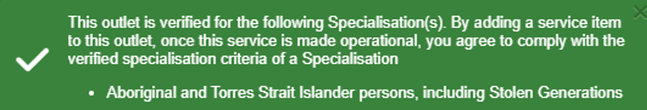

Manage specialisation verifications for the outlet
- Select your outlet from the Outlet Administration page.
- Go to Manage Verifications.
- The Manage Specialisation Verifications page opens. This page allows you to:
- Lodge a new application to be assessed by the department.
- View and manage application(s) submitted
- View finalised applications

Managing applications
You can manage specialisation applications from the Manage Specialisation Verifications page ‘Applications’ tab to:
- View draft, in-progress and re-issued applications.
- Delete draft applications by selecting the Delete icon at the top right corner of the application’s card. Deleting a draft application will remove it from your Applications in progress view.
- Withdraw submitted applications by selecting the Delete icon at the top right corner of the application’s card. Withdrawing an application will remove it from your Applications in progress view and display it in the Finalised applications view.
- View and filter finalised and withdrawn applications.
- View a read only version of your finalised or withdrawn applications.
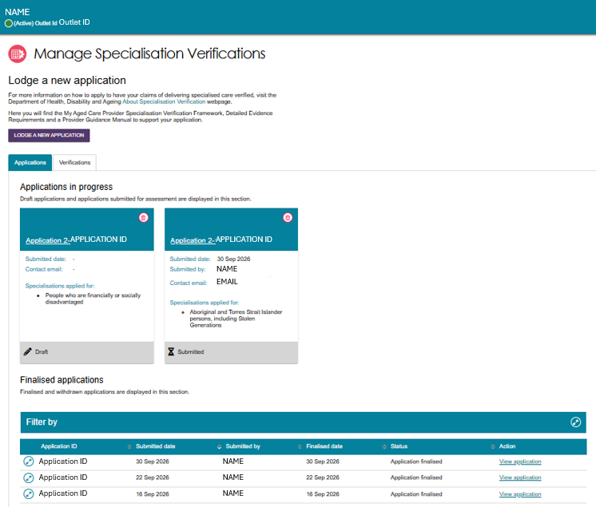

Managing verifications
You can view current specialisation verifications from an outlet card or manage all verifications from the Manage Specialisation Verifications page ‘Verifications’ tab.
- In Outlet Administration, open the outlet card and select the Expand (double arrows) icon next to Verified Specialisation(s).
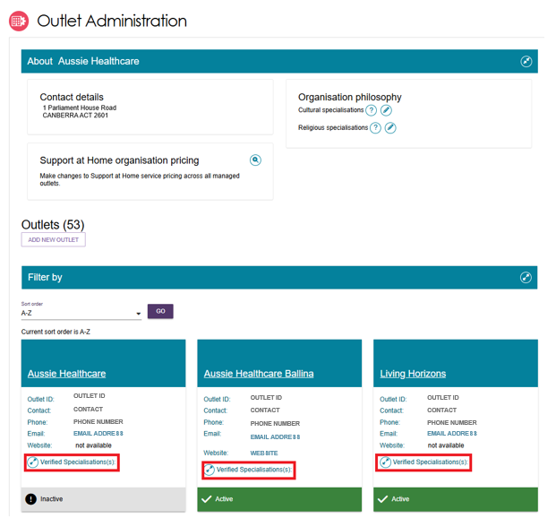
- The outlet card displays current verified specialisations for that outlet. If no current verifications exist, the card shows ‘No current specialisation verifications for this outlet’.
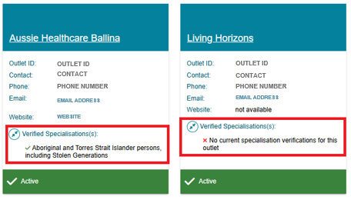

- Select the outlet card to open the outlet details, then select ‘Manage Verifications’ to open the Manage Specialisation Verifications page. Then select the Verifications tab to view all verified specialisation details.
This page shows the details of each specialisation assessed as verified, including its status and validity dates.
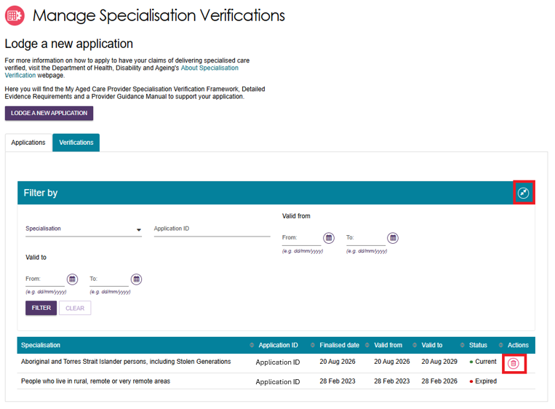
- To filter the list, select the Expand icon. You can filter by specialisation, application ID, and validation ‘from’ and ‘to’ dates. Select FILTER to apply your chosen filters.
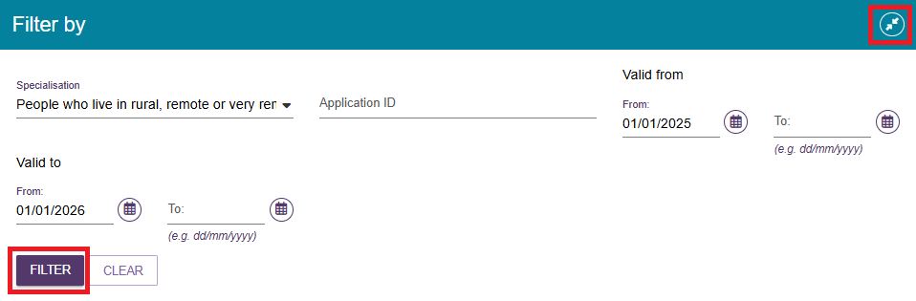
- To remove a specialisation, select the Delete icon. You can remove specialisations with a status of Current or Expiring Soon.
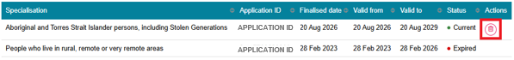
- Select REMOVE to confirm. Once you remove a specialisation, you cannot restore it. To regain the specialisation, you must submit a new application and complete the verification process again.

This action will remove the specialisation details from the internal Find a Service Provider and Match and Refer search tools as well as the My Aged Care Website Find a Provider tool.
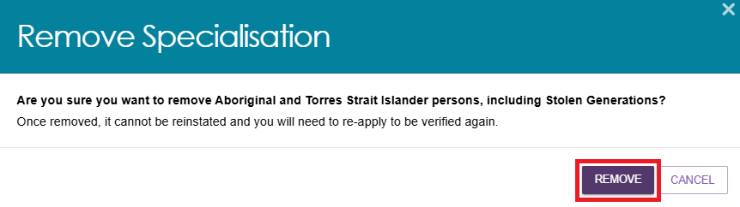

Submitting a new application
- Go to your outlet from the Outlet Administration Page.
- Select Manage Verifications located at the bottom left of the page.
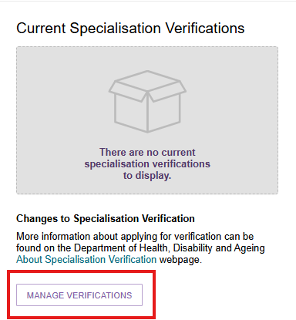
- Select LODGE A NEW APPLICATION.
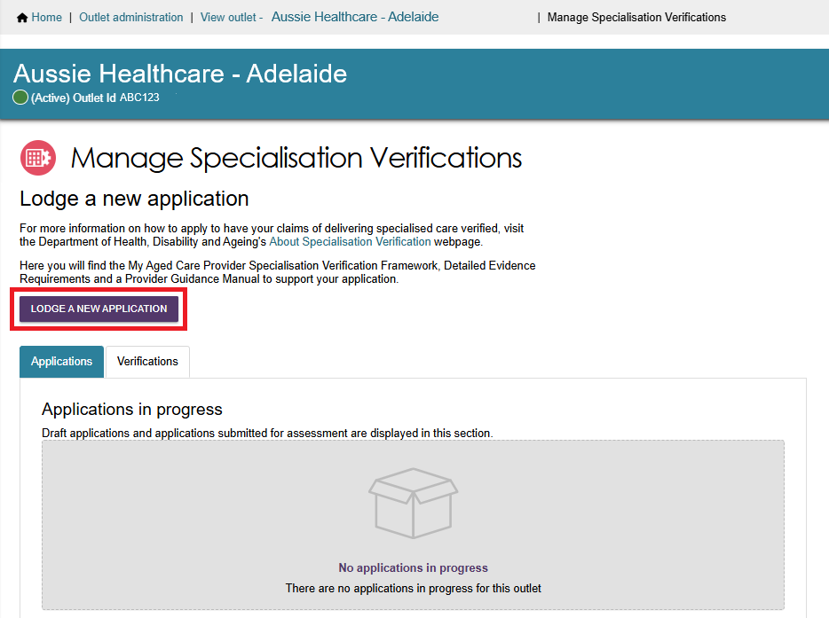
- The Step 01 Information page explains how to complete your application. It includes links to information about the Specialisation Verification program and the Specialisation Verification Framework. It also explains how the department collects, uses and protects your personal information.
- Select Next to continue.
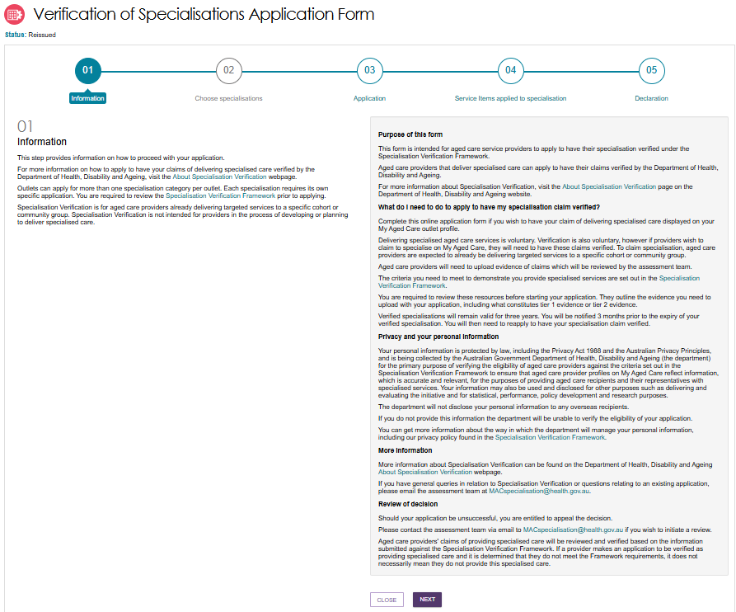
The Step 02 Choose specialisation page displays.
This page shows the outlet's current verification status for each specialisation, such as Current or Not Verified.
- Select the radio button for the specialisation you want to apply for, then select Next to continue.

You can apply for one or more specialisation categories for an outlet. However, you must submit a separate application for each specialisation.
Note: you cannot select a specialisation with the status of Draft or Verification In progress as an application for this specialisation has already commenced.
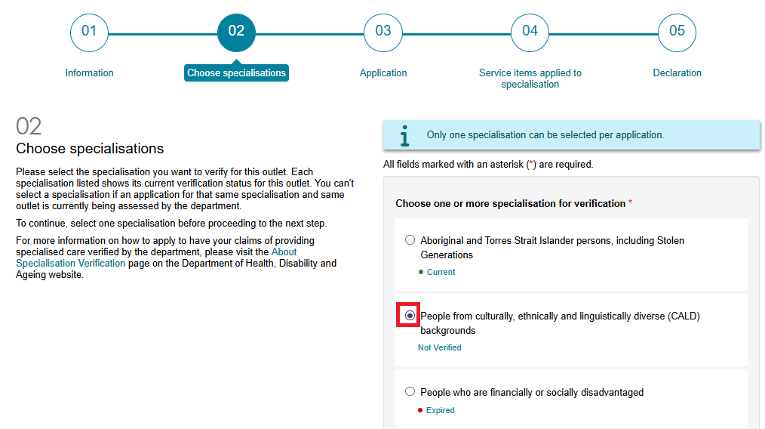
If you select a specialisation that already has a Current verification status, such as when you want to renew an existing verification, the system displays the following information:
‘You currently have an active verification for this Specialisation category. Once this application is finalised, the previous verification will end, and the new verification will be applied. If your application is unsuccessful, your outlet will no longer hold an active Specialisation for this category. Any changes will be reflected on your My Aged Care profile. You can withdraw this application prior to submission for assessment with no impact to your active Specialisation for this category.’
You can still select NEXT to continue.
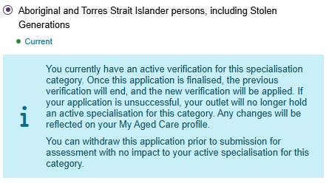
- The Step 03 Application page displays. This page outlines the evidence you must provide to support your application for the selected specialisation.
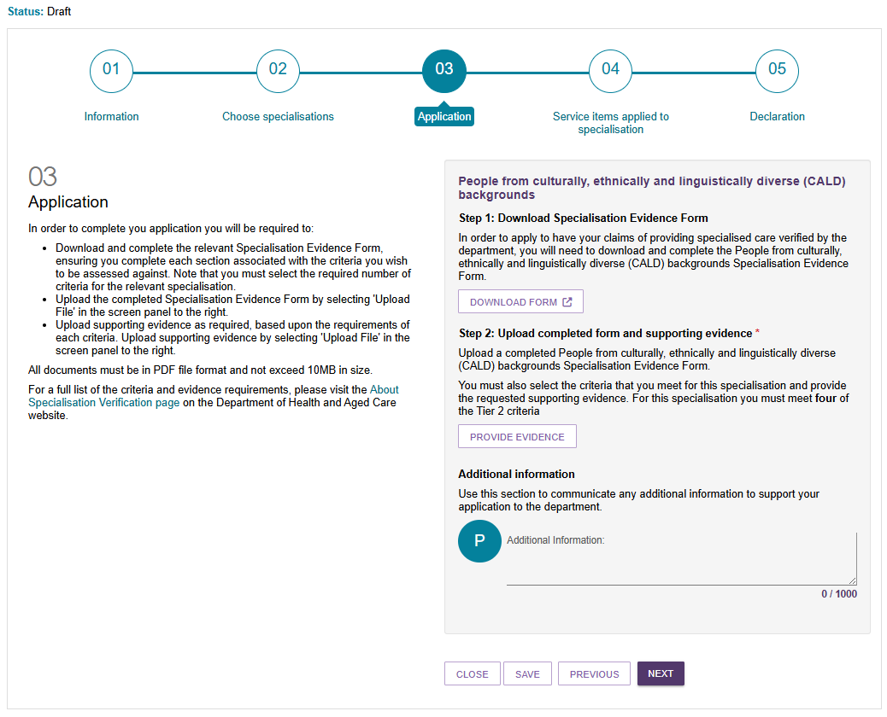
! | If you need to take any action, the system displays instructions at the top of the page as an information banner or error message.  Below are examples of an information banner and error message:  - This example shows an information banner to guide selection of ‘one’ specialisation per application.  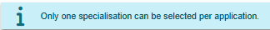  - This example shows an error message, produced when the criterion selection does not meet the minimum requirements. Selection of ‘Return to Step 3’ sends the provider back to this step to make the necessary updates.  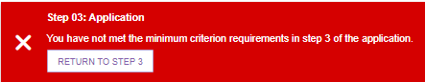
- Select DOWNLOAD FORM to download the evidence form. Complete and save the form before you continue.
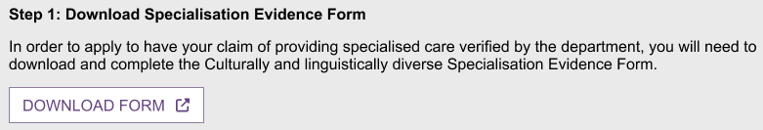
- Select PROVIDE EVIDENCE to commence the upload of the completed evidence form and any supporting documents for your criteria selections. The evidence requirements vary by specialisation. Follow the on-screen instructions for each selection to determine if you need to upload documents. For example, the People from culturally, ethnically and linguistically diverse (CALD) backgrounds specialisation requires selection of at least four Tier 2 criteria. Dependent on the Tier 2 criteria selected, this may mean at least 4 documents, (one document per criterion) is required, plus the specialisation evidence form.
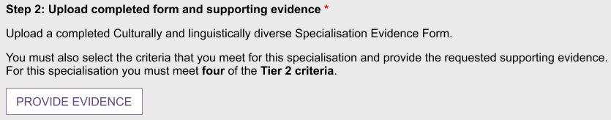
- Upload your documents, one at a time.
Upload the Specialisation Evidence Form from Step A by selecting ‘Specialisation Evidence Form’ in the drop-down list, select ‘Choose Files to upload the document. Select SUBMIT to continue.
Then, select the relevant criterion item from the drop-down list, select ‘Choose Files’ to upload one or more documents. Select SUBMIT to continue. Repeat for each criterion you wish to be assessed against.
All documents must be in PDF format, not exceed 10 MB in size and have a filename that does not exceed 135 characters in length.
SPECIALISATION EVIDENCE FORM - CALD EXAMPLE
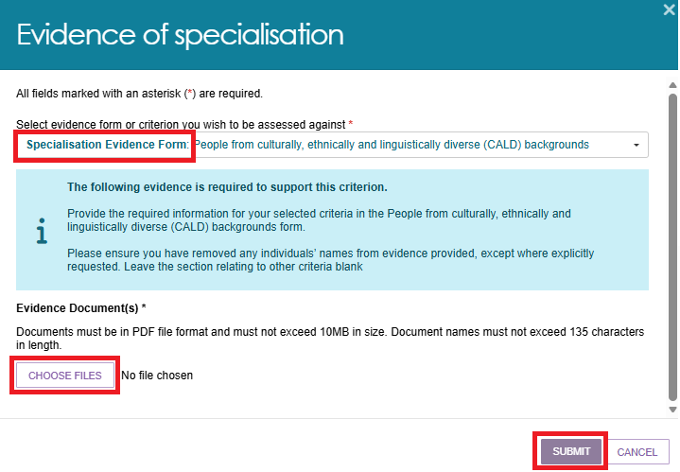
CALD Tier 2 Criterion Example
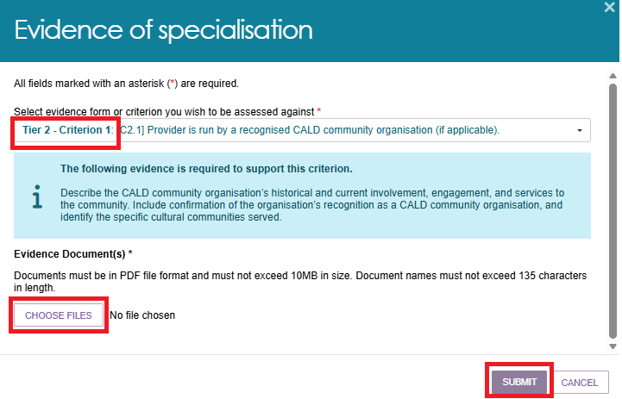
- After you upload a document, the page displays the document name and document type. Select the expand icon to view more information about the related evidence criterion.
You can also:
- remove the uploaded document.
- remove the entire section.
The warning message ‘You have not met the minimum criterion requirements’ remains visible until you upload the necessary evidence documents to meet the requirements.
! | If all required evidence is not included, an error message will be displayed at the end of the application process, requiring action before the application can be submitted for assessment.
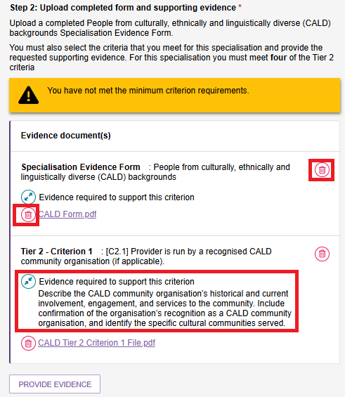
- If needed, enter any extra information in the Additional Information field.
- Select NEXT to continue.
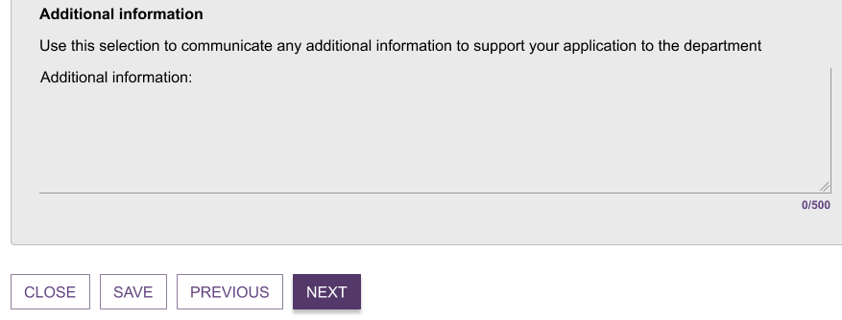
- The Step 04: Service Items Applied to Specialisation page opens.
If the department approves your application, the specialisation applies across all program type Operational and Offline service items linked to the parent outlet. The page displays these service items on the right-hand side. (If you add a new service item to this outlet later, the system will automatically apply all current verified specialisations of the parent outlet to that service item.)
This page shows:
- The program types linked to the outlet, such as Support at Home and the Commonwealth Home Support Programme (CHSP) and Residential Care.
- The service items available under each non-Support at Home program type , such as Social Support Individual, and Meals.
- A single service item called ‘Support at Home’ for Support at Home program type.
- The NAPS Service ID for each service item.
- The name of each service item.
- Select the expand icon to view more details about a program type and its service items.
- Select NEXT to continue.
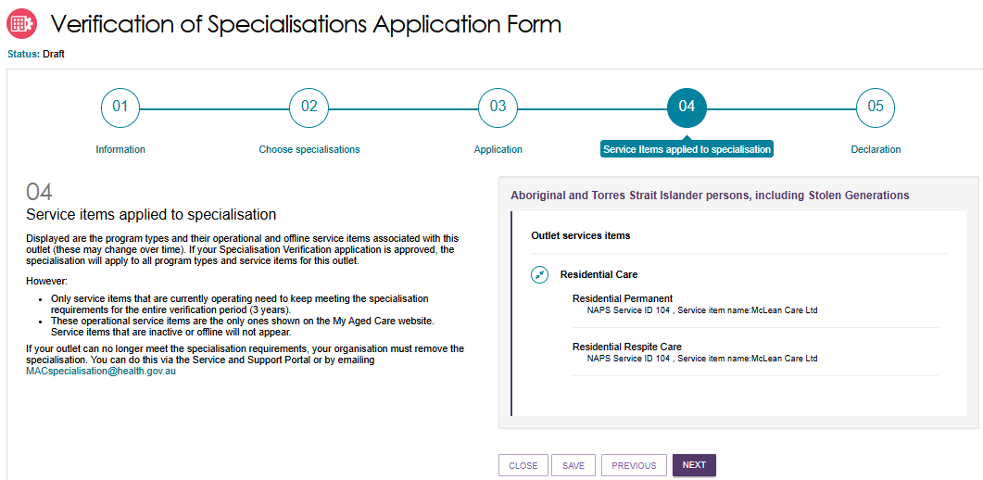
- The Step 05: Declaration page opens.
- Read the declaration. If you agree with it, select the checkbox next to your name to confirm that you meet the requirements and accept the terms and conditions.
- Select SUBMIT to submit your application.
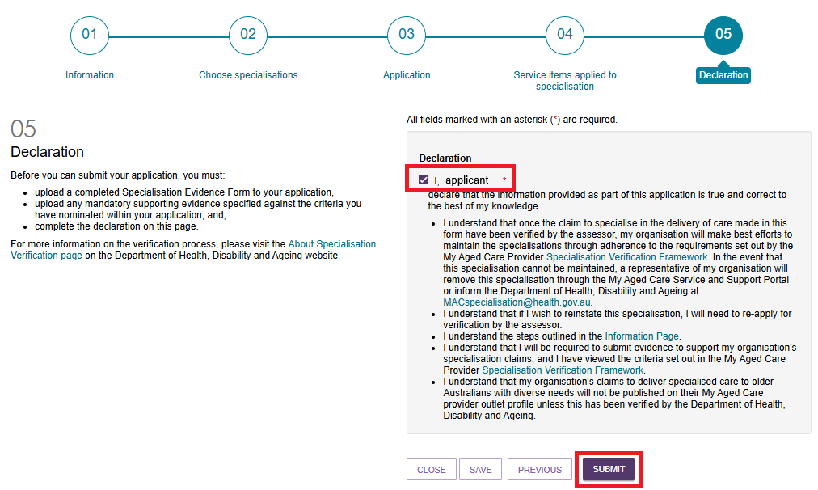
This image shows an example of an error message that may appear. Follow the instructions provided in the error message to resolve the issue, then select SUBMIT to continue.
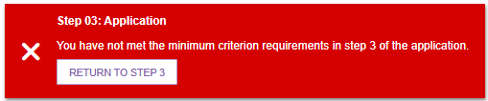
- Your application will appear in the Manage specialisation verifications page under the ‘Applications’ tab.
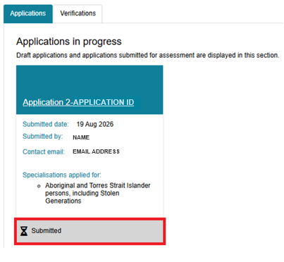

Reissued applications
The department may re-issue an application if you need to provide additional information or evidence to support your selected specialisation. The application displays in the Applications tab with a status of Reissued.
You need to update and resubmit a reissued application within 10 Business days.
To update and resubmit a re-issued application:
- Go to your outlet from the Outlet Administration Page.
- Select Manage Verifications located at the bottom left of the page.
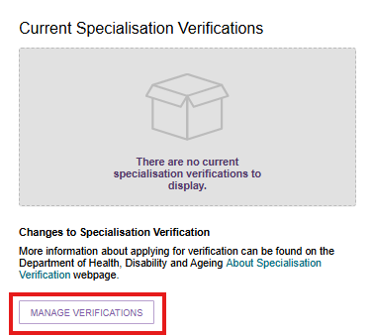
- Select the Applications tab, all applications in progress will be displayed. For a Reissued application, an information banner will display that shows a countdown of the 10 business days remaining to update the specialisation.
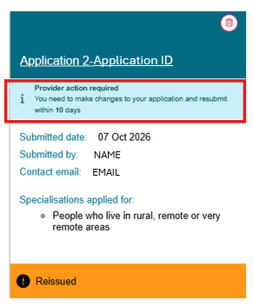
If the application is not resubmitted during this period, the information banner will display an ‘overdue’ status message.
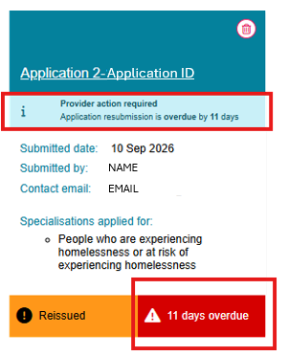
- Select the Reissued application.
- The Step 01 Information page displays. Review the information, then select NEXT.
- The Step 03 Application page displays.
An information banner will display at the top of this page, with a countdown of days remaining to update the specialisation.
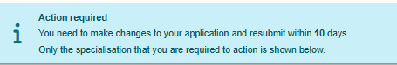
Where action is not taken within the allocated time, the information banner message will update and display the number of days the application resubmission is overdue.
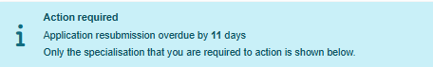
- Review the assessor’s instructions and provide the requested evidence.
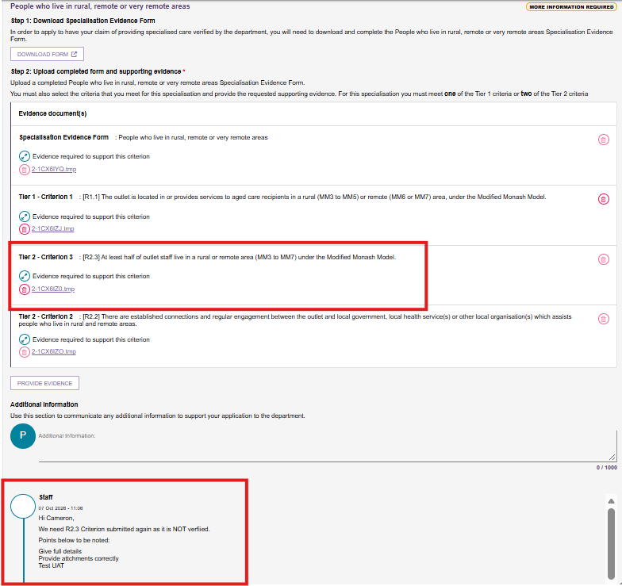
For instructions on providing and uploading evidence, refer to section 3.4.5 Submitting a new application.

- If needed, enter any extra information in the Additional Information field. Select NEXT to continue.
- The Step 04 Service Items Applied to Specialisation page displays all operational and offline service items linked to the parent outlet. Review the service item information, then select NEXT.
- The Step 05 Declaration page displays. Read the declaration. If you agree with it, select the checkbox next to your name to confirm that you meet the requirements and accept the terms and conditions.
- Read the declaration. If you agree with it, select the checkbox next to your name to confirm that you meet the requirements and accept the terms and conditions.
- Select SUBMIT to resubmit your application. The application will display in the Applications tab Applications in progress view with a status of Submitted.

Viewing applications
- To view an application in progress, open the outlet’s Manage Specialisation Verifications page, go to the ‘Applications’ tab and select the application name.
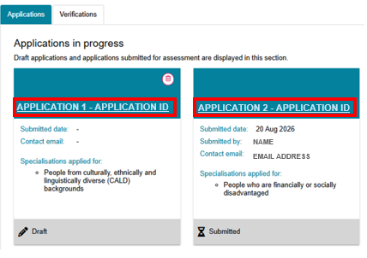
- If the application has been submitted and has a status of ‘Submitted’, ‘Awaiting assessment’, ‘Assessment In Progress’ or ‘Assessment finalised’, you can only view the Page 01: Information of the application, the other pages are not displayed.

- Select CLOSE to return to the Manage Specialisation Verifications page.
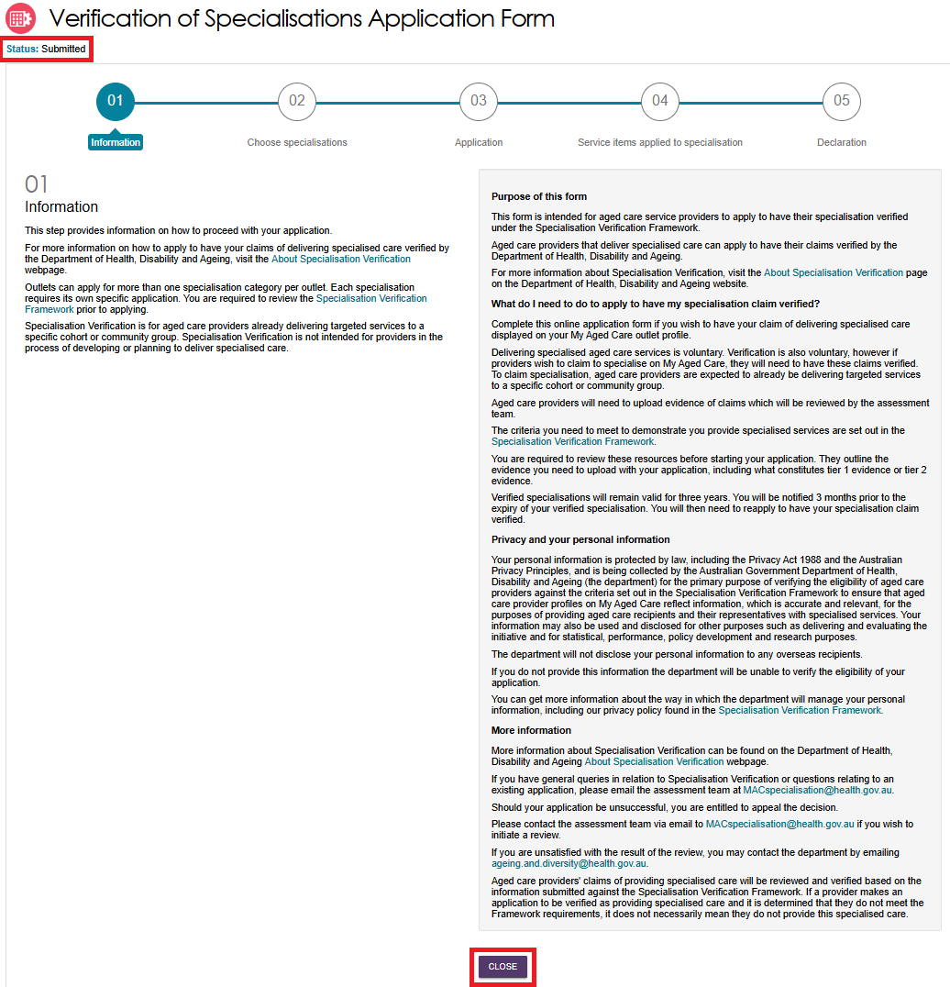
If your application is in Draft status, you can select PREVIOUS or NEXT to move through the application. You can complete the remaining steps to submit your application, including uploading evidence documents. However, you cannot change your specialisation – that page is greyed out.
- Select SAVE to save your application. Select CLOSE to return to the Manage Specialisation Verifications page.
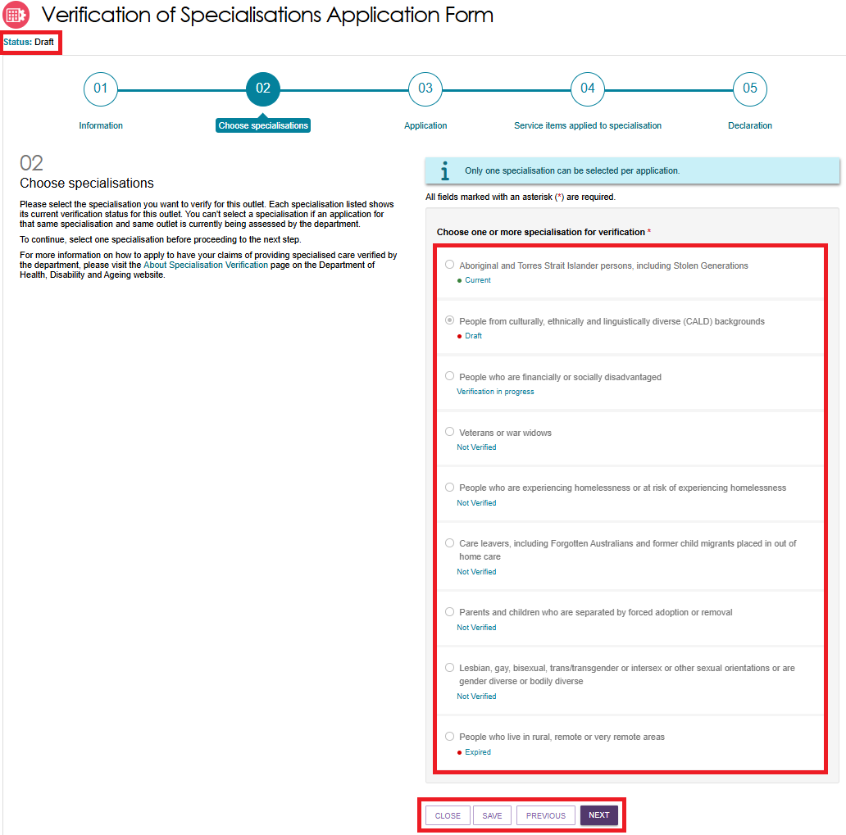
To view a finalised or withdrawn application, select View application. You can also expand the application to view the specialisation(s) included in the application and whether the verification was successful.
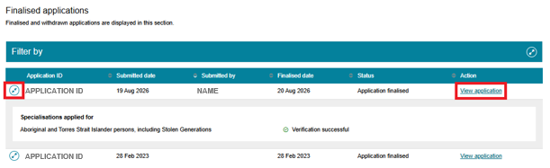
- You can view all pages of your application. Select PREVIOUS or NEXT to move between pages.

Page 03: Application also shows whether your application was successful. You can also open and download your evidence documents from this page.
- Select CLOSE to return to the Manage Specialisation Verifications page.
! | If you have any applications assessed during the off-system period between 1 November 2025 and 19 October 2026, Attachments submitted during this period will not be shown on Page 03: Application screen. Please email MACspecialisation@health.gov.au for copies.
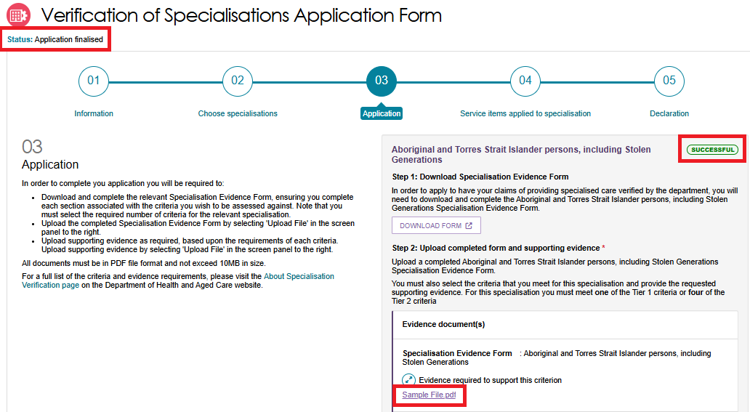
! | Legacy Verified Specialisations and Applications  Providers that have completed (finalised or withdrawn) applications under the 2022 Specialisation Verification framework can view a read-only version of your application in this portal. The screen display will look different to the applications completed under the 2025 framework. The name of the verified specification/s will also display according to the 2022 Framework.  STEP 04 SCREEN OF THE 2022 FRAMEWORK  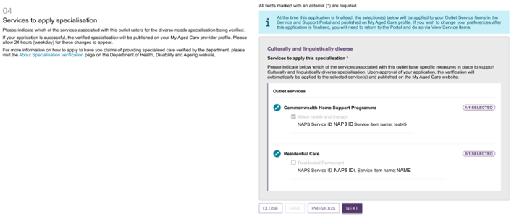
- You can also filter applications. To filter the list, select the Expand icon. You can filter by specialisation, application date, and validity date. Select FILTER to apply your chosen filters.

Creating and maintaining service Items
Providers will need to create and maintain information about the aged care services that their organisation provides (known as service items in the Service and Support Portal) in order to receive referrals through My Aged Care.
Service items in general include:
- Service sub-types, for non-Support at Home programs
- Services, for Support at Home
- Service types, which are groupings of Support at Home services
- Service groups, which are groupings of Support at Home service types.
It is important that information about services that are provided are kept up to date as the information is publicly displayed for prospective My Aged Care recipients and their support network on the service finder on the My Aged Care website (www.myagedcare.gov.au), and used by My Aged Care contact centre staff and assessors to refer clients to service(s).
Services need to be linked to one or more of your outlets.

Adding a service item
When adding a Support at Home service item, the system will add a complete set of service items (which includes Service Groups, Service Types and Services).
Normally there is no need to add more than one Support at Home service item for an outlet unless the organisation is offering Support at Home services in different manners from the same outlet.
Please contact the contact centre to discuss if you are considering adding more than one instance of Support at Home service items.
Follow these steps to add a service item:
- From the Outlet administration page, select the name of the outlet on the outlet card that you want to add a service item to.
The View Outlet page then appears.
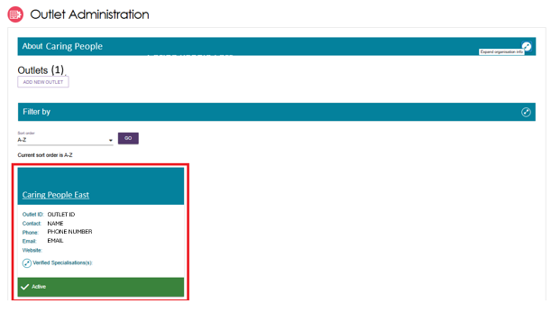
- From the View outlet page, select VIEW SERVICE ITEMS.
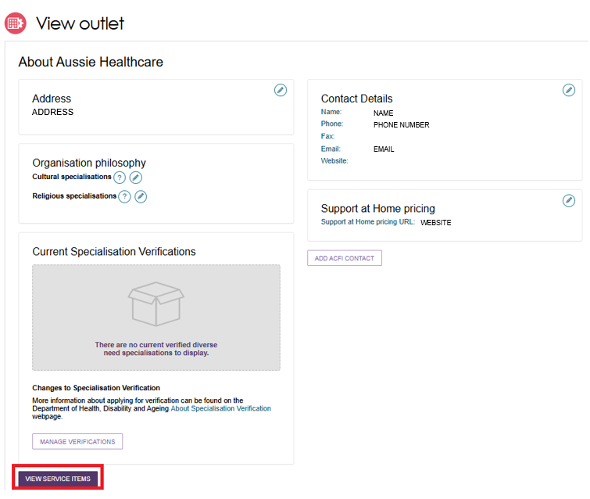
- From the View Service Items page, select the applicable Program tab.
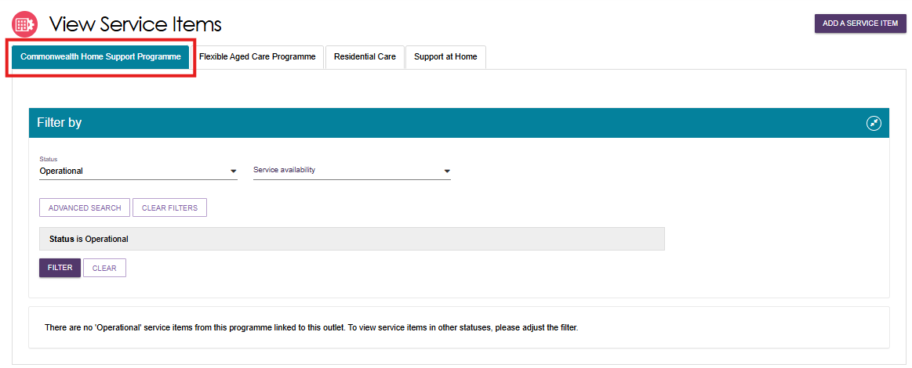
A list of the existing Service Items for that Program will be listed. The list will be filtered by the indicated criteria (e.g. Status of ‘Operational’ or ‘Offline’). Other filters are available.
- Select the ADD A SERVICE ITEM button.
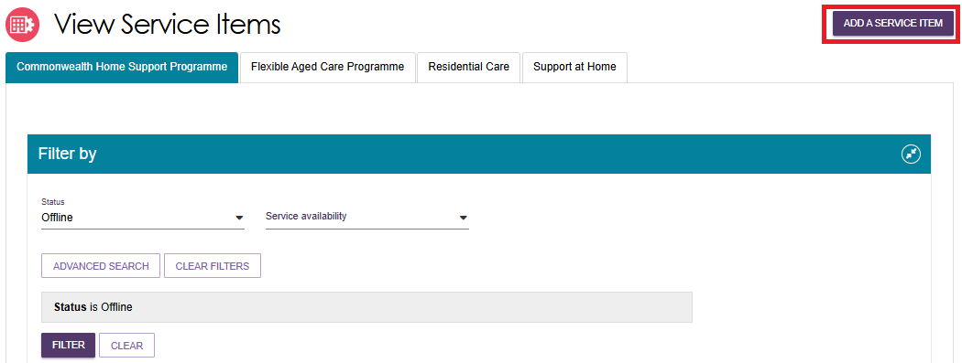
- Select the Program for the service item that you wish to add.
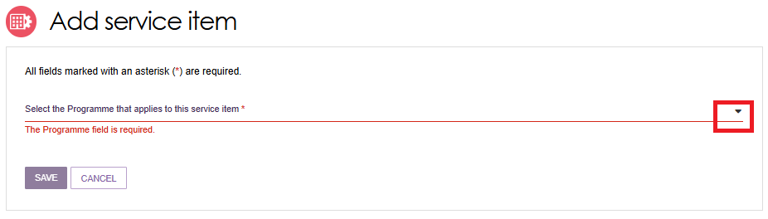
Once the program is selected, the funding type will appear as Funded.
The option to change this selection is not available as all Commonwealth aged care program services must be approved and subsidised by the Australian government.
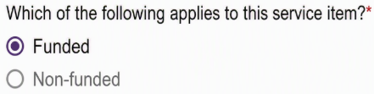
- Select a service inventory item to associate with the service item to be added.
Non-Support At Home Service Item Example
An example of a program where a longer list of possible service inventory items may be presented, and where filtering functionality may be used.
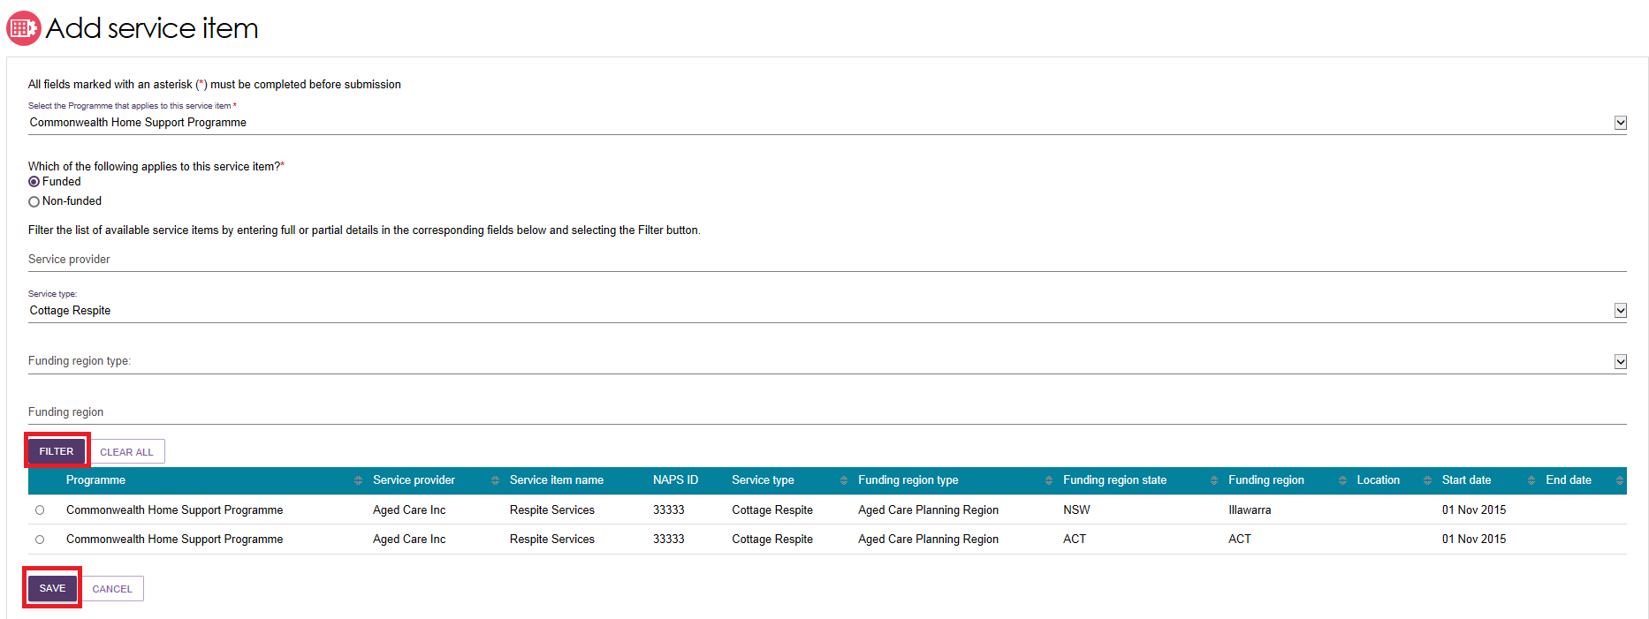
Support at Home example
An example of a program where a short list of possible service inventory items may be presented, and where no filtering functionality is available.
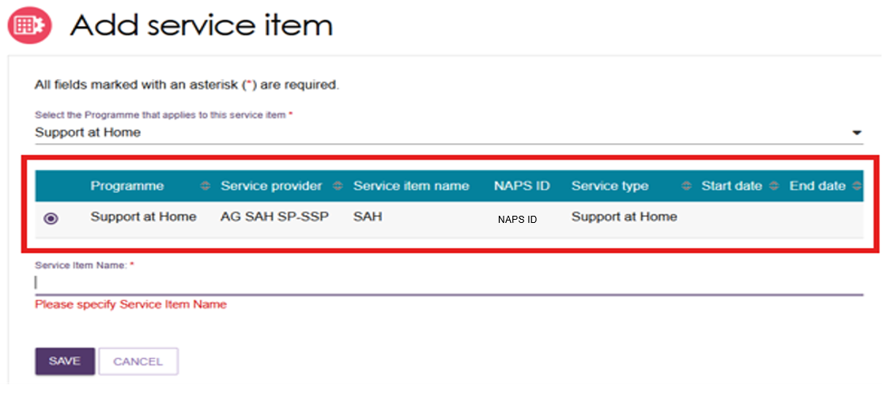
The service (inventory) item name will normally provide guidance as to which one to select.
Select the one that you want to add to your outlet by selecting the relevant service inventory item.
In the example above, you will also need to supply a unique service item name before selecting the SAVE button (refer to step 8 below).
For Residential Care where a lengthy list of possible service inventory items may be presented, and where the application of one or more filters may reduce the number of possible selections, select the radio button at the beginning of the row to select the one to add.
Residential Care Example
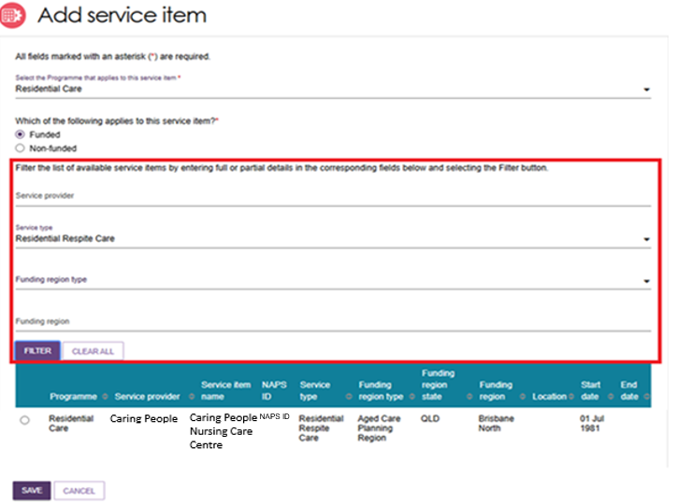
The added service item will inherit its name from the ‘service item name’ column value of the selected row.
- Specify a unique service item name (for Support at Home). Specifying a meaningful Service Item Name will assist in distinguishing different service offerings from the same outlet.
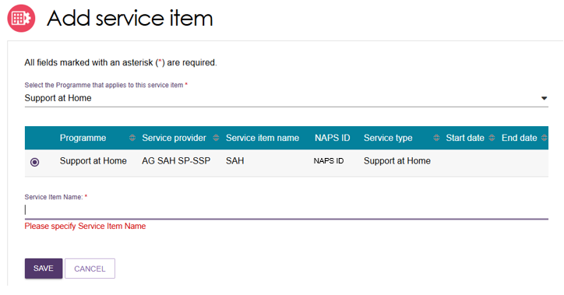

- The service item will now display in the Outlet details page under Services.
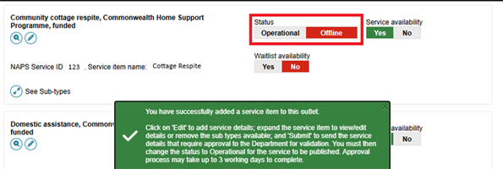
The new service will be listed with a status of Offline.
A banner will also indicate that you have successfully added a service item to the outlet, and to remind you to Edit and Submit.
The status will need to be changed to Operational before it is displayed on the public service finder. Refer to Activating or deactivating a service item for more information.
! | If this service item belongs to an outlet that has one or more verified specialisations, you must comply with the requirements of those specialisation/s.
- Once service items have been added to an outlet, you can filter the list of services under a specific program by status, service availability and waitlist availability.
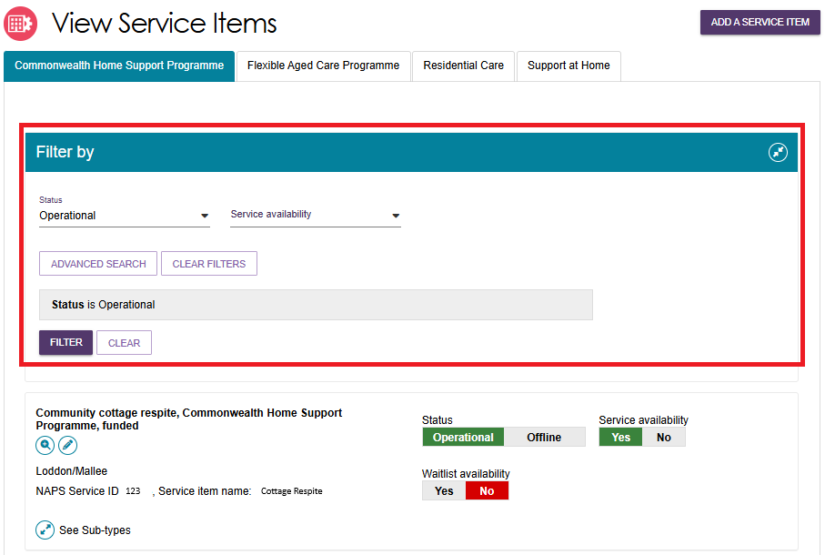

Editing a service item
You can edit service item details, including:
- Service item name
- Service delivery area
- Specialised services (refer to Editing the Organisation Philosophy)
- Promotional attachments (for residential facilities)
- Support at Home-specific attributes e.g. service-based pricing.
- Detailed description for the service item.
Service information will be displayed on the Service Finder on the My Aged Care website.
When you update this information, the changes will appear on the Service Finder by the next day.
Follow these steps to edit service information:
! | Only non-contractual information can be edited in the Service and Support Portal.
- From the Outlet administration page, select the name of the outlet on the outlet card that you want to add a service item to. The View Outlet page then appears.
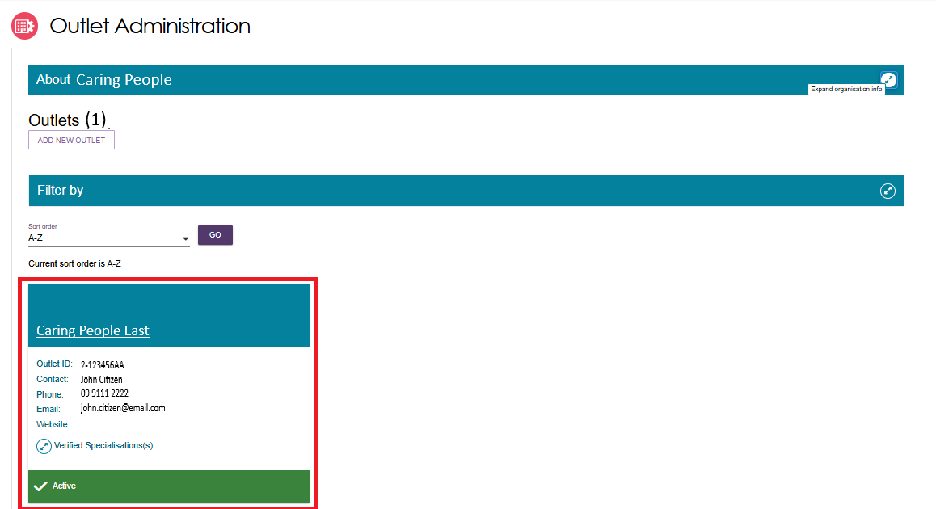
- From the View outlet page, select VIEW SERVICE ITEMS.
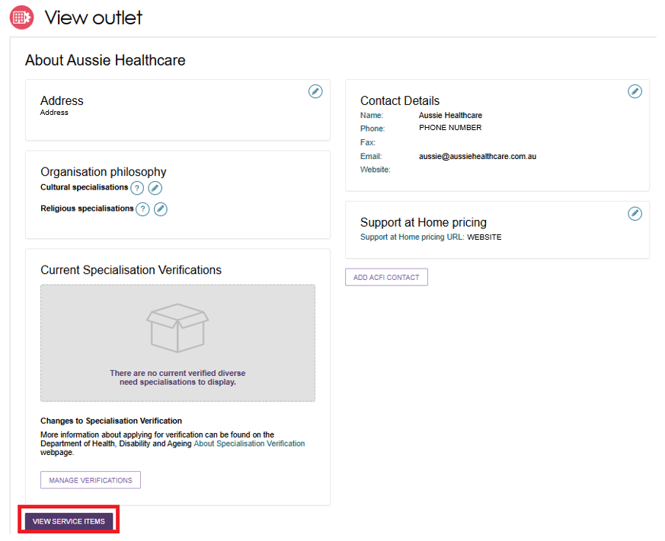
- Select the Edit (Pencil) icon which is located either next to the relevant service item,
or next to the Support at Home heading.
Support At Home Service Item Example
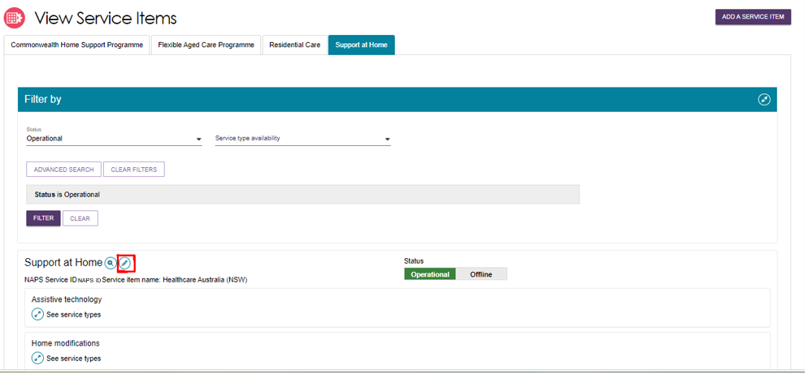
Non-Support At Home Service Item Example
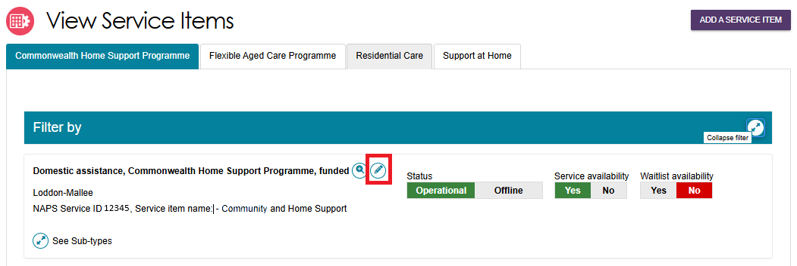
- The Service details page will display.
! | There are different options presented on a Support at Home service details page and a CHSP (Commonwealth Home Support Program) service details page.  Support at Home services are managed by delivery area. You can select multiple service types and items available within that area.  CHSP providers will remain limited to a single service type and ACPR (Aged Care Planning Region), based on contractual information for each service item.
Make the required changes and select SAVE.
Read-only information is contractual information and cannot be edited via the Service and Support Portal. Any additional service information can be added in the Service description free text field.
This information will be displayed in the public service finder on the My Aged Care website to assist clients in selecting a provider.

Editing availability and waitlists for a service
To indicate that a waitlist is offered for a service, you must ensure the waitlist availability status on the service item is set to Yes – to show that a waitlist is available, or No – to show that there is no waitlist.
- From the Outlet administration page, select the name of the outlet on the outlet card that you want to add a service item to. Then from the View Outlet page, select View Service Items.
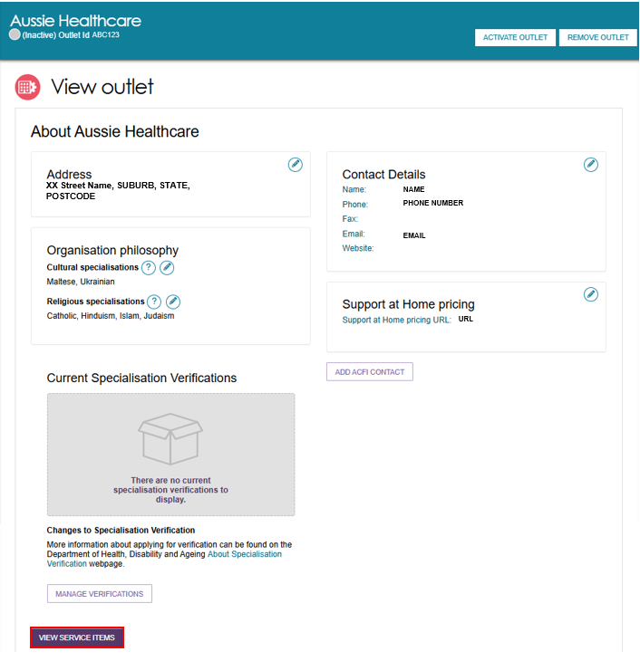
- Select the relevant service/waitlist availability status (yes / no) by toggling the Yes | No switch. The location of the Yes | No switches will depend on the type of outlet and service chosen.
Support At Home Example
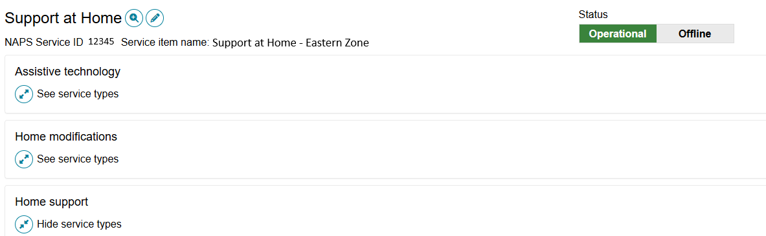
Use the expander icon to reveal the applicable service types for the service group; and services for the selected service type.
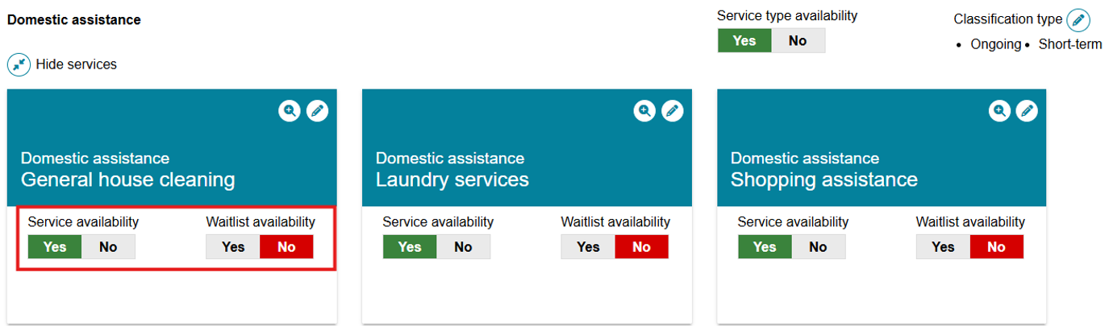
! | Support At Home Waitlists  Placing a participant on a provider waitlist does not pause the Support at Home place take-up deadline. If the take-up deadline expires while the participant remains waitlisted, the allocated place will lapse and be automatically withdrawn.  Providers should avoid waitlisting participants once funding has been allocated and ensure timely acceptance and commencement of services.
Non-Support At Home Example
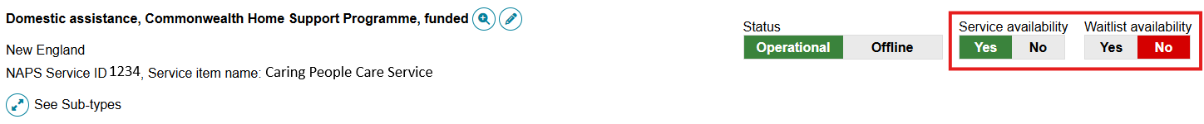

Editing service delivery area
Information about the areas you deliver Commonwealth-funded services in (referred to as service delivery areas in the Service and Support Portal) are pre-populated, based on your contractual information.
Service delivery areas can be edited for CHSP, Flexible Aged Care Program, Support at Home and Residential Care service items.
All providers (except residential care) must review their service delivery area information and edit if required. Remove selected suburbs from the ‘List of serviced suburbs’ if you do not deliver services in that location. Alternatively, use the ‘Remove all’ function to reconfigure your list of suburbs.
CHSP providers: Make sure Service Delivery information matches the ACPR where you are funded to provide services. Clearly list the postcodes and suburbs within that ACPR where you currently provide services. To keep this information accurate, organisation and outlet administrators should review the service delivery area(s) for each service to confirm that it reflects where services are actually delivered. This information is usually identified in CHSP funding agreements as Aged Care Planning Regions.
! | Service Delivery Area information and the Find a Provider Tool  Service Delivery Area and other information are publicly displayed in the Find a Provider tool, located in the aged care gateway portals and the My Aged Care website. This means:  - It impacts the referrals sent by contact centre staff and assessors  - It tells the client which services are available in their area  - It is required for location-based service searches.  You must ensure your service delivery area information are accurate.
Follow these steps to edit the service delivery area:
- From the Outlet administration page, select the name of the outlet on the outlet card that you want to add a service item to. Then from the View Outlet page, select View Service Items.
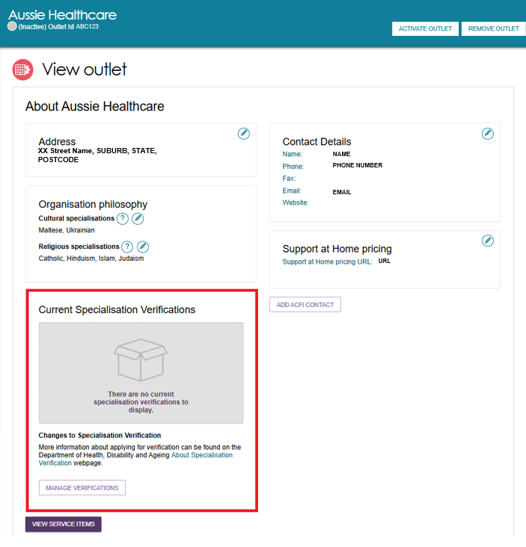
- On the View Service Items page, select the Edit icon next to the relevant service
item, or next to the ‘Support at Home’ heading.
Non-Support At Home Example
Support At Home Example
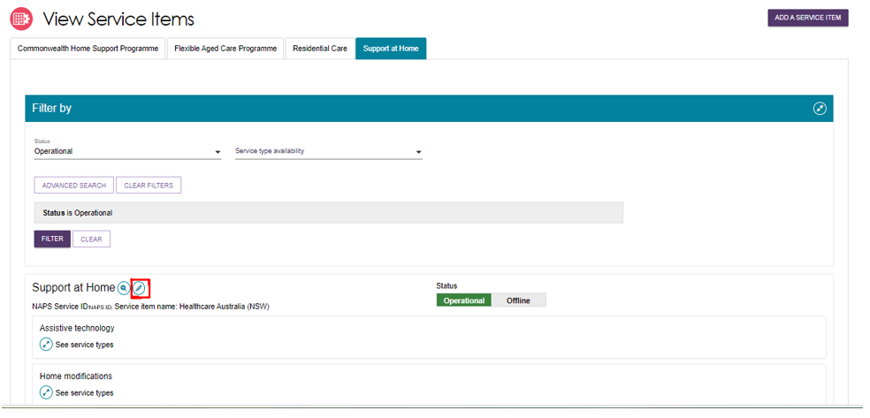
- The Service details page will display. Select Edit (Pencil) next to the Service delivery area section.
Non-Support At Home Example
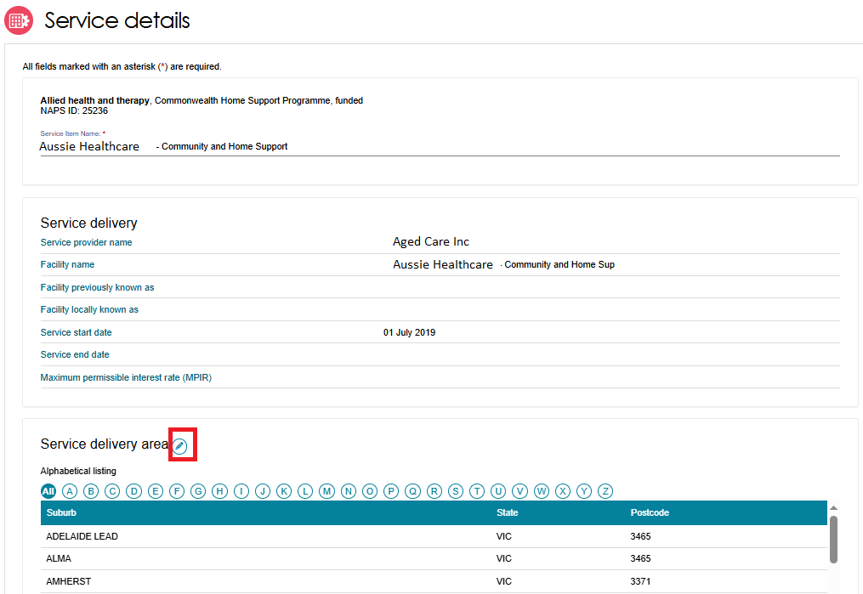
For Support At Home, there are no suburbs listed.
Support At Home Example
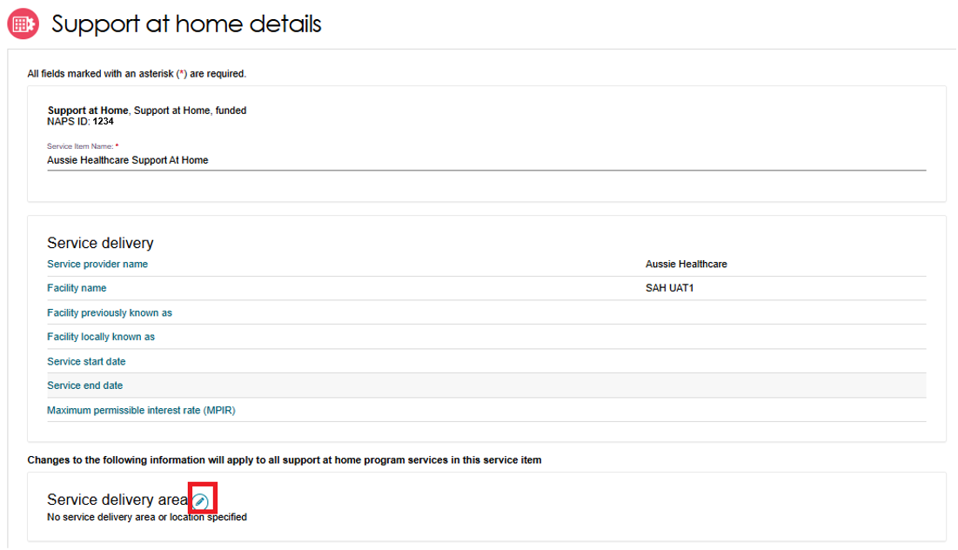
- The Edit service delivery details page will display.
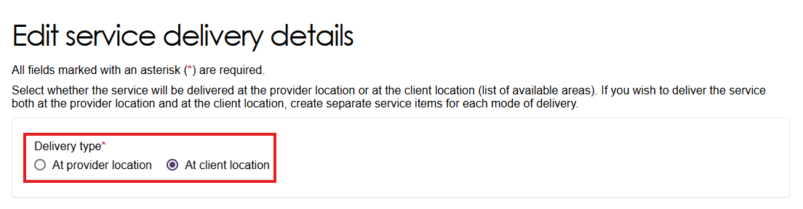
If prompted, select ‘At provider location’ for residential services, or select ‘At client location’ for non-residential services.
For Support at Home, this choice is hidden. By default, ‘At client location’ is selected.
Once selected, the choice cannot be changed without assistance from the Contact Centre.
- Search for and Add suburbs.
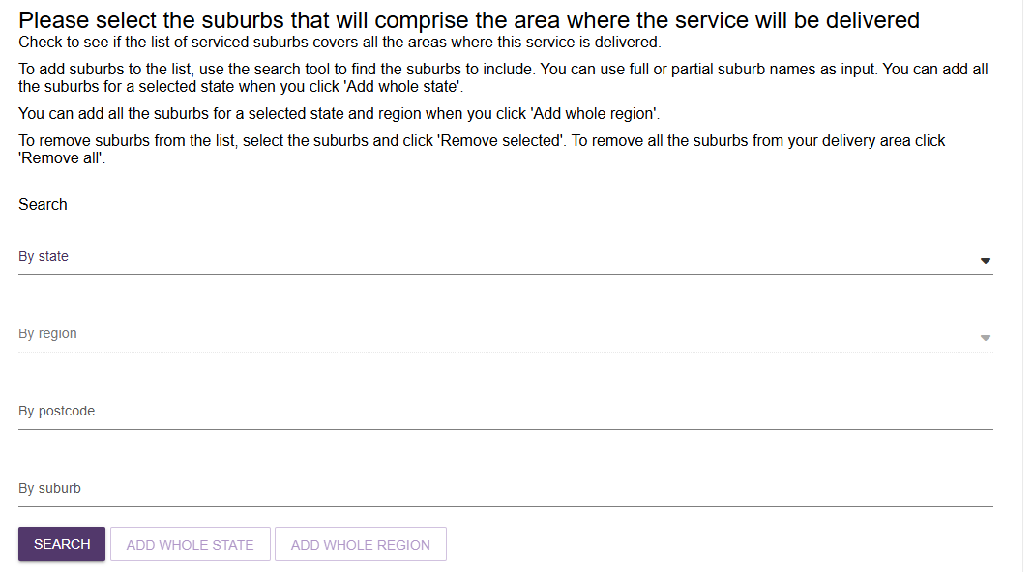
Use the search dialogue to obtain a list of suburbs that match the specified search criteria.
Suburb Search Results List Example
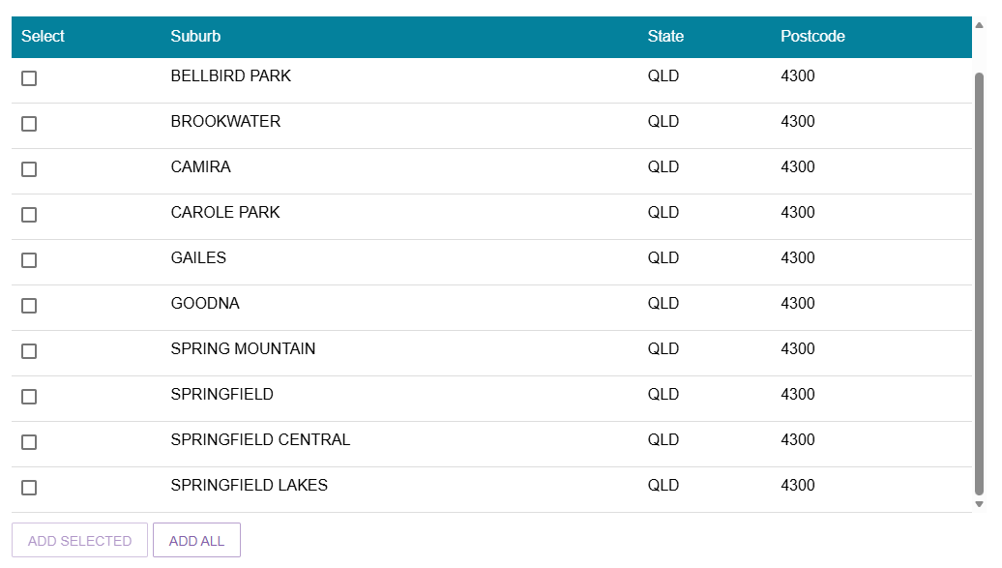
Select those suburbs which are to be added to the service delivery area.
- Review suburb list and Save changes.
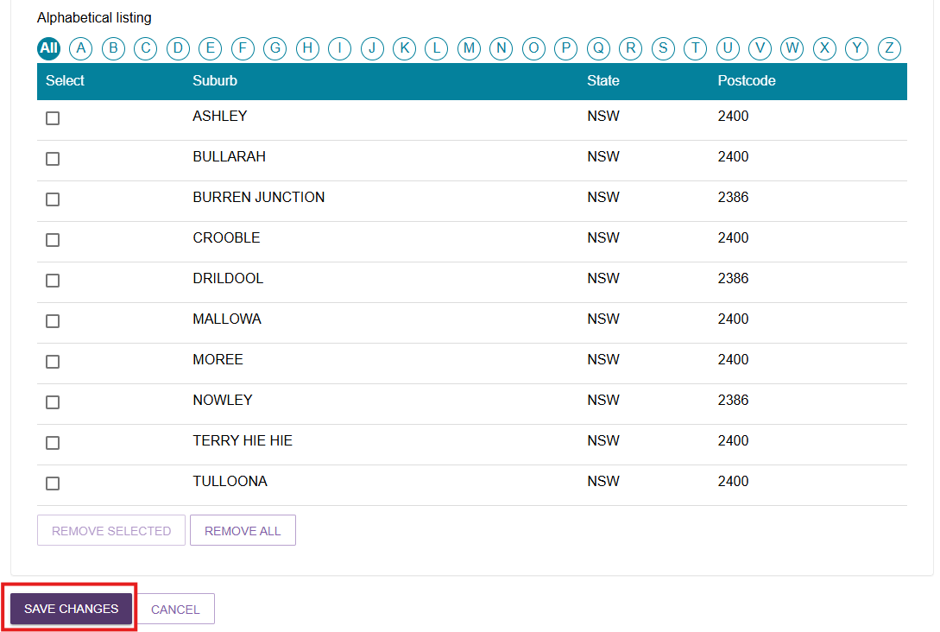

Specialisations
The Specialisations section contains Specialisation Verification, specialised services (if applicable), and languages. This is configured on the service item record. Service providers of all program types can identify their ability to provide aged care services that cater to these specialisations.
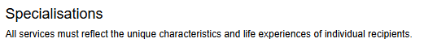

Specialisation Verification
This section shows two lists: specialisations that the outlet has applied for and were verified by the department under either the 2022 or 2025 Specialisation Verification Framework on the left-hand side, and specialisations that the provider can apply to have verified for the outlet on the right-hand side.
If there are no current verified specialisations to display, an information message appears.
You can only apply for, manage, or update Specialisation Verification at the outlet level. Changes are automatically applied to all Operational and Offline service items linked to that outlet, and the updated information displays in this section.
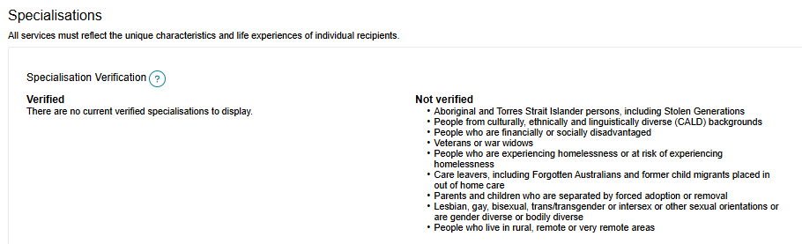

Specialised Services
You can indicate that an outlet service item offers the following Specialised Services.
Although these services are not verified like the verified specialisations section, you should only select those with specific measures in place which demonstrate your specialised service offering.
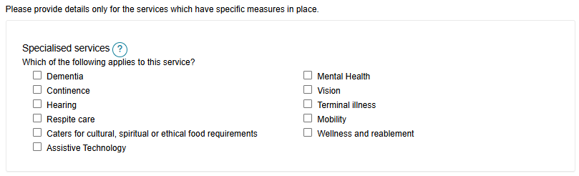

Languages
- To indicate that services are being delivered in a language other than English, select the SELECT LANGUAGES AVAILABLE button.
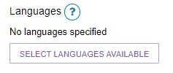
- Select one or more languages then select SAVE.
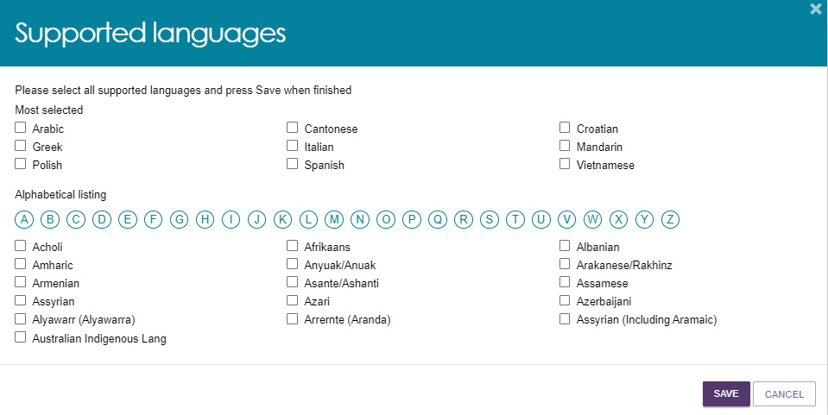
- The languages will be displayed. Select the Pencil (edit) icon to change languages.
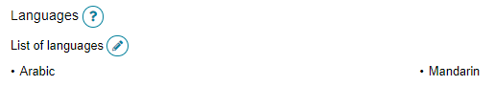

Attaching promotional material
Residential Care providers can add promotional material to be displayed in the service finder.
Promotional material content will not appear on the Service Finder until it has been reviewed and approved by the Department. Approval takes two business days. Once approved, the material will be visible on the Service Finder on the My Aged Care website.
Support at Home, Transition Care and Commonwealth Home Support Programme (CHSP) providers have the option to attach promotional material in the portal; however, this material will not display on the service finder.
Follow these steps to attach promotional material (for example, photos, brochures, menus).
- From the Outlet administration page, select the name of the outlet on the outlet card that you want to add a service item to. Then from the View Outlet page, select View Service Items.
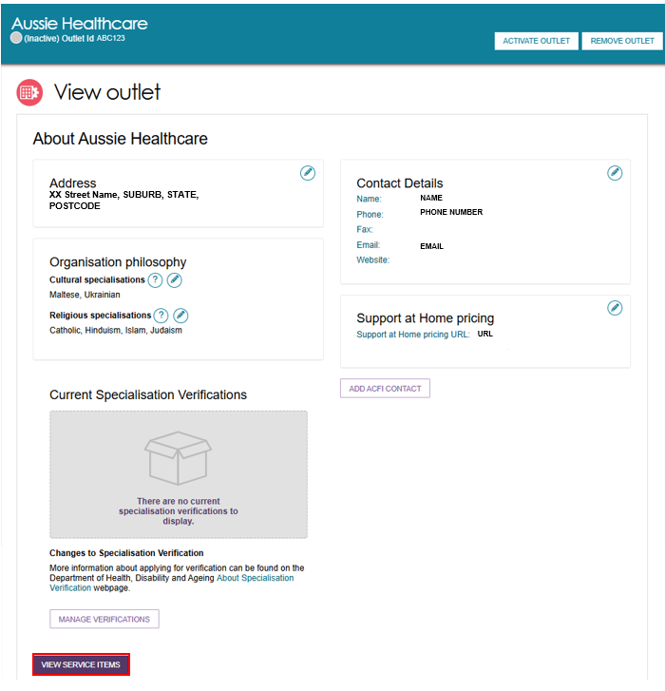
- On the View Service Items page, select your program’s tab (e.g. Support at Home) and edit the relevant service item by selecting the Edit icon to the right of the service or program name.
Non-Support At Home Example

Support At Home Example
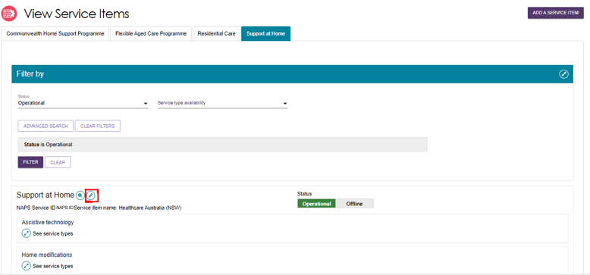
- The Service details page will display.
- Scroll down to the Promotional section.
- Select Browse to find and attach your promotional material (file types supported include .jpg, .jpeg, .png, .pdf, .rtf, .doc and .docx) and select Save and Submit Requested Changes for Approval after entering information about the attachment.
The Feature Photo option in the Type of the attachment dropdown will be the primary image displayed to users of the service finder.
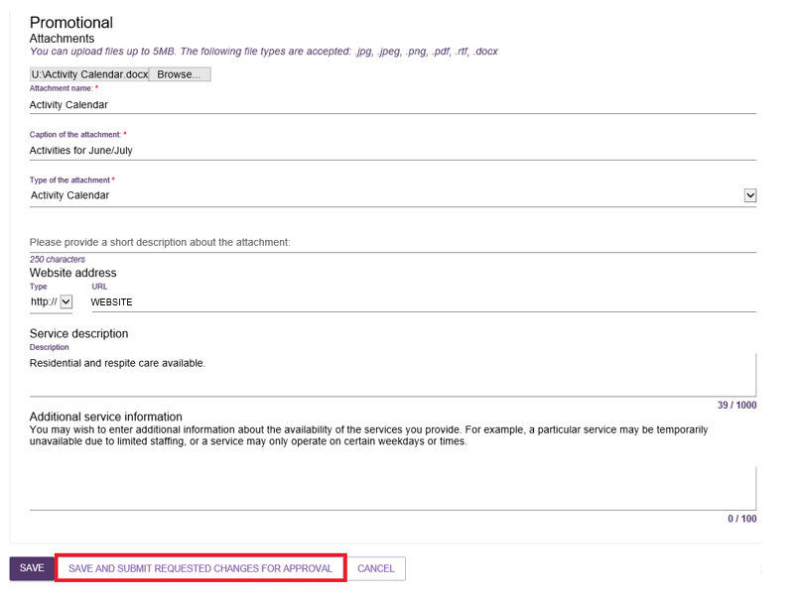

At the bottom of the screen, a confirmation will display, and a warning message will prompt you to submit the service item update to the Department for approval.
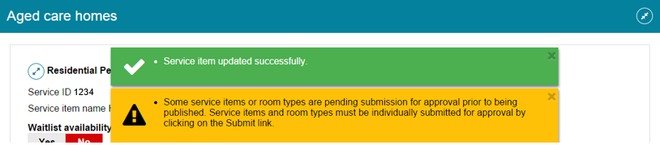

Removing a service sub-type
Follow these steps to remove a service sub-type for a service item (for non-Support at Home services).
! | Support at Home services are pre-populated based on what the outlet or organisation is approved for (Provider registered category) and therefore cannot be deleted or removed from the Service and Support Portal.
- At the Outlet Administration Tile, select the name of the outlet on the Outlet card you want to remove a service sub-type from.
The View outlet page then appears.
- Select VIEW SERVICE ITEMS.
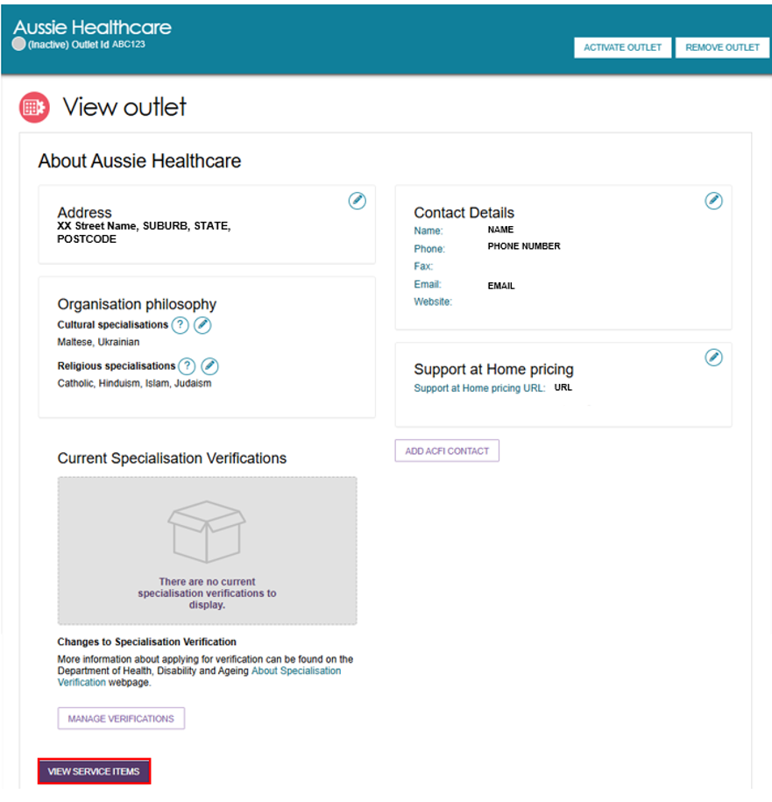
- Select the blue arrow next to See Sub-types under the service to see expanded service details.
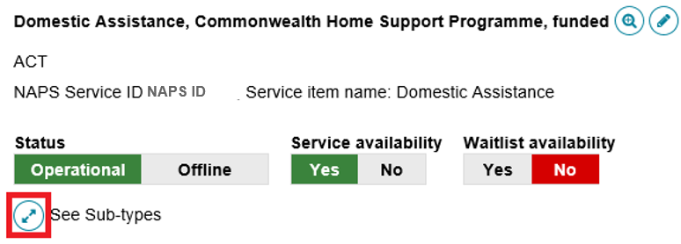
- Then select ADD/REMOVE SUBTYPES.
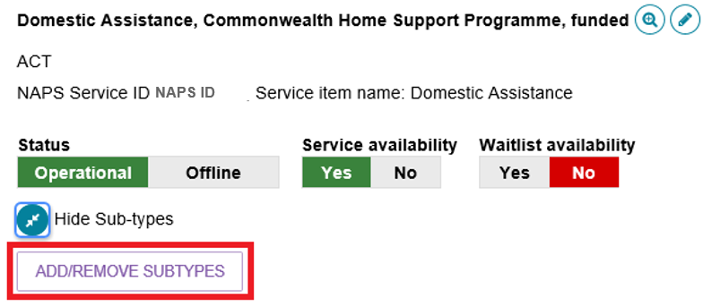
- In the Add/Remove Subtypes box, deselect the service/s you want to remove from the service item and select SAVE.
The service will then be removed, and information about the service will not display in the service finder.
Note that when removing subtypes, there must be at least one service remaining.
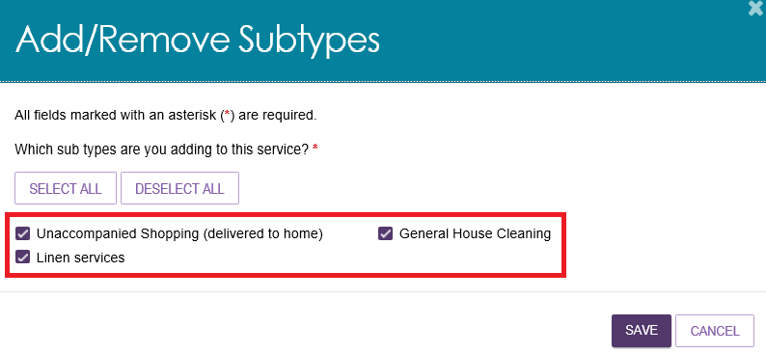

Configuring service attributes
When you are configuring a service item, several attributes specific to the delivery of your particular service item will become available to select and display on the service finder.

These include Specialisation Verification, Specialised Services and others mentioned in this section. They can be found in the Service Details page of the service item, or the Support At Home Details page of the Support at Home service.
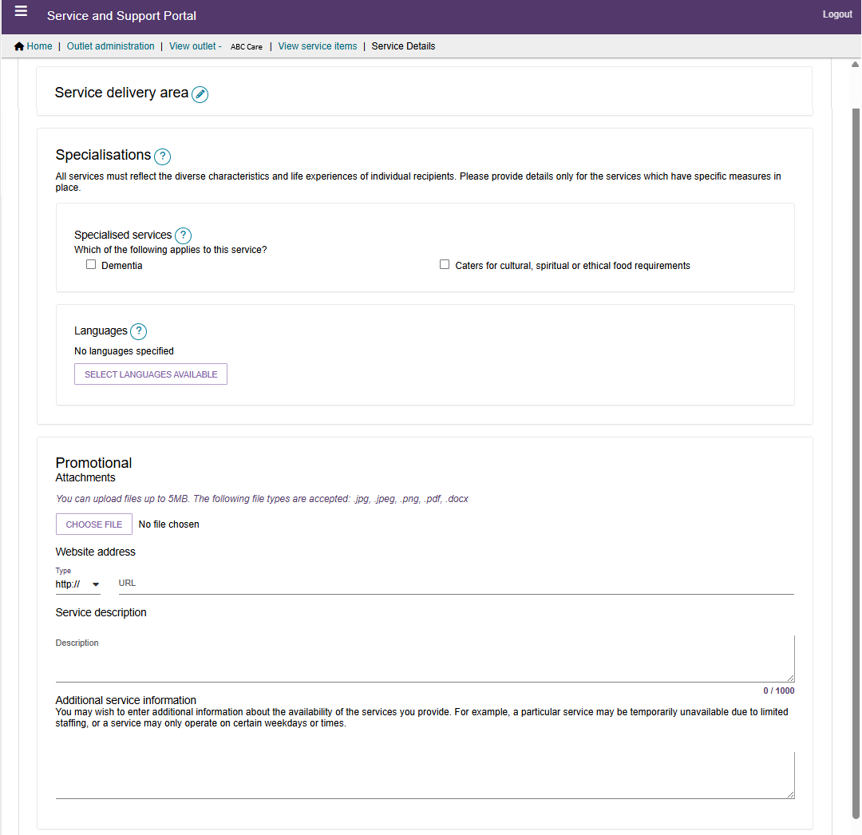

Classifications
For Support at Home services, you can modify the Classification type for either Ongoing or Short-term for each service type. For example, you prefer to offer a particular service type on an ongoing support period basis only.
- Navigate to the Support at Home service type that you want to edit the classification type for, by following the steps in Editing a service item. Then, select Edit (Pencil) next to the Classification Type.
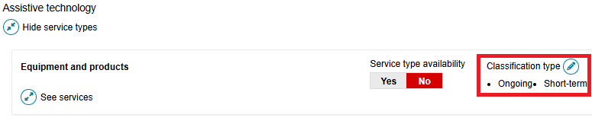
- At the pop up, select Ongoing and/or Short-term and select SAVE.
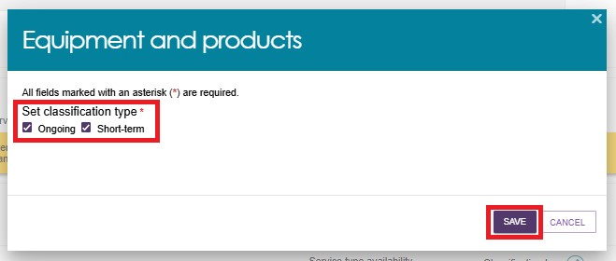

Hours of operation (non-Support at Home)
You can outline hours of operation for CHSP and other non-Support at Home services.
By default, you can enter standard Monday to Friday, Saturday, and Sunday hours. You can also specify individual working days by using the Customise option.
- Navigate to the service type that you want to edit by following the steps in Editing a service item.
- Select the service you want to edit the hours of operation by selecting on the corresponding Pencil edit icon next to the service sub-type name.
Non-Support At Home Example
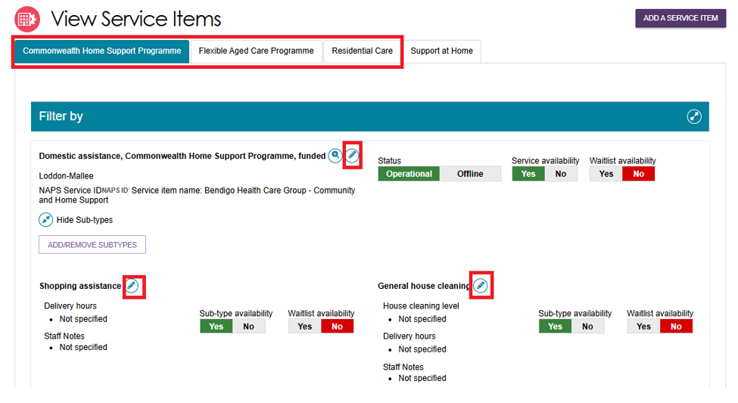
- Enter the start and end times for the applicable day.
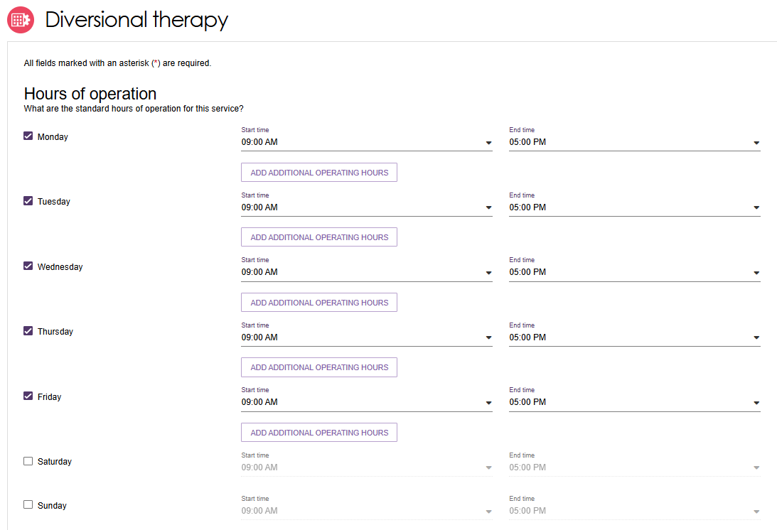

Delivery Hours (Support at Home)
Delivery Hours are specified for the Support at Home services and are not applicable to other programs (see Hours of Operation).
Support At Home Example
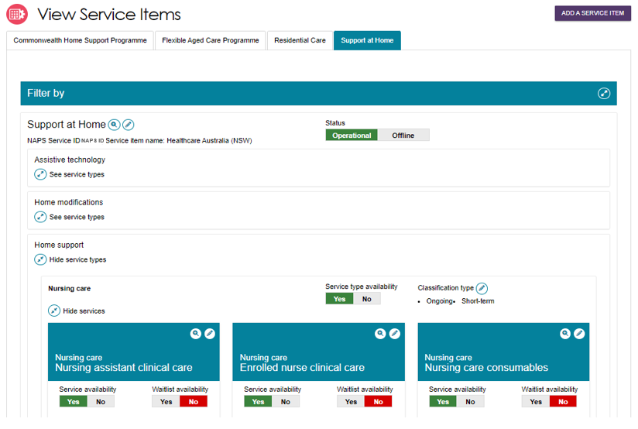
- Select the Pencil (edit) icon on the service tile. This will open the service edit page. Standard hours are active by default and cannot be changed.
- Select the checkbox for any other service delivery hours you offer for the service. For example, if you offer the service to the client in Non-standard or on Saturdays, then select that option.
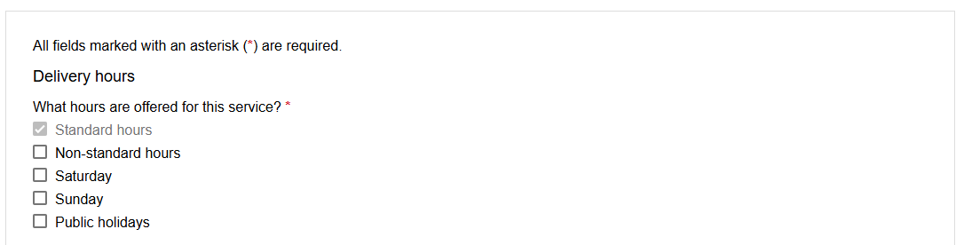
- Select the applicable checkboxes for the delivery hours offered.
When you select a delivery hours checkbox the corresponding Common Price field will become active and you must have a price before saving the record.
- Select the SAVE CHANGES button at the bottom of the page. This information will be passed to My Aged Care and utilised in various website tools.

Staffing notes
Staffing notes can be specified for each program.
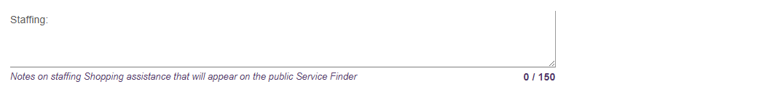

Service specific delivery details
Depending on the selected service, additional delivery details may be captured on this page. This information is used on the Assessor Portal to assist in finding a provider that can deliver services suitable for the client. Some services may only have some options available.
Transport service specific example
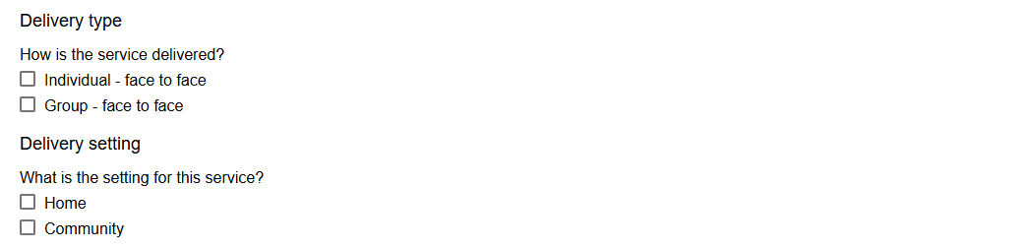

Service Description
Enter any further information about your service here, and it will be displayed at the Service Finder.
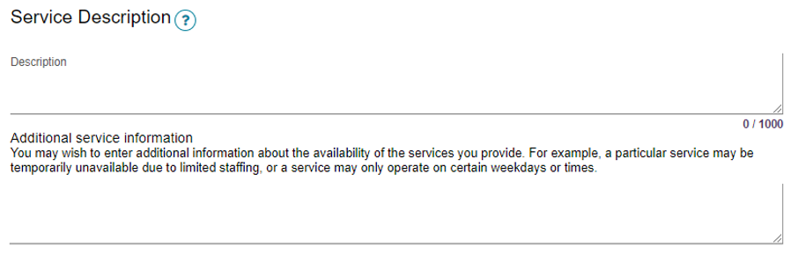

Pricing Information (Support at Home)
This section covers pricing information for Support at Home only.
For room pricing for Residential Care please refer to Rooms (Residential Care).
Support at Home program outlets must provide:
- service level prices for all available Support at Home Services within each Outlet.
- It is also highly recommended to add a pricing website link (URL). This will be shared with My Aged Care Website to assist aged care participants find your published pricing.
If pricing is not entered for Support at Home services, you will not be able to:
- save a new service item and make it Operational
- save changes to partially complete existing pricing information
- confirm that pricing information has been reviewed, then pricing data will then not be supplied to My Aged Care to support tools such as the Fee Estimator.
! | The Support at Home’s service item allows you to configure the services you deliver and their prices for a particular delivery area or region.  Pricing is entered at the service level for each service item within the outlet.
To view outlet-wide information for Support at Home:
- Select the outlet from the Outlet Administration tile, then select ‘View Service Items’.
- select the Support at Home tab, then select the Magnifying Glass (view) icon to the right of the ‘Support at Home’ heading.
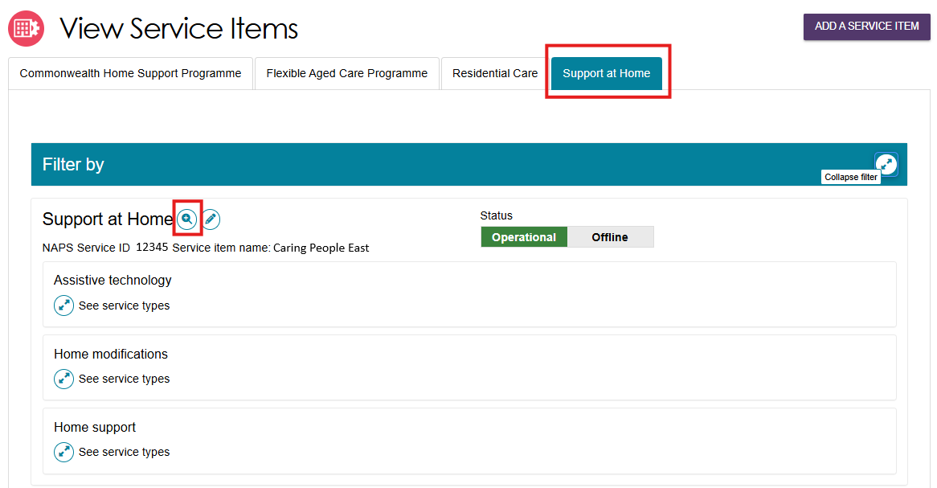
To view individual Support at Home services:
- Select the outlet from the Outlet Administration tile, then select ‘View Service Items’.
- select the Support at Home tab, then expand any service groups and service types, then select the Magnifying Glass (view) icon of the appropriate service card.
For example, the below image shows:
- the Assistive technology service group
- the Equipment and products service type
- three services:
  - Self-care products
  - Assistive technology prescription and clinical support
  - Communication and information management products
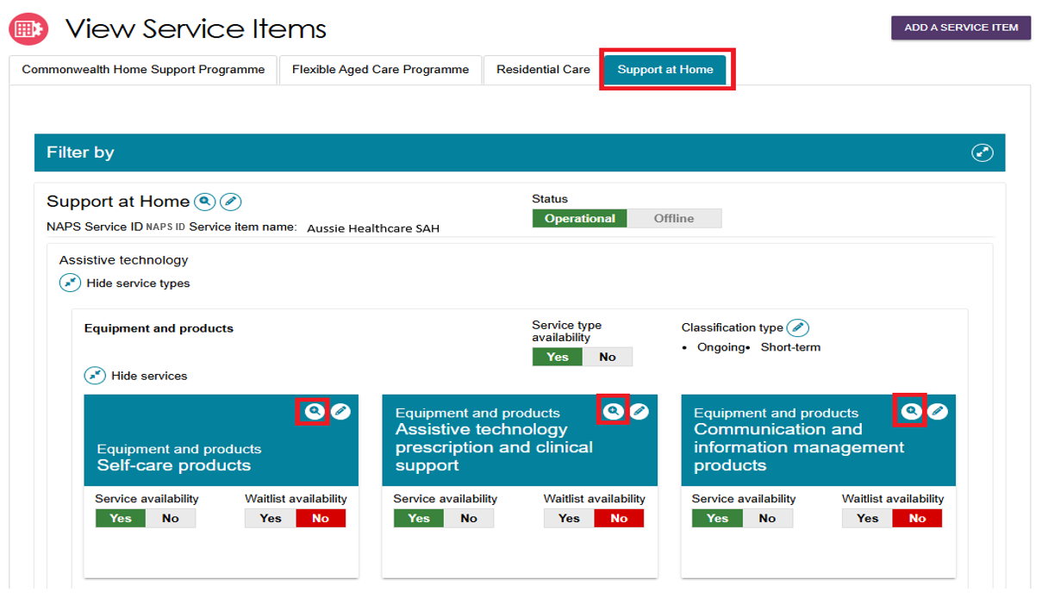

Updating Pricing Information at the Organisation Level
! | This functionality is available to Organisation Administrators only.  Organisational level pricing can be applied to every outlet service item that delivers Support at Home services. It will override existing pricing changes at the outlet service level if they already exist. Ensure that your Outlet Administrator/s are aware of your Organisational level pricing changes before you Apply pricing to all Outlets.
- Go to the Outlet Administration page by following the steps in Viewing outlets.
- Select the View (magnifying glass) button to the right of the Support at Home Organisation Pricing section. If your organisation does not offer or deliver Support at Home program services, you do not need to complete this.
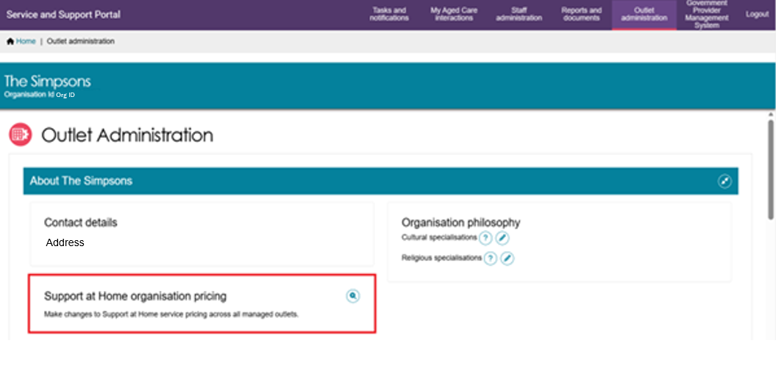
- A list of service groups and service types displays. This list will only show Service Groups and Service types associated with your Organisation’s Registration Categories. Select the Edit (Pencil) button to the right of the service type/s that you would like to update.
The Last updated, Last updated to outlets, and Outlet update status columns are blank until you add pricing for services within the service type record.
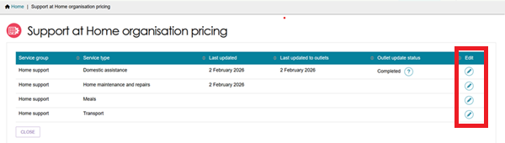
- For each service type selected using the Edit Pencil icon above, the corresponding ‘Pricing for Service’ page appears. All your organisation’s available services within the service type and the common price fields for each delivery time period displays here. A domestic assistance page example is shown below.
Domestic Assistance Pricing Page Example
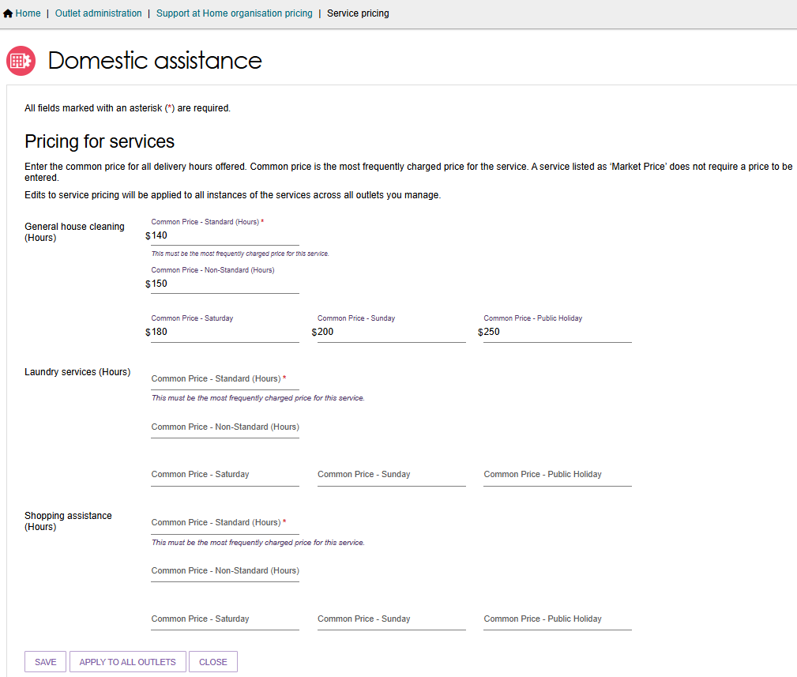
Nursing Care Pricing Page Example
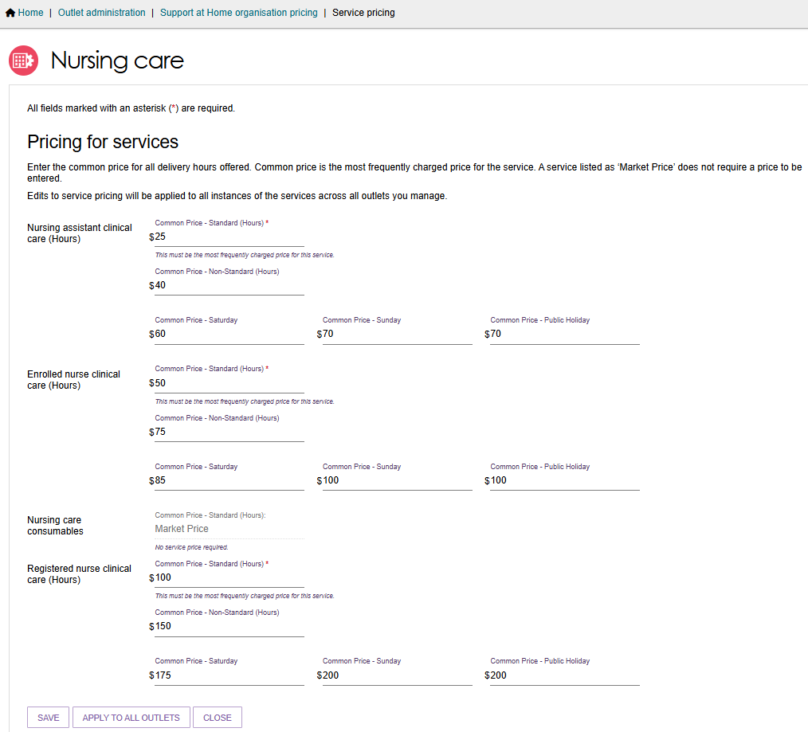
All mandatory fields (marked with a red asterisk) must be entered, for example ‘Common price – Standard (hours)’. If not entered you will receive error messages:
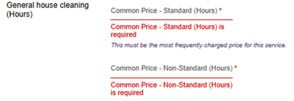

- You must provide Common Price – Standard (Hours) for all Services that will be marked as available. When marked available, this will appear selected as a default option. Enter a value from $0.00 to $999.99, but this value must be the most frequently charged price for the service.
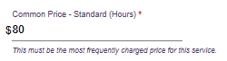
If you do not deliver a service within the service type, you can enter $0.00 if you need to enter a value in the mandatory field. You MUST then mark this service as not available on all the applicable Support at Home service items.
For any service listed as Market Price you are not required to enter a price value.
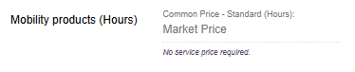
- Select SAVE to save your progress and to be taken back to the Support at Home pricing page. This will only save the pricing on the Organisation level.
- Select APPLY TO ALL OUTLETS button when you are ready to apply the pricing you have entered to all of the organisation’s outlets with a Support at Home service item. This is possible only after entering all mandatory Service pricing under a Service Type.
When applying pricing to all Outlets, only the prices will be copied down where that service delivery hours is selected. Standard hours are defaulted and will always be copied down.
For example, you enter all pricing at the organisation level. However, in some service items the additional service delivery hours selected is only Non-standard and Saturday, then only those prices will be copied to that service item.
- Select CLOSE to go back to the Support at Home pricing page without any edits made or saved.
! | When applying organisational pricing to all outlets, the pricing will copy down to all Support at Home Service items, regardless of Operational or Offline status.
- When APPLY TO ALL OUTLETS is selected, an Information Banner appears: ‘We’re currently updating your selected pricing change across all outlets. This may take up to an hour or more to complete.
You can continue working while the prices are being updated, and refresh this page to see if the update has completed. If any errors occur, information will be sent to the designated organisation email contact’.
- The Outlet update status will be displayed. For more information select the Question Mark icon. You will not be able to edit during this time.
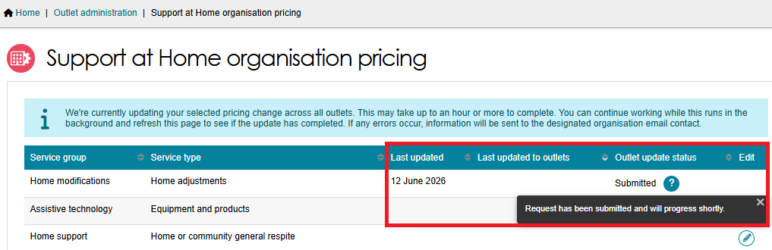
- When pricing has applied to all outlets, the Outlet update status is Completed, and you can edit again.
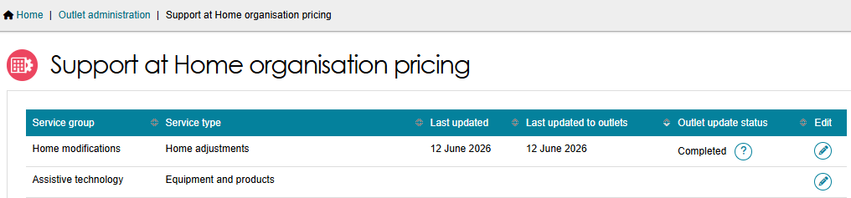

Updating Pricing Information at the Outlet Level
- Navigate to the Outlet Administration page by following the steps in Viewing outlets. Then, select your outlet card from the Outlet tiles.
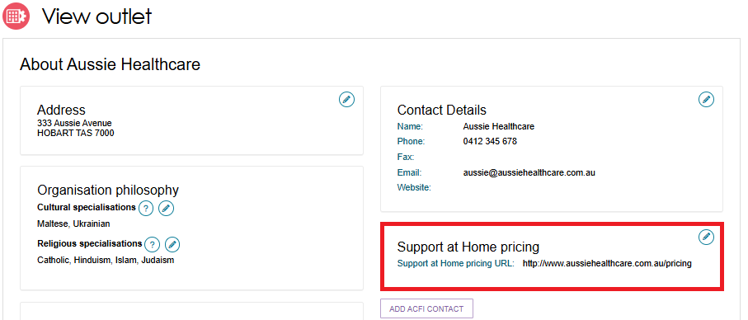
- The outlet details page will be displayed. Then select the Edit (pencil) icon to the right of the Support at Home pricing section.
The Support at Home pricing pop up appears.
Under the Full Price List section, a pricing schedule website link (URL) can be added.
- To add a pricing schedule website link type in the URL in the Provide a website link section. Ensure that the website URL you enter is a valid website address. Use the URL Scheme field to select the if the URL is https:// or http://.
- Finally, select whether you want to
- Apply to this outlet only, or
- Apply to this outlet and its Support at Home service items.
- Then, select Save button.
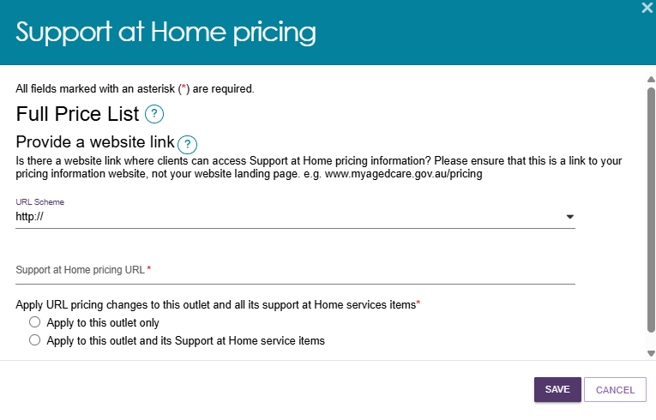
The Pricing URL will now appear at the View Outlet page.
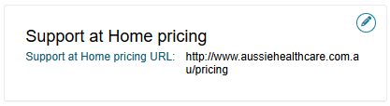

Updating Pricing Information at the Service Item Level
You can also update the service item pricing URL or supply a price schedule attachment specific to that delivery area/region.
- Choose your outlet from the Outlet Administration tile, then select View Service Items.
- From the View Service Items page, select the Support at Home tab, then the Edit (Pencil) icon to the right of the ‘Support at Home’ heading.
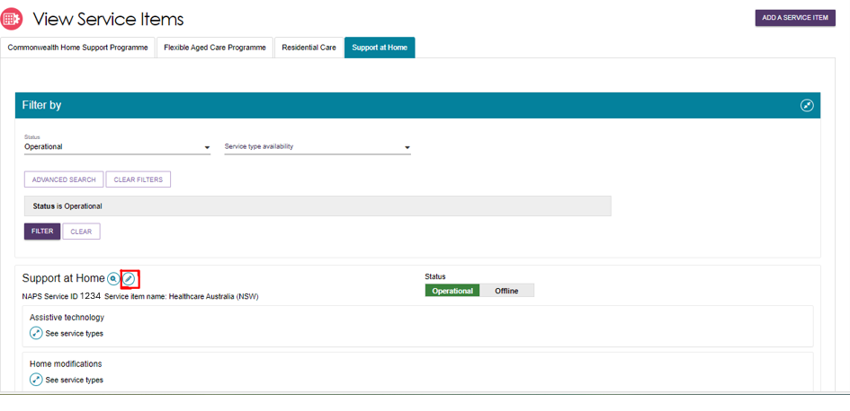
- The Support at Home details Page appears.
This contains all configuration available for the service item.
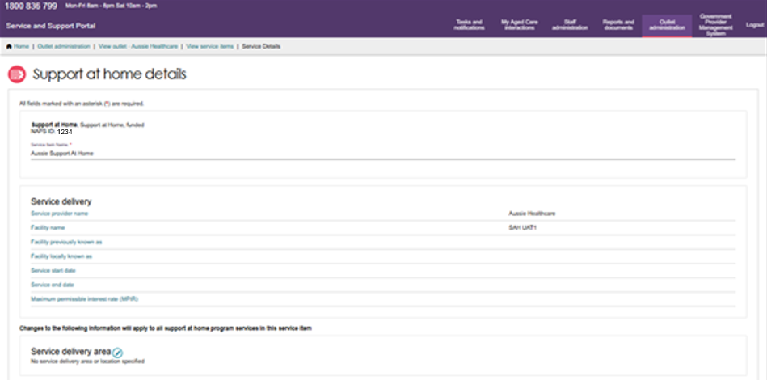
- Scroll to the bottom of the page to the Full Price List section.
In the URL Scheme section, select whether your website link is HTTP or HTTPS. Then, enter the website link in the URL section. The below screenshot shows an example website link. You can also upload a pricing schedule here.
- Finally, select Save.
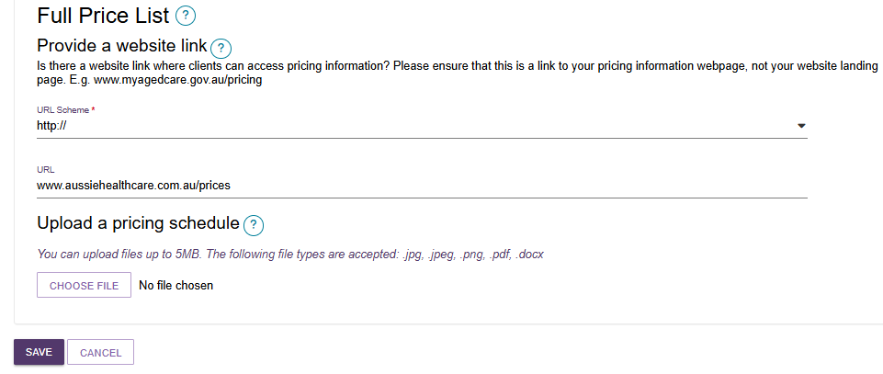

Updating Pricing at the Service Level
! | Service pricing at the Organisational level will be automatically applied to all service level pricing. Be aware of any Support at Home organisational pricing changes that the Organisational Administrator may do.  It is important to provide pricing at the service level to support My Aged Care website tools such as Find a Provider or Fee Estimator. There is flexibility to have service level availability and pricing by service delivery area (region).
At the service level, you can update pricing based on the unit type, for example: per hour, trip or meal for individual services. If you have entered pricing at the Organisation level this information can now be used to autofill, if the service level price does not already exist.
- Select the Support at Home tab, then expand any service groups/service types, then select the Edit (Pencil) icon of the appropriate service card.
The example below shows the Home Support service group, Meals service type, and Meal Delivery service.
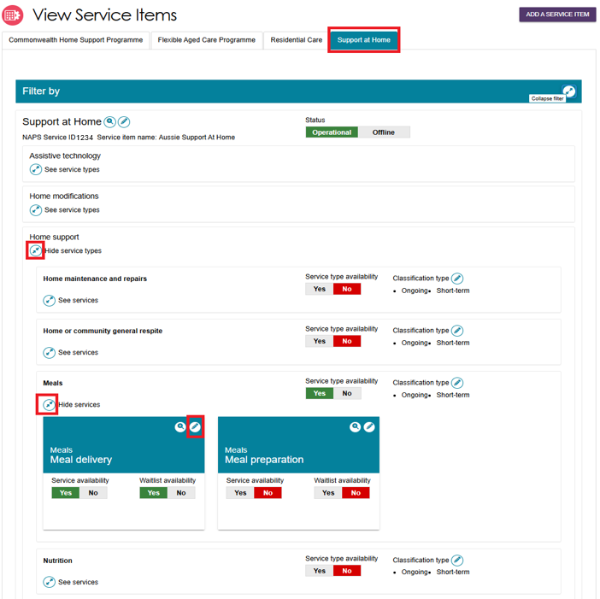
- The Edit Service sub-type page appears. The appearance of the page will vary depending on which service you have selected.
Auto filling prices from the Organisation level
When you edit a Service’s pricing, the system will autofill the common prices from the Organisation level. This will only happen when:
- if there is price/s set at the Organisation level (also referred as reference price) and
- when you select the delivery hours option/s you offer for the service.
When the pricing is auto filled, an information banner also appears.
These prices are pre-filled for your convenience. You can keep this figure or apply a new price based on the delivery area; however, you must ensure you save to apply the pricing. data.
Entering prices at the Service level
If you have not entered any pricing at the organisation level the fields will be blank and you must at minimum enter a service price for Common price – Standard (hours). In this page, Standard Hours is displayed as ticked by default.
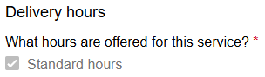
For Common Price – Non-Standard (Hours), Common Price – Saturday, Common Price – Sunday, and Common Price – Public Holiday, only enter availability and prices for them if your organisation offers these hours. There is flexibility to have Service item specific pricing here.
You can enter the hours in the Delivery hours section. The Pricing for service section will only display the delivery hour types that are selected in the Delivery Hours section.
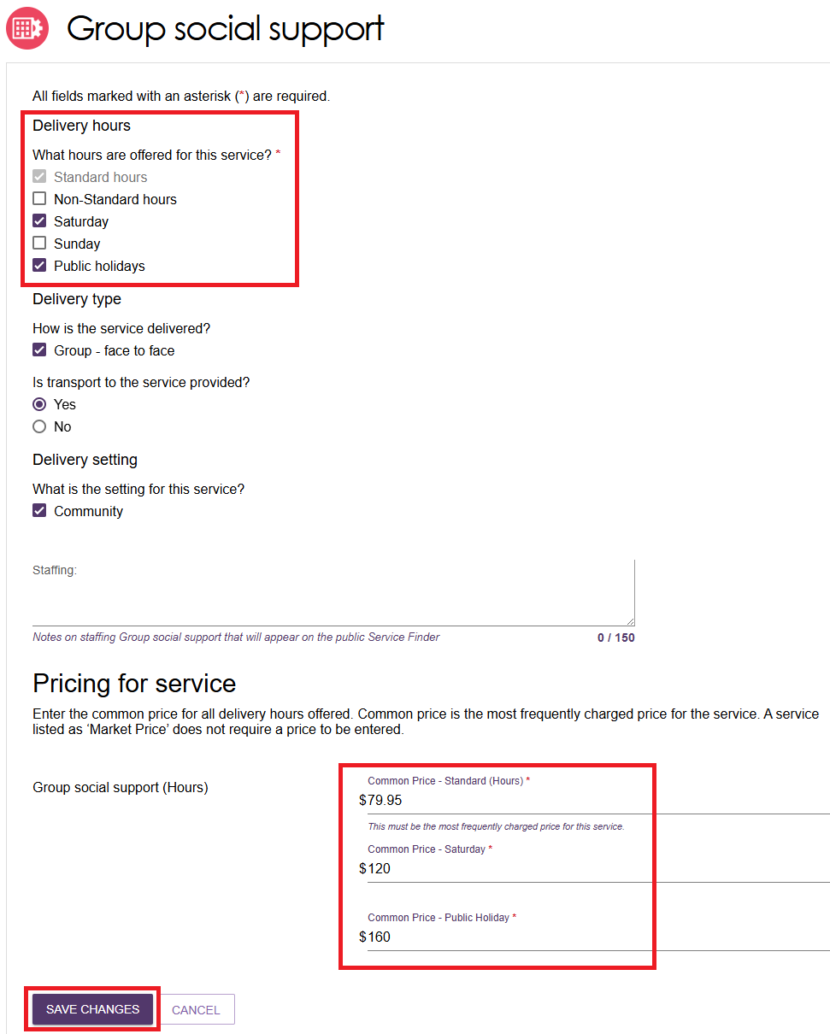
All mandatory fields (marked with a red asterisk) must be entered, for example ‘Common price – Standard (hours)’. If not entered you will receive error messages:
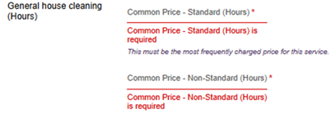
If service prices exist, and you adjust the availability setting (for example from No to Yes), the system will provide a message to review the pricing. It is encouraged to check the price details and complete any other prices for offered time periods and then SAVE.
This will be required to be completed for all available and waitlist services before changing the service item status to Operational.
Individual service pricing examples
For (Hours) services, enter the per hour price delivered during the time period.
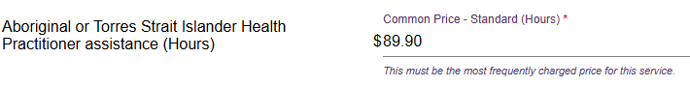
For meal delivery, enter the price per meal delivered during the time period. For example, in the Common price – standard (hours) section, enter the price for each meal delivered during standard hours.
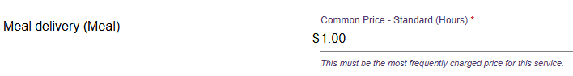
For transport services, enter the price per trip during the time period. For example, in the Common price – standard (hours) section, enter the price for each trip undertaken during standard hours.
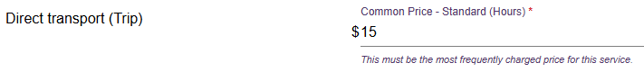
Some services such as consumables will default to Market price. No price is required to be entered.
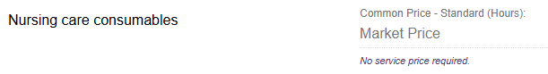
If a service is on a waitlist, it is highly recommended to add service pricing to ensure this is visible on the Service Finder or Fee Estimator tools.
All pricing information saved, including pricing schedule attachments, will appear by the next day on the Service Finder on the My Aged Care website, and do not require approval from the Department.

Reporting service pricing status
The Support at Home Pricing Status report enables Organisation Administrators and Outlet Administrators to view the service price status and identify which Services require pricing updates and when they were last updated.
The report will provide a full extract of all your Support at Home service pricing for all outlets, service items and price fields.
- Go to Reports and Documents tile of the portal home page, then select the Support at Home Pricing Status link.
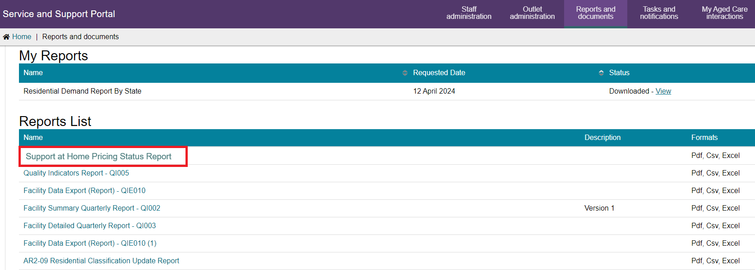
- This will open a Report View page. Begin typing the Outlet name to select, you can add additional outlets.
- Then, Select the output type and then the Request Report button.
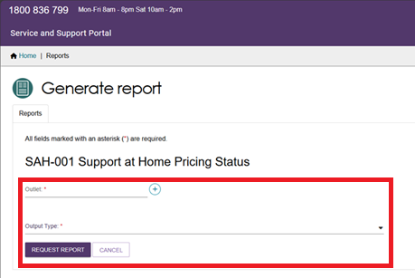
- The report will run and be available to download in your My Report section once completed.
There is an estimated 24 hours delay in the data entry to being available in the report. For example, if you entered data into the portal yesterday, it should be available to view today.
- Checking Pricing completion
Once you open the report, it will default to a sort order by Outlet and Operational service items and available services. This is intended to help you identify any missing pricing required to be entered.

A compliant Outlet is one where an Outlet is an active outlet with an operational Service item where a service/s availability = yes and common price – standard hours field contains a price value. The following sample report shows compliance, non-compliance and where compliance rule is not applicable.
- Row 1 indicates compliance with the rule.
- Row 2 with the red highlighted cell (under ‘Common Price – Standard Hour’ column) indicates the non-compliant price for that service. Note that the report will NOT highlight any non-compliant cells.
- Row 3 is not required to be assessed against the rule as the Service is not available. Any service item that is Offline is also not assessed against the rule as well as Inactive Outlets.
Price review/maintenance
Pricing must be reviewed and updated quarterly. This report can assist in providing a review of all the pricing entered and the last updated date. The last updated date is when any one of the service price time periods has been updated.
You will be able to identify if a service price has not been updated based on the last updated date. For example, if prices for the services have not changed in 3 or 6 months. This may indicate that it needs a review against your common prices for that service.

Rooms (Residential Care)

Add a room type
! | This section applies to Residential Care only and does not apply to Commonwealth Home Support Program or Support at Home programs.
Residential Care providers can add information about the types of rooms their organisation offers. Follow these steps to add a room and room information. Fields marked with an asterisk (*) are mandatory.
- Select Outlet administration from the homepage. Select the name of the outlet on the Outlet Card you want to add room information to.
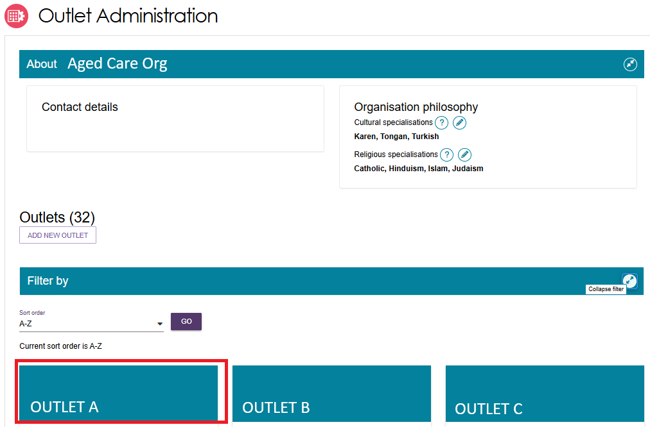
- The View outlet page appears. Select the VIEW SERVICE ITEMS button.
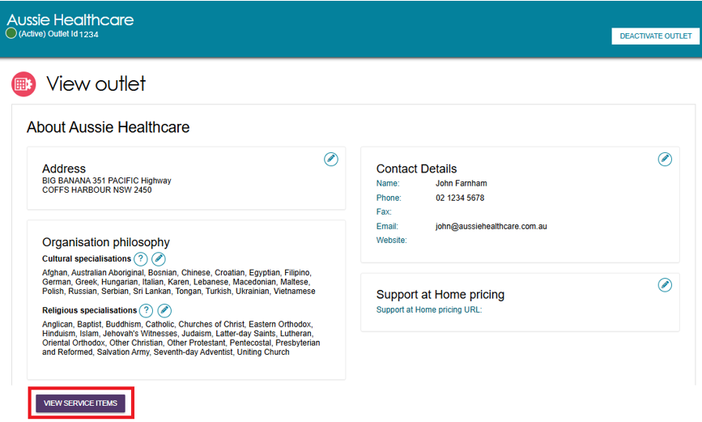
- From the View Service Items page, select Resident Care from the tab options.
Choose your service. Select Expand (blue arrow) next to See room types.
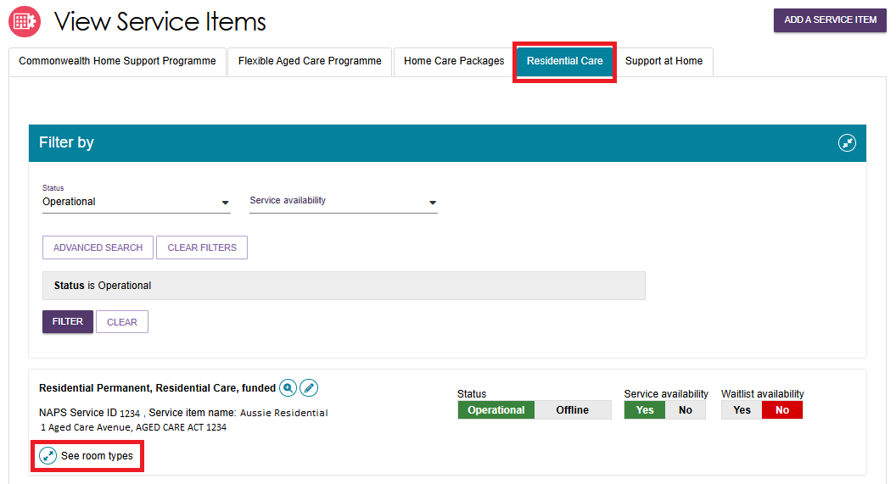
- Then Select ADD ROOM TYPE.
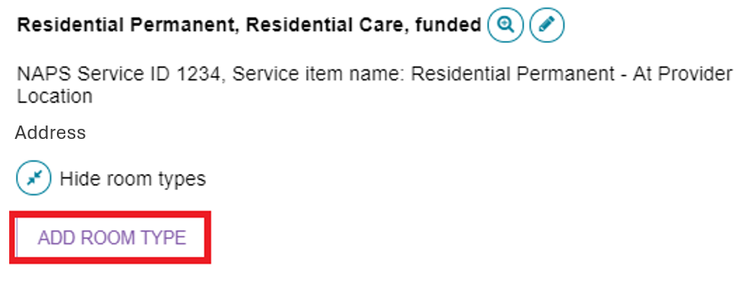
- The Room Type page appears. Enter required information in the General room information and Pricing information sections. Ensure mandatory fields (red asterisk) are completed.
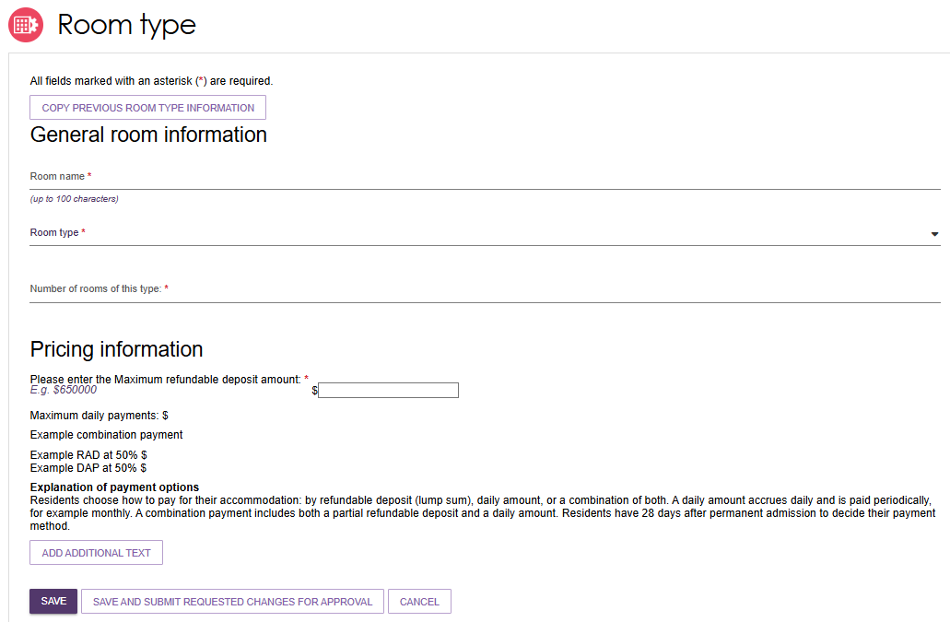

- In the Pricing Information section, enter the room’s Maximum Refundable Deposit (RAD). If you enter an amount higher than the maximum allowed, an information banner appears similar to the example below.
To publish and charge a room price above the maximum allowed (or the equivalent daily payment), you must have a valid approval from the Independent Health and Aged Care Pricing Authority (IHACPA), formerly known as the Aged Care Pricing Commissioner.
! | If you do not have approval for your RAD price for the room type, you cannot publish or charge this price. Conditional approval does not constitute approval until you have received a satisfaction of conditions letter from IHACPA.
The below fields will appear and need to be completed for rooms priced over the maximum allowed:
- Approval or Conditional Approval
- Date of IHACPA approval (or Aged Care Pricing Commissioner approval) – IHACPA approvals are valid for 4 years. Once you enter the required approval details for a room, you will receive automatic notifications when your approval is nearing expiry. These will be sent at 6, 4 and 2 months before your Date of IHACPA approval indicates expiry. Rooms will be removed from My Aged Care if 4 years passes from your Date of IHACPA approval.
- IHACPA approval reference number – This is only required if your approval was granted on or after 1 July 2024. Approval letters issued prior to 1 July 2024 do not have an approval number.
- You will also need to attach and name the IHACPA approval letter for the room.
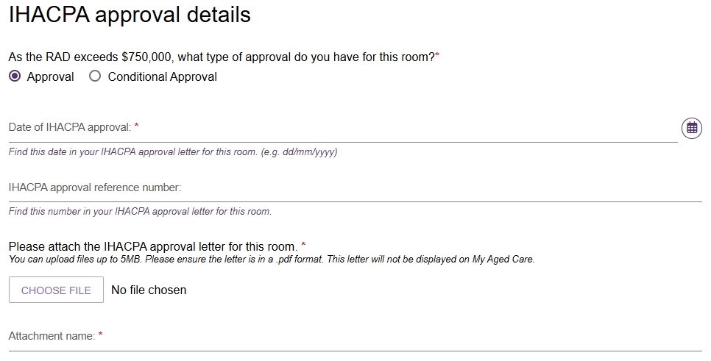
- Enter the required information under Key feature statement.
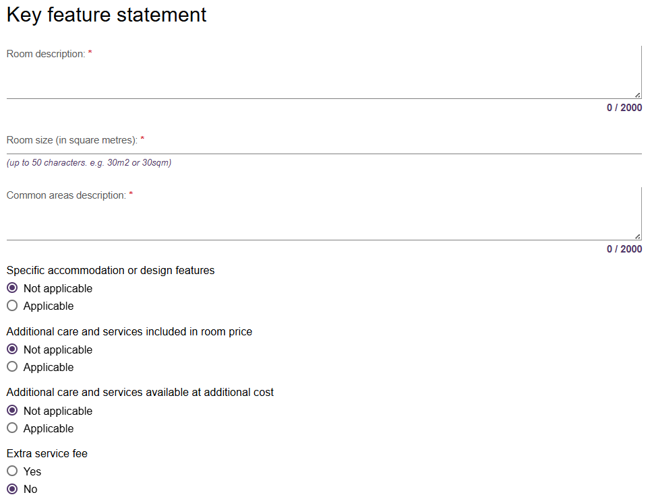
When entering room size (in square metres):
- if there is variation in room sizes, enter the size range of the room type from smallest to largest, e.g. 20sqm - 25sqm.
- indicate if the room size entered includes ensuite, e.g. 20sqm - 25sqm incl. ensuite.
- do not include private outdoor areas such as balconies or courtyards.
- Please ensure that the room size entered aligns with information provided to IHACPA in your application for these rooms.
- Select SAVE AND SUBMIT REQUESTED CHANGES FOR APPROVAL.
! | If you select SAVE, this room information will be saved only and not submitted for publication.
This room information will be displayed on the service finder once approved for publication by the Department (allow three business days).
If your room is not approved for publication, you will receive an email explaining the action you need to undertake before resubmitting. You can update your room request and submit again.

Edit room details
Residential Care providers can edit existing room information. Follow these steps to edit a room. Fields marked with an asterisk (*) are mandatory.
- To edit the details for a room, select the edit (pencil).icon next to the room’s listing.
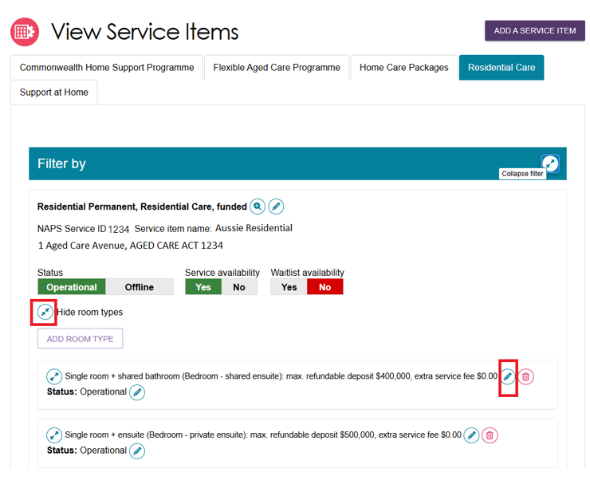
- The Edit Room Type page appears. Select the reason for resubmission from the drop-down menu and the continue to edit the details of the room.
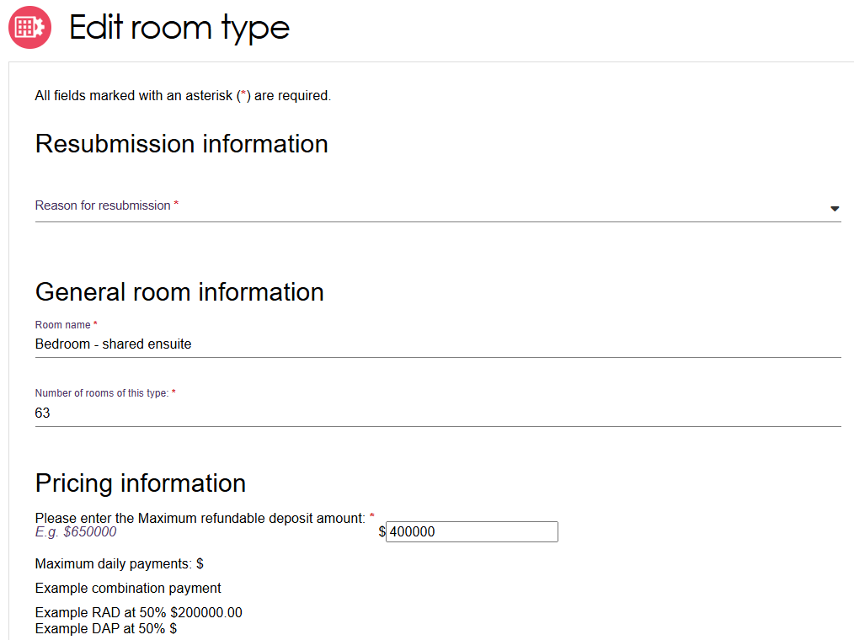
! | Providers with an IHACPA approved maximum Refundable Accommodation Deposit over the maximum allowed can also index the room price in line with legislation. For details on calculating the indexation of approved RADs visit www.ihacpa.gov.au.  If you have selected Indexation of approved max RAD as the Reason for resubmission, you can only change the room price. If you wish to change other fields for the room, select a different resubmission reason.
- Scroll down to the bottom of the page. Select SAVE AND SUBMIT REQUESTED CHANGES FOR APPROVAL.
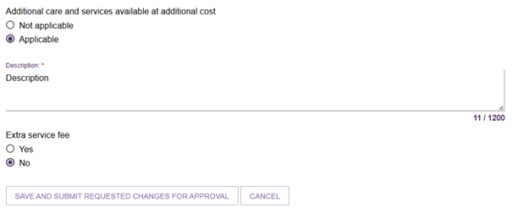
Once submitted, you will be redirected back to the View Service Items page and a green
banner will display at the bottom of the screen confirming the edits were successfully submitted.

Change room status
- Select the edit icon (pencil) next to the Status of the room you want to set as Offline or Operational.
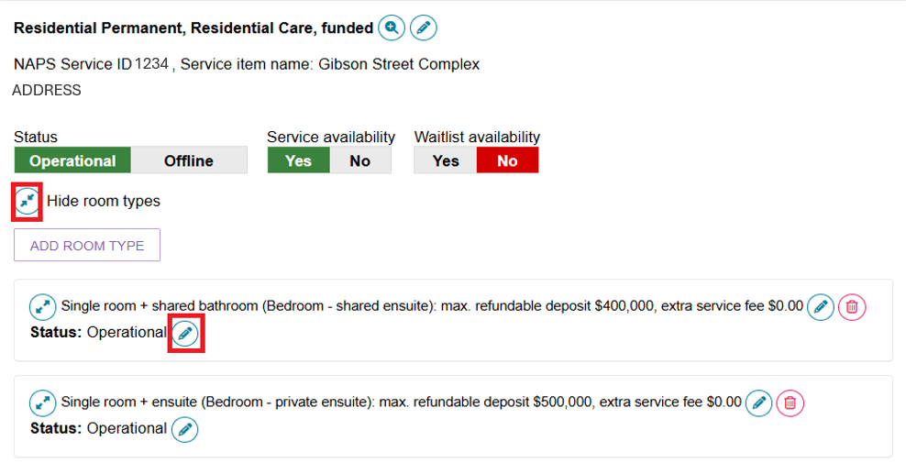
- From the pop-up select Offline (not displayed) from the change room status and select the reason for the change.
When you set the room to Offline a warning banner will appear advising that offline rooms are not displayed on My Aged Care.
- Select SAVE.
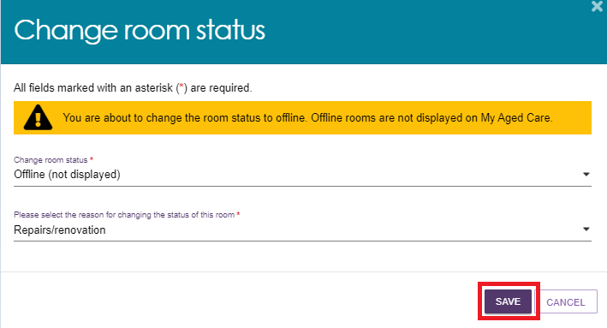
A message will appear advising that you have successfully changed the status of the room.
The status of the room will now display as Offline.

If you wish to make an Offline room Operational:
- click on the edit icon (pencil) next to Status: Offline.
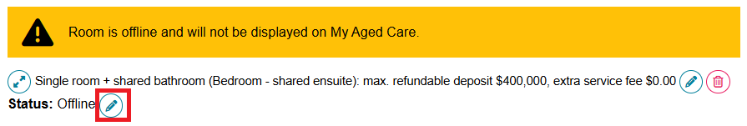
- Select Operational (displayed) from the change status drop-down menu followed by the reason for the change.
- Then select SAVE.
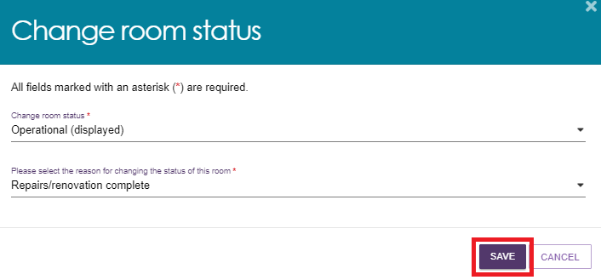
A green message will appear advising that you have successfully changed the status of the room and the room will show as Operational.
The room will be displayed on My Aged Care within 24 hours.


Delete a room
Residential Care providers can choose to permanently delete a room. Note that deletion of a room cannot be reversed.
- Select the delete icon (bin) next to the room you wish to delete.
Ensure you select the correct room as the deletion of a room cannot be reversed.
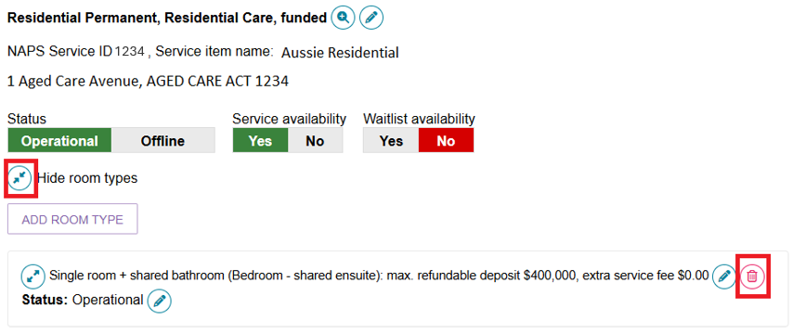
- From the pop-up, select the reason for deleting the room and select DELETE.
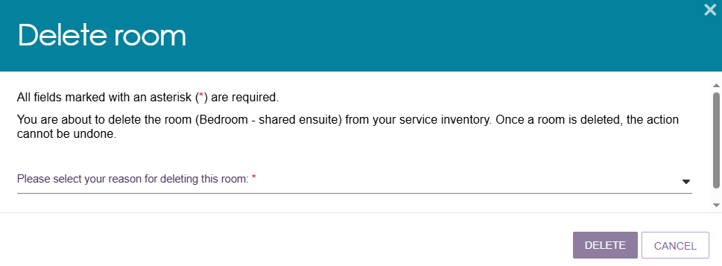
A green banner will display at the bottom of screen confirming the room has been successfully deleted.


Transferring service items
! | Access to the functionality described in this guide has been disabled in the Service and Support Portal for ALL programs from 1st November 2025 until further notice.  If you require the transfer of services or clients, please contact the My Aged Care Service Provider and Assessor Helpline on 1800 836 799, who will be able to assist you.

Activating or deactivating a service item
The reasons for deactivating a service item typically include:
- Residential: Facility is no longer accepting residents.
- Commonwealth Home Support Program (CHSP): The service is no longer being delivered in the specified area.
- Support at Home: Selected services are no longer being delivered in the referral area.
Follow these steps to activate or deactivate a service:
- Select Outlet administration from the homepage, then select the outlet that contains the service items that you want to activate/deactivate, and then select VIEW SERVICE ITEMS.
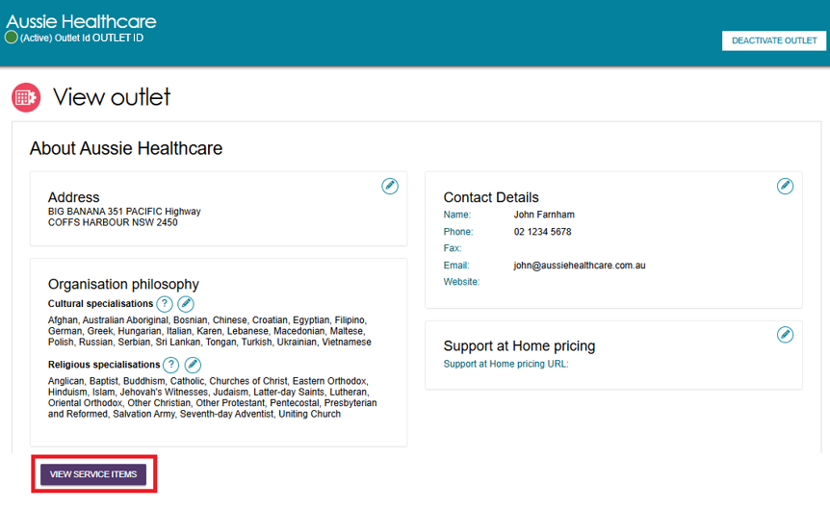
- Select the appropriate tab corresponding to the program.
! | The Residential Care tab should only be selected when working with Residential Care services. If you edit CHSP items, ensure the CHSP tab is selected.
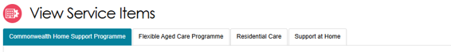
- For the services that have been added to the outlet, select Operational to activate the service item. Alternatively, select Offline to deactivate the service item under the Status heading.
Only Operational services will display in the service finders.
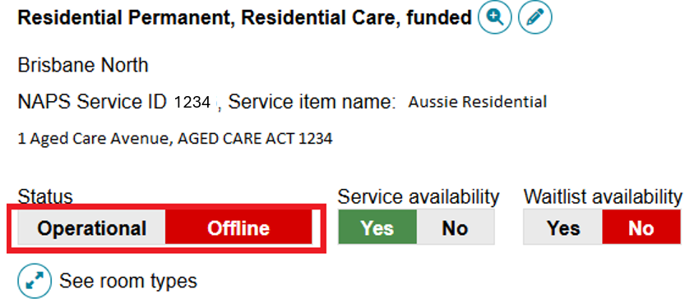
For Support at Home, the Operational or Offline status applies to every service group, service type and service that your outlet is approved for.
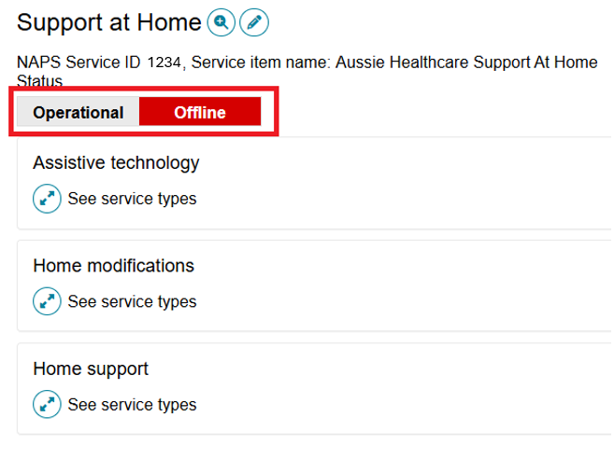

! | The Offline status has replaced Inactive status and should be used to indicate where a funded service is not currently offered by the provider. For example, the service is at capacity. Services that are Inactive are services that are no longer funded by the department. Inactive services will not be visible in the My Aged Care Service and Support Portal.  Please contact the My Aged Care service provider and assessor helpline on 1800 836 799 if you have questions about your Inactive services.

Maintaining service delivery outlets

Activating an outlet
After service items are added, outlet(s) need to be made active so that:
- The service items display in the service finder.
- Contact centre staff and assessors can send electronic referrals to the appropriate outlet.
Follow these steps to activate an outlet:
- Navigate to the View Outlet details from the Outlet administration page for the outlet that you want to activate and select ACTIVATE OUTLET.
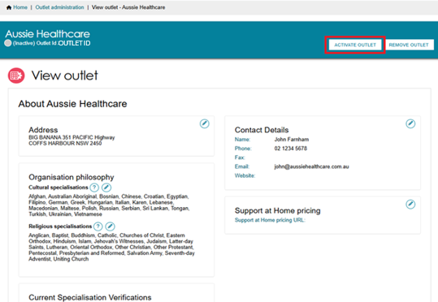
- Select ACTIVATE OUTLET to confirm that you wish for this information to be displayed in the service finder. A warning message will display:
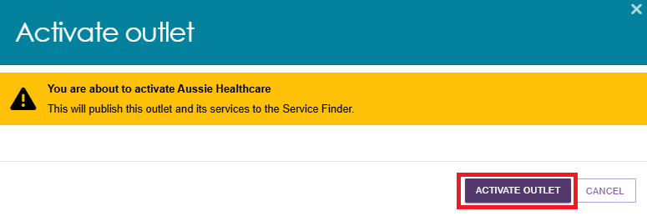
Your outlet is now active and operational service item information will display in the service finder and will display as Active in the Service and Support Portal. Assessors can only match and refer to active services.
Card View
Image of the Outlet card with a green tick banner at the bottom that says Active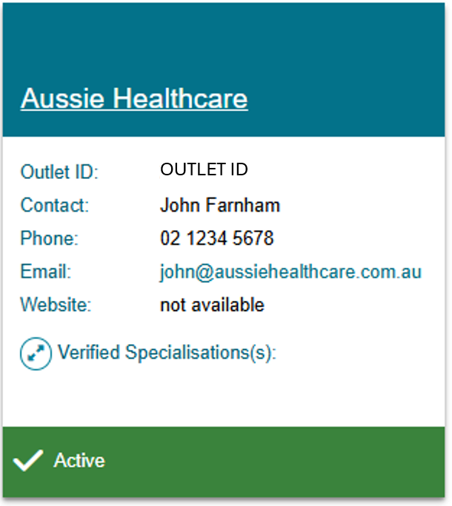
Outlet View
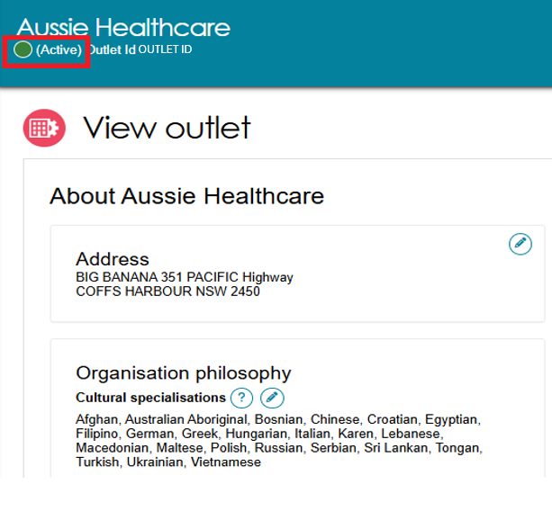

Deactivating an outlet
To remove an outlet from the service finder on the My Aged Care website, and stop referrals being sent to the outlet, it must be deactivated.
! | An outlet cannot be made inactive if there are accepted and commenced services.
Follow these steps to deactivate an outlet:
- Select Outlet Administration from the homepage.
- Navigate to the View Outlet details from the Outlet administration page for the outlet that you want to deactivate and select DEACTIVATE OUTLET.
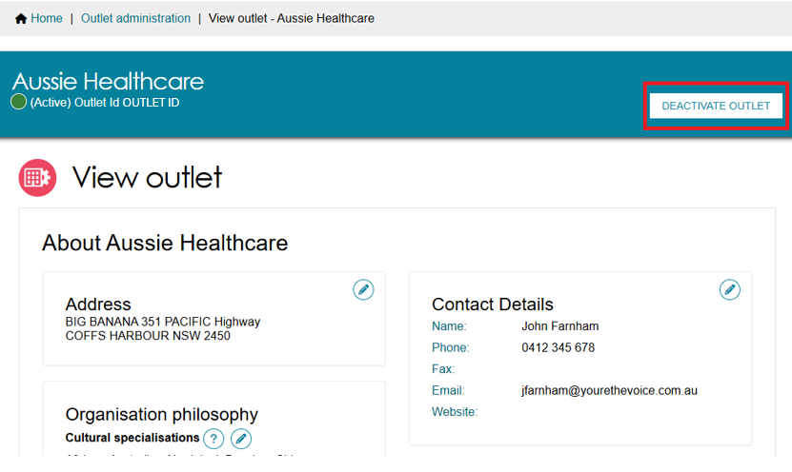
- Select DEACTIVATE OUTLET to confirm that you wish to deactivate the outlet.
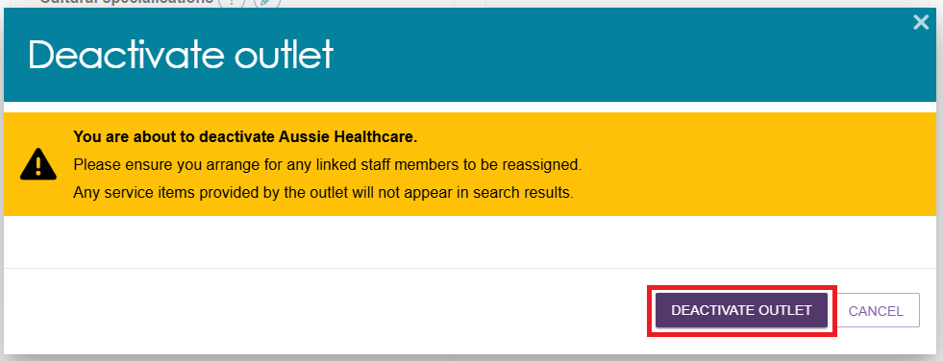
The outlet is now inactive, does not display on the relevant service finder or receive
referrals, and displays as Inactive in the Service and Support Portal.

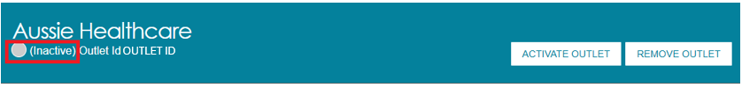

Removing an outlet
! | If you want to create an outlet with the same name as the one you removed, you will need to call the My Aged Care service provider and assessor helpline on 1800 836 799.
To remove an outlet from the Portal, it must be in the status of Inactive. Follow these steps to remove an outlet:
- Select Outlet administration from the homepage.
- Navigate to the View Outlet details from the Outlet administration page for the inactive outlet you wish to remove and select REMOVE OUTLET.
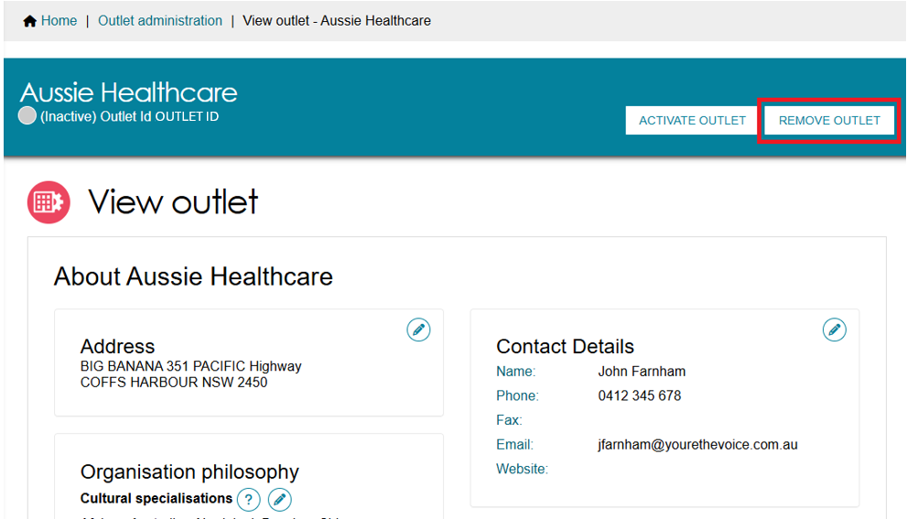
- Select REMOVE OUTLET to confirm you wish to remove the outlet.
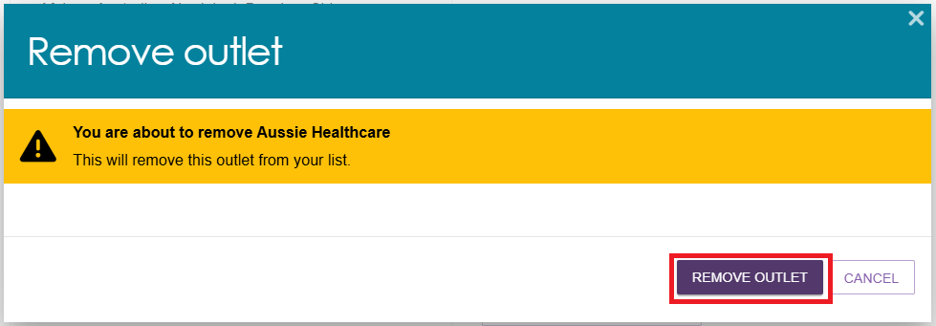
The outlet will no longer display in the Service and Support Portal.


Editing outlet details
Follow these steps to edit an outlet:
! | Only non-contractual information can be edited in the Service and Support Portal.
- Select Outlet administration from the homepage.
- Select the name of the outlet on the Outlet card you want to edit.
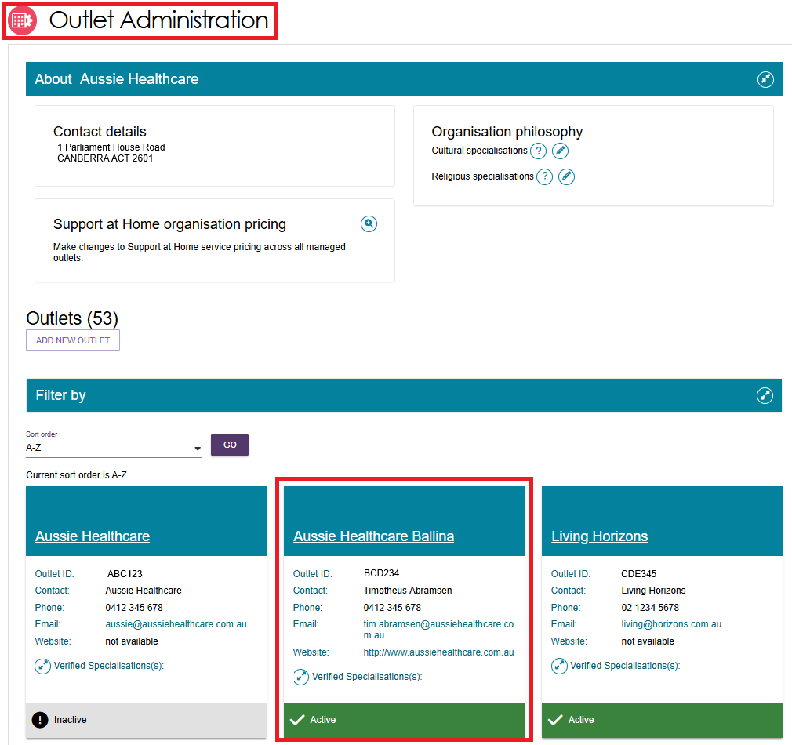
- On the View outlet page, select the area that you would like to edit, Address, Contact details or Organisation philosophy.
You can also change the Organisation philosophy when viewing your outlet information.
For more information on Organisation Philosophy refer to Editing the organisation philosophy.
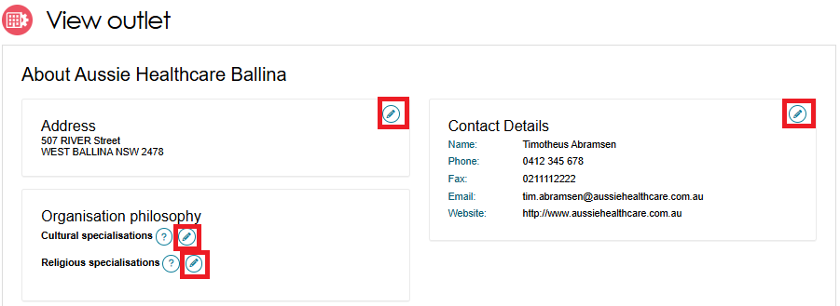
- Edit information and select SAVE CHANGES. To edit address details, select Edit next to the outlet address.
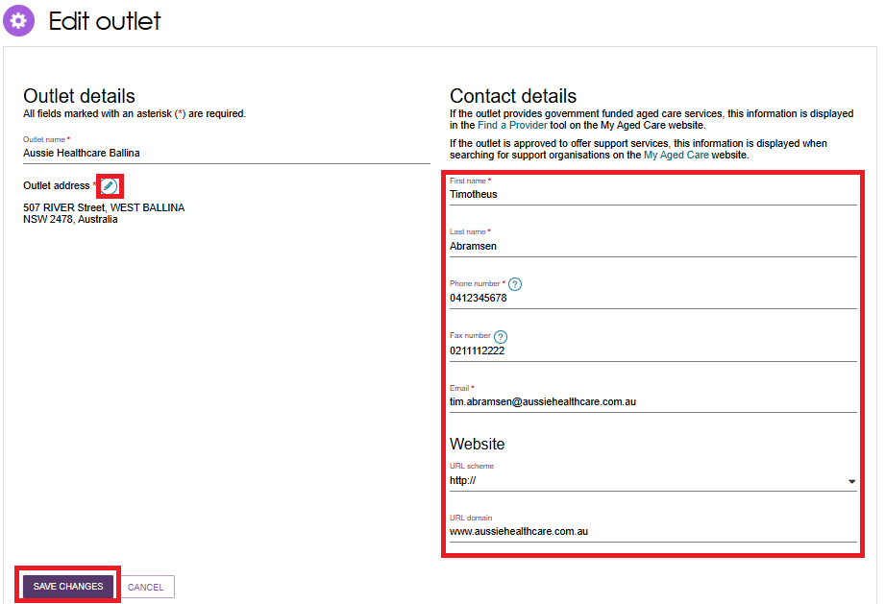

Tasks and notifications

Viewing tasks and notifications
Follow these steps to view tasks and notifications:
! | You must log onto the relevant outlet to view its tasks. You can do this by selecting the outlet you wish to log in to next to the Logout link at the top right of the portal.
- Select the Tasks and notifications tile from the homepage.
To view tasks for your organisation, select Tasks. Select an outlet to view tasks related to that outlet.
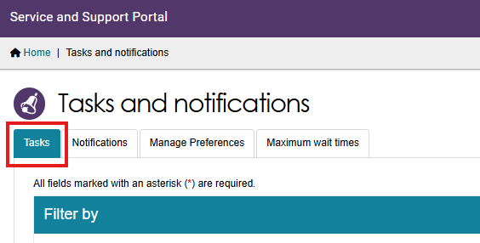

In the Tasks tab, you will be able to view all tasks that are relevant to your role. You can sort tasks by:
- Due date
- Category
- Title/Description
- Aged Care User ID
- Client name
- Activity ID.
! | Tasks that have been marked as important for your outlet by your outlet administrator will be displayed with a visual indicator.  The managing preferences section in this guide explains how to set tasks as important.
- To view notifications for your organisation, select Notifications. Select an outlet to view tasks related to that outlet.
You will only be able to see tasks and notifications that are associated to your outlet and for clients you are providing services to. Assessors will be able to see all tasks and notifications for clients.
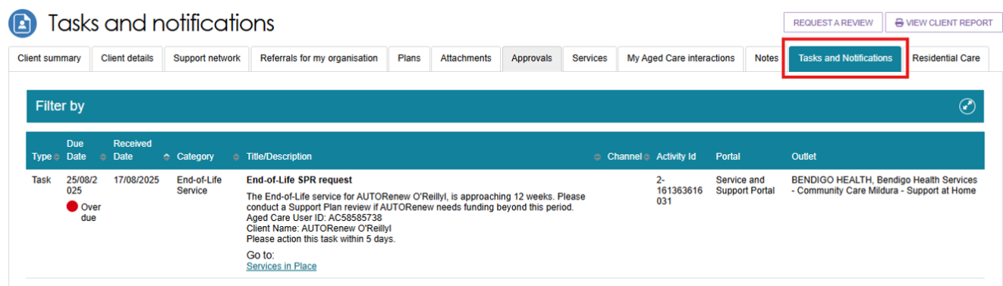
- You can search for specific tasks using the filter options or using custom filters in Advanced Search. Select the arrows to the right to expand or collapse the filter options.
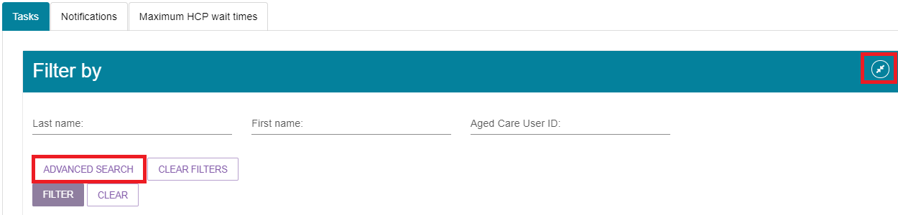
To apply custom filters, select ADVANCED SEARCH and choose filters from the drop-down menu and select ADD FILTER for each filter you want to apply. The filters include:
- Activity ID
- Aged Care User ID
- Category
- Date received
- Due date
- First name
- Last name
- Marked as important
- Overdue tasks
- Role
- Title.
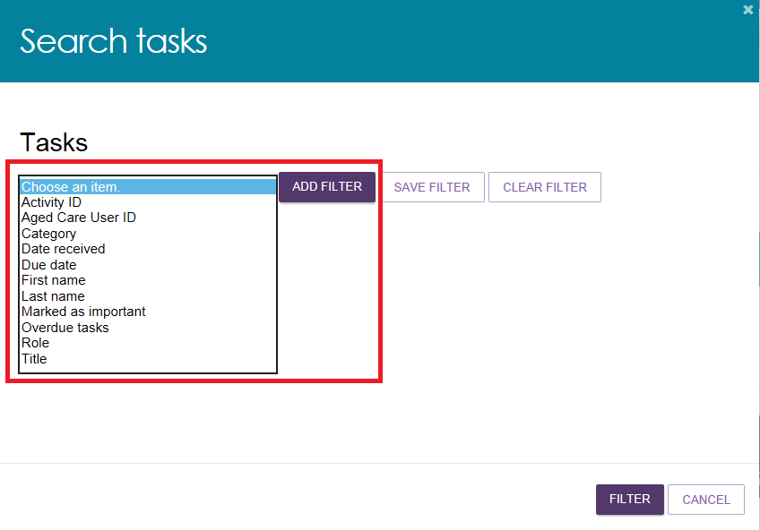
- The hyperlink under the task description will take you directly to the individual record
and the section of the portal where you can action the task.
Alternatively, you can navigate to the clients record by selecting the client’s Aged Care
ID from the tasks list.
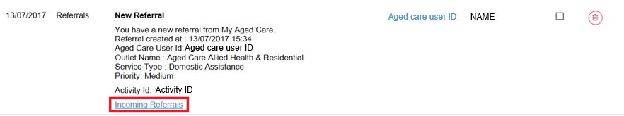
For example, selecting the link in an Overdue referral task will take you directly to the Incoming referrals tab where you can review the referral and determine whether to accept or reject the referral or place the client onto a waitlist, where appropriate.
Once the action required from the task has been completed, the task will automatically be removed from your task list.

Managing task and notification preferences
You must be an Administrator to manage task and notification preferences for your organisation or outlet. If you need to add this role to your user account, please see your organisation administrator.
As an Administrator, you will be able to:
- Edit email address and email frequency for new task and notifications
- Turn off visibility of notifications in the Portal
- View description of each task and notification, including which user types will be able to see them
- Edit individual task and notification preferences
- Mark a task or notification as important to your outlet.
These settings will affect all staff assigned to your outlet, so please ensure all staff are made aware of any changes you make.
- Select the Tasks and notifications tile from the homepage.
- Select the Manage Preferences tab.
If you are the Organisation Administrator, you will be able to select which outlet you want to configure task and notification preferences for. If you are the Administrator for your outlet, you will only be able to see your outlet’s preferences.
- Then, select Change Preferences.
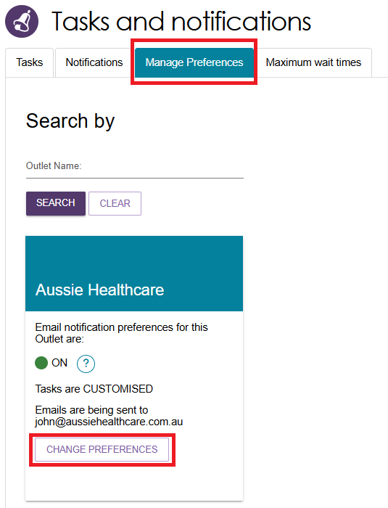
The preferences page for the outlet will open. At the top of the page, you can configure the overall preferences for email preference, email address, email frequency and notification visibility in the portal.
You can choose to hide all notifications or hide individual notification types for the outlet. Selecting No to hide all means that no notifications for the outlet will be visible to staff associated with the outlet.
Selecting No for an individual notification type means that only notifications of that type will be hidden for staff associated with the outlet.
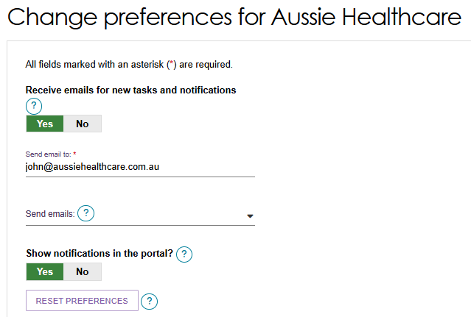
Tasks and notifications are sorted by category. Select the expander icon to expand/collapse each category.
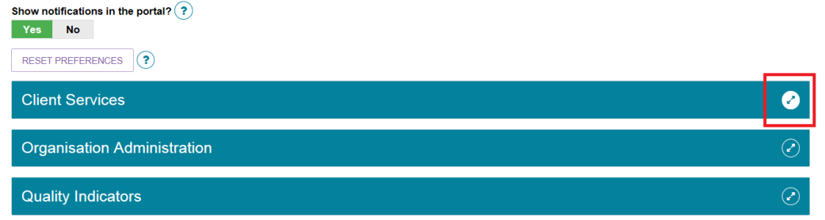
For each task or notification, you will be able to view:
- Type (e.g. task or notification)
- Title and brief description of the why the task or notification has triggered
- User type who can view or action the task or notification.
For each task or notification, you will be able to individually configure:
- Whether to send an email when a task or notification generate
- Frequency of email notification, if enabled
- Whether to display a task or notification as important in the portal.
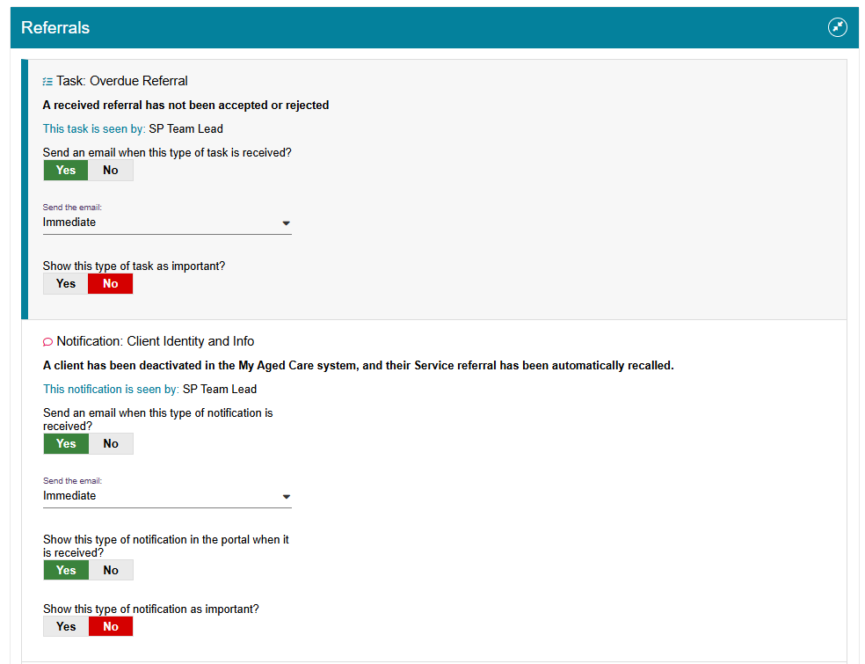
If you choose to mark a task or notification as important, staff within your outlet who can view that particular task or notification will see a visual indicator in their portal.
For example, a notification of home care correspondence.
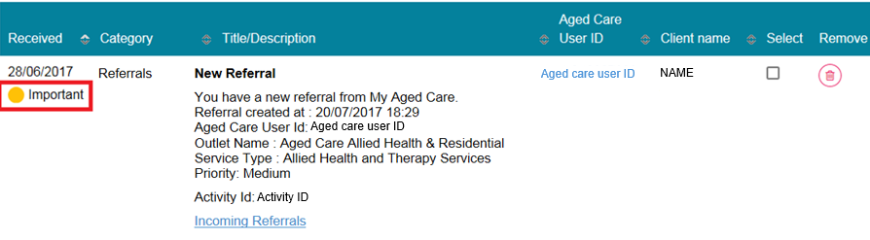
- Select SAVE when all changes have been made.
You can reset the preferences by selecting RESET PREFERENCES at the top of the page.
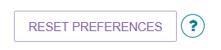

Creating and maintaining staff accounts
Once you have created your organisation’s outlets, you can create and maintain staff accounts.
For more information about staff roles refer to Staff Roles in the Service and Support Portal.

Viewing staff accounts
Select Staff Administration from the homepage to view all staff who have access to the Service and Support Portal.
You can sort the staff list alphabetically or by the outlet(s) assigned to each staff member.
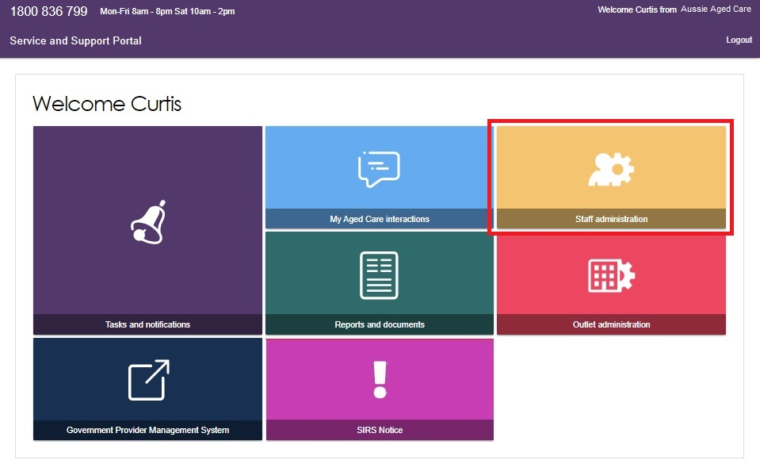

Adding new staff accounts, allocating roles and outlets
After creating your organisation's outlets, you can add staff accounts.
When you create a staff account, you must:
- assign one or more roles
- assign the staff member to one or more outlets.
A staff member can hold multiple roles at the same time, including Administrator, Team Leader and Staff Member. Their roles apply across all assigned outlets.
! | Staff with the Organisation Administrator role can manage all outlets within the organisation.  Staff with the Outlet Administrator role can only manage services and staff for the outlet(s) assigned to them.
Follow these steps to add a staff account:
- Select Staff Administration from the homepage.
- Select ADD NEW STAFF.
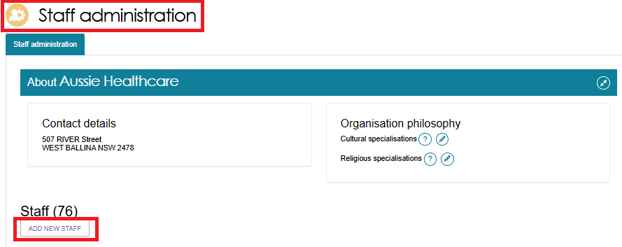
- Enter the staff member's details, including:
- first name
- last name
- unique email address
- contact number.
- Then assign the required role(s) and outlet(s), and select Save.
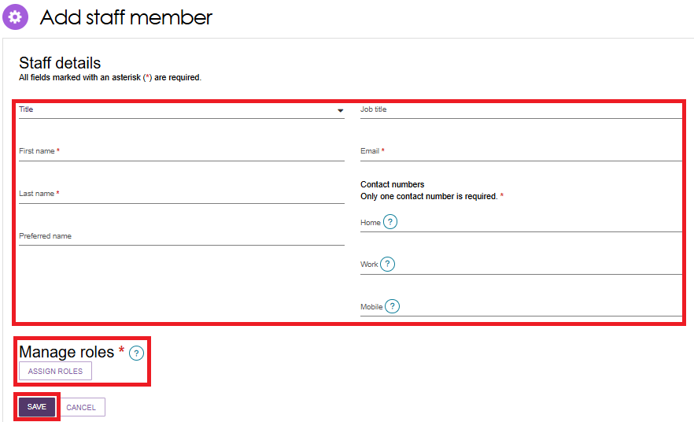
- Choose whether to assign the staff member at the Organisation Level or Outlet Level:
- Organisation Level gives access to organisation details and all associated outlets.
- Outlet Level gives access to one, multiple or all selected outlets within the organisation.
- Select Save, then Save Roles.
Service Provider Administrators can assign additional roles to staff within their outlet.
A person assigned the administrator role at the organisation level:
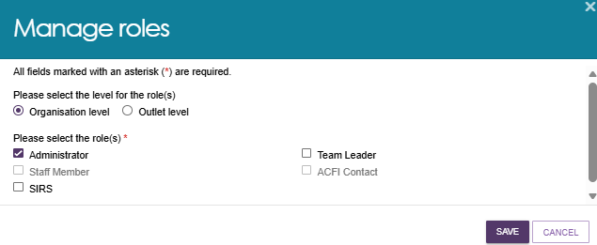
A person assigned the roles of administrator and team leader at the outlet level:
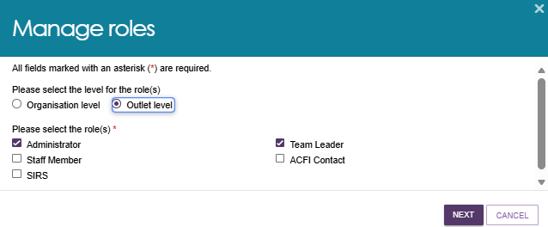
Choosing an outlet for the role:
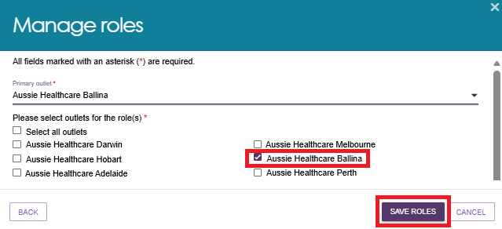
! | The first time each staff member logs into the Service and Support Portal, they must follow the steps outlined in Logging in to the Aged Care Systems.

Editing a staff account
Follow these steps to edit a staff account:
- Select Staff Administration from the Portal homepage. Select the staff member's name from the Staff list.
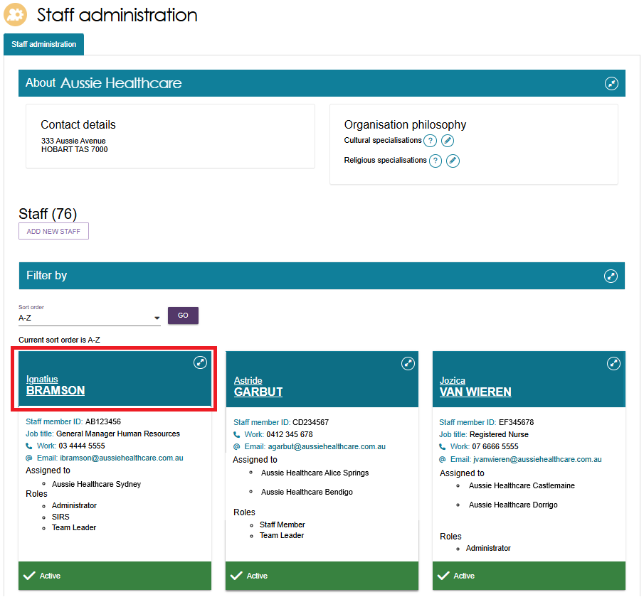
- Select EDIT STAFF DETAILS.
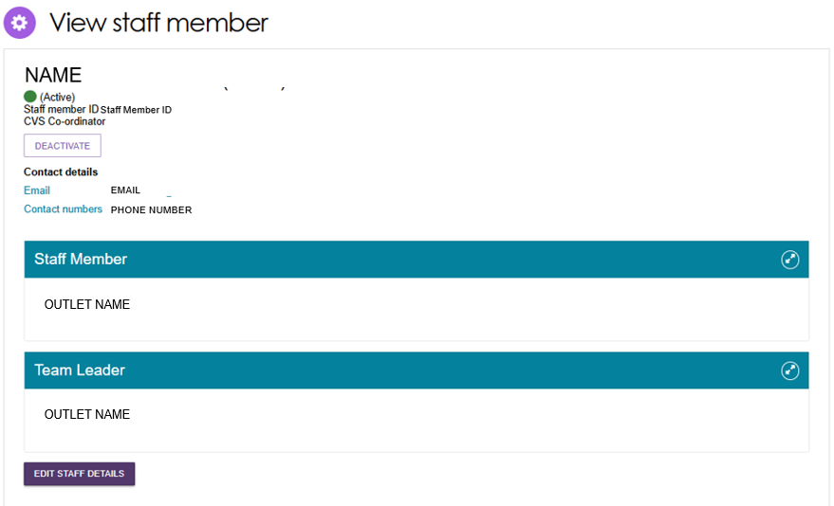
- Update the staff member's details and select Save.
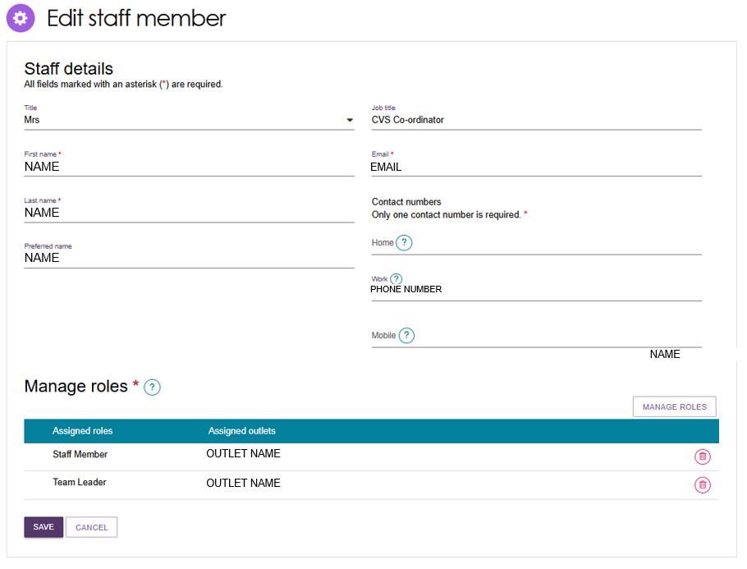

Deactivating staff accounts
Deactivating a staff account permanently locks the account and removes the staff member's access to the Service and Support Portal.
Follow these steps to deactivate a staff account:
- Select Staff Administration from the Portal homepage.
- From the Staff Administration page, select the name of the staff member on the Staff card that you want to deactivate.
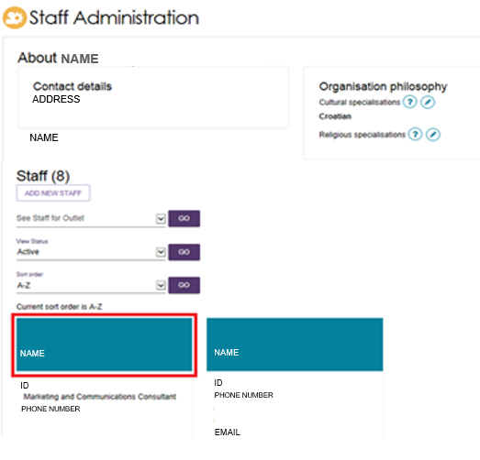
- On the View Staff Member page, select Deactivate.
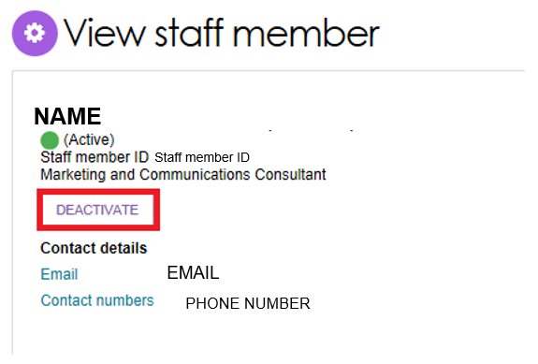
- Select Deactivate Account to confirm.
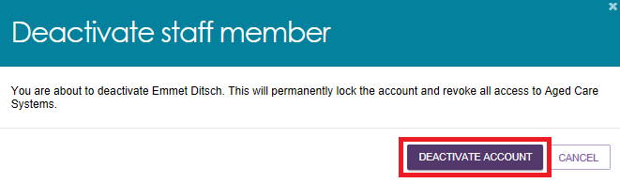
The staff account will be marked as Inactive in the Service and Support Portal.

Removing staff accounts
You can remove staff members who have already been deactivated. Once removed, they will no longer appear in the Service and Support Portal.
! | For information on removing a staff member’s authorisations in the Relationship Authorisation Manager (RAM), refer to Logging in to the Aged Care Systems | Australian Government Department of Health, Disability and Ageing.
Follow these steps to remove a staff account:
- Select Staff Administration from the Portal homepage.
- On the Staff Administration page, select Inactive from the View Status drop-down list to display inactive staff members.
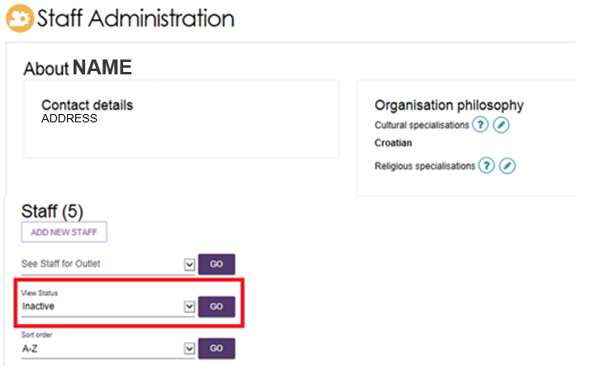
- Select the name of the staff member you want to remove.
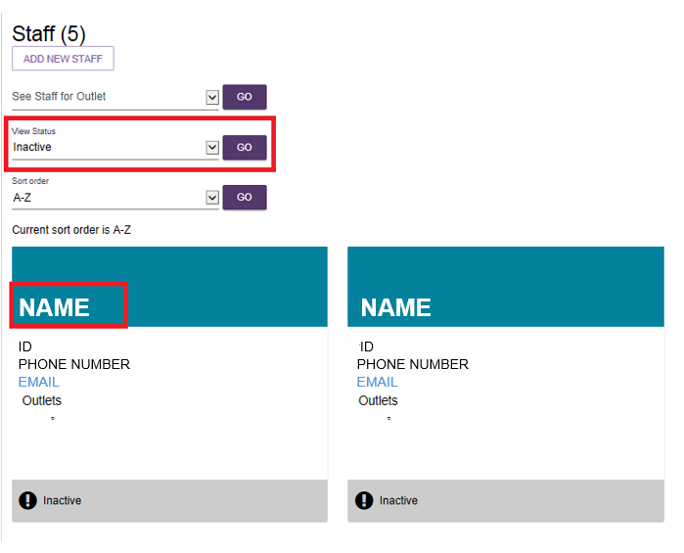
- On the View Staff Member page, select Remove.
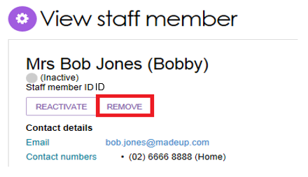
- Select Remove again to confirm.
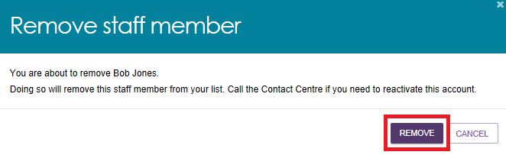

Generating reports and accessing forms
You can use the Service and Support Portal to generate reports, view reports and access forms. You can also print documents using the Reports feature.

Generating reports
Administrators, Team Leaders and Staff Members can generate reports.
Follow these steps to generate a report:
- Select Reports and Documents from the homepage.
The Reports and Forms page opens. This page contains two tabs:
- Reports
- Forms
The Reports tab shows:
- recently requested reports
- available reports.
The Recently Requested Reports section displays client record PDFs that you have generated.
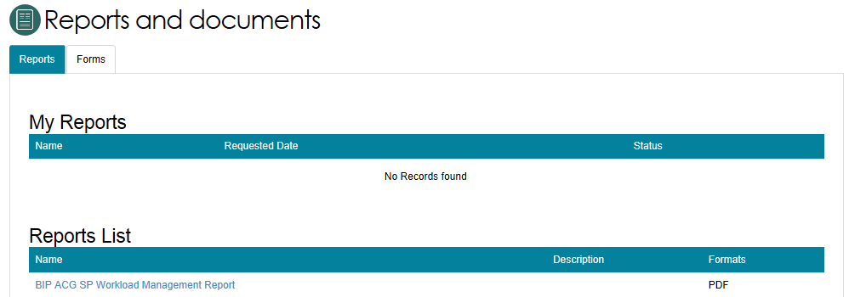
- Select the report you want to generate from the Reports list.
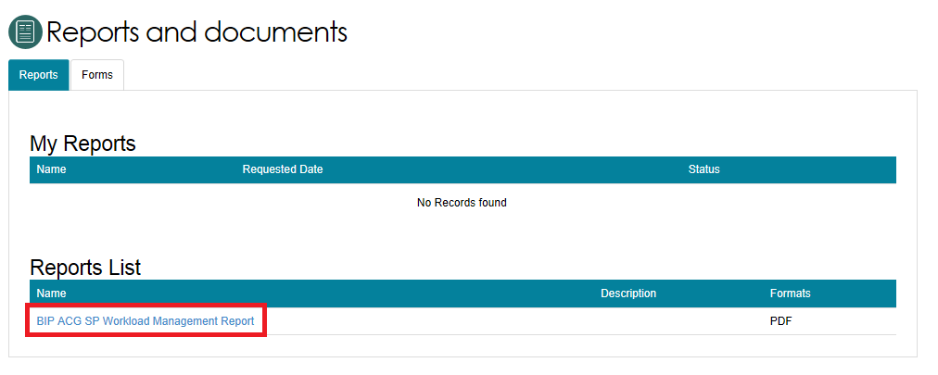

- Select an Outlet ID, enter a start date and end date, and choose an output format (CSV or PDF).
- Select Request Report.
- If you do not want to generate the report, select Cancel.
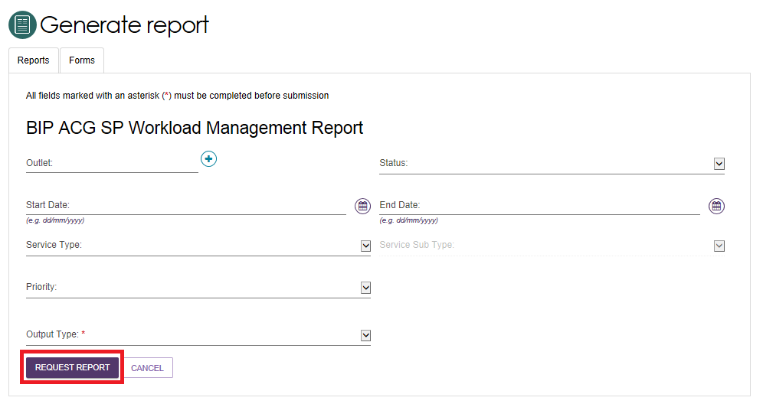

Viewing reports
Follow these steps to view a report:
  - Select Reports and Documents from the Portal homepage.
  - On the Reports and Forms page, find the report in the Recently Requested Reports list.
  - Select View next to the report.
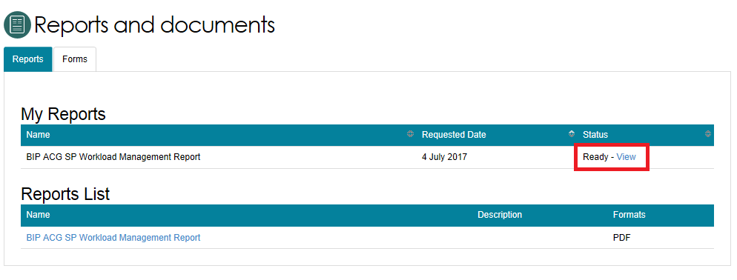
  - Choose one of the following actions:
- Open to view the report
- Save to download the report
- Cancel to close the action window.
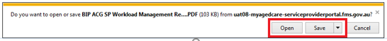

Accessing forms
Follow these steps to access forms:
  - Select Reports and Documents from the Portal homepage.
  - Select the Forms tab.
  - View and access the available forms from the list displayed.
