Service and Support Portal User Guide - Creating service delivery outlets and adding service information
This guide is for administrators who use the My Aged Care Service and Support Portal. It explains how to create, update, and maintain information about service delivery outlets.
The My Aged Care website and the Find a Provider tool display information about each provider’s aged care services. Keeping service delivery information accurate helps older people and their support network find suitable services. It also enables My Aged Care Contact Centre staff and assessors to refer clients to the right services.
Notes 2
Viewing outlets 2
Creating or adding a new outlet 3
Editing the organisation philosophy 8
Specialisation verification 10
Adding service items to an outlet 12
Adding and removing service sub-types 17
Activating or deactivating a service item 19
Adding and editing service attributes 21
Specialisations 24
Verified Specialisations 24
Specialised Services 25
Languages 25
Hours of operation (non-Support at Home) 26
Delivery Hours (Support at Home) 27
Staffing notes 28
Service specific delivery details 28
Pricing information (Support at Home) 29
Maintaining service and waitlist availability 41
Editing a service delivery area 42
Adding a room type to a residential facility 47
Activating an outlet 49
Deactivating an outlet 50
Removing an outlet from the Service and Support Portal 51
For more information or support 52

Notes
- Providers must keep their service information up to date so My Aged Care can send referrals to the appropriate service.
- Only Organisation Administrators can create outlets in the Service and Support Portal. Once an outlet has been created, staff can be assigned to it and service delivery information can be added.
- Only Organisation Administrators and Outlet Administrators can add or update service information.
- An outlet is the entry point for clients to access services and may be linked to a physical location. Although an outlet often represents a service location, its main purpose is to manage client intake and service delivery. Your organisation must create at least one outlet in the Portal to add and maintain service information. To display your services in the service finders, you must have an active outlet and at least one operational service item with a configured delivery area or service location.
- Residential Care and Support at Home providers must maintain pricing information.
- For information about transferring services between outlets or moving clients between services, refer to the My Aged Care Service and Support Portal user guide – Advanced outlet and service management – Transferring clients and services.

Viewing outlets
! | Team leaders and Staff members do not have access to the Outlet Administration tile. Only users with the appropriate administrator role can view and manage outlets.
To view your organisation’s outlets:
- Select Outlet administration from the home page.
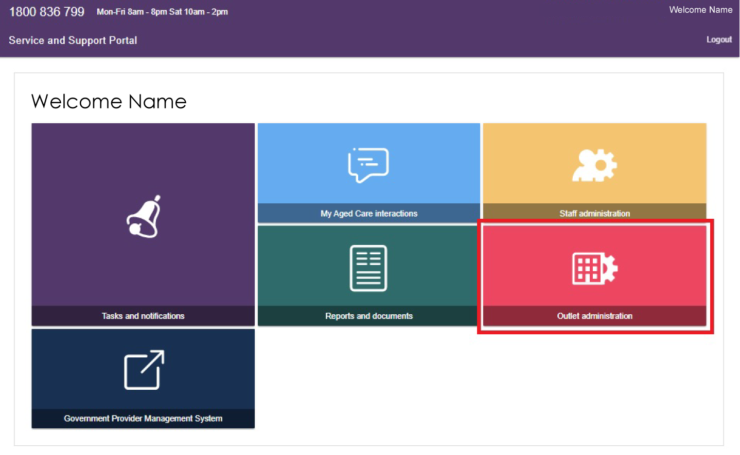
- The Outlet Administration page displays all outlets for your organisation.
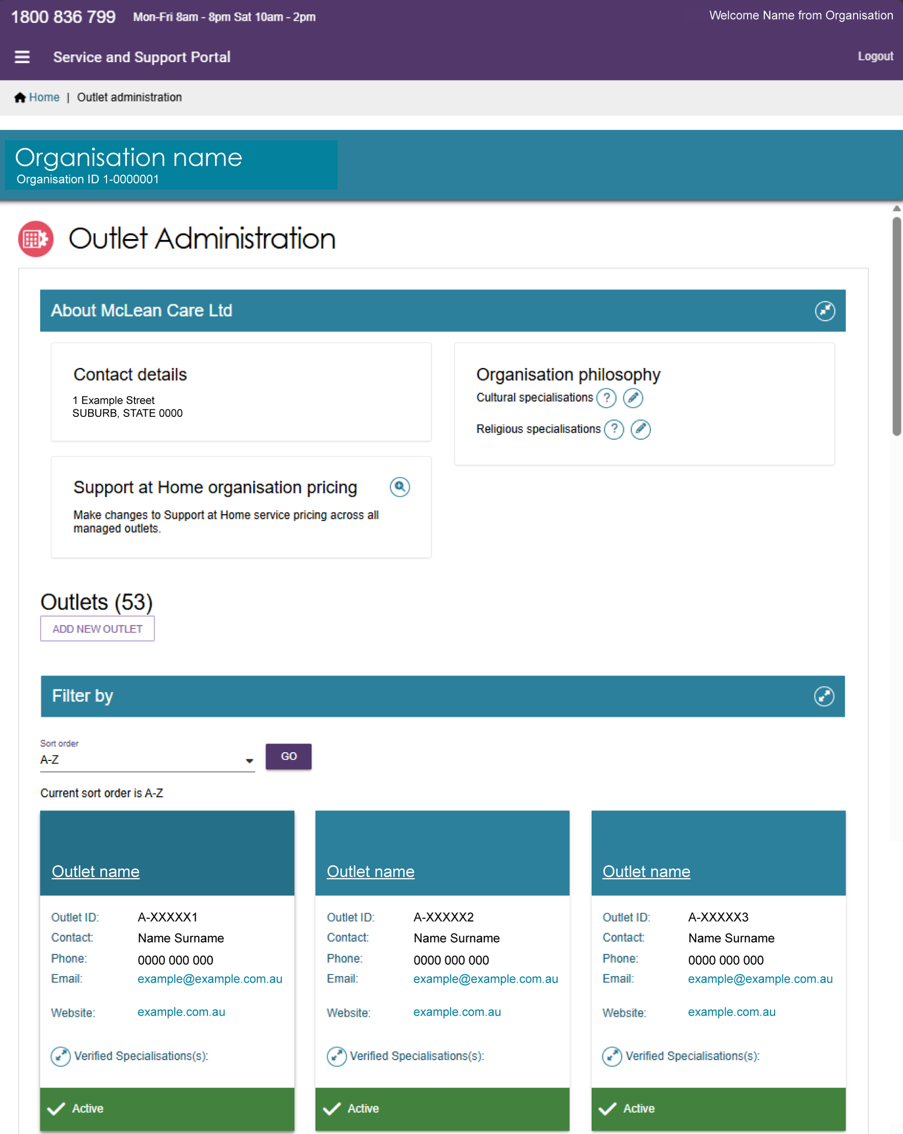

Creating or adding a new outlet
Administrators must create outlets in the Service and Support Portal before they can add service information.
When you create an outlet, the Portal automatically sets its status to Inactive. Before the outlet can become operational, you must activate it and create at least one service item. This guide explains how to activate an outlet later.
Follow these steps to create an outlet:
- Select Outlet administration from the home page.
- On the Outlet Administration page, select ADD NEW OUTLET.
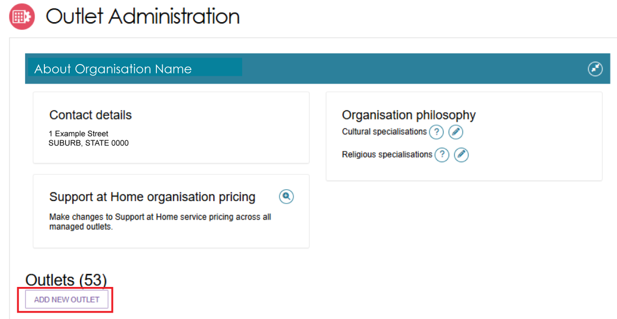
- Enter the outlet details.
To add an outlet address, select ADD OUTLET ADDRESS.
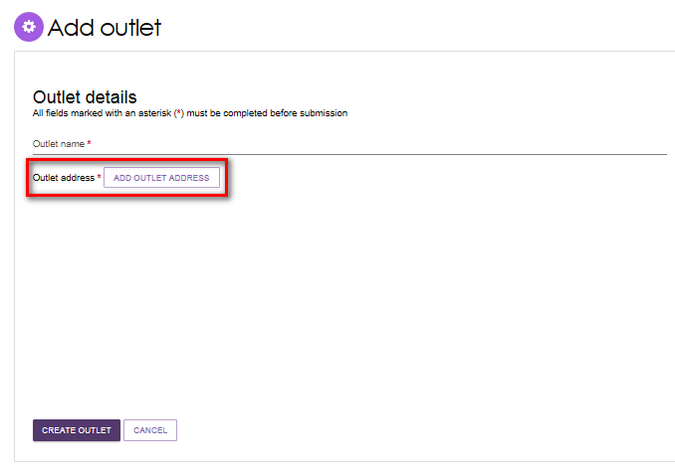
- Enter the address details and select VALIDATE THIS ADDRESS.
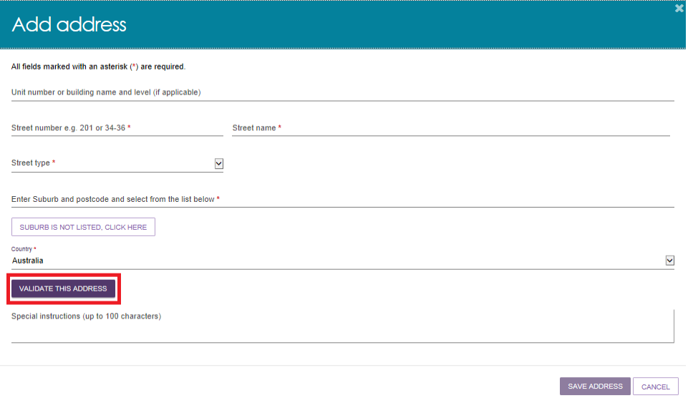
- Check that the address is correct, then select SAVE ADDRESS.
If the address is correct but does not appear in the search results, select Not found, use entered address anyway.
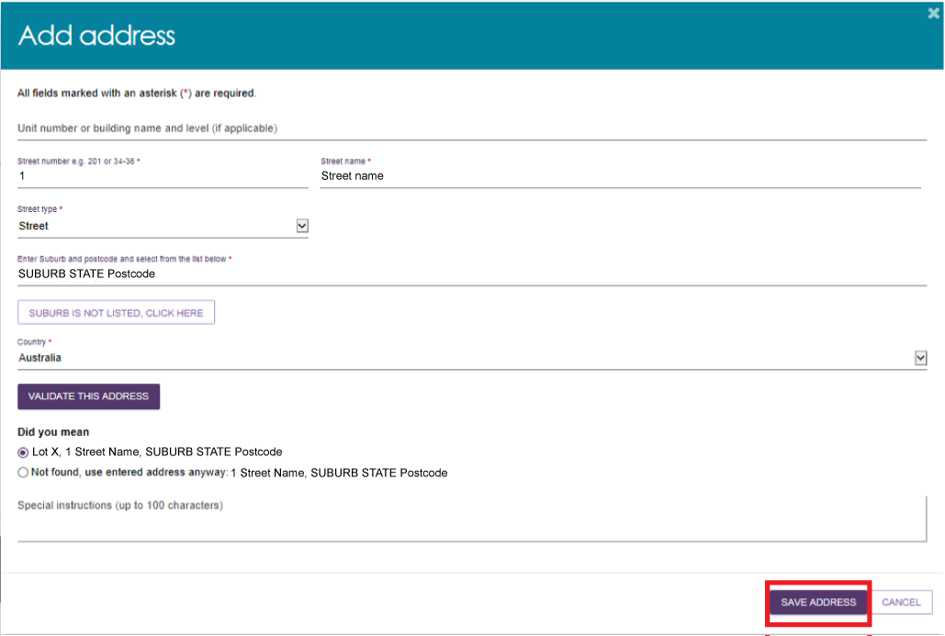
- Complete the remaining fields. Select CREATE OUTLET to save the record and create the outlet.
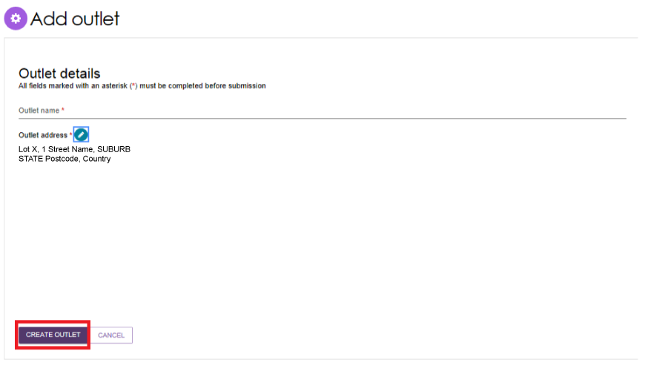
- The outlet is now created and the address and contact details are saved.
The outlet remains Inactive until you add at least one service item and set the service item status to Operational or Offline. Once this is done, you can change the outlet status to Active.
You can now add or update information on the outlet record, including:
- Organisational philosophy
- Support at Home pricing information (if applicable).
Any current verified specialisations appear in the Current Specialisation Verification section. For more information about applying for and managing specialisations, refer to the Specialisation Verification section of this guide.
Repeat these steps for any additional outlets your organisation needs.
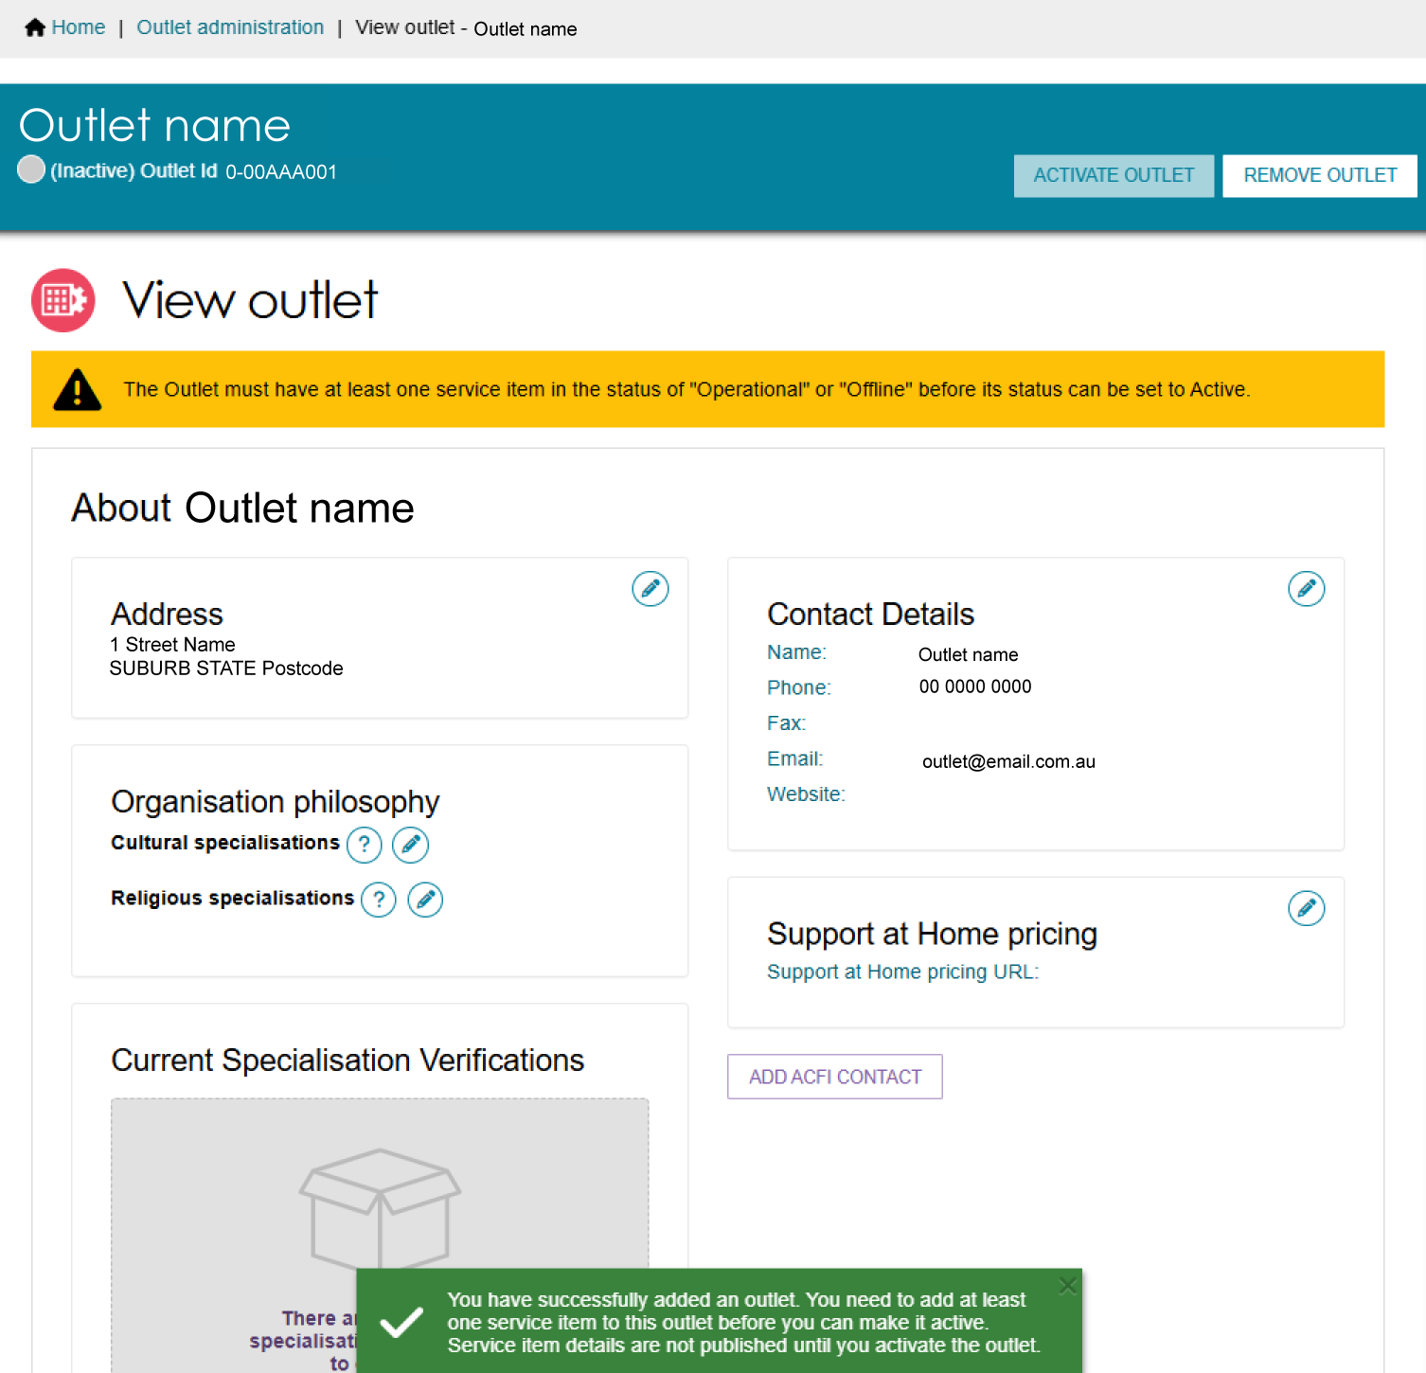

Editing the organisation philosophy
- Add or edit cultural specialisations:
Select the Edit icon next to Cultural specialisations to select those groups that you have a focus on providing culturally specific care to.
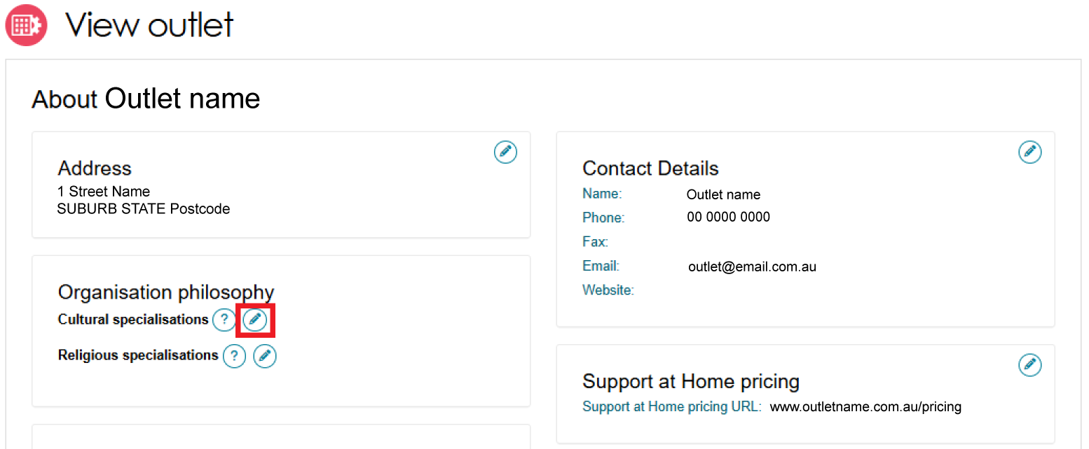
Select all supported cultures for your outlet. You can also select a letter from the Alphabetical listing to go to cultures starting with that letter. Select SAVE when finished.
Cultural Specialisations are self-nominated by the provider and will automatically apply to all service items of the outlet. This specialisation is not published on the My Aged Care Website but will be available in the internal service finder tool.
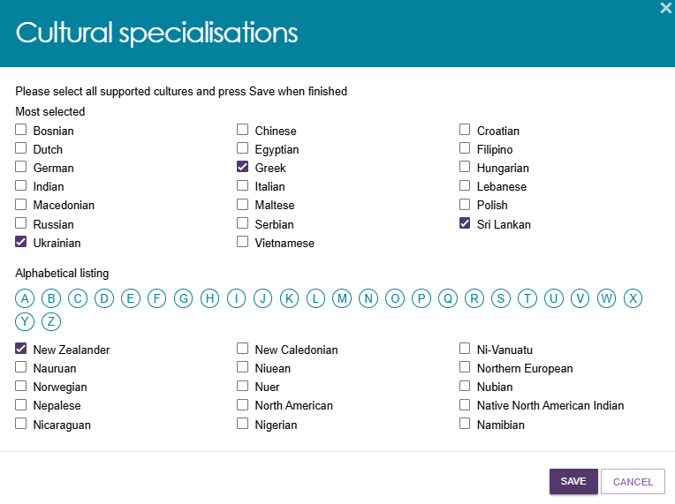
- Add or edit religious specialisations:
Select the Edit icon next to Religious specialisations to indicate if you have a focus on delivering care that aligns with particular religious needs or values.
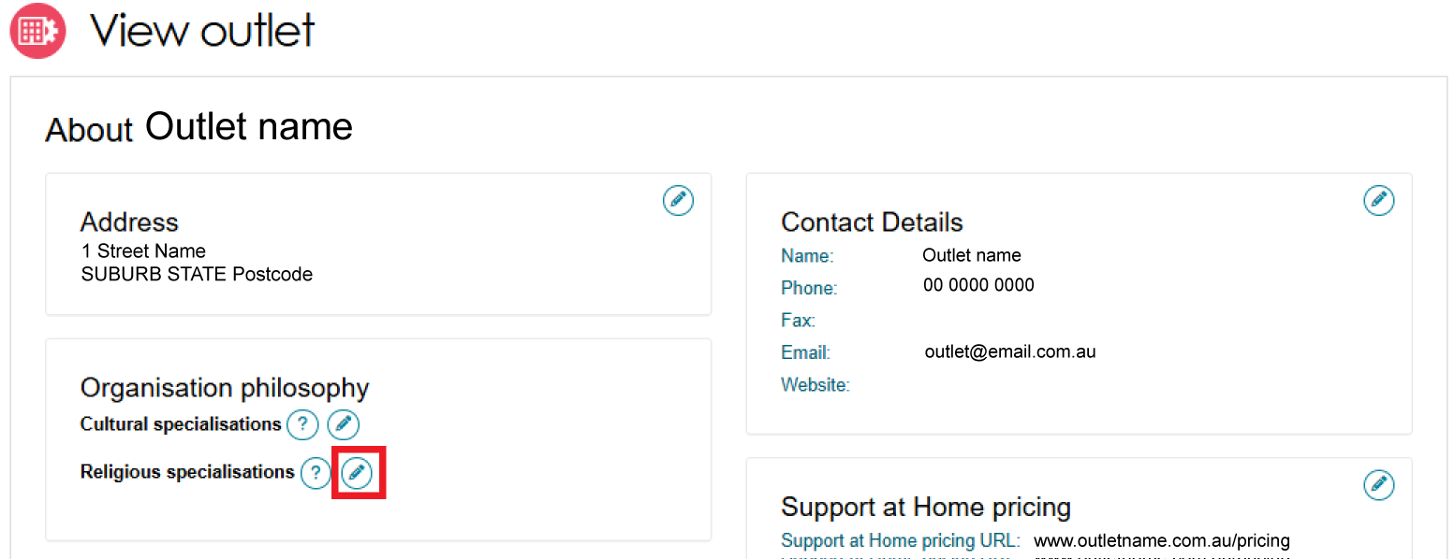
Select all supported religions for your outlet. You can also select a letter from the Alphabetical listing to go to religions starting with that letter. Select SAVE when finished.
Religious specialisations are automatically applied to all service items offered within your outlet. They are also published on the My Aged Care Find a Provider website.
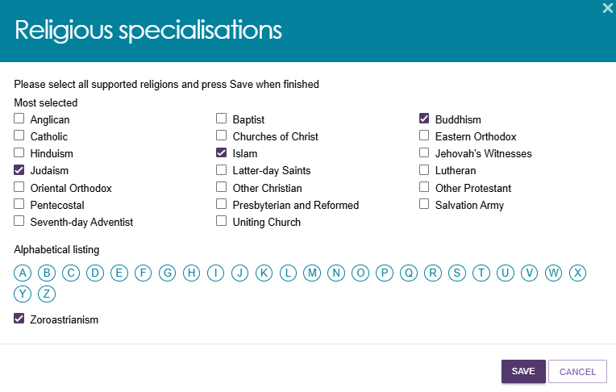
- Your selections will appear in the View Outlet page and displayed in alphabetical order.
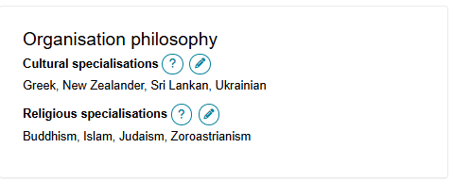

Specialisation verification
All aged care service providers must deliver inclusive services that meet each person's individual needs, regardless of where they live, their background, or their life experiences.
Some providers choose to offer specialised aged care services tailored to the needs of specific groups or communities. Through Specialisation Verification, providers can formally demonstrate their expertise in supporting these groups.
While all providers must meet the Aged Care Quality Standards, Specialisation Verification is optional. It allows providers to show they have additional expertise in delivering specialised aged care services.
To become verified, a provider must show that their service outlet meets the requirements of the 2025 Specialisation Verification Framework for a specific specialisation group or community. Providers do this by submitting evidence to support their application.
A service outlet can be verified in any of the nine specialisation areas:
- Aboriginal and Torres Strait Islander persons, including the Stolen Generations
- Veterans or war widows
- People from culturally, ethnically, and linguistically diverse (CALD) backgrounds
- People who are financially or socially disadvantaged
- People who are experiencing homelessness or at risk of experiencing homelessness
- Parents and children who are separated by forced adoption or removal
- Care leavers, including Forgotten Australians and former child migrants placed in out of home care
- Lesbian, gay, bisexual, trans/transgender or intersex or have other sexual orientations or are gender diverse or bodily diverse
- People who live in rural, remote, or very remote areas.
Outlets with current verified specialisations appear in Service Finder and Match and Refer. This helps assessors and My Aged Care contact centre staff find services that meet an older person's specific needs.
Current verified specialisations also appear in the Find a Provider tool on the My Aged Care website. This helps older people and their support network find, compare and choose suitable aged care services.
A Specialisation Verification remains valid for three years from the date it is issued, unless it is removed or renewed earlier.
Verification is applied at the outlet level. Any service items linked to that outlet automatically inherit the verified specialisation.
When an outlet has one or more current verified specialisations, the View Outlet page displays the specialisation name, verification date and expiry date. The image below shows an outlet that does not have any current verified specialisations:
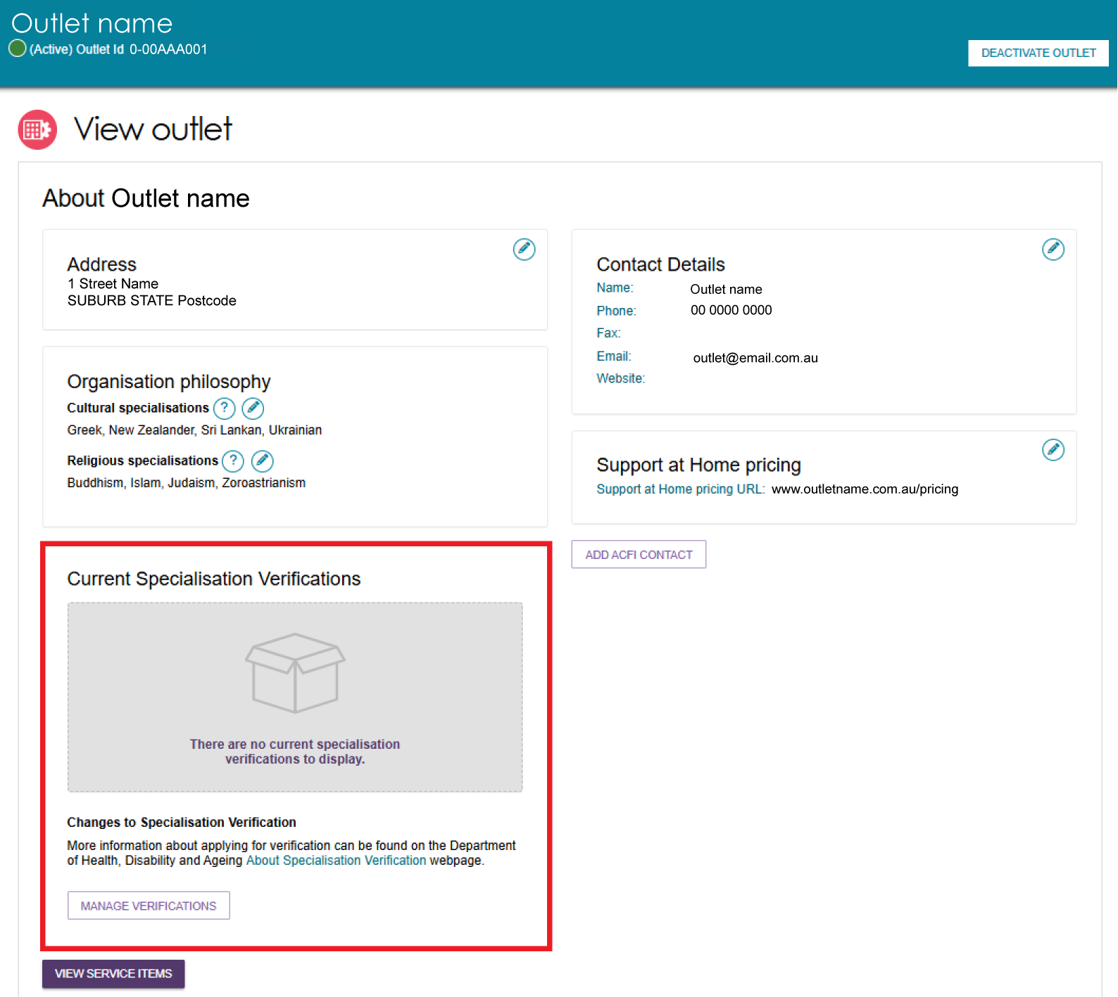
Providers may have current verified specialisations that were assessed under the 2022 Specialisation Verification Framework. These specialisations will continue to appear alongside any current verified specialisations assessed under the 2025 Specialisation Verification Framework. All displayed specialisations use a consistent naming convention regardless of the framework they were assessed under, shown below as the ‘Display Specialisation Name’:
2022 Specialisation Verification Framework – Specialisation Name | 2025 Specialisation Verification Framework – Specialisation Name | Displayed Specialisation Name
Aboriginal and Torres Strait Islander peoples and communities | Aboriginal and Torres Strait Islander persons, including Stolen Generations | Aboriginal and Torres Strait Islander persons, including Stolen Generations
Veterans | Veterans or war widows | Veterans or war widows
People from culturally and linguistically diverse (CALD) backgrounds | People from culturally, ethnically and linguistically diverse (CALD) backgrounds | People from culturally, ethnically and linguistically diverse (CALD) backgrounds
People who are financially or socially disadvantaged | People who are financially or socially disadvantaged | People who are financially or socially disadvantaged
People who are homeless or at risk of becoming homeless | People who are experiencing homelessness or at risk of experiencing homelessness | People who are experiencing homelessness or at risk of experiencing homelessness
Parents separated from children by forced adoption/removal | Parents and children who are separated by forced adoption or removal | Parents and children who are separated by forced adoption or removal
Care leavers | Care leavers, including Forgotten Australians and former child migrants placed in out of home care | Care leavers, including Forgotten Australians and former child migrants placed in out of home care
Lesbian, gay, bisexual, transgender and intersex (LGBTI) people | Lesbian, gay, bisexual, trans/transgender or intersex or other sexual orientations or are gender diverse or bodily diverse | Lesbian, gay, bisexual, trans/transgender or intersex or other sexual orientations or are gender diverse or bodily diverse
People who live in rural or remote areas | People who live in rural, remote or very remote areas | People who live in rural, remote or very remote areas
! | From 1 November 2025, all new Specialisation Verification applications are assessed under the 2025 Specialisation Verification Framework.
To view the current verified specialisations for a service item, refer to the Verified Specialisations section of Adding and editing service attributes.
For information about how to:
- apply for Specialisation Verification
- manage a Specialisation Verification application
- view successful, unsuccessful, current, or expired applications for an outlet.
refer to the Specialisation Verification section in the My Aged Care – Service and Support Portal user guide – Part 1: Administrator functions.
For more information about eligibility and evidence requirements visit the Specialisation Verification for aged care services website page.

! | From 1 November 2025, the Service and Support Portal assesses all new Specialisation Verification applications under the 2025 Specialisation Verification Framework.  When you transfer a service item to another outlet, the Portal removes any verified specialisations inherited from the original outlet. The transferred service item then automatically inherits any current verified specialisations assigned to the new outlet.

Adding service items to an outlet
- On the Outlet Administration page, select the name of the outlet where you want to add a service item.
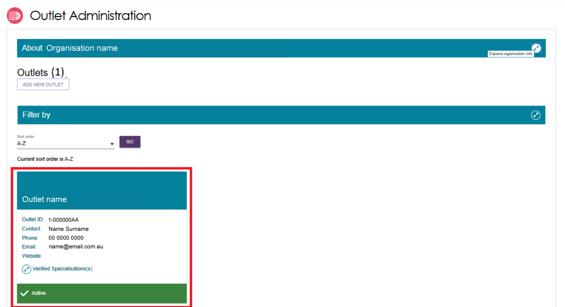
- On the View Outlet page, select VIEW SERVICE ITEMS.
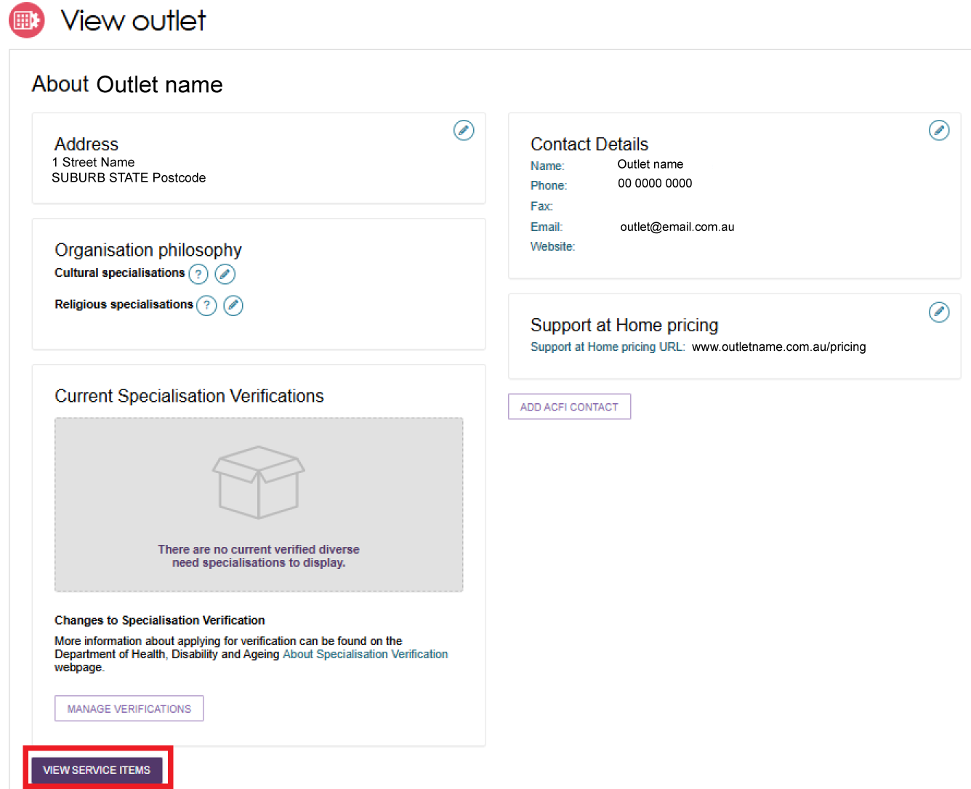
- On the View Service Items page, select the relevant Program tab. The page will display the existing service items for that program. By default, the list is filtered by the selected criteria (for example, Operational or Offline status), but you can apply other filters as needed.
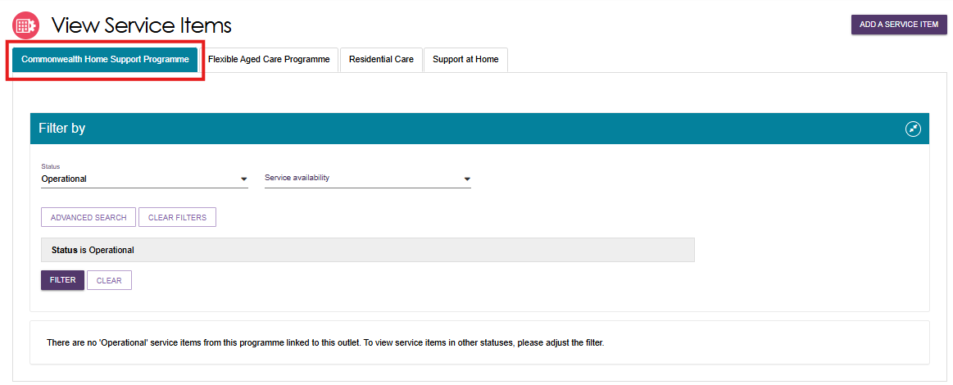
- Select ADD A SERVICE ITEM.
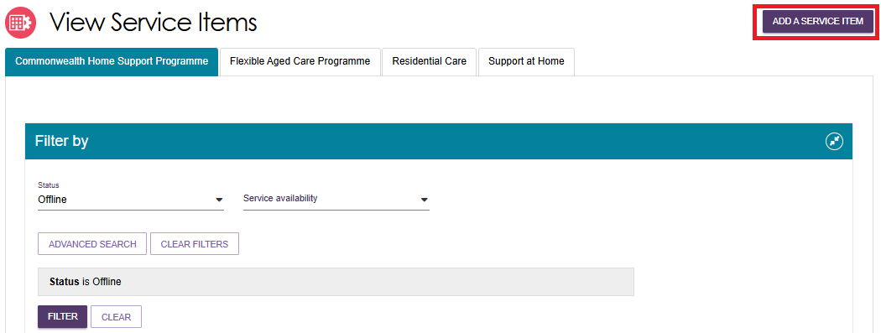
- Select the program for the service you want to add.
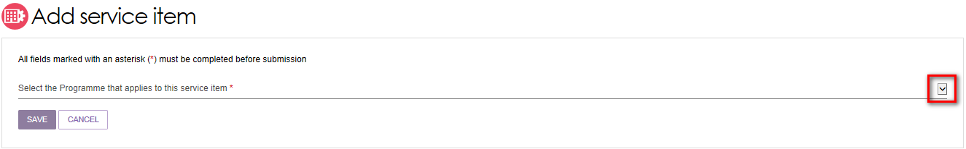
The funding type automatically displays as Funded. You cannot change this setting because all Commonwealth aged care program services must be approved and funded by the Australian Government.
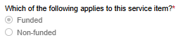
- Select the service item you want to add to the outlet, then select SAVE. To narrow the list of available service items, enter search criteria and use the FILTER function.
If you are adding a new Support at Home service item, you must enter a unique name in the Service Item Name field.

Non-Support At Home service item example
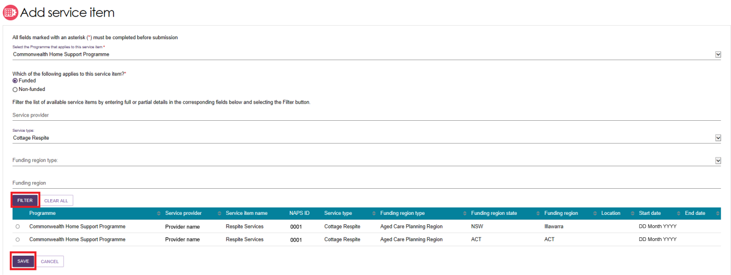
Support At Home service item example
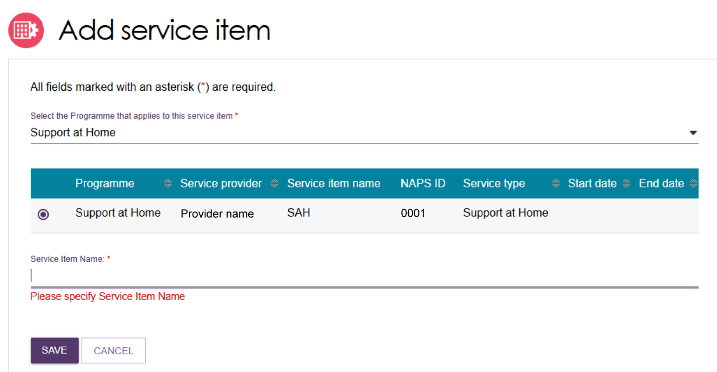
- The new service item now appears in the outlet's service list. The Portal sets the service item status to Offline by default. Before the service can appear in the public service finder, you must change its status to Operational.
The Portal displays a confirmation banner to show that the service item was added successfully and reminds you to edit and submit the service details.
If you add a new Support at Home service item, the Portal also reminds you to provide Support at Home pricing information by adding either a website URL or an attachment.
This guide explains how to activate a service item later.
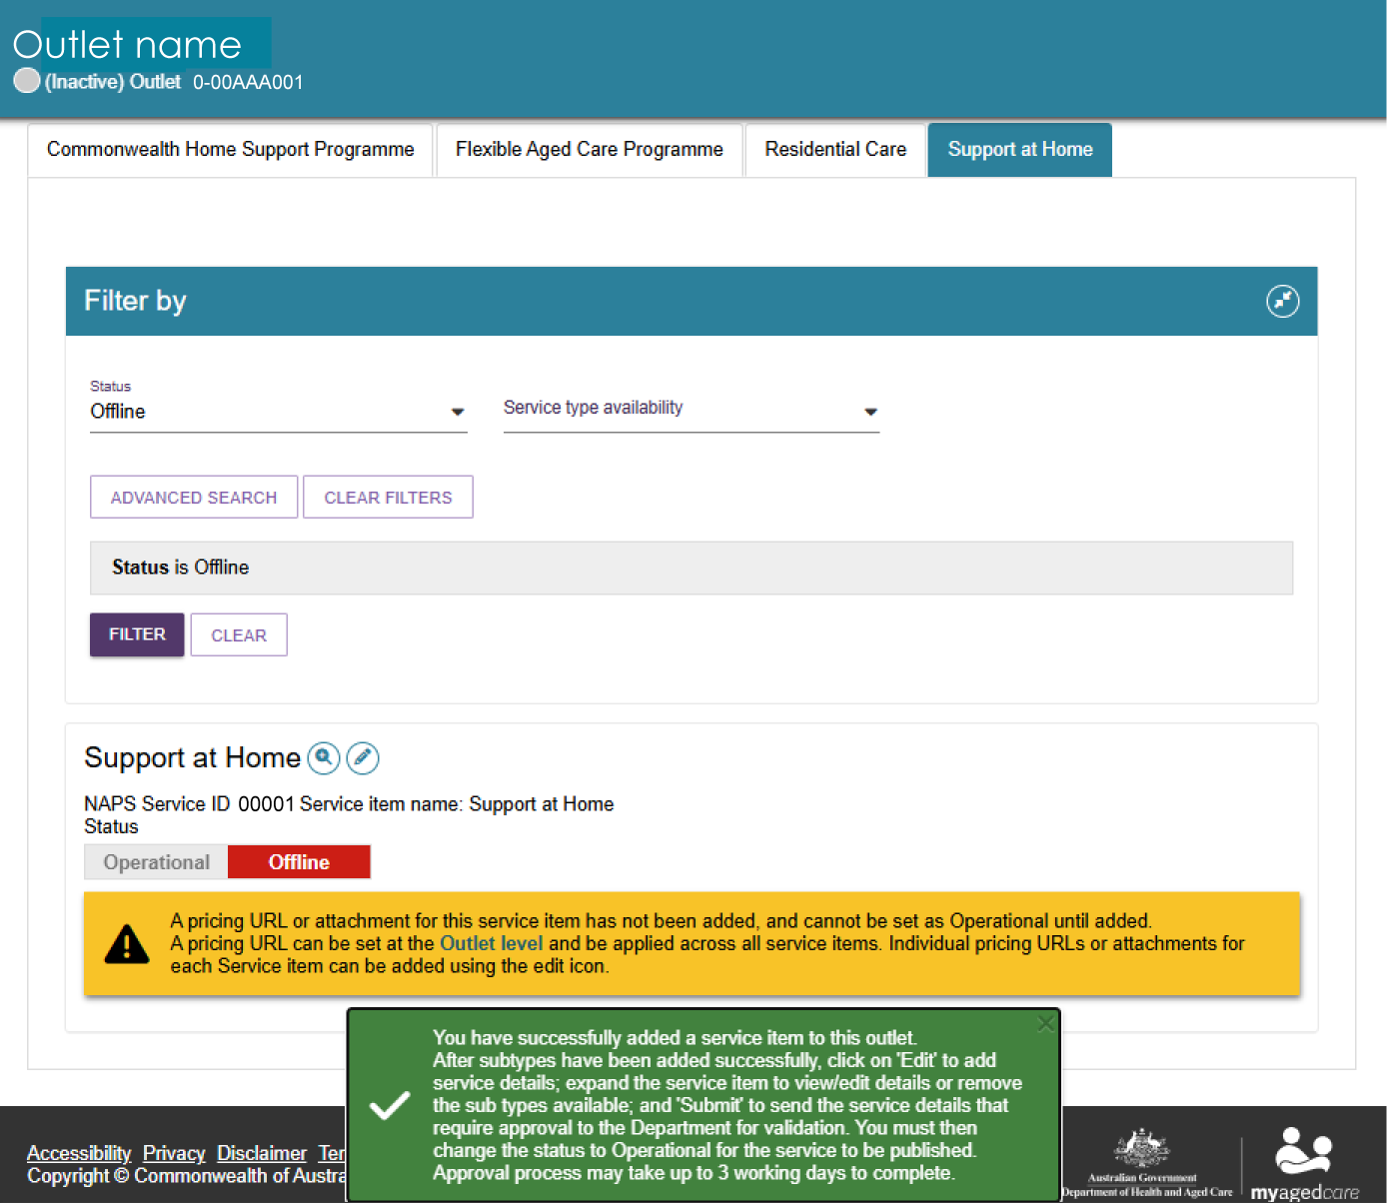
- After you add service items to an outlet, you can filter the service list by status, service availability, and waitlist availability within each program.
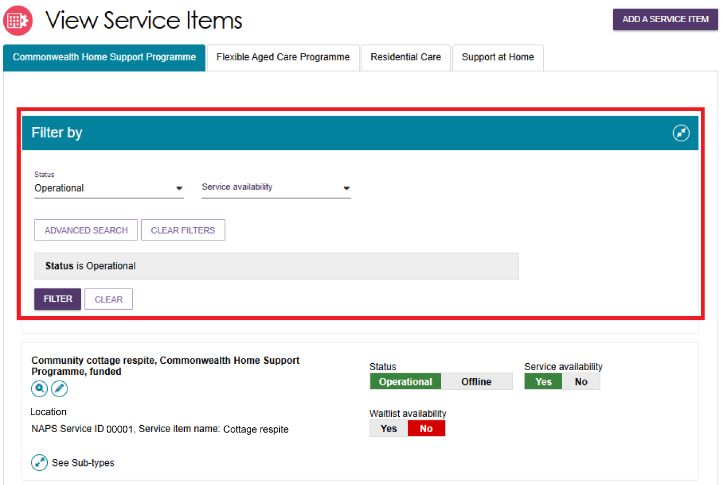

Adding and removing service sub-types
For the Commonwealth Home Support Programme (CHSP), you can add or remove service sub-types from a single screen.
! | This function does not apply to Support at Home services. Eligible outlets automatically receive all approved services based on their registration category.
Follow these steps to add or remove a service sub-type:
- On the Outlet Administration page, open the outlet where you want to manage service sub-types. Select VIEW SERVICE ITEMS.
- Select See Sub-types under the relevant service to expand the service details.
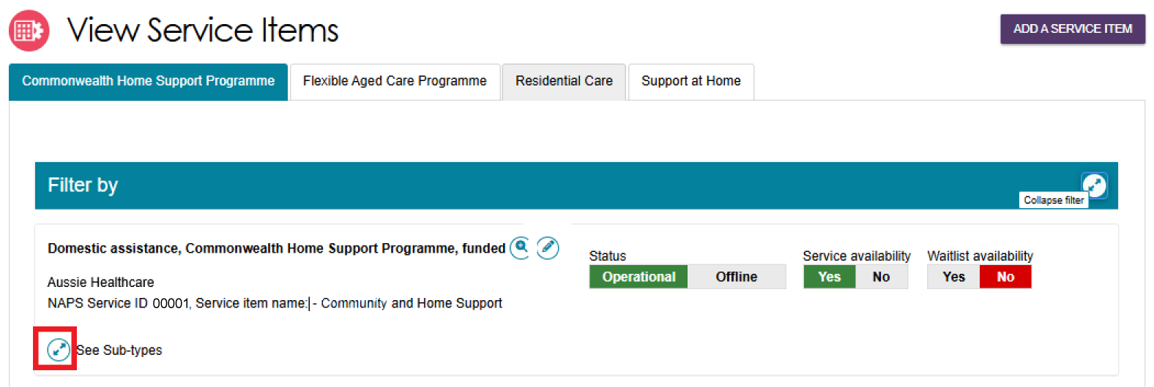
- Select ADD/REMOVE SUBTYPES.
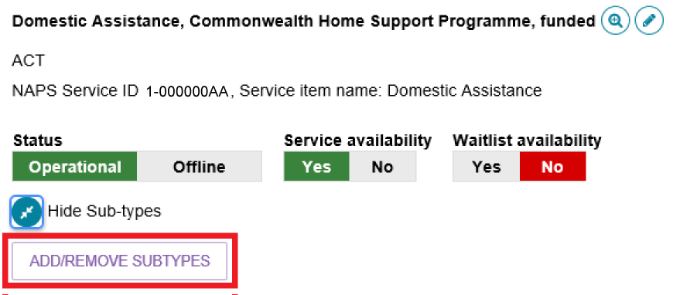
- Select or clear the required sub-types. Select SAVE to apply your changes.
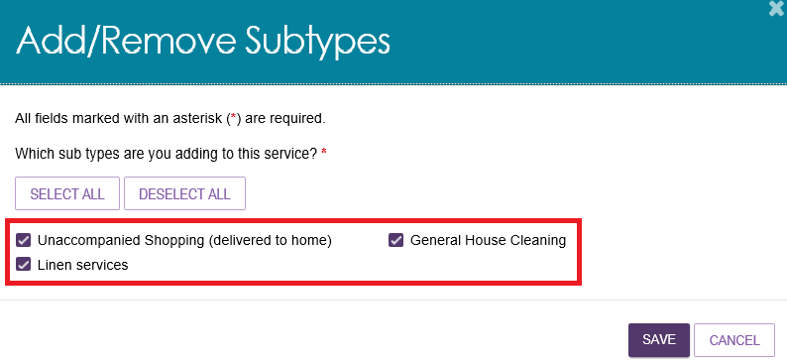
Activating or deactivating a service item
- On the Outlet Administration page, open the outlet that contains the service item you want to activate or deactivate. Select VIEW SERVICE ITEMS.
- Under the Status section, select Operational to activate the service item or Offline to deactivate it.
For non-Support at Home services, the status toggle appears on the right side of the screen next to the service name.
For Support at Home service items, the status toggle appears at the top of the service item listing. Changing the status applies to all service types and services within that service item.
Non-Support At Home Example
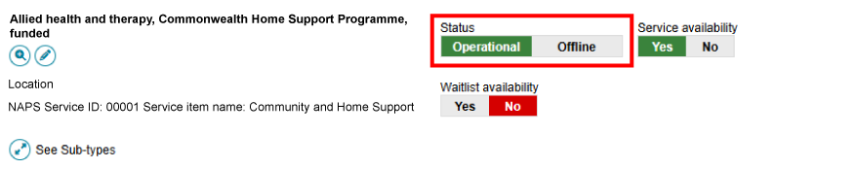
Support At Home Example
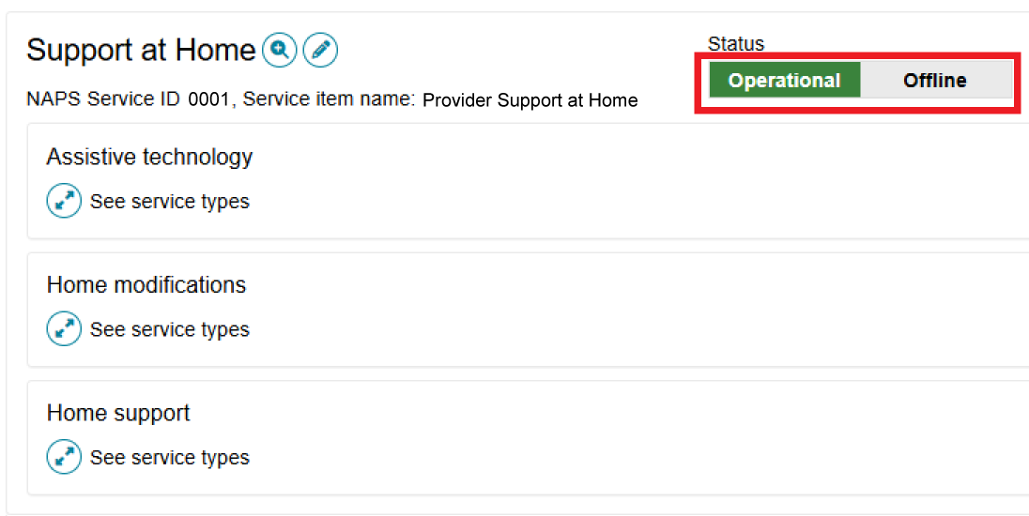
Only service items with a status of Operational appear in the service finders.
Use the Offline status when you are not currently offering a service in a delivery area or region. For example, you may set a service to Offline if it has reached capacity and cannot accept new clients.

Editing a service item
- You can update a service item by selecting the Edit (pencil) icon next to the service item or service group name.
Non-Support At Home example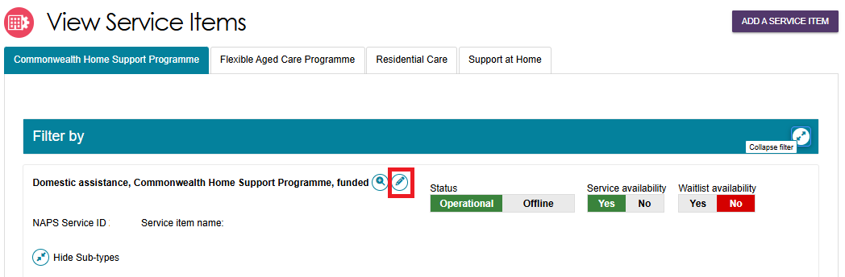
Support At Home example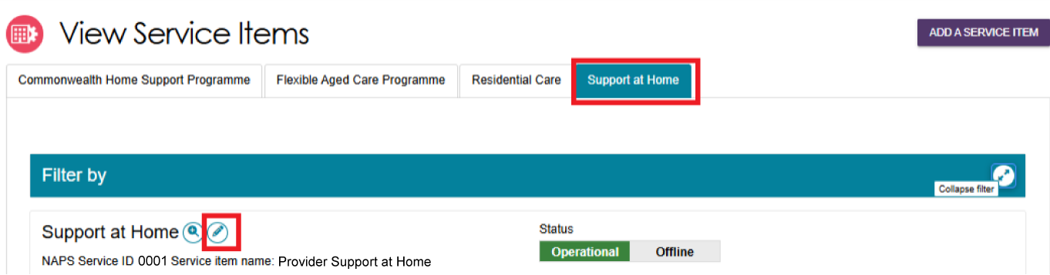
- The Service Item Details page displays. You can update information such as:
- Service item name
- Service delivery area
- Whether the service focuses on a specialised service area
- Promotional attachments (for residential facilities)
- Support at Home information, such as service-based pricing
- A detailed service description.
! | For details about organisation philosophies and specialisations, refer to Editing the Organisation Philosophy, Specialisations and Verified Specialisations sections.
Make the required changes and select SAVE.
Some information is read-only because it comes from contractual records and cannot be changed in the Service and Support Portal.
You can add additional information in the Service Description field. This description appears in the public service finder on the My Aged Care website and helps clients understand and choose your services.
! | The information available on a Service Details page differs between Support at Home and Commonwealth Home Support Programme (CHSP) services.  For Support at Home services, you manage services by delivery area. Within each delivery area, you can select multiple service types and services that your organisation provides.  For CHSP services, each service item is linked to a single service type and Aged Care Planning Region (ACPR) based on contractual information. You cannot change these contractual details in the Service and Support Portal.

Adding and editing service attributes
Service attributes for Support at Home, CHSP, Residential Care, and other aged care programs are available in the Service Details section (or Support at Home Details section) within the Outlet Administration tile.
Service Details page
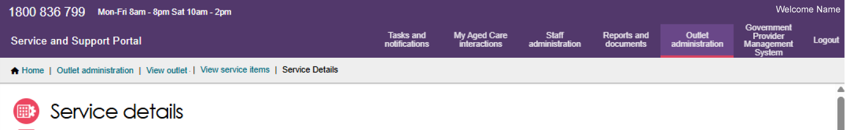
Support at Home Details page
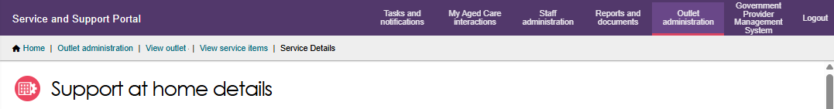
Attributes for individual services, also known as service sub-types, are managed within the relevant service record.
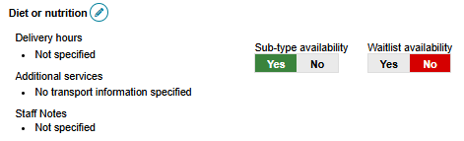
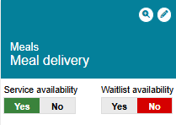
Some service attributes also appear on the View Outlet page.
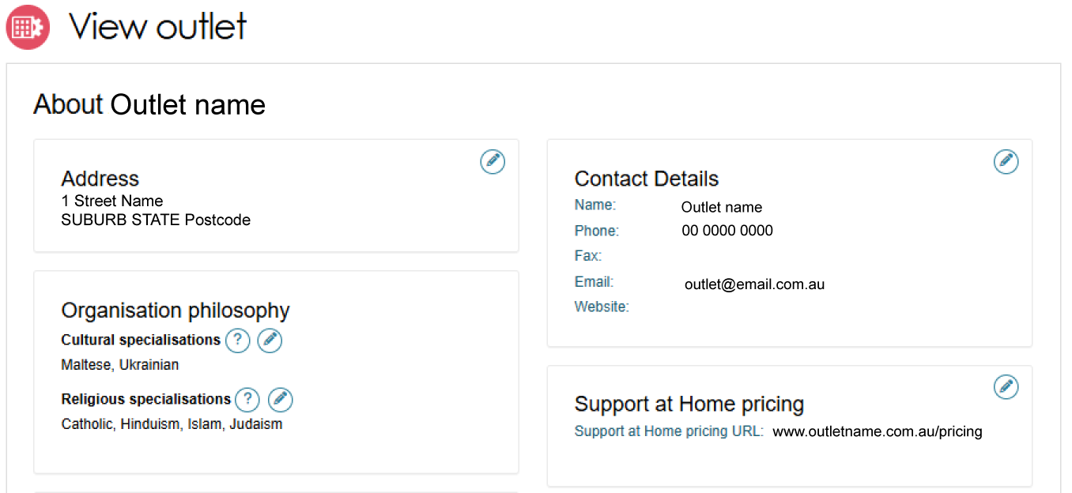
To access service attributes:
- Select Outlet Administration from the home page.
- Select the relevant outlet.
- Select VIEW SERVICE ITEMS.
- Select the appropriate program tab:
- CHSP
- Flexible Aged Care Programme
- Residential Care
- Support at Home.
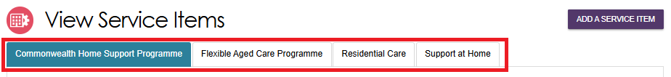
- The Service Details tab contains key information about the service, including:
- Contact details
- Service delivery information
- Service delivery area
- Specialisations
- Operating hours
- Pricing (where applicable)
- Service descriptions.
The Specialisations section includes three areas:
- Specialisation Verification
- Specialised Services
- Languages.
The following sections explain each of these attributes in more detail.

Specialisations
The Specialisation section includes Specialisation Verification, Specialised Services, and Languages.
For Support at Home services, you manage these attributes at the program level. For other programs, such as CHSP, you manage them at the service item level.
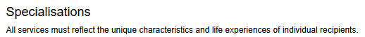
The outlet specialisations listed under Organisation Philosophy relate to cultural and religious characteristics. For more information, refer to Editing the Organisation Philosophy.

Specialisation Verification
The Specialisation Verification section displays two lists:
  - Verified: Displays all current specialisations verified for the outlet by the department under either the 2022 or 2025 Specialisation Verification Framework.
- Not Verified: Displays the specialisations that the provider can apply to have verified for the outlet.
You can only apply for, manage, or update Specialisation Verification at the outlet level. Changes are automatically applied to all Operational and Offline service items linked to that outlet, and the updated information displays in this section.
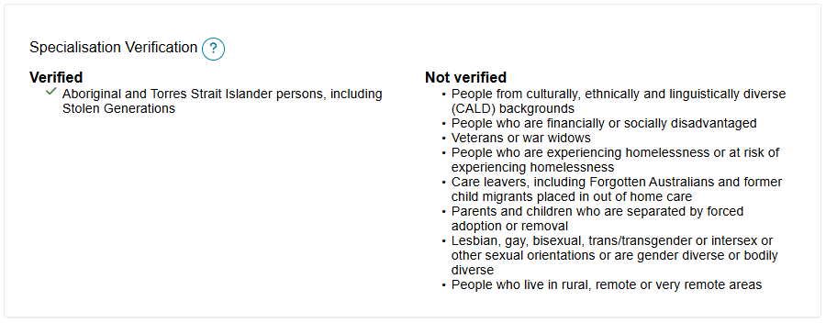

Specialised Services
You can indicate that a service item offers one or more Specialised Services.
Only select services where your organisation has specific practices, programs, or measures in place to support that specialised service offering.
Specialised Services are self-declared by the provider and are not verified by the department. They differ from the verified specialisations shown in the Specialisation Verification section.
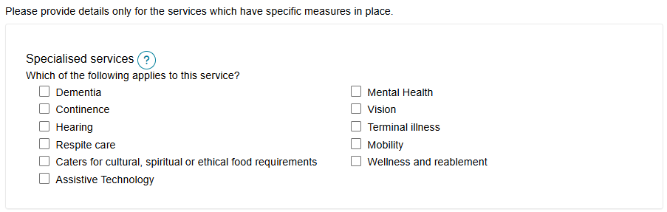

Languages
To show that your outlet service item caters for specific language requirements:
  - In the Languages section under Specialisations, select SELECT LANGUAGES AVAILABLE.
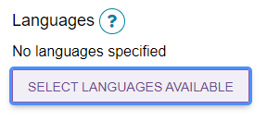
  - Select all supported languages for your outlet. To quickly find a language, select a letter from the alphabetical list to view languages that begin with that letter. Select SAVE when you have finished.
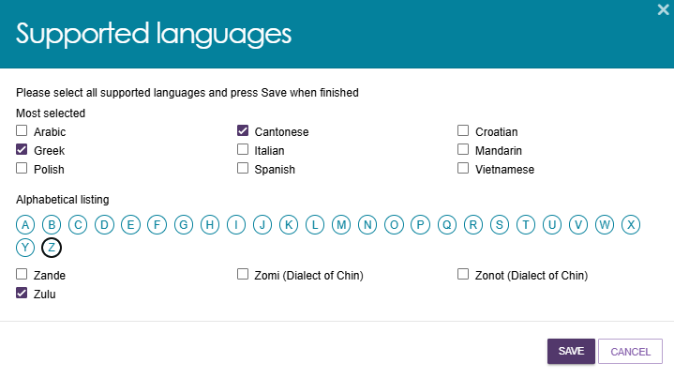
  - The selected languages appear in the List of Languages section. To update the languages, select the Edit (pencil) icon.
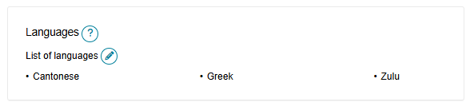

Hours of operation (non-Support at Home)
You can record hours of operation for CHSP and other non-Support at Home services. By default, you can enter operating hours for Monday to Friday, Saturday, and Sunday.
If your service operates on different hours each day, use the Customise option to enter hours for individual days.
To update hours of operation:
- Open the service item by following the steps in Editing a Service Item.
- Select the Edit (pencil) icon next to the relevant service sub-type.
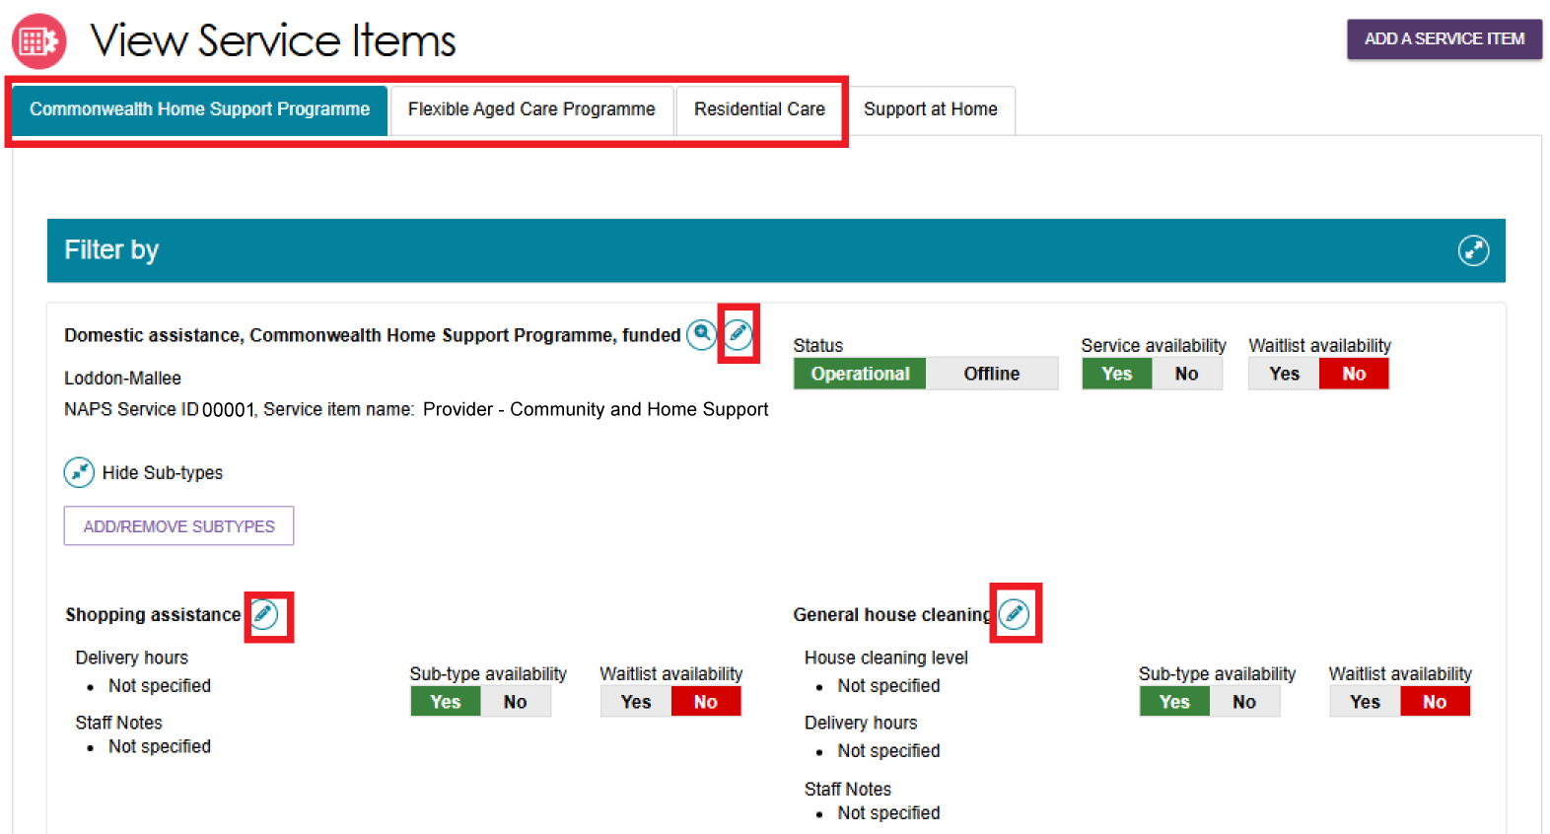
- Enter the start and end times for each applicable day and save your changes.
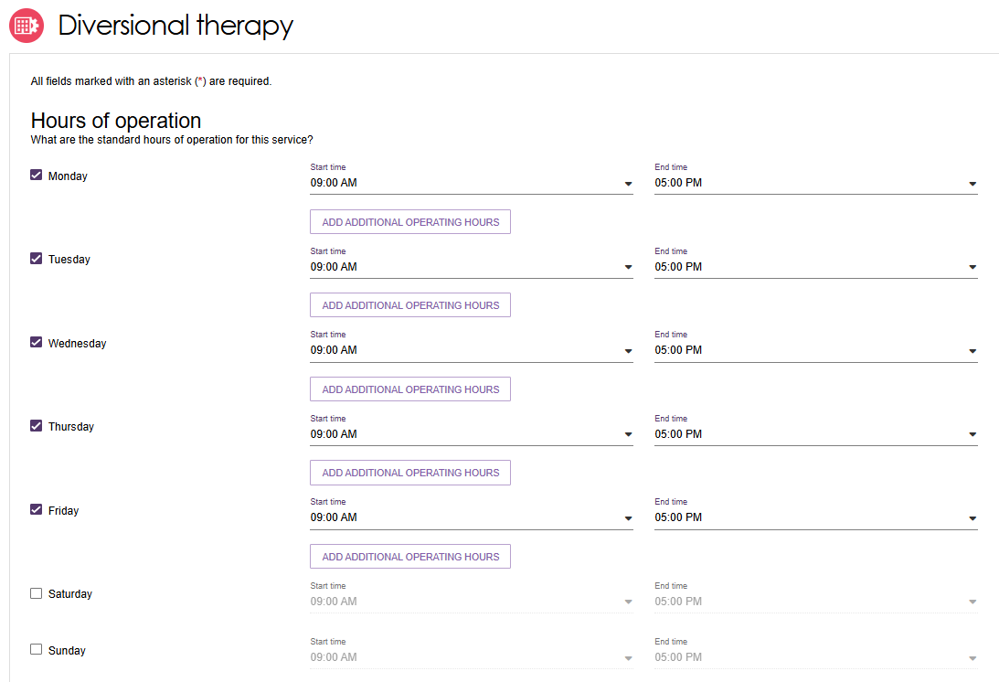

Delivery Hours (Support at Home)
Delivery Hours only apply to Support at Home services. They do not apply to other programs. For information about other programs, refer to Hours of Operation.
  - From the outlet page, select View Service Items, then select Support at Home.
Select the Edit (pencil) icon on the relevant service tile. In this example, you would open Nursing care from the Home Support service group.
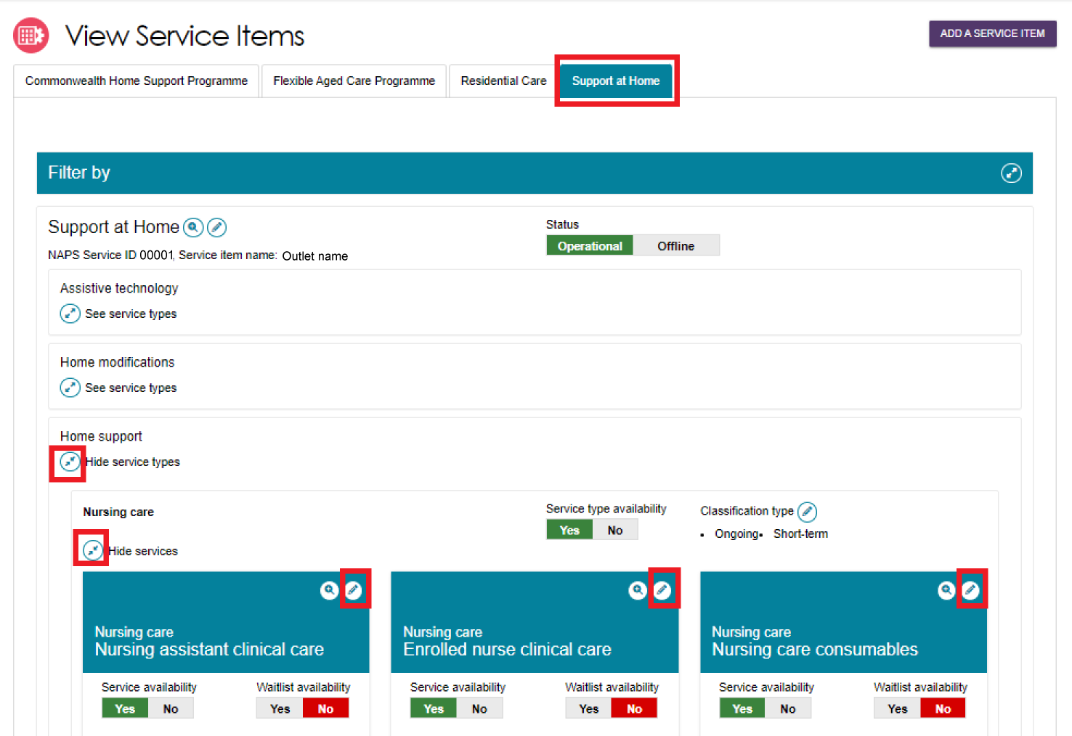
  - The Edit Service page opens. Review the standard delivery hours. These are selected by default and cannot be changed.
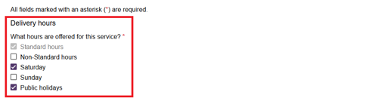
  - Select the checkboxes for the delivery hours your service provides.
When you select a delivery hours option, the corresponding Common Price field becomes active. Enter a price before you save the record.
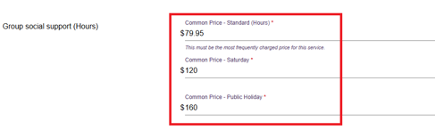
  - Select SAVE CHANGES at the bottom of the page.

Staffing notes
You can add staffing notes for each program. Use these notes to provide additional information about the staff who deliver the service. You can maintain separate notes for each program.
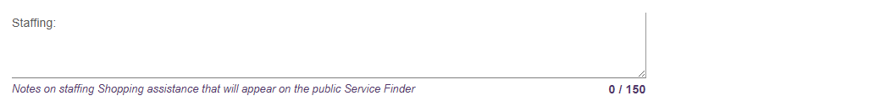

Service specific delivery details
Depending on the service, you can record additional delivery information on this page. This information helps assessors find providers that can deliver services that meet a client's needs.
The fields available depend on the service type, so some services may show only certain options.
Transport service specific example
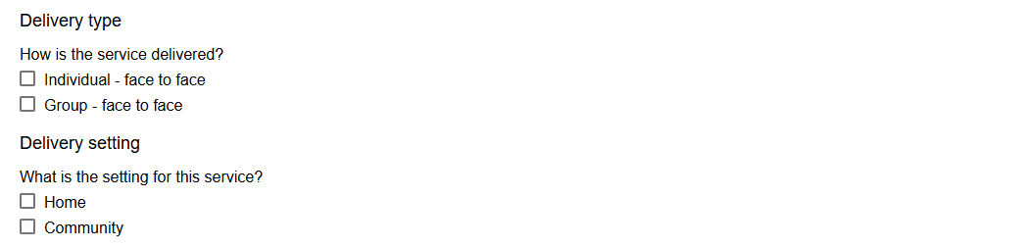
You can also enter a service description and add other relevant information about the service. The service description can contain up to 1,000 characters.
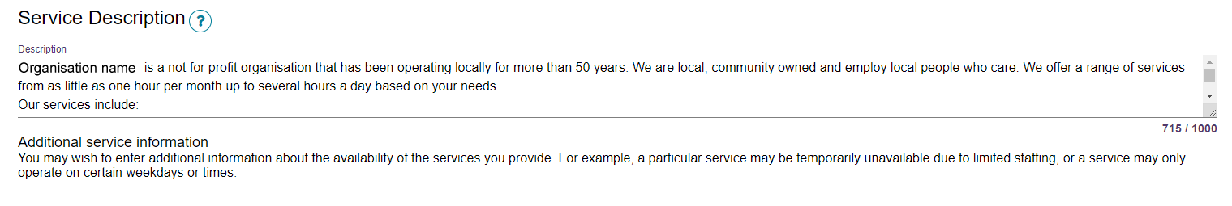

Pricing information (Support at Home)
The Support at Home service item lets you set up the services you deliver and their prices for a specific delivery area or region.
For information about room pricing in Residential Care refer to Adding a room type to a residential facility.
Support at Home outlets must:
- Enter service-level prices that correspond to the delivery hours for all available Support at Home services offered by the outlet.
- Add a pricing website link (URL). This is strongly recommended, as My Aged Care publishes this link to help older people and their support network find your pricing information.
If you do not enter pricing information for Support at Home services, you cannot:
- Save a new service and make it operational
- Add or save a pricing website link (URL)
- Save changes to partially completed pricing information
- Confirm that you have reviewed the pricing information.
If you do not confirm your pricing information, My Aged Care will not publish your pricing data or use it in tools such as the Fee Estimator.

Updating Support at Home Pricing Information at the Organisation Level
!  ! | This functionality is available to Organisation Administrators only.  Organisational level pricing can be applied to every outlet service item that delivers Support at Home services. It will override existing pricing changes at the outlet service level if they already exist. Ensure that your Outlet Administrator/s are aware of your Organisational level pricing changes before you apply pricing to all Outlets.
- Go to the Outlet Administration page by following the steps in Viewing Outlets.
- Select the View (magnifying glass) button to the right of the Support at Home Organisation Pricing section.
If your organisation do not offer or deliver Support at Home program services, you do not need to complete this.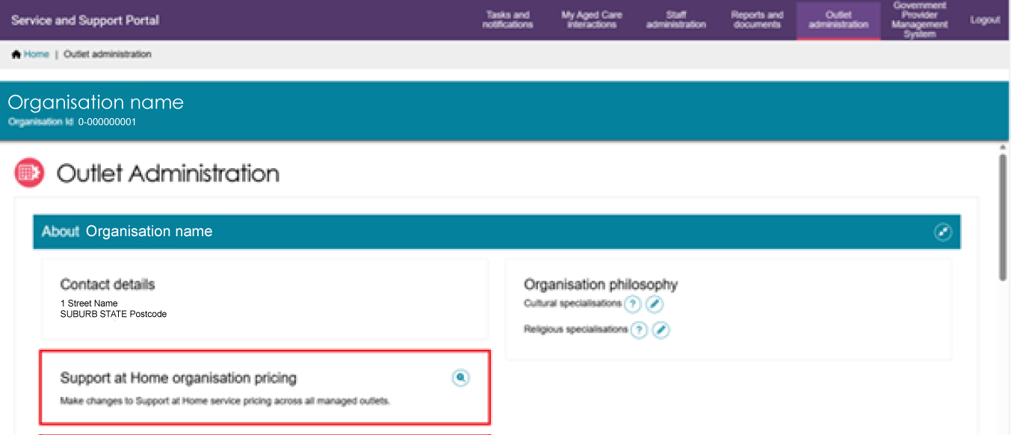
- A list of service groups and service types displays. This list will only show Service Groups and Service types associated with the your Organisation’s Registration Categories. Select the Edit (Pencil) button to the right of the service type/s that you would like to update.
The Last updated, Last updated to outlets, and Outlet update status columns are blank until you add pricing for services within the service type record.
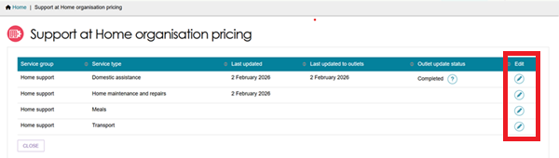
- For each service type that you selected Edit from the above step, the corresponding ‘Pricing for Service’ page appears.
All of your organisation’s available services within the service type and the common price fields for each delivery time period displays here. A domestic assistance page and a nursing care page example are shown below.
Domestic assistance pricing page example
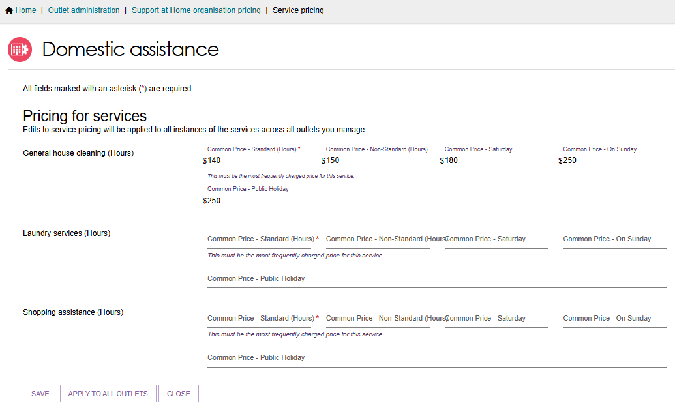
Nursing care pricing page example
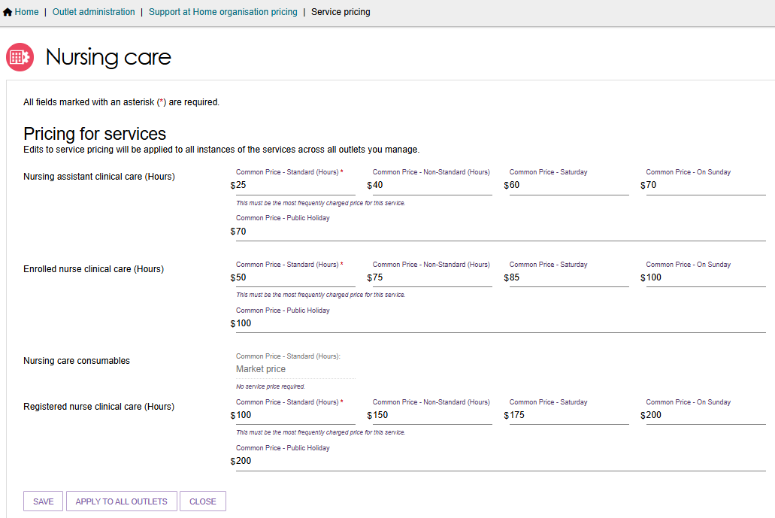
All mandatory fields (marked with a red asterisk) must be entered, for example ‘Common price – Standard (hours)’.
You must provide Common Price – Standard (Hours) for all Services that will be marked as available. You can enter a value from $0.00 to $999.99.
If you do not deliver a service within the service type, you can enter $0.00 if you need to enter a value in the mandatory field. You MUST then mark this service as not available on all the applicable Support at Home service items. For any service listed as ‘Market Price’ are you not required to enter a price value.
Select SAVE to save your progress and to be taken back to the Support at Home pricing page. This will only save the pricing on the Organisation level.
Select APPLY TO ALL OUTLETS to apply the pricing you have entered to all of the organisation’s outlets with a Support at Home service item. This is possible only after entering all mandatory Service pricing under a Service Type.
When applying pricing to all Outlets, only the prices will be copied down where that service delivery hours is selected. Standard hours are defaulted and will always be copied down.
For example, you enter all pricing at the organisation level. However, in some service items the additional service delivery hours selected is only Non-standard and Saturday, then only those prices will be copied to that service item.
Select CANCEL or CLOSE to go back to the Support at Home pricing page without any edits made or saved.
! | When applying organisational pricing to all outlets, the pricing will copy down to all Support at Home Service items, regardless of Operational or Offline status.
- When APPLY TO ALL OUTLETS is selected, an Information Banner appears: ‘We’re currently updating your selected pricing change across all outlets. This may take up to an hour or more to complete. You can continue working while this runs in the background and refresh this page to see if the update has completed. If any errors occur, information will be sent to the designated organisation email contact’.
The Outlet update status will be displayed. For more information select the Question Mark icon.
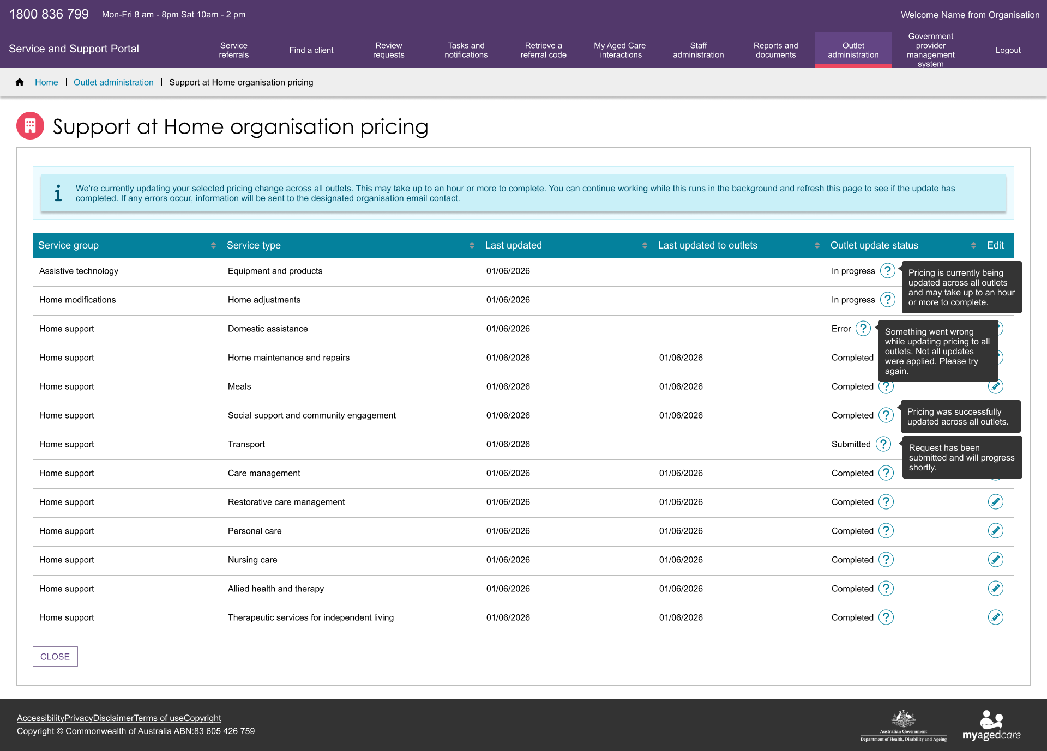

Updating Pricing Information at the Outlet Level
- Choose your outlet from the Outlet Administration page tiles.
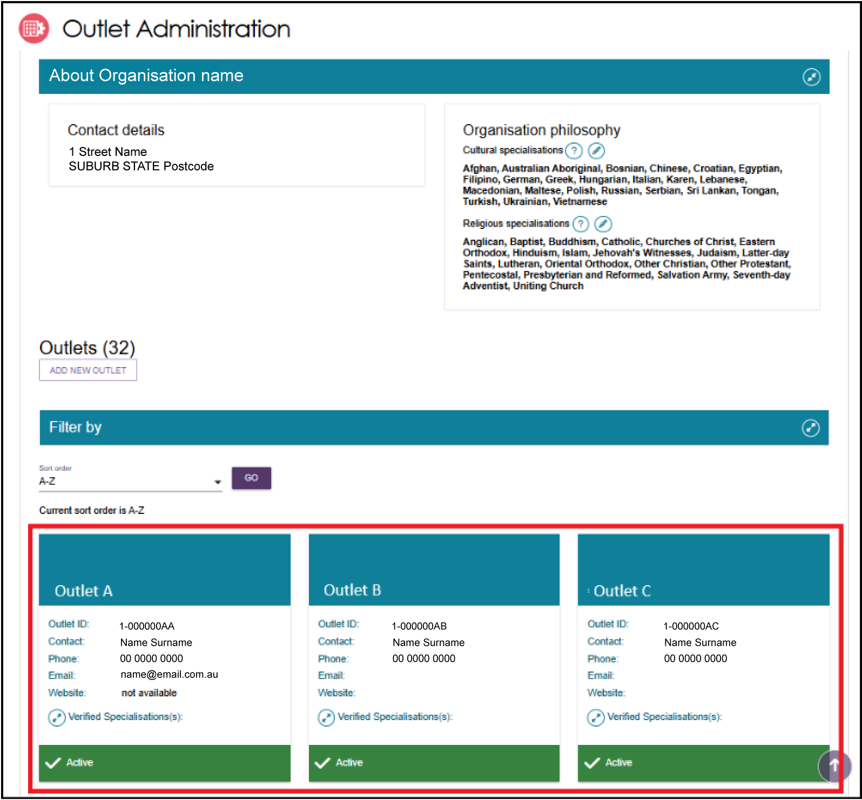
2. The outlet details page will be displayed. Select the Edit (pencil) icon to the right of the Support at Home pricing section.
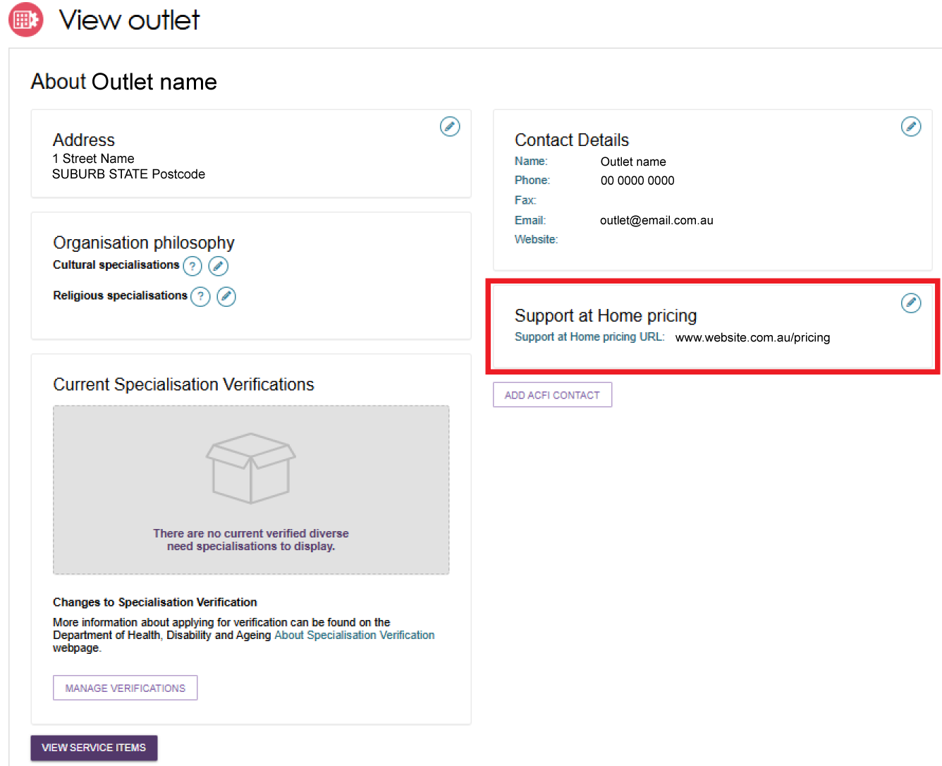
- The Support at Home pricing pop up appears.
Under the Full Price List section, a pricing schedule website link (URL) can be added.
To add a pricing schedule website link type in the URL in the Provide a website link section. Ensure that the website URL you enter is a valid website address. Use the URL Scheme field to select the if the URL is https:// or http://.
Finally, select whether you want to
- Apply to this outlet only, or
- Apply to this outlet and its Support at Home service items.
Then, select Save button.
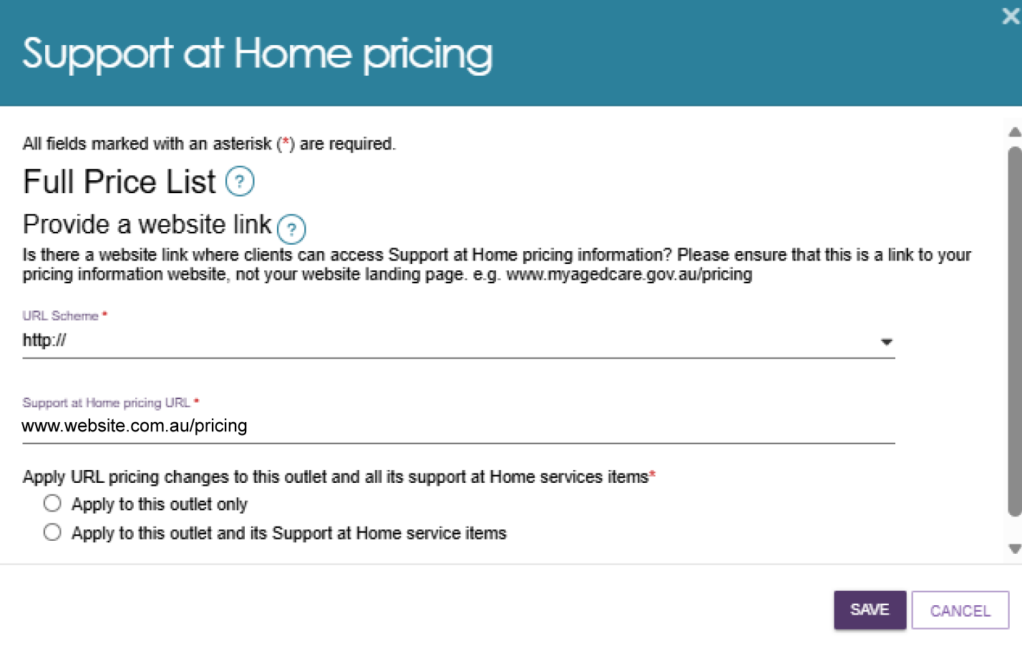
- The Pricing URL will now appear at the View Outlet page.
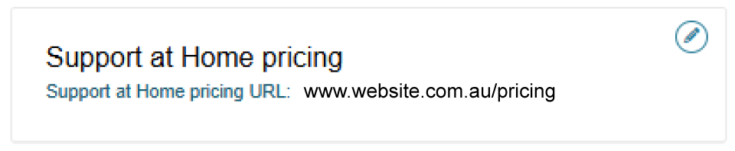

Updating Pricing Information at the Service Item Level
You can also update the service item pricing URL or supply a price schedule attachment specific to that delivery area/region.
- Choose your outlet from the Outlet Administration tile, then select View Service Items.
- From the View Service Items page, select the Support at Home tab, then the Edit (Pencil) icon to the right of the ‘Support at Home’ heading.
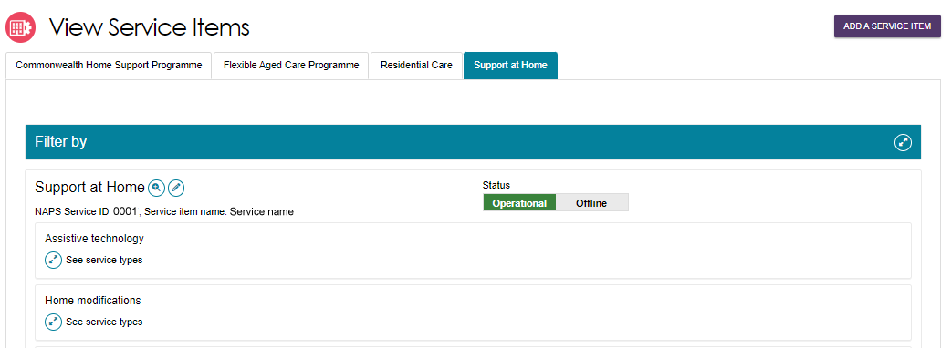
- The Support at Home details Page appears. This contains all configuration available for the service item.
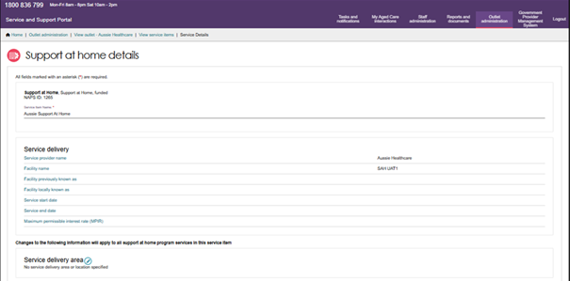
- Scroll to the bottom of the page to the Full Price List section.
In the URL Scheme section, select whether your website link is HTTP or HTTPS. Then, enter the website link in the URL section. The below screenshot shows an example website link.
You can also upload a pricing schedule here.
Finally, select Save.
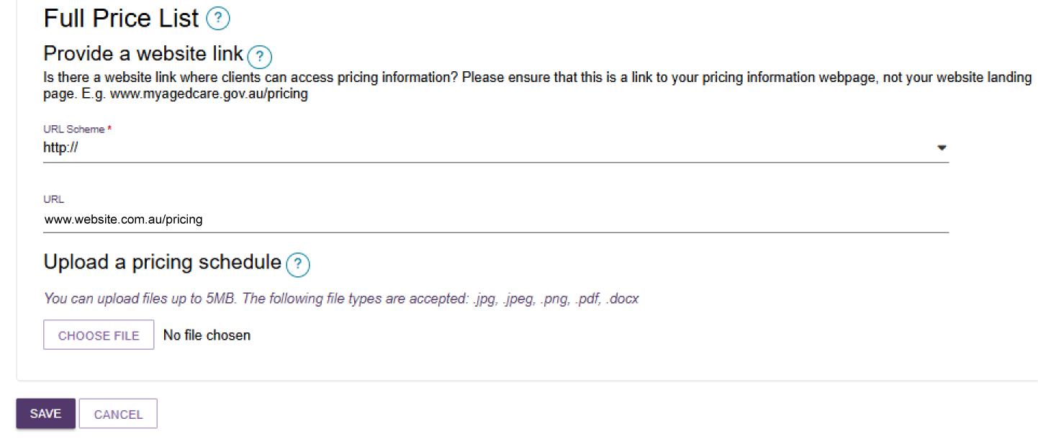

Updating pricing information at the service level
! | Service pricing at the Organisational level will be automatically applied to all service level pricing.  Be aware of any Support at Home organisational pricing changes that the Organisational Administrator may do.
At the service level, you can update pricing based on the unit type such as per hour, trip or meal for individual services. If you have entered pricing at the Organisation level this information can now be used to autofill, if the service level price does not already exist.
- Choose your Support at Home outlet from the Outlet Administration tile, then select View Service Items.
- Select the Support at Home tab, then expand any service groups/service types, then select the Edit (Pencil) icon of the appropriate service card.
The below example shows the Home Support service group, Meals service type, and Meal Delivery service.
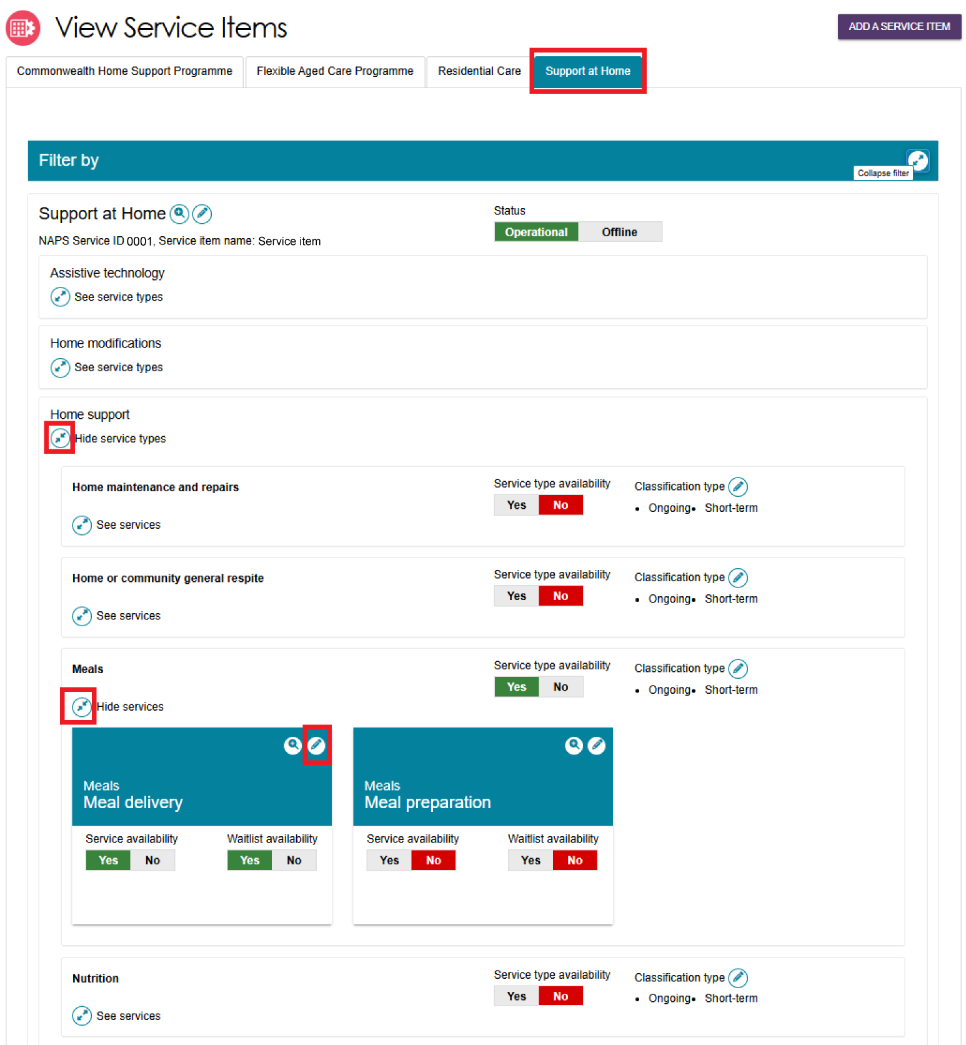
The Service Details page appears. The appearance of the page will vary depending on which service you have selected.
An example of a generic service’s page is shown below.
When you edit a Service’s pricing, the system will autofill the common prices from the Organisation level. This will only happen when:
- if there is price/s set at the Organisation level (also referred as reference price) and
- when you select the delivery hours option/s you offer for the service.
When the pricing is autofilled, an information banner also appears.
These prices is pre-filled for your convenience. You can keep this figure or apply a new price based on the delivery area, however you must ensure you save to apply the pricing data.
If you have not entered any pricing at the organisation level the fields will be blank and you must at minimum supply a service price for Common price – Standard hours. When you select additional delivery hours you must the enter the corresponding common price for that period.
Generic Service Details Page Example
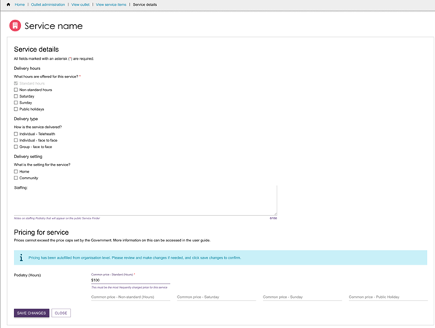
If service prices exist, and you adjust the availability setting (for example from No to Yes), the system will provide a message to review the pricing. It is encouraged to check the price details and complete any other prices for offered time periods and then save.
You can continue to add pricing in the other delivery hours offered e.g., Non-standard Hours, Saturday, Sunday, and Public Holiday. There is flexibility to have Service item specific pricing.
! | It is important to provide pricing at the service level to support My Aged Care website tools such as Find a Provider or Fee Estimator. There is flexibility to have service level availability and pricing by service delivery area (region).
This will be required to be completed for all services before changing the service item status to Operational.
For (Hours) services, enter the per hour price delivered during the time period.
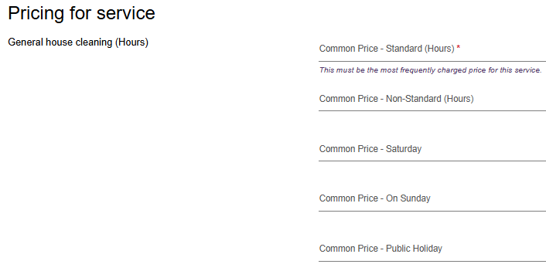
For meal delivery, enter the price per meal delivered during the time period. For example, in the Common price – standard (hours) section, enter the price for each meal delivered during standard hours.
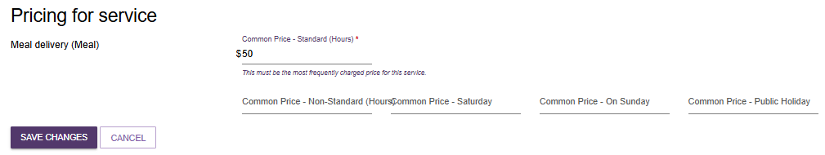
For transport services, enter the price per trip during the time period. For example, in the Common price – standard (hours) section, enter the price for each trip undertaken during standard hours.
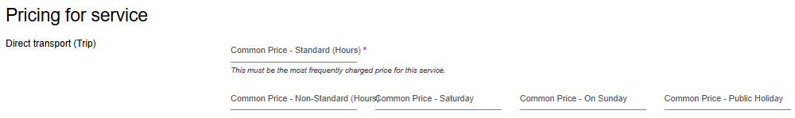
Some services such as consumables will default to ‘Market price’. No price is required to be entered.
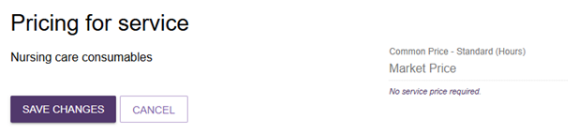
- If a service is on a waitlist, it is highly recommended to add service pricing to ensure this is visible on the Service Finder or Fee Estimator tools.
- All pricing information saved, including pricing schedule attachments, will appear by the next day on the Service Finder on the My Aged Care website, and do not require approval from the Department.
To view the pricing information entered, navigate back to the service where the pricing was updated, expand the service, and select the magnifier icon.
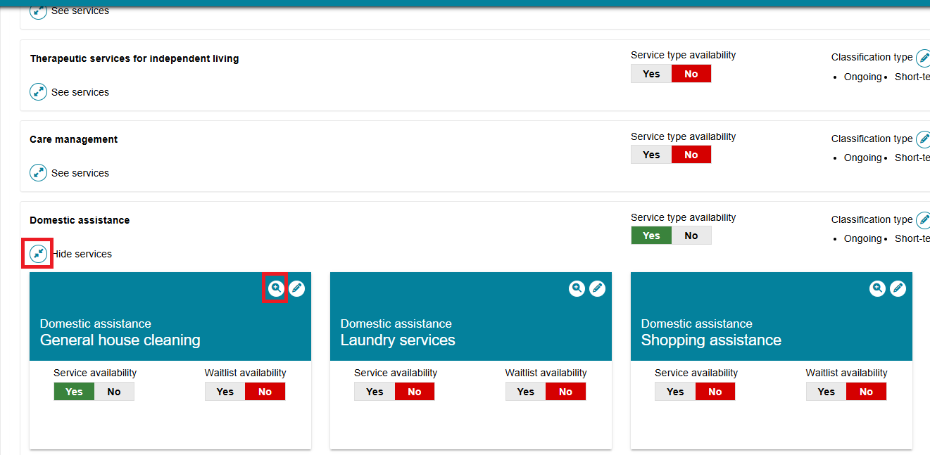
A pop-up window will appear with the pricing information for that service.
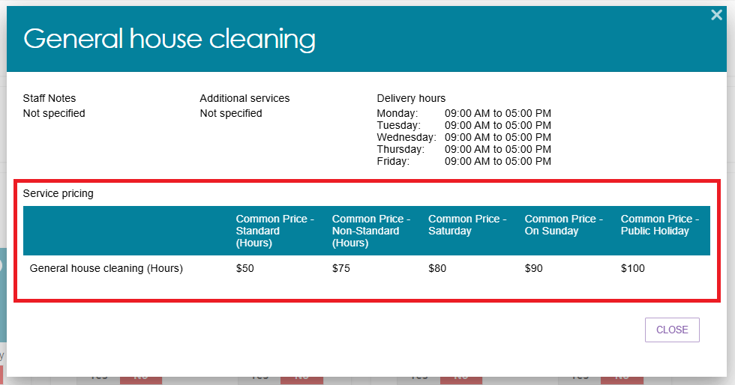

Reporting service pricing status
The Support at Home Pricing Status report enables Organisation Administrators and Outlet Administrators to view the service price status and identify which Services require pricing updates and when they were last updated.
The report will provide a full extract of all your Support at Home service pricing for all outlets, service items and price fields.
Go to Reports and Documents tile of the portal home page, then select the Support at Home Pricing Status link.
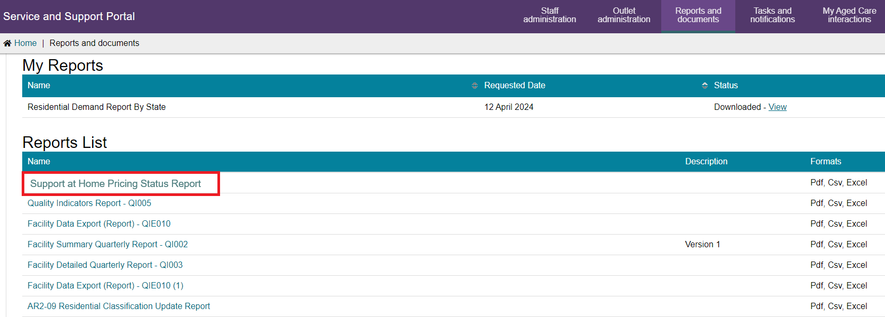
This will open a Report View page. Begin typing the Outlet name to select, you can add additional outlets. Then, Select the output type and then the Request Report button.
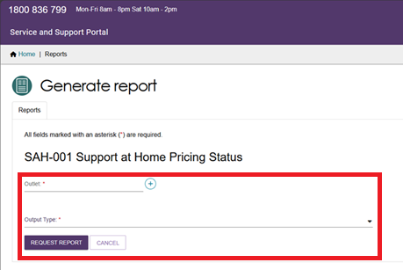
The report will run and be available to download in your My Report section once completed.
There is an estimated 24 hours delay in the data entry to being available in the report. For example, if you entered data into the portal yesterday, it should be available to view today.
Checking Pricing completion
Once you open the report, it will default to a sort order by Outlet and Operational service items and available services. This is intended to help you identify any missing pricing required to be entered.
A compliant Outlet is one where an Outlet is an active outlet with an operational Service item where a service/s availability = yes and common price – standard hours field contains a price value.
The following sample report shows compliance, non-compliance and where compliance rule is not applicable.
- Row 1 indicates compliance with the rule.
- Row 2 with the red highlighted cell (under ‘Common Price – Standard Hour’ column) indicates the non-compliant price for that service. Note that the report will NOT highlight any non-compliant cells.
- Row 3 is not required to be assessed against the rule as the Service is not available. Any service item that is Offline is also not assessed against the rule as well as Inactive Outlets.
Price review/maintenance
Pricing must be reviewed and updated quarterly. This report can assist in providing a review of all the pricing entered and the last updated date. The last updated date is when any one of the service price time periods has been updated.
You will be able to identify if a service price has not been updated based on the last updated date. For example, if prices for the services have not changed in 3 or 6 months. This may indicate that it needs a review against your common prices for that service.

Maintaining service and waitlist availability
You can maintain information about the availability of service items via the Service and Support Portal.
To maintain a waitlist, you must ensure that the waitlist availability status on the service item is set to Yes to turn on the waitlist, or No to turn off the waitlist. Service and waitlist availability information will be displayed on the service finder via the My Aged Care website. When you change availability information it will appear by the next day on the My Aged Care service finder on the My Aged Care website. You will still be required to add service pricing if you waitlist a service.
- Navigate to the View Outlet details from the Outlet administration page for the outlet that you want to edit service and waitlist information and select VIEW SERVICE ITEMS.
- Select the relevant service/waitlist availability status (Yes / No).by toggling the Yes | No switch. The location of the Yes | No switches will depend on the type of outlet and service chosen.
For non-Support at Home services such as CHSP or Residential Care: the toggles are to the right of each service heading, and at the sub-type level by expanding See sub-types.
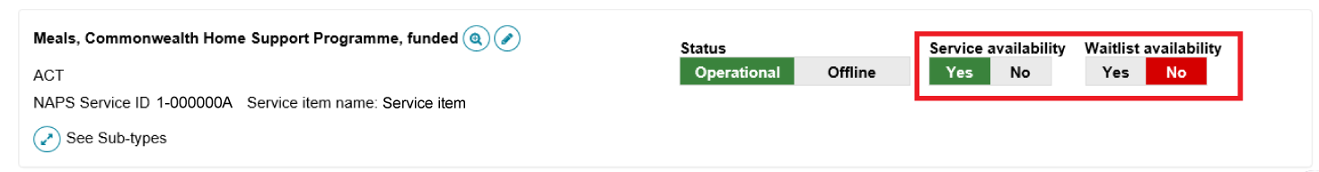
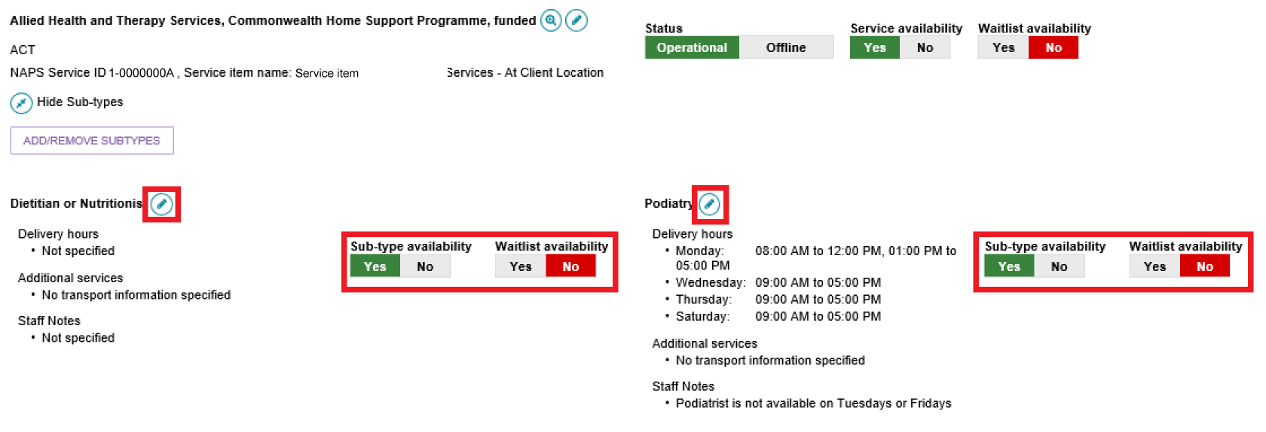
For Support at Home services, expand the service group, then expand the service type, and finally expand the service. There is a service availability toggle and a waitlist availability toggle in each service’s card. For the Service type to be available you must have at least one service with availability as Yes. To mark a service available you must provide the Common Price - Standard (Hours) at a minimum.
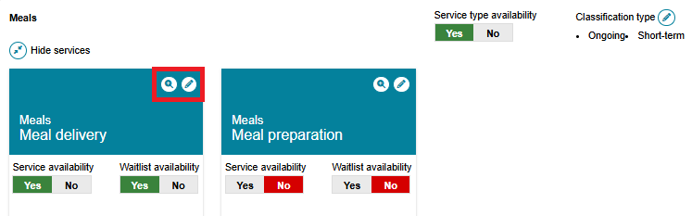

Editing a service delivery area
Information about the areas you deliver Commonwealth-funded services in (referred to as service delivery areas in the portal) are pre-filled, based on your contractual information. All providers (except Residential care) must review their service delivery area information and edit if required. It is important that you ensure the service delivery area(s) is accurate. This information is publicly displayed in the service finders and forms the basis of the referrals sent by contact centre staff and assessors.
For service items under the CHSP and Flexible Aged Care programs, select the at client location option. For Residential based services, select the at provider location option.
! | For Support at Home services, service delivery area details are defaulted to at client location. Any edits will apply for all service types and services underneath the Support at Home provider’s listing.
Follow these steps to edit a service delivery area:
- Navigate to the service item page from the Outlet Administration tile.
- On the View Service Items page, select Edit next to the relevant service item, or for the Support at Home program, the Edit icon next to the Support at Home heading.
Non-Support at Home example
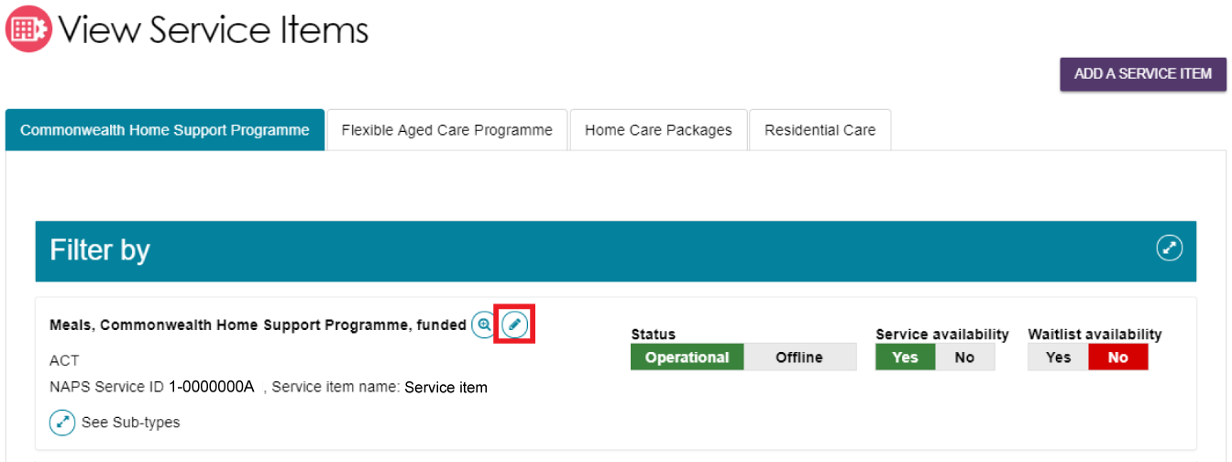
Support at Home example
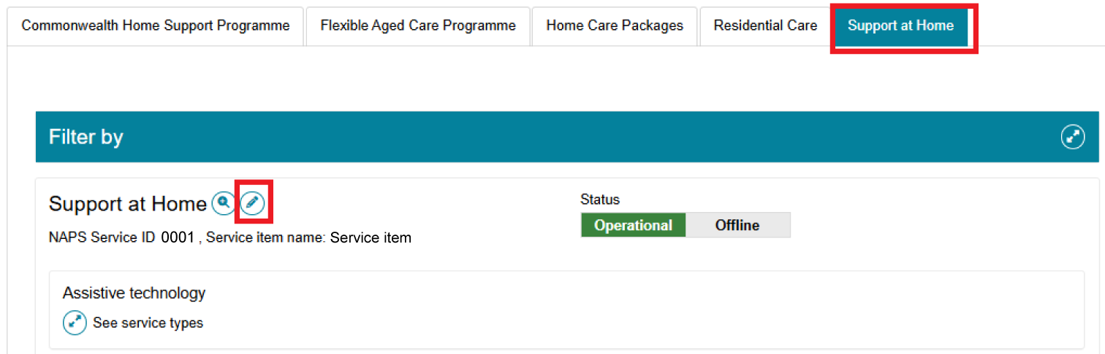
The Service details page will display.
- Select Edit (Pencil) next to the Service delivery area section.
Non-Support At Home example
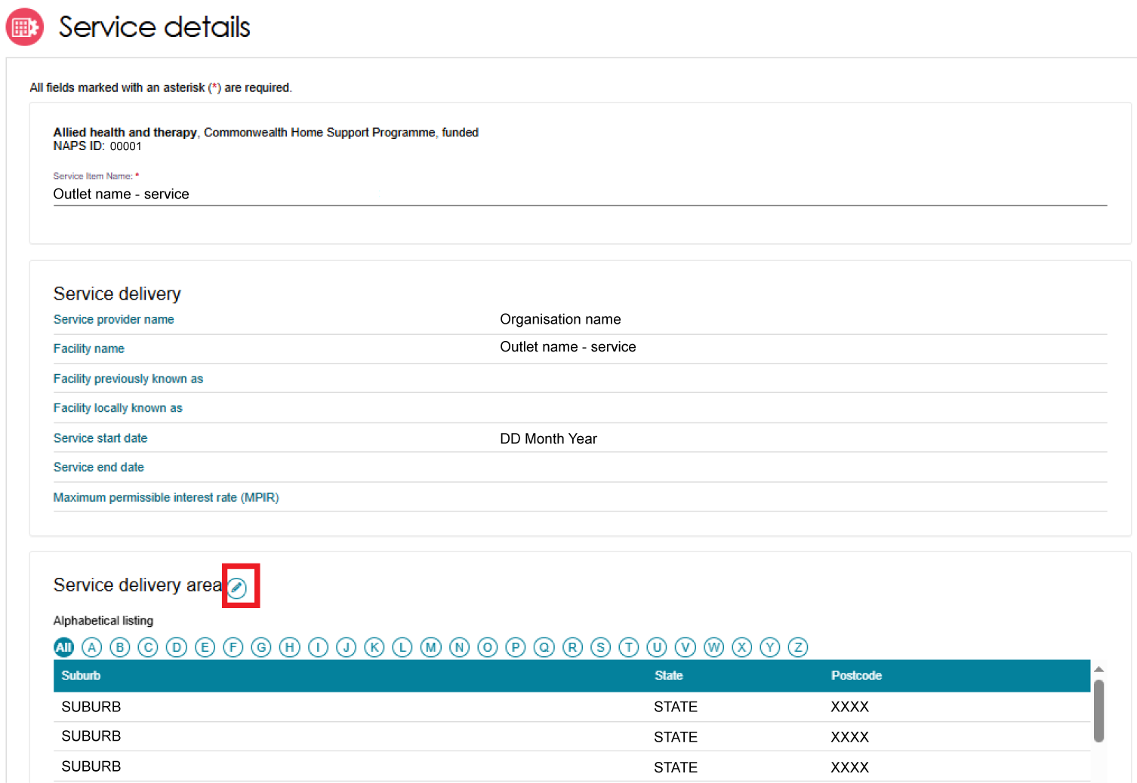
For Support at Home, there are no suburbs listed.
Support at Home example
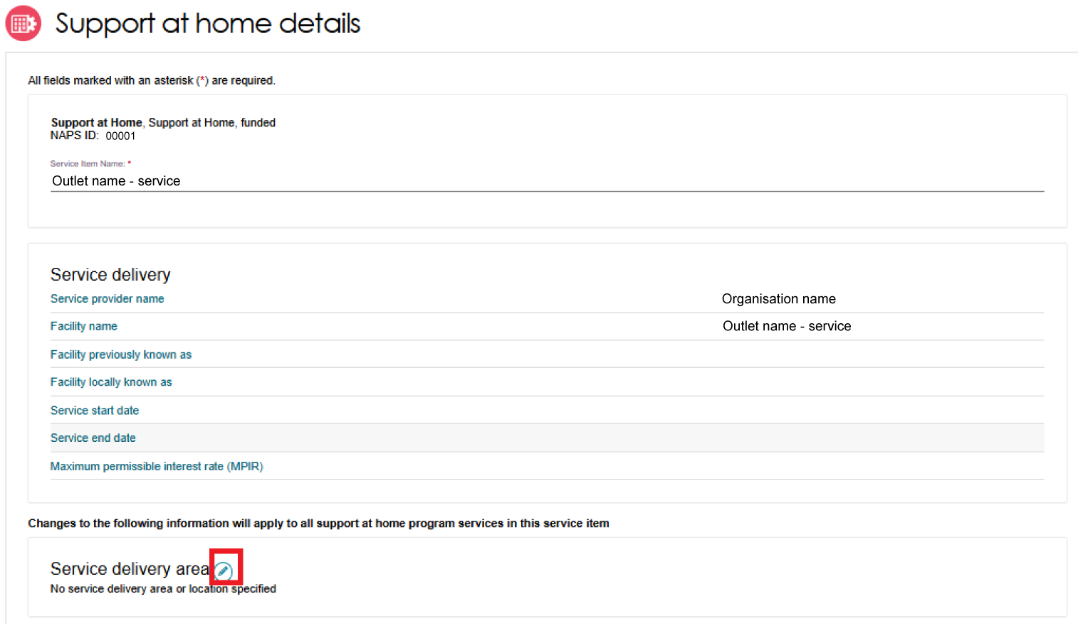
- The Edit Service Delivery Details page appears.
Select the service delivery type.
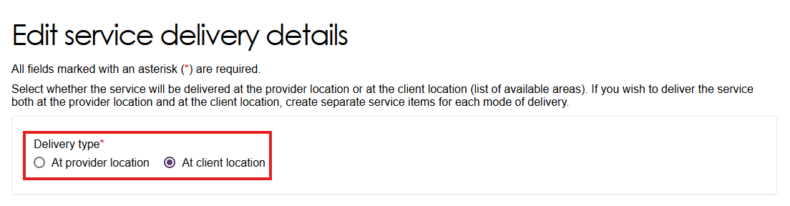
If prompted,
- Select ‘At provider location’ for residential services
- Select ‘At client location’ for non-residential services.
Note: For Support at Home, this choice is hidden. By default, ‘At client location’ is selected.
Once selected, the choice cannot be changed without assistance from the Contact Centre.
If you have selected At provider location, enter the address of the provider then select Validate This Address. Then select Save Changes.
- Search for and add suburbs and locales.
You can search by states, region, postcode and/or suburb.
Non-Support at Home - Edit service delivery details page - At client location
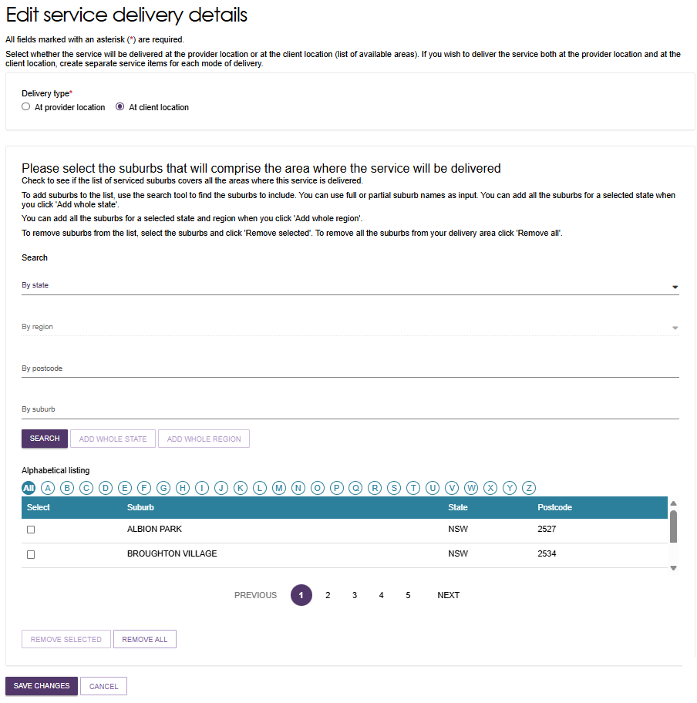
Non-Support at Home - Edit service delivery details page - At provider location
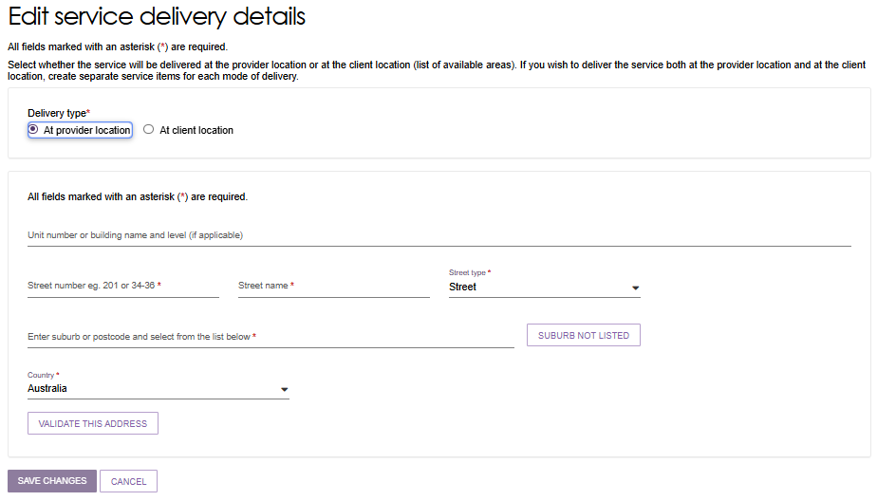
Support at Home - Edit service delivery details page
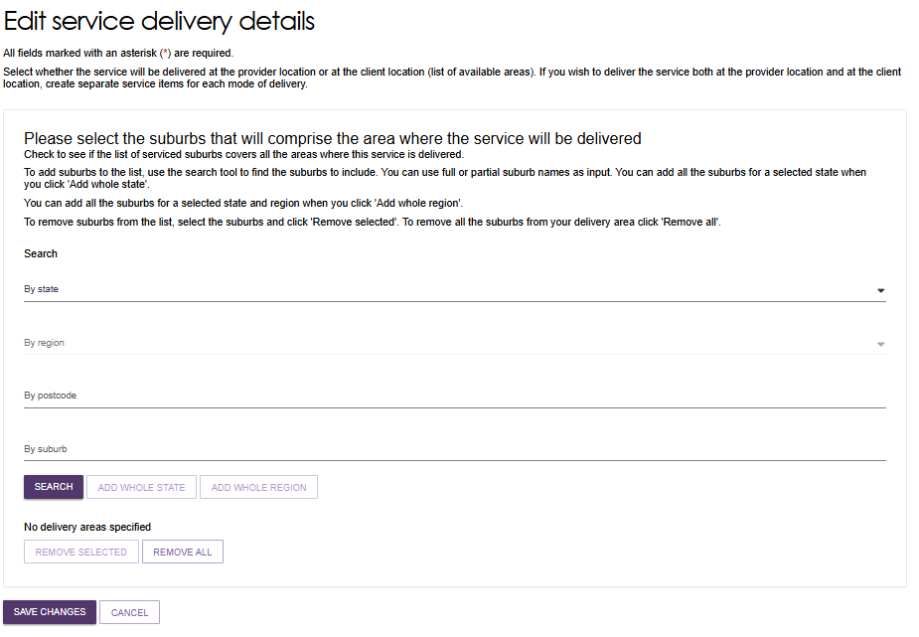
If you have selected At client location, you can choose the state or suburb(s) the service is delivered in. By default, the entire region, in which you are funded to provide service, is selected.
You can choose to search for a specific suburb to add, add all the suburbs in the selected state, or add all the suburbs in the selected region.
To remove suburbs from the list, select the suburbs you wish to remove using the checkbox and select REMOVE SELECTED, or use REMOVE ALL to start configuring your list of suburbs from the beginning.
Finally, select Save Changes to save the selected suburbs.
Select Cancel to go back to editing the service.
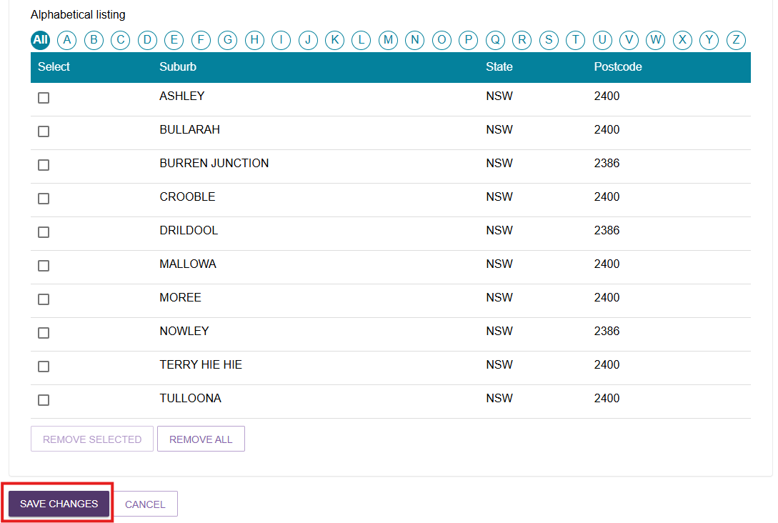

Adding a room type to a residential facility
- Choose your outlet from the Outlet Administration tile, then select View Service Items.
- At the View Service Items page, navigate to a Residential Care service then select See room types.
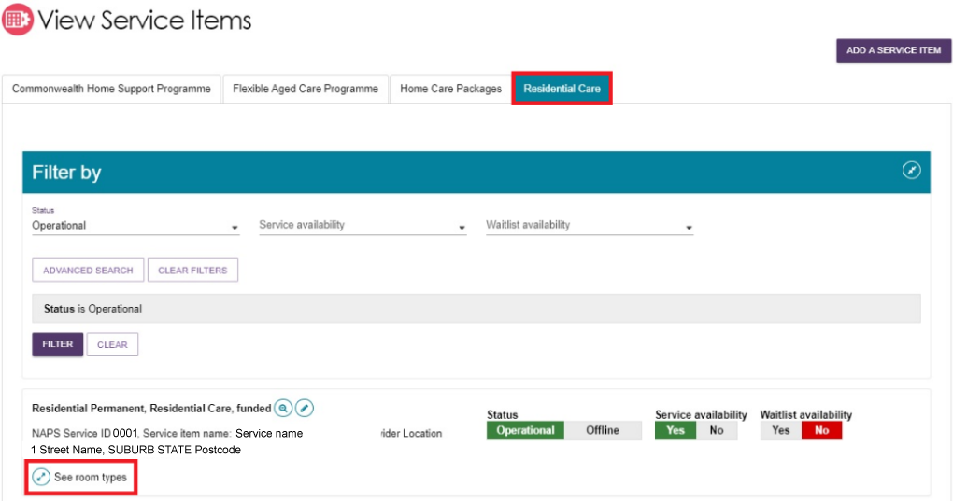

- Then select ADD ROOM TYPE.
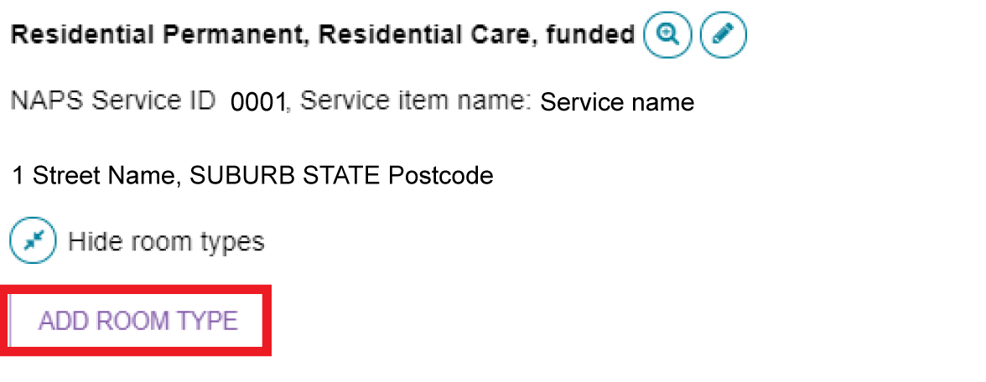
- The Room type page will be displayed. Enter the required information in the General room information and Pricing information sections.
Fields marked with a red asterisk (*) are mandatory.
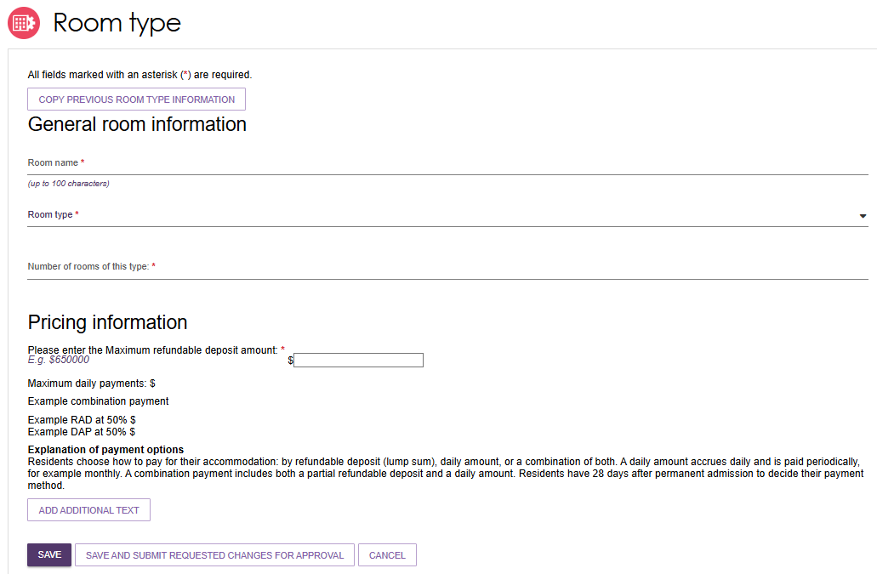
! | Accommodation prices above the maximum allowed Refundable Accommodation Deposit amount (or equivalent daily payment) must be approved by the Independent Health and Aged Care Pricing Authority (IHACPA).  If IHACPA have not approved this price, or you have not submitted an application for approval of this price, you cannot publish this price. You cannot charge this price until it is approved by IHACPA.  Please note that when an approval is granted IHACPA, the approved amount is not automatically updated on the My Aged Care website. Providers must update their own pricing information using the Aged Care Service and Support Portal.
- Enter the required information under Key feature statement. Select SAVE AND SUBMIT REQUESTED CHANGES FOR APPROVAL after all required information has been entered. This room information will display on the service finder once approved by the department (allow 3 business days).
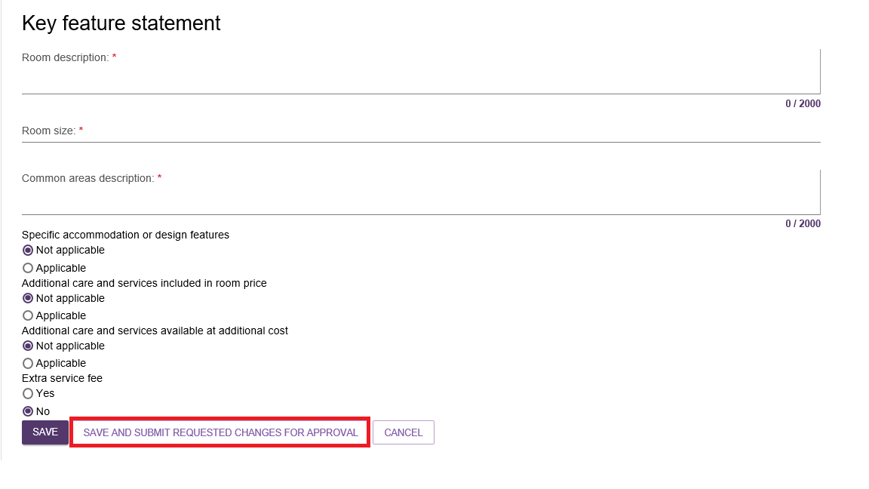
! | If you save the room type but do not select Submit, you will be notified that there are room types requiring approval by the department and be prompted to submit the room type to the department prior to displaying on the public service finder.

Activating an outlet
After service items are added, outlet(s) need to be made active so that the following occurs:
- The service items display in the service finder
- Contact centre staff and assessors can send electronic referrals to the appropriate outlet
- Assessors can match and refer to active services.
- Navigate to the View Outlet details from the Outlet administration page for the outlet that you want to activate and select ACTIVATE OUTLET.
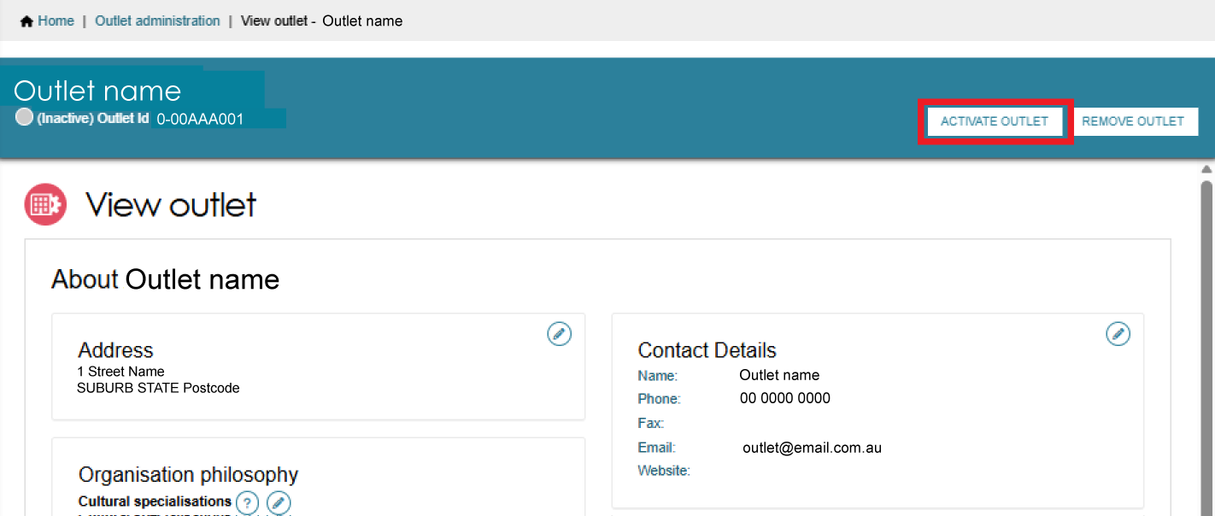

- Select ACTIVATE OUTLET at the bottom of the pop up, to confirm that you wish for this information to be displayed in the service finder. A warning message will display.
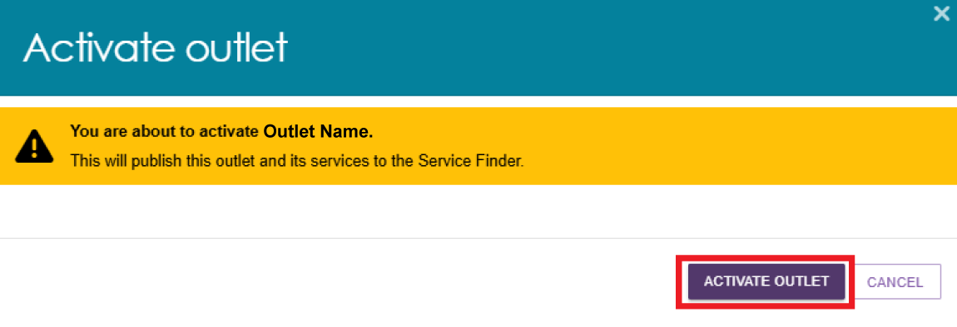
Your outlet is now active and operational service item information will display in the service finder, and will display as Active in the Service and Support Portal.
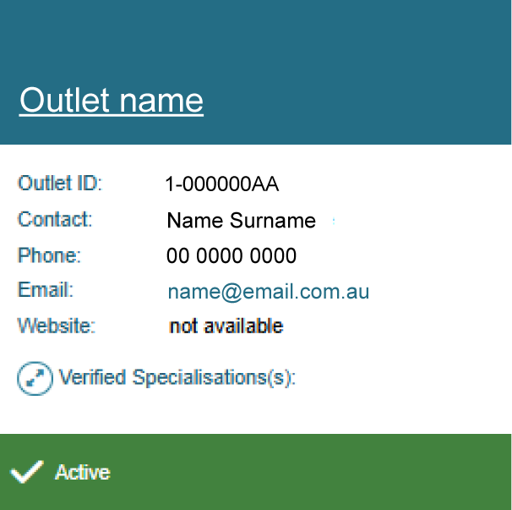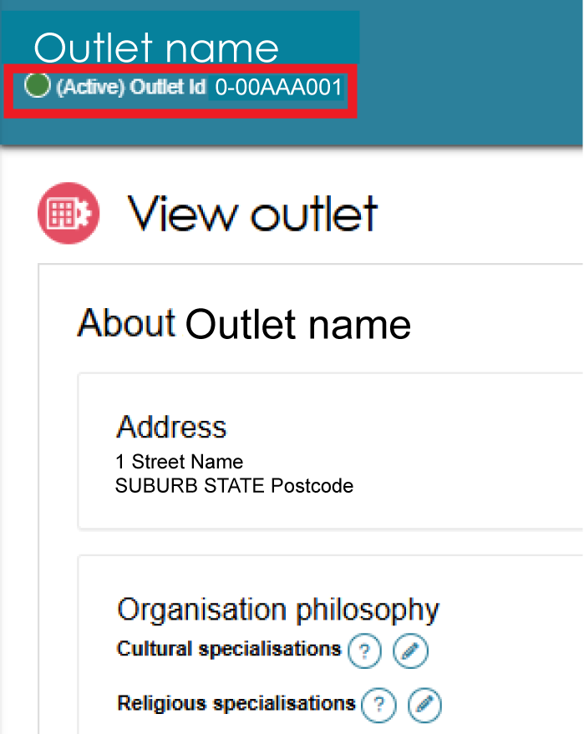

Deactivating an outlet
To remove an outlet from the service finders and stop referrals being sent to the outlet, it must be deactivated. An outlet cannot be made inactive if there are accepted and commenced services.
Navigate to the View Outlet details from the Outlet administration page for the outlet that you want to deactivate and select DEACTIVATE OUTLET.
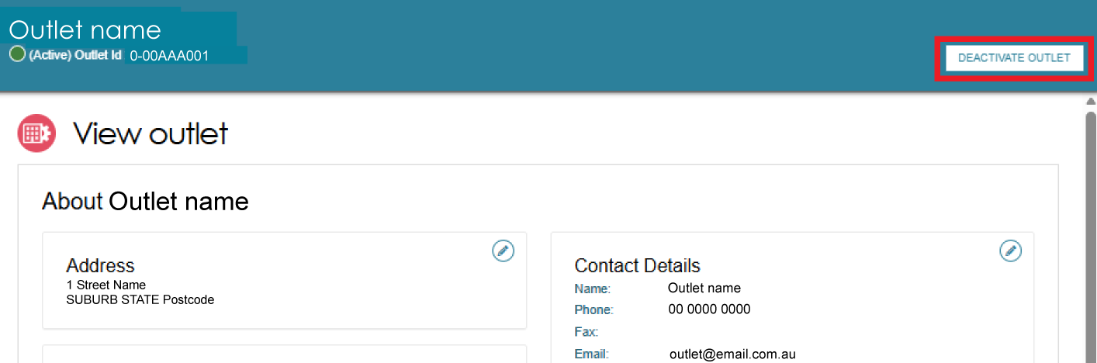
Select DEACTIVATE OUTLET again at the bottom of the pop up, to confirm that you wish to deactivate the outlet.
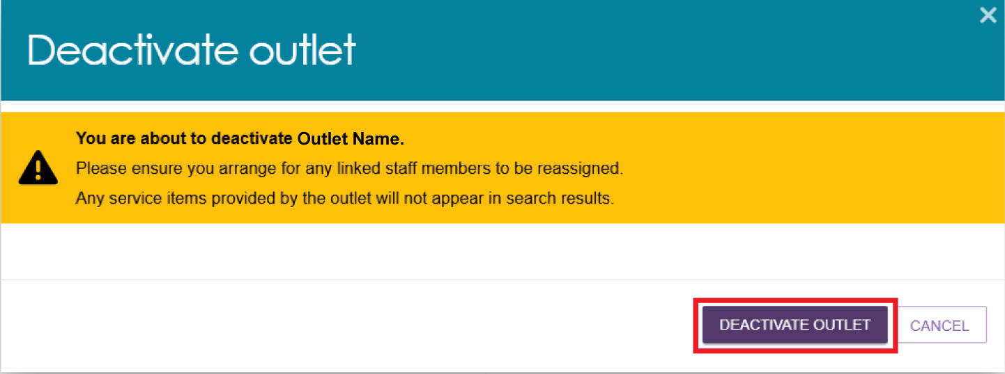
The outlet is now inactive, does not display on the relevant service finder or receive referrals, and displays as Inactive in the Service and Support portal.

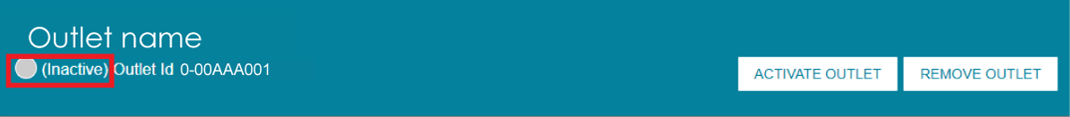

Removing an outlet from the Service and Support Portal
To remove an outlet from the Service and Support Portal, it must be in the status of ‘Inactive’.
- Navigate to the View Outlet details from the Outlet administration page for the inactive outlet you wish to remove and select REMOVE OUTLET.
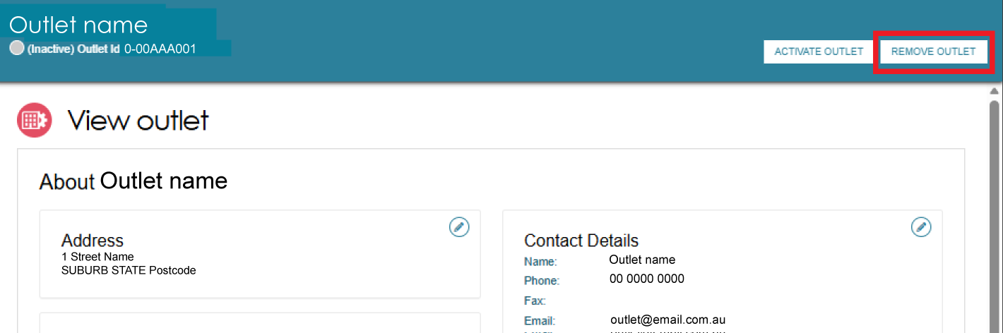
- Select REMOVE OUTLET at the bottom of the pop up to confirm you wish to remove the outlet.
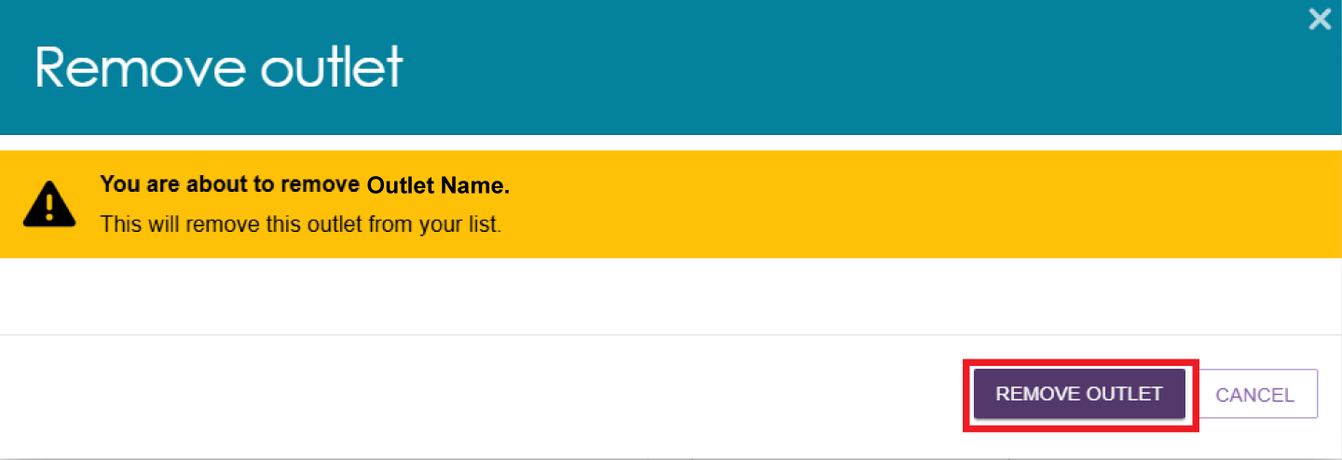
The outlet will no longer display in the Service and Support Portal.

! | If you want to create an outlet with the same name as the one you removed earlier, you will need to call the My Aged Care service provider and assessor helpline on 1800 836 799.

For more information or support
Further information is available from the Service and Support Portal Resources page.
The My Aged Care service provider and assessor helpline is available on 1800 836 799.

