Service and Support Portal User Guide Administrator Functions for NATSIFACP

This guide helps National Aboriginal and Torres Strait Islander Flexible Aged Care Program (NATSIFACP) providers perform Administrator functions in the My Aged Care Service and Support Portal.
Use this guide together with “My Aged Care – Service and Support Portal user guide – Part 1: Administrator functions”.

Contents
1 Service and Support Portal 2
1.1 Temporary Arrangements 2
1.2 Extra Information for NATSIFACP users of the Portal 2
2 The Administrator Role 2
2.1 Service Delivery Outlets 2
2.1.1 Information Usage 2
2.1.2 Minimum Requirements 2
2.1.3 Creating outlets 3
2.1.4 Inactivating outlets 3
2.1.5 Viewing outlets 3
2.1.6 Editing Outlets 4
2.2 Service Items 5
2.2.1 Adding a service item 5
2.2.2 Editing a service item 5
3 Extra Information for NATSIFACP Users of the Portal 6
3.1 Managing Service Referrals 6
3.2 Client Service Delivery information 6
3.3 Tasks and Notifications 6
3.4 Client Records 6

Service and Support Portal

Temporary Arrangements
! | This guide uses the abbreviation NATSIFACP to refer to the National Aboriginal and Torres Strait Islander Flexible Aged Care Program.
This guide explains the temporary arrangements for creating NATSIFACP outlets and service items. These arrangements remain in place until further notice.
Section 2.1 (Service Delivery Outlets) and Section 2.2 (Service Items) replace the corresponding sections in ‘My Aged Care – Service and Support Portal user guide – Part 1: Administrator functions’.
This guide is part of the Service and Support Portal Resources collection. The collection provides access to a range of resources, including fact sheets, guides, quick reference guides, and videos.

Extra Information for NATSIFACP users of the Portal
Section 3 provides NATSIFACP users with additional information to help them understand their Services set up and managing functions in the Service and Support Portal.

The Administrator Role

Service Delivery Outlets
These instructions in this section replace the instructions in the Creating service delivery outlets section of ‘My Aged Care – Service and Support Portal user guide – Part 1: Administrator functions’.

Information Usage
My Aged Care displays service delivery outlet information in the My Aged Care Find a Provider tool on the My Aged Care website.
People seeking aged care services and their support network use this information to find and access services.
My Aged Care Contact Centre staff and assessors use this information to search for providers and to make referrals.
Administrators are responsible for setting up and maintaining this information to support accurate search results and referrals.

Minimum Requirements
A NATSIFACP provider must have at least one outlet, named as either a Help at Home outlet or an Aged Care Home outlet.
Providers who offer both Help at Home and Residential services will have one outlet for each even though the service type will be the same.
A provider can have multiple outlets of the same type.
Each Aged Care Home outlet has its own physical address.
Each Help at Home outlet provides services to a defined delivery area of suburbs and postcodes.

Creating outlets
The department currently creates outlets on behalf of NATSIFACP providers.
To add and activate an outlet, providers must give the department:
- the outlet address
- the primary contact's details
- service details, including the service name (see the Service Items section below)
After the department creates an outlet, they will include a descriptor to the outlet and service names to show the outlet type. For example:
- Aussie Healthcare (Help at Home)
- Wombat Cottages (Aged Care Home).

Inactivating outlets
The department currently inactivates outlets on behalf of NATSIFACP providers.
An outlet cannot be made inactive if it has active service referrals.
To request for an outlet to be inactivated, providers must email NATSIFACP@health.gov.au.

Viewing outlets
To view outlets, including outlets the department has created for your organisation, follow these steps:
- Select Outlet administration tile from the homepage.
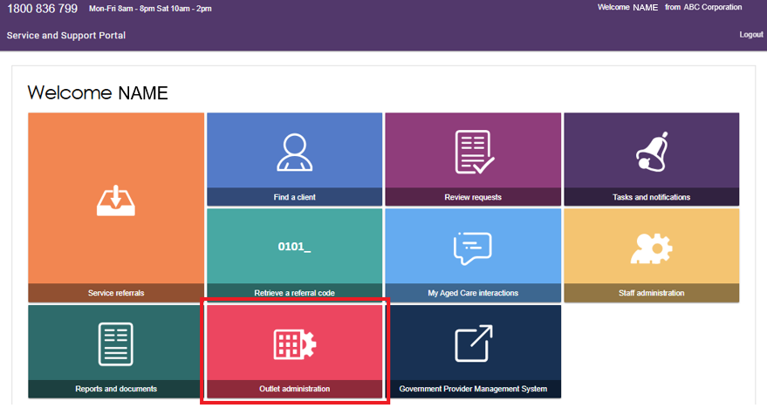
- The system displays all outlets for your organisation, including active outlets, inactive outlets, and any new outlets the department has created.
Select the outlet you want to view.
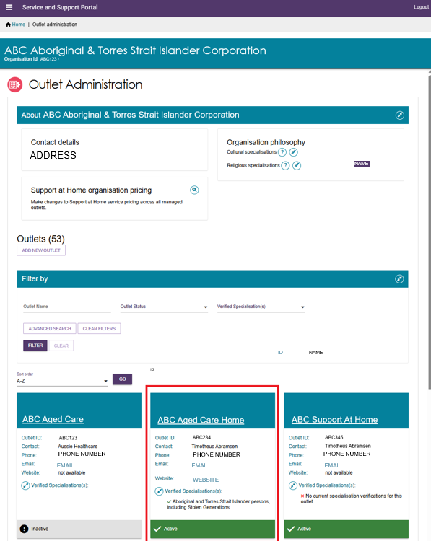

Editing Outlets
Only edit the Organisation Philosophy and Verified Specialisations sections of your outlets.
For instructions, refer to: Section 3.3 (Editing the Organisation philosophy) and Section 3.4 (Specialisation Verification) of ‘My Aged Care – Service and Support Portal user guide – Part 1: Administrator functions’.

Service Items
These instructions in this section replace the instructions in Section 4, Creating and maintaining service items, of ‘My Aged Care – Service and Support Portal user guide – Part 1: Administrator functions’.

Adding a service item
The department currently adds service items on behalf of NATSIFACP providers.
To add a service item, providers must give the department the following information:
- the outlet name where the service item will be added
- the service item name.
- the program: Flexible Aged Care Programme
- the service type: Services under the NATSIFACP
- the type of service item:
  - Help at Home (At Client Location) and service delivery area/s, or if
  - Aged Care Home (At Provider Location) and service delivery address.
This information is the minimum required to add a service item to an outlet.
When the department creates a service item, the system sets its initial status to Offline.

Service Delivery Area
For an At Client Location service item, the service delivery area includes a defined group of suburbs and postcodes. Providers must tell the department the delivery area and if they want to add or remove any specific suburbs from the service delivery area.

Service Delivery Address
For an At Provider Location service item, the service address is the street address of the aged care home.

Editing a service item
For instructions on editing service items, refer to the Creating and maintaining service items section of the ‘My Aged Care – Service and Support Portal user guide – Part 1: Administrator functions’. You can do the following:
- Updating a service item
- update service availability and waitlists settings
- update the service delivery area
- add and maintain specialisations such as Specialisation Verification, specialised services, and languages.
- attach promotional material
For information about other service item functions, refer to these sections of My Aged Care – Service and Support Portal user guide – Part 1: Administrator functions:
- configuring service attributes
- transferring service items
- activating or deactivating a service item.
To request an update to service items, providers must email NATSIFACP@health.gov.au.

Extra Information for NATSIFACP Users of the Portal
NATSIFACP users can use the following information and resources to help them use the Service and Support Portal. You can find the guides referenced in this section in the Service and Support Portal resource collection.

Managing Service Referrals
Each provider outlet must have at least one person assigned the Team Leader role in the portal.
The Team Leader manages service referrals in the portal, including:
- accepting referrals
- accepting referrals to a waitlist
- rejecting referrals
- revoking referrals after acceptance.
For more information, refer to the Service and Support Portal user guide – Manage referrals for service.

Client Service Delivery information
Providers must record service delivery information in the My Aged Care client record for all clients who have accepted services.
The My Aged Care Service and Support Portal user guide – Recording and updating client service delivery information explains how to record and update this information.
A Team Leader can manage referrals and perform all functions available to a Staff Member.

Tasks and Notifications
The Service and Support Portal assigns tasks to provider staff members, such as actioning a service referral. The portal also sends notifications about important events and updates.
For more information, refer to My Aged Care – Service and support portal user guide – Tasks and notifications.

Client Records
The client record contains client details, service referral details, assessment information, documents attached to the client record, care approval information, service delivery information, client interactions with My Aged Care and all notes created about the client.
Staff Members and Team Leaders can search for and view client records in the My Aged Care Service and Support Portal.
For more information, refer to My Aged Care Service and Support Portal user guide – The client record.

