Assessor Portal User Guide 8 – Referring for services
Following an assessment, a client may need services to support their identified needs. With the client's consent, assessors can refer the client for the services recommended in the support plan. Assessors base these referrals on the client's preferred service provider, or prioritised list of providers, and their location preferences.
This guide shows you how to:
- Search for service providers using the Find a Provider tool
- Search for service providers using the service finder in the client’s support plan
- Refer for Help at Home and Aged Care Homes services
- Refer for Support at Home services.

Client Journey Tracker 2
Referral types 2
Sequential referral 3
Broadcast referral 3
Referral codes 3
No Care Approval 4
Urgent Referrals 4
Searching for service providers using the Find a Service Provider tile 4
Searching for service providers using the Service Finder in the Support Plan 13
Assessments tile 14
Find a Client tile 15
Tasks and Notifications tile 16
After support plan completion 17
Find Provider 17
Searching by map location 24
Referring for Help at Home and Aged Care Homes services 26
Issuing a referral for service 26
Recalling a referral 30
Issuing a referral code 31
Referring for Support at Home services 34
Support at Home Priority System and allocation of funding 34
Issuing a referral for service 35
Recalling a referral 40
Issuing a Support at Home referral code 41
Managing rejected service referrals 42

Client Journey Tracker
The Client Journey Tracker is a visual tool that shows where a client is in their My Aged Care journey and what happens next. It displays above the Client Summary.
When a client is approved for care, their tracker will show their next step as ‘an assessor will be in touch to help find a service provider… alternatively, use the Find a Provider tool on the My Aged Care website…’.
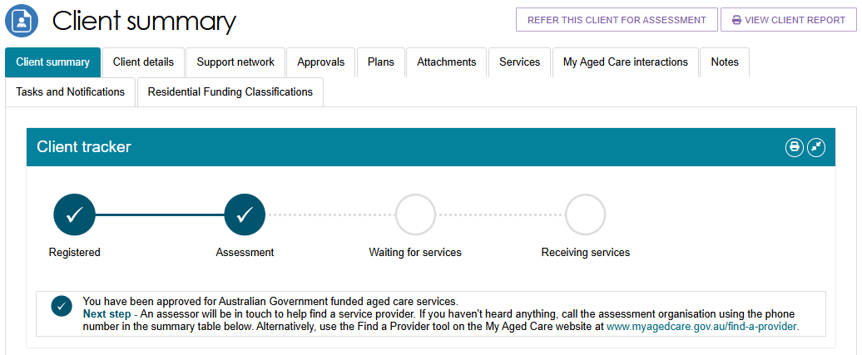
You can confirm the client’s status by going to their client summary page. Do this by going to their client card or listing, and then select VIEW FULL CLIENT RECORD.

Referral types
! | Consent  Before issuing a referral, you must obtain consent from the client or their supporter or guardian. To do this, complete the referral for services section of the My Aged Care Assessment Consent Form, which you can download from the Documents & Reports tile in the My Aged Care Assessor Portal.  For more information about obtaining consent when generating referrals, refer to the Assessment Manual.

For services recommended in the client’s support plan, you can search for providers and match the client to their preferred provider, or a prioritised list of providers. Base the referral on the client’s location, preferences, and service availability.
You can create one of three types of referrals:
- Send a Sequential Referral.
- Send a Broadcast Referral.
- Give the client a referral code so they can contact providers and choose their preferred provider.
You can also choose not to make a referral by issuing a No Care Approval.
! | For CHSP only: From 23 February 2026, you cannot recommend No Care Approval during a Comprehensive Assessment if the client has a recommended CHSP service. If you select No Care Approval, the system will display an error message. The option to add CHSP services will not be available.

Sequential referral
With a Sequential Referral, you send the client's referral to providers in the order of the client's preference. The client can nominate one or more preferred providers.
If the first provider cannot accept the referral, the system automatically sends it to the next provider on the list.
! | From 1 November 2025, all permanent residential care referrals must be sent using Broadcast Referral mode.

Broadcast referral
With a Broadcast Referral, you send the client's referral to all available providers at the same time. Multiple providers may contact the client to discuss whether they can deliver the required services.
Once one provider accepts the referral, the other providers can no longer view the client's information.

Referral codes
For residential aged care services, assessors will usually provide the client with a referral code rather than sending an electronic referral through the Assessor Portal.
If the client has already identified a preferred provider or discussed their care needs with specific providers, you can send an electronic referral instead.
For Support at Home, clients receive a referral code when funding is allocated. Services Australia sends the code with the client's funding allocation or upgrade letter, and it is also included in the support plan.
You can provide the referral code to the client so they can contact Support at Home providers before choosing their preferred provider.
If the client has already selected or discussed care options with a Support at Home provider, you can send an electronic referral instead.

No Care Approval
If you recommend No Care Approval because the client has withdrawn their application for care or does not wish to apply for care under the Act, select COMPLETE SUPPORT PLAN AND CONTINUE TO MATCH AND REFER from any tab in the client's support plan.
The Client Journey Tracker and summary will show that ‘you have not been approved to access government-funded aged care services’.

Urgent Referrals
Home Support Assessors, Comprehensive Assessors, and Triage Delegates can send urgent service referrals directly to providers without waiting for delegate approval.
You can only recommend an urgent referral during a client's assessment. You cannot recommend an urgent referral during a period of support or as part of a Support Plan Review.
You can only refer a client urgently to MPSP or NATSIFACP services if the client already has an active approval for another care type.

Searching for service providers using the Find a Service Provider tile
- From the Assessor Portal home page, select the Find a Service Provider tile to search for service providers without using the match and refer process.
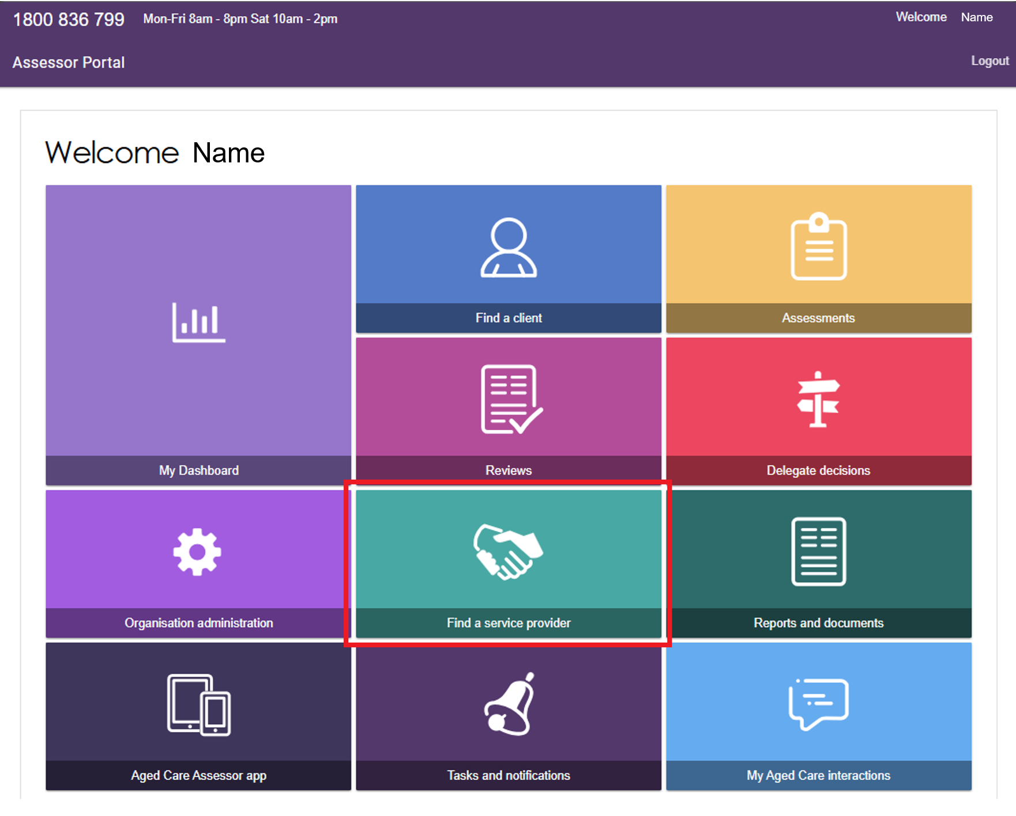
- The Find a service provider page appears. Select a service category from the drop-down list:
- Aged Care Homes
- Help at Home
- Support at Home.
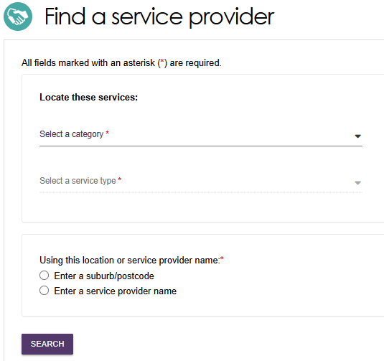
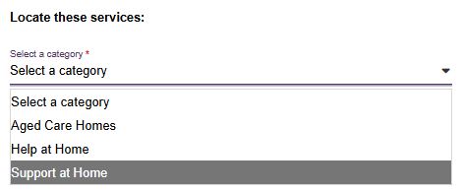
- For Aged Care Homes, select Residential Permanent, Residential Respite Care, or Services under the MPSP (Multi-purpose service program).
! | Residential Respite High Care and Residential Respite Low Care are for historical searches only. Do not search for these when referring for services for your client.
- For Help at Home services, choose from:
- all service types that are in the Commonwealth Home Support Program
- services under the NATSIFACP (National Aboriginal and Torres Strait Islander Flexible Aged Care Program)
- Short Term Restorative Care
- Specialised Support Services (Advisory services).
! | Short-Term Restorative Care are for historical searches only. Do not search for this when referring for services for your client.
- For Support at Home, select one or more service groups:
- Home Modifications
- Assistive Technology
- Home Support
Then select one or more service types.
- For Home Modifications, you can only select Home Adjustments.
- For Assistive Technology, you can only select Equipment and Products.
- For Home Support, the drop-down list displays the available service types:
- Home or community general respite
- Nutrition
- Therapeutic services for independent living
- Domestic assistance
- Home maintenance and repairs
- Meals
- Social support and community engagement
- Transport
- Care management
- Restorative care management
- Personal care
- Nursing care
- Allied health and therapy.
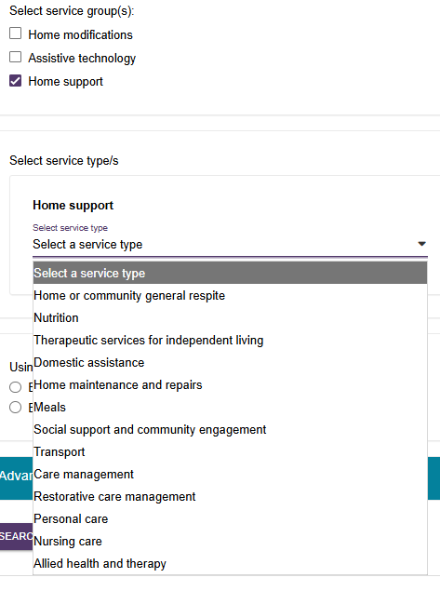
- Some service types allow you to further select individual services.
In the Transport example below, select ADD/REMOVE SERVICES, then select Direct transport and/or Indirect transport.
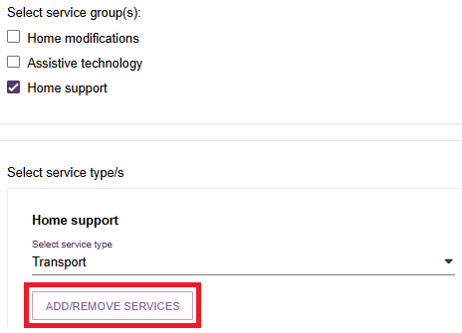
- Be sure to select SAVE when complete.
This will take you back to the Find a service provider page.
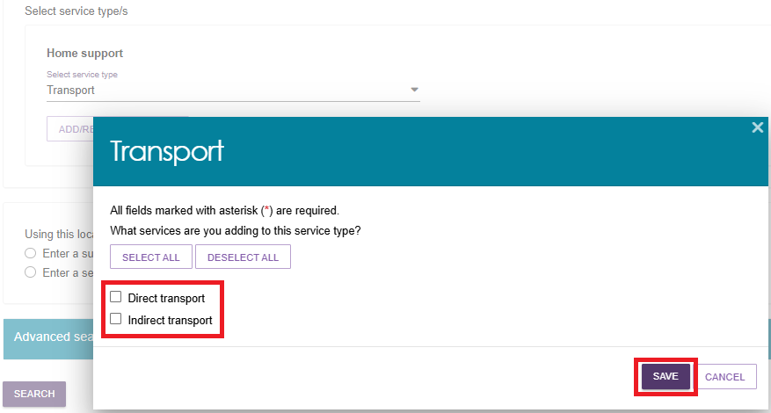
- After selecting the required options under Help at Home, Aged Care Homes, or Support at Home, enter a suburb or postcode and select a location from the drop-down list. Alternatively, enter a service provider name.
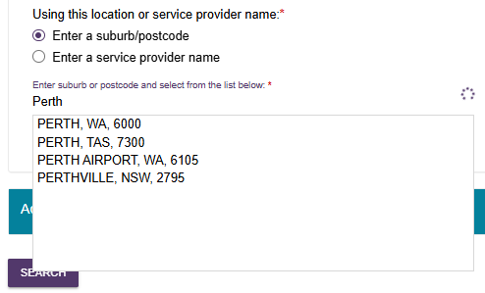
- You can refine your search results if needed:
- For Aged Care Homes and Help at Home, use Specialisation Verification, Specialised Services, or Languages filters to find providers that meet specific requirements
- For Support at Home, expand the Advanced Search section and use filters such as Specialisation Verification, Specialised Services, Languages, Culture, Religion, or Keyword.
Find a Service Provider page for Aged Care Homes or Help at Home
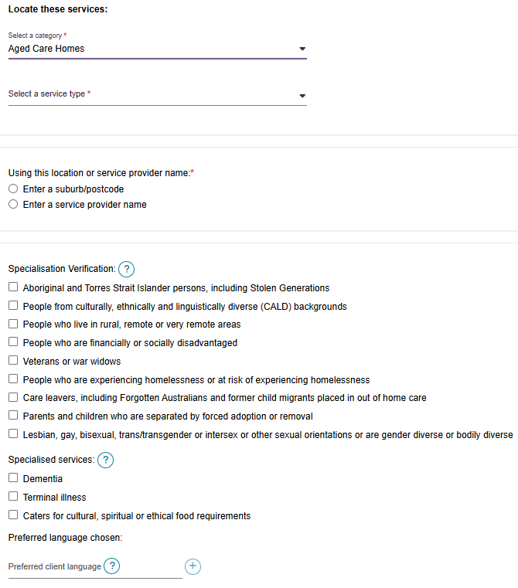

The Expanded Advanced search section for Support at Home
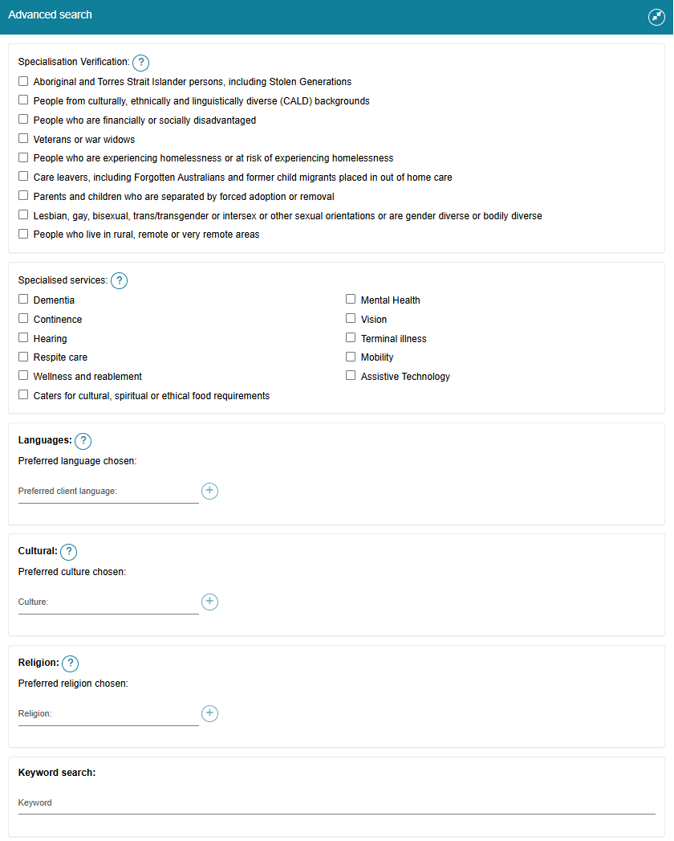
- Select SEARCH.
The system displays a list of matching providers. In this Support at Home example, three of the 40 matching providers are shown. Each result displays the provider's name, location, phone number, and the services that match your search criteria.
To view more details about a provider, select the magnifying glass icon in the top-right corner of the provider entry.

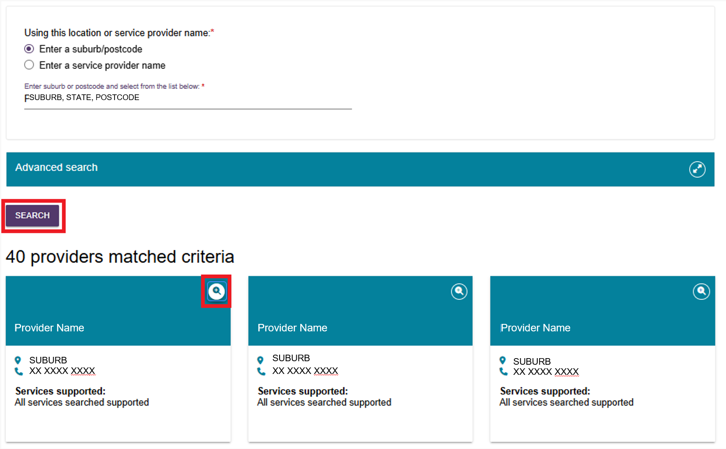
- The provider's details open in a separate browser page. The information may include:
- Whether the provider is a Commonwealth Government-recognised organisation
- A link to regulatory decisions information
- The service groups and service types the provider offers, service availability, classification type, and additional service details
- Contact information
- For Support at Home, pricing information, including the full price list, website, and pricing schedule
- For Aged Care Homes, room information and costs
- Specialisations, including Specialisation Verification, Specialised Services, and Languages.

Aged Care Homes Provider Listing
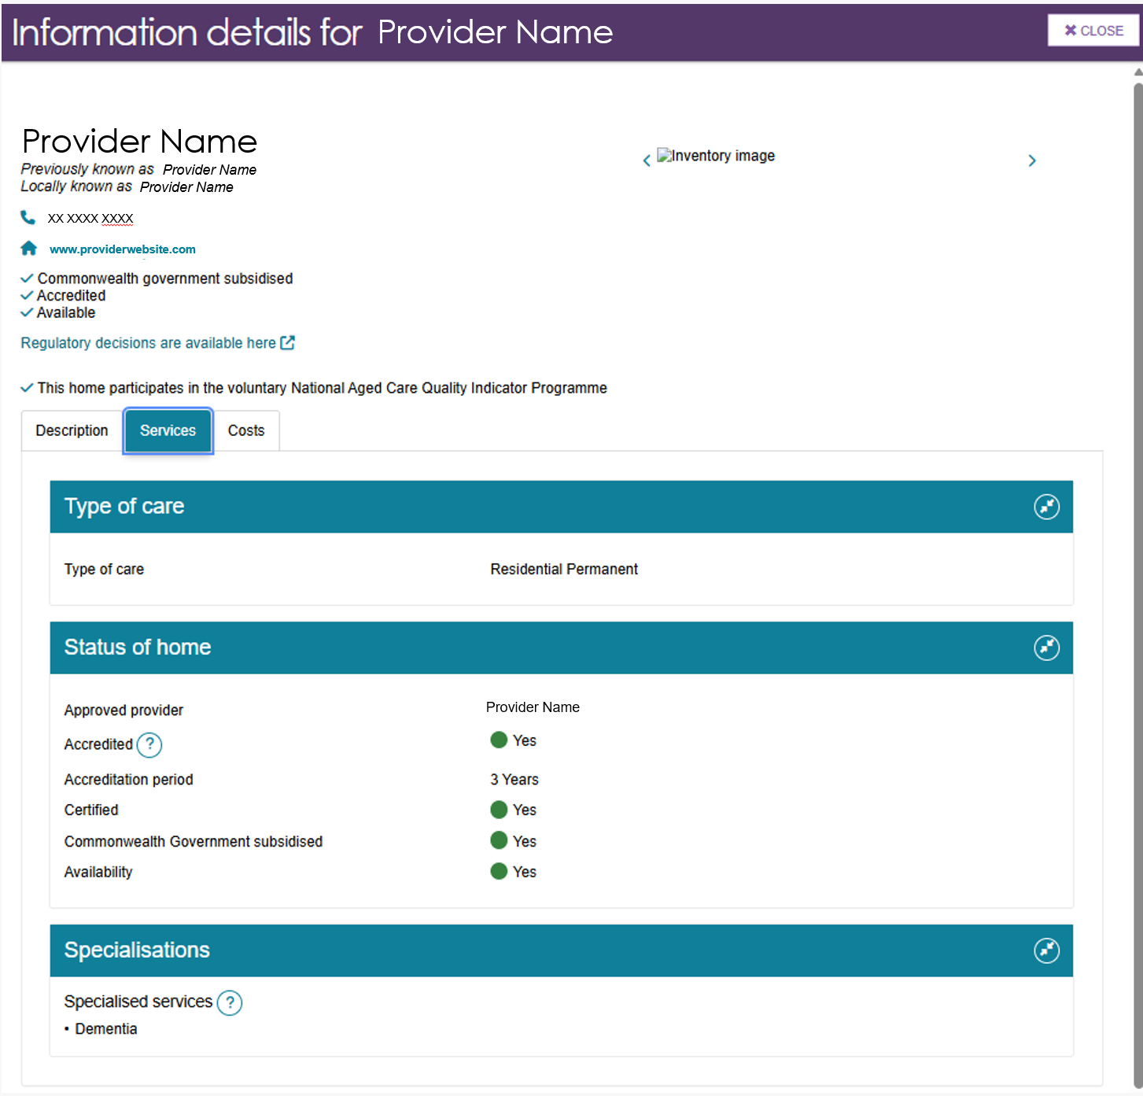
Help at Home Provider Listing
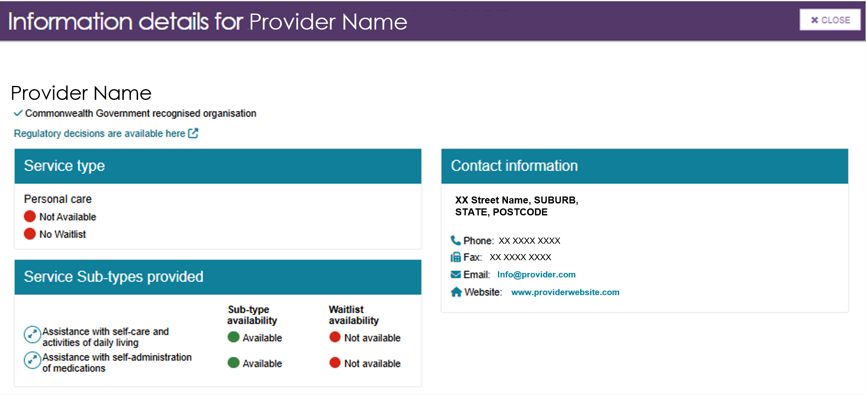

Support at Home Provider Listing (truncated)
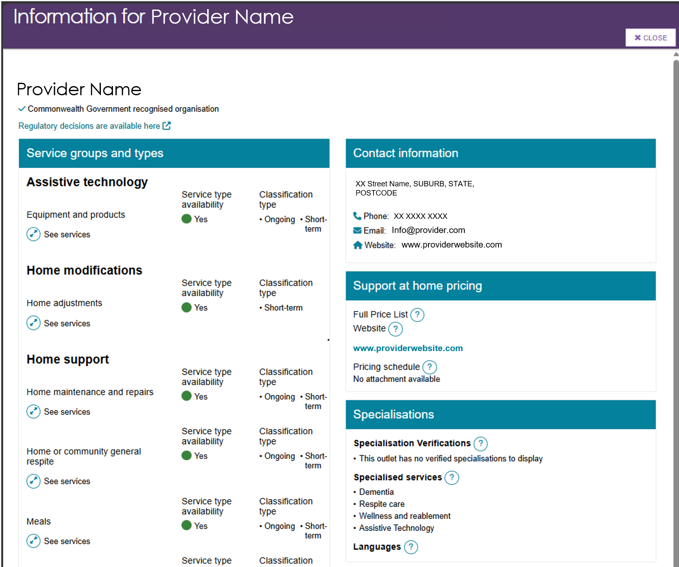
- Select the Question mark icon to show more information about the topic (help text).
In this example, the help text relates to the Support at Home Full Price List.
Support at home pricing - Full price list
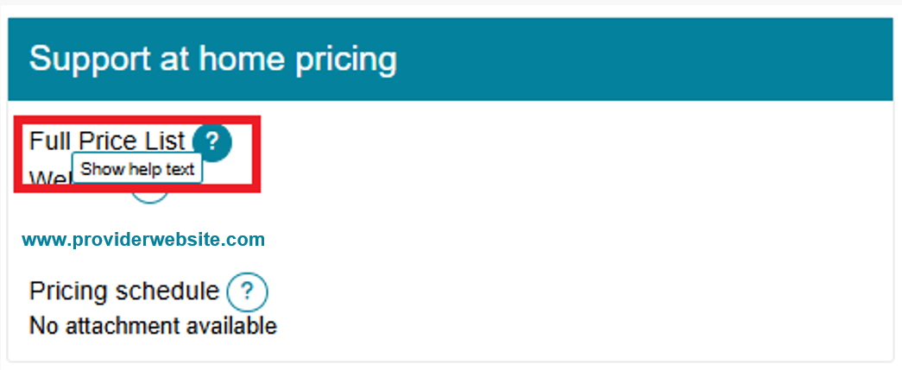
Full Price List - Help Text
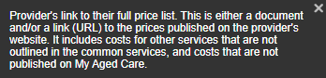

Select ‘See services’ to expand the list of services, or ‘Hide services’ to collapse it.
This image below shows the expanded view of the Home Support – Home Maintenance and Repairs section of the provider's listing.
Select the Magnifying glass icon to view more details about a service, including its delivery hours and pricing.
The examples below use Gardening to demonstrate how this information is displayed.
Home support - Home Maintenance and Repairs section of Provider listing
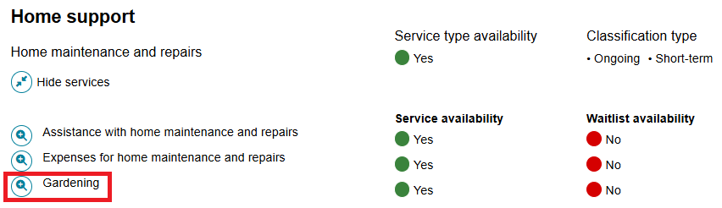
Gardening Service Details and Service Pricing
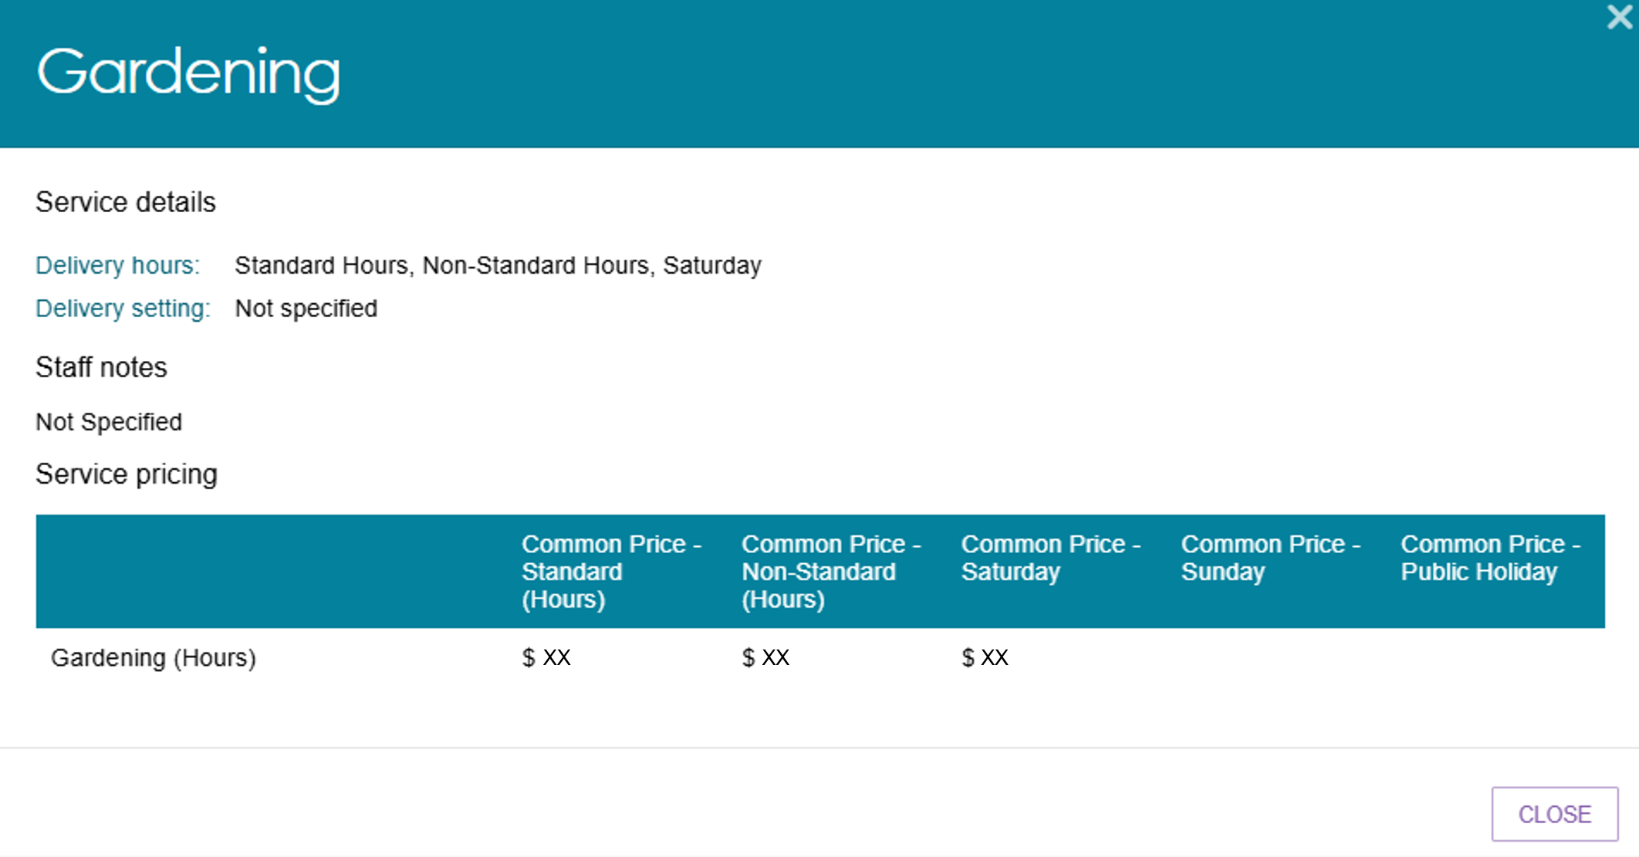

Searching for service providers using the Service Finder in the Support Plan
- To refer a client for services, first open the client's Support Plan and Services record. You can access it in one of four ways:
- From the Assessments tile
- From the Find A Client tile
- From the Tasks and Notifications tile, or
- Immediately after completing the client's support plan.
- Once the client’s Support Plan opens continue with instructions in Find Provider.

Assessments tile
Select the Assessments tile from the assessor portal home screen.
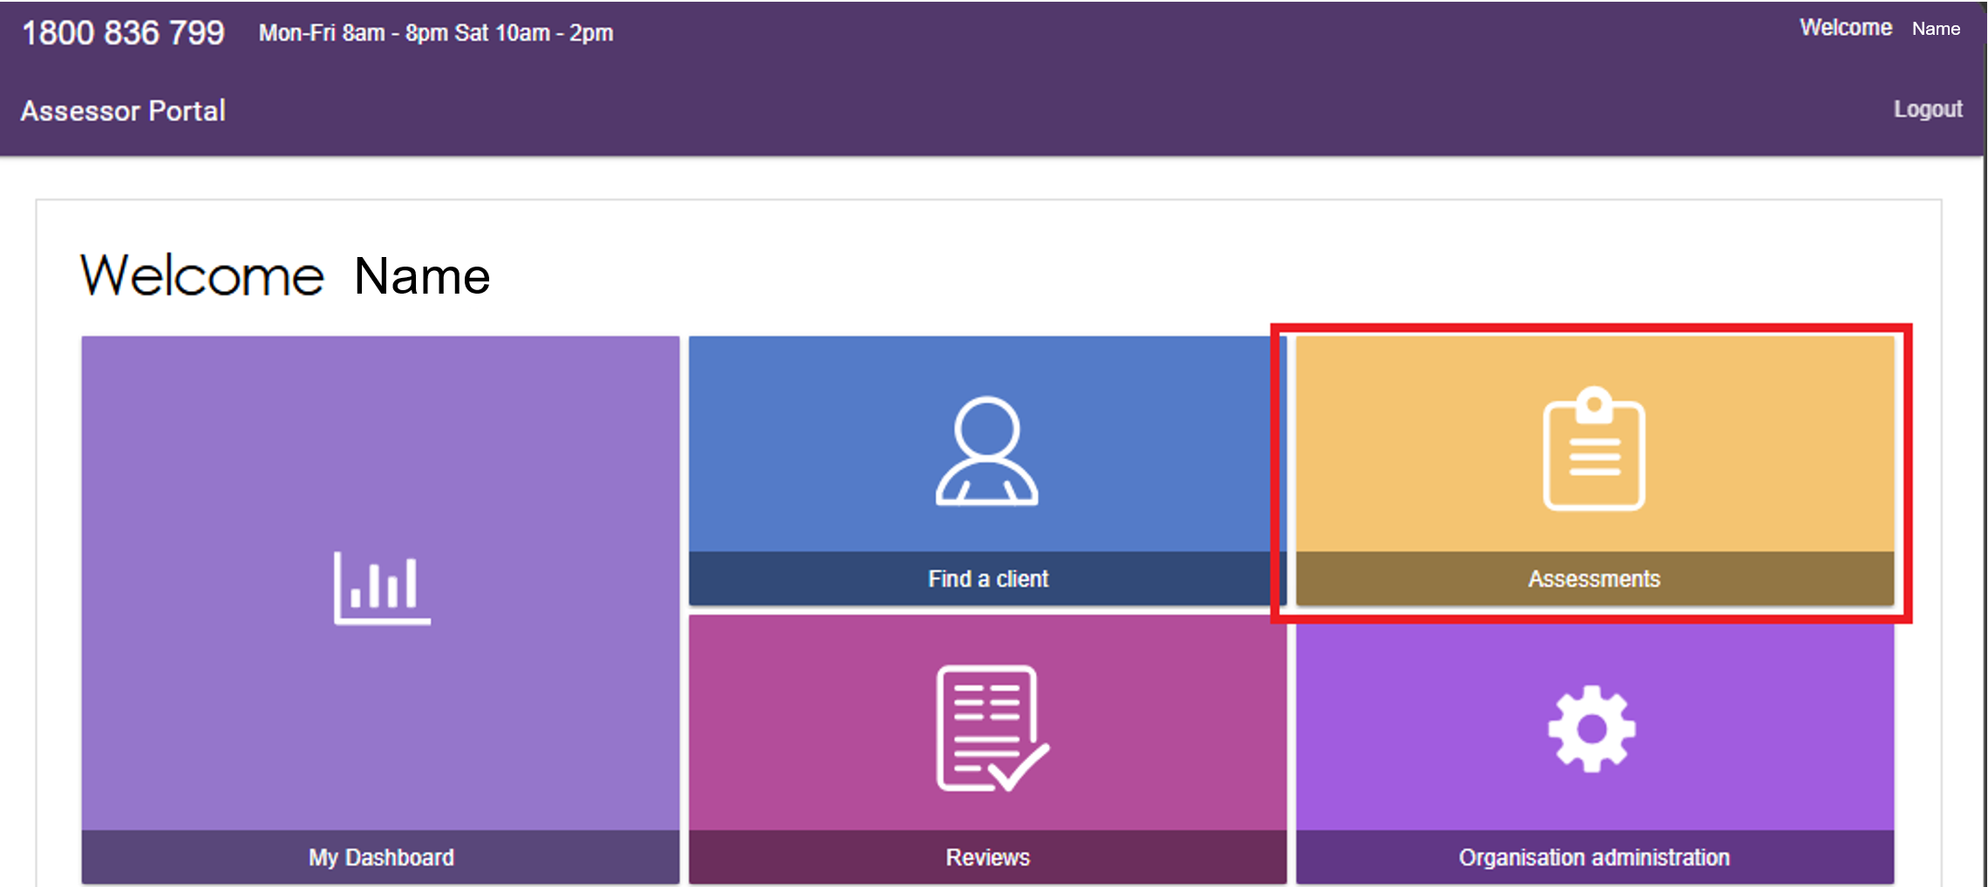
Select a client within the Current assessments tab.
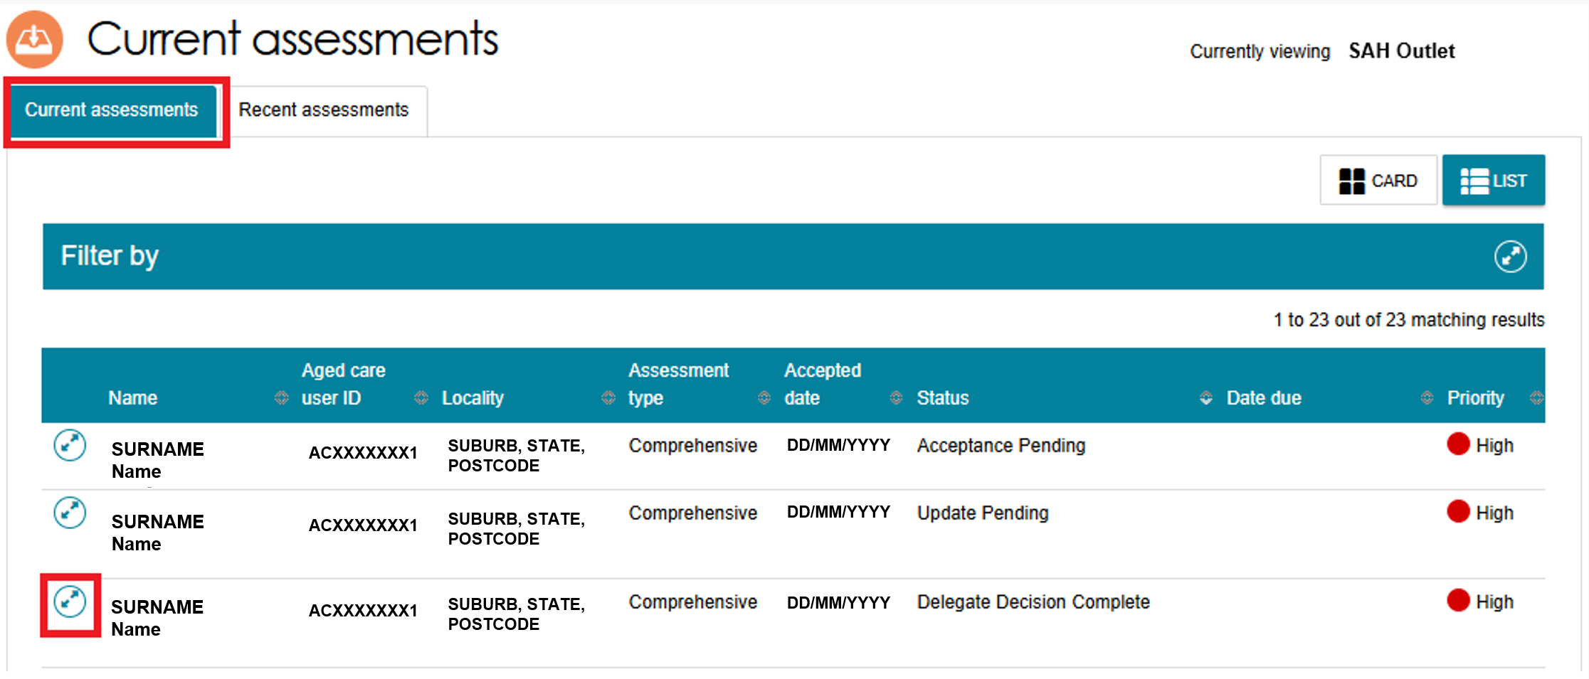
Select the client’s support plan link.
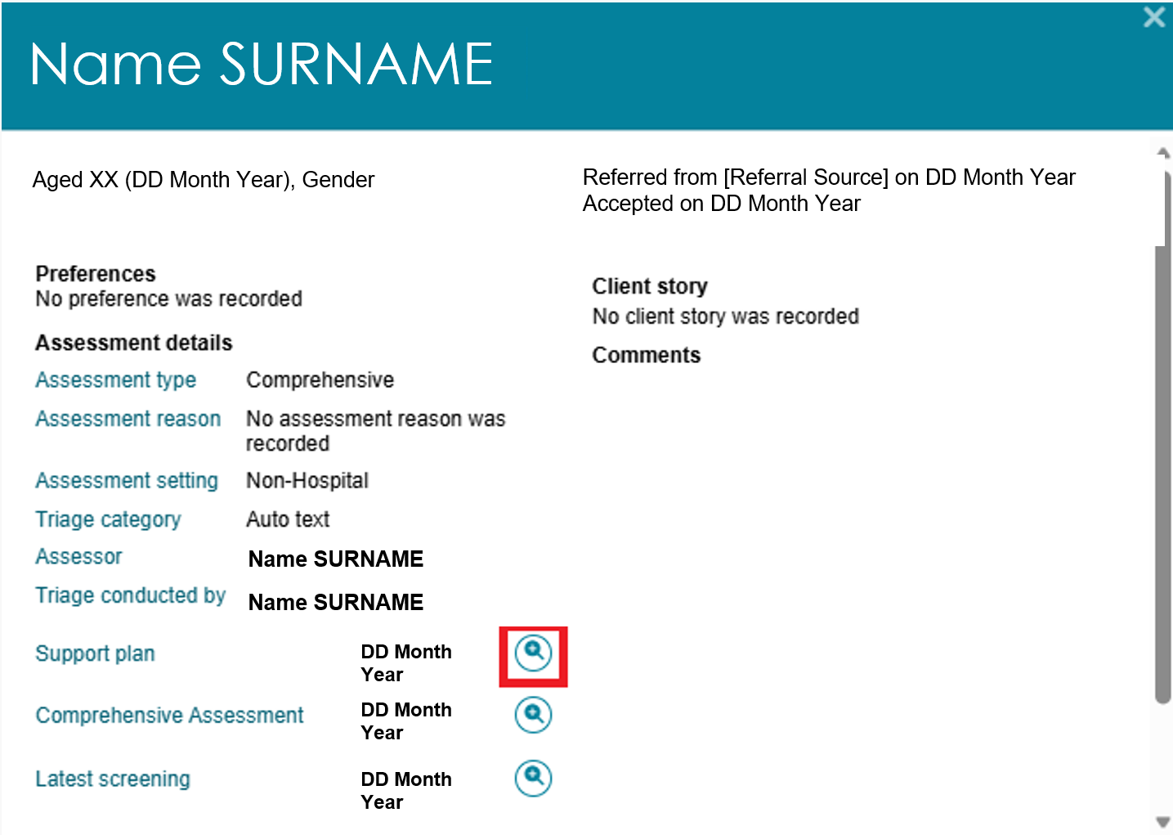

Find a Client tile
Select the Find a Client tile from the Assessor portal homepage.
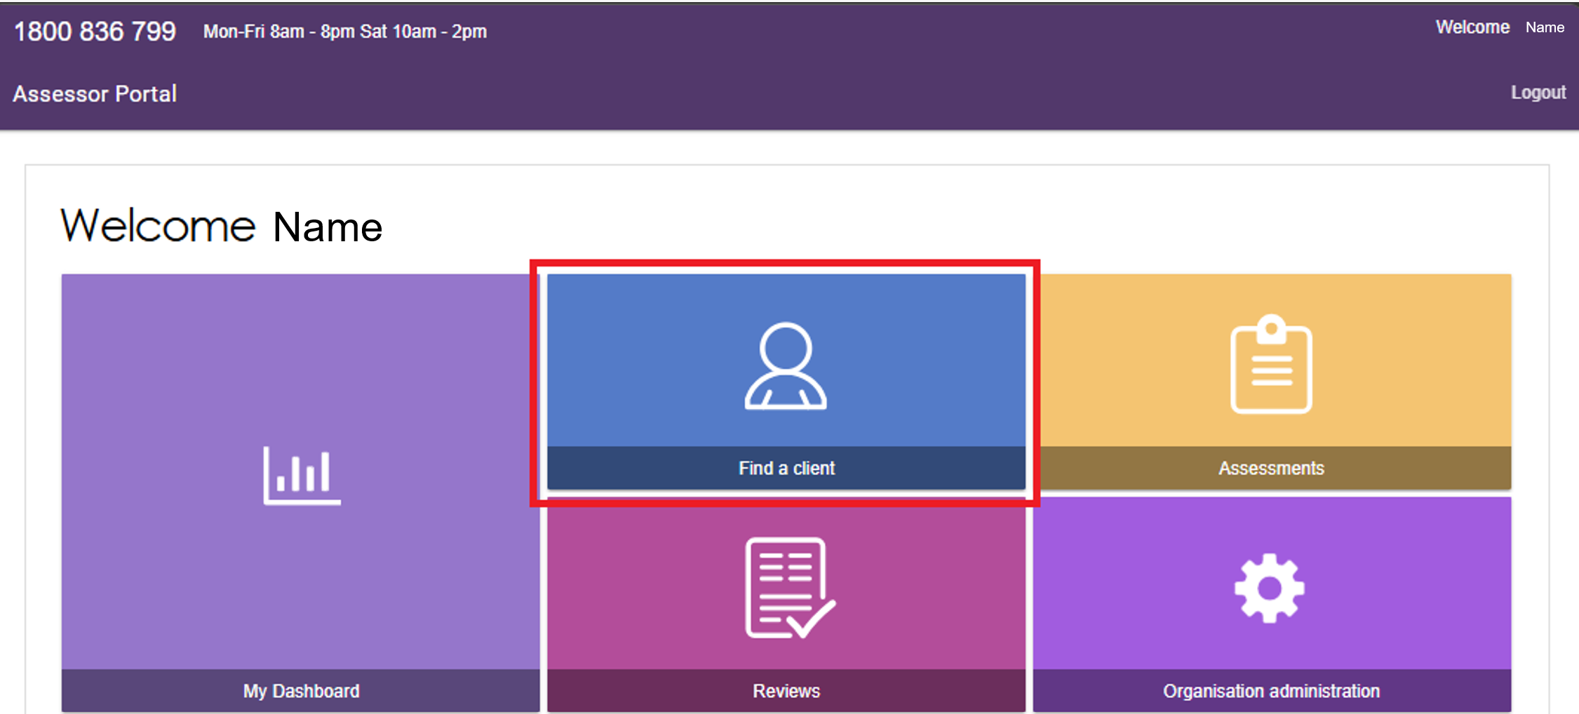
Search for your client directly using Last Name, First name, Aged Care user ID or the Advanced Search option.
You can also select the client from the Recently Viewed Persons section.
Once you find the client, select their record to open it.
Find a client page, searching by Last name and First name
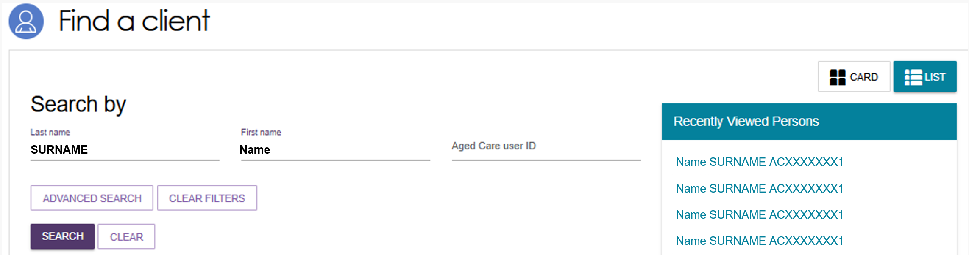
Find a client page with search results
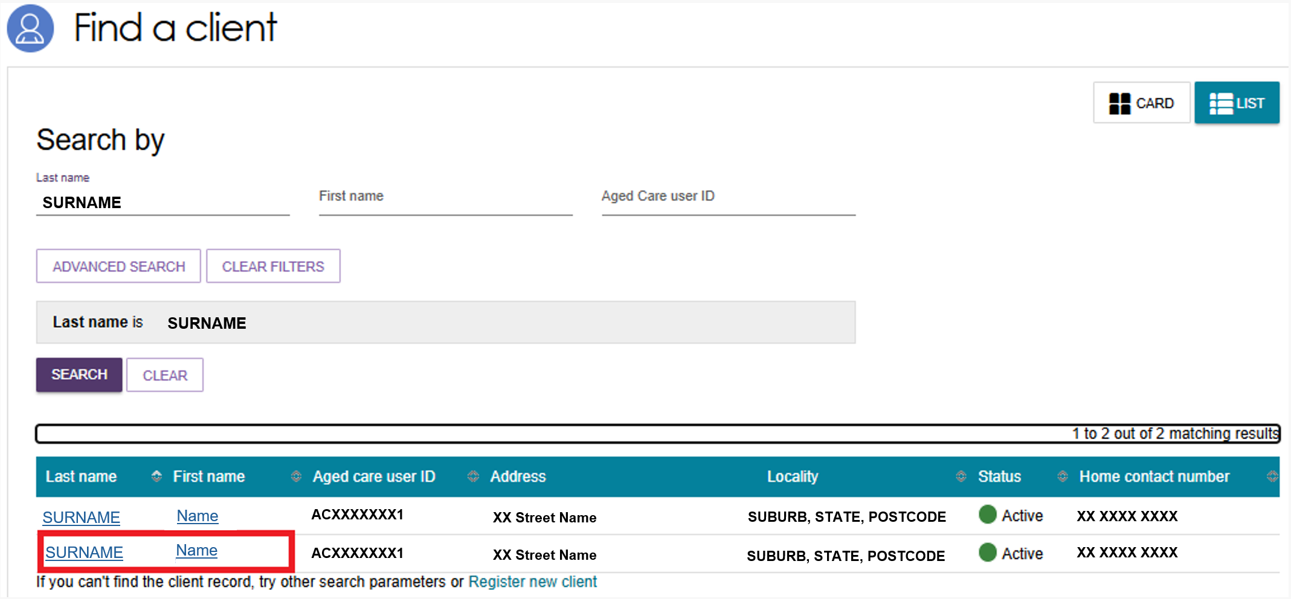

Open the client’s Support Plan.
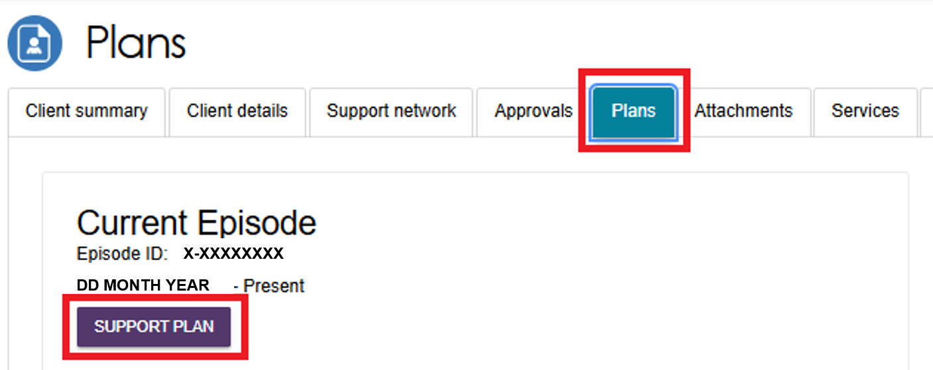

Tasks and Notifications tile
Select the Tasks and Notifications tile from the Assessor portal homepage.
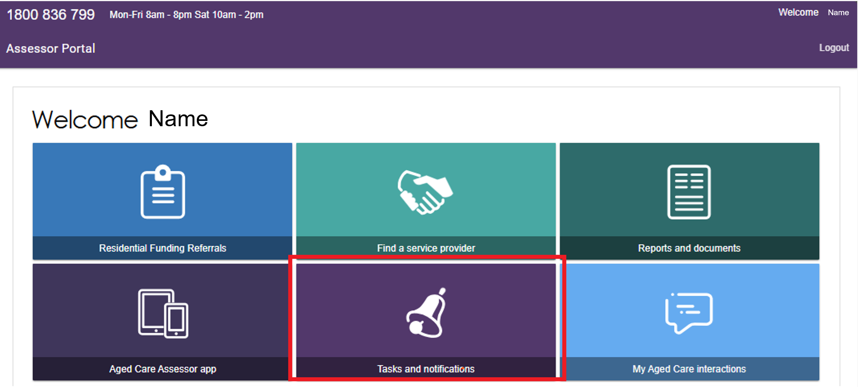
Go to the Notifications tab, then search for the client.
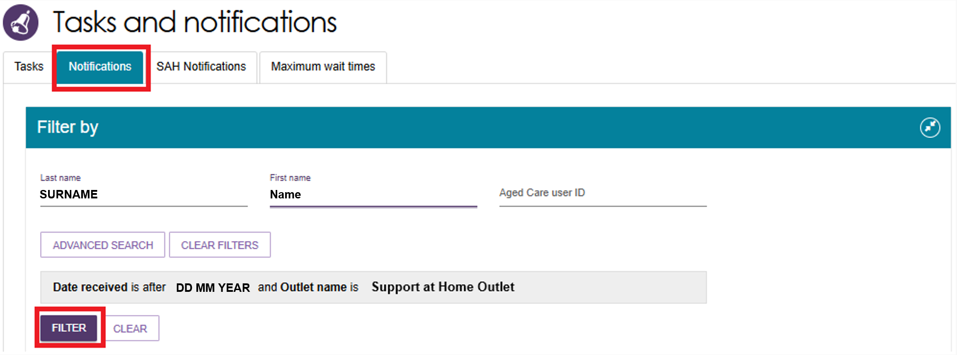

Select the Match and Refer link.
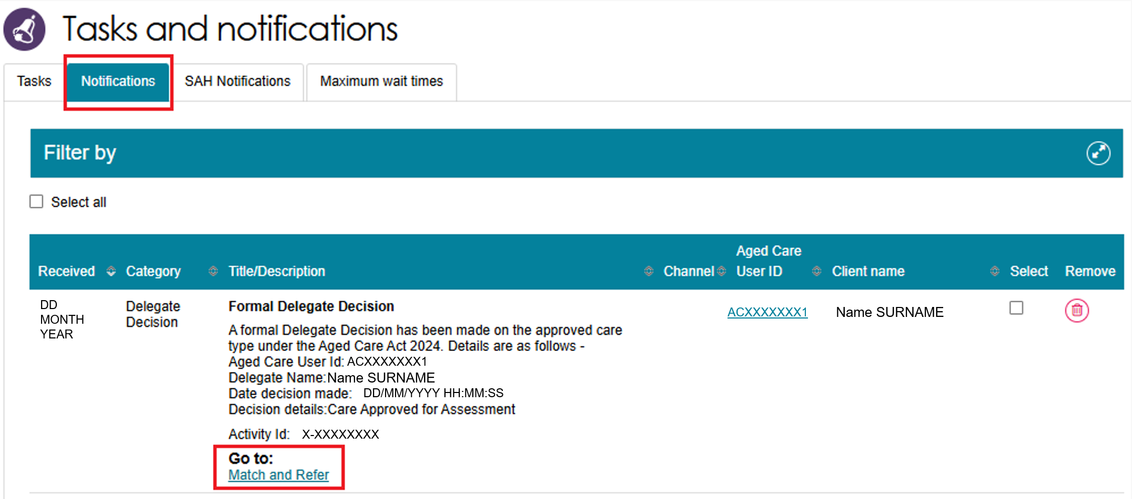

After support plan completion
When you finish developing the support plan with the client and the Delegate approves the service recommendations, select COMPLETE SUPPORT PLAN AND CONTINUE TO MATCH AND REFER.
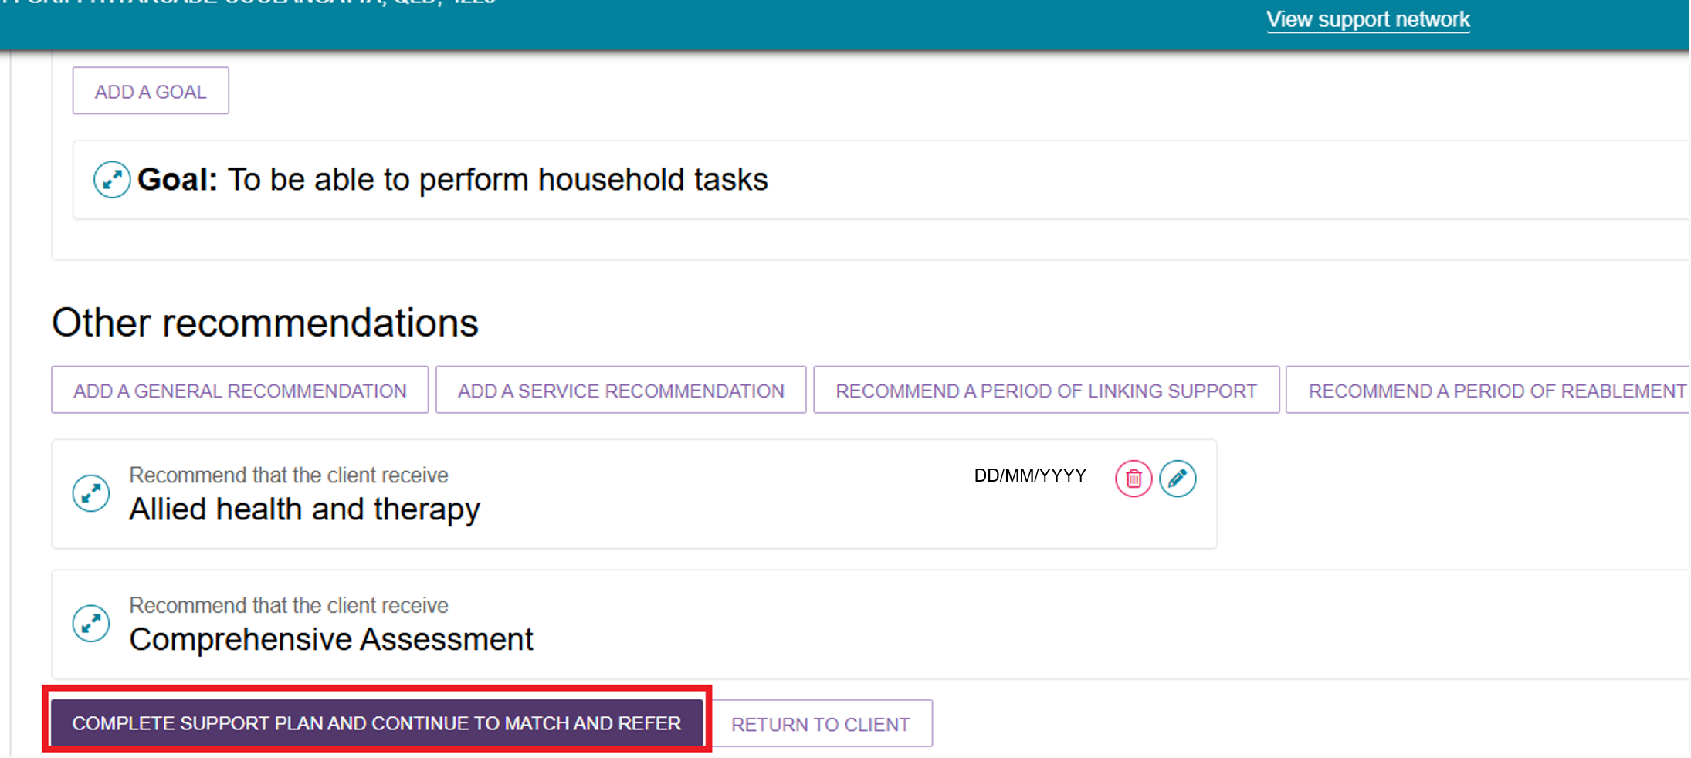

Find Provider
After opening the client’s Support Plan and Services page from one of these four ways:
- From the Assessments tile
- From the Find A Client tile
- From the Tasks and Notifications tile, or
- Immediately after completing the client's support plan.
- The system opens the Manage Services & Referrals tab, from the client’s Support Plan and Services page.
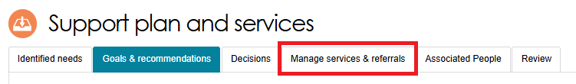
- The services you added in the Goals and Recommendations tab appear under Services Not Yet in Place.
Select FIND PROVIDERS to search for providers and create electronic referrals.
For clients assessed for Support at Home services, the FIND PROVIDERS button is only available when Support at Home funding has been allocated. For more information refer to Referring for Support at Home services.
Support at Home
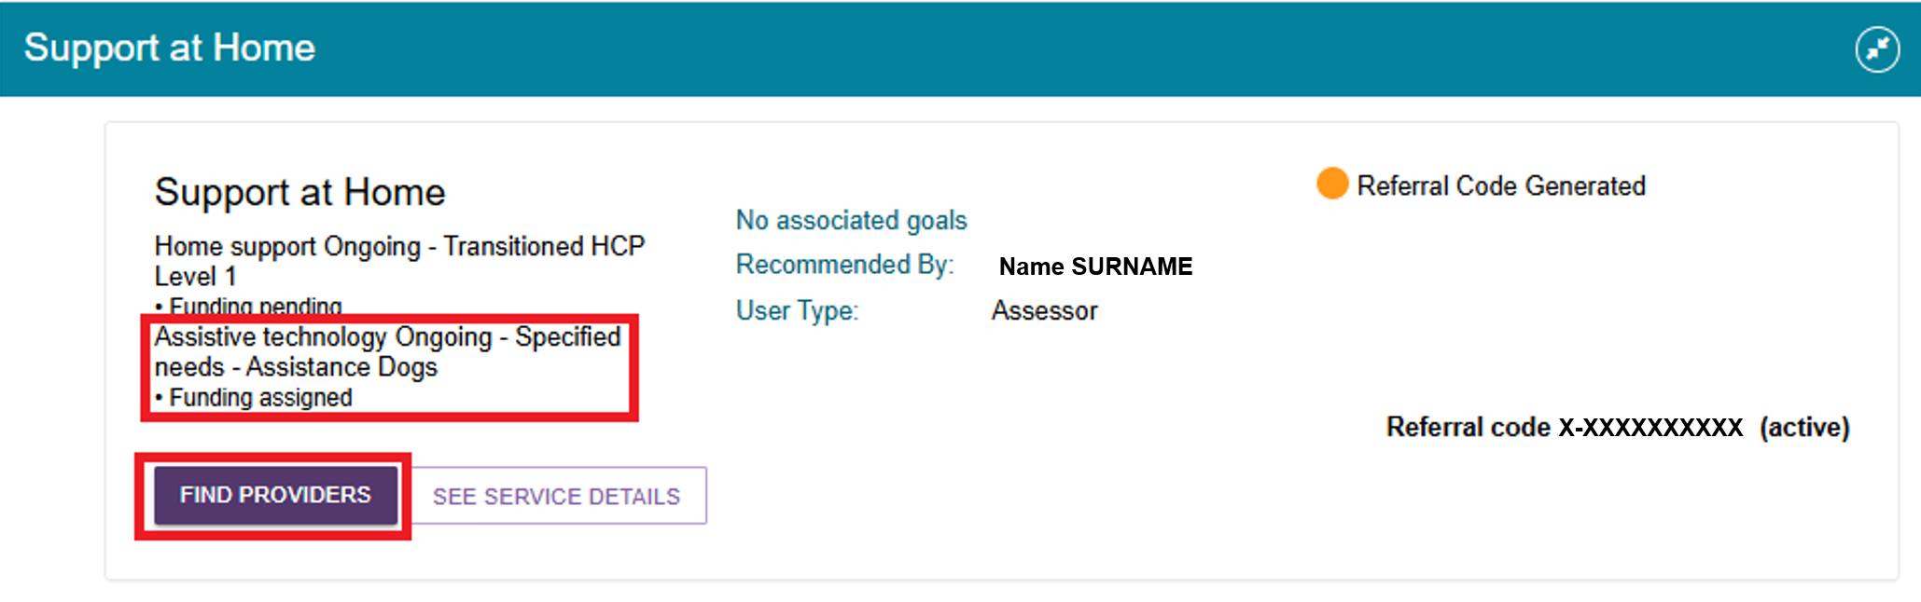
Where available, you can select multiple services at the same time. For example:
- Select all Help at Home services, then select FIND HELP AT HOME PROVIDERS
- Select all Aged Care Home services, then select FIND AGED CARE HOME PROVIDERS.
Help at Home providers
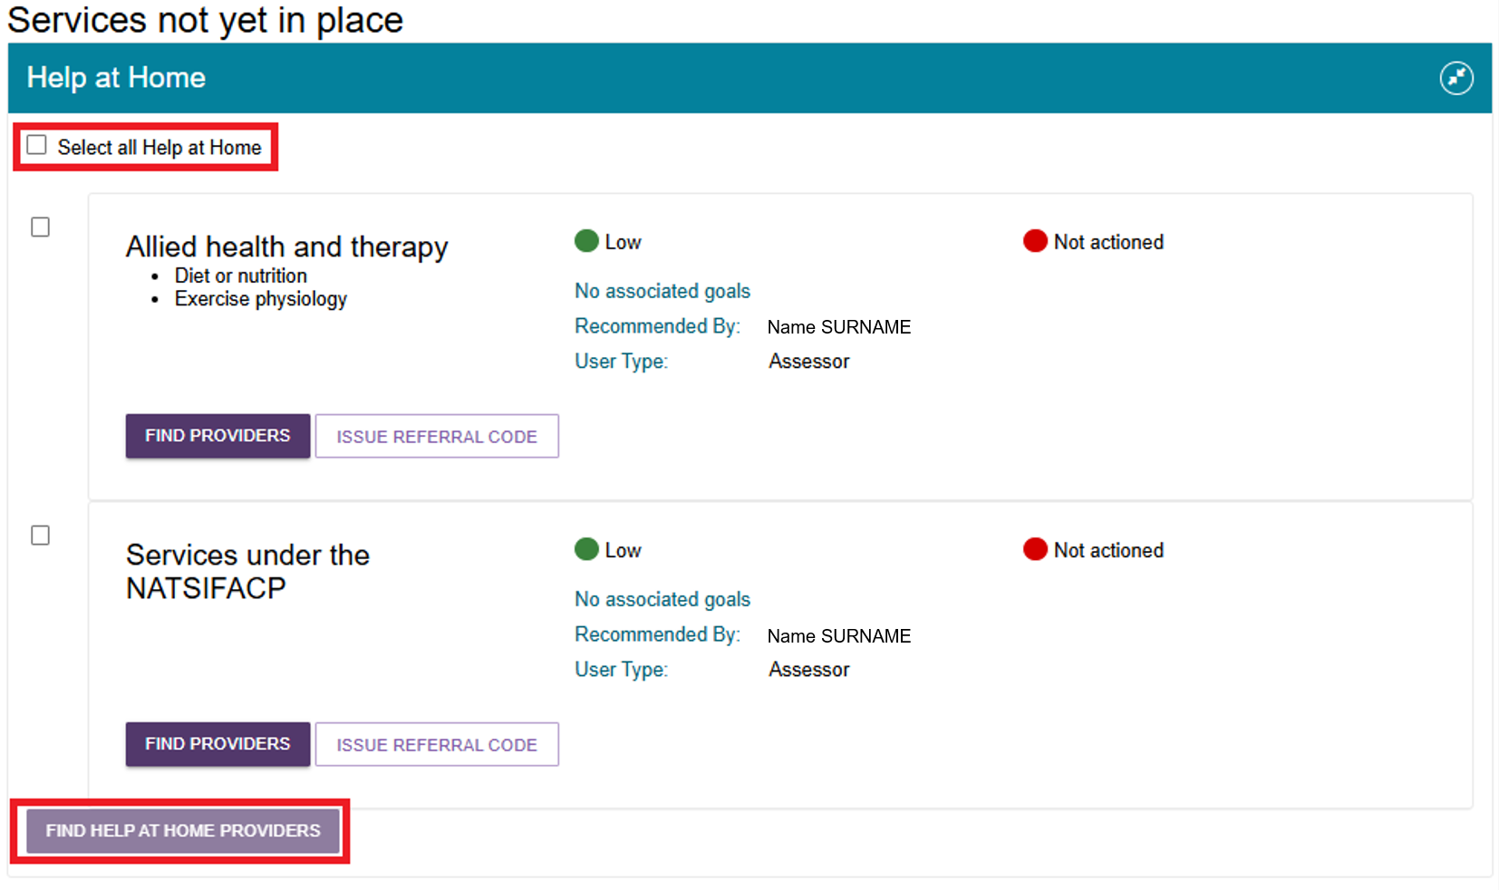
In the below example, all Aged Care Homes are already pre-selected, then you can select FIND AGED CARE HOMES PROVIDERS.
Aged Care Homes providers
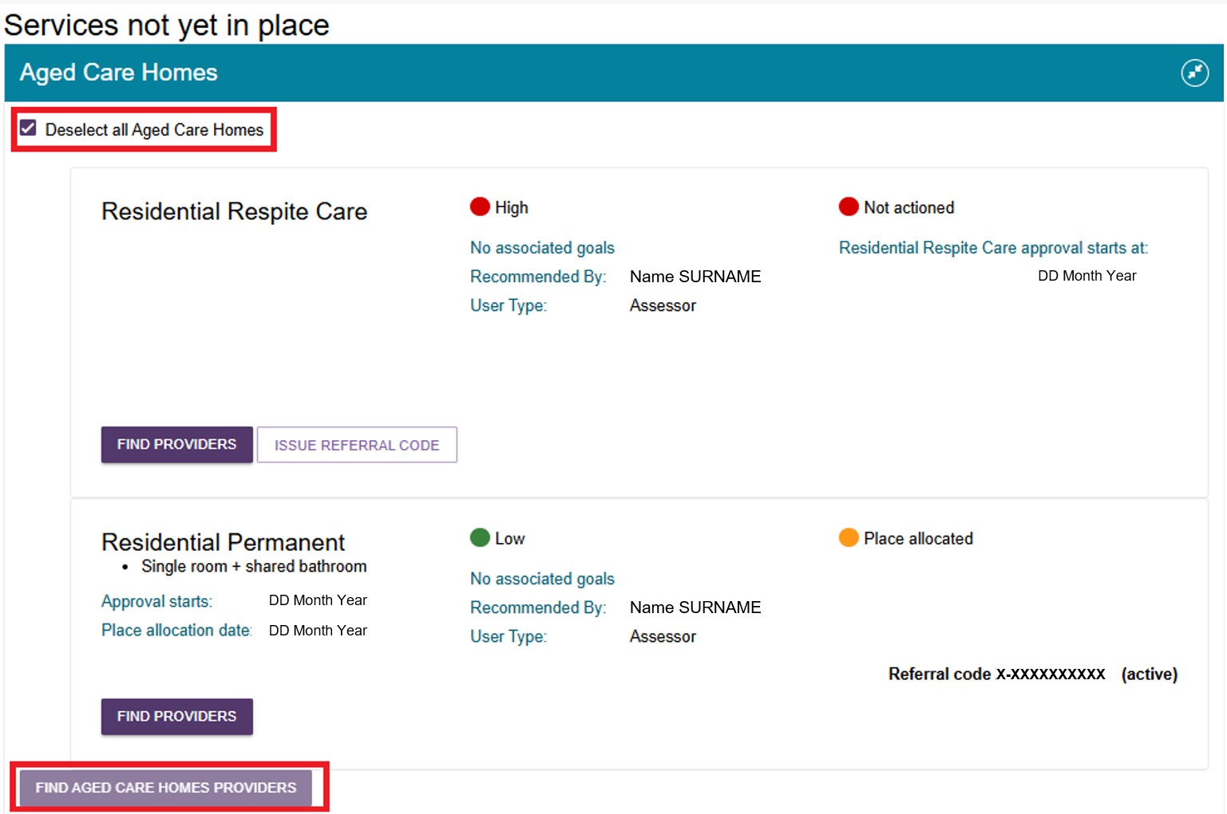
- The Service Finder page opens and displays the service or services you selected in the previous step.
Search using the available criteria and then select SEARCH.
Depending on the service type, you may be able to search using:
- Specific services within a service type to better match the client's needs. For example, Shopping Assistance within the Domestic Assistance service type
- The client's service delivery address
- The preferred service delivery location, such as: the client's location, or the provider's location
- A provider name
- A map-based location search.
Depending on the service, the search may use either:
- a region or area-based search, such as services delivered in the client's home, or
- a proximity-based search, such as services provided at a centre or facility.
You can also use detailed search options to refine results. These options include whether the client has previously received services from a provider and whether the provider offers specific specialisations needed to meet the client's requirements.

The search results will display in the following configuration depending on the criteria used when searching for services.
Service Provider Search Results Display Configuration table
Search method | Service delivery location | Map View | List View
Client Address; or  Suburb/Postcode | At Client Location | Outlet Address | Outlet Address
Client Address; or  Suburb/Postcode; or  Select A Location | At Provider Location | Address where services will be delivered | Outlet Address and service delivery address (under the individual service)
Service provider name | N/A | Map will be hidden for all services except Residential Care services | Outlet Address and service delivery address (under the individual service)
Refer to these image examples below for:
- A Service Finder page for a Help at Home service.
- Service Finder page for some Support at Home services.
Service Finder page for a Help at Home service
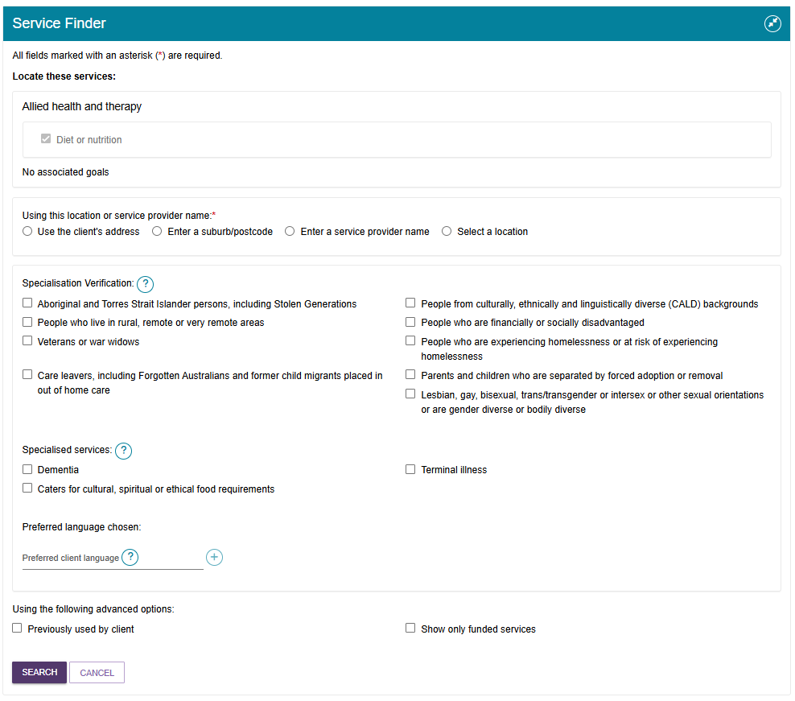
Service Finder Page for some Home Support services
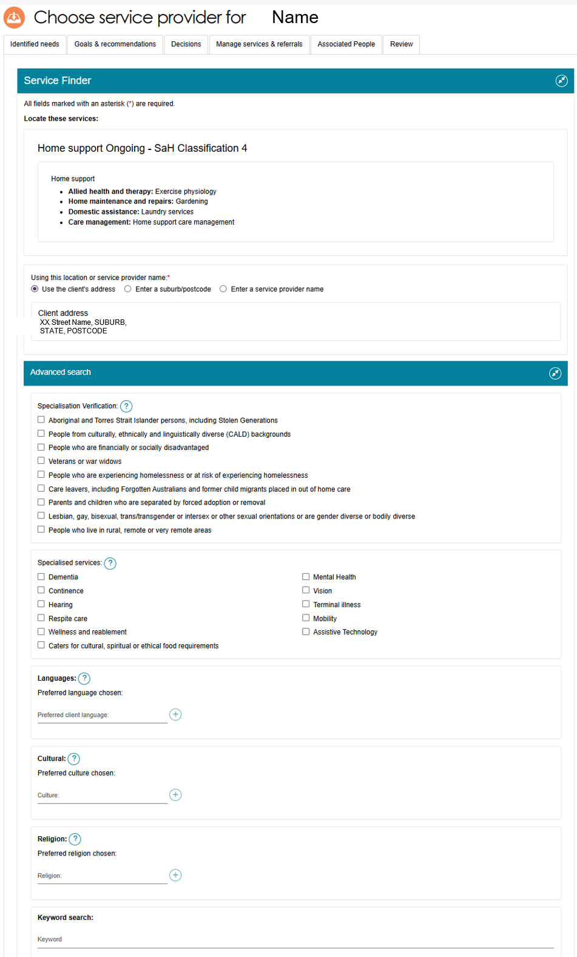
- The Service Finder then displays providers that match your criteria.
Non-Support at Home Service Finder results page
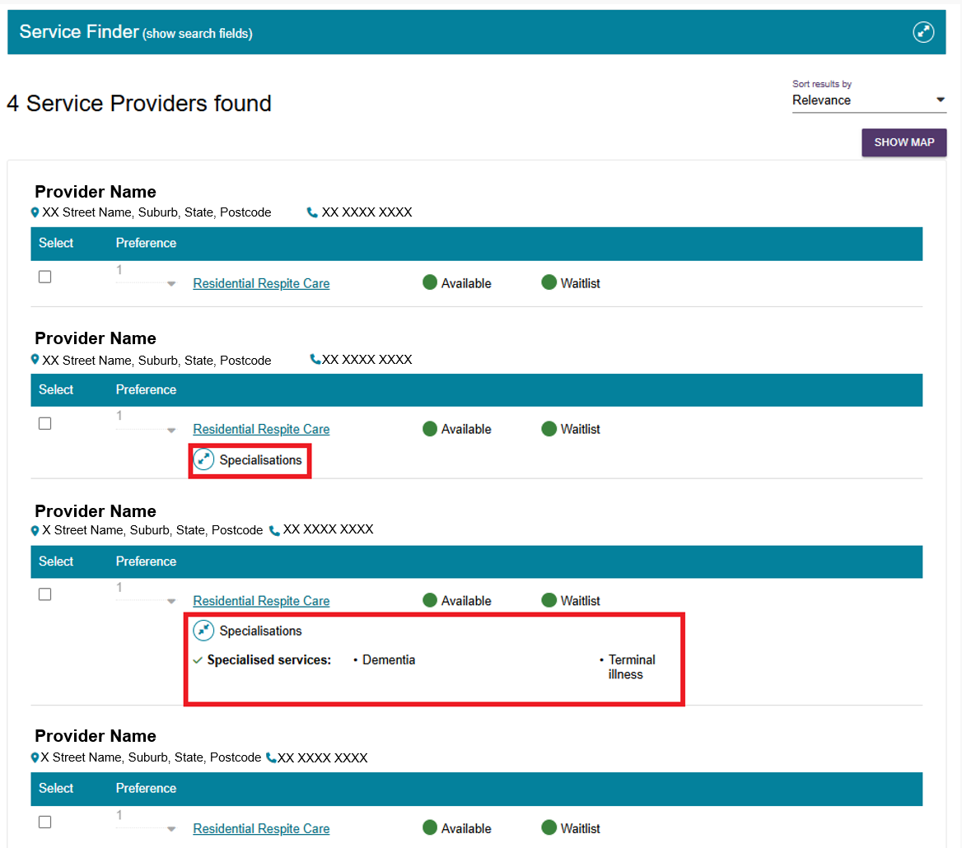
Support at Home Service Finder results page
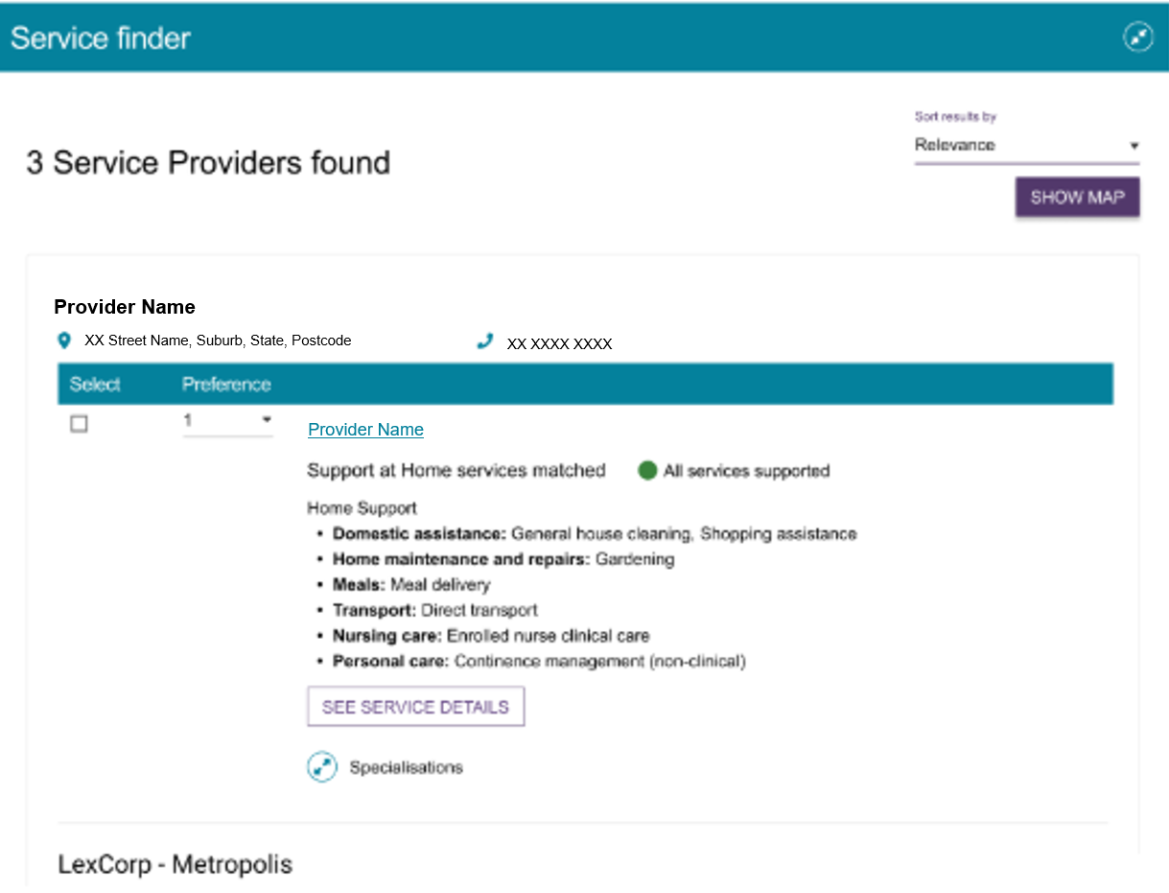
For more information on how to refer services from the Service Finder page, refer to:
- Referring for Help at Home and Aged Care Homes services
- Referring for Support at Home services.
- Select the provider's name in the search results to view more information about the provider.
You can view any regulatory decisions that apply to the provider by selecting the Regulatory decisions are available here link under the provider's contact details.
For care types covered under the Act, the provider details page also includes information such as service status, service costs, and other relevant details.
Information Page of a Support at Home provider (truncated example)
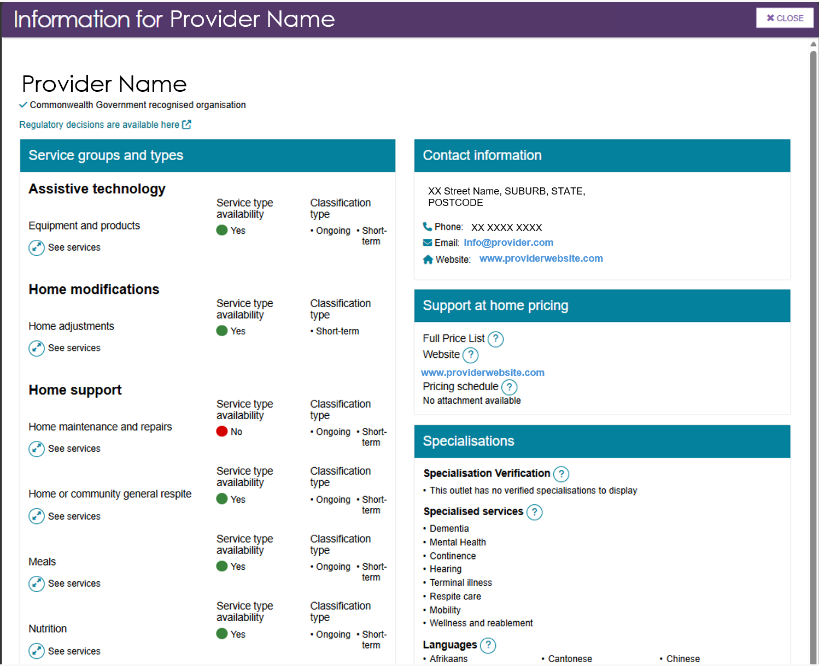
For example, for Permanent Residential Care, the page shows the facility's accreditation information and the costs of different room types.
Information details page for a Residential Permanent provider
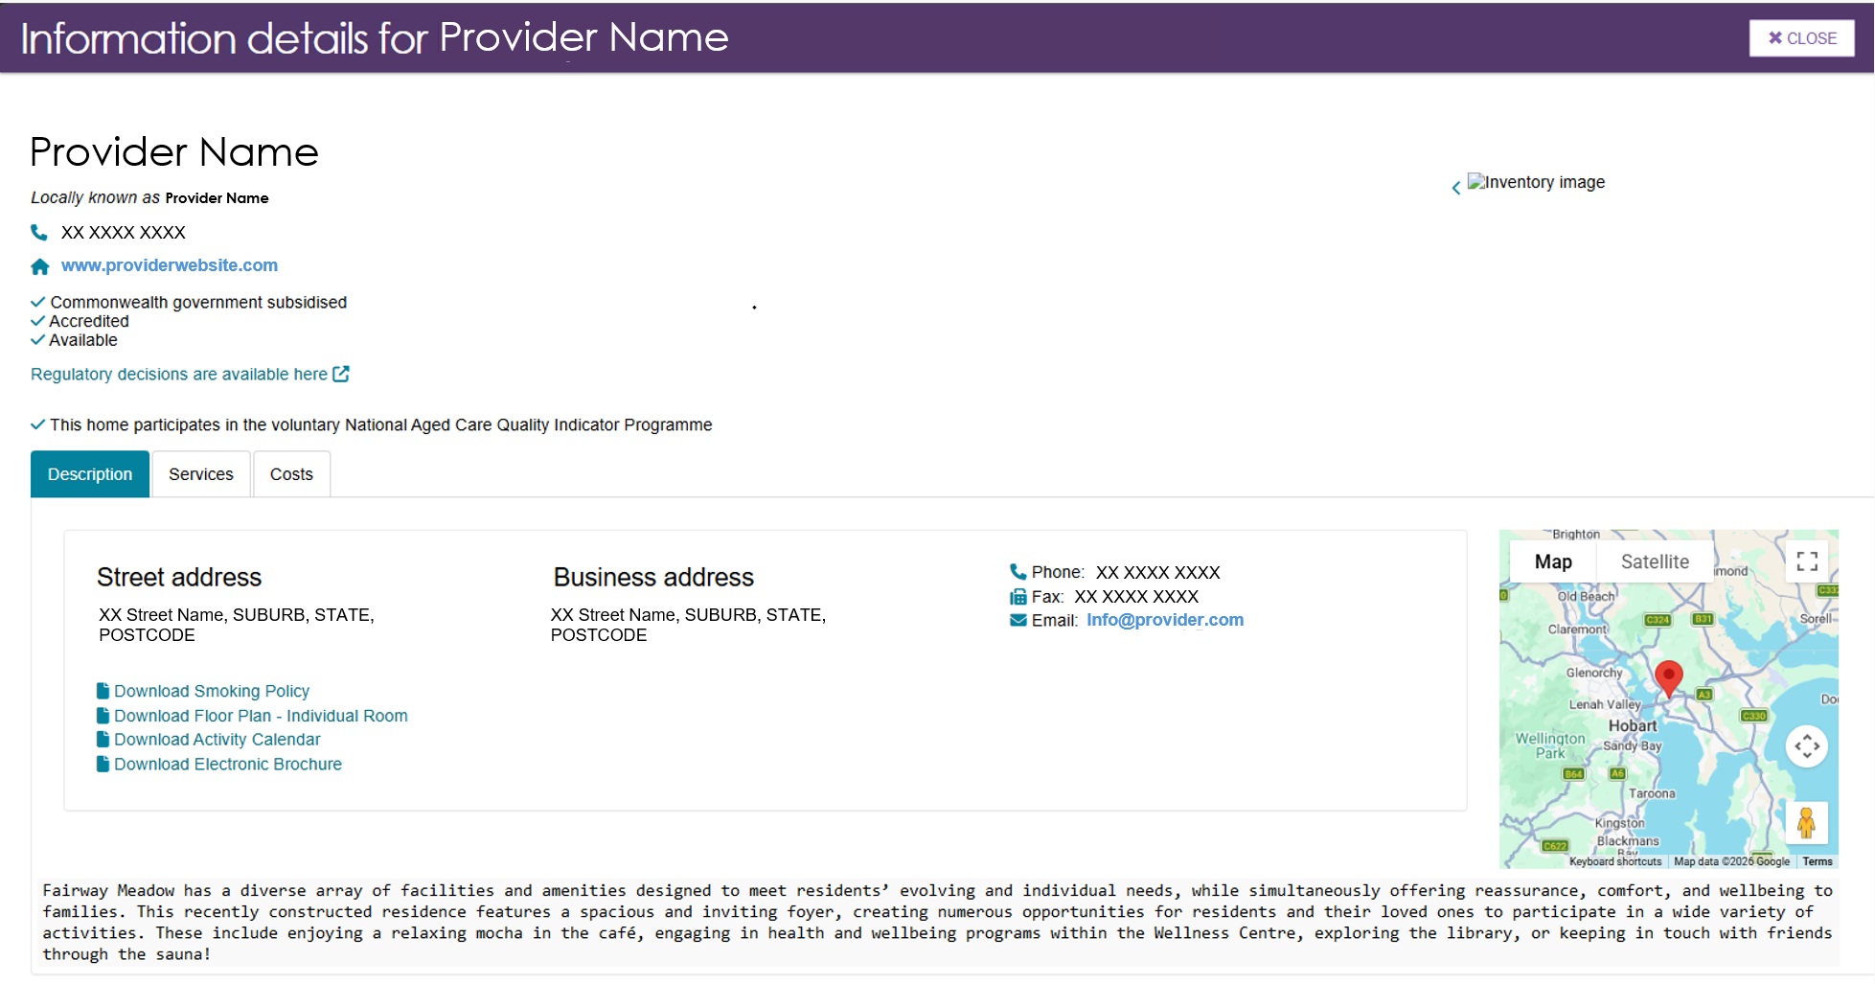

Searching by map location
- To search by map location, select Select a Location.
Place a pin on the map by selecting (or clicking on) the desired location. To choose a different location, move the pin to a new position. You can view nearby areas by clicking and dragging the map.
Enter a search radius in kilometres, for example, 100 km.
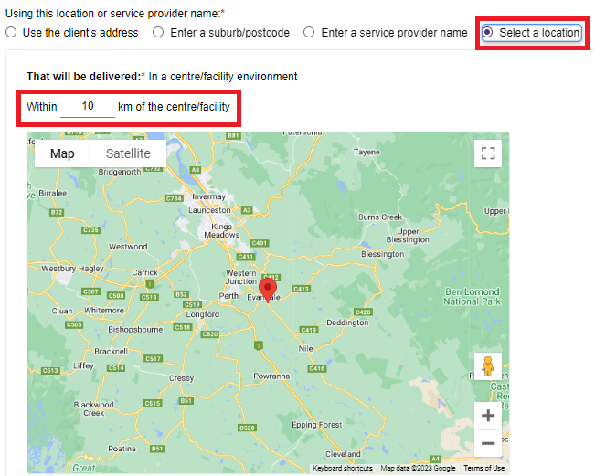
- The system displays service providers that deliver services within the search radius you entered.
In this example, two providers (Pins 1 and 2) are located within the search radius of the selected location (the unnumbered pin).

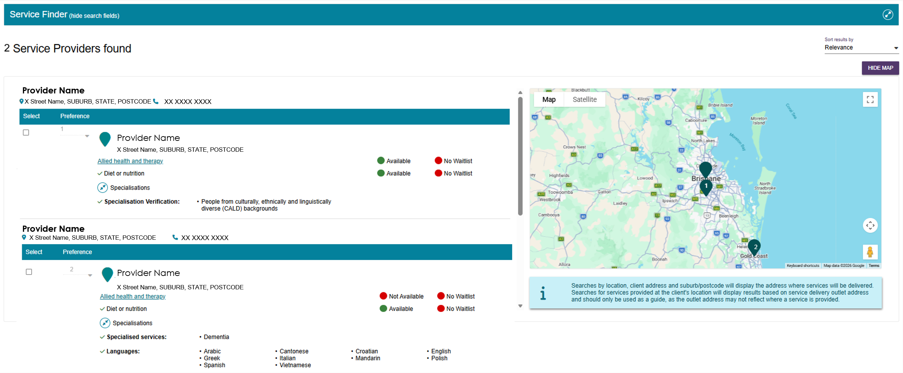
If no providers match your search criteria, the system displays an information message that:
- identifies the service or services you searched for, and
- advises that no providers matched all of the selected criteria.
If this occurs, review and adjust your search criteria before searching again.
- The system sorts search results by relevance. If multiple providers have the same relevance, the system displays them in a random order.
Select Hide Map to switch to the list view.
When you are viewing the list, select Show Map to return to the map view.
Map view (truncated example)
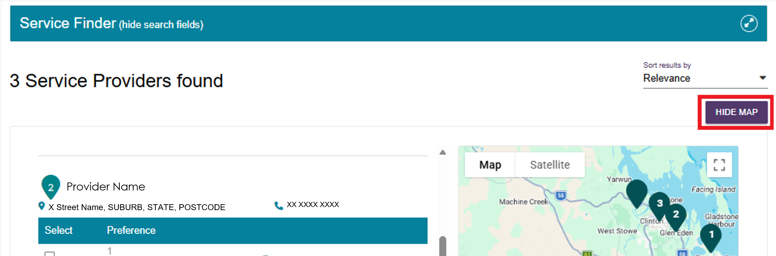
List view (truncated example)
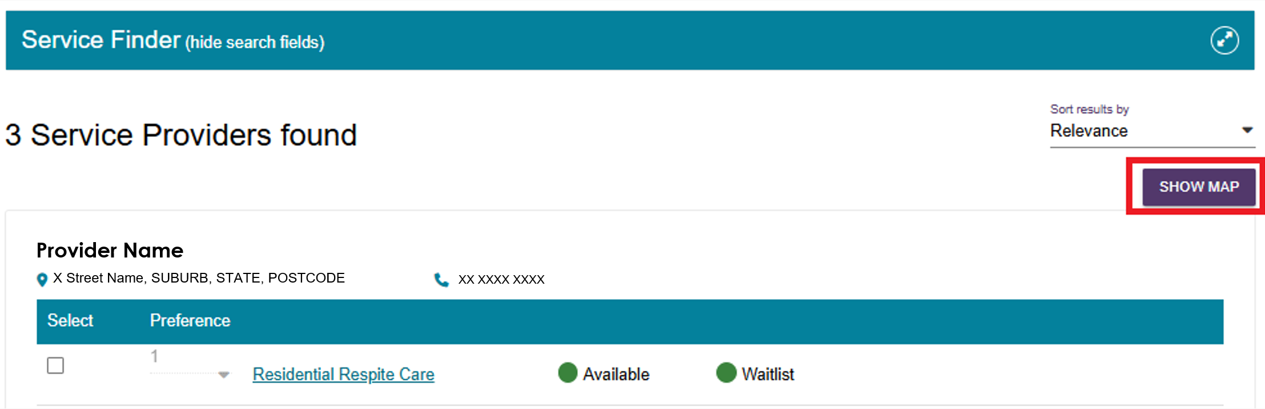

Referring for Help at Home and Aged Care Homes services

Issuing a referral for service
! | Prior consent required  Before issuing a referral, you must obtain consent from the client or their supporter or guardian.  Use the My Aged Care Assessment Consent Form to record this consent.  The form includes consent scripts and fields for recording consent to service referrals. You can access it from the Reports and Documents tile in the Assessor Portal.
- After searching for Help at Home or Aged Care Home providers, either through the Find a Service Provider tile or the Service Finder in the support plan, the Service Finder page displays a list of matching providers.
Each provider listing includes a link for the service they offer, such as Residential Respite Care. The listing also shows service availability and any waitlist information.
Select the Specialisations expand icon to view the provider's specialised service offerings. Under Specialisation Verification, the system only displays verified specialisations. Whereas, the system will display any non-verified specialisation offerings a provider has self nominated.
Select Hide services to collapse the expanded view.
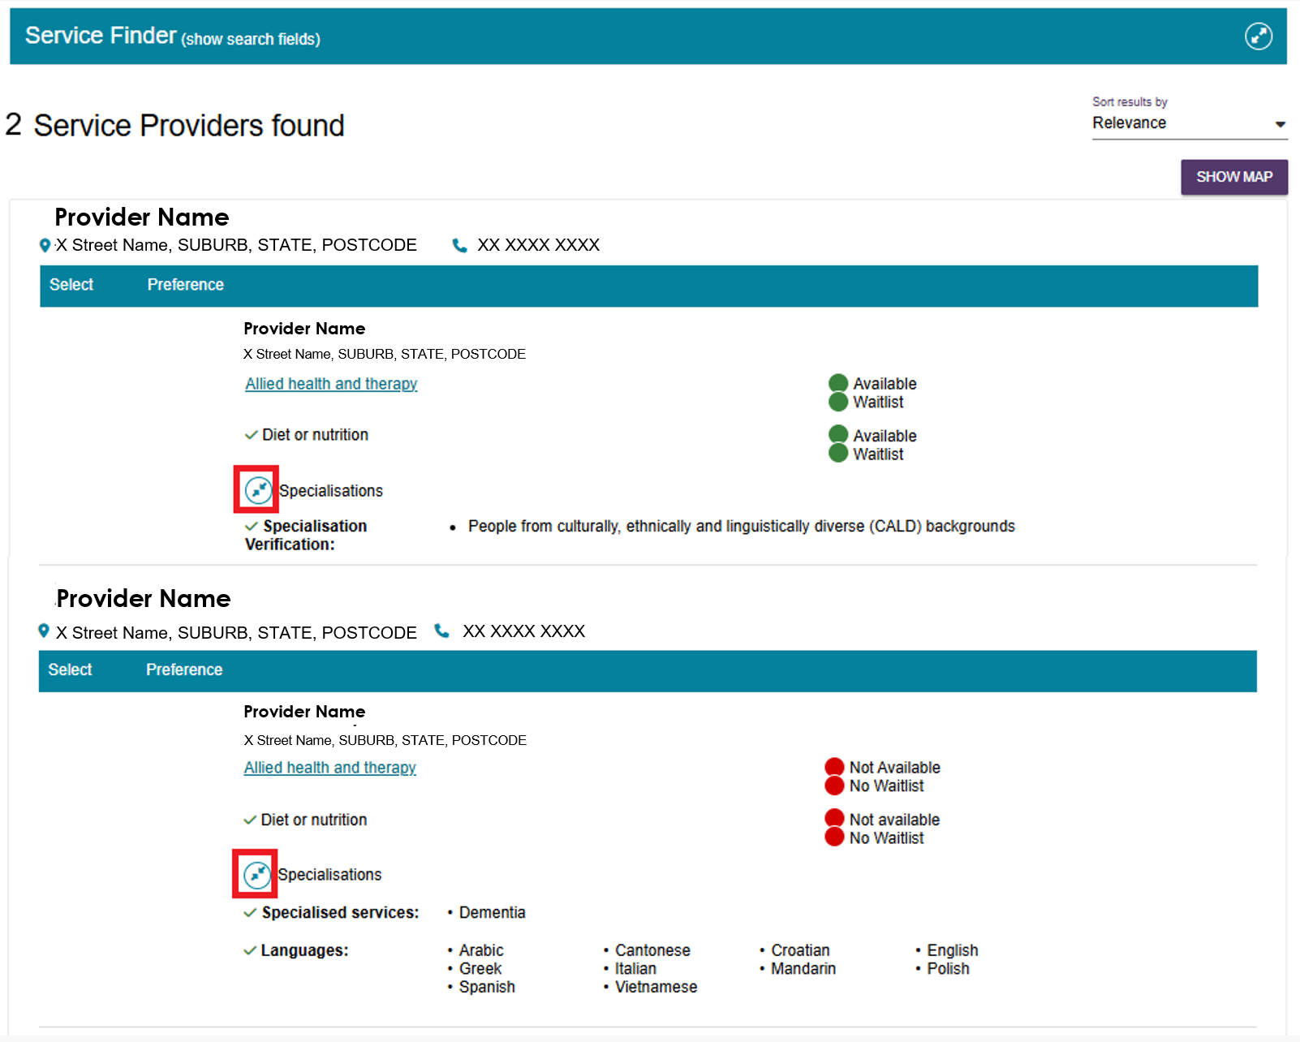

- Select the client's preferred service provider or providers, confirm that you have the client's consent to send the referrals, and then select SAVE SELECTION AND CONSENT.
- For broadcast referrals, set all selected providers to 1st. Before you send a broadcast referral, make sure the client understands that multiple providers may contact them about the referral.
- For sequential referrals, rank the providers in the order of the client's preference.
The example below shows three Permanent Residential Care providers selected for a broadcast referral.
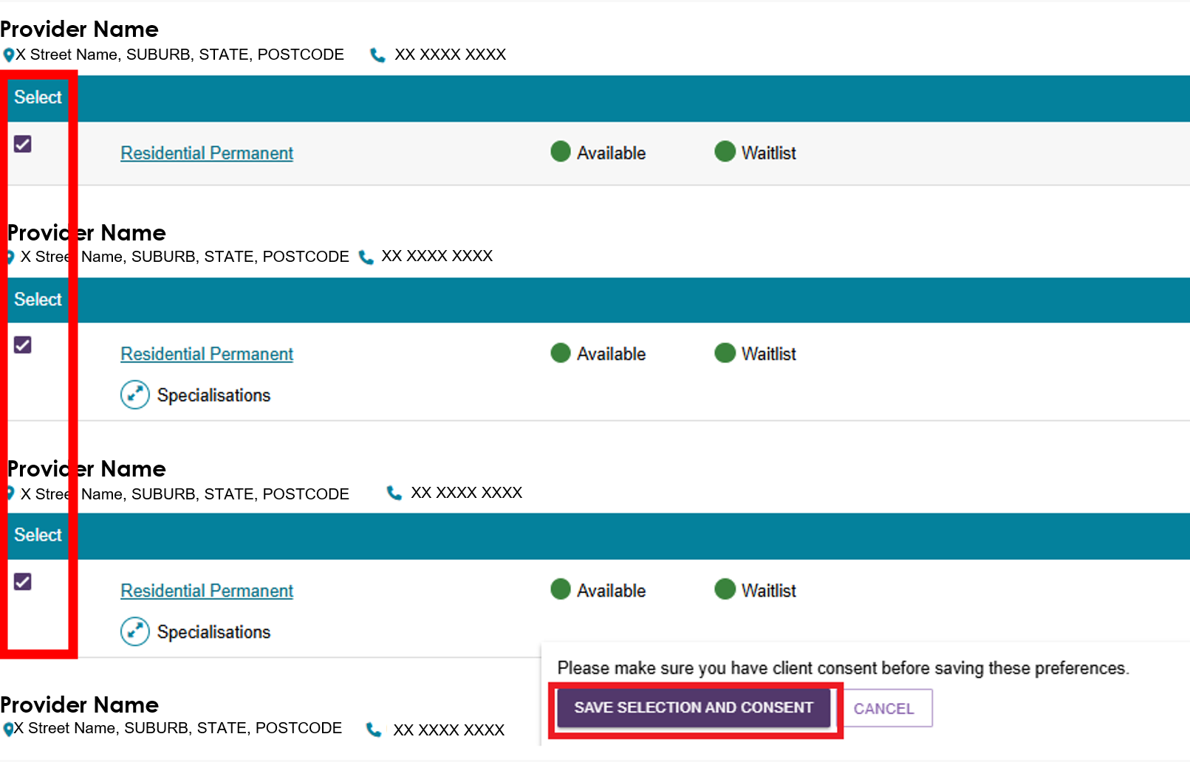
The example below shows three Residential Respite Care providers selected for a sequential referral.
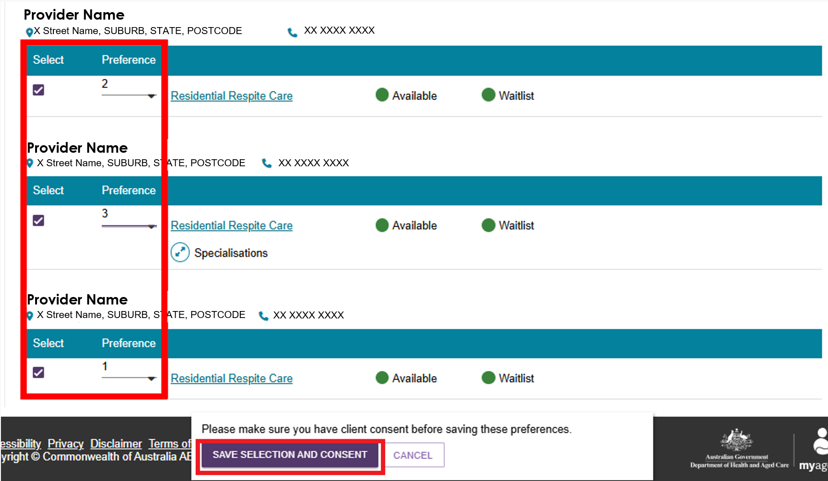
! | Waitlisting  If the client's preferred providers are unavailable, the client may choose to join a waitlist. The search results show whether a provider offers a waitlist.  For sequential referrals, if a provider places the client on a waitlist, the system automatically sends the referral to the client's next preferred provider.  Clients can join multiple waitlists at the same time.  A client remains on a provider's waitlist until the provider has a place available and accepts the referral.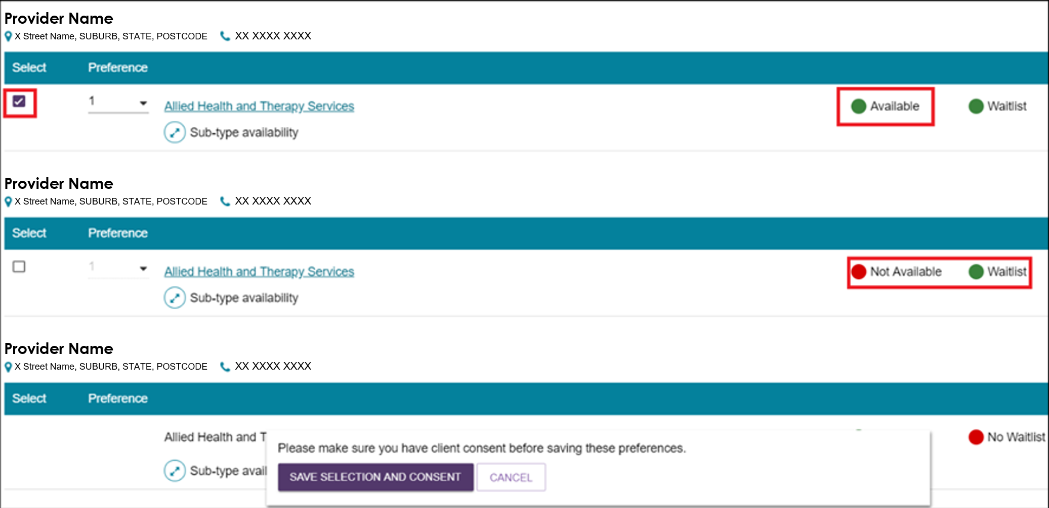
- The selected provider or providers now appear against the recommended service.
Select CHANGE THIS SELECTION to add more provider preferences.
To update or remove existing provider preferences, select EDIT PREFERENCES.
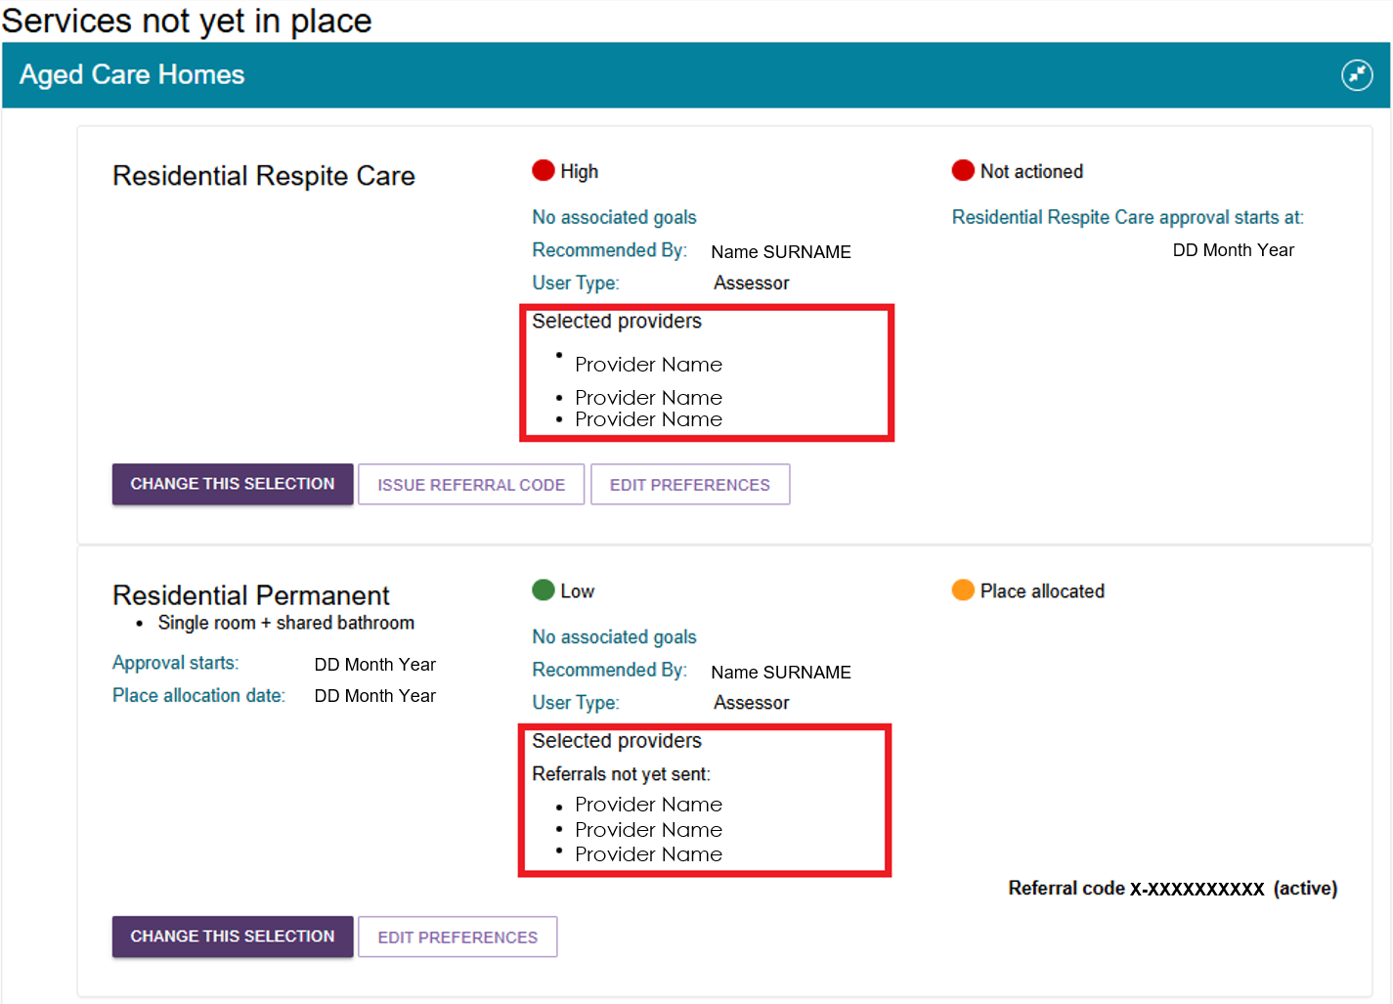
- To issue electronic referrals, select SEND REFERRALS.
! | The SEND REFERRALS button is only available in the following situations:  - For non-urgent CHSP services, after the Delegate approves the service recommendation.  - For non-urgent MPSP or NATSIFACP services, when the client also has an active approval for Residential Care, Transition Care, Home Support, Assistive Technology, or Home Modifications services.  - For all urgent referrals, except CHSP urgent referrals submitted after the approval cease date.
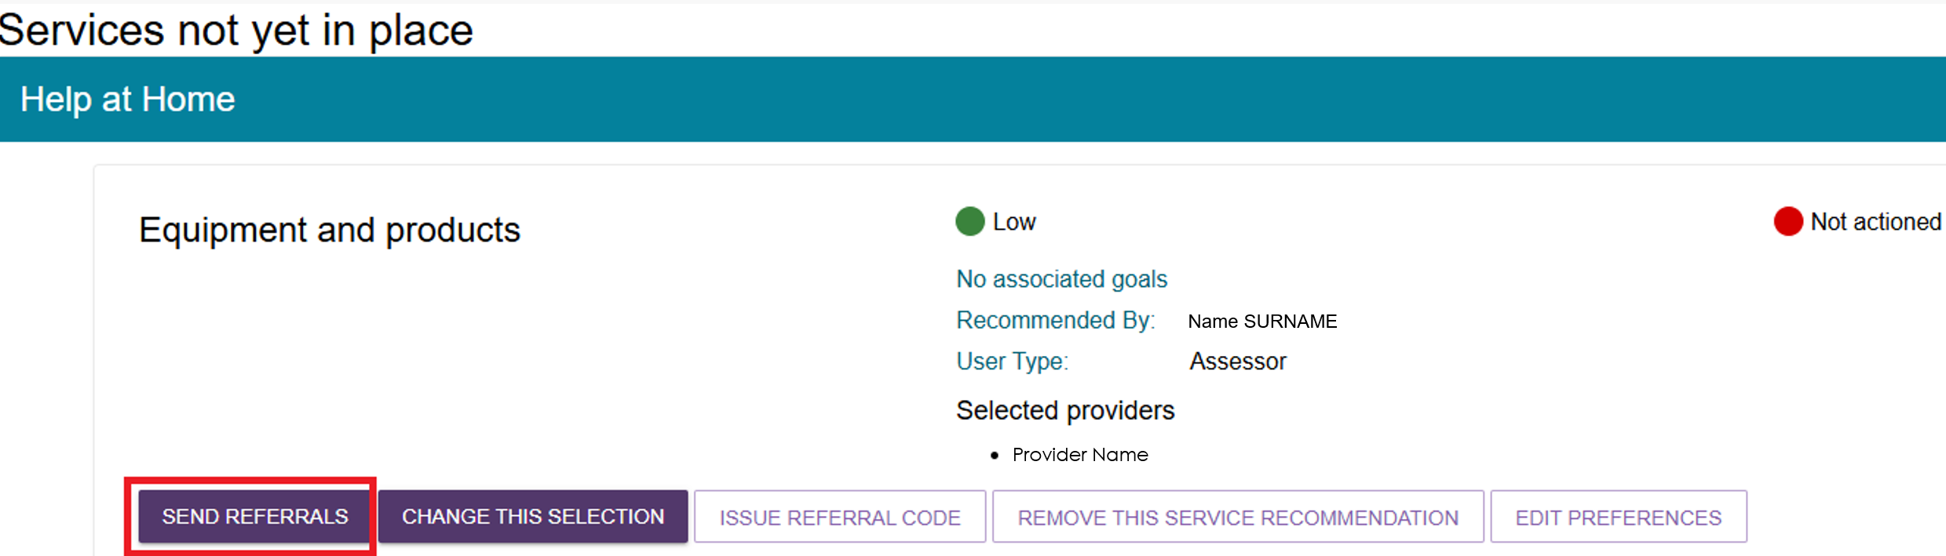
The Send Referrals screen opens and allows you to review the provider preferences and add any information that may help the provider before you send the referrals.
You can also remove a provider by selecting the relevant checkbox and then choosing REMOVE.
After reviewing all information, select SEND REFERRAL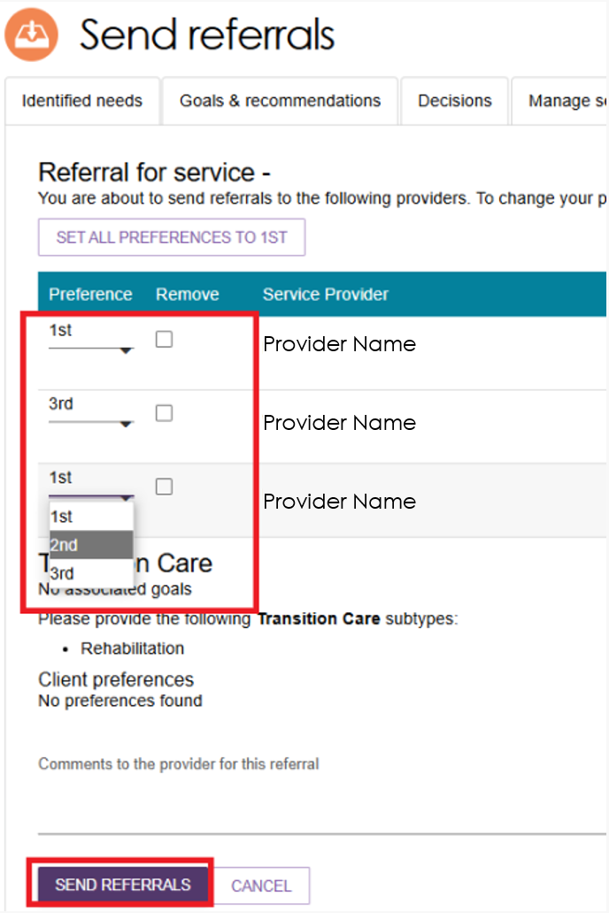
- After you send the referrals, the system displays a confirmation message. The system also shows the status of each referral.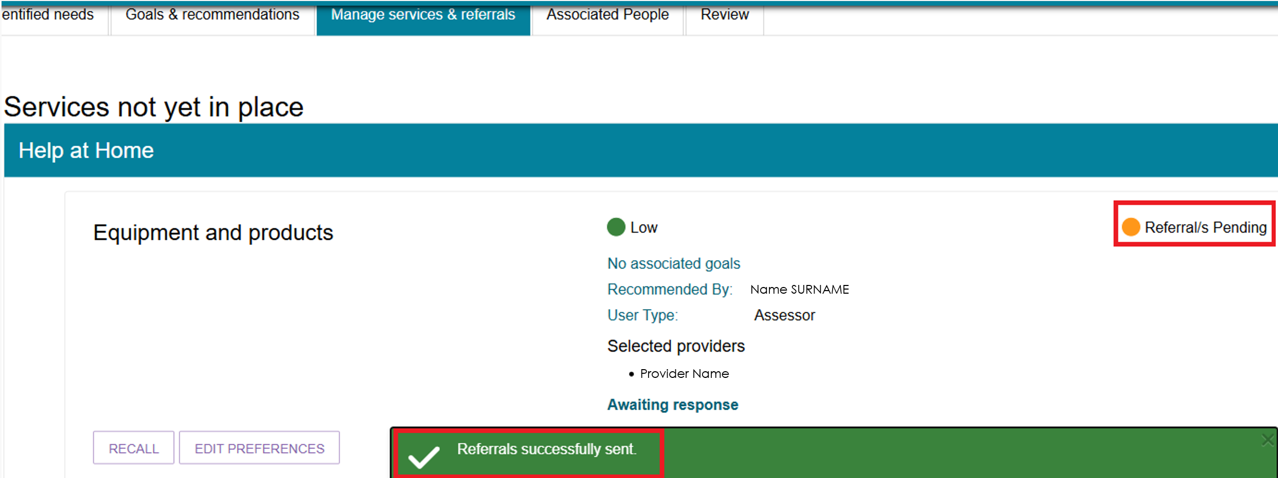
- When a provider accepts a referral, the service moves to the Waiting for Services section.
The system can display the following referral statuses:
Category | Status
Service not yet in place | Not actioned, Rejected referral, Recalled referral, Referral/s pending, Accepted to waitlist
Services pending | Referral code generated, Referral accepted but services have not commenced
Service in place | Services are being provided
The Client Journey Tracker will show that ‘your referral for services has been sent to one or more providers’.
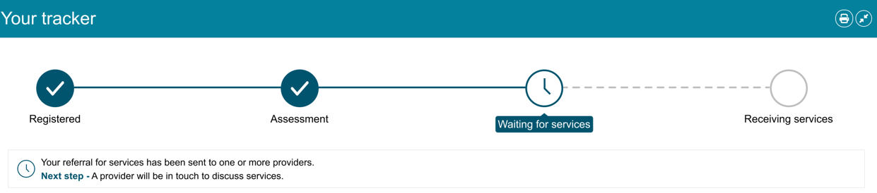

Recalling a referral
When you send a Help at Home or Aged Care Home referral, the provider must accept or reject it. You can recall the referral before the provider takes action.
- On the Manage Services & Referrals tab, select RECALL.
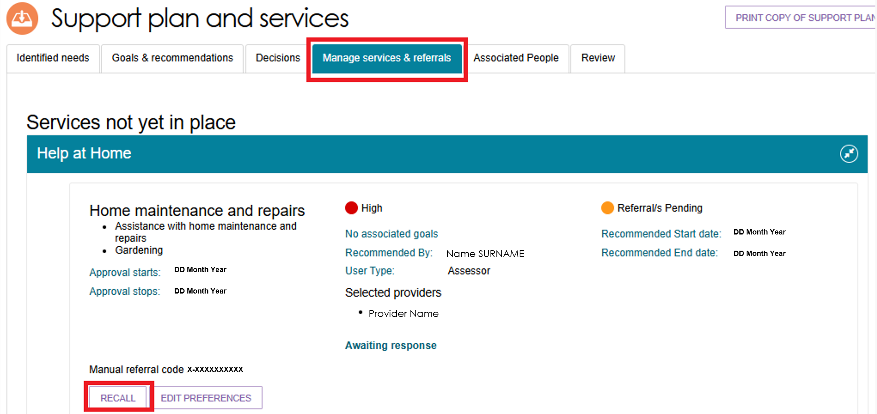
- In the pop-up window, select the provider you want to recall the referral from, then select RECALL REFERRALS.
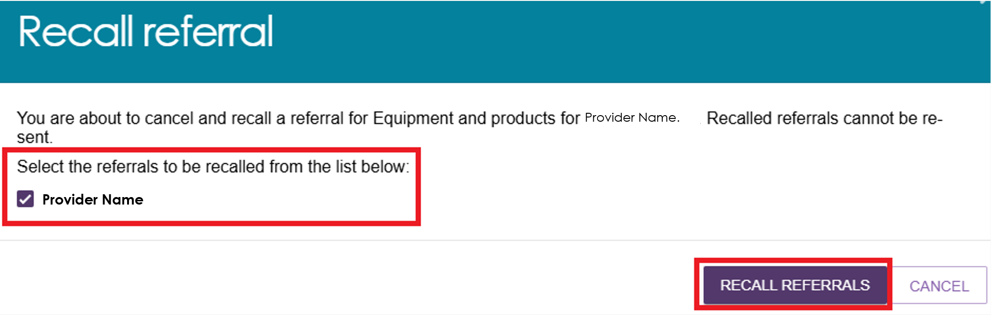
- The system displays a confirmation message when it successfully recalls the referral or referrals.
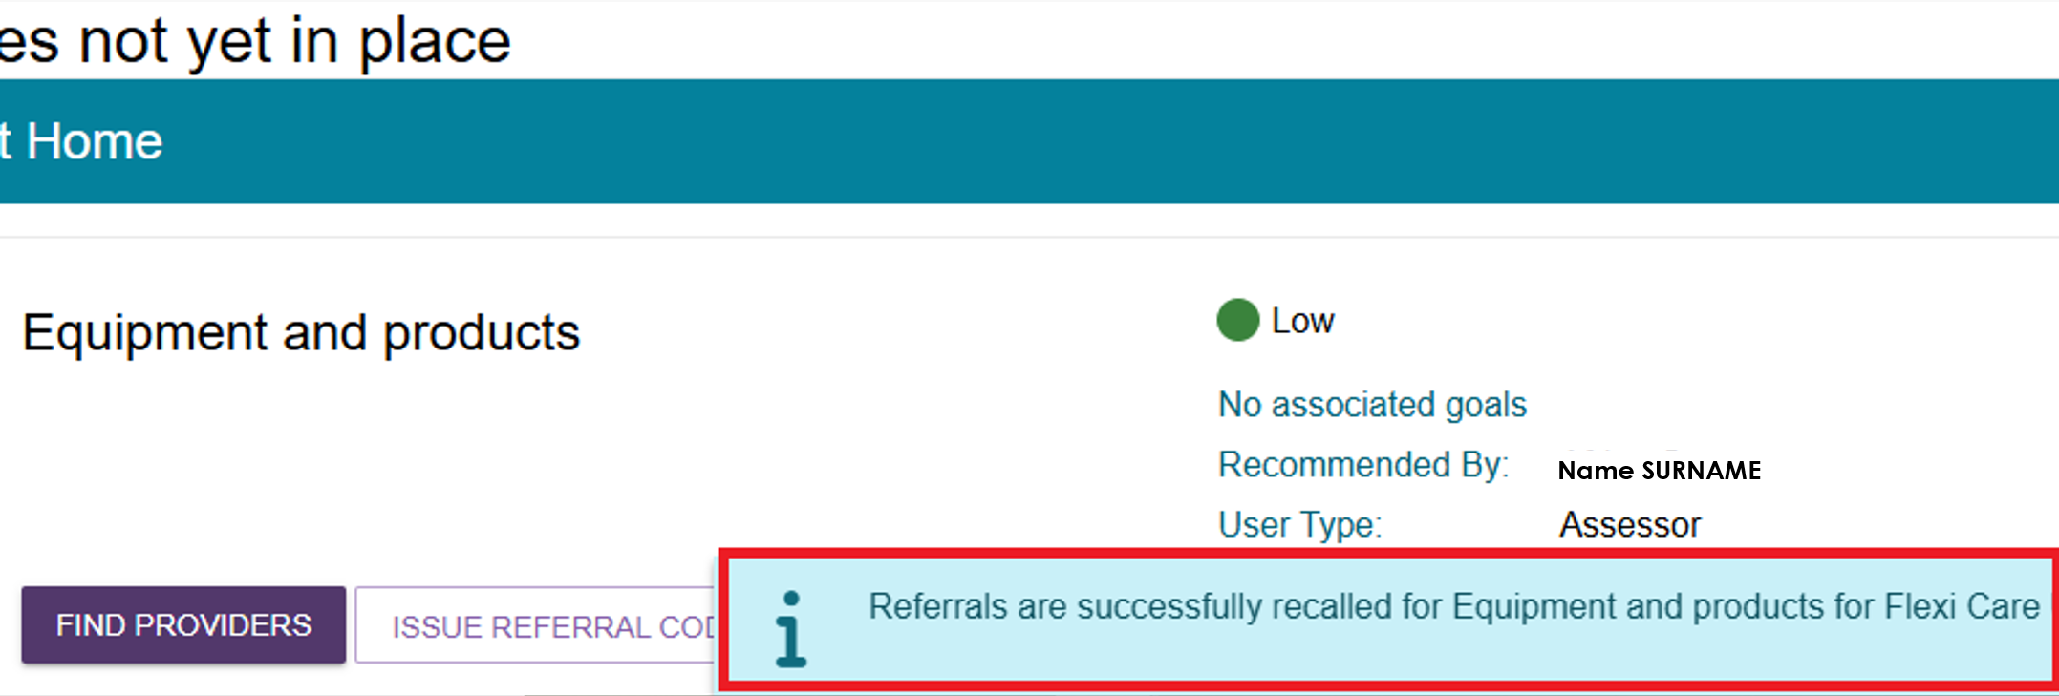
- The system updates the referral status to Recalled Referrals.
For sequential referrals, the status does not change to Recalled Referrals until you recall the referral from the final preferred provider.
If you recall a referral, you cannot send that referral to the same provider again. However, you can send a referral for that service to a different provider.
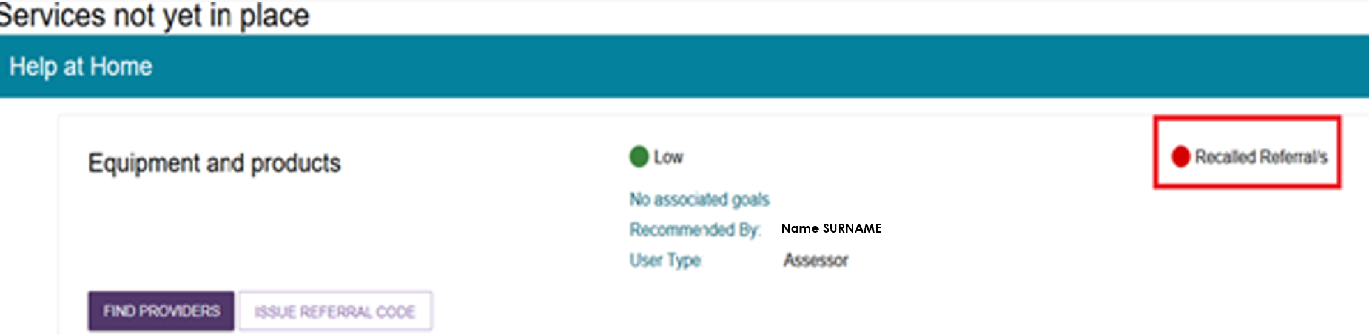

Issuing a referral code
! | Assessors can only issue referral codes to clients or service providers after the Assessment Delegate completes and signs the Notice of Decision. This requirement applies to all service referrals, including CHSP referrals.  For more information, refer to Chapter 9: Finalising the Assessment and Service Referral of My Aged Care Assessment Manual.  The ISSUE REFERRAL CODE button is only available in the following situations:  - For all CHSP services, after Delegate approval.  - For non-urgent MPSP or NATSIFACP services, when the client also has an active approval for Residential Care, Transition Care, Home Support, Assistive Technology, or Home Modifications services.  - For all urgent referrals, except CHSP urgent referrals submitted after the approval cease date.
- From the client's Support Plan, open the Manage Services & Referrals tab and select ISSUE REFERRAL CODE for the relevant service.
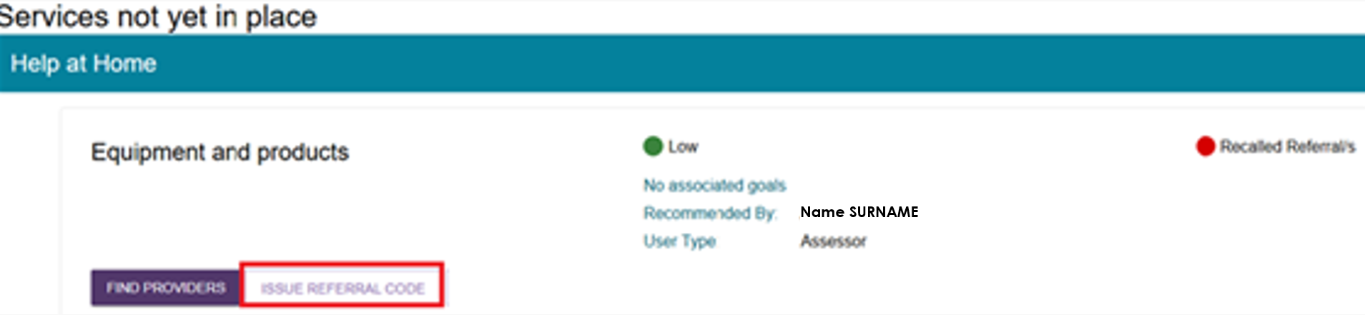
- A confirmation message appears. Select ISSUE REFERRAL CODE to continue.
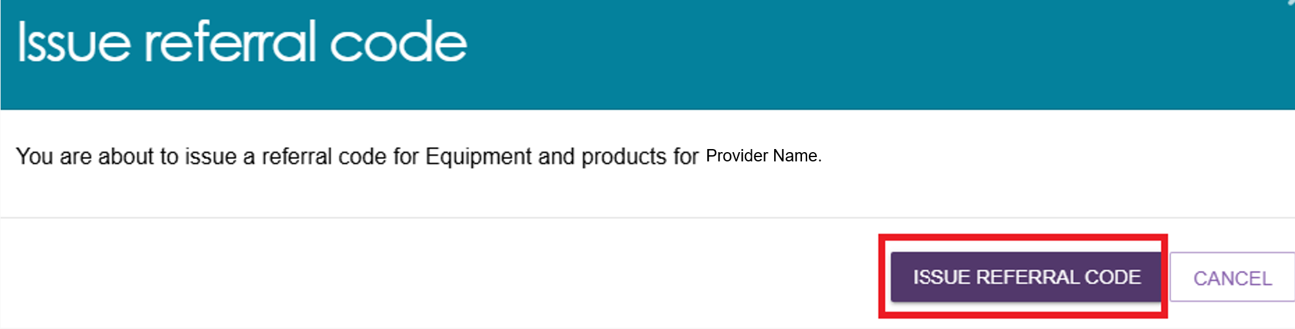
- The system generates the referral code and displays a confirmation message. The referral details appear in the Services Pending section.
The system also displays the referral code in the referral list. Print the referral code letter and give it to the client.
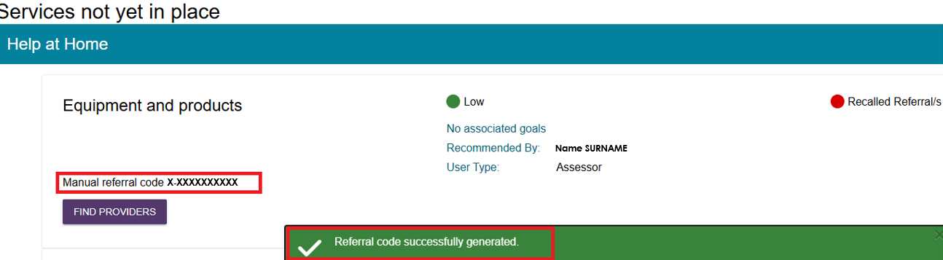

- Select GENERATE REFERRAL CODE LETTER to print the referral code letter.
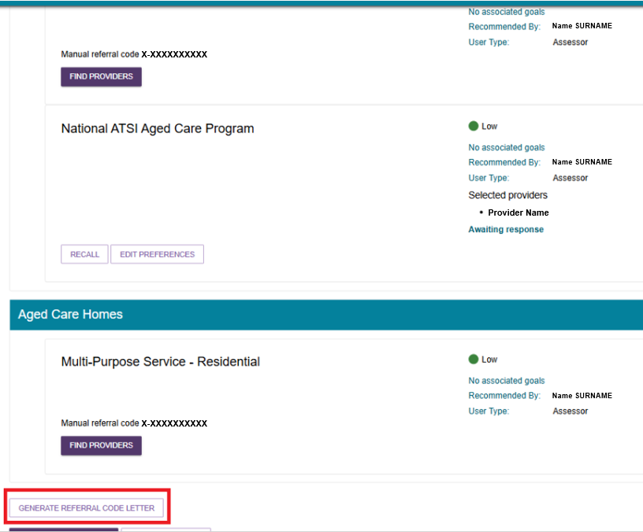
- The system displays a processing message while it generates the letter.
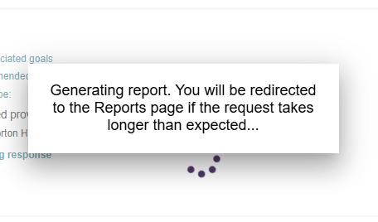
- When the letter is ready, you can download it from the Reports and Documents page.
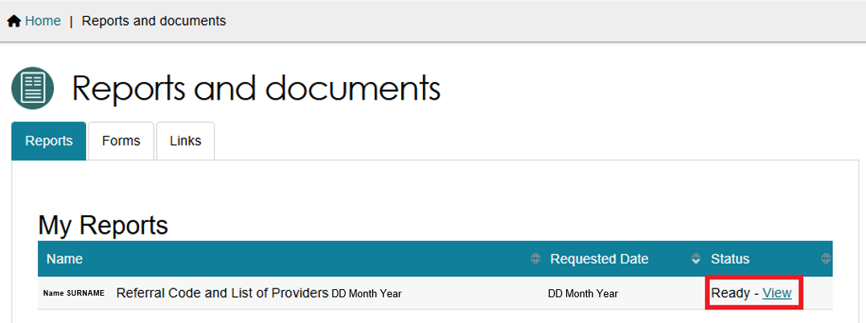
- The example below shows a generated referral code letter.
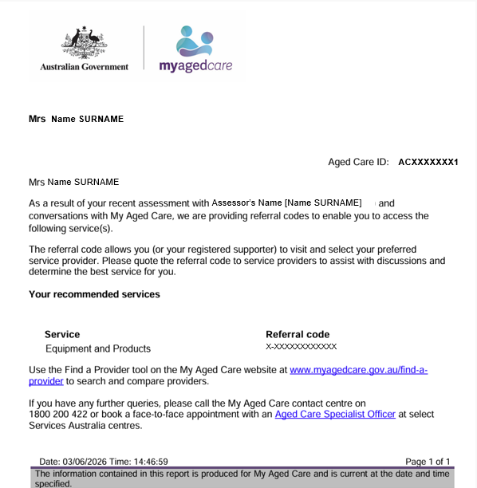

Referring for Support at Home services
! | Prior consent required  You must obtain consent from the client or their supporter guardian in their support network prior to issuing a referral.  You should use the My Aged Care Assessment Consent Form.  The Consent Form includes the consent scripts and fields to record the consent for service referrals. It is located via the Reports and Documents tile within the assessor portal.

Support at Home Priority System and allocation of funding
For Home Support services, you can match and refer a client to a service provider when:
- the client receives ongoing classification funding through the Support at Home Priority System, or
- the client is approved for the Restorative Care Pathway or End-of-Life Pathway.
Depending on the client's circumstances, the Client Journey Tracker may display one or more of the following statuses:
- You have been placed on the Support at Home Priority System
- Your Support at Home classification funding has been allocated for one or more classifications
- Your Support at Home classification funding has been allocated for all classifications.
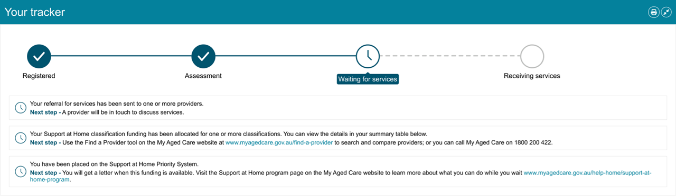
When the client receives ongoing classification funding, the system automatically generates a referral code and sends a letter to the client, with a copy to their supporter or supporters. The letter explains how to use the referral code to start services before the take-up deadline.
For clients approved for the Restorative Care Pathway or End-of-Life Pathway, the system generates a referral code in the client's support plan if:
- no service referral has been issued, and
- the client has not previously been approved for an ongoing Support at Home classification.
The Notice of Decision tells the client how to start services before the take-up deadline and explains what to do if their current provider does not offer Restorative Care.
If the client or their supporter has chosen to receive email notifications, the system sends an email when classification funding is allocated.
For more information about setting up email notifications for clients and supporters, refer to My Aged Care - Assessor Portal User Guide 2 - Registering support people and adding relationships.
If you have chosen to receive Support at Home correspondence for the client, the system will notify you when the funding is allocated. You can then begin the matching and referral process if needed.
Issue all electronic referrals through the client's support plan under Manage Services & Referrals.

Issuing a referral for service
  - After searching for Support at Home providers, either through the Find a Service Provider tile or the Service Finder in the support plan, the Service Finder page displays a list of matching providers.
Each provider listing includes a link that displays the provider outlet's name. The results may include multiple outlets from the same organisation.
The system ranks providers based on how many of the selected Home Support services they can deliver, from the highest number of matching services to the lowest.
Each listing also shows whether the provider has:
- All services supported
- Partial services supported
- No services supported.
Below this indicator, the system displays the specific Home Support services that match your search criteria.
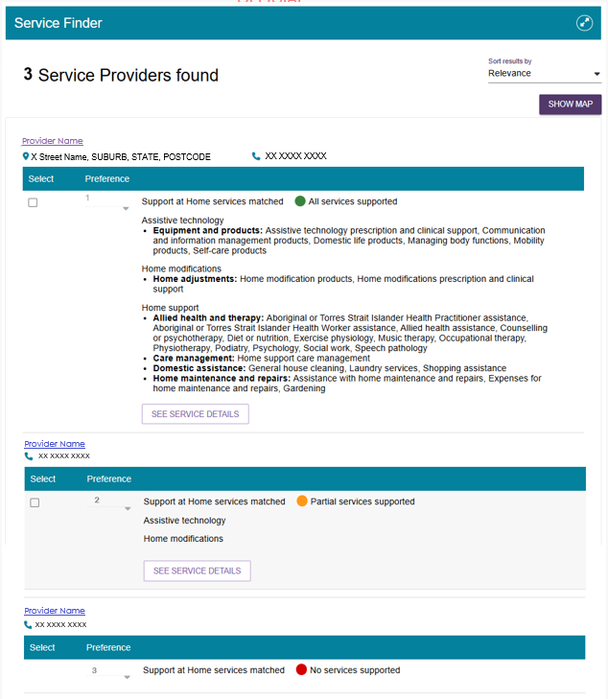

  - Select SEE SERVICE DETAILS to view more information about the service, including service availability and waitlist options.
Select the expand icon or ‘See services’ to view detailed service information, including availability and waitlist availability.
Select ‘Hide services’ to collapse the expanded view.
Service Details pop up showing See Services and Hide Services functions
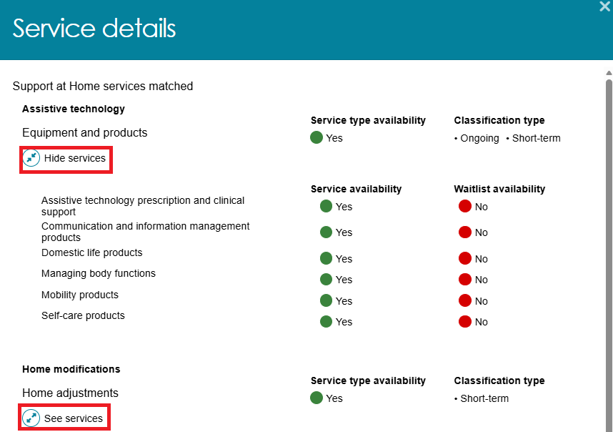
  - To select providers, tick the checkbox next to each provider's listing. Then choose a preference from the drop-down list, where 1 is the client's first preference, 2 is the second preference, and so on.
Once you have selected the providers and recorded the client's preferences, select SAVE SELECTION AND CONSENT at the bottom of the screen.
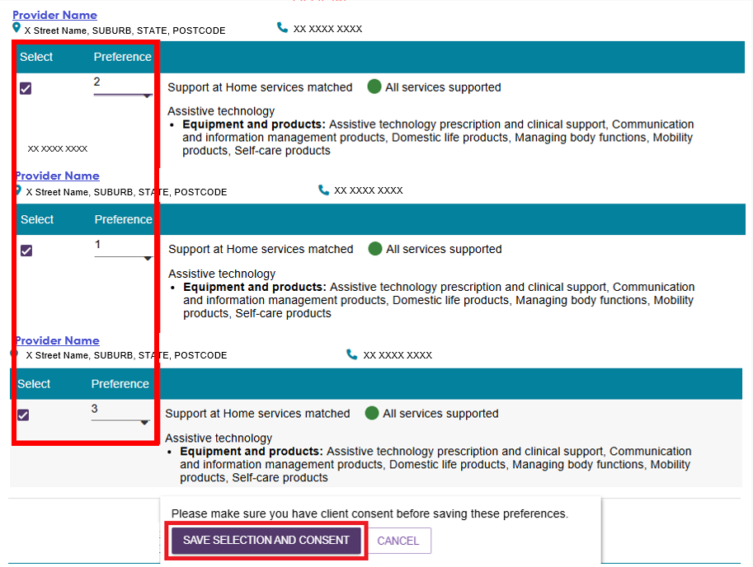
If the save is successful, the system displays a green confirmation message: ‘You have successfully saved your referral selection(s) and associated preferences’.
  - The client's Manage Services & Referrals tab now displays the selected providers.
Select SEND REFERRALS to open the Send Referrals page.
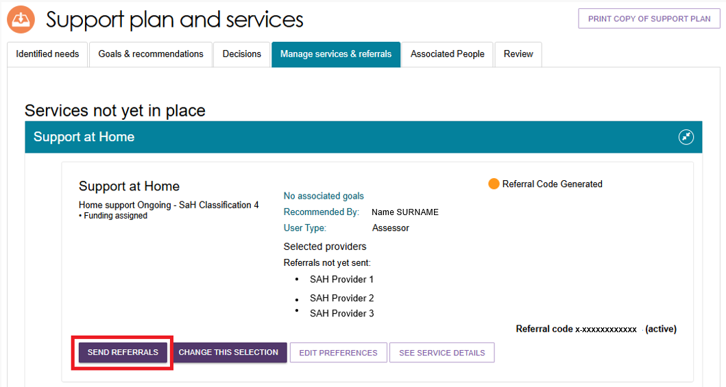
Before sending the referrals, you can update your selections by:
- Selecting SET ALL PREFERENCES TO 1st to make all providers first preference.
- Removing a provider by ticking the checkbox in the Remove column.
- Changing a provider's preference by selecting the current preference in the Preference column and choosing a new preference from the drop-down list.
You can also add comments for the provider in the Comments to the Provider for this Referral field.
When you are ready, select SEND REFERRALS.
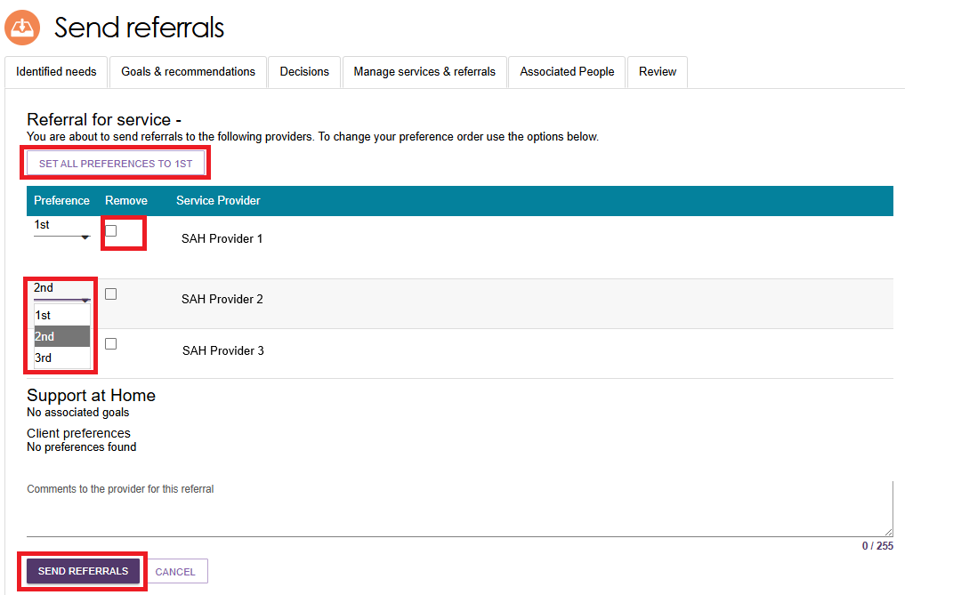
  - The Manage Services & Referrals tab then displays a status of Referral(s) Pending for Support at Home services. The tab also lists the selected providers in order of referral status.
For sequential referrals, the system sends the referral to the client's first-preference provider first. The remaining providers display a status of Awaiting Response.
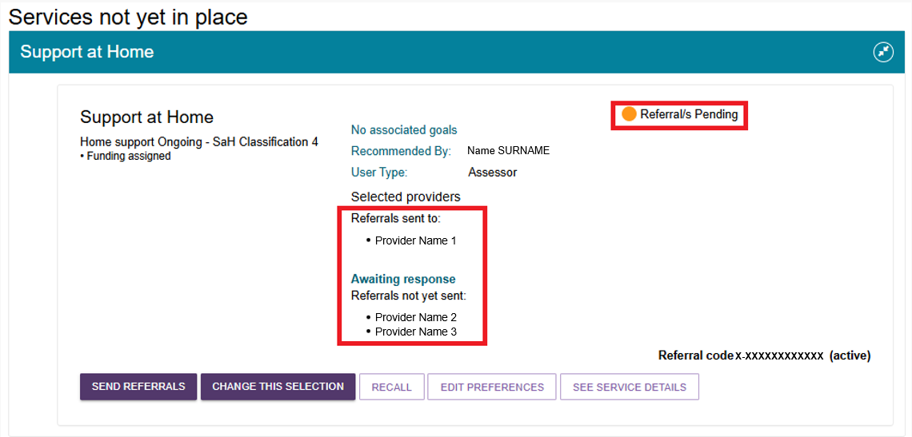
The Client Journey Tracker also updates to show that ‘your referral for services has been sent to one or more providers’.
You can also:
- Select SEND REFERRALS for any referrals that have not yet been sent
- Select CHANGE THIS SELECTION to open the Service Finder and update provider selections
- Select RECALL to recall one or more referral/s
- Select EDIT PREFERENCES to update provider preferences and view current waitlist status and availability
- Select SEE SERVICE DETAILS to view additional information about a service.

Recalling a referral
- To recall a Support at Home referral, select RECALL from the relevant referral listing.
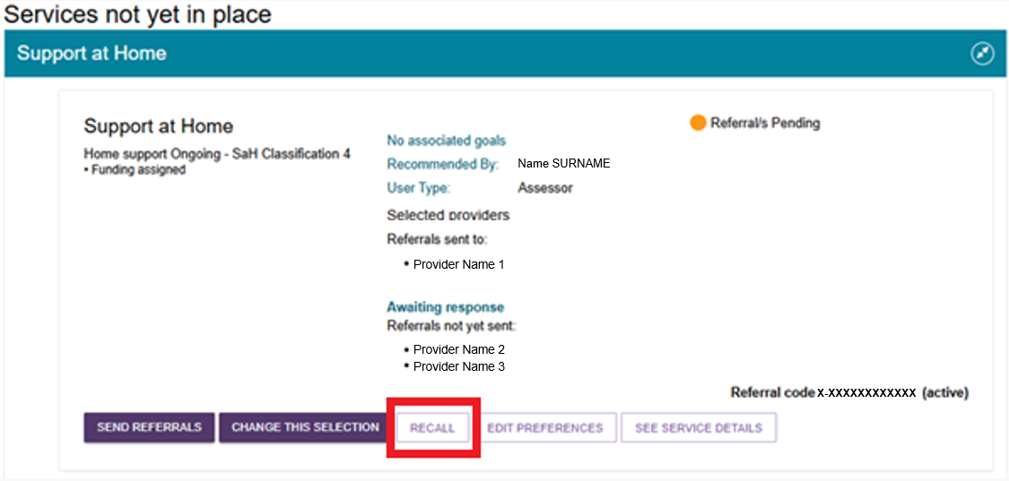
- The Recall Referral window opens. Select the referral or referrals you want to recall by ticking the relevant checkbox, then select RECALL REFERRALS.
In this example, the referral to the client's first-preference provider is being recalled.
Once you recall a referral, you cannot send it to the same provider again.
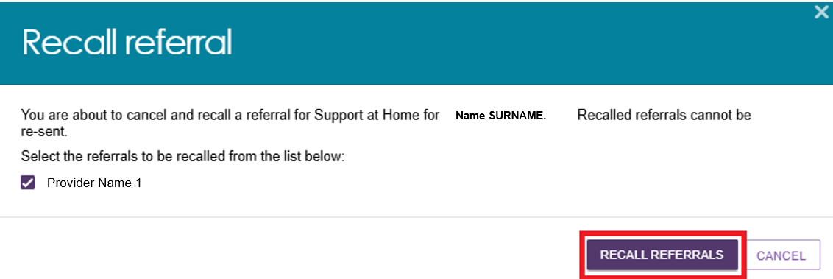
- If the recall is successful, the system displays an information message: ‘Referrals are successfully recalled for Support at Home for [Client’s name]’.
- The Manage Services & Referrals tab updates to reflect the recalled referral.
For sequential referrals:
- The Referrals Sent To section now displays the client's second-preference provider
- The Referrals Not Yet Sent section now displays the client's third-preference provider.
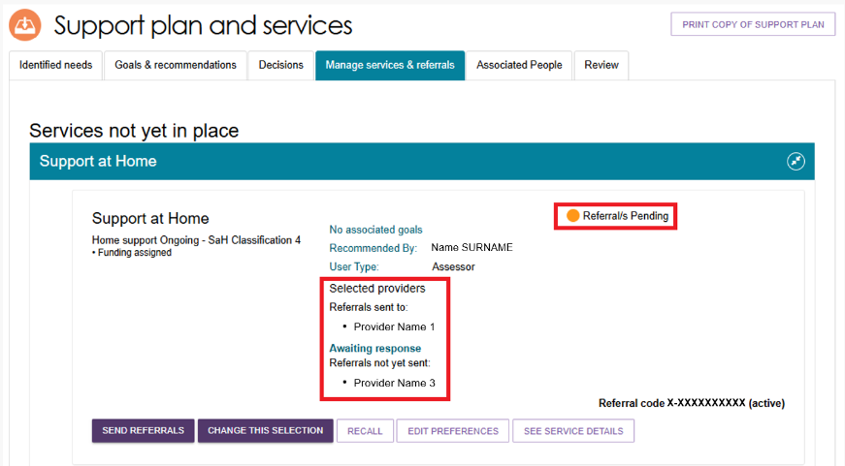

Issuing a Support at Home referral code
A client can change providers without changing their referral code.
You can view the status of a Support at Home referral code in the Manage Services & Referrals tab. The referral code status appears in the top-right corner of the service listing and can be one of the following:
- Active – The client has an assigned Support at Home classification and can use the referral code.
- Used – The referral code relates to a previous approval and can no longer be used by the client or a service provider.
- Inactive – The client has advised that they do not want services, or their assigned Support at Home classification has been withdrawn without being replaced or upgraded.
- Disabled – A provider has accepted a service referral. The system disables the referral code so other providers cannot use it until it is reactivated.
If a client wants to reactivate their referral code, for example when changing providers, the client or their supporter can do this through their My Aged Care online account or by contacting the My Aged Care contact centre.
You can also reactivate a referral code from the Manage Services & Referrals tab in the client's support plan.
The example below shows a disabled referral code and highlights the REACTIVATE REFERRAL CODE button.
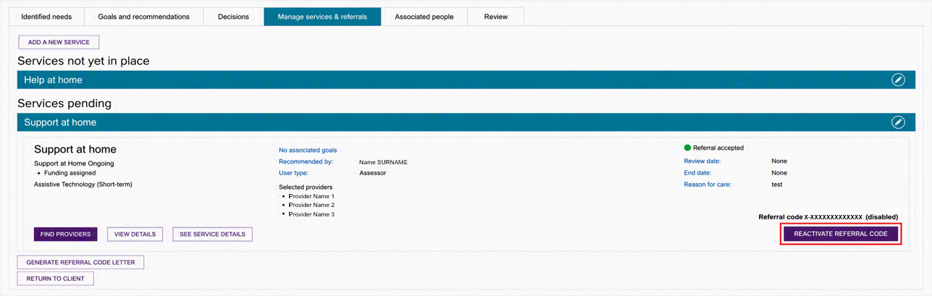

Managing rejected service referrals
To help clients access suitable services and provide a consistent experience, the system returns a referral to you if a provider rejects it and the client has no remaining referral preferences.
If a provider rejects the client's final referral preference, you will:
- Receive an All Referrals Rejected task notification.
- Be able to discuss the outcome with the client and either:
- send referrals to different providers, or
- accept a provider's offer to place the client on a waitlist.
To follow up a rejected referral:
- Go to the Tasks tab in Tasks and Notifications and select the All Referrals Rejected link to open the client's support plan. Alternatively, select the Aged Care User ID link to open the client's record.
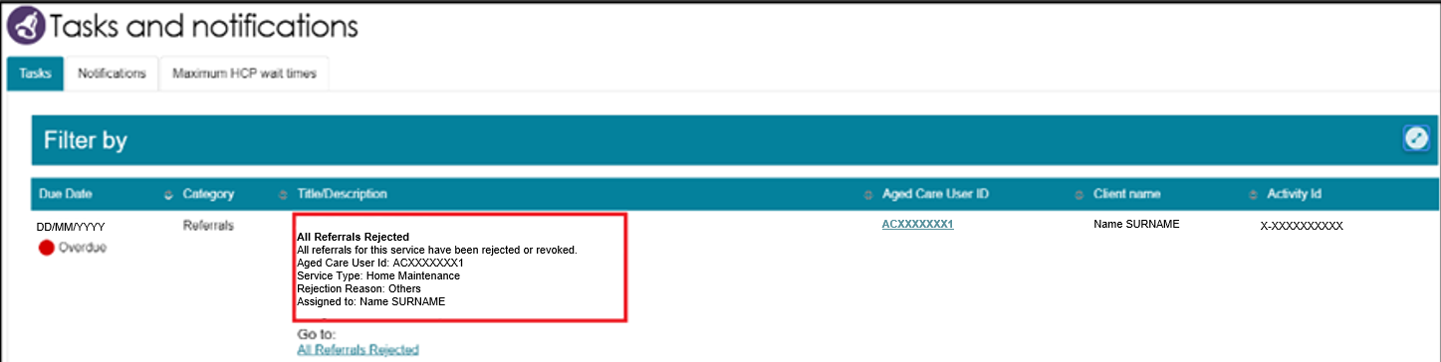
If you know the client's name, you can also view their tasks and notifications directly from the Tasks and Notifications tab in the client record.
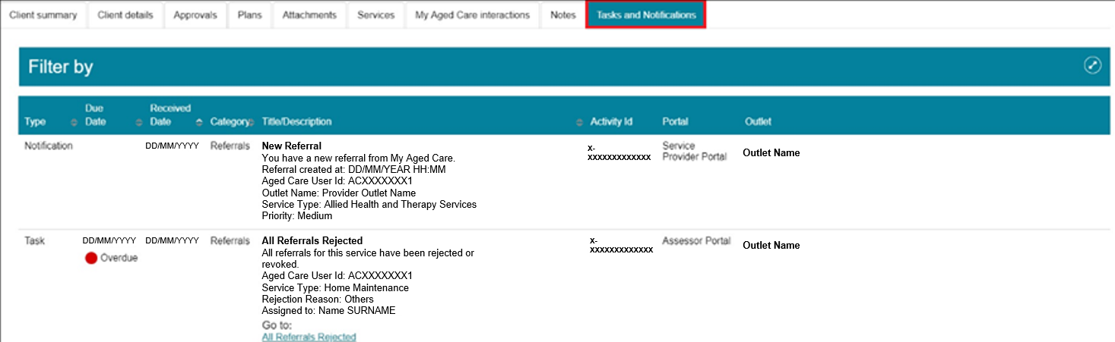
- If you open the support plan from the notification, the Manage Services & Referrals tab opens automatically. The rejected service displays a status of Rejected Referral(s). (You can also view the status of the client's other referrals.)
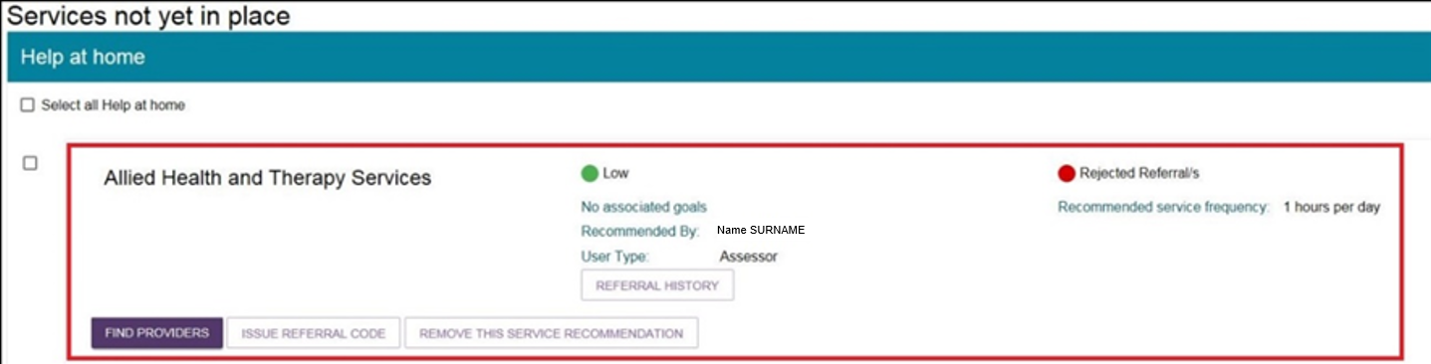

- For rejected referrals, select Referral History to view the reason for the rejection.
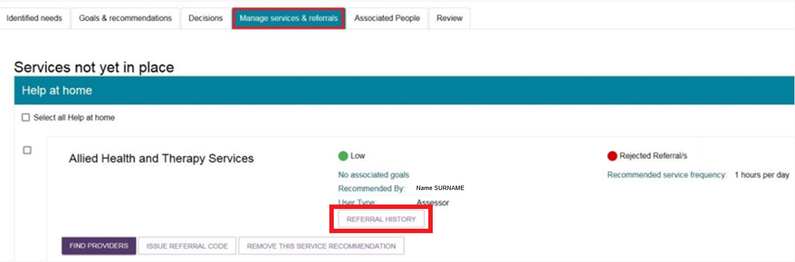
- After reviewing the rejection reason, you can:
- send referrals to different providers, or
- generate a referral code for the client.
Follow the referral process described earlier in this guide.
Depending on the reason for the rejection, you may need to add more information to the referral or discuss alternative options with the client before sending another referral.

