Assessor Portal User Guide 7 – Completing a Support Plan and Support Plan Review
This user guide is for aged care needs assessors who use the My Aged Care Assessor Portal to complete a support plan or conduct a Support Plan Review.
! | Starting from 1 November 2025, the Aged Care Act 2024 and the Support at Home program came into effect with significant change to support plans in the IAT.  To ensure the right IAT is used, and triage can continue for priority referrals, any assessments in the following statuses already started prior to 1 November 2025 and in progress on 1 November 2025 must be restarted:  - Triage complete, main assessment not started  - Triage complete, main assessment in progress (includes incomplete support plan)  - Main assessment completed, awaiting delegate decision (comprehensive assessments)  For information on the Restart Assessment Process, please refer to Management of active assessments for 1 November 2025 transition – Standard Operating Procedure and Restarting In Progress Assessments for Support at Home (instructional video).  This is available from your Assessment Organisation.

! | Starting from 1 November 2025, there are changes to assessment delegations under the Aged Care Act 2024, for both Clinical and Non-clinical Assessment Delegates.  To understand Assessment Delegate changes, refer to ‘Chapter 7: Delegations and Approvals under the Act’ of My Aged Care Assessment Manual.  For CHSP only: From 29 June 2026, Home Support assessments will require delegate approval in the system, following the same process as comprehensive assessments.  Manual Delegate Approval is no longer required for Home Support assessments.  Assessors should now follow the standard system-based delegate approval process, consistent with comprehensive assessments.

Table of contents
The Support Plan 4
The Identified needs tab 4
Adding an assessment summary 5
Goals and recommendations tab 7
Accepting the IAT Recommendation 7
Overriding the IAT Recommendation 7
Types of Recommendations 11
Linking Recommendations to Goals 12
Viewing the Recommendation after a delegate decision 13
Adding Recommendations 16
General Recommendation 16
Service Recommendation 17
No Care Type Under the Act 19
No Care Approval/No Change to Existing Care Approvals 20
Period of Linking Support 23
Period of Reablement 24
Care type for Delegate decision 24
Support at Home Recommendations 27
Adding Home Support services 27
Viewing Recommended SaH services 30
Assistive technology and Home modifications (AT-HM) Recommendations 31
Adding a Home modification Recommendation 31
Viewing Home modification Service Recommendation 33
Editing Home modification Recommendation 34
Adding an Assistive technology Recommendation 35
Viewing Assistive technology Service recommendation 38
Editing Assistive technology Recommendation 39
Adding Client Concerns and Goals 40
Linking Goals to Existing Support at Home Recommendations 42
Recording Service Frequency and Intensity 45
Support at Home - Restorative Care Pathway 46
Overriding to Restorative Care Pathway 46
Editing IAT Outcome to Restorative Care Pathway 48
Recommending Second Unit of Restorative Care Pathway 49
End-of-Life Pathway 50
Overriding to End-of-Life Pathway 52
Flagging End-Of-Life to an existing SaH Restorative Care Pathway 54
Revert End-of-Life Flag 57
Overriding a Transitioned HCP Classification to the End-of-Life Pathway 58
Reverting to End-of-Life for Transitioned Home Care Package (HCP) clients 61
Completing the Support Plan 62
'Returned to Assessor’ status 64
Amendments to the IAT 64
Reviewing and Resubmitting the returned IAT 66
Amendments to the support plan 71
Finalising the support plan 71
Finalising a Support Plan for Support at Home classification 74
Ending a period of Reablement or linking support 74
Printing a copy of the support plan 78
Support Plan Reviews 80
Viewing a Support Plan Review 80
Starting a Support Plan Review 81
Recommending a new assessment 88
Issuing an assessment referral as a result of a Support Plan Review 91
Ad hoc Support Plan Reviews 94
Scheduling an Ad hoc Support Plan Review 94
Transferring a Support Plan Review 98
Support Plan Review for Support at Home 99
Support Plan Review for services following an End-of-Life Pathway episode 99
Revert to the previous ‘latent’ SaH classification 99
Reassessment for a New Support at Home Classification Following an End-of-Life Episode 103

The Support Plan
A client’s support plan records their care needs and outlines how to address them. It includes:
- Areas where the client needs support or has concerns about their care.
- Goals the client wants to achieve.
- Recommended services or actions to help achieve those goals.
During the face-to-face assessment, the client works with the assessor to develop their support plan.
The Support Plan contains the following tabs:
- Identified Needs – records the client’s care and support needs.
- Goals & Recommendations – records the client’s goals and recommended services or actions.
- Manage Services & Referrals – manages service referrals and referral status.
(Refer to My Aged Care – Assessor Portal User Guide 8 – Referring for services)
- Associated People – lists people linked to the client’s support plan.
- Review – records when the support plan should be reviewed.
This guide focuses on the Goals & Recommendations tab.

The Identified needs tab
The Identified Needs tab summarises the needs identified during the assessment that must be addressed in the client’s support plan. If the client has completed a Support Plan Review, the tab also displays information from their most recent review.
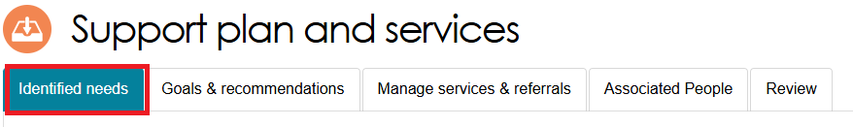
Headings in the Identified Needs tab
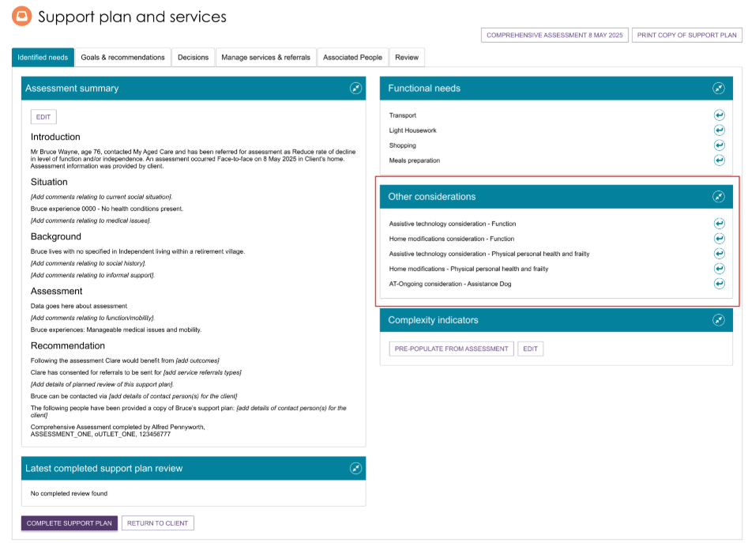

Adding an assessment summary
When completing a support plan, you can add an Assessment Summary in the Identified Needs tab.
The Assessment Summary appears on the printed support plan provided to the client. It can also support future assessments and is visible to service providers who receive a referral for the client.
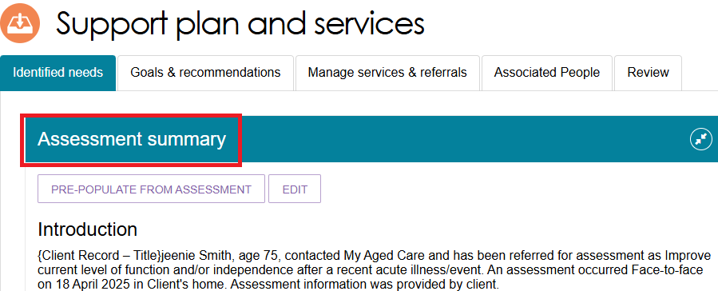
To create an Assessment Summary using information recorded in the assessment:
- Select PRE-POPULATE FROM ASSESSMENT.
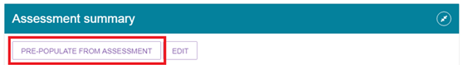
- The system automatically adds available information from the assessment. Information that can be automatically included is marked with an icon (an arrow leaving a square).
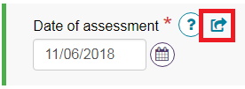
- You can:
- enter the missing information in the assessment
- add the information directly to the Assessment Summary
- remove the instruction from the Assessment Summary.
- If information is missing, the system displays the field name in square brackets, for example, [field name]. The system may also display prompts for information that cannot be automatically populated, for example, [example instruction].
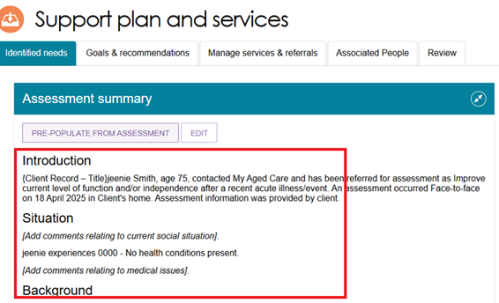
If you want to create or update the Assessment Summary manually:
- Select EDIT.
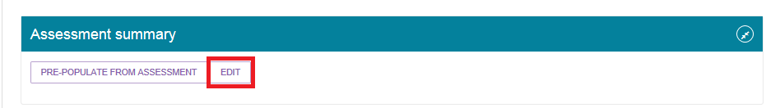
- Select CONFIRM EDIT to open the editable version.
After you select CONFIRM EDIT and save your changes, the PRE-POPULATE FROM ASSESSMENT option is no longer available.
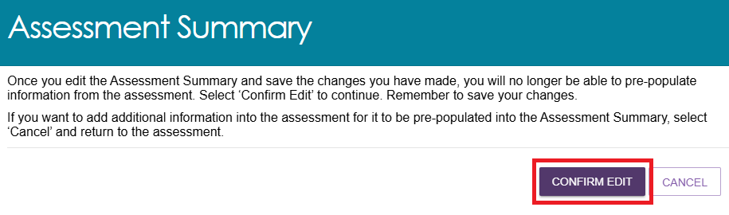
- Enter or update the required information.
The Assessment Summary has a limit of 5,000 characters. If pre-populated information causes the summary to exceed this limit, remove or summarise older content to reduce its length.
- When you finish updating the Assessment Summary, select SAVE.
! | You can continue to edit the Assessment Summary after saving. Save your work regularly, as the Assessment Summary does not support auto-save.

Goals and recommendations tab
The Goals & Recommendations tab is where you record the client’s areas of concern, goals, and any recommended services or other actions to help address those concerns.
This tab also displays the client’s Integrated Assessment Tool (IAT) outcome and recommended classification(s). The system determines the recommendation(s) based on information recorded in the IAT assessment and the client’s current care approvals.
In some cases, more than one active approval may appear. For example, if a client has an active Restorative Care Pathway (RCP) approval and receives a Support at Home (SaH) Classification 1-8 approval following a reassessment, the tab will display both classifications.

Accepting the IAT Recommendation
To accept the IAT Outcome, go to the IAT Outcome and Classifications section and select ACCEPT.
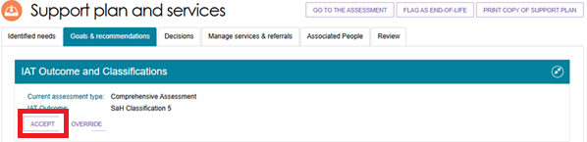

Overriding the IAT Recommendation
Refer to the other sections in this guide for Overriding to Restorative Care Pathway and Overriding to End-of-Life Pathway.
! | The IAT allows an ongoing Support at Home classification to be overridden to a different ongoing classification level. However, assessors must not do this, and delegates must not approve assessments where it has occurred.  You cannot override an ongoing Support at Home classification outcome to a higher or lower ongoing Support at Home classification level. This requirement aligns with section 81-10 of the Aged Care Rules.
  - To override a recommended classification, select OVERRIDE under the IAT Outcome and Classifications heading.
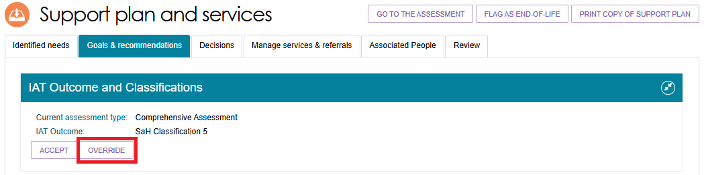
  - The Override IAT Outcome pop-up appears. Enter:
- the new classification
- the override reason
- the override reason description.
The classifications available for selection depend on the original IAT outcome. You can only select classifications that comply with the Aged Care Rules. For more information, refer to the My Aged Care Assessment Manual.
The appearance of the pop-up and the available options vary depending on the original IAT outcome and the override you choose. Below is an example of an Override IAT outcome pop up.
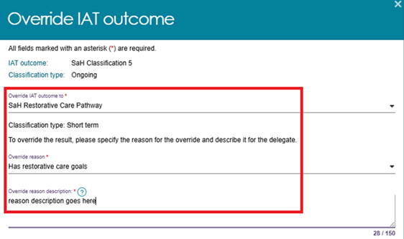
If you are overriding to any classification other than Restorative Care Pathway, select an option from the RCP reject reason drop-down list.
The available options are:
- Not suitable/eligible for RCP
- Seeking ongoing services
- Other.
(If you are overriding to Restorative Care Pathway, refer to the Overriding to Restorative Care Pathway section of this guide).
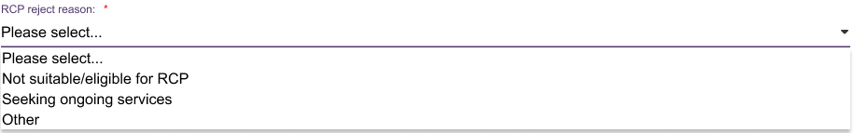
If you select Other, enter a description explaining the reason.
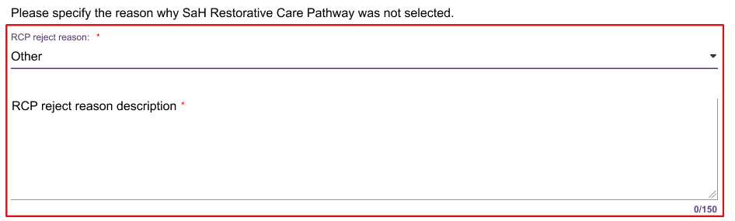
  - If you select a Support at Home classification, indicate whether the client is seeking Support at Home services by selecting:
- Seeking services, or
- Not seeking services.
An information message may appear to remind you that the client’s preference determines whether they are included in the Support at Home priority system.
  - Select SAVE TO PLAN, OVERRIDE, or ACCEPT after you complete all fields.
  - After you accept or override the classification or recommendation, the system opens a new screen. Use this screen to select the services available under the classification that you want the client to receive, and record the frequency and intensity for each service.
This example of the Add Home Support Services page displays the services available under each service type. For example, the Allied Health and Therapy service type may include several services for you to choose from.
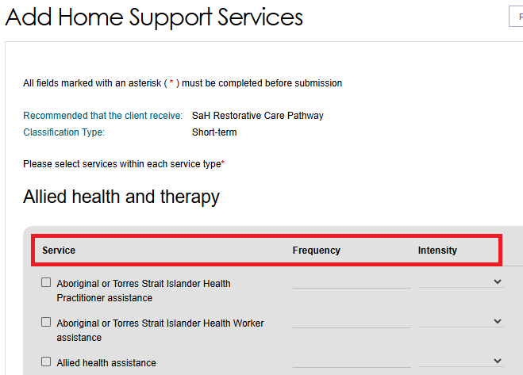
  - Enter all required values, then select SAVE TO PLAN at the bottom of the page.
The following image shows examples of chosen transport services, with frequency and intensity recorded.
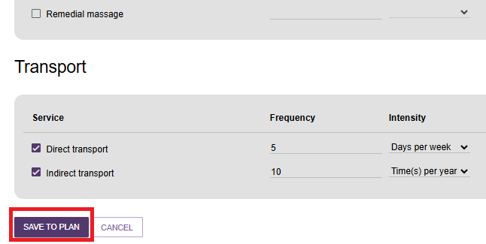
  - The system displays the updated classification on the client’s Goals and Recommendations tab.
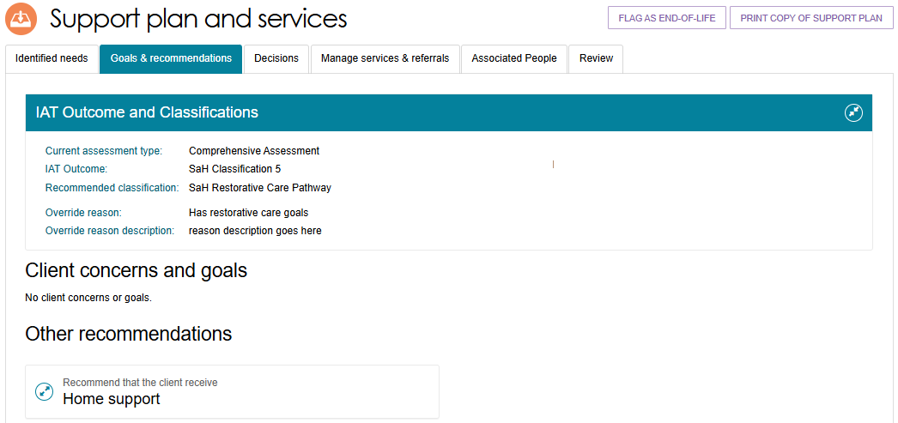
If the client already has an existing classification, the system displays it beside the updated classification in the Existing Classification section.
The image below shows an example of a client with a Transitioned HCP Classification under Support at Home, as per the Aged Care Act 2024. This is displayed in the Existing Classification section.
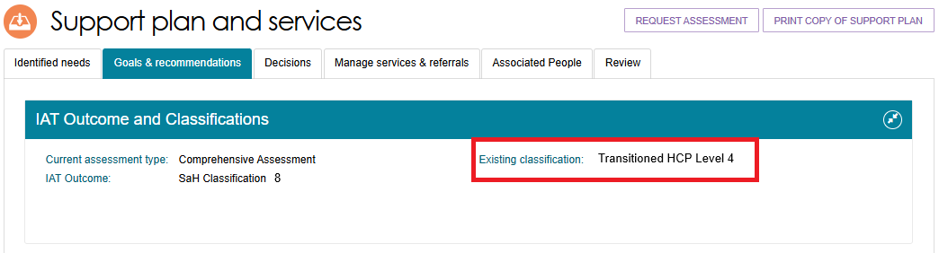
The system displays this existing classification for reference only. You must still select the services the client requires.
For clinical aged care needs assessors (clinical assessors):
- CHSP - refer to Manual Delegate Approval for CHSP – Standard Operating Procedure and instructional videos for comprehensive and home support assessments.
- Support at Home Classifications recommendations – refer to Adding Home Support services for a Support at Home Classification.
For non-clinical aged care needs assessors (non-clinical assessors):
- CHSP – refer to Manual Delegate Approval for CHSP – Standard Operating Procedure and instructional videos for comprehensive and home support assessments.
- Support at Home – you should consider converting the assessment to a comprehensive assessment under the supervision of a staff member who holds a clinical assessor role.

Types of Recommendations
You can add or remove seven types of recommendations in a support plan after completing an assessment:
! | For Support at Home, refer to Adding Home Support services for a Support at Home Classification and Assistive technology and Home modifications (AT-HM) Recommendations.
General recommendations are non-Commonwealth funded supports that you and the client identify. The client or assessor actions these recommendations, not a service provider. For example, you may recommend that the client visit a health professional or join a local support group.
Service recommendations add funded services to the client’s support plan, such as Commonwealth Home Support Programme (CHSP) services.
Assistive technology recommendations provide access to assistive technology through the Support at Home program.
Home modification recommendations provide access to home modifications through the Support at Home program.
Recommended long-term living arrangement applies only to comprehensive assessments. After discussing goals with the client and/or their supporter, select the most suitable long-term living arrangement from the available accommodation options. You can only add this recommendation after completing a comprehensive assessment.
Care type for Delegate decision recommendations apply only to comprehensive assessments where CHSP is not recommended. These recommendations relate to care types under the Aged Care Act 2024 and require Delegate approval.
Linking support recommendations apply when a client’s complex circumstances make it difficult to access aged care services. Linking support helps the client connect with the services they need.
Recommendations for a period of reablement provide time-limited interventions that help the client achieve specific goals or outcomes. These interventions can help the client adapt to a loss of function, regain confidence, or improve their ability to carry out daily activities. Examples include learning a new skill, modifying the home environment, or accessing equipment or assistive technology.

Linking Recommendations to Goals
Recommendations can be linked to one or more concerns and goals, or you can add them as Other Recommendations. For more information about linking support and reablement, refer to the My Aged Care Assessment Manual.
A recommendation can be linked to multiple goals. When you add a recommendation, you can link it to one or more goals, or leave it unlinked.
- In the Other Recommendations section of the Goals & Recommendations tab, select the recommendation you want to add. You can then choose whether to link the recommendation to a relevant goal. The recommendation will appear under the Other Recommendations heading.
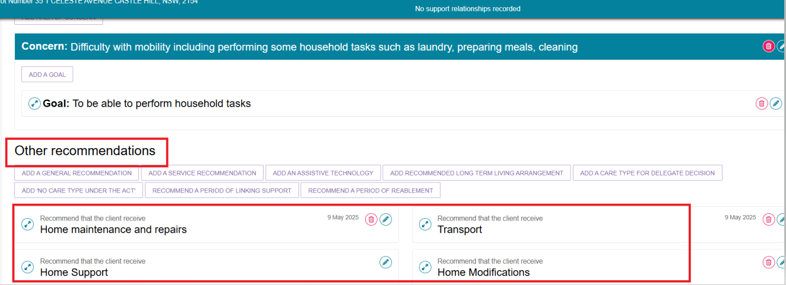
You can also add a recommendation directly to an area of concern and goal. Select the double arrow next to the goal, then select an option under Add to this goal on the right side of the panel.
When you add a recommendation this way, the recommendation appears under the selected goal.
To view the recommendation details, select the double arrow to the left of the goal.
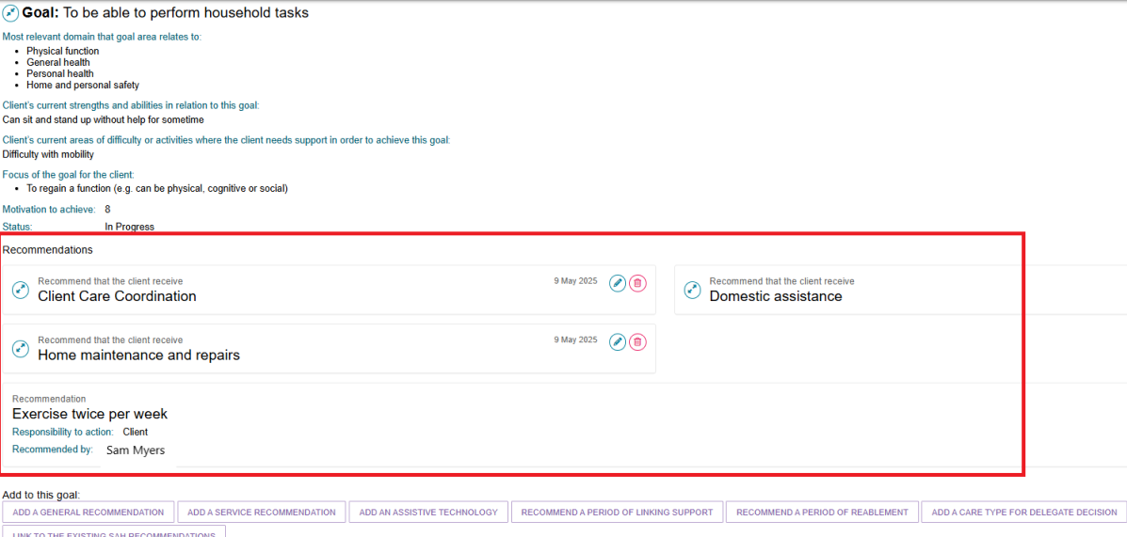

- To remove the link between a recommendation and its associated goals, select the Edit (pencil) icon next to the recommendation. Select UNLINK THIS RECOMMENDATION FROM ALL GOALS, then select SAVE TO PLAN.
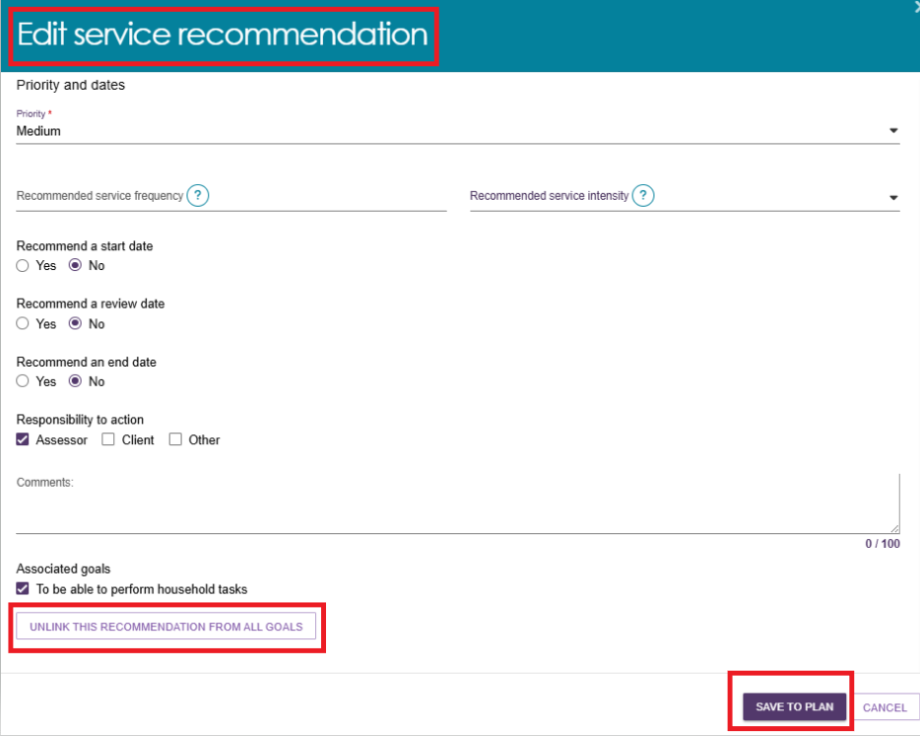

Viewing the Recommendation after a delegate decision
After you enter the goals and recommendations, send the assessment to the delegate for review and decision-making.
Once the delegate completes their review, you can view the outcome and find out:
- which recommended services the delegate approved
- which recommended services the delegate modified
- any new services the delegate added.
To view this information:
- Use Find a Client in the Assessor Portal to open the client record.

- Select the Plans tab, then select Support Plan.
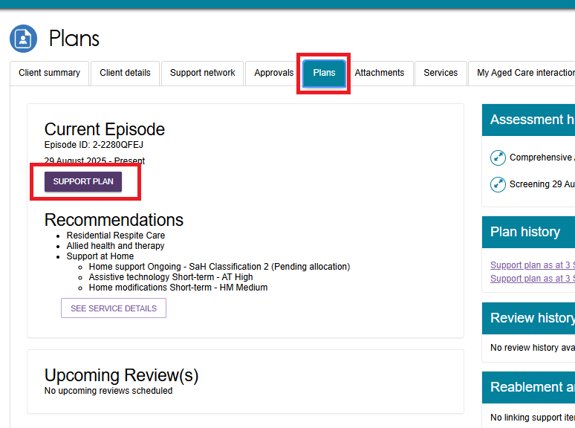
- In the client’s Support Plan and Services screen, select the Decisions tab.
The Decisions tab shows the outcome of the delegate’s review, including any approved, modified, or newly recommended services.
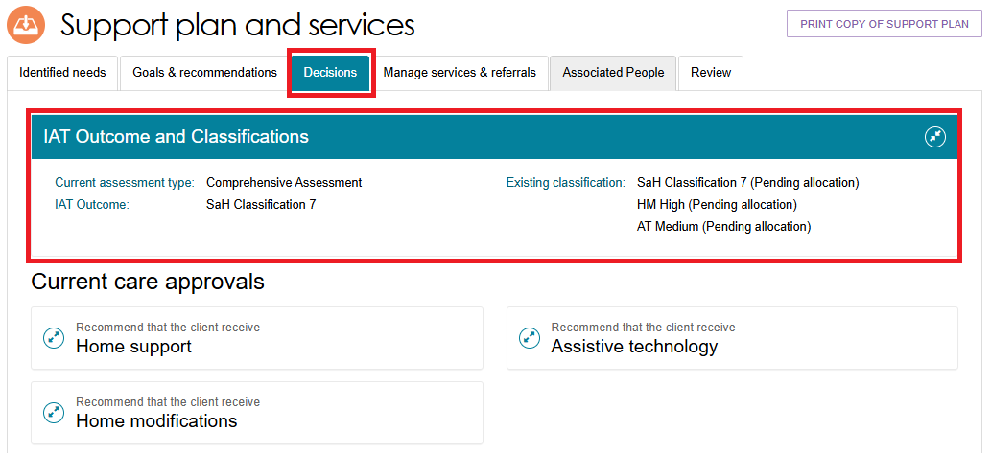

- Scroll to the Delegate Decisions and Comments section to view all decisions the delegate made about the services recommended for the client.
This section provides a detailed summary of:
- approved services
- modified services
- newly recommended services
- any comments or reasons provided by the delegate.
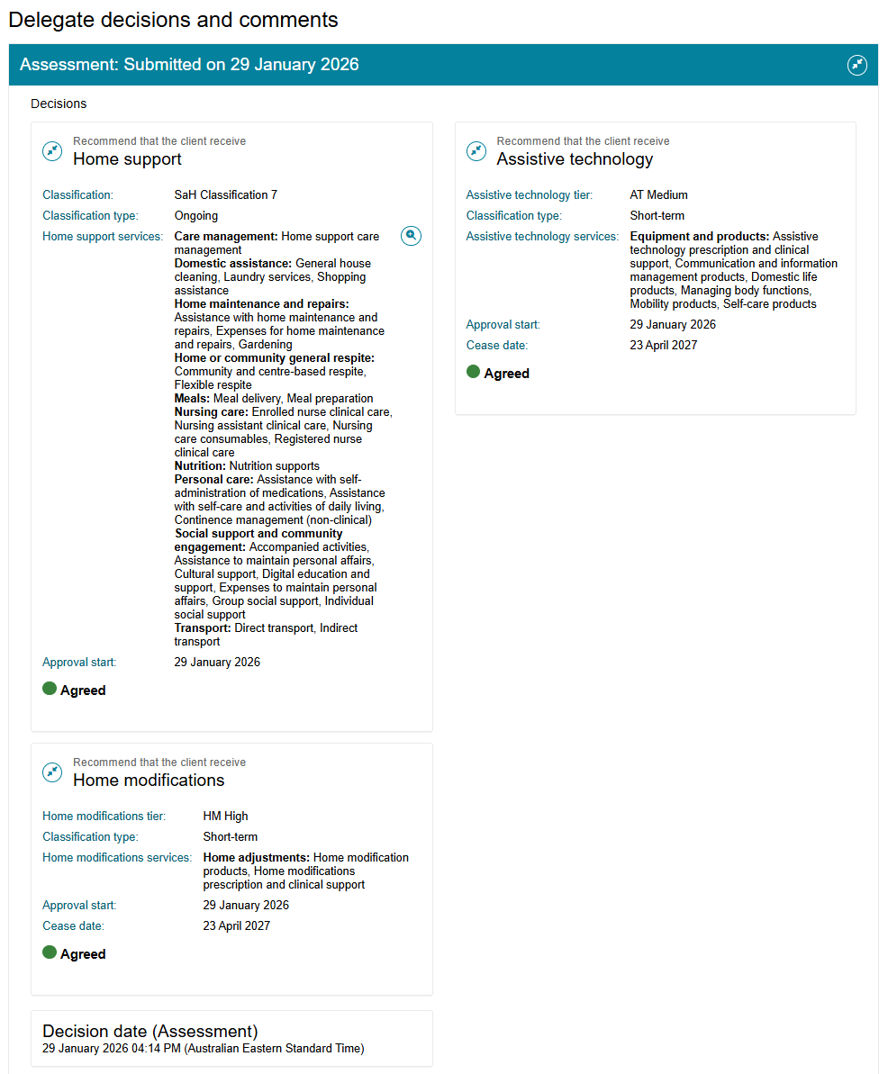

Adding Recommendations
- To add a general recommendation, go to General Recommendation.
- To add a service recommendation, go to Service Recommendation.
- To add a Home modification, go to Adding a Home modification Recommendation.
- To add an Assistive technology Service, go to Adding Assistive technology Recommendation.
- To add a recommendation for a period of linking support, go to Period of Linking Support.
- To add a recommendation for a period of reablement, go to Period of Reablement.
- To add a recommendation for a Care type for Delegate decision, go to Care type for Delegate decision.
- To add a recommendation of No Care Type Under the Act, go to No Care Type Under the Act.
- To add a recommendation for No Care Approval or for No Change to Existing Care Approvals, go to No Care Approval/No Change to Existing Care Approvals.

General Recommendation
- Select Add a general recommendation.
Examples of general recommendations include:
- Develop an emergency care plan.
- Connect with a GP or other health professional.
- Seek support with decision-making.
- Obtain a smoke alarm.
- Develop a personal emergency plan.
- Explore getting a personal alarm.
- When the Add General Recommendation pop-up appears, enter the recommendation details. If you want to link the recommendation to a goal, select the checkbox. Then select SAVE TO PLAN.
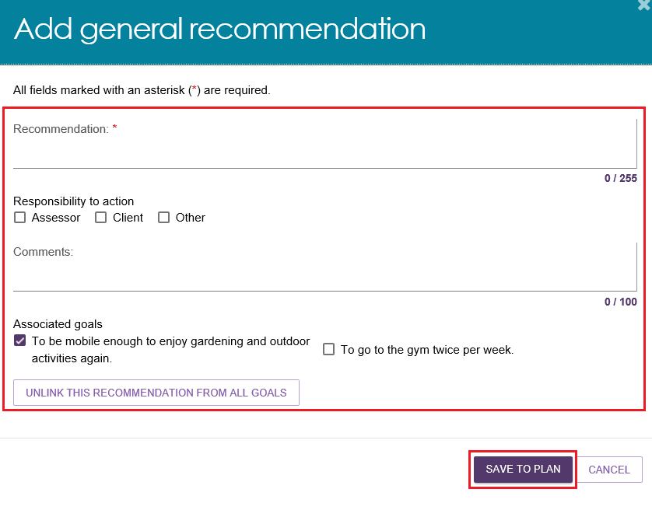
- During the assessment, you can add general recommendations directly to the support plan. Select Add as Recommendation to include the recommendation in the client's support plan. The recommendation will then appear in both the Identified Needs tab and the Goals & Recommendations tab of the support plan.

Service Recommendation
- Select Add Service Recommendation.
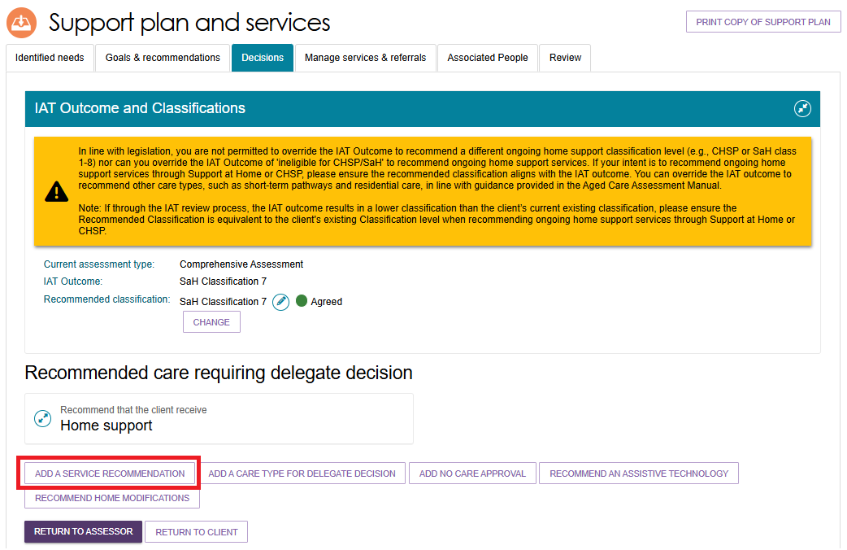
- When the pop-up appears, select the recommended service and complete all mandatory fields.
Use the Comments field to describe the specific services the client needs within the recommended Support at Home service type. Base your comments on the needs identified during the assessment and the goals recorded in the support plan. For example:
- Unable to travel beyond walking distance.
- Requires transport to attend health clinic appointments.
When finished, select SAVE TO PLAN.
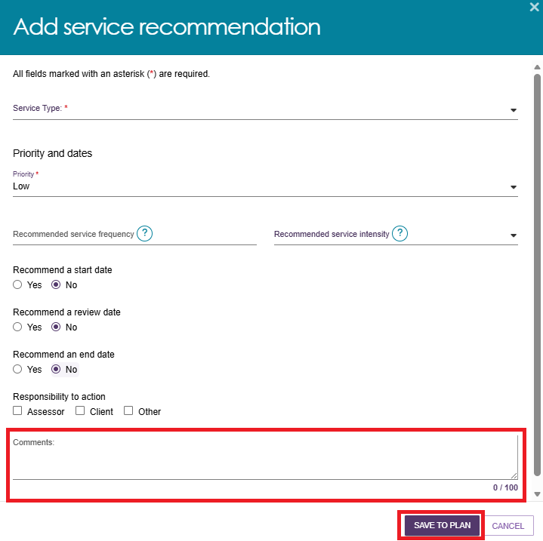
- For Support at Home service recommendations, the system automatically applies the priority calculated by the Integrated Assessment Tool (IAT).
For more information on Support at Home Assistive technology services and Home modification services, refer to the Support at Home - Assistive technology and Home modifications (AT-HM) Recommendations section.
! | Transitioned Clients from MPS or NATSIFAC Program  Assessors can select Services under the MPSP and Services under the NATSIFACP as Service Recommendations.  The system identifies transitioned clients by the text MPSP NATSIFACP Deeming on the Client Summary page and the Goals and Recommendations tab of the client record.  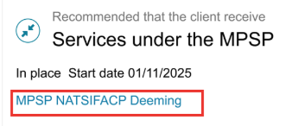  The system also displays an information message to remind assessors that the client is approved to access services through an MPSP or NATSIFACP provider.

No Care Type Under the Act
Use No Care Type Under the Act when a client withdraws their application for care under the Aged Care Act. This outcome does not require delegate approval.
This option is available before you accept or override the IAT outcome. It does not appear if you accept an IAT recommendation for a Support at Home (SaH) or CHSP classification.
  - Select Add No Care Type Under the Act.
In some cases, Add No Care Type Under the Act may be the only available recommendation. When this occurs, all other recommendation options are unavailable until you accept or override the IAT outcome.
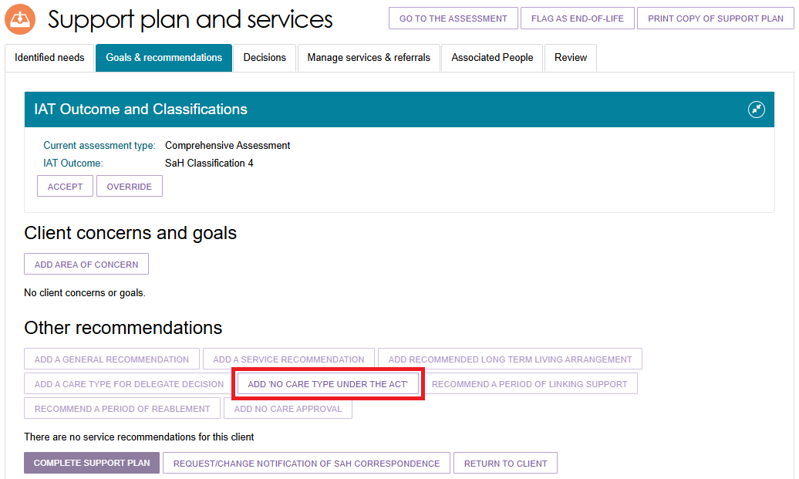
  - When the pop-up appears, select the reason for recommending No Care Type Under the Act. Add comments if required, then select SAVE TO PLAN.
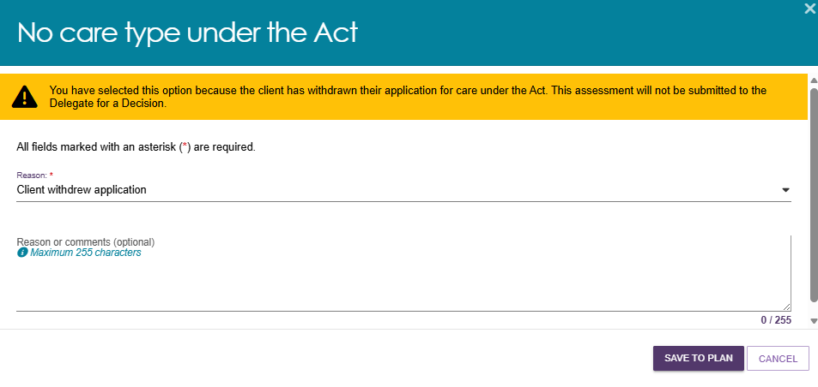

  - If you add No Care Type Under the Act from the Other Recommendations section, the recommendation appears under that heading. The system does not link this recommendation to a goal.
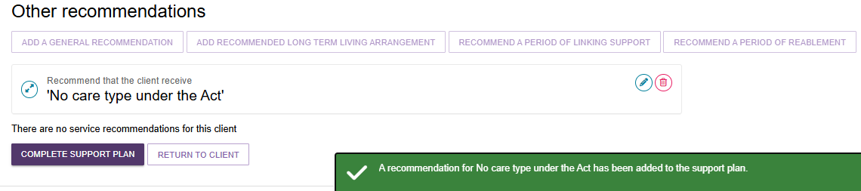

No Care Approval/No Change to Existing Care Approvals
No Care Approval and No Change to Existing Care Approvals are special care type recommendations that require a delegate decision.
Comprehensive assessors and home support assessors can add either recommendation to an IAT assessment and submit the assessment to a delegate for approval before they finalise the support plan.
You cannot use these options during a support period or a support plan review.
Use No Care Approval when:
- the client has no previous care approvals
- the client has been assessed
- no services or care approvals are recommended because the IAT outcome shows the client is not eligible for CHSP or Support at Home based on their assessed needs.
You must accept the IAT outcome before selecting this option.
Use No Change to Existing Care Approvals when:
- you are completing a reassessment, and
- the reassessment does not change the client's existing care approvals.
This option requires delegate approval and is only available when the client already has care approval records.
Follow these steps to add No Care Approval or No Change to Existing Care Approvals:
- Select NO CARE APPROVAL or NO CHANGE TO EXISTING CARE APPROVALS from the Other Recommendations section. You can also add these recommendations directly to a client's goal.
No Care Approval example
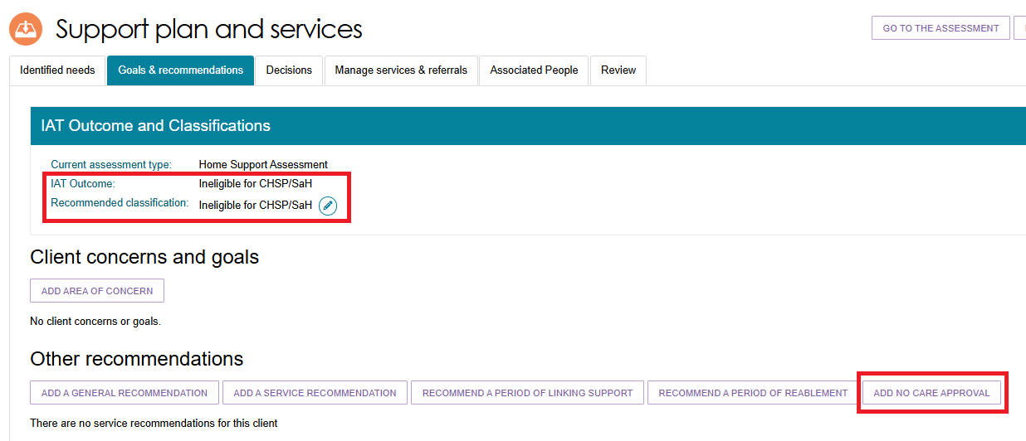
No Change to Existing Care Approvals example
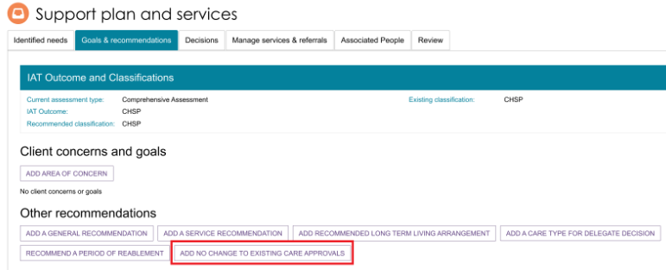
Adding recommendation directly to a goal
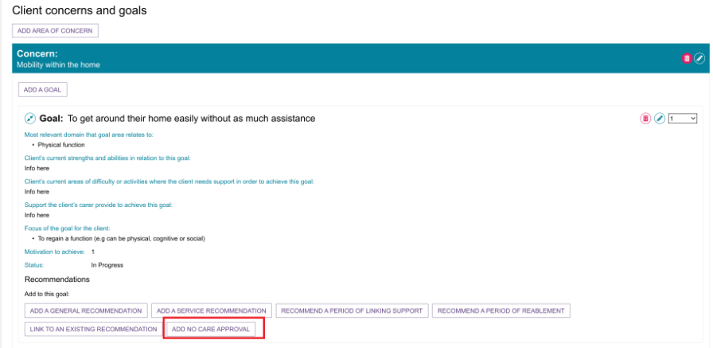
- If required, enter comments or a reason in the pop-up window.
Select SAVE TO PLAN.
No Care Approval example
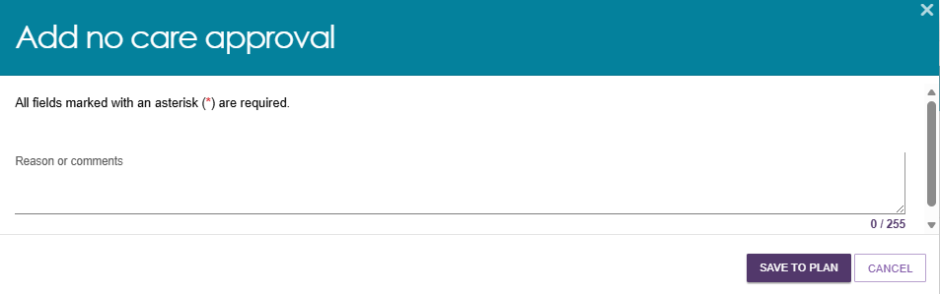
No Change to Existing Care Approvals example
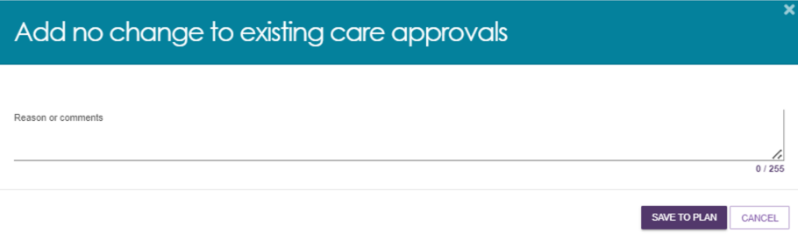
- The recommendation appears in the client's Goals & Recommendations section of the support plan. A confirmation message displays to show that the recommendation has been added. Submit the assessment to a delegate for decision and approval.
No Care Approval example
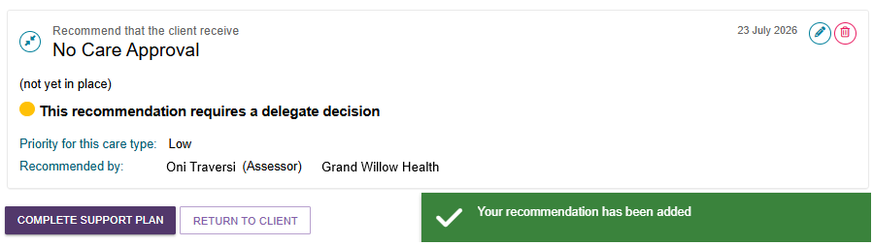
No Change to Existing Care Approvals example
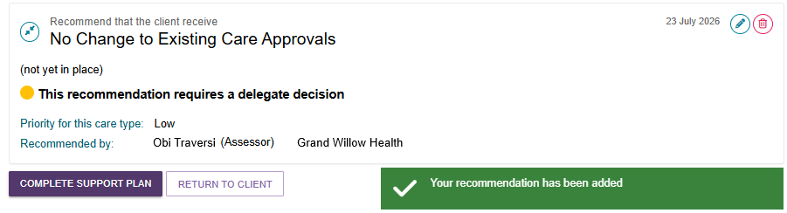

! | CHSP, MPSP or NATSIFAC in the support plan  If the client already has a CHSP, MPSP, or NATSIFACP recommendation in their support plan, including CHSP services marked as urgent, you can complete the support plan for a comprehensive assessment without adding:  - Care Type for Delegate Decision  - No Care Approval  - No Change to Existing Care Approvals.  Otherwise, an error message will appear:

Period of Linking Support
- Select RECOMMEND A PERIOD OF LINKING SUPPORT.
- When the pop-up appears:
- Enter the start date and recommended end date for the linking support period.
- Select a reason for recommending linking support from the drop-down list.
- Add any relevant comments.
- Link the recommendation to one or more goals if applicable.
- Select RECOMMEND to save the recommendation to the client's support plan.
During a linking support period, you can request and receive approval for extensions to Transition Care and Residential Respite Care services.
For more information about linking support, refer to My Aged Care Assessment Manual.
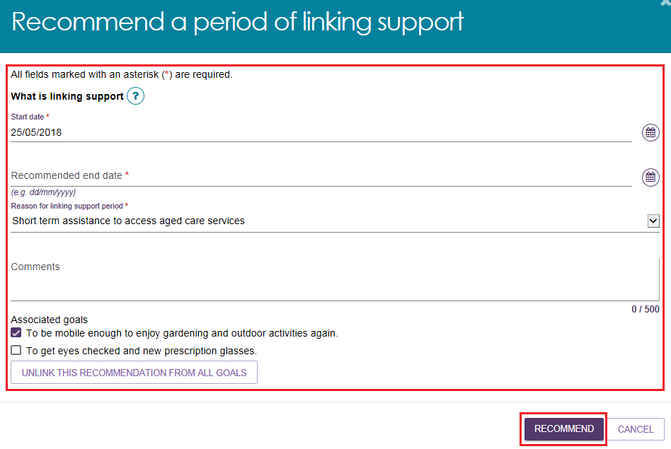

Period of Reablement
- Select RECOMMEND A PERIOD OF REABLEMENT.
- When the pop-up appears:
- Enter the start date and recommended end date for the reablement period.
- Select a reason for recommending reablement from the drop-down list.
- Add any relevant comments.
- Link the recommendation to one or more goals, if applicable.
- Select RECOMMEND to save the recommendation to the client's support plan.
During a reablement period, you can request and receive approval for extensions to Transition Care and Residential Respite Care services.
For more information about reablement, refer to the My Aged Care Assessment Manual.
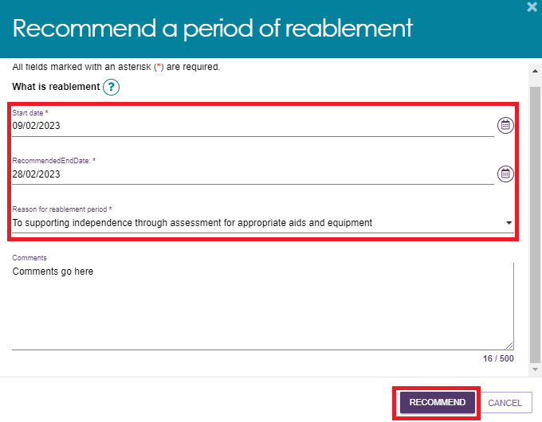

Care type for Delegate decision
- Select ADD A CARE TYPE FOR DELEGATE DECISION. You can add this recommendation under a goal or as a separate recommendation.
ADDING A CARE TYPE AS PART OF A GOAL
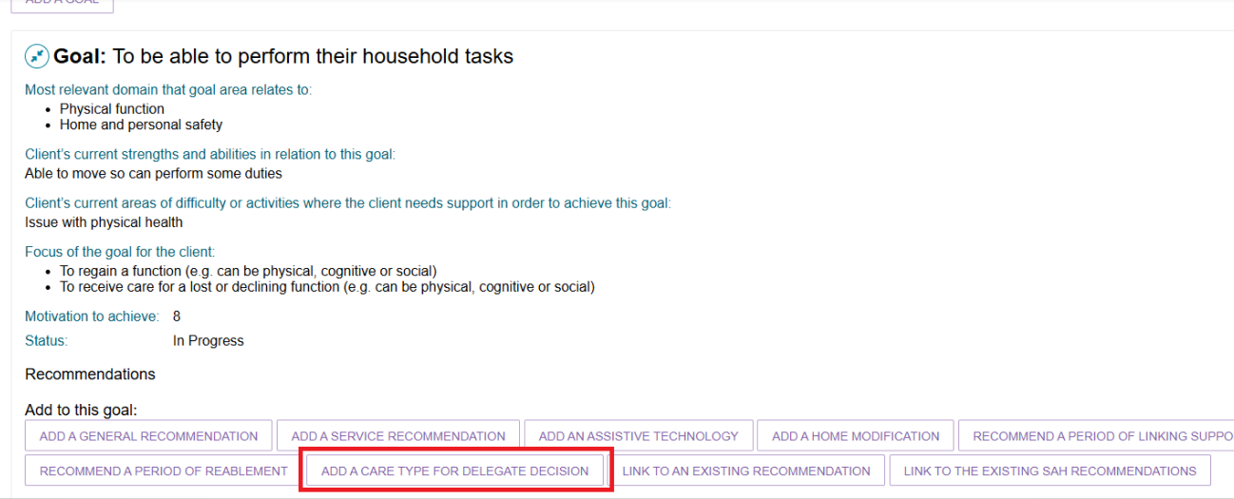
ADDING A CARE TYPE SEPARATELY
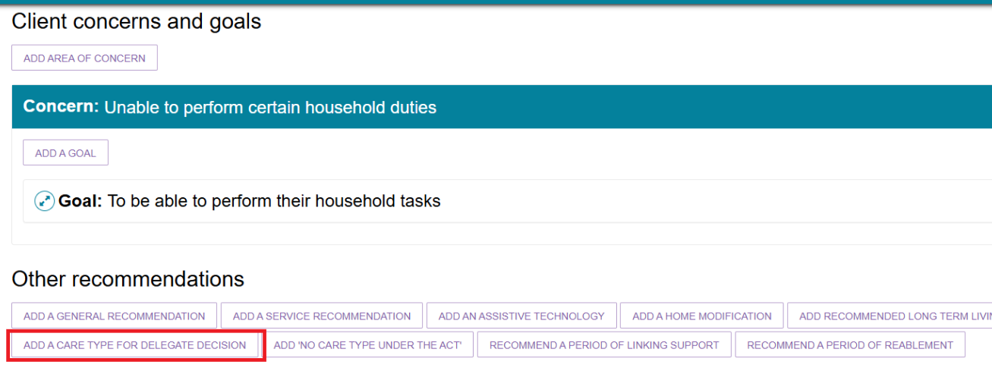
- In the pop-up window:
- Select the appropriate care type.
- Enter a reason and any comments, if required.
- Select SAVE TO PLAN.
The available care types are:
- Residential Permanent Care
- Residential Respite Care
- Transition Care.
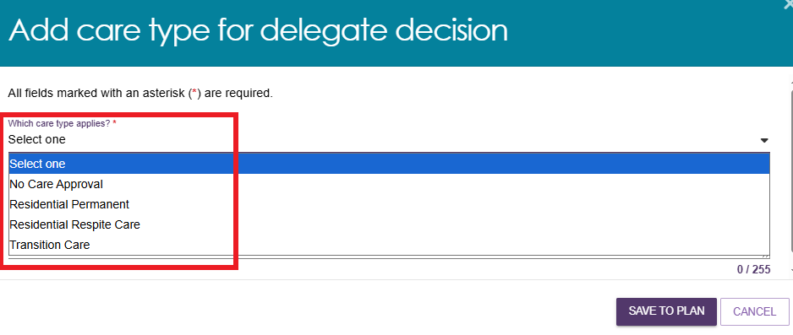
! | If the client is under 65 years of age, complete the additional fields that record their exceptional circumstances.
- After you select a care type, the pop-up expands to display additional fields. Enter the required information, including the priority or urgency of the care type.
For Residential Permanent Care, select the appropriate urgency level.
For Residential Respite Care, the urgency automatically defaults to High and cannot be changed.
Refer to the My Aged Care Assessment Manual for guidance on selecting the appropriate urgency level.
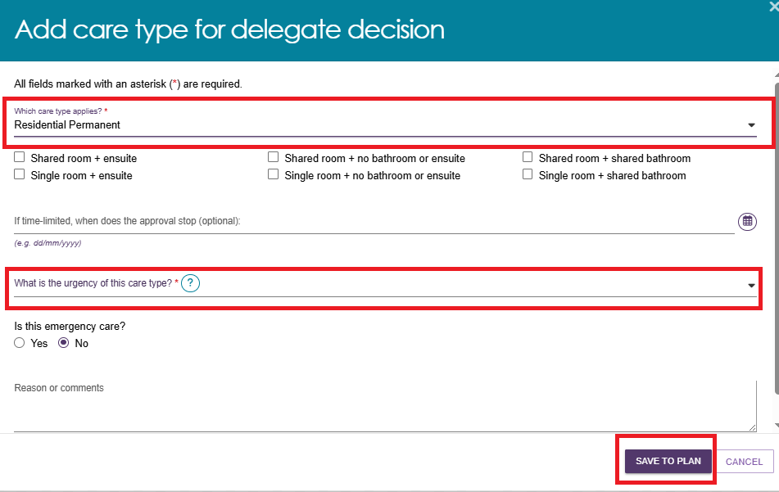
For Residential Respite Care, make sure you:
- select the DEMMI checkbox, and
- enter a valid reason.
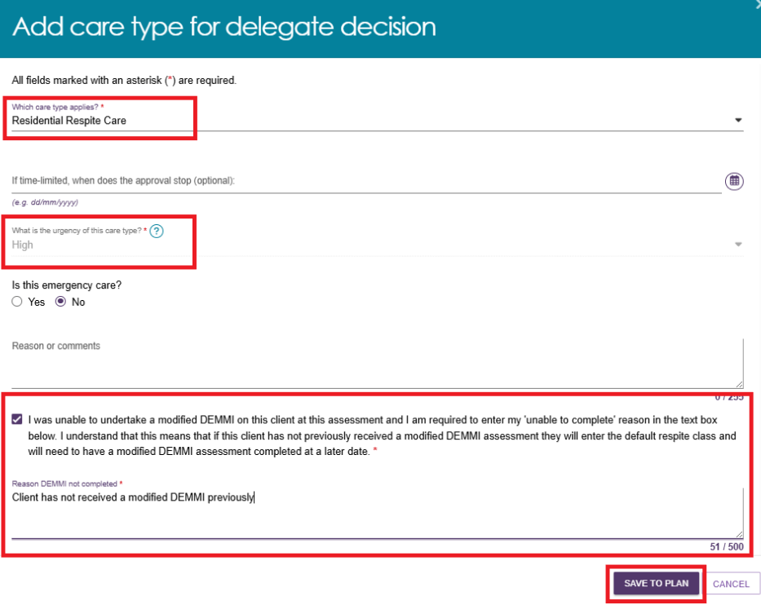

- Select SAVE TO PLAN.
! | If the client's home address is not recorded, the system displays a warning message prompting you to update the address before continuing.  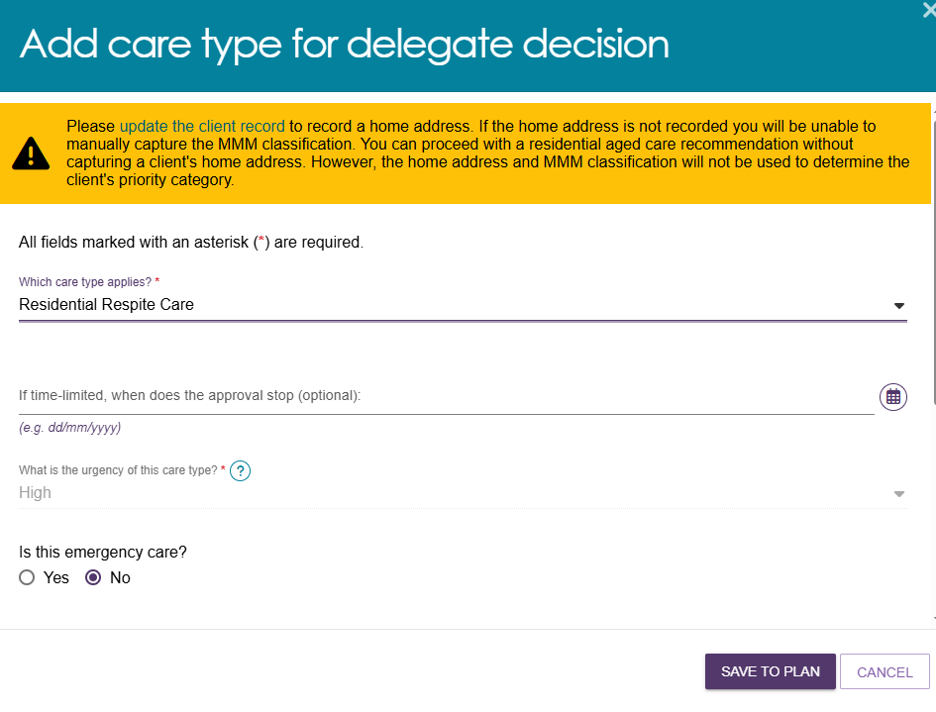

Support at Home Recommendations

Adding Home Support services
After the clinical assessor accepts the Support at Home classification, add the Home Support services the client needs.
! | If you do not select a service, the Support at Home service provider cannot deliver that service to the client. This may result in the need for a Support Plan Review to add the service to the client’s Support at Home classification.  When completing a Support at Home assessment, select all relevant service types when making recommendations in the support plan. This helps reduce the number of Support Plan Reviews required.  The only exception is Allied Health and Therapeutic Services for Independent Living. You must select this manually based on the client’s identified goals.
  - For each recommended service, select the checkbox and enter the required frequency and intensity.
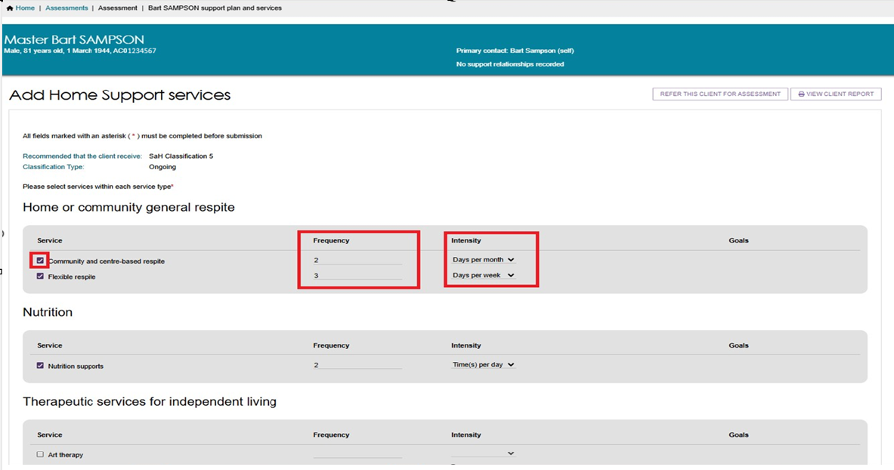
  - Review all recommended services and make sure you have selected the services the client needs and deselected any that are not required.
  - Select SAVE TO PLAN.
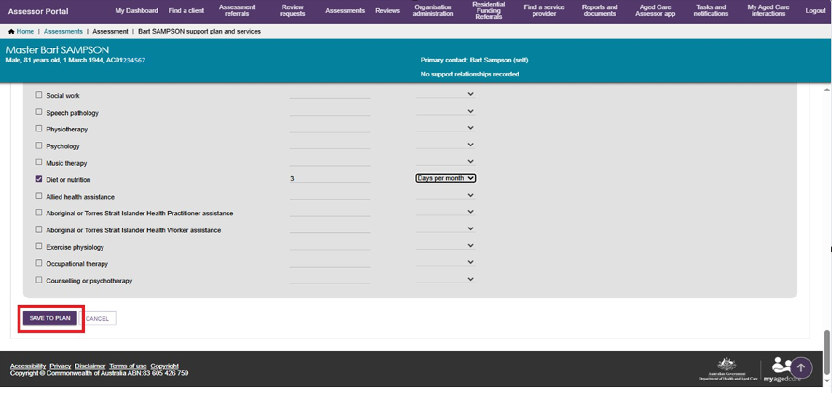
  - After you save the plan, the system returns you to the Goals & Recommendations tab. A banner will advise that it may take up to 60 seconds for the new services to appear.
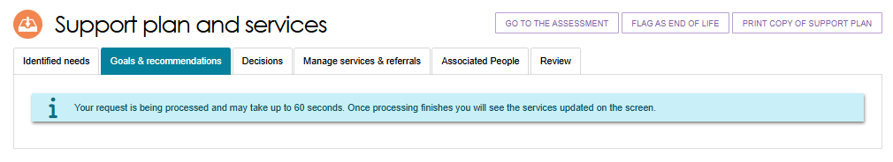
To view the Support at Home service recommendations:
- Expand the relevant section.
- Select the View (magnifying glass) icon next to a service recommendation.
- Review the service details, including the recommended frequency.
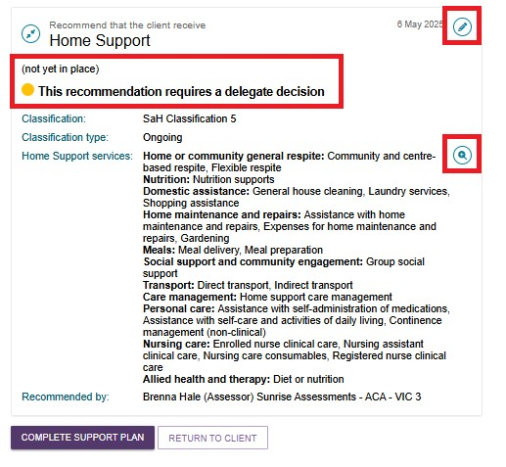
- Use the expand buttons to view additional information.
- Select CLOSE to return to the support plan.
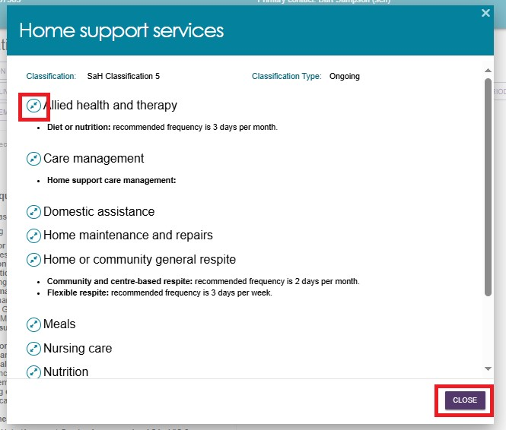
- When you have finished making all required changes, select COMPLETE SUPPORT PLAN REVIEW.

Viewing Recommended SaH services
- To view the details and status of services recommended under a client’s Support at Home classification, go to the Goals & Recommendations tab and locate the Other Recommendations section.
- Select the expand icon next to the service recommendation, then select the View (blue magnifying glass) icon.
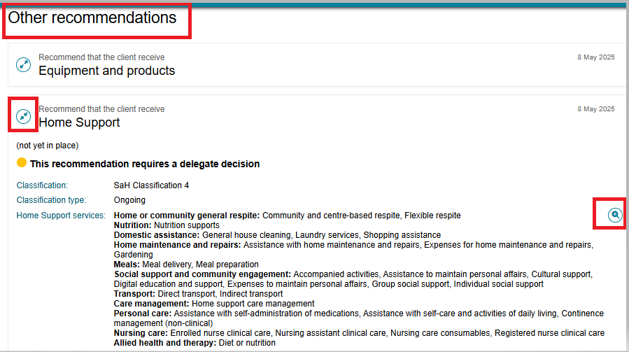
- A pop-up window will open and display all recommended services.
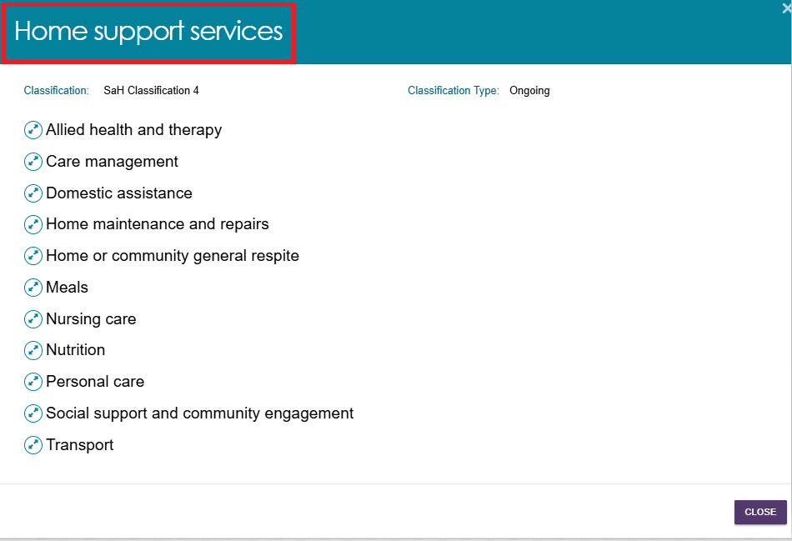
- Select the expand card icon to view detailed information and the status of each recommended service.
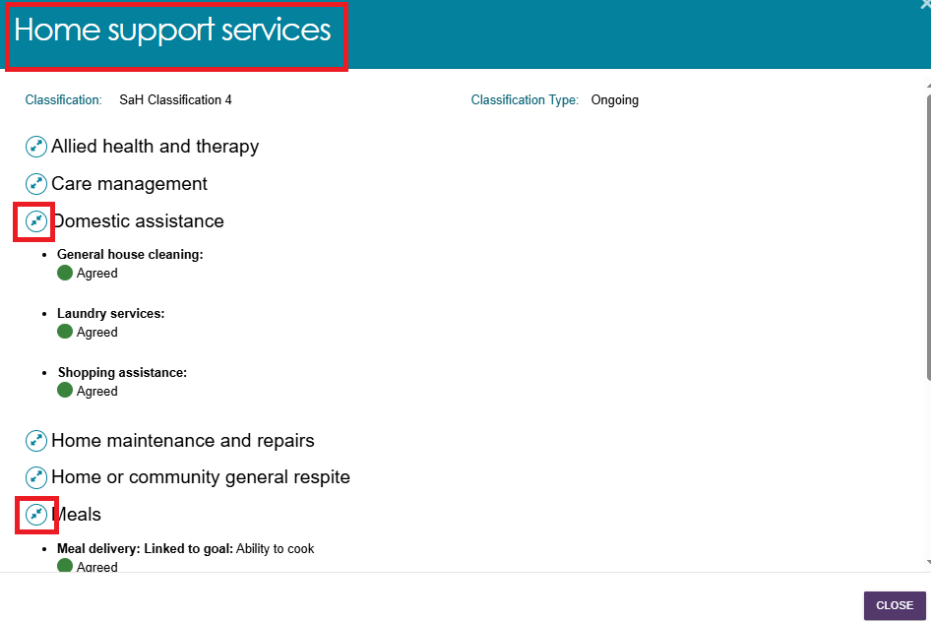

Assistive technology and Home modifications (AT-HM) Recommendations
This section explains how to view, add, and edit Assistive Technology and Home Modifications (AT-HM) recommendations.

Adding a Home modification Recommendation
! | Before adding or editing a Home Modification recommendation, refer to:  - The Support Plan section of My Aged Care – Integrated Assessment Tool (IAT) User Guide  - The Approving AT and HM under Support at Home and Approving AT and HM under CHSP sections under Chapter 8 of the My Aged Care Assessment Manual  - The AT-HM Scheme Guidelines for support plans and support plan reviews. Assessment Operations Managers can access the AT-HM Tier Guide on the Assessor SharePoint site and provide it to assessors as required.  - Assessor workforce training.
If the client has received a Support at Home classification through the IAT, you can add a Home Modification recommendation during the assessment.
- Go to the client's Goals & Recommendations tab in the Support Plan and Services screen.
If you selected AT/HM Short-term in the Other Considerations section of the IAT, the system displays a reminder message: "Please consider the identified needs captured in the Other Considerations section when making an AT or HM funding tier recommendation."
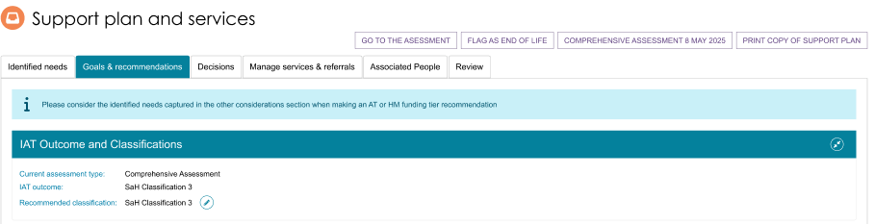
- Scroll to the Other Recommendations section and select ADD A HOME MODIFICATION.
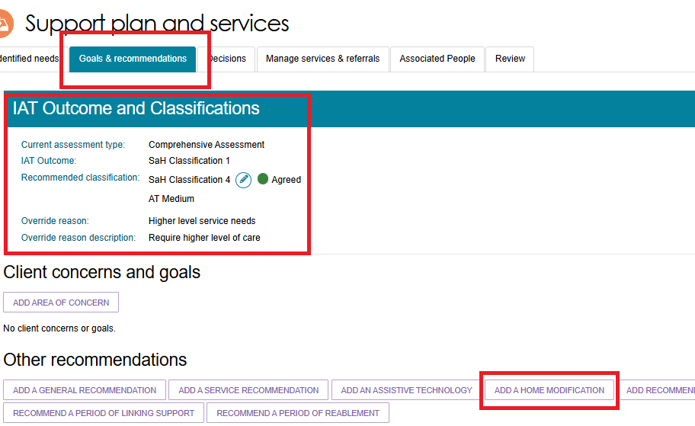
- The Add Home Modification Recommendation screen opens.
- Select the appropriate Home Modification Tier from the drop-down list (HM Low, HM Medium, or HM High).
- The system automatically populates the associated Service Type(s).
- If required, select Edit next to Linked Goals to link relevant goals.
- For the question "The client's preference for seeking Home Modification services through the Support at Home program is", select Seeking services.
- Select SAVE TO PLAN.
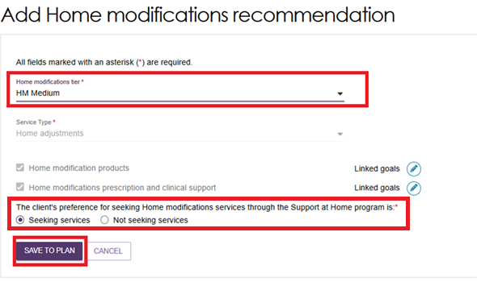
- The Home Modification recommendation will appear in the Other Recommendations section of the client's Goals & Recommendations tab.
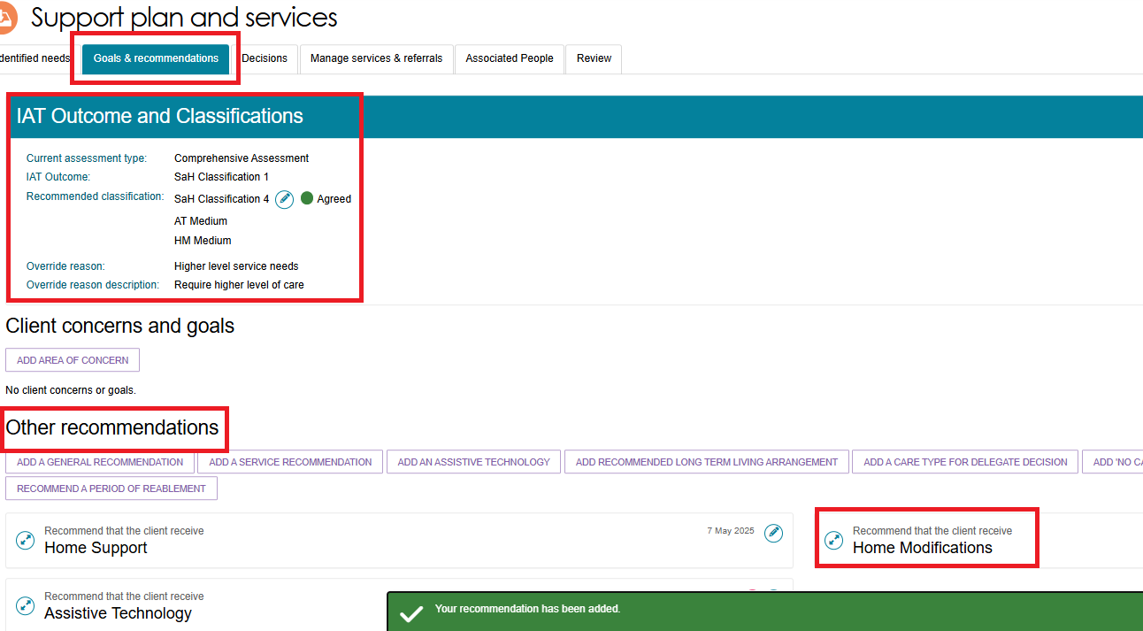

Viewing Home modification Service Recommendation
- In the Other Recommendations section, select the Edit (pencil) icon next to the Home Modification recommendation.
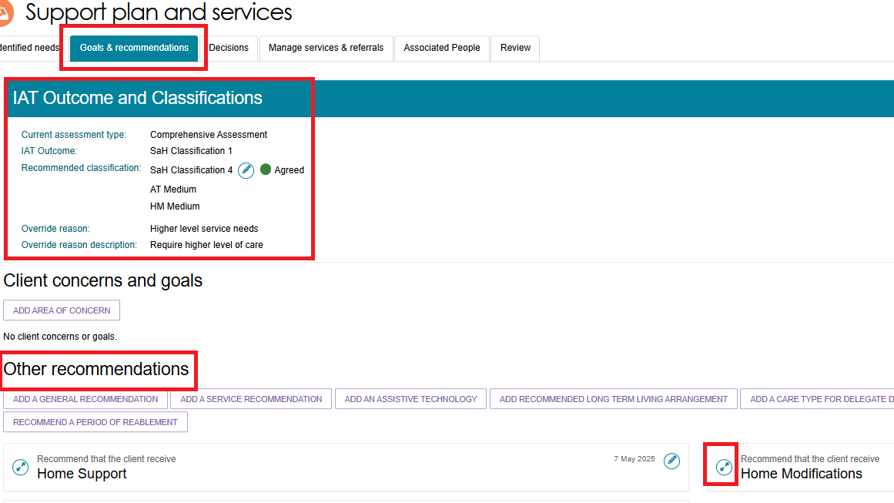
- The system displays the details of the recommended Home Modification service.
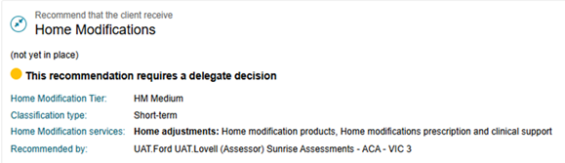

Editing Home modification Recommendation
- To edit a Home modification recommendation, select the blue pencil (edit) icon on the top right hand corner of the Home modification service.
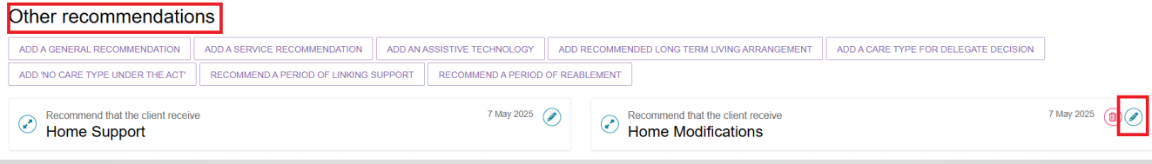
- The Editing Home modifications recommendation page displays. Apply the required changes and select SAVE TO PLAN.
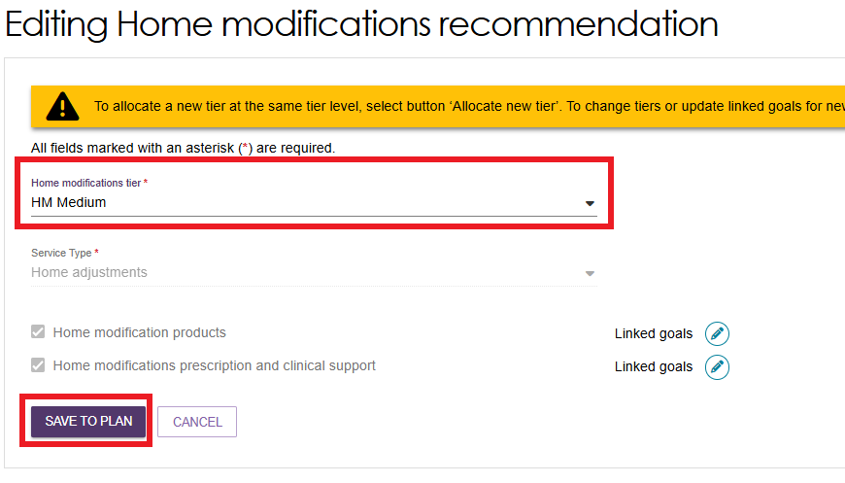

Adding an Assistive technology Recommendation
! | Before adding or editing an Assistive Technology recommendation, refer to:  - The Support Plan section of My Aged Care – Integrated Assessment Tool (IAT) User Guide  - The Approving AT and HM under Support at Home and Approving AT and HM under CHSP sections under Chapter 8 of the My Aged Care Assessment Manual  - The AT-HM Scheme Guidelines on support plan or support plan reviews for AT-HM. Assessment Operations Managers can access the AT-HM Tier Guide on the Assessor SharePoint site and provide it to assessors as required.  - Assessor workforce training.
If the client has received a Support at Home classification through the IAT, you can add an Assistive Technology recommendation during the assessment.
- Go to the client's Goals & Recommendations tab in the Support Plan and Services screen.
If you selected AT/HM Short-term in the Other Considerations section of the IAT, the system displays a reminder message: "Please consider the identified needs captured in the Other Considerations section when making an AT or HM funding tier recommendation."
The system may also display other information messages to help you make an Assistive Technology recommendation.
- Scroll to the Other Recommendations section and select ADD ASSISTIVE TECHNOLOGY.
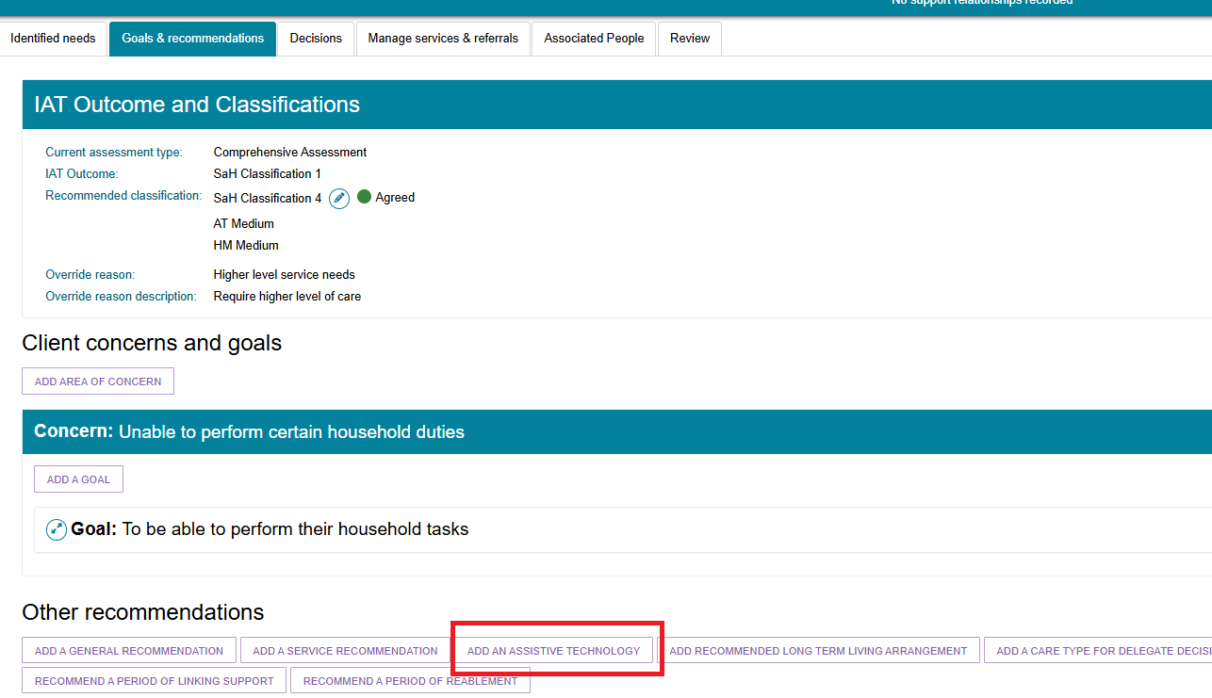
- The Add Assistive Technology Recommendation screen opens.
- Select the appropriate Classification Type (Ongoing or Short-term).
- Select either a Specified Need (for example, Assistance Dogs) or an Assistive Technology Tier (AT Low, AT Medium, or AT High) from the drop-down lists.
- Based on your selection and the client's classification, the system may automatically populate and pre-select the relevant service types.
- For the question "The client's preference for seeking Assistive Technology services through the Support at Home program is", select Seeking services.
- Select SAVE TO PLAN.
- The Assistive Technology recommendation appears in the Other Recommendations section of the client's Goals & Recommendations tab.
! | The system does not display linked goals for service recommendations carried over from a previous assessment.

Add AT recommendation - Ongoing Assistance Dogs
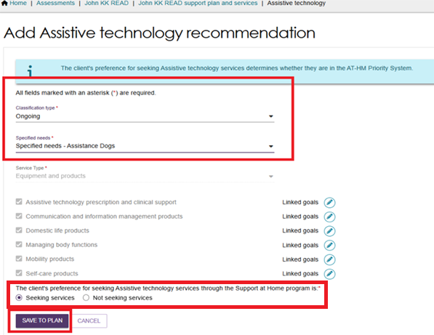
Add AT recommendation - Short Term, Medium Tier
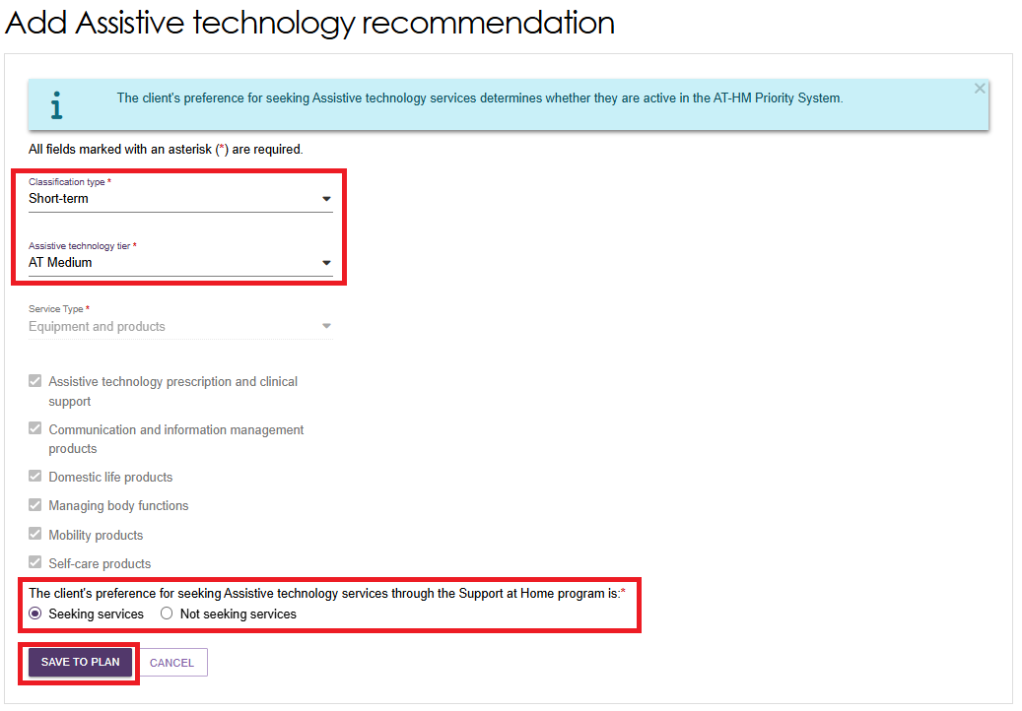

Viewing Assistive technology Service recommendation
  - After you add an Assistive Technology recommendation, it appears in the Other Recommendations section of the client's Goals & Recommendations tab.
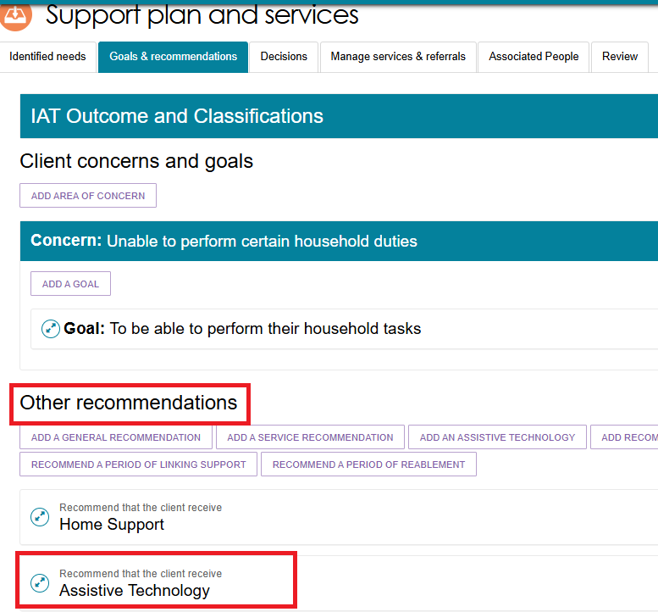
  - To view the recommended Assistive Technology services, select the Expand icon next to Assistive Technology.
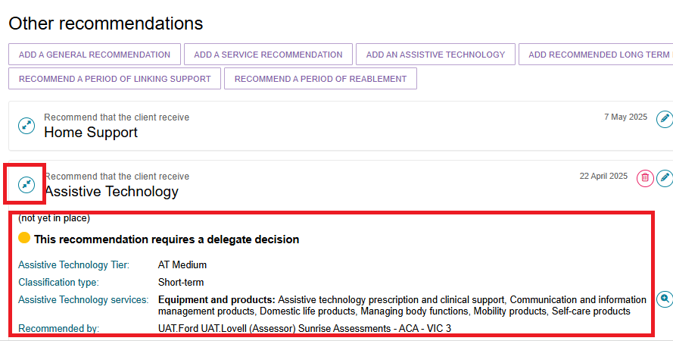

Editing Assistive technology Recommendation
- In the Other Recommendations section, select the Edit (pencil) icon in the upper-right corner of the Assistive Technology recommendation.
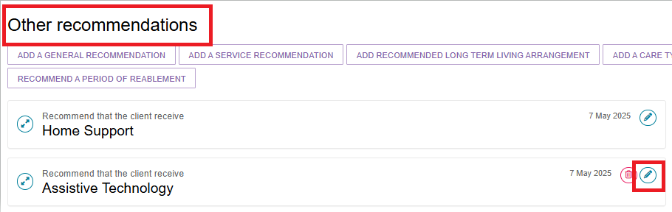
- The Edit Assistive Technology Recommendation screen opens.
Make the required changes and select SAVE TO PLAN.
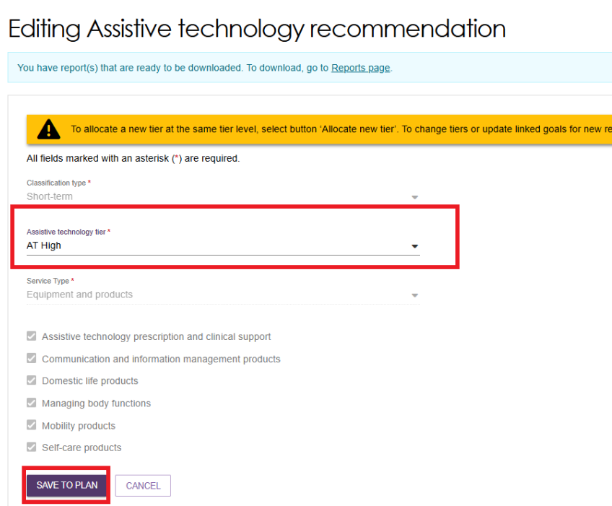

Adding Client Concerns and Goals
- On the Support Plan and Services page, select the Goals & Recommendations tab.
In the Client Concerns and Goals section, select ADD AREA OF CONCERN.
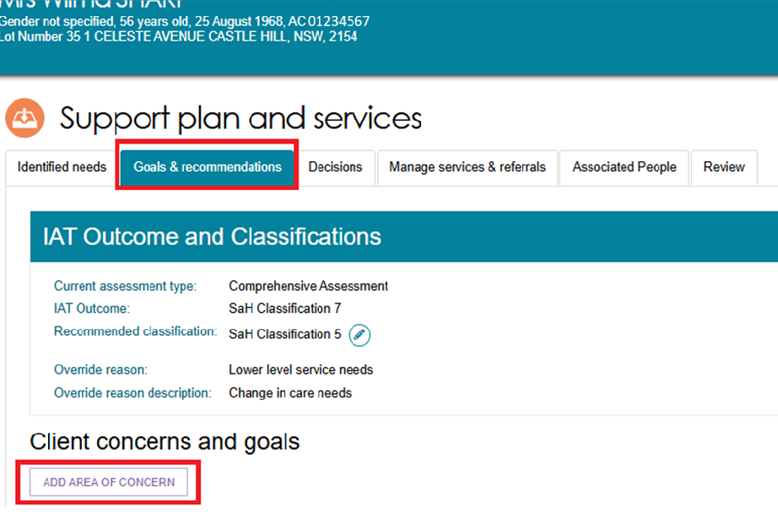
- In the pop-up window, enter the area of concern and select SAVE TO PLAN.
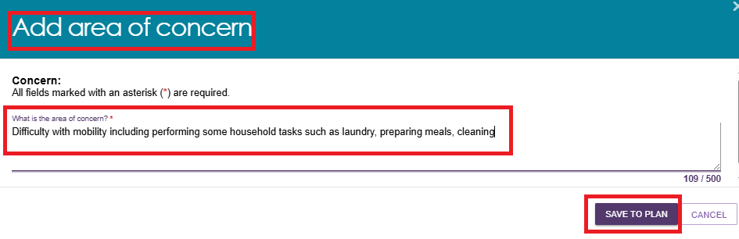
- The area of concern appears in the Client Concerns and Goals section.
- Select the Delete (bin) icon to remove the area of concern.
- Select the Edit (pencil) icon to update the area of concern.
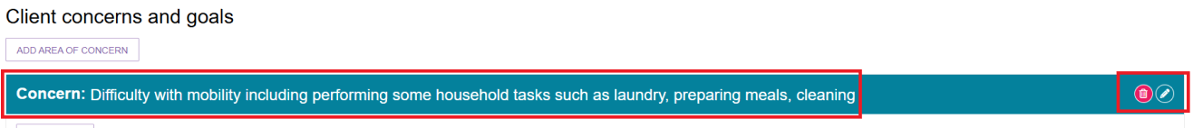

- To add a goal for the area of concern, select ADD A GOAL.
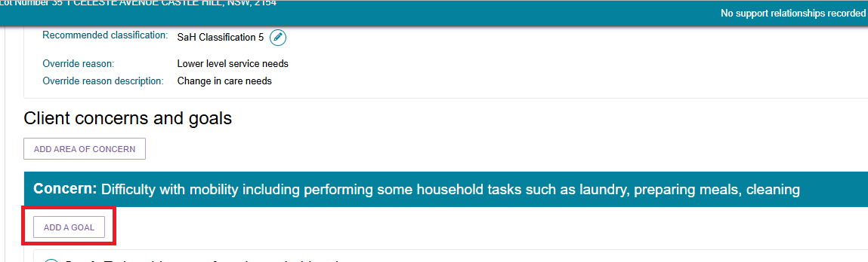
In the pop-up window, enter the goal, record the client’s motivation to achieve it on a scale of 1 to 10 (where 1 is least motivated and 10 is most motivated), select the goal status, and then select SAVE TO PLAN.
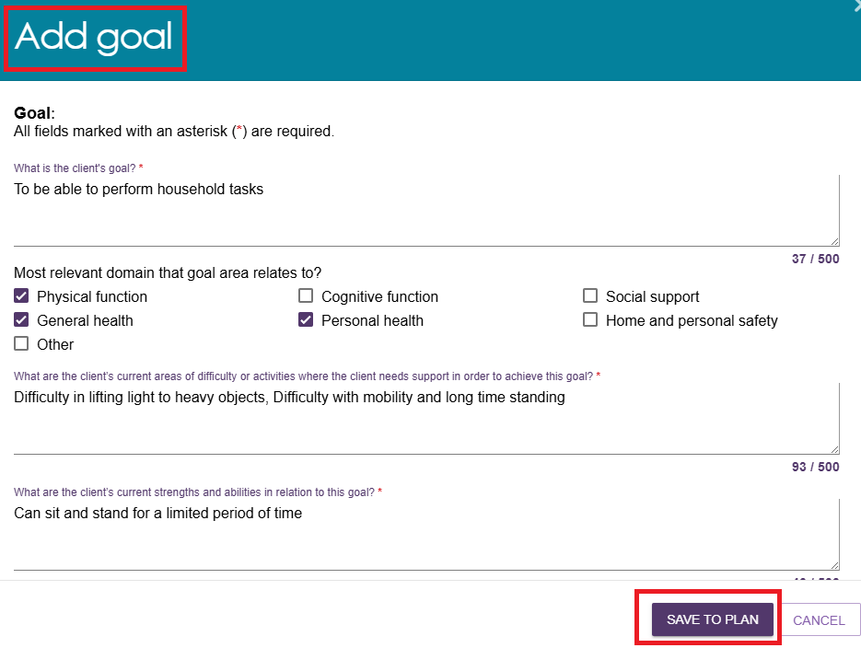
- The goal appears under the relevant area of concern in the Client Concerns and Goals section.
- Select the Edit (pencil) icon to update the goal.
- Select the Delete (bin) icon to remove the goal if it is no longer relevant.
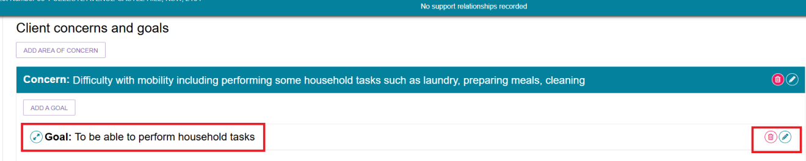
- To add more areas of concern and goals, repeat the previous steps.
! | Changing the Display Order of Areas of Concern or Goals  If you have added multiple areas of concern or goals, you can change the order in which they appear.  Use the drop-down list on the right side of the area of concern or goal, and select the required position. The system updates the display order accordingly.  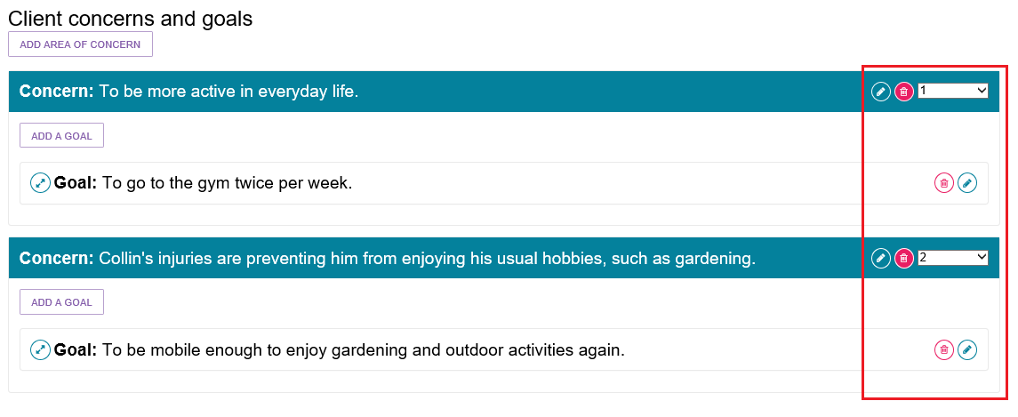
- You can also add service recommendations to help the client achieve their goals.
Select the Expand icon next to the relevant goal.
Select the appropriate recommendation button.
For more information, refer to Adding Recommendations.
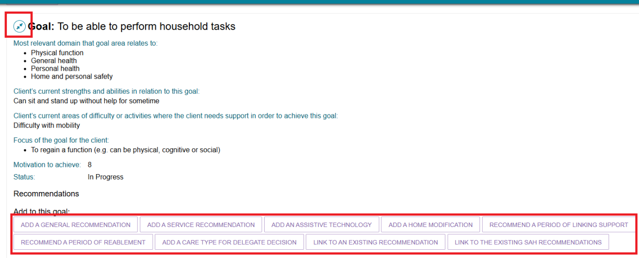

Linking Goals to Existing Support at Home Recommendations
Assessors can link goals in the support plan to existing Support at Home service recommendations.
- On the client's Support Plan and Services screen, select the Goals & Recommendations tab and go to the Client Concerns and Goals section.
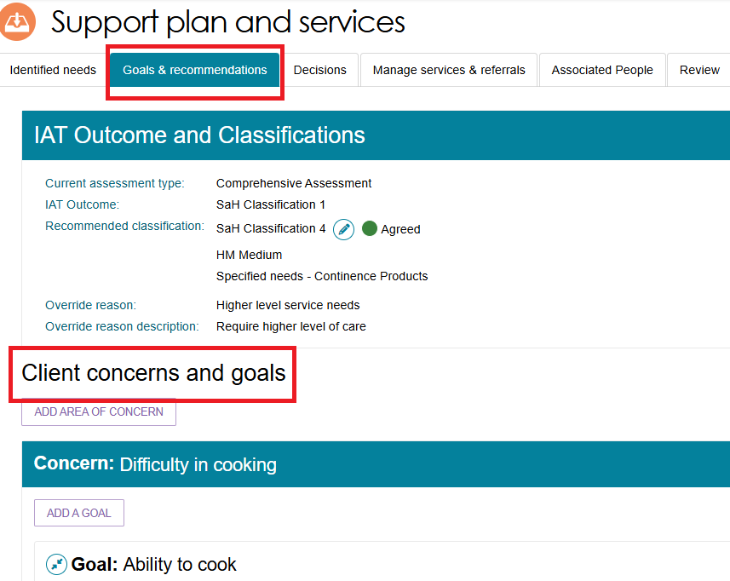
- Select the Expand icon next to the relevant goal, then select LINK TO EXISTING SAH RECOMMENDATIONS.
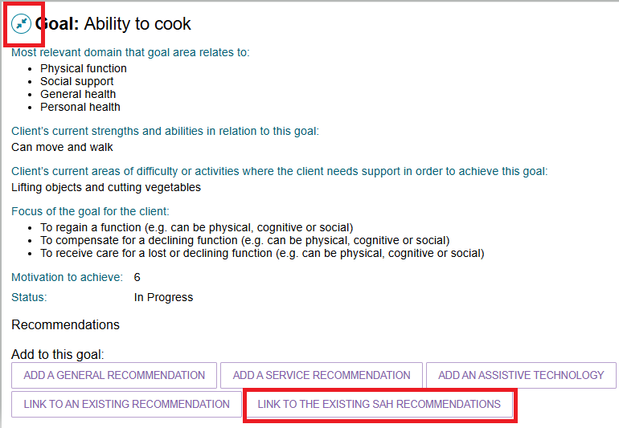
- The Link to Existing SaH Recommendations screen opens.
- Select a recommendation (classification) from the drop-down list.
- Select the Expand icon to view the available service types.
- Select the checkbox next to each service you want to link to the goal.
- Select SAVE TO PLAN.
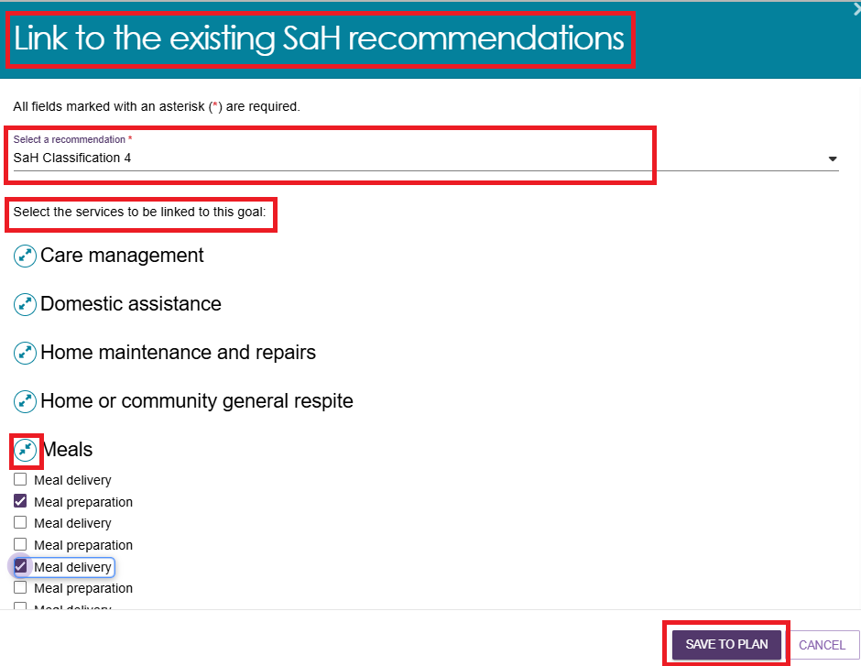
- The linked Support at Home recommendation appears under the relevant goal in the Client Concerns and Goals section.
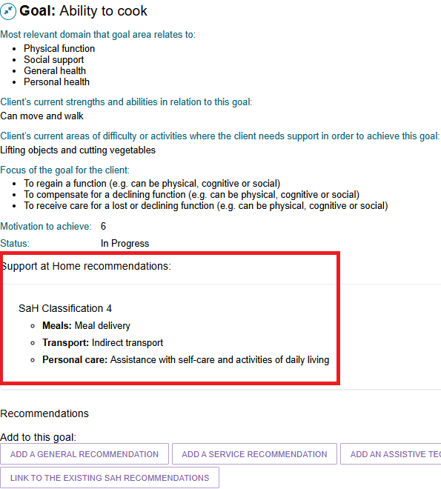

Recording Service Frequency and Intensity
You can record the recommended frequency and intensity for each service you recommend. This is optional.
Record any information discussed with the client, including their preferences for how often they would like to receive the service and the level of support they need. Service providers can use this information as a guide when agreeing on service frequency and intensity with the client.
If a client does not want to access a service immediately, or only needs it occasionally, you should still create the service recommendation. The client can access the service later by contacting the My Aged Care Contact Centre, which can arrange electronic referrals from recommendations already included in the client's support plan.
Providing details about the recommended services helps service providers and Contact Centre staff understand whether a service is needed for a specific purpose or as ongoing support.
This information also helps the Contact Centre determine whether it can make a referral directly or whether it needs to request a Support Plan Review from the assessment organisation.
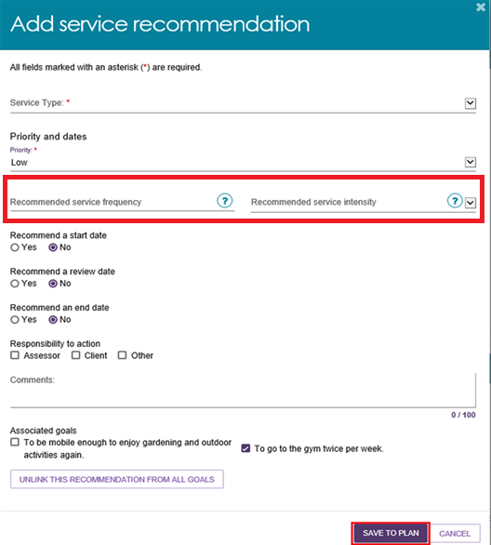

Support at Home - Restorative Care Pathway

Overriding to Restorative Care Pathway
After a client receives an IAT outcome, you can override the outcome to the Support at Home (SaH) Restorative Care Pathway.
- Go to the client's Support Plan and select the Goals & Recommendations tab, and Select OVERRIDE.
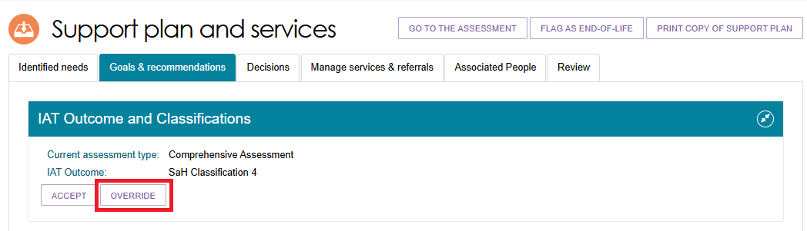
- The Override IAT Outcome pop-up window opens.
- In Override IAT Outcome To, select SaH Restorative Care Pathway.
- Select an override reason.
- Enter a description of the reason for the override.
- Select SAVE TO PLAN.
The system may display a warning message advising you to review and add recommended services again.
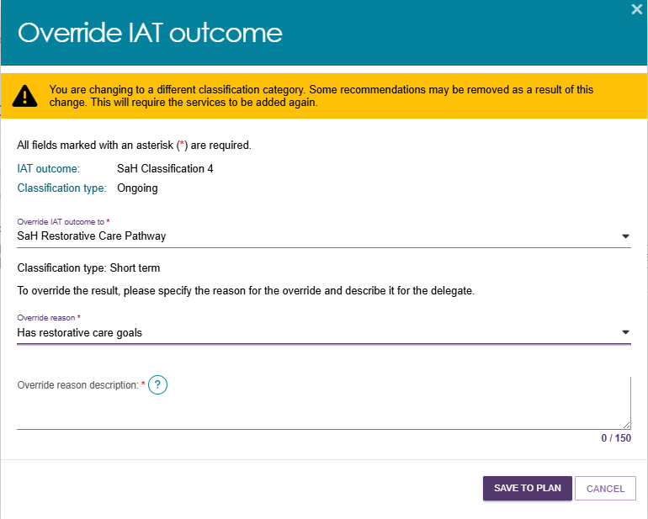
- If the original IAT outcome was a Support at Home classification, review the list of Home Support services and select SAVE TO PLAN.
The system may display the following message: "Your request is being processed and may take up to 60 seconds. Once processing finishes, you will see the services updated on the screen."
- The Goals & Recommendations page displays again. Return to the IAT Outcome and Classification section to view the updated outcome.
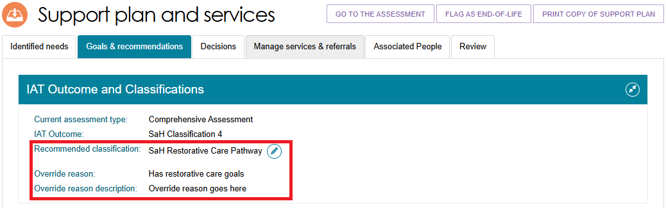
If you overrode a Support at Home classification, the classification now displays as SaH Restorative Care Pathway.
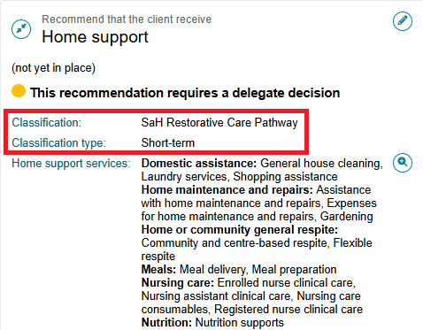
- After you accept the classification or recommendation, the Add Home Support Services screen opens.
- Enter the required services for each available service type.
- Record the recommended frequency and intensity for each service.
- The Home Support Restorative Care Management service is selected by default and cannot be changed.
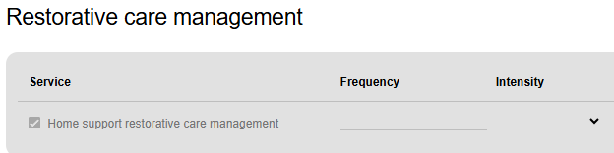

Editing IAT Outcome to Restorative Care Pathway
To edit an existing IAT Outcome to the Restorative Care Pathway:
- Open the client's support plan from the Client Record, Current Assessments, or Recent Assessments tab.
- On the Goals & Recommendations tab, select Edit Classification. The Edit Recommended Classification window opens.
- In the Override IAT Outcome To drop-down list, select SaH Restorative Care Pathway.
An information message advises that adding the Restorative Care Pathway automatically includes the AT Medium and HM Medium classifications. You can edit or remove these recommendations if required.
- In the Override Reason drop-down list, select one of the following reasons:
- Has restorative care goals
- Delay/prevent ongoing services
- Needs early intervention care
- Other.
- Enter the reason for the override in the Override Reason Description field. Then select SAVE TO PLAN.
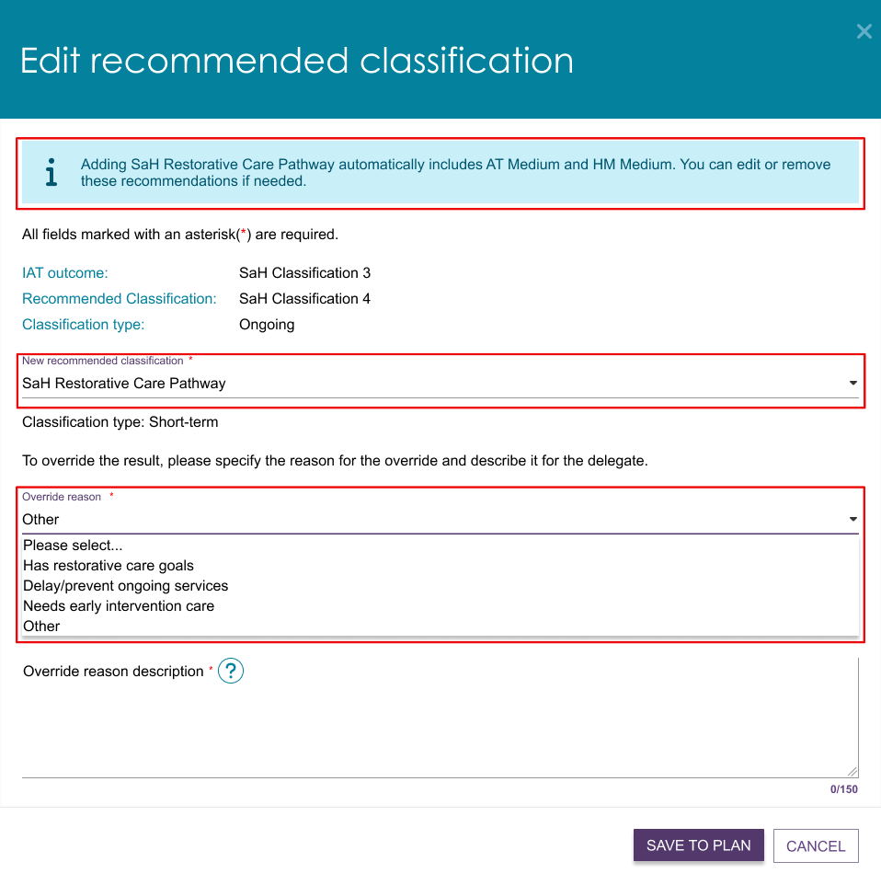

Recommending Second Unit of Restorative Care Pathway
If a client has an approved and active Support at Home (SaH) Restorative Care Pathway in their support plan, you can recommend a second unit of Restorative Care Pathway within 16 weeks of the first unit starting.
Before recommending or approving a second unit, confirm that the client has started receiving services under the first Restorative Care Pathway unit.
! | Do not approve a second unit if the client has not started using their first Restorative Care Pathway unit.
If a delegate approves the second unit, the system creates a new Restorative Care Pathway approval. The approval start date is the date of delegate approval, and the approval end date matches the end date of the first unit.
You can remove the second unit recommendation if circumstances change.
- Go to the Support Plan and Services section and select the Goals & Recommendations tab.
Under IAT Outcome and Classifications, confirm that the existing classification is SaH Restorative Care Pathway.
Select ADD SECOND UNIT OF RESTORATIVE CARE PATHWAY.
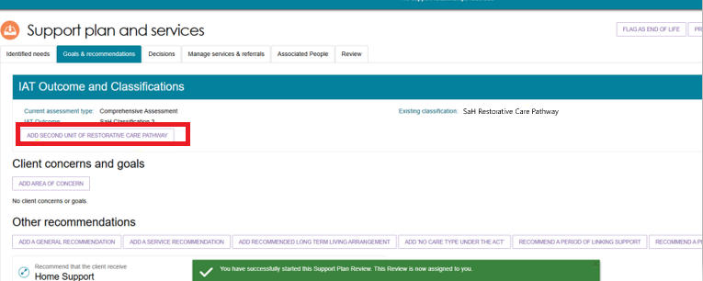
- A new window opens. Select ADD SECOND UNIT to confirm the recommendation.
The system then begins the process to create the RCP - Approval of Second Unit of Funding recommendation.
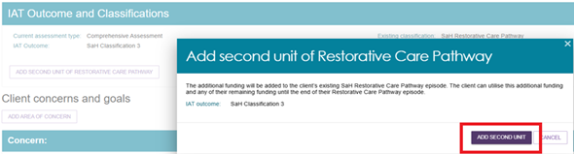

- If you need to withdraw the recommendation, select REMOVE SECOND UNIT OF RESTORATIVE CARE PATHWAY.
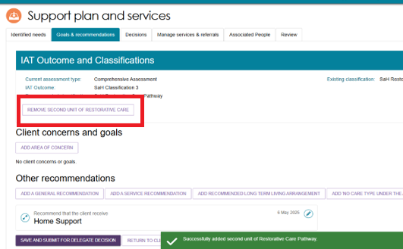
In the confirmation window, select REMOVE.
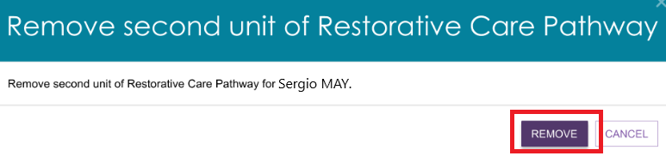

End-of-Life Pathway
This section explains how to edit and override IAT outcomes to include the End-of-Life (EoL) Pathway.
For clients starting a new Support Plan Review for services following an EoL episode, refer to the relevant section of Support Plan Reviews.

! | Before you recommend or approve the End-of-Life Pathway, you must:  - Flag the client as End-of-Life in the My Aged Care assessor portal.  - Validate the client's End-of-Life Pathway form in accordance with the current process described in the Assessment Manual.  You can complete these actions during the client's assessment, from the client record, or during a Support Plan Review  On the Support Plan and Services page  In the Client Card  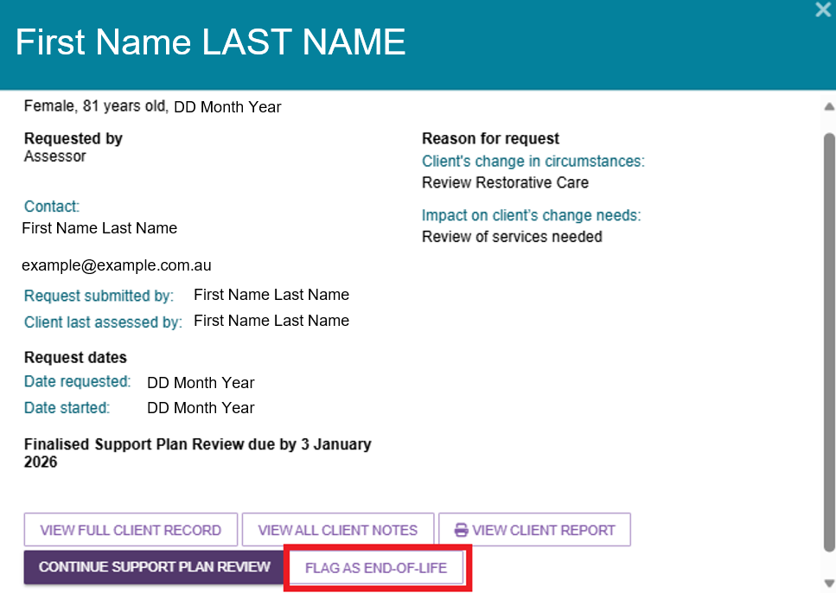  Validating the End-of-Life Form  Assessment delegates must confirm that the End-of-Life Pathway form has been completed correctly when the client has been flagged as End-of-Life in the My Aged Care assessor portal.  When reviewing the form, you must:  - Confirm that the client's details match the information recorded in the assessor portal.  - Check that all sections of the Medical Assessment have been completed. Confirm that:  - The client has a life expectancy of three months or less.  - The client has an Australian-modified Karnofsky Performance Status (AKPS) score of 40 or less.  - A medical practitioner or nurse practitioner has completed and signed the form.  A client is not eligible for approval under the End-of-Life Pathway unless all required criteria in the Medical Assessment section have been met.

Overriding to End-of-Life Pathway
Before you can override an IAT outcome to the End-of-Life (EoL) Pathway, you must first flag the client as End-of-Life.
  - Open the client's support plan.
Search for the client, or
Open the client's record, select the Plans tab, and then select Support Plan.
  - Select the Goals & Recommendations tab, then choose OVERRIDE TO END-OF-LIFE or Edit Classification.
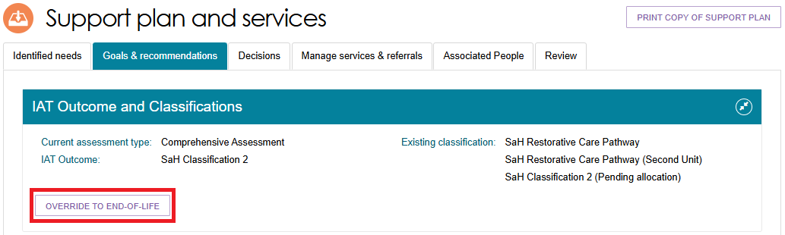
  - The Override IAT Outcome window opens.
An information message advises that overriding to the End-of-Life Pathway automatically adds the AT Medium classification to the client's support plan. You can edit or remove this recommendation if required.
Any Home Modification recommendations will be removed when you override to the End-of-Life Pathway.
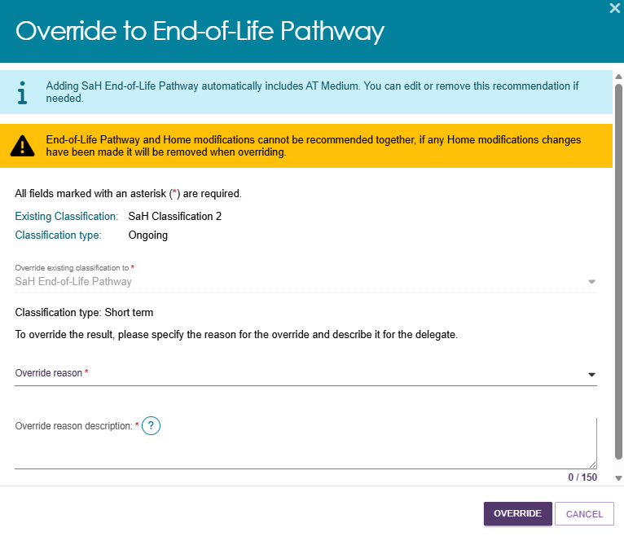
  - Select an Override Reason from the drop-down list and enter a description of the reason for the override. Select OVERRIDE.
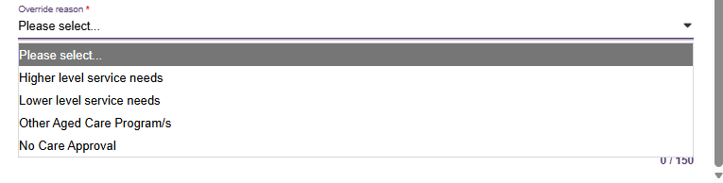
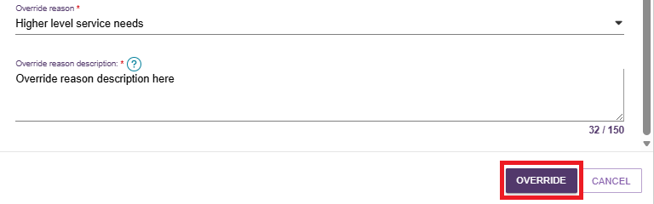
  - If the override is successful, the IAT Outcome and Classifications section displays:
- SaH End-of-Life Pathway
- The override reason
- The override reason description
If applicable, REVERT buttons may appear, allowing you to return the client to their previous classification.
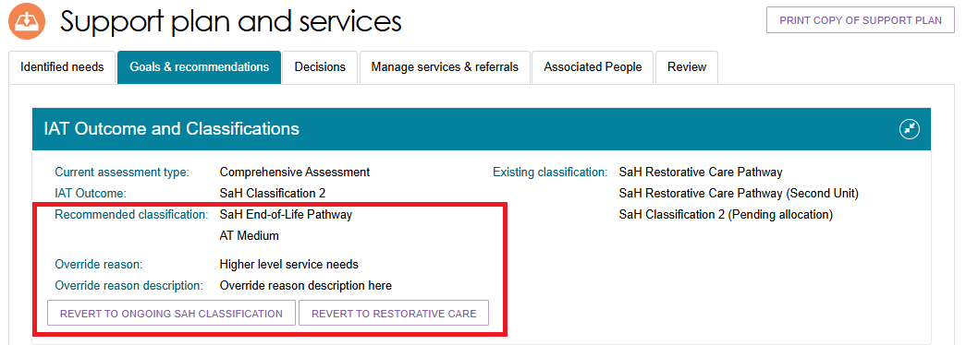
  - Review the client's Home Support services and update them if required to align with the End-of-Life Pathway.
To edit the services, select the Edit (pencil) icon in the Home Support recommendation under the Other Recommendations section.
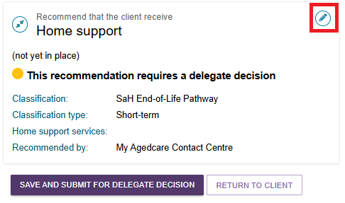

Flagging End-Of-Life to an existing SaH Restorative Care Pathway
If a client has been flagged as End-of-Life, you can change their classification to SaH End-of-Life Pathway when:
- The current classification is SaH Restorative Care Pathway.
- The End-of-Life Pathway form has been verified.
- You have not yet submitted the Support Plan Review for delegate decision.
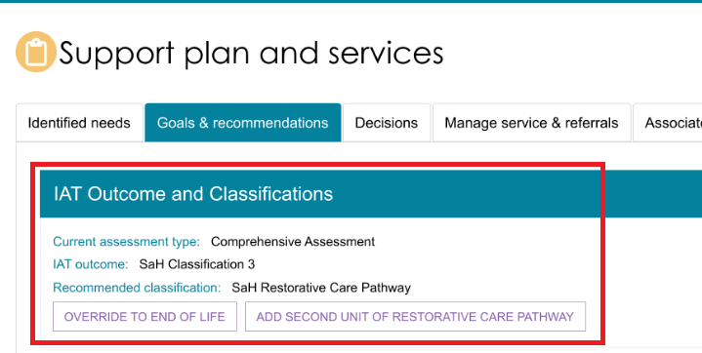

  - On the client's Goals & Recommendations tab, go to the IAT Outcome and Classifications section and select OVERRIDE TO END OF LIFE.
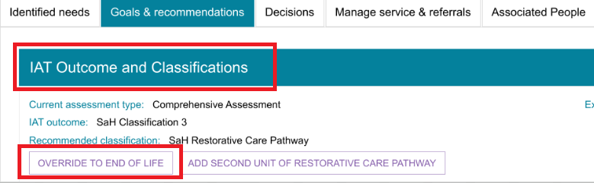
  - Review the information in the recommendations section, then select COMPLETE AND FINALISE SUPPORT PLAN REVIEW.
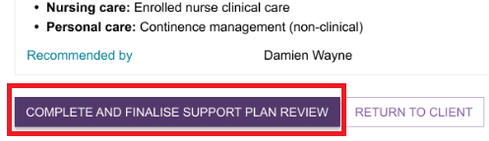
  - The IAT Outcome and Classifications section updates to show SaH End-of-Life Pathway as the recommended classification.
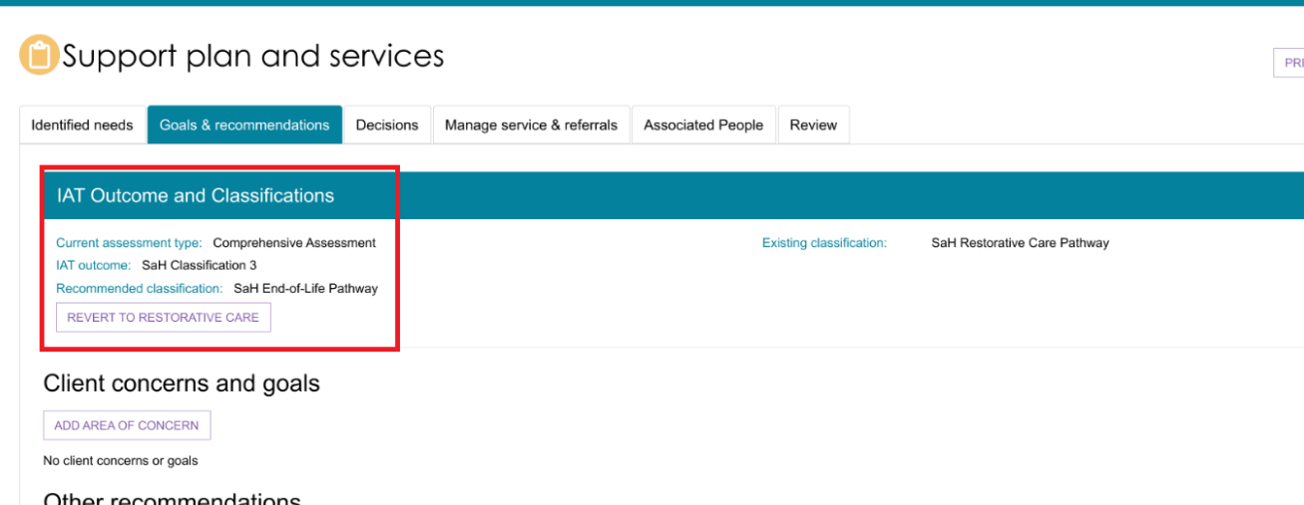
  - Select SAVE AND SUBMIT FOR DELEGATE DECISION.
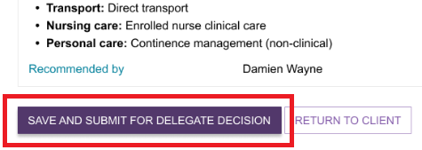
! | If the client or their supporter guardian decides they no longer want the assessment flagged as End-of-Life, you can revert the classification to the client's ongoing classification.
  - Complete the Support Plan Review details:
- Select the review outcome from the drop-down list.
- Record who participated in the plan review.
Select COMPLETE AND FINALISE SUPPORT PLAN REVIEW to finalise the review.
After you complete the Support Plan Review, you cannot edit the outcome details. The system records these details in the client's support plan.
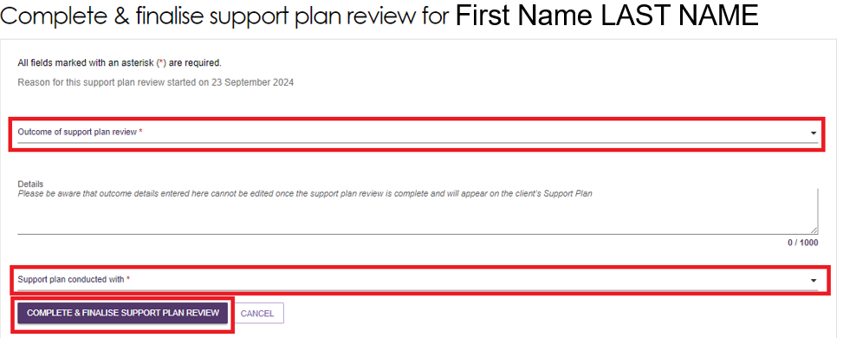
! | If you add a period of reablement or linking support during a Support Plan Review, the system automatically sets the review outcome to Updates to Existing Plan. After you complete the review, the assessment remains open so you can start the support period.
! | If the Support Plan Review identifies the need for a new assessment, refer to Issuing an assessment referral as a result of a Support Plan Review.
  - The completed Support Plan Review appears on the Plans tab of the client's record.
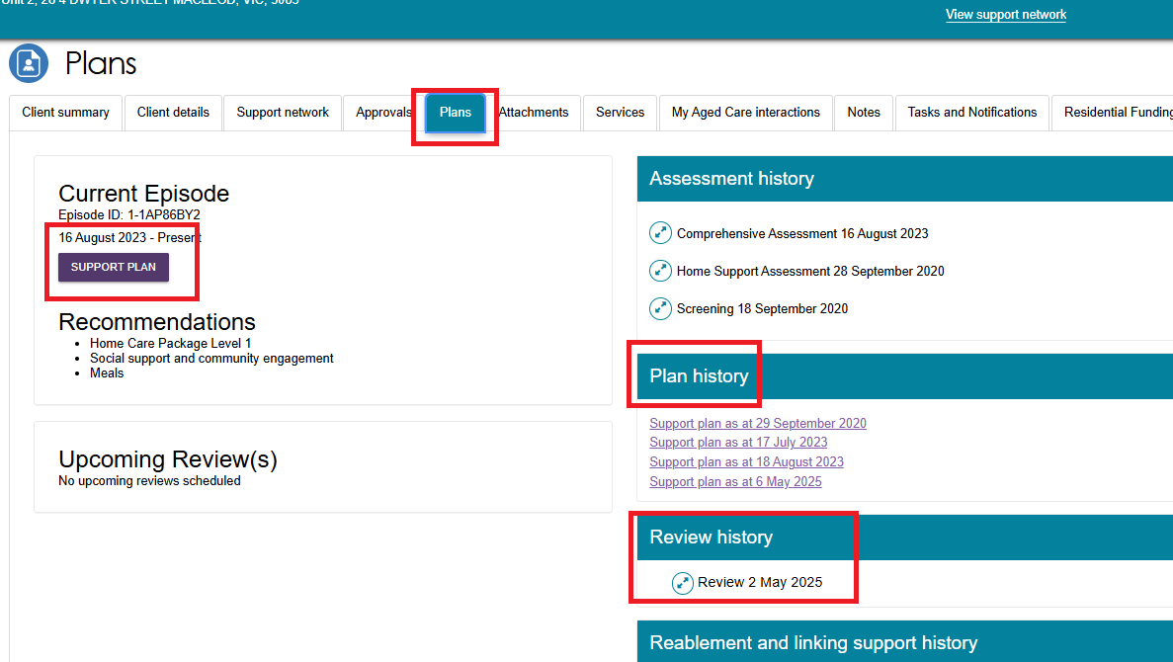

Revert End-of-Life Flag
If the client or their supporter guardian decides they no longer want the assessment flagged as End-of-Life, you can revert the classification to the previous ongoing recommendation.
- Open the client's profile and select the Goals & Recommendations tab.
- In the IAT Outcome and Classifications section, confirm that the recommended classification is SaH End-of-Life Pathway. Select the REVERT button for the previous classification. For example, REVERT TO RESTORATIVE CARE.
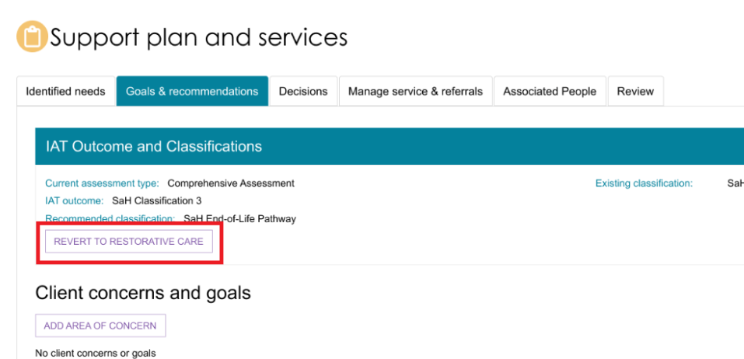
- In the confirmation window, select REVERT.
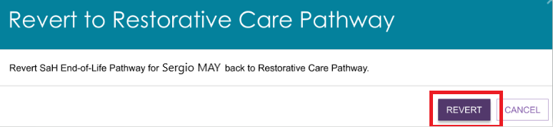
- After you confirm the action, the system returns you to the Goals & Recommendations tab and restores the previous classification.
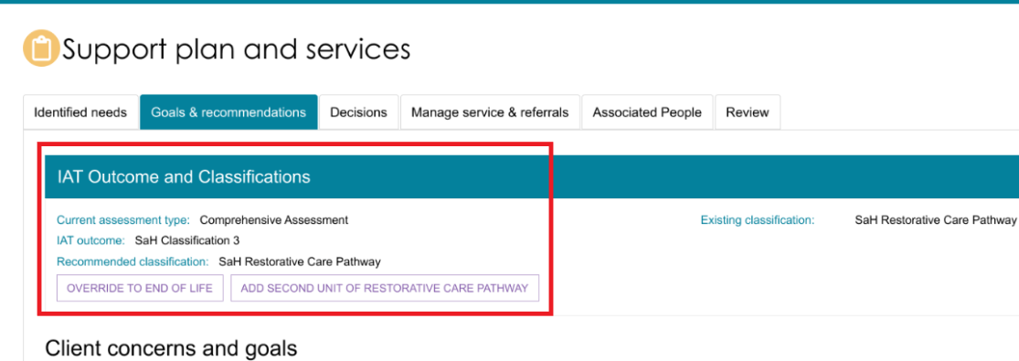

Overriding a Transitioned HCP Classification to the End-of-Life Pathway
After the End-of-Life Pathway form has been verified, you can override a client's classification from Transitioned HCP Level 1-4 to SaH End-of-Life Pathway during a Support Plan Review.
Transitioned clients do not have pre-created services. You need to add Home Support services that meet the client's end-of-life care needs.
- Open the client's profile and select the Goals & Recommendations tab.
In the IAT Outcome and Classifications section, confirm that the existing classification is Transitioned HCP Level 1-4.
Select OVERRIDE TO END OF LIFE.
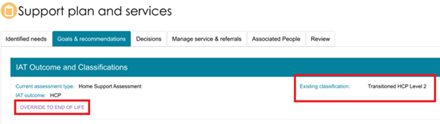
- The Override to End-of-Life Pathway window opens. Enter the required information and select OVERRIDE.
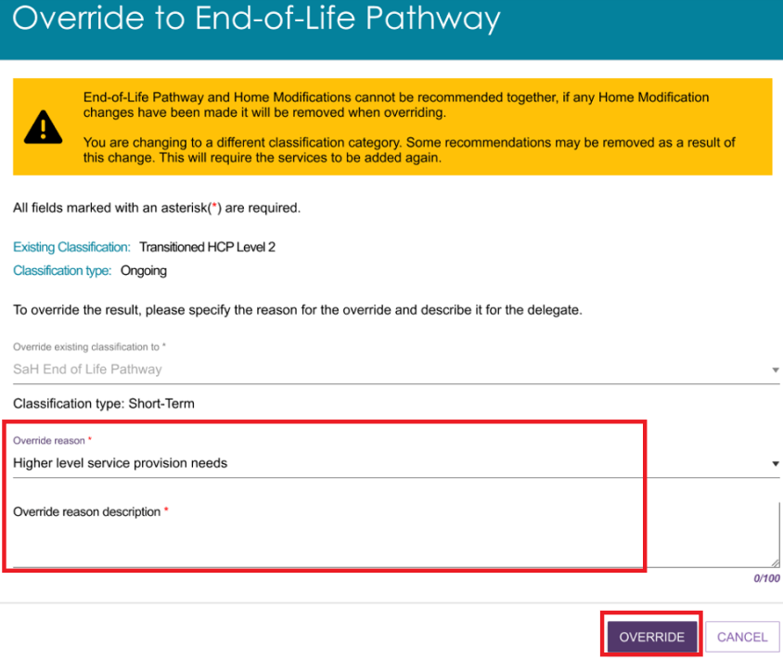
- The Add Home Support Services screen opens.
Consider the client's needs and the End-of-Life Pathway approval when selecting services.
- Select the required services.
- Enter the recommended frequency and intensity for each service.
- Link any relevant goals.
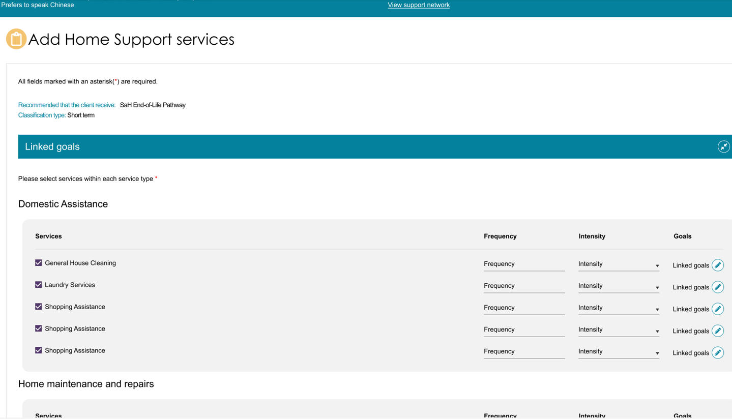
- Select SAVE TO PLAN.
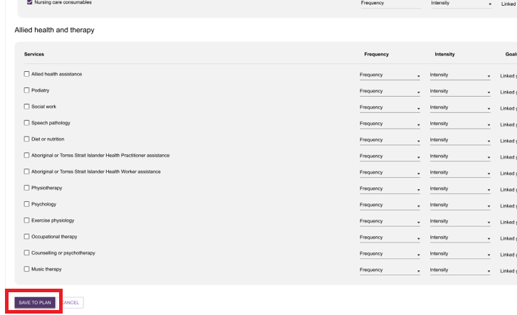
- The system returns you to the Goals & Recommendations tab.
At this stage, you can revert to the transitioned classification if required.
- Select SAVE AND SUBMIT FOR DELEGATE DECISION.
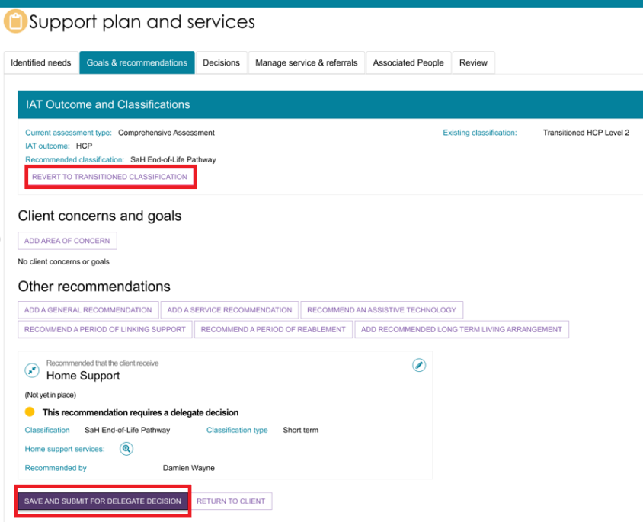
! | If the client's current classification is SaH End-of-Life Pathway, you can override it back to Transitioned HCP Level 1-4 before submitting the support plan for delegate decision.  After you complete the override, you can also revert back to SaH End-of-Life Pathway if required.  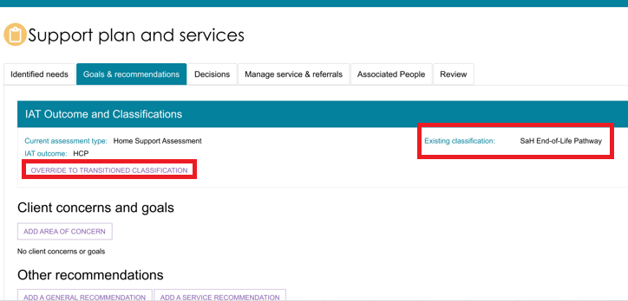

Reverting to End-of-Life for Transitioned Home Care Package (HCP) clients
After you override an End-of-Life Pathway classification to a Transitioned HCP classification, you can revert the client back to the End-of-Life Pathway if needed.
- Go to the client's Goals & Recommendations tab.
In the IAT Outcome and Classifications section, confirm that the existing classification is SaH End-of-Life Pathway. Select REVERT TO END OF LIFE.
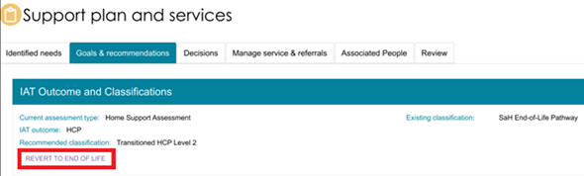
- A confirmation window opens. Select REVERT to confirm the change.
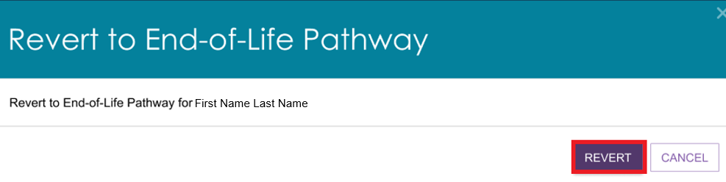
- The system returns you to the Goals & Recommendations tab with the End-of-Life Pathway classification restored.

Completing the Support Plan
Follow these steps to complete and submit the support plan:
- Review the support plan and confirm that:
- All required service and general recommendations have been added.
- The client's goals and areas of concern are accurate and complete.
After you complete the support plan, you cannot edit it unless the delegate returns the assessment for changes.
- Select COMPLETE SUPPORT PLAN from any tab within the client’s support plan.
- If the client has a Support at Home classification (ongoing or short-term) but does not have a recorded home address or Modified Monash Model (MMM) classification, the system displays a reminder to record the client's address.
You can still proceed without recording the address at this stage by selecting CONTINUE TO COMPLETE SUPPORT PLAN.
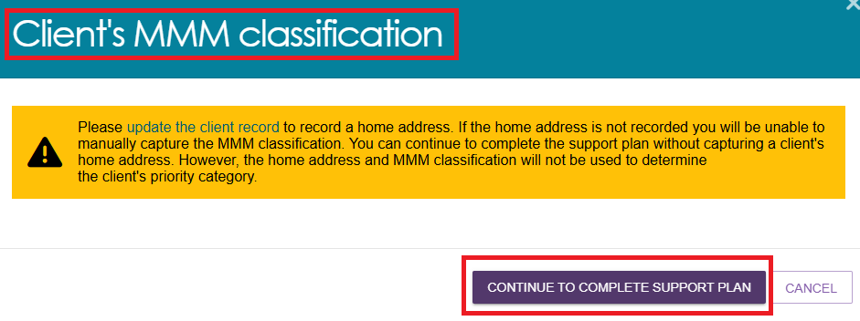
! | If you continue without recording the client's home address, the system displays the following warning message:  “A home address is required in order to complete the assessment.”  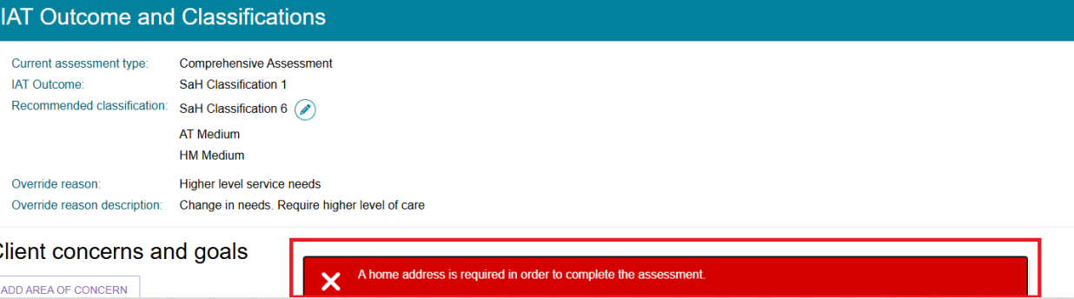
- If the client's address has been recorded but the system cannot determine an MMM classification (MMM1 to MMM7), you must update the client's MMM classification before completing the support plan.
If the MMM classification is not known, select UNKNOWN from the drop-down list.
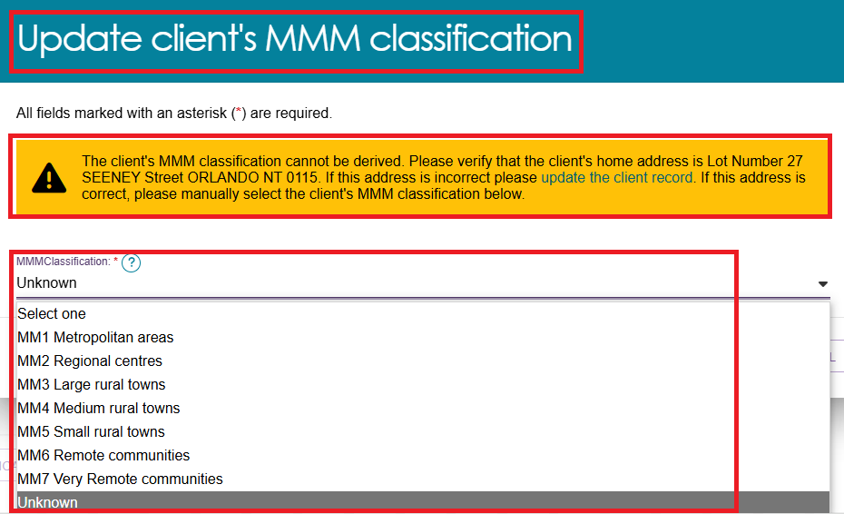
- Select SAVE TO PLAN.
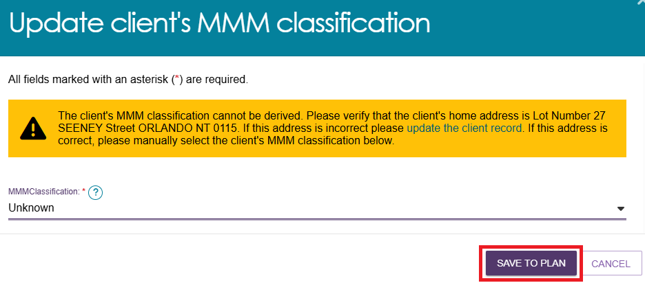
- The system takes you to the Decisions tab. Scroll to the bottom of the page and select SAVE AND SUBMIT FOR DELEGATE DECISION.

- In the confirmation window, select the appropriate checkbox and then select SUBMIT.
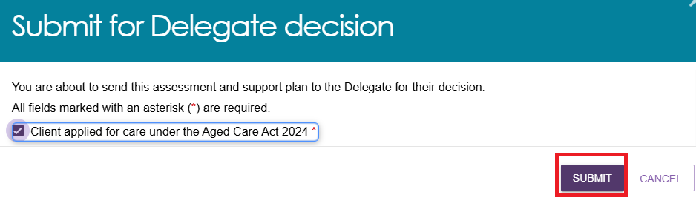
- A confirmation message appears, advising that the assessment and support plan have been submitted to the delegate for review and decision.


'Returned to Assessor’ status
A delegate may return a Support Plan Review or IAT assessment if changes are needed. When this happens, the assessment status changes to Returned to Assessor.

Amendments to the IAT
If a delegate identifies issues with the IAT, they may return the assessment and provide instructions for the required changes. A delegate can return an assessment to an assessor only once.
You can view returned assessments on the Assessments tab under Returned to Assessor.
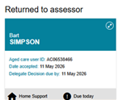
When an IAT assessment is returned, the client record displays:
- An information banner advising that the delegate has requested a review of the IAT and directing you to the delegate's notes for further instructions.
- A Notes to Assessor to Review IAT section containing the delegate's feedback.
- A View Details button to open the delegate's notes.
- A Continue Assessment button that opens the IAT so you can make the requested changes.
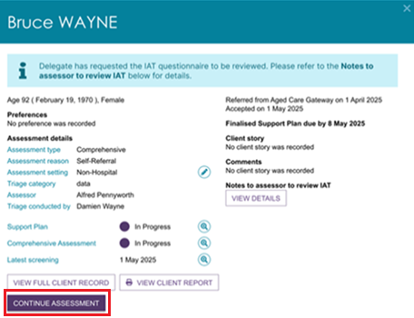
You can also view the delegate's request from the client's Support Plan and Services page on the Goals & Recommendations tab.
An information banner appears in the IAT Outcome and Classifications section. Select Go to Assessment to open the IAT and make the requested changes.
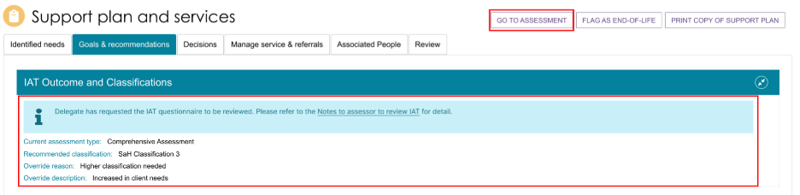
To review the delegate's feedback, open the Notes to Assessor to Review IAT window. This window displays instructions and comments for the relevant IAT sections that require amendment.
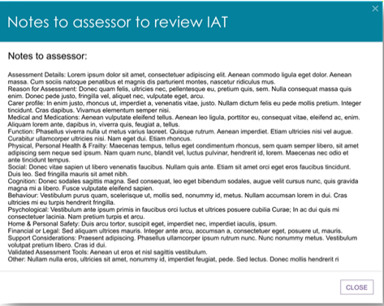

Reviewing and Resubmitting the returned IAT
Follow these steps to review a returned IAT and resubmit it to the delegate.
  - Go to the Assessments tile in the Assessor Portal. Open the client's assessment from the Current Assessments tab under Returned to Assessor.
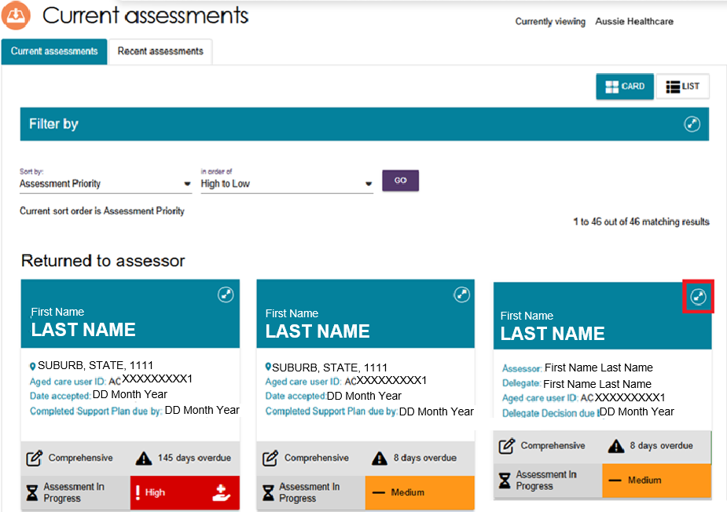
  - Review the delegate's feedback by selecting View Details in the Notes to Assessor to Review IAT section on the client card.
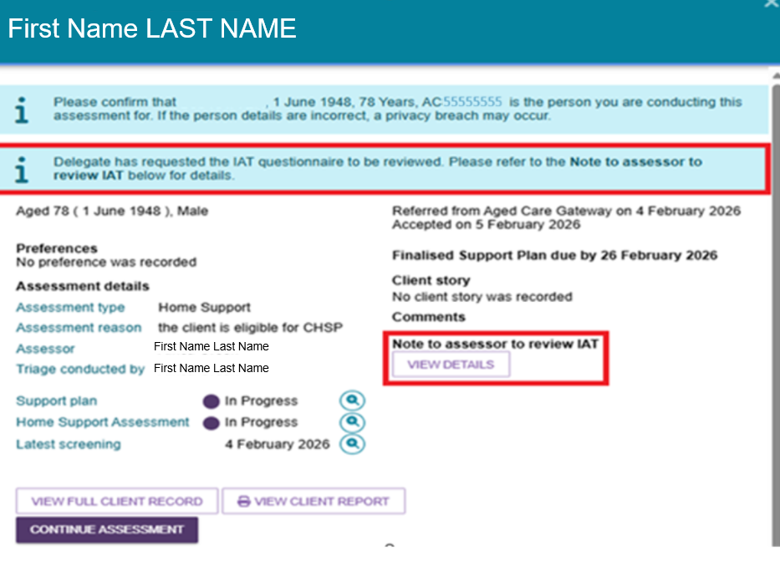

Alternatively, open the client's Support Plan and Services page, select the Goals & Recommendations tab, and then select the Notes to Assessor to Review IAT link in the information banner within the IAT Outcome and Classifications section.
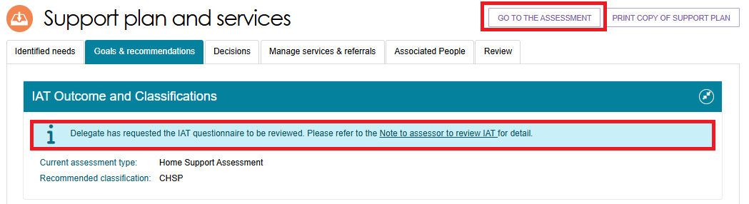
  - The Notes to Assessor to Review IAT window opens and displays:
- The relevant IAT topics.
- The delegate's comments and instructions for each topic.
Review the instructions and identify the changes you need to make.
Select Close and then:
- Select Continue Assessment from the client card, or
- Select Go to Assessment from the Support Plan and Services page.
  - Review the IAT and make the requested changes.
When a delegate returns an IAT:
- The system clears all review checkboxes, including page review checkboxes.
- The system clears the Goals Review button.
- You must complete all mandatory questions again and reselect all review checkboxes before finalising the IAT.
After you re-finalise the assessment, the delegate cannot return the IAT for review again.
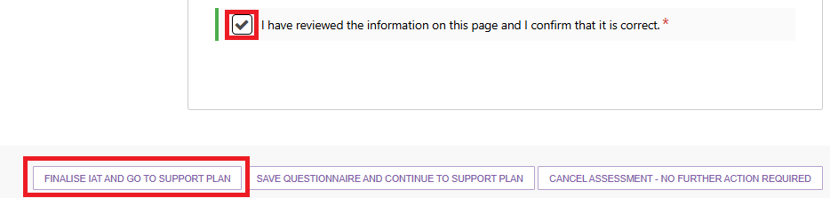
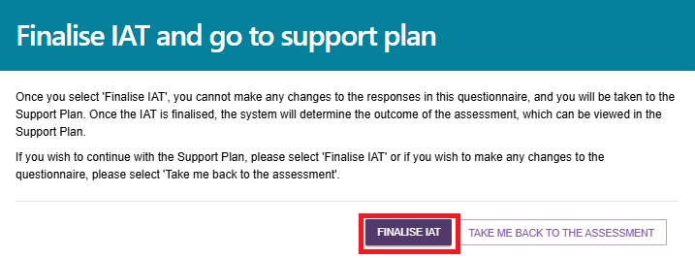
  - Once you finalise the IAT, the client's IAT outcome may change.
The system may display the following message: Please revise the Recommended Classification and Support Plan recommendations based on the new IAT Outcome.
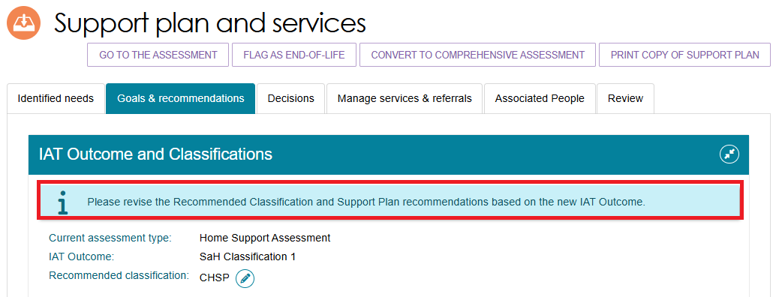
Review:
- The recommended classification.
- Any related prompts or recommendations, such as Restorative Care Pathway, Assistive Technology, or Home Modifications.
If you intend to recommend an ongoing Home Support classification, make sure the Recommended Classification matches the new IAT Outcome by using the edit function.

If the new IAT outcome results in a lower classification than the client's existing classification, ensure the Recommended Classification remains equivalent to the client's current classification when recommending ongoing Home Support services through Support at Home or CHSP.
If appropriate, you can still override the Recommended Classification to recommend a short-term pathway or Residential Care.
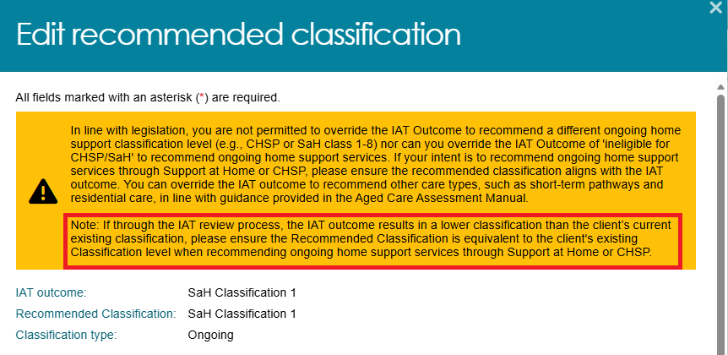
  - Review and update the client's support plan if required to reflect the new IAT outcome and recommendations.
When you finish reviewing the classification and support plan, select COMPLETE SUPPORT PLAN.
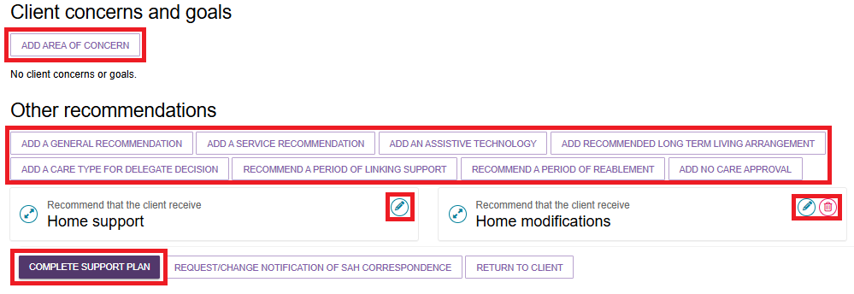
  - The Note to Delegate window opens.
Enter details of the changes you made in response to the delegate's feedback.
- The Notes to Delegate field is mandatory.
- The field includes a pre-filled list of IAT domains for reference. You can edit or remove this text as required.
- Non-clinical assessors must record all clinical supervisors involved in the assessment process.
If you leave the field blank, the system displays an error message.
Select CONTINUE TO COMPLETE SUPPORT PLAN.
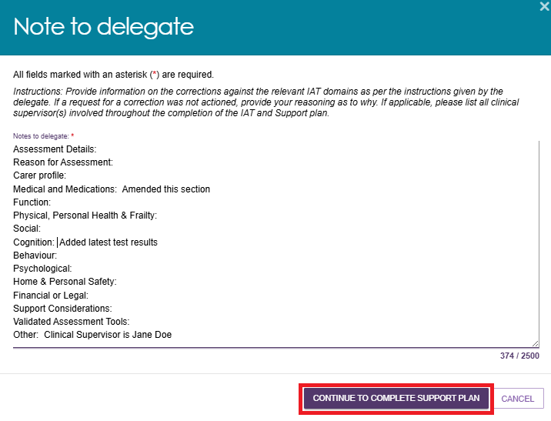

  - After completing all required changes, select SAVE AND RESUBMIT FOR DELEGATE DECISION.
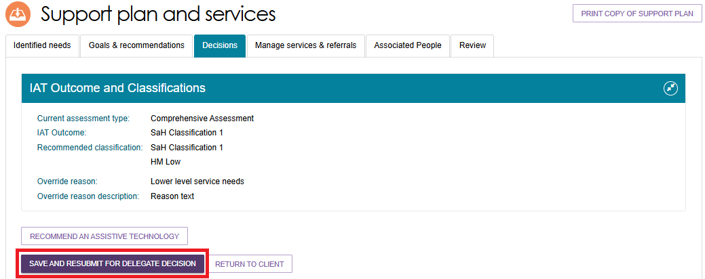
In the confirmation window, select SUBMIT.
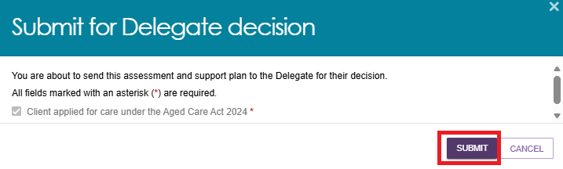
  - If the resubmission is successful, the system displays a confirmation message advising that it has submitted the assessment to the delegate.
An information banner also appears stating that the assessor has reviewed the IAT as requested by the delegate.
Select the here link in the banner to view both:
- Your Notes to Delegate, and
- The delegate's Notes to Assessor.
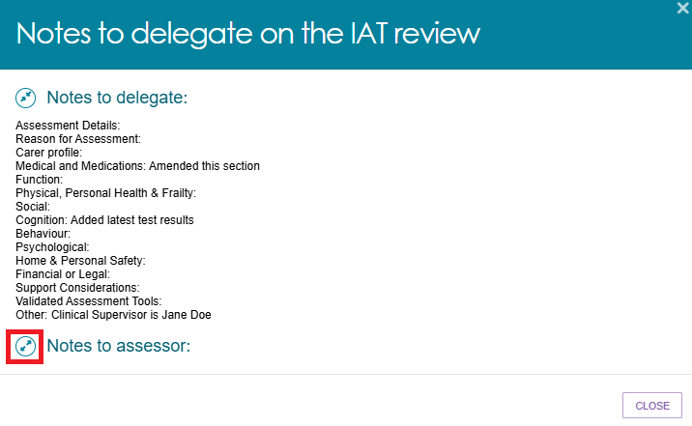

Amendments to the support plan
After you complete the IAT assessment, finalise the support plan, and submit your recommendations for delegate decision, the delegate may return the Comprehensive Assessment or Home Support Assessment if changes are required to the support plan.
Returned assessments appear in the Returned to Assessor section of the Assessments tab.
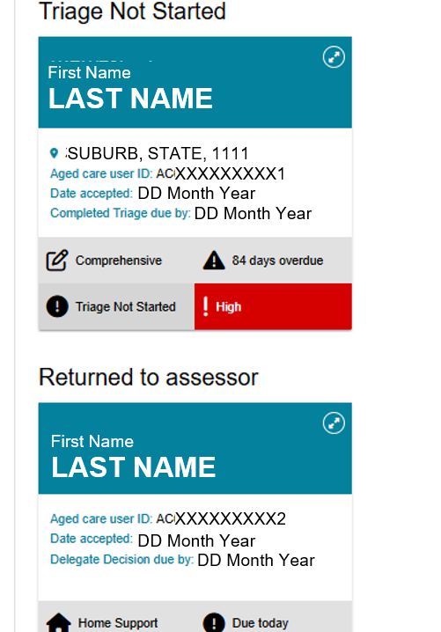
When a delegate returns an assessment, review the instructions provided and make the required updates. Depending on the delegate's feedback, you can amend:
- Client concerns and goals
- Service recommendations
- Other recommendations
- The assessment summary
For detailed guidance on amending a returned assessment, refer to the Assessment Manual.

Finalising the support plan
After you complete the assessment and support plan, arrange referrals for the recommended services before you finalise the support plan.
For detailed instructions refer to My Aged Care – Assessor Portal User Guide 8 – Referring for services.
! | Finalise the client's support plan after you have made an effective referral for the recommended services, or when the client chooses not to proceed with aged care services or wants to manage their own referrals.  A referral is considered effective when:  - A service provider accepts the referral.  - The client chooses to manage their own referral arrangements.  - The assessment determines that no further action is required from the assessor.

! Do not issue CHSP referral codes until the Assessment Delegate has approved the recommendation.
For instructions on issuing CHSP referral codes, refer to:
- Chapter 9: Finalising the Assessment and Service Referral of My Aged Care Assessment Manual.
- instructional videos for comprehensive and home support assessments.
  - From any tab in the client's support plan, select FINALISE SUPPORT PLAN.
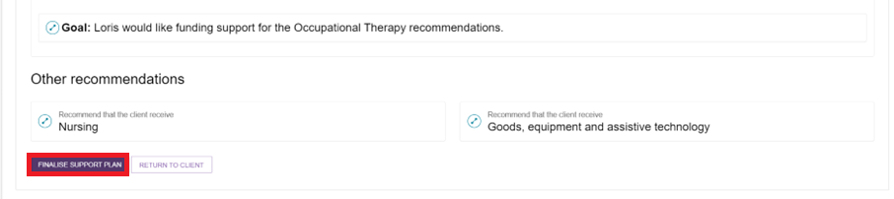
  - A confirmation window opens.
    - The system automatically displays the referral status for each recommended service type.
    - If a referral has a status of Not Actioned, you must record a reason.
  - If you conducted the face-to-face assessment in a remote location, make sure you select the Remote Assessment indicator before finalising the support plan.
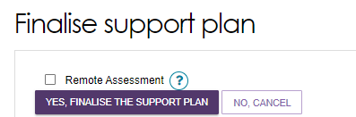
Review the referral outcomes and select YES, FINALISE THE SUPPORT PLAN.
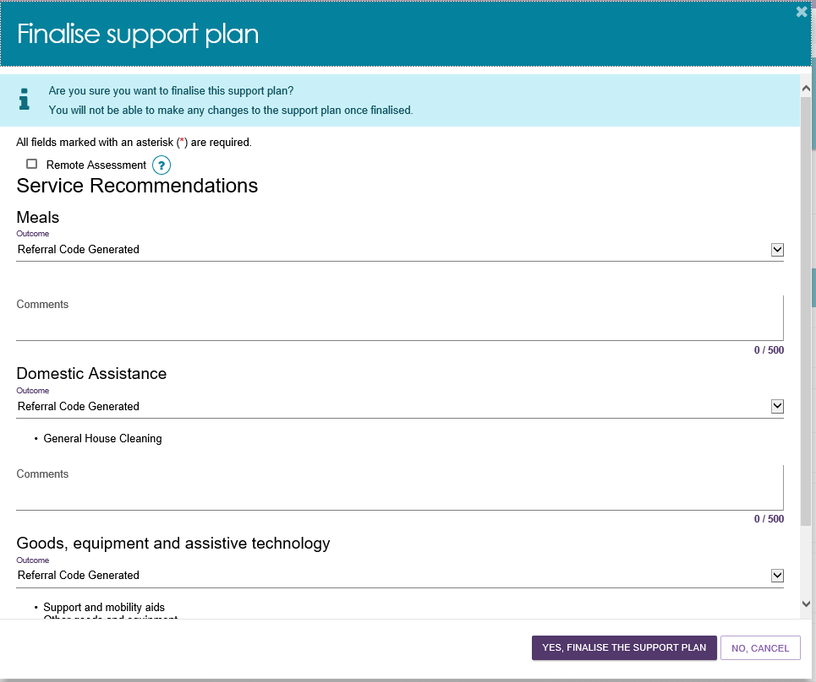
! | If you are recording outcomes for a client in a remote location, you can select Community-based Care as the outcome.  You must enter comments about the outcome if you select either Not Actioned or Community-based Care following a remote assessment.  Provide clear and detailed comments to explain the reason for the selected outcome.  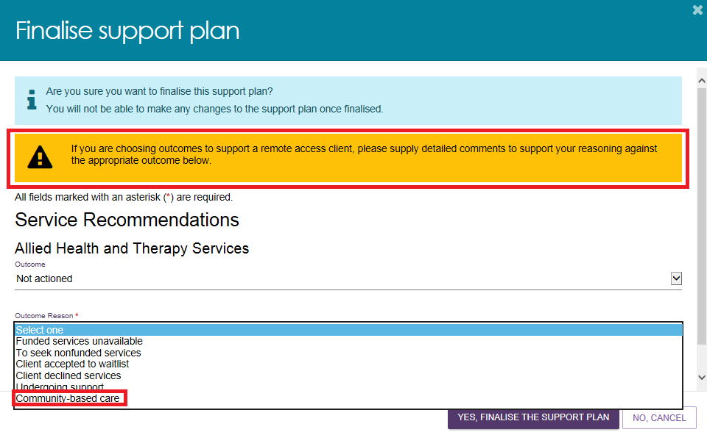
  - The system displays a confirmation message advising that the support plan has been finalised.

Finalising a Support Plan for Support at Home classification
When you finalise a support plan that includes a recommended Support at Home classification, the screen does not display individual services for outcome recording. Instead, it displays a single item called Support at Home.
Select YES, FINALISE THE SUPPORT PLAN to finalise the support plan.
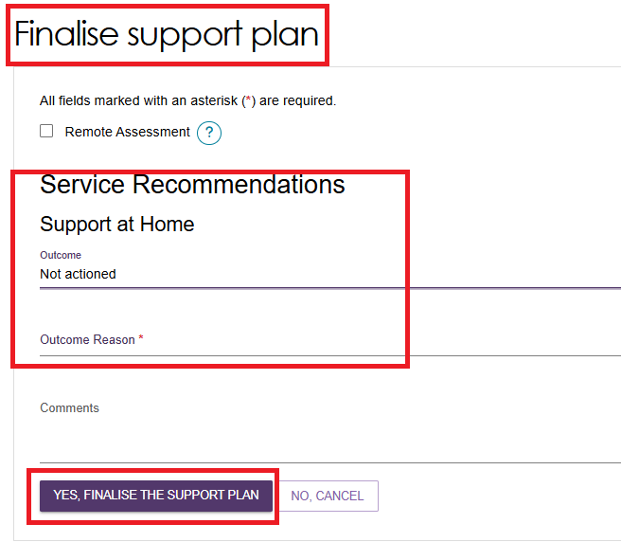

Ending a period of Reablement or linking support
You can end a reablement or linking support period in one of two ways:
Option 1: End a support period individually
- On the Goals & Recommendations tab of the client's support plan, select END LINKING SUPPORT PERIOD or END REABLEMENT PERIOD.
- Enter the support period end date and outcome.
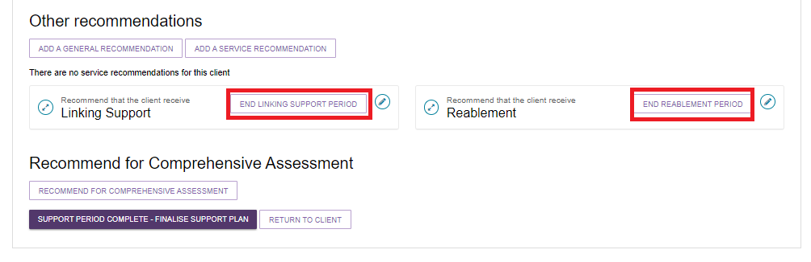
- If you want to finalise the support plan but keep the support period open, select FINALISE SUPPORT PLAN & KEEP OPEN FOR SUPPORT PERIOD.
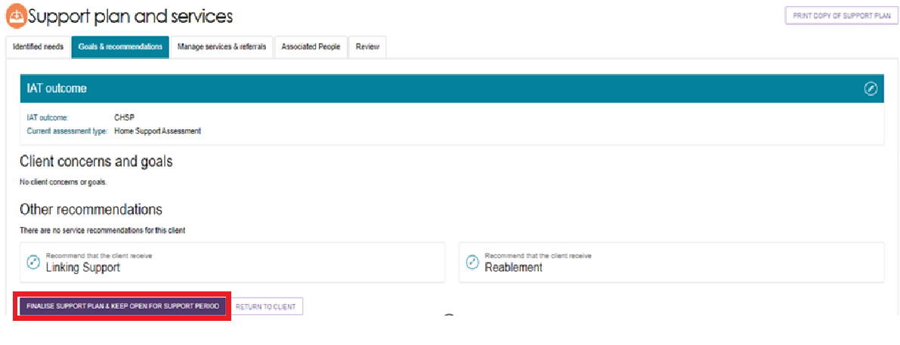
- A confirmation window will appear. Select YES, FINALISE THE SUPPORT PLAN.
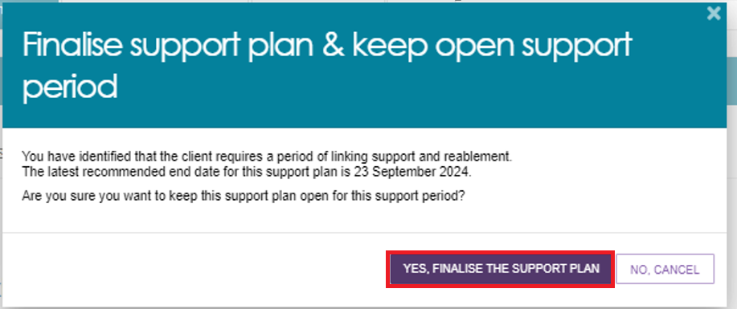
Option 2: End all support periods at the same time
- On the Goals & Recommendations tab of the client's support plan, select SUPPORT PERIOD COMPLETE – FINALISE SUPPORT PLAN.
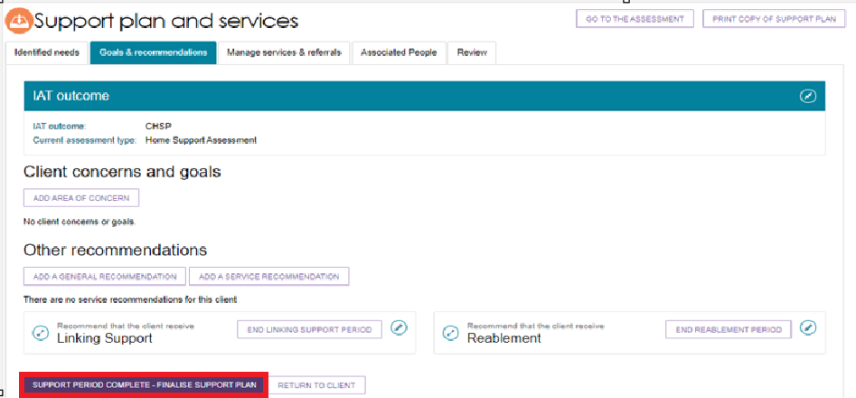
- The system displays all active linking support and reablement periods.
Enter an end date and outcome for each support period.
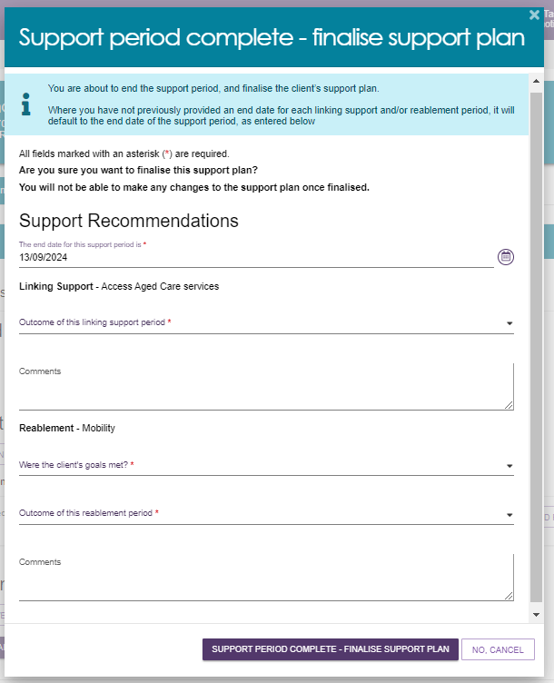

Ending a Reablement Period
- Select END REABLEMENT PERIOD next to the Reablement tile under Other recommendations.
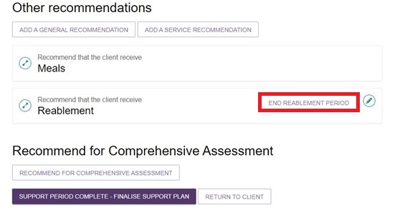
- The End period of reablement window opens.
Complete the two mandatory questions:
- Were the client's reablement goals met?
- What was the outcome of the reablement period?
Select the outcome from the drop-down list.
Mandatory fields are marked with an asterisk (*).
Enter any additional information about the reablement period in the Comments field.
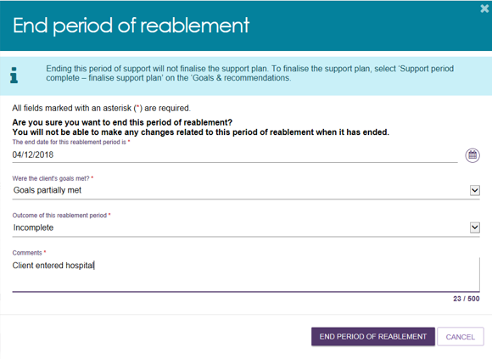
! | If a client is receiving linking support or reablement, a team leader may ask you to end the support period so they can assign a Support Plan Review.  If the support period needs to continue, you can ask the team leader to cancel the review and allow the support period to remain active.

Printing a copy of the support plan
You can print a PDF copy of the client's support plan from the assessor portal.
The PDF includes the client's:
- most recent completed Support Plan Review (if available)
- Assessment Summary
- Goals & Recommendations, including areas of concern
- recommended services
- referral codes, where applicable
- strategies
- current care approvals.
To print the support plan:
- Select PRINT COPY OF SUPPORT PLAN from the client record or support plan.
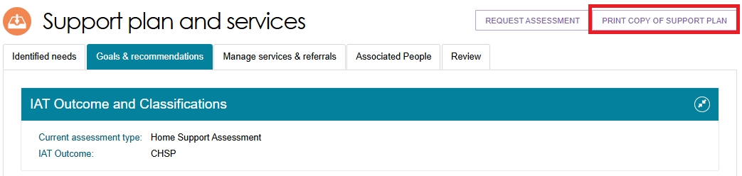
- A blue banner appears at the bottom of the screen while the report is being generated. Select Reports page to open the Reports and documents page.

- On the Reports and documents page, select View.
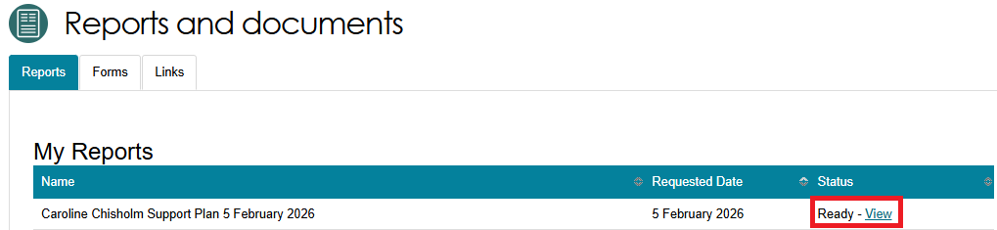
- The PDF version of the support plan downloads to your device. You can now print the document.
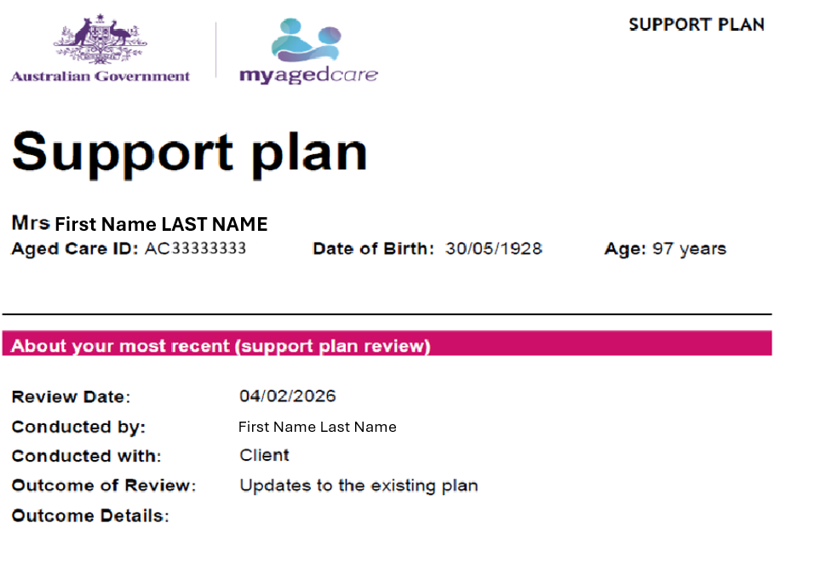
If the client has a previously completed Support Plan Review, the Support Plan Review (first completed) section appears before the Goals & Recommendations section.
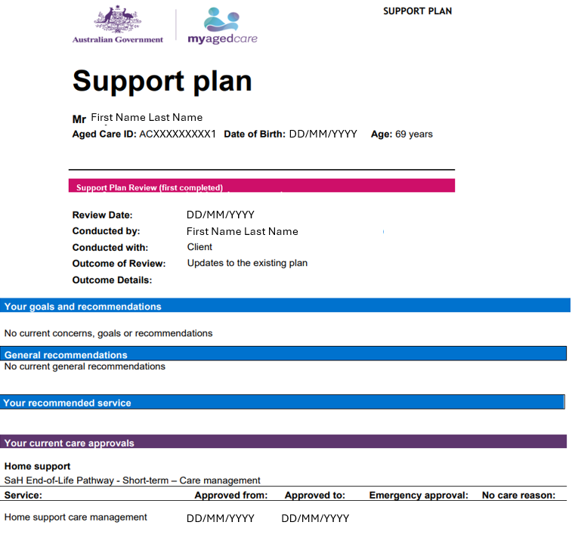

Support Plan Reviews

Viewing a Support Plan Review
- Select the Reviews tile on the home page to view all Support Plan Reviews assigned to you.
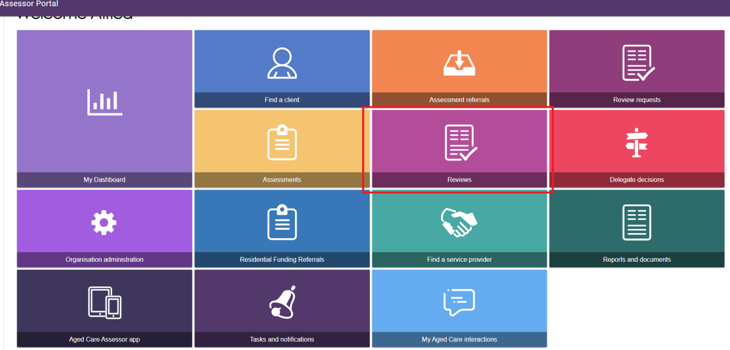
- Open the Current reviews tab to view your assigned Support Plan Reviews.
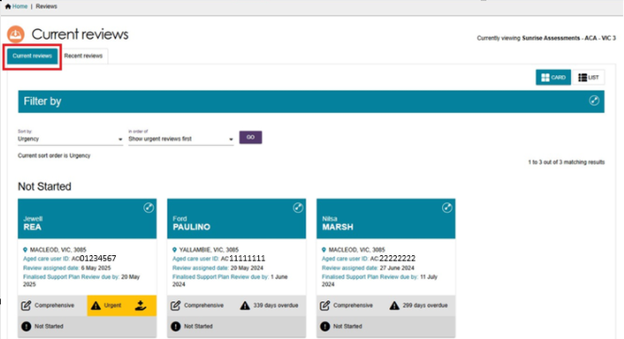
- Select the expand button at the top of a review card to view more details.
The review card displays:
- the assessment type
- the review urgency
- whether the review is overdue.
If the review relates to the End-of-Life Pathway, the card also displays the End-of-Life Pathway icon.
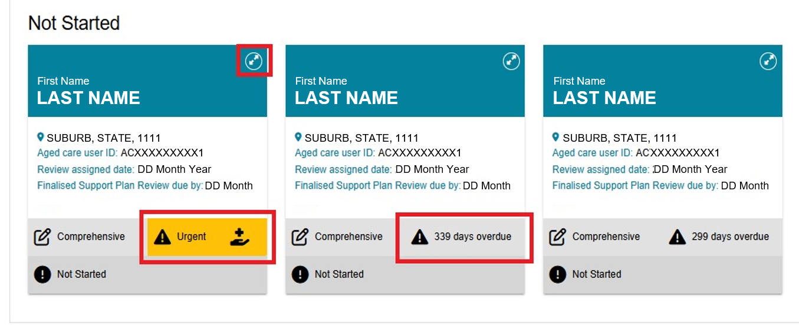
- If the review is for End-of-Life Pathway services, select the Edit (pencil) icon to verify or add the End-of-Life Pathway Form.For information about verifying the End-of-Life Pathway Form, refer to the My Aged Care Assessment Manual.
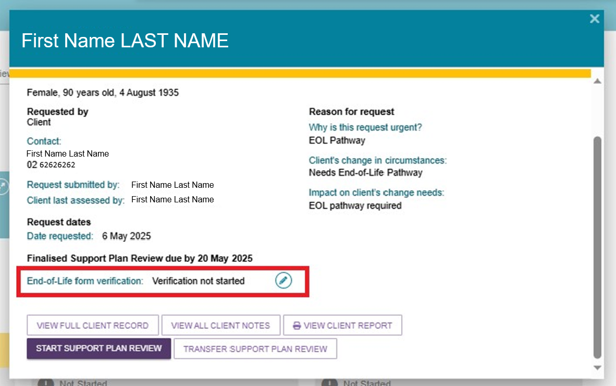

Starting a Support Plan Review
Follow these steps to start a Support Plan Review assigned to you.
- Expand the client card in either Card View or List View, then select START SUPPORT PLAN REVIEW.
Alternatively, go to the Current reviews page, expand the client card, and select START SUPPORT PLAN REVIEW.

Expanded client card or list view
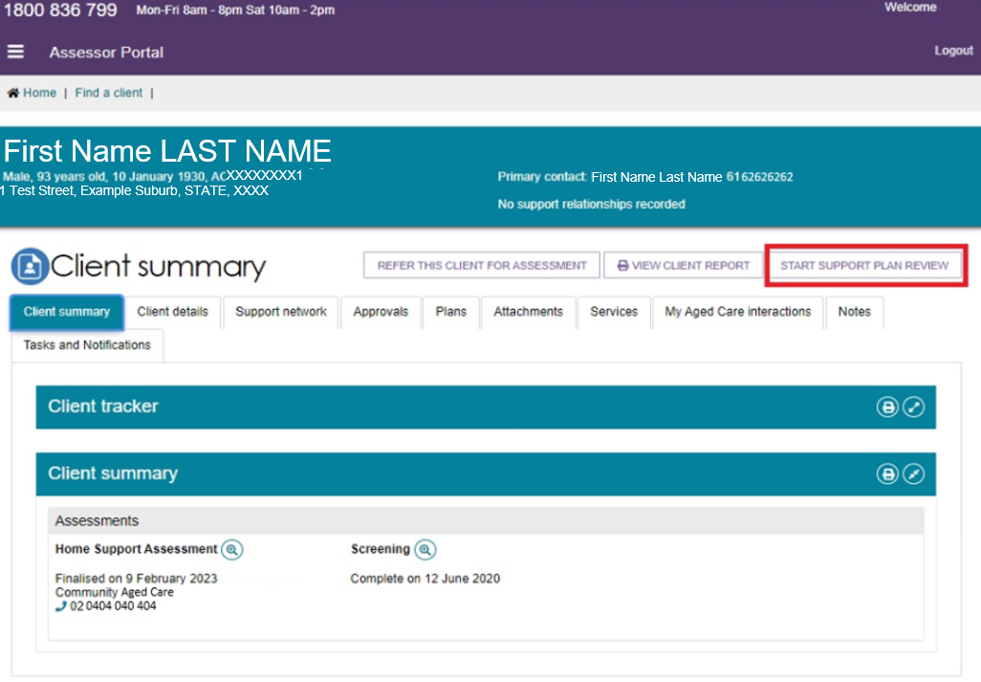
Expanded client card or list view, with the client tracker expanded showing that the client has reached the Support Plan Review stage.
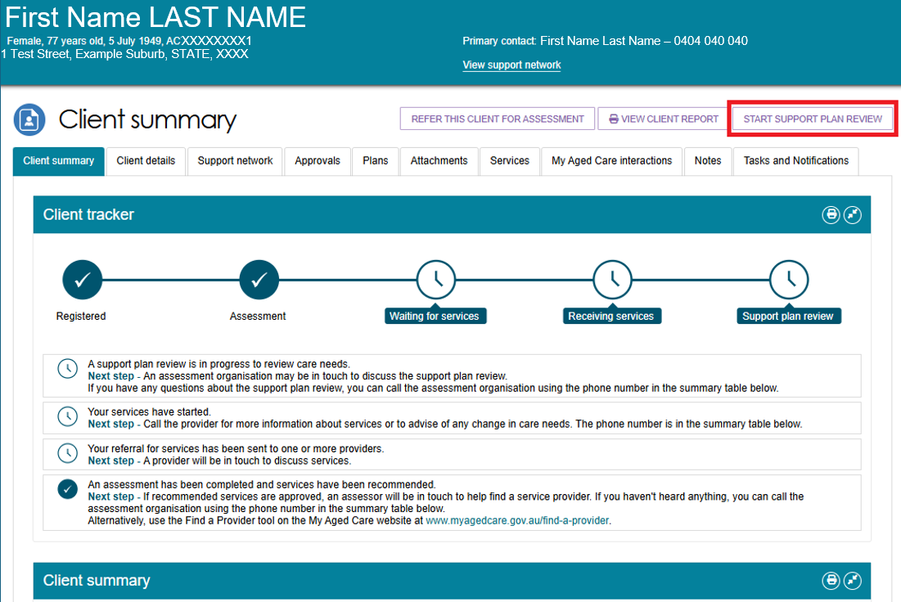
Current Reviews Page
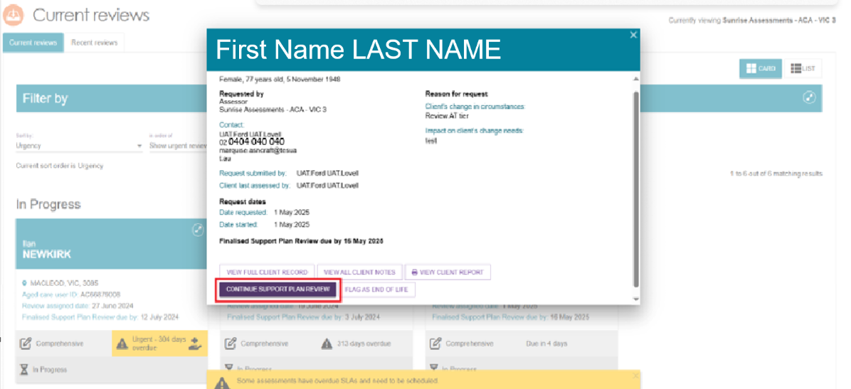
- In the Before you start the Support Plan Review window, select one of the following options:
- CONTINUE TO SUPPORT PLAN REVIEW
- RECOMMEND A NEW ASSESSMENT
Select CONTINUE TO SUPPORT PLAN REVIEW to start the review.
If the client's circumstances have changed significantly and you have evidence that they require a higher level of care, such as a letter from a GP or allied health professional, select RECOMMEND A NEW ASSESSMENT instead of completing a Support Plan Review.
! | You do not need to complete a Support Plan Review to extend an End-of-Life episode from 12 weeks to 16 weeks. The system extends the episode automatically. Completing a Support Plan Review during an active End-of-Life episode immediately ends End-of-Life funding.
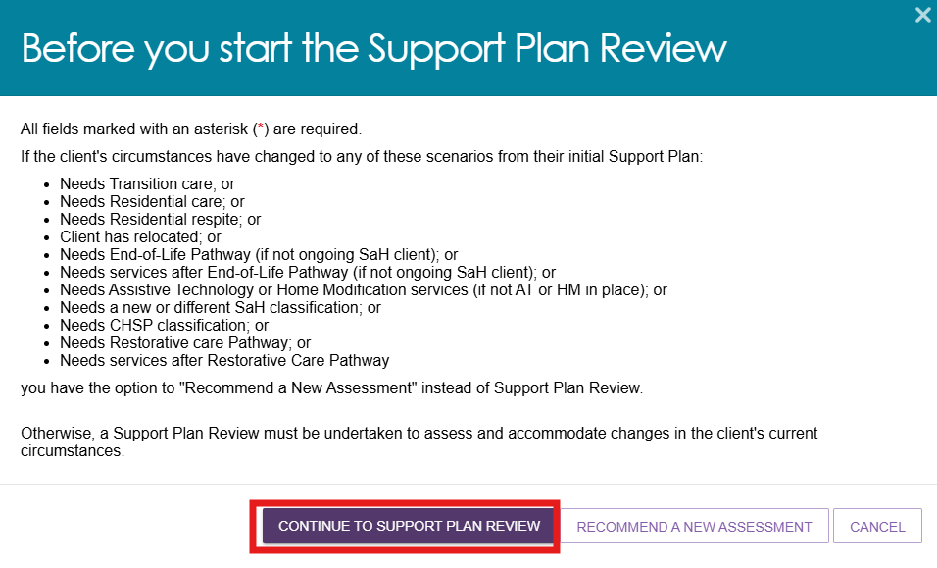
- When prompted, record the client's consent to share their information with My Health Record.
- Select Yes or No based on the client's response.
- Select who made the decision from the drop-down list.
- If a supporter guardian provides consent, enter their first name before continuing.
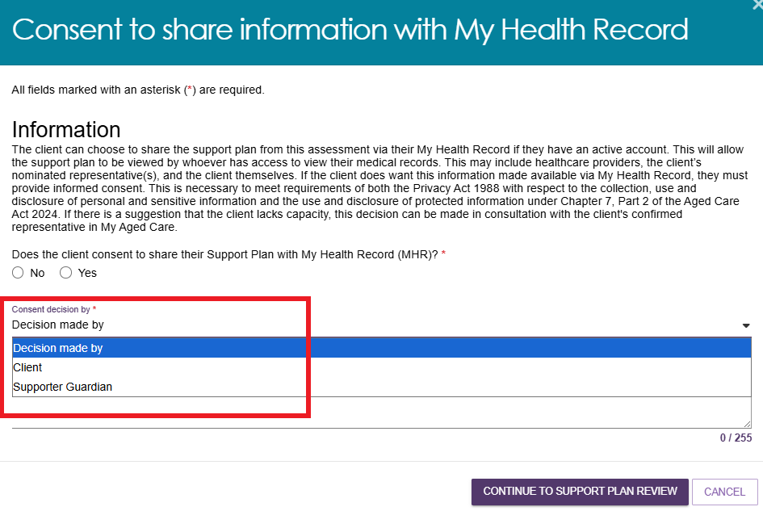
- If the client does not consent to sharing their support plan with My Health Record, enter a reason for the decision.
If someone other than the supporter guardian made the decision, enter the person's first name and the reason for declining consent.
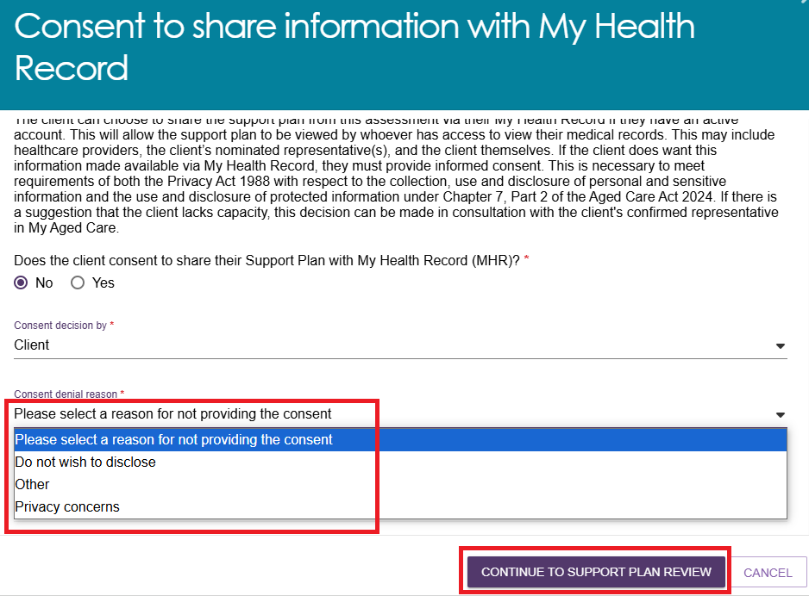

- Select CONTINUE TO SUPPORT PLAN REVIEW.
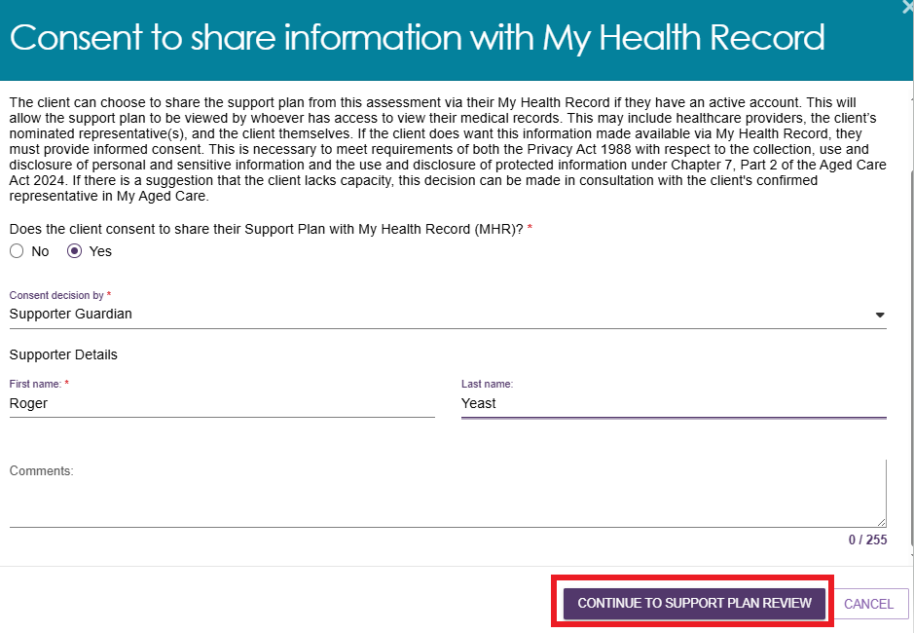
- After you start the review, you can update information in the following sections:
- Assessment Summary
- Client Motivations
- Goals & Recommendations, including linking support and reablement recommendations
- Manage Services & Referrals
- Associated People
- Review
When you finish updating the support plan, select COMPLETE & FINALISE SUPPORT PLAN REVIEW.
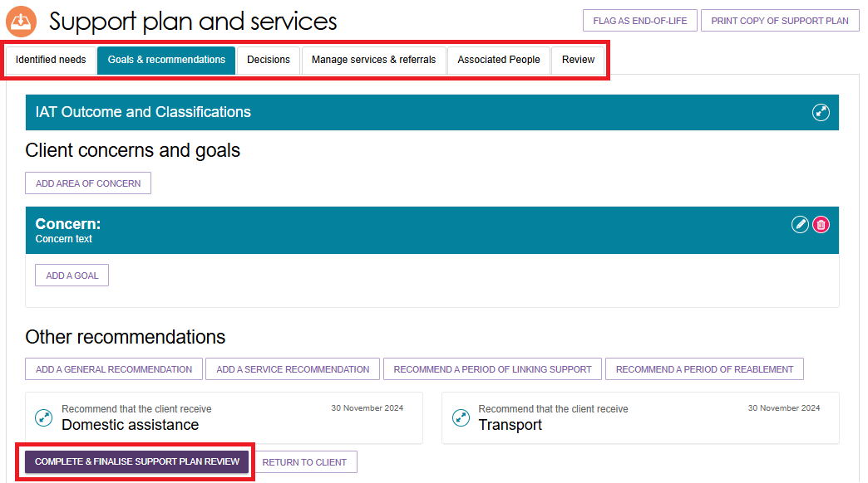
! | Previously recommended CHSP, MPS or NATSIFAC services  For clients with CHSP, MPSP or NATSIFACP services that were recommended before 23 February 2026, you cannot delete these services from the client's IAT assessment during a Support Plan Review or while the support plan is Undergoing Support.  In the Goals & Recommendations section of the client's support plan, historical CHSP, MPSP and NATSIFACP services do not display a Delete button.  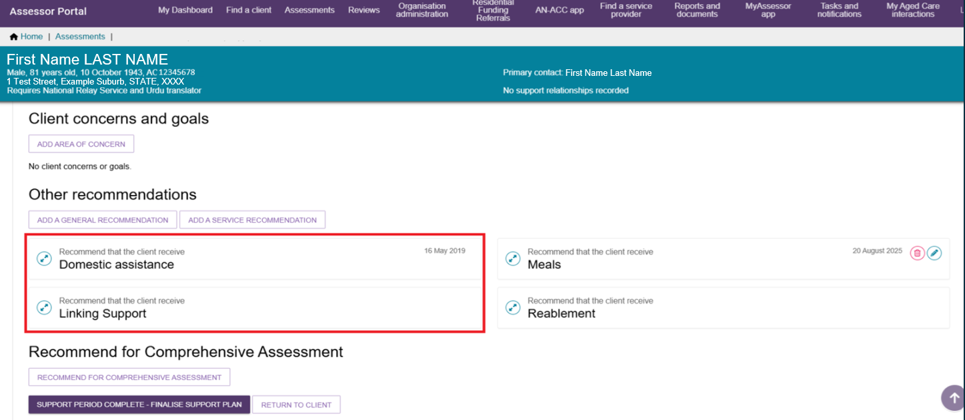
- The Complete & Finalise Support Plan Review page opens.
- Complete all mandatory fields, including the Outcome of support plan review and details of who participated in the review.
- You can also record service outcomes and comments for each service recommendation.
- Select COMPLETE & FINALISE SUPPORT PLAN REVIEW.
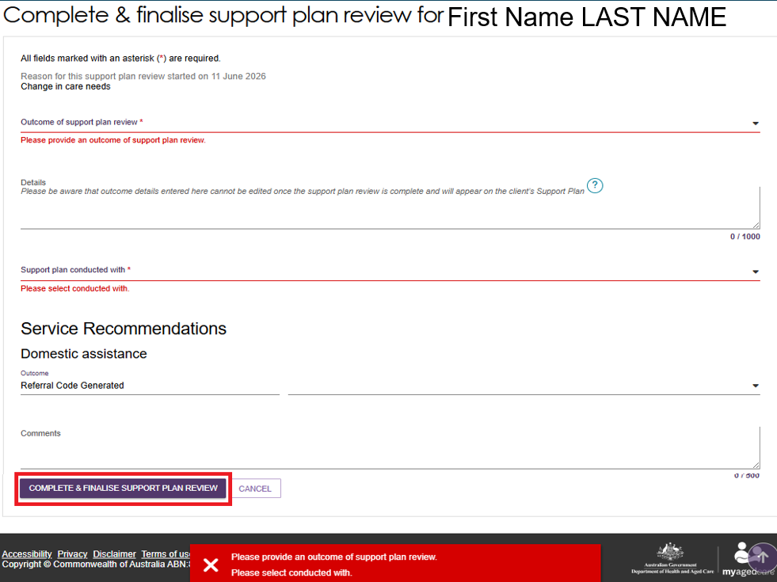
- If the review outcome is a reassessment, enter the review outcome, the reason for the new assessment referral, and the organisation that will receive the referral.
- You can only create a new assessment referral when the client requires one or more of the following:
- Transition Care
- Residential Care
- Residential Respite
- Services because the client has relocated
- End-of-Life Pathway (for clients who do not already receive ongoing Support at Home services)
- Services after an End-of-Life Pathway episode (for clients who do not already receive ongoing Support at Home services)
- Assistive Technology or Home Modifications that are not already in place
- A new or different Support at Home classification
- CHSP classification
- Restorative Care Pathway
Services after a Restorative Care Pathway.
! | A new assessment after the End-of-Life Pathway is only required if the person did not receive an inactive Support at Home classification during their initial assessment.  If the person has an inactive Support at Home classification, continue with the Support Plan Review unless changes in their needs or circumstances require a reassessment.
f

Recommending a new assessment
Follow these steps if the client's circumstances have changed and it is more appropriate to refer them for a new assessment instead of completing a Support Plan Review.
- Expand the client card in either Card View or List View, then select START SUPPORT PLAN REVIEW.
Alternatively, go to the Current reviews page, expand the client card, and select START SUPPORT PLAN REVIEW.
Expanded client card view or list view
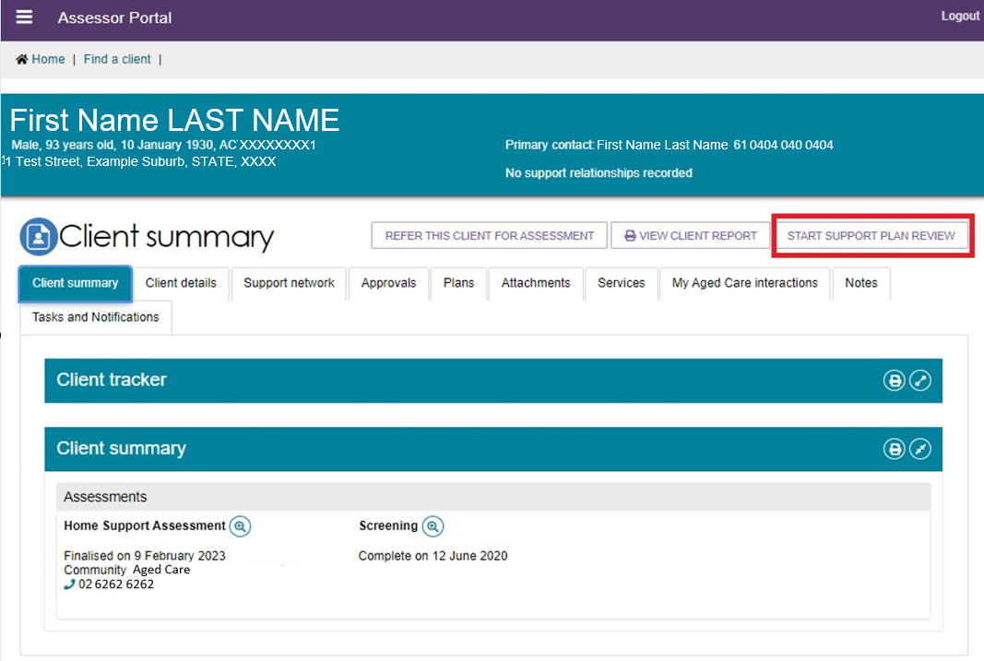
Current Reviews page
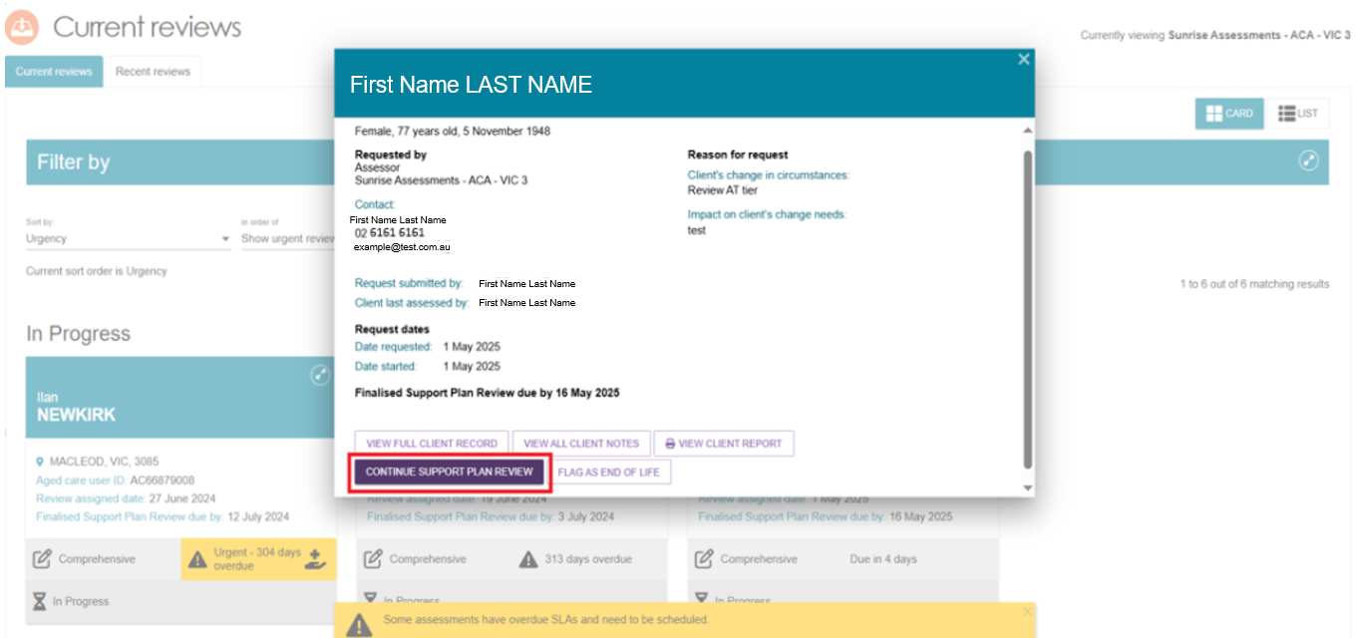

- In the Before you start the Support Plan Review window, select RECOMMEND A NEW ASSESSMENT.
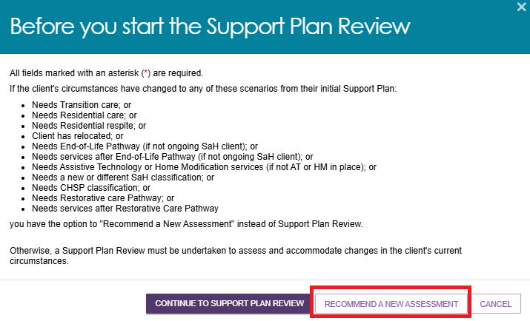
- A window opens for you to complete or finalise the Support Plan Review and create a referral for a new assessment.
      - Select the reason for the new assessment. Available options include:
      - Needs Transition Care
      - Needs Residential Care
      - Needs Residential Respite
      - Client has relocated
      - Needs End-of-Life Pathway (for clients who do not receive Support at Home services)
      - Needs services after the End-of-Life Pathway (for clients who do not receive Support at Home services, such as CHSP clients)
      - Needs Assistive Technology or Home Modifications that are not already in place
      - Needs a new or different Support at Home classification
      - Needs a Commonwealth Home Support Programme classification
      - Needs a Restorative Care Pathway
      - Needs services after a Restorative Care Pathway.
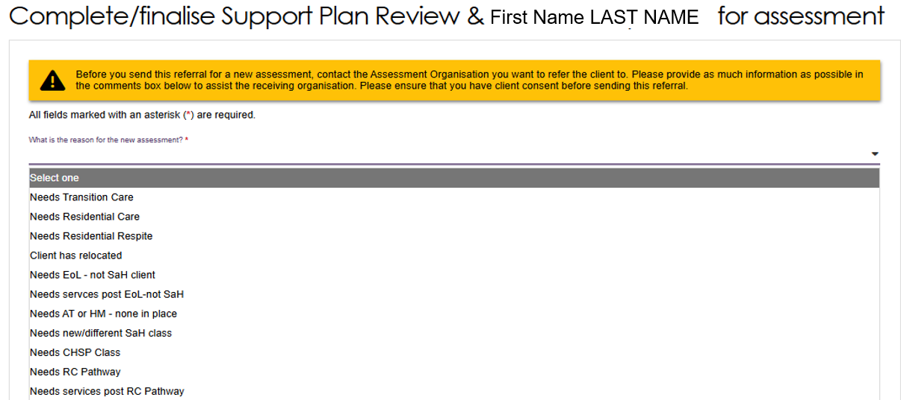
      - Assign this referral to either yourself or your organisation, or another organisation.
      - Select the assessment type:
- Home Support, or
- Comprehensive. If you select Comprehensive, choose the appropriate outlet.
      - Select the assessment priority
      - Add any comments if necessary.
      - Select COMPLETE/FINALISE SUPPORT PLAN REVIEW & REFER ASSESSMENT.
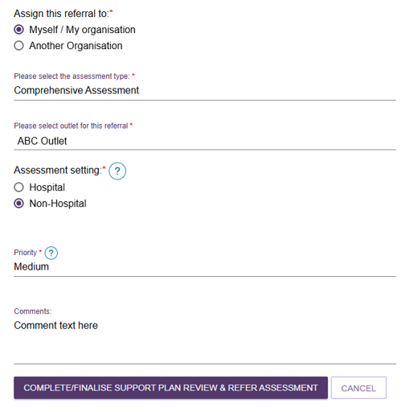

Issuing an assessment referral as a result of a Support Plan Review
You can refer a client for a new assessment when you complete a Support Plan Review.
  - In the Complete & Finalise Support Plan Review section of the client's support plan, select A new assessment required.
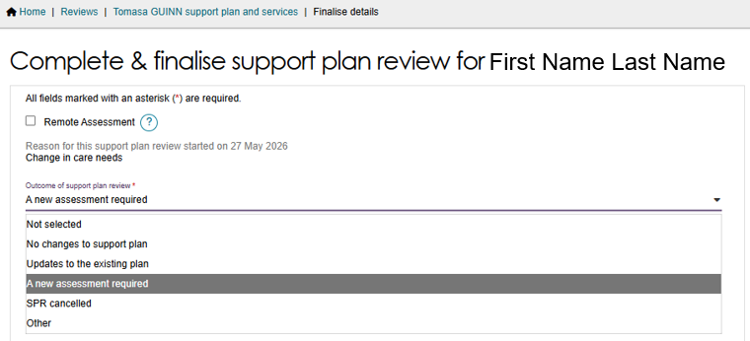
  - Complete all mandatory fields on the Complete & Finalise Support Plan Review page.
  - At the bottom of the page, create an assessment referral before you complete the review.
You can assign the referral to:
- Myself
- My Organisation
- Another Organisation.
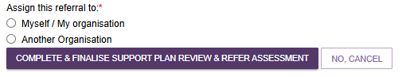
If you select Myself or My Organisation:
- Select the assessment type.
- Select the referral outlet.
- If you selected a Comprehensive Assessment, select the assessment setting.
- Select the referral priority.
- Add comments if required.
- Select COMPLETE & FINALISE SUPPORT PLAN REVIEW & REFER ASSESSMENT.
Then, select COMPLETE & FINALISE SUPPORT PLAN REVIEW & REFER ASSESSMENT.
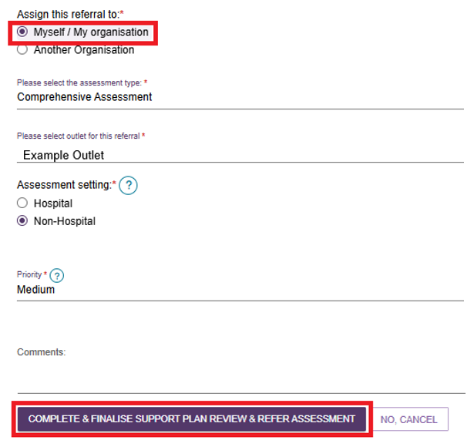
If you select Another Organisation:
- Select the assessment type.
- If you selected a Comprehensive Assessment, select the assessment setting.
- Search for the assessment organisation using either the client's address or an alternative assessment address.
If you select Use the client's address, the system removes any alternative assessment addresses from the client's profile when it issues the referral.
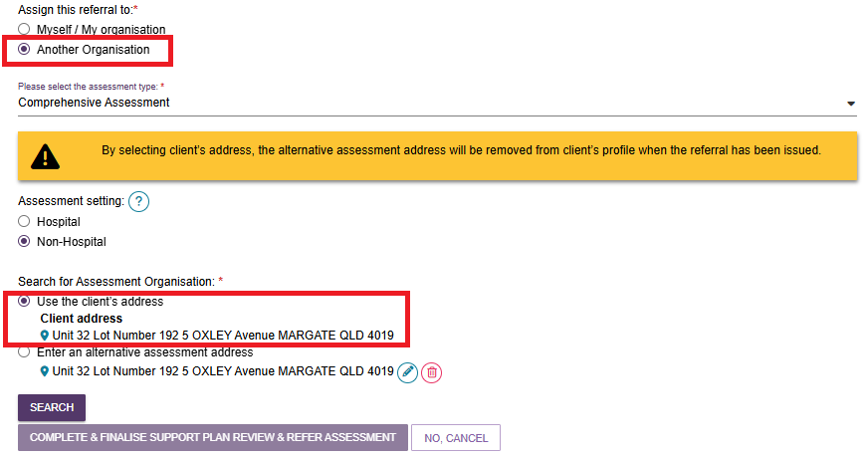
If you enter an alternative assessment address, you can use the displayed address or select the Edit (pencil) icon to enter a different address.
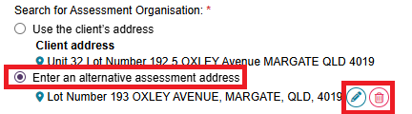
- Select SEARCH and choose the appropriate assessment organisation.
- Select the assessment priority.
- Add comments if required.
- Select COMPLETE & FINALISE SUPPORT PLAN REVIEW & REFER ASSESSMENT.
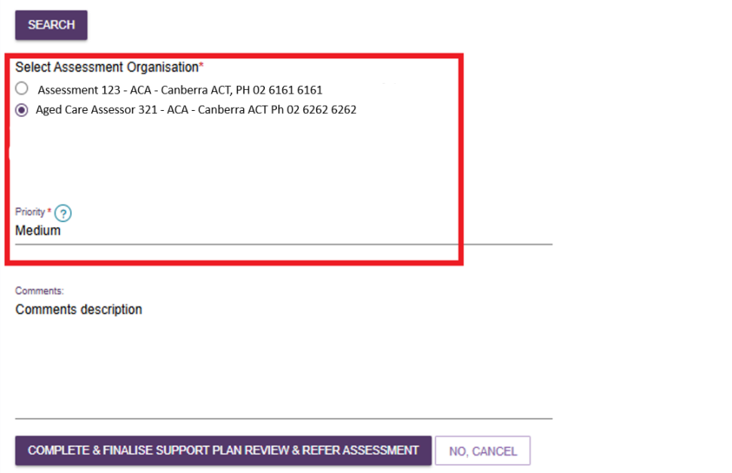
- When you complete the Support Plan Review, a green confirmation banner appears.
- If you assigned the referral to yourself, the new assessment appears in the Current assessments tab.
- If you assigned the referral to My Organisation or Another Organisation, it appears in the Incoming referrals queue for a team leader.


! | All assessments, including those created from a Support Plan Review, must go through the triage process.  For more information refer to My Aged Care – Assessor Portal User Guide 3 – Managing referrals for assessment and support plan reviews.

Ad hoc Support Plan Reviews
You can start an ad hoc Support Plan Review for any client assessed by your assessment outlet. You do not need an assigned Support Plan Review.
To start an ad hoc review, select START SUPPORT PLAN REVIEW from any tab in the client's record. You can also start a review by selecting the client card on the Current Reviews page.
An ad hoc review overrides any scheduled review. If the scheduled review is no longer required, the team leader should cancel it from the Upcoming Reviews tab.

Scheduling an Ad hoc Support Plan Review
Schedule an ad hoc Support Plan Review when a significant change in the client's needs, health, or circumstances affects the level or type of care they require.
  - Go to the Review tab on the Support Plan and Services screen.

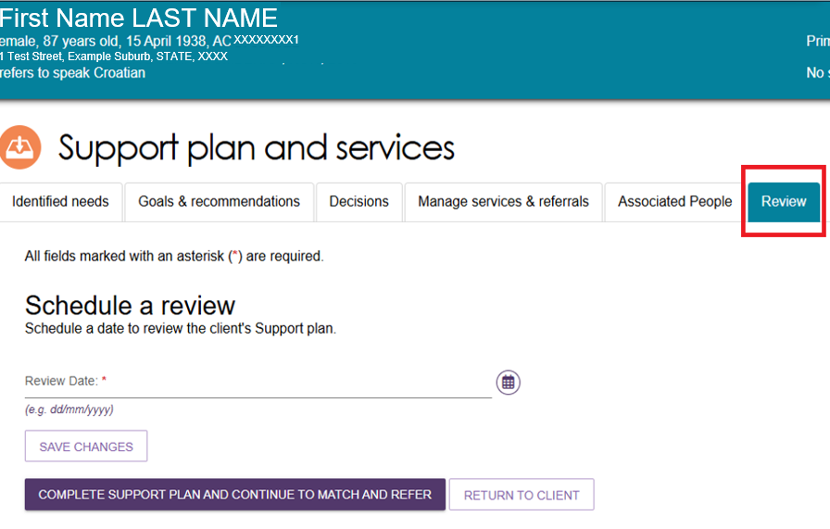
  - Under Schedule a Review, select the Calendar icon, choose a future review date, and select SAVE CHANGES.
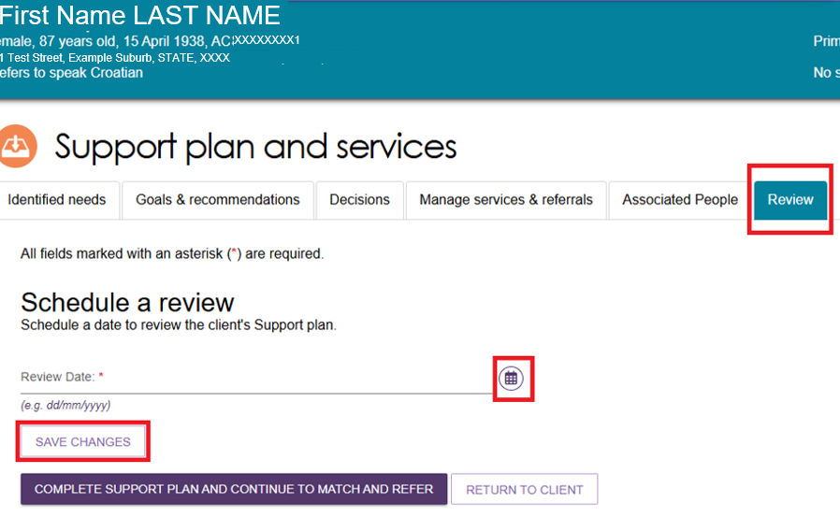
  - Select COMPLETE SUPPORT PLAN AND CONTINUE TO MATCH AND REFER.
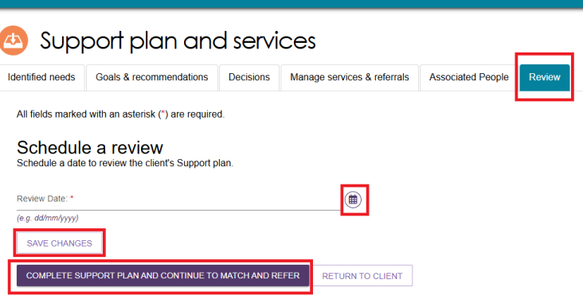
  - On the client's Plans tab, select START SUPPORT PLAN REVIEW.
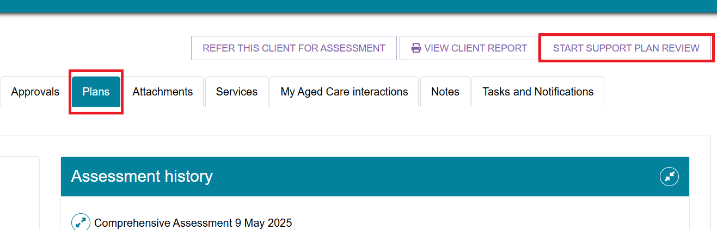
  - On the next screen, select CONTINUE TO SUPPORT PLAN REVIEW.
  - Complete the required fields on the Consent screen and select CONTINUE TO SUPPORT PLAN REVIEW.
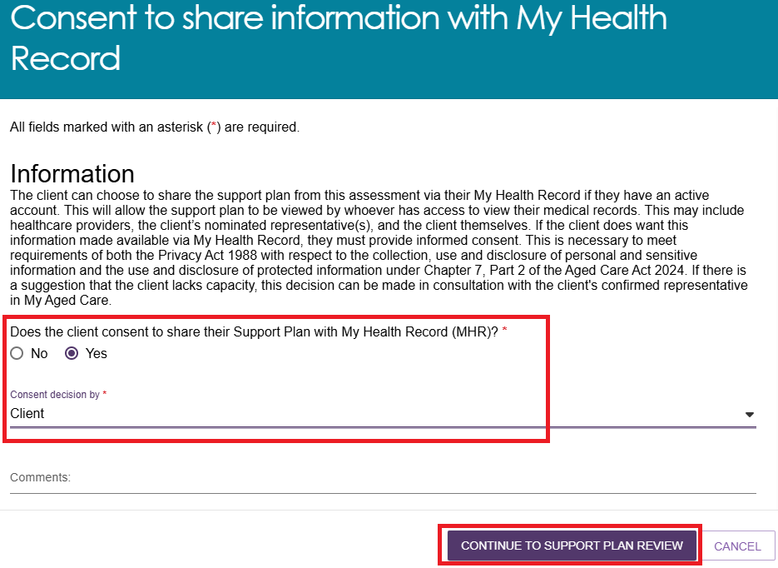
  - When prompted, select the reason for the client's change in circumstances.
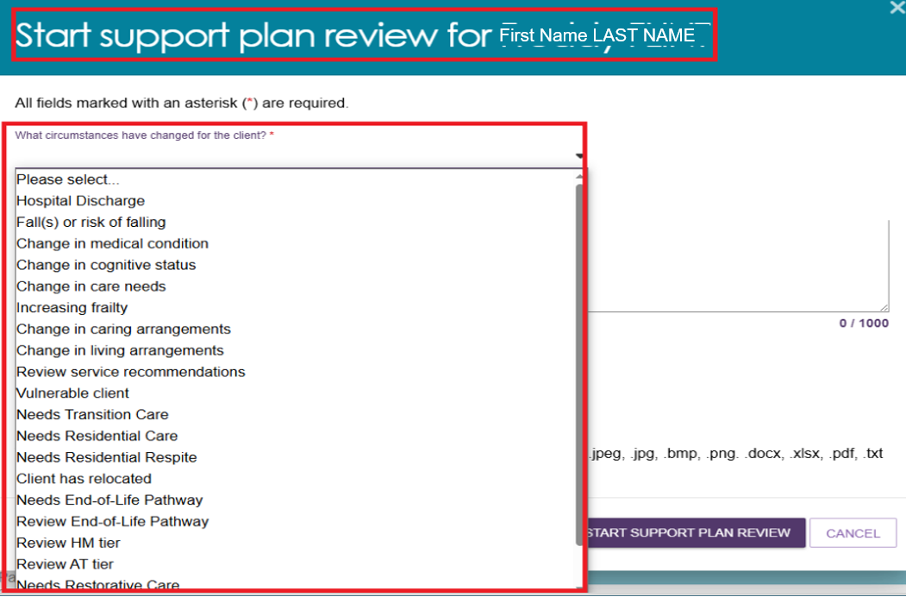
  - Enter the required information and upload supporting documents, such as a letter from a qualified health professional, if needed.
  - Select START SUPPORT PLAN REVIEW.
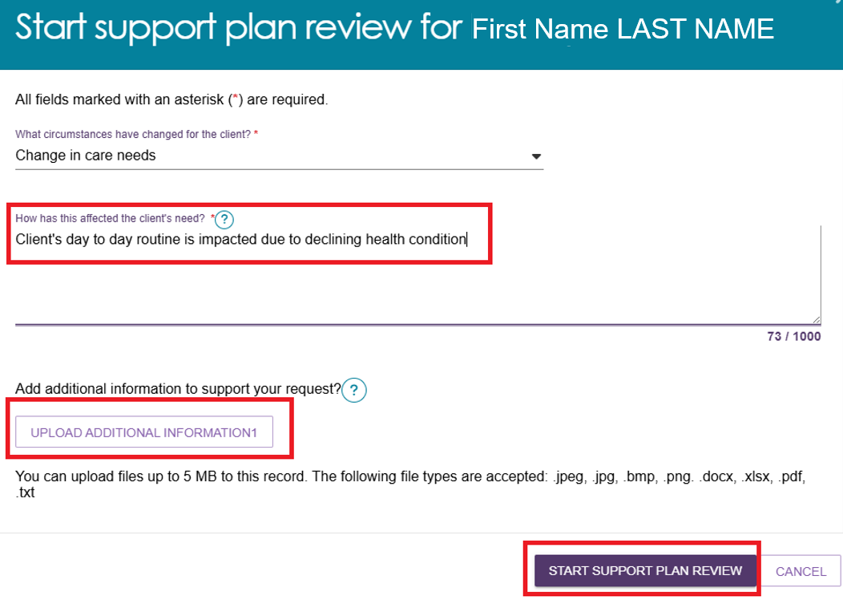

Transferring a Support Plan Review
Assessors and team leaders can transfer a Support Plan Review to another assessment organisation.
  - Go to Current Reviews and select the client card for the Support Plan Review you want to transfer. Select TRANSFER SUPPORT PLAN REVIEW.
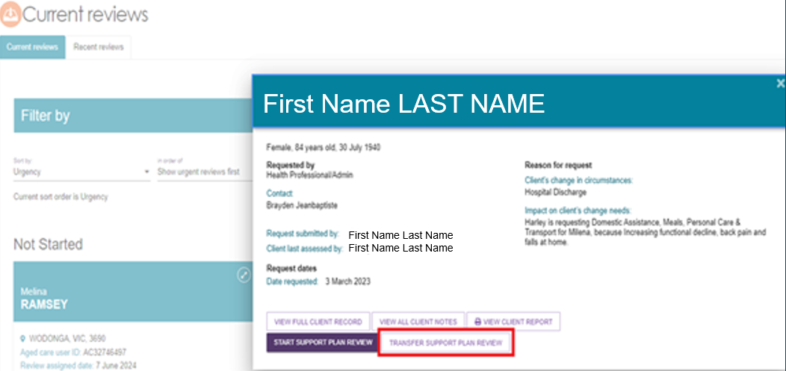
  - Enter the reason for the transfer.
Search for and select the assessment organisation that will receive the Support Plan Review.
Select TRANSFER to complete the transfer.
After the transfer is complete, the system displays a banner reminding you to:
- contact the receiving assessment organisation, and
- obtain the client's consent before transferring the Support Plan Review.
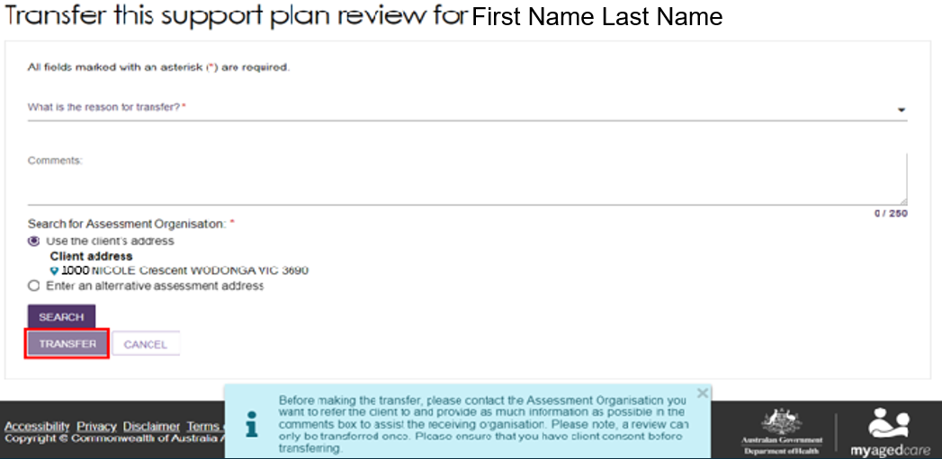
! | Support Plan Reviews can only be transferred once.

Support Plan Review for Support at Home
Conduct a Support Plan Review when a client's circumstances, goals, or care needs change and you need to review their current Support at Home services. The review helps ensure the client's services remain appropriate, effective, and aligned with their preferences and needs.
Use the Goals & Recommendations tab to record the client's:
- areas of concern
- goals to address those concerns
- service recommendations
- general recommendations
- care type recommendations.
Support at Home care types are delivered under the Aged Care Act 2024. If a care type recommendation requires delegate approval, add a care type for delegate decision.

Support Plan Review for services following an End-of-Life Pathway episode
You may receive a Support Plan Review (SPR) request for a client who is approaching the end of their End-of-Life Pathway episode or whose End-of-Life episode has ended and who requires ongoing services.
Complete the Support Plan Review to assess the client's current needs and determine whether to:
- return the client to their previous (latent) Support at Home classification, or
- recommend a reassessment so the client can access a higher ongoing Support at Home classification.
For example, a client may have originally received a Support at Home Classification 4, then accessed the End-of-Life Pathway, and now require an ongoing Support at Home Classification 8 to meet their increased care needs.
In most cases, the client's service provider initiates this Support Plan Review. The provider submits the request by selecting Review End-of-Life Pathway as the reason for the Support Plan Review.

Revert to the previous ‘latent’ SaH classification
Follow these steps to return a client to their previous (latent) Support at Home classification.
  - Open the Support Plan Review (SPR) request from the client's record.
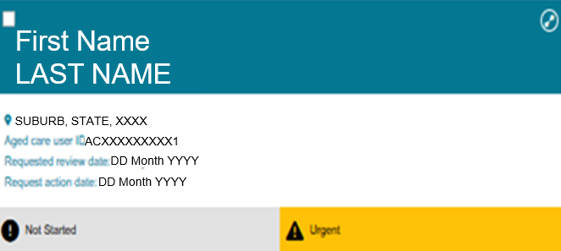
  - Review the reason for the request. The service provider may have identified that the client:
- has exceeded their End-of-Life Pathway period, or
- is approaching the end of their 16-week End-of-Life services.
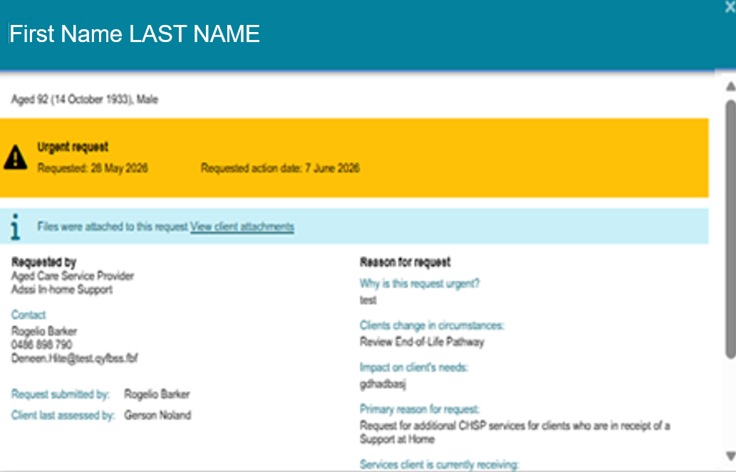
  - Go to the Goals & Recommendations tab on the Support Plan and Services page.
In the IAT Outcome and Classifications section, an information banner shows that the client is currently on the End-of-Life Pathway and can only be recommended for a latent or higher ongoing Support at Home classification.
Select Revert to Ongoing Support at Home Classification or Override to Transitioned HCP Classification.

Revert to Ongoing SAH Classification example
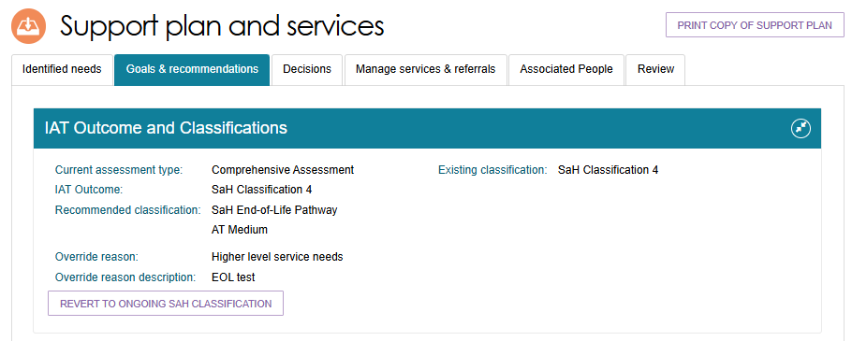
Override to Transitioned HCP Classification example
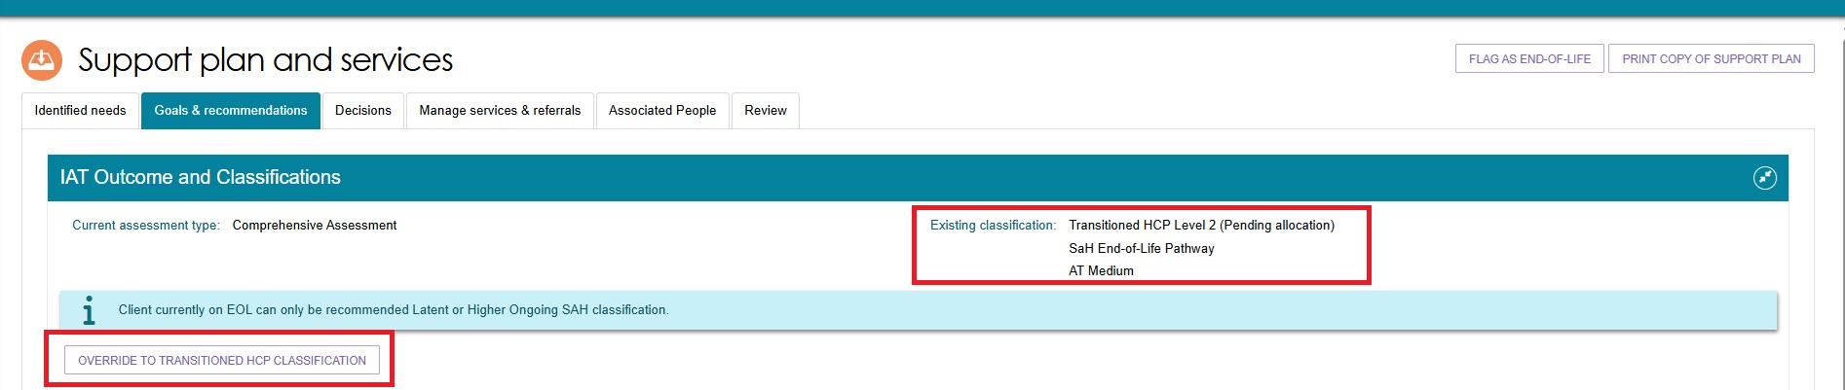
  - When the confirmation window appears, select REVERT or OVERRIDE to continue.
Revert to ongoing SAH Classification pop up example
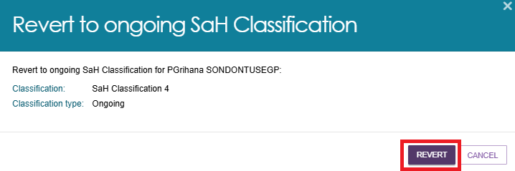
Override to Transitioned HCP Classification pop up example
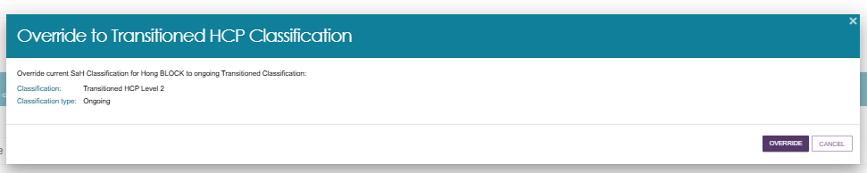

  - If the update is successful, the system displays a green confirmation banner.
  - The IAT Outcome and Classifications section updates to show the client's current classification and the override reason Latent Pending.
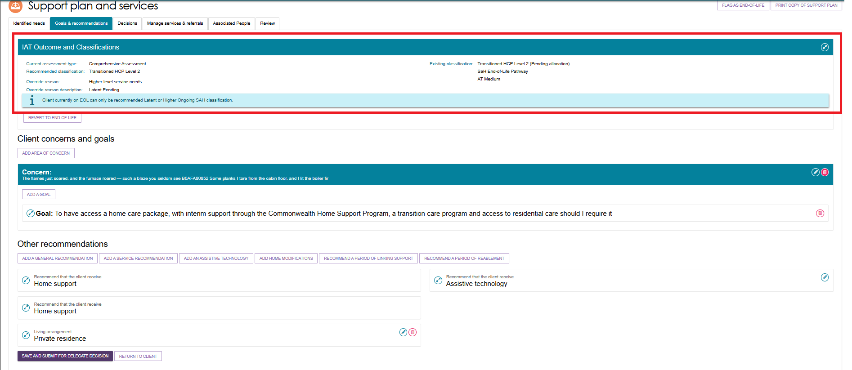
  - Complete the Support Plan Review and record the outcome in the system. This transitions the client from the End-of-Life Pathway to their latent ongoing Support at Home classification and supports continuity of services.
Go to the Decisions tab, then select SAVE AND SUBMIT FOR DELEGATE DECISION.
  - In the Submit for Delegate Decision window, confirm that the client applied for care under the Aged Care Act 2024 by selecting the checkbox, then select SUBMIT.
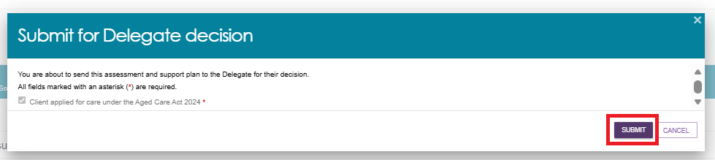
  - The system displays a green confirmation banner to show that it has sent the assessment and support plan to the delegate for a decision.

Reassessment for a New Support at Home Classification Following an End-of-Life Episode
- Go to the client's Plans tab and select REQUEST A REVIEW.
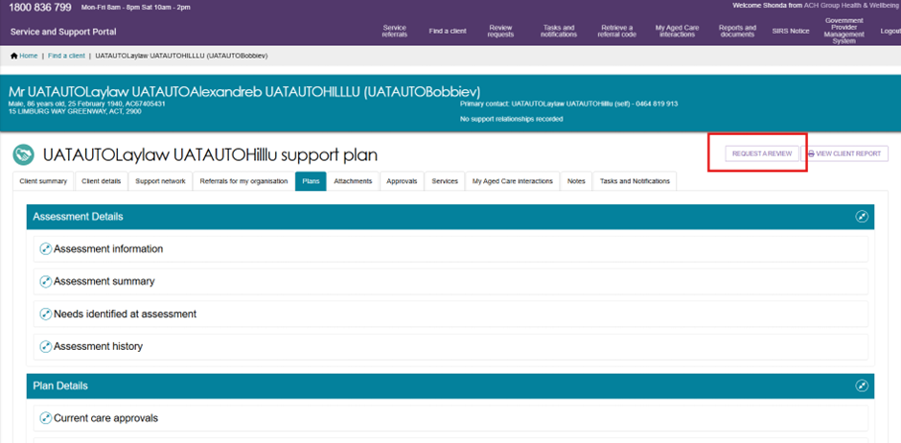
- On the Request a Review page, complete all mandatory fields and upload any relevant documents, such as a care plan.
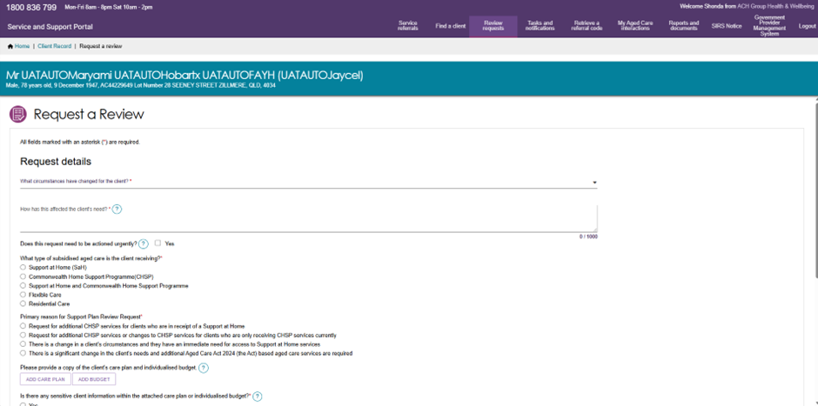

The team leader will assign the assessment to an appropriate assessor.
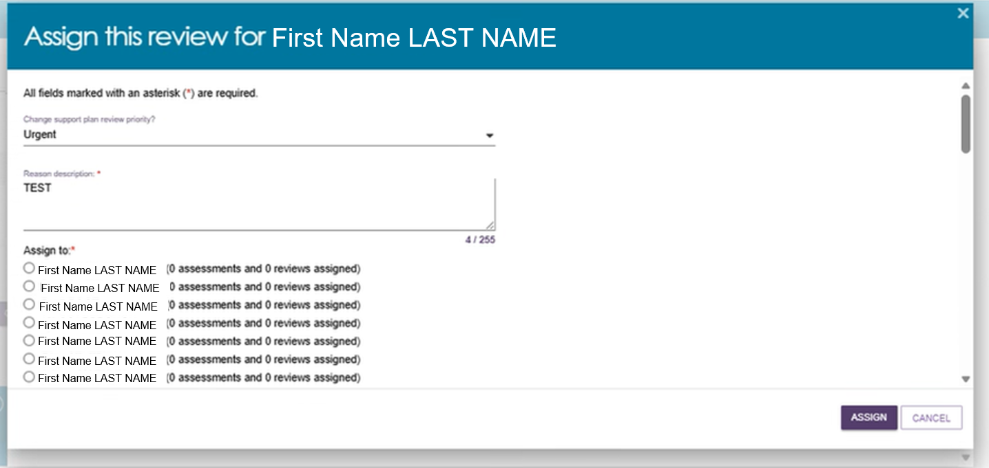
- The assigned assessor should go to the Reviews tile on the Assessor Portal home page and open the Not Started section on the Current Reviews page.
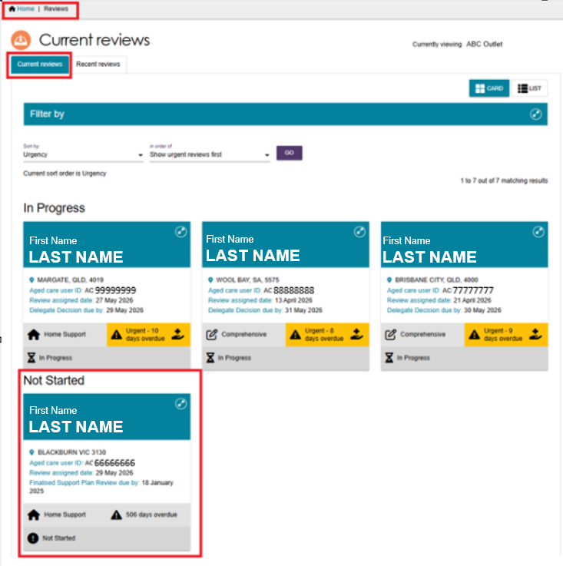
- Find the client's review card and select START SUPPORT PLAN REVIEW.
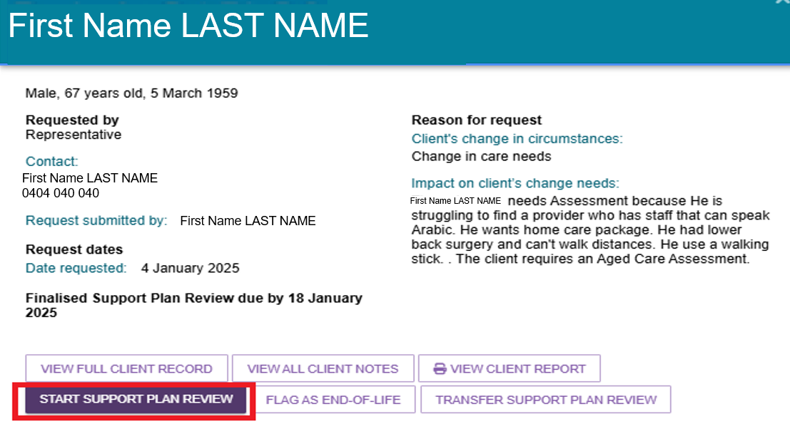
- In the Before you start the Support Plan Review window, select RECOMMEND A NEW ASSESSMENT.
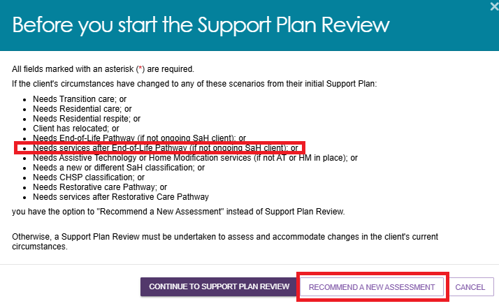
- Select START TRIAGE. After completing triage, select START ASSESSMENT.

Start Triage
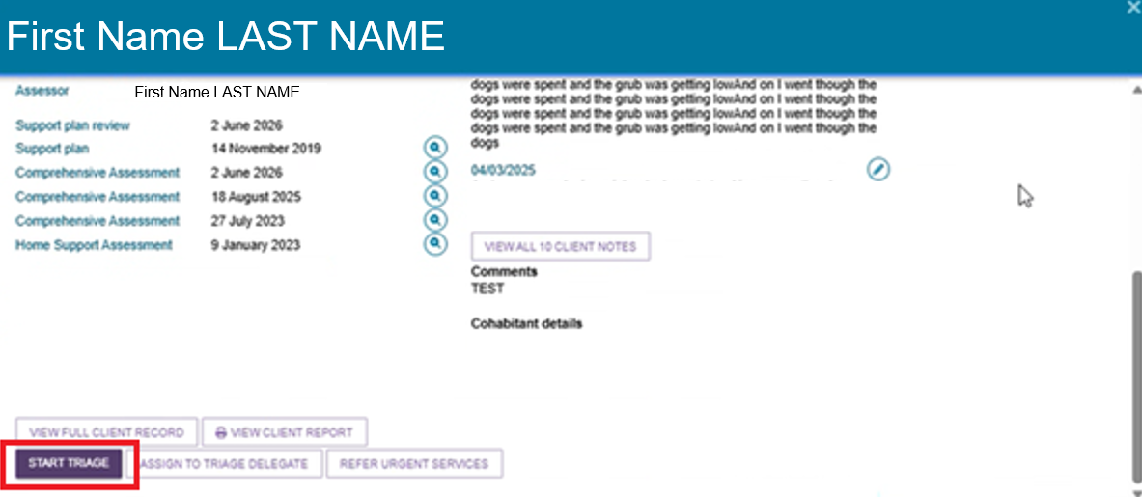
Start Assessment
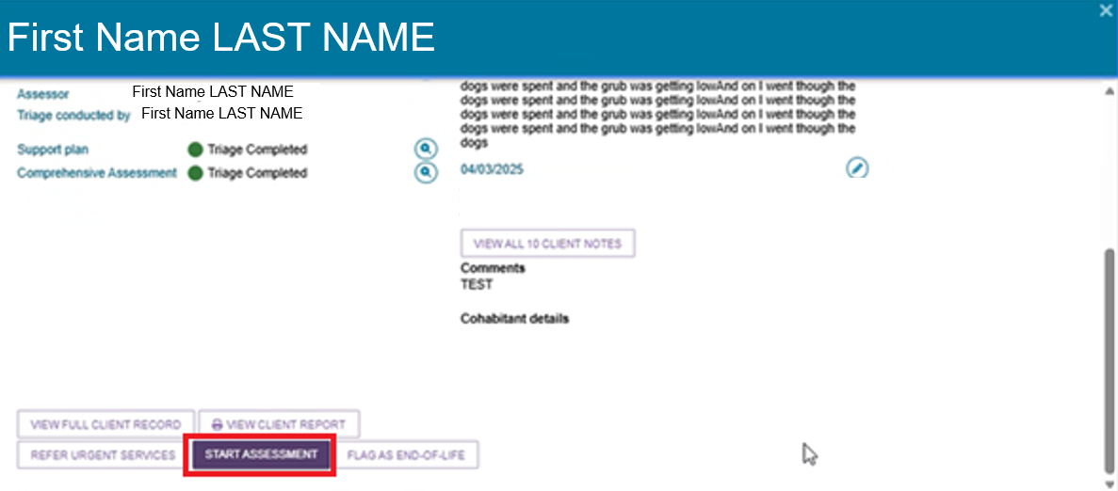
- Complete the assessment and select FINALISE IAT.
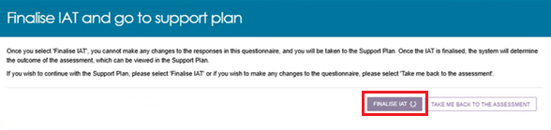
- The reassessment outcome appears in the Goals & Recommendations tab.
An information message explains that you can only recommend the client's latent Support at Home classification or a higher ongoing classification.
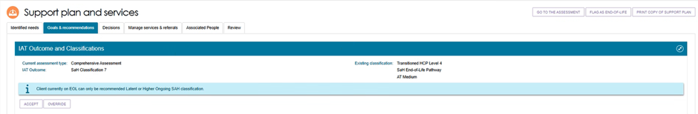
- Accept the new Support at Home classification, complete the assessment and support plan, and submit the recommendation for delegate decision using the standard process.
