Assessor Portal User Guide 6 – Completing an Assessment
This guide explains the roles and responsibilities of assessors when completing an aged care assessment in My Aged Care. It covers:
- Non-clinical assessors, who can complete Home Support Assessments
- Clinical assessors, who can complete Comprehensive Assessments
Assessors can complete the Integrated Assessment Tool (IAT) using:
- the Assessor Portal (covered in this guide)
- the Aged Care Assessor App, and upload the assessment when they next have internet access
- a printed or blank copy of the IAT, and enter the information into the Assessor Portal after completing the assessment
If you only have an Organisation Administrator or Outlet Administrator role, you cannot view or complete assessments in the Assessor Portal.
For detailed instructions on completing an assessment, refer to the Integrated Assessment Tool (IAT) User Guide.
! | On 1 November 2025, the Aged Care Act 2024 and the Support at Home program come into effect with significant change to support plans in the IAT.  To ensure the right IAT is used, and triage can continue for priority referrals, any assessments in the following statuses already started prior to 1 November 2025 and in progress on 1 November 2025 must be restarted:  - Triage complete, main assessment not started  - Triage complete, main assessment in progress (includes incomplete support plan)  - Main assessment completed, awaiting delegate decision (comprehensive assessments).  For information on the Restart Assessment Process, please refer to Management of active assessments for 1 November 2025 transition – Standard Operating Procedure and Restarting In Progress Assessments for Support at Home (instructional video).

Viewing assessments 3
Starting an assessment 5
Completing an assessment 15
Assessment features 17
Clinical attendance (for non-clinical assessors) 19
Health Conditions 21
Adding Identified Needs 23
Viewing and adding carers in the assessment 25
Adding a Sensitive Attachment in the assessment 29
Navigating the Validated Assessment Tools 33
Modified de Morton Mobility Index (DEMMI) and Residential Respite Care (Clinical assessor) 35
Saving an assessment 38
Finalising the IAT 39
Accepting or Overriding an Assessment 46
Accepting IAT Outcome 46
Overriding IAT Outcome 49
Recommending SaH Restorative Care Pathway 50
Overriding for transitioned clients undergoing reassessment 52
Overriding to the SaH End-of-life Pathway 52
Converting to Comprehensive Assessment 53
Flagging an Assessment as End of Life 54
Cancelling an assessment 60

Viewing assessments
Follow these steps to view an assessment:
- Select Assessments on the homepage.
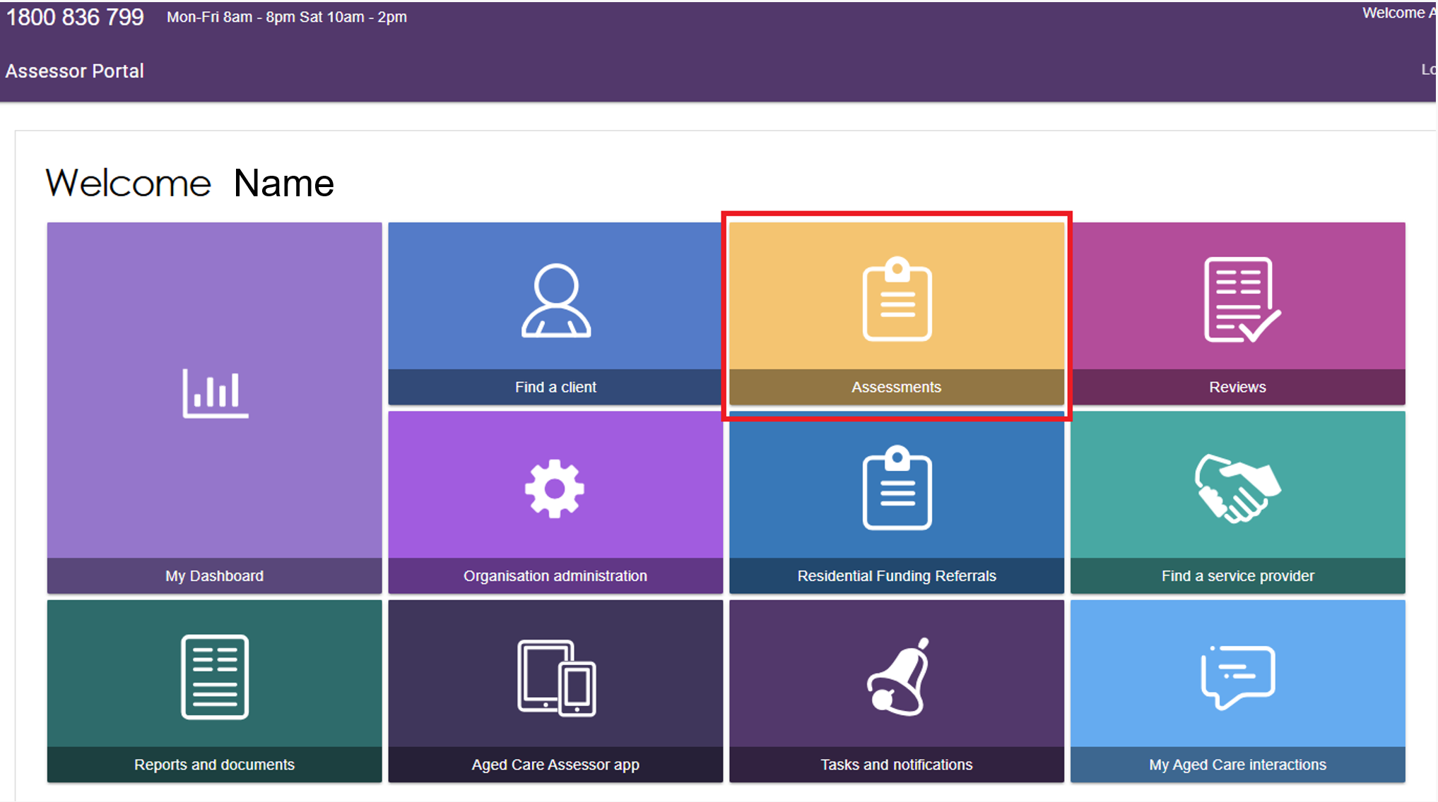
- From the Assessments tile, assessors can view all assessments assigned to them under the Current Assessments tab. This tab includes assessments with the following statuses:
- Triage not started
- Assessment not started
- Assessment in progress
- Assessment completed but not yet finalised
- Assessment awaiting delegate decision (not applicable for reviews)
- Delegate decision completed but not finalised (not applicable for reviews).
- Assessments returned to the assessor from the delegate.
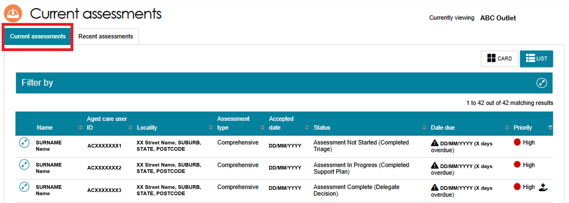
For more information about assessments returned to the assessor from the delegate, refer to My Aged Care – Assessor Portal User Guide 7 – Completing a support plan and support plan review.

! | To view the next Key Performance Indicator milestone (for example, Finalised Support plan) and due date for an assessment, go to the client’s referral card.  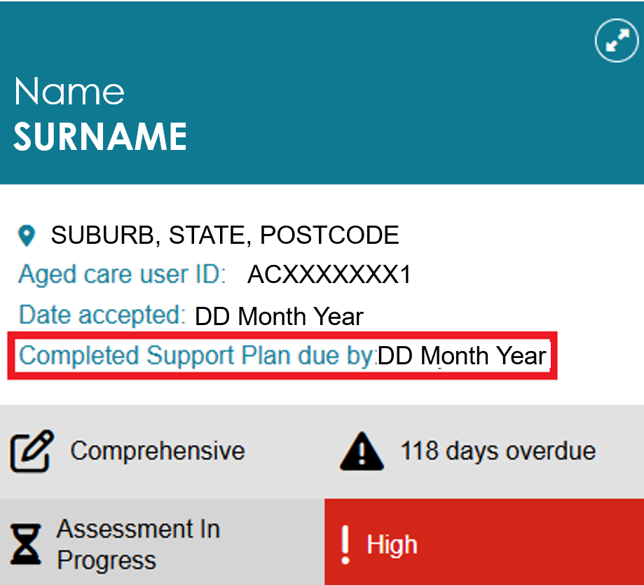
- The Recent assessments tab shows assessments that have been finalised, cancelled, and/or closed. It also contains completed and cancelled Support Plan Reviews.
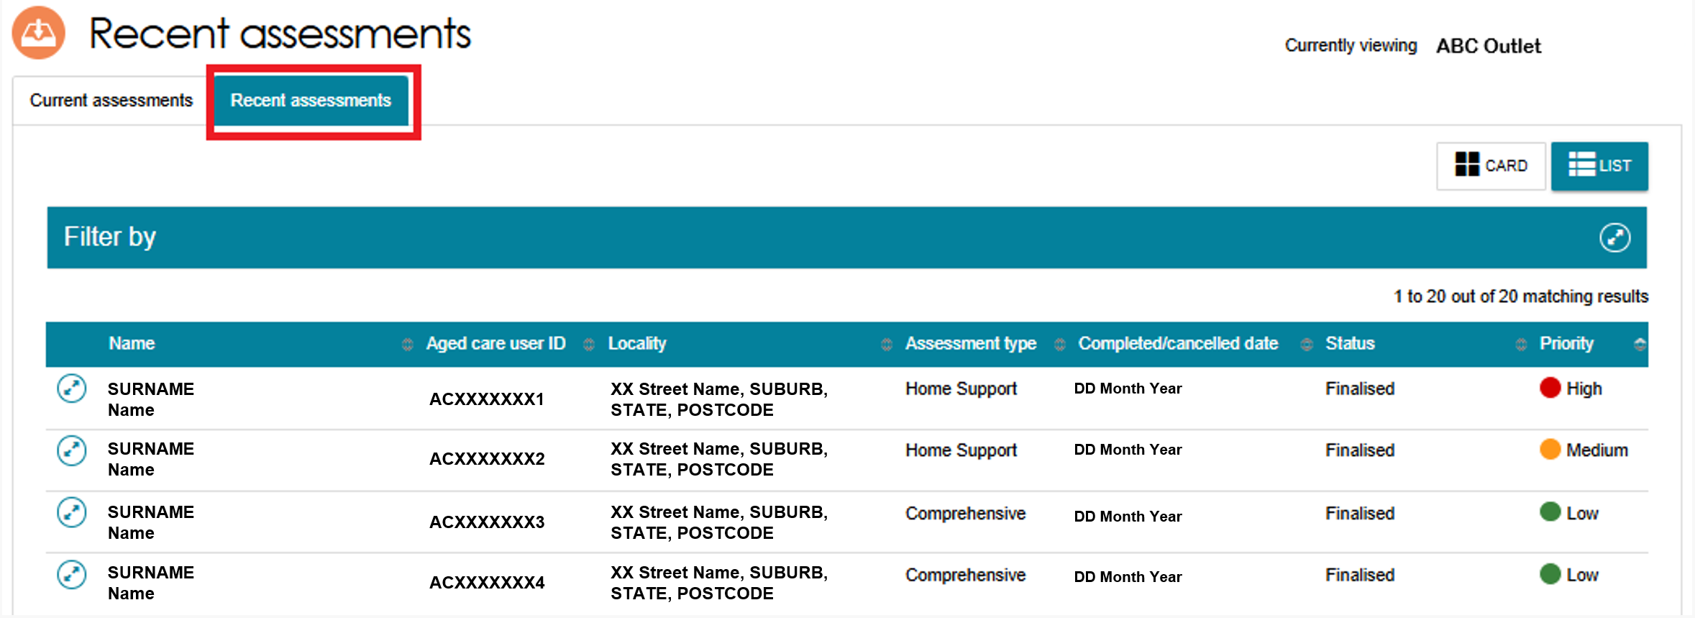
! | You can sort and filter assessments. For more information refer to the My Aged Care – Assessor Portal User Guide 3 – Managing referrals for assessment and support plan reviews.

Starting an assessment
- To start an assessment, select a client from the Assessment Not Started heading, and then select the double arrow icon on the top right-hand corner of the client card.
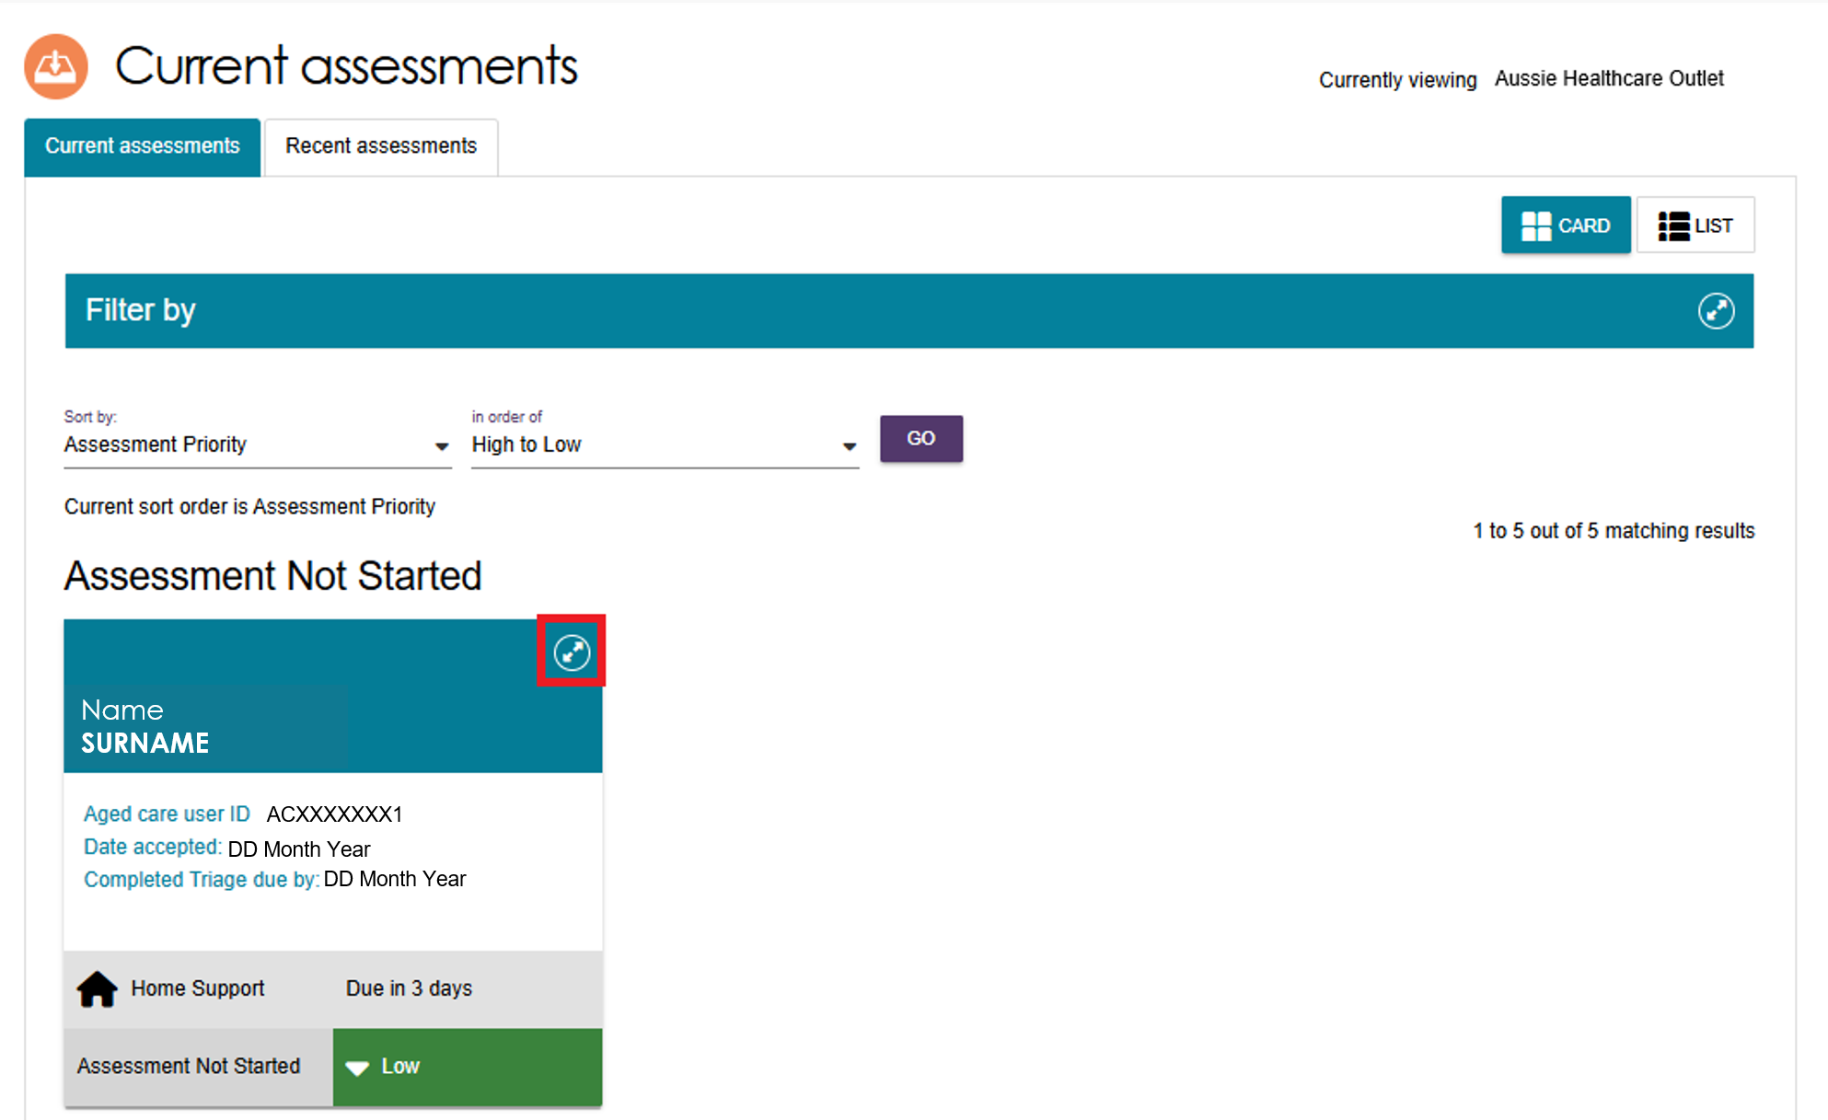
The client card shows a summary of the client’s information. Assessors can view read-only copies of previous screenings, triages, and assessments; as well as referral-related attachments and the client’s support plan, if one is available.
! | When you open the client card, the Support plan status is shown as Triage Completed. To view details from the screening and triage, select the magnifying glass icon.  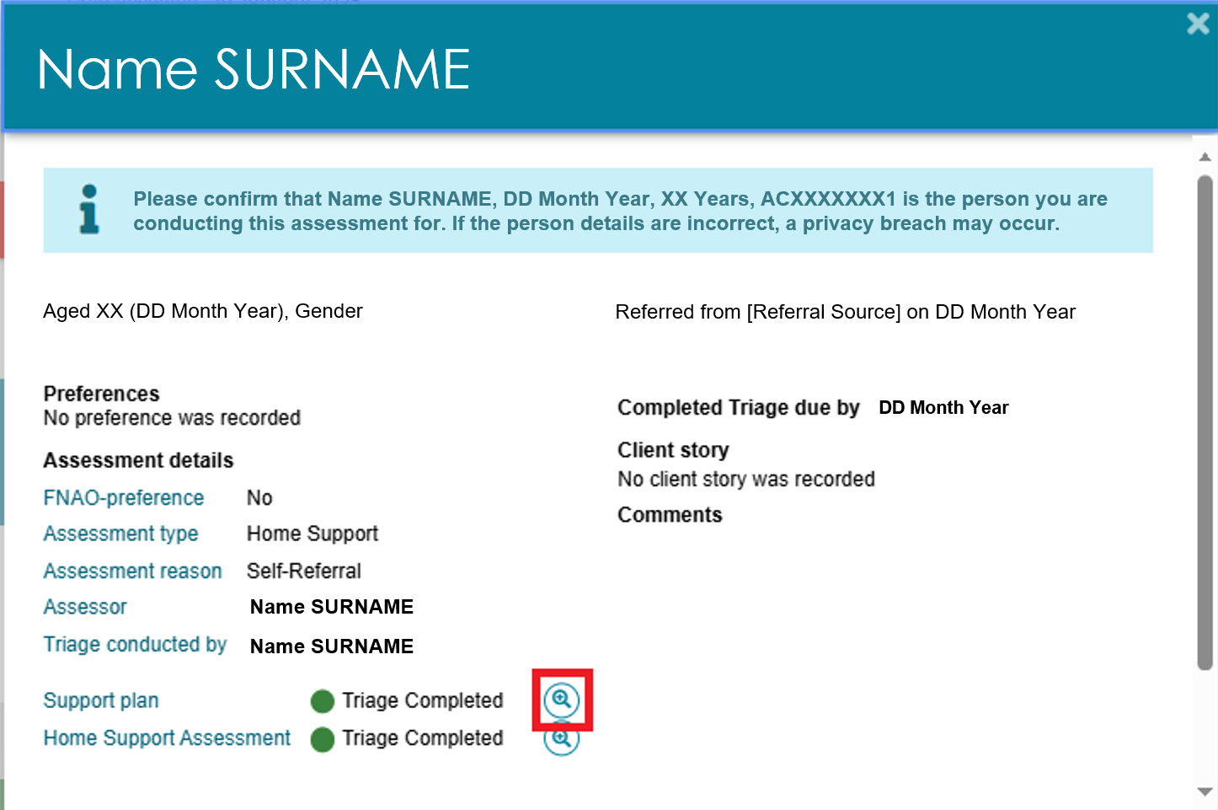

- For comprehensive assessments, clinical assessors can select the assessment setting before starting the assessment. Select the Edit (pencil) icon next to Assessment Setting.
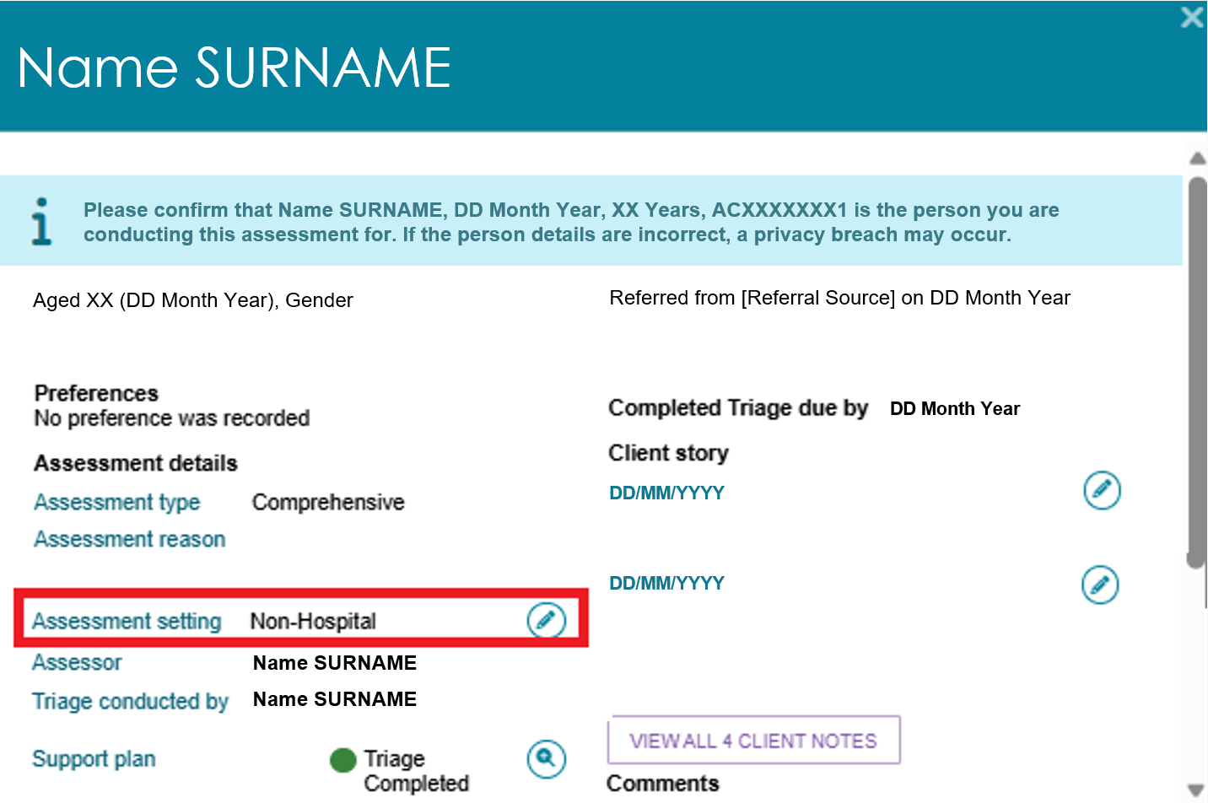
- The Assessment setting pop up appears. Select Hospital or Non-Hospital and then select Save.
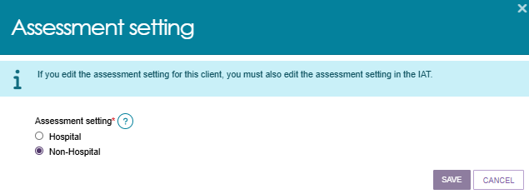
- The Assessment setting entered here must be the same as the value recorded in the Integrated Assessment Tool (IAT).If either value is changed, clinical assessors must update both fields so they match.
Before starting an assessment, clinical assessors can change a Home Support Assessment to a Comprehensive Assessment. To do this, select CONVERT TO COMPREHENSIVE ASSESSMENT.
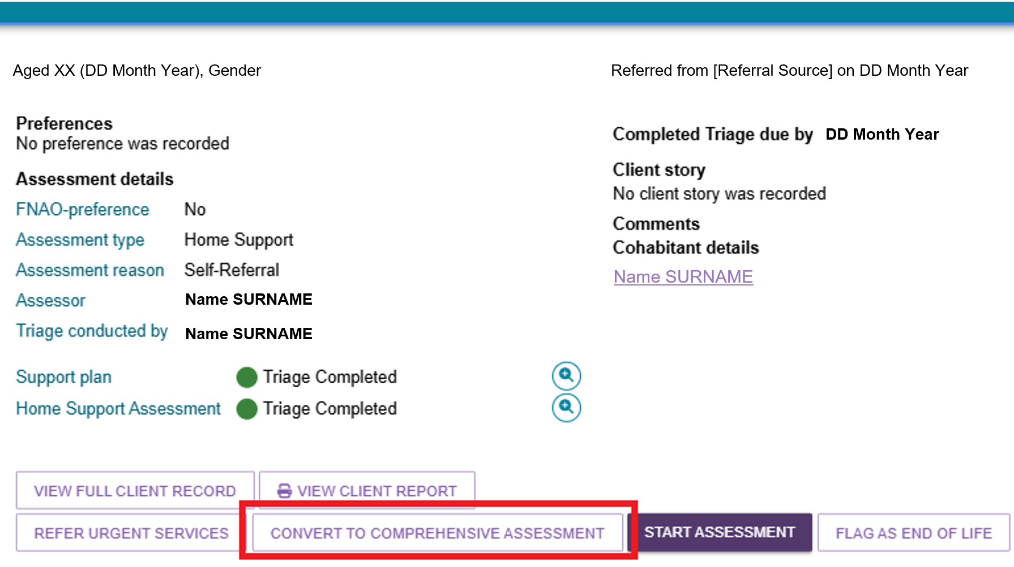
- The reason for the change will be automatically filled. Enter your Reason or comments about converting the assessment.
Non-clinical assessors who want to change a Home Support assessment to a Comprehensive assessment must also enter the name of the supervising clinical assessor.
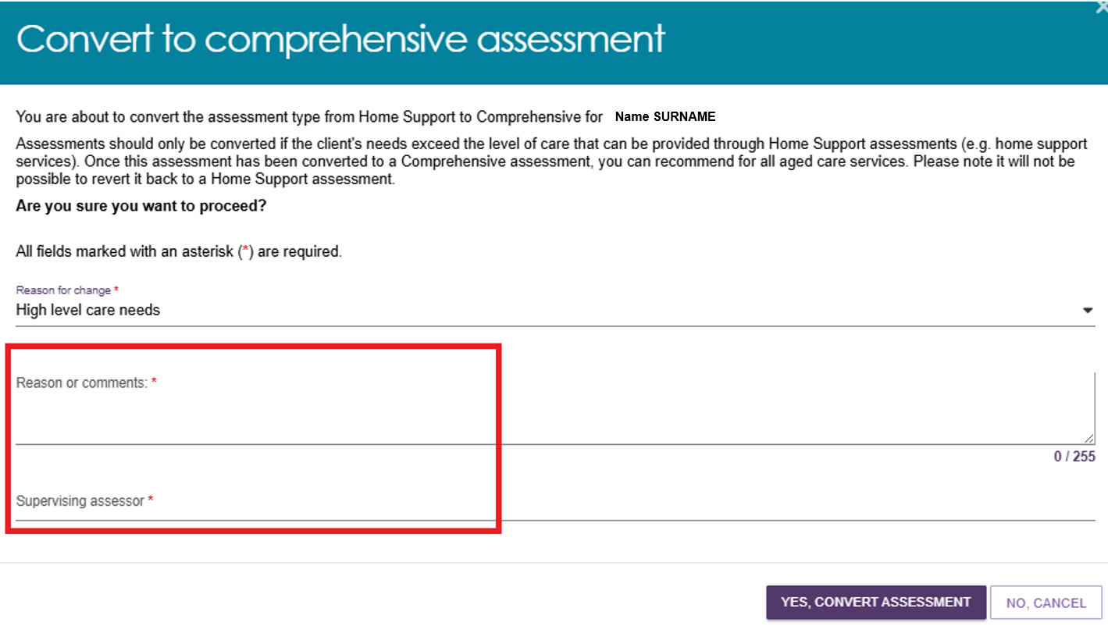
- Once you have completed the required information, select YES, CONVERT ASSESSMENT to continue. After an assessment has been converted to a Comprehensive assessment, it cannot be changed back to a Home Support assessment. The assessment type will then be shown as a Comprehensive Assessment.
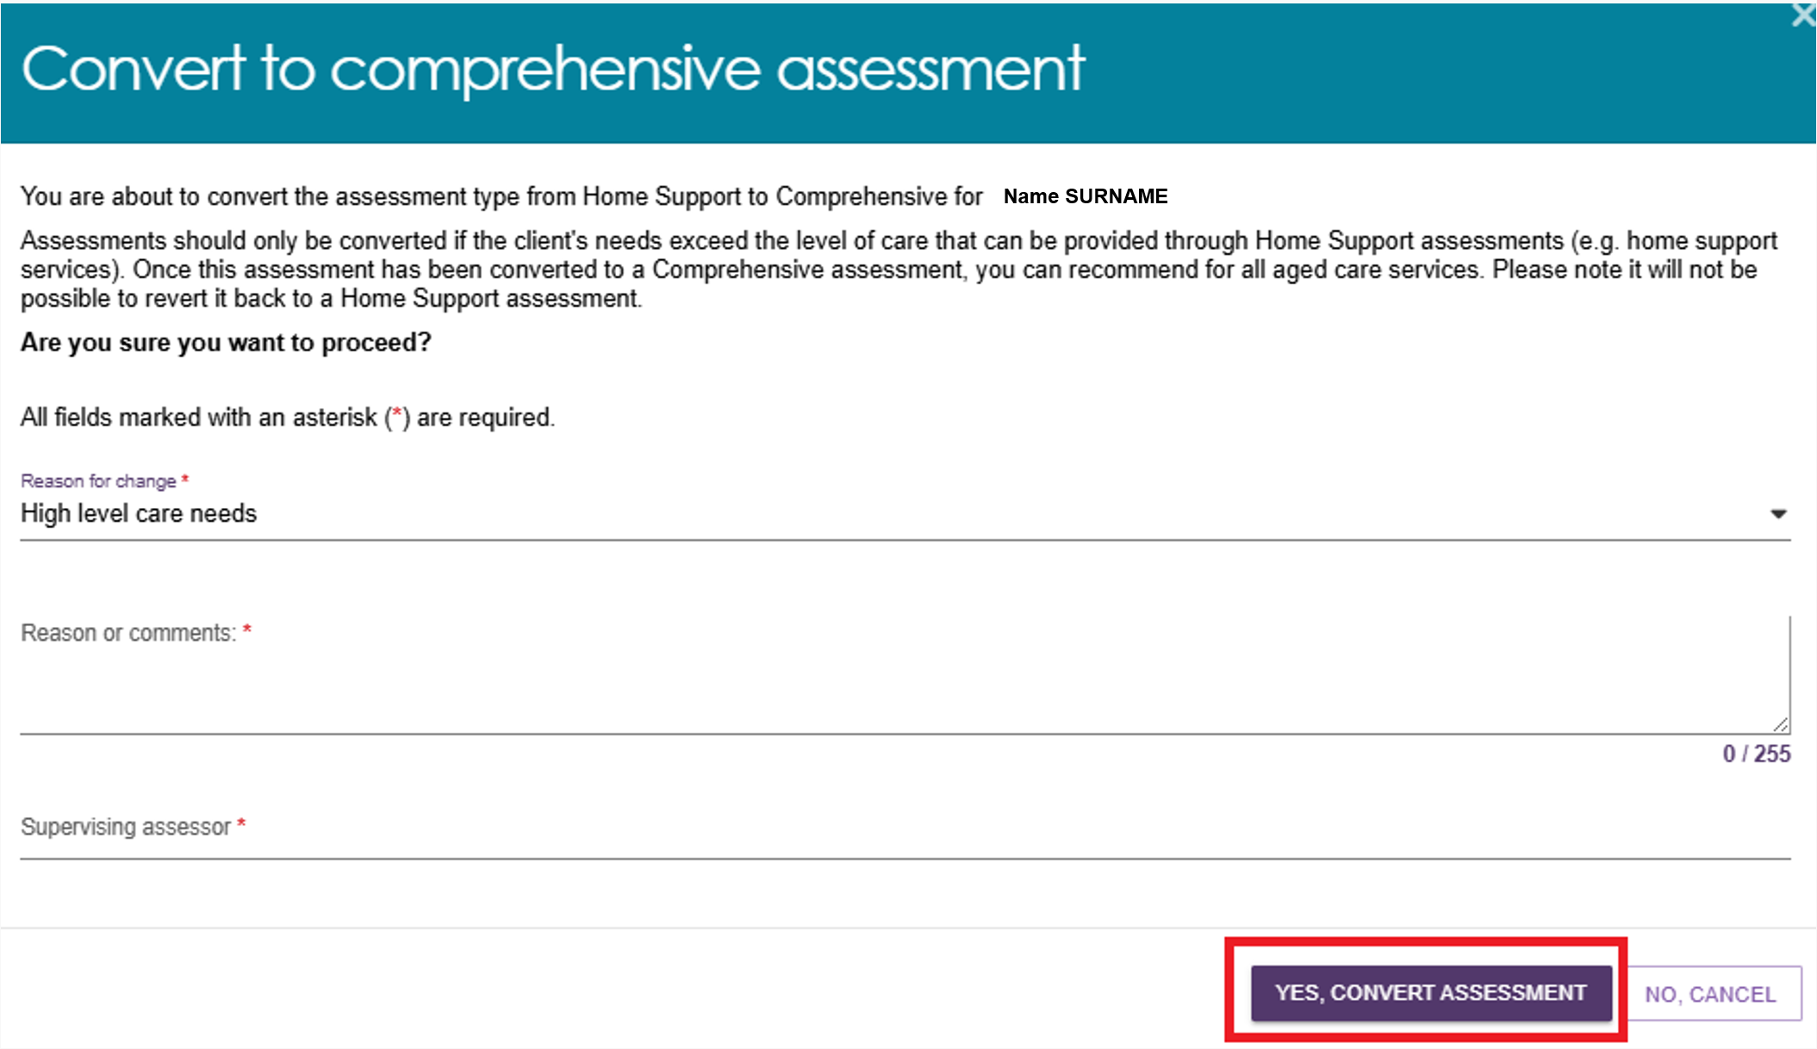
- The assessment type will now be shown as Comprehensive Assessment. When you are ready to begin, select START ASSESSMENT.
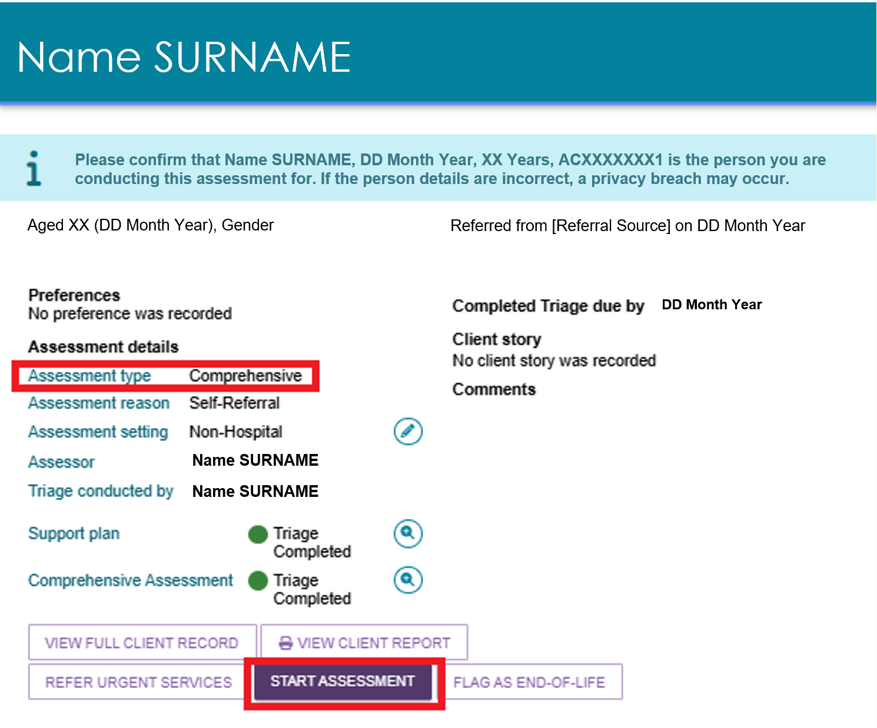
- Record client consent before starting the assessment.
Read the relevant consent script from the My Aged Care Assessment Consent Form to the client, and record their response. If you believe the client may not have the capacity to provide consent, complete the form with the client’s confirmed supporter or supporter guardian recorded in My Aged Care.
Download the My Aged Care Assessment Consent Form from the Reports & Documents tile in the Assessor Portal.
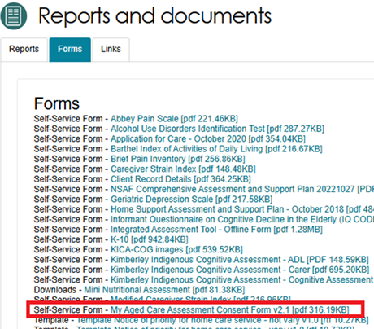
- If the client gives consent, select the relevant consent options in the Consent for Assessment pop-up (shown in the next page) and then select CONTINUE. During this step, obtain the signed copy of the Aged Care Assessment Consent Form.
! | If the client does not give consent, the system displays a warning message advising that you cannot continue with the assessment. Enter the reason the assessment could not be completed. If you select Other, please specify, provide additional details in the free-text field.  Select SAVE AND CLOSE to cancel the assessment.  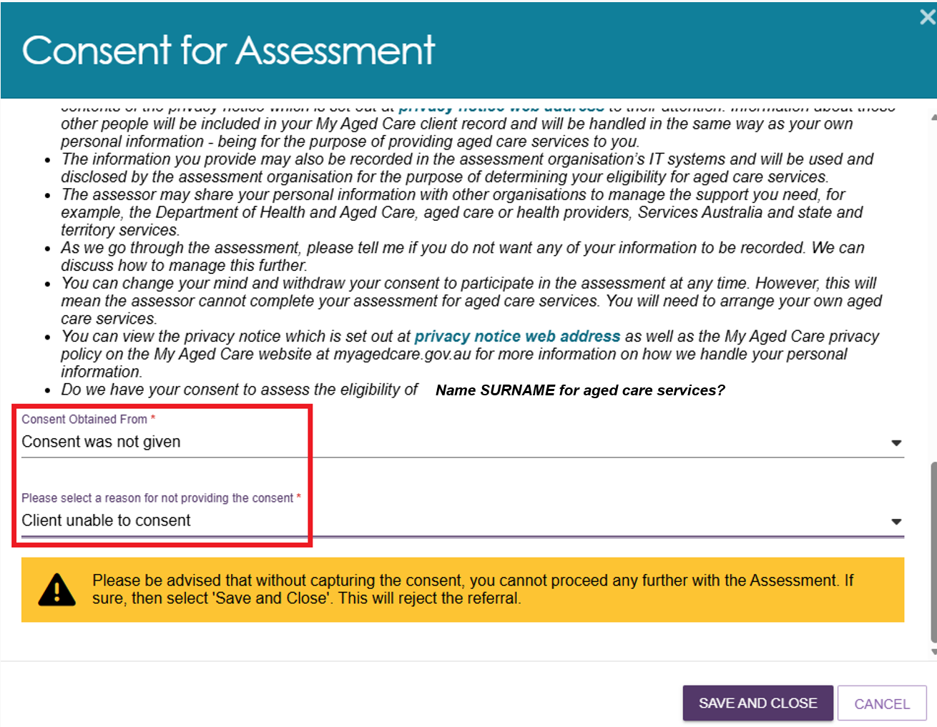
Consent for Assessment pop-up
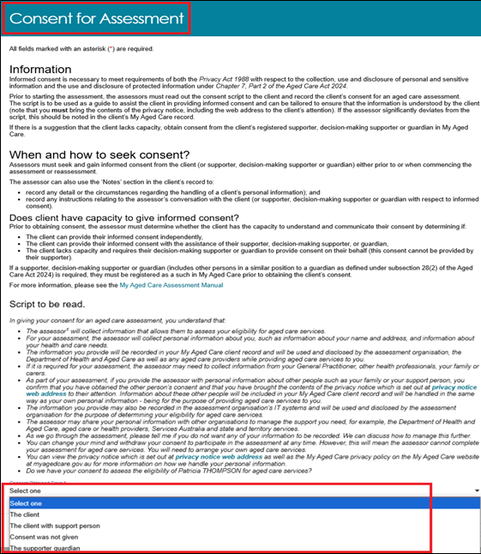
- You can Pre-populate the IAT with existing client information or start a blank assessment.
For new clients who have not completed a screening or have had a previous assessment, you can pre-populate the IAT using information from the triage.
If the client has completed a screening, you can also select to pre-populate the IAT with information from the screening. If the client has had a previous assessment you can choose to use information from that assessment as well.
After selecting the information that you want to use, select CONFIRM SELECTION.
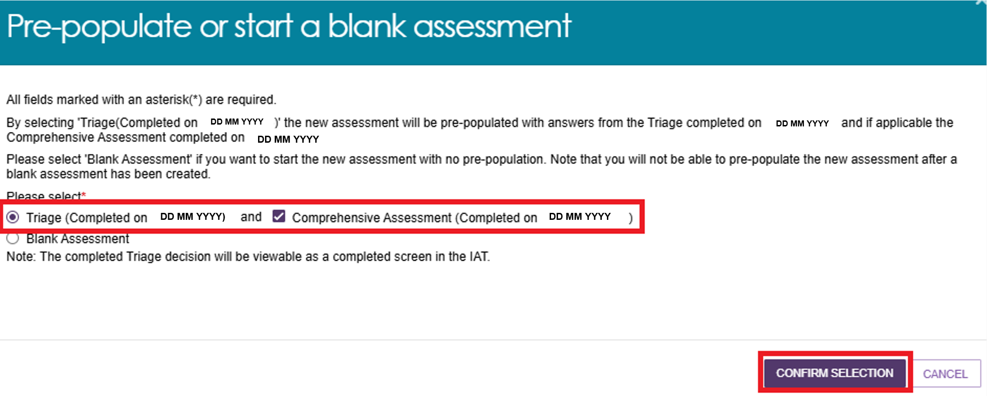
If you do not wish to pre-populate the IAT select Blank Assessment.
! | If you select Blank Assessment, you cannot reverse this decision during the assessment.
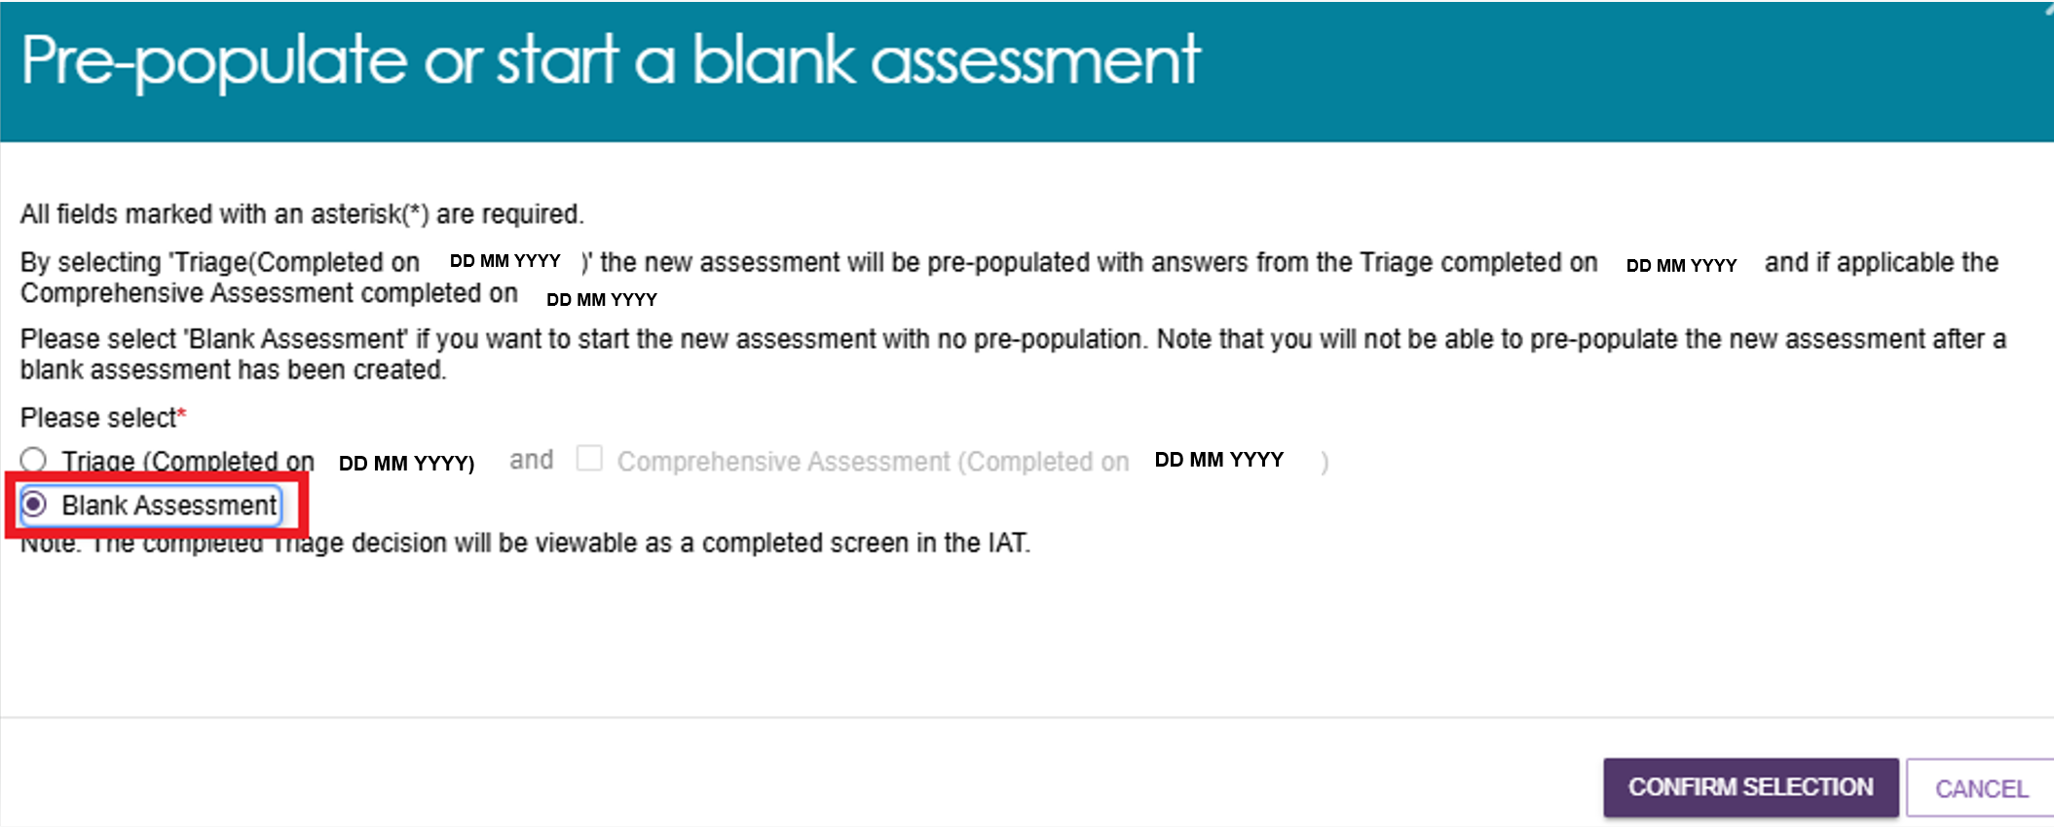
- Review and update the client’s demographic information, including:
- Whether the assessment is being completed remotely
- The client’s personal details and background
- Whether the client would prefer a First Nations Assessment Organisation (if available)
- Government identification details such as Medicare card number.
The system pre-populates these details from the triage record. Update any information if needed.
After confirming the correct details are correct, select SAVE AND CONTINUE TO ASSESSMENT.
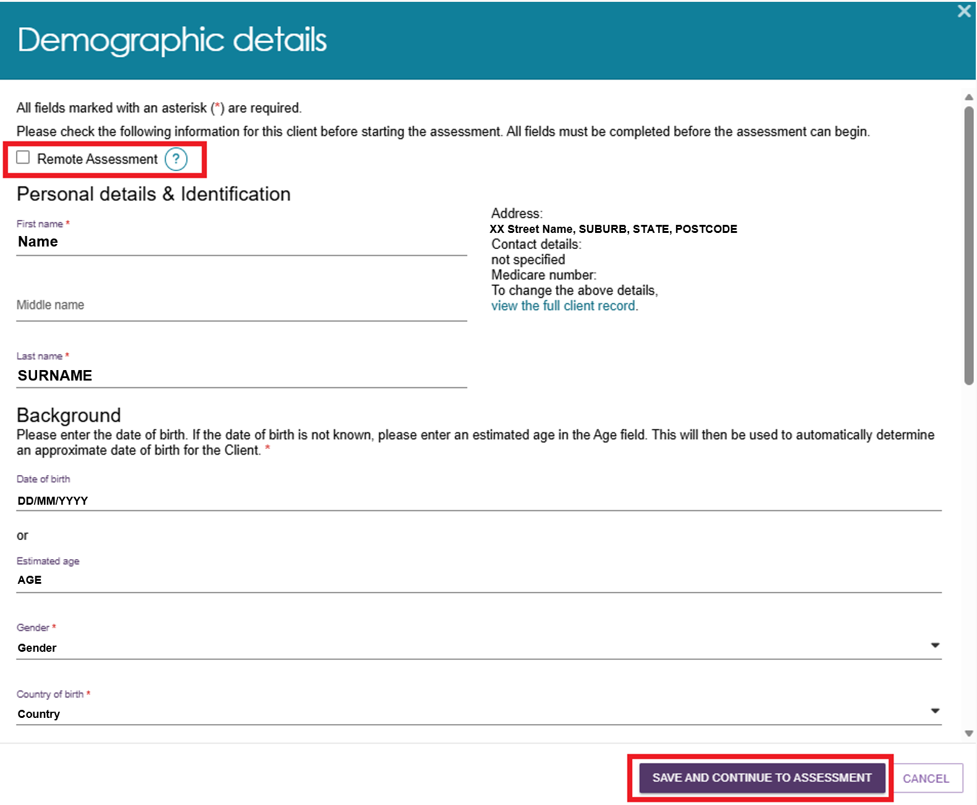
! | It is important to ensure that the client’s Aboriginal or Torres Strait Islander identity is accurately captured, as this will trigger the system to display Validated Assessment Tools that are appropriate to use with First Nations people if required.  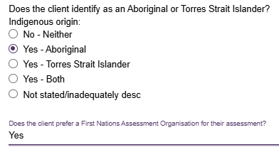  A client’s Medicare card number must be correctly entered to ensure that their My Health Record can be successfully linked if they consent to do so.  
! | Select Remote Assessment only when you complete a face-to-face assessment in a remote (MM6) or very remote (MM7) area. Recording remote assessments accurately helps improve reporting and supports future planning for clients in remote communities. To check whether a client lives in a MM6 or MM7 area, use the Health Workforce Locator:  1. Select Start the Locator Now from the home page  2. Enter the client’s address  3. The MM number displays in the Summary section.  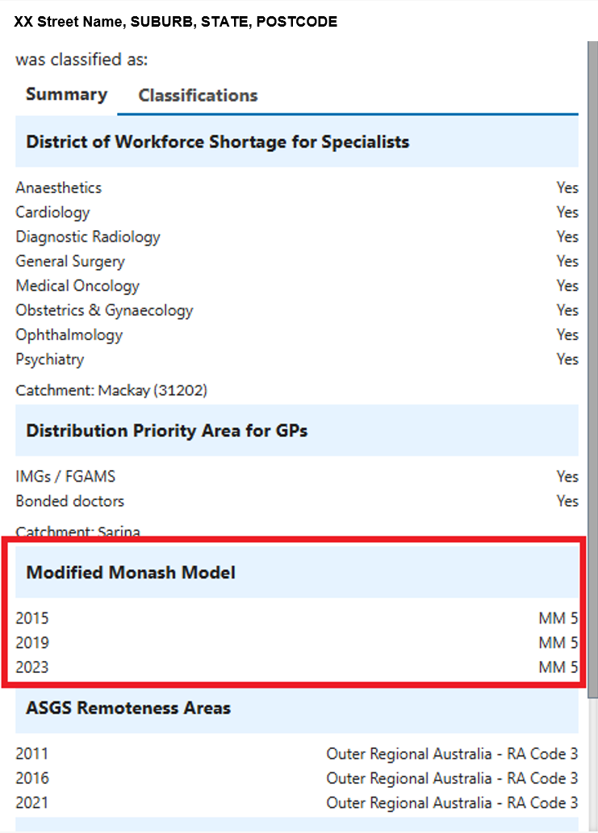
- If an assessor needs to update a client’s demographic details after they have commenced the assessment, they can do so from the CLIENT DETAILS tab of the Client Record by navigating through the FIND A CLIENT tile from the homepage.
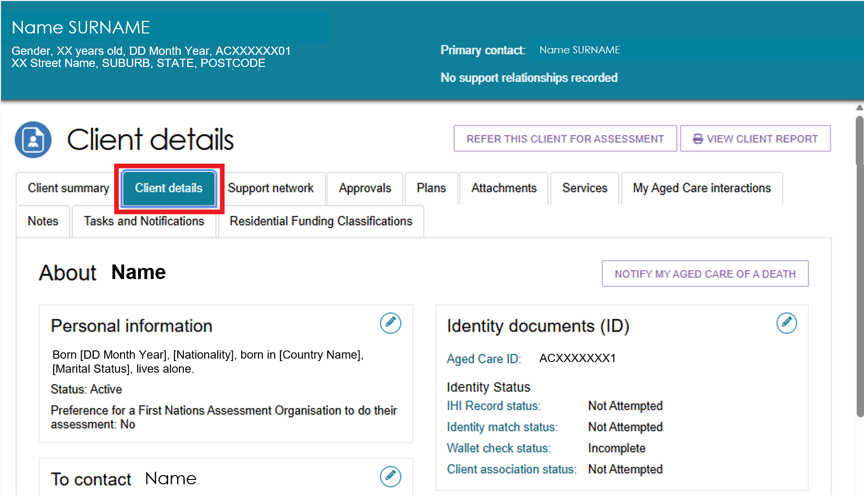
- A record of any previous screenings or assessments will be accessible through the PLANS tab of the client record under ASSESSMENT HISTORY.
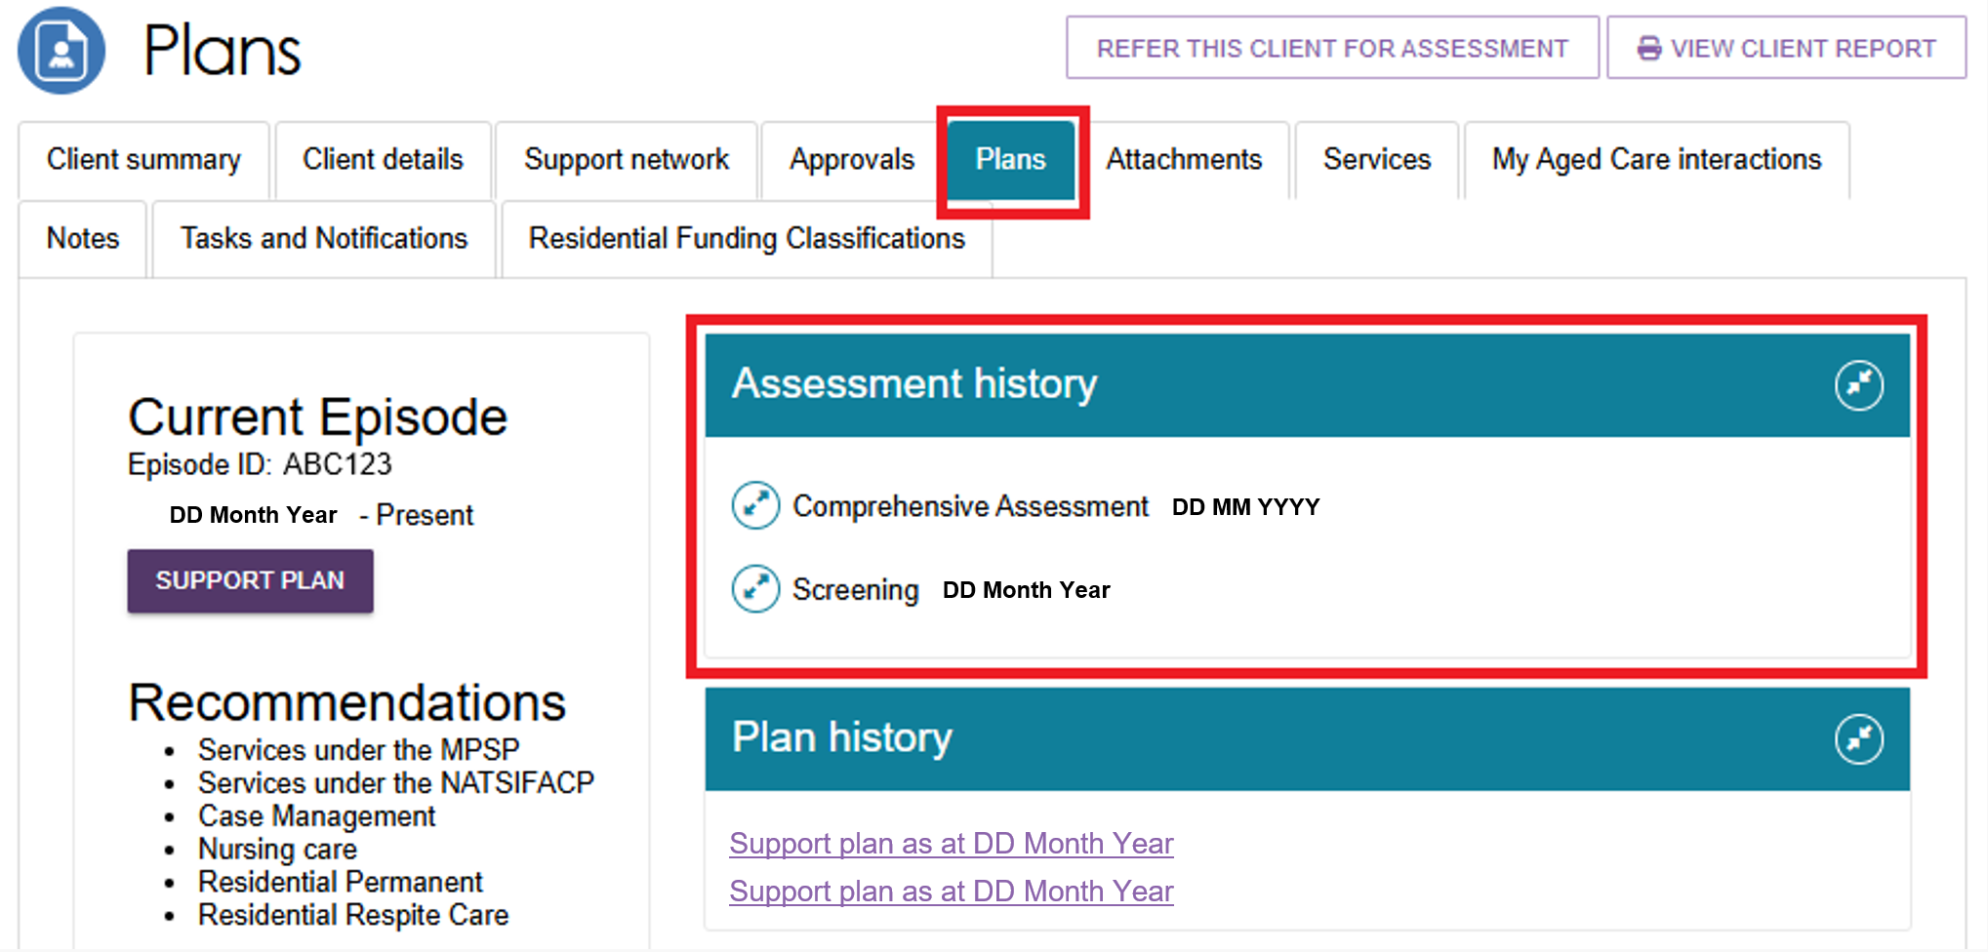

Completing an assessment
! | The Client Journey Tracker is a visual tool that shows where a client is in their My Aged Care journey and what happens next. It displays above the Client Summary. During the assessment, the client's tracker displays: "An assessment to determine care needs is in progress."  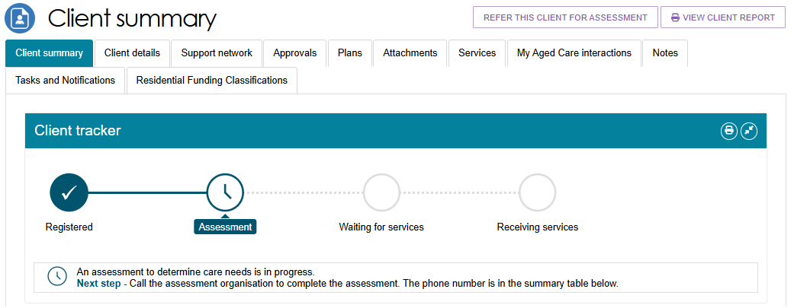
! |  | The Integrated Assessment Tool (IAT) uses an algorithm to help assessors make consistent recommendations based on a client’s needs. The algorithm analyses the client’s assessment responses and current aged care approvals, then recommends appropriate aged care services. After you finalise the IAT, the recommended services appear on the Support Plan and Services page under the Goals and Recommendations tab.  In some cases, the system also displays information messages to indicate that the client may be suitable for:  - the Restorative Care Pathway  - Support at Home  - Assistive Technology  - Home Modifications.
- When you start an assessment, the Demographic Details page opens. The system may pre-fill some information from an earlier triage, screening, or assessment. Review the details, update them if needed, and make sure all required fields are complete. When you are ready to continue, select SAVE AND CONTINUE TO ASSESSMENT.
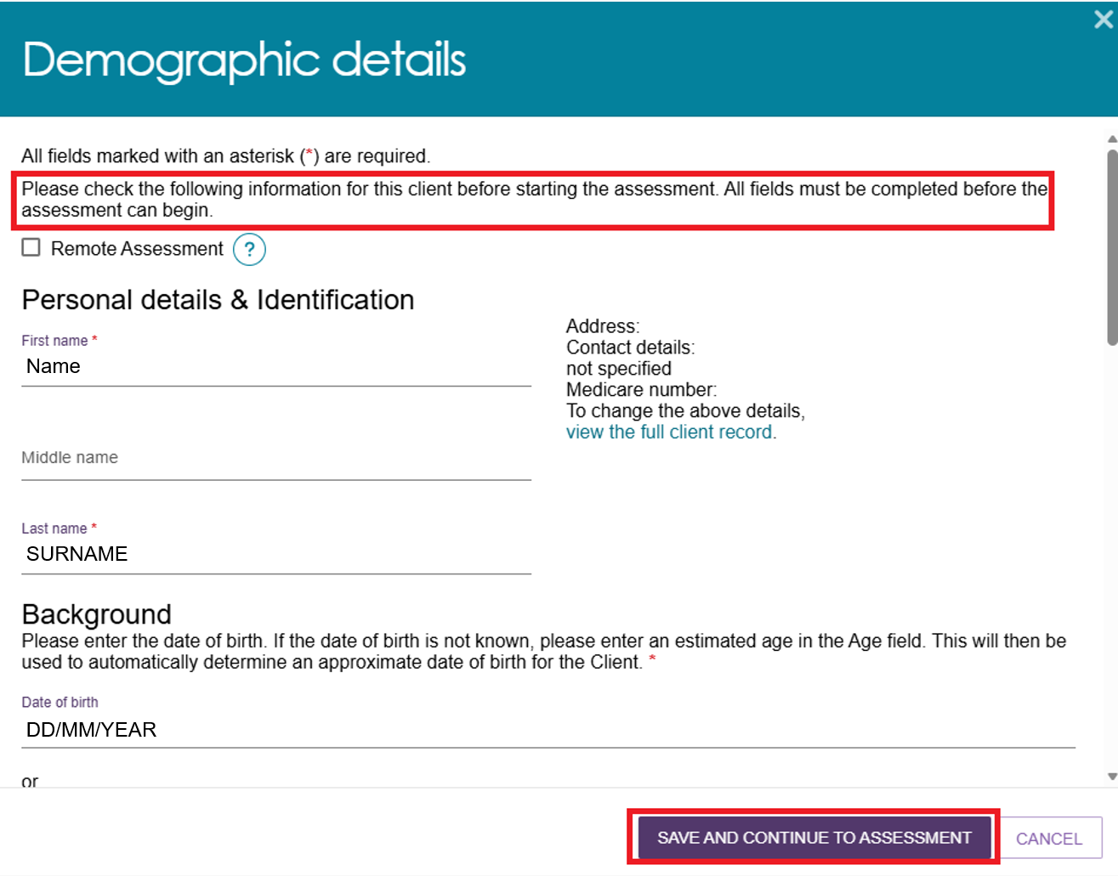
- The Assessment Details page opens. Key client information appears at the top of each assessment page for quick reference.
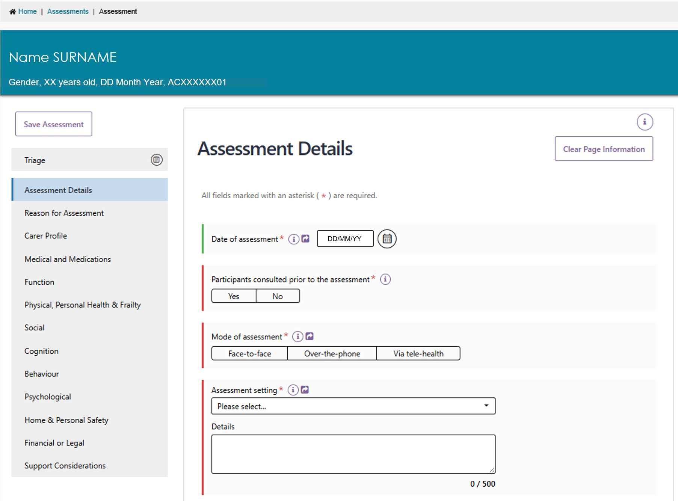
- To view information collected during triage, select TRIAGE from the navigation bar. The triage information opens in read-only mode.
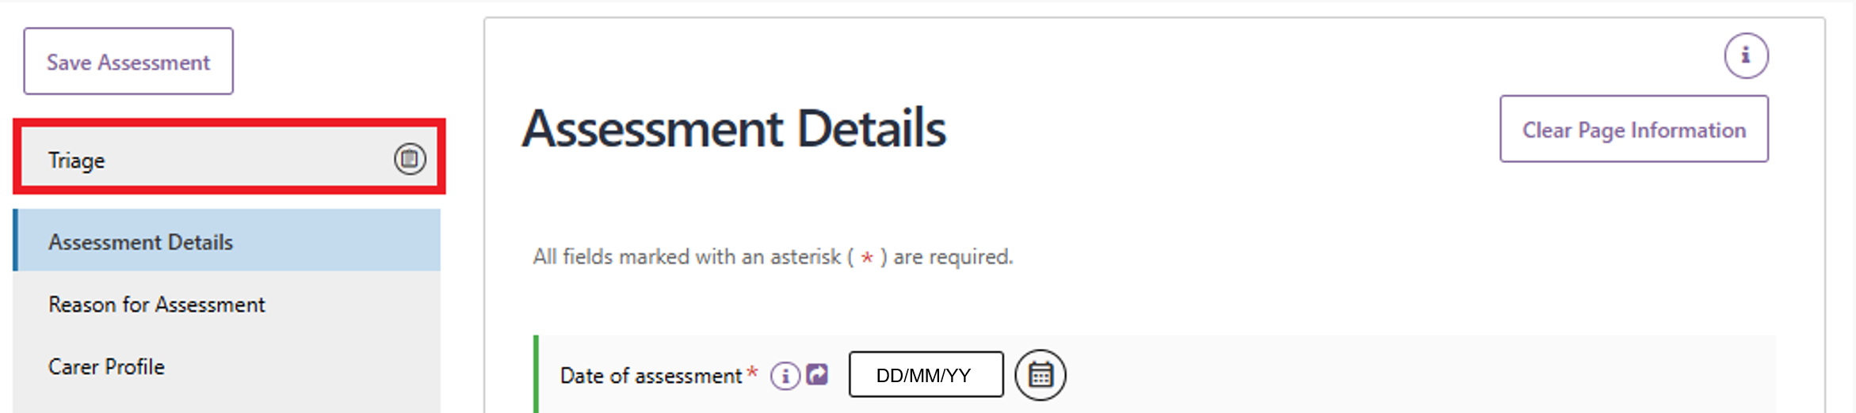
- The navigation bar moves with you as you scroll through the assessment. A tick appears next to the section in the navigation bar when you have completed that section.
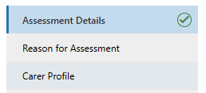
! | To protect client information, the system automatically logs you out after a period of inactivity. If there is no activity for 25 minutes, the system displays a warning message. If the system remains inactive for another 5 minutes, it automatically logs you out. You will then need to log in again before continuing the assessment.

Assessment features
- To remove any information you have entered on the current page, select Clear Page Information in the top-left corner of the page.
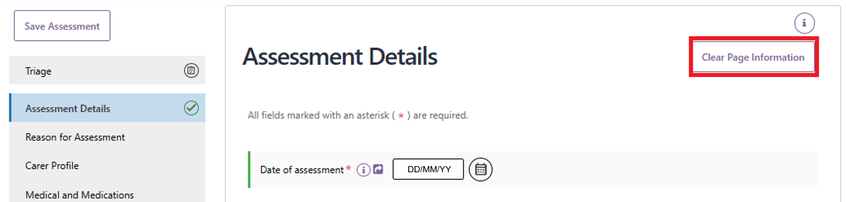
- A pop-up message appears. Select Yes, clear page information. To remove all information entered on the page.
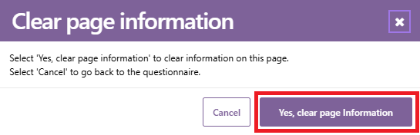
! | Pages that do not contain Validated Assessment Tool triggering questions will only give you the options to Clear Page or Cancel. On pages that contain Validated Assessment Tools trigger questions, you also have the option to select Clear All.  When you select Clear Page, the system shows a progress indicator while it removes the information. Clearing the page also removes any selected check boxes that triggers the display of a Validated Assessment Tool.  To clear information entered in a Validated Assessment Tool, either select Clear All, or go to the page where the tool is located and select Clear Page Information.
- Visual indicators help you complete the form. If you have not answered a required question, a red line appears beside the field. Once you answer the required question, this line changes to green.
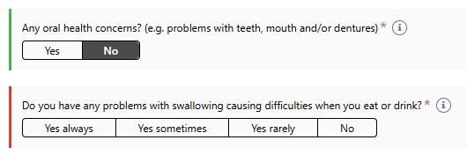
- Some answers require you to provide additional information. When this happens, a red asterisk (*) appears next to the relevant field to show that it is now required.
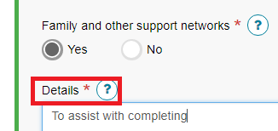
- Some answers may trigger additional questions. Complete these questions to provide more information about the client’s needs based on the response you selected.
- Select the Information icon next to a question to view on-screen help text. The help text remains open until you select the X to close it or open a different help text box.
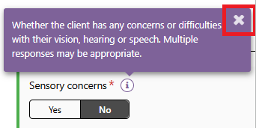
- At the bottom of each page, select both required checkboxes:
- ‘I have reviewed the information on this page and I confirm that it is correct.’
- ‘I have confirmed that any required goals are added to the Support Plan.’
To continue, select Next in the bottom-right corner of the page, or choose the next section from the navigation bar. The system automatically saves your assessment information as you move between pages.
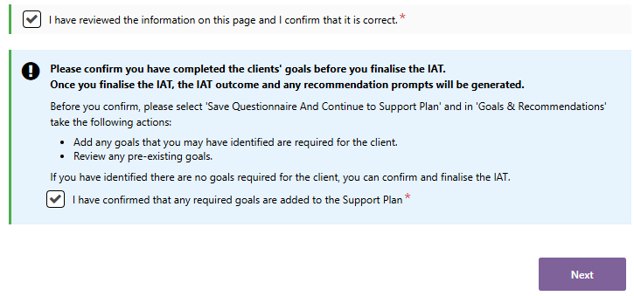
- When you complete all required questions on a page, marked by an asterisk (*) and a red line, a green tick appears next to that section in the navigation bar to show it is complete.
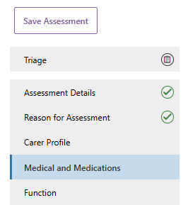

Clinical attendance (for non-clinical assessors)
The IAT uses threshold questions to identify when a client may need a more detailed clinical or comprehensive assessment. These questions are highlighted with a blue banner.
Your answer to a threshold question may trigger additional clinical questions.
For example, if you answer No to the question "Is the client managing urinary incontinence issues?", the system displays additional questions that require input from a clinical assessor.
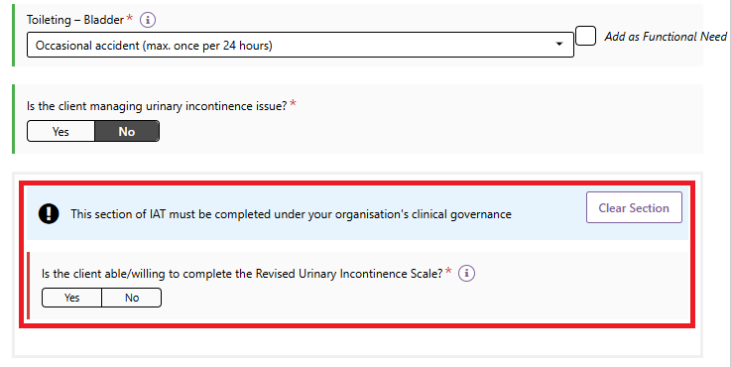
Non-clinical assessors can only complete these questions through the clinical attendance process, in line with their assessment organisation’s clinical governance framework.
To complete these questions:
- Select Yes to confirm that you are completing this section of the IAT under your organisation’s clinical governance arrangements.
- Enter or select the name of the supervising clinical assessor who provided the clinical attendance.
- Select SAVE DETAILS.
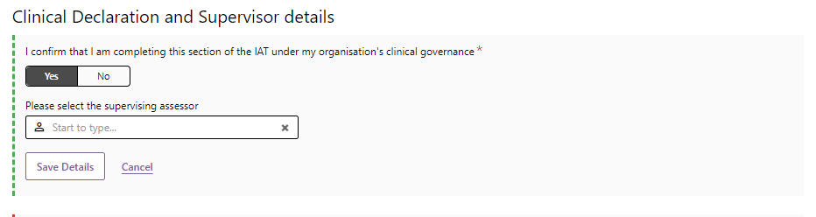
After you save the details, the supervising clinical assessor’s information appears in the IAT. You can then continue completing the assessment with clinical supervision.
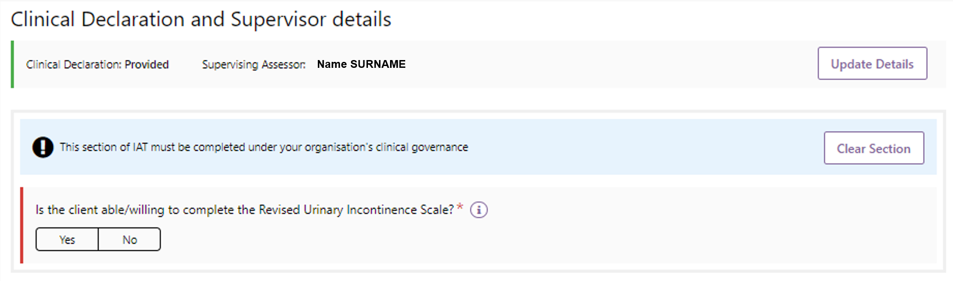

Health Conditions
In the Medical and Medications section, add the client's health conditions by searching for the condition name or code.
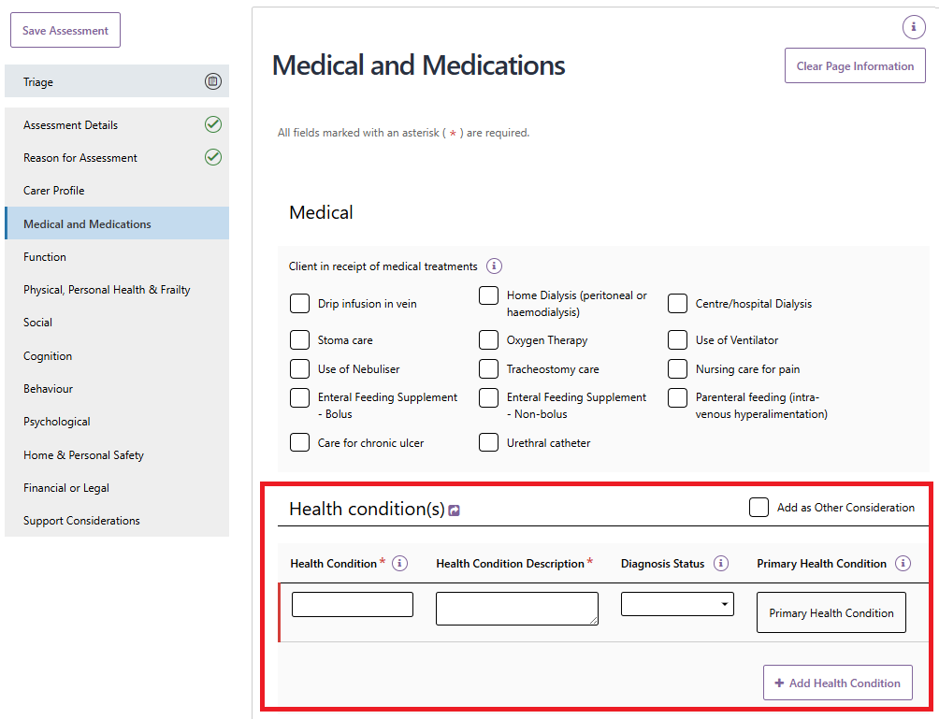
You can add up to 10 health conditions for each assessment.
Start typing in the search field and select the appropriate health condition from the list of options.
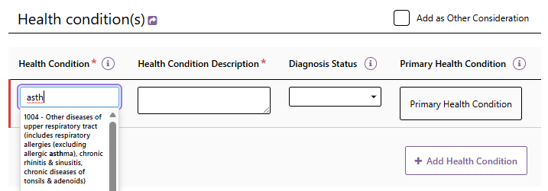

After selecting a condition, update the description if needed to reflect the client's circumstances and choose the relevant Diagnosis Status.
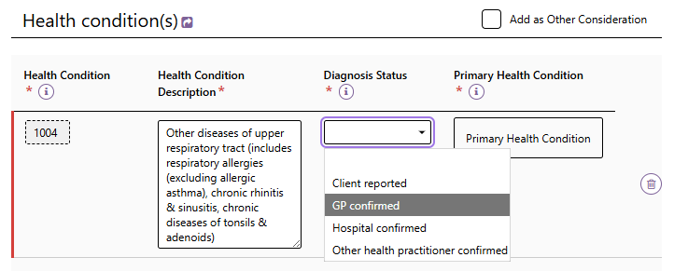
To add another health condition, select + Add Health Condition. To remove a health condition, select the bin icon.
You must also identify the client's Primary Health Condition. You can choose to include health conditions as Other Considerations in the client's Support Plan.
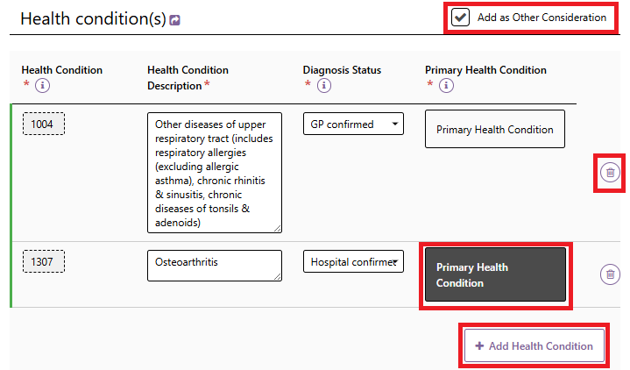

Adding Identified Needs
As you complete the assessment, you can add information to the client’s Support Plan by selecting:
- Add as Functional Need
- Add as Complexity Indicator
- Add as Other Consideration
- Add as Recommendation.
When available, these options appear as checkboxes on the right-hand side of the relevant IAT questions.
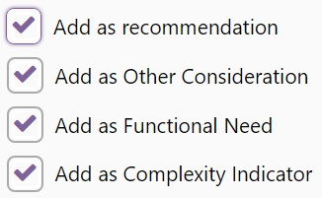
Add As Functional Need example
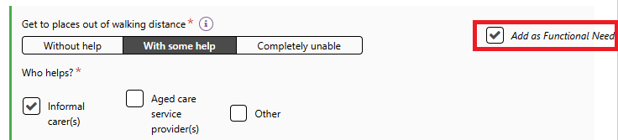
Add As Other Consideration and Add as Recommendation examples
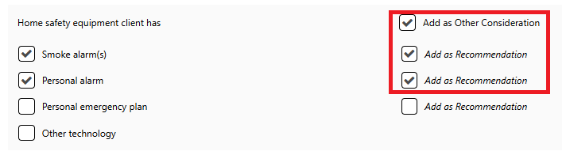
In some cases, the system automatically selects these checkboxes based on the answers you enter.
For example, if a client has an assistance dog, is eligible for and able to access the Physical Assistance Dogs Program, and the dog meets the HealthDirect definition of an assistance dog; the system automatically adds Assistive Technology – Assistance Dog as an Other Consideration in the Support Plan.
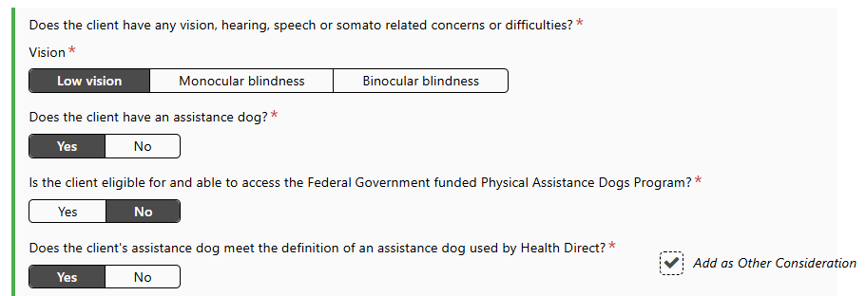
You can also add Assistive Technology and Home Modifications as Other Considerations in the Support Plan.
The system displays this option at the end of seven assessment topics:
- Medications
- Function
- Physical Personal Health and Frailty
- Social
- Cognition
- Psychological
- Home and Personal Safety.
Use this option to identify whether the client may need funding for assistive technology or home modifications.
When you select this option, the Add as Other Consideration checkbox is automatically selected and cannot be changed.
When you select these checkboxes, the information appears in the relevant sections of the client’s Support Plan.
Functional Needs, Complexity Indicators, and Other Considerations appear on the Other Considerations tab and in the Assessment Summary.
Recommendations appear on the Goals & Recommendations tab.
! | Remember to add any Assistive technology and Home modifications considerations to the client’s support plan. Refer to My Aged Care – Assessor Portal User Guide 7 – Completing a support plan and support plan review.

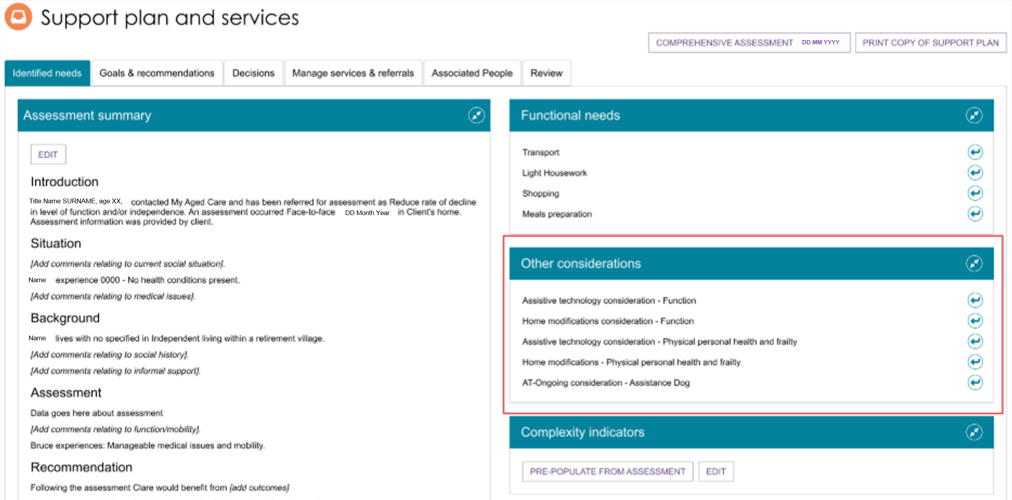

Viewing and adding carers in the assessment
You can view, add, and update carer information directly from the assessment without returning to the client record.
  - In the navigation menu, select Carer Profile, then select View/Add Carers.
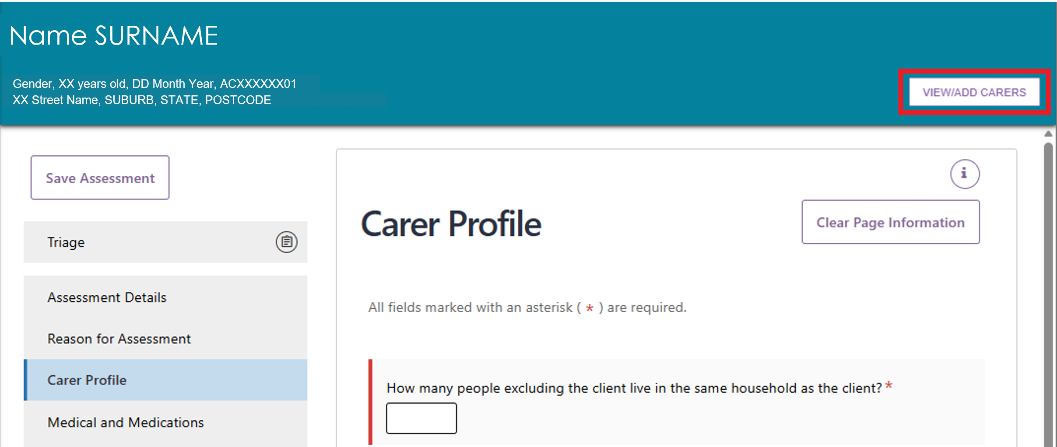
  - A pop-up window opens and displays any carers already linked to the client. To add a new carer, select Add a Carer.
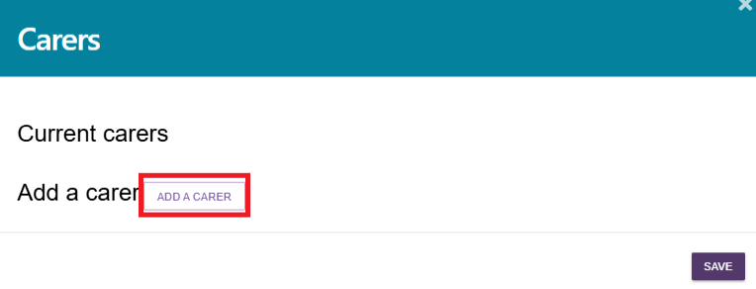
  - Enter the person's first and last name, then select Search. To search using more information, select Show More Search Fields and enter the available details.
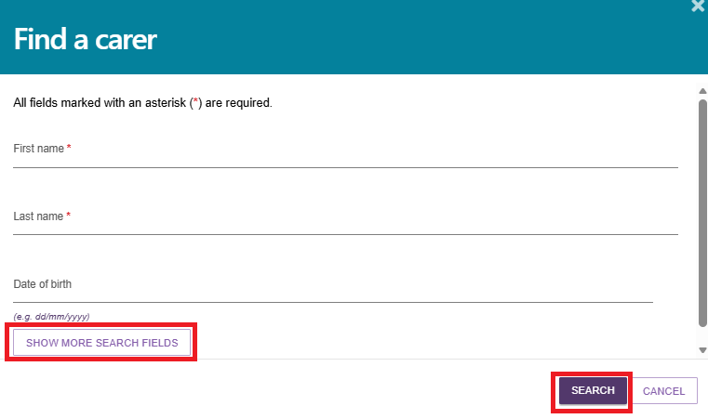
  - If the person already has a record, they appear in the search results. Select the radio button next to their name to open additional fields, including client consent, carer consent, and the carer's relationship to the client. Then select Add.
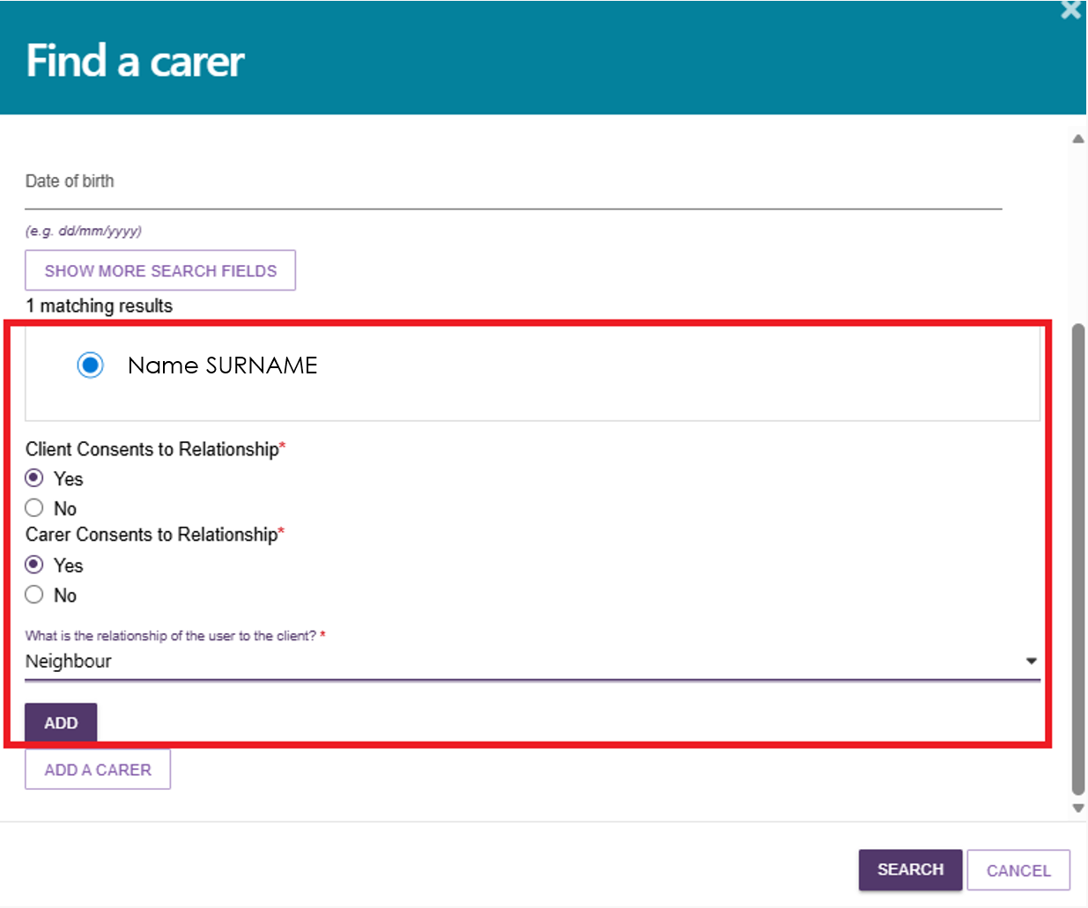
  - A confirmation message appears to let you know that you have successfully added a carer.
Select Save to save your changes.
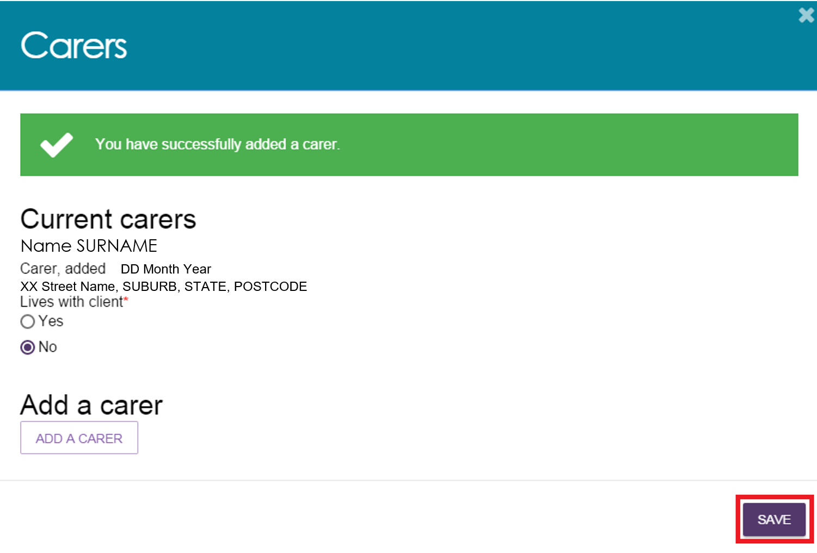
If there are no results, or you want to add a different carer, select ADD A CARER.
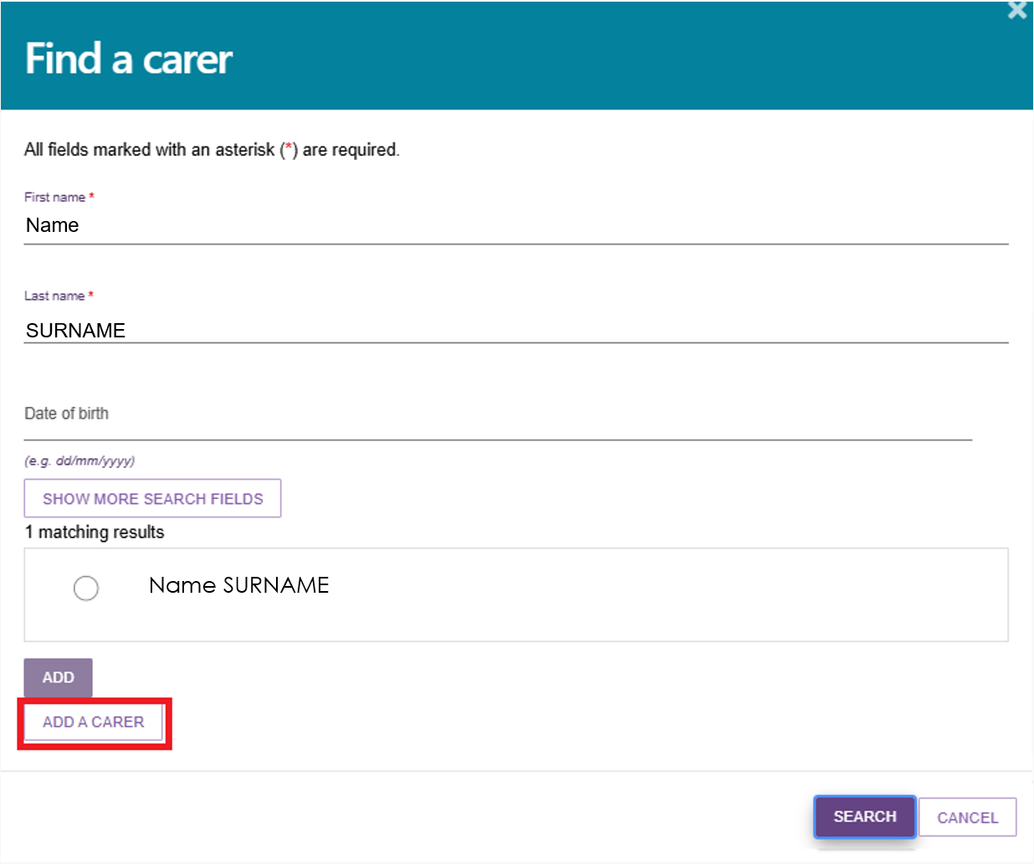
  - Enter all required information about the carer, including confirmation that both the client and the carer have consented to the relationship. Then select Save.
At this stage, consent is only required to create the client-carer relationship in the My Aged Care system. Once you create the relationship, the carer appears in the client’s support network and becomes available to add to the client’s support plan later.
You must obtain consent for any future changes to the client-carer relationship.
For information about recording consent for referrals or call-backs from the Carer Gateway and/or National Dementia Helpline, go to Assessor Portal User Guide 2 – Registering support people and adding relationships.
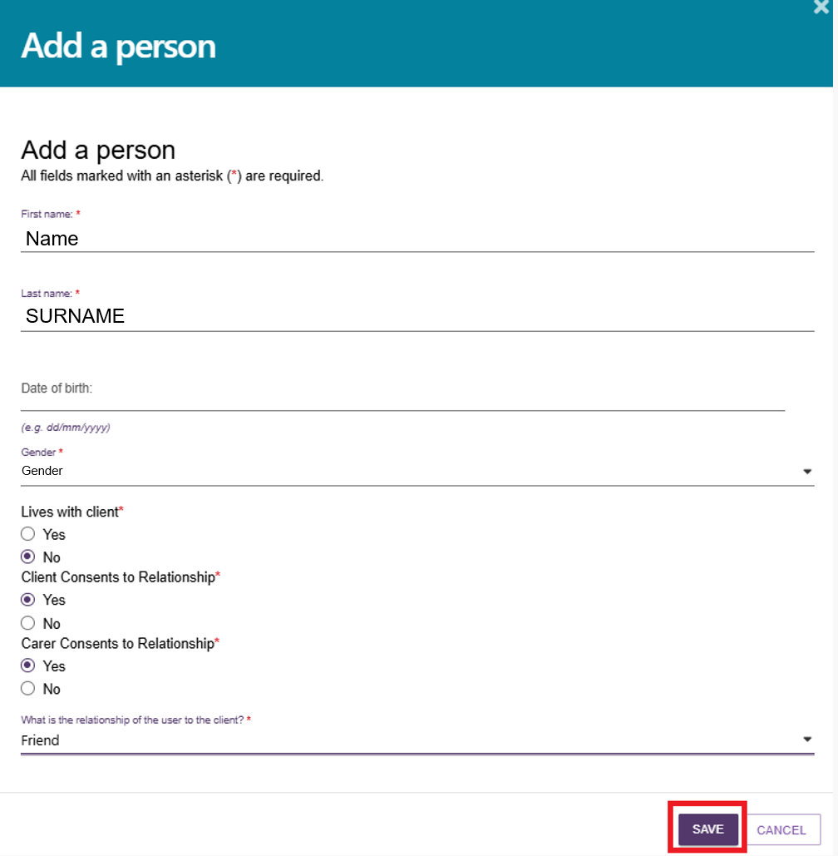
  - A confirmation message appears to confirm that you have successfully added a carer.
Select Save to save your changes.
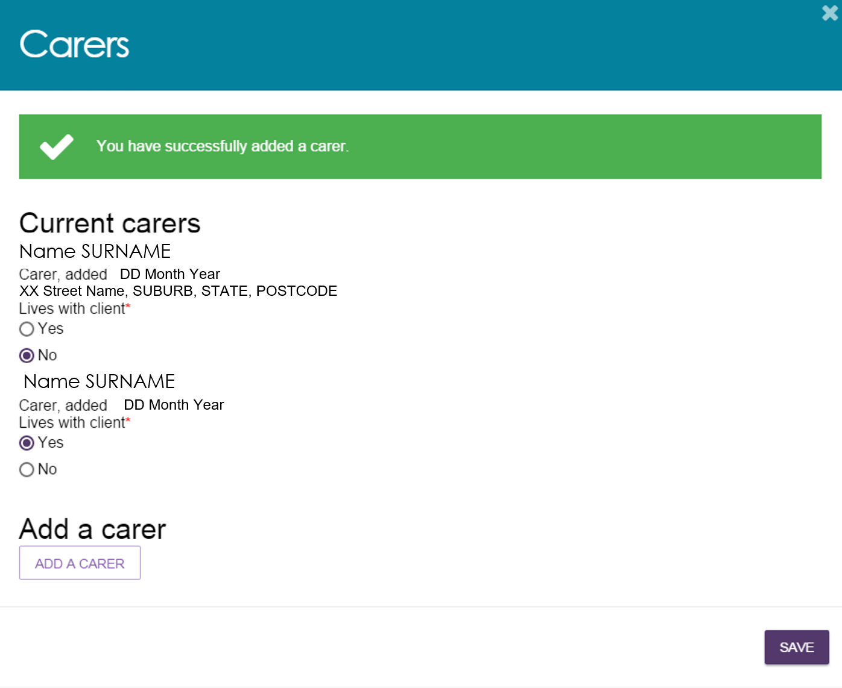

Adding a Sensitive Attachment in the assessment
Assessors can add sensitive client information as part of the assessment.
- To download the Sensitive Attachment Form, go to the Support Considerations section of the IAT and select Download Sensitive Attachment Form.
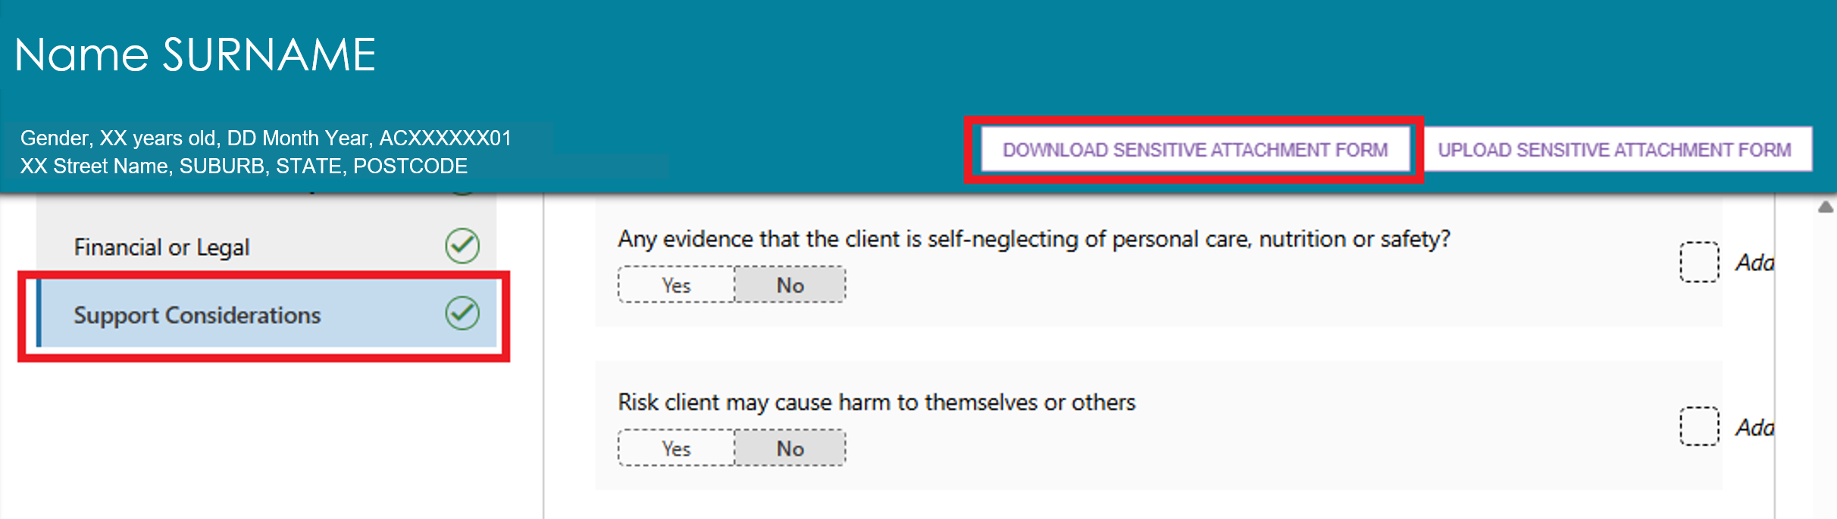
You can also download the form from the Forms tab in the Reports & Documents section of the assessor portal.
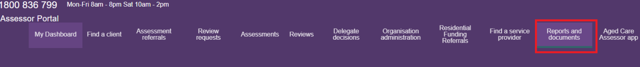
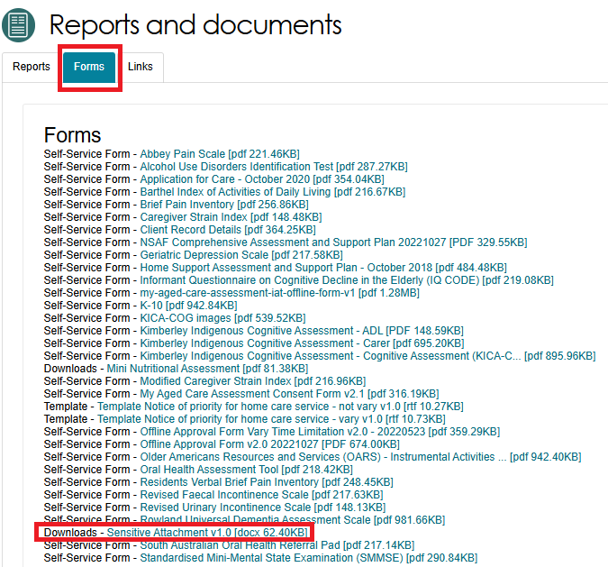
Once downloaded, the Sensitive Attachment form will display.
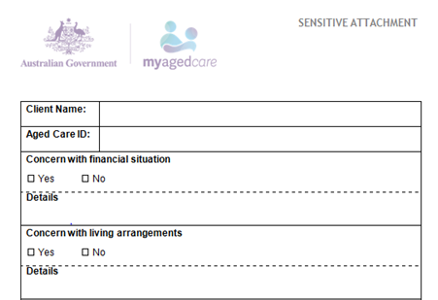
- Complete the form, then upload it by selecting Upload Sensitive Attachment Form on the Support Considerations page. You can also upload it from the Attachments page by selecting Add an Attachment.
Support Considerations page of the IAT assessment
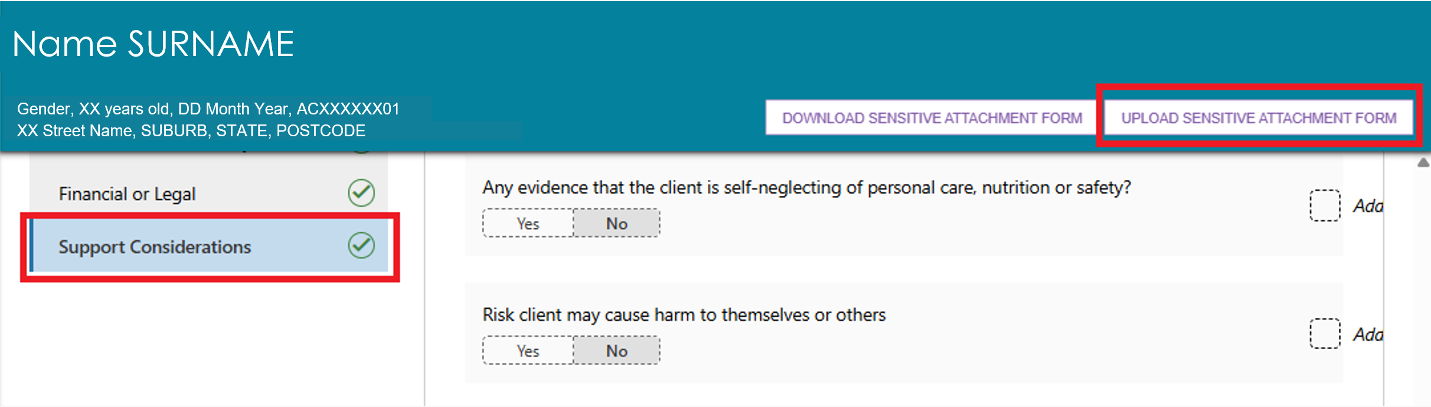
Attachments Page
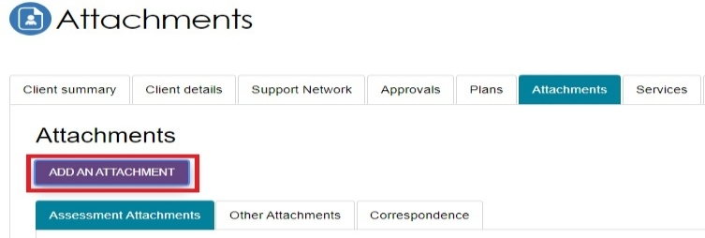
- The Upload sensitive attachment pop up, or the Add an attachment pop up, appears. Enter the required details for the attachment.
If you are using Add An Attachment, select either Sensitive Attachment or Sensitive Client Status as the attachment type.
Select Upload to submit the file.
Upload sensitive attachment pop up
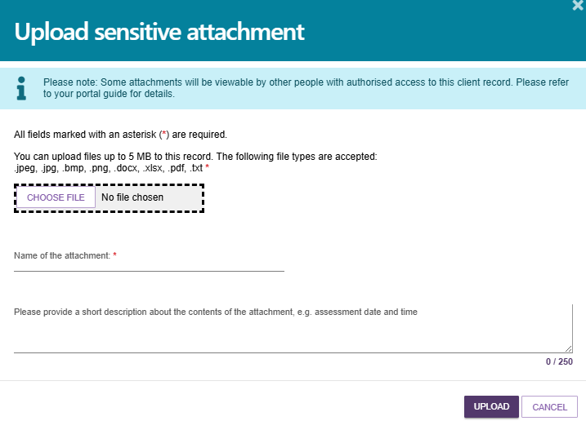
Add an attachment pop up with the Type Of Attachment drop down expanded
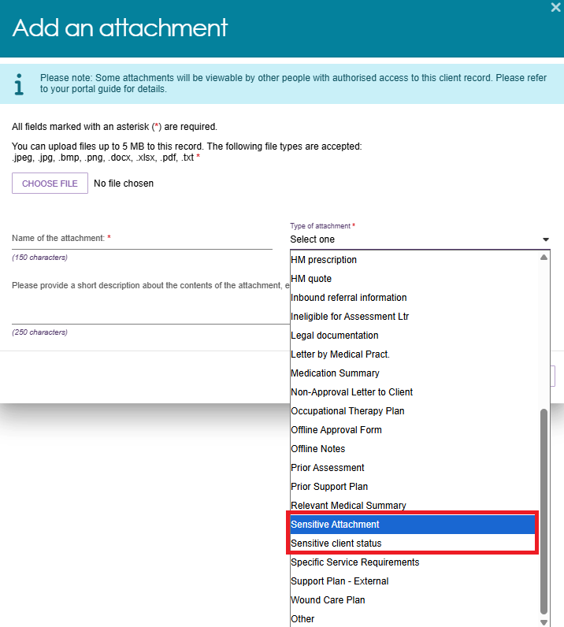
- Once successfully uploaded, a green banner will display at the bottom of the screen.
- The sensitive attachment appears in the Other Attachments tab on the client's Attachments page. The client's personal details section also displays a Sensitive Attachment indicator.
If you do not want the attachment and its details to appear on the Attachments page, select Hide from View.
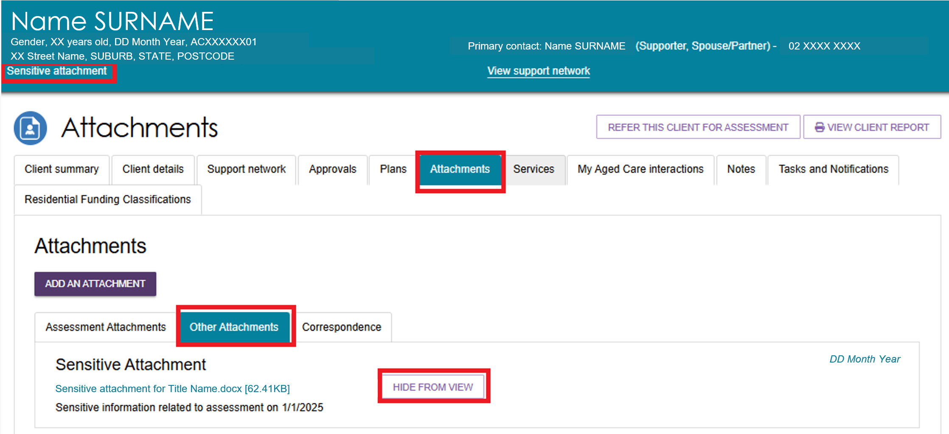
! | If you add a Sensitive Attachment during the assessment, record this on the Support Considerations page.  Sensitive attachments are only visible to My Aged Care contact centre staff and assessors. Clients cannot view them through their My Aged Care online account, and service providers cannot access them directly.  When a service provider accepts the client's referral, the system notifies them that sensitive information is available. The provider can then contact the client's assessor or the My Aged Care contact centre to request access to the information.  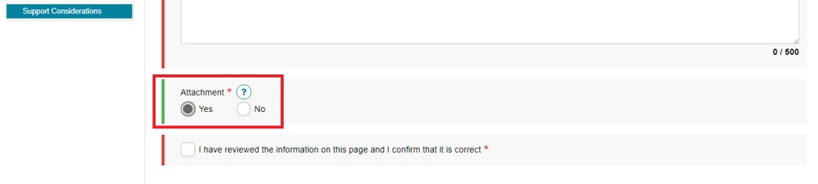

Navigating the Validated Assessment Tools
- Use Validated Assessment Tools (VATs) to help assess a client's needs. The system includes a range of VATs, with some built directly into the Integrated Assessment Tool (IAT) and others available as optional tools when needed. For example, the Duke Social Support Index is built into the Social section of the IAT.
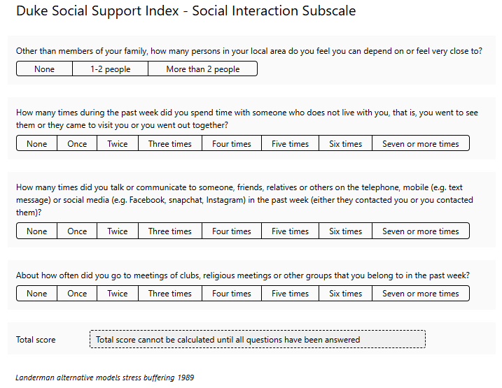
- Some Validated Assessment Tools (VATs) only appear when the client's responses indicate they may be relevant and the client agrees to complete them.
For example, the Revised Urinary Incontinence Scale appears when the client's responses indicate urinary incontinence and the client is willing and able to complete the tool.
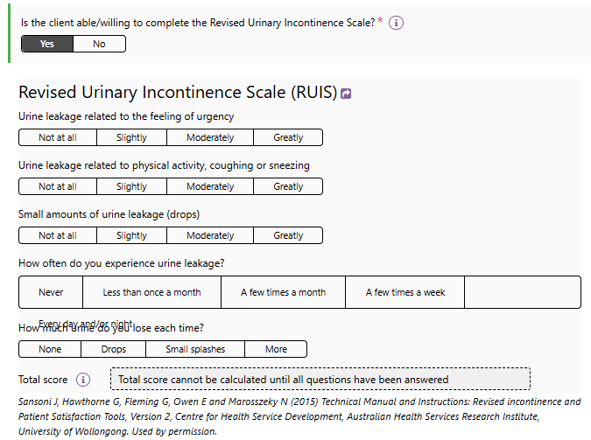
- The system automatically calculates the total score for these Validated Assessment Tools (VATs) based on the client's responses.
Your assessment organisation can also choose to use other validated assessment tools that are not included in the IAT. If you use these tools, upload the completed forms as attachments to the client's record.
You can download blank copies of these tools from the Reports & Documents section of the assessor portal.
- If you need to remove responses from a Validated Assessment Tool (VAT), select the eraser icon to clear the tool's responses.
! | Assessors must complete all required screening tools in the Cognition section.  If the client does not have a confirmed dementia diagnosis and does not complete either Step 1 GP-Cog or Step 2 GP-Cog, you must record the reason why the client did not complete the cognitive screening tool.  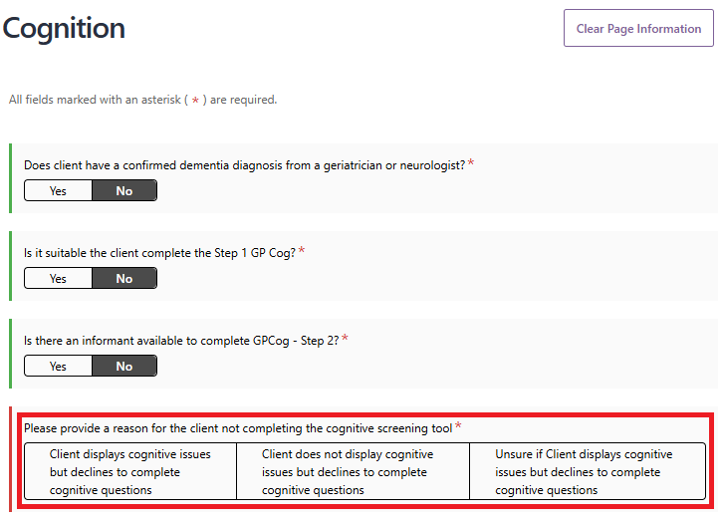

Modified de Morton Mobility Index (DEMMI) and Residential Respite Care (Clinical assessor)
The IAT includes a validated assessment tool called the Modified de Morton Mobility Index (DEMMI-Modified).
Only clinical assessors can complete this tool, and they must do so during a face-to-face assessment when assessing a client's needs for residential respite services.
Non-clinical assessors must not complete the DEMMI-Modified, including under clinical attendance arrangements.
The information collected through the DEMMI-Modified contributes to the Australian National Aged Care Classification (AN-ACC).
- In the Function section of the IAT, answer the question: Are you likely to recommend residential respite care? Select Yes or No.
If you select Yes, the system asks a second question: De Morton Mobility Index (DEMMI)? Select Yes or No.
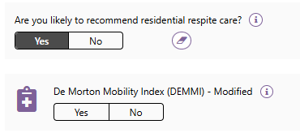
- If you answer Yes to the above question, you must complete the DEMMI-Modified assessment.
The DEMMI-Modified will appear in the navigation bar below the Function section.
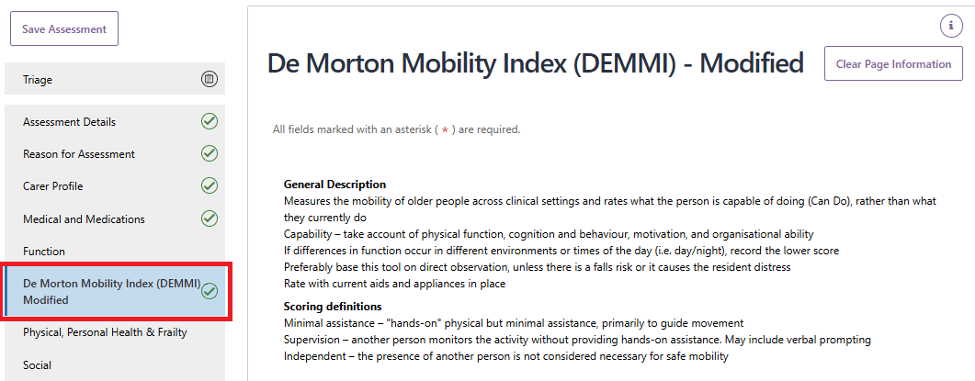
- Complete the four sections of the DEMMI-Modified by selecting the option that best reflects the client's mobility.
- Bed
- Chair
- Static Balance (No Gait Aid)
- Walking.
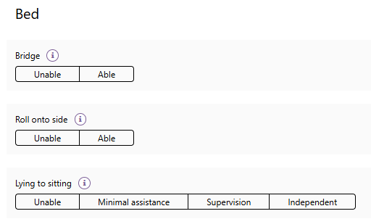
- Select the Help icon to reveal help text.
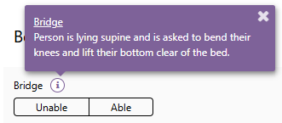
- Select the Eraser icon to clear your answer.

- After completing all required sections, confirm that the information on the page is correct and that you have added any required goals to the Support Plan. Then select Next.
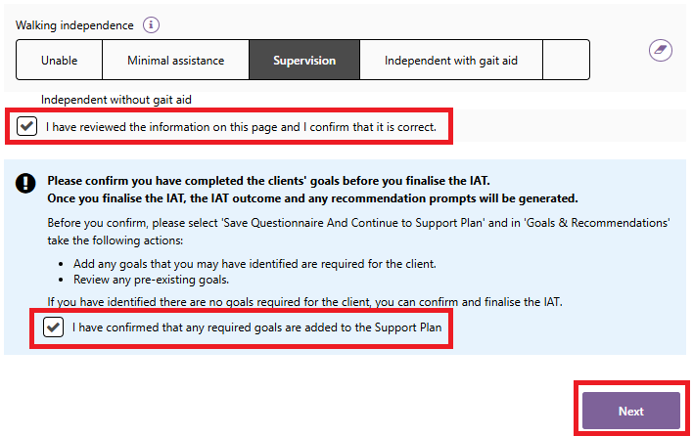

- Continue completing the assessment and submit your recommendation for residential respite care for delegate approval.
If you recommend residential respite care without completing the DEMMI-Modified, the system prompts you to select a declaration checkbox and to enter a reason for not completing the DEMMI-Modified.
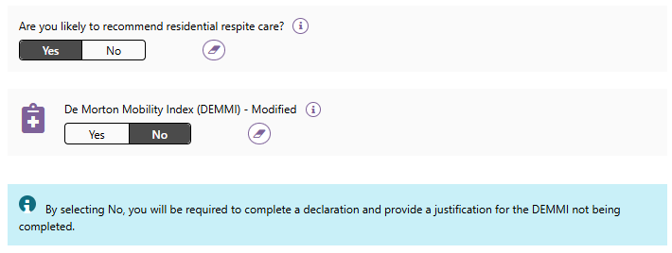
The Add Care Type for Delegate Decision pop-up displays the declaration checkbox and the field where you enter the reason for not completing the DEMMI-Modified.
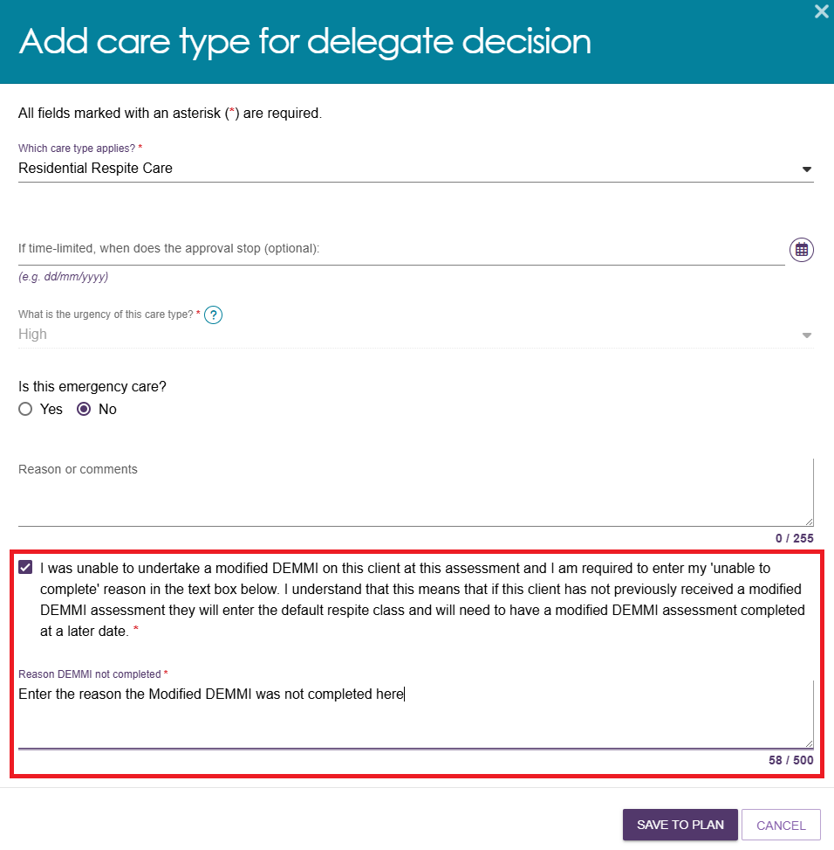

Saving an assessment
- If you are not ready to finish the assessment, select Save Assessment to save your progress.
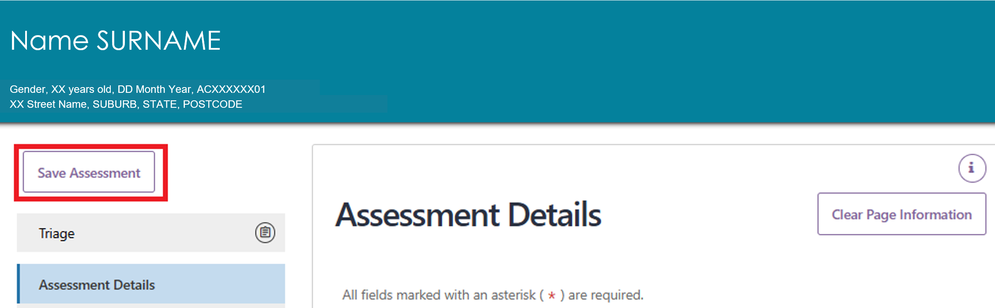
- The system displays a green confirmation message to let you know the assessment has been saved successfully.
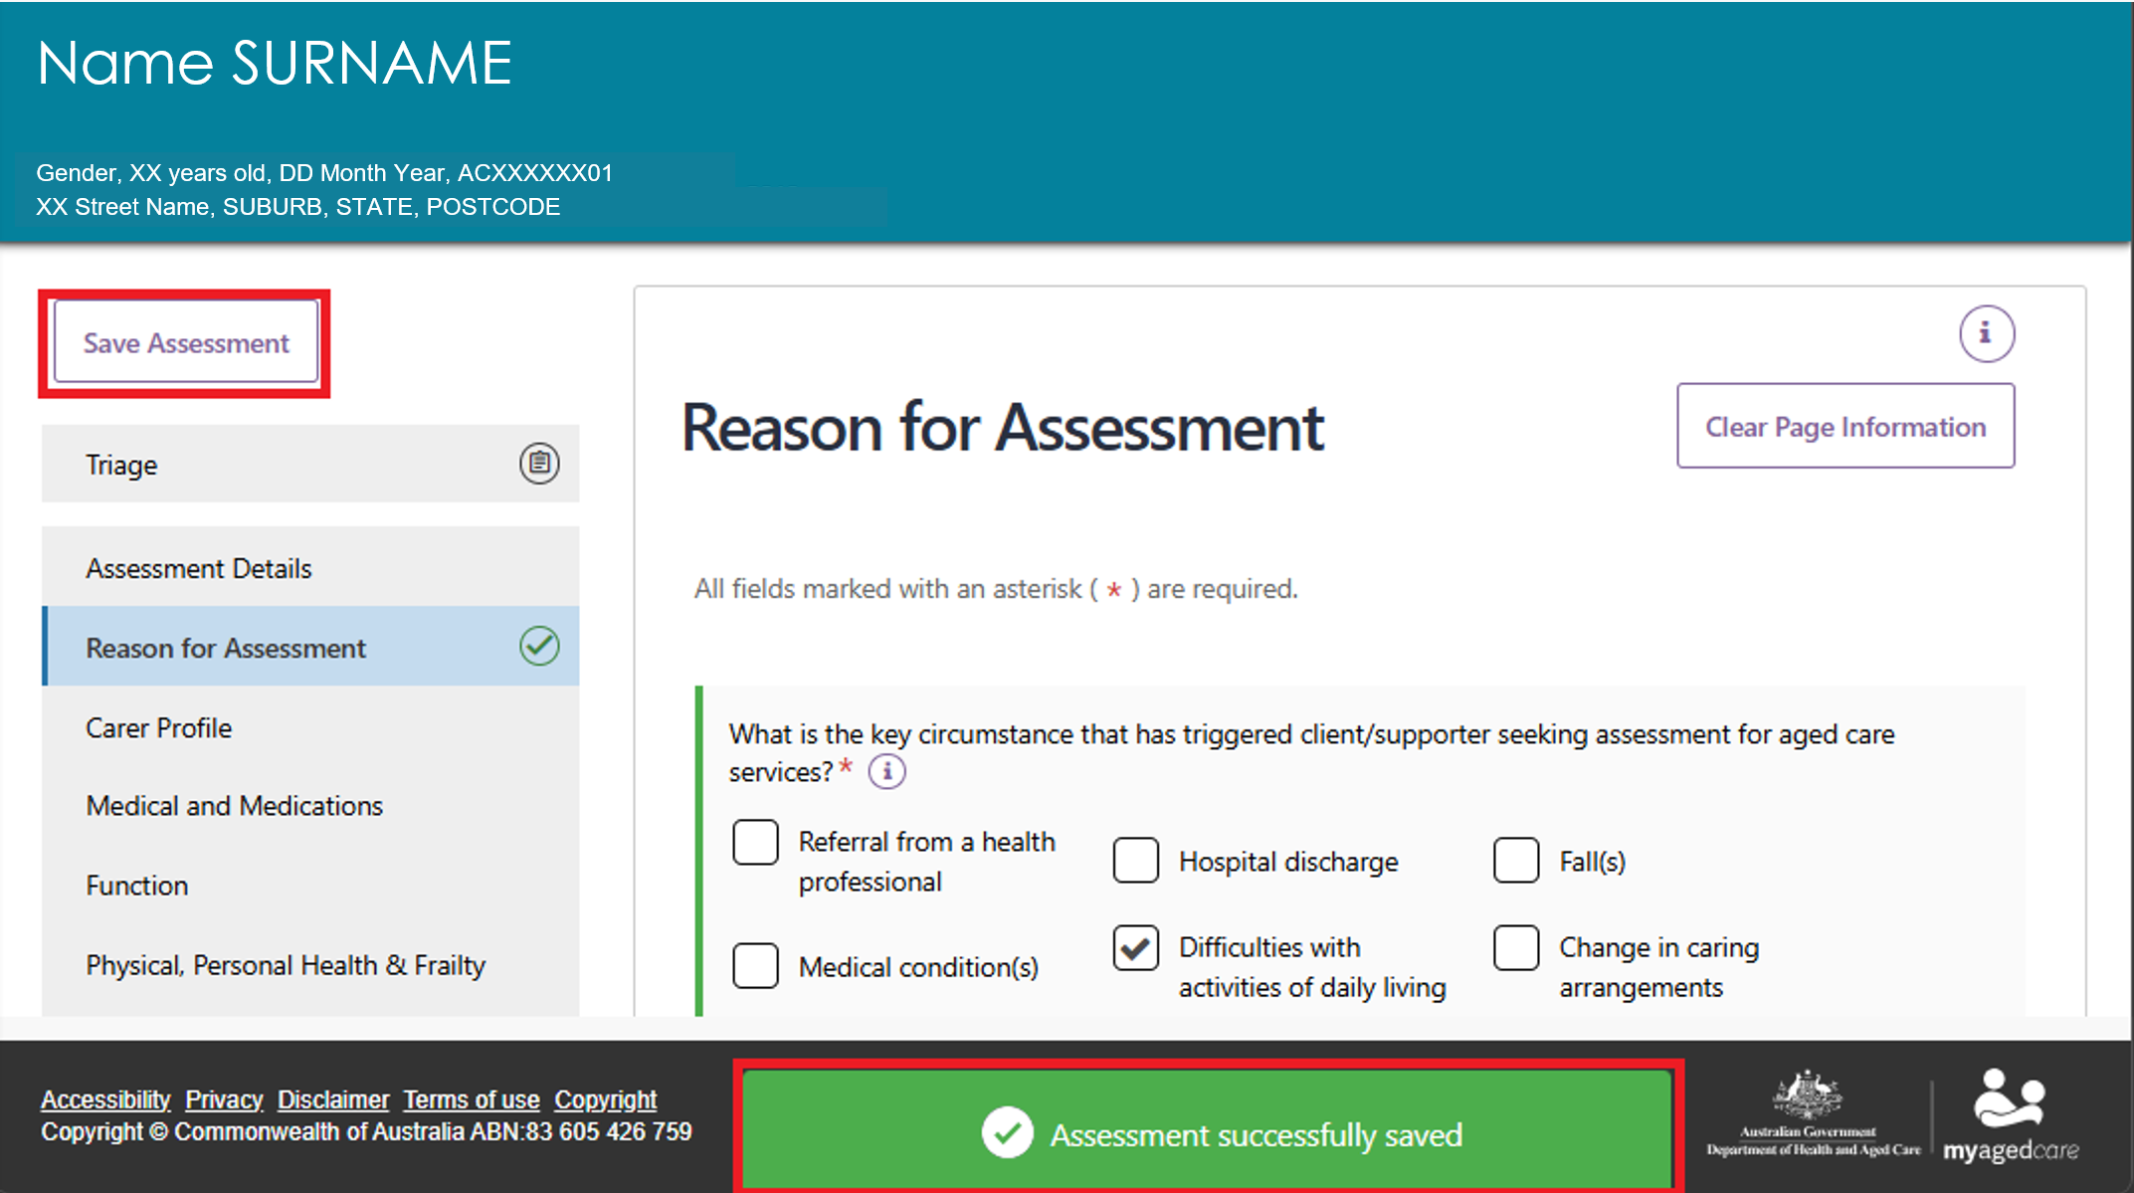
- You can return and continue the assessment at a later time. If you want to work on the support plan before finishing the assessment, select Save Questionnaire and Continue to Support Plan at the bottom of the page.
- The assessment appears in the Assessment In Progress section of your Current Assessments tab.
To help prevent data loss, the system also saves your work automatically at regular intervals, including when the portal is idle.
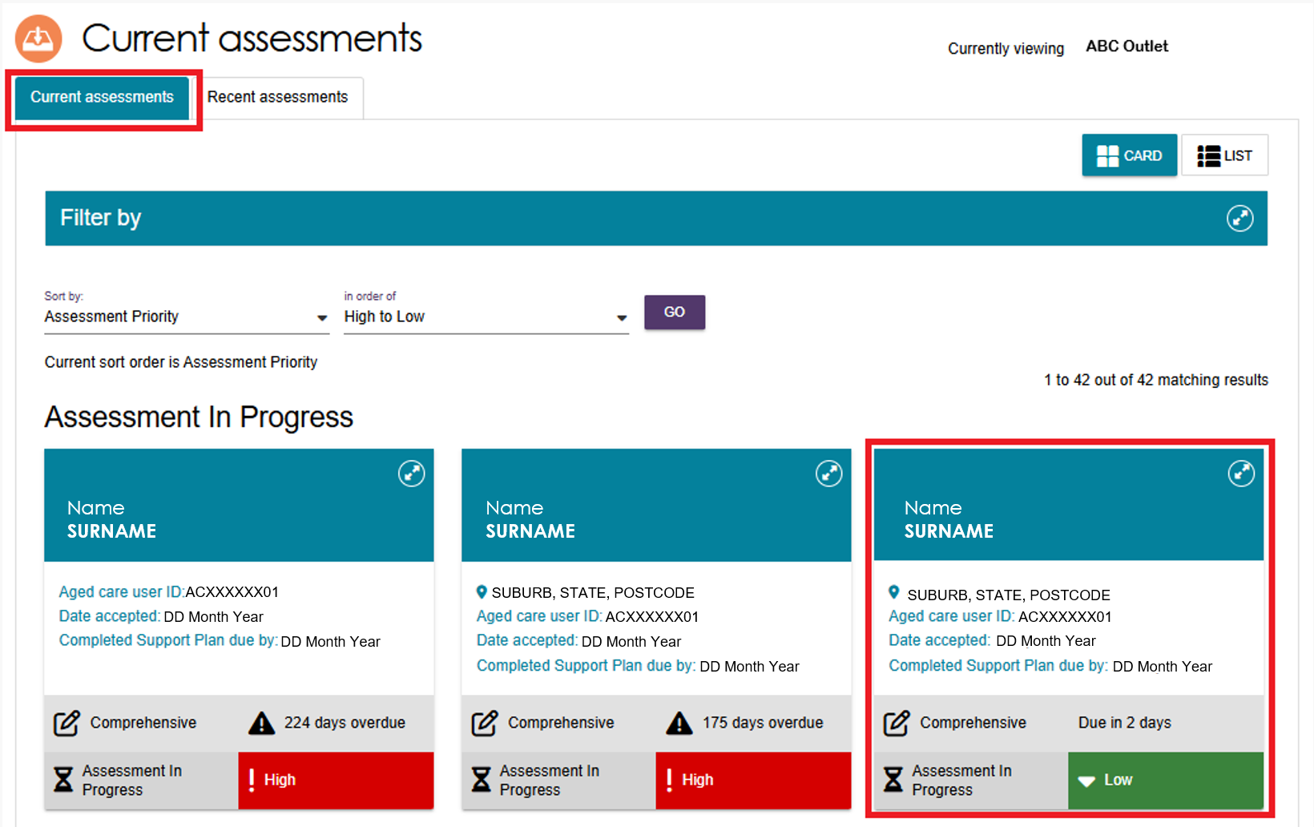

Finalising the IAT
- Before you finalise the IAT, make sure you have recorded and completed the client’s goals.
For more information about goals, refer to My Aged Care – Assessor Portal User Guide 7 – Completing a support plan and support plan review
- When you have completed all required assessment questions, select Finalise IAT and Go to Support Plan at the bottom of the assessment page.

- The system then displays a pop-up asking whether the client consents to sharing their support plan through My Health Record. The pop-up includes:
- information about sharing the support plan
- guidance on when and how to obtain consent, including whether the client has the capacity to provide informed consent
- a consent script to read to the client
- options to record consent for service referrals and consent to share the support plan through My Health Record.
! | A client can withdraw their consent at any time by calling the My Aged Care Contact Centre on 1800 200 422.  Assessors can also update a client's consent through the Client Details tab in the client record.  For more information regarding this please refer to the My Aged Care – Assessor Portal User Guide 4 – Navigating and updating the client record.
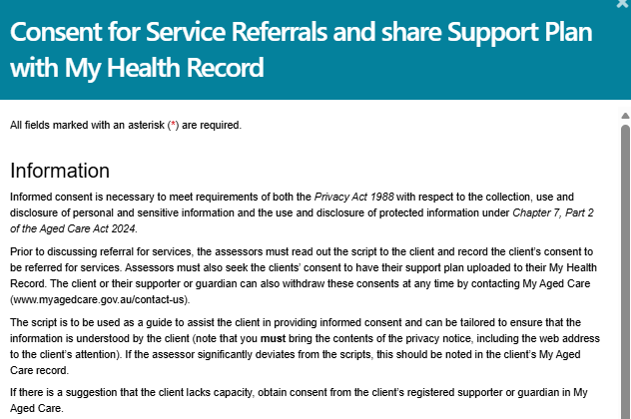
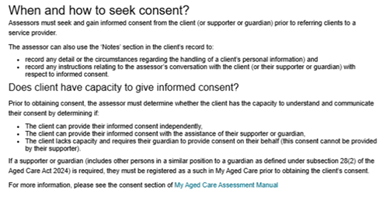
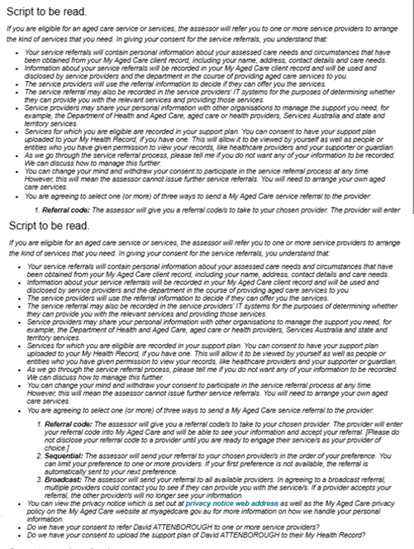
- After reading the Consent to Service Referrals information to the client or their supporter, record their decision by selecting the appropriate consent option.
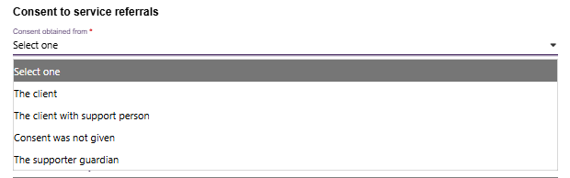
- Ask the client whether they consent to sharing their Support Plan through My Health Record (MHR), and select Yes or No. If the client gives consent, select Yes, record who made the decision, and then select Continue.
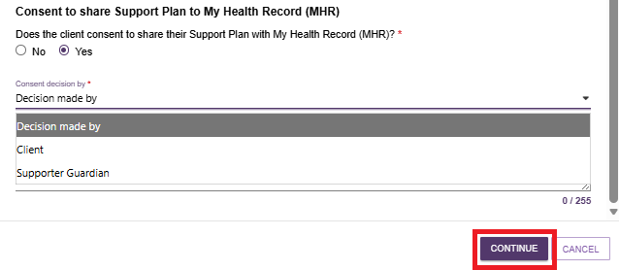
If the client does not give consent, select No.
Record who made the decision, then select the reason for not providing consent from the drop-down list.
Select Continue to proceed.
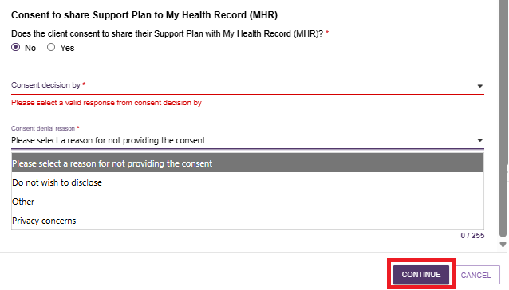
- If a supporter or guardian made the consent decision, enter their first name before selecting Continue. You can also enter their last name and add comments if needed.
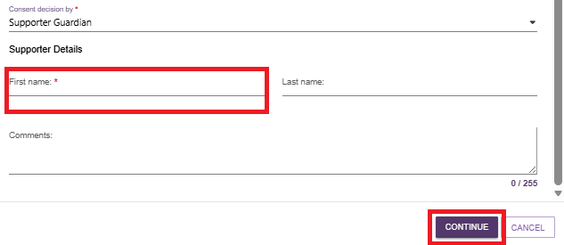
- Another pop-up will then display. Select FINALISE IAT to complete the assessment.
! | Once you finalise the IAT, you cannot make any further changes unless the Assessment Delegate returns it to you for amendment. Before selecting Finalise IAT, review the assessment carefully and make sure all information is complete and accurate.  For information about assessments returned by a delegate for changes, refer to My Aged Care – Assessor Portal User Guide 7 – Completing a support plan and support plan review.
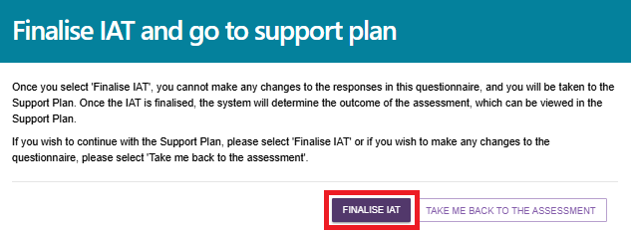
- A green confirmation message appears at the bottom of the screen stating: "Consents for Service Referrals and My Health Record were updated successfully."
- The system then takes you to the client’s Support Plan and Services page to complete the support plan.
If the client agreed to share their support plan through My Health Record, a green confirmation message appears at the bottom of the Support Plan and Services page to confirm that the link was created successfully.
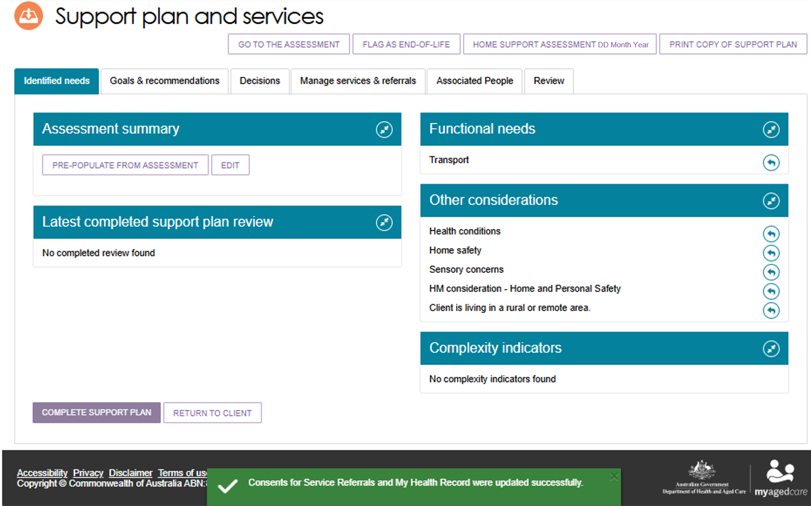
! | If the client’s My Health Record does not link successfully, the system displays an amber error message instead of a green confirmation message.  If you see the message "Unable to share data as the system could not find an active My Health Record", tell the client that their support plan cannot be uploaded to My Health Record. If they need assistance, advise them to contact the My Health Record Helpline on 1800 723 471.  If you see the message "Unable to retrieve the client's Healthcare Identifier, so we cannot match them with their My Health Record. Their Support Plan cannot be made available in their My Health Record", contact the My Aged Care Service Provider and Assessor Helpline on 1800 836 799.  In both cases, you can still complete the client's Support Plan, but the system will not upload it to My Health Record when you finalise it.
- You can reopen the assessment from the Support Plan and Services page, by selecting Go to the Assessment on the Identified Needs tab.
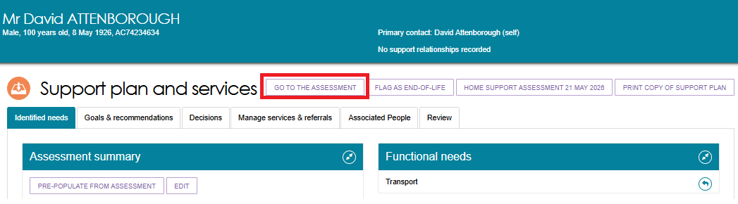
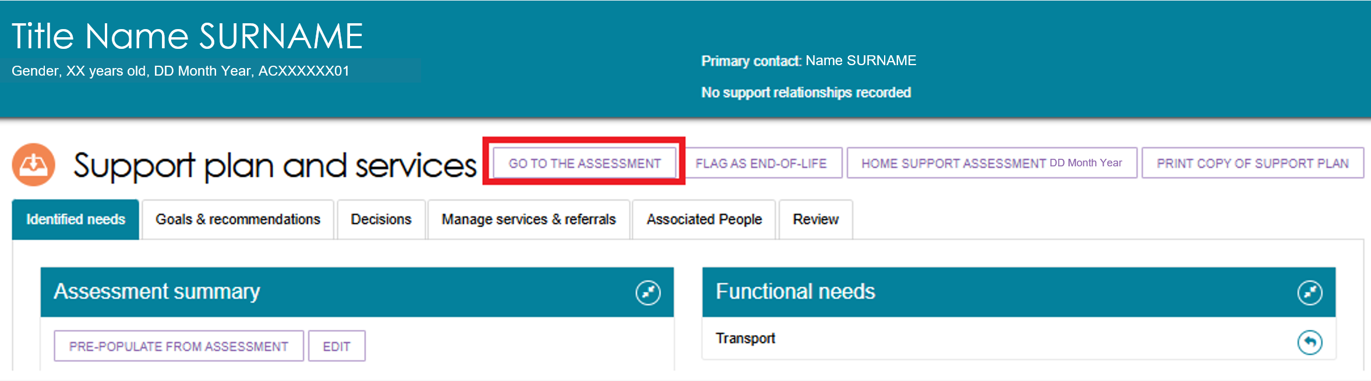
- You can also return to and review Functional Needs, Other Considerations, and Complexity Indicators by selecting the return arrow. Any Assistive Technology (AT) and Home Modifications (HM) identified during the assessment also appear here.
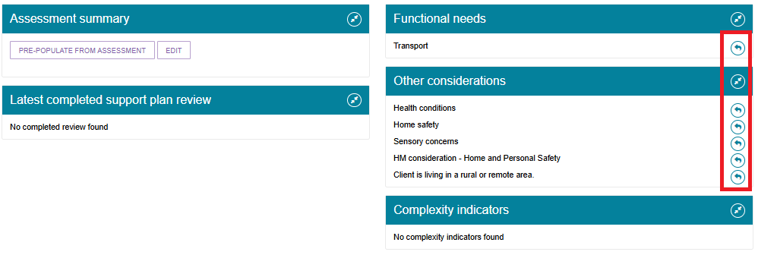
- The assessment outcome from the IAT appears in the Goals and Recommendations tab.
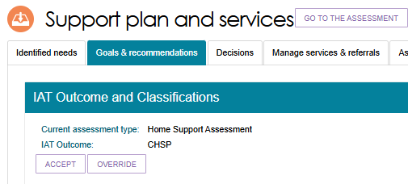

Accepting or Overriding an Assessment
When the IAT outcome appears, you can either accept the recommendation or override it.
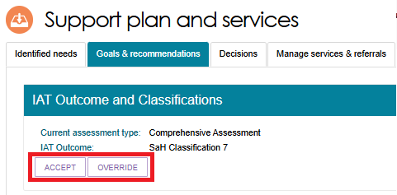
! | The IAT will allow an ongoing Support at Home Classification to be overridden to a different ongoing classification level. However, assessors must not undertake this action and delegates must not approve assessments where this occurs.  An ongoing SaH classification outcome cannot be overridden to an ongoing lower or higher SaH classification outcome (in line with section 81-10 of the Aged Care Rules).

Accepting IAT Outcome
To accept the recommendation, select Accept. The system displays a confirmation message asking you to confirm your decision. If you still want to proceed, select Accept again.
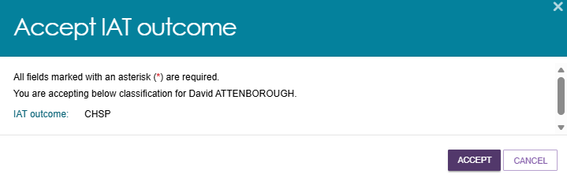
If the client receives a Support at Home (SaH) classification, the system displays a message explaining that the client’s preference for seeking home support services determines whether they are active in the Support at Home Priority System.
Select the client's preference:
- Seeking Services if the client wants to access home support services through the Support at Home program.
- Not Seeking Services if the client does not want to access home support services at this time.
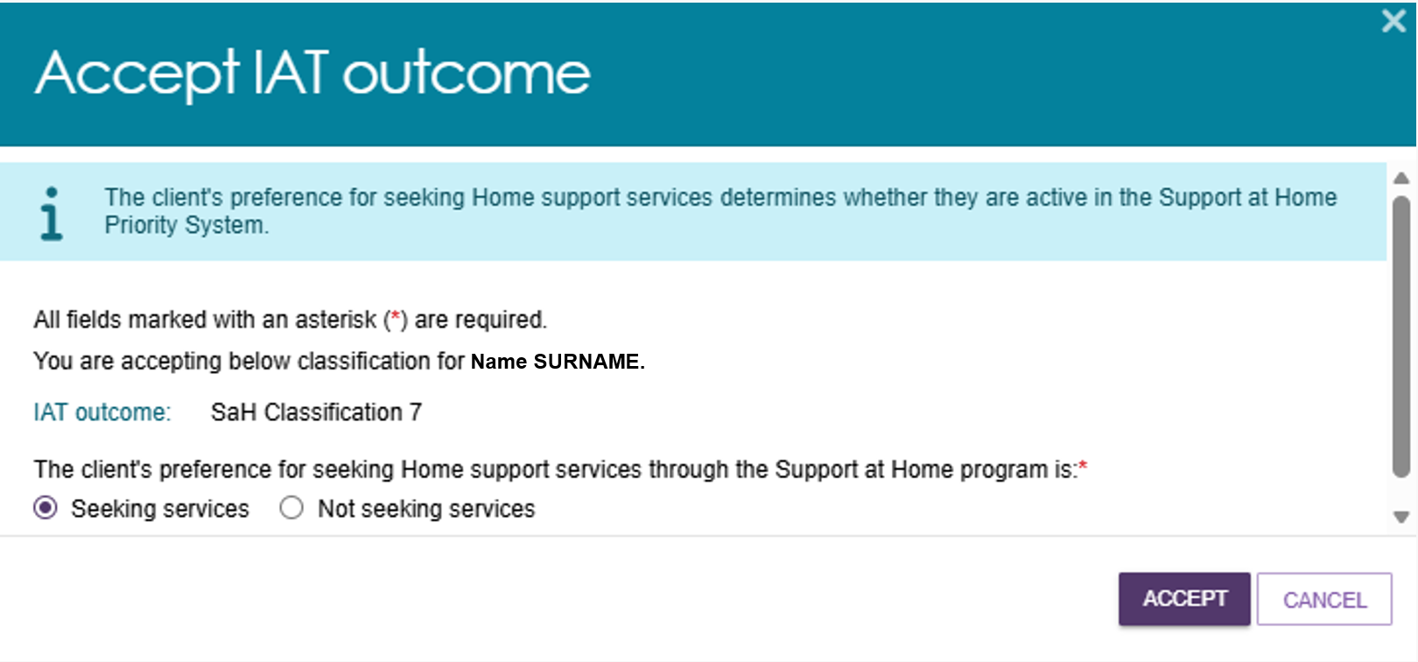
If the client receives a Support at Home (SaH) classification and is not seeking Home support services, select Not seeking services. Then select a reason at the drop down:
- Deceased
- Care needs reduced
- Permanent residential care
- Other care arrangements
- Means testing
- Does not want Restorative care
- Did not wish to specify
- Returned mail
- Other. Please specify
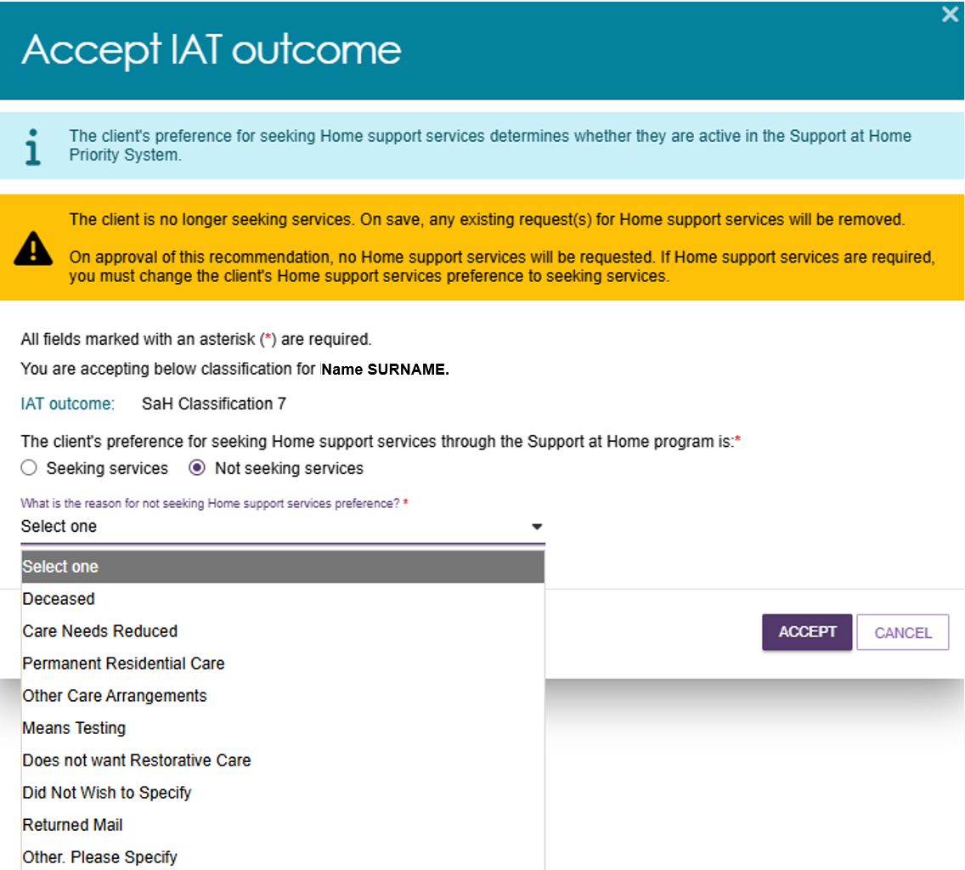
If Other. Please specify is selected, enter the reason in the text box below.
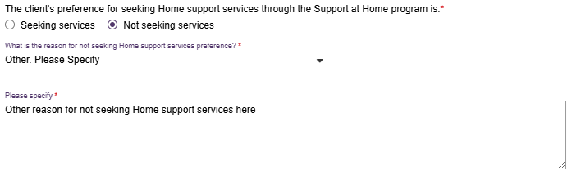
Finally, select ACCEPT.
The client will have any existing requests for Home support services removed, and no Home support services requested.

! | Transitioned Home Care Package (HCP) clients  When you complete a reassessment for a transitioned client and the Integrated Assessment Tool (IAT) recommends a Transitioned Home Care Package (HCP) Level 1, 2, 3, or 4 classification, the system displays a warning message on the Accept IAT Outcome screen.  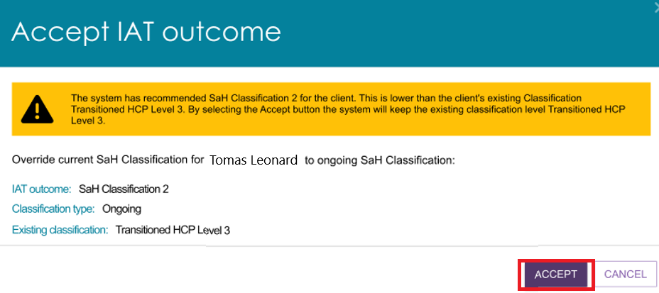

Overriding IAT Outcome
When you select Override, the Override IAT Outcome window opens.
Enter the following information:
- the outcome you want to override the IAT recommendation to
- the reason for the override
- a description explaining the override reason.
After entering the required information, select Save to Plan.
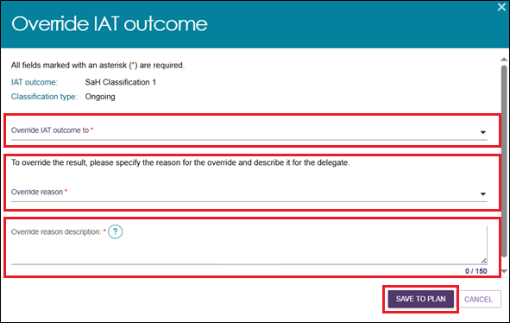
If the recommended classification is Support at Home, End of Life, or a Residential Care Program, the system takes you to the Add Home Support Services page. Review the recommended services and choose whether to accept or override them.
Refer to My Aged Care – Assessor Portal User Guide 7 – Completing a support plan and support plan review for information on how to add Home support services.
! | Legislation and Overriding IAT Outcomes  In line with legislation, you are not permitted to:  - recommend a different ongoing Home Support classification level.  - override ‘Ineligible for CHSP/SaH’ to any ongoing Home Support services.  You are permitted to recommend short-term pathways and Residential Care according to the rules of the My Aged Care Assessment Manual.  Recommending ongoing Home Support services via Support at Home or CHSP  - Ensure the recommended classification aligns with the IAT outcome.  - If after an IAT review, the IAT outcome shows a lower classification than the client’s current classification, ensure the recommended classification is equivalent to the client’s existing classification.  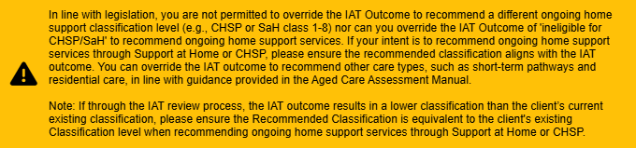

Recommending SaH Restorative Care Pathway
Assessors can override an IAT outcome (SaH Classifications 1–8, and Ineligible for CHSP/SaH) to SaH Restorative Care Pathway (RCP). This applies to both initial assessments and reassessments, and to transitioned and non-transitioned clients.
When you override the outcome to SaH Restorative Care Pathway, the system automatically adds Assistive Technology (AT) Medium and Home Modifications (HM) Medium recommendations. You can review, change, or remove these recommendations if needed.
Overriding the outcome to RCP may remove some existing recommendations. If required, add these recommendations back to the support plan.
- Select ‘SaH Restorative Care Pathway’ at the Override IAT Outcome to drop-down.
- Select an override reason at the Override reason drop-down
The override reasons available for this pathway are:
- Has restorative care goals
- Delay/prevent ongoing services
- Needs early intervention care
- Other.
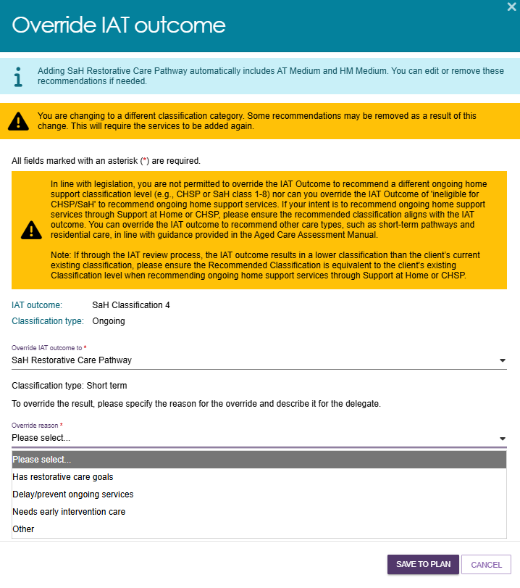
- Enter the override reason description in the text box below the drop-down.
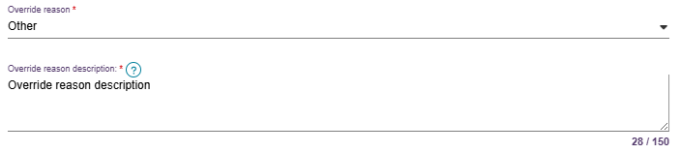
- Finally, select SAVE TO PLAN.

! | Recommending RCP From Ongoing SaH Classification only  The IAT also allows a CHSP classification to be overridden to RCP during a comprehensive assessment. However, assessors must not undertake this action and delegates must not approve assessments where this occurs.  Where a CHSP classification outcome is generated, RCP cannot be recommended for approval (in line with section 81-15 of the Aged Care Rules).  An ongoing SaH classification must be generated to override and recommend RCP for approval.

Overriding for transitioned clients undergoing reassessment
For transitioned clients being reassessed, the Override IAT Outcome list shows:
- all Support at Home (SaH) classifications that are the same as or higher than the client's current Active Transitioned Classification
- SaH Restorative Care Pathway
- SaH End-of-Life Pathway.
The list does not show the client's current IAT outcome.
If the IAT outcome is higher than the client's Active Transitioned Classification, the list also includes the client's current Active Transitioned Classification as an override option.

Overriding to the SaH End-of-life Pathway
When you select SaH End-of-Life Pathway and confirm the override, the system automatically applies the appropriate latent classification based on the override rules.
The system also automatically selects Assistive Technology (AT) Medium.
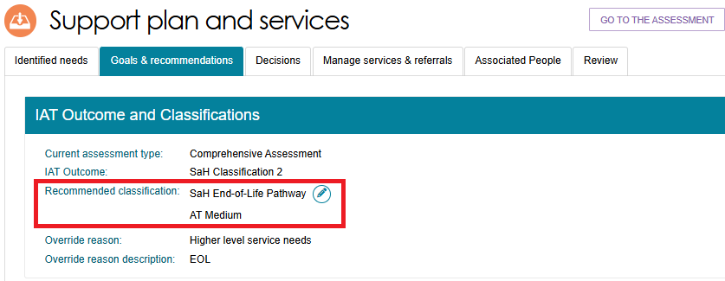

Converting to Comprehensive Assessment
Non-clinical assessors can change a Home Support Assessment to a Comprehensive Assessment after finalising the IAT and receiving an outcome recommendation, provided their organisation delivers both assessment types.
- On the Goals & Recommendations tab, select Convert to Comprehensive Assessment in the top-right corner of the page.
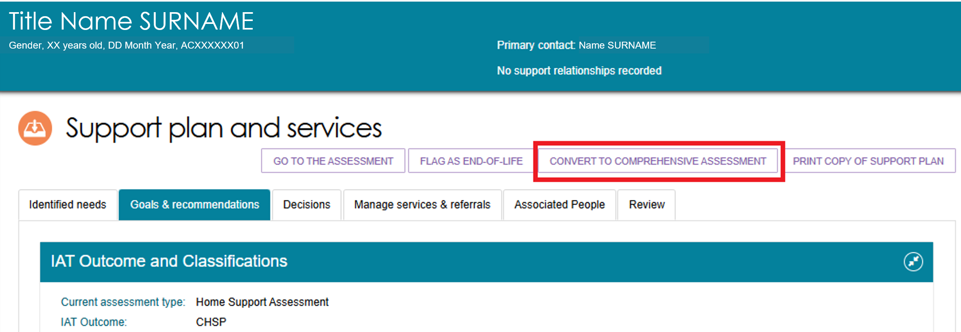
- The system automatically selects High Level Care Needs as the reason for the conversion. Enter any additional comments, then select Yes, Convert Assessment.
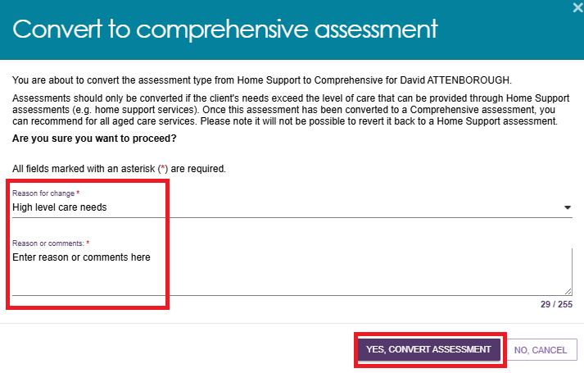
- The system displays a green confirmation message to confirm the assessment has been converted successfully. The IAT outcome also updates to show that a Comprehensive Assessment has been completed.
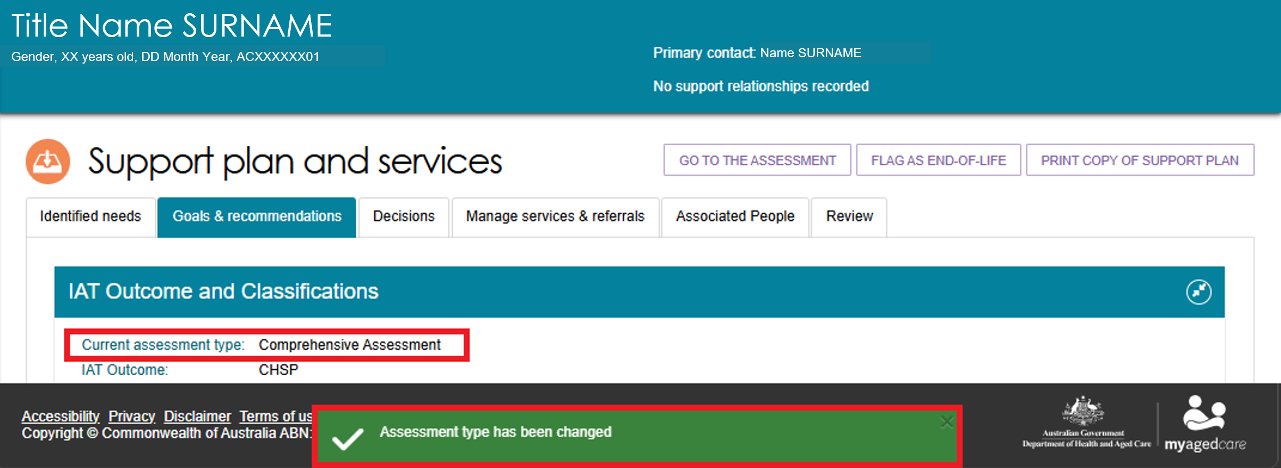

Flagging an Assessment as End of Life
If a qualified health professional has assessed the client and provided supporting evidence that the client is approaching end of life, you can flag the client as End of Life.
- In the Current Assessments tab, go to the Assessment Not Started section and select the expand card icon for the client.
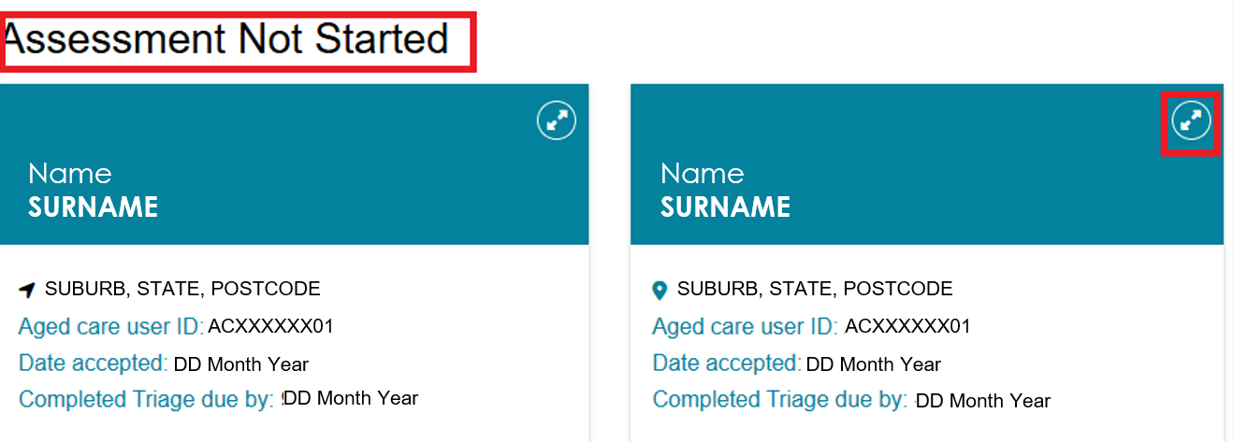
- In the pop-up window, select Flag as End of Life.
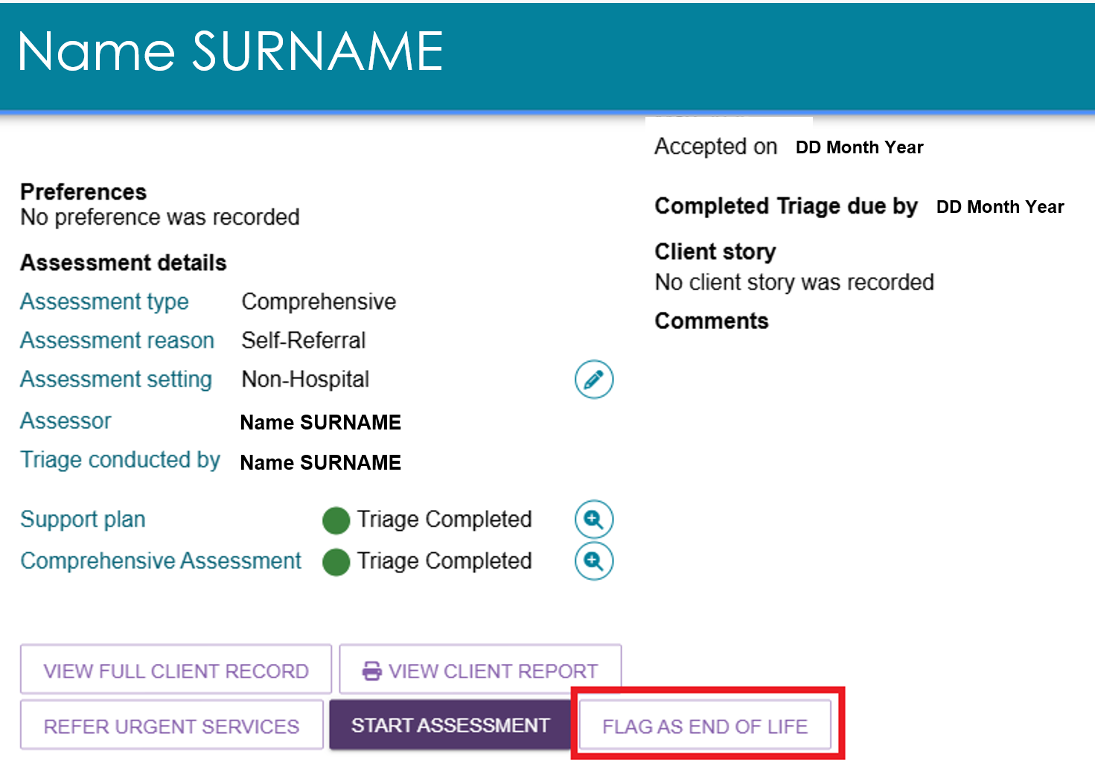
! | You can also start the End-of-Life process while an assessment is in progress. On the client's Goals & Recommendations tab, select Flag as End of Life and follow the prompts.  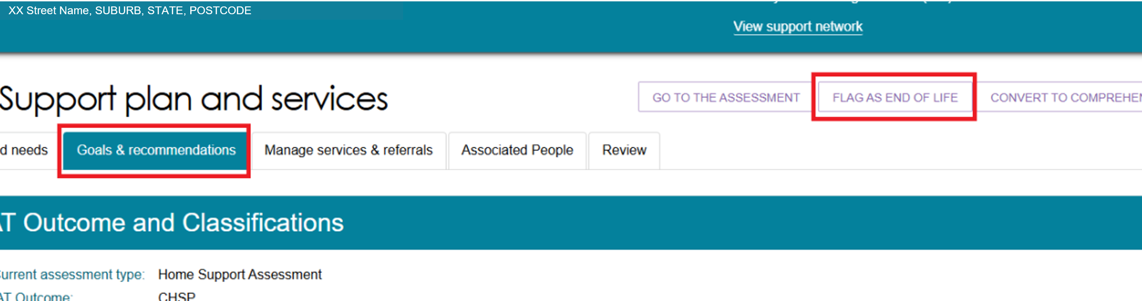

- The Flag referral as End-of-Life window opens. Select the appropriate verification option from the drop-down list based on the documents provided.
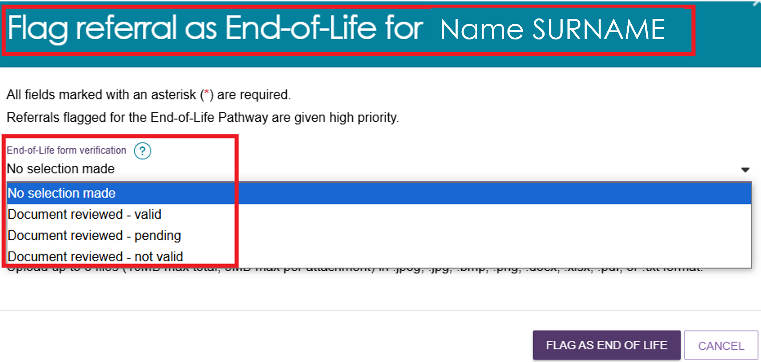
- Select the UPLOAD ATTACHMENT button to start uploading documents.
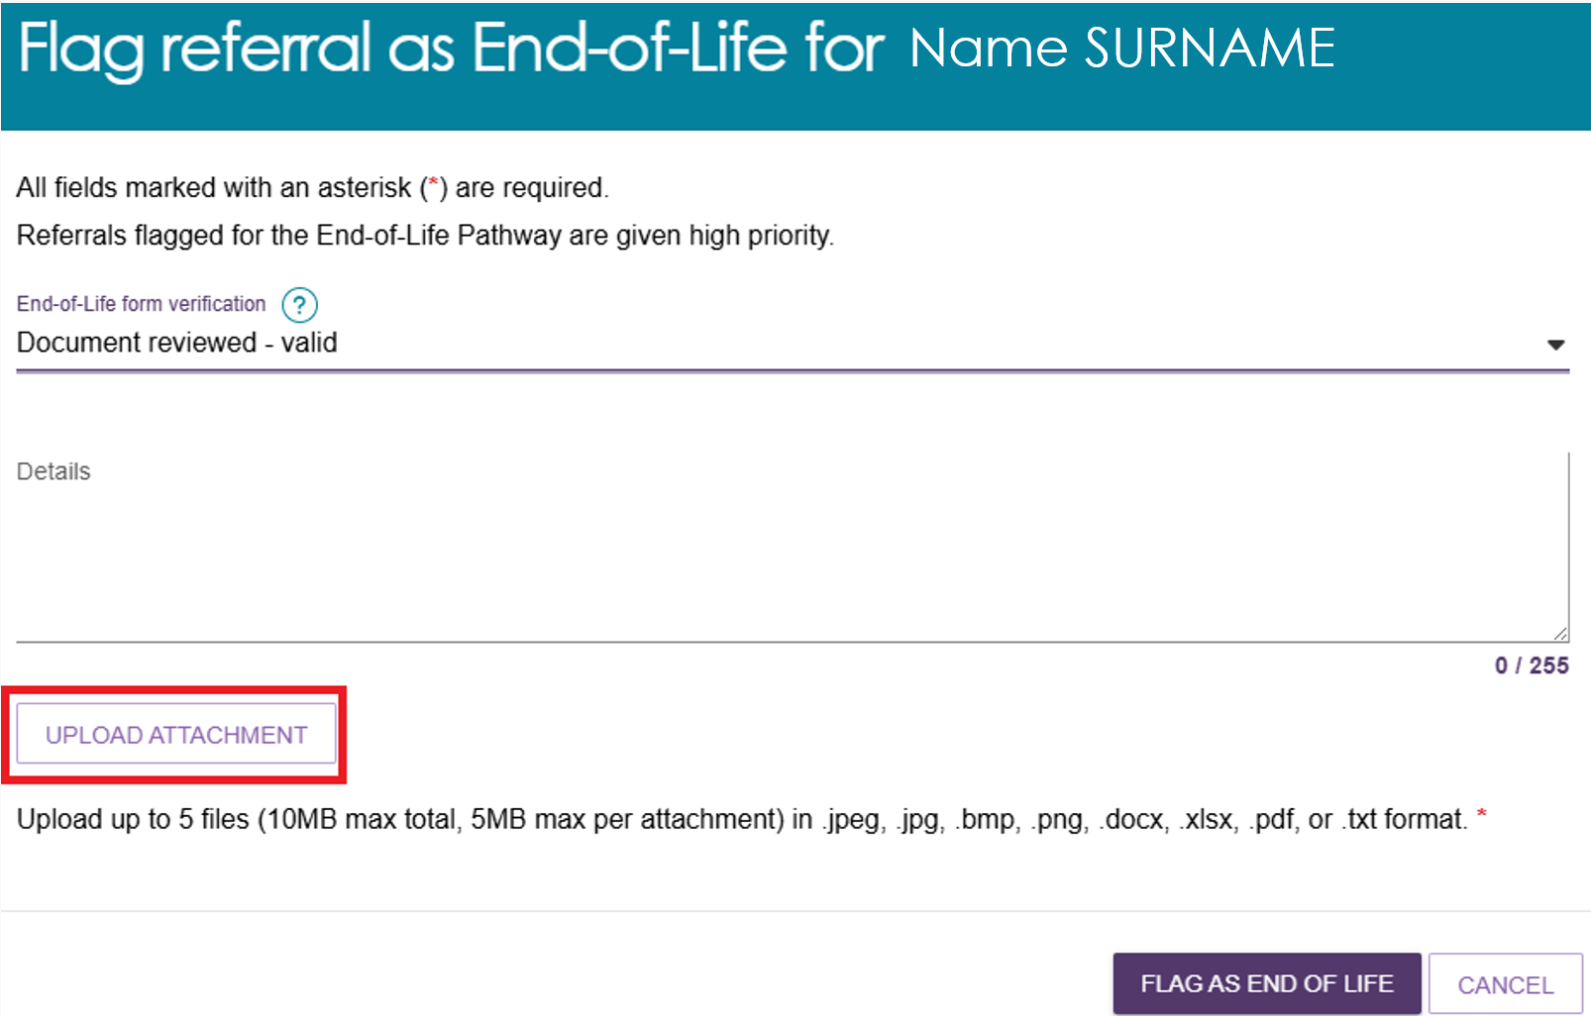
! | If the client cannot provide the required documents, or the documents are not valid, you can complete the verification process from the Goals & Recommendations tab by selecting Verify End of Life Form in the top-right corner of the page.  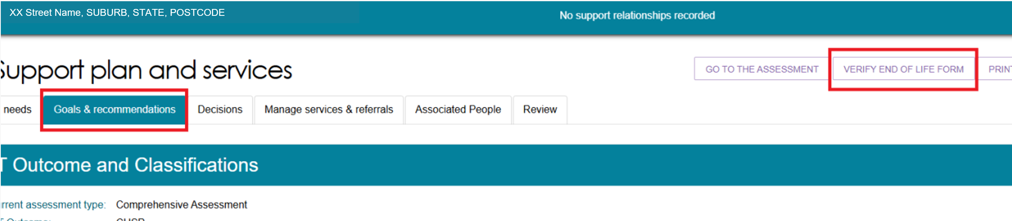
- The Add Attachment window opens. Upload documents from the qualified medical professional that support the client’s end-of-life diagnosis.
Select Choose File and upload the required document. Make sure the document meets all requirements shown on the screen.
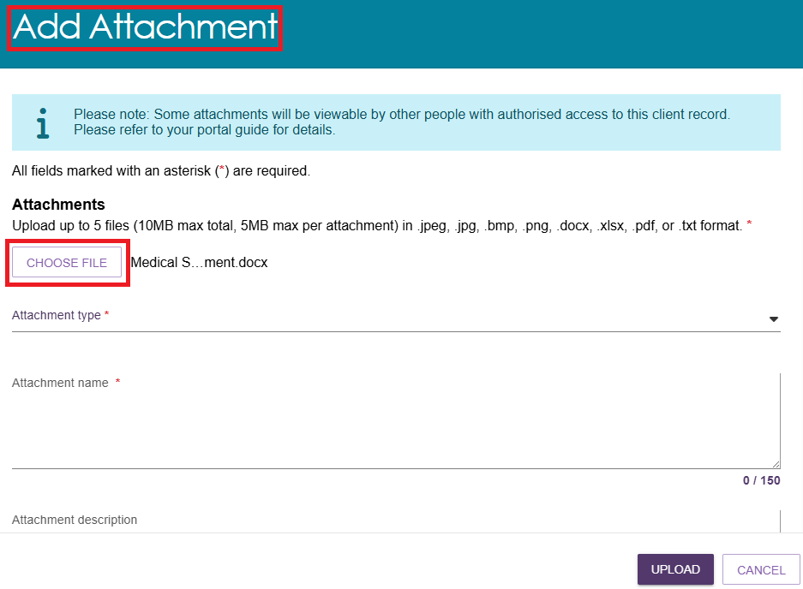
- Select the appropriate Attachment Type from the drop-down list and enter an Attachment Name.
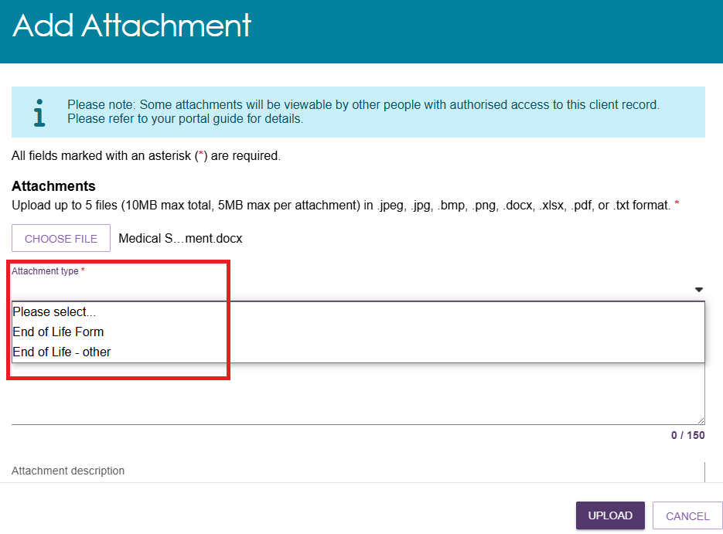
- Select UPLOAD.
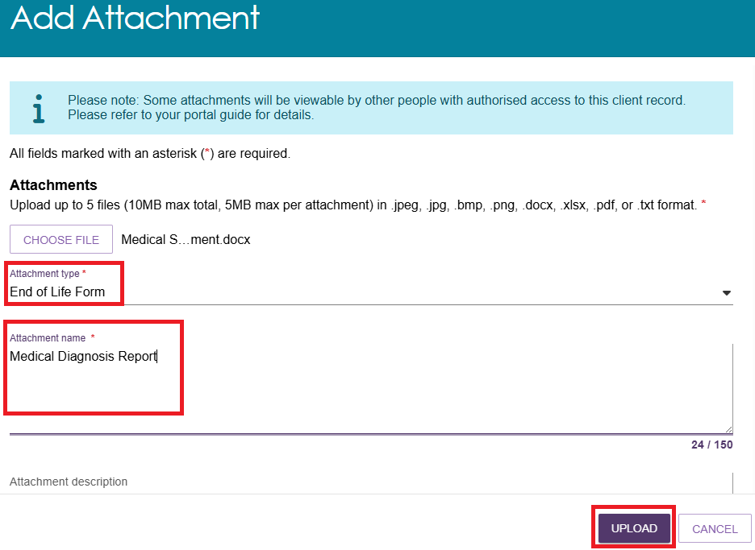
- The system displays the uploaded document for review.
To upload additional supporting documents, select Upload Attachment. You can upload up to five files, provided each file meets the required criteria.
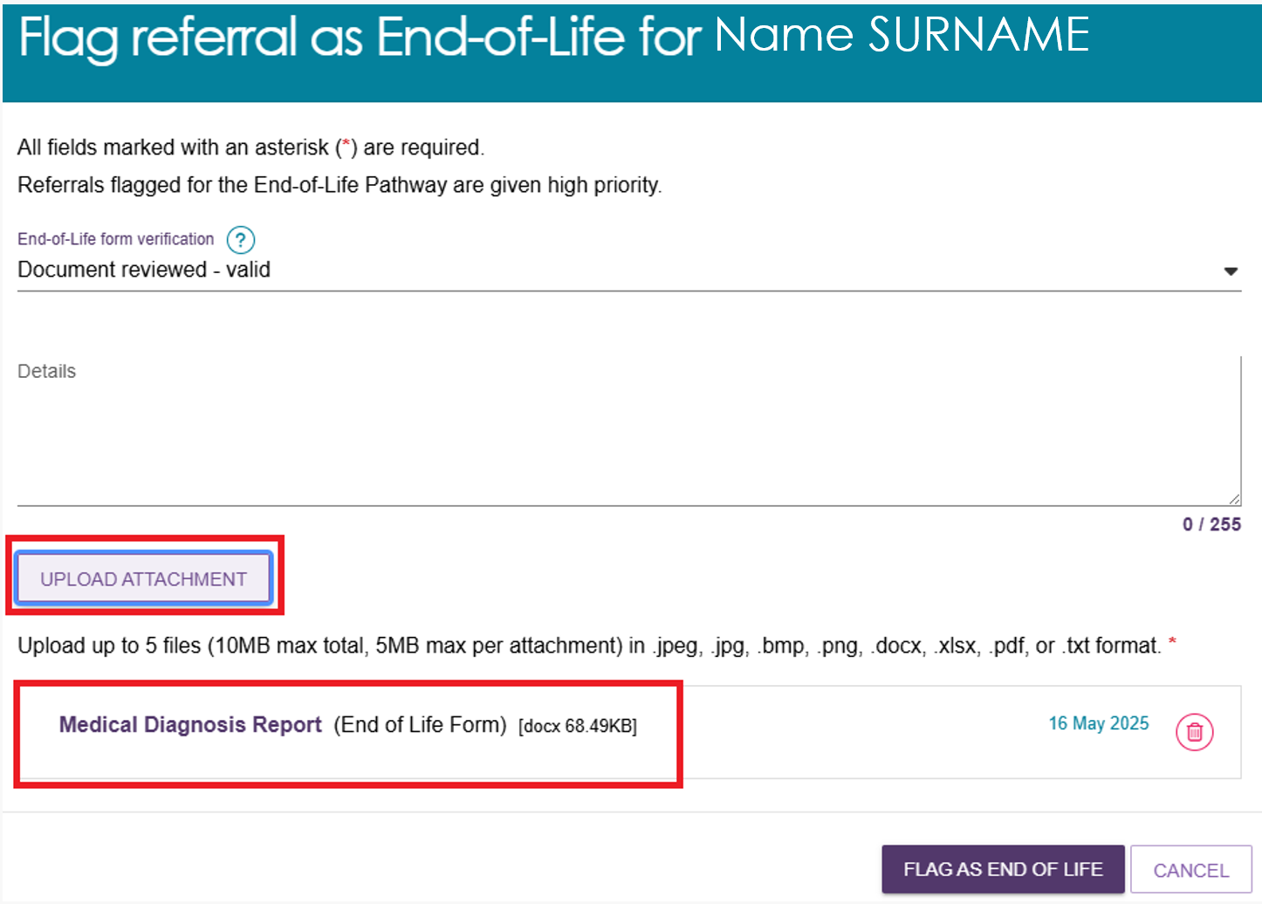
- Once all relevant documents are attached, Select FLAG AS END OF LIFE.
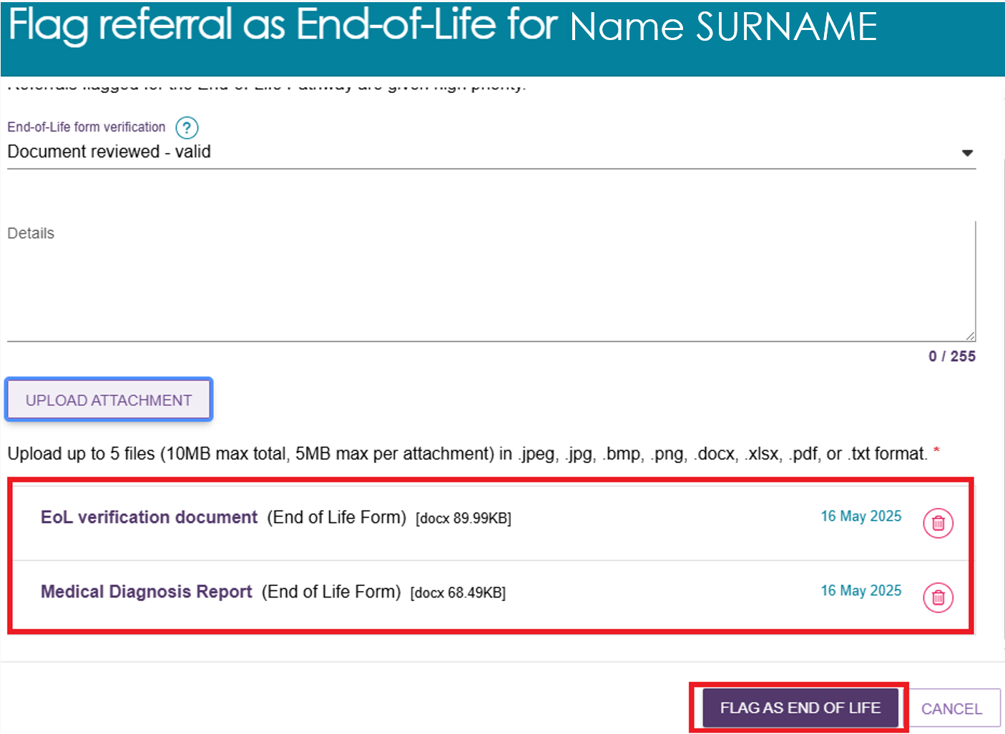
- On the Current Assessments page, the client appears in the Assessment Not Started section with a red hand icon containing a cross, indicating that the client has been flagged as End of Life.
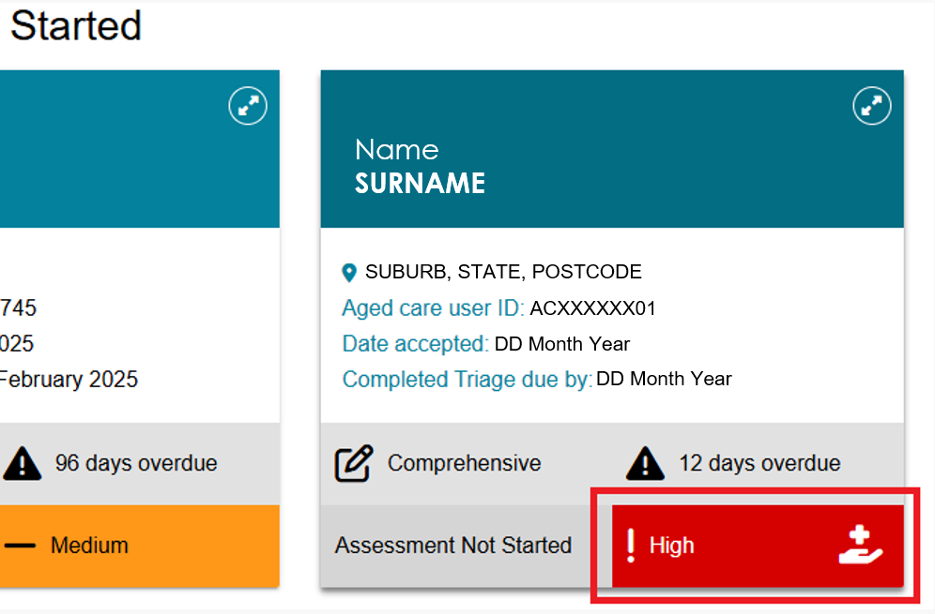
! | More information on flagging a referral as End of Life can be found in Assessor Portal – User Guide 7 – Completing a support plan and support plan review.

Cancelling an assessment
If you need to cancel an assessment, you can do this from within the assessment. Record the reason for the cancellation by adding a note or interaction to the client's record.
- At the bottom of the assessment page, select Cancel Assessment – No Further Action Required.
- Select the reason for cancelling the assessment from the Reason for Ending the Assessment drop-down list.
If you select Client Deceased, go to Step 4.
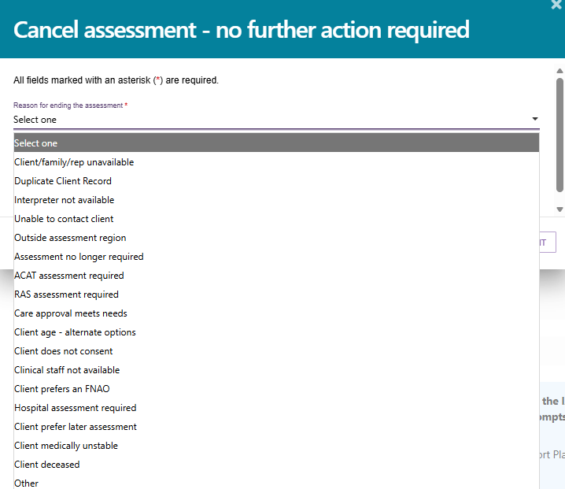
- Enter comments explaining why you are ending the assessment, then select Cancel Assessment.
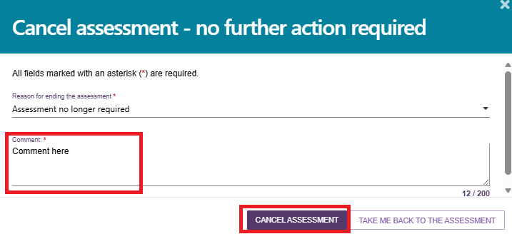
- If you cancel an assessment because the client has died, enter the following information and then select Cancel Assessment:
- who informed you of the client's death, when they informed you, and how they informed you (for example, "Mrs Smith called to advise that Mr Smith passed away on Saturday")
- the client's date of death, if known
- any supporting attachments, such as a death certificate or hospital discharge documents
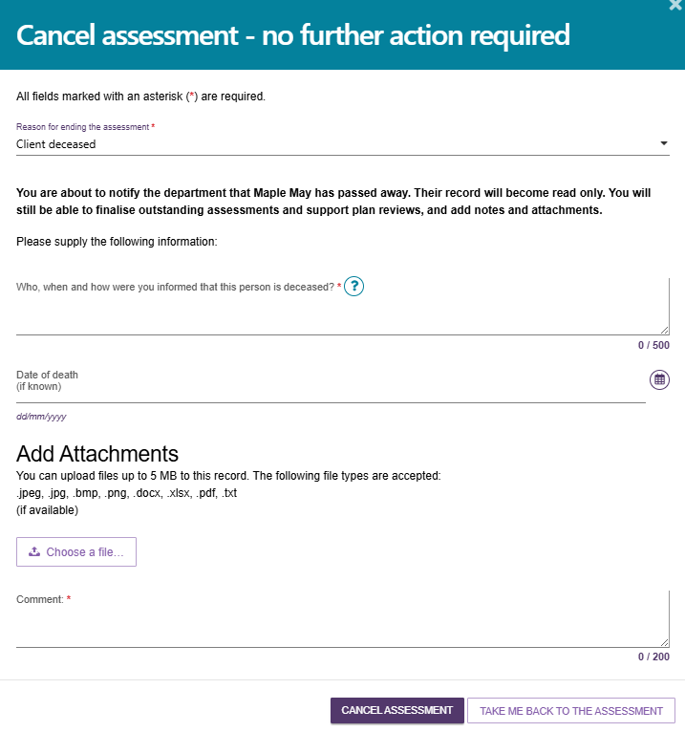
! | If you cancel an assessment because the client is deceased, the system updates the client's status to Deceased and changes their record to read-only.  The system also:  - recalls any unaccepted service referrals  - stops any services currently in place  - removes the client's access to the client portal.  After the status changes to Deceased, My Aged Care no longer sends correspondence to the client or their supporters.  If the client is active in the Support at Home Priority System or has been assigned aged care services, the system removes them from the priority system and withdraws any assigned services.
- The system displays a confirmation message to show that the assessment has been cancelled successfully.
The system then takes you to the Client Summary page, where the assessment status appears as Cancelled.
- After you cancel the assessment, the client's information moves to the Recent Assessments tab.
You can still find the client later using the Find a Client search function.
