Assessor Portal User Guide 4 – Navigating and updating the client record
This guide outlines the contents and functions of the client record at a high level. Client records grant aged care needs assessors (assessors), providers, and My Aged Care staff with a single point of reference for client information.
The client record is also a valuable tool for easily setting up emergency contacts, disseminating important information between client, and facilitating the assessment of clients.
After a client and/or their support network has provided consent to enable their personal details to be appropriately recorded in My Aged Care and shared with assessors and Aged Care service providers, you will be able to interact with the many tabs of the client record elements as described in this guide.
If the client and/or their carer request a call back from Carer Gateway and/or the National Dementia Helpline, assessors will need to obtain further consent in the relevant area in the assessor portal.

Accessing the client record 3
Accessing a sensitive client record 5
Accessing the client record of a client assigned to me 6
The Client Summary tab 10
The Client Details tab 13
Notification Preferences 14
Adding a Post Office Box address 16
Recording consent to share information with My Health Record 18
Notifying My Aged Care that the client is deceased 20
The Support Network tab 22
The Approvals tab 22
The Plans tab 25
The Attachments tab 25
The Services tab 28
The My Aged Care interactions tab 29
The Notes tab 30
Note types 31
Note add & view permissions 32
Adding client notes 32
Viewing and editing client notes 33
The Tasks and Notifications tab 35
The Residential Funding Classifications tab (clinical needs assessors) 35
More Information 35

Accessing the client record
The Find a Client function enables assessment organisations to search for all clients registered with My Aged Care. Assessment Organisations can only search for clients who have been referred to, and accepted by their organisation.
- Log in to the My Aged Care assessor portal. From the home screen select the Find a client tile.
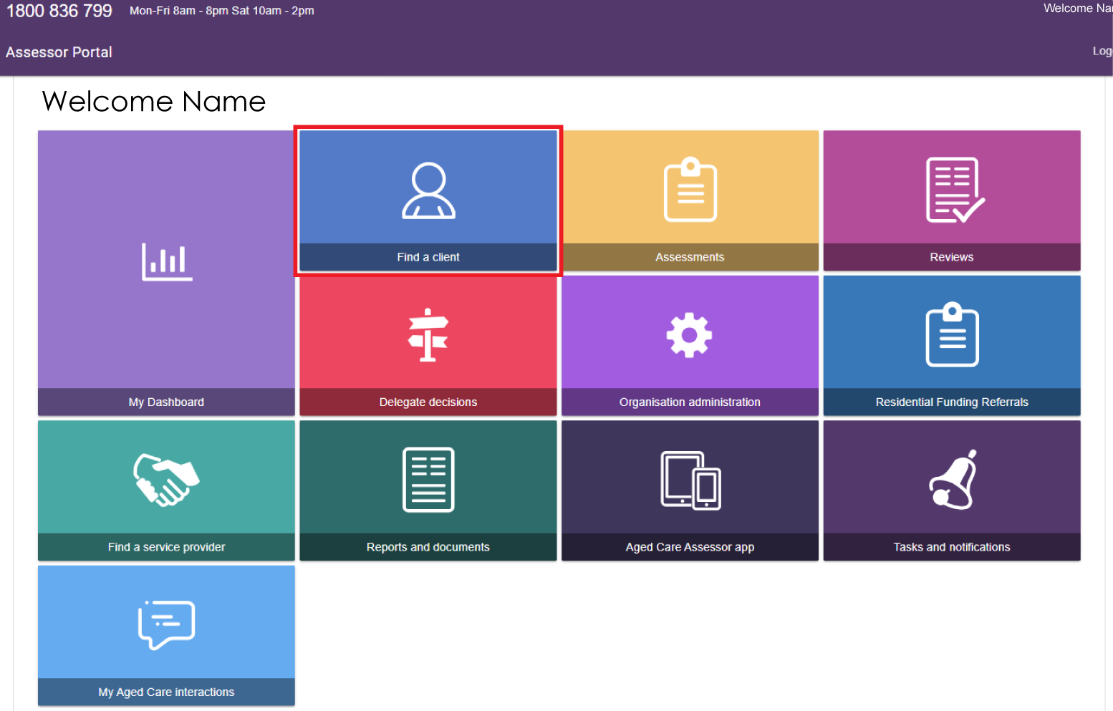
- You can do a basic search by entering the First Name, Last Name, or Aged Care User ID into the fields, and then selecting the SEARCH button.
To go directly to a recently viewed client, use the links under Recently Viewed Persons heading on the right.
You can change the display between Card View and List View by selecting the relevant button on the right.
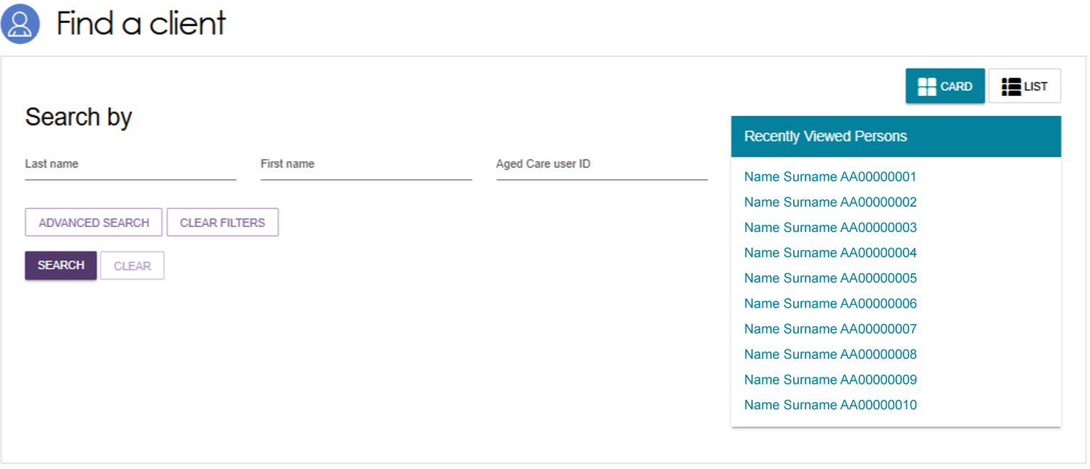
- Alternatively, you can do an advanced search. Advanced search works by applying filters to the list of clients. These filters include options such as First Name, Home Contact Number, Postcode etc. By adding multiple filters together, specific groups of clients can be found.
Select the ADVANCED SEARCH button from the Find a Client screen. The Search clients pop-up window will open. Use the drop-down arrow to choose the kind of filter you wish to add. Then, select the ADD FILTER button to reveal the input field for that filter.
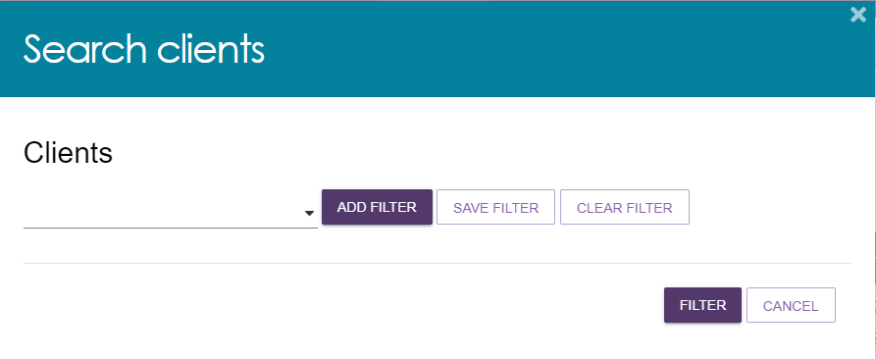
- Fill in the input field that appears with the information required. You can repeat the process above to add additional filters to the advanced search. A maximum of 7 filters can be applied at once. Once you have finished adding filters, select the FILTER button to begin your advanced search.
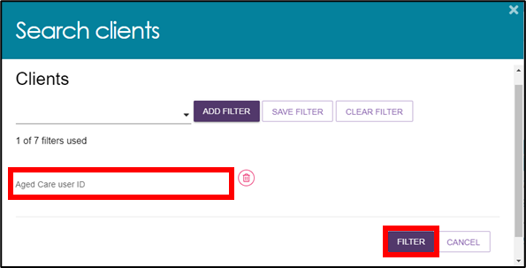
- Select the name of your chosen client to proceed to their client record.
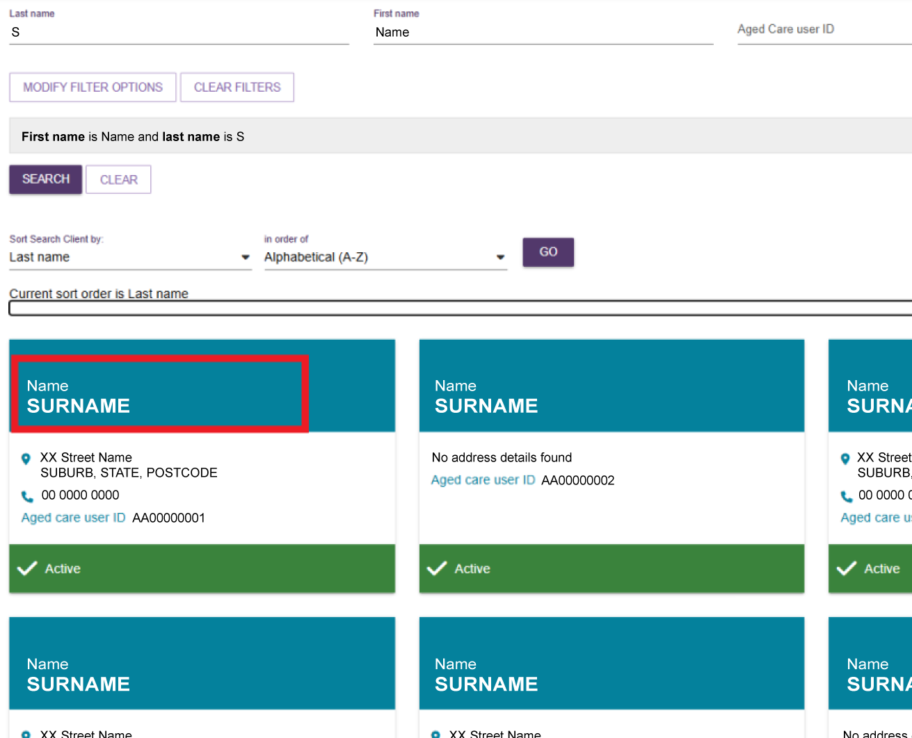

Accessing a sensitive client record
A sensitive client record may contain one or more:
- sensitive attachment
- sensitive client status
- sensitive notes.
In the Client Record, the client details banner will have wording to this effect underneath the client’s address, to identify that this record contains sensitive information.
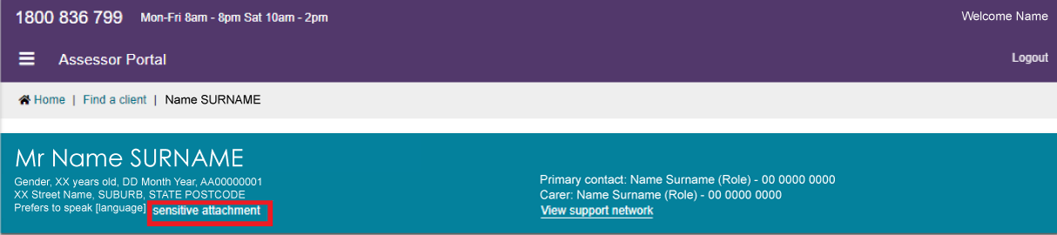
To access the sensitive information, refer to the Attachments tab and the Notes tab for more details.

Accessing the client record of a client assigned to me
- Log in to the My Aged Care assessor portal and select the Assessments tile.
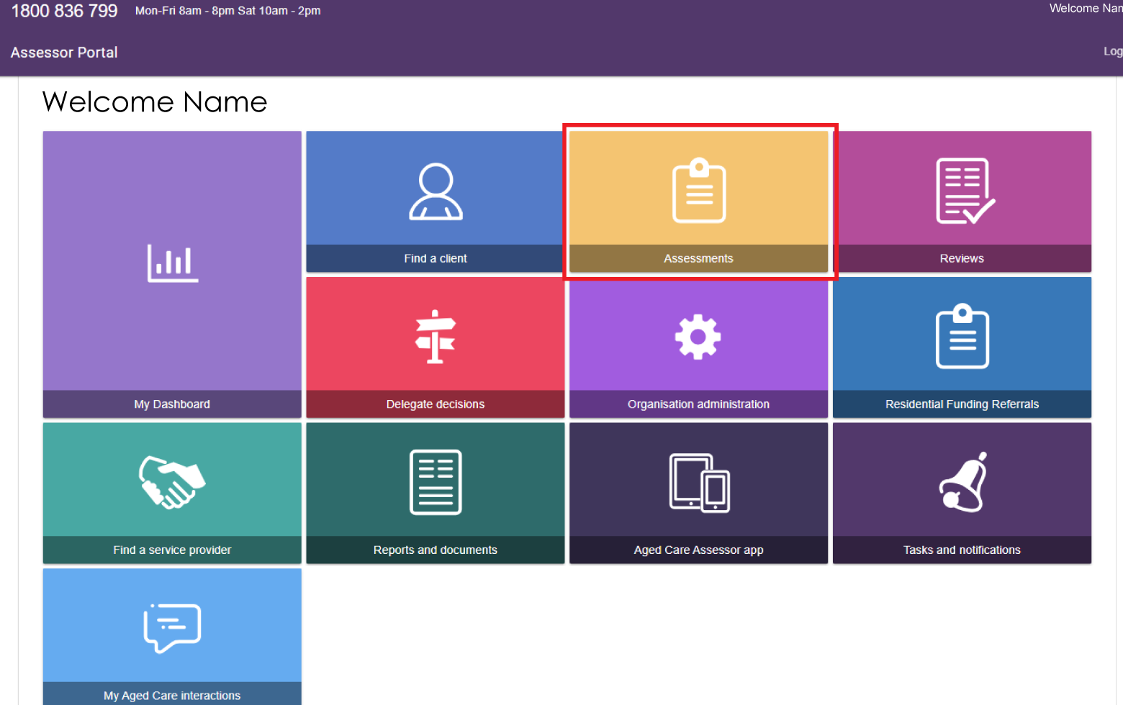
- If you have access to more than one outlet, select your client’s assessment outlet from the drop-down list, then select the SELECT OUTLET button to continue.
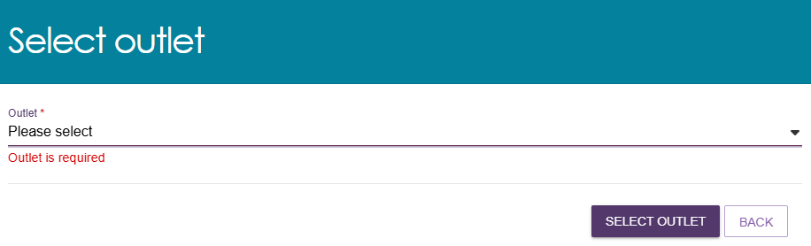
- You can use filter headings such as Last Name, Aged Care ID, or Locality to sort your assigned clients. Once you have found the appropriate client, use the expand button (To the left of the listing in List view, or at the top right corner of the card in Card view) to view more details.
List View
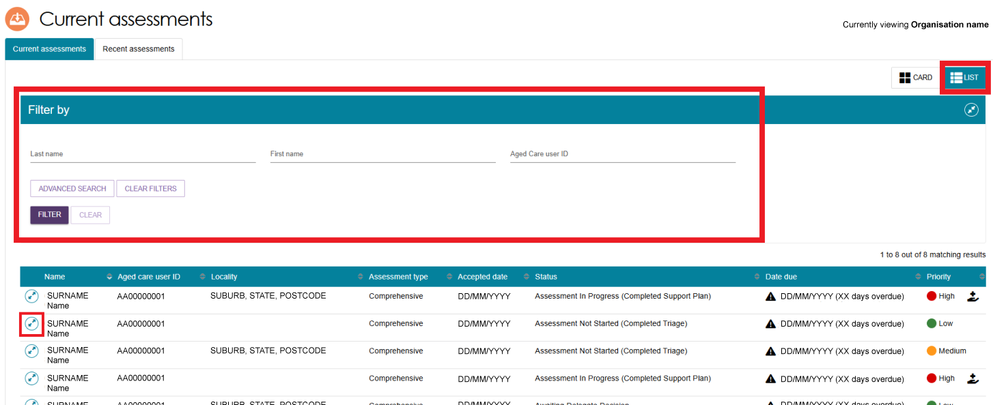
Card View
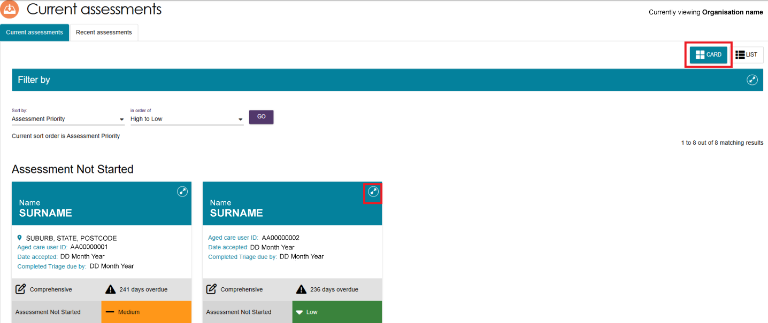

- A pop-up will then display with expanded details for that client. From this pop-up you can view the statuses of client’s support plan and assessment. Further information can be viewed by selecting the magnifying glass next to the status.
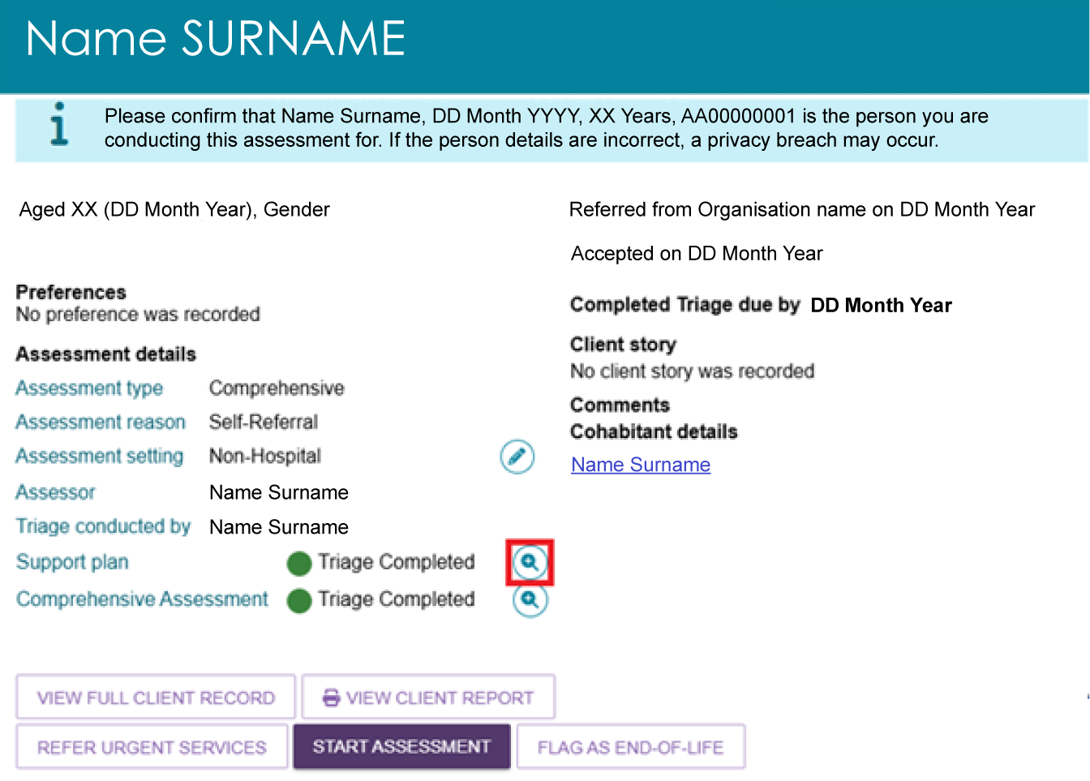
- If applicable, you can view Cohabitant details. A cohabitant refers to another aged care client who lives at the same address as the client undergoing assessment and has a recorded active relationship with the client. Up to two cohabitants will be listed under this heading.
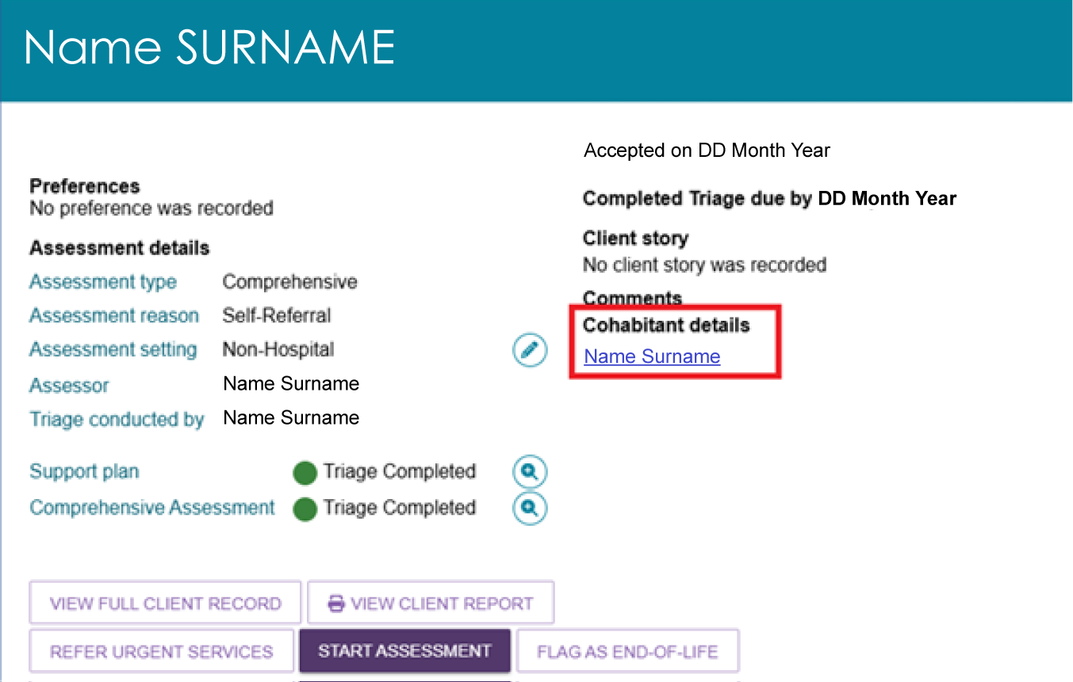
- Select the VIEW FULL CLIENT RECORD button to navigate to the client record page.
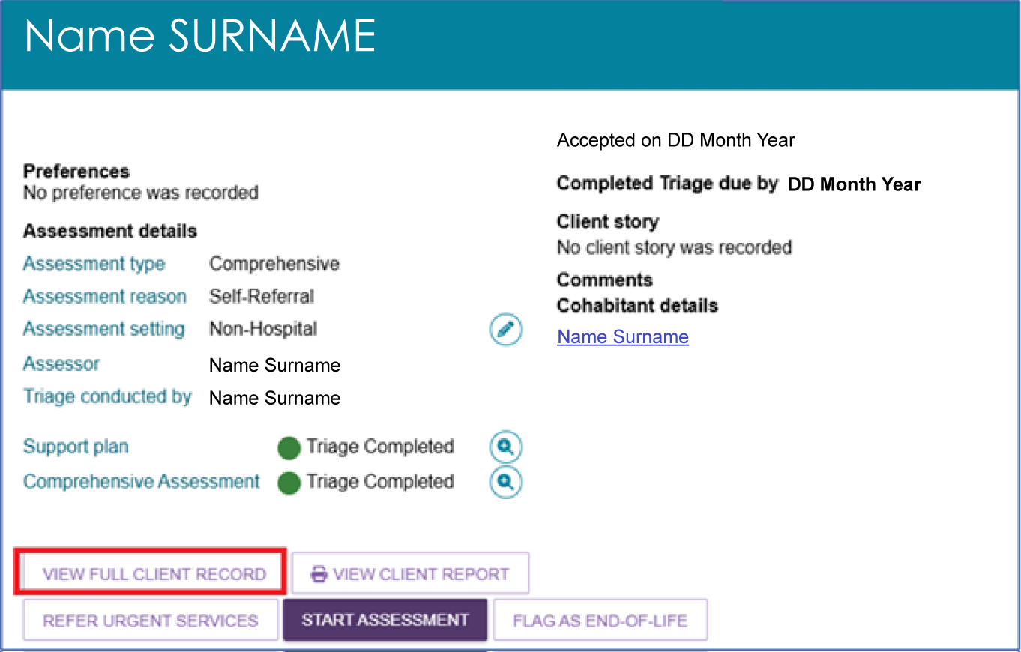
- You can generate a summary PDF report without opening the client record. The report includes client details, support network details, notes, assessment history, care approvals, and the client's interactions with My Aged Care. Select VIEW CLIENT REPORT to generate the report.
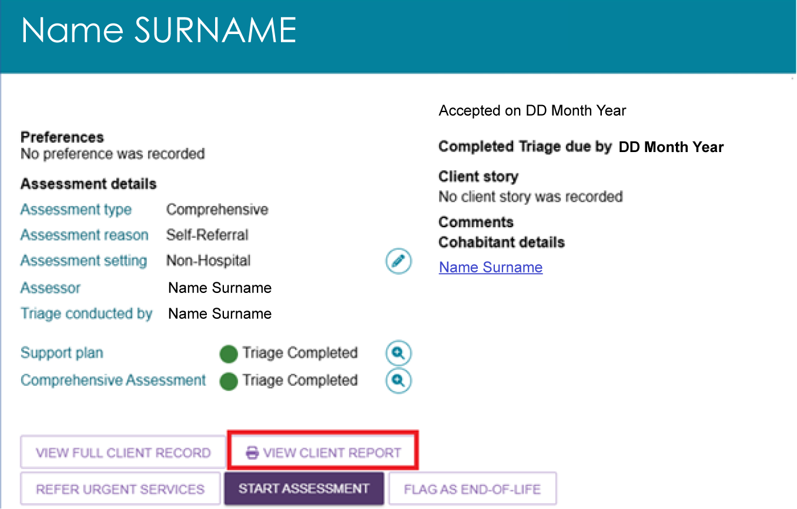

The Client Summary tab
The Client summary tab serves as the primary location for assessors to quickly access client information and coordinate care effectively. It contains the Client Journey Tracker which is a visual tool that shows where a client is in their My Aged Care journey and what happens next. Underneath the tracker, the Client Summary provides an overview of a client’s completed and in-progress assessments; recommendations and approvals; and their service delivery status.
- Select the VIEW FULL CLIENT RECORD button from the client’s card or listing to navigate to Client summary screen.
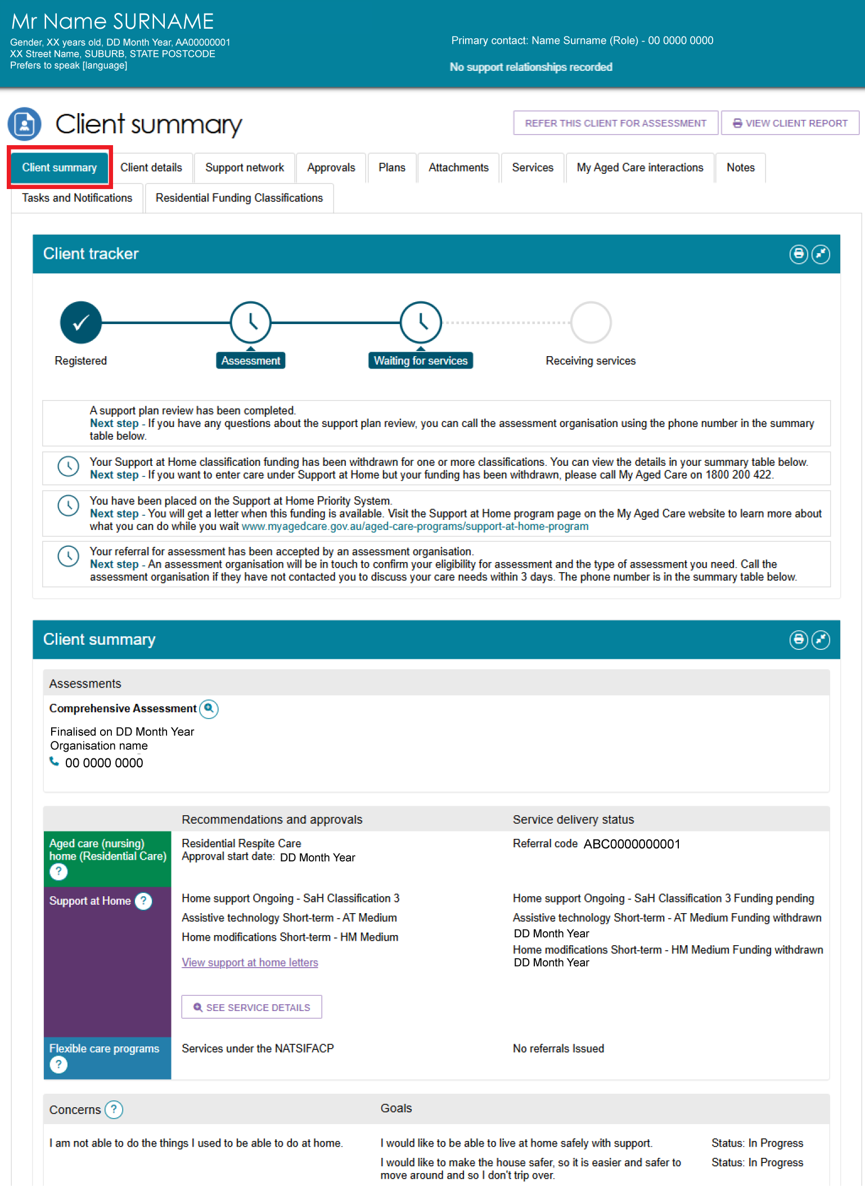
- The below image shows an example of a client transitioned from a Home Care Package (HCP) classification.
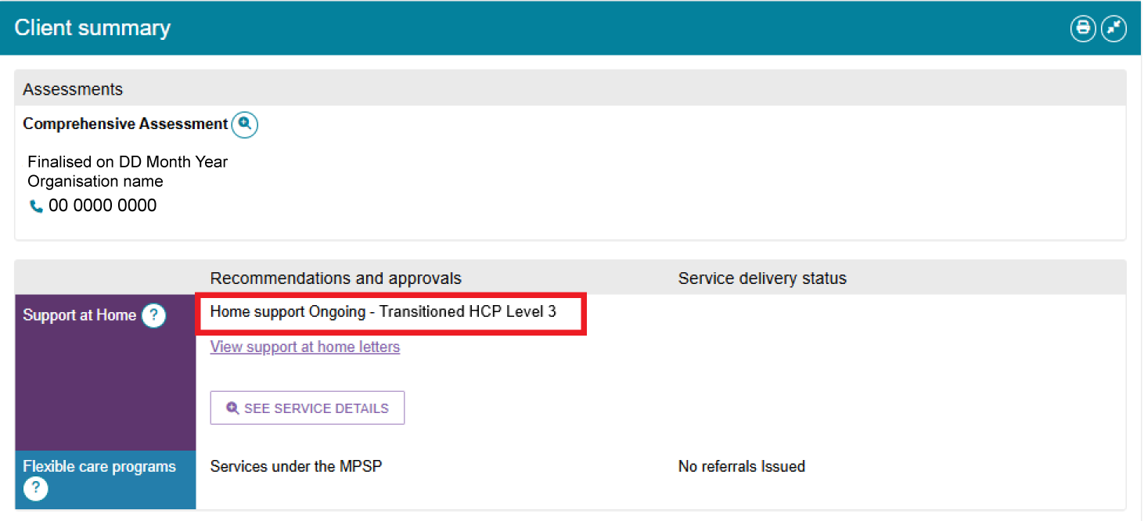
The below image shows an example of a client transitioned from the Multi-Purpose Service Program (MPSP) or the National Aboriginal or Torres Strait Islander Flexible Aged Care Program (NATSIFACP), and is deemed suitable for accessing services or funding under the program:
- Information message states that ‘client is approved to access services through a provider under MPSP or NATSIFACP’
- The phrase ‘(MPSP NATSIFACP Deeming)’ appears next to the approved service/s.
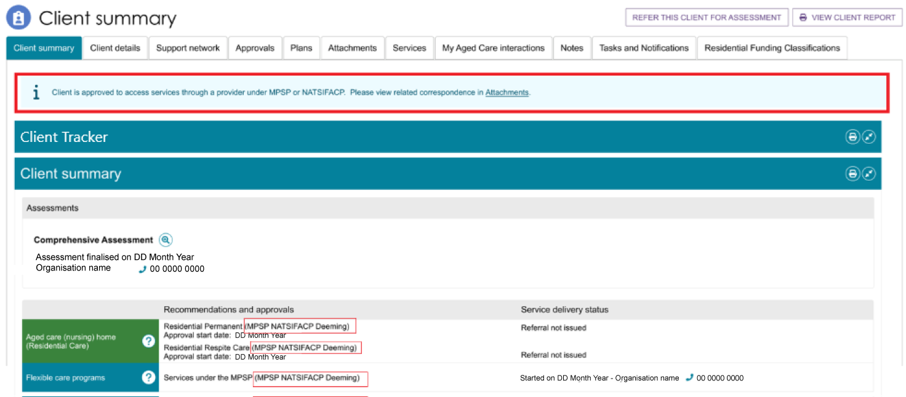
- Select See Service Details under the Recommendations and Approvals section to view more information about the client's linked services.
This section shows details about the client's linked services, including the service provider, referral history, funding status, service progress, and any short-term supports such as reablement. It helps assessors track service delivery and check that the support being provided matches the client's support plan.
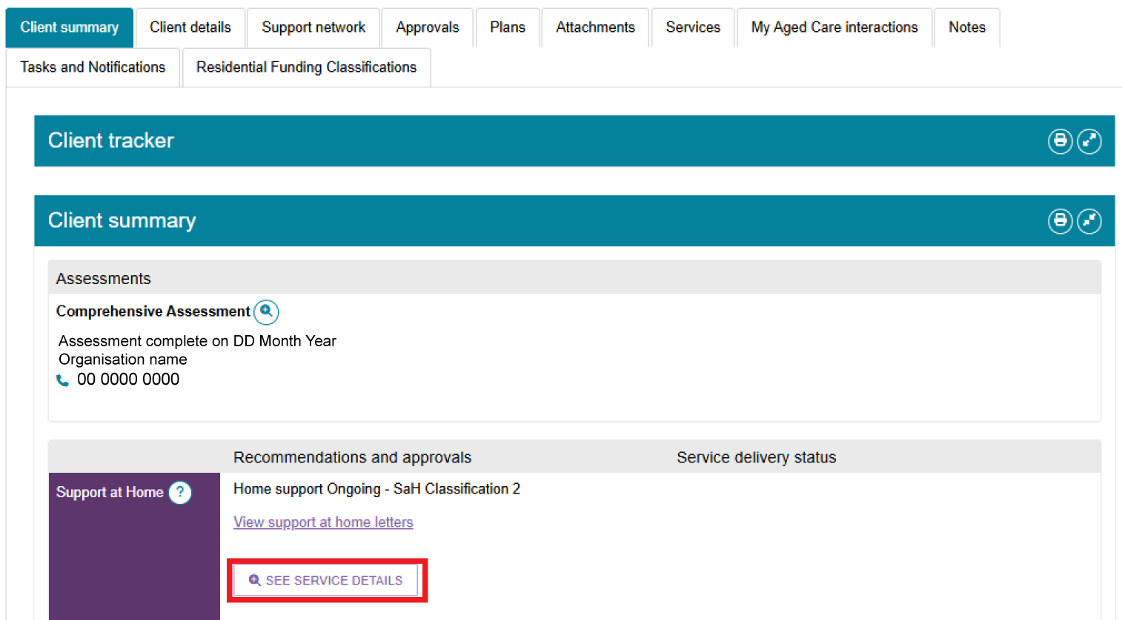
- A pop-up window will appear showing all recommended services. Select the Expander icon to view more details about a service. You can also view the funding status for each recommended service.
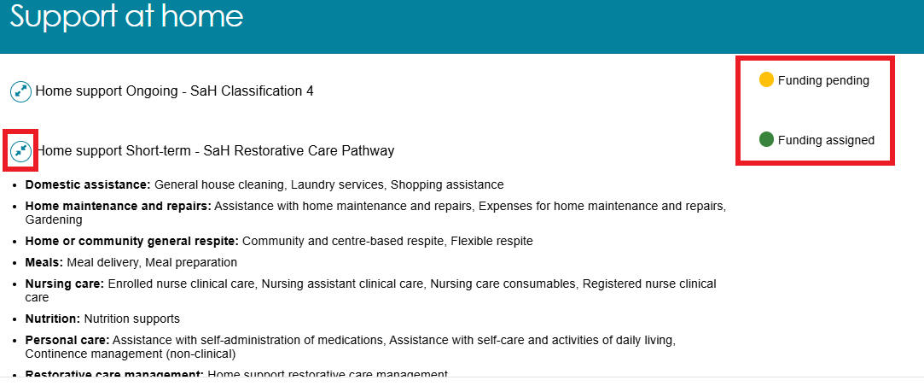
The below image shows an example of same pop-up for a client with Transitioned Home Care Package (HCP) classification.
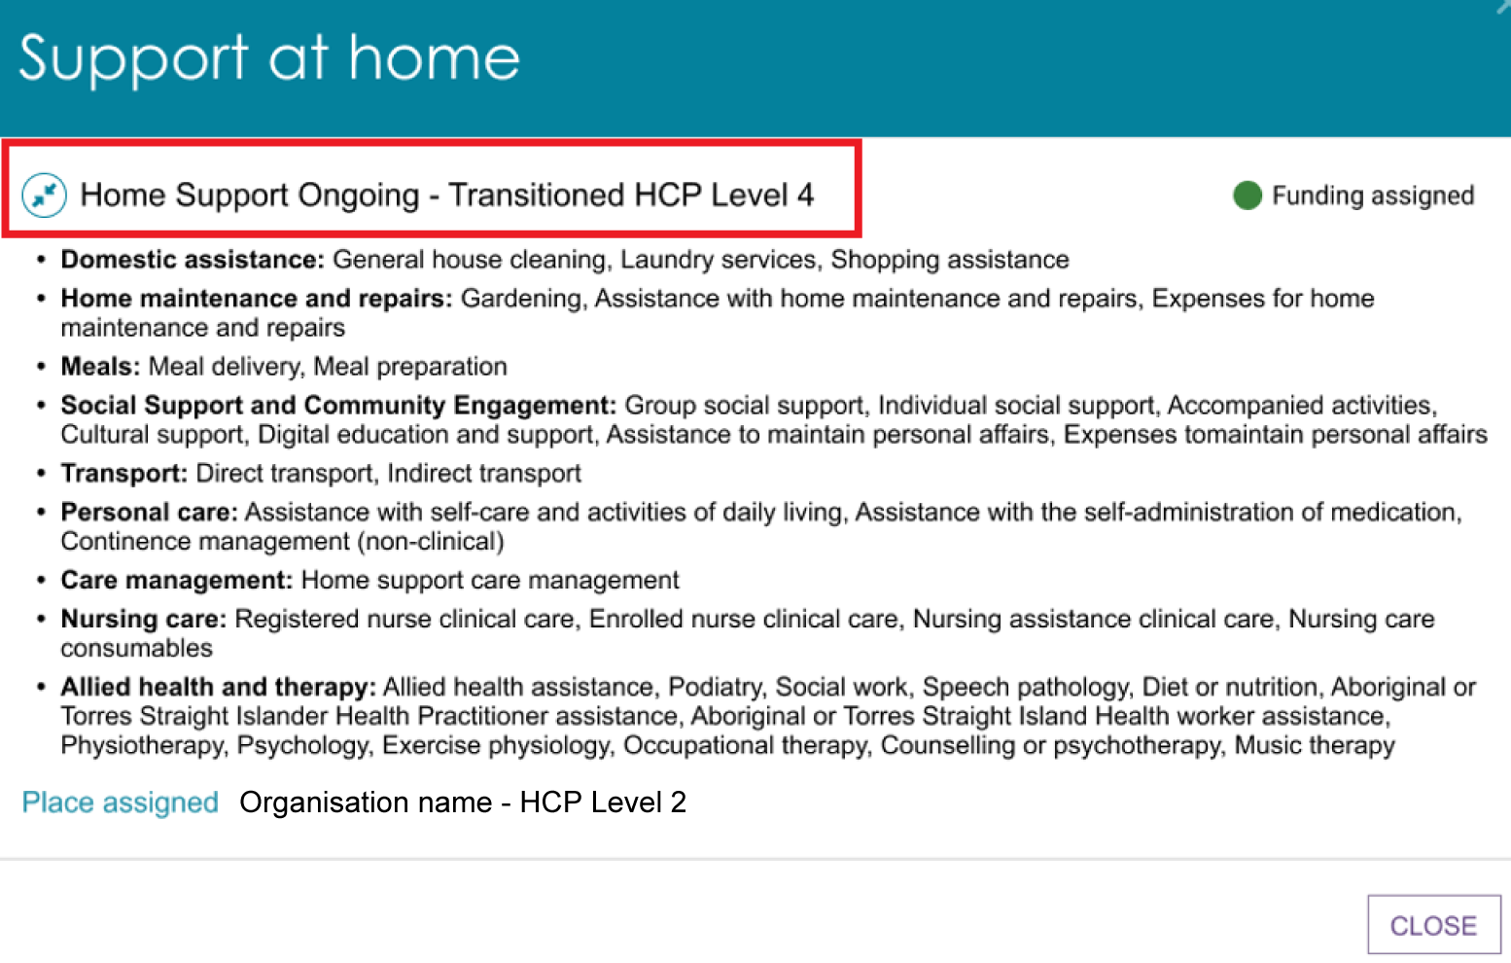
- Select the Print Page (Printer) button at the right-hand side of each heading to print the Client Summary information.
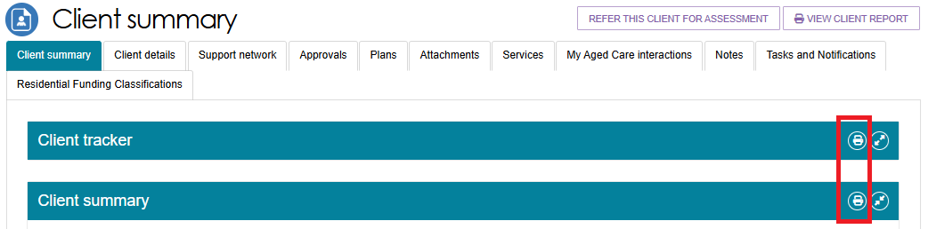

The Client Details tab
The Client Details tab shows a detailed profile of the client. It includes important personal and demographic information that supports the assessment process and care planning.
It gives assessors a complete and up-to-date view of the client's information to support informed decisions and accurate, person-centred care planning. The page also contains an option to notify My Aged Care when the client is deceased.
Update any details by selecting the Edit icon at the top right corner of each section.
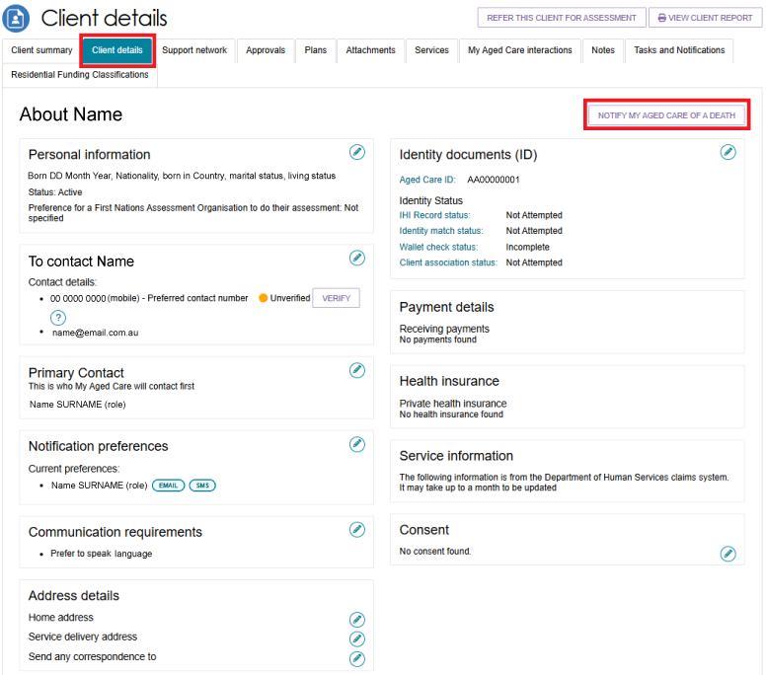
The client or someone in their support network can nominate a Primary Contact. This information helps assessors, My Aged Care contact centre staff, and service providers identify the main contact for the client. The system does not use this field to determine who receives care-related correspondence.
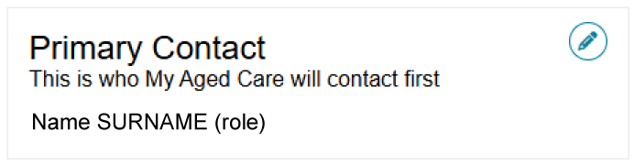

Notification Preferences
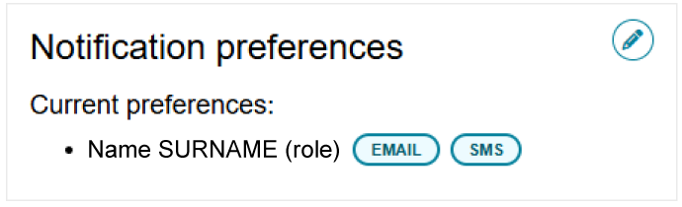
My Aged Care clients and their support network can also receive email and/or SMS notifications when a client reaches the following key stages of their My Aged Care journey:
- client registration is complete
- the client’s assessment is finalised
- the client is approved for care after completing a Comprehensive assessment
- a client receives a Support at Home service assignment, or the system generates a letter for them, such as an assignment or withdrawal letter
- a Support Plan Review request has been submitted
- when a support relationship becomes active, is declined, becomes inactive, or is about to expire
- the submission and processing of documents related to support relationships.
For more information about setting up and configuring notifications for clients and/or their support network, refer to My Aged Care – Assessor Portal User Guide 2 – Registering support people and adding relationships.
! | When adding or updating an address, make sure to select VALIDATE THIS ADDRESS before saving. This helps ensure the address is correct so that the client and their support network can receive communications from the My Aged Care system.  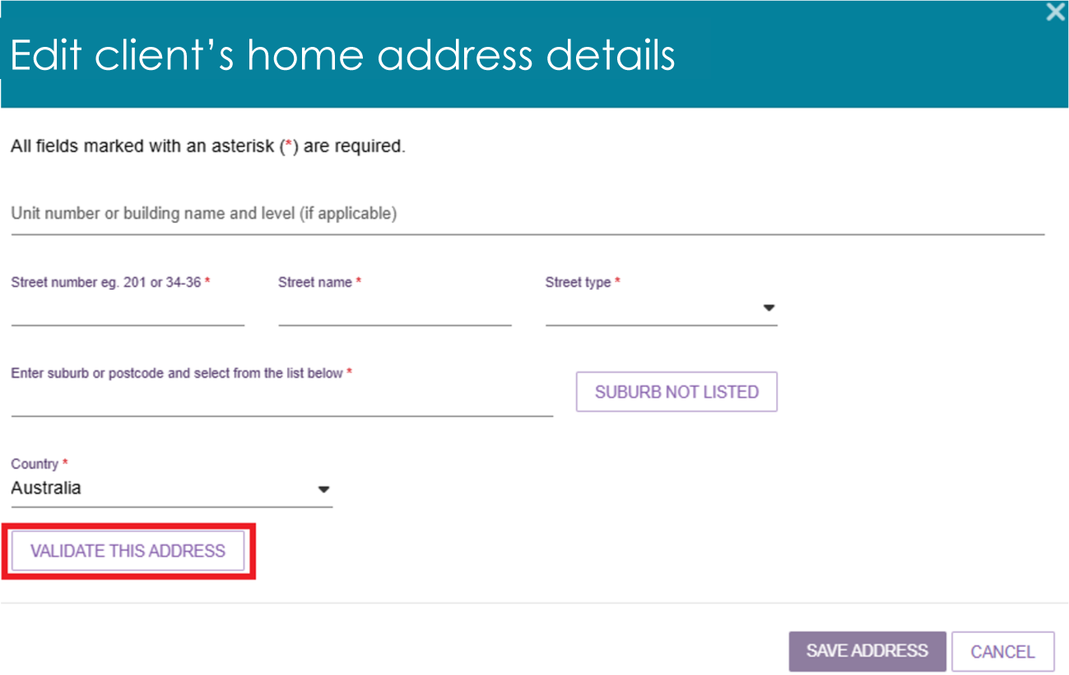

Adding a Post Office Box address
Only Clinical assessors and assessment delegates can add a Post Office Box address to a client record as the preferred address for all correspondence.
- In the Address details section of the Client details page, select the edit icon next to Send any correspondence to.
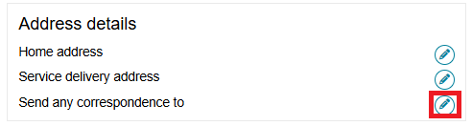
- Enter the PO Box type and number under the ‘Unit number of building name and level’ section. Enter the rest of the address as directed, then select VALIDATE THIS ADDRESS.
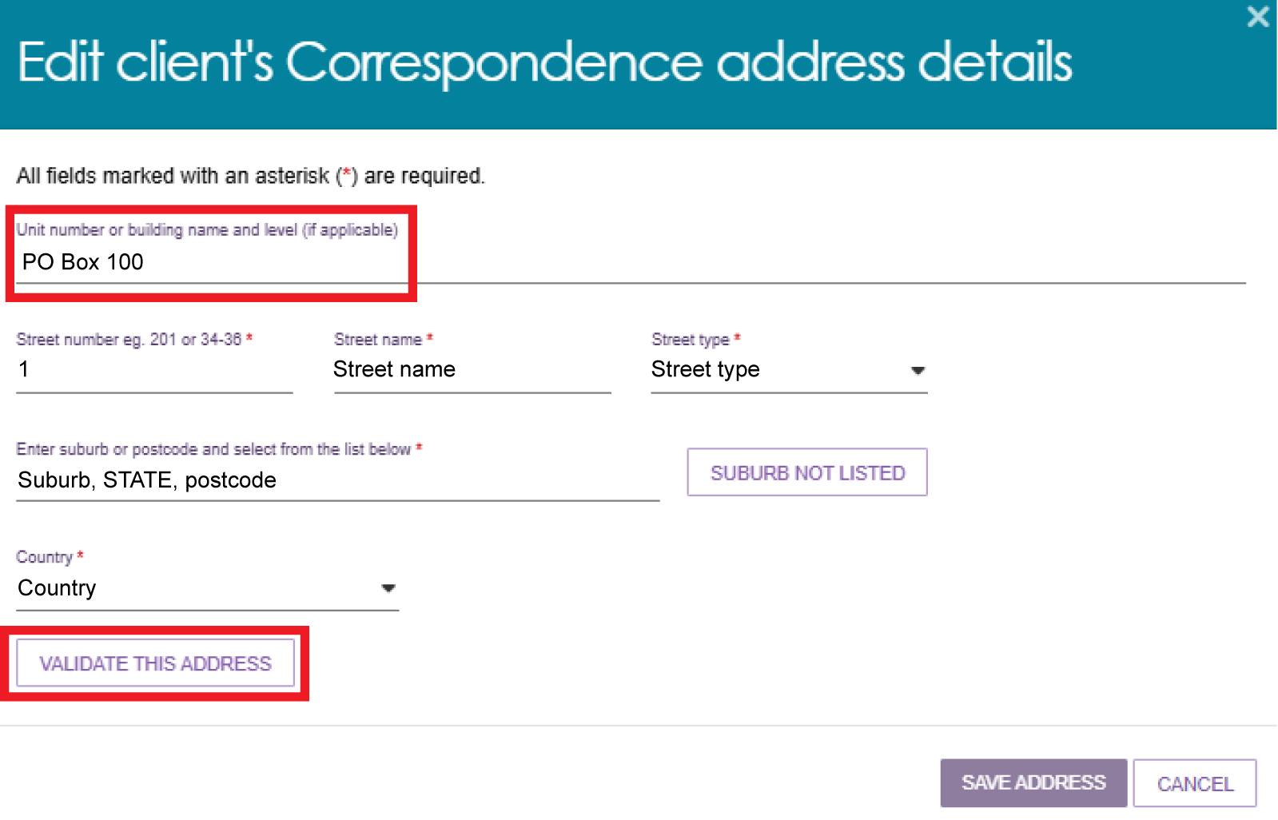
- If the PO Box address is valid, the Save Address button becomes available. If the system cannot validate the address, it displays a list of alternative addresses. Select the most appropriate option, or choose Not found, use entered address anyway. Then select Save Address.
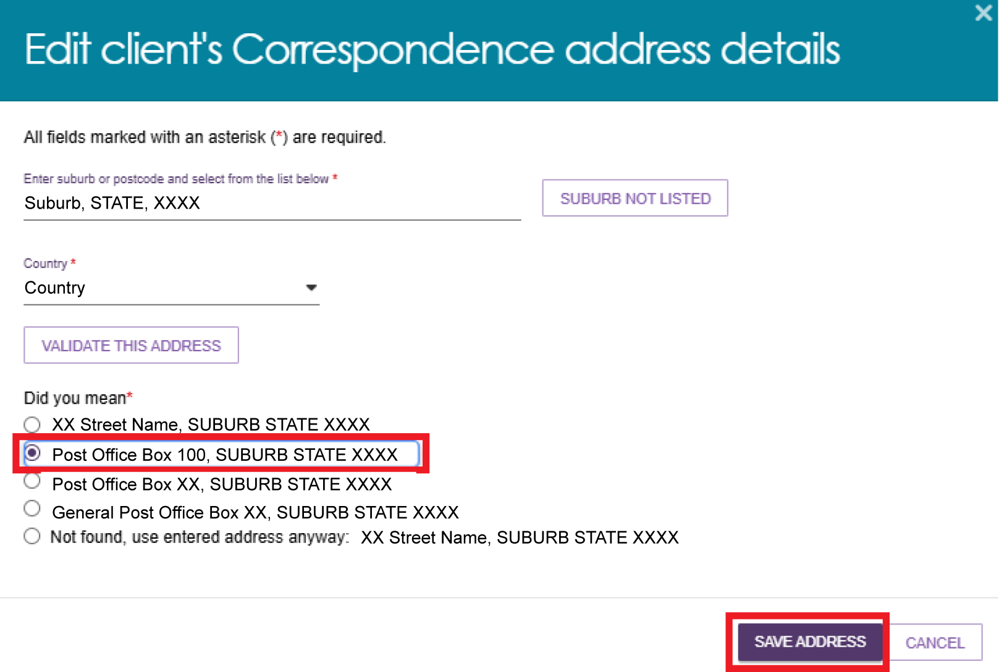
- A green banner appears: ‘Client address was updated successfully’.
The PO Box address displays in the Address details section, underneath ‘Send any correspondence to’.
Select the SEND CORRESPONDENCE TO HOME ADDRESS button if you do not want to send correspondence to the PO Box.
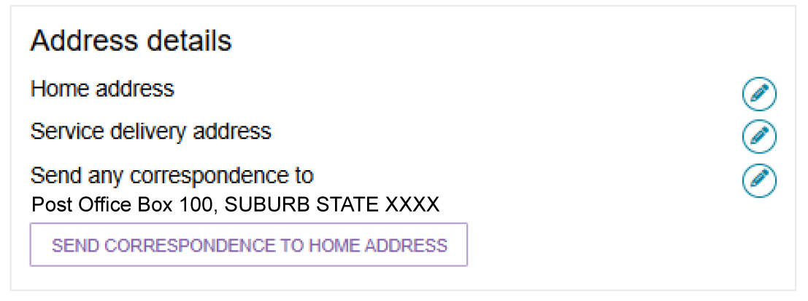

Recording consent to share information with My Health Record
You can view and update the client's consent to share information with My Health Record in the Consent section.
- To update a client’s consent, select the EDIT (pencil) icon.
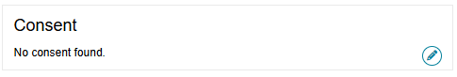
- A pop-up window will appear. If the client agrees to share their information with My Health Record, select Yes, indicate whether the consent was provided by the client or their Supporter Guardian, and then select Save.
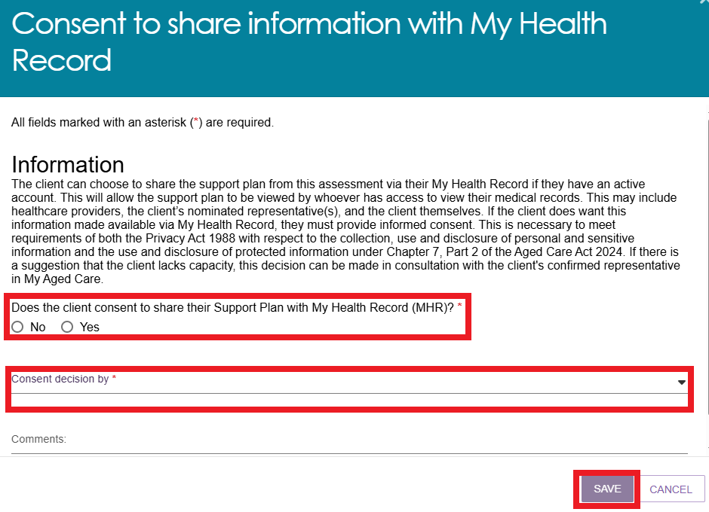
! | If a Supporter Guardian makes the consent decision, you must enter their first name before you can continue.  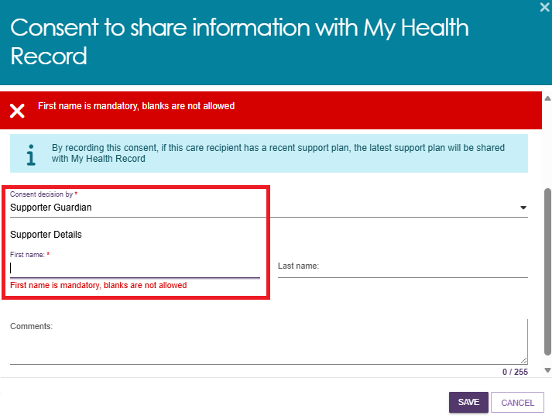
If the answer is No and the client or their Supporter Guardian is withdrawing consent, any support plan information previously shared with My Health Record will be removed.
Select a reason for declining consent from the drop-down list, then select Save.
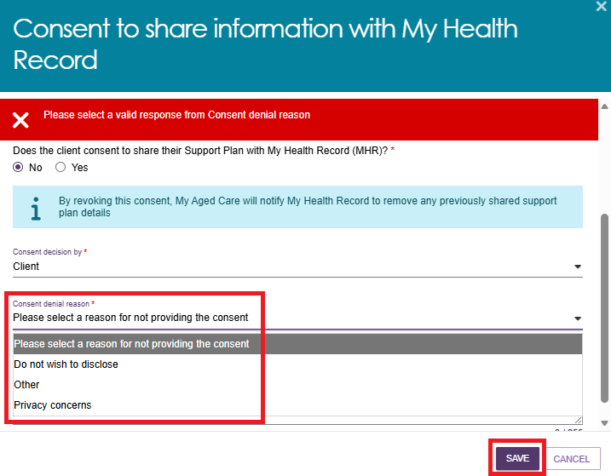
If Other is selected as the reason for declining consent, you must enter a comment explaining the reason before selecting Save.
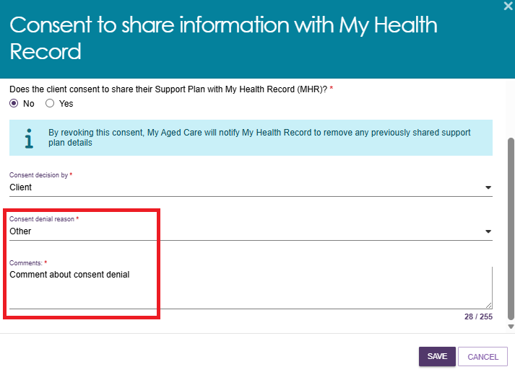

Notifying My Aged Care that the client is deceased
If a client's status is marked as Deceased, their record becomes read-only, and you will no longer be able to update their information. Once this status is recorded in My Aged Care, the client's support network will lose access to the record. Notifications will be sent to the client's assessor and provider, advising them to close or complete any outstanding tasks. You can still add notes and attachments to the client record, and any assessments already in progress can be finalised after the status has been updated.
A banner will be displayed on all tabs of the client record. If the client’s status is incorrect, please contact the service provider and assessor helpline on 1800 836 799.
- Select the NOTIFY MY AGED CARE OF A DEATH button, located in the top right corner of the Client Details page in the client record.
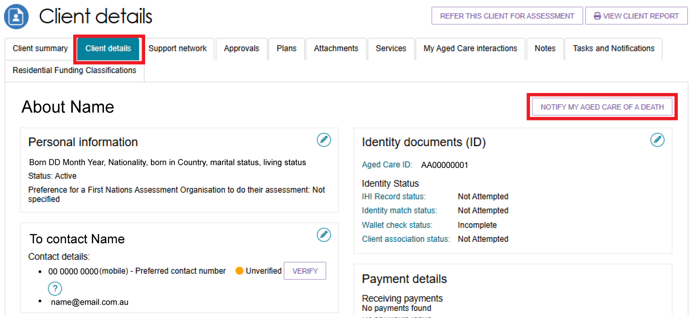
- A pop-up screen will prompt you to input all information and upload the supporting documents as required. Select SAVE.
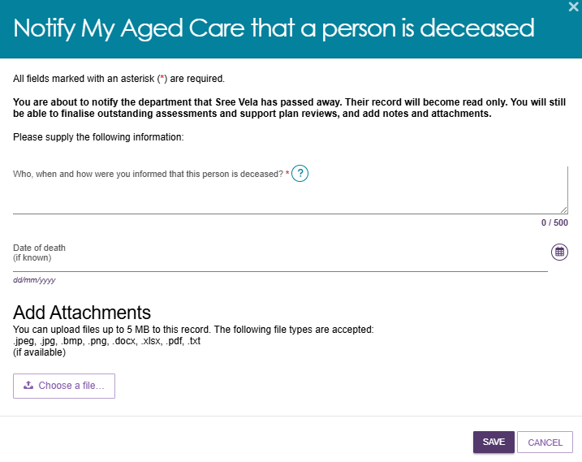
- A pop up reminds you that these changes cannot be reverted.
To confirm, select OK.
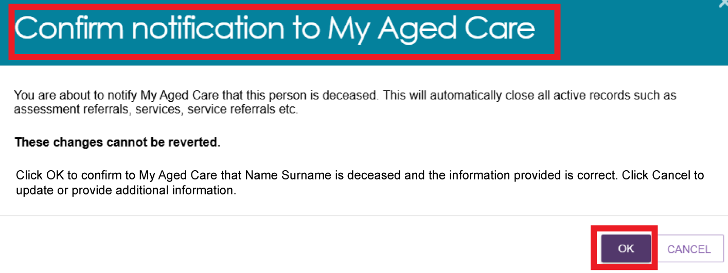
- The Client Details page opens and displays the following information.
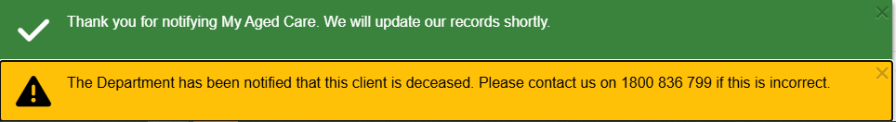
- The client status will be updated to deceased on the records. The client card will appear as shown below. If there are any in-progress assessments for the client, a notification will be sent to the associated assessor and provider advising them to close or finalise the in-progress tasks.
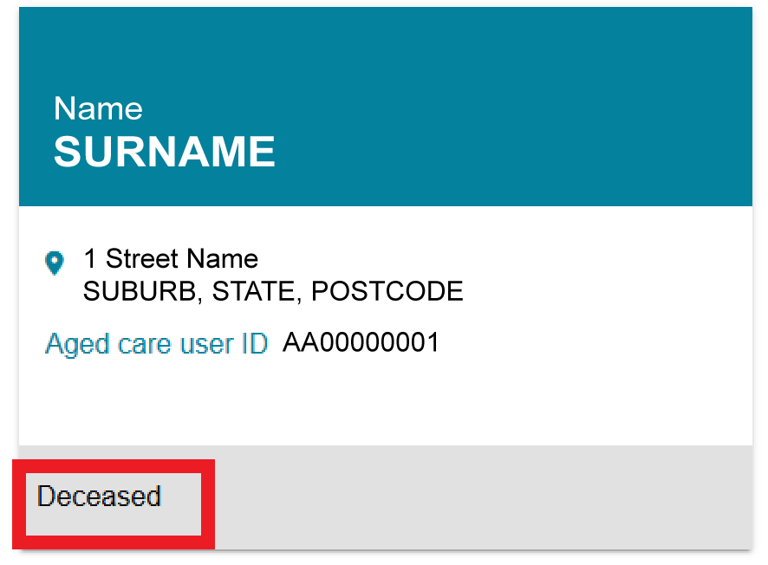

The Support Network tab
The Support Network tab provides a summary of the people and relationships that play a role in supporting the client.
This includes informal support such as family members, friends, or neighbours, as well as formal supporters like carers, supporter guardians, or supporter organisations.
The tab outlines each person’s relationship with the client, their role in the client’s care, and their contact details if relevant.
This information helps assessors understand the client’s current support structure and identify any gaps in care or additional support needs.
For more information about creating supporter relationships, refer to My Aged Care – Assessor Portal User Guide 2 – Registering support people and adding relationships.
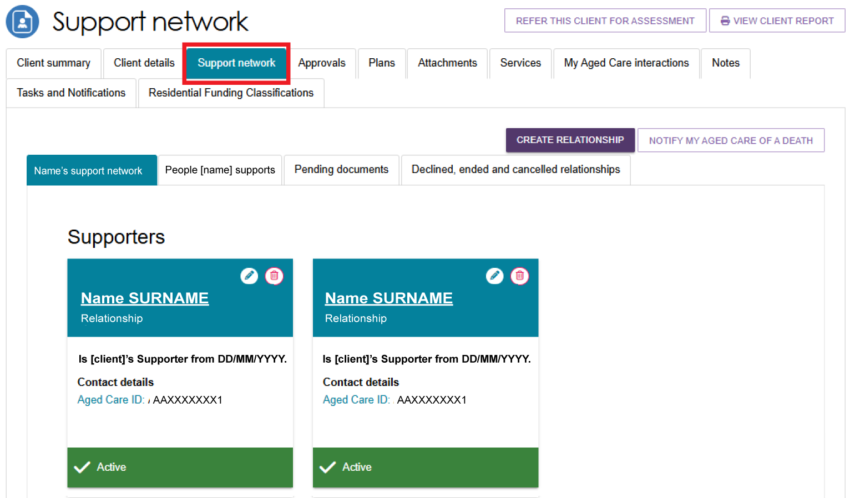

The Approvals tab
The Approvals tab shows the outcomes of a client's assessments and the government-funded services they are approved to receive. This information helps assessors, clients, and service providers understand the client's care options, make appropriate referrals, and plan services.
To view more information about an approval, select the Expand button next to it. This displays additional details, such as the approval status, priority category, and correspondence notification settings.
- Select the Approvals tab to navigate to the approvals page of the client record.
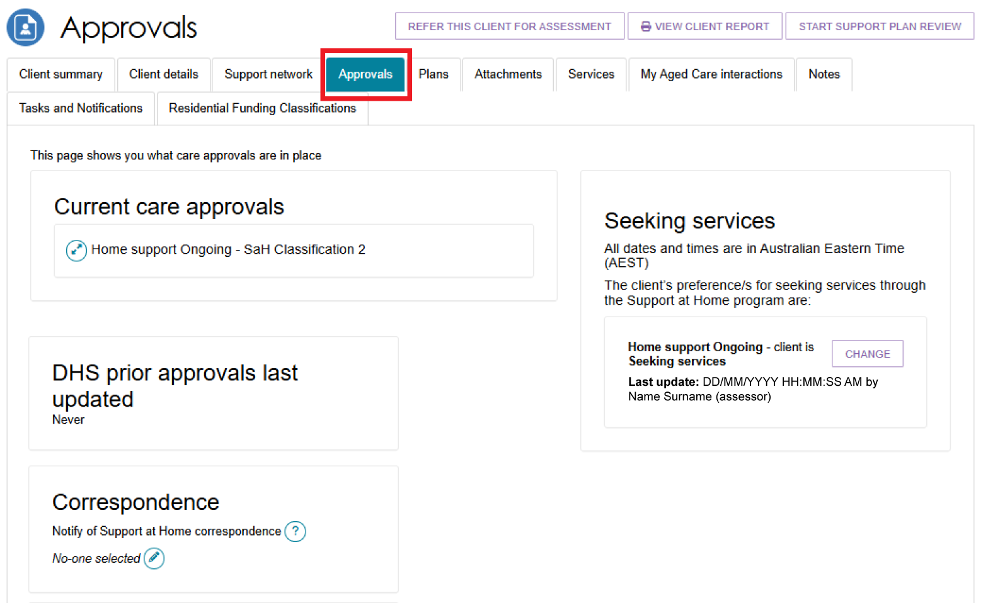
The below image shows an example of a client who was previously approved for a Home Care Package. In the Current Care Approvals section, this client has a new status of ‘Home support ongoing - Transitioned HCP Level [number]’
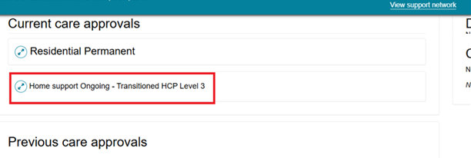
The Previous Care Approvals section shows any lapsed or ceased approvals, including Urgent Commonwealth Home Support Program (CHSP) services.
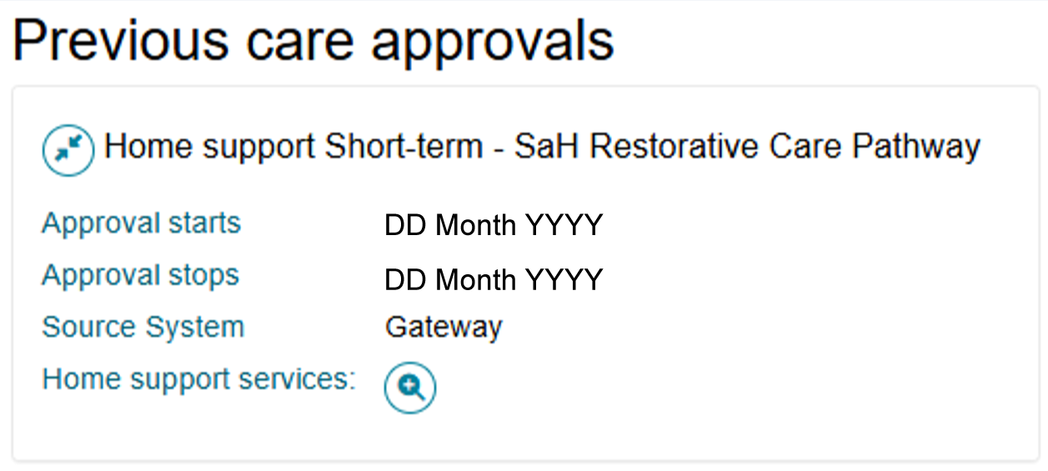
- Select the expand icon next to the relevant care approval to view more details.
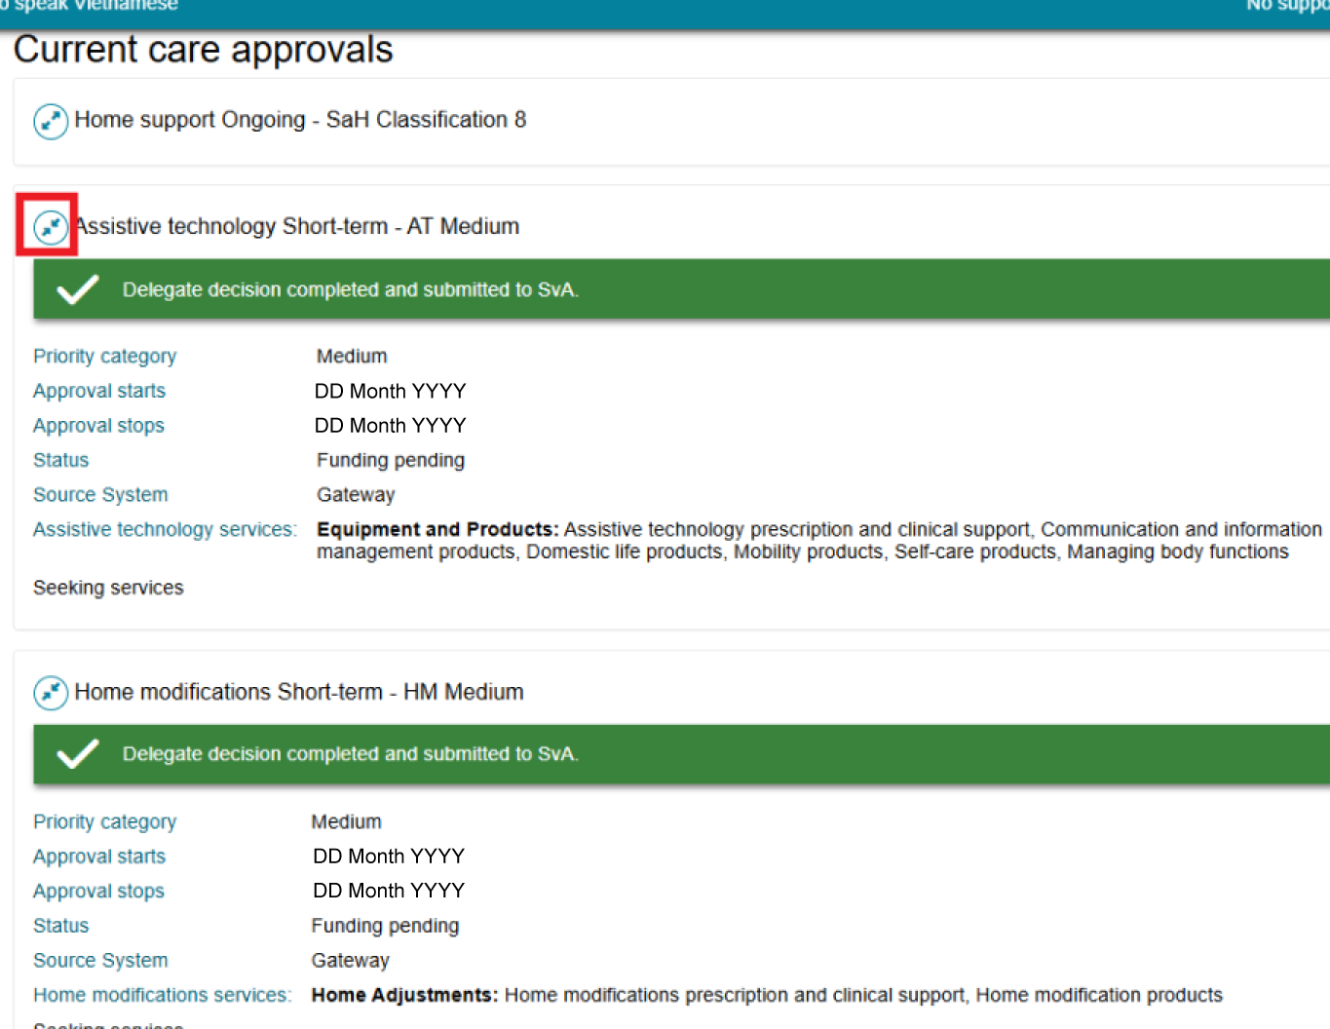
- If the client's circumstances change and they no longer want a service they are currently seeking, select Change and update the service from Seeking to Not Seeking. You must complete this process for each approved Support at Home service type. If the client's place was previously withdrawn, advise them to contact My Aged Care to rejoin the Support at Home Priority System.
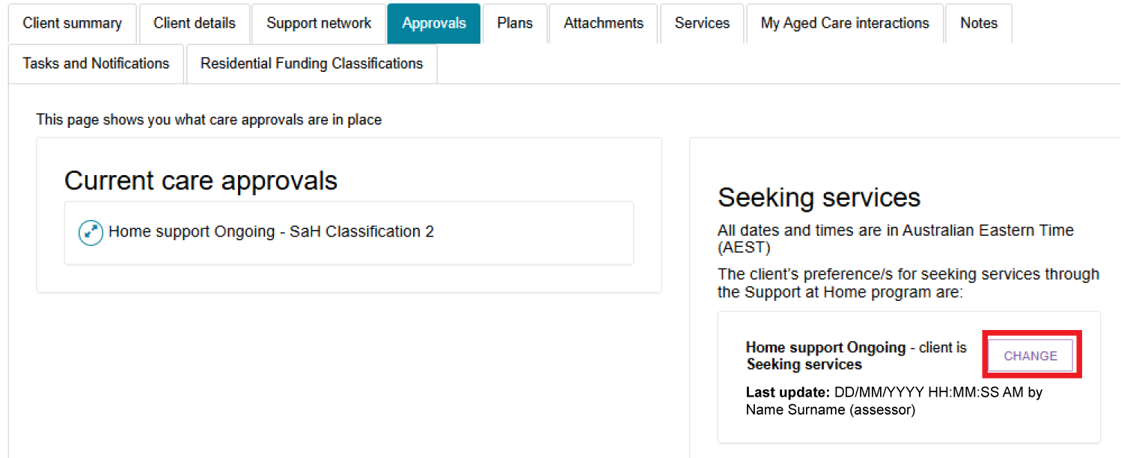

The Plans tab
The Plans tab provides a summary of the client’s support plan, outlining the outcomes of their assessment and the services or goals identified to meet their needs.
- Select the Plans tab to navigate to the plans page of the client record.
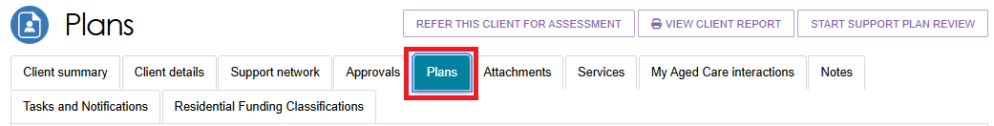
- To view more information about an assessment, select the Expand button next to the relevant item under Assessment History.
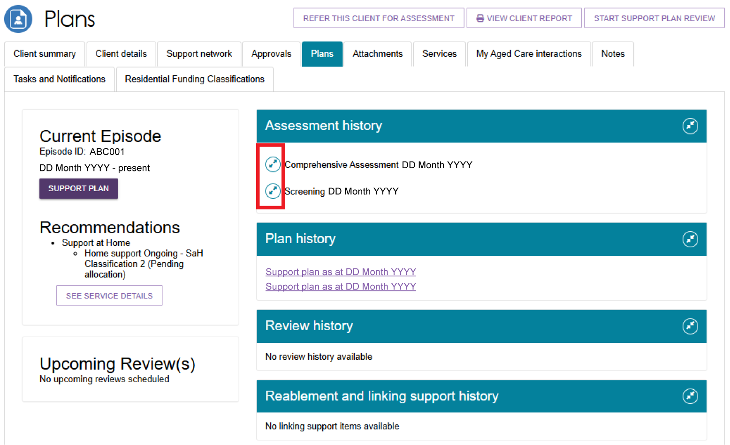

The Attachments tab
The Attachments tab contains all documents attached to the client's record, including those uploaded through the Aged Care Assessor App. Assessors can use this tab to view, upload, and manage attachments related to a client’s assessment and care planning.
- Assessment Attachments are any documents that are relevant to the client’s assessment, for example, clinical notes or a discharge summary. This includes Notice of Decision (approval or non-approval) letters that assessors can generate and upload.
- Other Attachments are documents that relate to the clients’ general circumstances, for instance, documents related to the establishment of a support relationship (including legal in documentation), and Occupational Therapist drawings used in home modifications. You can also view Proof of Progression documents in this section.
- Correspondence includes letters and documents generated in My Aged Care about Support at Home services. My Aged Care sends these letters to clients at different stages of their service journey and also sends copies to their nominated support person or people.
- Sensitive Attachments are documents that contain client information of a sensitive nature. For example, documents about a client’s financial situation, safety concerns and legal issues that may impact the provision of services.
- Select the Attachments tab to navigate to the attachments page of the client record.
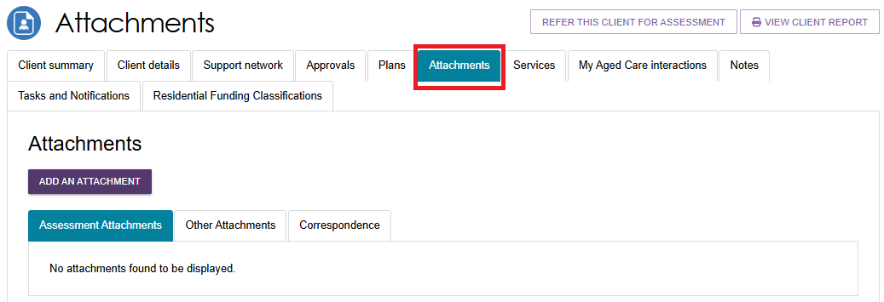
- To add an attachment, select the ADD ATTACHMENT button.
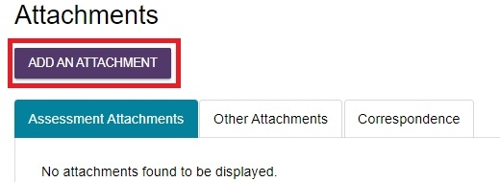
- A pop-up window will appear, prompting you to find and upload the desired attachment. Search your computer for the document you wish to attach by selecting the Choose file button.
Provide additional details by inputting the Name of the attachment, choosing the Type of attachment from the drop-down lists, and providing a short description. Finally, select the UPLOAD button to save your attachment to the client record.
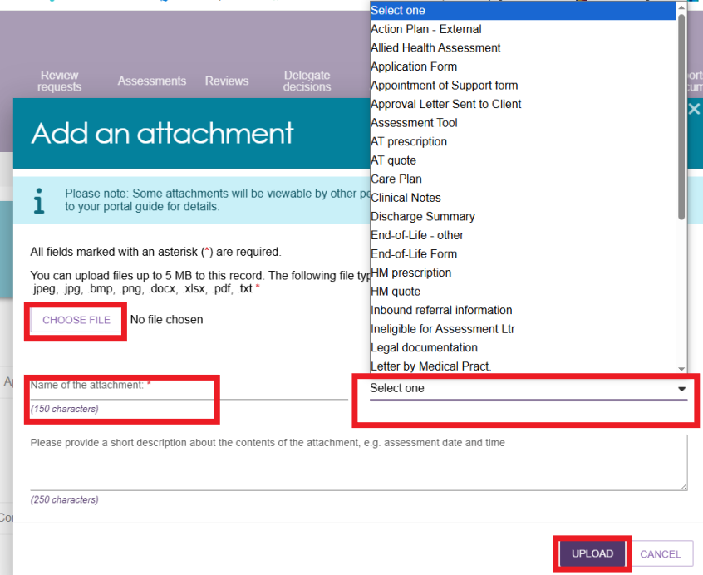
! | Where a client record has a Sensitive Attachment and the client is referred for service provision, service provider(s) will be notified that a Sensitive Attachment exists for the client. Service providers cannot view sensitive attachments; they will be directed to contact the assessor who conducted the last assessment, or the My Aged Care Service Provider and Assessor Helpline on 1800 836 799 to access information within the Sensitive Attachment.  Sensitive attachments are not visible through the My Aged Care online account and will be visible only to assessors and My Aged Care contact centre staff.
- Your attachment will appear in the Assessment Attachment tab, or the Correspondence tab.
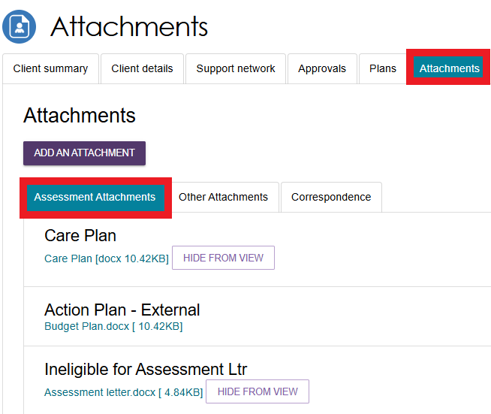
- Sensitive attachments will appear in the Other Attachments tab.
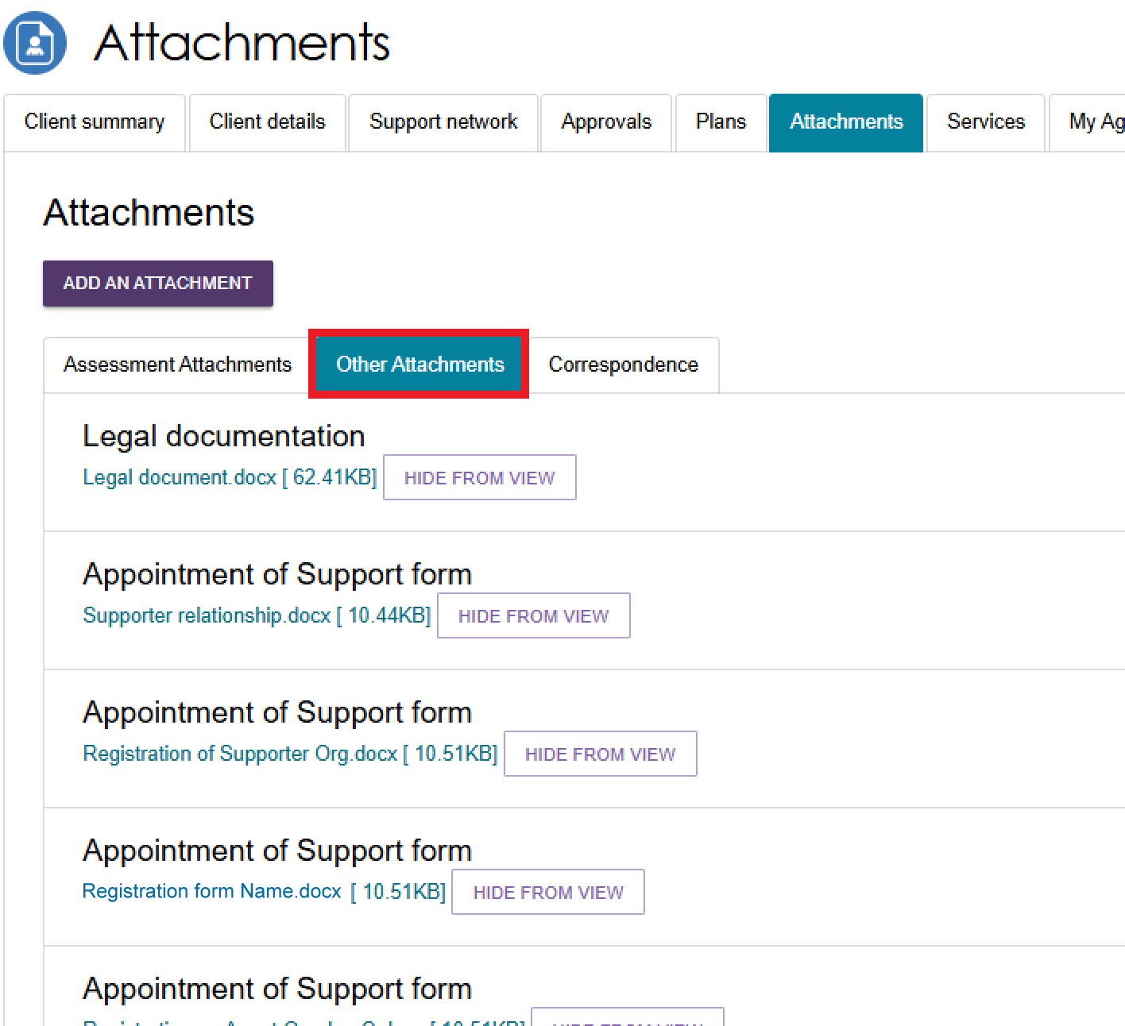

The Services tab
The Services tab provides a central view of the client’s current and past interactions with aged care services. It helps assessors track referrals, service uptake, and provider engagement. This section is crucial for ensuring service continuity, preventing duplication of referrals, and monitoring whether the client is receiving appropriate support based on their assessed needs.
Select the Services tab to open the client's Services page. This page includes the following sections:
- Services from other systems: View records of services the client previously received in other systems. For example, clients who transitioned from Short-Term Restorative Care (STRC) can view their STRC approval records and subsidised care records in this section.
- Services not yet in place: View approved services that have not started.
- Services in place: View the services the client is currently receiving.
- Previous services: View services received previously.
Only sections with records appear on the page. Select the Expand button on the right of a section heading to display its records.
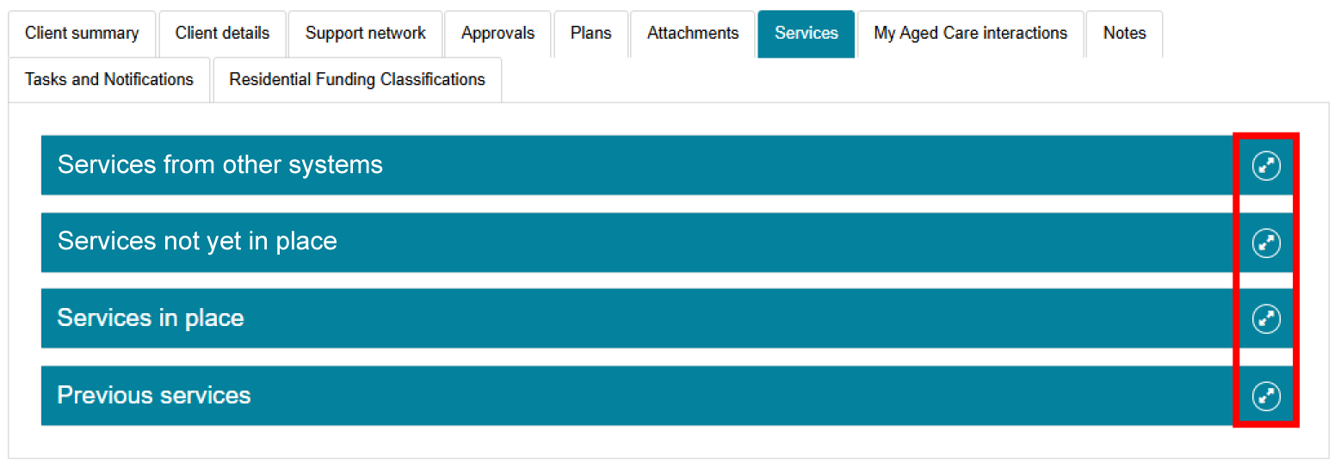

The below image shows some services in place. It contains contact details of the service provider, accepted date, start and end date, recommended start and end date, and service frequency. If applicable, the listing also shows the approval start and/or end date.
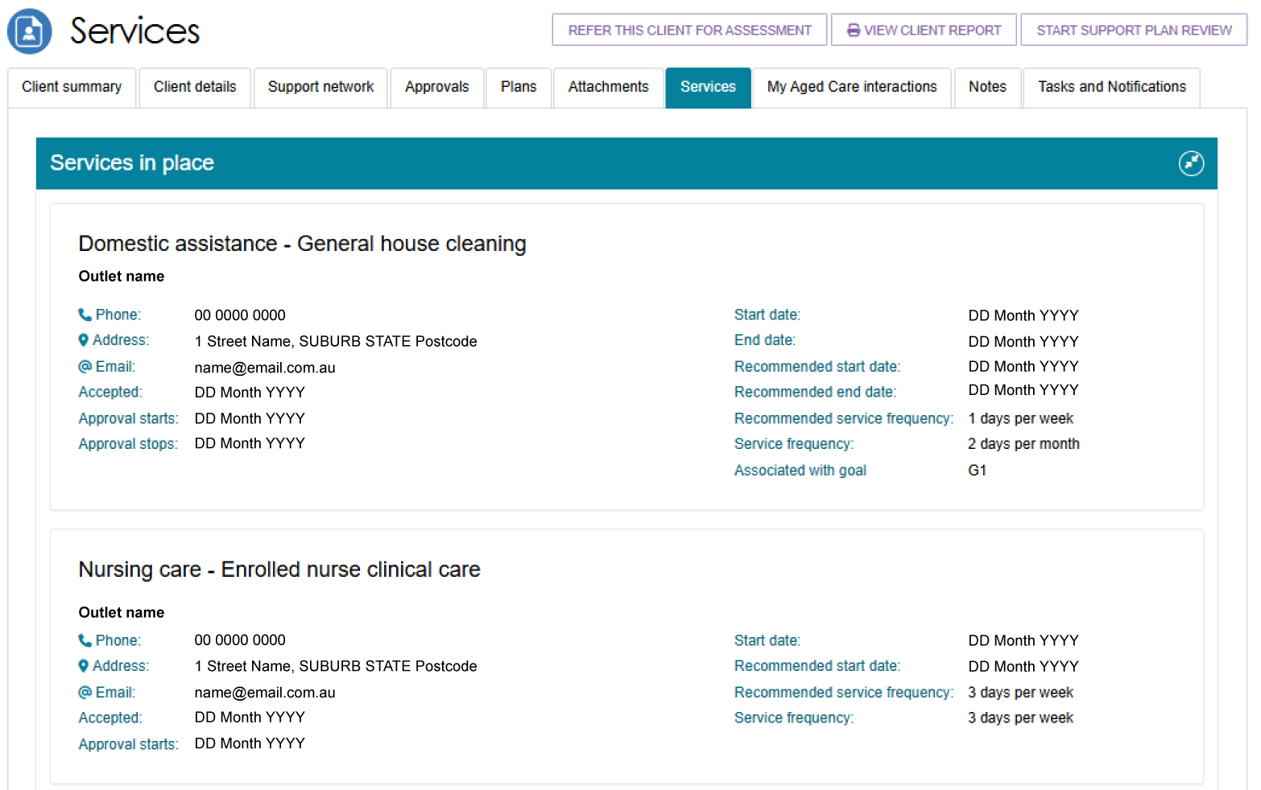

The My Aged Care interactions tab
The My Aged Care Interactions tab shows the client's history of contact with My Aged Care. This includes appointments with Aged Care Specialist Officers, calls to the My Aged Care Contact Centre, and records of consent for callback requests to services such as Carer Gateway and the National Dementia Helpline.
This information helps assessors stay up to date with the client's interactions with My Aged Care, supports continuity of care, and reduces the risk of important communications being missed or duplicated.
For more information about the Carer Gateway and National Dementia Helpline referrals, go to My Aged Care – Assessor Portal User Guide 2 – Registering support people and adding relationships.
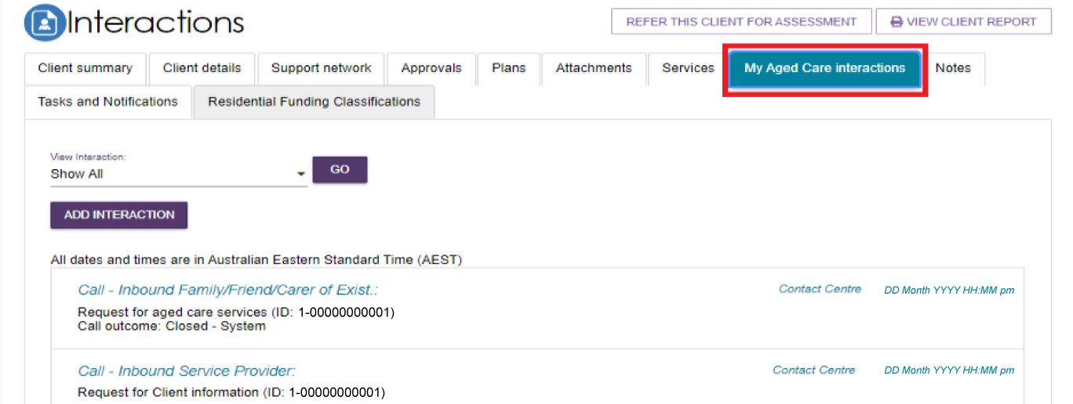

The Notes tab
My Aged Care contact centre staff, Aged Care Specialist Officers, assessors, and service providers can view and add several types of notes about clients through the My Aged Care portals.
Assessors can also view and add these notes in the Aged Care Assessor App.
Refer to the tables on the following pages for information about note types and permissions according to role.
!  !  ! | All notes are subject to Freedom of Information legislation.  Triage Delegates should review the notes tab prior to completing the triage process as not all information captured from screening is pre-populated.  You may view client records that were transferred from another assessment outlet. This is because Department staff can transfer client records linked to an inactive assessment outlet to an active assessment outlet in the same assessment organisation or to another assessment organisation.  This means that you will view a note of the transfer in the client’s My Aged Care record.
Select the Notes tab to navigate to the notes page of the client record. The Notes tab contains notes that have been created about the client. Assessors can add new notes about the client from this tab.
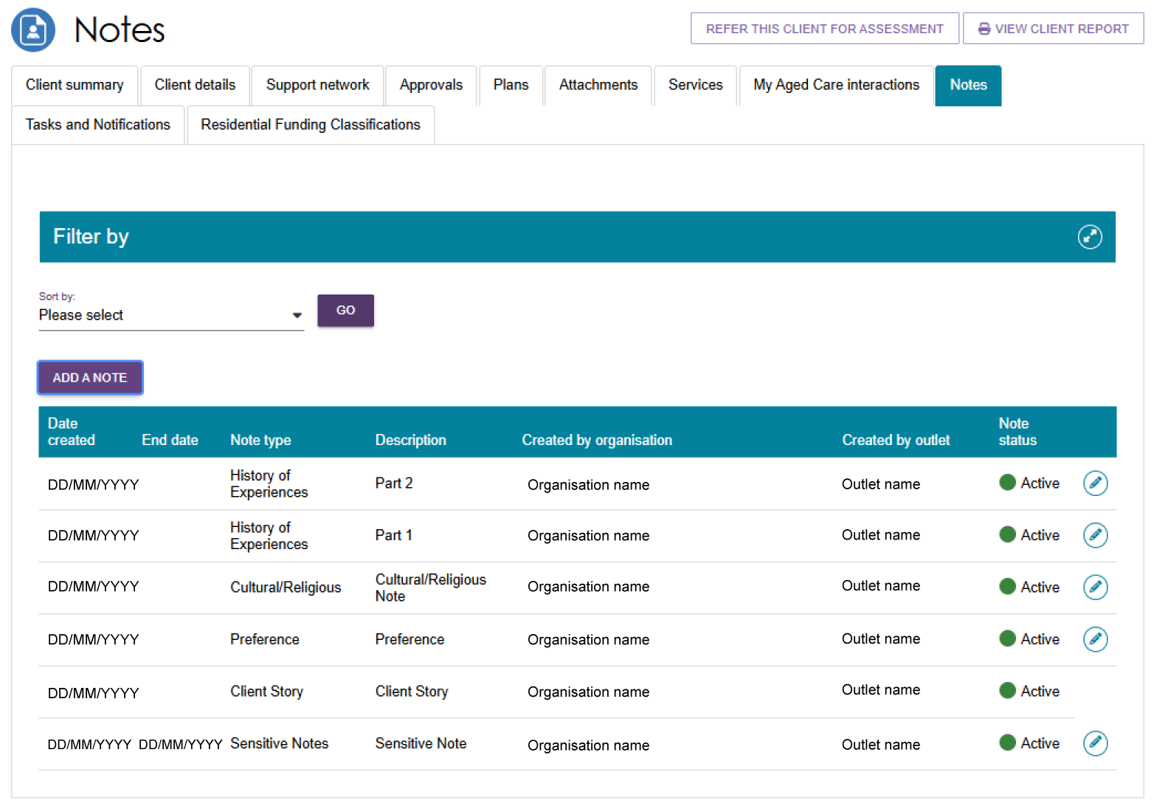

Note types
This table shows a selection of important note types, their description and example text.
Note type | Description | Examples
Client story | A summary of the client’s current circumstances. Assessors, My Aged Care contact centre, service providers and clients can view these notes. | Mrs Jones has just been discharged from hospital and is seeking help at home. She lives with husband and has early onset dementia.
Sensitive notes | Information of a sensitive nature about the client that needs to be available for assessment or provision of some services. A sensitive note will display a flag on the portal for the service provider against the client. They may contact the My Aged Care contact centre or assessor for additional information, which will only be provided to them if relevant to their service provision. This note will not be displayed to service providers or clients in their portals. | - Mr Smith is HIV positive.  - Mrs Johns has an abusive relationship with son.
Preference | Clients stated service provision preferences. Assessors and My Aged Care contact centre staff can view these notes. | - Mrs Marten would prefer a Catholic provider.  - Mr Dobruk is affiliated with the Croatian community.
Observations | Observations from service provider and/or assessor’s interactions with the client. Assessors, My Aged Care contact centre staff and service providers can view these notes. | - There is a dog on the property.  - Mrs Shean seems more energetic than she did during my last visit.
Referral Note | Notes accompanying a client’s referral. This can be an initial referral, subsequent referral or referral from one assessment outlet to another. | This client record has now been transferred from Outlet A to Outlet B on 01/01/2024.
Other | Additional information about the client. Assessors, My Aged Care contact centre staff, service providers and clients can view these notes.  Examples of other notes include: Client Story - Returned mail, Cultural/Religious, History of Experiences, Gender Identity/Sexual Pref notes. | Mrs Jones has planned respite on 01/08/2017.
! | When My Aged Care contact centre staff or assessors add a sensitive note about a client, all service providers who are sent a referral will view a flag informing them that there is a sensitive note about the client and instruct them to call the My Aged Care contact centre or the assessor for more information. This information also appears on the client’s record.  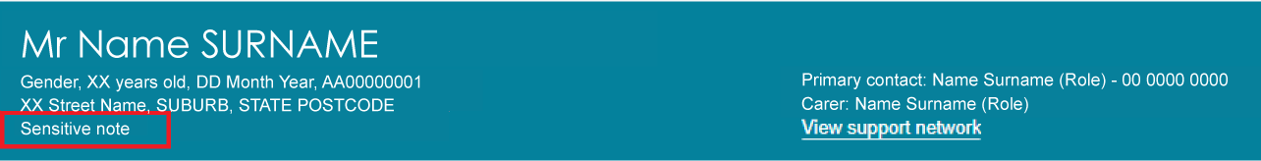

Note add & view permissions
The table below shows each role in the assessor portal and their permissions to add or view a selection of note types.
Role | Add Note Types | View Note Types
Assessors | All | All
Service Providers | Observations  Other | Other  Client Story  Observations  Sensitive (Flag only, no content)
Clients (and their support network) | Other | Other  Client Story
My Aged Care  Contact Centre Staff | Client Story, Sensitive Notes, Preference, all “Other” notes except Observations. | All
Aged Care Specialist Officers  (Face to face support in Services Australia centres) | All | All

Adding client notes
The following section outlines how to add client notes using the assessor portal. For instructions
on how to add notes in the Aged Care Assessor App, refer to the Aged Care Assessor Application User Guide.
- Select the Notes tab to navigate to the notes page of the client record. Then, select the ADD NOTE button to start creating a new note.
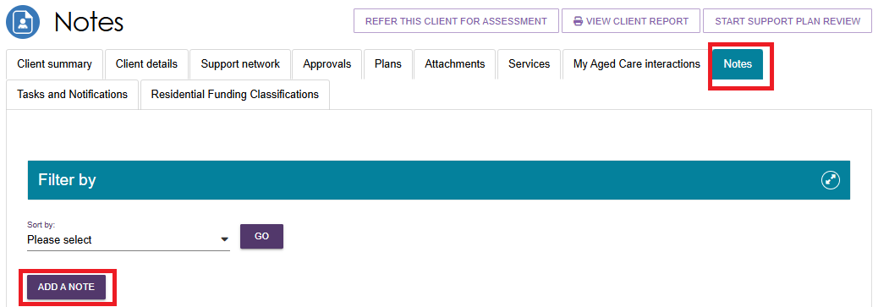
- A pop-up box will appear. Select the Type of the note you wish to add using the drop-down list and input the description (that is: the content of the note itself). You can hover over the help icon in the pop-up box for additional information about the note types. If you are unsure which category is most appropriate, please refer to the information in the help icon.
! | You cannot delete a note once saved. Check that the information is correct before saving.
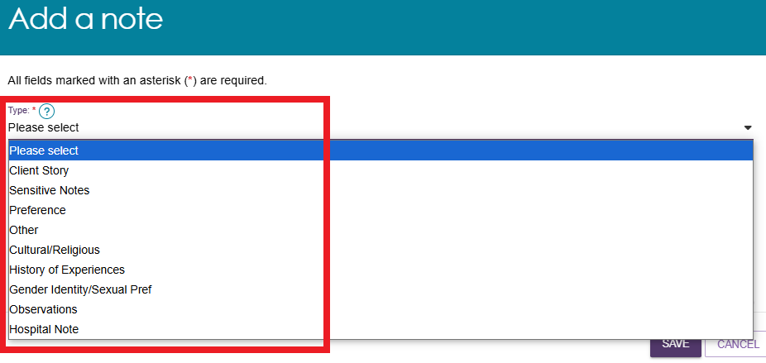
- Select SAVE to finish your note.
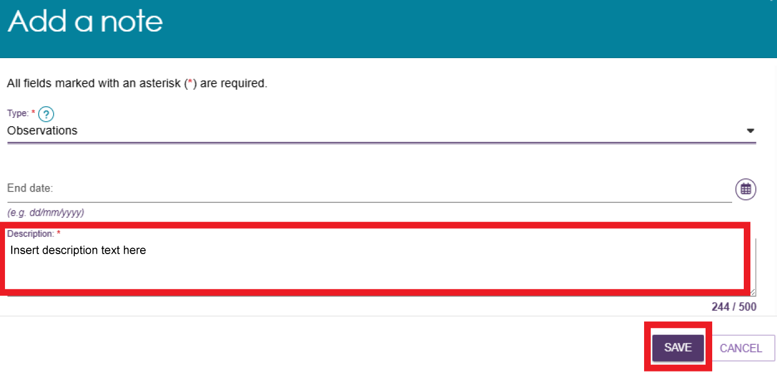

Viewing and editing client notes
This section explains how to view and update client notes in the Assessor Portal. To learn how to view and update notes in the Aged Care Assessor App, please refer to the Aged Care Assessor Application User Guide.
- Select the Notes tab to navigate to the notes page of the client record. Then, select the Edit (pencil) icon to the right of the note you wish to edit. Note that there is no Edit icon available for Client Story notes.
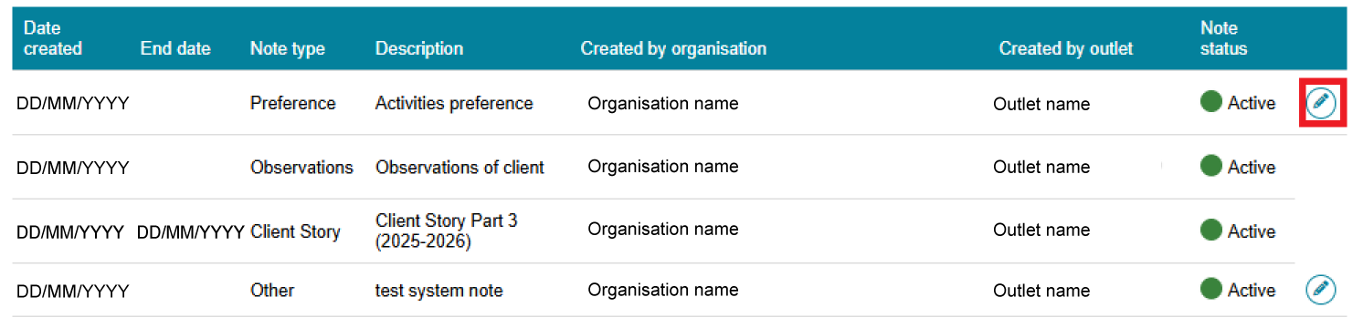
- A pop-up box will appear. To make a note Active or Inactive, use the drop-down list to select the desired status. Then, select SAVE to finish your note.
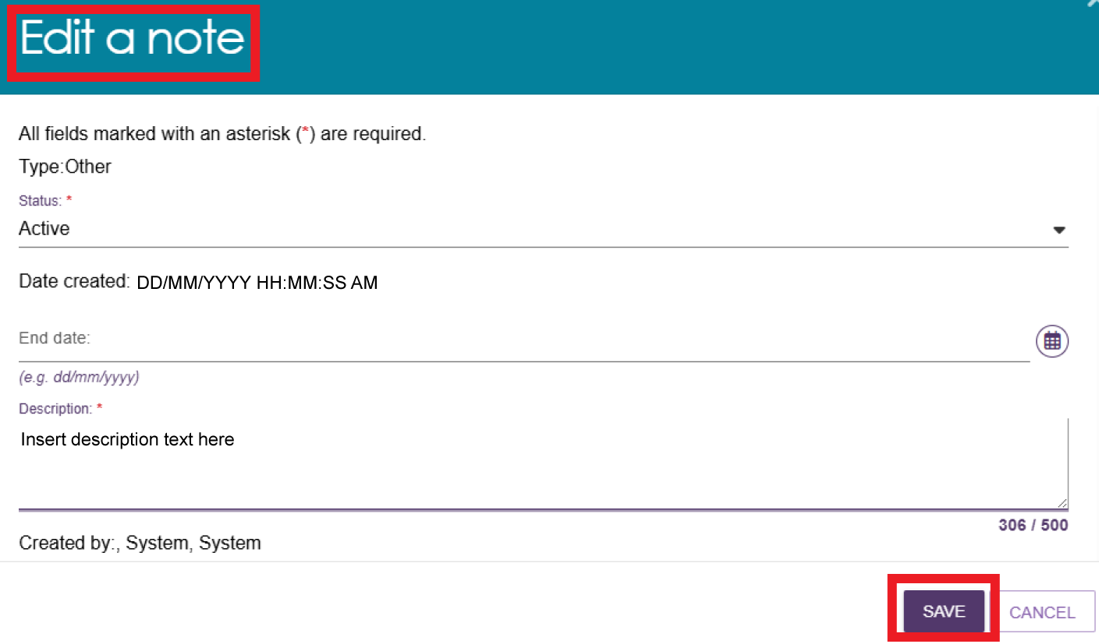
- Client Story notes can also be viewed by assessors in the Assessments section of the assessor portal. Select the link to the Assessments section of the assessor portal at the very top of the page. Then, select expand a client summary by using the expand icon on the left of the row.
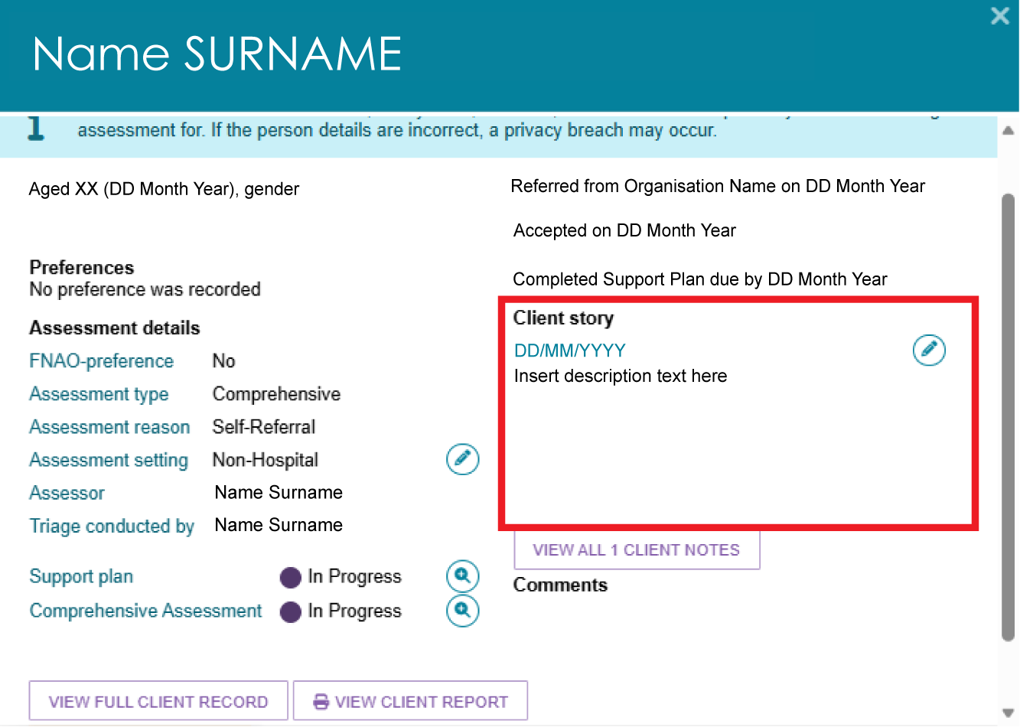
! | Client story notes cannot be edited after they are created. To make changes, assessors and providers can mark the original note as inactive and create a new note, helping ensure records are not lost.  If you are concerned that information in these records is incorrect, contact the My Aged Care service provider and assessor helpline on 1800 836 799.

The Tasks and Notifications tab
All tasks and notifications relevant to the client will be displayed in this page. Assessors will be able to view all tasks and notifications relevant to the client. Providers will only be able to view tasks or notifications that are associated to their assessment outlet, for clients that they are providing services to. Select the Tasks and Notifications tab to navigate to the interactions page of the client record.
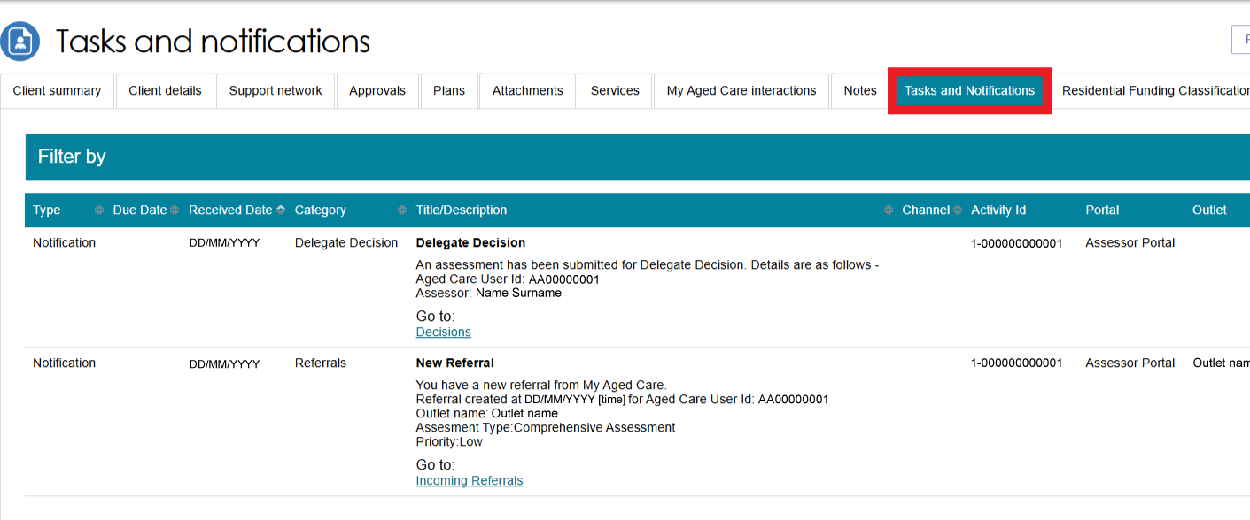
For a complete view of all tasks and notifications, refer to the Tasks and Notifications tile assessable from the assessor portal front page.

The Residential Funding Classifications tab (clinical needs assessors)
Residential Funding Classifications are part of the Australian National Aged Care Classification (AN-ACC) system, designed to replace the Aged Care Funding Instrument (ACFI) for the purposes of allocating government funding for residential aged care. Clinical needs assessors can view the client’s current AN-ACC classification, and classification history using this tab.
Select the Residential Funding Classifications tab to navigate to the classifications page of the client record.
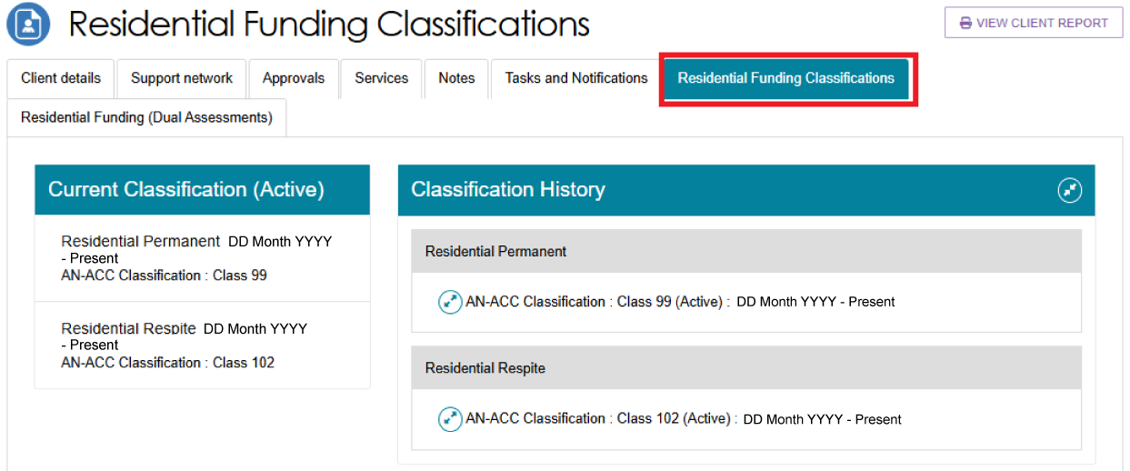

More Information
For further assistance, you can call the My Aged Care service provider and assessor helpline on 1800 836 799.

