Assessor Portal User Guide 2 - Registering Support people and adding Relationships
This guide helps aged care needs assessors (assessors) register support people and manage their relationships with clients.
You will usually complete these tasks in the My Aged Care assessor portal. You can also complete some tasks in the Aged Care Assessor App.
A client's support network can include:
- Registered Supporters
- other individuals
- agents
- organisations
- nominated staff members from approved organisations.
There are three types of Registered Supporters:
- Supporter
- Supporter Lite
- Supporter Guardian.
These people support clients when they interact with My Aged Care. This may include communicating with assessors, service providers, and the My Aged Care Contact Centre.

Types of support for clients 3
Supporter 3
Supporter Lite 4
Supporter Guardian 4
Supporter Organisation and Organisational Supporters 5
Supporter Guardian Organisation and Organisational Supporter Guardians 5
Agent Organisation and Organisational Agents 5
How can I nominate or request to register a person or organisation as a registered Supporter or agent? 6
Viewing my client’s relationships 6
Creating a Supporter relationship 8
Creating a Supporter Lite relationship 17
Activating a Supporter Lite relationship 20
Creating a Supporter Guardian relationship 23
Creating a Supporter Organisation relationship 31
Creating a Supporter Guardian Organisation relationship 37
Creating an Organisational Agent relationship 43
Creating a Carer, Emergency Contact, GP, or Support Person relationship 47
Registering a new person for a support relationship 50
Activating a pending relationship 54
Via Assessment Referrals 54
Via Support Network Tab 56
Removing a relationship 60
Viewing Suspended Relationships 63
Viewing Declined, Ended and Cancelled relationship 64
Configuring notification preferences for clients and their support people 65
Verifying mobile phone number 66
Configuring notification preferences 67
Requesting a call back from Carer Gateway or National Dementia Helpline 69
Viewing call back and consent history 70
More information 71

Types of support for clients
Older Australians (‘Clients’) can receive support from the following relationship types:
- Supporter
- Supporter Lite
- Supporter Guardian
- Supporter Organisation
- Agent Organisation.
A client's support network may also include their:
- General Practitioner (GP)
- emergency contacts
- carer, if applicable.
Together, these people and organisations form the client's Support Network, which helps the client access and use My Aged Care services.
! | Registered Supporters  A Registered Supporter is a person registered as a Supporter under section 37(1) of the Aged Care Act. My Aged Care uses three Registered Supporter roles:  - Supporter  - Supporter Lite  - Supporter Guardian.  Registered Supporters must understand their role and responsibilities and act in line with the client's wishes and preferences.  A Registered Supporter must have a record in My Aged Care. In most cases, this person is someone the client knows and trusts, such as a family member, friend, or neighbour.  In the assessor portal and other My Aged Care systems, only the terms Supporter, Supporter Lite, and Supporter Guardian are used.

Supporter
A Supporter (previously called a regular representative) can request, access and share information in line with the client’s will and preferences. A Supporter can also communicate the client's decisions, including consent.
To activate a Supporter relationship:
- the client must agree to the relationship
- the Supporter must agree to the relationship
- the client must consent to information sharing (data sharing)
- the Supporter must complete a Conflict of Interest (COI) declaration.
Information sharing allows the Supporter to receive information that My Aged Care may or must provide to the client under the Act.
The Supporter may:
- receive copies of the client’s correspondence, including Support at Home letters. If the law allows or requires My Aged Care to give this information to the client, the Supporter can receive it because the client has consented to information sharing during registration. If not, the Supporter can request the information in line with the client's wishes and preferences.
- request information on the client's behalf in line with the client's wishes and preferences
- communicate the client's decisions, including consent, in line with the client's wishes and preferences
- act as the client's primary contact if the client or the client's Supporter Guardian appoints them to that role.

Supporter Lite
Unlike a Supporter, a Supporter Lite does not receive information through automatic information sharing (known as ‘data sharing’) because the client has not provided consent. This includes information that My Aged Care may or must provide to the client under the Act. As a result, a Supporter Lite does not receive all the documents and communications that My Aged Care sends to the client.
To activate a Supporter Lite relationship:
- the client must agree to the relationship
- the Supporter Lite must agree to the relationship
- the Supporter Lite must complete a Conflict of Interest (COI) declaration
- the System Governor must approve the COI declaration and the relationship.
The Supporter Lite may:
- Request and share information on the client's behalf, in line with the client's wishes and preferences, including in My Aged Care
- Communicate the client's decisions to others, in line with the client's wishes and preferences, including decisions recorded in My Aged Care
- Act as the client's primary contact if the client or the client's Supporter Guardian appoints them to that role. This is expected to be uncommon.

Supporter Guardian
A Supporter Guardian (previously called an authorised representative) is a Registered Supporter who can make decisions and act on the client's behalf when they have legal decision-making authority that is currently active.
To create a Supporter Guardian relationship, you must provide evidence of the person's legal decision-making authority under the Aged Care Act 2024. Upload any relevant legal or medical documents to My Aged Care for review by the System Governor.
The required legal documents depend on the decision-making arrangements in the relevant state or territory. In some cases, you must also provide medical evidence, such as a letter from a medical practitioner, to show that the client no longer has decision-making capacity.
A Supporter Guardian must:
- receive copies of the client's correspondence, including Support at Home letters, when the information may or must be provided to the client under the Act
- request and share information on the client's behalf in line with the client's wishes and preferences
- communicate the client's decisions, including decisions recorded in My Aged Care
- make decisions on the client's behalf when their legal authority applies and is active
- act as the client's primary contact when the client directs them to do so, or when their legal authority allows them to act in that role.
The System Governor must approve a Supporter Guardian relationship before it becomes active. To approve the relationship, the System Governor must verify that the person has current legal authority to make decisions for the client.
Only the Supporter Guardian or the System Governor can end a Supporter Guardian relationship. However, the client can ask the System Governor to review the relationship and consider ending it.
Assessors can submit a Supporter Guardian relationship request, but the relationship remains Pending until the System Governor approves it. My Aged Care notifies the relevant parties once approval is complete. If legal documentation extends an existing arrangement, the Supporter Guardian can provide the updated documents without submitting a new registration form.

Supporter Organisation and Organisational Supporters
A Supporter Organisation is an organisation that the department recognises as a client's registered Supporter, such as a public guardian or state trustee. An Organisational Supporter is a staff member or employee of that organisation.
An Organisational Supporter performs the Registered Supporter role on behalf of the organisation rather than as an individual.
By default, all staff members of a Supporter Organisation can support the client. Depending on the relationship, staff members may act as Supporters or Supporters Lite.
A client can also nominate one specific staff member from the Supporter Organisation to act as their only Supporter or Supporter Lite.

Supporter Guardian Organisation and Organisational Supporter Guardians
A Supporter Guardian Organisation is an organisation that has legal authority to make decisions on behalf of the client.
By default, all staff members of a Supporter Guardian Organisation can support the client. These staff members act as Supporter Guardians.

Agent Organisation and Organisational Agents
An Agent Organisation is an organisation approved by the department to support clients in My Aged Care. Examples include advocacy services, Indigenous facilitator services, and care finder services. An Organisational Agent is a staff member or employee of an Agent Organisation.
! | From 1 November 2025, My Aged Care no longer supports individual agent relationships. All agents must belong to an Agent Organisation.
By default, all staff members of an Agent Organisation can support the client and act as Agents.
A client can also nominate one specific staff member from an Agent Organisation to act as their only Organisational Agent.
.

How can I nominate or request to register a person or organisation as a registered Supporter or agent?
Use the assessor portal to nominate or register a person or organisation as part of a client's support network. Follow the steps in this guide to create the relationship.
You can also create support relationships using the Aged Care Assessor App. For more information, refer to the Aged Care Assessor Application User Guide.
As part of the registration process, upload a Registration of a Supporter form from the My Aged Care website, if required.

Viewing my client’s relationships
- Select Find a client from the assessor portal homepage. You can also select the Find a client link from any page in the portal.
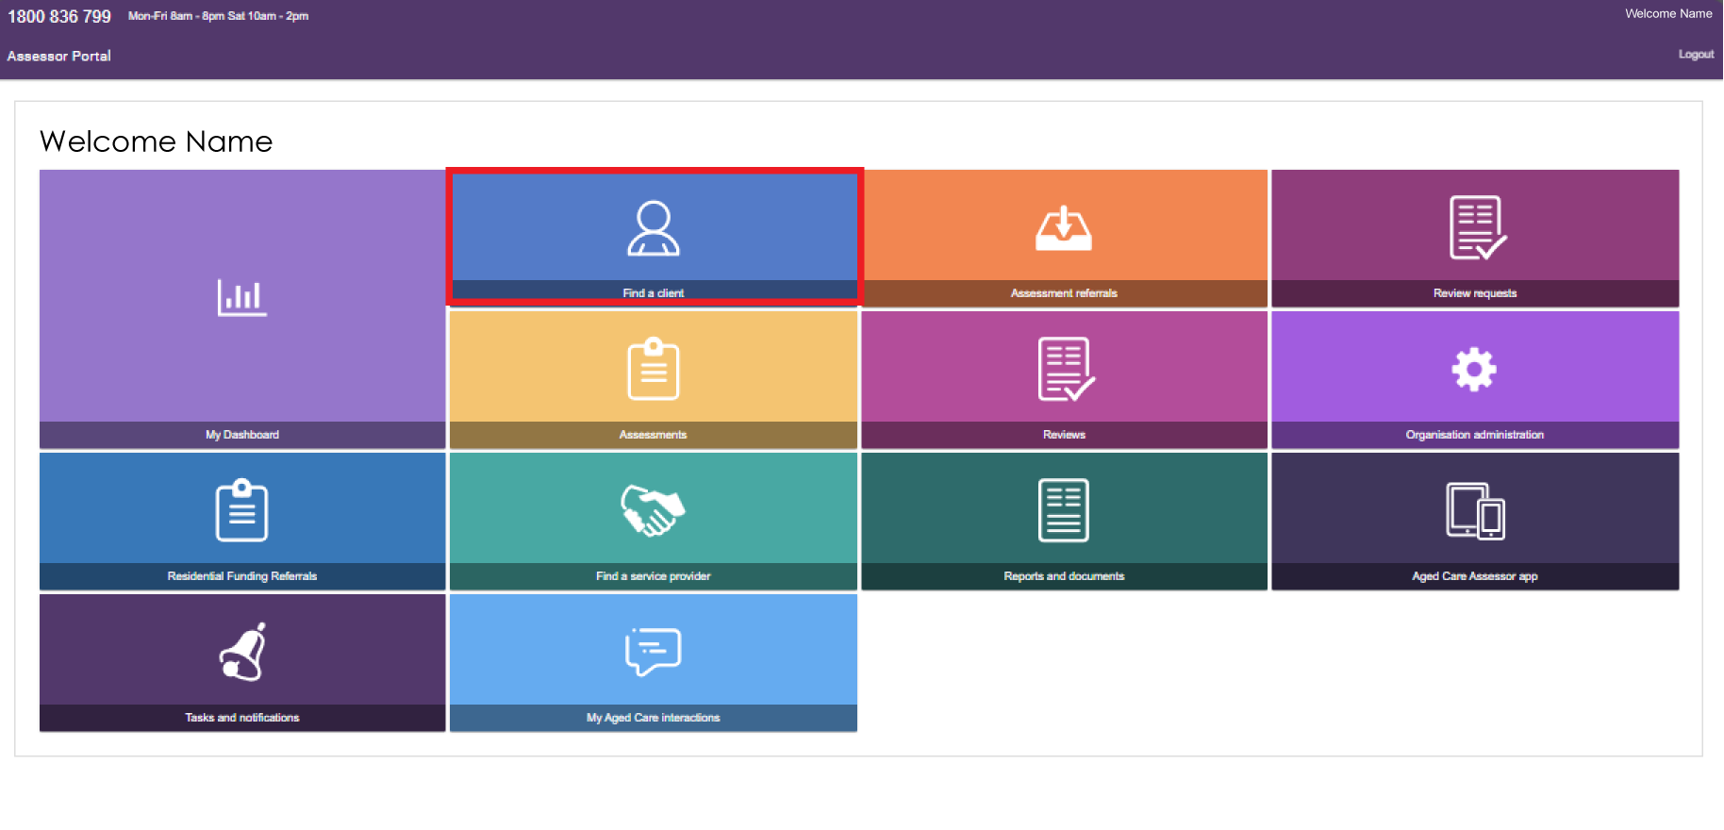
- On the Find a client page, search for the client.
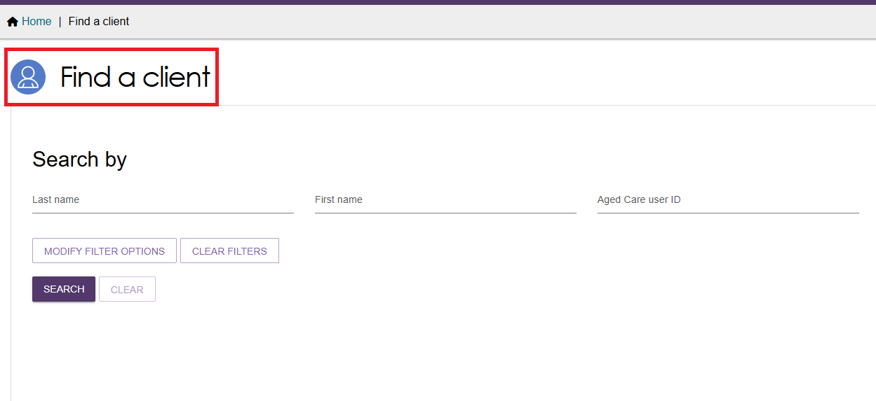
- Open the client's record from either Card View or List View.
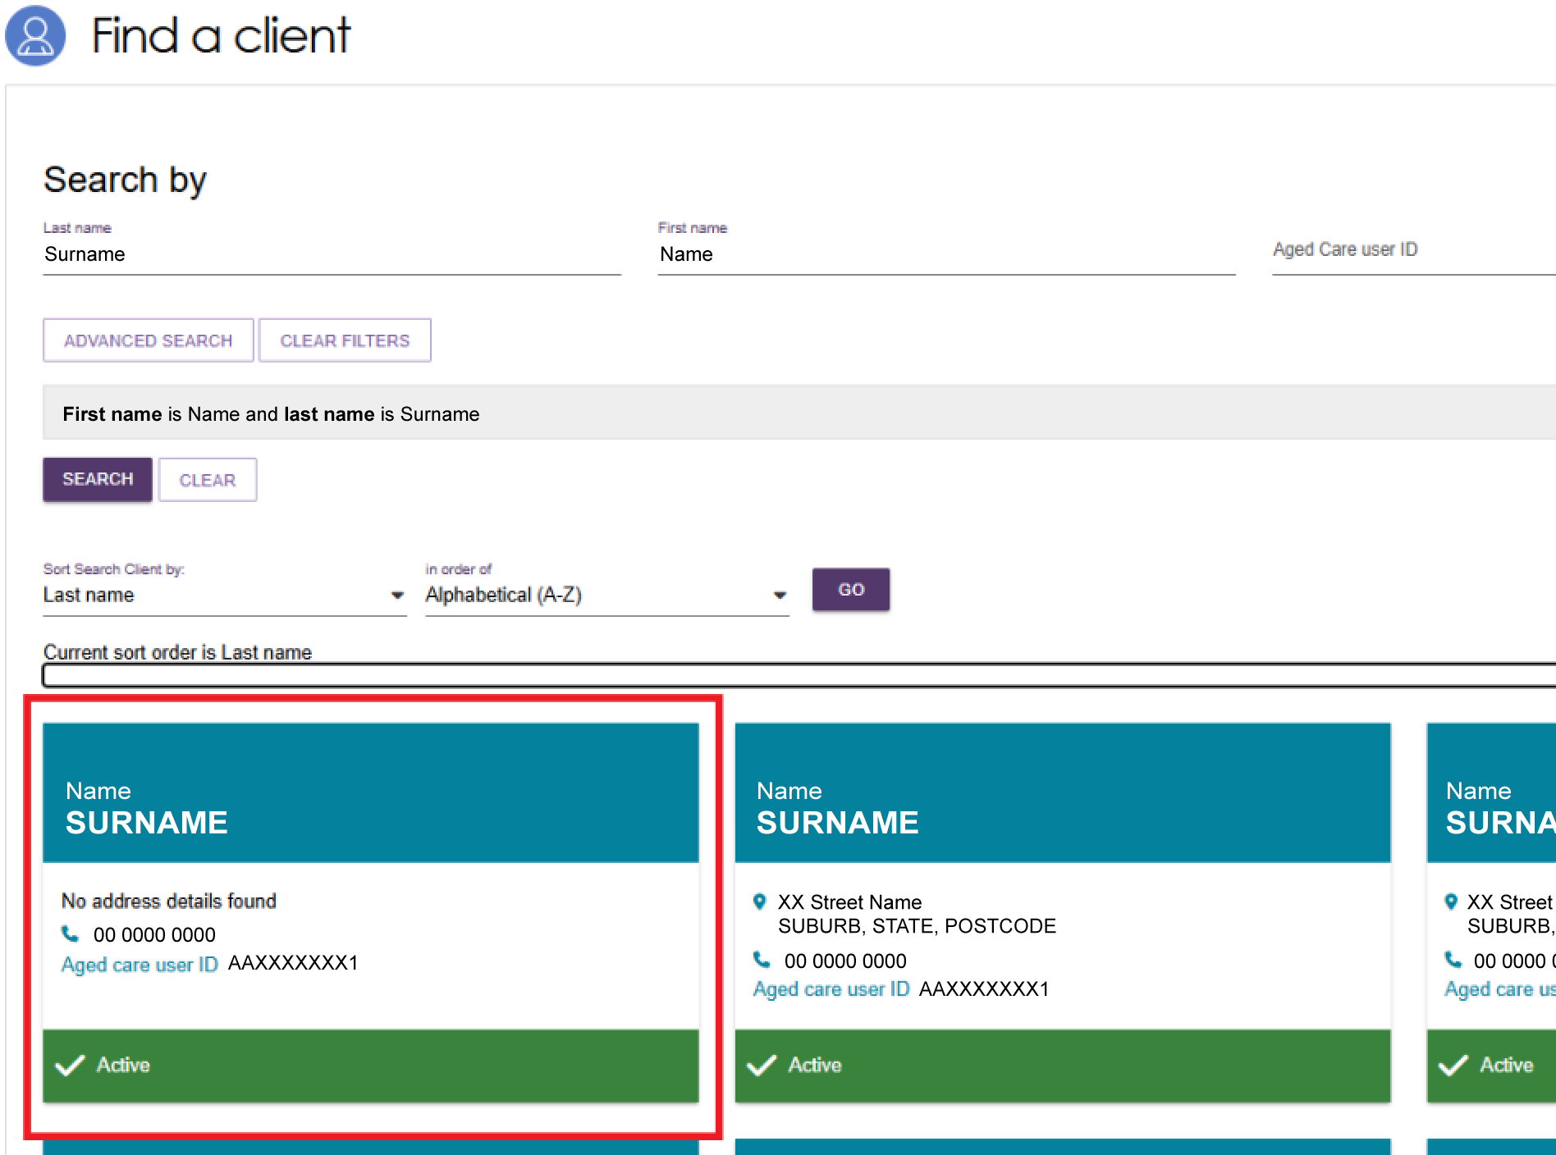
- If the client already has support relationships, they appear under the Primary contact details in the banner. Select View support network to open the Support network tab.
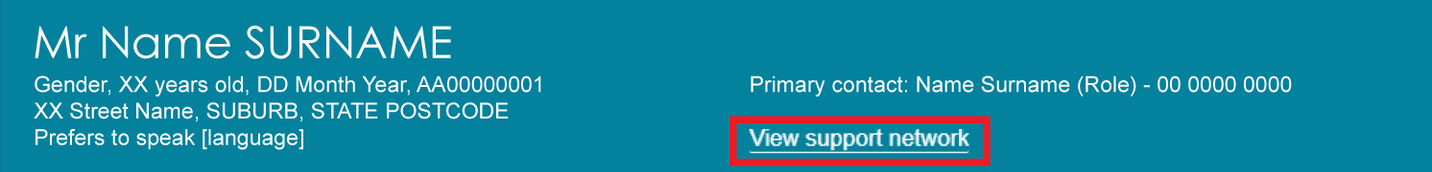
If the client has no support relationships, the message No support relationships recorded appears.
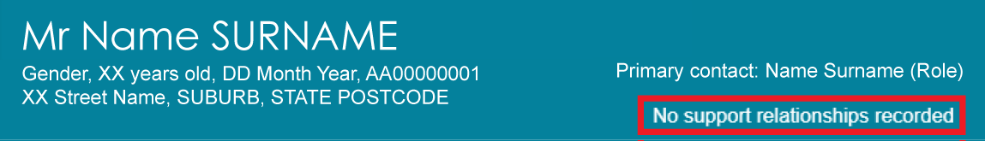
- In the Support network tab, you can view the client's relationships in four sub-tabs:
- Client's support network shows the people, organisations, and other contacts that support the client.
- People client supports shows the people and relationships that the client supports.
- Pending documents shows documents that require action before a relationship can be established.
- Declined, Ended and Cancelled relationships shows relationships that have been declined, ended, or cancelled, including registered Supporter relationships cancelled by the System Governor.
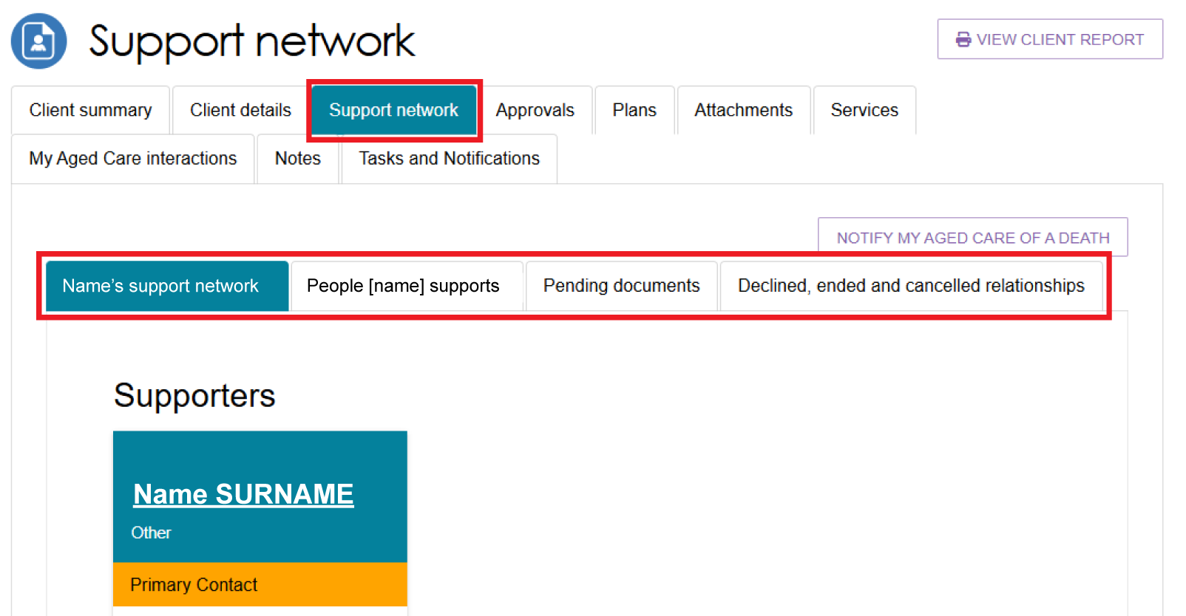

Creating a Supporter relationship
Before you create a Supporter relationship, check that the client and relationship do not already exist in My Aged Care. Search for the client and review their current support relationships. For more information, refer to My Aged Care – Assessor Portal User Guide 1 – Registering and referring clients for assessments.
Once you have confirmed there are no duplicate records, you can create a Supporter relationship for the client.
! | If the new Supporter relationship exceeds the maximum number allowed, My Aged Care sends the request to the System Governor for review and action.
- From the client’s Support network tab, select CREATE RELATIONSHIP.
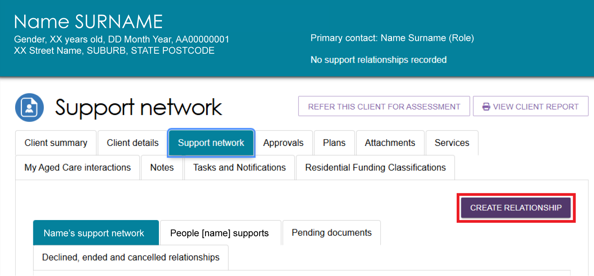

- On the Create relationship for client page, go to Section 01 – About client's relationship and select Supporter.
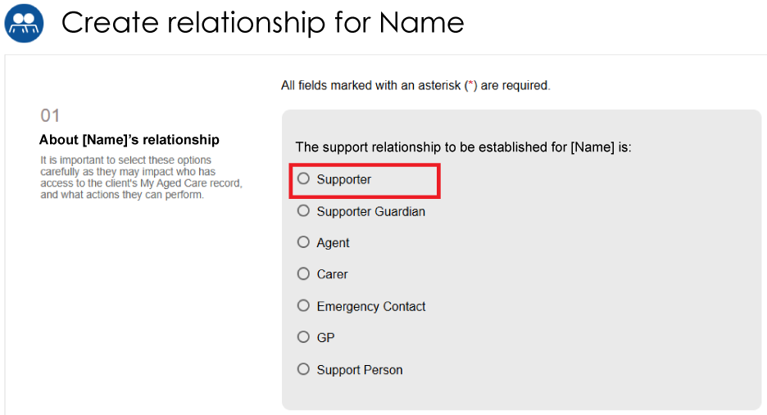
- For Is the support relationship with a Person or an Organisation?, select Person.
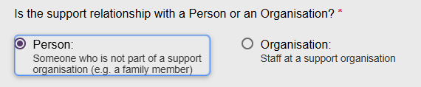
- To continue, either:
- the person must be with the client in person or by phone or video call, or
- the client must have a completed Registration of a Supporter or organisation form.
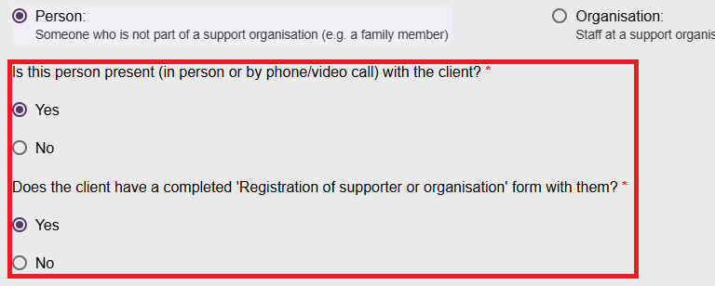
If both answers are No, the system displays an error message and you cannot continue.
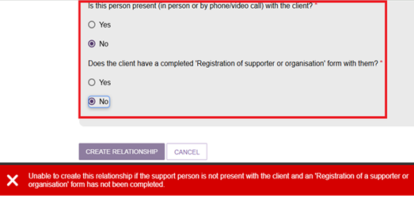
- In Section 02 – Add support person details, enter the Supporter's first name and last name, then select SEARCH. This helps prevent duplicate records in My Aged Care.
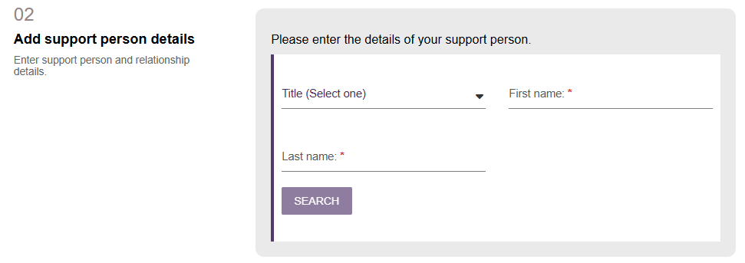
- If the search does not return a matching record:
- Select CONTINUE TO REGISTER.
- Follow the steps in Registering a new person for a support relationship.
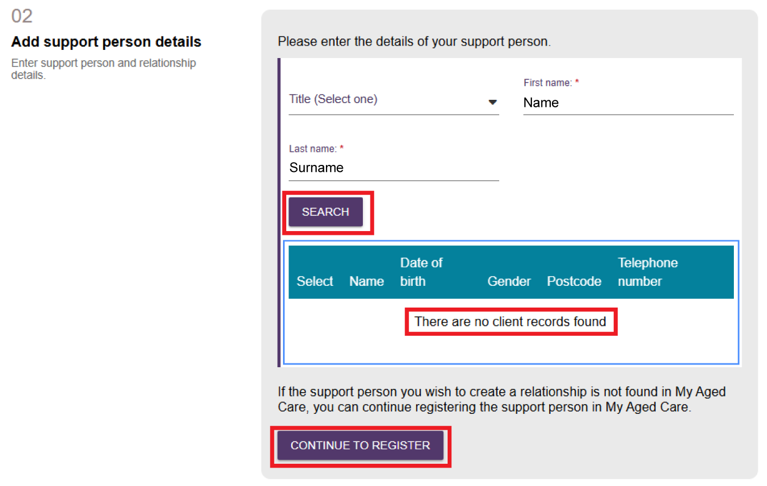
If the search returns a matching record:
- Select the correct record.
- Select the confirmation checkbox to confirm you have chosen the correct person.
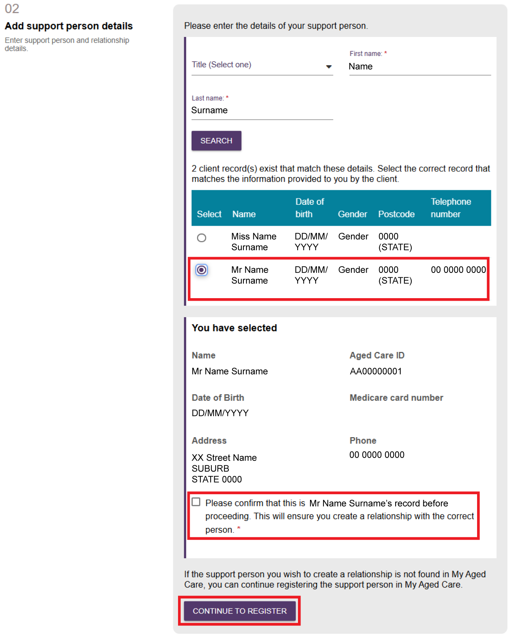
- Enter the Relationship to client and Relationship start date. You can also enter a Relationship end date, if required.
.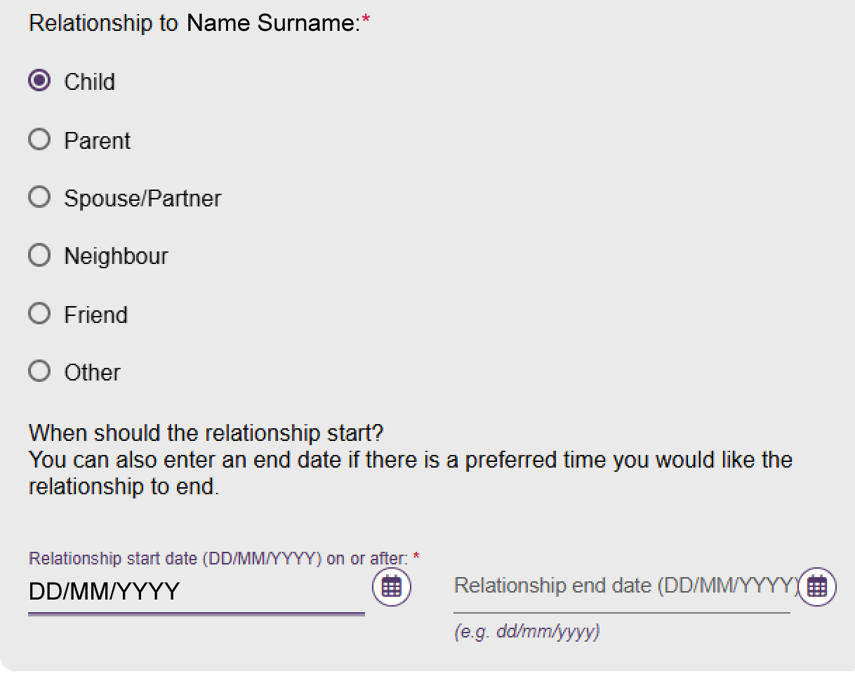
- In Section 03 – Registration of Supporter or organisation form, select CHOOSE FILE and upload the Registration of a Supporter form.
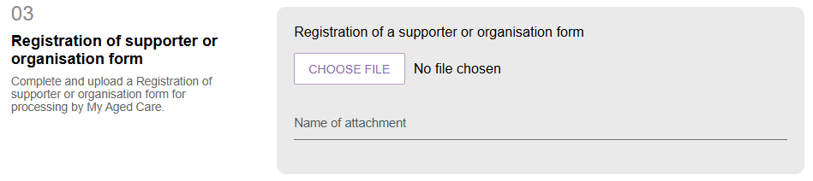
- Enter a name for the attachment.
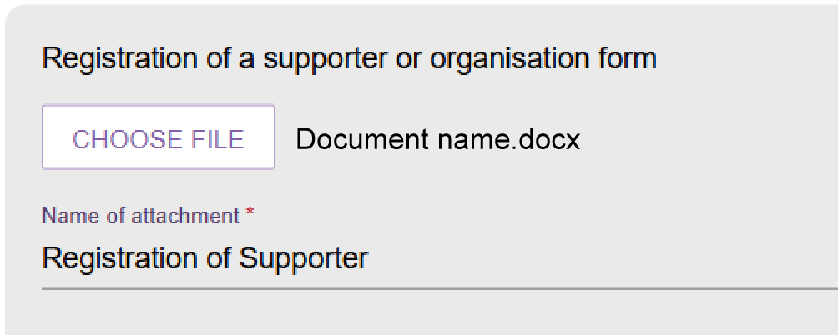
- In Section 04 – Add documentation, select ADD AN ATTACHMENT and upload any supporting documents.
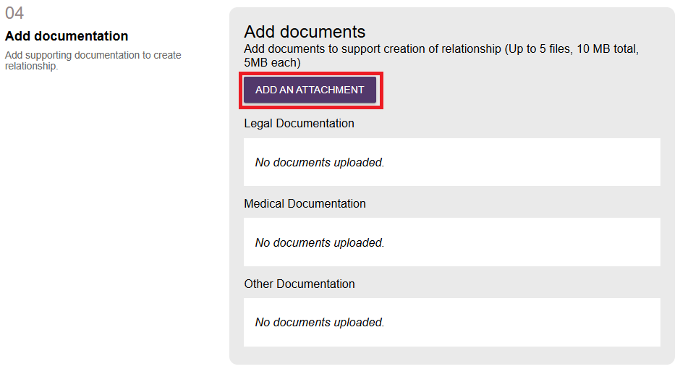
Select the required file or files and then select UPLOAD. Make sure the document meets the requirements shown on screen.
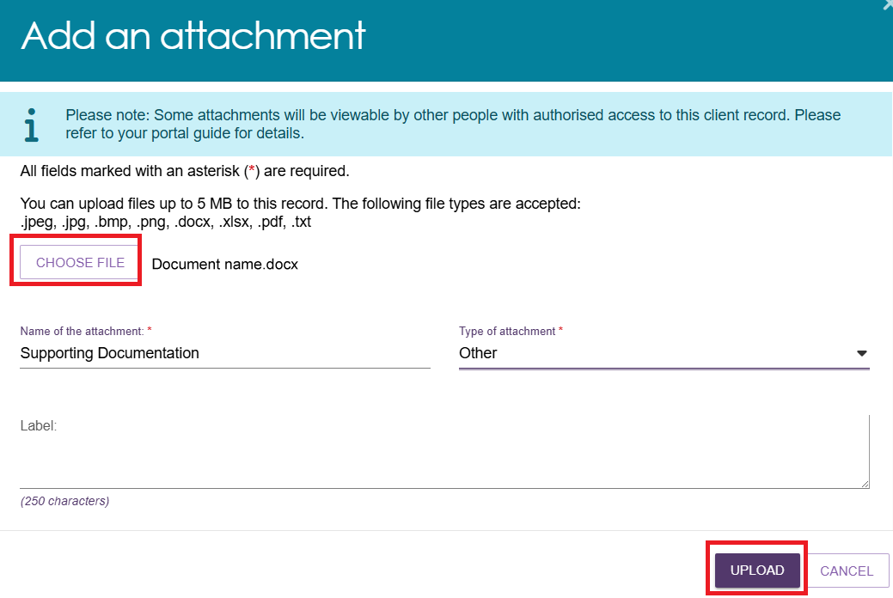
Repeat this process until you have uploaded all required documents.
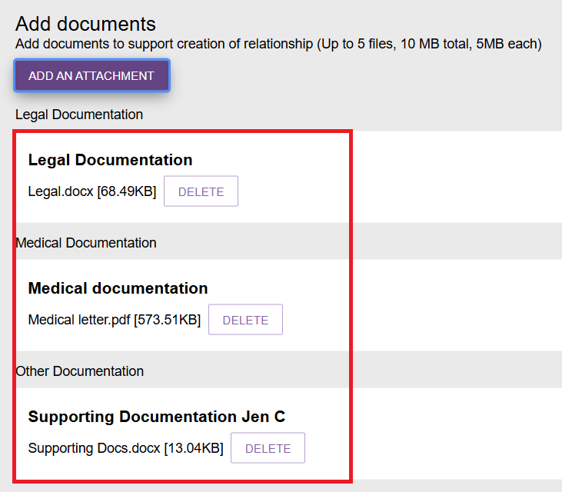
- In Section 05 – Consent, review the:
- Supporter's consent declaration
- Supporter's conflict of interest declaration
- Client's consent declaration
- Client's information-sharing declaration
- Supporter duties and terms and conditions.
Read the information before completing the declarations.
- Complete the Supporter's consent declaration.
- Select Yes or No.
- The Supporter or the assessor can complete this declaration.
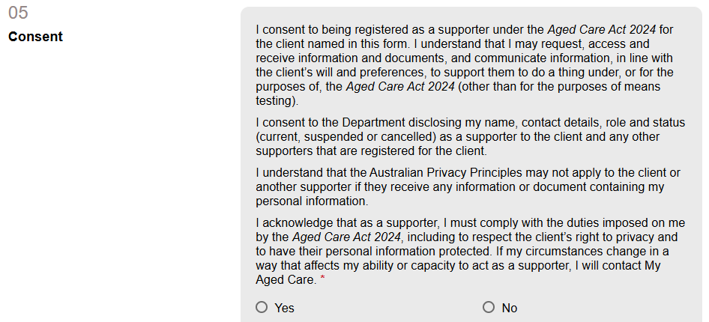
If you select No, the remaining Supporter declaration and the client's consent declaration appear. Continue to step c.
If you select Yes, the Conflict of Interest declaration appears followed by the remaining consent questions.
Select View Details to review the Supporter's duties and the My Aged Care terms and conditions.
- Complete the Supporter's conflict of interest declaration.
- Select Yes or No.
- The Supporter or the assessor can complete this declaration.
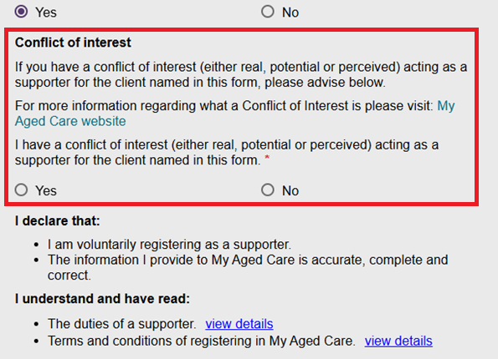
If you select Yes, enter the conflict of interest details and continue to step c.
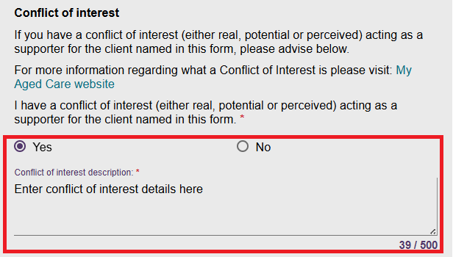
If you select No, continue to step c.
- Complete the client's consent declaration.
- Select Yes or No.
- The client or the assessor can complete this declaration.
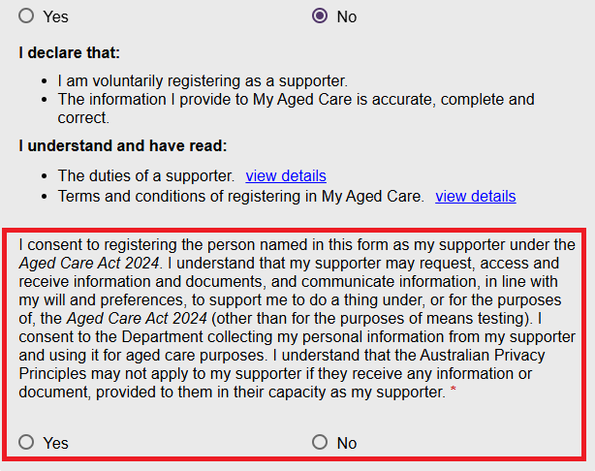
If you select No, the relationship request cannot continue because the client has not consented to registering the Supporter. If needed, contact the My Aged Care Contact Centre on 1800 200 422.
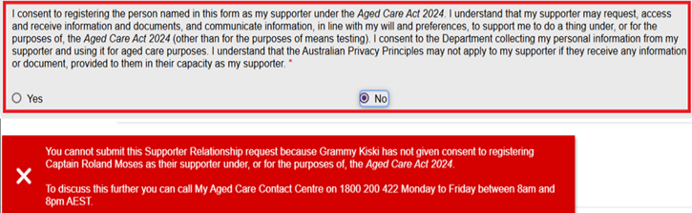
If you select Yes, an additional declaration appears.
- Complete the client's information-sharing declaration.
- Select Yes or No.
If you select Yes, the CREATE RELATIONSHIP button becomes active. Select CREATE RELATIONSHIP to create the relationship.
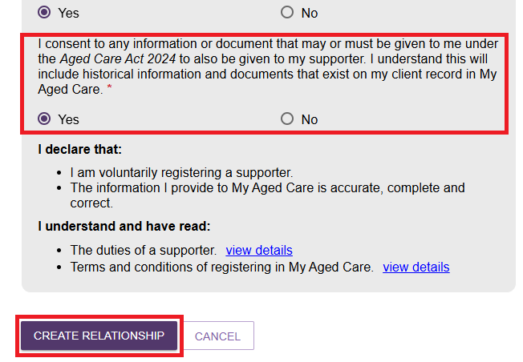
If the client does not agree to share information, you can create a Supporter Lite relationship instead.
! | - If all consent responses are Yes, My Aged Care creates the relationship immediately.  - If any consent response is No, the relationship is created with a Pending status. For more information, refer to the My Aged Care Assessment Manual.
- The system returns you to the client's Support Network screen. The Supporter's details appear in a tile, and a green banner confirms the relationship was created successfully.
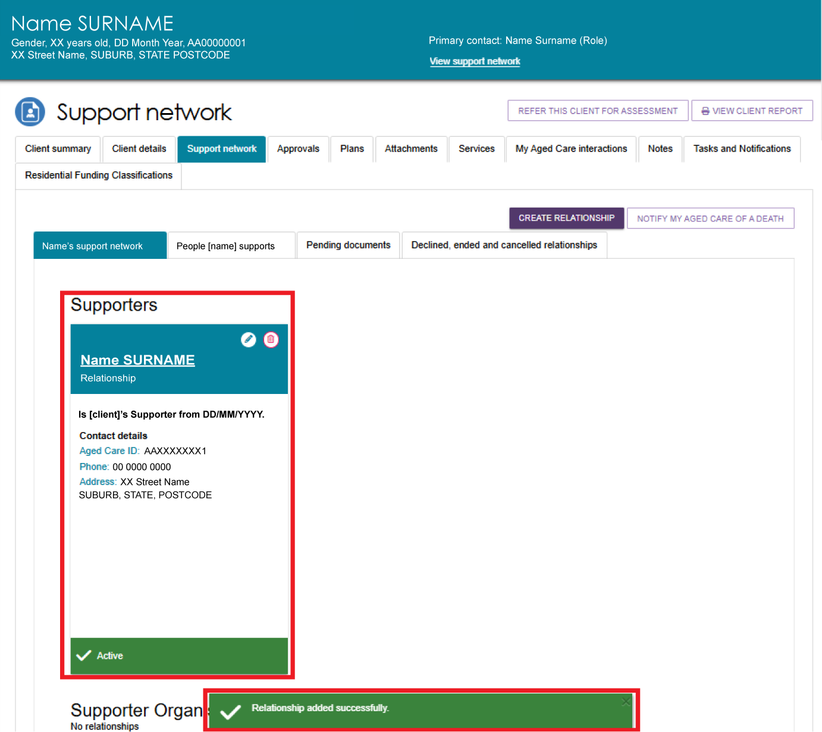

Creating a Supporter Lite relationship
The steps for creating a Supporter Lite relationship are the same as for creating a Supporter relationship. The difference is in the consent declarations.
- From the Support Network screen, Select CREATE RELATIONSHIP button.
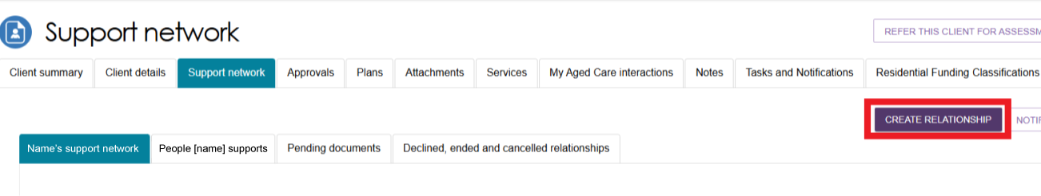
- Complete Sections 01 to 04 and enter all required information.
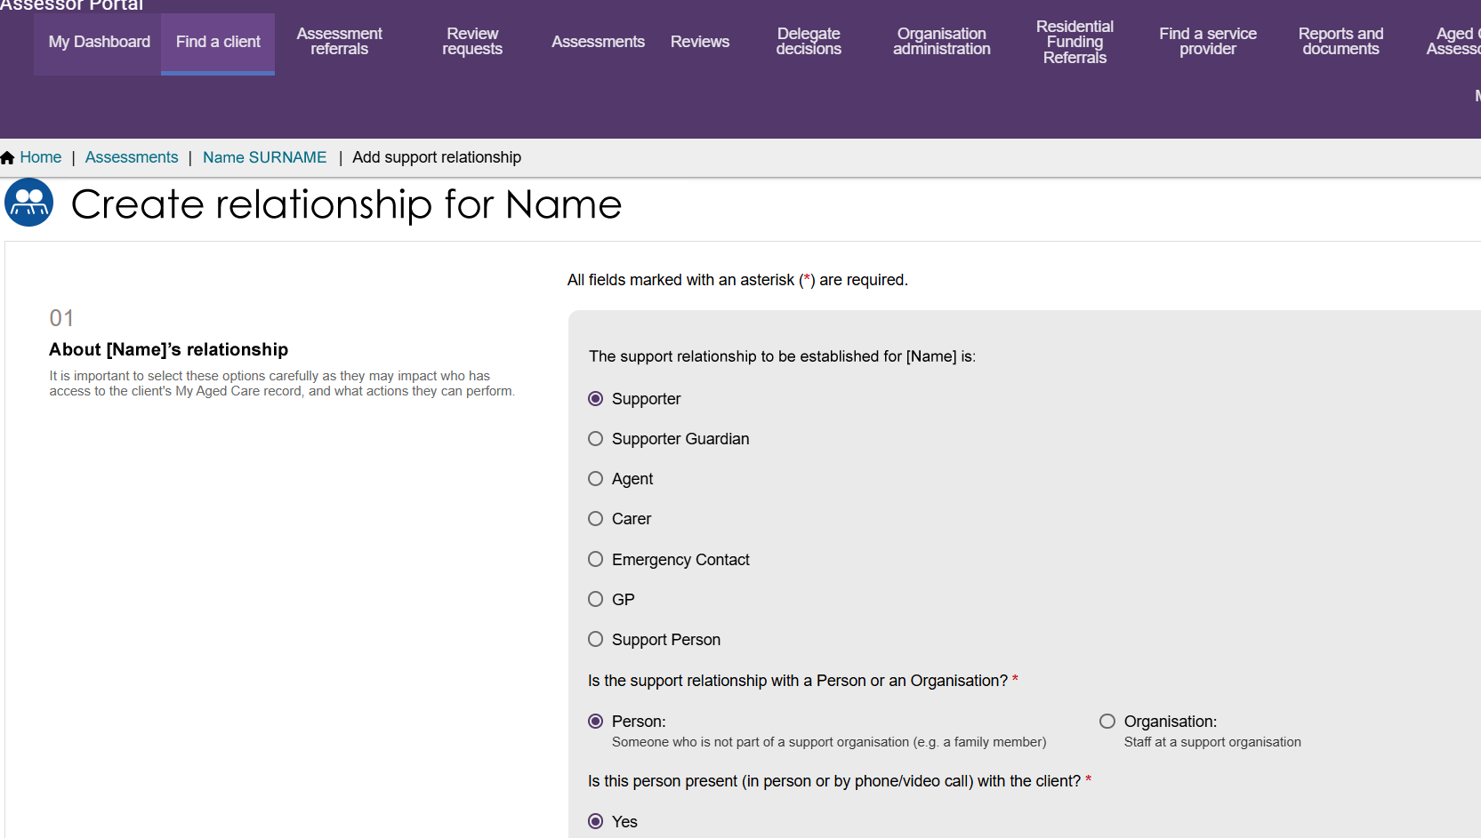
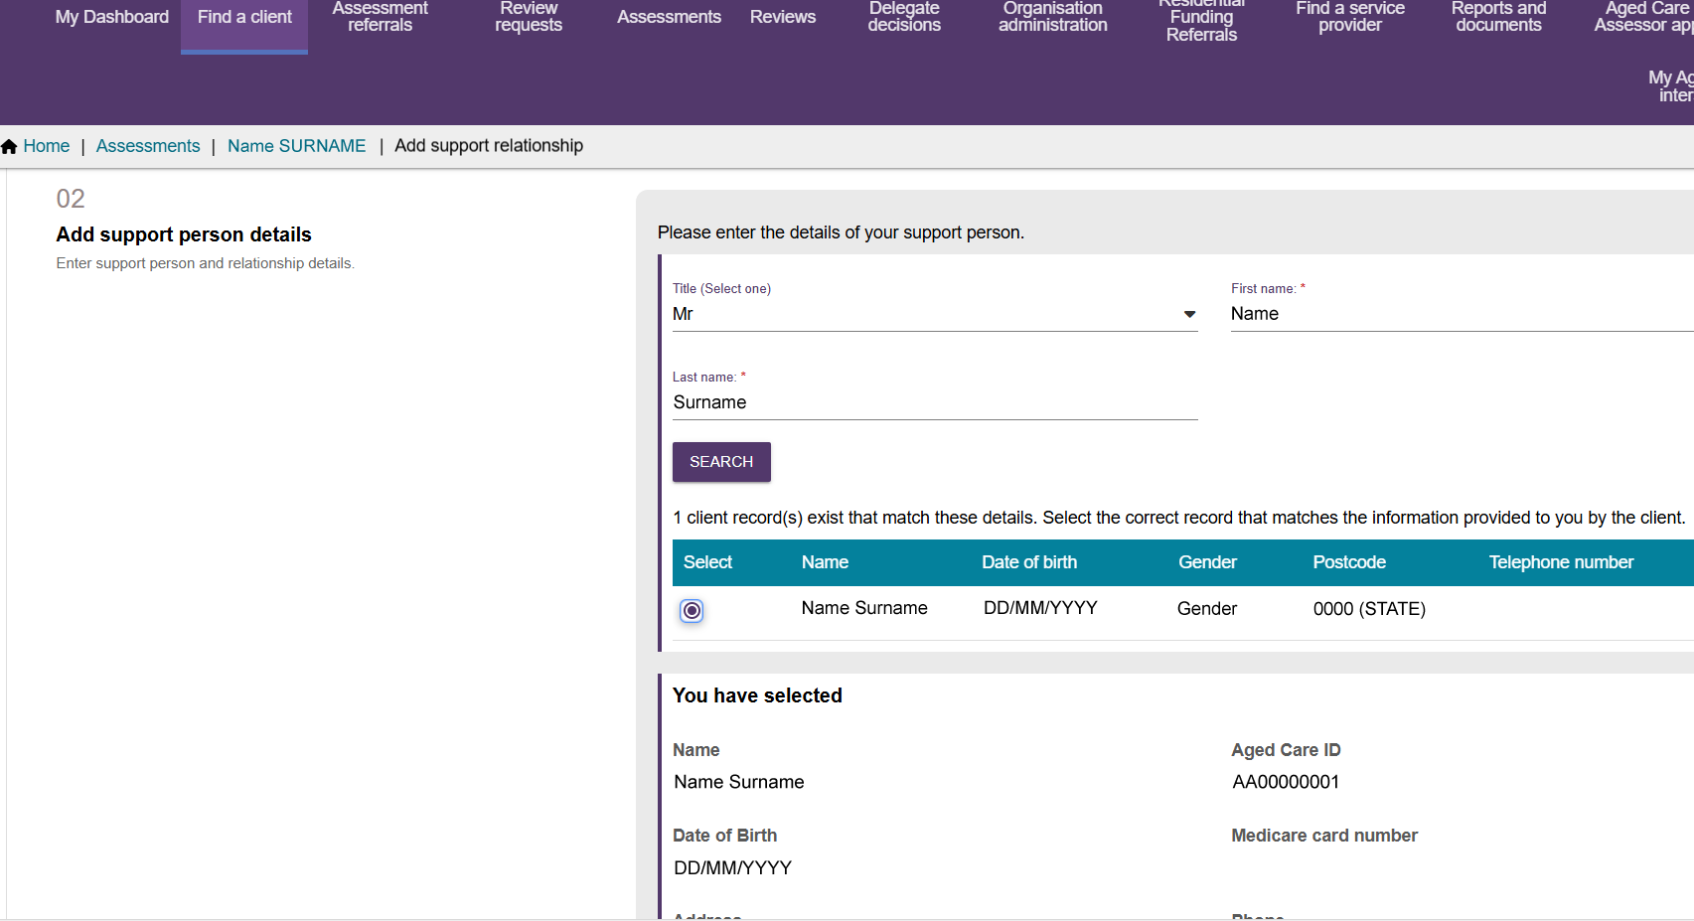
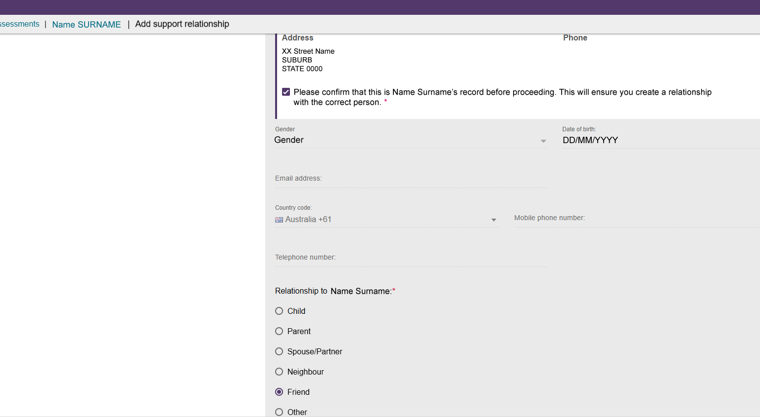
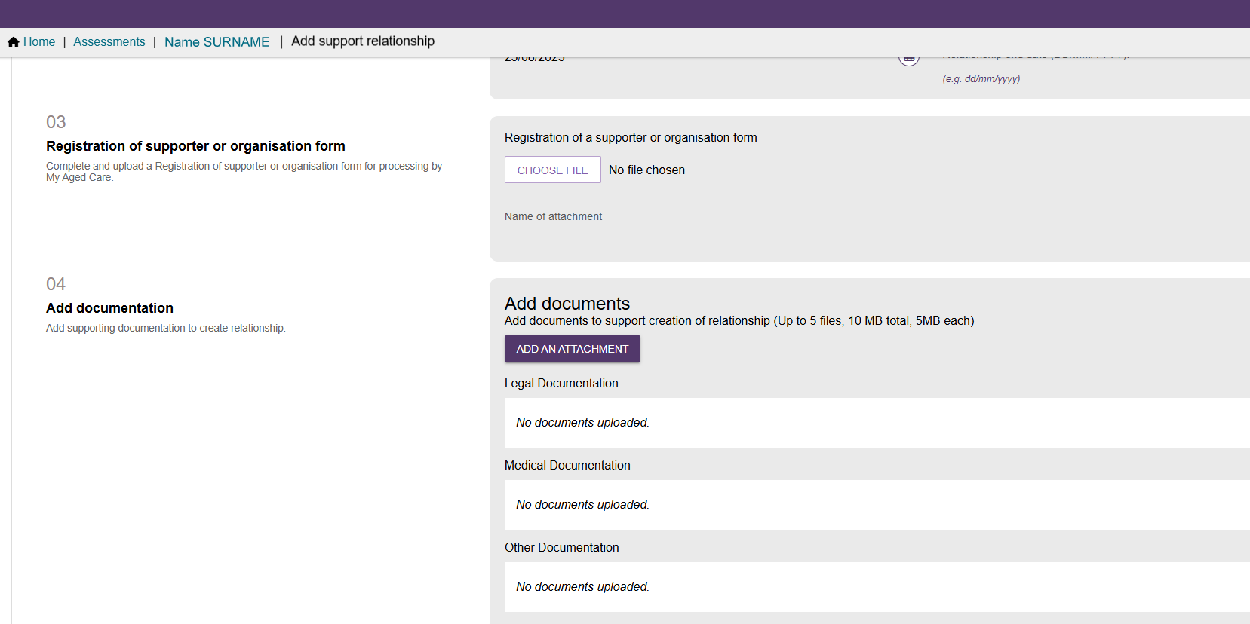
- In Section 05 – Consent, select Yes for the first consent declaration.
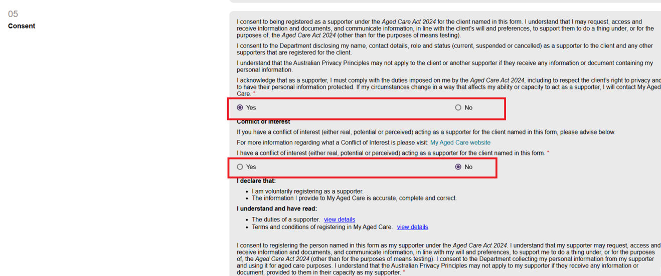
- When the second consent question appears, select No.
An information message appears to advise that the client has not consented to sharing certain information with the Supporter.
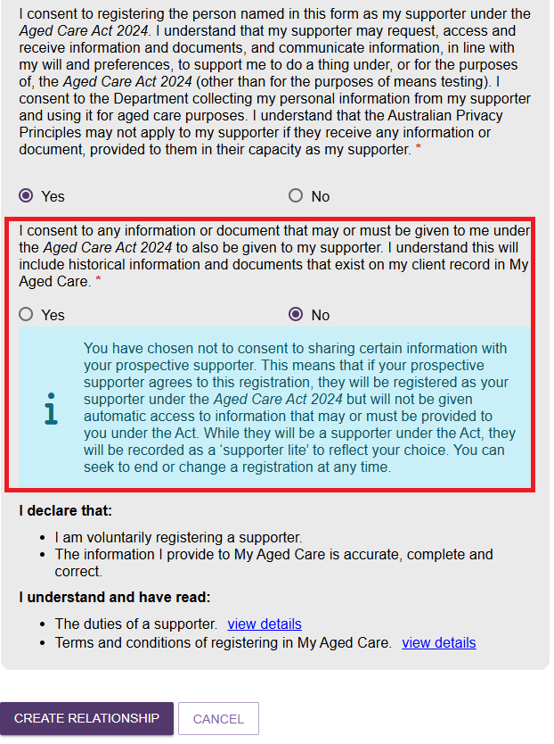
- Review the information you entered and select CREATE RELATIONSHIP.
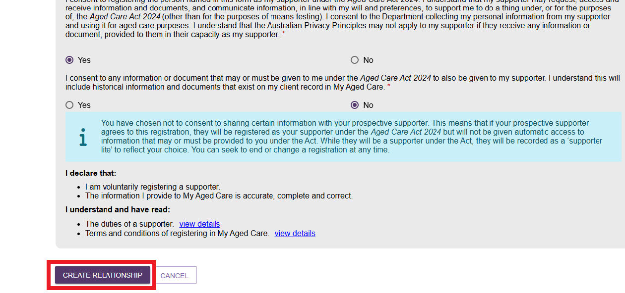
- A green banner appears to confirm that the relationship was created successfully.

- The new relationship appears on the Support Network screen under the SUPPORTERS tab. The relationship tile shows the date the relationship becomes active, based on the date you entered when creating the relationship.
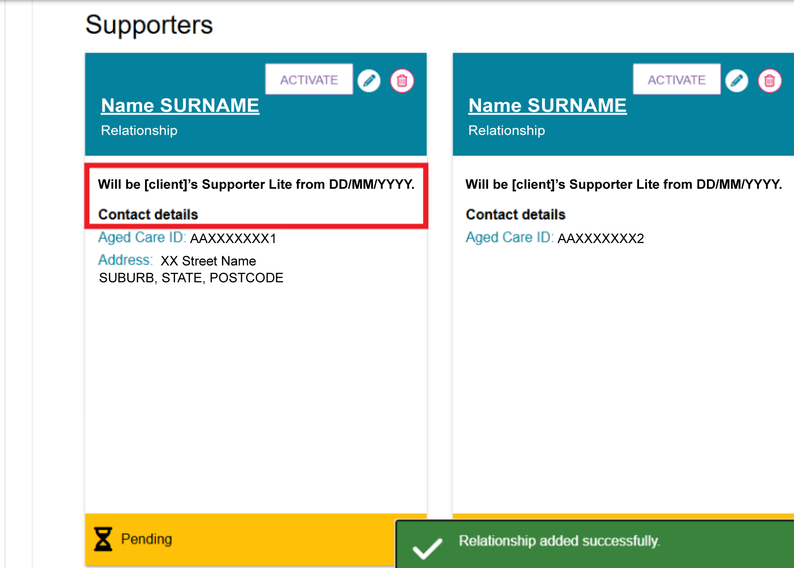

Activating a Supporter Lite relationship
After you create a Supporter Lite relationship, it appears in the client's Support Network tab with a Pending status and an ACTIVATE button. Once activated, the Supporter Lite can also view the relationship in their own account.
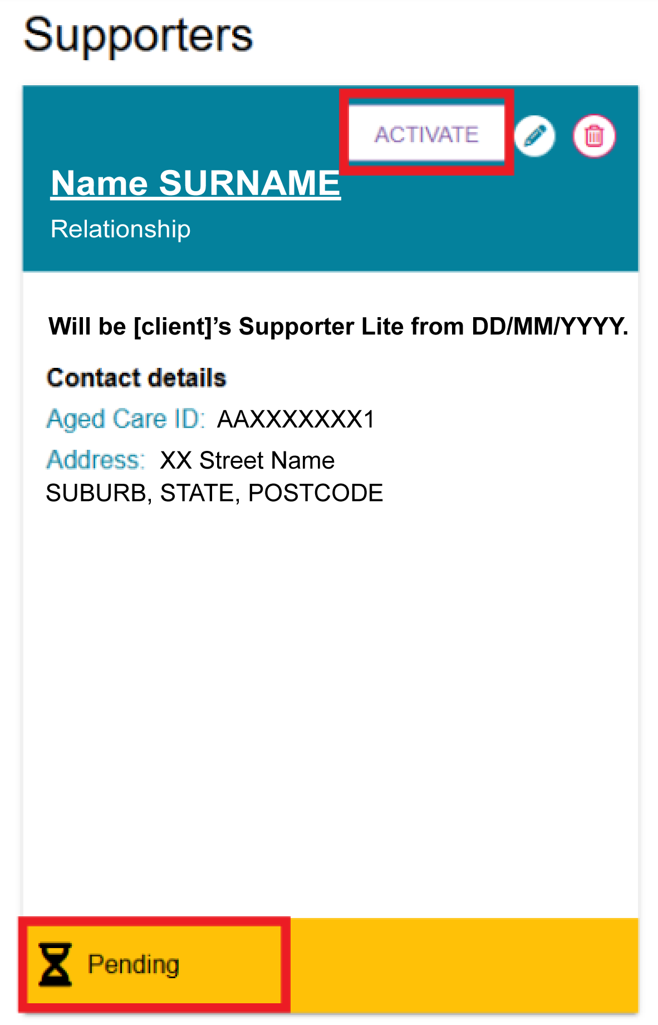
  - On the relevant Supporter Lite tile, select ACTIVATE.
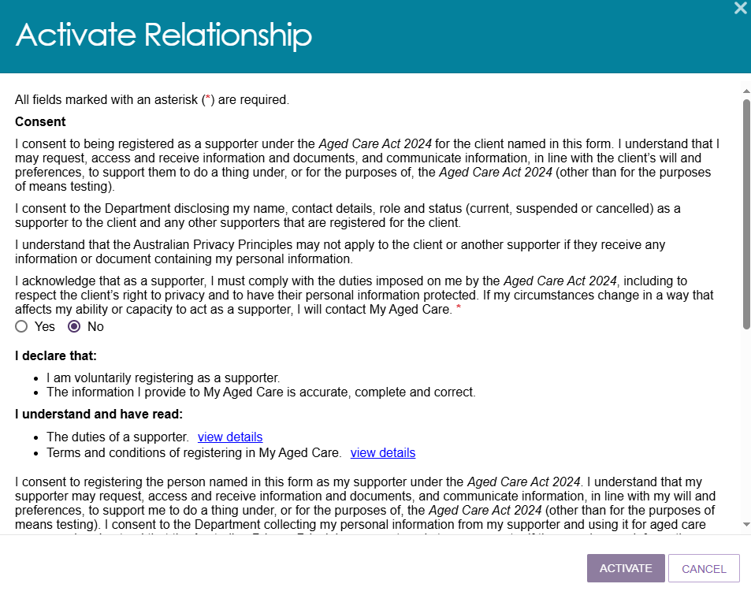
  - Review the information in the pop-up window and complete any required consent responses.
Select ACTIVATE.
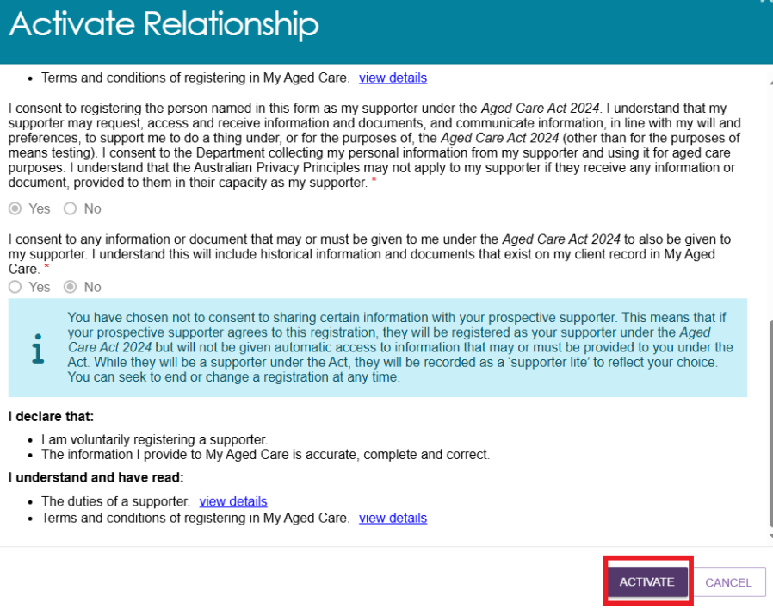
  - A green banner appears to confirm that the relationship is active.
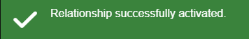
  - Check the Supporter Lite tile to confirm the status has changed from Pending to Active.
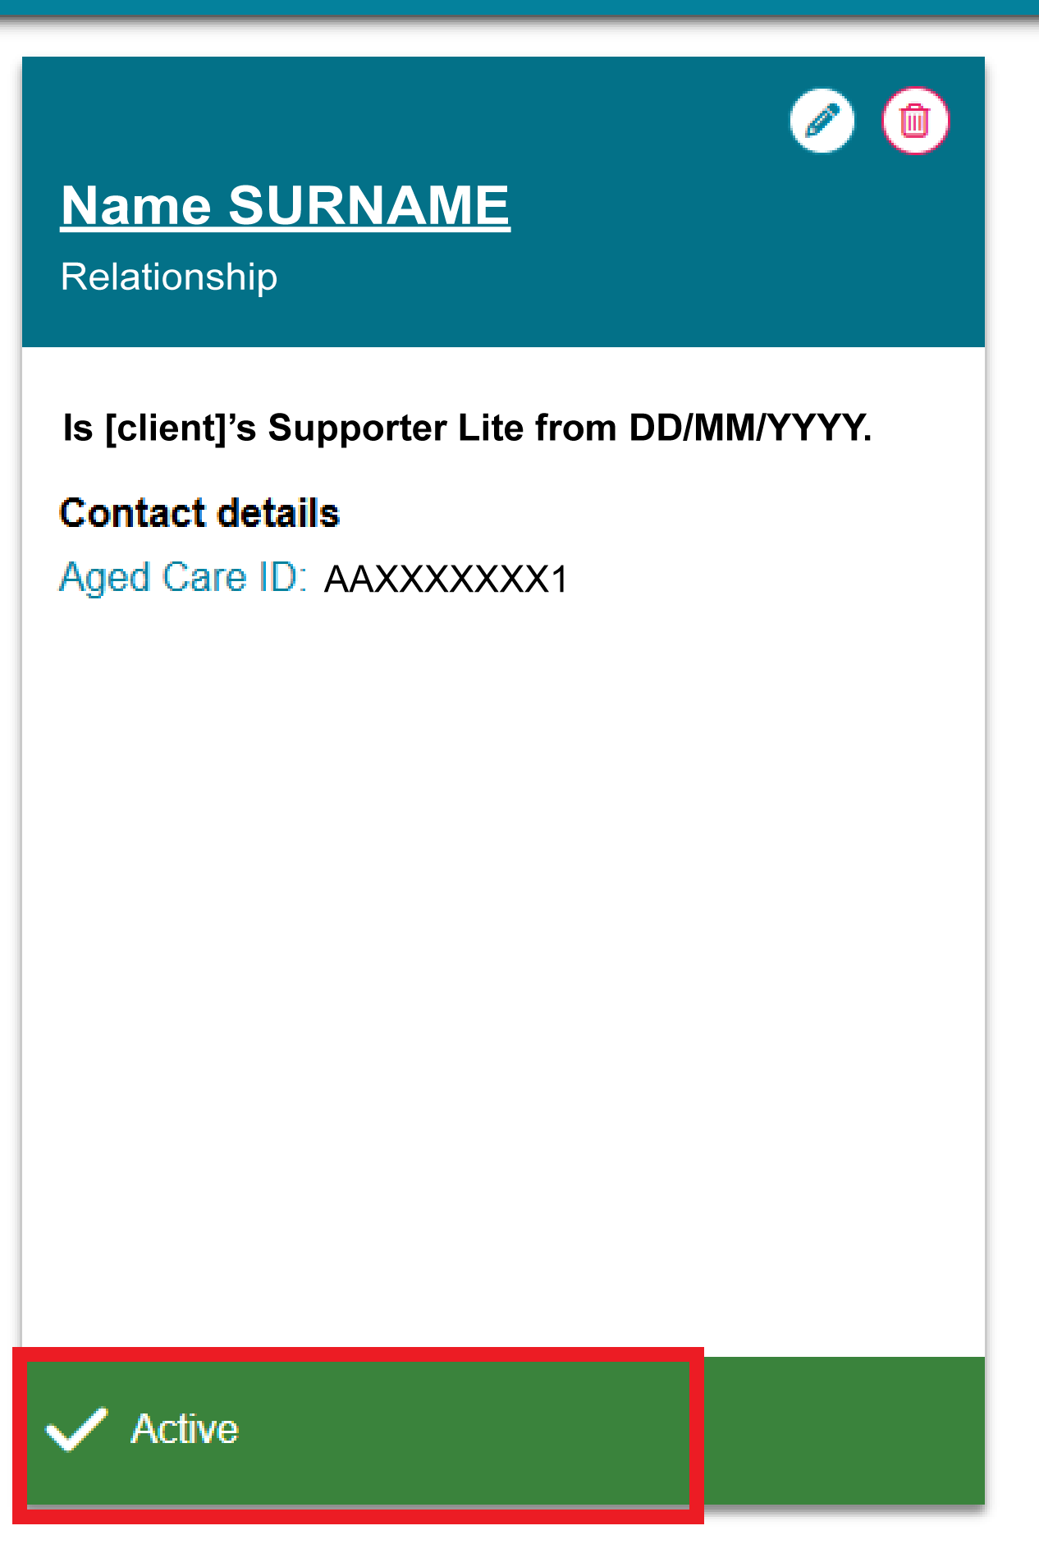
  - If you set the relationship to start on a future date, it remains Pending until that date. The Supporter Lite tile displays a message showing when the relationship will become active.
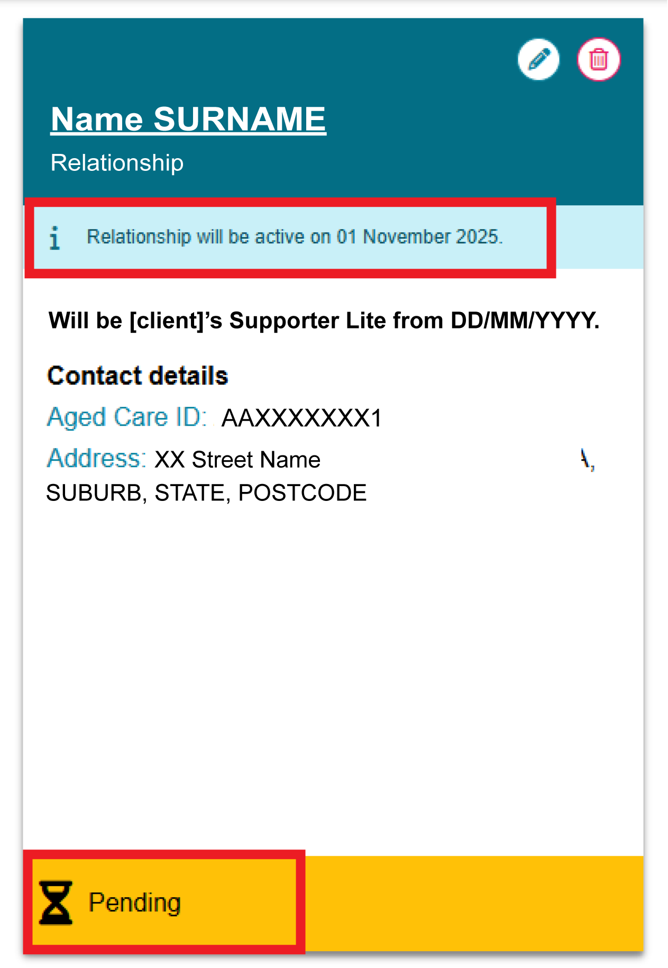

Creating a Supporter Guardian relationship
Before you create a Supporter Guardian relationship, check that the client and relationship do not already exist in My Aged Care. Search for the client and review their current support relationships. For more information, refer to My Aged Care – Assessor Portal User Guide 1 – Registering and referring clients for assessments.
Once you have confirmed there are no duplicate records, you can create a Supporter Guardian relationship for the client.
- From the client’s Support network tab, select CREATE RELATIONSHIP.
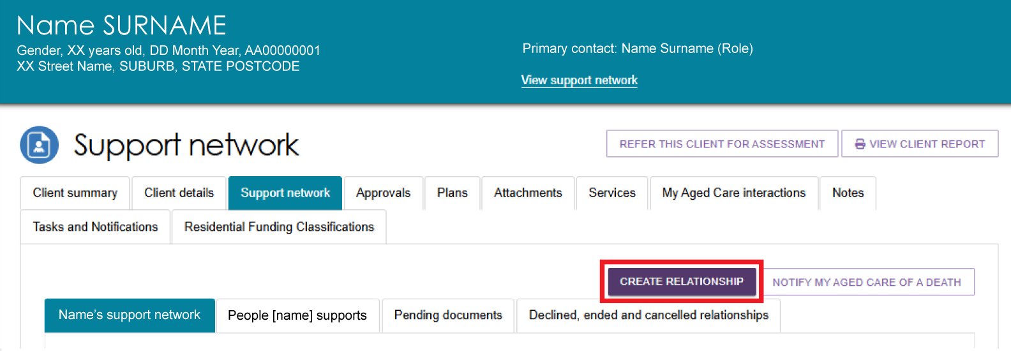
- On the Create relationship for client page, go to Section 01 – About client's relationship and select Supporter Guardian.
For Is the support relationship with a Person or an Organisation?, select Person.
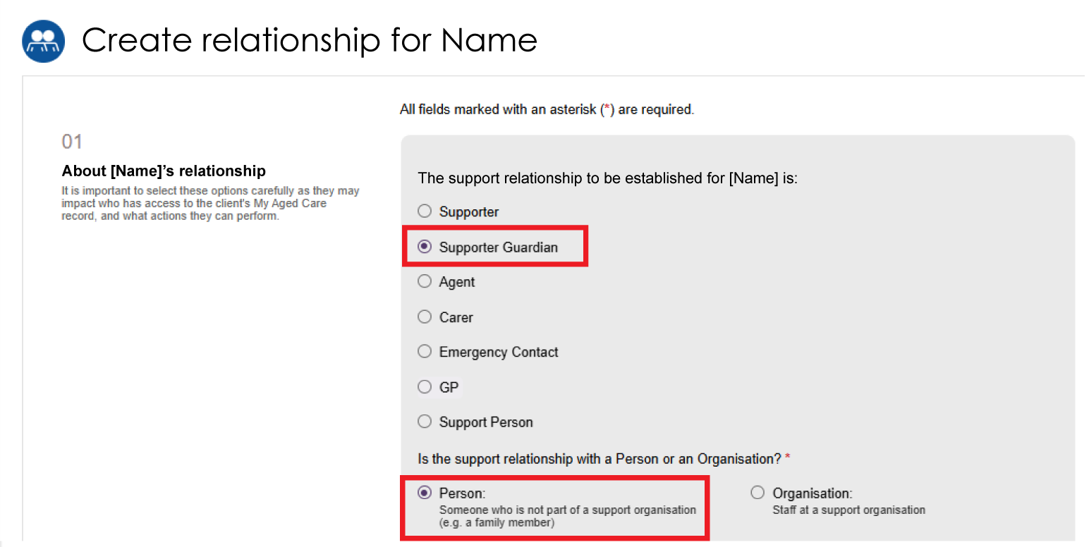
- Answer the following questions:
- Is this person present with the client (in person or by phone/video call)?
- Does the client have a completed Registration of a Supporter or organisation form?
To continue, at least one answer must be Yes.
If both answers are No, the system displays an error message and you cannot continue.
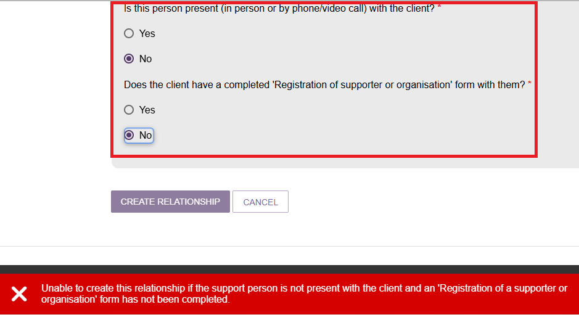
- In Section 02 – Add support person details, enter the Supporter Guardian's first name and last name, then select SEARCH. This helps prevent duplicate records.

- If the search does not return a matching record:
- Select CONTINUE TO REGISTER.
- Follow the steps in Registering a new person for a support relationship.
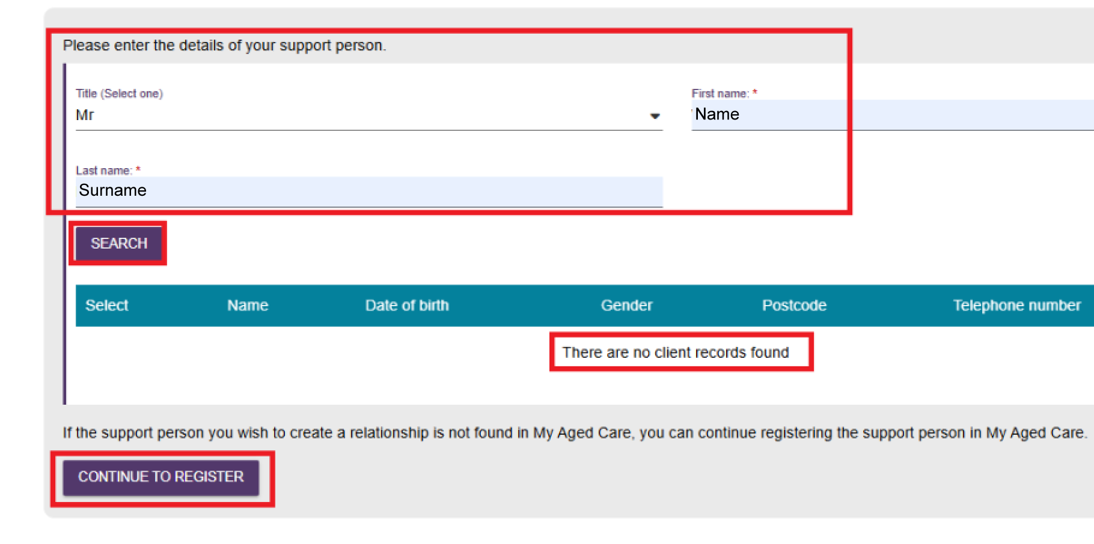
- If the search returns a matching record:
- Select the correct record.
- Select the confirmation checkbox to confirm you have chosen the correct person.
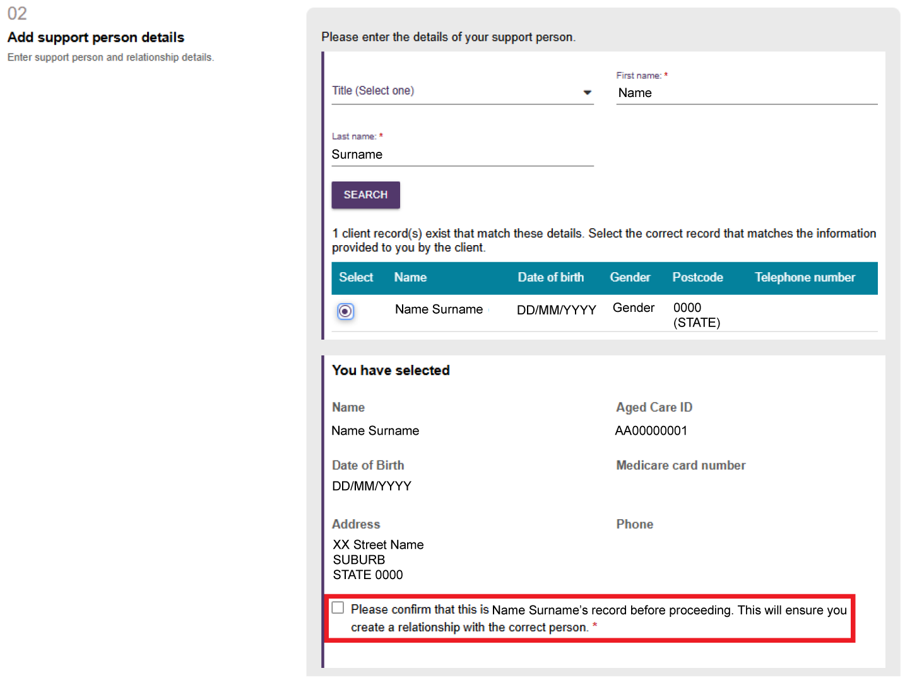

- Enter the Relationship to client and Relationship start date. You can also enter a Relationship end date.
! | If legal documents include an end date, the relationship end date must match the date in those documents.
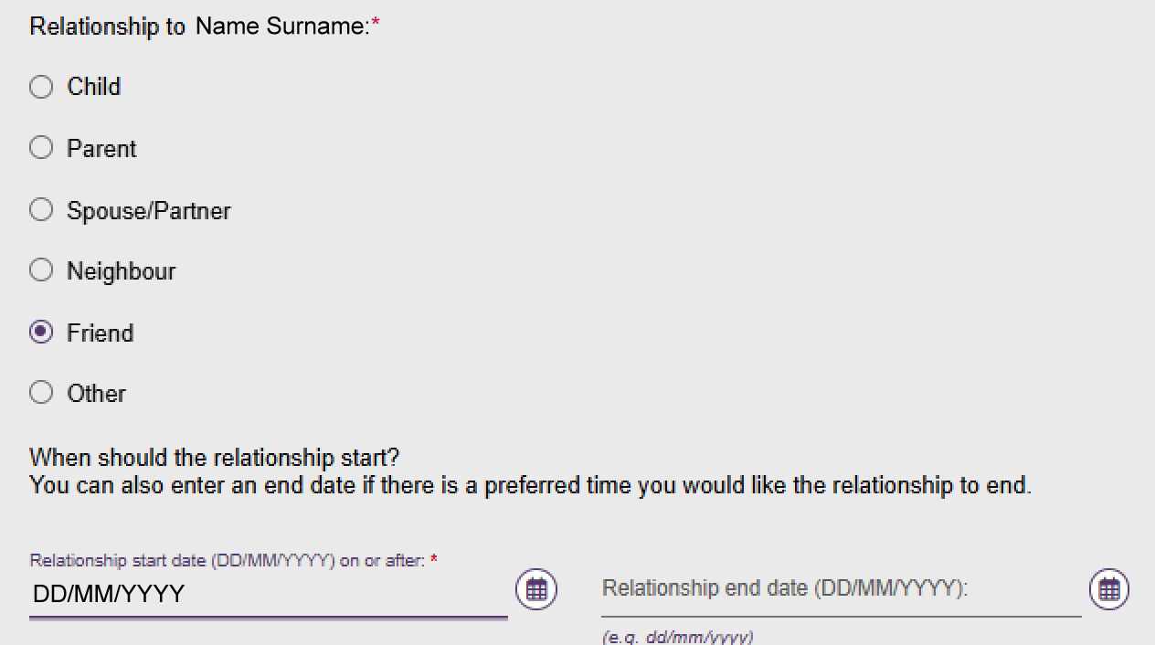
- In Section 03 – Registration of Supporter or organisation form, upload the registration form and enter an attachment name.
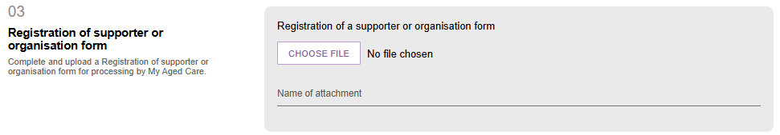
- In Section 04 – Add documentation, indicate whether you can verify the Supporter Guardian's legal authority to act on the client's behalf.
! | - If you can verify the legal documents, select Yes and upload the verified documents.  - If you cannot verify the documents, select No, upload the documents, and select SUBMIT TO MY AGED CARE. My Aged Care creates a pending relationship and sends the documents to the My Aged Care Contact Centre for verification.  - If no legal documents are available, advise the prospective Supporter Guardian that you can submit the request for review, but they must provide evidence of their legal decision-making authority before My Aged Care can register them as a Supporter Guardian. They can submit the documents through their online account or through the My Aged Care Contact Centre.
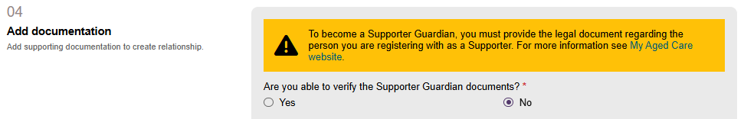
- Select ADD AN ATTACHMENT and upload the required supporting documents.
- You must upload a legal document, such as a guardianship order or enduring power of attorney.
- Enter a name for each document.
- If needed, upload a medical practitioner's letter to support the request.
- If you have a combined legal and medical document, upload it as Legal Documentation.
For more information, refer to My Aged Care Assessment Manual.
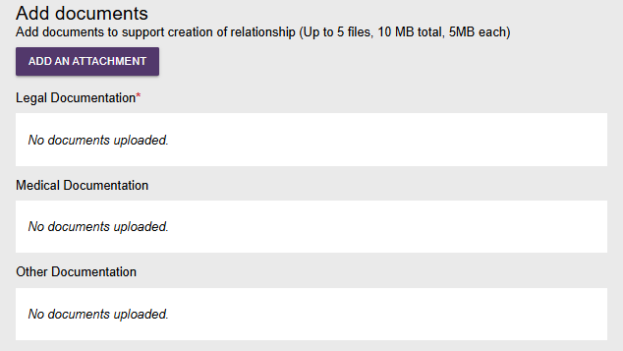
- If you have additional documents, upload each file and select UPLOAD. Make sure all documents meet the requirements shown on screen.
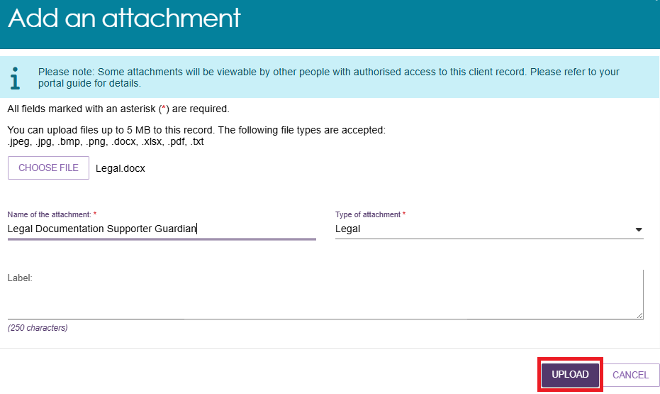
To remove a document, select Delete next to the relevant document.
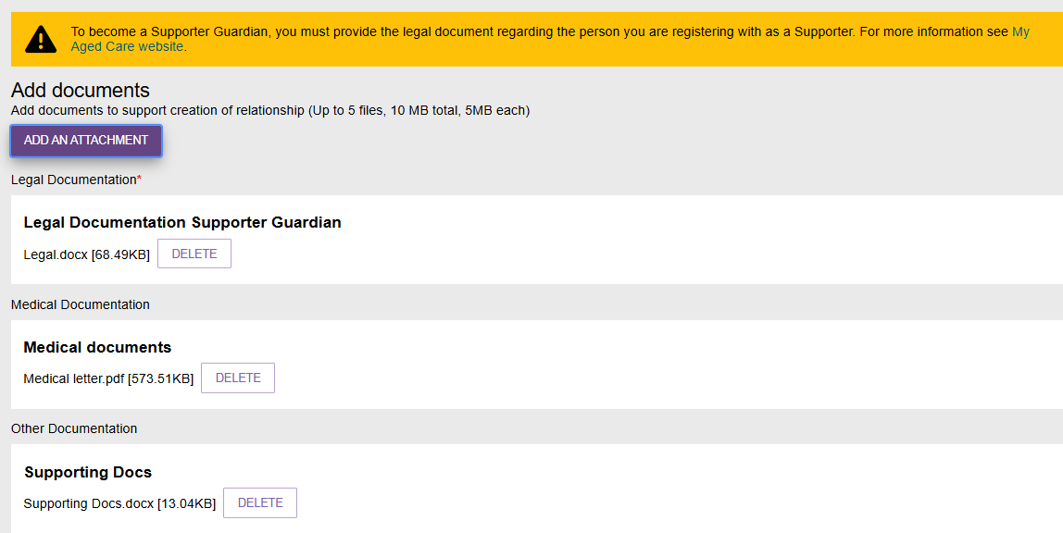
- In Section 05 – Consent, complete the Supporter Guardian's consent declaration.
- The Supporter Guardian must select Yes for the request to continue.
- If the Supporter Guardian selects No, you cannot submit the request.
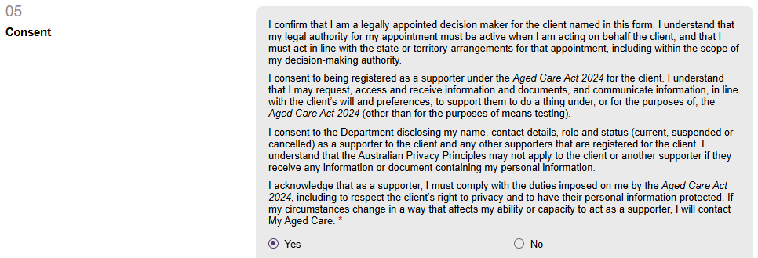
- Complete the Conflict of Interest declaration.
- Select Yes or No.
- If you select Yes, enter the conflict of interest details.
- Select View Details to review the duties of a Supporter and the My Aged Care terms and conditions.
When complete, select SUBMIT TO MY AGED CARE.
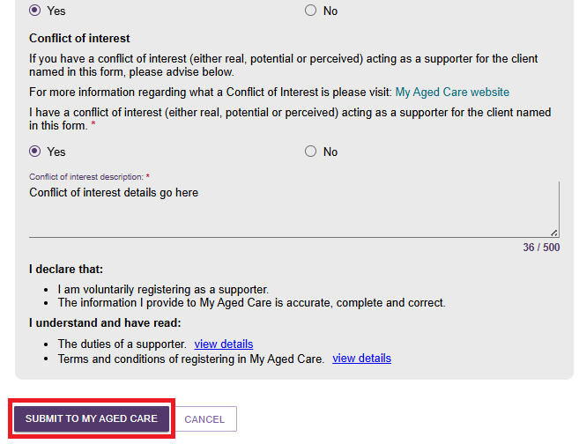
- The system returns you to the client's Support Network screen. The Supporter Guardian relationship appears with one or more of the following:
- a green banner confirming the relationship was created successfully
- a yellow Pending banner
- an information message advising that delegate approval is required.
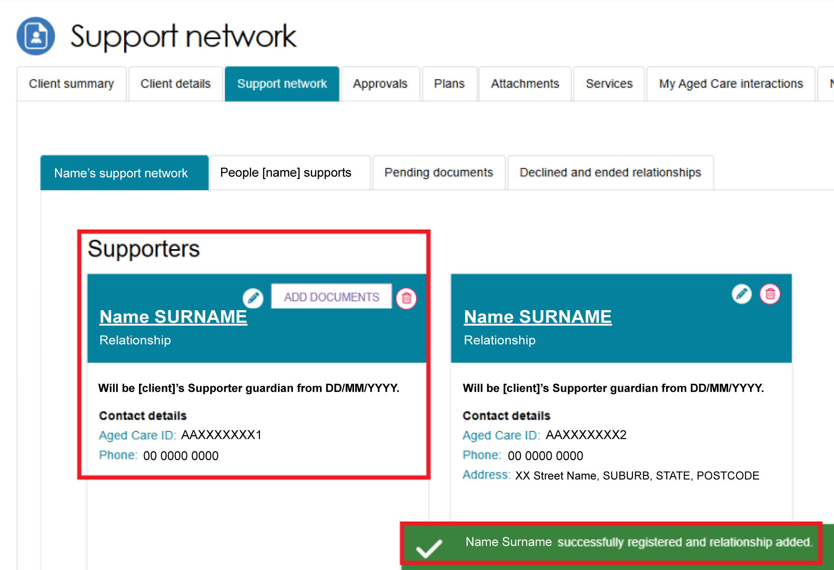
If the status reason is Pending Delegate Decision, the relationship displays a Pending status and a message stating Relationship undergoing delegate approval until the delegate makes a decision.
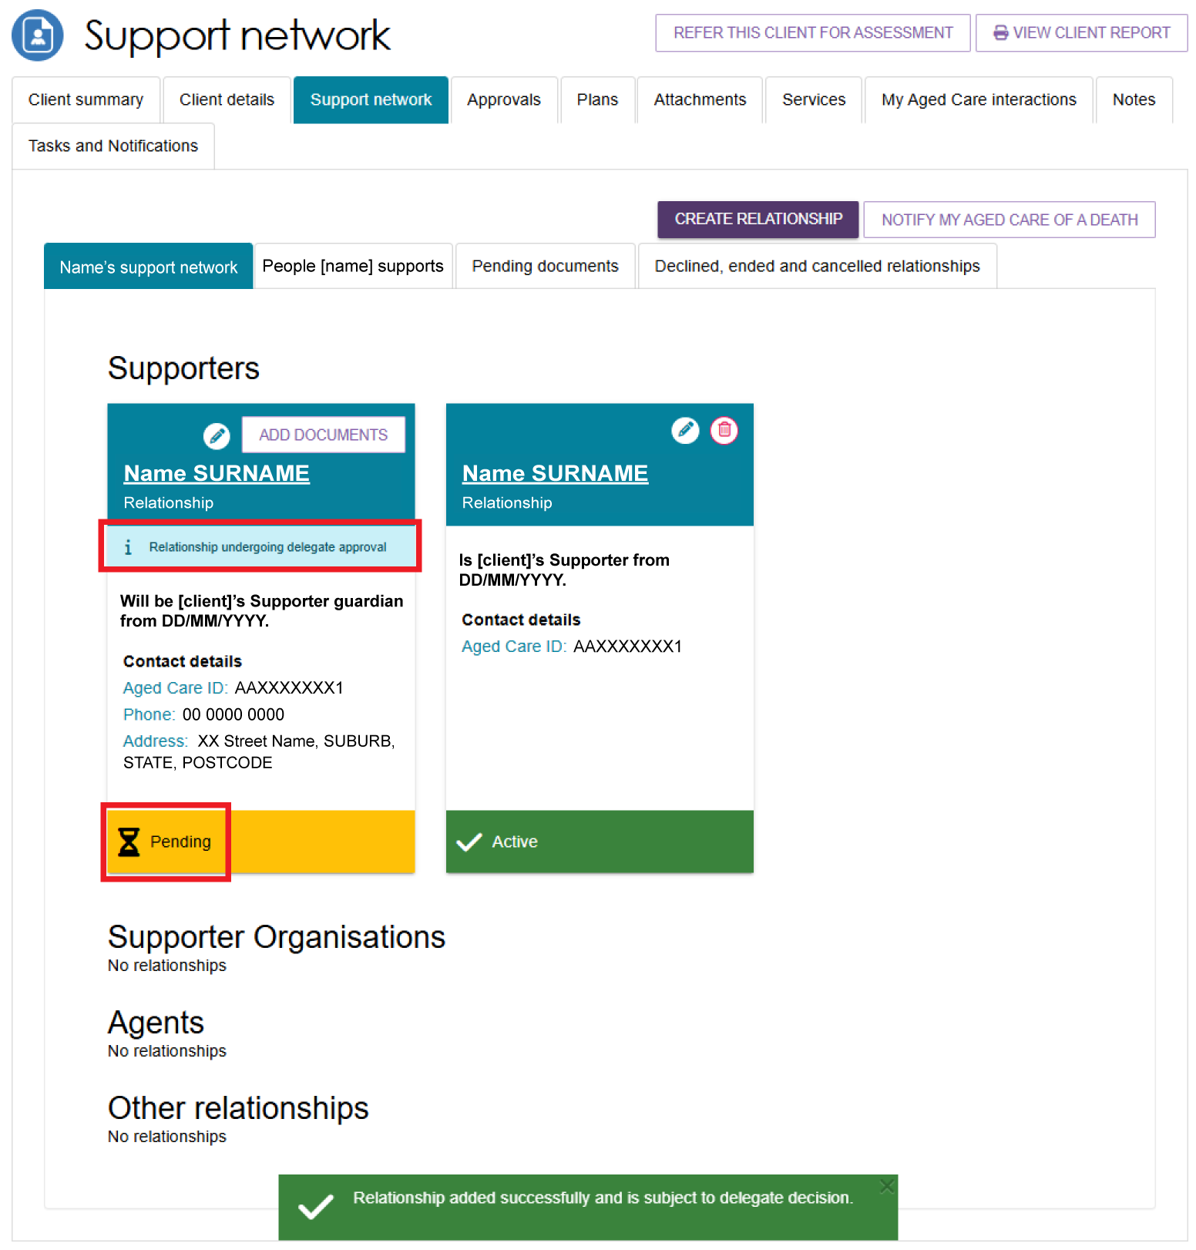
- To add more documents later, select ADD DOCUMENTS on the Supporter Guardian tile.
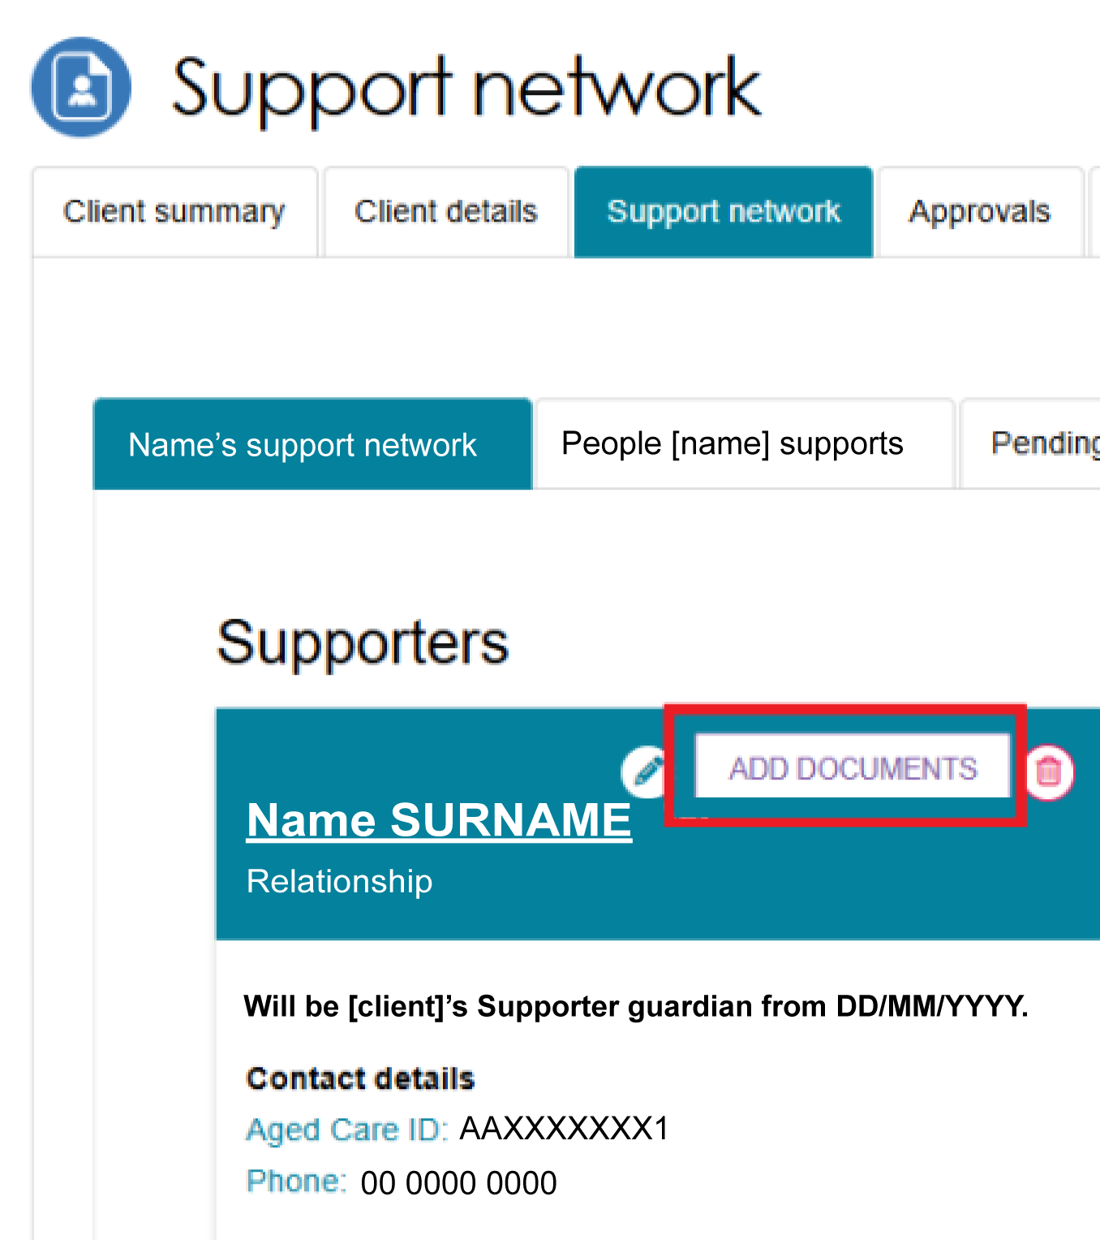
- If additional documents are required, a yellow banner appears below the relationship tile to indicate that documents are still pending.
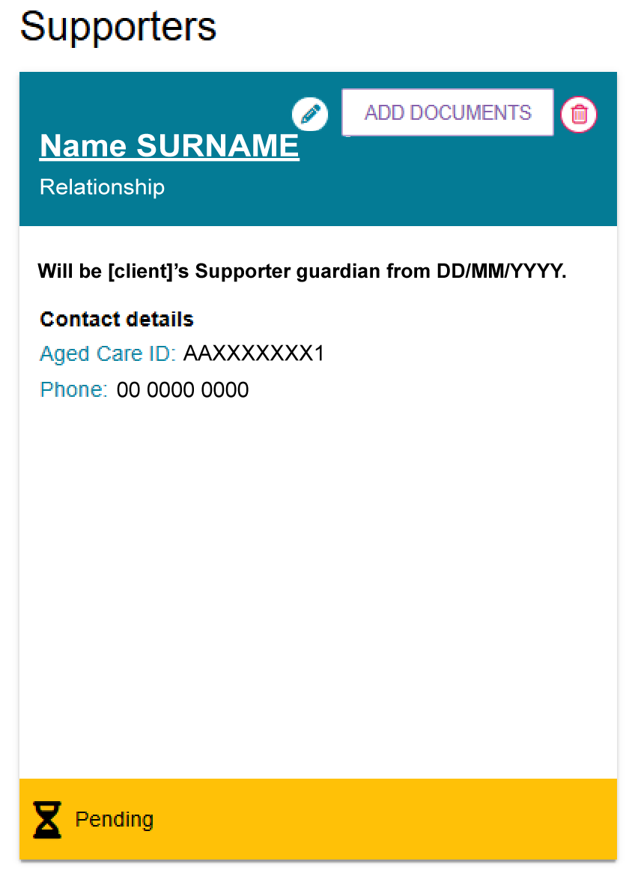

Creating a Supporter Organisation relationship
Before you create a Supporter Organisation relationship, check that:
- the organisation does not already have a matching relationship in My Aged Care
- no previous Supporter Organisation relationship has been cancelled
- the organisation can meet the duties of a Supporter.
Search for the organisation and review its current support relationships. For more information, refer to My Aged Care – Assessor Portal User Guide 1 – Registering and referring clients for assessments.
Supporter Organisation relationship requests require delegate approval.
- From the client’s Support network tab, select CREATE RELATIONSHIP.
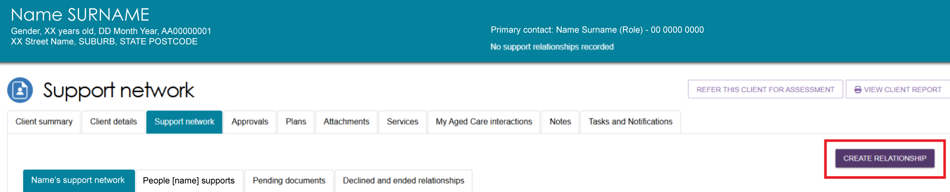
- On the Create relationship for client page, go to Section 01 – About client's relationship. Select Supporter, then select Organisation.
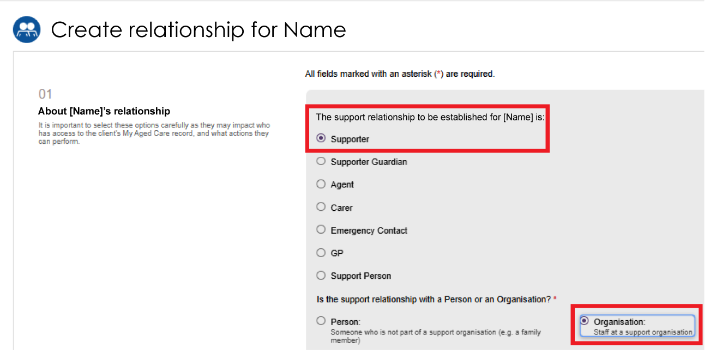
- In Section 02 – Add support organisation details, search for the organisation by entering:
- the organisation name, or
- a suburb or postcode.
Select SEARCH.
You can also limit the search by distance from a suburb or postcode.
Suburb or Postcode search example
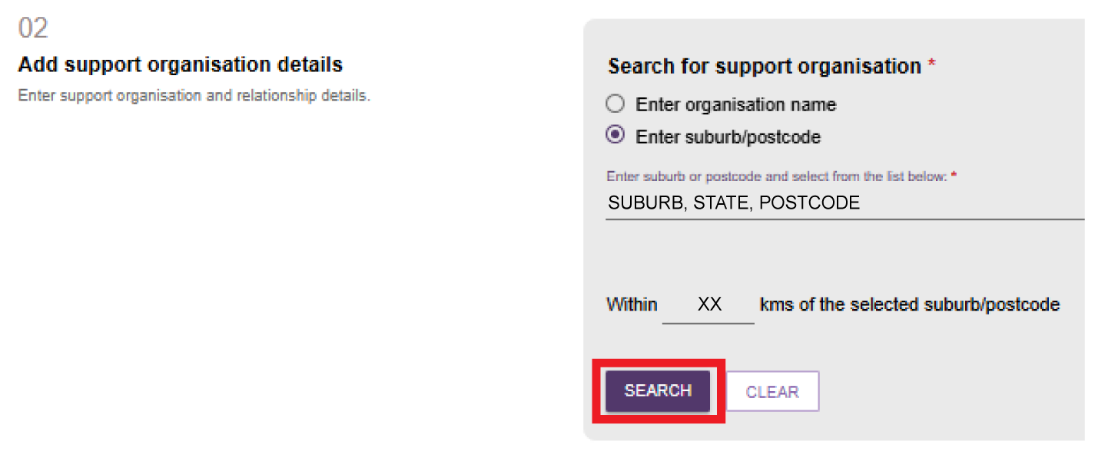
Organisation name search example
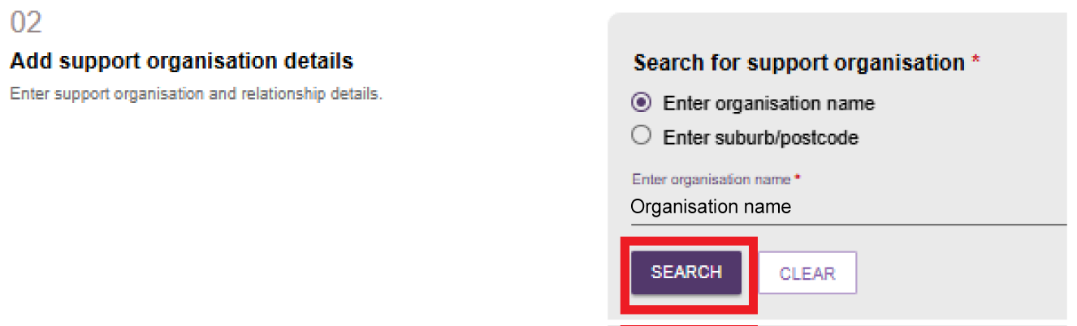
! | Only recognised Supporter Organisations appear in the search results. If you cannot find an organisation, refine your search or search on the My Aged Care website.
- Select the organisation from the search results.
- Enter the relationship start date.
If required, enter:
- a relationship end date, and/or
- the full name of the staff member the client wants to work with exclusively.
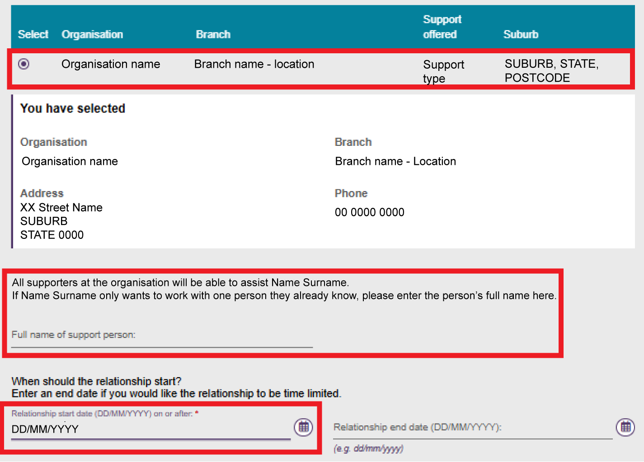
  - In Section 03 – Registration of Supporter or organisation form, select CHOOSE FILE and upload the registration form. Enter a name for the attachment.
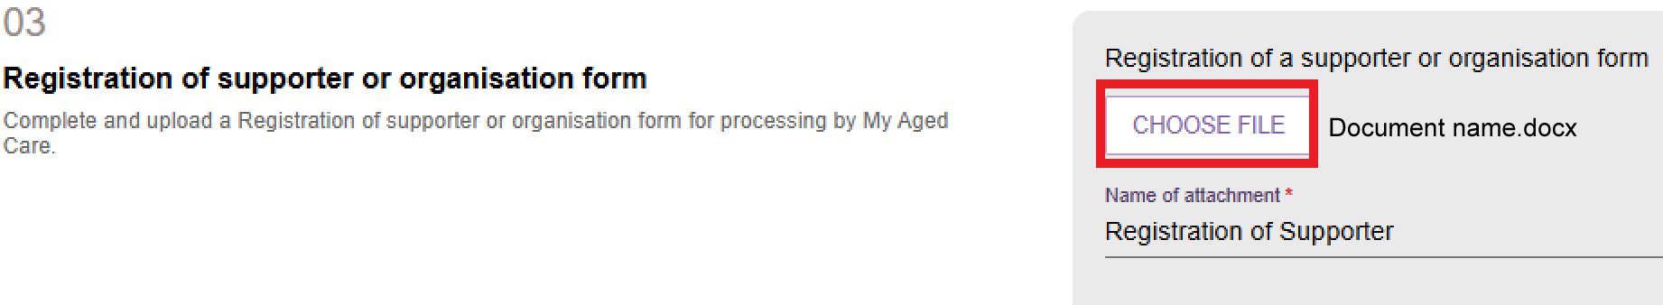

  - In Section 04 – Add documents, select ADD AN ATTACHMENT and upload any supporting documents related to the registration.
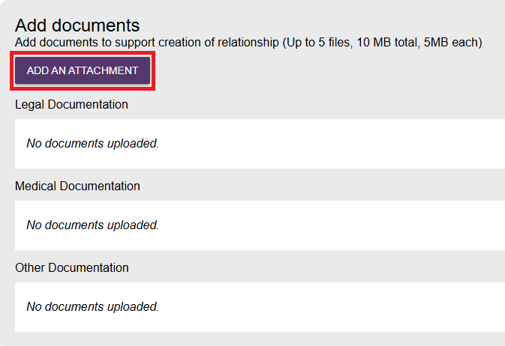
  - On the Add an attachment screen, select the file and then select UPLOAD.
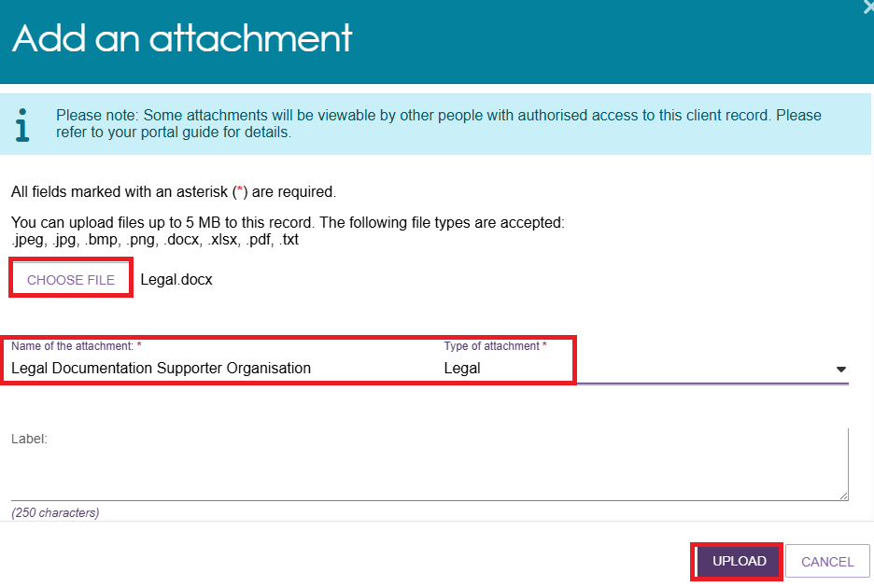
  - In Section 05 – Consent, complete the Supporter Organisation's consent declaration by selecting Yes or No.
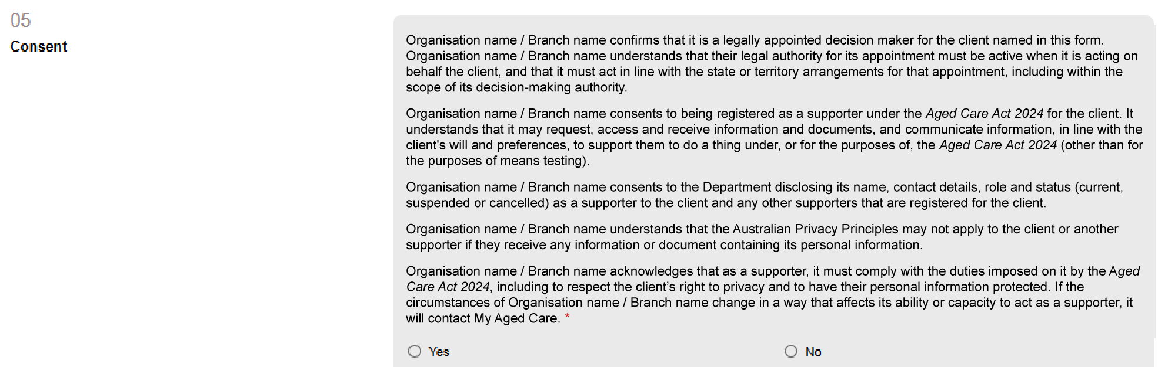
If you select No, you cannot continue and the SUBMIT TO MY AGED CARE button remains unavailable.
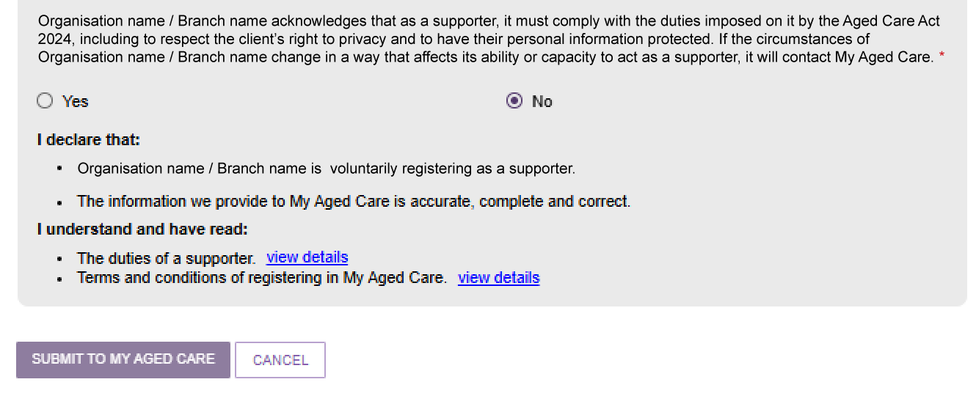
If you select Yes, complete the Supporter Organisation's Conflict of Interest declaration.
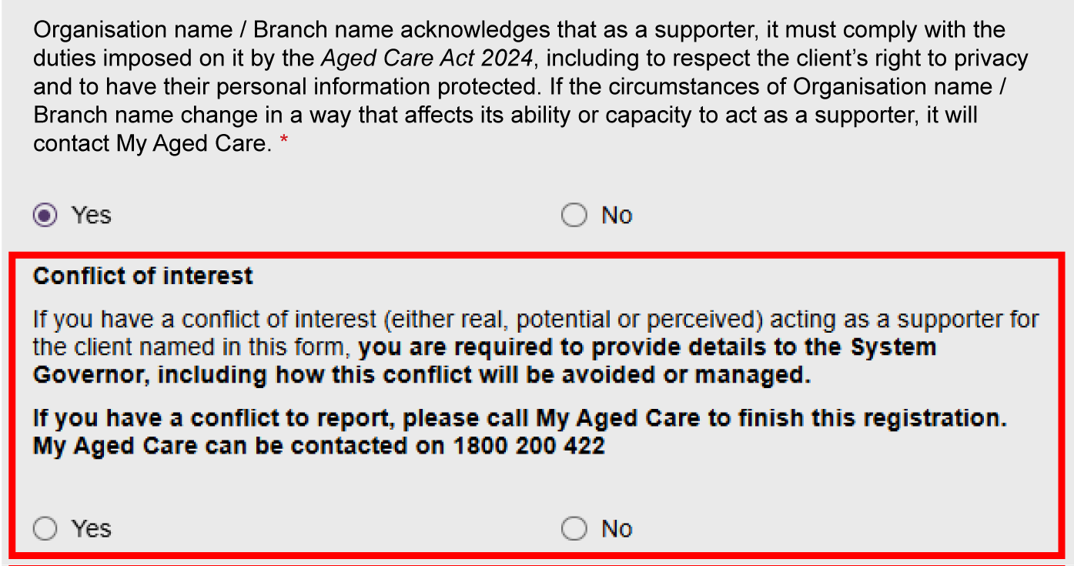
If you select Yes to the Conflict of Interest declaration, enter the conflict of interest details.
! | Record the conflict of interest details in the Supporter Organisation's own words and ensure the organisation agrees with the wording.
Review the final clauses of the declaration.
Select View Details to review the duties of a Supporter and the My Aged Care terms and conditions.
Select SUBMIT TO MY AGED CARE.
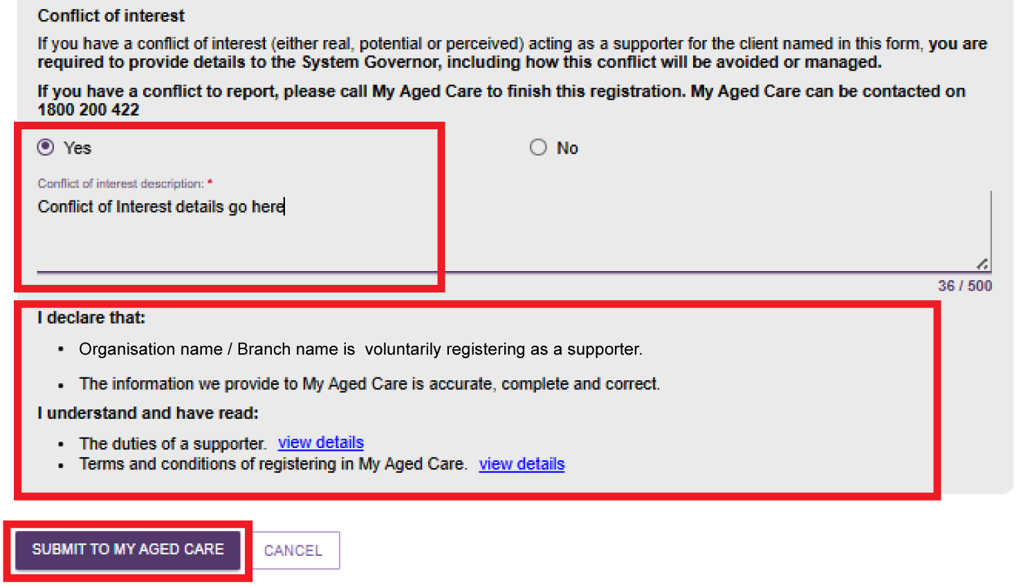
  - The Supporter Organisation relationship appears on the client's Support Network screen. A green banner confirms the relationship request was submitted successfully.
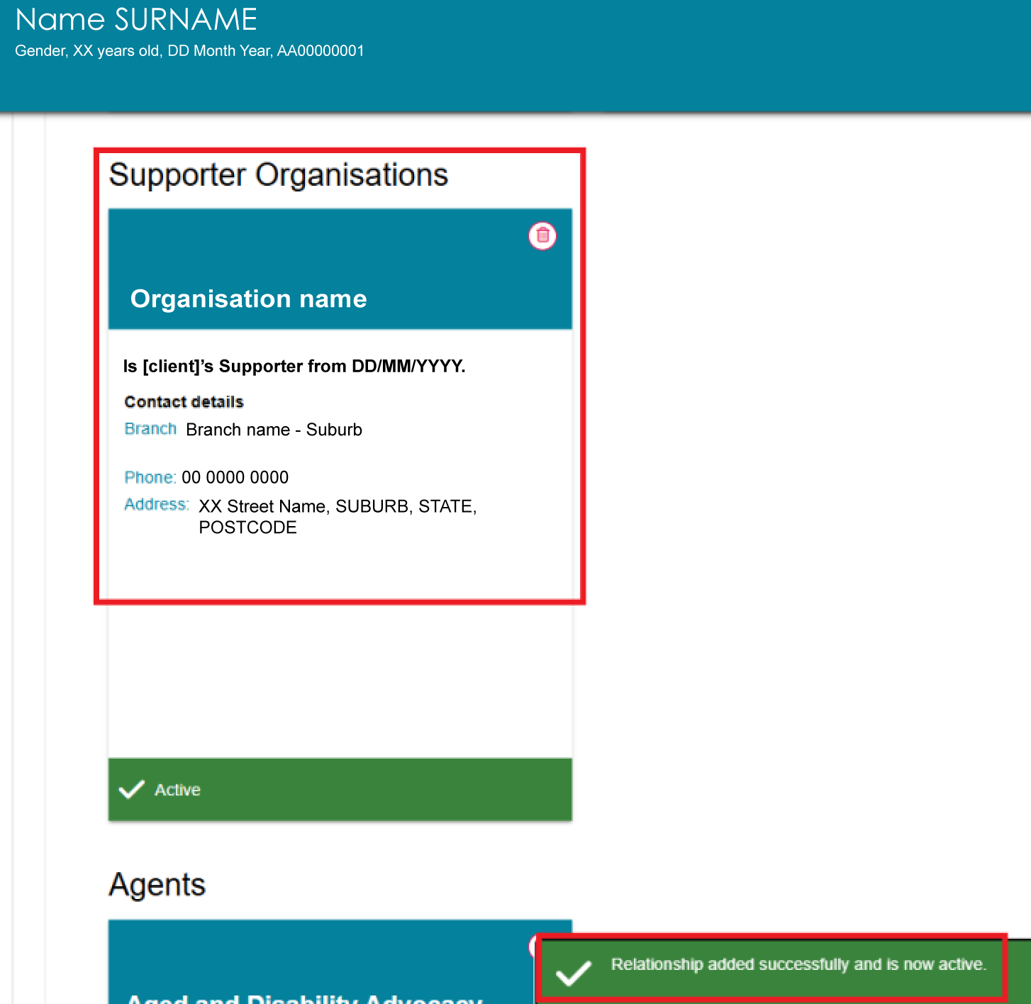

Creating a Supporter Guardian Organisation relationship
Before you create a Supporter Guardian Organisation relationship, check that the organisation and relationship do not already exist in My Aged Care. Search for the organisation and review its current support relationships. For more information, refer to My Aged Care – Assessor Portal User Guide 1 – Registering and referring clients for assessments.
Once you have confirmed there are no duplicate records, you can create a Supporter Guardian Organisation relationship request for the client.
Supporter Guardian Organisation relationship requests require delegate approval.
- From the client’s Support network tab, select CREATE RELATIONSHIP.
- On the Create relationship for client page, go to Section 01 – About client's relationship. Select Supporter Guardian, then select Organisation as the relationship type.
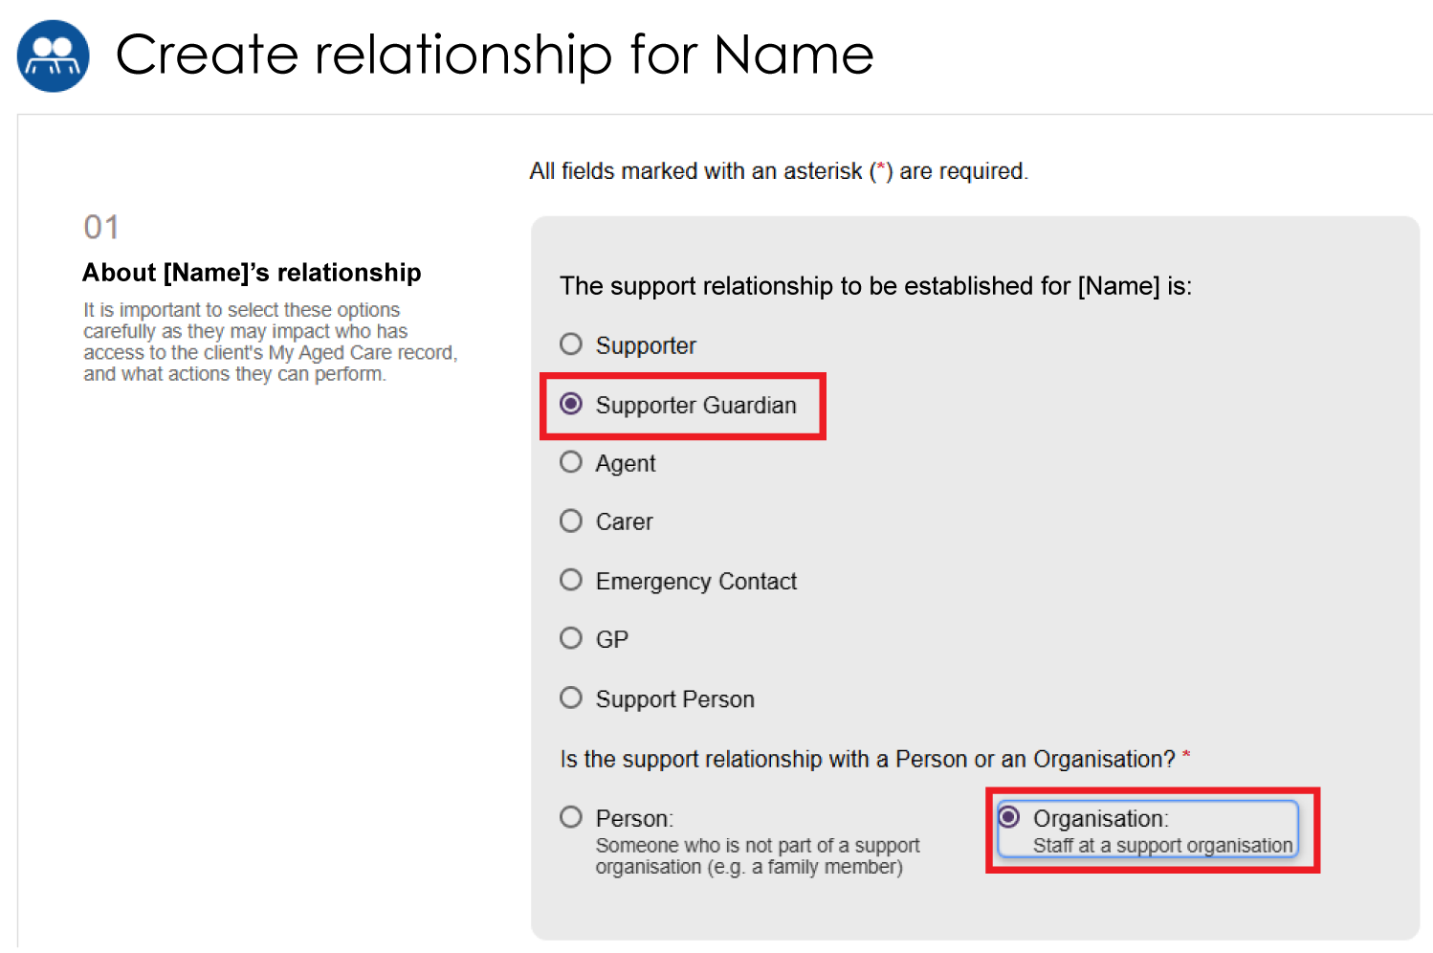

- In Section 02 – Add support organisation details, search for the organisation by entering:
- the organisation name, or
- a suburb or postcode.
Select SEARCH.
You can also limit the search by distance from a suburb or postcode.
Suburb or Postcode search example
Organisation name search example
- Select the organisation from the search results.
- Enter the relationship start date.
You can also enter:
- a relationship end date, and/or
- the full name of the Supporter Guardian within the organisation that the client wants to work with exclusively.
! | If the legal documents include an end date, the relationship end date must match the date in those documents.
- In Section 03 – Registration of Supporter or organisation form, select CHOOSE FILE and upload the registration form. Enter a name for the attachment.
- In Section 04 – Add documentation, indicate whether you can verify the organisation's legal authority to act on the client's behalf.
! | - If you can verify the legal documents, select Yes and upload the verified documents.  - If you cannot verify the legal documents, select No, upload the documents, and select SUBMIT TO MY AGED CARE. My Aged Care creates a pending relationship and sends the documents to the My Aged Care Contact Centre for verification.  - If legal documents are not available, advise the organisation that it must submit the required documents through its online account or through the My Aged Care contact centre before My Aged Care can establish the relationship.
- Select ADD AN ATTACHMENT and upload the required supporting documents.
! | - You must upload a legal document, such as a guardianship order or enduring power of attorney.  - Enter a name for each document.  - If required, upload a medical practitioner's letter to support the client's need for a Supporter Guardian organisation.  - For more information, refer to My Aged Care Assessment Manual.
Select the required file and then select UPLOAD.
Repeat this process until you have uploaded all required documents. Make sure all documents meet the requirements shown on screen.
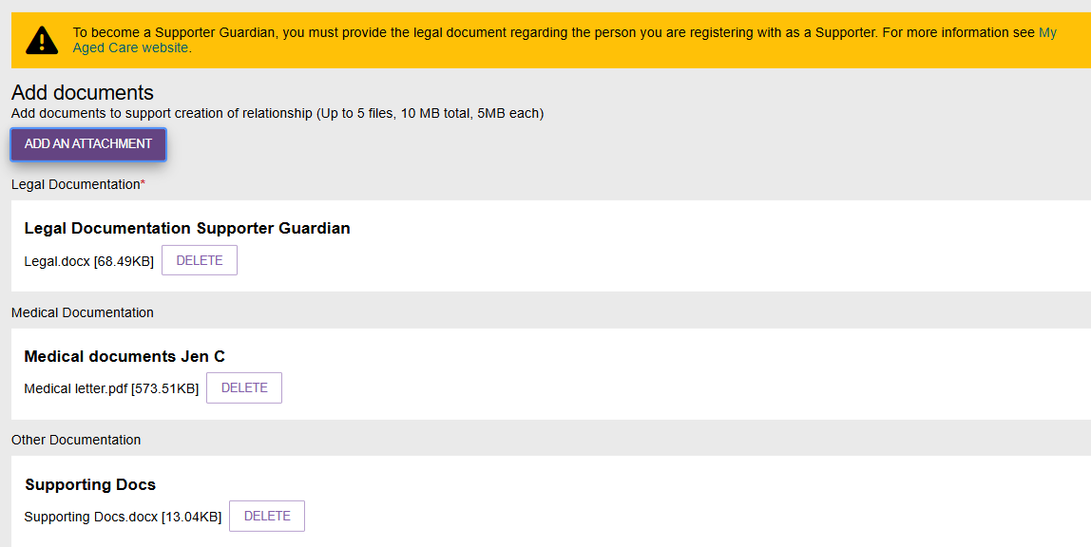
- In Section 05 – Consent, complete the Supporter Guardian Organisation's consent declaration.
- The Supporter Guardian Organisation, or the assessor on its behalf, must select Yes for the request to continue.
- If you select No, you cannot continue and the SUBMIT TO MY AGED CARE button remains unavailable.
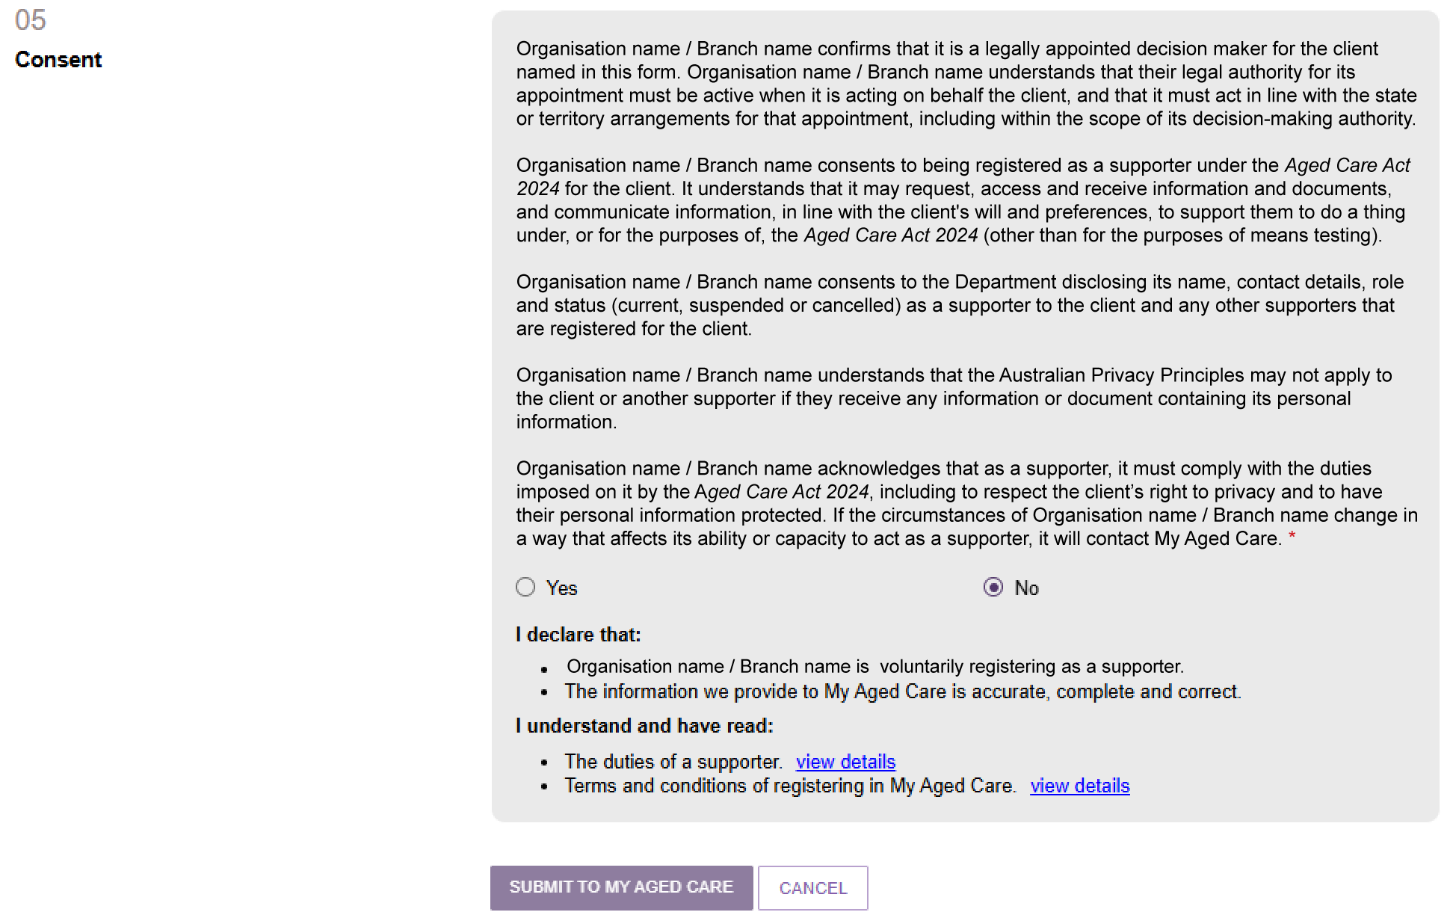
- After you select Yes, complete the Conflict of Interest declaration.
- Select Yes or No.
- If you select Yes, enter the conflict of interest details in the text box.
- Select View Details to review the duties of a Supporter and the My Aged Care terms and conditions.
Select SUBMIT TO MY AGED CARE.
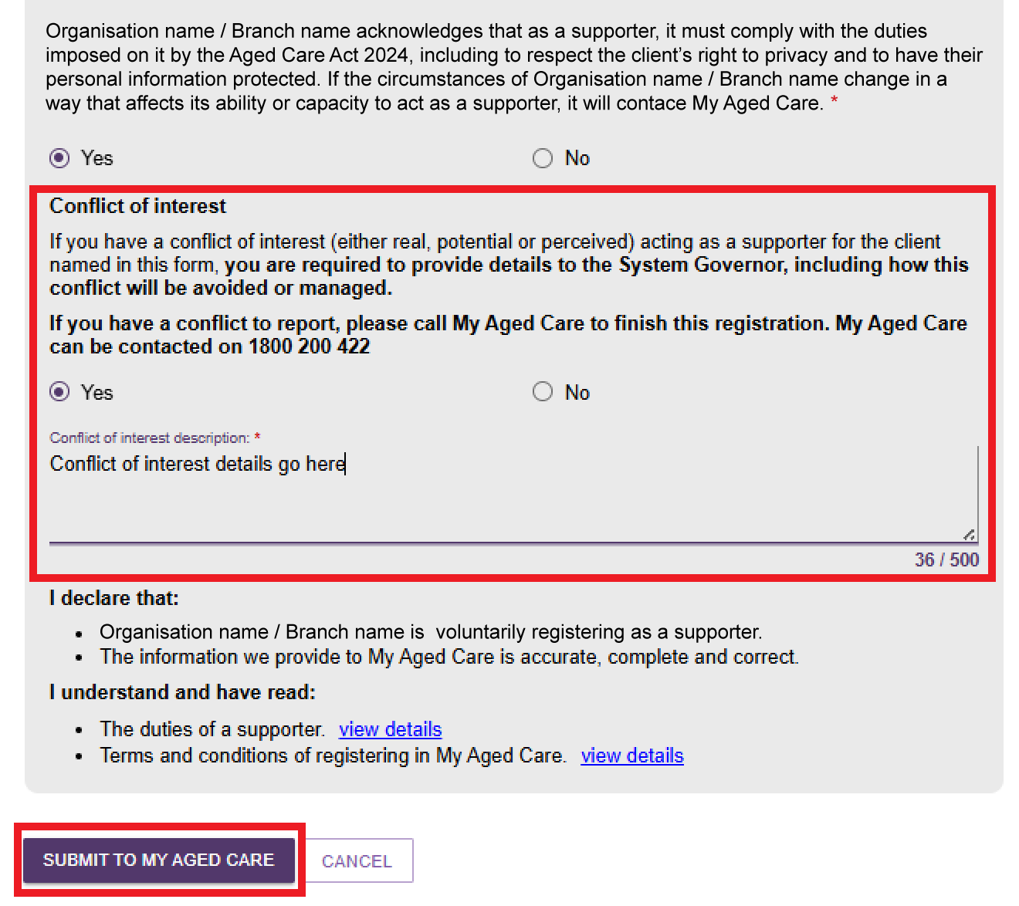
- The relationship appears on the client's Support Network screen. Depending on its status, you may see:
- a green banner confirming the relationship request was submitted successfully
- a yellow Pending banner
- an information message advising that delegate approval is required before the relationship can be approved.
Pending banner, Pending delegate approval example
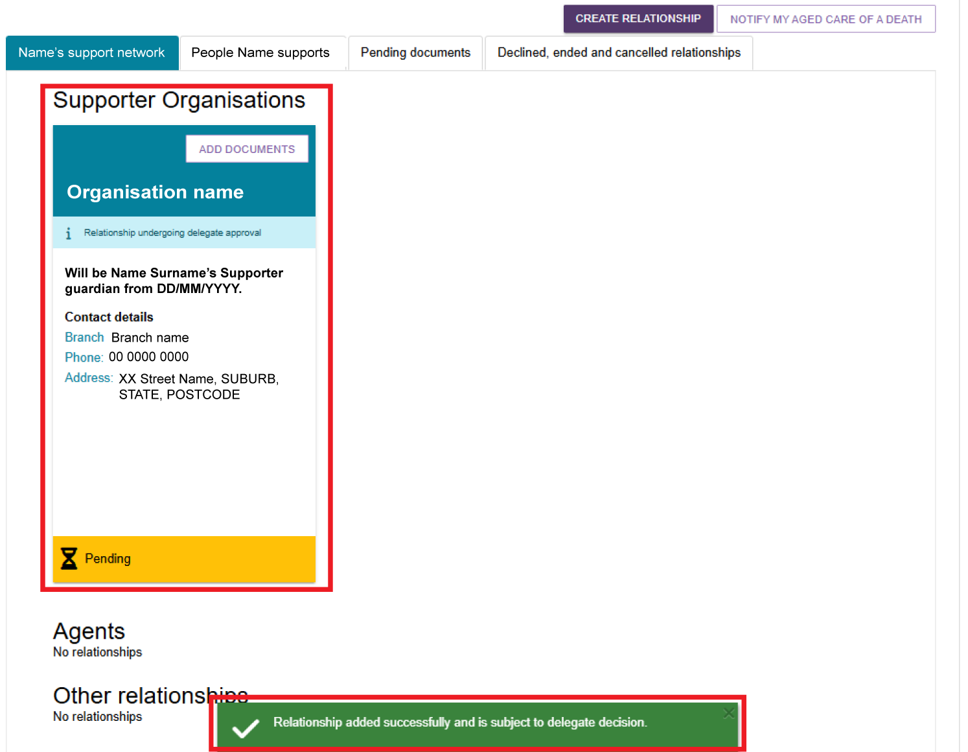

Creating an Organisational Agent relationship
Before you create an Organisational Agent relationship, check that the client and relationship do not already exist in My Aged Care. Search for the client and review their current support relationships. For more information, refer to My Aged Care – Assessor Portal User Guide 1 – Registering and referring clients for assessments.
Once you have confirmed there are no duplicate records, you can create an Organisational Agent relationship for the client.
- From the client’s Support network tab, select CREATE RELATIONSHIP.
- On the Create relationship for client page, go to Section 01 – About client's relationship and select Agent.
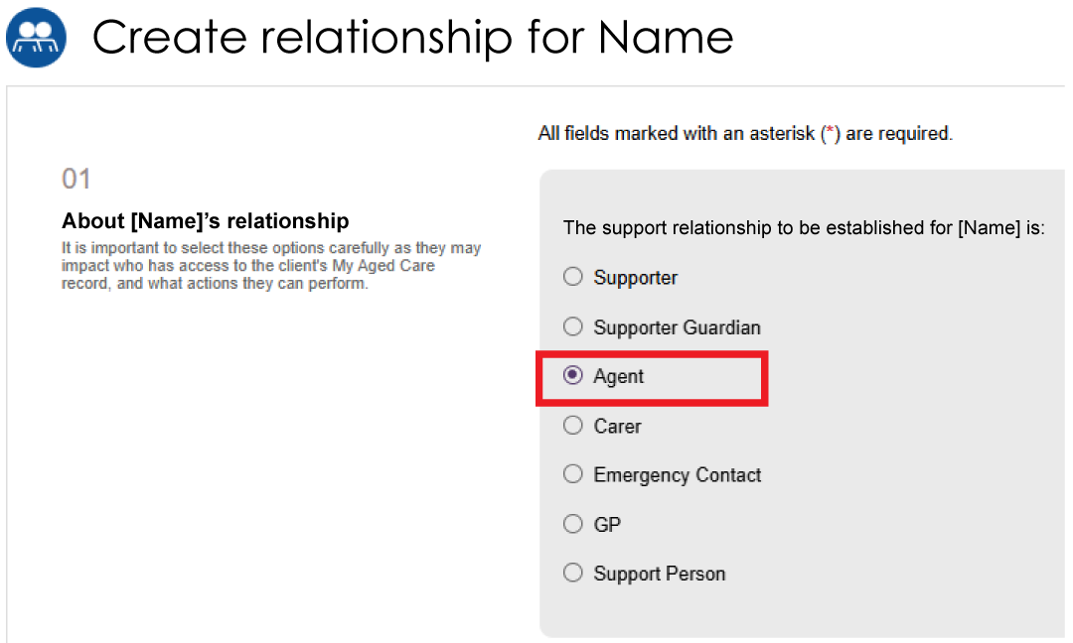
- In Section 02 – Add support organisation details, search for the organisation by entering:
- the organisation name, or
- a suburb or postcode.
Select SEARCH.
You can also limit the search by distance from a suburb or postcode.

Suburb or Postcode search example
Organisation name search example
! | Only approved Agent Organisations appear in My Aged Care. If you cannot find an organisation, refine your search or search on the My Aged Care website.
- Select the organisation from the search results.
! | Agent Organisations may provide different types of support. The Support Offered column may show Advocate, Care Finder, or Indigenous Facilitator.
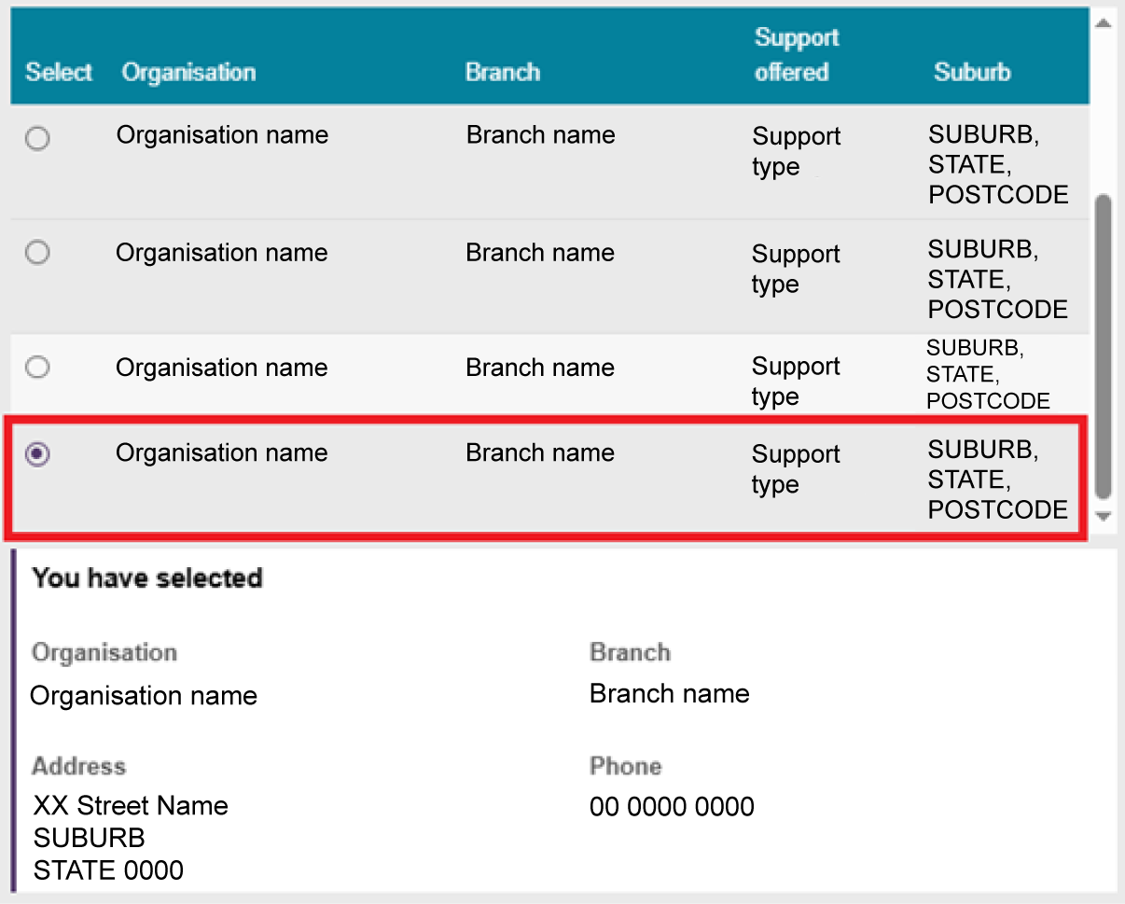
- Enter the relationship start date.
You can also:
- enter a relationship end date, and/or
- record the name of the specific agent the client wants to work with exclusively.
Depending on the organisation's support type, the nominated person will act as the client's Advocate, Care Finder, or Indigenous Facilitator.
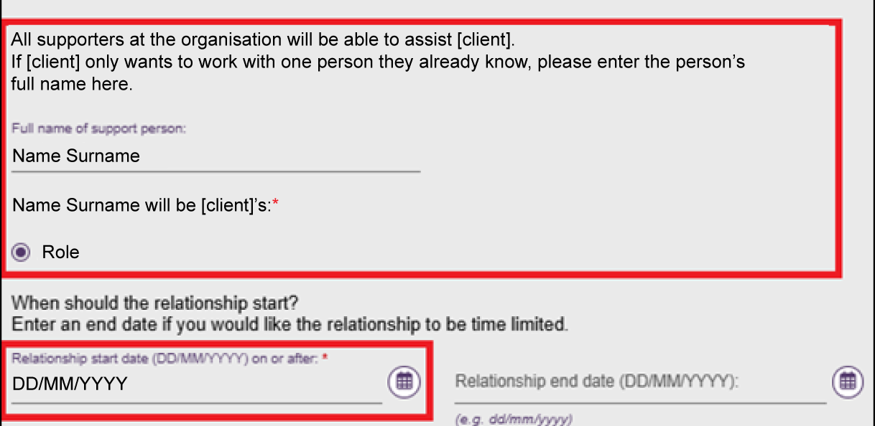
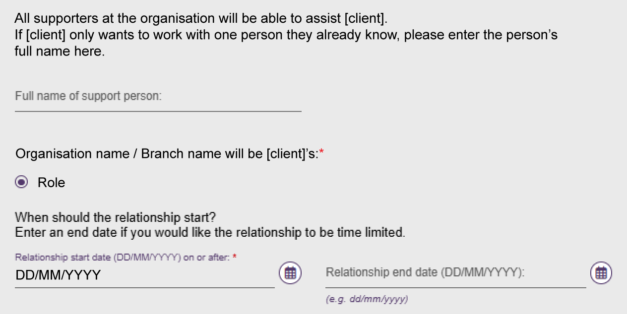
- In Section 03 – Registration of Supporter or organisation form, select CHOOSE FILE and upload the registration form. Enter a name for the attachment.
- In Section 04 – Consent, record the client's consent for the Agent Organisation to support them by selecting Yes or No.
- If you select No, you cannot create the relationship and the CREATE RELATIONSHIP button remains unavailable.
- If you select Yes, select CREATE RELATIONSHIP to complete the request.
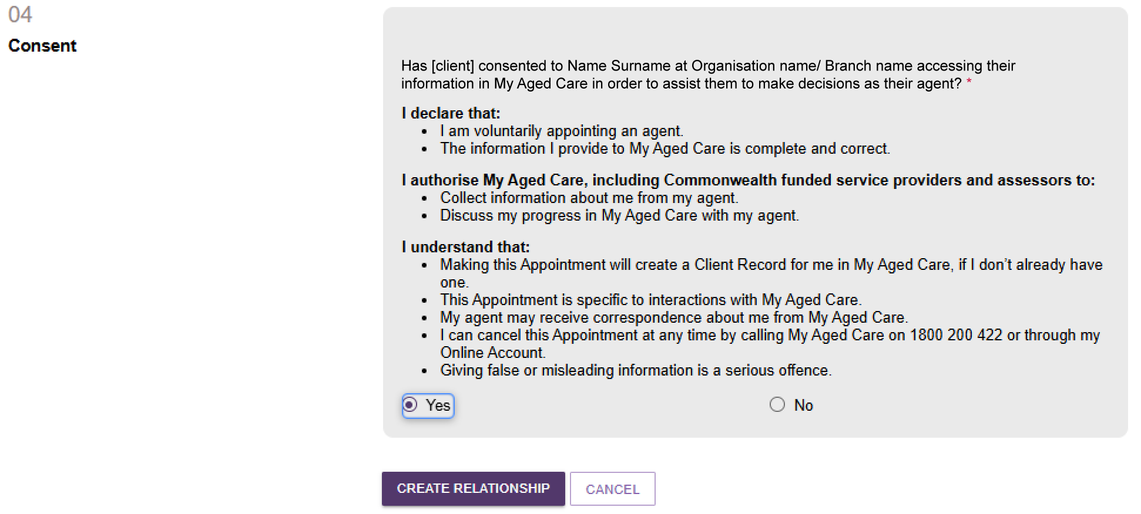
- The system returns you to the client's Support Network screen. The Agent Organisation relationship appears with a green banner confirming the relationship was created successfully.
The relationship remains in Pending status until it is activated. For more information, refer to Activating a pending relationship.
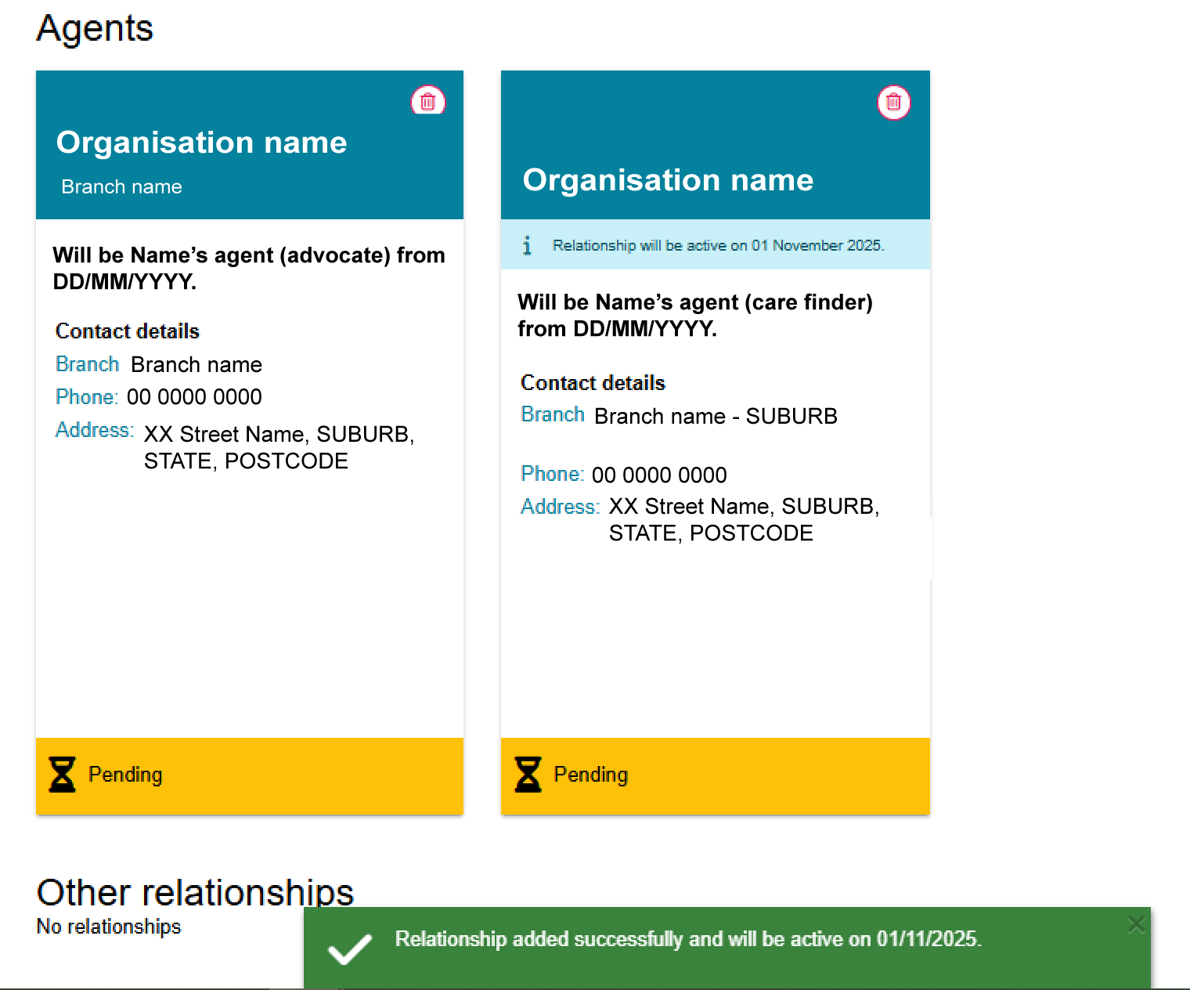

Creating a Carer, Emergency Contact, GP, or Support Person relationship
Before you create a new relationship, check that the client and relationship do not already exist in My Aged Care. Search for the client and review their current support relationships. For more information, refer to My Aged Care – Assessor Portal User Guide 1 – Registering and referring clients for assessments.
Once you have confirmed there are no duplicate records, you can create a relationship for a carer, emergency contact, GP, or support person.
The process is the same for all four relationship types.
- From the client’s Support network tab, select CREATE RELATIONSHIP.
- On the Create relationship for client page, go to Section 01 – About client's relationship and select the relationship type you want to create.
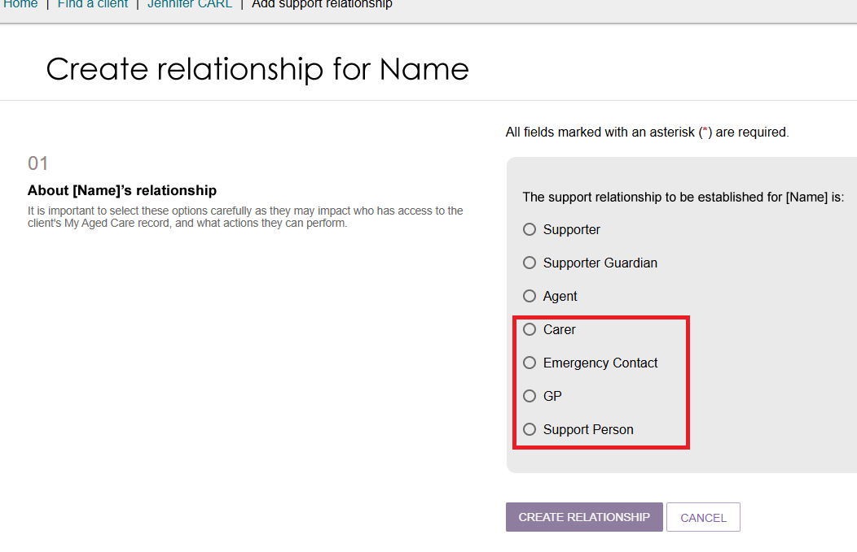
- In Section 02 – Add support person details, enter the person's first name and last name, then select SEARCH. This helps prevent duplicate records in My Aged Care.
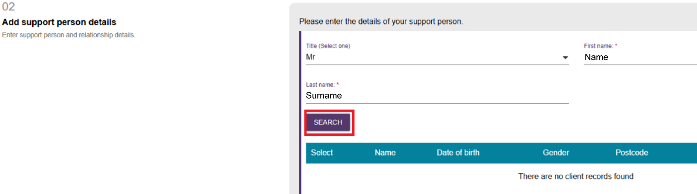
- If the search does not return a matching record:
- Select CONTINUE TO REGISTER.
- Follow the steps in Registering a new person for a support relationship.
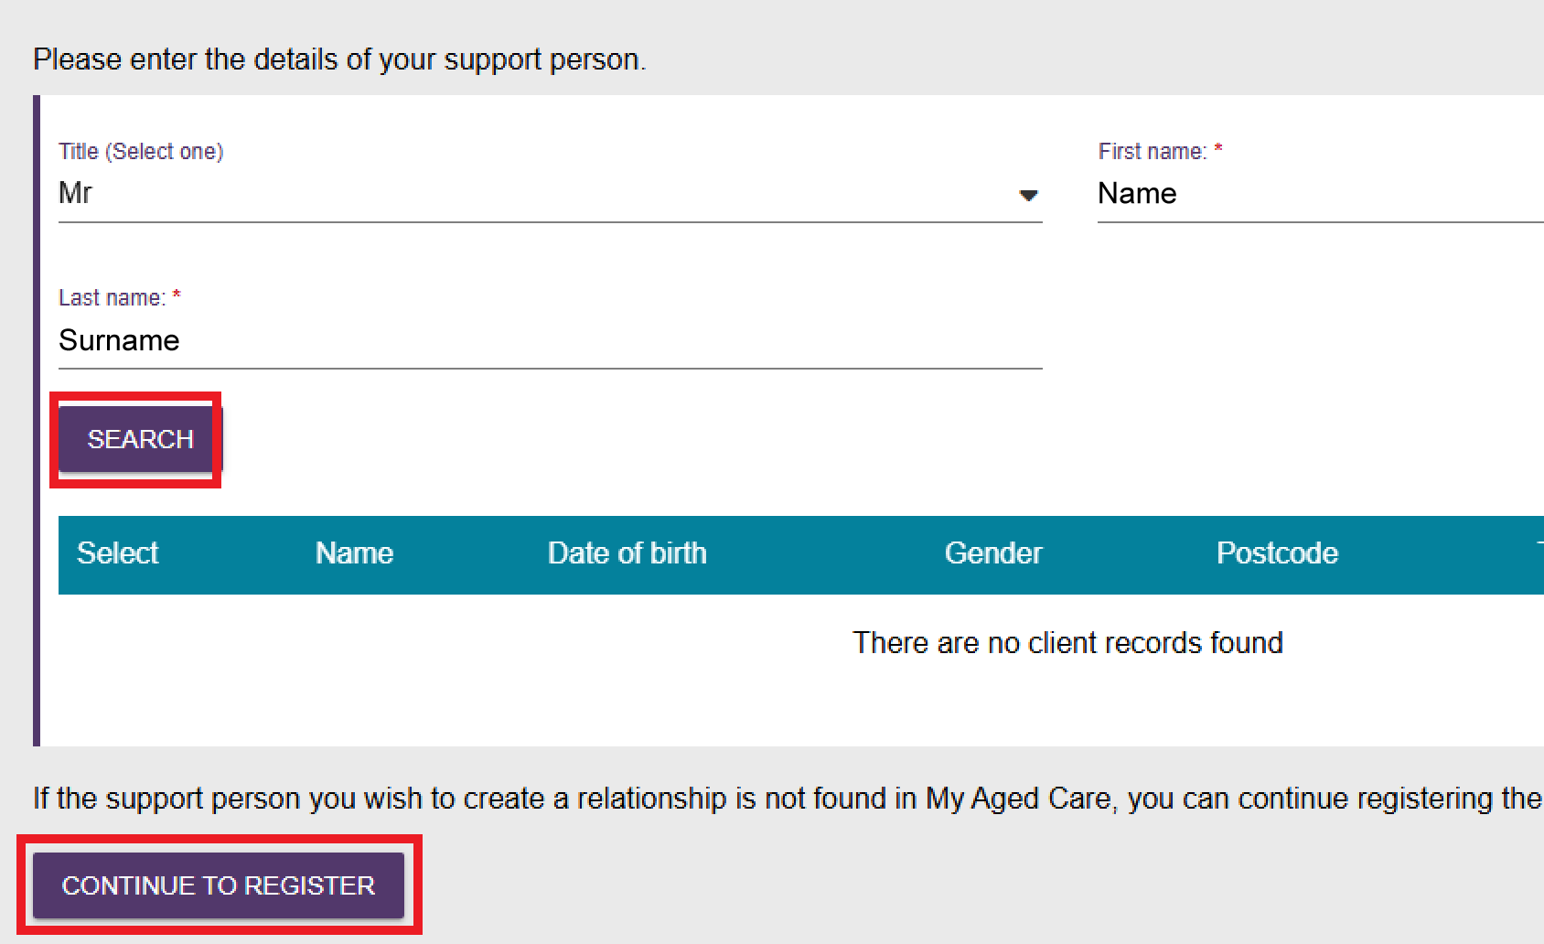
- If the person is already registered in My Aged Care:
- Search using their first and last name.
- Select the correct record from the search results.
- Select the confirmation checkbox to confirm you have chosen the correct person.
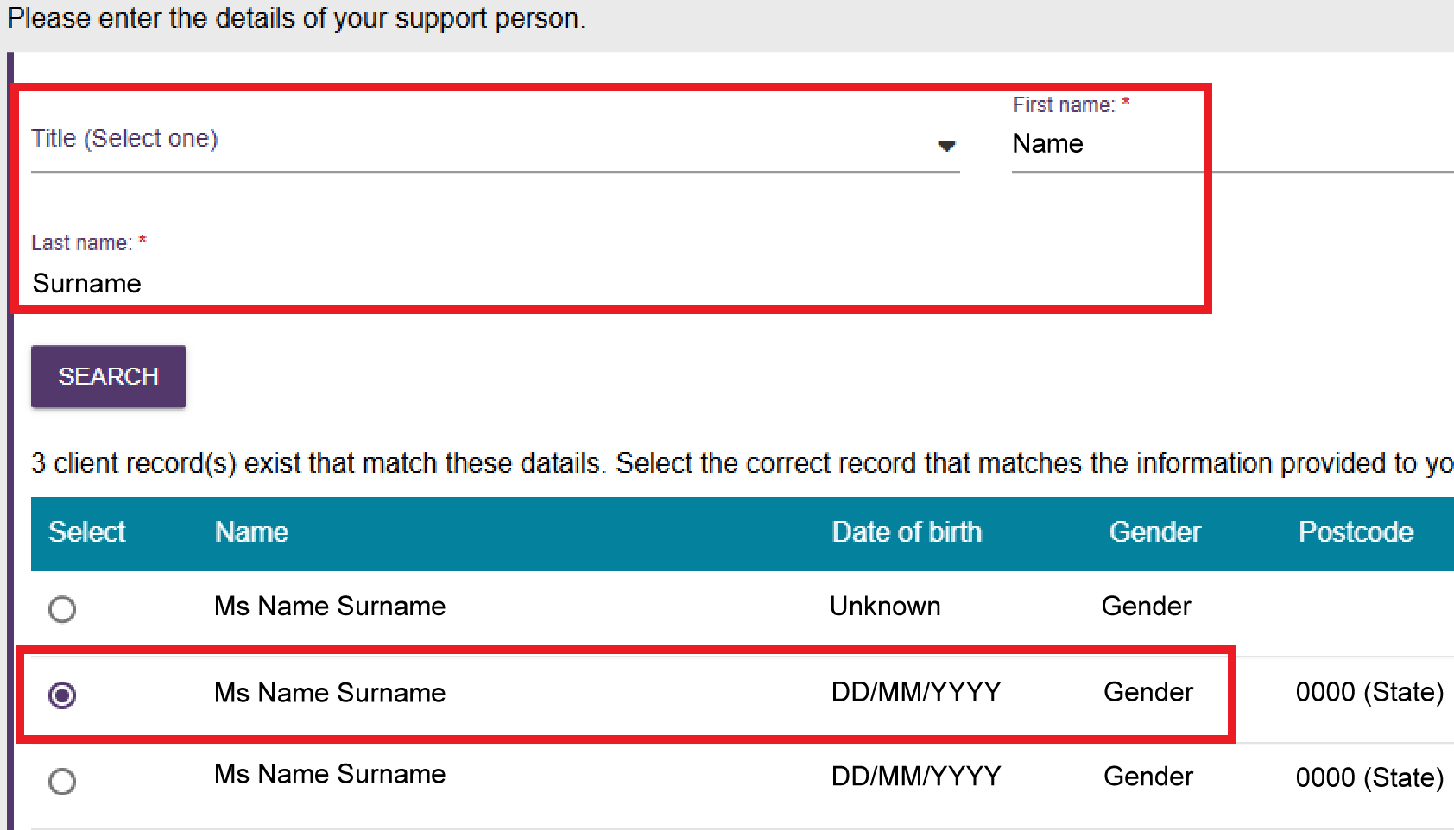
- In the Relationship to client field, select the option that best describes the relationship.
Select CREATE RELATIONSHIP.
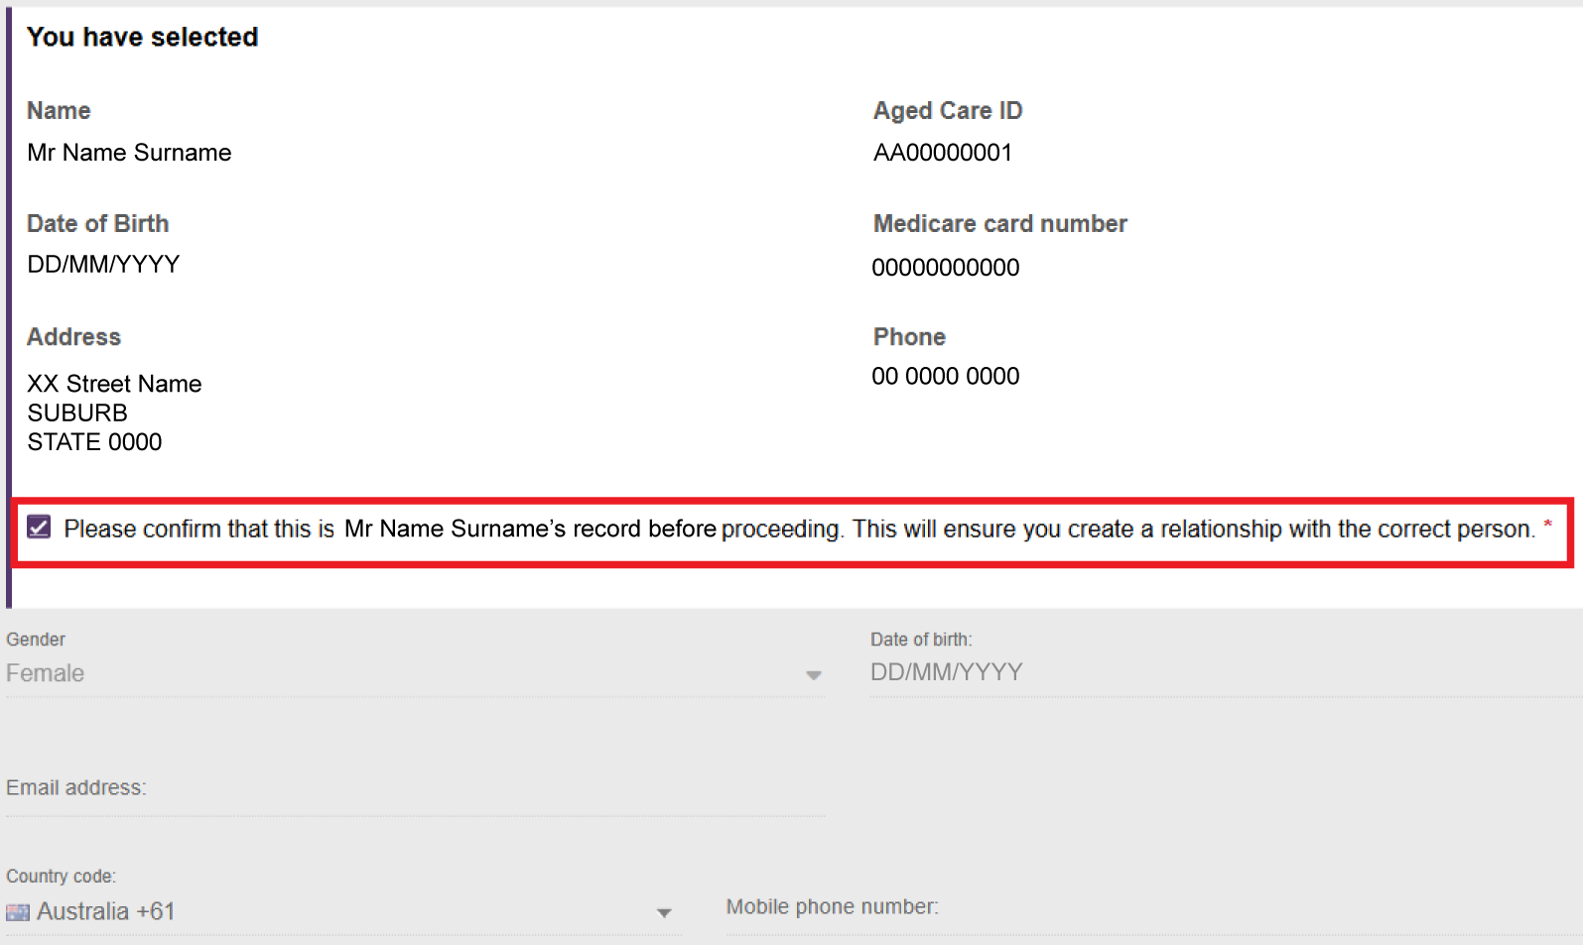
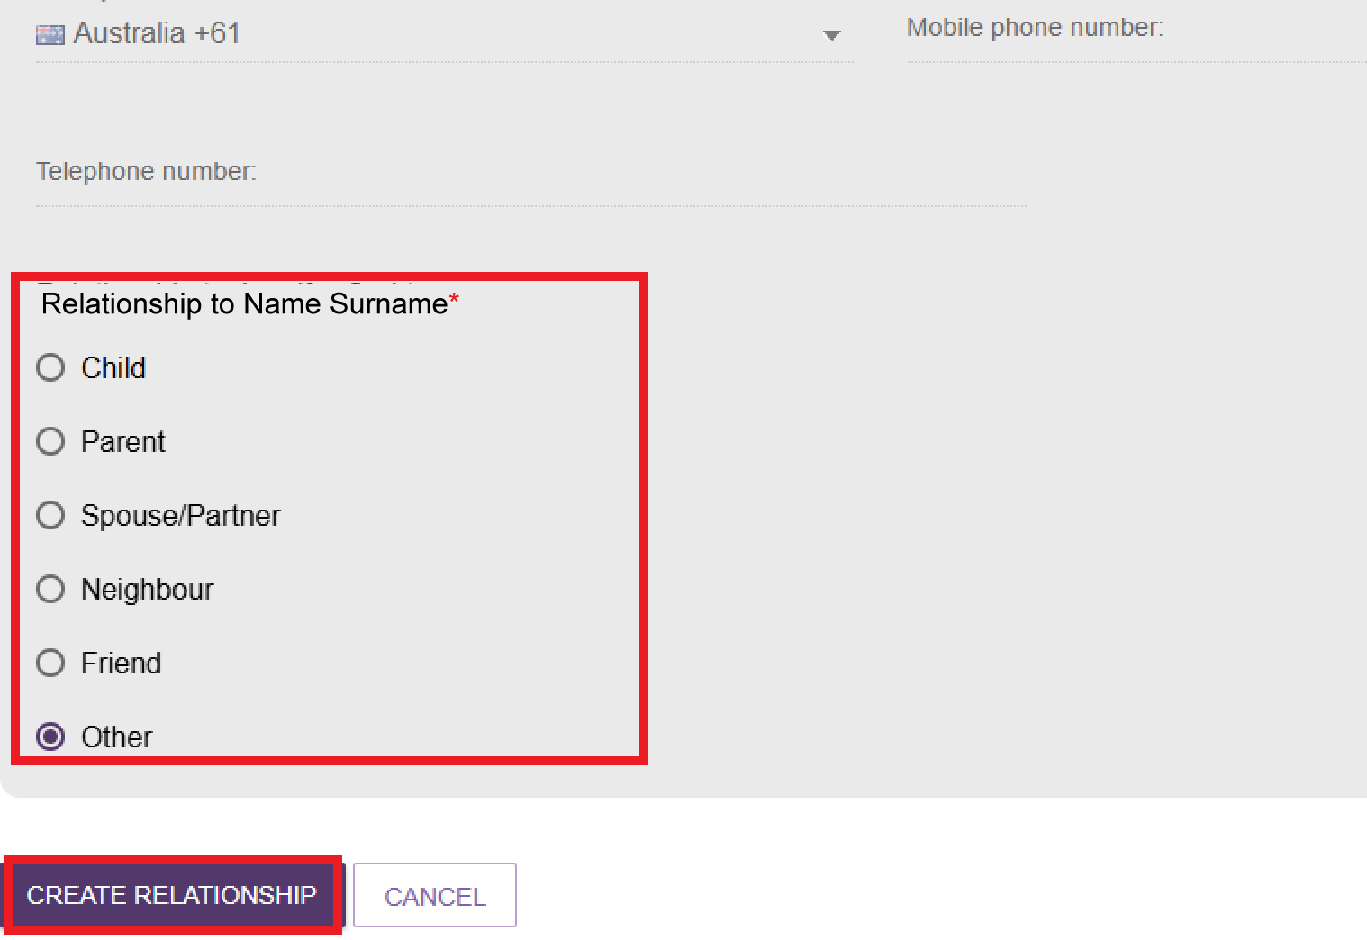
- The new relationship appears on the client's Support Network screen.
! | After you add a carer relationship, a REQUEST CALL BACK option becomes available on the carer's relationship tile.  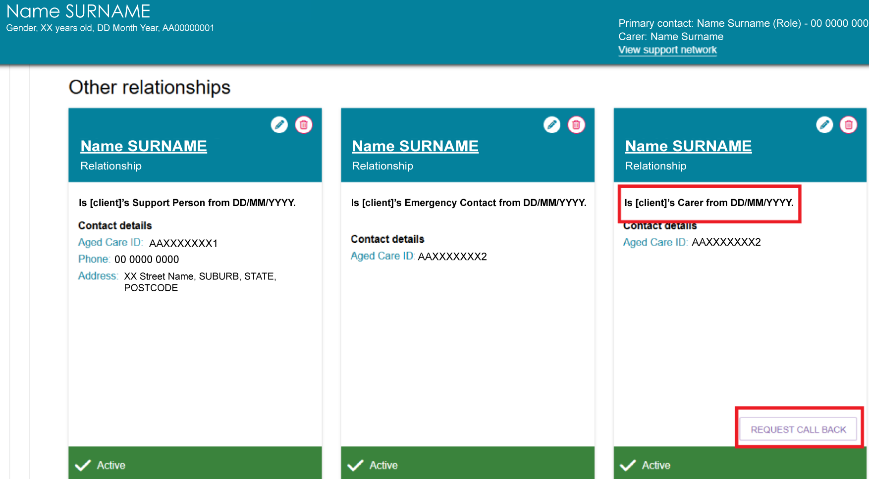

Registering a new person for a support relationship
If the person is not already registered in My Aged Care, you can create a new record and add the relationship.
    - In Section 02 – Add support person details, select CONTINUE TO REGISTER.
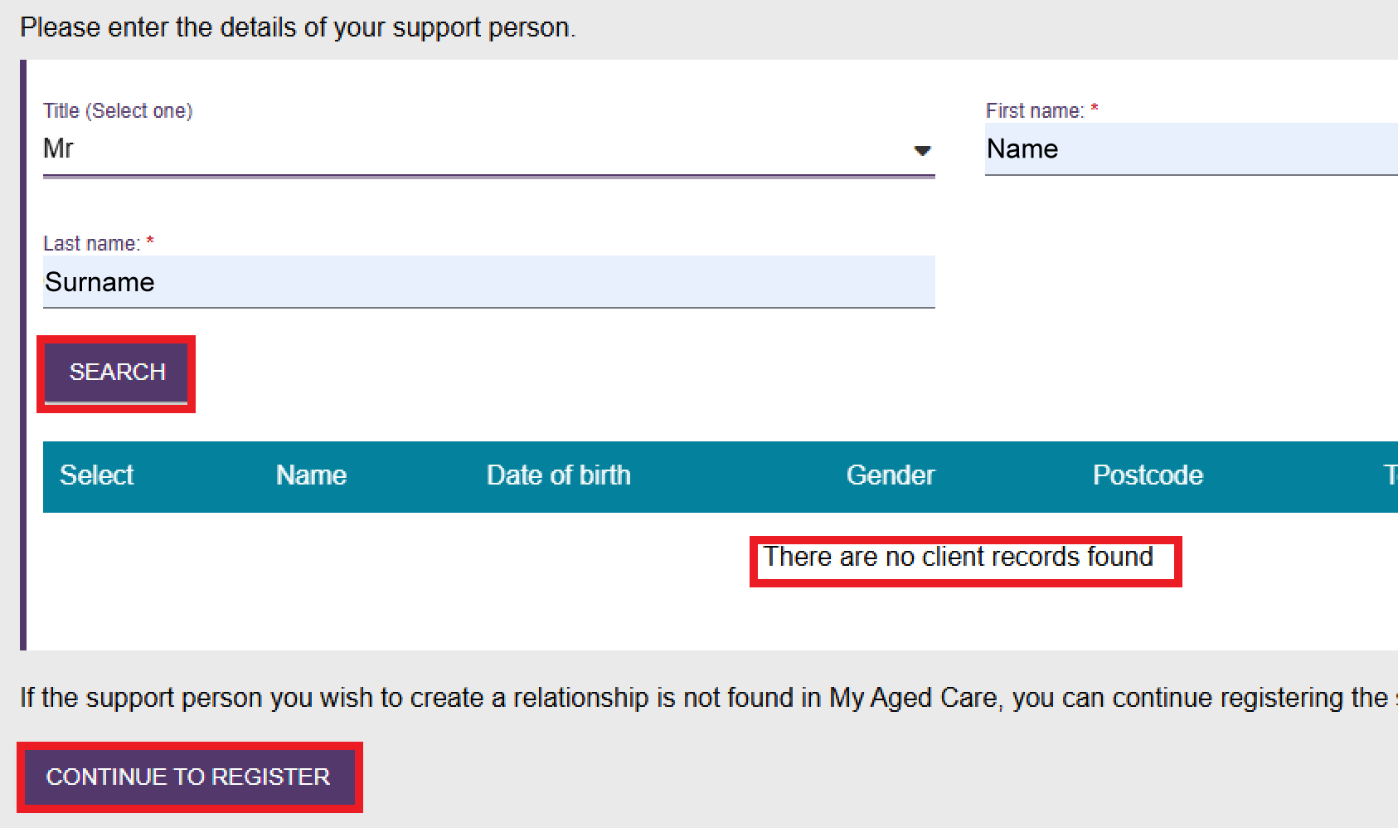
    - Enter the support person's details, including:
- Title
- First name
- Last name
- Gender
- Date of birth, or estimated age if the date of birth is unknown
- Email address
- Mobile phone number or contact phone number, including the country code.
These contact details can be used for SMS and email notifications.
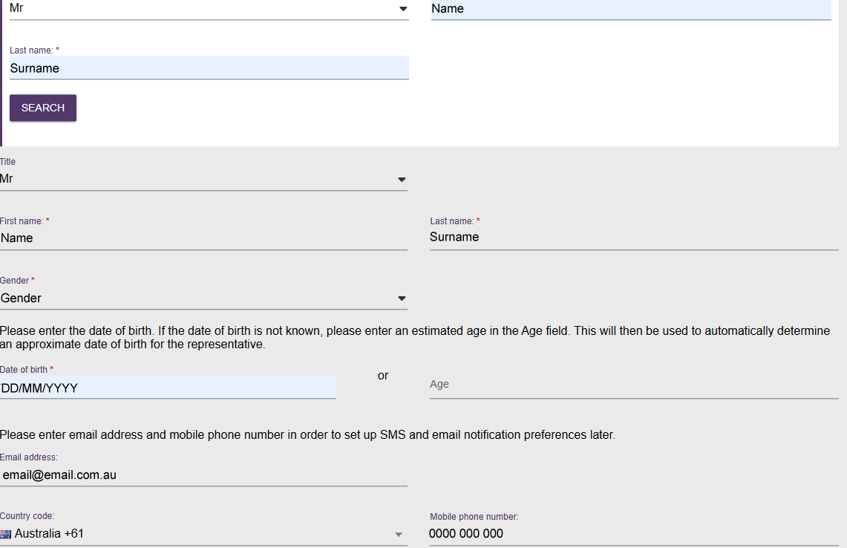
    - Select the person's relationship to the client.
    - If you want to record the person's home address, select Add home address for relationship.
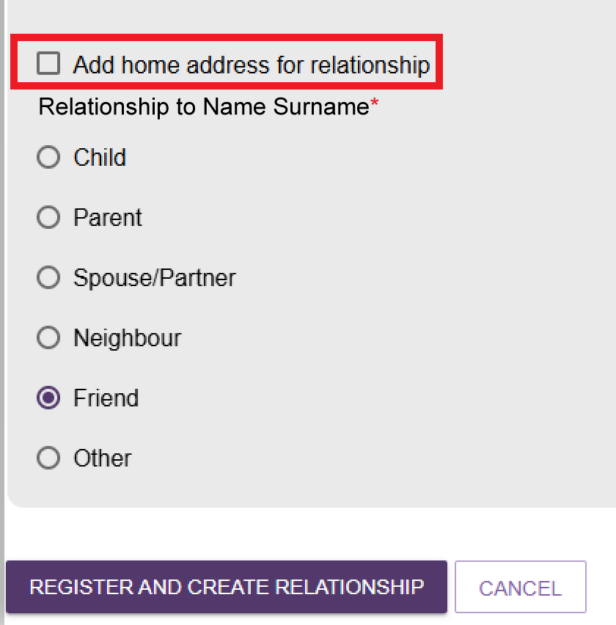
    - Enter the address details:
- Street number
- Street name
- Street type
- Suburb and postcode.
Select the correct address from the list that appears.
If the address does not appear, select SUBURB IS NOT LISTED, CLICK HERE and enter the address manually.
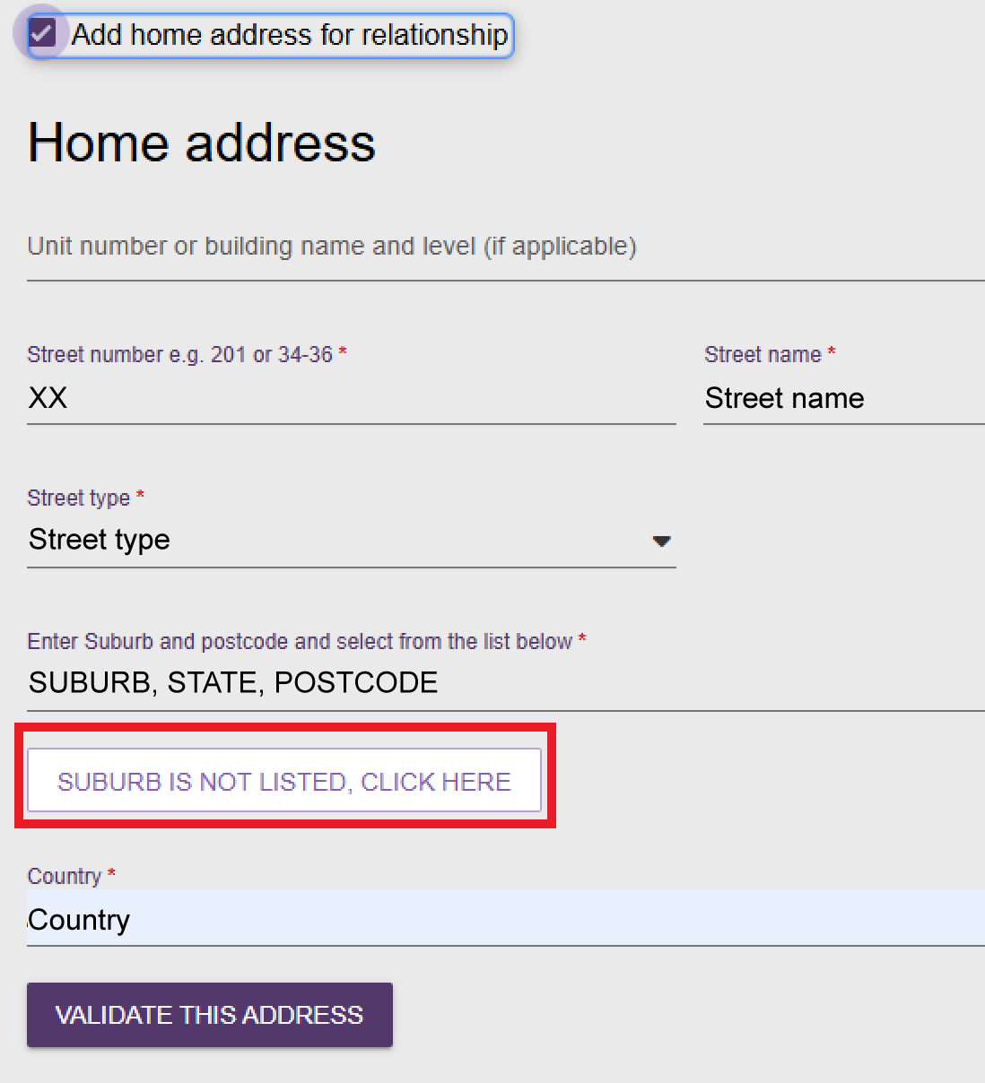
    - Enter the country and select VALIDATE THIS ADDRESS.
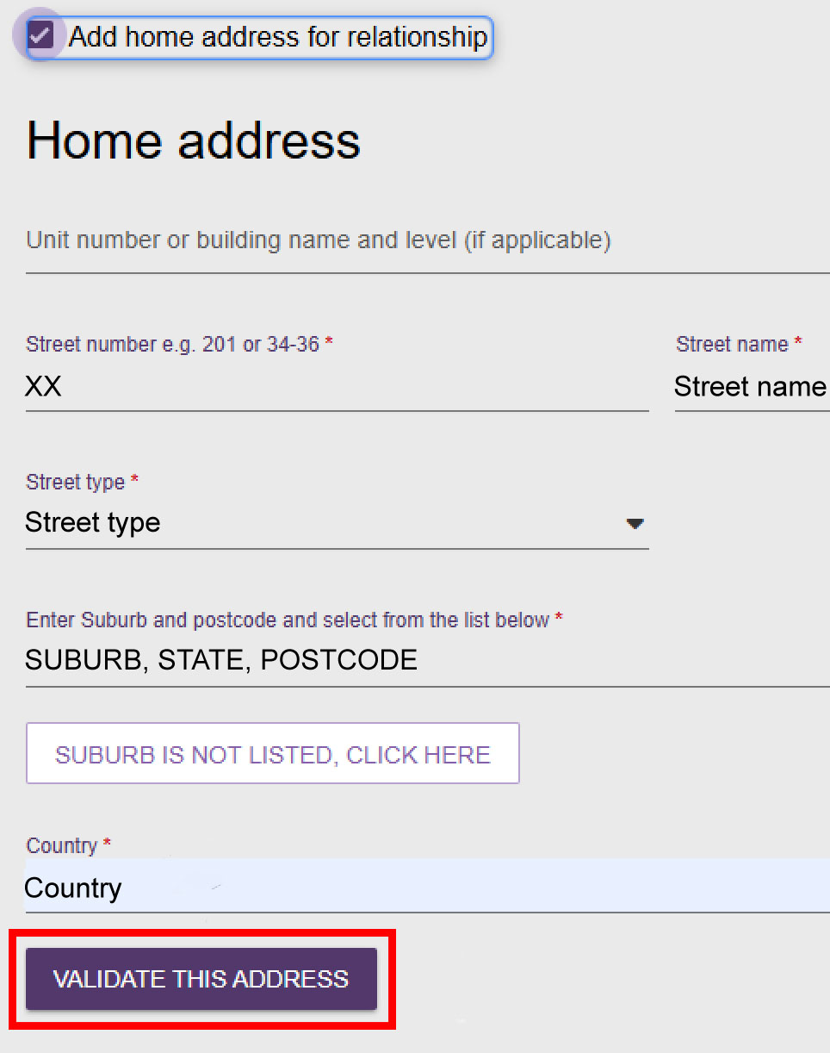
    - If the system cannot validate the address:
- Check that the address is correct.
- If the address is correct, select Not found, use entered address anyway.
- If required, enter additional information in the Special instructions field.
- Select REGISTER AND CREATE RELATIONSHIP.
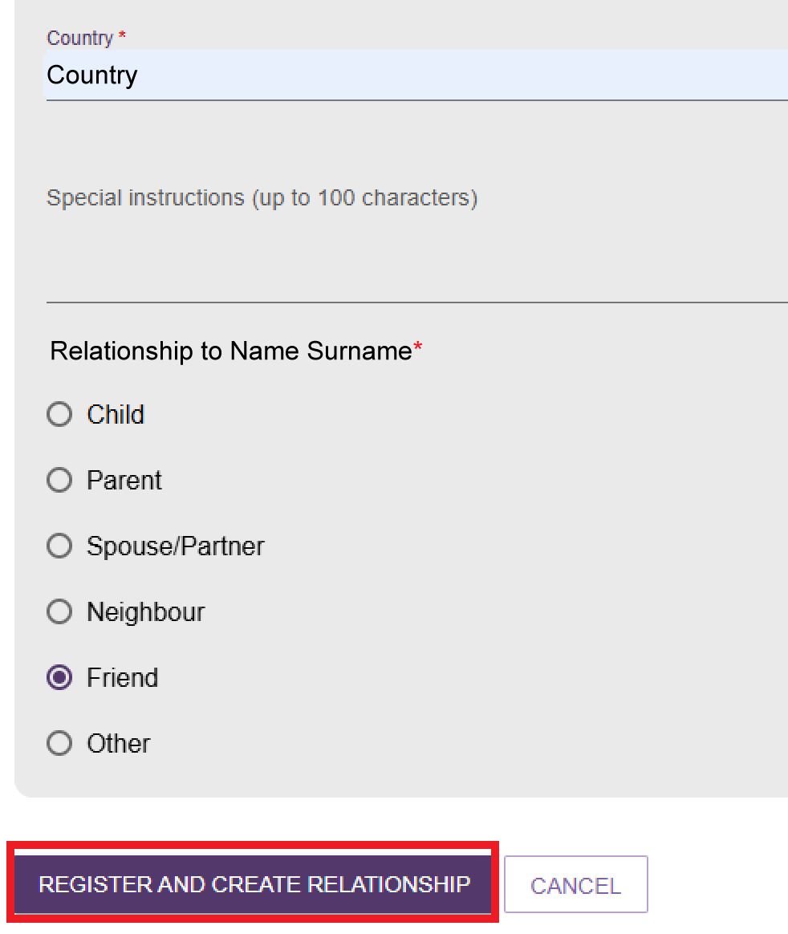
- The system returns you to the client's Support Network screen. The Agent Organisation relationship appears with a green banner confirming that the relationship was created successfully.
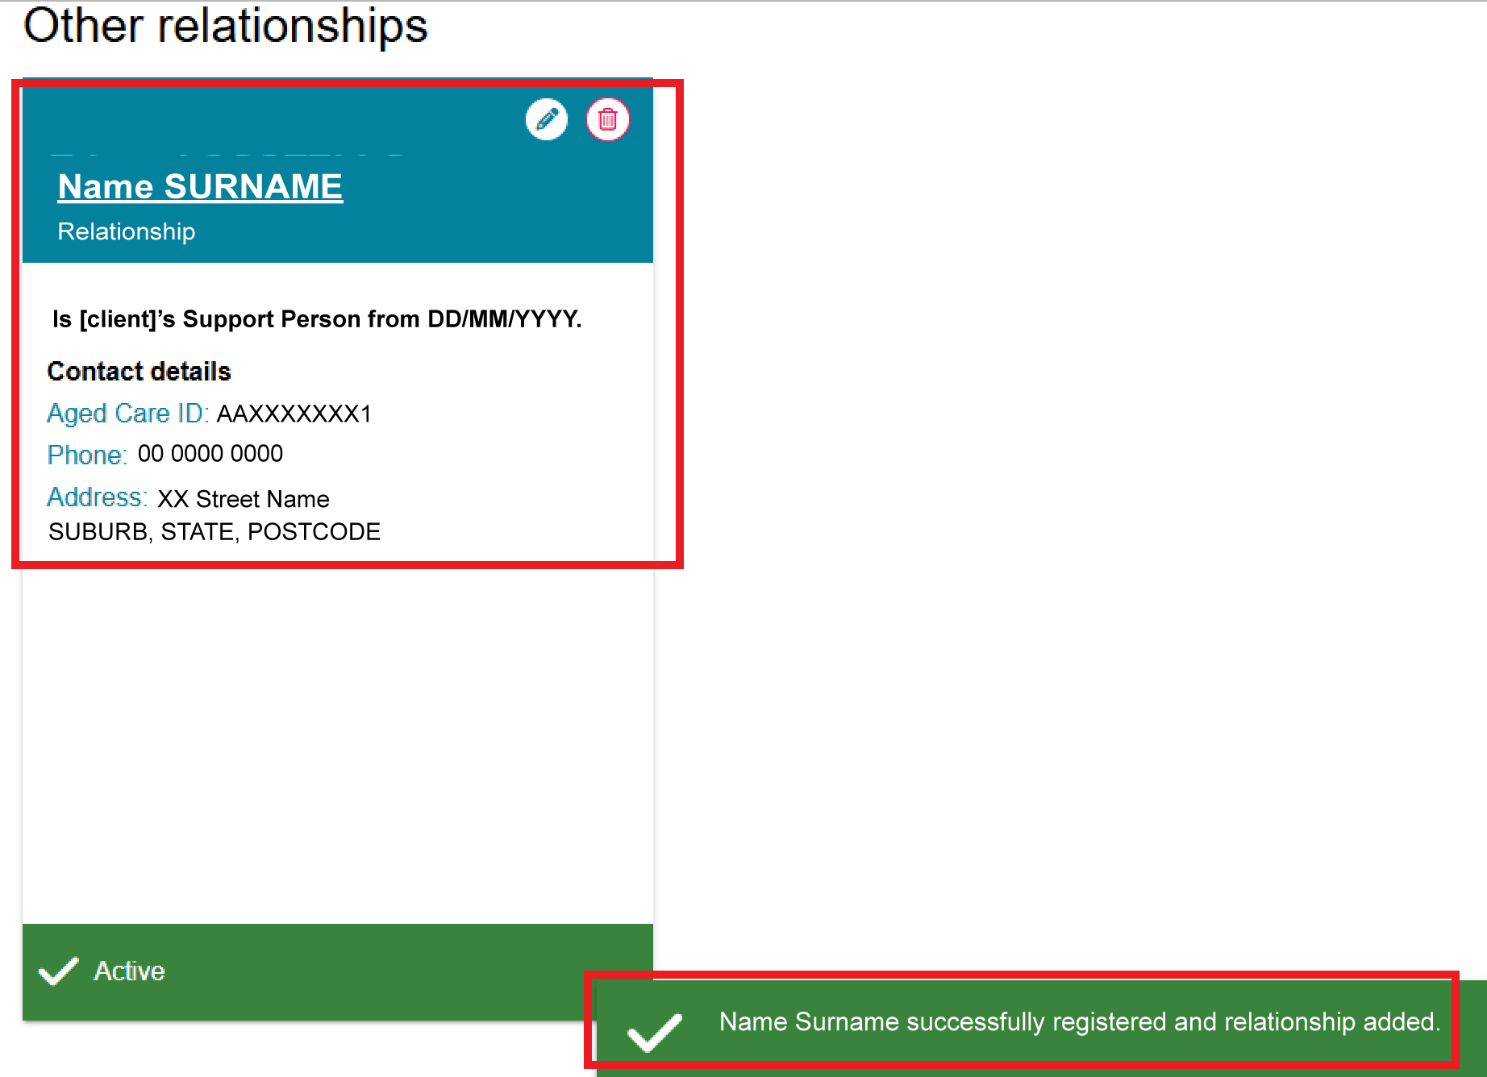
! | You can also view this relationship in the Supporter's Support Network tab.  - Select the Supporter's name on the relationship tile.  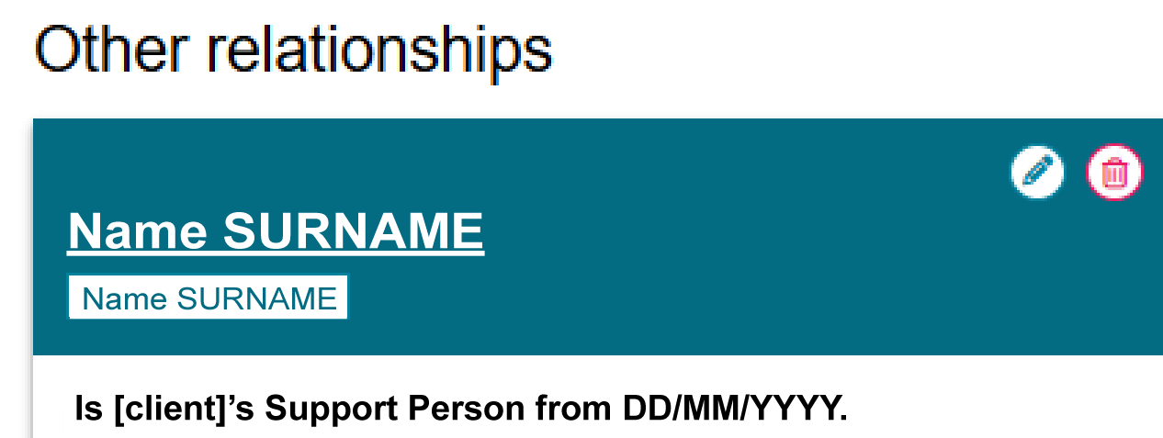  - On the Supporter's record, select the Support Network tab. Select People [Supporter] Supports to view the people the Supporter supports.  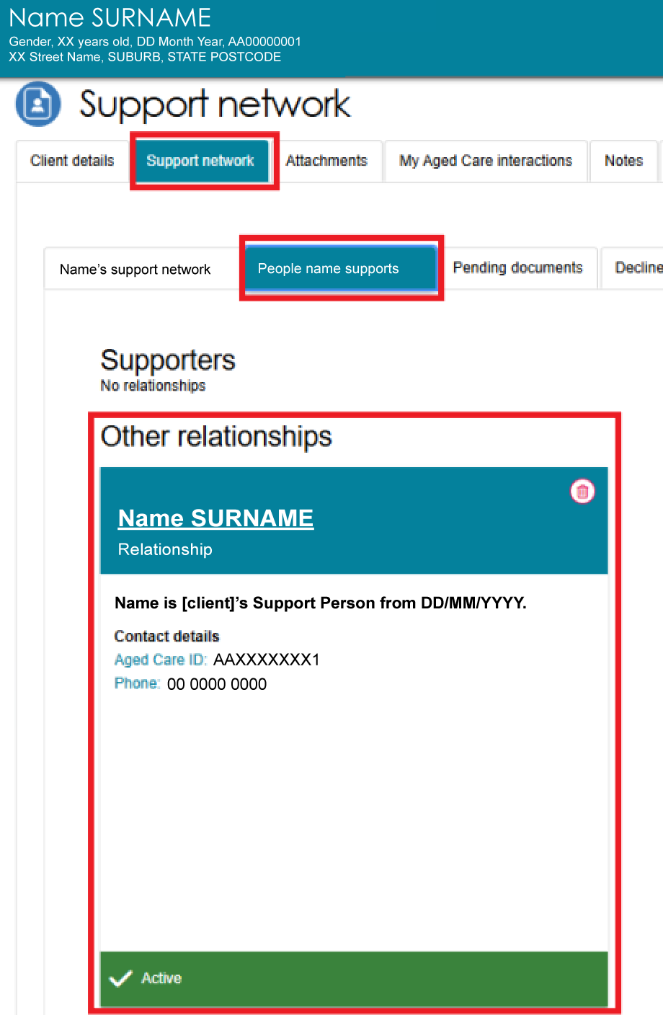

Activating a pending relationship
! | This function does not apply to Supporter Guardian relationship requests.
A Registered Supporter, Agent, or Organisation relationship has a Pending status when:
- one or more parties have not provided consent
- the relationship requires delegate approval
- required documents are missing.
Pending status does not apply to Carer, Emergency Contact, GP, or Support Person relationships.
! | Clients can nominate Supporters and Organisational Agents through the Apply for an assessment online form on the My Aged Care website. These relationships are created with a Pending status and must be activated before the support person or organisation can assist the client. An assessor or team leader can obtain the missing consents and activate the relationship.
You can activate a pending relationship in two ways:
- from an assessment referral
- from the client's Support Network tab.

Via Assessment Referrals
You can view pending Supporters and other support people in your Current assessments tab.
- In the assessor portal, select the Assessments tab.
- Find the client and select the Expand (double-arrow) icon in either Card View or List View.
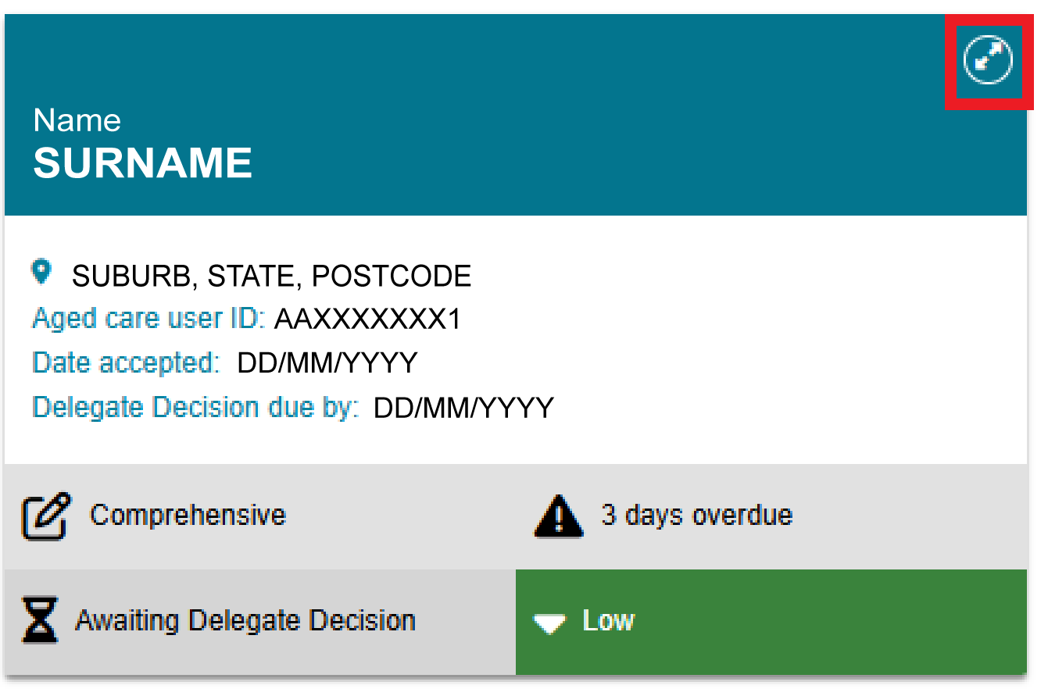
- If the client has pending support relationships, a notification banner appears on the client's tile. Select the support relationships link to open the client's Support Network tab.
Team Leaders can also view this banner on assessment referrals and reviews and can use it to activate pending support relationships.
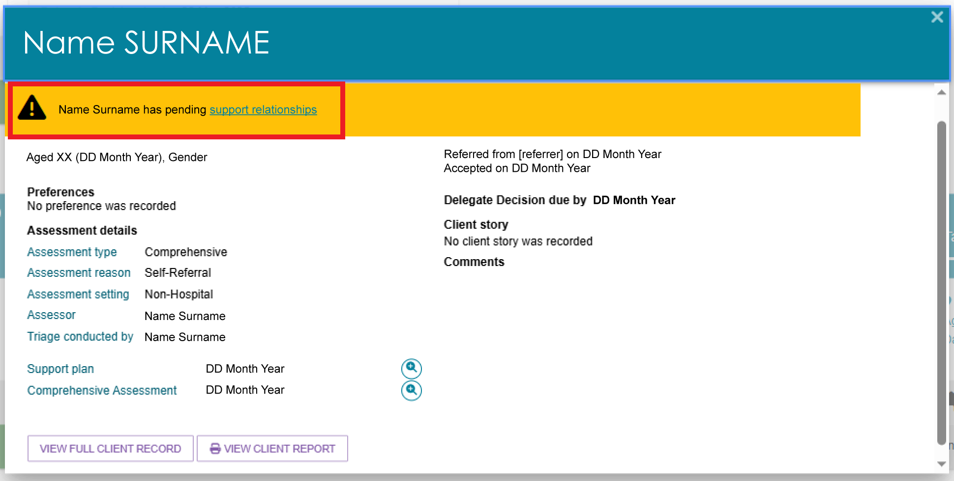
- Find the pending support person's tile and continue from Step 3 in the Via Support Network Tab section.
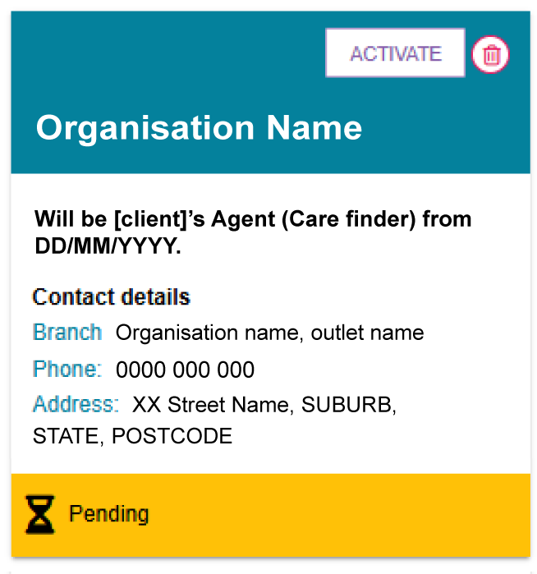
! | If a client's registered Supporter has died, notify My Aged Care as soon as possible. This helps keep the client's records up to date and allows appropriate support arrangements to be reviewed.  The client, a registered Supporter, or another authorised person can notify My Aged Care by contacting the My Aged Care Contact Centre. My Aged Care may request supporting documents, such as a death certificate, to verify the update.  To report the death of a client's nominated Supporter:  - Search for the nominated Supporter using the FIND A CLIENT tile.  - Open the Supporter's record and go to the CLIENT DETAILS page.  - Select NOTIFY MY AGED CARE OF A DEATH.

Via Support Network Tab
- Open the client's record.
If the client has a pending support relationship, a notification appears on the Client Summary page.
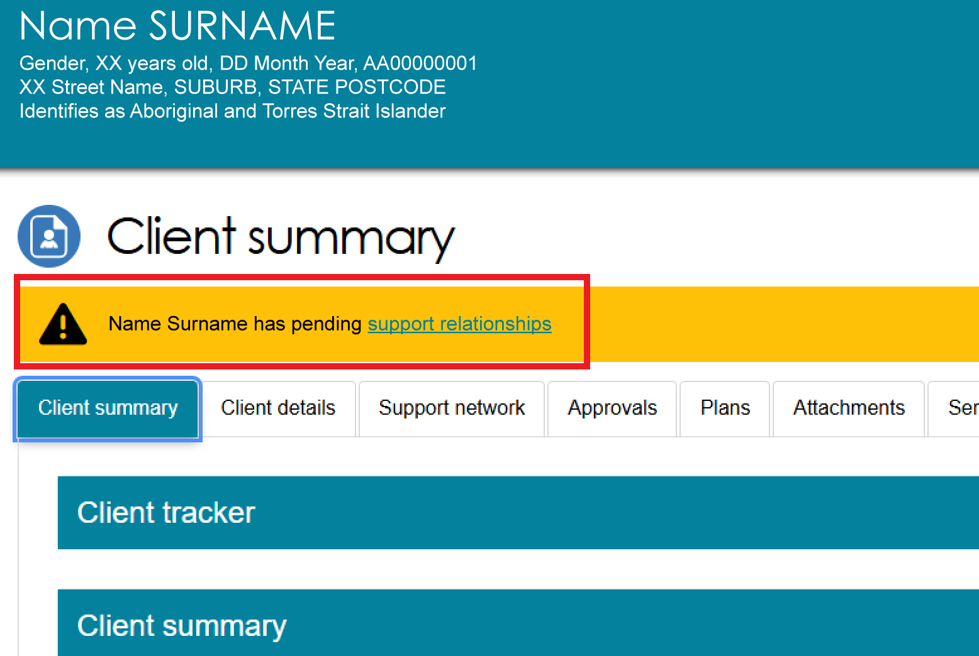
- Select the Support Network tab.
The Client's support network sub-tab opens by default. This tab shows the people and organisations that have active or pending relationships with the client.
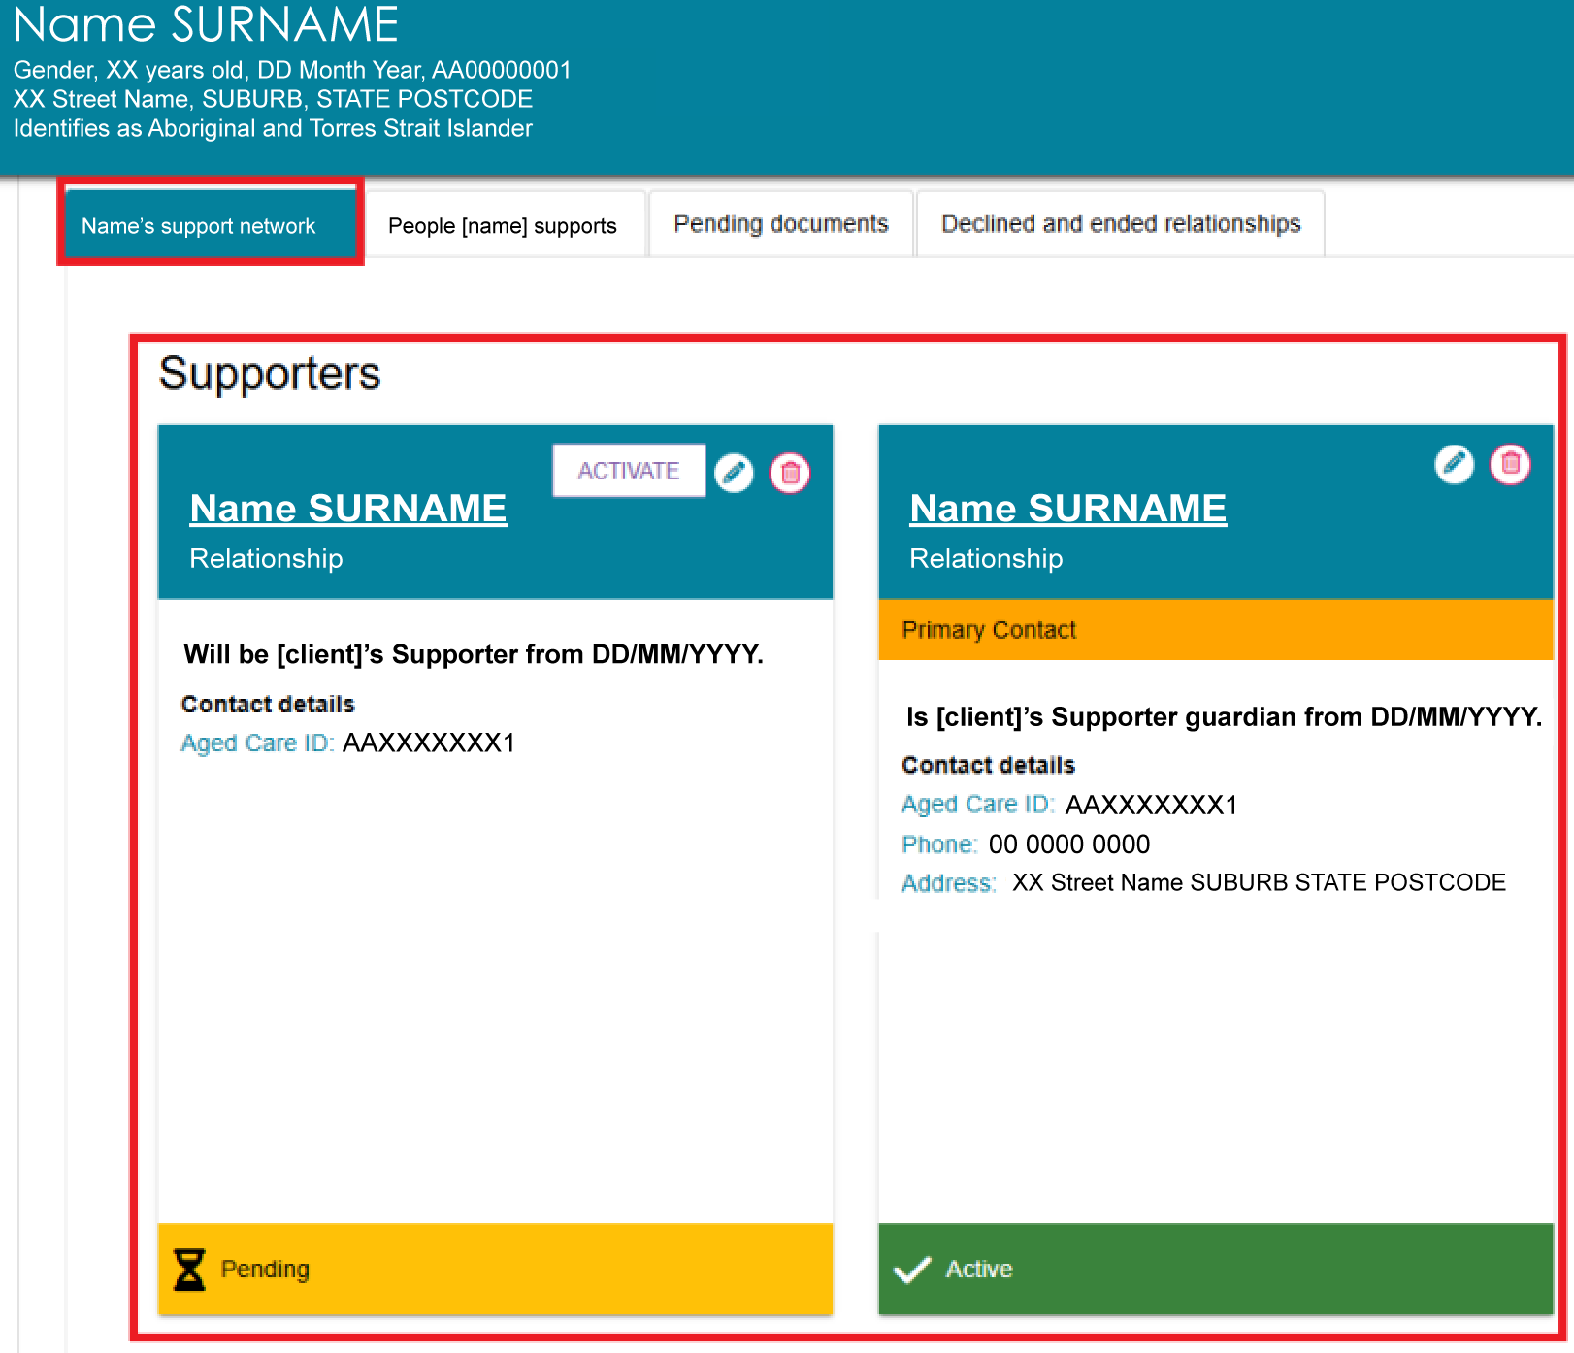
- To activate a pending relationship, select the ACTIVATE button on the relevant relationship card.
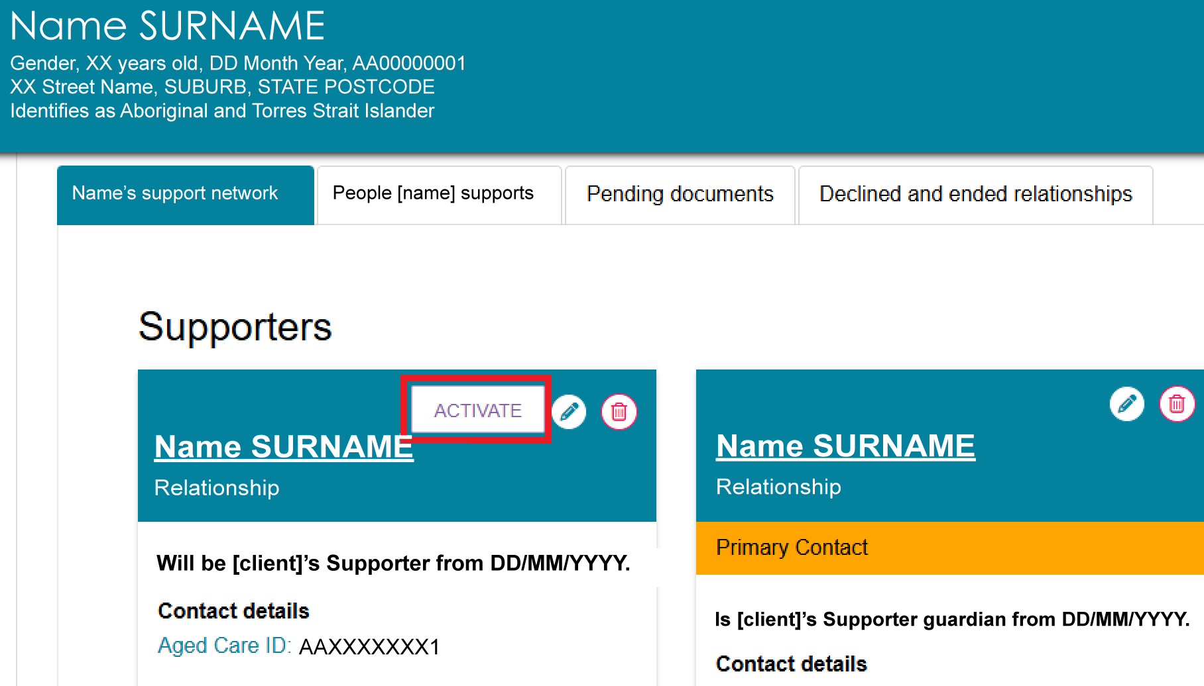
! | You cannot activate relationships that are waiting for delegate approval in the Assessor Portal.  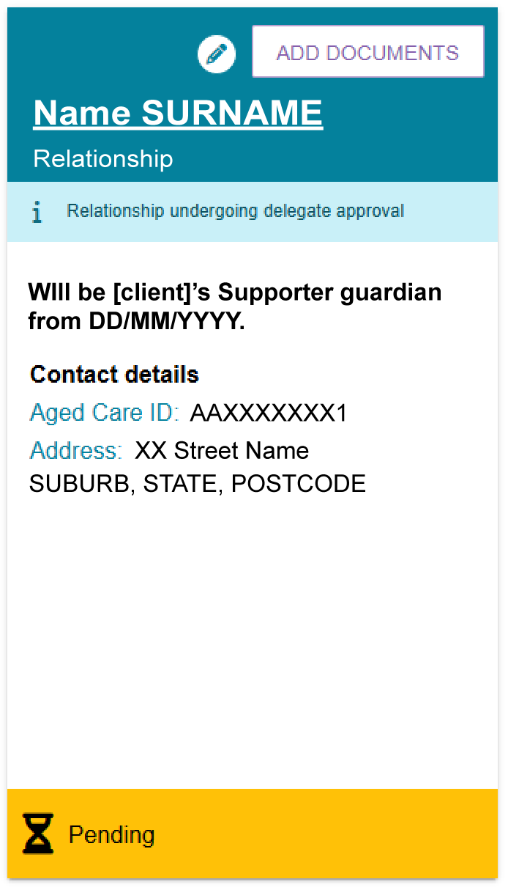
- Complete the information in the activation pop-up.
The information displayed depends on the consents and documents already provided when the relationship was created.
- Make sure each person understands the declaration and consent they are providing.
- Record consent by selecting Yes.
- For most relationship types, both parties must consent before you can activate the relationship.
- For Supporter Guardian relationships, only the prospective Supporter Guardian's consent is required.
- Upload any required documents.
- Select ACTIVATE.
The following example image shows the Activate Relationship pop-up for a registered Supporter relationship.
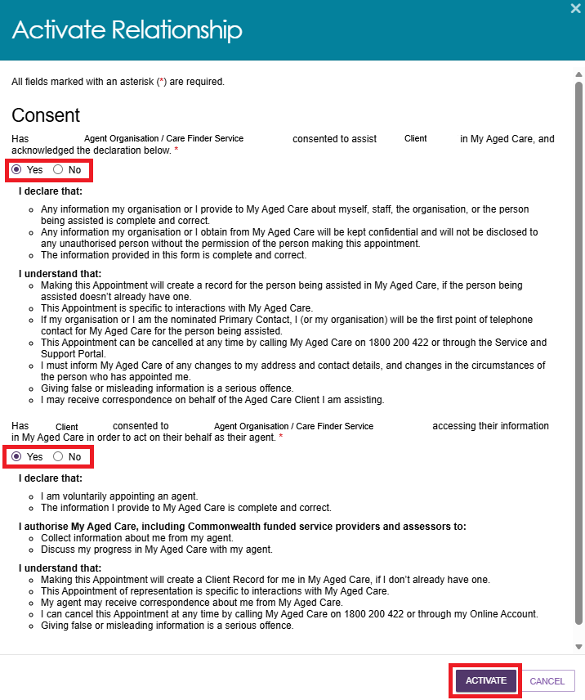
- After activation, the relationship displays as Active in the Support Network tab. The relationship card shows the support person's or organisation's details, including contact information, primary contact status (if applicable), and the relationship type and duration.
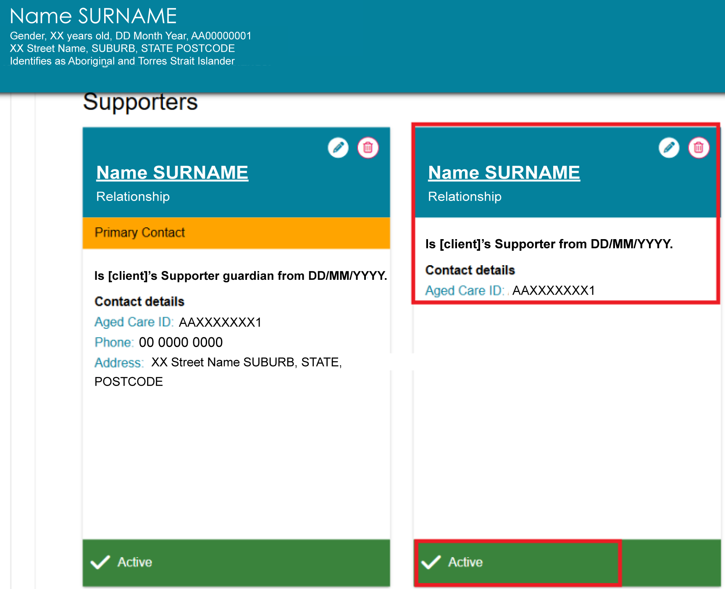
! | If a relationship remains pending because a party has not provided consent within 30 days, the relationship status changes to Lapsed.  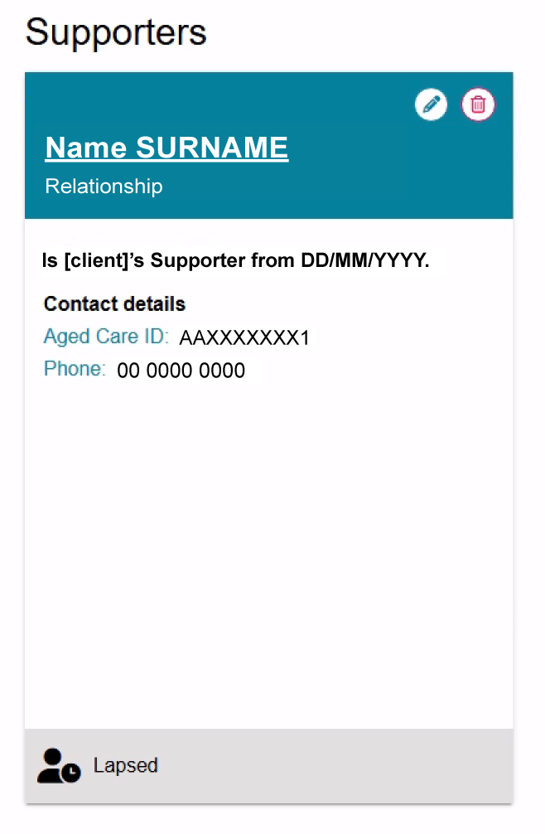

Removing a relationship
You can remove most relationship types. However, a client cannot request the removal of a Supporter Guardian relationship.
- On the relevant relationship card, select the rubbish bin icon.
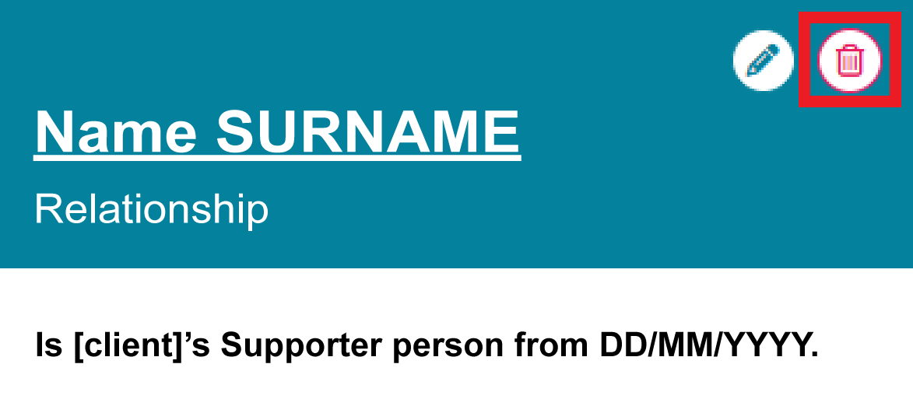
- Select a reason for removing the relationship.
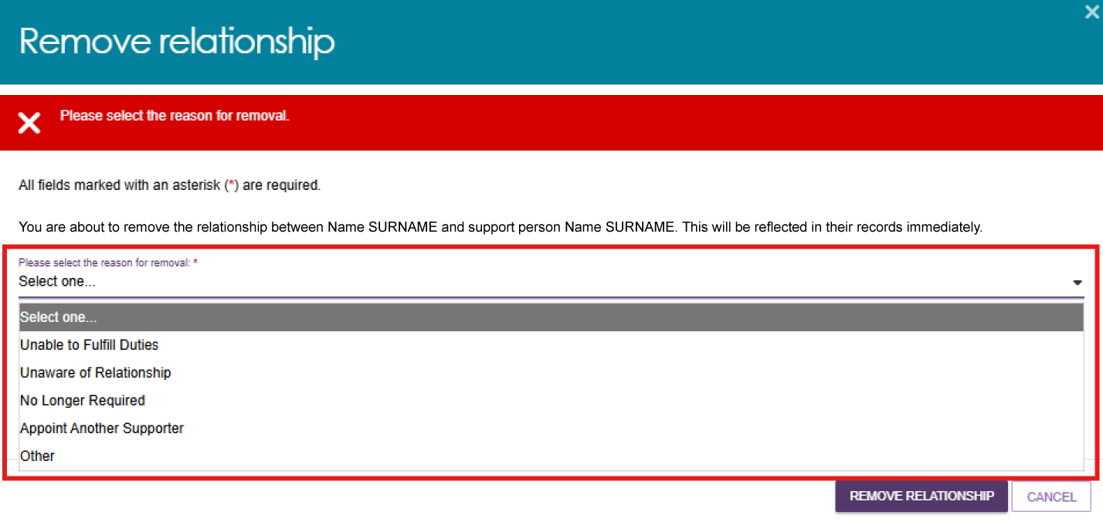
- In the confirmation window, select REMOVE RELATIONSHIP.
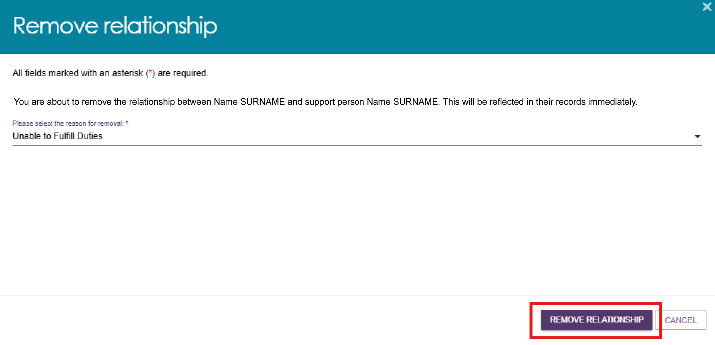
- The relationship is removed from the client's Support Network tab and moves to the Declined and Ended Relationships tab.
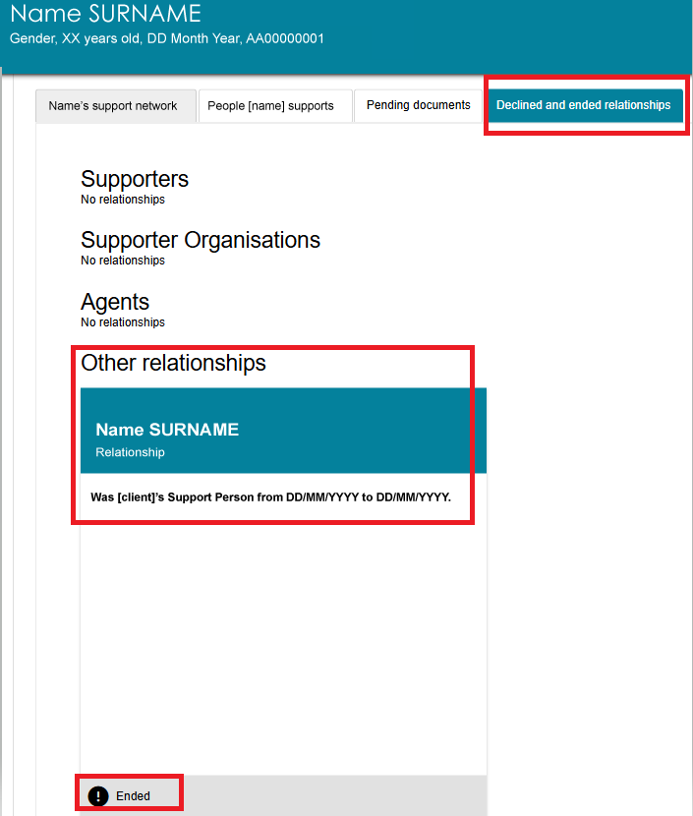
Removing a relationship from the Supporter's record
A registered Supporter can also remove a relationship from the People [client] supports tab.
- Open the Support Network tab. Select People [client] supports to view the people the client supports.
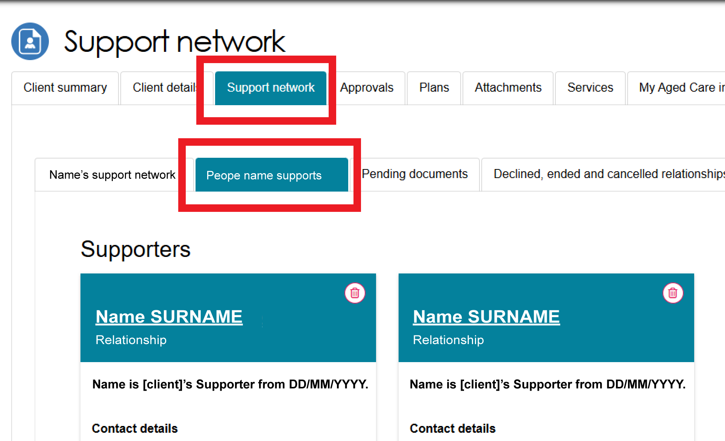
- In the Supporters section, find the relevant client card and select the red bin icon.
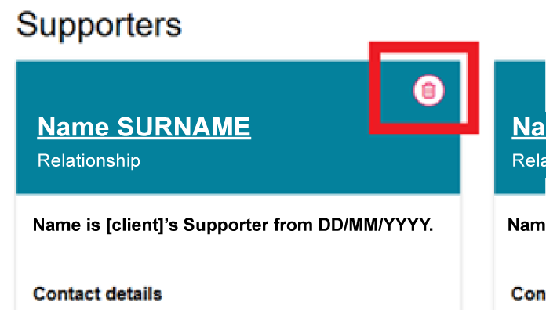
- In the REMOVE RELATIONSHIP window, select a reason for removal:
- Unable to fulfil duties
- Unaware of relationship
- No longer required
- Appoint another Supporter
- Other.
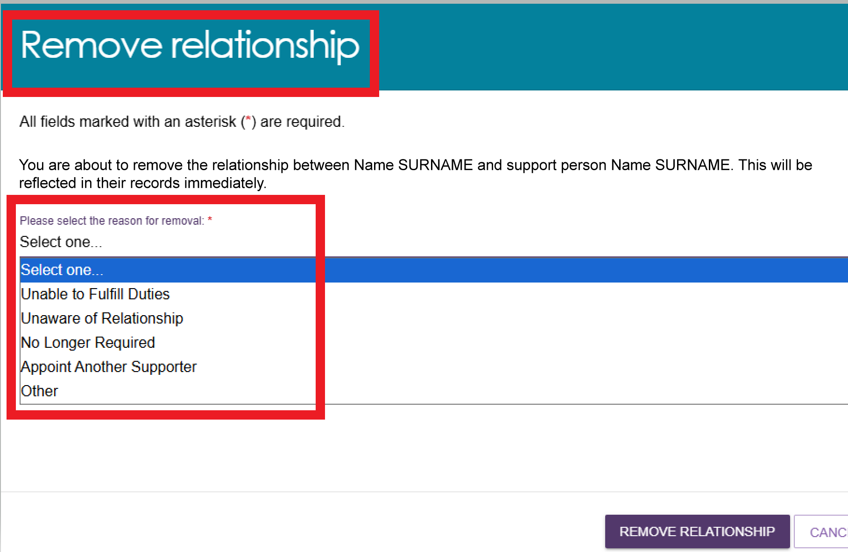
- Select REMOVE RELATIONSHIP.
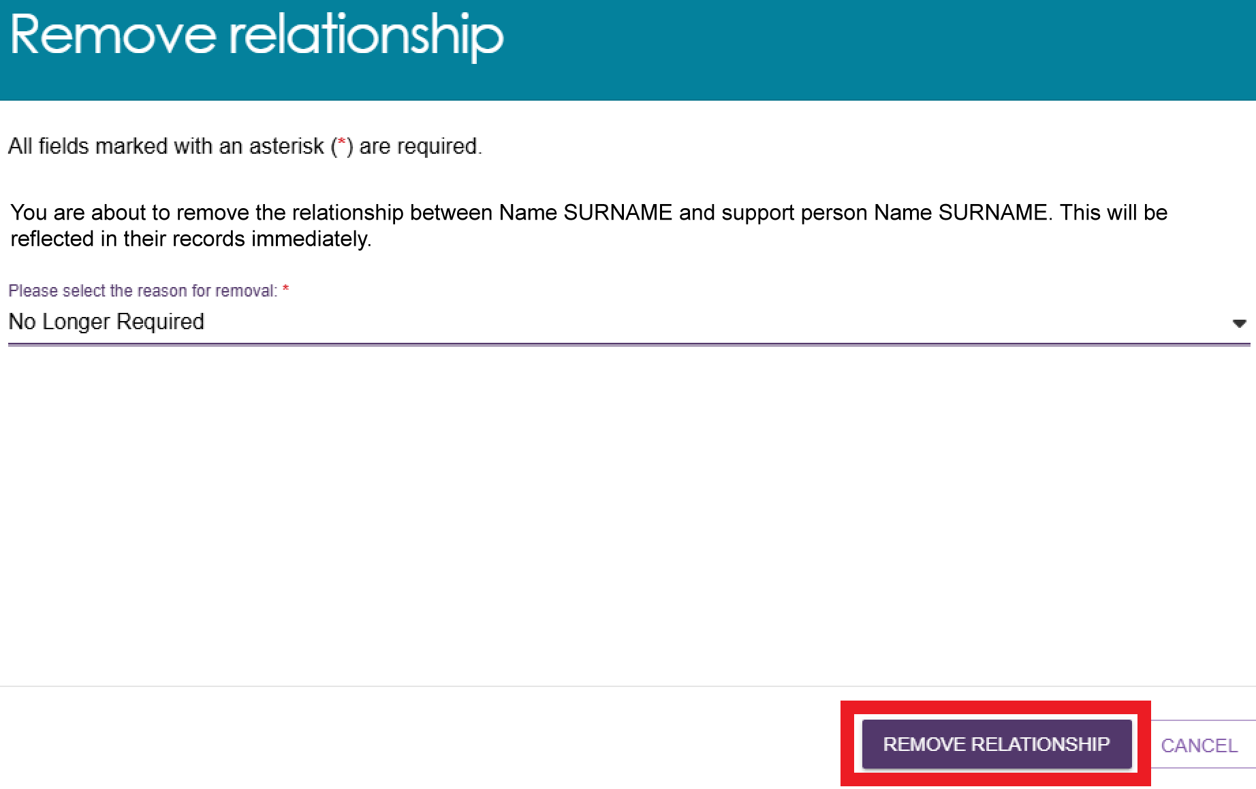
- A green banner confirms that the relationship was removed successfully.
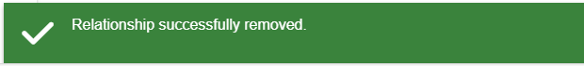

Viewing Suspended Relationships
The System Governor may suspend a relationship when they receive information that requires them to review the relationship. During the review process, the Supporter, Supporter Lite, or Supporter Guardian receives a notification and can respond before the System Governor decides whether to lift the suspension or cancel the relationship.
While a relationship is suspended, the Supporter cannot receive information or act on behalf of the client.
You can view suspended Supporter, Supporter Lite, and Supporter Guardian relationships in the client's Support Network tab. These relationships display a Suspended status.
! | Departmental staff initiate suspension actions. Once a relationship is suspended, My Aged Care updates the relationship status across all My Aged Care portals.
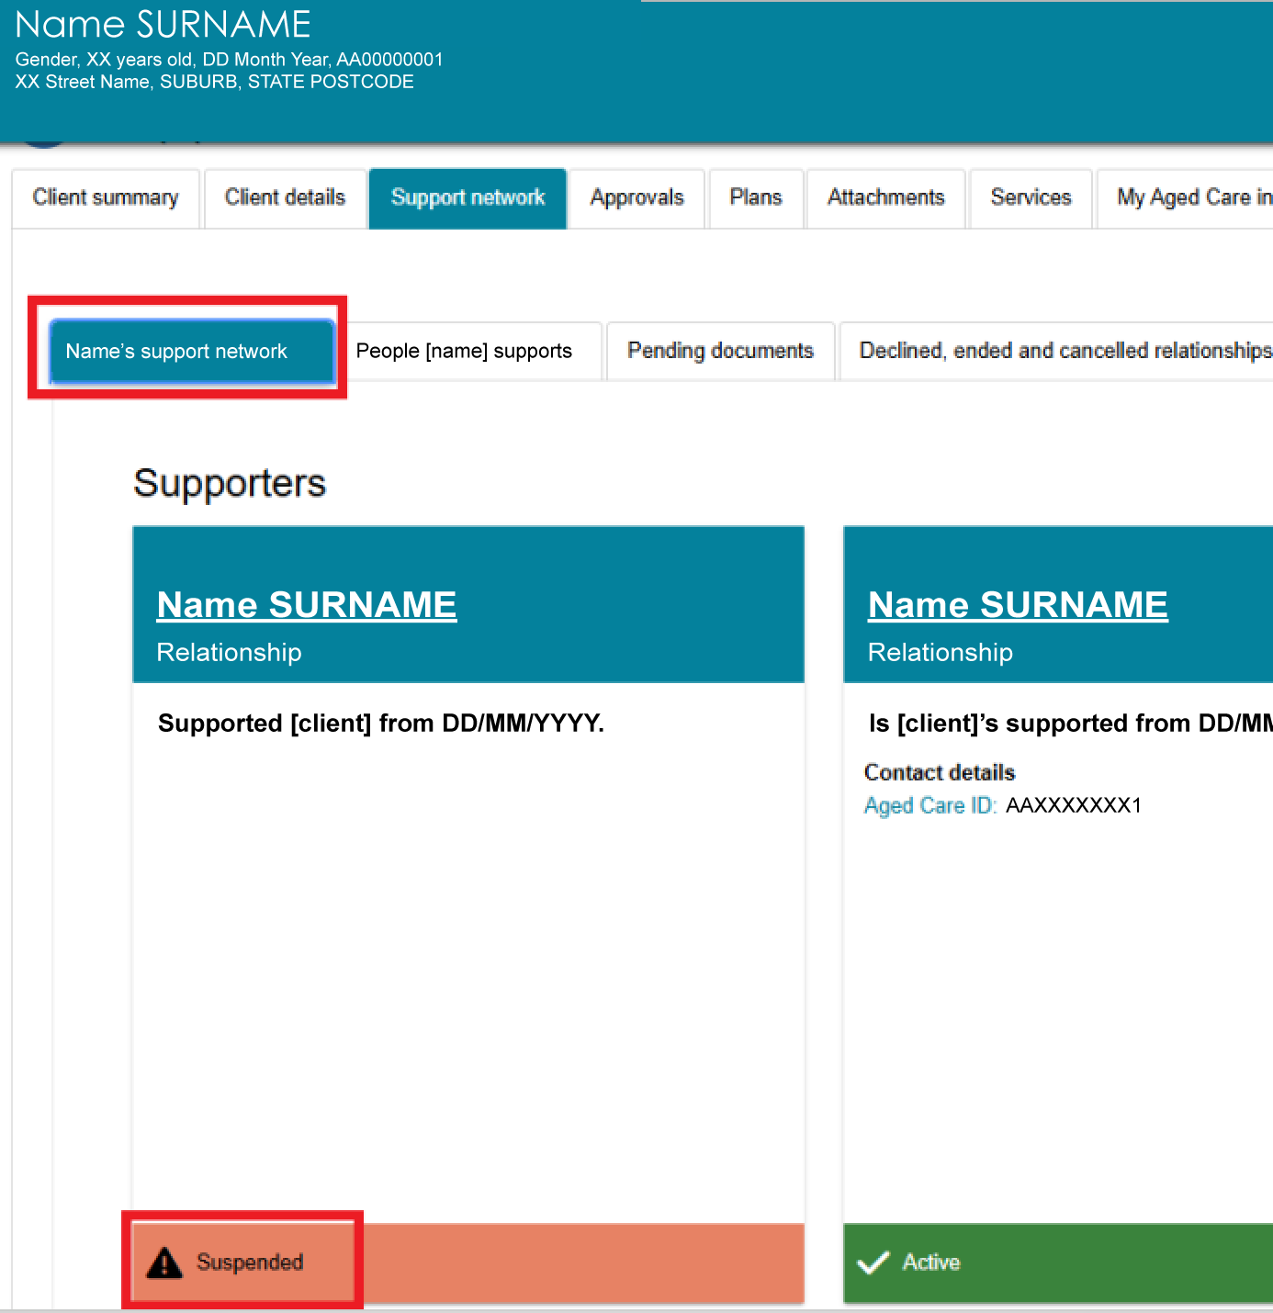

Viewing Declined, Ended and Cancelled relationship
A relationship can have a Declined, Ended, or Cancelled status.
A relationship is Declined when a nominated Supporter chooses not to accept a relationship request from the client or an assessor. This status applies only to people nominated for a Supporter role.
The System Governor can also decline a relationship if:
- a conflict of interest cannot be managed, or
- other information supports declining the relationship, such as a previous cancellation between the parties.
- A relationship is Cancelled when the System Governor starts the cancellation process.
! | Departmental staff initiate decline and cancellation actions. Once processed, My Aged Care updates the relationship status across all My Aged Care portals.
An Ended relationship means the Supporter can no longer access information or act on the client's behalf. This status appears when someone removes the relationship in the assessor portal by following the Removing a relationship process.
You can view Declined, Ended, and Cancelled relationships in the Declined, Ended and Cancelled relationships tab.
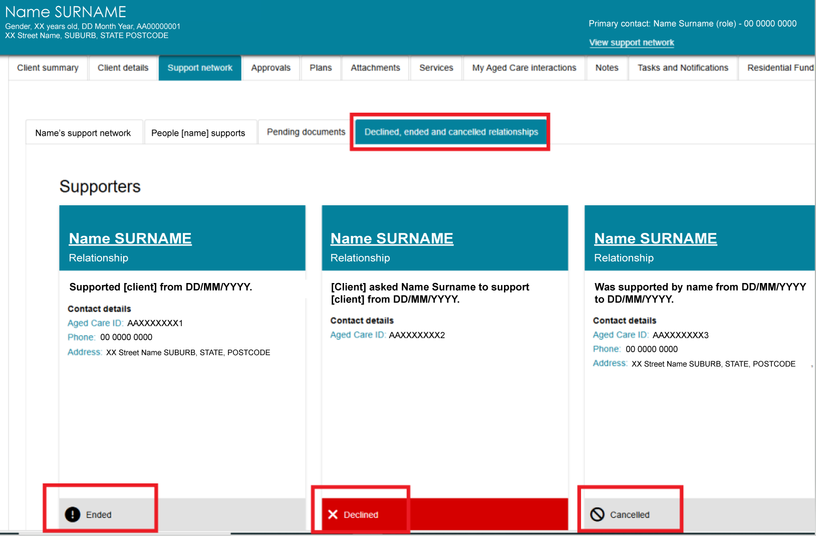

Configuring notification preferences for clients and their support people
Clients and the people who support them, including agents, registered Supporters, support organisations, carers, and other support people, can choose to receive email and/or SMS notifications about key events in the client's My Aged Care journey. These notifications can include updates when:
- client registration is complete
- an assessment is finalised
- the client is approved for care following a home support or comprehensive assessment
- Support at Home funding is assigned
- a Support at Home letter is issued, such as an assignment or withdrawal letter
- permanent Residential Care is assigned
- a Residential Care letter is issued, such as an assignment or withdrawal letter
- a Support Plan Review request is submitted
- a support relationship is activated, declined, inactivated, or nearing expiry
- documents relating to support relationships are submitted or actioned.
Support organisations acting as Agents, Supporters, or Supporter Guardians automatically receive email notifications when the information may or must be provided to the client under the Act. These organisations cannot receive SMS notifications.
People with a Supporter Lite role only receive notifications about changes to their own record. My Aged Care does not send any other automated notifications to this role.
New clients can choose to receive email and/or SMS notifications during registration. Existing clients and support people can update their notification preferences through:
- the assessor portal
- the client's online account
- the My Aged Care contact centre on 1800 200 422.
To receive SMS notifications, the client or support person must have a verified mobile phone number. Verify the mobile number before you configure notification preferences.
The steps below use the client's record as an example. You can follow the same process for a support person by opening their Client Details tab.
Follow the steps below to set up and manage email and SMS notifications.

Verifying mobile phone number
- Open the client's record and select the Client details tab.
If the client's mobile number is not verified, a notification banner appears asking you to verify the number.
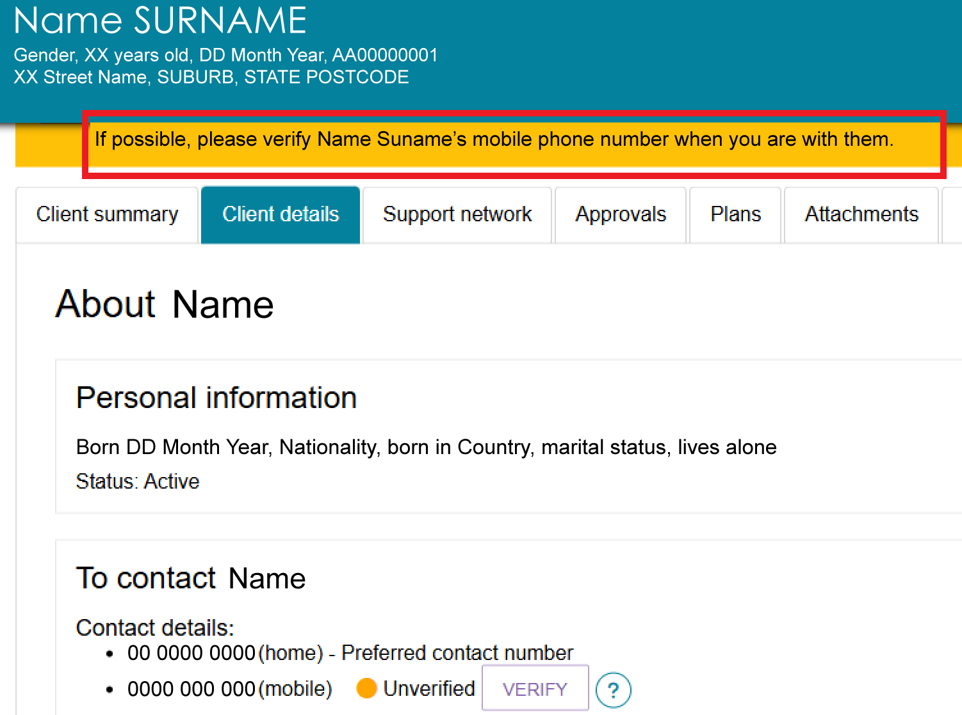
- Select VERIFY next to the mobile number.
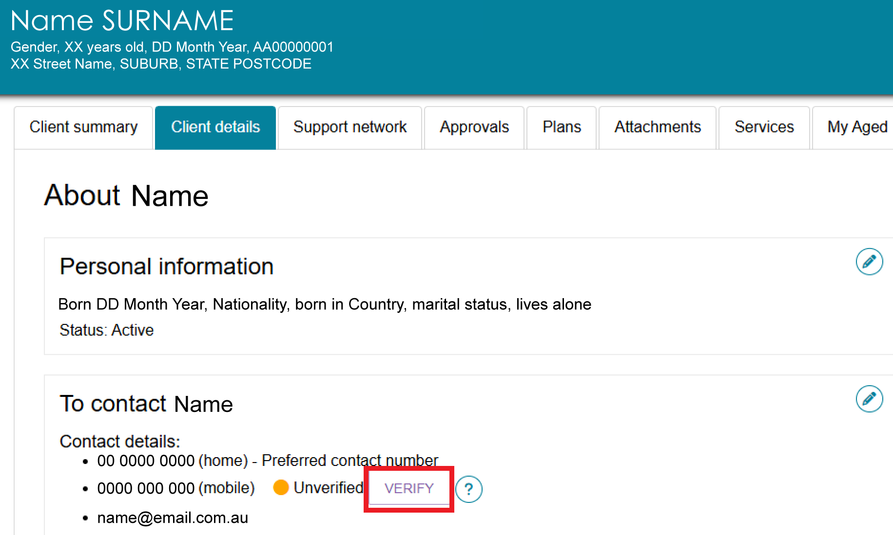
- Enter the 6-digit verification code sent to the client's mobile phone, then select VERIFY.
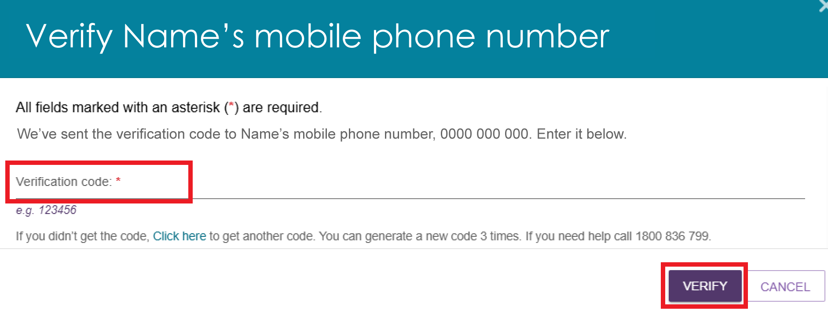
- After you enter the correct code, the mobile number status changes from Unverified to Verified and the system displays a confirmation message.
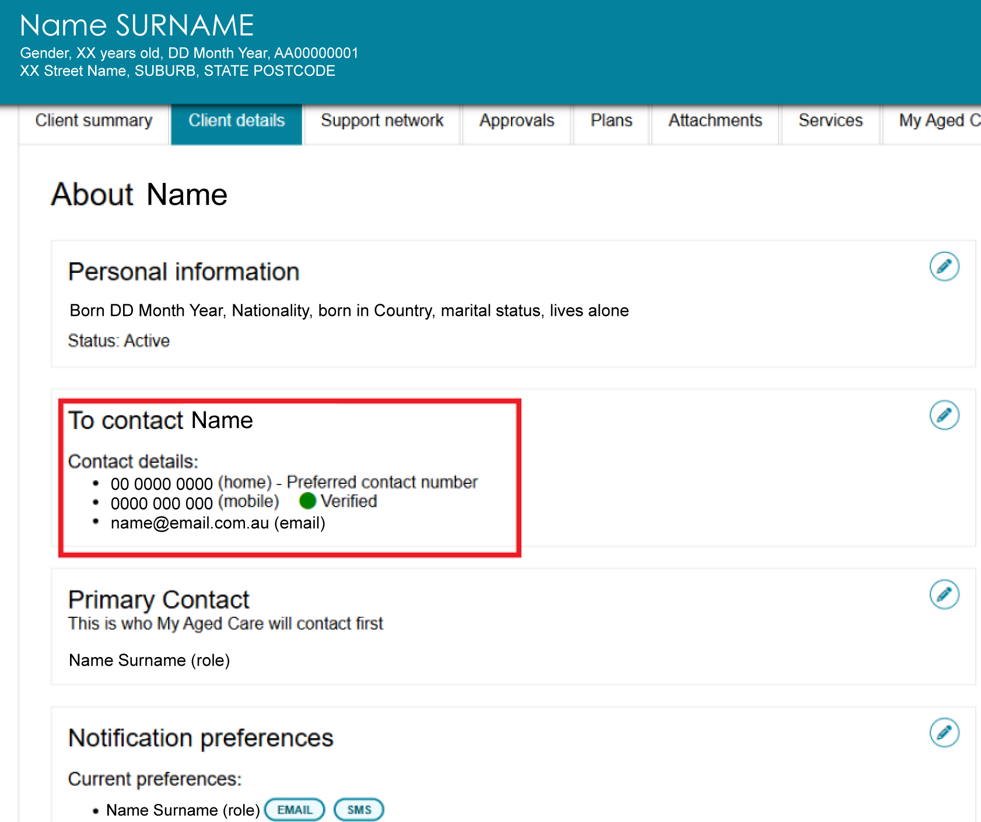

Configuring notification preferences
! | My Aged Care only sends SMS notifications to verified mobile phone numbers.  Refer to Verifying Mobile Phone Number.
- In the Client details section, select the edit icon next to Notification preferences.
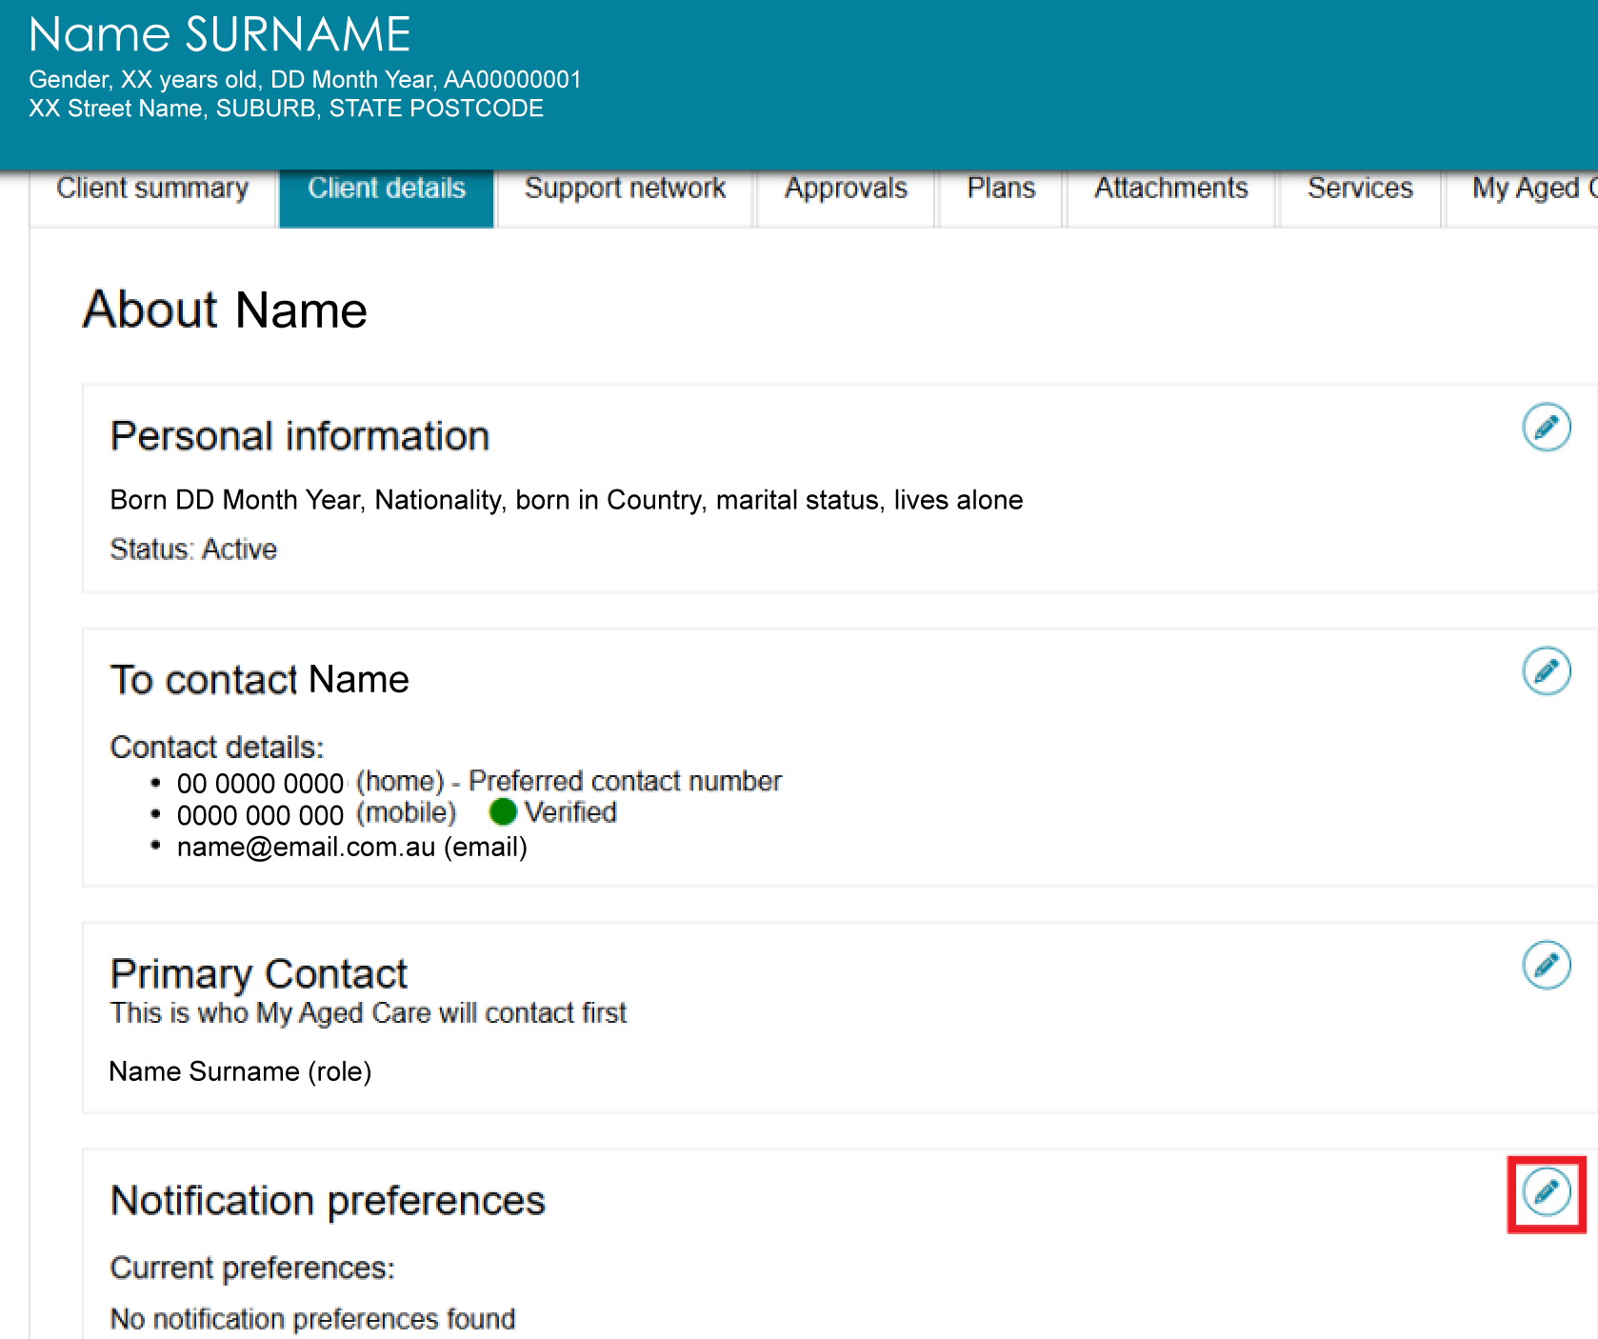
- In the pop-up window, choose who will receive email and/or SMS notifications.
- To enable notifications about a client, tick Consent to send SMS and emails about [client’s name] checkbox.
- Select the people who should receive notifications, including the client (Self) and any support people listed.
- Clear a checkbox to stop sending notifications to that person.
- When you finish, select SAVE CHANGES.
! | Email notifications for support organisations are mandatory and appear for information only. You cannot remove them.
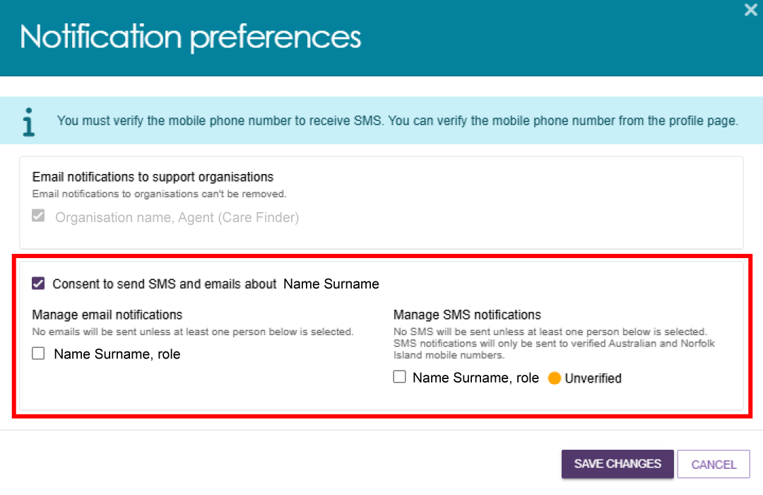
! | Clients and support people must provide an email address and/or mobile phone number and consent to receive notifications from their own record.  My Aged Care does not send notifications if the person does not have a valid email address, a verified mobile phone number, or consent to receive notifications.  If a client and a support person share the same verified mobile number, My Aged Care sends only one SMS notification to that number.
- After you save your changes, the Notification preferences section displays the selected recipients and their notification methods using Email and SMS icons.
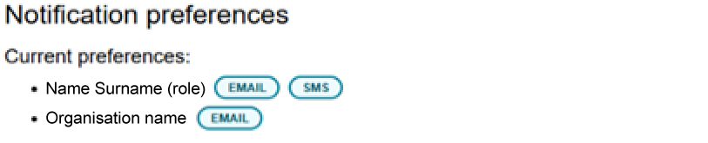

Requesting a call back from Carer Gateway or National Dementia Helpline
Carers who are registered in My Aged Care can access support services for themselves through the Carer Gateway and the National Dementia Helpline.
You can record the client's and carer's consent in the assessor portal and request a call back from one or both services.
- Find the client who has a carer. Refer to viewing my client's relationships for instructions.
- In the Other Relationships section, find the carer's relationship card and select REQUEST CALL BACK.
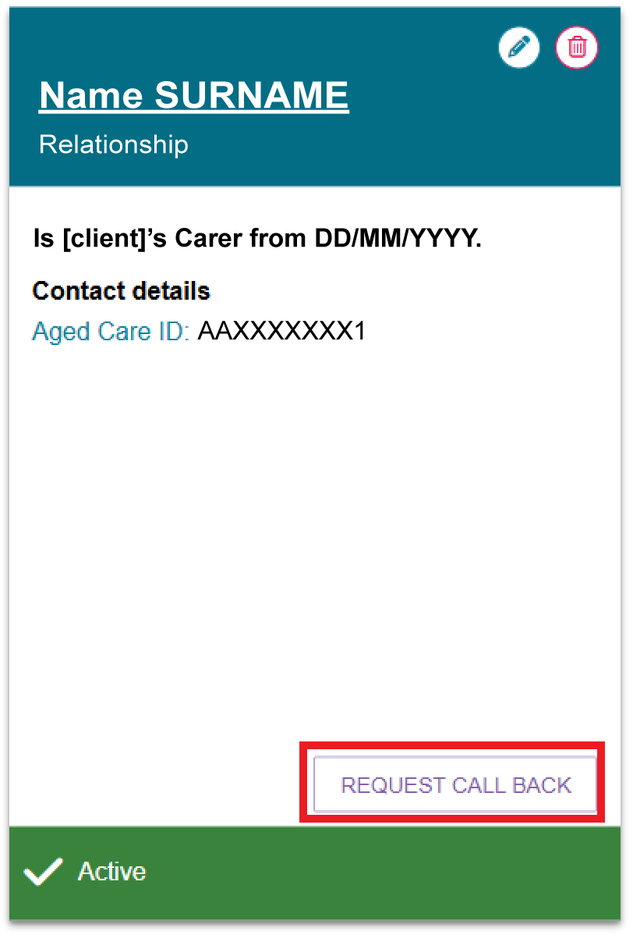
- Review the information on the Request Call Back screen. This screen explains:
- how My Aged Care will share the client’s and carer’s information
- the services available through Carer Gateway and the National Dementia Helpline.
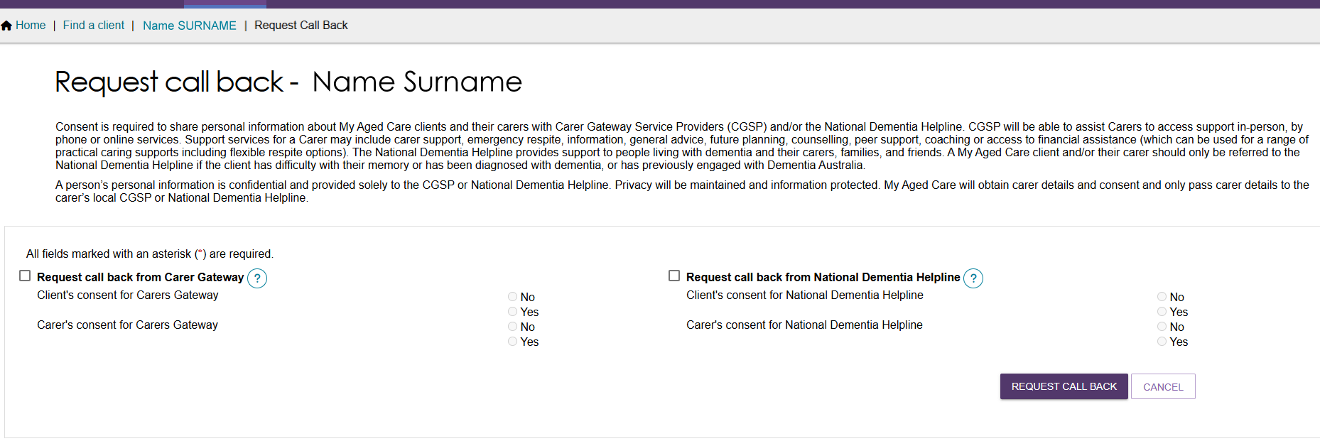
- Record the client's and/or carer's consent for each selected service.
Review or update the client's and carer's contact details.
Select REQUEST CALL BACK.
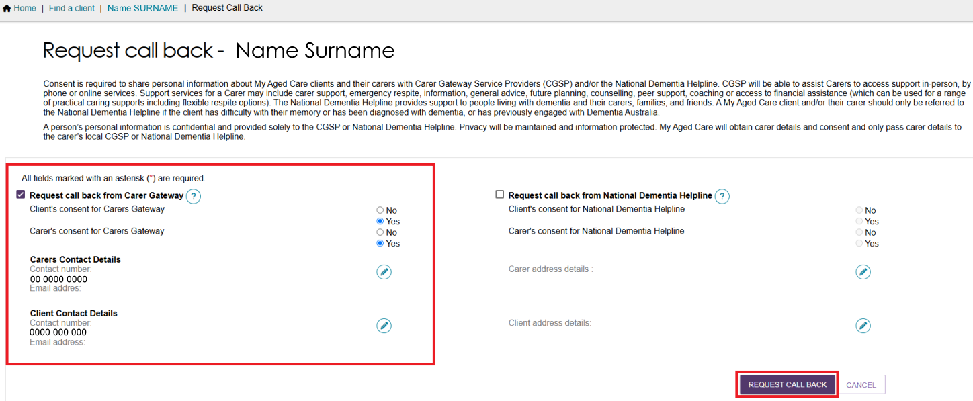
! | To submit a call back request:  - the carer must consent to the request  - both the client and carer’s home addresses must be recorded  - if the client or carer has a phone number recorded in their profile, the contact number must also be completed.

Viewing call back and consent history
The Assessor Portal records call back requests and consent information in the My Aged Care Interactions tab.
- Open the client's record and select the My Aged Care Interactions tab.
- From the View Interaction drop-down list, select Call Back Requests, then select GO.
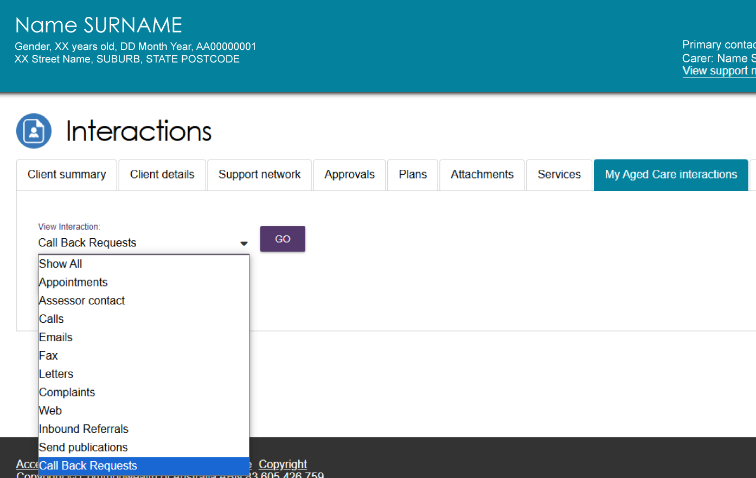
- Review the Carer Call Back Requests displayed on the screen.
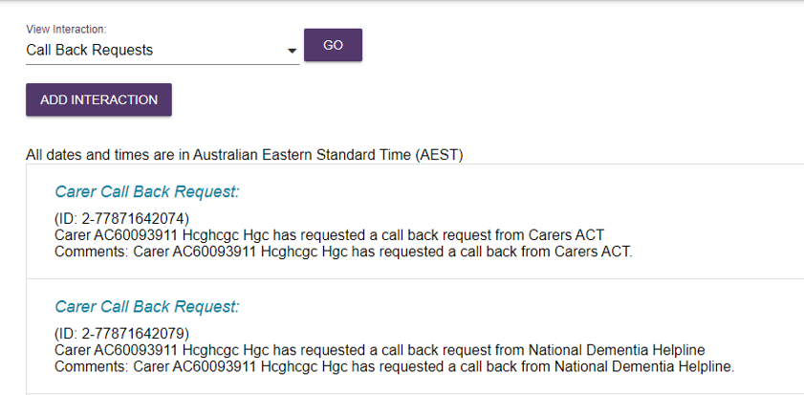

More information
For additional help, contact the My Aged Care service provider and assessor helpline on 1800 836 799.

