Assessor Portal User Guide 11 – Assessment Delegate Support Role
The Assessment Delegate Support role in the My Aged Care assessor portal helps the Assessment Delegate with administrative tasks. People assigned this role can print support plans and generate, print and upload referral code letters and approval letters.
Assessment Delegate Support staff carry out these tasks under the direction of the Assessment Delegate.
Clinical Assessment Delegates can approve an older person for all service groups, classification types and classification levels under the Aged Care Act (2024).
Non-clinical Assessment Delegates can only approve:
- Entry-level home support services
- Assistive Technology (AT) services
- Home Modification (HM) services
This includes the following classification levels: CHSP class, AT CHSP, and AT-HM.

Contents
Accessing client information 3
Printing the support plan 7
Generating referral code letters 8
Notice of Decision Letters 10
Generating Approval Letters 10
Uploading Approval Letters 13
Generating Non-Approval Letters 18
Uploading Non-Approval Letters 21

Accessing client information
- To find a client's information and print a copy of their record, select Find a client from your homepage.
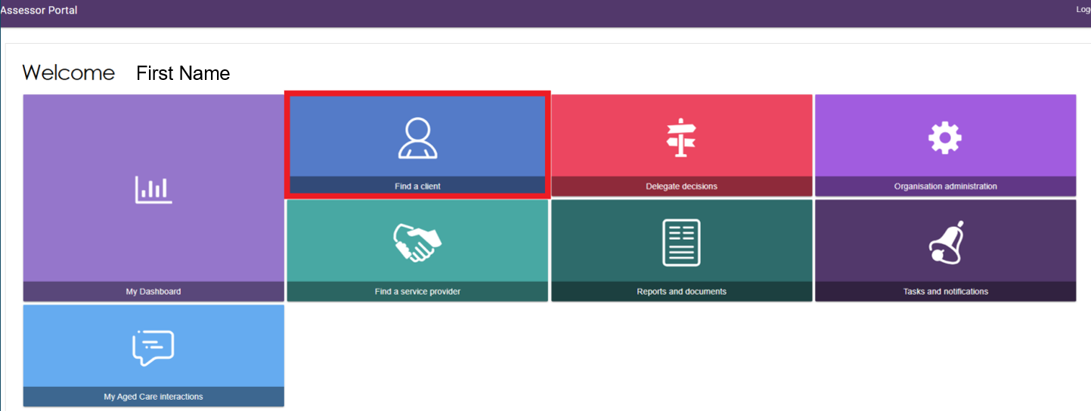
- Search for the client using the Find a client function. The Recently Viewed Persons section shows client records you have recently opened. Depending on your browser, this section appears either on the right side of the page or at the bottom.
Use Advanced Search to search using additional fields. For more information, refer to the My Aged Care – Assessor Portal User Guide 1 – Registering and referring clients for assessments .
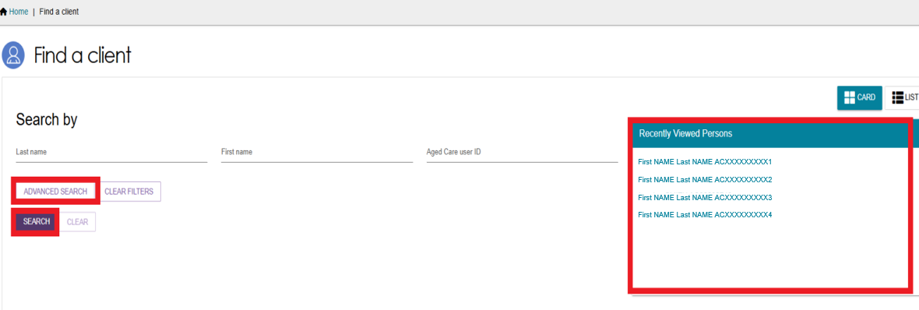
- Select the client’s name from the search results.
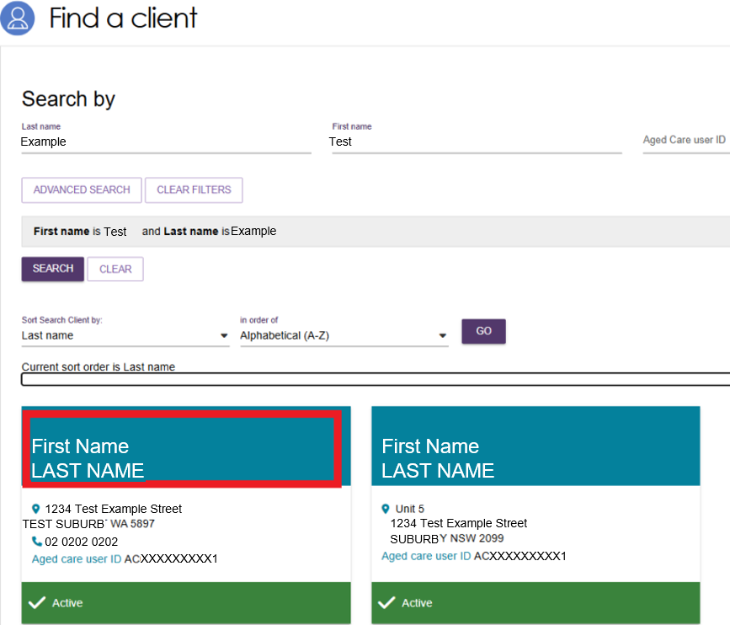
- You can sort the search results by several criteria, including:
- Last name
- First name
- Aged Care User ID
- Suburb
- State
- Postcode
- Date of birth.
Select the sorting criteria and display order you want, then select GO.
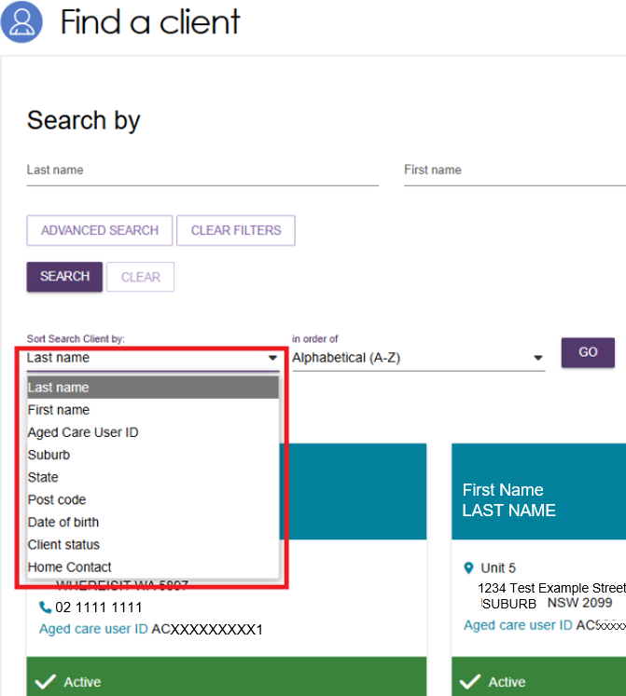
- Select the client's name to open the Client Summary page. To view and print the client's record, select VIEW CLIENT REPORT.
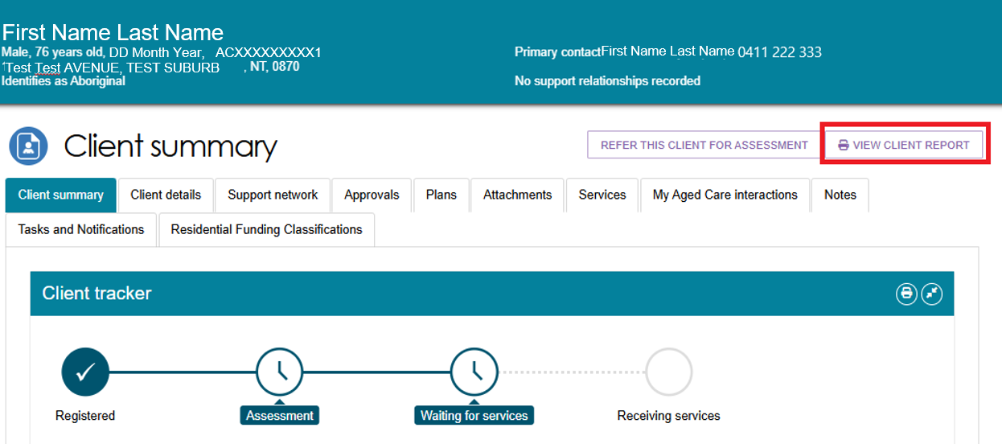
- A Generating Report pop-up appears. When the report is ready, the Rich Text Format (RTF) file opens in your browser. You can then open or download the file.
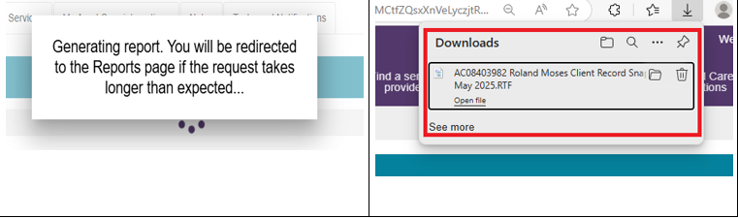
- The RTF file contains a copy of the client's record.
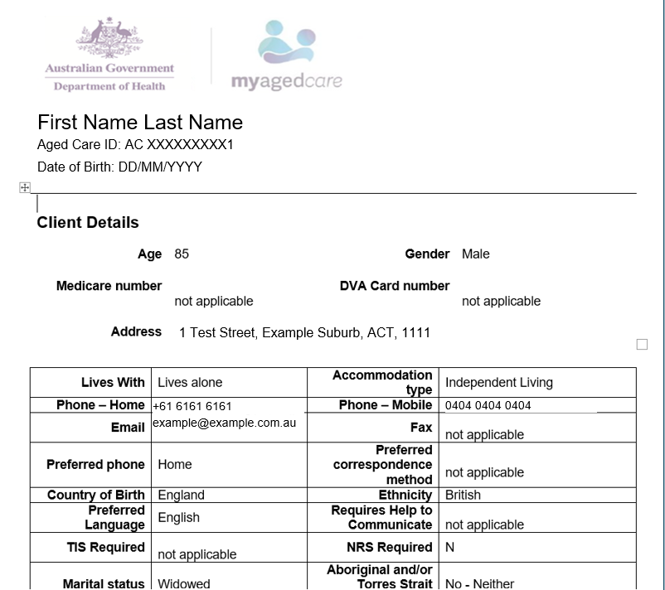

Printing the support plan
- To view and print a support plan, open the client's record and select the Plans tab. Then select Support Plan.
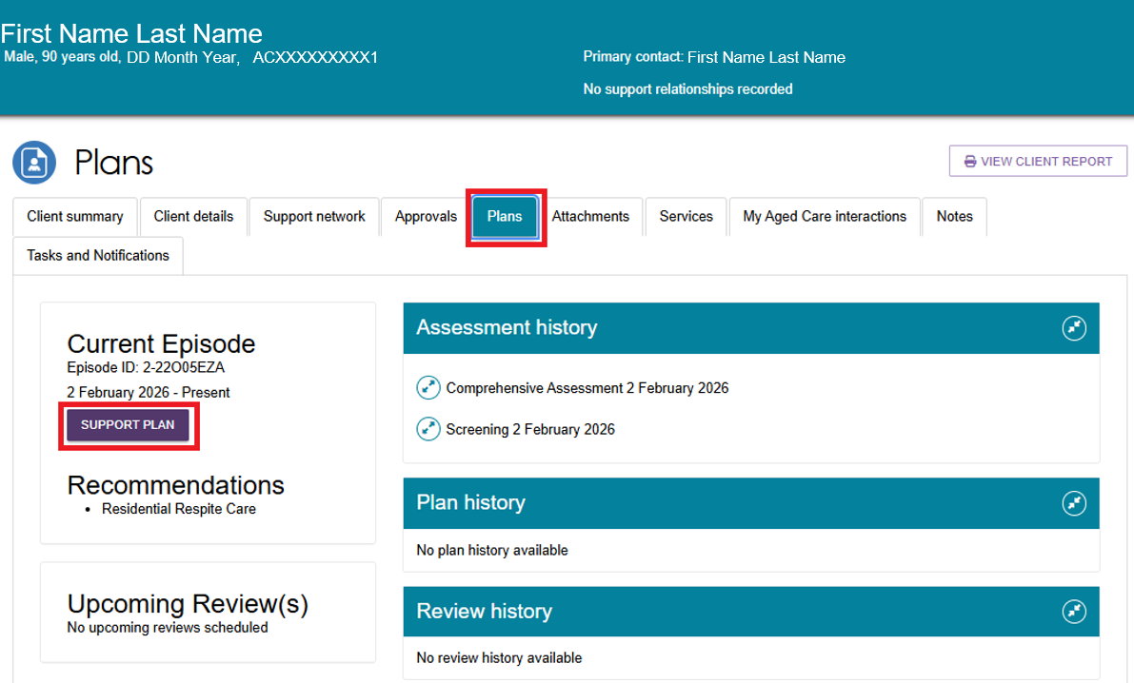
- The Goals & recommendations tab opens. To print the support plan, select PRINT COPY OF SUPPORT PLAN.
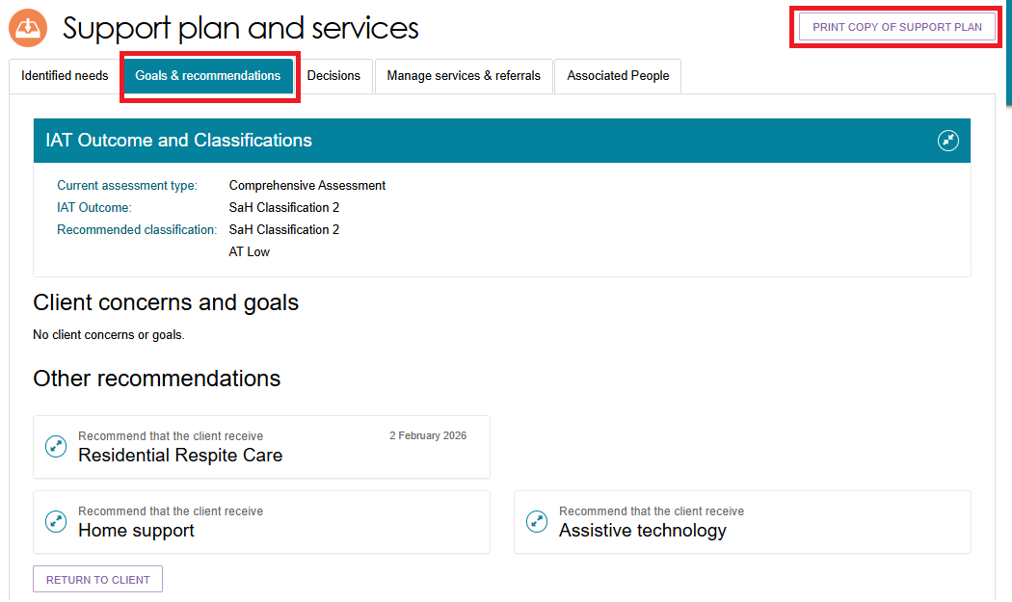
- If the report takes longer than expected to generate, an information message may appear at the bottom of the screen. Select the link in the message to open the Reports page.

- On the Reports page, select View to open the support plan. You can also access the Reports page from the Reports and Documents tile on the Assessor Portal home page.
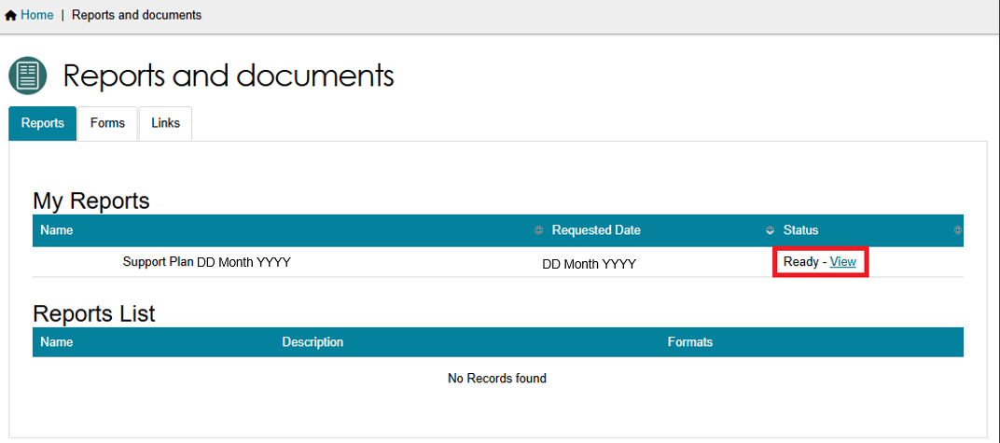
- When the support plan is ready, download it through your browser and print it from your computer or device. The example below shows a support plan in the Downloads section of the Microsoft Edge browser.
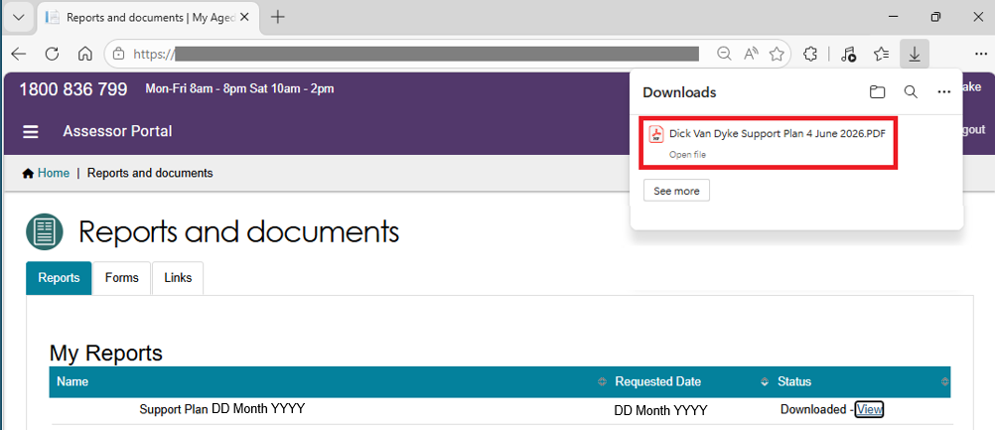

Generating referral code letters
- Open the client's record, select the Plans tab, and then select Support Plan.
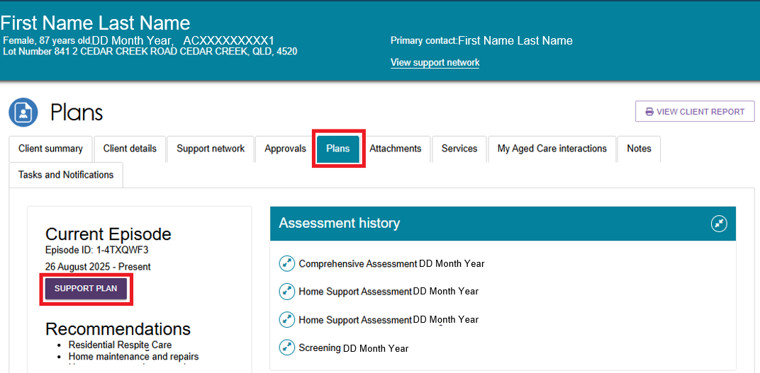
- Select the Manage services & referrals tab. This page shows the client's service referrals and lets you generate a referral code letter.
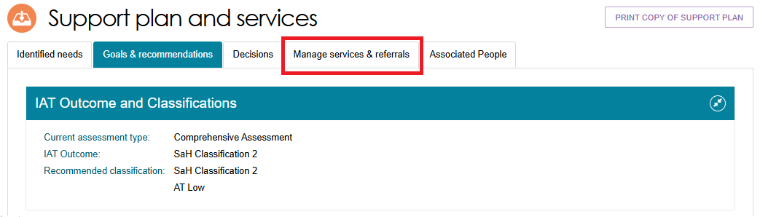
- Select GENERATE REFERRAL CODE LETTER at the bottom of the page.
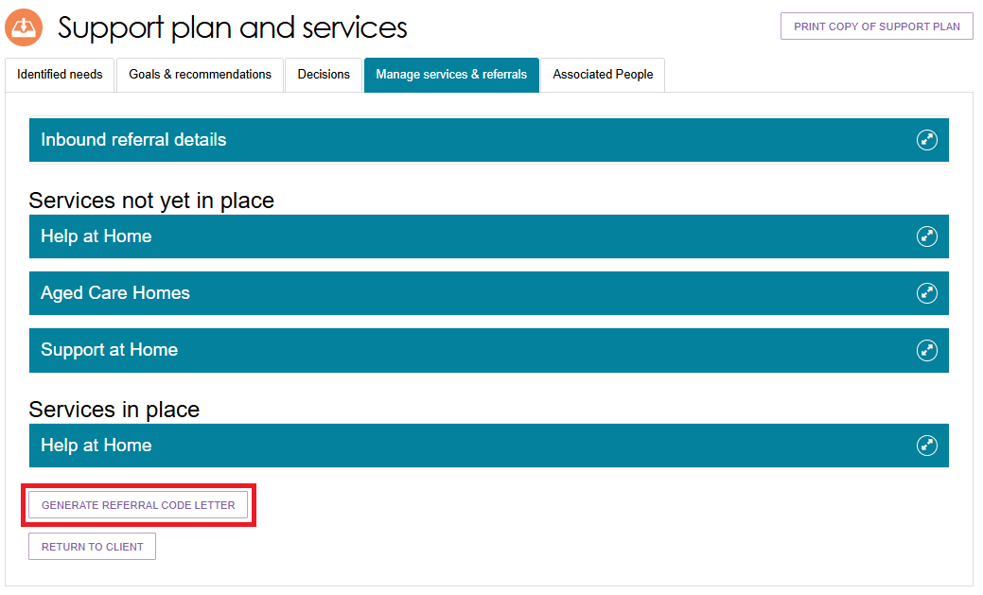
- When the letter is ready, go to the Reports page and select View to open it. You can also open the Reports page from the Reports and Documents tile on the Assessor Portal home page

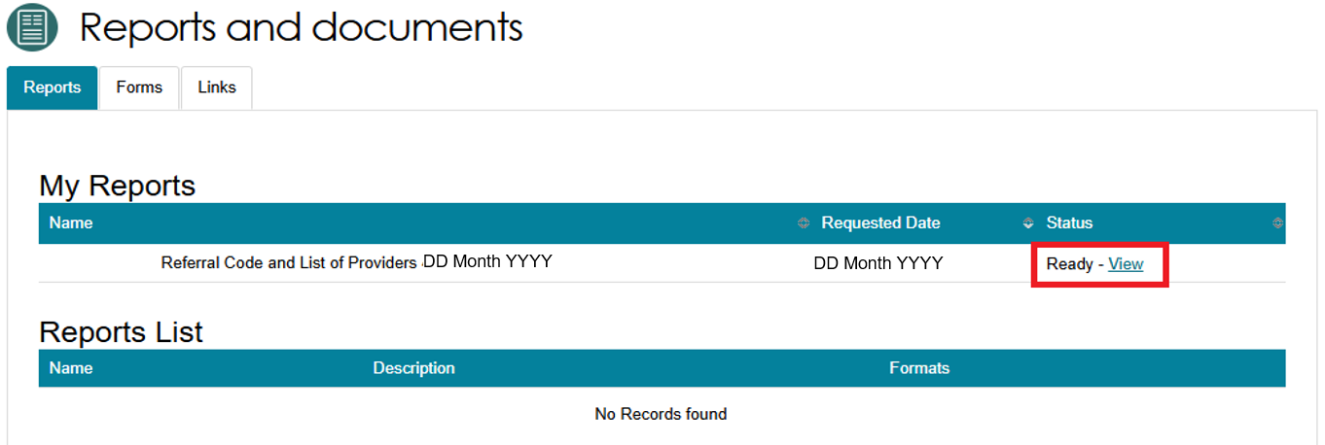
- Download the referral code letter through your browser and print it from your computer or device. The example below shows a referral code letter in the Downloads section of the Microsoft Edge browser.
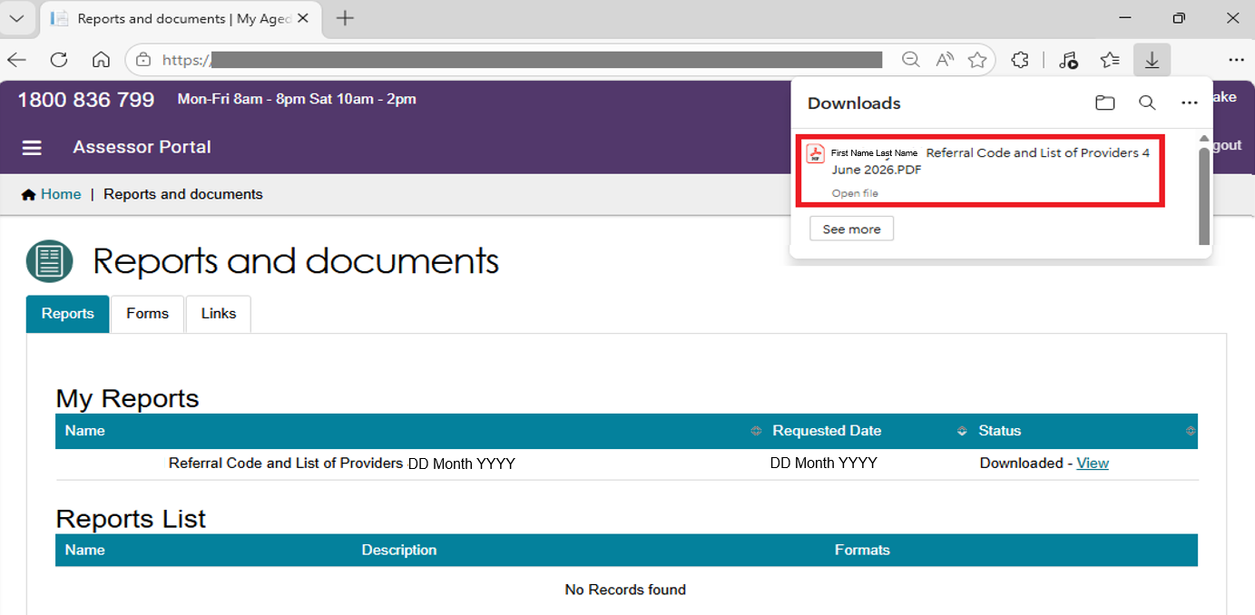

Notice of Decision Letters
After the Assessment Delegate makes a decision, the Assessment Delegate Support can generate and upload the Notice of Decision (NoD) letter. This includes both approval letters and non-approval letters.
The system also sends the NoD letter to the older person's registered supporters, except for supporters-lite. Refer to My Aged Care – Assessor Portal User Guide 2 – Registering support people and adding relationships for more information.

Generating Approval Letters
- From the home page, select the Delegate Decisions tile. Then select the client from the client card or the list on the Decision History tab.
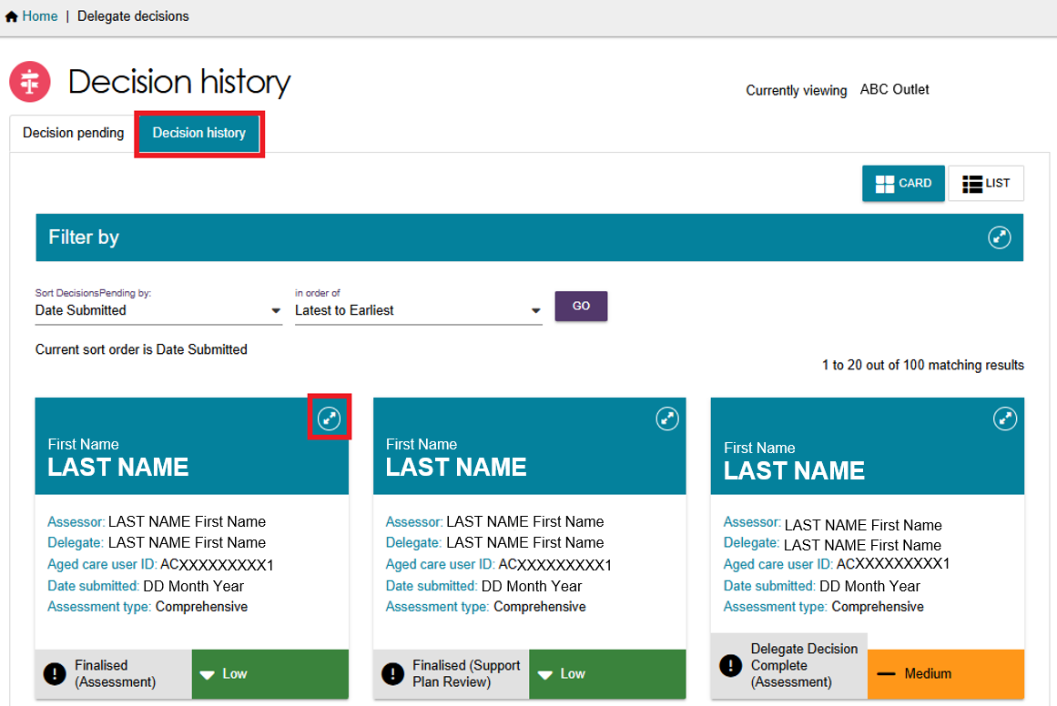
- Select VIEW SUPPORT PLAN.
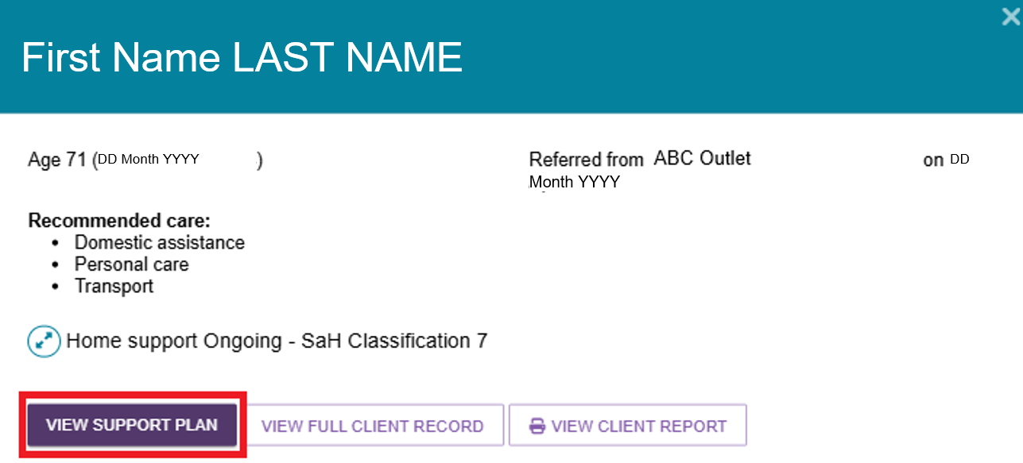
- The client's Decisions tab on the Support Plan and Services page opens.
Select GENERATE APPROVAL LETTER at the bottom of the page.
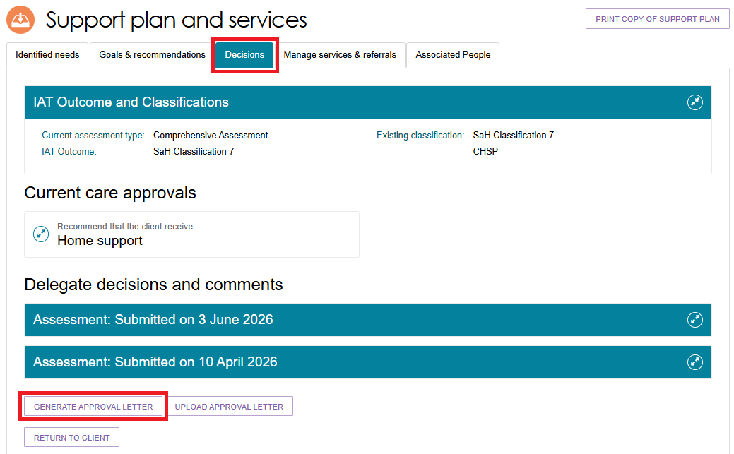
- Confirm the client’s name, then select GENERATE APPROVAL LETTER.
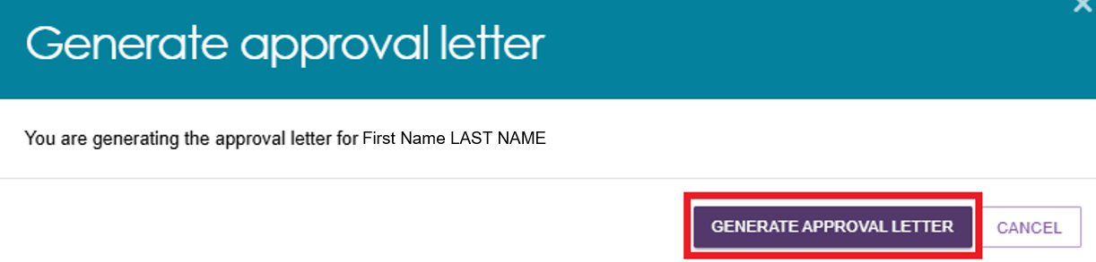

- The letter appears in the Reports and Documents section of the portal with a status of Processing. When the letter is ready, the status changes and a View link appears. Open the letter using the View link.
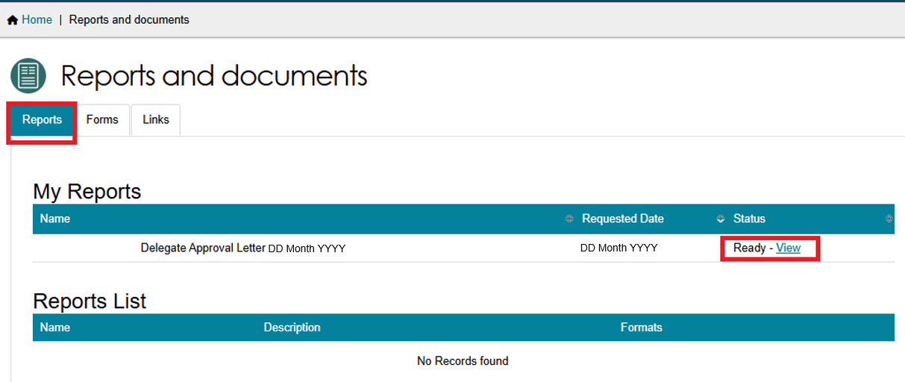
- Your browser downloads the letter to your computer or device as a Rich Text Format (RTF) document. You can then print the letter for the Assessment Delegate to sign.
! | The Assessment Delegate must sign all Notice of Decision (NoD) letters. Before you upload a signed letter to the portal, save or convert it to PDF format.

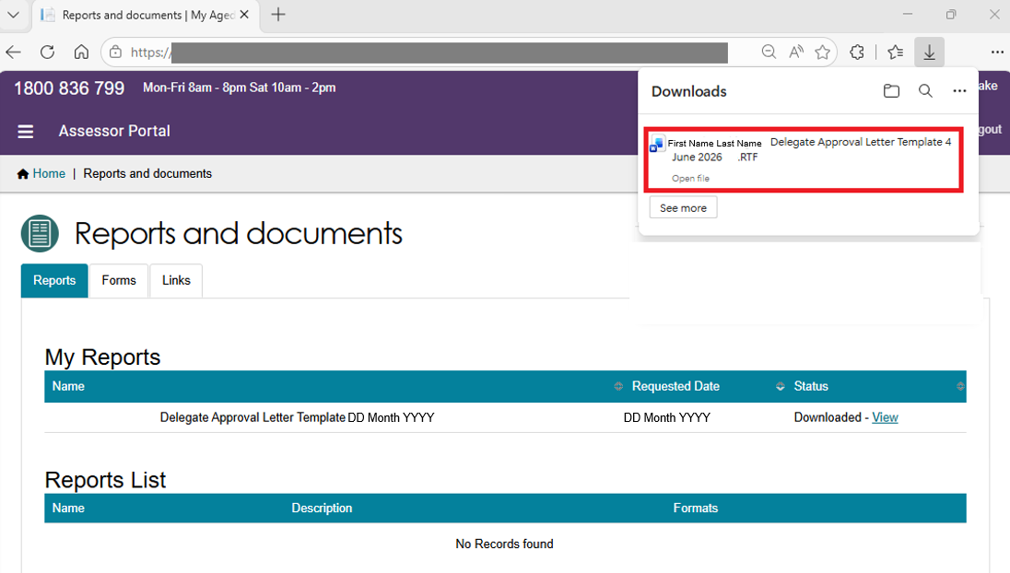

Uploading Approval Letters
After the Assessment Delegate signs the letter, upload it to the client's record using the Upload Approval Letter button on the Decisions tab of the support plan.
You can also upload the letter from the Attachments tab in the client record by selecting Add an Attachment.
For CHSP-only recommendations, you can upload Notice of Decision (NoD) letters from the Goals & Recommendations tab.
For second-unit Restorative Care Pathway (RCP) approval letters, complete the Second Concurrent Unit of RCP Funding – Approval or Non-approval template in the Reports and Documents section of the Assessor Portal. Once you complete the template, use Upload Approval Letter to upload the letter to the client's record.
Second Concurrent Unit of RCP Funding letter template
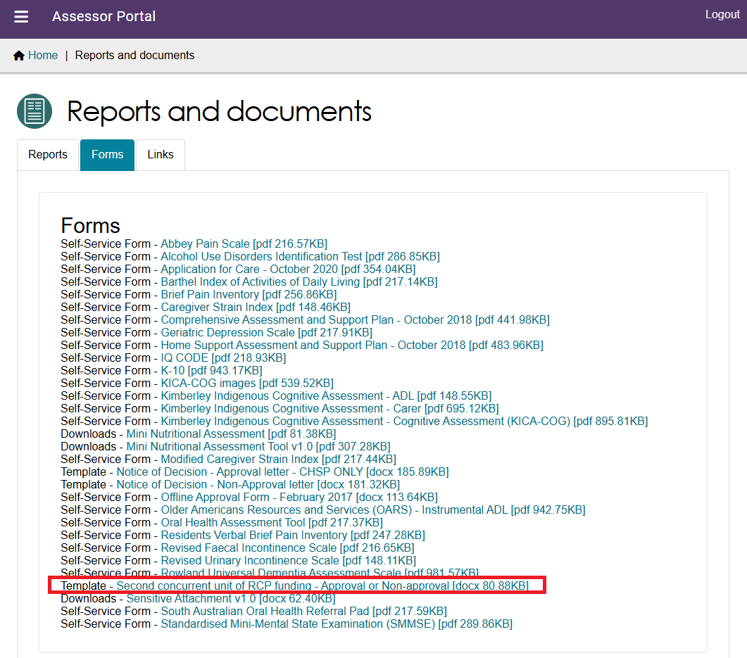

From the support plan
- Open the client's record and select the Plans tab. On the Plans page, select Support Plan.
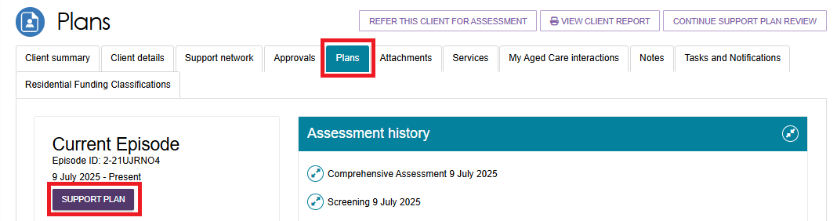

- The Support Plan and Services page opens. Select the Decisions tab, then select Upload Approval Letter at the bottom of the page under Delegate decisions and comments.
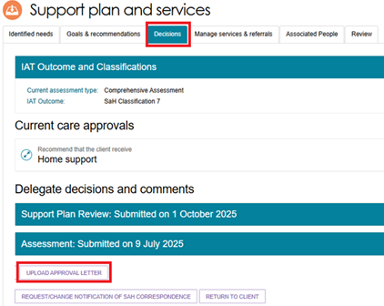
- The Upload Approval Letter window opens. Select the approval letter file you want to upload.
Enter a name for the attachment. Make sure the Attachment Type is set to Approval letter sent to client.
You can also enter a short description of the attachment.
Select UPLOAD to add the letter to the client's record.
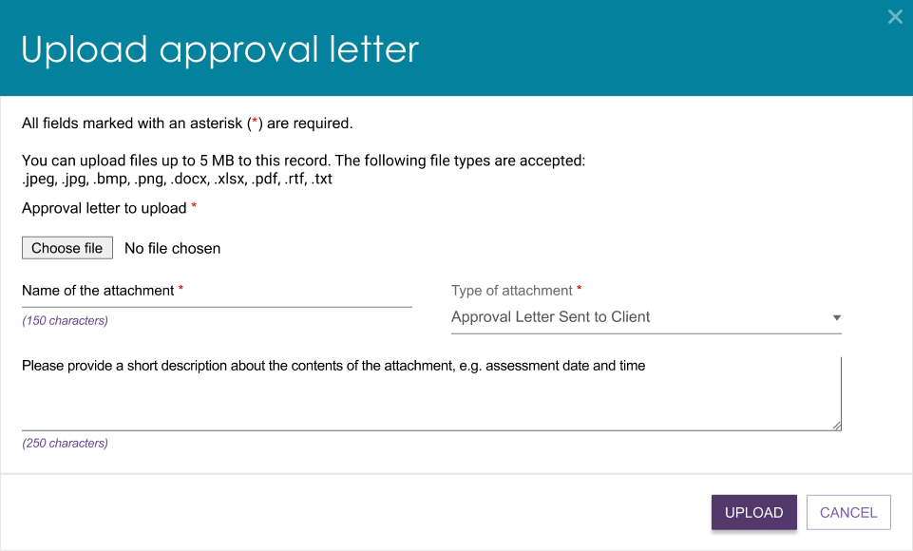
- Choose the letter and then select Open.
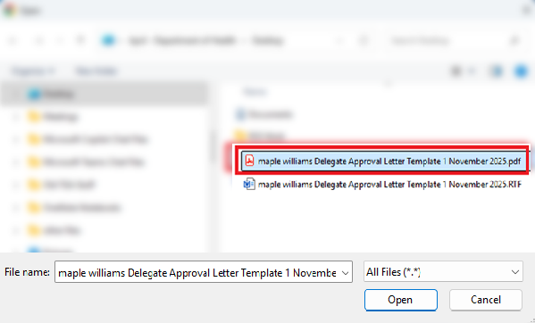
- The file name appears next to the Choose File button. Select Upload.
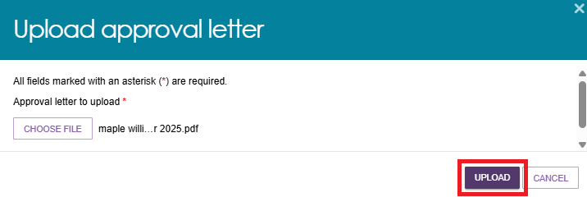
- A confirmation message appears to let you know the upload was successful. You can now find the letter in the Attachments tab of the client's record.


From the attachments tab
You can also upload the letter from the Attachments tab in the client's record.
- Open the client's record and select the Attachments tab. Then select Add an Attachment.
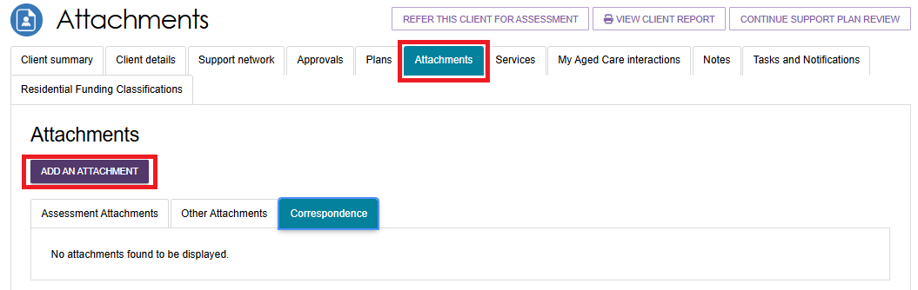
- Select Choose File.
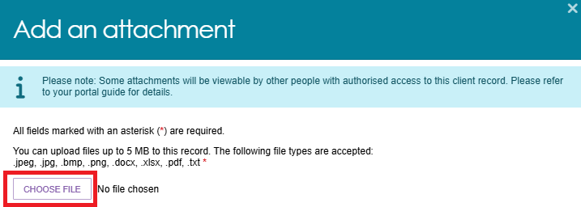
- Select the approval letter and then select Open.
- The file name appears next to the Choose File button.
Enter a name for the attachment. Select Approval Letter Sent to Client as the attachment type. If needed, add a short description, such as the assessment date and time.
Select Upload.
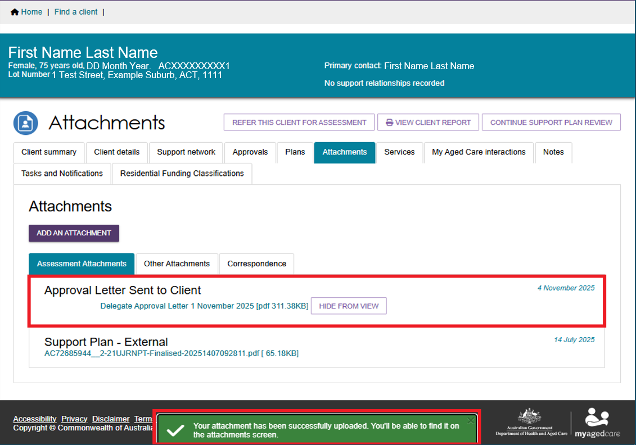
- The letter now appears under the Assessment Attachments tab of the Attachments page.

Generating Non-Approval Letters
- From the home page, select the Delegate Decisions tile. Then select the client from the client card or the list on the Decision History tab.
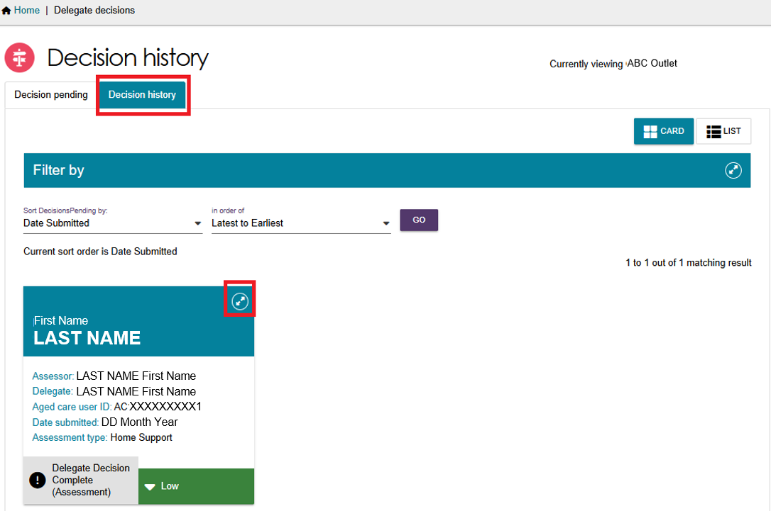
- Select VIEW SUPPORT PLAN.
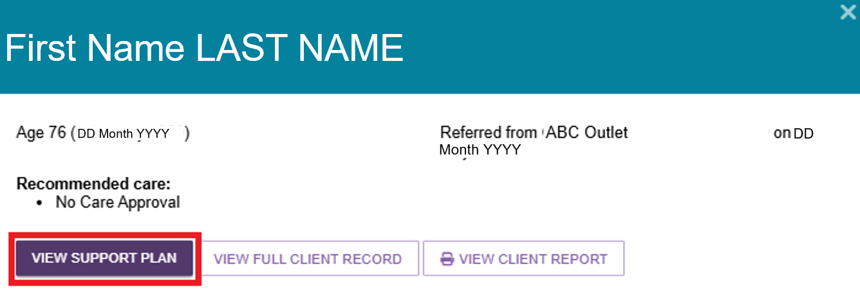
- The client's Decisions tab on the Support Plan and Services page opens. Select GENERATE NON-APPROVAL LETTER at the bottom of the page.
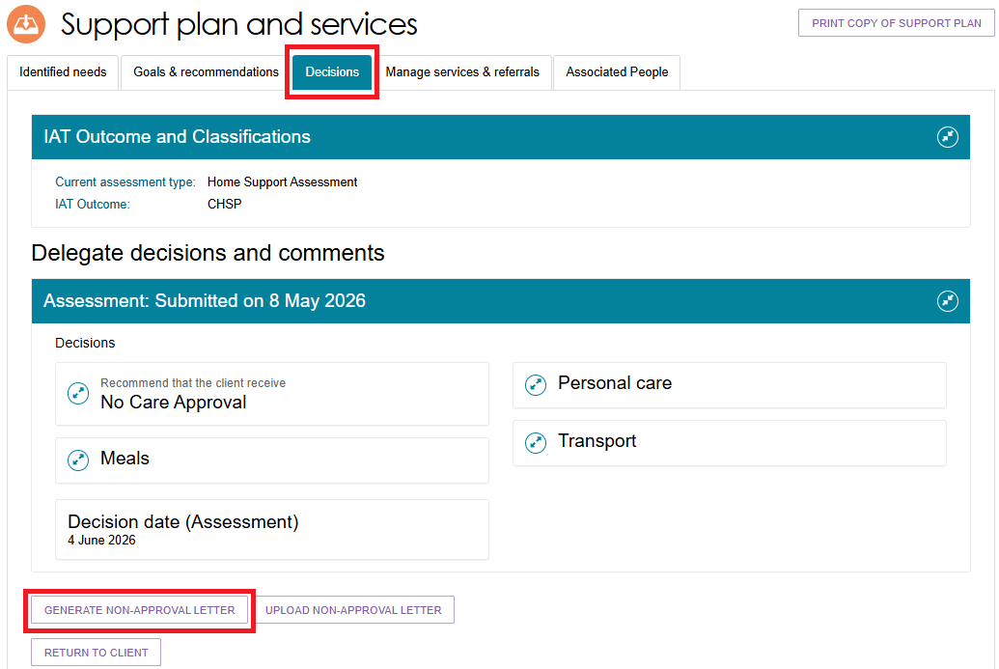
- The system starts generating the non-approval letter and saves it in the Reports and Documents section of the portal. When the letter is ready, a View link appears in the Status column.
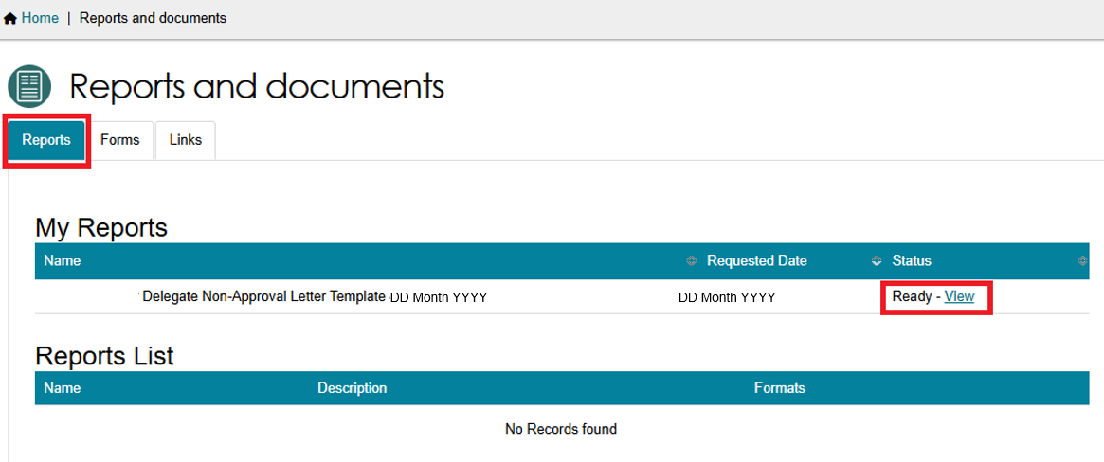
- Select View to open the letter. Your browser downloads the letter to your computer or device as a Rich Text Format (RTF) document. You can then print the letter for the Assessment Delegate to sign.
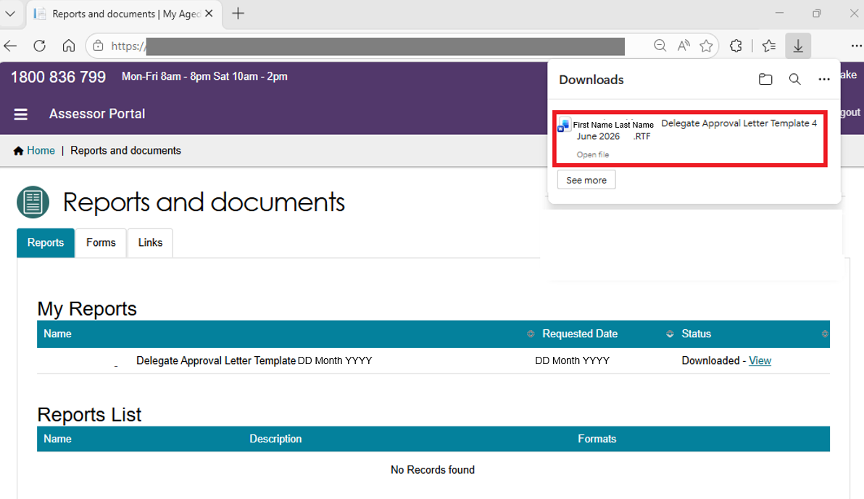
! | The Assessment Delegate must sign all Notice of Decision (NoD) letters. Before you upload a signed letter to the portal, save or convert it to PDF format.

Uploading Non-Approval Letters
After the Assessment Delegate signs the letter, upload it to the client's record using Upload Non-Approval Letter on the Decisions tab of the support plan.
You can also upload the letter from the Attachments tab in the client's record by selecting Add an Attachment.
For Comprehensive Assessments, the Upload Non-Approval Letter option is only available for No Care Approval decisions and similar outcomes.
For CHSP-only recommendations, you can also upload Notice of Decision (NoD) letters from the Goals & Recommendations tab.
For second-unit Restorative Care Pathway (RCP) non-approval letters, complete the Second Concurrent Unit of RCP Funding – Approval or Non-approval template in the Reports and Documents section of the Assessor Portal.
Once you complete the template, use Upload Non-Approval Letter to upload the letter to the client's record.
Second Concurrent Unit of RCP Funding letter template

From the support plan
- Open the client's record and select the Plans tab. On the Plans page, select Support Plan.
- The Support Plan and Services page opens. Select the Decisions tab, then select Upload Non-Approval Letter at the bottom of the page under Delegate decisions and comments.
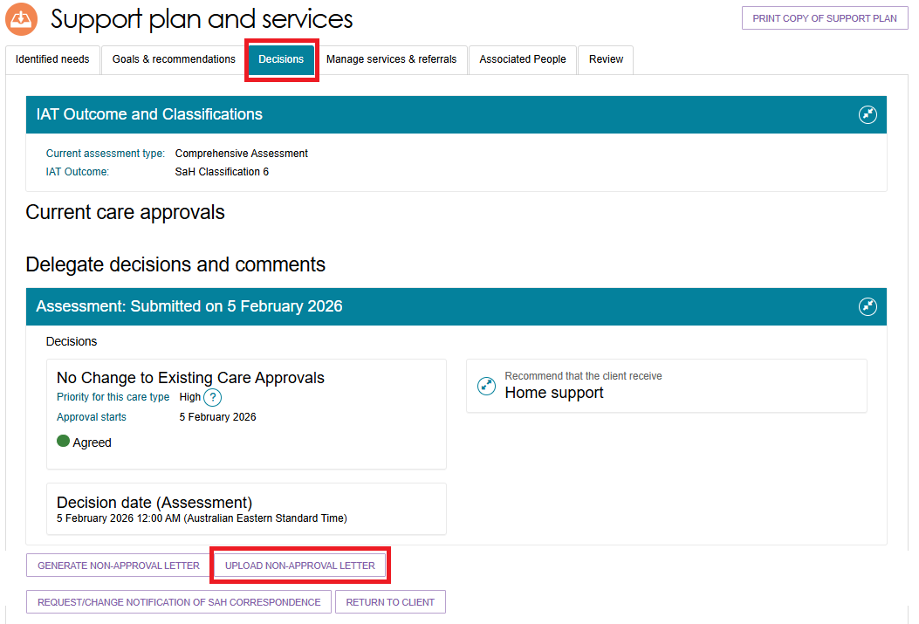
- In the Upload Non-Approval Letter window, select Choose File.
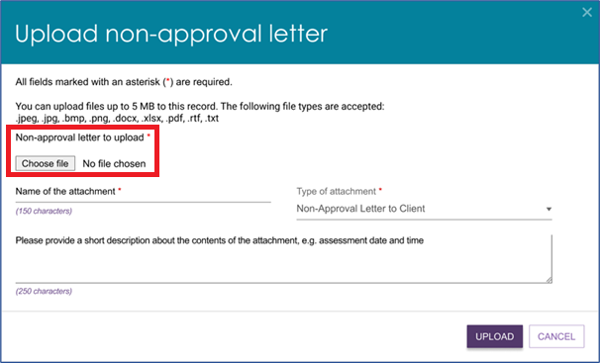
- Select the letter you want to upload, then select Open.
- The file name appears next to the Choose File button. Enter a name for the letter and make sure the Attachment Type is set to Non-Approval Letter to Client.
You can also add a short description of the letter if needed.
Select UPLOAD.
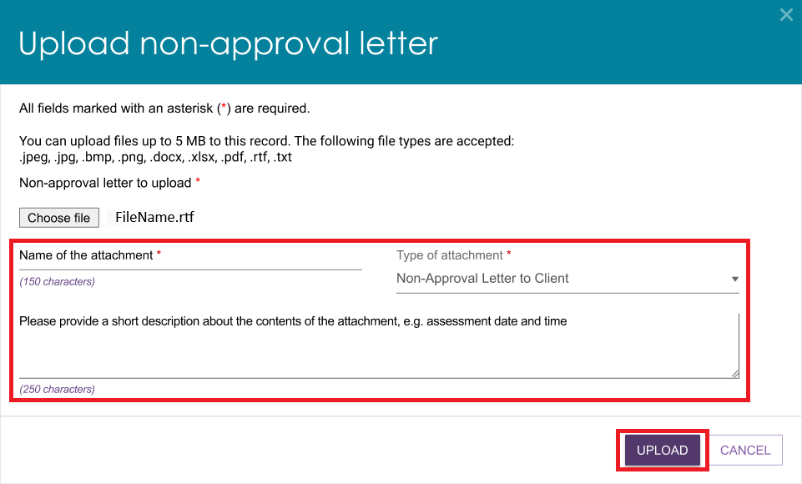
- A confirmation message appears to let you know the upload was successful. You can now find the letter in the Attachments tab of the client's record.

From the attachments tab
You can also upload the letter from the Attachments tab in the client's record.
- Open the client's record and select the Attachments tab. Then select Add an Attachment.
- In the Add an Attachment window, select Choose File.
- Select the non-approval letter you want to upload, then select Open.
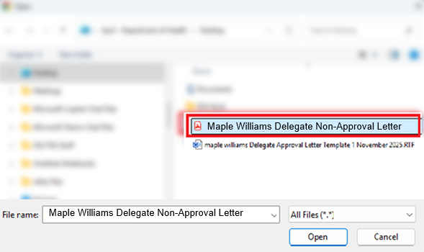

- The file name appears next to the Choose File button. Enter a name for the attachment and select Non-Approval Letter Sent to Client as the attachment type.
If needed, add a short description, such as the assessment date and time.
Select Upload.
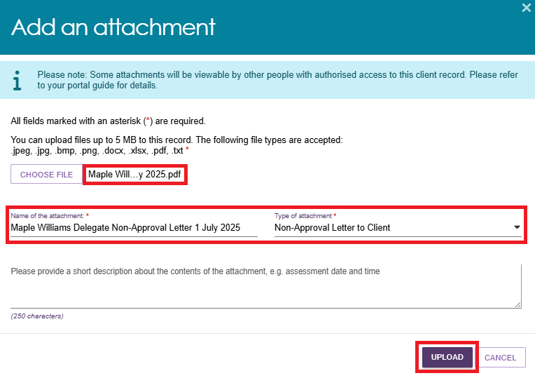
- The letter now appears under the Assessment Attachments tab of the Attachments page.
