Assessor Portal User Guide 10 – Assessment Delegate Processes
This guide helps Assessment Delegates use the My Aged Care Assessor Portal to complete functions required under the Aged Care Act 2024 in their role as a System Governor.
You can use the portal to:
- View and action delegate decisions.
- Request corrections to care approval decisions.
- Request and approve care extensions.
Clinical Assessment Delegates can approve older people for all service groups, classification types and classification levels available under the Aged Care Act 2024.
Non-clinical Assessment Delegates can only approve:
- Entry-level home support services
- Assistive Technology (AT) services
- Home Modification (HM) services
These approvals are limited to the following classification levels:
- CHSP Class
- AT CHSP
- AT-HM Classifications.
! | To understand the responsibilities of Clinical and Non-clinical Assessment Delegates under the Aged Care Act 2024, refer to Chapter 7, Delegations and Approvals under the Act, in the My Aged Care Assessment Manual.  From 29 June 2026, My Aged Care will replace the offline process for Non-clinical Delegate decisions with a fully integrated workflow in the assessor portal.

Contents
The Assessment Delegate home screen 2
The Assessment Delegate + Assessor dual role home screen 4
Client Journey Tracker 4
Viewing an item for decision 6
Assigning an item for decision 9
Reassigning for decision 12
Recording a delegate decision 14
Editing a recommended classification 16
Viewing details about existing approvals 19
Returning an assessment to an assessor 20
Receiving reviewed IAT from assessor 24
No Care Approval and No Change to Existing Care Approvals 27
Clinical Delegate workflow process 28
Agreeing with recommendations 28
Disagreeing with recommendations 30
Agreeing or disagreeing with a Support at Home Recommendation 33
Editing a recommendation 38
Adding a care type 40
Recommending a Home Modification Service under Support at Home 41
Recommending an Assistive Technology Service under Support at Home 43
Recommending a second Restorative Care Pathway unit 46
Changing a decision 48
Editing a recommended classification 49
Finalising your decision 51
Non-Clinical Delegate workflow process 55
Agreeing with recommendations 55
Disagreeing with recommendations 57
Editing a recommendation 60
Changing a decision 61
Adding CHSP services 62
Finalising your decision 64
Notice of Decision (approval or non-approval) letter and SaH Restorative Care Pathway (Second Unit) approval and non-approval letter 69
Approval Letters 69
Non-approval Letters 73
Managing services and referrals 77
Requesting correction to care approval decision 77
Making changes to the Decision Date of the delegate decision 79
Requesting a Correction to Remove and Add Care Classifications within a care type 80
Requesting and Approving Care Extensions 86

The Assessment Delegate home screen
Clinical and Non-clinical Assessment Delegates can access the same tiles on the Assessor Portal home page. The key difference is the types of assessments and approvals each role can manage.
Clinical Assessment Delegates can:
- Approve older people for all service groups, classification types and classification levels under the Aged Care Act 2024.
- Assign and approve decisions for Comprehensive and Home Support assessments.
- Initiate correction requests for Comprehensive and Home Support assessments.
Non-clinical Assessment Delegates can:
- Approve entry-level home support, Assistive Technology (AT), and Home Modification (HM) services only.
- Approve assessments with the following classification levels: CHSP Class, AT CHSP, HM CHSP.
- Approve decisions and initiate correction requests for Home Support assessments only.
Both Clinical and Non-clinical Assessment Delegates can:
- Record recommendations for No Care Approval.
- Record recommendations for No Change to Existing Care Approvals.

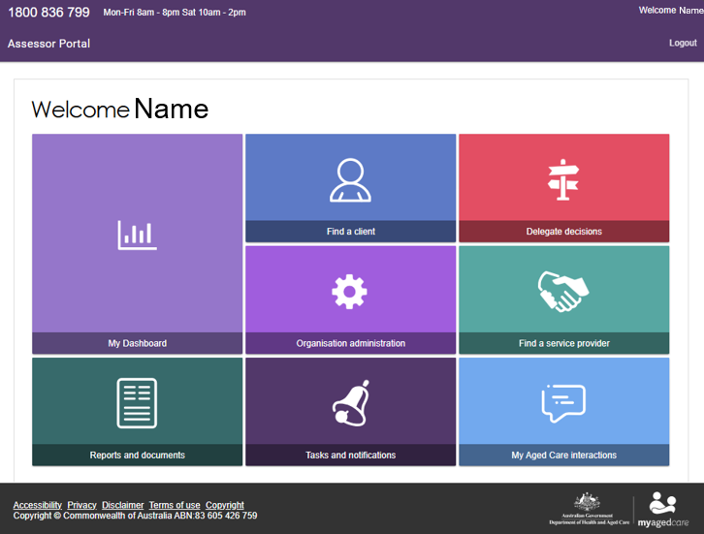

The Assessment Delegate + Assessor dual role home screen
If you are both an Aged Care Needs Assessor and an Assessment Delegate, the Assessor Portal home page will display the following view.

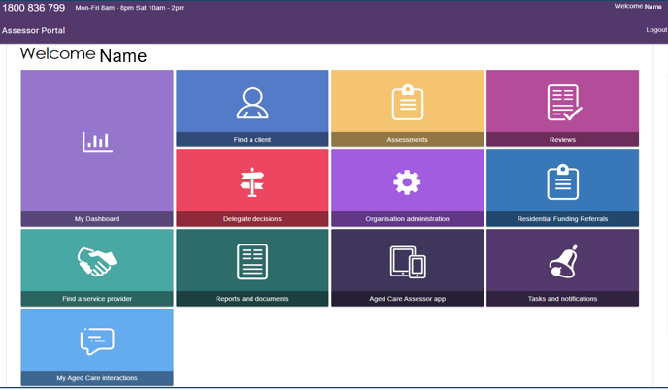
For information on how to apply for an Assessment Delegate role, refer to the My Aged Care – Assessor Portal User Guide 12 – Managing delegate roles.

Client Journey Tracker
The Client Journey Tracker is a visual tool that shows where a client is in their My Aged Care journey and what happens next. It displays above the Client Summary. As an example, when a client has been assessed and recommended for one or more services that requires delegate approval, their tracker will show that ‘services have been recommended for approval’:
You can confirm the client’s status by going to their client summary page. Do this by going to their client card or listing, and then select VIEW FULL CLIENT RECORD.
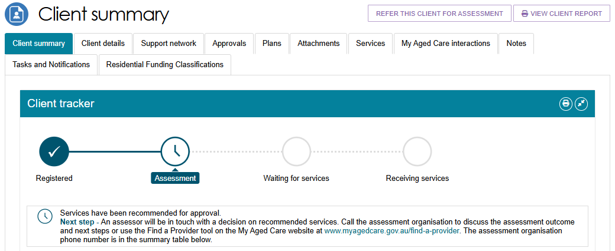
Assessment history
Assessment Delegates can use the Plans tab in the client record to review a client's assessment history and support delegate approval decisions.
In the Assessment History section, you can view key information, including:
- Whether a non-clinical needs assessor converted a Home Support Assessment to a Comprehensive Assessment.
- Details of the clinical supervising assessor associated with the assessment.

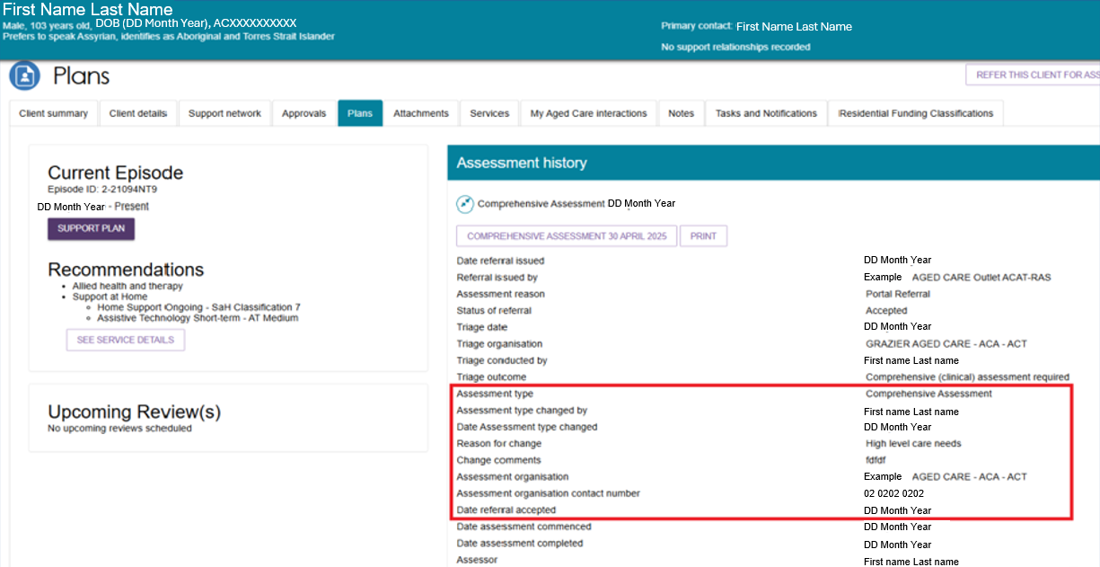

Viewing an item for decision
Clinical and Non-clinical Assessment Delegates can access the Delegate Decisions tile from the Assessor Portal home page. From there, they can view decisions in the Decision Pending and Decision History tabs.
Delegates can also use the My Dashboard tile to view a summary of delegate decisions in their outlet, including:
- The total number of delegate decisions.
- The number of decisions assigned to them.
- The number of unassigned decisions.
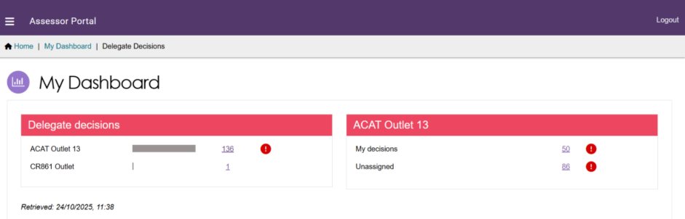
Follow these steps to view assessments that require a delegate decision.
- Select Delegate Decisions from the home page.
- Open the Decision Pending tab to view assessments awaiting a delegate decision.
You can use the First Name, Last Name, and Aged Care User ID filters to find specific assessments. To access more filter options, select Advanced Search.
You can also sort the results by:
- Assessment status
- Last name
- First name
- Aged Care ID
- Date submitted
- Priority (urgency)
- Assessor name
- Delegate name
- Due date.
You can choose the order in which the results are displayed.
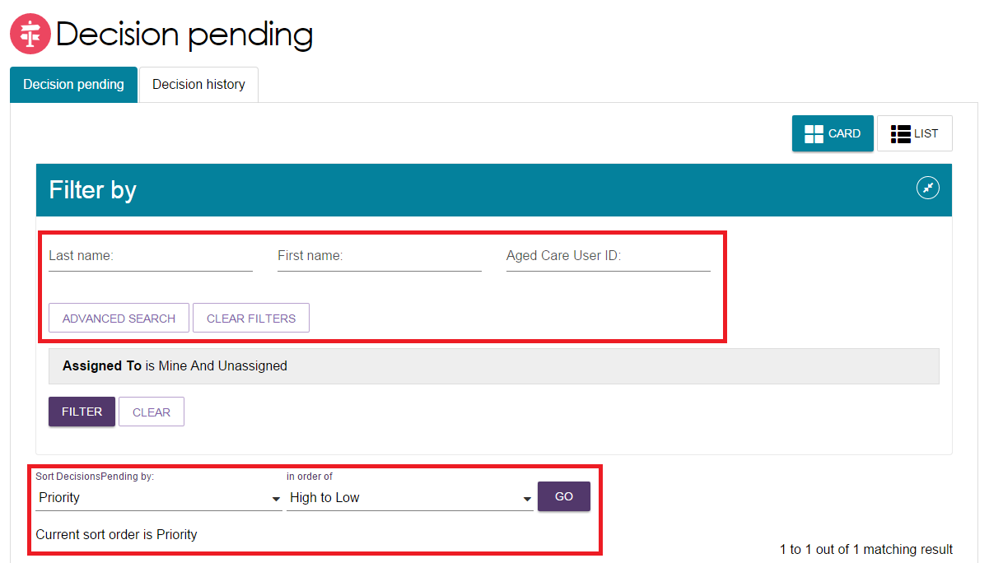
- In Card View, the status appears at the bottom of the client card.
- In List View, the status appears in the Assessment Status column.
The Due Date for each assessment awaiting a delegate decision is visible in both Card View and List View. You can also sort and filter pending decisions by due date.Decisions Pending tab - Card View

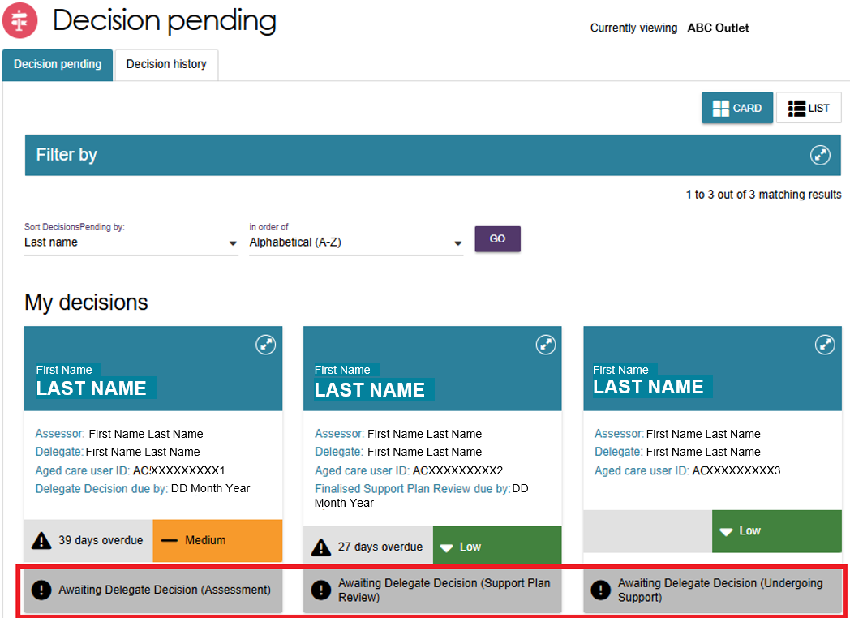
Decisions Pending tab - List View

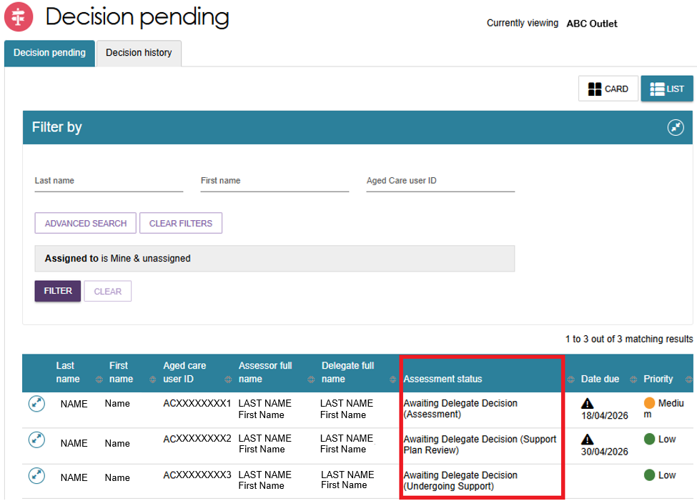
Select the Decision History tab to view delegate decisions you have previously completed.

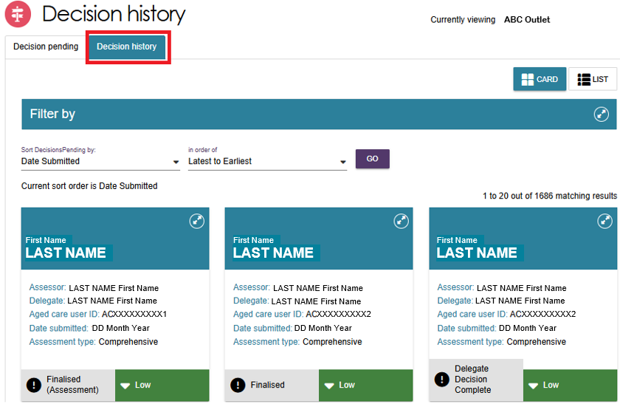
- In both the Decision Pending and Decision History tabs, you can switch between Card View and List View to display client records in your preferred format.

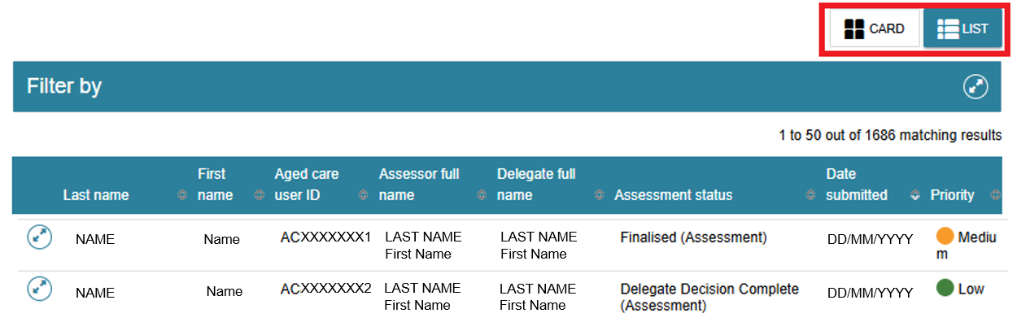

Assigning an item for decision
A Clinical Assessment Delegate can assign Comprehensive Assessments and Home Support Assessments to themselves. They can also assign Home Support Assessments to other Clinical Assessment Delegates or Non-clinical Assessment Delegates within their outlet.
A Non-clinical Assessment Delegate can assign Home Support Assessments to themselves or to other Non-clinical Assessment Delegates within the same outlet.
To assign a client:
  - In Card View, select the expand arrows on the client card to view a summary of the client's information in a pop-up window, then select ASSIGN.
In List View, select the expand arrows next to the client to view a summary of the client's information.
- Card View
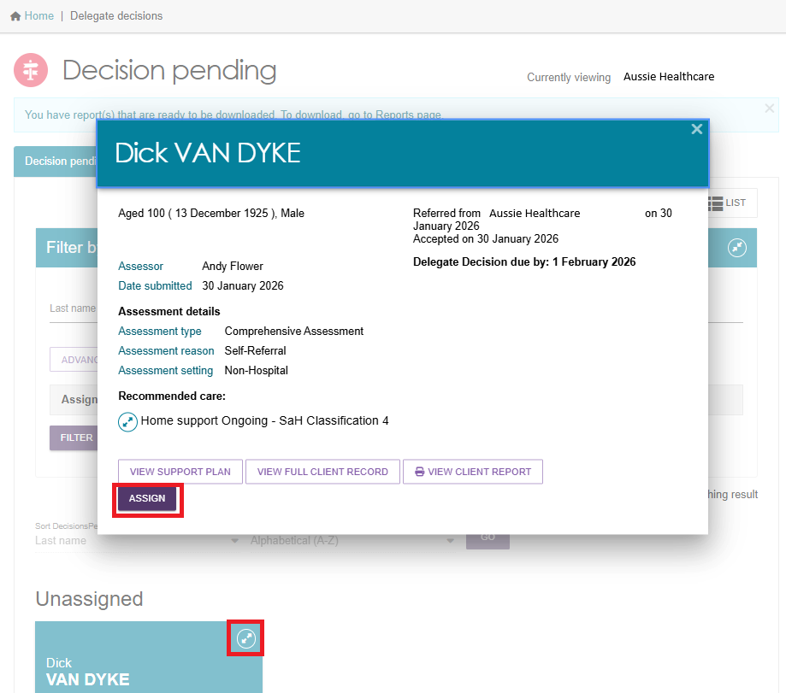
List View

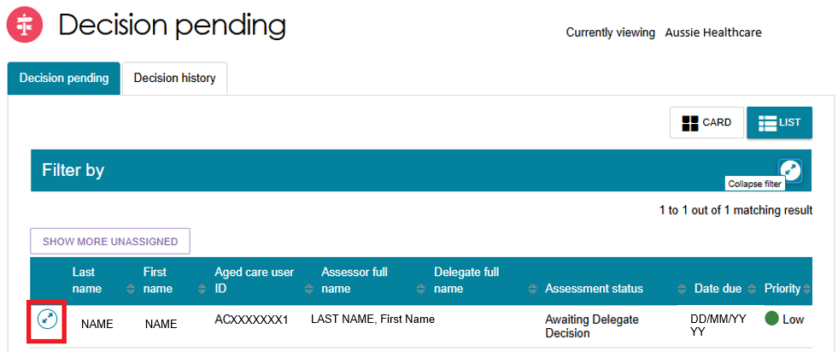
  - Select ASSIGN to assign the assessment to yourself or another Delegate.

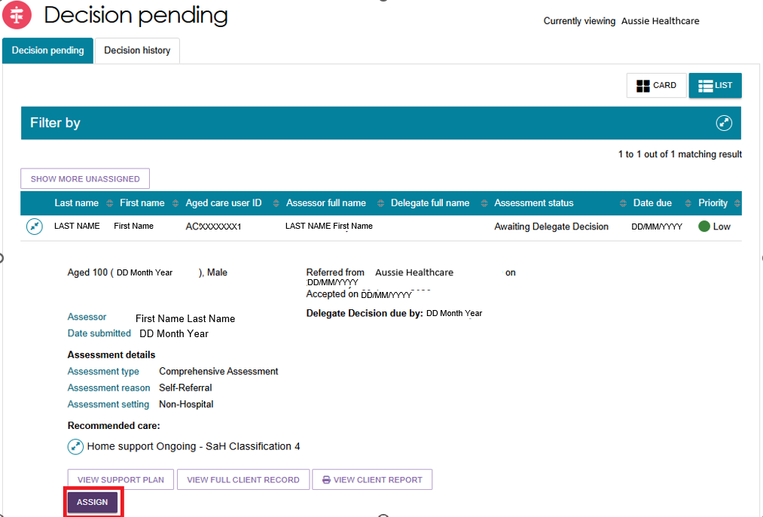
  - In the pop-up window, select the Delegate who will receive the assessment, or select Me to assign it to yourself. Then select ASSIGN.

- 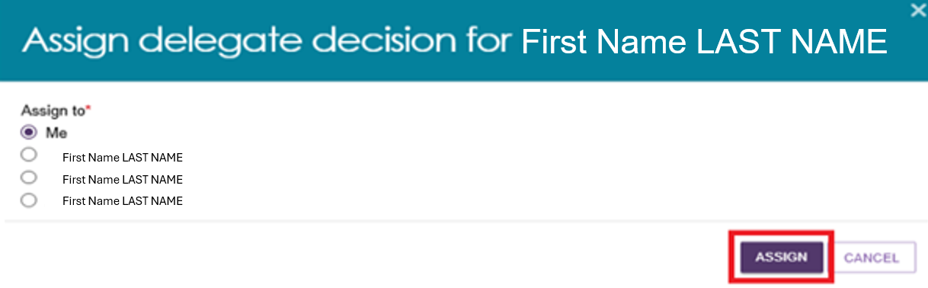
  - A confirmation message will appear. The assessment will then appear in the assigned Delegate's queue, or under My Decisions if you assigned it to yourself.

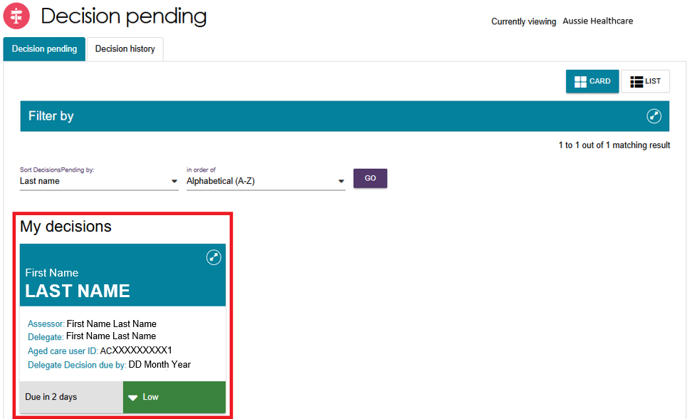

Reassigning for decision
Follow these steps to reassign an item for decision:
- In Card View, select the expand arrow on the client card to view a summary of the client's information, then select REASSIGN.
In List View, select the expand arrow next to the client's name to view more information, then select REASSIGN.
- Card View

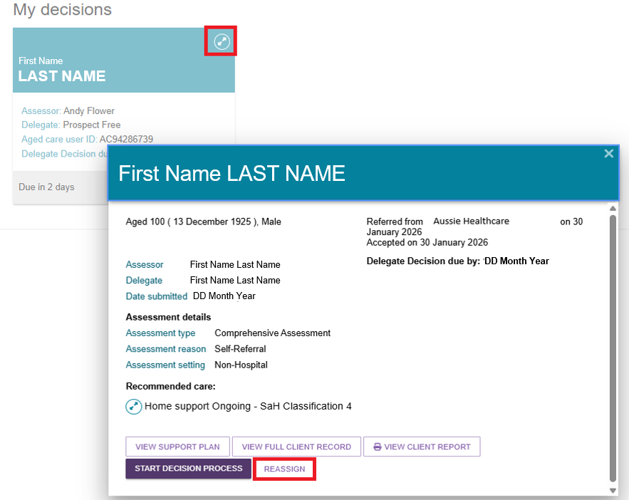
List View

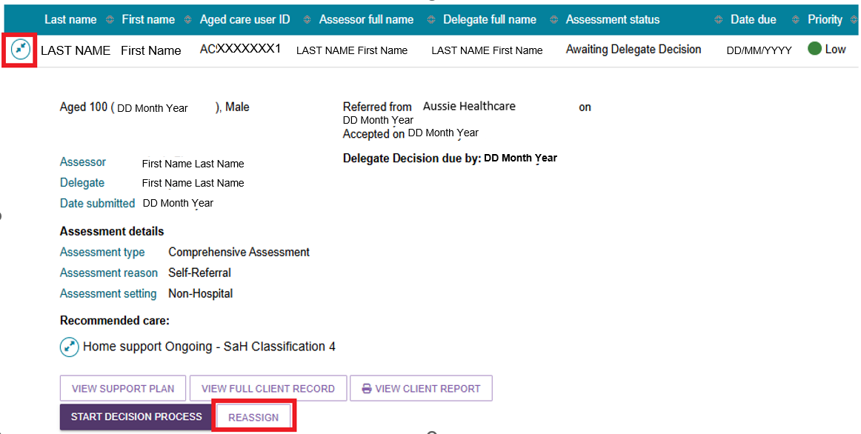
- Select the Delegate you want to assign the item to, or if you want to remove the assignment, select Place back in delegate queue. Then select REASSIGN.

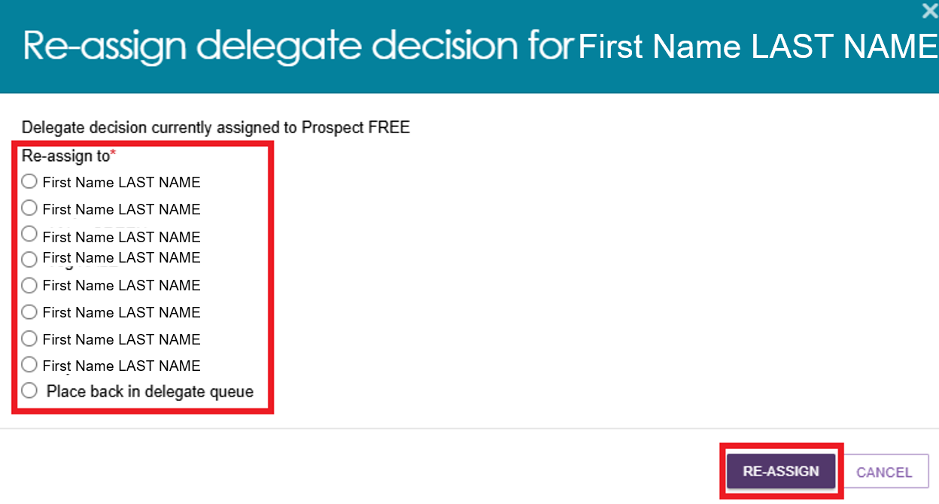
- A confirmation message will appear to confirm that you have reassigned the item or returned it to the delegate queue.

Recording a delegate decision
Before you make a delegate decision, review the client's full record, assessment, support plan and any attached documents. This helps ensure you have enough evidence to support your decision.
For example:
- You can view the assessor's assessment summary in the Identified Needs tab of the support plan.
- Information banners may appear in the Client Summary to indicate that the client is already approved for certain services.
Follow these steps to record your delegate decision:
Viewing decisions information
- Go to the Delegate Decisions tile from the home page and select the Decision Pending tab.
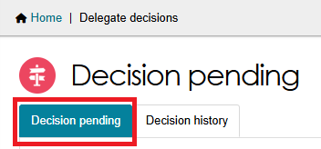
- Open the client record:
- In Card View (shown below), select the expand arrow on the client card to view a summary of the client's information, then select START DECISION PROCESS.
- In List View, select the expand arrow to view the client's information, then select START DECISION PROCESS.

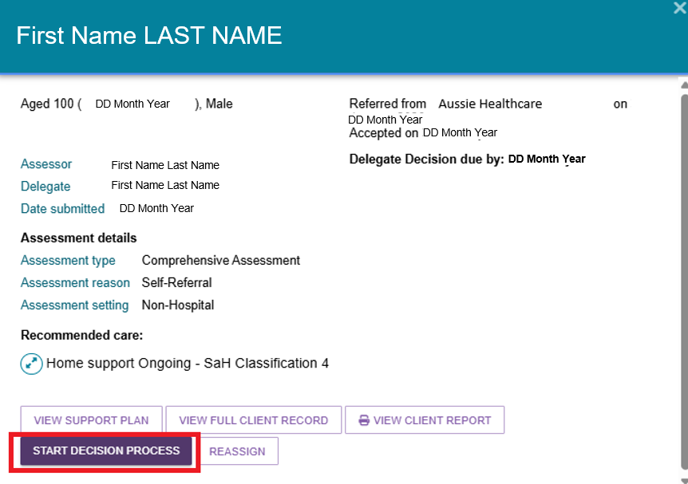
Clinical Assessment Delegates only: If you are also the assessor who completed the client's assessment or support plan review, the system will display an error message.
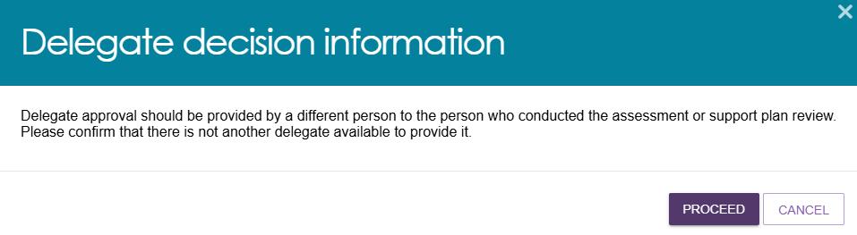
- The system will open the Decisions tab in the client's support plan. Review the recommendations submitted by the assessor here.
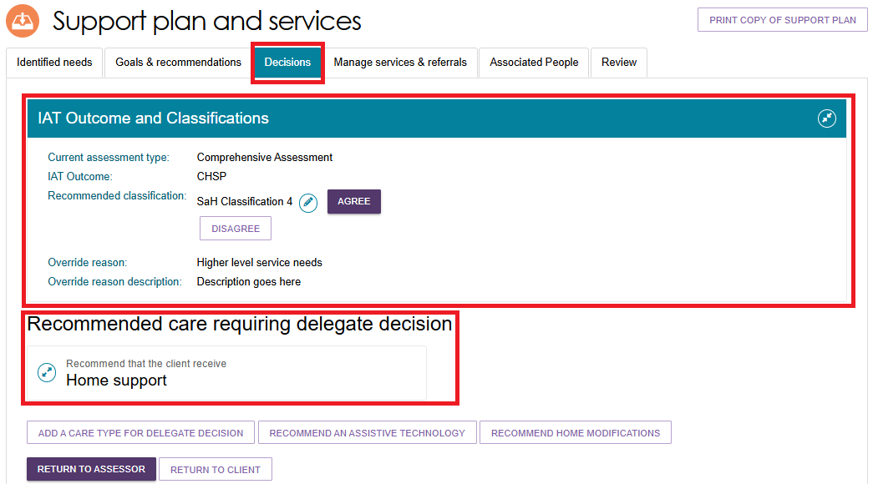
- If you previously asked the assessor to review the IAT questionnaire, you may also receive a message confirming that the review has been completed. Use the link provided in the message to view the IAT review.
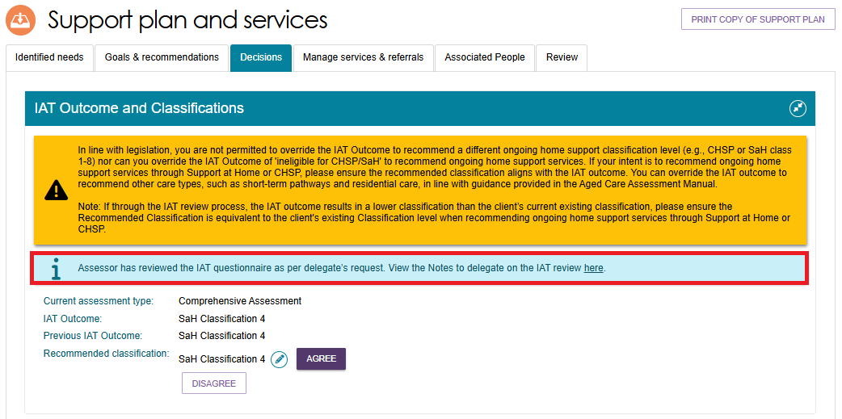

Editing a recommended classification
- Go to the Delegate Decisions tile and open the client record as described in Viewing Decisions information.
- Select the pencil (Edit) icon next to the current recommended classification.
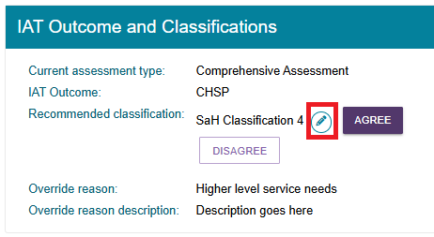
- In the Edit Recommended Classification window:
- Select the new recommended classification.
- Select an override reason.
- Enter a description explaining the change.
- Review and action any warning messages that appear.
- Complete any additional mandatory fields, such as the client's preference for seeking Home Support services.
! | An ongoing Support at Home classification outcome cannot be overridden to an ongoing lower or higher SaH classification outcome (in line with section 81-10 of the Aged Care Rules). Assessors must not undertake this action and delegates must not approve assessments where this occurs, or override and select a lower or higher classification.
Select SAVE TO PLAN.
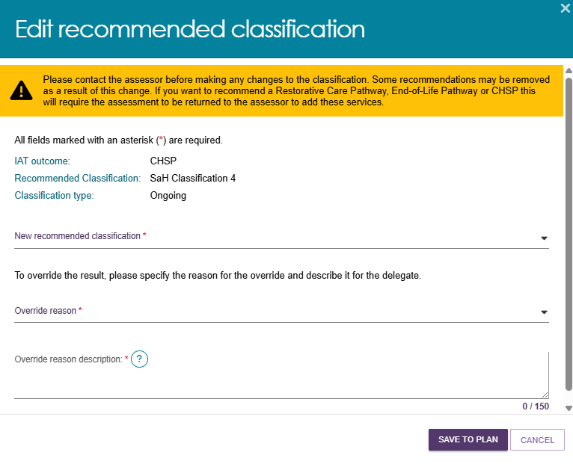

- For Support at Home classifications:
The Edit Home Support Services screen will open and display the default services associated with the selected classification.
Review the service details and update the service, frequency and intensity as needed.
Select SAVE TO PLAN at the bottom of the page.
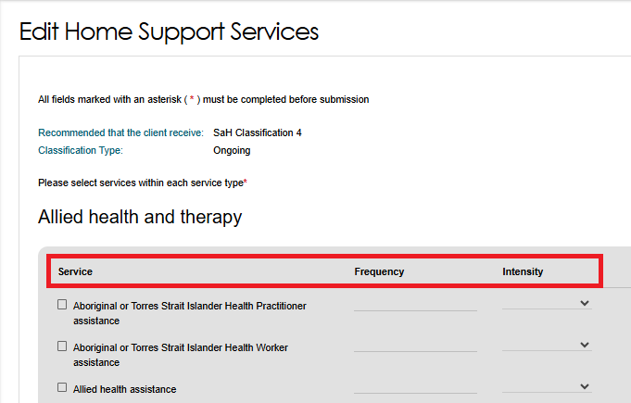
- The updated recommended classification will appear in the IAT Outcome and Classifications section of the Decisions tab. The update may take up to 60 seconds to display.
- Clinical Assessment Delegates can correct Residential Permanent recommendations within 43 days of making the decision. During this period, you can:
- Add a Residential Permanent recommendation.
- Remove a Residential Permanent recommendation.
- Change the urgency level.
- Update the approval expiry date.
- Update emergency needs.
- Update the Delegate date (approval start date).

Viewing details about existing approvals
- To view the details and status of a decision for a recommended service, open the Decisions tab and go to the Current Care Approvals section.
Select the expand icon next to the service, then select the blue View (magnifier) icon.

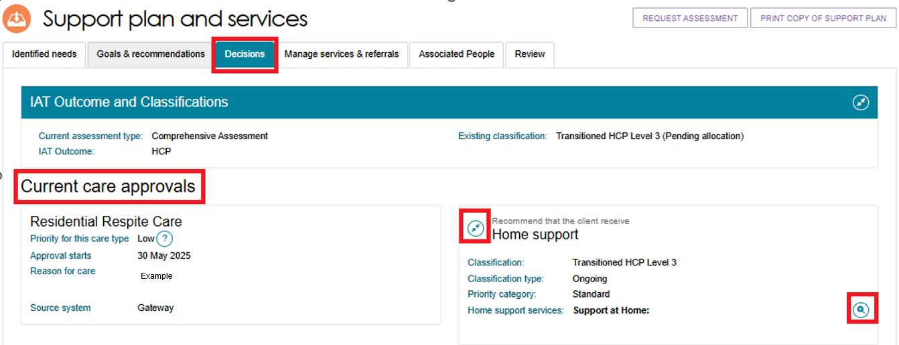
- A pop-up window will open and display the classification, approval type, and all approved services.
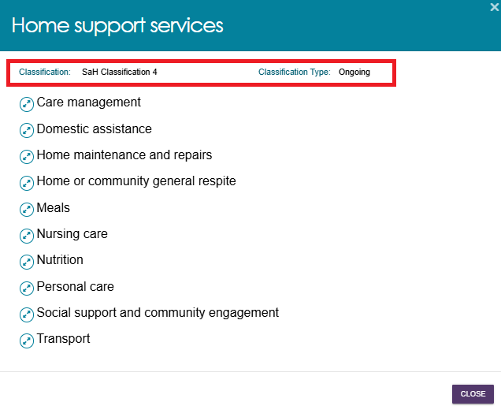
- Select the expand icon to view additional details, including: Approved services, Approval start date, and Approval end date.
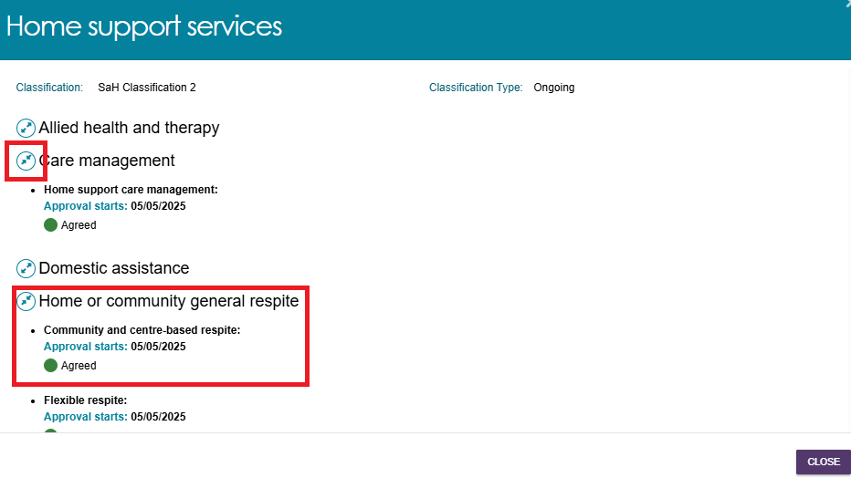

Returning an assessment to an assessor
You may need to return an assessment to the assessor in certain situations, including when:
- You need more evidence to support a decision.
- The recommended care level is not appropriate or does not meet the client's needs.
- The assessor needs to correct information, such as spelling errors.
- The assessor needs to review the Integrated Assessment Tool (IAT) data for a Comprehensive Assessment or Home Support Assessment.
- The support plan contains incorrect service approvals.
Select RETURN TO ASSESSOR to send the assessment back to the original assessor. The assessor can then update the support plan or review the IAT and resubmit the assessment for a delegate decision.
You can only return an assessment to the assessor before you agree or disagree with any recommendations.
If you select RETURN TO CLIENT, the system will take you back to the client's record.
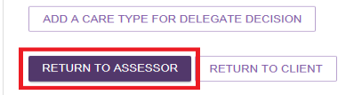
Follow these steps to return an assessment to the assessor:
- From the Delegate Decisions tile, open the Decisions tab on the client's Support Plan and Services page. Select RETURN TO ASSESSOR at the bottom of the page.

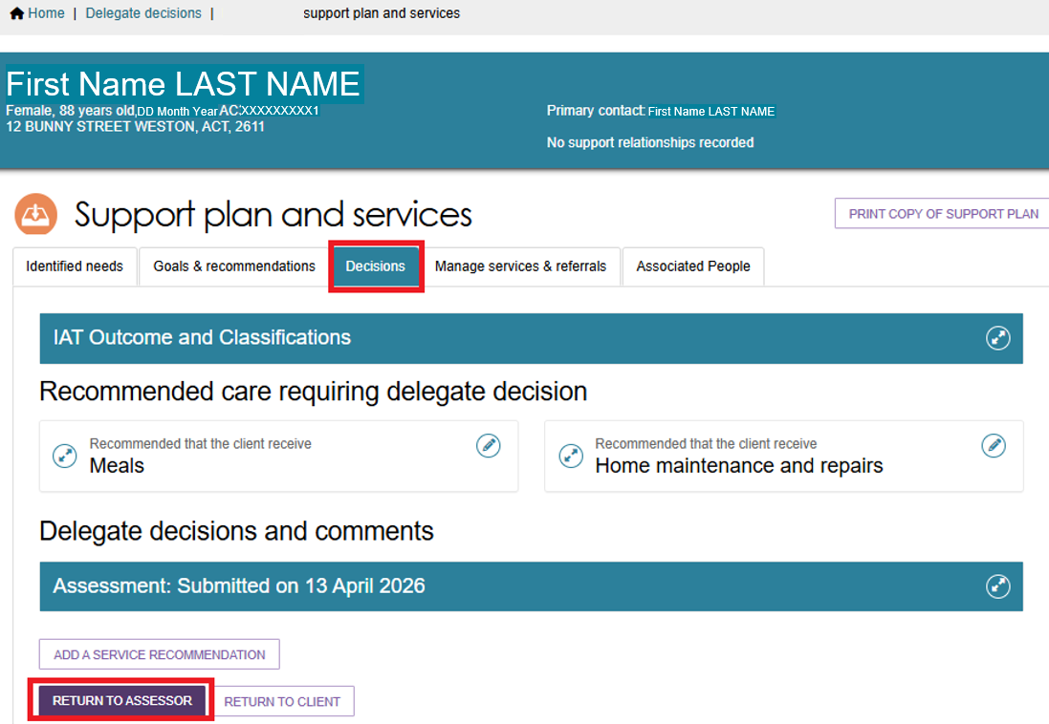
- The Return to Assessor window will open.
If the assessor only needs to review and update the support plan, select Return Assessment. You can return an assessment for support plan updates more than once.
- 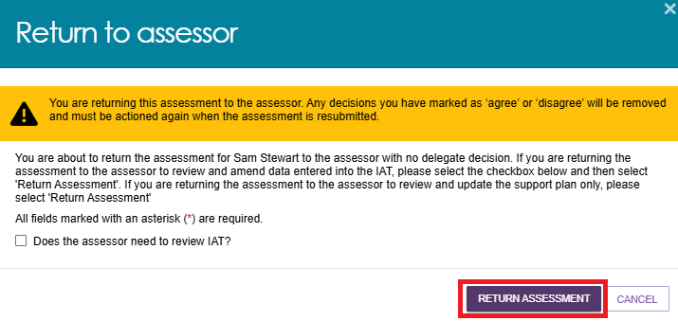
A green confirmation message will appear to confirm that the system has returned the support plan to the assessor. The client's card or listing will no longer appear in your Decision Pending queue.
- If you need the assessor to review the Integrated Assessment Tool (IAT), select the Does the assessor need to review IAT? checkbox.
The system will display a warning that it will clear any recorded decisions. You can only request an IAT review once.
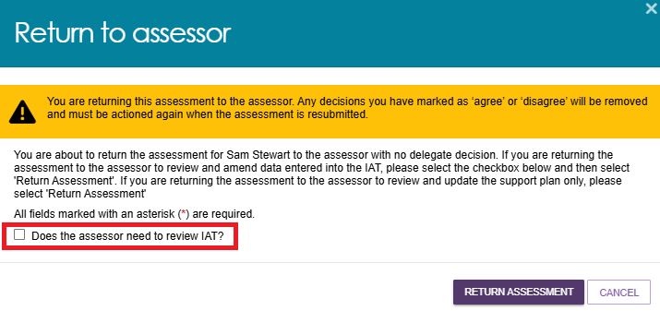

- The window will expand to display a section for IAT review notes.
The system pre-fills the IAT domain names. Enter your feedback against the relevant IAT domains. You can enter up to 2500 characters.
When you have finished, select RETURN ASSESSMENT.
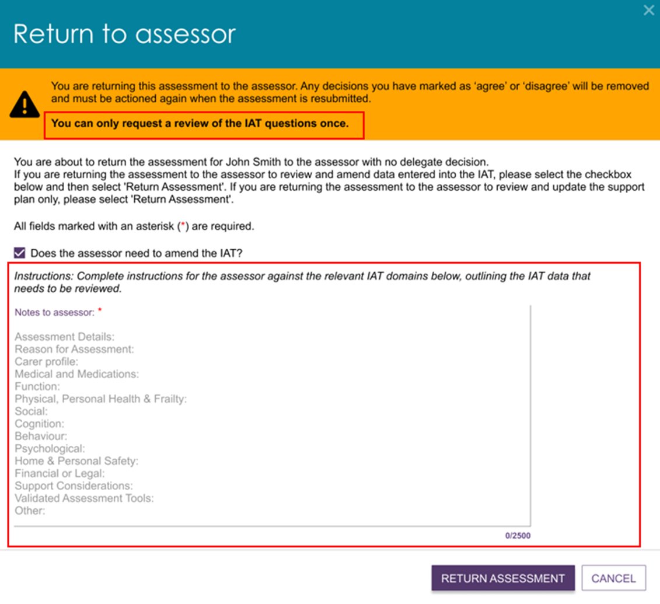
- A green confirmation message will appear to confirm that the system has returned the support plan to the assessor.
The client's card or listing will no longer appear in your Decision Pending queue.
If the assessment has already been returned for an IAT review, the Return to Assessor window will:
- Display a warning that the system will clear any recorded decisions.
- Refer only to returning the assessment for Support Plan updates.
- No longer display the Does the assessor need to review IAT? checkbox.
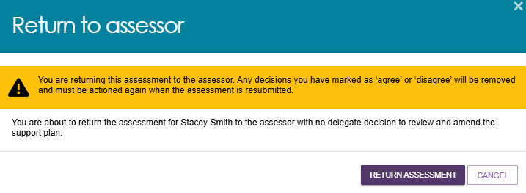

Receiving reviewed IAT from assessor
After the assessor completes the requested changes, finalises the IAT, and resubmits the support plan, you can review the assessor's notes before restarting the decision process.
Follow these steps to review the assessor's IAT changes and restart the decision process:
- Go to the Delegate Decisions tile and open the Decision Pending tab. Select the client's card or listing.

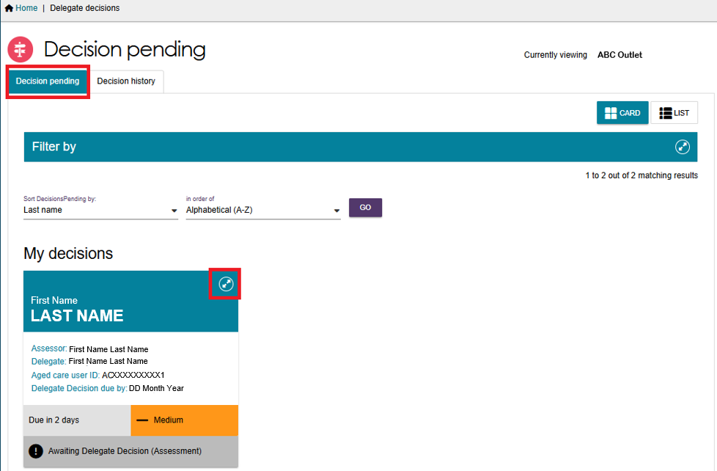

- An information message will appear:
‘Assessor has reviewed the IAT questionnaire as per delegate’s request. Please refer to the Notes to delegate on the IAT review below for details’.
Select VIEW DETAILS under Notes to Delegate on the IAT Review.

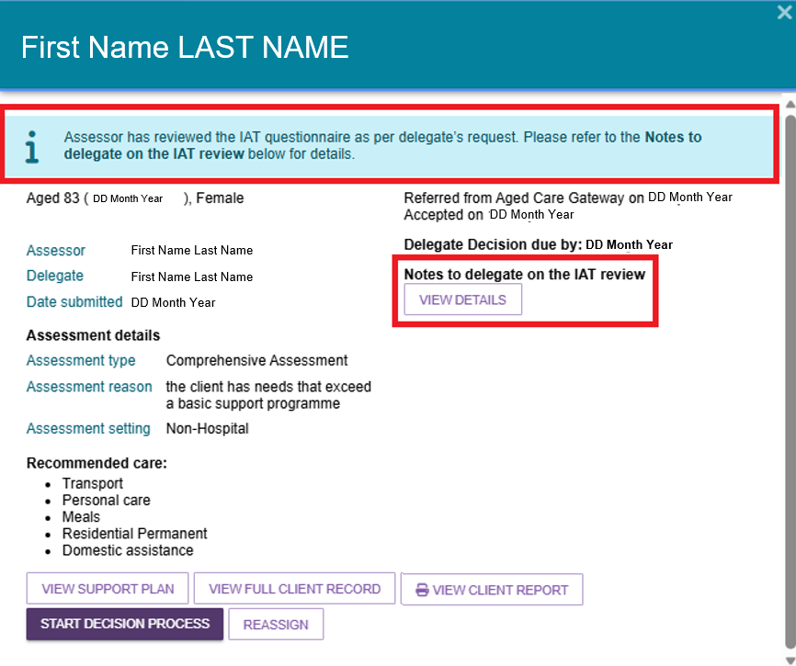
- The Notes to Delegate on the IAT Review window will open.
You can:
- View the assessor's notes at the top of the window.
- View the original delegate notes below.
- Select the expand icon to open or collapse each section.
Select CLOSE to return to the client's record.
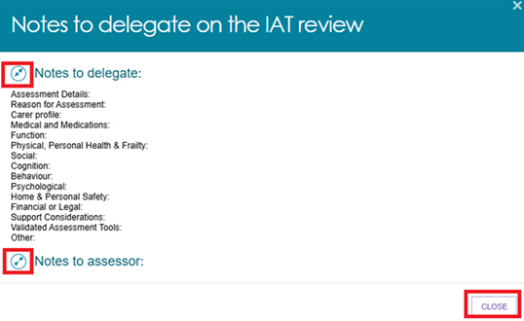
- From the client's card or list view, select START DECISION PROCESS to begin or continue the decision process. The Decisions page will display:
- The updated support plan, if the assessor made changes.
- The updated IAT outcome.
- The previous IAT outcome, where applicable.
You can also view the assessor's IAT review notes from this page. Select the link in the information message: ‘Assessor has reviewed the IAT questionnaire as per delegate’s request. View the Notes to delegate on the IAT review here’.
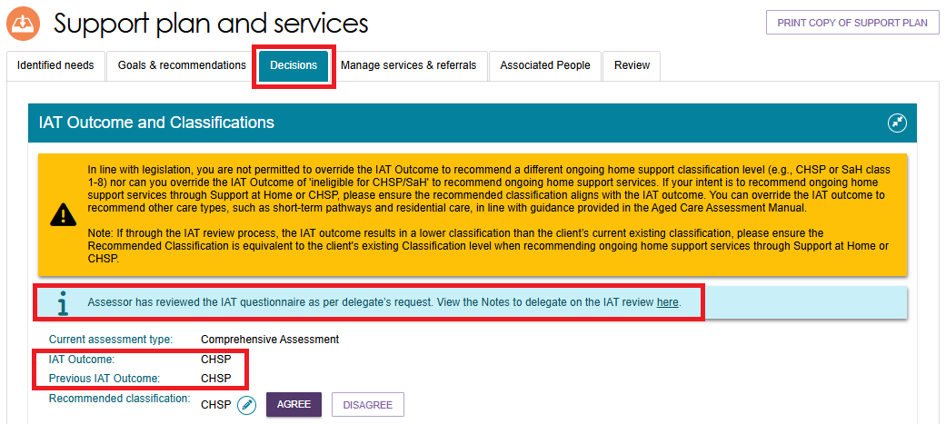

No Care Approval and No Change to Existing Care Approvals
You can add a recommendation for No Care Approval or No Change to Existing Care Approvals when completing a Home Support Assessment or a Comprehensive Assessment.
The No Care Approval and No Change to Existing Care Approvals buttons are available in the Goals & Recommendations tab of the client's Support Plan and Services page. The system may also display these options while you are adding a goal.
No Care Approval is available when the client has no existing care approvals.
No Change to Existing Care Approvals is available when the client already has care approvals in place.
The image below shows the Add No Change to Existing Care Approvals button in the Other Recommendations section of the client's Goals & Recommendations tab.
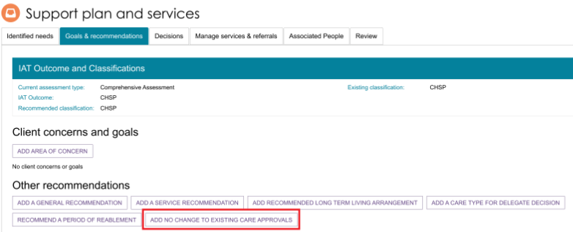This image below shows the Add No Care Approval button, in both the Goal section and in the Other Recommendations section of the client’s Support Plan and Services page.
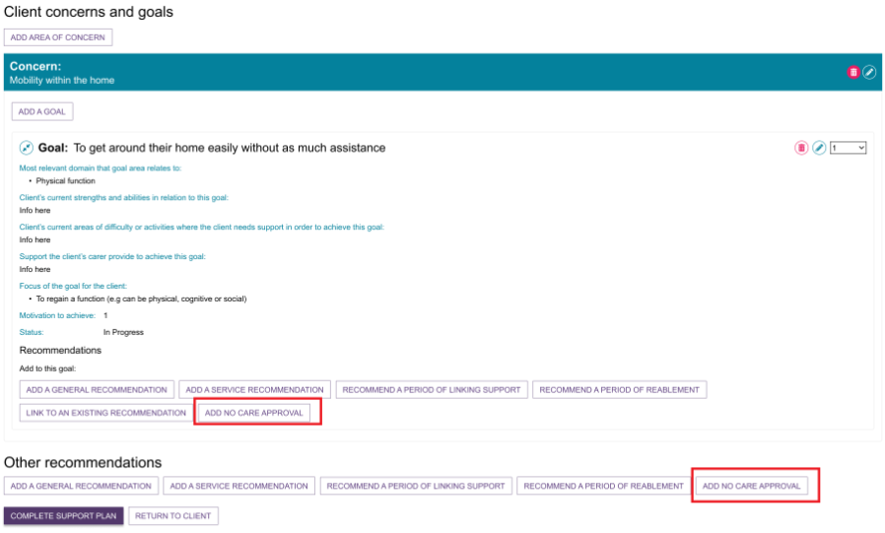
Assessors can recommend No Care Approval or No Change to Existing Care Approvals while completing an assessment. These recommendations require a delegate decision.
Assessors cannot add No Care Approval or No Change to Existing Care Approvals during the support period or as part of a support plan review.

Clinical Delegate workflow process
Clinical Assessment Delegates can approve older people for all service groups, classification types and classification levels under the Aged Care Act 2024.
! | Clinical Delegate requirements for Comprehensive (CHSP only) assessment outcomes  When a Comprehensive Assessment results in a CHSP-only outcome, a Clinical Assessment Delegate who did not complete the assessment must approve the recommendation.  A clinical assessor must not approve their own comprehensive assessment.  All comprehensive assessments require separation between the assessor and delegate roles. This separation helps maintain appropriate clinical governance and oversight.  An assessor can also act as the delegate only when they complete a Home Support Assessment that results in a CHSP-only recommendation.
! | Clinical Assessment Delegates can also approve entry-level home support services. Organisations may choose to assign Home Support Assessments to Clinical Assessment Delegates instead of Non-clinical Assessment Delegates.

Agreeing with recommendations
- To approve a recommendation made by the Clinical Assessor for a service other than Support at Home (such as Residential Care, Transition Care Program (TCP) or CHSP), select AGREE under the recommended care type. If the assessor has recommended more than one care type, repeat this step for each recommendation.
- To approve a Support at Home service recommendation, refer to Agreeing or disagreeing with a Support at Home Recommendation.

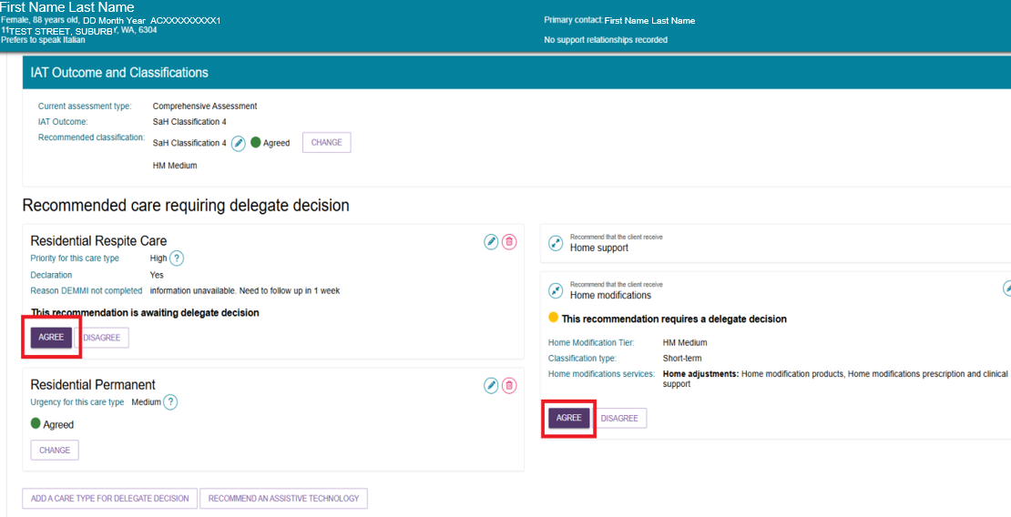
- A confirmation window will ask you to confirm that you approve the recommendation. If needed, enter an approval end date and add comments.
Select AGREE to record your decision.

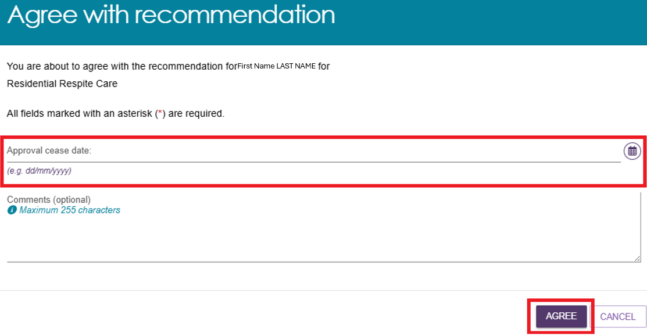
- A confirmation message will appear, and the recommendation status will change to Agreed.
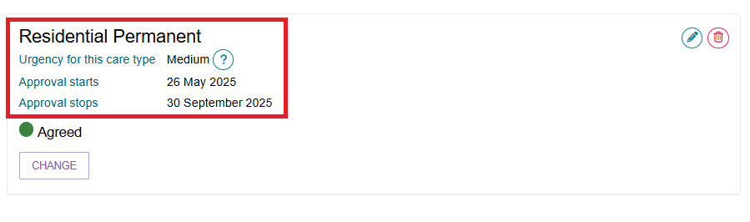
! | Reissuing CHSP Referrals for Urgent Services  Clients who receive urgent services must complete an assessment. If the assessment approves ongoing CHSP services, the system must generate new referrals for those services.  - CHSP providers can continue delivering urgent services until the assessment is complete.  - Once the delegate approves ongoing CHSP services, the urgent service referral should end.  - The system must generate new CHSP referrals before the provider can continue delivering services on an ongoing basis.  If the delegate does not approve the urgent service:  - The system will recall the direct-to-provider referral if the provider has not started the service.  - If the provider has already started the service, the system will notify the provider that the urgent service is not approved and that they must stop delivering the service.

Disagreeing with recommendations
Disagreeing with a recommendation means you do not approve the recommended care type.
If the assessor adds a recommendation in error, you can disagree with that recommendation and, if needed, add a different recommendation.
! | An ongoing Support at Home classification outcome cannot be overridden to an ongoing lower or higher SaH classification outcome (in line with section 81-10 of the Aged Care Rules). Assessors must not undertake this action and delegates must not approve assessments where this occurs, or override and select a lower or higher classification.
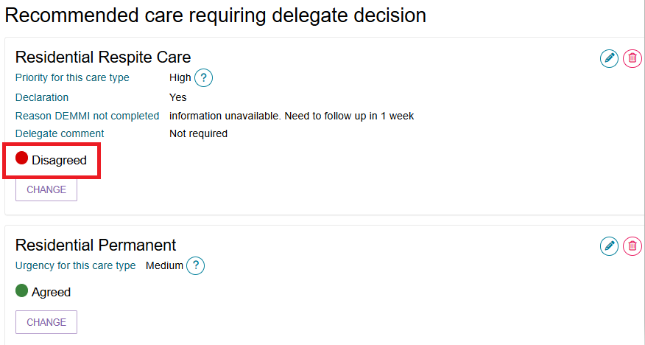
Follow the steps below to disagree with a recommendation:
- Select the expand button to view the recommended care type.
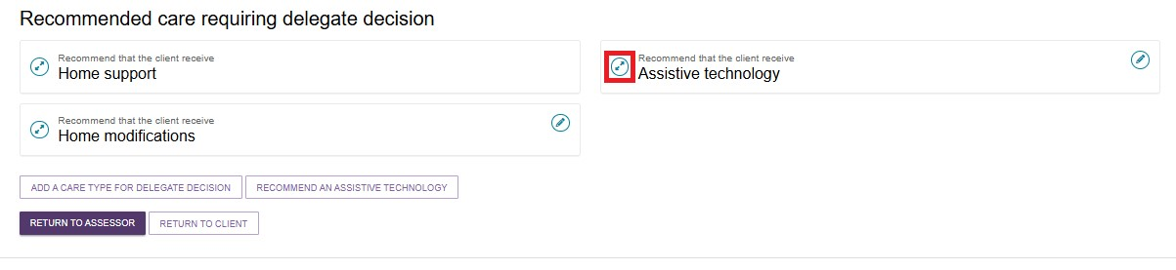
- Select DISAGREE below the recommended care type.
If you disagree with more than one recommended care type, repeat this step for each recommendation.
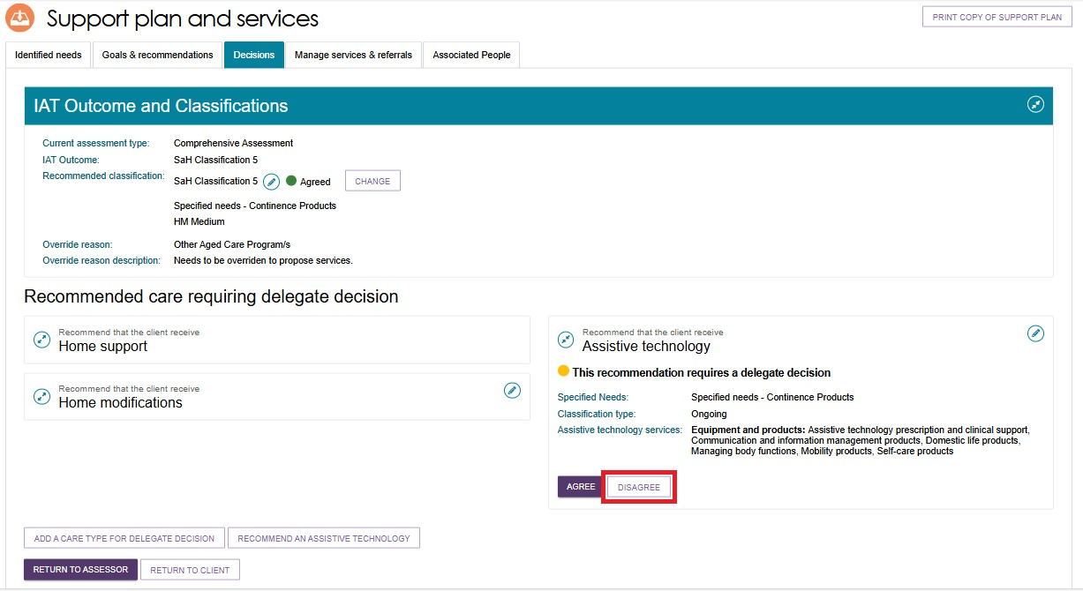
- Enter a comment explaining why you disagree with the recommendation, then select DISAGREE.
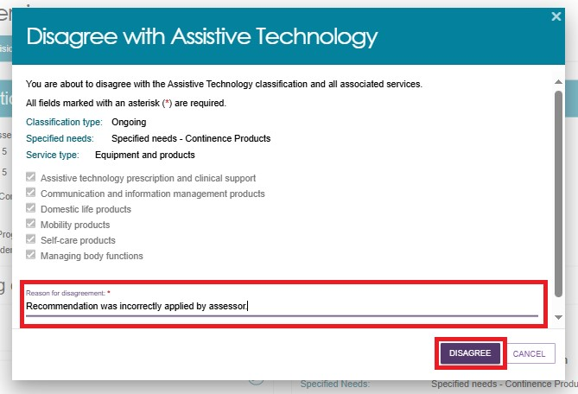
- A confirmation message will appear, and the recommendation status will change to Disagreed.
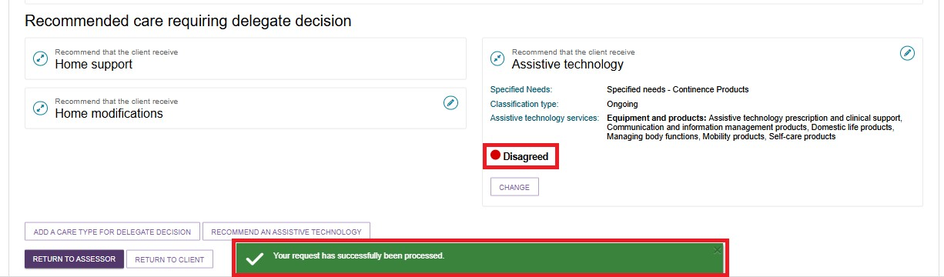
- If you need to update your decision, select CHANGE. You can only use this option before you complete the approval process by selecting Save and Delegate. Refer to the Changing a Decision section for more information.
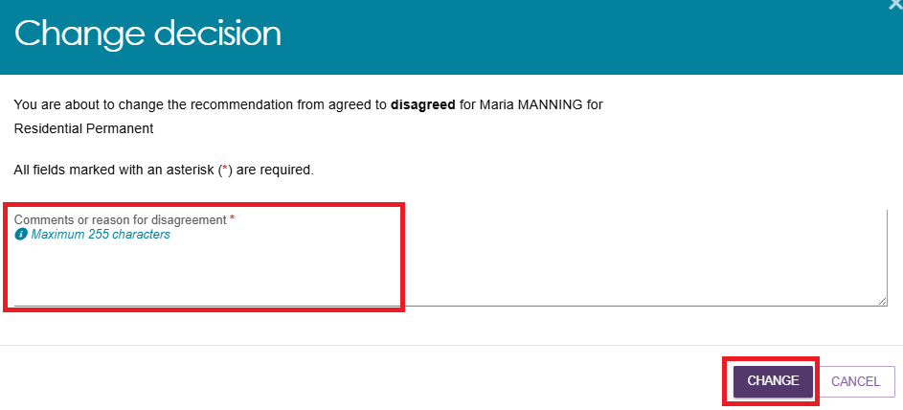

- If you disagree with all recommendations and do not add any new approval decisions, the Save Decision and Delegate window may prompt you to select No Care Approval before you can complete the delegate decision. Go to No Care Approval and No Change to Existing Care Approvals for more information.
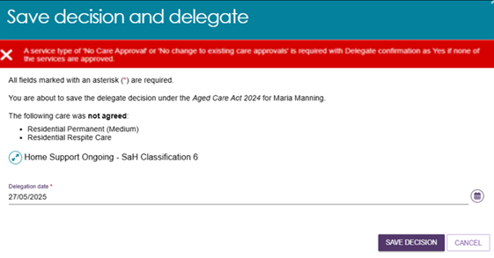

Agreeing or disagreeing with a Support at Home Recommendation
Follow these steps to apply a delegate decision for a client with a recommended Support at Home classification:
- In the Recommend that the client receive Home Support section, select APPLY DELEGATE DECISION.
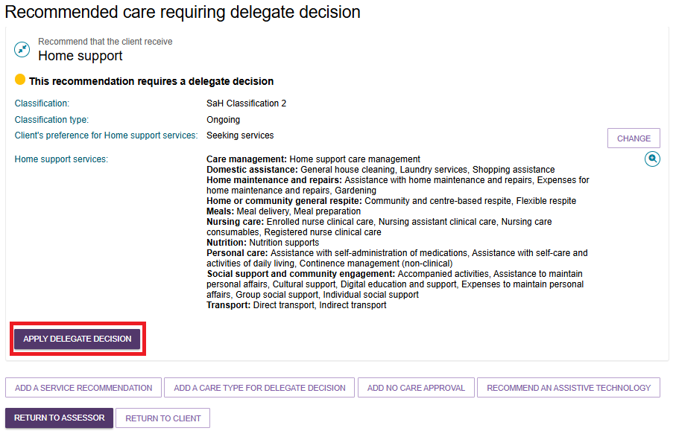
- Review the assessor’s recommended services, including the service type, service, frequency and intensity.
You can:
- Select individual services.
- Select multiple services.
- Use Select All to select all services.
Then select:
- AGREE WITH SELECTED SERVICES, or
- DISAGREE WITH SELECTED SERVICES.
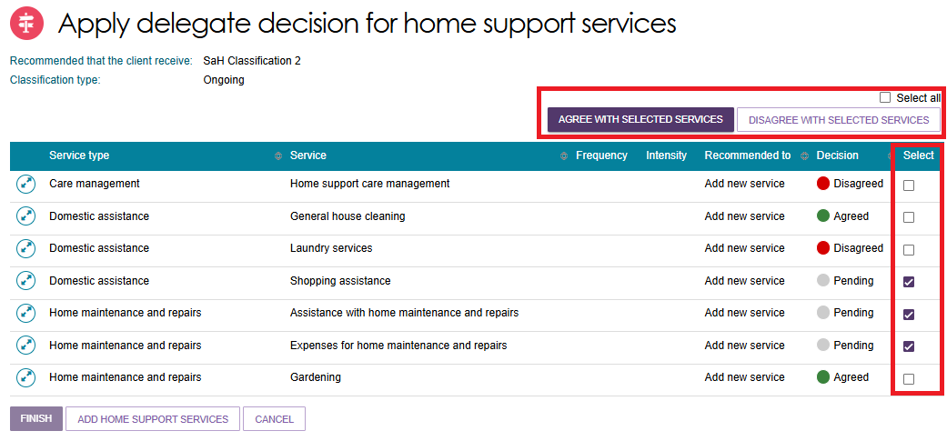
- To review or update an individual service, select the expand icon and then choose AGREE, DISAGREE or UPDATE SERVICE.
If you select UPDATE SERVICE, you can add or change the service frequency and intensity. Select UPDATE to save your changes.
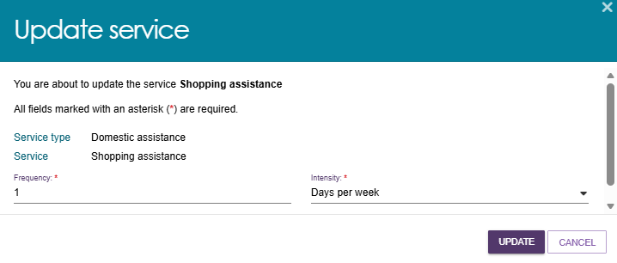
The system will display the updated frequency and intensity on the Apply Delegate Decision for Home Support Services page.
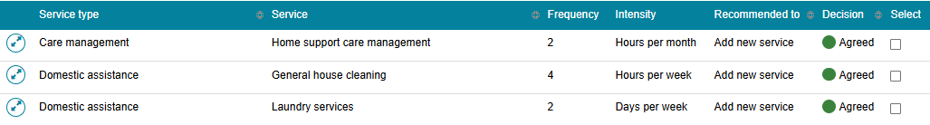
- If you disagree with one or more recommended services, select DISAGREE WITH SELECTED SERVICES. Enter the reason for your decision and then select DISAGREE.
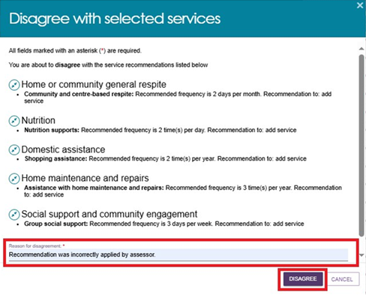
- If you agree with one or more recommended services, select the relevant service checkboxes and then select AGREE WITH SELECTED SERVICES.
The system will include any frequency or intensity changes you made.
If you select a service that you previously disagreed with, the system will replace your earlier decision.
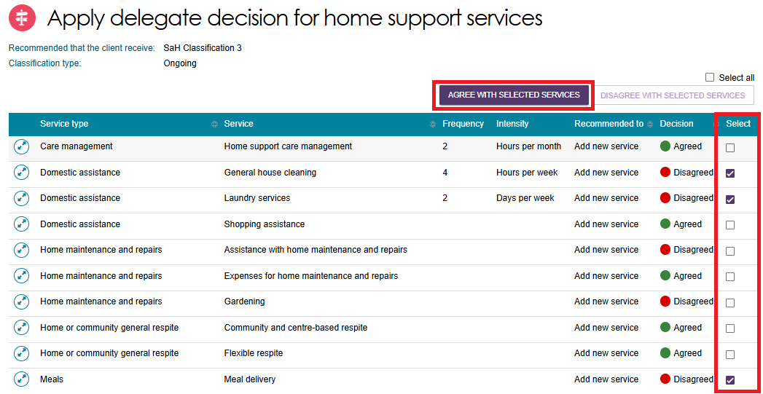
Select AGREE to confirm.
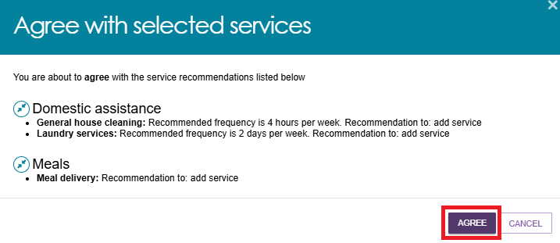
- To add Support at Home services that the assessor did not recommend, select ADD HOME SUPPORT SERVICES at the bottom of the page.

- The Add Home Support Services page will open. Add the required services, frequencies and intensities, then select SAVE TO PLAN.
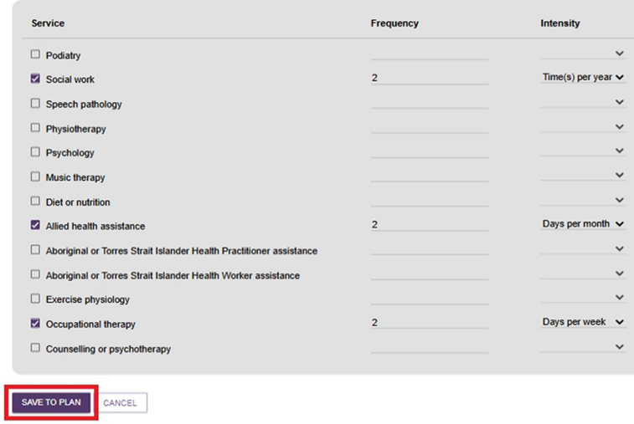
- Review the services you added and select FINISH when you are ready to continue.
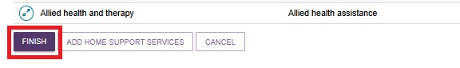
- The system will return you to the Decisions tab of the client's Support Plan and Services page.
At this stage, the Recommend that the client receive Home Support section still displays the assessor's original recommendations.
To review your delegate decisions, select the View (magnifying glass) icon.
When you are satisfied with your decisions, select SAVE AND DELEGATE at the bottom of the page.
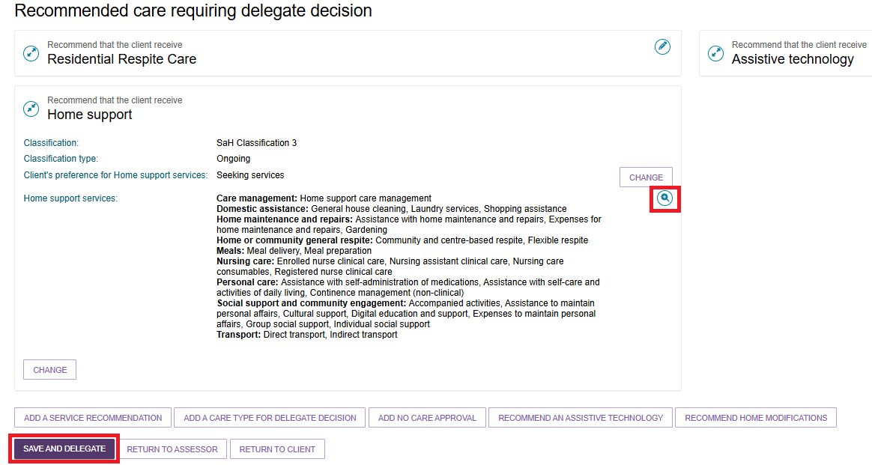
- The Save Decision and Delegate window will open.
The window displays:
- Services you approved, including any updated frequencies and intensities.
- Services you did not approve.
Enter the delegation date and select SAVE DECISION.
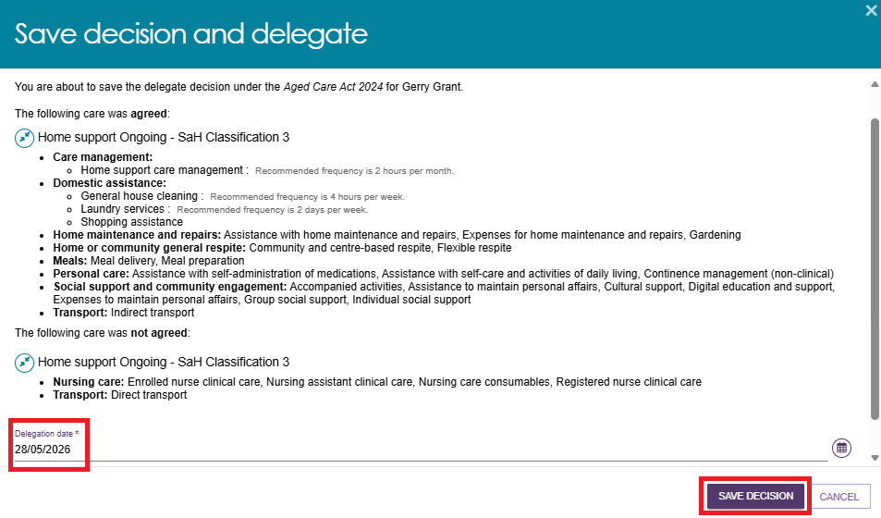
The Support Plan and Services page will display the approval start date.
You can now generate Notice of Decision letters, and Request/change notification of Support at Home correspondence.

Editing a recommendation
- To change a care type or level of care recommended by the assessor, select the Edit icon next to the recommendation.
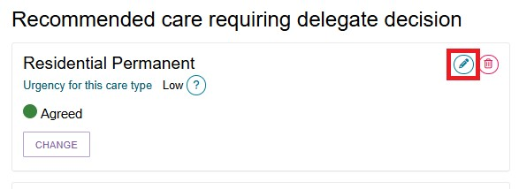
- The Edit Care Type window will open. Update the recommendation as needed, then select SAVE TO PLAN to save your changes.
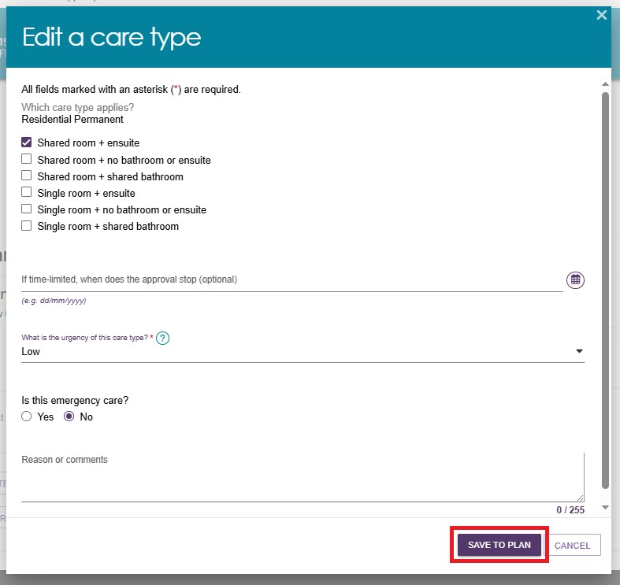

Adding a care type
Assessment Delegates can add an additional care type for delegate decision when needed.
  - In the Decisions tab of the client's Support Plan and Services page, select ADD A CARE TYPE FOR DELEGATE DECISION at the bottom of the page.

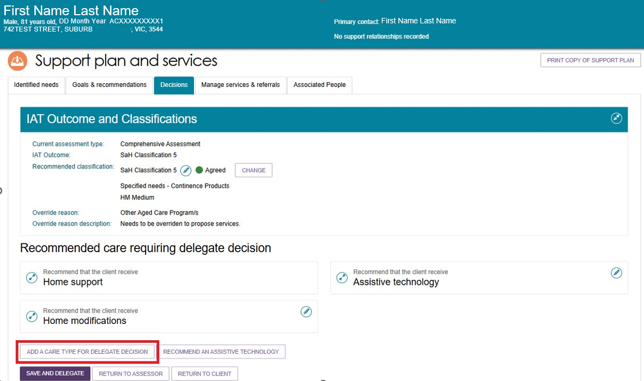
  - In the pop-up window, select the appropriate care type from the drop-down list. Then select the priority for the care type. (The list includes some historical care types. Only use these care types in approved circumstances).
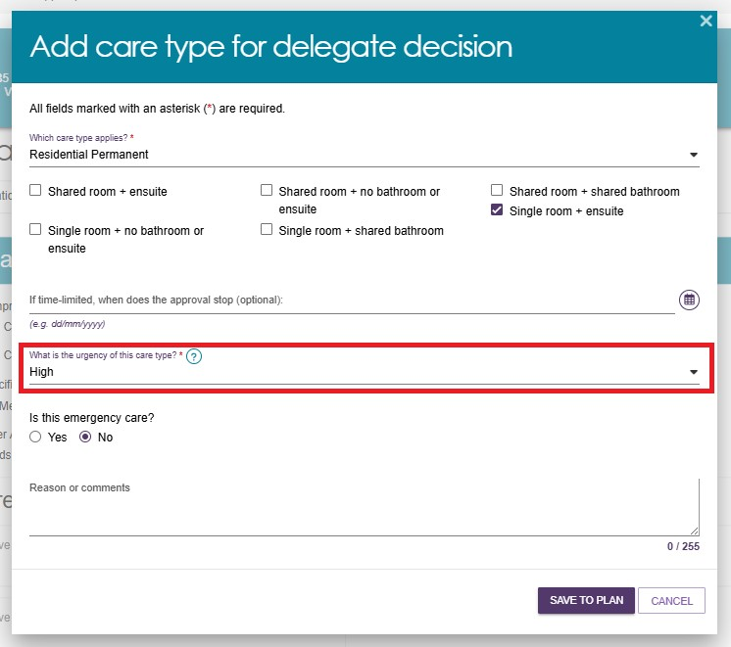
  - The system will add the care type to the Recommended Care Requiring Delegate Decision list and mark the decision as Agreed.
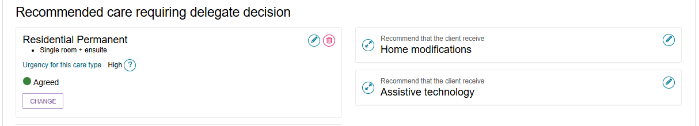

Recommending a Home Modification Service under Support at Home
! | When considering adding/editing Home modifications care recommendations, refer to:  - Support Plan section of My Aged Care – Integrated Assessment Tool (IAT) User Guide  - Approving AT and HM under Support at Home and Approving AT and HM under CHSP sections under Chapter 8 of the My Aged Care Assessment Manual  - Delegate training.
As a Delegate, you can recommend a Home Modification (HM) service when an assessment shows that changes to the client's home are needed to support their safety, independence, or ability to remain at home. Follow these steps to add a Home Modification recommendation:
- From the Decisions tab, select RECOMMEND HOME MODIFICATIONS.
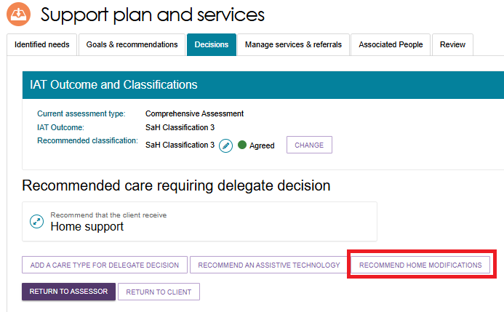The Add Home Modifications Recommendation screen will open.
- Select the appropriate Home Modification tier (Low, Medium, or High) from the drop-down list.
- The Service Type field will appear pre-filled and cannot be changed.
- Indicate whether the client wants to seek Home Modification services through the Support at Home program.
Select SAVE TO PLAN to add the recommendation.
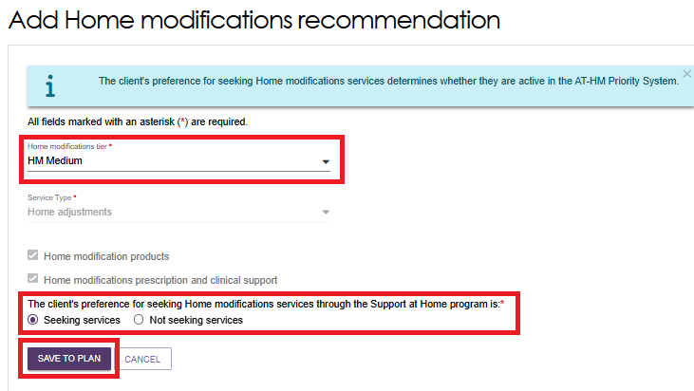

Recommending an Assistive Technology Service under Support at Home
! | When considering adding/editing Assistive technology care recommendations, refer to:  - Support Plan section of My Aged Care – Integrated Assessment Tool (IAT) User Guide  - Approving AT and HM under Support at Home and Approving AT and HM under CHSP sections under Chapter 8 of the My Aged Care Assessment Manual  - Delegate training.
As an Assessment Delegate, you can recommend an Assistive technology service when the client's assessment identifies a need for equipment or devices that support daily living, safety or independence. These services help clients live safely and independently at home.
Assistance Dogs are included under the Ongoing Assistive technology classification. In the system, this service is listed as Specified Needs – Assistance Dogs.
Follow these steps to add an Assistive technology recommendation:
From the Decisions tab, select RECOMMEND AN ASSISTIVE TECHNOLOGY.
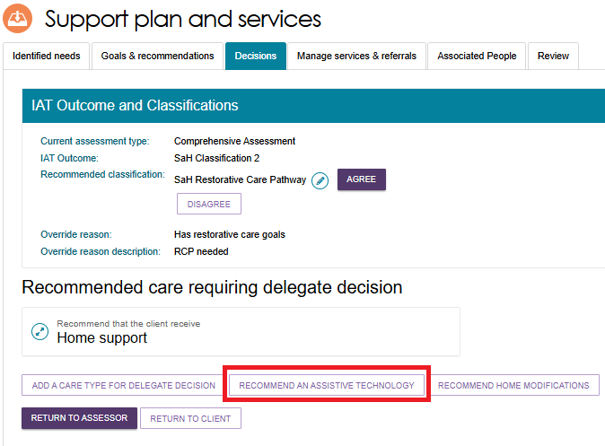
- The Add Assistive technology recommendation screen appears.
Select the classification type from the drop down list.
If the classification type is Short-term, select the technology tier from the drop-down list. If it is Ongoing, assistance dogs is available under the Specified Needs section.
Choose whether the client want to seek Assistive technology services through the Support at Home program. Then, select SAVE TO PLAN.
Assistive Technology Short Term example
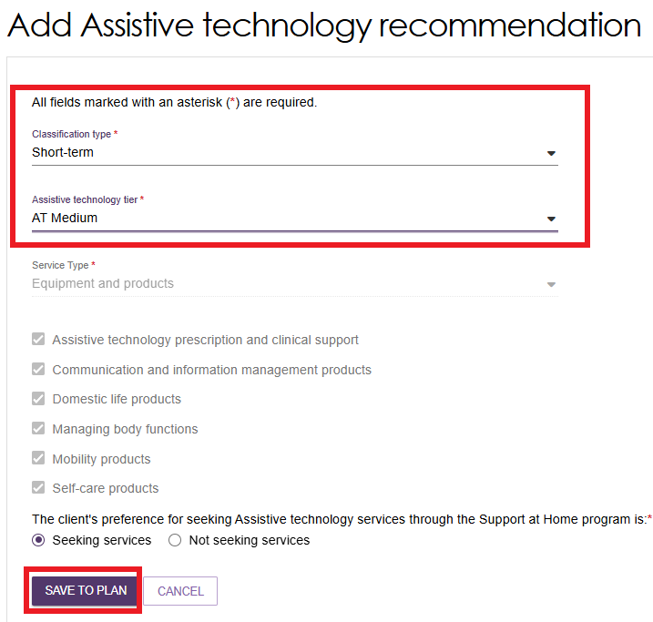
Assistive Technology Ongoing example
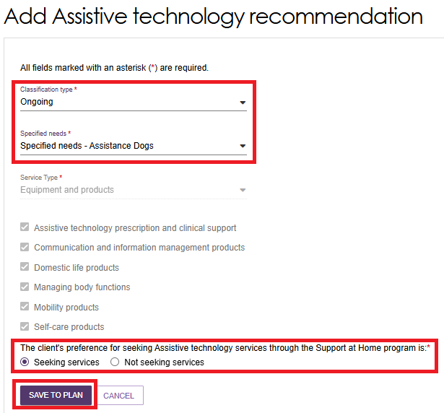
- The recommendation will be displayed within the Decisions tab under Recommended care requiring delegate decision section. Expand the item to view the details. Select AGREE or DISAGREE. You can also edit the recommendation using the Edit (Pencil) icon as shown in the example below.
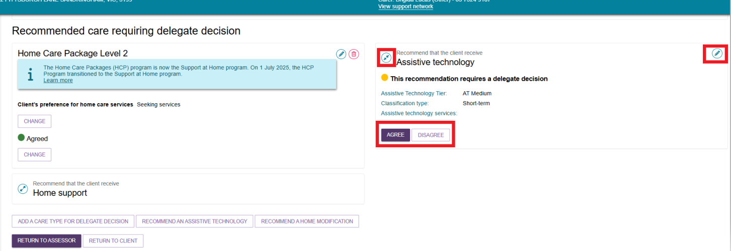

Recommending a second Restorative Care Pathway unit
! | A delegate should not approve both a client's Restorative Care Pathway (including any associated Assistive Technology and Home Modification recommendations) and the client's support plan review.  A different delegate should approve the support plan review wherever possible.  A delegate may approve both only if they can confirm that no other delegate is available to make the approval decision.
Clinical Assessment Delegates can add a second Restorative Care Pathway (RCP) unit during the delegate decision process when a client is already receiving a Restorative Care Pathway and is undergoing a Support Plan Review.
A limited number of RCP units are available each financial quarter. When considering a second RCP unit, assessors and delegates should monitor departmental communications about RCP unit availability before making a recommendation or approval decision.
! | Delegates must not add a second Restorative Care Pathway unit if the participant has not started their first Restorative Care episode.
- From the Assessor Portal home page, select the Delegate Decisions tile.
- Select the client who requires a second RCP unit. The client must already have an approved and active Restorative Care Pathway.
- Open the client's support plan, select the Decisions tab, and then go to the IAT Outcome and Classification section. Then, select ADD SECOND UNIT OF RESTORATIVE CARE PATHWAY.
- The Add Second Unit of Restorative Care Pathway window will open. Review the information provided, then select ADD SECOND UNIT.
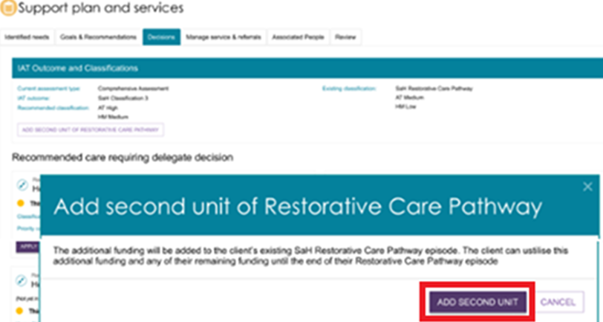
- The second RCP unit will appear in the client's Current Care Approvals section. The system will also record your decision in the Delegate Decisions and Comments section.
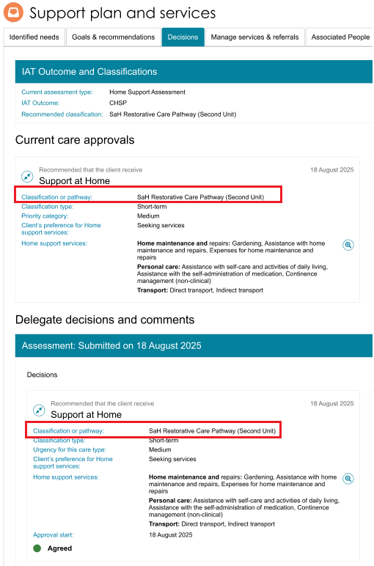

Changing a decision
- If you need to change your decision from Agreed to Disagreed, or Disagreed to Agreed, select CHANGE.
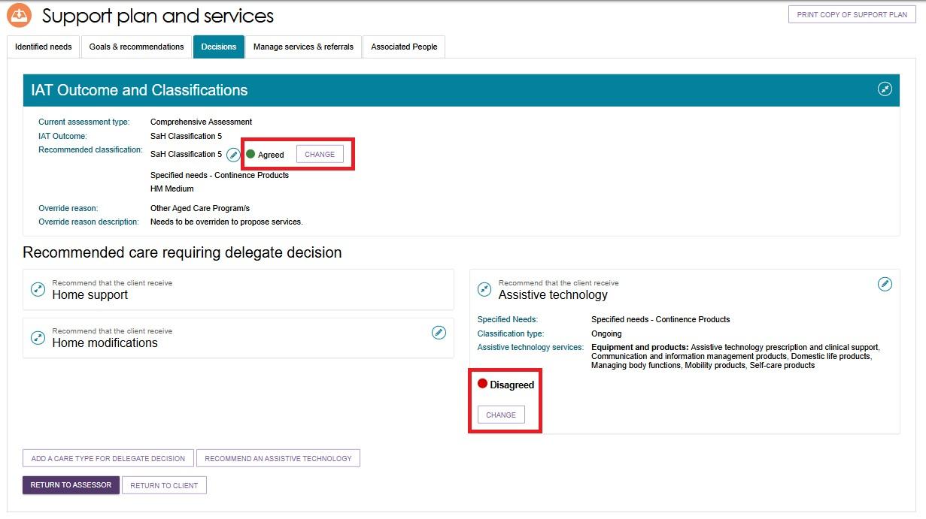
- In the pop-up window, enter an approval end date and add comments if required.
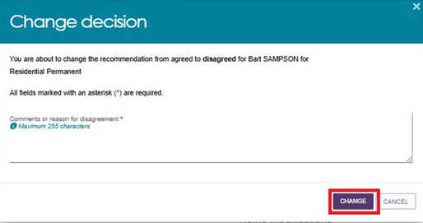
- If you change the decision from Agreed to Disagreed, enter a reason for the change.
You can only change a decision before you complete the approval process by selecting Save and Delegate.
- A confirmation message will appear.


Editing a recommended classification
- Go to the Delegate Decisions tile and open the client record as described in Viewing Decisions information.
- Select the Edit (pencil) icon next to the current recommended classification.
- The Edit Recommended Classification window will open.
- Select the new recommended classification.
- Select an override reason.
- Enter a description explaining the change.
- Review and action any warning messages that appear.
- Complete any additional mandatory fields, such as the client's preference for seeking Home Support services.
Select SAVE TO PLAN to save your changes.

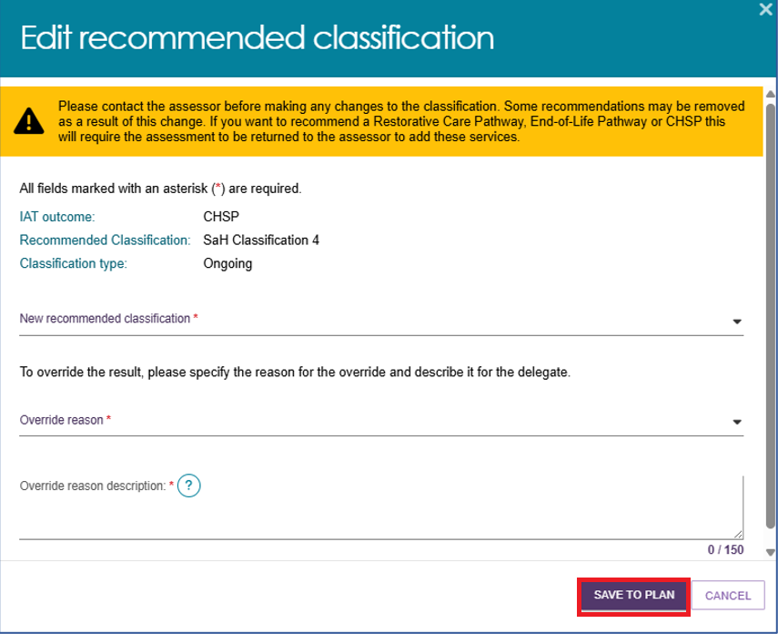
! | An ongoing Support at Home classification outcome cannot be overridden to an ongoing lower or higher SaH classification outcome (in line with section 81-10 of the Aged Care Rules). Assessors must not undertake this action and delegates must not approve assessments where this occurs, or override and select a lower or higher classification.
- If you select a Support at Home classification, the Edit Home Support Services screen will open.
- Review the default services for the selected classification.
- Confirm or update the service, frequency and intensity details.
- Select SAVE TO PLAN at the bottom of the page.
- The updated recommended classification will appear in the IAT Outcome and Classifications section of the Decisions tab. The update may take up to 60 seconds to display.
- 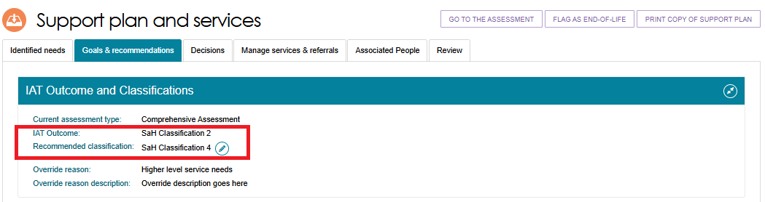
- Clinical Assessment Delegates can correct Residential Permanent recommendations within 43 days of making the decision. During this period, you can:
- Add a Residential Permanent recommendation.
- Remove a Residential Permanent recommendation.
- Change the urgency level.
- Update the approval expiry date.
- Update emergency needs.
- Update the Delegate date (approval start date).

Finalising your decision
Follow these steps to save and complete your delegate decision:
- After you have reviewed and recorded all decisions, select SAVE AND DELEGATE.
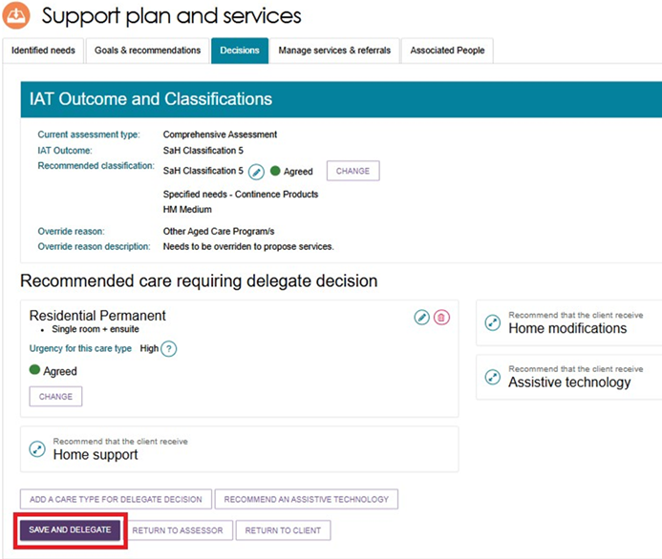
- The Save Decision and Delegate window will open and display:
- Care types you approved.
- Care types you did not approve.
Review the information carefully.
- If you need to update your decision, select CANCEL.
- Confirm that the delegation date is correct.
- For some care types, you can select the expand button to view additional details.
If you are satisfied with the decisions and the delegation date, select SAVE DECISION.
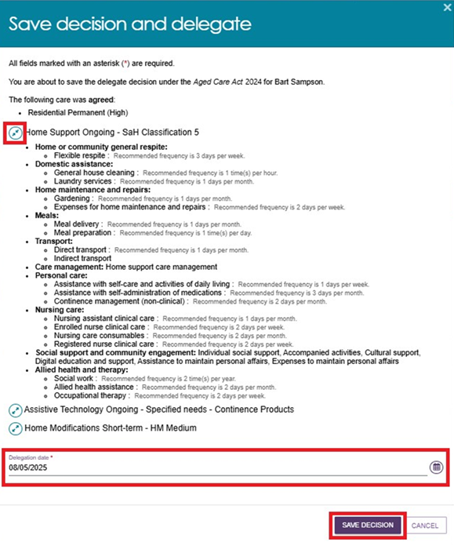
! | If you completed the approval process outside the system before recording it in the assessor portal, you can enter the earlier delegation date shown on the Approval Form.  You can download the Approval Form from the Reports and Documents tile in the assessor portal. The form provides evidence that you made the approval decision before entering it into the system.  Attach the completed Approval Form in the Attachments tab.  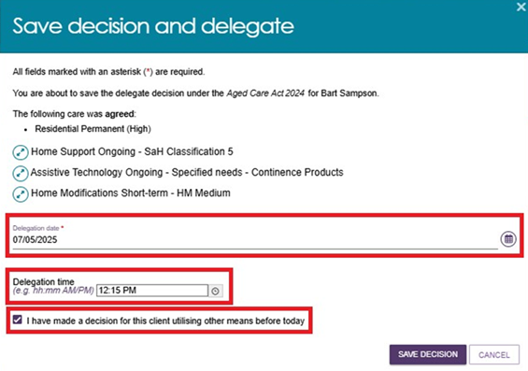
- A confirmation message will appear to confirm that:
- The system has sent the approvals to Services Australia for processing.
- The system has recorded the delegate decision.
- The system has sent the decision to the Clinical Assessor to finalise the client's support plan and complete service matching and referrals.
The Client Journey Tracker will then update to show one of the following messages:
- "You have been approved for Australian Government-funded aged care services", or
- "After careful consideration, you have not been approved to access Australian Government-funded aged care services".
The system will only display the approval message if you approve at least one service.
Client Journey Tracker showing client is approved for care
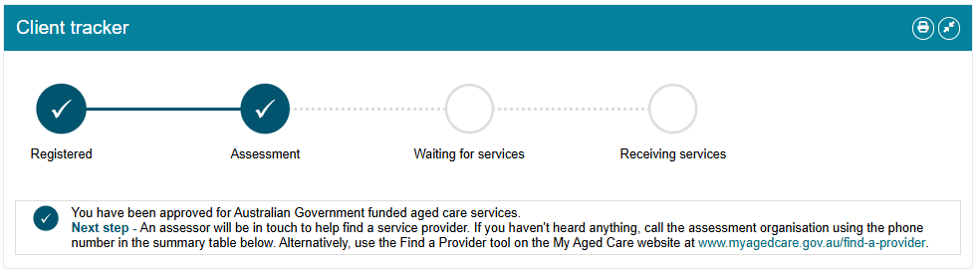

Non-Clinical Delegate workflow process
Non-clinical Assessment Delegates have the authority under the Act to approve entry-level services resulting from a Home Support Assessment.
They can approve access only to the Commonwealth Home Support Programme (CHSP), Assistive technology (AT), and Home modifications (HM) under CHSP. They cannot approve services under the AT-HM Scheme.
If the client requires any other type of approval, the assessor must convert the assessment to a Comprehensive Assessment. Once converted, the approval is sent to a Clinical Assessment Delegate for decision. A Clinical Assessment Delegate must approve all other service types and approvals, as outlined in the next section.

Agreeing with recommendations
To agree with the assessor’s recommendations:
- Select AGREE below the recommended service.

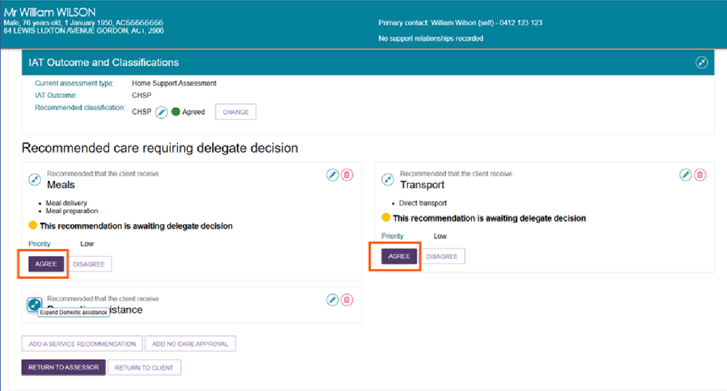
- When the confirmation pop-up appears, select AGREE to confirm your decision.
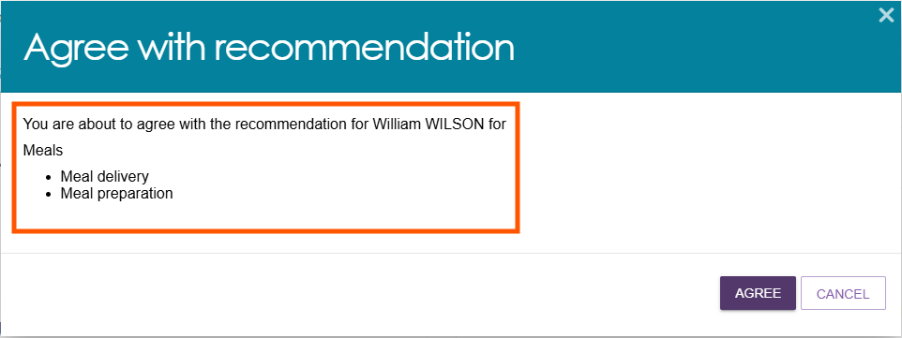
- The system displays a confirmation message and updates the recommendation status to Agreed.
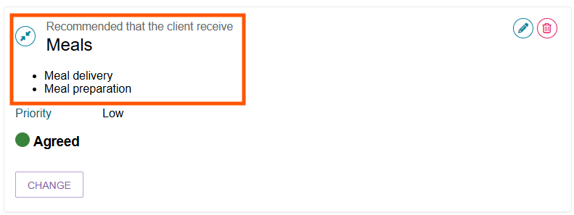

! | Urgent services and Ongoing CHSP Referrals  All clients who receive urgent services must complete an assessment. If the assessment approves ongoing CHSP services, you must create new CHSP referrals for those services.  - CHSP providers can continue delivering urgent services until the assessment is complete.  - When ongoing CHSP services are approved, the urgent service referral should end.  - Create new CHSP referrals so the provider can continue delivering services on an ongoing basis.  If the delegate does not approve the urgent service:  - If the service has not started, the system recalls the direct-to-provider referral.  - If the service has already started, the system notifies the provider that the urgent service is not approved and that they must stop delivering the service.

Disagreeing with recommendations
If you disagree with a recommendation, the system will not approve that service.
If an assessor adds a recommendation in error, you can disagree with that recommendation and, if needed, add your own recommendation.
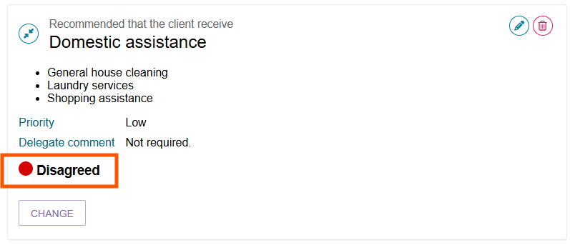
To disagree with a recommendation:
  - Select the expand button to view the recommended service.
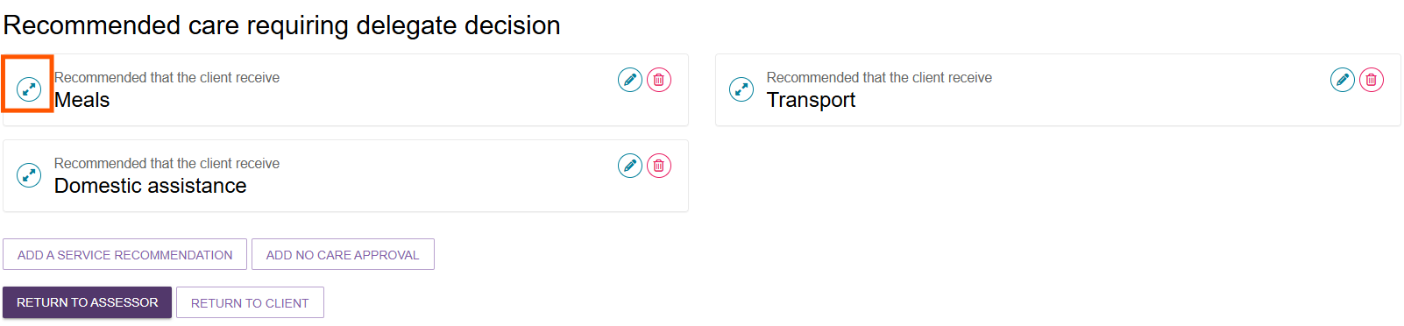
  - Select DISAGREE below the recommended service. Repeat this step for each recommendation you want to disagree with.
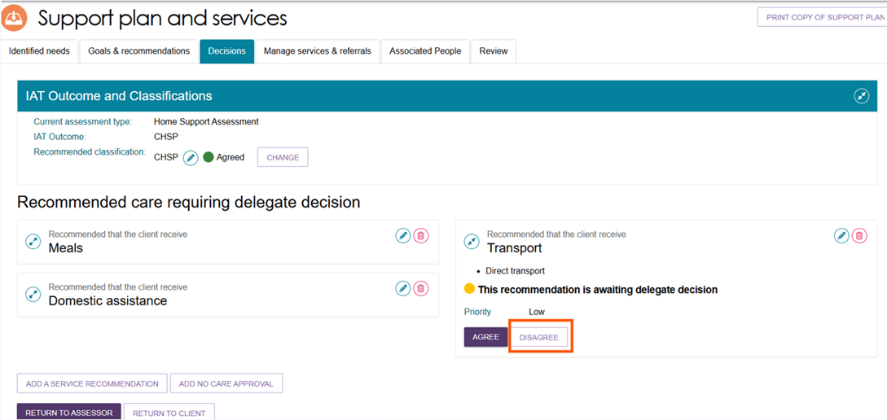
  - Enter a comment explaining why you disagree with the recommendation, then select DISAGREE.
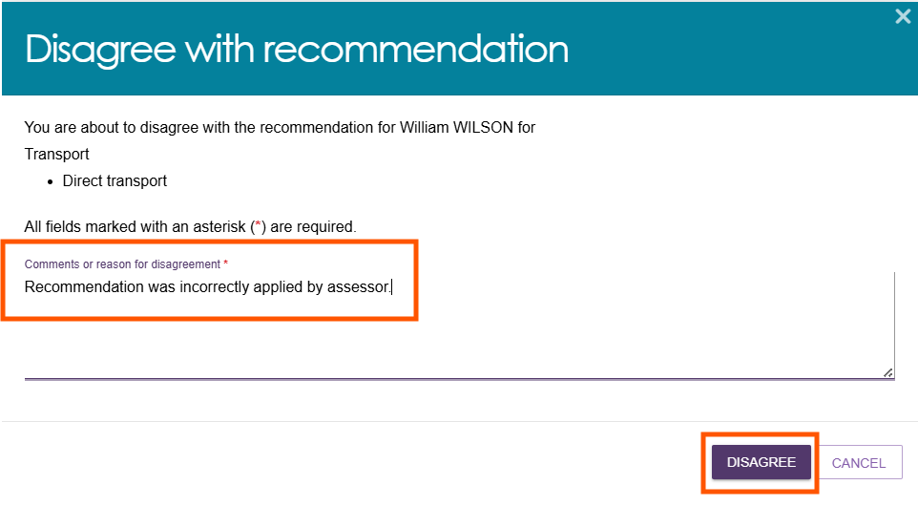
The system displays a confirmation message and updates the recommendation status to Disagreed.
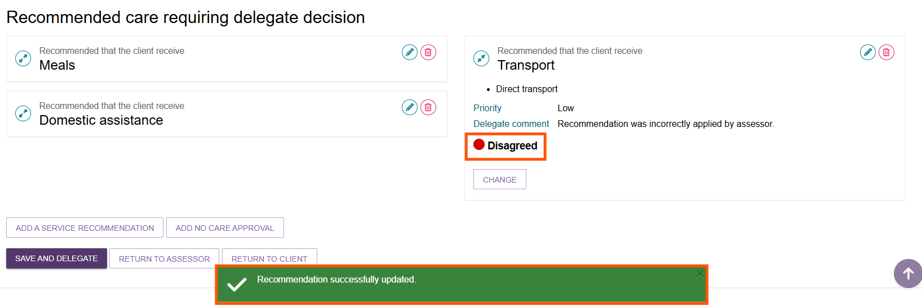

  - If you need to change your decision before completing the approval process, select CHANGE.
- This option is available only until you save and complete the approval process by selecting Save and Delegate.
- For more information, refer to Changing a Decision.
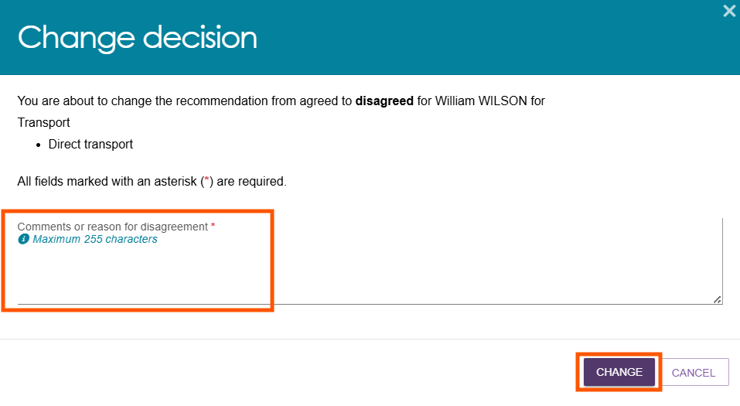

Editing a recommendation
To edit a service recommended by an assessor:
  - Select the Edit icon next to the recommendation.
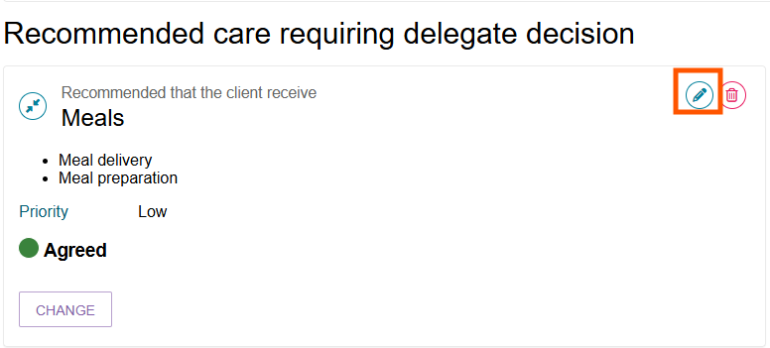
  - In the Edit Care Type pop-up, make the required changes.
Select SAVE TO PLAN to save your changes.
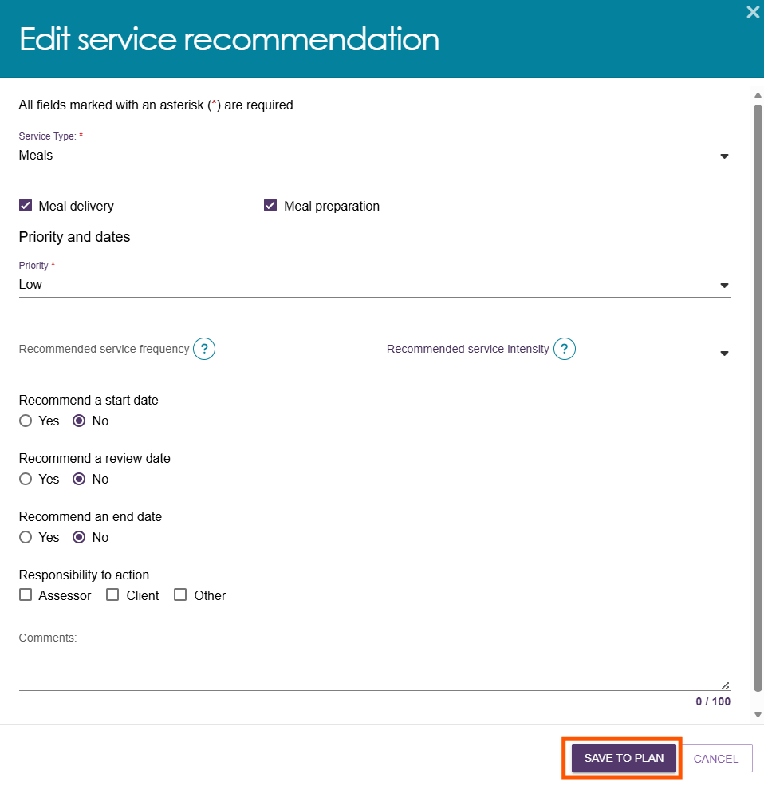

Changing a decision
To change your decision for a service:
- Select CHANGE to update your decision from Agreed to Disagreed, or from Disagreed to Agreed.
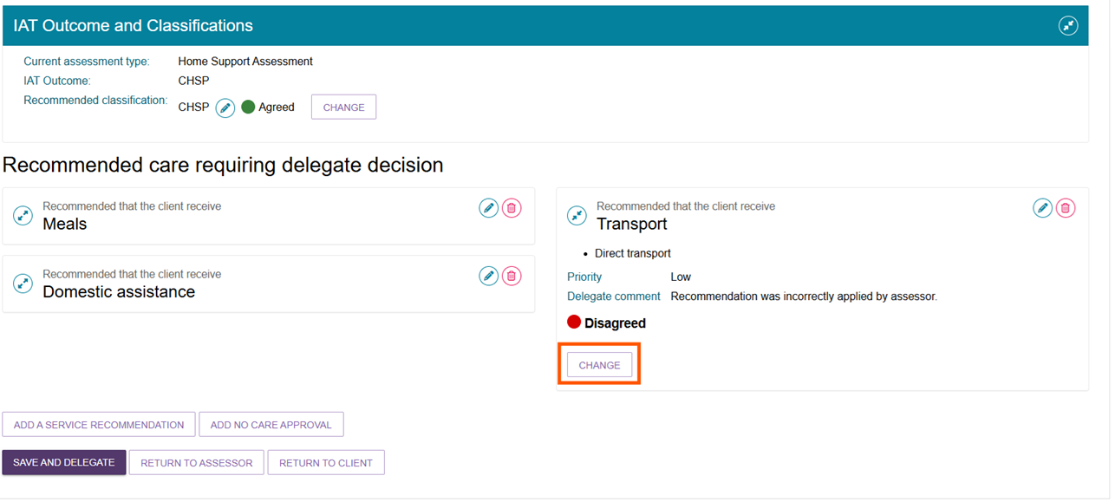
- In the pop-up window, add an approval cease date and comments if required.
- If you change the decision from Agreed to Disagreed, enter a reason for the change.
You can only change a decision before you complete the approval process by selecting Save and Delegate.
- The system displays a confirmation message.

Adding CHSP services
Non-Clinical Assessment Delegates can add service recommendations for a client when required.
- Select ADD A SERVICE RECOMMENDATION.

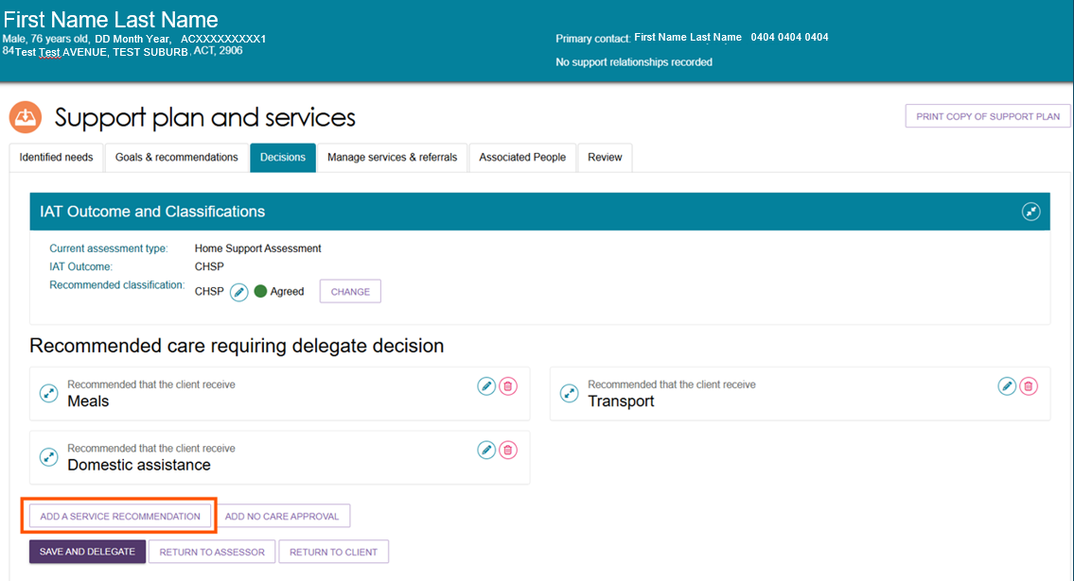
- In the pop-up window, select the appropriate service from the drop-down list.
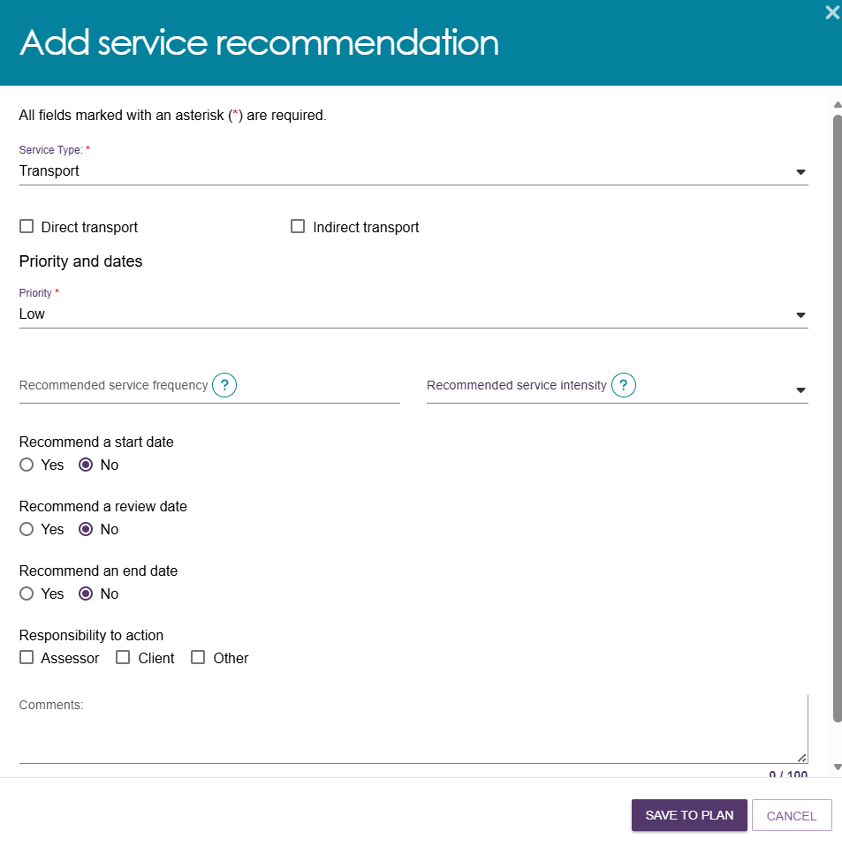
The system adds the service to the Support Plan and sets the decision to Agreed by default.
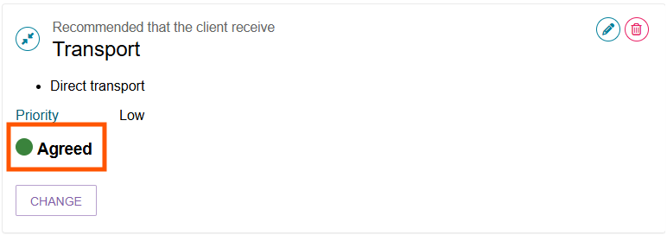

Finalising your decision
To complete the approval process:
- After making your decision, select SAVE AND DELEGATE.
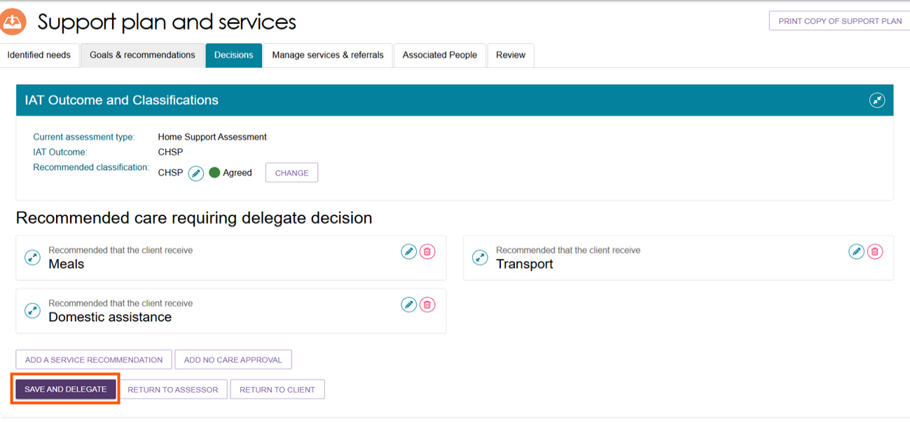
- Review the confirmation pop-up, which shows the services you agreed to and the services you did not agree to.
If you need to update your decision, select CANCEL and make the required changes.
Check that the delegation date is correct.
For some service types, select the expand button to view additional information.
If you are satisfied with the decision and the delegation date, select SAVE DECISION.
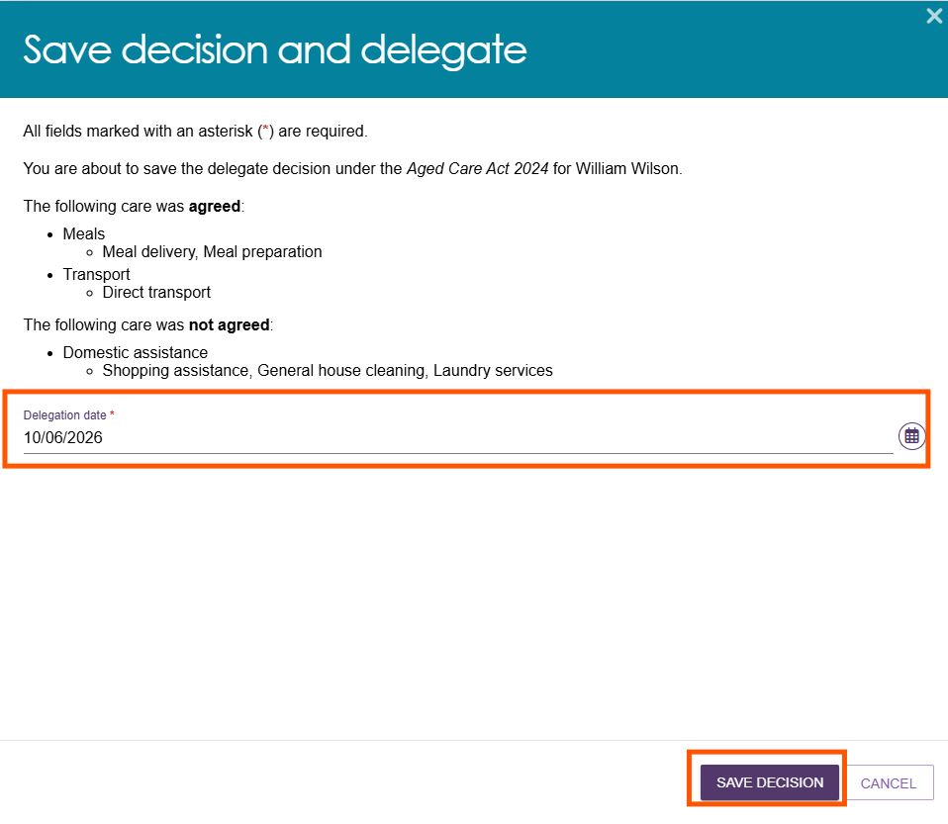
- After you save the decision, the Client Journey Tracker updates with one of the following messages:
‘You have been approved for Australian Government-funded aged care services.’ or
‘After careful consideration, you have not been approved to access Australian Government-funded aged care services.’
The client will only receive the approval message if you approve at least one service.
Client Journey Tracker showing client is approved for care

! | If you completed the approval outside the system before recording it in the portal, you can enter the earlier delegation date shown on the Approval Form.  You can download the Approval Form from the Reports and Documents tile in the Assessor Portal. The form provides evidence that you made the approval decision before recording it in the system.  Attach the Approval Form to the Attachments tab.
- Correspondence Notifications
If you approve a Support at Home classification or a Residential Care classification, you can choose to receive notifications about correspondence the department sends to the client.
For Support at Home, you may want to receive notifications if the client is vulnerable and may need support from a clinical assessor to connect with Home Support services.
Examples of Residential Care correspondence include:
- Allocation of a permanent residential care place.
- A notification that an approval is about to expire.
For more information about notifications and tasks in the assessor portal, refer to My Aged Care – Assessor Portal User Guide 9 – Tasks and notifications.
To set up correspondence notifications:
- Open the client's record and go to the Approvals tab.
In the Correspondence section, select the expand button.
You can nominate one person from the outlet to receive Support at Home correspondence notifications.
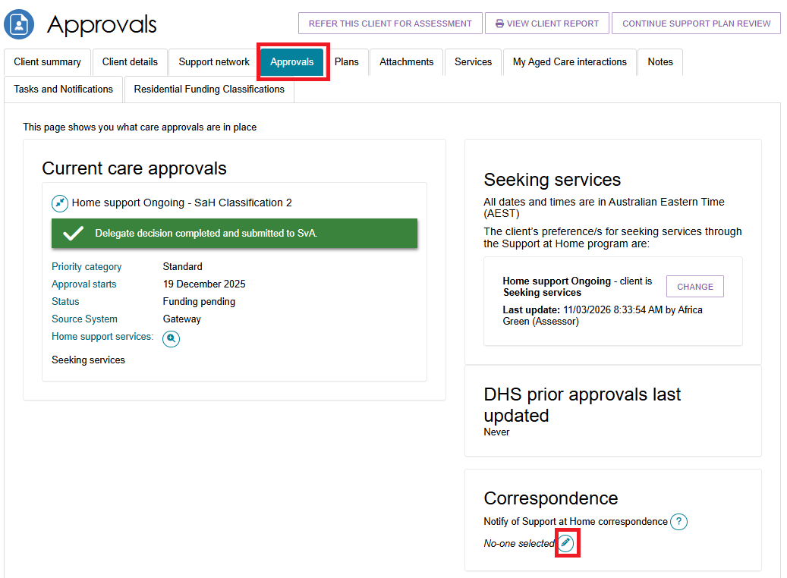
- A pop-up window appears. Select Notify of Home Care/Support at Home Correspondence. Select a recipient from the drop-down list, then select SAVE.
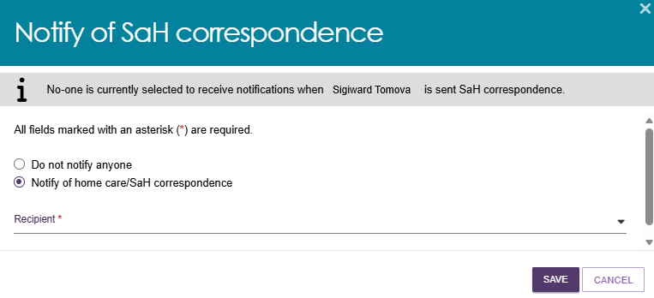
- Your nominated recipient appears in the Correspondence section of the client’s Approvals tab.
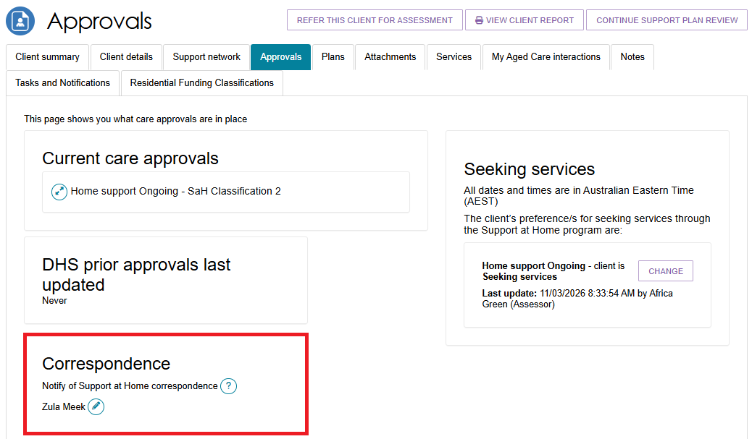

Notice of Decision (approval or non-approval) letter and SaH Restorative Care Pathway (Second Unit) approval and non-approval letter
After completing the delegate decision, you can generate and upload a Notice of Decision (NoD) letter or a Support at Home (SaH) Restorative Care Pathway (second unit) approval letter. You can do this for both approval and non-approval decisions.
To generate, print, and upload a letter:
- Open the client’s Support Plan and go to the Decisions tab.
- Select the appropriate letter option for the client’s circumstances.
The buttons on the Decisions tab and the options in the pop-up window will vary depending on the available letter types.
- Generate, print, and upload the required letter.
You can also upload Notice of Decision letters from the Attachments tab.
If you agree to more than one care type recommendation for a client, you only need to generate, upload, and print one approval letter. The letter will include all approved care types.
A person with the Delegate Support role can also generate, print, and upload these letters.

Approval Letters
! | For approval decisions, include the following information in the Notice of Decision:  - The approved service groups, and where relevant, the approved service types and services.  - The approved classification type for each service group.  - the approved classification levels for each service group.  - The approved priority category, where applicable.  - The reasons for the decision and the evidence that supports it.  - Information about the older person's review rights if they want to question or challenge the decision.  Including this information helps ensure clients receive clear, consistent, and high-quality decision letters.
To generate, upload, and save an approval letter:
      - Open the client’s profile and select the Plans tab. On the Plans page, select Support Plan.
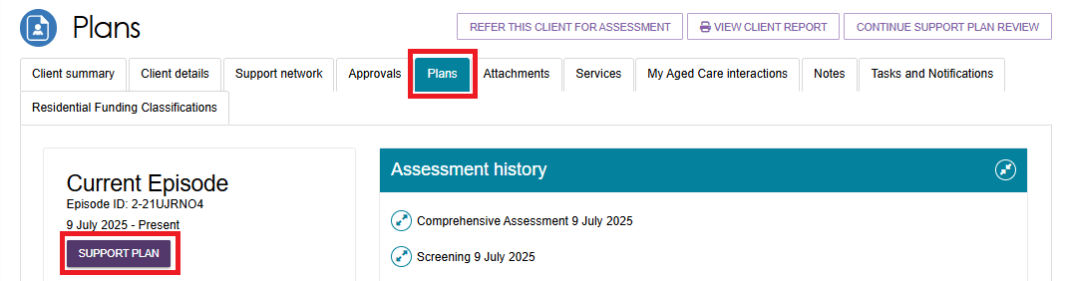
      - On the Support Plan and Services page, select the Decisions tab. At the bottom of the page, select GENERATE APPROVAL LETTER.
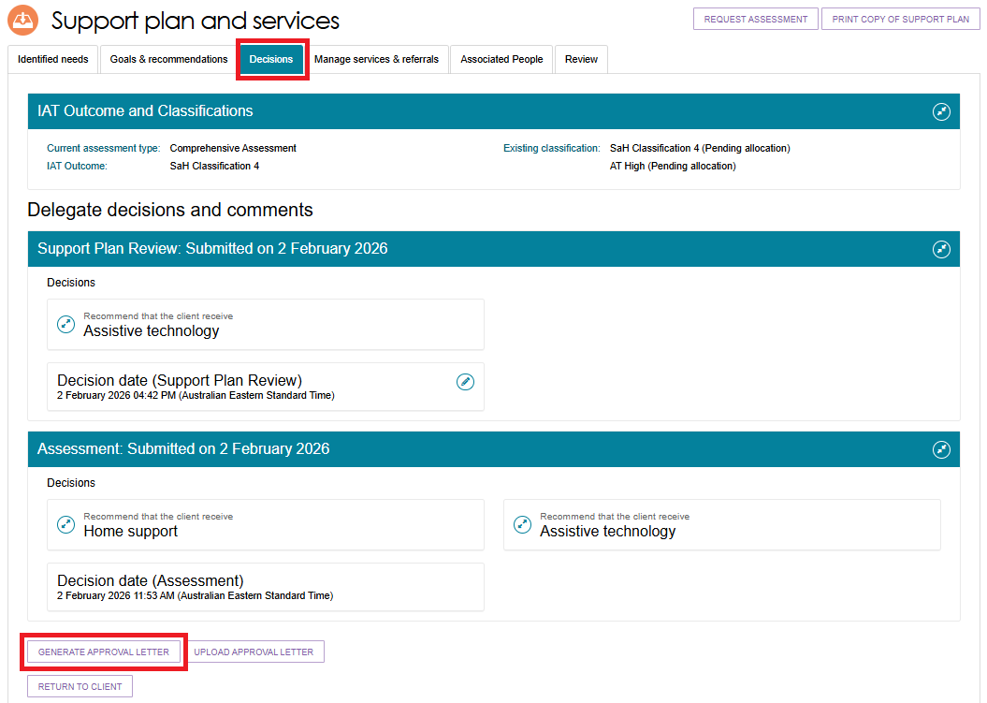
      - In the Generate Approval Letter pop-up, confirm that you have selected the correct client, then select GENERATE APPROVAL LETTER.
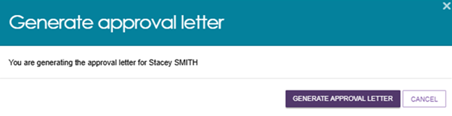
You can generate a Notice of Decision (NoD) approval or non-approval letter, or a Support at Home Restorative Care Pathway (Second Unit) approval letter using the same process.
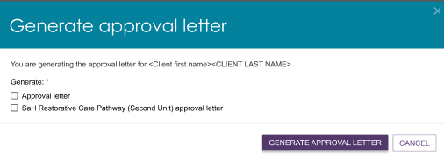
      - If the letter takes longer than expected to generate, the system redirects you to the Reports tab. Select View to open the letter.
The system keeps NoD letters and Referral Code letters in Recently Requested Reports for seven days. After that, you can generate them again using the same process.
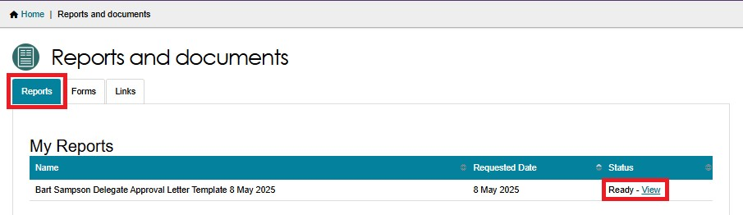
      - After signing the letter, return to the Decisions tab and select UPLOAD APPROVAL LETTER to upload it to the client’s record.
You can also upload the letter from the Attachments tab.
Decisions Tab
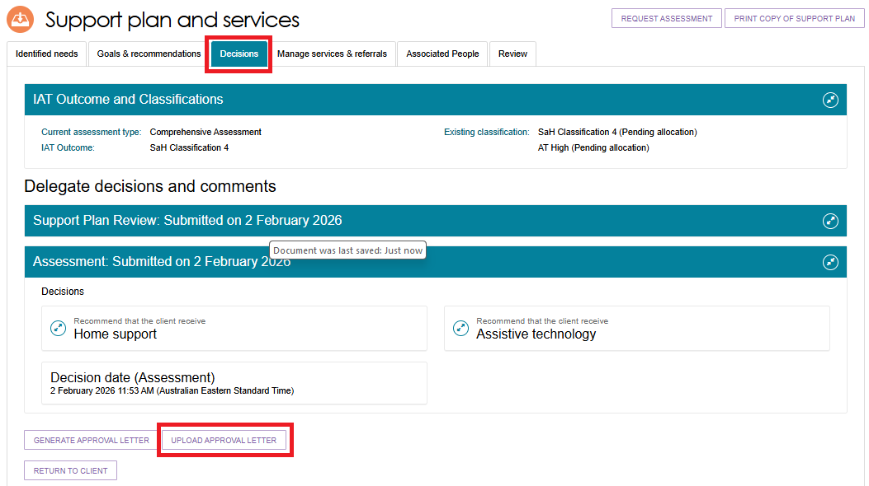
Attachments Tab
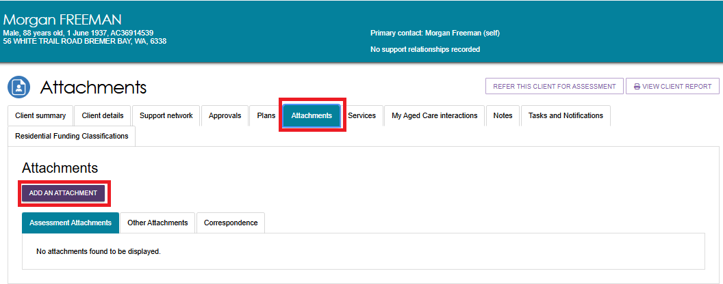
In the Upload Approval Letter or Add Attachment pop-up:
- Select the approval letter file to upload.
- Approval letters must be uploaded in PDF format. PDF format ensures the document cannot be changed after finalisation.
- The system generates NoD letters in Rich Text Format (.rtf) by default, but you cannot upload this format.
- Do not upload Word documents as formal approval letters.
- Enter an attachment name.
- If you are uploading the letter, select Approval letter sent to client as the attachment type.
- Optionally, add a short description.
- Select UPLOAD.
UPLOAD APPROVAL LETTER EXAMPLE
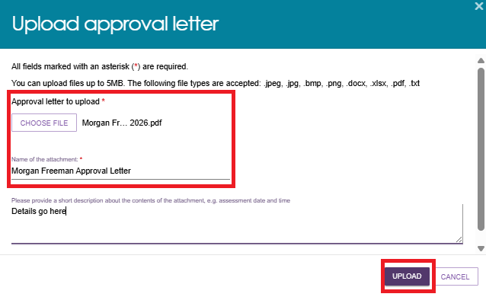
ADD AN ATTACHMENT EXAMPLE
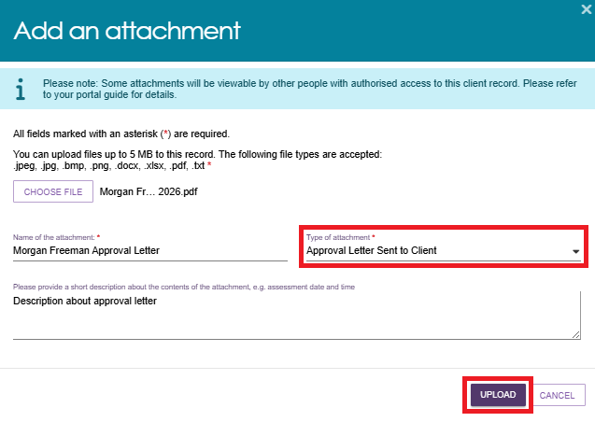
      - The uploaded letter appears in the Attachments tab.
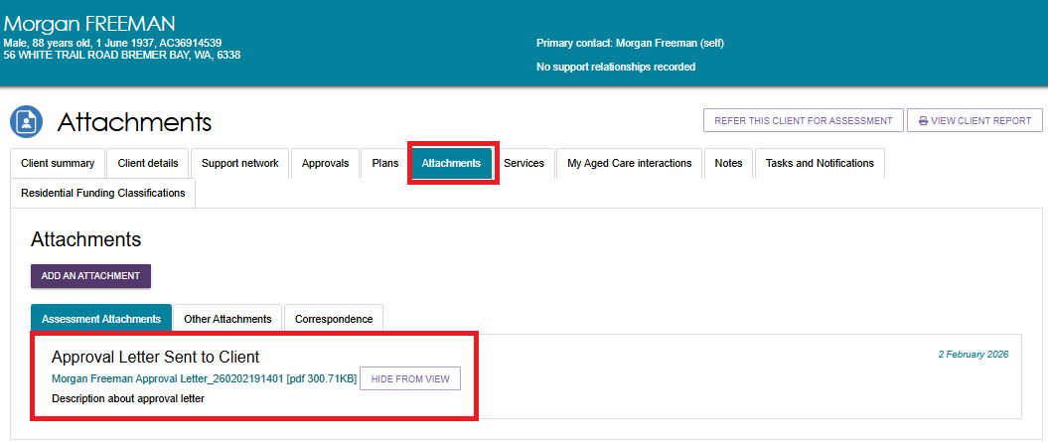

Non-approval Letters
Delegates can only generate a non-approval letter when the decision includes No Care Approval or No Change to Existing Care Approvals.
To generate, upload, and save a non-approval letter:
- Open the client’s profile and select the Plans tab. On the Plans page, select Support Plan.
- Go to the Decisions tab of the support plan and select GENERATE NON-APPROVAL LETTER at the bottom of the page.
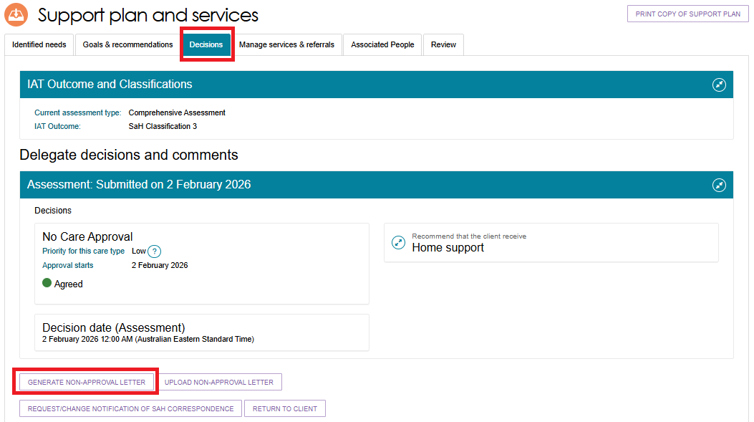
If the letter takes longer than expected to generate, the system redirects you to the Reports tab. Select View to open the letter.
The system keeps user-generated documents, including Notice of Decision (NoD) letters and Referral Code letters, in Recently Requested Reports for seven days. After that, you can generate them again using the same process.
If you do not approve a second concurrent unit of Restorative Care Pathway (RCP) funding, use the offline template Letter Template – Second Concurrent Unit of RCP Funding (or a similarly titled template). You can find this template in Reports and Documents under the Forms tab.
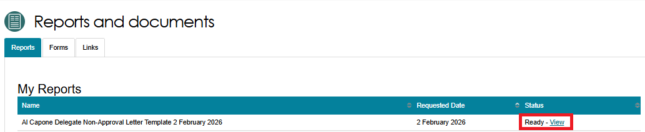
- After signing the letter, return to the Decisions tab and select UPLOAD NON-APPROVAL LETTER to upload it to the client’s record.
You can also upload the letter from the Attachments tab.
Decisions tab of the Support Plan
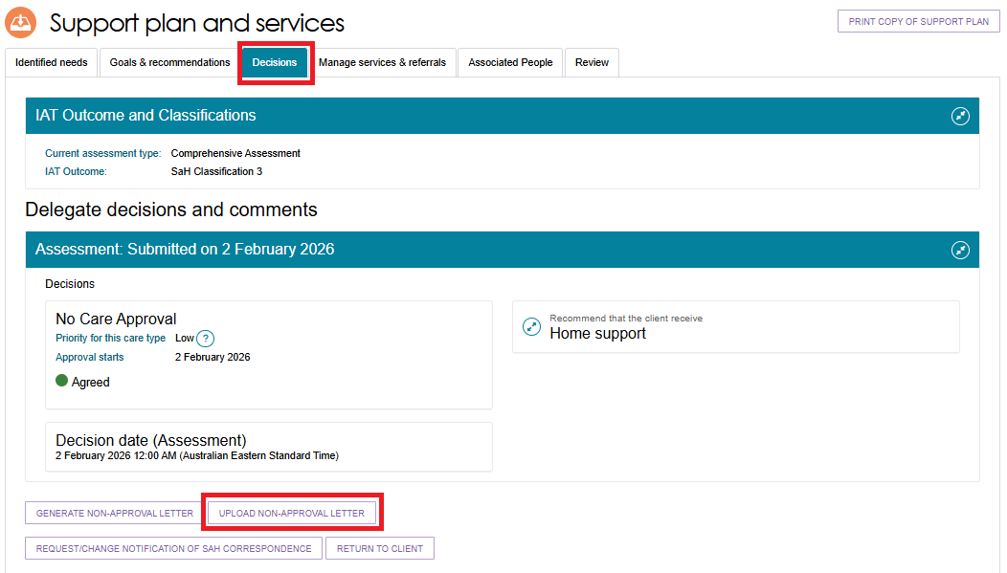
Attachments Tab of the Client Record

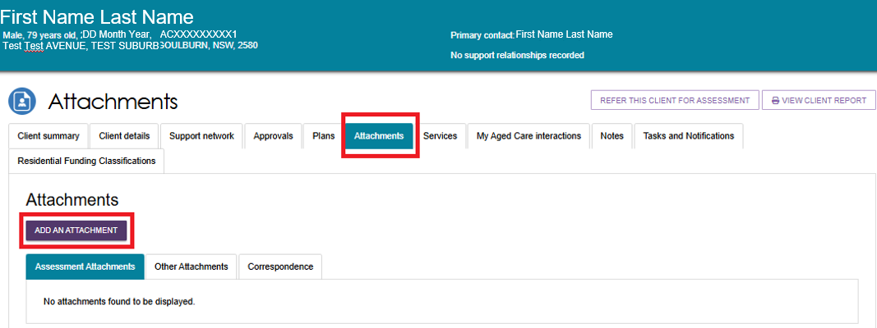
- In the Upload Non-Approval Letter or Add Attachment pop-up:
- Select the non-approval letter file.
- Upload the letter in PDF format only. PDF format ensures the document cannot be changed after finalisation.
- The system generates NoD letters in Rich Text Format (.rtf) by default, but you cannot upload this format.
- Do not upload Word documents as formal non-approval letters.
- Enter an attachment name.
- Select Non-approval letter sent to client as the attachment type.
- Optionally, enter a short description of the attachment.
- Select UPLOAD.
Upload Non-approval letter pop up example
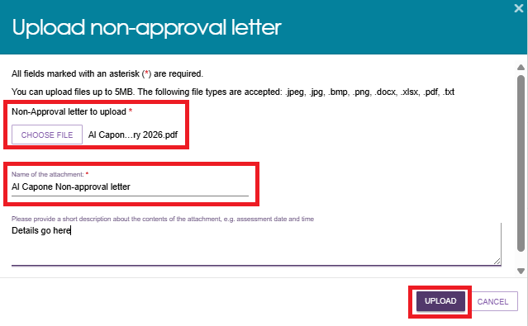
Add an attachment example
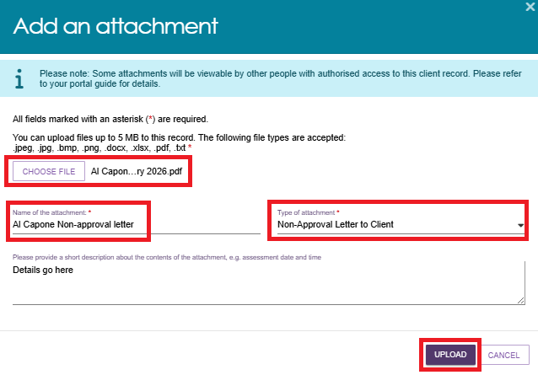
- The uploaded non-approval letter appears in the Attachments tab.

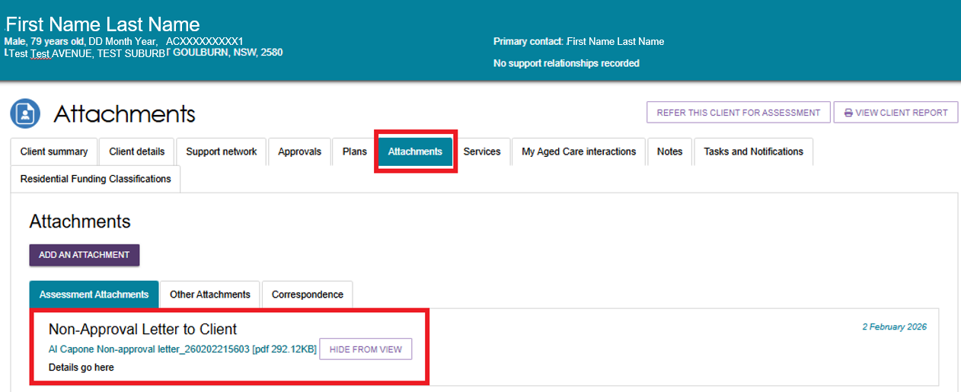

Managing services and referrals
Complete the Notice of Decision for a Home Support Assessment before you manage services or issue referrals. For more information about managing referrals, refer to Assessor Portal User Guide 8 - Referring for Services.

Requesting correction to care approval decision
You can request a correction if you make an error when recording a decision.
You can submit a correction request up to 42 days after the original delegation date, provided there are no active or commenced service referrals.
To request a correction to a care approval decision:
In the Delegate Decisions area of the portal, open the Decision History tab.
- Select the expand arrow on the client card to view a summary of the client’s information.
If you are using List View, expand the client information to access the same options.
- Select REQUEST CHANGES TO CARE APPROVAL DECISION.
- Card View

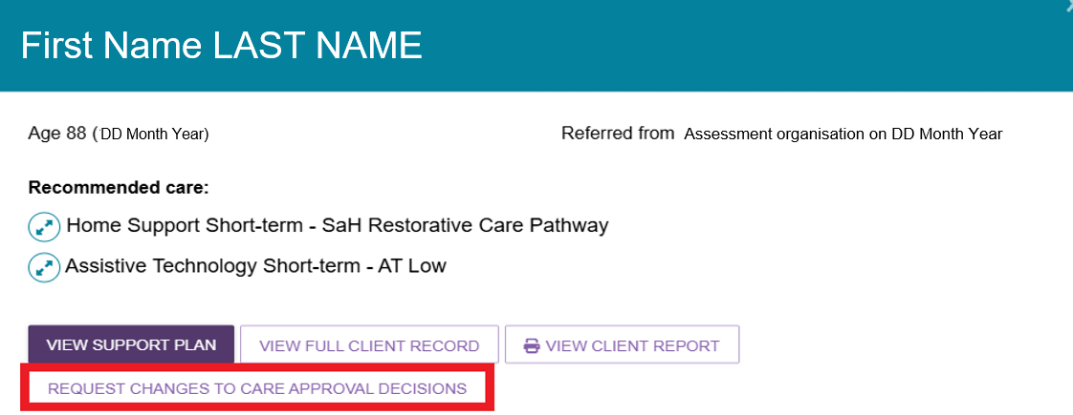
List View

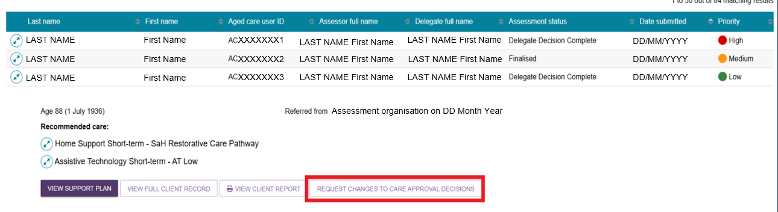
- Enter the reason for the change and provide supporting information. Ensure your reason aligns with the assessment information recorded for the client.
Select OK, START CHANGES.
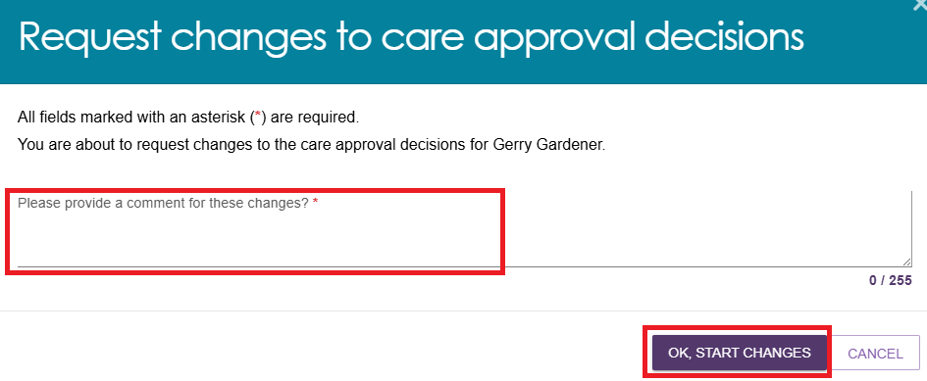
- The system redirects you to the client’s Support Plan and Services page and displays a confirmation message that the correction request is in progress.
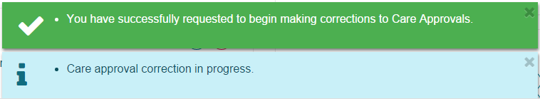
- Update the care approval decision as required. You can
- Add or remove care types.
- make changes to the commencement date of the delegate decision
- request a correction to remove and add care classifications within a care type.
- To view previous corrections, open the Decision History tab and select VIEW CORRECTIONS HISTORY.

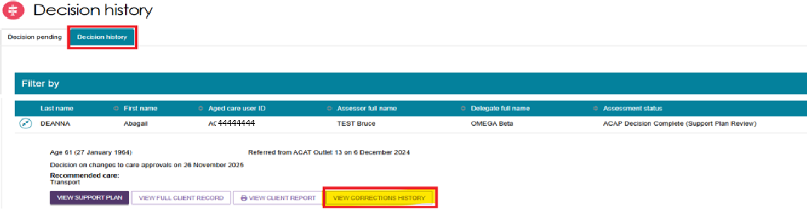

Making changes to the Decision Date of the delegate decision
Delegates can change the Decision Date (commencement date) of a delegate decision.
This option is available for Comprehensive Assessments and Home Support Assessments, and for all three decision stages: Assessment, Support Period, and Support Plan Review. However, you cannot change decisions for Permanent Residential Care, Residential Respite Care, or Transition Care during the Support Period or Support Plan Review stages.
If a client has multiple decision dates on their record, you can only change the most recent decision date.
To change the Decision Date:
- Before changing the decision date, complete the required declarations and attach the Offline Approval Form.
- Go to Delegate Decisions and Comments, open the relevant client record, and select the Edit (pencil) icon next to the Decision Date field.
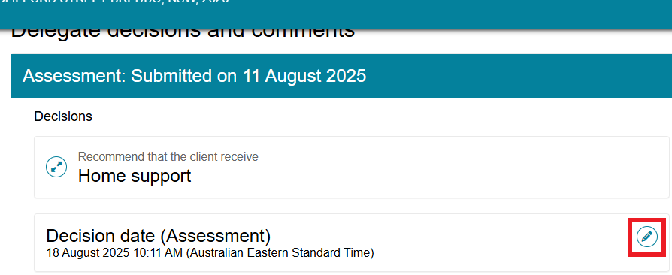
- In the Edit Delegation Date pop-up window, enter the required information.
- Use the date picker to select the delegation date.
- Use the time picker to select the delegation time.
- Select SAVE TO PLAN.
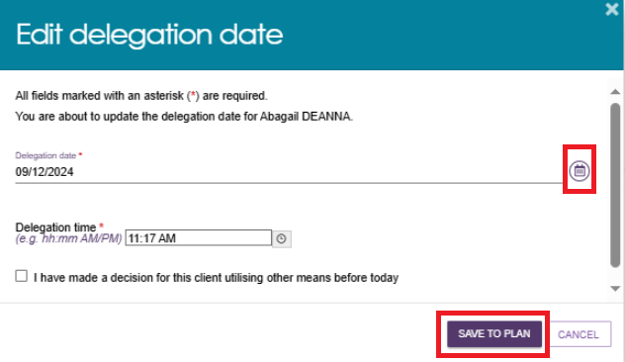
- The system displays green and blue banners confirming that it has saved the change and showing its status.
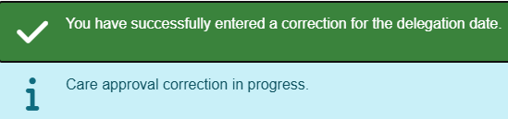
- Select SUBMIT FOR AGED CARE ASSESSMENT (ACAP) PROGRAM.
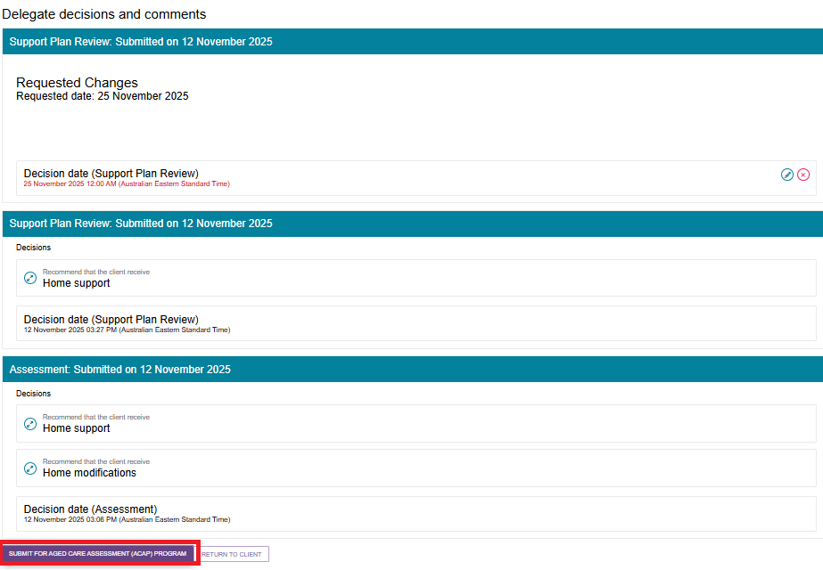

Requesting a Correction to Remove and Add Care Classifications within a care type
- To remove a care classification or service approval that was added in error, select the Remove (bin) icon next to the decision.
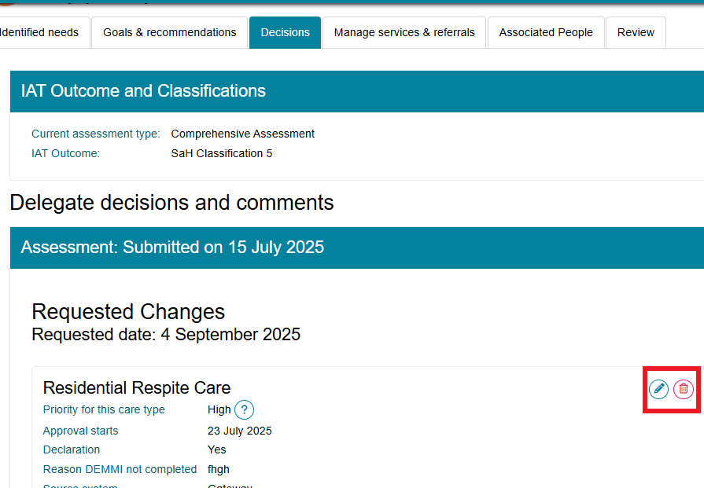
- In the confirmation pop-up, select REMOVE RECOMMENDATION.
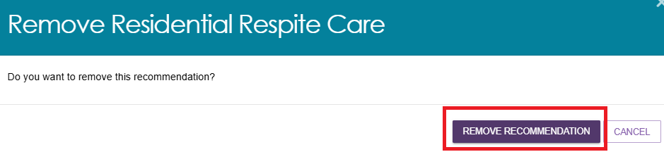
- The system displays a green banner to confirm that it has removed the care approval.
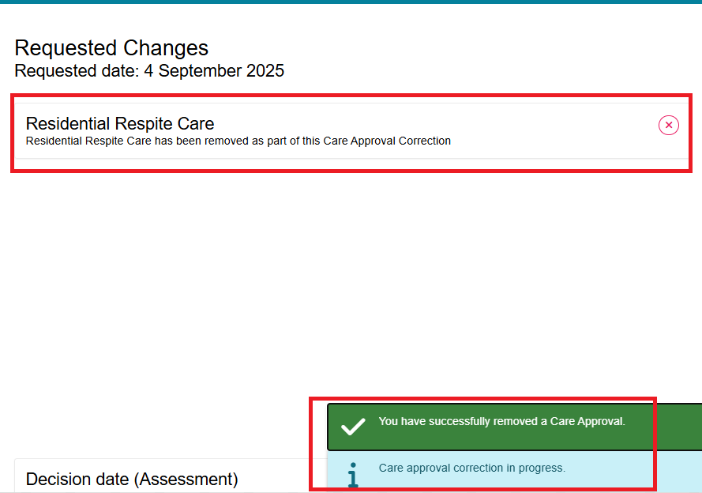
- To add the correct program or service approval, select ADD A CARE TYPE FOR DELEGATE DECISION.
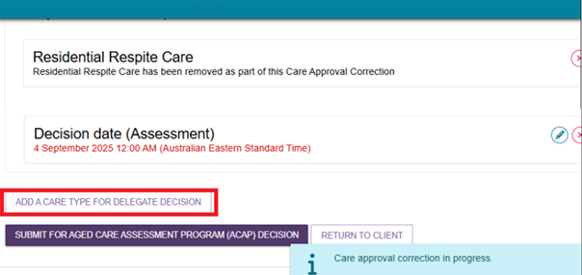

- In the pop-up window, enter the correct care type, service level, and priority for the Clinical Assessment Delegate decision.
- Complete all required fields marked with a red asterisk (*).
- Select SAVE TO PLAN.
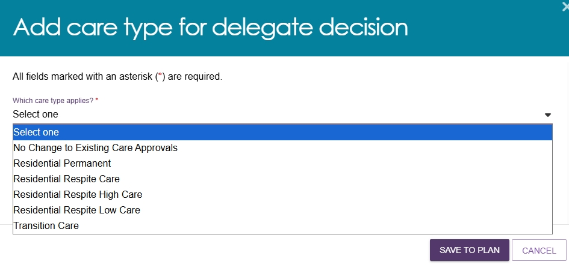
- After you save the changes, the system displays a blue banner to confirm that the care approval correction is in progress.
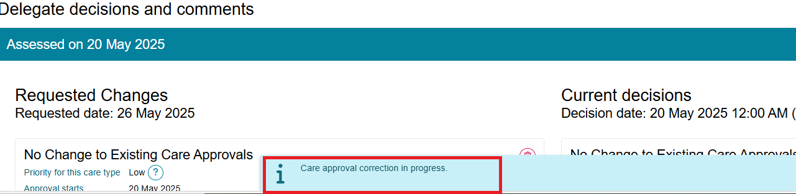
- If you leave the correction screen before submitting the correction request, return to the Decision History tab in Delegate Decisions and select the client record.
The client record will display an Update Pending status.

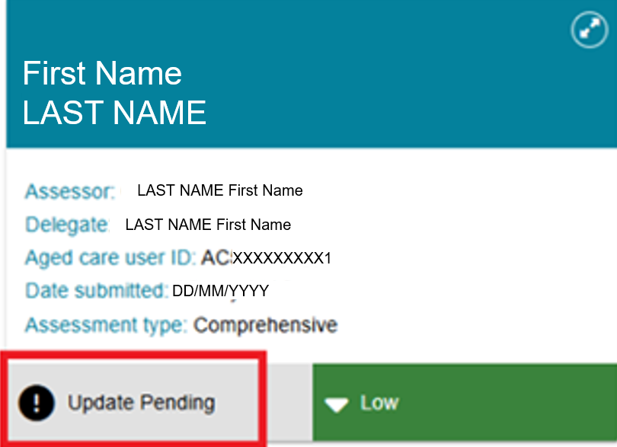

Then, select CONTINUE MAKING CHANGES TO CARE APPROVAL DECISIONS from the expanded client card on the Decision History page.

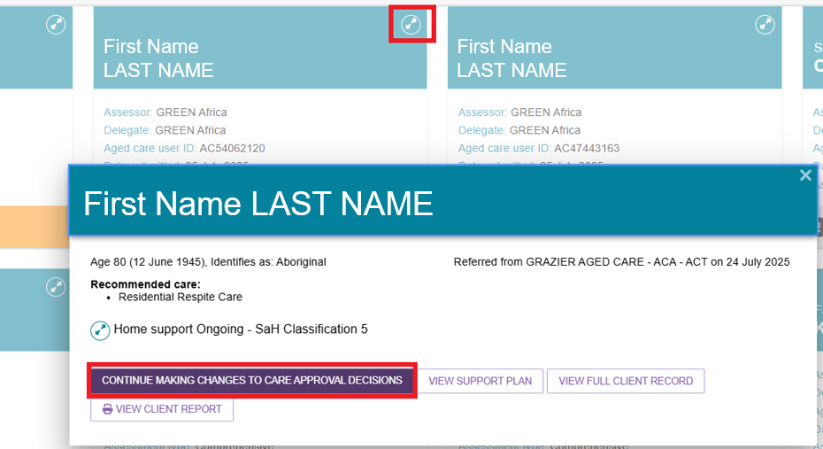
- Review the requested changes and make any required updates to the care approval decisions. When you have finished, select SUBMIT FOR AGED CARE ASSESSMENT PROGRAM (ACAP) DECISION.
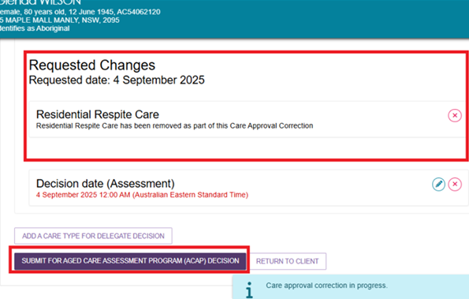
A confirmation pop-up will appear. Select SUBMIT to continue.
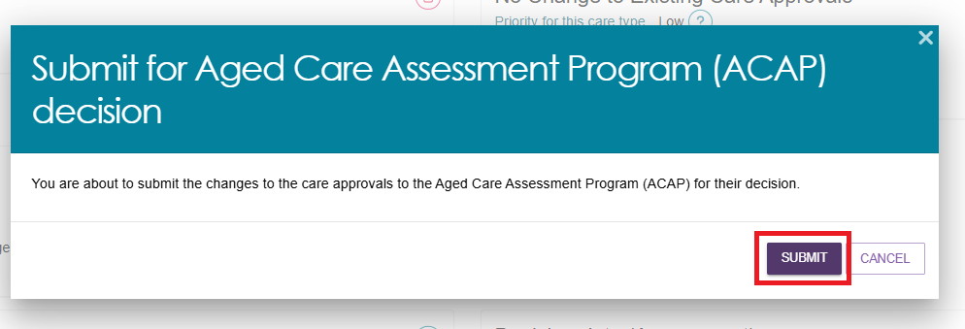
- The system displays a confirmation message advising that the Department's Aged Care Assessment Program (ACAP) delegate has received the correction request.
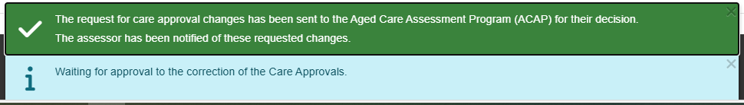
- The client record appears in the Decision History tab with an Acceptance Pending status.

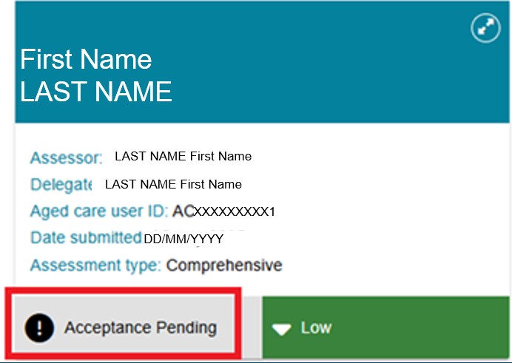
- Once the ACAP delegate reviews and finalises the correction request (outside of the Assessor Portal), the system updates the status accordingly.

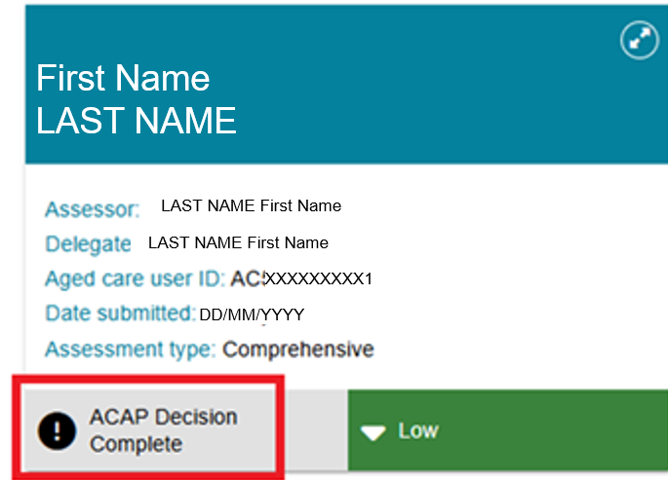

- You will also receive a notification on the Tasks and Notifications page.
- You can search for notifications using the client's last name, first name, Aged Care User ID, or the Advanced Search options.
- The notification includes links to the client record and the correction request.
- You can also remove the notification from the page.
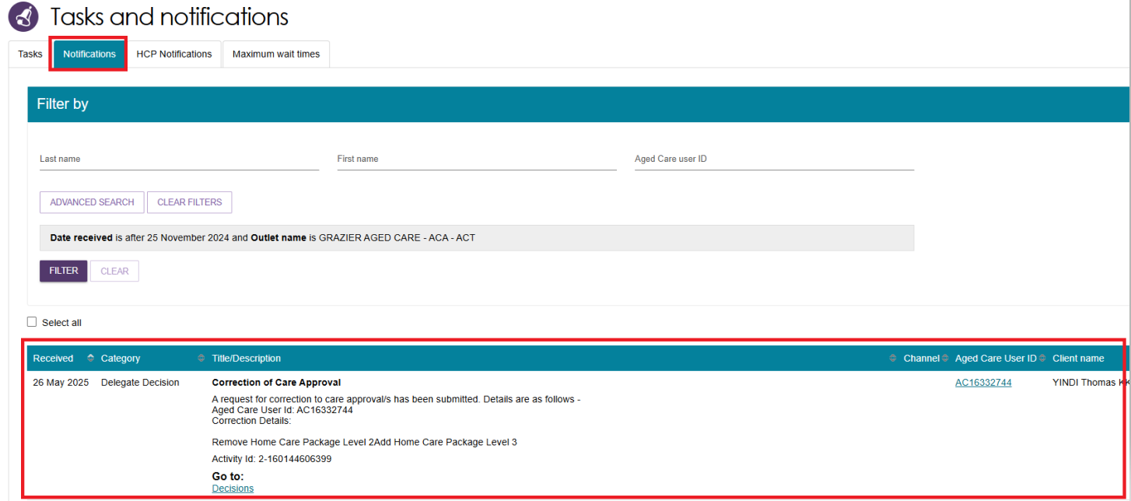
- After the Clinical Assessment Delegate completes the correction decision, you will receive another notification confirming that the correction is complete.
- The assessment status in the Decision History tab will update to ACAP Decision Complete. Select the expand arrow to view additional details, including the correction date and the outcome of the correction request.

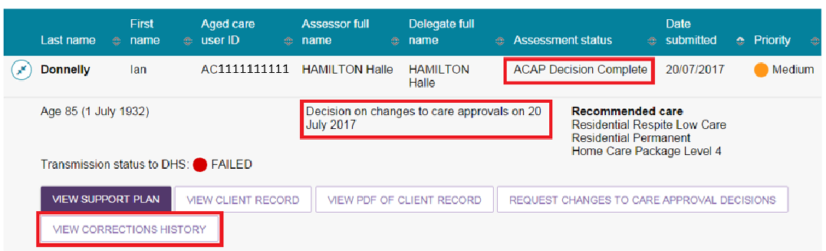
- To view the client's full correction history, select VIEW CORRECTIONS HISTORY.
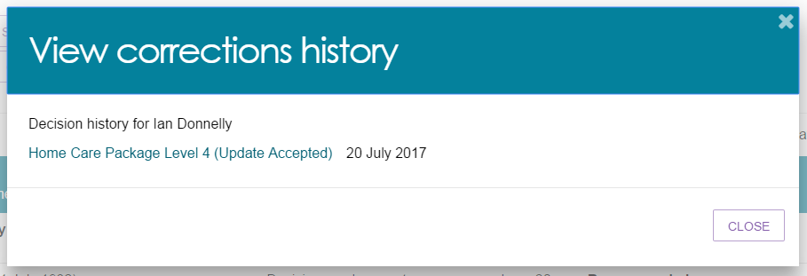

Requesting and Approving Care Extensions
Care extensions can be requested by clinical assessors or service providers.
For Residential Respite Care and Transition Care approvals, service providers can request a care extension on the client’s behalf through the My Aged Care Services and Support Portal.
For Residential Respite Care, clinical assessors can also request a care extension through the Assessor Portal for clients who live in the community and need additional respite care.
If a client has a current Residential Respite Care approval, needs additional respite days, and lives at home rather than in residential aged care, a service provider cannot request the extension on the client's behalf. In this situation, a Clinical Assessment Delegate must initiate the care extension request.
If you cannot complete a care extension request through the Assessor Portal, contact the Aged Care Service Provider and Assessor Helpline on 1800 836 799.
To make a decision about a care extension, follow the steps below.
- The extension request appears in the Decision Pending tab under Unassigned with a status of Acceptance Pending.
Open the client record by selecting the Expand icon in either Card View or List View.

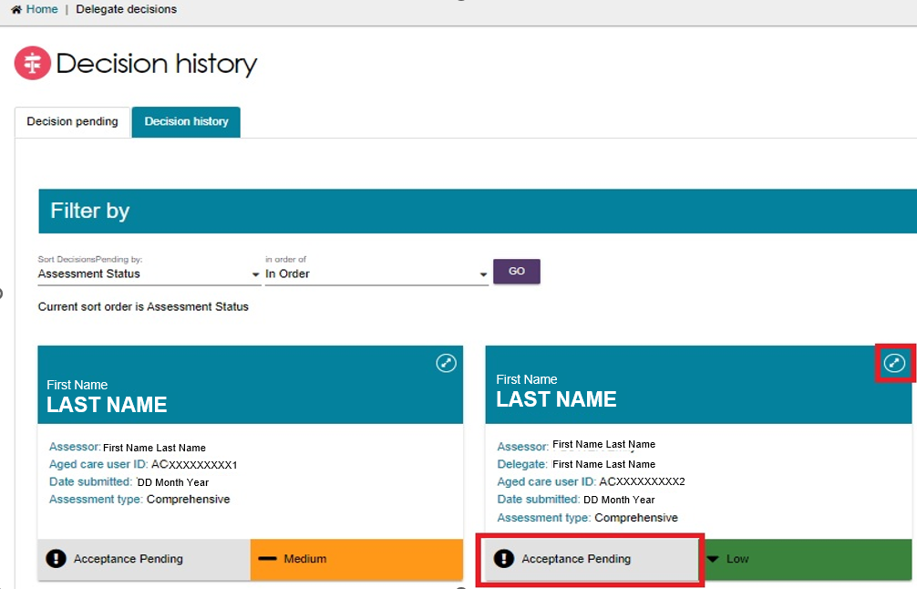
- If the request is not already assigned to you, assign it to yourself. The client will then appear under My Decisions.
Select START DECISION PROCESS.

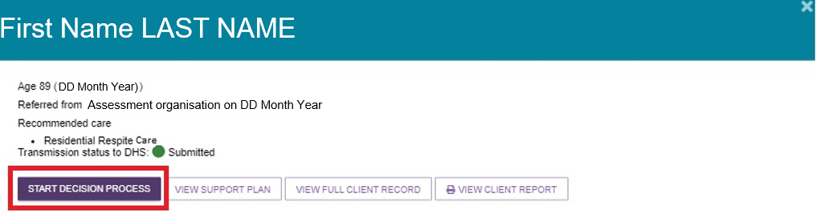
- Review the care extension request and select MAKE EXTENSION DECISION.
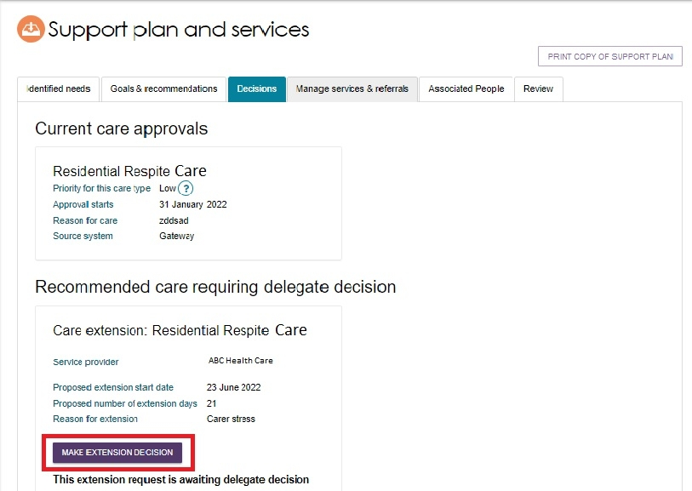
- In the pop-up window, select Yes or No to approve or decline the extension request. Complete the remaining required fields.
Select MAKE DECISION.
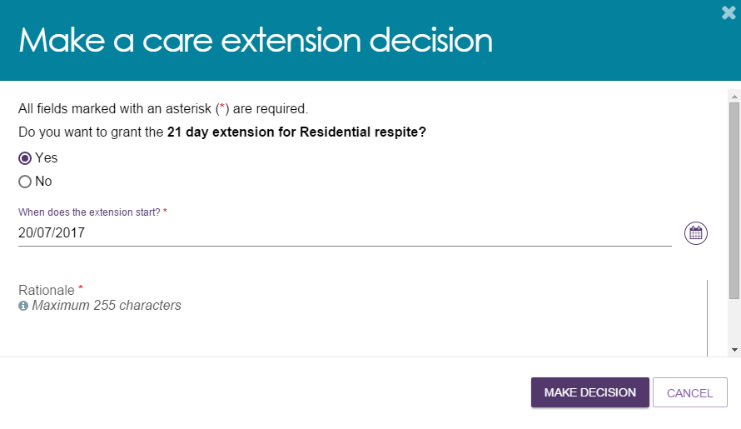

- The system displays a confirmation message and updates the extension request status to Granted or Not Granted.
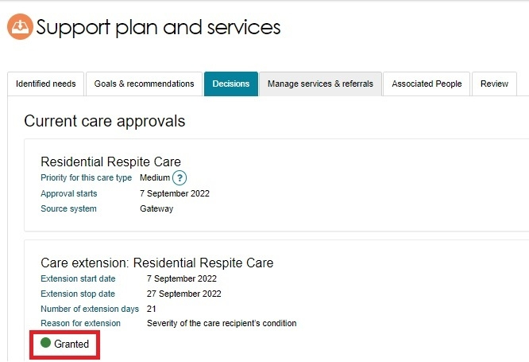
- (If the service provider submitted the extension request, they will receive a notification of the outcome in Tasks and Notifications in the Services and Support Portal.)
