My Aged Care Assessor Portal – Organisation Administrator User Guide

1. Background and Overview of the Assessor Portal 3
1.1 Purpose of the Guide 3
1.2 Privacy requirements 3
1.3 Introduction to using the Assessor Portal 3
1.4 How and when to direct people to My Aged Care 4
2. Assessor Portal access 5
3. Assessment organisation configuration in the Assessor Portal 5
3.1 Overview 5
3.2 Activating outlets 7
3.3 Staff roles 8
3.4 Homepage views by role type 9
3.4.1 Administrator homepage 9
3.4.2 Team Leader homepage 9
3.4.3 Needs Assessor homepage 10
3.4.4 Triage Delegate homepage 11
3.4.5 Assessment Delegate homepage 11
3.4.6 Assessment Delegate Support homepage 12
3.4.7 Residential Funding Assessor functions 13
3.4.8 Residential Funding Team Lead functions 14
4. Key functions by role type 14
4.1 Creating new staff accounts and assigning roles 16
4.2 Deactivate a staff account 20
4.3 Removing and reactivating a staff account 21
4.4 Edit a staff account 22
4.5 Find a service provider 24
4.6 End of Month (EOM) reporting 27

Background and Overview of the Assessor Portal

Purpose of the Guide
This guide explains how assessment organisation administrators use the My Aged Care Assessor Portal.
It is intended for organisations that conduct aged care needs assessments and/or residential aged care funding assessments.
The guide provides an overview of the portal and explains the tasks that users with the Administrator role can perform, including:
- Managing outlet information
- Creating and maintaining staff accounts
- Requesting changes to contractual information.
This guide does not include:
  - Detailed instructions for setting up organisations in the Relationship Authorisation Manager (RAM). You can find these on the RAM website.
- Detailed instructions for functions performed by users with the Team Leader, Assessor, Delegate, or Delegate Support roles. These are available on the department’s My Aged Care - Assessor Portal Resources webpage.
- Detailed instructions for residential funding assessment functions. For these, refer to the Aged Care Assessor Application User Guide.

Privacy requirements
Assessment organisations must comply with the requirements of the Privacy Act 1988, including the Australian Privacy Principles (APPs), when handling personal information in the assessor portal.
The Privacy Act sets out how organisations must collect, use, store, disclose, access and correct personal information.
Aged care needs assessors must also comply with section 534 of the Aged Care Act 2024 when using the assessor portal.

Introduction to using the Assessor Portal
The assessor portal is used to:
- Create and manage staff records
- Activate the Aged Care Assessor App
- Check where clients are in their My Aged Care journey.
- Manage referrals for assessments issued by the My Aged Care contact centre, Aged Care Specialist Officers, through the My Aged Care website or via the General Practitioner (GP) e-Referral function.
- Create, access and update client records, including setting up supporters and others in the client’s support network
- Conduct triage and assessments using the Integrated Assessment Tool (IAT)
- Develop client support plans
- Support Delegation processes (after home support and comprehensive assessments)
- Refer clients for aged care services or further assessment
- View the progress of Residential Aged Care (RAC) Funding Assessments
- Access forms and reports
- View and manage tasks and notifications, including from other My Aged Care portals
- Find a Service Provider and view their information.
Assessment organisations can also use the offline Aged Care Assessor App or a printed version of the IAT to support aged care needs assessments conducted in circumstances where the assessor does not have access to the internet.
For further information about the Aged Care Assessor App, refer to the Aged Care Assessor Application User Guide.
The printed version of the IAT can be downloaded from the Reports and documents tab in the assessor portal.
! | myID is the primary login option for assessors to securely access and use the assessor portal.  To access the assessor portal, staff must have an individual myID and be authorised to act on behalf of their organisation through the Relationship Authorisation Manager (RAM) service.  VANguard Federated Authentication Service (VANguard FAS) is an alternative login option for organisations with corporate network structure that includes a Single Sign On System (for example, Active Directory Federation Service).  For more information regarding accessing the assessor portal, visit Logging in to the Aged Care Systems.

How and when to direct people to My Aged Care
To access government-funded aged care services, a person must have a My Aged Care client record.
Clients can create their own record. The My Aged Care Contact Centre, Aged Care Specialist Officers (ACSOs) and assessors can also create records for people seeking aged care services.
If a person does not already have a client record, aged care needs assessors and Residential Aged Care (RAC) funding assessors can register them in My Aged Care.
Assessment organisations can only receive assessment referrals for clients who are registered in My Aged Care. For example, while assessing a client at home, an assessor may identify that the client's partner or cohabitant also needs an assessment but is not yet registered with My Aged Care. In this situation, the assessor must first register the partner or cohabitant before arranging an assessment for them.
Needs assessors and RAC funding assessors can register and self-refer clients for assessment in the assessor portal.
For detailed instructions, refer to My Aged Care – Assessor Portal User Guide 1 – Registering and referring clients for assessments.

Assessor Portal access
To access the assessor portal, each staff member must have a My Aged Care user account linked to a supported third-party authentication service.
For information about setting up user accounts and signing in to the system, refer to Logging in to the Aged Care Systems.

Assessment organisation configuration in the Assessor Portal
People with the Organisation Administrator role in the assessor portal are responsible for keeping information about their organisation's assessment services accurate and up to date.

Overview
! | The department creates and manages outlets on behalf of assessment organisations.  If your organisation's structure changes, contact the department so they can update the organisation details.
In My Aged Care, Each Service Area consists of one or more Aged Care Planning Regions (ACPRs). The number of outlets assigned to an organisation depends on the ACPRs within the Service Area where it operates.
Following are the examples of organisation structures in My Aged Care:
Example 1:
If an organisation called ABC Ltd. provides aged care needs assessments (Home Support Assessments and Comprehensive Assessments) in the NSW 1 Service Area, it will have three outlets:
- Northern Sydney
- Western Sydney
- Inner West
These outlets correspond to the three ACPRs that make up the NSW 1 Service Area.
Example 1 - An organisation with three outlets
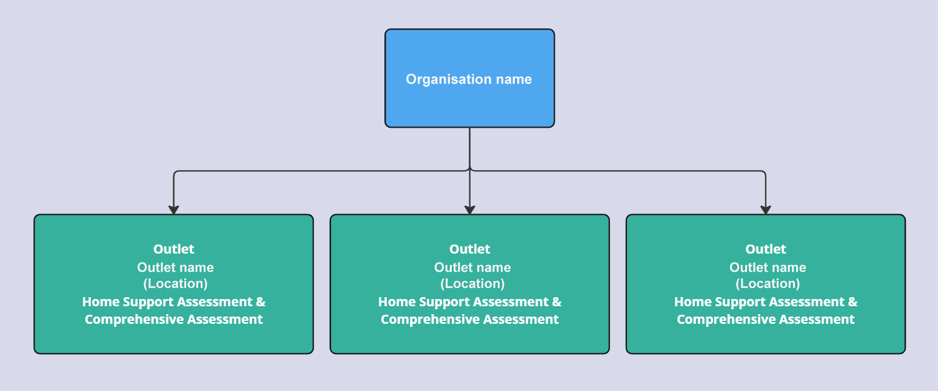

Example 2:
If BCD Ltd. provides both aged care needs assessments (Home Support Assessments and Comprehensive Assessments) and Residential Aged Care (RAC) funding assessments in VIC 4, it will have four outlets:
- Two outlets for aged care needs assessments (Home Support and Comprehensive)
- Two outlets for RAC funding assessments (Hume and Gippsland)
These outlets reflect the ACPRs within the VIC 4 Service Area.
Example 2 - An organisation with two Aged Care needs assessment outlets and two Residential aged care assessment outlets
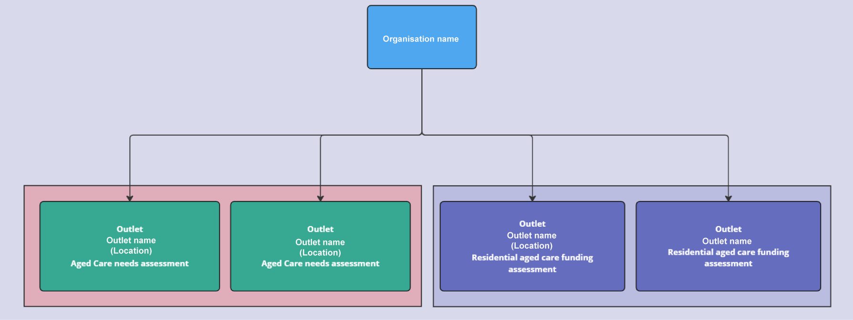
Outlet names
The department uses a standard naming convention for all outlets. Organisation Administrators must not change outlet names.
The department creates:
- One outlet for each ACPR that delivers aged care needs assessment services (Home Support Assessments and Comprehensive Assessments). The outlet name follows this format: Organisation Name - ACA - ACPR Region
- One outlet for each ACPR that delivers Residential Aged Care (RAC) funding assessment services. The outlet name follows this format: Organisation Name - RAC - ACPR Region.

Activating outlets
Follow these steps to activate an outlet:
- From the homepage, select Organisation administration.
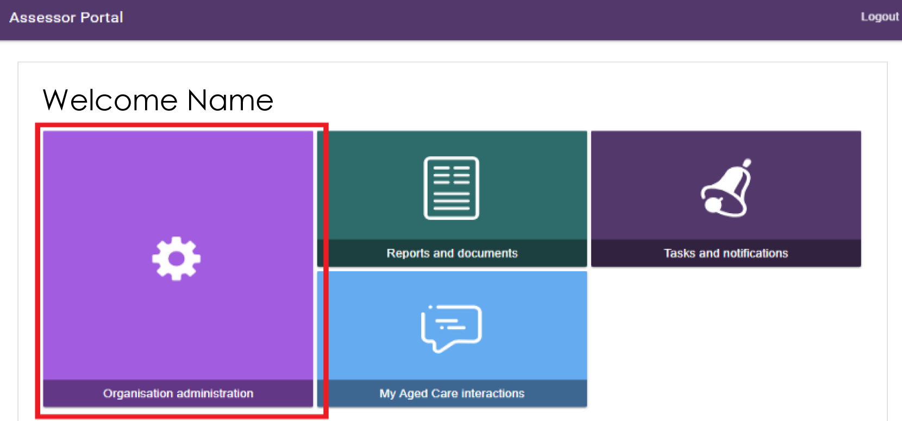
- Locate the inactive outlet and select the outlet name on the Outlet card.
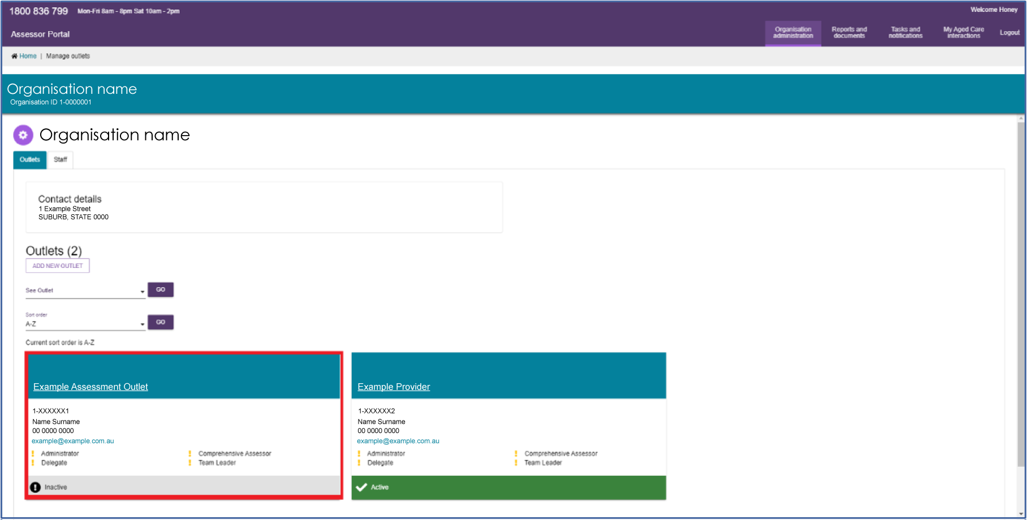
- Select Activate Outlet.
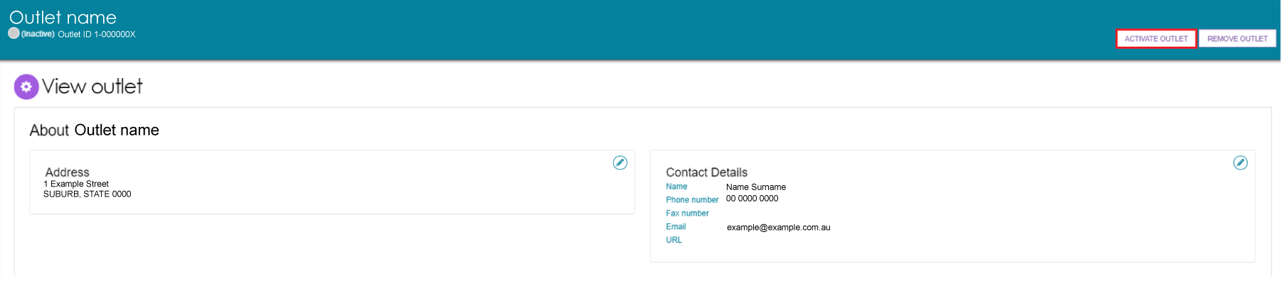
- When the warning message appears, select Activate Outlet again to confirm.
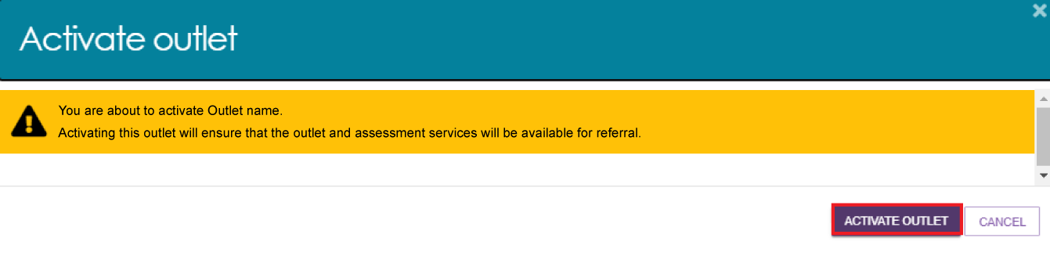
- The outlet is now active. You can view its status on the View Outlet page and the Outlet Administration page.
Once the outlet is active, its details will appear in the service finders on the My Aged Care website, and contact centre staff can send assessment referrals to the outlet.
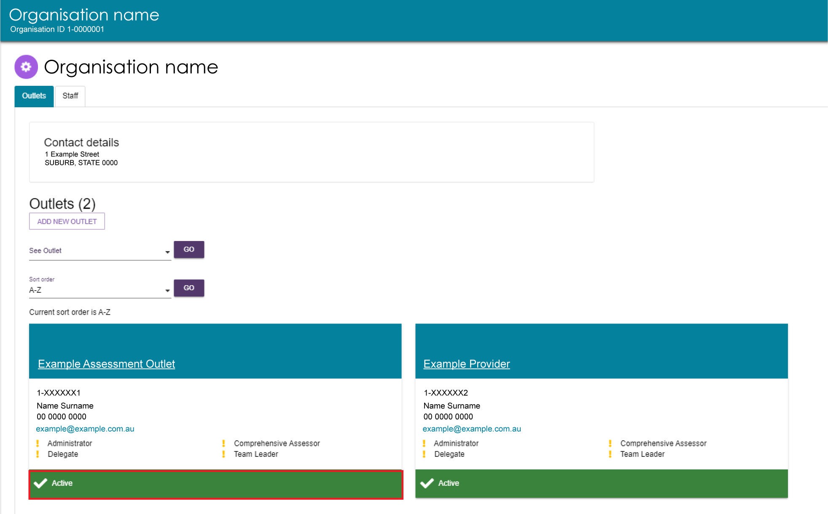

Staff roles
For more information, refer to Nominating an Organisation Administrator in Aged Care Systems in the Logging in to Aged Care Systems guide.
The organisation administrator assigns roles to staff members. They can also assign the administrator role to other staff who help set up and maintain organisation information in the assessor portal.
Assign roles based on each staff member’s responsibilities and after they have completed all required training.
! | If you have more than one role, your access applies across all outlets you can access in the assessor portal.

Homepage views by role type
The options you see on the assessor portal homepage depend on the role or roles assigned to you. If you have more than one role, your homepage displays the functions available for all your assigned roles.

Administrator homepage
Users with an Administrator role at the organisation level can view and manage information for the entire organisation in the portal.
Users with an Administrator role for one or more outlets can only view and manage information for the outlets assigned to them.
If you log in to the assessor portal as an Administrator, your homepage displays the following tiles:
- Organisation administration
- Reports and documents
- Find a service provider (Not available for residential funding assessment organisations)
- Find a client (Not available for residential funding assessment organisations)
- Tasks and notifications
- My Aged Care interactions.
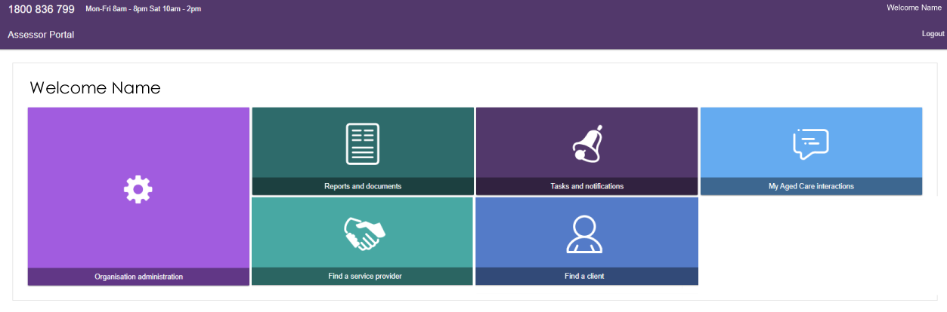

Team Leader homepage
People with the Team Leader role manage assessment referrals and assign assessment reviews.
If you log in to the assessor portal as a Team Leader, your homepage displays the following tiles:
- My Dashboard
- Find a client
- Assessment referrals, including Residential Funding Referrals
- Review Requests
- Organisation administration
- Find a service provider
- Reports and documents
- Tasks and notifications
- My Aged Care interactions.
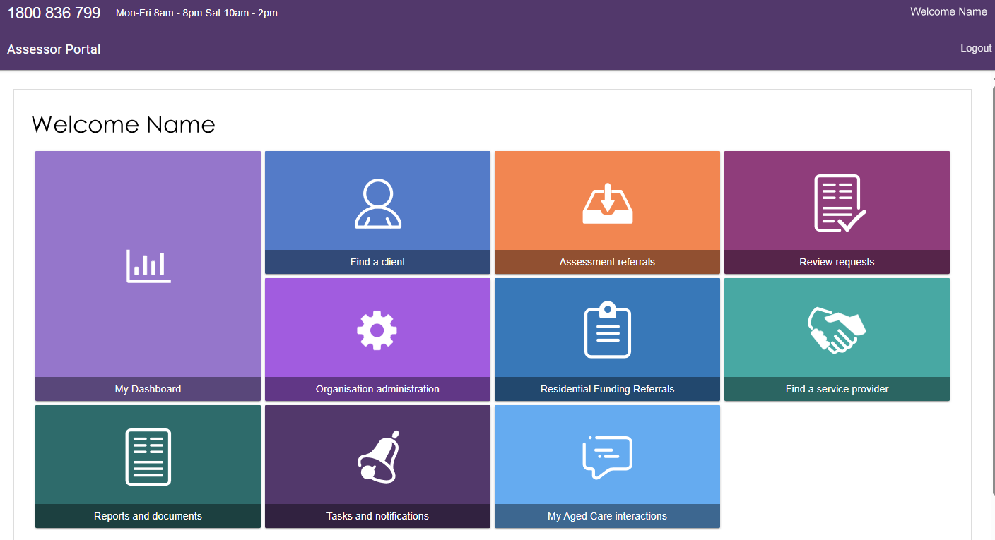

Needs Assessor homepage
People with a Needs Assessor role register new clients and complete client assessments.
If you log in to the assessor portal as a Needs Assessor, your homepage displays the following tiles:
- My Dashboard
- Find a client
- Assessments
- Reviews
- Find a service provider
- Reports and documents
- Aged Care Assessor App
- Tasks and notifications
- My Aged Care interactions.
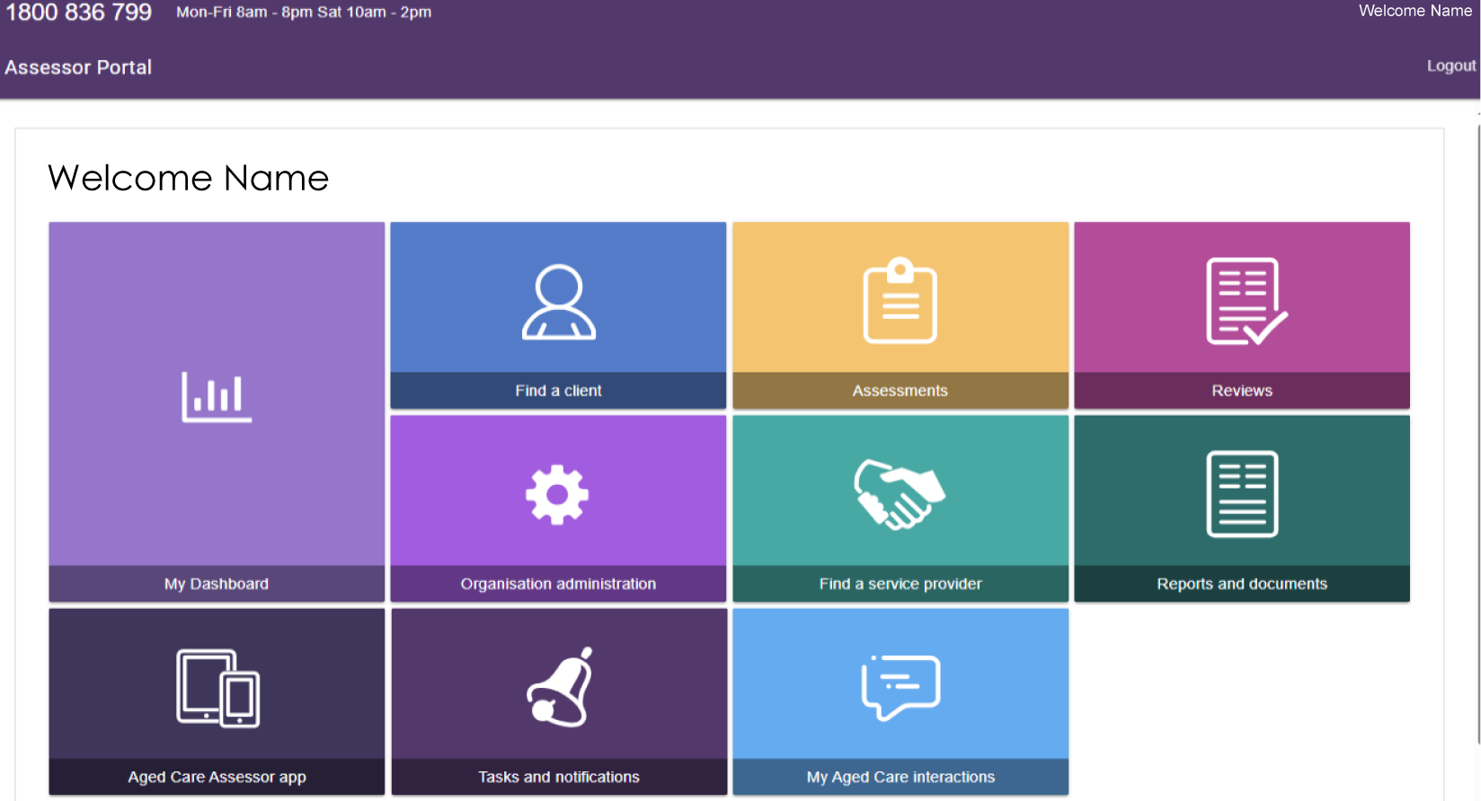

Triage Delegate homepage
! | Organisation Administrators cannot assign delegate roles. Instead, a Needs Assessor, Team Leader, or Operational Manager must submit an application for these roles.  For more information about applying for delegate roles, refer to My Aged Care Assessor Portal User Guide 12 – Managing delegate roles.
People with a Triage Delegate role complete triage activities.
If you log in to the assessor portal as a Triage Delegate, your homepage displays the following tiles:
- My Dashboard
- Find a client
- Assessment referrals
- Organisation administration
- Reports and documents.
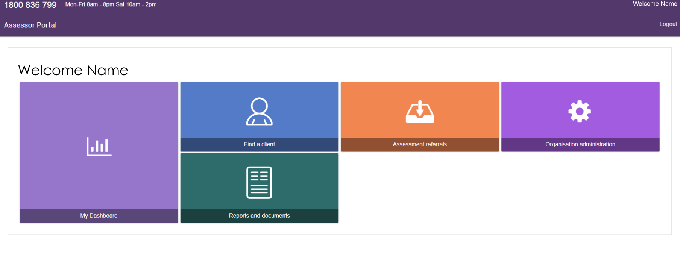

Assessment Delegate homepage
! | Organisation Administrators cannot assign delegate roles. Instead, a Needs Assessor, Team Leader, or Operational Manager must submit an application for a delegate role.  Clinical Assessment Delegates can approve all service groups, classification types, and classification levels under the Aged Care Act.  Non-Clinical Assessment Delegates can only approve entry-level home support, Assistive Technology, and Home Modification services. These services have classification levels of CHSP Class, AT-CHSP, or HM-CHSP. They can also make decisions and initiate corrections for Home Support assessments only.  For information about Assessment Delegate changes, refer to ‘Chapter 7: Delegations and Approvals under the Act’ of the My Aged Care Assessment Manual.  For information about applying for delegate roles, refer to My Aged Care Assessor Portal User Guide 12 – Managing delegate roles.

People with an Assessment Delegate role make delegate decisions for services that require approval under the Aged Care Act.
If you log in to the assessor portal as an Assessment Delegate, your homepage displays the following tiles:
- Delegate decisions
- Find a client
- Find a service provider
- Reports and documents
- Tasks and notifications
- Organisation administration
- My Aged Care interactions.
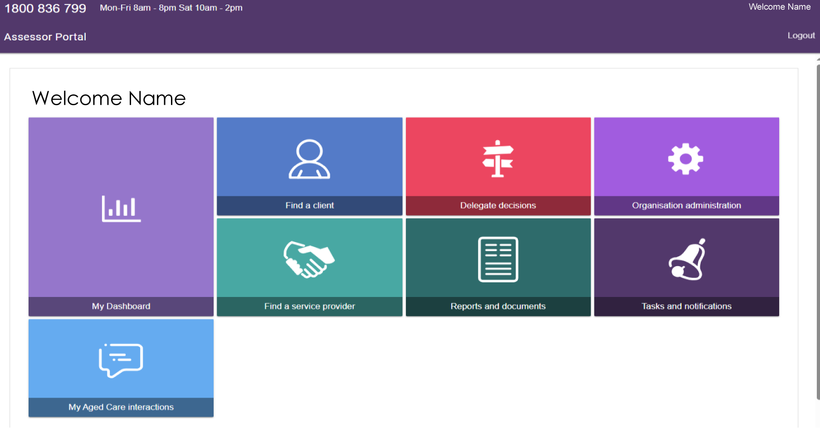

Assessment Delegate Support homepage
People with an Assessment Delegate Support role assist Assessment Delegates by generating, uploading, and printing Notices of Decision (approval and non-approval letters) and Referral Code Letters. They can also print client information from support plans and client records.
If you log in to the assessor portal as an Assessment Delegate Support user, your homepage displays the following tiles:
- Delegate decisions
- Find a client
- Organisation administration
- Find a service provider
- Reports and documents
- Tasks and notifications
- My Aged Care interactions.
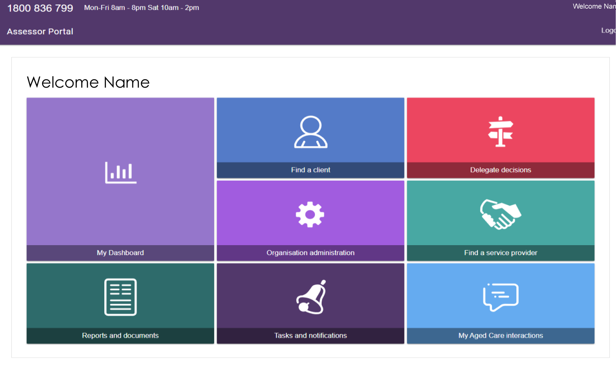

Residential Funding Assessor functions
People with a Residential Funding Assessor role can view the assessment referrals assigned to them, as well as referrals that have been closed. They can also accept and assign referrals.
If you log in to the assessor portal as a Residential Funding Assessor, your homepage displays the following tiles:
- Find a client
- Residential Funding Referrals
- Find a service provider
- Reports and documents
- Aged Care Assessor app
- Tasks and notifications
- My Aged Care interactions.
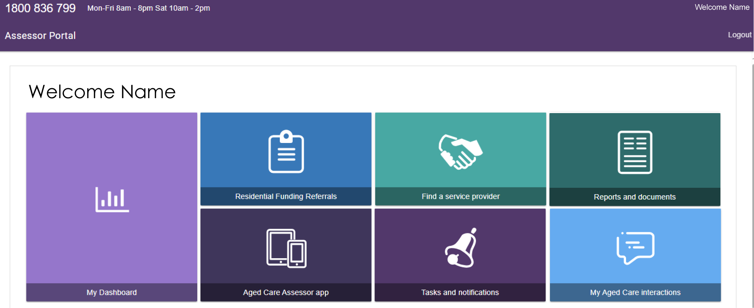

Residential Funding Team Lead functions
People with a Residential Funding Team Lead role can manage Residential Funding Referrals, generate reports and documents, find service providers, and perform other responsibilities related to their role.
If you log in to the assessor portal as a Residential Funding Team Lead, your homepage displays the following tiles:
- Residential Funding Referrals
- My Aged Care interactions
- Find a service provider
- Reports and documents
- Tasks and notifications.
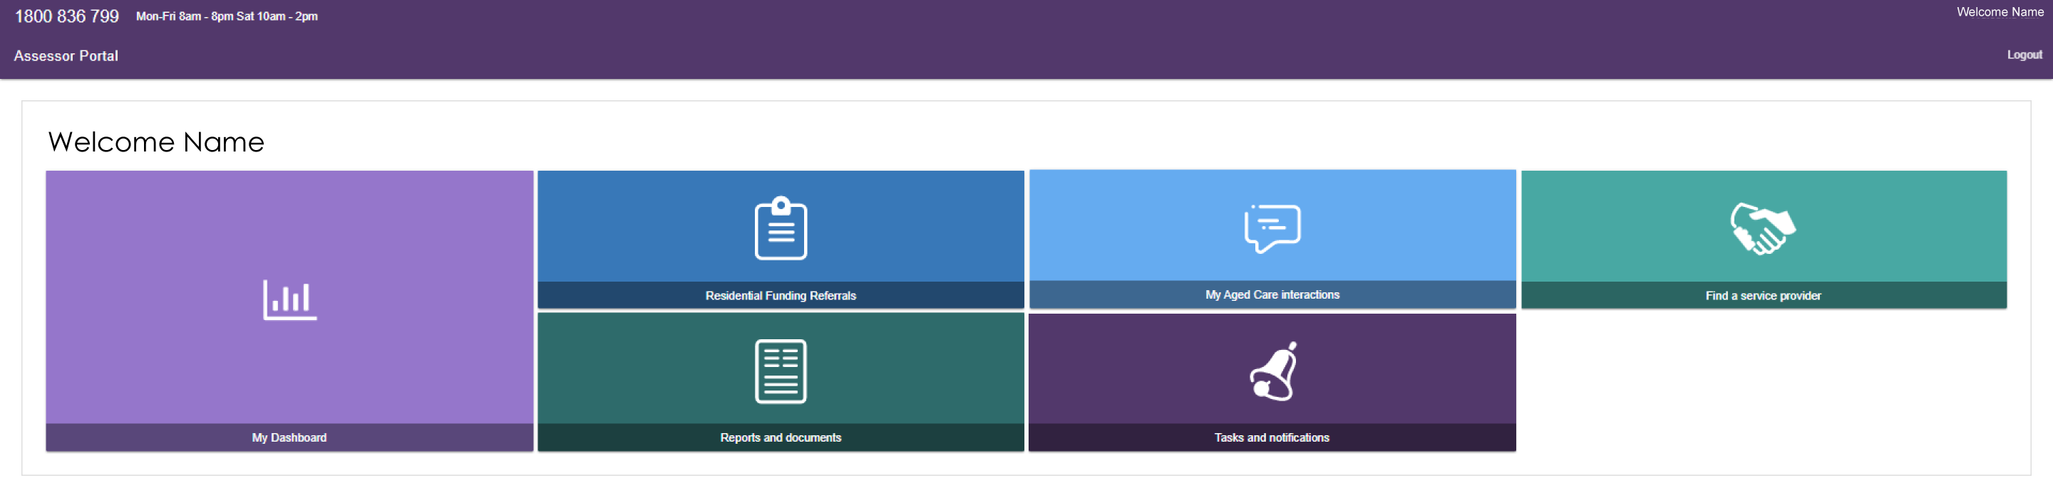

Key functions by role type
Administrators create and manage staff accounts in the assessor portal.
Staff can have more than one role at the same time. These roles include:
- Administrator
- Team Leader
- Needs Assessor
- Residential Funding Assessor
- Residential Funding Assessor (Restricted)
- Triage Delegate
- Clinical Assessment Delegate
- Non-Clinical Assessment Delegate
- Assessment Delegate Support.
The following tables describe the main functions of each role in the assessor portal. They also explain the roles that other teams, such as the contact centre, play in a client’s aged care journey.
The tables include both client-focused and organisation-focused responsibilities.

Client Focused Roles and Functions
Key Functions | Contact Centre | Administrator | Team Leader | Triage Delegate | Needs Assessor | RAC Funding Assessor | Assessment Delegate (clinical and non-clinical) | Assessment Delegate Support
View reports and documents |  | ü | ü | ü | ü | ü
Manage staff accounts |  | ü
Activate Aged Care Assessor app |  |  |  |  | ü | ü
View Client Journey Tracker | ü |  | ü | ü | ü |  | ü | ü
Provision of aged care information | ü | ü | ü | ü | ü | ü | ü | ü
Register a client or support person | ü |  |  |  | ü excluding Residential funding assessors)
Self-Refer a client |  |  |  |  | ü (limited)
Search for and view a client record |  |  | ü | ü | ü |  | ü | ü
Screening | ü |  |  |  | ü*
Complete triage |  |  |  | ü | ü**
Referral for assessment | ü |  |  |  | ü
Conduct assessment |  |  |  |  | ü
Enter assessment information on the client record (including completing the support plan) |  |  |  |  | ü |  | ü
Service matching and referrals | ü |  |  |  | ü
Management of assigned of Residential referrals |  |  | ü Residential Funding Assessor Team Leads only)
Action referral & deliver services
Accept and reject assessment referrals |  |  | ü
View tasks and notifications |  | ü | ü | ü | ü | ü | ü | ü
Manage task and notification preferences |  | ü
Client Focused Roles and Functions continued…
Key Functions | Contact Centre | Administrator | Team Leader | Triage Delegate | Needs Assessor | RAC Funding Assessor | Assessment Delegate (clinical and non-clinical) | Assessment Delegate Support
View and Reassign SaH notifications |  |  | ü
Record completed tasks in the portal |  |  | ü |  | ü
Approve Delegate decisions |  |  |  |  |  |  | ü
Print client information for the Delegate |  |  |  |  |  |  | ü | ü
Assign & transfer support plan reviews |  |  | ü |  | ü
Conduct Support Plan Reviews |  |  |  |  | ü
*A needs assessor who self refers will complete the screening component.
**A needs assessor can complete Triage if supervised by a Triage Delegate.
*** A Delegate can edit decisions within 43 days.
Organisation Focussed Roles and Functions
Key Functions | Administrator Role | Team Leader Role | Needs assessor Role | Triage Delegate | Assessment Delegate Role (clinical and non-clinical) | Assessment Delegate Support Role | RAC funding assessor
View My Aged Care interactions | ü | ü | ü | ü | ü | ü | ü
Request a change to contractual information | ü
Manage staff accounts: add, edit, deactivate and remove | ü

Creating new staff accounts and assigning roles
The first time a staff member logs in to the assessor portal, they must follow the steps in Logging in to the Aged Care Systems on the department’s website.
Follow these steps to create a new staff account:
- On the Organisation Administration page, open the Staff tab and select Add New Staff.
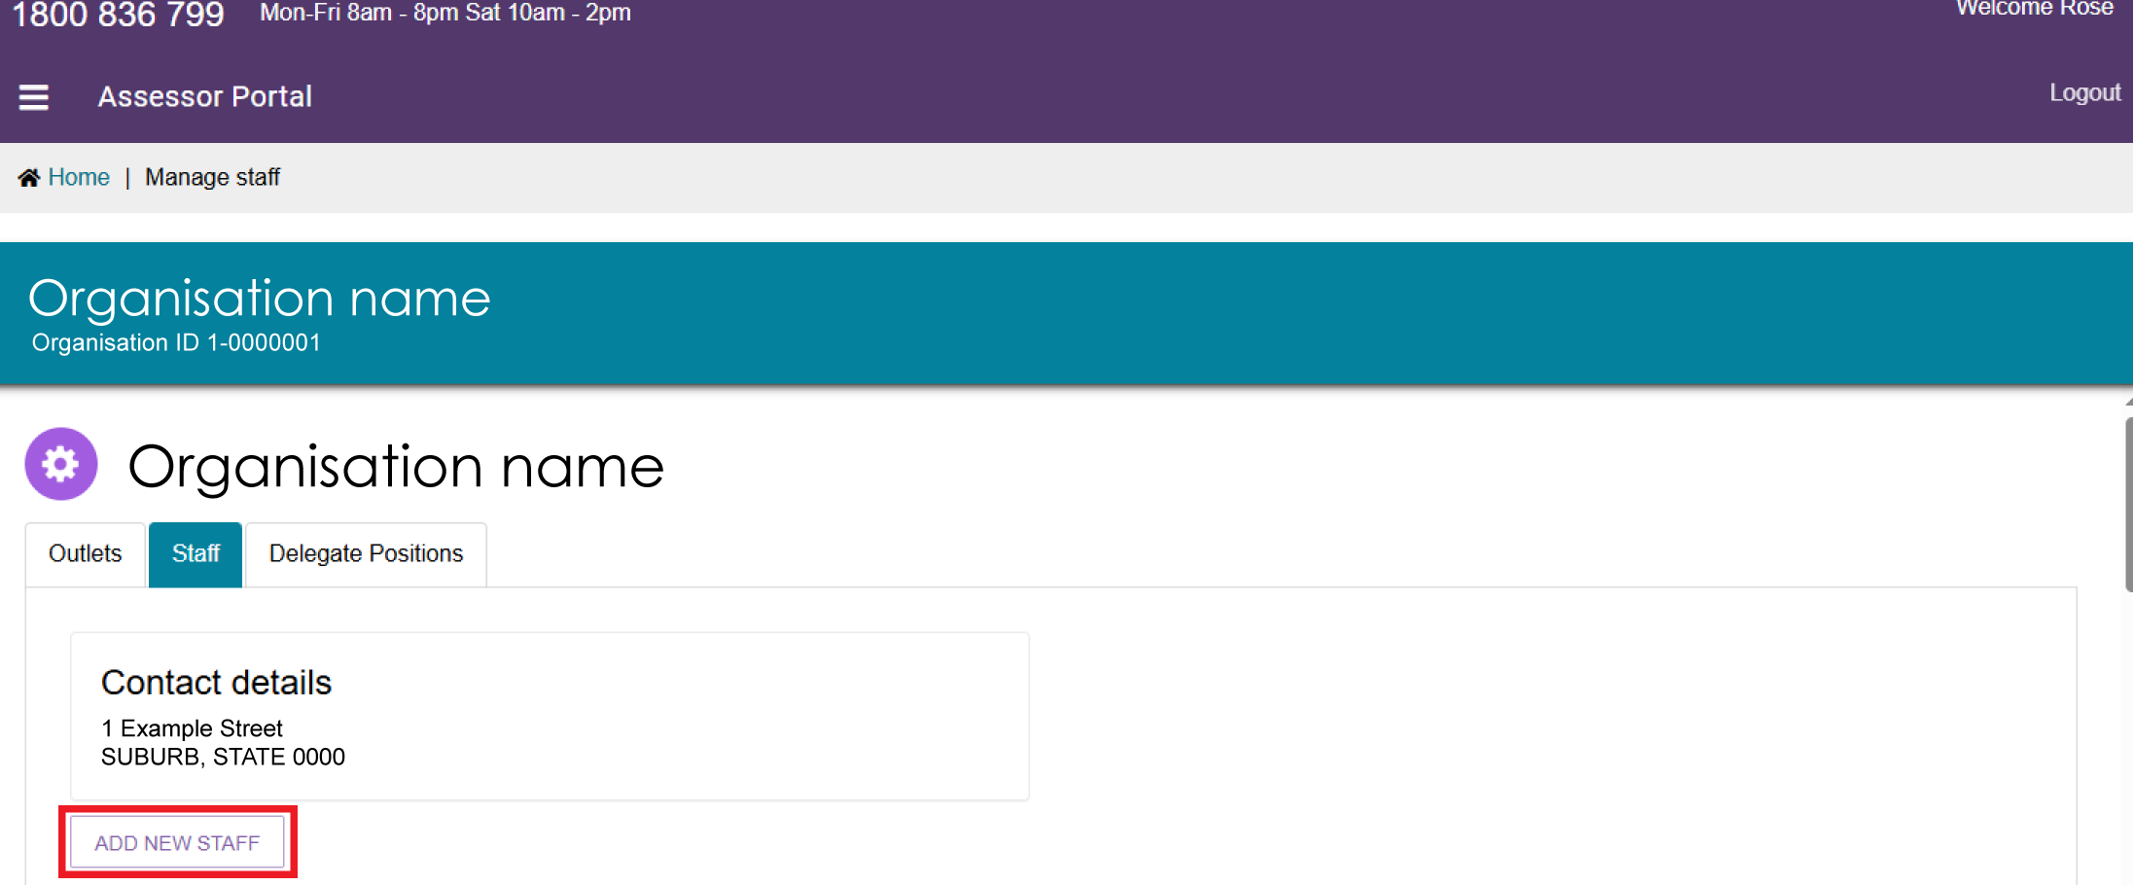
- Enter all mandatory fields, including:
- First name
- Last name
- Unique email address
- Contact number.
Indicate whether the staff member is accredited. Then assign one or more roles in the Manage Roles section.
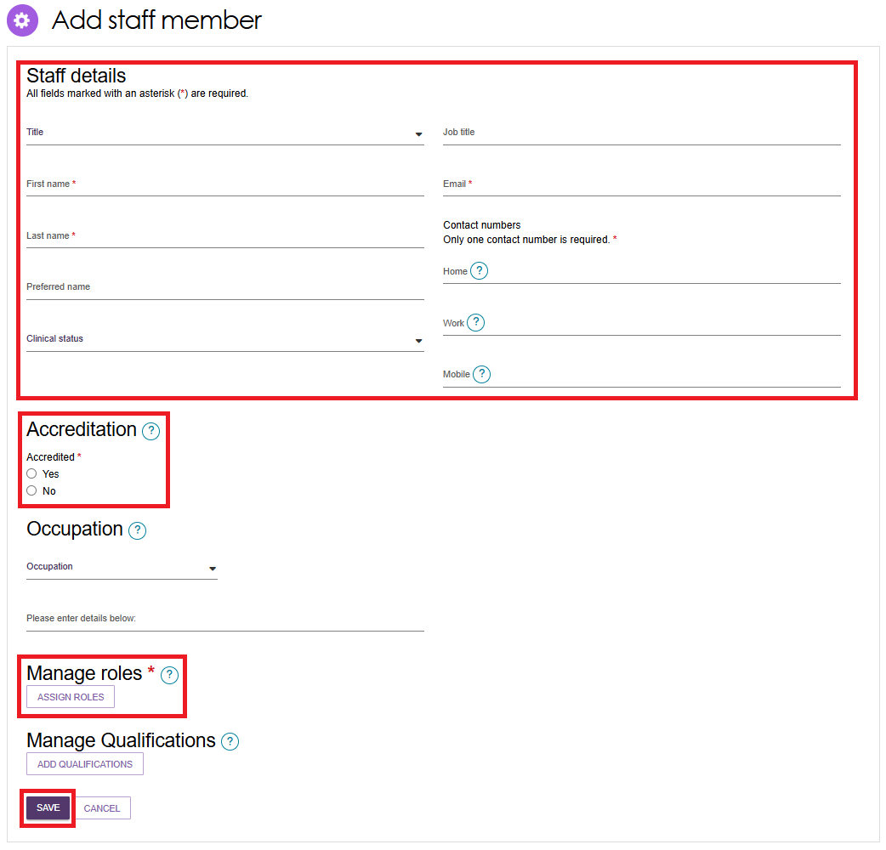
- In Manage Roles, select the role or roles you want to assign and select Save.
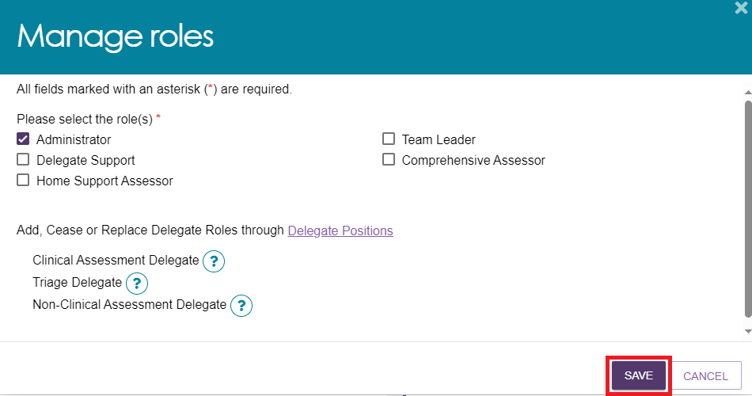
! |  | Organisation Administrators cannot assign delegate roles. Instead, a Needs Assessor, Team Leader, or Operational Manager must submit an application for a delegate role.  For information about applying for delegate roles, refer to My Aged Care Assessor Portal User Guide 12 – Managing delegate roles.
! | - Each staff member can have either the Residential Funding Assessor role or the Residential Funding Assessor (Restricted) role. They cannot hold both roles at the same time.  - Staff with a Residential Funding Assessor or Residential Funding Assessor (Restricted) role can also be assigned the Residential Funding Team Lead role.  - In line with the Single Assessment System Workforce Statement of Requirements, you must record the assessor’s Australian Health Practitioner Regulation Agency (AHPRA) ID and discipline in the Accreditation section of the Add Staff Member page when assigning any of the following roles:  - Residential Funding Assessor  - Residential Funding Assessor (Restricted)  - Clinical Needs Assessor (Comprehensive Assessor)  - Team Leader.  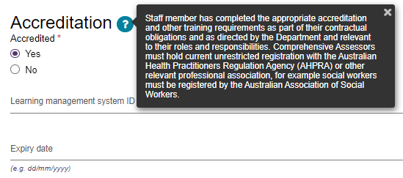
To assign an Administrator role across the entire organisation, select Organisation Level, then select Save Roles. The system automatically applies these roles to all outlets.
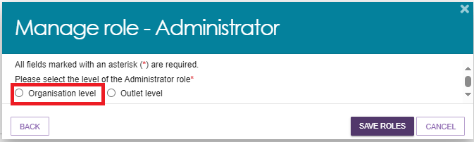
To assign a role to specific outlets only, select Outlet Level, choose the relevant outlets, then select Save Roles.
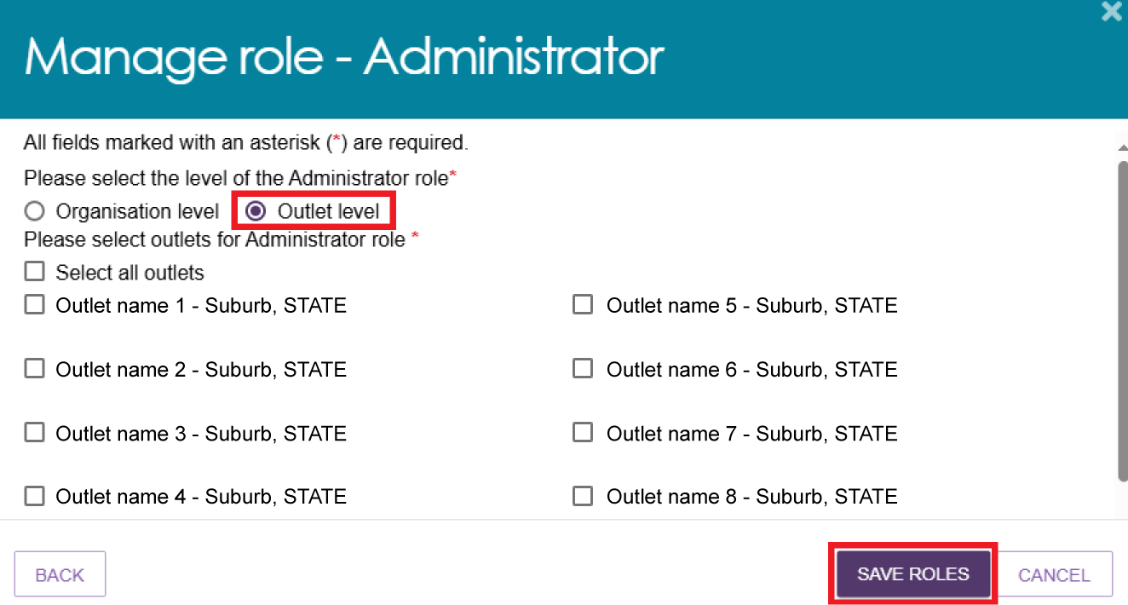
- A green confirmation banner appears when the roles are saved successfully. The Manage Roles section displays the assigned roles and any associated outlets.
Select Save to continue.
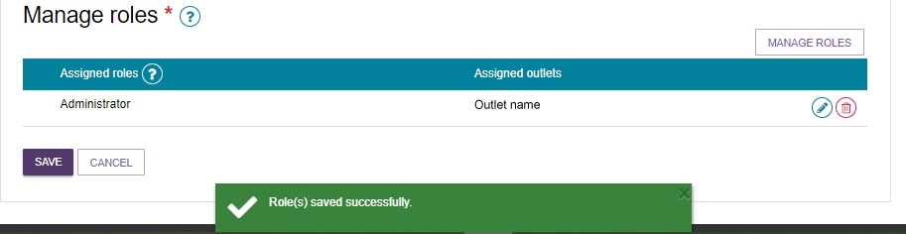
- The new staff member now appears in the Staff section of your organisation.
The staff card shows the staff member’s accreditation status and assigned roles.
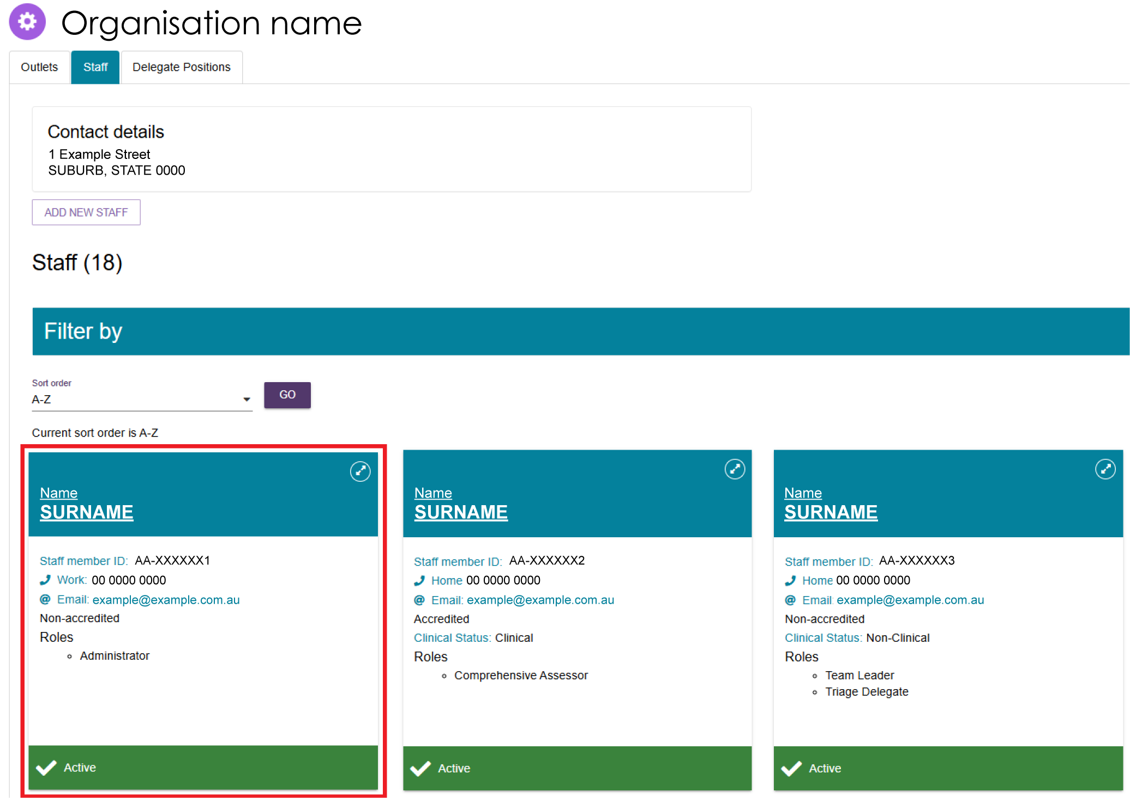

Deactivate a staff account
Follow these steps to deactivate a staff account:
- On the Organisation Administration page, open the Staff tab and select the staff member you want to deactivate.
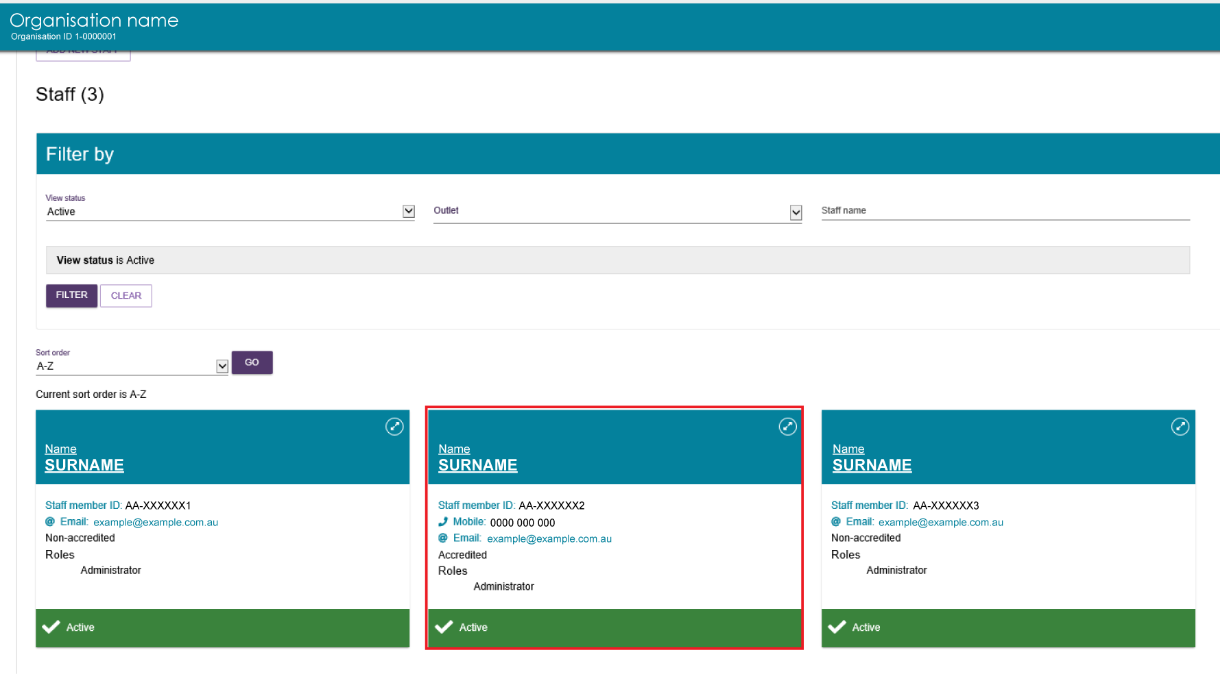
- On the View Staff Member page, select Deactivate.
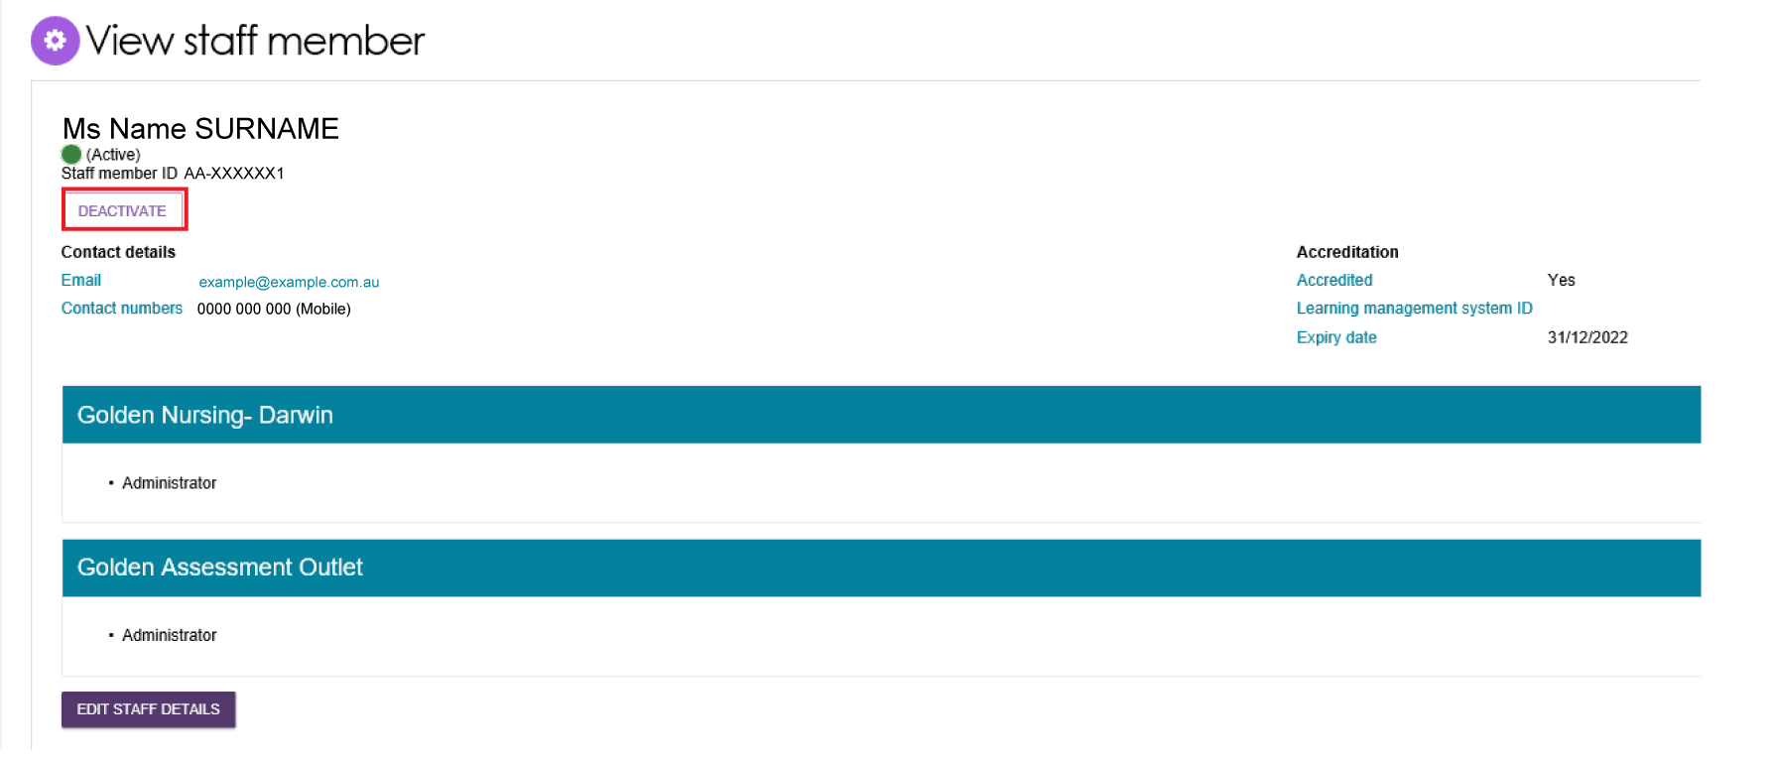
- Select Deactivate Account to confirm.
If the staff member has any assigned assessments, the confirmation message will display these assessments before you deactivate the account.
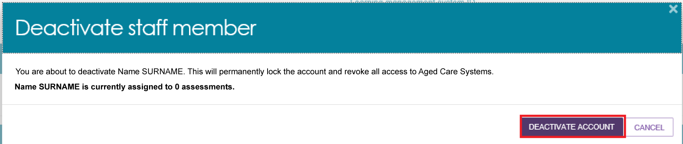

Removing and reactivating a staff account
Inactive staff members who have been deactivated can be removed from organisations and outlets. Once removed, they no longer appear in the assessor portal.
Follow these steps to remove an inactive staff member:
- On the Organisation Administration page, open the Staff tab.
Select Inactive from the View Status drop-down list to display inactive staff members.
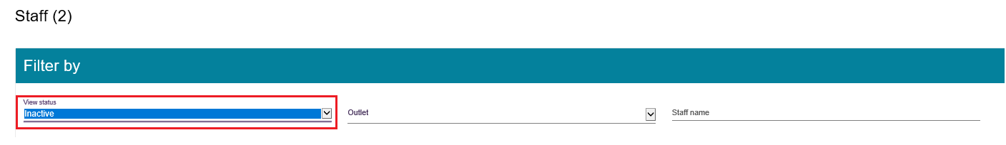
- Select the staff member you want to remove.
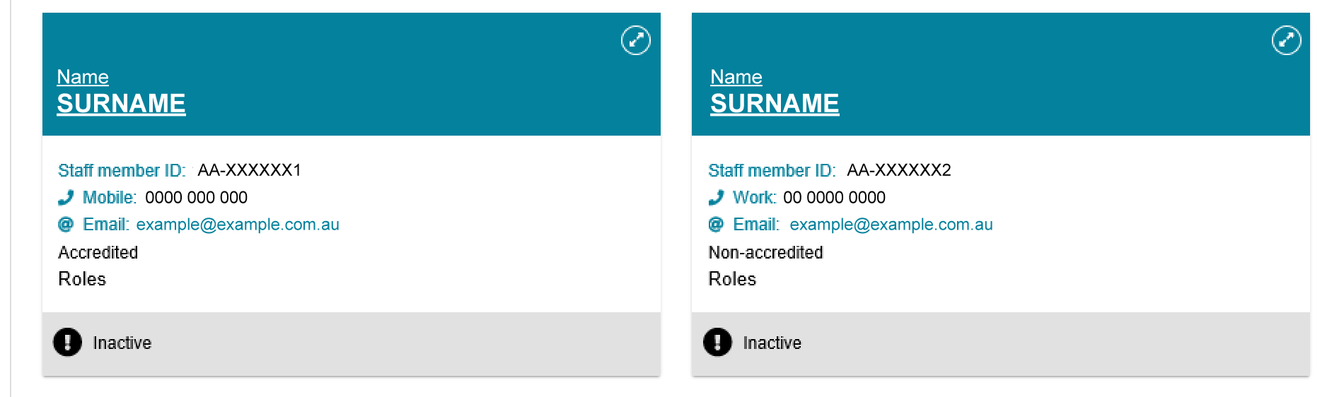
- On the View Staff Member page, select Remove or Reactivate.
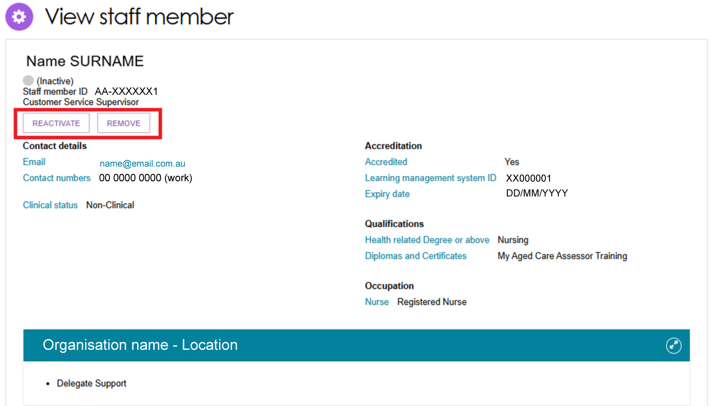
- Select Remove to remove the staff member from your staff list.
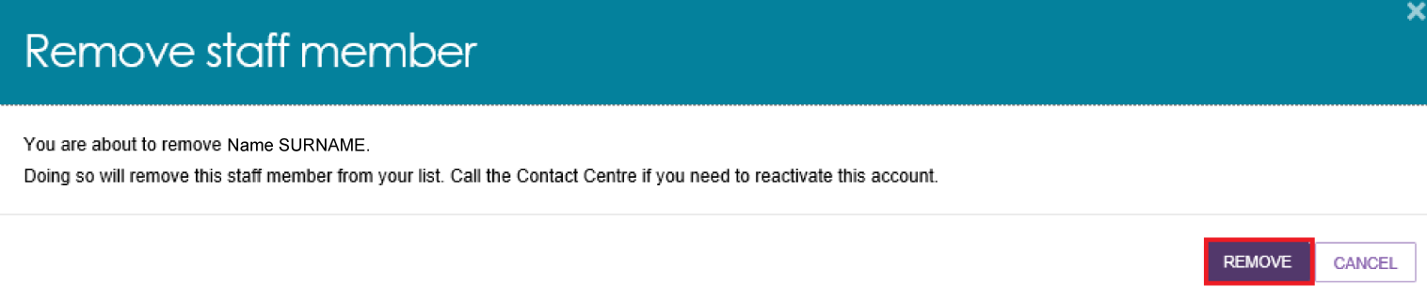
! | If you need to restore access for a staff member who has been removed, contact the My Aged Care Provider and Assessor Helpline on 1800 836 799.  You cannot create a new portal user account using the same email address as a removed staff member.

Edit a staff account
Follow these steps to edit a staff account:
- On the Organisation Administration page, open the Staff tab and select the staff member you want to edit.
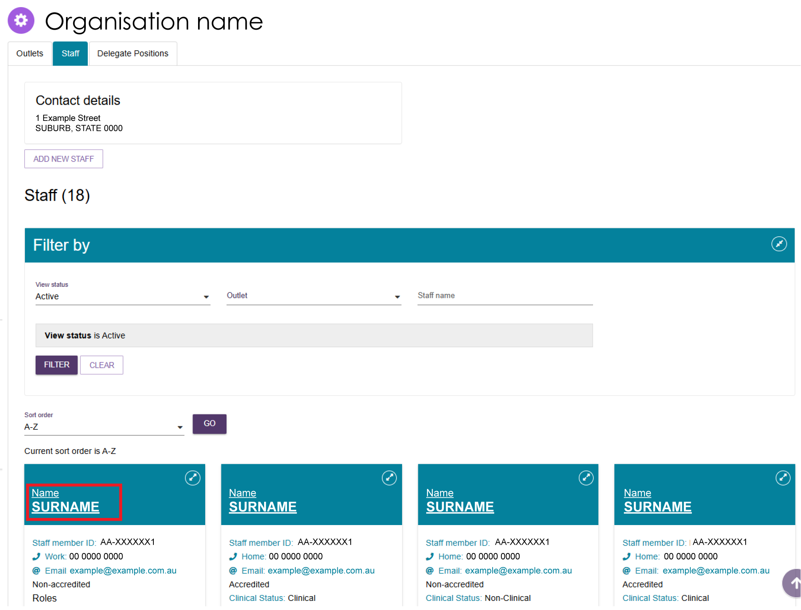
- On the View Staff Member page, select Edit Staff Details.
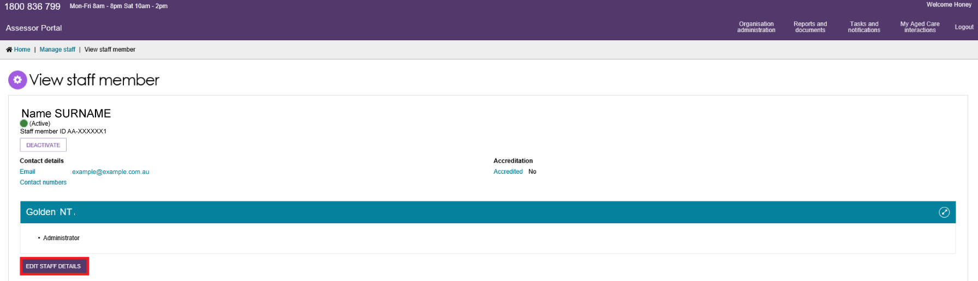
- You can update staff details and roles at any time.
To change roles, select Manage Roles or the Edit (pencil) icon. Update the staff member’s roles in the pop-up window, then select Save.
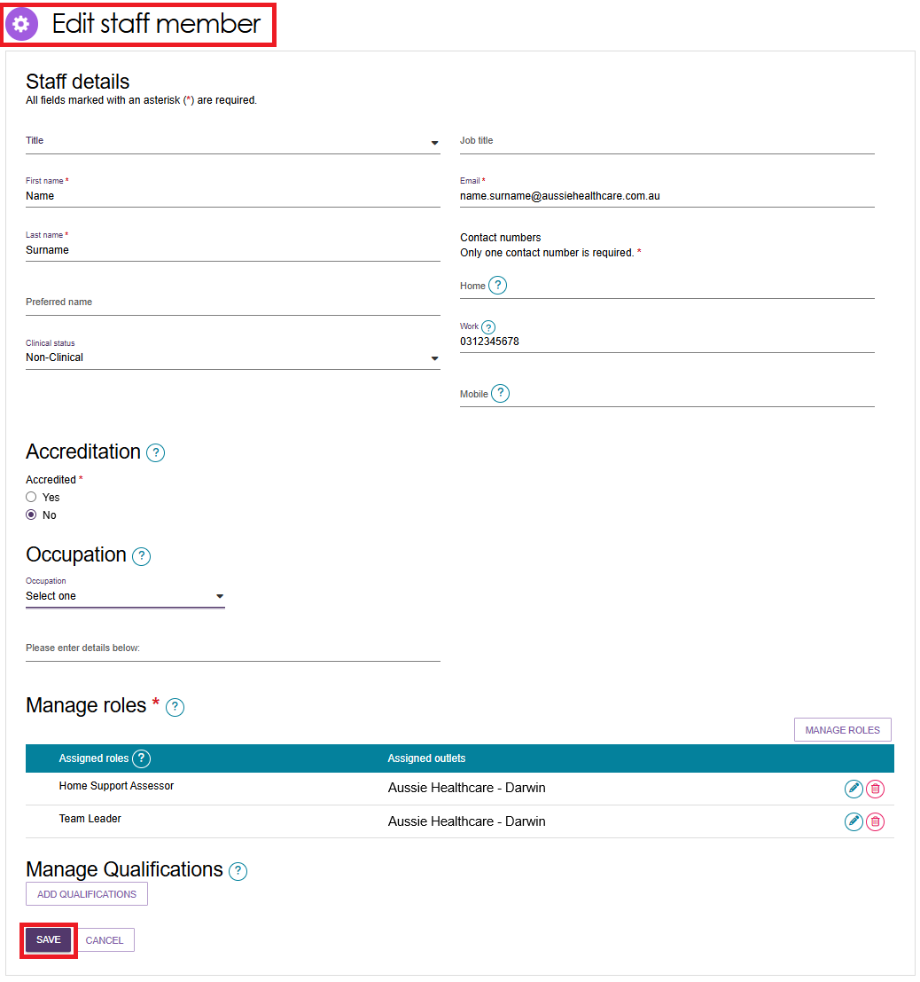

Find a service provider
The following roles can use the Find a Service Provider function in the assessor portal:
- Needs Assessor
- Team Leader
- Triage Delegate
- Clinical Assessment Delegate
- Non-Clinical Assessment Delegate
- Assessment Delegate Support.
Users assigned any of these roles can access the Find a Service Provider function from the assessor portal.
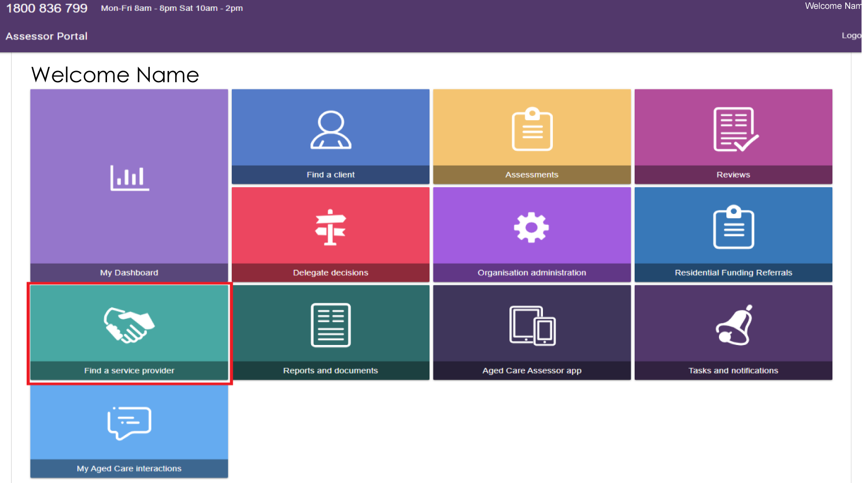
Search for providers by entering the category, service type, location, and verified specialisations. The search results appear below the search fields.
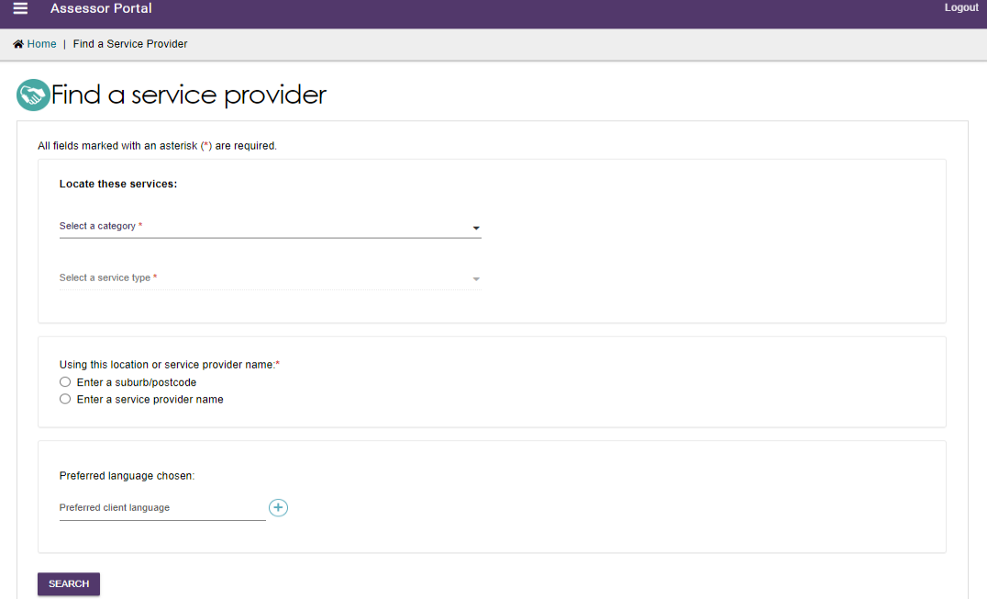
Each provider's service card shows key information, including:
- Suburb
- Phone number
- Service availability
- Waitlist availability.
Each service card also includes a link to the My Aged Care website, where you can find additional information, such as the provider’s compliance details. Select Expand on the service card to view more information about the provider.
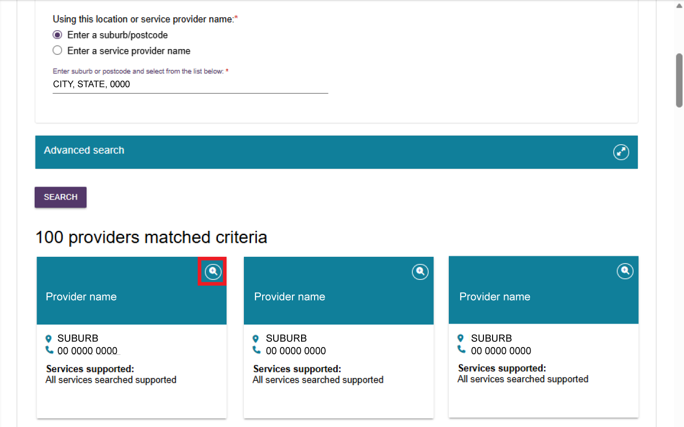
The provider’s details open on a new page. You can also hover over any help icon to see additional information about a specific topic.
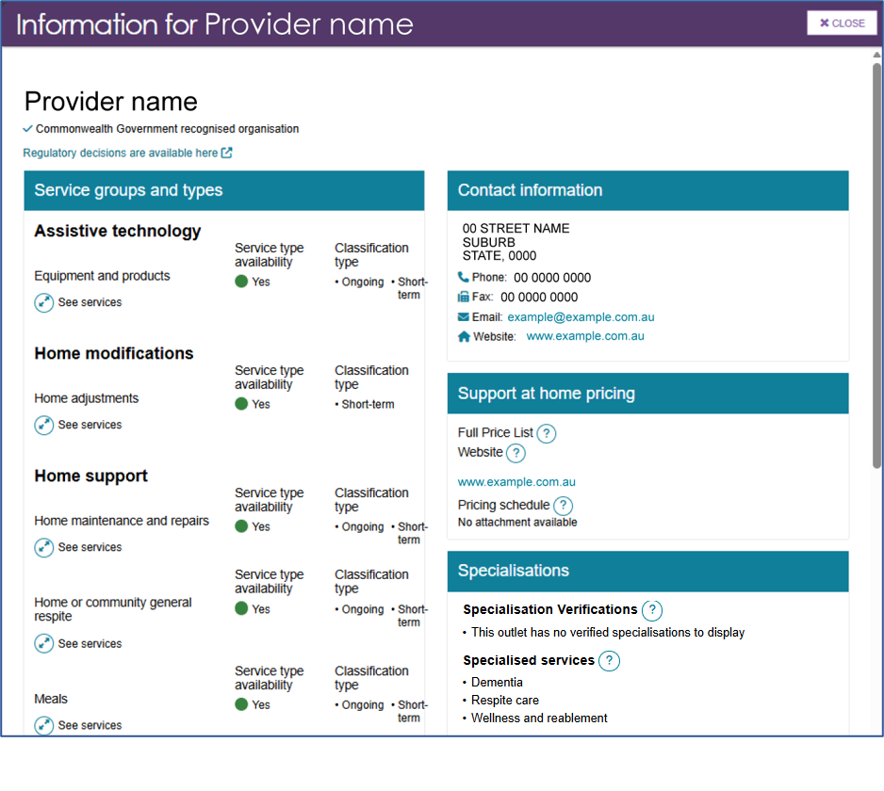

End of Month (EOM) reporting
Organisation Administrators and Team Leaders can generate a BIP EOM Preparation Invoice Report and send it to the department as supporting evidence for their End of Month (EOM) Assessment Invoice.
Follow these steps:
- From the assessor portal homepage, select Reports and Documents.
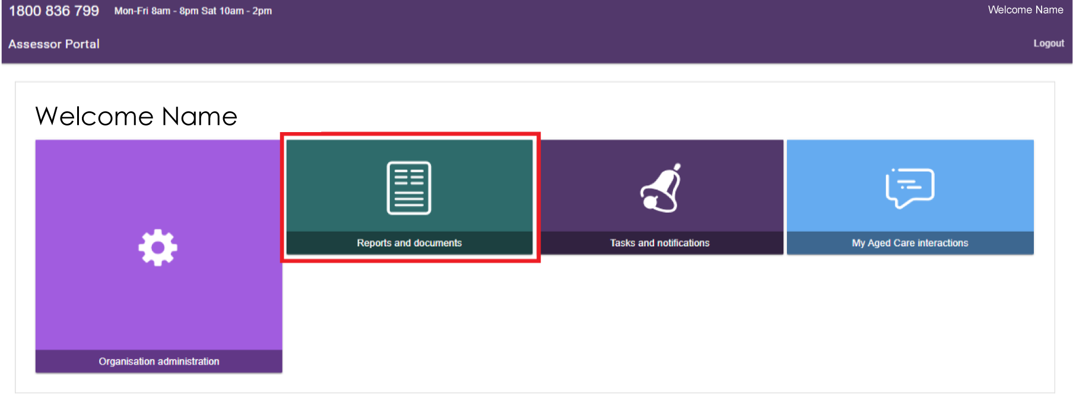
- Select BIP EOM Preparation Invoice Report.
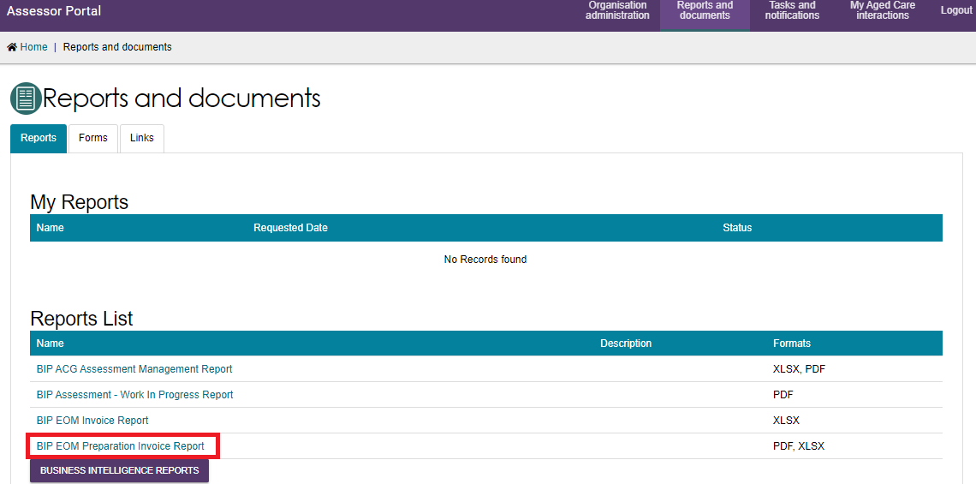
- On the Generate Report page:
- Select the correct Outlet ID.
- Enter the start date and end date for the reporting month.
- Select XLSX from the Output Type list.
- Select Request Report.
The system returns you to the Reports and Documents page, where the report appears under My Reports.
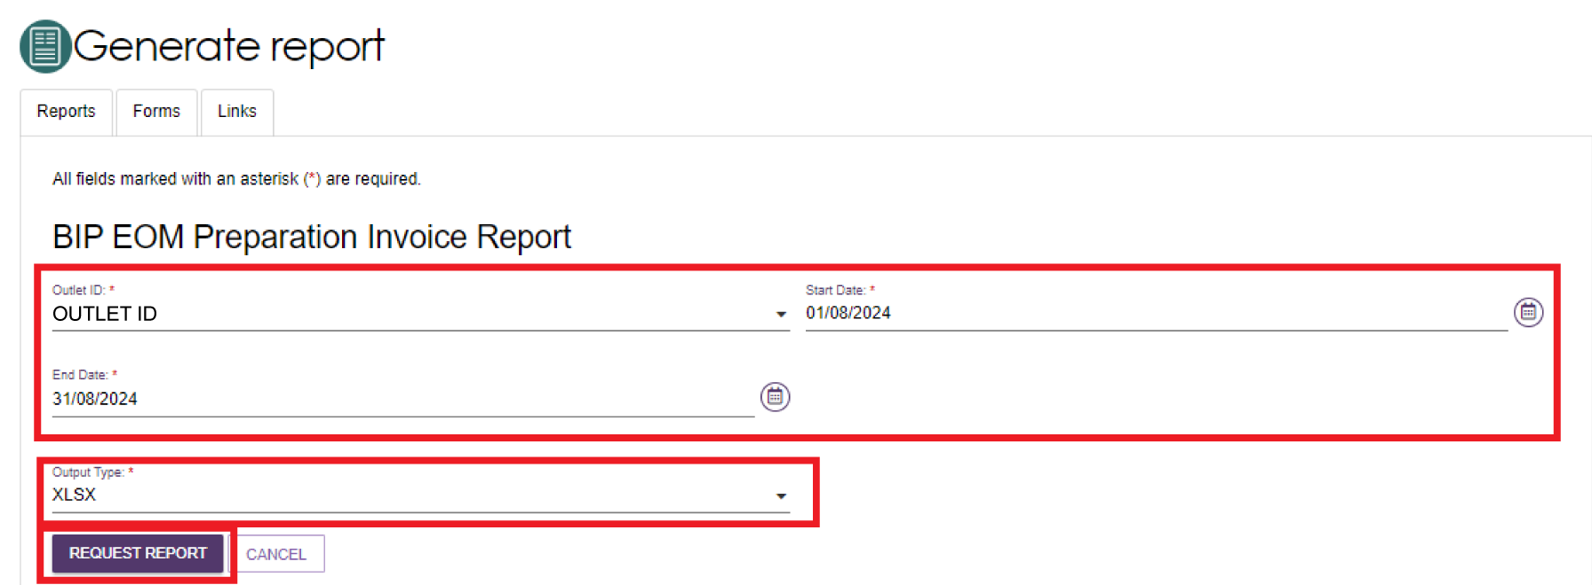
- Select View to open the report.
The report status initially shows Processing. Once the report is ready, the status changes to Ready - View.
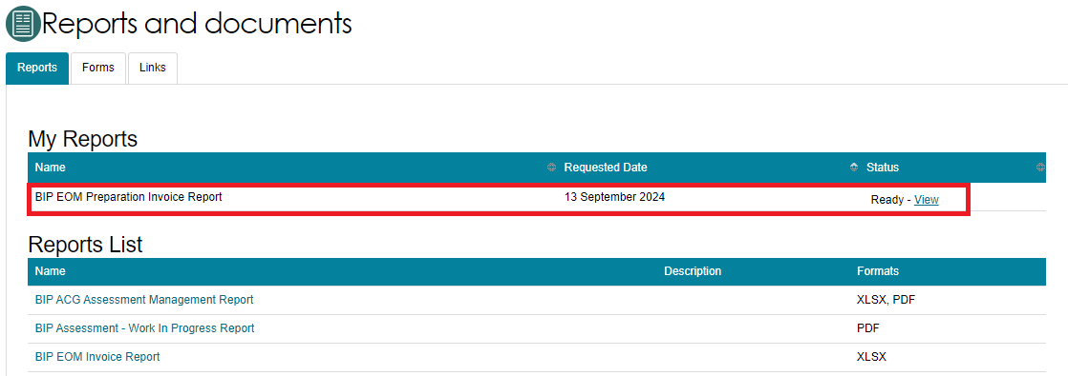
- Download the Excel file to your computer. To open it, select the Open file link from the Downloads pop-up in the top-right corner of your web browser.
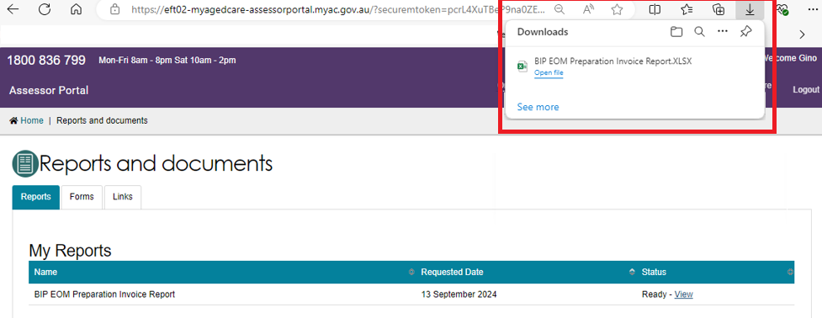
- Review the report in Microsoft Excel.
The report shows the total number of assessments and includes details for each assessment, such as:
- Unique assessment ID (Event ID)
- Assessor who completed the assessment
- Unique client ID
- Date the assessment was completed
- Assessment type recorded at the triage stage
- Whether the assessment was completed in hospital.
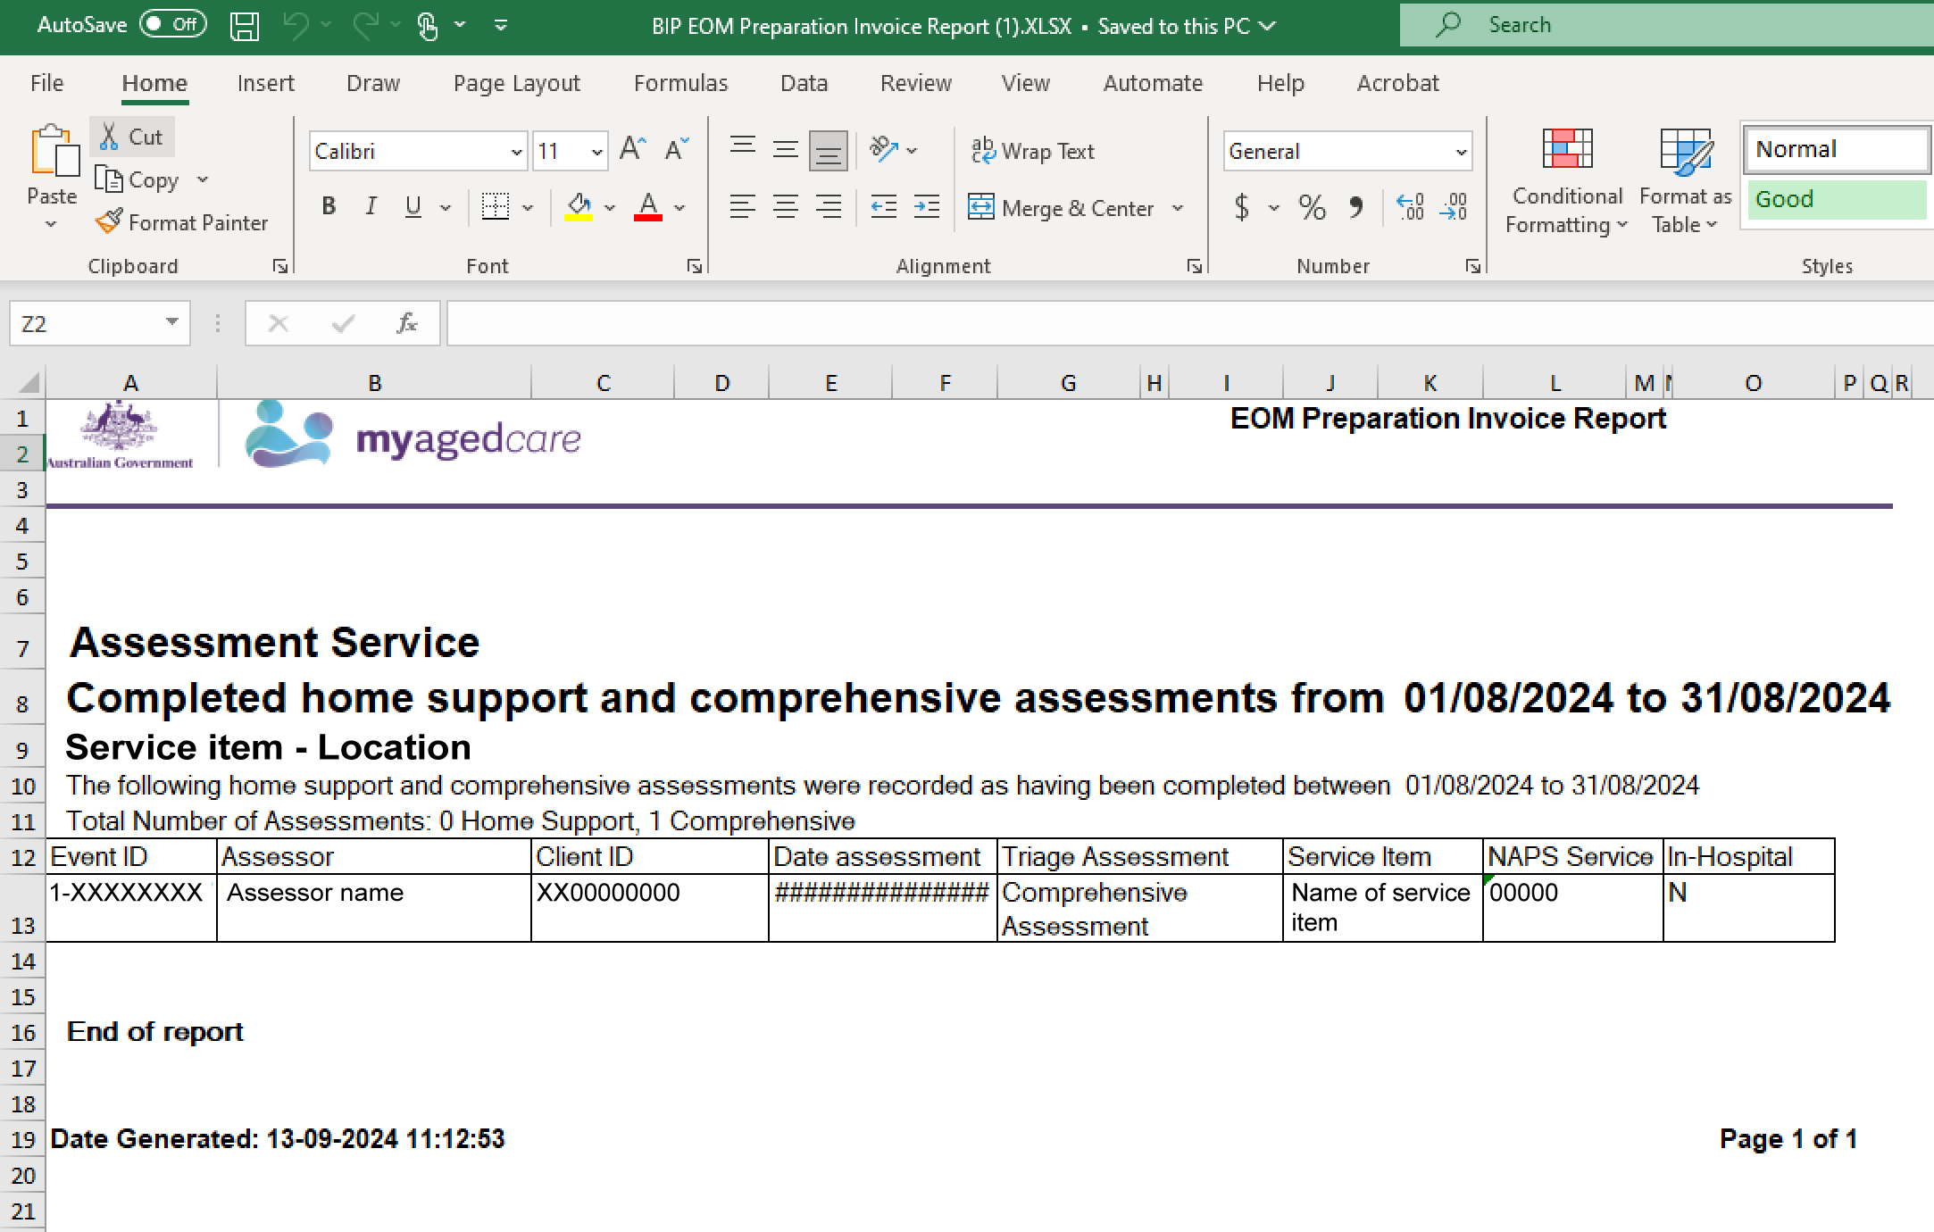
For more information regarding reporting, refer to the My Aged Care Assessment Manual.

