Medicare Mental Health Centres
2025 Clinical Review

About this report
This summary report presents key findings from the 2025 Clinical Review of Medicare Mental Health Centres. The review examined the effectiveness of the National Service Model in meeting the needs of people presenting to Medicare Mental Health Centres.
The review involved visits to 33 centres, engagement with 570 stakeholders (including 98 consumers and carers with lived experience), and workforce analysis. Adopting a collaborative approach, the review focused on understanding real-world experiences and drawing insights from those delivering and accessing services on the ground.
The review found that Medicare Mental Health Centres represent a distinctive and highly valued approach to mental health care. Stakeholders consistently described the model as accessible, welcoming and responsive to community need. Its strength lies not in any single intervention, but in the combination of trusted relationships, multidisciplinary team-based care, practical support and strong community connections.

Medicare Mental Health Centres
Medicare Mental Health Centres provide free, community-based support for adults experiencing mental health challenges or distress. People can access support without a referral or appointment.
The National Service Model consists of four core service components:
 | Respond to people with moderate to severe mental health needs, including those in significant distress or at heightened risk of suicide
 | Provide a central point to connect people to other services in the region through service navigation and warm referral pathways
 | Provide in-house assessment, information, and support to access services
 | Provide evidence-based short-to-medium term episodes of care
Services are delivered through multidisciplinary teams that may include psychologists, social workers, nurses, occupational therapists, counsellors, peer workers, psychiatrists, GPs, nurse practitioners and other psychosocial, community and cultural support roles.
Together, these workforce groups provide support for people's mental health, physical health, social and practical needs. This includes clinical care (assessment, treatment and support provided by qualified health professionals), as well as peer, psychosocial and community-based support.

Strengths of the model
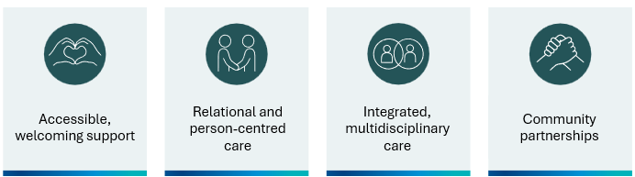
Across Australia, consumers, carers, staff and partners consistently described Medicare Mental Health Centres as accessible, welcoming and responsive to community need.

Accessible, welcoming support
One of the model's greatest strengths is its accessibility. Free, walk-in access without a referral or appointment reduces barriers and enables people to seek help when they need it most. The model’s welcoming, "no wrong door" and "can-do" culture also helps ensure people feel supported from their first point of contact. This ethos creates a strong foundation of inclusion, safety and dignity. Stakeholders consistently described services as responsive and solution-focused, with staff working alongside people to understand their needs and connect them with appropriate support.
Consumers highlighted the importance of the thoughtfully co-designed, trauma-informed physical spaces supported by a welcoming culture for helping reduce stigma and fostering trust and belonging. They described these environments as places where they felt safe, respected and listened to.

Relational and person-centred care
A defining strength of the model is its emphasis on trusted relationships. Consumers, families and carers consistently described the importance of having time to build trust with staff and receive support tailored to their individual circumstances rather than a one-size-fits-all approach.
The review found that relational care, made possible by strong interdisciplinary teamwork, is a key factor underpinning the model's effectiveness. Staff frequently described positive workplace cultures characterised by collaboration, shared purpose and the ability to work in ways that align with their professional values.

Integrated, multidisciplinary care
The review found that the model works best when all four core service components operate together as an integrated system. The mix of clinical, peer, psychosocial and cultural roles enable flexible, holistic care that responds to people’s diverse needs.

A multidisciplinary national workforce
Workforce information collected through the review identified more than 400 staff working across the 33 participating sites. The workforce included mental health clinicians, peer workers, integrated mental health workers (Aboriginal Health Workers, Transcultural Health Workers, vocational, family and mental health support workers), medical and physical health roles (including psychiatrists, GPs and nurse practitioners), students, and staff providing management and operational support.
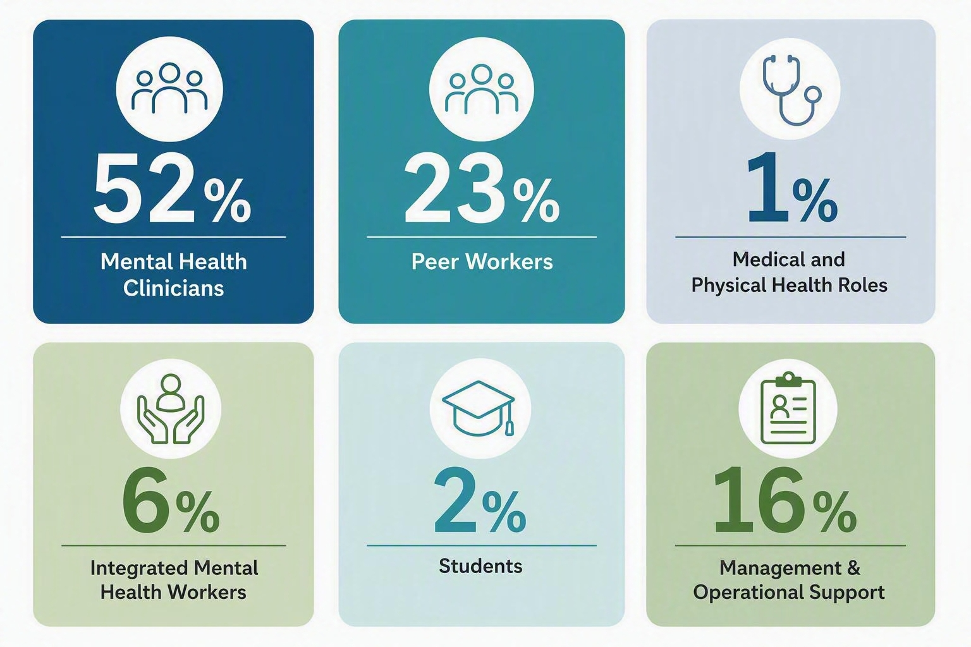

A diverse mental health clinician workforce
Mental health clinicians comprised the largest workforce group. The clinician workforce itself reflected a broad mix of disciplines including social work, nursing, counselling, psychology and occupational therapy professions. This diversity of professional background supports interdisciplinary practice and enables Medicare Mental Health Centres to respond to a wide range of consumer needs.
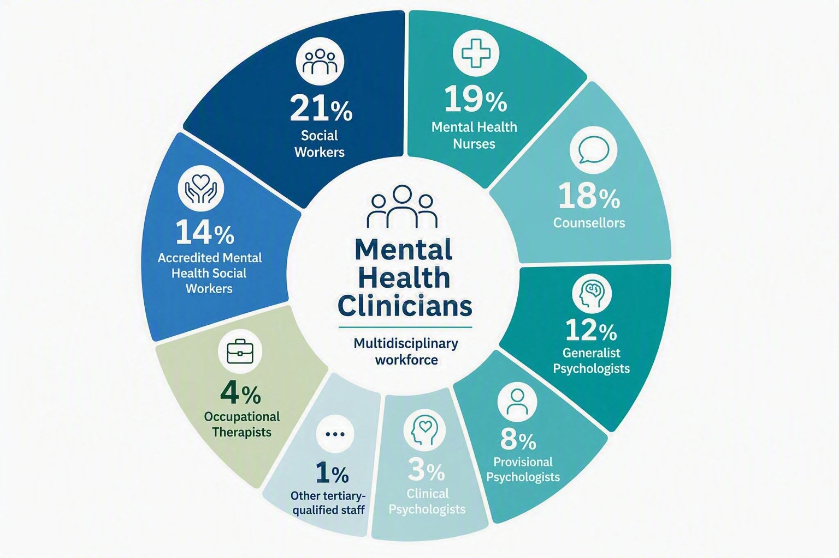
Stakeholders consistently highlighted the value of integrated, multidisciplinary support for people in distress. This may include service navigation, assessment and care planning and short- to medium-term multidisciplinary care within a single service model.
Peer workers were consistently identified as an integral component of this multidisciplinary approach. Stakeholders described the value of lived experience expertise in helping people feel understood, supported and connected. Peer workers were seen as making an important contribution to engagement, trust-building, service navigation and recovery-oriented care.

Community partnerships
Strong local partnerships and community engagement activities, such as co-design with people with lived experience, outreach to priority populations, and collaboration with local health and social services, were identified as important contributors to success. These activities help connect people to a broad range of supports, reduce the need to navigate services alone, improve continuity of care and reinforce the role of Medicare Mental Health Centres within their communities. Stakeholders also described community engagement as a core function of the model, supporting awareness, accessibility and local partnerships.
Overall, the review found that Medicare Mental Health Centres are filling a critical gap in Australia's mental health system by providing accessible, person-centred support that is highly valued by consumers, carers, staff and partners.

Key insights from the review
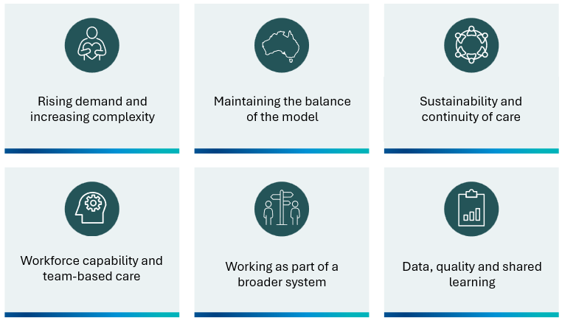
While the review found a strong and effective model, it also identified insights which will inform future development as the network continues to grow.

Rising demand and increasing complexity
Many centres reported growing demand for services and increasing complexity of needs among people seeking support. This reflects both community need and the success of the model in attracting people who may not otherwise engage with mental health services. As demand increases, maintaining the accessibility and the welcoming culture alongside balanced delivery of all four components of the model becomes increasingly important.

Maintaining the balance of the model
A recurring theme throughout the review was the importance of balancing national consistency and local flexibility. Stakeholders noted that some aspects of the model are fundamental to ensuring equitable, safe, high-quality and reliable care across the network, such as clinical governance arrangements, core service functions, multidisciplinary care and data collection. Other aspects, including outreach approaches, community partnerships and responses to priority populations, are best tailored to local context, culture, workforce realities and community need.
As the network continues to expand, stakeholders identified an opportunity to better define what good looks like across Medicare Mental Health Centres. Shared expectations across the network regarding quality, safety and service delivery could help support a consistently positive experience while preserving the flexibility needed to respond to local community needs. Stakeholders also noted the importance of clear roles and responsibilities across the Commonwealth, Primary Health Networks and service providers to support consistency, accountability and shared learning across a growing national network.

Sustainability and continuity of care
The review highlighted the importance of ensuring the model remains sustainable as the network continues to grow. Stakeholders noted that small centres have unique sustainability considerations relating to workforce capacity and development, access to senior and specialist expertise, and maintaining the full range of service functions in communities where local support and referral options are limited. Connecting smaller services with larger centres for supervision, workforce support, specialist expertise and shared learning are valuable ways to support sustainability while maintaining local responsiveness.
The review reinforced the importance of strong service navigation, community partnerships and warm referrals. As Medicare Mental Health Centres provide short- to medium-term support, effective connections with the broader service system are critical to ensuring people continue to receive the support they need, particularly where longer-term care is required.

Workforce capability and team-based care
The review pointed to the importance of further developing workforce capability and sustainability, including recruitment, retention and development across the multidisciplinary workforce. Stakeholders highlighted the value of ensuring people can access the range of clinical, psychosocial, physical health and lived experience expertise needed to support their care.
The review also identified opportunities to strengthen access to medical and physical health expertise. Stakeholders consistently reported that psychiatry, general practice and nurse practitioner functions add greatest value when integrated into multidisciplinary teams, supporting shared decision-making, workforce capability and holistic care, rather than being accessed solely through external referral pathways.
Clear role definitions, peer-specific supervision and organisational supports were identified as important enablers of a sustainable peer workforce and its ongoing contribution to frontline service delivery.
The review reinforced the importance of culturally responsive care that reflects the diversity of the communities being served. This included the value of First Nations peer and clinical roles, partnerships with Aboriginal Community Controlled Health Organisations, and approaches tailored to the needs of priority populations, including LGBTIQA+ people, culturally and linguistically diverse communities, and other groups who may experience barriers to accessing support.
Workforce capability, interdisciplinary practice, training and shared learning were recurring themes throughout stakeholder consultations and were seen as important considerations for the ongoing evolution of the network.

Working as part of a broader system
The review highlighted the importance of making it easier for people to access coordinated support as they move between services. Stakeholders emphasised the value of strong partnerships, clear pathways and continuity of care, helping consumers and carers access the right care at the right time. Collaboration between Medicare Mental Health Centres, state and territory mental health services, and local partners was strongest where structures and processes supported effective working relationships on the ground.

Data, quality and shared learning
Stakeholders highlighted the value of data, measurement and feedback systems as important enablers of quality improvement and for understanding service impact over time. Better visibility of service activity, outcomes and consumer experiences would support local learning, quality improvement and future planning across the network.
The review also highlighted the importance of national approaches to continuous improvement and shared learning as the network continues to expand.

Looking ahead
The review found broad support for the underlying design of the National Service Model. The model's strengths lie not in any single intervention, but in the combination of accessible walk-in support, welcoming environments, trusted relationships, multidisciplinary team-based care and strong community connections.
As the network continues to expand, protecting and strengthening these core elements will be critical to ensuring high-quality, person-centred support remains available to communities across Australia.
Looking ahead, stakeholders highlighted several themes likely to remain important as the network evolves. These include workforce capability, culturally responsive practice, service integration, quality improvement and the use of data to support learning across the network. Continued collaboration between governments, primary health networks, service providers, communities and people with lived experience will be important for ensuring the model continues to evolve in response to changing needs.
By building on its strengths and maintaining its commitment to accessible, welcoming and holistic care, Medicare Mental Health Centres are well placed to continue supporting people experiencing mental health challenges while contributing to a more connected, responsive and sustainable mental health system.

For more information about Medicare Mental Health Centres, visit:
medicarementalhealth.gov.au

