Managing CHSP service information in the My Aged Care ‘Find a provider’ tool
This document explains what Commonwealth Home Support Programme (CHSP) service providers need to do to manage their service information in the My Aged Care Website Find a Provider tool.
Contents
Introduction 2
Important Information 2
Administrators 2
Updating information in the Find a provider tool 3
Technical questions and assistance 3
CHSP Program Manual 3
Funding Agreement 4
Duplicate services 4
What is a duplicate service? 4
Action required – Duplicate entries 4
Specialisation Verification 4
Outlet names 5
Locational information in service names 5
Action required – Outlet names 5
Service delivery area information 6
Action required – Service delivery areas 6
Availability information 6
Support resources 6
User Guides 7
Videos 7

Introduction
Service providers (providers) must keep their information in My Aged Care (MAC) Website Find a Provider tool (herein referred to as Find a Provider) accurate and up to date. This information helps older Australians, their families, carers and support network find and compare aged care providers.
It is important that providers regularly update details such as service availability and the services they offer. Accurate information helps ensure people receive the right referrals.
The department requires you to:
- List each service only once at each location and remove any duplicate service listings by making them inactive.
- Use outlet names that do not include phone numbers or marketing slogans.
- Include only the areas where you can actually deliver services when setting service delivery areas.
- Keep availability information up to date.
- Apply for Specialisation Verification where your outlet offers tailored services in any of the nine specific cohort or community groups, refer to Specialisation Verification for aged care services | Australian Government Department of Health, Disability and Ageing for details.
- Nominate for each service your specialised services and languages where specific measures are in place to meet this specialised care. I
! | Under the Aged Care Quality Standards, providers must give consumers information that is current, accurate and timely. They must communicate this information clearly and in a way that is easy to understand, so consumers can make informed choices.  Make services operational (of active outlets) so they are available and searchable on MAC website Find a provider tool

Important Information
This document explains the requirements for managing CHSP service information in the Find a Provider tool.
It does not explain how to update information in the My Aged Care Service and Support Portal. The department provides resources on its website to help providers use the portal.
For updates from the department for aged care service providers, subscribe to the aged care sector announcements and newsletters.

Administrators
Administrators are responsible for setting up and managing their organisation in the My Aged Care Service and Support Portal. This includes managing outlets, service information and staff user accounts.
Organisation Administrators can view and manage information for the entire organisation in the portal.
Outlet Administrators can view and manage information only for the outlet or outlets assigned to them.

Updating information in the Find a provider tool
The majority of the service information you enter in the My Aged Care Service and Support Portal is published in the Find a Provider tool on the My Aged Care website.
When you update your service information in the portal, the changes will appear in the Find a Provider tool the following day.
The Find a Provider tool includes a disclaimer on each provider page that states providers are responsible for keeping their information accurate and up to date. This disclaimer does not apply to information that the department verifies, such as verified specialisations, or star ratings.
An example is shown below.
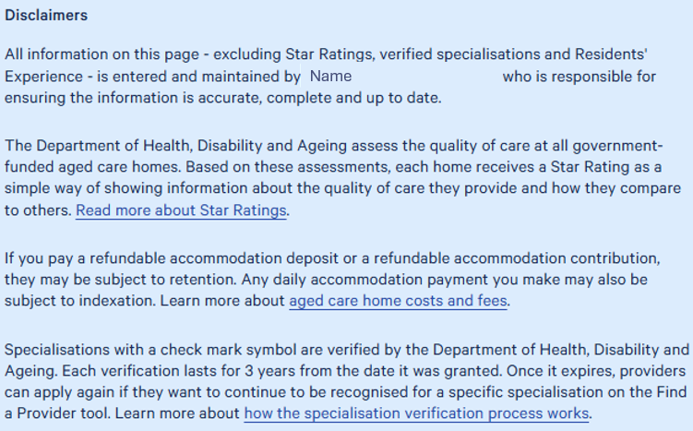
The My Aged Care website provides tips and guidance to help you improve your profile in the Find a Provider tool.

Technical questions and assistance
If you need technical support, call the My Aged Care service provider helpline on 1800 836 799 and select Option 2. The helpline operates from 8:00 am to 8:00 pm on weekdays and 10:00 am to 2:00 pm on Saturdays (AEST).
Only staff with the Organisation Administrator or Outlet Administrator role can request some changes through the helpline.
Before you call, make sure you have the details of the requested change ready, including the National Approved Provider System (NAPS) ID, outlet name, service, and service delivery area.

CHSP Program Manual
Under the CHSP Program Manual, service providers must update their service information in the My Aged Care Service and Support Portal. Accurate information helps people find services and supports the contact centre and aged care assessors to make appropriate referrals.

Funding Agreement
The service information you enter in My Aged Care Service and Support Portal must match the information in your current Funding Agreement. If you have questions about your Funding Agreement or contractual obligations, contact your Funding Arrangement Manager.

Duplicate services

What is a duplicate service?
A duplicate CHSP service occurs when the same organisation lists more than one operational service with:
- the same Outlet ID
- the same Service Type and Service Sub-type, and
- the same service delivery area.
For example, two domestic assistance service items with the same Service Sub-Types (such as House Cleaning), from the same Outlet, both delivering to a service delivery area of Parramatta NSW 2150, would be considered duplicate services.
The Find a Provider tool does not show duplicate CHSP service listings in search results.
Providers should regularly review their service listings and remove any duplicate services they identify by making them inactive.

Action required – Duplicate entries
If you have a duplicate service listing, you must correct it. Organisation Administrators and Outlet Administrators can do this in the My Aged Care Service and Support Portal by:
- Updating service delivery areas so that service listings do not cover the same postcodes.
- Changing duplicate outlets to inactive, where appropriate.
- Moving or consolidating clients from duplicate services, if needed.
These changes will help ensure your service information is accurate and prevent duplicate listings from appearing in My Aged Care.

Specialisation Verification
To claim a verified specialisation, you must provide care that meets the specific needs of people from unique backgrounds and life experiences. This care must go beyond the minimum requirements for inclusive, person-centred care set out in the Aged Care Quality Standards and the Statement of Rights.
Providers cannot have new Specialisation Verification claims added to their My Aged Care Website profile unless those claims have been verified.
To apply for Specialisation Verification, providers must lodge an application in the My Aged Care Service and Support Portal. Applications are assessed by the department. The assessor checks whether the outlet meets the requirements under the 2025 Specialisation Verification Framework (Framework) for the nominated specialisation category. The Framework explains the requirements providers must meet and the evidence they need to provide. Providers can apply for Specialisation Verification at any time.
My Aged Care Website publishes verified specialisations on provider profiles, including the validity period and criteria the provider has met under the Framework.
For more information about the verification process and how to apply, refer to About Specialisation Verification.

Outlet names
To help consumers find and compare services, providers should use outlet names that are clear, accurate and easy to understand. Outlet names should:
- Clearly identify the outlet.
- Accurately reflect the service or location.
- Not include promotional slogans.
- Not include phone numbers.
The outlet name appears in the search results of the My Aged Care Find a Provider tool, so it is important to use a name that helps consumers identify your service.

Locational information in service names
You do not need to include the service delivery area in your outlet name.
If you choose to include a location, region or state in your outlet name, make sure the service delivery area matches that location. For example, if your outlet name includes "NSW", the services delivered from that outlet should only be available within New South Wales.
For more information, refer to service delivery area information.
Examples of correct and incorrect outlet names
Incorrect outlet name | Correct outlet name
Happy Horizon home care - call us on 1800 555 555 | Happy Horizon home care
#1 home care services Quality Care Home Care NSW | Quality Care Home Care NSW
Happy Horizon – Best value care | Happy Horizon
1800 555 555 Quality Care Community Services | Quality Care Community Services

Action required – Outlet names
If your outlet name does not meet these requirements, you must update it. Organisation Administrators and Outlet Administrators can do this by:
- Reviewing outlet names to make sure they are clear, meaningful and helpful to consumers.
- Removing phone numbers, advertising messages and marketing slogans from outlet names.
- Checking that the service delivery area for each service matches the location shown in the outlet name.

Service delivery area information
Providers must make sure they can deliver services in all locations listed under Service Delivery Area in the My Aged Care Service and Support Portal. Accurate service delivery area information is important because many consumers use location when searching for services in the Find a Provider tool.
When you update a service delivery area, you can:
- Add a specific suburb or postcode.
- Add all suburbs in a selected state.
- Add all suburbs in a selected region.
Only select locations where you currently provide services. For example, if you select a whole state or a national service delivery area, you must be able to deliver services across all locations in that area, including rural and remote communities. Do not include locations where you plan to provide services in the future but do not currently operate.
Incorrect service delivery area information can:
- Delay access to services when referrals are rejected.
- Cause consumers to contact providers that cannot deliver services in their area.
CHSP providers should only list services in the service delivery areas covered by their Funding Agreement. You can update a service delivery area if it remains within the location, usually the Aged Care Planning Region, specified in your Funding Agreement.

Action required – Service delivery areas
To keep your service delivery area information accurate, Organisation Administrators and Outlet Administrators should:
- Review the service delivery area for each service to make sure it matches the areas where you currently deliver services. For CHSP providers, these areas will usually align with the Aged Care Planning Regions in your Funding Agreement.
- Remove any suburbs from the list of serviced suburbs if you do not deliver services there.
- Use the Remove all function if you need to clear the current list and set up a new service delivery area.

Availability information
Providers can update their service availability information in the My Aged Care Service and Support Portal. This information appears in the Find a Provider tool and helps My Aged Care contact centre staff and aged care assessors make referrals.
It is important to keep service availability information accurate. Incorrect information can:
- Delay access to services when referrals are rejected.
- Lead consumers to contact providers that do not have capacity to provide the service.
If you cannot provide a service at a particular time, your Organisation Administrator or Outlet Administrator should update the service availability information in the portal as soon as possible.

Support resources
The following resources can help you manage your service information in the My Aged Care Service and Support Portal:

User Guides
My Aged Care Service and Support Portal User Guide: Part One – Administrator Functions
Service and Support Portal User Guide – Advanced Outlet and Service Management – Transferring Clients and Services
Service and Support Portal User Guide – Creating Service Delivery Outlets and Adding Service Information
Managing your provider profile

Videos
How to transfer clients and services within and between outlets
How to configure outlet information – introduction
How to configure CHSP service information
These materials are available at the My Aged Care – Service and Support Portal Resources webpage.

