The Improving Palliative Care Training and Outcomes in Aged Care Evaluation, Final Report, was provided to the Department of Health, Disability and Ageing on 19 June 2026.

This version of the document includes redacted material protected by personal information as defined by the Privacy Act 1988.


  - Department of Health, Disability and Ageing

Improving Palliative Care Training and Outcomes in Aged Care Evaluation
  - Final Evaluation Report
8 May 2026



OUR VISION  To positively impact people’s lives by helping create better health services  OUR MISSION  To use our management consulting skills to provide expert advice and support to health funders, service providers and users |  | HMA acknowledges Traditional Owners of Country throughout Australia and recognises the continuing connection to lands, waters and communities.  We pay our respect to Aboriginal and Torres Strait Islander cultures, and to Elders both past and present.
 |  | 

Table of Contents
Abbreviations i
Executive summary ii
1 Introduction 1
1.1 The Measure 1
1.1.1 Objectives and intended outcomes 1
1.2 Evaluation aims 2
1.3 Purpose and structure of this document 2
2 Evaluation approach and method 3
2.1 Evaluation approach 3
2.1.1 Stage 1: Project initiation and planning 3
2.1.2 Stage 2: Evaluation plan 3
2.1.3 Stage 3: Development of data collection instruments 3
2.1.4 Stage 4: Data collection and analysis 5
2.1.5 Stage 5: Final evaluation report 6
2.2 Evaluation design and scope 7
2.2.1 Key evaluation areas 7
2.3 Evaluation limitations 7
Part A Project context and approach 9
3 Program context 10
Section A Policy context 10
3.1 National Palliative Care Strategy 10
3.2 State and territory palliative care policies 10
3.3 National palliative care guidance 11
3.4 Related national palliative care initiatives 11
3.5 Royal Commission 12
Section B Program arrangements 12
3.6 PEPA Aged Care 12
3.6.1 Design and delivery model 12
3.6.2 Administration, funding, and governance 13
3.6.3 Key performance indicators 13
3.7 PACOP 14
3.7.1 Design and delivery model 14
3.7.2 Administration, funding, and governance 15
3.7.3 Key performance indicators 15
Part B Evaluation findings and recommendations 18
4 Appropriateness 19
Analysis and findings 19
4.1 The Measure 19
4.1.1 Continued need for palliative care education, training, and quality improvement 20
4.1.2 Gaps and areas of duplication 21
4.2 PEPA Aged Care 23
4.2.1 Training content and delivery 23
4.2.2 Sustainability and reach of the training model 24
4.2.3 Clinical and cultural safety 25
4.3 PACOP 25
4.3.1 Systems approach 25
4.3.2 Resource investment and model complexity 26
4.3.3 Technology 27
4.3.4 Assessment tools 27
4.3.5 Outcome data accessibility 28
4.3.6 Clinical and cultural safety 28
5 Implementation 29
Analysis and findings 29
5.1 Implementation of the Measure 29
5.2 Implementation of PEPA Aged Care 30
5.2.1 Delivery of planned activities and outputs 30
5.2.2 Engagement and uptake 31
5.3 Implementation of PACOP 34
5.3.1 Delivery of planned activities and outputs 34
5.3.2 Engagement and uptake 35
6 Effectiveness 41
Analysis and findings 41
6.1 PEPA Aged Care 41
6.1.1 Improvements in workforce capability 41
6.1.2 Improvements in organisational capability, quality improvement, and collaboration 43
6.1.3 Improvements in health outcomes and quality of life 45
6.1.4 Factors influencing effectiveness 46
6.2 PACOP 47
6.2.1 Improvements in workforce capability 47
6.2.2 Improvements in organisational capability, quality improvement, and collaboration 49
6.2.3 Improvements in health outcomes and quality of life 52
6.2.4 Factors influencing effectiveness 54
7 Efficiency 56
Analysis and findings 56
7.1 PEPA Aged Care 56
7.1.1 Program funding and expenditure 57
7.1.2 Cost per placement and participant 59
7.1.3 Participation costs for sites 60
7.1.4 Program benefits 60
7.2 PACOP 61
7.2.1 Program funding and expenditure 61
7.2.2 Program cost per participating provider and home 63
7.2.3 Participation costs for aged care homes 64
7.2.4 Program benefits 64
8 Opportunities 67
9 Appendices 76
Appendix A Evaluation framework 76
Appendix B Stakeholders involved in consultations and case studies 88
Appendix C PEPA Aged Care program data 91
Appendix D PACOP program data 104
Appendix E Economic analysis approach 119
Appendix F References 125

Abbreviations
Abbreviation | Definition
ACQS | Aged Care Quality Standards
ACQSC | Aged Care Quality and Safety Commission
Department, the | Department of Health, Disability and Ageing
ED | Emergency department
ELDAC | End-of-Life Directions for Aged Care
FTE | Full-time equivalent
GP | General practitioner
HMA | Healthcare Management Advisors
IPEPA | Indigenous Program of Experience in the Palliative Approach
IT | Information technology
KEA | Key evaluation area
Measure, the | Extension of the Improving Palliative Care Training and Outcomes in Aged Care
MM | Modified Monash (Model)
NPCP | National Palliative Care Project
National Palliative Care Standards | National Palliative Care Standards for All Health Professionals and Aged Care Services
National Strategy | National Palliative Care Strategy
PACOP | Palliative Aged Care Outcomes Program
PCOC | Palliative Care Outcomes Collaboration
PEPA | Program of Experience in the Palliative Approach
PHN | Primary Health Network
QUT | Queensland University of Technology
Royal Commission | Royal Commission into Aged Care Quality and Safety

Executive summary
The Department of Health, Disability and Ageing (the Department) engaged Healthcare Management Advisors (HMA) to:
conduct an independent evaluation of the Extension of Improving Palliative Care Training and Outcomes in Aged Care Budget Measure (the Measure).
This document is the final report for the evaluation. It sets out the evaluation approach, findings, and opportunities for consideration in future, based on evaluation evidence.

The Measure
The Australian Government is committed to enhancing palliative care for older Australians, as recommended by the Royal Commission into Aged Care Quality and Safety (Royal Commission). In response to recommendations from the Royal Commission, the Australian Government allocated $18.98 million in the 2021–22 Budget (2021–22 to 2023–24) to establish the Improving Palliative Care Training and Outcomes in Aged Care measure. This measure funded three activities:
- Program of Experience in the Palliative Approach (PEPA) Aged Care
- Palliative Aged Care Outcomes Program (PACOP)
- End-of-Life Directions for Aged Care (ELDAC) Linkage activities.
A further $10.8 million (2024–25 to 2025–26) was allocated in the 2024–25 Budget to continue PEPA Aged Care and PACOP under the Measure. ELDAC Linkage activities were integrated into the existing ELDAC program and were out of scope for this evaluation.
The overarching objectives of the Measure were to:
- enhance training for the aged care workforce to improve the quality of and timely access to palliative care for older Australians
- support the development of organisational capabilities to deliver quality palliative care
- support the aged care workforce to deliver quality palliative and end-of-life care
- embed quality palliative care across aged care settings
- establish, maintain and strengthen linkages across the primary care, aged care, and palliative care sectors.
The intended outcomes of the Measure were:
- improved outcomes for patients and their families at the end of life
- high-quality, safe, and culturally appropriate palliative care that meets individual care needs
- increased general practitioner (GP), aged care provider, and other healthcare staff confidence and knowledge of palliative care and advance care planning
- establishment of links between primary care, aged care, and palliative care services
- aged care providers, GPs, or other healthcare workers are informed about palliative care, advance care planning and advance care directive resources, processes, legislation and accountabilities in the state or territory where the aged care service is located.
An overview of the two key activities within the scope of this evaluation, PEPA Aged Care and PACOP, is provided below.

PEPA Aged Care
PEPA Aged Care was developed and delivered by Queensland University of Technology (QUT). The program extended the existing PEPA program into aged care settings to build workforce and organisational capability in palliative care. PEPA Aged Care centred on the national delivery of ‘reverse PEPA Aged Care placements’, where experienced nurse educators provided tailored on-site palliative care education and training directly to staff within participating organisations (referred to as ‘placement sites’). This core activity was supported by education resources, knowledge translation activities, and service improvement initiatives, aimed at strengthening skills, confidence, and practice in delivering high-quality palliative care.

PACOP
PACOP was developed and delivered by the University of Wollongong as an extension of the established Palliative Care Outcomes Collaboration (PCOC) program. The program introduced a system-level framework to support residential aged care homes in embedding structured, evidence-based palliative care assessment and outcome measurement processes. The PACOP model combined routine screening assessments for all residents (known as the Profile Collection), systematic monitoring and response protocols for those with identified palliative care needs (known as the Outcomes Collection), and national benchmarking to track outcomes and inform quality improvement. The program was underpinned by a comprehensive educational program and communities of practice. By providing a national framework for consistent assessment, outcome measurement, and feedback, PACOP aimed to integrate palliative care into routine practice, strengthen organisational capability, and foster a culture of data-driven quality improvement in residential aged care.

Evaluation purpose and approach
The evaluation of the Measure commenced in March 2025 and culminated in a final report in May 2026. It included both formative and summative components to assess whether the Measure was appropriate, effective, and efficient. Findings may be used to inform continuous improvement and future funding decisions regarding the Measure.
All PACOP and PEPA Aged Care activities undertaken as part of the original 2021–22 Improving Palliative Care Training and Outcomes in Aged Care measure and the 2024–25 extension of the Measure were within scope.
The evaluation employed a mixed-methods approach, synthesising both qualitative and quantitative data from:
- an online survey of organisations providing aged care services, including both participants in PEPA Aged Care and/or PACOP and non-participating organisations (n=306 respondents)
- case study interviews with 12 aged care organisations, including four PEPA Aged Care sites, four aged care homes/providers participating in PACOP, and four non-participating organisations
- focus groups with 17 consumer, carer, and family representatives
- interviews with 93 key stakeholders, including government representatives, program delivery teams, related national palliative care initiatives, peak bodies and professional associations, aged care providers, and health professionals
- a review of Aged Care Quality and Safety Commission (ACQSC) performance reports (n=176) from 71 sites/homes participating in PEPA Aged Care or PACOP
- analysis of PEPA Aged Care and PACOP program data to examine program uptake, available outcomes, engagement activities, expenditure, and internal evaluation findings
- a desktop review which informed a comprehensive understanding of each program and the broader context of their implementation.

Limitations
The following limitations should be noted:
- The evaluation concluded prior to the end of current grant agreements (30 June 2026) and only included data from 1 November 2021 to 30 June 2025. Consequently, activities and outcomes delivered in the Measure’s final year were not captured.
- Outcome data were limited, with no health outcome data available for PEPA Aged Care and only a small amount for PACOP. This limited the ability to comprehensively assess program impact and precluded a full economic analysis. An exploratory economic analysis using PACOP data was undertaken to demonstrate an approach that could be considered in future economic analyses.
- Responses to the online survey were relatively low, limiting representativeness and generalisability of findings.
- Direct engagement with care recipients of organisations involved in PEPA Aged Care/PACOP was not possible due to ethical and recruitment challenges. However, critical input from consumer, family, and carer representatives was gathered through the focus groups.
- Data collected through the survey and consultations may reflect personal bias. This was mitigated by engaging a broad range of stakeholders.
- Some requested program data were missing or suppressed due to small cell counts, limiting the completeness and granularity of findings.
- Fewer ACQSC performance reports than planned were available for review, and very few reports were available pre- and post-participation in PEPA Aged Care/PACOP. This reduced the depth of analysis and limited the insights gathered from this data source.

Summary of key findings
A summary of key findings for each evaluation area examined is presented below.

Appropriateness
The Measure was widely perceived by stakeholders as a suitable and timely response to critical gaps in palliative care capability within the aged care sector, particularly in residential aged care settings. Its dual focus on workforce education through PEPA Aged Care and organisational systems and outcome monitoring through PACOP was considered strategically appropriate and aligned with relevant recommendations from the Royal Commission. The decision to fund adaptations of established, evidence-based programs (PEPA and PCOC) was endorsed by stakeholders, providing credibility and supporting rapid mobilisation. While the Measure was regarded as highly relevant for residential aged care, its applicability to both home care and the primary care sector was perceived as less clear. Stakeholders suggested that targeted strategies to strengthen engagement among home care providers and primary care professionals could strengthen multidisciplinary palliative care delivery and amplify the Measure’s impact.
Stakeholders consistently reported a strong and ongoing perceived need for palliative care education, training, and quality improvement in aged care, driven by system-level pressures, workforce challenges, and community factors. This need was expected to persist and potentially grow as regulatory reforms took effect and demographic pressures increased. Most stakeholders advocated for sustained investment in the Measure and its funded programs to address these challenges.
No direct duplication was identified between PEPA Aged Care and PACOP, and stakeholders generally viewed their activities as complementary. However, opportunities to strengthen strategic collaboration between the programs were identified to maximise their shared impact. More broadly, stakeholders reported perceived overlap and confusion arising from the number of palliative care initiatives targeting aged care. Clearer program positioning and more coordinated communication across initiatives were highlighted as important for improving sector understanding and provider engagement.

PEPA Aged Care
PEPA Aged Care was considered a suitable approach for addressing foundational workforce knowledge gaps in palliative care, particularly in residential aged care. Key strengths identified included its on-site reverse placement model, inclusive participation across both clinical and non-clinical roles, evidence-based training content, and financial support for participation. Cultural and clinical safety were embedded through tailored modules, culturally specific mentors, and support from Indigenous PEPA (IPEPA). However, sustainability was identified as a significant concern. Stakeholders emphasised that the one-off training model and limited reach within each site meant that benefits could diminish over time, particularly in the context of high workforce turnover in aged care. The need for mechanisms to support ongoing reinforcement was consistently highlighted. Some stakeholders also questioned the suitability of the reverse placement model for home care settings, suggesting that adapted delivery approaches may be required to support participation in this context.

PACOP
PACOP’s systematic, evidence-based approach was broadly viewed as conceptually appropriate and aligned with sector needs. Its emphasis on routine palliative care assessment, benchmarking, and quality improvement was generally supported. Clinical and cultural responsiveness were incorporated through the program’s evidence-based model of care, educational activities, translated resources, and plans to develop First Nations-focused materials. However, several practical challenges tempered stakeholder perceptions of the program’s suitability in practice. Stakeholders consistently identified the program’s complexity and resource intensity as barriers to implementation, which were compounded by ongoing digital integration issues. The suitability of some PACOP assessment tools was also questioned for residential aged care populations. Suggested refinements to any future iterations included simplifying the model to improve feasibility within aged care settings, accelerating IT integration activities to reduce administrative burden for providers, and continuing to validate and adapt assessment tools to ensure clinical appropriateness for aged care residents.

Implementation
The Measure was largely implemented as intended, with only minor contracting delays that did not significantly affect delivery of core activities. Leveraging the established infrastructure and evidence base of PEPA and PCOC reportedly enabled streamlined implementation and reduced lead time.

PEPA Aged Care
PEPA Aged Care delivered all planned activities and exceeded four of five key performance indicators during the evaluation period. However, completion of post-placement service improvement activities fell below planned targets, indicating challenges in sustaining engagement and translating placement learnings into practice within participating sites.
Program uptake grew steadily, with 471 reverse PEPA Aged Care placements delivered to 425 sites and 5,250 participants engaged nationally by June 2025. Key participation enablers included the on-site reverse placement model, funding for staff backfill, and strong organisational leadership.
Participation was concentrated in residential aged care, with limited reach into home and community care settings and minimal engagement from primary and allied health professionals.
Demand for reverse PEPA Aged Care placements consistently exceeded delivery capacity, evidenced by a waiting list of more than 60 sites in June 2025 and an average wait time of 18 weeks. Overall sector penetration remained modest at approximately 14% of aged care providers.
Identified barriers to participation included the finite capacity of the PEPA Aged Care nurse educator team and low program awareness. The program employed a deliberately narrow promotional strategy to manage demand within limited nurse educator capacity. However, this likely restricted program visibility and masked the true extent of unmet need. Referral source data were inconsistently collected, limiting insights into engagement pathways.

PACOP
PACOP delivered most planned activities during the evaluation period. However, planned IT integration activities were consistently delayed, largely due to competing priorities among IT vendors and internal capacity constraints.
Early provider participation targets for PACOP were exceeded, but uptake slowed over time. By June 2025, approximately 17% of aged care homes and 12% of providers nationally were registered in the program. Program uptake was driven primarily by smaller providers, while engagement among medium and larger providers remained relatively stable over time. Key enablers of participation included strong leadership commitment, alignment with sector reforms, and dedicated internal resources to champion and drive implementation. Identified barriers to participation and sustained engagement included the program’s resource intensity and lack of IT integration, both of which likely contributed to slowed uptake and limited participation in benchmarking activities. Stakeholders consistently highlighted the need for a simplified model, additional implementation support, and streamlined IT solutions to improve feasibility and support broader uptake. Low program awareness was also identified as a barrier to uptake. Although PACOP use multiple engagement channels, reliance on PACOP-owned platforms and minimal external marketing likely limited visibility. A broader engagement approach was recommended to improve reach and identify unmet demand.
By June 2025, nearly 70% of registered homes were implementing the full PACOP Profile and Outcomes Collections protocol, indicating depth of adoption. However, fewer than 30% of registered homes were engaged in national benchmarking, limiting opportunities for sector-wide quality improvement.
PACOP’s educational activities, including workshops, online modules, and communities of practice, were widely accessed and highly rated. Delivery models were adapted over time to meet evolving sector needs and expand reach.

Effectiveness
Evaluation findings indicated the Measure contributed to improvements in workforce and organisational capability in participating aged care sites/homes. Early outcome signals were mixed, likely reflecting the programs’ early stage of implementation and limitations in available data.

PEPA Aged Care
Triangulated evidence suggested that PEPA Aged Care contributed to perceived improvements in staff knowledge, skills, and confidence across core domains of palliative care delivery. Findings suggested that benefits were concentrated among direct aged care staff, including registered and enrolled nurses and personal care workers.
At the organisational level, sites reported greater integration of palliative care into core business, improved palliative care capability and culture, enhanced end-of-life planning, and strengthened linkages with external palliative care providers as a result of participation in PEPA Aged Care. Post-placement service improvement activities, such as internal education and resource development, were identified as an important mechanism for translating learning into practice.
Perceived outcomes for care recipients and families included timelier identification of palliative care needs, more consistent family communication and support, and improved end-of-life outcomes. However, these perceived outcomes could not be objectively validated due to the absence of measurable outcome data during the evaluation period.

PACOP
Evaluation findings indicated that PACOP contributed to improved staff confidence and capability in key domains of palliative care delivery, including recognising deterioration, initiating timely conversations, and collaborating with external providers. Findings suggested that benefits were likely concentrated among direct care staff. While PACOP survey respondents identified potential benefits for GPs, evidence suggested minimal participation among this group.
Participating homes reported positive improvements in a range of areas, including organisational palliative care capability and culture, processes for measuring and monitoring palliative care outcomes, and the use of data to inform quality improvement. Most PACOP survey respondents reported making organisational improvements as a result of participation, such as enhancing policies and procedures, developing new resources, delivering additional staff training, and strengthening external collaboration.
PACOP was perceived by stakeholders to improve care experiences for residents and families, primarily through supporting earlier identification of palliative care needs and better symptom management. However, benchmarking data did not consistently reflect these perceived gains, showing early improvements in some areas, such as pain management, alongside declines in several indicators of timely identification of palliative care needs, palliative care initiation, and stabilisation during acute phases. Several process benchmarking indicators tracking adherence to the PACOP protocol also declined over the evaluation period, suggesting implementation challenges in some homes.
Perceptions of the program’s impact on hospital utilisation were mixed, and PACOP assessment data did not yet show aggregate reductions in hospital or emergency department presentations, likely due to the early stage of program implementation and potential external confounding influences.

Efficiency
A comprehensive economic analysis was not feasible within the evaluation timeframe due to data and timing limitations. The efficiency assessment therefore focused on funding utilisation, cost-efficiency, and indicative benefits, highlighting opportunities to strengthen future value for investment.

PEPA Aged Care
The Australian Government provided QUT with $7.62 million to deliver PEPA Aged Care over 2021–22 to 2024–25. While the program was delivered within budget, a cumulative underspend of more than $2 million was carried forward to June 2025. Most budget lines were well below allocations, and rolled-over funds were largely unexpended, indicating delivery constraints.
Marketing spend remained low (~2% of total expenditure). This reflected the program’s deliberate strategy to manage demand within nurse educator capacity but likely contributed to low program awareness. Persistent waiting lists and stakeholder calls for recurring access to placements suggest an opportunity to utilise underspends to scale delivery.
Unit costs for reverse PEPA Aged Care placements stabilised after the initial implementation year. Throughput also increased (more participants per placement), suggesting early economies of scale. Cost efficiencies were achieved through resource sharing with other PEPA programs.
Benefits identified over the evaluation period were largely qualitative due to a lack of measurable outcome data. PEPA Aged Care achieved value through expanding access to palliative care education (training 5,250 participants across 425 sites), improving workforce skills and capability, and enhancing organisational readiness for palliative care. To enable future economic analysis and demonstrate value for investment, mechanisms to collect measurable outcome data will be required.

PACOP
The University of Wollongong received $11.94 million to deliver PACOP over 2021–22 to 2024–25. Actual expenditure ranged from 44% to 51% of available annual funding (including carried-forward balances), resulting in a cumulative underspend of $2.65 million by June 2025. Underspends occurred across all budget item lines. Key contributors to lower expenditure included delivery disruptions during the COVID-19 pandemic, staff recruitment challenges, and delays in IT infrastructure development. Despite these constraints, unit costs per registered provider, per home, and per benchmarking home declined substantially over the evaluation period without a proportional rise in total expenditure. These gains suggest economies of scale and increased throughput per PACOP staff member. However, with more than 70% of registered homes not yet participating in benchmarking activities, additional workforce capacity would likely be required to maintain quality and responsiveness as participation grows.
Marketing spend for PACOP was minimal (~3% of total expenditure), likely constraining reach and program visibility.
Early qualitative benefits reported for PACOP included improved organisational capability, stronger integration of palliative care into core business, and increased use of data to support quality improvement. Analysis of available PACOP assessment data showed no measurable impact on unplanned hospitalisations or emergency department visits within the evaluation period. Given that quantifiable impacts on hospital utilisation were not expected until at least five years post-implementation, these findings likely reflected the program’s early stage. More mature data and longer follow-up will be required before economic benefits can be reliably assessed.

Opportunities
Overall, the evaluation identified that the Measure and its funded programs had achieved clear progress to date in strengthening palliative care workforce and organisational capability in participating organisations, alongside implementation, scalability, and sustainability challenges. Taken together, the evaluation findings provide a basis for government to consider continuation of the Measure and its funded programs to address ongoing palliative care capability-building needs across the aged care sector. If the Measure were extended or adapted in future, targeted refinements could be considered to strengthen effectiveness, scalability, and sustainability.
Table ES.1.1 presents a set of opportunities, their rationales, and relevant evaluation findings for the Measure, PEPA Aged Care, and PACOP. These opportunities were synthesised from evidence across all evaluation activities. They are intended to inform consideration of future iterations of the Measure and its funded programs, drawing on lessons from the current funding period. Importantly, these opportunities were developed with consideration of the broader aged care policy environment and concurrent aged care reforms and focus on actions within the Measure’s scope.

Table ES.1.1: Opportunities for consideration
Opportunities | Rationale | Associated findings
The Measure | The Measure | The Measure
- If the Australian Government were to consider a future extension of the Measure, there is an opportunity to continue its focus on strengthening palliative care workforce training and organisational capability across the aged care sector, while addressing identified gaps in engagement with home and community aged care services and the in-reach workforce, including primary care and allied health professionals. | Evidence from the evaluation indicated that palliative care workforce training and organisational capability-building remained ongoing needs across the aged care sector, driven by workforce pressures, increasing care complexity, and heightened community expectations.  While the Measure was consistently viewed as relevant and timely, findings suggest its impact was strongest in residential aged care settings, with more limited uptake and perceived relevance within home and community aged care and primary care. Strengthening engagement with these sectors could support more integrated, multidisciplinary models of palliative care and improve outcomes for older Australians. | Finding 1. Evaluation evidence suggests that the Measure remained an appropriate and timely response to the needs of the aged care sector, addressing critical gaps in workforce and organisational capability. While stakeholders considered the Measure to be highly relevant to residential aged care, its applicability to home and community aged care services was perceived as less clear, given the design focus of PACOP and PEPA Aged Care. Similarly, its perceived relevance to the primary care sector was limited, with available data suggesting minimal engagement among primary care professionals. These findings suggest that targeted strategies to increase involvement across both home care and primary care could strengthen team-based palliative care and amplify the Measure’s impact.  Finding 2. There was a strong and ongoing perceived need for palliative care education, training, and quality improvement in aged care, driven by systemic, workforce, and community factors.  Finding 7. Identified gaps in palliative care training and support included targeted education for GPs, targeted support for home and community aged care services, and structured education for families and carers.
- If the Australian Government were to consider future iterations of the Measure, there is an opportunity to strengthen governance arrangements to more explicitly support active engagement and collaboration between funded programs, with the aim of leveraging synergies and maximising impact. | Stakeholders identified opportunities for stronger collaboration and integration between funded programs to better align activities and maximise collective impact. Embedding expectations for collaboration within governance and reporting processes, rather than relying on discretionary or informal mechanisms, could support more consistent engagement between programs and strengthen alignment of activities. | Finding 4. PEPA Aged Care and PACOP were conceptually distinct, and QUT and the University of Wollongong made concerted efforts to mitigate duplication of activities. However, opportunities exist to strengthen strategic collaboration and synergies between the programs.
- There is an opportunity to strengthen strategic coordination between all palliative care initiatives targeting aged care, alongside more consolidated and coherent communication to aged care providers about relevant initiatives. | Stronger program linkages between palliative care initiatives targeting aged care, such as through shared messaging, clearer articulation of respective program roles, or more explicit sequencing of participation between initiatives, could support a more coherent palliative care offering to the aged care sector, improve engagement, and maximise collective impact.  Evaluation findings also indicated that fragmented communication about palliative care initiatives made it difficult for aged care providers to understand where to engage, how programs differed, and how participation in one initiative related to participation in others. Perceived overlap between PACOP and ELDAC also reportedly contributed to sector confusion. More coordinated and consolidated communication across palliative care initiatives targeting aged care could therefore improve provider understanding, reduce perceptions of overlap, and support more informed participation decisions. In turn, this could improve engagement and uptake across the sector. | Finding 4. PEPA Aged Care and PACOP were conceptually distinct, and QUT and the University of Wollongong made concerted efforts to mitigate duplication of activities. However, there are opportunities to strengthen strategic collaboration and synergies between the programs.  Finding 5. There was a perception of overlap between PACOP and ELDAC due to their similar aims and system-level approaches. The need for clearer positioning and coordinated communication to reduce sector confusion was highlighted.  Finding 6. Stakeholders consistently reported that the large number of palliative care programs targeting aged care, combined with insufficient communication about their distinctions, had led to provider confusion and perceived overlap between initiatives. The need for initiatives to present clearer and more cohesive communication to the sector was highlighted. Stakeholders also saw a greater leadership role for the Australian Government in facilitating coordinated communication to the sector.
PEPA Aged Care | PEPA Aged Care | PEPA Aged Care
- If the Australian Government were to consider a future extension of PEPA Aged Care, there is an opportunity to strengthen the program’s scalability, reach, and sustainability, while maintaining its role in addressing foundational palliative care capability needs in the aged care workforce. Potential areas for consideration in any future iteration include:  - expansion of the national nurse educator workforce to better meet demand for reverse placements and support recurring access to training opportunities  - consideration of alternative delivery models (such as cascade or blended learning approaches) to improve scalability and sustainability  - adaptation of the program model and content for home and community care services  - broader and more tailored communication strategies, supported by specialist aged care marketing expertise, to enhance program visibility, surface latent demand, and inform future scaling  - targeted engagement strategies for underrepresented provider types (e.g. home care), workforce groups (e.g. primary care professionals), and leadership and governance levels. Strategies could include tailored messaging, strengthened linkages with PHNs and key peak bodies, consideration of financial assistance or incentives (e.g. aligning with professional development requirements), and the development of dedicated training streams. | Evaluation evidence indicated that PEPA Aged Care was effective in supporting foundational palliative care knowledge and capability gaps in the aged care workforce, particularly within residential aged care settings. However, the current one-off placement model and limited nurse educator capacity constrained the program’s ability to scale delivery and sustain outcomes within participating sites. Findings also indicated that the true scale of program demand remained unclear due to deliberately narrow promotional strategies. Addressing these constraints could support greater uptake and improved sustainability of learning outcomes in any future iteration of the program. | Finding 3. The underlying concepts and objectives of PEPA Aged Care and PACOP to uplift palliative care capability across the aged care sector were widely supported. However, as discussed in the following sections, refinements may be needed to address identified limitations and better align program delivery with sector needs.  Finding 8. PEPA Aged Care was considered appropriate for addressing foundational palliative care knowledge and capability gaps, particularly in residential aged care settings. Key strengths identified included the program’s on-site reverse placement model, inclusive delivery across staff roles, adaptable training content, and site-level funding support.  Finding 9. Sustainability was raised as a key concern for PEPA Aged Care due to the one-off training model and limited reach within sites. The model’s suitability for home care services was also questioned, which could limit its reach in this setting.  Finding 17. PEPA Aged Care was primarily promoted through existing PEPA communication channels, with available qualitative data suggesting that referrals relied heavily on ELDAC and PEPA. While this approach aimed to manage demand within available educator capacity, it likely constrained broader visibility and reach, leading to potential underrepresentation of sector demand.  Finding 19. PEPA Aged Care achieved steady uptake since launch, supported by practical design features such as on-site delivery and site funding. However, demand for placements consistently exceeded delivery capacity, and overall sector reach remained modest. Evaluation evidence indicates that uptake was likely influenced by the finite capacity of the nurse educator team, deliberately narrow promotional strategy, and broader workforce and system pressures within the aged care sector. Achieving sustained growth would likely require targeted strategies to expand educator capacity, enhance program visibility, and offer flexible training options.  Finding 20. PEPA Aged Care achieved national coverage and strong engagement in residential aged care settings, with most participants from direct care roles. However, participation by home and community-based aged care services and representation among primary and allied health care professionals remained limited, indicating areas where engagement could be strengthened in future iterations.  Finding 30. There was evidence that PEPA Aged Care contributed to perceived improvements in core palliative care knowledge and capabilities, particularly among nursing and personal care staff. Reported benefits were more limited among other health professional groups, likely reflecting lower levels of participation.  Finding 33. Factors identified as impacting the effectiveness of PEPA Aged Care included the one-off reverse placement model, competing organisational priorities, lack of direct leadership engagement, and the program’s relatively limited reach. Suggested strategies to improve the effectiveness and sustainability of outcomes included ongoing, recurring access to placements; expanded online resources and communities of practice; strengthened post-placement mentoring; leadership-focused training streams; and increased nurse educator capacity to broaden reach.  Finding 39. Although annualised funds were largely expended beyond program implementation, PEPA Aged Care was unable to scale delivery to meet program demand. This was reflected in persistent waiting lists and the accumulation of unspent funds, indicating capacity and delivery limitations.  Finding 41. Marketing expenditure for PEPA Aged Care was low (~2% of total program expenditure), aligning with the deliberately constrained approach to manage demand within limited educator capacity. However, this likely limited program visibility beyond existing networks. While this strategy achieved cost control, it likely made the true scale of unmet demand unclear.
- If the Australian Government were to consider a future extension of PEPA Aged Care, there is an opportunity to strengthen post-placement support to ensure that training outcomes translate into sustained practice change. | Post-placement service improvement activities were identified as a key mechanism for embedding PEPA Aged Care learnings into practice. However, evaluation findings indicated that engagement with these activities was inconsistent, impacted by competing organisational priorities and limited follow-up support once placements concluded. Future program design could consider embedding structured post-placement follow-up, such as scheduled check-ins, mentoring, and communities of practice. These mechanisms could help reinforce learning outcomes, address implementation barriers as they arise, and improve the sustainability of outcomes beyond the initial placement period. | Finding 16. PEPA Aged Care delivered all planned activities and exceeded four of five key performance indicators, reflecting strong planning and execution. However, completion of post-placement service improvement plans fell short of target, suggesting the need for stronger follow-up to support sites in translating learnings into practice.  Finding 33. Factors identified as potentially impacting the effectiveness of PEPA Aged Care included the one-off reverse placement model, competing organisational priorities, lack of direct leadership engagement, and the program’s relatively limited reach. Suggested strategies to improve the effectiveness and sustainability of outcomes included ongoing, recurring access to placements; expanded online resources and communities of practice; strengthened post-placement mentoring; leadership-focused training streams; and expansion of nurse educator capacity to broaden reach.
- If the Australian Government were to consider a future extension of PEPA Aged Care, there is an opportunity to strengthen the integration of outcome and referral source data collection within existing performance monitoring and governance frameworks to improve understanding of program impact and engagement pathways. | PEPA Aged Care established governance and reporting arrangements to support monitoring of program activity and outputs. However, the evaluation identified limitations in the availability of outcome-based data, impacting the ability to assess longer-term outcomes for older people and their families. Incorporating a small number of relevant outcome indicators into existing data collection frameworks could support monitoring and evaluation of program impact over time. It would also facilitate future economic analysis.  Additionally, systematic collection of referral source data would be beneficial in any future iteration. This would strengthen understanding of engagement pathways, highlight gaps in reach, and support targeted engagement and communication strategies. | Finding 18. Referral source data were not consistently collected for PEPA Aged Care, limiting understanding of engagement pathways and the ability to identify gaps in program reach.  Finding 32. PEPA Aged Care was perceived to indirectly enhance care quality and experiences for older people and families by improving workforce capability and organisational systems. However, the evaluation was unable to validate these perceived outcomes due to the absence of measurable outcome data during the evaluation period.  Finding 43. PEPA Aged Care performance indicators were largely output-focused. This allowed for adequate monitoring of program activity against contractual obligations. However, incorporating outcome-based measures in future would enable a more comprehensive understanding of program impact and facilitate economic analysis.
PACOP | PACOP | PACOP
- If the Australian Government were to consider a future extension of PACOP, there is an opportunity to strengthen the program’s scalability, feasibility, reach, and sustained implementation, while maintaining its role in supporting organisational palliative care capability in aged care. Potential areas for consideration in any future iteration include:  - simplification of the PACOP model, including data collection protocols and assessment tools, to reduce resource intensity and improve feasibility for a wider range of providers  - acceleration of digital integration activities to streamline PACOP data collection, reduce administrative burden, and support greater engagement in benchmarking  - consideration of financial support mechanisms to offset implementation and participation costs  - strengthened implementation support, such as dedicated mentors and ongoing refresher training, to facilitate successful implementation  - continued expansion of the PACOP workforce to enable strengthened implementation support and maintain quality as participation grows  - broader and more tailored communication strategies, supported by specialist aged care marketing expertise, to enhance program visibility and identify latent demand  - targeted engagement strategies to improve jurisdictional coverage and national representativeness  - continued focus on expanding engagement with GPs and other primary care professionals. | Evaluation findings indicated that PACOP was conceptually well aligned with sector needs and delivered early benefits for participating homes and staff. However, program implementation was impacted by the model’s resource intensity and persistent IT integration challenges, leading to scalability and sustainability challenges. Strengthening digital integration, simplifying program requirements, and enhancing implementation support could facilitate greater uptake and more consistent adherence over time.  Findings also indicated that PACOP’s engagement and communication approach may have limited visibility beyond motivated early adopters, making it difficult to determine the true extent of sector-wide demand. Broader and more tailored engagement strategies, including targeted outreach for primary care and improved jurisdictional coverage, could support broader uptake and inform planning for future scale. | Finding 3. The underlying concepts and objectives of PEPA Aged Care and PACOP to uplift palliative care capability across the aged care sector were widely supported. However, as discussed in the following sections, refinements may be needed to address identified limitations and better align program delivery with sector needs.  Finding 11. PACOP’s systematic, evidence-based approach was widely viewed as conceptually appropriate and aligned with sector needs.  Finding 12. Practical challenges, including resource intensity, implementation complexity, and IT integration obstacles, tempered stakeholder perceptions of PACOP’s suitability in practice. Evaluation evidence suggests that simplification of the program model, enhanced implementation support, and accelerated IT integration activities would be important considerations in improving feasibility and sustained uptake among providers.  Finding 23. The PACOP engagement strategy used multiple channels but relied heavily on PACOP-owned platforms and self-referral, with minimal referrals through sector partnerships and related initiatives (PEPA Aged Care and ELDAC). While this approach likely supported uptake among motivated providers, it may have constrained broader visibility across the aged care sector, masking potential unmet demand. Stakeholders also noted that existing communication materials could benefit from specialist aged care communications expertise to more clearly convey the program’s value and potential benefits.  Finding 24. PACOP achieved strong early growth in provider and aged care home participation, followed by a deceleration in later years. Uptake was driven primarily by smaller providers, while participation among medium and larger organisations remained relatively stable. Overall sector penetration was modest, with evidence suggesting that participation may have been influenced by factors including low awareness, IT interoperability challenges, perceived resource intensity, and the absence of financial support for participation.  Finding 27. Persistent IT integration issues and the program’s resource intensity were consistently identified as the most significant barriers to sustained participation in PACOP. These challenges created administrative burden and impacted benchmarking participation, suggesting the need for improved technology solutions, additional implementation support, and simplification of the program model.  Finding 29. Reported barriers to engaging with PACOP educational activities included access to training resources, high workload, and staffing constraints. Participants highlighted the value of continued access to training and dedicated implementation support.  Finding 34. Evidence suggests that PACOP contributed to perceived improvements in workforce capability in key domains of palliative care delivery within participating homes, particularly among direct care staff. Survey findings suggested potential cumulative benefits with sustained program engagement. While PACOP was identified as relevant and beneficial for GPs and other medical practitioners, qualitative evidence suggested that engagement among these groups was limited, highlighting opportunities to broaden participation.  Finding 35. Survey and case study evidence suggested that PACOP contributed to strengthening organisational capability and embedding structured processes for quality improvement and collaboration. Benchmarking data signalled some early signs of improvement in several domains.  Finding 36. Declines in key process benchmarking measures, including completion of scheduled Profile Collection assessments and timely initiation of palliative care using the Outcomes Collection, indicate that some homes were struggling to consistently adhere to the PACOP framework. These findings highlight ongoing implementation challenges.  Finding 38. Factors influencing PACOP’s effectiveness included leadership engagement, IT integration, workforce challenges, the availability of appropriate in-house clinical capability, and program reach.  Finding 44. PACOP had accumulated a significant unspent balance of $2.65 million over the four financial years from 2021–22 to 2024–25. Delays related to IT development and persistent staff recruitment challenges contributed to lower expenditure. These constraints likely impacted program reach and scale.  Finding 45. PACOP unit costs decreased per registered provider, per registered home, and per home participating in benchmarking, without an overall increase in expenditure. This pattern indicates economies of scale as program participation expanded, although benchmarking participation remained limited at the time of the evaluation.  Finding 46. PACOP delivered early qualitative and output-based benefits for participating homes and staff. Evidence from PACOP assessment data suggested no measurable impact on unplanned hospital use to date. This likely reflects the early stage of implementation, limited benchmarking participation, and the influence of external factors. More mature data and longer follow-up will be required before economic benefits can be reliably assessed.
- If the Australian Government were to consider a future extension of PACOP, there is an opportunity to continue validating and adapting the PACOP assessment tools to ensure clinical appropriateness for residential aged care populations, including people with dementia and cognitive impairment. | Residential aged care populations are characterised by a high prevalence of dementia and cognitive impairment, coupled with unpredictable end-of-life trajectories. This can complicate the application of assessment tools developed primarily for other settings. Evaluation findings suggested that some PACOP assessment items did not consistently reflect the needs or clinical circumstances of the residential aged care cohort. Continued validation and adaptation of assessment tools, alongside efforts to simplify data collection processes (see Opportunity 7), could enhance the clinical relevance and usability of PACOP data. | Finding 13. The suitability of some PACOP assessment tools for aged care populations was questioned, due to high levels of cognitive impairment and unpredictable end-of-life trajectories. This suggests a need for further validation and adaptation to ensure clinical appropriateness.

Introduction
The Department of Health, Disability and Ageing (the Department) engaged Healthcare Management Advisors (HMA) to:
conduct an independent evaluation of the Extension of Improving Palliative Care Training and Outcomes in Aged Care Budget Measure (Measure).

The Measure
The Measure was established in response to the Royal Commission into Aged Care Quality and Safety (Royal Commission), which identified significant gaps in the delivery of palliative care for older Australians. Informed by the Royal Commission’s recommendations, the Australian Government allocated $18.98 million in the 2021–22 Budget to establish the Improving Palliative Care Training and Outcomes in Aged Care measure. Three key activities were initially funded:
- Program of Experience in the Palliative Approach (PEPA) Aged Care
- Palliative Aged Care Outcomes Program (PACOP)
- End-of-Life Directions for Aged Care (ELDAC) Linkage activities.
In recognition of the ongoing importance of this work, the 2024–25 Budget provided an additional $10.8 million to continue PEPA Aged Care and PACOP under the Measure. ELDAC Linkage activities were integrated into the broader ELDAC program and were out of scope for this evaluation.

Objectives and intended outcomes
The overarching objectives of the Measure were to:
- enhance training for the aged care workforce to improve the quality of and timely access to palliative care for older Australians
- support the development of organisational capabilities to deliver quality palliative care
- support the aged care workforce to deliver quality palliative and end-of-life care
- embed quality palliative care across aged care settings
- establish, maintain and strengthen linkages across the primary care, aged care, and palliative care sectors.
The intended outcomes of the Measure were:
- improved outcomes for patients and their families at the end of life
- high-quality, safe, and culturally appropriate palliative care that meets individual care needs
- increased general practitioner (GP), aged care provider, and other healthcare staff confidence and knowledge of palliative care and advance care planning
- establishment of links between primary care, aged care, and palliative care services
- aged care providers, GPs, or other healthcare workers are informed about palliative care, advance care planning and advance care directive resources, processes, legislation and accountabilities in the state or territory where the aged care service is located.

Evaluation aims
The evaluation aimed to determine whether the Measure is appropriate, effective, and efficient. Findings may inform continuous improvement and future funding decisions regarding the Measure.

Purpose and structure of this document
The final evaluation report (this document) presents the broader contextual environment in which the Measure operates, an overview of the approach used to evaluate the Measure, and comprehensive evaluation findings and opportunities for consideration in any potential future iteration.
The remainder of this document is structured in two parts, as follows:
Part A – Project context and approach
- Chapter 2: provides the evaluation approach and method
- Chapter 3: provides the context of the evaluation
Part B – Evaluation findings and recommendations
- Chapter 4: presents findings on the appropriateness of the Measure and its funded activities
- Chapter 5: presents findings on the implementation of the Measure
- Chapter 6: summarises findings on the effectiveness of activities funded under the Measure in achieving the intended outcomes
- Chapter 7: presents findings on the efficiency of the funded activities
- Chapter 8: presents opportunities to inform potential future directions of the Measure and funded activities
- Chapter 9: Appendices
- Appendix A: Evaluation framework
- Appendix B: Stakeholders involved in consultations
- Appendix C: PEPA Aged Care program data
- Appendix D: PACOP program data
- Appendix E: Economic analysis approach
- Appendix F: References
Technical paper
In addition, this report is supported by a technical paper that presents detailed findings from two core data collection activities undertaken as part of the evaluation:
- a survey of aged care organisations
- case studies of aged care organisations
The technical paper should be read alongside this final evaluation report. Supporting evidence presented in the technical paper is cross-referenced throughout this document to provide additional depth and context to the findings.

Evaluation approach and method
This chapter provides a summary of the approach and method used to evaluate the Measure.

Evaluation approach
The evaluation of the Measure commenced in March 2025 and culminated in a final report due in March 2026. It was undertaken in a staged approach as summarised in Figure 2.1 and outlined in further detail in the following sections.
Figure 2.1: Staged approach to evaluating the Measure

Stage 1: Project initiation and planning
The initial project stage focused on confirming project scope and deliverables and establishing project management protocols. Key tasks included convening an inception meeting, preparing the detailed project plan, and developing communication and risk management strategies.

Stage 2: Evaluation plan
A comprehensive desktop review and preliminary stakeholder consultations were undertaken to inform a situation analysis, which provided context for the Measure and its funded activities. This stage also included a data scoping exercise and the development of a program logic (presented in Figure 2.2), which was based on a draft program logic model provided by the Department.
The situation analysis and program logic informed the development of a comprehensive evaluation plan, including an evaluation framework (see Appendix A). The evaluation framework presented the key evaluation questions by key evaluation area (KEA), sub-questions, indicators, and planned data sources.

Stage 3: Development of data collection instruments
Drawing on the evaluation plan, a suite of data collection tools was developed to collect quantitative and qualitative data for the evaluation. These included an online survey for aged care providers, case study and focus group discussion guides, stakeholder consultation protocols, and the protocol for the analysis of a sample of Aged Care Quality and Safety Commission (ACQSC) performance reports. Detailed data specifications were also developed to gather program data from QUT and the University of Wollongong for PEPA Aged Care and PACOP, respectively.
Figure 2.2: Program logic model for the evaluation of the Measure
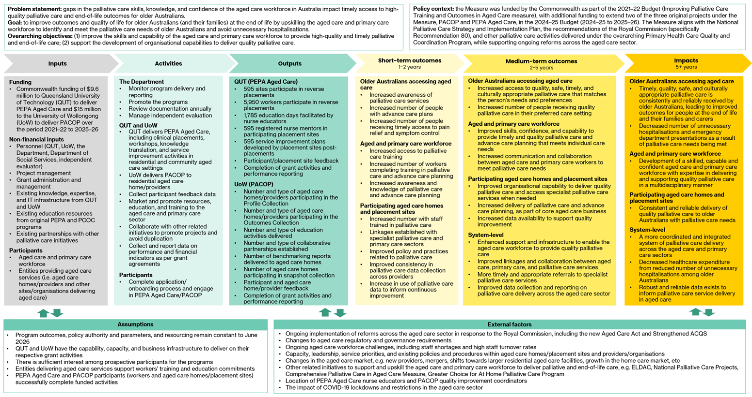

Stage 4: Data collection and analysis
Qualitative and quantitative data were collected from a range of sources to inform the evaluation of the Measure and its funded activities (PEPA Aged Care and PACOP). These are outlined below.
Qualitative data were thematically analysed, while quantitative data were analysed using descriptive approaches, including counts and percentages.
All data collection activities were conducted in accordance with ethical guidelines, and participation was voluntary.

Online survey of organisations providing aged care services
An online survey was distributed to all organisations providing aged care across Australia, including both participants and non-participants in PEPA Aged Care and/or PACOP. The survey aimed to explore and compare key aspects of palliative care service delivery, challenges, workforce training needs, and outcomes between organisations participating in PEPA Aged Care and/or PACOP and those not participating in either program. It also aimed to identify opportunities to improve the uptake and effectiveness of PEPA Aged Care and PACOP. The survey was open for eight weeks and promoted via the Department’s Your Aged Care Update e-newsletter, as well as PEPA Aged Care and PACOP electronic communication channels.
A total of 306 respondents were included in the final survey sample, representing an estimated 10% response rate among aged care providers nationally. The final sample included:
- 178 respondents from PEPA Aged Care sites (37.8% response rate among participating sites)
- 79 respondents from PACOP-participating providers (17.4% response rate among participating aged care homes)
- 82 respondents from providers not engaged with either program.
Detailed findings from the survey are presented in the accompanying technical paper and cross-referenced throughout this final report.

Case study interviews
Twelve case study interviews were conducted virtually with representatives from a purposive sample of aged care organisations, including four from each of the following:
- sites participating in PEPA Aged Care
- aged care homes/providers participating in PACOP
- non-participating organisations.
Case studies explored palliative care delivery, program impact, barriers and enablers, and opportunities for improvement. Recruitment was via the online survey conducted as part of the evaluation. A summary of the characteristics of aged care organisations participating in case studies is provided in Appendix B. The detailed case studies are presented in the separate technical paper accompanying this report. Relevant case study evidence is cross-referenced throughout this document.

Focus groups
Five online focus groups were held with a total of 17 consumer, carer, and family representatives. Participants were recruited through Palliative Care Australia and the Older Persons’ Advocacy Network. Each group comprised up to four participants and explored perceptions of palliative care quality, unmet needs, and enablers of high-quality care in aged care settings.

Stakeholder consultations
A total of 46 online stakeholder consultation interviews involving 93 individuals were conducted. These included representatives from government, program delivery teams, related national initiatives, peak bodies and professional associations, aged care providers, and health professionals. Consultations focused on the Measure’s appropriateness, implementation, effectiveness, and opportunities for improvement. The list of stakeholders involved in consultations is provided in Appendix B.

ACQSC performance reports
The ACQSC performance report analysis aimed to explore whether participation in PEPA Aged Care/PACOP supported organisations in meeting relevant ACQS and whether any observable changes or improvements to palliative care delivery were evident following program participation.
A total of 176 ACQSC performance reports (including 109 Audit Performance Assessment Reports and 61 Performance Reports) from 71 aged care organisations were reviewed. This comprised:
- 71 reports from 24 sites participating in PEPA Aged Care
- 105 reports from 47 aged care homes participating in PACOP.
Organisations were invited to participate in the analysis via QUT and the University of Wollongong and provided express consent for their site/home name and program participation dates to be shared for inclusion. To be eligible, organisations needed to have undergone at least one performance assessment between 1 November 2021 and 30 June 2025.

Program and financial data
Additional administrative, programmatic, and financial data were obtained from QUT (PEPA Aged Care) and the University of Wollongong (PACOP) in accordance with detailed data specifications derived from the evaluation framework. This included data on program uptake and engagement, available program outcomes, marketing activities, expenditure, and internal evaluation. Internal evaluation data sources accessed from QUT and the University of Wollongong included:
- PEPA Aged Care: pre- and post-placement participant evaluation survey data and anecdotal feedback collected from participants and sites (both collected on an ongoing basis)
- PACOP: snapshot survey data (conducted in May 2024), pre- and post-online learning module evaluation survey data, pre- and post-in-person workshop evaluation survey data, and anecdotal feedback collected from participating aged care homes.
The data period in scope for the evaluation was from the commencement of the Measure (1 November 2021) to 30 June 2025.

Desktop review
Key program documents, including grant funding agreements, Activity Work Plans, performance reports, and financial statements, were reviewed to provide additional context and inform relevant analyses. This was complemented by a review of publicly accessible information, such as relevant Commonwealth and jurisdictional policy and strategy documents, the National Palliative Care Standards for All Health Professionals and Aged Care Services, reports related to the Royal Commission, and information on related national palliative care initiatives, to inform understanding of the broader context of the Measure.

Stage 5: Final evaluation report
The final stage involved triangulating and synthesising all data and findings to address the key evaluation questions. A draft evaluation report was prepared and submitted for feedback, followed by the final evaluation report and presentation of key findings to the Department.

Evaluation design and scope
The evaluation was both formative and summative. It assessed the implementation of the Measure and funded activities and evaluated measurable short- to medium-term outcomes (based on the program logic) for which data were available. The evaluation employed a mixed-methods approach, with both qualitative and quantitative data informing the analysis (as outlined in the previous section).
The evaluation aimed to determine whether the Measure was appropriate, effective, and efficient to inform continuous improvement and future funding decisions regarding the Measure. Given these aims, the evaluation involved process, outcome, and economic components:
- Process component: examination of the process of implementing and delivering the Measure
- Outcome component: assessment of the extent to which the intended short- and medium-term outcomes for which data were available, and the overarching objectives were achieved
- Economic component: exploration of the cost-efficiency of the Measure.
All PACOP and PEPA Aged Care activities undertaken as part of the original 2021–22 Improving Palliative Care Training and Outcomes in Aged Care measure and the 2024–25 extension of the Measure were within the scope of the evaluation.

Key evaluation areas
The evaluation focused on four KEAs, each addressed by a specific key evaluation question (Figure 2.3).
Figure 2.3: KEAs for the evaluation of the Measure

A series of evaluation sub-questions supported the key evaluation questions, ensuring a comprehensive and targeted assessment. The KEAs, key evaluation questions, and evaluation sub-questions were used to develop the evaluation framework presented in Appendix A.
The analysis of each KEA and the evaluation findings are presented in Part B of this report, along with recommendations to support continuous improvement and future funding decisions regarding the Measure.

Evaluation limitations
The evaluation was designed to comprehensively assess the Measure and its funded activities. However, several limitations should be considered when interpreting the findings and recommendations:
- Timing of evaluation: the evaluation concluded before the end of the current grant agreements (30 June 2026) and only included data from 1 November 2021 to 30 June 2025. Activities and outcomes delivered after this period were therefore not captured in this report. This means the report may not reflect the full impact or any subsequent improvements made in the final year of program delivery.
- Limited outcome data: there was limited availability of health outcomes or resident-level data, with none available for PEPA Aged Care and a limited amount for PACOP. This constrained the ability to objectively assess the programs’ impact on outcomes for older people and precluded a comprehensive economic analysis. While an exploratory economic analysis utilising available outcome data from PACOP was undertaken to provide early insights into indicative quantifiable benefits, these results should be interpreted with caution due to data and methodological limitations (see Appendix E).
- Survey response rates: the evaluation sought direct input from end-users of PEPA Aged Care and PACOP through an online survey and case study interviews. However, survey response rates from participant cohorts were relatively low (37.8% for PEPA Aged Care and 17.4% for PACOP). As a result, survey findings may not fully represent the views and experiences of all program participants. Additionally, responses from non-participating organisations were low.
- Direct engagement with care recipients: due to ethical considerations and recruitment challenges, the evaluation did not directly engage with older people and their families with lived experience of PEPA Aged Care and/or PACOP. Instead, focus groups were conducted with consumer, family, and carer representatives to gather critical input.
- Potential for bias: data collected through the online survey, consultations, and case study interviews may reflect personal bias or self-interest. To mitigate this, a broad range of stakeholders was consulted, and contrasting views were synthesised in the analysis.
- Program data limitations: some data requested from PEPA Aged Care and PACOP were missing, unavailable, or suppressed due to small cell counts. This limited the completeness and granularity of some analyses.
- ACQSC performance report sample: the evaluation aimed to review 150 ACQSC performance reports from participating sites/homes (75 for each program). Lower-than-expected response rates limited the number of reports available for analysis, reducing the depth of insights. Additionally, fewer than 10 reports were available for sites/homes pre- and post-participation, largely because many sites/homes participated in PEPA Aged Care or PACOP relatively recently. The programs were not mentioned in any reports, meaning no findings could be directly attributed to program participation. Nevertheless, the reports provided useful context to triangulate findings from other evaluation data sources and offered valuable insights into how palliative and end-of-life care were assessed during the accreditation process.
- Project context and approach

Program context
This chapter outlines the broader policy context in which the Measure was established, including relevant national strategies, frameworks, and related initiatives aimed at strengthening palliative care delivery in aged care settings. It then provides an overview of the Measure itself, including its overarching objectives and a summary of the program arrangements for PEPA Aged Care and PACOP.
- Policy context
The Commonwealth and state and territory governments are committed to improving the quality of palliative care for all Australians, including older people accessing aged care services. In response, various policy initiatives have been implemented over the past several decades. Initiatives particularly relevant to the establishment of the Measure are outlined in the following sections.

National Palliative Care Strategy
Australia’s national approach to palliative care is outlined in the National Palliative Care Strategy 2018 (the National Strategy), which sets the overarching vision that ‘people affected by life-limiting illnesses get the care they need to live well’ [1]. The National Strategy identifies seven goals focused on understanding, capability, access, collaboration, investment, data, and accountability, underpinned by principles of person-centred, high-quality, and accessible care. An accompanying Implementation Plan prioritises actions to improve workforce capability, enhance coordination of care, embed advance care planning, and strengthen national data collection and reporting.
The National Strategy builds on earlier national frameworks and reflects findings from the evaluation of the 2010 Strategy, which highlighted the pivotal role of National Palliative Care Projects (NPCP)—including PEPA and PCOC—in advancing workforce training and data-driven quality improvement. These findings informed the decision to expand PEPA and PCOC into the aged care sector under the Measure.
The Measure directly supported the National Strategy’s objectives by funding initiatives that aimed to enhance workforce training, improve organisational capability, and promote best-practice palliative care in aged care settings.

State and territory palliative care policies
State and territory governments are responsible for the provision of palliative care services within their respective health systems. Most jurisdictions maintain palliative care frameworks aligned with the National Strategy, emphasising equitable access, a skilled workforce, and coordinated care across settings. State and territory policy and strategy frameworks include:
- New South Wales Health End of Life and Palliative Care Framework 2019–2024 [2]
- Victoria’s end-of-life and palliative care framework [3]
- Queensland Health Palliative and End of Life Care Strategy [4]
- South Australia’s Palliative Care Strategic Framework 2022–2027 [5]
- Western Australia’s End-of-Life and Palliative Care Strategy 2018–2028 [6]
- Tasmanian Palliative and End of Life Care Policy Framework 2022–27 [7]
- Australian Capital Territory Health Services Plan 2022–2030 [8].
The Measure complemented these jurisdictional policies by supporting national programs that targeted workforce skills and capability building across all states and territories.

National palliative care guidance
National guidance documents provide the foundation for safe, high-quality palliative care across all settings, including aged care. These include:
- National Palliative Care Standards: outline nine voluntary standards to guide best practice in non-specialist settings, emphasising person-centred care, comprehensive assessment, evidence-based practice, and integration across services [9].
- National Consensus Statement: Essential elements for safe, high-quality end-of-life care: sets principles for care that align with individual values and needs, considers cultural and psychosocial factors, and ensures multidisciplinary expertise [10].
- National Framework for Advance Care Planning Documents: promotes nationally consistent approaches to advance care planning, supporting individuals to communicate their preferences and guiding health professionals in enacting documented wishes [11].
The Measure aimed to advance these standards and frameworks by embedding evidence-based training and quality improvement activities in aged care. In doing so, it aimed to support providers to meet national expectations for comprehensive assessment, care planning, and multidisciplinary collaboration as part of high-quality palliative care delivery.

Related national palliative care initiatives
The Measure operated within a broader landscape of Australian Government-funded initiatives that collectively aim to improve palliative care access, workforce capability, and service integration. The Measure aligned with and complemented these initiatives by specifically targeting the aged care workforce and sector and addressing gaps identified by the Royal Commission. Key related initiatives include:
- Comprehensive Palliative Care in Aged Care measure: a $57.2 million investment (2018–2024) to improve access to quality palliative care in residential aged care. This initiative was delivered via a matched funding arrangement, enabling states and territories to tailor projects to local needs and priorities [12].
- Greater Choice for At Home Palliative Care Program: delivered through Primary Health Networks, this program focused on improving access to palliative care in the home setting, supporting coordination between primary care and aged care services, and building workforce capacity. While its scope differed from the Measure, both initiatives shared objectives of timely, appropriate care and improved collaboration across sectors [13].
- ELDAC: a national program funded by the Commonwealth government since 2017 that provided resources, guidance, and workforce development to strengthen palliative care and advance care planning in aged care [14] [15]. ELDAC built on the earlier Decision Assist program, which was delivered by a consortium led by Austin Health from 2012–13 to 2016–17
- NPCPs: NPCPs have been funded since the 1990s, with the overarching aim of improving the accessibility and quality of palliative care services for all Australians. The initiative provided grant funding to support a range of discrete projects primarily focused on research, education, training, quality improvement, and advance care planning. The most recent NPCP funding round in 2023 invested $53 million (2023–26) in 14 new and existing projects [16]. Notably, nine of these initiatives included a focus on supporting and upskilling the aged care and primary care sector in palliative care and advance care planning.

Royal Commission
The Royal Commission (2018–2021) conducted a comprehensive inquiry into the quality and safety of aged care services in Australia. The Final Report, tabled in March 2021, highlighted significant shortfalls in palliative care provision, including:
- inadequate training and skills among the aged care workforce
- limited recognition of palliative care as a core component of aged care
- lack of standardised systems to identify and address palliative care needs
- insufficient use of care plans and advance care planning
- insufficient access to, and integration of, specialist palliative care services
- inadequate reflection and regulation of palliative care delivery within the Aged Care Quality Standards (ACQS) [17].
Twelve of the Royal Commission’s 148 recommendations specifically addressed palliative care. Notably, Recommendation 80 called for regular palliative care training for all direct care workers in aged care. This recommendation and other insights from the Royal Commission directly informed the development of the Measure.
- Program arrangements
The following sections provide an overview of the two activities funded under the Measure that are within the scope of this evaluation: PEPA Aged Care and PACOP. For each initiative, a summary is provided covering program design and delivery, administrative and funding arrangements, governance structures, and key performance indicators.

PEPA Aged Care

Design and delivery model
PEPA Aged Care was an adaptation of the existing PEPA program, which has been delivered since 2003 under the Palliative Care Education and Training Collaborative, a government-funded NPCP led by QUT.
The PEPA Aged Care model centred exclusively on ‘reverse’ placements, whereby dedicated PEPA Aged Care nurse educators travelled to participating sites to deliver tailored palliative care training. Participating sites were offered a small funding contribution of up to $4,000 to support the costs associated with hosting the placement, including staff backfill. These key adaptations to the original PEPA model aimed to address the unique workforce and operational challenges of the aged care sector while retaining the core PEPA principles of experiential learning.
Reverse PEPA Aged Care placements typically involved small groups of at least eight staff and were run over two to four days, either in a single block or split sessions to accommodate workforce availability. Training content was customised based on organisational and learning needs assessments and might include clinical interventions, medication management, culturally responsive care, policy reviews, and communication strategies.
Post-placement support was provided to embed learning into practice, including mentoring arrangements and access to resources via an online learning management system and a recently established community of practice.
All organisations providing aged care services were eligible for PEPA Aged Care, including residential aged care homes, home care services, community services, and organisations providing care for Aboriginal and Torres Strait Islander communities. Placements were generally prioritised for home care services and sites in rural and remote areas, reflecting the significant need for education and support in these contexts.
All professional groups providing palliative care in aged care settings were eligible to attend, including personal care workers, nurses, allied health professionals, GPs, and Aboriginal health practitioners.

Administration, funding, and governance
QUT was funded to deliver PEPA Aged Care from November 2021, with successive extensions funding the program through to June 2026. Total grant funding of $9.632 million was allocated across two periods:
- $5.66 million for 2021–22 to 2023–24
- $3.97 million for 2024–25 to 2025–26
Under contractual arrangements, QUT was required to submit Activity Work Plans, six-monthly performance reports, and annual financial acquittals.
Program delivery was supported by a staffing model centred on nurse educators located across Australia to facilitate equitable access to reverse PEPA Aged Care placements. Nurse educator staffing levels increased from approximately four full-time equivalent (FTE) positions to eight FTE by mid-2025. Additional program support roles included a senior research assistant and an administration officer. In-kind support was also sourced as required from related initiatives delivered by QUT, including PEPA and Indigenous PEPA (IPEPA).
Program governance was provided through the existing Palliative Care Education and Training Collaborative National Advisory Group. Originally established to provide governance oversight for PEPA, IPEPA, and other initiatives delivered through the Palliative Care Education and Training Collaborative, the National Advisory Group’s remit was expanded to include PEPA Aged Care. This group met annually and included representatives from key palliative care, health professional, and education organisations, ensuring sector-wide input and alignment. In addition, the existing Aboriginal and Torres Strait Islander Advisory Group provided advice and direction on culturally safe care for First Nations communities as required.
Program evaluation was embedded within the original design of PEPA Aged Care through an evaluation framework underpinned by a detailed program logic. This framework aimed to guide data collection and assess program reach, effectiveness, and sustainability. It included plans to assess the quality of care provided to aged care recipients by collecting after-death audits from participating sites.

Key performance indicators
Performance monitoring was embedded in PEPA Aged Care through contractual reporting requirements. As shown in Table 3.1, QUT established five key performance indicators and targets for PEPA Aged Care over the initial grant funding period (2021–22 to 2023–24). Targets were adjusted in 2024 and 2025 to reflect funding extensions to 2025–26.
Table 3.1: PEPA Aged Care performance indicators and targets
Performance indicators | Targets  (2021–22 to 2023–24) | Targets  (2024–25 to 2025–26) | Targets  (Total)
Number of sites participating in reverse PEPA Aged Care placements | 275 | 353 | 628
Number of education days facilitated by PEPA nurse educators at reverse placement sites | 825 | 1,059 | 1,884
Number of reverse PEPA Aged Care placement participants¹ | 2,750 | 3,530 | 6,280
Number of registered nurses at participating sites acting as mentors to continue integration of palliative care post-placement² | 275 | 353 | 628
Number of post-placement service improvement plans developed³ | 275 | 353 | 628
Notes: ¹Assumes approximately 10 health and aged care staff per placement. ²Assumes one mentor per organisation. ³Assumes one plan developed per participating organisation.
Source: PEPA Aged Care 2021–2024 Activity Work Plan [18]; PEPA Aged Care 2021–2025 Activity Work Plan [19]; PEPA Aged Care 2025–2026 Activity Work Plan [20].

PACOP

Design and delivery model
PACOP was an adaptation of the existing national PCOC program. PCOC has been delivered by the University of Wollongong, in collaboration with QUT and the University of Western Australia, since 2005 as a government-funded NPCP [21]. PCOC aimed to systematically improve palliative care outcomes for patients accessing specialist palliative care and community-based services through standardised assessment and benchmarking.
Based on identified demand for similar support in the aged care sector, the PCOC model was initially adapted for residential aged care through the PCOC Wicking pilot (2019–21). Key adaptations incorporated into the subsequent PACOP model based on findings from the pilot included the addition of several targeted palliative care screening tools, a modified assessment frequency, and the development of two distinct assessment modules: the Profile Collection, for routine palliative care screening every three months, and the Outcomes Collection, for intensive monitoring and response when residents were identified as requiring palliative care. A Deteriorating Resident Tool was also introduced to facilitate timely intervention in the event of sudden declines.
The PACOP model comprised three core components (summarised in Figure 3.1):
- Profile and Outcomes Collections: a nationally standardised assessment framework and clinical response protocol to identify and manage palliative care needs.
- Benchmarking: six-monthly submission of de-identified assessment data to PACOP for national benchmarking and feedback reports to inform continuous quality improvement.
- Education: workshops, online modules, resources, and facilitated communities of practice to support implementation and use of benchmarking data.
Figure 3.1: Overview of the PACOP model
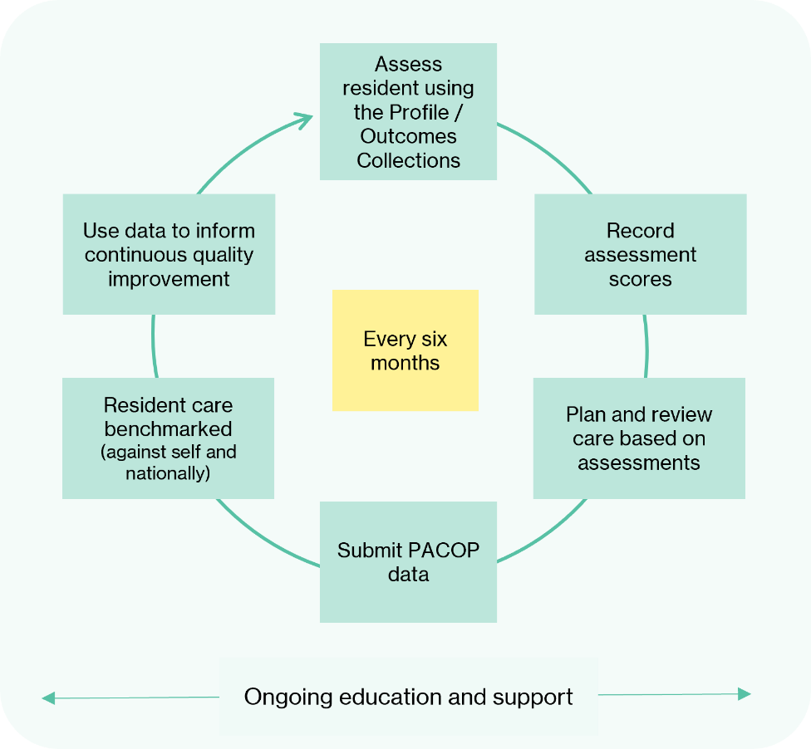
All residential aged care homes/providers were eligible to participate by registering via the PACOP website.
On enrolment in PACOP, all new participating aged care homes began by implementing the Profile Collection. Once homes successfully embedded and demonstrated their capability in using this component, they were supported in progressing to implementing the more advanced Outcomes Collection. Readiness assessments were conducted prior to enrolment, with tailored support provided to build capability where required.

Administration, funding, and governance
The University of Wollongong was funded to deliver PACOP from November 2021, with successive extensions funding the program through to June 2026. Total grant funding of $15.038 million was allocated across two periods:
- $8.91 million for 2021–22 to 2023–24
- $6.13 million for 2024–25 to 2025–26
Under grant agreement requirements, the University of Wollongong was required to submit Activity Work Plans, six-monthly performance reports, and annual financial acquittals.
Program delivery was supported by a multidisciplinary staffing model that included a PACOP director, a quality and education manager, statisticians/data managers, quality improvement facilitators, and administrative staff.
Governance arrangements evolved during the funding period. Initially, oversight was provided through a combined PACOP/PCOC Management Advisory Board and supporting groups. Following a business unit restructure in 2024, PACOP governance transitioned to a new Management Advisory Committee and Clinical Advisory Group, meeting biannually to ensure strategic oversight and sector engagement.

Key performance indicators
As part of contractual requirements, the University of Wollongong was required to specify performance indicators and targets for PACOP. Indicators and targets were established across a number of key domains of program activity for the initial funding period (2021–22 to 2023–24). These included indicators and targets for participation in the Profile and Outcomes Collection, as well as educational activities, benchmarking, and partnerships. The following section outlines performance indicators and targets related to participation in the PACOP Profile and Outcomes Collections.
The University of Wollongong established a new set of overarching performance indicators for the program’s extension period under the Measure (2024–25 to 2025–26). These are also outlined below.

Initial performance indicators and targets for Profile and Outcomes Collection participation (2021–22 to 2023–24)
For the initial funding period (2021–22 to 2023–24), targets for participation in the Profile and Outcomes Collections were set at the multi-site provider level (Table 3.2). The cumulative targets included 44 providers participating in the Profile Collection and 25 providers participating in the Outcomes Collection by June 2024.
Table 3.2: PACOP Profile and Outcomes Collection performance indicators
and targets (2021–22 to 2023–24)
Performance indicator | 2021–22 | 2022–23 | 2023–24
Profile Collection | N | N | N
Large multi-site providers (≥40 aged care homes) participating | 1 | 3 | 7
Medium multi-site providers (20–39 aged care homes) participating | 2 | 6 | 12
Medium-small multi-site providers (10–19 aged care homes) participating | 3 | 11 | 25
Total | 6 | 20 | 44
Outcomes Collection | N | N | N
Large multi-site providers (≥40 aged care homes) participating | 1 | 3 | 6
Medium multi-site providers (20–39 aged care homes) participating | 1 | 3 | 6
Medium-small multi-site providers (10–19 aged care homes) participating | 1 | 6 | 13
Total | 3 | 12 | 25
Source: PACOP Activity Work Plan 2021–2024 [22].

Revised performance indicators and targets (2024–25 to 2025–26)
Under the new Activity Work Plans developed for 2024–25 to 2025–26, the University of Wollongong specified a set of new formal performance indicators and measures (Table 3.3). These shifted away from specific numerical targets to broader, qualitative outcome-based measures directly aligned with the Measure’s intended outcomes.
Table 3.3: PACOP key performance indicators and measures (2024–25 to 2025–26)
Performance indicator | Measure
Improved outcomes for residents and their families at the end of life | Improved capabilities of the aged care workforce to monitor, recognise and respond to identified palliative care needs of residents and their families
Aged care homes deliver high-quality, safe, and culturally appropriate palliative care that meets individual care needs | Improved, nationally standardised, palliative care education and training builds the capacity of the aged care workforce to improve the quality of, and timely access to, palliative care for residents
The empowerment of GPs, aged care providers, and other healthcare workers with confidence and knowledge of palliative care and advance care planning | Improved capabilities of the aged care workforce, GPs, and other health care providers to communicate with residents and families to support advance care planning and delivery of palliative care in accordance with their needs, wants, and preferences
Collaborative links and relationships are facilitated between primary care, aged care and palliative care services | Establish, maintain, and strengthen linkages across the primary care, aged care, and palliative care sectors to improve the delivery of palliative care
Aged care providers, GPs, or other healthcare workers are informed about palliative care, advance care planning and advance care directive resources, processes, legislation, and accountabilities in the state or territory in which the aged care service is located | Improved knowledge sharing and use of available resources to support the delivery of palliative care in compliance with legislation at the Commonwealth and state or territory level
Source: PACOP Activity Work Plan, 2025–25 to 2025–26 [23].
To support the achievement of these indicators and measures in 2024–25 and 2025–26, PACOP also established targets for several key outputs, as outlined in Table 3.4.
Table 3.4: Planned PACOP outputs and targets to support
the achievement of formal performance measures
Planned output | 2024–25 | 2025–26
Number of aged care homes registered to participate in PACOP | 429 | 515
Number of aged care homes participating in both Profile and Outcomes Collections | 294 | 323
Number of aged care homes receiving benchmark reports | 69 | 86
Delivery of benchmarking workshops | 2 | 2
Number of completions of online learning modules | - | 400
Source: PACOP Activity Work Plan, 2025–25 to 2025–26 [23].

- Evaluation findings and recommendations

Appropriateness
This chapter focuses on KEA 1: Appropriateness. The key evaluation question to be addressed is: Is the Measure (still) the right response?
The questions to be addressed under KEA 1 are:
- To what extent were the activities funded under the Measure a suitable response to support the aged care and primary care workforce in identifying and meeting the palliative care needs of older Australians?
- To what extent is there still a need for palliative care education, training, and quality improvement in the aged care sector?
- How are the activities under the Measure supporting the delivery of safe and culturally appropriate palliative care?
- What gaps or areas of duplication exist in palliative care training for the aged care and primary care sectors?
Analysis and findings
The extent to which the Measure and its funded activities were a suitable response to support the aged care and primary care workforce in identifying and meeting the palliative care needs of older Australians was examined. While there was broad support for the Measure, stakeholders had mixed views on the suitability of the individual funded activities, PEPA Aged Care and PACOP. The sections below discuss the appropriateness of the Measure, PEPA Aged Care, and PACOP.

The Measure
The suitability of the Measure to strengthen workforce and organisational capability for quality palliative care through programs like PEPA Aged Care and PACOP was discussed at length with stakeholders. The continued need to build workforce capability in palliative care, along with the suitability of the funded programs within the existing aged care context, was also explored.
Consultation with the Department indicated that PEPA Aged Care and PACOP were strategically selected for funding under the Measure. Both programs were extensions of established, evidence-based national initiatives (PEPA and PCOC, respectively) with proven capability to adapt to aged care settings. Leveraging these existing delivery models, systems, and infrastructure was intended to enable rapid mobilisation of the two programs. Moreover, each program addressed a key area of need identified by the Royal Commission:
- PEPA Aged Care focused on workforce training and education to strengthen foundational palliative care skills, knowledge, and confidence among aged care staff
- PACOP targeted aged care provider systems, processes, and data collection to enhance organisational capability and drive quality improvement in palliative care.
Stakeholder feedback consistently affirmed the strategic appropriateness of the Measure and its dual focus design: education through PEPA Aged Care and systems/data through PACOP. This combination was widely regarded as an effective approach to address both aged care workforce capability and structural gaps in organisational systems and processes. Most stakeholders believed the Measure had the potential to improve palliative and end-of-life outcomes for older people and their families in participating organisations.
[The programs] are both important because they’re tackling different things. One is the data collection, monitoring, and quality improvement, and the other is the skills training and awareness building. You do need both. – Aged and primary care peak and professional body
Findings from the online survey reinforced this alignment, with PEPA Aged Care and PACOP participants reporting that engagement in both programs was driven by priorities consistent with the Measure’s intent (technical paper, Figure 5.1 and Figure 6.1).
Stakeholders also endorsed the decision to fund PEPA Aged Care and PACOP as extensions of the established and highly regarded PEPA and PCOC programs. They highlighted that leveraging the evidence-based foundations and reputations of these national initiatives enabled a rapid, credible response to sector needs.
However, stakeholders also highlighted that the Measure’s activities appeared particularly targeted toward residential aged care settings. PACOP was developed specifically for residential aged care, and PEPA Aged Care was commonly viewed as more naturally aligned with the residential aged care workforce structure and operating context. As a result, the applicability of the Measure to home and community aged care services was perceived as less clear. Similarly, the relevance of the Measure and its funded activities to the primary care sector was also perceived as limited. Available program participation data supported this view. Although GPs and allied health professionals were eligible to participate in both reverse PEPA Aged Care placements and PACOP educational activities, evidence suggested that engagement was minimal (Table 9.9, Appendix C and Table 9.26, Appendix D). Barriers to primary care involvement reported by stakeholders included low awareness, limited perceived applicability due to the programs’ strong focus on aged care staff, and financial and logistical challenges to participation for independent practitioners.
Stakeholders suggested that increased primary care involvement could support more consistent, team-based approaches to palliative care in aged care settings and strengthen the Measure’s impact. Recognising this gap, the University of Wollongong planned to develop a GP-specific education module and targeted reports for GPs and other health professionals [24]. Other strategies to strengthen primary care involvement suggested by stakeholders included developing targeted PEPA Aged Care education streams for GPs and allied health professionals; offering financial assistance; linking participation to professional development requirements; and partnering with Primary Health Networks (PHNs) and primary and allied health peak bodies to raise awareness.
- Evaluation evidence suggests that the Measure remained an appropriate and timely response to the needs of the aged care sector, addressing critical gaps in workforce and organisational capability. While stakeholders considered the Measure to be highly relevant to residential aged care, its applicability to home and community aged care services was perceived as less clear, given the design focus of PACOP and PEPA Aged Care. Similarly, its perceived relevance to the primary care sector was limited, with available data suggesting minimal engagement among primary care professionals. These findings suggest that targeted strategies to increase involvement across both home care and primary care could strengthen team-based palliative care and amplify the Measure’s impact.

Continued need for palliative care education, training, and quality improvement
Stakeholders consistently reported a strong and ongoing perceived need for palliative care education, training, and quality improvement in aged care. Evidence from all evaluation data sources indicated that this need remained significant, driven by a range of system-level, workforce, and community factors, as captured in Figure 4.1.
Figure 4.1: Drivers of the need for palliative care education,
training, and quality improvement in aged care
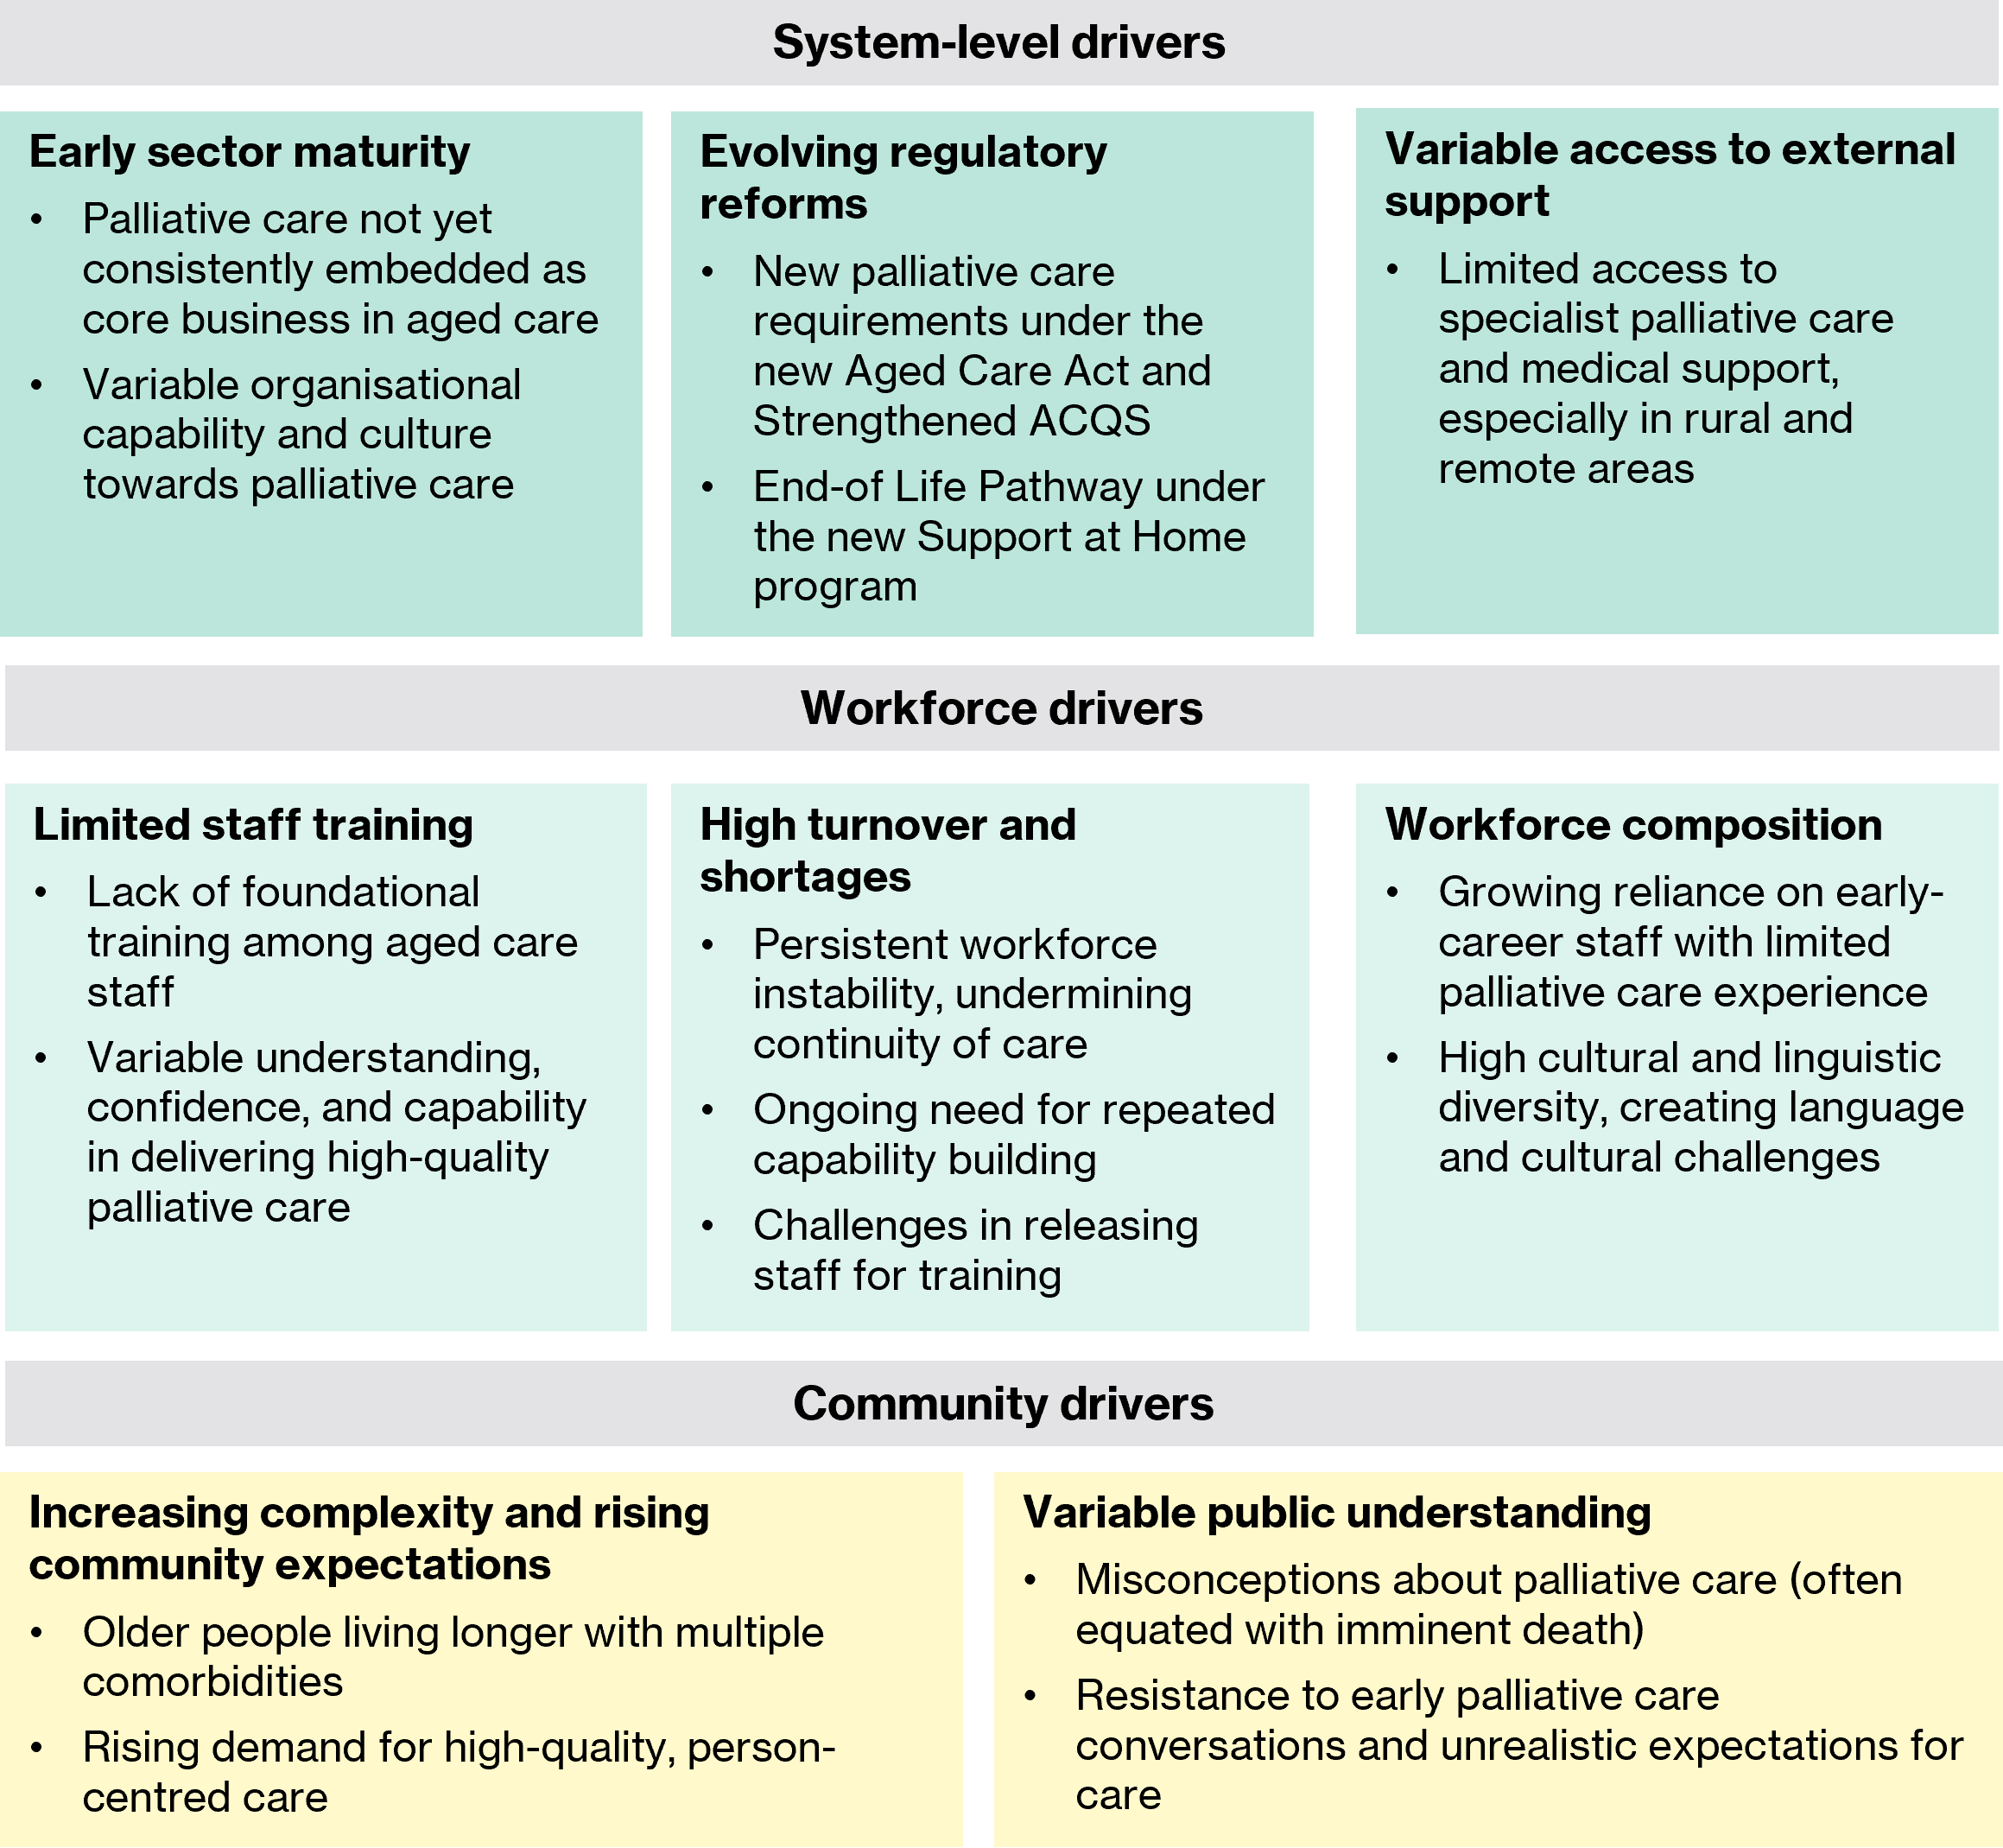
Given the scale of the systemic, workforce, and community challenges identified, stakeholders widely anticipated that the need for palliative care education and support in aged care would persist for the foreseeable future. Some felt that this need may even intensify as major aged care reforms took effect and demographic pressures increased. Online survey findings reinforced this view, with more than 80% of non-participating providers perceiving both a current and ongoing need for palliative care education, training, and quality improvement across the sector (technical paper, Figure 7.6).
Despite several perceived limitations in the designs of PEPA Aged Care and PACOP (discussed in Sections 4.2 and 4.3, respectively), there was a general consensus among interviewed stakeholders and online survey respondents (technical paper, Figure 8.8 and Figure 8.18) that both programs remained relevant and necessary. Most advocated for sustained investment to continue the programs in the medium- to longer-term.
Oh, it hasn’t even started. I recommend locking them in for another 15 years, because providers are going to need them. – Palliative care-related peak body
- There was a strong and ongoing perceived need for palliative care education, training, and quality improvement in aged care, driven by systemic, workforce, and community factors.
- The underlying concepts and objectives of PEPA Aged Care and PACOP to uplift palliative care capability across the aged care sector were widely supported. However, as discussed in the following sections, refinements may be needed to address identified limitations and better align program delivery with sector needs.

Gaps and areas of duplication
Potential gaps and duplication among PEPA Aged Care, PACOP, and other palliative care training initiatives were explored through analysis of program documentation, stakeholder consultations, focus groups, and the online survey.
A cross-analysis of PEPA Aged Care and PACOP found no evidence of direct duplication of activities funded under the Measure. However, areas of close alignment were evident, particularly in the programs’ shared focus on workforce education and training. Stakeholders raised no significant concerns about duplication, noting that the programs served different purposes: PEPA Aged Care provided foundational palliative care knowledge, while PACOP focused on administering and interpreting the PACOP clinical assessment framework. Generally, stakeholders viewed the program’s shared focus on workforce capability building as complementary rather than problematic, provided core messages remained consistent.
Several stakeholders highlighted opportunities to strengthen strategic alignment and integration between PEPA Aged Care and PACOP to maximise their shared impact. For example, it was suggested that sequencing reverse PEPA Aged Care placements as part of PACOP onboarding could be an effective way to establish consistent foundational skills within homes, enhancing PACOP implementation. While QUT and the University of Wollongong reported informal collaboration to manage duplication risks, stakeholders advocated for a formal partnership to better leverage program synergies.
You need a beautiful partnership between the two of them, because it is rolling education that has to happen if you want PACOP implemented and [PEPA Aged Care] is basic skills and foundational knowledge – Specialist palliative care representative
No direct duplication was identified between the Measure’s funded activities and other related major initiatives (e.g. NPCPs, ELDAC), although clear areas of alignment were present, particularly among initiatives involving workforce capability building activities and resources (e.g. PEPA/IPEPA, ELDAC, palliAged/CareSearch, Advance Care Planning Australia, activities funded through the Comprehensive Palliative Care in Aged Care Measure). Stakeholders generally supported this broad focus on supporting aged care providers in delivering high-quality palliative care, recognising the sector-wide need.
Despite this support, consultations highlighted several concerns about perceived overlap, most notably between PACOP and ELDAC. Stakeholders noted that both programs shared similar aims of embedding systematic approaches to palliative care, building workforce and organisational capability, and using data for quality improvement. They felt that distinctions between the programs had not been clearly communicated to the sector, creating confusion among aged care providers. While PACOP and ELDAC representatives reported a collaborative relationship, stakeholders suggested that clearer positioning and more coordinated communication were required to clearly articulate each program’s unique value proposition.
There’s capability building in ELDAC and PACOP, there’s how to do good palliative care, and how to use data for good quality improvement. They’re just doing it in slightly different ways. The ideas are the same, the premise is the same … The outcome is a huge amount of confusion for the sector. – Aged and primary care peak and professional body
This concern reflected a broader challenge identified through consultations. Stakeholders described a crowded palliative care initiative landscape, and the perception that multiple programs targeted similar workforce and organisational challenges. Interviewed providers described feeling overwhelmed by the volume of offerings and unclear about what each program entailed. Survey responses echoed these concerns, with perceived overlap reported between various initiatives (technical paper, Figure 8.11 and Figure 8.21).
Stakeholders attributed this confusion to a lack of clear, coordinated communication about the scope, aims, and nuanced differences between programs. They felt that each initiative had a responsibility to improve the clarity and accessibility of its own communication materials, while also improving collaboration with other programs to ensure consistent, aligned messaging to the sector. Additionally, stakeholders noted a facilitative role for government to support a more cohesive approach. Suggested mechanisms included a government-led guide for aged care providers outlining how programs intersect and their respective purposes, and regular sector forums to promote alignment.
During consultations and focus groups, several gaps in palliative care training and support across the aged care and primary care sectors were identified:
- Further education and upskilling for GPs: stakeholders reported variable palliative care knowledge and confidence among GPs. While recognising that general practice colleges play a central role, it was also suggested that PEPA Aged Care and PACOP could complement these efforts through targeted GP training and education. As outlined in Section 4.1, PACOP was planning to broaden its educational offerings for GPs.
- Targeted support for the home care sector: as discussed in Section 4.1, both PEPA Aged Care and PACOP were perceived as targeted toward residential aged care, with PACOP exclusively designed for this setting. Stakeholders highlighted a growing need to extend support to home and community aged care services, driven by changes under the new Support at Home program and shifting community expectations for care at home. Several major providers specifically recommended expanding PACOP into these settings. PACOP had begun addressing this gap through a separate pilot project (not funded under the Measure).
- Education for families and carers: the need for more structured palliative care education and support for families and carers was highlighted by focus group participants and several aged care providers. While acknowledging this fell outside the Measure’s current remit, stakeholders noted that better-informed families could reduce stress on aged care staff by improving communication and collaboration.
- PEPA Aged Care and PACOP were conceptually distinct, and QUT and the University of Wollongong made concerted efforts to mitigate duplication of activities. However, evaluation evidence suggests there were opportunities to strengthen strategic collaboration and alignment between the programs.
- There was a specific perception of overlap between PACOP and ELDAC due to their similar aims and system-level approaches. Stakeholders highlighted the need for clearer program positioning and coordinated communication to reduce sector confusion.
- Stakeholders consistently reported that the large number of palliative care programs targeting aged care, combined with insufficient communication about their distinctions, had led to provider confusion and perceived overlap between initiatives. The need for initiatives to present clearer and more cohesive communication to the sector was highlighted. Stakeholders also saw a greater leadership role for the Australian Government in facilitating coordinated communication to the sector.
- Identified gaps in palliative care training and support included targeted education for GPs, targeted support for home and community aged care services, and structured education for families and carers.

PEPA Aged Care
This section assesses the suitability of PEPA Aged Care to strengthen workforce capability for delivering safe, quality palliative care in aged care settings. It examines the program’s design, focusing on identified strengths and limitations.

Training content and delivery
PEPA Aged Care was widely regarded by interviewed stakeholders and case studies as an appropriate approach for addressing foundational knowledge and skill gaps in the aged care workforce. Survey findings reinforced this, with most PEPA Aged Care respondents reporting that the program met organisational needs (technical paper, Figure 8.5) and that they would recommend the program to colleagues (Table 9.13, Appendix C).
Interviewed stakeholders, PEPA Aged Care case studies (technical paper, Section 9.1), and online survey respondents (technical paper, Figure 5.4) consistently identified several features of the PEPA Aged Care model that were viewed as well-suited to the aged care setting. These included:
- Reverse PEPA Aged Care placement model: the in-person reverse placement training model was considered an appropriate approach for aged care, particularly residential aged care homes. The model addressed common logistical barriers to participation, enabled efficient training of a group of staff, and fostered a safe, reflective learning environment.
- Inclusivity across roles: the program’s potential to engage aged care staff across all levels and roles, from clinical professionals to kitchen and maintenance personnel, was seen to align with the aged care workforce structure and reinforce shared responsibility for palliative care.
- Quality and adaptability of training content: stakeholders highlighted the program’s evidence-based content, adaptability to the specific learning needs of each site based on needs assessment, and delivery by credible nurse educators as key contributors to perceived relevance.
- Financial support: the provision of funding to offset participation costs was regarded as an important enabling feature, addressing potential financial barriers to engagement.
That is a great model. Aged care services are all like, yes, but which one will come to us? It’s all about that. We can’t afford to not have the staff in the building, and we can’t afford to send them and backfill them. So, how can they come to us? – Palliative care-related peak body
That’s pure gold, the funding attached to it – Aged and primary care peak and professional body
- PEPA Aged Care was considered appropriate for addressing foundational palliative care knowledge and capability gaps, particularly in residential aged care settings. Key strengths identified included the program’s on-site reverse placement model, inclusive delivery across staff roles, adaptable training content, and site-level funding support.

Sustainability and reach of the training model
Despite these strengths, the sustainability of the one-off reverse PEPA Aged Care placement model emerged as a key concern, impacting the perceived appropriateness of the program for achieving sustained impact. Stakeholders consistently highlighted that the knowledge gained from a single training episode would quickly erode due to staff turnover, making it difficult for sites to maintain a consistent knowledge base across their workforce.
You get PEPA Aged Care coming in to provide some days of education, but then the staff move on, and you’re back to square one. Because you can’t request it on a frequent basis, that provides challenges. – Major aged care provider
Limited penetration within sites compounded this challenge, as only a portion of staff could typically participate in a single reverse placement (technical paper, Section 9.1). Without mechanisms for ongoing reinforcement or wider reach within sites, stakeholders expressed concern that the program’s benefits may be short-lived.
Survey findings from PEPA Aged Care participants echoed these concerns. Difficulty sustaining learning outcomes was cited as the second most common barrier to engagement (technical paper, Table 5.3), while ongoing access to training and support was the most frequently identified opportunity to improve the program (technical paper, Table 5.5).
The suitability of the PEPA Aged Care model for home care settings was also questioned. Logistical challenges in facilitating placements for geographically dispersed home care staff were highlighted. It was suggested that more flexible training formats, such as shadowing arrangements or blended learning models, could improve accessibility and support broader reach in home care settings.
- Sustainability was raised as a key concern for PEPA Aged Care due to the one-off training model and limited reach within sites. The model’s suitability for home care services was also questioned, which could limit its reach in this setting.

Clinical and cultural safety
Analysis of program documentation indicated that PEPA Aged Care incorporated appropriate mechanisms to support the delivery of safe and culturally appropriate palliative care. The program’s training content aligned with the National Palliative Care Standards and addressed key domains, such as systematic assessment, medication management, advance care planning, communication, and organisational processes.
Cultural safety was embedded into the program through modules and resources on culturally responsive communication and care for Aboriginal and Torres Strait Islander peoples and culturally and linguistically diverse communities. All nurse educators were trained in cultural safety, and the program had access to the IPEPA manager for leadership and guidance on palliative care for First Nations communities. In some cases, culturally specific mentors joined placements to ensure culturally appropriate delivery. The ability for training content to be adapted based on initial learning needs assessments enabled reverse placements to be tailored to each site’s clinical and cultural context.
Survey findings supported this assessment. Approximately three-quarters of PEPA Aged Care respondents to the online survey rated the program as very or extremely relevant in preparing their workforce to navigate clinical safety and cultural considerations (technical paper, Figure 8.4). Pre- and post-reverse placement evaluation survey data collected by PEPA Aged Care also showed marked improvements in participants’ confidence across a range of clinical and cultural safety domains. These included confidence in applying culturally centred care principles; identifying and responding to deterioration; assessing ongoing palliative care needs; and communicating effectively with older people, families, and external palliative care services (Figure 9.4, Appendix C).
- Clinical and cultural safety were integrated into the design and delivery of PEPA Aged Care. Program content aligned with the National Palliative Care Standards, and evaluation evidence indicates that participants perceived the program as appropriate for supporting aged care staff to deliver safe, culturally responsive palliative care.

PACOP
This section assesses the suitability of PACOP to strengthen organisational capability for systematically delivering and monitoring quality palliative care in a safe and culturally appropriate manner.

Systems approach
PACOP was developed as a comprehensive model to embed palliative care into routine practice in residential aged care. It aimed to equip providers with the tools and processes to systematically identify and respond to residents’ palliative care needs, supported by staff education and benchmarking to drive continuous quality improvement.
Stakeholders broadly endorsed the concept and intent of PACOP. The need for an evidence-based program to support aged care providers in identifying residents with palliative care needs and in monitoring and improving palliative care outcomes was consistently recognised as necessary, in principle.
I think this type of program is essential. It would really transform aged care. To be able to have visibility, data, tools to support the staff, to recognise those pain points, to be able to gather data and see where our gaps are, and to benchmark against other aged care facilities. – PACOP case study (case study 7)
Stakeholders highlighted the program’s standardised assessment framework for identifying and responding to palliative care needs as a key strength. Survey findings (technical paper, Figure 6.4) and most PACOP case studies (technical paper, Section 9.2) reinforced this view. The program’s systematic approach to assessment was considered appropriate for embedding objective, consistent methods for proactively managing resident deterioration in aged care.
It gives a proper assessment framework, which is often very much lacking in residential aged care homes – Specialist palliative care service representative
PACOP’s emphasis on benchmarking and data-driven quality improvement was also generally supported. This approach was viewed as an important step toward addressing current gaps in palliative care data collection and monitoring within the sector. The intrinsic value of using benchmarking to create a feedback loop that helped to identify and continually address service gaps was highlighted.
Anything that allows you to collect data and benchmark what you’re collecting and why you’re collecting and what difference it is making, is a terrific initiative – Aged and primary care peak and professional body
However, stakeholders also acknowledged that embedding benchmarking and data-driven quality improvement would require time and ongoing support, particularly given variable baseline palliative care capability across the sector and the current compliance-driven operating environment.
The program’s education model, which targeted both clinical and non-clinical staff, was also considered well aligned with the aged care workforce structure. Stakeholders and focus group participants highlighted the value of upskilling both clinical and non-clinical staff to identify and report changes in residents’ conditions.
- PACOP’s systematic, evidence-based approach was widely viewed as conceptually appropriate and aligned with sector needs.

Resource investment and model complexity
Despite strong conceptual support for PACOP, stakeholders and several case studies (technical paper, Section 9.2) raised concerns about the program’s complexity and resource demands, which tempered perceptions of its current suitability in practice. Stakeholders noted that implementation required a considerable change management process, encompassing staff training, integration into organisational processes, and potential changes to IT systems. Once implemented, ongoing data collection requirements were often viewed as complex and burdensome for a sector already facing operational pressures, workforce challenges, and extensive mandatory reporting obligations.
The PACOP assessment protocol was commonly described as lengthy, with some stakeholders noting overlap with Australian National Aged Care Classification funding assessment requirements. Stakeholders also noted that the program did not provide financial assistance to offset implementation and ongoing participation costs, impacting perceived feasibility.
While the value of a systematic palliative care assessment framework was widely recognised, stakeholders questioned whether the model was appropriately calibrated for the operational realities of the aged care sector in its current form. Consequently, the need to simplify aspects of the program to improve feasibility was consistently highlighted.
It needs to be simplified … it’s really not an appropriate model [for aged care] at the moment with its complexities. – PACOP case study (case study 7)
Specific suggestions included:
- Simplify the program model and data collection protocol: reduce the complexity of the program and the length of the assessment protocol. Suggestions included reducing the overall number of assessments required in both the Profile and Outcomes Collections and shortening the length of individual tools by removing non-essential items and response options. Several stakeholders also suggested consolidating the Profile assessment tools into a single, minimal screening tool focused on essential indicators of palliative care needs (e.g. three to four data items).
- Develop a lighter touch version: introduce a streamlined, more pragmatic version of PACOP to complement the existing comprehensive model. This could be offered as an alternative for providers seeking a less resource-intensive approach.

Technology
IT integration challenges also impacted perceptions of PACOP’s suitability within residential aged care. Despite the University of Wollongong working with IT vendors to integrate the PACOP framework into major aged care clinical systems since program inception, progress was slow due to competing IT changes associated with mandatory reforms.
Major aged care providers and case studies (technical paper, Section 9.2) reported that limited interoperability with existing provider systems created administrative inefficiencies, often requiring paper-based assessments or duplicate data entry across platforms. PACOP snapshot survey data provided further evidence of this issue, with more than 40% of providers relying exclusively on paper forms or later re-entering data manually into a digital system (Table 9.29, Appendix D).
While stakeholders acknowledged that IT system challenges were not unique to PACOP and that the University of Wollongong continued to work to address interoperability, these challenges remained a key perceived barrier to feasibility.
- Practical challenges, including resource intensity, implementation complexity, and IT integration obstacles, tempered stakeholder perceptions of PACOP’s suitability in practice. Evaluation evidence suggests that simplification of the program model, enhanced implementation support, and accelerated IT integration activities would be important considerations in improving feasibility and sustained uptake among providers.

Assessment tools
The appropriateness of specific assessment tools carried over from PCOC in specialist palliative care was also raised as a concern. Stakeholders highlighted that aged care residents typically had a long, complex, and unpredictable end-of-life trajectory. This was often characterised by frailty and high rates of cognitive impairment and dementia rather than a specific diagnosis. As a result, the validity and relevance of several of the original PCOC tools within a residential aged care cohort were questioned, including the Australian Karnofsky Performance Status and Symptom Assessment Scale. While the University of Wollongong had begun validating the Symptom Assessment Scale for aged care populations, several stakeholders suggested that further review and validation of other assessment tools may be needed to ensure clinical appropriateness in this context.
- The suitability of some PACOP assessment tools for aged care populations was questioned, due to high levels of cognitive impairment and unpredictable end-of-life trajectories. This suggests a need for further validation and adaptation to ensure clinical appropriateness.

Outcome data accessibility
While PACOP’s benchmarking focus was generally supported, some stakeholders questioned the suitability of the current six-monthly benchmark reporting cycle. This interval was perceived to limit the reports’ utility for providing outcome data to inform timely quality improvement at the service level. The current six-monthly reporting cycle was also considered misaligned with growing sector expectations for real-time dashboard-style access to performance data. The University of Wollongong was actively addressing this concern through plans to develop self-service dashboards as part of an IT integration project initiated in 2025 (see Section 5.3.2).

Clinical and cultural safety
Analysis of PACOP program documentation indicated that mechanisms to support safe and culturally responsive palliative care were embedded in the program’s design. The program model was underpinned by a comprehensive, evidence-based assessment and response protocol that used routinely collected data to guide person-centred care. Assessments incorporated self-reported and clinician-assessed indicators, resident preferences, and family input, ensuring that care planning reflected individual needs and preferences. The program included an escalation pathway to support timely access to palliative care within the aged care home or, when required, referral to specialist palliative care services. The program’s educational activities aimed to support staff in interpreting PACOP data and applying it to deliver safe, culturally responsive care. This person-centred, assessment-driven approach aligned with key domains of the National Palliative Care Standards, including systematic assessment, communication, and care coordination.
The University of Wollongong had also taken steps to strengthen PACOP’s cultural responsiveness, which was identified as an ongoing priority in the current funding round. Key resources had been translated into commonly used languages in aged care homes, and work was underway to develop First Nations-focused program materials in consultation with Aboriginal and Torres Strait Islander stakeholders [25]. These initiatives reflect the program’s commitment to ensuring inclusivity for both residents and the diverse aged care workforce.
Consistent with this assessment, PACOP survey respondents reported the program was relevant and applicable for supporting staff to address clinical safety and cultural considerations in palliative care delivery (technical paper, Figure 8.14).
- PACOP incorporated mechanisms to support clinical safety and cultural responsiveness, with ongoing work to strengthen cultural appropriateness and inclusivity.

Implementation
This chapter focuses on KEA 2: Implementation. The key evaluation question to be addressed is: How (well) is the Measure being delivered?
The questions to be addressed under KEA 2 are:
- To what extent was the Measure implemented and delivered as intended?
- What factors have impacted the Measure, and how (e.g. changes to funding or delivery models)? How have the activities under the Measure changed over time?
- What key strategies are used to engage the aged care and primary care workforce and service providers in the funded programs?
- To what extent have the aged care and primary care workforce and service providers taken up palliative care education, training and quality improvement activities through the Measure (including accessibility, attendance/engagement, and drop-out rates)?
- What are potential barriers and enablers (for aged care workers, clinicians, service providers or the health and aged care system) to accessing and completing palliative care education and training in the aged care and primary care sectors?
Analysis and findings
Evidence from stages 2 (situation analysis) and 4 (data collection) of the evaluation was synthesised and presented in the sections below to address KEA 2: Implementation questions.

Implementation of the Measure
The Measure was largely implemented as intended. The Australian Government contracted QUT to deliver PEPA Aged Care and the University of Wollongong to deliver PACOP under the Measure as planned, via Commonwealth Standard Grant Agreements. While there was a minor initial delay in finalising both agreements due to standard government grant processes, neither organisation reported that this delay had a material impact on subsequent milestones or the delivery of core activities. A similar contracting delay occurred when additional funding was confirmed in the 2024–25 Budget to extend the Measure. This was managed through Deeds of Variation until new agreements were finalised.
According to key governmental stakeholders, the Measure and its two activities, PEPA Aged Care and PACOP, aligned with planned objectives and initial intentions. Implementation was generally considered successful, with a key enabler being the ability to leverage the established credibility, evidence base, and infrastructure of the precursor programs (PEPA and PCOC). This approach was perceived to significantly reduce lead time, particularly for PEPA Aged Care. While PACOP required further adaptation for the residential aged care context during initial implementation, the program reportedly still benefited from PCOC’s foundational work and learnings.
They’ve really leveraged off the existing programs, PEPA and PCOC. That’s really impacted positively. Expanding existing established activities was certainly a good thing and allowed them to hit the ground running a lot faster. – Government stakeholder
- The Measure was largely implemented as intended, with only minor contracting delays that did not significantly affect the delivery of core activities. Leveraging the established infrastructure and credibility of the programs’ precursors (PEPA and PCOC) was perceived by stakeholders as enabling more streamlined implementation.

Implementation of PEPA Aged Care
This section examines the implementation of PEPA Aged Care, including the extent to which planned activities were delivered as intended, the factors that impacted delivery, engagement strategies, and program uptake.

Delivery of planned activities and outputs
Grant activity to deliver PEPA Aged Care was underpinned by Activity Work Plans. These articulated the planned activities for implementing and delivering the program, as well as the established performance indicators and targets. QUT submitted biannual performance reports to the Department outlining progress against planned activities and targets, as per contractual requirements.
QUT completed all activities outlined in the initial Activity Work Plan for PEPA Aged Care (2021–22 to 2023–24) and was on track to deliver planned activities under the program’s extension (2024–25 to 2025–26). This suggests effective program planning and implementation.
Across the evaluation period, the program performed strongly against four of five key performance indicators (Table 9.4, Appendix C). Cumulative targets for the number of participating sites, reverse placement participants, education days delivered, and registered nurses acting as mentors post-placement were all exceeded by 30 June 2025, demonstrating both demand for the program and effective delivery against output-based measures.
However, the cumulative target for post-placement service improvement plans was not fully achieved by 30 June 2025, with 84% of the overall target met. These plans were a key mechanism for translating reverse PEPA Aged Care placement learning outcomes into practice; however, six-monthly targets were met in only two of seven reporting periods, suggesting challenges in sustaining site engagement. Lower performance against this indicator was attributed to competing priorities and operational pressures within participating sites. While PEPA Aged Care nurse educators provided informal support to sites for several months post-placement, the lower completion rate suggests that more structured follow-up or mentoring may be needed to strengthen knowledge translation.
Despite strong overall delivery, QUT identified several key challenges that influenced program implementation. The COVID-19 pandemic initially disrupted provider capacity to release staff for training and required a rapid transition to online and hybrid delivery formats. Ongoing aged care workforce shortages contributed to placement delays and cancellations, while ensuring adequate nurse educator capacity and geographic coverage to meet growing demand remained a persistent challenge. This was reportedly compounded by short-term funding cycles that limited the ability to attract quality staff. In response to these challenges, QUT made several program adaptations. This included introducing more flexible delivery options (e.g. shorter training blocks) to accommodate workforce constraints and establishing a national pool of casual nurse educators to supplement the core team and improve geographic coverage.
- PEPA Aged Care delivered all planned activities and exceeded four of five key performance indicators, reflecting strong planning and execution. However, completion of post-placement service improvement plans fell short of the target, suggesting the need for stronger follow-up to support sites in translating learnings into practice.

Engagement and uptake
This section examines the strategies used to promote PEPA Aged Care to the aged care sector. It also explores the extent of program uptake and the key enablers and barriers influencing participation.

Program promotion
QUT’s engagement strategy primarily leveraged existing PEPA communication channels and networks. This included the overarching PEPA website, monthly national and jurisdictional PEPA meetings, monthly e-newsletters (~3,000 recipients annually), and social media. A dedicated PEPA Aged Care webpage was launched in 2022 and regularly updated.
Analysis of marketing and engagement data indicated steady growth in digital reach over the evaluation period (Table 9.5, Appendix C). Website views increased significantly, from 585 in 2021–22 to more than 10,500 in 2024–25, while PEPA Facebook followers grew from 1,000 to 1,845. Social media activity increased in 2024–25, with nine PEPA Aged Care-specific posts compared to only two in prior years, reflecting a shift toward more targeted promotion. However, broader promotional activities (paid advertising, conferences) were limited and largely concentrated in 2023–24 and 2024–25.
Referral source data was not consistently collected, limiting insights into engagement pathways. Qualitative feedback from PEPA Aged Care nurse educators indicated that ELDAC was the predominant referral source nationally, with other sources including direct self-referral and jurisdictional PEPA teams. Notably, PACOP was not identified as a referral source. This pattern suggests strong linkages among QUT-delivered programs (ELDAC, PEPA, and PEPA Aged Care) but limited engagement beyond these networks. This raises concerns about broader reach and potential exclusion of providers with the greatest need for support. Without proactive strategies to extend engagement beyond existing networks, the true extent of sector-wide demand and unmet need remains unclear.
QUT reported that PEPA Aged Care’s relatively limited engagement strategy was a deliberate approach to manage demand within available nurse educator capacity. However, stakeholders consistently reported low awareness of PEPA Aged Care across the aged care sector and noted that marketing materials were not always sufficiently tailored to clearly communicate the program’s value proposition to aged care providers. Stakeholders suggested that a broader and more diversified promotional strategy, supported by specialist aged care communications expertise, could improve understanding and help identify latent demand for the program, even if immediate capacity constraints prevented full uptake. In turn, this could help inform future planning by clarifying the scale and distribution of demand.
- PEPA Aged Care was primarily promoted through existing PEPA communication channels, with available qualitative data suggesting that referrals relied heavily on ELDAC and PEPA. While this approach aimed to manage demand within available educator capacity, it likely constrained broader visibility and reach, leading to potential underrepresentation of sector demand.
- Referral source data were not consistently collected for PEPA Aged Care, limiting understanding of engagement pathways and the ability to identify gaps in program reach.

Program uptake
PEPA Aged Care demonstrated steady uptake between program commencement on 1 January 2022 and 30 June 2025, meeting performance indicator targets established by QUT. Over this period, 471 reverse placements were delivered to 425 sites, engaging a total of 5,250 participants (Figure 5.1).
Figure 5.1: Number of PEPA Aged Care participating sites
and participants (1 January 2022 to 30 June 2025)
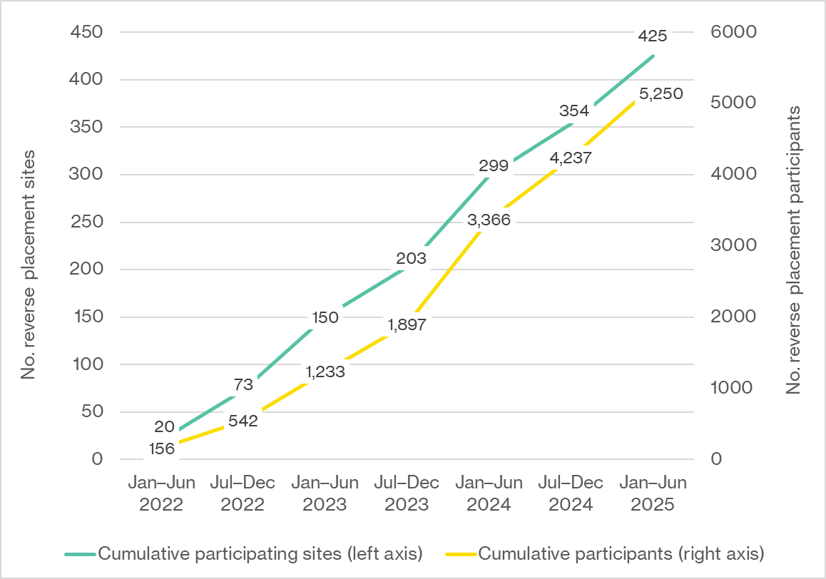
Source: PEPA Aged Care Final Report 2021–2024 [26], PEPA Aged Care performance report, 31 July 2025 [27].
Demand for the program consistently exceeded delivery capacity, as evidenced by a waiting list of 63 sites and an average wait time of 18.1 weeks as of 30 June 2025 (Figure 9.1, Appendix C). While this demonstrates strong interest among sites aware of the program, this demand likely reflects only a portion of sector-wide need, given the limited engagement strategies outlined in the previous section.
Notably, the average number of participants per placement site nearly doubled over the evaluation period, from 7.8 in 2021–22 to 15.0 in 2024–25 (Figure 9.3, Appendix C), suggesting deeper engagement within sites. QUT attributed this increase to its more proactive approach in setting expectations that sites release sufficient staff to maximise training benefits.
Consultations, case studies (technical paper, Section 9.1), and the online survey (technical paper, Table 5.4) identified several key factors that facilitated engagement with PEPA Aged Care. These included the program’s reverse placement design, which addressed common logistical and financial barriers to participation in training. Several case studies in rural and remote areas highlighted this as a particularly important enabler, removing prohibitive costs associated with sending staff off-site for training. Funding for staff backfill further offset participation costs. Strong organisational leadership was also cited across all data sources as an important enabler, ensuring the necessary time and resources were allocated. PEPA Aged Care survey respondents highlighted practical support from the PEPA Aged Care team, dedicated staff champions, and the program’s perceived value as key drivers.
Withdrawal rates for the program were relatively low, with 90% of sites completing a placement (Table 9.6, Appendix C). Most withdrawals occurred in residential aged care (n=46) and home care (n=8; Figure 9.2, Appendix C). The most commonly reported reasons for withdrawal were lack of response from sites (59.3%), staffing issues (18.5%), and lack of readiness (14.8%; Table 9.7, Appendix C). Withdrawal rates were highest in 2021–22 (50%), potentially linked to COVID-19 disruptions, but declined substantially in later years, suggesting increasingly effective site engagement.
Despite steady uptake and consistent performance against participation targets, PEPA Aged Care’s overall sector reach remained relatively modest. As of 30 June 2025, approximately 14% of aged care providers nationwide had participated in a reverse placement. This level of penetration was not unexpected, given the relatively early stage of program implementation. However, several key structural and systemic barriers were also identified across evaluation sources, likely impacting uptake. These included:
- the finite capacity of the nurse educator team, which constrained delivery and resulted in the deliberately narrow promotional strategy discussed in the previous section
- low sector awareness, reflecting the program’s limited engagement strategy
- aged care workforce shortages and high turnover, limiting providers’ ability to release staff despite backfill funding
- competing sector priorities and reform-related fatigue.
- PEPA Aged Care achieved steady uptake since launch, supported by practical design features such as on-site delivery and site funding. However, demand for placements consistently exceeded delivery capacity, and overall sector reach remained modest. Evaluation evidence indicates that uptake was likely influenced by the finite capacity of the nurse educator team, deliberately narrow promotional strategy, and broader workforce and system pressures within the aged care sector. Achieving sustained growth would likely require targeted strategies to expand educator capacity, enhance program visibility, and offer flexible training options.

Profile of PEPA Aged Care participating sites and participants
PEPA Aged Care achieved national coverage, delivering placements to sites across all states and territories, and all levels of remoteness (Table 9.10 and Table 9.11, Appendix C). The overall distribution of placements was broadly aligned with the national provider profile. Victoria, Queensland, and the Northern Territory were overrepresented, whereas New South Wales, South Australia, and very remote areas were underrepresented, though not to a significant extent.
Most reverse PEPA Aged Care placements were delivered in residential aged care settings (85.8%). Reach into other settings was more limited, with smaller proportions of placements delivered in community aged care (8.9%), other community care settings (including home care; 4.9%), and hospitals (0.4%; Table 9.8, Appendix C). This pattern likely reflects both higher demand in residential aged care and stakeholder perceptions that the reverse placement model was less suited to home care contexts (see Section 4.2.2).
As shown in Table 5.1 (with further detail in Table 9.9, Appendix C), participants represented a diverse range of roles. However, the majority were direct care staff, including nursing staff (39.5%) and non-clinical direct care workers (38.0%). Participation among allied health professionals (3.4%), mental health professionals (1.8%), medical practitioners (0.1%) and Aboriginal and Torres Strait Islander health workers (0.1%) was minimal. Given that most placements occurred in residential aged care and promotional strategies were primarily confined to existing PEPA channels, this pattern was not unexpected. As discussed in Section 4.1, stakeholders emphasised that strengthening engagement with primary and allied health professionals could support more integrated palliative care delivery in aged care settings.
Table 5.1: Number of PEPA Aged Care participants by financial year and professional role
Professional role | 2021–22  N | 2022–23  N | 2023–24  N | 2024–25  N | Total N | Total %
Clinical – nursing* | 109 | 486 | 744 | 735 | 2074 | 39.5%
Non-clinical direct care | 41 | 457 | 796 | 700 | 1994 | 38.0%
Non-clinical other# | 5 | 66 | 485 | 341 | 897 | 17.1%
Allied health~ | 6 | 49 | 67 | 58 | 180 | 3.4%
Mental health^ | 1 | 12 | 41 | 41 | 95 | 1.8%
Aboriginal and Torres Strait Islander health worker | 0 | 6 | 0 | 0 | 6 | 0.1%
Clinical – medical | 2 | 1 | 0 | 1 | 4 | 0.1%
Total | 164 | 1,077 | 2,133 | 1,876 | 5,250 | 100.0%
Notes: *Clinical – nursing includes registered nurses, enrolled nurses, and nurse practitioners. #Non-clinical other includes welfare officer, lifestyle and wellbeing, case management and coordination, community and support roles, and hospitality and domestic services. ~Allied health includes physiotherapist, occupational therapist, dietitian/nutritionist, pharmacist, podiatrist, diversional therapist, music therapist. ^Mental health includes clinical psychologist, social worker, counsellor, mental health worker, and pastoral carer.
Source: PEPA Aged Care program data provided by QUT, September 2025.
- PEPA Aged Care achieved national coverage and strong engagement in residential aged care settings, with most participants from direct care roles. However, participation by home and community-based aged care services, and by primary and allied health care professionals, was limited, indicating areas where engagement could be strengthened in future iterations.

Implementation of PACOP
This section examines the implementation of PACOP, including the extent to which planned activities were delivered as intended. It also outlines key factors impacting implementation and delivery, engagement strategies, and program uptake.

Delivery of planned activities and outputs
The University of Wollongong developed Activity Work Plans to guide PACOP implementation and submitted biannual performance reports to the Department in accordance with contractual requirements. Most activities outlined in the initial Activity Work Plan (2021–22 to 2023–24) were delivered. This included establishing governance arrangements, creating the PACOP dataset and national benchmarks, and developing educational materials. However, several activities were only partially achieved. This included meeting several provider participation targets and embedding PACOP within major aged care IT systems.
The University of Wollongong reported that initial implementation was influenced by several sector-wide challenges, including the COVID-19 pandemic, workforce shortages, market instability, and competing reform priorities. Internal governance changes within the University of Wollongong also slowed early staff recruitment, delaying some implementation activities. In addition, integrating PACOP into aged care clinical systems proved more challenging than initially anticipated, reflecting the complexity of the aged care IT environment and competing priorities for IT vendors linked to aged care reforms. Early program adaptations to address several of these challenges included introducing blended education models and communities of practice to support provider engagement and developing a standalone software program (palCentre) to enable providers to upload PACOP data.
Performance against provider participation targets set for the initial grant period (2021–22 to 2023–24) was strong in the early phase, with all six targets exceeded in 2021–22 (Table 9.18, Appendix D). This was supported in part by the transition of providers from the earlier PCOC Wicking pilot. However, participation performance declined over time, with five of six provider targets met in 2022–23 and only one in 2023–24. This was attributed to sector instability and delays in IT integration activities. Despite challenges in meeting participation targets, most performance targets for partnerships, education, and benchmarking were met or exceeded from 2021–22 to 2023–24.
Progress under the current PACOP Activity Work Plan (2024–25 to 2025–26) was positive. Achievement of key output targets and self-reported progress against performance indicators indicated strong performance in 2024–25 (Table 9.19, Appendix D). The primary exception was the implementation of a planned cloud-based data platform intended to address ongoing IT interoperability challenges. This activity was reportedly delayed due to internal resourcing constraints.
- In the initial funding period (2021–22 to 2023–24), the University of Wollongong delivered most planned activities for PACOP. After strong early results against provider participation targets, performance declined over the initial funding period, attributed to sector instability and IT integration challenges. Despite this, performance was strong in other core activity areas, including education, partnerships, and benchmarking.
- The University of Wollongong was progressing well against the current Activity Work Plan (2024–25 to 2025–26), with key output targets achieved and positive progress reported against outcome-based indicators. However, plans to develop a new cloud-based data platform were delayed, highlighting ongoing issues with IT infrastructure development.

Engagement and uptake
This section examines the extent to which PACOP successfully engaged the aged care sector and achieved uptake among providers and homes. It outlines the strategies used to promote the program, patterns of provider and home registration over time, and the profile of participating homes. Key enablers and barriers influencing uptake and sustained participation are also considered.

Program promotion
The University of Wollongong employed a multi-layered engagement approach to promote PACOP. Initial engagement strategies included direct targeting of aged care providers and the development of partnerships across the sector. As of June 2025, formal partnerships had been established with 18 specialist palliative care services/Local Health Districts, 22 PHNs, and 10 aged care training organisations and peak bodies [25]. The University of Wollongong reported regularly engaging with these partners to promote PACOP through activities such as presentations at network and state forums, GP education events, and sector information sessions.
Other engagement strategies included webinars, conference presentations, e-newsletters, promotional videos, and a small number of print and digital media activities.
Between 2021–22 and 2024–25, the University of Wollongong delivered a total of 134 engagement initiatives (Table 9.20, Appendix D). Activity peaked in 2022–23 with 62 initiatives, before declining to 43 initiatives in 2023–24 and 27 initiatives in 2024–25. More than half of all activities were delivered through PACOP-owned channels. These included 49 educational videos and 19 webinars published on the PACOP YouTube channel, as well as nine PACOP e-newsletters. Broader promotional activities, such as conference attendance and presentations (33) and external media (nine promotions), were comparatively limited, although conference attendance increased over time, indicating a stronger sector presence.
Referral data indicated that self-referral was the dominant pathway (72%), followed by direct contact (13%), and the PCOC Wicking trial (7%). Referrals from PHNs and Local Health Districts were minimal. Notably, fewer than five referrals were reported through ELDAC and none through PEPA Aged Care. These findings suggest that current engagement strategies may have been effective in reaching providers actively seeking palliative care support. However, reliance on PACOP-owned channels and limited external marketing may have limited broader reach, making it difficult to gauge true sector-wide demand. Consistent with this, stakeholders reported low program awareness across the aged care sector. They also noted that although existing communication materials were professional, marketing collateral could benefit from specialist aged care communications expertise. Specialist expertise was thought to be potentially more effective at conveying the program’s value proposition and potential benefits to providers.
These findings highlight the need for a more diversified engagement strategy, supported by specialist aged care marketing expertise, to reach providers that may not self-identify or have the capacity to engage without targeted outreach.
- The PACOP engagement strategy used multiple channels but relied heavily on PACOP-owned platforms and self-referral, with minimal referrals through sector partnerships and related initiatives (PEPA Aged Care and ELDAC). While this approach likely supported uptake among motivated providers, it may have constrained broader visibility across the aged care sector, masking potential unmet demand. Stakeholders also noted that existing communication materials could benefit from specialist aged care communications expertise to more clearly convey the program’s value and potential benefits.

Program uptake
PACOP achieved steady growth in provider and aged care home registrations over the evaluation period, although momentum slowed over time. The total number of aged care providers registered in PACOP increased from 56 in 2022–23 to 74 in 2023–24, and then to 85 in 2024–25. Similarly, the number of registered individual aged care homes grew from 145 in 2022–23 to 300 in 2023–24 and 454 by June 2025.
Analysis of year-on-year uptake indicated that program growth peaked early, with provider registrations increasing by 32% in 2023–24 and slowing to 15% in 2024–25. Aged care home registrations followed a similar pattern, rising by 107% in 2023–24 and 51% in 2024–25. These findings indicate strong initial momentum followed by a deceleration in growth.
When participation in the Profile and Outcomes Collection was examined by provider size, findings indicated that growth in both program components was primarily driven by smaller providers with fewer than 10 homes (Figure 5.2 and Figure 5.3). Participation among medium and larger providers remained relatively stable, particularly for the Profile Collection. This pattern indicates both demand among smaller providers and challenges in expanding participation among larger organisations.
Figure 5.2: Number of aged care providers implementing the
Profile Collection, by provider size (January 2021 to December 2024)
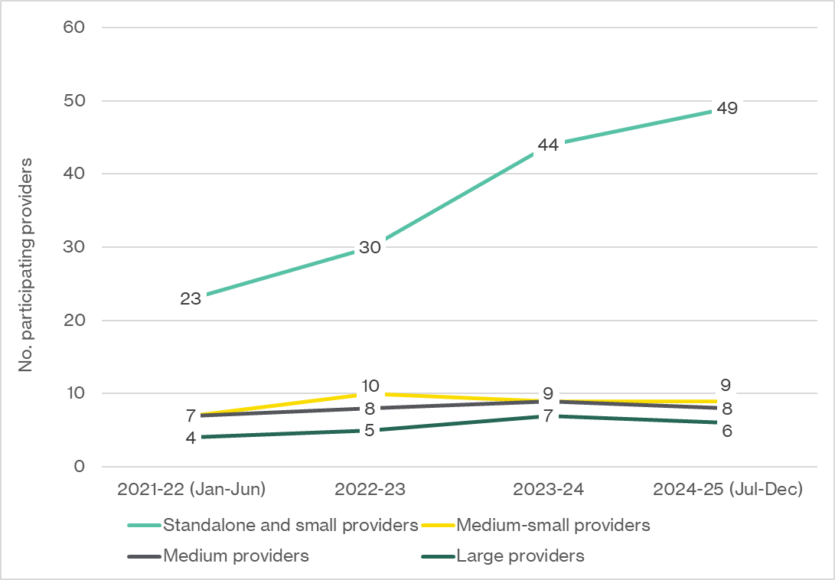
Source: PACOP Performance Report, July 2022 [28], PACOP Performance Report, January 2023 [29], PACOP Performance Report, July 2023 [30], PACOP Performance Report, July 2024 [31], PACOP Final Report, 2025 [24].
Figure 5.3: Number of aged care providers implementing the Profile and Outcomes Collections, by provider size (January 2021 to December 2024)
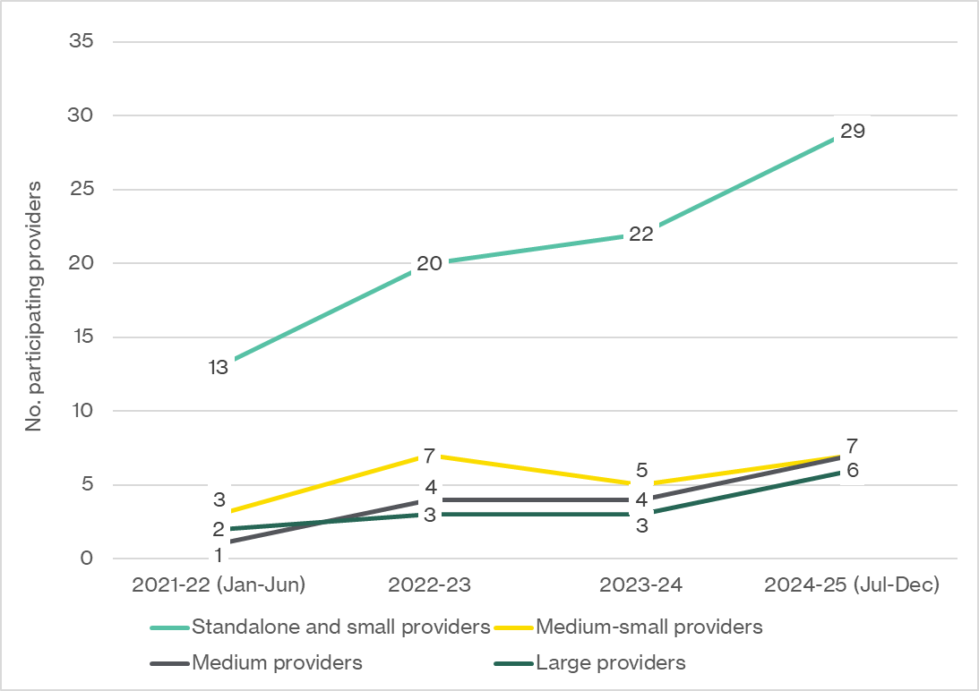
Source: PACOP Performance Report, July 2022 [28], PACOP Performance Report, January 2023 [29], PACOP Performance Report, July 2023 [30], PACOP Performance Report, July 2024 [31], PACOP Final Report, 2025 [24].
Findings from the online survey (technical paper, Table 6.4), PACOP case studies (technical paper, Section 9.2), and stakeholder consultations identified several key enablers of participation in PACOP. These included:
- strong leadership buy-in and engagement
- the program’s perceived value and alignment with sector reforms, including the Strengthened ACQS
- dedicated staff to champion and drive participation
- support from the PACOP team.
However, PACOP’s overall sector penetration remained moderate, with approximately 17% of aged care homes and 12% of providers nationally registered in the program by June 2025. While this level of reach reflects PACOP’s early stage of implementation, it may also point to a range of factors influencing uptake. Insights from the online survey (technical paper, Table 6.3 and Figure 7.1), case studies (technical paper, Sections 9.2 and 9.3), and stakeholder consultations identified several key barriers to program uptake. These included:
- low program awareness, likely linked to the limited engagement strategies discussed above
- lack of IT integration with provider systems, leading some providers to defer participation until resolved
- the perceived resource intensity of implementation and absence of financial support (as discussed in Section 4.3.2)
- competing organisational priorities and reform-related fatigue
- variable organisational readiness for palliative care.
Together, these findings indicate early sector interest in PACOP. However, slowing levels of uptake and modest overall penetration highlight factors that influenced uptake and participation during the evaluation period.
- PACOP achieved strong early growth in provider and aged care home participation, followed by a deceleration in later years. Uptake was driven primarily by smaller providers, while participation among medium and larger organisations remained relatively stable. Overall sector penetration was modest, with evidence suggesting that participation may have been influenced by factors including low program awareness, IT interoperability challenges, perceived resource intensity, and the absence of financial support for participation.

Profile of participating homes
Homes registered in PACOP were located in all states and territories except the Northern Territory (Table 9.21, Appendix D). While this reflected progress toward national coverage, the absence of homes in the Northern Territory remained a gap that PACOP reported it was actively working to address. Jurisdictional patterns showed a concentration in New South Wales (45% of registered homes), likely reflecting PACOP’s initial focus in that state. Victoria, Western Australia, and South Australia were underrepresented, while Tasmania was slightly overrepresented compared to the national provider population.
By remoteness, 73% of registered homes were located in metropolitan and regional areas (MM1–2), and 27% in rural and remote areas (MM3–7), broadly consistent with the national distribution (Table 9.22, Appendix D). More granular data on remoteness were not available for this evaluation due to data suppression.

Depth of participation
By June 2025, almost 70% of aged care homes participating in PACOP were implementing both the Profile and more advanced Outcomes Collections, indicating a relatively high level of adoption among participating homes (Table 5.2).
Table 5.2: Point-in-time count of aged care home
participation by PACOP implementation stage
Implementation stage | 2022–23 | 2023–24 | 2024–25 | Total
Profile Collection only | 29 | >63 | >8 | 107
Profile and Outcomes Collection | 86 | 87 | 141 | 314
Not actively participating/other | 30 | 3 | 0 | 33
Total | 145 | 155 | 154 | 454
Source: PACOP program data provided by the University of Wollongong, September 2025.
Formal withdrawals from PACOP were minimal (fewer than five), suggesting high retention. Cited reasons for withdrawal included organisational mergers, competing priorities, and IT system changes.
Participation in national benchmarking, a key indicator of implementation maturity, increased over the evaluation period, from 19 homes (13.1% of registered homes) in 2022–23 to 131 homes (28.9%) in 2024–25 (Table 5.3). This exceeded PACOP’s target of 69 homes by June 2025. However, these findings also indicate that approximately 70% of participating homes were not engaged in benchmarking, limiting opportunities for these homes to leverage PACOP data for quality improvement.
Table 5.3: Number and proportion of aged care homes
participating in PACOP national benchmarking
Indicator | 2022–23 | 2023–24 | 2024–25
Cumulative number of registered aged care homes | 145 | 300 | 454
Number of homes participating in national benchmarking | 19 | 67 | 131
Proportion of homes participating in national benchmarking | 13.1% | 22.3% | 28.9%
Source: PACOP program data provided by the University of Wollongong, September 2025.
Most homes participating in benchmarking were at the Profile stage (70%) and concentrated in New South Wales (76%; Table 9.23, Appendix D). This pattern suggests scope to further expand benchmarking participation among homes implementing the more advanced Outcomes Collection and across a broader range of jurisdictions.
Importantly, while 421 homes were registered as actively using PACOP, the program did not have a clear, systematic mechanism to confirm the extent to which homes not participating in benchmarking (n=290) were consistently applying the program in practice. This created some uncertainty around the depth of clinical integration across all participating homes.
- PACOP achieved coverage in most states and territories, but there was underrepresentation in some jurisdictions and no participating homes in the Northern Territory. By June 2025, nearly 70% of registered homes were using both Profile and Outcomes Collections, indicating depth of adoption. However, fewer than 30% of registered homes were engaged in national benchmarking overall, limiting the program’s potential for driving sector-wide quality improvement. While the remaining non-benchmarking homes were classified as actively participating, there were limited insights into the extent to which these homes were using PACOP in practice.
Given PACOP’s comprehensive system-level focus, understanding the practical enablers and constraints influencing sustained participation was a key focus of case studies (technical paper, Section 9.2), the online survey (technical paper, Table 6.3 and Table 6.4), and consultations with major aged care providers. Findings indicated that sustained engagement was strongest where:
- organisational leadership prioritised PACOP and positioned it as a strategic priority
- dedicated internal resources were allocated to support implementation and ongoing participation
- the program was adapted and integrated into local workflows, including IT systems where possible.
These factors ensured PACOP was adequately resourced and aligned with routine systems, reducing administrative burden and supporting integration into everyday practice. Some providers reported that adapting elements of the prescribed model to better fit local practice, such as adjusting the number of assessment tools used or the frequency of administration, meant sacrificing some aspects of benchmarking capability. However, providers generally viewed this trade-off as acceptable to achieve practical and sustainable implementation.
Several key barriers to implementation and sustained engagement were also identified. IT integration challenges were consistently cited as the most significant barrier. Limited interoperability led to a reliance on paper-based processes or duplicated data entry across multiple systems, creating substantial administrative burden and impacting benchmarking participation. The need for improved IT integration was consistently emphasised.
The program’s resource intensity and complexity were also identified as key barriers to both implementation and ongoing participation, particularly for larger providers. Providers noted that rollout was often more complex and resource-intensive than initially expected, requiring substantial organisational investment. Stakeholders advocated for simplifying the model and strengthening implementation support to improve feasibility.
Broader sector-wide barriers, including workforce turnover, staffing shortages, and competing organisational priorities, were also reported to influence sustained participation.
- Evaluation findings indicated that sustained participation in PACOP was enabled by strong leadership commitment, allocation of dedicated internal resources, and adaptation of the PACOP model to fit local workflows. However, tailoring the prescribed model to local contexts sometimes reduced benchmarking capability, reflecting a trade-off some providers accepted to achieve practical implementation.
- Persistent IT integration issues and the program’s resource intensity were consistently identified as the most significant barriers to sustained participation in PACOP. These challenges created administrative burden and impacted benchmarking participation, suggesting a need for improved technology solutions, additional implementation support, and simplification of the program model.

Participation in PACOP educational activities
PACOP delivered an expanding suite of educational activities that were adapted over time to accommodate provider needs and the early impacts of the COVID-19 pandemic. Program data indicated strong uptake and engagement across multiple formats:
- workshops: 2,988 individuals (Table 9.25, Appendix D) participated in 155 in-person and online workshops between 2022–23 and 2024–25 (Table 9.24, Appendix D)
- online modules: introduced in 2023–24; 470 enrolments by June 2025 (Table 9.26, Appendix D)
- communities of practice: 238 sessions involving 2,056 participants from 248 homes (55% of registered homes; Table 9.27, Appendix D).
Face-to-face education was concentrated in New South Wales but demonstrated reach beyond metropolitan areas (Table 9.25, Appendix D).
Several key barriers to engagement in PACOP educational activities were reported. These included limited access to follow-up education and training resources, high workload, and staffing constraints (Table 9.30, Appendix D).
Feedback from participants indicated high satisfaction with PACOP educational activities. Approximately 95% of workshop participants and 90% of online module participants agreed their training experience was positive and that the content was appropriate. Suggestions for improving PACOP educational activities include expanding access to on-site and refresher training and providing ongoing support for implementation.
- PACOP’s educational activities were widely accessed and highly rated by participants. Delivery models were adapted over time to meet sector needs and expand reach.
- Reported barriers to engaging with PACOP educational activities included access to training resources, high workload, and staffing constraints. Participants highlighted the value of continued access to training and dedicated implementation support.

Effectiveness
This chapter focuses on KEA 3 Effectiveness: What difference is the Measure making?
The questions to be addressed under KEA 3 are:
- To what extent have activities under the Measure improved the knowledge, skills and confidence of the aged care and primary care workforce to deliver high-quality palliative care and advance care planning in the aged care system?
- To what extent have the activities under the Measure supported the development of organisational capabilities and confidence to deliver high-quality palliative care?
- To what extent has the Measure supported embedding quality improvement and outcomes (e.g. system improvement)?
- To what extent has the Measure supported collaboration and integration between the aged care, primary care and palliative care sectors?
- How and to what extent do the activities under the Measure improve the health outcomes and quality of life of patients and families involved?
- Are there subgroups for which activities under the Measure provide more benefit (e.g. higher uptake or reinforcement of palliative care training, increased palliative care needs being met, improved health outcomes or quality of life)?
- What factors have facilitated or hindered the effectiveness of the Measure?
Analysis and findings
The sections below examine the effectiveness of the Measure in achieving its intended outcomes. It explores the extent to which the funded programs contributed to strengthening workforce capability, organisational systems and capability, and outcomes for older people and their families. Findings presented in the sections below draw on triangulated evidence from multiple sources, including the online survey, case studies, stakeholder interviews, and evaluation surveys conducted by PEPA Aged Care and PACOP.

PEPA Aged Care
This section examines the extent to which PEPA Aged Care contributed to improving workforce and organisational capability in palliative care, system improvement, collaboration and integration across sectors, and outcomes for older people and their families. The analysis also explores variation in observed benefits across subgroups and identifies factors influencing the program’s effectiveness.

Improvements in workforce capability
A central objective of PEPA Aged Care was to strengthen capability within the aged care workforce. Evidence from the online survey, case studies, and PEPA Aged Care pre/post-placement evaluation surveys consistently indicated that the program contributed to perceived improvements in workforce capability, particularly among nursing and non-clinical aged care staff.

Capability gains across core domains
The majority of PEPA Aged Care respondents to the online survey (>75%) reported moderate or significant improvements in the knowledge, skills, and confidence of their staff in core domains of palliative care, including:
- identifying palliative care needs
- providing high-quality palliative care
- facilitating advance care planning
- collaborating with external services to deliver palliative care (Figure 6.1).
Figure 6.1: Reported impact of PEPA Aged Care participation on staff knowledge, skills, and confidence in delivering palliative care (n=178)
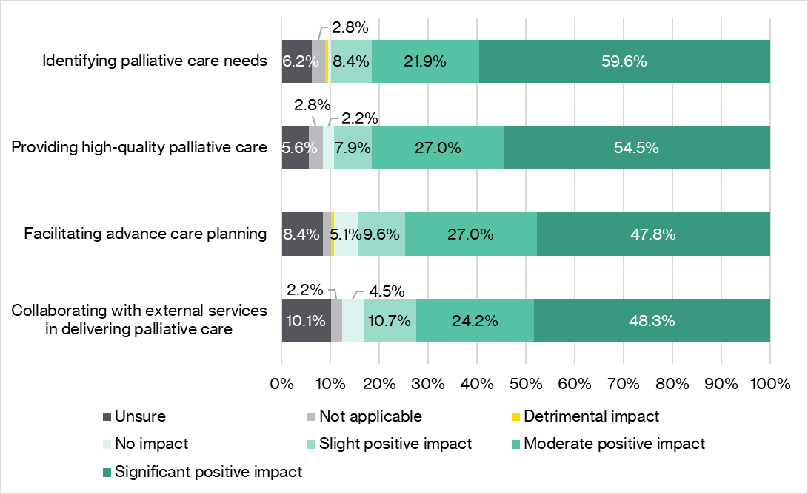
Source: HMA online survey, August 2025.
Similarly, pre/post-placement evaluation survey data collected by PEPA Aged Care indicated improvements across a range of key domains of palliative care knowledge and skills (Figure 9.4, Appendix C). Largest improvements were reported in the ability to apply principles of culturally centred care (+17%), confidence in end-of-life discussions (+15%), and confidence in contacting external palliative care services (+12%).
Qualitative evidence from case studies (technical paper, Section 9.1) and post-placement participant reflections (Table 9.14, Appendix C) reinforced these findings. Case study sites consistently reported greater staff confidence and capability in recognising deterioration, communicating with families, and facilitating advance care planning.
The staff say now that they feel confident in palliative care … The personal care workers particularly felt more confident … It was able to make people feel comfortable, give them the tools that they needed to be able to recognise and report. – PEPA Aged Care case study (case study 1)
One case study site described how this confidence enabled rapid response to unexpected palliative care needs for a new resident, resulting in a dignified end-of-life experience and positive family feedback.
That was a good example of the confidence that staff had in knowing what was happening and what they needed to do, even though we hadn’t been able to develop a relationship with her or her family, because she wasn’t a long-standing resident. The feedback that came from the family – they were so impressed with how she was treated, with how they were treated, and how quickly things were put into place to support them. – PEPA Aged Care case study (case study 4)
Post-placement reflections from participants also highlighted informal knowledge-sharing behaviours among staff, suggesting a multiplier effect that extended beyond those directly involved in reverse placements.
I have discussed with colleagues regarding the information I learnt within the PEPA training and have helped to better their knowledge as well as my own – PEPA Aged Care participant

Variation in benefit across workforce streams
Analysis of participation and online survey data (technical paper, Figure 5.3) suggested that the program’s benefits were likely concentrated among staff directly involved in day-to-day care, including registered nurses, enrolled nurses, and personal care workers. These groups represented the majority of participants (see Section 5.2.2) and were identified by survey respondents as deriving the greatest benefit from PEPA Aged Care, reflecting both higher demand and need within these roles. Survey respondents also indicated that staff with limited prior palliative care experience may gain particular value from the program.
Around 40% of online survey respondents also identified potential benefits for allied health professionals and one-quarter for GPs and other medical professionals (technical paper, Figure 5.3). However, participation among these groups was minimal (see Section 5.2.2).
- There was evidence that PEPA Aged Care contributed to perceived improvements in core palliative care knowledge and capabilities, particularly among nursing and personal care staff. Reported benefits were more limited among other health professional groups, likely reflecting lower levels of participation.

Improvements in organisational capability, quality improvement, and collaboration
Evidence from surveys, case studies, and stakeholder interviews indicates that PEPA Aged Care contributed to strengthening organisational capability, fostering a culture of quality improvement, and improving collaboration with external providers among participating sites. However, participation data indicated that these organisational benefits may not be evenly distributed across the aged care sector, with most placements occurring in residential aged care settings (Table 9.8, Appendix C). As discussed in Section 5.2.2, participation among home and community care services was limited.

Organisational capability gains
Survey and case study evidence indicated that PEPA Aged Care contributed to building organisational capability and integrating palliative care into core business among participating sites. As shown in Figure 6.2, more than three-quarters of PEPA Aged Care survey respondents reported the program had a moderate or significant positive impact on organisational capability to deliver high-quality palliative care, integration of palliative care into core business, and overall organisational culture around palliative care and quality improvement. The majority of respondents also cited positive impacts on the quality of palliative and end-of-life care plans and advance care planning documentation. These findings suggest that PEPA Aged Care influenced both palliative care practice and culture within participating sites.
Figure 6.2: Reported impacts of PEPA Aged Care on the quality, integration, capability, and culture around palliative care and quality improvement (n=178)
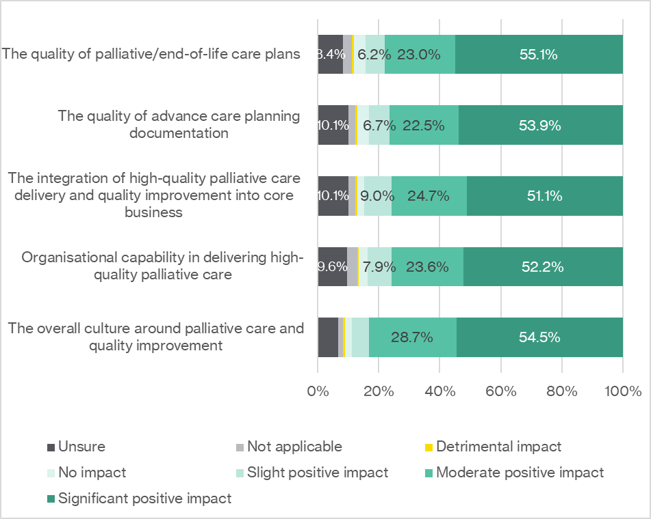
Source: HMA online survey, August 2025.
Case study findings were consistent with survey results, with all sites describing improvements in organisational culture around palliative care and care delivery practices (technical paper, Section 9.1). Sites attributed these changes to increased workforce confidence, reduced discomfort around discussions of death and dying, and enhanced organisational systems and processes supporting quality palliative care.

Implementation of quality improvement initiatives
Post-placement service improvement activities were identified as a key mechanism for translating learnings from reverse PEPA Aged Care placements into organisational practice. Completed by the majority of sites (84%; Table 9.4, Appendix C), reported initiatives ranged from internal education and knowledge transfer to policy refinement, resource development (e.g. quick reference guides, palliative care packs), and awareness-raising campaigns (technical paper, Table 5.1). Two-thirds of PEPA Aged Care survey respondents reported that the program had led to tangible changes or quality improvement initiatives. More than 80% believed these changes would be sustained to a moderate or large extent within their organisation (technical paper, Figure 8.7), suggesting potential for longer-term organisational benefit.
The program’s mentorship model aimed to reinforce organisational capability by fostering internal leadership among registered nurses. Uptake of this component was strong, with 1,655 mentors engaged across 425 sites (an average of four per site; Table 9.4, Appendix C). However, the evaluation was unable to determine the sustainability or long-term effectiveness of this role. As a potential indicator of sustained organisational knowledge and interest in palliative care, available sector-wide monitoring, such as the Aged Care Workforce Survey, could provide valuable insights into the broader impact of such mentorship initiatives over time.

Collaboration and integration with external services
Strengthening linkages between participating sites and external palliative care services was an important program objective. To support this, sites were required to complete a mapping exercise of local service providers. Training content also included modules on identifying referral pathways and communicating with external healthcare providers.
As discussed in Section 6.1.1, approximately three-quarters of PEPA Aged Care survey respondents reported moderate or significant gains in staff capability to collaborate with external services as a result of program participation. Almost 80% cited similar improvements at the organisational level (technical paper, Figure 5.5). In addition, approximately 40% of respondents reported improving communication with external palliative care providers, and one-third reported enhancing or creating referral pathways following participation in PEPA Aged Care (technical paper, Table 5.1).
Pre/post-placement evaluation survey data and participant reflections reinforced these findings, highlighting improved confidence to contact palliative care services and greater clarity on when and how to involve other providers (Figure 9.4 and Table 9.14, Appendix C).
These findings suggest that PEPA Aged Care enhanced organisational capability and readiness to deliver integrated care, a key driver of system-level quality improvement.
- Findings demonstrated that PEPA Aged Care contributed to building organisational capability, cultural change, quality improvement initiatives, and strengthening collaboration with external providers in participating sites, laying the groundwork for system-level improvement. However, participation was concentrated in residential aged care, suggesting that benefits were primarily focused on this setting.

Improvements in health outcomes and quality of life
The perceived impact of PEPA Aged Care on health outcomes and quality of life for older people and their families was explored through focus groups with consumer, carer, and family representatives, the online survey, and post-placement reflections from participants. While QUT had initially intended to collect after-death audit data from participating sites to assess care quality outcomes, these data had not been collected to June 2025, reportedly due to data collection challenges. This limited the availability of data on measurable outcomes for the evaluation. As a result, findings presented in this section are based on stakeholder perceptions rather than objective indicators.

Perceived impacts on care and outcomes
When PEPA Aged Care was described to focus group participants, there was broad agreement that the program was likely to improve aged care staff confidence, knowledge, and skills in identifying palliative care needs and providing appropriate care. In turn, focus group participants generally expected that these improvements would translate into better care and outcomes for older people and their families.
Survey findings aligned with these views. Approximately 80% of PEPA Aged Care survey respondents perceived a moderate or significant positive impact of the program on key indicators, including the timely identification of palliative care needs, health outcomes and quality of life throughout the palliative care journey, and end-of-life outcomes (Figure 6.3).
Figure 6.3: Respondents’ perceptions of the impact of PEPA Aged Care participation
on older people and families (n=178)
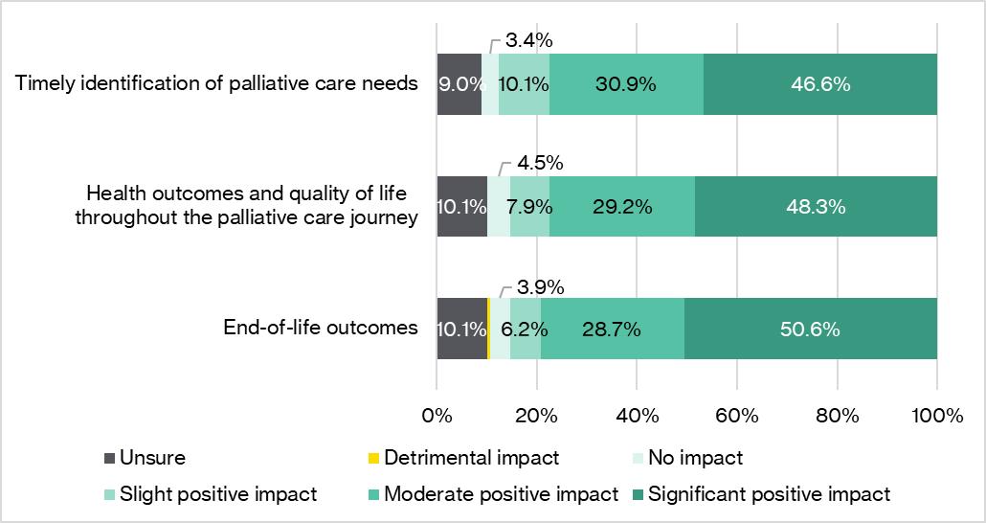
Source: HMA online survey, August 2025.
Qualitative feedback from PEPA Aged Care survey respondents highlighted improvements in family communication and support, person-centred care, symptom management, and advance care planning (technical paper, Table 5.2). One example provided by a survey respondent illustrated this impact:
A care manager at our service was supporting a client with a terminal illness. The client’s family, from a culturally diverse background, avoided discussing end-of-life preferences due to cultural taboos. The care manager felt unequipped to initiate these conversations. Through the specialised program, the care manager gained confidence and skills to approach these conversations with sensitivity. With support from the [PEPA Aged Care] facilitator and a clinical mentor, they used tools to initiate a respectful conversation with the family. This led to open communication; assessment of the client’s end-of-care needs; development of an advance care directive; and a clear care pathway. The client received person-centred care, and their symptoms were well-managed. They passed away peacefully at home, surrounded by loved ones. This experience transformed the care manager and the team, increasing their confidence in delivering culturally responsive palliative care. – PEPA Aged Care survey respondent
Post-placement evaluation survey data reinforced these perceptions, with almost all participants agreeing that the program would improve both their care of people with life-limiting illness and their organisation’s care delivery (Figure 9.5, Appendix C).
Findings from PEPA Aged Care survey respondents on the perceived impact of program participation on hospital utilisation, including unplanned hospital admissions and ED visits, were inconclusive (technical paper, Figure 5.8 and Figure 8.9). These mixed results may reflect a range of factors, including the program’s early stage of implementation and external influences.
- PEPA Aged Care was perceived to indirectly enhance care quality and experiences for older people and families by improving workforce capability and organisational systems. However, the evaluation was unable to validate these perceived outcomes due to the absence of measurable outcome data during the evaluation period.

Factors influencing effectiveness
Several factors were identified as shaping the overall effectiveness and sustainability of PEPA Aged Care in improving workforce capability, organisational capability, and outcomes for older people and their families:
- Single training placement model: while the reverse placement model was viewed as effective for initial staff capability building, the one-off nature of training was widely perceived as insufficient for sustaining currency of knowledge and skills over time, particularly in the context of high staff turnover. Stakeholders proposed several strategies that could support reinforcement of learning over time, including:
- providing ongoing, recurring access to reverse placements (annual or biannual, potentially as shorter refresher sessions after the initial placement)
- offering a longer structured program (e.g. 12-month engagement with monthly sessions) to embed training outcomes more deeply and across a broader cross-section of staff within participating sites
- expanding virtual resources and communities of practice to supplement the core reverse placements and facilitate ongoing peer support.
- Competing priorities and resource constraints: as noted in Section 5.2.1, competing organisational priorities and workforce challenges reportedly limited some sites’ ability to engage in post-placement activities to embed and sustain learnings. Suggested solutions to address this included:
- strengthening the support provided to sites following placements through more structured follow-up or ongoing mentoring
- linking site funding directly to the completion of post-placement activities to incentivise engagement.
- Limited leadership engagement: some stakeholders expressed concern that without active leadership engagement to foster and drive integration of palliative care, program outcomes may not be sustained. It was suggested that developing distinct PEPA Aged Care training streams for managers and governance roles could enhance the program’s effectiveness and sustainability.
- Program scale and reach: stakeholders cautioned that without wider reach, PEPA Aged Care may not adequately meet the needs of the aged care sector. Achieving genuine change was seen as contingent on reaching a critical mass of staff and aged care providers, including those beyond residential aged care settings. Opportunities identified to extend the program’s reach included:
- expansion of the nurse educator workforce to support scalability
- cascade or train-the-trainer delivery models (e.g. training clinical educators to filter knowledge within organisations)
- blended learning approaches (e.g. offering a blend of online and in-person learning options)
- linking training to professional development requirements to incentivise staff participation and engagement.
- Factors identified as potentially impacting the effectiveness of PEPA Aged Care included the one-off reverse placement model, competing organisational priorities, lack of direct leadership engagement, and the program’s relatively limited reach. Suggested strategies to improve the effectiveness and sustainability of outcomes included ongoing, recurring access to placements; expanded online resources and communities of practice; strengthened post-placement mentoring; leadership-focused training streams; and increased nurse educator capacity to broaden reach.

PACOP
This section explores the extent to which PACOP contributed to strengthening workforce capability, enhancing organisational systems and collaboration, and improving care experiences and outcomes for older people and their families. It also examines variation in reported benefits across participant groups and factors influencing program effectiveness.

Improvements in workforce capability
PACOP’s educational activities, including online modules, workshops, webinars, and communities of practice, were designed to build capability in the aged care workforce.

Capability gains across key domains
Evidence from the online survey, case studies, and pre/post-training evaluation surveys conducted by PACOP indicated that the program contributed to perceived improvements in workforce capability. Findings from the online survey showed that between 72% and 77% of PACOP respondents reported moderate or significant gains in staff knowledge, skills, and confidence to recognise palliative care needs, deliver high-quality palliative care, facilitate advance care planning, and work effectively with external providers (Figure 6.4). Most survey respondents believed these gains would be sustained within their organisation over time (technical paper, Figure 8.13), suggesting potential for lasting impact. However, given ongoing workforce pressures within the aged care sector, the extent to which these capability gains are sustained in practice remains uncertain (see Section 6.2.4).
Figure 6.4: Reported impact of PACOP on staff knowledge, skills,
and confidence in delivering palliative care (n=79)
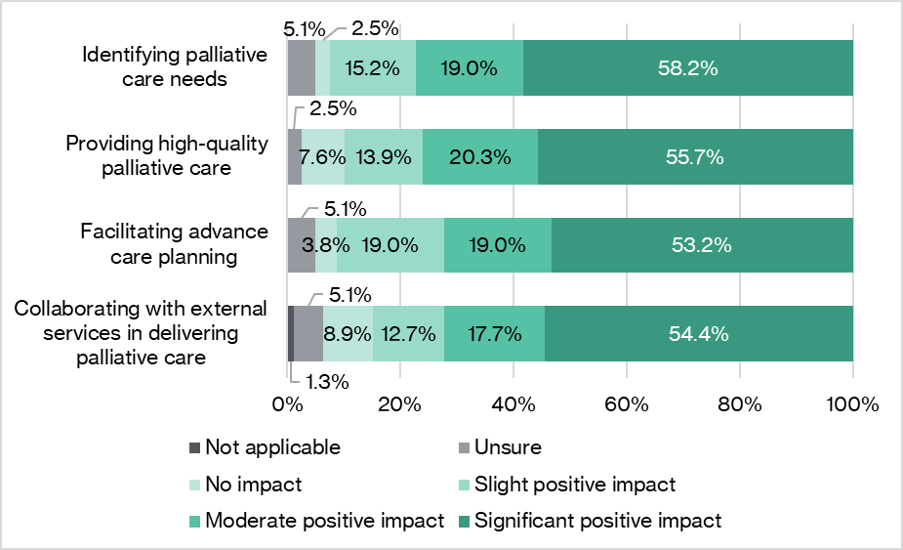
Source: HMA online survey, August 2025.
Case study insights reinforced these findings. Most PACOP case studies reported improved confidence and capability among both clinical and non-clinical staff to identify palliative care needs, initiate sensitive conversations, and provide quality care (technical paper, Section 9.2).
It’s taking the fear out of [the staff] … We’ve got more registered nurses and enrolled nurses being able to have a conversation now. Carers are feeling quite comfortable with how to manage and care for these people. – PACOP case study (case study 6)
Pre/post-evaluation survey data from PACOP workshop and online module participants also showed reported gains in a number of domains, including using palliative care assessment tools, assessing frailty and functional status, communicating with external providers, and identifying palliative care needs (Figure 9.7 and Figure 9.8, Appendix D). These improvements aligned with PACOP’s focus on timely and coordinated palliative care.

Variation in benefit across workforce streams
Insights from the online survey suggested that PACOP’s workforce benefits were concentrated among staff directly involved in care delivery, including registered nurses, personal care workers, and enrolled nurses (technical paper, Figure 6.3). Limited enrolment data for PACOP online modules supported this, indicating these groups comprised the majority of participants (Table 9.26, Appendix D). This alignment is to be expected, given PACOP relies on direct care staff to operationalise its structured assessment and monitoring framework.
Exploratory subgroup analysis of online survey data indicated that longer participation in PACOP may be associated with greater reported gains in workforce capability, particularly in identifying palliative care needs, delivering high-quality care, and facilitating advance care planning (technical paper, Table 8.6). While these findings suggest a potential cumulative benefit, they should be interpreted with caution due to small sample sizes.
Notably, approximately 45% of PACOP survey respondents identified the program as relevant and beneficial for GPs and other medical practitioners (technical paper, Figure 6.3). While limited participation data were available to confirm the extent of engagement among these groups, stakeholder feedback indicated low participation. This reinforces the opportunity to strengthen engagement with GPs and other healthcare professionals (see Section 4.1).
- Evidence suggests that PACOP contributed to perceived improvements in workforce capability in key domains of palliative care delivery within participating homes, particularly among direct care staff. Survey findings suggested potential cumulative benefits with sustained program engagement. While PACOP was identified as relevant and beneficial for GPs and other medical practitioners, evidence suggested that engagement among these groups was limited, highlighting potential opportunities to broaden participation.

Improvements in organisational capability, quality improvement, and collaboration
PACOP aimed to embed a structured palliative care model in aged care homes, support the use of data for continuous improvement, and foster collaboration across aged care, primary care, and specialist services. Evidence from surveys, case studies, benchmarking data, and stakeholder consultations suggests that PACOP contributed to organisational capability development and improved integration within participating homes. However, evaluation findings also point to ongoing challenges related to sustainability and reach.

Organisational capability and cultural change
Approximately three-quarters of PACOP survey respondents reported moderate or significant positive impacts on organisational capability, integration of palliative care and quality improvement, and organisational culture as a result of participation (Figure 6.5). A similar proportion of respondents also noted improvements in the quality of palliative and end-of-life care plans and advance care planning documentation, suggesting a perceived improvements in care planning practices.
Figure 6.5: Reported impacts of PACOP on the quality, integration, capability, and culture around palliative care and quality improvement (n=79)
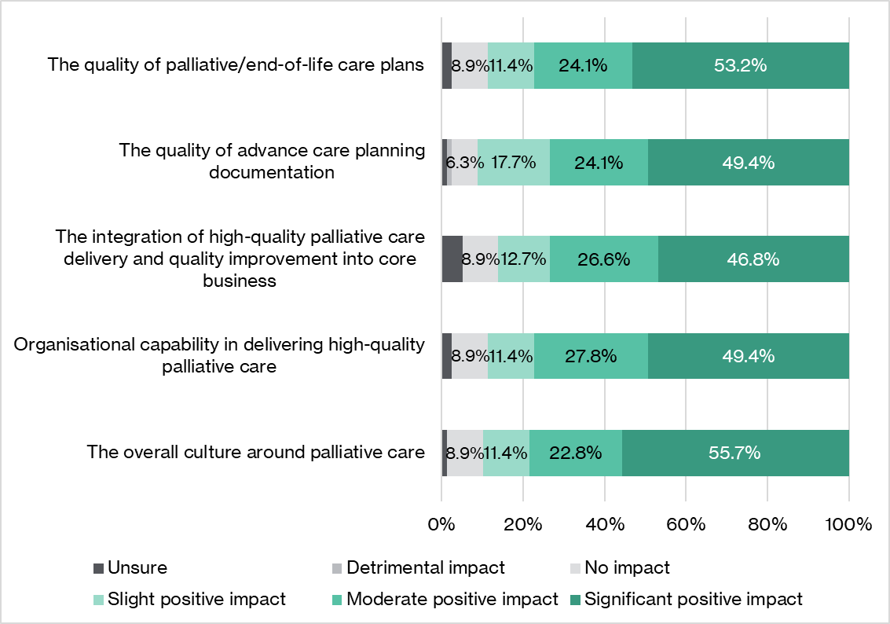
Source: HMA online survey, August 2025.
In addition, three-quarters of online survey respondents (technical paper, Figure 8.17) and three of four case studies (technical paper, Section 9.2) reported that their organisation confidently used the PACOP assessment tools to identify and respond to residents’ palliative care needs. This suggests the program was effective in building organisational capability to integrate structured palliative care processes into routine practice.

Embedding quality improvement through data
There was evidence to suggest that PACOP’s structured assessment tools and benchmarking approach helped drive quality improvement in participating homes. Around 75% of survey respondents reported that PACOP had at least a moderate impact on organisational capability in measuring and monitoring palliative care outcomes, identifying areas for improvement, and implementing quality improvement initiatives (Figure 6.6).
Figure 6.6: Reported impact of PACOP participation on organisational
quality improvement in palliative care (n=79)
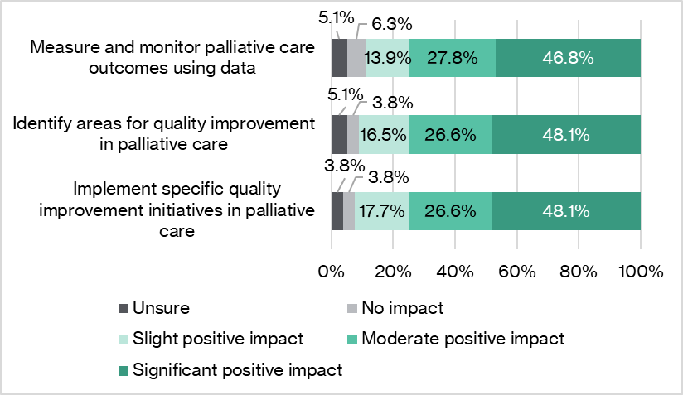
Source: HMA online survey, August 2025.
Around 70% of online survey respondents also reported their organisation regularly used PACOP data or benchmarking reports to inform quality improvement initiatives (technical paper, Figure 8.17). Common initiatives reported by PACOP survey respondents as a result of participation included improvements to palliative care policies and procedures, development of palliative care resources, delivery of additional staff education, and improvements to clinical protocols (technical paper, Table 6.1). More than 85% of respondents believed these improvements would be sustained over time (technical paper, Figure 8.16), suggesting potential for lasting organisational change. One case study also highlighted that benchmarking reports were beginning to inform service-level gap analysis and action planning (technical paper, Section 9.1).
Available benchmarking data from participating homes between January 2023 and June 2025 demonstrated emerging improvements in several PACOP indicators of organisational capability. These included:
- timely screening of new high-need admissions (increased from 28% to 49% of admissions), suggesting improved organisational capability in the early identification of palliative care needs among newly admitted residents
- the proportion of residents who died with an advance care plan in place (increased from 51% to 78%), indicating stronger integration of advance care planning processes and more proactive conversations about end-of-life care (Table 9.28, Appendix D).
However, several key process-related benchmarking indicators declined over this period. This included the completion of quarterly Profile Collection assessments to screen for palliative care needs and prompt commencement of palliative care using the Outcomes Collection (Table 9.28, Appendix D), suggesting inconsistent adherence to core PACOP workflows in some participating homes. While these patterns likely reflect the early stage of program implementation and varying local capability, they may also reflect broader implementation challenges (see Section 5.3.2), underscoring the importance of feasibility and implementation support.
It is important to note that findings from benchmarking data represent initial signals rather than definitive outcomes and should be interpreted with caution. Embedding a structured, data-driven program like PACOP is inherently a long-term process, requiring ongoing commitment and iterative refinement before measurable organisational benefits can be fully realised.

Collaboration and integration with external services
Survey, case study, and consultation findings suggested that PACOP contributed to improved collaboration and integration among aged care providers and external services involved in palliative care delivery.
As reported in Section 6.2.1, approximately 70% of PACOP survey respondents reported moderate or significant gains in staff confidence to work with external services. Three-quarters of respondents cited similar improvements at the organisational level (technical paper, Figure 6.5). Survey findings also suggested that these gains translated into tangible organisational improvements. Nearly half of respondents reported their organisation had created or enhanced referral pathways, and 40% actively improved collaboration and communication with external providers as a result of program participation (technical paper, Table 6.1).
Stakeholder consultations highlighted improved communication with medical and specialist palliative care professionals as a key perceived benefit of the program. It was noted that PACOP provided a consistent language and structured framework, enabling aged care staff to articulate residents’ conditions and needs more effectively. In turn, stakeholders felt this would support more constructive conversations with GPs and specialist services.
PACOP gives the nurse the tools to actually have a good discussion with a doctor. It gives them grounding, it gives them the story, it gives the information. Rather than just saying to the doctor, this is what this person’s got, it’s actually grounded in a proper framework. – Specialist palliative care service representative
Consistent with this, one case study (technical paper, Section 9.2) reported that PACOP assessment data strengthened communication with GPs.
Together, these findings suggest that PACOP helped participating homes to embed processes (e.g. referral pathways, structured communication) that supported collaboration and care integration across sectors.

Variation in benefits
There was some evidence to suggest that PACOP’s effectiveness in improving organisational capability varied by provider characteristics and length of participation. Participation data (see 5.3.2) indicated stronger demand among smaller providers (fewer than 10 homes). Consistent with this, stakeholders perceived PACOP as particularly beneficial for smaller providers, especially those without dedicated in-house palliative care support. Smaller providers were also viewed as having greater capacity to embed the comprehensive PACOP model, with their scale allowing for more effective control and consistency in implementation. Conversely, stakeholders perceived the program as being less beneficial for providers with well-developed palliative care systems and processes.
Exploratory subgroup analysis of online survey findings indicated a potential cumulative benefit of sustained program engagement on the integration of high-quality palliative care into core business and organisational capability in delivering high-quality palliative care (technical paper, Table 8.7). These findings should be interpreted cautiously due to sample size limitations.
- Survey and case study evidence suggested that PACOP contributed to strengthening organisational capability and embedding structured processes for quality improvement and collaboration. Benchmarking data signalled some early signs of improvement in several domains, including timely screening of new admissions and advance care planning.
- Declines in key process benchmarking measures, including completion of scheduled Profile Collection assessments and timely initiation of palliative care using the Outcomes Collection, indicate that some homes were struggling to consistently adhere to the PACOP framework. These findings highlight ongoing implementation and feasibility challenges.

Improvements in health outcomes and quality of life
Evaluation findings suggested that PACOP was perceived to indirectly influence resident health outcomes and family experiences, primarily through earlier identification of palliative care needs and improved communication.

Perceived improvements in care and family experience
As shown in Figure 6.7, the majority (around 75%) of PACOP survey respondents perceived moderate or significant positive impacts of the program on key indicators of care quality, including timely identification of palliative care needs, health outcomes and quality of life throughout the palliative care journey, and end-of-life outcomes.
Figure 6.7: Respondents’ perceptions of the impact of PACOP
on health and end-of-life outcomes (n=79)
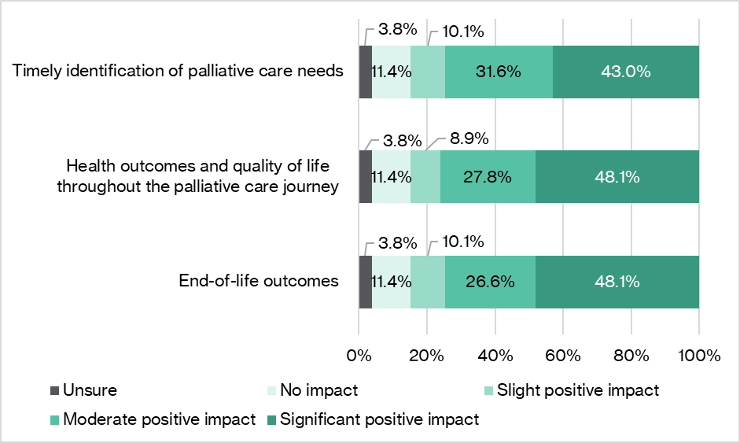
Source: HMA online survey, August 2025.
Qualitative examples from PACOP survey respondents reinforced these findings, highlighting improved family support and communication between staff and better symptom management (technical paper, Table 6.2). One respondent described the impact of the program as follows:
Participation in PACOP has helped enhance our approach to palliative care by improving communication between staff, residents, and families. Staff have become more confident in recognising signs of decline, initiating timely end-of-life discussions, and providing symptom management. Families have reported feeling more supported and informed, which has improved their overall satisfaction and reduced anxiety during the palliative phase. – PACOP survey respondent
Other examples described targeted improvements in pain management and proactive family engagement.
Through our participation in PACOP, we identified gaps in pain management for residents at the end of life. PACOP highlighted areas for improvement in pain management and family communication. We introduced more frequent pain assessment, prompt interventions and structured family meetings soon after a resident begins palliative care. This improved comfort for residents and reduced stress for families. – PACOP survey respondent
Several case studies (technical paper, Section 9.2) and interviewed stakeholders echoed these themes, identifying PACOP’s structured assessment framework as a key enabler of earlier recognition of deterioration and proactive care planning.
We’re identifying earlier that people are starting to deteriorate and need palliative care. We’re doing our family case conferences earlier to prepare the families and have things in place, and then we have been able to manage those people in the facility. – PACOP case study (case study 6)
A potentially really realised strength would be early identification ... the idea that we are trying to pull things further down to say, let’s think about could this person be in the last six months of life, the last year of life? It actually gives time for people to reconceptualise care over a period. – Representative from a related national palliative care initiative
Findings from a snapshot survey conducted by PACOP supported these perceptions. Almost 90% of respondents agreed that PACOP improved routine monitoring of residents’ needs, and around 80% agreed it improved communication with families (Figure 9.9, Appendix D).
The program’s impact on hospital utilisation was examined through both the online survey and PACOP assessment data. Perceptions of PACOP’s influence on palliative care-related hospital utilisation among respondents to the online survey were highly mixed (technical paper, Figure 6.10 and Figure 8.19). This was reflected in PACOP assessment data, which showed that the average proportion of residents experiencing one or more unplanned hospitalisations or ED presentations (across all causes, not just palliative care-related events) rose by approximately five percentage points over January 2023 to June 2025 (Figure 9.6, Appendix D). Taken together, these findings suggest that the introduction of PACOP has not yet produced a detectable reduction in unplanned hospital use at an aggregate level. However, these findings should be interpreted with caution, given the early stage of program implementation. Additionally, the direction and magnitude of change in hospital use are likely influenced by multiple factors beyond the program’s scope, including resident acuity, social and demographic characteristics, clinical complexity, and broader system pressures.

Resident outcome benchmarking insights
Analysis of PACOP benchmarking data (January 2023 to June 2025; Table 9.28, Appendix D) showed early signs of improvement in several resident-focused outcome indicators, including:
- pain management within three days: improved from 38% to 81% (+44 percentage points), exceeding the 60% benchmark and suggesting better symptom control for residents
- pain stability over time: marginal improvement from 10% to 14% (+4 percentage points).
However, some declines were also evident in:
- early identification of palliative care needs prior to death: slight decline from 72% to 66% (-6 percentage points), suggesting ongoing challenges in timely recognition of palliative needs
- timely commencement of palliative care: fell from 24% to 11% via the Outcomes Collection (-12 percentage points) and from 53% to 23% via the Deteriorating Resident Tool (-31 percentage points)
- unstable phases ending within three days: declined from 63% to 35% (-28 percentage points), suggesting challenges in stabilising residents during acute phases.
As noted in Section 6.2.2, declines were also evident in several process measures (e.g. administering quarterly Profile Collection assessments, initiating timely Outcomes Collection assessments). This suggests variable adherence to core PACOP workflows in some homes, with potential downstream implications for resident-level outcomes.
Available benchmarking data did not allow for analysis of potential variation in benefits by resident demographics, geography, remoteness, provider size, or implementation stage. Data suppression requirements limited the granularity of available information, preventing meaningful data interrogation.
Overall, these benchmarking insights should be interpreted as early signals only. The small proportion of registered homes engaged in benchmarking (<30%) and the early stage of implementation limit the extent to which conclusions about resident-level outcomes can be determined at this time.
- PACOP was perceived by stakeholders to improve care experiences for residents and families, primarily through earlier identification of palliative care needs and better symptom management. However, benchmarking data did not consistently reflect these perceived gains, showing early improvements in pain control alongside declines in several indicators of timely identification, care initiation, and stabilisation during acute phases. Additionally, mixed survey views and program data suggest no clear reduction in unplanned hospital use to date. This may reflect the early stage of implementation and potential external confounding influences.

Factors influencing effectiveness
Synthesis of findings from the online survey, case studies, stakeholder consultations, and program data identified several key factors that both helped and hindered PACOP’s effectiveness in achieving the intended outcomes:
- Leadership and organisational readiness: strong leadership emerged as a critical enabler for embedding the program as a core business priority and creating the conditions for cultural change. Conversely, limited leadership engagement or organisational instability undermined the ability to maintain focus and prioritise PACOP.
- IT integration: limited integration of PACOP with provider IT systems was consistently identified as both a key implementation challenge (Section 5.3.2) and a barrier to effectiveness. Homes relying on paper-based processes were able to apply PACOP principles but were typically excluded from benchmarking activities, limiting their ability to use data for continuous quality improvement—a cornerstone of the PACOP model. Manual processes were also associated with increased administrative burden, reduced staff engagement, and sustainability risks.
- Workforce and organisational pressures: high staff turnover, workforce shortages, and competing organisational priorities were reported to disrupt implementation and dilute program impact. These pressures highlighted the importance of ongoing education and refresher training to maintain capability and momentum.
- Clinical capability gaps: stakeholders noted that PACOP’s effectiveness in enhancing resident outcomes would be influenced by the availability of sufficient clinical expertise within organisations. There was some concern that variable access to skilled clinicians could impact the appropriate translation of PACOP assessment findings into timely, quality care.
- Program scale and reach: as with PEPA Aged Care, stakeholders highlighted that without broader and deeper uptake, PACOP’s sector-wide impact would likely remain incremental rather than transformative. They emphasised that wider implementation would be required to achieve genuine system-level change.
- Factors influencing PACOP’s effectiveness included leadership engagement, IT integration, workforce challenges, the availability of appropriate in-house clinical capability, and program reach.

Efficiency
This chapter focuses on KEA 4: Efficiency. The key evaluation question to be addressed is: How well have resources been used?
The questions to be addressed under KEA 4 are:
- What are the broad costs and benefits of activities under the Measure, including short-, medium- and long-term outcomes?
- Where relevant, how efficiently are the activities utilising funding the Australian Government provides?
- Where relevant, how can activities better utilise funding provided by the Australian Government?
A comprehensive economic analysis of the Measure was not feasible for either PEPA Aged Care or PACOP due to data and timing limitations identified through the program logic (Figure 2.2).
For PEPA Aged Care, data on measurable outcomes were unavailable. While the program had planned to collect after-death audit data from participating sites to assess care quality and outcomes, this did not occur due to data collection challenges. In addition, impacts with potential economic significance, such as reductions in hospital utilisation, were not expected to emerge until at least five years post-implementation, beyond the timeframe of the evaluation.
Similarly, while PACOP collected several outcome indicators as part of benchmarking reporting (e.g. unplanned hospitalisations and ED presentations), the evaluation occurred approximately three years after large-scale implementation, well before anticipated population-level benefits were expected to be realised.
Other constraints to conducting a full economic analysis included the absence of baseline comparator data, attribution challenges due to concurrent reforms, and the potential confounding influence of other palliative care-related initiatives. Additionally, the project scope did not allow for the collection of new outcome indicators to support quantifiable benefit analysis. Consequently, the efficiency assessment focused on a limited cost-efficiency analysis.
Analysis and findings
An assessment of program expenditure and operational efficiency was undertaken for PEPA Aged Care. For PACOP, a high-level mixed-methods analysis was conducted to quantify indicative benefits, where data permitted (see Appendix E for further detail).
The sections below present insights into how resources were deployed, the extent to which economies of scale were achieved and areas where delivery constraints influenced efficiency for PEPA Aged Care and PACOP.

PEPA Aged Care
This section examines how efficiently PEPA Aged Care utilised available funding and resources, the extent to which operational efficiencies were achieved, and the qualitative benefits delivered within the evaluation timeframe. It also identifies opportunities to better leverage available funding.

Program funding and expenditure
The Australian Government provided QUT $7.62 million to deliver PEPA Aged Care over the evaluation period (2021–22 to 2024–25; Table 7.1). No additional funding sources contributed to program delivery.
Program expenditure averaged $1.4 million per year, resulting in a cumulative underspend of more than $2 million by June 2025. This was largely due to significant underspends in the first two years, attributed to a slight delay in program commencement, early impacts of the COVID-19 pandemic, operational efficiencies, and invoicing delays for site grants.
Expenditure increased markedly in 2023–24 and 2024–25, with 91–99% of annual allocated grant funding used in these financial years. However, including carried-forward balances from previous years, only 46–50% of the total available funds were expended in 2023–24 and 2024–25. This indicates delivery and capacity constraints that limited the program’s ability to fully utilise cumulative funding within these periods.
Performance reporting identified an intention to use the rolled-over funds to deliver an additional 120 placements in 2024–25 (over and above original targets) [32]; however, available documentation did not confirm whether this additional activity was delivered.
Program data and stakeholder feedback indicated unmet demand for PEPA Aged Care, as evidenced by persistent waiting lists and stakeholder feedback regarding the importance of recurring access to reverse placements. Taken together, these findings suggest an opportunity to convert cumulative underspends into delivery outputs to improve the program’s scalability, such as by expanding the nurse educator workforce and/or considering alternative delivery models (e.g. blended learning approaches, train-the-trainer models).
Table 7.1: Comparison of PEPA Aged Care income and expenditure by financial year
Financial metric | 2021–22 | 2022–23 | 2023–24 | 2024–25 | Average
Grant funding | $1,850,000 | $1,887,000 | $1,925,000 | $1,960,000 | $1,905,500
Balance brought forward | $0 | $1,173,768 | $1,879,160 | $1,897,501 | $1,388,027
Funds available | $1,850,000 | $3,060,768 | $3,804,160 | $3,857,501 | $3,143,107
Total expenditure | $676,232 | $1,181,608 | $1,906,659 | $1,787,607 | $1,388,027
% annual grant spent | 37% | 63% | 99% | 91% | 72%
% available funds spent | 37% | 39% | 50% | 46% | 43%
Surplus | $1,173,768 | $705,392 | $18,341 | $172,393 | $517,473
Closing balance | $1,173,768 | $1,879,160 | $1,897,501 | $2,069,893 | $1,237,607
Sources: Aged Care Audit Financials and Financial Declarations for 2021–24, 2021–22, 2022–23, 2024–25, and December 24–June 25.
- Although annualised funds were largely expended beyond program implementation, PEPA Aged Care was unable to scale delivery to meet program demand. This was reflected in persistent waiting lists and the accumulation of unexpended funds, indicating capacity and delivery limitations.
Table 7.2 presents aggregated budgets and expenditures by cost type for PEPA Aged Care from 2021–22 to 2024–25. Additional breakdowns by financial year are provided in Table 9.15, Appendix C.
Salaries accounted for the largest share of expenditure (53% of actual spend), with 78% of the allocated budget used over the evaluation period. Staffing costs increased significantly as the program scaled, reflecting growth in headcount (from six to 11 staff) and total FTE (from 4.2 to 7.9; Table 9.17, Appendix C). Nurse educators accounted for the majority of salary costs (over 92%), with relatively small allocations for research and administrative roles.
PEPA Aged Care also benefited from cost-sharing arrangements with other programs delivered by QUT, most notably the provision of an in-kind 0.5 FTE managerial role funded through PEPA/IPEPA. This arrangement resulted in an estimated 10% reduction in salary expenditure over the evaluation period, equating to approximately $293,816 in avoided costs (Table 9.16, Appendix C). Without this contribution, salary costs would have increased by 7–22% annually.
Further efficiencies were gained by sharing resources and infrastructure with other PEPA programs, including office space, a learning management system, and printed materials. While the total value of these shared contributions was not available, data indicated that PEPA Aged Care contributed only a portion of the overall costs, suggesting additional cost efficiencies.
Several budget line items recorded expenditure significantly below their allocated budgets, indicating over-allocation or underutilisation. Education design and implementation accounted for only 15% of its allocation, with limited activity in two of the four years (Table 9.15, Appendix C). Consumables were also underspent, accounting for 26% of the budgeted costs. Participating site grants were also underutilised. While $1.15 million was allocated for these grants, only 55% was expended. The average grant per completed placement was $988, compared with the planned $4,000–$4,500 per site (Table 9.15, Appendix C). Data on the number of sites that received grant funding or on the reasons for opting out were not available for the evaluation. However, one large case study site reported declining funds to redirect availability to smaller sites. This suggests that the design and utilisation of the site funding mechanism may not have aligned fully with site needs during the evaluation period.
Marketing expenditure rose substantially in 2023–24 and 2024–25, aligning with program scale-up (Table 9.15, Appendix C). Despite this growth, marketing represented a small share (approximately 2%) of total program expenditure and utilised only 69% of allocated funding. This reflects the deliberate choice to rely on existing low-cost channels, such as PEPA networks and social media, to manage demand within limited educator capacity (see Section 5.2.2). While this approach was financially efficient, it may have constrained broader visibility, limiting insight into the full extent of unmet demand.
Table 7.2: Budget and expenditure for PEPA Aged Care grant period 2021–25
Item | Budget | % | Expenditure | % | Proportion of budget spent
Salaries | $3,723,739 | 49% | $2,919,481 | 53% | 78%
Overheads/  QUT fees | $1,358,926 | 18% | $1,358,926 | 24% | 100%
Travel and accommodation | $850,000 | 11% | $436,825 | 8% | 51%
Education design and implementation | $265,000 | 3% | $38,882 | 1% | 15%
Marketing/ promotion | $199,000 | 3% | $136,836 | 2% | 69%
Consumables | $122,261 | 2% | $31,444 | 1% | 26%
Participating site grants | $1,152,000 | 15% | $629,714 | 11% | 55%
TOTAL* | $7,670,926 | - | $5,552,107 | - | -
Sources: PEPA Aged Care program data 2021–24, PEPA Aged Care 2021–2024 Activity Work Plan [18], PEPA Aged Care 2021–2025 Activity Work Plan [19], PEPA Aged Care 2025–2026 Activity Work Plan [20].
*Note: data reporting was not consistent throughout the grant periods, particularly between grants; HMA has assumed that the overheads budget for FY 2024–25 matched the January–June 2025 budget, since no overheads were mentioned in the 2024–25 budget.
- Staff salaries represented around half of PEPA Aged Care’s budget and expenditure, with cost savings realised through resource sharing with other programs. Utilisation of program funds varied, with underspend across most budget lines, indicating potential over-allocation or unmet delivery capacity.
- Marketing expenditure for PEPA Aged Care was low (~2% of total program expenditure), aligning with the deliberately constrained approach to manage demand within limited educator capacity. However, this likely limited program visibility beyond existing networks. While this strategy achieved cost control, it likely made the true scale of unmet demand unclear.

Cost per placement and participant
The efficiency of funding utilisation was assessed by examining expenditure relative to reverse PEPA Aged Care placements and participants (Table 7.3). Across the evaluation period, the average cost per completed placement was $16,478, while the average cost per participant was $1,767. Excluding the initial implementation year (only 20 completed placements), the average cost per completed placement decreased to $10,700, and the average cost per participant decreased to $981.
Although operational efficiencies were reported over time, such as streamlined travel arrangements, the cost per placement remained relatively steady after the initial implementation year (ranging from $9,090 to $11,697). Similarly, cost per participant declined sharply after the first year of implementation and then stabilised. This indicates early economies of scale during program establishment, followed by relatively consistent resource use per unit of output.
Program data indicated that the average number of participants per placement increased over time, while delivery formats evolved; for example, the length of placements increased (Table 9.12, Appendix C) and training was delivered in more flexible blocks. These changes likely offset some early efficiency gains, as although more participants per placement improved throughput, longer and more flexible formats likely increased nurse educator time and logistical complexity. This likely contributed to stabilising unit costs rather than to further reductions.
Table 7.3: PEPA Aged Care expenditure relative to the number of placements
and participants by financial year
Efficiency measure | 2021–22 | 2022–23 | 2023–24 | 2024–25 | Average
Expenditure | $676,232 | $1,181,608 | $1,906,659 | $1,787,607 | $1,388,027
Number of complete placements | 20 | 130 | 163 | 158 | 118
Cost per complete placement | $33,812 | $9,090 | $11,697 | $11,314 | $16,478
Number of all placements* | 40 | 144 | 172 | 232 | 147
Cost per all placements | $16,906 | $8,205.61 | $11,085 | $7,705 | $10,975
Placement participants | 164 | 1,077 | 2,133 | 1,876 | 1,313
Cost per placement participant | $4,123 | $1,097 | $894 | $953 | $1,766.82
Average number of participants per placement | 8.2 | 8.3 | 13.1 | 11.9 | 11.1
Sources: PEPA Aged Care program data, PEPA Aged Care Audit Financials and Financial Declarations for 2021–24, 2022–23, 2024–25, and December 24–June 25, PEPA Aged Care program data provided by QUT, September 2025.
* Includes placements that are complete, incomplete (including being processed), or withdrawn
- Unit costs for PEPA Aged Care decreased after the initial implementation year and then stabilised, suggesting early economies of scale followed by relatively consistent resource use per output.

Participation costs for sites
The evaluation sought to identify direct and indirect costs incurred by sites participating in PEPA Aged Care. Findings from the online survey indicated that nearly two-thirds of PEPA Aged Care respondents were unsure whether their organisation incurred out-of-pocket costs, likely because financial oversight was not a component of their specific roles (technical paper, Figure 8.10).
Around one-quarter of respondents reported that their organisation incurred out-of-pocket costs associated with participation. These were primarily attributed to staff participation time and staff backfill. When asked to provide estimates of costs associated with participation, seven respondents did so. Reported estimates ranged widely from $200 to $25,000. Given the small number of respondents providing cost estimates and lack of detailed contextual information in the survey, it was not possible to determine the reasons behind the observed variation in estimates. However, it is possible that this variability reflects differences in service type, organisational size, staffing structures, duration and format of staff participation, or the extent to which backfill was required. Given survey limitations, these findings should be interpreted cautiously.

Program benefits
As outlined in the preceding chapters, PEPA Aged Care delivered benefits that aligned with many of the anticipated short- and medium-term outcomes in the program logic (Figure 2.2). These benefits were largely qualitative and cannot be quantified within the current evaluation period. However, they likely represent meaningful value for money, consistent with expected program outputs. Key benefits included:
- expanded workforce training reach:
- 5,250 staff completed reverse PEPA Aged Care placements
- palliative care training delivered across 425 sites
- self-reported improvements in workforce and organisational palliative care capability, integration, and culture:
- enhanced staff knowledge, skills, confidence, and capability to provide timely and quality palliative care and advanced care planning
- strengthened organisational capability and integration of palliative care as part of the core business
- improved communication and collaboration with external providers
- enhanced timeliness and quality of palliative care delivery for older people.
In the absence of quantifiable outcomes, these benefits illustrate progress in building workforce capability and organisational readiness for palliative care in participating sites, contributing to sector improvement. Collection of measurable outcome data, such as changes in hospital utilisation alongside workforce capability metrics, would improve the ability to quantify longer-term benefits and support future economic evaluation.
- PEPA Aged Care performance indicators were largely output-focused. This allowed for adequate monitoring of program activity against contractual obligations. However, incorporating outcome-based measures in future would enable a more comprehensive understanding of program impact and facilitate economic analysis.

PACOP
This section examines funding utilisation, unit costs, reported participation costs, and both early, quantifiable and non-quantifiable benefits for PACOP. Given the early stage of program implementation and the complexity of embedding benchmarking systems across the residential aged care sector, the analysis focuses on cost-efficiency and indicative benefits. Findings should be interpreted in the context of timing and data limitations.

Program funding and expenditure
The University of Wollongong received $11.94 million to deliver PACOP during the evaluation period (2021–22 to 2024–25). No additional funding sources contributed to program delivery.
Table 7.4 presents budgets and expenditures by cost type for PACOP based on available data for the 2021–22 to 2024–25 financial years. Under grant arrangements, unspent funds were carried forward between financial years. Actual program expenditure by financial year ranged from 44% to 51% of total funding available. When accounting for carry-forward balances, there was a closing unspent balance of approximately $2.65 million by June 2025. Underspends relative to annual allocations occurred across all budget item lines, with no clear attribution of rolled-over funds to specific activities in the following financial years in financial or performance reports. Reported reasons cited for lower expenditure included delays in program commencement, staff recruitment challenges, and reduced travel costs due to COVID-19 restrictions in 2021–22. Additional factors included unplanned staff movements, staff recruitment freezes during faculty transitions, and delays in planned IT integration activities [28] [29] [30] [30] [25] [24].
Nearly $1 million was allocated in the 2024–25 budget for the development of new IT infrastructure. However, this activity was delayed due to internal resourcing constraints [25].
Staff salaries accounted for the largest share of total expenditure (58%), followed by overheads/other operational costs (e.g. office space, university IT systems and maintenance; 30%), and travel, training, and workshops (7%). The projected budget for staff salaries increased across financial years to reflect a growing number of participating homes, with PACOP’s workforce expanding from five staff (4.8 FTE) in 2021–22 to 14 staff (11.4 FTE) in 2024–25 (Table 9.31, Appendix D). However, salaries remained a significant area of underspend, suggesting ongoing staff recruitment challenges and subsequent risks to program delivery capacity. The University of Wollongong attributed recruitment challenges to the short-term grant funding cycles under the Measure, which made it difficult to attract high-quality staff. There were no clear mitigation strategies outlined in the risk management plans within the Activity Work Plans to address staff recruitment issues other than bolstering existing staff FTE.
Overheads for PACOP nearly doubled in 2024–25 to $909,000 (43% of total expenditure). Program data indicated this was related to changes in infrastructure contribution within the University of Wollongong, which increased from 15% of grant funding in the initial funding period (2021–22 to 2023–24) to 30% in 2024–25 to 2025–26. Shared infrastructure included office space, University of Wollongong IT systems, and business services.
The University of Wollongong reported that PACOP shared IT and data system costs with other programs administered within the same research centre. For example, a joint evaluation of data security, privacy, and ethics across multiple programs cost $141,300, of which PACOP contributed $57,000 (40%), representing a potential saving of up to $84,300. However, the full extent of other shared costs between PACOP and other programs, as well as potential associated savings, could not be quantified based on data available to the evaluation.
Marketing spend was minimal (3% of total expenditure) and, as outlined in Section 5.3.2, relied on low-cost channels rather than paid advertising. This approach likely constrained visibility beyond existing networks and potentially masked latent demand.

Table 7.4: Budget and expenditure for PACOP for financial years 2021–22 to 2024–25
Category | 2021–22 | 2022–23 | 2023–24 | 2024–25 | Total | % | Annual average
Income | $ | $ | $ | $ | $ | % | $
Grant funding | $2,911,000 | $2,969,000 | $3,028,000 | $3,030,000 | $11,938,000 | - | $2,984,500
Balance carried forward | $0 | $1,435,969 | $2,335,089 | $1,731,529 | - | - | $1,834,196
Total funding available | $2,911,000 | $4,404,969 | $5,363,089 | $4,761,529 | - | - | $4,360,147
Expenditure | $ | $ | $ | $ | $ | % | $
Salaries | $917,575 | $1,293,037 | $1,595,276 | $914,482 | $4,720,371 | 58% | $1,180,093
Travel, training, workshops | $25,206 | $173,299 | $225,963 | $130,813 | $555,280 | 7% | $138,820
Communication/marketing | $12,787 | $86,205 | $105,851 | $23,062 | $227,905 | 3% | $56,976
IT system and data | $2,621 | $4,483 | $39,031 | $6,728 | $52,864 | 1% | $13,216
Overheads/other operational costs (e.g. office space, university IT infrastructure and maintenance, university business services) | $516,842 | $512,856 | $470,059 | $909,000 | $2,408,756 | 30% | $602,189
Board and governance | - | - | - | $2,455 | $2,455 | 0% | $2,455
Client support services and consumables | - | - | - | $67,951 | $67,951 | 1% | $67,951
Training and development | - | - | - | $525 | $525 | 0% | $525
Consultants and contractors | - | - | - | $51,915 | $51,915 | 1% | $51,915
Total expenditure | $1,475,031 | $2,069,880 | $2,436,180 | $2,106,931 | $8,088,021 | - | $2,022,006
% available funds spent | 51% | 47% | 45% | 44% | - | - | 47%
Surplus/deficit | $1,435,969 | $899,120 | $591,820 | $923,069 | - | - | $962,495
Closing balance | $1,435,969 | $2,335,089 | $2,926,909 | $2,654,598 | - | - | $2,338,141
Sources: PACOP 2021–2024 Activity Work Plan, PACOP 2024–2025 Activity Work Plan, PACOP 2025–2026 Activity Work Plan, University of Wollongong Financial Statement November 2021 to December 2024.

- PACOP accumulated a significant unspent balance of $2.65 million over the four financial years from 2021–22 to 2024–25. Delays related to IT development and persistent staff recruitment challenges contributed to lower expenditure. These constraints likely impacted program reach and scale.

Program cost per participating provider and home
As shown in Table 7.5, PACOP achieved considerable scale-up between 2022–23 and 2024–25. The number of registered providers increased by 52%, the number of registered homes grew by 213%, and the number of homes participating in benchmarking rose by 589%. This expansion drove reductions in unit costs by 33% per registered provider ($36,962 to $24,787), 67% per registered home ($14,275 to $4,641), and 85% per home participating in benchmarking ($108,941 to $16,083). These reductions occurred without a proportional increase in total expenditure (which remained relatively stable at $2.07–$2.43 million), suggesting that the number of homes supported by PACOP staff members increased significantly over time. These findings also indicate that economies of scale were realised as fixed costs (e.g. overheads) were spread across more participating homes/providers. However, despite the scale-up achieved by June 2025, more than 70% of homes were not yet participating in benchmarking. This highlights that, while unit costs decreased as participation grew, a large proportion of homes had not yet engaged with the most resource-intensive component of the program. As benchmarking participation expands, additional workforce capacity will likely be required to maintain quality and responsiveness.
Table 7.5: PACOP expenditure relative to the number of registered
aged care providers and homes by financial year
Efficiency measure | 2022–23^ | 2023–24 | 2024–25 | % change (2022–23 to 2024–25)
Total expenditure | $2,069,880 | $2,436,180 | $2,106,931 | 2%
Number of registered providers* | 56 | 74 | 85 | 52%
Cost per registered provider | $36,962 | $32,921 | $24,787 | -33%
Number of registered homes* | 145 | 300 | 454 | 213%
Cost per registered home | $14,275 | $8,121 | $4,641 | -67%
Number actively participating homes* | 115 | 267 | 421 | 266%
Cost per actively participating home | $17,999 | $9,124 | $5,006 | -72%
Number of homes participating in benchmarking | 19 | 67 | 131 | 589%
Cost per home participating in benchmarking | $108,941 | $36,361 | $16,083 | -85%
Source: PACOP program data provided by the University of Wollongong, September 2025, PACOP Financial declaration 2024–25 and Financial statements July 2021 to December 2024
Notes: *Numbers are cumulative totals given the ongoing nature of the PACOP program. ^Any data from the implementation year was rolled up in FY 2022–23 for reporting purposes.
- PACOP unit costs decreased per registered provider, per registered home, and per home participating in benchmarking, without an overall increase in expenditure. This pattern indicates economies of scale as program participation expanded, although benchmarking participation remained limited at the time of the evaluation.

Participation costs for aged care homes
The online survey sought feedback on direct and indirect costs associated with PACOP participation. Among PACOP survey respondents, over half indicated they were unsure whether their organisation incurred any out-of-pocket costs (technical paper, Figure 8.20). This likely reflects the clinical focus of most respondents.
Just over one-third of respondents reported out-of-pocket expenses, attributed to IT system modifications, travel and accommodation costs, staff backfill, and staff participation time. Around 20% reported no substantial costs.
When asked to estimate total out-of-pocket costs associated with participation, only three respondents provided indicative estimates:
- two described costs as ‘several thousand dollars’
- one estimated ‘10 days’ worth of wages’ for education and staff backfill.
These limited findings impact the ability to assess the economic impact of participation for aged care homes and providers.

Program benefits
While PACOP remained in the early implementation phase, emerging evidence indicates meaningful progress toward its intended outcomes. This section examines both indicative quantifiable and non-quantifiable program benefits observed to date.

Quantifiable benefits
Two key program outcomes were identified for high-level analysis to assess the potential economic benefits associated with PACOP: reductions in unplanned hospitalisations and reductions in ED presentations. The exploratory analysis was made possible through the availability of a literature-based comparator [33] and published cost values [34]. The analysis outlined in this section used a mixed-methods approach to estimate the theoretical benefits associated with PACOP. The approach drew on program outcome data (January 2023 to June 2025), published average costs for hospital and ED events, and a conservative attribution method informed by the literature and the online survey findings. A detailed description of the analytical approach, data sources, assumptions, and limitations is provided in Appendix E.
Table 7.6 summarises the estimated theoretical cost avoidance associated with reduced unplanned hospitalisations and ED presentations among residents in homes participating in PACOP benchmarking over January 2023 to June 2025 (for a detailed breakdown of calculations, see Table 9.34, Appendix E). Based on conservative attribution assumptions, the total indicative potential benefit was estimated at approximately $1.72 million. This figure reflects only direct benefits and excludes other potential savings (e.g. indirect or intangible benefits).
Table 7.6: Estimated theoretical cost avoidance of reduced
unplanned hospitalisations and ED presentations among PACOP
residents over two and a half years (January 2023 to June 2025)
Variable | Unplanned hospitalisations | ED presentations
Total PACOP residents included in analysis | 18,231 | 18,231
PACOP residents with one or more reported outcome (n) | 3,629 | 4,185
Population cumulative incidence (based on Harrison et al., 2024)^ | 33.4% | 37.8%
Estimated prevalence in PACOP cohort (n) | 6,089 | 6891
Difference between population^ and PACOP (n) | 2,460 | 2,706
Average cost per event | $6,670* | $980
Potential cost avoidance | $16,409,227 | $2,652,192
Estimated attribution to PACOP# | 9% | 10.5%
Subtotal | $1,476,830 | $278,480
TOTAL | - | $1,715,528
Notes: ^Harrison et al. 2024, Australian Health Review 48(2), 182–190 [33]. *Based on an average value of acute, non-acute, and subacute care based on the National Hospital Cost Data Collection. #based on the survey findings of 30.4% attribution of hospitalisation utilisation reduction benefits to PACOP (technical paper, Figure 6.10) and approximately a 1:1 ratio of palliative care to non-palliative care hospitalisations [35].
However, as reported in Section 6.2.3, available PACOP assessment data to June 2025 showed no clear evidence of reduced unplanned hospital use attributable to PACOP. In fact, data indicated a slight increase in the proportion of residents with one or more unplanned hospitalisations or ED presentations since January 2023 (Figure 9.6, Appendix D). These mixed signals suggest that the theoretical benefit presented in Table 7.6 is unreliable at present and should be interpreted with caution. This is likely due to a range of factors, including:
- the early stage of program implementation
- the complexity of attributing changes in hospital utilisation to PACOP
- external influences such as resident characteristics, clinical complexity, sector reform, program interdependence, and broader system pressures.
Given current limitations, the analysis presented in this section aims to outline a high-level methodological approach that could be considered in future economic analyses, once sufficient time has passed for expected benefits to be realised (i.e. at least five years post-implementation). Continued monitoring and analysis beyond five years post-implementation will be required to reliably assess PACOP’s impact on quantifiable outcomes.

Non-quantified benefits
Beyond quantifiable benefits, PACOP delivered qualitative benefits aligned with anticipated short- and medium-term outcomes in the program logic (Figure 2.2), demonstrating potential investment value. As outlined in preceding chapters, these included:
- expanded access to workforce and organisational capability building:
- 86 providers and 454 homes registered to use the PACOP framework
- 131 homes actively participating in benchmarking
- approximately 3,500 staff completed educational workshops or learning modules
- reported improvements in organisational readiness and integration:
- improved staff knowledge, skills, confidence, and capability to provide timely and quality palliative care and advanced care planning
- enhanced organisational systems for integrating palliative care as part of core business
- increased consistency of palliative care data collection and reporting
- increased use of palliative care data to inform continuous quality improvement
- improved collaboration and communication across sectors
- foundational steps toward improved resident outcomes:
- self-reported improvements in the timeliness and quality of palliative care delivery
- early evidence of improved pain management and advance care planning practices based on benchmarking data.
Taken together, these benefits indicate progress in developing the capability and infrastructure required for more systematic, data-driven palliative care delivery in residential aged care settings. Expansion of benchmarking participation and continued maturation of PACOP data systems would strengthen the basis for future economic analysis.
- PACOP delivered early qualitative benefits for participating homes and staff. Evidence from PACOP assessment data suggested no measurable impact on unplanned hospital use to date. This likely reflects the early stage of implementation, limited benchmarking participation, and the influence of external factors. More mature data and longer follow-up will be required before economic benefits can be reliably assessed.

Opportunities
This chapter presents opportunities to inform potential future iterations of the Measure.
Overall, the evaluation found that the Measure and its funded programs achieved clear progress in strengthening palliative care workforce and organisational capability among participating organisations, alongside implementation, scalability, and sustainability challenges. Taken together, evaluation evidence provides a credible case for government to consider continuation of the Measure and the funded programs to address ongoing palliative care capability-building needs across the aged care sector. If a future extension of the Measure were considered, targeted refinements could further strengthen scalability, effectiveness, and sustainability.
The opportunities outlined in this chapter were synthesised from findings across all evaluation activities. They are structured to address areas where implementation, effectiveness, and scalability could be strengthened, based on evidence observed during the evaluation period.
Importantly, these opportunities were framed with consideration of the broader aged care environment. Several key challenges identified through the evaluation, including workforce turnover and shortages, and the early stage of palliative care sector maturity, were not unique to the funded programs but reflected sector-wide conditions. As such, opportunities focus on actions within the scope of the Measure and funded initiatives, rather than prescribing solutions for broader systemic reform.
The evaluation also acknowledges concurrent reforms shaping the aged care landscape, including the implementation of the strengthened ACQS, the new Aged Care Act, and the Support at Home program in November 2025. These reforms were likely to influence provider priorities and capability requirements and should be considered in any future decisions relating to the Measure.
Table 8.1 presents the opportunities, associated rationale, and relevant evaluation findings for the Measure, PEPA Aged Care, and PACOP.

Table 8.1: Opportunities for consideration
Opportunities | Rationale | Associated findings
The Measure | The Measure | The Measure
- If the Australian Government were to consider a future extension of the Measure, there is an opportunity to continue its focus on strengthening workforce training and organisational capability across the aged care sector, while addressing identified gaps in engagement with home and community aged care services and the in-reach workforce, including primary care and allied health professionals. | Evidence from the evaluation indicated that palliative care workforce training and organisational capability-building remained ongoing needs across the aged care sector, driven by workforce pressures, increasing care complexity, and heightened community expectations.  While the Measure was consistently viewed as relevant and timely, findings suggest its impact was strongest in residential aged care settings, with more limited uptake and perceived relevance within home and community aged care and primary care. Strengthening engagement with these sectors could support more integrated, multidisciplinary models of palliative care and improve outcomes for older Australians. | Finding 1. Evaluation evidence suggests that the Measure remained an appropriate and timely response to the needs of the aged care sector, addressing critical gaps in workforce and organisational capability. While stakeholders considered the Measure to be highly relevant to residential aged care, its applicability to home and community aged care services was perceived as less clear, given the design focus of PACOP and PEPA Aged Care. Similarly, its perceived relevance to the primary care sector was limited, with available data suggesting minimal engagement among primary care professionals. These findings suggest that targeted strategies to increase involvement across both home care and primary care could strengthen team-based palliative care and amplify the Measure’s impact.  Finding 2. There was a strong and ongoing perceived need for palliative care education, training, and quality improvement in aged care, driven by systemic, workforce, and community factors.  Finding 7. Identified gaps in palliative care training and support included targeted education for GPs, targeted support for home and community aged care services, and structured education for families and carers.
- If the Australian Government were to consider future iterations of the Measure, there is an opportunity to strengthen governance arrangements to more explicitly support active engagement and collaboration between funded programs, with the aim of leveraging synergies and maximising impact. | Stakeholders identified opportunities for stronger collaboration and integration between funded programs to better align activities and maximise collective impact. Embedding expectations for collaboration within governance and reporting processes, rather than relying on discretionary or informal mechanisms, could support more consistent engagement between programs and strengthen alignment of activities. | Finding 4. PEPA Aged Care and PACOP were conceptually distinct, and QUT and the University of Wollongong made concerted efforts to mitigate duplication of activities. However, there are opportunities to strengthen strategic collaboration and synergies between the programs.
- There is an opportunity to strengthen strategic coordination between all palliative care initiatives targeting aged care, alongside more consolidated and coherent communication to aged care providers about relevant initiatives. | Stronger program linkages between palliative care initiatives targeting aged care, such as through shared messaging, clearer articulation of respective program roles, or more explicit sequencing of participation between initiatives, could support a more coherent palliative care offering to the aged care sector, improve engagement, and maximise collective impact.  Evaluation findings also indicated that fragmented communication about palliative care initiatives made it difficult for aged care providers to understand where to engage, how programs differed, and how participation in one initiative related to participation in others. Perceived overlap between PACOP and ELDAC also reportedly contributed to sector confusion. More coordinated and consolidated communication across palliative care initiatives targeting aged care could therefore improve provider understanding, reduce perceptions of overlap, and support more informed participation decisions. In turn, this could improve engagement and uptake across the sector. | Finding 4. PEPA Aged Care and PACOP were conceptually distinct, and QUT and the University of Wollongong made concerted efforts to mitigate duplication of activities. However, there are opportunities to strengthen strategic collaboration and synergies between the programs.  Finding 5. There was a perception of overlap between PACOP and ELDAC due to their similar aims and system-level approaches. The need for clearer positioning and coordinated communication to reduce sector confusion was highlighted.  Finding 6. Stakeholders consistently reported that the large number of palliative care programs targeting aged care, combined with insufficient communication about their distinctions, had led to provider confusion and perceived overlap between initiatives. The need for initiatives to present clearer and more cohesive communication to the sector was highlighted. Stakeholders also saw a greater leadership role for the Australian Government in facilitating coordinated communication to the sector.
PEPA Aged Care | PEPA Aged Care | PEPA Aged Care
- If the Australian Government were to consider a future extension of PEPA Aged Care, there is an opportunity to strengthen the program’s scalability, reach, and sustainability, while maintaining its role in addressing foundational palliative care capability needs in the aged care workforce. Potential areas for consideration in any future iteration include:  - expansion of the national nurse educator workforce to better meet demand for reverse placements and support recurring access to training opportunities  - consideration of alternative delivery models (such as cascade or blended learning approaches) to improve scalability and sustainability  - adaptation of the program model and content for home and community care services  - broader and more tailored communication strategies, supported by specialist aged care marketing expertise, to enhance program visibility, surface latent demand, and inform future scaling  - targeted engagement strategies for underrepresented provider types (e.g. home care), workforce groups (e.g. primary care professionals), and leadership and governance levels. Strategies could include tailored messaging, strengthened linkages with PHNs and key peak bodies, consideration of financial assistance or incentives (e.g. aligning with professional development requirements), and the development of dedicated training streams. | Evaluation evidence indicated that PEPA Aged Care was effective in supporting foundational palliative care knowledge and capability gaps in the aged care workforce, particularly within residential aged care settings. However, the current one-off placement model and limited nurse educator capacity constrained the program’s ability to scale delivery and sustain outcomes within participating sites. Findings also indicated that the true scale of program demand remained unclear due to deliberately narrow promotional strategies. Addressing these constraints could support greater uptake and improved sustainability of learning outcomes in any future iteration of the program. | Finding 3. The underlying concepts and objectives of PEPA Aged Care and PACOP to uplift palliative care capability across the aged care sector were widely supported. However, as discussed in the following sections, refinements may be needed to address identified limitations and better align program delivery with sector needs.  Finding 8. PEPA Aged Care was considered appropriate for addressing foundational palliative care knowledge and capability gaps, particularly in residential aged care settings. Key strengths identified included the program’s on-site reverse placement model, inclusive delivery across staff roles, adaptable training content, and site-level funding support.  Finding 9. Sustainability was raised as a key concern for PEPA Aged Care due to the one-off training model and limited reach within sites. The model’s suitability for home care services was also questioned, which could limit its reach in this setting.  Finding 17. PEPA Aged Care was primarily promoted through existing PEPA communication channels, with available qualitative data suggesting that referrals relied heavily on ELDAC and PEPA. While this approach aimed to manage demand within available educator capacity, it likely constrained broader visibility and reach, leading to potential underrepresentation of sector demand.  Finding 19. PEPA Aged Care achieved steady uptake since launch, supported by practical design features such as on-site delivery and site funding. However, demand for placements consistently exceeded delivery capacity, and overall sector reach remained modest. Evaluation evidence indicates that uptake was likely influenced by the finite capacity of the nurse educator team, deliberately narrow promotional strategy, and broader workforce and system pressures within the aged care sector. Achieving sustained growth would likely require targeted strategies to expand educator capacity, enhance program visibility, and offer flexible training options.  Finding 20. PEPA Aged Care achieved national coverage and strong engagement in residential aged care settings, with most participants from direct care roles. However, participation by home and community-based aged care services, and by primary and allied health care professionals, remained limited, indicating areas where engagement could be strengthened in future iterations.  Finding 30. There was evidence that PEPA Aged Care contributed to perceived improvements in core palliative care knowledge and capabilities, particularly among nursing and personal care staff. Reported benefits were more limited among other health professional groups, likely reflecting lower levels of participation.  Finding 33. Factors identified as impacting the effectiveness of PEPA Aged Care included the one-off reverse placement model, competing organisational priorities, lack of direct leadership engagement, and the program’s relatively limited reach. Suggested strategies to improve the effectiveness and sustainability of outcomes included ongoing, recurring access to placements; expanded online resources and communities of practice; strengthened post-placement mentoring; leadership-focused training streams; and increased nurse educator capacity to broaden reach.  Finding 39. Although annualised funds were largely expended beyond program implementation, PEPA Aged Care was unable to scale delivery to meet observed demand. This was reflected in persistent waiting lists and the accumulation of unspent funds, indicating capacity and delivery limitations.  Finding 41. Marketing expenditure for PEPA Aged Care was low (~2% of total program expenditure), aligning with the deliberately constrained approach to manage demand within limited educator capacity. However, this likely limited program visibility beyond existing networks. While this strategy achieved cost control, it likely made the true scale of unmet demand unclear.
- If the Australian Government were to consider a future extension of PEPA Aged Care, there is an opportunity to strengthen post-placement support to ensure that training outcomes translate into sustained practice change. | Post-placement service improvement activities were identified as a key mechanism for embedding PEPA Aged Care learnings into practice. However, evaluation findings indicated that engagement with these activities was inconsistent, impacted by competing organisational priorities and limited follow-up support once placements concluded. Future program design could consider embedding structured post-placement follow-up, such as scheduled check-ins, mentoring, and communities of practice. These mechanisms could help reinforce learning outcomes, address implementation barriers as they arise, and improve the sustainability of outcomes beyond the initial placement period. | Finding 16. PEPA Aged Care delivered all planned activities and exceeded four of five key performance indicators, reflecting strong planning and execution. However, completion of post-placement service improvement plans fell short of target, suggesting the need for stronger follow-up to support sites in translating learnings into practice.  Finding 33. Factors identified as potentially impacting the effectiveness of PEPA Aged Care included the one-off reverse placement model, competing organisational priorities, lack of direct leadership engagement, and the program’s relatively limited reach. Suggested strategies to improve the effectiveness and sustainability of outcomes included ongoing, recurring access to placements; expanded online resources and communities of practice; strengthened post-placement mentoring; leadership-focused training streams; and expansion of nurse educator capacity to broaden reach.
- If the Australian Government were to consider a future extension of PEPA Aged Care, there is an opportunity to strengthen the integration of outcome and referral source data collection within existing performance monitoring and governance frameworks to improve understanding of program impact and engagement pathways. | PEPA Aged Care established governance and reporting arrangements to support monitoring of program activity and outputs. However, the evaluation identified limitations in the availability of outcome-based data, impacting the ability to assess longer-term outcomes for older people and their families. Incorporating a small number of relevant outcome indicators into existing frameworks could support monitoring and evaluation of program impact over time. It would also facilitate future economic analysis.  Additionally, systematic collection of referral source data would be beneficial in any future iteration. This would strengthen understanding of engagement pathways, highlight gaps in reach, and support targeted engagement and communication strategies. | Finding 18. Referral source data were not consistently collected for PEPA Aged Care, limiting understanding of engagement pathways and the ability to identify gaps in program reach.  Finding 32. PEPA Aged Care was perceived to indirectly enhance care quality and experiences for older people and families by improving workforce capability and organisational systems. However, the evaluation was unable to validate these perceived outcomes due to the absence of measurable outcome data during the evaluation period.  Finding 43. PEPA Aged Care performance indicators were largely output-focused. This allowed for adequate monitoring of program activity against contractual obligations. However, incorporating outcome-based measures in future would enable a more comprehensive understanding of program impact and facilitate economic analysis.
PACOP | PACOP | PACOP
- If the Australian Government were to consider a future extension of PACOP, there is an opportunity to strengthen the program’s scalability, feasibility, reach, and sustained implementation, while maintaining its role in supporting organisational palliative care capability in aged care. Potential areas for consideration in any future iteration include:  - simplification of the PACOP model, including data collection protocols and assessment tools, to reduce resource intensity and improve feasibility for a wider range of providers  - acceleration of digital integration activities to streamline PACOP data collection, reduce administrative burden, and support greater engagement in benchmarking  - consideration of financial support mechanisms to offset implementation and participation costs  - strengthened implementation support, such as dedicated mentors and ongoing refresher training, to facilitate successful implementation  - continued expansion of the PACOP workforce to enable strengthened implementation support and maintain quality as participation grows  - broader and more tailored communication strategies, supported by specialist aged care marketing expertise, to enhance program visibility and identify latent demand  - targeted engagement strategies to improve jurisdictional coverage and national representativeness  - continued focus on expanding engagement with GPs and other primary care professionals. | Evaluation findings indicated that PACOP was conceptually well aligned with sector needs and delivered early benefits for participating homes and staff. However, program implementation was impacted by the model’s resource intensity and persistent IT integration challenges, leading to scalability and sustainability challenges. Strengthening digital integration, simplifying program requirements, and enhancing implementation support could facilitate greater uptake and more consistent adherence over time.  Findings also indicated that PACOP’s engagement and communication approach may have limited visibility beyond motivated early adopters, making it difficult to determine the true extent of sector-wide demand. Broader and more tailored engagement strategies, including targeted outreach for primary care and improved jurisdictional coverage, could support broader uptake and inform planning for future scale. | Finding 3. The underlying concepts and objectives of PEPA Aged Care and PACOP to uplift palliative care capability across the aged care sector were widely supported. However, as discussed in the following sections, refinements may be needed to address identified limitations and better align program delivery with sector needs.  Finding 11. PACOP’s systematic, evidence-based approach was widely viewed as conceptually appropriate and aligned with sector needs.  Finding 12. Practical challenges, including resource intensity, implementation complexity, and IT integration obstacles, tempered stakeholder perceptions of PACOP’s suitability in practice. Evaluation evidence suggests that simplification of the program model, enhanced implementation support, and accelerated IT integration activities would be important considerations in improving feasibility and sustained uptake among providers.  Finding 23. The PACOP engagement strategy used multiple channels but relied heavily on PACOP-owned platforms and self-referral, with minimal referrals through sector partnerships and related initiatives (PEPA Aged Care and ELDAC). While this approach likely supported uptake among motivated providers, it may have constrained broader visibility across the aged care sector, masking potential unmet demand. Stakeholders also noted that existing communication materials could benefit from specialist aged care communications expertise to more clearly convey the program’s value and potential benefits.  Finding 24. PACOP achieved strong early growth in provider and aged care home participation, followed by a deceleration in later years. Uptake was driven primarily by smaller providers, while participation among medium and larger organisations remained relatively stable. Overall sector penetration was modest, with evidence suggesting that participation may have been influenced by factors including low awareness, IT interoperability challenges, perceived resource intensity, and the absence of financial support for participation.  Finding 27. Persistent IT integration issues and the program’s resource intensity were consistently identified as the most significant barriers to sustained participation in PACOP. These challenges created administrative burden and impacted benchmarking participation, suggesting the need for improved technology solutions, additional implementation support, and simplification of the program model.  Finding 29. Reported barriers to engaging with PACOP educational activities included access to training resources, high workload, and staffing constraints. Participants highlighted the value of continued access to training and dedicated implementation support.  Finding 34. Evidence suggests that PACOP contributed to perceived improvements in workforce capability in key domains of palliative care delivery within participating homes, particularly among direct care staff. Survey findings suggested potential cumulative benefits with sustained program engagement. While PACOP was identified as relevant and beneficial for GPs and other medical practitioners, qualitative evidence suggested that engagement among these groups was limited, highlighting potential opportunities to broaden participation.  Finding 35. Survey and case study evidence suggested that PACOP contributed to strengthening organisational capability and embedding structured processes for quality improvement and collaboration. Benchmarking data signalled some early signs of improvement in several domains.  Finding 36. Declines in key process benchmarking measures, including completion of scheduled Profile Collection assessments and timely initiation of palliative care using the Outcomes Collection, indicate that some homes were struggling to consistently adhere to the PACOP framework. These findings highlight ongoing implementation and feasibility challenges.  Finding 38. Factors influencing PACOP’s effectiveness included leadership engagement, IT integration, workforce challenges, the availability of appropriate internal clinical capability, and program reach.  Finding 44. PACOP had accumulated a significant unspent balance of $2.65 million over the four financial years from 2021–22 to 2024–25. Delays related to IT development and persistent staff recruitment challenges contributed to lower expenditure. These constraints likely impacted program reach and scale.  Finding 45. PACOP unit costs decreased per registered provider, per registered home, and per home participating in benchmarking, without an overall increase in expenditure. This pattern indicates economies of scale as program participation expanded, although benchmarking participation remained limited at the time of the evaluation.  Finding 46. PACOP delivered early qualitative benefits for participating homes and staff. Evidence from PACOP assessment data suggested no measurable impact on unplanned hospital use to date. This likely reflects the early stage of implementation, limited benchmarking participation, and the influence of external factors. More mature data and longer follow-up will be required before economic benefits can be reliably assessed.
- If the Australian Government were to consider a future extension of PACOP, there is an opportunity to continue validating and adapting the PACOP assessment tools to ensure clinical appropriateness for residential aged care populations, including people with dementia and cognitive impairment. | Residential aged care populations are characterised by a high prevalence of dementia and cognitive impairment, coupled with unpredictable end-of-life trajectories. This can complicate the application of assessment tools developed primarily for other settings. Evaluation findings suggested that some PACOP assessment items did not consistently reflect the needs or clinical circumstances of the residential aged care cohort. Continued validation and adaptation of assessment tools, alongside efforts to simplify data collection processes (see Opportunity 7), could enhance the clinical relevance and usability of PACOP data. | Finding 13. The suitability of some PACOP assessment tools for aged care populations was questioned, due to high levels of cognitive impairment and unpredictable end-of-life trajectories. This suggests a need for further validation and adaptation to ensure clinical appropriateness.

Appendices
- Evaluation framework
The program logic informed the development of the evaluation framework for the evaluation of the Measure.
The evaluation framework sets out:
- the KEAs, which provide the broad focus areas for the evaluation
- the key evaluation questions and sub-questions the evaluation sought to address
- data sources used to assess each evaluation question
- data analysis methods.
Table 9.1 presents the evaluation framework.
Table 9.1: Evaluation framework
# | Evaluation sub-questions | Indicators | data sources | analysis method
1 | Implementation: How (well) is the Measure being delivered? | Implementation: How (well) is the Measure being delivered? | Implementation: How (well) is the Measure being delivered? | Implementation: How (well) is the Measure being delivered?
1.1 | To what extent was the Measure implemented and delivered as intended? | - Extent to which planned activities were implemented and delivered as intended  - Number and proportion of performance indicator targets achieved annually for the funded programs  - Proportion of contractual reporting delivered on agreed basis | - Desktop review (e.g. Activity Work Plans, performance and financial reporting)  - Stakeholder consultations: funded organisations, the Department  - PEPA Aged Care/PACOP program data | - Descriptive statistics  - Thematic analysis
1.2 | What factors have impacted the Measure, and how (e.g. changes to funding or delivery models)? How have the activities under the Measure changed over time? | - Description of any significant changes to the Measure or funded programs since implementation, including the internal and external factors reported to have influenced these changes (e.g. changes to funding levels, timeframes, staffing, or delivery models)  - Stakeholder perceptions of the impact of changes to the Measure or program activities on program delivery | - Desktop review (e.g. Activity Work Plans, performance and financial reporting)  - Stakeholder consultations: funded organisations, government stakeholders, palliative care-related peak bodies, aged and primary care peak and professional bodies, major aged care providers | - Thematic analysis
1.3 | What key strategies are used to engage the aged care and primary care workforce and service providers in the funded programs? | - Description of engagement strategies and referral pathways employed to engage the aged care and primary care workforce and entities providing aged care services in the funded programs  - Reach of engagement activities delivered by the funded organisations, overall and by activity type  - Growth in the number of participating workers/entities providing aged care services in each program over time, analysed in the context of the reach of engagement activities and the estimated eligible population  - Stakeholder perceptions of the effectiveness and appropriateness of the engagement strategies and referral pathways used by the funded organisations  - Reasons for participation/non-participation reported by entities providing aged care services  - Level of intention to participate in the future reported by non-participating entities providing aged care services  - Reported opportunities to improve awareness of and engagement with the funded program | - Desktop review (e.g. Activity Work Plans, performance reporting)  - Stakeholder consultations: funded organisations, the Department, aged and primary care peak and professional bodies, major aged care providers, representatives from related national initiatives, health professionals  - PEPA Aged Care/PACOP program data | - Descriptive statistics  - Thematic analysis
1.4 | To what extent have the aged care and primary care workforce and service providers taken up palliative care education, training and quality improvement activities through the Measure (including accessibility, attendance/engagement and drop-out rates)? | - Number of individual workers participating in PEPA Aged Care:  - reverse placements  - workshops  - online learning modules  - community of practice  - Number of placement sites participating in PEPA Aged Care reverse placements, by service type  - Number and percentage of PEPA Aged Care workers/placement sites participating in post-placement activities, by service type  - Number and percentage of placement sites participating in PEPA Aged Care that developed post-placement service improvement plans, by service type  - Withdrawal/drop-out rates from PEPA Aged Care placements and reasons why  - Number of:  - aged care providers registered in PACOP  - aged care providers actively participating in PACOP, by stage of implementation (Profile Collection or Outcomes Collection)  - individual aged care homes actively participating in PACOP, by stage of implementation (Profile Collection or Outcomes Collection)  - individual aged care homes reporting outcomes data to PACOP  - individual aged care homes receiving benchmarking reports  - Number of:  - aged care staff participating in PACOP education workshops, by workshop type  - aged care staff participating in PACOP communities of practice  - completions of PACOP online learning modules, by module type  - Withdrawal/drop-out rates from PACOP and reasons why | - Desktop review (e.g. Activity Work Plans, performance reporting, previous evaluations)  - Stakeholder consultations: funded organisations, major aged care providers  - PEPA Aged Care/PACOP program data | - Descriptive statistics
2 | Appropriateness: Is the Measure (still) the right response? | Appropriateness: Is the Measure (still) the right response? | Appropriateness: Is the Measure (still) the right response? | Appropriateness: Is the Measure (still) the right response?
2.1 | To what extent were the activities funded under the Measure a suitable response to support the aged care and primary care workforce in identifying and meeting the palliative care needs of older Australians? | - Level of alignment between the Measure’s objectives and the activities delivered by the funded programs  - Rationale provided for the selection of the funded programs and the specific activity types within each program in relation to the identified needs of the aged care and primary care workforce  - Extent to which stakeholders perceived the activities funded under the Measure to be a suitable response to support the aged care and primary care workforce to identify and meet the palliative care needs of older Australians | - Desktop review (e.g. Activity Work Plans, performance reporting)  - Stakeholder consultations: funded organisations, ACQSC, palliative care-related peak bodies, aged and primary care peak and professional bodies, major aged care providers, health professionals, consumer representative peak bodies, representatives from related initiatives  - Focus groups with consumer representatives | - Thematic analysis  - Critical analysis
2.2 | To what extent is there still a need for palliative care education, training, and quality improvement in the aged care sector? | - Stakeholder perceptions of the continued need for the specific programs funded through the Measure and the key gaps the programs are perceived to address  - Stakeholder perceptions of the ongoing need for palliative care education, training, and quality improvement in the aged care sector  - Stakeholder suggestions for alternative or additional types of activities that might be more suitable for addressing future palliative care education, training, and quality improvement needs in the aged care sector  - Analysis of changes in learning objectives and priority areas identified by PEPA Aged Care placement sites over the life of the Measure  - Stakeholder perceptions of the longer-term sustainability and application of knowledge and skills gained through the funded programs and the extent to which this impacts the ongoing need for similar education and training  - Level of over/undersubscription (if any) in the funded programs over the life of the Measure and reported reasons why  - Reported participation in/use of other palliative care education, training, and quality improvement initiatives among entities providing aged care services  - Stakeholder suggestions for alternative ways to fund and deliver the program activities, e.g. by consolidating within existing programs | - Stakeholder consultations: the Department, ACQSC, funded organisations, palliative care-related peak bodies, aged and primary care peak and professional bodies, major aged care providers, health professionals, consumer representative peak bodies, representatives from related initiatives  - PEPA Aged Care/PACOP program data  - Survey of entities providing aged care services  - Case studies of entities providing aged care services  - Focus groups with consumer representatives | - Descriptive statistics  - Thematic analysis
2.3 | How are the activities under the Measure supporting the delivery of safe and culturally appropriate palliative care? | - Description of specific activities or content in the funded programs that explicitly navigate safety and cultural considerations within palliative care delivery  - Extent to which the funded activities align with relevant aspects of the National Palliative Care Standards  - Evidence of consultation with relevant stakeholders with expertise in safety and cultural considerations in palliative care delivery in the design and delivery of program activities  - Evidence of mechanisms to tailor or adapt program activities/content to meet specific safety or cultural needs within providers and target communities  - Stakeholder perceptions and illustrative examples (both positive and negative) of the relevance and applicability of program content/activities in equipping the aged and primary care workforce to navigate safety and cultural considerations within palliative care delivery | - Desktop review (e.g. Activity Work Plans, performance reporting, program documentation)  - PEPA Aged Care/PACOP program data  - Stakeholder consultations: funded organisations, palliative care-related peak bodies, major aged care providers, health professionals, consumer representative peak bodies, representatives from related initiatives  - Survey of entities providing aged care services  - Case studies of entities providing aged care services  - Analysis of ACQS performance reports | - Descriptive statistics  - Thematic analysis
2.4 | What gaps or areas of duplication exist in palliative care training for the aged care and primary care sectors? | - Description of identified gaps or duplication between the funded programs and other existing palliative care training programs, resources, and initiatives for the aged care and primary care sectors  - Opportunities to address gaps or duplication in palliative care training for the aged and primary care sectors identified by stakeholders | - Desktop review (e.g. program documentation, previous evaluations, grey literature)  - Stakeholder consultations: funded organisations, ACQSC, the Department, palliative care-related peak bodies, aged and primary care peak and professional bodies, major aged care providers, health professionals, representatives from other related initiatives  - Case studies of entities providing aged care services | - Descriptive statistics  - Thematic analysis  - Critical analysis
2.5 | What are potential barriers and enablers (for aged care workers, clinicians, service providers or the health and aged care system) to accessing and completing palliative care education and training in the aged care and primary care sectors? | - Identified barriers and enablers to participating in the funded programs  - Identified barriers and enablers to accessing and completing palliative care education and training in the aged care and primary care sectors more broadly  - Reported opportunities to mitigate or leverage identified barriers and enablers | - Desktop review (e.g. performance reporting, previous evaluations)  - Stakeholder consultations: funded organisations, ACQSC, aged and primary care peak and professional bodies, major aged care providers, health professionals, representatives from other related initiatives  - Survey of entities providing aged care services  - Case studies of entities providing aged care services | - Thematic analysis
3 | Effectiveness: What difference is the Measure making? | Effectiveness: What difference is the Measure making? | Effectiveness: What difference is the Measure making? | Effectiveness: What difference is the Measure making?
3.1 | To what extent have activities under the Measure improved the knowledge, skills and confidence of the aged care and primary care workforce to deliver high-quality palliative care and advance care planning in the aged care system? | - Change in self-reported knowledge, skills, and confidence in delivering high-quality palliative care and advance care planning among PEPA Aged Care participants  - Placement site-reported impact of participation in PEPA Aged Care on workers’ knowledge, skills, and confidence in delivering high-quality palliative care and advance care planning  - Self-reported confidence among aged care homes/providers participating in PACOP in using PACOP assessment tools to identify and respond to identified palliative care needs  - Aged care home/provider-reported impact of participation in PACOP on workers’ knowledge, skills, and confidence in delivering high-quality palliative care and advance care planning  - Perceptions of stakeholders on how the funded programs have impacted the ability of the aged care and primary care workforce to deliver high-quality palliative care and advance care planning within the aged care system  - Evidence of improved quality of care delivery for residents/clients at the end of life | - Stakeholder consultations: funded organisations, ACQSC, aged and primary care peak and professional bodies, major aged care providers  - PEPA Aged Care/PACOP program data  - Survey of entities providing aged care services  - Case studies of entities providing aged care services  - Analysis of ACQS performance reports | - Descriptive statistics  - Thematic analysis
3.2 | To what extent have the activities under the Measure supported the development of organisational capabilities and confidence to deliver high-quality palliative care? | - Number of aged care homes participating in PACOP that have progressed to the Outcomes Collection, indicating a higher level of integration and capability  - Change over time in PACOP outcome measures among participating aged care homes relative to national benchmarks  - Number of PEPA Aged Care placement sites with a staff member acting as a mentor to continue integration post-placement  - Specific changes in policies, processes, procedures, and systems as a result of the funded programs, as reported by aged care homes/providers participating in PACOP and placement sites participating in PEPA Aged Care  - Extent to which aged care homes/providers participating in PACOP and placement sites participating in PEPA Aged Care report the Measure has supported them to embed the delivery of high-quality palliative care and advance care planning as part of core business  - Stakeholder perceptions of the impact of the funded programs on organisational capacity and confidence in delivering quality palliative care  - Stakeholder perceptions of the impact of the funded programs on access to quality, safe, and culturally appropriate palliative care for older Australians  - Evidence of the impact of the funded programs on the quality of:  - palliative/end-of-life care plans  - advance care planning documentation | - Stakeholder consultations: funded organisations, ACQSC, aged and primary care peak and professional bodies, major aged care providers  - PEPA Aged Care/PACOP program data  - Survey of aged entities providing aged care services  - Case studies of entities providing aged care services  - Analysis of ACQS performance reports | - Descriptive statistics  - Thematic analysis
3.3 | To what extent has the Measure supported embedding quality improvement and outcomes (e.g. system improvement)? | - Extent to which aged care homes/providers participating in PACOP and placement sites participating in PEPA Aged Care report making changes or implementing quality improvement activities related to palliative care as a result of the funded programs (e.g. developed/improved relevant policies, amended existing or created new resources or processes to support palliative care delivery, conducted further training or education, amended existing or created new clinical protocols, etc.), and perceived sustainability of any changes made  - Extent to which aged care homes/providers participating in PACOP and placement sites participating in PEPA Aged Care report the Measure has supported them to embed quality improvement and outcomes (e.g. system improvement)  - Stakeholder perceptions of the extent to which the Measure has contributed to a culture of quality improvement in palliative care within their workplace and/or the aged care sector  - Number and percentage of PEPA Aged Care placement sites that developed post-placement service improvement plans  - Number and percentage of PEPA Aged Care placement sites that implemented/completed post-placement service improvement plans  - Number and type of post-placement activities undertaken by PEPA Aged Care participants/placement sites  - Number and proportion of participating aged care homes receiving PACOP benchmark reports  - Number of aged care homes participating in PACOP that report using PACOP data and/or benchmarking reports to support quality improvement initiatives | - Stakeholder consultations: funded organisations, major aged care providers  - PEPA Aged Care/PACOP program data  - Survey of entities providing aged care services  - Case studies of entities providing aged care services  - Analysis of ACQS performance reports | - Descriptive statistics  - Thematic analysis
3.4 | To what extent has the Measure supported collaboration and integration between the aged care, primary care and palliative care sectors? | - Change in self-reported collaboration with other external service providers reported by PEPA Aged Care participants/placement sites  - Change in self-reported confidence in collaborating with other external service providers reported by PEPA Aged Care participants/placement sites  - Changes in the number and/or nature of linkages with other providers (aged care, primary care or specialist palliative care) reported by aged care homes/providers participating in PACOP and placement sites participating in PEPA Aged Care as a result of participation in the funded programs  - Stakeholder perceptions of the extent to which the Measure has led to demonstrable improvements in collaboration and integration between the aged care, primary care, and specialist palliative care sectors, and the perceived impact of this improved collaboration on:  - the timeliness and appropriateness of referrals to other providers (e.g. specialist palliative care, primary care)  - end-of-life outcomes (e.g. reduced unplanned hospitalisations, increased likelihood of dying in preferred location) | - Stakeholder consultations: funded organisations, aged and primary care peak and professional bodies, major aged care providers, health professionals, representatives from related initiatives  - PEPA Aged Care/PACOP program data  - Survey of entities providing aged care services  - Case studies of entities providing aged care services  - Analysis of ACQS performance reports | - Descriptive statistics  - Thematic analysis
3.5 | How and to what extent do the activities under the Measure improve the health outcomes and quality of life of patients and families involved? | - Evidence of improvements against national benchmarks related to residents’/clients’ and families’ health outcomes and quality of life over time among aged care homes participating in PACOP  - Evidence of impacts on end-of-life outcomes attributed to the Measure (e.g. place of death, palliative care needs met, carer/family impacts)  - Evidence of impacts on healthcare utilisation attributed to the Measure (e.g. unplanned hospital admissions, emergency department presentations, or length of hospitalisation)  - Stakeholder-reported impacts of the Measure on residents’/clients’ and families’ health outcomes and quality of life  - Stakeholder-reported unintended (positive or negative) consequences of the Measure’s activities on patients or their families | - Stakeholder consultations: major aged care providers, ACQSC, palliative care-related peak bodies, consumer representative peak bodies  - PEPA Aged Care/PACOP program data  - Survey of entities providing aged care services  - Case studies of entities providing aged care services  - Focus groups with consumer representatives | - Thematic analysis
3.6 | Are there subgroups for which activities under the Measure provide more benefit (e.g. higher uptake or reinforcement of palliative care training, increased palliative care needs being met, improved health outcomes or quality of life)? | - PEPA Aged Care worker participation rates by discipline, sector, jurisdiction, and geographical location  - Change in self-reported knowledge, skills, and confidence in delivering high-quality palliative care and advance care planning among PEPA Aged Care participants, by worker discipline, sector, jurisdiction, and geographical location  - Change in reported knowledge, skills, and confidence in delivering high-quality palliative care and advance care planning among aged care homes/providers participating in PACOP, by provider size, jurisdiction, and geographical location  - PACOP implementation progress and outcomes, by aged care home/provider size, jurisdiction, and geographical location  - PACOP education participation rates by worker type, sector, and geographical location  - Examination of any differential impact on residents’/clients’ outcomes based on resident/client characteristics (e.g. age, primary diagnosis, setting, geographical location, culturally and linguistically diverse status, Aboriginal and Torres Strait Islander status)  - Stakeholder perceptions of the perceived relevance and benefit of the Measure for specific types of workers and entities delivering aged care services | - PEPA Aged Care/PACOP program data  - Stakeholder consultations: funded organisations, aged and primary care peak and professional bodies, major aged care providers, health professionals, consumer representative peak bodies  - Survey of entities providing aged care services  - Case studies of entities providing aged care services | - Descriptive statistics  - Thematic analysis
3.7 | What factors have facilitated or hindered the effectiveness of the Measure? | - Description of identified internal and external factors that facilitated or hindered the effectiveness of the Measure  - Reported adherence to PACOP protocols among participating aged care homes  - Description of potential strategies to leverage enablers and mitigate barriers to the effectiveness of the Measure | - Desktop review (e.g. Activity Work Plans, performance reporting)  - Stakeholder consultations: funded organisations, ACQSC, palliative care-related peak bodies, aged and primary care peak and professional bodies, major aged care providers, health professionals, consumer representative peak bodies  - Survey of entities providing aged care services  - Case studies of entities providing aged care services  - Focus groups with consumer representatives | - Thematic analysis
4 | Efficiency: How well have resources been used? | Efficiency: How well have resources been used? | Efficiency: How well have resources been used? | Efficiency: How well have resources been used?
4.1 | What are the broad costs and benefits of activities under the Measure, including short-, medium- and long-term outcomes? | - Total expenditure on PEPA Aged Care/PACOP, disaggregated by expense type and financial year  - Variance between actual and budgeted costs to deliver PEPA Aged Care/PACOP, by financial year  - Direct and indirect costs associated with participation reported by aged care homes/providers participating in PACOP and placement sites participating in PEPA Aged Care (e.g. staff backfill costs, time)  - Number of aged care homes/providers participating in PACOP/placement sites participating in PEPA Aged Care relative to the funding invested, by financial year  - Number of workers trained through PEPA Aged Care relative to the funding invested, by financial year  - Perceived improvements in workforce knowledge, skills, and confidence in palliative care relative to program costs  - Perceived improvements in organisational capabilities and confidence to deliver high-quality palliative care relative to program costs  - Perceived impacts of the funded programs reported by stakeholders on:  - healthcare utilisation costs  - resident/client outcomes at the end of life | - Desktop review (e.g. performance and financial reporting, previous evaluations, published and grey literature)  - Stakeholder consultations: funded organisations, major aged care providers  - PEPA Aged Care/PACOP program data  - Survey of entities providing aged care services  - Case studies of entities providing aged care services  - Evaluation findings (questions 3.1, 3.2, 3.5) | - Descriptive statistics  - Thematic analysis  - Triangulation of evaluation findings
4.2 | Where relevant, how efficiently are the activities utilising funding the Australian Government provides? | - Average cost per participant trained in PEPA Aged Care, by financial year, controlling for any shared infrastructure or resourcing with the existing PEPA program  - Average cost per aged care home participating in PACOP, by financial year, controlling for any shared infrastructure or resourcing with the existing Palliative Care Outcomes Collaboration (PCOC) program  - Ratio of administrative costs to direct program delivery costs for PEPA Aged Care and PACOP, by financial year  - Efficiency of recruitment and retention strategies (e.g. cost per recruited aged care home/placement site, drop-out rates relative to investment in engagement strategies) | - Desktop review (e.g. Activity Work Plans, performance and financial reporting)  - PEPA Aged Care/PACOP program data | - Descriptive statistics
4.3 | Where relevant, how can activities better utilise funding provided by the Australian Government? | - Stakeholder suggestions for potential cost savings or more efficient resource allocation within the funded programs  - Identification of any redundant or overlapping activities within or between the funded programs where resources could be streamlined  - Identification of opportunities to leverage existing resources, partnerships, or technology to enhance program reach and impact without significant additional cost | - Desktop review (e.g. Activity Work Plans, performance and financial reporting)  - Stakeholder consultations: funded organisations, the Department, representatives from related initiatives  - PEPA Aged Care/PACOP program data | - Thematic analysis

- Stakeholders involved in consultations and case studies
The evaluation was contingent on engagement with a diverse range of stakeholders. Key stakeholder groups were identified to ensure a comprehensive and in-depth assessment of the Measure’s implementation, appropriateness, effectiveness, and efficiency, including the perspectives of sector stakeholders, aged care providers, and consumer representatives. Key sector stakeholders involved in consultations are presented in Table 9.2 and the characteristics of case study interview participants are shown in Table 9.3.
Table 9.2: Stakeholders involved in consultations
Stakeholder type | Consultation status
Government | Government
The Department, Palliative Care Section | Consulted
The Department, Residential Care Division | Invited
The Department, Quality and Assurance Section | Invited
The Department, Support at Home Policy and Operations Branch | Invited
ACQSC | Consulted
Funded organisations | Funded organisations
University of Wollongong | Consulted
Queensland University of Technology | Consulted
PACOP Improvement Facilitator team | Consulted
PEPA Aged Care nurse educator team | Consulted
Palliative care-related peak bodies | Palliative care-related peak bodies
Palliative Care Australia | Consulted
Dementia Australia | Consulted
Aged and primary care peak and professional bodies | Aged and primary care peak and professional bodies
National Aged Care Alliance | Invited
Ageing Australia | Consulted
Catholic Health Australia | Consulted
Palliative Care Nurses Australia | Consulted
Australian Primary Health Care Nurses Association | Consulted
Australian Nursing and Midwifery Foundation | Consulted
Australian Medical Association | Consulted
Royal Australian College of General Practitioners | Consulted
Australian College of Rural and Remote Medicine | Consulted
Allied Health Professionals Australia | Consulted
Australian Association of Gerontology | Consulted
National Aboriginal and Torres Strait Islander Ageing and Aged Care Council | Consulted
Consumer representative peak bodies | Consumer representative peak bodies
Council on the Ageing | Consulted
LGBTIQ+ Health Australia | Consulted
Older Person’s Advocacy Network | Declined
Seniors Australia | Declined
Federation of Ethnic Communities Councils of Australia | Invited
Partners in Culturally Appropriate Care | Consulted
Selected major aged care providers | Selected major aged care providers
Opal HealthCare | Invited
HammondCare | Consulted
Regis | Consulted
Estia Health Aged Care | Consulted
Bolton Clarke | Consulted
Bupa Aged Care | Invited
Uniting | Consulted
Anglicare | Invited
Illawarra Retirement Trust | Invited
Goodwin | Invited
Warrigal | Consulted
RSL Lifecare | Invited
Benetas | Consulted
Bethanie | Consulted
Eldercare | Consulted
Catholic Healthcare | Consulted
Juniper | Consulted
Representatives from related national initiatives | Representatives from related national initiatives
ELDAC | Consulted
PCOC | Consulted
CareSearch/palliAged | Consulted
Health professionals | Health professionals
15 health professionals, including:  - Geriatrician (n=2)  - GP (aged care special interest; n=2)  - Palliative care nurse practitioner (n=2)  - Registered nurse  - Personal care worker (n=2)  - Representatives of a regional specialist palliative care service, including allied health professionals (n=6) | Consulted
Table 9.3: Characteristics of case study participants
# | Cohort | Jurisdiction | Remoteness | Care type
1 | PEPA Aged Care participant | NT | MM6 | Residential aged care, respite, disability, transition care
2 | PEPA Aged Care participant | New South Wales | MM5 | Residential aged care
3 | PEPA Aged Care participant | Australian Capital Territory | MM1 | Home care, transition care
4 | PEPA Aged Care participant | South Australia | MM4 | Residential aged care
5 | PACOP participant | Various | Various, including metropolitan and regional/rural | Residential aged care
6 | PACOP participant | Queensland | MM4 | Residential aged care
7 | PACOP participant | Various | Various, including metropolitan and regional/rural | Residential aged care
8 | PACOP participant | New South Wales | MM5 | Residential aged care
9 | Non-participating organisation | Various | Various, regional and rural | Residential aged care
10 | Non-participating organisation | Various | Various, including metropolitan and regional/rural | Home care
11 | Non-participating organisation | South Australia | Various, including metropolitan and regional/rural | Residential aged care
12 | Non-participating organisation | Victoria | MM1 | Residential aged care

- PEPA Aged Care program data
This appendix provides additional PEPA Aged Care program data referenced through the report, including data on performance, promotional activities, uptake, PEPA Aged Care evaluation surveys, and financial data.

PEPA Aged Care program performance
Table 9.4 summarises performance against PEPA Aged Care’s five performance indicators and targets by six-monthly reporting period (1 January 2022 to 30 June 2025).
Table 9.4: PEPA Aged Care performance against six-monthly targets (1 January 2022 to 30 June 2025)
Reporting period | Measure type | Number of sites participating in reverse placements | Number of education days facilitated by PEPA nurse educators at placement sites | Number of reverse placement participants | Number of registered nurses at participating sites acting as mentors | Number of post-placement service improvement plans developed | % of key performance indicators achieved during reporting period
Jan–Jun 2022 | Target | 30 | 90 | 300 | 30 | 30 | -
Jan–Jun 2022 | Actual | 20 | 52 | 156 | 80 | 16 | -
Jan–Jun 2022 | Performance | 67% | 58% | 52% | 267% | 53% | 20%
Jul–Dec 2022 | Target | 50 | 150 | 500 | 50 | 50 | -
Jul–Dec 2022 | Actual | 53 | 143 | 386 | 141 | 68 | -
Jul–Dec 2022 | Performance | 106% | 95% | 77% | 282% | 136% | 60%
Jan–Jun 2023 | Target | 60 | 180 | 600 | 60 | 60 | -
Jan–Jun 2023 | Actual | 77 | 191 | 691 | 246 | 49 | -
Jan–Jun 2023 | Performance | 128% | 106% | 115% | 410% | 82% | 80%
Jul–Dec 2023 | Target | 60 | 180 | 600 | 60 | 60 | -
Jul–Dec 2023 | Actual | 53 | 157 | 664 | 196 | 45 | -
Jul–Dec 2023 | Performance | 88% | 87% | 111% | 327% | 75% | 40%
Jan–Jun 2024 | Target | 75 | 225 | 750 | 75 | 75 | -
Jan–Jun 2024 | Actual | 96 | 319 | 1,469 | 395 | 63 | -
Jan–Jun 2024 | Performance | 128% | 142% | 196% | 527% | 84% | 80%
Jul–Dec 2024 | Target | 60 | 180 | 600 | 60 | 60 | -
Jul–Dec 2024 | Actual | 55 | 197 | 879 | 285 | 69 | -
Jul–Dec 2024 | Performance | 92% | 109% | 147% | 475% | 115% | 80%
Jan–Jun 2025 | Target | 84 | 252 | 840 | 84 | 84 | -
Jan–Jun 2025 | Actual | 71 | 240 | 1,005 | 312 | 41* | -
Jan–Jun 2025 | Performance | 85% | 95% | 120% | 371% | 49% | 40%
Total (Jan 2022 to Jun 2025) | Target | 419 | 1,257 | 4,190 | 419 | 419 | -
Total (Jan 2022 to Jun 2025) | Actual | 425 | 1,299 | 5,250 | 1,655 | 351 | -
Total (Jan 2022 to Jun 2025) | Performance | 101% | 103% | 125% | 395% | 84% | 80%
Notes: *Participants are provided with three months to complete post-placement service improvement plans. Therefore, the actual number of plans completed was expected to increase.
Source: PEPA Aged Care Final Report 2021–2024 [26], PEPA Aged Care performance report, 31 July 2025 [27], supplementary PEPA Aged Care program data provided by QUT, September 2025.

PEPA Aged Care promotional activities
Table 9.5 provides a high-level summary of PEPA Aged Care’s promotional activities across four financial years.
Table 9.5: Summary of PEPA Aged Care promotional activities (2021–22 to 2024–25)
Channel | Metric | 2021–22 | 2022–23 | 2023–24 | 2024–25 | Total
Marketing activities | Total number of activities | 12 | 6 | 14 | 21 | 53
PEPA Aged Care website | Page views | 585 | 1,001 | 3,290 | 10,562 | 15,438
Facebook | PEPA/IPEPA page followers (cumulative) | 1,000 | 1,449 | 1,644 | 1,845 | 1,845
Facebook | PEPA Aged Care posts | 0 | 1 | 1 | 9 | 11
PEPA newsletter | Number of newsletters sent | 10 | 3 | 3 | 4 | 20
PEPA newsletter | Recipients | 2,750 | 3,184 | 3,477 | 3,369 | -
Advertising (Australian Ageing) | Paid print/electronic campaigns | 0 | 0 | 3 | 0 | 3
Conferences/events | Number attended/presented | 0 | 0 | 6 | 5 | 11
Source: PEPA Aged Care program data provided by QUT, September 2025.

PEPA Aged Care uptake and engagement data
This section presents program data on PEPA Aged Care placements and participants.

Average wait time for reverse placements
Figure 9.1 presents the average number of weeks sites spent on the waiting list for PEPA Aged Care, by financial year.
Figure 9.1: Average number of weeks spent on the waiting list for PEPA Aged Care
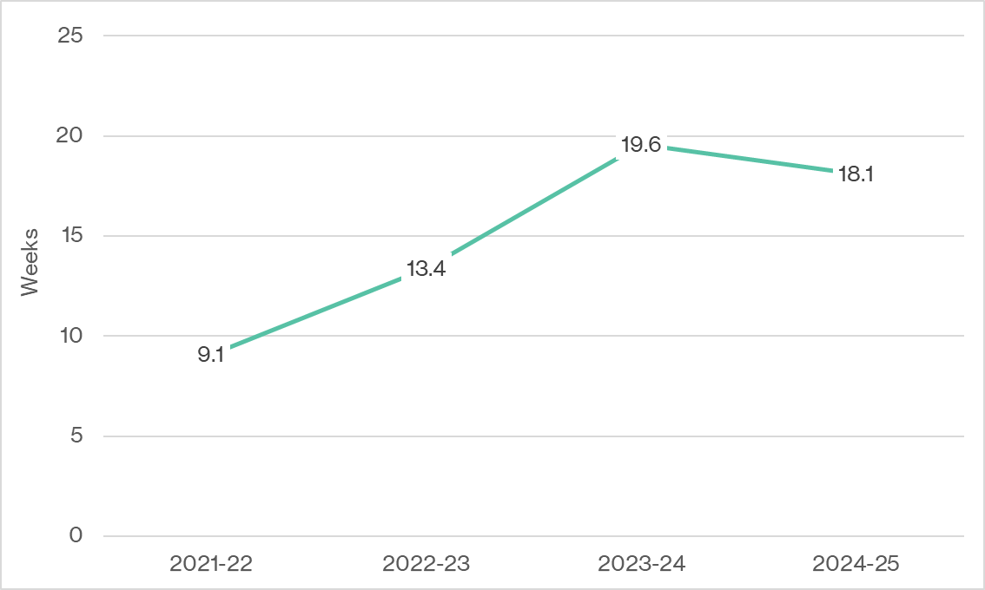
Notes: Some records lacked complete or accurate data on the time from application to first placement. In these cases, an estimated 8-week timeframe was applied, based on observed averages. Actual timelines may vary due to factors such as site readiness, staffing availability, cancellations/rescheduling, and PEPA Aged Care team capacity.
Source: PEPA Aged Care program data provided by QUT, September 2025.

Withdrawals
The number of completions and withdrawals from PEPA Aged Care by financial year are presented in Table 9.6.
Table 9.6: PEPA Aged Care withdrawals by financial year
Placement outcome | 2021–22 | 2022–23 | 2023–24 | 2024–25 | Total | %
Complete | 20 | 130 | 163 | 158 | 471 | 89.7%
Withdrawn | 20 | 14 | 9 | 11 | 54 | 10.3%
Total | 40 | 144 | 172 | 169 | 525 | 100%
Source: PEPA Aged Care program data provided by QUT, September 2025.
Figure 9.2 shows the proportion of PEPA Aged Care withdrawals by setting.
Figure 9.2: PEPA Aged Care withdrawals by setting
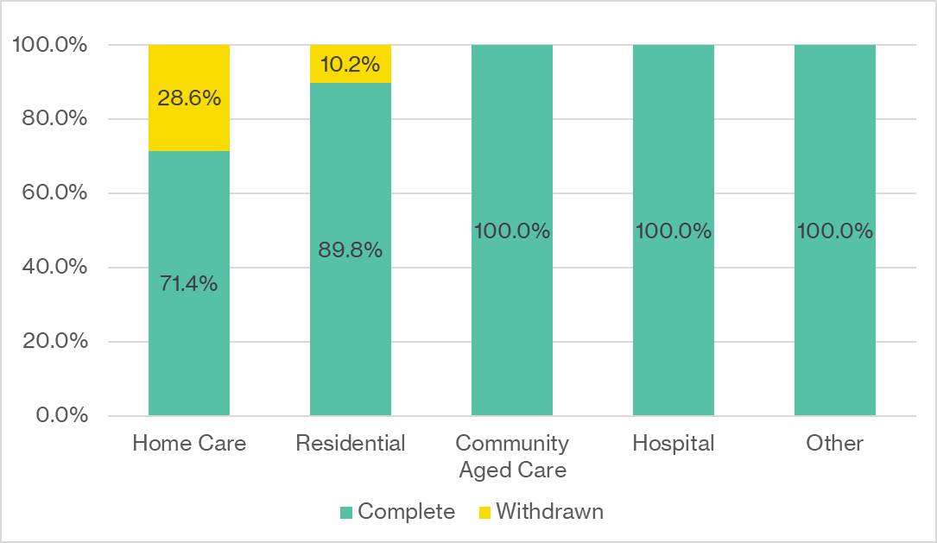
Source: PEPA Aged Care program data provided by QUT, September 2025.
Table 9.7 outlines the reported reasons for withdrawal from PEPA Aged Care.
Table 9.7: Reasons for withdrawal from PEPA Aged Care
Reason | 2021–22 | 2022–23 | 2023–24 | 2024–25 | Total | %
Site not responding | 16 | 9 | 3 | 4 | 32 | 59.3%
Staffing issues | 1 | 5 | 2 | 2 | 10 | 18.5%
COVID-19 outbreak | 1 | 0 | 0 | 0 | 1 | 1.9%
Site not ready | 1 | 0 | 3 | 4 | 8 | 14.8%
No reason provided | 1 | 0 | 1 | 1 | 3 | 5.6%
Total | 20 | 14 | 9 | 11 | 54 | 100.0%
Source: PEPA Aged Care program data provided by QUT, September 2025.

Average number of participants per placement site
Figure 9.3 shows the average number of participants per placement site, by financial year.
Figure 9.3: Average number of participants per reverse PEPA Aged Care placement site
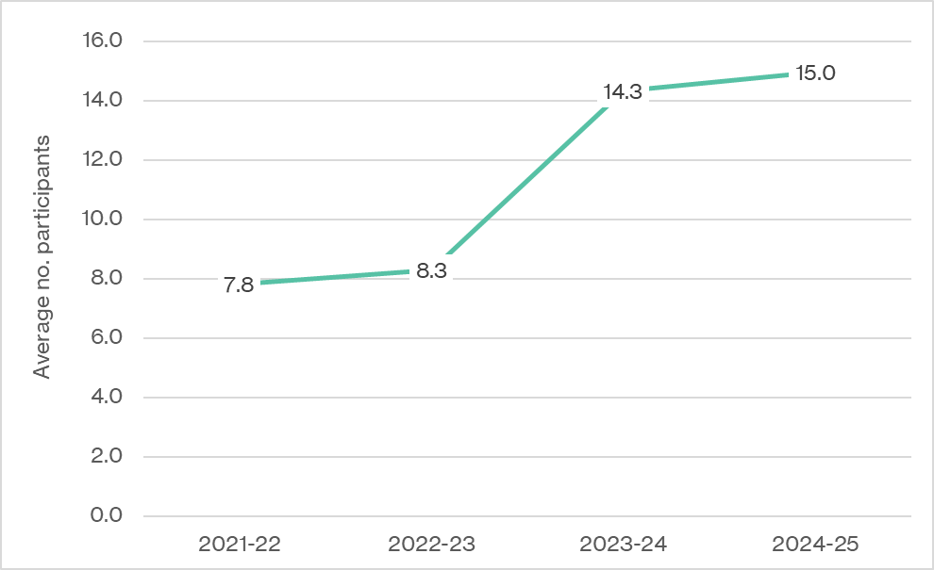
Source: PEPA Aged Care Final Report 2021–2024 [26], PEPA Aged Care performance report, 31 July 2025 [27].

Placement setting
Table 9.8 presents the number of reverse placements by financial year and setting.
Table 9.8: Number of reverse PEPA Aged Care placements by financial year and setting
Setting | 2021–22  N | 2022–23  N | 2023–24  N | 2024–25  N | Total N | Total %
Residential aged care | 19 | 118 | 131 | 136 | 404 | 85.8%
Community aged care | 0 | 1 | 25 | 16 | 42 | 8.9%
Other community care* | 1 | 10 | 7 | 5 | 23 | 4.9%
Hospital | 0 | 1 | 0 | 1 | 2 | 0.4%
Total | 20 | 130 | 163 | 158 | 471 | 100.0%
Notes: *Other settings include home care, domiciliary nursing, hotel services, maintenance, administration, and group home settings. These data capture the number of placements delivered (n=471) rather than placement sites (n=425).
Source: PEPA Aged Care program data provided by QUT, September 2025.

Professional role of PEPA Aged Care participants
The professional roles of PEPA Aged Care participants by financial year are shown in Table 9.9.
Table 9.9: PEPA Aged Care participants by financial year and professional role
Role | 2021–22 | 2022–23 | 2023–24 | 2024–25 | Total | %
Aboriginal and Torres Strait Islander health worker | 0 | 6 | 0 | 0 | 6 | 0.1%
Assistant in nursing/personal care worker/ personal care assistant | 41 | 457 | 796 | 700 | 1,994 | 38.0%
Clinical psychologist | 0 | 0 | 0 | 1 | 1 | 0.0%
Counsellor | 0 | 0 | 0 | 2 | 2 | 0.0%
Dietitian/ nutritionist | 0 | 1 | 1 | 0 | 2 | 0.0%
Diversional therapist | 3 | 30 | 46 | 42 | 121 | 2.3%
Enrolled nurse | 24 | 99 | 149 | 134 | 406 | 7.7%
GP | 1 | 1 | 0 | 1 | 3 | 0.1%
Medical specialist | 1 | 0 | 0 | 0 | 1 | 0.0%
Mental health worker | 0 | 0 | 1 | 2 | 3 | 0.1%
Music therapist | 1 | 0 | 2 | 0 | 3 | 0.1%
Nurse Practitioner | 0 | 0 | 4 | 5 | 9 | 0.2%
Occupational therapist | 1 | 4 | 9 | 5 | 19 | 0.4%
Pastoral carer | 1 | 9 | 19 | 18 | 47 | 0.9%
Pharmacist | 0 | 0 | 0 | 2 | 2 | 0.0%
Physiotherapist | 1 | 13 | 9 | 8 | 31 | 0.6%
Podiatrist | 0 | 1 | 0 | 1 | 2 | 0.0%
Registered nurse | 85 | 387 | 591 | 596 | 1,659 | 31.6%
Social worker | 0 | 3 | 21 | 18 | 42 | 0.8%
Welfare officer | 0 | 3 | 5 | 4 | 12 | 0.2%
Other* | 5 | 63 | 480 | 337 | 885 | 16.9%
Total | 164 | 1,077 | 2,133 | 1,876 | 5,250 | 100.0%
Notes: *Other includes lifestyle and wellbeing (e.g. lifestyle coordinator); case management and coordination (e.g. home care package care manager); community and support roles (e.g. community aged care coordinator and volunteer social support); and hospitality and domestic services (e.g. hospitality services coordinator, cleaner, and kitchen staff).
Source: PEPA Aged Care program data provided by QUT, September 2025.

Reverse placement location
Table 9.10 presents PEPA Aged Care placements by jurisdiction and financial year.
Table 9.10: PEPA Aged Care placements by financial year and jurisdiction
Jurisdiction | 2021–22 | 2022–23 | 2023–24 | 2024–25 | Total | % | National data
Victoria | 1 | 35 | 49 | 60 | 145 | 30.8% | 24.5%
New South Wales | 1 | 15 | 50 | 40 | 106 | 22.5% | 32.0%
Queensland | 15 | 53 | 26 | 24 | 118 | 25.1% | 20.0%
Western Australia | 0 | 8 | 26 | 14 | 48 | 10.2% | 8.5%
South Australia | 1 | 3 | 5 | 9 | 18 | 3.8% | 8.7%
Australian Capital Territory | 0 | 4 | 5 | 3 | 12 | 2.5% | 1.3%
Northern Territory | 2 | 5 | 1 | 8 | 16 | 3.4% | 2.0%
Tasmania | 0 | 7 | 1 | 0 | 8 | 1.7% | 2.9%
Total | 20 | 130 | 163 | 158 | 471 | 100.0% | 100.0%
Notes: These data capture the number of placements delivered (n=471) rather than placement sites (n=425).
Source: PEPA Aged Care program data provided by QUT, September 2025, GEN Aged Care data 2025.
Table 9.11 shows the distribution of PEPA Aged Care placements by remoteness and financial year.
Table 9.11: PEPA Aged Care placements by financial year and remoteness
MM | 2021–22 | 2022–23 | 2023–24 | 2024–25 | Total | % | National data
MM1 | 14 | 76 | 106 | 106 | 302 | 64.1% | 58.6%
MM2 | 3 | 12 | 13 | 9 | 37 | 7.9% | 9.1%
MM3 | 0 | 14 | 13 | 16 | 43 | 9.1% | 10.0%
MM4 | 0 | 6 | 17 | 11 | 34 | 7.2% | 6.7%
MM5 | 1 | 14 | 12 | 8 | 35 | 7.4% | 10.5%
MM6 | 0 | 7 | 2 | 6 | 15 | 3.2% | 2.5%
MM7 | 2 | 1 | 0 | 2 | 5 | 1.1% | 2.6%
Total | 20 | 130 | 163 | 158 | 471 | 100.0% | 100.0%
Notes: These data capture the number of placements delivered (n=471) rather than placement sites (n=425).
Source: PEPA Aged Care program data provided by QUT, September 2025, GEN Aged Care data 2025.
Table 9.12 presents the number and proportion of PEPA Aged Care participants by number of placement days and financial year.
Table 9.12: Number and proportion of PEPA Aged Care participants by
number of placement days and financial year
days | 2021–22 | 2022–23 | 2023–24 | 2024–25
1 | 45 (27%) | 256 (24%) | 102 (5%) | 86 (5%)
2 | 87 (53%) | 559 (52%) | 691 (32%) | 595 (32%)
3 | 13 (8%) | 119 (11%) | 682 (32%) | 920 (49%)
4 | 19 (12%) | 143 (13%) | 658 (31%) | 275 (15%)
Total participants | 164 | 1,077 | 2,133 | 1,876
Average number of placement days | 2.04 | 2.14 | 2.89 | 2.74
Source: PEPA Aged Care program data provided by QUT, September 2025.

PEPA Aged Care evaluation survey data
Table 9.13 presents participant responses to a question in the post-placement evaluation survey conducted by PEPA Aged Care regarding whether participants would recommend the program to colleagues.
Table 9.13: Proportion of survey respondents who would recommend
PEPA Aged Care to colleagues
Question | 2021–22  n (%) | 2022–23  n (%) | 2023–24  n (%) | 2024–25  n (%)
Will you recommend PEPA Aged Care to your colleagues? | 110 (100.0%) | 226 (100.0%) | 158 (100.0%) | 210 (99.4%)
Figure 9.4 presents participant responses to the pre- and post-placement evaluation survey conducted by PEPA Aged Care.

Figure 9.4: Pre/post-placement PEPA Aged Care evaluation survey responses (n=704)
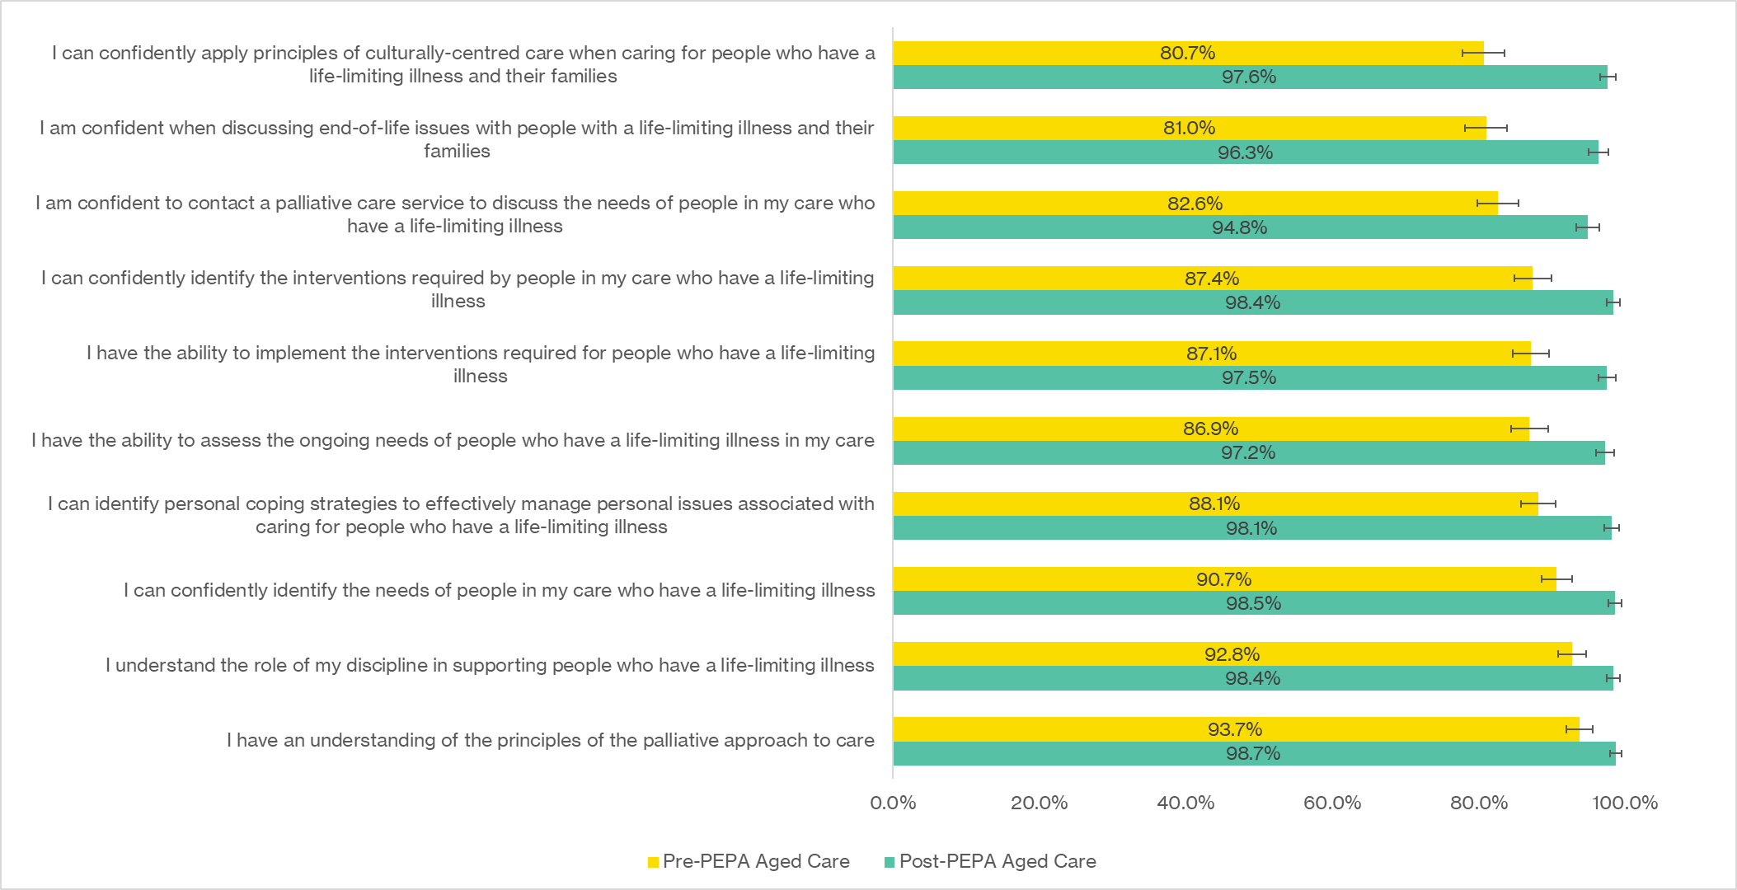
Source: PEPA Aged Care program data provided by QUT, September 2025.

Table 9.14 provides a qualitative analysis of key areas of learning and new skills acquired by PEPA Aged Care participants, based on participant reflections.
Table 9.14: Key areas of learning and new skills acquired during the reverse PEPA Aged Care placement (2023–24 to 2024–25; n=2,546)
THEME | EXAMPLE STATEMENTS
Palliative and end-of-life care knowledge  Expanded understanding of what palliative and end-of-life care involves, including core principles, goals, and differences between the two | ‘Palliative care is about helping patients have the best possible quality of life with dignity.’  ‘Better understanding of what palliative care is and how to apply it at work.’
Communication skills  Improved confidence and techniques for engaging in challenging or sensitive conversations with residents, families, and team members | ‘Communication about death and communication skills for those conversations.’  ‘Learned how to communicate effectively with family members and residents during the dying process.’
Recognising deterioration and symptom assessment  Enhanced ability to identify signs of decline and initiate appropriate care responses | ‘Recognising signs of deterioration and how to manage them.’  ‘I now know how to use assessment tools like SPICT, PCOC, SOAP to track symptoms.’
Symptom management and medications  Practical knowledge and skills in managing pain, breathlessness, nausea, agitation, and understanding medication use (e.g. opioids) | ‘Managing symptoms like pain and nausea using both medications and non-drug approaches.’  ‘Myths about morphine have been busted. I now understand its use in palliative care.’
Holistic and person-centred care  Emphasis on treating the whole person—physically, emotionally, socially, and spiritually—and respecting individual preferences and values | ‘Understanding that care should be tailored to a person’s values and cultural beliefs.’  ‘Learning how to take a holistic approach that includes emotional and spiritual needs.’
Advance care planning and directives  Stronger understanding of advance care planning/advance care directive processes and how to engage residents and families in early discussions about preferences | ‘The importance of early advance care planning and understanding the difference between advance care plan and advance care directive.’  ‘Learning how to talk to families about the resident’s care wishes and future plans.’
Self-care and emotional resilience  Recognition of the emotional toll of palliative care work and strategies for managing personal wellbeing | ‘Learned how important self-care is so I can care for others.’  ‘I now understand the value of debriefing and reflection in handling grief and stress.’
Grief, loss, and bereavement support  Gained insight into supporting families before and after death, including understanding the grieving process | ‘Learned how to offer emotional support to families and respond to grief.’  ‘Understanding the stages of grief and how to support someone through them.’
Cultural competence  Awareness of how to provide culturally safe and respectful care, particularly at the end of life | ‘Recognising and respecting cultural beliefs during end-of-life care.’  ‘Supporting families with legacy work, storytelling, and memory-making.’
Teamwork and interdisciplinary collaboration  Improved awareness of working as part of a healthcare team and knowing when and how to involve others | ‘Understanding the importance of teamwork when supporting someone who is dying.’  ‘Learning when to contact the GP, allied health, or spiritual care.’
Use of tools, resources and documentation  Familiarity with practical tools (e.g. SPICT, STOP and WATCH) and confidence in using them for assessment and communication | ‘Use of assessment tools like SPICT, PCOC, SOAP to track resident needs.’  ‘Learning how to use documentation like care plans and ACDs effectively.’
Source: PEPA Aged Care program data provided by QUT, September 2025.
Figure 9.5 presents responses to the post-placement evaluation survey conducted by PEPA Aged Care.
Figure 9.5: Post-placement PEPA Aged Care evaluation survey responses (n=704)
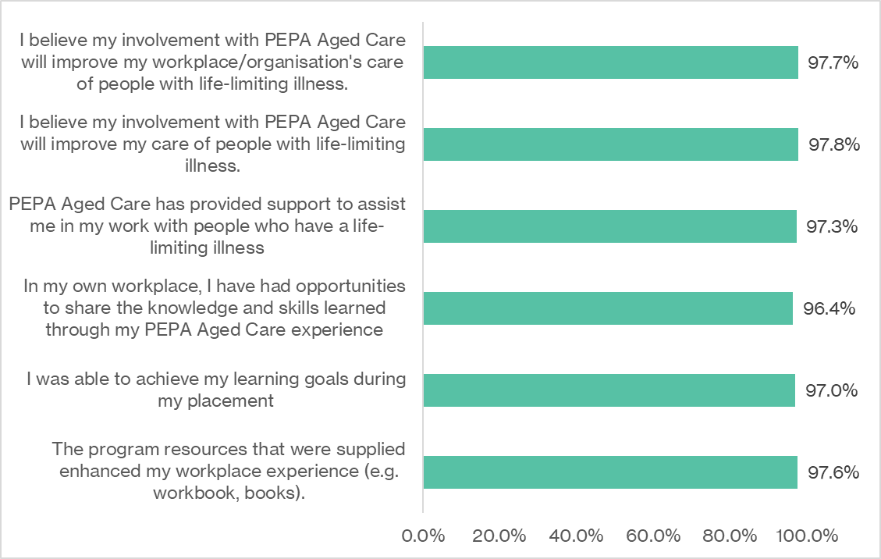
Source: PEPA Aged Care program data provided by QUT, September 2025.

PEPA Aged Care financial analysis
Table 9.15 provides a breakdown of PEPA Aged Care expenditure across different financial years by expense type.
Table 9.15: PEPA Aged Care expenditure by financial year, and the average proportion of expenditure, with some items analysed relative to the number of complete placements
Expense type | June 2021–July 2022 | July 2022–June 2023 | July 2023–June 2024 | July 2024–June 2025 | Total | Average
Salaries | $248,104 | $621,043 | $911,082 | $1,139,253 | $2,919,481 | $729,870
Per complete placement | $12,405 | $4,777 | $5,589 | $7,210 | - | $7,496
Travel and accommodation | $15,693 | $86,248 | $170,378 | $164,506 | $436,825 | $109,206
Per complete placement | $785 | $663 | $1,045 | $1,041 | - | $884
Education design and implementation | $600 | $0 | $38,282 | $0 | $38,882 | $9,720
Marketing/promotion | $320 | $8,984 | $75,179 | $52,353 | $136,836 | $34,209
Overheads | $406,500 | $415,750 | $425,250 | $111,426 | $1,358,926 | $339,731
Consumables | $5,015 | $4,958 | $4,087 | $17,384 | $31,444 | $7,861
Participating site grants | $0 | $44,626 | $282,402 | $302,686 | $629,714 | $157,428
Per complete placement | $0 | $343 | $1,733 | $1,916 | - | $998
Sources: PEPA Aged Care financial and program data 2021–25.
Table 9.16 lists the in-kind costs of a managerial salary and indicates potential costs to PEPA Aged Care if the program had paid for the managerial salary.
Table 9.16: Table modelling potential salary expenditure increases without the in-kind managerial support from PEPA and IPEPA by financial year
Financial year | In-kind manager salary | PEPA Aged Care salary costs | Potential PEPA Aged Care salary costs | Potential % increase
2021–2022 | $54,502 | $248,104 | $302,606 | 22%
2022–2023 | $75,403 | $621,043 | $696,446 | 12%
2023–2024 | $78,632 | $911,082 | $989,714 | 9%
2024–2025 | $85,279 | $1,139,253 | $1,224,532 | 7%
Total | $293,816 | $2,919,481 | $3,213,297 | 10%
Source: PEPA Aged Care financial data 2021–25.
Table 9.17 provides a summary of PEPA Aged Care salary expenditure by financial year.
Table 9.17: Breakdown of PEPA Aged Care salaries, headcount, and FTE (where available) by financial year
Source: PEPA Aged Care program data provided by QUT, September 2025.

- PACOP program data
This appendix provides additional PACOP program data referenced through the report, including data on performance, promotional activities, uptake, PACOP evaluation surveys, and financial data.

Analysis of program performance
This section summarises PACOP performance against established performance indicators during the evaluation period.

PACOP participation indicators (2021–22 to 2023–24)
Table 9.18 presents analysis of PACOP performance against cumulative provider targets specific to 2021–22 to 2023–24.
Table 9.18: PACOP performance against cumulative targets (2021–22 to 2023–24)
Performance indicator | 2021–22 (Jan–Jun only)  Target | 2021–22 (Jan–Jun only)  Actual | 2021–22 (Jan–Jun only)  Performance | 2022–23 (Jul–Jun)  Target | 2022–23 (Jul–Jun)  Actual | 2022–23 (Jul–Jun)  Performance | 2023–24 (Jul–Jun)  Target | 2023–24 (Jul–Jun)  Actual | 2023–24 (Jul–Jun)  Performance
PACOP Profile Collection | N | N | % | N | N | % | N | N | %
Cumulative number of participating large multi-site providers (≥40 aged care homes) | 1 | 4 | 400%  Met | 3 | 5 | 167%  Met | 7 | 7 | 100%  Met
Cumulative number of participating medium multi-site providers (20–39 aged care homes) | 2 | 7 | 350%  Met | 6 | 8 | 133%  Met | 12 | 9 | 75%  Not met
Cumulative number of participating medium–small multi-site providers (10–19 aged care homes) | 3 | 7 | 233%  Met | 11 | 10 | 91%  Not met | 25 | 9 | 36%  Not met
PACOP Outcomes Collection | N | N | % | N | N | % | N | N | %
Cumulative number of participating large multi-site providers (≥40 aged care homes) | 1 | 2 | 200%  Met | 3 | 3 | 100%  Met | 6 | 3 | 50%  Not met
Cumulative number of participating medium multi-site providers (20–39 aged care homes) | 1 | 1 | 100%  Met | 3 | 4 | 133%  Met | 6 | 4 | 67%  Not met
Cumulative number of participating medium–small multi-site providers (10–19 aged care homes) | 2 | 3 | 150%  Met | 6 | 7 | 117%  Met | 13 | 5 | 38%  Not met
Proportion of key performance indicators achieved annually | - | - | 100% | - | - | 83% | - | - | 17%
Source: PACOP Performance Report, July 2022 [28], PACOP Performance Report, January 2023 [29], PACOP Performance Report, July 2023 [30], PACOP Performance Report, July 2024 [31], PACOP Final Report, 2025 [24].

2024–25 performance indicators
Table 9.19 outlines reported performance against outcome-based performance indicators specified for 2024–25.
Table 9.19: Performance against PACOP indicators (2024–25)
Indicator | Measure | Reported performance
Improved outcomes for residents and their families at the end of life | Improved capabilities of the aged care workforce to monitor, recognise and respond to identified palliative care needs of residents and their families | - 430 aged care homes participated under the PACOP framework, providing care for approximately 38,800 residents  - 94 homes submitted data and received benchmarking reports, with national benchmarks showing improvements in timely assessment, responsive action planning, anticipatory pain management, and identification of palliative care needs prior to death
Aged care homes deliver high-quality, safe, and culturally appropriate palliative care that meets individual care needs | Improved, nationally standardised, palliative care education and training builds the capacity of the aged care workforce to improve the quality of, and timely access to, palliative care for residents | Between January and June 2025, PACOP delivered 81 education workshops (59 face-to-face, 22 virtual) to 1,300 participants. Education focused on embedding PACOP’s standardised assessment and response protocols, supported by 47 communities of practice involving 519 staff from 241 homes.
The empowerment of GPs, aged care providers, and other healthcare workers with confidence and knowledge of palliative care and advance care planning | Improved capabilities of the aged care workforce, GPs, and other health care providers to communicate with residents and families to support advance care planning and delivery of palliative care in accordance with their needs, wants, and preferences | Post-education surveys demonstrated significant gains in knowledge and confidence, particularly in using assessment tools and responding to palliative care needs
Collaborative links and relationships are facilitated between primary care, aged care and palliative care services | Establish, maintain, and strengthen linkages across the primary care, aged care, and palliative care sectors to improve the delivery of palliative care | PACOP facilitated partnerships and engagement through workshops and communities of practice, promoting linkages between aged care, primary care, and specialist palliative care services
Aged care providers, GPs, or other healthcare workers are informed about palliative care, advance care planning and advance care directive resources, processes, legislation, and accountabilities in the state or territory in which the aged care service is located | Improved knowledge sharing and use of available resources to support the delivery of palliative care in compliance with legislation at the Commonwealth and state or territory level | Education sessions incorporated state and national legislative requirements and accountabilities regarding advance care planning, with improvement facilitators actively supporting providers to understand and meet their responsibilities
Source: PACOP Performance Report, July 2025 [25].

PACOP promotional activities
Table 9.5 provides a high-level summary of PACOP’s promotional activities across four financial years, as well as reported reach of activities where available.
Table 9.20: Summary of PACOP promotional activities (2021–22 to 2024–25)
Channel | 2021–22 | 2022–23 | 2023–24 | 2024–25 | Total | Reach (to Sept 2025)
Conferences/events | 1 | 9 | 9 | 14 | 33 | Unknown
Direct aged care provider engagement | - | 12 | - | - | 12 | 12 providers
PACOP e-newsletter | - | 1 | 4 | 4 | 9 | Unknown
Print and digital media | - | 4 | 2 | 1 | 7 | Unknown
PACOP webinar | 2 | 10 | 6 | 1 | 19 | 742 registrations
External webinar | - | - | 1 | 4 | 5 | 1,174 views of recorded webinars
PACOP educational video/YouTube | 1 | 24 | 21 | 3 | 49 | 11,131 views
Total | 4 | 62 | 43 | 27 | 134 | -
Source: PACOP program data provided by the University of Wollongong, September 2025.

PACOP uptake and engagement

Characteristics of participating homes
Table 9.21 outlines the jurisdiction of homes participating in PACOP by financial year.
Table 9.21: Jurisdiction of aged care homes participating in PACOP by financial year
Jurisdiction | 2022–23 | 2023–24 | 2024–25 | Total | % | National data
Victoria | 20 | 10 | 76 | 106 | 23.3% | 31.8%
New South Wales | 68 | 103 | 34 | 205 | 45.2% | 28.3%
Queensland | 20 | 10 | 9 | 39 | 8.6% | 9.5%
Western Australia | 13 | 15 | 17 | 45 | 9.9% | 17.6%
South Australia | <5 | 10 | >10 | 24 | 5.3% | 8.8%
Australian Capital Territory | >5 | >5 | <5 | 16 | 3.5% | 2.6%
Northern Territory | 0 | 0 | 0 | 0 | 0.0% | 1.0%
Tasmania | 15 | <5 | <5 | 19 | 4.2% | 0.3%
Total | 145 | 155 | 154 | 454 | 100.0% | 100.0%
Source: PACOP program data provided by the University of Wollongong, September 2025, GEN Aged Care data 2025.
Table 9.22 shows the distribution of participating homes by remoteness and financial year
Table 9.22: Remoteness of aged care homes participating in PACOP by financial year
MM | 2022–23 | 2023–24 | 2024–25 | Total | % | National data
MM1–2 | 96 | 113 | 121 | 330 | 72.7% | 71.4%
MM3–7 | 49 | 42 | 33 | 124 | 27.3% | 28.7%
Total | 145 | 155 | 154 | 454 | 100.0% | 100.0%
Source: PACOP program data provided by the University of Wollongong, September 2025, GEN Aged Care data 2025.

Characteristics of homes participating in benchmarking
Table 9.23 illustrates the characteristics of homes participating in PACOP benchmarking.
Table 9.23: Profile of aged care homes participating in PACOP benchmarking
Characteristic | 2022–23 | 2023–24 | 2024–25
Number of homes receiving benchmarking by implementation stage | N | N | N
Profile Collection | 10 | 47 | 92
Outcomes Collection | 9 | 20 | 39
Number of homes receiving benchmarking by jurisdiction | N | N | N
Victoria | <5 | 5 | 5
New South Wales | 8 | 47 | 100
Queensland | <5 | 5 | 5
Western Australia | <5 | <5 | 17
South Australia | 0 | 0 | 0
Australian Capital Territory | <5 | 6 | <5
Northern Territory | 0 | 0 | 0
Tasmania | 0 | 0 | <5
Number of homes receiving benchmarking by remoteness | N | N | N
MM1 | >9 | >44 | 75
MM2 | <5 | <5 | 10
MM3–7 | 5 | 18 | 46
Source: PACOP program data provided by the University of Wollongong, September 2025.

PACOP educational activities
The number and profile of PACOP workshops delivered by financial year are presented in Table 9.24.
Table 9.24: Number and profile of PACOP workshops delivered
Characteristic | 2022–23 | 2023–24 | 2024–25 | Total
Workshop type | N | N | N | N
PACOP Full Fundamentals | 16 | 35 | 47 | 98
PACOP Profile Fundamentals | 1 | 19 | 10 | 30
PACOP Outcomes Fundamentals | 1 | 5 | 6 | 12
PACOP SAS for Care Staff | 0 | 1 | 8 | 9
Benchmarking workshop | 1 | 1 | 1 | 3
Benchmarking supplement session | 1 | 1 | 1 | 3
Total | 20 | 62 | 73 | 155
Delivery mode | N | N | N | N
Face-to-face | 20 | 51 | 52 | 123
Online | 0 | 11 | 21 | 32
Total | 20 | 62 | 73 | 155
Location | N | N | N | N
MM1–2 | 12 | 32 | 37 | 81
MM3–7 | 6 | 15 | 15 | 36
Total | 18 | 47 | 52 | 117
Source: PACOP program data provided by the University of Wollongong, September 2025.
Table 9.25 shows the number and jurisdiction of PACOP workshop participants.
Table 9.25: Number and location of PACOP workshop participants
Characteristic | 2022–23 | 2023–24 | 2024–25 | Total
Workshop type | N | N | N | N
PACOP Full Fundamentals | 298 | 733 | 907 | 1,938
PACOP Profile Fundamentals | 18 | 338 | 131 | 487
PACOP Outcomes Fundamentals | 18 | 32 | 42 | 92
PACOP SAS for Care Staff | 0 | 56 | 202 | 258
Benchmarking workshop | 50 | 52 | 60 | 162
Benchmarking supplement session | 0 | 30 | 21 | 51
Total | 384 | 1,241 | 1,363 | 2,988
Jurisdiction | N | N | N | N
Victoria | 31 | 185 | 289 | 505
New South Wales | 301 | 793 | 333 | 1,427
Queensland | 17 | 32 | 159 | 208
Western Australia | 0 | 119 | 159 | 278
South Australia | 0 | 73 | 143 | 216
Australian Capital Territory | 35 | 21 | 32 | 88
Northern Territory | 0 | 0 | 0 | 0
Tasmania | 32 | 24 | 43 | 99
Total | 416 | 1,247 | 1,158 | 2,821
Source: PACOP program data provided by the University of Wollongong, September 2025.
Table 9.26 presents the number and profile of enrolments in PACOP online modules.
Table 9.26: Number and profile of PACOP online module enrolments
Characteristic | Total
Module type | N
PACOP Fundamentals | 315
PACOP SAS for Care Staff | 155
Total | 470
Jurisdiction | N
Victoria | 87
New South Wales | 131
Queensland | 94
Western Australia | 9
South Australia | 10
Australian Capital Territory | 0
Northern Territory | 0
Tasmania | 8
Total | 339
Professional role | N
Registered nurse | 147
Enrolled nurse | 53
Care staff | 10
Clinical nurse educator | 9
Clinical nurse consultant | 8
Aged care home manager | 0
Other | 20
Total | 238
Source: PACOP program data provided by the University of Wollongong, September 2025.
Table 9.27 provides an overview of engagement with PACOP communities of practice by financial year.
Table 9.27: Engagement with PACOP Communities of Practice
Metric | 2022–23 | 2023–24 | 2024–25 | Total
Number of Community of Practice sessions | 27 | 93 | 118 | 238
Number of individual participants | 138 | 744 | 1,174 | 2,056
Number of participating homes represented | N/A | N/A | N/A | 248
Source: PACOP program data provided by the University of Wollongong, September 2025.

PACOP benchmark data
Table 9.28 summarises performance against national PACOP benchmarks from January 2023 to June 2025.
Table 9.28: National PACOP benchmarking summary (January 2023–June 2025)
# | Indicator | Bench-mark | Jan–June 2023  N¹ | Jan–June 2023  n² | Jan–June 2023  % | Jul–Dec 2023  N¹ | Jul–Dec 2023  n² | Jul–Dec 2023  % | Jan–Jun 2024  N¹ | Jan–Jun 2024  n² | Jan–Jun 2024  % | Jul–Dec 2024  N¹ | Jul–Dec 2024  n² | Jul–Dec 2024  % | Jan–Jun 2025  N¹ | Jan–Jun 2025  n² | Jan–Jun 2025  % | National performance  Jan 2023–Jun 2025
1 | Percentage of new admissions with AN-ACC Class 1 and 13 have a Profile three-part clinical assessment completed within three days | 90% | 90 | 25 | 28% | 298 | 92 | 31% | 484 | 159 | 33% | 1,480 | 568 | 38% | 1,749 | 860 | 49% | +21 percentage points
2 | Percentage of residents for whom a Profile assessment is completed every three months | 90% | 262 | 178 | 68% | 1,098 | 625 | 57% | 1,300 | 657 | 51% | 3,209 | 1,401 | 44% | 5,195 | 1,926 | 37% | -31 percentage points
3 | Percentage of residents with identified palliative care needs who had a relevant palliative care-related Action Plan item selected | 90% | 116 | 82 | 71% | 471 | 262 | 56% | 406 | 214 | 53% | 1,204 | 581 | 48% | 1,812 | 811 | 45% | -26 percentage points
4 | Percentage of residents who report moderate/severe symptom distress for any item in the Palliative Care Outcomes Collaboration Symptom Assessment Scale (PCOC-SAS), have an internal or external action selected on the action plan to address their needs | 90% | 84 | 46 | 55% | 695 | 298 | 43% | 609 | 192 | 32% | 1,187 | 471 | 40% | 1,614 | 655 | 41% | -14 percentage points
5 | Percentage of residents for whom end-of-life needs, wants, and preferences are documented | 90% | 874 | 708 | 81% | 1,972 | 1,655 | 84% | 2,453 | 1,995 | 81% | 5,762 | 4,603 | 80% | 7,266 | 5,877 | 81% | No change
6 | Percentage of residents identified as needing palliative care through the Profile assessment OR Deteriorating Resident Tool prior to death | 90% | 39 | 28 | 72% | 157 | 98 | 62% | 181 | 121 | 67% | 667 | 407 | 61% | 926 | 612 | 66% | -6 percentage points
7 | Percentage of residents who died with an advance care plan/advance care directive in place | 90% | 61 | 31 | 51% | 181 | 144 | 80% | 217 | 156 | 72% | 1,098 | 602 | 55% | 1,090 | 851 | 78% | +27 percentage points
8 | Percentage of residents for whom palliative care (Outcomes Collection) commenced within 24 hours of identification of the need for palliative care using the Profile assessment | 90% | 102 | 24 | 24% | 369 | 49 | 13% | 328 | 47 | 14% | 247 | 40 | 16% | 603 | 67 | 11% | -12 percentage points
9 | Percentage of residents for whom palliative care (Outcomes Collection) commenced within 24 hours of identification of the need for palliative care using the Deteriorating Resident Tool | 90% | 45 | 24 | 53% | 186 | 78 | 42% | 123 | 70 | 57% | 239 | 110 | 46% | 594 | 134 | 23% | -31 percentage points
10 | Percentage of residents who have moderate or severe symptom distress for any item on the daily PCOC-SAS assessment have an Outcomes FULL assessment completed within 24 hours | 9I0% | 57 | 19 | 33% | 464 | 178 | 38% | 529 | 70 | 13% | 935 | 128 | 14% | 1,301 | 110 | 8% | -25 percentage points
11a | Percentage of residents who report moderate or severe distress from pain (PCOC-SAS) will have absent or mild distress from pain within three days | 60% | 24 | 9 | 38% | 266 | 191 | 72% | 180 | 117 | 65% | 190 | 121 | 64% | 396 | 321 | 81% | +44 percentage points
11b | Percentage of residents in the Outcomes Collection who predominantly had absent or mild distress PCOC-SAS score for pain during the reporting period | 60% | 109 | <5 |  | 258 | 27 | 10% | 393 | 49 | 12% | 338 | 81 | 24% | 727 | 100 | 14% | +14 percentage points
12 | Percentage of residents’ unstable phases that ended three days or less | 60% | 8 | 5 | 63% | 49 | 7 | 14% | 64 | 17 | 27% | 77 | 27 | 35% | 78 | 27 | 35% | -28 percentage points
Notes: N¹ = the total number of residents/assessments included. N² = number of residents/assessments that met the indicator. % = percentage of residents/assessments that met the indicator.
Source: PACOP program data provided by the University of Wollongong, September 2025.

Figure 9.6 presents the proportion of residents who had one or more unplanned hospitalisation or ED presentations.
Figure 9.6: Proportion of residents who had one or more unplanned hospitalisations and the proportion of residents who had one or more ED presentations by half-yearly intervals
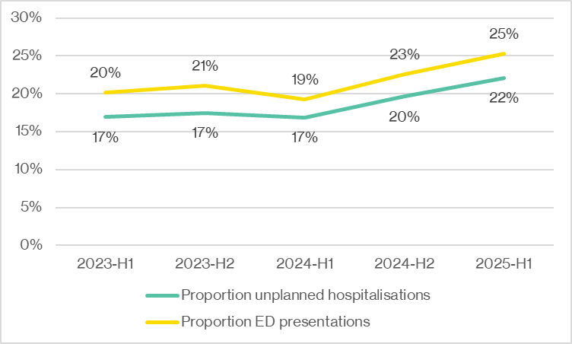
Source: PACOP program data provided by the University of Wollongong, September 2025.

PACOP education evaluation survey data
Figure 9.7 presents the proportion of respondents to the pre/post-PACOP workshop survey who reported feeling mostly or very confident across a range of domains following training.
Figure 9.7: Proportion of respondents to the PACOP workshop evaluation
survey (n=1,488) reporting feeling mostly or very confident
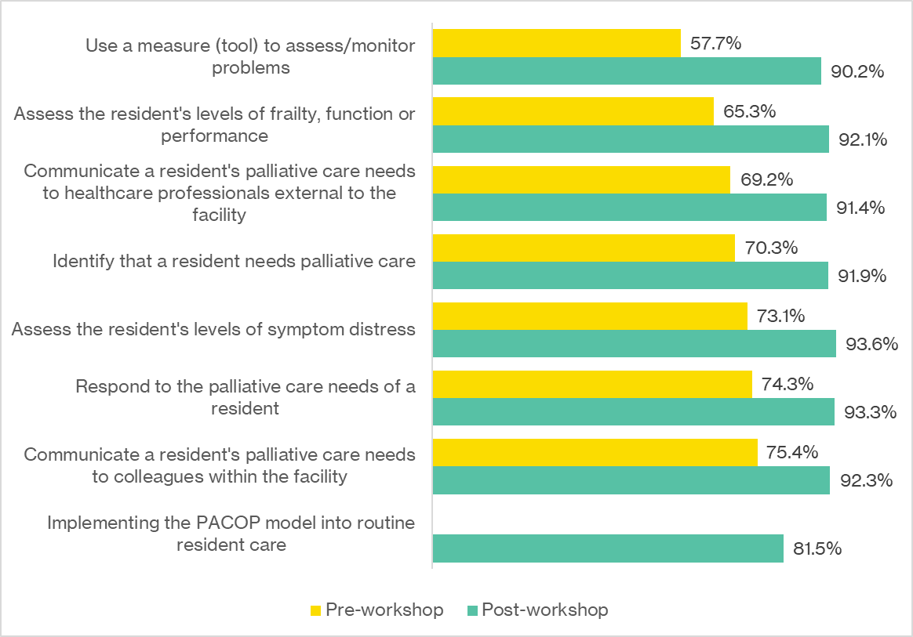
Source: PACOP program data provided by the University of Wollongong, September 2025.
Figure 9.8 shows the proportion of respondents to the pre/post-PACOP online module survey who reported feeling mostly or very confident across a range of domains following training.
Figure 9.8: Proportion of respondents to the PACOP learning module evaluation survey (n=172) reporting feeling mostly or very confident
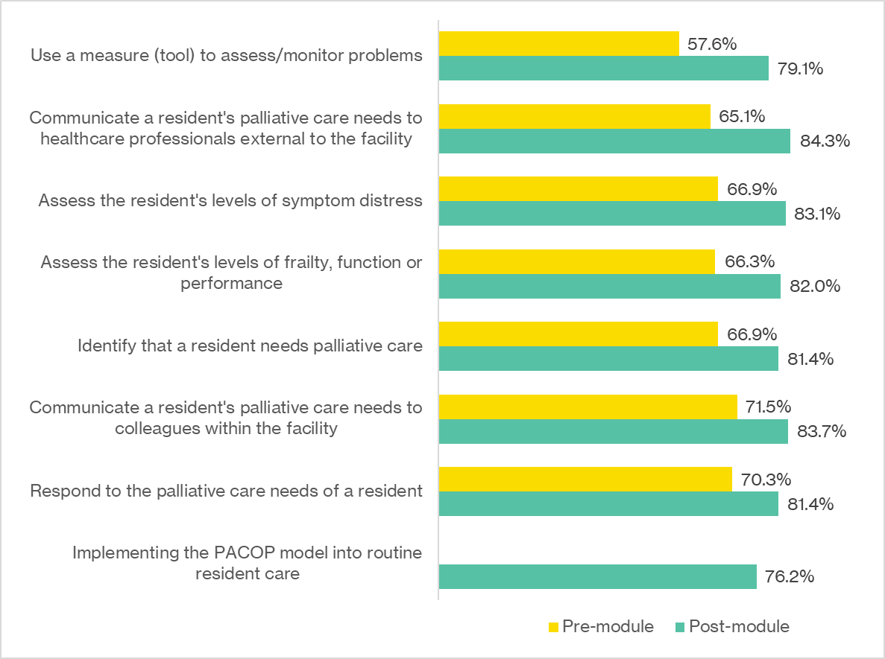
Source: PACOP program data provided by the University of Wollongong, September 2025

PACOP snapshot survey data
Table 9.29 presents the method of recording PACOP data reported by respondents to the PACOP snapshot survey.
Table 9.29: Reported method of recording PACOP data (n=60)
Method | n | %
Assessments are entered directly into palCentre | 27 | 45.0%
On paper forms that are later entered into palCentre | 12 | 20.0%
On paper forms only | 10 | 16.7%
Assessments entered directly into a client management system | 7 | 11.7%
On paper forms that are later entered into a client management system that is not palCentre | 4 | 6.7%
Total | 60 | 100.0%
Source: PACOP program data provided by the University of Wollongong, September 2025.
Table 9.30 shows the factors that impacted PACOP training, as reported by respondents to the PACOP snapshot survey.
Table 9.30: Reported factors that impact PACOP training (n=61)
Factor | n | %
Access to education and training resources | 42 | 68.9%
Workload | 39 | 63.9%
Staffing levels | 35 | 57.4%
Staff turnover | 24 | 39.3%
Protected training time | 21 | 34.4%
Team culture | 18 | 29.5%
Financial cost | 10 | 16.4%
Other | 3 | 4.9%
Total | 61 | 100.0%
Source: PACOP program data provided by the University of Wollongong, September 2025.
Figure 9.9 shows the perceived extent to which PACOP impacted key aspects of resident care, as reported by respondents to the PACOP snapshot survey.
Figure 9.9: Perceptions of the extent to which PACOP
improved resident care outcomes (n=61)
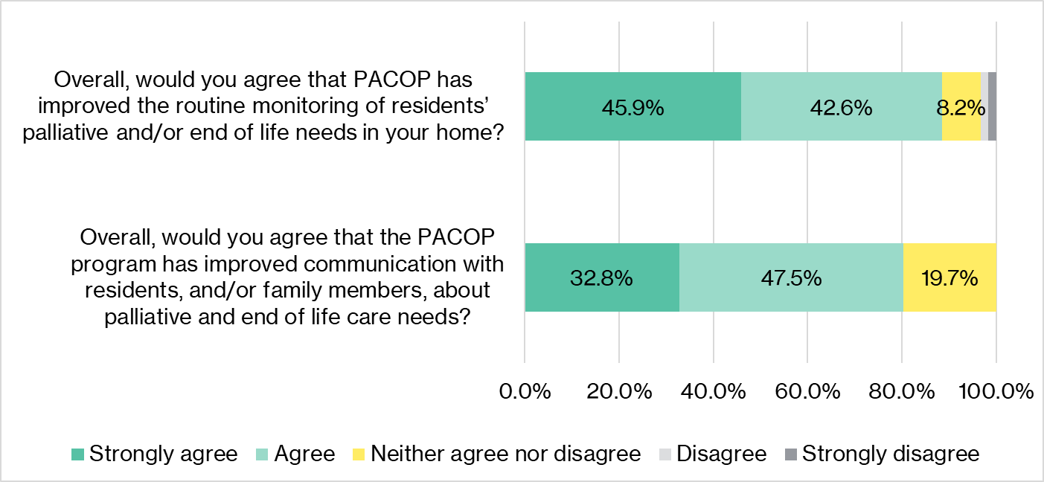
Source: PACOP program data provided by the University of Wollongong, September 2025.PACOP financial analysis.
Table 9.31 provides a breakdown of PACOP salary expenditure by financial year.
Table 9.31: Breakdown of PACOP salaries, headcount, and FTE (where available) by financial year
Source: PACOP program data provided by the University of Wollongong, September 2025. N.P. = not provided. N/A = not applicable

- Economic analysis approach
The economic analysis component of this evaluation comprised a high-level, mixed-methods cost-benefit analysis conducted for PACOP only, given the availability of relevant outcome data. The analysis was designed to provide contextual insights to inform the broader evaluation rather than constitute a detailed or comprehensive economic assessment. It was not intended as a standalone element and does not include elements of a traditional economic analysis (e.g. Net Present Value, Internal Rate of Return, discounting, or sensitivity testing).
The focus was on direct costs and benefits. Indirect costs were not reviewed in detail due to complex allocation requirements. Potential indirect benefits (e.g. productivity gains) were deemed low priority for this evaluation.
The approach aligned with the program logic and incorporated both qualitative and quantitative elements to support a high-level cost-benefit analysis. Key steps included:
- Development of a hypothesis-based analysis schema
- mapping of funded program activities and identification of areas of overlap
- development of high-level assumptions for each stage of the schema
- targeted research to confirm evidence links between activities and outcomes
- Identification of in-scope costs and segmentation by category
- review of financial data by program area and activity (actual spend versus budgeted, where possible)
- examination of administrative documentation and stakeholder feedback
- estimation of in-kind contributions at the funded organisation level (order-of-magnitude estimates only)
- identification of any transferred or in-kind costs at the home/provider level
- Identification of in-scope benefits and segmentation by category
- the focus was on outcomes with measurable health system impact and potential to quantify an economic value
- Confirmation of valuation approach and methodology
- literature review to identify cost benchmarks and quantification methods
- calculation of valuations using best-practice guidelines
- triangulation with qualitative inputs to validate assumptions
- synthesis of findings into high-level insights.
Figure 9.10 summarises the steps for conducting a high-level cost-benefit analysis of PACOP. The cost analysis included identifying available data by submitting a data request to PACOP for outcomes data, program documentation, and financial data.
Data sources for the economic analysis included:
- primary data: outcomes and financial data provided by PACOP in response to HMA’s detailed data request
- secondary data: published literature and grey sources for comparators and cost values, focusing on palliative care outcomes in Australia or comparable health systems.
Figure 9.10: Steps taken to approach the economic analysis
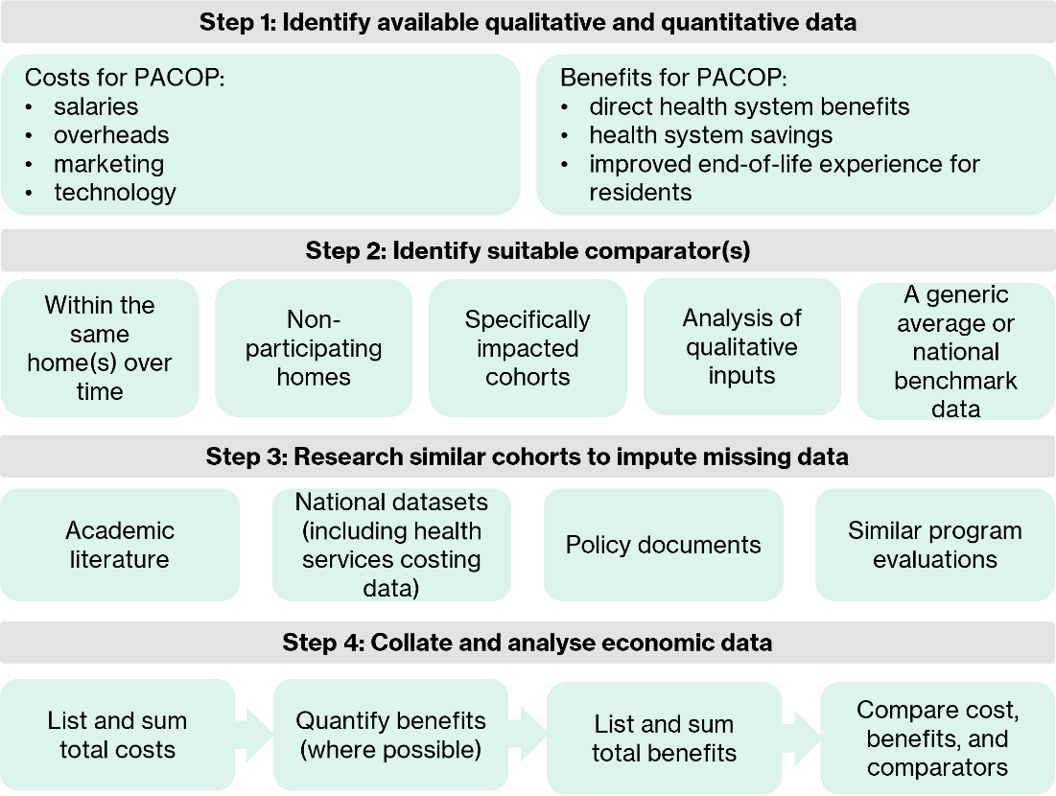
To estimate benefits, the analysis calculated the change in value (delta) for each outcome domain and compared it to a counterfactual scenario. The following comparators were considered to determine both the delta and counterfactual:
- improvement over time in the same aged care home/placement site venue
- improvement observed in participating aged care homes/placement sites versus non-participating entities (where data is available)
- improvement in specific impacted cohorts, where this could be separated
- analysis of qualitative inputs (e.g. anecdotal feedback-based approach)
- comparison with a generic average or national benchmark data.
The comparator was sourced from relevant literature. The following steps were undertaken for the analysis:
- Outcome data collection
- Data were sourced from PACOP’s three-monthly Profile assessments, indicating whether each resident had one or more unplanned hospitalisations or ED presentations. These outcomes included all causes, not just palliative care-related events.
- Comparator analysis
- The number of PACOP residents with each outcome was compared to expected proportions for people aged ≥65 years in permanent residential aged care, based on an Australian retrospective cohort study of over 200,000 individuals [33] (see Table 9.32).
- Delta calculation
- The proportion of unplanned hospitalisations and ED presentations in the PACOP and comparator cohorts was calculated. There were lower rates of both events in the PACOP cohort than in the comparator cohort.
- Quantification of benefits
- Published cost data (see Table 9.32) were applied to estimate potential savings. Average cost per unplanned hospitalisation was derived from acute, subacute, and non-acute admitted hospitalisation data (Table 9.33).
- Attribution to PACOP
- Attribution was estimated using evaluation survey data and literature-based ratios:
- online survey findings indicated 30.4% of respondents believed PACOP slightly or significantly reduced palliative care-related hospitalisations and ED presentations. Given that this relates only to palliative care-related outcomes, it could not be used as a direct estimation of attribution.
- literature [33] and Australian Institute of Health and Welfare (AIHW) data [35] informed the proportion of events likely to be palliative care-related:
- 28.8% took hospital leave for palliative care and 27.0% took hospital leave for reasons other than palliative care [35], approximately a 1:1 ratio
- exits from permanent residential aged care to hospital for palliative care-reasons and non-palliative care-reasons were 1.0% and 1.3% respectively [35], also approximately a 1:1 ratio
- Harrison et al. 2024 [33]: 58.9% of all hospitalisations were unplanned, equating to approximately 29.5% palliative care-related unplanned hospitalisations using the 1:1 ratio
- Harrison et al. 2024 [33]: 71.0% of ED presentations resulted in a hospital admission, equating to approximately being 35.5% palliative care-related, based on 1:1 ratio. This does not count any ED presentations that were palliative care-related but did not result in a hospitalisation, as those data were unknown.
- based on these data sources, the estimated attribution was 9% for unplanned hospitalisations (30% PACOP attribution for 30% of hospitalisations that were palliative care-related) and 10.5% for ED presentations (30% attribution for 35% of palliative care-related ED presentations). These attribution rates were applied to the gross cost avoidance to calculate PACOP’s estimated monetised benefit.

Limitations
Results of the analysis should be interpreted with caution due to the following limitations:
- the analysis did not constitute a detailed economic evaluation (as such, calculation of Net Present Value, Internal Rate of Return, detailed discounting, and sensitivity analysis were not undertaken)
- full economic analysis approaches (such as cost-effectiveness analysis comparing alternative activities and options for the Measure) were out of scope
- indirect costs were not reviewed in detail due to their complex allocation and likely transfer and interdependency between program activities and other functions (e.g. shared administrative staff supporting multiple activities)
- PACOP outcome data reported whether residents had ‘one or more’ unplanned hospitalisations or ED presentations; the analysis assumed one event per resident, which may underestimate actual utilisation
- PACOP outcome data included all unplanned hospitalisations and ED presentations, not exclusively palliative care-related, meaning some events were outside PACOP’s scope of influence
- fewer than 30% of participating homes participated in benchmarking and were included in the analysis, limiting representativeness and increasing the risk of bias
- attribution relied on survey responses and literature-based ratios, introducing uncertainty. Interdependencies with other palliative care initiatives were not assessed, and the relative impact of overlapping programs could not be comprehensively determined.
- lack of a suitable internal comparator (e.g. non-participating homes) required reliance on literature-based benchmarks, which may not fully reflect the PACOP cohort
- costs were based on national averages, which may not represent hospitalisation costs for older or palliative care cohorts.

Table 9.32: A summary description of the literature used to inform the economic analysis
Author, year (Country) | Title | Description | Method | Data included | Findings
Harrison et al. 2024 (Australia) [33] | Hospitalisations and emergency department presentations by older individuals accessing long-term aged care in Australia | A study examining ED presentations, unplanned hospitalisations and potentially preventable hospitalisations in older people receiving long-term care by type of care received (i.e. permanent residential aged care or home care packages in the community), in Australia in 2019 | A retrospective cohort study was conducted using the Registry of Senior Australians National Historical Cohort. Individuals were included if they resided in South Australia, Queensland, Victoria or New South Wales, received a home care package or permanent residential aged care in 2019 and were aged ≥65 years. | The study included 203,278 individuals accessing permanent residential aged care (209,639 episodes) and 118,999 accessing home care packages in the community (127,893 episodes) | Unplanned hospitalisations  - Permanent residential care: 33.4%  - Home care: 39.8%  Emergency department presentations  - Permanent residential care: 37.8%  - Home care: 43.1%
Independent Health and Aged Care Pricing Authority, 2025 (Australia) | National Hospital Cost Data Collection Public Sector Report, 2022–23 | This report presents a summary of the National Hospital Cost Data Collection Public Sector 2022–23 results | Linkage of activity-based funding data on different patient services provided (submitted quarterly by Australian hospitals) and National Hospital Cost Data Collection cost data, an annual submission of costs associated with patient activity | A total of 45.5 million National Hospital Cost Data Collection records and 53.3 million activity-based funding activities. A total of 44.2 records were in scope and could be linked. | Average cost per ED presentation was $980, per acute episode was $6,239, per subacute/non-acute episode was $23,356, and per subacute/non-acute phase was $7,450

Table 9.33 and Table 9.34 present the calculations used to support the components of the cost-benefit analysis for PACOP.
Table 9.33: Hospital data and costs across acute, subacute, and non-acute care
Activity stream | Unit | In scope record | In scope cost (millions) | Average cost
Acute | Episodes | 6,506,233 | $40,595 | $6,239
Subacute and non-acute | Episodes | 164,415 | $3,840 | $23,356
Subacute and non-acute | Phases | 72,889 | $543 | $7,450
TOTAL | Records | 6,743,537 | $44,978 | $6,670
Source: Independent Health and Aged Care Pricing Authority, National Hospital Cost Data Collection Public Sector Report 2022–23.
Table 9.34: Determining a monetary value on reduced unplanned hospitalisations and ED presentations among PACOP residents by half-year
Measure | 2023–H1 | 2023–H2 | 2024–H1 | 2024–H2 | 2025–H1 | TOTAL
PACOP assessment data | N | N | N | N | N | N
Total residents | 881 | 2,049 | 2,247 | 5,722 | 7,332 | 18,231
One or more unplanned hospitalisations (n) | 149 | 358 | 378 | 1,123 | 1,621 | 3,629
One or more ED presentations (n) | 178 | 431 | 434 | 1,290 | 1,852 | 4,185
Cohort proportions based on Harrison 2024^ | N | N | N | N | N | N
Estimated unplanned hospitalisations based on 33.4% prevalence (n) | 294 | 684 | 750 | 1,911 | 2,449 | 6,089
Estimated ED presentations based on a 37.8% prevalence (n) | 333 | 775 | 849 | 2,163 | 2,771 | 6,891
Potential cost avoidance – unplanned hospitalisations | N | N | N | N | N | N
Potential unplanned hospitalisations avoided (n) | 145 | 326 | 372 | 788 | 828 | 2,460
Value (at $6,670* per event) | $968,844 | $2,176,861 | $2,484,562 | $5,256,947 | $5,522,013 | $16,409,227
With a 9% attribution | $87,196 | $195,918 | $223,611 | $473,125 | $496,981 | $1,476,830
Potential cost avoidance – ED presentations | N | N | N | N | N | N
Potential ED presentations avoidance (n) | 155 | 344 | 415 | 873 | 919 | 2,706
Value (based on $980 per visit) | $151,918 | $336,652 | $407,059 | $855,458 | $901,106 | $2,652,192
With a 10.5% attribution | $15,951 | $35,348 | $42,741 | $89,823 | $94,616 | $278,480
^Harrison et al. 2024, Australian Health Review 48(2), 182–190 [33]. *An average value of acute, non-acute, and subacute care based on the National Hospital Cost Data Collection.

- References

[1] | Australian Government Department of Health and Aged Care, “National Palliative Care Strategy 2018,” 2019.
[2] | NSW Ministry of Health, “NSW Health End of Life and Palliative Care Framework 2019-2024,” NSW Ministry of Health, 2019.
[3] | State of Victoria Department of Health and Human Services, “Victoria’s end of life and palliative care framework,” State of Victoria, 2016.
[4] | State of Queensland - Queensland Health, “Queensland Health Palliative and End-of-Life Care Strategy,” State of Queensland, 2022.
[5] | Government of South Australia - SA Health, “South Australia's Palliative Care Strategic Framework 2022-2027,” Government of South Australia, 2022.
[6] | Government of Western Australia - Department of Health, “Western Australia’s End-of-Life and Palliative Care Strategy 2018–2028,” Government of Western Australia, 2018.
[7] | State of Tasmania - Department of Health, “Tasmanian Palliative and End of Life Care Policy Framework 2022–27,” State of Tasmania, 2022.
[8] | ACT Government, “ACT Health Services Plan 2022-2030,” 2022.
[9] | Palliative Care Australia, “National Palliative Care Standards for All Health Professionals and Aged Care Services,” Palliative Care Australia, 2022.
[10] | Australian Commission on Safety and Quality in Health Care, “National Consensus Statement: Essential elements for safe, high-quality end-of-life care,” Australian Commission on Safety and Quality in Health Care, 2023.
[11] | Australian Government Department of Health and Aged Care, “National framework for advance care planning documents,” Commonwealth of Australia, 2021.
[12] | Australian Government Department of Health and Aged Care, “Comprehensive Palliative Care in Aged Care measure,” 2024. [Online]. Available: https://www.health.gov.au/our-work/comprehensive-palliative-care-in-aged-care-measure?language=en.
[13] | Australian Government Department of Health and Aged Care, “Greater Choice for At Home Palliative Care Program,” 2025. [Online]. Available: https://www.health.gov.au/our-work/greater-choice-for-at-home-palliative-care-program.
[14] | End of Life Directions for Aged Care, “About us,” 2025. [Online]. Available: https://www.eldac.com.au/About-Us.
[15] | Palliative Care Australia, “End of Life Directions for Aged Care (ELDAC),” 2025. [Online]. Available: https://palliativecare.org.au/project/end-of-life-directions-for-aged-care-eldac/.
[16] | “New funding for palliative care projects,” 26 May 2026. [Online]. Available: https://www.markbutler.net.au/news/media-releases/new-funding-for-palliative-care-projects.
[17] | G. Pagone and L. Briggs, “Royal Commission into aged care quality and safety final report: care, Dignity and Respect,” Commonwealth Government of Australia, Canberra, 2021.
[18] | Queensland University of Technology, “PEPA Aged Care 2021-2024 Activity Work Plan,” QUT, 2021.
[19] | Queensland University of Technology, “PEPA Aged Care 2021-2025 Activity Work Plan,” QUT, 2024.
[20] | Queensland University of Technology, “PEPA Aged Care 2025-2026 Activity Work Plan,” QUT, 2025.
[21] | Palliative Care Outcomes Collaboration, “About PCOC,” 2025. [Online]. Available: https://www.uow.edu.au/australasian-health-outcomes-consortium/pcoc/about/.
[22] | University of Wollongong, “PACOP Activity Work Plan 2021-2024,” University of Wollongong, 2021.
[23] | University of Wollongong, “PACOP Activity Work Plan, 2024-25 to 2025-26,” 2025.
[24] | University of Wollongong, “PACOP Final Report, 31 January 2025,” University of Wollongong, 2025.
[25] | University of Wollongong, “PACOP Performance Report, 31 July 2025,” 2025.
[26] | Queensland University of Technology, “PEPA Aged Care Final Report, 31 January 2025,” QUT, 2025.
[27] | Queensland University of Technology, “Performance Report, 31 July 2025,” QUT, 2025.
[28] | University of Wollongong, “PACOP Performance Report, 30 July 2022,” University of Wollongong, 2022.
[29] | University of Wollongong, “PACOP Performance Report, 31 January 2023,” University of Wollongong, 2023.
[30] | University of Wollongong, “PACOP Performance Report, 31 July 2023,” University of Wollongong, 2023.
[31] | University of Wollongong, “PACOP Performance Report, 31 July 2024,” University of Wollongong, 2024.
[32] | Queensland University of Technology, “PEPA Aged Care Performance Report January 2024 - June 2024,” Department of Health, 2024.
[33] | S. Harrison, C. Lang, T. Eshetie, M. Crotty, C. Whitehead, K. Evans, M. Corlis, S. Wesselingh, G. Caughey and M. Inacio, “Hospitalisations and emergency department presentations by older individuals accessing long-term aged care in Australia,” Australian Health Review, vol. 48, no. 2, p. 182–190, 2024.
[34] | Independent Health and Aged Care Pricing Authority, “National Hospital Cost Data Collection Public Sector Report, 2022-23,” 2023.
[35] | Australian Institute of Health and Welfare, “Palliative care services in Australia – Palliative care for people living in residential aged care,” 30 October 2025. [Online]. Available: https://www.aihw.gov.au/reports/palliative-care-services/palliative-care-services-in-australia/contents/palliative-care-in-residential-aged-care. [Accessed 16 December 2025].

Providers, services and places in aged care, GEN Aged Care Data, 2025.
Providers, services and places in aged care, GEN Aged Care Data, 2025. Proxy estimate based on the total number of aged care providers operating in 2024 across all service types (home support, home care, residential care, transition and short-term restorative care, and other flexible care). The true number of unique aged care providers may be slightly lower, as some organisations deliver multiple service types under a single entity. These estimates exclude primary care organisations that may also be eligible for PEPA Aged Care (e.g. general practice, ACCHO), meaning the figures likely underrepresent the total eligible provider population.
Providers, services and places in aged care, GEN Aged Care Data, 2025.
Providers, services and places in aged care, GEN Aged Care Data, 2025.
Defined as ‘a short-term stay in hospital of at least one night, which does not involve permanent discharge from permanent residential aged care’
HMA has assumed that the definitions of unplanned hospitalisation are consistent across both PACOP and the Harrison study, and that Harrison et al. 2024 includes relevant potentially preventable hospitalisations within the total number of unplanned hospitalisations.

