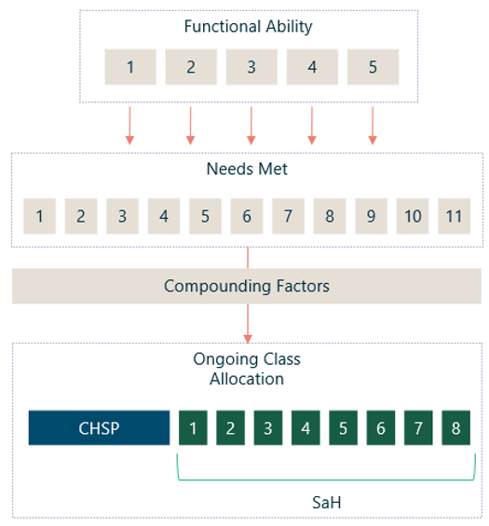
Integrated Assessment Tool high-level classification algorithm decision tree

