Integrated Assessment Tool (IAT) classification algorithm decision tree

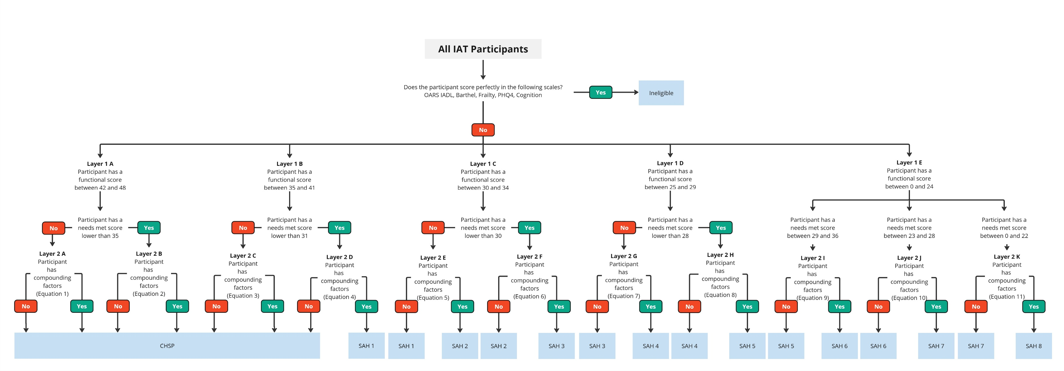
Detailed

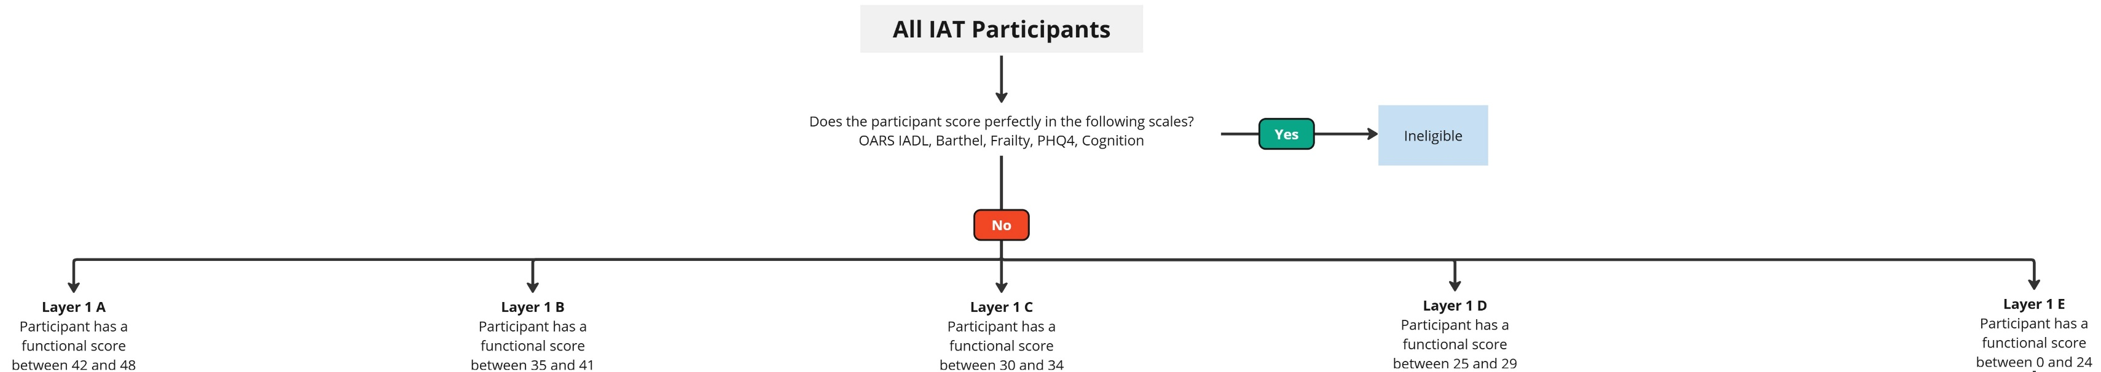
Functional ability component of classification algorithm decision tree

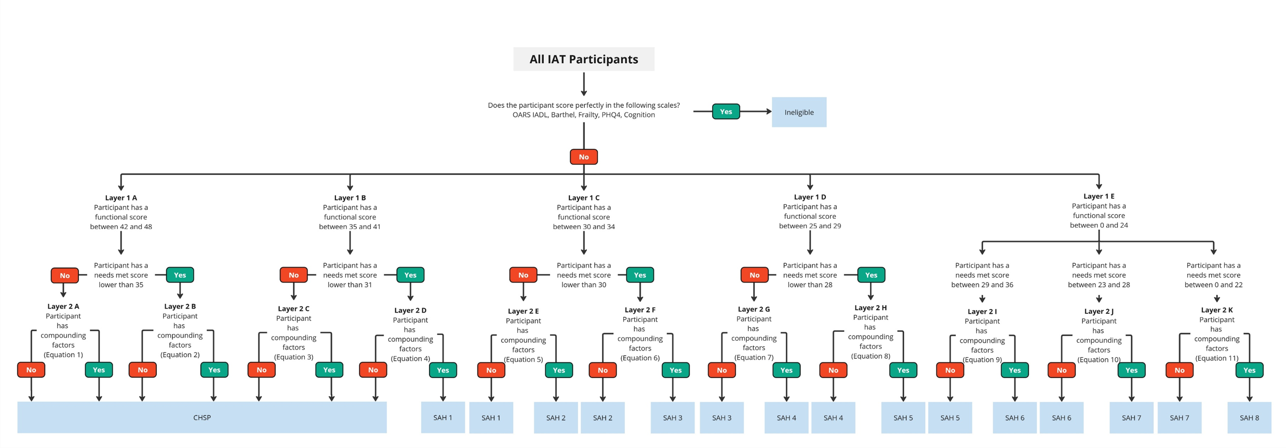
Example of needs met component of classification algorithm

Example of compounding factors component of classification algorithm decision tree

Aged Care Rules 2025 81-10 table
Describes the scores for each level of the detailed IAT classification algorithm decision tree
Classification levels and criteria
Item | Column 1  Classification level | Column 2  Criteria
1 | CHSP class | Any of the following:  (a) the individual:  (i) has a functional independence score of 42-48; and  (ii) has a needs met score of 35 or 36;  (b) the individual:  (i) has a functional independence score of 42-48; and  (ii) has a needs met score of 0-34;  (c) the individual:  (i) has a functional independence score of 35-41; and  (ii) has a needs met score of 31-36;  (d) the individual:  (i) has a functional independence score of 35-41; and  (ii) has a needs met score of 0-30; and  (iii) does not have significant compounding factors
2 | SAH class 1 | Either:  (a) the individual:  (i) has a functional independence score of 35-41; and  (ii) has a needs met score of 0-30; and  (iii) has significant compounding factors; or  (b) the individual:  (i) has a functional independence score of 30-34; and  (ii) has a needs met score of 30-36; and  (iii) does not have significant compounding factors
3 | SAH class 2 | Either:  (a) the individual:  (i) has a functional independence score of 30-34; and  (ii) has a needs met score of 30-36; and  (iii) has significant compounding factors; or  (b) the individual:  (i) has a functional independence score of 30-34; and  (ii) has a needs met score of 0-29; and  (iii) does not have significant compounding factors
4 | SAH class 3 | Either:  (a) the individual:  (i) has a functional independence score of 30-34; and  (ii) has a needs met score of 0-29; and  (iii) has significant compounding factors; or  (b) the individual:  (i) has a functional independence score of 25-29; and  (ii) has a needs met score of 28-36; and  (iii) does not have significant compounding factors
5 | SAH class 4 | Either:  (a) the individual:  (i) has a functional independence score of 25-29; and  (ii) has a needs met score of 28-36; and  (iii) has significant compounding factors; or  (b) the individual:  (i) has a functional independence score of 25-29; and  (ii) has a needs met score of 0-27; and  (iii) does not have significant compounding factors
6 | SAH class 5 | Either:  (a) the individual:  (i) has a functional independence score of 25-29; and  (ii) has a needs met score of 0-27; and  (iii) has significant compounding factors; or  (b) the individual:  (i) has a functional independence score of 0-24; and  (ii) has a needs met score of 29-36; and  (iii) does not have significant compounding factors
7 | SAH class 6 | Either:  (a) the individual:  (i) has a functional independence score of 0-24; and  (ii) has a needs met score of 29-36; and  (iii) has significant compounding factors; or  (b) the individual:  (i) has a functional independence score of 0-24; and  (ii) has a needs met score of 23-28; and  (iii) does not have significant compounding factors
8 | SAH class 7 | Either:  (a) the individual:  (i) has a functional independence score of 0-24; and  (ii) has a needs met score of 23-28; and  (iii) has significant compounding factors; or  (b) the individual:  (i) has a functional independence score of 0-24; and  (ii) has a needs met score of 0-22; and  (iii) does not have significant compounding factors
9 | SAH class 8 | The individual:  (a) has a functional independence score of 0-24; and  (b) has a needs met score of 0-22; and  (c) has significant compounding factors

