Government Provider Management System User Guide: Performance and Star Ratings application (Registered Provider Portal)
October 2026
Version 1.8
This Government Provider Management System (GPMS) User Guide provides Performance reviewers, at both the provider and Home/Branch level, with guidance for accessing, viewing and printing Star Ratings, strengthened Quality Standards, and regulatory decisions information in the GPMS Registered Provider Portal.

Contents
1. Introduction 3
1.1. Purpose 3
1.2. Before proceeding 3
1.3. Login to the GPMS portal 4
2. Further information and support 4
3. Accessing the Performance and Star Ratings application 4
4. Viewing Star Ratings 5
5. Star Ratings status types 14
6. Viewing Quality Standards 15
7. Viewing regulatory decisions 19
8. Printing 22
8.1. Generate a Star Ratings PDF report – provider preview 22
8.2. Printing Star Ratings, Quality Standards and regulatory decisions information 25

Introduction
Star Ratings for residential aged care provides transparent and nationally consistent measurement of aged care quality, supporting:
- older people, their families and carers to make more informed choices about their aged care
- provider engagement in improving the quality of services delivered to older people
- government transparency and improvement of aged care at a system level.

Purpose
This User Guide has been designed to support users with GPMS roles of Performance reviewer (Org) and Performance reviewer (Home/Branch) to:
- view current and historic:
  - Star Ratings, including Overall Star Rating and sub-category ratings and the metrics used to calculate the ratings
  - performance against the strengthened Aged Care Quality Standards (strengthened Quality Standards)
  - regulatory decisions
- preview new Star Ratings, including the metrics used to calculate the ratings before it is published for the next period.

Before proceeding
Please be advised of the following:
The Department of Health, Disability and Ageing (the Department) will retain records of users’ access to GPMS and when prompted, the user must accept the GPMS Terms of Use to be able to access the system.
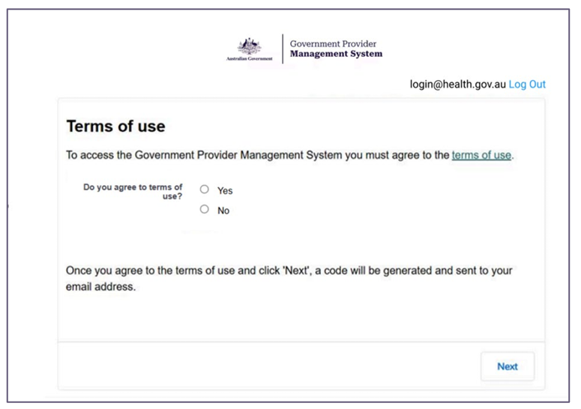

Login to the GPMS portal
To log into the GPMS portal please visit Log In Using | Service Provider Portal.To log into the GPMS Registered Provider Portal to access and view Star Ratings, Quality Standards and regulatory decisions, please visit Log In Using | Service Provider Portal.
Please refer to the Logging in to the Aged Care Systems for more information about Accessing the GPMS portal.

Further information and support
Visit Star Ratings for residential aged care | Australian Government Department of Health and Aged Care for information on Star Ratings.
For information on how Star Ratings are calculated please refer to the Star Ratings Provider Manual.
For more information on GPMS, including how to add, remove and edit GPMS users, please refer to the Government Provider Management System webpage.
If you require further assistance to login to GPMS please contact the My Aged Care service provider and assessor helpline on 1800 836 799, Monday to Friday (8am to 8pm) and Saturday (10am to 2pm) local time across Australia.
For translating and interpreting services, call 131 450 and ask for My Aged Care service provider and assessor helpline on 1800 836 799.
To use the National Relay Service, visit About the National Relay Service (NRS) | Access Hub or call 1800 555 660.
To access sign language interpreting and captioning services through Deaf Connect, call 1300 773 803 or email interpreting@deafconnect.org.au.

Accessing the Performance and Star Ratings application
Star Ratings and compliance information is accessed through the GPMS Registered Provider Portal. The primary purpose of the Performance and Star Ratings application is to allow you to view Star Ratings, Quality Standards and regulatory decisions information.
To access the Performance and Star Ratings application you will need to have either the Performance reviewer (Org) or Performance reviewer (Home/Branch) access role.
If you do not have this role you will need to discuss your need with your Organisation Administrator. If you are unsure of who in your organisation is an Organisation Administrator, please contact the My Aged Care service provider and assessor helpline on 1800 836 799 for assistance.
If you are an Organisation Administrator, you can assign yourself Performance reviewer access.
For more information on how Organisation Adminstrators can assign themselves, or a team member access to the Performance and Star Ratings application refer to the Government Provider Management System – User guide.
If you are not an Organisation Administrator at the time of being given Performance reviewer access, you will receive a welcome email with the details of the GPMS portal URL and next steps.
Refer to the Logging in to the Aged Care Systems for information about accessing the GPMS portal.

Viewing Star Ratings
Please note:
To access the Star Ratings tile in the Performance and Star Ratings application, you will require either the Performance reviewer (Org) or Performance reviewer (Home/Branch) access role.
If you cannot see the Performance and Star Ratings application on the GPMS Registered Provider Portal landing page, notify your Organisation Administrator for the matter to be resolved.
Once you are in the GPMS Registered Provider Portal, you can access the Preformance and Star Ratings application, by completing the following actions:
- In the GPMS Registered Provider Portal landing page, select the Performance and Star Ratings application.
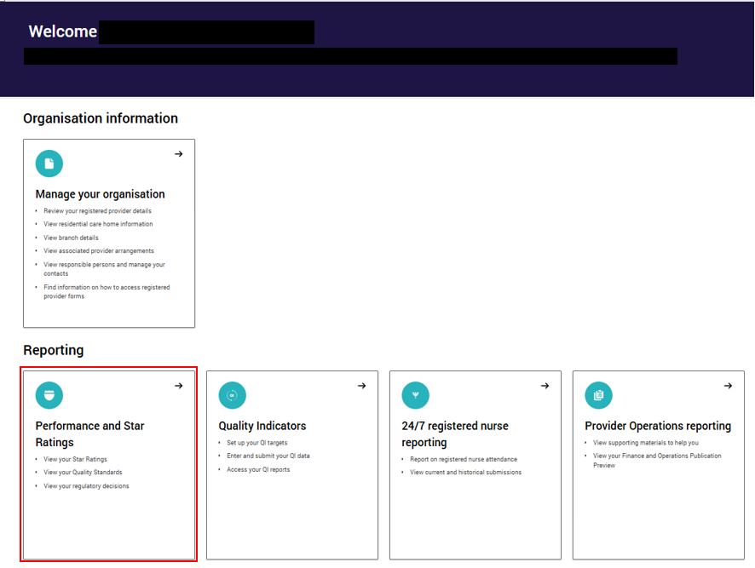
- Select the Star Ratings tile.
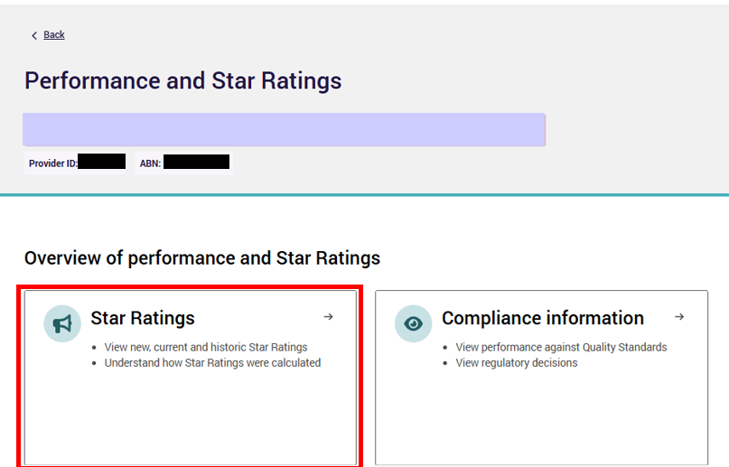
The Star Ratings screen will display the list of all residential care homes currently associated with your provider for those with Performance reviewer (Org) access role. Those with Performance reviewer (Home/Branch) access role will only see the Homes/Branches they have been granted access to.
- You can find the Star Ratings summary of each residential care home on this page. You can filter the results by name, reporting period, Star Rating and status.
- To view details of the Overall Star Rating and sub-category ratings click the arrow on the record you would like to see and select View ratings.
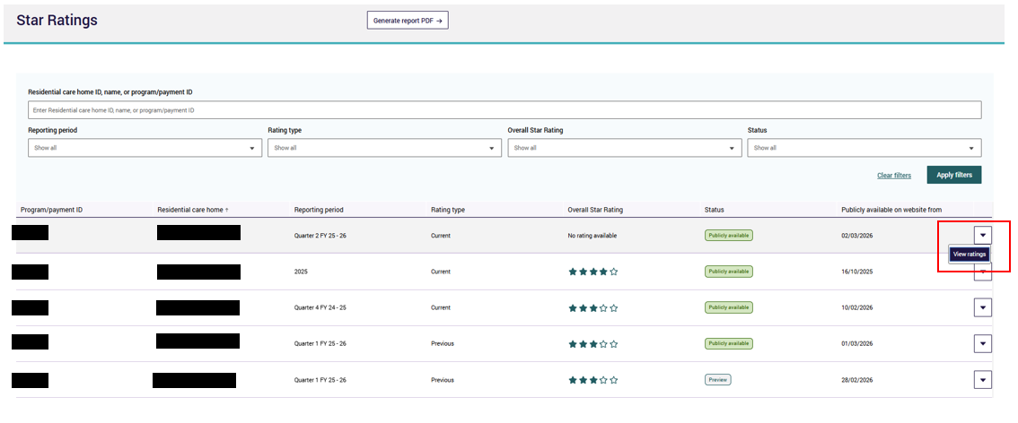
- When you select View ratings, you will be taken to a screen where you can preview any new ratings and see current and historic ratings your residential care home has received, including the Overall Star Rating and sub-category ratings.
- Select the Overall Star Rating or sub-category tab to see the selected rating and history.
- Overall Star Rating and sub-category rating history can be viewed as a graph or in a table. Click on the arrow next to ‘View as a table’ to view the ratings history in a table format.
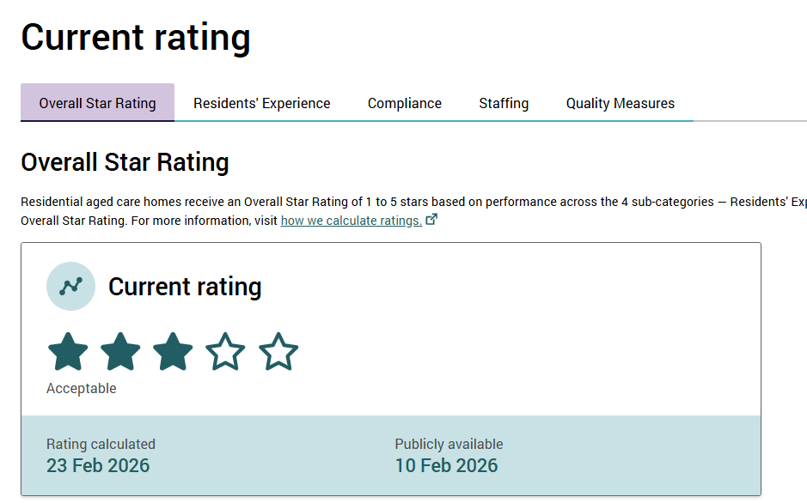
Please note:
A rating may not be calculated due to an exemption being granted by the Department of Health, Disability and Ageing.
If this occurs, the warning below will be visible on the rating page.
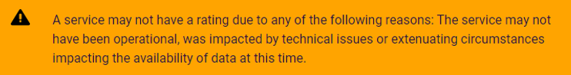

Example of the Overall Star Rating
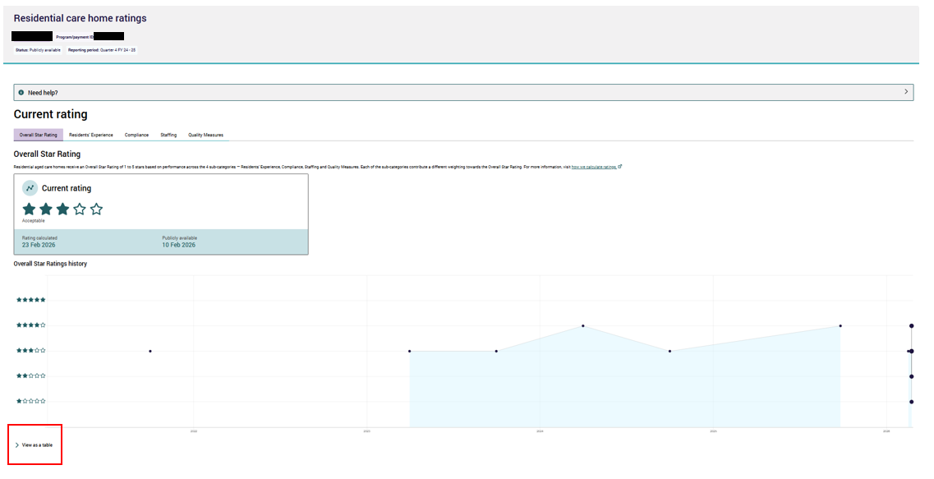
Where new ratings are available to preview prior to publication on the My Aged Care website, the new rating will display alongside the current Overall Star Rating and each sub-category rating together with the date the new rating was calculated.
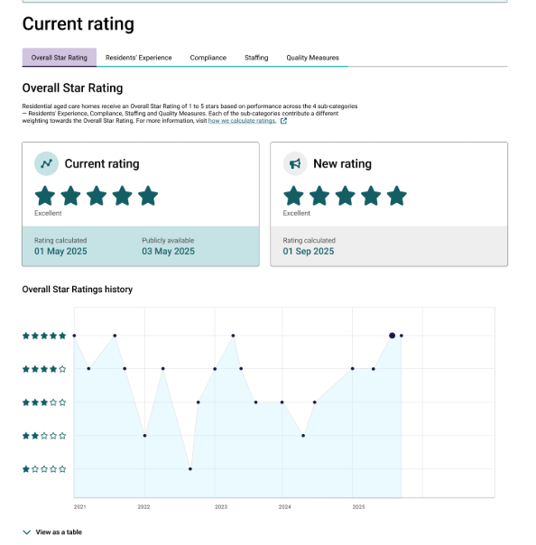

Example of the Residents’ Experience rating
The current and new Residents’ Experience ratings will display together with results of the home’s most recently completed annual Residents’ Experience Survey results.
When only a current Residents’ Experience rating is available, it will display as:
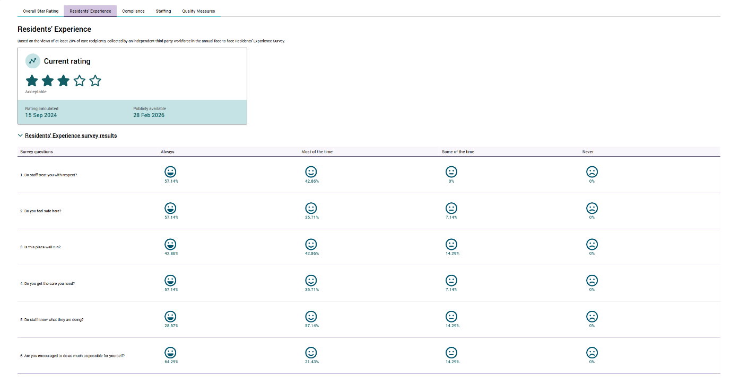
When a new and current rating are both available, it will display as:
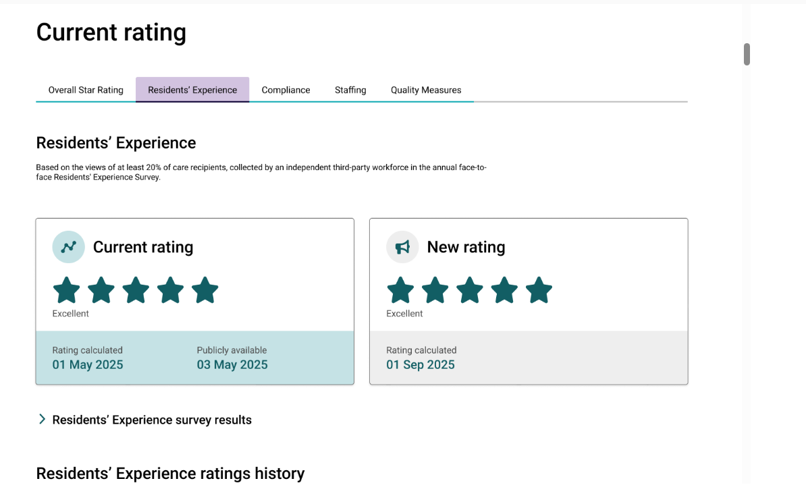
Please note:
A residential care home will not receive a Residents’ Experience rating if they chose not to participate in the annual Residents’ Experience Survey and this will also result in no Overall Star Rating. Information to explain the reason why a residential care home does not have a Residents’ Experience rating will be displayed on the GPMS Registered Provider Portal and on the My Aged Care website.

Example of the Compliance rating
Select the Compliance tab to see the selected rating and history.
The current Compliance rating will display together with:
- any current and non-current regulatory decisions issued/made against a registered aged care provider and attributed to the residential care home
- the residential care home’s graded assessment outcomes against the strengthened Quality Standards.
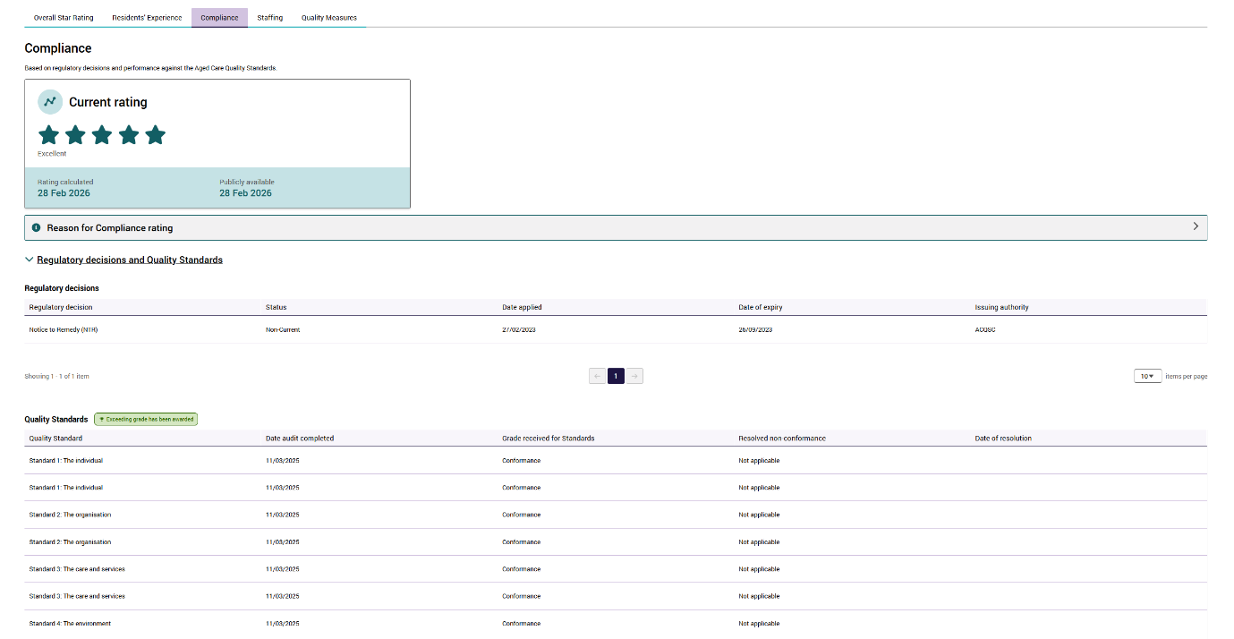
Please note:
The Compliance rating can change daily in response to:
1. regulatory decisions, once received by the Department from the issuing body
2. a residential care home’s graded assessment outcomes against the strengthened Quality Standards.

Example of the Staffing rating
The current and new Staffing ratings will display alongside the home’s performance against their care minute targets, including for:
- total nursing and personal care
- care from a registered nurse, including the contribution of care time delivered by an enrolled nurse to meet the increased registered nurse care minute target, up to 10 percent
- care from enrolled nurses
- care from personal care workers and assistants in nursing.
When only a current rating is available, it will display as:
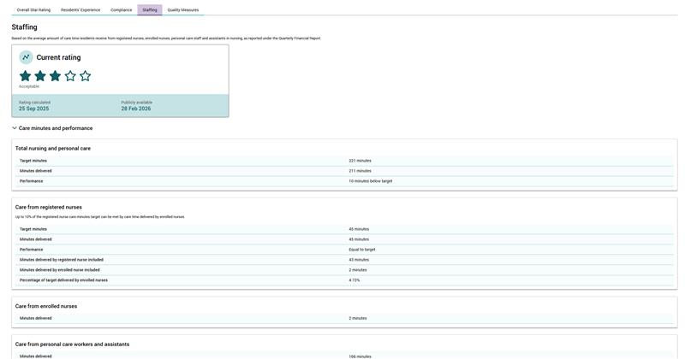
When a new and current rating are both available, it will display as: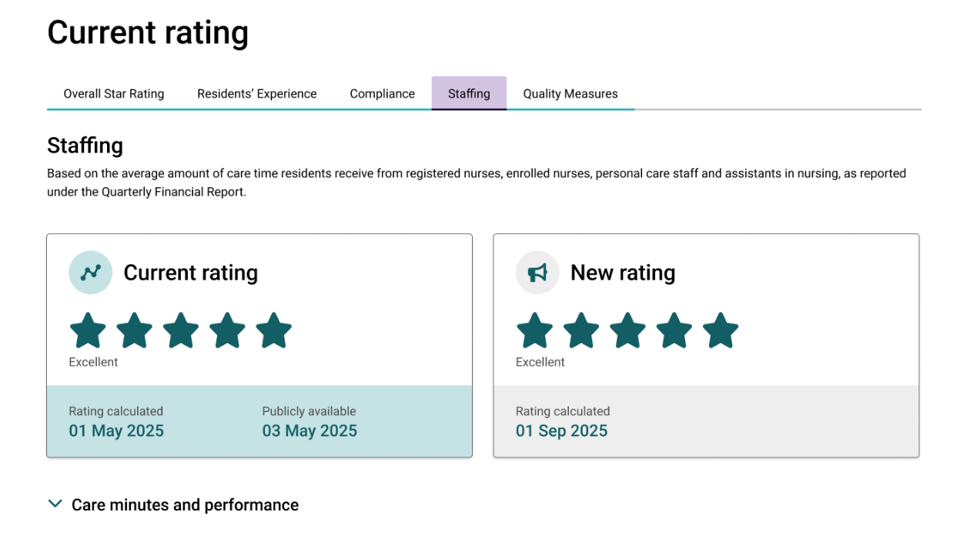
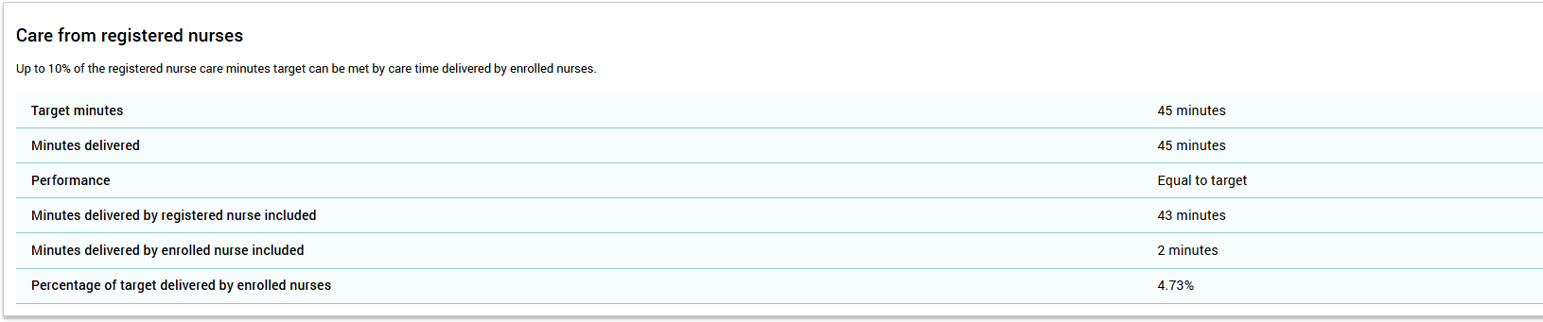
Please note:
A residential care home will not receive a Staffing rating if they do not report their care minute data on time or at all or if they fail to pass quality checks, and this will also result in no Overall Star Rating. Information to explain the reason why a residential care home does not have a Staffing rating will be displayed on the GPMS Registered Provider Portal and on the My Aged Care website.

Example of the Quality Measures rating
The current and new Quality Measures ratings will display together with results of the residential care home’s current performance against:
- each of the five quality indicators and associated categories reported under the National Aged Care Quality Indicator Program used to calculate the current rating
the national average of each quality indicator and associated categories.
When only a current rating is available, it will display as:
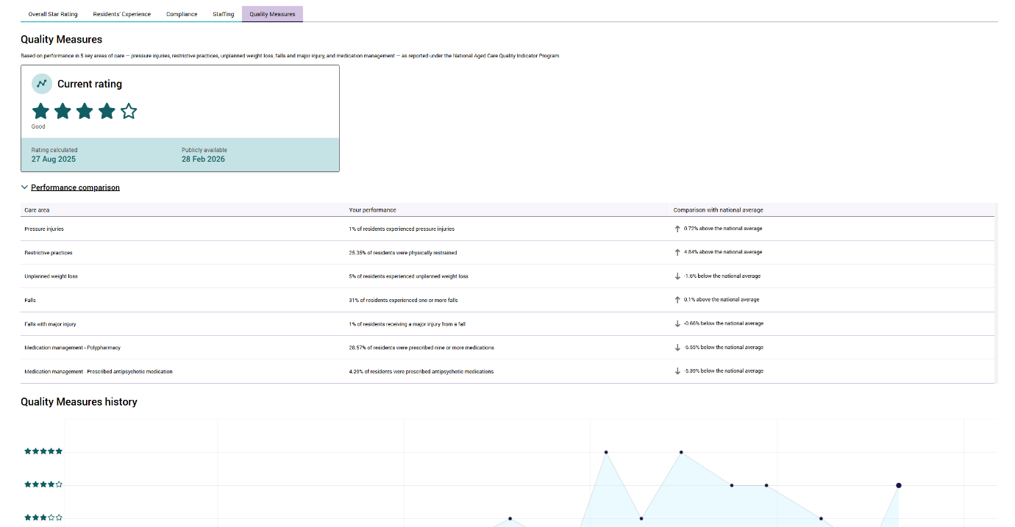
When a new and current rating are both available, it will display as:
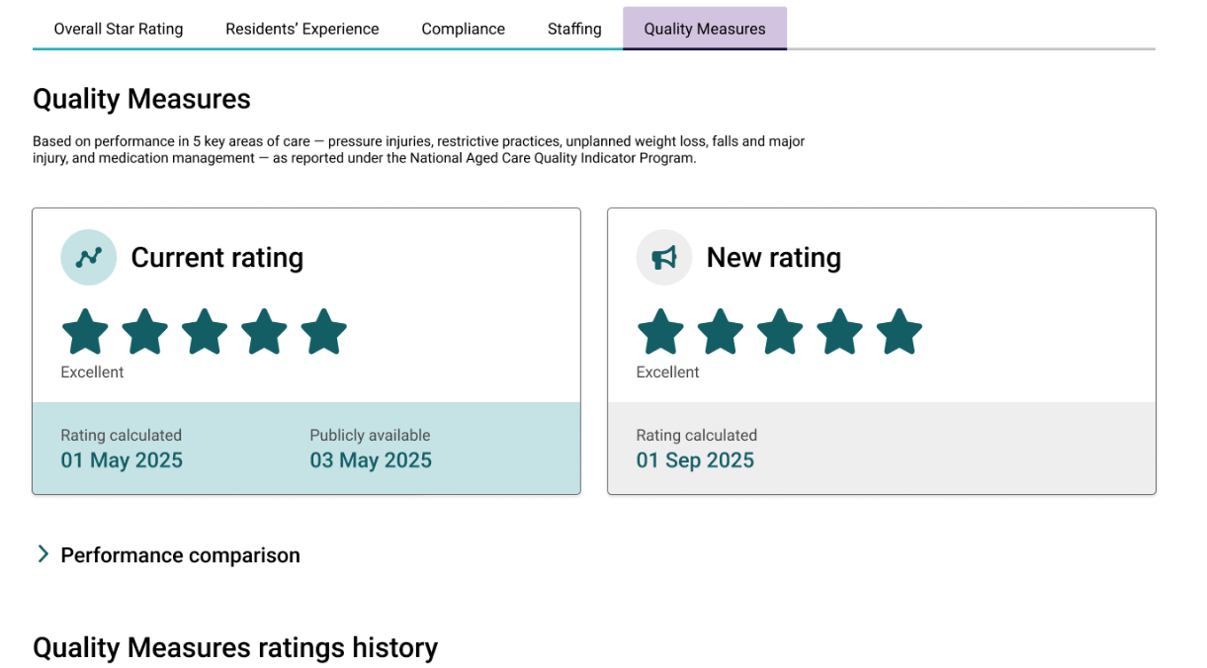
Please note:
A residential care home will not receive a Quality Measures rating if they did not submit their National Aged Care Quality Indicator Program data on time or at all and this will also result in no Overall Star Rating. Information to explain that a residential care home does not have a Quality Measures rating due to late or non-submission will be displayed on the GPMS Registered Provider Portal and on the My Aged Care website.
Please note:
If you encounter technical errors affecting the display of Star Ratings and/or the data used to calculate the rating in the GPMS Registered Provider Portal or on the My Aged Care website, please report them to the My Aged Care service provider and assessor helpline on 1800 836 799.
The helpline is open Monday to Friday between 8am-8pm and Saturday between
10am to 2pm.

Star Ratings status types
Each Star Ratings entry has a status informing how and where the rating is being displayed.
The Star Rating status is viewable on the main Star Ratings tab.
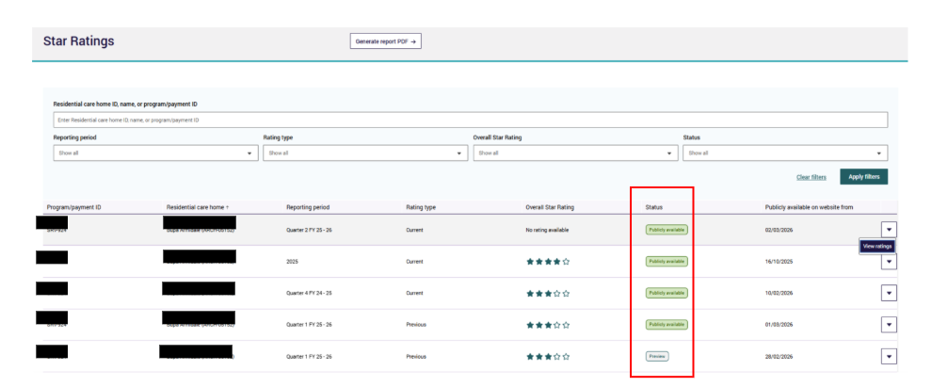
There are three possible status types:
Status type | Meaning
Preview | The Star Rating has been published to the GPMS Registered Provider Portal to be previewed ahead of being made publicly available.
Publicly available | The Star Ratings is publicly available on the My Aged Care website.
Under review | The Star Rating is under review and/or under investigation by the Department and is currently not available on the GPMS Registered Provider Portal or on the My Aged Care website.

Viewing Quality Standards
You can use the Performance and Star Ratings application in the GPMS Registered Provider Portal to view compliance information including performance against strengthened Quality Standards.
Please note:
To access the Performance and Star Ratings application you will need to have either the Performance reviewer (Org) or Performance reviewer (Home/Branch) access role.
If you do not have this role you will need to discuss your need with your Organisation Administrator. If you are an Organisation Administrator, you can assign yourself Performance reviewer access.
Current and previous outcomes of audits against the strengthened Quality Standards under the Aged Care Act 2024 can be viewed by accessing the Compliance information tile in the Performance and Star Ratings application. Follow these steps:
- On the GPMS Registered Provider Portal landing page, select the Performance and Star Ratings application.
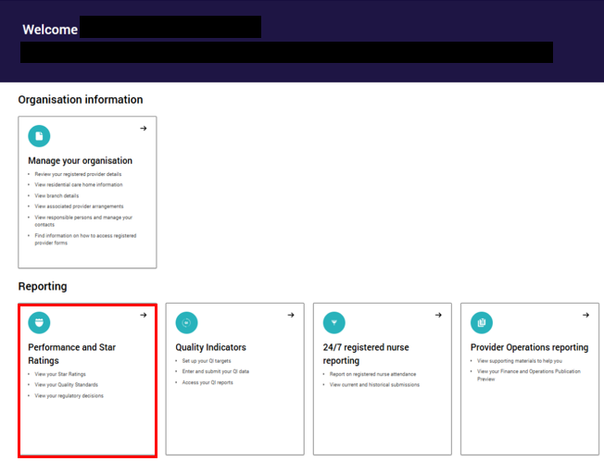
On the Performance and Star Ratings application landing page, select the Compliance information tile.
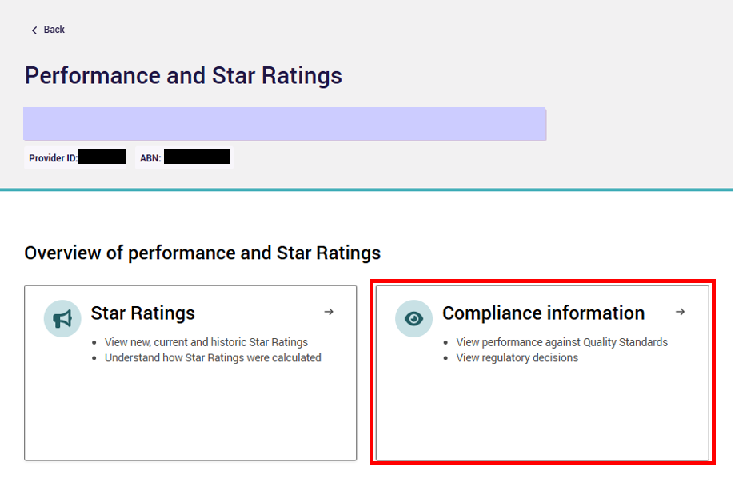
You will be taken to the Compliance information display. Select Quality Standards tab.
You will see a list of records for the strengthened Quality Standards assessment for all services associated with the provider ID. Navigate to the record you would like to view, click the arrow and select View details. If GPMS has not received any audit outcomes against the strengthened Quality Standards for your organisation, you will not be able to view any records.
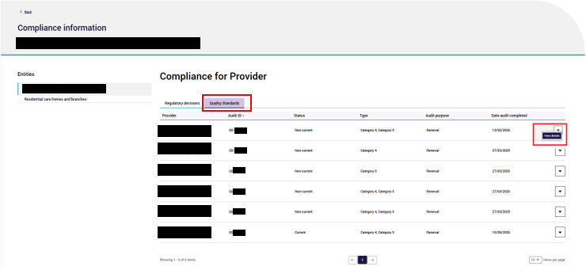

- To view a list of records for the strengthened Quality Standards assessment for Category 6 residential care homes and branches only, select Residential care homes and branches from the left hand menu under Entities. You will see a list of records for the respective residential care home. Navigate to the record you would like to view, click the arrow and select View details.
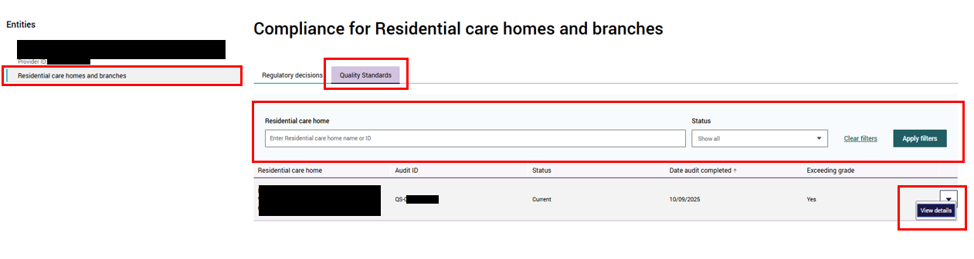
You will be taken to the Quality Standards audit display which provides information about the assessment against the strengthened Quality Standards.

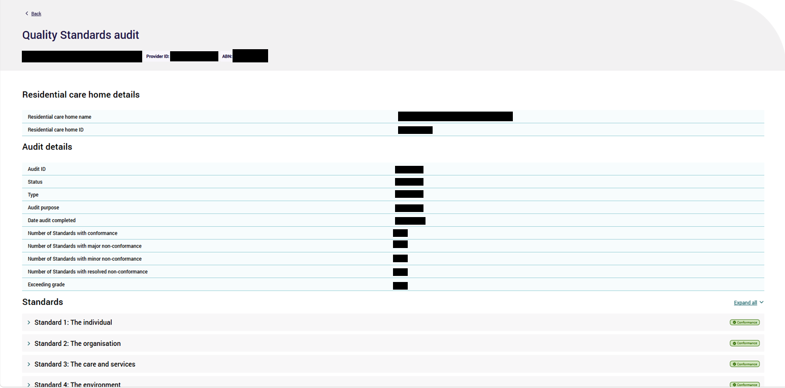
Select Expand all to view information about the outcomes against each Standard.

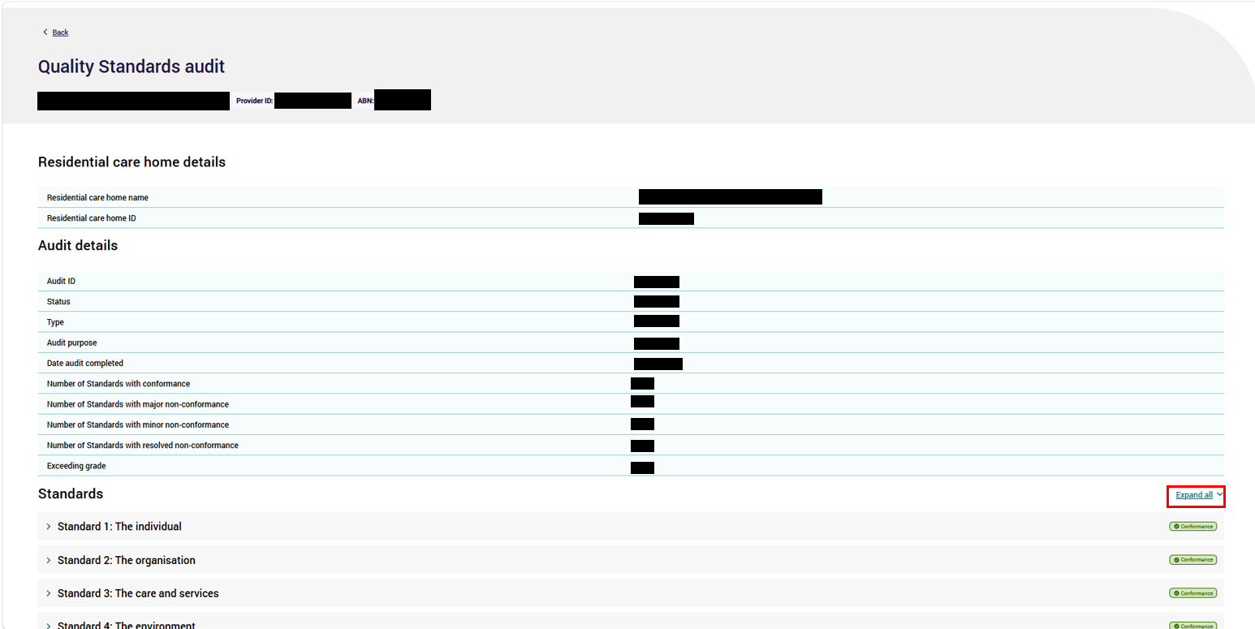
Example of Quality Standards details page when ‘Expand all’ is clicked.
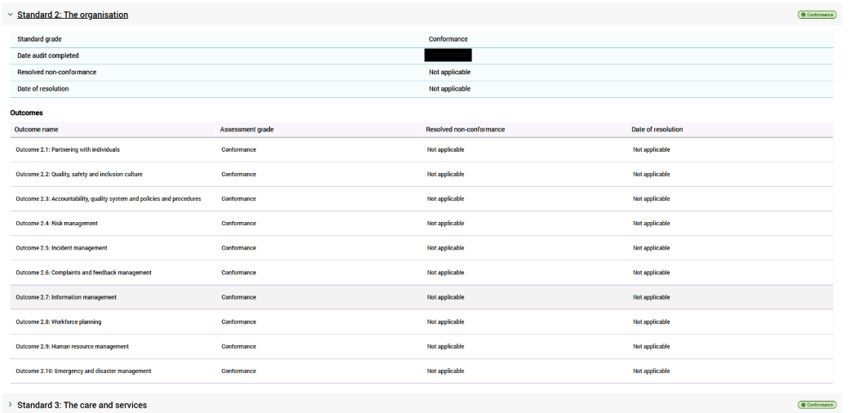

- Select Collapse all to revert to previous view where the list of Standards and the overall grade against each Standard is visible in brackets (if available and applicable).

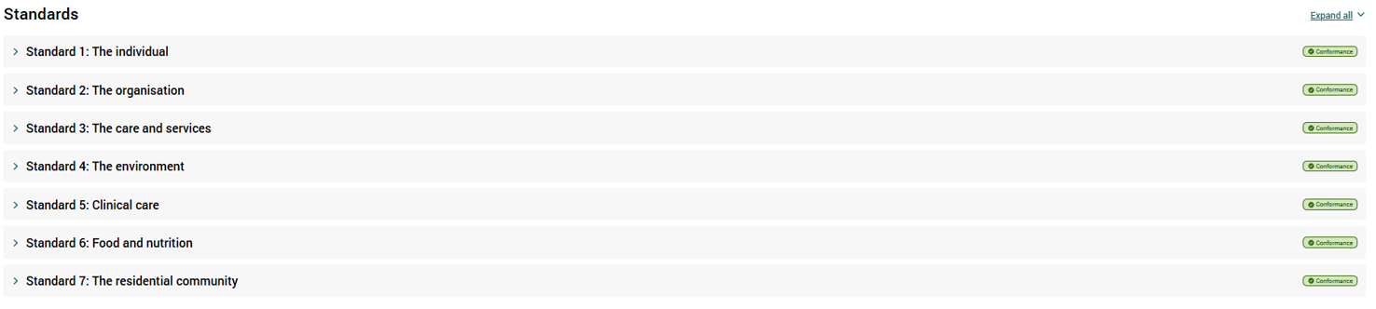

Please note:
Strengthened Quality Standards audit information displayed on GPMS differs between the provider level and residential care home and branch level because of the Quality Standards that need to be met by each registration category. The registration category determines the Quality Standards that are visible.

Viewing regulatory decisions
You can use the Performance and Star Ratings application in the GPMS Registered Provider Portal to view compliance information including regulatory decisions.
Please note:
To access the Performance and Star Ratings application you will need to have either the Performance reviewer (Org) or Performance reviewer (Home/Branch) access role.
If you do not have this role you will need to discuss your need with your Organisation Administrator.
If you are an Organisation Administrator, you can assign yourself Performance reviewer access.
Current and historic regulatory decisions applied to your provider and its residential care homes and/or branches can be viewed by accessing the Compliance information tile in the Performance and Star Ratings application. Follow these steps:
- On the GPMS Registered Provider Portal landing page, select the Performance and Star Ratings application.
On the Performance and Star Ratings landing page, select the Compliance Information tile.
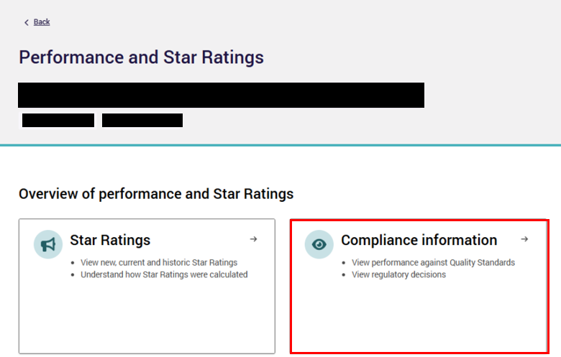
You will be taken to the Compliance information display. Select the Regulatory decisions tab to view a list of current and historic regulatory decisions applied to your provider or its residential care homes and/or branches.
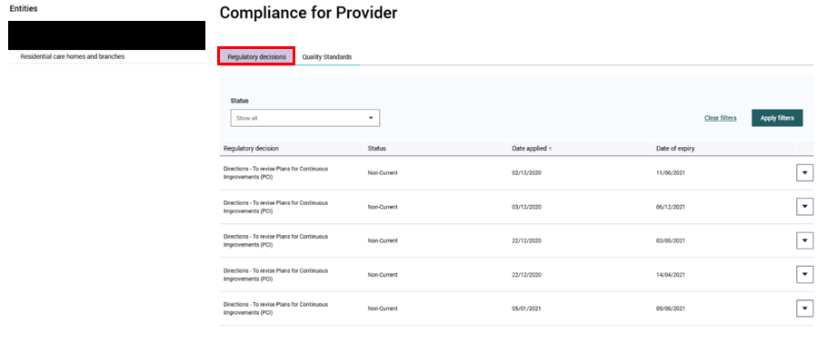
The default view will show all current and historic regulatory decisions applied to the provider.
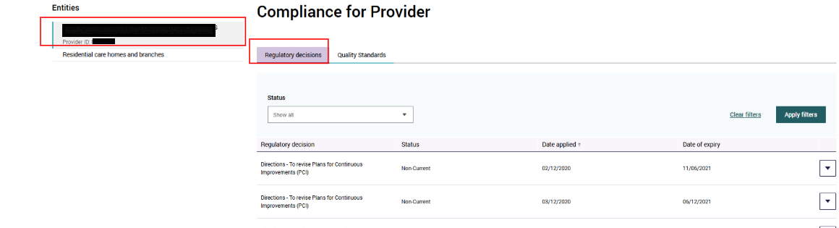
- To view regulatory decisions for a particular residential care home or branch, select Residential care homes and branches from the left-hand menu under Entities.
To view details of a particular current or historic regulatory decision, select the arrow button and then select View details arrow to be taken to the regulatory decisions details display. Use the search filters to find regulatory decisions based on the Residential care home/branch name or ID, and/or the regulatory decision status.
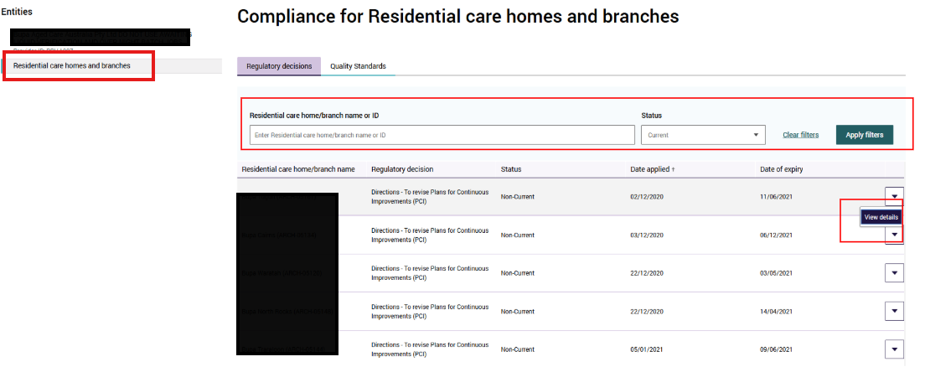
Example of a regulatory decision details display
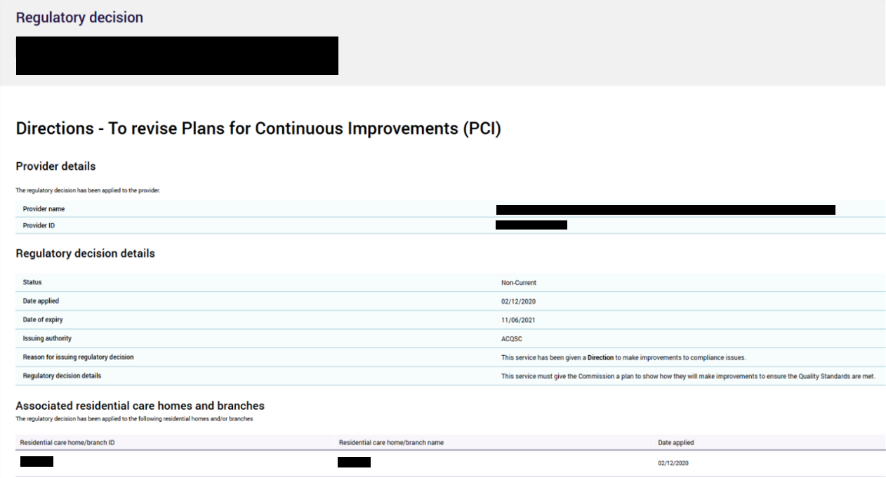
Please note:
If a regulatory decision does not apply to any associated residential care homes and/or branches for a provider, the table ‘Associated residential care homes and branches’ will display a message as follows: ‘The regulatory decision has not been applied to a residential care home or branch associated with this provider.’

Printing
A PDF report of your Star Ratings will be available to download in GPMS during the provider preview period, before ratings are published on the My Aged Care website.
See steps at 8.1 for how to generate a Star Ratings PDF report during the provider preview period.
You can also print published Star Ratings, strengthened Quality Standards information and regulatory decisions on the GPMS Registered Provider Portal from the Performance and Star Ratings application. See steps at 8.2 for how to print published Star Ratings, strengthened Quality Standards or regulatory decisions information from the Registered Provider Portal using the ‘print screen method’.

Generate a Star Ratings PDF report – provider preview
The provider preview period occurs before each quarterly update. Providers will receive correspondence alerting them to preview dates before each update.
Please note:
Your PDF report will only be available during the provider preview period.
For the best user experience, we recommend using the Safari browser.
Once you are in the GPMS Registered Provider Portal, you can download your PDF report of your Star Ratings provider preview by completing the following steps:
- In the Performance and Star Ratings application, select the Star Ratings tile.
The Star Ratings screen will display the list of all residential care homes currently associated with your provider based on your GPMS user profile. Select Generate report PDF.
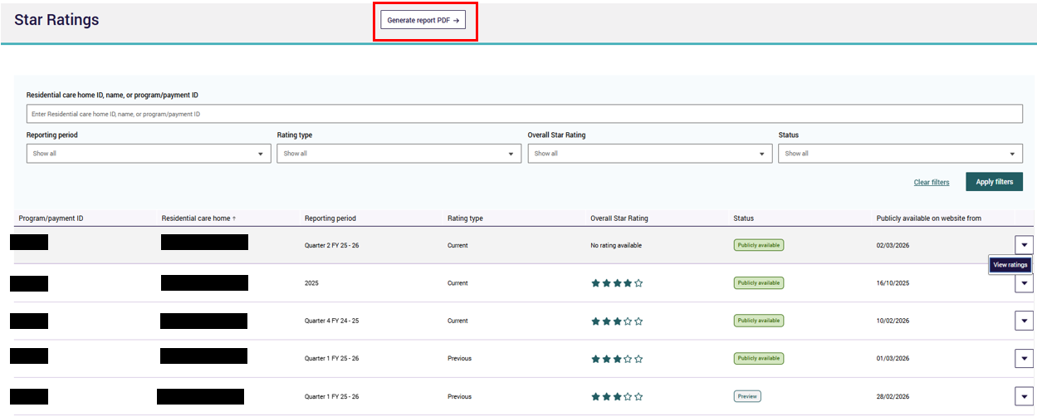
Select the rating you would like to see by filtering by residential care home ID, name or program/payment ID.
Once the residential care home is selected use the bar chart icon (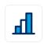) to launch Analytical Studio in a new tab or select Generate Report.
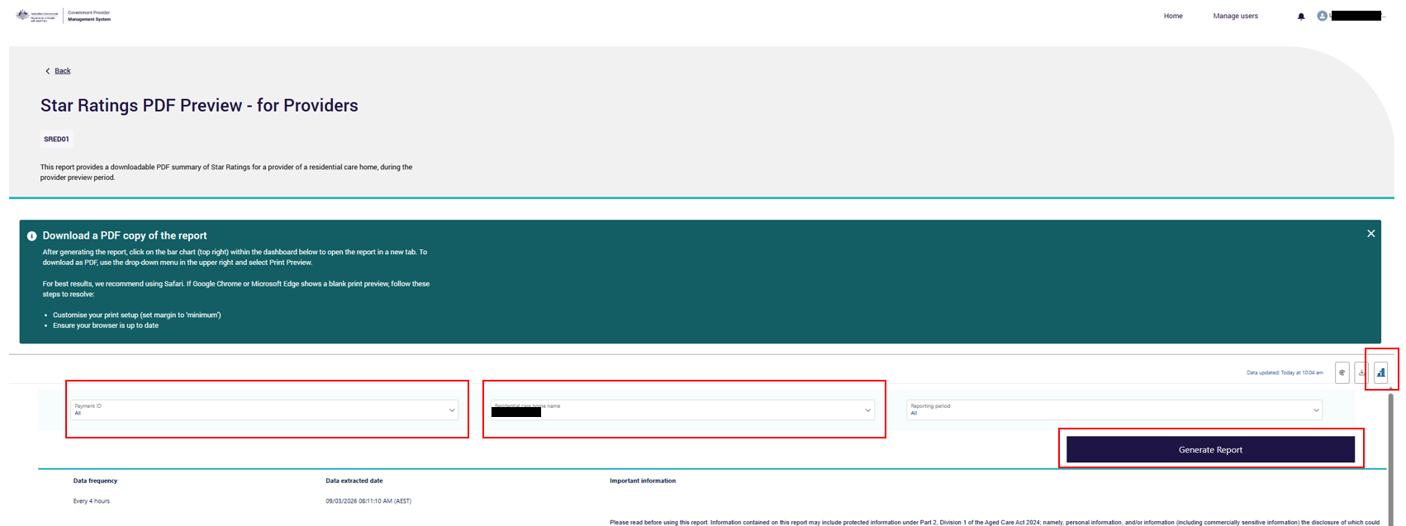
A new browser page ‘CRM Analytics | Salesforce’ will load. Select the Residential care name for the residential care home you want to view. You can adjust this filter to see residential care homes linked to your GPMS user profile. You do not need to select any other filters.
The Preview Report page appears. You can scroll down to see the complete report, or select Return to Filters to return to the filters page.
To save the report as a PDF, select the dropdown menu in the upper right corner, then select Print button.
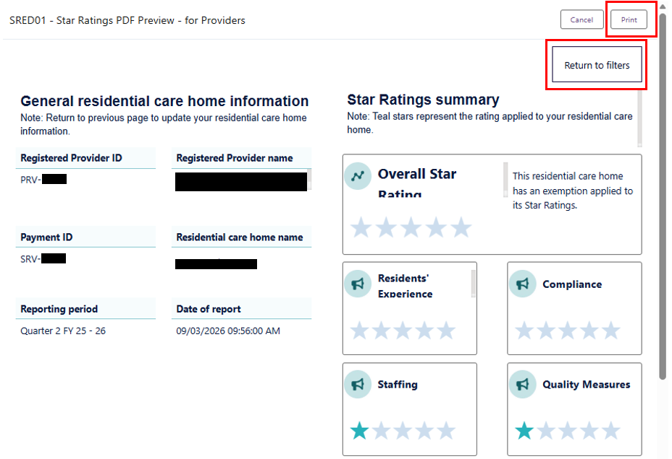
- The Print pop-up appears.
Select Save as PDF.
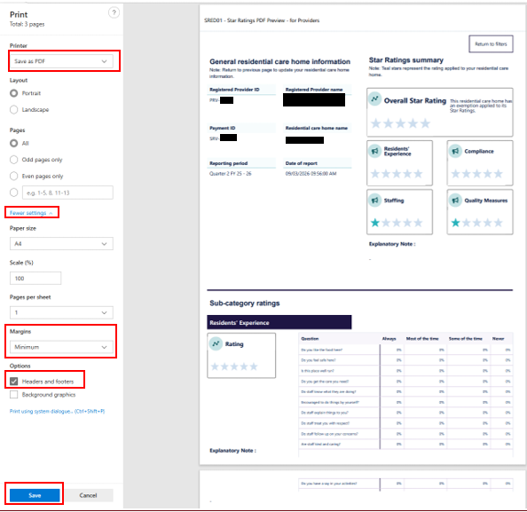
Then, select More Settings, in the margins drop down select Minimum and tick Headers and footers. This will ensure that the entire report will be displayed in the PDF preview.
Select Save.
Please note:
These printer settings are also displayed in the PDF Preview Report page for your convenience.
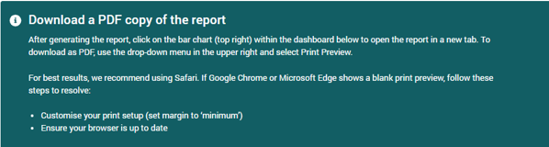

Printing Star Ratings, Quality Standards and regulatory decisions information
The following ‘print screen’ method can be used to print Star Ratings, Quality Standards and regulatory decisions information.
- Navigate to the respective Star Rating, Quality Standards audit or regulatory decision display in the GPMS Registered Provider Portal that you would like to print.
Expand all data fields, right click anywhere on the screen and select Print.

Example of printing an Overall Star Rating or sub-category rating details page
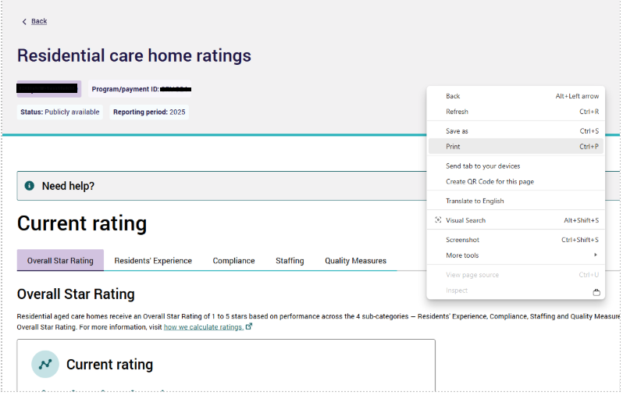

Example of printing a Quality Standards audit details page
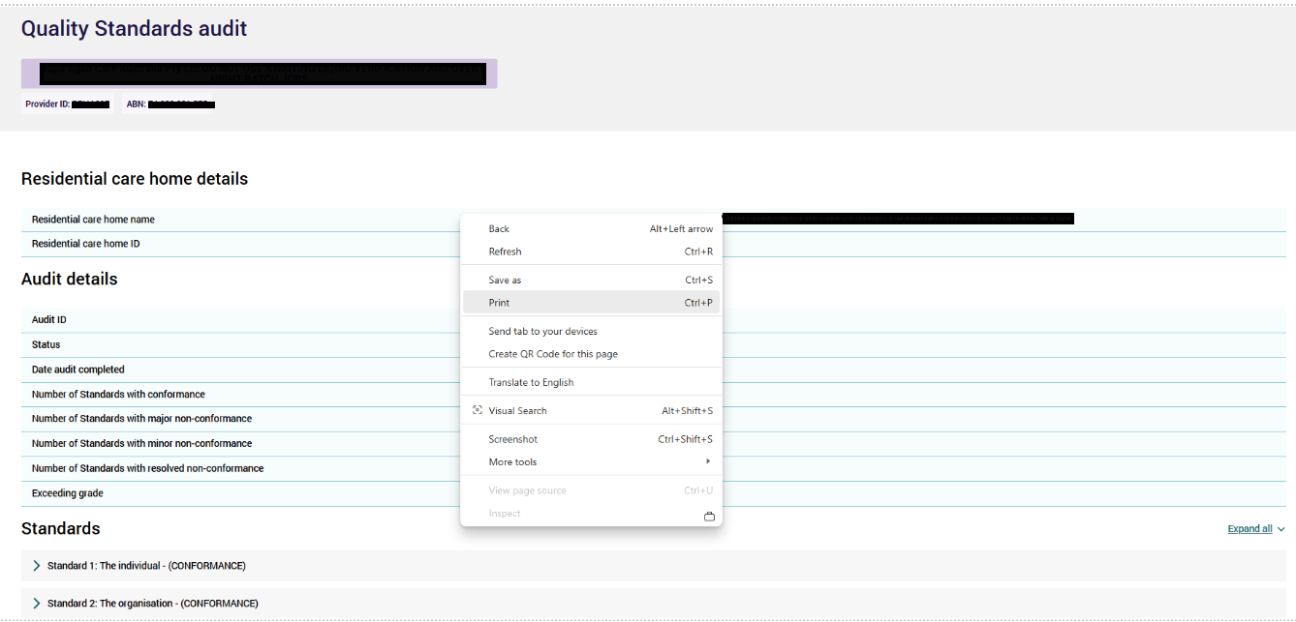
To print grades for Standards and outcomes, select Expand all before printing.

Example of printing a regulatory decision details page
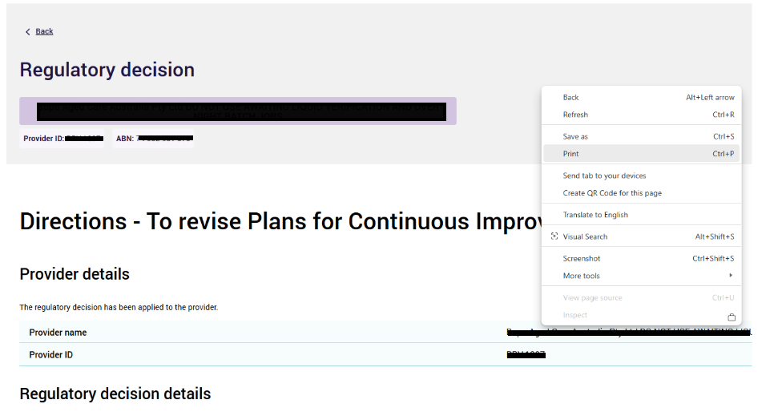
To open a print preview click Print and select Save as PDF.
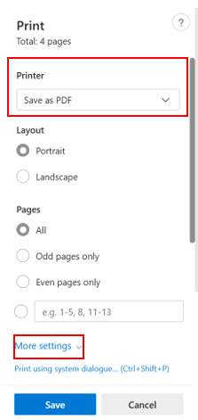
Select More settings and change the scale to 45 and Print.
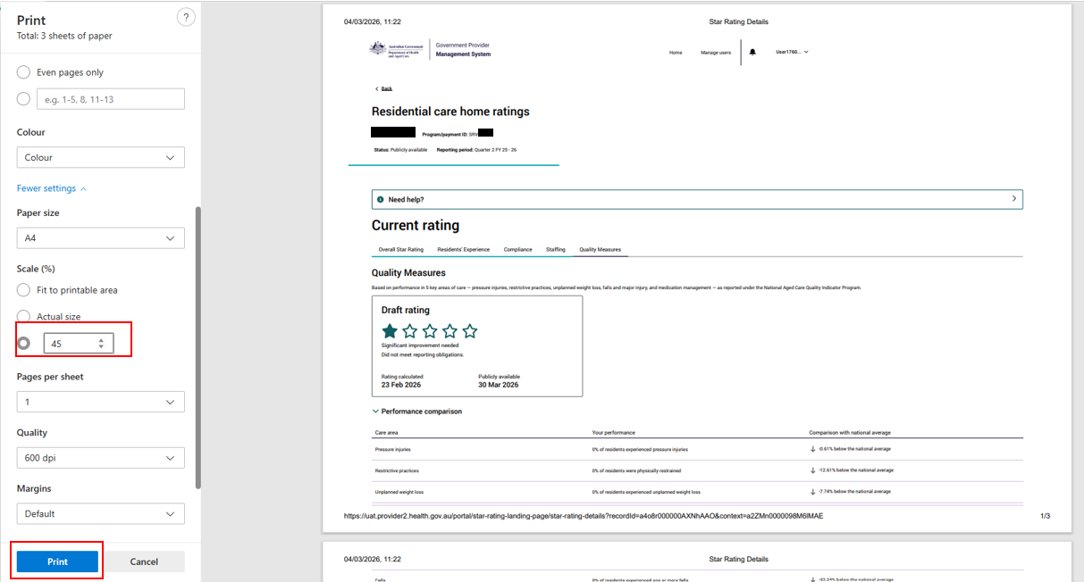
Please note:
The ‘right click to print’ on any browser tab functionality may look and behave different based on the browser or device you are using.

