Final Report: Evaluation of the Primary Care Enhancement Program (Phase 2)

  - Prepared for the Department of Health, Disability and Ageing
Title: | Final Report: Evaluation of the Primary Care Enhancement Program (Phase 2)
Prepared for: | Department of Health, Disability and Ageing
Prepared by: | Institute for Social Science Research, The University of Queensland
Date: | 28 August 2026
Project work package lead

------------------------------------------
Associate Professor Fran Boyle
The Institute for Social Science Research at The University of Queensland (UQ) acknowledges the Traditional Owners and their custodianship of the lands on which UQ operates. We pay our respects to their Ancestors and their descendants, who continue cultural and spiritual connections to Country.

Acknowledgements
This work was commissioned by the Australian Government Department of Health, Disability and Ageing. We thank all members of the Department of Health, Disability and Ageing project team, including Genevieve Johnsson, Kat Davies, Tegan Rosenberg, Rebecca Donnelly, and Nicholas Lennox, for their constructive feedback and helpful guidance.
We thank all participants who completed interviews for their time and for sharing valuable experiences and insights. We also thank Elyssa Tzioutzias for her support in collating resource mapping spreadsheets for the project, Nic Coops for research support, and Gina Nuttall for assistance with visual design.
We sincerely thank all PHN staff who participated for their collaboration and openness in sharing insights to support the evaluation.

Authors
(Listed in alphabetical order by surname)
Associate Professor Fran Boyle (Project Lead)  Dr Katie Brooker  Dr Mary Lou Chatterton  Dr Julie Dean  Dr Catherine Franklin  Dr Sebastian Kocar | Dr Yong Yi Lee  Dr Kieren Lilly  Dr Aditi Lohan  Ms Shelby Marrington  Dr Jennifer Maturi  Ms Noor Yousef

Suggested citation
Boyle FM, Dean JH, Lohan A, Lilly KJ, Kocar S, Yousef N, Chatterton ML, Lee YY, Brooker K, Maturi J, Franklin C, Marrington S. (2026). Final Report: Evaluation of the Primary Care Enhancement Program (Phase 2). Institute for Social Science Research, The University of Queensland.
Contents
List of Tables 5
List of Figures 5
Acronyms and abbreviations 6
Glossary 7
Primary Care Enhancement Program (PCEP): Phase 2 Evaluation Summary 8
Executive Summary 9
1. Introduction 13
1.1 Intellectual disability health as a priority 13
1.2 Background and previous evaluation work 14
1.3 Objectives and scope of the Phase 2 evaluation 15
2. Evaluation design and methods 18
2.1 Overview of the evaluation design 19
2.2 Data sources 19
2.3 Data constraints and limitations 22
3. Findings 24
3.1 Implementation 25
3.2 Effectiveness 42
3.3 Efficiency 52
3.4 Appropriateness 58
4. Considerations for future implementation 67
4.1. Future directions and broader applicability 68
4.2. Considerations for future implementation 70

List of Tables
Table 1: Summary of CESPHN direct delivery and WVPHN collaborative commissioning models for in-practice QIAs and training 28
Table 2: Participation in CCQ and PHT online learning modules by stakeholder group 30
Table 3: Primary care workforce participation in CESPHN and WVPHN in-practice QIAs and training sessions (April 2025-March 2026) 31
Table 4: Participation in community workshops by stakeholder group (June 2025-April 2026) 32
Table 5: Number of patients with intellectual disability identified pre- and post-QIA to cleanse and code data (CESPHN and WVPHN) 44
Table 6: Patients identified as requiring an AHA reminders in CESPHN’s Intellectual Disability Primary Care Inclusion Program 44
Table 7: Summary of the total PCEP budget across all 4 participating PHNs for financial year 2024–25 54
Table 8: Summary of estimated PCEP spending by target group for financial year 2024–25 54
Table 9: Summary of the total PCEP budget across all 4 participating PHNs for financial year 2025–26 55
Table 10: Summary of estimated PCEP spending by target group for financial year 2025–26 55
Table 11: Comparison of PCEP with other government-funded intellectual disability health initiatives 63

List of Figures
Figure 1: Summary of PCEP Phase 1 and Phase 2 evaluation timing 15
Figure 2: Four core data sources that inform the evaluation 19
Figure 3: Number of consultations across each stakeholder group 21
Figure 4: Summary of the geographical context, key initiatives, and approaches to implementing PCEP for each PHN 26
Figure 5: Person-centred care supported by PCEP across practice, sector and system levels 27
Figure 6: Number of resources across practice, sector and system levels 34
Figure 7: PHN local priority focus area resources 35
Figure 8: Cumulative curves indicate a steady increase in overall engagement over time 36
Figure 9: Completed AHAs across 16 participating practices in CESPHN (11 March 2024-31 March 2026). Source: POLAR (CESPHN) 45
Figure 10: Completed AHAs across 20 practices participating in PCEP Phase 1, CESPHN (January 2023-February 2025). Source: POLAR, CESPHN 46
Figure 11: Completed AHAs across 3 practices participating in PCEP Phase 1 and Phase 2 in CESPHN (January 2023-March 2026). Source: POLAR, CESPHN 46
Figure 12: Knowledge of healthcare considerations for people with intellectual disability increased following completion of PHT’s online training modules 48
Figure 13: Most participants in CESPHN’s in-practice training reported applying specific strategies in day-to-day patient care and observed benefits in their professional practice 48
Figure 14: Confidence in using systems to accurately identify and support patients increased after WVPHN’s in-practice training 49

Acronyms and abbreviations
Acronym/abbreviation | Definition
AHA | Annual Health Assessment
CESPHN | Central and Eastern Sydney Primary Health Network
CCQ | Country to Coast Queensland
CHAP | Comprehensive Health Assessment Program for people with intellectual disability
CPD | Continuing Professional Development
DFV pilots | Improving Health System Responses to Family and Domestic Violence PHN pilots
DSO | Disability Sector Organisation
KEQs | Key Evaluation Questions
LGBTQIA+ | Lesbian, gay, bisexual, transgender, queer/questioning, intersex, asexual and other sexually or gender diverse identities
MBS | Medicare Benefits Schedule
NCEIDH | National Centre of Excellence in Intellectual Disability Health
PCEP | Primary Care Enhancement Program for people with intellectual disability
PHN | Primary Health Network
PHT | Primary Health Tasmania
POLAR | Population Level Analysis and Reporting
QALY | Quality-Adjusted Life Year
QI | Quality Improvement
QIAs | Quality Improvement Activities
SIL | Supported Independent Living
SNOMED CT | Systematized Nomenclature of Medicine Clinical Terms
WVPHN | Western Victoria Primary Health Network

Glossary
Term | Definition as used in this report
Disability sector organisation (DSO) | An organisation that provides services, advocacy, or support to people with disability, including intellectual disability, and their families. These organisations include non-government organisations, community groups and other service provider organisations.
Comprehensive Health Assessment Program (CHAP) | The CHAP is an evidence-based tool for conducting annual health assessments for people with intellectual disability in Australia.
Easy Read | Easy Read is a way to present information to support understanding for people with intellectual or learning disability.
HealthPathways | HealthPathways is a web‑based clinical resource offering evidence‑informed guidance on the assessment and management of common health conditions, together with referral pathways tailored to local services.
PCEP PHNs | The 4 PHNs funded by the PCEP pilot project: CCQ, CESPHN, PHT and WVPHN.
People with intellectual disability | People who experience significant limitations in intellectual functioning and adaptive behaviour, which affect every day social and practical skills. These limitations begin in childhood and are typically lifelong.
People with intellectual disability and their support networks | Refers to individuals with intellectual disability and the people who provide support to them, including family members, carers, and both formal (e.g. paid support workers, service providers) and informal supports (e.g. friends, community members).
Program-level evaluation | A way of assessing how well a program is working in terms of what it was meant to do, how it was implemented and the outcomes it achieved.
Quality-adjusted life year (QALY) | A widely used outcome measure that captures health gains by combining improvements in both life expectancy and health-related quality of life (with one QALY representing one additional year lived in full health).
Quality improvement activity (QIA) | A structured, data-driven process undertaken by a primary care practice to identify, implement, and evaluate changes that improve the quality, safety, and effectiveness of care for patients with intellectual disability.
Reasonable adjustment | A change to healthcare processes or environments – at individual, organisational, or system levels – to ensure people with disability, including intellectual disability, can access and receive safe and appropriate care.
Whole-of-sector approach | An approach that engages all relevant parts of a sector – including providers, workforce, local organisations, and other partners – to support program objectives and system-level change, rather than focusing on individual services or provider groups.

Primary Care Enhancement Program (PCEP): Phase 2 Evaluation Summary

Overview
The Primary Care Enhancement Program (PCEP) is an Australian Government-funded pilot delivered through 4 Primary Health Networks (PHNs) to improve primary health care for people with intellectual disability. This evaluation, conducted by The University of Queensland’s Institute for Social Science Research, examined Phase 2 implementation and outcomes from October 2024 to June 2026.

Key findings
1. PCEP is showing promising early results
The evaluation found evidence of improvements in primary care systems, processes and workforce capability. While the evaluation timeframe did not allow assessment of health outcomes, findings indicate that PCEP is contributing to the practice and system changes needed to support improved healthcare outcomes over time.
2. Implementation support is central to PCEP's success
PCEP's distinctive contribution is not the provision of training and resources alone, but the support provided to practices to implement and sustain change. Whole-of-practice approaches, quality improvement activities (QIAs) and tailored implementation support helped practices improve patient identification, coding, recall and reminder systems and preventive care processes.
3. Participating practices are strengthening systems that support preventive care
Evidence from participating practices showed:
100 additional patients with intellectual disability identified through improved coding processes
273 patients with intellectual disability identified for Annual Health Assessment (AHA) reminders
early evidence of increased AHA completions
increased confidence, knowledge and capability among primary care professionals.
These findings demonstrate that longstanding barriers to preventive health care for people with intellectual disability can be effectively addressed.
4. PCEP is contributing to broader system capability
In addition to strengthening primary care, PCEP supported capability across the disability and support sectors. Training, resources and collaborative activities helped strengthen connections between general practices, disability service providers, people with intellectual disability and their networks. This broader engagement supports more coordinated, person-centred care and extends the program's impact beyond participating practices.
5. Strong foundations have been established for future scale-up
This evaluation showed that PCEP is a valuable mechanism for improving primary care for people with intellectual disability. A substantial suite of resources, tools and implementation approaches has now been developed, creating opportunities for wider adoption across PHNs, primary care services and community organisations.

Overall conclusion
PCEP is demonstrating promising early progress and is helping practices implement more inclusive and proactive approaches to care for people with intellectual disability. Future investment should prioritise implementation support, dissemination of established resources, ongoing co-design with people with lived experience, and more robust evaluation of long-term outcomes.

Executive Summary
The Primary Care Enhancement Program (PCEP) is an Australian Government-funded pilot project designed to improve access to quality health care for people with intellectual disability. As a key initiative under the National Roadmap for Improving the Health of People with Intellectual Disability (the Roadmap), PCEP is funding 4 Primary Health Networks (PHNs) – Country to Coast Queensland (CCQ), Central and Eastern Sydney (CESPHN), Primary Health Tasmania (PHT), and Western Victoria (WVPHN) – to strengthen primary care capability through training, resources, quality improvement activities (QIAs) and implementation support.
As part of the Australian Government’s Mid-Year Economic and Fiscal Outlook (MYEFO) announced on 17 December 2025, the PCEP pilot received an additional $3.8 million to extend the pilot for 2 more years until June 2028.
This evaluation report, prepared by The University of Queensland's Institute for Social Science Research, presents Phase 2 evaluation findings from October 2024 to June 2026, building on the Phase 1 evaluation by Abt Global (formerly Abt Associates) from May 2022 to July 2024.

Evaluation Approach
The evaluation was structured around a set of key evaluation questions and associated sub-questions addressing implementation, effectiveness, efficiency and appropriateness of the program.
A non-experimental, mixed-methods approach was used, combining routinely collected data, stakeholder consultation, and document review. The evaluation spanned 4 PHNs, each with different implementation approaches, activities and data collection processes. The absence of a unified dataset and limitations in data extraction and reporting tools amongst PHNs limited the analysis of practice-level data and program outcomes. However, triangulation of data from diverse sources provides reasonable confidence in the overall findings and conclusions. Rather than comparing PHNs, this evaluation synthesised evidence from multiple sources to identify common achievements while recognising each PHN's unique contribution.

Key Findings against Evaluation Questions

 Implementation
The implementation domain assessed the extent to which PCEP was delivered as intended, focusing on 3 areas: the uptake of PCEP training by primary care staff; the reach of PCEP resources to people with intellectual disability and their support networks; and the identification of barriers influencing program delivery and engagement beyond those identified in the first evaluation.

Key Findings
PCEP was implemented across 4 PHNs using contextually tailored approaches that reflected local population needs and organisational priorities. While implementation varied, all PHNs shared a common focus on workforce capability development, inclusive care, the embedding of lived experience in training and resources, and quality improvement within primary care.
The program achieved strong engagement across the primary care workforce, particularly among nurses, practice managers and administrative staff. During Phase 2:
- 913 training completions were recorded
- 49 new resources were developed (with a further 33 being developed or refined)
- digital resources demonstrated substantial reach, with over 13,500 webpage views, 7,600 YouTube views, and 1,900 HealthPathways views across the reporting period.
The evaluation found that a comprehensive suite of core intellectual disability health resources is now available nationally. Future value is likely to come from their dissemination, adaptation and implementation support to promote uptake and integration into practice, rather than continued development of new resources.
By making these resources more widely available, PCEP can support broader adoption of effective practices across primary care and community settings, increasing the program’s reach beyond directly funded organisations.
A key evaluation finding is that PCEP’s distinguishing feature is not just the provision of training and resources, but its focus on implementing whole-of-practice approaches. This includes tailored onsite training for GPs, nurses, practice managers and administrative staff to strengthen communication, reasonable adjustments and inclusive care, together with QIAs and ongoing implementation support provided to practices to translate learning into practice change.
Some barriers to PCEP implementation had persisted since the Phase 1 evaluation, reflecting broader system-level challenges in intellectual disability health care. Competing demands on general practice time, challenges in supporting complex care, and difficulties prioritising the program in some practices were frequently cited. Refinements to program activities, including QIAs to support practices to identify, cleanse and code data for patients with intellectual disability helped address some challenges, particularly limited GP time and difficulties identifying people with intellectual disability within practice data systems.
Improved collaboration between PCEP PHNs and adaptation of successful models from other PHN initiatives (such as Family and Domestic Violence Pilots) strengthened implementation and supported continuous improvement across the program.

 Effectiveness
The effectiveness domain examined whether participation in PCEP activities contributed to observable changes for primary care practitioners and in primary care settings, and whether people with intellectual disability and their support networks perceived improvements in health care practice from their practitioners and service providers who participated in the program.

Key Findings
PCEP is demonstrating strong early progress towards its intended outcomes, with evidence of changes in primary care systems, processes, and workforce capability that support improved care for people with intellectual disability.
The program is helping to fill an implementation gap within primary care by helping practices identify patients with intellectual disability, improve coding and data quality processes, establish recall and reminder systems, and embed inclusive care processes into routine practice.
Evidence from participating practices demonstrated:
- 100 additional patients identified through improved coding processes
- 273 patients identified for Annual Health Assessment (AHA) reminders
- early evidence of increased AHA completions
- increased confidence in, knowledge of, and use of evidence-informed approaches among primary care professionals supporting patients with intellectual disability.
Although the evaluation timeframe did not allow assessment of health outcomes, findings indicate that PCEP is contributing to the practice changes needed to support improved healthcare outcomes over time.
Due to challenges in recruiting people with intellectual disability who had consulted with PCEP-trained primary care providers, it was not possible to directly assess changes in healthcare practice linked to the program. However, feedback from people with intellectual disability and their support networks reinforced the importance of a whole-of-practice approach in supporting inclusive care. Participants consistently highlighted that their healthcare experiences depend not just on individual clinicians, but on the entire practice environment. PCEP is seeking to address this by building capability across the primary care workforce.

 Efficiency
The efficiency domain included two sub-questions, assessing the overall cost of the PCEP and identifying activities that represent the best value for money.

Key Findings
Formal cost-effectiveness could not be assessed within the evaluation period. However, the findings suggest that PCEP represents a relatively modest investment with emerging evidence of system-level change.
Phase 2 expenditure totalled approximately $3.05 million across 2024-25 and 2025-26. Most funding was directed towards workforce capability development and information and resources for healthcare professionals.
Several limitations hindered the ability to evaluate the value for money credentials of different PCEP activities undertaken by PHNs. Additional data collected consistently across participating PHNs, which can facilitate continued monitoring, are needed to provide evidence of which activities provide the best value for money and whether early gains in practice-level changes translate into sustained improvements in preventive care, service utilisation, health outcomes and cost-effectiveness.

 Appropriateness
The appropriateness domain examined whether PCEP is the most appropriate mechanism for improving primary care for people with intellectual disability. It included three sub-questions: one explored stakeholders’ views on the value of PCEP activities compared with a scenario where the program did not exist, while the other two examined PCEP’s contribution beyond other Roadmap initiatives and broader primary care reforms, and the ability of PCEP to build capability in meeting the needs of First Nations and culturally and linguistically diverse (CALD) people with intellectual disability.

Key Findings
Stakeholders consistently viewed PCEP as an appropriate and valued mechanism for improving primary care for people with intellectual disability.
The evaluation found that PCEP fills a gap not routinely addressed by other initiatives. The program’s unique value lies in supporting implementation within primary care settings, its whole-of-practice approach, and strengthening local care pathways, rather than the provision of training and education resources alone.
Stakeholders reported that even small, practical changes in communication, accessibility, patient identification and recall and reminder systems can make a meaningful difference to healthcare experiences and outcomes of people with intellectual disability.
PCEP has helped establish intellectual disability health as a recognised area of practice, increasing its visibility, accountability, and integration across primary care.
Strong alignment with National Centre of Excellence in Intellectual Disability Health (NCEIDH) initiatives presents opportunities for more coordinated national approaches, including sharing of evidence-based training and resources, clinician networks and co-design expertise. Greater collaboration across national initiatives could improve efficiency and maximise the impact of public investment.
While PCEP’s overall capability to address the needs of First Nations and CALD populations has not yet been tested, stakeholders identified opportunities for future adaptation through culturally safe co-design, partnerships with community-controlled organisations, and tailored implementation approaches.

Conclusions
Taken together, the evaluation findings suggest that PCEP is making promising progress towards its intended objectives, is delivering meaningful outcomes, and has established foundations that could support future expansion and adaptation.
The program's most significant contribution is its ability to support implementation and practice change within primary care settings. This evaluation shows that along with training and resources, practices require support to identify patients, establish recall and reminder systems, improve data quality, and embed inclusive care into routine practice. PCEP provides this support.
The evaluation also demonstrates that PHNs provide an effective platform for delivering this work. By leveraging existing relationships, infrastructure, and quality improvement capability, PHNs have successfully implemented locally tailored approaches while contributing to shared national objectives.
Combined with the growing suite of tools, resources and practice supports now available, the program is well positioned to support broader system-wide uptake and potentially deliver benefits across multiple priority cohorts.

Considerations for future implementation
Overall, the findings indicate that PCEP has strong potential to be scaled and adapted for broader implementation across PHNs, drawing on a strong foundation of resources, expertise and implementation experience. The program’s future success will depend less on developing additional resources and more on supporting implementation, measuring and monitoring outcomes, and scaling effective elements.
Key considerations for future implementation include:
- Continuing and expanding PCEP through PHNs, leveraging established accountability structures, and balancing local implementation flexibility with nationally consistent core program components.
- Strengthening lived experience leadership and co-design, ensuring sufficient time and resourcing for this.
- Supporting a standardised approach to PCEP education, training and resource sharing.
- Establishing a national implementation and knowledge-sharing platform.
- Continuing to strengthen whole-of-practice and cross-sector capacity building by supporting the upskilling of multidisciplinary teams across general practice, people with intellectual disability, their support networks and the disability workforce.
- Developing a national outcomes framework and minimum dataset to strengthen future monitoring, evaluation, and assessment of long-term outcomes.

1. Introduction
- Intellectual disability health as a priority
People with intellectual disability experience significantly poorer health outcomes than the broader population. These disparities include premature mortality with a median age of death of 54 years, more than double the death rate from preventable causes, and high rates of emergency department presentations and potentially preventable hospital admissions.0F
Poor access to primary care is a major contributor to health inequities for people with intellectual disability.1F Most healthcare professionals have minimal training in intellectual disability health care and communication needs and many identify a lack of skills, knowledge and confidence in providing preventive health care to people with intellectual disability.2F Reasonable adjustments are often overlooked while lower levels of health literacy and psychosocial factors, such as fear and anxiety among people with intellectual disability add further barriers, resulting in unmet health needs.3F
Improving the health of people with intellectual disability requires accessible, coordinated care that meets their unique needs.
The Australian Government introduced major policy initiatives in response to the recommendations from the Royal Commission into Violence, Abuse, Neglect and Exploitation of People with Disability. The Disability Royal Commission called for urgent action to improve the health of all people with disability. Key initiatives include Australia’s Disability Strategy 2021-2031, a ten-year framework focused on improving inclusion across multiple sectors, including health and wellbeing, and the National Roadmap for Improving the Health of People with Intellectual Disability (the Roadmap).
The Roadmap sets out steps to creating a health system where people with intellectual disability are valued, respected, and able to access high-quality, timely, and comprehensive care. The Primary Care Enhancement Program for people with intellectual disability (PCEP) is a key Roadmap priority, forming part of Element C: Support for health care professionals to provide better care for people with intellectual disability.
The PCEP is a pilot project funded by the Australian Government to improve access to quality health care for people with intellectual disability through a range of targeted activities that aim to:
- increase the skills and ability of general practitioners (GPs) and other health professionals to deliver effective health care for people with intellectual disability
- improve the health literacy of people with intellectual disability, their carers and family members.
An initial investment of $6.56 million (from 2020-21 to 2023-24) was made to develop the PCEP. As part of the Australian Government Response to the Royal Commission into Violence, Abuse, Neglect and Exploitation of People with Disability, a further $3.7 million (from 2024-25 to 2025-26) was invested to continue the pilot for 2 years, through to June 2026. An additional $3.8 million, 2-year extension of the PCEP was announced as part of the 2025-26 Mid-Year Economic and Fiscal Outlook (MYEFO).
The PCEP pilot project is funding 4 Primary Health Networks (PHNs) to deliver training and develop resources on intellectual disability health for practising health professionals, and people with intellectual disability, their family members, carers, and support workers. PCEP operates in 4 PHN regions:
- Country to Coast Queensland (CCQ)
- Central and Eastern Sydney (CESPHN)
- Primary Health Tasmania (PHT)
- Western Victoria (WVPHN)
- Background and previous evaluation work

PCEP activities
The 4 PHNs participating in the PCEP are leading initiatives that share a common goal: to enhance the ability of primary healthcare services to deliver equitable and inclusive care for people with intellectual disability.
Each PHN implemented the PCEP in distinct ways, tailoring their approaches to reflect local population needs, service systems, and organisational priorities. The PHNs had different implementation starting points and existing capacity, with some building on prior work in the area and others developing new activities from the ground up. In implementing the PCEP, PHNs combined commissioning and direct capacity-building support for primary care providers, with the balance between these approaches varying across PHNs.
While their strategies and activities vary, all 4 PHNs are implementing actions such as:
- providing training for GPs and primary care practice staff
- introducing quality improvement activities (QIAs)
- strengthening referral pathways, and
- producing and promoting co-designed informational resources, including Easy Read versions.
Engagement with people with intellectual disability, their support networks and local support organisations is central to many of these activities.
The Department engaged the Council for Intellectual Disability (CID) to develop resources and training materials for health professionals and people with intellectual disability. These co-designed resources were made available to the 4 pilot PHNs by March 2022 and offered a basis for PHNs to supplement, adapt and develop materials to:
- deliver the PCEP training sessions to a range of health professionals such as GPs, practice nurses, dentists, pharmacists, and allied health professionals
- promote the PCEP resources to health professionals
- promote PCEP health literacy resources to people with intellectual disability and their support networks.
Across the 4 PHNs, resources and activities have continued to be expanded and tailored to local contexts.

Previous evaluation and timelines
A preliminary Phase 1 evaluation of PCEP activities from 2022 to 2024 was completed by Abt Global (formerly Abt Associates) in July 2024. The Phase 1 evaluation focused on the pilot’s implementation and early impacts on improving primary health care professionals' knowledge and skills in providing health care to people with intellectual disability, enhancing care pathways, and increasing access to intellectual disability health resources.
The Department of Health, Disability and Ageing (the Department) engaged The University of Queensland’s Institute for Social Science Research to conduct the Phase 2 evaluation of the PCEP (Figure 1). The purpose of this next evaluation phase, running from October 2024 to June 2026, was to build on the program evaluation undertaken to date, assess further evidence of improved practices, and draw on these and earlier findings to consider implications for PCEP expansion and scalability within the broader PHN context.
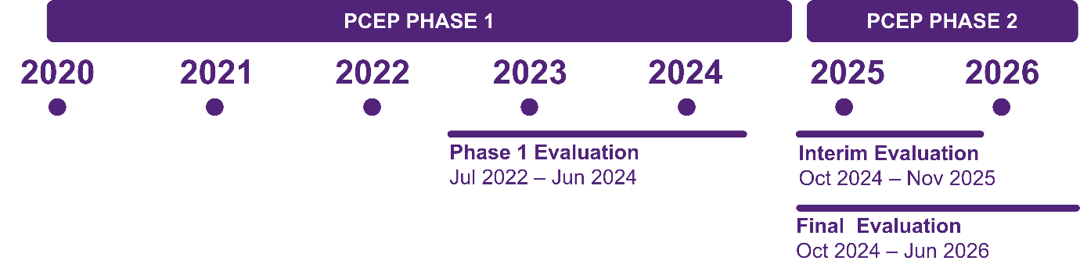
Figure 1: Summary of PCEP Phase 1 and Phase 2 evaluation timing
The Phase 1 evaluation showed that each PHN had delivered training, resources and health literacy initiatives and that co-design with people with intellectual disability was a key feature. Early indications were that PCEP had led to improved knowledge, confidence and skills among primary care providers, including GPs and practice staff, along with greater awareness and use of health resources for people with intellectual disability. Initially slow uptake, including limited GP engagement, appeared to be increasing. The evaluation time horizon and data constraints meant findings were focused largely on intermediate steps toward improved patient care with limited assessment of longer-term outcomes.
This Phase 2 evaluation places greater emphasis on demonstrating changes in primary care practice and settings that are improving, or are likely to improve, patient care and outcomes. It also examines progress and responses in relation to recommendations, enablers and barriers identified in the earlier evaluation with a view to informing potential expansion of PCEP across other PHNs.
- Objectives and scope of the Phase 2 evaluation
The evaluation has 4 key objectives:
- to quantify the appropriateness and reach of the PCEP training and resources
- to quantify any observable changes in health care practice by primary care professionals and practice staff following engagement with the PCEP activities
- to report on any perceived changes experienced by people with intellectual disability and their supporters when receiving primary care services from primary care professionals and practice staff who have engaged with the PCEP activities
- to identify the most effective and efficient PCEP activities that support improved primary care for people with intellectual disability.
The evaluation is structured around a set of Key Evaluation Questions (KEQs) and associated sub-questions. The KEQs reflect core evaluation criteria to ensure a comprehensive approach that encompasses:

- Implementation
- Effectiveness
- Efficiency
- Appropriateness

The KEQs were reviewed with the Department during the development of our evaluation plan, and minor updates were made to ensure alignment with program objectives. An indicator matrix was developed to align indicators with each KEQ, specify data sources, and guide measurement and reporting across the evaluation (Appendix A: Evaluation Indicator Matrix).
Key evaluation questions
KEQ 1 Implementation: How well is PCEP being delivered?
  - What was the uptake of the PCEP training by primary care practitioners across activity type?
  - What was the reach of the PCEP resources to people with intellectual disability and their support networks?
  - Were there barriers to the delivery and uptake of the program, beyond those identified during the first evaluation?
KEQ 2 Effectiveness: How effective is PCEP?
  - Does participation in PCEP activities result in observable changes for primary care practitioners and in primary care settings?
  - Do people with intellectual disability and their supporters observe any perceived changes in health care practice from their primary care practitioner and service provider who has participated in PCEP activities?
KEQ 3 Efficiency: Has PCEP achieved its objectives to a level that demonstrates value for money
  - What is the cost of PCEP and its underlying activities?
  - Which activities represent the best value for money?
KEQ 4 Appropriateness: Is PCEP the most appropriate mechanism for achieving improvements in the quality of primary care for people with intellectual disability?
  - To what extent do the stakeholders find PCEP activities valuable, compared to a scenario where these activities do not exist?
  - Is there evidence to demonstrate that PCEP has had a significant impact, over and above other related programs or initiatives that are being delivered under the Roadmap and through other primary care reforms?
  - Can PCEP build capability in supporting the needs of people with intellectual disability from First Nations and Culturally and Linguistically Diverse (CALD) populations?
The Phase 2 evaluation is guided by an evaluation plan endorsed by the Department on 13 December 2024 and is supported by the PCEP program logic (Appendix B: Program Logic). Co-designed by the Department and the disability sector in 2021, the program logic depicts the pathways through which inputs, actions and outputs are intended to achieve the desired outcomes and impacts.
The program logic guided PHNs in designing local project plans for pilot implementation and was the foundation for the initial evaluation. The initial Abt Global Phase 1 evaluation framed PCEP activities (outputs and deliverables) according to 4 work streams agreed with pilot PHNs during the evaluation co-design process:

- Work stream 1 (WS1): Workforce Training and Development
- Work stream 2 (WS2): Care Pathways
- Work stream 3 (WS3): Information and Resources
- Work stream 4 (WS4): Engagement and Advocacy

In this Phase 2 evaluation, we have used this categorisation as a broad guiding framework for a consistent monitoring and evaluation approach.
This final report summarises the evaluation process and presents the results of the Phase 2 evaluation to 30 April 2026, including key findings, conclusions and considerations.
A Supplementary Document accompanies the report and includes the evaluation indicator matrix, program logic, and information on data sources and limitations.

- Evaluation design and methods
This mixed-methods program-level evaluation draws on data from 4 PHNs participating in the PCEP, each with differing activities and approaches to data collection.
- Overview of the evaluation design
The evaluation applied a mixed methods design to address the KEQs and associated sub-questions. A non-experimental approach was used, combining routinely collected data with stakeholder consultation and document review methods. The program-level evaluation spans 4 PHNs, each with differing activities and data collection approaches. In the absence of a single unified dataset, each PHN provided data relevant to its specific activities and reporting processes. A jointly developed Data Charter outlined agreed expectations and timelines for data delivery and a structured framework to support data reporting across PHNs.
The evaluation does not seek to compare PHNs. Rather, findings have been integrated, where possible, to identify common insights and program-level achievements and outcomes, while also highlighting the unique contributions of each PHN to the PCEP.
The following sections outline the data sources that inform the evaluation, concluding with a summary of key data limitations.
- Data sources
The evaluation drew on 4 core data sources, as summarised in Figure 2. Each is outlined briefly below, with additional detail provided in Appendix C: Data sources and limitations.
  Service records, operational and survey data |   Economic evaluation  data |   Stakeholder consultation |   Policy and program documents
General practice data (POLAR)  Administrative and survey data  Resource mapping | Budget cost and program delivery breakdown data | PHN representatives  Primary care professionals and practice staff  Disability support organisation representatives  People with intellectual disability and their support networks  NCEIDH representatives | Review of key PCEP documents  Review of other related initiatives delivered under the Roadmap  Rapid audit of non-PCEP PHN websites
Figure 2: The 4 core data sources that inform the evaluation

Service records, operational and survey data

General practice data (POLAR)
PHN-extracted general practice data using the Population Level Analysis and Reporting (POLAR) data extraction and reporting tool was available and analysed for 2 PHNs (CESPHN and WVPHN). De-identified data was extracted for all active patients identified as having an intellectual disability within participating practices. Intellectual disability is defined for the purposes of the extraction using an agreed-upon set of Systematised Nomenclature of Medicine Clinical Terms (SNOMED CT) encompassing intellectual disability and related diagnoses that involve intellectual disability (Appendix C: Data sources and limitations; Table C1). For CESPHN, POLAR data was available for 33 practices engaged in PCEP Phase 1 only (n=17), Phase 2 only (n=13), or both Phase 1 and Phase 2 (n=3) from January 2023 to April 2026. For WVPHN, POLAR data was available from October 2024 to April 2026 for 5 practices.

Administrative and survey data
We sought and analysed routinely collected relevant administrative data from all 4 PHNs from July 2024 to April 2026 to describe the implementation, uptake, and reach of the PCEP training and resources.
Where available, we also analysed data from other sources shared by the participating PHNs, including pre- and post-training and event survey data held by PHNs and post-module survey data. Relevant qualitative information was also identified and extracted from the above sources to support interpretation.

Resource mapping
A rapid resource mapping exercise was undertaken to develop a high-level overview of resources developed and used by PHNs during PCEP Phase 2. A structured spreadsheet was developed to collate this information using administrative data provided by PHNs. PHNs were invited to review the draft spreadsheet and make corrections or updates as required. The intention was to highlight the breadth and focus of resources rather than serve as a comprehensive audit.

Economic evaluation data
Determining whether a program provides value for money requires the use of economic evaluation, i.e. the comparative analysis of 2 or more alternative courses of action in terms of both their costs and outcomes. We adopted a pragmatic approach, assessing the PCEP program costs relative to the outcomes achieved. We surveyed each of the 4 PHNs to obtain data on:
- the total budget allocated to PCEP Phase 2 in Financial Years (FY) 2024-25 and 2025-26
- the percent allocation of funds across different PCEP activities
- the total amount of underspent funds that were carried over to the next financial year, for FY 2024-25 and FY 2025-26, where applicable.
The health economics team worked with each PHN to ensure that the total budget values provided align with the Department’s records. They also worked with each PHN to allocate the total annual budget across the 4 previously defined work streams, based on the PCEP program logic.
Costs are reported as consolidated totals across all PHNs for each of the 4 work streams.
A full economic evaluation was not possible due to limitations of the outcome data and the lack of a comparator. An exploratory analysis was conducted to estimate the level of health improvement, measured in quality-adjusted life years (QALYs) gained, required for the PCEP Phase 2 program to be considered cost-effective.

Stakeholder consultation
Stakeholder consultation took place throughout the evaluation. Online interviews and discussion groups were conducted between June 2025 and April 2026 with:
- participating PHN representatives and program staff, to understand PCEP Phase 2 activities and implementation experiences
- primary care professionals and practice staff (e.g. GPs, practice nurses, practice managers), to explore perceptions of PCEP uptake, implementation, and factors influencing engagement
- Disability support organisation (DSO) representatives, to capture perspectives on PCEP implementation and engagement with PHNs
- people with intellectual disability and their support networks, to understand experiences of receiving care
- representatives from selected non-PCEP PHNs, to gather insight into their work in intellectual disability health, and views on potential expansion of PCEP
- NCEIDH representatives, to identify areas of alignment with PCEP that could be leveraged to support future implementation.
Figure 3 summarises stakeholder participation across consultation groups. In total, more than 60 individuals participated in consultations, with many of the small group discussions involving several participants.
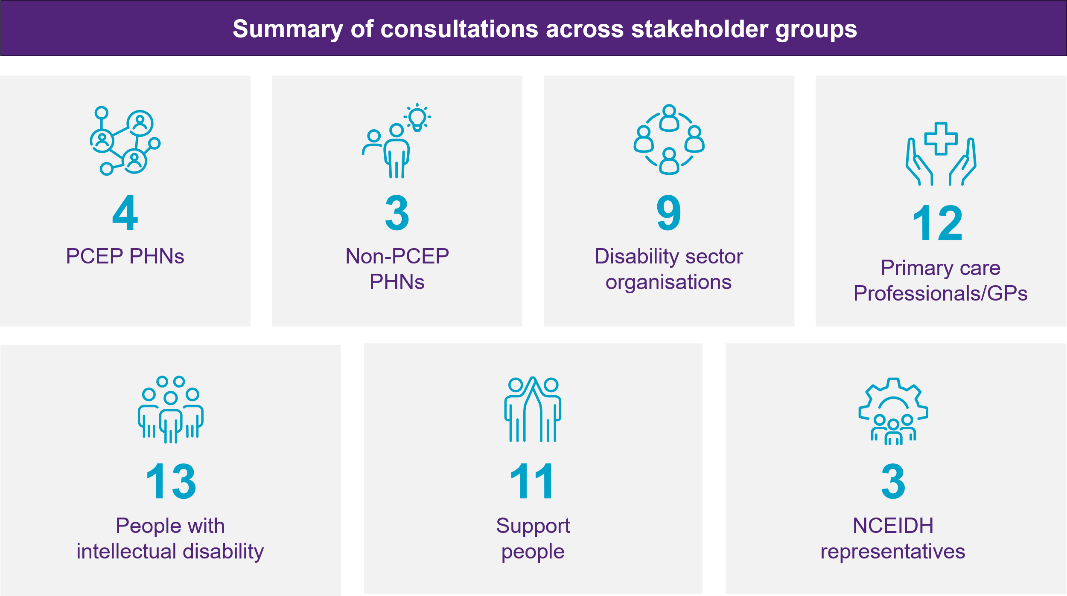
Figure 3: Number of consultations across each stakeholder group
Note: The number of individuals exceeds the number of consultations, as some of the above consultations included multiple participants. PCEP PHN consultations included various PHN representatives and program staff; non-PCEP PHNs included PHN representatives.

Policy and program documents
A rapid review of key PCEP program documents complemented the stakeholder consultation data. The review included:
- landscape analysis – to assess how the PCEP program aligns with other Australian Government initiatives funded under the Roadmap
- audit of non-PCEP PHN websites – focusing on the availability of resources related to intellectual disability health.

Ethics approvals
Ethics approvals for the project were obtained from The University of Queensland’s Human Research Ethics Committee following full committee review: ID number 2024/HE002363 (3 March 2025) and ID number 2025/HE000465 (19 September 2025).
- Data constraints and limitations
The evaluation findings should be interpreted in light of limitations in the available data (Appendix C: Data sources and limitations), while also recognising the strengths of the mixed-methods design and collaborative evaluation approach in supporting a balanced and evidence-informed assessment of implementation and emerging outcomes. Key data considerations are outlined below.

Implementation differences across PHNs
PHNs have implemented and adapted activities differently over time due to staffing changes, shifting priorities and local contexts. Some activities will have longer-term effects on practice that are not yet captured in this evaluation. For example, changes in annual health assessments (AHAs), care plans and medication reviews may take several months to become evident, due to the time between patient reminders and appointments. Differences in regional readiness, existing sector engagement, and prior funded activities may also have influenced the availability of data. As a result, impacts vary across PHNs and some longer-term effects on practice may not yet be evident.

Practice data limitations
Practice-level analysis focused on data sourced using the POLAR data extraction and reporting tool (used by CESPHN and WVPHN). Primary Sense is the data extraction tool used by CCQ and PHT, and this software could not reliably identify patients with intellectual disability or support consistent comparisons over time. Therefore, practice data is limited and only available for 2 (CESPHN and WVPHN) out of the 4 participating PHNs.
While POLAR data was available for all CESPHN practices engaged in PCEP Phase 1 and Phase 2, for WVPHN, this data was only available for Phase 2, which limits comparisons between pre-PCEP, PCEP Phase 1, and Phase 2. As a result, analysis focused on POLAR data available during PCEP Phase 2, with comparisons to earlier data where possible.
While SNOMED CT coding was used in POLAR, it is not exhaustive and patients who are not coded under SNOMED CT may be missed. The accuracy of identification also relies on consistent clinical coding. Patients whose intellectual disability or cognitive impairment is not formally coded, or whose condition is recorded only in free text, may not be captured, possibly resulting in under-representation in the data. Qualitative evidence was used to explain, extend and contextualise the findings.

Screening data limitations
Diagnostic screening data was not included because POLAR does not reliably link screening information to specific population groups, particularly for screening that occurs outside general practice. Instead, the evaluation reports on related practice activities, including mental health plans, care plans, medication reviews and AHAs. That said, AHAs were the primary focus of both the WVPHN and CESPHN QIAs. Although changes in other Medicare Benefits Schedule (MBS) item numbers may have occurred during the project period, these outcomes were not directly targeted by QIAs and should therefore be considered potential secondary effects rather than intended outcomes. Further, some Phase 2 activities were completed too recently at the time of this evaluation to identify observable changes in clinical practice and for those changes to then be reflected in POLAR data. Future monitoring is required to capture long-term practice changes.

Limitations around the value for money analysis
A full economic evaluation could not be undertaken due to limitations of the outcome data and the absence of a comparator.

Limitations in stakeholder representation
The stakeholders who participated in consultations were a targeted sample and may not reflect the full range of perspectives across all groups affected by or involved in PCEP activities. Recruiting people with intellectual disability who had consulted with PCEP-trained primary care providers proved challenging. This reflects the frequently reported barriers to research participation experienced by this population.4F Successful recruitment generally relied on highly engaged organisations with established relationships and a commitment to supporting participation. Other organisations and providers did not have capacity to actively recruit individuals with intellectual disability. As a result, while perspectives on care experiences were explored, it was not possible to directly assess perceived changes in healthcare practice attributable to the program.
- Findings

The evaluation findings are structured according to the KEQs and their sub-questions. Findings are grouped within the 4 evaluation domains: Implementation, Effectiveness, Efficiency, and Appropriateness.
Key points are highlighted throughout to enable quick scanning, with supporting detail and analysis provided under each section.

- Implementation
How well is PCEP being delivered?
This section examines how the PCEP is being implemented across the 4 participating PHNs. It focuses on implementation approaches, uptake of activities, and factors influencing program delivery.
Key Points
- PCEP was implemented successfully across 4 diverse PHN contexts, with each PHN tailoring its approach to local needs while maintaining a shared focus on improving primary care for people with intellectual disability.
- Whole-of-practice approaches, including tailored onsite training, QIAs and implementation support, helped practices translate learning into action and overcome barriers identified in Phase 1, particularly limited GP time and challenges in identifying people with intellectual disability within practice data systems.
- Strong engagement was achieved across the primary care workforce, particularly among nurses, practice managers and administrative staff, reflecting the growing role of multidisciplinary teams in supporting AHAs and QI.
- A variety of engagement mechanisms supported participation, including online modules, education and community workshops, peer learning and collaboration with disability and community organisations.
- Improved collaboration between PCEP PHNs and adaptation of successful models from other PHN initiatives (such as Domestic and Family Violence [DFV] PHN pilots) strengthened implementation and supported continuous improvement across the program.
- People with intellectual disability and their support networks were meaningfully involved in the development of training and resources.

Varied approaches to implementing PCEP
Across the 4 participating PHNs, PCEP has been implemented using contextually tailored approaches that reflect local population needs and organisational priorities. Common elements include an emphasis on workforce capability development, the embedding of lived experience in training and resources, and initiatives to strengthen inclusive care within general practice. However, approaches vary in how these elements are delivered, including differences in delivery models (e.g. direct delivery and collaborative commissioning models), and areas of strategic focus (e.g. disaster preparedness, oral health, Supported Independent Living [SIL] provider training, quality improvement [QI]). These differences represent complementary pathways towards shared program objectives. Figure 4 summarises the geographical context, key initiatives, and approaches to implementing PCEP for each PHN, alongside shared initiatives and common approaches across the program.

  Shared PCEP PHN activities and approaches |   Country to Coast  Queensland |   Primary Health  Tasmania |   Central & Eastern Sydney Primary Health Network |   Western Victoria Primary Health Network
  Lived experience embedded in PCEP training and resources    Resources, training and education across primary care practice staff, disability sector, people with lived experience and their support networks    Enhanced referral options through PHN HealthPathways    Dedicated PCEP roles supporting education, training and system strengthening    Linkages to non-PCEP initiatives and events | CONTEXT  Geographically and demographically diverse across 12 local government areas, serving a population of around 841,000  KEY INITIATIVES  Accredited e-learning for primary care, including locally produced videos co-developed with people with lived experience (Healthy Together Project)  QI resources for primary care professionals (Intellectual Disability QI Toolkit)  Initiatives to strengthen health integration with disaster resilience for people with intellectual disability  APPROACH  Whole-of-system strengthening  Collaborative commissioning with disability  sector organisations | CONTEXT  Covers the state of Tasmania, with a geographically dispersed population of around 558,000 across 29 local government areas  KEY INITIATIVES  Co-designed resource development and dissemination including:  Accredited e-learning modules for healthcare professionals  Short video for general practices developed with people with lived experience and primary care practices  Targeted resources addressing priority needs  APPROACH  Whole of primary care practice capacity-building  Statewide coordination  Collaborative commissioning | CONTEXT  Meeting the needs of 1.6 million people in highly populated urban region across 12 local government areas  KEY INITIATIVES  Incentivised, in-practice training and QIAs for primary care practices (Intellectual Disability Primary Care Inclusion Program)  Training and resources for primary care and SIL providers including videos and CPD events5F  APPROACH  Whole of primary care practice capacity-building using direct PHN delivery model  Concurrent capacity building with disability sector organisations | CONTEXT  Covers regional, rural and remote communities across 21 local government areas, serving a population of around 618,000  KEY INITIATIVES  Development of an incentivised, in practice training and support package for primary care (Intellectual Disability QI in General Practice program)  Evidence-informed tools and resources using a ‘test and refine approach’  APPROACH  Whole of primary care practice capacity-building  Collaborative commissioning of primary care QI and training with disability sector organisations (Specialist Intellectual Disability Integrator role)
Figure 4: Summary of the geographical context, key initiatives, and approaches to implementing PCEP for each PHN

Figure 5 presents PCEP activity across PHNs as a single, unified program, illustrating how these activities collectively contribute to an integrated healthcare ecosystem.
- People with intellectual disability and their support networks are at the centre of all PCEP activities.
- The left-hand circle represents training and education delivered directly to primary care practices, including tailored, onsite training and practice support programs as well as online training and resources.
- The right-hand circle represents the whole of sector strategy, which focuses on training, education and partnerships across organisational boundaries. This includes targeted training for DSO and SIL providers.
- These core PCEP activities operate within a broader system level context. This includes the wider dissemination of online training and resources to other health and social care providers, the expansion of referral pathways (including HealthPathways), and opportunistic collaboration with other PHN-related initiatives to amplify impact.
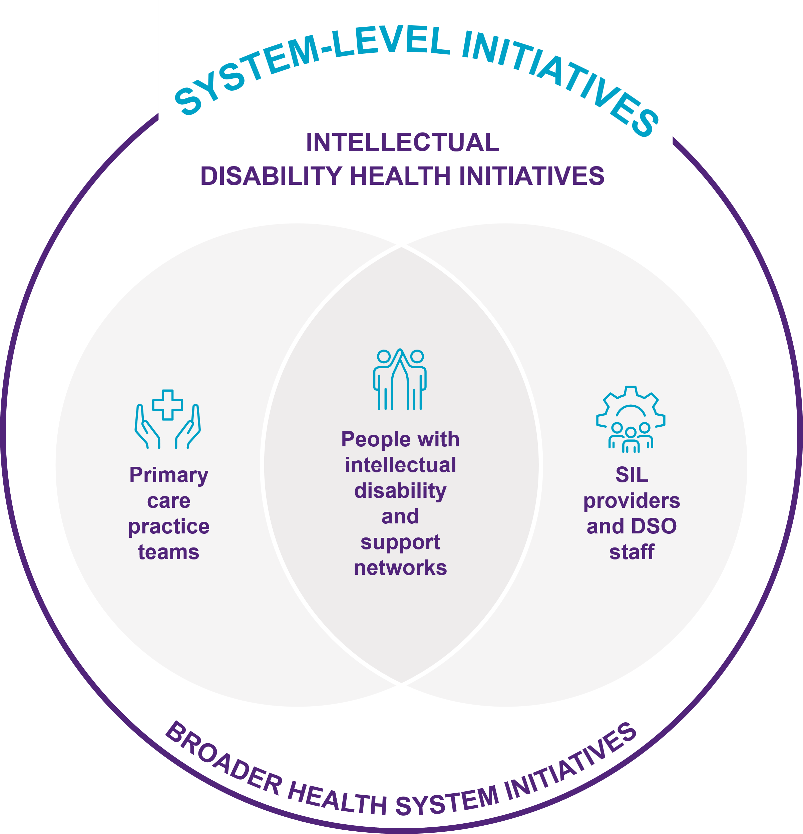
Figure 5: Person-centred care supported by PCEP across practice, sector and system levels

Internal PHN or collaborative commissioning delivery models
In Phase 2, PHNs trialled a range of approaches to PCEP implementation, piloting different delivery models. A key area of variation was the approaches taken by CESPHN and WVPHN to delivering in-practice QI and training activities. CESPHN delivered the program directly through its internal team, and WVPHN commissioned Access Your Supports (AYS), a DSO, to work directly with general practices to deliver training and QIAs. Findings from stakeholder consultations indicated that both models were able to support PCEP implementation through different pathways. The choice between direct and commissioned delivery appears to be less important than the quality of relationships, clarity of roles, and the degree to which both intellectual disability expertise and primary care knowledge are meaningfully integrated into delivery.
Table 1 summarises features of the 2 distinct delivery approaches by CESPHN and WVPHN.

Table 1: Summary of CESPHN direct delivery and WVPHN collaborative commissioning models for in-practice QIAs and training
Model capability | Direct delivery  model (CESPHN) | Collaborative commissioning  model (WVPHN)
  Delivery  approach | PCEP PHN (Project GROW) team delivers training and QIAs directly to practices, supported by other internal PHN teams | Disability sector organisation (DSO) commissioned as Specialist Disability Integrators work with practices to deliver QI and training activities, supported by the PHN through capability building, foundational tools, resources and implementation support
  Expertise and workforce | Project GROW team brings specific intellectual disability expertise, with this being an important requirement for recruitment to these roles  Draws on broad organisational knowledge across other internal PHN teams | Intellectual disability expertise is core – knowledge is grounded in the DSO’s day-to-day work with people with intellectual disability  Complementary clinical and disability expertise helps bridge the gap between clinicians and people with intellectual disability
  Agility and governance | Able to get direct feedback from practices after each visit and pivot immediately when issues arise  PHN senior management closely involved and can make timely decisions on budget and priorities | Strong partnership between the PHN and the DSO supported by regular two-way communication, reporting and collaborative workshops, enabling a responsive test and refine approach  Both PHN and DSO are value-adding to each other’s work and learning from each other
  Practice  relationships and engagement | Benefits on pre-existing relationships and trust between PHN and practices  Prior close collaboration by PHN with different services in the region (complex care, intellectual disability services) and linking in practices with services  Intellectual disability health experience of Project GROW team resonates with practice teams | DSO builds on established PHN–practice relationships and trust, creating a collaborative approach to engagement  DSO became an extension of the broader program team, reinforcing key messages and supporting practice needs  Intellectual disability health experience of DSO staff resonates with practice teams

Uptake of PCEP training by primary care professionals and practice staff
Key Points
- Online learning modules and workshops were delivered, with 913 total completions (387 online; 526 workshop-based).
- There was strong engagement across the primary care workforce, particularly among nurses and practice administration staff and managers.
- High uptake aligns with the expanding role of the primary care workforce in supporting AHAs and strengthening the quality of care in primary care settings.

Online learning modules
There were 8 online learning modules delivered as part of PCEP Phase 2. There were 5 modules developed by CCQ and 3 by PHT (launched in March 2026). Together, these modules cover core areas of practice:
- Strengthening intellectual disability health in primary care, including welcoming patients, improving health appointments, supported decision-making, communication, providing reasonable adjustments, and navigating primary health services (including transition to adult care)
- Clinical care and management, including chronic disease management, oral health, and polypharmacy and safe prescribing.
Between April 2025 and April 2026, there were 347 completions and 84 enrolments in CCQ and PHT learning modules, respectively6F (Table 2).
Table 2: Participation in CCQ and PHT online learning modules by stakeholder group
Stakeholder group | CCQ module completions (April 2025-April 2026) | PHT module enrolments (March-April 2026)
PHN staff | 167 | 14
Nurses | 73 | 9
Allied health professionals | 28 | 12
GPs | 12 | 12
Practice managers | 15 | 4
Practice administration staff | 10 | 12
Other clinical/healthcare providers | 8 | 2
SIL and DSO staff | 7 | 0
Other, not specified | 27 | 19
Total | 347ª | 84
ª Completions refer to the total number of completions across modules (e.g. one individual who completed all 5 CCQ modules would be counted 5 times).
 “[PCEP] has sparked the awareness…the ever-changing world of disability and inclusion, and it's just sort of kept that fire burning just so it doesn't die, you don't get complacent. It helped everyone like we still need to do this every day”
Lead nurse, PHT

Training sessions and workshops for primary care professionals and practice staff
CESPHN and WVPHN delivered in-practice QIAs and training workshops focused on enhancing health outcomes for people with intellectual disability to 27 practices in total (17 practices in CESPHN and 10 practices in WVPHN). Topic areas included:
- Strengthening intellectual disability health care in primary care, including conducting AHAs, communication, and providing reasonable adjustments for people with intellectual disability
- Cleansing and coding data in clinical software
- Comprehensive Health Assessment Program (CHAP) tool education and update training
- GP resource distribution
- Implementation and feedback on resources
- Implementation and enhancement of recall and reminder systems
Between April 2025 and March 2026, 390 primary care practice staff participated in in-practice QIAs and training sessions (Table 3). GPs accounted for the largest proportion of session attendance (39%), followed by nurses (28%) and practice managers (27%).
Table 3: Primary care workforce participation in CESPHN and WVPHN in-practice QIAs and training sessions (April 2025-March 2026)
Role in primary care | Number attended
GPs | 154
Nurses | 110
Practice managers | 105
Practice administrative staff | 11
Medical students | 4
Other, not specified | 6
Total | 390
Note: Numbers represented here exclude specific QIA sessions focused on coding patients with intellectual disability in practice software and developing recall and reminder processes, as these are discussed in section 3.2. Numbers and roles of attendees also do not perfectly reflect how the training is used in practice. For example, practice GPs were required to review patient records to determine whether intellectual disability diagnoses should be recorded in a clinical file regardless of whether they attended training sessions.
Across all training, the strong uptake among GPs and nurses is encouraging, given their critical role in CHAP delivery, coordinating care and ensuring adjustments are implemented in everyday practice in primary care settings for people with intellectual disability. In-practice QIA and training sessions appeared to engage GPs more than online modules. This pattern may reflect implementation factors, including the higher number of workshops delivered and the more recent rollout of some online modules, which may have limited their reach. Financial incentives for in-practice training and the clinically focused content of several workshops with higher GP attendance may also have contributed.
During stakeholder consultations, participants such as the GP below reported that the sessions were “very meaningful”, noting increased confidence, improved communication skills and better approaches to supporting patients with intellectual disability.
“I have had patients with intellectual disability [and used the CHAP], but we didn’t know how to move on. So now I know what to do, how I emphasise a holistic approach, how I make the patients comfortable…I feel that I’m more confident, I know how to make the surroundings more conducive...the patient focus…the communication skills.”
GP, WVPHN

Community workshops and training
As part of PCEP, PHNs also delivered community workshops to people with intellectual disability and their support networks, including family members and both formal (e.g. paid support workers, service providers) and informal (e.g. friends, community members) support networks. Topic areas included:
- Intellectual disability healthcare training for SIL providers, DSO staff and people with intellectual disability and their support networks (CCQ, CESPHN, and PHT)
- Preparing for AHAs (CESPHN and PHT)
- Disaster preparedness and emergency readiness (CCQ)
Between June 2025 and April 2026, 698 participants attended the community workshops (Table 4). People with intellectual disability and their family members/carers accounted for the largest proportion of workshop attendees (73%), followed by SIL providers and DSO staff (16%).
Table 4: Participation in community workshops by stakeholder group (June 2025-April 2026)
Stakeholder group | Workshop participation numbers
People with intellectual disability and carers | 510
SIL and DSO staff | 109
Clinical/healthcare provider | 27
Others, not specified | 52
Total | 698

Reach and engagement with PCEP resources
Key Points
- There were 49 new resources developed in Phase 2, with a further 33 in development or refinement. Resources included webpages, videos, Easy Read materials, learning modules, and practical tools (e.g. checklists, guides, templates).
- Digital resources achieved substantial reach with over 13,500 webpage views, 7,600 YouTube views, and 1,900 HealthPathways views across the reporting period. The number of resources developed in Phase 2 is substantially lower than in Phase 1, reflecting a more targeted approach over time.
- Most resources were developed separately by each PHN, resulting in moderate duplication of effort and content. While local adaptation is important, shared foundational resources across all 4 PHNs covering core topics would promote consistency and efficiency.
- PHNs have recognised opportunities for greater coordination and shared resources, with some collaborative efforts underway. The National Centre of Excellence in Intellectual Disability Health (NCEIDH) has a potential role in developing and maintaining centrally produced resources.
- A robust suite of core resources has now been established nationally. Future efforts may yield greater value from dissemination, adaptation and implementation support to promote uptake and integration into practice, with less emphasis on continued development of new resources.
Within PCEP, resources refer to the range of materials, tools and supports developed and shared with primary healthcare workforce and people with intellectual disability and their support networks. Resources encompassed a diverse range of formats, including videos, Easy Read documents, webpages, learning modules, fact sheets, presentation slide decks, templates, guides or booklets, checklists and visual aids. Collectively, these resources supported professional education and training, enhanced health literacy for people with intellectual disability and their support networks, and supported QI and the delivery of inclusive, person-centred care in primary healthcare settings.
While more than 240 resources were newly developed or identified as an existing resource to supplement the suite of CID resources in Phase 1, PHNs took a more targeted and intentional approach in Phase 2, developing a total of 49 new resources (and 33 more in development and refinement) to better meet local needs and avoid unnecessary fragmentation and duplication.
Figure 6 shows the distribution of PCEP Phase 2 resources across different audience groups, reflecting a whole-of-practice and whole-of-sector approach.
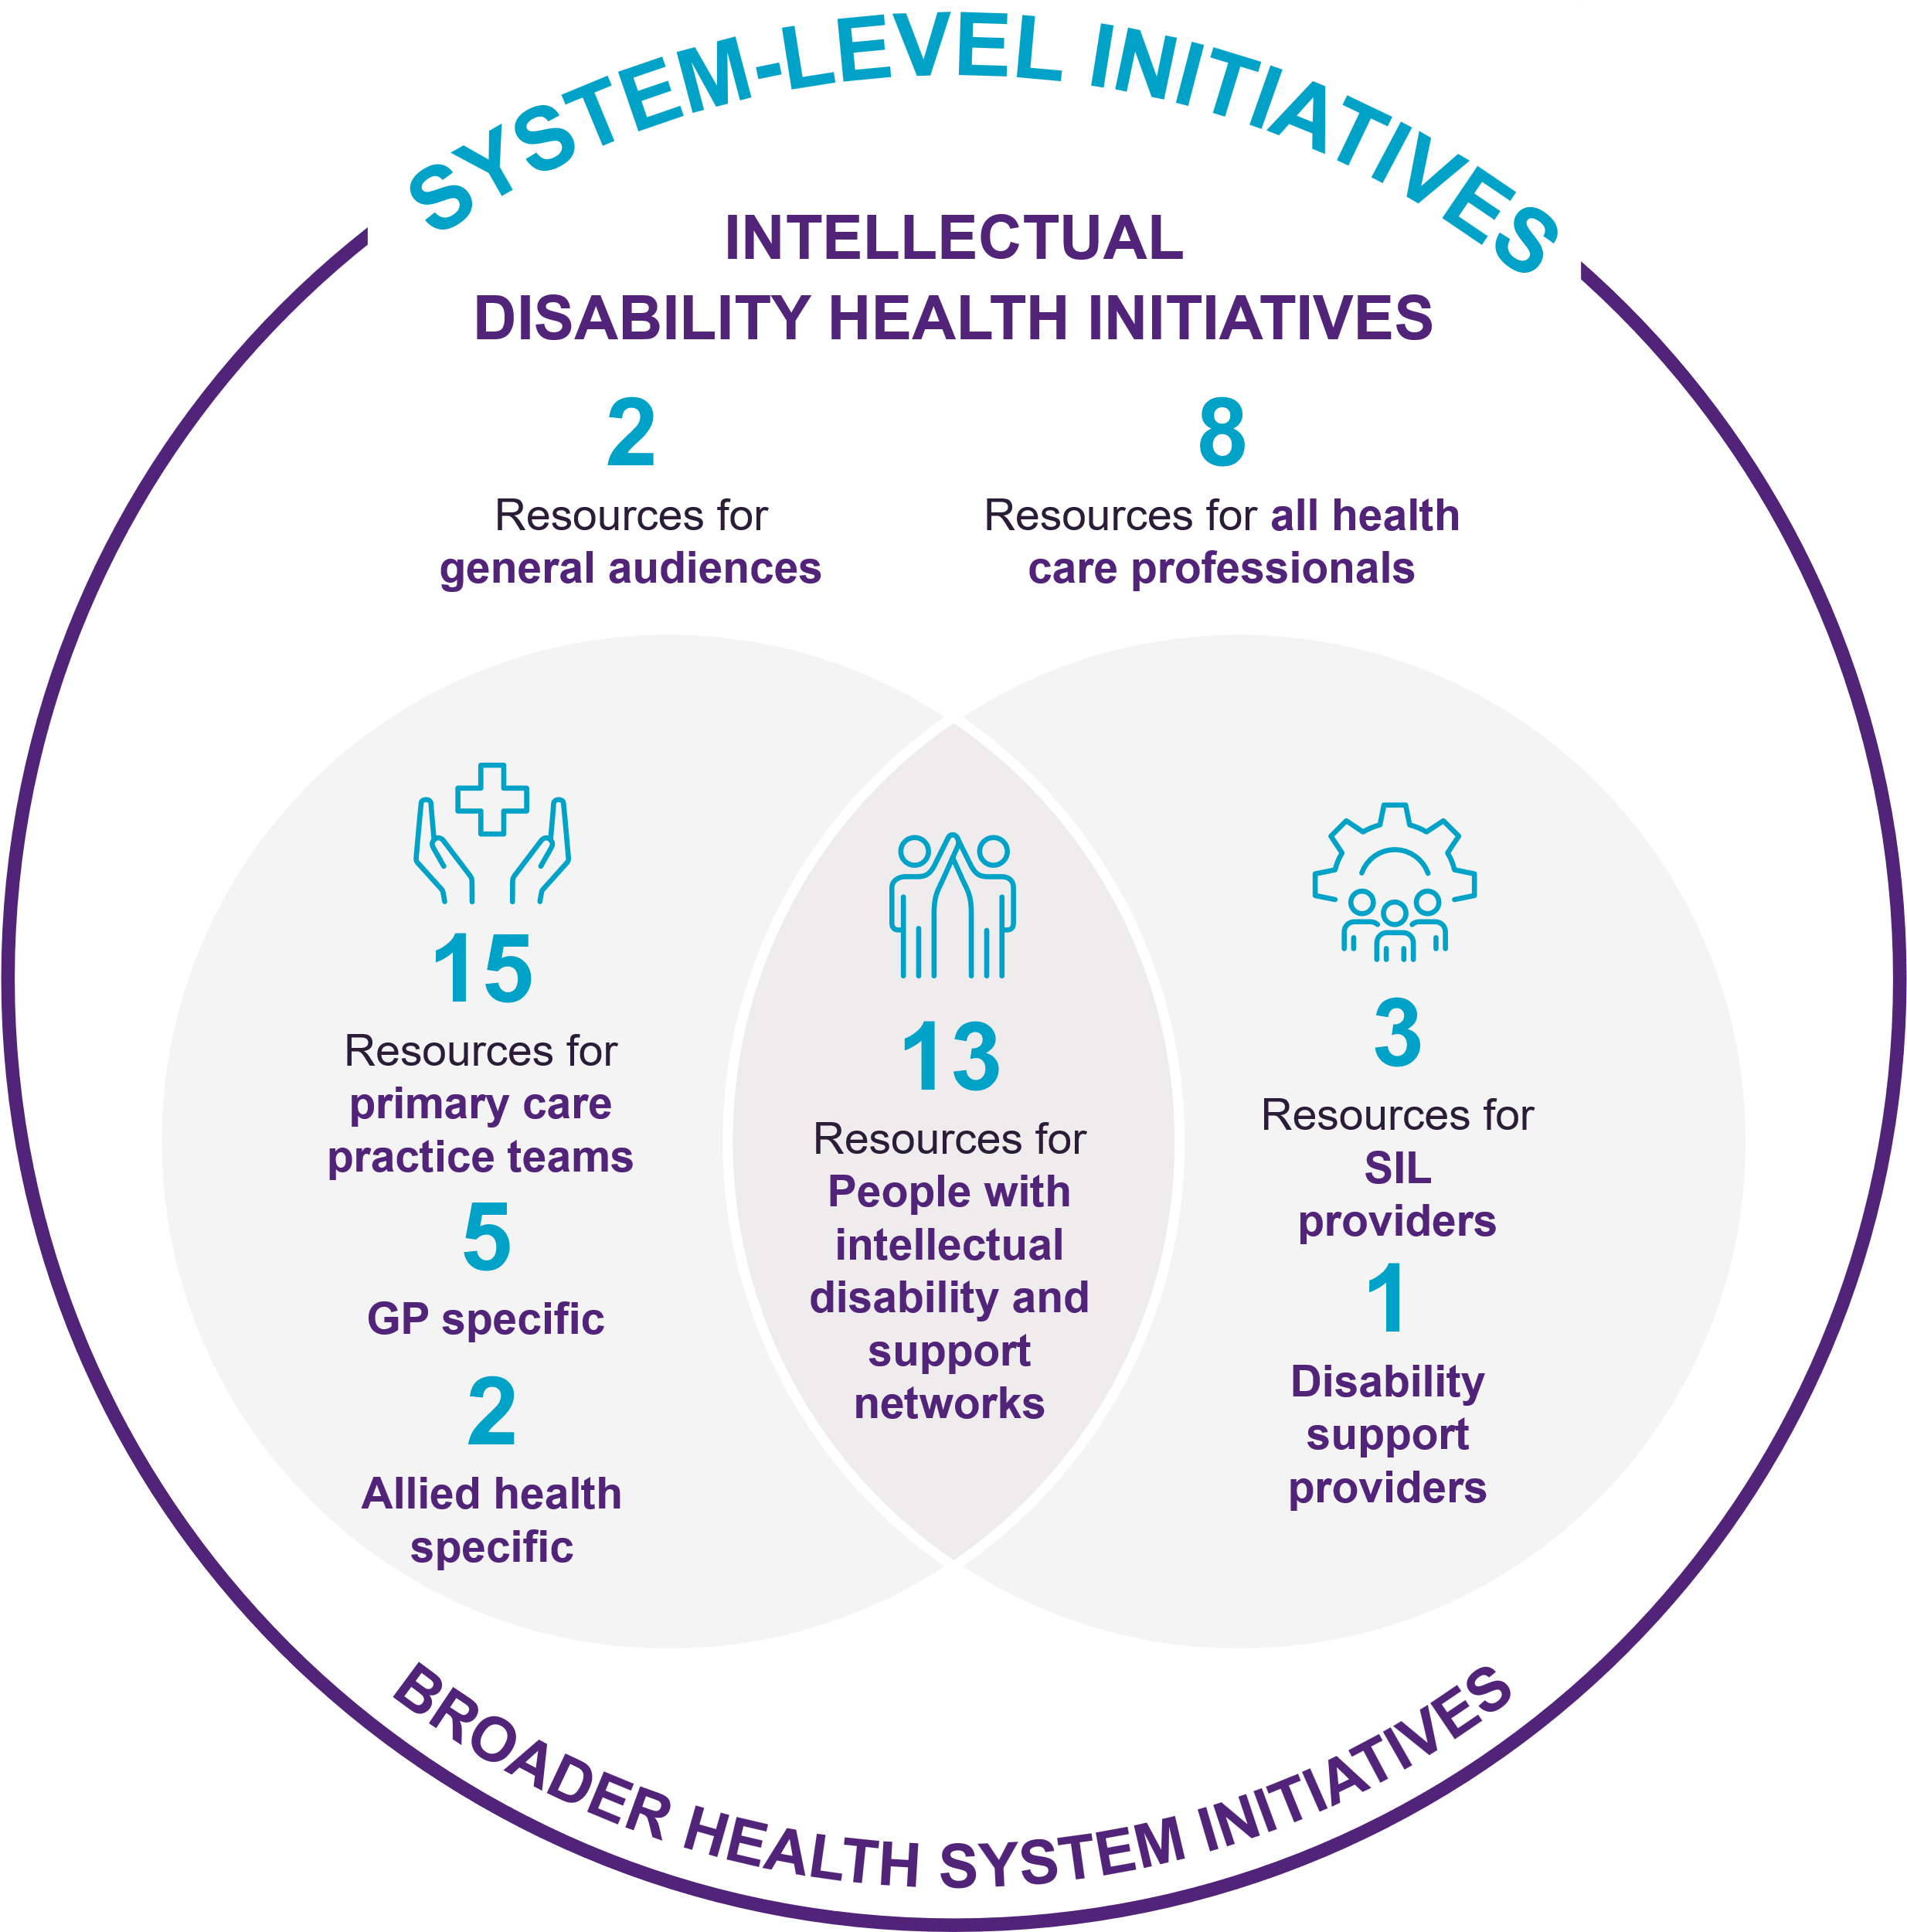
Figure 6: Number of resources across practice, sector and system levels

Types of resource topic areas
All 4 PHNs developed a set of foundational resources aimed at improving healthcare delivery and outcomes for people with intellectual disability. These include foundational information on intellectual disability, AHAs (including CHAP), communication, reasonable adjustments and accessibility, and approaches to support treatment and ongoing care.
In addition to these core materials, each PHN developed resources aligned with their local priority focus areas (Figure 7).
The snapshot below provides an example of practical enablers that contributed to effective implementation.
CCQ | PHT | CESPHN | WVPHN
- Lived experience videos  - Health integration with disaster preparedness resources | - Transition to adult health services  - Oral health resources | - SIL provider training resources  - Oral health resources | - QI in general practices, supported by a catalogue of clinical tools and resources  - Easy read resources for practice settings
Figure 7: PHN local priority focus area resources
The development of similar foundational resources across multiple PHNs in Phase 2 risks duplication of content and effort, particularly for common topics such as intellectual disability, AHAs, and reasonable adjustments. While some overlap is appropriate and important for local adaptation, greater coordination and sharing of core resources could help reduce inefficiencies and improve consistency across the program. PHNs have identified this and started collaborating on the use of resources. For example, CCQ’s lived experience videos are being utilised in CESPHN training. Another example is that PHT recently led a webinar for the disability sector on improving health outcomes for people with intellectual disability. This webinar was supported by all 3 other PCEP PHNs, such as WVPHN’s contribution to content development and stakeholder engagement.
Additionally, while all PHNs developed a small number of project-specific resources in Phase 2, many of the resources used by practices were developed in Phase 1 and continued to be used extensively throughout Phase 2. For example, the AHA Checklist developed by CESPHN in Phase 1 remained a key resource supporting implementation in Phase 2.
Some PHN stakeholders noted that as the National Centre of Excellence in Intellectual Disability Health (NCEIDH) was not operational during the early phases of the PCEP, there was a lot of time spent in the development of resources by individual PHNs and the potential for duplication, however with the development of NCEIDH, it may now be well-placed to play a role in the development of centrally produced resources, further reducing overlap and fragmentation.

Reach and engagement with digital resources
PHNs reported more than 13,500 website views, approximately 7,600 YouTube views, and over 1,900 views of HealthPathways pages. These digital resources served unique audiences; website and YouTube video views reflect engagement from a wide range of audiences, including GPs, disability support organisations, and people with intellectual disability and their families and carers. HealthPathways pages are clinician-facing resources primarily used by GPs. Given these differences, no direct comparisons can be made in reach and engagement with different digital resources. Instead, below we present an overview of general trends over time.
Overall, reach increased gradually over time. A dip in engagement during the second half of 2025 preceded a slight increase in website views in 2026. Webpages were the primary entry point across all PHNs, with individual PHNs, such as CESPHN recording up to 6,635 webpage views. Video content, such as YouTube videos, which were introduced by CESPHN and WVPHN, also generated strong engagement (e.g. over 5,500 YouTube views in CESPHN and over 2,000 in WVPHN), demonstrating the value of varied delivery approaches; however, on average, viewers watched only a small proportion of longer videos. Use of HealthPathways was more variable across PHNs, showing increased uptake in 2026 for several PHNs. Overall, these findings suggest that a mix of platforms can support uptake and may be suited to different contexts and uses (Figure 8), with estimates used from July 2025 onward to account for differences in PHN reporting periods (see note). There is an opportunity for all PHNs to enhance program effectiveness by incorporating the full range of digital resources and drawing on lessons learned from the successful implementation of other PHNs.
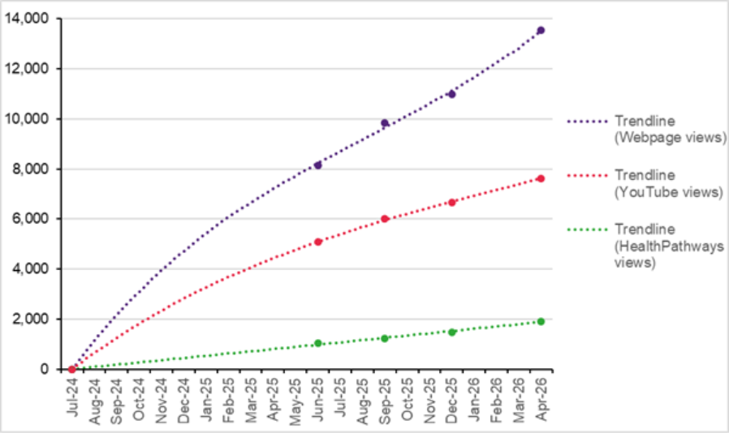
Figure 8: Cumulative curves indicate a steady increase in overall engagement over time
Note: PHNs provided data for different time periods. All PHNs reported data for the initial 12-month period (July 2024–June 2025). For the subsequent period (July 2025–April 2026), PHNs reported data in largely overlapping intervals of 3–4 months. To present cumulative digital reach over time across all PHNs combined, estimates were applied for the period from July 2025 onward.

Qualitative data from stakeholder consultations indicated that PCEP resources have been well-received. Having immediate point-of-care resources available was valuable for GPs. As one GP said, “…doctors like to have something they can go to straight away and have a look when they are referring patients on somewhere else … they need to have those at their fingertips”. Easy Read resources and those incorporating perspectives of people with intellectual disability and their support networks were particularly welcomed.
" What I love about it is those videos and the actual people that have intellectual disability and their carers, because you can see the inside…you can see sometimes a bit of, you know, that frustration that comes up when someone's talking about something that's really close to heart and it really tugs on those heartstrings of like that person gets frustrated just like me… it’s pretty good…”
DSO representative CCQ
Some stakeholders provided suggestions about other types of resources that could be helpful, such as letter templates or phone scripts to convey to patients the importance of completing the CHAP.
“When telling the patient about the CHAP assessment, they're wanting to know, ‘Well, why should we do it and who has access to the data?’…we probably need more support with trying to convince them to do it because it has been difficult… Even a template letter that we could send them or a dialogue that we could say during a phone call…the reasons why, what it means for them”.
Practice manager, WVPHN
In response to this feedback, WVPHN developed patient letter templates and phone scripts to support practices in explaining the purpose, benefits and privacy considerations of the CHAP. These resources have since been piloted, tested, refined and published for use. CESPHN had also developed Easy Read resources during Phase 1 to communicate with patients about attending and completing the CHAP (e.g. Big Health Check resource). Together, these examples highlight the value of sharing resources and learnings across PHNs, building on existing work and supporting consistent, high-quality approaches to patient communication.
Enablers and barriers to the delivery and uptake of PCEP activities
Key Points
- Whole-of-practice approaches with tailored onsite training and support helped strengthen GP engagement and overcome barriers identified in Phase 1, including limited time for training.
- Strengthening the whole-of-sector strategy initiated in Phase 1 fostered cross-organisational partnerships, amplifying the impact of initiatives beyond GP practices.
- Refinements to PCEP training including QIAs to enhance data extraction and reporting helped address persistent barriers identified in Phase 1, including limited GP time and challenges in identifying people with intellectual disability in data systems.
- Components from the Domestic and Family Violence (DFV) PHN pilots, identified as valuable, are being adopted by CESPHN and WVPHN in PCEP Phase 2.

Enablers to PCEP implementation
Qualitative data identified key enablers supporting the implementation of PCEP across participating PHNs. Many of these enablers were established in Phase 1 and subsequently strengthened over time. Other enablers have emerged, particularly in relation to whole‑of‑practice training programs, a whole-of-sector strategy and increased collaboration between PCEP PHNs, including the sharing of lessons learned, resources, and strategic implementation approaches.

Practice‑level engagement and motivation
The whole-of-practice training programs implemented by CESPHN and WVPHN used a suite of approaches to engage GPs, including targeted practice outreach, tangible incentives, onsite training and ongoing liaison. It is important to note that some PHNs may not be positioned to provide direct financial incentives to general practices under current policy and commissioning arrangements, and that their role typically involves engaging practices across a range of initiatives, many of which do not include incentive payments.
Team-based approaches, including involvement of practice nurses, managers and reception staff, supported the embedding of PCEP activities beyond individual GPs, and encouraged shared responsibility for integrating learning into routine practice. Engagement was also enhanced in practices with identified ‘champions’ or a strong existing commitment to intellectual disability care.
“[Practice Manager’s] leadership and engagement enhance the likelihood of sustained practice change and integration of inclusive approaches”
CESPHN administrative data feedback

Fit‑for‑purpose training and resources
Meaningful involvement of people with intellectual disability and their support networks helped ensure training and resources were relevant, accessible and grounded in real‑world needs. Training materials and QIAs were further strengthened by tailoring content to the primary care context, including streamlined, solution‑focused guidance on key topics such as referral pathways and appropriate use of MBS items. Endorsement by peak bodies enhanced credibility, while Easy Read resources supported clearer communication with people with intellectual disability and others with literacy challenges.

Involvement of people with lived experience and DSOs
Strong interest from DSOs and SIL providers, including opportunities for cross-sector training, supported shared understanding and coordination between primary care and disability services. The view across stakeholder groups was that involving people with intellectual disability in the delivery of training helped strengthen engagement, challenge misconceptions and make content more relatable and practical.

PHN leadership and system support
PHNs enabled a coordinated approach to implementation across organisational boundaries due to their established relationships with primary care practices and other organisations with relevant intellectual disability health expertise. Their understanding of the sector, along with commissioning experience enabled PHNs to leverage existing initiatives and events to maximise reach and engagement. In Phase 2, collaboration between PCEP PHNs strengthened shared learning, resource sharing and strategic testing of different implementation approaches. The development and dissemination of education and training resources through PHN infrastructure and platforms has also supported program objectives beyond directly funded activities.
“It has been really valuable for us to get an update on the different activities of the other PHNs and how we can link in and share resources. For example, we have shared our quality improvement resources with quite a few PHNs. We've discussed the mental health work that WVPHN has done. We've recently connected a disability consultant with PHT, who are doing the webinar around the CHAP as well’
PHN representative, CESPHN
“Learnings about the databases, about POLAR, about data extraction, about how other PHNs work, all those kinds of things were all really brilliant learnings to go forward but then also knowing that rather than repeating things, we were able to collaborate with having our own pathways as well.”
PHN representative, WVPHN

The Improving Health System Responses to Family and Domestic Violence (DFV) PHN pilot initiatives may provide relevant insights for PCEP, highlighting a number of key enablers for implementing integrated, whole-of-practice approaches in primary care. The enablers presented draw on findings from the final evaluation report of the initial DFV PHN pilot (2019–2022), delivered across 6 PHNs.
DFV PHN Pilots: A snapshot of program enablers
Delivered across an initial 6 PHNs with $7.5 million over 3 years (now expanded to 12 PHNs), the pilots focused on training and resource development, capacity building within practices, and system integration activities to support coordinated, high-quality care – areas of clear synergy with PCEP. Similar to PCEP, the DFV pilots adopted a tailored, place-based, whole-of-practice approach, with delivery supported by dedicated system integrator roles acting as conduits between primary care and DFV services.
DFV evaluation findings indicate the pilots were widely regarded as valuable, useful, important, and necessary, with system integrator roles and DFV-related training having the greatest impact on strengthening primary care capacity. Success was also underpinned by practical enablers including engagement of DFV services, complementary resources and tools, regular face-to-face contact with practices, and financial incentives to support participation. Together, these findings emphasise the importance of dedicated integration roles, targeted training, and flexible, context-sensitive implementation as key enablers of effective service integration, directly informing PCEP delivery.

Barriers to PCEP implementation
Some barriers to PCEP implementation had persisted since Phase 1 evaluation findings, reflecting enduring system-level challenges in intellectual disability health. Competing demands on general practice time, challenges in supporting complex care, and difficulties prioritising the program in some practices were frequently cited. Awareness of and ease of access to the diverse PCEP education and training resources also remained a barrier. Several challenges are now being addressed through targeted education for primary care practices to improve identification, reminder, and recall processes in practice software and increasing the involvement of the wider practice team in the delivery of disability healthcare.

Competing time, workload and funding pressures for GPs
As identified in PCEP Phase 1, primary care practices continue to face significant time constraints and competing clinical priorities, reducing capacity to engage with PCEP, although refinements to the training model have begun to mitigate this barrier. Most GPs provide care for only a relatively small number of people with intellectual disability in their practices.7F As a result, PCEP training may not be prioritised, contributing to lower uptake. In some practices, reduced availability of practice managers (for example, roles shared across multiple clinics) limited coordination and implementation of PCEP activities. Inadequate resourcing for complex case management, including limitations in MBS billing arrangements, created financial and workforce disincentives for practices, particularly those without nursing or multidisciplinary support. These longstanding funding pressures reflect significant system-level constraints not directly addressed within the program design.

Awareness and access to training and resources
Some healthcare providers were unaware of available PCEP training and resources. It is possible that some resources were still being developed, established, or actively promoted at the time of the evaluation. Information and resources were provided through multiple channels (e.g. webpages, video content) housed in different places, sometimes making them difficult to locate and navigate. GPs expressed a preference for a centralised, ‘one‑stop shop’ to access resources relevant to primary care, patients, families and carers, that enabled different formats to be offered and remain easy to find.

Limitations in digital infrastructure
Limitations in clinical software and data extraction and reporting tools constrained practices’ ability to identify people with intellectual disability within patient data, a recurring challenge throughout the evaluation. While tools such as POLAR partially address this issue, gaps remain, particularly where patients are not coded using SNOMED CT. Where the CHAP tool was not integrated into practice software, manual processes increased administrative burden and reduced usability.8F

PHN implementation and workforce factors
In some PHNs, contractual processes for PCEP‑commissioned organisations contributed to delays in implementation, and turnover within PCEP teams slowed program delivery. Where PHN staff had limited prior experience working with people with intellectual disability, initial hesitancy in engagement was reported. This has been partially mitigated through training that includes lived experience input. Funding uncertainty constrained long‑term planning, relationship‑building and engagement with priority groups. In the context of these constraints, the development and dissemination of practical tools and resources through PHN platforms supported ongoing implementation and knowledge sharing across the primary care sector.

- Effectiveness
How effective is the program?
This section examines whether participation in PCEP activities led to observable changes in primary care practice and settings, and whether people with intellectual disability and their support networks perceived improvements in healthcare delivery from primary care staff who took part in the program.
Key Points
- PCEP is demonstrating strong progress towards its intended outcomes, with early evidence of changes in primary care systems, processes, and workforce capability that support improved care for people with intellectual disability.
- The program is filling an implementation gap within primary care. Implementation support is enabling practice-level change through improved identification of patients with intellectual disability, enhanced coding and data quality processes, establishing reminder and recall systems, and embedding inclusive care processes into routine practice.
- While improvements in health outcomes cannot yet be measured, there is credible evidence that PCEP is driving the practice changes required to achieve them.
- The whole-of-practice model is addressing aspects of care that matter to people with intellectual disability. Feedback from people with intellectual disability and their support networks highlighted that their healthcare experiences depend on the entire practice environment, not just individual clinicians. This reinforces the importance of engaging reception staff, practice managers, nurses, and GPs in implementing inclusive care.

Observable changes in primary care professionals and settings
An important medium-term outcome for PCEP is that primary care professionals apply new knowledge in practice, such as communicating well with people with intellectual disability and using adjustments to meet their needs. This application of knowledge applies to direct care and to broader service settings and organisational structures.
Key Points
- Available quantitative evidence, primarily from CESPHN, indicates that PCEP is contributing to observable practice-level changes, with current indicators showing alignment with PCEP’s intended outcomes.
- In-practice QIAs and training conducted by CESPHN and WVPHN in Phase 2 has:
- enabled 22 general practices to identify 100 additional patients with intellectual disability in practice software through improved coding processes, addressing a key barrier identified in Phase 1.
- identified 273 patients with intellectual disability for reminders following CESPHN’s AHA-focused QIA, creating opportunities for more proactive and systematic care.
- provided early evidence of increases in AHA completions, indicating that practices are beginning to translate program activities into changes in clinical care processes.
- 17 HealthPathways pages about intellectual disability health across the 4 PHNS were viewed 1,204 times, demonstrating engagement with clinical guidance.
- The most-viewed HealthPathways pages align with PCEP-related content, including AHAs (33%), mental health (22%) and challenging behaviours (17%).
- Pre- and post-training surveys across the 4 PHNs show increased confidence in, knowledge of, and use of evidence-informed approaches among primary care professionals supporting patients with intellectual disability.

Changes following PCEP’s in-practice QIAs (CESPHN and WVPHN)
The Phase 1 evaluation emphasised the importance of addressing the limitations of processes to identify patients with intellectual disability in practice software and recording rates of AHAs using clinical extraction tools to improve data to measure the impact of the PCEP on health outcomes. Two PHNs (CESPHN and WVPHN) are explicitly addressing these limitations through QIAs designed to improve the identification of people with intellectual disability through improved coding processes, as well as increase reminders and uptake of AHAs among patients with intellectual disability.
Both programs provided whole-of-practice, on-site QIAs and training workshops to support general practices to:
- cleanse and code data for patients with intellectual disability in clinical software
- develop reminder and recall processes to support patients with intellectual disability to participate in an AHA
- conduct AHAs
- build knowledge and skills in intellectual disability healthcare
- provide reasonable adjustments for people with intellectual disability.
Both programs offered financial incentives to general practices to support participation in program activities. Participation in both programs was open to general practices through an Expression of Interest process. For CESPHN, 18 practices signed Memoranda of Agreement, with 17 practices completing the program between April 2025 and January 2026. For WVPHN, 35 practices submitted an Expression of Interest, and the program had capacity to enrol 10 as program participants between October 2025 and May 2026.
Findings on the effectiveness of the CESPHN and WVPHN in-practice QIAs are below.

Updates to disability status indicators in practice software
Analysis of QIAs from CESPHN and WVPHN to cleanse and code data for patients with intellectual disability in practice software showed that an additional 100 patients with intellectual disability were identified across 22 participating practices9F (Table 5).
Table 5: Number of patients with intellectual disability identified pre- and post-QIA to cleanse and code data (CESPHN and WVPHN)
  # Practices |   Pre-QIA |   Post-QIA |   % Change
22 | 273 | 373 | +100 (37%)

AHA reminder and recall processes
Data from the QIA to develop AHA reminders and recalls showed that all participating CESPHN practices10F identified patients with intellectual disability who required an AHA reminder, with 304 patients identified across 17 practices. Prior to this activity, 7 of the 17 practices had not completed any AHAs for patients with intellectual disability in the previous 12 months. This represents an almost tenfold (881%) increase compared to AHA completions in the prior 12 months (Table 6).
Table 6: Patients identified as requiring an AHA reminder in CESPHN’s Intellectual Disability Primary Care Inclusion Program
Annual Health Assessments - CESPHN
  # Practices |   # in past 12 months |   # identified for a reminder |   % Change
17 | 31 | 304 | +273 (881%)
Note: This timeframe represents the 12 months before the date of the QIA. This data differs across practices, as practices completed the QIAs in different sessions.
Of the 347 patients with intellectual disability identified across practices in CESPHN, 9 (2.6%) identified as Aboriginal and/or Torres Strait Islander, and 52 (14.9%) were unspecified.

Completed AHAs with patients with intellectual disability
Analysis of AHA completion data across 16 CESPHN practices11F found that 41 AHAs were completed before Phase 2 implementation12F, and a further 27 AHAs completed across 9 practices during PCEP Phase 2 (Figure 9). Five AHAs were completed at 3 practices that had not previously completed an AHA with a patient with intellectual disability in the previous year, suggesting new engagement with AHA processes for patients with intellectual disability.
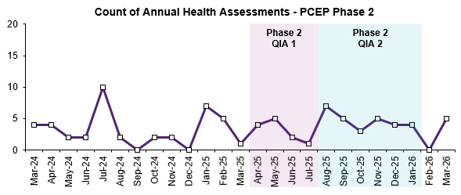
Figure 9: Completed AHAs across 16 participating practices in CESPHN (11 March 2024-31 March 2026). Source: POLAR (CESPHN)
Analysis of AHA completions in WVPHN practices showed that, before PCEP’s in-practice training, 30 active patients with intellectual disability were identified, of whom 5 had an AHA between October 2024 and October 2025, completed across 4 practices. An additional 3 AHAs were completed in December 2025, including one at a practice that had not previously completed an AHA for a patient with intellectual disability in the prior period. Notably, all 3 patients were not previously identified in participating practices’ POLAR data, suggesting that improvements in identifying disability status in practice software supported increased identification of patients and uptake of AHAs.
The evaluation timeframe did not allow for capturing a longer time period following QIA to send reminders to patients with intellectual disability for an AHA, particularly as it may take several months for patients to book and attend appointments following the completion of QIA 2 and subsequent AHA reminders. This limits assessment of the longer-term impacts of PCEP on AHA completion. Ongoing monitoring of AHA recalls, reminders and completions is recommended.

Completed AHAs by PCEP Phase 1 practices
Longer-term analysis of AHAs completed by 20 primary care practices participating in PCEP Phase 1 from January 2023-February 2025 showed a small increasing trend in AHA completions among patients with intellectual disability over time, suggesting sustained impact from Phase 1 training. Continued monitoring after PCEP Phase 2 would allow comparison with this Phase 1 trend over time (Figure 10).
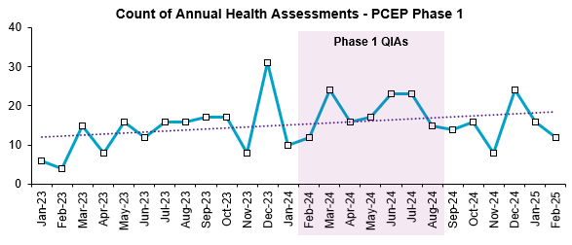Figure 10: Completed AHAs across 20 practices participating in PCEP Phase 1, CESPHN (January 2023-February 2025). Source: POLAR, CESPHN
For the 3 practices that participated in both PCEP Phase 1 and Phase 2 (CESPHN), no AHAs were completed for patients with intellectual disability prior to PCEP. During or after participation in the program’s QIAs, 17 AHAs were completed. This suggests that participation in PCEP may have changed how these practices deliver AHAs (Figure 11).
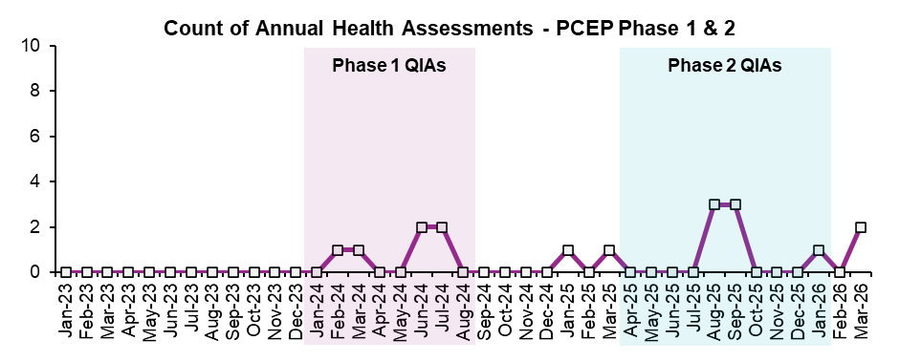Figure 11: Completed AHAs across 3 practices participating in PCEP Phase 1 and Phase 2 in CESPHN (January 2023-March 2026). Source: POLAR, CESPHN

Completion of care plans, mental health plans and medication reviews
Although not the focus of the QIAs, changes in care planning and medication review activities were assessed before and after Phase 2 implementation, noting that increases may reflect AHAs prompting follow-up care and referral. Prior to PCEP Phase 2 (March 2024-March 2025, CESPHN), 16 practices completed 163 care plans, 61 mental health plans and 5 medication reviews. Following participation in QIAs (April 2025-March 2026) there were an additional 40 care plans, 28 mental health plans and 16 medication reviews. The number of practices conducting medication reviews increased from 2 before PCEP Phase 2, to 5 during or after implementation, including 4 practices that had not conducted a medication review for patients with intellectual disability in the year before PCEP.
Before WVPHN’s program implementation, 6 patients had at least one care plan (across 4 practices), and 3 patients had at least one mental health plan (across 3 practices). Following program implementation, an additional 2 patients received a mental health plan, including one newly identified patient with intellectual disability in practice software.
These findings provide early evidence of increased care planning and review activities following PCEP Phase 2, particularly for medication reviews. Ongoing monitoring of these primary care plans and reviews is required to assess longer-term changes following QI and training activities.

Use of HealthPathways pages pre- and post-PCEP implementation
The 4 PCEP PHNs provide a web-based portal (HealthPathways) for primary care practices and other healthcare professionals, offering locally relevant, evidence-based guidance to support the assessment, management and appropriate referral of patients with intellectual disability.
Across the 4 PHNs, there were 17 HealthPathways, with a total of 1,204 views between July 2024 and April 2026. The most commonly viewed pages focused on AHAs with people with intellectual disability (33% of total views), mental health assessment or mental illness (22%), challenging behaviours or behaviours of concern (17%), or genetics-related content (9%). Overall, the content of these HealthPathways pages was broadly aligned with PCEP-related content across PHNs.
These findings reflect the focus on improving the AHA process for patients with intellectual disability, as well as the broad aim of supporting the health and wellbeing of people with intellectual disability across PHNs.

Perceived changes in practice among training participants
Survey data from participants of online learning modules, training sessions and workshops delivered across PHNs was analysed to assess perceived changes in practice among training participants. Findings from PCEP Phase 2 are consistent with those from the Phase 1 evaluation across all PHNs, indicating that PCEP strengthened primary care providers’ ability to deliver inclusive, person-centred care to people with intellectual disability. These findings highlighted the ongoing benefits of the program, including improving knowledge, confidence, and the use of systems to identify and support patients with intellectual disability.
The snapshots below illustrate findings across the 4 PHNs.

E-learning modules and workshops (delivered by CCQ, CESPHN and PHT)
- A high level of suitability and relevance was reported for the e-learning modules provided by CCQ, as well as high levels of participant satisfaction. A majority of participants who completed the e-learning modules on Chronic Disease Management and Oral Health (which had larger sample sizes) confirmed that the objectives were met, reporting that they were “entirely satisfied” and that the activity “entirely met” their learning needs; a slightly lower, though still substantial, proportion also indicated that the activity was “entirely relevant”.
- Changes in self-reported confidence were observed before and after SIL workshops provided by CESPHN. After attending the training, all participants reported at least some level of confidence in providing each of the 5 types of support covered in the workshop. Most reported high confidence in supporting clients to achieve health goals after their AHA, communicating with GPs, and identifying and communicating reasonable adjustments prior to appointments.
- The online training module delivered by PHT was associated with an increase in knowledge of healthcare considerations for people with intellectual disability. While most participants (53%) reported moderate knowledge before the training, 85% reported good to proficient knowledge after the training. The proportion of participants who strongly agreed that they felt confident advocating for appropriate care rose from 53% to 68%, with no participants (strongly) disagreeing after the training (Figure 12).
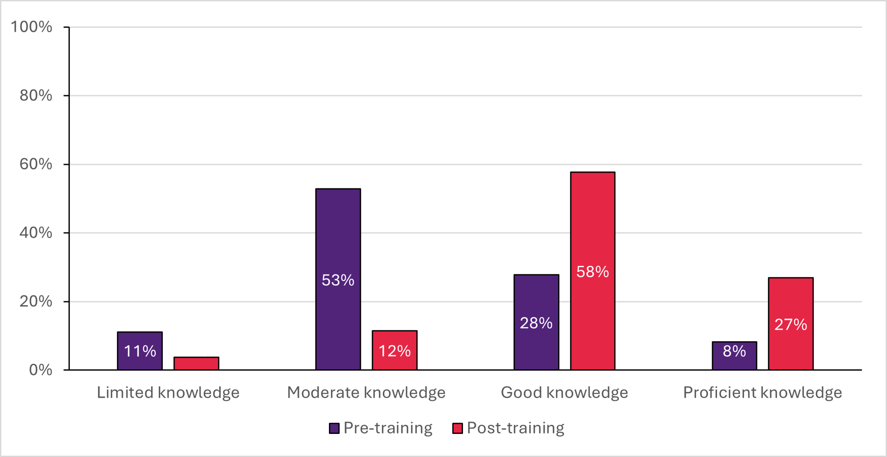
Figure 12: Knowledge of healthcare considerations for people with intellectual disability increased following completion of PHT’s online training modules

In-practice QIAs and training (delivered by CESPHN and WVPHN)
The in-practice QIAs and training provided by CESPHN and WVPHN was associated with increased perceived benefits in professional practice and confidence.
- The majority of participants in CESPHN’s in-practice training program reported observing benefits in their professional practice following participation in the training sessions, as demonstrated, for example, across two separate surveys administered to different samples of participants. This included higher reported effectiveness in the 12-month follow-up survey than in the final evaluation survey, which may reflect the longer period participants had to implement and recognise benefits in practice (Figure 13), highlighting the importance of considering time-related factors when evaluating the effectiveness of PCEP through post-training surveys.
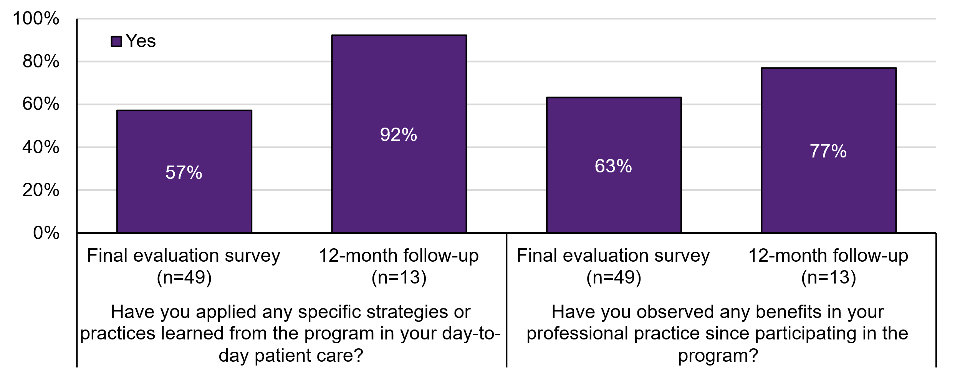
Figure 13: Most participants in CESPHN’s in-practice training reported applying specific strategies in day-to-day patient care and observed benefits in their professional practice
"The ability for people to go into GP practices and give more practical tips on how this can be done is quite useful. Instead of … ‘This is what you should be doing. Well, this is how you can actually do it. And this is [the] way around some of the common problems we find.’”
GP, CESPHN
- Participants in WVPHN’s in-practice training program reported increased confidence in providing care to patients with intellectual disability and in using existing systems to accurately identify and support these patients (Figure 14). The proportion of participants who were extremely confident in providing care increased from 18% to 31%, and no participant reported less than moderate confidence after attending the training. While 41% of participants reported using adapted communication before the training and approximately half were unsure, 100% reported adapting their communication after the training.
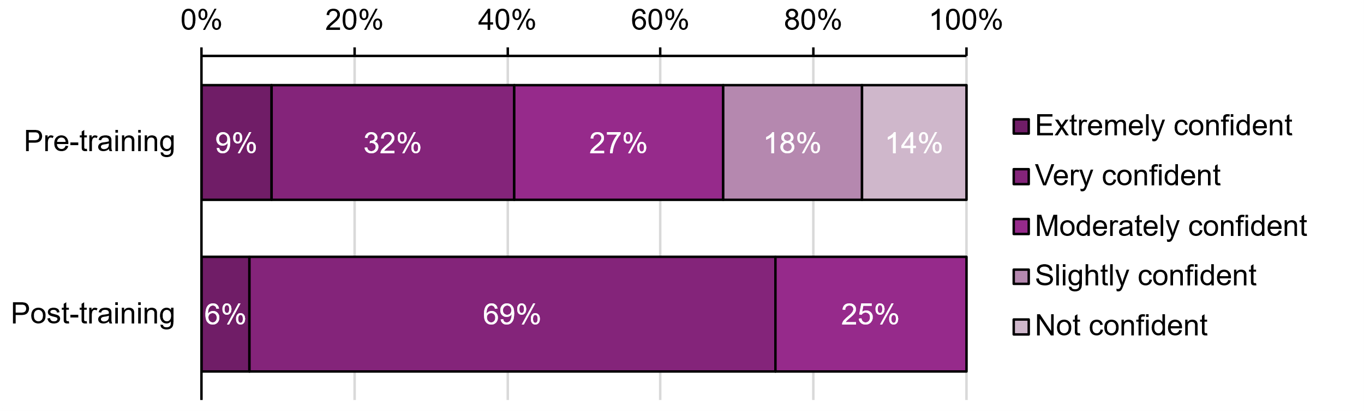
Figure 14: Confidence in using systems to accurately identify and support patients increased after WVPHN’s in-practice training
Overall, participants reported increased confidence following PCEP training, particularly in supporting inclusion, communicating health information, managing condition-specific needs, supporting AHAs and screening, providing referrals, applying legal principles, and accessing relevant care information.
"Annual reminders, doubling of our assessments, providing reminders to patients, providing educational material to patients. So, it's been a few different things. But the main thing there for me is the staff are now more confident than they were 6 months back. So, it's a whole practice approach where everyone's aware of a care plan, assessment, this is what we're doing”
Practice manager, WVPHN

Perceived changes in healthcare practice by people with intellectual disability and their support networks
Key Points
- People with intellectual disability and their support networks shared rich insights into their experiences of primary care generally, describing what helps and what does not.
- Due to challenges in recruiting people with intellectual disability who had consulted with PCEP-trained primary care providers, it was not possible to directly assess changes in healthcare practice linked to the program.
- Varied healthcare experiences described by people with intellectual disability indicate that PCEP is targeting aspects of care that matter most to them.
- Their care experiences depend on the whole practice, not just individual clinicians, highlighting the importance of engaging all roles and embedding inclusive practices across primary care settings.
- Recruiting people with intellectual disability who had consulted with PCEP-trained primary care providers presented challenges. As a result, it was not possible to directly assess perceived changes in healthcare practice attributable to the program. However, those who participated in interviews – 13 people with intellectual disability, along with members of their support networks – provided rich descriptions of what they experience as good and poor care. Their descriptive accounts align closely with the principles and care practices that PCEP aims to promote, providing indirect support that the program is targeting those aspects of care that matter to people with intellectual disability.
While this evidence does not enable attribution to PCEP, it highlights ongoing challenges in primary care access, communication and quality, and reinforces the continued relevance of the program’s objectives. Overall, people with intellectual disability spoke of highly variable healthcare experiences. Some described responsive, person-centred practice – “He did a test to see where my mental health was at… he listened and took it seriously” – while others described rushed or dismissive care: “They don’t believe that I actually have mental health problems”.
Common themes and messages from interviews with people with intellectual disability and their support networks included:
- Communication was the most consistent challenge: many GPs still used jargon, speak too quickly, or directed conversation to carers, leaving people unsure, anxious, not believed, or unable to ask questions or decline treatment.
- Easy Read and other accessible formats were valued but rarely provided, and carers often needed to step in to translate or advocate.
- Many participants had never heard of an AHA.
- Use of reasonable adjustments was variable, and they were mostly provided only when requested. Quiet spaces, longer appointments, and sensory supports were seen as helpful but were not typically proactively offered. Many people did not know they could request adjustments or expect to be included in decisions.
- Structural issues such as workforce shortages, rotating clinicians, inaccessible booking systems, and long waits made it harder for some participants to see the same GP and feel comfortable in their care.
Several participants spoke of how their experiences across the whole of practice impacted care. Some noted that practice nurses provided accessible care, and others described administrative staff as not always responsive to their needs.
Overall, these findings suggest that while PCEP provides a strong framework, challenges that led to its development persist, and ongoing work to embed these practices across primary care settings remains of high value.
Future evaluation would benefit from targeted recruitment strategies to enable direct assessment of changes associated with PCEP-trained primary healthcare professionals and practice staff.

- Efficiency
Has PCEP achieved its objectives to a level that demonstrates value for money?
This section assesses the overall cost of PCEP and whether it provided value for money.
Key Points
- While formal cost-effectiveness was unable to be determined, PCEP represents a relatively modest investment with emerging evidence of system-level change. A total of $3.05 million was invested across Phase 2 (FY 2024-25 and FY 2025-26), with funding directed towards activities designed to strengthen primary care capability and improve care for people with intellectual disability.
- Previous sections of this report show that PCEP is influencing primary care systems and behaviours and has achieved measurable reach and engagement.
- Additional data and continued monitoring are needed to provide evidence of which activities provide the best value for money. Further data and monitoring would also support analysis of whether early gains in practice-level changes translate into sustained improvements in preventive care, service utilisation, health outcomes, and cost-effectiveness.
Cost of PCEP and its underlying activities
Key Points
- The PCEP Phase 2 program spent $3.05 million across FY 2024-25 and 2025-26.
- Training and development activities received the largest proportion of PCEP Phase 2 funding (54% FY 2024-25; 31% FY 2025-26).
- Over 80% of training and development funding was directed toward healthcare professionals.
- Over 60% of information and resources funding was directed toward healthcare professionals.
- There was substantial variation between PHNs in expenditure patterns across financial years.
- Expenditure variation reflects both planned delays in the commencement of PCEP activities and unplanned delays due to the fulfilment of service provider contracts being behind schedule and challenges with staff vacancies.
We surveyed each of the 4 PHNs to obtain data on:
- the total budget allocated to PCEP Phase 2 in Financial Years (FY) 2024-25 and 2025-26
- the percentage allocation of funds across different PCEP activities according to the 4 work streams
- expenditure patterns over financial years.
The results of these surveys are collated in Tables 7 to 10.
All 4 PHNs had the same budget allocation for FY 2024–25; however, there is wide variation in the total budget spent across this period. Contributing factors for the variation in funds spent include delays in expenditure due to the timing of contract commencements, planning and co-design processes to support expenditure on activities planned for 2025-26, service providers being behind schedule in fulfilling ongoing contracts and challenges with staff vacancies.
The total budget spent in FY 2024–25 across all 4 PHNs was $966,416, with the largest proportion (54%) allocated to ‘Training and development’ activities, followed by 26% spent on ‘Information and resources’, 10% on ‘Engagement and advocacy’ and 9% on ‘Care pathways’. Estimates of the budget spent on specific groups indicates that the majority of the budgets for training and development (82%) and information and resources (66%) were allocated to healthcare professionals.

Table 7: Summary of the total PCEP budget across all 4 participating PHNs for financial year 2024–25
Budget Item | Total
Total budget spent in FY 2024-2025 | $966,416
Estimated amount spent by PCEP activity group
Training and development | $522,922
Care pathways | $88,637
Information and resources | $255,185
Engagement and advocacy | $99,672
NOTE. Consolidated activity group categories were developed for the purpose of the evaluation and may not align clearly with all PHN activities. Findings should be interpreted as estimates only.
Table 8: Summary of estimated PCEP spending by target group for financial year 2024–25
Budget Item | Total
Estimated budget allocation to training and development by target group
Healthcare professionals | $427,094
People with intellectual disability, family and carers | $84,716
Both | $11,113
Estimated budget allocation to information and resources by target group
Healthcare professionals | $167,514
People with intellectual disability, family and carers | $72,012
Both | $15,659

The total budget spent in FY 2025-26 across all 4 PHNs was $2,079,394. This is based on the assumption that all available funds were spent in that financial year. The largest proportion of the budget (33%) was allocated to ‘Information and resources’, closely followed by 31% spent on ‘Training and development’, 21% on ‘Care pathways’ and 16% on ‘Engagement and advocacy’. Similar to the prior financial year, the majority of the budgets for training and development (84%) and information and resources (64%) were allocated to healthcare professionals.

Table 9: Summary of the total PCEP budget across all 4 participating PHNs for financial year 2025–26
Budget Item | Total
Total budget spent in FY 2025-2026 | $2,079,394
Estimated amount by PCEP activity group
Training and development | $455,596
Care pathways | $306,430
Information and resources | $490,766
Engagement and advocacy | $233,066
Note: Consolidated activity group categories were developed for the purpose of the evaluation and may not align clearly with all PHN activities. Findings should be interpreted as estimates only. Estimated amounts by PCEP activity group were only available from 3 of the 4 PHNs.
Table 10:Summary of estimated PCEP spending by target group for financial year 2025–26 financial year 2025–26
Budget item | Total
Estimated budget allocation to training and development by target group
Healthcare professionals | $382,757
People with intellectual disability, family and carers | $53,491
Both | $19,348
Estimated budget allocation to information and resources by target group
Healthcare professionals | $315,619
People with intellectual disability, family and carers | $155,799
Both | $19,348
Note: Estimated budget allocations were only available from 3 of the 4 PHNs.

Value for money of PCEP activities
Key Points
- Several limitations hinder the ability to evaluate the value for money credentials of different PCEP activities undertaken by PHNs.
- Future research using data from the Household, Income and Labour Dynamics in Australia (HILDA) survey may be able to estimate the cost per QALY gained that is attributable to the PCEP program, once appropriate data becomes available.
Analysing value for money using standard economic evaluation methods involves the analysis of costs and outcomes resulting from a program when compared to the cost and outcomes that would occur if care as usual was provided instead. The absence of a matching control group by which to assess the costs and outcomes that would otherwise occur in the absence of the PCEP program is a major limiting factor for conducting a rigorous value for money assessment.
Additional challenges included variations between PHNs in the stages of implementation, the specific activities undertaken by each of the 4 PHNs and the lack of quantitative data on client-reported outcomes among people with intellectual disability, families and carers (e.g. measurement of changes in health-related quality of life or health assessments resulting from PCEP activities).
This evaluation considered value for money for the PCEP PHN program, not individual PCEP activities. Due to a lack of data to inform an assessment of value for money for PCEP Phase 2, we present an exploratory analysis to estimate the level of health improvement required for the PCEP Phase 2 program to be considered cost-effective (as measured in quality-adjusted life years [QALYs] gained). A QALY is a widely used outcome measure that captures health gains by combining improvements in both life expectancy and health-related quality of life (with one QALY representing one additional year lived in full health).
This exploratory analysis included all 4 PHNs (CCQ, CESPHN, PHT and WVPHN) based on cost data provided for PCEP Phase 2 across FY 2024–25 and FY 2025–26. The total population across these 4 PHNs was estimated to be 3.99 million (Australian Bureau of Statistics, Disability, Ageing and Carers, Australia: Summary of Findings). Of these, 1.8% are estimated to have an intellectual disability (National Roadmap for Improving the Health of People with Intellectual Disability) and a further 15% are likely to undertake an AHA (note: this is around double the 7% estimate typically observed in GP clinics that have not adopted QIAs) (Inclusion Australia, It’s Doctor Time!).
PCEP Phase 2 was estimated to reach 10,779 individuals across the 4 PHNs, with a total program cost of approximately A$3.05 million. This equates to an average cost of $283 per person. At a commonly applied Australian willingness-to-pay threshold of $50,000 per QALY13F, the PCEP Phase 2 program would need to generate 0.0057 QALYs per person to be considered cost-effective (equivalent to around 2.0 additional days in full health). This value should be interpreted with caution since this is an exploratory analysis.
There is limited published economic evidence on similar programs to PCEP Phase 2 which seek to improve health assessments for people with intellectual disability; with available findings being mixed. A modelled economic evaluation of health checks for people with intellectual disability in the United Kingdom14F found that 0.0743 QALYs were gained over an individual’s remaining lifetime, when compared to having no health checks. As the model followed individuals from age 40 years until death and assumed an average remaining life expectancy of 35 years, this corresponds to an average annual QALY gain of approximately 0.002 per person; which is substantially lower than the gain required for PCEP to be cost-effective. Bauer et al. (2019) also reported substantial incremental costs associated with health checks (£4,787 or approximately A $9,000) resulting in an incremental cost-effectiveness ratio of £85,000/QALY – well above the UK threshold of £30,000/QALY15F. They concluded that health checks were not cost-effective. By contrast, an Australian study analysing Medicare data found that adults with intellectual disability who received health assessments incurred costs similar to those who did not16F.
Future research is needed to evaluate the costs and outcomes attributable to the PCEP program. An analysis using data from the HILDA survey (e.g. SF-6D data to calculate QALY outcomes in PHNs funded by PCEP Phase 2) may be a useful next step. However, the data required to estimate outcomes up to FY 2025-26 (end of PCEP Phase 2) will not be made available until Release 26 (covering Waves 1 to 26) is published, which is expected in early 2028.

- Appropriateness
Is PCEP the most appropriate mechanism for improving primary care for people with intellectual disability?
This section considers whether PCEP is a suitable and meaningful way of improving the quality of primary care for people with intellectual disability. It examines how stakeholders valued PCEP activities compared to having no such program, its contribution beyond other Roadmap initiatives, and its potential to build capability in supporting people with intellectual disability from First Nations and CALD communities.
Key Points
- PCEP is an appropriate and valued mechanism for improving primary care for people with intellectual disability. The program is addressing a recognised gap in primary care capability, system supports and implementation assistance, not routinely filled by other initiatives.
- PCEP makes a distinct contribution to the broader objectives of the National Roadmap. The program’s unique value lies in its focus on implementation support, whole-of-practice approach, and strengthening local care pathways, rather than the provision of training and education resources alone.
- PCEP leverages existing PHN infrastructure and relationships. By building on established PHN networks, practice engagement mechanisms, digital platforms, and QI systems, the program has been able to support implementation without creating substantial new infrastructure.
- The program demonstrates potential for scalability and applicability beyond its primary target population, but this remains largely untested. The combination of workforce training, digital resources, implementation support, QIAs, and established PHN delivery mechanisms provides a foundation that could be expanded to reach additional practices and population groups.

Stakeholders’ perceptions of the value of PCEP activities
Key Points
- PCEP was widely regarded as an appropriate and valued mechanism for improving primary care for people with intellectual disability.
- Whole-of-practice, multidisciplinary training was seen to strengthen primary care capacity and coordination.
- Even small, practical changes in primary care were considered to make a meaningful difference for people with intellectual disability.
- Training and resources for people with intellectual disability and their support networks, including SIL staff, were seen as integral to completing the CHAP and enabling effective follow up care.
- PCEP was reported to have helped legitimise intellectual disability health as a core area of practice, increasing its visibility, accountability, and integration across primary care.
- Lived experience underpinned PCEP design, with strong involvement in some activities. Opportunities were identified to support more consistent lived experience involvement as a key component across regions and activities.

Implementing a whole-of-practice approach
Stakeholders working in primary care settings consistently highlighted the value of a whole-of-practice approach, particularly the inclusion of in-practice training for all staff. This approach was seen as important for strengthening on-the-ground primary care capacity to better support people with intellectual disability, with the potential to reduce avoidable hospitalisations and reliance on tertiary services. A manager of a practice that had taken part in WVPHN QIAs described how, after 6 months, they had been able to assess patient data, identify new and existing patients who were eligible for plans, and begin completing those plans. This had been done effectively by involving “every aspect of the team, whether nursing, reception, admin, so everybody can use these tools to effectively communicate with patients”.
Alongside this observation was the insight that initiatives to support people with intellectual disability in primary care settings do not need to be complex and that some small changes can be impactful. As a practice manager noted “you can do small changes no matter what size your practice is, and that’s actually going to have a really big impact for patients with intellectual disability.”
“I think when you hear reasonable adjustments or disability accessibility, it feels much bigger than what it normally is. You know, sometimes it is just little small tweaks, little changes. Changes that can be made to not having people waiting in the waiting room for 20 minutes…I think there's a lot of people that are still not aware that if you make enough of those tweaks then you make it a more accessible service.”
PHN representative, CESPHN

Enabling support networks for people with intellectual disability
Many stakeholders, including primary care staff, identified that the involvement of support workers and support networks for people with intellectual disability as integral to completing the CHAP and supporting follow-up.
Alignment with key dimensions of healthcare quality described by people with intellectual disability (as noted in an earlier section) suggests that PCEP is appropriately designed to address their priorities.
While PCEP supported primary care professionals in CHAP delivery, stakeholders noted that some people with intellectual disability preferred not to attend face-to-face clinic appointments. This highlighted a need for additional training and support for people with intellectual disability, their support networks and organisations, to enable engagement with health assessments in ways that are safe and accessible.

Addressing intellectual disability health training gaps
Several primary care providers noted that the PCEP model helps address longstanding gaps in undergraduate and early professional training, where intellectual disability health has often received limited attention across the primary care workforce. A DSO representative highlighted that PCEP’s focus on primary healthcare helps shift the burden of education and advocacy away from people with intellectual disability and their support networks, by better equipping healthcare providers to meet their needs.
“It's been for so long on the advocates and the participants and their support networks to educate the providers around …feeling like they're battling all the time to advocate for their person. And instead, somebody else can educate and feedback the other way.”
DSO representative, PHT

Creating an authorising environment for action
PCEP had provided a form of legitimacy or authorisation for an area of health care that has often been marginalised. As one PHN stakeholder observed, PCEP had led to a shift in thinking about intellectual disability healthcare, from discretionary to a core component of practice, describing how PCEP has “provided a structure, a process and a series of accountabilities to enable the work in intellectual disability to occur”. The stakeholder noted that previously this work was undertaken without external reporting and seen as “a ‘nice to have’ not a ‘we have to do this’”.
Stakeholders also noted how the program had raised the visibility of intellectual disability health by creating an enabling authorising environment that had supported greater consideration of how intellectual disability health intersects with other priority areas and populations. This has enabled a broader range of activities and a stronger system integration role for PHNs, as well as facilitating opportunities for discussion with services and senior leaders that had not tended to occur before.
“We're now starting to see practices now reaching out to us and now start to see these conversations happening about how do people improve their service for people with intellectual disability. We're now starting to see executive at the local districts coming to me in meetings, almost unprompted, raising the issue around, for example, ‘How do we promote vaccination in people with intellectual disability? How do we get the health checks done?’ We would not be having that conversation 2 years ago.”
PHN representative, CESPHN

Involvement of people with lived experience
People with lived experience were involved in the development of original CID resources used in Phase 1, as well as highly involved in the development of some subsequent resources and training. In some cases, this involvement was substantial. For example, a PHN representative described how they had developed a strong relationship with a DSO, which enabled ongoing engagement with people with lived experience, including co-facilitating training, reviewing documents and providing feedback throughout the process.
However, the extent of this involvement appears to have varied across activities. Greater and more systematic inclusion of people with lived experience at all stages of development and implementation is widely recognised as good practice, as it can improve relevance, acceptability and uptake. Achieving this requires dedicated expertise and resourcing. There may be opportunities for NCEIDH to strengthen this approach through partnerships that support sustained and meaningful co-design.

Comparative impact of PCEP in relation to other initiatives
Key Points
- Consultation and document analysis identified PCEP’s distinct contribution within the Roadmap, particularly through its whole-of-practice support and role in shaping local care pathways.
- Strong alignment with NCEIDH initiatives presents opportunities for more coordinated national approaches, including sharing of evidence-based training and resources, clinician networks and co-design expertise.
- A rapid audit of non-PCEP PHN websites suggests PCEP is addressing a gap in the availability and visibility of intellectual disability health resources, where provision is otherwise limited and inconsistent.
- Greater collaboration across national initiatives could improve efficiency and maximise the impact of public investment.

Comparative scope of PCEP with other national intellectual disability health initiatives
In addition to PCEP, 2 key Australian government initiatives funded under the Roadmap aim to improve training, resources and support for healthcare professionals and people with intellectual disability and their support networks. These initiatives are outlined below and compared with PCEP in Table 10 to identify the unique contribution of PCEP to intellectual disability health in primary care.
Improving the implementation of AHAs for people with intellectual disability
The improving the implementation of AHAs for people with intellectual disability initiative aims to increase access to, and uptake of, AHAs for people with intellectual disability. This involves use of MBS items for AHAs, for which people with intellectual disability are eligible, and use of the CHAP, a tool specifically developed to meet the health needs of people with intellectual disability. The main elements of the initiative are described below.
Making a best-practice tool for AHAs freely available to consumers. In November 2022, the Department obtained a perpetual licence to develop and distribute the CHAP, originally developed at The University of Queensland. Updated versions of the CHAP are now available free of charge on the Department’s website.
The It’s Doctor Time! Campaign delivered by Inclusion Australia from August 2024 to August 2025 to encourage people with intellectual disability to have an AHA through their GP. It’s Doctor Time! featured a suite of resources for people with intellectual disability, GPs and clinic staff, families and support networks including fact sheets, social story templates, posters, service provider policy statements, conversation cards, YouTube videos and a media kit.
Developing a digital version of the CHAP to be integrated into GPs’ software. In June 2023, the Department funded the Australian Digital Health Agency (ADHA) to develop a digital version of the CHAP tool, for GP clinical information software vendors to integrate into their systems. ADHA made the digital CHAP and the associated Implementation Guides accessible to GP clinical software vendors on 5 November 2025. Integration is expected to occur in late 2026.
National Centre of Excellence in Intellectual Disability Health
The National Centre of Excellence in Intellectual Disability Health (NCEIDH) is led by the University of New South Wales, as a consortium of 9 organisations comprising universities, research institutes, and disability advocacy organisations. People with intellectual disability are directly involved in co-design, governance and delivery. NCEIDH aims to support the delivery of the Roadmap by improving health services, providing resources and education, identifying and advocating for national priority issues, and improving and conducting research to strengthen the evidence base for intellectual disability health.
The comparison matrix in Table 11 shows areas of complementarity and points of distinction between PCEP and other Roadmap initiatives. This analysis shows that PCEP makes a unique contribution by providing whole-of-practice implementation support for primary care and by promoting local care pathways to support more integrated locally responsive care.
Areas of overlap between PCEP and other government-funded initiatives highlights opportunities for greater alignment, including ensuring consistent and up-to-date training, improving access to high-quality resources, and maximising the impact of public investment by reducing duplication and strengthening collaboration.
Table 11: Comparison of PCEP with other government-funded intellectual disability health initiatives
Intellectual disability health initiatives | PCEP | Improving the implementation of AHAs for people with intellectual disability | National Centre  of Excellence  in Intellectual  Disability  Health
Promotes AHA (CHAP) | Yes | Yes | Yes
Provides healthcare professional training | Yes | No | Yes
Develops and delivers healthcare professional information and resources | Yes | Yes | Yes
Delivers information and resources to people with intellectual disability, and their families and supporters of people with intellectual disability | Yes | Yes | Yes
Promotes local care pathways (HealthPathways) | Yes | Indirect - CHAP tool facilitates referrals | Indirect – training and education facilitates referral pathways, but not specific local care pathways
Implementation support for primary care practices | Yes | No | No

NCEIDH synergies supporting PCEP implementation
Interviews with NCEIDH stakeholders identified areas of alignment with PCEP that could be leveraged to support future implementation:
- Knowledge Exchange Hub: Under development at the time of this report, the Hub (also known as Our Health Space) aims to collate intellectual disability health resources and support a more strategic, coordinated approach to sharing evidence‑based resources nationally.
- National Intellectual Disability Clinician Network: This network brings together healthcare professionals working with people with intellectual disability to facilitate knowledge sharing and support improvements in the quality of care.
- Co‑design expertise: NCEIDH has established expertise in co‑design, supporting meaningful involvement of people with intellectual disability in health education, requiring intentional and appropriately resourced approaches.

Research synergies informing PCEP implementation
Other synergies for consideration include opportunities for PCEP to be informed by a range of Australian Government-funded research projects. These projects, supported through NCEIDH, National Health and Medical Research Council (NHMRC) and Medical Research Future Fund (MRFF) targeted calls for research, aligned with Roadmap commitments, address several topic areas directly relevant to PCEP, including:
- Upskilling practice nurses in the use of the CHAP
- Development of resources to support people with intellectual disability to access blood tests, including desensitisation protocols and sensory-informed preparation
- Trauma-informed care guidelines for people with intellectual disability
- Development of a mental health assessment tool for people with intellectual disability
- Initiatives to improve oral healthcare for children and young people with intellectual disability
- Guidance on sedation for medical investigations
- Development of patient-reported experience and outcome measures for people with intellectual disability.

Rapid audit of non-PCEP PHN websites
A rapid desktop audit of PHN websites not involved in the PCEP initiative suggested that the availability and visibility of targeted intellectual disability health resources across PHNs was limited and unevenly distributed across PHNs. This indicates a lack of consistency in publicly available information for health care providers, people with intellectual disability and their support networks.
Of the 27 non-PCEP PHN websites reviewed, 19 did not appear to feature any content specifically addressing intellectual disability health. The remaining 8 PHNs hosted at least one relevant resource, covering a range of topics, including:
- information on intellectual disability specialised assessment in mental health stepped care
- news items on local specialist services for people with intellectual disability and professional development opportunities for healthcare providers
- palliative care resources for people with intellectual disability
- dementia care for people with intellectual disability.
Several PHNs, including Brisbane South PHN and Brisbane North PHN, hosted multiple intellectual disability health resources on their websites.
The limited availability of intellectual disability health resources on non-PCEP PHN websites suggests that PCEP is filling an identified gap and delivering impact beyond other primary care reforms or related initiatives.

Capability to support people from First Nations and CALD populations
Key Points
- PHNs prioritised improving care for people with intellectual disability, with the expectation that inclusive practices (e.g. communication supports and reasonable adjustments) may benefit diverse population groups.
- While some PCEP resources, such as Easy Read materials and oral health resources, have shown some broader applicability for First Nations and CALD groups, the program’s overall capability to meet the specific needs of these population groups has not yet been tested.
- Effective expansion will require deliberate co-design, partnerships with community-controlled organisations and adaptation of training, resources and QIAs.
Based on stakeholder consultations, PCEP demonstrates potential to build capability in supporting the needs of people with intellectual disability from First Nations and CALD populations, but this capability has not yet been fully realised or systematically implemented in Phase 2.
PHN stakeholders emphasised that people with intellectual disability were their primary priority group for support within PCEP, with the view that improvements in accessibility, such as communication supports, reasonable adjustments, and inclusive practice can create broader pathways for inclusion across diverse groups. In this sense, PCEP reflects an intersectional approach, where centring the needs of a highly marginalised group may generate benefits for other populations, including those from First Nations and CALD backgrounds. Several stakeholders expressed a view that “getting primary care right” for people with intellectual disability was likely to improve care for other populations.
There are emerging indications of broader utility of PCEP resources – for example, the Oral Health Booklet (adapted from NSW Health) has been well-received by First Nations organisations and services in PHT, also demonstrating opportunities for sharing of resources and adapting for local contexts.
Easy Read materials and visual supports developed for people with intellectual disability have reportedly improved accessibility for individuals with limited English proficiency – highlighting potential crossover benefits.
“Pictorial resources have been a great resource to have. Even for people where there might be a language issue too, for people who can’t strongly speak English, it has been help all round.”
Practice manager, WVPHN
PHNs have generally taken a sequenced or maturity-based approach, focusing first on embedding PCEP activities within mainstream primary care before extending to additional priority populations. This approach reflects both strategic intent and practical constraints, including the complexity of engaging First Nations communities in a culturally appropriate way, which requires sustained genuine partnerships, community leadership, and adherence to established protocols.
“With regards to First Nations, it's not something that we haven't thought a lot about. We do think about it, but dealing with First Nations communities isn't just like a little add-on on the side of a project. It requires a lot of thinking, engaging with Aboriginal communities, going through the right channels, needs to be driven by First Nations people. There's a lot of cultural awareness and sensitivities around that. And then combining intellectual disability with that, even more so...”
PHN representative, CESPHN
Uncertainty around program funding and duration has also limited the extent to which PHNs have pursued targeted initiatives for First Nations and CALD populations, given concerns about initiating work that cannot be sustained and the potential risk to community relationships.
While direct adaptation for CALD and First Nations populations has not been a primary focus during this phase, PHN stakeholders consistently identified the need for future phases of the program to incorporate more deliberate co-design and tailoring for priority populations. Effective expansion would require culturally safe co-design processes, partnerships with community-controlled organisations, and adaptation of training, resources, and QIAs to reflect culturally specific needs.
Overall, while current evidence is insufficient to determine whether PCEP can effectively meet the needs of First Nations and CALD populations at scale, the program has established foundational elements that could support future adaptation. Realising this potential will require additional time, sustained resourcing, and community-led approaches, as well as deliberate efforts to embed equity considerations into program delivery and governance.

Other priority population groups
Beyond First Nations and CALD populations, as part of ongoing work, consideration could be given to how PCEP could address the needs of underserved groups that are known to experience significant and intersecting barriers to healthcare access. Stakeholder consultation identified 2 specific groups: people who are in contact with the justice system and those who are socially isolated or marginalised.
In addition, stakeholders across PHNs, DSOs and primary care practices highlighted a “missing cohort” of individuals who experience intellectual disability or cognitive impairment but do not meet current diagnostic criteria which requires onset in childhood (before age 18). This includes individuals with acquired cognitive impairment (e.g. following stroke, epilepsy, or long-term health conditions). Despite experiencing substantial functional limitations, such as difficulties with literacy, employment, and independent living, these individuals are often ineligible for intellectual disability-specific supports and health assessments.
The identification of these groups highlights an opportunity for future PCEP expansion to consider more flexible, needs-based approaches to inclusion, including models that take into account functional impairment in addition to, or in the absence of, formal diagnosis. This would enable PCEP to respond to a broader range of people currently underserved within existing care and support systems, enhancing equitable access and inclusion for those who do not meet traditional diagnostic criteria.

- Considerations for future implementation
This section presents considerations for future and ongoing PCEP development based on findings from the evaluation.

- Future directions and broader applicability

Opportunities for refinement and further development
Opportunities to support refinement, continuation, and future scale-up of PCEP were identified by stakeholders, including representatives of PHNs not currently participating in PCEP. Overall, several areas were consistently identified:
- Strengthening engagement with general practice, such as tailored resources for reception staff and ongoing support mechanisms such as longer-term PCEP check-ins and telephone advice lines for clinicians, providing timely expert support in intellectual disability health
- Enhancing training and resources, including tools to support initial engagement with people with intellectual disability (e.g. structured scripts for first contact), and developing micro-credential training across priority intellectual disability health content areas
- Leveraging existing tools and resources developed through PHN platforms (e.g. HealthPathways, PHN webpages) to support broader dissemination, consistency of practice, and sustainability of program outcomes beyond directly funded activities
- Improving primary care software systems, including better integration of AHAs within practice platforms
- Expanding the PCEP model to support other groups who face similar barriers to accessing primary care, for example people who are in contact with the justice system, those who are socially isolated or marginalised, and individuals with intellectual disability or cognitive impairment not meeting current eligibility criteria due to the requirement for diagnosis in childhood.

Perspectives of non-PCEP PHNs
Representatives of 3 non-PCEP PHNs were consulted to seek perspectives and insights on the potential for PCEP expansion. Overall, they expressed strong interest in the potential of PCEP. People with intellectual disability were viewed as a priority population group, and alignment with the Roadmap was seen as beneficial in ensuring the program responds to nationally identified need. PCEP’s focus on upskilling clinicians to meet the health care needs of people with intellectual disability and its capacity to engage with general practice through a structured and visible program – an area that remains consistently challenging – was an identified strength.
“Having a well thought out project in the intellectual disability health space is useful in providing awareness for GPs and making sure it’s on their radar. So, I guess it’s easier once there’s a huge project up and running…If it’s just in passing that we talk about it with providers, it can get lost with all the other information and everything else they’re trying to provide in their service.”
Non-PCEP PHN representative
Through this consultation, a number of considerations were identified as important for transferability to other PHN regions.

Implementation decisions informed by needs assessment and service mapping
Decisions about implementing PCEP were seen as needing to be informed by needs assessment and service mapping within PHNs, recognising geographic variation. The importance of resource allocation based on community need was emphasised, along with challenges in identifying need due to limitations in available data extraction and reporting tools, with systems such as Primary Sense, not consistently identifying people with intellectual disability.

Complementarity with existing initiatives
PCEP was viewed as having the potential to complement existing PHN-led initiatives rather than duplicate them “so we're not reinventing the wheel” and can “leverage off the good work that has already been done”.
Non-PCEP PHNs reported a range of intellectual disability health initiatives, including workforce education programs, such as low-intensity mental health treatment manuals delivered by allied health professionals, and face-to-face workshops designed to improve mainstream services’ ability to respond to the needs of people with intellectual disability, supported by a suite of online resources. One PHN had direct engagement with PCEP, hosting PCEP resources on its website for use by primary care practices and supporting a NCEIDH funded project to improve health assessments for people with intellectual disability. PCEP’s ability to more effectively engage GPs and primary care practices was identified as a key strength in complementing these existing efforts.

Existing PHN infrastructure
Stakeholders emphasised the importance of being able to implement at scale through existing PHN scaffolding and infrastructure, noting interventions that are aligned with PHN‑funded service models are more readily scalable.

Ability to achieve broad reach across large geographical areas
The importance of avoiding micro‑specialisation was highlighted, with a preference for models that support broad reach across large geographical areas. Models that enable healthcare providers to support people with overlapping needs, rather than relying on a small number of GPs with a specialist interest, were viewed as more appropriate.
“If you could make each general practice 5% better in managing intellectual disability health, you probably generate 20,000 plus better health outcomes in a year…So how do you generate a network effect across, rather than having 5 GPs who are really interested in doing more, how do you get 3,000 GPs to do a little more?”
Non-PCEP PHN representative

Aligned to principles of family-centred primary care
PCEP was viewed as well aligned with principles of family‑centred primary care and as a mechanism to support a broader cohort of GPs to do “a little more” within their existing scope of practice, rather than relying on a small number of highly specialised providers.

Value of a staged, core model with local adaptation
A staged rollout of PCEP, based on a core model with scope for local adaptation was viewed positively by stakeholders. The progress made by the 4 PCEP PHNs could offer “the base level and supporting materials” to enable other PHNs to tailor for their contexts, consistent with a hub-and-spoke model. Clear coordination mechanisms, such as a lead PHN or community of practice to support communication and shared learning as implementation progresses was considered important, along with flexibility to respond to local community needs and adequate funding to support effective implementation.
Examples of program rollouts were cited by PHN representatives, among them being the MyMedicare program rollout, where one PHN assumed a leadership and coordination role, and the DFV PHN pilots (see earlier program snapshot), which may offer relevant lessons for future implementation.
This feedback from a small number of non‑participating PHN representatives provides early, exploratory insights. Further engagement with a broader range of PHNs would help to confirm how widely these perspectives are shared and to better understand practical considerations for implementation at scale.
- Considerations for future implementation
Taken together, the evaluation findings suggest that the PCEP model has strong potential to be scaled and adapted for broader implementation across PHNs, drawing on the resources, expertise and lessons developed in earlier phases.
The program has built clear momentum, and the evaluation has identified enabling conditions likely to support sustainable scale‑up. The evaluation findings inform the following recommendations (and suggested responsible entities).

Program design, delivery and system coordination
- Continue to deliver PCEP through PHNs, which provide a strong enabling environment with established governance and accountability structures. Their existing relationships with general practice and the broader primary care sector support effective implementation of activities that are responsive to local contexts. (Lead: Department; implementation: PHNs)
- Allow flexibility in implementation across PHNs, recognising variation in local context, readiness, partnerships, and priorities, while supporting shared approached and collaboration across PHNs to minimise duplication and maximise impact. Flexibility was viewed positively by participating and non-participating PHNs, as it enabled tailoring of activities. The overall approach to implementation appears less important than maintaining the integrity of core PCEP components, principles and its evidence-informed approach. (Lead: Department; implementation: PHNs)
- Adopt a staged approach to expansion, considering different models of program implementation. There was consistent support among both PCEP and non-PCEP PHNs for a hub-and-spoke or lead-PHN model, with phased implementation across additional PHNs enabling the use of existing resources and lessons learned, while accommodating variation in PHN readiness, priorities and local context. (Lead: Department; implementation: PHNs)
- Develop cross-PHN governance and shared learning mechanisms to support coordinated and consistent PCEP implementation, ensuring that implementation insights are leveraged across PHNs (Lead: Department; implementation: PHNs), including:
  - a national forum or community of practice for PCEP-funded PHNs, enabling shared learning, dissemination of implementation insights and, and consistency across phases.
  - a cross-PHN governance approach to support a collective strategy, align key priorities and facilitate coordinated action.
- Harness synergies between PCEP and NCEIDH activities to strengthen PHN-level implementation and national system initiatives, including alignment with existing platforms and networks where appropriate such as national resource collections, clinical networks, and co-design expertise. (Lead: Department and PHNs, with NCEIDH where appropriate)

Lived experience and partnerships
- Embed lived experience within cross-PHN governance and advisory structures to inform strategic decision making and maintain a focus on outcomes that matter to people with intellectual disability. (Lead: PHNs, with Department)
- Centre lived experience in all program design and delivery, supporting genuine input from people with intellectual disability and their support networks in developing training and resources. This consistently valued feature of PCEP resources is critical to delivering person-centred care that is responsive to real-world needs. (Lead: PHNs, with input from disability partners and experts where appropriate)
- Ensure sufficient time and resourcing for co-design, recognising it as a core component of quality program delivery. Evidence from participating PHNs showed that actively involving people with intellectual disability and their support networks and using a range of co-design approaches produced clear benefits but required significant dedicated time, specialised expertise and appropriate resourcing. Partnering with organisations with relevant expertise (e.g. NCEIDH) can support effective co-design. (Lead: Department; implementation: PHNs, with support from experts where appropriate)
- Strengthen shared learning on co-design and lived experience across PHNs, supporting the dissemination of approaches and lessons learned, while recognising the importance of tailoring to local context within consistent overarching frameworks. (Lead: PHNs, with other expertise and networks where appropriate)

Knowledge sharing and training
- Continue to promote and disseminate high-quality, transferable educational resources, supporting uptake by PHNs, healthcare providers, the disability sector, and other relevant stakeholders. (Lead: PHNs, with other networks where appropriate)
- Support a centralised approach to PCEP education, training and resource sharing to improve accessibility and minimise duplication. This could include leveraging platforms such as the NCEIDH Knowledge Exchange Hub (also known as Our Health Space), or PHN-led coordination mechanisms. (Lead: Department; implementation: PHNs, drawing on existing platforms)
- Strengthen quality, consistency and usability of educational resources, including through quality assurance processes and categorisation by intended use (e.g. setting, target audience, and accompanying instructions for application). (Lead: Department; input from PHNs and relevant expertise where appropriate)
- Expand and share nationally consistent Easy Read resources, to support preparation for, participation in, and follow-up after AHAs, as well as other priority health topics. These resources should be suitable for use across primary care practices and SIL settings. Implementation should draw heavily on the existing high-quality resources developed by Inclusion Australia for the ‘It’s Doctor Time!’ campaign to encourage more people with intellectual disability to see their GP for a yearly health check. (Lead: Department; implementation: PHNs, with input from other organisations with relevant expertise where appropriate)

Cross-sector, whole-of-practice capacity building
- Continue to strengthen PCEP as a cross-sector, whole-of-practice capacity-building model, centred around on-site, multidisciplinary training and engagement across general practice and the disability sector (including SIL and DSO providers). This approach supports practical, relationship-based learning, reduces reliance on GP-only engagement, and enables more coordinated, person-centred care. (Lead: PHNs, with Department)
- Provide financial and non-financial incentives for general practices to support meaningful participation in PCEP, recognising the additional time, complexity, and resource requirements associated with providing care for people with intellectual disability, acknowledging that some PHNs may not be in a position to provide direct incentives under current policy settings (Lead: Department)
- Strengthen cross-sector capability by supporting the upskilling of people with intellectual disability, their support networks and the disability workforce, improving their ability to access, navigate and engage with primary healthcare, and enabling more coordinated care across sectors. This should involve close collaboration with NCEIDH and other expert organisations to support evidence-informed training, resources and knowledge sharing across sectors. (Lead: PHNs, with disability sector partners and organisations with relevant expertise)
- Align PCEP with broader PHN priorities and intersecting sectors (e.g. mental health, acute and tertiary care, oral health and emergency services, and other priority population initiatives), to support more seamless, integrated pathways across the health and social care system. (Lead: PHNs, with Department)

Ongoing monitoring and evaluation
Ongoing monitoring of PCEP activities, including reach and impacts on general practice and health outcomes for people with intellectual disability, requires ongoing and routine data collection. Data collection should be designed to minimise burden on PHNs and practices, while offering alignment and enabling aggregation across the program. Measuring longer-term outcomes of PCEP, such as changes in clinical practice with patients with intellectual disability, will require ongoing monitoring of changes in the use of AHAs and other relevant screening tools.
- Establish an agreed minimum data set for all PHNs involved in PCEP activities. This should be supported by a standardised reporting template for regular reporting to the Department, such as every 6 months, or within an agreed timeframe. (Lead: Department; implementation PHNs). Based on the data available for the evaluation, and current data limitations, recording of the following for each PCEP activity is recommended:
  - activity type (e.g. workshops, online trainings, QIAs)
  - activity start dates, end dates, and duration
  - activity lead and/or facilitator type (e.g. internal PHN, commissioned provider)
  - activity audience(s) (e.g. people with intellectual disability, general practice staff, disability support organisations)
  - activity reach, including the number of participants across audiences (e.g. number of participants who are nurses, general practitioners, administrative staff)
  - demographic information about activity participants, including gender, age, Aboriginal and/or Torres Strait Islander status, and region
  - feedback from activity participants (where applicable)
  - recording of whether formal feedback was collected and, if so, a simplified summary of feedback.
- Develop and disseminate a data dictionary to accompany the PCEP minimum data set to provide clear definitions and guidance to ensure consistent data collection across PHNs. (Lead: Department, drawing on relevant expertise where appropriate)
- Develop and implement a standardised core feedback survey for use by PHNs delivering PCEP activities. The survey should include a set of consistent items to enable aggregation and comparison of data across activity types. There should also be flexibility for PHNs to include survey components tailored to specific local activities. A standardised approach would address current use of bespoke surveys, which limits the ability to assess outcomes across the program. (Lead: Department; implementation: PHNs)
- Implement reporting of the number of AHAs and other key primary care activities (e.g. care plans, medication reviews, screening) for patients with intellectual disability, including the number of patients identified for reminders across practices engaged in PCEP. This will require continued work with general practices to enhance the coding of patients with intellectual disability in practice software. This could include finding avenues to improve identification within Primary Sense or creating general practice processes to assist practitioners in identifying patients with intellectual disability, where POLAR clinical software is not in use. (Lead: PHNs, with general practices)
These considerations set out a coherent framework for scaling and embedding PCEP across PHNs, supporting improved access, quality and continuity of care for people with intellectual disability, and enabling monitoring and evaluation of progress.

Contact details
Associate Professor Fran Boyle
f.boyle@uq.edu.au
issr.uq.edu.au

Institute for Social Science Research
The University of Queensland
CRICOS Provider 00025B • TEQSA PRV12080

Trollor J, Srasuebkul P, Xu H, Howlett S. Cause of death and potentially avoidable deaths in Australian adults with intellectual disability using retrospective linked data. BMJ Open. 2017;7(2): e013489.
Barrington M, Fisher KR, Harris-Roxas B, Spooner C, Trollor JN, Weise J. Access to healthcare for people with intellectual disability: a scoping review. Scandinavian Journal of Public Health. 2025;0(0).
Caltabiano P, Bailie J, Laycock A, Shea B, Dykgraaf SH, Lennox N, Ekanayake K, Bailie R. Identifying barriers and facilitators to primary care practitioners implementing health assessments for people with intellectual disability: a Theoretical Domains Framework-informed scoping review. Implement Sci Commun. 2024 Apr 16;5(1):39
Eveleigh M, Bailie J, Laycock A, Dykgraaf SH, Caltabiano P, Shea B, Lennox N, Ekanayake K, Bailie RS. Access to preventive health assessments for people with intellectual disability: a systematic scoping review informed by the Levesque Access Framework. BMC Health Serv Res. 2025 Jul 1;25(1):867.
Doody, O., L. Murphy, R. Ryan, R. Lyons, W. Tang, and L. Bourke. 2025. The Recruitment and Retention of Individuals With Intellectual Disability in Randomized Controlled Trials: A Scoping Review. British Journal of Learning Disabilities 54: 171–211. https://doi.org/10.1111/bld.70010.
In CESPHN, PCEP activities are delivered under Project GROW.
Participation data was shared differently by the 2 PHNs, reflecting their stage of implementation. CCQ reported module completions over a 12-month period (April 2025-April 2026), while PHT – following the recent launch of their online modules – reported enrolment data over a 2-month period. As the data reflect different measures, they are not directly comparable and are presented separately.
Lennox NG, Diggens JN, Ugoni AM. The general practice care of people with intellectual disability: barriers and solutions. J Intellect Disabil Res. 1997 Oct;41 (Pt 5):380-90.
A separate project addressing digitisation of the CHAP tool for integration into GP software is currently underway.
CESPHN practices = 17; WVPHN practices = 5. Not all practices had data available at the time of the final evaluation report.
Data extracted pre-PCEP implementation is only available for CESPHN, as many participating WVPHN practices only recently began using POLAR
Data were only available for 16 practices at the time of reporting, as the final practice completed QIA 2 outside the reporting period.
Note this number differs from Table 6 as the number of AHA completions recorded by practices depends on the timing of their QIA sessions.
There is no explicit willingness-to-pay (WTP) threshold adopted in Australia for decision making. However, $50,000 per QALY gained is a commonly used ‘rule of thumb’ WTP threshold in health technology assessment (HTA). Carter R, Vos T, Moodie M, Haby M, Magnus A, Mihalopoulos C. Priority setting in health: origins, description and application of the Australian Assessing Cost-Effectiveness initiative. Expert Review of Pharmacoeconomics & Outcomes Research. 2008;8(6):593-617.
Bauer, A., Taggart, L., Rasmussen, J. et al. Access to health care for older people with intellectual disability: a modelling study to explore the cost-effectiveness of health checks. BMC Public Health 19, 706 (2019). https://doi.org/10.1186/s12889-019-6912-0
Bauer, A., Taggart, L., Rasmussen, J. et al. Access to health care for older people with intellectual disability: a modelling study to explore the cost-effectiveness of health checks. BMC Public Health 19, 706 (2019). https://doi.org/10.1186/s12889-019-6912-0
Gordon LG, Holden L, Ware RS, Taylor MT, Lennox NG. Comprehensive health assessments for adults with intellectual disability living in the community - weighing up the costs and benefits. Aust Fam Physician. 2012 Dec;41(12):969-72. PMID: 23210122.

