Evaluation of
Medicare Mental Health Centres
and the Medicare Mental Health Phone Service

About Medicare Mental Health Centres
Medicare Mental Health Centres are an Australian Government initiative, providing free mental health support to people with moderate to high levels of psychological distress or mental health need through short-to-medium term episodes of care. Medicare Mental Health Centres offer immediate support, and no appointment or referral is needed. Centres are staffed by qualified professionals and people with lived experience and can provide warm referrals to other local services where appropriate.
They have been designed to fill a gap in Australia’s mental health system for people who require greater support, or more timely and affordable support, than is available through other Commonwealth or state and territory mental health services. Multiple reviews and inquiries have recommended the introduction of services to fill this gap.
Centres employ multidisciplinary teams, each with a unique mix of clinical and non-clinical roles to best meet the needs of their local community. Teams are made up of a combination of lived experience workers, social workers, psychologists, psychiatrists, nurses, GPs and other allied health workers.
In August 2026, there are 55 centres operating across the country, in a range of metropolitan, rural and remote locations, with 92 centres to be open by mid-2030.

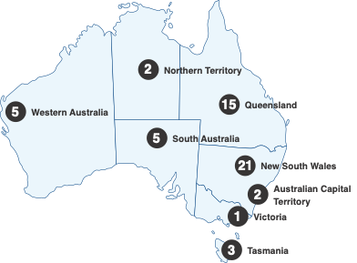

About the Medicare Mental Health Phone Service
The Medicare Mental Health Phone Service is a free national phone line designed to provide support and guidance for people who call, as well as for family members and loved ones.
It is not a crisis support service, but a way to connect people with local mental health services, provide information and advice, and conduct an initial assessment to understand individual needs.

Delivery of services
Medicare Mental Health Centres and the Medicare Mental Health Phone Service are delivered in partnership with Primary Health Networks (PHN).
Both programs rely on the Intake, Assessment and Referral Decision Support Tool
(IAR-DST). Assessment processes are designed to identify suicide risk, immediate safety needs, and the most appropriate response. This tool supports clinicians and trained staff to assess and recommend appropriate services or treatment for people presenting with mental health concerns.

About the evaluation
An Evaluation of Medicare Mental Health Centres and the Medicare Mental Health Phone Service (evaluation) was commissioned by the Australian Government to assess the extent to which these two programs have met their policy intent.
It was conducted by Monash University and the University of Melbourne throughout 2024 and 2025 using a mix of qualitative and quantitative data sources, including reviewing over 230 program documents, consumer and service provider survey responses and interviews, focus groups with PHN representatives, and routinely collected program (and comparator) data.
The evaluation included the first 20 centres opened across Australia and all provider organisations involved in the phone service.

Overview of Medicare Mental Health Centre findings
The evaluation sought to understand how well the Medicare Mental Health Centre program is meeting its overarching policy intent of providing free, accessible, high-quality mental health care to adults experiencing moderate to high levels of mental health need. This care is delivered by multidisciplinary care teams over extended hours.
A National Service Model guides operation of the centres through four core elements:
 | Respond to people with moderate to severe mental health needs, including those in significant distress or at heightened risk of suicide
 | Provide a central point to connect people to other services in the region through service navigation and warm referral pathways
 | Provide in-house assessment, information, and support to access services
 | Provide evidence-based short-to-medium term episodes of care
Findings relating to each of the elements of the National Service Model are explored below.

Respond to people with moderate to severe mental health needs, including those in significant distress or at heightened risk of suicide

What the evaluation found
Data analysis showed that centres are most often supporting people with moderate or severe levels of psychological distress. Results from IAR-DST assessments showed that people visiting centres most often have level 3 IAR-DST scores (moderate intensity care needed). Measurement of people’s levels of psychological distress using a different, simple method of assessment (called the Kessler Psychological Distress Scale or K10) showed that most people entering centres reported severe psychological distress.
Further analysis showed that that people with high distress levels had the greatest levels of clinical improvement.

Provide a central point to connect people to other services in the region through service navigation and warm referral pathways

What the evaluation found
The evaluation found that the multidisciplinary team model is supporting the successful delivery of a balanced mix of care. The most common services are being delivered by social workers, peer support workers, general psychologists, and a range of other allied health workers. While psychological interventions and psychosocial support sessions made up just over half of all session types, almost one third of sessions were clinical care coordination appointments.

*Other services includes but is not limited to: clinical nursing services, child or youth specific assistance, suicide prevention specific assistance, culturally specific assistance and access to Allied Psychological Services.
**Other professionals includes but is not limited to: alcohol and other drug workers, counsellors, case workers/managers, First Nations peer workers, student placements.
***Other includes but is not limited to: GPs, mental health nurses, psychiatrists, clinical psychologists etc.

This indicates that centres are delivering a relatively balanced mix of clinical care and social support, aligned with their role as holistic, community-based hubs to connect people with a range of services.
However, the evaluation also suggested that integration with local services could be improved, with external services often unaware of the centres or unsure of their role in the sector.

Provide in-house assessment, information, and support to access services

What the evaluation found
Approximately four in five people (80%) were being assessed with the IAR-DST assessment tool at intake during 2024. This has reduced from approximately 95% completion rate in early 2022, indicating that compliance with this core element of the model may have dropped off as visitor numbers have increased over time.
While 80% of people receiving an IAR-DST assessment at intake is a strong majority, some centres choose to engage people with soft-entry peer worker sessions before standard intake, building trust where needed before undergoing formal assessment (IAR-DST).


Provide evidence-based short-to-medium term episodes of care

What the evaluation found
On average, people have around ten service contacts per episode of care, and the average episode duration is three to four months.
The consumer interviews showed that many people were referred and connected to other services following their time with the centre, with many receiving multiple referrals out to other services. Where centres are providing short-to-medium term support, they are also connecting people to ongoing services to ensure continuity of care.


Source: Primary Mental Health Care Minimum Data Set

Strengths of the service model

Consumer experience
Evaluation findings indicate that centres are appropriate in meeting peoples’ needs, with most agreeing that they would return to a centre for future services and overall strong mental health improvements through self-assessment.
On a 10-point scale, people rated their mental health an average of 3.5 before accessing services, and 6.9 after. When compared with other PHN commissioned programs, people visiting centres had greater improvements in quality of life and clinical outcome scores.

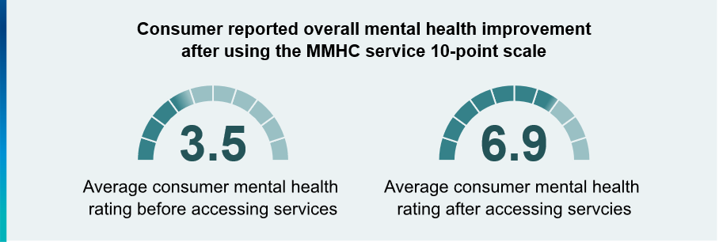

Service provider perspectives
Service providers agreed that centres have a positive impact on consumers. Many clinicians also reported a positive impact on the family and friends of people using centre services, through access to information and advice on support, and reduced costs and wait times.
Staff also expressed that centres are particularly beneficial for people who face barriers to accessing traditional mental health services, such as First Nations people, people from culturally and linguistically diverse communities, and those in older age groups.

Impact of the program
National data sets showed that Australia-wide mental health ambulance attendances reduced by 3% following the introduction of the first six centres. While this data does not directly show cause and effect, it does suggest that centres could be helping to reduce hospital burden across communities.

Findings for further investigation

Governance and oversight
During early implementation, centres reported challenges with clinical governance and clear role definitions. The lack of a shared governance framework has hindered shared learnings and innovations across the network of centres. This has limited the development of consistent quality improvement processes and contributed to inefficiencies in service planning and delivery.
These issues appear to have improved over time, however there is still room for further improvement as more centres are established. In surveys and interviews, service providers and PHN staff expressed the need for greater support, governance and clinical oversight of the program.

Program data
The evaluation shows that centres are responding well to people in significant distress but notes that outcome data is often missing. Missing data rates have improved over time, however significant limitations remain, including psychological distress scores, which are central to outcome assessment.
Of those people with completed outcome assessments, approximately one in three (33%) showed statistically significant improvement and one in four (25%) achieved clinically significant recovery. However, only approximately one third of people (33%) had completed outcome assessments at the beginning and end of their treatment episode. Greater outcome assessment data is needed to fully understand the effectiveness of centres.
Operational challenges for staff members also included limitations in data capture, with existing software failing to record work conducted outside formal episodes of care.
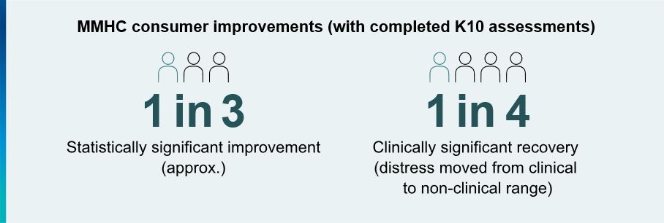

Workforce
The multidisciplinary team model of the program is key to its success. However, there are challenges to achieving the right balance. Centres report unclear definitions of staff roles, particularly relating to the responsibilities for peer workers who were often expected to take on more administrative work. Due to workforce shortages across the sector and limited funding, there are also reported difficulties achieving the right mix of skills, hiring the desired roles, and offering competitive salaries.
Centres work best with short wait times and out-of-hours access, so challenges with workforce availability and stability can impact the quality of service provision.

Service integration and public awareness
Providers and PHN staff emphasised the need for increased communication activities and public awareness campaigns for the program to build awareness and explain the model of care.
Greater awareness is also needed among other health and mental health care providers to improve integration between services.

Future directions
Long-term success for centres requires delivery of integrated care through a stable, multidisciplinary workforce supported by strong governance and clear role definitions.
When assessing the overall strength of the program, the evaluation concluded that Medicare Mental Health Centres is a successful program that should continue without large redesign or overhaul needed. Instead, the evaluation offers some suggested improvements to target the areas of the program that require additional support.

Program governance
The Commonwealth should enhance program governance, especially as the network of centres continues to expand, and investigate what level of national clinical governance would be appropriate to better support centre staff and outcomes for people visiting the centres. The program could provide a framework for implementation, outlining expectations of staffing, service integration, and governance.

Program data
Future evaluation and continuous improvement require more and better data. The current dataset alone cannot be easily used to inform future placement of services. Planning would be significantly enhanced with better linkage of relevant national datasets, ideally in conjunction with local workforce and service provision modelling tools. This would help to inform and support important decisions, such as where new services should be established.

Workforce
Workforce challenges persist across the entire health and mental health system in Australia, not just in the centre program. The department should investigate further what can be done within the current workforce environment to support centres, such as encouraging centres to partner with universities to provide student placement opportunities or promoting the inclusive culture and rewarding work of the program.

Promotion and service integration
Service integration is another challenge that is not unique to centres in the context of the Australian mental health sector, although centres face this challenge alongside a lack of broad community and provider awareness of the program. More promotion and communication would help ensure the right people are accessing centres and that they are better understood by the rest of the sector.
This will also contribute to more effective integration of centres into the mental health system as a program providing not only psychological care, but holistic coordination support.

Evaluation – Medicare Mental Health Phone Service

Overview of findings
The Medicare Mental Health phone service is designed to provide people with accessible mental health support – including information, advice, assessment, and referral to local services.
The Commonwealth funds PHNs to implement their own local phone service, adapting the program to meet the unique needs of their location.
The phone service is a crucial resource for people who might otherwise struggle to access mental health services as there are no eligibility requirements. The evaluation found that community awareness of the service is low and that many potential consumers might not know it exists.
The growth in the reach of the phone service has been significant, with the number of calls more than doubling from approximately 50,000 in 2022-2023 to over 120,000 in
2023-2024. This increase in demand is a good sign for the program, but more needs to be done to spread awareness to the general population.

Strengths of the model
A key aim of the phone service is to offer a seamless care pathway for consumers to receive the right level of care at the right time to meet their mental health needs.
This requires the phone service staff in each area to have strong relationships with local services and keep updated waitlist information to direct users to the most appropriate support.
The evaluation refers to this information as a local service directory – and findings show that the success of the phone service is largely dependent on the quality and timely updates of each PHN’s local service directory.
Overall, the feedback from those who had used the phone service, phone service staff, and PHN staff was that the phone service is a simple access point for mental health support.

Feedback
 | Positive Experience | Negative Experience | Key Factor
Consumers | Where the phone service contacted external services on their behalf, ensuring referrals connect and following up | Disorganisation from the service, communication gaps and lack of follow-up, having to retell their stories | Organised and proactive service delivery
Providers | Having a strong relationship network with local services, regularly updated directories | Poor local networks especially in rural and remote areas | Strong network of relationships and updated directories
PHNs | Having clinical staff to handle calls, having high-quality training available | Limited capacity and knowledge to establish service directories where they don’t already exist, unable to meet demand due to workforce challenges | Strong workforce able to deliver the service and establish relationships

Approximately half of the consumer cohort surveyed attributed the phone service to improvements in their mental health and wellbeing.
- More than half of respondents reported than the phone service improved their knowledge of available mental health services and strategies. They also felt that the removal of barriers to care was a contributing factor to their improved mental health.

Findings for further investigation
Feedback is mixed across consumer, provider, and external stakeholder groups – indicating that the program is delivered somewhat inconsistently across different regions and PHNs.
Where the phone service was working well, staff and stakeholders reported the following factors that helped enable their success:
- Integrating with MMHCs or other PHN services to share resources and maximise efficiency
- System capability to access and transfer patient assessment/referral information between the phone service and MMHCs
- Prioritising resourcing to develop service directories where they need to be established and to maintain ongoing updates
Where there were more challenges implementing the model, feedback included the following barriers:
- Workforce shortages and difficulty finding and training staff with the needed abilities and knowledge to provide the service
- Lack of free or low-cost services to refer people to, difficulty collaborating with services, and high demand across the mental health sector
- Communication challenges, whether through the inability of systems to share consumer information or through the service failing to adequately follow up or reach out where needed.

Future directions

Governance and oversight
The current governance arrangements should be reviewed to identify where centralised supports can be strengthened to achieve greater national consistency for the phone service. Preserving the ability for PHNs to adapt the phone service to their local needs is important, but the inconsistency within the program needs to be addressed through stronger national oversight and support for the program.

Program data
The data for evaluation and analysis of the program could be improved with standard financial and workforce reporting. This would create a greater body of information to evaluate in the future, along with a stronger understanding of the resource allocation and effectiveness of services across different PHNs.
The program would also benefit from responsive forecasting to appropriately allocate resources across services when most needed. This would also support greater national consistency, allowing the department and PHNs to work together to manage increased demand without compromising service quality.

Workforce
The department should consider developing national guidance on role definitions for phone service staff, outlining consistent expectations for the program across all PHNs. Alongside guidance, training should be provided or made available to all staff on topics including mental health assessment, crisis intervention, and cultural competency.
More support is needed to improve job stability and staff retention, such as longer employment contracts and greater flexible working arrangements.

Service integration and public awareness
The department should identify strategies to support and enhance collaboration between services. Relationships need to be built and strengthened across the mental health sector, and the Commonwealth can play a key role in leading by example and making connections with non-government organisations or state and territory services.
The department should also continue to support the MMH Phone Service Community of Practice as an important pillar for the shared learning and collaboration across the network of service providers and PHNs.

For more information about Medicare Mental Health Centres, visit:
medicarementalhealth.gov.au

