Electronic National Residential Medication Chart (eNRMC)

Dispensing arrangements - transition to conformant eNRMC systems
19 September 2026
This fact sheet explains the dispensing arrangements available to pharmacists while residential aged care homes transition from Transitional electronic National Residential Medication Chart (eNRMC) systems to conformant eNRMC systems.
These arrangements apply during the current eNRMC implementation period, while residential aged care homes are adopting conformant eNRMC systems and some pharmacies are still moving from Electronic Prescribing - Participating Software Conformance Profile v2.3 (EP CPv2.3) dispensing software to Electronic Prescribing - General Prescribing Systems and Other Connecting Systems Conformance Profile v3.0.1 (EP CPv3.0.1) conformant dispensing software.
Expanded functionality available in dispensing systems conformant with EP CPv3.0.1 includes the ability to retrieve electronic medication chart prescriptions directly from the National Prescription Delivery Service (NPDS). In contrast, EP CPv2.3 systems do not support retrieval of electronic medication chart prescriptions from the NPDS, requiring pharmacists to manually transcribe prescription information from the eNRMC into their dispensing software. The applicable dispensing pathway depends on the combination of the eNRMC system that creates the prescription and the dispensing software used by the pharmacy.

How will pharmacists identify electronic prescribing (CPv3.0.1) conformance in their system?
When a prescription is created in an eNRMC prescribing system conformant with Electronic Prescribing – Medication Chart Prescribing Systems Conformance Profile v3.0.2 (EP eNRMC CPv3.0.2), the prescription will include a QR code or barcode. Pharmacies using EP CPv3.0.1 conformant dispensing software can scan the QR code or barcode to retrieve the electronic medication chart prescription from the NPDS. A QR code or barcode is generated for each prescription or medication chart order to enable prescription retrieval.
Use the decision tree (figure 1) below to identify the applicable dispensing pathway based on the pharmacy’s dispensing software, whether a QR code or barcode is present and valid, and whether the prescription can be retrieved from the NPDS.

Which eNRMC dispensing pathway should pharmacists use?
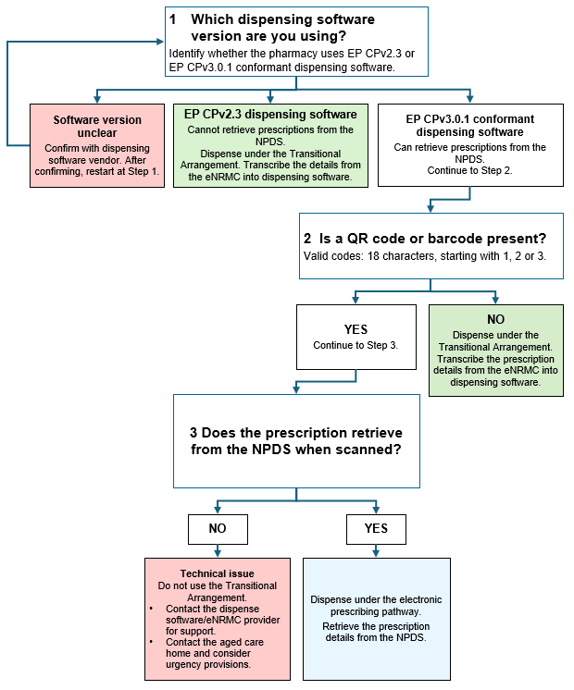
Figure 1: Decision tree for determining the applicable eNRMC dispensing pathway

Figure 1 helps pharmacists identify the correct dispensing pathway. The table below summarises the dispensing and claiming arrangements that apply to the most common eNRMC and dispensing software combinations during the transition.

If the prescription is created using a... | And the pharmacy is using... | What can the pharmacy do?
Transitional eNRMC system | EP CPv2.3 or CPv3.0.1 conformant dispensing software | Use the Transitional pathway (transcribe from the eNRMC into the dispensing software) for Pharmaceutical Benefits Scheme (PBS) supply and claiming.
EP CPv3.0.2 conformant eNRMC system | EP CPv2.3 dispensing software | Use the Transitional pathway (transcribe from the eNRMC into the dispensing software) for PBS supply and claiming. EP CPv2.3 dispensing software does not support retrieval of electronic medication chart prescriptions from the NPDS. The pharmacy may therefore rely on the eNRMC and manually transcribe the medicine information into its dispensing software.
EP CPv3.0.2 conformant eNRMC system | EP CPv3.0.1 conformant dispensing software | Use the electronic prescribing pathway (use QR code or barcode). The pharmacy must retrieve prescriptions from the NPDS. The Transitional Arrangement cannot be used as an alternative pathway, including where there are technical issues.

What happens if there are technical issues?
If a pharmacy is using EP CPv3.0.1 conformant dispensing software with a conformant eNRMC system, prescriptions created through the electronic prescribing pathway must be retrieved through the NPDS and processed under the electronic prescribing pathway.
If a prescription cannot be retrieved, determine whether it was created under the Transitional pathway or electronic prescribing pathway. Figure 1 can assist pharmacists to identify the applicable pathway.
      - Prescriptions created under the electronic prescribing pathway in a conformant version of the eNRMC system will contain a valid token or barcode. Valid token or barcodes will be 18 characters and start with 1, 2 or 3.
- Prescriptions created under the Transitional pathway in a Transitional version of the eNRMC system will not include a valid token or barcode. In these cases, pharmacists can operate under the Transitional Arrangement and transcribe the prescription details directly from the eNRMC into their dispensing software.
If the prescription was generated under the electronic prescribing pathway and cannot be retrieved using the token or barcode due to a system outage, token issue, barcode issue or other technical problem, pharmacists should follow the guidance below.

The table below explains the actions available to pharmacists when a prescription created through the electronic prescribing pathway (EP CPv3.0.2 eNRMC with EP CPv3.0.1 dispensing software) cannot be retrieved from the NPDS, and the actions that are not permitted in these circumstances.
What pharmacists can do | What pharmacists cannot do
✓ Contact their dispensing software vendor and/or eNRMC software provider for support. | ✗ Use the Transitional Arrangement for dispensing or PBS claiming where the prescription cannot be retrieved due to a technical issue.
✓ Contact the relevant residential aged care home and consider supplying the medicine under urgency provisions, which allow supply based on a copy of a medication chart. These provisions restrict supply within 72 hours from the creation of a copy and limit supply to a single PBS maximum quality. Pharmacists are required to keep the copy of the medication chart for two years, to meet their PBS record keeping obligations. | ✗ Supply directly from the eNRMC, without keeping a copy of the medication chart for two years, to meet their PBS record keeping obligations.

Schedule 8 medicine restrictions
S8 medicines can be prescribed using an eNRMC, but they are NOT eligible for ongoing supply regardless of medicine order type, ie regular, PRN, short course. Prescribing and supply must comply with both PBS requirements and state and territory legislation governing controlled substances.
For a streamlined S8 PBS item, pharmacists should confirm the prescription includes the relevant streamlined authority code and is limited to the PBS maximum quantity and for that item. Pharmacists must NOT supply the medicine more than the PBS maximum quantity. If further treatment is required, a new prescription is needed.
If prolonged treatment with a S8 medicine is clinically necessary, prescribers must obtain an authority approval from Services Australia for an extended supply.
For an authority required S8 PBS item, pharmacists should confirm that an appropriate PBS authority approval is in place, and that the prescription includes the relevant authority approval number, quantity and duration covered by the authority. Supply must be limited to what is authorised and must also comply with applicable state and territory controlled-drug requirements.

Key actions for pharmacists
Pharmacists should:
- confirm the conformance status and deployment timing of their dispensing software with their software vendor;
- use the Transitional pathway only where it applies, including where the prescription is created in a conformant eNRMC system and the pharmacy is still using CPv2.3 dispensing software or the prescription was created under the Transitional pathway but is displaying in an EP CPv3.0.2 eNRMC system;
- use only the electronic prescribing pathway once the pharmacy has EP CPv3.0.1 conformant dispensing software and is receiving prescriptions from a conformant eNRMC system; and
- contact their software vendor if they experience technical issues retrieving prescriptions through the electronic prescribing pathway. Technical issues do not allow the pharmacy to use the Transitional pathway instead.
Residential aged care homes should continue working with their eNRMC software vendor to transition from Transitional eNRMC systems to conformant eNRMC systems during the implementation period.

How the Transitional Arrangement supports these dispensing arrangements
The Department of Health, Disability and Ageing has amended the National Health (Transitional Electronic National Residential Medication Chart) Special Arrangement 2025 to support the dispensing arrangements described in this fact sheet during the current implementation period.
The amendment supports continuity of PBS medicine supply and claiming where a prescription is created in an EP CPv3.0.2 conformant eNRMC system but the pharmacy is still using CPv2.3 dispensing software. It does not change the expected workflow where both the eNRMC system and dispensing software are conformant to the EP CPv3.0 series.
Pharmacists should also be aware that not all PBS items can be supplied or claimed through an eNRMC. Some items, such as Section 100 medicines, require another prescribing or claiming process. Pharmacists should refer to the Department’s eNRMC Collection page for information about when eNRMC and electronic prescribing arrangements apply.

More information
For more information about electronic prescribing in residential aged care, including implementation requirements, conformance arrangements and transition timeframes, visit the Department’s eNRMC Collection page.
You can also refer to the Agency’s Electronic Prescribing Conformance Register for software conformance information.

