DRMC 2 October 2026 – Communique
Commonwealth, state and territory Disability Ministers met on 2 October 2026 in Darwin and online for the fourth Disability Reform Ministerial Council (DRMC) meeting of the year.
Ministers noted that coordination across jurisdictions and portfolios has commenced to inform the annual progress report on the Disability Royal Commission recommendations and reaffirmed their shared commitment to making progress as a matter of priority.
Ministers discussed the policy intent behind new framework planning. Ministers noted the significance of the changes for people with disability and their families, and the importance of testing and validation work currently underway to ensure new framework planning works effectively. Ministers engaged with the complexity of the changes and the need for timely collective work to meet current timeframes.
Ministers were briefed by Professor Christine Imms on the work of the Technical Advisory Group (TAG) on NDIS Functional Capacity and noted the draft Framework for Assessing Functional Capacity in the National Disability Insurance Scheme (NDIS). Ministers discussed the importance of ensuring participant-centered, consistent and equitable assessment arrangements, including for First Nations communities and people living in regional and remote Australia.
Ministers noted progress on the development of the Inclusive Communities Fund, including the engagement with the disability community and other stakeholders that is informing the design of the Fund.
Ministers received an update on the establishment of the Foundational Supports Negotiation Group (FSNG). The FSNG provides a forum for Commonwealth, state and territory officials to negotiate additional foundational supports for people with disability outside the NDIS beyond Thriving Kids.
Ministers were briefed on implementation of support determinations under the NDIS Amendment (Securing the NDIS for Future Generations) Act 2026 (the Amendment Act) from 1 October 2026 and noted supporting communication and stakeholder engagement activities. Ministers emphasised that participant safety and wellbeing must remain central to the implementation of support determinations and the High Support Needs variation pathway. Ministers raised community concerns and discussed the importance of safeguarding and monitoring to mitigate the risks of unintended impacts from support determinations.
Ministers discussed the establishment of more structured opportunities for consultation on pricing throughout the Annual Pricing Review cycle following the governance changes introduced by the Amendment Act.
Ministers noted the important milestone of the phased rollout of Thriving Kids supports and services commencing on 1 October 2026. Ministers provided updates on implementation in their jurisdictions and welcomed ongoing collaboration to improve outcomes for children, their families and kin.
Ministers agreed to preserve Specialist Disability Accommodation (SDA) eligibility for participants who transitioned to the NDIS from state and territory funded disability accommodation, and to facilitate the renewal of ageing SDA stock.
Ministers agreed to the NDIS Evidence Advisory Committee 2026-27 Work Plan and noted progress made on the 2025-26 Work Plan.
Ministers noted an update on hospital discharge data for NDIS participants and committed to further discussions around barriers to timely discharge.
Ministers agreed that their next meeting will be held in Perth on 15 December 2026.
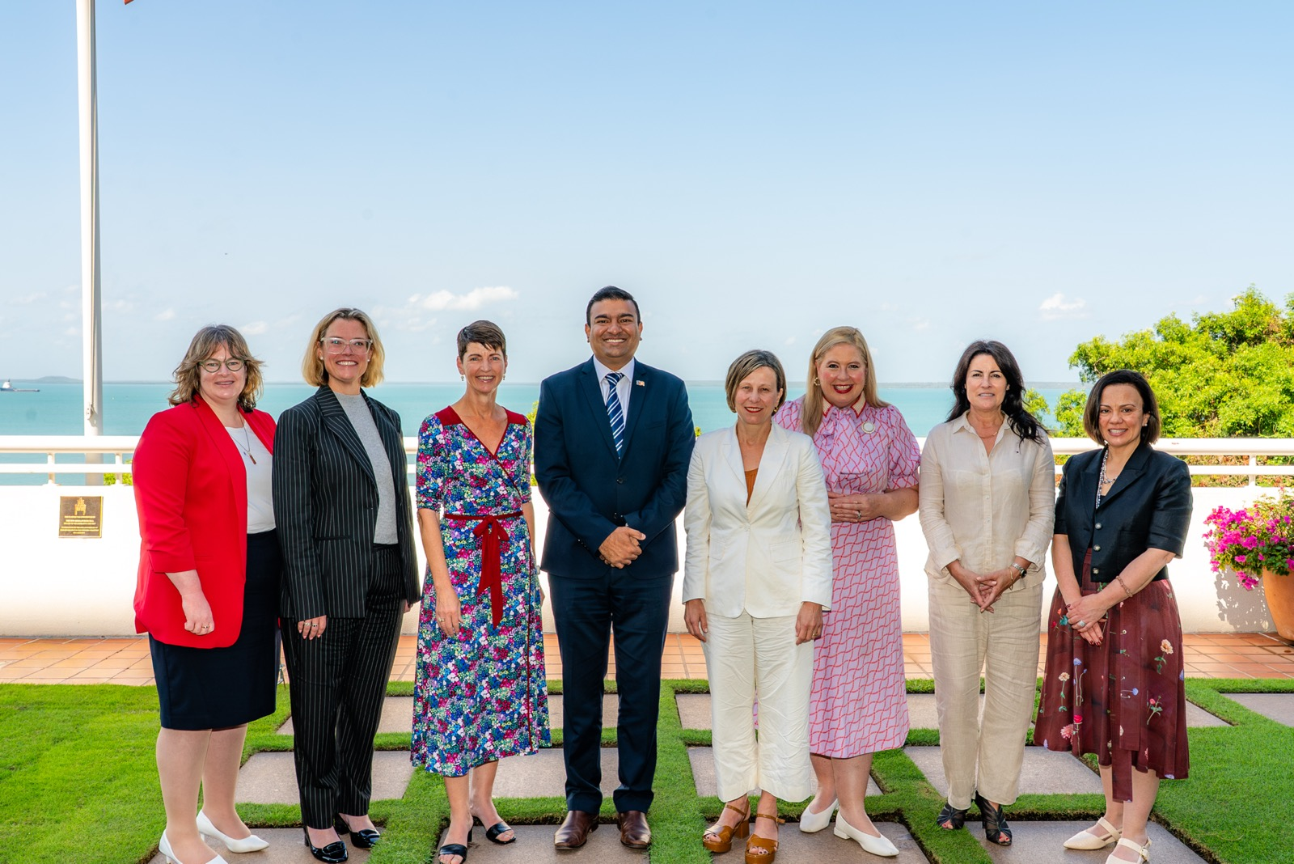

L-R: Minister Orr (ACT), Minister Beazley (WA), Minister Washington (NSW), Minister Charls (NT), Minister McAllister (Minister for the NDIS), Minister Hildyard (SA), Minister Palmer (Tas), Minister Blandthorn (Vic)
Apologies: Minister Camm (Qld). Minister Bates (Qld) attended online for Minister Camm.

