Residents’ Experience Survey
  - Understanding residents’ experiences (2023-2025)
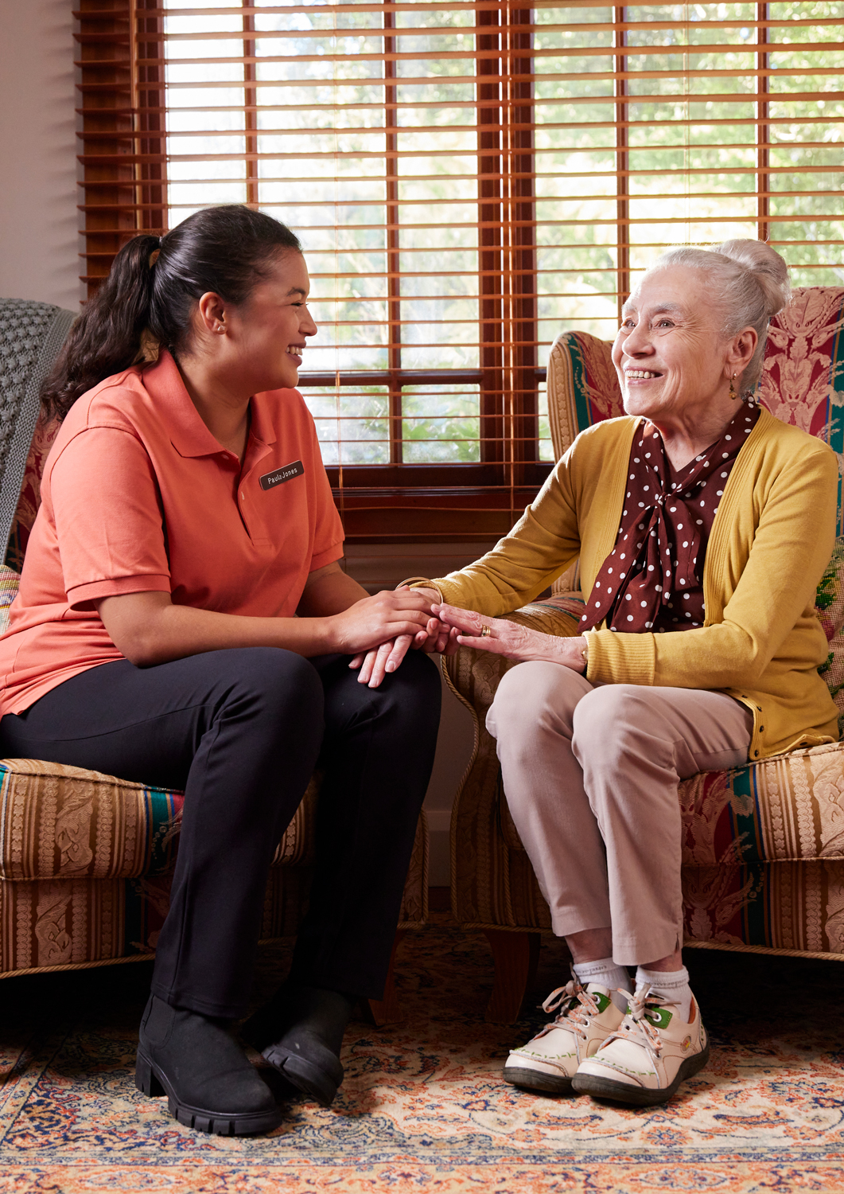

Contents
Glossary of Terms 5
Executive Summary 6
1 Introduction 10
1.1 About the RES 10
1.2 Participation in the RES 11
1.3 How to interpret this report 13
2 Overall satisfaction 15
2.1 Satisfaction outcomes 15
2.2 Satisfaction by home type 16
2.3 Summary 18
3 Independence, autonomy and freedom of choice 19
3.1 Independence, autonomy and freedom in RES 19
3.2 Independence and autonomy by home type 19
3.3 Summary 21
4 Quality and safety 22
4.1 Quality and safety in RES 22
4.2 Quality and safety by home type 24
4.3 Summary 26
5 Communication and complaints 27
5.1 Communication and complaints in RES 2025 27
5.2 Communication and complaints by home type 28
5.3 Summary 29
6 Experience across diverse groups 30
6.1 Overall satisfaction across diverse groups 31
6.2 Independence, autonomy and freedom of choice across diverse groups 32
6.3 Quality and safety across diverse groups 32
6.4 Communication and complaints across diverse groups 34
6.5 Summary 34
7 Free text analysis: what residents said 36
7.1 How findings were analysed 36
7.2 Most common categories in free-text responses 36
7.3 What residents value the most: Q13 in detail 39
7.4 What residents would change: Q14 in detail 42
7.5 Free text results by home type & resident characteristics 45
7.5.1 Q13 positive responses 45
7.5.2 Q14 negative responses 46
7.6 Free-text results by resident characteristics 48
7.6.1 Q13 positive responses 48
7.6.2 Q14 negative responses 48
7.7 Summary 49
8 Conclusion 50
Appendix A. Reporting positive responses and sample sizes 51
Defining positive responses 51
Interpreting sample sizes 51
Appendix B. National Residents’ Experience Report (RER) 53
Appendix C. Diversity analysis 61
Appendix D. Free-Text analysis 71
How free-text responses were analysed 71
Sentiment analysis 72
Category results used in this report 73
Validation, reproducibility and privacy 82
Free-text limitations 83
Appendix E. Free-text regression analysis by resident characteristics 84

Glossary of Terms

ACT | Australian Capital Territory
API | Application Programming Interface
CALD | Culturally and Linguistically Diverse
FSD | Financially and Socially Disadvantaged
LGBTQI+ | Lesbian, Gay, Bisexual, Transgender, Queer, Intersex, and more
MMM | Modified Monash Model
NSW | New South Wales
NT | Northern Territory
OR | Odds Ratio
QLD | Queensland
RACHs | Residential Aged Care Homes
RE Rating | Residents’ Experience Rating
RER | Residents’ Experience Report
RES | Residents’ Experience Survey
SA | South Australia
TAS | Tasmania
The Department | The Department of Health, Disability and Ageing
VIC | Victoria
WA | Western Australia

Executive Summary
The Residents’ Experience Survey (RES) is an annual survey of residents in residential aged care homes. It includes 14 questions designed to capture residents’ experience of care, comprising 12 fixed-response questions and 2 open-ended questions. The survey is funded by the Department of Health, Disability and Ageing (the Department) and delivered independently by a consortium led by HealthConsult. It was introduced in 2022 in response to the Royal Commission into Aged Care Quality and Safety and contributes 33% to a home’s Overall Star Rating.
The survey is conducted annually in more than 2,500 residential aged care homes in Australia. In 2025, 44,318 surveys were completed.
This report presents findings from 3 RES rounds (2023 to 2025) across 4 key themes: Overall satisfaction, Independence, autonomy and freedom of choice, Quality and safety and Communication and complaints.
The report also analyses experiences across diverse groups and presents findings from the survey's two open-ended questions.
Sector overview (2023–2025)
Across the three years covered in this report, positive response rates improved for most fixed-response questions. Overall satisfaction reached its highest level since the survey was introduced.
However, results varied by resident characteristics. First Nations and CALD residents were less likely to give positive responses on several questions, indicating that positive experiences were not reported evenly across all resident groups.
Positive responses to questions about safety, respect, staff kindness and receiving the care needed remained high. The exception was food, which remained the lowest-rated fixed-response question. This did not improve over the reporting period, and was the most common improvement area raised in residents’ free-text responses.
Key findings from RES 2025
- Overall satisfaction reached its highest level since the survey began. In 2025, 89% of residents said they would recommend their aged care home, up from 85% in 2023.
- Positive responses improved across nearly every measure between 2023 and 2025, including being treated with respect (96%), feeling safe (96%), staff being kind and caring (96%), receiving the care they need (94%), and staff knowing what they are doing (89%).
- Food remained the lowest-rated fixed-response question and did not improve over the reporting period (69% in 2025, similar to 70% in both 2023 and 2024). Food was also the most common improvement area raised in residents' free-text responses, appearing in 39.5% of negative Q14 responses.
- Communication and complaints improved but remained the lowest-scoring theme outside food: 81% of residents said staff explain things to them (up from 77% in 2023), and 85% said staff follow up when issues are raised (up from 82% in 2023).
- Experiences varied across resident groups. First Nations and CALD residents were less likely to give a positive response on several measures, including being treated with respect, feeling safe and receiving the care they needed. Rural and remote residents were more likely to give a positive response across most measures, and veterans were more likely to recommend their aged care home.
- Staff were central to both what residents valued and what they would change. Staff kindness and responsiveness was the most common positive theme raised in residents’ free-text responses, appearing in 43.7% of positive Q13 responses. Staffing levels and training was also the second most-mentioned improvement category, appearing in 32.7% of negative Q14 responses.
The National Residents’ Experience Report
For the first time, this report includes the National Residents’ Experience Report (RER). The National RER presents the national distribution of responses for each RES question, providing a consolidated sector benchmark. RACHs can use the National RER alongside their individual RER to compare results with national patterns across each domain of resident experience.

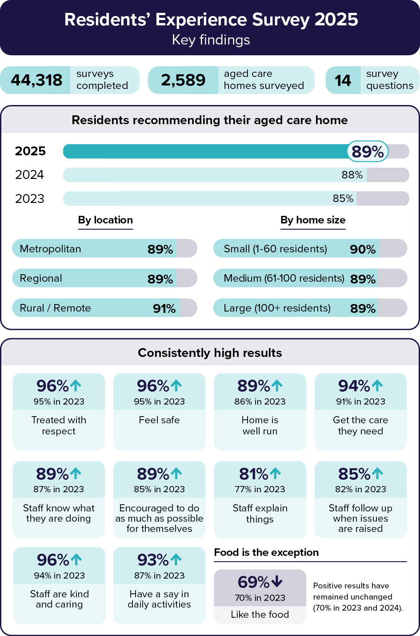
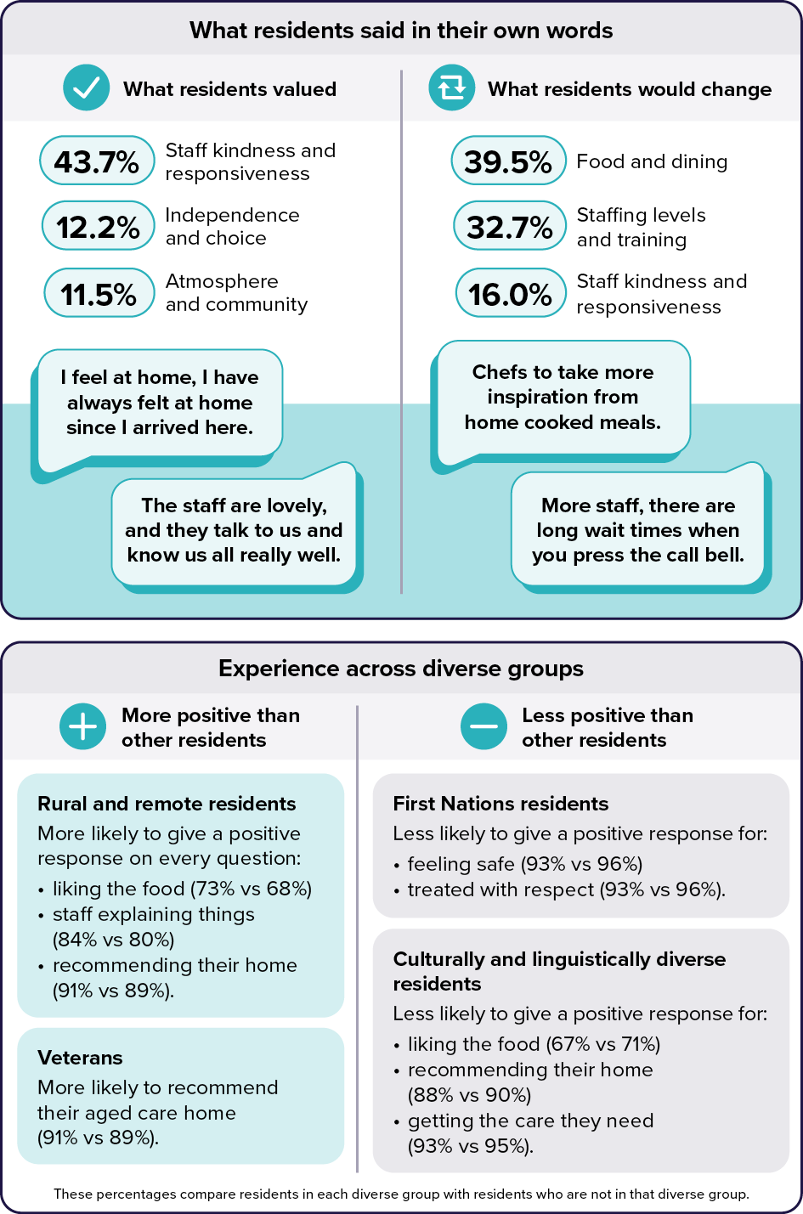

Introduction
This report presents the findings from the Residents' Experience Survey (RES), an independent survey of aged care residents. The RES is carried out annually in more than 2,500 residential aged care homes across Australia.
The Department of Health, Disability and Ageing introduced RES in 2022 in response to the Royal Commission into Aged Care Quality and Safety. Four rounds have now been completed: 2022, 2023, 2024 and 2025. This report focuses on the 2025 results and draws on data from earlier years to show how reported resident experience has changed over time.

About the RES
The RES asks residents 14 questions about their experience of care. The first 12 questions use a fixed response scale: always, most of the time, some of the time, or never.
- Do staff treat you with respect?
- Do you feel safe here?
- Is this place well run?
- Do you get the care you need?
- Do staff know what they are doing?
- Are you encouraged to do as much as possible for yourself?
- Do staff explain things to you?
- Do you like the food here?
- Do staff follow up when you raise things with them?
- Are staff kind and caring?
- Do you have a say in your daily activities?
- How likely are you to recommend this residential aged care home to someone?
The final 2 questions are open-ended, which means residents can answer in their own words.
- What would you say is the best thing about this service?
- What is one thing you would suggest as an improvement at this service?

The RES is used to generate 2 key outputs:
- Residents’ Experience Report (RER): Each participating aged care home receives a report showing residents' answers to Questions 1 to 12, with comparisons across the most recent 3 years.
- Star Ratings: The RES contributes to the Residents' Experience (RE) Rating, which carries a 33% weighting toward a home's Overall Star Rating. Star Ratings are updated quarterly and published on My Aged Care.
More information about the RES, including resident-facing materials and guides for providers, is available on the Department's website at https://www.health.gov.au/our-work/residents-experience-survey/

Participation in the RES
In each home, residents are randomly selected to participate in the RES. Participation is voluntary, and residents may decline for any reason. While the primary aim of the RES is to gather feedback directly from residents, there are instances where a resident may be unable to take part in the survey. In this case, the survey may be completed by a proxy. In 2025, proxy surveys were only sought from a formally appointed representative that was registered with My Aged Care.
Both consent and completion rates have improved since 2023 (see Figure 1). Overall, consent rose from 80% in 2023 to 92% in 2025, and completion rose from 77% to 92% over the same period. Directly surveyed residents have driven the improvement while rates for proxy respondents have remained stable at around 90% for completion and consent throughout.
Figure 1: Consent and completion rates over time
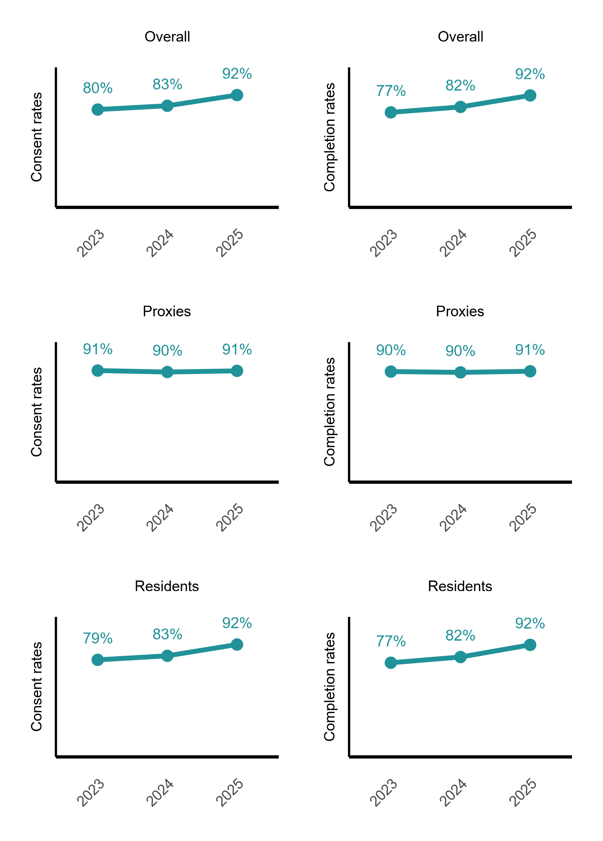

How to interpret this report
At a sector level, this report provides insight into:
- Areas of the resident experience with the highest levels of satisfaction
- Areas where satisfaction remains lower and may require improvement
- Differences in results by home size and geographic location
- Differences in results across provider types
- Experiences of residents from diverse backgrounds
The findings are grouped into four themes, aligned with the Statement of Rights for Older People in the Aged Care Act 2024. The Act came into force on 1 November 2025 and places the rights of older people at the centre of aged care regulation.
The four themes reflected in this report are:
- Independence, autonomy, empowerment and freedom of choice (Chapter 3)
- Quality and safe funded aged care services (Chapter 4)
- Person-centred communication and ability to raise issues without reprisal (Chapter 5)
- Equitable access (Chapter 6)
The remaining two Statement of Rights themes - privacy and information, and advocates, significant persons and social connections - are not directly measured by the RES. However, aspects of these themes are reflected in some survey questions and in residents’ free-text responses.
Appendix A explains how positive responses are defined and provides the sample sizes used for key subgroup analyses. This supports interpretation of results where findings are reported for smaller resident groups or linked resident characteristics.
Table 1 outlines how the 12 fixed-response survey questions align to each theme and chapter of the report.
Table 1: RES questions addressed in this report
Chapter 2: Overall satisfaction
- How likely are you to recommend this residential aged care home to someone?
Chapter 3: Independence, autonomy and freedom of choice
- Do you have a say in your daily activities?
- Are you encouraged to do as much as possible for yourself?
Chapter 4: Quality and safety
- Do staff treat you with respect?
- Do you feel safe here?
- Is this place well run?
- Do you get the care you need?
- Do staff know what they are doing?
- Do you like the food here?
- Are staff kind and caring?
Chapter 5: Communication and complaints
- Do staff explain things to you?
- Do staff follow up when you raise things with them?
Chapter 6: Experience across diverse groups
- All questions

Overall satisfaction
This chapter examines residents' reported overall satisfaction with their aged care home in 2025, and how it has changed since 2023. It also looks at how satisfaction varied by home size, location and provider type.
Overall satisfaction is measured using responses to the question:
- How likely are you to recommend this residential aged care home to someone?
This question is used as the proxy measure for overall satisfaction throughout this report. Unless otherwise stated, the percentages refer to the proportion of residents who gave a positive response, defined as answering either “Always” or “Most of the time”.

Satisfaction outcomes
Most residents would recommend their aged care home to someone, and the proportion who would do so has increased each year since 2023.
In 2025, 89% of residents reported they would recommend their aged care home to someone, compared with 85% in 2023 (see Figure 2).
Figure 2: Overall satisfaction over time
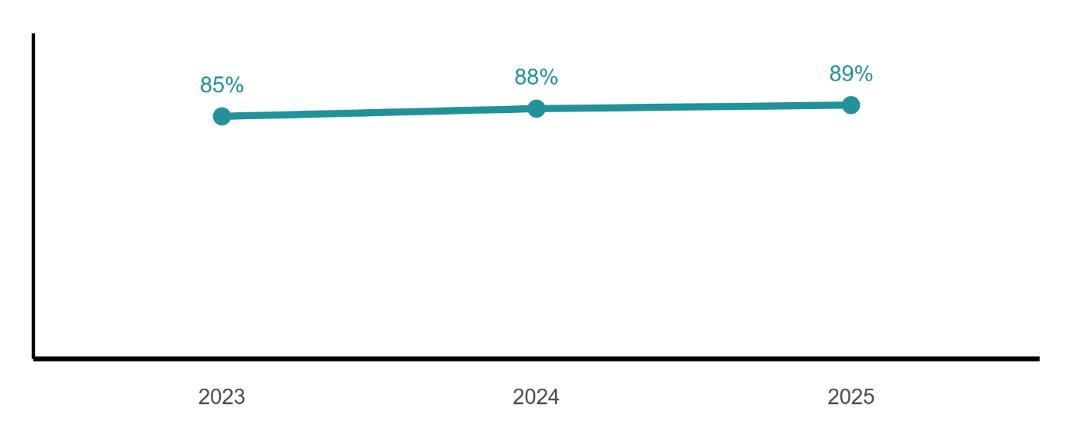
Overall satisfaction is high and relatively consistent across all types of aged care homes.
Figure 3 shows that in 2025, positive responses ranged from 89% to 91% across rurality categories and home sizes, indicating only minimal variation in resident satisfaction.

Figure 3: Overall satisfaction in RES 2025, by rurality and home size
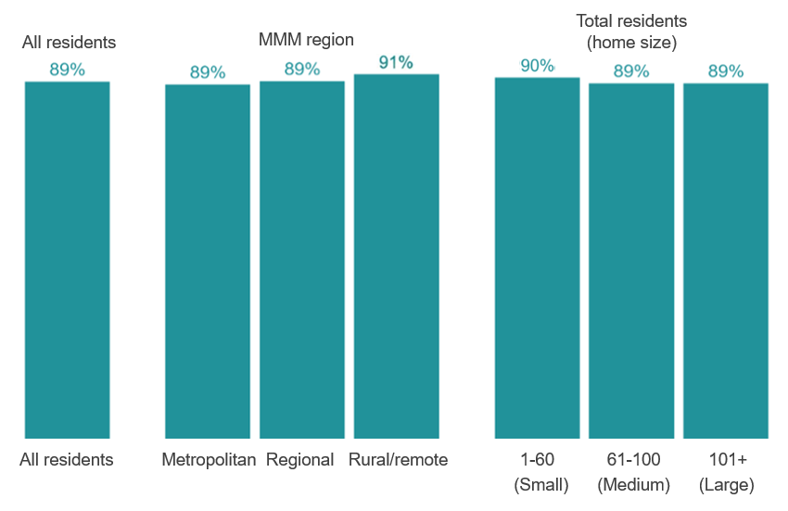
Note: Metropolitan = MMM 1; Regional = MMM 2; Rural/Remote = MMM 3-7.

Satisfaction by home type
Overall satisfaction was high across home types in 2025, with some variation by location and home size.
Table 2 shows positive response rates by home size, location and provider type.
- Results were very similar by home size: Residents in small homes (1–60 residents) gave a higher positive response rate of 90%, compared with 89% in both medium (61–100) and large (101+) homes.
- Results varied more by home location: 91% of residents in NSW gave a positive response, followed by 90% in QLD. Positive response rates were lowest in the NT, SA and WA, at 81%, 85% and 86% respectively. NSW, QLD, SA, WA and the NT (NT based on a smaller sample, n=118) all differed significantly from the national rate, while the ACT, TAS and VIC did not.
- Results also varied by provider type: 93% of residents in government-operated homes gave a positive response, compared with 90% in not-for-profit homes and 87% in for-profit homes. All three provider types differed significantly from the national rate of 89%.
Table 2: Overall satisfaction in RES 2025, by home type
Home type | Overall satisfaction in RES 2025 | Total residents surveyed in 2025
Home size
101+ residents (large) | 89% | 16,373
61-100 residents (medium) | 89% | 15,154
1-60 residents (small) | 90% | 12,791
Home location
Home in the ACT | 87% | 530
Homes in NSW | 91% | 14,133
Homes in NT | 81% | 118
Homes in QLD | 90% | 8,561
Homes in SA | 85% | 3,827
Homes in TAS | 89% | 1,027
Homes in VIC | 89% | 11,921
Homes in WA | 86% | 4,201
Provider type
Not-for-profit provider | 90% | 26,137
For-profit provider | 87% | 15,891
Government provider | 93% | 2,290
*General population overall satisfaction = 89%.

Summary
Overall satisfaction with aged care homes was high in 2025 and has increased since 2023. Nationally, 89% of residents gave a positive response, up from 85% in 2023. Results were very similar by home size and broadly consistent across metropolitan, regional and rural locations.
Some variation was observed by provider type and jurisdiction. Positive response rates were highest in government-operated homes (93%) and lowest in for-profit homes (87%). By jurisdiction, NSW had the highest positive response rate (91%), while the NT, SA and WA had the lowest positive response rates.

Independence, autonomy and freedom of choice
This chapter provides a high-level overview of residents’ independence, autonomy and freedom of choice. It analyses responses to the following 2 RES questions:
- Are you encouraged to do as much as possible for yourself?
- Do you have a say in your daily activities?
Unless otherwise stated, percentages refer to the proportion of residents who gave a positive response, defined as answering either “Always” or “Most of the time”.

Independence, autonomy and freedom in RES
Residents reported high levels of independence, autonomy and freedom of choice in 2025, with results improving since 2023.
In 2025, 89% of residents reported that they were encouraged to do as much as possible for themselves, an increase from 85% in 2023. Similarly, 93% stated that they had a say in their daily activities, up from 87% (Figure 4).
Figure 4: Independence, autonomy and freedom of choice
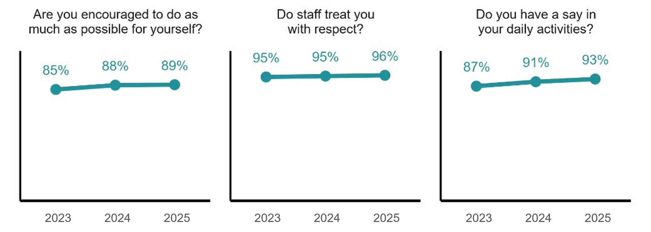

Independence and autonomy by home type
Residents' experiences of independence, autonomy and freedom of choice were broadly similar across home sizes and provider types in 2025, with the greatest variation by home location (Table 3Table 3).
- Results were similar by home size. For encouragement to do as much as possible for themselves, positive response rates were 88–90% across home sizes, within a percentage point of the national rate (89%). For having a say in daily activities, 93% of residents gave a positive response across all home sizes.
- Results varied by home location. For encouragement to do as much as possible for themselves, most jurisdictions (NSW, QLD, VIC, TAS and the ACT) were within a few percentage points of the national rate for this question (89%). SA was the exception at 78%, a substantial 11 percentage-point difference below it. WA and the NT were moderately lower (WA: 83%, NT: 82%; NT based on a smaller sample, n=118). For having a say in daily activities, most jurisdictions were within a few percentage points of the national rate (93%), with SA (85%) moderately lower and the NT (88%, n=118) somewhat lower.
- Results were broadly similar by provider type. For-profit homes scored slightly lower than government-operated and not-for-profit homes on both questions, but the differences were negligible (within a few percentage points of the national rates of 89% and 93%). Government-operated results are based on a smaller sample (n=2,290) than the other provider categories and should be interpreted with caution.

Table 3: Independence and autonomy in RES 2025, by home type
Home type | Are you encouraged to do as much as possible for yourself? | Do you have a say in your daily activities? | Total residents surveyed in 2025
Home size
101+ residents (large) | 89% | 93% | 16,373
61-100 residents (medium) | 88% | 93% | 15,154
1-60 residents (small) | 90% | 93% | 12,791
Home location
Home in the ACT | 92% | 94% | 530
Homes in NSW | 92% | 95% | 14,133
Homes in NT | 82% | 88% | 118
Homes in QLD | 93% | 95% | 8,561
Homes in SA | 78% | 85% | 3,827
Homes in TAS | 91% | 94% | 1,027
Homes in VIC | 87% | 91% | 11,921
Homes in WA | 83% | 95% | 4,201
Provider type
Not-for-profit provider | 89% | 93% | 26,137
For-profit provider | 88% | 92% | 15,891
Government provider | 91% | 93% | 2,290

Summary
Residents responded positively to the two questions grouped under the independence, autonomy and freedom of choice theme, and both measures improved since 2023. In 2025, 89% of residents said they were encouraged to do as much as possible for themselves, and 93% said they had a say in their daily activities, placing this theme among the higher-scoring areas of the report. Results were similar across home sizes and provider types, with the clearest variation by jurisdiction: SA was substantially lower and WA and the NT moderately lower on encouragement to do as much as possible for themselves. Results for the NT are based on a smaller sample (n=118) than other jurisdictions and should therefore be interpreted with caution.

Quality and safety
This chapter provides a high-level overview of residents’ perceptions of their quality and safety in aged care. It analyses responses to the following 7 RES questions:
- Do you like the food here?
- Do staff treat you with respect?
- Do you feel safe here?
- Is this place well run?
- Do you get the care you need?
- Are staff kind and caring?
- Do staff know what they are doing?
Note: The findings in this chapter should be read as residents' reported experiences of quality and safety, not as a complete assessment of quality and safety in aged care homes.
Unless otherwise stated, percentages refer to the proportion of residents who gave a positive response, defined as answering either “Always” or “Most of the time”.

Quality and safety in RES
Overall, residents reported positive perceptions of quality and safety in aged care homes, with positive response rates increasing since 2023 for all measures, with the exception of food.
In 2025, positive response rates ranged from 69% to 96% across the seven measures (see Figure 5):
- The highest results were for staff being kind and caring (96%), feeling safe (96%) and being treated with respect (96%).
- Confidence that the home is well run (89%) and that staff know what they are doing (89%) recorded the lowest results in this theme, aside from food.
- Four of the seven measures improved by at least 2 percentage points since 2023.
- Food recorded the lowest positive response rate within this theme. In 2025, 69% of residents reported they like the food, similar to 70% in 2023 and 2024. Food is the only quality and safety measure that has not improved over the reporting period.
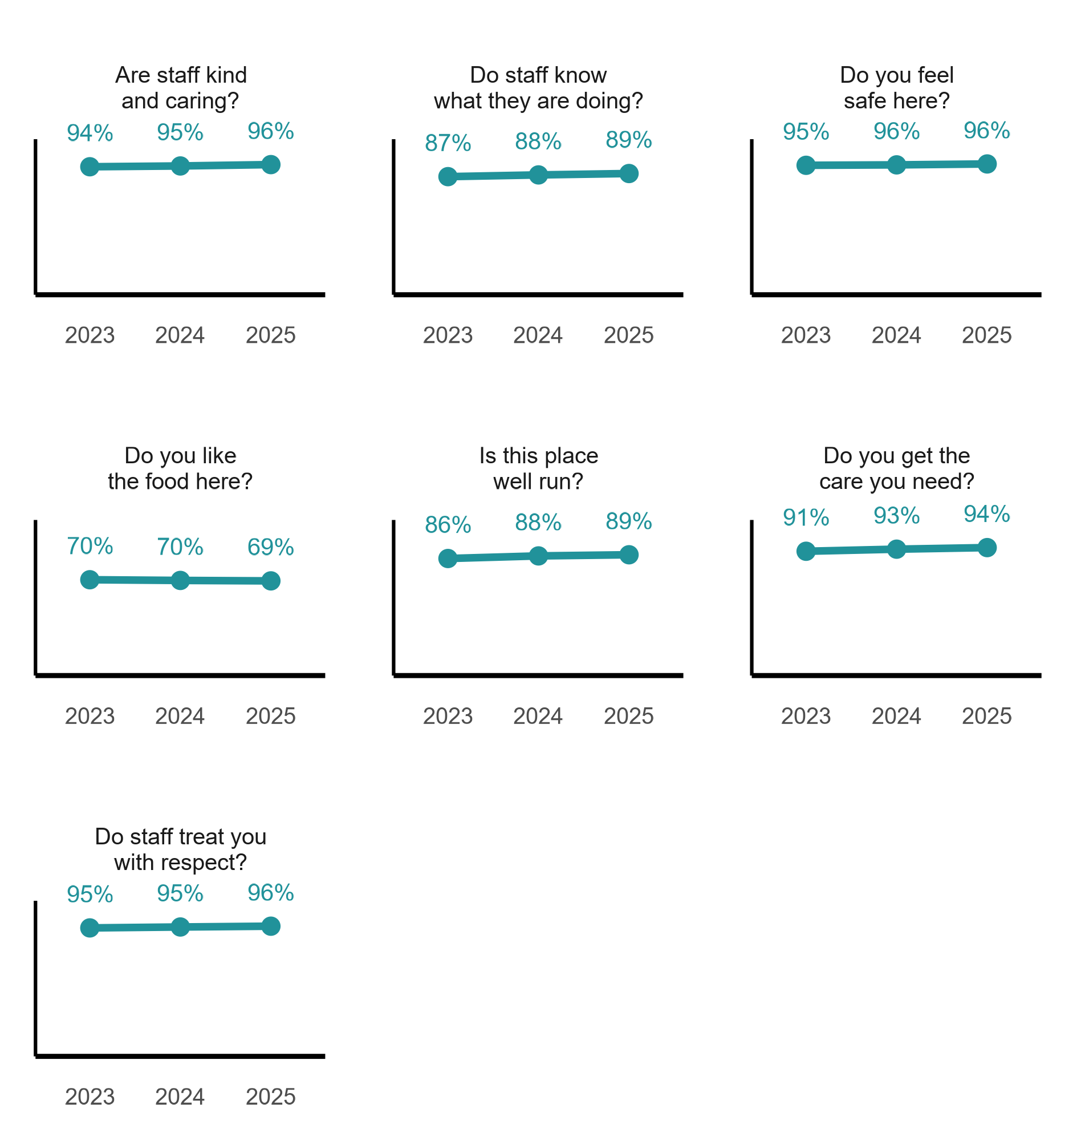
Figure 5: Quality and safety in RES

Quality and safety by home type
Residents' experiences of quality and safety were similar across home size, location and provider type in 2025, with food showing the greatest variation (see Table 4).
- Results were similar by home size for most measures. Positive response rates for feeling safe, being treated with respect, receiving the care needed and staff kindness were high and very similar across all home sizes (94–96%). Whether the home was well run and whether staff knew what they were doing differed only slightly (91% in small homes compared with 88% in medium and large homes - a negligible difference). Food showed the widest variation by home size, though differences remained modest: 73% in small homes compared with 67% in large homes, either side of the national food rate of 69%.
- Results varied by home location. Most jurisdictions were within 2 percentage points of the national rates for feeling safe (96%), being treated with respect (96%), receiving the care needed (94%) and staff kindness (96%), a negligible difference. The NT was the exception, at 5 percentage points below the national rate for being treated with respect (91%) and for receiving the care needed (89%), both moderate differences. Food showed the widest variation, ranging from 61% in WA to 74% in the NT, which is a moderate difference either side of the national food rate (69%). Confidence that the home is well run was 7 percentage points below the national rate (89%) in the NT (82%), a moderate difference, and 4 points below in SA and WA (both 85%), a modest difference. Staff knowing what they are doing was 5 percentage points below the national rate (89%) in both the NT and SA (both 84%), a moderate difference. The NT result is based on a smaller sample (n=118) than other jurisdictions and should therefore be interpreted with caution.
- Results also varied by provider type, most notably for food. Food had the lowest positive response rate across all provider types. Compared with the national rate for food (69%), for-profit (67%) and not-for-profit (70%) homes differed negligibly, while government-operated homes (77%) were 8 percentage points above it - a moderate difference. Government-operated homes also recorded the highest positive response rates for whether the home was well run (93%), receiving the care needed (97%) and staff knowing what they were doing (93%). These results are based on a smaller sample (n=2,290) than the other provider categories and should be interpreted with caution.

Table 4: Quality and safety in RES 2025, by home type
Home type | Do you like the food here? | Do you feel safe here? | Do staff treat you with respect? | Is this place well run? | Do you get the care you need? | Do staff know what they are doing? | Are staff kind and caring? | Total residents surveyed in 2025
Home size
101+ residents (large) | 67% | 96% | 96% | 88% | 94% | 88% | 96% | 16,373
61-100 residents (medium) | 68% | 96% | 96% | 88% | 94% | 88% | 96% | 15,154
1-60 residents (small) | 73% | 96% | 96% | 91% | 95% | 91% | 96% | 12,791
Home location
Homes in ACT | 65% | 98% | 98% | 88% | 94% | 88% | 98% | 530
Homes in NSW | 71% | 96% | 96% | 91% | 95% | 91% | 96% | 14,133
Homes in NT | 74% | 92% | 91% | 82% | 89% | 84% | 92% | 118
Homes in QLD | 71% | 97% | 97% | 88% | 95% | 90% | 97% | 8,561
Homes in SA | 64% | 95% | 94% | 85% | 90% | 84% | 93% | 3,827
Homes in TAS | 73% | 96% | 96% | 88% | 94% | 88% | 96% | 1,027
Homes in VIC | 70% | 97% | 96% | 89% | 95% | 90% | 96% | 11,921
Homes in WA | 61% | 96% | 95% | 85% | 92% | 87% | 96% | 4,201
Provider type
Not-for-profit provider | 70% | 97% | 96% | 89% | 94% | 89% | 96% | 26,137
For-profit provider | 67% | 96% | 96% | 88% | 94% | 88% | 95% | 15,891
Government provider | 77% | 97% | 97% | 93% | 97% | 93% | 97% | 2,290

Summary
Residents reported positive experiences of quality and safety in their aged care home in 2025. Six of the seven measures recorded positive response rates of 89% or above, and four of the seven improved by 2 percentage points.
Food was the clear exception. It recorded the lowest positive response rate within this theme (69% in 2025), has not improved since 2023, and showed the greatest variation across home sizes, locations and provider types.

Communication and complaints
This chapter provides an overview of residents’ experiences regarding communication and complaint handling within aged care homes. It analyses responses to the following 2 RES questions:
- Do staff explain things to you?
- Do staff follow up when you raise things with them?
Unless otherwise stated, percentages refer to the proportion of residents who gave a positive response, defined as answering either “Always” or “Most of the time”.

Communication and complaints in RES 2025
Residents reported improved experiences of communication and complaint handling in 2025.
In 2025, 81% of residents agreed that staff explained things to them, an increase from 77% in 2023. Similarly, 85% of residents said that staff follow up when issues are raised, up from 82% in 2023 (see Figure 6).
Figure 6: Communication and complaints in RES
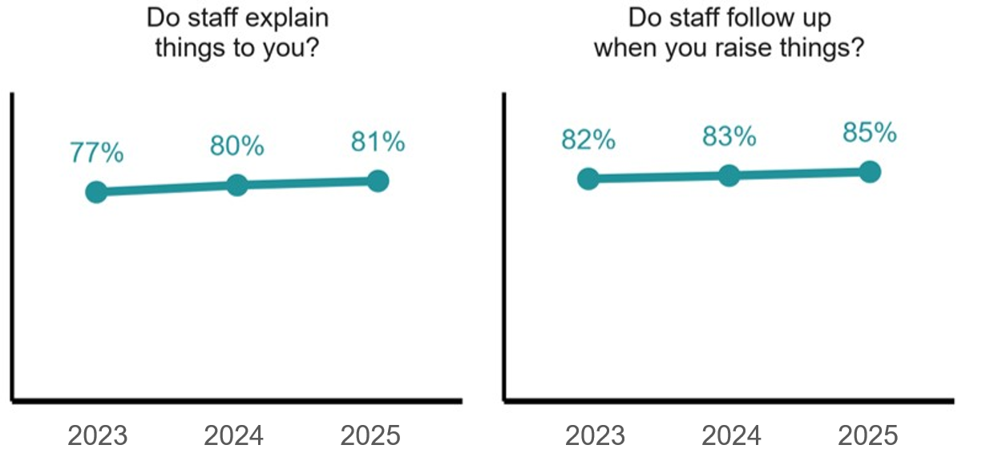

Communication and complaints by home type
Residents' experiences of communication and complaint handling were similar across home sizes and provider types in 2025, with the greatest variation by home location (see Table 5).
- Results were very similar by home size: For staff explaining things, positive response rates were 81–83% across home sizes, within a couple of percentage points of the national rate (81%). For staff following up when issues were raised, rates were 84–86%, within 1 percentage point of the national rate (85%).
- Results varied by home location: For staff explaining things, two jurisdictions were within a few percentage points of the national rate (81%); QLD was moderately higher (86%), while the NT (74%), SA (75%) and WA (75%) were moderately lower. For staff following up when issues were raised, most jurisdictions were close to the national rate (85%), with NSW (88%) and TAS (87%) slightly higher and WA (78%), SA (80%), the NT (81%) and ACT (82%) moderately lower. The NT result is based on a smaller sample (n=118) than other jurisdictions and should therefore be interpreted with caution.
- Results were broadly similar by provider type: For-profit homes scored slightly lower than not-for-profit and government-operated homes on both measures, but the differences were small (within a few percentage points of the national rates of 81% and 85%). Government-operated homes recorded the strongest results on both (85% and 89%), based on a smaller sample (n=2,290) than the other provider categories, and should be interpreted with caution.
Table 5: Communication and complaints in RES 2025, by home type
Home type | Do staff explain things to you? | Do staff follow up when you raise things? | Total residents surveyed in 2025
Home size
101+ residents (large) | 81% | 84% | 16,373
61-100 residents (medium) | 81% | 84% | 15,154
1-60 residents (small) | 83% | 86% | 12,791
Home location
Homes in ACT | 78% | 82% | 530
Homes in NSW | 85% | 88% | 14,133
Homes in NT | 74% | 81% | 118
Homes in QLD | 86% | 85% | 8,561
Homes in SA | 75% | 80% | 3,827
Homes in TAS | 83% | 87% | 1,027
Homes in VIC | 79% | 85% | 11,921
Homes in WA | 75% | 78% | 4,201
Provider type
Not-for-profit provider | 82% | 85% | 26,137
For-profit provider | 80% | 84% | 15,891
Government provider | 85% | 89% | 2,290

Summary
Residents reported improved experiences of communication and complaint handling in 2025, with 81% saying staff explain things to them (up from 77% in 2023) and 85% saying staff follow up when issues are raised (up from 82% in 2023). With the exception of food, both measures continue to record lower positive response rates than the other themes in this report.
Results were similar across home sizes and provider types, with the clearest variation by jurisdiction: the NT, SA and WA were moderately lower on staff explaining things, while QLD was moderately higher. Government-operated homes recorded the strongest results across both measures, noting the smaller sample (n=2,290).

Experience across diverse groups
RES collects diversity information to help understand whether residents from different backgrounds report different experiences of care. This chapter examines reported experiences across seven diverse groups and tests whether differences between groups remain after accounting for selected resident and home characteristics.
A note on how to read this chapter. Chapters 2 to 5 report the percentage of residents who gave a positive response. In this chapter onward, results are reported as adjusted comparisons: they show whether a group was more or less likely to give a positive response than other residents, after accounting for factors such as proxy use, home size, state, and provider type. These are expressed as odds ratios (OR). An OR above 1 means the group was more likely to give a positive response; below 1 means less likely; and the result is only highlighted where it is statistically significant (p<0.05). Odds ratios are adjusted for proxy use, home size, jurisdiction and provider type, while the descriptive percentages are unadjusted. A significant odds ratio can therefore sit alongside a small or negligible difference in raw positive-response rates.
This chapter reports results only for diverse groups with at least 100 respondents. Below this threshold, confidence intervals are too wide to support reliable interpretation, so these results are not reported publicly or included in odds ratio analysis.
Two retained groups should be interpreted with caution. Residents who are homeless or at risk of homelessness (n=206) and residents who are financially and socially disadvantaged (n=825) could only be identified where disclosed during the survey and at this point in time, cannot be validated against Departmental data sources, so their size may be understated.
Unless otherwise stated, percentages refer to the proportion of residents who gave a positive response, defined as answering either “Always” or “Most of the time”.
The number of completed surveys for each group was:
- Homeless or at risk of homelessness: n=206
- First Nations: n=819
- Financially and socially disadvantaged (FSD): n=825
- Veterans: n=2,011
- Rural/remote: n=13,409
- Culturally and linguistically diverse (CALD): n=16,230

Detailed results by diverse group are provided in Appendix C.
Diverse group information was drawn from three sources for RES 2025:
- Departmental Residents Data: Some diversity fields were available in the data provided by the Department.
- RACH Manager confirmation: On arrival at the RACH, surveyors worked with the RACH Manager to confirm which residents were identified as belonging to a diverse group.
- Resident conversation: Where appropriate, surveyors explored diversity information through respectful conversation with residents during and after the survey, using standardised scripts and prompts.

Overall satisfaction across diverse groups
Residents who were veterans or living in rural or remote areas were more likely to recommend their aged care home than other residents. First Nations and CALD residents were less likely to recommend their aged care home.
Overall satisfaction was measured using responses to the question “How likely are you to recommend this residential aged care home to someone?
After accounting for proxy use, home size, state and provider type:
- First Nations residents were less likely to recommend their aged care home than residents who were not First Nations (OR 0.75, 95% CI 0.61–0.94, p<0.05).
- CALD residents were less likely to recommend their aged care home than residents who were not CALD (OR 0.93, 95% CI 0.87–0.99, p<0.05).
- Veterans were more likely to recommend their aged care home than residents who were not veterans (OR 1.21, 95% CI 1.04–1.43, p<0.05).
- Rural/remote residents were more likely to recommend their aged care home than residents who were not rural/remote (OR 1.10, 95% CI 1.02–1.18, p<0.05).

Independence, autonomy and freedom of choice across diverse groups
First Nations and CALD residents were less likely to give a positive response for some measures.
This section examines responses to two RES questions:
- Are you encouraged to do as much as possible for yourself?
- Do you have a say in your daily activities?
Across diverse groups, positive responses ranged from 87% to 93% for being encouraged to do as much as possible for themselves, and from 92% to 95% for having a say in daily activities. After accounting for proxy use, home size, state and provider type:
- First Nations residents were less likely than residents who were not First Nations to give a positive response for both being encouraged to do as much as possible for themselves (OR 0.74, 95% CI 0.59–0.94, p<0.05) and having a say in daily activities (OR 0.63, 95% CI 0.49–0.84, p<0.05). The descriptive differences were negligible (encouraged 89% vs 89%; say 92% vs 93%).
- CALD residents were less likely than residents who were not CALD to say they were encouraged to do as much as possible for themselves (OR 0.92, 95% CI 0.86–0.98, p<0.05).
- Rural/remote residents were more likely than residents who were not rural/remote to give a positive response for both being encouraged to do as much as possible for themselves (OR 1.23, 95% CI 1.14–1.32, p<0.05) and having a say in daily activities (OR 1.27, 95% CI 1.16–1.39, p<0.05).

Quality and safety across diverse groups
First Nations and CALD residents were less likely to give a positive response for feeling respected, safe and well cared for, while rural/remote residents were more likely to give a positive response for respect, safety, care, staff capability, food and staff kindness.
This section examines responses to seven RES questions:
- Do staff treat you with respect?
- Do you feel safe here?
- Is this place well run?
- Do you get the care you need?
- Do staff know what they are doing?
- Do you like the food here?
- Are staff kind and caring?
Across diverse groups, positive responses ranged from 93% to 97% for being treated with respect, 93% to 97% for staff being kind and caring and for feeling safe, 93% to 95% for receiving the care needed, 86% to 91% for staff knowing what they are doing, 84% to 90% for whether the home is well run, and 65% to 73% for liking the food. After accounting for proxy use, home size, state and provider type:
- First Nations residents were less likely than residents who were not First Nations to give a positive response for being treated with respect (OR 0.52, 95% CI 0.39–0.70, p<0.05), feeling safe (OR 0.48, 95% CI 0.36–0.65, p<0.05), receiving the care they needed (OR 0.73, 95% CI 0.55–0.98, p<0.05), and staff being kind and caring (OR 0.66, 95% CI 0.48–0.92, p<0.05). The descriptive differences were modest for respect (93% vs 96%) and feeling safe (93% vs 96%), and negligible on getting the care they need (93% vs 94%) and staff kindness (95% vs 96%).
- CALD residents were less likely than residents who were not CALD to give a positive response for being treated with respect (OR 0.79, 95% CI 0.71–0.87, p<0.05), feeling safe (OR 0.80, 95% CI 0.72–0.89, p<0.05), receiving the care they needed (OR 0.86, 95% CI 0.79–0.94, p<0.05), staff knowing what they were doing (OR 0.92, 95% CI 0.86–0.98, p<0.05), liking the food (OR 0.85, 95% CI 0.81–0.89, p<0.05), and staff being kind and caring (OR 0.81, 95% CI 0.73–0.89, p<0.05).
- Rural/remote residents were more likely than residents who were not rural/remote to give a positive response for being treated with respect (OR 1.17, 95% CI 1.04–1.32, p<0.05), feeling safe (OR 1.15, 95% CI 1.02–1.31, p<0.05), receiving the care they needed (OR 1.18, 95% CI 1.07–1.30, p<0.05), staff knowing what they were doing (OR 1.11, 95% CI 1.04–1.20, p<0.05), liking the food (OR 1.11, 95% CI 1.06–1.17, p<0.05), and staff being kind and caring (OR 1.23, 95% CI 1.09–1.38, p<0.05)
- Financially and socially disadvantaged residents were less likely than residents who were not financially and socially disadvantaged to give a positive response for staff knowing what they were doing (OR 0.78, 95% CI 0.63–0.98, p<0.05) and staff being kind and caring (OR 0.66, 95% CI 0.49–0.92, p<0.05). The descriptive differences were negligible (staff capability 88% vs 89%; kindness 94% vs 96%).
- Residents who were homeless or at risk of homelessness were less likely than residents who were not homeless or at risk of homelessness to give a positive response for the home being well run (OR 0.59, 95% CI 0.41–0.88, p<0.05) and liking the food (OR 0.69, 95% CI 0.52–0.93, p<0.05). The descriptive differences were moderate (well-run 84% vs 89%, and food 65% vs 69%).

Communication and complaints across diverse groups
First Nations and CALD residents were less likely to give a positive response for staff explaining things clearly, and First Nations residents were also less likely to give a positive response for staff following up when issues were raised. Rural/remote residents were more likely to give a positive response for both measures.
This section examines responses to two RES questions:
- Do staff explain things to you?
- Do staff follow up when you raise things with them?
Across diverse groups, positive responses ranged from 79% to 84% for staff explaining things, and from 82% to 87% for staff following up when issues were raised. After accounting for proxy use, home size, state and provider type:
- First Nations residents were less likely than residents who were not First Nations to give a positive response for staff explaining things to them (OR 0.78, 95% CI 0.65–0.94, p<0.05) and staff following up when they raised things with them (OR 0.74, 95% CI 0.61–0.89, p<0.05). The descriptive differences were negligible for explaining things (81% vs 81%) and modest for following up (82% vs 85%).
- CALD residents were less likely than residents who were not CALD to say staff explained things to them (OR 0.93, 95% CI 0.88–0.98, p<0.05).
- Rural/remote residents were more likely than residents who were not rural/remote to give a positive response for staff explaining things to them (OR 1.11, 95% CI 1.05–1.18, p<0.05) and staff following up when they raised things with them (OR 1.12, 95% CI 1.05–1.19, p<0.05).

Summary
First Nations and CALD residents were less likely than other residents to give a positive response across several measures, including being treated with respect, feeling safe and receiving the care they needed. The gaps were more pronounced for First Nations residents, although the underlying differences in positive response rates were modest or negligible in each case. This is consistent with the trends observed in 2023, where First Nations and CALD residents also reported lower positive responses than their counterparts. However, there has been an improvement in the positive responses for these groups since 2023. First Nations residents reported more positively across all 12 questions since 2023, while CALD residents reported more positively for all questions except “Do you like the food here?” since 2023.
Residents who were financially and socially disadvantaged were less likely to give a positive response for staff knowing what they were doing and staff being kind and caring, and residents who were homeless or at risk of homelessness were less likely to give a positive response for the home being well run and for liking the food. Results for both groups are based on smaller samples and should be interpreted with caution.
Rural and remote residents reported the most consistently positive experiences, and veterans were more likely to recommend their aged care home.
These findings are consistent with broader evidence that some First Nations and CALD older people may face barriers to accessing culturally safe, responsive and person-centred care, including language barriers, cultural disconnection and services that may not always meet their cultural needs and preferences. Similarly, older people who are financially and socially disadvantaged, or experiencing or at risk of homelessness, may face additional barriers related to social isolation, financial hardship and complex support needs. In response, the Australian Government is implementing reforms to strengthen cultural safety, improve access to culturally appropriate care, reduce barriers to accessing aged care services, and support more equitable aged care experiences and outcomes for diverse and vulnerable groups of older Australians living in residential aged care homes.

Free text analysis: what residents said
This chapter presents an analysis of residents’ responses to the following two RES questions:
- What would you say is the best thing about this service?
- What is one thing you would suggest as an improvement at this service?
Unlike the 12 fixed-response questions, these two questions allow residents to raise what matters most to them, in their own words.
In RES 2025, 35,418 of the 44,318 residents surveyed provided a response to Question 13 (Q13), and 22,667 residents to Question 14 (Q14).
This chapter presents the main findings from residents’ free-text responses, including the most common categories raised, how these relate to the report’s themes, and how responses varied by home type and resident group.

How findings were analysed
Free-text responses were analysed using an Artificial Intelligence (AI) text analysis tool, known as a large language model, run within a secure environment. The model first proposed categories based on its review of the responses. These categories were then manually reviewed, consolidated and refined into a final taxonomy of 20 (Q13) and 18 (Q14) categories, which was used to classify each response by meaning. Each response was also assigned a sentiment classification: positive, negative, neutral or mixed.
Sentiment classification was used to support the category analysis.
Detailed methodology can be found in Appendix D.

Most common categories in free-text responses
Residents' free-text responses centred on two themes: staff featured most often in what residents valued, and food featured most often in what residents would change.
Figure 7 and Figure 8 show the ten categories most frequently raised in residents’ positive (Q13) and negative (Q14) responses, ranked by how often they appeared.
The Q13 percentages are calculated from the 34,993 positive-sentiment responses that were assigned at least one category, and the Q14 percentages from the 20,193 negative-sentiment responses assigned a category. A small number of responses received a sentiment but no category, which is why these numbers differ from the totals reflected in Table 25 and Table 26 (see Appendix D). A single response could mention more than one category, so the percentages do not sum to 100%.

Figure 7: Percentage of top 10 categories mentioned in Q13 Positive responses (n=34,993)
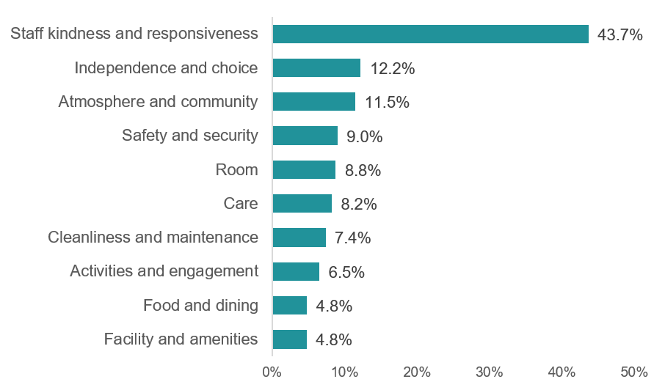
Figure 8: Percentage of top 10 categories mentioned in Q14 Negative responses (n=20,193)
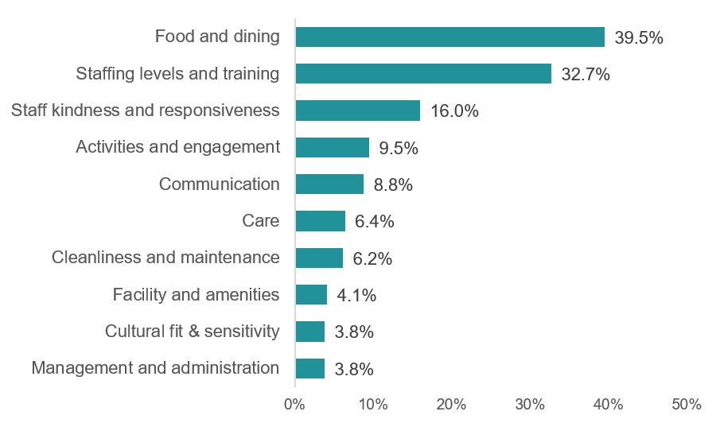

- Staff were the most common focus of positive comments. Staff kindness and responsiveness was the most-mentioned Q13 category, appearing in 43.7% of positive responses - more than three times as often as the next category. Staff also featured prominently in improvement suggestions, with staffing levels and training mentioned in 32.7% of negative Q14 responses and staff kindness and responsiveness mentioned in 16.0%.
- Food was the most common improvement area raised by residents. Food and dining was the most-mentioned Q14 category. Where Q13 food praise was largely generic (see Figure 9), Q14 responses are specific about what residents would change. To understand what aspects of food residents were responding to, every food-related response was further classified into one of six subcategories: food in general, food quality, food variety, food presentation and appearance, food temperature, and culturally appropriate food. Food quality (39.3%) and food variety (32.6%) together account for around 72% of all food-related improvement suggestions.

Figure 9: Food subcategories mentioned in Q13 Positive Food & Dining responses (n=1,685)
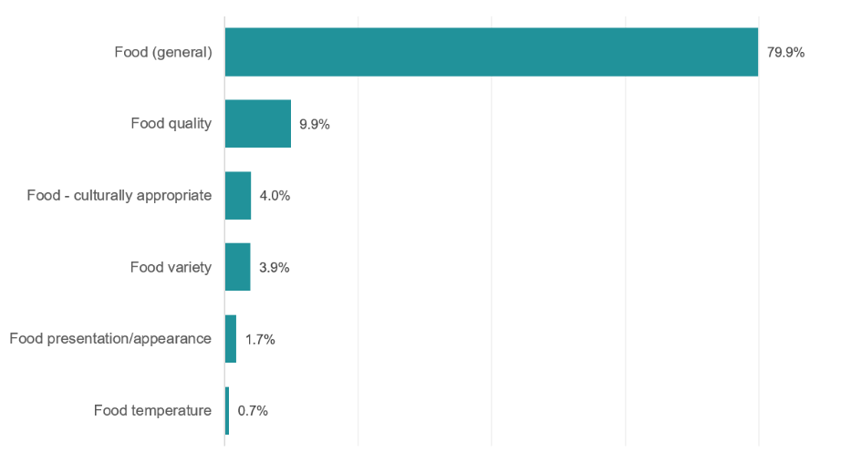

Figure 10: Food subcategories mentioned in Q14 Negative Food & Dining responses (n=7,980)
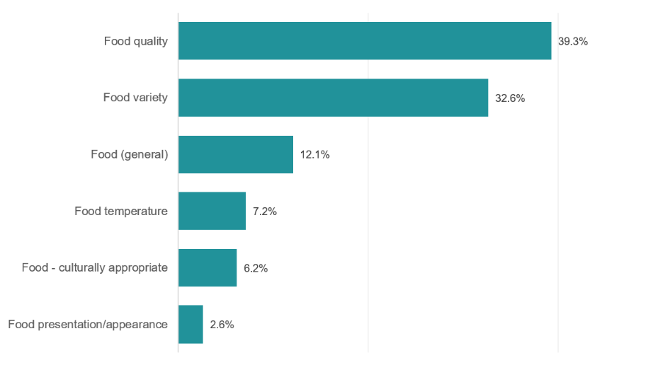

What residents value the most: Q13 in detail
This section outlines the categories most frequently raised in Q13 positive responses, in order of frequency. Cross-question contrasts (how the same category surfaces in Q14) are noted in the next section.
Table 6: What residents value the most (Question 13)
Category | What residents commonly said | Example responses
Staff - kindness and responsiveness | Individual qualities of the people caring for them, such as kindness, attentiveness, and respect. | - "The staff are lovely, and they talk to us and know us all really well."  - "The staff, I only need to press the buzzer and they come straight away."  - "The best thing about this place is the friendliness of the staff."
Independence and choice | Being able to make their own decisions about daily routines, retaining freedom of movement around the home, and continuing activities they had done before entering care. | - "You get a lot of freedom and can say no if you don't want to do things."  - "I have my own room and privacy. I can do what I want, when I want."  - "I can come and go as I please."
Atmosphere and community | The feeling of being at home, the warmth of the resident community, the sense of being among friends, and the social connections formed with other residents and staff. | - "I feel at home, I have always felt at home since I arrived here."  - "It has a bright and positive environment."  - “Love, calming and happy atmosphere. I feel relaxed here.”
Safety and security | Feeling physically safe, secure in their belongings, and confident that help would arrive in an emergency. Some framed safety as the relief of no longer worrying about risks they had faced when living independently. | - “You feel safe here. You can go to somebody if you need anything.”  - “The best thing about this place is the security.”
Room | The size, comfort and personal feel of their room, having their own space and the views from their window. | - "The views from my window."  - "My room is beautiful and well set up with my own bathroom."
Care | Explicit references to clinical and personal care attention, distinct from the relational qualities of staff. Residents valued knowing that medical needs were attended to and that help was available when needed. | - "The care - they are good at keeping up with medicines."  - “The best thing about this place is the administration of the medication.”
Cleanliness and maintenance | The overall cleanliness of the home, the regular cleaning of rooms and shared areas, and general tidiness. | - “It's very clean and spotless. The staff are always well dressed and very pleasant. The laundry process is terrific.”  - “It's really clean and well equipped and some of the staff are exceptional. The range of activities is good. Nice selection of meals on offer.”
Activities and engagement | Organised activities, outings and the social engagement provided. This also includes entertainment provided within the home, like television usage and movies. | - “The accessibility and going outside for activities, plenty of variety.”  - “The day trips, the excursions, the cafe, the common rooms are big and I don't feel lonely.”
Food and dining | Positive food comments tended to be generic rather than specific, with the majority of residents expressing general satisfaction rather than praising particular aspects of food and dining. | - "I am happy with the food they cook and enjoy it."  - "The food, it is always so well presented."  - “I like that I have cold and hot food choices with each meal.”
Facility and amenities | The broader physical environment: common areas, gardens and amenities. | - “I like to sit in the garden when its sunny.”  - “That it is a fairly new home, big open spaces, very clean and the staff are wonderful, the quality of care is great.”

What residents would change: Q14 in detail
This section walks through the categories most frequently raised in Q14 responses, in order of frequency. Each entry describes what residents said and includes examples drawn from their responses.
Table 7: What would residents change (Question 14)
Category | What residents commonly said | Example responses
Food and dining | Residents spoke about food quality and variety, with residents asking for more flavoursome, home-style cooking. | - "The food has no flavour. The staff in the kitchen are not chefs just cooks and don't understand how to cook real food."  - "Chefs to take more inspiration from home cooked meals. The food here feels very institutionalised."  - “Cut down on rice as there's always too much rice.”
Staffing levels and training | Concerns about staff numbers, training and capability. Residents raised understaffing, particularly on weekends, overnight, and at peak care times. They also raised staff turnover, age, reliance on agency staff, and gaps in training. | - "They need to increase staff, they're always short staffed, especially on weekends."  - "More training for the carers."  - “More staff, there are long wait times when you press the call bell. Better pay for carers.”
Staff: kindness and responsiveness | Raises concerns about interpersonal conduct or responsiveness to specific requests, rather than the quality or number of staff. | - "For staff to treat me like an adult, they talk down to me."  - "Don't answer buzzer, they don't listen to feedback the whole place needs improvement."  - "The staff in the dining room can be very sharp in the way they speak to residents."
Activities and engagement | Residents typically asked for more variety in activities, more frequency, or activities better matched to their interests and physical capabilities. | - “More/better activities, we don't have enough entertainment.”  - “The home needs to have 2 Lifestyle coordinators on the weekend as there needs to be more weekend activities on low care level.”
Communication | Requests for clearer information about changes to care or routines, more responsive communication with families, and better handover between staff across shifts. | - "More communication with family. The residents need more care and monitoring."  - "Better communication between staff for a better follow up."
Care | Referenced gaps in follow-through, slow escalation, and inconsistent attention to personal care routines. | - “Staff should provide regular checks on residents who are legally blind. Personal assistance can be better managed.”  - “Continuity of care and familiar staff. More specific exercises and physio for residents with dementia.”
Cleanliness and maintenance | Residents raised inconsistent cleaning standards, bathroom hygiene, smell and slow responses to maintenance requests. | - “They could improve keeping residents' rooms and clothes cleaner.”  - “There seems to be a lack of upkeep of the facilities.”
Facility and amenities | Concerns about facility size, storage, equipment and shared facilities such as bathrooms, with residents asking for improved areas and better-equipped amenities. | - “The bathrooms are in desperate need of a renovation and need to be reconfigured. It is difficult for residents to manoeuvre onto the toilets.”  - “Nicer outdoor shaded areas so family can spend time with residents outdoors as there's a courtyard but it's open and on hot days, it is not nice to sit outside.”
Cultural fit and sensitivity | Broader cultural needs around food, religion and social practice. Overlaps with but is distinct from language barriers, which captures the specifically linguistic dimension of cross-cultural communication. | - “Nothing here for my culture, I don't feel respected.”  - “There needs to be less prejudice against residents' religion preferences.”
Management and administration | Residents raised dissatisfaction with the responsiveness of management to complaints, delays in administrative processes, lack of follow-through on issues raised, and changes in management practices that affected daily life in the home. | - "Improve the administration process, I think the paperwork should all go to digital."  - "To be a bit more organised. The home could be more efficient."

Free text results by home type & resident characteristics
This section reports how the top three categories from Q13 and Q14 vary across home characteristics: home size, location, provider type and rurality. Detailed breakdowns are provided in Table 8 and Table 9.

Q13 positive responses
Staff kindness and responsiveness was the most common positive category across all home types (See Table 8).
- Results were broadly similar by home size. Staff kindness and responsiveness was mentioned in 45.1% of positive responses from residents in small homes, compared with 44.2% in medium homes and 42.1% in large homes. Smaller homes had slightly higher mentions of Atmosphere and community (13.3%, compared with 11.0% in medium homes and 10.4% in large homes).
- Results varied more by home location. Staff kindness and responsiveness was mentioned most often in VIC (45.4%) and WA (44.9%) and least often in SA (37.8%). Independence and choice was mentioned most often in TAS (15.1%) and WA (14.0%), while Atmosphere and community was mentioned most often in the NT (16.3%) and TAS (14.8%). Results for the NT and ACT are based on smaller samples than other jurisdictions and should therefore be interpreted with caution.
- Results were broadly similar by provider type and rurality. Government-operated homes had the highest mentions of all three top Q13 categories: Staff kindness and responsiveness (46.4%), Independence and choice (13.4%) and Atmosphere and community (13.7%). By rurality, metropolitan homes had slightly higher mentions of Staff kindness and responsiveness (44.1%), while rural/remote homes had higher mentions of Atmosphere and community (13.8%).
Table 8: Top 3 Q13 Positive categories, by home type
Home type | Staff - kindness & responsiveness | Independence &  choice | Atmosphere & community
Home size
101+ operational places (large)  (n=12,189) | 42.1% | 11.7% | 10.4%
61-100 operational places (medium)  (n=11,858) | 44.2% | 12.1% | 11.0%
1-60 operational places (small)  (n=10,316) | 45.1% | 13.0% | 13.3%
Home location
Homes in ACT  (n=424) | 40.6% | 8.3% | 9.2%
Homes in NSW  (n=11,321) | 44.0% | 12.1% | 12.1%
Homes in NT  (n=98) | 41.8% | 11.2% | 16.3%
Homes in QLD  (n=6,616) | 43.5% | 11.4% | 11.0%
Homes in SA  (n=3,133) | 37.8% | 12.6% | 10.0%
Homes in TAS  (n=755) | 40.5% | 15.1% | 14.8%
Homes in VIC  (n=9,436) | 45.4% | 12.2% | 12.5%
Homes in WA  (n=3,210) | 44.9% | 14.0% | 8.3%
Provider type
Not-for-profit provider  (n=20,701) | 42.8% | 12.6% | 12.0%
For-profit provider  (n=12,415) | 44.7% | 11.4% | 10.3%
Government provider  (n=1,877) | 46.4% | 13.4% | 13.7%
MMM rurality
Metropolitan  (n=23,759) | 44.1% | 11.7% | 10.6%
Regional  (n=3,076) | 41.5% | 13.7% | 12.1%
Rural/remote  (n=8,158) | 43.2% | 13.2% | 13.8%
Note: n = number of valid Q13 responses (responses assigned Positive sentiment with no processing errors). Total valid Q13 responses: n=34,993.

Q14 negative responses
Food and dining was the most common improvement category across most home types, with larger variation than observed in Q13 positive responses (See Table 9).
- Results were broadly similar by home size. Food and dining was mentioned more often in negative responses from residents in large homes (41.6%) than in medium homes (39.6%) or small homes (36.5%). Staffing levels and training was mentioned at similar levels across home sizes, ranging from 31.1% in small homes to 33.6% in medium homes.
- Results varied more by home location. Food and dining was mentioned most often in the ACT (47.0%) and NSW (41.7%), and least often in SA (33.3%). Staffing levels and training was mentioned most often in QLD (37.2%) and least often in the NT (25.4%) and WA (26.6%). Staff kindness and responsiveness was mentioned most often in the NT (23.9%) and ACT (19.2%).
- Results were broadly similar by provider type and rurality. Food and dining was mentioned less often in government-operated homes (31.8%) than in not-for-profit homes (39.1%) or for-profit homes (41.0%). Staffing levels and training was mentioned more often in regional (37.2%) and rural/remote homes (35.8%) than in metropolitan homes (31.2%).
Table 9: Top 3 Q14 Negative categories, by home type
Home type | Food & dining | Staffing - levels & training | Staff - kindness & responsiveness
Home size
101+ operational places (large)  (n=7,814) | 41.6% | 33.0% | 16.4%
61-100 operational places (medium)  (n=6,967) | 39.6% | 33.6% | 15.7%
1-60 operational places (small)  (n=5,412) | 36.5% | 31.1% | 15.7%
Home location
Homes in ACT  (n=281) | 47.0% | 29.2% | 19.2%
Homes in NSW  (n=6,704) | 41.7% | 33.5% | 18.1%
Homes in NT  (n=71) | 38.0% | 25.4% | 23.9%
Homes in QLD  (n=3,799) | 40.1% | 37.2% | 15.1%
Homes in SA  (n=1,942) | 33.3% | 30.3% | 17.5%
Homes in TAS  (n=400) | 38.0% | 33.5% | 17.3%
Homes in VIC  (n=5,065) | 39.3% | 31.9% | 13.6%
Homes in WA  (n=1,931) | 37.0% | 26.6% | 14.0%
Provider type
Not-for-profit provider  (n=11,782) | 39.1% | 33.7% | 16.0%
For-profit provider  (n=7,535) | 41.0% | 31.2% | 16.2%
Government provider  (n=876) | 31.8% | 33.7% | 13.2%
MMM rurality
Metropolitan  (n=13,999) | 40.4% | 31.2% | 16.4%
Regional  (n=1,757) | 38.0% | 37.2% | 15.4%
Rural/remote  (n=4,437) | 37.5% | 35.8% | 14.8%
Note: n = number of valid Q14 responses (responses assigned Negative sentiment with no processing errors). Total valid Q14 responses: n=20,193.

Free-text results by resident characteristics
This section examines whether the categories most often raised in residents’ free-text responses varied by diverse group status. The analysis focuses on the top three Q13 positive categories and the top three Q14 negative categories. Detailed regression results are provided in Appendix E.

Q13 positive responses
CALD residents were less likely to mention staff kindness in their responses, while residents who were homeless or at risk of homelessness, and rural and remote residents, more often raised independence, choice and community.
The three most common categories in positive responses to Q13 were staff kindness and responsiveness, independence and choice, and atmosphere and community. After accounting for proxy use, home size, state and provider type:
- Staff kindness and responsiveness: CALD residents were also less likely to mention this category than residents who were not CALD (OR 0.94, 95% CI 0.89–0.98, p<0.05).
- Residents who were homeless or at risk of homelessness were more likely to mention independence and choice than other residents (OR 1.80, 95% CI 1.22–2.59, p<0.05).
- Residents who were homeless or at risk of homelessness were less likely to mention atmosphere and community than other residents (OR 0.52, 95% CI 0.27–0.90, p<0.05). Rural and remote residents were more likely to mention this category than residents who were not rural or remote (OR 1.11, 95% CI 1.03–1.20, p<0.05).

Q14 negative responses
First Nations residents were less likely to raise food and dining, while rural and remote residents more often raised staffing levels and training.
The three most common categories in negative responses to Q14 were food and dining, staffing levels and training, and staff kindness and responsiveness. After accounting for proxy use, home size, state and provider type:
- First Nations residents were less likely to mention food and dining than residents who were not First Nations (OR 0.73, 95% CI 0.59–0.91, p<0.05).
- Rural and remote residents were more likely to mention staffing levels and training than residents who were not rural or remote (OR 1.17, 95% CI 1.09–1.26, p<0.05).
- Financially and socially disadvantaged residents were more likely to mention staff kindness and responsiveness than residents who were not financially and socially disadvantaged (OR 1.44, 95% CI 1.13–1.82, p<0.05).

Summary
Residents' free-text responses centred on two themes: staff were the most common focus of positive comments, and food the most common focus of improvement suggestions. Staff kindness and responsiveness appeared in 43.7% of positive responses - more than three times as often as the next category - while food and dining was the most-mentioned improvement area, with food quality and variety together accounting for around 72% of food-related suggestions.
Staff featured on both sides. Beyond the praise for kindness and responsiveness, staffing levels and training was the second most common improvement area (32.7% of negative responses), reflecting concerns about staff numbers, training and availability, particularly on weekends and overnight. Communication showed the widest gap between the two questions: rarely raised as a strength but one of the most common improvement areas.

Conclusion
This report draws on 44,318 surveys completed across 2,589 residential aged care homes in Australia. It provides a broad view of residents' reported experiences of aged care in 2025 and how these have changed since 2023. Four findings are central to the 2025 results.
Overall satisfaction remained high and has increased since 2023. In 2025, 89% of residents gave a positive response when asked whether they would recommend their aged care home, up from 85% in 2023. Positive response rates were also high for feeling safe, being treated with respect, receiving the care they need, and having a say in daily activities. Results were similar across home sizes, with the clearest variation by location and provider type.
Staff were central to residents' experiences, both to what residents valued and to what some would like improved. Staff kindness and responsiveness was the most common category in positive responses to Question 13, appearing in 43.7% of positive responses, while staffing levels and training was the second most common improvement category in negative responses to Question 14, appearing in 32.7% of negative responses.
Food remained the clearest area for improvement. It was the only measure that did not improve between 2023 and 2025 and recorded the lowest positive response rate in 2025. Food and dining was also the most common category raised in negative responses to Question 14, with residents most often identifying food quality and variety as areas for change.
Experiences were not uniform across resident groups. First Nations and CALD residents were less likely to give positive responses on several measures, while veterans and residents in rural or remote areas were more likely to. These differences indicate that strong sector-wide results can coexist with meaningful variation between groups.

Reporting positive responses and sample sizes
This appendix explains how positive responses are defined in this report and provides the sample sizes used for key subgroup analyses. It is intended to support consistent interpretation of the results, particularly where findings are reported for smaller resident groups or linked resident characteristics.

Defining positive responses
The RES uses a four-point response scale for Questions 1 to 12:
- “Always”
- “Most of the time”
- “Some of the time”
- “Never”
For this report, responses of “Always” and “Most of the time” are classified as positive responses. Responses of “Some of the time” and “Never” are classified as negative responses.
This classification supports clear and consistent reporting of positive resident experience across the 12 fixed-response questions. However, it also reduces the sensitivity of the response scale. By grouping “Always” with “Most of the time”, and “Some of the time” with “Never”, the analysis does not capture differences in response intensity within each category. Results should therefore be interpreted as the proportion of residents who gave a positive response, rather than as a detailed measure of the strength or consistency of residents’ experiences.

Interpreting sample sizes
Sample sizes are reported to show how many completed surveys contributed to each subgroup result. They are provided to support the interpretation of the descriptive and regression result analysis, particularly where results are based on smaller subgroups.
Table 10 summarises the sample sizes for the main subgroup analyses used in this report.
For analyses using linked resident characteristics, the sample size reflects the number of completed surveys that could be linked to the relevant characteristic.
Table 10: Sample sizes used in subgroup analyses
Analysis area | Group or variable | Number of completed surveys
Total RES 2025 | All completed surveys | 44,318
Home size | 1 to 60 residents (small) | 12,791
Home size | 61 to 100 residents (medium) | 15,154
Home size | 101 or more residents (large) | 16,373
State | ACT | 530
State | NSW | 14,133
State | NT | 118
State | QLD | 8,561
State | SA | 3,827
State | TAS | 1,027
State | VIC | 11,921
State | WA | 4,201
Provider type | Not-for-profit provider | 26,137
Provider type | For-profit provider | 15,891
Provider type | Government provider | 2,290
Diversity | Financially and socially disadvantaged residents | 825
Diversity | Veterans | 2,011
Diversity | LGBTQI+ residents | 71
Diversity | Homeless or at risk of homelessness | 206
Diversity | First Nations residents | 819
Diversity | CALD residents | 16,230
Diversity | Rural or remote residents | 13,409
Diversity | Care leavers | 60
Diversity | Residents affected by forced adoption | 23
Note: Some residents may belong to more than one diverse group, so diversity group sample sizes should not be summed. Sample sizes for linked-data analyses reflect the number of completed surveys with the relevant linked characteristic available.

National Residents’ Experience Report (RER)
This National RER shows the national average distribution of results for each RES question. This allows homes to compare their own results against the national average.
How to use the National RER
In order to make comparison as easy as possible, the National RER is presented in the same format as the RER distributed to homes.
- The first page of the National RER provides background information on the RES, survey structure and the RERs. It also shows some statistics for the survey, such as:
  - The number of residents surveyed
  - The number of residents excluded
  - How many responses were completed by proxies
  - The dates when surveying started and finished
- The second and third pages of the National RER (titled “Residents’ Experience Survey results – 2025”) show the proportion of all participating residents in Australia who responded “Always”, “Most of the time”, “Some of the time” or “Never” for each question in 2025.
- The fourth and fifth pages of the National RER (titled “Residents’ Experience Survey results – historical data”) show the proportion of all participating residents in Australia who responded “Always”, “Most of the time”, “Some of the time” or “Never” for each question in 2025, 2024 and 2023.
- To compare your results with the National RER, match each question in your RER with the national results and compare the percentage breakdowns. If the proportion of “Always” or “Most of the time” responses is higher than the national average, your home is performing above average for that question.
Residents’ Experience Report – National RER
Service ID: | All homes
Date of Survey visit: | Jan 2025-Dec 2025
Total number of residents*: | 195,212
- Total number of surveys completed: | 44,318
- Number of surveys completed by residents: | 40,529
- Number of surveys completed by proxy: | 3,789
- Number of excluded** residents: | 2,972
Residents’ Experience Survey
The experiences of older people in RACHs give vital insight into the quality of care they receive.
In response to the recommendations made by the Royal Commission into Aged Care Quality and Safety, the Australian Government adopted a comprehensive approach to quality measuring and reporting. This includes Star Ratings, which have been published since December 2022 on My Aged Care for all in-scope RACHs. Star Ratings present simple, at a glance information that improves transparency and can help older people in Australia, as well as their representatives, to make informed choices about residential aged care.
The Residents’ Experience Survey is an annual survey of each residential aged care home. The number of residents surveyed is dependent on the size of the aged care home. The Residents' Experience Rating contributes a 33% weighting to a home's overall Star Rating.
About the surveys
The survey includes 14 questions: 12 Likert-scale questions and 2 free text questions. The responses to each question have been aggregated and used to generate this Residents' Experience Report. For more information about the questions, please visit https://www.health.gov.au/our-work/residents-experience-survey.
About the Residents’ Experience Report
This report provides you with information about where your aged care home is doing well, and what you can improve on. The vital insights in this report can be used to implement direct improvements to the safety and quality of care provided and track residents’ experience in consecutive years.
Making improvements can positively impact the Residents’ Experience Rating, which is the heaviest weighted component towards the overall Star Rating.
This report compares up to 2 years prior data on your residents’ experience to your results this year.
For more information on how to improve your Star Rating, visit the Department of Health, Disability and Ageing website. If your aged care home participated in the previous survey rounds, the results can be located on the My Aged Care website.

*Total number of residents is calculated using Department of Health, Disability and Ageing’s Data of Aged Care User IDs assigned to the Service ID, refreshed within a three-month period of the Date of Survey visit.
**Residents excluded as per exclusion criteria (i.e., has been a resident for less than six weeks, has a life expectancy of four weeks or less, is under respite care, and no longer a resident at the service due to being discharged or deceased)
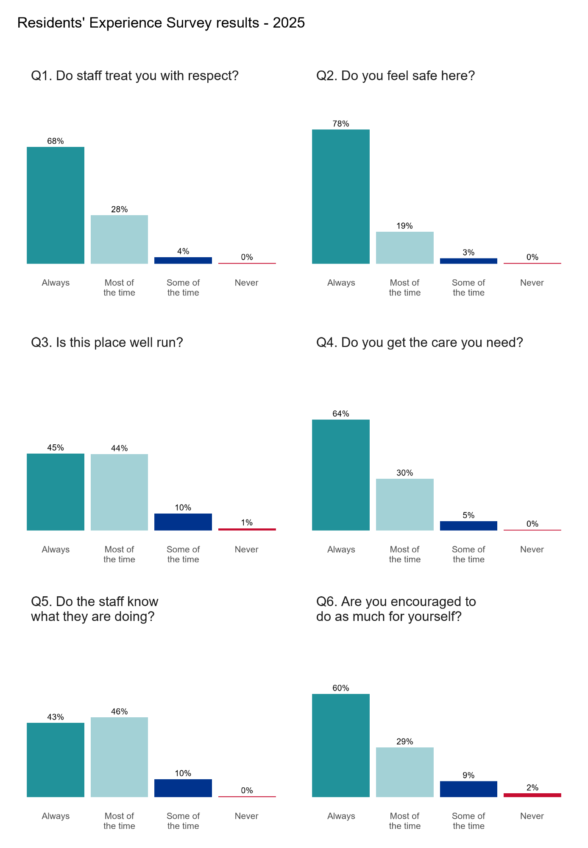
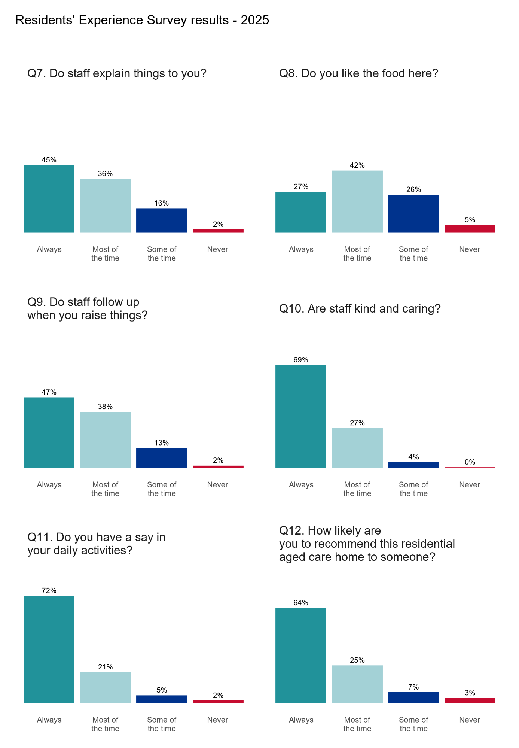

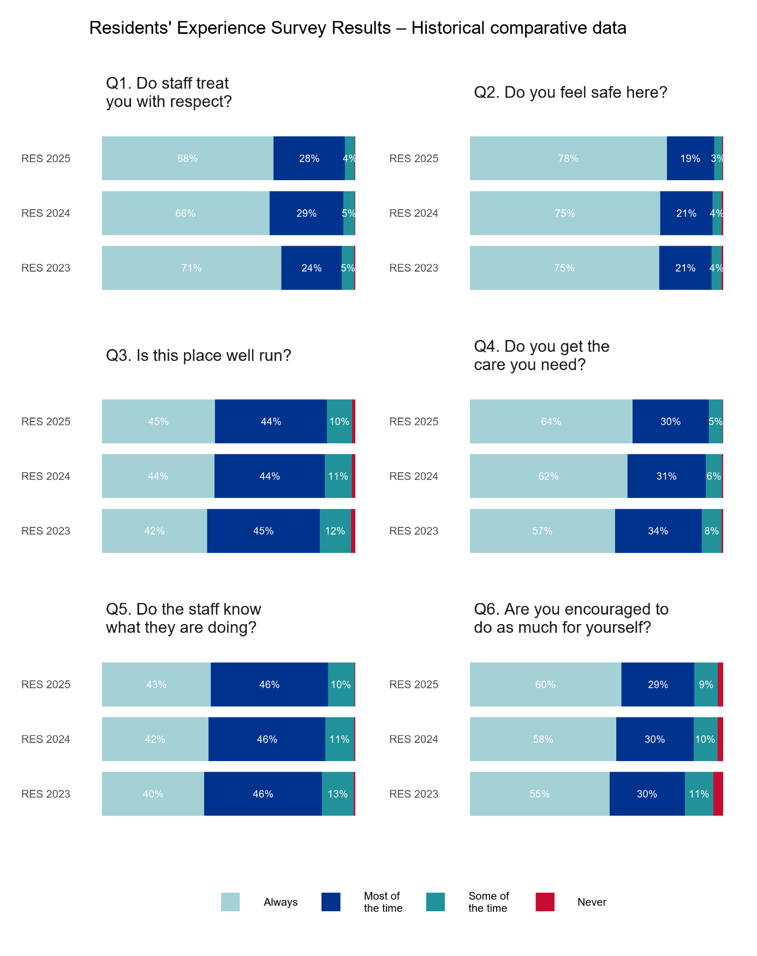

2025 n=44,318, 2024 n=36,221, 2023 n=37,382

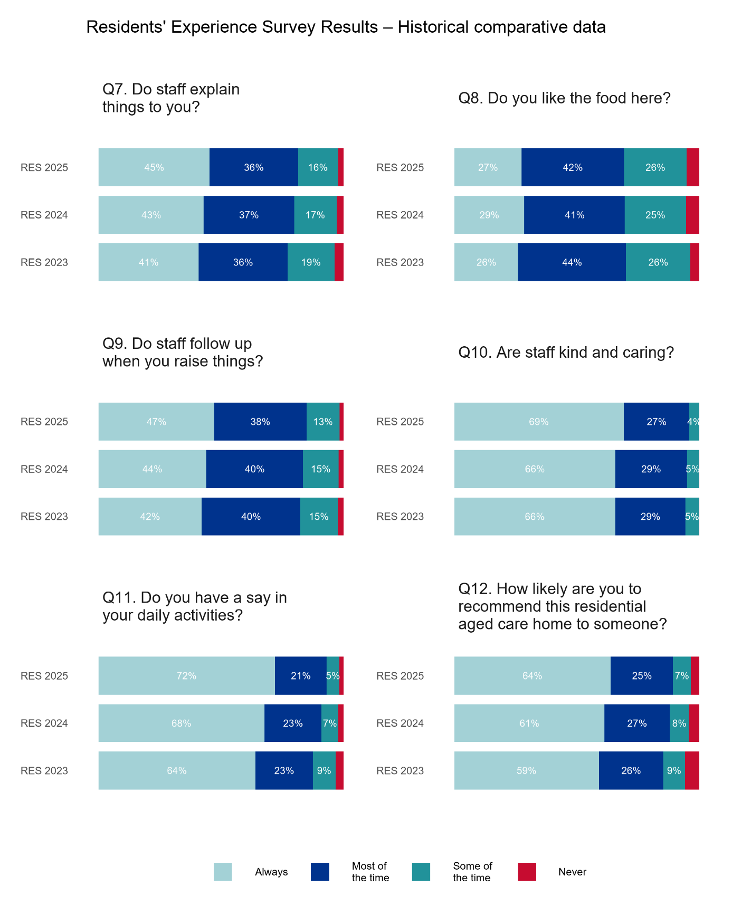
2025 n=44,318, 2024 n=36,221, 2023 n=37,382
Please note: Percentage labels for the "Never" category have been excluded from the charts as they represent 6% or less of responses.

Table 11: Historical comparative data of RES (2023-2025)
Question |  | 2023  Always |  | 2023  Most of the time |  | 2023  Some of the time |  | 2024  Always |  | 2024  Most of the time |  | 2024  Some of the time |  | 2025  Always |  | 2025  Most of the time |  | 2025  Some of the time
Q1. Do staff treat you with respect? |  | 71% |  | 24% |  | 5% |  | 66% |  | 29% |  | 5% |  | 68% |  | 28% |  | 4%
Q2. Do you feel safe here? |  | 75% |  | 21% |  | 4% |  | 75% |  | 21% |  | 4% |  | 78% |  | 19% |  | 3%
Q3. Is this place well run? |  | 42% |  | 45% |  | 12% |  | 44% |  | 44% |  | 11% |  | 45% |  | 44% |  | 10%
Q4. Do you get the care you need? |  | 57% |  | 34% |  | 8% |  | 62% |  | 31% |  | 6% |  | 64% |  | 30% |  | 5%
Q5. Do staff know what they are doing? |  | 40% |  | 46% |  | 13% |  | 42% |  | 46% |  | 11% |  | 43% |  | 46% |  | 10%
Q6. Are you encouraged to do as much as possible for yourself? |  | 55% |  | 30% |  | 11% |  | 58% |  | 30% |  | 10% |  | 60% |  | 29% |  | 9%
Q7. Do staff explain things to you? | 41% |  | 36% |  | 19% |  | 43% |  | 37% |  | 17% |  | 45% |  | 36% |  | 16%
Q8. Do you like the food here? | 26% |  | 44% |  | 26% |  | 29% |  | 41% |  | 25% |  | 27% |  | 42% |  | 26%
Q9. Do staff follow up when you raise things with them? | 42% |  | 40% |  | 15% |  | 44% |  | 40% |  | 15% |  | 47% |  | 38% |  | 13%
Q10. Are staff kind and caring? | 66% |  | 29% |  | 5% |  | 66% |  | 29% |  | 5% |  | 69% |  | 27% |  | 4%
Q11. Do you have a say in your daily activities? | 64% |  | 23% |  | 9% |  | 68% |  | 23% |  | 7% |  | 72% |  | 21% |  | 5%
Q12. How likely are you to recommend this residential aged care home to someone? | 59% |  | 26% |  | 9% |  | 61% |  | 27% |  | 8% |  | 64% |  | 25% |  | 7%

Diversity analysis
This appendix presents detailed descriptive and regression results for residents identified as belonging to one or more diverse groups. Diversity information was drawn from Departmental Residents Data, RACH Manager confirmation, and resident conversation where appropriate. In the Departmental Residents Data, veteran status was identified through the DVA Entitlement field, CALD status through the CALD Status field, First Nations status through the Indigenous field, and rural/remote status through the service’s Modified Monash Model classification. Other diverse group information was confirmed onsite as part of the RES process.
The analysis includes seven diverse groups: financially and socially disadvantaged residents, veterans, LGBTQI+ residents, residents who were homeless or at risk of homelessness, First Nations residents, CALD residents, and rural/remote residents. Residents could belong to more than one diverse group, so groups are not mutually exclusive. Each group was analysed separately by comparing residents identified as belonging to that group with residents not identified as belonging to that group.
Three groups were excluded from the regression analysis because they fell below the 100-respondent threshold: LGBTQI+ residents (n=71), care leavers (n=60) and residents affected by forced adoption (n=23). Below this threshold, confidence intervals are too wide to support reliable estimation of adjusted odds ratios.
Descriptive results are still presented where appropriate. For the regression analysis, models tested whether differences between each diverse group and other residents remained after accounting for proxy use, home size, state and provider type.
In the regression tables, the rows under “finding of interest” are the main results for interpretation. The rows under “adjustment variables” are included to show the full model specification. These variables help account for differences in survey completion and service context, but should not be interpreted as the main findings of this analysis.
Table 12: Proportion of positive responses to all RES questions, by diverse group
Question | FSD | Non-FSD | Vet | Non-Vet | LGBTQI+ | Non-LGBTQI+ | HL | Non-HL | CL | Non-CL | FA | Non-FA | FN | Non-FN | CALD | Non-CALD | R/R | Non-R/R
Q1. Do staff treat you with respect? | 95% | 96% | 96% | 96% | 94% | 96% | 94% | 96% | 98% | 96% | 100% | 96% | 93% | 96% | 95% | 96% | 97% | 96%
Q2. Do you feel safe here? | 95% | 96% | 97% | 96% | 93% | 96% | 95% | 96% | 100% | 96% | 100% | 96% | 93% | 96% | 96% | 97% | 97% | 96%
Q3. Is this place well run? | 89% | 89% | 89% | 89% | 83% | 89% | 84% | 89% | 93% | 89% | 83% | 89% | 88% | 89% | 88% | 89% | 90% | 88%
Q4. Do you get the care you need? | 94% | 94% | 94% | 94% | 90% | 94% | 94% | 94% | 95% | 94% | 100% | 94% | 93% | 94% | 93% | 95% | 95% | 94%
Q5. Do staff know what they are doing? | 88% | 89% | 89% | 89% | 82% | 89% | 86% | 89% | 90% | 89% | 96% | 89% | 88% | 89% | 88% | 90% | 91% | 88%
Q6. Are you encouraged to do as much as possible for yourself? | 92% | 89% | 90% | 89% | 85% | 89% | 93% | 89% | 87% | 89% | 87% | 89% | 89% | 89% | 87% | 90% | 91% | 88%
Q7. Do staff explain things to you? | 83% | 81% | 83% | 81% | 80% | 81% | 79% | 81% | 77% | 81% | 91% | 81% | 81% | 81% | 80% | 82% | 84% | 80%
Q8. Do you like the food here? | 71% | 69% | 69% | 69% | 72% | 69% | 65% | 69% | 72% | 69% | 78% | 69% | 70% | 69% | 67% | 71% | 73% | 68%
Q9. Do staff follow up when you raise things with them? | 86% | 85% | 86% | 85% | 83% | 85% | 84% | 85% | 85% | 85% | 83% | 85% | 82% | 85% | 84% | 85% | 87% | 84%
Q10. Are staff kind and caring? | 94% | 96% | 97% | 96% | 93% | 96% | 95% | 96% | 97% | 96% | 100% | 96% | 95% | 96% | 95% | 96% | 97% | 96%
Q11. Do you have a say in your daily activities? | 95% | 93% | 93% | 93% | 92% | 93% | 95% | 93% | 95% | 93% | 87% | 93% | 92% | 93% | 92% | 94% | 94% | 92%
Q12. How likely are you to recommend this residential aged care home to someone? | 88% | 89% | 91% | 89% | 83% | 89% | 86% | 89% | 88% | 89% | 100% | 89% | 87% | 89% | 88% | 90% | 91% | 89%

Abbreviations: FSD = financially and socially disadvantaged; Vet = veterans; LGBTQI+ = lesbian, gay, bisexual, transgender, queer, intersex and other sexuality, gender and bodily diverse people; HL = homeless or at risk of homelessness; FN = First Nations; CALD = culturally and linguistically diverse; R/R = rural or remote; CL = care leavers; FA = residents affected by forced adoption.

Table 13: Adjusted odds ratios for overall satisfaction across diverse groups
Variable | Odds Ratio (95% CI) | p-value
Findings of interest
Financially and socially disadvantaged | 0.86 (0.69, 1.08) | 0.1799
Veterans | 1.21 (1.04, 1.43) | <0.05
Homeless or at risk of homelessness | 0.67 (0.46, 1.02) | 0.0524
First Nations | 0.75 (0.61, 0.94) | <0.05
CALD | 0.93 (0.87, 0.99) | <0.05
Rural/remote | 1.10 (1.02, 1.18) | <0.05
Adjustment variables
Proxy | 1.39 (1.24, 1.57) | <0.05
Home Size (101+)* | 0.93 (0.86, 1.01) | 0.0701
Home Size (61-100)* | 0.93 (0.86, 1.01) | 0.0794
State (NSW)** | 1.54 (1.18, 1.98) | <0.05
State (NT)** | 0.72 (0.43, 1.24) | 0.2193
State (QLD)** | 1.50 (1.15, 1.94) | <0.05
State (SA)** | 0.87 (0.66, 1.12) | 0.2895
State (TAS)** | 1.11 (0.81, 1.52) | 0.5153
State (VIC)** | 1.23 (0.94, 1.59) | 0.1135
State (WA)** | 0.96 (0.73, 1.25) | 0.7586
Provider type (Government)*** | 1.73 (1.46, 2.07) | <0.05
Provider Type (Not-for-profit)*** | 1.29 (1.21, 1.37) | <0.05
Reference categories: * Home size – 1-60. ** State – ACT. *** Provider type – For profit
Table 14: Adjusted odds ratios for positive responses to being encouraged to do as much as possible, by diverse group
Variable | Odds Ratio (95% CI) | p-value
Findings of interest
Financially and socially disadvantaged | 1.17 (0.90, 1.54) | 0.2476
Veterans | 1.00 (0.86, 1.16) | 0.9881
Homeless or at risk of homelessness | 1.12 (0.68, 2.00) | 0.6669
First Nations | 0.74 (0.59, 0.94) | <0.05
CALD | 0.92 (0.86, 0.98) | <0.05
Rural/remote | 1.23 (1.14, 1.32) | <0.05
Adjustment variables
Proxy | 0.48 (0.44, 0.52) | <0.05
Home Size (101+)* | 0.86 (0.80, 0.94) | <0.05
Home Size (61-100)* | 0.84 (0.78, 0.91) | <0.05
State (NSW)** | 1.00 (0.72, 1.36) | 0.9977
State (NT)** | 0.40 (0.23, 0.71) | <0.05
State (QLD)** | 1.23 (0.88, 1.68) | 0.1988
State (SA)** | 0.31 (0.22, 0.42) | <0.05
State (TAS)** | 0.86 (0.58, 1.25) | 0.4255
State (VIC)** | 0.58 (0.42, 0.79) | <0.05
State (WA)** | 0.46 (0.33, 0.63) | <0.05
Provider type (Government)*** | 1.35 (1.15, 1.59) | <0.05
Provider Type (Not-for-profit)*** | 1.09 (1.02, 1.16) | <0.05
Reference categories: * Home size – 1-60. ** State – ACT. *** Provider type – For profit
Table 15: Adjusted odds ratios for positive responses to having a say in daily activities, by diverse group
Variable | Odds Ratio (95% CI) |  | p-value
Findings of interest
Financially and socially disadvantaged | 1.32 (0.96, 1.88) |  | 0.1049
Veterans | 0.96 (0.80, 1.15) |  | 0.6325
Homeless or at risk of homelessness | 1.05 (0.58, 2.15) |  | 0.8772
First Nations | 0.63 (0.49, 0.84) |  | <0.05
CALD | 0.97 (0.89, 1.05) |  | 0.3819
Rural/remote | 1.27 (1.16, 1.39) |  | <0.05
Adjustment variables
Proxy | 0.30 (0.27, 0.33) |  | <0.05
Home Size (101+)* | 1.04 (0.94, 1.15) |  | 0.4184
Home Size (61-100)* | 1.03 (0.94, 1.14) |  | 0.4935
State (NSW)** | 1.14 (0.76, 1.63) |  | 0.5095
State (NT)** | 0.45 (0.23, 0.91) |  | <0.05
State (QLD)** | 1.18 (0.79, 1.70) |  | 0.4034
State (SA)** | 0.35 (0.23, 0.50) |  | <0.05
State (TAS)** | 0.93 (0.58, 1.45) |  | 0.7416
State (VIC)** | 0.69 (0.46, 0.99) |  | 0.0567
State (WA)** | 1.36 (0.90, 1.99) |  | 0.1297
Provider type (Government)*** | 1.28 (1.06, 1.55) |  | <0.05
Provider Type (Not-for-profit)*** | 1.15 (1.06, 1.24) |  | <0.05
Reference categories: * Home size – 1-60. ** State – ACT. *** Provider type – For profit
Table 16: Adjusted odds ratios for positive responses to being treated with respect, by diverse group
Variable | Odds Ratio (95% CI) |  | p-value
Findings of interest
Financially and socially disadvantaged | 0.83 (0.60, 1.17) |  | 0.2689
Veterans | 1.11 (0.87, 1.42) |  | 0.4217
Homeless or at risk of homelessness | 0.62 (0.36, 1.16) |  | 0.1039
First Nations | 0.52 (0.39, 0.70) |  | <0.05
CALD | 0.79 (0.71, 0.87) |  | <0.05
Rural/remote | 1.17 (1.04, 1.32) |  | <0.05
Adjustment variables
Proxy | 2.52 (1.99, 3.23) |  | <0.05
Home Size (101+)* | 0.99 (0.87, 1.12) |  | 0.8191
Home Size (61-100)* | 0.96 (0.85, 1.08) |  | 0.4942
State (NSW)** | 0.59 (0.32, 1.00) |  | 0.0685
State (NT)** | 0.29 (0.12, 0.68) |  | <0.05
State (QLD)** | 0.70 (0.38, 1.18) |  | 0.2145
State (SA)** | 0.35 (0.19, 0.59) |  | <0.05
State (TAS)** | 0.59 (0.30, 1.09) |  | 0.1084
State (VIC)** | 0.60 (0.33, 1.01) |  | 0.0769
State (WA)** | 0.48 (0.26, 0.81) |  | <0.05
Provider type (Government)*** | 1.45 (1.11, 1.94) |  | <0.05
Provider Type (Not-for-profit)*** | 1.11 (1.01, 1.23) |  | <0.05
Reference categories: * Home size – 1-60. ** State – ACT. *** Provider type – For profit
Table 17: Adjusted odds ratios for positive responses to feeling safe, by diverse group
Variable | Odds Ratio (95% CI) | p-value
Findings of interest
Financially and socially disadvantaged | 0.71 (0.52, 1.00) | <0.05
Veterans | 1.13 (0.88, 1.48) | 0.3624
Homeless or at risk of homelessness | 0.74 (0.41, 1.52) | 0.3674
First Nations | 0.48 (0.36, 0.65) | <0.05
CALD | 0.80 (0.72, 0.89) | <0.05
Rural/remote | 1.15 (1.02, 1.31) | <0.05
Adjustment variables
Proxy | 0.90 (0.76, 1.07) | 0.2271
Home Size (101+)* | 1.04 (0.91, 1.18) | 0.6031
Home Size (61-100)* | 0.97 (0.85, 1.11) | 0.6644
State (NSW)** | 0.55 (0.27, 0.98) | 0.0644
State (NT)** | 0.28 (0.11, 0.73) | <0.05
State (QLD)** | 0.57 (0.28, 1.02) | 0.0842
State (SA)** | 0.36 (0.18, 0.64) | <0.05
State (TAS)** | 0.48 (0.23, 0.94) | <0.05
State (VIC)** | 0.61 (0.30, 1.08) | 0.122
State (WA)** | 0.50 (0.25, 0.91) | <0.05
Provider type (Government)*** | 1.20 (0.92, 1.58) | 0.192
Provider Type (Not-for-profit)*** | 1.24 (1.12, 1.38) | <0.05
Reference categories: * Home size – 1-60. ** State – ACT. *** Provider type – For profit
Table 18: Adjusted odds ratios for positive responses to the home being well run, by diverse group
Variable | Odds Ratio (95% CI) |  | p-value
Findings of interest
Financially and socially disadvantaged | 0.94 (0.75, 1.18) |  | 0.5677
Veterans | 0.97 (0.84, 1.13) |  | 0.7018
Homeless or at risk of homelessness | 0.59 (0.41, 0.88) |  | <0.05
First Nations | 0.82 (0.66, 1.02) |  | 0.0719
CALD | 0.95 (0.89, 1.01) |  | 0.0922
Rural/remote | 1.03 (0.96, 1.11) |  | 0.3571
Adjustment variables
Proxy | 1.30 (1.16, 1.46) |  | <0.05
Home Size (101+)* | 0.76 (0.70, 0.83) |  | <0.05
Home Size (61-100)* | 0.81 (0.75, 0.88) |  | <0.05
State (NSW)** | 1.34 (1.01, 1.73) |  | <0.05
State (NT)** | 0.65 (0.38, 1.14) |  | 0.1204
State (QLD)** | 1.08 (0.82, 1.40) |  | 0.5851
State (SA)** | 0.76 (0.57, 0.99) |  | <0.05
State (TAS)** | 0.97 (0.70, 1.33) |  | 0.8433
State (VIC)** | 1.11 (0.84, 1.44) |  | 0.4588
State (WA)** | 0.78 (0.59, 1.02) |  | 0.0716
Provider type (Government)*** | 1.62 (1.35, 1.94) |  | <0.05
Provider Type (Not-for-profit)*** | 1.14 (1.07, 1.21) |  | <0.05
Reference categories: * Home size – 1-60. ** State – ACT. *** Provider type – For profit
Table 19: Adjusted odds ratios for positive responses to getting the care needed, by diverse group
Variable |  |  | Odds Ratio (95% CI) |  | p-value
Findings of interest
Financially and socially disadvantaged |  |  | 0.85 (0.63, 1.17) |  | 0.3065
Veterans |  |  | 0.91 (0.76, 1.11) |  | 0.3526
Homeless or at risk of homelessness |  |  | 0.77 (0.45, 1.43) |  | 0.3638
First Nations |  |  | 0.73 (0.55, 0.98) |  | <0.05
CALD |  |  | 0.86 (0.79, 0.94) |  | <0.05
Rural/remote |  |  | 1.18 (1.07, 1.30) |  | <0.05
Adjustment variables
Proxy |  |  | 0.89 (0.78, 1.02) |  | 0.0969
Home Size (101+)* |  |  | 0.86 (0.77, 0.96) |  | <0.05
Home Size (61-100)* |  |  | 0.83 (0.74, 0.92) |  | <0.05
State (NSW)** |  |  | 1.21 (0.82, 1.73) |  | 0.3127
State (NT)** |  |  | 0.50 (0.25, 1.02) |  | <0.05
State (QLD)** |  |  | 1.14 (0.77, 1.64) |  | 0.4942
State (SA)** |  |  | 0.51 (0.34, 0.74) |  | <0.05
State (TAS)** |  |  | 0.82 (0.52, 1.27) |  | 0.3914
State (VIC)** |  |  | 1.03 (0.69, 1.47) |  | 0.8931
State (WA)** |  |  | 0.75 (0.50, 1.08) |  | 0.133
Provider type (Government)*** |  |  | 1.56 (1.22, 2.01) |  | <0.05
Provider Type (Not-for-profit)*** |  |  | 1.07 (0.98, 1.16) |  | 0.1477
Reference categories: * Home size – 1-60. ** State – ACT. *** Provider type – For profit
Table 20: Adjusted odds ratios for positive responses to staff knowing what they are doing, by diverse group
Variable | Odds Ratio (95% CI) |  |  |  | p-value
Findings of interest
Financially and socially disadvantaged | 0.78 (0.63, 0.98) |  |  |  | <0.05
Veterans | 0.95 (0.83, 1.11) |  |  |  | 0.5246
Homeless or at risk of homelessness | 0.69 (0.46, 1.05) |  |  |  | 0.069
First Nations | 0.81 (0.65, 1.02) |  |  |  | 0.0623
CALD | 0.92 (0.86, 0.98) |  |  |  | <0.05
Rural/remote | 1.11 (1.04, 1.20) |  |  |  | <0.05
Adjustment variables
Proxy | 1.23 (1.10, 1.39) |  |  |  | <0.05
Home Size (101+)* | 0.74 (0.68, 0.80) |  |  |  | <0.05
Home Size (61-100)* | 0.76 (0.70, 0.82) |  |  |  | <0.05
State (NSW)** | 1.20 (0.90, 1.56) |  |  |  | 0.1997
State (NT)** | 0.66 (0.38, 1.18) |  |  |  | 0.1433
State (QLD)** | 1.16 (0.87, 1.52) |  |  |  | 0.2902
State (SA)** | 0.63 (0.47, 0.82) |  |  |  | <0.05
State (TAS)** | 0.90 (0.64, 1.24) |  |  |  | 0.5225
State (VIC)** | 1.03 (0.78, 1.35) |  |  |  | 0.8109
State (WA)** | 0.81 (0.61, 1.07) |  |  |  | 0.1493
Provider type (Government)*** | 1.58 (1.32, 1.91) |  |  |  | <0.05
Provider Type (Not-for-profit)*** | 1.14 (1.07, 1.22) |  |  |  | <0.05
Reference categories: * Home size – 1-60. ** State – ACT. *** Provider type – For profit
Table 21: Adjusted odds ratios for positive responses to liking the food, by diverse group
Variable | Odds Ratio (95% CI) |  | p-value
Findings of interest
Financially and socially disadvantaged | 0.97 (0.83, 1.14) |  | 0.7284
Veterans | 0.94 (0.86, 1.04) |  | 0.2552
Homeless or at risk of homelessness | 0.69 (0.52, 0.93) |  | <0.05
First Nations | 0.87 (0.74, 1.01) |  | 0.0687
CALD | 0.85 (0.81, 0.89) |  | <0.05
Rural/remote | 1.11 (1.06, 1.17) |  | <0.05
Adjustment variables
Proxy | 1.75 (1.62, 1.90) |  | <0.05
Home Size (101+)* | 0.76 (0.72, 0.80) |  | <0.05
Home Size (61-100)* | 0.82 (0.78, 0.87) |  | <0.05
State (NSW)** | 1.22 (1.01, 1.46) |  | <0.05
State (NT)** | 1.44 (0.93, 2.29) |  | 0.1132
State (QLD)** | 1.27 (1.05, 1.53) |  | <0.05
State (SA)** | 0.89 (0.74, 1.08) |  | 0.2431
State (TAS)** | 1.28 (1.02, 1.61) |  | <0.05
State (VIC)** | 1.14 (0.95, 1.37) |  | 0.1607
State (WA)** | 0.78 (0.64, 0.94) |  | <0.05
Provider type (Government)*** | 1.30 (1.17, 1.46) |  | <0.05
Provider Type (Not-for-profit)*** | 1.08 (1.04, 1.13) |  | <0.05
Reference categories: * Home size – 1-60. ** State – ACT. *** Provider type – For profit
Table 22: Adjusted odds ratios for positive responses to staff being kind and caring, by diverse group
Variable |  | Odds Ratio (95% CI) |  |  | p-value
Findings of interest
Financially and socially disadvantaged |  | 0.66 (0.49, 0.92) |  |  | <0.05
Veterans |  | 1.18 (0.93, 1.53) |  |  | 0.1867
Homeless or at risk of homelessness |  | 0.84 (0.46, 1.71) |  |  | 0.5959
First Nations |  | 0.66 (0.48, 0.92) |  |  | <0.05
CALD |  | 0.81 (0.73, 0.89) |  |  | <0.05
Rural/remote |  | 1.23 (1.09, 1.38) |  |  | <0.05
Adjustment variables
Proxy |  | 2.28 (1.82, 2.90) |  |  | <0.05
Home Size (101+)* |  | 0.88 (0.77, 0.99) |  |  | <0.05
Home Size (61-100)* |  | 0.91 (0.80, 1.04) |  |  | 0.159
State (NSW)** |  | 0.53 (0.28, 0.91) |  |  | <0.05
State (NT)** |  | 0.26 (0.11, 0.64) |  |  | <0.05
State (QLD)** |  | 0.72 (0.38, 1.23) |  |  | 0.268
State (SA)** |  | 0.27 (0.14, 0.47) |  |  | <0.05
State (TAS)** |  | 0.54 (0.27, 1.01) |  |  | 0.0655
State (VIC)** |  | 0.56 (0.30, 0.96) |  |  | 0.0516
State (WA)** |  | 0.49 (0.26, 0.85) |  |  | <0.05
Provider type (Government)*** |  | 1.32 (1.01, 1.73) |  |  | <0.05
Provider Type (Not-for-profit)*** |  | 1.23 (1.11, 1.36) |  |  | <0.05
Reference categories: * Home size – 1-60. ** State – ACT. *** Provider type – For profit
Table 23: Adjusted odds ratios for positive responses to staff explaining things, by diverse group
Variable | Odds Ratio (95% CI) |  | p-value
Findings of interest
Financially and socially disadvantaged | 1.02 (0.85, 1.24) |  | 0.8296
Veterans | 1.02 (0.90, 1.15) |  | 0.7741
Homeless or at risk of homelessness | 0.71 (0.51, 1.01) |  | 0.0503
First Nations | 0.78 (0.65, 0.94) |  | <0.05
CALD | 0.93 (0.88, 0.98) |  | <0.05
Rural/remote | 1.11 (1.05, 1.18) |  | <0.05
Adjustment variables
Proxy | 2.07 (1.86, 2.30) |  | <0.05
Home Size (101+)* | 0.85 (0.79, 0.90) |  | <0.05
Home Size (61-100)* | 0.90 (0.84, 0.96) |  | <0.05
State (NSW)** | 1.43 (1.15, 1.77) |  | <0.05
State (NT)** | 0.79 (0.50, 1.27) |  | 0.3194
State (QLD)** | 1.70 (1.36, 2.10) |  | <0.05
State (SA)** | 0.76 (0.61, 0.94) |  | <0.05
State (TAS)** | 1.20 (0.92, 1.56) |  | 0.177
State (VIC)** | 0.93 (0.75, 1.15) |  | 0.5135
State (WA)** | 0.79 (0.63, 0.98) |  | <0.05
Provider type (Government)*** | 1.35 (1.18, 1.54) |  | <0.05
Provider Type (Not-for-profit)*** | 1.06 (1.00, 1.12) |  | <0.05
Reference categories: * Home size – 1-60. ** State – ACT. *** Provider type – For profit
Table 24: Adjusted odds ratios for positive responses to staff following up when issues are raised, by diverse group
Variable | Odds Ratio (95% CI) |  | p-value
Findings of interest
Financially and socially disadvantaged | 0.98 (0.80, 1.21) |  | 0.8442
Veterans | 1.09 (0.96, 1.25) |  | 0.198
Homeless or at risk of homelessness | 0.83 (0.57, 1.24) |  | 0.3368
First Nations | 0.74 (0.61, 0.89) |  | <0.05
CALD | 0.95 (0.90, 1.01) |  | 0.0781
Rural/remote | 1.12 (1.05, 1.19) |  | <0.05
Adjustment variables
Proxy | 1.61 (1.44, 1.79) |  | <0.05
Home Size (101+)* | 0.89 (0.83, 0.96) |  | <0.05
Home Size (61-100)* | 0.89 (0.83, 0.96) |  | <0.05
State (NSW)** | 1.57 (1.25, 1.97) |  | <0.05
State (NT)** | 1.02 (0.62, 1.75) |  | 0.929
State (QLD)** | 1.30 (1.03, 1.62) |  | <0.05
State (SA)** | 0.84 (0.66, 1.06) |  | 0.1544
State (TAS)** | 1.35 (1.01, 1.80) |  | <0.05
State (VIC)** | 1.23 (0.97, 1.54) |  | 0.0753
State (WA)** | 0.79 (0.63, 1.00) |  | 0.0532
Provider type (Government)*** | 1.44 (1.24, 1.67) |  | <0.05
Provider Type (Not-for-profit)*** | 1.14 (1.08, 1.21) |  | <0.05
Reference categories: * Home size – 1-60. ** State – ACT. *** Provider type – For profit

Free-Text analysis
This appendix explains how the free-text responses to Questions 13 and 14 were analysed. It covers the development of the category framework, the classification approach, sentiment classification, validation, reproducibility, privacy and limitations. General guidance on interpreting RES results is provided in Appendix A.

How free-text responses were analysed
In RES 2024, free-text responses were analysed using keyword matching: a response was counted under a topic if it matched a set of pre-defined words. While straightforward, this approach recognises only the specific words chosen in advance and does not capture responses that raise topics with more nuanced language.
In RES 2025, every free-text response was instead read and assigned to a category based on its meaning, using a large language model run locally within a secure environment. The 2025 approach classifies responses by sentiment and contextual meaning rather than by pre-defined keywords. It was carried out in two phases:
Phase 1: To establish the set of categories, a high-capacity model (Qwen 2.5 72B) reviewed 10 independent random samples of 500 responses for each question (5,000 per question) and proposed 10-15 categories per sample. This produced 65-67 unique categories per question. The analysis team then manually reviewed, consolidated and refined these categories into a locked taxonomy of 20 (Question 13) and 18 (Question 14) categories across each free-text question. Table 29 and Table 30 set out the full category framework.
Phase 2: The classification model (Qwen 3 14B) then reviewed each individual Question 13 and Question 14 response alongside the category framework. After classification, every response received a primary category, 0-3 secondary categories and a small number of key quotes drawn directly from the resident own words.
The same model assigned each response a sentiment:
- Positive: Expressing praise, satisfaction, contentment, or approval.
- Negative: Expresses complaint, criticism, dissatisfaction, or concern.
- Mixed: Contains both a clearly positive AND a clearly negative element, with both stated explicitly.
- Neutral: Non-committal, factual without sentiment, or a non-response (e.g. 'nothing', 'N/A', 'can't think of anything', 'no comment').

To ensure the sentiment analysis model aligned with the specific nuances of aged care survey responses in Australia, strict rulesets were applied to the instructions.
- Handling understatement: Mild positives and litotes common in Australian vernacular (e.g. “no complaints”) were classified as Positive rather than Neutral or Negative.
- Handling non-responses: Answers such as “nothing to say”, “can’t think of anything”, were classified as Neutral. This prevented non-responses from falsely inflating the Positive/Negative scores across both questions.
- Contextualising improvements: For Question 14, constructive suggestions for change (e.g. “better food” or “more activities”) were classified as Negative, as the desire for improvement implies the current state of the service is not fully satisfactory.

To ensure that the category analyses reflect residents' actual evaluative meaning, responses were filtered by sentiment before tabulating category mentions. Question 13: what residents value most is restricted to responses classified as Positive (n=35,001), excluding the small number of responses where residents used the prompt to express dissatisfaction or to register a non-response. Question 14: what residents would improve is restricted to responses classified as Negative (n=20,202), excluding responses indicating no suggestion.
A small number of responses were assigned a sentiment but could not be assigned a category, due to model limitations. As a result, the category-level results reflected in the body of this report are based on n=34,993 for Q13 (8 fewer than the 35,001 total Positive sentiment responses) and n=20,193 for Q14 (9 fewer than the 20,202 total Negative sentiment responses).

Sentiment analysis
The sentiment analysis processed all 58,246 non-blank responses across both free-text questions. A distinct contrast in tone was observed which mirrors the intent of the respective questions, seen in Table 25 and Table 26 below.
The sentiment analysed in Question 13 was overwhelmingly Positive (98.8%), highlighting that residents largely utilised this opportunity to express genuine appreciation. The fraction of Negative (0.3%) and Mixed (0.1%) responses in this section typically represented residents who framed their answer around overall dissatisfaction or used the space to register a pressing complaint despite the prompt’s positive framing.
Understandably, most Question 14 responses were classified as Negative (89.1%). However, 9.0% provided a Neutral response to the improvement question. A manual review indicates these were predominantly variations of “nothing to improve” or “nothing I can think of”. Additionally, the Positive classified sentiments (1.7%) in these responses included variations of “I’m happy here” or “everything is fine”. The combination of these two categories in Question 14 highlights a cohort of residents who are satisfied with their current care environment.
Table 25: Sentiment distribution, RES 2025 (Question 13)
Sentiment category | Number of responses (n) | Percentage of total (%)
Positive | 35,001 |  | 98.8
Neutral | 270 |  | 0.8
Negative | 116 |  | 0.3
Mixed | 31 |  | 0.1
Total valid responses | 35,418 |  | 100.0
Note: Of the 35,001 Positive responses, 34,993 were also assigned at least one category and form the basis of the category analysis (Table 27). Eight responses received a sentiment but no category due to model limitations.
Table 26: Sentiment distribution, RES 2025 (Question 14)
Sentiment category | Number of responses (n) | Percentage of total (%)
Negative | 20,202 |  | 89.1
Neutral | 2,040 |  | 9.0
Positive | 384 |  | 1.7
Mixed | 41 |  | 0.2
Total valid responses | 22,667 |  | 100.0
Note: Of the 20,202 Negative responses, 20,193 were also assigned at least one category and form the basis of the category analysis (Table 28). Nine responses received a sentiment but no category due to model limitations.

Category results used in this report
The main free-text results use sentiment-filtered valid responses. For Question 13, this means Positive responses. For Question 14, this means Negative responses. Responses in other sentiment classes are reported in the sentiment tables but are excluded from the topic-level category counts.
A response could be assigned more than one category. As a result, the percentages in the category tables do not sum to 100%. A response could also be assigned no category, which is why the category counts are lower than the sentiment counts. The 10 most frequently raised categories in Question 13 Positive sentiment responses can be seen in Table 27, and the 10 most frequently raised categories in Question 14 Negative responses can be seen in Table 28.
Table 27: Top 10 most frequently raised categories in Q13 Positive responses (n=34,993)
Theme | Category name |  |  | Total Mentions | % of Total valid responses*
Quality and safety |  | Staff - kindness & responsiveness | 15,284 |  |  | 43.7%
Independence, autonomy & freedom of choice |  | Independence & choice | 4,281 |  |  | 12.2%
Living environment |  | Atmosphere & community | 4,016 |  |  | 11.5%
Quality and safety |  | Safety & security | 3,155 |  |  | 9.0%
Living environment |  | Room | 3,073 |  |  | 8.8%
Quality and safety |  | Care | 2,878 |  |  | 8.2%
Living environment |  | Cleanliness & maintenance | 2,583 |  |  | 7.4%
Quality and safety |  | Activities & engagement | 2,287 |  |  | 6.5%
Quality and safety |  | Food & dining | 1,685 |  |  | 4.8%
Living environment |  | Facility & amenities | 1,671 |  |  | 4.8%
*Valid responses are those assigned as positive sentiment only with no processing errors, N/A or blank responses and those that could not be classified are excluded.
Table 28: Top 10 most frequently raised categories in Q14 Negative responses (n=20,193)
Theme | Category name | Total Mentions | % of Total valid responses*
Quality and safety | Food & dining | 7,980 | 39.5%
Quality and safety | Staffing - levels & training | 6,608 | 32.7%
Quality and safety | Staff - kindness & responsiveness | 3,225 | 16.0%
Quality and safety | Activities & engagement | 1,918 | 9.5%
Communication and complaints | Communication | 1,776 | 8.8%
Quality and safety | Care | 1,296 | 6.4%
Living environment | Cleanliness & maintenance | 1,246 | 6.2%
Living environment | Facility & amenities | 837 | 4.1%
Quality and safety | Cultural fit & sensitivity | 768 | 3.8%
Communication and complaints | Management & administration | 766 | 3.8%
*Valid responses are those assigned as negative sentiment only with no processing errors, N/A or blank responses and those that could not be classified are excluded.
The category framework was designed to capture the main topic of each response while retaining secondary topics where residents raised more than one issue. Each category was also mapped to the broader report themes used in the main body of the report. Question 13’s category framework is outlined in Table 29, and Question 14’s in Table 30.
Table 29: Q13 category framework
Category | Description | Theme
Activities and engagement | Availability and variety of activities, outings, entertainment (including TV, newspapers, books, DVDs), and engagement opportunities. | Quality and safety
Atmosphere and community | Homely feel, sense of community, and relationships with other residents. | Living environment
Care | Clinical care, personal care, medical management, medication, and dementia-specific care. | Quality and safety
Cleanliness and maintenance | Cleanliness, hygiene, and ongoing housekeeping (e.g. the home being clean, rubbish removal, laundry, repairs to broken items). Does NOT cover building age, design quality, renovation needs, or physical noise issues - those belong in Facility & Amenities. | Living environment
Communication | Communication between staff, residents, and families (clarity, frequency, and follow-up). | Communication and complaints
Cultural fit and sensitivity | Cultural appropriateness of food, staff understanding of resident background, and language support. | Quality and safety
Facility and amenities | Physical structure and condition of the building (age, outdated appearance, design, layout, noise from doors/hallways, need for renovation), plus amenities, gardens, and outdoor spaces. | Living environment
Food and dining | Quality, variety, presentation, and service of food and meals (including dietary needs and meal times). | Quality and safety
Independence and choice | Ability to make own decisions, maintain autonomy, and have a say in daily life. | Independence, autonomy and freedom of choice
Location | Convenient location of the facility, proximity to family, or familiar surroundings. | Living environment
Management and administration | Leadership, management practices, and organisational issues. | Communication and complaints
No concerns / nothing to improve | Resident indicates they have no suggestions or concerns (e.g. 'nothing', 'no comment', 'all good', 'nothing to improve'). Use ONLY when the response contains no specific topic - if any topic is mentioned, classify by that topic. | Other
Other | Responses that do not fit any other category. | Other
Overall satisfaction | Vague positive remarks about the service or home overall with no specific aspect emphasised. Use this for general expressions of being satisfied. Only classify by a specific topic if the resident clearly names one (food, staff, room, activities, etc.). | Other
Privacy | Personal space, privacy in the resident's room, and privacy during care. | Independence, autonomy and freedom of choice
Room | Room size, comfort, layout, and personal items in the room. | Living environment
Safety and security | The resident's feeling of safety and being looked after, or concerns about security gaps (e.g. 'I feel safe', 'secure environment'). Use Independence & Choice instead when the resident frames security measures (locked doors, gates, restrictions) as limits on their freedom. | Quality and safety
Spiritual support | Religious or spiritual support and accommodation of religious practice. | Quality and safety
Staff kindness and responsiveness | Behaviour, attitude, kindness, attentiveness, and professionalism of individual staff members. About how staff treat residents as people. Does NOT cover wait times or how many staff are on shift - those belong in Staffing levels & training. | Quality and safety
Staffing levels and training | Number of staff available, staff training, consistency, turnover, and wait times for staff to respond (since long waits are a staffing-level problem rather than an individual behaviour problem). | Quality and safety
Table 30: Q14 category framework
Category | Description | Theme
Activities and engagement | Availability and variety of activities, outings, entertainment (including TV, newspapers, books, DVDs), and engagement opportunities. | Quality and safety
Atmosphere and community | Homely feel, sense of community, and relationships with other residents. | Living environment
Care | Clinical care, personal care, medical management, medication, and dementia-specific care. | Quality and safety
Cleanliness and maintenance | Cleanliness, hygiene, and ongoing housekeeping (e.g. the home being clean, rubbish removal, laundry, repairs to broken items). Does NOT cover building age, design quality, renovation needs, or physical noise issues - those belong in Facility & Amenities. | Living environment
Communication | Communication between staff, residents, and families (clarity, frequency, and follow-up). | Communication and complaints
Cultural fit and sensitivity | Cultural appropriateness of food, staff understanding of resident background, and language support. | Quality and safety
Facility and amenities | Physical structure and condition of the building (age, outdated appearance, design, layout, noise from doors/hallways, need for renovation), plus amenities, gardens, and outdoor spaces. | Living environment
Food and dining | Quality, variety, presentation, and service of food and meals (including dietary needs and meal times). | Quality and safety
Independence and choice | Ability to make own decisions, maintain autonomy, and have a say in daily life. | Independence, autonomy and freedom of choice
Language barriers | Difficulty understanding non-English-speaking staff (a specific complaint about staff comprehension). | Communication and complaints
Management and administration | Leadership, management practices, and organisational issues. | Communication and complaints
No concerns / nothing to improve | Resident indicates they have no suggestions or concerns (e.g. 'nothing', 'no comment', 'all good', 'nothing to improve'). Use ONLY when the response contains no specific topic - if any topic is mentioned, classify by that topic. | Other
Other | Responses that do not fit any other category. | Other
Privacy | Personal space, privacy in the resident's room, and privacy during care. | Independence, autonomy and freedom of choice
Room | Room size, comfort, layout, and personal items in the room. | Living environment
Safety and security | The resident's feeling of safety and being looked after, or concerns about security gaps (e.g. 'I feel safe', 'secure environment'). Use Independence & Choice instead when the resident frames security measures (locked doors, gates, restrictions) as limits on their freedom. | Quality and safety
Staff kindness and responsiveness | Behaviour, attitude, kindness, attentiveness, and professionalism of individual staff members. About how staff treat residents as people. Does NOT cover wait times or how many staff are on shift - those belong in Staffing levels & training. | Quality and safety
Staffing levels and training | Number of staff available, staff training, consistency, turnover, and wait times for staff to respond (since long waits are a staffing-level problem rather than an individual behaviour problem). | Quality and safety
Table 31: Food subcategories
Subcategory | Definition
Food (general) | Mentions food positively or negatively without specifying a particular aspect. Generic statements like “the food is good/bad”.
Food quality | Mentions taste, freshness, how well food is cooked, nutritional quality, or quality of ingredients.
Food – culturally appropriate | Mentions cultural, ethnic, religious, or dietary preferences not being met or being well-catered for.
Food variety | Mentions range of choices, menu rotation, limited options, or wanting more diverse meals.
Food presentation/appearance | Mentions how food looks, plating, visual appeal, or appearance of meals.
Food temperature | Mentions food being served cold, hot enough, lukewarm, or the temperature of meals.

The following tables illustrate how the category framework was applied to residents’ free-text responses. Table 32 provides examples of primary and secondary categorisation for the 10 most frequently raised categories in Question 13 Positive responses. Table 33 provides examples of categorisation for the 10 most frequently raised categories in Question 14 Negative responses.
These examples demonstrate how the large language model supported interpretation of context, meaning and topic within residents’ comments, including where a single response referred to more than one aspect of care.

Table 32: Example primary & secondary categorisation - top 10 most frequently raised categories in Q13 Positive responses
Response | Primary category | Secondary category
“The staff are kind and my room is beautiful.” | Staff - kindness & responsiveness | Room
“The freedom to do the things I want. I like the games that they do here, especially the bingo.” | Independence & choice | Activities & Engagement
“I'm treated well, it feels like home. If I am sick the carers will refer me to the doctors and nurses. The staff look after me.” | Atmosphere & community | Staff - kindness & responsiveness, Care
“I feel safe. It feels like home. They have lots of entertainment and activities.” | Safety & security | Activities & Engagement, Atmosphere & Community
“I like my room and privacy. It is as good as being at home. I like the company around me.” | Room | Privacy, Atmosphere & Community
“The constant care, there is always someone there to provide the support.” | Care | Staff - kindness & responsiveness
“It is clean, well organised, good food. Most of the staff are really good here.” | Cleanliness & maintenance | Staff - kindness & responsiveness, Food & Dining
“The music and entertainment activities are my favourite. I'm never alone, I always have company.” | Activities & engagement | Atmosphere & Community
“The food is good and I love the bus trips.” | Food & dining | Activities & Engagement
“The gardens are lovely and the freedom that the residents have is really great.” | Facility & amenities | Independence & Choice
Table 33: Example primary & secondary categorisation - top 10 most frequently raised categories in Q14 Negative responses
Response | Primary category | Secondary category
“The food is frozen and premade, doesn't taste good. Medication comes late quite often.” | Food & dining | Care
“The place is understaffed, there always a smell in the RACH and can be jarring at time.” | Staffing - levels & training | Cleanliness & Maintenance
“Some staff can be disrespectful. Not knocking on my door and walking in. I've had an issue with one staff member; the staff member wasn't very friendly.” | Staff - kindness & responsiveness | Privacy
“Needs more activities. Management sometimes doesn't listen.” | Activities & engagement | Management & Administration
“Better communication between staff, more variety in the food.” | Communication | Food & Dining
“Better standard of medical care.” | Care
“Bathroom floors are a hazard (slippery). Medical care needs improvement (slow service). Food needs improvement, food and cuppas are served cold.” | Cleanliness & maintenance | Care, Food & Dining
“It's a very old building and could use some work done to it.” | Facility & amenities
“More staff that speak Greek, for a Greek home there is not enough Greek speaking staff.” | Cultural fit & sensitivity | Staffing - levels & training
“There needs to be more correspondence between the management and the residents.” | Management & administration | Communication

Validation, reproducibility and privacy
To assess classification accuracy, an independent, 4 random samples of 100 responses were manually reviewed by an analyst for each of the four classification tasks: category assignment and sentiment classification across both questions.
For category validation, responses were randomly sampled across the whole dataset and labelled using the same schema as the model. For sentiment validation, the natural distribution is highly skewed (Q13: 98.8% Positive, Q14: 89.1%), so a stratified design was used instead. 25 responses from each of the four model-assigned sentiment classes (Positive, Negative, Mixed, Neutral) were randomly drawn for both questions and shuffled. Manual labels for all classification tasks were then compared with the respective model output for each response.
Agreement with manual labels was high across all four tasks, Table 34 displays the high-level accuracy results for the validation process.
Disagreements on category were typically at the boundary between closely related categories, or on short generic statements where multiple labels are defensible. Disagreements on sentiment were also concentrated at the boundaries, particularly for Positive / Mixed sentiments in Q14, where the line between generic praise and praise with minor caveats was tight.
Table 34: Validation results of classification model (n=100 per task)
Classification task | Sample design | Accuracy
Q13 Categories | Random | 89.2%
Q14 Categories | Random | 93.9%
Q13 Sentiment | Stratified, 25 per model-assigned class | 89.0%
Q14 Sentiment | Stratified, 25 per model-assigned class | 87.0%
Note: Accuracy for Q13 Categories & Q14 Categories was calculated as: $\frac{True Positives}{True Positives+False Positives+False Negatives}$
Accuracy for Q13 Sentiment & Q14 Sentiment was calculated as: $\frac{Number of Responses}{Correct Matches}$

The classification was configured for a fully reproducible analysis. The Qwen 2.5 72B and Qwen 3 14B models were run in deterministic states, fixed seeds, and constrained output with category-name validation against the locked taxonomies.
All processing of response was carried out on a single, highly secure local virtual machine within the HealthConsult environment. No model calls were made to any external API or cloud-hosted databases.

Free-text limitations
The 2025 approach captures a broader range of topics than traditional keyword matching, but the results should still be interpreted considering the limits of topic-based classification.
Naturally overlapping categories/sentiment. Residents frequently raise topics that sit at the intersection of two or more categories. The same is true of sentiment, particularly for shorter responses where either a Positive or Mixed sentiment classification was defensible.
Classification accuracy. The categories and sentiments in this report were assigned by a language model. Validation against manually reviewed samples found agreement of 89.2% (Question 13 categories), 93.9% (Question 14 categories), 89.0% (Question 13 sentiment) and 87.0% (Question 14 sentiment). This is an accepted limitation of the method: on average around one in ten responses is assigned a category or sentiment that a human reviewer would have coded differently.
General-satisfaction responses without specific topics. Many responses expressed overall contentment without naming a specific aspect of the service (e.g. "everything is great", "I'm happy here", "no complaints"). These are captured under Overall satisfaction and No concerns / nothing to improve.
Sentiment direction capture. The four-class sentiment framework excludes responses that are not relevant to the question. However, the directional-based classification means that intensity-based comparisons (e.g. "how strongly did residents feel about staff?") are not available from the current framework.

Free-text regression analysis by resident characteristics
This appendix presents detailed regression results examining whether the categories most often raised in residents’ free-text responses varied by diverse group status.
The analysis focuses on the top three categories from positive responses to Question 13, “What would you say is the best thing about this service?”, and the top three categories from negative responses to Question 14, “What is one thing you would suggest as an improvement at this service?”
For each category, separate regression models were used to test whether residents identified as belonging to a diverse group, had different adjusted odds of mentioning that category after accounting for proxy use, home size, state and provider type.
In the regression tables, the rows under “finding of interest” are the main results for interpretation. The rows under “adjustment variables” are included to show the full model specification. These variables help account for differences in survey completion and service context, but should not be interpreted as the main findings of this analysis.
Table 35: Regression results for Q13 positive responses mentioning staff kindness and responsiveness, by diverse group status
Variable | Odds Ratio (95% CI) |  |  | p-value
Finding of interest
Financially and socially disadvantaged |  | 0.94 (0.80, 1.10) |  | 0.4654
Veterans |  | 0.98 (0.88, 1.08) |  | 0.6674
Homeless or at risk of homelessness |  | 0.75 (0.54, 1.03) |  | 0.0795
First Nations |  | 0.91 (0.78, 1.08) |  | 0.2901
Culturally and linguistically diverse (CALD) |  | 0.94 (0.89, 0.98) |  | <0.05
Rural/remote |  | 0.96 (0.91, 1.01) |  | 0.1257
Adjustment variables
Proxy |  | 2.18 (2.03, 2.34) |  | <0.05
Home Size (101+)* |  | 0.87 (0.82, 0.92) |  | <0.05
Home Size (61-100)* |  | 0.97 (0.91, 1.02) |  | 0.2304
State (NSW)** |  | 1.09 (0.89, 1.33) |  | 0.4165
State (NT)** |  | 1.08 (0.68, 1.68) |  | 0.7519
State (QLD)** |  | 1.08 (0.89, 1.33) |  | 0.4384
State (SA)** |  | 0.83 (0.67, 1.02) |  | 0.076
State (TAS)** |  | 0.97 (0.76, 1.23) |  | 0.7818
State (VIC)** |  | 1.12 (0.92, 1.37) |  | 0.2777
State (WA)** |  | 1.06 (0.86, 1.31) |  | 0.5657
Provider type (Government)*** |  | 1.01 (0.91, 1.13) |  | 0.8387
Provider type (Not-for-profit)*** |  | 0.94 (0.90, 0.98) |  | <0.05
Reference categories: * Home size – 1-60. ** State – ACT. *** Provider type – For profit
Table 36: Regression results for Q13 positive responses mentioning independence and choice, by diverse group status
Variable | Odds Ratio (95% CI) |  | p-value
Finding of interest
Financially and socially disadvantaged | 1.15 (0.92, 1.43) |  | 0.2107
Veterans | 1.01 (0.86, 1.17) |  | 0.9188
Homeless or at risk of homelessness | 1.80 (1.22, 2.59) |  | <0.05
First Nations | 1.10 (0.87, 1.38) |  | 0.4214
Culturally and linguistically diverse (CALD) | 0.96 (0.89, 1.03) |  | 0.241
Rural/remote | 1.06 (0.98, 1.14) |  | 0.1574
Adjustment variables
Proxy | 0.16 (0.13, 0.19) |  | <0.05
Home Size (101+)* | 0.96 (0.88, 1.04) |  | 0.2961
Home Size (61-100)* | 0.96 (0.89, 1.05) |  | 0.3983
State (NSW)** | 1.58 (1.13, 2.28) |  | <0.05
State (NT)** | 1.25 (0.58, 2.50) |  | 0.5491
State (QLD)** | 1.44 (1.03, 2.10) |  | <0.05
State (SA)** | 1.63 (1.15, 2.38) |  | <0.05
State (TAS)** | 1.90 (1.28, 2.87) |  | <0.05
State (VIC)** | 1.63 (1.16, 2.37) |  | <0.05
State (WA)** | 2.06 (1.45, 3.00) |  | <0.05
Provider type (Government)*** | 1.12 (0.95, 1.31) |  | 0.1744
Provider type (Not-for-profit)*** | 1.09 (1.01, 1.17) |  | <0.05
Reference categories: * Home size – 1-60. ** State – ACT. *** Provider type – For profit
Table 37: Regression results for Q13 positive responses mentioning atmosphere and community, by diverse group status
Variable | Odds Ratio (95% CI) |  | p-value
Finding of interest
Financially and socially disadvantaged | 0.95 (0.74, 1.20) |  | 0.659
Veterans | 1.05 (0.90, 1.22) |  | 0.5209
Homeless or at risk of homelessness | 0.52 (0.27, 0.90) |  | <0.05
First Nations | 1.13 (0.88, 1.42) |  | 0.3216
Culturally and linguistically diverse (CALD) | 0.94 (0.88, 1.01) |  | 0.1194
Rural/remote | 1.11 (1.03, 1.20) |  | <0.05
Adjustment variables
Proxy | 0.98 (0.88, 1.10) |  | 0.7665
Home Size (101+)* | 0.80 (0.73, 0.87) |  | <0.05
Home Size (61-100)* | 0.83 (0.76, 0.91) |  | <0.05
State (NSW)** | 1.31 (0.95, 1.85) |  | 0.1193
State (NT)** | 1.75 (0.91, 3.25) |  | 0.0843
State (QLD)** | 1.21 (0.87, 1.73) |  | 0.2701
State (SA)** | 1.05 (0.75, 1.51) |  | 0.7987
State (TAS)** | 1.58 (1.08, 2.35) |  | <0.05
State (VIC)** | 1.37 (0.99, 1.95) |  | 0.0668
State (WA)** | 0.88 (0.62, 1.27) |  | 0.4676
Provider type (Government)*** | 1.05 (0.90, 1.23) |  | 0.5315
Provider type (Not-for-profit)*** | 1.13 (1.05, 1.22) |  | <0.05
Reference categories: * Home size – 1-60. ** State – ACT. *** Provider type – For profit
Table 38: Regression results for Q14 negative responses mentioning food and dining, by diverse group status
Variable | Odds Ratio (95% CI) |  | p-value
Finding of interest
Financially and socially disadvantaged | 1.13 (0.92, 1.39) |  | 0.2278
Veterans | 1.10 (0.96, 1.27) |  | 0.1506
Homeless or at risk of homelessness | 0.97 (0.66, 1.41) |  | 0.8563
First Nations | 0.73 (0.59, 0.91) |  | <0.05
CALD | 1.06 (1.00, 1.13) |  | 0.0531
Rural/remote | 0.96 (0.90, 1.03) |  | 0.2301
Adjustment variables
Proxy | 0.23 (0.21, 0.26) |  | <0.05
Home Size (101+)* | 1.15 (1.07, 1.25) |  | <0.05
Home Size (61-100)* | 1.08 (1.00, 1.17) |  | <0.05
State (NSW)** | 0.88 (0.69, 1.13) |  | 0.3216
State (NT)** | 0.77 (0.44, 1.31) |  | 0.3385
State (QLD)** | 0.80 (0.62, 1.02) |  | 0.0767
State (SA)** | 0.62 (0.48, 0.80) |  | <0.05
State (TAS)** | 0.74 (0.54, 1.01) |  | 0.0604
State (VIC)** | 0.81 (0.64, 1.04) |  | 0.0986
State (WA)** | 0.78 (0.60, 1.00) |  | 0.0541
Provider type (Government)*** | 0.78 (0.66, 0.91) |  | <0.05
Provider type (Not-for-profit)*** | 0.95 (0.89, 1.01) |  | 0.083
Reference categories: * Home size – 1-60. ** State – ACT. *** Provider type – For profit
Table 39: Regression results for Q14 negative responses mentioning staffing levels and training, by diverse group status
Variable | Odds Ratio (95% CI) |  | p-value
Finding of interest
Financially and socially disadvantaged | 0.94 (0.76, 1.17) |  | 0.6018
Veterans | 0.89 (0.77, 1.03) |  | 0.112
Homeless or at risk of homelessness | 0.86 (0.57, 1.28) |  | 0.4726
First Nations | 1.00 (0.80, 1.23) |  | 0.9747
CALD | 0.94 (0.88, 1.00) |  | 0.0659
Rural/remote | 1.17 (1.09, 1.26) |  | <0.05
Adjustment variables
Proxy | 1.70 (1.55, 1.86) |  | <0.05
Home Size (101+)* | 1.14 (1.05, 1.24) |  | <0.05
Home Size (61-100)* | 1.16 (1.07, 1.26) |  | <0.05
State (NSW)** | 1.19 (0.92, 1.56) |  | 0.1925
State (NT)** | 0.82 (0.44, 1.47) |  | 0.5153
State (QLD)** | 1.42 (1.09, 1.86) |  | <0.05
State (SA)** | 1.04 (0.79, 1.37) |  | 0.7976
State (TAS)** | 1.16 (0.83, 1.61) |  | 0.3956
State (VIC)** | 1.14 (0.87, 1.49) |  | 0.3462
State (WA)** | 0.85 (0.65, 1.13) |  | 0.2535
Provider type (Government)*** | 1.14 (0.97, 1.34) |  | 0.1181
Provider type (Not-for-profit)*** | 1.13 (1.06, 1.21) |  | <0.05
Reference categories: * Home size – 1-60. ** State – ACT. *** Provider type – For profit
Table 40: Regression results for Q14 negative responses mentioning staff kindness and responsiveness, by diverse group status
Variable | Odds Ratio (95% CI) |  | p-value
Finding of interest
Financially and socially disadvantaged | 1.44 (1.13, 1.82) |  | <0.05
Veterans | 0.91 (0.75, 1.09) |  | 0.2937
Homeless or at risk of homelessness | 1.09 (0.66, 1.72) |  | 0.7288
First Nations | 1.09 (0.83, 1.41) |  | 0.5286
CALD | 1.05 (0.97, 1.14) |  | 0.2486
Rural/remote | 0.94 (0.86, 1.03) |  | 0.1812
Adjustment variables
Proxy | 1.06 (0.94, 1.19) |  | 0.3102
Home Size (101+)* | 1.03 (0.93, 1.14) |  | 0.5578
Home Size (61-100)* | 0.98 (0.88, 1.08) |  | 0.6528
State (NSW)** | 0.92 (0.68, 1.26) |  | 0.5914
State (NT)** | 1.34 (0.70, 2.46) |  | 0.365
State (QLD)** | 0.74 (0.55, 1.02) |  | 0.0621
State (SA)** | 0.90 (0.66, 1.25) |  | 0.5217
State (TAS)** | 0.89 (0.60, 1.33) |  | 0.5645
State (VIC)** | 0.66 (0.49, 0.91) |  | <0.05
State (WA)** | 0.67 (0.49, 0.94) |  | <0.05
Provider type (Government)*** | 0.89 (0.71, 1.10) |  | 0.291
Provider type (Not-for-profit)*** | 0.95 (0.87, 1.03) |  | 0.2067
Reference categories: * Home size – 1-60. ** State – ACT. *** Provider type – For profit

To reduce the risk of identification, a Residents’ Experience Report is only provided to aged care homes where a minimum of four residents have completed the survey, and its Residents’ Experience Star Rating may be partially published or not displayed. See Residents’ Experience Survey A guide for providers Version 2.3.
This report reflects the proxy arrangements that applied during RES 2025. Following commencement of the Aged Care Act 2024 on 1 November 2025, proxy eligibility requirements have changed. Proxy surveys are now only sought from an active appointed decision-maker (as per section 28 of the Aged Care Act 2024).
The report describes observed percentage differences in plain language, presents actual percentages where relevant, and reports statistical significance separately where regression analysis was conducted.
Throughout this report, sample size caveats are applied where a finding could be misread without context because one group in a comparison is substantially smaller than the others. Specific sample sizes are reported wherever a caveat is applied. Please also see Appendix A for a full table of sample sizes.
Throughout this report, specific sample sizes are reported wherever a caveat is applied. Please also see Appendix A for a full table of sample sizes.
Three groups fell below the 100-respondent threshold and were excluded from the odds ratio analysis: LGBTQI+ residents (n=71), care leavers (n=60) and residents affected by forced adoption (n=23). For care leavers and residents affected by forced adoption, one or more response categories additionally demonstrated complete separation — with all observations falling into either the positive or negative outcome category — which can produce unstable or biased estimates and unreliable odds ratios.

