Quarterly Financial Snapshot
Aged Care Sector

Quarter 2 2025-26
1 October to 31 December 2025

Contents

Introduction 3
Aged care reform 4
Residential aged care 6
Support at Home 8
Residential aged care 10
Financial performance 10
Average care minutes 15
Staff cost and time 16
Hourly rates 18
Food and nutrition 20
Support at Home 21
Financial performance 21
Staff cost 25
Hourly rates 26
Unspent funds 28
Glossary 29
Appendix 30

Introduction
The Australian Government is committed to transparency in aged care. The publication of financial information gives valuable insights to the sector and community.
The Department of Health, Disability, and Ageing (the department) publishes a Quarterly Financial Snapshot (QFS) on the Australian aged care sector. The QFS:
- provides transparency about providers’ finances and operations and helps older people and their families make informed decisions about their care
- provides information for aged care providers to compare and benchmark their performance with sector-level results
- supports the monitoring of critical financial metrics across the aged care system
- complements other publications, such as the:
- annual Financial Report on the Australian Aged Care Sector (FRAACS)
- registered nurse coverage in aged care dashboard
- care minutes in residential aged care dashboard
- service-level financial and operations information available on My Aged Care through the ‘Find a Provider’ tool.
This QFS covers 1 October to 31 December 2025 (Q2 2025-26), and includes an introductory summary, results for the residential care sector, and results for the Support at Home sector.
The Support at Home program commenced on 1 November 2025. At the time of writing the report, package utilisation data was not available to use, so information on utilisation is not published in this report.
The Appendix contains tips on how to read the QFS, including provider type definitions, information about data sources, and methodologies used.
An Excel data extract containing all headline figures from QFS reports published to date is available on the department’s website. It includes a breakdown of results by provider types.
The department would like to thank all aged care providers who completed the Quarterly Financial Report (QFR) and helped develop the QFS.

Aged care reform
The Australian Government is continuing to develop programs and initiatives that underpin high quality and safe aged care in Australia.

Data reference: Timeframes and acronyms used in this report
Report timeframes
- The financial results presented in this report are year-to-date (YTD) covering the six-month period ending 31 December 2025 or quarter 2 (Q2) 2025-26.
- This is the first quarter that contains aged care financial reporting post commencement of the Aged Care Act 2024 (Cth) on 1 November 2025.
- Terminology in this report therefore reflects operations of residential and Support at Home providers under the Aged Care Act 2024 (Cth). References to home care have now been replaced with Support at Home.
- Descriptive comparisons are provided to YTD results for the six-month period ending 31 December 2025, and graphic comparisons are provided to YTD results for the six-month period ending 31 December in 2022, 2023, and 2024. For readability, results are presented as being for ‘Q2’, for example, ‘Q2 2025-26’.
Acronyms
- prpd (residential care) refers to ‘per resident per day’. Dividing sector results by the total number of residents and days allows the data to be standardised. This is calculated by the total dollar amount divided by the care payment entitlement days (as reported by Services Australia).
- pppd (Support at Home) refers to ‘per participant per day’. This standardised result is derived by dividing sector results by the total claim days.
- pp refers to ‘percentage point’. This is the difference between two percentages, used to avoid confusion with a relative percentage change. For example, a 0.3 percentage point change is observed when a value moves from 2.0% to 2.3%.
- NPBT and EBITDA refer to net profit before tax and earnings before interest, taxes, depreciation, and amortisation, respectively. These indicators are monitored to understand changes in financial performance.

Reform impacts on Q2 2025-26 results
The Q2 2025-26 results show the impact on providers of the following initiatives:
- additional investment to fund the Fair Work Commission’s (FWC) further decisions in the Aged Care Work Value Case, which included a wage increase on 1 October 2025 for aged care nurses and many aged care workers:
- an increase of 2.8% to the 24/7 registered nurse supplement on
1 March 2025 to assist providers to meet the FWC’s Stage 3 decisions, and
- an increase to Home Care Package (HCP) subsidy rates by 0.93% and 0.10% on 1 January 2025 and 1 March 2025, respectively, to assist providers to meet the FWC’s Stage 3 decisions.
- consecutive increases in the AN-ACC price, from $280.01 to $282.44 from
1 March 2025 and to $295.64 in October 2025, and adjustments to the class and base care tariff weights.
- consecutive increases to the hotelling supplement from $13.46 to $15.60 from
1 July 2025, and to $22.15 from 20 September 2025.
- measures announced in the Government’s response to the Aged Care Taskforce:
- requiring providers to permanently retain 2% per annum of Refundable Accommodation Deposits and Refundable Accommodation Contributions (capped at five years of retentions) from 1 November 2025
- requiring providers to index Daily Accommodation Payments twice per year by the consumer price index for residents that enter care on or after 1 November 2025, and
- an increase to the maximum room price a provider can charge without approval from the Independent Health and Aged Care Pricing Authority (IHACPA) from $550,000 to $750,000 on 1 January 2025 with annual indexation on 1 July each year ($758,627 during Q2 2025-26).
- the release of an additional 20,000 HCPs in September 2025 (ahead of the implementation of the Support at Home program on 1 November 2025).
- grant funding to eligible Support at Home providers operating in areas where aged care services are limited.
Information on aged care reform is available on the department’s website.

Residential aged care
Overview of financial performance
The EBITDA margin and NPBT margin for the residential care sector decreased between Q2 2024-25 and Q2 2025-26 (Figure 1).
Figure 1: Summary of financial performance for residential aged care providers at Q2 2025-26, and comparison with Q2 2024-25
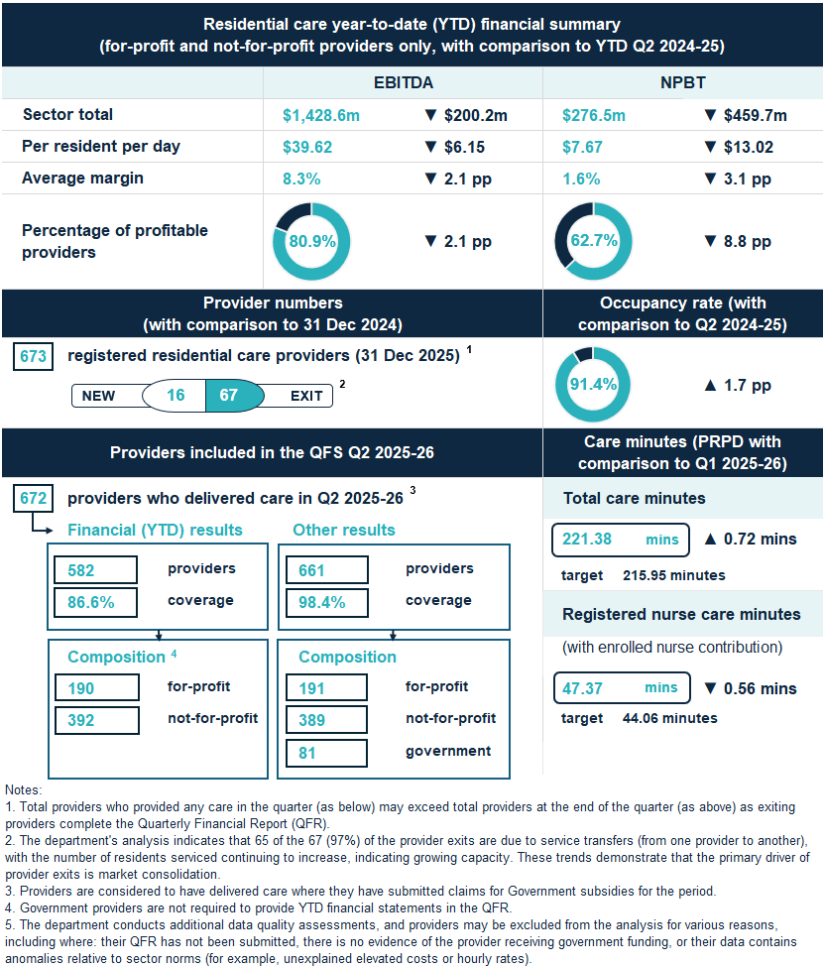

Key insight
- The sector NPBT margin decreased between Q2 2024-25 and Q2 2025-26, as operating expense growth outpaced revenue growth.
The sector recorded NPBT of $276.5 million (NPBT margin of 1.6%) in Q2 2025-26, a decrease from Q2 2024-25 ($736.2 million and NPBT margin of 4.7%).
Sector revenue growth (9.9%) was driven by a 15.0% increase in AN-ACC funding. Meanwhile, sector operating expense growth (12.5%) was driven by increased direct care labour costs through:
- increased wages for direct care staff, following FWC decisions
- increased compliance with care minute and 24/7 registered nursing requirements, and
- the linking of care funding to care minute delivery in non-specialised homes in metropolitan areas from Q2 2025-26 onwards.
A small number of providers had significant write-offs of intercompany balances in the first half of 2025-26 resulting in large non-operating expenses. These write-offs, which are of a magnitude not previously seen since the QFS commenced in 2022-23, are reflected in the Q2 2025-26 results, but were not reflected in the Q1 2025-26 results. When excluding the impact of the write-offs, the sector average NPBT margin would have been 2.6%, rather than 1.6%, with the 2.6% slightly lower than the 2.9% reported in the Q1 2025-26 QFS.

Support at Home
Overview of financial performance
The financial performance of the Support at Home sector decreased between Q2 2024-25 and Q2 2025-26 (Figure 2).
Figure 2: Summary of financial performance for Support at Home providers at Q2 2025-26, and comparison with Q2 2024-25
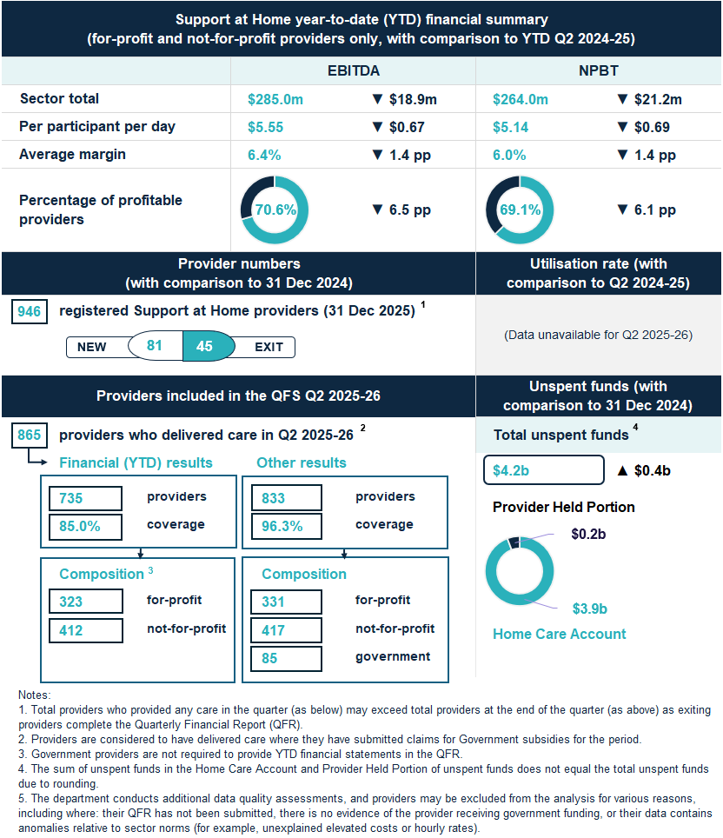

Key insight
- The decrease in the sector’s EBITDA and NPBT results in Q2 2025-26, when compared to Q2 2024-25, was driven by operating expense growth exceeding revenue growth.
In Q2 2025-26, the total sector EBITDA was $285.0 million, a decrease of $18.9 million (6.2%) from Q2 2024-25. Similarly, sector NPBT decreased by $21.2 million (7.4%) over the same time, totalling $264.0 million in Q2 2025-26. Consistent with these results, there were decreases in the EBITDA and NPBT margins, with the average EBITDA margin falling from 7.8% in Q2 2024-25 to 6.4% in Q2 2025-26 and the average NPBT margin falling from 7.3% in Q2 2024-25 to 6.0% in 2025-26.
These trends were driven by the sector’s expense growth (9.8%) exceeding growth in revenue (8.2%).

Residential aged care

Financial performance

Financial summary
The net profit position of the residential aged care sector decreased between
Q2 2024-25 and Q2 2025-26 (Table 1). In Q2 2025-26:
- revenue grew by $37.25 prpd (up 8.5%). This was primarily driven by a
$0.8 billion increase in AN-ACC funding, from $5.6 billion in Q2 2024-25 to
$6.4 billion in Q2 2025-26.
- expenses (operating and non-operating) grew by $50.27 prpd (up 12.0%). This was driven by higher labour costs, specifically, increased wage costs and care time delivered.
- sector EBITDA was $1,428.6 million, with an average EBITDA margin of 8.3% (down from 10.4% in Q2 2024-25).
- sector NPBT was $276.5 million, with an average NPBT margin of 1.6% (down from 4.7% in Q2 2024-25).
Table 1: Q2 2025-26 and comparison with Q2 2024-25, summary of financial performance of residential for-profit and not-for-profit aged care providers
 | Total | PRPD | Change from Q2  2024-25 PRPD
Revenue | $17,156.4m | $475.80 | ▲ $37.25
Operating expenses | $15,727.8m | $436.18 | ▲ $43.40
EBITDA | $1,428.6m | $39.62 | ▼ $6.15
Average EBITDA margin | 8.3% | 8.3% | ▼ 2.1 pp
Non-operating expenses | $1,152.1m | $31.95 | ▲ $6.87
NPBT | $276.5m | $7.67 | ▼ $13.02
Average NPBT margin | 1.6% | 1.6% | ▼ 3.1 pp
Note: The average EBITDA and NPBT margins (which indicate the EBITDA and NPBT returns on revenue) are calculated by dividing the sector EBITDA and NPBT results by the sector total revenue.

Profitable providers
At Q2 2025-26:
- 62.7% of providers were profitable (defined by NPBT) (down 8.8 pp from
Q2 2024-25) (Figure 3).
- profitable providers serviced 69.8% of residents (down 4.6 pp from Q2 2024-25).
Figure 3: Percentage of profitable providers and percentage of residents serviced by profitable providers at Q2 2025-26, and comparison with Q2 2024-25
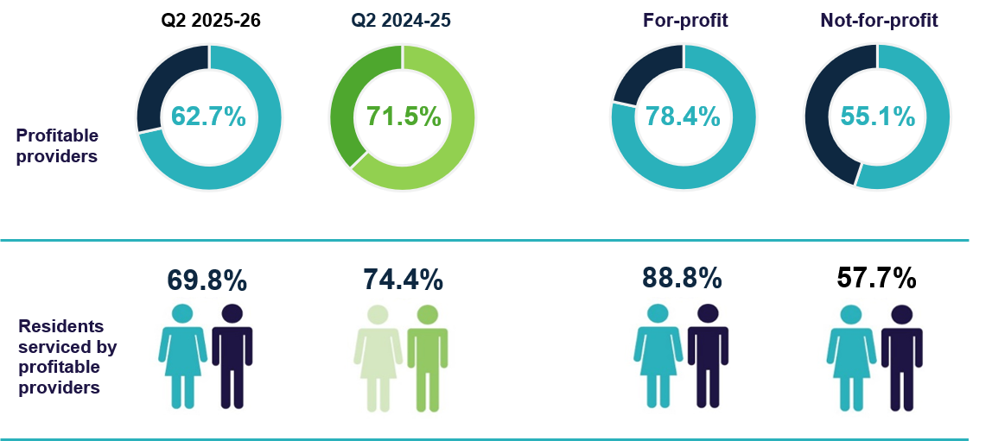

Median EBITDA and NPBT margin
In Q2 2025-26:
- the median EBITDA margin for the sector was 6.6% (down 1.7 pp from Q2 2024-25). This means an EBITDA return of $6.60 for every $100 of revenue earned (Chart 1).
- the median NPBT margin for the sector was 2.2% (down 2.0 pp from Q2 2024-25), which means a NPBT return of $2.20 for every $100 of revenue earned (Chart 2).
Chart 1: Median and quartile EBITDA margin
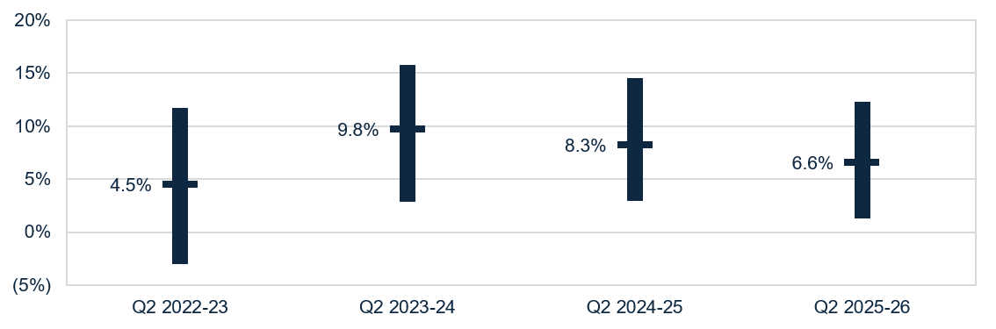

Chart 2: Median and quartile NPBT margin
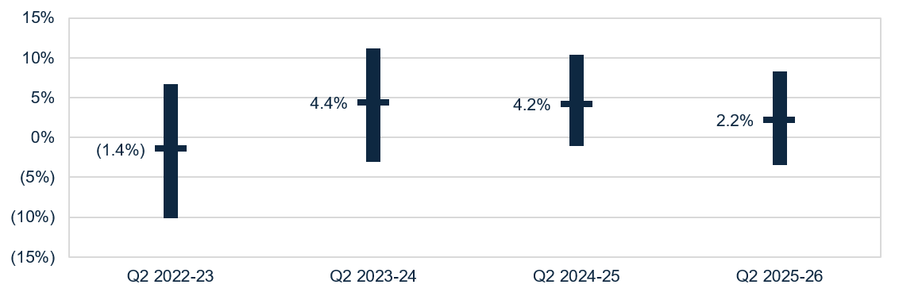

Occupancy
In Q2 2025-26, the average occupancy rate was 91.4% (up 1.7 pp from Q2 2024-25) (Chart 3).
Chart 3: Average occupancy rate
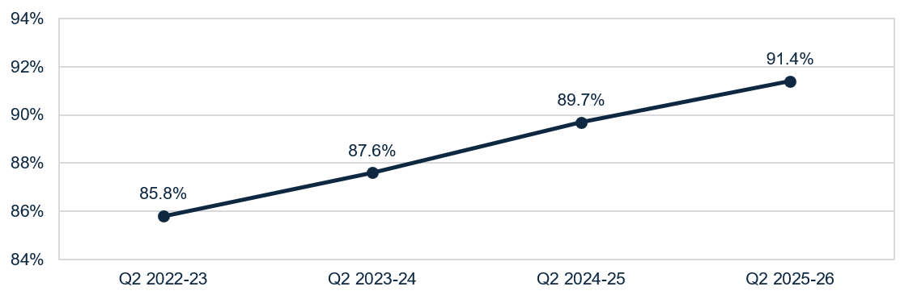
Residential care occupancy rate (%) = (occupied bed days for residential care services ÷ operational bed days for residential care services) x 100, where:
- residential care occupied bed days for an approved residential care service, refers to the total number of days that operational beds for the service were occupied by individuals to whom funded residential care services were delivered.
- residential care operational bed days for an approved residential care service, means the total number of days that residential care beds covered by the approval of the home were not offline beds.
- residential care offline beds for an approved residential care home, means residential care beds covered by the approval of the home that are covered by a notice under section 167 of the Aged Care Act 2024, given in accordance with section 167-70 of the Aged Care Rules 2025.
Notes:
1. The occupancy rate is for mainstream (permanent and respite) residential aged care services only. It excludes places or beds used to deliver other Commonwealth-funded aged care services, including the National Aboriginal and Torres Strait Islander Flexible Aged Care Program, the Transition Care Program, and Multi-Purpose Services, and excludes beds used to deliver non-aged care or non-Commonwealth funded services, including private residential care, NDIS services, or health services.
2. Residential care offline beds includes beds offline due to: a lack of capacity to deliver care due to workforce or operational issues; redevelopment, refurbishment, or extension of whole or part of the building or site in which the residential care service is delivered; the opening of new residential care home in stages, or the pending permanent closure of whole or part of the residential care home in which a residential care service is delivered.

Liquidity
In Q2 2025-26, the median liquidity ratio for the sector was 0.47 (Chart 4), meaning providers had cash and financial assets available equivalent to slightly less than half of their short-term liabilities. The liquidity position has steadily improved since
Q2 2022-23, with a further improvement in Q2 2025-26, even after allowing for the recalculation of liquid assets to include trade receivables (the ratio would have been 0.46 under the previous calculation).
Chart 4: Median and quartile liquidity ratio
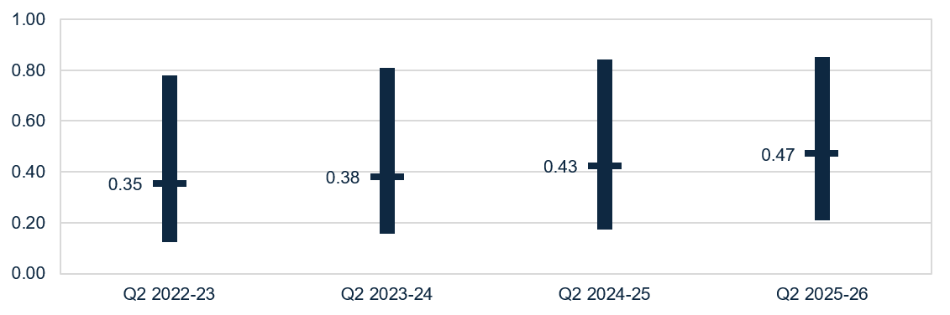
Note: From Q1 2025-26, the liquidity formula includes trade receivables as liquid assets. This is aligned with the Aged Care Quality and Safety Commission’s Financial and Prudential Standards.

Capital adequacy
In Q2 2025-26, the median capital adequacy ratio for the sector was 0.30 (up
0.02 pp from Q2 2024-25) (Chart 5), meaning for every $100 of assets owned, $30 was funded through equity and $70 through debt or other liabilities.
Chart 5: Median and quartile capital adequacy ratio
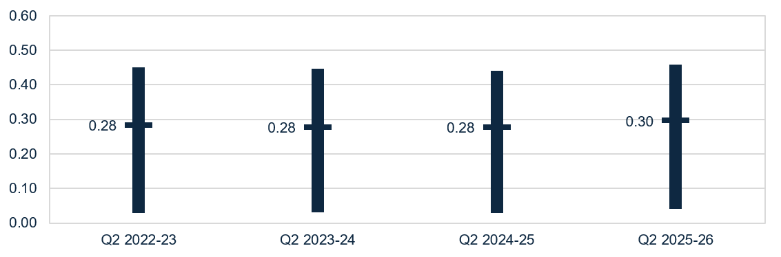
Capital adequacy ratio = (net assets - intangible assets) ÷ (total assets - intangible assets)
Note: Intangible assets are removed from the calculation as they are not considered to have value in the event of insolvency. This more realistically reflects the available capital to absorb unforeseen circumstances.

Wages to revenue
In Q2 2025-26, wages as a proportion of revenue for the sector was a median of 73.2% (up 2.0 pp from Q2 2024-25) (Chart 6).
Chart 6: Median and quartile wages to revenue percentage
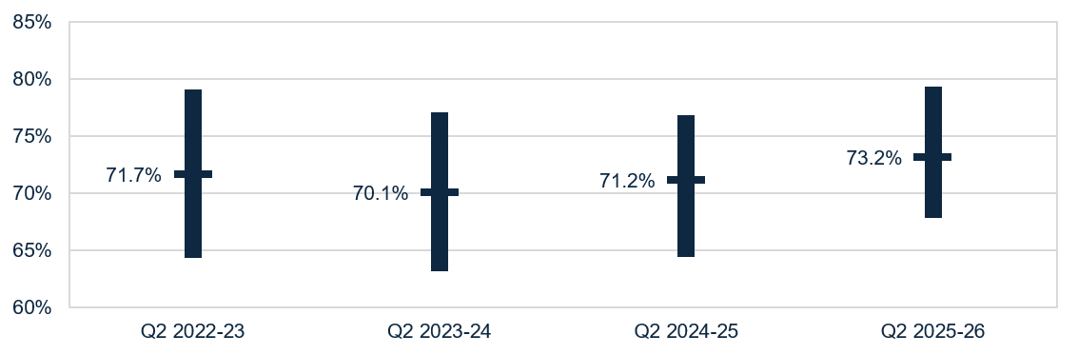

Average care minutes
- In Q2 2025-26, the sector average target for total care minutes was 215.95 minutes prpd, and 44.06 minutes prpd for registered nurse care time, including up to 10% of enrolled nurse time.
- The sector delivered above the care minute targets with residents receiving an average of 221.38 total care minutes prpd (up 0.72 minutes prpd, or 0.3% from Q1 2025-26) (Table 2).
- This includes 47.37 minutes delivered by a registered nurse (down 0.56 minutes prpd, or 1.2% from Q1 2025-26). This includes enrolled nurse time, which can contribute up to 10.0% of the registered nurse care minutes target.
- 74.2% of homes met their service-level total care minutes targets, up 6.8 pp from Q1 2025-26.
- 81.6% of homes met their service-level registered nurse targets (with enrolled nurse contribution), up 0.7 pp from Q1 2025-26.
- 65.2% of homes met both their service-level total care and registered nurse care minute targets (with enrolled nurse contribution), up 5.2 pp from Q1 2025-26.
Table 2: Q2 2025-26 and comparison with Q1 2025-26, average care minutes met prpd (sector and by provider type) ¹
 | Sector | Change from Q1 2025-26 | For-profit | Not-for-profit | LST government
Registered nurses | 44.34 | ▼0.59 | 42.61 | 44.11 | 73.13
Registered nurses  (with enrolled nurse contribution) | 47.37 | ▼0.56 | 45.99 | 46.86 | 77.35
Enrolled nurses | 12.32 | ▲0.16 | 9.14 | 10.43 | 90.66
Personal care workers & assistants in nursing | 164.72 | ▲1.15 | 168.23 | 166.78 | 78.33
Total ² | 221.38 | ▲0.72 | 220.02 | 221.29 | 241.98
Notes:
1. Average care minutes prpd is calculated by dividing total care minutes delivered by occupied bed days (not claim days).
2. The total sector care minutes result does not equal the sum of care minutes by role due to rounding. Minor discrepancies may also exist between the results above and those published in the Care minutes in residential aged care dashboard due to timing of data extraction.

Staff cost and time

Total median staff cost and time
Total median staff costs and time increased from Q2 2024-25 to Q2 2025-26.
Costs were $269.13 prpd (up $33.25 or 14.1% from Q2 2024-25) and total time was 240.06 minutes prpd (up 7.49 minutes or 3.2% from Q2 2024-25) (Table 3).
Personal care workers and assistants in nursing (the largest component) saw a 17.0% ($23.61) increase in costs and 3.1% (4.87 minutes) increase in minutes.
This growth, along with that in registered nurse costs and time, was expected with the increase in the mandatory care minutes responsibility from Q2 2024-25.
Table 3: Q2 2025-26 and comparison with Q2 2024-25, median staff cost and time prpd ¹
 | Cost  PRPD | Change from  Q2 2024-25 | Minutes PRPD | Change from Q2 2024-25
Registered nurses | $67.25 | ▲ $7.29 | 44.54 | ▲1.82
Enrolled nurses | $11.20 | ▲ $0.36 | 10.58 | ▼0.07
Personal care workers & assistants in nursing | $162.43 | ▲ $23.61 | 163.72 | ▲4.87
Allied health staff | $5.83 | ▲ $0.14 | 4.13 | ▲0.05
Diversional, lifestyle, recreation or activities officers | $7.33 | ▲ $1.35 | 8.94 | ▲1.25
Care management staff | $6.42 | ▲ $0.65 | 3.67 | ▲ 0.08
Total median ² | $269.13 | ▲ $33.25 | 240.06 | ▲7.49
Notes:
1. Direct labour costs include all on-costs for engaging staff (such as superannuation, leave, allowances), whereas the hourly rates presented in this QFS are the base gross hourly rates of pay and do not include on-costs.
2. Total median staff cost and time is derived from the totals calculated in the individual QFR submissions and is not the sum of the medians in the sub-categories listed above. Local, state and territory government providers are included in this data.

Agency staff cost and time
In Q2 2025-26:
- agency staff costs represented 6.0% of total direct care labour costs (down
1.9 pp from Q2 2024-25) (Table 4).
- agency staff hours represented 4.8% of total direct care labour hours (down
1.0 pp from Q2 2024-25).
Agency staff costs and hours decreased for all staff roles.
Table 4: Q2 2025-26 and comparison with Q2 2024-25, agency staff costs and hours as a percentage of direct care costs and hours
 | Agency costs as % of total | Change from  Q2 2024-25 | Agency hours as % of total | Change from  Q2 2024-25
Registered nurses | 7.4% | ▼ 3.3 pp | 5.9% | ▼ 1.8 pp
Enrolled nurses | 4.9% | ▼ 1.2 pp | 3.8% | ▼ 0.7 pp
Personal care workers & assistants in nursing | 3.7% | ▼ 1.2 pp | 3.2% | ▼ 0.8 pp
Total direct care | 6.0% | ▼ 1.9 pp | 4.8% | ▼ 1.0 pp

Allied health median staff cost and time
The median total cost and time for allied health services prpd were $5.83 and 4.13 minutes (Table 3), respectively.
The highest median allied health cost and time prpd was for physiotherapists.
The median cost was $3.63 prpd (up $0.21 or 5.9% from Q2 2024-25) (Table 5). The median minutes delivered by physiotherapists was 2.62 minutes prpd (down 0.02 or 0.6% from Q2 2024-25).
Table 5: Q2 2025-26 and comparison with Q2 2024-25, median allied health cost and time prpd
 | Cost  PRPD | Change from  Q2 2024-25 | Minutes PRPD | Change from  Q2 2024-25
Physiotherapist | $3.63 | ▲ $0.21 | 2.62 | ▼0.02
Podiatrist | $0.41 | ▲ $0.03 | 0.25 | ▼0.01
Dietetic care | $0.31 | ▲ $0.03 | 0.16 | ▲0.01
Speech pathologist | $0.21 | ▲ $0.03 | 0.08 | ▲0.01
Note: Results for occupational therapists, allied health assistants, and other allied health have not been included as over half of QFR respondents did not report expenditure for these categories. Local, state and territory government providers are included in this data.

Hourly rates
In Q2 2025-26, median sector hourly rates increased for all direct care staff compared to Q2 2024-25. The sector median of the average hourly rate was:
- $53.35 for registered nurses (up $2.83 or 5.6% from Q2 2024-25) (Chart 7)
- $40.00 for enrolled nurses (up $3.00 or 8.1% from Q2 2024-25) (Chart 8)
- $35.13 for personal care workers and assistants in nursing (up $3.03 or 9.4% from Q2 2024-25) (Chart 9).
These average hourly rates are for staff employed per the employee award, enterprise agreement or contract. It does not include on-costs, penalty rates or casual rates. Nil-value responses are excluded.
Note for all charts that data collection for highest and lowest median hourly rates commenced in Q4 2022-23. As such, these figures are not available for Q2 2022-23.
Chart 7: Highest, average, and lowest hourly rates (medians) paid to registered nurses
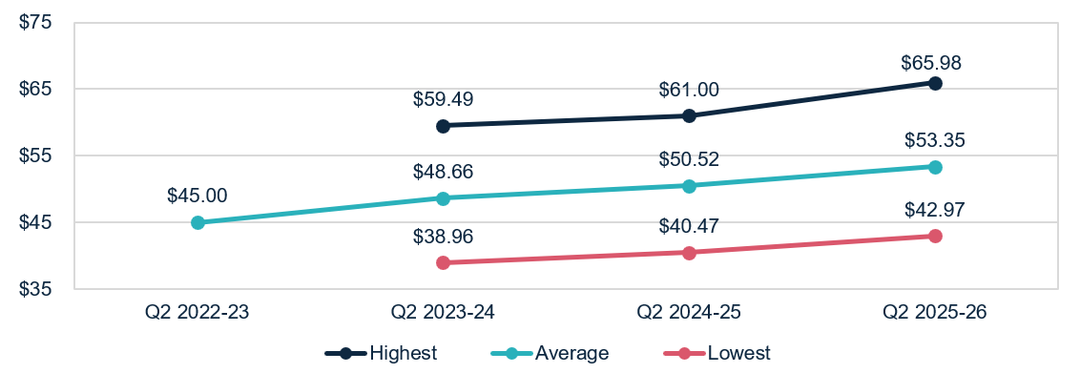

Chart 8: Highest, average, and lowest hourly rates (medians) paid to enrolled nurses
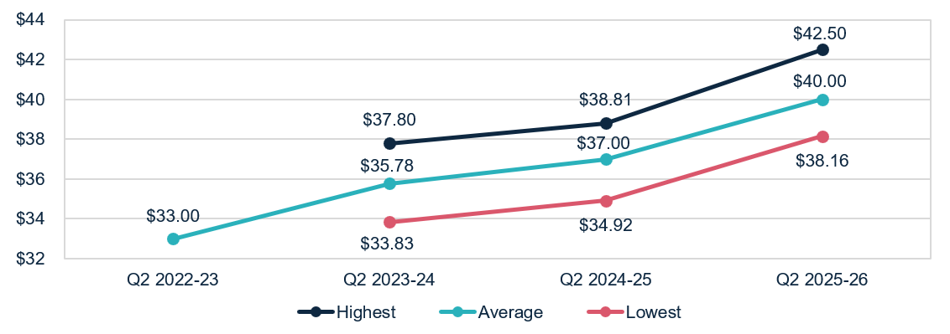

Chart 9: Highest, average, and lowest hourly rates (medians) paid to personal care workers and assistants in nursing
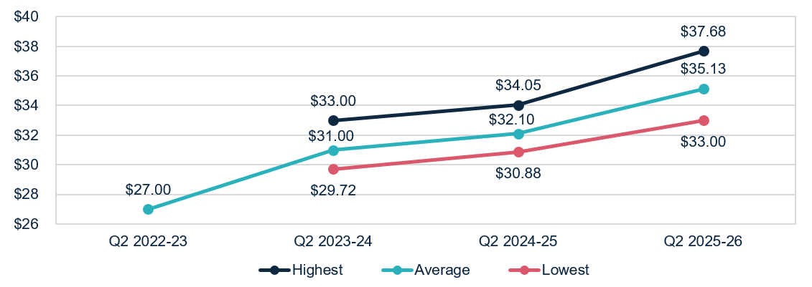

Food and nutrition
In Q2 2025-26, at a sector level:
- the median total cost of food and ingredients was $16.25 prpd (up $0.76 or 4.9% from Q2 2024-25) (Chart 10).
- the proportion of the total cost of food and ingredients spent on fresh food and ingredients (foods free of GST as per itemised purchase receipts) was 83.5%
(up 0.5 pp from Q2 2024-25).
Chart 10: Median food and ingredients cost prpd
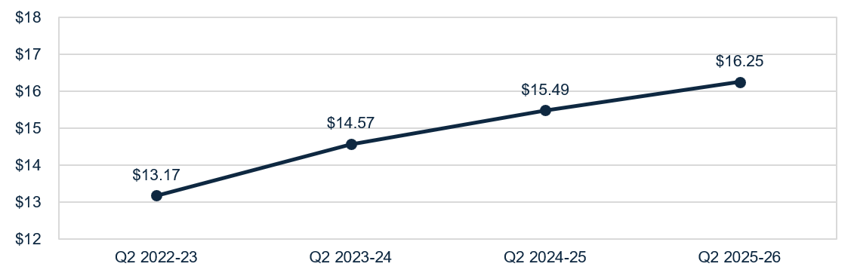

Insight 1: Impact of provider catering location and organisation type on food and nutrition expenditure
Provider reporting through the QFR shows additional variation in the median prpd food and ingredient costs by catering location and organisation type. These figures relate to the costs of the ingredients, and do not include labour costs for food preparation. In Q2 2025-26, food and nutrition expenditure varied by:
catering location, with spend lower in providers reporting onsite catering only ($16.07 prpd), compared to providers using offsite catering only or a mix of onsite and offsite catering ($17.85 prpd).
organisation type, with spend consistently lower in for-profit providers ($15.62 prpd), compared to not-for-profit providers ($16.00 prpd) and LST government providers ($20.82 prpd).
Refer to the QFS data extract for additional trends in food and nutrition expenditure.

Support at Home

Financial performance

Financial summary
The EBITDA and NPBT position of the Support at Home sector decreased between Q2 2024-25 and Q2 2025-26 (Table 6). In Q2 2025-26:
- revenue grew by $6.54 pppd (up 8.2%).
- expenses (operating and non-operating) grew by $7.23 pppd (up 9.8%). This was driven by an increase in labour costs.
- sector EBITDA was $285.0 million, with an average EBITDA margin of 6.4% (down 1.4 pp from Q2 2024-25).
- sector NPBT was $264.0 million, with an average NPBT margin of 6.0% (down 1.3 pp from Q2 2024-25).
Table 6: Q2 2025-26 and comparison with Q2 2024-25, summary of financial performance of Support at Home for-profit and not-for-profit aged care providers
 | Total | PPPD | Change from Q2  2024-25 PPPD
Revenue | $4,433.0m | $86.35 | ▲ $6.54
Operating expenses | $4,148.1m | $80.80 | ▲ $7.20
EBITDA | $285.0m | $5.55 | ▼ $0.67
Average EBITDA margin | 6.4% | 6.4% | ▼ 1.4 pp
Non-operating expenses | $21.0m | $0.41 | ▲ $0.03
NPBT | $264.0m | $5.14 | ▼ $0.69
Average NPBT margin | 6.0% | 6.0% | ▼ 1.3 pp
Note: The average EBITDA and NPBT margins (which indicate the EBITDA and NPBT returns on revenue) are calculated by dividing the sector EBITDA and NPBT results by the sector total revenue.

Profitable providers
At Q2 2025-26:
- 69.1% of providers were profitable (defined by NPBT) (Figure 4). This was a decrease of 6.1 pp from Q2 2024-25.
- profitable providers serviced 74.8% of Support at Home participants. This was a decrease of 6.8 pp from Q2 2024-25.
Figure 4: Percentage of profitable providers and percentage of Support at Home participants serviced by profitable providers at Q2 2025-26, and comparison with Q2 2024-25
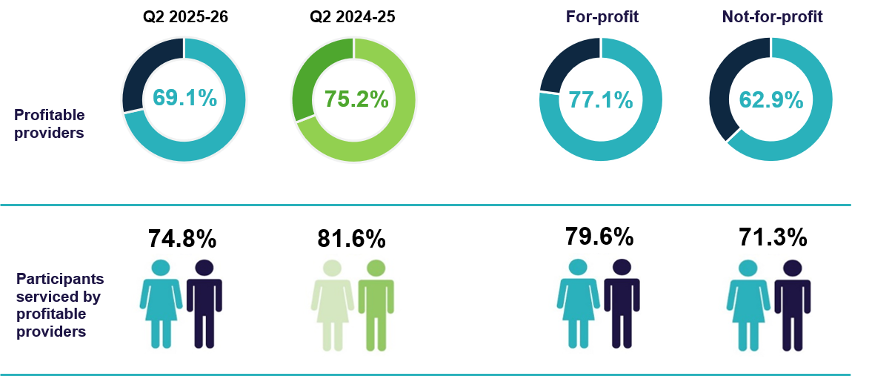

Median EBITDA and NPBT margin
In Q2 2025-26:
- the median EBITDA margin for the sector was 5.1% (down 2.0 pp from Q2 2024-25, which means an EBITDA return of $5.10 for every $100 of revenue earned (Chart 11).
- the median NPBT margin for the sector was 4.6% (down 1.8 pp from Q2 2024-25), which means a NPBT return of $4.60 for every $100 of revenue earned (Chart 12).
Chart 11: Median and quartile EBITDA margin
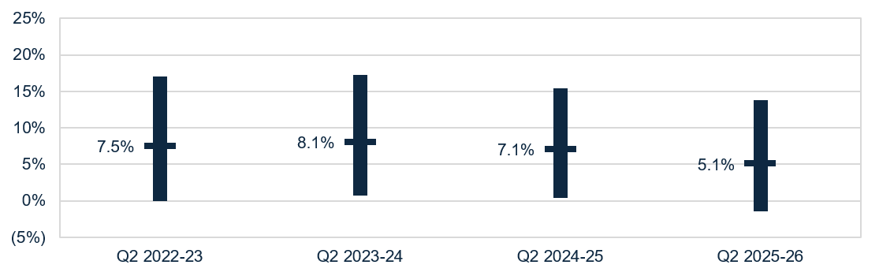
Chart 12: Median and quartile NPBT margin
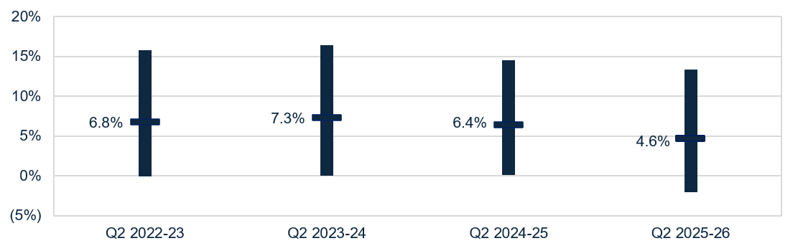

Liquidity
In Q2 2025-26, the median sector liquidity ratio was 1.13 (Chart 13). This means for every $100 of debt obligations, providers had $113 in liquid assets. While the liquidity position of the sector has remained consistent since Q2 2022-23, there was an improvement following the recalculation of liquid assets in Q2 2025-26.
Chart 13: Median and quartile liquidity ratio
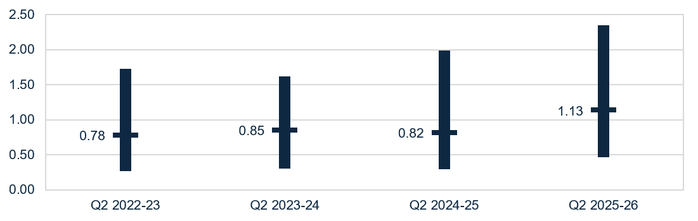
Note: From Q1 2025-26, the liquidity formula includes trade receivables as liquid assets. This is aligned to the Aged Care Quality and Safety Commission’s Financial and Prudential Standards.

Capital adequacy
In Q2 2025-26, the sector median capital adequacy ratio was 0.51 (Chart 14), consistent the Q2 2024-25 position. This means for every $100 of assets owned, $51 was funded through equity and $49 through debt or other liabilities.
Chart 14: Median and quartile capital adequacy ratio
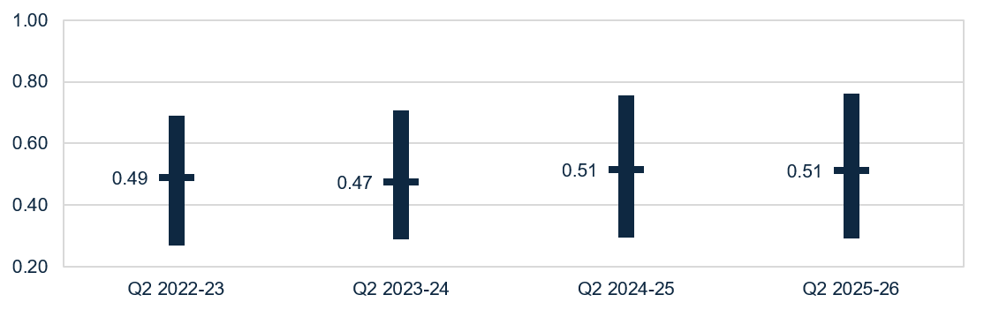
Capital adequacy ratio = (net assets - intangible assets) ÷ (total assets - intangible assets)

Wages to revenue
In Q2 2025-26, wages as a proportion of revenue for the sector was a median of 61.5% (Chart 15), an increase of 1.0 pp from Q2 2024-25. Wages include salaries and employment benefits, agency and subcontractor costs, and management fees. Wages do not include staff training and development.
Chart 15: Median and quartile wages to revenue percentage
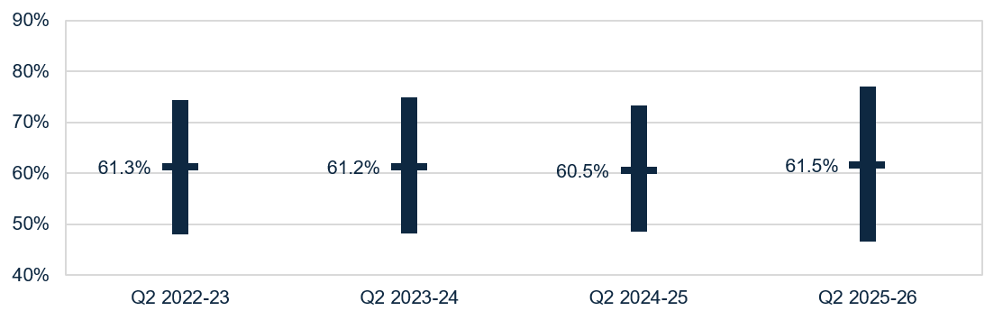

Staff cost
In Q2 2025-26, the total median staff costs increased to $59.84 pppd (up $4.54 or 8.2% from Q2 2024-25) (Table 7).
Table 7: Q2 2025-26 and comparison with Q2 2024-25, median staff cost ¹
 | Cost PPPD | Change from Q2 2024-25 PPPD
Registered nurses ² | $1.42 | ▲ $0.27
Personal care staff | $24.12 | ▼ $3.28
Allied health staff | $4.60 | ▲ $0.55
Other direct care staff | $4.34 | ▲ $3.80
Care management staff | $7.62 | ▲ $0.17
Administrative & non-care staff | $7.36 | ▲ $0.04
Total median ³ | $59.84 | ▲ $4.54

Notes:
1. Staff travel, or work done on administration tasks during care staff paid hours, is included in the results of Chart 15, which shows the median wages to revenue percentage. All provider types are included in this data, including local, state and territory government providers.
2. Data for enrolled nurses has not been included as 67.2% of Support at Home providers did not report expenditure in this category.
3. Total median staff cost is derived from the totals calculated in the individual QFR submissions and is not the sum of the medians in the sub-categories listed above.

Hourly rates
In Q2 2025-26, the sector median of the average hourly rates increased for all direct care staff in comparison to Q2 2024-25:
- $54.87 for registered nurses (up $3.50 or 6.8% from Q2 2024-25) (Chart 16)
- $41.34 for enrolled nurses (up $3.01 or 7.9% from Q2 2024-25) (Chart 17)
- $36.09 for personal care staff (up $1.73 or 5.0% from Q2 2024-25) (Chart 18).
Average hourly rates are for staff employed per the employee award, enterprise agreement or contract. These do not include on-costs, penalty rates, casual rates, agency fees and subcontracting arrangements. Nil-value responses are excluded.
Note for all charts that data collection for highest and lowest median hourly rates commenced in Q4 2022-23. As such, these figures are not available for Q2 2022-23.
Chart 16: Highest, average, and lowest hourly rates (medians) paid to registered nurses
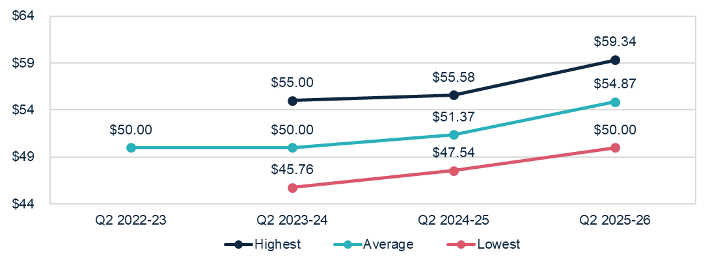
Chart 17: Highest, average, and lowest hourly rates (medians) paid to enrolled nurses
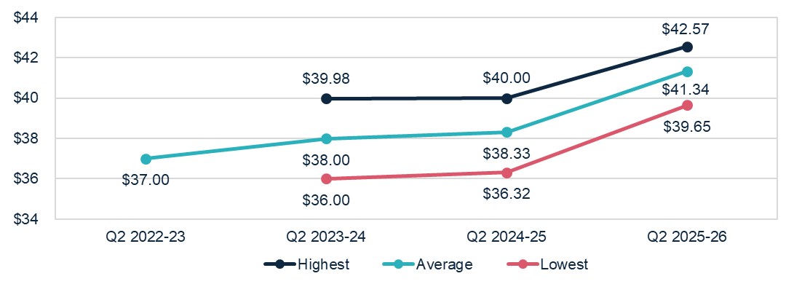
Chart 18: Highest, average, and lowest hourly rates (medians) paid to personal care staff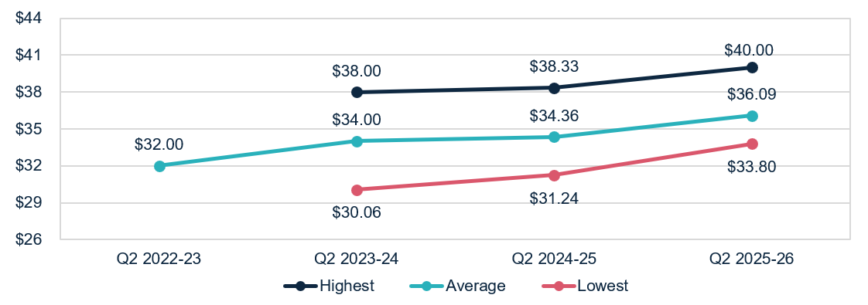

Unspent funds
At 31 December 2025, there was $4.2 billion in unspent funds (up $0.4 billion from 31 December 2024) (Chart 19). This includes:
- $3.9 billion of unspent funds in the Home Care Account (up $0.4 billion)
- $0.2 billion in the Provider Held Portion of unspent funds (down $0.1 billion).
A participant’s Home Care Package unspent funds balance was retained in the transition to the Support at Home Program on 1 November 2025, and can be used to fund assistive technology, home modifications, and/or pay approved services once their quarterly budget has been fully exhausted.
Chart 19: Unspent funds
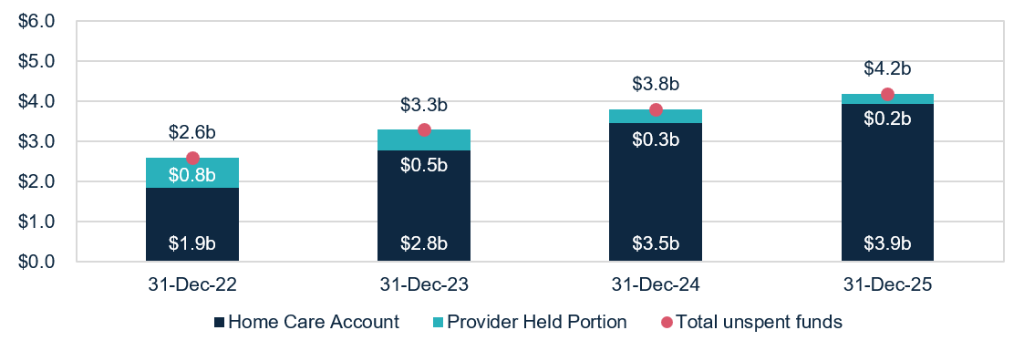

Glossary
Term | Description
Australian National Aged Care Classification  (AN-ACC) funding model | Is a case mix funding model that represents the care component of residential aged care funding. AN-ACC is designed to provide equitable care funding to approved residential aged care homes, by linking subsidy to characteristics of homes and residents. The Independent Health and Aged Care Pricing Authority provides annual pricing advice to the Minister for Aged Care, Disability and Seniors on the AN-ACC model.
Care minutes | Refers to the amount of care time people in government-funded residential aged care homes receive from registered nurses, enrolled nurses, personal care workers and assistants in nursing.
Capital adequacy ratio | Measures a provider's net asset position divided by total asset position (not including intangibles). This ratio can be used as an indicator of a provider's ability to absorb unexpected losses through their net asset position (also known as an asset buffer).  Intangible assets are removed as they are not considered to have value in the event of insolvency.
EBITDA margin | Is used as an indicator of a provider’s financial performance and underlying profitability before accounting for depreciation assumptions, tax obligations or financing choices.  EBITDA margins focus on a provider’s operating profitability and cash flow. The higher the EBITDA margin is, the lower operating expenses are in comparison to total revenue.
Fair Work Commission (FWC) decisions | The Australian Government is providing funding to support the FWC’s decisions under the Aged Care Work Value Case. The Government also provides funding to support FWC decisions relating to Annual Wage Reviews through usual program funding arrangements. These decisions are collectively referred to as ‘FWC decisions’ in this report.
Total labour (staff) costs | Includes salaries for all care and non-care staff, superannuation, bonuses and incentives, allowances, termination payments, value of fringe benefits, salary sacrifice and leave entitlements. Training costs for all employment categories are included under ‘Administration and non-care staff’ costs. Total worked staff hours excludes leave and training hours and only includes the time spent delivering care.
Liquidity ratio | Measures the availability of cash and financial assets to cover providers' debt obligations (without raising external capital) if they were to become immediately due and payable. If the ratio result is greater than 1.0, the provider has more cash and financial assets than their debt obligations.  If the ratio result is less than 1.0, the provider’s debt obligations are more than their cash and financial assets.
Support at Home program | The Support at Home program replaced the Home Care Packages Program and the Short-Term Restorative Care Programme on  1 November 2025.

Appendix

How to read the QFS

Comparison data
Charts include a comparison with the same quarter across four financial years to highlight trends in performance over time. Results and comparisons are reported at the sector-level to understand the change in performance, excluding seasonality.
The exception is data presented in relation to the average care minutes delivered by residential aged care providers (sector and by provider type), which compares to the immediate prior quarter.
Data notes: Throughout the document, this grey box gives guidance on calculations, data notes and caveats, to support aged care providers to interpret the results and benchmark their performance against sector-level results.
Quartile charts show the median, upper quartile (the 75th percentile) and lower quartile (the 25th percentile). This highlights the spread of reported results.

Insights
Insights
Throughout the document, these boxes are used to highlight key findings in relation to the data presented, including the trend in the data over time.

Provider type definitions
Percentage of services is calculated using the proportion of claim days from a provider.
Provider type | Definition
Sector | Consolidated view of the provider types shown in the chart, figure or table.
For-profit | Providers that are either a Private Incorporated Body or a Publicly Listed Company.
Not-for-profit | Providers that are either charitable, community based or religious organisations.
Local, state and territory (LST) government | Providers owned by a local, state and territory government. This acronym is used in tables and charts. These providers do not report YTD financial data in the QFR.

Data sources and method
- The QFS primarily draws on data collected from aged care providers through the QFR. The QFR data published in this QFS report was extracted from the department’s Ageing and Aged Care Data Warehouse (CASPER).
- QFR data is unaudited but must be authorised by a director of a provider’s board, a member of the governing body, or one of the provider’s Key Personnel (for government providers). The department undertakes data validation processes, and providers may be invited to re-submit data if anomalies are identified.
- The department conducts additional data quality assessments, and providers may be excluded from the analysis for various reasons, including where:
- there is no evidence of the provider receiving government funding, or
- their data contains anomalies relative to sector norms (for example, unexplained elevated costs or hourly rates).
- The QFS presents the financial summary, wages to revenue percentage, EBITDA margin and percentage of profitable providers in YTD format. This ensures information is presented the way it has been collected, and consistent with standard accounting practices. Care minutes, labour costs and food and nutrition are reported as quarter-specific results only.
- Provider entry and exit data is extracted from the Government Provider Management System. Some providers may be counted in both residential and Support at Home for entry and exit data.
- The QFS draws on data collected through departmental sources.
- Sector-level results published in the QFS may differ from information on the
My Aged Care website. The QFS presents median results at the provider-level, while the My Aged Care website presents median results at a service-level.

Previous snapshots and feedback
Previous QFS publications are available on the department’s website. The QFS will evolve over time, and the department is committed to working with the sector to inform future publications. Feedback is welcome and should be directed to QFS.FRAACS@health.gov.au.

Note: The sum of unspent funds in the Home Care Account and Provider Held Portion of unspent funds does not equal the total unspent funds due to rounding.

